REVISIONS
DESCRIPTION |  |  |  |  |  | DATE
DRAFT

DISTRIBUTION STATEMENT A
APPROVED FOR PUBLIC RELEASE; DISTRIBUTION IS UNLIMITED.
APPROVALS
AUTHORIZED SIGNATURES | REPRESENTING |  |  |  |  | DATE
GPS NAVSTAR JPO
SMC/CZ (AFMC)
Boeing
SPACE SYSTEMS DIVISION
* An asterisk affixed to the approval signature indicates that the approval is subject to exceptions taken in the "Letter of Exception" contained in Appendix I of this document.
INTERFACE CONTROL DOCUMENT 16 April 01
UNLESS OTHERWISE SPECIFIED:  DIMENSIONS ARE IN INCHES.  TOLERANCES ON:  DECIMALS ANGLES  XX = ±0.03 ±0° 30' XXX = ±0.01 | DR BY |  |  | ARINC Incorporated  2250 E. Imperial Highway, Suite 450  El Segundo, CA 90245-3509
 | CHK BY
 | APPROVALS |  |  | ICD TITLE  Navstar GPS Space Segment / User Segment L5 Interfaces
THIS DOCUMENT SPECIFIES TECHNICAL REQUIREMENTS AND NOTHING HEREIN CONTAINED SHALL BE DEEMED TO ALTER THE TERMS OF ANY CONTRACT OR PURCHASE ORDER BETWEEN ALL PARTIES AFFECTED.
 |  |  |  | SIZE  A | CODE IDENT NO.  OVYX1 |  | DRAWING NO.  ICD-GPS-705
 |  |  |  | SCALE: N/A | REV: |  | SHEET I

(This page intentionally left blank.)

REVISION RECORD
LTR | DESCRIPTION | DATE | APPROVED
NC | Initial Draft Release | 16 Apr 01

(This page intentionally left blank.)

Page Revision Record
Pages Revision Pages Revision

(This page intentionally left blank.)

TABLE OF CONTENTS
1 SCOPE 1
1.1 Scope 1
1.2 ICD Approval and Changes 1
2 APPLICABLE DOCUMENTS 3
2.1 Government Documents 3
2.2 Non-Government Documents 3
3 REQUIREMENTS 5
3.1 Interface Definition 5
3.2 Interface Identification 6
3.2.1 Ranging Codes 6
3.2.1.1 L5-Codes 6
3.2.1.2 Non-Standard Codes 7
3.2.2 NAV Data 7
3.2.3 L5 Signal Structure 10
3.3 Interface Criteria 10
3.3.1 Composite Signal 10
3.3.1.1 Frequency Plan 10
3.3.1.2 Correlation Loss 10
3.3.1.3 Carrier Phase Noise 10
3.3.1.4 Spurious Transmissions 11
3.3.1.5 Phase Quadrature 11
3.3.1.6 Signal Power Levels 11
3.3.1.6.1 User-Received Signal Levels 11
3.3.1.6.2 Satellite-Transmitted Signal Levels 12
3.3.1.7 Equipment Group Delay 13
3.3.1.7.1 Group Delay Uncertainty 13
3.3.1.7.2 Group Delay Differential 14
3.3.1.8 Signal Coherence 14
3.3.1.9 Signal Polarization 14
3.3.2 PRN Code Characteristics 14
3.3.2.1 Code Structure 14
3.3.2.2 Code Generation 16
3.3.2.3 Q5 Synchronization Sequence 20
3.3.3 Navigation Data 20
3.3.3.1 Navigation Data Modulation 21
3.3.3.1.1 Forward Error Correction 21
3.3.3.1.2 Neuman-Hoffman Code 23
3.3.4 GPS Time and SV Z-Count 23
4 NOT APPLICABLE 27
5 NOT APPLICABLE 29
6 NOTES 31
6.1 Acronyms 31
6.2 Definitions 33
6.2.1 User Range Accuracy 33
6.2.2 SV Block Definitions 33
6.2.2.1 Developmental SVs 33
6.2.2.2 Operational SVs 33
6.2.2.2.1 Block II SVs 34
6.2.2.2.2 Block IIA SVs 34
6.2.2.2.3 Block IIR SVs 34
6.2.2.2.4 Block IIF SVs 34
6.2.2.2.5 Block III SVs 34
6.2.3 Operational Interval Definitions 34
6.2.3.1 Normal Operations 35
6.2.3.2 Short-term Extended Operations 35
6.2.3.3 Long-term Extended Operations 35
6.2.4 GPS Week Number 35
6.3 Supporting Material 35
6.3.1 L5 Received Signals 35
6.3.2 Integrated phase noise characteristics 35
10 APPENDIX I: LETTERS OF EXCEPTION 37
10.1 Scope 37
10.2 Applicable Documents 37
10.3 Letters of Exception 37
20 APPENDIX II: GPS NAVIGATION DATA STRUCTURE FOR DATA ID NO. 3 39
20.1 Scope 39
20.2 Applicable Documents 39
20.2.1 Government Documents 39
20.2.2 Non-Government Documents 39
20.3 Requirements 40
20.3.1 Data Characteristics 40
20.3.2 Message Structure 40
20.3.3 Message Content 40
20.3.3.1 Message Type 1 Clock, Health and Accuracy Parameters 47
20.3.3.1.1 Message Type 1 Clock, Health and Accuracy Parameter Content 47
20.3.3.1.1.1 Transmission Week Number 47
20.3.3.1.1.2 SV Accuracy (L5) 47
20.3.3.1.1.3 SV Health (L5) 47
20.3.3.1.1.4 Issue of Data, Clock (IODC) 48
20.3.3.1.1.5 Long-term Extended Operations 48
20.3.3.1.1.6 SV Clock Correction 48
20.3.3.1.1.7 Estimated Group Delay Differential (L1-L5) 48
20.3.3.1.1.8 Estimated L2/L5 Group Delay Differential 48
20.3.3.1.1.9 Estimated L5 Q5/I5 Group Delay Differential 48
20.3.3.1.2 Message Type 1 Clock, Health and Accuracy Parameter Characteristics 49
20.3.3.1.3 User Algorithms for Message Type 1 Clock Data 49
20.3.3.1.3.1 User Algorithm for SV Clock Correction 49
20.3.3.1.3.2 L1/L5 Group Delay Correction 52
20.3.3.1.3.3 L2/L5 Group Delay Correction 53
20.3.3.1.3.4 L1/L5 Ionospheric Correction 53
20.3.3.1.3.5 L2/L5 Ionospheric Correction 54
20.3.3.1.3.6 L5 Q-code/I-code Correction 54
20.3.3.1.3.7 Example Application of Correction Parameters 54
20.3.3.2 Message Type 1 and 2 Ephemeris Parameters 55
20.3.3.2.1 Message Type 1 and 2 Ephemeris Parameter Content 55

20.3.3.2.2 Message Type 1 and 2 Ephemeris Parameter Characteristics 57
20.3.3.2.3 User Algorithm for Ephemeris Determination 57
20.3.3.2.3.1 Curve Fit Intervals 57
20.3.3.2.3.2 Parameter Sensitivity 57
20.3.3.2.3.3 Coordinate Systems 57
20.3.3.2.3.3.1 ECEF Coordinate System 57
20.3.3.2.3.3.2 Earth-Centered, Inertial (ECI) Coordinate System 57
20.3.3.2.3.4 Geometric Range 57
20.3.3.3 Message Type 3 Parameters 58
20.3.3.3.1 Message Type 3 Parameter Content 58
20.3.3.3.1.1 Coordinated Universal Time (UTC) and GPS Time Parameters 58
20.3.3.3.1.2 Ionospheric Data 58
20.3.3.3.1.3 SV Health (L1/L2) 58
20.3.3.3.1.4 Code(s) on L2 Channel 60
20.3.3.3.1.5 Data ID 60
20.3.3.3.2 Algorithms Related to Message Type 3 Data 60
20.3.3.3.2.1 Coordinated Universal Time (UTC) and GPS Time 60
20.3.3.3.2.2 Ionospheric Model 61
20.3.3.4 Message Type 4 Almanac Parameters 61
20.3.3.4.1 Message Type 4 Almanac Parameter Content 61
20.3.3.4.1.1 Almanac Data 61
20.3.3.4.1.2 SV Health (L1 and L2) 63
20.3.3.4.1.3 SV Health (L5) 63
20.3.3.4.1.4 Anti-Spoof (A-S) Flags and SV Configurations 66
20.3.3.4.1.5 Almanac Reference Week 66
20.3.3.4.2 Algorithms Related to Message Type 4 Data 66
20.3.3.4.2.1 Almanac 66
20.3.3.4.2.2 Almanac Reference Time 66
20.3.3.4.2.3 Almanac Time Parameters 66
20.3.3.5 Message Type 5 66

20.3.4 Timing Relationships 67
20.3.4.1 Paging and Cutovers 67
20.3.4.2 SV Time vs. GPS Time 67
20.3.4.3 Speed of Light 68
20.3.4.4 Data Sets 68
20.3.4.5 Reference Times 68
20.3.5 Data Frame Parity 68
20.3.5.1 Parity Algorithm 69
LIST OF FIGURES

Figure 3-1 GPS Space Segment to User Segment Interfaces 5
Figure 3-2 Generation of Codes 15
Figure 3-3 Modulation of Signals 16
Figure 3-4 XA Shift Register Generator Configuration 18
Figure 3-5 XB Shift Register Generator Configuration 19
Figure 3-6 Relative Phases Between the XA and XB Sequences 20
Figure 3-7 Convolutional Encoder 22
Figure 3-8 Convolutional transmit/Decoding Timing Relationships 22
Figure 3-9 Time Line Relationship of a Six-Second Message 25
Figure 6-1 User Received Minimum Signal Levels 36
Figure 10-1 Letters of Exception 37
Figure 20-1 Message Type 1 Format 41
Figure 20-2 Message Type 2 Format 42
Figure 20-3 Message Type 3 Format 43
Figure 20-4 Message Type 4 Format 44
Figure 20-5 Message Type 5 Format 45
Figure 20-6 Sample Application of Correction Parameters 56

LIST OF TABLES

Table 3-I Code Phase Assignments 8
Table 3-II Composite L5 Transmitted Signal Phase 12
Table 3-III Received Minimum L5 RF Signal Strength 13
Table 6-I I5 and Q5 Signal-in-Space Link Budget Summary 36
Table 20-I Message Type 1 Clock, Health and Accuracy Parameters 51
Table 20-II UTC Parameters 59
Table 20-III Almanac Parameters 62
Table 20-IV L5 NAV Data Health Indications 64
Table 20-V Codes for Health of SV L5 Signal Components 65

(This page intentionally left blank.)

1. SCOPE

1.1 Scope. This Interface Control Document (ICD) defines the requirements related to the interface between the Space Segment (SS) of the Global Positioning System (GPS) and the Navigation Users of the GPS for the L5 Navigation Signal.

1.2 ICD Approval and Changes. ARINC Incorporated has been designated the Interface Control Contractor (ICC), and is responsible for the basic preparation, approval, distribution, and retention of the ICD in accordance with YEN 75-13A. The following signatories must approve this ICD to make it effective:

a. Space Segment Contractor BLOCK IIF
Boeing,
Space Systems Division

b. Control Segment Contractor Boeing,
Space Systems Division

c. Navstar GPS Joint Program Office SMC/CZ (AFMC)

Initial signature approval of this ICD can be contingent upon a letter of exception delineating those items by paragraph numbers that are not a part of the approval. Such letters of exception can be prepared by any of the signatories and must be furnished to the ICC for inclusion in Appendix I of the approved and officially released version of the ICD.

Changes to the approved version of this ICD can be initiated by any of the signatories and must be approved by all above signatories. The ICC is responsible for the preparation of the change paper, change coordination, and the change approval by all signatories in accordance with YEN 75-13A. Designated signatories can approve proposed changes to this ICD without any increase in the scope of a specific contract by so specifying in a letter of exception. Such letters of exception must be furnished to the ICC for inclusion in the released version of the approved change and in Appendix I of the subsequent revised issues of the ICD.

Whenever all the issues addressed by a letter of exception are resolved, the respective signatory shall so advise the ICC in writing. When some (but not all) of the exceptions taken by a signatory are resolved, the signatory shall provide the ICC with an updated letter of exception. Based on such notifications -- without processing a proposed interface revision notice (PIRN) for approval -- the ICC will omit the obsolete letter of exception from the next revision of the ICD and will substitute the new one (if required).

Review cycles for all Proposed Interface Revisions Notices (PIRNs) is 45 days after receipt by individual addressees unless a written request for a waiver is submitted to the ICC. Reviewing parties with delinquent responses will be charged with an automatic letter of exception.

2. APPLICABLE DOCUMENTS

2.1 Government Documents. The following documents of the issue specified contribute to the definition of the interfaces between the GPS Space Segment and the GPS Navigation User Segment, and form a part of this ICD to the extent specified herein.

Specifications
Federal
None
Military
ICD-GPS-200, Navstar GPS Space Segment / Navigation User Interfaces
Other Government Activity
None
Standards
Federal
None
Military
None
Other Publications
YEN 75-13A  16 Nov 1979  with Change Notice 1 | Interface Control Working Group

2.2 Non-Government Documents. The following documents of the issue specified contribute to the definition of the interfaces between the GPS Space Segment and the GPS Navigation User Segment and form a part of this ICD to the extent specified herein.

Specifications
None

Other Publications
None

(This page intentionally left blank.)

3. REQUIREMENTS

  - 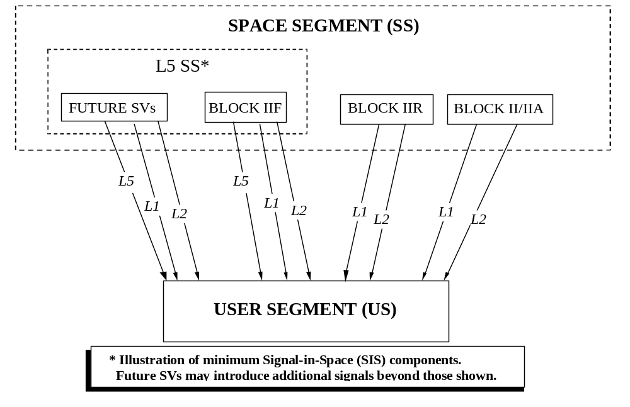Interface Definition. The signal interface between the GPS Space Segment (SS) and the GPS Navigation Users consists of three radio frequency (RF) links: L1, L2 and L5. Figure 3-1 illustrates the interface between the SS and the users. The L5 link is only available on Block IIF and the planned future Block III SVs. Utilizing these links, the space vehicles (SVs) of the SS shall provide continuous earth coverage for signals that provide to the users the ranging codes and the system data needed to accomplish the GPS navigation (NAV) mission. These signals shall be available to a suitably equipped user with RF visibility to an SV, including users in terrestrial and near-terrestrial applications as well as users in orbital applications up to geosynchronous altitude. The civil functions of the L1 and L2 RF links are specified in ICD-GPS-200. Only the L5 link and its relationship with the L1 and L2 links will be specified herein.
Figure 3-1. GPS Space Segment to User Segment Interfaces

3.2 Interface Identification. The carriers of the L5 L-band link are modulated by two bit trains in phase quadrature. One is a composite bit train generated by the Modulo-2 addition of a pseudo-random noise (PRN) ranging code, synchronization sequence, and the downlink system data (referred to as NAV data), and the other is modulated with only a PRN ranging code and synchronization sequence that differ from the ranging code used with the NAV data.

3.2.1 Ranging Codes. Two PRN ranging codes are transmitted on L5: the in-phase code (denoted as the I5-code); and the quadraphase code (denoted as the Q5-code). Code-division-multiple-access techniques allow differentiating between the SVs even though they all transmit at the same L5 frequency. The SVs will transmit intentionally "incorrect" versions of the I5 and the Q5-codes when needed to protect the users from receiving and utilizing anomalous NAV signals as a result of a malfunction in the SV. These two "incorrect" codes are termed non-standard I5 (NSI5) and non-standard Q5 (NSQ5) codes.

3.2.1.1 L5-Codes. The PRN L5-codes for SV ID number i are independent, but time synchronized, ranging codes, I5_{i}(t) and Q5_{i}(t), of 1 millisecond in length at a chipping rate of 10.23 Mbps. For each code, the 1-millisecond sequences are the Modulo-2 sum of two sub-sequences referred to as XA and XB_{i}; their lengths are 8,190 chips and 8,191 chips, respectively, that restart to generate the 10,230 chip code. The XB_{i} sequence is selectively delayed, thereby allowing the basic code generation technique to produce a set of 74 (37 I5 and 37 Q5) mutually exclusive code sequences of 1-millisecond in length. Of these, 32 pairs are designated for use by SVs, while the remaining 5 pairs are reserved. Assignment of these code phase segments by SV-ID number (or other use) is given in Table 3-I. SV-ID numbers and PRN are identical to those for the L1 and L2 signals as specified in ICD-GPS-200.

The 74 codes are a selected subset of over 4000 possible codes that could be generated using the selective delay. The remaining codes are reserved for other L5 signal applications such as Satellite Based Augmentation System (SBAS) satellite signals.

3.2.1.2 Non-standard Codes. The NSI5 and NSQ5 codes, used to protect the user from a malfunction in the SV (reference paragraph 3.2.1), are not for utilization by the user and, therefore, are not defined in this document.

3.2.2 NAV Data. The system data, D(t), includes SV ephemerides, system time, SV clock behavior data, status messages and time information, etc. The 50 bps data is coded in a rate ½ convolutional coder. The resulting 100 symbols per second (sps) symbol stream is Modulo-2 added to the I5-code only; the resultant bit-trains are used to modulate the L5 in-phase (I) carrier. The content and characteristics of data ID number 3 are given in Appendix II of this document. Data ID number 2 is used for L1 and L2 C/A-code, and data ID number 1 is no longer used. In general, the data content is based on that modulated on the C/A-codes in the L1 and L2 channels of the SV, with data specific to the L5 signal added, and a different error detection encoding used.

The L5 quadraphase (Q5) carrier has no data.

Table 3-I. Code Phase Assignments (sheet 1 of 2)
GPS PRN  Signal No.* | XB Code Advance – Chips** |  | Initial XB Code State***
GPS PRN  Signal No.* | I5 | Q5 | I5 | Q5
1  2  3  4  5  6  7  8  9  10  11  12  13  14  15  16  17  18  19 | 266  365  804  1138  1509  1559  1756  2084  2170  2303  2527  2687  2930  3471  3940  4132  4332  4924  5343 | 1701  323  5292  2020  5429  7136  1041  5947  4315  148  535  1939  5206  5910  3595  5135  6082  6990  3546 | 0101011100100  1100000110101  0100000001000  1011000100110  1110111010111  0110011111010  1010010011111  1011110100100  1111100101011  0111111011110  0000100111010  1110011111001  0001110011100  0100000100111  0110101011010  0001111001001  0100110001111  1111000011110  1100100011111 | 1001011001100  0100011110110  1111000100011  0011101101010  0011110110010  0101010101001  1111110000001  0110101101000  1011101000011  0010010000110  0001000000101  0101011000101  0100110100101  1010000111111  1011110001111  1101001011111  1110011001000  1011011100100  0011001011011
* PRN sequences 33 through 37 are reserved for other uses (e.g. ground transmitters).
** XB Code Advance is the number of XB clock cycles beyond an initial state of all 1s .
*** In the binary notation for the first 13 chips of the I5 and Q5 XB codes as shown in these columns. The rightmost bit is the first bit out. Since the initial state of the XA Code is all 1s, these first 13 chips are also the inverse of the initial states of the I5 or Q5-codes.

NOTE: The code phase assignments constitute inseparable pairs, each consisting of a specific I5 and a specific Q5-code phase, as shown above.

Table 3-I. Code Phase Assignments (sheet 2 of 2)
GPS PRN  Signal No.* | XB Code Advance – Chips** |  | Initial XB Code State***
GPS PRN  Signal No.* | I5 | Q5 | I5 | Q5
20  21  22  23  24  25  26  27  28  29  30  31  32  33  34  35  36  37 | 5443  5641  5816  5898  5918  5955  6243  6345  6477  6518  6875  7168  7187  7329  7577  7720  7777  8057 | 1523  4548  4484  1893  3961  7106  5299  4660  276  4389  3783  1591  6518  749  1138  1661  3210  4332 | 0110101101101  0010000001000  1110111101111  1000011111110  1100010110100  1101001101101  1010110010110  0101011011110  0111101010110  0101111100001  1000010110111  0001010011110  0000010111001  1101010000001  1101111111001  1111011011100  1001011001000  0011010010000 | 1100001110001  0110110010000  0010110001110  1000101111101  0110111110011  0100010011011  0101010111100  1000011111010  1111101000010  0101000100100  1000001111001  0101111100101  0101111100001  1011001000100  1011000100110  0110010110011  0011110101111  0100110001111
* PRN sequences 33 through 37 are reserved for other uses (e.g. ground transmitters).
** XB Code Advance is the number of XB clock cycles beyond an initial state of all 1s .
*** In the binary notation for the first 13 chips of the I5 and Q5 XB codes as shown in these columns. The rightmost bit is the first bit out. Since the initial state of the XA Code is all 1s, these first 13 chips are also the inverse of the initial states of the I5 or Q5-codes.

NOTE: The code phase assignments constitute inseparable pairs, each consisting of a specific I5 and a specific Q5-code phase, as shown above.

3.2.3 L5 Signal Structure. The L5 consists of two carrier components that are in phase quadrature with each other. Each carrier component is bi-phase shift key (BPSK) modulated by a separate bit train. One bit train is the Modulo-2 sum of the I5-code, NAV data, and synchronization sequence while the other is the Q5-code with no NAV data, but with another synchronization sequence. For a particular SV, all transmitted signal elements (carriers, codes, synchronization sequences, and data) are coherently derived from the same on-board frequency source.

3.3 Interface Criteria. The criteria specified in the following define the requisite characteristics of the L5 interface.

3.3.1 Composite Signal. The following criteria define the characteristics of the composite L5 signal.

3.3.1.1 Frequency Plan. The L5 signal is contained within a 24 MHz band centered about L5. The carrier frequencies for the L1, L2 and L5 signals shall be coherently derived from a common frequency source within the SV. The nominal frequency of this source -- as it appears to an observer on the ground -- is 10.23 MHz. The SV carrier frequency and clock rates -- as they would appear to an observer located in the SV -- are offset to compensate for relativistic effects. The clock rates are offset by f/f = -4.4647E-10, equivalent to a change in the I5 and Q5-code chipping rate of 10.23 MHz offset by a f = -4.5674E-3 Hz. This is equal to 10.22999999543 MHz. The nominal carrier frequency (f₀) -- as it appears to an observer on the ground – shall be 1176.45 MHz, or 115 times 10.23 MHz.

3.3.1.2 Correlation Loss. Correlation loss is defined as the difference between the SV power received in a 24 MHz bandwidth and the signal power recovered in an ideal correlation receiver or matched filter implementation of the same bandwidth. The worst case correlation loss occurs when the I5 carrier is modulated by the sum of the I5-code and the NAV data stream. For this case, the correlation loss apportionment shall be as follows:

- SV modulation and filter imperfections: 0.6 dB
- Ideal UE receiver waveform distortion (due to 24 MHz filter): 0.4 dB

3.3.1.3 Carrier Phase Noise. The phase noise spectral density of the unmodulated carrier shall be such that a phase locked loop of 10 Hz one-sided noise bandwidth shall be able to track the carrier to an accuracy of 0.1 radians root mean square (RMS). See additional supporting material for phase noise characteristics in section 6.2.1.

3.3.1.4 Spurious Transmissions. In-band spurious transmissions shall be at least 40 dB below the unmodulated L5 carrier over the allocated 24 MHz channel bandwidth.

3.3.1.5 Phase Quadrature. The two L5 carrier components modulated by the two separate bit trains (I5-code plus data and Q5-code with no data) shall be in phase quadrature (within ±100 milliradians) with the Q5 signal carrier lagging the I5 signal by 90 degrees. Referring to the phase of the I5 carrier when I5_{i}(t) equals zero as the "zero phase angle", the I5- and Q5-code generator output shall control the respective signal phases in the following manner: when I5_{i}(t) equals one, a 180-degree phase reversal of the I5-carrier occurs; when Q5_{i}(t) equals one, the Q5 carrier advances 90 degrees; when the Q5_{i}(t) equals zero, the Q5 carrier shall be retarded 90 degrees (such that when Q5_{i}(t) changes state, a 180-degree phase reversal of the Q5 carrier occurs). The resultant nominal composite transmitted signal phases as a function of the binary state of the modulating signals are as shown in Table 3-II.

3.3.1.6 Signal Power Levels. The L5 signal power levels are specified for two service volumes: terrestrial and orbital. The terrestrial service volume is defined from the earth’s surface up to and including 3000 km altitude. The space service volume is defined from 3000 km above the earth’s surface up to and including geosynchronous orbit. Specified values of radio frequency (RF) minimum signal power are referenced to the extremities within each service volume. In the terrestrial service volume case, the minimum case refers to the locus of points at the intersection formed by the GPS transmit antenna beam and the earth where any user’s elevation angle equals five (5) degrees. In the space service volume case, the minimum case refers to the locus of points at the intersection formed by the GPS transmit antenna beam (measured ±13.9° from boresight) and a sphere with radius equal to 42164 km, corresponding to geosynchronous orbit radius.

3.3.1.6.1 User-Received Signal Levels. The SV shall provide L5 navigation for terrestrial users and orbital users, in accordance with the minimum and maximum levels specified in Table 3-III into a 0 dB_{ic} circular polarized user receiving antenna (located near ground for terrestrial users), when the SV is above a 5-degree elevation angle. For orbital users, the same antenna configuration as terrestrial users is assumed. Additional related data is provided as supporting material in paragraph 6.3.1.

3.3.1.6.2 Satellite-Transmitted Signal Levels. The specified minimum user-received RF signal power levels are used to derive electrical power and antenna gain requirements aboard the GPS SV. Specifically, the required Effective Radiated Isotropic Power (EIRP) is related to minimum received isotropic power, when nominal channel losses are a maximum, by the relationship:

RIP_{MIN}(f) = EIRP_{REQ}(f) - L_{FS}(f)- L_{ATMOS}(f) (in dB)
where
L_{ATMOS}(f) = Atmospheric Path Loss ≡ 0.5 dB
L_{FS}(f) is Free Space Path Loss ≡ 10*log(4πρ_{MAX}/λ_{f})² (dB)
and
ρ_{MAX} = maximum SV-to-User geometric slant range (in meters)
For a user and a vehicle at a 5 deg elevation, the slant range is 25,251.6 km.
λ_{f} = wavelength of L₅ carrier frequency 1176. 45 Mhz (in meters) = 0.2548 m

For the terrestrial service volume the required composite EIRP will be 28.5 dBW and for the orbital service volume it will be TBD dBW.

Table 3-II. Composite L5 Transmitted Signal Phase
Nominal Composite L5  Signal Phase* | Code State
 | I5 | Q5
0°  -90°  +90°  180° | 0  1  0  1 | 0  0  1  1
* Relative to 0, 0 code state with positive angles leading and negative angles lagging.

Table 3-III. Received Minimum L5 RF Signal Strength *
Production Version | Channel | User Signal Levels (in dBW)
Production Version | Channel | Terrestrial |  | Orbital
Production Version | Channel | Min | Max | Min | Max
Block IIF | I5 | -157 | -150 | TBD | TBD
Block IIF | Q5 | -157 | -150 | TBD | TBD
Future SVs | I5 | TBD | TBD | TBD | TBD
Future SVs | Q5 | TBD | TBD | TBD | TBD
* Minimum power levels based on minimum Space Vehicle EIRP at 13.83 degrees off nadir, as averaged over azimuth, nominal orbital temperatures and over its specified design life with an assumed atmospheric loss of 0.5 dB

3.3.1.7 Equipment Group Delay. Equipment group delay is defined as the delay between the radiated output of the L5 ranging signal from a specific SV (measured at the antenna phase center) and the output of that SV's on-board frequency source; the delay consists of a bias term and an uncertainty. The bias term is of no concern to the users of the L1-C/A and L5 Q5-codes since it is included in the clock correction parameters relayed in the NAV data, and is therefore accounted for by the user computations of system time (reference paragraph 20.3.3.1.3.1). However, single frequency L1-C/A, L2-C/A, and L5 users must correct for the delay between the composite L1/L5 time and these single-frequency codes. The uncertainty (variation) of these delays and the relationship of the timing between composite L1/L2 P(Y)-code timing (“GPS Time”) and composite L1-C/A and L5-Q codes (“L5 Time”) are defined in the following.

3.3.1.7.1 Group Delay Uncertainty. The effective uncertainty of the group delays shall not exceed 3.0 nanosecond (two sigma).

3.3.1.7.2 Group Delay Differential. The group delay differential between the radiated L1-C/A, L2-C/A, and L5-I5 codes are specified as consisting of random plus bias components. The mean differential is defined as the bias component and will be either positive or negative. For a given navigation payload redundancy configuration, the absolute value of the mean differential delay between combinations of the L1-C/A, L2-C/A, and L5-I5 shall not exceed 30.0 nanoseconds. The random variations about the mean shall not exceed 3.0 nanoseconds (two-sigma). The group delay differences between the L5-I5 signal and that represented in the SV L5 clock corrections will be broadcast in the L5 NAV message.

3.3.1.8 Signal Coherence. All transmitted signals for a particular SV shall be coherently derived from the same on-board frequency standard; all digital signals shall be clocked in coincidence with the PRN transitions for the P-signal and occur at the P-signal transition speed. On the L5 channel the data transitions of the two modulating signals (i.e., that containing the I5-code and that containing the Q5-code) shall be such that the average time difference between the transitions does not exceed 3.0 nanoseconds (two-sigma). The signal coherence difference between the L5-I5 signal and the L5-Q5 signal will be broadcast in the L5 NAV message.

3.3.1.9 Signal Polarization The transmitted signal shall be right-hand circularly polarized (RHCP). For the angular range of ±14.3 degrees from boresight, L5 ellipticity shall be no worse than TBD dB.

3.3.2 PRN Code Characteristics. The characteristics of the I5- and the Q5-codes are defined below in terms of their structure and the basic method used for generating them. Figures 3-2 and 3-3 depict simplified block diagrams of the scheme for generating the 10.23 Mbps I5_{i}(t) and Q5_{i}(t) patterns, and for Modulo-2 summing the I5 patterns with the NAV bit train, D(t), which is rate 1/2 encoded and clocked at 100 sps. In addition, the 100 sps symbols are modulated with a 10-bit Neuman-Hoffman code that is clocked at 1 kHz. The resultant composite bit trains are then used to modulate the L5 in-phase carrier. The Q5-code is modulated with a 20-bit Neuman-Hoffman code that is also clocked at 1 kHz.

3.3.2.1 Code Structure. The I5_{i}(t) pattern (I5-code) and the Q5_{i}(t) pattern (Q5-code) are both generated by the Modulo-2 summation of two PRN codes, XA(t) and XBI_{i}(n_{Ii}, t) or XBQ_{i}(n_{Qi}, t), where n_{Ii} and n_{Qi} are initial states of XBI_{i} and XBQ_{i} for satellite i. There are over 4000 unique XB codes generated using different initial states of which 74 are assigned and identified in Table 3-I using the same basic code generator.

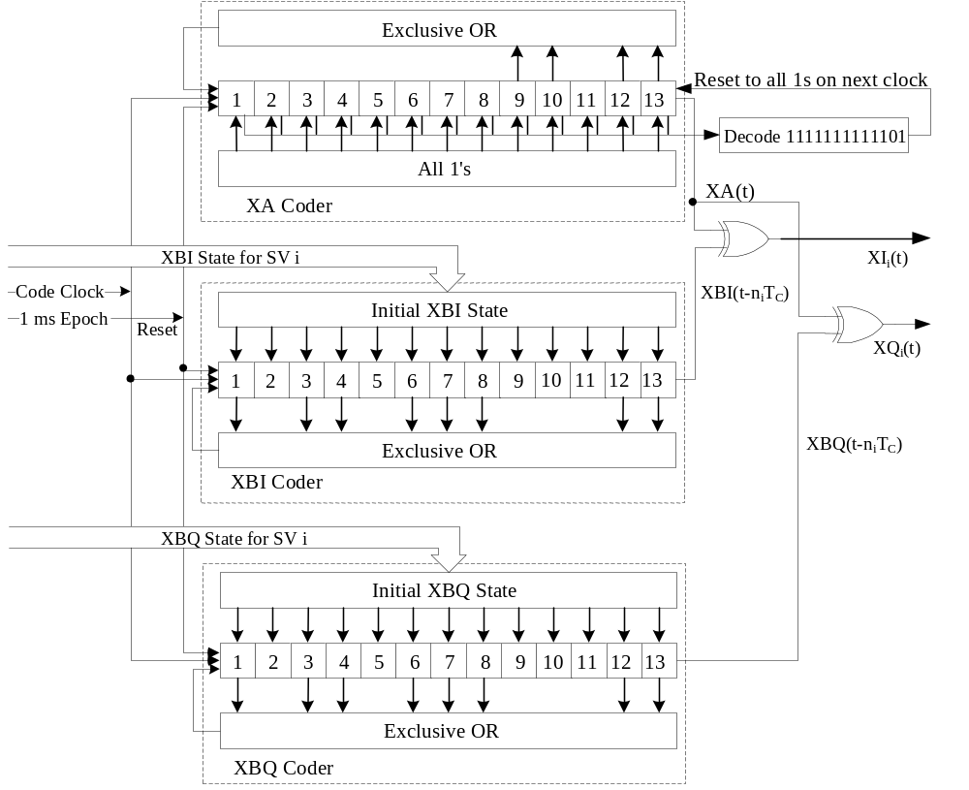
Figure 3-2. Generation of Codes
Figure 3-3 Modulation of Signals
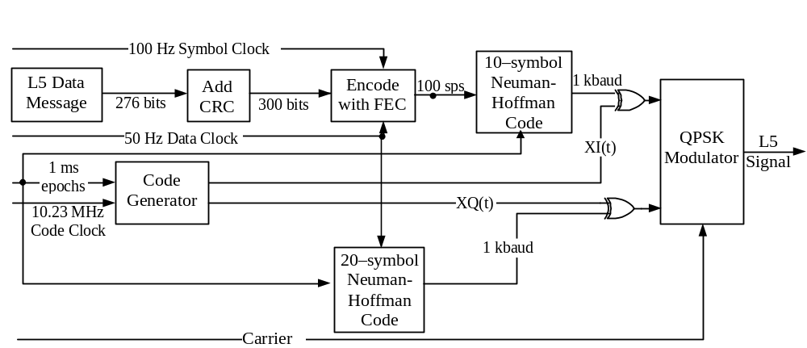
3.3.2.2 Code Generation. Each I5_{i}(t) pattern (I5-code) and Q5_{i}(t) pattern (Q5-code) are the Modulo-2 sum of two extended patterns clocked at 10.23 Mbps (XA and XBI_{i} or XBQ_{i}). XA is an 8190 length code, with an initial condition of all 1s, that is short cycled 1-chip before its natural conclusion and restarted to run over a period of 1 millisecond (synchronized with the L1 frequency C/A-code) for a total of 10230 chips. The XBI_{i} and XBQ_{i}, with initial conditions indicated in Table 3-I, are also 8191 length codes that are not short cycled. They are restarted at their natural completion and run over a period of 1 millisecond (synchronized with the XA code) for a total of 10230 chips. The polynomials for XA and XBI_{i} or XBQ_{i} codes, as referenced to the shift register input, are:

XA: 1+ x⁹ + x¹⁰ + x¹² + x¹³, and
XBI_{i} or XBQ_{i}: 1 + x + x³ + x⁴ + x⁶ + x⁷ + x⁸ + x¹² + x¹³.

Samples of the relationship between shift register taps and the exponents of the corresponding polynomial, referenced to the shift register input, are as shown in Figures 3-4 (XA code) and 3-5 (XB codes). In the case of the XB codes, the shift register can either be initialized with all 1s and delayed n_{i} states as specified in Table 3-I, or initialized with the state indicated in Table 3-I.

The state of each generator can be expressed as a code vector word which specifies the binary sequence constant of each register as follows: (a) the vector consists of the binary state of each stage of the register, (b) the stage 13 value appears at the right followed by the values of the remaining states in order of descending stage numbers, and (c) the shift direction is from lower to higher stage number with stage 13 providing the current output. This code vector convention represents the present output and 13 future outputs in sequence. Using this convention, at each XA epoch (state 8190), the XA shift register is initialized to the code vector 1111111111111, while at each XB epoch (state 8191), the XB shift register is initialized to a code vector peculiar to the PRN number and phase. The XB code vectors are as indicated in Table 3-I. Alternatively, the XB shift register is initialized to the code vector 1111111111111 and advanced n_{i} states as indicated in Table 3-I.

The natural 8191 chips of the XA sequence is shortened to 8190 chips to cause precession of the second XA sequence with respect to the natural 8191 chip XB sequence, as shown in Figure 3-6. Re-initialization of the XA shift register produces a 10230-chip sequence by omitting the last 6151 chips of the second natural XA sequence, or reinitializing to all 1s at the 1 ms epoch. The XB shift register is simply allowed to run its natural course until the next 1 ms epoch when it is reinitialized at its initial state, B0, based upon PRN number and phase. This results in the phase of the XB sequence leading by one chip during the second XA sequence in the 1-millisecond period. Depending upon the initial state of the XB sequence, a third 8191 chip sequence may be started before the 10230-chip sequence is completed. Two different scenarios that may result are shown in Figure 3-6.

In scenario a, the initial state of the XB sequence, B0, is less than State 6152. Thus, the second natural XB sequence does not run to completion prior to the next 1 ms epoch. In scenario b, the initial state of the XB sequence, B0, is greater than State 6151. Thus, the second natural XB sequence runs to completion and a third natural sequence starts (except when B0 is State 6152) prior to the next 1 ms epoch.

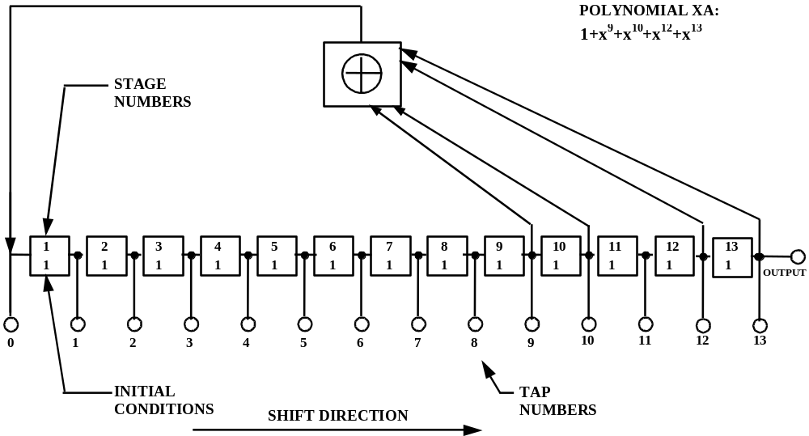

Figure 3-4. XA Shift Register Generator Configuration

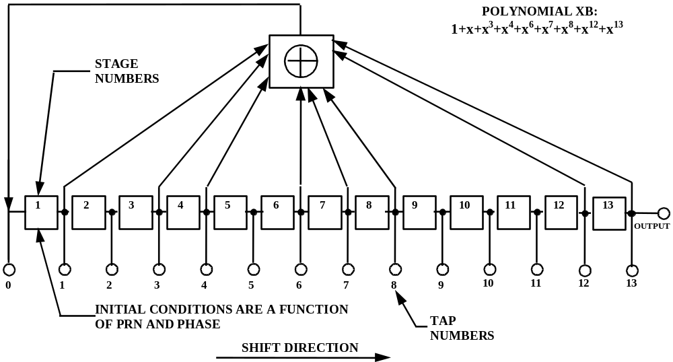

Figure 3-5. XB Shift Register Generator Configuration

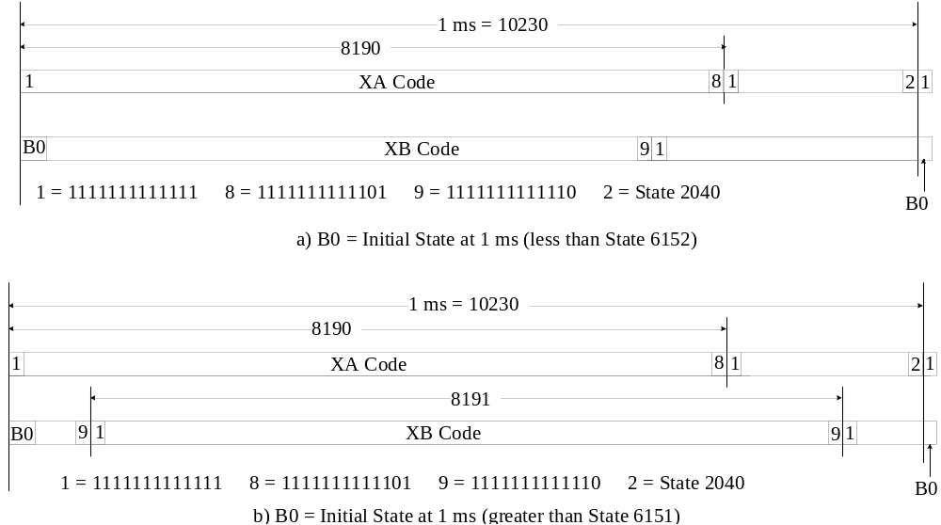Figure 3-6. Relative Phases Between the XA and XB Sequences

3.3.2.3 Q5 Synchronization Sequence. Each of the 1 ms Q5-code blocks are further encoded with a 20-bit Neuman-Hoffman code. The 20 bits are Modulo-2 added to the code chips at the PRN code epoch rate of 1 kHz. The code, nh20(t), starting coincident with the 20 ms data epoch on the I5 channel, is as follows:

nh20(t) = 0 0 0 0 0 1 0 0 1 1 0 1 0 1 0 0 1 1 1 0

3.3.3 Navigation Data. The content and format of the NAV data for data ID number 3 are given in Appendix II of this document (reference paragraph 20.3.3.3.1.5). Data ID number 2 is used for L1 and L2 C/A-code, and data ID number 1 is no longer used.

3.3.3.1 Navigation Data Modulation. The NAV bit train, D(t), is rate 1/2 encoded and, thus, clocked at 100 symbols per second (sps). In addition, the 100 sps symbols are modulated with a 10-bit Neuman-Hoffman code that is clocked at 1 kHz. The resultant symbol sequence is then summed with PRN code and used to modulate the L5 in-phase carrier.

3.3.3.1.1 Forward Error Correction. The NAV bit train, D(t), will always be rate 1/2 convolutional encoded with a Forward Error Correction (FEC) code. Therefore, the symbol rate is 100 sps. The convolutional coding will be constraint length 7, with a convolutional encoder logic arrangement as illustrated in Figure 3-7. The G1 symbol is selected on the output as the first half of a 20-millisecond data bit period coincident with the first bit of the 20-bit Q5 Neuman-Hoffman code.

Six-second navigation messages broadcast by the SV are synchronized with every fourth of the SV’s P(Y)-code X1 epochs. Although these epochs are not necessarily accessible to the L5 user, they are used within the SV to define GPS Time. However, message synchronization does provide the L5 user an access to the time of every 4th P(Y)-code X1 epoch. Thus, herein, reference will continue to be made to these X1 epochs. See ICD-GPS-200 for details.

Because the FEC encoding convolves successive messages, it is necessary to define which transmitted symbol is synchronized to SV time, as follows. The beginning of the first symbol that contains any information about the first bit of a message will be synchronized to every fourth X1 epoch. The users’ convolutional decoders will introduce a fixed delay that depends on their respective algorithms (usually 5 constraint lengths, or 35 bits), for which they must compensate to determine system time from the received signal. This convolutional decoding delay and the various relationships with the start of the data block transmission and SV time are illustrated in Figure 3-8 for the L5 signal.
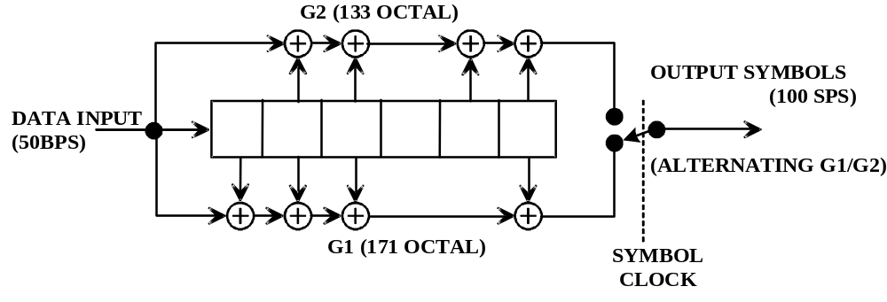
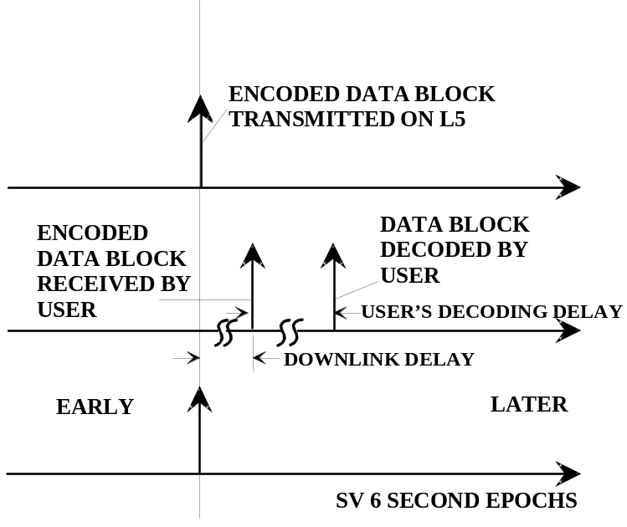Figure 3-7. Convolution Encoder
Figure 3-8. Convolutional transmit/Decoding Timing Relationships

3.3.3.1.2 Neuman-Hoffman Code. Each of the 100 sps symbols are further encoded with a 10-bit Neuman-Hoffman code. The 10 bits are Modulo-2 added to the symbols at the PRN code epoch rate of 1 kHz. The code, nh(t), starting at the 100 sps symbol transitions, is as follows:

Symbol = 1: nh(t) = 1111001010
Symbol = 0: nh(t) = 0000110101

3.3.4 GPS Time and SV Z-Count. GPS time is established by the Operational Control Segment (OCS) and is referenced to a UTC (as maintained by the U.S. Naval Observatory) zero time-point defined as midnight on the night of January 5, 1980/morning of January 6, 1980. GPS Time, as defined in ICD-GPS-200, is the ensemble of corrected composite L1/L2 P(Y) SV times, corrected via the clock corrections in the L1 and L2 NAV data and the relativity correction. L1/L5 Time will be derived from GPS time to compensate for the offset between L1/L2 P(Y) SV times and L1-C/A/L5-Q5 SV times and may therefore be different than GPS Time. The largest unit used in stating GPS Time is one week defined as 604,800 seconds, concatenated with the GPS week number. GPS Time may differ from UTC because GPS Time is a continuous time scale, while UTC is corrected periodically with an integer number of leap seconds. There also is an inherent but bounded drift rate between the UTC and GPS time scales. The OCS controls the GPS time scale to be within one microsecond of UTC (Modulo one second).

The L5 NAV data contains the requisite data for relating GPS Time to UTC, as defined in ICD-GPS-200, and L1/L5 Time to GPS Time. The accuracy of this data during the transmission interval will be such that it relates L1/L5 Time to GPS Time to within 3.0 nanoseconds (two sigma). This data is generated by the CS (or provided to the CS); therefore, the accuracy of these relationships may degrade if for some reason the CS is unable to upload data to an SV.

In each SV the X1 epochs of the P-code of the L1 and L2 offer a convenient unit for precisely counting and communicating time. Time stated in this manner is referred to as Z-count, which is given as a 29-bit binary number consisting of two parts as follows:

a. The binary number represented by the 19 least significant bits of the Z-count is referred to as the time of week (TOW) count and is defined as being equal to the number of X1 epochs that have occurred since the transition from the previous week. The count is short-cycled such that the range of the TOW-count is from 0 to 403,199 X1 epochs (equaling one week) and is reset to zero at the end of each week. The TOW-count's zero state is defined as that X1 epoch which is coincident with the start of the present week. This epoch occurs at (approximately) midnight Saturday night-Sunday morning, where midnight is defined as 0000 hours on the Coordinated Universal Time (UTC) scale which is nominally referenced to the Greenwich Meridian. Over the years the occurrence of the "zero state epoch" may differ by a few seconds from 0000 hours on the UTC scale since UTC is periodically corrected with leap seconds while the TOW-count is continuous without such correction. A truncated version of the TOW-count, consisting of its 17 most significant bits, is contained in each of the six-second messages of the L5 downlink data stream; the relationship between the actual TOW-count and its truncated message version is illustrated by Figure 3-9.

b. The ten most significant bits of the Z-count are a Modulo 1024 binary representation of the sequential number assigned to the current GPS week (see paragraph 6.2.4). The range of this count is from 0 to 1023 with its zero state being defined as the GPS week number zero and every integer multiple of 1024 weeks, thereafter (i.e. 0, 1024, 2048, etc.).

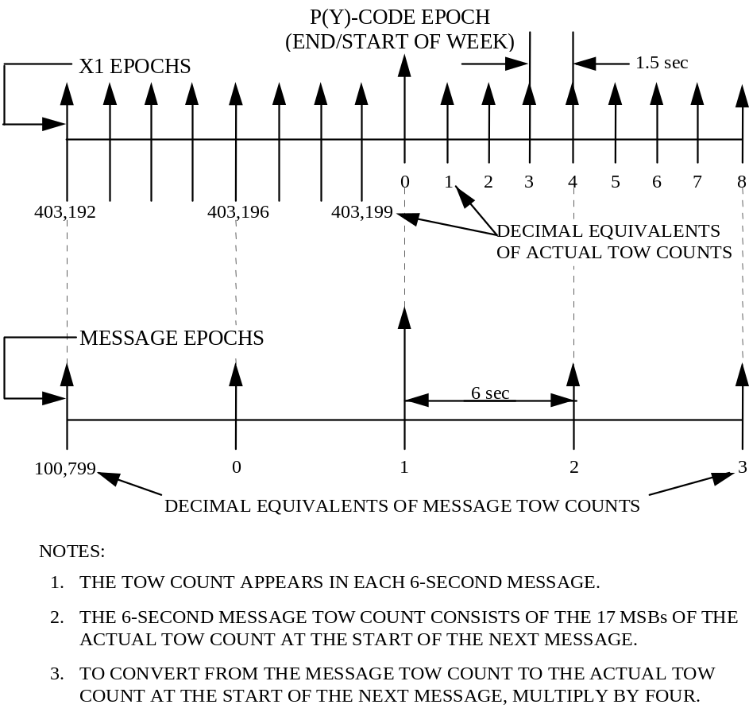Figure 3-9. Time Line Relationship of a Six-Second Message

(This page intentionally left blank.)

4. NOT APPLICABLE
(This page intentionally left blank.)
5. NOT APPLICABLE
(This page intentionally left blank.)

6. NOTES
6.1 Acronyms
AFMC - Air Force Materiel Command
A-S - Anti-Spoof
Autonav - Autonomous Navigation
bps - bits per second
BPSK - Bi-Phase Shift Key
C/A - Course/Acquisition
CRC - Cyclic Redundancy Check
CS - Control Segment
dB - Decibel
dBW - Decibels with respect to 1 Watt
DN - Day Number
DoD - Department of Defense
ECEF - Earth-Centered, Earth-Fixed
ECI - Earth-Centered Inertial
EIRP Effective Radiated Isotropic Power
FEC - Forward Error Correction
GPS - Global Positioning System
Hz - Hertz
I5 - Inphase L5 Signal
ICC - Interface Control Contractor
ICD - Interface Control Document
ID - Identification
IERS - International Earth Rotation Service
IODC - Issue of Data, Clock
IODE - Issue of Data, Ephemeris
IRM - IERS Reference Meridian
IRP - IERS Reference Pole
LSB - Least Significant Bit
LSF - Leap Seconds Future
MCS - Master Control Station
MSB - Most Significant Bit
NAV - Navigation
NSI5 - Non-Standard I-Code
NSQ5 - Non-Standard Q-Code
OCS - Operational Control Segment
PIRN - Proposed Interface Revision Notice
PRN - Pseudo-Random Noise
P(Y) - Precise (Anti-Spoof) Code
Q5 Quadrature L5 Signal
RF - Radio Frequency
RHCP Right Hand Circular Polarization
RMS - Root Mean Square
SA - Selective Availability
SBAS Space Based Augmentation System
sps Symbols per Second
SS - Space Segment
SV - Space Vehicle
SVN - Space Vehicle Number
TBD - To Be Determined
TBS - To Be Supplied
TOW - Time Of Week
URA - User Range Accuracy
URE - User Range Error
USNO - U.S. Naval Observatory
UTC - Coordinated Universal Time
WGS 84 - World Geodetic System 1984
WN - Week Number

6.2 Definitions

6.2.1 User Range Accuracy. User range accuracy (URA) is a statistical indicator of the ranging accuracy obtainable with a specific SV and a specific ranging signal or signals. L5 URA (URA₅) is greater than or equal to a one-sigma estimate of the user range errors in the L5 navigation data for the transmitting satellite. It includes ephemeris and clock errors resulting after the corrections specified in Section 20.3 for the L5 or L1/L5 user are applied. It does not include any errors introduced in the user set or the transmission media. While the URA₅ may vary over a given message fit interval, the URA₅ index (N) reported in the NAV message corresponds to the maximum value of URA₅ anticipated over the fit interval.

6.2.2 SV Block Definitions. The following block definitions are given to facilitate discussion regarding the capability of the various blocks of GPS satellites to support the SV-to-user interface.

6.2.2.1 Developmental SVs. See paragraph 6.2.2.1 of ICD-GPS-200.

6.2.2.2 Operational SVs. The operational satellites are designated Block II, Block IIA, Block IIR, Block IIF and Block III SVs. Characteristics of these SVs are provided below. These SVs all transmit a configuration code of 001 (reference 20.3.3.4.1.4). The navigation signal provides no direct indication of the type of the transmitting SV.

6.2.2.2.1 Block II SVs. See paragraph 6.2.2.2.1 of ICD-GPS-200. These satellites do not broadcast the L5 signal.

6.2.2.2.2 Block IIA SVs. See paragraph 6.2.2.2.2 of ICD-GPS-200. These satellites do not broadcast the L5 signal.

6.2.2.2.3 Block IIR SVs. See paragraph 6.2.2.2.3 of ICD-GPS-200. These satellites do not broadcast the L5 signal.

6.2.2.2.4 Block IIF SVs. The block of operational future SVs developed by Boeing are designated as SVNs 67-TBD and are termed "Block IIF" SVs. The Block IIF operational SVs do broadcast the L5 signal. Paragraph 6.2.3 may not apply.

6.2.2.2.5 Block III SVs. The block of operational planned SVs will be termed "Block III" SVs. The Block III operational SVs will broadcast the L5 signal.

6.2.3 Operational Interval Definitions. The following three operational intervals have been defined. These labels will be used to refer to differences in the interface definition as time progresses from SV acceptance of the last navigation data upload.

6.2.3.1 Normal Operations. The SV is undergoing normal operations whenever the fit interval flag (reference paragraph 20.3.3.2.3.1) is zero.

6.2.3.2 Short-term Extended Operations. The SV is undergoing short-term extended operations whenever the fit interval flag is one and the IODE (reference paragraph 20.3.4.4) is in the range 0-239, 256-495, 512-751, or 768-1007.

6.2.3.3 Long-term Extended Operations. The SV is undergoing long-term extended operations whenever the fit interval flag is one and the IODE is in the range 240-255, 496-511, 752-767, or 1008-1023.

Note: the DoD Navigation User Segment and Time Transfer User have no requirement to operate, and may not operate properly, whenever any SV is operating in long-term extended operations.

6.2.4 GPS Week Number. See paragraph 6.2.4 of ICD-GPS-200 and paragraphs 20.3.3.1.1.1, 20.3.3.3.1.1, and 20.3.3.3.2.1.

6.3 Supporting Material

6.3.1 L5 Received Signals. The guaranteed minimum user-received L5 signal levels are defined in paragraph 3.3.1.6. Additional supporting material is in Figure 6-1 (TBD). The minimum power of the near-ground user-received L5 signals as a function of SV elevation angle is calculated using the following assumptions: (a) the atmospheric path loss is 0.5 dB, (b) the average SV antenna gain with worst-case polarization loss will be used to determine minimum EOL EIRP at 14.3 degrees off nadir; and (c) TBD. The specified power levels identified in §3.3.1.5 are based on the overall link budget given in Table 6-I.

6.3.2 Integrated phase noise characteristics- As an aid to user equipment receiver LO design a plot will be provided of a typical GPS Block IIF carrier phase noise spectral density distribution and integration interval.

Table 6-I. I5 and Q5 Signal-in-Space Link Budget Summary
Link Component | I5 or Q5
Minimum EIRP* at 14.3 degrees off nadir angle (dBW) | 25.5
Free Space Loss (dB) | -182
Atmospheric Loss (dB) | -0.5
Receiver Antenna Gain (dB) | 0
Minimum Received Power (dBW) | -157
* Includes polarization loss relative to a RHCP antenna at end-of-life, nominal orbital temperatures, and azimuth averaged antenna gain. Gain variation from 14.3 degrees EOE to nadir shall not exceed 2 dB decrease. Composite EIRP power is 28.5 dBw , composite received power is –154 dBw.

Figure 6-1. User Received Minimum Signal Levels (TBD)

10. APPENDIX I. LETTERS OF EXCEPTION

10.1 Scope. As indicated in paragraph 1.2, initial signature approval of this document, as well as approval of subsequent changes to the document, can be contingent upon a "letter of exception". This appendix depicts such "letters of exception" when utilized by any signatory of this document in the initial approval cycle and/or in the change approval process. The ICC will omit such letters of exception from subsequent revisions of this document based on written authorization by the respective signatory (without processing a proposed interface revision notice (PIRN) for approval). When some (but not all) of the exceptions taken by a signatory are resolved, the signatory shall provide the ICC with an updated letter of exception for inclusion in the next ICD revision (without processing a PIRN for approval).

10.2 Applicable Documents. The documents listed in Section 2.0 shall be applicable to this appendix.

10.3 Letters of Exception. If signature approval of this document -- as affixed to the cover page -- is marked by an asterisk, it indicates that the approval is contingent upon the exceptions taken by that signatory in a letter of exception. Any letter of exception which is in force for the revision of the ICD is depicted in Figure 10-1. Signatories for whom no letter of exception is shown have approved this version of the document without exception.

Figure 10-1 Letters of Exception (TBD)

(This page intentionally left blank.)
20. APPENDIX II. GPS NAVIGATION DATA STRUCTURE FOR DATA ID NO. 3

20.1 Scope. This appendix describes the specific GPS navigation (NAV) data structure denoted by data ID number 3. This data ID number, when transmitted as part of the NAV data, shall be represented by the two-bit binary notation as 10. Data ID number 2 is used for L1 and L2 C/A-code, and data ID number 1 is no longer used.

20.2 Applicable Documents.

20.2.1 Government Documents. In addition to the documents listed in paragraph 2.1, the following documents of the issue specified contribute to the definition of the NAV data related interfaces and form a part of this Appendix to the extent specified herein.

Specifications
None
Standards
None
Other Publications
None

20.2.2 Non-Government Documents. In addition to the documents listed in paragraph 2.2, the following documents of the issue specified contribute to the definition of the NAV data related interfaces and form a part of this Appendix to the extent specified herein.

Specifications
None
Other Publications
none

20.3 Requirements

20.3.1 Data Characteristics. The L5 channel data stream mostly contains the same data as the L1 and L2 channels, but in a different format. Also, the L5 data stream uses a different parity algorithm.

20.3.2 Message Structure. As shown in Figures 20-1 through 20-5, the L5 message structure utilizes a basic format of six-second 300-bit long messages. Each message contains a CRC parity block consisting of 24 bits covering the entire six-second message (300 bits) (reference Section 20.3.5). At present, only message types 1-5 are defined. Message types 6 through 64 are reserved.

20.3.3 Message Content. Each message starts with an 8-bit preamble – 10001011, followed by a 6-bit message type ID and the 17-bit message time of week (TOW) count. When the value of the message TOW count is multiplied by 6, it represents SV time in seconds at the start of the next 6-second message. An “alert” flag, when raised (bit 32 = “1”), indicates to the user that the SV URA₅ may be worse than indicated in Message Type 1, and the SV should be used at the user’s own risk. A 6-bit PRN number, with a range of 1 to 37, starts at bit 33 of Message Types 1, 3, 4 and 5.
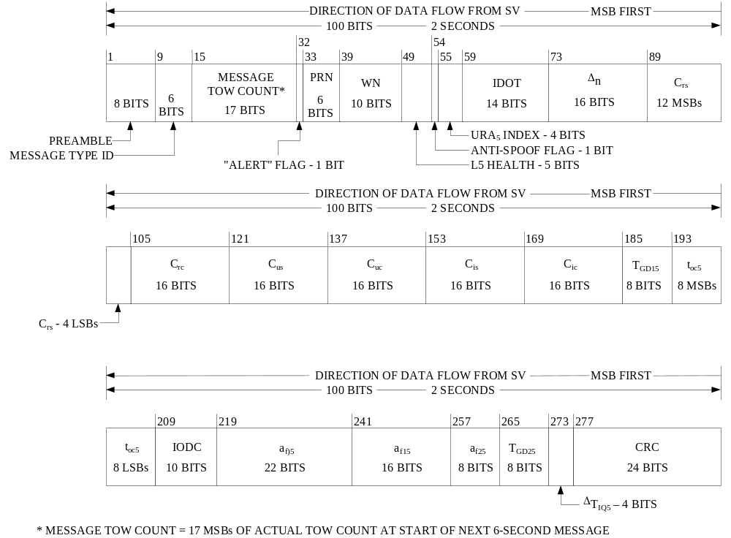

Figure 20-1. Message Type 1 Format
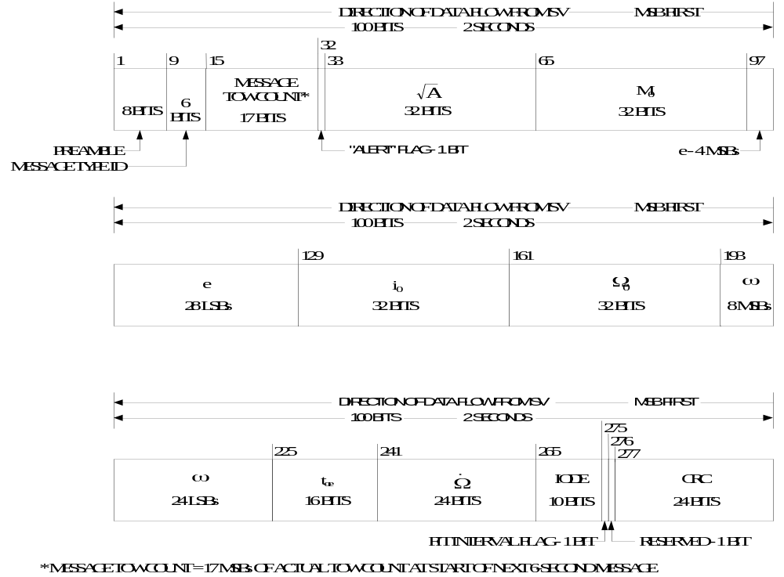

Figure 20-2. Message Type 2 Format
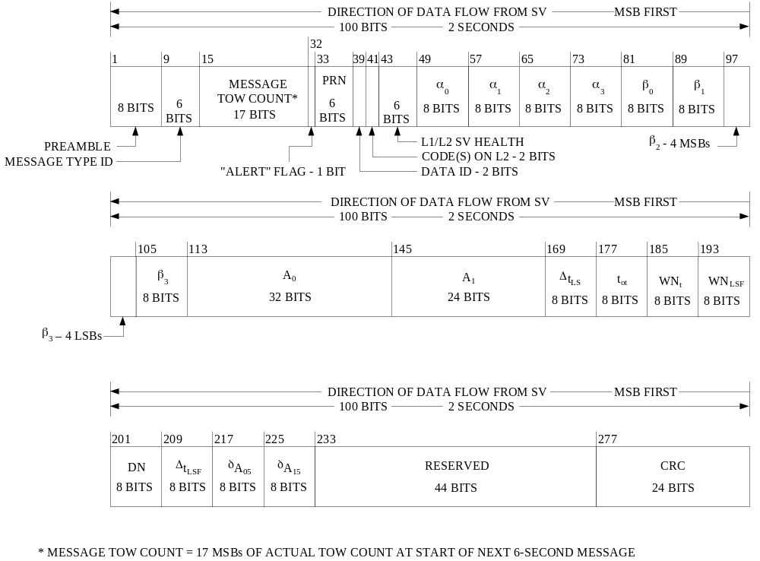

Figure 20-3. Message Type 3 Format
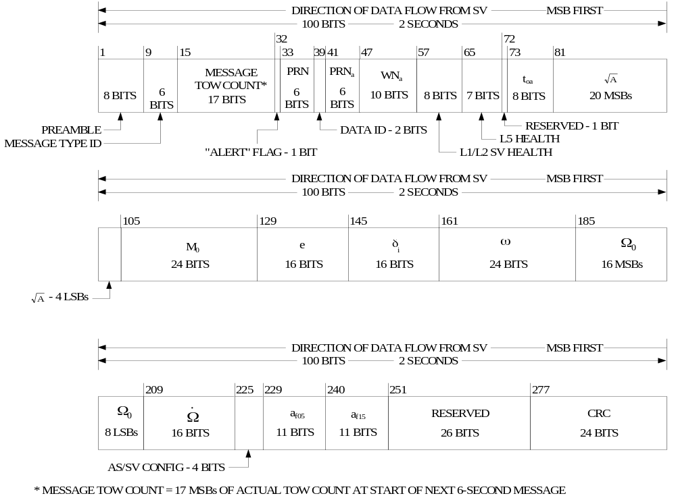

Figure 20-4. Message Type 4 Format
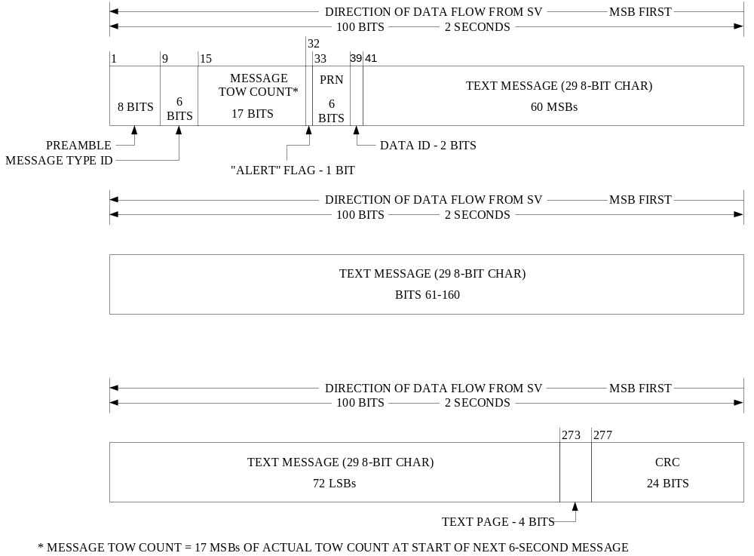

Figure 20-5. Message Type 5 Format

(This page intentionally left blank.)

20.3.3.1 Message Type 1 Clock, Health and Accuracy Parameters.

20.3.3.1.1 Message Type 1 Clock, Health and Accuracy Parameter Content. The clock parameters in Message Type 1 describe the SV time scale during the period of validity. The parameters in a data set shall be valid during the interval of time in which they are transmitted and shall remain valid for an additional period of time after transmission of the next data set has started. The timing information for the messages is described in Section 20.3.4.

20.3.3.1.1.1 Transmission Week Number. The ten bits starting at bit 39 shall contain the ten MSBs of the 29-bit Z-count as qualified in paragraph 20.3.3.3.1.1 of ICD-GPS-200.

20.3.3.1.1.2 SV Accuracy (L5). Bits 55 through 58 shall contain the URA₅ index of the SV (reference paragraph 6.2.1) for the unauthorized (non-Precise Positioning Service) user. The URA₅ index (N) is an integer in the range of 0 through 15 and follows the same rules as the URA index, as defined in paragraph 20.3.3.3.1.3 of ICD-GPS-200.

20.3.3.1.1.3 SV Health (L5). The five-bit health indication in bits 49 through 53 refers to the transmitting SV for the L5 signal. The MSB shall indicate a summary of the health of the NAV data, where

0 = all NAV data are OK,
1 = some or all NAV data are bad.

The four LSBs shall indicate the health of the L5 signal components in accordance with the codes given in paragraph 20.3.3.4.1.3. The health indication shall be given relative to the “as designed” capabilities of each SV (as designated by the configuration code - see paragraph 20.3.3.4.1.4). Accordingly, any SV that does not have a certain capability will be indicated as “healthy” if the lack of this capability is inherent in its design or if it has been configured into a mode that is normal from a user standpoint and does not require that capability.

Additional SV health data are given in Message Type 4, the Almanac message. The data given in Message Type 1 may differ from that shown in Message Type 4 on other SVs since the latter may be updated at a different time.

20.3.3.1.1.4 Issue of Data, Clock (IODC). Bits 209 through 218 shall contain the IODC. The IODC indicates the issue number of the data set and thereby provides the user with a convenient means of detecting any change in the correction parameters. Constraints on the IODC as well as the relationship between the IODC and the IODE (issue of data, ephemeris) terms are defined in paragraph 20.3.4.4.

20.3.3.1.1.5 Long-term Extended Operations. Whenever the fit interval flag indicates a fit interval greater than 4 hours, the IODC can be used to determine the actual fit interval of the data set (reference section 20.3.4.4).

20.3.3.1.1.6 SV Clock Correction. Message Type 1 contains the parameters needed by the users for apparent SV L1/L5 clock correction (t_{oc5}, a₂₅, a₁₅, a₀₅). The related algorithm is given in paragraph 20.3.3.1.3.1.

20.3.3.1.1.7 Estimated Group Delay Differential (L1-L5). The L1-L5 correction term in Message Type 1, T_{GD15}, is for the benefit of “L1-C/A only” or “L5-Q5 only” users; the related user algorithm is given in paragraph 20.3.3.1.3.2. The value of negative zero or bit string [1 0 0 0 0 0 0 0] shall mean that T_{GD15} is not available.

20.3.3.1.1.8 Estimated L2/L5 Group Delay Differential. The L2/L5 group delay correction term, T_{GD25}, for the benefit of single frequency L2-C/A users and dual frequency L2/L5 users is contained in Message Type 1; the related user algorithms are given in paragraphs 20.3.3.1.3.3 and 20.3.3.1.3.5. The value of negative zero or bit string [1 0 0 0 0 0 0 0] shall mean that T_{GD25} is not available.

20.3.3.1.1.9 Estimated L5 Q5/I5 Group Delay Differential. The L5 I5/Q5 group delay correction term, T_{IQ5}, for the benefit of L5 users tracking the I5-code is contained in Message Type 1; the related user algorithms are given in paragraphs 20.3.3.1.3.3 and 20.3.3.1.3.5. The value of negative zero or bit string [1 0 0 0] shall mean that T_{IQ5} is not available.

20.3.3.1.2 Message Type 1 Clock, Health and Accuracy Parameter Characteristics. For those parameters whose characteristics are not fully defined in Section 20.3.3.1.1, the number of bits, the scale factor of the LSB (which is the last bit received), the range, and the units shall be as specified in Table 20-I.

20.3.3.1.3 User Algorithms for Message Type 1 Clock Data. The algorithms defined below (a) allow all users to correct the code phase time received from the SV with respect to both SV code phase offset and relativistic effects, (b) permit the “single frequency” (L1-C/A, L2-C/A or L5), “dual L1 and L5 frequency”, and “dual L2 and L5 frequency” users to compensate for the effects of SV group delay differential (the user who utilizes both the L1-C/A and L5-Q5 frequencies does not require this correction, since the clock parameters account for the induced effects), and (c) allow the user of the L5 I5-code to correct for the timing error between the I5 and Q5-codes. Those users who utilize the “dual L1 and L2 frequencies” shall use the corrections provided in the L1 or L2 NAV messages.

20.3.3.1.3.1 User Algorithm for SV Clock Correction. The polynomial defined in the following allows the user to determine the effective SV PRN code phase offset referenced to the phase center of the antennas (Δt_{sv}) with respect to GPS L5 system time (t) at the time of data transmission. The coefficients transmitted in Message Type 1 describe the offset apparent to the two-frequency (L1 and L5) user for the interval of time in which the parameters are transmitted. This estimated correction accounts for the deterministic SV clock error characteristics of bias, drift and aging, as well as for the SV implementation characteristics of group delay bias and mean differential group delay. Since these coefficients do not include corrections for relativistic effects, the user’s equipment must determine the requisite relativistic correction. Accordingly, the offset given below includes a term to perform this function.

The user shall correct the time received from the SV with the equation (in seconds)
t = t_{sv} - Δt_{sv} (1)
where
t = L5 GPS system time (seconds),
t_{sv} = effective SV PRN code phase time at message transmission time (seconds),
Δt_{sv} = SV PRN code phase time offset (seconds).

The SV PRN code phase offset is given by

Δt_{sv} = a_{f05} + a_{f15}(t - t_{oc5}) + a_{f25}(t - t_{oc5})² + Δt_{r} (2)
where
a_{f05}, a_{f15} and a_{f25} are the polynomial coefficients given in Message Type 1, t_{oc5} is the clock data reference time in seconds (reference paragraph 20.3.4.5), and Δt_{r} is the relativistic correction term (seconds) which is given in paragraph 20.3.3.3.3.1 of ICD-GPS-200.

Note that equations (1) and (2), as written, are coupled. While the coefficients a_{f05}, a_{f15} and a_{f25} are generated by using GPS time as indicated in equation (2), sensitivity of t_{sv} to t is negligible. This negligible sensitivity will allow the user to approximate t by t_{SV} in equation (2). The value of t must account for beginning or end of week crossovers. That is, if the quantity t - t_{oc5} is greater than 302,400 seconds, subtract 604,800 seconds from t. If the quantity t - t_{oc5} is less than -302,400 seconds, add 604,800 seconds to t.

The control segment will utilize the alternative but equivalent expression for the relativistic effect when estimating the NAV parameters described in paragraph 20.3.3.3.3.1 of ICD-GPS-200.

Since the SV clock corrections of equations (1) and (2) are estimated by the CS using dual frequency L1 and L5 measurements, the single-frequency L5 user and the dual frequency L2/L5 user must apply additional terms to equations (1) and (2). These terms are described in paragraphs 20.3.3.1.3.2 and 20.3.3.1.3.3.

Table 20-I. Message Type 1 Clock, Health and Accuracy Parameters
Parameter | No. of  Bits** | Scale  Factor  (LSB) | Effective  Range*** | Units
Week No.  SV accuracy (URA₅)  SV health (L5)  T_{GD15}  T_{GD25}  T_{IQ5}  IODC  t_{oc5}  a_{f25}  a_{f15}  a_{f05} | 10  4  6  8*  8*  4*  10  16  8*  16*  22* | 1  1  2⁻³¹  2⁻³¹  2⁻³¹  2⁴  2⁻⁵⁵  2⁻⁴³  2⁻³¹ | 604,784 | weeks  (see text)  discrete  seconds  seconds  seconds  (see text)  seconds  sec/sec²  sec/sec  seconds
* Parameters so indicated are two’s complement, with the sign bit (+ or -) occupying the MSB;

** See Figure 20-1 for complete bit allocation in Message Type 1;

*** Unless otherwise indicated in this column, effective range is the maximum range attainable with indicated bit allocation and scale factor.
20.3.3.1.3.2 L1/L5 Group Delay Correction. The L1 and L5 correction term, T_{GD15}, is monitored to account for the effect of SV group delay differential between L1 C/A-code and L5 Q5-code. The value for T_{GD15} is based on measurements made by the SV contractor during SV manufacture. The value of T_{GD15} for each SV may be subsequently updated to reflect the actual on-orbit group delay differential. This correction term is only for the benefit of “single-frequency” (L1 or L5) users; it is necessitated by the fact that the SV clock offset estimates reflected in the a_{f05} clock correction coefficient (see paragraph 20.3.3.1.3.1) are based on the effective PRN code phase as apparent with two frequency ionospheric corrections. Thus, the user who utilizes the L1 frequency only must modify the code phase offset in accordance with paragraph 20.3.3.1.3.1 with the equation

(Δt_{SV})_{L1} = Δt_{SV} - T_{GD15}

where T_{GD15} is provided to the user as Message Type 1 data. For the user who utilizes L5 only, the code phase modification is given by

(Δt_{SV})_{L5} = Δt_{SV} - γ₁₅T_{GD15}

where, denoting the nominal center frequencies of L1 and L5 as f_{L1} and f_{L5} respectively,

γ₁₅ = (f_{L1}/f_{L5})² = (1575.42/1176.45)² = (154/115)².

The value of T_{GD15} is not equal to the mean SV group delay differential, but is equal to the delay differential multiplied by 1/(1-γ₁₅). That is,

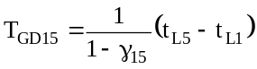

where t_{Li} is the GPS time the i^{th} frequency signal is transmitted from the SV.

20.3.3.1.3.3 L2/L5 Group Delay Correction. The L2/L5 group delay correction term, T_{GD25}, is calculated by the CS to account for the effect of SV group delay differential between the composite dual frequency L1/L5 time and L2 C/A-code time based on measurements made by the SV contractor during SV manufacture. The value of T_{GD25} for each SV may be subsequently updated to reflect the actual on-orbit group delay differential. This correction term is for the benefit of all L2-only and L2/L5 users; it is necessitated by the fact that the SV clock offset estimates reflected in the a_{f05} clock correction coefficient (see paragraph 20.3.3.1.3.1) are based on the effective composite L1/L5 measurement as apparent with L1/L5 ionospheric corrections. Thus, the user who utilizes the L2 frequency only must modify the code phase offset in accordance with paragraph 20.3.3.1.3.1 with the equation

(Δt_{SV})_{L2} = Δt_{SV} – T_{GD25}

where T_{GD25} is provided to the user as Message Type 1 data. The value of T_{GD25} is not equal to the mean SV group delay differential, but is equal to

T_{GD25} = t_{L1} – t_{L2} + T_{GD15}

to account for the group delay difference between the L1/L5 and L2 signals.

20.3.3.1.3.4 L1/L5 Ionospheric Correction. The two frequency (L1 C/A-code and L5 Q5-code) user shall correct for the group delay due to ionospheric effects by applying the relationship:

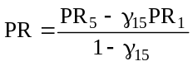
where
PR = pseudorange corrected for ionospheric effects,
PR_{i} = pseudorange measured on the L-band channel indicated by the subscript.

and
γ₁₅ = (f_{L1}/f_{L5})² = (1575.42/1176.45)² = (154/115)²..

The clock correction coefficients are based on “two frequency” measurements and therefore account for the effects of mean differential delay in SV instrumentation.
20.3.3.1.3.5 L2/L5 Ionospheric Correction. The two frequency (L2 and L5) user shall correct for the group delay due to ionospheric effects by applying the relationship:

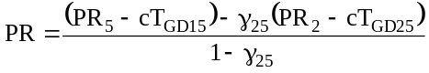
where
γ₂₅ = (f_{L2}/f_{L5})² = (1227.6/1176.45)² = (24/23)²

This additional correction for the dual frequency L2/L5 users is due to the fact that the SV clock offset estimates reflected in the clock correction coefficients (see paragraph 20.3.3.1.3.1) are based on the effective PRN code phase as apparent with two frequency (L1/L5) ionospheric corrections, not the two frequency (L2/L5) ionospheric corrections.

20.3.3.1.3.6 L5 Q-code/I-code Correction. The L5 Q-code/I-code group delay correction term, ΔT_{IQ5}, is calculated by the CS to account for the effect of SV group delay differential between the L5 Q-code and L5 I-code based on measurements made by the SV contractor during SV manufacture. The value of ΔT_{IQ5} for each SV may be subsequently updated to reflect the actual on-orbit group delay differential. It is defined such as to be positive when the I-code transitions lead the Q-code transitions, and negative when the I-code transitions lag the Q-code transitions.

20.3.3.1.3.7 Example Application of Correction Parameters. A typical system application of the correction parameters for a user receiver is shown in Figure 20-6. The ionospheric model referred to in Figure 20-6 is discussed in paragraph 20.3.3.3.2.2 in conjunction with the related data contained in Message Type 3.

20.3.3.2 Message Type 1 and 2 Ephemeris Parameters

20.3.3.2.1 Message Type 1 and 2 Ephemeris Parameter Content. The contents of the ephemeris representation parameters in Message Types 1 and 2 are defined below, followed by material pertinent to the use of the data.

The ephemeris parameters describe the orbit of the transmitting SV during the curve fit intervals described in section 20.3.4. Table 20-II of ICD-GPS-200 gives the definition of the orbital parameters using terminology typical of Keplerian orbital parameters; it is noted, however, that the transmitted parameter values are expressed such that they provide the best trajectory fit in earth-centered, earth-fixed (ECEF) coordinates for each specific fit interval. The user shall not interpret intermediate coordinate values as pertaining to any conventional coordinate system.

The issue of ephemeris data (IODE) term provides the user with a convenient means for detecting any change in the ephemeris representation parameters. The IODE is provided in Message Type 2 for the purpose of comparison with the 10 bits of the IODC term in Message Type 1. Whenever these two terms do not match, a data set cutover has occurred and new data must be collected. The timing of the IODE and constraints on the IODC and IODE are defined in paragraph 20.3.4.4.

Any change in the Message Type 1 and 2 data will be accomplished with a simultaneous change in both the IODC and IODE words. The CS will assure that the t_{oe} value, for at least the first data set transmitted by an SV after an upload, is different from that transmitted prior to the cutover.

A “fit interval” flag is provided in Message Type 2 to indicate whether the ephemerides are based on a four-hour fit interval or a fit interval greater than four hours (reference paragraph 20.3.3.2.3.1).

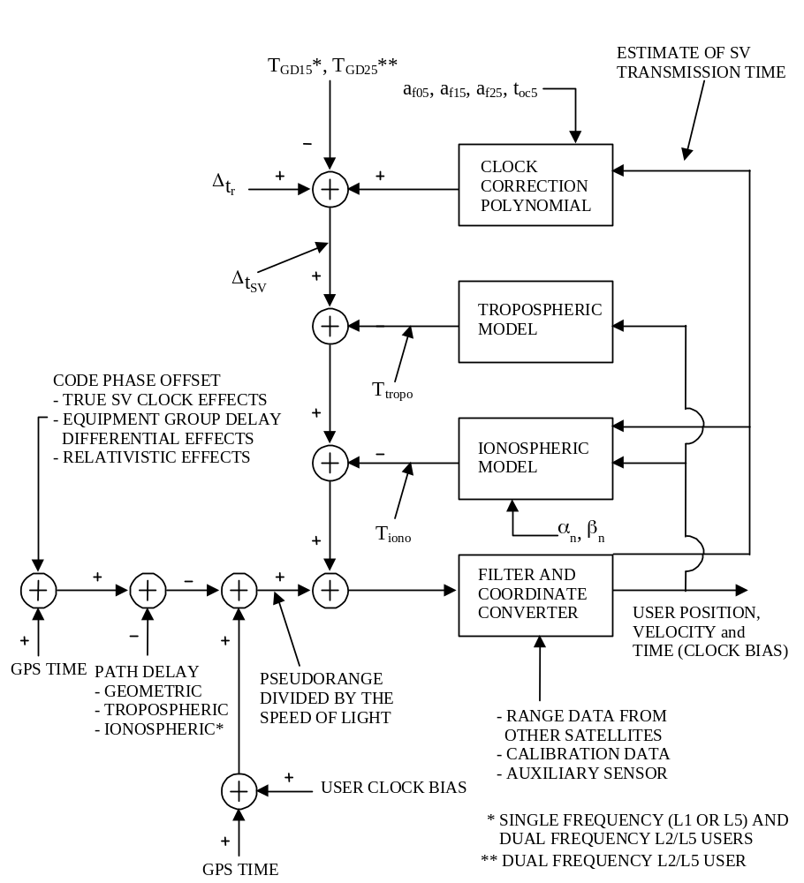Figure 20-6. Sample Application of Correction Parameters

20.3.3.2.2 Message Type 1 and 2 Ephemeris Parameter Characteristics. For each ephemeris parameter contained in Message Types 1 and 2, the number of bits, the scale factor of the LSB (which is the last bit received), the range, and the units are as specified in Table 20-III of ICD-GPS-200. See Figures 20-1 and 20-2 for complete bit allocation in Message Types 1 and 2.

20.3.3.2.3 User Algorithm for Ephemeris Determination. The user shall compute the ECEF coordinates of position for the phase center of the SVs’ antennas utilizing a variation of the equations shown in Table 20-IV of ICD-GPS-200. The ephemeris parameters are Keplerian in appearance; the values of these parameters, however, are produced by the CS via a least squares curve fit of the predicted ephemeris of the phase center of the SVs’ antennas (time-position quadruples; t, x, y, z expressed in ECEF coordinates). Particulars concerning the periods of the curve fit, the resultant accuracy, and the applicable coordinate system are given in the following subparagraphs.

20.3.3.2.3.1 Curve Fit Intervals. Bit 275 of Message Type 2 is a “fit interval” flag which indicates the curve-fit interval used by the CS in determining the ephemeris parameters, as follows:

0 = 4 hours,
1 = greater than 4 hours.

The relationship of the curve-fit interval to transmission time and the timing of the curve-fit intervals is covered in section 20.3.4.

20.3.3.2.3.2 Parameter Sensitivity. See paragraph 20.3.3.4.3.2 of ICD-GPS-200.

20.3.3.2.3.3 Coordinate Systems

20.3.3.2.3.3.1 ECEF Coordinate System. See paragraph 20.3.3.4.3.3.1 of ICD-GPS-200.

20.3.3.2.3.3.2 Earth-Centered Inertial (ECI) Coordinate System. See paragraph 20.3.3.4.3.3.2 of ICD-GPS-200.

20.3.3.2.3.4 Geometric Range. See paragraph 20.3.3.4.3.4 of ICD-GPS-200.

20.3.3.3 Message Type 3 Parameters. The contents of Message Type 3 are defined below, followed by material pertinent to the use of the data.

20.3.3.3.1 Message Type 3 Parameter Content. Message Type 3 contains UTC and ionospheric parameters and other data.

20.3.3.3.1.1 Coordinated Universal Time (UTC) and GPS Time Parameters. Message Type 3 shall contain the parameters related to correlating UTC time with GPS Time and parameters to relate L5 GPS Time to GPS Time. The bit length, scale factors, ranges, and units of these parameters are given in Table 20-II. The related algorithms are described in paragraph 20.3.3.3.2.1.

The UTC and GPS Time parameters shall be updated by the CS at least once every six days while the CS is able to upload the SVs. If the CS is unable to upload the SVs, the accuracy of the UTC parameters transmitted by the SVs will degrade over time.

20.3.3.3.1.2 Ionospheric Data. The ionospheric parameters which allow the “L1 only”, “L2 only” or “L5 only” user to utilize the ionospheric model (reference paragraph 20.3.3.3.2.2) for computation of the ionospheric delay are contained in Message Type 3. The bit lengths, scale factors, ranges, and units of these parameters are given in Table 20-X of ICD-GPS-200. See Figure 20-3 for complete bit allocation in Message Type 3.

The ionospheric data shall be updated by the CS at least once every six days while the CS is able to upload the SVs. If the CS is unable to upload the SVs, the ionospheric data transmitted by the SVs may not be accurate.

20.3.3.3.1.3 SV Health (L1/L2). The six-bit health indication in bits 43 through 48 refers to the transmitting SV for the L1 and L2 signals. The health indication is described in paragraph 20.3.3.3.1.4 of ICD-GPS-200.

Additional SV health data are given in Message Type 4, the Almanac message. The data given in Message Type 3 may differ from that shown in Message Type 4 on other SVs since the latter may be updated at a different time.

Table 20-II. UTC Parameters
Parameter | No. of  Bits** | Scale  Factor  (LSB) | Effective  Range*** | Units
A₀  δA₀₅  A₁  δA₁₅  Δt_{LS}  t_{ot}  WN_{t}  WN_{LSF}  DN  Δt_{LSF} | 32*  8*  24*  8*  8*  8  8  8  8****  8* | 2⁻³⁰  2⁻³⁰  2⁻⁵⁰  2⁻⁵⁰  1  2¹²  1  1  1  1 | 602,112  7 | seconds  seconds  sec/sec  sec/sec  seconds  seconds  weeks  weeks  days  seconds
* Parameters so indicated are two’s complement with the sign bit (+ or -) occupying the MSB;

** See Figure 20-3 for complete bit allocation in Message Type 3;

*** Unless otherwise indicated in this column, effective range is the maximum range attainable with indicated bit allocation and scale factor;

**** Right justified.

20.3.3.3.1.4 Code(s) on L2 Channel. Bits 41 and 42 of Message Type 3 shall indicate which code(s) is (are) commanded ON for the L2 channel. The codes are described in paragraph 20.3.3.3.1.2 of ICD-GPS-200.

20.3.3.3.1.5 Data ID. Bits 39 and 40 of Message Type 3 (and the same bits in Message Types 4 and 5) shall contain the data ID which defines the applicable GPS NAV data structure. Data ID one (denoted by binary code 00) was utilized during Phase I of the GPS program and is no longer in use; data ID two (denoted by binary code 01) is used on the L1 and L2 C/A and P(Y)-code signals. Data ID three (denoted by binary 10) is used on this L5 signal. Future data IDs shall be defined as necessary.

20.3.3.3.2 Algorithms Related to Message Type 3 Data. The following algorithms shall apply when interpreting Coordinated Universal Time, L5 GPS Time and Ionospheric Model data in the NAV message.

20.3.3.3.2.1 Coordinated Universal Time (UTC) and GPS Time. Message Type 3 includes: (1) the parameters needed to relate GPS Time to UTC and L5 GPS Time to GPS Time, and (2) notice to the user regarding the scheduled future or recent past (relative to NAV message upload) value of the delta time due to leap seconds (Δt_{LSF}), together with the week number (WN_{LSF}) and the day number (DN) at the end of which the leap second becomes effective. Information required to use these parameters to calculate t_{UTC} is in paragraph 20.3.3.5.2.4 of ICD-GPS-200.

The GPS Time/L5 GPS Time relationship is given by

t_{E} = t_{E,L5} + δA₀₅ + δA₁₅ (t_{E,L5} – t_{ot})

where t_{E,L5} is the estimated GPS L5 Time in seconds relative to end/start of week.

20.3.3.3.2.2 Ionospheric Model. The “two frequency” (L1 C/A and L5 Q5) user shall correct the time received from the SV for ionospheric effect by utilizing the time delay differential between L1 and L5 (reference paragraph 20.3.3.1.3.2). The “one frequency” user, however, may use the model given in Figure 20-4 of ICD-GPS-200 to make this correction. The calculated value of T_{iono} is referred to the L1 frequency; if the user is operating on the L5 frequency, the correction term must be multiplied by γ₁₅ (reference paragraph 20.3.3.1.3.2). It is estimated that the use of this model will provide at least a 50 percent reduction in the single - frequency user’s RMS error due to ionospheric propagation effects. During extended operations, if the CS is unable to upload the SVs, the use of this model will yield unpredictable results.

20.3.3.4 Message Type 4 Almanac Parameters. The contents of Message Type 4 are defined below, followed by material pertinent to the use of the data.

20.3.3.4.1 Message Type 4 Almanac Parameter Content. Message Type 4 contains almanac data.

20.3.3.4.1.1 Almanac Data. Message Type 4 contains the almanac data and SV health words for up to 32 SVs (the health words are discussed in paragraphs 20.3.3.1.1.3 and 20.3.3.3.1.3). The almanac data are a reduced-precision subset of the clock and ephemeris parameters. The number of bits, the scale factor (LSB), the range, and the units of the almanac parameters are given in Table 20-III. The algorithms and other material related to the use of the almanac data are given in paragraph 20.3.3.4.2.

The almanac parameters shall be updated by the CS at least once every 6 days while the CS is able to upload the SVs. If the CS is unable to upload the SVs, the accuracy of the almanac parameters transmitted by the SVs will degrade over time.

Table 20-III. Almanac Parameters
Parameter | No. of  Bits** | Scale  Factor  (LSB) | Effective  Range*** | Units
e  t_{oa}  _{i}****  OMEGADOT  (A)^{1/2}  (OMEGA)₀  M₀  a_{f05}  a_{f15} | 16  8  16*  16*  24  24*  24*  24*  11*  11* | 2⁻²¹  2¹²  2⁻¹⁹  2⁻³⁸  2⁻¹¹  2⁻²³  2⁻²³  2⁻²³  2⁻²⁰  2⁻³⁸ | 602,112 | dimensionless  seconds  semi-circles  semi-circles/sec  meters^{1/2}  semi-circles  semi-circles  semi-circles  seconds  sec/sec
* Parameters so indicated are two’s complement with the sign bit (+ or -) occupying the MSB;

** See Figure 20-4 for complete bit allocation in Message Type 4
*** Unless otherwise indicated in this column, effective range is the maximum range attainable with indicated bit allocation and scale factor;

**** Relative to i₀ = 0.30 semi-circles.

20.3.3.4.1.2 SV Health (L1 and L2). Message Type 4 contains two types of SV health data for the SV indicated with by the PRN_{a} parameter: (a) L1 and L2 health, and (b) L5 health. The L5 health data is described in paragraph 20.3.3.4.1.3. The eight-bit L1/L2 health words are defined in paragraph 20.3.3.5.1.3 and Table 20-VII of ICD-GPS-200.

The data given in Message Type 3 of the other SVs may differ from that shown in Message Type 4 since the latter may be updated at a different time.

The predicted health data will be updated at the time of upload when a new almanac has been built by the CS. The transmitted health data may not correspond to the actual health of the transmitting SV or other SVs in the constellation.

20.3.3.4.1.3 SV Health (L5). The three MSBs of the seven-bit L5 health words in Message Type 4 shall indicate health of the NAV data in accordance with the code given in Table 20-IV. The five-bit L5 health words in Message Type 3 provide a one-bit summary of the NAV data’s health status in the MSB position in accordance with paragraph 20.3.3.3.1.3. The four LSBs of both the seven-bit and the five-bit words provide the health status of the SV’s signal components in accordance with the code given in Table 20-V.

The data given in Message Type 3 of the other SVs may differ from that shown in Message Type 4 since the latter may be updated at a different time.

The predicted health data will be updated at the time of upload when a new almanac has been built by the CS. The transmitted health data may not correspond to the actual health of the transmitting SV or other SVs in the constellation.

Table 20-IV. L5 NAV Data Health Indications
Bit Position in 7-Bit L5 Health Word |  |  | Indication
1 | 2 | 3
0  0  0  0  1  1  1  1 | 0  0  1  1  0  0  1  1 | 0  1  0  1  0  1  0  1 | ALL DATA OK  PARITY FAILURE -- some or all parity bad  PREAMBLE FORMAT PROBLEM -- any departure from standard format (e.g., preamble misplaced and/or incorrect, etc.), except for incorrect Z-count, as reported in TOW  Z-COUNT BAD -- any problem with Z-count value not reflecting actual code phase  Message Types 1 and 2 -- one or more elements in one or more of the messages are bad  Message Types 3 and 4 -- one or more elements in one or more of the messages are bad  ALL UPLOADED DATA BAD -- one or more of the uploaded elements in any one (or more) of the messages are bad  ALL DATA BAD -- one or more elements in any one (or more) of the messages are bad

Table 20-V. Codes for Health of SV L5 Signal Components

MSB LSB | Definition
0 0 0 0  0 0 0 1  0 0 1 0  0 0 1 1  0 1 0 0  0 1 0 1  0 1 1 0  0 1 1 1  1 0 0 0  1 0 0 1  1 0 1 0  1 0 1 1  1 1 0 0  1 1 0 1  1 1 1 0  1 1 1 1 | All Signals (I & Q) OK  All Signals (I & Q) Weak*  All Signals (I & Q) Dead  I Signal Has No Data Modulation  I Signal Is Weak  I Signal Is Dead  Q Signal Is Weak  Q Signal Is Dead  L5 Specific Data Is Bad  L5 Parity Is Bad  Spare  Spare  Spare  Spare  Spare  More Than One Combination Would Be Required To Describe Anomalies
* 3 to 6 dB below specified power level due to reduced power output, excess phase noise, SV attitude, etc.

20.3.3.4.1.4 Anti-Spoof (A-S) Flags and SV Configurations. Bits 225 to 228 of Message Type 4 shall contain a four-bit-long term for each of up to 32 SVs to indicate the A-S status (of the L1 and L2 signals) and the configuration code of each SV. The terms are defined in paragraph 20.3.3.5.1.6 of ICD-GPS-200.

20.3.3.4.1.5 Almanac Reference Week. Bits 47 through 56 of Message Type 4 shall indicate the number of the week (WN_{a}) to which the almanac reference time (t_{oa}) is referenced (see paragraphs 20.3.3.4.1.1 and 20.3.3.4.2.2). The WN_{a} term consists of eight bits which shall be a Modulo 256 binary representation of the GPS week number (see paragraph 4.2.4) to which the t_{oa} is referenced. Bits 73 through 80 of Message Type 4 shall contain the value of t_{oa}, which is referenced to this WN_{a}.

20.3.3.4.2 Algorithms Related to Message Type 4 Data. The following algorithms shall apply when interpreting Almanac data in the NAV message.

20.3.3.4.2.1 Almanac. The almanac is a subset of the clock and ephemeris data, with reduced precision. The user algorithm is essentially the same as the user algorithm used for computing the precise ephemeris from the Message Type 1 and 2 parameters (see paragraph 20.3.3.2.3). The almanac content for one SV is given in Table 20-III. Important information about the almanac calculation is contained in paragraph 20.3.3.5.2.1 of ICD-GPS-200.

20.3.3.4.2.2 Almanac Reference Time. See the two subparagraphs labeled Normal and Short-term Extended Operations and Long-term Extended Operations of paragraph 20.3.3.5.2.2 of ICD-GPS-200.

20.3.3.4.2.3 Almanac Time Parameters. See paragraph 20.3.3.5.2.3 of ICD-GPS-200.

20.3.3.5 Message Type 5. Message Type 5 is reserved for special messages with the specific contents at the discretion of the Operating Command. It can accommodate the transmission of 29 eight-bit ASCII characters. The requisite 232 bits occupy bits 41 through 272 of Message Type 5. The eight-bit ASCII characters shall be limited to the set described in paragraph 20.3.3.5.1.10 of ICD-GPS-200.

20.3.4 Timing Relationships. The following conventions shall apply.

20.3.4.1 Paging and Cutovers. Paging of messages is completely arbitrary, but sequenced to provide optimum user performance. Message types 1 and 2 shall be broadcast at least once every 24 seconds. All other messages shall be broadcast in-between, not exceeding the maximum update interval in Table 30-III. Message type 5 will be broadcast as needed, but will not reduce the maximum update interval of the other messages. Type 5 messages that are longer than one page shall not necessarily be broadcast consecutively.

Table 20-III. Message Content Broadcast Intervals
Message Data | Message Type | Maximum Update Interval (seconds)
Clock/Ephemeris  Ephemeris  Ionosphere/UTC  Almanac  Text message | 1  2  3  4  5 | 24  24  96  48*  as needed
* At least one SV almanac will come within 48 sec. All almanacs for the entire constellation will be broadcast at least every 576 sec.

20.3.4.2 SV Time vs. GPS Time. In controlling the SVs and uploading of data, the CS shall allow for the following timing relationships:

a. Each SV operates on its own SV time;
b. All time-related data (TOW) in the messages shall be in SV-time;
c. All other data in the NAV message shall be relative to GPS time;
d. The acts of transmitting the NAV messages shall be executed by the SV on SV time.

20.3.4.3 Speed of Light. See paragraph 20.3.4.3 of ICD-GPS-200.

20.3.4.4 Data Sets. The IODE is a 10 bit number equal to the 10 bit IODC of the same data set. The transmission of IODC and IODE values in different data sets shall be such that the transmitted IODC and IODE will be different from any value transmitted by the SV during the preceding seven days. The range of IODC and IODE will be as given in Table 20-XII of ICD-GPS-200.

Cutovers to new data sets follow the rules in the second subparagraph of paragraph 20.3.4.4 of ICD-GPS-200.

The start of the transmission interval for each data set corresponds to the beginning of the curve fit interval for the data set. Each data set remains valid for the duration of its curve fit interval.

Normal Operations. Message Type 1 and 2 data sets are transmitted by the SV for periods of one hour. The corresponding curve fit interval is four hours. The corresponding curve-fit interval will be four hours.

Short-term and Long-term Extended Operations. The transmission intervals and curve fit intervals with the applicable IODC/IODE ranges are given in Table 20-XII of ICD-GPS-200.

20.3.4.5 Reference Times. See paragraph 20.3.4.5 of ICD-GPS-200.

20.3.5 Data Frame Parity. The data signal contains parity coding according to the following conventions.

20.3.5.1 Parity Algorithm. Twenty-four bits of CRC parity will provide protection against burst as well as random errors with a probability of undetected error ≤ 2-24 = 5.96×10-8 for all channel bit error probabilities ≤ 0.5. The CRC word is calculated in the forward direction on a given message using a seed of 0. The sequence of 24 bits (p₁,p₂,...,p₂₄) is generated from the sequence of information bits (m₁,m₂,...,m₂₇₆) in a given message. This is done by means of a code that is generated by the polynomial

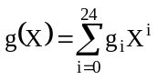

where

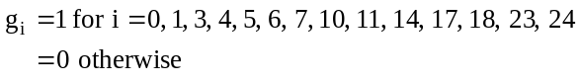

This code is called CRC-24Q (Q for Qualcomm Corporation). The generator polynomial of this code is in the following form (using binary polynomial algebra):

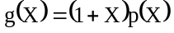

where p(X) is the primitive and irreducible polynomial

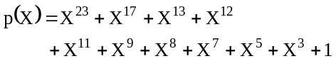

When, by the application of binary polynomial algebra, the above g(X) is divided into m(x)x²⁴, where the information sequence m(x) is expressed as

The result is a quotient and a remainder R(x) of degree < 24. The bit sequence formed by this remainder represents the parity check sequence. Parity bit p_{i}, for any i from 1 to 24, is the coefficient of x^{24-i} in R(x).

This code has the following characteristics:

1) It detects all single bit errors per code word.

2) It detects all double bit error combinations in a codeword because the generator polynomial g(X) has a factor of at least three terms.

3) It detects any odd number of errors because g(X) contains a factor 1+X.

4) It detects any burst error for which the length of the burst is ≤ 24 bits.

5) It detects most large error bursts with length greater than the parity length r = 24 bits. The fraction of error bursts of length b > 24 that are undetected is:

a) 2⁻²⁴ = 5.96 × 10⁻⁸, if b > 25 bits.

b) 2⁻²³ = 1.19 × 10⁻⁷, if b = 25 bits.

