Satellite Analysis Procedures for National Scale Land Cover Map Update

Don Leckie, Morgan Cranny, Michael Henley,
Joan Luther, Olivier van Lier, and Elizabeth Malta
___________________________

Abstract. National scale land cover maps generated from medium resolution satellite data such as Landsat have been produced for various countries and regions of the world. There is now a need to update them. It is desirable to have the new updated map compatible with the original map such that, if land cover of an area is different on the updated map it reflects a true change in land cover rather than a spurious difference related to the vagaries of land cover classification. It is also desirable to capitalize on the work done in the original land cover classification to make the update process as efficient as possible. Land cover update procedures were explored, developed and tested. Update of the circa 2000 land cover map of the Earth Observation for Sustainable Development of Forests (EOSD) project of the Canadian Forest Service, Canadian Space Agency and partners is the target or example application. The principle is to identify areas of change and classify the new cover types within these areas. Non-change areas will remain the same class as the previous land cover classification. Efficiencies are gained since often only a small fraction of the land base needs to be examined and given a new land cover class, and the nature of these new land covers is limited.

Various change mask procedures to determine potential areas of land cover change were examined including spectral change indices and 2-date unsupervised classification. A change mask generated from a K-means clustering algorithm using all 6 bands from each date of imagery was selected as the nominal approach. It gave more flexibility than thresholding spectral indices and provided information during the change labelling process that was useful to later land cover classification. It was determined that the change mask should be generous (i.e. be inclusive of change at the risk of incorporating non-change areas). The standard EOSD K-means single date land cover classification was then applied to the time 2 image using the change mask as input, and clusters within the change mask were then labelled to land cover. This was a simple and effective procedure and permits the land cover to be the same as the time 1 classification even if there was no change in cover class under the change mask. The method developed and tested mainly on a site of mixed land cove rand use n central British Columbia (Prince George) and was applied to three diverse trial regions (southwestern Northwest Territories, central Quebec and western Newfoundland). The method worked well, was able to account for ephemeral changes that do not change cover class such as moisture conditions and phenology, was compatible with the time 1 land cover map, and was efficient and cost effective. Such procedures are viable and suitable for operational implementation at national, regional and local levels.

Introduction

Canada has produced national land cover map of its forested region based on classification of circa 2000 Landsat imagery. Mapping is into 23 broad land cover classes stressing forest categories. These include broadleaf, conifer and mixedwood in three density classes (dense, open and sparse), various shrub and wetland classes plus open classes such as bryoid, graminoid and exposed land. This was produced under the Earth Observation for Sustainable Development of Forests (EOSD) project by the Canadian Forest Service and its partners and supported by the Space Agency and its Government Related Initiatives Program (Wood et al., 2002; Wulder at al. 2003). Along with this, change mapping procedures were developed (Leckie et al., 2002; Walsworth et al., 2003; Walsworth and Leckie, 2004) and forest above ground biomass estimates and maps produced. Recently Agriculture and Agri-Food Canada has completed a similar land cover map for the agriculture regions as part of the National Land and Water Information System (Agriculture and Agri-Food Canada, 2008) and Canada Centre for Remote Sensing created a Landsat-based land cover map for northern Canada concentrating on north of the tree line (Olthof et al., 2008). It is desirable to update these maps on a periodic basis (e.g. a five year interval). Updated land cover products and derived data sets will be used as an input to national and global reporting and analyses. An important property of an updated map is that it is compatible with the original map at time 1 and that differences are related to true changes in cover type. Thus it is an updated map, not another independent land cover map produced at time 2.

This project concentrates on developing procedures for updating the EOSD land cover map and demonstrates, using regional trials, that a land cover update can be done on a nation-wide basis. It does not attempt to map change and change type itself. In this paper a general approach was chosen and detailed exploration of specific procedures suitable for operational implementation was conducted primarily using a method development site centred on Prince George, BC and secondary information from a site at Petawawa, Ontario. The goal of this phase was to produce recommendations for a method or methodological options. The recommended procedures plus selected variants were then tested in trials over three regions covering a variety of landscapes, change types, EOSD land cover classification procedures and operational considerations.

Methods Development

The general philosophy explored for the land cover update process was to first develop a change mask and then classify land cover within the change mask only. The objective of this approach is to produce an updated land cover map consistent with the initial EOSD map in areas where there is no real change in land cover and do so with an efficient procedure. It is anticipated that such an approach will be efficient since a new classification of all land cover over the whole image is not needed and there will be a limited number of new land cover classes in the changed area and these will be restricted to types of cover expected in change areas.

Within this general approach there are many options and variants. In developing operational procedures key questions are:
- what method should be used for producing the change mask and how inclusive should the change mask be,
- how should the land cover under the change mask be classified.
To explore these questions various aspects were investigated and scenarios tested using data from a development site near Prince George, BC. Cranny et al. (2008a) describe these in more detail.

The Prince George development site is a 135 by 105 km area in central British Columbia and has several landscape types ranging from forest with industrial forest harvest, an agriculture region with characteristics similar to the prairie fringe, and a mixed urban, rural residential, agriculture and forestry zone around Prince George itself. One Landsat scene was used (49/22) with the EOSD land cover produced from an August 16, 2001 Landsat 7 image and the second time 2 image August 10, 1990 Landsat 5 image. Thus the land cover update is actually backdating the EOSD classification to 1990.

Change Masking Methods
Two approaches to generating change masks were examined: a) 2 date classification and labelling to change or no-change, and b) spectral change filters. For the 2 date classification, a K-means approach was chosen as it has proven effective for change mapping through the EOSD change project was used (Leckie et al., 2002; Walsworth et al., 2003, Walsworth and Leckie, 2004). K-means clustering was also the nominal EOSD land cover classification method (Wulder et al., 2004). Within the 2-date change mask generation procedure, several clustering scenarios were investigated to determine the optimal approach for selecting clusters for the change masking. Using the K-means algorithm, bands 1 through 5 and 7 from both time 1 and time 2 images and a sample of input pixels from the whole image, the classification was run requesting 120, 200 and 241 clusters. No significant benefit was found in terms of time used to label the scene by using fewer clusters. Additionally, more confusion was present when using fewer clusters. Reduced input band sets (bands 2, 3, 4, 5, 7 and 3, 4, 5, 7) with 241 clusters requested were also tested. There seemed to be no advantage to a reduced band set, so it was decided to use all bands for 2-date cluster mask production, although a reduced band set might sometimes prove somewhat better depending on atmospheric conditions, the type of ground cover present or the nature of the change conditions in a specific geographic area.

Regarding spectral change filters, there are numerous methods of combining spectral bands to aid in change detection. For spectral filtering, it was decided to concentrate on the tassel cap features commonly used for change detection (wetness and greenness). Three variants were produced: a wetness difference change mask, a greenness difference change mask and a combined wetness/greenness change mask. For each variant, upper and lower thresholds were chosen beyond which pixels were considered change. The combined greenness wetness filter added the two masks together.

One can also use different input regions to generate the 2-date clusters. In addition to using the whole image as input, a combined method was tried applying spectral change to generate a mask that was then used as input into a 2-date clustering which in turn was manually labelled change or no-change. For example, a generous change mask was generated from a wetness index difference to show change that restricts possible non-change pixels. Next, 2-date clustering was performed under this wetness mask and the output was further labelled as change or no change to create a new change mask. This process was repeated with a restrictive wetness mask.

Evaluation of Change Mask Approaches
The different options for producing a change mask above were evaluated regarding how well they generate a change mask for time 2 land cover classification. It was determined that:
- All masks were reasonably effective.
  - The spectral change masks were easier to generate and less time consuming to threshold into a change mask than the 2-date clustering approach.
  - The 2-date change clustering was next easiest.
  - The combined spectral 2-date clustering approaches were the most difficult and time consuming because they used both masking processes.
- Spectral masks are quite subjective in terms of what thresholds to use whereas, in the 2-date clustering, the choice is more clear whether a cluster is actual change, however there still can be some clusters that include mixed change and no change.
- The unsupervised clustering approach forces the analyst to evaluate context and the landscape of the changed areas and provides an opportunity to assign notes to clusters as to what the time 2 cover type is. This process is useful in the later time 2 land cover classification.
- A difficulty with the clustering mask is that some types of change that are not common may not generate a distinct cluster and therefore might be excluded from a change mask.
- The approaches combining spectral and 2-date clustering were effective and capitalize on the strengths of both methods. They help make the change cluster labelling process easier and highlight possible areas of change missed in the 2-date clustering process (e.g., due to change types with few pixels).
Overall, considering the effectiveness of the change masks, information on the land cover gained during the mask generation process and ease of production of the masks, it was decided to recommend the 2-date clustering approach for the production of the change masks. Other methods are acceptable and the combined approach has merit. The optimum method may vary with landscape type and amount and type of change.

Generosity of Change Mask
Within the change mask approach there is also variability regarding how inclusive or exclusive one can be when creating the mask. Two thresholds were explored for the spectral differencing masks. The first is a generous threshold that would include a significant number of pixels that may not be change, ensuring all change was captured. The second is a restrictive threshold that would try to reduce the non-change area included in order to minimize the amount of input data and area being considered. An important issue is how inclusive the change masks should be of non-change pixels at the risk of excluding change pixels. There is a continuum of degrees of generosity in terms of including or excluding change. For the spectral filters, we investigated what we termed a generous mask and a restrictive mask. For the 2-date clustering approach, because a decision was made on each cluster, the distinction between generous and restrictive is less clear, but the same concept was explored.

The restrictive change mask generally produced a better change mask and perhaps better land cover underneath this change mask. A comparison of the end land cover results using a generous versus restrictive masks however, showed similar end results in the time 2 land cover classification. The danger of the restrictive mask approach is that some areas of change and new land cover type can be excluded. Therefore, considering production of an overall updated land cover map, it was thought that a more generous change mask would produce a more complete updated land cover map. For example, if the change mask is too fine, areas of new land cover may be missed, whereas, if the mask includes areas of non-change, during the time 2 land cover classification process these should get classified anyways as a similar land cover as the time 1 land cover (that is, no change). In other words, the risk of making an error in the time 2 land cover by using a generous mask is lower than if using a restrictive mask. Thus a generous change mask was recommended.

Land Cover Classification Under Change Mask
Once a method for producing a change mask is selected, the land cover must be classified under the mask. It is desirable to use a similar method as applied for the original EOSD land cover classification (the nominal EOSD land cover method was a single date K-means unsupervised classification). Thus a tentative procedure was examined that consisted of K-means clustering of the time 2 Landsat data with all 6 visible near-infrared bands under the change mask as input. A 2-date unsupervised classification directly to land cover classes was also investigated and for completeness, single step procedures bypassing the generation of a change mask were explored.

An approach applying a two-date unsupervised clustering (K-means) was conducted using the whole scene as input, 241 clusters and all bands. If successful this would save time as it would accomplish both processes in one step. The resulting clusters were then labelled to time 2 land cover directly using EOSD standards. This method labels the resultant clusters directly as changed land cover. That is, it looks for clusters that represent change in land cover and labels the time 2 land cover of those clusters. This process essentially produces a labelled time 2 classification in one step and, if effective, would be a simple and quick method to update time 2 land cover. This procedure produced poor results. While it was time efficient, the classification had trouble segregating classes. This resulted in significant errors of commission that rendered the output unsuitable.

A repeat independent time 2 EOSD classification simply conducts a single date EOSD land cover classification using the whole time 2 image as input. This procedure produced poor results. Because full time 2 classification was done, no efficiencies were gained in the process. Spurious differences in classifications of pixels resulted where there was no true difference in the land cover classes between the dates (e.g., due to the vagaries of the classification process). Thus there definitely appears to be a need for, and advantages to, a method other than a new and independent EOSD classification.

The proposed procedure of a simple time 2 K-means classification under the change mask was also explored using different change mask inputs (the 2-date clustering change mask and a spectral greenness/wetness change mask). The pixels under the change mask were the input for generating the time 2 clusters, but the clusters generated in each scenario were applied to the entire time 2 image rather than only the area under the change mask. When updating the original EOSD land cover map, only those pixels under the change mask were kept for the land cover update product. Running the classification over the whole image was done mainly to help label the clusters (e.g., relate clusters to the time 1 cover types in unchanged areas) and secondarily to determine if the time 1 classification might be in error or to possibly capture real change that was omitted by the change mask. This produced good results and was clearly better than the two date classification labelled directly time 2 land cover or a completely new time 2 land cover classification. Subjectively, the approach using the 2-date clustering change mask was better at detecting exposed land change from forestry activity and detecting new forest roads compared to the spectral mask approach. Some change in the agricultural areas however was missed by the mask, but the land cover class of these areas did not change. The spectral mask produced more salt and pepper pixels, which were sometimes false change and not cover class differences.

Summary
It was determined that generating a change mask followed by a time 2 land cover clustering within it is a good approach. Considering efficiencies and the end product time 2 land cover classification, the 2-date change mask is recommended. It is also more flexible and the nature of the change clusters being examined (type of change, associated land cover, etc) can be assessed while it is being categorized as change/no change. A generous change mask is also preferred. However, spectral change masks and variants on the approach will also produce good results. Operationally, in addition to having a core procedure, it may be useful to allow flexibility to account for variation in landscapes, change amounts and types, and image quality or dates.

From these recommendations and conclusions, an operational procedure and variants were defined and applied in several pilot regions. Cranny et al. (2008b) detail the procedures and provide the required scripts. The update imagery is orthorectified to match the time 1 imagery. A temporal image-to-image relative radiometric normalization is then applied using a cursory stable forest mask. This helps to compensate for phenology and natural variation, provides a common look for visual procedures, and potentially provides for signature extension between classification dates. A K-means unsupervised classification (PCI, 2001) is performed using all 12 channels from time 1 and time 2, the whole image as input (i.e. no mask), a 50% sample of the pixels, 241 requested clusters, a movement threshold of .01 and a maximum of 12 iterations of the clustering. The resulting classification is then labelled either change or no change and a new bitmap is created of the change clusters. There is an opportunity at this point to make notes regarding possible time 2 land cover or other issues like phenological differences or indeed to label the time 2 land cover of a specific change cluster that goes uniquely to a single time 2 cover class. If there are any mixed change/no change pixels then the image can be reclustered using a mask to identify only those clusters. If there is any question, the clusters should be labelled as change (i.e. generous mask).

The time 2 data is then clustered using input pixels for the clustering from only under the change mask, but applying the land cover classification over the entire image. All 6 bands from time 2 are used as input for the classification; the panchromatic band is not used. Unlike the standard EOSD method, separate vegetation masks are not used, the classification is performed under the change mask only. There are less diverse types of cover in the change area and consequently less variation in the signatures so classifying separately under different vegetation masks is not required. The rest of the procedure keeps the parameters of the original EOSD classification with 241 clusters requested, 50% sample under the change mask; a movement threshold of 0.1 and maximum 12 iterations. The classification is then labelled by cover type using available ancillary data, the time 1 EOSD classification and any information gained from the initial change/no change classification. If any clusters prove to be too difficult to separate they can be classed as mixed and then reclustered in another classification step. This will likely happen very rarely.

Once labelled, this data is then modeled into the time 1 classification. This involves replacing the pixels that have changed in the existing product with the new classification to create a complete time 2 classification. The final step uses water/wetland/agriculture/DEM modeling scripts to model the newly updated time 2 classification to the same standards as the original EOSD classification. This creates appropriate wetland classes and removes issues with shadow being classified as water in areas of high relief. The classified time 2 data is then input into the product generation process. GenProd is a set of scripts which take the classified data and create map product tiles that follow the 1:250,000 scale NTS map sheet format. Each product includes the classified image data in GeoTIFF format, a shape file with mosaic cut lines and associated metadata and support files.

Application of Methodology on Trial Regions

To test the effectiveness of the proposed land cover update methodologies, the results from the development work plus tests in three distinct trial areas. These four areas (Figure 1) not only represent various land cover conditions but also represent a range of EOSD time 1 classification methods or external input data. Table 1 gives the imagery used in each site. The trials are designed to determine if the general approach produces good results, is operationally feasible and is robust or adaptable enough to meet the different situations expected in an operational scenario for updating the EOSD classification.

Each trial region plus the Prince George development site represents important landscape types and brings different issues to the fore.

a) Northwest Territories
- Typical of much of the non-developed NWT, it is in the southwestern region where the underlying geology is sedimentary rock. It has similar characteristics as the parts of the NWT within the Precambrian shield.
- Change is dominated by fire and much of the vegetation cover is shrub, herb, open or sparse forest which is difficult to classify. These classes grade into each other and can change spectral values depending on moisture conditions, phenology and other factors.
- An externally generated land cover classification was used for parts of EOSD. For the trial area, the classification was produced prior to EOSD by the government of the NWT using a supervised classification technique. It was to different specifications and used only three spectral bands.
- Parts of 2 scenes.

b) Quebec
- Typical of boreal forest with active forest management. Main changes include harvest and fire.
- EOSD land cover is produced by a different unsupervised classification approach than the standard EOSD product, as was done in much of Quebec
- Parts of 3 scenes.

c) Newfoundland
- Terrain varied from forest, to upland barren lands, to urban and rural development. Forestry activity and some urban and infrastructure development were the main change causes.
- A spectral filter approach to generating the change mask was tested.
- Backdating was tested, going back in time from EOSD land cover in circa 2000 to land cover in 1990.
- The work was conducted by CFS-Corner Brook by personnel not familiar with the update procedure and this was a test of the portability of the training material, manual and procedure.
- Parts of 3 scenes, but the scenes were mosaicked and radiometrically normalized. Processing and analysis was done on the entire mosaic. The area represents the Humber River Basin.

d) Prince George British Columbia method development site
- Typical interior BC industrial forest setting with most change being harvest, in particular clearcuts, but also includes an agriculture region similar to the prairie fringe and a mixed land use region of urban, rural residential, agriculture and forestry near Prince George Topography was rolling.
- The nominal EOSD classification procedure was used.
- A reverse update (backdate) was conducted (i.e. the 2000 EOSD classification was used as the starting point and 1990 as the target date for update).
- One scene only.
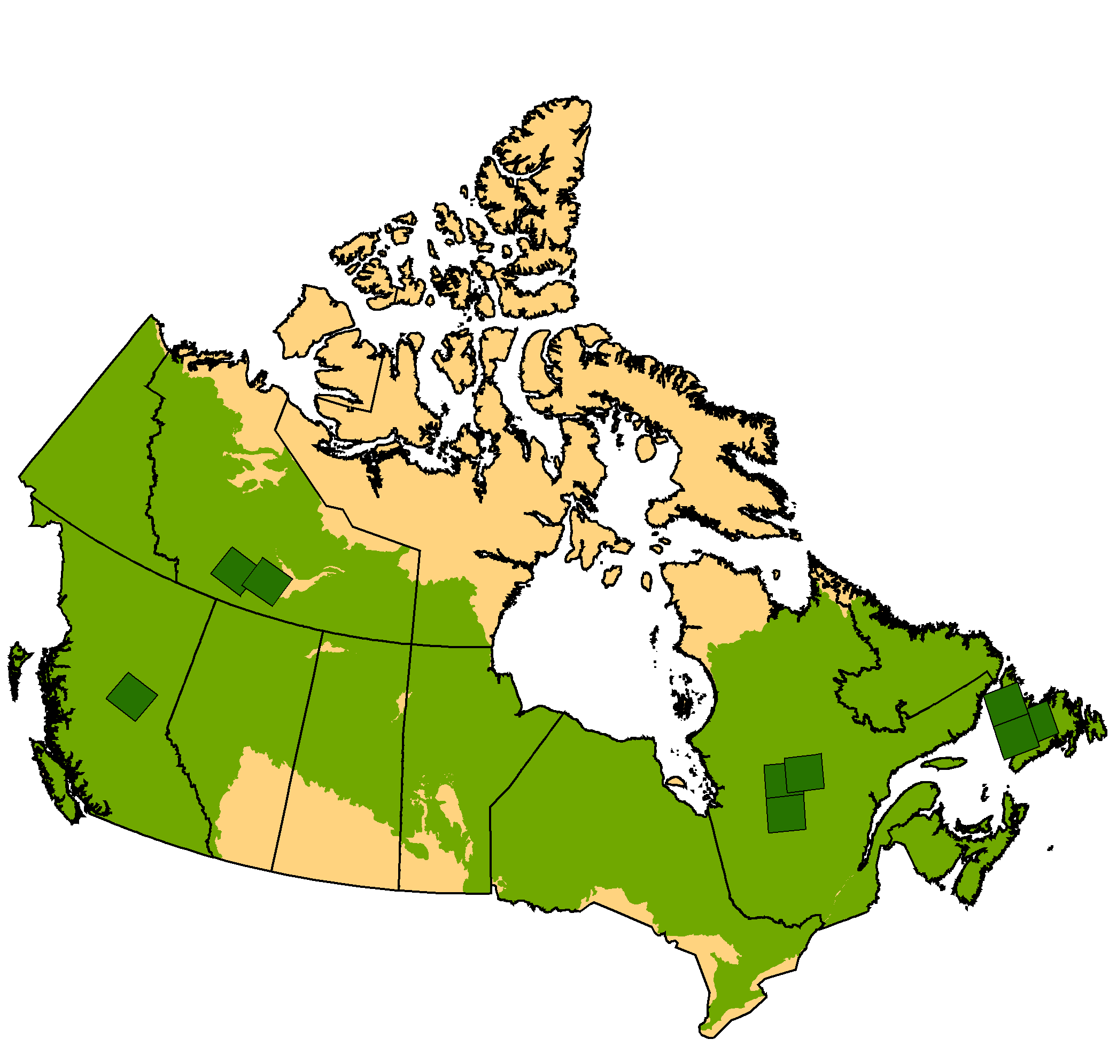
Legend
Trial Site
Forested Area
Figure 1. Location of method development and land cover update trials.

Northwest Territories Trial
The NWT pilot region covers an area southwest of Great Slave Lake starting near Hay River, NWT in scene 47/17 and extends westward to Fort Simpson in scene 49/17 (Figure 2). The EOSD land cover is generated from an external classification done before EOSD by the government of NWT with supervised classification techniques and used variable classes that were translated (cross walked) to the most appropriate EOSD classes.

The 2-date clustering run on scene 47/17 ,which has a time interval of 9 years, yielded 232 clusters, 73 of these labelled as change representing 15% of the image in the change mask (Table 1). Clustering under this change mask using time 2 data only produced 165 clusters. These were labelled for land cover and encompassed 10 cover classes, mostly conifer open, wetland herb, wetland treed or water (Table 1). Final assessment showed that 29% of the change pixels were labelled to the same class in time 2 that was present in time 1. The net result was that just over 10% of the image was determined to have changed land cover class between time1 and time 2. Table 1 gives similar information for scene 49/17, for which the change mask showed a high amount of change at 33%. Most of the changes in land cover class on the updated map (Table 1) for scene 47/17 were related to water and wetlands due to moisture condition changes, and on scene 49/17 herb and sparse or open conifer due to revegetation of burned areas. Conifer open was responsible for 31% of the land cover change updated for 47/17, but this was due to a case of both changing spectral values and issues with the time 1 classification. The original conifer classes were different from EOSD and somewhat straddled the EOSD class definitions. In the update, since new clusters were formed and labelled, some areas were labelled conifer open that were previously conifer dense. The images, change masks and time 1 and 2 classifications for 49/17 are shown in Figure 2.

The imagery and test site demonstrate some of the difficult situations that might be encountered. Scenes 47/17 and 49/17 at time 1 were acquired two days apart in late June 1996. During this time, the water table was relatively low with a large number of dry lake beds and contracted lakes that created large areas of exposed earth and marshy shoreline around smaller open water bodies which under normal conditions as in 2005 are under shallow water. These fluctuating water levels and moisture conditions caused a significant number of the change events. The more favourable moisture conditions also benefit vegetation growth, and the amount and vigour of vegetation especially the ground vegetation and shrub classes were higher. As well, phenology also caused some spectral changes in the broadleaf classes which had not greened up fully on the June, 1996 data, especially on scene 49/17. The impact of moisture condition and phenology on vegetation caused change to be detected that was not related to a land cover class change.

These cases of spectral change without cover class change were recognized during the labelling of the clusters for the change mask and were then removed from the change mask. For scene 49/17 the final area of the change mask was reduced from 33% to 20% of the image. In the case of water level changes and consequent cover class differences, these were kept as class changes. For example, in scene 47/17, 8% of the pixels that change cover type on the updated map went to water, representing the areas that were dry in 1996 and water in 2004. As well, 23% of the area under the change mask was classed as wetland herb representing vegetation on previously dry wetland area.

The nominal approach to land cover update is to only change the time 1 land cover where there is a true change in class and not correct for possible errors in the time 1 classification. However, the approach can be used to improve the time 1 land cover in areas where the initial classification was wrong. For example, the prominent fire on the 1996 image of scene 49/17 was likely a few years old in 1996 as some residual vegetation is present, but little forest regeneration was evident. The nature of the time 1 classification resulted in many of these areas being labelled as exposed land, even though some residual cover was present. An attempt to improve the time 1 classification for this use was made by evaluating the clusters in time 2 against imagery from time 1 and if the cluster was deemed not to have changed from time 1 to time 2, but was a different cover type than used in time 1, it was relabelled to the true land cover type. Then these clusters were put into a separate layer for use in modifying the time 1 map. Roughly 5% of the image (9 clusters) met these criteria and had the cover type changed to one of three classes: herb, conifer open and broadleaf open. These clusters were placed in a separate layer containing areas where the new time 1 land cover should replace the original land cover.

Quebec Trial
The Quebec study site was located north of the towns of Chapais and Chibougamau and surrounds Lac Mistassini. It lies on a transition zone across the limit of taiga and boreal shield ecozones. Many natural and anthropogenic disturbances occur every year. The c2000 Quebec EOSD land cover product was created using the enhancement classification methodology (ECM) (Beaubien et al., 1999). Essentially, ECM captures most of the visible information content of enhanced near-infrared, middle infrared and red spectral channels, by converting these bands into classes and conducts an iterative unsupervised classification.

The three scenes in the area have time intervals from 8 to 3 years and the amount of change associated decreased from 20% down to 2% (Table 1). The corresponding number of change clusters and percent area with land cover class also decreased. Since the main changes were harvest and forest fire, the dominant new land cover types were exposed land, conifer sparse, shrub and herb. In the time 2 clustering process, exposed land often creates a large number of clusters. For example, in scene 15/24, 98 of the 176 time 2 clusters were associated with exposed land, but this only represented 25% of the area, whereas approximately half the changed pixels were coniferous sparse, yet these only occurred in 21 clusters.

Another issue was demonstrated on this site. For scene 16/24 there was cloud and cloud shadow on the time 1 image. The method detects these as changed areas and gives a time 2 land cover. For example, considerable amount of the new conifer open for scene 16/24 was due to areas occupied by cloud in time 1. This type of class change that is not necessarily related to a true land cover change can be flagged as such to separate it from true change. Also, if one wanted to speculate that there was no change between time 1 and 2, then the new class could be used to infill and improve the time 1 map.

Newfoundland Trial
The Western Newfoundland study area (9,290 km²) is defined by the perimeter of the Humber River Basin (Figure 3). The basin is the subject of study of critical issues such as sustainable forest harvest, habitat protection, and managing of forests considering factors such as insect and disease, carbon sequestration and public input (Hearn et al., 2008). Several different aspects of the land cover update approach were tested with this trial. Method design work indicated that spectral filters can serve as an alternate tool for creating the change mask. As well, the method is designed to be able to backdate land cover (i.e. go back in time).

The adaptability of the procedure to mosaics of multiple images was tested. This would further increase the efficiency of map production since several scenes could be processed and analyzed at one time. This required careful consideration of radiometric normalization procedures. The time 1 scenes were corrected to top-of-atmosphere radiance during the initial EOSD production and cloud and cloud shadow areas were removed. The time 1 scenes were further radiometrically normalized to a 2001 MODIS 32-day composite image using Theil-Sen robust regression (Olthof et al., 2005). The time 2 imagery was then normalized to the time 1 imagery using the band statistical comparison technique (Joyce and Olsson, 1999). Processing and analysis was done on time 1 and 2 mosaics of all scenes.

A spectral change mask based on a tasselled cap wetness index was used and gave a final change mask that represented 10% of the study site. The single date classification of the time 2 (earlier image) had similar characteristics as the classification of the other sites that used the 2-date unsupervised classification as the change mask (Table 1). Figure 3 gives results. The backdate procedure successfully identified change in areas of depletion and dense regeneration. Areas of recent regeneration in 1990 that became denser by 2001, however, were notably difficult to capture in the change mask. Dense conifer and mixedwood were the most common new cover classes (Table 1) representing changed areas that were exposed land or herb in 2000 (i.e., clearcut areas). The area that changed from forest (1990) to non-forest (2001) according to the backdate process (1.9% of the basin) corresponded well with harvested areas mapped in the forest management inventory (2.0% of the basin).

Discussion and Conclusions

The results of the methods development and trial studies showed that the procedures for land cover update are feasible in an operational context. In general the methods produced land cover classification that were compatible with the time 1 classification such that change in land cover class was due to real change as opposed to the vagaries of the clustering and labelling process. The methods were effective both going forward in time (updating) and backward in time (backdating). It worked well on the Newfoundland trial which was processed and analyzed as a mosaic of imagery rather than individual scenes. The diversity of Canada's landscapes and variety of drivers for forest change is a large challenge. The Prince George development site and the trial regions explored in this project cover a good range of complexities. The method was shown to be robust and adaptable. It handled cases of differences among the two images due to phenology, water level, moisture conditions, and cloud cover in time 1. It also dealt with cases of circa 2000 EOSD land cover produced by the standard procedure, as well as by an alternate unsupervised technique and an independent supervised classification to different land classes that had to be translated to the EOSD legend. The trials showed that there can be systematic errors in the original classification and some of these can be recognized and remedied if desired. The fact that the time 2 classification is run over the whole image can help in determining if there is error or differences between the labels assigned to unchanged areas between time 1 and 2.

The procedure, as anticipated, was efficient and did reduce importantly the effort in producing a land cover map. Table 1 indicates that the area that needs to be examined for land cover and the number of land cover classes involved is much reduced over a full new time 2 classification. The time 2 classification could be done simply. The variety, nature and list of expected cover types in the change areas were limited. As well, the time 2 classification did not involve splitting the landscape into different vegetation and surface categories and classifying these separately, as was done for the EOSD land cover procedure. From analysis of times taken to conduct the procedures on the trial areas (Cranny et al., 2008a), an estimate of 3-5 days per scene is reasonable, with 5 days for complex and problematic scenes like some of those of the NWT trial and 3.5 days for moderate to simple cases like the Quebec site. In some landscapes where there is little or no change only a day may be needed.

Canada would benefit significantly from an update of the circa 2000 EOSD land cover and indeed also from update of the land cover maps of its agriculture south and northern regions. This would enable Canada to better respond to national and international reporting requirements and provide current information for policy development, decision making, study of climate change issues and sustainable development activities. This project has developed an efficient and effective procedure suitable for producing a second updated land cover map of Canada's forest region compatible with the year 2000 EOSD land cover. Specific end-to-end procedures and scripts are available (Cranny et al., 2008b). The basic procedures are applicable to other land cover classifications. The procedures can be applied or adapted by others working at the local, national and even international level.

Acknowledgements

The Canadian Forest Service has undertaken this land cover update project with support from the Canadian Space Agency Government Research Initiative Program (GRIP) in a project entitled “Keeping Forest Cover Information Relevant for Canadians”. Provinces and territories in all trial sites contributed data and input to the project. The Humber River Basin Project, a partnership led by Sir Wilfred Grenfell College, Memorial University, supported the analysis of the Western Newfoundland trial site. We also thank our Canadian Forest Service colleagues at the Laurentian Forestry Centre and Northern Forestry Centres for providing data and assisting with logistics.

References

Agriculture and Agri-Food Canada. 2008. The National Land and Water Information Service (NLWIS). Available from http://www.agr.gc.ca/nlwis/index_e.cfm?s1=data_
donnees&s2=details&s3=lc-ct&page=lc-ct_plus

Cranny, M., D. Leckie, M. Henley, E. Malta, O. Van Lier and J. Luther. 2008a. Keeping Forest Cover Information Relevant for Canadians: Demonstration and Planning for Land Cover Update of Forested Regions of Canada. Final Report to Canadian Space Agency. Report DRS-R-001, Natural Resources Canada, Canadian Forest Service, Pacific Forestry Centre, Victoria, BC, Canada, March 2008. 40 p.

Cranny, M., E. Malta, M. Henley, D. Leckie and N. Walsworth. 2008b. Land Cover Update for the Earth Observation for Sustainable Development of Forests: Procedures Manual. Report DRS-T-001, Pacific Forestry Centre, Canadian Forest Service, Natural Resources Canada, Victoria, BC, Canada, March 2008. 68 p.

Beaubien, J, J. Cihlar, G. Simard and R. Latifovic. 1999. Land cover from multiple Thematic Mapper scenes using a new enhancement-classification methodology. Journal Geophysical Research. 194:27909-27920.

Hearn, B., J. E. Luther and D. Gray. 2008. An integrated risk analysis framework in support of sustainable forest management in Canada: project overview. In: Implementing Ecosystem-based Management Approaches in Canada’s Forests: A Science-Policy Dialogue, Edited by B. McAfee, and C. Malouin, Natural Resources Canada, Canadian Forest Service, Ottawa. p. 38-41.

Joyce, S. and H. Olsson. 1999. Long-term forest monitoring with temporal-spectral trajectories from Landsat TM data. Proceedings IUFRO Conference on Remote Sensing and Forest Monitoring. Rogow, Poland. p. 68-81.

Leckie, D.G. N. Walsworth, J. Dechka and M. Wulder. 2002. An investigation of two date unsupervised classification in the context of a national program for Landsat based forest change mapping. International Geoscience and Remote Sensing Symp. and 24th Canadian Symp. Remote Sensing, Toronto, Ontario, June 24-28, 2002. p.1307-1311.

Olthof, I., D., Pouliot, R. Fernandes and R. Latifovic. 2005. Landsat-7 ETM+ radiometric normalization comparison for northern mapping applications. Remote Sensing of Environment. 95:388-398.

Olthof, I., R. Latifovic and D. Pouliot. 2008. A new circa-2000 land cover map of northern Canada at 30-m Landsat resolution. Proc. 10th International Circumpolar Remote Sensing Symposium and 29th Canadian Symposium on Remote Sensing. June 2-5, 2008. 9 p.

PCI. 2001. ImageWorks User’s Guide Version 8.2. PCI Geomatics Enterprises Inc., Richmond Hill, Ontario. Chapter 3, pp. 180 - 184.

Walsworth, N.A., D.G. Leckie. and H. Chen. 2003. Design considerations and elements for a system for monitoring change in Canada’s forests. Second International Workshop on the Analysis of Multitemporal Remote Sensing Images. European Commission Joint Research Centre, Ispra, Italy, July 16-18, 2003. CD-ROM.

Walworth, N. and D. Leckie. 2004. Forest Change Mapping for the Earth Observation for Sustainable Development of Forests Program: Approach and Procedures Document. Internal Report, Natural Resources Canada, Canadian Forest Service, Pacific Forestry Centre, Victoria, BC, Canada, December 2004, 192 p.

Wood, J.E., M.D. Gillis, D.G. Goodenough, R.J. Hall, D.G. Leckie, J. E. Luther and M.A. Wulder. 2002. Earth Observation for Sustainable Development of Forests (EOSD): Project Overview. International Geoscience and Remote Sensing Symposium (IGARSS), Toronto, June 24-28, 2002. Vol.3, pp. 1299-1302.

Wulder, M.A., J.A. Dechka, M.A. Gillis, J.E. Luther, R.J. Hall, A. Beaudoin and S.E. Franklin. 2003. Operational mapping of the land cover of the forested area of Canada with Landsat data: EOSD land cover program. Forestry Chronicle. 79:1075-1083.

Wulder, M., M. Cranny, J. Dechka and J. White. 2004. An illustrated methodology for land cover mapping of Forests with Landsat-7 ETM+ data: Methods in Support of EOSD
Land Cover, Version 3. Natural Resources Canada, Canadian Forest Service, Pacific Forestry Centre, Victoria, BC, Canada, March 2004. 35 p.

Table 1. Change mask and update land cover classification characteristics for the trial sites and scenes within them.

Test site | Scene path/row | Time 1 year | Time 2 year | Difference (years) | 2-Date Change Mask |  |  | Time 2 classification under change mask
 |  |  |  |  | # of clusters | # of change clusters | % area of change clusters | # of clusters | # cover classes | % pixels same class as time 1 | Total % area with land cover class change | Classes of areas with majority of cover class change
NWT | 47/17 | June 25, 1996 | Aug 21, 2005 | 9 | 232 | 73 | 15 | 165 | 10 | 29 | 10 | conifer open -31%; wetland herb- 23%; wetland treed 11%; water -8%
NWT | 49/17 | June 23, 1996 | June 29, 2004 | 8 | 160 | 40 | 33 | 196 | 11 | 23 | 15 | 80% were either herb, conifer open, conifer sparse, wetland treed or wetland shrub
Quebec | 15/24 | July 1, 1998 | July 20, 2005 | 7 | 204 | 29 | 20 | 176 | 8 | 30 | 14 | conifer sparse -51%; exposed land -25%; shrub low - 20%
Quebec | 16/24 | Aug. 28, 2002 | July 11, 2005 | 3 | 151 | 22 | 7 | 84 | 10 | 30 | 5 | conifer open, water and exposed land were most common classes
Quebec | 16/25 | Aug. 28, 2002 | July 14, 2006 | 4 | 148 | 8 | 2 | 18 | 6 | 2 | 1.6 | exposed land - 45%; shrub low - 29%; herb - 23%
Newfoundland | 05-24, 05/25, 04/26 | Sept. & Aug. 2001 | Aug., 1990 | 11 | -* | -* | 10* | 147 | 11 | 8 | 9 | conifer dense - 40%; mixedwood dense - 13% (represent harvest areas)

* spectral mask used

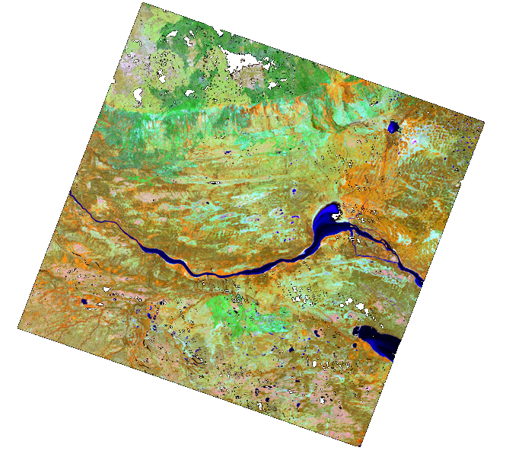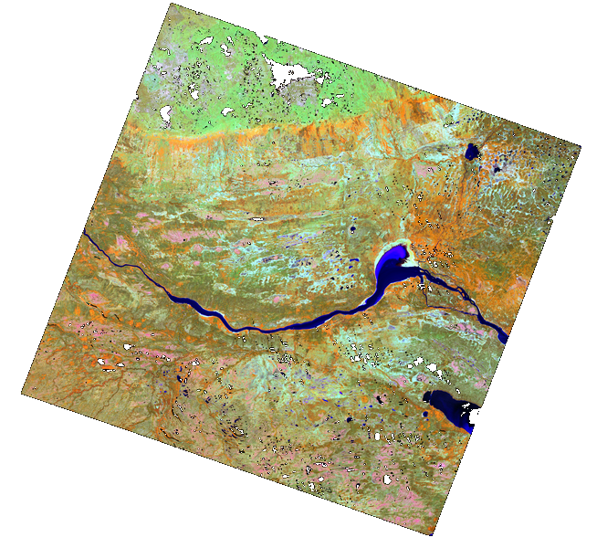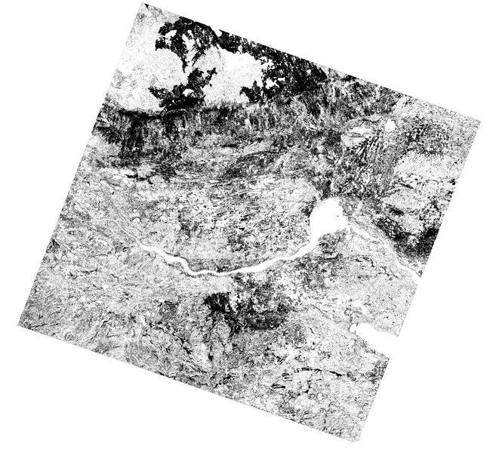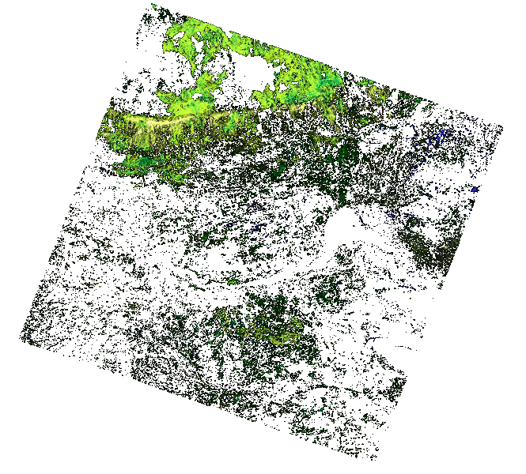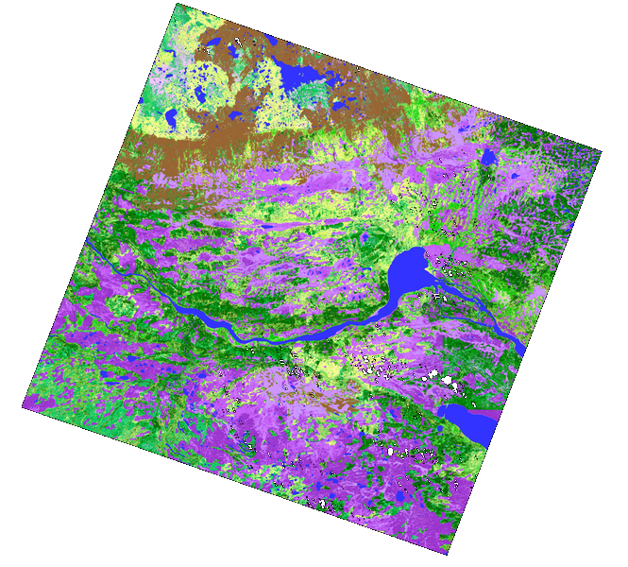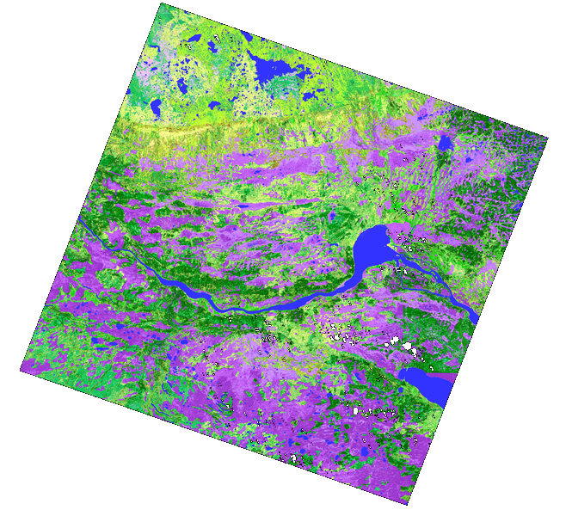
Figure 2. Northwest Territories trial region scene 49/17. Top left is time 1 Landsat image (bands 4, 5 and 3 as red,green and blue), top right is time 2 Landsat image, middle left is change/no change mask, middle right is labellled mask, bottom left is EOSD time 1 land cover and bottom right is updated EOSD time 2 land cover.
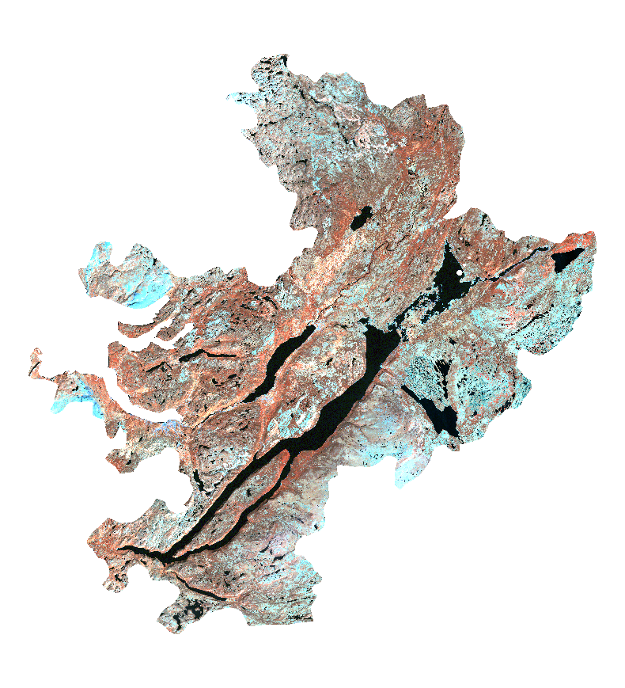
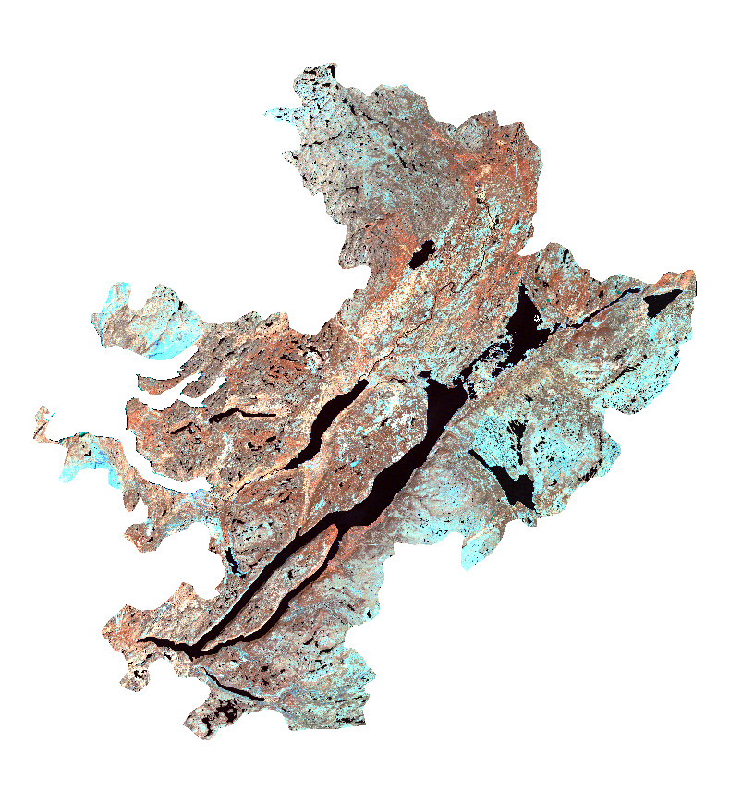

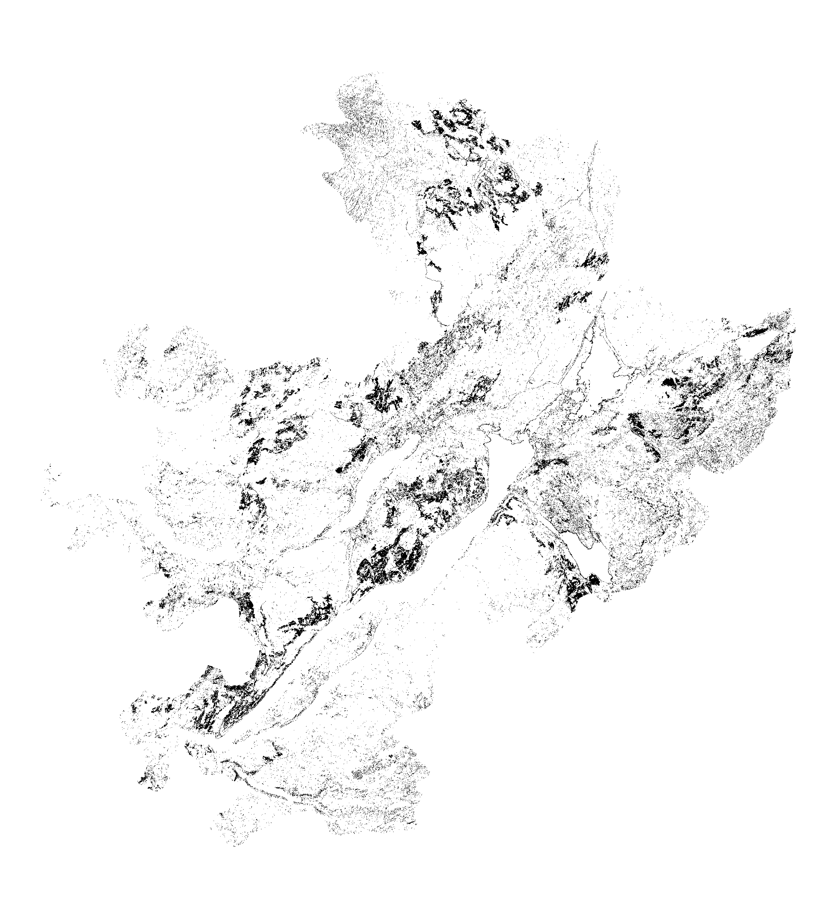
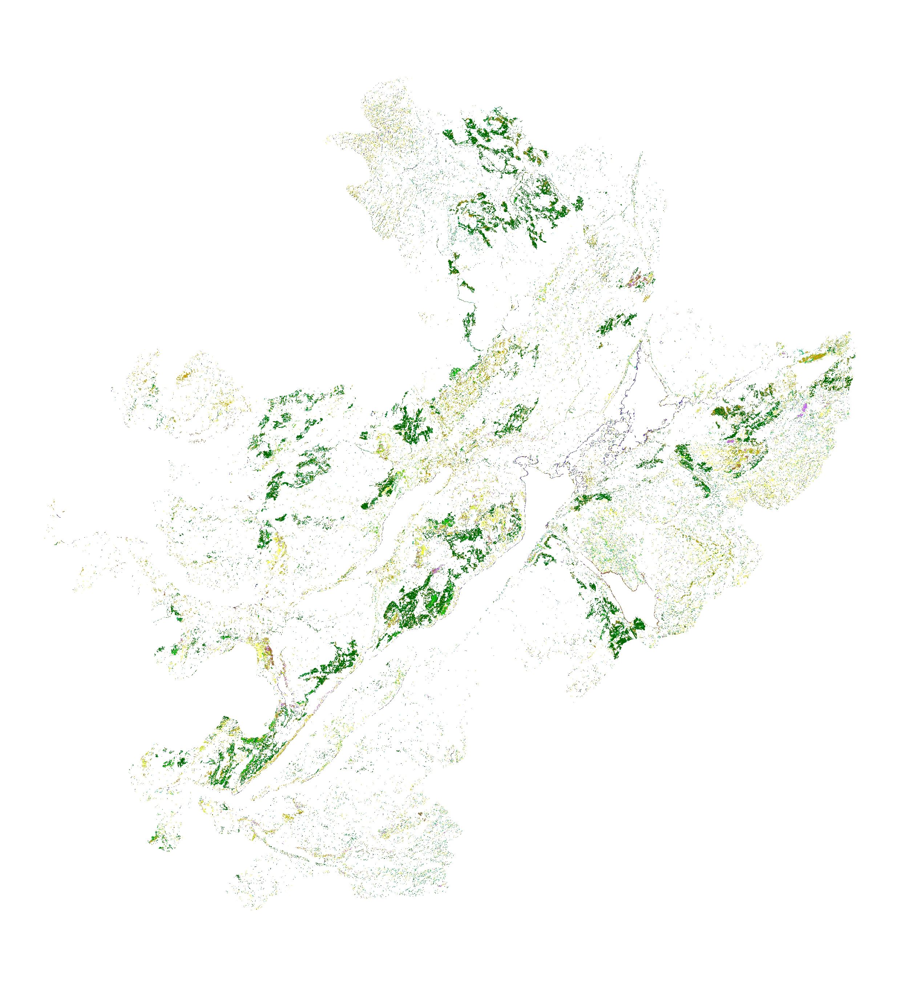

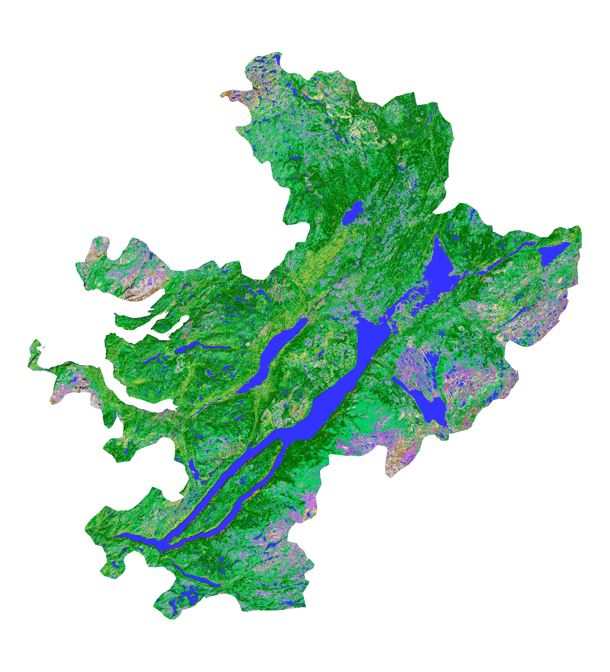
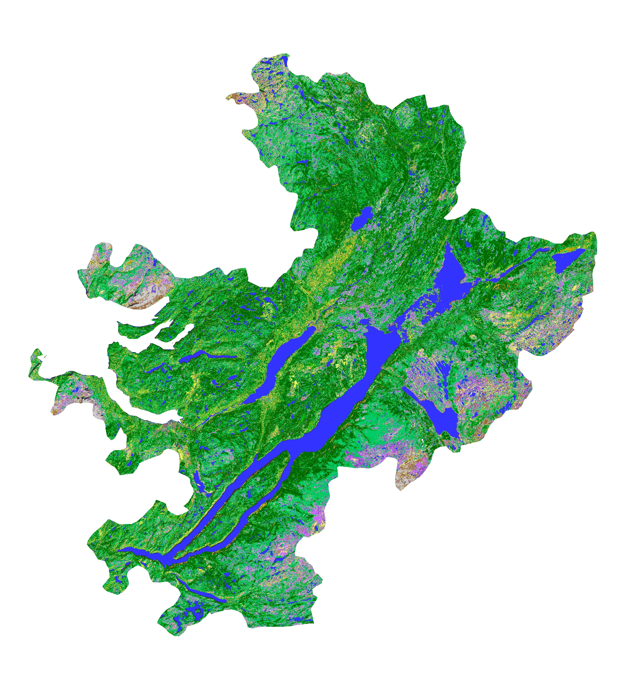

Figure 3. Newfoundland trial region (Humber River Basin). Top left is time 1 Landsat image (bands 4, 5 and 3 as red,green and blue), top right is time 2 Landsat image, middle left is change/no change mask, middle right is labellled mask, bottom left is EOSD time 1 land cover and bottom right is updated EOSD time 2 land cover.

