Package Characteristics: CLCC LF

Feature | Value
Package Length | 8.80 mm
Package Width | 8.80 mm
Package Thickness | 1.71 mm
Castellation width | 0.63 mm
Castellation pad length | 1.27 mm
Castellation height | 1.71 mm
Die Length | No Die
Pitch | 1.27 mm
Weight | 0.384 g
CTE | 5.043 ppm/C
Layer 1 Metallization | Gold
Layer 1 Plating Thickness | 0.003 mm
Layer 2 Plating Metallization | Nickel
Layer 2 Plating Thickness | 0.0038 mm
Lead/Termination Metallization | Tungsten
Metallization Thickness | 0.046 mm

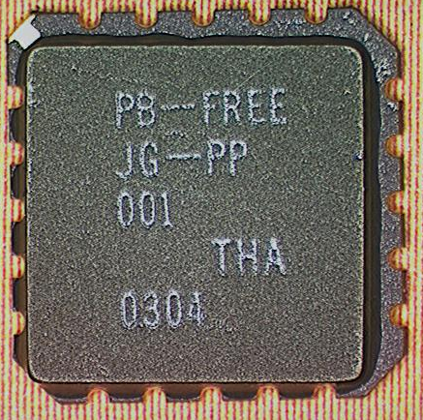
Top View

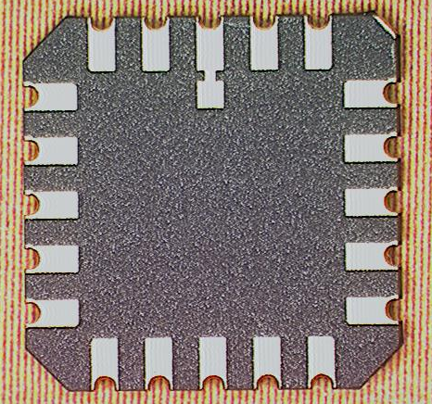
Bottom View

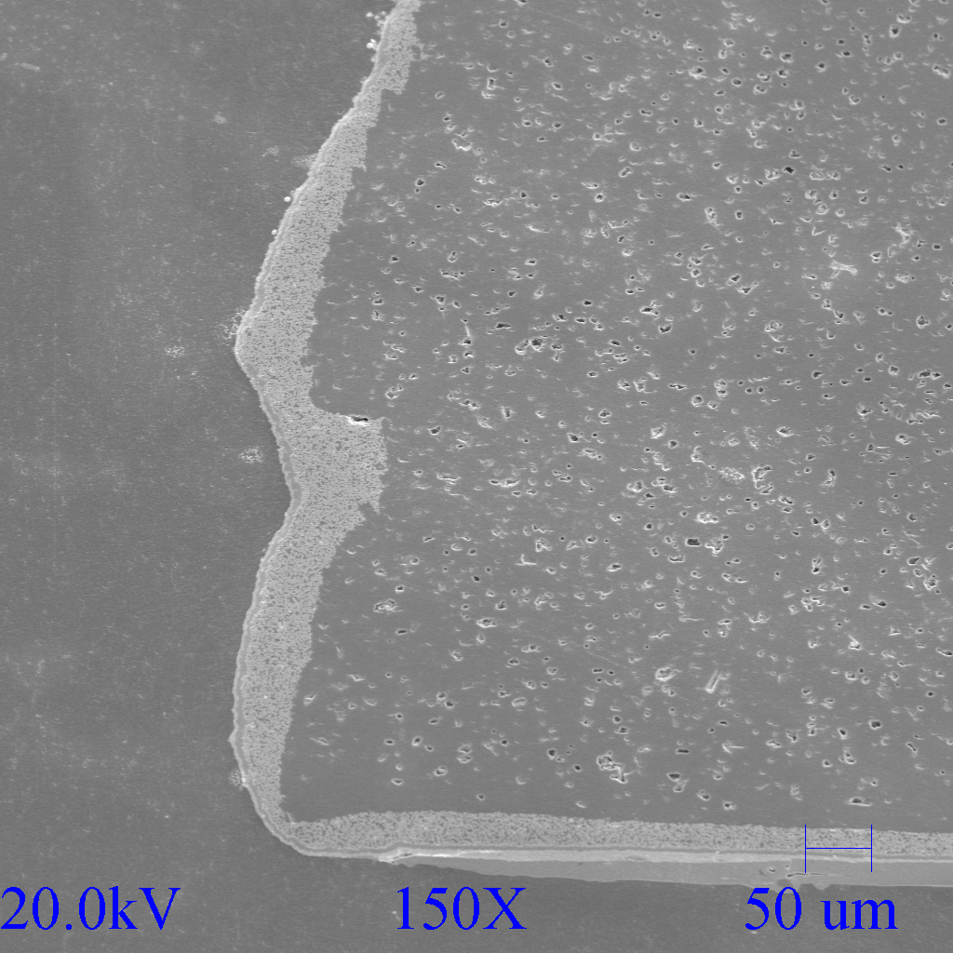
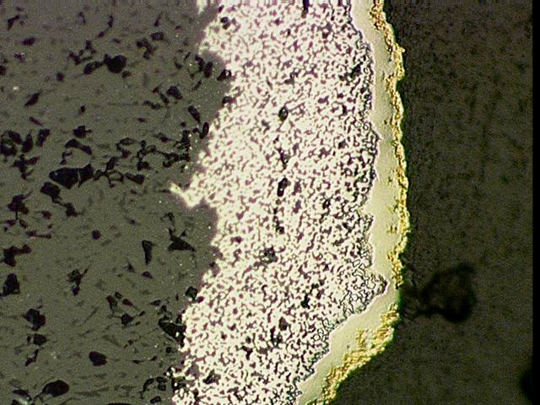
Cross-section of lead
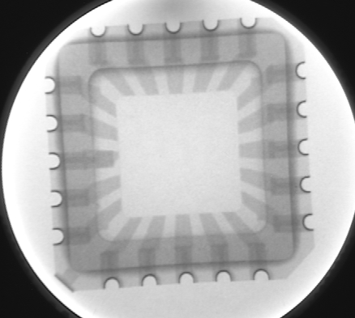

SEM of cross-section

X-Ray

