Table of Contents
List of Exhibits…………………………………………………………………………iii
List of Tables………………………………………………………………………..…iv
1. Introduction 1
1.1 Using This Manual 1
1.2 Definition of Ramp Meters 1
1.3 Purpose of Ramp Meters 1
1.4 Benefits of Ramp Meters 1
1.4.1 Temporal Shift of Demand 2
1.4.2 Spatial Shift of Demand 3
1.4.3 Modal Shift 3
1.4.4 Collision Reduction 3
1.5 Drawbacks of Ramp Meters 4
1.6 Application of Recommendations 4
2. Ramp Meter Warrants 5
2.1 Purpose of Warrant Process 5
2.2 Geographic Scope of Study 5
2.3 Data Requirements 5
2.4 Individual Warrants 5
2.4.1 Warrant One – Recurring Congestion Warrant⁷ 6
2.4.2 Warrant Two – Collision History Pattern⁷ 6
2.4.3 Warrant Three – Freeway Level of Service⁷ 6
2.4.4 Warrant Four – Modal Shift⁷ 6
2.4.5 Warrant Five – Redistribution of Access⁷ 6
2.4.6 Warrant Six – Sporadic Congestion Warrant⁷ 7
2.4.7 Warrant Seven: Total Volume Warrant⁹ 7
2.4.8 Warrant Eight: Right Lane plus Ramp Volume Warrant⁹ 7
2.4.9 Warrant Nine: Geometric Warrant⁹ 7
2.5 Overall Ramp Metering Warrant 8
2.6 Warrant Analysis Example 8
3. Ramp Meter Design 11
3.1 Introduction 11
3.2 Design Volume 11
3.3 Choosing the Number of Lanes to Meter 11
3.4 Freeway Entrance Types 12
3.4.1 Taper Type Entrances 12
3.4.2 Parallel Type Entrances 14
3.4.3 Design Guidelines Choosing Entrance Types 15
3.5 Design Guidelines for Placement of Stop Bars 15
3.6 Design Guidelines for Queue Storage 16
3.7 Design Guidelines for the Removal of HOV Preferential Lanes 17
3.8 Design Guidelines for the Installation of HOV Preferential Lanes for Ramps 17
3.9 Design Guidelines for Ramp Meter Enforcement Areas 18
3.10 Single Lane Metered Ramp Design 20
3.11 Dual Lane Metered Ramps 23
3.12 Ramp Meter Retrofit Applications 25
3.12.1 One-Lane Ramp Meter to Two-Lane Ramp Meter Conversion 25
3.12.2 One-Lane + HOV Conversion to Two-Lane Ramp Meter 28
3.13 Ramp Meter Hardware 31
3.13.1 Signals 31
3.13.2 Beacons 34
3.13.3 Mainline Detectors 35
3.13.4 Ramp Detectors 37
3.13.5 Cabinet Assembly 41
3.14 Ramp Meter Pavement Marking 47
3.15 Ramp Meter Signing 49
3.16 Typical Conduit and Junction Box Layout 49
4. Ramp Meter Operation 51
4.1 Ramp Meter Stand-Alone Local Operation 51
4.2 Ramp Meters as an Element of the Freeway Management System 52
4.3 Communications with ADOT Traffic Operations Center 52
4.3.1 Ramp Meter Message Formats 53
4.4 Integration with ADOT Traffic Operations Center 54
4.5 Ramp Metering Rate Selection 54
4.5.1 Arrival Discharge Chart 54
4.5.2 Computer Simulation 58
4.6 Ramp Metering Modes 58
4.7 Ramp Metering Rates 59
4.7.1 Ramp Meter as a Stand-Alone Strategy 60
4.7.2 Default Metering Rates 60
4.7.3 Recommended Speeds 61
4.7.4 Impact of Incidents 61
4.8 Ramp Meter Equity 62
4.9 Enforcement of Ramp Meters 63
5. Ramp Meter Maintenance 64
5.1 Personnel 64
5.2 Training 64
5.3 Commonly Reported Malfunctions 65
5.4 Preventative Maintenance 65
5.5 Unscheduled Maintenance 66
5.6 Detection Maintenance 66
5.7 Maintenance Documentation 67
5.8 Maintenance Evaluation 67
Acronyms 68
Glossary 69
References 71

List of Exhibits

Exhibit 2.1: Ramp Meter Warrant Flowchart……..……………………………...…10
Exhibit 3.1: Tapered and Parallel Freeway Entrance Types……………………..13
Exhibit 3.2: Typical Ramp Meter Enforcement Area………………………………20
Exhibit 3.3: Single Lane Metered Ramp……………………………………………22
Exhibit 3.4: Dual Lane Metered Ramp……………………………………………...26
Exhibit 3.5: One Lane to Two Lane Meter Conversion……………………………27
Exhibit 3.6: One Lane + HOV to Two Lane Meter Conversion…………………..30
Exhibit 3.7: Typical Ramp Meter Signal Pole………………………………………31
Exhibit 3.8: Ramp Meter Signal Pole……………………………………………….33
Exhibit 3.9: Typical Flashing Beacon……………………………………………….34
Exhibit 3.10: Flasher Assembly……………………………………………………...36
Exhibit 3.11: Typical 341 Cabinet Assembly……………………………………….41
Exhibit 3.12: 341 Controller Cabinet Foundation Details…………………………43
Exhibit 3.13: Model 179 Controller………………………………………………….44
Exhibit 3.14: Input File Layout……………………………………………………….46
Exhibit 3.15: Ramp Meter Stop Bar Striping……………………………………….48
Exhibit 3.16: Typical Ramp Meter Sign……………………………………………..49
Exhibit 3.17: Typical Conduit and Junction Box Layout…………………………..50
Exhibit 4.1: Arrival Discharge Calculation Worksheet Template…………………56
Exhibit 4.2: Arrival Discharge Calculation Worksheet Example………………….57

List of Tables

Table 1.1: Ramp Meter Benefits……………………………………………………...2
Table 2.1: Total Volume Warrant Criteria…………………………………………....7
Table 3.1: Recommended Number of Lanes………………………………………11
Table 3.2: Acceleration Length………………………………………………………14

Introduction

1.1 Using This Manual

This manual is intended to provide guidelines covering the design, operation and maintenance of ramp meters on ADOT freeways for ADOT design engineers, design consultants, operators, and maintenance personnel, as well as city and county personnel working on ADOT freeways. It is a supplement to, but does not supersede the ADOT Roadway Design Guidelines (Publication # 31-089), ADOT Standard Plans, ADOT Standard Specifications, ADOT FMS Design Guidelines, Roadway Design Memoranda, and other current design policies. This guidelines document is not a textbook or a substitute for engineering knowledge, skill, experience or judgment. It is not intended that any standard of conduct or duty toward the public shall be created or imposed by this guideline. Special situations may call for variations as conditions and experience warrant.

1.2 Definition of Ramp Meters

Ramp meters are traffic control signals that control the flow of traffic entering a freeway facility. ⁷

Purpose of Ramp Meters

Ramp metering is an effective traffic management strategy to maintain an efficient freeway system and to protect the investment made in constructing freeways by keeping them operating at or near capacity.⁵

The primary purpose of ramp metering is to mitigate recurring congestion and associated collisions by spreading out queues of vehicles wishing to enter the freeway over time. By spreading out queues, it also provides for a safer merging of vehicles.

1.4 Benefits of Ramp Meters

Ramp meters are an operational strategy to reduce congestion and increase safety on ADOT’s freeway system. Typical benefits of ramp meters include:

- Travel time savings
- Improved travel time reliability
- Reduction in number of collisions
- Increase in freeway throughput

The magnitude of the benefits varies widely depending on the nature of the deployment and the operational policies for the ramp meter installation. The prevailing Level of Service (LOS) of the mainline is also a key factor in ramp meter effectiveness.

The Highway Capacity Manual indicates that at LOS A, the density is low enough to allow smooth merging with virtually no impedance in the traffic stream. Therefore, ramp meter usage during the free flow conditions of LOS A does not offer benefits, as there are no flow improvements to be made. At LOS B, the ability of vehicles to maneuver within the traffic stream is slightly restricted, and ramp metering can be slightly beneficial in improving merging operations by spreading the queues out over time. At LOS C and D, the ability of vehicles to maneuver within the traffic stream is noticeably restricted, which means that there is greater opportunity for ramp metering to improve the traffic flow. LOS E describes operation at capacity, with virtually no usable gaps in the traffic stream, and ramp metering loses its effectiveness. LOS F describes breakdowns in vehicular flow, resulting in queues. The benefits of ramp meters are greatest on facilities where the ability to maneuver is restricted, but not impossible. In this context, that can be considered equivalent to Level of Service (LOS) C, or D, as defined in the Highway Capacity Manual.¹¹ At LOS A and B, there is typically not enough volume for ramp metering to be beneficial, while at LOS E and F, congestion is too severe to be mitigated by ramp metering alone.

Table 1.1 summarizes the average benefits derived from ramp meter implementation and also shows the range of benefits cited in a number of published studies.

Table 1.1: Ramp Meter Benefits⁶
Measure of Effectiveness | Average Improvement | Range of Improvement
Travel Time | 22% | 7% to 91%
Reduced Collisions | 29% | 5% to 50%
Increased Throughput | 38% | 0% to 86%
Improved Travel Time Reliability | Not Quantified | Not Quantified

The following sections explain how ramp meters achieve these benefits.

1.4.1 Temporal Shift of Demand

A temporal shift in demand is a shift of travel demand in time. For example, motorists may shift a trip made for convenience such as a shopping trip to off-peak hours. Delays imposed at freeway entrances by ramp meters have the effect of deferring the time of arrival to downstream bottlenecks and to the merge area. The temporal shifts caused by the use of ramp meters delay the onset of congestion, by helping to reduce the likelihood that demand exceeds capacity at critical bottlenecks. This strategy can be deployed as a point treatment to ease congestion in a busy merge area or on a systemwide basis using multiple meters to limit the volume at a bottleneck many miles downstream.

Excessive demand at entrance ramps is also caused by common work hours. For example, many workers leave work at 5 PM, creating a five to fifteen minute surge in traffic that exceeds the capacity of the facility. Often times, this results in congestion and breakdown of the facility. Ramp metering can cause a temporal shift in demand when discretionary trips are avoided during the peak periods. In some major cities, commuter trips are also shifted to outside the peak period, when freeway users elect to defer their trips outside the peak periods by working flextime, exercising or dining near work.

1.4.2 Spatial Shift of Demand

Spatial demand shift occurs when freeway users elect to use alternative routes. The most common shift is to a downstream ramp that is less congested, thus reducing the variability in ramp usage. For example, before metering is implemented the upstream ramp may have a volume of 1,200 vph and the downstream ramp may have a volume of 300 vph. After an appropriate metering plan is implemented, each ramp is likely to have a volume much closer to 750 vph. In addition, metering will have a tendency to divert short trips from the freeway to arterials. When the meter is on, the delay motorists incur at the ramp meter is matched or exceeded by travel time savings on the freeway itself. The level of benefit is related to trip length. Motorists with long trips will find that the wait at the meter is worthwhile. Others with shorter trips, typically three or fewer miles in length, often find that completing the trip entirely on surface streets is faster. A careful balance must be struck between freeway congestion management using ramp meters and surface street traffic impacts that may affect the livability of communities located near the alternate routes.

1.4.3 Modal Shift

Theoretically, it is feasible to shift demand from the single-occupant vehicle (SOV) to transit or other high occupancy vehicles (HOV) when preferential treatment is given to these types of vehicles. In ramp metering, preferential HOV treatment is achieved through the use of special HOV bypass lanes to avoid queues at metered ramp sites. In order for these programs to be effective, adequate transit and ridesharing opportunities must be available. In addition, adequate enforcement of HOV bypass facilities must be provided to avoid SOV usage of these facilities.

1.4.4 Collision Reduction

Ramp metering tends to reduce the number and severity of rear-end collisions on the mainline, because the acceleration and deceleration patterns of stop-and-go driving are reduced. In addition, the frequency of sideswipe collisions in the merge area are reduced, because of reduced side friction and the availability of gaps to allow the merging of a single vehicle rather than a platoon of vehicles.

1.5 Drawbacks of Ramp Meters

Some of the potential drawbacks of ramp meters are listed below:

- Ramp meters encourage motorists on short trips to divert to surface streets, potentially increasing congestion on surface streets.

- Ramp queues may impact the operation of adjacent surface streets.

- Ramp meters may be perceived as ineffective because the delays they impose to motorists are easily perceived, while the delays they eliminate or reduce are harder to observe.

- Ramp meters may result in an increase in low-speed rear-end collisions on the on-ramp due to ramp meter signalization.

1.6 Application of Recommendations

The design advice and typical designs presented in this guidelines document should not be directly applied to ramp meter retrofit projects without giving consideration to customizing the geometric design features to meet site and traffic conditions of the ramp and mainline including:

- Roadway Geometry
- Design Volume
- Design Speeds
- Collision Patterns
- HOV Volumes

It is also important to consider conducting overall interchange traffic flow analysis such as highway capacity and specific traffic signal operation analysis, including phasing and timing splits as they relate to traffic queues on the on-ramps.

These guidelines do not cover every aspect of every ramp meter application that may arise on ADOT freeways. Sound engineering judgment is required for implementation of the design guidelines in this document. All ramp meter retrofit designs should be reviewed by ADOT Traffic Engineering on a case-by-case basis.

When feasible, it is desirable to exceed the minimums presented.

Ramp Meter Warrants

This chapter presents a systematic methodology for determining whether ramp metering is warranted. The installation of ramp control signals should be preceded by an engineering study of the physical and traffic conditions on the highway facilities likely to be affected.

2.1 Purpose of Warrant Process

The purpose of the warrant process is to have a common, formal procedure in place that can be applied in a variety of candidate ramp metering cases to determine whether ramp meter deployment is appropriate. A number of individual warrants are considered, some of which are subjective and qualitative, while others are more objective and quantifiable. The overall warrant process incorporates these individual warrants in a process that balances both the qualitative and quantitative conditions of a candidate ramp meter location.

The warrant process can be applied to ramps that are being considered for ramp metering, as well as for existing metered ramps that are being considered for modification or removal of existing metering.

2.2 Geographic Scope of Study

The study should include the ramps, ramp connections, and surface streets that would be affected by the ramp control, as well as the freeway section concerned.

2.3 Data Requirements

The following traffic data should be collected:

- Current traffic volumes, for both the mainline and ramp
- Future traffic volumes for design year, for both the mainline and ramp
- Collision data, for both the mainline and ramp
- Freeway and ramp operating speeds

Either current or future volumes can be used in the warranting process, depending on the availability of data and the nature of the application being considered. Current volumes should be collected at a maximum of fifteen-minute time increments.

Individual Warrants

The following are the individual warrants that are used to determine if ramp metering is warranted for a particular ramp. The results of these individual warrants are analyzed by the overall warrant process to determine if ramp metering is warranted at a particular ramp location.

2.4.1 Warrant One – Recurring Congestion Warrant⁷

Does the freeway operate at speeds less than 50 mph for a duration of at least 30 minutes for 200 or more calendar days per year?

____ Yes ____ No

2.4.2 Warrant Two – Collision History Pattern⁷

Is there a high frequency of crashes (collision rate along the freeway exceeds mean collision rate in the subject metropolitan area) near the freeway entrances because of inadequate merge area and congestion?

____ Yes ____ No

2.4.3 Warrant Three – Freeway Level of Service⁷

Will the ramp meter or system of ramp meters contribute to maintaining a specific level of service (LOS) identified in the region’s transportation system management (TSM) plan?

____ Yes ____ No

2.4.4 Warrant Four – Modal Shift⁷

Will the ramp meter or system of ramp meters contribute to maintaining a higher level of vehicle occupancy through the use of HOV preferential treatments as identified in the region’s transportation system management (TSM) plan?

____ Yes ____ No

2.4.5 Warrant Five – Redistribution of Access⁷

Will the ramp meter or system of ramp meters contribute to balancing demand and capacity at a system of adjacent ramps entering the same facility?

____ Yes ____ No

2.4.6 Warrant Six – Sporadic Congestion Warrant⁷

Does the ramp meter or system of ramp meters mitigate predictable sporadic congestion on isolated sections of freeway because of short peak period loads from special events or from severe peak loads of recreational traffic?

____ Yes ____ No

2.4.7 Warrant Seven: Total Volume Warrant⁹

Table 2.1: Total Volume Warrant Criteria
Number of Mainline Lanes in One Direction including Auxiliary Lanes that Continue at least 1/3 Mile downstream from Ramp Gore | Criteria Volume  Ramp Plus Mainline Volume Downstream of Gore (total vph)
2 | 2,650
3 | 4,250
4 | 5,850
5 | 7,450
6 | 9,050

This warrant is met when the criteria in Table 2.1 is satisfied. Is the ramp plus mainline volume greater than the tabulated criteria for the design hour?

____ Yes ____ No

2.4.8 Warrant Eight: Right Lane plus Ramp Volume Warrant⁹

Ramp metering is warranted when the volume of the ramp plus the mainline right lane exceeds 2,100 vph. Is the criteria defined above met, during the design hour?

____ Yes ____ No

2.4.9 Warrant Nine: Geometric Warrant⁹

Do the existing or proposed ramp geometry permit safe and effective ramp metering?

____ Yes ____ No

At some locations, steep inclines on a ramp may warrant against implementing ramp metering at that location. Available lane widths may also be inadequate for metering.

2.5 Overall Ramp Metering Warrant

Follow the steps below to determine whether ramp metering is warranted.

- Are any of Warrants One, Two, Three, Four, Five, or Six satisfied? If yes to any, go to Step 2. If no to all, STOP – ramp metering is not warranted.

- Are either Warrants Seven or Eight satisfied? If yes to either, go to Step 3. If no to both, STOP – ramp metering is not warranted.

- An exception to the two previous criteria is that ramp metering may be warranted solely due to current or anticipated high collision rates at a location. Therefore, in some cases at the discretion of ADOT, if Warrant 2 is satisfied, ramp metering can be warranted even if Warrants Seven and Eight are both not satisfied.

- Is Warrant Nine satisfied? If yes, ramp metering is warranted. If no, STOP – ramp metering is not warranted.

Exhibit 2.1 illustrates the warrant analysis procedure in flowchart format.

2.6 Warrant Analysis Example

The following example shows how the warrant analysis process can be followed for a hypothetical ramp meter warrant case.

In this example, assume that the following conditions exist at a candidate ramp meter site:

- Four lanes of mainline traffic
- Total mainline peak hour volume of 6400 vph
- Right Lane plus ramp volume of 1700 vph
- Statistically above-average collision rates at ramp entrance
- No existing HOV or transit facilities
- Agency desires to improve LOS
- Even distribution of demand and capacity at adjacent on-ramps
- No significant special event or sporadic congestion
- Mainline speed is maintained at 50 mph throughout the day for the majority of days
- Adequate geometry for safe and effective ramp metering

Based on the above example conditions, the following results can be observed for the individual and overall warrants. We can see from the warrant analysis that ramp metering is warranted in this case.

Individual Warrants
Warrant Number | Result
Warrant One | No
Warrant Two | Yes
Warrant Three | Yes
Warrant Four | No
Warrant Five | No
Warrant Six | No
Warrant Seven | Yes
Warrant Eight | No
Warrant Nine | Yes

Overall Warrant Step One: Are any of Warrants
One, Two, Three, Four, Five, or Six satisfied?
YES, Continue

Overall Warrant Step Two: Are either Warrants
Seven or Eight satisfied? YES, Continue
Geometry Warrant: Is Warrant Nine
satisfied? YES, therefore Ramp
Metering is Warranted.

Exhibit 2.1 Ramp Meter Warrant Flowchart
Warrant 1 Is Speed <50mph for >30min & >200 days/yr?

Yes

Warrant 7: Is Overall Volume Warrant Met?
Identify Candidate Ramp Meter Location
Collect Traffic Data:
1. Current volumes
2. Future volumes
3. Collision data
4. Operating speeds
5. Ramp geometry
Warrant 2: Is There High Collision Frequency?
Warrant 3: Does Metering Help TSM LOS Goal?
Warrant 4: Does Metering Help TSM HOV Goal?
Warrant 5: Does Metering Balance Demand & Capacity?
Warrant 6: Does Metering Spread Peak Loads Over Time?
Warrant 8: Is Ramp plus Right Lane Warrant Met?
STOP – Ramp Metering Not Warranted
YES – Ramp Metering Is Warranted
STOP – Ramp Metering Not Warranted
Warrant 9:
Does Ramp Geometry Permit Metering?
No
No
No
No
No
No
No
Yes
Yes
Yes
Yes
Yes
No
Yes
Yes
No
Yes

Ramp Meter Design

3.1 Introduction

This chapter discusses ramp meter design. The initial sections focus on selecting the design hour volumes and selecting the number or lanes that should be metered based on volume criteria. Later sections in this chapter discuss design guidelines applicable to all ramp meters. Finally, specific details for specific ramp configurations, such as one lane, two lane and retrofit applications are discussed.

3.2 Design Volume

This section lists the design volume criteria for new ramp meter installations and retrofit applications.

- Geometric design of new facilities should be based on future peak-hour traffic volumes 20 years after completion of the construction.⁴

- Geometric design of operational improvements such as ramp meter conversions (e.g., one-lane ramp meter to two-lane ramp meter) should be based on future volumes, if such projected volumes are available, and if right-of-way and geometric constraints allow. At a minimum, ramp meter conversions should be based on current volumes. ⁴

3.3 Choosing the Number of Lanes to Meter

The future peak hour volume should be used to determine the number of lanes that a ramp meter requires for basic operation. Queue storage capacity is another determining factor for the number of lanes to be provided, as discussed later in this Chapter. Table 3.1 provides guidance on the number of lanes to meter based on design hour volume.

Table 3.1: Recommended Number of Lanes⁸

Ramp Volume (RV, vph) | Ramp Treatment
180 < RV < 500 | Single Lane Ramp Meter
500 < RV < 900 | Consider Two Lane Ramp Meter for Queue Storage
900 < RV < 1,350 | Two Lane Meter
RV > 1,350 | Two Lane Meter; and consider adding an additional freeway lane and recheck warrants

In addition to peak hour volumes, roadway lane geometry should be a factor in the number of metered lanes. In some cases, dual left or right turn lanes from the surface to the ramp may suggest the use of dual lane metering.

3.4 Freeway Entrance Types

Two common types of entrance ramp treatments are provided to allow drivers entering a highway to accelerate until the desired highway speed is reached. The taper type provides for a direct entry onto the freeway at a flat angle. The parallel type of entrance provides an acceleration lane to meet the highway operating speed. See Exhibit 3.1.

The following discussion does not cover all of the freeway entrance types that may be encountered during ramp meter design, but rather is meant as a general guide. Situations such as auxiliary lanes, add lanes, freeway-to-freeway ramps, horizontal and vertical curves of the mainline, and various other situation are not discussed here, but can be referenced in various other ADOT design documents.

3.4.1 Taper Type Entrances

A taper type entrance will operate smoothly at all volumes up to and including the design capacity of the merging area. By relatively minor speed adjustments, the entering driver can see and use any available gap in the through-traffic stream. The entrance is merged onto the freeway with a long uniform taper. The desired taper rate is 50:1 to 70:1 between the outer edge of the acceleration lane and the edge of the through traffic lane. The gap acceptance length should also be considered in a taper type of design.

The geometrics of the ramp should be such that the motorists can attain a speed that is within 15 miles per hour of the operating speed by the time they reach the point where the left edge of the ramp joins the traveled way of the freeway. This point is known as the point of convergence and is often assumed to be the point where the right stripe of the ramp is offset 12 feet from the right stripe of the mainline.

Ramp length for a taper type entrance should be based on the longer of the:

- Gap Acceptance Length (L_{g})
- Acceleration Length (L_{a})

3.4.1.1 Gap Acceptance Length

The gap acceptance length is the distance from the nose of the ramp to the point of convergence. Typical ramp nose widths are 2 feet to 10 feet. (See Exhibit 3.1) Minimum gap acceptance length should be in the range of 300 to 500 feet depending on nose width.

3.4.1.2 Acceleration Distance

The distance needed for acceleration in advance of the point of convergence is determined by the difference between the operating speed on the ramp and the operating speed of the highway. For a ramp meter, the acceleration length will begin at the stop bar and end at the point of convergence. Table 3.2 shows recommended acceleration lengths from the stop bar to the point of convergence for various design speeds for grades up to 2%.

Table 3.2: Acceleration Length¹

Highway Design Speed V (mph) | Speed Reached V_{a} (mph) | Acceleration Length L_{a} (feet)
50 | 39 | 720
55 | 43 | 960
60 | 47 | 1,200*
65 | 50 | 1,410*
70 | 53 | 1,620*
75 | 55 | 1,790*
* Increase taper from 50:1 to 70:1 when feasible.

When truck volumes of three or more axle trucks exceed 5% on entrance ramps to freeways with sustained grades exceeding 3% a minimum of 500 feet of additional acceleration area should be provided beyond the ramp convergence point.

3.4.2 Parallel Type Entrances

A parallel type of entrance design provides for an additional lane to enable a vehicle to accelerate to freeway speed before merging. The driving maneuver to enter the freeway is similar to a lane change to the left. Parallel entrances provide operational and safety benefits because more time is provided for merging vehicles to find a gap.

A taper is provided at the end of the added lane. A taper length of 300 feet is suitable for design speeds up to 70 miles per hour.¹ The length of a parallel acceleration lane is measured from the point where the left edge of the traveled way of the ramp joins the traveled way of the freeway to the beginning of the downstream taper.

A horizontal curve with a radius of 1,000 feet and a length of 200 feet should be provided in advance of the lane, if possible.¹ If the curve radius is too short, undesirable merging operations will result from motorists driving directly onto the freeway without using the acceleration lane.

Recommendations for ramp entrances using the parallel end treatment are summarized below.

- Provide an acceleration length based on the design speed. (See Table 3.2)

- Provide an acceleration length not less than 1,200 feet when it is anticipated that the merge will frequently carry volumes approaching capacity.

- Provide a 200-foot-long horizontal curve with a 1,000-foot radius upstream of the acceleration lane.

- Provide a tapered end treatment a minimum of 300 feet long, to terminate the acceleration lane. The taper should be preceded by a full width lane length of at least twice the length of the taper.

3.4.3 Design Guidelines Choosing Entrance Types

ADOT’s established design criteria for selecting tapered versus parallel entrance types are summarized below.¹³

- All new or reconstructed entrance ramps in the urban and “urban fringe” areas of metropolitan Phoenix and Tucson shall be constructed as parallel type entrance ramps.

- Entrance ramps in other urban areas such as Yuma and Flagstaff should be evaluated on a case-by-case basis for parallel or tapered type entrance design.

3.5 Design Guidelines for Placement of Stop Bars

This section summarizes design policies for the placement of ramp stop bars. Another term sometimes used for the stop bar is limit-line.

- The stop bar location should be determined based by the selected transition taper, and the required acceleration length.

- The stop bar should be located a minimum of 75 feet upstream from the point where the ramp gore is 23 feet wide.

- Use a single 18-inch-wide white line for the stop bar.

- Do not use staggered stop bars on multi-lane ramps.

3.6 Design Guidelines for Queue Storage

This section provides design guidelines for selecting appropriate queue storage lengths for ramp meters.

- The necessary storage is highly impacted by the operation of the interchange traffic signal depending on the overall traffic turning movements. If the cycle length is too long, the queues on on-ramps are likely to be longer too. Therefore, ramp meter queue storage should be coordinated with entire interchange traffic signalization.

- Adequate storage lengths for queues should be provided for all ramp meter installations.

- A two-lane storage area should be considered for ramps having a peak hour volume between 500 and 900 vph. A two-lane storage area should be provided for all ramps with peak hour volume greater than 900 vph.

- To minimize the impact on local street operations, ramp meter storage should be contained on the ramp whenever possible.

- The storage length that can be provided on the ramp itself may be limited by downstream weaving and merging distance requirements and right-of way constraints.

- If the storage area cannot be provided on the ramp by widening or lengthening, improvements to the local street system near the ramp should be considered to provide the required storage.

- The current peak period of 5 or 15-minute arrival rates and anticipated or current ramp meter discharge rates should be used to calculate the required storage length.

- A vehicle spacing of 30 feet from front of vehicle to front of vehicle is recommended for designing storage on metered ramps.

- Additional spacing should be provided at locations where there are a significant percentage of long vehicles such as trucks, buses, or recreational vehicles.

The metering rate and demand are major factors in determining the required queue storage length. Metering rates are discussed under the Ramp Meter Operation chapter of this document.

3.7 Design Guidelines for the Removal of HOV Preferential Lanes

The following points should be considered regarding the removal of HOV preferential bypass lanes.

- The removal of HOV preferential treatments should be considered as a part of every ramp meter modification project, especially if violation rates are greater than 50%.

- HOV preferential lanes should be removed if pavement delineation and signing cannot provide adequate guidance to direct SOVs to safely enter or merge into the SOV lane.

- HOV lanes should be removed if roadway geometrics could cause an SOV to become inadvertently trapped in the HOV lanes. A common example would be dual left turn lanes entering a freeway ramp.

- HOV lanes should be removed if HOV and SOV utilization is unbalanced and the storage area of both lanes is needed for general-purpose ramp queue storage.

- HOV lanes should be removed if a direct access HOV drop ramp is available within 1.25 miles of the proposed HOV lane.⁴ An HOV drop ramp, is a dedicated freeway ramp serving a freeway HOV lane, without the need to merge across multiple general purpose lanes to enter the freeway HOV lane.

- HOV lanes should be removed if high collision rates due to the existing ramp metering are shown to be significant.

- All lane drops should be designed in accordance with existing ADOT standards.

3.8 Design Guidelines for the Installation of HOV Preferential Lanes for Ramps

The following points should be considered regarding the installation of HOV preferential bypass lanes.

- HOV preferential ramp meter lanes should be considered only in locations with mainline HOV lanes or transit facilities.

- HOV preferential ramp meter lanes should only be considered for locations that have concurrence from DPS to provide adequate enforcement.

- The HOV preferential lane should be located on the right side, if present.

- Specific HOV lane treatments must be tailored to the unique conditions at each ramp location.

- HOV preferential lanes should not be installed when pavement delineation and signing cannot provide adequate guidance to direct SOVs to safely enter or merge into the SOV lane.

- HOV lanes should not be installed when roadway geometrics could cause an SOV to become inadvertently trapped in the HOV lanes. A common example would be dual left turn lanes entering a freeway ramp.

- HOV lanes should not be installed when the storage area of both lanes is needed for general-purpose ramp queue storage.

- HOV lanes should not be installed when a direct access HOV drop ramp is available within 1.25 miles of the proposed HOV lane. An HOV drop ramp, is a dedicated freeway ramp serving a freeway HOV lane, without the need to merge across multiple general-purpose lanes to enter the freeway HOV lane.

- When HOV lanes are initially implemented, they should be implemented with the understanding that the HOV lane may be used as a second metered lane in the future.

3.9 Design Guidelines for Ramp Meter Enforcement Areas

The following guidelines provide design recommendations for ramp meter enforcement areas. Enforcement area details should be reviewed by DPS during the site design process.

- The enforcement area is not required for a single lane meter, since the probability of violation is low; however:

- Provision for a future enforcement area should be considered for all new ramp meter installations, if geometric constraints allow.

- Paved enforcement areas for two-lane ramp meters should be considered when possible.

- An enforcement area should be considered on ramps having HOV preferential treatments.

- When all lanes of the ramp are metered, the enforcement area should begin as close to the ramp meter stop bar as practical, without creating a geometric situation that would allow vehicles to queue up in the enforcement area.

- Where unmetered HOV bypass facilities exist, the enforcement area should begin 150 to 175 feet downstream of the ramp meter stop bar.

- Enforcement areas should be 15 feet wide, when feasible.

- Enforcement areas should begin with a 30 foot long taper when possible.

- Enforcement areas should be 75 to 100 feet long.

- Enforcement areas should taper back into the shoulder with a taper in the range of 10:1 to 15:1, to allow enforcement vehicles to safely merge into traffic.

- Enforcement area dimensions may be customized to fit site conditions.

Figure 3.2 illustrates a typical enforcement area.

The decision of whether or not to implement an enforcement area is dependent upon the specific ramp meter site. Coordinate all enforcement area implementation with the ADOT Project Manager.

3.10 Single Lane Metered Ramp Design

This section presents recommended guidelines for single lane metered ramps.

Single lane entrance ramps may be designed for volumes of up to 900 vph.

This section summarizes the recommended horizontal alignment features for one lane metered ramps. Exhibit 3.3 depicts a typical one lane metered ramp.

- Recommended pavement widths for single lane entrance ramps are as follows.

Description | Traveled Way | Inside Shoulder | Outside Shoulder
One Lane Metered Ramp | 12 Feet | 2 Feet | 8 Feet

- Recommended minimum pavement widths for single lane entrance ramps at locations that may be a future two lane ramp are as follows.

Description | Traveled Way | Inside Shoulder | Outside Shoulder
One Lane Metered Ramp | 12 Feet | 8 Feet | 8 Feet

- Additional pavement width should be provided when the radius of the ramp is less than 300 feet.

- When paved shoulders are provided on ramps, they should have a uniform width.

- Ramps should have a lateral clearance to any barrier or fixed object on the right outside edge of the traveled way of at least six feet, as measured from the edge of traveled way to closest portion of the barrier or fixed object. Eight to ten feet is preferred.

- Ramps should have a lateral clearance to any barrier or fixed object on the left outside edge of the traveled way of at least four feet, as measured from the edge of traveled way to closest portion of the barrier or fixed object.

- The lateral clearance to any barrier or fixed object must never be less than two feet.¹

- Ramps should be designed without barrier curbs.

3.11 Dual Lane Metered Ramps

The following volume and storage criteria apply to dual lane metered ramps:

- Dual lane metered ramps should be considered when volumes reach 500 to 600 vph and a single lane will provide insufficient storage.

- Dual lane ramp meters are highly recommended when the ramp volume exceeds 900 vph.

- When ramp volumes reach 1,350 vehicles per hour, an additional freeway lane should be considered downstream of the ramp meter.

4. Dual lane entrance ramps may be designed for volumes of up to 1,800 vph.

- Consider upgrading to a two-lane ramp meter when insufficient storage space is provided by a single lane ramp meter, or when drivers queue up two cars across in a single lane at the stop bar.

The guidelines below describe the recommended features for dual lane entrance ramps.

- Acceleration distance requirements for dual lane ramp meters are generally the same as single lane ramp meters.

- When upgrades exceed 2 percent and the volume of 3 axle trucks entering the freeway exceeds 5%, a dual lane acceleration area should be considered, to allow passenger cars to pass heavy vehicles.

- As with a single lane ramp, when truck volumes of 3 or more axle trucks exceed five percent on entrance ramps to freeways with sustained grades exceeding 3% a minimum of 500 feet of additional acceleration area should be provided beyond the ramp convergence point.

- When ramp volumes exceed 1,350 vph, a 1,000 foot auxiliary lane or add lane should be provided beyond the ramp convergence point.

- Recommended minimum pavement widths for dual lane entrance ramps without right-of-way constraints are as follows:

Description | Traveled Way | Inside Shoulder | Outside Shoulder
Two Lane Metered Ramp | 24 Feet | 2 Feet | 2 Feet

- Recommended minimum pavement widths for dual lane entrance ramps with right-of-way constraints or on structures are as follows:

Description | Traveled Way | Inside Shoulder | Outside Shoulder
Two Lane Metered Ramp | 22 Feet | 2 Feet | 2 Feet

If minimum pavement widths cannot be satisfied, ADOT Roadway Engineering must approve the design on an individual basis.

- On loop ramps having a radius of 300 feet or less, consider widening the right lane to accommodate design vehicle off-tracking, where the curvature of the horizontal curvature of the ramp causes the rear wheels of the vehicle to track outside the lane striping.

- The multi-lane segment should transition to a single lane width between the ramp meter limit line and the point where the 6 foot separation point between the left edge of the ramp and the right edge of the mainline traveled way.

- Lane drop transitions should be accomplished with a taper of 50:1.

- A lesser taper may be warranted by specific site conditions. As an example loop ramps will normally not allow traffic to reach speeds to warrant a 50:1 taper.

- When the design speed of the ramp is 50 mph or less, the lane drop should be accomplished with a taper in the range of 30:1 to 50:1.

- The lane drop taper must never be less than 15:1 regardless of site conditions.¹

- Before the start of the taper, there should be an adequate tangent distance to accommodate high ramp speeds when the ramp meter is not in operation.

- When paved shoulders are provided on ramps, they should have a uniform width.

- Ramps should have a lateral clearance to any barrier or fixed object on the right outside edge of the traveled way of at least six feet, as measured from the edge of traveled way to closest portion of the barrier or fixed object. Eight to ten feet is preferred.

- Ramps should have a lateral clearance to any barrier or fixed object on the left outside edge of the traveled way of at least four feet, as measured from the edge of traveled way to closest portion of the barrier or fixed object.

- The lateral clearance to any barrier or fixed object must never be less than two feet, as measured from the edge of traveled way to closest portion of the barrier or fixed object.

- Ramps should be designed without barrier curbs.

Exhibit 3.4 illustrates a typical dual lane metered ramp.

3.12 Ramp Meter Retrofit Applications

Ramp meter retrofit applications are special cases of one and two lane ramp meter designs. Generally, existing conditions will require some deviation from the ideal design criteria described above. The minimum design criteria presented in this guideline should be met for all applications including the retrofit application, where practical.

Geometric design for ramp meter retrofit applications should be based on current peak-hour traffic volume. If traffic data less than two years old is not available at the time of the design, data should be collected before proceeding with the design.

3.12.1 One-Lane Ramp Meter to Two-Lane Ramp Meter Conversion

This section describes some design criteria for conversion of ramp meters from one lane to two lane configurations. The work to convert a ramp meter from one lane to two lanes is often minor striping, signing and electrical work. See Exhibit 3.5.

- Recommended minimum pavement widths for dual lane entrance ramps without right-of-way constraints are as follows.

Description | Traveled Way | Inside Shoulder | Outside Shoulder
Two Lane Metered Ramp | 24 Feet | 4 Feet | 8 Feet

- Recommended minimum pavement widths for dual lane entrance ramps with right-of-way constraints or on structures are as follows.

Description | Traveled Way | Inside Shoulder | Outside Shoulder
Two Lane Metered Ramp | 22 Feet | 2 Feet | 2 Feet

- Avoid placing shoulder striping in gutters or other drainage areas.

- Never use tapers less than 30:1 for ramps having design speeds greater than 50 mph.

- Never use tapers less than 15:1 for ramps having design speeds less than or equal to 50 mph.

3.12.2 One-Lane + HOV Conversion to Two-Lane Ramp Meter

Conversion of a one lane + HOV ramp meter to a two lane ramp meter should be subject to the following guidelines:

- Continued operation of existing HOV bypass lanes should be considered near transit centers that generate a significant transit usage (such as Park and Ride facilities).

- Removal of HOV preferential lanes should be considered if a history of inadequate enforcement that cannot be corrected exists.

- Removal of HOV preferential bypasses should be considered when adequate pavement delineation and signing cannot provide adequate guidance to direct SOVs to safely enter or merge into the SOV lane.

- Removal of HOV preferential bypasses should be considered when roadway geometrics could cause an SOV to become inadvertently trapped in the HOV lanes. A common example would be dual left turn lanes entering a freeway ramp.

- Removal of HOV preferential bypasses should be considered when HOV and SOV utilization is unbalanced and the storage area of two lanes is needed for general purpose ramp queue storage.

- Removal of HOV preferential bypasses should be considered when a direct access HOV drop ramp is available within 1.25 miles of the proposed HOV lane.

- Removal of unmetered HOV preferential bypasses should be considered if a collision pattern suggests that high speed unmetered HOV vehicles are not safely merging with the low-speed metered vehicles.

The conversion process to convert a single lane plus HOV bypass ramp to a dual lane metered ramp involves the steps listed below. Exhibit 3.6 shows an example of a conversion.

The following is an appropriate conversion process:

- Remove HOV preferential signing.

- Remove HOV pavement markings.

- Modify stop bar and striping as needed for site conditions.

- Add advance warning sign and beacon “Ramp Metered When Flashing” for newly metered lane.

- Add “One Vehicle Per Green Sign.”

- Add “Stop Here on Red Sign.”

- Add “Merge Warning Sign” as needed.

- “All Vehicles Must Stop” signs should be placed when converting a non-metered HOV bypass to metered operation.

- Add ramp meter head and pole for newly metered lane.

- Upgrade detection as required to match that of two-lane ramp meter.

3.13 Ramp Meter Hardware

The following sections provide guidance in the selection and placement of ramp meter hardware, including signals, poles, detectors, and controller cabinets.

3.13.1 Signals

Exhibit 3.7: Typical Ramp Meter Signal Pole
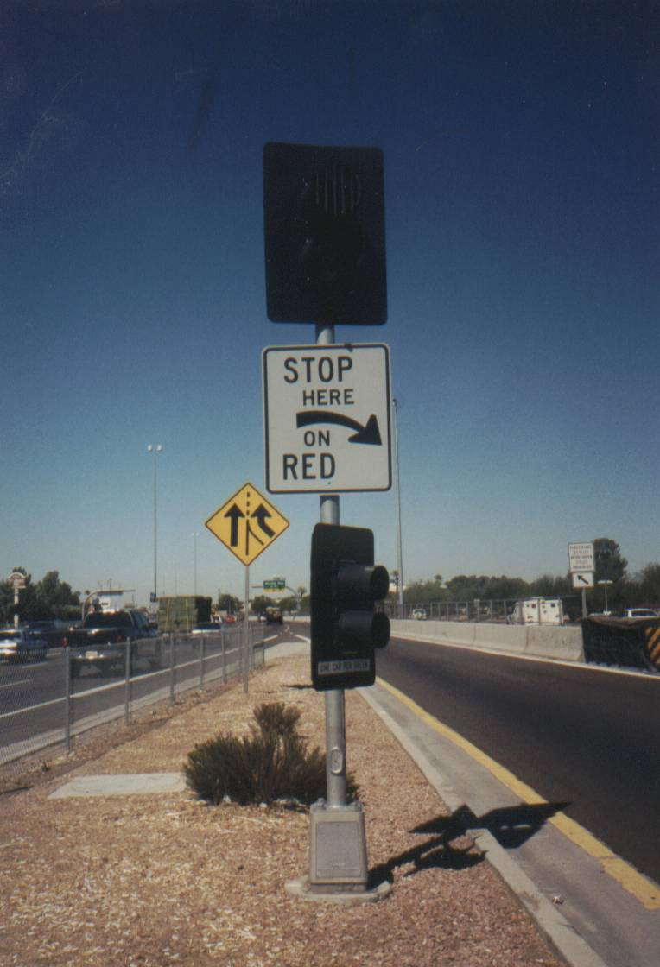
- For a single lane ramp meter, use a Type A pole (per ADOT Standard Drawings) on the left side of the ramp, aligned with the stop bar.

- For a dual lane metered ramp, use two Type A poles with one pole on each side of the ramp, aligned with the stop bar.

- Use a breakaway base on the Type A pole unless it is located behind barrier or outside the clear zone.

- Some sites may require special wall mounting details of ramp meter heads, due to space limitations for the installation of separate Type A poles.

- Type A poles are to be equipped with (See Exhibit 3.8):

  - Red & Green 12” LED Signal Head mounted at 10 foot elevation facing the ramp traffic 300 ft back from the stop bar.
  - A 2” Red LED enforcement indication mounted at 10 foot elevation, facing the downstream enforcement area.
  - A 30” x 36” “Stop Here on Red (RT) or (LT) R-10-6 Sign using black letters on a white background, mounted directly below 12” signal head.
  - Red & Green 8” LED Signal Head mounted at 4 foot 6” elevation, facing vehicles stopped at the stop bar.
  - A 2 5/8” by 18” sticky back “One Vehicle Per Green” sign with black text on a white background mounted on the signal backplate, below the green 8” head.
  - A backplate for each signal head.
  - A visor for each signal head. Use a tunnel visor with louvers when required to shield the view of the ramp meter heads from the freeway mainline.
- Mast arm poles may be used for two lane metered ramps, when needed due to site constraints that restrict the use of Type A poles.

- Mast arm poles should be located 40’ downstream of the stop bar.

- Mast arm poles must be located outside the clear zone or protected with barrier.

- Mast arm poles are to be equipped with:

  - Red & Green 12” LED Signal Heads for each lane.
  - The bottom of the lowest signal head or sign mounted on the mast arm must be a minimum of 17’ above the pavement surface.
  - A 2” Red LED enforcement indication mounted on the back of each head., facing the downstream enforcement area.
  - A 48” x 20” “1 Car Per Green Each Lane” Sign using black letters on a white background.
  - A backplate and visor for each signal head.
  - Use a tunnel visor with louvers when required to shield the view of the ramp meter heads from the freeway mainline.
- Use LED indications for all new ramp heads.

- Wire each lane’s head(s) with a separate five conductor #14 AWG cable from the head to the controller.

3.13.2 Beacons

Exhibit 3.9: Typical Flashing Beacon
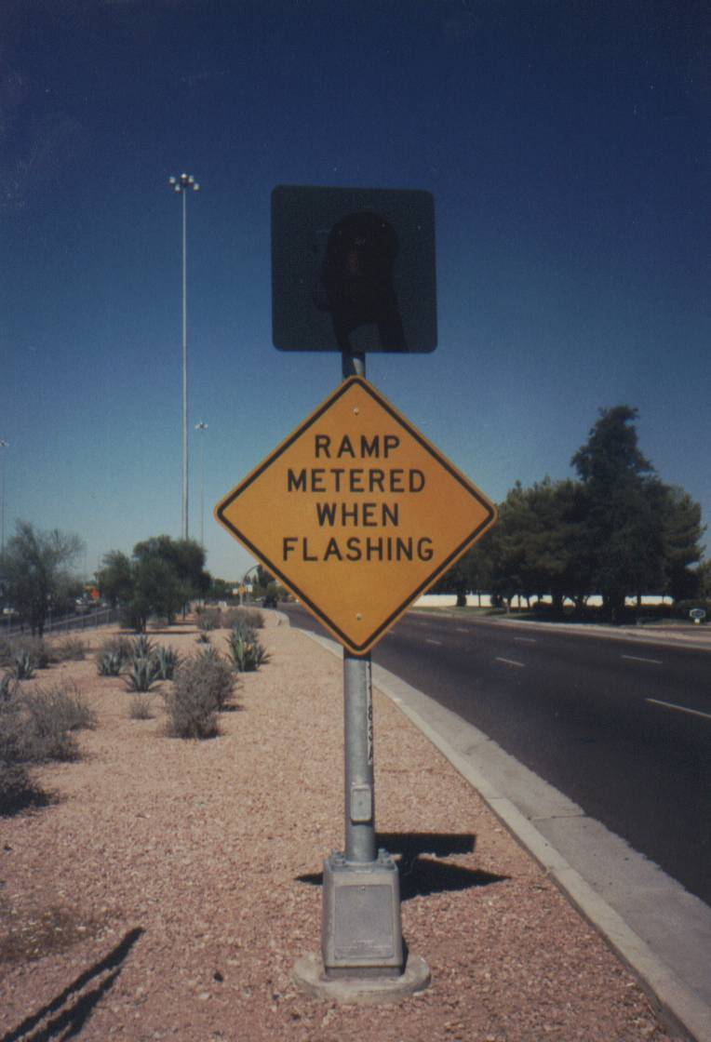
- ADOT’s current policy is to use a Type A pole on the left side of the ramp, aligned with the advance queue detector (AQD).

- For a dual lane ramp, use two Type A poles with one pole on each side of the ramp, aligned with the AQD detector.

- In special situations where stopping sight distance is limited, consider alternative placements of the beacon to enhance the safety of the ramp meter operation.

- In frontage road situations, it may not be feasible to place the right side beacon in a position in the optimum position.

- In frontage road situations, site-specific situations may require placement of the beacon in the gore area between the ramp and frontage road, placement of the beacon on a mast arm pole or omission of the beacon.

- MUTCD stopping sight distance criteria must be used in analyzing each situation.

- Use a breakaway base on the Type A pole unless it is located behind barrier or outside the clear zone.

- Some sites may require special wall mounting details of beacons due to space limitations for the installation of separate Type A poles.

- Type A poles are to be equipped with a flasher assembly (See Exhibit 3.10).

- Yellow 12” LED Signal Head mounted at 10 foot elevation facing traffic entering the ramp.

- A 36” x 36” “Ramp Metered When Flashing” W3-4 Sign using black letters on a yellow background, with a bottom elevation of 6’6”.

- A backplate and a visor for the flasher head.

- Use LED indications for all new flasher heads.

- Wire each lane’s flasher head with a separate five conductor #14 AWG cable from the head to the controller.

3.13.3 Mainline Detectors

This section provides guidelines on the deployment of mainline detection.

- The freeway mainline detection is for traffic responsive ramp meter operation and traffic monitoring purposes.

- Any detection technology that can provide accurate volume, occupancy and speed information is suitable as a mainline detection technology.

- Inductive loop detectors are the most common mainline detection technology.

- Non-intrusive passive acoustic detectors have been used on some of the more recent freeway management system installation and retrofit projects.

- Use of non-intrusive detection should be considered at sites where mainline lanes are being shifted from their original position or will be shifted in the foreseeable future.

- When feasible, use of preformed loops is preferred over the use saw cut loops.

- Place the mainline detection zones between 10 and 400 feet upstream of the nose of the gore.

- The position of the detection zone should be adjusted within the range to allow uniform spacing among detector stations.

- Typical mainline detector station is 1/3 mile.

- Never place mainline detector stations less than ¼ mile or greater than ½ mile apart.

- Avoid placing detector stations in lane taper or heavy merging and weaving areas.

- Do not place loops on bridge decks less than 2,000 feet in length. For bridge decks over 2,000 feet in length, detection may be provided as described in the FMS Design Guidelines.

- When installing loops avoid lateral pavement joints.

- Separate upstream and downstream loops by 18 feet leading edge to leading edge to form a speed trap of consistent length.

- When loops are used, use six by six foot squared loops.

- When lanes are 12 feet wide or wider, offset the loops by two feet from the center of the lane towards the shoulder for the outside lane.

- Center loops in any lane that is less than 12 feet wide or that is not adjacent to a shoulder.

- Use a separate lead-in cable for each loop.

- Identify each mainline loop as 1D, 1U, 2U, etc. Where 1 or 2 indicates the lane number counting from the right and U or D indicate upstream or downstream in the direction of traffic.

3.13.4 Ramp Detectors

The following detectors are to be provided on metered ramps. The detectors are listed in order as a vehicle would typically encounter them while traveling down the ramp:⁹

- Advance Queue Detector (AQD)
- HOV Interrupt (If installed)
- Demand (also known as input)
- Passage (also known as output)

3.13.4.1 Queue Detector

- This detector is also known as the Advance Queue Detector (AQD).

- The purpose of this detector is to cause the ramp meter to cycle at a faster rate when the queue is sufficiently long that a probability of queue spillback onto the surface street exists.

- For one lane ramps, a 6’ wide by 20’ long loop ramp is placed at the AQD distance. (See #8 below.)

- For newly metered two lane ramps a 6’ long by 20’ wide loop is placed across both lanes of the ramp at the AQD distance.

- When the width of the traveled way on a two lane metered ramp exceeds twenty-eight feet, the width of the AQD loop should be increased to 6 foot long by 24 foot wide, to reduce the possibility that queued vehicles will not stop on the detector.

- When retrofitting a one lane metered ramp with an HOV bypass lane, the existing 6 foot wide x 20 foot long loop in the metered lane should be supplemented with a 6 x 6 loop in the lane to be converted into a metered lane or a new 6 foot long x 20 foot wide loop may be cut.

- The AQD distance is measured from the trailing edge of the AQD loop to the edge of pavement of the cross street.

- The AQD distance is derived using a formula based on the design hour volume and distance X, which is the length of the ramp between the edge of pavement of the cross street and the stop bar.

- The following table provides the AQD calculation formula for a single lane ramp based on the design hour volume and computes AQD for a typical ramp with the distance X=900 feet between the ramp stop bar and cross road edge of pavement.

- Maximum AQD is 300 feet.

- An AQD calculation formula should be used for ramps that are less than 1,200 feet long. For ramps 1,200 feet or greater in length use AQD_{max}= 300 feet.

- AQD Calculation Formula
Design Hour Volume (DHV) | AQD Formula | Formula Result (based on X=900 ft) | Recommended AQD_{Typ} (based on X=900 ft)
DHV >1,080 | AQD=.39X | 351 | 300 feet
1080>DHV>900 | AQD=.34X | 306 | 300 feet
900>DHV>720 | AQD=.28X | 252 | 252 feet
DHV<720 | AQD=.25X | 225 | 225 feet

- For ramps with an X distance of less than 400 feet between the ramp stop bar and the edge of the crossroad pavement, an AQD_{min} = 100 feet may apply.

- A single lead in is provided from the AQD loop to the controller.

- When two AQD loops are installed in a retrofit installation, the loops should be connected in parallel to a single lead-in.

3.13.4.2 HOV Interrupt

- The purpose of this detector is to provide gaps in the metered traffic for vehicles bypassing the queue in the HOV bypass lane.

- This detector is only used when a ramp is equipped with an HOV lane.

- This detector should be disconnected when a metered One Lane + HOV Bypass ramp is converted to a two lane metered ramp.

- When the HOV bypass interrupt detector is required, install it in the HOV lane 350 feet upstream of the ramp stop bar.

- The HOV interrupt loop shall be a single six by six loop with a dedicated lead in cable to the controller.

3.13.4.3 Demand Detectors

- These detectors are also known as input detectors.

- The purpose of these detectors is to sense the presence of vehicle demand at the stop bar. This presence is used by the controller firmware to determine the signal operation.

- These detectors consist of two six by six foot loops centered in each metered lane.

- Place the leading edge of the loop nearest the stop bar 3 feet upstream of the stop bar.

- Separate the leading edges of the two loops in each lane by 16 feet.

- Connect the two demand detectors in a single lane in parallel and provide one detector lead-in cable for each lane’s demand detectors.

3.13.4.4 Passage Detector

- This detector is also known as the output detector.

- The purpose of this detector is to terminate the green interval after a vehicle clears the stop bar. Upon passage of a vehicle over this detector, a new metering cycle starts.

- The trailing edge of this detector should be located 6 feet downstream of the stop bar.

- Use a six by six loop for passage detection in each lane.

- For lanes 12 feet or wider, the detector may be centered in the lane.

- For narrow lanes, offset the detector away from the center of the ramp, so that the edge of each loop is 2 foot from the right or the left shoulder.

- Each passage detector needs a dedicated lead-in cable to the controller.

3.13.4.5 Off-Ramp Detectors

- This detector does not affect the operation of the ramp meter.

- The purpose of this detector is to provide traffic volume and occupancy data for the freeway management system. This information can then be used for long term planning purposes.

- Freeway to freeway connectors should be equipped with off-ramp detectors.

- This detector consists of one six by six loop per off ramp lane.

- This detector is installed downstream of the ramp gore and upstream of any area of the ramp that has been widened to accommodate turning movements or provide storage.

- Each off-ramp detector has a dedicated lead in cable to the closest controller cabinet.

3.13.5 Cabinet Assembly

This section provides guidelines and information about the ramp meter cabinet and controller assembly. The first set of guidelines focuses on the controller location requirements. The remainder of the guidelines deal with the cabinet equipment.

Exhibit 3.11: Typical 341 Cabinet Assembly
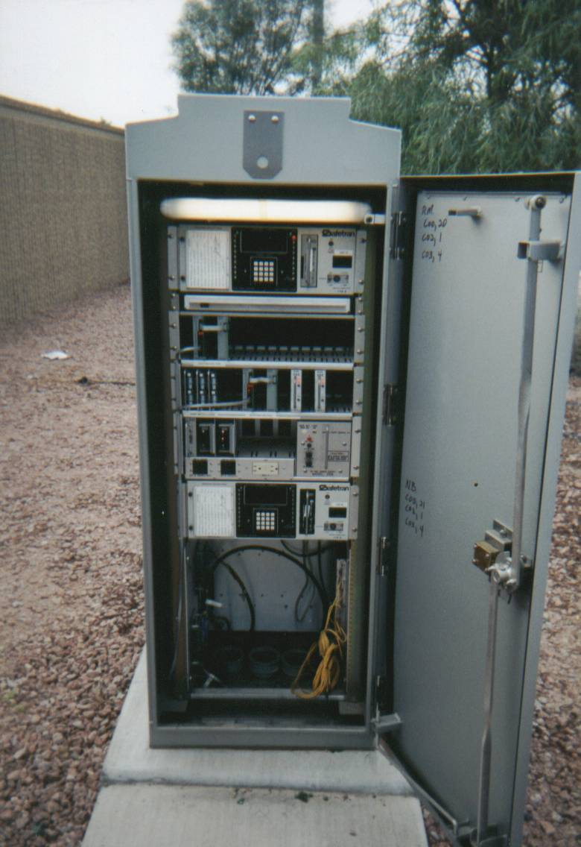
- The specific location of a ramp controller cabinet should be determined for each specific site.

- The preferred location of the controller cabinet is on the right side of the ramp.

- Safety should be a factor in placing the cabinet.

- The cabinet must be placed outside the clear zone, per AASHTO Guidelines. This is typically 30 feet from the edge of the mainline traveled way or 20 feet from the edge of the ramp traveled way.

- When clear zone requirements cannot be met, the cabinet must be protected by a barrier such as guardrail or concrete barrier.

- The cabinet location should provide a safe work environment for people servicing the cabinet.

- The cabinet must be placed at least 5 feet away from the barrier to allow for deflection of guardrail upon impact and room to work near the cabinet.

- A maintenance pad should be provided adjacent to the front and rear doors of the cabinet.

- The slope adjacent to the cabinet base should be 2:1 or flatter.

- The cabinet should be located a minimum of 20 feet upstream of the stop bar, so that the ramp signal heads are visible from the front door of the cabinet.

- The cabinet should be located no further than 540 feet from the furthest 6 x 6 loop and no further than 700 feet from the furthest 6 by 20 foot loop.

3.13.5.1 Foundation Details

Typical controller cabinet foundation details are shown in Exhibit 3.12.

Reinforcing steel in cabinet foundations does not serve a structural purpose and its omission on future ramp metering projects should be considered.

Model 179 Controller

The Model 179 controller unit is used for detector data processing and ramp metering by ADOT. The Model 179 controller is based on an MC6809 microprocessor. (See Exhibit 3.13) Controller memory resides on a separate PROM module card. The Model 179 is designed to operate in the hostile environmental conditions found in Arizona.

3.13.5.3 Ramp Control Firmware

Custom ramp control firmware that resides on a Model 412 PROM Module currently controls all ADOT ramp meters. The firmware was developed for ADOT by Bi Trans Systems. All firmware functions (except holiday scheduling) can be controlled using the 179 controller’s keyboard and convenient hexi-decimal memory map.

3.13.5.4 Non-Volatile Random Access Memory (NVRAM)

The 179 controller is equipped with NVRAM and battery backup to ensure that ramp timing parameters are not lost during a power outage. A battery back-up is also provided to allow the clock and downtime accumulator to continue to function for an extended period in the event of a power outage.
Exhibit 3.13: Model 179 Controller


3.13.5.6 Communications Port
The Model 179 is equipped with an internal slot for installation of a modem. Some of the controllers installed on FMS Phase I and Phase II used telephone modems located in this slot. For the newer phases of the FMS an RS-232 connection is made to the C2 connector to connect a separate fiber-optic data transceiver. Future ramp metering projects using fiber-optic communications may use fiber-optic data transceivers that mount internally in the modem slot of the 179 controller. These products have recently become available from fiber-optic equipment manufacturers and have been used in Texas.
The 179 hardware is capable of data transmission at rates from 300 bps to 19,200 bps. ADOT ramp meters using copper communications lines communicate at 1200 and 2400 bps. More recent installations using fiber-optic transceivers operate at a data rate of 9,600 bps.

3.13.5.7 Inputs and Outputs
The 179 controller uses a large square military style connector, known as the C1 connector to handle controller input and outputs. The hardware supports up to 44 inputs and 56 outputs. (See Exhibit 3.14)
Inputs are used to connect detectors and AC isolators that monitor the status of controller outputs, which control the beacon and the ramp meter indications. DC isolators can also be used in detector slots, to assert a constant call on a detector input. A position in the input file corresponds to each controller input. The controller cabinet is provided with two input files. The upper input file is known as the I File and the lower input file is known as the J File. Each controller input file features 14 slots that each have an upper and lower input. The table below shows the common inputs used in the ADOT ramp metering system. The controller also has inputs to monitor gate positions and special function outputs, which are not used in the current ADOT ramp metering system.
Modification of the input file to combine both Queue detectors into slot three should also be performed.
The controller outputs come from the C1 connector at a logic voltage level, which is not suitable for switching 120 VAC lamp loads. Model 200 load switches are used to convert logic level voltages into 120 VAC to power the beacon and a meter on sign, which is typically not used with ADOT ramp meters.

Exhibit 3.14: Input File Layout

Input File | Slot 1 | Slot 2 | Slot 3 | Slot 4 | Slot 5 | Slot 6 | Slot 7 | Slot 8 | Slot 9 | Slot 10 | Slot 11 | Slot 12 | Slot 13 | Slot 14
I | Lane 1 Upstream Detector | Lane 2 Up Detector | Lane 3 Upstream Detector | Lane 4 Upstream Detector | Lane 5 Upstream Detector | Lane 6 Upstream Detector | Left/Lane 7 Upstream/ Exit Detector | Right/Lane 8 Upstream/ Exit Detector | Not Used | Not Used | Not Used | Not Used | Not Used | Not Used
I | Lane 1 Down Stream Detector | Lane 2 Down Stream Detector | Lane 3 Down Stream Detector | Lane 4 Down Stream Detector | Lane 5 Downstream Detector | Lane 6 Downstream Detector | Left/Lane 7 Down Stream/ Exit Detector | Right/Lane 8 Down Stream/ Exit Detector | Not Used | Not Used | Not Used | Not Used | Not Used | Not Used
J | Left Lane Ramp Input Detector | Left Queue Detector | Right Ramp Output Detector | Not Used | Not Used | Not Used | Not Used | Not Used | Not Used | Left Lane Red Monitor | Right Lane Red Monitor | Beacon Monitor Input | Gate Up Monitor Input (Not Used) | Special Function Monitor Input (Not Used)
J | Left Lane Ramp Output Detector | Right Ramp Input Detector | Right Ramp Queue Detector | Not Used | Not Used | Not Used | Not Used | Not Used | Not Used | Left Lane Green Monitor | Right Lane Green Monitor | Sign Monitor (Not Used) | Gate Down Monitor Input (Not Used) | Special Function Monitor Input (Not Used)

Power Distribution Assembly

The power distribution assembly (PDA) #4 houses four switch packs. The switch packs are assigned to the following functions:
Description | Function
Switch Pack # 1 | Left Lane Red  Beacon  Left Lane Green
Switch Pack #2 | Right Lane Red  Right Lane Green
Switch Pack # 3 | Gate & Sign Control Functions  (Not used in Arizona)
Switch Pack # 4 | Special Function Outputs (Not Used in Arizona)

The power distribution assembly is also equipped with a set of circuit breakers to protect circuits controlling:
- Controller Equipment
- Ramp Indications
- Ground Fault Circuit Interrupter Protected Convenience Outlets
- CCTV Equipment
A Model 204 solid state flasher is provided to flash the beacon. In addition, a flash transfer relay and Model 208 conflict monitor are provided. The model 34X cabinets are also equipped with a slide-out drawer to store documents and hold a notebook computer while working on the cabinet.

3.14 Ramp Meter Pavement Marking

- Use spayed alkylid thermoplastic 0.060” thick for ramp meter striping.

- Use alkylid thermoplastic 0.090” thick for the stop bar.

- The stop bar should be 18” wide and run from edge line to edge line.

- The right edge line of the ramp should be a 6” wide solid white line.

- When the right edge of the ramp is in a frontage road gore area, a 12” white right edge line should be used.

- The center line of a two lane metered ramp should be a 6” wide white solid line in areas where lane changing is to be discouraged, typically within 250 feet upstream of the stop bar. The remainder of center line to the cross street should be a 6” white broken lane line.

- The center line for a ramp with an HOV bypass lane should be a 6” wide white solid line in areas where lane changing is to be discouraged, typically a minimum of 250 feet upstream of the stop bar. This white solid line may be extended further upstream, based on the geometry of the on-ramp near the cross street. The remainder of center line to the cross street should be a 6” white broken lane line.

- The center line of the ramp should end at the ramp meter stop bar.

- The left edge line of the ramp should be a 6” solid yellow line from the cross street to the ramp meter stop bar.

- The left edge of the ramp between the ramp meter stop bar and the freeway gore should be a 12” solid white gore line.

- Striping should not be located in gutters. If geometric constraints require striping to be placed in gutter, this should be reviewed on a case-by-case basis with ADOT Traffic Engineering.

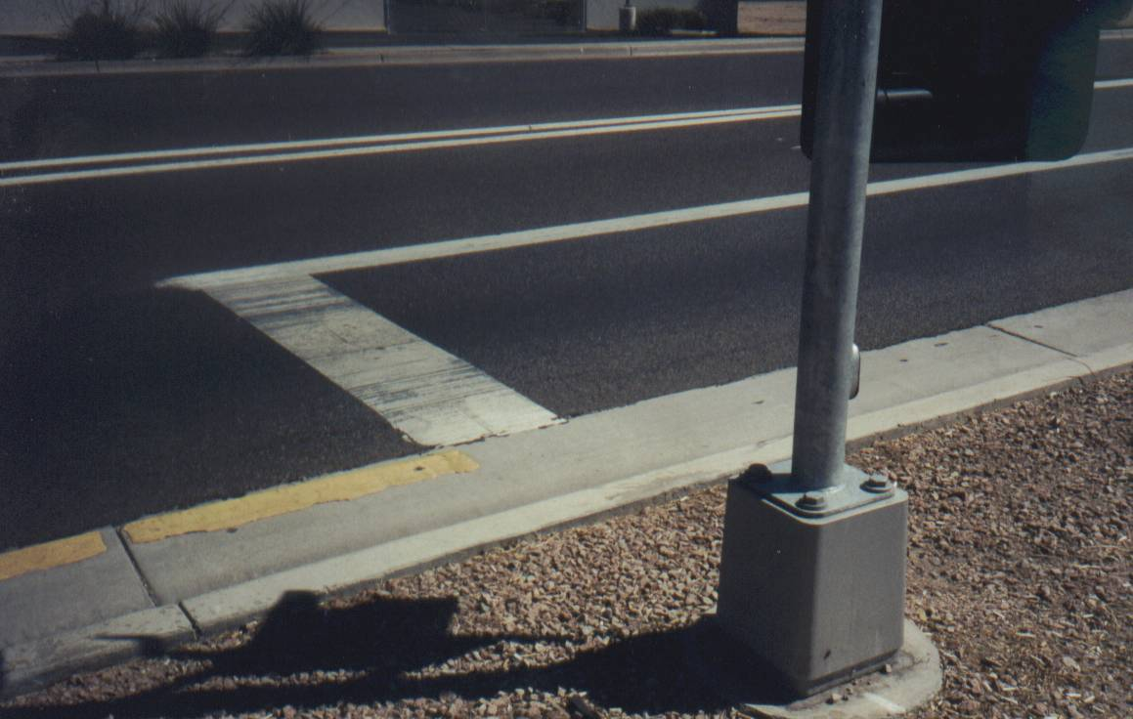

Exhibit 3.15: Ramp Meter Stop Bar Pavement Markings (HOV Bypass)

3.15 Ramp Meter Signing
Exhibit 3.16: Typical Ramp Meter Sign
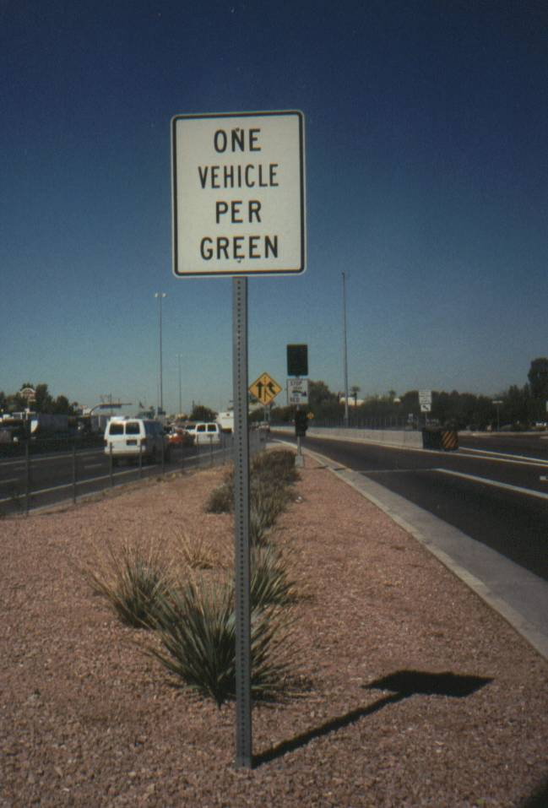
This section describes ramp meter signing design guidelines. A typical ramp meter sign is shown in Exhibit 3.16.

- Ramp meter signing includes the following signs:

  - Ramp Metered When Flashing (W3-4)
  - One Vehicle per Green (R10-13)
  - One Car per Green Each Lane (R89-1)
  - Stop Here on Red (R10-6a)
  - Right Lane Ends (W4-2R)
  - Merging Traffic (W4-1)
  - All Vehicles Stop On Red (use for newly metered ramp lanes)
- All ramp meter signs should be installed in accordance with the MUTCD. In some retrofit situations, geometric constraints may not allow this. Any deviation from the MUTCD must be reviewed by ADOT Traffic Engineering on a case-by-case basis.

- Ramp meter signing should be coordinated with the ramp guide signs and appropriate regulatory signs (e.g. Do Not Enter or Wrong Way)

- When an HOV bypass is installed appropriate HOV Lane signage must be installed:

  - Carpools Buses & Motorcycles Only (R-91)
  - Right Lane Do Not Stop (R-88) signs should be placed in the non-metered lane upstream of the meter.
  - Advance HOV signs should be installed on local streets when they are striped for mandatory turns into HOV facilities.

Typical Conduit and Junction Box Layout

Exhibit 3.17 illustrates the typical location of junction boxes and routing of conduit for a ramp meter site.

4. Ramp Meter Operation

The operation of the ADOT ramp meters, which are located in the Phoenix area, is the responsibility of the Traffic Operations Center (TOC).

4.1 Ramp Meter Stand-Alone Local Operation

The following is an overview of the stand-alone local operation of an ADOT ramp meter site when metering is active.

- If the ramp meter signals are not operating, then they go through “startup” procedures to begin operation. On a single lane ramp, startup consists of the meter going from a darkened state to a green signal. For startup on dual lane ramps, the left meter gives a green signal, while the right meter remains dark. Once the left meter gives a red signal, the right meter gives a green signal.

- Once the ramp meter signals are in operation, if there are no vehicles activating the demand loops, the signal heads give a red signal until the maximum red time is reached.

- When a vehicle approaches the on-ramp stop bar and passes over the demand loop detector, a green signal is displayed.

- The vehicle then crosses the ramp meter stop bar and travels over the passage detector as it continues down the ramp toward the mainline.

- As the vehicle passes over the passage detector, the display turns red, and the cycle timer is reset. If the maximum green time elapses prior to the vehicle passing over the passage detector, then the signal will go red, and the cycle timer is reset.

- The signal remains red until another call is placed by the demand detector, or until the maximum red time is reached, at which point the signal displays a green.

The minimum times for green and red signal indications is user-preselectable, and are typically set at 1.5 seconds red and 1.5 seconds green. The actual meter rates are ideally determined based on right lane mainline volumes, as discussed later in this chapter.

If the controller recognizes a failure of the demand or passage loops, then it switches the signal operation into cycled timing.

4.2 Ramp Meters as an Element of the Freeway Management System

The following section describes how ramp meters interrelate with the freeway management system.

- Ramp meters in freeway management system-equipped areas are an element of the ADOT freeway management system.

- In areas where the freeway management system is not yet deployed, ramp meters may be used as a stand-alone congestion mitigation strategy.

- The ramp metering subsystem of the ADOT FMS supports some commands to alter the ramp meter rate from the TOC.

4.3 Communications with ADOT Traffic Operations Center

This section provides a brief overview of how ramp meters communicate with the ADOT TOC.

- Controllers are polled for ramp meter information every 60 seconds by the ADOT FMS. The meters return status information in response to each poll. Detector information is separately polled in 20-second poling cycles.

- Ramp meter timing parameters may be downloaded to each 179 controller from the TOC.

- Most ramp meter timing parameters can be uploaded from each 179 controller to check what timing parameters are currently in the 179 controller’s local database.

- Ramp meters are connected to the node buildings over twisted-pair or fiber-optic cables. In the node building, the ramp meter data is combined with other data and then sent to the TOC over single-mode fiber-optic cable.

- Multiple 179 controllers are multi-dropped on to the same low-speed 1,200; 2,400; or 9,600 bps data circuit.

- Up to 8 controllers may share a 1,200 or 2,400 bps copper pair data circuit.

- Up to 30 controllers may share a 9,600 bps fiber-optic data circuit.

- Low-speed data from ramp meters is concentrated in node buildings at various field locations, using Sun node processors.

- SUN node processors communicate with the TOC using a Fiberlign DS-0, 10-Base-T Ethernet, and SONET OC-12. These processors are used regardless of whether twisted-pair or fiber-optic cable is used to communicate between the devices and the node buildings.

4.3.1 Ramp Meter Message Formats

Four message formats are used to control and monitor the ramp meter and set and modify its operating parameters. These formats are used to communicate from the FMS to the ramp meter field controllers. These formats are:

- Format 1 Command
- Format 1 Feedback
- Format 2 Command
- Format 2 Feedback

These four message formats work as follows:

- Format 1 Command is used to poll the ramp meter during normal operations at regular intervals.

- When the ramp controller receives the Format 1 Command, it responds with Format 1 Feedback, which includes:
  - Number of violations by lane
  - Meter status
- Format 2 Command is used to read the ramp meter's operating parameters.

- Format 2 Feedback is used by the Controller to send the ramp meter's operating parameters.

- Format 2 Command and Format 2 Feedback are sent on an "as-needed" basis whenever the ramp meter configuration parameters are to be read or modified. At such times, the Format 2 commands are sent in addition to, not in place of, the Format 1 commands.

4.4 Integration with ADOT Traffic Operations Center

The FMS database in the TOC should be updated each time a new ramp is to be connected to the freeway management system.

- To define a ramp meter in the TOC databases the following information must be known:
  - Physical location (route, direction & cross street)
  - Coordinates (latitude & longitude) of cabinet
  - Node Processor Number Assigned
  - Communications Circuit # Assigned Primary & Secondary
  - Drop # programmed into the controller memory
  - Data rate for the assigned channel
  - Detector mapping to physical locations on the roadway
  - Adjacent link lengths to upstream and downstream detector/ramp meter stations
- Although a secondary communication circuit is used in the FMS database, the use of secondary communications circuits 01 and 02 has been discontinued in current deployments of the FMS due to the high level of reliability of the fiber-optic communications.

- This information must be programmed into the device database for the FMS to recognize the new equipment.

- In some cases, ramp metering is further integrated into the TOC to operate ramp meters not individually but as a group. The purpose of operating ramp meters as a group is to reduce traffic flow to downstream bottlenecks, which may be permanent (e.g. a lane drop) or temporary (an incident).

- The exact format and architecture of the FMS database is documented in the Freeway Management System Database Table Reference Manual, available from the TOC.

4.5 Ramp Metering Rate Selection

4.5.1 Arrival Discharge Chart

Ramp metering rates can be selected at an individual ramp using a simple Arrival and Discharge Chart. Exhibit 4.1 shows an arrival discharge calculation worksheet template, and Exhibit 4.2 is a sample of a completed worksheet. The chart uses arrival and discharge rates in vehicles per hour for each six minute or 1/10 hour time interval. The area of each square in the plot represents 10 vehicles.

The instructions for using the chart are as follows:

- Plot arrival rates for each six minute time period in bar graph style for the duration of the study period. The arrival times should be obtained from traffic counts. The study period should be selected to coincide with the relevant peak demand.

- On the same chart plot the discharge rate in the same fashion.

- Beginning with time zero, move to a point where the arrival rate exceeds the discharge rate. This is the starting point where delay begins. Vehicles arriving before the starting point experience no delay because there is no existing queue and the discharge rate is greater than the arrival rate.

- For each time interval of the chart to the right of the starting point where the queue begins, calculate the area under the arrival rate curve by reading the number from the right axis and record on Line A.

- Repeat for Discharge Rate and Enter on Line B.

- Calculate Delta for Each Time Interval. This is the cumulative difference of the areas under lines A and B.

- Delta continues to increase as long as the arrival rate exceeds the discharge rate. At the point where the discharge rate exceeds the arrival rate, delta begins to decrease representing dissipation of the queue and there is no further delay.

- Determine the Maximum Delta and the Sum of the Deltas. Use the information to compute the following:
  - Maximum Queue, vehicles (Maximum delta * area of each square)
  - Maximum Queue Length, feet (Maximum queue * headway)
  - Total Delay, vehicle-hours (Sum of the Deltas)
  - Total Vehicles Delayed, vehicles (Discharge rate * time)
  - Average Delay (Total delay/total vehicles)
- The number of vehicles in the queue at the end of any six minute period is equal to the number of arrivals minus the total number discharged up to that period.

- The maximum queue occurs at the end of the six-minute time period, which has the greatest difference between the arrival and discharge rates.

4.5.2 Computer Simulation

The use of a model is recommended to develop corridor specific ramp meter timing plans when a corridor is to be newly metered. (For example, parts of Loop 101.)

In practice, these calculations are best performed with a computer simulation model. FREQ12 is a frequently used model for the optimization of ramp meter rates. FREQ12 can also be used to simulate various ramp metering scenarios for comparison in terms of user selected measures of effectiveness such as vehicle or person hours of delay.

The FREQ is a Windows-based program with an interactive graphical user interface. To simplify operation, the model includes comprehensive input checking, carefully selected default values, on-screen graphic representation of the simulation results, and user-selected output options including traffic performance contour maps. The two models contained within the FREQ12 system are: FREQ12PE, an entry control macroscopic model for analyzing ramp metering; and FREQ12PL, an on freeway priority macroscopic model for analyzing HOV facilities. The FREQ system of models has received extensive testing over many years and has been applied to freeway corridors in numerous urban areas throughout the United States and abroad.

CORSIM is another computer simulation tool that can be utilized. CORSIM is a microscopic model well-suited for predicting queue lengths and other operational measures of effectiveness.

4.6 Ramp Metering Modes

ADOT ramp meters can run in the following modes:

Mode | Description
1. Manual | The user specifies the current operation of the meter from the front panel of the controller
2. Central Override Mode | Communication with the FMS central must be present for this mode to function. The FMS specifies whether the meter should run with rate 0 to 7.
3. Locally Traffic Responsive | The metering rate is selected by monitoring the volume and/or speed of traffic flow in the mainline lanes adjacent to the ramp meter. The meter selects a range of operating rates permitted by the user.
4. Time of Day/Day of Week | The times and days when the meter will operate are constrained by the user. The meter can be set to operate either at one of the rates permitted by the user or in locally traffic responsive mode.
5. Fixed Time | The meter operates at a set rate at the times specified by the user and the days specified by the user.

ADOT operates the majority of ramp meters under Time of Day mode. These ramp meters operate during set time periods during morning and/or afternoon peak time periods. Of these ramps, some operate with a fixed cycle rates, while others are locally traffic responsive.

4.7 Ramp Metering Rates

Standard ramp meter practice is that the metering rate is determined by the expected mainline volume and by a decision on how much volume can be allowed in on the particular ramp. Metering rates can be determined by analyzing historical volume data for the location. More responsive metering rates can be established by use of information from upstream and/or downstream detectors in the mainline, so that ramp metering rates are computed in real time to respond to current demand levels and mainline conditions.

Caltrans research suggests the effective operating rate for a ramp meter ranges between 240 and 900 vehicles per hour per lane. Nine hundred vehicles per hour in a single lane equates to four-second ramp meter cycles. In Arizona, three second ramp meter cycles are used to achieve 1,200 vehicle per hour metering rates.

At the other end of the ramp metering rate spectrum, 240 vehicles per hour equates to a ramp meter cycle of 15 seconds. These cycles typically consist of two seconds of green and thirteen seconds of red. Longer cycles tend to lead to high violation rates, poor public perception and demonstrate a reduced ability to control traffic.

ADOT ramp control firmware supports eight different ramp metering rates. Rate 0 specifies that the meter is to be off. Rate 7 specifies that the meter is to display a constant green indication. A constant green indication is not normally used in Arizona. Rates 1 through 6 can be user-specified to provide ramp metering with cycles in the range of 3 seconds to 255 seconds. Cycle lengths longer than 15 seconds are not recommended.

Queue override ramp metering changes the rate plan selected based on the presence of vehicles on a Queue Detector. The purpose of this feature is to meter at a faster rate until the queue dissipates.

- Until a central ramp control strategy can be implemented, operation of the meters in a locally traffic responsive mode using a fixed time of day schedule is recommended.

- The parameter recommended for selecting the rate plan should be right lane mainline detector volume.

- Begin metering at rate plan #1 (least restrictive) when the right lane volume reaches 1,800 vph.

- Gradually increase to rate plan #6 (most restrictive) as the right lane volume builds to 2,200 vph.

- If right lane volume is not available, move one lane over to the left and use that lane’s detector information until detector data becomes available.

4.7.1 Ramp Meter as a Stand-Alone Strategy

Ramp metering is typically implemented along a stretch of freeway at multiple adjacent on-ramps. However, in addition to improving flow along a stretch of freeway, ramp metering can also be introduced at individual locations in order to improve flow condition at that specific location alone.

Ramp meters can be effective in breaking up platoons to ease merging in areas where other FMS features are not yet present.

Stand-alone ramp meters can also mitigate localized bottleneck locations.

4.7.2 Default Metering Rates

The Department has selected a metering plan to achieve systemwide uniformity in ramp meter operation. The plans are primarily designed to provide platoon dispersion and slightly spread the peak. The uniform plans are not intended to create delay of sufficient length to divert trips from the freeway to surface streets. The standard hours for ramp meter operations are:

Period | Time
AM Peak | 6:00 – 9:00 AM
PM Peak | 3:00 – 7:00 PM

The parameters used in the plan are as follows:

Parameter | Standard Setting
Minimum Green | 1.5 seconds
Maximum Green | 1.5 seconds
Minimum Red | 1.5 seconds
Maximum Red | 10.0 seconds

Six uniform metering rates are used:

Metering Level | Rate (veh/minute) | Rate (veh/hour) | Cycle Length (seconds)
1 | 20 | 1,200 | 3
2 | 18 | 1,080 | 3.33
3 | 16 | 960 | 3.75
4 | 14 | 840 | 4.29
5 | 12 | 720 | 5
6 | 10 | 600 | 6

The appropriate metering rate is selected based on the volume of the right lane of the mainline, as described in the previous section.

To reduce the probability of rear-end collisions, a soft-start of the ramp metering sequence is recommended. The soft-start sequence for a two lane ramp meter is typically as follows:

- Activate the Flashing Beacon
- Wait 10 seconds
- Display a green ball in the primary lane while second lane signal remains dark.
- Begin normal metering operation

4.7.3 Recommended Speeds

The goal of ramp metering is to operate freeways at their highest level of efficiency. Ramp meters have been shown to increase throughput on congested sections of freeway up to 3%. Based on the Highway Capacity Manual, the highest throughputs on freeways are achieved at speeds between 50 and 53 mph. As a result, the goal of a ramp metering system is to keep freeway traffic moving at speeds of 50 to 53 mph.

4.7.4 Impact of Incidents

For the purposes of ramp metering, incidents can be viewed as the temporary introduction of a bottleneck located downstream of one or more ramps. By using detection downstream of the incident location, the actual capacity of the bottleneck can be measured in vph. The goal of ramp metering is to reduce the rate of vehicles entering the freeway, without spilling back into the surface streets.

The first step in doing this is to define the freeway segment in which ramp meters will need to be adjusted or activated. This is typically all ramp meters upstream of the incident until an unmetered freeway-to-freeway connector or ramp is encountered.

Either a model or a simple arrival discharge worksheet can be used to compute suitable metering rates. The most common result of the calculation, if the capacity reduction is significant, is that all of the ramp meters on the segment should be operated at the most restrictive rate permitted by the agency’s metering policy (e.g. 240 vph or until the queue spills back onto the queue detector or the metering rate has been reduced to 80% of the original ramp volume).

Depending on the upstream capacity reduction, ramp metering rates downstream of the incident can often be increased or the meters can be temporarily deactivated.

4.8 Ramp Meter Equity

Research to answer the basic question of which members of the community benefit from ramp metering has sometimes been termed ramp meter equity in recent literature. In general, ramp metering benefits drivers making longer trips at the expense of drivers making shorter trips. This general observation is consistent with the basic purpose of the freeway system: Making long trips at relatively high speed.

When HOV facilities are provided, HOVs normally benefit at the expense of single-occupant vehicles. This is consistent with the goal of maximum movement of people rather than vehicles.

All motorists seem to benefit from ramp metering by making travel times more predictable. Individuals and businesses located near metered ramps may, however, suffer from the metering program due to increased congestion on surface streets near the ramps. Pollutant emissions at these points may also be greater than they were before the ramp metering program was implemented.

A ramp meter equity policy should allow the benefits and drawbacks of ramp meters to be distributed fairly. This is normally done by limiting ramp waits to a few minutes and ensuring that adequate storage for queues is provided.

ADOT currently does not have a specific ramp meter equity policy in place.

4.9 Enforcement of Ramp Meters

Attributes of effective ramp meter enforcement programs in other jurisdictions are described below. Frequent coordination between the Department of Transportation and the Department of Public Safety (DPS) is essential to effective ramp meter enforcement.

- To achieve compliance with ramp meter indications, continuous and selective enforcement of the ramp meters is required.

- Enforcement of ramp meters with HOV bypass facilities should be a priority.

- A public awareness campaign, specifying the consequences of violating a meter should be part of the enforcement campaign to encourage voluntary compliance.

- Signs indicating the maximum fine amount for a violation are used in California to encourage compliance.

- Automated enforcement is used in Arizona for red traffic light violations. The technology is suitable for ramp meter enforcement. Public acceptance of the technology for ramp meter enforcement may be more difficult to achieve because the safety arguments in favor of deploying the technology are less compelling in the ramp meter enforcement application than in the traffic signal enforcement application.

5. Ramp Meter Maintenance

5.1 Personnel

Currently, ADOT uses agency personnel trained in ramp meter maintenance. A two-person crew should be able to provide preventative maintenance for up to 50 ramp meters. Additional staff may be needed for unscheduled maintenance. The qualifications of these personnel include coursework and military experience in electronics. Journeyman electrician licensing is a helpful qualification. Trained electricians have the basic skills required for ramp meter maintenance. Ramp meter maintenance personnel should also possess at least a Class B commercial drivers license to allow operation of bucket trucks and line trucks, if heavy maintenance such as pole replacement will be performed.

Personnel responsible for ramp meter timing adjustments should be professional engineers, engineers-in-training or traffic engineering technicians, who have been trained in basic highway capacity and freeway operations principles.

Contracted personnel may also be used to perform all maintenance functions or selected maintenance functions. Although ADOT currently does not contract its ramp meter maintenance functions to the private sector, many local agencies do contract with private firms that provide traffic signal maintenance services. These firms possess the basic skills to maintain ramp meters, as well. Contracted personnel can be effectively used to overcome deferred maintenance backlogs or perform special functions such as detector replacement.

5.2 Training

Personnel performing ramp meter maintenance should be trained in the following areas:

- Work Zone Safety
- Electrical Safety
- Safe work practices/OSHA regulations
- ADOT Policies and Procedures
- Basic Electronics
- Basic Traffic Engineering Principles
- ADOT Ramp Control Firmware Operation
- Ramp Control Cabinet Hardware

Most employees involved in ramp meter maintenance bring knowledge of electronics to the job. This knowledge is often derived from military training or a community college electronics technology program.

Effective training in traffic engineering principles is needed for individuals who do not have formal schooling in this area. The International Municipal Signal Association (IMSA) offers certification classes in closely related fields including:

- Work Zone Safety
- Signing & Striping I & II
- Traffic Signals I, II and III

A Traffic Engineering Technician course is also available through Northwestern University, for individuals desiring a more in-depth understanding of traffic engineering principles.

Training on ADOT’s specific control equipment is also provided by FMS contractors installing each new Phase of the FMS. These sessions provide introductions to the 179 controller hardware, fiber-optic communications, and other FMS equipment. The ADOT ramp control firmware must be learned through on-the-job training.

5.3 Commonly Reported Malfunctions

Historically, the three most commonly reported malfunctions in ADOT’s ramp meters are as follows:

- Non-functional detectors.
- Non-functional load switches.
- Two simultaneous green signal indications for adjacent metered lanes.

5.4 Preventative Maintenance

ADOT has established Routine Signal Maintenance and Inspection performance guidelines that document the preventative maintenance (PM) that should be performed for each ramp meter site.¹² This document lists the following PM tasks that should be performed every three months:

At controller:

- Check timing of all controllers as per timing card.
- Clean all fixed components and wiring harnesses.
- Tighten and secure all mounting hardware and terminal connection screws.
- Check ventilating fans and thermostats. Install new dust filters.
- Lubricate locks, ventilating fan motors and graphite the cabinet locks.
- Check voltage and current for abnormal readings.
- Recaulk controller cabinet if necessary.
- Remove graffiti from cabinet.

In the field:

- Check alignment and operation of signal heads. Assure proper orientation of optically programmed and louvered signal heads.
- Assure that all poles have handhole covers.
- Check condition of all pull boxes and covers.
- Check condition and operation of all detectors.
- Replace inoperative lamps.
- Make minor repairs to loops.
- Check for missing pole number stickers and replace if necessary.

In addition, the following PM activities should be performed:

- Check communications system (Verify send and receive of local modem.)
- Check controller clock.
- Verify timing parameters.
- Log service activities performed.

For annual maintenance, the following PM activities should be performed:

- All incandescent ramp meter bulbs should be replaced during an annual maintenance visit.
- When Light Emitting Diode (LED) signal indications are used, the relamping frequency is typically three to seven years.
- Signs and signal heads and beacon lenses should also be washed during the annual maintenance visit, if needed.

5.5 Unscheduled Maintenance

This task involves responding to malfunctioning ramp meters upon request. An individual should be on call-back duty at all times to respond to unscheduled maintenance requests. If the individual is unable to rectify the problem during an after hours site visit, the ramp meter may be deactivated and repaired during normal working hours.

5.6 Detection Maintenance

Detection maintenance is often deferred due to the difficulty in maintaining loop detectors under live traffic. A list of non-functioning detectors should be kept current at all times, so that detection maintenance crews can take advantage of other closures in the area to perform detection repair or replacement. To avoid indefinite deferral of detection maintenance, detection maintenance should be scheduled for each freeway segment at least once every one to two years. Because of the specialized equipment involved many agencies will contract this service to a specialist firm.

5.7 Maintenance Documentation

A basic cabinet log should be maintained. The cabinet log should include:

- The date and time of the visit.
- The purpose of the visit (e.g. PM, report of red lamp out, etc.).
- The action taken.
- The name of the responsible employee.

Identical information should be kept in the maintenance worker’s truck for regular management reporting. In addition, the maintenance worker must keep a record of supplies and materials used.

5.8 Maintenance Evaluation

The reports obtained from individual maintenance workers should be compiled into management reports by a maintenance supervisor. The management reports can then be used to assess the effectiveness of the current maintenance program and to determine if any changes in the current maintenance program are required. Information contained in management reports should include:

- Number & type of services performed
- Labor hours expended by classification for regular and overtime
- Materials used versus budgeted materials for the month and fiscal year to date
- Ongoing listing of deferred maintenance needs and aging report for deferred maintenance items.
- Other data needed to track whether the organization is meeting its goals (e.g. mean time between failure & mean time to repair.

Acronyms

AASHTO: American Association of Highway Transportation Officials
AC: Alternating Current
ADOT: Arizona Department of Transportation
AQD: Advance Queue Detector
ATMS: Advanced Traffic Management Systems
AWG: American Wire Gauge
BPS: Bits Per Second
DC: Direct Current
DHV: Design Hour Volume
DPS: Department of Public Safety
EIA-232: Electronic Industries Alliance Standard for Serial Communication
FMS: Freeway Management System
FREQ: Family of Computer Simulation Models for Traffic Operations
GFCI: Ground Fault Circuit Interrupter
HCM: Highway Capacity Manual
HOV: High Occupancy Vehicle
IMSA: International Municipal Signal Association
K: Kilo
L_{a}: Acceleration Length
L_{g}: Gap Acceptance Length
LED: Light Emitting Diode
LOS: Level of Service
MPH: Miles per Hour
MUTCD: Manual on Uniform Traffic Control Devices
NVRAM: Non-Volatile Random Access Memory
OSHA: Occupational Health and Safety Administration
PDA: Power Distribution Assembly
PHV: Peak Hour Volume
PROM: Programmable Read Only Memory
RV: Ramp Volume
RS-232: Electronic Industries Alliance Standard for Serial Communication
SOV: Single-occupant Vehicle
SS-50: Standard for Industrial Data Bus
TOC: Traffic Operations Center
TSM: Transportation System Management
VAC: Volts Alternating Current
VPH: Vehicles per Hour

Glossary

Acceleration Length: A distance along the ramp that allows for safe acceleration of vehicles to merge with mainline traffic.

Advance Queue Detector: An inductive loop located along the ramp near the surface street used to monitor whether the queue has reached a certain length.

Clear Zone: An unobstructed area provided beyond the edge of traveled way for the recovery of errant vehicles, including shoulders.

Demand Detector: An inductive loop used to monitor if a vehicle is immediately upstream of the ramp meter stop bar.

Enforcement Area: A paved area adjacent to the traveled way downstream of a ramp meter stop bar, used law enforcement vehicles.

Flashing Beacon: An advance warning device used to alert motorists to the presence of the ramp meter.

Gap Acceptance Length: A section of the ramp that provides sufficient time and distance to allow safe performance of a desired merging maneuver. Measured as the distance from nose of the ramp to the point of convergence.

High Occupancy Vehicle (HOV): Vehicles that carry two or more people.

Hourly Volume: The number of vehicles passing a given point along the roadway during one hour.

HOV Bypass: Lanes or other facilities that allow HOV vehicles to pass by a ramp meter without having to stop at the signal.

HOV Interrupt Detector: An inductive loop located in an HOV lane used to provide gaps for HOV vehicles.

Level of Service (LOS): A qualitative rating of the effectiveness of a highway in serving traffic, measured in terms of operating conditions. The Highway Capacity Manual identifies operating conditions ranging from "A" for free flow operations to "F" for forced or breakdown flow.

Modal Shift: A change in travel demand characterized by use of alternate modes such as transit, HOV, ridesharing, bicycles, etc.

Model 179 Controller: A microprocessor unit located in a field cabinet used to control the ramp metering operation.

Nose of Ramp: A point along the ramp having some dimensional width that separates the ramp from the mainline.

Passage Detector: An inductive loop used to monitor if a vehicle is immediately downstream of the ramp meter stop bar.

Point of Convergence: The point along a ramp lane where width of the ramp lane decreases to below the standard lane width and the ramp merges with mainline.

Queue Storage Length: The length along the ramp that is capable of holding a queue of vehicles approaching the ramp meter without spilling over to the surface street.

Ramp Meter: Traffic control signals that control the flow of traffic entering a freeway facility.

Spatial Shift: A change in travel demand characterized by the use of alternate routes.

Temporal Shift: A change in travel demand relative to time.

Traveled Way: The portion of the roadway for the movement of vehicles, exclusive of shoulders, frequently defined by striping.

References

- American Association of State Highway and Transportation Officials, A Policy on Geometric Design of Highways and Streets, Fourth Edition, Chapter 10, page 827- 869, 2001.

- Arizona Department of Transportation, Intermodal Transportation Division, Plan and Profile of Proposed State Highway Phoenix District (I-10, I-17, SR-51, US-60) CM-900-0(196)P, 999 MA 000, Phoenix Area Ramp Meters, March 31, 1999.

- Arizona Department of Transportation, Intermodal Transportation Division, Plan and Profile of Proposed State Highway Phoenix District (I-10, I-17) CM-900-A(31), 999 MA 000, Ramp Metering Conversion Preliminary 95% Review, 2002.

- Caltrans Traffic Operations Program, Department of Transportation, Business, Transportation and Housing Agency, Ramp Meter Design Guidelines, January 2000.

- Caltrans Traffic Operations Program, Department of Transportation, Business, Transportation and Housing Agency, Ramp Meter Design Guidelines, August 1995.

- Cambridge Systematics, et al, Executive Summary, Twin Cities Ramp Meter Evaluation, February 1, 2001.

- Federal Highway Administration, Millennium Edition, Manual on Uniform Traffic Control Devices, 2001.

- Kimley-Horn & Associates, Background Technical Memorandum Ramp Metering FAST, prepared for Nevada Department of Transportation, February 22, 1999.

- Kimley-Horn & Associates, Arizona Department of Transportation, Freeway Management System Design Guidelines, September 2002.

- JHK & Associates, Utah Department of Transportation, Ramp Meter Design Statewide Design Guidelines, February 1997.

- Transportation Research Board, National Research Council, Highway Capacity Manual, Chapter 13 and 25, 2000.

- Arizona Department of Transportation, Intermodal Transportation Division – Highway Maintenance, Performance Guideline; Routine Signal and Lighting Maintenance and Inspection Form, 2002.

- Arizona Department of Transportation, Roadway Engineering Group, Memorandum – Design of Urban Freeway Entrance and Exit Ramps, May 18, 2001.

