Plasma Physics Concepts in Beams

Pat Colestock
Los Alamos National Lab

Goals for these lectures:

Familiarize you with the concepts and terminology of plasma physics

Describe specific plasma applications in accelerator science

Develop some new accelerator concepts based on similar phenomena in plasmas

Course emphasis will be conceptual

Some prerequisites:

Basic understanding of electromagnetics

Familiarity with basic concepts of circular and linear accelerators

Mathematical dexterity

Syllabus of the Course

Lecture #1

Basic physical parameters
Debye shielding
Plasma oscillations
Sheaths
Plasma sources
DC discharges

Lecture #2

Distribution Function
Vlasov/Boltzmann equation
Solution methods
Moments
Application
Beam distributions

Lecture #3

Diffusion
Collisions
Dielectric function
Beam transport
Space charge forces

Lecture #4

Wave propagation fundamentals
Linear plasma waves
Analogues in storage rings
Analogues in linacs

Lecture #5

Three-wave coupling
Quasilinear diffusion
Application to storage rings

Lecture #6

Nonlinear Landau damping
Solitons
KDV and NLS equations
Experiments

Lecture #7

Echoes

Lecture #8

Intense beam transport
Halo generation
Plasma acceleration

Lecture #9

Thermal fluctuations
Weak turbulence
Strong turbulence

What is a plasma ?

A plasma is essentially a gas of charged particles. Typically it is a gas where the interparticle electric potential energy is smaller than the average particle kinetic energy.

Plasmas are commonly electrically neutral, but not always. Particle beams are examples of non-neutral plasmas.

A key feature of plasmas is that the interparticle interaction exhibits a long-range collective behavior that is very different from that observed in uncharged gases. The term plasma physics is synonymous with the study of this collective behavior, both linear and nonlinear.

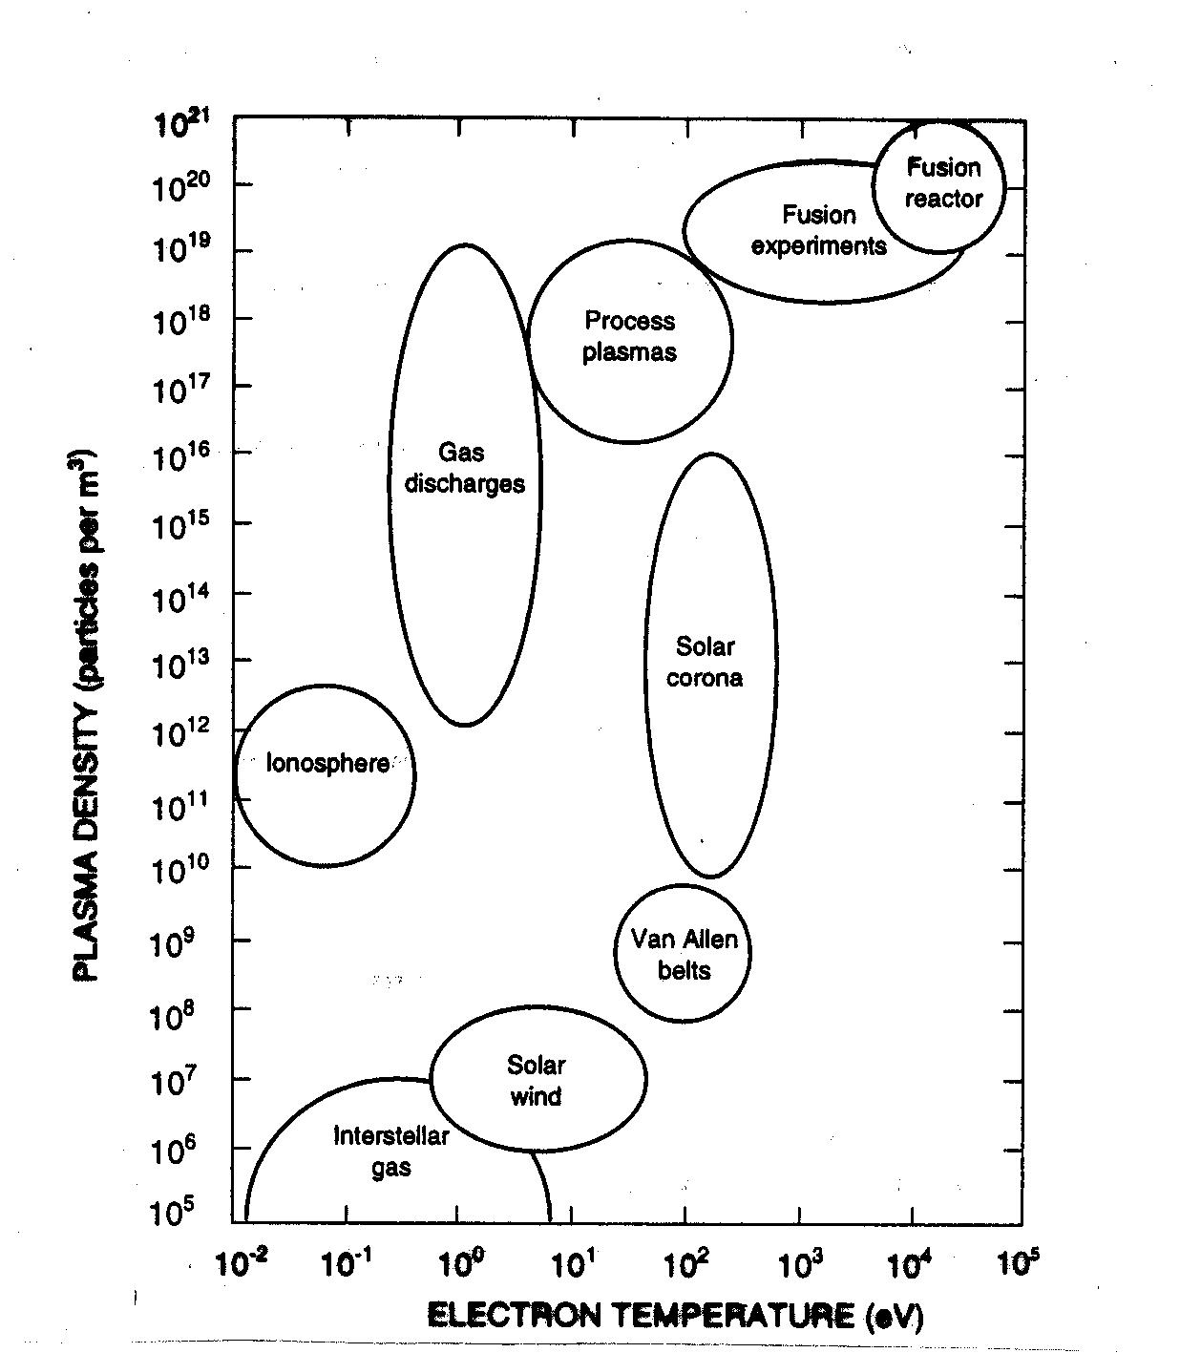
Ref: Rutherford and Goldston
A plasma is in essence an ensemble of particles exhibiting collective behavior.

A fundamental concept in describing such ensembles is the distribution function, used because it is usually impossible to describe the behavior of individual particles in this many-body system.

f(x,v) = probability density that particles exist between x, v and x+dx, v+dv in six-dimensional phase space

Maxwellian distribution ⬄ most probable distribution

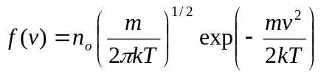 (in one dimension)

Where does this come from?

We start with the thermodynamic definition of temperature, defined for systems in equilibrium

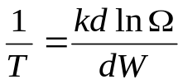

where k is Boltzmann's constant, k ln Ω = S, entropy, and where Ω is the number of microstates available for a system with total energy W.

Now we pose the question what is the probability that a given particle has an energy W_{i} ? In a system in equilibrium, this particle obtains a given energy by removing this amount from the rest of the system.

Thus, the total system energy becomes W_{tot} - W_{i} and we can expand Ω as follows
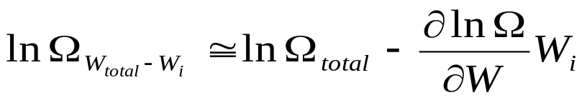

Taking the exponential of this expression gives us the number of microstates available for a particle of energy W_{I} Thus the probability for a particle to be found in this state is

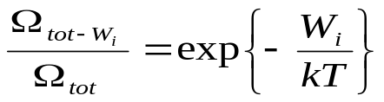

We ignore, for now, any potential energy the particle may have and write the probability that a particle can be found in a velocity space volume 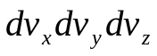 as

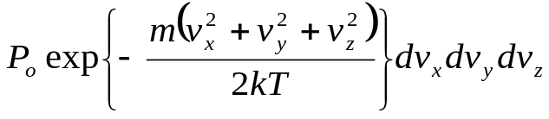

Note: Implicit in the above result is the fact that we have assumed the plasma to be spatially uniform, and all particles to be indistinguishable. Not true, of course, in general.
We further adopt the normalization that

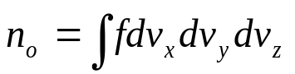

which leads to the so-called Maxwell-Boltzmann distribution (in 3-D)

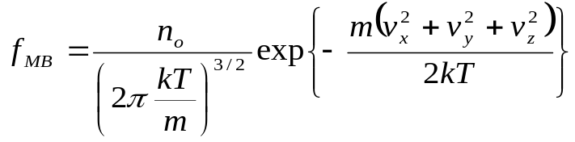

This distribution is the fundamental distribution function for a plasma in equilibrium, i.e. at a minimum of free energy. In these lectures, we will be concerned with small (or sometimes large) deviations of a plasma from this equilibrium state.

Also in the future, we will relax the condition that the plasma is spatially uniform, and use a distribution function that is a function of both velocity and configuration space.

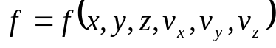

This situation is frequently encountered in beams where f is a function on phase space. This implies the equilibrium discussed above can be evaluated in a local sense.

We also note that a high-energy beam also typically has a Gaussian (or Maxwell-Boltzmann) distribution in the particles' rest frame. This is only true when the potential energy part of W is small compared to the kinetic part. In addition, it requires that the thermalization time, sometimes referred to as the filamentation time, is short with respect to the beam lifetime. Thermalization can occur as a result of true random process, like collisional scattering or radiation, as well as due to a number of nonlinear collective
processes.
Debye Shielding

A plasma in equilibrium is electrically neutral and isothermal. Now consider the perturbation of this equilibrium that occurs when a test charge is introduced, forming a potential φ. Thus the particle energy is given by

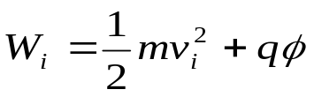

and integrating the distribution function over all velocity space to find the density of both ions and electrons gives

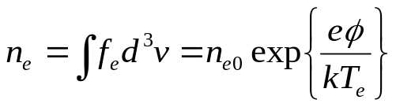

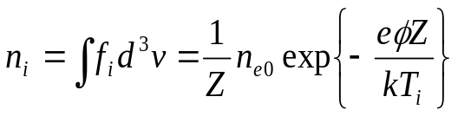

This implies that electrons will tend to gather near positive charges, and vice versa in equilibrium, which will lead to shielding of the original test charge.
For purposes of illustration, we assume a one-dimensional plasma and solve for the potential distribution using Poisson's equation

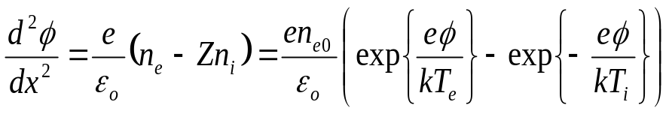

We now invoke the assumption that the potential energy is much smaller than the kinetic energy

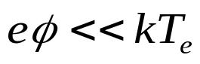

and take T_{i} ~ 0, which allows us to expand the exponentials

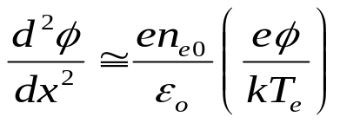

and this equation has the solution

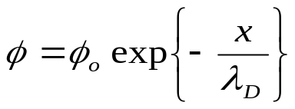

where
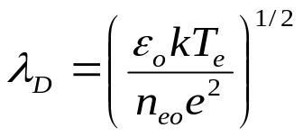
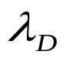is the Debye length and represents the characteristic scale over which the potential from a test charge can exist in the plasma.

Another implicit assumption in the preceding derivation is that the density in the region of nonzero potential is a smooth function of space. This means there must be a sufficient number of charges within a Debye sphere so that the 'graininess' of the potential is a negligible effect. This is a typical feature of a neutral plasma, and is part of the definition of the plasma state.

However, in a beam, or nonneutral plasma, this is not always true, though usually it is.

The number of particles in a Debye sphere is given approximately by

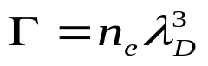

and 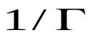is known as the plasma parameter. We typically want Γ >> 1.

For a typical laboratory plasma, T_{e} ~ 3 eV,
n_{e} = 10¹⁹ m⁻³,mwith the number of particles in a Debye sphere ~ 10³, adequate for our purposes.
Plasma Oscillations

To understand the oscillatory behavior of a plasma, we consider a slab of uniform, neutral plasma composed of equal numbers of electrons and singly-charged ions

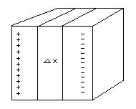

For the purposes of this discussion, the ions are taken to be immobile due to their mass, and we displace (somehow) all the electrons by a distance Δx.

Using Gauss' Law, we may write the resulting 1-D electric field as

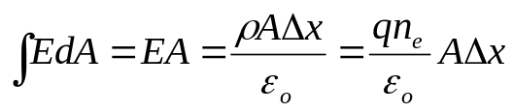

➔ 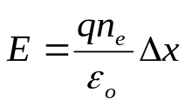

The force on an individual electron is -qE and the electron's motion follows from Newton's Law

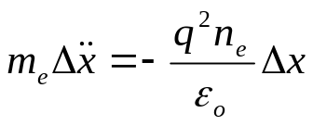

The resulting oscillatory behavior occurs at the plasma frequency given by

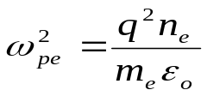

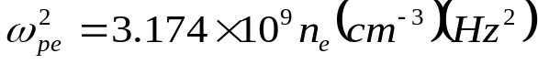

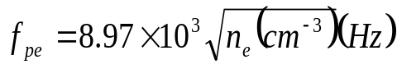

This frequency is at the heart of the collective behavior of a plasma, and forms the basis for a rich variety of wave phenomena, linear and nonlinear.

We note that the Debye length can be expressed in terms of the plasma frequency as

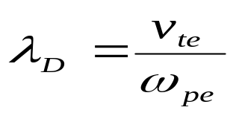

where v_{te} is the mean thermal speed 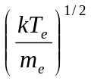.

This suggests the rather intuitive picture that the Debye length is the distance over which an average particle can travel before the plasma can respond with shielding.

In a beam, a similar frequency can be defined, however there is some ambiguity due to relativistic effects, and the exact definitions depend on the particular application. If we define all quantities in the lab frame, the effective density in the moving frame is lower by a factor 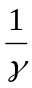. However, the electron's mass is also lower by resulting in an apparent cancellation, i.e. the plasma frequency appears to be the same in both the moving frame and the lab frame. But the analysis must be applied differently to plasma oscillations parallel or perpendicular to the motion.

The appropriate formulation is to transform the time, length scale and fields according to the Lorentz transformation from one frame to another, resulting in two different expressions for parallel and perpendicular directions.

For transverse motion we have

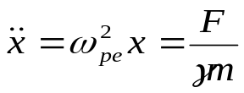

The force term is made up of a Coulomb repulsion that is reduced by magnetic attraction thus

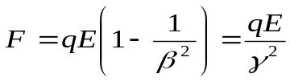

which yields

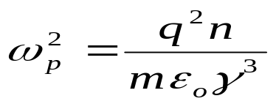

The same result may be obtained by transforming the plasma frequency from the beam frame to the lab frame.
Now for the longitudinal motion, the reduction of the Coulomb force does not occur; however, the longitudinal motion involves a different effective mass.

This can be seen by

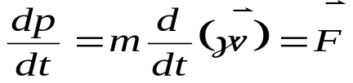

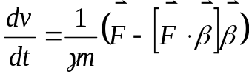 ; 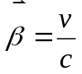

The effective longitudinal mass is seen to be 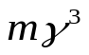.

We may define a temperature using the invariance of the normalized transverse emittance (we will see this later)

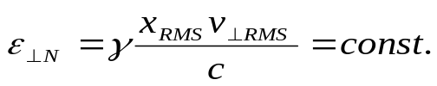

Let a transverse temperature be defined by 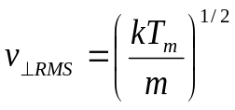
We then find the temperature scales as

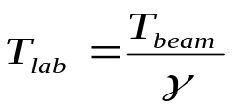

Assuming 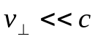, i.e. the transverse motion is non-relativistic, we may construct the effective Debye length

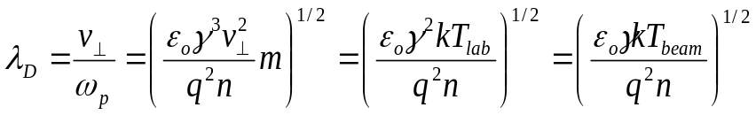

We note that a relativistic beam is typically very 'non-Maxwellian', meaning very different temperatures exist in the perpendicular and parallel directions. And the Debye lengths for relativistic beams are usually much greater than the beams themselves. So do we still have a plasma? Yes, but not a conventional one. More on this topic later.

Plasma Sheaths

A consequence of Debye shielding is the formation of a boundary layer, called a sheath, at the interface between the plasma and any surface, conducting or non-conducting.

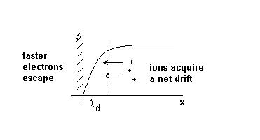

At any boundary, the electrons typically leave the plasma faster than the ions, leaving a net positive charge behind. This builds up a retarding field which tends to confine electrons and expel ions. The field builds up until an equilibrium in the particle fluxes is reached.

An important consequence of a sheath is the fact that the energy of ions leaving a plasma is typically characteristic of the mean electron energy in the plasma.

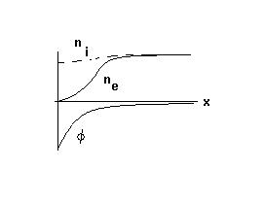
The potential variation across a sheath.

We wish to solve for the self-consistent drift velocity that the ions must acquire. By energy conservation, we have

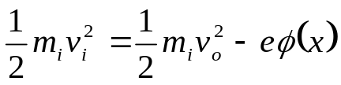

where v_{o} is the ion drift velocity in the plasma we wish to find.

We now assume that the electrons are in local thermodynamic equilibrium. Remember this means that

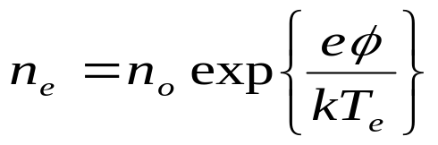

Now the continuity relation gives us an expression for the local ion density

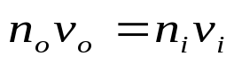

Poisson's equation then becomes

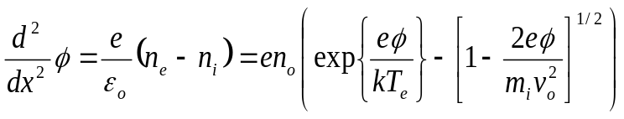

This is difficult to solve directly, but a consistency relation can be found by multiplying by 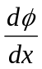 and integrating once

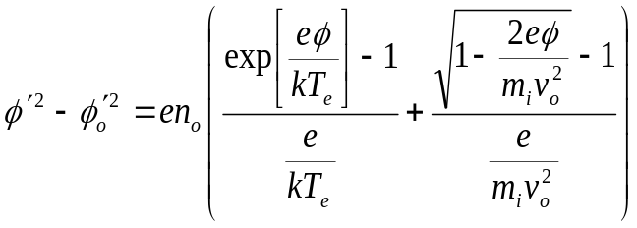

Now assuming that 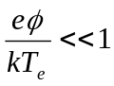 and expanding the right hand side in a Taylor series leads to the consistency relation known as the Bohm sheath criterion

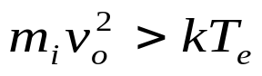

The implication of this criterion is that ions must drift into the sheath region faster than the ion sound speed.

And whenever particles drift faster than the speed of some wave in a medium, this can lead to instability, or collective oscillations. Hence, sheaths can be a source of instabilities
Child-Langmuir Law

Another aspect of the sheath is the retardation of electron flow due to the build-up of space charge.

An expression for this effect can be found by considering the motion in 1-D

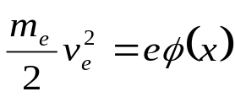

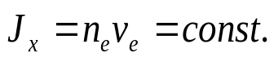

along with Poisson's equation for the potential

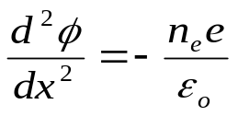

Substituting for the density n_{e}

From the continuity relation, we find

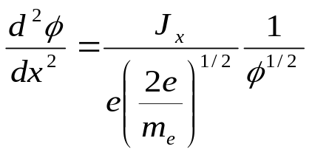

This equation can be integrated once to give

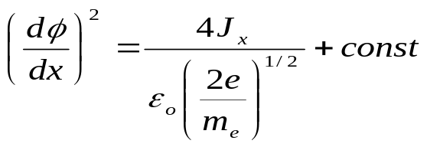

Now using the boundary conditions that

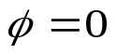 at x = 0

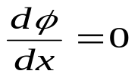 at x = 0

this equation can be integrated again to give

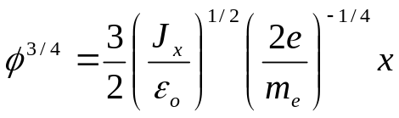

For an applied voltage V_{o} this relation implies the potential can be replaced by the expression

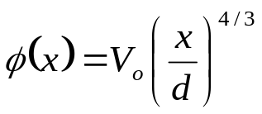

Substituting this expression for leads to the final result known as the Child-Langmuir law.
It describes the flow of electron current across a sheath, and is the primary scaling law at work in vacuum tubes, among many other situations.

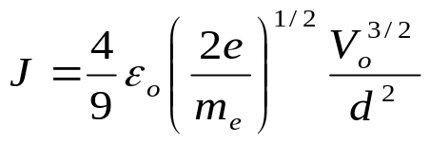

Example: Langmuir Probes

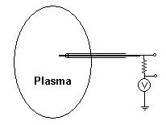

If an external bias is applied to a wire conductor inserted into a plasma, either ion or electrons can be collected, depending on the polarity.
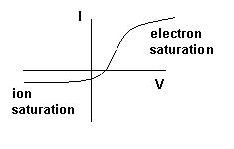

If the plasma is largely unperturbed by the probe (i.e. it doesn't collect too much current), then each particle species has a particle flux given by

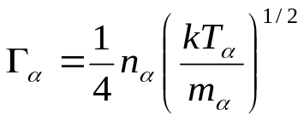

so that for a probe of area A, the collected current is

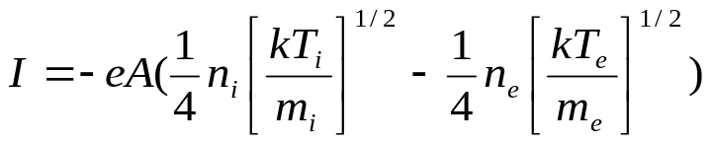

However, due to Debye shielding, the plasma is strongly perturbed in the vicinity of the probe and particles must fall across a sheath potential in the manner we have just studied.

The electron density varies according to the local equilibrium condition

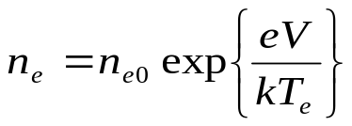

Moreover, the ion flux is an invariant across any surface (in this 1-D problem) so we can calculate the ion flux to the probe at any convenient place, and we choose to do so at the edge of the sheath.

At this point the plasma is quasi-neutral,

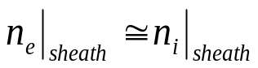

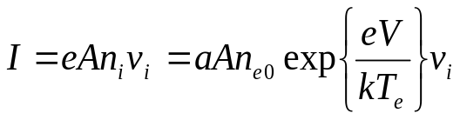

But for typically low temperature ion plasmas, the ion velocity is given by only that which it acquires as it falls across the sheath,

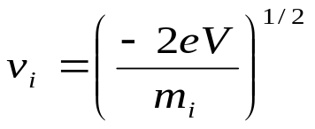

Using the Bohm sheath criterion (at equality) we have

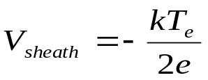

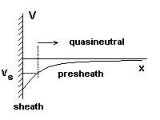

So finally, we get for the collected current

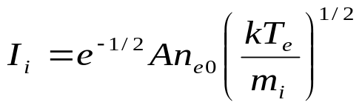

which is called the ion saturation current, namely the current collected at large negative voltages when all the electrons are repelled.

Note that the ion current depends on the electron temperature, which is due to the collective character of the ion and electron flows. The above expression can be used to deduce the electron density, if the electron temperature is known.

The total current to the probe is given by

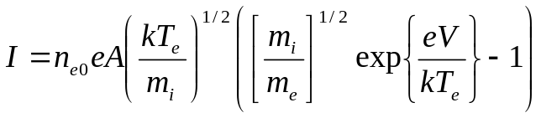

We note that there is also a geometric correction due to the fact that the sheath thickness changes slightly with applied voltage. For a cylindrical probe, for instance, this increase is given by

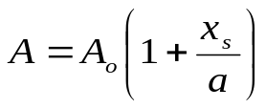

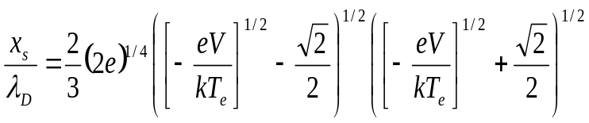

and is related to the Child-Langmuir law in cylindrical geometry, and in this case, the ions are the charge carriers.

Plotting the V-I characteristic of the probe, the logarithmic slope can be used to find T_{e}, and once found, then the ion saturation current gives n_{e}.

There is no easy way to find T_{I} since the ion velocities are determined mainly by the electron supported sheath. Hence the ion temperature drops out of the equation. This is not the cast when the ion temperatures are comparable to the electron temperature, but this case is rare experimentally, and the equations must then be solved numerically.

How do we make a plasma?

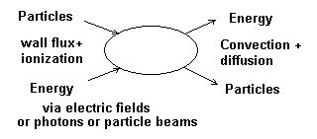

Particle balance:

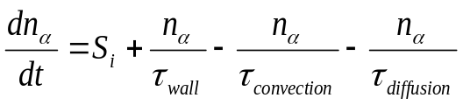

Energy balance:

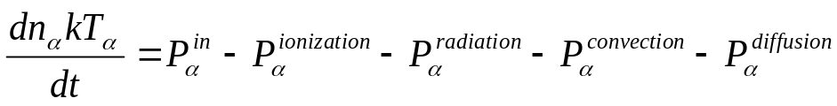

We will now take a look at some of the mechanisms that can produce or destroy particles in the bulk plasma and at the plasma surface.
Ionization:

Electron impact

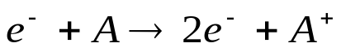

Ion Ionization potential

H 13.6 eV
He 24.6
Ne 21.6
Ar 15.8

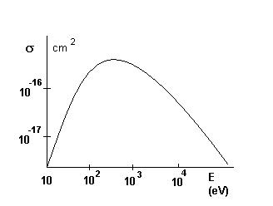

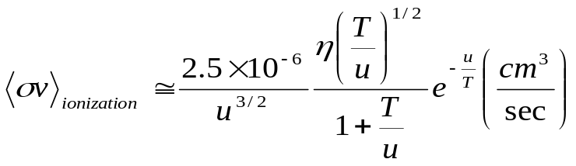

η = # of equivalent electrons
u = ionization potential
T = electron temperature (eV)

Dissociative ionization

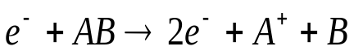

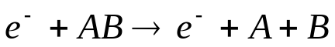

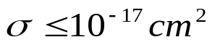 at 100 eV

Photoionization

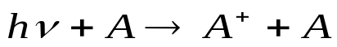

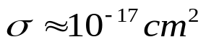 at 1000 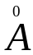

Charge exchange

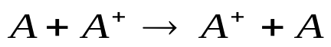

This does not produce an change in the ion density, so why does it matter? ---> Energy balance

Example:

Plasma creation with particle beams

A plasma can be readily created in and around a particle beam propagating through a neutral gas.

The plasma density increases as

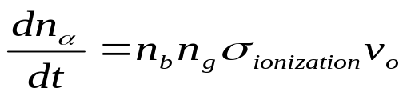

where n_{b} is the beam density, n_{g} is the gas density, 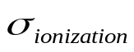is the cross-section for ionization and v_{o} is the beam velocity.

As the gas becomes ionized, like-signed particles are repelled and opposite-signed particles become trapped in the beam's potential well. The characteristic time for a beam to become neutralized by ionization traversing a gas-filled region is given by

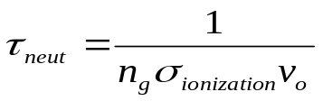

with a characteristic length

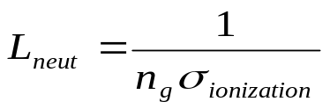
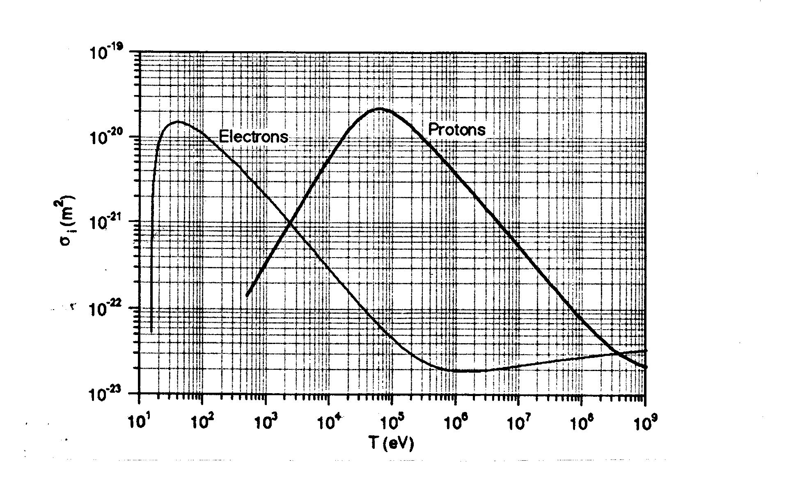
Ref: Reiser

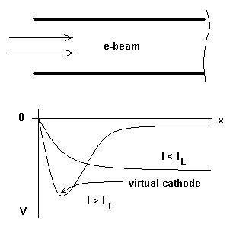

As the beam enters the tube, the potential decreases along
the beam owing to the presence of unneutralized electrons.
If the beam current is greater than a limiting current I, the electrons accumulate near the entrance and form a virtual cathode that reflects the electrons backward.

However, if the tube is gassy, the beam neutralization increases until the electron beam can propagate. So why not always use gassy tubes? → Because the presence of plasma causes a whole new set of possible collective modes resulting in over-focusing and instability, not surprisingly at the plasma frequency.

Ion acceleration can also occur due to the large virtual cathode potential. This effect in dense plasmas is the basis for plasma accelerators, to be covered later in these lectures.
DC Glow Discharges

Discharge formation by electrical breakdown

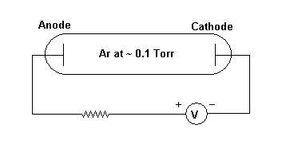

Initially, the resistance of the gas is much greater than that of the resistor. At first, only a small current will flow due to any free electrons and ions from cosmic radiation.

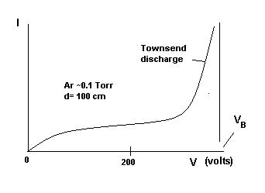

As V increases, the number of charge carriers increases and the discharge resistance decreases until the voltage reaches a constant value at V_{B}. The is the region of initial breakdown called the Townsend discharge.
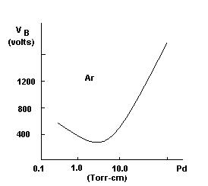

The value of V_{B} depends on the gas species and follows Paschen's Law which relates V_{B} to the product of gas pressure and electrode spacing (i.e. the electric field).

As V is further increased, the rate of production of Ar⁺ by electron impact is sufficient to produce cathode secondary electrons to cause the ionization. Since a typical ion impact induced secondary emission coefficient is 0.1, each secondary electron thus produced must be responsible for 10 - 20 ionizations.

In the initial stage of glow formation, the discharge covers only part of the cathode surface and the voltage V and current density J are roughly constant. This is the so-called normal glow used in voltage regulator tubes. As the current is increased, the cathode coverage increases until it is fully covered. Then the Child-Langmuir law takes over and this regime is called the abnormal glow.

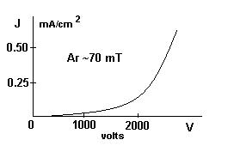

Structure of the discharge:

The DC glow arranges itself into several characteristic regions as shown below

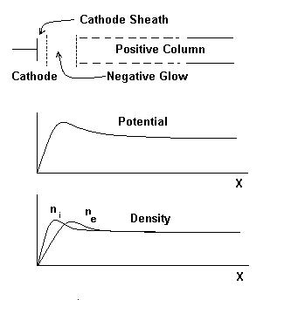

Cathode Region:

A narrow luminous layer at the cathode surface resulting from excitation and surface bombardment. A large voltage drop occurs across the cathode sheath. The electrons produced at the cathode are accelerated away from the sheath and the ion toward the cathode according to the C-L law.

Negative Glow Region:

A plasma with 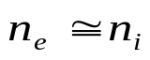. The glow results from Ar excitation by electron impact. Electrons from the cathode are accelerated by V and provide the main energy input to the discharge. They are in local thermodynamic equilibrium with typical values

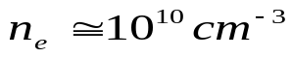
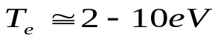
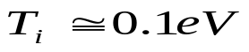

The energy transfer to the Ar⁺ ions is aided by collective effects. The electrons are rapidly thermalized (at typically 2-5 eV) and carry out the bulk of the ionization in the positive column.
Positive Column

A luminous region with . Energy and momentum imparted by the electric field to the electrons are lost through collisions with the Ar. Charged particle creation is balanced by losses to the wall. Manifest collective behavior: instabilities and anomalous transport.

Anode Region:

A sheath exists such that the plasma potential is about 10 eV above the anode potential. Secondary electrons are created by electron bombardment. These are accelerated by the anode sheath and become a source of particles and energy for the positive column.

The DC discharges just described occur in many applications, but are limited by rather poor confinement of particles and energy (actually no confinement at all!). Also these discharges produce hot electrodes with the associated metallic erosion. Other types of sources have been developed which improve confinement by the use of magnetic fields, and eliminate electrode erosion issues by using RF electric fields. These will be covered later in this course.
Summary of Lecture #1

Plasma are composed of ensembles of charged (and neutral) particles which may, or may not, be in charge and thermal equilibrium. If it is, the result is a Maxwellian distribution.

As a result of the free motion of charges, Debye shielding will occur over a characteristic length known as the Debye length (what else?).

The fields produced by perturbations of the charge neutrality cause a restoring force which acts over a characteristic time, causing plasma oscillations at the plasma frequency.

The state of a plasma depends on an anlysis of the mechanisms by which particles and energy are fed into and lost from the system. Many types of collisions are possible, often simultaneously at work.
References:

1. F. Chen, Introduction to Plasma Physics and Controlled Fusion, Plenum Press, 1990

2. S. Tanenbaum, Plasma Physics, McGraw-Hill, 1967

3. M. Reiser, Theory and Design of Charged Particle Beams, Wiley, 1994

4. J. Cobine, Gaseous Conductors, Dover, 1958

5. I. H. Hutchinson, Principles of Plasma Diagnostics, Cambridge University Press, 1987

