USDA Foreign Agricultural Service
GAIN Report

Template Version 2.09

Global Agriculture Information Network

Required Report - public distribution
Date: 6/14/2004
GAIN Report Number: KS4028
KS4028
Korea, Republic of
Tobacco and Products
Annual
2004

Approved by:
Marcus E. Lower
U.S. Embassy
Prepared by:
Stanley S. Phillips / Sunyoung Choi

Report Highlights:
Korean leaf tobacco area and production are forecast to contract again in 2004. Elimination of domestic leaf tobacco purchasing requirements in 2001 and privatization of KT&G, the former state-owned tobacco processing firm, in December 2002 paved way for Korean tobacco processors to shift from domestic to imported tobacco.

Includes PSD Changes: Yes
Includes Trade Matrix: Yes
Annual Report
Seoul [KS1]
[KS]
Table of Contents
Situation and Outlook 3
Leaf Tobacco Production 3
Leaf Tobacco Consumption 3
Leaf Tobacco Trade 3
Leaf Tobacco Stock 4
Cigarette Market Situation 4
PS&D 6
PS&D for Tobacco, Unmfg, Total 6
PS&D for Flue Cured Tobacco 6
PS&D for Flue Cured Tobacco 7
PS&D for Burley Tobacco 7
PS&D for Burley Tobacco 8
PS&D for Cigarette 8
PS&D for Cigarette 9
Production – Unmanufactured Tobacco Total 9
Production – Unmanufactured Tobacco Total 10
Trade Matrix 11
Korea: Total Imports of Unmanufactured Tobacco for CY 2003 – 2004 11
Korea: Imports of Burley for CY 2003 – 2004 11
Korea: Imports of Flue-cured for CY 2003 – 2004 12
Korea: Imports of Oriental for CY 2003 – 2004 12
Korea: Imports of Tobacco stems for CY 2003 – 2004 12
Korea: Total Exports of Unmanufactured Tobacco for CY 2003 – 2004 13
Korea: Exports of Burley for CY 2003 – 2004 13
Korea: Exports of Flue-cured for CY 2003 – 2004 13
Korea: Exports of Tobacco stems for CY 2003 – 2004 13
Korea: Exports of Filter Tip Cigarette for CY 2003 – 2004 14
Price Tables 15
Korea: Purchase price of Burley and Flue-cured Tobacco by KT&G for CY 2003 15
Korea: Imports Prices of Flue-cured and Oriental Tobacco 15
Korea: Exports Prices of Burley and Flue-cured Tobacco 15
Market Share 16
Korea: Domestic and Foreign Cigarette Sales 16
Korea: Cigarette Sales by Major Market Competitors for CY 2003 – 2004 16
Korea: Market Share of Top 4 Foreign Cigarettes for CY 2001 – 2003 16
Tariffs and Taxes 17
Korea: Taxes and Charges for Cigarettes 17
Korea: Tobacco and Cigarette Tariff Rates 17

Situation and Outlook

Korean leaf tobacco area and production are forecast to contract again in 2004. Elimination of domestic leaf tobacco purchasing requirements in 2001 and privatization of KT&G, the former state-owned tobacco processing firm, in December 2002 paved the way for Korean tobacco processors to shift from domestic to imported tobacco. Accordingly, domestic tobacco production is expected to continue to decline.

Remarkably strong cigarette exports, reaching 30.9 billion pieces in 2003, boosted foreign leaf tobacco imports. Domestic cigarette consumption, however, is expected to contract in response to a 500 won ($0.42 per pack) increase in cigarette prices. The price increase in cigarettes, schedule for the latter half of 2004, is one component of the government’s anti-smoking campaign.

Leaf Tobacco Production

KT&G’s requirement to purchase domestic leaf tobacco expired in 2001. Since expiration of the domestic purchase requirements, Korean leaf tobacco production has decreased sharply.

Total leaf tobacco production in 2004 is forecast at 36,380 MT. Area planted in 2004 is expected to decrease 17 percent from 2003. In 2003, total leaf tobacco production decreased to 35,666 MT; a 17 percent decrease from 2002 production of 43,013 MT. Frequent rain while the tobacco was in its growth stage and limited sunshine during the harvesting season retarded yields and reduced tobacco production in 2003. Flue-cured production in 2003 decreased to 24,729 MT from 30,447 MT in 2002. Burley production decreased to 10,937 MT from 16,206 MT in 2002. Stocks of burley in Korea are relatively high at present. Processors are expected to draw down burley stocks over the next couple of years. Accordingly, production of burley is expected to contract while processors work off stocks.

The number of tobacco growers decreased to 21,592 in 2003 from 25,935 in 2002 along with the reduction in leaf tobacco production. Korean tobacco grower numbers are expected to decrease to 17,000 in 2004.

Leaf Tobacco Consumption

Korea’s total leaf tobacco consumption in 2004 is estimated to increase to 62,038 MT from 59,532 MT as a result of increased cigarette exports and local manufacturing of foreign brand cigarettes in Korea. However, the usage weight of domestic leaf tobacco is not expected to increase as a result of increased cigarette exports and more domestic production of foreign brand cigarettes. KT&G (the largest cigarette manufacturer in Korea) increased the usage of foreign leaf tobacco to 20 percent in 2003. British American Tobacco (BAT) Korea and Philip Morris (PMI) Korea are expected to expand their market shares in 2004. However, BAT and PMI have no plans to use local leaf tobacco. Japan Tobacco International (JTI), a Japanese cigarette manufacturer that has exported cigarettes to Korea in the past, responded to an increase in the Korea import tariff on imported cigarettes (to 40 percent) in 2004 by consigning production of the brands that were previously produced in Japan to KT&G to be produced domestically in Korea.

Leaf Tobacco Trade

Leaf tobacco imports are forecast to increase to 29,000 MT in 2004 along with the continuing increase of Korean cigarette exports to the Middle East and Central Asia. In 2003, Korea’s leaf tobacco imports increased to 27,623 MT; a 59 percent increase from 17,419 MT in 2002. Tobacco imports have been bolstered by entry of two foreign cigarette manufacturers (BAT Korea and PMI Korea) that began production in Korea in March 2003.

Foreign cigarette companies operating in Korea in 2003 did not consume domestic leaf tobacco, which is considerably more expensive than imported leaf tobacco. As a result, imports of leaf tobacco in 2003 increased to 27,623 MT from 11,697 MT in 2002. Concurrently 5,777 MT of tobacco stems (tobacco refuse) were imported again in 2003, the first since 1992 (3,842 MT).

Out of the total amount of leaf tobacco imported by manufacturers in Korea in 2003 (27,623 MT), nearly all (23,541 MT) was classified as flue-cured. Flue-cured tobacco arrived in Korea from Brazil (8,674 MT), the United States (5,109 MT), and China (4,946 MT). Flue-cured imports from China were up substantially from only 600 MT in 2002. Korea also imported 3,299 MT of oriental leaf tobacco from Greece and Turkey in 2003, a 42 percent decrease from 5,722 MT in 2002.

In the past when KT&G’s had a requirement to purchase local production, KT&G regularly exported leaf tobacco at a loss to reduce the high inventory. Now that there is no local purchasing requirement, exports of leaf tobacco have dropped sharply.

Leaf Tobacco Stock

According to KT&G, the optimum leaf tobacco stock (including domestic and imported tobacco) to have on hand for cigarette manufacturing is around 75,000 MT, which would represent about 2 years of consumption capacity. However, ending stocks in 2003 were estimating an 116,000 MT. Ending stocks in 2004 are expected to continue to decrease, driven by receding domestic tobacco production and strong export demand for cigarettes.

Cigarette Market Situation

An intensive anti-smoking campaign and expected increases in cigarette prices during the second half of 2004 are forecast to reduce Korean cigarette consumption in 2004. Conversely, Korean cigarette production is forecast to increase to 123,700 million pieces to meet strong export demand from the Middle East, Central Asia and new markets in China and the United States. In 2004, total local cigarette sales are expected to decrease to 90,000 million pieces from 96,780 million pieces in 2003.

Due to local cigarette manufacturing by two foreign-owned companies, foreign cigarette imports in 2003 decreased dramatically to 5,339 million pieces from 18,841 million in 2002. Imports are expected to continue to decrease in 2004 in line with Japan Tobacco International’s decision to have their brands produced in Korea by KT&G.

Cigarette prices are expected to increase during the second half of 2004 in response to a revision of the National Health Promotion Act. Currently, a “health fund” tax of 150 Korean won per pack of cigarettes is in effect. Under the revision of the Act, the “health fund” tax will increase to 650 won per pack. The Ministry of Health and Welfare (MOHW) estimated that the resulting cigarette price increases would cause 5 percent reduction in total cigarette consumption. Korea is still one of Asia’s largest cigarette markets with about 60 percent of male adults being smokers, compared to roughly 30 percent in other economically advanced countries.

Among cigarette manufacturers in Korea, KT&G commanded a 76.6 percent share in 2003, while foreign competitors’ share increased to 23.3 percent from 21.6 percent in 2002. Despite aggressive marketing by foreign manufacturers in Korea, KT&G has maintained market share with the introduction of a variety of lower nicotine and tar containing cigarettes to meet the needs of increasingly health-conscious smokers.

Korea’s cigarette market is shifting rapidly to the low-tar (less than 5mg per piece) and low-nicotine cigarettes in 2004. Ultra-low tar (less than 3mg per piece) cigarette sales reached 50 percent of total sales in January 2004. In 2003, domestic and foreign manufacturers introduced 12 new cigarettes to the market. Among the 12 new products, 75 percent were low and ultra-low cigarettes. Premium cigarettes (over 1800 won per pack) accounted for 58 percent of sales in 2003 and are expected to grow to 67 percent in 2004.

KT&G’s total cigarette exports increased to 30,900 million pieces in 2003, a 44 percent increase from 21,400 million pieces in 2002. Exports accounted for 29 percent of total sales volume in 2003. KT&G invested in a manufacturing factory in Turkey in 2004 and is expected to produce in Turkey in 2005.

PS&D

PS&D for Tobacco, Unmfg, Total

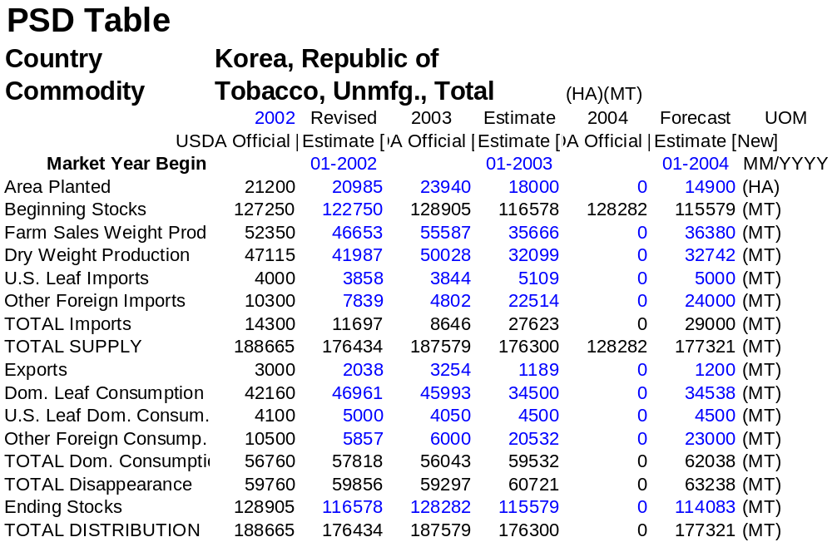

PS&D for Flue Cured Tobacco

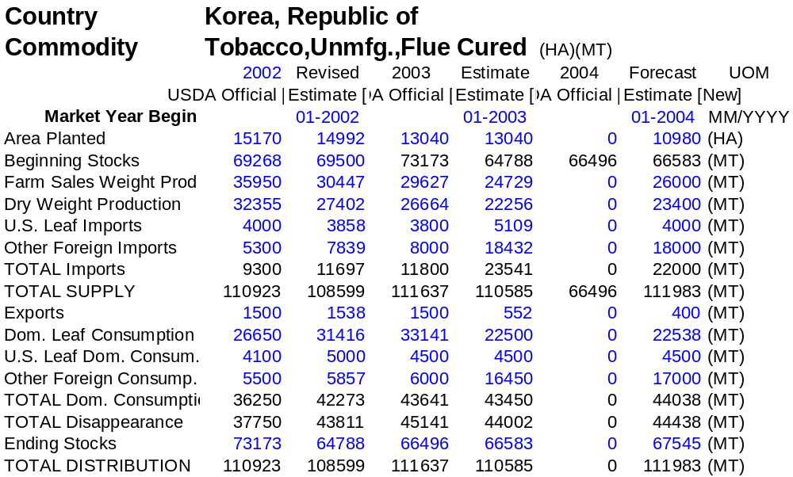

PS&D for Burley Tobacco

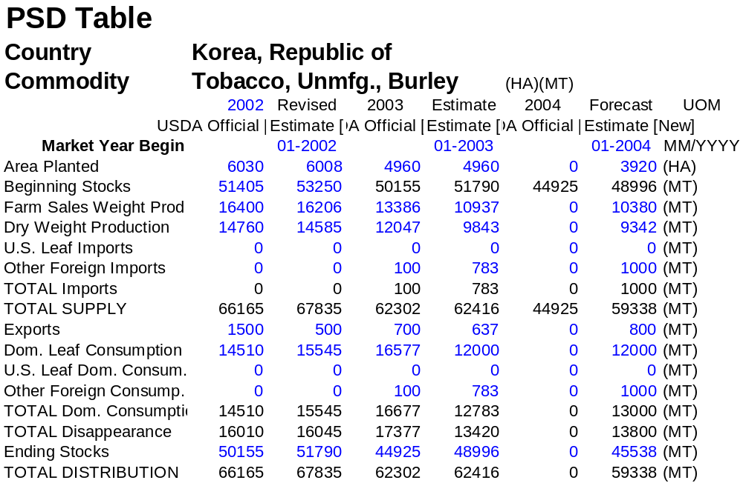

PS&D for Cigarette

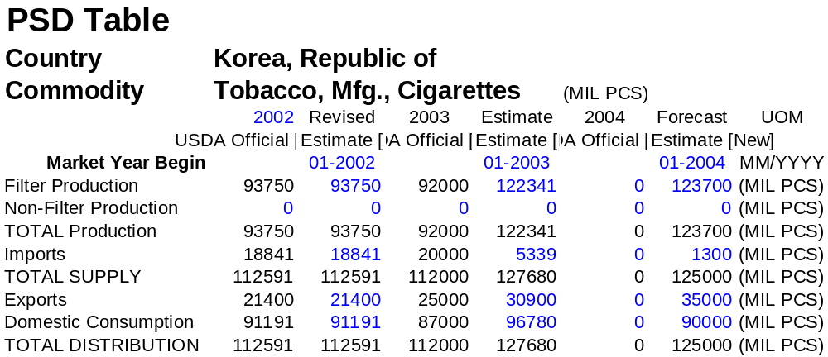

Production – Unmanufactured Tobacco Total
 | Area Planted |  |  | Production
 | (Hectares) |  |  | (Metric Tons)
 | 2002 | 2003 | 2004 | 2002 | 2003 | 2004
Tobacco, Unmfg., Burley | 6,008 | 4,960 | 3,920 | 16,206 | 10,937 | 10,380
Dark Air & Sun Cured | 0 | 0 | 0 | 0 | 0 | 0
Dark Air Cured | 0 | 0 | 0 | 0 | 0 | 0
Dark Fire Cured | 0 | 0 | 0 | 0 | 0 | 0
Tobacco, Unmfg., Flue Cured | 14,992 | 13,040 | 10,980 | 30,447 | 24,729 | 26,000
Light Air Cured | 0 | 0 | 0 | 0 | 0 | 0
Tobacco, Unmfg., Oriental | 0 | 0 | 0 | 0 | 0 | 0
Tobacco, Unmfg. | 20,985 | 18,000 | 14,900 | 46,653 | 35,666 | 36,380

Trade Matrix

Korea: Total Imports of Unmanufactured Tobacco for CY 2003 – 2004
Country | CY 2003 |  | CY 2004 (Jan. – Mar.)
 | MT | US$ 000 | MT | US$ 000
Brazil | 8,710 | 28,139 | 1,831 | 6,231
P.R. China | 4,946 | 10,179 | 56 | 178
USA | 5,109 | 40,732 | 749 | 6,152
India | 1,628 | 1,407 | 0 | 0
Greece | 4,693 | 24,610 | 1,570 | 7,759
Turkey | 1,096 | 2,719 | 463 | 972
Uganda | 305 | 1,348 | 0 | 0
Malawi | 232 | 593 | 0 | 0
Argentina | 198 | 678 | 0 | 0
Bangladesh | 40 | 91 | 59 | 148
Mexico | 104 | 433 | 52 | 203
Italy | 79 | 276 | 78 | 275
Macedonia | 31 | 120 | 321 | 1,637
Iran | 0 | 0 | 200 | 278
Bulgaria | 13 | 25 | 0 | 0
Other | 439 | 1,940 | 53 | 233
Total | 27,623 | 113,290 | 5,432 | 24,066
Source: Korea Trade Information Services (KOTIS)

Korea: Imports of Burley for CY 2003 – 2004
Country | CY 2003 |  | CY 2004 (Jan. – Mar.)
 | MT | US$ 000 | MT | US$ 000
Uganda | 305 | 1,348 | 0 | 0
Malawi | 232 | 593 | 0 | 0
Mexico | 104 | 433 | 52 | 203
Italy | 79 | 276 | 78 | 275
Brazil | 36 | 147 | 139 | 513
Other | 27 | 103 | 0 | 0
Total | 783 | 2,900 | 268 | 991
Source: Korea Trade Information Services (KOTIS)

Korea: Imports of Flue-cured for CY 2003 – 2004
Country | CY 2003 |  | CY 2004 (Jan. – Mar.)
 | MT | US$ 000 | MT | US$ 000
Brazil | 8,674 | 27,992 | 1,692 | 5,718
USA | 5,109 | 40,732 | 749 | 6,152
P.R. China | 4,946 | 10,179 | 56 | 178
Greece | 2,534 | 12,878 | 0 | 0
India | 1,628 | 1,407 | 0 | 0
Argentina | 198 | 678 | 0 | 0
Bangladesh | 40 | 91 | 59 | 148
Other | 412 | 1,835 | 53 | 233
Total | 23,541 | 95,792 | 2,609 | 12,429
Source: Korea Trade Information Services (KOTIS)

Korea: Imports of Oriental for CY 2003 – 2004
Country | CY 2003 |  | CY 2004 (Jan. – Mar.)
 | MT | US$ 000 | MT | US$ 000
Greece | 2,159 | 11,732 | 1,570 | 7,759
Turkey | 1,096 | 2,719 | 463 | 972
Macedonia | 31 | 120 | 321 | 1,637
Iran | 0 | 0 | 200 | 278
Bulgaria | 13 | 25 | 0 | 0
Other | 0 | 2 | 0 | 0
Total | 3,299 | 14,598 | 2,554 | 10,646
Source: Korea Trade Information Services (KOTIS)

Korea: Imports of Tobacco stems for CY 2003 – 2004
Country | CY 2003 |  | CY 2004 (Jan. – Mar.)
 | MT | US$ 000 | MT | US$ 000
India | 3,669 | 705 | 1,560 | 323
P.R. China | 1,540 | 896 | 0 | 0
Bangladesh | 154 | 83 | 0 | 0
Spain | 134 | 136 | 0 | 0
Brazil | 47 | 44 | 79 | 71
Philippines | 0 | 0 | 537 | 107
Indonesia | 0 | 0 | 115 | 23
USA | 115 | 109 | 0 | 0
Argentina | 2 | 3 | 0 | 0
Malawi | 0 | 0 | 77 | 41
Uganda | 38 | 30 | 0 | 0
Other | 78 | 63 | 0 | 0
Total | 5,777 | 2,069 | 2,368 | 565
Source: Korea Trade Information Services (KOTIS)

Korea: Total Exports of Unmanufactured Tobacco for CY 2003 – 2004
Country | CY 2003 |  | CY 2004 (Jan. – Mar.)
 | MT | US$ 000 | MT | US$ 000
Greece | 997 | 4,263 | 432 | 1,772
France | 192 | 685 | 0 | 0
Bulgaria | 0 | 0 | 97 | 382
Other | 0 | 0 | 0 | 0
Total | 1,189 | 4,948 | 529 | 2,154
Source: Korea Trade Information Services (KOTIS)

Korea: Exports of Burley for CY 2003 – 2004
Country | CY 2003 |  | CY 2004 (Jan. – Mar.)
 | MT | US$ 000 | MT | US$ 000
Greece | 445 | 1,659 | 215 | 715
Bulgaria | 0 | 0 | 97 | 382
France | 192 | 685 | 0 | 0
Other | 0 | 0 | 0 | 0
Total | 637 | 2,344 | 312 | 1,097
Source: Korea Trade Information Services (KOTIS)

Korea: Exports of Flue-cured for CY 2003 – 2004
Country | CY 2003 |  | CY 2004 (Jan. – Mar.)
 | MT | US$ 000 | MT | US$ 000
Greece | 552 | 2,604 | 217 | 1,057
Other | 0 | 0 | 0 | 0
Total | 552 | 2,604 | 217 | 1,057
Source: Korea Trade Information Services (KOTIS)

Korea: Exports of Tobacco stems for CY 2003 – 2004
Country | CY 2003 |  | CY 2004 (Jan. – Mar.)
 | MT | US$ 000 | MT | US$ 000
Russia | 1,021 | 262 | 373 | 104
Other | 0 | 0 | 0 | 0
Total | 1,021 | 262 | 373 | 104
Source: Korea Trade Information Services (KOTIS)
Korea: Imports of Filter Tip Cigarettes for CY 2003 – 2004
Country | CY 2003 |  | CY 2004 (Jan. – Mar.)
 | MT | US$ 000 | MT | US$ 000
Japan | 3,390 | 49,344 | 650 | 8,750
U.K. | 685 | 8,827 | 3 | 94
German | 584 | 9,788 | 0 | 17
USA | 572 | 9,036 | 58 | 886
Holland | 281 | 6,162 | 0 | 8
P.R. China | 156 | 835 | 46 | 395
Greece | 12 | 114 | 2 | 16
Philippines | 12 | 40 | 0 | 0
Hong Kong | 3 | 38 | 0 | 10
Indonesia | 2 | 20 | 0 | 4
Spain | 3 | 33 | 0 | 0
Other | 2 | 85 | 0 | 0
Total | 5,702 | 84,322 | 759 | 10,180
Source: Korea Trade Information Services (KOTIS)

Korea: Exports of Filter Tip Cigarette for CY 2003 – 2004
Country | CY 2003 |  | CY 2004 (Jan. – Mar.)
 | MT | US$ 000 | MT | US$ 000
U.A.E. | 21,268 | 99,678 | 6,659 | 32,142
Afghanistan | 9,562 | 44,653 | 1,972 | 9,328
Turkmenistan | 7,492 | 32,581 | 2,281 | 10,009
USA | 1,895 | 27,364 | 305 | 4,515
Kyrgyzstan | 1,107 | 5,502 | 252 | 1,098
Uzbekistan | 486 | 2,326 | 80 | 364
Iran | 262 | 1,268 | 2,056 | 12,780
Russia | 231 | 1,936 | 146 | 1,323
P.R. China | 220 | 3,572 | 92 | 1,482
Mongolia | 179 | 1,575 | 39 | 326
Jordan | 504 | 2,201 | 0 | 0
Other | 684 | 6,063 | 233 | 2437
Total | 43,890 | 228,719 | 14,115 | 75,804
Source: Korea Trade Information Services (KOTIS)

Price Tables

Korea: Purchase price of Burley and Flue-cured Tobacco by KT&G for CY 2003
Stalk Position | Leaf & Cutter (KRW / KG) 1/ |  |  |  | Tip & Lug (KRW / KG)
Grade | No. 1 | No. 2 | No. 3 | No. 4 | No. 1 | No. 2 | No. 3
Burley | 6,610 | 5,980 | 5,570 | 4,430 | 5,570 | 4,750 | 4,120
Flue-cured | 7,660 | 6,940 | 6,330 | 5,020 | 6,330 | 5,430 | 4,660
1/ Korean Won / KG
Source: Korea Tomorrow and Global (KT&G) Corporation

Korea: Imports Prices of Flue-cured and Oriental Tobacco
(Unit: US$/KG, CIF basis)
Year | 1996 | 1997 | 1998 | 1999 | 2000 | 2001 | 2002 | 2003
Flue-cured | 8.41 | 9.07 | 9.16 | 8.49 | 6.71 | 4.95 | 4.61 | 4.07
Oriental | 5.45 | 5.45 | 6.07 | 5.37 | 4.8 | 4.65 | 3.8 | 4.42
Source: Korea Trade Information Services (KOTIS)

Korea: Exports Prices of Burley and Flue-cured Tobacco
(Unit: US$/KG, FOB basis)
Year | 1996 | 1997 | 1998 | 1999 | 2000 | 2001 | 2002 | 2003
Burley | 4.6 |  | 4.33 | 4.13 | 3.85 | 3.85 | 3.93 | 3.68
Flue-cured | 4.43 | 4.14 | 4.31 | 4.87 | 4.95 | 4.22 | 4.28 | 4.71
Source: Korea Trade Information Services (KOTIS)

Market Share

Korea: Domestic and Foreign Cigarette Sales
(Unit in Million Sticks)
Year | Domestic | Growth | Foreign | Growth | Total | Growth
1992 | 96,356 | 2.7 | 5,333 | 6.9 | 101,689 | 2.9
1993 | 99,119 | 2.9 | 7,158 | 34.2 | 106,277 | 4.5
1994 | 87,699 | -11.5 | 8,549 | 19.4 | 96,248 | - 9.4
1995 | 88,293 | 0.7 | 12,490 | 46.1 | 100,783 | 4.7
1996 | 93,010 | 5.3 | 11,509 | - 7.9 | 104,519 | 3.7
1997 | 92,622 | - 0.4 | 11,686 | 1.5 | 104,308 | - 0.2
1998 | 101,326 | 9.4 | 5,246 | - 55.1 | 106,572 | 2.2
1999 | 89,322 | -11.8 | 6,167 | 17.6 | 95,489 | - 10.4
2000 | 95,068 | 6.4 | 9,872 | 60.1 | 104,940 | 9.9
2001 | 83,416 | - 12.3 | 15,501 | 57.1 | 98,917 | - 5.7
2002 | 72,350 | - 13.3 | 18,841 | 21.5 | 91,191 | - 7.8
2003 | 74,265 | 2.6 | 22,516 | 19.5 | 96,780 | 6.1
Source: Industry Data

Korea: Cigarette Sales by Major Market Competitors for CY 2003 – 2004
(Unit in Million Sticks)
Company | CY 2002 |  | CY 2003 |  | CY 2004 (Jan-Apr)
 | Sales | Mkt Shr. | Sales | Mkt Shr. | Sales | Mkt Shr.
KT&G (Korea) | 72,350 | 79.34% | 74,265 | 76.7% | 22,878 | 76.9%
British American Tobacco (U.K.) | 9,774 | 11.72% | 12,355 | 12.8% | 3,660 | 12.3%
Philip Morris (USA) | 5,209 | 5.71% | 6,389 | 6.6% | 2,329 | 7.8%
Japan Tobacco (Japan) | 3,820 | 4.19% | 3,728 | 3.9% | 852 | 2.9%
Other | 38 | 0.04% | 45 | 0% | 14 | 0.1%
Total | 91,191 | 100.0% | 96,780 | 100.0% | 29,735 | 100.0%
Source: Industry Data

Korea: Market Share of Top 4 Foreign Cigarettes for CY 2001 – 2003
(Unit in %)
Company | CY 2002 | CY 2003 | CY 2004 (Jan-Mar)
Dunhill (BAT) | 50.2% | 53.9% | 54.8%
Virginia Slims (PM) | 15% | 12.2% | 12.5%
Mild Seven (JT) | 19% | 15.4% | 12.3%
Marlboro (PM) | 9.3% | 8.2% | 10.4%
Other | 6.5% | 10.3% | 10.0%
Total | 100.0% | 100.0% | 100.0%
Source: Industry Data

Tariffs and Taxes

Korea: Taxes and Charges for Cigarettes
(As of February 1. 2002, Unit in Korean Won)
Tax and Charge | Retail price of 2,000 Won per pack of cigarettes
Taxes  → Consumption (Excise) tax  → Education Tax (50% of Consumption Tax)  → Value added tax (10% of wholesale price)  Charges  → Health Fund (Public Health Promotion Supporting Fund)  → Green Fund (Public Environment Supporting Fund)  → Subsidy Fund (Leaf Tobacco Cultivation Stabilizing Fund) 1/  Subtotal of taxes and charges | 510  255  164  150 (650) 2/  4  10  ……………………………  1,093
Retailer Margin (10% of retail price) | 200
Net Cost per pack of cigarettes | 707
1/ Subsidy fund is charged to KT&G only, not foreign cigarette manufacturers in Korea.
2/ In accordance with the expected revision of National Health Promotion Act, a 500 Won is scheduled to increase from July 2004.
Source: Industry Data

Korea: Tobacco and Cigarette Tariff Rates
HS code | Description | Actual Applied Rates |  |  | WTO Bound Rates 1/
HS code | Description | 2003 | 2004 | 2005 | 2003 | 2004 | 2005
2401 | Unmanufactured tobacco | 20 | 20 | 20 | 55.7 | 54.0 | 54.0
2402 | Cigars, cheroots, cigarillos, and cigarettes, of tobacco or of tobacco substitutes | 30 | 40 | 40 | 69.0 | 65.5 | 65.5
2403 | Other manufactured tobacco and manufactured tobacco substitutes, “homogenized” or “reconstituted” tobacco, tobacco extracts and essences | 40 | 40 | 40 | 69.0 | 65.5 | 65.5
1/ According to the WTO agreement, the tariff rate is scheduled to drop evenly over a 10 year from 1995 to 2004.

