

Report of 1st International GPM GV Requirements Workshop
[4–7 November 2003; Abingdon, U.K.]

Nations/Regions Represented

Australia, Austria, Brazil, Canada, China, European Union, Finland,
France, Germany, Greece, India, Israel, Italy, Japan, Korea, Netherlands,
South Africa, Spain, Taiwan, United Kingdom, United States,
West Africa AMMA (Benin, Niger, Senegal)

Final: Version 1.1 (March 2005)

Editorial Committee

1. Chandra V. Chandrasekar <chandra@engr.colostate.edu>
2. Elizabeth Ebert <e.ebert@bom.gov.au>
3. John Goddard <j.w.f.goddard@rl.ac.uk>
4. Martin Hagen <martin.hagen@dlr.de>
5. Paul Hwang <paul.h.hwang@nasa.gov>
6. Alberto Mugnai <a.mugnai@isac.cnr.it>
7. Kenji Nakamura <nakamura@ihas.nagoya-u.ac.jp>
8. Jae-Cheol Nam <jcnam@metri.re.kr>
9. Eric A. Smith <eric.a.smith@nasa.gov>
10. Chung-Hsiung Sui <sui@c.c.ncu.edu.tw>
11. Carron Wilson <c.l.wilson@rl.ac.uk>
12. Sandra E. Yuter <yuter@atmos.washington.edu>

Table of Contents

Page
Executive Summary (E.A. Smith) v

1.0 Overview of GPM Mission (E.A. Smith) 1

2.0 Description of GPM’s Ground Validation Programme 3
2.1 Introduction (E.A. Smith) 3

2.2 Principal Scientific Objectives of International GPM GV Research Programme 6
(E.A. Smith, A. Mugnia, & K. Nakamura)
2.2.1 Standard GPM Precipitation Retrieval Algorithms (A. Mugnai & K. 7
Nakamura)
2.2.2 NWP as GV Evaluation Tool (P. Bauer) 9
2.2.3 Hydrometeorological Modeling as GV Evaluation Tool (C.-H. Sui) 10

2.3 Organizational Structure (V. Levizzani) 10

2.4 GV Measurement Requirements (S. Yuter, E. Ebert, & J. Goddard) 11

2.5 GV Data Policy (J. Goddard, P. Hwang, & K. Nakamura) 13

2.6 Multi-National, Multi-Regional, & Multi-Agency Sites 14
2.6.1 Concept of Virtual GV Site (C.V. Chandrasekar, J. Goddard, & M. Hagen) 14
2.6.2 European Virtual GV Supersite (M. Hagen) 14
2.6.3 NOAA Hydrometeorological Testbed Program (M. Ralph) 15
2.6.4 DOE-ARM Southern Great Plains Site (T. Ackerman & M. Miller) 15

2.7 GV System Design 16
2.7.1 Copyleft and GNU General Public License (S. Yuter) 16
2.7.2 Validation System Design and Integration: International GV Perspective 17
(C.V. Chandrasekar)

2.8 Web Site for International GV Coordination (E. Ebert) 20

3.0 Working and Summary Group Reports 23
3.1 Working Group Reports (Working Group Chairs and Raporteurs) 23
3.1.1 WG#1a: Retrieval Error Characterization (E. Ebert & T. L’Ecuyer) 23
3.1.2 WG#2a: Regional Mapping of GV Error using Supersite Network 24
(M. Hagen & R. Cifelli)
3.1.3 WG#3a: New Challenges and Ideas for GV Research (C.V. Chandrasekar 25
& E. Gorgucci)
3.1.4 WG#4a: GV Opportunities for Operational Raingauge/Radar Networks 25
(R. Ferraro & C. Kidd)
3.1.5 WG#1b: International GPM GV Organizational Requirements 27
(V. Levizzani & R. Lawrence)
3.1.6 WG#2b: Scientific Goals of GPM GV Research Program (K. Okamoto 28
& P. Hwang)
3.1.7 WG#3b: Accuracy Requirements (P. Bauer & J. Schulz) 29
3.1.8 WG#4b: Basic Radar Products & Implications for Observation Strategy 31
(S. Yuter & J. Koistinen)

3.2 Summary Group Reports (Summary Group Leads) 38
3.2.1 Potential GV Site Concept (V. Levizzani & J. Goddard) 38
3.2.2 Country, Region, and Agency Site Readiness (D. Everett & J-C. Nam) 40

4.0 GV Site Status and Future Plans 41

4.1 Nation by Nation Infrastructure Summaries 41
4.1.1 Australia (Elizabeth Ebert) 41
4.1.2 Austria (Michael Schoenhuber) 42
4.1.3 Brazil (Roberto Calheiros & Humberto Ribeiro da Rocha) 43
4.1.4 Canada (Paul Joe) 45
4.1.5 China (Lu Naimeng & Zhang Wen-Jian) 46
4.1.6 Finland (Jarmo Koistinen) 47
4.1.7 France (Guy Delrieu) 49
4.1.8 Germany (Martin Hagen) 51
4.1.9 Greece 52
4.1.10 India (Gemsrinivasa Viswanathan) 53
4.1.11 Israel (Daniel Rosenfeld) 54
4.1.12 Italy (Eugenio Gorgucci & Giorgio Roth) 55
4.1.13 Japan 62
4.1.14 Korea (Jae-Cheol Nam and Byung-Ju Sohn) 63
4.1.15 Netherlands (Remko Uijlenhoet, Herman Russchenberg,
& Iwan Holleman) 65
4.1.16 South Africa (Deon Terblanche) 67
4.1.17 Spain (Daniel Sempere-Torres & Sergi Paricio-Ferrero) 68
4.1.18 Taiwan (Chung-Hsiung Sui) 69
4.1.19 United Kingdom (John Goddard & Carron Wilson) 71
4.1.20 United States (Steven Rutledge, Rober Cifelli, Sandra Yuter
& Robert Wood) 74
4.1.21 West Africa (Everett Joseph, Greg Jenkins Jose Fuentes) 80

4.2 Nation-by-Nation GV Site Readiness Summary (D. Everet, P. Hwang, & J.-C. Nam) 82

5.0 High-level Recommendations for Successful International GPM GV Programme 95
(E.A. Smith, A. Mugnai, & K. Nakamura)

6.0 GPM GV Point of Contact for Nation/Region 98

7.0 References 99

8.0 Appendices 101
8.1 Attendees of Abingdon Meeting 101

8.2 Agenda of Abingdon Meeting 103

8.3 Web Access to Abingdon Meeting Presentation Materials 105

Executive Summary

The 1st International Global Precipitation Measurement (GPM) Ground Validation (GV) Requirements Workshop, held in Abingdon, England in November 2003 and hosted by the Rutherford-Appleton Laboratory, began the process of developing an internationally organized GPM GV research program -- backed up by a globally-distributed network of GV sites with concomitant support organizations and participating scientists. The objectives of the 1st workshop were to define a set of broad science requirements under which the GPM GV site network can be developed. As a result, participants completed the definition plan of broad set of scientific objectives and requirements which motivates the international GPM GV research program and helps define the basic operation of the GV site network.

The fundamental scientific objectives driving the international GPM GV Research Program are: (1) to establish quantitative uncertainties in GPM satellite precipitation retrievals, (2) to develop improved satellite precipitation retrieval algorithms, and (3) to seek better understanding of the underlying macro- and micro-physics of precipitation life cycles.

To help achieve these objectives, three types of GV sites are envisioned: (1) Standard GV Sites, (2) GV Supersites, and (3) Virtual GV Sites. A Standard GV Site would be expected to conduct its operations autonomously, without any commitments for conducting operational, near-realtime data acquisition, processing, or reporting -- but to contribute to the GV research program through scientific engagement and making selective GV products available to GPM research and applications participants, preferably via internet access.

GV Supersites, along with bearing the same scientific and GV product dissemination responsibilities as the Standard GV Sites, will require routine and near-realtime GV data acquisition, data processing, and low bandwidth data communications (reporting and receiving) with GPM’s central Precipitation Processing System (PPS) at the NASA/Goddard Space Flight Center under a standard protocol (yet to be defined). The underlying GV data of consequence involved in Supersite activity will enable: (a) the generation of independent error characterization information concerning GPM’s standard rainrate products, primarily for use by data assimilation specialists at operational and experimental weather and hydrometeorological prediction centers, and (2) the identification of flaws and weaknesses in the standard algorithms in a manner which stimulates continuous algorithm improvement.

Virtual GV Sites, such as being envisioned by a consortium of some nine national groups within the European Union, will consist of a coordinated array of Standard GV Sites and GV Supersites -- with the main intent of providing a much greater cross-cut of GV measurements. products, and assimilated information than is allowable or affordable by any single independent site.

Resulting from the Abingdon workshop, the following report was generated. It is electronically available at GPM GV web site: http://gpm.gsfc.nasa.gov/workshops.html, Report of 1st International GPM GV Requirements Workshop.

A GPM GV Point of Contact for Nations/Regions was established:
1. Australia Elizabeth Ebert <e.ebert@bom.gov.au>
2. Austria Michael Schoenhuber <michael.schoenhuber@joanneum.at>
3. Brazil (2) Roberto Calheiros <calheiros@www.radar.ipmet.unesp.br>
Carlos Morales <morales@model.iag.usp.br>
4. Canada (2) Paul Joe [Ontario] <paul.joe@ec.gc.ca>
David Hudak [Ontario] <David.Hudak@ec.gc.ca>
5. China Lu Naimeng < lunaimeng@nsmc.cma.gov.cn>
6. European Union (BALTRAD) Ralf Bennartz <bennartz@aos.wisc.edu>
7. Finland Jarmo Koistinen <jarmo.koistinen@fmi.fi>
8. France Nicolas Viltard <viltard@cetp.ipsl.fr>
9. Germany Martin Hagen <martin.hagen@dlr.de>
10. Greece (2) Emmanouil Anagnostou <manos@engr.uconn.edu>
Vasso Kotroni <kotroni@meteo.noa.gr>
11. India Raju Garudachar <raju_garudachar@hotmail.com>
12. Israel (2) Daniel Rosenfeld <daniel@vms.huji.ac.il>
Eyal Amitai <eyal@radar.gsfc.nasa.gov>
13. Italy Eugenio Gorgucci <e.gorgucci@isac.cnr.it>
14. Japan Shuji Shimizu<shuji.shimizu@jaxa.jp>
15. Korea Byung-Ju Sohn <sohn@snu.ac.kr>
16. Netherlands Remko Uijlenhoet < Remko.Uijlenhoet@wur.nl>
17. South Africa Deon Terblanche <deon@metsys.weathersa.co.za>
18. Spain Daniel Sempere-Torres <sempere@grahi.upc.es>
19. Taiwan Ming-Dah Chou <mdchou@atmos1.as.ntu.edu.tw>
20. United Kingdom John Goddard <j.w.f.goddard@rl.ac.uk>
21. United States Matt Schwaller <mathew.r.schwaller@nasa.gov>
22. West Africa Consortium Everette Joseph <ejoseph@howard.edu>

1.0 Overview of GPM Mission

Globally distributed, continuous, and high-quality measurements of accumulation, intensity, and temporal evolution of precipitation are valued for a wide range of basic- and applications-oriented research -- of international interest and consequence. However, unlike acquisition of more homogenous meteorological fields such as pressure and temperature, obtaining high quality precipitation measurements is particularly challenging due to precipitation’s stochastic and rapidly evolving nature. In general, precipitation systems exhibit spatially heterogeneous rainrates over local to regional domains, and highly fluctuating rainrate intensities over time -- up to large spatial scales. Thus, it is usual to observe a broad spectrum of rainrates over a few hours for a given locale or region. For this reason and the fact that most of the world is not equipped with precision rain measuring sensors (i.e., reliable raingauges and/or radars), the current rain measurement of choice for regional to global analysis is obtained from satellite remote sensing.

The purpose of the International Global Precipitation Measurement (GPM) Program is to develop a next generation / space-based measuring system which can fulfill the requirements for frequent, global, and accurate precipitation measurements -- continuously acquired along with well-defined and quantitative metrics of the measurements’ systematic and random errors. The ultimate goal of the associated GPM Mission, being developed as an international collaboration of space agencies, weather and hydrometeorological forecast services, research institutions, and individual scientists, is to serve as the flagship mission for a variety of international water-related research and applications programs. These include global water and energy cycle (GWEC) programs participating in the World Climate Research Program (WCRP) / Global Energy and Water Cycle Experiment (GEWEX), and basic research, applications-oriented research, and operational environmental forecasting programs within individual nations and national consortiums. Because water cycling and the availability of fresh water resources, including their predicted states, are of such immense concern to most nations, and because precipitation is the fundamental driver of all environmental water issues -- developing a space-based, globally-inclusive precipitation measuring system has become a pressing issue for a large body of nations.

The design and development of the GPM Mission is an outgrowth of valuable knowledge and published findings enabled by the Tropical Rainfall Measurement Mission (TRMM) and produced by various U.S., Japanese, and European Union (EU) research teams, plus other individual scientists. Based on TRMM, from consideration of basic physical principles associated with direct sensing of precipitation from space, and with a realistic view of economic constraints, it is now recognized that the GPM Mission must consist of a constellation of satellites, some dedicated, and some conveniently available from other experimental / operational missions supported by various of the world’s space agencies, i.e., “satellites of opportunity”.

The heart of the GPM constellation is the GPM Core Satellite, under joint development by NASA and the Japan Aerospace Exploration Agency (JAXA). As with TRMM, the basic workshare arrangement between NASA and JAXA is that JAXA will provide the radar and the launch, while NASA will provide the radiometer, the satellite bus, and the ground segment. The Core Satellite is the central rain measuring observatory which will fly both a dual frequency (Ku/Ka-band) precipitation radar called DPR, and a high resolution, multichannel passive microwave (PMW) rain radiometer called GMI. The Core Satellite is required to serve as the calibration reference system and the fundamental microphysics probe to enable an integrated measuring system made up of eight additional constellation-support satellites. Each support satellite is required to carry one or more precipitation sensing instruments, but at a minimum, some type of PMW radiometer measuring at several rain frequencies.

Fortunately, the GPM constellation has had the welcome attention of the European Space Agency (ESA), the Italian Space Agency (ASI), and the Canadian Space Agency (CSA), along with a consortium of European and Canadian scientists plus other international colleagues, who are seeking the opportunity for the contribution of a European GPM (EGPM) satellite whose instrument capabilities would strengthen the core measurement scheme. This EGPM observatory would be specially outfitted with an advanced rain radiometer using a mix of window and molecular O₂ sounding frequencies, and a Ka-band, high-sensitivity (5 dBZ) radar -- a combination of instruments suitable for measurements of light and warm rainfall, moderate to heavy drizzle, and light to moderate snowfall. All these types of precipitation are largely outside the dynamic range of the Core Satellite’s instruments, but are important contributors to the Earth’s water cycle at mid- to high-latitudes, with warm rain and drizzle very important contributors in the tropics, especially in the extended marine stratocumulus regions. It is anticipated, based on mission-life specifications and expected launch dates, that the time-frame for the Core and EGPM Satellites to support the constellation architecture is approximately 20010-14 -- noting this period could be extended were mission lifetimes to exceed specifications.

The GPM Mission consists of four main components. The first is the space hardware making up the constellation measuring system as described. The second is the data information system, referred to as the GPM Precipitation Processing System (PPS), a system which will reside at the NASA/Goddard Space Flight Center (GSFC) -- interconnected to a distributed data information network (involving such sites as JAXA/EORC and ESA/EDC sites in Tokyo and Frascati) whose main function would be to serve regional datas users. The main responsibilities of the NASA PPS are: (1) to acquire level 0 and 1 sensor data, (2) to produce and maintain consistent level 1 calibrated / earth located radiometer brightness temperatures (T_{B}s) and radar reflectivities (Zs), (3) to process level 1 data into consistent level 2 and 3 standard precipitation products, (4) to disseminate precipitation products through both “push” and “pull” data transfer mechanisms, and (5) to assure archival of all data products acquired or produced by the PPS -- either within the PPS or through suitable arrangements with other data archive services.

The third mission component, and central to the following report, is the internationally-organized GPM ground validation (GV) programme, which will consist of a worldwide network of GV measuring sites and their associated scientific and technical support organizations. A subset of these sites are referred to as “GV Supersites”, designating that they will operate in a semi-continuous, near-realtime mode under a well-defined GV data reporting protocol supported by the GSFC PPS. Other types of sites will be Standard GV Sites with a main function of contributing to the GV science program but not required to report near-realtime data, and Virtual GV Sites (now under consideration by a consortium of European Union groups affiliated with some nine countries). A Virtual GV Site consists of a distributed and coordinated network of sites whose members would selectively operate in either Supersite or Standard Site mode. The main function of the GPM GV program will be: (1) to acquire ground-based sensor data relevant to the validation of and/or comparison with satellite sensor measurements and standard precipitation product retrievals, (2) to produce, archive, and publicly make available on the Internet, standard GV products, (3) if a Supersite, to provide near-realtime error characteristics concerning instantaneous rainrate retrievals from the core-level satellites (i.e., Core and EGPM satellites), consisting of bias, bias uncertainty, and spatial error covariance information, and (4) if a Supersite, to support ongoing standard algorithm improvement by reporting significant errors in instantaneous retrievals from the core-level satellites to scientific groups authoring and maintaining the standard rainrate algorithms, including with the reports, essential core (and core-type) satellite and GV data needed to interpret effectively algorithm breakdowns. Error characteristics of ~7.5% accuracy and ~20% precision for instantaneous retrievals -- which will produce 3-hourly GPM precipitation products -- represent projected estimates of the underlying retrieval uncertainties. These anticipated error factors are based on results from recent TRMM validation analyses being used to help design the GPM Mission’s International GV Program.

The fourth mission component is the most valuable of the entire mission -- that being the people involved, i.e., the collection of individual scientists, engineers, and program officials making up the various science teams from participating nations, as well as the oversight committee / working group infrastructure that will manage and coordinate the international aspects of the mission. Because the GPM Mission is expected to be flexible and fluid in design, enabling space hardware assets to come and go as the situation evolves (referred to as the “rolling wave” constellation approach), allowing for new and changing PPS and GV site facilities and capabilities, and accepting that the underlying scientific effort is a shared responsibility -- the people involved will practice international diplomacy as well as adhere to their fundamental responsibilities and commitments within their own organizations and sovereign nations.

With these four components, the GPM Mission will have the capability to provide physically-based retrievals on a global basis, with ~3-hour sampling assured at any given Earth coordinate ~90% of the time -- such frequent diurnal sampling made possible by a mixed non-sunsynchronous / sunsynchronous satellite orbit architecture. Ultimately, however, it will be the people involved that will demonstrate how an internationally-sanctioned collective effort can be used to acquire a long-sought measuring capability of one of the Earth’s most fundamental variables and one of life’s most precious commodities.

2.0 Description of GPM’s Ground Validation Programme
2.1 Introduction

The International GV Research Programme of GPM will be extremely important in achieving mission success because the quality of the satellite precipitation retrievals, in the eyes of many, will be only as good as independent assessment and verification will allow. Because precipitation is a global variable, and globally diverse in nature (as schematically illustrated in Figure 1), it stands to reason that, to the extent possible, the GV research program should be globally distributed. This means at the outset, that just as the space hardware component of the mission must be international in design because the mission requires a constellation of low orbiting satellites much too expensive for any single space agency, the GV component must be international in design since no single nation can practically deploy (or afford) a global network of GV measuring sites. Fortunately, as the Abingdonj meeting demonstrated, there is great interest from a number of world-wide organizations and individuals in establishing an internationally-based GPM GV network. Figure 2 provides a site map designating potential participating nations (in the case of Japan and the United States, two (2) and three (3) GV sites are anticipated, respectively).

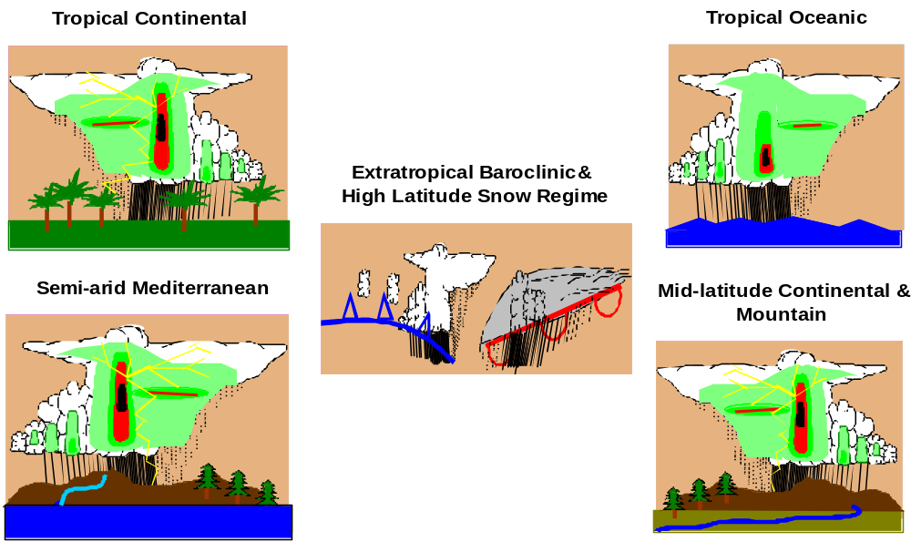

Figure 1: GPM’s GV strategy requires sampling selection of global rainfall regime.

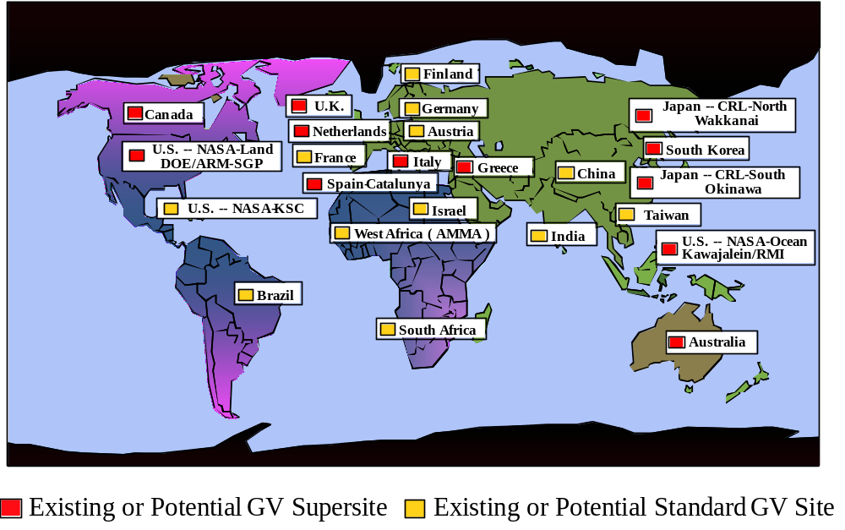

Figure 2: Current status of potential GPM ground validation site network.
The importance of a GV research program tailored for the GPM Mission stems from three basic concerns relevant to precipitation measurement. The first is measurement uncertainty and the need to quantify uncertainty in detail, so that users of GPM precipitation retrievals can interpret their research and applications results with all due caution and constraint. The second involves the natural inclination to continually improve the retrieval algorithms used to make the space-based measurements. This process cannot be done in isolation from independent precipitation datasets which are needed to assess algorithm performance, both physically and statistically, and at scales below those associated with the level 1 satellite measurements.

The third concern is associated with the need for continually improving the independent ground-based GV measurements themselves. Historically, ground-based measurements of precipitation have been beset with difficulties, whether they have been acquired from collection raingauges, optical raingauges, disdrometers, submerged acoustic phonics, non-attenuating radars, attenuating radars, long-wave Doppler profiling radars, or other more specialized sensors. Nonetheless, there have been impressive engineering innovations applied to ground precipitation sensors in the last two decades. Wide aperture raingauges with improved protection from wind effects, drop-counting raingauges, extended spectrum disdrometers, common aperture / multi-frequency Doppler profilers, and dual-polarization / dual-frequency radars are just some of the engineering developments that have produced more accurate ground-based precipitation measurements (e.g., Bringi and Chandrasekar 2001). Given this background, it is incumbent that ground-based sensors continue to improve. Moreover, for the GPM Mission to be engaged in improving global precipitation datasets, it should sponsor improvements in independent, ground-based measuring systems -- an issue that needs attrention within GPM’s International GV Research Program.

GPM’s International GV Research Program will require the deployment of a heterogeneous mix of measuring sites operating under a straightforward scientific strategy. Ultimately, participating organizations must represent their own self-interests and concerns. By the same token, the GPM Mission requires some degree of consistency across the eventual site network. GPM’s GV sites are classified into three types: (1) those sites which conduct their operations according to their own institutional requirements, while serving the greater science process by engaging in GPM’s scientific forums and publication processes related to GPM validation studies -- this first type of site is referred to as a “Standard GV Site”, designating that its responsibilities represent the baseline commitment to GPM, (2) those sites which, in addition to the responsibilities for a Standard GV Site, also routinely report information to the NASA/GSFC Precipitation Processing System (PPS) on a near-realtime basis and according to a standardized protocol, information needed to calculate continuous GPM precipitation retrieval error characterization (metrics for bias, bias uncertainty, and spatial error covariance at high spatial resolution ), and to support in a routine fashion an information exchange process with the PPS designed to enable continuous improvement of GPM’s standard precipitation retrieval algorithms, accomplished by detecting and reporting to the PPS significant algorithm failures associated with instantaneous satellite retrievals found in site overpass data that the PPS will routinely transmit to the given sites’s data processing system -- this second type of site is referred to as a “GV “Supersite” -- designating that it conducts routine GV data acquisition-processing-reporting operations using the standard PPS communications protocol for support of error charicterization and algorithm improvement processes which require near-realtime operations, and (3) collections of sites which intend to operate in a coordinated fashion under both Standard GV Site and GV Supersite modes, but enabling a diverse set of GV foci that enables the whole to greater than the sum of its parts -- this third type of site is referred to as a “Virtual GV Site”, designating that it is made up of a collection of individual sites which coordinate GV coverage of a region (a group of European Union nations are anticipated to operate in the Virtual GV Site mode). As evident from Figure 1, these three types of sites, if most or all participate, would provide excellent sampling of the variety of precipitation systems distributed over the Earth.

Thus, the design of GPM’s International GV Program provides for the participating organizations to deploy a heterogeneous network of GV sites on their own terms and with their own preferred instrumentation -- and in the event they agree to participate in GV Supersite mode, they would be required to transmit routine data to GSFC’s PPS needed for retrieval error characterization (i.e., error factors desired at forecast centers utilizing NWP rainfall data assimilation for optimizing the assimilation process), and needed for algorithm improvement. Because of the necessity for routine operations, GV Supersites would also be required to be affiliated with some type of on-site or remote-site Science Information Center (SIC). The resultant virtual SIC network would exchange data with the GSFC node of the PPS, receiving satellite overpass data from the PPS, while transmitting low bandwidth error characterization information and algorithm error reports back to the PPS -- all according to the standard protocol. Participating scientists and engineers at any of the sites would be invited, as a matter of course, to participate in GPM’s International GV scientific forums (plus other forums), and to communicate their relevant scientific findings through the open literature.

2.2 Principal Scientific Objectives of International GPM GV Research Programme

The main scientific objectives of the GPM GV programme are as follows:

- Evaluate and quantify error characteristics, uncertainties, and shortcomings in GPM precipitation products through variety of direct statistical and physical validation diagnostic methods, as well as modeling methods (e.g., environmental prediction using precipitation data assimilation, water budget analysis, climate model reanalysis) -- at data latencies desired by GPM’s GV client communities, to enable optimal use of GPM precipitation retrieval products for scientific research and applications.

- Improve GPM’s physically-based standard precipitation retrieval algorithms (designed for satellite radiometer and radar inputs) based on comprehensive ground observations of precipitation and precipitating storm systems used to provide algorithm error detection guidance -- fostering continuous improvement process by use of fluid and low latency data and information communications between GV Supersites and GSFC-PPS.

- Develop, archive, and make publicly available through Internet, standard GV data products applicable for GV research and for developing improved methodologies in conducting ground validation research -- and in so doing encourage creation of new GV technologies, emphasizing those that lead to higher retrieval accuracies, greater precisions, and ultimate greater understanding of precipitation’s physical processes.

- Encourage operational users to confirm usefulness of space-based precipitation products based on forecast verification testing, hydrometeorological prediction outcomes, agrometeorological modeling assessments, climatonomy descriptions -- and other model-based, climatological-based, or descriptive applications.

2.2.1 GPM’s Standard Precipitation Retrieval Algorithms

One important finding from the TRMM validation programme has been that simple comparison against conventional surface rainfall data, as derived from raingauges and scanning rain radars, is not sufficient for calibrating the TRMM algorithms or for discovering ways to improve the algorithms. In essence, measurements from space have improved so much that parameter tuning is no longer satisfactory. Instead, we need a physically-based validation programme for ensuring radiometrically consistent rain retrievals.

One of GPM’s primary standard level 2 rain retrieval algorithms will be for the DPR. Since Japan is responsible for the development of the DPR instrument, it will take the lead on development of algorithms applicable to DPR measurements. Notably, the standard level 2 algorithm itself, has not yet been completely specified and is still open to new ideas.

The DPR actually consists of two radars at Ku-band (13.6 GHz) and Ka-band (35 GHz). The GPM Ku-band radar will be nearly identical to TRMM’s Ku-band Precipitation Radar (PR), while the Ka-band radar represents new development. Several types of instantaneous rainrate profile algorithms are anticipated for development, as a function of the two different ground swath widths associated with the two distinct scan angles carved out by the two radars. One algorithm for the Ku-Ka narrow swath region will fully combine both radar’s reflectivity signatures. Another algorithm can be envisaged for the Ku-band width swath region which would include extrapolating Ka-band information outside its narrower swath. Other algorithms might consist of Ku-only, Ka-only, and perhaps a combined radar-radiometer algorithm involving both Ku/Ka-band measurements along with GMI measurements.

To support this effort, the GPM GV programme will be needed to assess the different DPR instantaneous rainrate estimates and to guide the algorithm developers in improvement of the baseline algorithms. In general, in comparison to microwave radiometer-based precipitation retrieval (for either surface rainfall or rainrate profiles), radar-based precipitation retrieval involves more direct formulations. Nonetheless, the DPR algorithms will involve a number of model parameters, the main ones being the bulk variables needed to describe the underlying drop size distribution (DSD). Using two co-aligned K-band radars which provide differential reflectivity, two parameters of the DSD can be obtained, e.g., N₀ and D₀ in an inverse exponential distribution. Other parameters related to make attenuation corrections due to water vapor and cloud droplets must be assumed in the algorithms. Accounting for heterogeneous beam filling effects also involves crucial physical assumptions. Direct validation of the associated parameters related to these various assumptions will require a different approach to that used by the TRMM GV programme, and places a greater burden on the GPM GV programme to enhance the types of sensors and their utilization in seeking to achieve physical validation of the GPM standard algorithms

The measurements required for validating GMI radiometer algorithms (and for other GPM microwave radiometers) are likely to be similar to those required for validating the DPR algorithms. However, more emphasis will be needed on describing the detailed 3-dimensional microphysical structure of the precipitation, including: phases and habits of the precipitating hydrometeors (e.g., cloud droplets, rain droplets, pristine crystals, snow crystals, ice aggregates, graupel/hail particles, and melting ice particles), size distributions of these hydrometeors, water vapor distribution, and the distinct boundaries of the cloudy and raining regions. Rain radars (at S-, C-, X-, and K-band) with polarization diversity and cloud radars (90 GHz) will be able to provide essential information on some of these parameters. Doppler wind profiling radars have the potential to derive DSD information aloft concerning the larger liquid and ice hydrometeors. Knowledge of surface thermometric and radiometric conditions is also important in radiometer-based retrieval. There is an analogous surface issue for the DPR algorithms because they will require alternative knowledge of the path integrated attenuation (PIA) via the Surface Reference Technique (SRT). For a 2-radar system, the surface reference technique (SRT) becomes more complicated, albeit very useful information in the development of dual-frequency SRT algorithms can be provided from SRT data already gathered by TRMM. To validate the new SRT algorithms, independent near-surface measurements of the surface backscattering cross sections under both rain-free and rainy conditions will be needed.

It is emphasized that surface observations of rainfall from dense raingauge networks, disdrometers, and scanning ground radars will continue to be needed. However, to go beyond what has been already accomplished by the TRMM GV programme, more accurate spatial and temporal matching of ground and space observations will be needed, better calibration monitoring of the gauges and radars will be needed, and better methods of combining the ground measurements based on their respective strengths will be needed . In order to upscale the GV observations in both space and time, certain GV sensors, particularly the dense raingauge networks (and relevant disdrometers), any higher frequency X- and K-band scanning ground rain radars, and any Doppler profiling radars, must be embedded in the larger domains associated with the lower frequency S- and C-band scanning ground rain radars and/or the wide area/low density raingauge networks.

Validation of snowfall retrievals over continental landscapes, particularly for dry snow, is another important GV issue. Even on the ground, obtaining snowfall water equivalence observations with ground sensors is difficult. Thus, one or more “Snow Supersites” will be needed. Notably, estimation of wet snowfall over ocean, which is considered a more tractable retrieval problem, has been a difficult with TRMM measurements. Thus, newer retrieval methodologies for the GPM Mission will be required.

For microwave radiometer-based rainrate profile retrievals, one evolving methodology involves “type/regime characterization” of precipitation systems dependent on a cloud resolving model (CRM) producing radiometer brightness temperature synthesis using a coupled microwave radiative transfer model (RTE model). For this algorithm approach, the global diversity of the GPM GV site network will become the most important factor.

Finally, it should to be recognized that the validation of 3-hourly rain maps, assembled from measurements obtained from the various constellation satellites, will require a different GV methodology than appropriate for instantaneous rainfall products produced by the DPR and GMI, plus the other microwave radiometers. In the case of TRMM, comparisons with blends of ground and satellite data (such as GPCP products) were performed. Presumably, an analagous approach will be needed for the GPM Mission.

2.2.2 NWP as GV Evaluation Tool

Improvements made during the last decade to the quality of forecasts produced by numerical weather prediction (NWP) models in operational and experimental meteorological centers have been the result of several factors. Greater computing resources have enabled increased horizontal and vertical resolutions and therefore have allowed a better description of small-scale processes such as cloud and precipitation formation. Another factor has been better specification of initial conditions to start both deterministic and ensemble forecasts. The definition of “best” initial state of a NWP model is performed in operational centers within a data assimilation system. The role of a data assimilation system is to optimally combine short-range forecasts (typically between 6 and 12 hours) and meteorological observations covering a 6 to 12-hour window. This analysis provides an improved description of the state of the atmosphere on the model grid at a given time. Based on these techniques and the concomitant increases in data, forecast skill scores on large-scale dynamical fields (such as geopotential height at 500 hPa) have been significantly improved during the recent years, particularly in the Southern Hemisphere (Simmons and Hollingsworth 2001).

The assimilation of observations related to the water cycle in cloudy and rainy regions can provide improved initial humidity fields that can lead to improved forecasts of clouds and rain. This is associated with the dominant role of latent heat release produced by cumulus clouds on tropical dynamics and on extra-tropical severe storms. A major challenge for data assimilation originates from the high spatial and temporal variability of clouds and rain, since current systems are designed for atmospheric variables having larger spatial scales (>500 km) and lower temporal variability (>6 hours). Despite these limitations, the assimilation of precipitation observations has been under investigation during the last twenty years.

With the advent of 3D and 4D variational assimilation systems, it is now possible to include rainfall rates in the analysis like any other kind of observation -- despite the more complex cloud and rain microphysical processes that are involved. For example, the National Centers for Environmental Prediction (NCEP) has recently introduced operationally an assimilation of satellite derived rain rates from SSM/I and TMI in their 3D-Var system. Along the same lines, ECMWF is developing a methodology to allow the assimilation of precipitable water in rainy areas in their 4D-Var assimilation system. A number of preliminary studies (e.g., Marécal and Mahfouf 2002) have demonstrated that analyses and forecasts can be improved by assimilating such information from either retrieved rain rates (Mahfouf et al. 2003), or directly from observed microwave radiances (Moreau et al. 2003).

With this background, it is evident that a NWP system (dynamical model, physics packages, and data assimilation scheme) offer several ways to evaluate the quality of precipitation data:

- Direct comparison of model fields with observations since model fields are obtained from consistent global physical process modeling and constrained by large observational data volumes.
- Improvement of analyses when satellite radiometer-based cloud and precipitation data are assimilated:
- directly, through comparison with standard validation measurements (e.g., from raingauges, ground-based radars, spaceborne radars);
- indirectly, through comparison with other cloud/rain-related observations (e.g., infrared and/or passive microwave radiances).
- Improvement of forecasts when cloud/precipitation data are assimilated:
- globally, with forecast skill scores of key meteorological parameters;
- regionally, with event-related evaluations (e.g., referring to tropical cyclone track forecasts).

2.2.3 Hydrometeorological Modeling as GV Evaluation Tool

Hydrometeorological modeling refers to quantitative precipitation modeling (QPF) and its application to land hydrometeorological models. In using this type of modeling for GPM GV purposes, the following approaches are recommended:

First, a cloud-resolving atmospheric model (CRM), i.e., a primitive equation model using nonhydrostatic dynamics and detailed physics, particulary for: (a) boundary layer flux and turbulence processes, (b) solar and infrared radiative transfer and heating/cooling rates, and (c) explicit cloud microphysical processes, is used to assimilate surface/upper-air satellite-based and/or radar-based precipitation measurements -- or latent heating estimates derived from these measurement.

Second, a physically-based and detailed land hydrometeorology model (HYDROMET) is used for estimating hydrological responses to precipitation (such as soil moisture build up, evapotranspiration, runoff, and other canopy/soil water storage and exchange processes) over selected catchments utilizing detailed digital soil type/texture and land-use/land-cover information.

Third, the simulated rainfall accumulations from the coupled CRM-HYDROMET model over various integration periods are validated against surface measurements of hydrological variables including precipitation and stream discharges. Such an example is shown in the diagrams presented in Figure 3 for two rainfalls events from Supertyphoon Herb (1996) and Typhoon Nari (2001) over the Reservoir Shiehmen catchment in Taiwan. Once a validated and accurate CRM-HYDROMET modeling system is developed using the above recommended approaches, it can be can applied over different catchments, ultimately using in situ hydrological measurements to validate GPM rainfall, hydrometeor profiles, and latent heat generation. The validated modeling system can, in turn, be used with GPM precipitation as inputs to better estimate hydrological cycle processes within the selected catchment. The validated modeling system can also be used for QPF and other related hydrological applications such as flood warning and water resources management.

2.3 Organizational Structure

To achieve the above objectives, we need coordination between a widespread body of research and operational organizations. In addition to the routine observational programs being managed by a diversive set of meteorological and hydrological agencies, a number of national and multi-national precipitation system study projects are planned or are already underway. We should encourage and coordinate information and data exchange between these programs and projects with repect to the GPM GV programme which will be responsible for management of information/data exchage vis-à-vis GPM’s network of GV sites, according. This process should be conducted within a well-defined international framework.

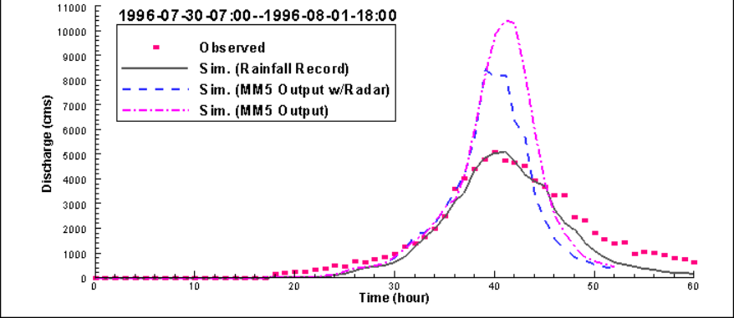

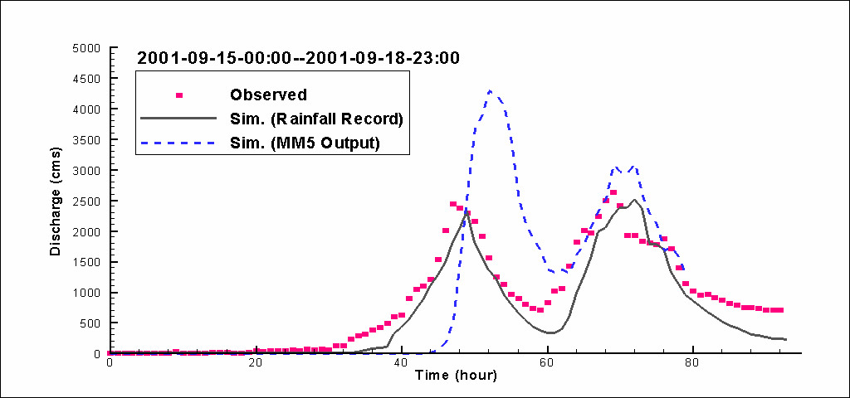

Figure 3: Lifecycles of observed and simulated rainfalls events for 1996 Supertyphoon Herb (upper diagram) and 2001 Typhoon Nari (lower diagram) over Reservoir Shiehmen catchment in Taiwan.

One approach to achieve the desired coordination is to form an international GV Coordination Working Group within GPM’s international framework. This group would oversee:

- management and coordination of information/data exchange between precipitation-related observational programs and projects, and GPM’s GV programme including its network of GV sites
- identification and summarization of advantages and deficiencies in all observations used for GPM validation purposes
- development of effective mechanisms for direct interactions with GPM algorithm developers
- creation of GPM GV data management and data dissemination policy
- definition of effective communications protocol for data exchange between GPM GV sites

2.4 GV Measurement Requirements

It is anticipated that data collected by international partner GV sites will be used for multiple applications in GPM ground validation. These applications will include evaluation of satellite estimates of such phenomena as: (a) precipitation existence, (b) surface rainfall accumulation, (c) vertical structure of rainrate, (d) vertical structure hydrometeor densities and DSD properties, (e) precipitation type (i.e., rain, snow, melting ice), (f) relative pattern of precipitation intensity, and (g) vertical profile of latent heating.

The greatest bandwidth of GV data will come from scanning S-, C-, X-, and K-band radar observations, however many other lower bandwidth but important GV observations will be produced, including measurements from: (a) raingauges, (b) disdrometers, (c) radiosondes, (d) instrumented towers and ballon-sondes, (e) various upward-viewing radiometers, high-frequency radars, and Doppler profiling radars, (f) ceilometers and sky cameras, (g) downward viewing K-band radars, and (h) other specialized observations. Analyses and short-term forecasts from NWP models will provide estimates of 4-dimensional temperature, humidity, and winds -- plus other key 4D model outputs. Each individual partner GV site would be expected to acquire its own specific combination of GV datasets, and then be prepared to contribute those data and data products they have approved for release for general use, rather than prescribe a "one size fits all" specification for the GPM GV programme.

Specific information concerning the GV datasets, including details of the instrumentation, spatial and temporal sampling characteristics, calibration or other conversion factors, analysis or averaging schemes applied to the data, and etc., will be required to use these data effectively and accurately by the user community. Recognizing that any of the GV data are, at best, only estimates of the true physical state, one additional requirement will be that the GV data be accompanied by reasonable descriptions and estimates of their known error characteristics.

We recognize that the absolute calibration of GV data, particularly radar reflectivity and differential reflectivity variables, may be revised after data are collected and recorded. It is recommended that partner sites send detailed records of calibration estimates to the GPM GV archive and stabilize and automate calibration to the degree possible. It is also recommended that GV products minimize dependence on absolute calibration values.

In order to maximize the utility and flexibility of the archived GV data, the data need to be available in a format that facilitates processing and reprocessing for diverse applications by many investigators over a period of years. It is recommended that the radar data be available in a polar coordinate format that preserves information on the azimuth angle relative to true north, elevation angle, and range gate spacing. Data should be archived either in a public domain format or a format that is readily transferable into a public domain format.

Data of greatest interest to the GPM GV programme falls into several categories:

- data obtained during any precipitation event,
- data obtained during overpasses of GPM Core or Constellation Satellites,
- data obtained during overpasses of GPM Core or Constellation Satellites -- with precipitation.

It is important to note that many overpasses will not have coincident precipitation events and many precipitation events will not have coincident overpasses. The most valuable subset of data for GV is represented by category (3) which is the intersection of categories (1) and (2). A satellite overpass is nearly instantaneous and represents a snapshot of a precipitation event. The next most desired category of data is category (1) which will provide information on regional precipitation climatology, storm structure, evolution, and satellite temporal sampling errors. It is anticipated that a subset of precipitation events, such as those that lead to flooding, may be of high joint interest among the GPM GV partners. The types of high interest precipitation events need to be identified in collaboration with the international partners and prioritized for storm duration data collection. There is also value to GV in the subset of overpasses without precipitation since the unambiguous absence of precipitation can help constrain satellite algorithm parameters pertaining to precipitation existence.

To be considered as an international partner GPM GV site, it is recommended that at minimum the site contribute operational radar and on-site gauge (rain/snow) data to the archive with at least 80% availability. It is recognized that information from research radars will have lower availability, depending, for example, on the degree of automation of data collection, levels of funding and competing requirements. It is recommended that, as a minimum, category (3) data should be available from research radars for at least 50% of significant events.

Ideally, the partner operational radar and on-site raingauge data sets are to be deposited at the designated archive within 48 hours of data collection to allow for rapid tuning and/or monitoring of the performance of the space measurement. Near realtime GV data usage, such as space-ground real time synergy, will require near realtime GV data delivery. Other sources of GV data, for example, raingauge observations from national cooperative networks and data from research radars, may not be available so quickly, although partners should strive to submit supporting GV data within a 2-week time frame. Some delay may be acceptable for the off-line validation or parameter tuning in the algorithms. It would be valuable to set agreed and realistic targets for delivery of data, tailored to each site and dataset, so that the user community can have a reasonable expectation of when data will become available. For consistency among sites and with WMO data sets, all GPM GV data sets should utilize UTC time and metric units.

2.5 GV Data Policy

It is recommended that the data policy for the GPM GV Programme should abide by the following three requirements:

- GV data should be made available to research community.

It is understood that each country/organization/agency has its own data policy, background, and operational constraints. However, an open data policy is essential for the maximum utilization and improvement of the space data. The GPM data will be global in nature, and thus validation in many regions and countries will be important. Currently, discussion for the Global Earth Observation (GEO) summit is underway. There, the open data policy has been strongly promoted.

- Delay of GV data transmission should be minimized.

- Level of availability of GV data requires further discussion.

For example, full volume scanning radar data are generally required. However, some facilities may have difficulty in providing this type of data because of limiting constraints such as manpower shortage. Some agencies may not have enough financial support for continuous GV data acquisition and data processing. Operational agencies may provided for continuous GV operations while research organizations may have difficulties in providing this service. All of these issue will require futher deliberation during future International GPM GV Workshops.

2.6 Multi-National, Multi-Regional, & Multi-Agency Sites
2.6.1 Concept of Virtual GV Site

[In progress.]

2.6.2 European Virtual Supersite

Due to the political structure in Europe there are several national or regional weather services, research agencies and universities. Various sites are operated in Europe which are suited for ground validation in the scope of GPM and the European contribution EGPM. In addition weather radar networks are operated in all countries and data are exchanged within Europe. Europe offers a wide range of different climatic zones and precipitation systems ranging from deep convection to baroclinic frontal systems and snow regions.

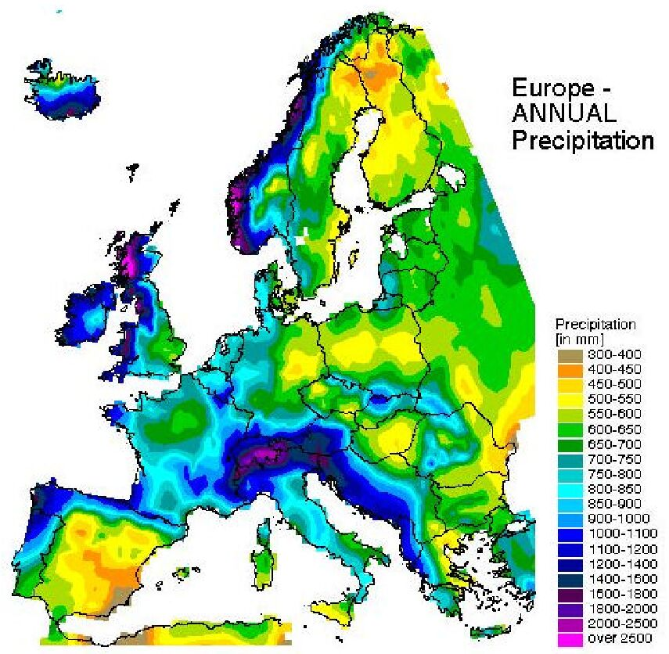
Currently several institutions have shown interest to participate with their observational sites to the the GPM and EGPM programme (see Figure 4). These sites are equipped with excellent instrumentation. However, not all of the sites can offer a complete set of instruments as would be anticipated for a supersite. Financial constrains can limit upgrading of the sites. Currently no transnational instrumented observation sites are planned. Also, not all of the proposed sites are located in regions where precipitation is observed with sufficient frequency during the year. It will be not possible with the individual sites to cover all of the required features necessary for a physical ground validation within GPM and EGPM. It is expected that the sites have strengths in some points and will be able to provide sufficient information for the retrieval of the error structure for specific precipitation situations and climatic conditions.
Chilbolton
Cabouw
Bonn
Palaiseau
Oberpfaffenhofen
Rome
Catalunya
Graz
Sodankylä
Figure 4: Identification of potential GPM GV sites in Europe creating EU Virtual GV Supersite.

In order to benefit from the research strengths of the existing instrumentation as well as the scientists associated with the programmes, the best strategy toward a ground validation program would be an integrated approach where all these ground validation sites are tied together to a distributed or virtual ground validation supersite.

The concept of a distributed or virtual supersite will be based on a networking infrastructure, both physical and organizational. Physical networking consists of the exchange of data and routines. It is envisaged to exchange instruments for calibration and intercomparison campaigns. Several institutions operate mobile radars and other instruments. Those instruments and radars should be available for focused observation campaigns at any of the existing sites or in other regions of interest. These could be areas or precipitation systems where the determination of the complete error structure is not possible with the existing instrumentation. Organizational networking means a structure where the participating site mangers, the national weather services and GPM and EGPM representatives will be presented. This network and the respective steering committee has the task to coordinate the activities within the European sites. It should be envisaged that financial resources will be available through European agencies and their supporting programmes. Besides keeping an inventory of available instruments and their quality, it will be necessary to monitor the error structure at each of the sites. Recommendations for measurement strategies, further instrumentation, coordinated projects and field campaigns will be made by the committee on the basis of the observed error structures or scientific needs. Field campaigns will also be necessary to gain sufficient information about the quality of operational weather radar networks. Currently each service runs different scanning strategies and data evaluation algorithms. The combination of weather radar networks essentially covers the whole of Europe. Monitoring their quality at the supersites will considerably increase the potential area for ground validation.

In summary the concept of a distributed or virtual supersite will increase the observational area and thus increase the number of satellite overpasses for various regions and precipitation systems. Through the networking activities it will be possible to provide a maximum of information even though not all sites are fully instrumented.

2.6.3 NOAA Hydrometeorological Testbed Program

[In progress.]

2.6.4 DOE-ARM Southern Great Plains Site

The Department of Energy’s Atmospheric Radiation Measurement (ARM) program (www.arm.gov) operates Climate Research User Facilities (CRUFs) to study the effects of clouds on global climate change. The largest and best-instrumented ARM CRUF is located in the Southern Great Plains (SGP) of the United States. The SGP ARM CRUF, which is the largest and most extensive climate research field site in the world, consists of in situ and remote-sensing instrument clusters arrayed across approximately 55,000 square miles (143,000 square kilometers) in north-central Oklahoma. The heart of the SGP site is the heavily instrumented Central Facility located on 160 acres of cattle pasture and wheat fields southeast of Lamont, Oklahoma. The central facility contains state-the-art cloud profiling remote sensors, an extensive array of surface radiation sensors, and a wide variety of sensors that provide supporting information about the local atmospheric state. Boundary and extended facilities that contain subsets of the central facility information are distributed over the balance of the ARM SGP CRUF. The ARM SGP CRUF lies within the Arkansas Red River Basin and contains two smaller, experimental watersheds that have been used in past hydrologic studies: the Little Washita (operated by Department of Agriculture) and the Walnut River Watershed.

The ARM SGP CRUF will be used to study precipitation processes and feedbacks in support of the NASA GPM G/V program. Techniques have been developed by ARM that enable the data from multiple sensors (passive and active) to be combined to form best estimates of the location of clouds within the column and the entire ARM CRUF domain. These data are used to produce estimates of the microphysical and radiative properties of the clouds. In the latter case, ARM currently produces estimates of the Broad-band Heating Rate Profile (BBHRP) for the column above the central facility and the entire SGP site. These heating rate profiles help quantify radiative feedbacks between clouds and larger scale circulation, and between radiation and precipitation processes.

Evaluation of the atmospheric water budget, including precipitation, over SGP ARM CRUF requires information about the large scale forcing in the region. This forcing can be estimated using variational analysis techniques developed by ARM, which are now operational. The variational analysis product quantifies water vapor concentration and distribution, as well as advection, along with a wide variety of additional forcing information. These analyses are necessary to achieve closure in the atmospheric water budget, which is essential for precipitation process research.

Contained within the ARM SGP ACUF is the Atmospheric Boundary Layer Experiment (ABLE) site. The ABLE site is well suited for NASA GPM studies because it routinely operates a set of atmospheric instrumentation in the Walnut River Watershed (WRW). The WRW has an area of about 75 km by 100 km, which is two orders of magnitude smaller than the ARM SGP site. It is a sufficiently small, nearly closed catchment basin containing a moderate level of ecosystem diversity, which is amenable to computing many of the components of the hydrological budget. ABLE has supported two major field campaigns on boundary layer meteorology by the Cooperative Atmosphere-Surface Exchange Study (CASES) consortium of scientists (LeMone et al. 2000). Instrumentation operated routinely for DOE at the ABLE site includes a network of rain gauges, surface energy components at two locations, soil moisture profiles in several locations, net ecosystem exchange of carbon at an Ameriflux site, and boundary layer radar wind profilers at three locations. While the ABLE site is somewhat removed from the ARM CRUF central facility, it is a valuable source of additional information for NASA GPM G/V activities.
In summary, the ARM SPG CRUF provides a unique opportunity to extend NASA GPM capabilities through validation and process research. ARM is well equipped to contribute significantly in both areas.

2.7 GV System Design
2.7.1 Copyleft and GNU General Public License

GPM GV partners have many activities in common. Similar types of observations are recorded, converted into common formats, quality-controlled, and processed into end-user products. If freely available, some existing software could either be used as is or adapted for many GPM GV applications. A mechanism is needed to facilitate the use and modification of source code among partner facilities while preserving the rights of the program’s authors.

Uncopyrighted source code can be shared and improved upon but has the disadvantage that anyone can make a few changes to it and then convert the program into a proprietary software product.

Copyleft is a general method for making a software program into free software and requiring all modified and extended versions of the program to be free software as well. A program that is copylefted contains a copyright statement by the author and distribution terms. The distribution terms constitute a legal instrument that gives everyone the rights to use, modify, and redistribute the program’s code or any program derived from it but only if the distribution terms are unchanged. As part of the terms of the license, the source code must be freely available for use, modification, and redistribution.

The GNU General Public License (http://www.gnu.org/copyleft/gpl.html) is a specific means of implementing copyleft. GNU provides distribution terms text for insertion into source code to implement the General Public License. The distribution terms text remains in all subsequent versions of the source code. Modified files must also contain prominent notices stating the author and date of any change.

An existing software library package, the TRMM Office Radar Software Library (http://trmm-fc.gsfc.nasa.gov/trmm_gv/software/rsl/index.html), contains general functions for reading, writing, and manipulating radar data. This package is published under the GNU General Public License and is the foundation of many TRMM GV product algorithms. Other groups are encouraged to copyleft their software to facilitate exchange and adaptation of source code among GV partners.

2.7.2 Validation System Design & Integration: International GV Perspective

A. Introduction: Development of the Ground Validation system from “System Engineering” principles enables, a “top down“ flow of requirements into the GV system. These can be traced to the formulation of the GPM mission within the context of the Global Water and Energy Cycle. The key elements of the GPM program that will provide the driver for the GV system are essentially the “mission goals”.

The purpose of this section is to develop international GPM-GV system design methodologies so that it fits well within the overall GPM system. The term “ validation” itself is a key aspect of system engineering “ termed System Validation”. Thus the ground validation program can be readily seen as satisfying one of the key elements of the system engineering principles for the GPM system.

Validation can be seen either as a subsystem of the GPM system or an “ important system engineering process” for the GPM, because every system has to be validated. In order to develop the design aspects of international GV so that it satisfies both aspects, several system engineering terminologies are defined in the GPM-GV context. In addition the GPM-GV system should be designed to provide the latitude needed as part of any scientific discovery process. Just as the GPM mission, the GV part of it also may envision many scientific discoveries and technical developments.

The GPM-GV system is an assembly of elements such as remote sensors and in-situ devices to realize the overall “ validation function” that could not be achieved by an individual element alone. Each element of GPM-GV may satisfy an individual requirement, but the overall system provides the “ collective action” of system validation. We should be able to develop “ minimum set of “ elements necessary along with desirable properties for risk mitigation. Development of GPM-GV system should include:

- definition of exact functions to be performed by system as dictated from GPM system,
- examination of ability to perform system function, accounting for physical limitations, availability of resources, and capabilities,
- development of GPM GV system architecture and define hierarchy of subsystems,
- definition of procedures that can be used to test functionality,
- system integration.
- demonstrating required performance and operation of system throughout its life, including maintenance and upgrades.

B. Essential Features of GPM-GV System: The essential features of the GPM-GV system can be divided into four parts namely:

- System Function Definition: These include our current determination of what we want the GPM-GV system to do. These lists can be constructed from the GPM system goals. List of such functions are as follows:

i. validation of GPM as a system that can be done from ground, such as GPM sensor system calibration,
ii. validating and assisting GPM in quantifying space-time variation in rainfall, relationship between rain microphysics/latent heating/DSD properties,
iii. validating and assisting GPM in accurate, precise, frequent & globally distributed measurements of instantaneous rainrate & latent heat release,
iv. validating and assisting GPM in error characterization of precipitation retrievals,
v. validating and assisting GPM in frequent sampling & complete continental coverage of high resolution rainfall measurements including snowfall, hazardous flood forecasting and fresh water resources prediction.

- Communications: The communication aspects of the GV system specially establishes the protocols of who communicates with who. Is there inter-site or inter-process communication? Protocols as to GV system communications with GPM satellite algorithm system, as well as communication between GV sites and hierarchy of subsystems are established here. Data communications is a very important part, especially for the international aspects of the GV programme.

C. Requirements Development and Users: The international GPM/GV system is created to meet the goals of the GPM system. Establishing the requirements is a “ crucial step” in the process. Users of the GV system include, the main GPM system, the scientific community and the GPM-GV site scientists. A user is anyone who plays role in any stage of the life cycle and not just the end user. In addition because of the scientific nature of the GPM mission, the requirement document for GV subsystem needs to be fine tuned as the needs of the global partner communities, and scientific understandings change over time. The architecture of the GPM-GV system needs to be able to accommodate these changes. There is a separate requirements document being prepared for GPM-GV. The requirements can be broken up into different levels as described below.

Special international considerations in the GPM-GV requirements process, such as environmental, political and competitive factors. If these need to be considered they must be included in the requirements document. Examples may be U.S. GPM-GV will not be able to accommodate more than two sites. Additional example can be EU GPM GV site will be a distributed site.

The following categories of function requirements, stipulated with international GPM GV in mind, would help ensure most of the lower level detailed requirements are captured:

- Performance Defining What GPM GV System Must Do: This requirement must come from goals where functional requirements could form level 1 system requirements. Suggested set of these requirements for GPM GV system are as follows:

i. make measurements to assist in validating and refining physical formulations used for satellite algorithms,
ii. provide error characterization of precipitation retrievals,
iii. make better measurements of local precipitation than satellite,
iv. observe space and time characteristics of precipitation at local scales better than satellite,
v. assist in validating microphysical and DSD assumptions in retrievals and models,
vi. assist in validating full scale observations of continental rainfall and snowfall,
vii. assist in validating hydrometeorological applications such as flood forecasting.

- Special Constraints: These requirements may include ensuring coverage to, say, continents, oceans, and mountainous regions. They may also include ensuring measurements of both rainfall and snowfall.

- Interface Requirements of International GV Programme with rest of GPM: These requirements will ensure that GPM GV ‘s role in issues such as algorithm development are being made part of system design process.

- Ease of User Access: These requirements would be used to define data access -- communications again being able to trace to system goals. For example, it should be straigthtforward to check if functionalities are being met.

- Life Cycle: These requirements could specify, for example, when international GPM GV sites must start operating.

D. International GPM GV System Architecture: Establishing the architecture is perhaps the most important process in addition to establishing requirements, in development of the GPM GV system. The architecture building is typically a visionary and creative process, that ensures all future changes can be implemented without fundamentally breaking the architecture. The architectural design creates the form of the international GPM GV system. There are a few important features that must be envisioned in the GPM-GV system architecture as given below:

- integration of heterogeneous remote sensor and in situ data from around globe,
- incorporation of theoretical information principles in distinguishing and assimilating multi-sensor environments; as example, information from single raingauge in isolated area may be more important than information from similar raingauge co-located with radar,
- developing strategy how subsystems should interact, thereby defining communications architecture,
- modularity for upgrades,
- reliability and risk.

The precipitation measurement systems in the earth domain (as opposed to space) include, ground based and airborne radars, in-situ measurement devices such as disdrometers, rain gages and airborne measurement probes. In addition airborne radars are also available for precipitation measurement. Based on the technical expertise developed in traditional disciplines, these observations could be divided into “ horizontal thrust areas” such as remote sensing instruments, in situ observations, cross-platform simulation and modeling, and outreach. The international GPM GV super sites can then be seen as “vertical integration” sites across the thrust areas. Such a “cross discipline” integration will be an important task of a GV Supersite manager (that encompasses, all three parts . This process also defines a GV Supersite that should perhaps do all four parts. A GV Supersite could be defined as one that addresses all functionalities listed above. Figure 5 schematically illustrates the horizontal thrust areas (classical disciplines) and vertical integration of these thrust areas at four hypothetical GV Supersites, while Figure 6 schematically illustrates a tentative GV architecture.

2.8 Web Site for International GV Coordination

As discussed earlier, the primary ground validation of GPM products will make use of observations of precipitation and related quantities from a number of well instrumented "super-sites" located in several countries around the globe. The detailed ground validation work will be done by the organizations providing the GV data, that is, in a distributed rather than a centralized fashion. The GV data will be openly available to the GPM community, so theoretically any center could validate satellite products using data from other sites. Realistically speaking, centers would most likely focus their efforts primarily on their own validation site(s).

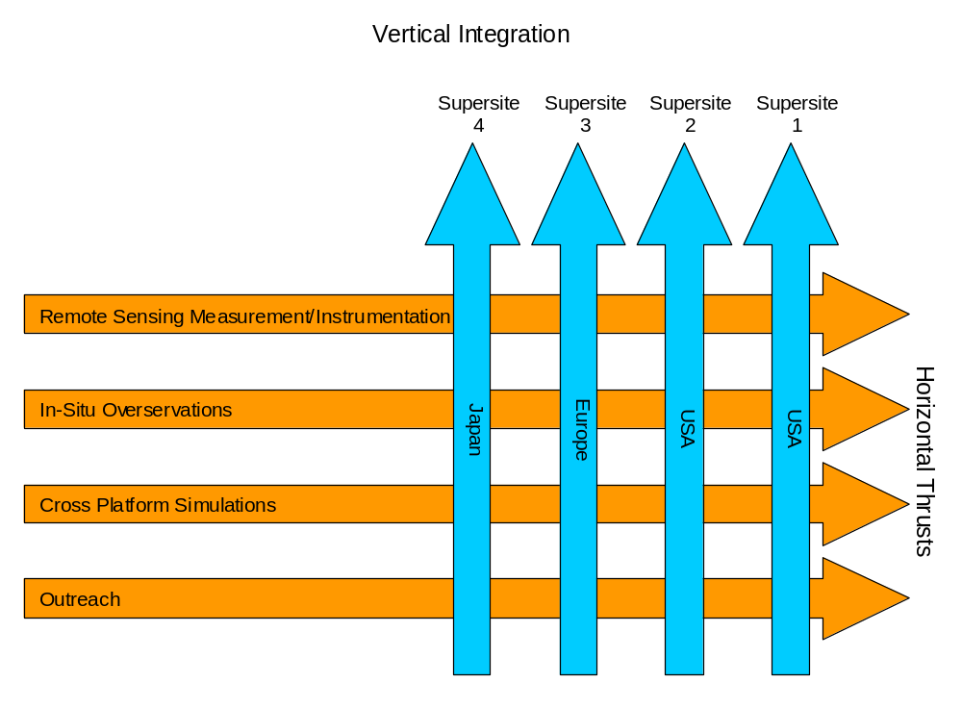

Figure 5: Technical discipline areas and vertical integration of these activities at GV Supersites.

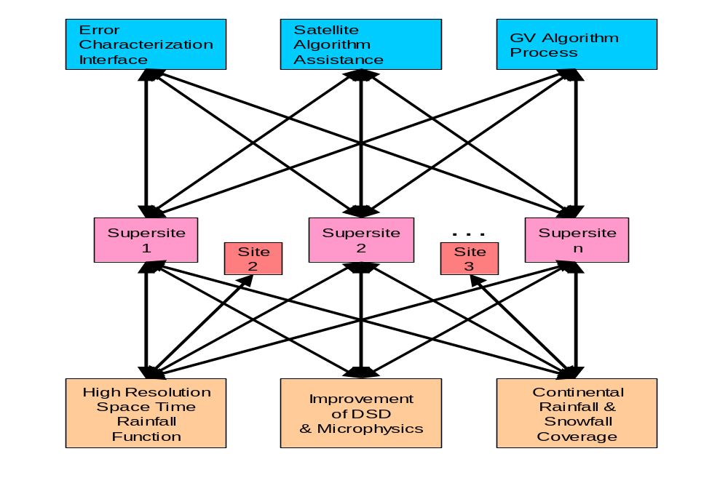

Figure 6: Architectural overview of GPM and suggested GV architecture.
The experience of the TRMM ground validation program was that it was not possible to enforce a set process for calibrating GV data and conducting identical satellite product validation at all sites. No two sites were exactly the same, and so different validation methods were employed in different places. This will also be the case for GPM GV. Rather than prescribe some "lowest common denominator" product generation, we believe it is better to let each center produce its own optimally calibrated and quality-controlled reference data, and use these to evaluate the GPM satellite products.

Given the distributed nature of GPM GV, there is a need to coordinate and assemble the GV results from various international sites into a larger view. Ideally, these results could be accessed via a GPM GV "Validation Central" web site that would not only give an overview of the performance of the GPM algorithms and products across the range of GV sites, but also provide a forum for discussion of the results.

Advantages of such an international GV web site would include:

- algorithm developers, GV providers, and GPM product users would be able to get "big picture" concerning GPM performance,
- information concerning GPM performance across variety of precipitation regimes would help ensure that satellite products are used appropriately,
- results would be shared much faster than normally possible via international meetings,
- errors would be detected and fixed more quickly,
- broader discussion of validation results would enable greater improvements in satellite algorithms, and possibly also in reference data,
- GV scientists would easily view and share validation methods,
- GPM would be ensured improved visibility and accountability.

3.0 Working and Summary Group Reports (De-tersed)
3.1 Working Group Reports
3.1.1 WG#1a: Retrieval Error Characterization

Team
E. Ebert (Chair), T.L’Ecuyer (Raporteur), [remainder to be compiled]

A. What is meant by "error"? The total error of GPM products will have contributions from temporal and spatial sampling errors, precipitation detection errors, and algorithm errors. The GV program will make use of research done for TRMM and other programs to try to quantify the relative contributions of each type of error.

The actual satellite error is further augmented by a component due to errors in the reference data itself. It will be difficult, maybe impossible, to untangle the error in the reference data from that of the satellite estimates. The GV program must supply uncertainty estimates not only for the satellite estimates but also for the reference data itself, and provide detailed information on how the uncertainty estimates are derived.

B. Error characterization requirements: While the working group did not wish to specify a list of particular validation statistics, we did discuss some fundamental requirements for particular user groups. At the most basic level, precipitation detection errors must be quantified in terms of critical thresholds and frequency of occurrence.

B.1. Error characterization requirements for climate research: involve estimates of bias errors. The imperfect quality of the GV data may not allow us to say whether low amplitude behavior of satellite estimates (long-term trends, for example) are reliable. Research will be needed to determine the temporal and spatial scales for which bias estimates are possible.

B.2. Error characterization requirements for data assimilation in NWP models: involve estimates of random errors (+/- σR) in the satellite products (which could be rain rate, brightness temperature, reflectivity, liquid water content, etc., depending on how the assimilation is done). In particular, this means estimating the diagonal and off-diagonal elements of the error covariance matrices. The GV program will address this requirement by computing the error covariance structures at GV sites and exporting those estimates to a more global scale using the combined DPR and GMI observations. The question remains as how to best extend these error estimates to the radiometers on the constellation satellites.

B.3. Error characterization requirements for nowcasting: involve estimates of occurrence of extreme (unacceptable) errors.

B.4. Finally, error characterization requirements for algorithm developers: were acknowledged to be very complex but were not discussed in detail, as the group ran out of time. Algorithm developers will need to work closely with GV providers to ensure their needs are met.

C. Stratification of error characterization results into homogeneous subsets: according to (for example) latitude bands, season, land/ocean, and storm type will help provide more robust estimates of spatially and temporally varying uncertainties.

D. Particular topics where GV can make big difference: In addition to "standard" validation, there are some areas where GV can make a big difference in improving the quality of GPM products. One would be to establish the limits of the sensors for precipitation detection (e.g., what is the sensor's sensitivity and how does that depend on the spatial and temporal resolution of the data or product?). The GV program should be able to characterize the low-rainrate end of the rainfall distribution and its regional distribution (through surface and remote instrumentation and CloudSat). GV data will be particularly useful in the evaluation of GPM products for extreme events, the evaluation of rainfall spectra, and the characterization of multi-scale variability. It can also provide information for use in the satellite algorithms e.g. a priori databases, physical assumptions such as DSD, freezing level, beamfilling, etc.

E. Processing and dissemination of error information: The detailed local error characterization will be done on a site by site basis by GV participants, while the Precipitation Processing System (PPS) will be responsible for applying the global error characterization model(s) to the full GPM satellite dataset and supplying the error estimates to the end user.

F. GV data latency: Timeliness of the GV data and error characterization is an important issue. The more quickly these become available, the more effective they will be for the algorithm developers and GPM product user community. Is basic-level near-real-time (days or even hours) GV possible or practical? If so, errors detected by the GV processing could be used as an early-warning system for satellite (or GV) product quality. More detailed error analysis products would not be subject to such stringent timeliness requirements.

3.1.2 WG#2a: Regional Mapping of GV Error using Supersite Network

Team
M. Hagen (Chair), R. Cifelli (Raporteur), [remainder to be compiled]

A. Error transfer from local to regional scale: The topic of this working group was the discussion of the question: “How can we transfer the error assessed at a supersite to sites outside the radar range?”

B. Precipitation classification: It was agreed that one solution could be the classification of precipitation in a number (say 20) different types. The classification based on precipitation types seems more appropriate than a classification based on climate regimes. Precipitation types are defined by instantaneous observations, whereas climate regimes are defined on a long-term basis. If the error characteristics have been studied for a given precipitation type at a supersite it is assumed that the error characteristics for that type can be transferred outside the supersite range. Further validation will be performed at other ground validation sites observing the same precipitation type in order to verify the error characteristics. It is not expected that any supersite can observe all precipitation types. Therefore, additional field observing programmes (FOP’s) can be initiated to determine the error characteristic in other regions not covered by a supersite. FOP’s can also be used to redefine precipitation classification.

C. Definition of precipitation types: The definition of the precipitation types should be based upon the GPM microwave imager (GMI), since this instrument measures much more indirectly compared to the dual-frequency precipitation radar (DPR). Also, the temporal and spatial coverage by GMI is much higher than with the DPR. The classification has to be developed in close cooperation with the GPM rain retrieval algorithm developers. Their input is also needed for the enhancement and refinement of the classification. The classification can be based on physical parameters, like rain layer depth, ice layer depth, melting layer intensity, etc., or on statistical observations.

D. Land and ocean differences: It is assumed that the classification has also to consider land and ocean differences, since GMI will perform differently there. It was also noted that it will be difficult to assess the error in costal regions (problems with GMI algorithms are expected there) and in mountainous regions (ground validation by radar or gauge is difficult). Most difficult will be shallow snow layers since they cannot be observed by ground based radars except at close distances, nor by gauges, and even the DPR will not see them.

3.1.3 WG#3a: New Challenges and Ideas for GV Research

Team
V. Chandrasekar (Chair), E. Gorgucci (Raporteur), L. Facheris, J.D. Fuentes, D. Hudak, H. Hanado, A. Illingworth, P. Hwang, V. Levizzani, C. Matzler, A. Mugnai, H. Russchenberg, and M. Schoenhuber

A. Sources of new challenges
  - transition from TRMM to GPM eras:
i. system engineering
ii. rainfall characterization
iii. microphysics/hydrometeor identification/quantification
  - global integration.

B. New challenges and ideas for GV research
- ground radar community should go to drawing board, think out of box, and come up with solutions to snowfall remote sensing,
- research into characterizing tail of snowfall distribution,
- characterize remote sensing of mixed phase precipitation,
- microphysical/electromagnetic model validation for remote sensing of ice phase (combine with airborne experiments),
- light precipitation (fully characterized by GV),
- what about precipitation not reaching ground (more common at mid and high latitudes) -- should GV charaterize this type of precipitation?,
- GV observational research to validate cloud models,
- system integration.

3.1.4 WG#4a: GV Opportunities for Operational Raingauge/Radar Networks

Team
R. Ferraro (Chair), C. Kidd (Raporteur), [remainder to be compiled]

A. Current status of operational raingauge & radar networks
- USA: daily raingauge and radar currently used (www); 158 NEXRADs over US; Doppler 6-10-min scans; Wind profiler networks; USGS gauges,
- UK: good daily raingauge and radar network – access?,
- Europe: radar data accessible (UK RAL/BADC),
- Global GTS: 3-hourly raingauge (US ftp),
- Scandinavia: Baltex radar/raingauge data, high latitudes (55-68N), vertical profiles, raingauge adjusted,
- Spain: raingauge and C-band radar data – coastal SE: (www)
- Others: it would be worthwhile for GPM to compile detailed inventory of datasets with relevant information (URLs, POCs, etc.)

B. “Value added” potential
- error characterization:
i. different time scales
ii. different spatial scales
iii. meteorology (rain intensity / wind)
iv. raingauge accuracy (single/multiple-colocated collectors)
- common methodology:
i. metadata
ii. standards
iii. checklists -- possible errors and corrections

C. Data delivery
- data access: ftp, www?
- data format: common data formats for different data types (radar from US, UK, etc)
- data latency: routine delivery and time delay
- data documentation: comprehensive information on data, POC, decoders/software
- data display issues -- reference gifs/jpegs
- data archive by operational agencies for raungauge/radar datasets required

D. Obstacles
- time zones and daily data for raingauges
- cooperation between organizations/states/countries
- minimum detectable rainrates
- low level precipitation below radar‘s minimum tilt angle
- radar Z-R relationships

E. GPM possibilities
- radar:
i. NEXRAD: priorities for polarimetric upgrade?
ii. local media radars
- raingauge networks:
i. standardization
ii. error improvements (multiple colocated raingauges)
iii. automated networks
- utilization of other snowfall measurements/precipitation gauges
- international cooperation -- politics/WMO

F. Concluding note
Operational networks should be seen as a key element of any GPM GV campaign by providing the framework and wider context that encompass the GV Supersites.

3.1.5 WG#1b: International GPM GV Organizational Requirements

Team
V. Levizzani (Chair), R. Lawrence (Raporteur), I. Bibyk, R. Calheiros, L. Facheris, R. Ferraro, J. Goddard, E. Gorgucci, C. Kidd, M. Kitchen, K. Nakamura, J.C. Nam, M. Ralph, G. Roth, H. Russchenberg, and D. Yang

A. Complete inventory of existing sites
location
instrumentation (existing + planned)
site availability prior to launch
scope of site
characterization of sites: e.g., core site, secondary site, other

B. Sites to be established
National activities for establishing GPM GV facilities
National and International research projects

C. Additional support for GPM GV
need to encourage other countries to fill existing gaps

D. Northern latitude sites
needed for snowfall retrieval validation

E. Field campaigns and temporary sites
to be established based on special needs

F. Site coordination
requires significant interactions

G. Country/site/institution participation
motivation needed
need for communicating benefits
coordination with WMO, e.g., GEO

H. Set up of protocol for GPM GV site definition

I. Data delivery: realtime or near-realtime issues
e.g., error characterization for data assimilation purposes or special applications

J. Global change understanding poses less stringent data delivery timing
e.g., precise “measurements” required for IPCC as opposed to “rough estimates” for GEWEX

K. Data availability
free and open exchange of scientific data

L. Potential sites with high-quality research and/or operational radars
AUSTRALIA Brisbane & Darwin
BRAZIL Sao Paulo & SIVAM radar network in Amazon
CANADA Montreal and southern Canadian radar network
CHINA TBD
EU BALTEX radar network, Cabauw, Catalunya radar network, Chibolton, Oberpfaffenhofen, Palaiseau & southern France radar network, Rome & Italian radar network
GREECE TBD
INDIA ISRO’s southern India radar sites
ISRAEL TBD
JAPAN Okinawa & Wakkanai
KOREA South Korean radar network
RMI Kwajalein’s K-POL site
SOUTH AFRICA TBD
TAIWAN Taiwanese radar network
USA ARM-SGP NEXRAD-Pol, Barrow NEXRAD, California NEXRADs, Colorado CHILL & S-POL radars, Florida NEXRADs, Texas NEXRADs, Wallops Island N-POL radar
WEST AFRICA AMMA radar network

3.1.6 WG#2b: Scientific Goals of GPM GV Research Program

Team
K. Okamoto (Chair), P. Hwang (Raporteur), B. Goodison, C.V. Chandrasekar, R. Cifelli, J.D. Fuentes, R. Hood, D. Hudak, A. Mugnai, E.A. Smith, C.H. Sui, A. Tokay, and R. Uijlenhoet

Scientific goals of GPM GV Research Program are to develop and improve an international strategy to measure and validate precipitation over a range of time and space scales over the globe. Its scope covers: 1. algorithm, 2. water budget, 3. NWP, 4. data assimilation, 5. etc.

A. GV research to improve precipitation measurement contributes to:
- algorithm improvement
- hydrometeorological process modeling
- new measuring systems
- ground remote sensing and in situ measurement of snow
- cloud life cycle processes related to precipitation systems
- improvement of surface emission and scattering characterization
- improvement of numerical models

B. Better understanding of error characterization in near-realtime: for GPM space-borne sensor products.

C. Development of scientific methodology: to integrate and interpret heterogeneous globally distributed GV data.

3.1.7 WG#3b: Accuracy Requirements

Team
P. Bauer (Chair), J. Schulz (Raporteur), [remainder to be compiled]

A. General remarks
- Major point in describing accuracy requirements is understanding of processes instead of only giving accuracy thresholds and goals for surface rain rate. For instance, GV is for validating mm/h but it is more important to validate processes, e.g. accuracy of 0.1 mm/h at 2 mm/h rain rate means different things in different areas. Number of constraints of problem is most relevant part, accuracy of DSD, LWC, etc.
- Can accuracy of GV and satellite products be defined in same way?
- We need error distributions!
- Situation classification scheme.
- Define interface between science and engineers, i.e.. put scientific profile into work. What is minimum set of instruments needed for achieving required accuracy, e.g., with radar, are polarization and Doppler capabilities needed?
- Do we need models to fill gaps of information?
- Accuracy in relation to different applications?
- Is there accuracy limit? [This question has to be answered because decisions to spend money are at stake.]

B. Retrieval error sources
Instrument dependent:
- sensitivity (detection)
- calibration
- sampling (temporal)
- Matching / representativity
- transformations between parameters (linearity, unknown physics)
- scene dependence
- natural variability
- geophysical noise
- geophysical bias (climatic anomaly; El Niño)

Do we need models to fill gaps of information?

Empirical methods like trend analysis to beat errors down in successive levels are needed. From methodological side, is it solved by additional information inserted at different levels?

Should a priori knowledge, e.g. more rain during El Niño year, go into analysis?

Requirements depend on quality of GV data.

C. Information level
- spatial and temporal sampling/coverage (includes accumulation), correlations
- secondary parameter: RR, Q2, snowfall accumulation (δSF)
- primary parameter: T, q, N(D), rho(D),
- calibrated measurement and sensitivity: Ze, TB, ….
- detection, sensitivity, classifiction

D. Methodology to estimate accuracy
- long time series analyses
- spatial distribution analyses
- error modelling
- hardware design (e.g., use of polarization radar)
- experiment design:
i. case studies
ii. processes
iii. extra data (e.g., use of IOPs)
iv. use of models

Table 1: [title needs to be inserted].

Applications/Accuracy Requirements | Process  Studies* | Algorithm Validation | Hydrology | Nowcasting | NWP | Climate
Detection Sensitivity | + | + | +
Calibrated Measurement and Sensitivity: e.g., Ze, TB, …. | + | + |  |  | +
Primary Parameter: e.g., T, q, N(D), r(D) | + | +
Secondary Parameter: e.g., RR, Q2, SF accumulation (dSF) | + | + | + | + | +
Sampling/Covering/  Correlations | + Only sampling |  | + |  | + | +

*Mesoscale Models Parametrization improvements
Global Models
General understanding Microphysics
Radiative Transfer
Electromagnetic issues

Matrix entry A13 (hydrology/detection) sensitivity limit vs. pdf(parameter).

Matrix entry A32 Parameters for algorithm developer: Full set of N(D) is required ( mean and variances are not enough).

Matrix entry A55 (NWP/sampling) need error covariance,
Off diagonal terms

Matrix entry A56 (Climate/sampling), gauges at a sufficient density for pinning down bias errors.

3.1.8 WG#4b: Basic Radar Products & Implications for Observation Strategy

Team:
S. Yuter (Chair), J. Koistinen (Raporteur), S. DiMichele, M. Hagen, A. Illingworth, S. Shimizu, and D. Wolff

A. Summary: Working Group 4b made recommendations for GV partner local radar products and associated observation strategies. Three general categories of products are described: text products summarizing information on the statistical characteristics of the radar data and derived parameters, 2D products providing maps of the horizontal variability of near surface radar observed and derived parameters, and 3D products describing volumetric echo structure. Regional composites could include products based on several of the 2D and 3D single radar products. Several types of time-integrated 2D and 3D products are also recommended. A brief discussion of useful ancillary data from other sources and remaining challenges concludes the report.

B. Background: The recommended GV radar products address the scientific objectives defined at the GPM GV Working Group meeting in Seattle, Washington in February 2002 (Yuter et al. 2002). These objectives are:

- determination of minimum detectable surface precipitation rate,
- classification of precipitation in (x,z) and (x,y) dimensions into hydrometeor categories such as rain, snow, mixed, and graupel/hail,
- classification of 3-dimensional precipitation structure,
- determination of spatial pattern of surface precipitation intensity,
- quantitative estimation of surface precipitation rate,
- description of errors associated with each of above items (a-e).

During the October 2003 Precipitation Measurement Missions meeting in Greenbelt, Maryland, tasks related to the evaluation of the satellite estimated vertical profile of latent heating were added to the GPM GV responsibilities. The specific objectives for latent heating validation are still being defined but include collection of volumetric horizontal divergence data and classification of radar echo into convective and stratiform precipitation components.

The working group focused on potential GV products associated with surface-based scanning radars including S-band, C-band or X-band Doppler polarimetric and non-polarimetric radars. Based on presentations at the meeting, potential GV partner radars include a mixture of operational radars with fixed scan strategies and research radars with flexible scan strategies. It is anticipated that logistical, geographical, and operational constraints will limit partner radars to data collection for a subset of the recommended products. The full list of recommended products in this document represents a superset of products from a variety of radar types and locations.

C. General recommendations: These recommendations represent the consensus of the working group:

  - It is vital that information on uncertainties be routinely included with every GV observed and derived product.
  - Polar coordinate data from participating radars will be archived and available for use by all GV partners (see Section 3).
  - Cartesian products are easier to compare to satellite data than polar coordinate data since range dependencies can be minimized when Cartesian grid is appropriately scaled for radar characteristics and maximum product range. Since some interpolation schemes can introduce artifacts and degrade information, common high quality objective interpolation methodology needs to be agreed upon and adapted to ensure quality and consistency among Cartesian products from different sites.
  - For all GPM applications, snow accumulation should be expressed in units of equivalent liquid per unit time. Snow accumulation depths vary with crystal shape and temperature and hence are difficult to compare among sites and storms.
  - Observed products such as radar reflectivity should have non-meteorological echoes identified with bad quality flag and confidence level. Non-meteorological echoes should be removed before derived products are calculated.

D. Archival of original radar measurements: Polar coordinate radar data represent a key data set for GV. All other products are derived (and reprocessed) from the originally recorded polar data. It is vital to the success of GV that the originally recorded radar data be archived and accessible. The archived format should either be a public domain format or one that is readily transferable to a public domain format. The archived polar coordinate data must preserve information on the azimuth angle relative to true north, the elevation angle, and the range gate spacing.

To be of value for error characterization products utilized by operational users, GV radar data needs to be available soon after data collection. Ideally, partner radar data should be deposited at the designated GV archive within 48 hours of data collection. It is recognized that some radar data sets may not be available within 48 hours. These data sets will be valuable for detailed analysis and climatological applications which have less stringent latency requirements.

Quality control (QC) should be applied to the polar coordinate data prior to processing of derived products. Local knowledge should be applied as much as possible in the removal of non-meteorological echoes especially for QC parameters which vary with space and time. GPM GV may find it useful to apply a second round of QC if it is capable of detecting additional non-meteorological echoes or if the automated national system does not include advanced QC techniques.

Distinguishing pixels with no precipitation from those with lost precipitation signal will likely be a demanding task. The latter category includes beam blocking due to mountains which can vary with the thermodynamic profile and radar beam overshooting of shallow precipitation at long ranges which can vary storm to storm. Individual quality factors at each pixel could be summed into a general quality class flag.

E. Text products: The purpose of text products is to provide an easy to use summary of radar observed and derived products. Likely applications of text products are to identify times of interest for detailed study within the GV data sets, and for comparison of basic statistics among the GV sites, GPM satellites, and regional model output.

F. 2D near-surface scan products: The purpose of 2D near-surface scan products is to document the horizontal variability of observed and derived parameters. 2D products are based on a single low-level elevation angle PPI scan (≤ 1°). These products are distinguished from 3D
Table 2: Recommended text products. By definition, all products contain information on uncertainties of constituent variables.

Name | Description
Precip area above Z thresholds | X km² of precip within radar domain of Y km² for Z thresholds of 0, 10, 20 dBZ
Surface precipitation types present | Rain, snow, mixed, graupel/hail
Presence of distinct melting layer | Yes or No in volume
Rain layer depth | km – average, standard deviation, min, max within volume
Ice layer depths for Z thresholds | km - average, standard deviation, min, max within volume for Z thresholds of 0, 10, 20 dBZ
Echo top height for Z thresholds | km – average, standard deviation for Z thresholds of 0, 10, 20 dBZ
Attenuation correction (X- and C-band radars) | Whether attenuation correction is applied and some information on its application.
Coincident GPM Core and Constellation Satellite overpasses | Time, distance to nadir, ascending or descending and name of satellite
Z, (ZDR) calibration | Offset and its uncertainty versus recorded data

Notes on text products
- Suggested Z thresholds include values below and above expected GPM core satellite DPR sensitivity.
- Echo top height is dependent on radar sensitivity and scan strategy which varies from radar to radar. Hence echo top height statistics will be difficult to compare among sites.

products which require volume scans, i.e. a set of PPIs at different elevation angles. Applications of 2D products include comparison with a wide range of satellite intermediate and final map products.

All the products on the table below are recommended to be on an objectively interpolated Cartesian grid (Trapp and Doswell 2000). Since radar characteristics such as beam width and the maximum usable product range vary among radars and precipitation vertical structures, the optimal Cartesian grid resolution and size may be radar and seasonally specific.

When multiple coordinated radars are available within a region, some of the 2D map products below may be able to be produced as regional composites (Section 8).

As part of GV site documentation, a detailed map is needed of the surface background types in terms of water, land, and potentially land-surface type (urban, forest, grassland etc) for each pixel in the 2D Cartesian grid.

G. 3D volume scan products: 3D products require volume scans containing several elevation angles. These products document the 3D variability of observed and derived parameters. Some of these products are 2D maps derived from volumetric data. The working group decided it made more sense to group products by type of radar scan needed to produce them as compared to their
Table 3: Recommended 2D products where QC indicates quality-controlled variable. By definition, all products contain information on uncertainties of constituent variables.

Name | Description
QC-Z long range surveillance scan | Cartesian map of observed reflectivity based on low PRF surveillance scan at low elevation angle
QC-observed radar variables within lowest tilt of volume scan | Cartesian map of each of observed parameters which serve as input for derived 2D products
Location of non-meteorological echoes | Diagnostic map -- non-meteorological echo tagged with bad quality flag and confidence (may be incorporated into QC-Z and QC-observed products)
Attenuation correction  (X- and C-band radars) | Diagnostic PPI scan showing attenuation correction values in dBZ at each polar coordinate pixel
Range where radar beam overshoots precipitation | Diagnostic map of usable radar range for each volume -- of particular interest for shallow precipitation
Precipitation echo locations | Derived Cartesian map -- existence of precip echo for various Z thresholds (say 0, 10, 20 dBZ) (for some applications mm/h thresholds may be useful)
Surface precipitation by hydrometeor type | Derived Cartesian map of estimated surface values, including rain, snow, mixed rain and snow, graupel/hail (of particular interest in midlatitudes)
Convective and stratiform precipitation | Derived Cartesian map -- objective classification of radar echo regions (of particular interest in tropics for use in partitioning latent heating)
R derived from Z | Derived Cartesian map of estimated surface precip intensity (rainrate or snowfall) based on reflectivity, scan geometry, and storm structure without use of polarimetric parameters (vertical profile correction applied to each pixel should be included as field in this product)
Hybrid R | As above except including available polarimetric variables as appropriate

Notes on 2D products
- 2D maps include products representing both data at height of radar beam and estimates of real ground/sea surface value derived from measurements at height of radar beam -- which is always above surface. Precipitation type and rainrate will be compared to surface-based in situ measurements. T hese categories of map products are, by definition, estimates of surface values which take into account vertical profile of precipitation.
- Overlaying surface precipitation intensity and surface precipitation hydrometeor type maps will distinguish snow rates from rainrates.
- Using -10 dBZ threshold within 50-km range of radar would be useful for precipitation echo locations in snow.
- Depending on how GV convective/stratiform classification algorithm is modified for GPM, it may become 3D product. Current TRMM GV convective stratiform product is given on 2 x 2 km horizontal resolution Cartesian grid to 150 km range based on information in lowest tilt of radar volume scan (Steiner et al. 1995). Algorithm parameters are tuned for particular precipitation climatology and radar with volumetric data (Yuter and Houze 1997). Current TRMM PR convective stratiform algorithm utilizes combination of horizontal (5 x 5 km) and vertical (250 m at nadir) precipitation echo information (Awaka et al. 1998).
- Maximum range that hybrid techniques for estimating R can be successfully applied is subject of active research within radar community. Within literature, these techniques are often restricted in range compared to non-polarimetric methods.

output format. For example, echo top height is a 2D map but 3D data are required to derive it so it is classified as a 3D product.

Primary applications are comparison to 3D observed and derived products from the DPR and for assessment of physical assumptions regarding the 3D storm structure used in estimating surface precipitation from satellite passive microwave observations. Divergence products are for evaluation of satellite-derived latent heating estimates.

With the exception of the RHI product (see notes below) and the VVP and VAD products, the balance of products in the Table 4 are recommended to based on data objectively interpolated to a 3D Cartesian grid. See comments on 2D products (Section 5) regarding grid resolutions and sizes.

Table 4: Recommended 3D products where QC represents quality controlled variable. By definition, all products contain information on uncertainties of constituent variables.

Name | Description
RHI along satellite track during GPM Core Satellite overpasses with precipitation | For comparison to DPR obs, satellite-derived attenuation correction, and D_{o}
QC-observed radar variables within volume | 3D Cartesian volume of observed parameters -- which serve as input for derived Cartesian 3D products
Location of non-meteorological echoes | Diagnostic 3D volume -- non-meteorological echo tagged with bad quality flag and confidence (may be incorporated into QC-observed products)
Attenuation correction  (X- and C-band radars) | Diagnostic PPI volume showing attenuation correction values in dBZ at each polar coordinate pixel
Echo top | Derived Cartesian map of maximum height of precip echo for various Z thresholds (say 0, 10, 20 dBZ)
Rain layer height | Derived Cartesian map -- expected to vary across baroclinic fronts
Hydrometeor classification | Derived Cartesian 3D volume -- echo volume pixels classified by hydrometeor type (requires polarimetric parameters)
Vertically integrated LWC and IWC | Derived Cartesian map of vertically integrated values based on Z or polarimetric parameters
Velocity Volume Processing (VVP) -- yields profiles of horizontal winds, divergence, and Z | Derived profiles based on cylindrical volume of radial velocity and Z data within 30-40 km range of radar
Velocity Azimuth Display (VAD) -- horizontal wind and divergence profiles | Derived profile based on conical volume of radial velocity data within precip echo
CFADs of Z by category | Derived array of joint frequency distribution with height of Z for categories of precip echo within 3D Cartesian volume
Vertical profiles of Z by category | Derived from precip echo within 3D Cartesian volume
CFADs of horizontal divergence by category for multi-Doppler or bistatic sites | Derived array of joint frequency distribution with height of divergence for categories of precipi echo within 3D Cartesian volume
Vertical profiles of horizontal divergenceby category for multi-Doppler or bistatic sites | Derived from precip echo regions within 3D Cartesian volume

Notes on 3D products
- Working group makes strong recommendation to obtain RHIs parallel to GPM Core Satellite track within DPR K_{u}-band swath. To be of most value, largest dimension of GV radar’s effective beamwidth should not exceed ground resolution of DPR instrument. Only subset of GV partner radars will have operational flexibility to obtain these RHIs. Applications of this RHI product may require both polar coordinate and objectively interpolated Cartesian versions.
- Echo top height (see notes in Section 4). Also, -10 dBZ threshold would be useful within 50-km range of radars with sufficient sensitivity.
- Rain layer height is similar but not identical to bright band height. Rain layer height is parameter used in radiative transfer calculations.
- Contoured frequency by altitude diagrams (CFADs, Yuter and Houze 1995) of Z by categories are current TRMM GV product. Their purpose is to provide concise information on frequency distribution with altitude of Z such as skewedness, modes, min, and max etc.
- Categories of precipitation for profiles and CFADs include combinations of total, convective, and stratiform precipitation components with surface types of land, ocean, coastal, and all used for TRMM. For GPM, additional categories are added for midlatitude sites related to surface precipitation types such as rain, snow, mixed, and graupel/hail.
- Quality of VVP (Waldteufel and Corbin 1979; modified by Koscielny et al. 1982) and VAD (Lhermitte and Atlas 1961; Browning and Wexler 1968) products is function of volume scan strategy, i.e., number and spacing of elevation angles and maximum elevation angle, and how well assumption of horizontal homogeneity holds within analyzed volume. Stratiform precipitation, which is more uniform in horizontal, usually yields higher quality VVP and VAD output than convective precipitation. In practice, these products are usually derived for subset of scanned volume less than 50-km range from radar.

H. Time-integrated products: The working group recommends the use of only two accumulation time periods which can be combined by users into a variety of customizable time scales such as 5-day, calendar months, 30-day periods, seasonal, etc. The two recommended time scales are:

- 24 hours (0000 UTC-2359 UTC)
- storm duration

Storm duration may be difficult to define precisely. We suggest guidelines be developed for GPM GV on this topic. Based on working group discussions and the current TRMM products, the time-integrated products identified in Table 5 are suggested.

Table 5: Recommended time-integrated products for both 24 hour and storm duration time periods (see above discussion concerning precipitation categories). By definition, all products contain information on uncertainties of constituent variables.

Name
Rainfall accumulation maps in units of mm height per m² area
Snowfall accumulation maps in units of equivalent liquid mm height per m² area
Accumulated vertical profiles of Z by precipitation category
Accumulated CFADs of Z by precipitation category

Included with all time integrated products should be information on the time interval between the radar scans used to compute the product. The time interval between low level scans should ideally be ≤ 5 min. For each time-integrated product, information on data gaps and the associated confidence level are also needed. For example, for days with no data gaps or if the radar was taken down during a non-precipitating period for scheduled maintanence, the confidence that the 24 hour total represents the actual accumulation would be high. In contrast, if the radar broke down in the middle of a storm, the confidence would be low. Note that confidence level in this context relates to temporal sampling gaps. Information on the total uncertainty of the time-integrated products based on their sampling interval and on the uncertainties in the instantaneous precipitation rate and Z products is also needed.

I. Regional composite products: Regional composite products based on data from multiple coordinated radars (Michelson et al. 1999, Raschke et al. 2001, Koistinen and Michelson 2002) have the benefits large area, overlapping coverage, and often enhanced quality compared to single radar products. Since these data are likely to be processed and reprocessed for multiple applications, data arrays are needed for GPM GV applications. Potential regional composite products may be able to be adapted from a subset of the 2D and 3D products discussed in Sections 5 and 6.

J. Ancillary data: The working group briefly discussed several other types of surface-based measurements that would add significant value to the weather radar observations. These are:

- Ceilometer-measured cloud-base heights
- Vertical profiles of liquid and ice water contents from cloud radars.

Additionally, NWP outputs for the GV radar domain including the hourly thermodynamic profile above each site, 3D winds, and cloud and rain parameters would be very useful to have in a form that facilitates comparison with the radar products. It is recommended that the NWP outputs over the GV sites data be developed as a GV product and archived with the local radar site products.

K. Some remaining challenges: The successful validation of satellite-derived snow estimates requires progress on several challenges in snow measurement from the ground. Current methods for estimation of snow rate from observed radar reflectivity are widely considered to be unreliable. A research focus on this problem is needed in order to characterize and potentially reduce uncertainties to acceptable levels for GPM applications. Another important challenge is the validation of light snow rates which is difficult with current instruments. Some new instruments including the DRI/NCAR hotplate and weighing gauges by Geonor and OTT need to be tested for GPM applications and their uncertainties characterized under a range of conditions.

In the course of writing up this report, several issues arose which will need to be addressed at future meetings:

- Given differences in radar beam widths and maximum usable range, to what degree should Cartesian product grid resolutions and sizes be standardized among partner radars.
- Where is responsibility for removal of non-meteorological echos in observed radar parameters? Are they to be flagged at local sites before data are sent on to GV archive or should QC be performed on archived data prior to product processing? It may be difficult to require standardized QC methodology to be performed by operational radars.

3.2 Summary Group Reports
3.2.1 Potential GV Site Concept

A. What is a GPM GV site required to do?
- provide primary inputs into GV process
i. reflectivity calibration
ii. spatial information (horizontal and vertical, bright band,..)
iii. rainfall rate and snowfall
iv. DSD properties
- provide additional physical inputs
i. cloud properties
ii. PBL structure including initiation of convection and turbulence
iii. radiation and energy exchanges
- address different climate types
i. high latitudes
ii. mid latitudes
iii. tropics
iv. complex orography
v. maritime, continental, and coastal areas
- address different dominant rainfall types
i. convective rainfall
ii. stratiform rainfall
iii. drizzle and warm rainfall
iv. snowfall and other frozen forms of precipitation

A core grouping of GPM GV sites should be operated continuously. However, available resources and seasonality of certain phenomena should be part of this consideration.

B. Field campaigns at certain sites will be desirable
- to bring together instruments of opportunity
- to be phased and colocated with international experiments being planned independently (e.g., AMMA)

C. Primary infrastructure for each GV site
- although different sites will concentrate on different instrument suites, minimal instrumentation shuold include:
i. rainfall: calibrating raingauges, disdrometers, and at least one operational or dedicated research radar (S- or C-band) which is close to GV site, with 2-km resolution, preferably with full polarization for detailed studies, and capability for volume scanning
ii. snowfall: scanning (X-band) radar, heated plates and snow gauges, and optical forward scattering devices (e.g., Parsivel, 2D video disdrometer)
- high capacity internet connection
- data archive containing at least several Terabytes

D. Secondary infrastructure for each GV site
- Doppler wind profiling radar (preferably dual-frequency)
- Lidars - aerosol, PBL, water vapor, thin clouds (supercooled layers, ice crystals)
- cloud radars (94 GHz) for LWCs/IWCs
- upward pointing X- or K-band Doppler radar (rainrates, bright band, DSD, latent heating)
- upward pointing microwave radiometer for LWP and ground-equivalent measurements vis-a-vis satellite radiometers
- SW/LW radiometers for radiative fluxes and energy budget analysis
- PBL instrumentation, sonic anemometers, flux towers
- microwave link for path integrated rain rate

E. Desirable characteristics of each GV site
- network-embedded so that natural upscaling of products can be implemented
- flexibility to derive necessary parameters, e.g., not all operational networks can provide Z rather than R

F. Finally, each GV site requires
- to be “officially” designated
- to be appointed with clear attribution of duties, e.g., rain, snow, cloud-aerosol interactions, etc. -- because:
i. national or international organizations will be funding site activities
ii. funding organization must be clearly motivated
iii. benefits to funding organization must be clearly evident

3.2.2 Country, Region, and Agency Site Readiness

In order to obtain an initial perspective of each county’s readiness insofar as GV instrumentation infrastructure, ad hoc selected representatives from each country in attendence (or that had been invited to attend but could not) were asked to prepare brief summaries of the most likely current (or future) GV instrumentation that might be applicable for the GPM GV site network. The national summaries are presented in section 4.2. It should be cautioned that these summaries are not necessarily complete or fully accurate. Instead, they represent an attempt by the selected representatives to provide a rough estimate of infrastructure assetts.

4.0 GV Site Status and Future Plans
4.1 Nation by Nation Summaries

The following 21 sub-sections provide brief summary descriptions of current GV and anticipated GPM GV capabilities and activities in each of the 21 countries represented at the Abingdon Workshop through invitation to the meeting (17 of 21 national representatives or groups of representatives were able to attend).

    - Australia

GPM Ground Validation In Australia

GPM ground validation in Australia will be conducted using a two-pronged approach. In northern tropical Australia, the Bureau of Meteorology has a well-instrumented climate monitoring station at Darwin (12S, 131E). Within a (200 km)² region there are two C-band radars (one Doppler and one dual-polarized), a 50/920 MHz profiler, a disdrometer, a C-scale network of 25 rain gauges, half of which are co-located with automatic weather stations, and a mesoscale rain gauge network with a large number of gauges. In addition the Department of Energy maintains an Atmospheric Radiation Measurement program (ARM) Tropical Western Pacific site at Darwin, with a complete array of instrumentation for measuring meteorological, cloud, and radiative conditions (for details please see http://www.arm.gov/docs/sites/twp/darwin.html). The Darwin observations have been used

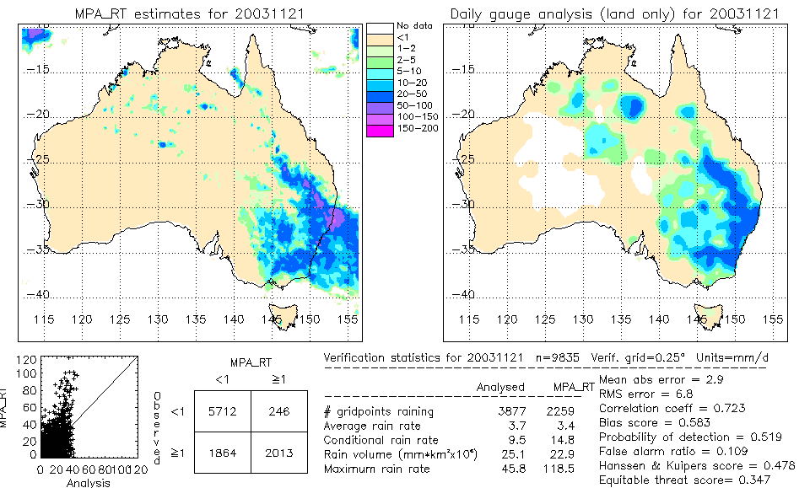

Figure 7: Large-scale validation for one of GSFC's real-time TRMM-based algorithms.

extensively to validate TRMM satellite precipitation estimates, and have the advantage of being able to sample both maritime and continental convection. An additional site will be developed near Brisbane (27S, 153E) employing an S-band dual polarization, dual frequency radar and associated rain gauge observations.

In addition to the above "supersite" approach, a national scale validation will be conducted using the Bureau of Meteorology's operational daily rain gauge analysis, based on ~1000 observations (real-time), or ~5000 observations (a few months after real time). An example of large-scale validation for one of GSFC's real-time TRMM-based algorithms is shown in Figure 7 Validation can easily be extended to monthly and seasonal time scales. On sub-daily time scales, the Bureau is developing an hourly gauge-calibrated radar rainfall analysis at 1 km spatial resolution. This product will be used to validate the space-time structure of the satellite rainfall fields, including the representation of the diurnal cycle.

    - Austria

Ground Validation Site Status and Future Plans – IAS, JOANNEUM RESEACH, Graz, Austria

IAS, the Institute of Applied Systems Technology (director Prof. O. Koudelka), looks back onto a three decades lasting tradition in investigating and modelling tropospheric effects on radio wave propagation. Especially the Radar and Propagation Research Group (head Prof. W.L. Randeu) has accumulated extensive experience and tools most relevant also for GPM ground validation work. A dual-polarisation, frequency-agile C-band research weather radar has been developed and set up in cooperation with ESA / ESTEC, data analysis includes e.g. rain retrieval algorithms, rain cell and melting layer studies, comparison of satellite- and radar-derived rainfall rates. Ground validation work in Graz is deemed to be of special importance because of the surrounding mountainous terrain and the more continental Austrian type of climate.

Present status of site: Whereas the C-band weather radar would need some refurbishment, instrumental observation presently focuses on acquiring precipitation microstructure data using the imaging 2D-Video-Distrometer (2DVD), two units are in operation. Furthermore all Austria is covered by four routine operation weather radars (C-band, 5 minutes refresh time) and by a dense raingauge network, a close relationship to the operators exists. To measure cloud base, a Lidar is in operation. IAS runs projects investigating precipitation particle scattering amplitudes, including irregularly shaped and mixed-phase particles (snowflakes and ice crystals). Relevant modelling work is supported using data from the imaging 2D-Video-Distrometer units.

Future plans: Refurbishment of the research weather radar station is being discussed at the moment, including possibly to set up a Ka-band radar, also allowing observations of cloud formation processes. Within the closer range of the radar ( < 15 km ) the following would be of interest:
- detailed analysis of precipitation events over the city of Graz
- comparisons with 2DVD units along a mountain height profile, including ice and snow scattering
- set up of auxiliary instruments for measurement of atmospheric radiation
- operation of a 1280 MHz Windprofiler (retrieving vertical profiles of wind and turbulence, co-sited with the pulsed LIDAR)

Thus it is prediction, explanation and verification of satellite measurements, to be done in the specific climatic and topographic situation of Graz. Figure 8 provides a schematic illustration.

In the last two years Austria has suffered both – severe flooding and drought. IAS is fully aware of the importance of relevant observations and research.

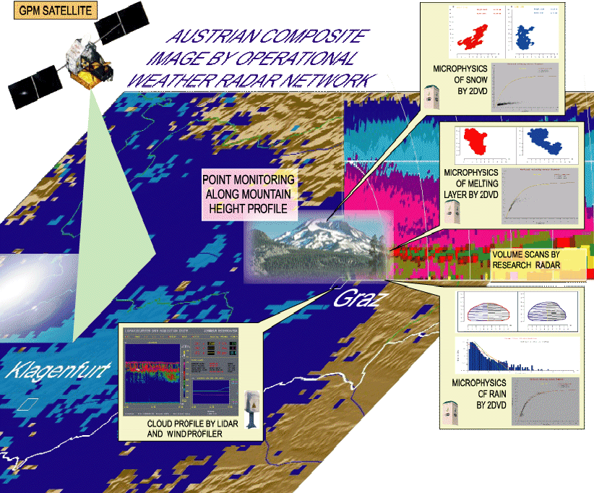

Figure 8: Schematic illustration of IAS plans for GV research in Graz, Austria.

    - Brazil

GPM Ground Validation in Brazil

Ground validation activities in Brazil, in support of precipitation measurements to be performed by GPM satellite constellation, are being considered mainly by universities, research institutions and government agencies/organizations. Both ground based measurements and research aspects are contemplated in those activities. They are briefly approached below.

Ground based measurements:
a) Weather radars - In general, presently existing radars fall into the two governmental level groups, i.e, federal and state. At the Federal level are the SIV AM (System for the Surveillance of the Amazon) with 10 S-band Doppler systems, the Air Force network also with 10 S-band Doppler radars, the Federal University of Pelotas with one S-band Doppler system which will undergo a major up-date/up-grade in the near future to resume operations and the University of Alagoas with an old non-coherent C-band to which a Doppler capability is to be added as part of a modernization of the system. The State level systems are the three-set network in São Paulo featuring two S-band Dopplers and one non-coherent 10 cm system, the Simepar (Meteorological System of the State of Paraná) radar which is a 10 cm Doppler deploying a 1 degree beam-width antenna (all the others have a 2-degree beam) and the State of Ceara X-band.

b) Raingages - There are several operators of raingages in the country, both of government and private nature. Synoptic totals only and recording gages integrate the existing networks with different relative numbers of each type. In the State of São Paulo, for instance, there is an approximate ratio of 3:1 (totaling/recording) for the hydrological system network. Examples of main networks are presented in the sequence.

- Paraná State network: about 120 recording gages, a substantial portion of it within the Simepar 240 km radar range.
- São Paulo State network: more than 300 recording gages (within radar 240 km radar range since the radar coverage practically spans the whole State).

Among the countrywide networks, there is a comprehensive system for agrometeorological purposes, comprising about 2400 daily total gages.

Research efforts: Universities and research organizations are carrying out, or planning, developments related to the GPM program. Some of those efforts are specifically envisaging validation issues. On going research on this can be found, for instance, in the Universities of São Paulo (USP) and of the State of São Paulo (UNESP), and the National Institute for Space research (INPE).

Topics include measurement strategies, matching procedures for data comparison from different sensors, sampling characteristics, retrieval algorithms, validation through end-products (e.g. catchment response, equivalent latent heat release/NWP), etc.

Among a few preliminary results already obtained using radar data are climatologically consisted Tb-Z(R) relationships.

Comments: A number of instruments of direct interest for validation are planned for deployment in the near future. This is the case with a dual-polarization, Doppler X-band radar which will operate in the metropolitan area of the city of São Paulo and a new S-band Doppler, prepared for later addition of dual-polarization capability, which will be installed somewhat away from the São Paulo metro area. They will work coupled to a micronet of 20 automatic weather stations covering the bulk of metro São Paulo. The synergistic observations with these systems is expect to provide particularly accurate precipitation estimates, invaluable for satellite rainfall validation. The above mentioned systems are originally specified to integrate the Hydrometeorological System of the State of São Paulo (SIHESP), which is now under development. In this sense, is also emblematic the establishment of a statewide telemetering raingage network, in the context of the SIHESP project. Strict quality control procedures to be implemented should provide quite reliable data, of particular value for validation. Dedicated validation sites being/to be implemented for specific programs - as is the case for the Aqua polar platform - are another relevant potential support for the GPM GV. On the other hand, experiments of opportunity offer many possibilities for validation data base.

The TroCCiBras/Troccinox (Tropical Convection, Cirrus and Nitrogen Oxides Experiment/Brazil) and Hibiscus field campaigns, developed during the January-March, 2004 period based in Bauru-São Paulo is a good example.

Data then obtained, such as hydrometeor population in the upper portion of heavy rain clouds, are basic for validating satellite rainfall microwave radiometry.

While much representative, information here provided are - as stated - only examples of ongoing/planned activities on the GPM GV theme and, thus, is far from exhaustive. Also, it is naturally biased towards the projects carried out by, and those close to, the rapporteurs.

Outlook: Some actions are now being initiated to organize the knowledge about GPM related activities in Brazil, of which GV is a major issue. Synergism is being sought among those involved. A much complete survey of GV GPM possibilities in Brazil should emerge soon, among the first results of those actions.

While issues about spacecrafts and sensors here for GPM are at most very speculative as of now, one would not say this is out of question. Although in a much different context, a meteorological payload has already been considered for a future Brazilian geo-stationary satellite.

    - Canada

Canadian Ground Validation Opportunities

Canada is a vast northern country consisting of diverse meteorological and precipitation regimes. Snow constitutes a significant portion of the annual precipitation. Observation systems within Canada are designed to measure all precipitation types and in severe environments. In a very broad sense, (i) snow constitutes a greater proportion of the precipitation with increasing latitude and distance from coastal regions, (ii) continental snow systems tend to have lighter snowfall rates than coastal systems, (iii) lake effect snow falls can create localized highly variable long lived precipitation patterns, (iv) Arctic tends to be uniformally light.

There are several unique ground validation opportunities for GPM in Canada.

- The operational Canadian Nipher shielded gauge has been shown to be the most effective of the operational snow gauges in use worldwide. It has been extensively studied and wind corrections are readily available.

- The Canadian Radar Network consists of thirty C-Band Doppler radars and one S-Band Doppler radar. The radars are highly sensitive to snow – typically they have a sensitivity of -40 dBZ at 1km range. The radar network is set up to detect low level precipitation systems: (a) Eleven of the radars are equipped with 0.65º beams. (b) Negative elevation angles are used in winter. Both are designed to better detect and estimate low level snow fall.

- As part of the Automatic Weather Observation System, 95 Precipitation Occurrence Observation Sensor (POSS) are operational. While they are currently tasked to report on the occurrence of precipitation, they have the capability to estimate precipitation type, precipitation rate (including snowfall), and particle size distributions on a minutely basis. Processing is in place to retrieve these parameters but telecommunication modifications are needed to retrieve them.

- The Canadian Mesoscale Observation Testbed (C-MOST) is centred around the Montreal area and consists of a UHK, VHF profilers, Xband Vertically pointing Doppler radar, polarization S Band radar and mesonet surface observations including POSS and snow gauges. This site is influenced by east coast weather systems and tends to have higher snowfall rates.

- Canada produces Snow Water Equivalent maps on a routine basis using satellite radiometric measurements. These maps were developed through extensive research and have been validated in various regions in Canada.

- Several instrumented sites are available besides the CMOST site. A possible western site which is influenced by continental systems and lighter precipitation rates is located near Bratt’s Lake. It is located in a flat region of the country. The Centre for Atmospheric Research (CARE) is a instrumented precipitation sensor research site near Toronto that is influence by Lake Effect snow falls. Radisson, Quebec is a site established by Quebec Hydro for precipitation and snowpack research. It is influenced by Lake Effect snows from Hudson Bay. Several Arctic sites (Alert, Resolute) may also be possible if established in collaboration with other research programs. The Environment Research Aircraft Facility is an airborne microphysical and remote sensing facility used to study precipitation processes.

    - China

Potential Applications of MVRI on Precipitation Retrieval and its Validation

Compared with conventional raingauge and radar observations, the Meteorological satellites could provide real-time rainfall information. In addition, satellite derived rain products are the only available precipitation datasets over oceans and remote areas where there are lack of conventional rainfall measurements. China has a plan to launch the Microwave Radiation Imager (MVRI) onboard FY-3 satellite in the near future. MVRI is a multi-frequency conical scanning microwave imager, with horizontal/vertical (H/V) polarization channels similar to the Special Sensor Microwave Imager (SSM/I). A research project has been established to explore a precipitation retrieval technique using MVRI measurements. This rain retrieval algorithm could be ready in 2006. A statistic approach using scattering index has been developed with SSM/I data and synthetic retrieval tests using MVRI are in progress. Meanwhile, NSMC is developing a physical precipitation retrieval algorithm that is expected to lead to better rainfall retrievals.

NSMC, a meteorological satellite operational center in China, is interested in participating in the global precipitation measurement (GPM) project. There are large variations of precipitation over China. For example, the annual precipitation is about 50 mm in the northwest part of Tibetan plateau, while it is over 2000 mm in the southeast region of China. With these extreme climate rainfall zones, China is in effort to achieve better precipitation measurements both in time-space. Since ground validation (GV) program is always very important in satellite rainfall measurements, NSMC also has a GV program with the FY-3 project. The existing raingauge observation network is very good in China and the increasing ground Doppler radar coverage could provide additional rain measurements. These observations should provide a good opportunity to conduct GV activities. They are not only important to FY-3 project, but also useful to GMP project. NSMC would like to be one of the partners in the GPM family to exchange information and contribute to the GPM. FY-3 project is expecting to use GPM core satellite measurements for its GV program and seeking opportunities to participate in the GPM GV Research Program.

Great successes in precipitation retrieval have been made since the launch of TRMM and more accurate rainfall observations are expected in the GPM era. There are huge potential applications with the GPM and the FY-3 polar orbiting meteorological satellite measurements in China. China is preparing to collaborate with communities of satellite observations and to contribute to better global precipitation observations.

    - Finland

Possibilities for GPM Validation in Finland

Finland is located in the boreal forest zone between latitudes 60 N and 70 N and has a severe snowfall climate. The number of snow cover days varies from 100 in the southwestern archipelago to 220 in Lapland. Mean annual precipitation is 400-700 mm. Snow has many socioeconomic impacts, e.g. the average winter season road snow clearance costs are 100 million Euros. The Finnish Meteorological Institute (FMI) is willing to act as a partner in the GPM validation, especially snowfall, by providing reference data and research cooperation. As the launches of GPM and EGPM will hopefully take place around 2008 and later, this document can not describe in detail the future validation equipment but only give an overview of the possibilities. A more detailed observational plan can be created later.

Finland has good experience in the remote sensing of snow water equivalent and snow depth on the ground. Therefore FMI and the Finnish Environment Institute (SYKE) are going to take responsibilities of these issues in the EUMETSAT Hydro-SAF, which is under preparation (a summary of remote sensing of snow on the ground is given by Pylkkö et al., 2003). The ground snow depth estimated from satellites could be used as a reference for long period GPM accumulation measurements.

The main validation data will be obtained from the weather radar measurements, radio soundings and from surface sensors. The operational radar network consists of 7 (8 in 2006) C-band Doppler radars from which the polar measurement data (typically 4-10 elevation angles, 360 azimuth angles, 500 range bins, 5-15 minute time intervals) is archived already now. We have developed e.g. methods for the network composites to correct underestimation of surface precipitation due to the shallow vertical profiles of reflectivity (VPR) in snowfall and real time spatial adjustment of the Z-R/Ze-S relation according to the actual hydrometeor water phase at each measurement bin. Reliability masks for radar products are under development. Summary of the long experience in radar-based snowfall measurements at FMI can be found in Koistinen et al. (2003).

As an example of radar data the following image, Figure 9, presents the cumulative distribution function of the radar reflectivity factor at ground (sfc) and at the heights of 2000 m and 4000 m above ground based on 54 000 measured VPRs in snowfall during a 12 month period. The curves indicate that serious care must be given to the sensitivity of the K-band precipitation radars in the GPM/EGPM-program.

We have also good possibilities to perform regional precipitation validation widely as a North European cooperation applying the high-quality gauge-radar integrated BALTEX precipitation products, covering major part of the Baltic sea catchment area with more than 30 radars, see Koistinen and Michelson(2002) an d http://www.gkss.de/baltex/baltex_frame_builder.html (path: Data and Data Centers, BALTEX Radar Data Center, Products).

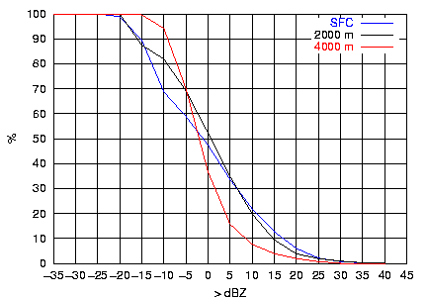

Figure 9: Cumulative distribution function of the radar reflectivity factor at ground (sfc), 2000 m, and 4000 m above ground based on 54 000 measured VPRs in snowfall during a 12 month period.

Snowfall measurements at ground are obtained from snow courses, from ordinary gauges with wind shields and from sensitive weighing gauges (OTT or Geonor). A well equipped ground reference site has two options, depending on the actual latitude coverage of the GPM sensors: (1) Sodankylä, and (2) Helsinki-Jokioinen. Sodankylä (67 N) has 200 snow cover days/year and is already heavily equipped with appropriate meteorological sensors as it is a WCRP/GEWEX CEOP validation station, see http://www.joss.ucar.edu/ghp/ceopdm and http://www.fmi.fi/research_polar/polar_2.html .

Helsinki-Jokioinen (60-61 N) is a bimodal station, which has less frequent snow (150 days) and no masts for flux measurements but, on the other hand, windprofilers and quite obviously a polarimetric C-band research and test radar as well as a mesoscale testbed with lot of surface AWS sensors. All these additional measurements compared to the Sodankylä site are taken care as a cooperation by FMI, University of Helsinki and Vaisala company. Jokioinen acts as a WMO test site for a large collection of solid precipitation gauges.

    - France

Cevennes-Vivarais Mediterranean Hydrometeorological Observatory

The "Cévennes-Vivarais Mediterranean Hydro-Meteorological Observatory" (OHM-CV is the French acronym, see the web site: http://www.lthe.hmg.inpg.fr/OHM-CV/index.html) is a research initiative aimed at improving the understanding and modelling of the intense Mediterranean rain events that frequently result in devastating flash-floods in the South of France (e.g., Nîmes 1988, Vaison la Romaine 1992, Aude 1999, Gard 2002, Cévennes 2003) like in other Mediterranean countries. The OHM-CV has received the label of “Environment Research Observatory” (ORE) from the French Ministry of Research in 2002. A primary objective of the observatory is to bring together the skills of meteorologists and hydrologists, modellers and instrumentalists, researchers and practitioners, to cope with these rather unpredictable events.

Due to the difficulties in observing extremes, the OHM-CV observation strategy is comprised of three complementary lines: (i) detailed, long-lasting and modern hydro-meteorological observation over part of the region of interest, the Cévennes-Vivarais region; (ii) post-flood investigation after all the extreme events occurring over the entire French Mediterranean region and (iii) use of historical and palaeo-hydrological information available on past floods. The first observation strategy, with the Cévennes-Vivarais pilot site, is of special interest for the GPM project. Over this 160 x 200 km2 flash-flood prone region (Figure 10), the operational hydro-meteorological observation system is already very rich with three weather radar systems of the Météo France ARAMIS network, 160 hourly rain gauges, 400 daily rain gauges and 45 stage and discharge stations over the main right bank tributaries of the Rhône river.

An on-going action of the OHM-CV is devoted to the creation of a data base for research by collecting and critically analysing the operational data for a period of more than 10 years, starting in 2000. Several concerted actions are also realized by the research/operational communities in order to progressively upgrade the Cévennes-Vivarais observation system. For instance, (1) the usefulness of a volume scanning strategy for meteorological and hydrological applications is being tested with the Bollène and Nîmes weather radar systems, (2) experiments are realized to assess the potential of GPS for measuring the water vapour inflow into the Cévennes-Vivarais region, (3) remote sensing techniques are being developed for measuring the river discharges during floods. Besides these observation and instrumental activities, high-resolution non-hydrostatic meteorological models and rainfall-runoff distributed models are developed and evaluated, prior to their further coupling with the ultimate objective of obtaining an integrated forecast of the phenomena of interest.

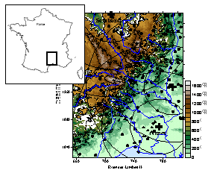

Figure 10: Cévennes-Vivarais Mediterranean Hydrometeorological Observatory. Coloured map shows topography (in m ASL), while 3 weather radars are indicated by crosses and 40-km range indicators. Black circles and triangles give locations of 1-hour raingauge network.
    - Germany

GPM Ground Validation in Germany

In Germany ground validation for GPM is available through the national weather service, Deutscher Wetterdienst (DWD) and through other local research organizations.
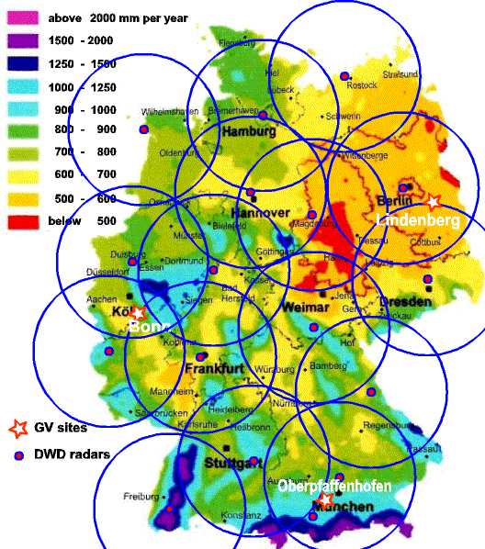
DWD operates a network of 16 C-band Doppler weather radars. The network is dense and almost whole Germany is covered within the 120 km range of the radars. The radars run volume scans every 15 minutes and provide various products for the end users. In addition a special high resolution precipitation scan is performed every 5 minutes at each radar and data are available as hourly and daily sums. DWD also operates an additional radar at the radar research laboratory on top of Hohenpeißenberg Mountain. This radar is operated independent from operational constrains. This radar will be upgraded to a polarimetric radar within the next years. Through co-operation with state water authorities a dense automatic rain gauge network is jointly operated in Southern Germany. DWD runs projects together with hydrological institutions to provide real-time calibration of radar measured precipitation with rain gauges.
Figure 11: Annual precipitation in Germany. Circles represent 120-km range of operational weather radars. Asterisks show locations of proposed GV sites.

Besides the operational nationwide precipitation measurements by DWD, at the time three locations have been identified to act as ground validation site. These are:

- Bonn: The University of Bonn operates a X-band weather radar. Cooperation exists with local operators of rain gauges. The institute also operates a multi-frequency radiometer which is suited to retrieve the liquid water path and other atmospheric properties. Rain gauges, disdrometer and vertical pointing rain radars are also available.

- Lindenberg: At the Lindenberg observatory the DWD runs operational and research instruments mainly for boundary layer research. Active and passive remote sensing instruments like wind profilers, RASS, vertical pointing rain radar, radiometer, ceilometer are available.

- Oberpfaffenhofen: The Institute of Atmospheric Physics at the German Aerospace Center (DLR) operates at Oberpfaffenhofen a polarimetric Doppler research weather radar. The radar is supplemented with a bistatic Doppler radar network, which enables the retrieval of the 3D wind vector field. Within the range of the radar data from the dense rain gauge network of DWD are available. In close range to the radar the DWD operates two radars: Hohenpeißenberg and Munich. Additional instruments are various lidar systems, ceilometer, disdrometer and high resolution rain gauges. A mobile Ka-band cloud radar is planned. DLR operates several research aircraft. With the DLR radar different climatic zones are covered, flat plane (500 m MSL) and high Alpine mountains (3000 m MSL). A German research station at the Zugspitze (2964 m MSL) can be used for additional measurements within snow.

    - Greece

GPM Ground Validation in Greece

[To be completed]

    - India

Ground Validation for Global Precipitation Mission in India

Ground Validation of Spaceborne Precipitation sensors was conducted in India in the context of Tropical Rainfall Measuring Mission (TRMM) .Units of Indian Space Research Organization (ISRO) such as Radar Development Cell (RDC), National MST Radar Facility (NMRF) , Gadanki, Space Applications Centre (SAC), have contributed to this effort. The following set of instruments participated in the ground validation activities:

  - S-Band Doppler Weather Radar ( called Megha-2700) established at the south eastern coast of India. This radar is located strategically to monitor the tropical cyclone systems.
  - MST Radar a VHF profiler established at Gadanki village.
  - Co-located instruments such as disdrometer, Optical Rain Gauge and a Lower Atmospheric Wind Profiler - LAWP (L-Band Profiler) were used for characterizing tropical rainfall.

Modeling studies were undertaken at Space Applications Center, Ahmedabad. All the above instruments were managed by ISRO. India Meteorological Department (IMD) was supported by NASA for Ground Validation efforts by upgrading (IMD’S) existing Weather Radar at Karaikkal, to a digital receiver and recording system. Comparison of the aerial rainfall retrievals from the horizontally scanning DWR with the vertically profiling precipitation radar from TRMM as well as TMI were made. Efforts were made to deduce drop size distribution from the L-Band Profiler including comparison with the disdrometer data.

Recently a team from NASA visited India in connection with the Ground Validation for GPM. Based on the discussions held with the NASA team, a consolidated proposal on Ground Validation is being submitted for which ISRO will be the lead agency, with participation from the concerned Centres and Units of ISRO as well as other interested agencies at the national level including IMD and university groups to contribute towards the Ground Validation Program of GPM. It is also relevant to state that ISRO is planning to launch a multifrequncy radiometer space craft called Meghatropques,( a collaborative project CNES) that will likely form one of the constellation satellites for GPM. Ground validation efforts for this spacecraft are also consistent with those for GPM.

The instrumentation systems which will be participating in the Ground Validation Program as of now are following:

- DWR Megha - 2700 developed by ISRO– RDC for IMD and located at SDSC, SHAR along with co-located supporting instruments such as rain gauge and disdrometer (supplied by Centre for Earth Sciences, Thiruvananthapuram). It is also proposed to upgrade this DWR into a dual-polarization system.

- The DWR system located at Chennai namely Gematronik 1500 of IMD. This system operates at horizontal polarization only. It is proposed to conduct certain dual Doppler retrievals using this Radar along with DWR- Megha 2700 located at SDSC SHAR.

- The MST Radar operating at 53 MHz and its co-located facilities including Lower Atmospheric Wind Profiler (LAWP) operating at 1357 MHz, an optical rain gauge and disdrometer, from National MST Radar Facility, Gadanki.

- It is also proposed that one existing C-Band Radar located at Thumba Equatorial Rocket Launching Station, Vikram Sarabhai Space Centre, Thirvanathanpuram will be converted into a dual-polarized Weather Radar in the foreseeable future. This Radar will be supported by a number of existing rain gauge stations in and around Thiruvanathanpuram.

India gets its rainfall mainly through monsoons starting from early June till end of November with a break in monsoon occurring sometime towards the end of August. The onset of South West monsoon is seen over the Kerala coast which will be detected by the C-Band Weather Radar and the aerial rainfall estimation will be made. The East coast of Southern India will be visited by the North East monsoon in the months of October to December. The rainfall during this North East monsoon will be measured by the DWR’s located at SHAR and Chennai along with Profilers at Gadanki. There will also be a number of pre-monsoon thunder showers occurring inland especially over Gadanki which will also be characterized by the planned measurement systems. In addition the radars will provide continuous coverage over the annual tropical cyclone season.

Currently all the Radar systems and other instruments have stand alone data recording and analysis facilities. A proposal to network the data obtained from each instrument will be worked out to enable archival at a Central location (TBD) for Ground Validation and co-related processing of the data obtained from each sensor. It is expected that this network operation of precipitation measuring instrumentation systems would result in providing a very effective validation program for precipitation over South India to support the GPM Mission. In addition modeling and data analysis studies at SAC with data from this network will provide an important component.

    - Israel

Ground Validation Activities in Israel

Israel is a small country with little territorial coverage to offer surface ground validation in the old sense. This realization became apparent with respect to TRMM. Instead, Israel will continue contributing to validation of space borne retrieved cloud microstructure, precipitation forming processes and the way these processes are affected systematically by differences in the thermodynamic and aerosol composition of the troposphere. These cloud properties are inherently important to GPM, as demonstrated recently by Rosenfeld and Ulbrich (2003). They have shown that cloud microstructure can profoundly affect the rain drop size distribution in a way that can cause systematic biases in radar and passive microwave estimated rainfall by factors > 2. Such biases would be smaller with the dual frequency radar on the mother GPM satellite. But application of these principles to the rest of the GPM constellation has the potential of large improvement of the accuracy of the rainfall measurements on a global scale.

The two main assets for that in Israel are: (1) a King-Air C90 cloud physics research aircraft, with cloud physics and aerosol probes, and (2) an explicit microphysics cloud model (The Hebrew University Cloud Model, developed by Prof. Alexander Khain), to be used for simulating the clouds and precipitation that are validated by the aircraft measurements, and apply a forward radiative transfer model for calculating the radiative signatures that should be seen by the GPM constellation.

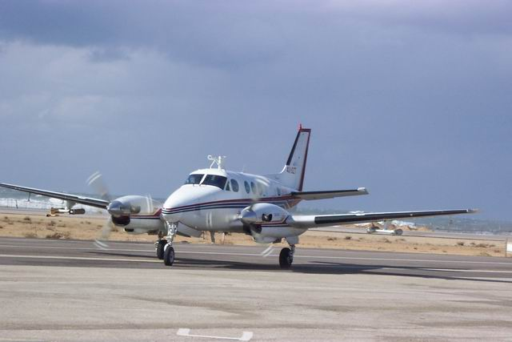

Figure 12: Picture of Israeli cloud physics aircraft, with aerosol and precipitation probes under wings, and aerosol-sampling intake on top.

    - Italy

GPM Italian GV Site

Introduction: Italian climate is a typical Mediterranean one. As far as precipitation is concerned, yearly amount varies from 2000 mm (Alps and Apennines) to 400 mm (Islands and Southern Italy). Most rainy season is fall, while precipitation is scarce during summer, which is not, however, totally dry (in Rome: 33 rainy days in winter, 29 in spring and fall, and 12 in summer). Peaks precipitation intensities are recorded during fall and summer storms. Intense precipitation often occurs in narrow cost lines bounded by mountains, which are thus exposed to high hydrogeological risk. Due to its position in the Mediterranean Sea and the complexity of its territory, climate of Italy is not homogeneous; anyway, Rome can be considered a significant representative sample of an “average” Mediterranean climate of Italy.

Infrastructures for GV: The Italian GV validation infratructure will be built upon the CNR-ISAC atmospheric observatory in Rome, the CNR-ISAC Polar 55C weather radar, sited in Rome and the Italian meteo radar network through its focal point at CIMA in Savona, which collect also real time data from about 750 rainfall gauge station in Italy.

CNR-ISAC atmospheric observatory in Rome: The site is located in the central part of Italy, 30 km northeast of the coast of the Tyrrehnian Sea and 20 km southeast of Rome. This position makes this site very representative of the Mediterranean climate and suitable for studying the interaction between the local and the mesoscale circulation, the sea-land transition influence in the formation of precipitation, and for observing precipitation in an urban area of huge importance such as the city of Rome. The infrastructure, easily accessible, is provided with laboratories and open areas were most the equipment is installed.

Two large open areas are available for instrumentation: a 2300 m2 grass field and the 500 m2 roof of the main building of the Institute. VHF radar wind profiler for clear air wind observation, sodar, minisodar, lidar (a multiple receiver system utilizing simultaneously the Rayleigh-Mie and Raman techniques to profile aerosol, temperature and water vapor), micrometeorological mast, radiometric stations, automatic weather station and microlidar, are installed in the open field; while the Polar 55C C-band weather radar and the 60 GHz temperature profiler (MTP5) are installed on special structures on the roof of the building. An HRPT satellite reception station is also running. Available instrumentation will possibly be improved for GV activities through ground-based radiometer and/or dual frequency radar.

Additional instrumentation in the area of Rome, which could be potentially adopted for GV, includes also the telemetered raingauge network owned by several public bodies and managed by the Italian Hydrologic and Oceanic Service which is constituted by 37 gauges with a density of 1/14.8 km2 and the sounding station of Italian Meteo Services located within 30 km from the Polar 55C radar.

Polar 55C weather radar: Many of the envisioned radar GV activities are centered on the Polar 55C research radar, a coherent C-band, dual polarization radar developed by Italian National Research Council. The radar system operated from 1991 and 2001 near Florence (Italy) also for the need of Mesoscale Alpine Programme. The system was installed in 2001 in the Rome Site and upgraded in 2002 with a new digital receiver. With the current configuration, it can provide measurements of the reflectivity factor at horizontal polarization, the differential reflectivity, the mean and standard deviation of the Doppler velocity, and, finally, the specific differential phase. The coverage of Polar 55C includes a portion of the Thyrrenian Sea, the city of Rome and a portion of the west side of Appennine range. The favorable position of the Polar 55C, close to a major urban area and to the Thyrrenian Sea, is particularly useful to use polarimetric radar data to highlight the contributions of land-sea interaction and of urban areas in the cloud and precipitation formation mechanisms in a regional model.

Italian radar network: The Italian radar network has been planned by the Dipartimento di Protezione Civile (the Italian Civil Protection Department). Real time data from the network will be collected by DPC and by CIMA in Savona. A competition is, at present, open to select the manufacturer and the number, out from a total of 14 planned, of new radars to be installed in this first round. This plan, aims at a) providing adequate and homogeneous coverage of the Italian territory; b) integrating in the network the coverage provided by the 12 existing radars managed by Regional authorities and the 6 managed by the Italian Air Force, and c) to establish a common framework for the optimal use of all Italian operational weather radars. The 14 new installations will be equipped with C-band radar with doppler and polarimetric capabilities. The network is expected to be operational from the end of 2004 with 8 new installations and a satellite based data communication system.

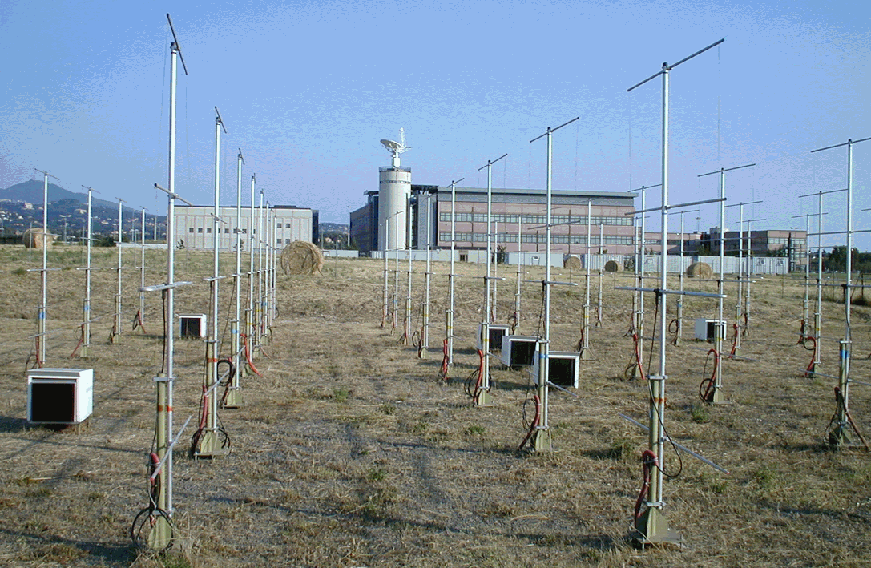

Figure 13: Antenna array of VHF wind profiler (foreground) and offset fed paraboloid antenna of Polar 55C weather radar (background) at Rome CNR-ISAC site.

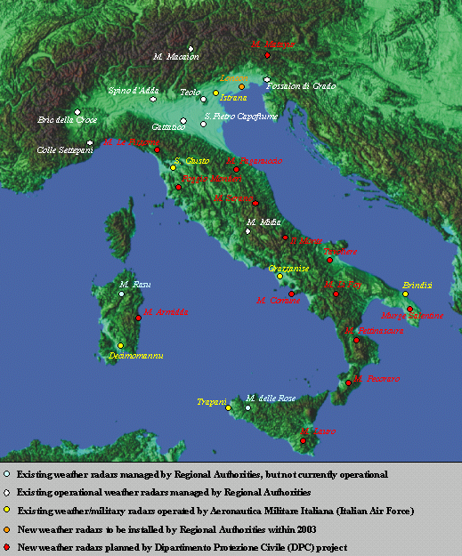

Figure 14: Existing weather radar sites for Italy along with 14 new Polarimetric Doppler radar system sites planned by DPC.

Table 6: Location of existing weather radars in Italy belonging to Regional Authorities. “Site” names (with respective Province abbreviation within brackets) are those pictured in Figure 13 and 14. Main specifications are also given in terms of manufacturer, Doppler capability, operating frequency band, dual polarization option, beamwidth and radome presence. Current status is referenced to 31 December 2001. Membership to METEONET Italian network is also noted.

Weather Radar Site | Main Specifications | Current status
Name: San Pietro Capofiume (BO)  Owner: ARPA Emilia Romagna  Site: Lat. 44°39’22’’, Lon. 11°37’26’’  Altitude: 11 m | Manufacturer: ALENIA-SMA  Doppler: YES  Band: : C  Dual polarization: YES  Beamwidth: 0.9°  Radome: NO | Operational;  member of the Italian  METEONET network
Name: Monte Grande - Teolo (PD)  Owner: ARPA Veneto  Site: Lat. 45° 21’ 46’’, Lon. 11° 40’ 25’’  Altitude: 472 m | Manufacturer: EEC-ERICSSON  Doppler: YES  Band: C  Dual polarization: NO  Beamwidth: 1°  Radome: YES | Operational;  member of the Italian  METEONET network
Name: Spino d’Adda (CR)  Owner: CNR  Manager: PoliMI  Site: Lat. 45° 24’ 00’’, Lon. 9° 30’ 00’’  Altitude: 80 m. | Manufacturer: ALENIA  Doppler: YES  Band: S  Dual polarization: NO  Beamwidth: 2°  Radome NO | Operational;  member of the Italian  METEONET network
Name: Fossalon di Grado (GO)  Owner: ARPA Friuli Venezia Giulia  Site : Lat. 45° 43’ 40’’, Lon. 13° 28’ 00’’  Altitude: 25 m. | Manufacturer: ALENIA-SMA  Doppler: YES  Band: C  Dual polarization: YES  Beamwidth: 0.9°  Radome: NO | Operational;  member of the Italian  METEONET network
Name: Preturo (AQ)  Owner: Regione Abruzzo - CETEMPS  Site: Lat. 42° 22’ 48’’, Lon. 13° 19’ 12’’  Altitude: 680 m. | Manufacturer: EEC-ERICSSON  Doppler: YES  Band: C  Dual polarization: NO  Beamwidth: 1.6°  Radome YES | Operational;  External member of the Italian METEONET network; to be moved to M. Midia
Name: Monte Macaion (BZ)  Owner: Autorità di bacino dell’Adige  Manager: Province di Trento e Bolzano  Site : Lat. 46° 29’ 44’’, Lon. 11° 12’ 37’’  Altitude: 1890 m. | Manufacturer: EEC-ERICSSON  Doppler: YES  Band: C  Dual polarization: NO  Beamwidth: 1°  Radome: YES | Operational;  member of the Italian  METEONET network
Name: Bric della Croce (TO)  Owner: Regione Piemonte  Site: Lat. 45°1’53’’, Lon. 7°43’59’’  Altitude: 720 m | Manufacturer: ALENIA  Doppler: YES  Band: C  Dual polarization: NO  Beamwidth: 1°  Radome: YES | Operational;  member of the Italian  METEONET network
Name: Monte Rasu Bono (SS)  Owner: Regione Sardegna - SAR  Site: Lat. 40° 25’ 21’’, Lon. 9° 00’ 19’’  Altitude: 1259 m. | Manufacturer: ALENIA-ERICSSON  Doppler: YES  Band: C  Dual polarization: YES  Beamwidth: 0.95°  Radome: YES | To be tested;  Not operational.
Name: Monte delle Rose (PA)  Owner: Regione Sicilia  Site: Lat. 37° 39’ 14’’, Lon. 13° 25’ 06’’  Altitude: 1436 m. | Manufacturer: EEC-ERICSSON  Doppler: YES  Band: C  Dual polarization: NO  Beamwidth: 0.9°  Radome: YES | Tested;  Not operational.
Name: Colle Settepani (SV)  Owner: Regioni Liguria e Piemonte  Site: Lat. 44° 14’ 57’’, Lon. 8° 11’ 55’’  Altitude: 1387 m. | Manufacturer: ALENIA-SMA  Doppler: YES  Band: C  Dual polarization: YES  Beamwidth: 1°  Radome: YES | Testing phase; operational within the middle of 2002.
Name: Gattatico (RE)  Owner: DSTN  Manager: ARPA Emilia Romagna  Site: Lat. 44° 47’ 29’’, Lon. 10° 29’ 57’’  Altitude: 34 m. | Manufacturer: ALENIA-SMA  Doppler: YES  Band: C  Dual polarization: YES  Beamwidth: 0.9°  Radome: NO | Testing phase; operational within the middle of 2002.
Name: Loncon (VE)  Owner: ARPA Veneto  Site: Lat. 45° 41’ 12’’, Lon. 12° 47’ 12’’  Altitude: 14 m. | Manufacturer: EEC-ERICSSON  Doppler: YES  Band: C  Dual polarization: NO  Beamwidth: 0.9°  Radome: YES | To be installed within the beginning of 2003

Table 7: Location of existing weather radars in Italy belonging to Italian Air Force. “Site” names (with respective Province abbreviation within brackets) are those pictured in Figure 13 and 14. Main specifications are also given in terms of manufacturer, Doppler capability, operating frequency band, dual polarization option, beamwidth and radome presence. Current status is referenced to 31 December 2001.

Weather Radar Site | Main Specifications | Current status
Name: Brindisi (BR)  Owner: Aeronautica Militare Italiana  Site: Lat. 40° 38’ 00’’, Lon. 17° 57’ 00’’  Altitude: 25 m. | Manufacturer: ALENIA  Doppler: YES  Band: C  Dual polarization: YES  Beamwidth: 0.9°  Radome: NO | Not operational
Name: San Giusto (PI)  Owner: Aeronautica Militare Italiana  Site: Lat. 43° 40’ 47’’, Lon. 10° 38’ 24’’  Altitude: 25 m. | Manufacturer: ALENIA  Doppler: YES  Band: C  Dual polarization: YES  Beamwidth: 0.9°  Radome: NO | Operational
Name: Grazzanise (NA)  Owner: Aeronautica Militare Italiana  Site: Lat. 41° 02’ 59’’, Lon. 14° 04’ 12’’  Altitude: 30 m. | Manufacturer: PLESSEY  Doppler: NO  Band: C  Dual polarization: NO  Beamwidth: 1.5°  Radome: NO | Operational
Name: Istrana (VE)  Owner: Aeronautica Militare Italiana  Site: Lat. 45° 40’ 47’’, Lon. 12° 05’ 59’’  Altitude: 30 m. | Manufacturer: PLESSEY  Doppler: NO  Band: C  Dual polarization: NO  Beamwidth: 1.5°  Radome: NO | Operational
Name: Trapani (TP)  Owner: Aeronautica Militare Italiana  Site: Lat. 37° 55’ 12’’, Lon. 12° 30’ 00’’  Altitude: 30 m. | Manufacturer: PLESSEY  Doppler: NO  Band: C  Dual polarization: NO  Beamwidth: 1.5°  Radome: NO | To be installed
Name: Decimomannu (CA)  Owner: Aeronautica Militare Italiana  Site : Lat. 39° 21’ 00’’, Lon. 8° 58’ 12’’  Altitude: 30 m. | Manufacturer: PLESSEY  Doppler: NO  Band: C  Dual polarization: NO  Beamwidth: 1.5°  Radome: NO | To be installed

Table 8: Locations of 14 new Polarimetric Doppler radar systems planned by DPC. “Site” names are those pictured in Figure 13 and 14. “Zone” indicates geographical area, while “Region” is related to respective regional Authority.

SITE | ZONE | REGION | LATITUDE  (ED50) | LONGITUDE  (ED50) | ALTITUDE (m)
Monte Mataiur | Friuli/Slovenia | Friuli-Venezia Giulia | 46°12’46’’ | 13°31’50’’ | 1641
Monte Le Pizzorne | Toscano/Ligure | Toscana | 43°57’46’’ | 10°36’40’’ | 1026
Monte Paganuccio | Medio  Adriatico | Marche | 43°38’17’’ | 12°44’59’’ | 976
M. Poggio di Montieri | Toscana  Litoranea | Toscana | 43°07’38’’ | 11°00’18’’ | 1051
Monte Serano | Appennino  Centrale | Umbria | 42°51’36’’ | 12°47’59’’ | 1428
Il Monte | Abruzzo  Adriatico | Abruzzo | 41°56’22’’ | 14°37’15’’ | 692
Piana di Montenero | Puglia  Settentrionale | Puglia | 41° 43’23’’ | 15°41’18’’ | 1022
Monte Comune | Campania  Penisola Sorrentina | Campania | 40°37’51’’ | 14°27’38’’ | 877
Monte Li-Foi | Basilicata | Basilicata | 40°38’16’’ | 15°41’32’’ | 1354
Località Casarano | Puglia  Meridionale | Puglia | 39°59’51’’ | 18°11’34’’ | 211
Monte Pettinascura | Calabria  Ionica | Calabria | 39°22’15’’ | 16°37’07’’ | 1708
Monte Pecoraro | Calabria  Tirrenica | Calabria | 38°31’33’’ | 16°20’46’’ | 1423
Monte Armidda | Sardegna Meridionale | Sardegna | 39°52’59’’ | 09°29’42’’ | 1261
Monte Lauro | Sicilia  Meridionale | Sicilia | 37°07’04’’ | 14°49’41’’ | 960

    - Japan

GPM Ground Validation in Japan

[to be completed]

    - Korea

GPM Ground Validation in Korea

Korea is located in between continental and maritime weather regime, influenced by the North Pacific high during the summer and by the Siberian high during the winter. As summer approaches a rainfall zone develops over northern China, Korea, and Japan from mid-June to late July. Northward shift of the anticyclone is also noticed during this period. This abrupt northward advance of monsoon front is thought to be phase-locked signal with an intraseasonal oscillation. The formation of a new rainfall area is regionally known as the Changma in Korea.

Formation of deep convective clouds and heavy rainfall events are quite often during this rainy season. Rain system is thought to be rather complicated due to the presence of complex terrain in the Korean peninsula in which mountains range from the northeast to the middle south Korea. During the winter period, precipitation is often associated with the lake effect of the Yellow Sea when northerly and north-westerly flows are prevalent. Thus Korea experiences various forms of precipitation, providing an ideal validation site examining rain products retrieved under various conditions. Valuable information on rainfall characteristics can be obtained by carefully analyzing measurements from already equipped over the Korean peninsula. Followings are instruments which may be used for the GV purposes.

Raingage network: Korea has a long history in measuring precipitation, which dates back to 14th century when the world’s first raingage was invented and had been used for regular observation until a modern rain gauge was introduced in later 19th century. Estimating the precipitation over the peninsula, Automated Weather Station (AWS) network is established by the Korean Meteorological Administration (KMA). The network consists of 536 uniformly distributed (approximately 40 gauges per 1-degree box), 0.5-mm resolution, automatically reporting-tipping raingages, continuously operated by the KMA. Figure 15 depicts the geographical distribution of the AWS network in which one-minute rain estimates are reported.

Radar network: Since the first S-band radar was stationed at the top of the Kwan-ak mountain of Seoul in 1969, the radar network is established covering the most of Korean peninsula. They consist of C-band Doppler radars installed at Gosan in Jeju island, Donghae, Gunsan, Chungsong, and Baekryungdo and S-band Doppler radars installed at Jindo, Kwanaksan, Chulwon, and Busan. These radar network may be used for validating GPM rainfall products, in conjunction with raingage observations. The radar for the research is different from the operational radars in terms of frequency, polarization and mobility, using X-band Doppler with the dual polarization capabilities installed at a trailer.

National Center of Intensive Observation of Severe Weathers: Enhancing our understanding of heavy rainfall system in summer and improving model prediction capability, one observatory is established for intensive data observations, in particular, for severe weather in summer associated with typhoon and Changma. Also aimed are long-term monitoring of surface fluxes for improvement of physical processes between land surface and atmosphere, and study on the formation and development mechanism of heavy rainfall system. Main instruments are 1.3 GHz-WPR, Autosonde (Vaisala), micro rain radar, optical rain gage, X-band Doppler radar. A 20m flux tower is available. Detailed description for the instruments is given in the following Table 9.

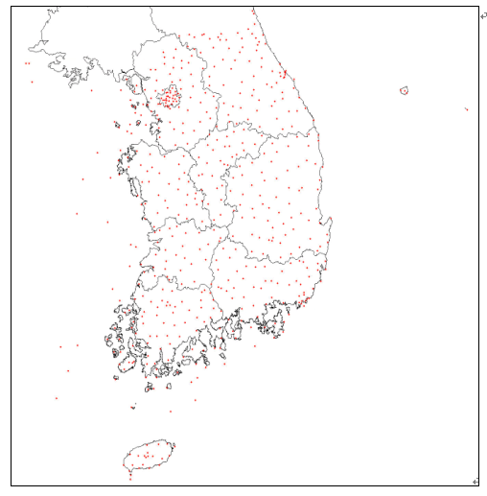

Figure 15: Automated Weather Station(AWS) raingauge network over Korean peninsula.

Table 9: Meteorological equipment installed at National Center for Intensive Observation of Severe Weather.

 | Meteorological  Equipment | Observation Elements | Application | Installation
1 | 1.3GHz-WPR  (Sumitomo, Japan) | Wind direction,  Wind speed | Producing one-minute profile of vertical and horizontal wind | December, 2002
2 | Autosonde  (Vaisala, Finland) | Pressure, Temperature, Relative humidity, Wind | Producing three-hourly upper-air observation data | January, 2002
3 | Micro Rain Radar  (Met-Tech, Germany) | Reflectivity, Rain rate, Liquid water content(LWC),  Drop size distribution | Producing vertical profiles of rain rate, LWC and drop size distribution | May, 2002
4 | Optical Rain Gauge  (STCI, USA) | Rain rate | Producing information to distinguish between rain and snow and precipitation intensity | May, 2002
5 | 20 m Flux Tower  (ADTEC ,Korea) | Net radiation, Wind, CO₂and H₂O concentration. Soil temp. | Producing sensible, latent, radiative fluxes over the land surface | July, 2002
6 | X-Band Doppler Weather Radar  (EEC, USA) | Reflectivity, Radial velocity, G-DR(Differential reflectivity) | Producing reflectivity and wind | November, 2002
    - Netherlands

Cabauw Experimental Site for Atmospheric Research in Netherlands

The Cabauw Experimental Site for Atmospheric Research (CESAR) is the Netherlands’ national atmospheric remote sensing facility, located near the village of Cabauw, approximately 20 km SW of Utrecht (http://www.cesar-observatory.nl). CESAR is operated by a consortium of major universities and research institutes involved in experimental research towards cloud-aerosol-radiation interactions, atmospheric composition, precipitation, and land surface-atmosphere interactions. Close collaboration exists with several foreign research groups, particularly from Germany. The observational facility is being used for process studies of atmospheric and land surface processes, monitoring of long-term tendencies in climate parameters, the development of new measurement techniques, the validation of satellite observations, and the training of young scientists. The central theme of CESAR is sensor synergy for atmospheric profiling and water/energy budget studies via both (ground-based) remote sensing and in situ observations.

The Cabauw site, with its 213 m meteorological tower, has been the experimental research facility of the atmospheric research group at the Royal Netherlands Meteorological Institute (KNMI) since the early 1970s (http://www.knmi.nl/onderzk/atmoond/cabauw/cabauw.html). In the framework of CESAR, the original collection of ground-based in situ and remote sensing instruments has been upgraded to enable the study of cloud-aerosol-radiation interactions, atmospheric composition, precipitation, and land surface-atmosphere interactions (Table 10). CESAR has been operational since the summer of 2001. Since then, it has been the center stage of several international measurement campaigns: Baltex Bridge Cloud Campaigns 1 and 2 (BBC1, 2); CESAR Rainfall Experiment 2002 (C-Rex’02). Currently, hydrological research efforts are going on to close the water budget of several polder areas that surround the Cabauw site through detailed measurements of the inputs (precipitation, groundwater), outputs (discharge, evaporation) and storage changes (open water levels, unsaturated zone). Ultimately, such polders could act as huge (~25 km²) rain gauges. In summary, CESAR will provide unique opportunities for ground validation research related to GPM.

Table 10: Research instrumentation available at CESAR.

Remote Sensing Instruments | In Situ Instruments  measurement tower | In Situ Instruments  ground-based
1 GHz wind profiler  3 GHz rain / cloud radar  10 GHz rain radar  35 GHz cloud radar  94 GHz cloud radar  2 doppler weather radars  Ceilometer  Non-scanning lidar  Raman lidar  Scanning lidar  UV Radiometer  IR radiometer  Microwave radiometer  42 GHz beacon receiver  GPS receiver  Scintillometer (X-LAS)  Pyranometer | SJAC  Optical particle counter  FSSP-95  Nephelometer  Sonic anemometer  Infrared fluctuation meter  Gas analyzer  Aethalometer  Sun photometer  Humidograph  Wind sensor  Temperature sensor | Radiosonde  20 Rain gauges  3 Disdrometers  TDR soil moisture sensors  Groundwater tubes  Discharge measurements  Operational gauge networks

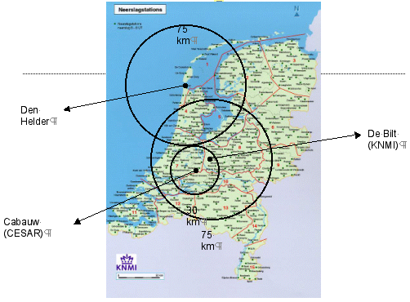
MRR-2
2DVD
SPO

Figure 16: Daily rainfall stations (~300) and radar range markers: 75-km around operational KNMI C-band doppler radars in De Bilt and Den Helder and 30-km around planned X-band weather surveillance radar SOLIDAR (scanning radar which will be mounted on top of meteorological tower at Cabauw).

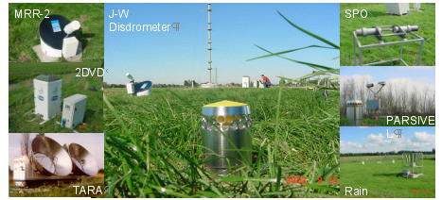

Figure 17: Rainfall instrumentation during CESAR Rainfall Experiment 2002 (C-Rex ’02) that took place at Cabauw site between 1 September and 31 December 2002.

    - South Africa

Ground Validation Facilities in South Africa

The South African Weather Service (SAWS) has entered into a new research and development project with the Water Research Commission for the development of integrated rainfall estimation over Southern Africa. This project builds on a previous initiative called the Spatial Interpolation and Mapping of Rainfall (SIMAR), which produced integrated rain gauge, radar and satellite rainfall products. The new project is undertaken in partnership with the University of Natal and includes a capacity building component as well as the integration of Meteosat Second Generation (MSG) data and products.

The SAWS has developed a system to automatically log and communicated data from tipping bucket rain gauges via the SMS service of the cell phone network. In the attached figure this system is shown. A network of these real-time automated rain gauges has been deployed over the continental interior region of the country, which is also well covered by S-band radar. In the near future a similar network will be deployed over the eastern coastal areas where the characteristics of rainfall is quiet different. These networks will provide the ideal opportunity to verify other rainfall estimation techniques.

The SAWS and other South African partners have also been successful to obtain funding as part of the PUMA Outlook Activities to ensure MSG product development and implementation in South Africa. One of the components of this project is also rainfall estimation verification and development.

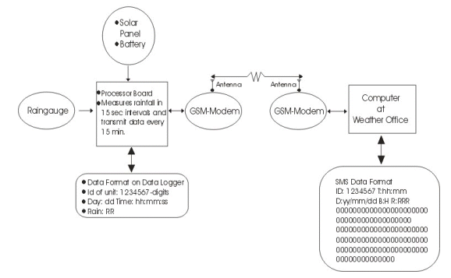

Figure 18: Schematic diagram of realtime raingauges.

    - Spain

Catalunya GV Site Status and Future Plans

METEOCAT and GRAHI-UPC have proposed Catalunya as a validation supersite for GPM mission.

The supersite design will be based on a dense C-band radar network complemented by a raingauge network and other hydrometeorological measurements, operationally working 24/24 hours 365 days per year. This configuration will allow us to have a region of about 15000 km² in which any volume of space will be measured by 3 different radars at the same time, available operationally. Also 3 super dense GPM pixels (5 raingauges+disdrometer in a 4 by 4 km box) are planned to be equipped in the surroundings of Barcelona to study the variability inside a GPM pixel.

The strong collaboration between Meteocat (who will operate the supersite), the GRAHI (who will carry out the studies and develop the processing algorithms and operational tools) and other operational agencies as the Water Agency of Catalunya (ACA) the Sewer management company (CLABSA) and the Spanish National Meteorological Institute (INM), is the base of the supersite potentiality.

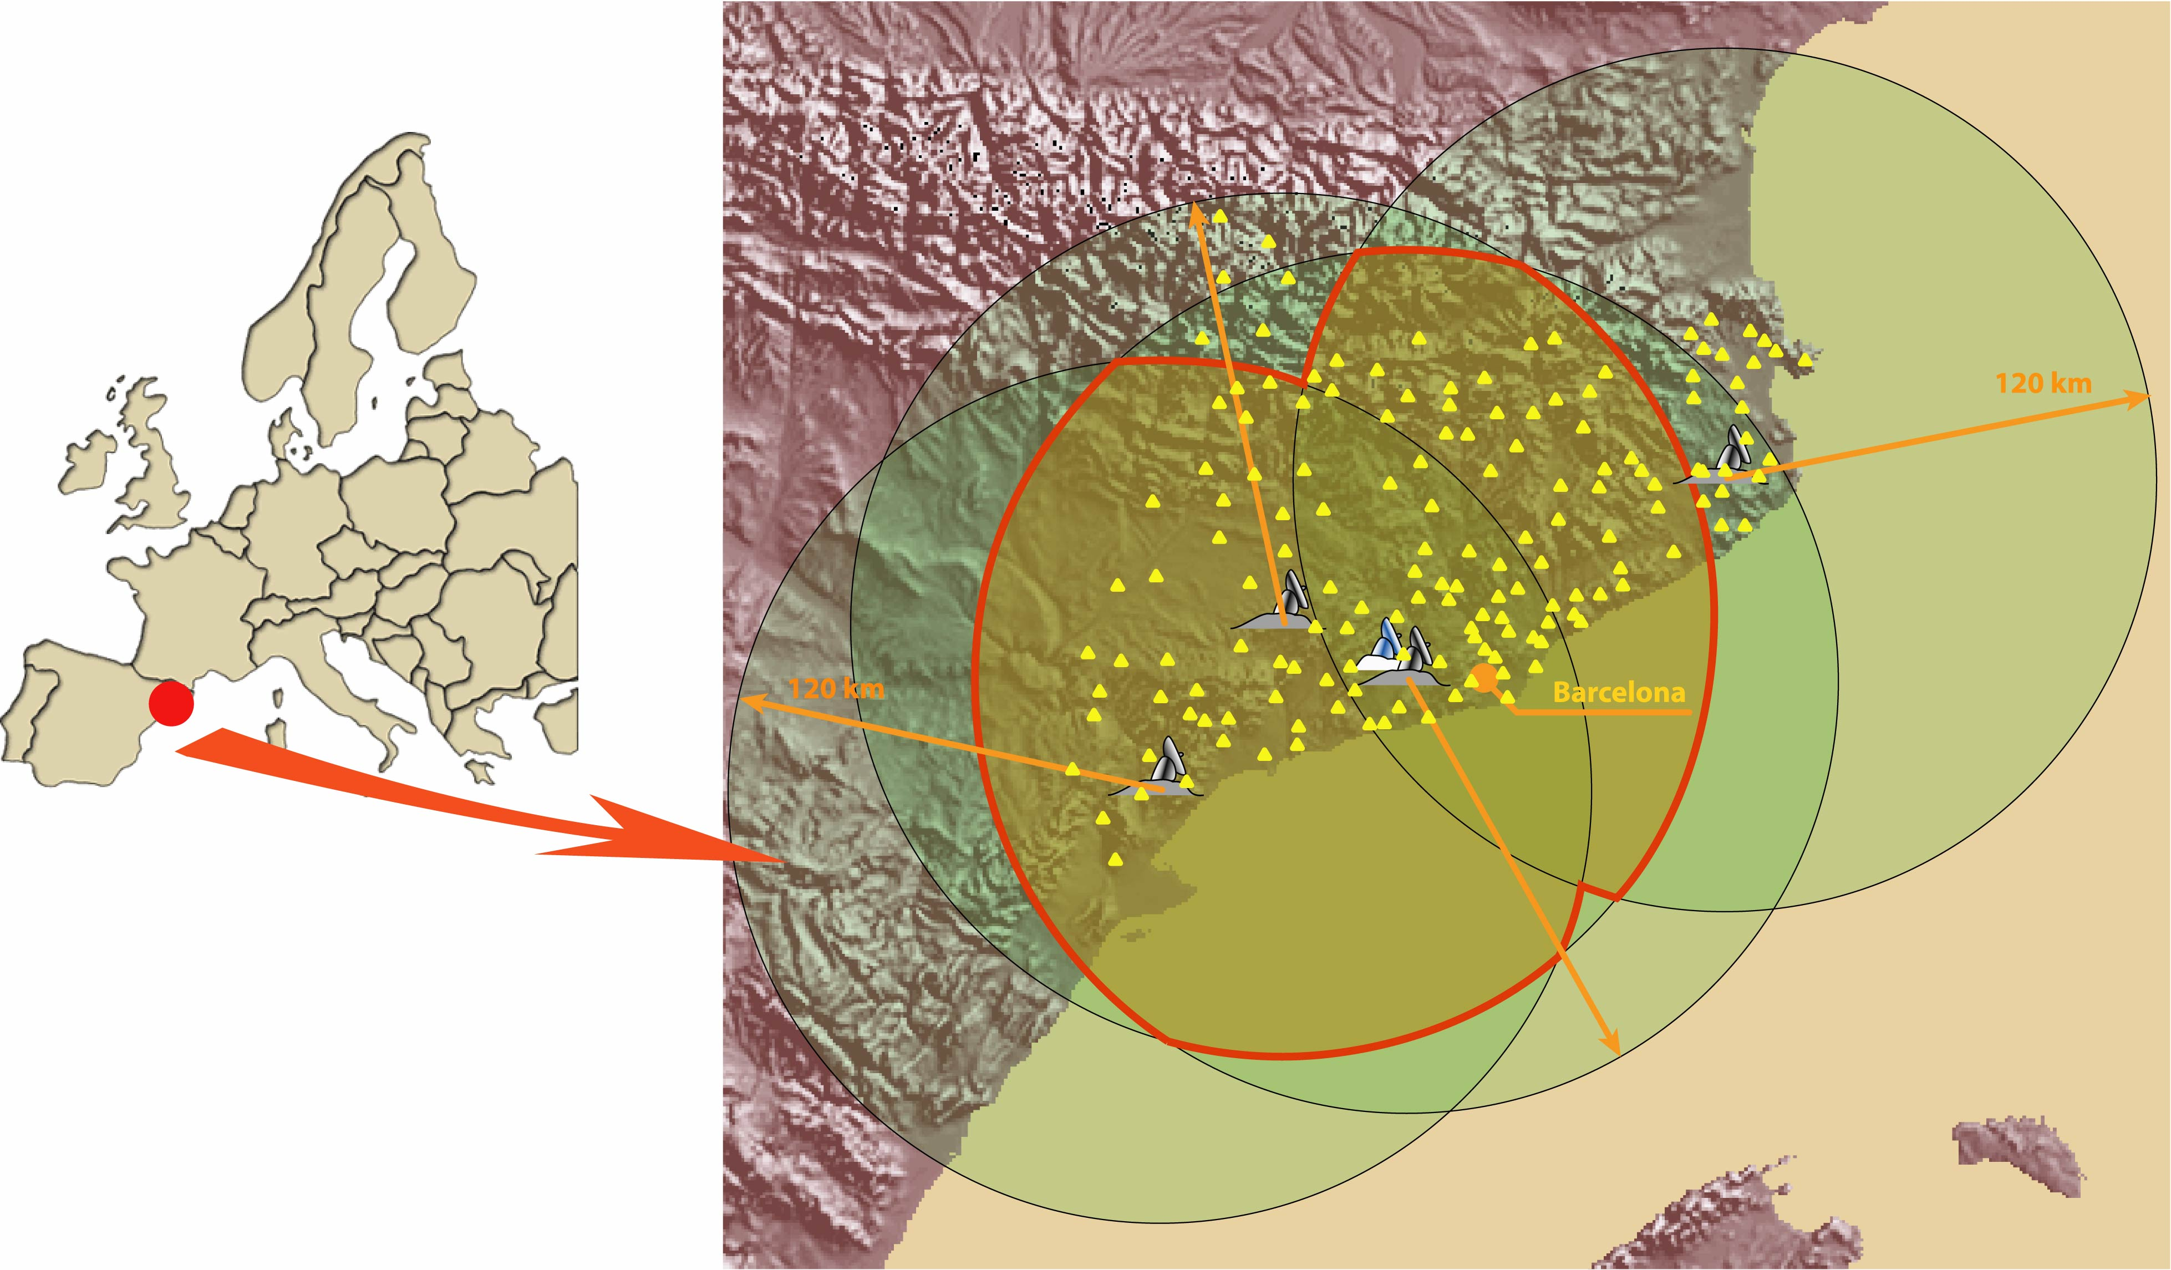

Figure 19: Catalunya GV Supersite region.

The strong collaboration between Meteocat (who will operate the supersite), the GRAHI (who will carry out the studies and develop the processing algorithms and operational tools) and other operational agencies as the Water Agency of Catalunya (ACA) the Sewer management company (CLABSA) and the Spanish National Meteorological Institute (INM), is the base of the supersite potentiality.

The regional government of Catalunya has announced its compromise with the GPM mission (press conference of 25 November 2003), and the acceptation of the invitation received from NASA to prepare a demonstration project of the supersite: http://www.grahi.upc.es/menu/GPM/index_gpm.htm . The project have also received the support of the EC, by the way of the R+D project VOLTAIRE (EVK2-2002-CT-00155) to design the setup of the supersite, and of the Catalan Science Foundation to run the demonstration project, and it is part of the validation program included on the EGPM project, presently in stage A at ESA.

In occasion of the World Meteorological Day (23 March 2004) the Catalan government (the minister of Environment) will formally confirm the commitment of the regional government with the GPM mission driving a validation supersite at Catalunya.

    - Taiwan

GPM Activity in Taiwan

The radar and surface rain-gauge network in Taiwan (see Figure 20) are maintained by the Central Weather Bureau (CWB). The facility is the central component of the CWB quantitative precipitation estimate/prediction (QPE/F) projects that consists of the following:

- Measurements are being made by the Radar network (see Figure 20) with observation frequency: 6-10 min. A QC procedure is first applied to the raw measurements to remove ground and sea clutters, solitary and strip echoes. Then, a vertical Z-profile adjustment is performed to extrapolate the Z values from the lowest scanning level to surface.
- Surface precipitations are measured at the automatic rain gauge stations (see Figure 20) with observation frequency: at least 10 min.
- The QPE project utilizes measurements by radars, GIS, satellite, and lightening, together with a regional model to derive gridded surface precipitation data through the following procedures: i) quality control of gauge data (hourly rainfall), ii) local biases calculated at each gauge station, iii) objective analysis of biases onto the QPE grid, iv) adjust of the hourly QPE precipitation products, v) accumulations are based on the local bias adjusted QPE, vi) local Gauge Adjusted Radar QPE, vii) adaptable Z-R relationships, viii) improvement of a regional model utilizing the gridded rainfall data.

Compliment to the CWB facility, the National Central University has a S-band polarimetric/Doppler radar, a VHF radar, disdrometers, and Integrated Sounding System (ISS). The facility at the NCU represents the achievement of a group of faculty members who have devoted to the radar and rainfall research for the past ten or more years. This group of scientists also participated in the TRMM project and performed the following research: 1) quality control of radar and raingauge data, 2) radar rainfall estimate algorithms development, 3) mesoscale dynamics of precipitation system study, 4) SCSMEX experiment, 5) new instruments development.

In addition to the above facility and research activities, many scientists in Taiwan are interested in the GPM GV project. At the first stage of the Taiwan participation in the GV project, the following teams have been identified:

• The Central Weather Bureau
The CWB will continue the improvement of QPE and QPF projects through the following:
1) Develop the QC and QA procedures for its surface rainfall measurements
2) Adjust radar Z-R relations using the surface rainfall data
3) Improve 0~2hr QPF product through a statistical analysis of the radar data
4) Improve 2~12hr QPF product through a data initialization and assimilation system

• NCU Radar Team
This project will carry out the following research:
1) Develop rainfall algorithm with multiple instruments at NCU including polarized radar, disdrometers, Integrated Sounding System-ISS profiler radar
2) Perform ground truth validation of rainfall from multiple instruments
3) Study dynamics and microphysics of precipitation systems

• Satellite Team
This team will perform satellite rainfall retrievals using TRMM/TMI/PR & NOAA/AMSU and ground validation using rain gauge data

• QC/QA Raingauge and Hydrological Data
This project will perform a QC/QA analysis of rain gauge data and Spatial Interpolation of Hydrological Data through the following:
1) Rainfall QC
2) Conduct careful cross-check of rainfall against downstream flow data;
3) Implement pixel-average-rainfalls (PAR) estimation based on the spatial variation characteristics of rainfall data;
4) Evaluating the performance of existing raingauge network based on information entropy and geostatistics.

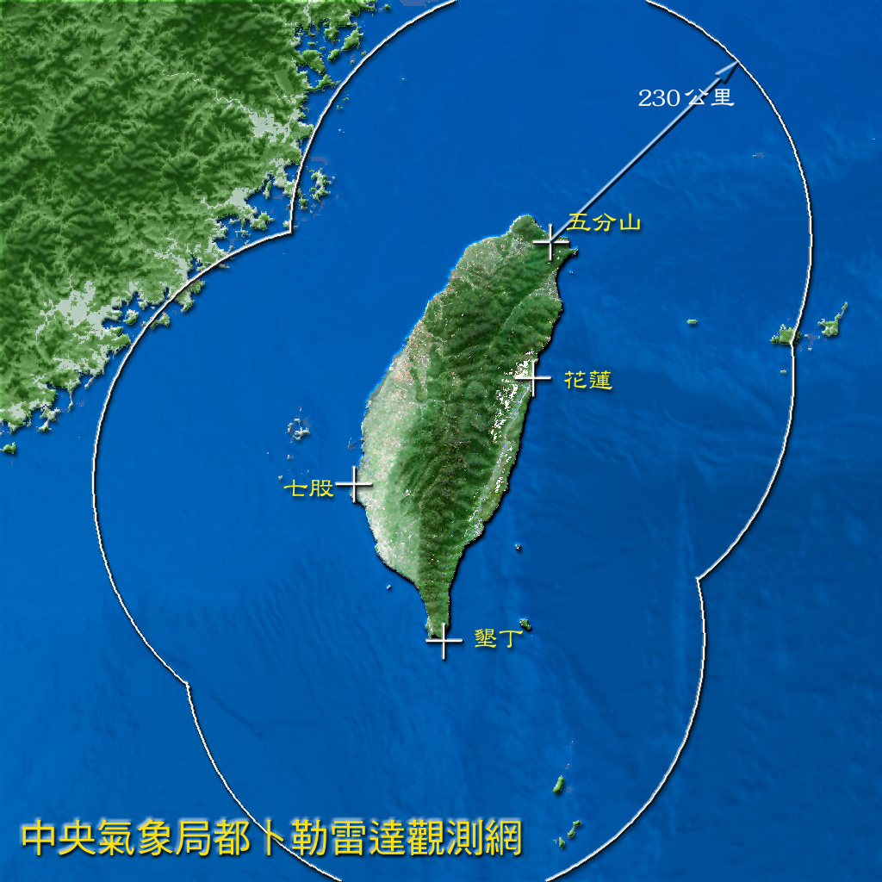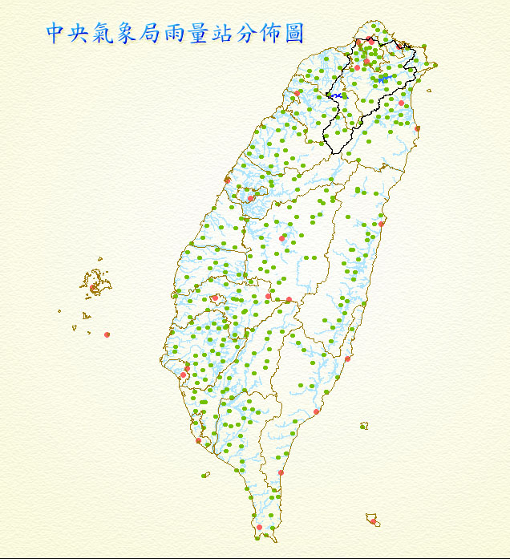

Figure 20: Locations and spatial coverage of surface radars (left panel) and surface rainfall stations (right panel) installed by Central Weather Bureau . Triangle indicates position of NCU site. By 2005, Polarimetric/Doppler radar will be set up at this location.

    - United Kingdom

Ground Validation within United Kingdom

The UK ground validation will cover Southern England and utilise instrumentation and knowledge from the Met Office, the CCLRC Chilbolton Facilities for Atmospheric and Radio Research (CFARR), and the Department of Meteorology at the University of Reading. The climate in the UK is maritime and temperate; the average annual rainfall in Southern England is about 900 mm, spread uniformly through the year.

The UK Met Office operates a Radar network that covers most of the Southern UK at 1 and 2km resolution (Figure 21). The Radars provide continuous rainfall measurements 24 hours a day under an automated system, which executes reflectivity scans at eight elevations every five minutes. CCLRC operates the world renowned CFARR which hosts the Chilbolton Advanced Meteorological Radar (CAMRa) (see Figure 22).

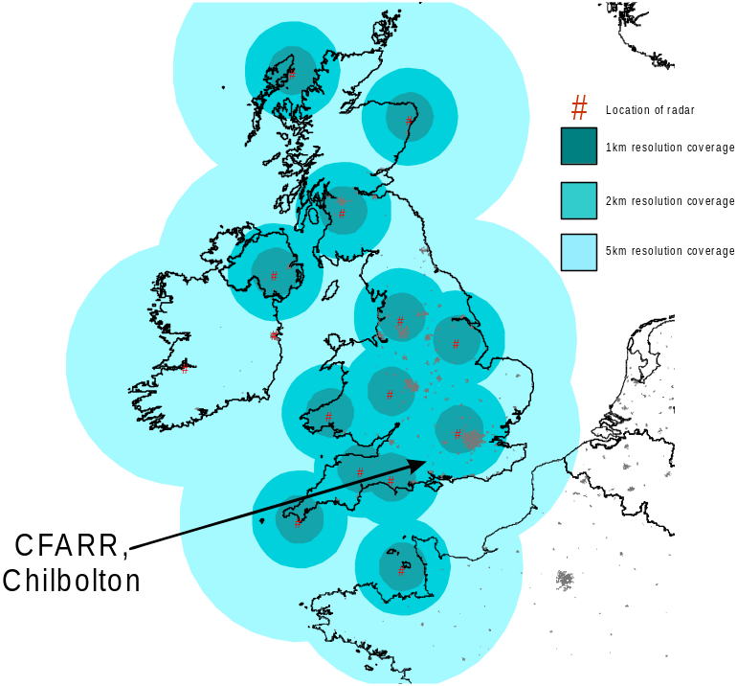 | 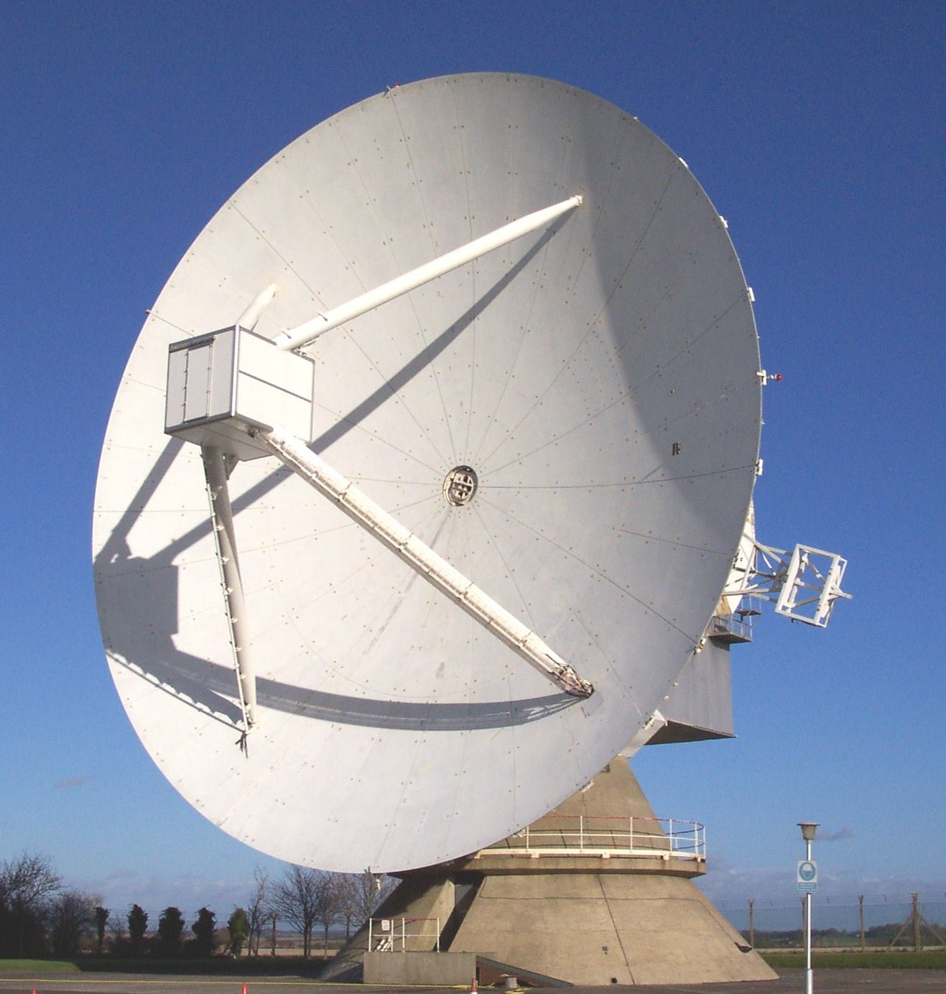
Figure 21: UkK Met Office radar network. | Figure 22: 25-metre fully steerable radar at CFARR.

CAMRa is a 3GHz polarisation-Doppler fully scanning S-band radar with a 0.25º beam width. Attenuation is low at this frequency, and precipitation data can be accurately recorded to about 100 kilometres range. It transmits and receives both horizontal and vertical polarisation, and records full reflectivity and phase information. Products include reflectivity, differential reflectivity, Linear depolarisation ratio, radial velocities, spectral width, and correlation parameters. The CAMRa radar would primarily be used to provide detailed vertical structure of individual events, including melting layer heights and storm dynamics, while the Met Office network will provide accurate information on the horizontal precipitation structure. The Met Office FAAM Bae146 aircraft (Figure 23) would also be available for campaigns, to develop remote sensing techniques, improve understanding of physical processes and help develop model parameterisations.

Within a one hundred kilometre range of Chilbolton, the Met Office have at least 19 rain gauges, while more data could also be obtained from the Environment Agency’s raingauge network. Located at CFARR is a suite of rain gauges consisting of; Rapid Response Drop Counting rain gauges, an Optical gauge, a Joss Disdrometer, a Tipping Bucket rain gauge and a self-syphoning capacitance gauge. Located 8km SSE of CAMRa is CFARR’s remote site Sparsholt which operates a Disdrometer, Tipping Bucket Raingauge and a Rapid Response drop counting gauge.
Sharing the 25 metre dish with CAMRa is a 1275 MHz Clear-air Radar, ACROBAT, used to study frontal dynamics, urban meteorology and cloud physics. Chilbolton also operates two zenith pointing cloud radars, Galileo at 94GHz and Copernicus at 35 GHz, a UV Raman Lidar, an IR ceilometer, visible and IR radiometers, a cloud camera and a met station. These provide routine quality controlled products such as target classification, cloud fraction, ice water content, liquid water content, turbulent kinetic energy dissipation rate and temperature.

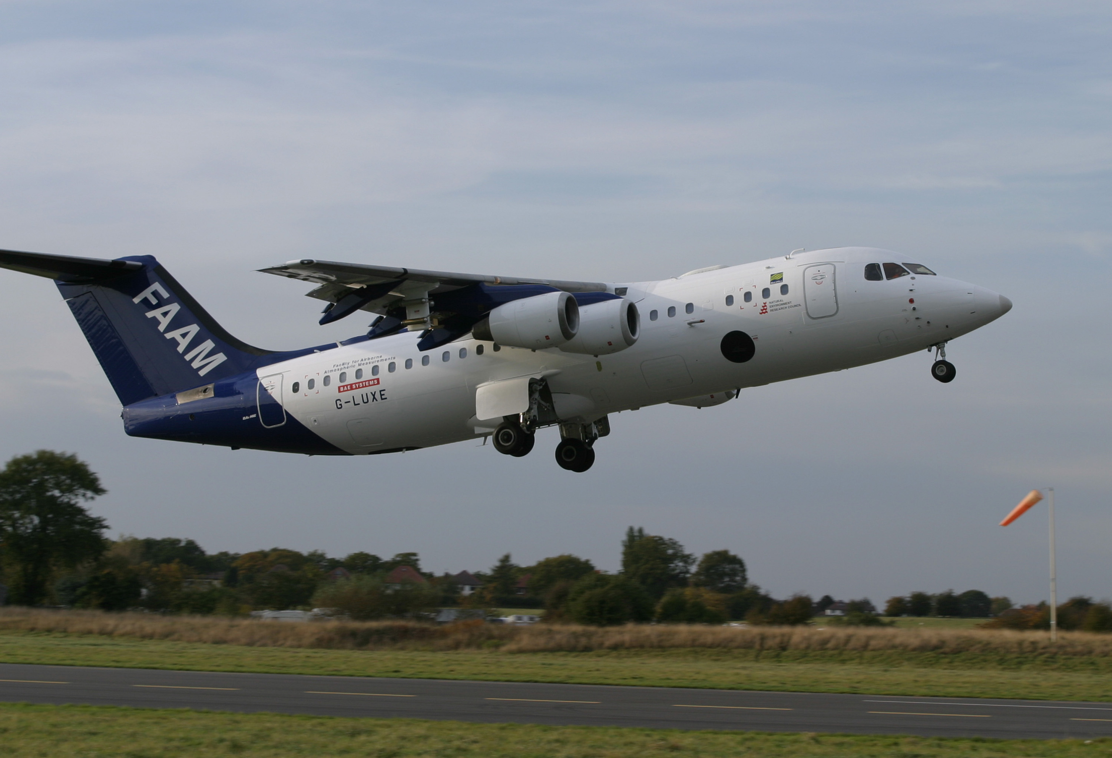

Figure 23: UK FAMM BAe 146 aircraft.

Within a one hundred kilometre range of Chilbolton, the Met Office have at least 19 rain gauges, while more data could also be obtained from the Environment Agency’s raingauge network. Located at CFARR is a suite of rain gauges consisting of; Rapid Response Drop Counting rain gauges, an Optical gauge, a Joss Disdrometer, a Tipping Bucket rain gauge and a self-syphoning capacitance gauge. Located 8km SSE of CAMRa is CFARR’s remote site Sparsholt which operates a Disdrometer, Tipping Bucket Raingauge and a Rapid Response drop counting gauge.
Sharing the 25 metre dish with CAMRa is a 1275 MHz Clear-air Radar, ACROBAT, used to study frontal dynamics, urban meteorology and cloud physics. Chilbolton also operates two zenith pointing cloud radars, Galileo at 94GHz and Copernicus at 35 GHz, a UV Raman Lidar, an IR ceilometer, visible and IR radiometers, a cloud camera and a met station. These provide routine quality controlled products such as target classification, cloud fraction, ice water content, liquid water content, turbulent kinetic energy dissipation rate and temperature.

All the data gathered at CFARR are quality controlled and converted to a standard data format, NetCDF. This data is released through the British Atmospheric Data Centre (BADC), http://badc.nerc.ac.uk/ , which caters for thousands of users, both from within the UK and from overseas.

    - United States

Ground Validation within United States

Summary of Continental GPM Supersite Concept

Consensus from the TRMM Science Community calls for developing a NASA GPM continental supersite in north central Oklahoma. This will be accomplished by augmenting the existing Atmospheric Radiation Measurement (ARM) program Cloud and Radiation Testbed (CART) site with precipitation observing platforms. The combined suite of ARM and GPM instruments at the CART site is intended to provide an unprecedented set of cloud and precipitation observations in one location. Current instrumentation at the ARM CART site includes:

- Continuous ground based monitoring (AOS) and occasional aircraft profiling of aerosols
- Radiosonde launches (up to 4 per day)
- Column water vapor and cloud liquid water (MWR)
- Vertical profiles of water-vapor, cloud and aerosol-related quantities (Raman Lidar)
- 50 and 915 MHz Wind Profiler and RASS
- 35 GHz vertically pointing radar (MMCR)
- Cloud base height (Vaisala Ceilometer)
- Cloud base and PBL height (Micropulse Lidar)
- Eddy Correlation Flux Surface Bowen Ratio measurements
- 60 m meteorological tower, precipitation and snow depth gauges

With regard to required instrumentation for precipitation measurements at the Continental GPM site, a consensus has been reached that both an S-band polarimetric radar and a dense rain gauge network (and disdrometers) be established. It is expected that additional instrumentation will be determined over the next year. During the TRMM Science meeting in October 2003, a break-out session on needs and requirements of the NASA GPM Continental Supersite was held and the following action items and recommendations were the outcome of that session:

- TRMM ground validation (GV) provides a useful roadmap for GPM validation.
- Discussed concept of “rainfall regime”: can expected “physics” of precipitation in footprint of TRMM/GPM/ground based radar (D_{o}, Z profile), be described or linked to routinely available data like low level winds, reconstructed soundings, aerosol observations, etc?
- Recommend that work on regime classification continue since it would provide useful guidance to satellite algorithm developers (e.g., in regime xxx, use Z-R relation yyy…).
- Conduct a design study that would lead to a rain “standard” at the OK ARM CART site for use in the pre-GPM era consisting of dense gauges, distrometers, and a dual-wavelength profiler. This would be the accepted precipitation metric. Involve polarimetric radars for detailed intercomparison as these radars will be used in other locations for GV within the GPM era. Radars are transfer standard. S and X-band polarimetric systems are required.
- Assess the role of the central. Florida gauge/radar network as well as the Wallops Is. Rain measuring facility in both the GPM pre-flight era and mission era. These sites have excellent capabilities and would provide for additional precipitation regimes to be identified and quantified. Also, when same regime is identified between two sites, we need to verify that they have the same physical characteristics (rain pdf Do, etc)
- Algorithm developers will need to work closely with GV team and help design required measurements for GV.
- It was recognized that validation for the dual precipitation radar (DPR) may require several detailed field campaigns that would provide information on vertical structure of the drop size distribution (DSD).
- We have a recognized gap in our ability to routinely measure characteristics of ice aloft—mixing ratio, particle size distribution, density. Supercooled liquid water (SLW) is also problematic due to its transient nature and we should investigate radiometric techniques for use in GPM GV. Also, investigate the use of UAV’s to carry out routine measurements of SLW and ice aloft.
- GV design must capture multi temporal and spatial scales of precipitation variability.

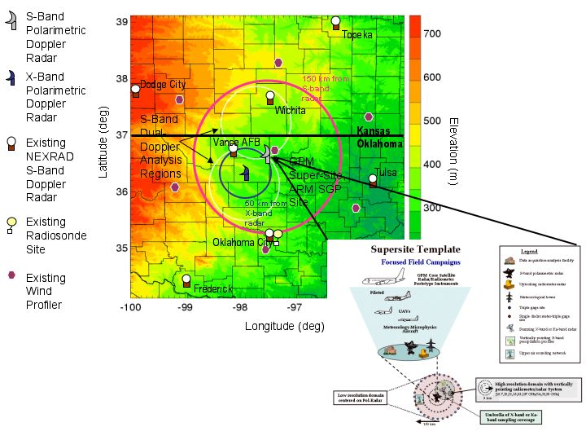

Figure 24: Location of proposed NASA GPM continental GV Supersite with respect to surrounding observational network and design concept for precipitation measurements at Supersite.

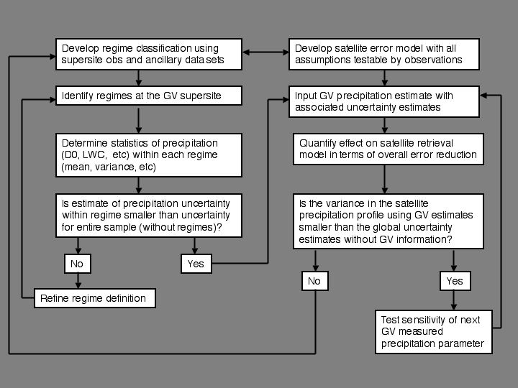

Figure 25: Flow chart illustrating concept for GV and satellite algorithm team interaction.

Kwajalein Atoll, Republic of Marshall Islands (Location: 8.7°N ; 167.7°E)

Overview: Kwajalein Atoll is part of the Republic of the Marshall Islands (RMI). The nation consists of a group of atolls that lie halfway between Hawaii and Papua New Guinea (Figure 26). Kwajalein Island is the largest and southernmost island within Kwajalein Atoll. The island is less than 15 sq km in area and the highest point is less than 10 m above mean sea level. Formerly an American protectorate, the RMI entered into a Compact of Free Association with the United States upon independence in 1986. The agreement guaranteed the continued American use of the Reagan Test Site (RTS) of the US military. The island is accessible by commercial airline and military transport.

Researchers have conducted meteorological experiments from Kwajalein for several decades. Recent activities include KWAJEX (Yuter et al., 2004) which took place in 1999, and ongoing radar and rain gauge data collection since 1998 as part of NASA TRMM Ground Validation (Schumacher and Houze 2000). Kwajalein receives on average ~2600 mm of rainfall each year. Its location at 8.7° N is on the northern boundary of the mean location of the west Pacific ITCZ. Precipitation is highly seasonal (Figure 27), and varies with the seasonal oscillation of the ITCZ. Much of the precipitation is associated with deep convective cloud systems, which are modulated by both coherent wave motions trapped in the tropical waveguide and tropical depression-like disturbances (Sobel et al. 2003). Approximately three-quarters of the island’s precipitation occurs between May and November (Figure 27), but measurable precipitation occurs on 50-70% of days all year round (Figure 28).

Kwajalein Island has a permanent Doppler dual polarization S-band radar facility (Table 11) originally developed for US Army and FAA and upgraded by NASA for TRMM Ground Validation applications. Radar coverage spans 360 degrees and is virtually unimpaired over marine waters. The current nominal scan strategy for the radar was developed to optimize US Army, FAA, and NASA Ground Validation applications and has significantly higher vertical resolution than NWS NEXRAD scans. Upper air soundings are obtained twice daily at 0 and 12 UTC with a GPS radiosonde system. In support of NASA TRMM, rain instruments have been installed on several islands including a 500-m scale array of tipping bucket gauges on Roi- Namur and Joss-Waldvogel disdrometers on Kwajalein and Roi-Namur (Table 12). The US Army contract for weather operations at RTS including the S-band radar changed in October 2003 from Aeromet Inc. of Tulsa, OK to 3D Research Corporation of Huntsville, AL.

Table 11: Characteristics of Kwajalein S-band Doppler dual polarization radar.

 | Kwajalein S-band
Model | Modified DWSR-93S
Wavelength | 10.71 cm
Peak transmit power | 250 kW horizontal  250 kW vertical
Pulse duration (µsec) | 0.7
Minimum detectable signal | -108 dBm
Antenna gain | ~45 dB
PRF | variable 393-960 Hz
Polarization | Horizontal and vertical
Beamwidth | 1.12°
Antenna and radome dimensions | 8.23 m parabolic dish, 11.5-m sphere
Antenna height | 24.8 m above MSL
Maximum scan speed | 16 °/sec
Elevation range | -0.4 to 90.5°
Recorded radar variables | Z_{H}, V_{r}, SW, Z_{DR}, ρ_{HV}, φ_{DP}
Radar processor and software | Sigmet RVP7, RCP02, and IRIS software

Table 12: Rain instrumentation at Kwajalein Atoll. Tipping bucket gauges were installed on outlying non-RTS islands in 1998-99 under agreement with RMI weather service and NWS, but those gauges reported only sporadically at first and more recently not at all. Instruments in this table are all on RTS-controlled islands.

Island | Qualimetrics tipping bucket  with MadgeTech logger | Joss-Waldvogel disdrometer  with logging on PC | Range from  radar (km) | Within  clutter pattern of lowest radar scan (0.4°)
Kwajalein | 2 in pair | 1 within hedge shelter | 0 | Yes
Carlos | 2 in pair | - | 15 | Yes
Meck | 2 in pair | - | 30 | Yes
Legan | 2 in pair | - | 33 | Intermittent
Illeginni | 2 in pair | - | 49 | No
Gagan | 2 in pair | - | 66 | No
Roi-Namur | 7 gauges in 5 positions within 500m scale array | 1 within hedge shelter | 80 | No

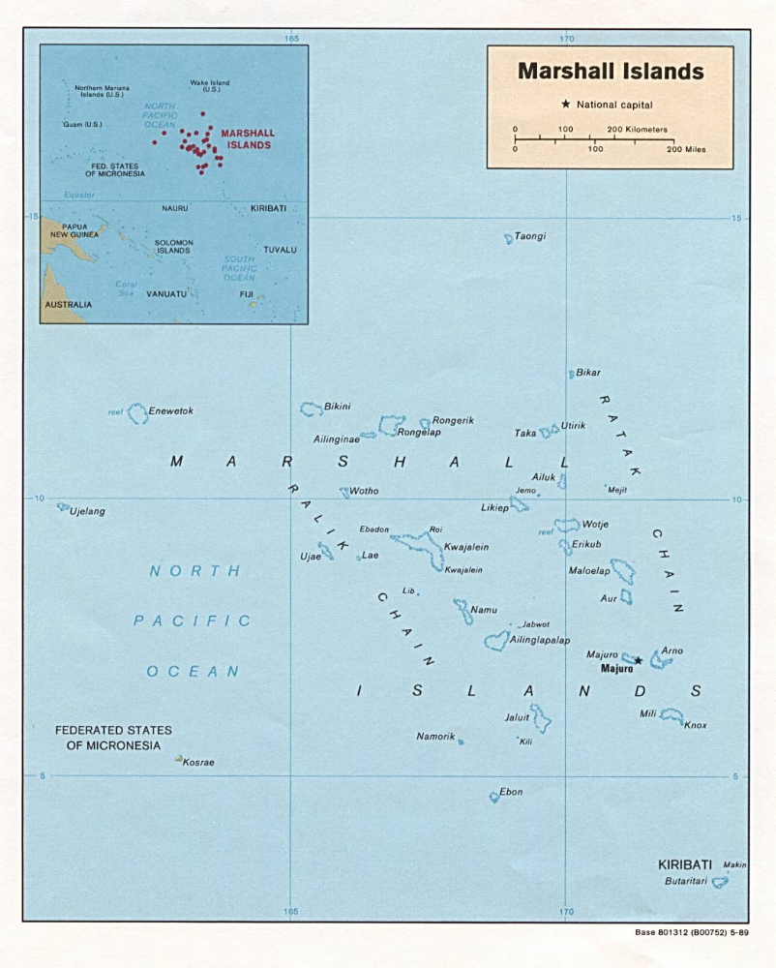

Figure 26: Republic of Marshall Islands (RMI) (1989). Kwajalein Atoll lies at 8.5N and 167.5E -- it is the world’s largest atoll. Reagan Test Site encompasses several islands within atoll, including Kwajalein Island itself, located at southern tip of atoll. [University of Texas at Austin Library]

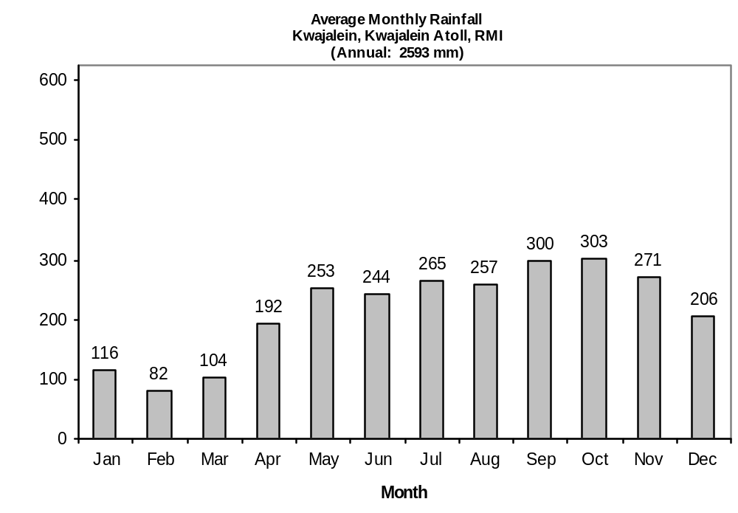

Figure 27: Rainfall for Kwajalein Island, RMI. [National Climatic Data Center, NOAA]

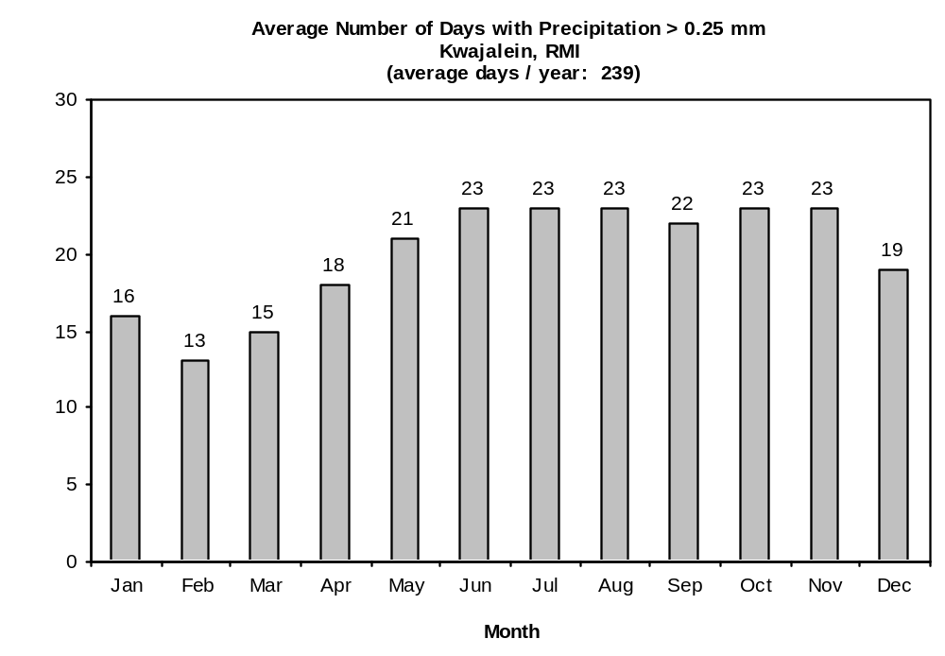
Figure 28: Average frequency of rainfall for Kwajalein, RMI. [NCDC]
    - West Africa

GPM GV Activities in West African Nations (Benin, Niger, Senegal) (Everett Joseph, Greg Jenkins and Jose Fuentes)

There are several existing and planned measurement programs that provide significant opportunity for a West Africa GV site. One effort is the Howard University West Africa Rainfall Analysis project which is a participant in the NASA precipitation program. The Howard project is working to establish physical as well as support infrastructure for a GV site in Dakar Senegal through development of a partnership among Howard University, NASA, Ecole Superieure Polytechnique of Cheikh Anta Diop University, and Direction De La Meteorologie Nationale (DMN; the Nation Meteorological Service) and other institutions in Senegal.

Initial measurements will be conducted as part of the African Monsoon Multidisciplinary Analysis (AMMA) [AMMA, 2003; and US-AMMA SSG, 2003] experiment that is planned for the rainy season of 2006. A brief description of AMMA is given below. The focus of the Howard measurement effort in Senegal in 2006 will be to characterize the precipitation structure and antecedent conditions of the regime that is unique to coastal West Africa. For this purpose a dense gauge network (40) with disdrometers will be deployed to capture the small scale (dense network on a pixel scale) and large scale rainfall variability; this network will remain in place long-term. Thermodynamic and dynamic measurements will also be conducted using flux towers, profiles, and balloons. The gauge network will also provide error bounds for ground-based radar rainfall estimates. The NASA precipitation program will most likely support deployment of the NASA Polarmetric Radar (NPOL) to provide the ground-based radar rain measurements. The Laboratory for Atmospheric Physics-Simeon Fongong (LAPSF) in Ecole Superieure Polytechnique of Cheikh Anta Diop University has existing rain gauges and disdrometers that will enhance the planned network. More significantly, DMN will purchase at least one S-Band radar to expand coverage across Senegal (possibility for dual-Doppler coverage during SOP2-3), a number of automated weather stations, an aircraft with cloud physics measurement capabilities, and will enhance its communication and internet capacity. These investments stem from a mandate given to DMN by the President of Senegal, Abdoulaye Wade, to examine the possibility of rain enhancement by cloud seeding including the monitoring of cloud and precipitation processes. The Howard team is working with university and government officials to integrate the objectives of AMMA and a GPM GV site into the national plan of Senegal for precipitation measurement.

The CATCH regional surface network (illustrated in Figure 29), which covers Benin, Niger, Togo, Ghana, Burkina, and Mali provides opportunity for an interior GV site. The three mesosites in CATCH will play a central role in AMMA over the LOP: Oueme, Niamey, and Gourma. Each has 45, 34, and 11 raingauges, respectively. The French will locate an X-band Radar in the Oueme catchment during the AMMA EOP. Operation weather radars are shown in Figure 29. The US AMMA science team has proposed intensive observation during SOP1-2 in the meridianal transect of the CATCH domain that will include dual-Doppler capabilities and airborne radars.

AMMA: AMMA is a multi-year, international project aimed at improving understanding of the West African Monsoon (WAM) and its influence on the physical, chemical and biological processes on a global and regional scale, and relating climate variability to societal issues and monitoring strategies. AMMA will utilize existing monitoring infrastructure (national services and ongoing measurement programs), but will directly and indirectly make enhancements to the quality and frequency of surface observations across West Africa: gauge networks, radars, radiosoundings, and soil properties. AMMA will be conducted across multiple spatial and temporal observing scales. The long and enhanced observing periods (LOP and EOP), which will extend to 2007, and 2010+, respectively, may directly overlap with GPM; however, the special observing period in 2006 (designed to span one WAM cycle) will have the most comprehensive measurement activities, and will yield significant understanding of the characteristics of the West African precipitation regime, which will be invaluable to GPM. The regional coverage of AMMA is illustrated in Figure 29. The key AMMA sites include: coastal (Senegal), Benin, and Niamey. These locations may represent the best opportunity for GPM GV in West Africa because they have the most accurate and reliable – which will be enhanced in AMMA – observational infrastructure that is support through local and international collaboration.

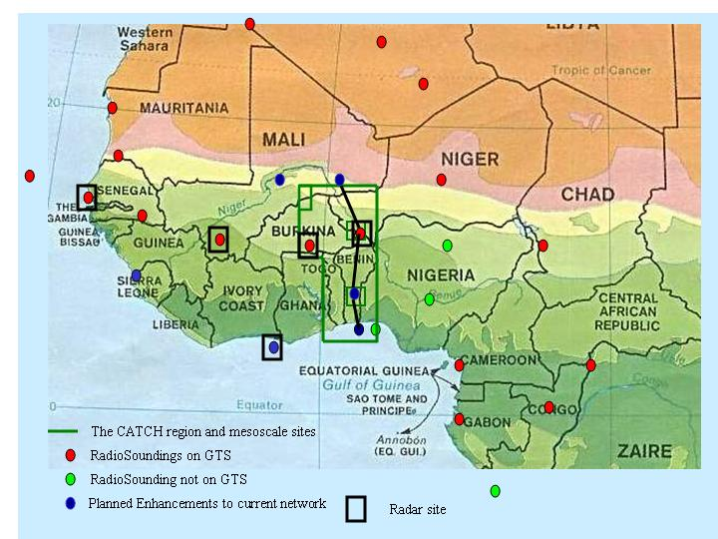

Figure 29: Existing and planned surface observation networks in West Africa that will operate during AMMA SOP and EOP/LOP. [Source: US-AMMA SSG, 2003]
4.2 Nation/Region-by-Nation/Region GV Site Readiness Summary

    - Australia (Provided by Elizabeth Ebert)

Facility | Agency | Equipment | Status | Additional Info
Darwin | BMRC
Darwin | BMRC | C-band Doppler Radar | operational
Darwin | BMRC | C-band Polarimetric Radar | operational
Darwin | BMRC | Rain Gauges | operational
Darwin | BMRC | Dense Rain Gauge Network | operational
Darwin | BMRC | 50/920 MHz Profiler | operational
Darwin | BMRC | Radiosonde | operational
Darwin | BMRC | Automated Weather Stations | operational
Darwin | US DOE | ARM Atmospheric Radiation and Cloud Station | operational
Brisbane (CP2) |  |  | planned
Brisbane (CP2) |  | S- and X-band Polarimetric Radar | planned (2004)
Brisbane (CP2) |  | 220 Rain Gauges | operational
National | BoM | Radar-Rain Gauge Network | operational | Primarily costal; 500 synoptic, 1500 telemetric, 4000 cooperative rain gauges

    - Austria (Provided by Michael Schoenhuber)

Facility | Agency | Equipment | Status | Additional Info
Graz |  | Polarimetric Radar

    - Brazil (Provided by Roberto Calheiros)

Facility | Agency | Equipment | Status | Additional Info
National
National | Ministry of Agriculture, National Institute of Meterology | >2300 Rain Gauges (not all networked) |  | agroclimatology
National | UNESP (University) | M55 Geophysica aircraft
National | UNESP (University) | Falcon 20 E-5 aircraft
National |  | Sugar Cane Growers
National |  | Hydrological Operators
Parana | State Govt
Parana | State Govt | S-Band Doppler Radar | Operational
Parana | State Govt | Rain Gauge Network | Operational
Sao Paulo | State Govt
Sao Paulo | State Govt | S-Band Radar | Operating (to be moved)
Sao Paulo | State Govt | X-band Dual Polarization Doppler (Metro area of Sao Paulo) | planned (early 2004)
Sao Paulo | State Govt | X-Band for coastline | planned (2004)
Sao Paulo | State Govt | S-Band Dual Doppler 1deg class antenna | planned
Sugar Cane |  | 2-Dedicated micro-meterological research stations
Cerrado |  | Dedicated micro-meterological research station
Santarem/Amazon |  | Dedicated micro-meterological research station
Bananal Island |  | Dedicated micro-meterological research station
Sivam | Federal Govt
Sivam | Federal Govt | 10 Networked Radars | 6 operating | covers legal Amazonia
Sivam | Federal Govt | 200 Meterological stations | part operational | covers legal Amazonia
Sivam | Federal Govt | 60 AWS | part operational | covers legal Amazonia

    - Canada (Provided by David Hudak)

Facility | Agency | Equipment | Status | Additional Info
National |  |  |  | large emphasis on snow, low-level snow in valleys
National |  | C-band Radar Network along southern border (31) | operational
National |  | Precipitation Occurrence Sensing System (POSS) (95) | operational | small X-band bistatic radar for detecting precip type, occurence, & accum
National |  | Ground Stations (95) | operational | with the POSS
National |  | 2 aircraft | operational
C-MOST |  |  |  | Canadian Mesoscale S T
C-MOST |  | 45 ground stations | operational
C-MOST |  | 2 bi-static links | operational
C-MOST |  | X-band Radar | operational
C-MOST |  | S-band Dual Pol Radar | operational
C-MOST |  | 2 Wind Profilers | operational
C-MOST |  | GPS Rcvr | operational
CARE |  |  |  | Centre for Atmospheric Research Experiment
CARE |  | C-band Dual-polarization Radar | planned (2004) | set up for low-level precipitation off of Great Lakes
CARE |  | X-band Radar | operational
CARE |  | 915 MHz Wind Profiler | operational

    - China (Provided by Lu Naimeng)

Facility | Agency | Equipment | Status | Additional Info
National | China Meteorological Administration | S-band Dual-Pol Radar | operational
National | China Meteorological Administration | C-band Dual-Pol Radar | operational
National | China Meteorological Administration | X-band Radar | operational
National | China Meteorological Administration | 2300 Rain Gauges | operational

    - European Union {Provided by Ralf Bennartz)

Facility | Agency | Equipment | Status | Additional Info
BALTRAD |  | 30 radars from 11 countries
BALTRAD |  | Rain Gauges

    - Finland (Provided by Jarmo Koistinen)

Facility | Agency | Equipment | Status | Additional Info
Sodankyla  (latitude 67 N) CEOP reference site | FMI | C-band Doppler weather radar | operational | 3D polar data continuously archived
Sodankyla  (latitude 67 N) CEOP reference site | FMI | 48-metre instrumented mast | operational | Temperature, wind, CO2, O3 eddy-covariance fluxes, solar and terrestrial radiation components etc.
Sodankyla  (latitude 67 N) CEOP reference site | FMI | Radiosonde | operational
Sodankyla  (latitude 67 N) CEOP reference site | FMI | UV-radiation spectrophotometer
Sodankyla  (latitude 67 N) CEOP reference site | FMI | AWS stations | operational
Sodankyla  (latitude 67 N) CEOP reference site | FMI | Rain & snow gauges | operational
Sodankyla  (latitude 67 N) CEOP reference site | FMI | Snow depth poles and devices | operational | 200 snow days a year
Sodankyla  (latitude 67 N) CEOP reference site | FEI | Snow courses
Helsinki – Jokioinen  (latitude 60-61 N) WMO Nowcast and Mesoanalysis Testbed (provisional) | FMI | C-band Doppler weather radar network | operational | 3D polar data continuously archived
 | Vaisala/HU | C-band polarimetric radar | Under construction
 | FMI/Vaisala | AWS stations (100) | Under con. | Meso-network
 | FMI | Rain & snow gauges | operational
 | FMI | Weighing gauges | operational
 | FMI | Rain&snow gauge field | operational | Manual observations
 | FMI | Snow depth poles and  ultrasound sensors | operational | 150 snow days a year
 | FMI | Instrumented mast, 300m | operational | T,V, RH
 | FMI | Radiosonde | operational
 | FMI | Ceilometers | operational
 | Vaisala | Wind profiler(s) | test use
 | Vaisala | Radiosonde | test use

    - France (Provided by Guy Delrieu)

Facility | Agency | Equipment | Status | Additional Info
Palaiseau
Palaiseau |  | Radars |  | CETP
OHM-CV (Observatoire Hydrométéorologique Méditerranéen Cévennes-Vivarais)  The OHM-CV observation window (200x160 km2) is located in southeastern France.  The region is  subject to intense and long lasting rain events and subsequent flash-floods | Environment Research Observatory  (ORE) of French Ministry of Research
 |  | 2 S-band radar systems  1 C-band radar system | operational | ARAMIS network, Météo France
 |  | 400 daily raingauges  160 hourly rain gauges | operational | Météo France, DDE30, DDE07
 |  | 45 stream gauge stations | operational | DDE30, DDE07, DIREN RA, DIREN LR, EDF
 |  | GPS + weather stations | Research | LGIT, LDL, CNRM  (in operation each autumn since 2002)
 |  | Doppler-polarimetric X-band radar | Research | LTHE, (not before 2008)
 |  | Disdrometer | Research | LTHE (permanent operation since 2004)
 |  | Scintillometer | Research | LTHE (not before 2007)
 |  | Innovative stream gauge stations (video, radar) | Research | LTHE (not before 2005)
 |  | Hillslope hydrological instrumentation for several representative basins | Research | HSM, EMA, LTHE  (partly existing, to be developed in next 3 years)

    - Germany (Provided by Martin Hagen)

Facility | Agency | Equipment | Status | Additional Info
Oberpfaffenhofen
Oberpfaffenhofen | DLR | C-band Polarimetric Doppler Radar | operational
Oberpfaffenhofen | DLR | Celiometer | operational
Oberpfaffenhofen | DLR | Lidars | operational
Oberpfaffenhofen | DLR | Ka-band Cloud Radar | planned (2006)
Oberpfaffenhofen | DLR | Aircraft | operational
Oberpfaffenhofen | German Weather Service | 100 Rain Gauges | operational | 2 owned by DLR
Oberpfaffenhofen | DLR | Disdrometers | operational
Oberpfaffenhofen | German Weather Service | 2 Weather Radars | operational
Bonn | U of Bonn
Bonn | U of Bonn | X-band Doppler Radar | operational
Bonn | U of Bonn | Multi-Frequency Radiometer | operational
Bonn | U of Bonn | Rain Gauges | operational
Lindenberg | German Weather Service
Lindenberg | German Weather Service | 484 MHz Wind Profiler | operational
Lindenberg | German Weather Service | 1250 MHz Wind Profiler | operational

    - Greece

Facility | Agency | Equipment | Status | Additional Info
TBD

    - India

Facility | Agency | Equipment | Status | Additional Info
TBD
    - Israel (Provided by Eyal Amitai & Daniel Rosenfeld)

Facility | Agency | Equipment | Status | Additional Info
 | The Hebrew University of Jerusalem | Cloud physics Aircraft  Explicit microphysics modeL  Microphyisical retrievals from MSG | Use of  Own model  Own methodology | Work with RAINCLOUDS and Hebrew University Cloud Model

    - Italy (Provided by Eugenio Gorgucci)

Facility | Agency | Equipment | Status | Additional Info
National
National |  | 16 C-band Radars | operational | not networked, various capabilities
National | Civil Protection Department, CIMA | 6 C-Band Doppler Dual-Pol | planned (2004) | continuous operational data collection
National | Civil Protection Department, CIMA | 8 C-Band Doppler Dual-Pol | proposed (2006) | continuous operational data collection
National | Civil Protection Department, CIMA | Rain Gauges | operational
Rome | CNR-ISAC |  |  | Info from ppt slide
Rome | CNR-ISAC | C-band Doppler Dual-Pol | operational
Rome | CNR-ISAC | VHF Wind Profiler | operational | 24 hour operation
Rome | CNR-ISAC | SODAR | operational | acoustic sounder, 3 receivers
Rome | CNR-ISAC | Multiple Receiver Lidar | operational | aerosol, temp, water vapor
Rome | CNR-ISAC | Vehicle-Mounted Lidar (532 nm) | operational
Rome | CNR-ISAC | Microlidar (µLID elastic backscatter lidar) | operational
Rome | CNR-ISAC | Meterorological Measurements | operational | temp, humidity, etc
Rome | CNR-ISAC | Sun Photometer (440-1020 nm) | operational | aerosol optical depth, precipitable water, aerosol size distribution, refractive index and single scattering albedo. It is part of NASA GSFC AERONET
Rome | CNR-ISAC | NET Radiometer | operational | incoming SW and outgoing LW

    - Japan (Provided by Toshio Iguchi)

Facility | Agency | Equipment | Status | Additional Info
Okinawa | JAXA, CRL |  |  | sub-tropical
Okinawa | JAXA, CRL | C-band Polarimetric Radar (COBRA/COBRA+) | operational | 6-minute scan
Okinawa | JAXA, CRL | C-Band Polarimetric Radar (COBRA Jr.) | operational | zenith-looking
Okinawa | JAXA, CRL | Rain Gauges | operational
Okinawa | JAXA, CRL | Disdrometers | operational
Okinawa | JAXA, CRL | 24 GHz Micro Rain Radar | operational | MRR-2
Okinawa | JAXA, CRL | 400 MHz Wind Profiler | operational
Okinawa | JAXA, CRL | 1300 MHz Wind Profiler | operational
Wakkanai | JAXA, CRL |  |  | snow validation for DPR; 45.38 deg N, 141.68 deg E
Wakkanai | JAXA, CRL | Wind Profiler | planned
Wakkanai | JAXA, CRL | Video Disdrometer | planned
Wakkanai | JAXA, CRL | Microwave Precipiation Radar (MPR) | planned
Wakkanai | JAXA, CRL | Ku-band Radar | planned
Wakkanai | JAXA, CRL | W-band Radar | planned

    - Korea (Provided by Jae-Cheol Nam)

Facility | Agency | Equipment | Status | Additional Info
National | KMA
National | KMA | 536 Rain Gauges, 13 x 13 km 1 minute readout | operational | .1 and .5 mm tipping bucket
National | KMA | 10 Radars (c-,s-band) | operational
National | KMA | 10 Wind Profilers | planned (2004 (2), 2005)
Hae Nam (KEOP supersite) | METRI/KMA |  |  | operating as CEOP supersite
Hae Nam (KEOP supersite) | METRI/KMA | S-band Doppler Radar | Operational
Hae Nam (KEOP supersite) | METRI/KMA | C-band Doppler Radar | Operational
Hae Nam (KEOP supersite) | METRI/KMA | X-band Doppler Radar | Operational
Hae Nam (KEOP supersite) | METRI/KMA | Autosonde | Operational
Hae Nam (KEOP supersite) | METRI/KMA | Boundary Layer Wind Profiler | Operational
Hae Nam (KEOP supersite) | METRI/KMA | Micro Rain Radar | Operational
Hae Nam (KEOP supersite) | METRI/KMA | Flux Tower (10 m) | Operational
Hae Nam (KEOP supersite) | METRI/KMA | Optical Rain Gauge | Operational
Hae Nam (KEOP supersite) | METRI/KMA | Radiometer | Operational

    - Netherlands (Provided by Remko Uijlenhoet)

Facility | Agency | Equipment | Status | Additional Info
Cabauw | Consortium of Universities and Research Centers |  |  | Cabauw Experimental Site for Atmospheric Research (CESAR); Clouds/aerosols/radiation, atmospheric composition, precipitation, land surface/atmosphere
Cabauw | Consortium of Universities and Research Centers | 1 GHz Wind Profiler | operational
Cabauw | Consortium of Universities and Research Centers | 3 GHz Rain-Cloud Profiler | operational | 3-beam Doppler Polarimetric
Cabauw | Consortium of Universities and Research Centers | 35 GHz Cloud Radar | operational
Cabauw | Consortium of Universities and Research Centers | X-band Radar | planned (2004) | high resolution scanning radar, 30 m resolution, 30 km range
Cabauw | Consortium of Universities and Research Centers | 94 GHz Cloud Radar | uncertain | GKSS contribution
Cabauw | Consortium of Universities and Research Centers | Non-scattering Lidar | operational
Cabauw | Consortium of Universities and Research Centers | Raman Lidar | operational
Cabauw | Consortium of Universities and Research Centers | Scanning Lidar | operational
Cabauw | Consortium of Universities and Research Centers | 30 Rain Gauges | 12 operational, others by end of 2003 | 1 per square km
Cabauw | Consortium of Universities and Research Centers | Microwave Radiometer | operational | U of Bonn contribution
Cabauw | Consortium of Universities and Research Centers | 2 Optical Disdrometers | operational
Cabauw | Consortium of Universities and Research Centers | 2-D Video Disdrometer | operational | ESA/ESTEC contribution
Cabauw | Consortium of Universities and Research Centers | Substantial other meterological equipment | operational | IR Radiometer, UV Radiometer, pyranometer, 213 m flux/radiation tower, Ceilometer, ARM-type measurements, …
Cabauw | Consortium of Universities and Research Centers | 27 GHz Link | proposed
National | KNMI
National | KNMI | 2 C-Band Doppler Radars | operational | De Bilt, Den Helder
National | KNMI | 350 Daily Rain Gauges | operational | 1/100 sq km
National | KNMI | 35 Auto Rain Gauges (10 min) | operational | 1/1000 sq km
National | KNMI | 10's of gauges from water authority | operational

    - South Africa

Facility | Agency | Equipment | Status | Additional Info
TBD

    - Spain (Provided by Daniel Sempere-Torres)

Facility | Agency | Equipment | Status | Additional Info
Catalunya | UPC |  |  | interesting events of heavy rain: 2 events per year > 100 mm/day; 1 event per 2 yr > 200 mm/day; 15,000 sq km total area seen by 3 radars
Catalunya | UPC | 3 C-Band Doppler Radars | operational
Catalunya | UPC | 2 C-Band Doppler Radars | planned (2003, 2004)
Catalunya | UPC | Rain Gauges, 1/100 sq km | operational
Catalunya | UPC | Rain Gauges, 1/64 sq km | planned
Catalunya | UPC | Radiosondes
Catalunya | UPC | hydrological monitoring |  | hydrological validation using runoff model

    - Taiwan (Provided by Chung-Hsiung Sui)

Facility | Agency | Equipment | Status | Additional Info
National |  |  |  | working on TRMM GV, plan to use multiple sensors for micro-physical determination
National |  | 360 Automatic Rain Gauges | operational | hourly data routinely available, can output at 1 minute resolution
National |  | 30 to 40 Rain Gauges | planned
National |  | 5 Weather Radars | operational
National |  | S-band Dual Polarization Doppler Radar | planned (2004)
National |  | VHF Radar | operational
National |  | Integrated Sounding System | operational | includes wind profiler
National |  | 2 2-D Disdrometers | operational
National |  | 3 J-W Disdrometers | operational

    - United Kingdom (Provided by John Goddard)

Facility | Agency | Equipment | Status | Additional Info
National | MET OFFICE | Radar Network | operational | 5-minute scans, 1-2 km resolution
National | MET OFFICE | 19 MET Office rain gauges | operational
National | NERC / MET OFFICE | MET Office FAAM BAe146 Aircraft | operational
Chilbolton | CCLRC | 3 GHz Polarisation Doppler Radar | operational | 25 m antenna, 0.25 º beam width
Chilbolton | CCLRC | 1275 MHz clear-air radar | operational | 25 m antenna
Chilbolton | CCLRC | 94 GHz Doppler Cloud Radar | operational
Chilbolton | CCLRC | 35 GHz Doppler Cloud Radar | operational
Chilbolton | CCLRC | UV Raman Lidar | operational
Chilbolton | CCLRC | IR Lidar Ceilometer | operational
Chilbolton | CCLRC | 22.2, 28.8, 37.5 GHz Millimetre wave Radiometers | operational
Chilbolton | CCLRC | 2-frequency links for path attenuation measurements | planned
Chilbolton | CCLRC | Radid response drop-counting rain gauges | operational
Chilbolton | CCLRC | Joss disdrometers | operational
Chilbolton | CCLRC | Optical Rain Gauge | operational
Chilbolton | CCLRC | Tipping bucket gauges | operational
Chilbolton | CCLRC | Self-syphoning capacitance gauge | operational
Chilbolton | CCLRC | Cloud camera | operational
Chilbolton | CCLRC | Met station | operational
Chilbolton | CCLRC | Visible and IR Broadband Radiometers | operational

    - United States (Provided by Mark Miller and Sandra E. Yuter)

Facility | Agency | Equipment | Status | Additional Info
National | NOAA |  |  | Operational data collection
National | NOAA | NEXRAD Radar
National | NOAA | Rain Gauges
National | NOAA | Other Extensive Meterological Monitoring
National | NOAA | Hydro-Meterological Testbeds | operating and planned | Substantial set of precipitation instruments
Continental Site |  |  | developing concept and requirements | considering DOE ARM site in OK
Continental Site | NASA | S-band Polarimetric Radar | planned
Continental Site | NASA | X-band Polarimetric Radar | planned
Continental Site | NASA | Rain Gauges | planned
Continental Site | NASA | Disdrometers | planned
Continental Site | NASA | Dense Rain Gauge Network | planned
Continental Site | DOE | Aerosols | operational | ARM
Continental Site | DOE | Radiosondes | operational | ARM
Continental Site | DOE | 915 MHz Wind Profiler | operational | ARM
Continental Site | DOE | 35 GHz cloud radar | planned (2004) | ARM
Continental Site | DOE | 94 GHz cloud radar | operational | ARM
Continental Site | DOE | lidar | operational | ARM
Continental Site | DOE | S-band vertical point radar | proposed | ARM
Continental Site | DOE | NEXRAD Radar | operational | ARM
Ocean Site |  |  | developing concept and requirements | considering Kwajalein Atoll
Ocean Site | NASA | S-Band Doppler Dual Polarization Radar | operational
Ocean Site | NASA | Qualimetrics tipping buckets | operational
Ocean Site | NASA | Joss-Waldvogel disdrometers | operational
Central Florida |  |  |  | around Kennedy Space Center
Central Florida | NOAA | NEXRAD Radar | operational | Melbourne
Central Florida | NOAA | Rain Gauge Network | operational
Central Florida | NASA | Dense Rain Gauge Network | operating, tlm system planned | 20 pairs on 2 km grid
Central Florida | NASA | Very High Density Rain Gauge Network | proposed | 20 pairs in 2 km x 2 km region
Central Florida | NASA | 222 meteorological sensors on 44 towers | operational | 1200 sq km area
Central Florida | NASA | 50 MHz Doppler wind profiler | operational
Central Florida | NASA | 915 MHz Wind Profiler | operational
Central Florida | NASA | Lightning detection and ranging (66 MHz rcvrs) | operational
Central Florida | NASA | Disdrometer network | proposed | 3 disdrometers + interpolation/extrapolation algorithm
Central Florida | NASA/NOAA | S-band Polarimetric Doppler Radar | operational
Central Florida | NASA/NOAA | C-band Doppler Radar | operational
Central Florida | USGS | X-band Polarimetric Radar | planned
Central Florida | USGS | Vertically-Pointed Radar | operational
Central Florida | USGS | Rain Gauges | operational
Central Florida | USGS | Microwave Links | operational
Central Florida | USGS | 2-D Video Disdrometer | operational
Central Florida | USGS | Impact Disdrometers | operational
Florida Keys | NASA
Florida Keys | NASA | 10 Rain Gauges | operational
Florida Keys | NASA | 1 Disdrometer | operational

    - West Africa Consortium (Provided by Everette Joseph)

Facility | Agency | Equipment | Status | Additional Info
Dakar | Howard U, U of VA, U of ND, Cheikh Anta Diop (U of Dakar) LPA, Senegal, NASA
Dakar |  | S-Band NPOL Polarimetric Radar | proposed (2006)
Dakar |  | Rain Gauges | proposed (2006)
Dakar |  | Disdrometers | proposed (2006)
Dakar | Dakar | C-Band Radar | operational | calibration problems
Dakar | Dakar | S-Band Radar | planned
Benin | African Multi-Disciplinary Monsoon Analysis |  |  | substantial equipment planned for 2004
Benin | France | X-Band Radar | planned (2004)
Benin |  | Catch Basin Network | planned (2004)
Benin |  | Aircraft | planned (2004)

5.0 High-level Recommendations for Successful International GPM GV Programme

- GPM’s GV Research Programme should be designed both to validate and improve GPM’s standard precipitation retrieval algorithms and to better understand physical and dynamical nature of precipitating storms.
- Global network of GPM GV sites should be established by international partners to enable comprehensive ground-based observations of precipitation system’s 3-dimensional structure (dynamic, thermodynamic, macrophysical, and microphysical processes and properties), along with capability for continuous observational monitoring of storm life cycles.
- International GV working group should be established within GPM Mission’s international framework to ensure and manage data / information exchange between GV sites and other precipitation-centric data gathering operations (i.e., operational data collection programs, specialized national / international research-oriented data acquisition projects, and national / international field experiments focused on cloud and precipitation processes) -- all of this designed for strong interactions with algorithm developers.
- Subset of GV sites should operate as GV Supersites to enable near-realtime error characterization for data assimilation applications and to enable continuous algorithm improvement through near-realtime detection of significant errors in GPM’s standard precipitation algorithms.
- One or more Virtual GV Sites should be established to enable diverse sensor observations of regional area(s).
- At least one GV Supersite for land-based snowfall validation should be implemented.
- Dependable instruments and methods for measurement of rainfall and snowfall over ocean should be developed.
- All GPM GV scientific data, i.e., all GV data and GV data products offered for release to GPM Mission by GV site operators (and thus designated as GPM GV scientific data) should be provided on free and open exchange basis with GPM science and engineering community. Free and open GV data policy should be written into GPM Mission’s “charter”.
- Data transmission delays of GPM GV scientific data should be minimized.

6.0 GPM GV Point Of Contact for Nation/Region

1. Australia Elizabeth Ebert <e.ebert@bom.gov.au>
2. Austria Michael Schoenhuber <michael.schoenhuber@joanneum.at>
3. Brazil (2) Roberto Calheiros <calheiros@www.radar.ipmet.unesp.br>
Carlos Morales <morales@model.iag.usp.br>
4. Canada (2) Paul Joe [Ontario] <paul.joe@ec.gc.ca>
David Hudak [Ontario] <David.Hudak@ec.gc.ca>
5. China Lu Naimeng < lunaimeng@nsmc.cma.gov.cn>
6. European Union (BALTRAD) Ralf Bennartz <bennartz@aos.wisc.edu>
7. Finland Jarmo Koistinen <jarmo.koistinen@fmi.fi>
8. France Nicolas Viltard <viltard@cetp.ipsl.fr>
9. Germany Martin Hagen <martin.hagen@dlr.de>
10. Greece (2) Emmanouil Anagnostou <manos@engr.uconn.edu>
Vasso Kotroni <kotroni@meteo.noa.gr>
11. India Raju Garudachar <raju_garudachar@hotmail.com>
12. Israel (2) Daniel Rosenfeld <daniel@vms.huji.ac.il>
Eyal Amitai <eyal@radar.gsfc.nasa.gov>
13. Italy Eugenio Gorgucci <e.gorgucci@isac.cnr.it>
14. Japan Shuji Shimizu<shuji.shimizu@jaxa.jp>
15. Korea Byung-Ju Sohn <sohn@snu.ac.kr>
16. Netherlands Remko Uijlenhoet < Remko.Uijlenhoet@wur.nl>
17. South Africa Deon Terblanche <deon@metsys.weathersa.co.za>
18. Spain Daniel Sempere-Torres <sempere@grahi.upc.es>
19. Taiwan Ming-Dah Chou <mdchou@atmos1.as.ntu.edu.tw>
20. United Kingdom John Goddard <j.w.f.goddard@rl.ac.uk>
21. United States Matt Schwaller <mathew.r.schwaller@nasa.gov>
22. West Africa Consortium Everette Joseph <ejoseph@howard.edu>

7.0 References

AMMA, 2003: An international research project and field campaign. http://medias.obs-mip.fr/amma/.

Awaka, J., T. Iguchi, and K. Okamoto, 1998: Early results on rain type classification by the Tropical Rainfall Measuring Mission (TRMM) precipitation radar. Proc. URSI-F Symp. on Wave Propagation and Remote Sensing [Aveiro, Portugal], 143-146.

Bringi, V.N., and C.V. Chandrasekar, , 2001: Polarimetric Doppler Weather Radar. Cambridge University Press, Cambridge, 636 pp.

Browning, K.A., and R. Wexler, 1968: The determination of kinematic properties of a wind field using Doppler radar. J. Appl. Meteor., 7, 105-113.

Koistinen, J., and D.B. Michelson, 2002: BALTEX weather radar-based precipitation products and their accuracies. Boreal Env. Res., 7, 253-263.

Koistinen, J., D.B. Michelson, H. Hohti, and M. Peura, 2003: Operational measurement of precipitation in cold climates. Weather Radar: Principles and Advanced Applications (P. Meischner, ed., 337 pp), Springer, Berlin, 78-114. [ISSN 1610-1677; ISBN 3-540-000328-2]

Koscielny, A.J., R.J. Doviak, and R. Rabin, 1982: Statistical considerations in the estimation of divergence from single Doppler radar and application to prestorm boundary layer observations. J. Appl. Meteorol., 21, 197-210.

Lhermitte, R.M., and D.A. Atlas, 1961: Precipitation motion by pulse Doppler radar. Proc. 9th Weather Radar Conf. [Boston], Amer. Meteorol. Soc., Boston, MA, 218-223.

Mahfouf, J.-F., V. Marécal, and P. Bauer, 2003: The assimilation of SSM/I and TMI rainfall rates in the ECMWF 4D-Var system. Quart. J. Roy. Met. Soc., submitted.

Marécal V., and J.-F. Mahfouf, 2002: Four-dimensional variational assimilation of total column water vapour in rainy areas. Mon. Wea. Rev., 130, 43-58.

Michelson, D.B., T. Anderson, C.G. Collier, Z. Dziewit, J. Koistinen, S. Overgaard, J. Riedl, and V. Zhukov, 1999: The international radar network for the Baltic Sea Experiment. Preprints, 29th Radar Meteorology Conference [12-16 July 1999; Montreal, Canada], Amer. Meteorol. Soc., Boston, MA, 317-320.

Moreau, E., P. Lopez, P. Bauer, A.M. Tompkins, M. Janiskovà, and F. Chevallier, 2003: Variational retrieval of temperature and humidity profiles using rain-rates versus microwave brightness temperatures. Quart. J. Roy. Met. Soc., submitted.

Pylkkö, P., B. Bizzarri, G. Blöschl, S. Metsämäki, and J. Pulliainen, 2003: Status of snow monitoring. EUMETSAT H-SAF internal document (15 Dec 2003), 10 pp.

Raschke E., J. Meywerk, K. Warrach, U. Andrae, S. Bergström, F. Beyrich, F. Bosveld, K. Bumke, C. Fortelius, L.P. Graham, S.–E. Gryning, S. Halldin, L . Hasse, M. Heikinheimo, H.–J. Isemer, D. Jacob, I. Jauja, K.–G. Karlsson, S. Keevallik, J. Koistinen, A. van Lammeren, U. Laas, J. Launiainen, A. Lehmann, B. Liljebladh, M. Lobmeyer, W. Matthäus, T. Mengelkamp, D.B. Michelson, J. Napiorkowski, A. Omstedt, J. Piechura, B. Rockel, F. Rubel, E. Ruprecht, A.–S. Smedman, and A. Stigebrandt, 2001: The Baltic Sea Experiment (BALTEX): A European contribution to the investigation of the energy and water cycle over a large drainage basin. Bull. Amer. Meteor. Soc., 82, 2389-2413.

Rosenfeld D., and C.W. Ulbrich, 2003: Cloud microphysical properties, processes, and rainfall estimation opportunities. Chapter 10 of Radar and Atmospheric Science: Chapter 10 -- A Collection of Essays in Honor of David Atlas (R.M. Wakimoto and R. Srivastava, eds.). AMS Meteorological Monographs, 52, 237-258.

Schumacher, C., and R.A. Houze, Jr., 2000: Comparison of radar data from the TRMM satellite and Kwajalein oceanic validation site. J. Appl. Meteor., 39, 2151-2164.

Simmons, A., and A. Hollingsworth, 2001: Some aspects on the improvement in skill of numerical weather prediction. ECMWF Technical Memorandum No. 342, European Center for Medium Range Weather Forecasting, Reading, England.

Sobel, A.H., S.E. Yuter, C.S. Bretherton, and G.N. Kiladis, 2003: Large-scale meteorology and deep convection during TRMM KWAJEX. Mon. Wea. Rev., in press.

Steiner, M., R.A. Houze, Jr., and S.E. Yuter, 1995: Climatological characterization of three-dimensional storm structure from operational radar and rain gauge data. J. Appl. Meteor., 34, 1978-2007.

Trapp, R.J., and C.A. Doswell III, 2000: Radar data objective analysis. J. Atmos. Oceanic Technol., 17, 105-120.

US-AMMA SSG, 2003: A proposal for US participation in the African Monsoon Multidisciplinary Analysis (AMMA) project. http://www.joss.ucar.edu/amma.

Waldteufel, P., and H. Corbin, 1979: On the analysis of single Doppler radar data. J. Appl. Meteor., 18, 532 - 542.

Yuter S.E., and R.A. Houze, Jr., 1995: Three-dimensional kinematic and microphysical evolution of Florida cumulonimbus. Part II: Frequency distributions of vertical velocity, reflectivity, and differential reflectivity. Mon. Wea. Rev., 123, 1941-1963.

Yuter, S.E., and R.A. Houze, Jr., 1997: Measurements of raindrop size distributions over the Pacific warm pool and implications for Z-R relations. J. Appl. Meteor., 36, 847-867.

Yuter, S., R. Houze, V. Chandrasekar, E. Foufoula-Georgiou, M. Hagen, R. Johnson, D. Kingsmill, R. Lawrence, F. Marks, S. Rutledge, and J. Weinman, 2002: GPM Draft Science Implementation Plan Ground Validation Chapter. Accessible at: www.arxiv.org, arXiv:physics/0211095, 22 pp.

Yuter, S.E., R.A. Houze, Jr., E.A. Smith, T.T. Wilheit, and E. Zipser, 2005: Physical characterization of tropical oceanic convection observed in KWAJEX. J. Appl. Meteor., in press.

8.0 Appendices
8.1 Attendees of Abingdon Meeting

Surname | First Name | Company / University / Agency | Country | E-mail Address
Amitai | Eyal | NASA - GSFC | USA | eyal@radar.gsfc.nasa.gov
Bauer | Peter | ECMWF | UK | peter.bauer@ecmwf.int
Bibyk | Irene | NASA - GSFC | USA | Irene.Bibyk@nasa.gov
Bidwell | Steven | NASA - GSFC | USA | Steven.W.Bidwell@nasa.gov
Calheiros | Roberto | IPMET | Brazil | calbeiros@ipmet.unesp.br
Chandrasekar | V | Colorado State University | USA | chandra@engr.colostate.edu
Chen | Wann-Jin | Chung Cheng Inst. of Technology | Taiwan | Wannjin@ccit.edu.tw
Cifelli | Robert | Colorado State University | USA | rob@radarmet.atmos.colostate.edu
Di Michelle | Sabatino | Institute of Atmopsheric Sciences and Climate (ISAC) | Italy | S.DiMichele@isac.cnr.it
Ebert | Elizabeth | Bureau of Meteorology Research Centre | Australia | e.ebert@bom.au
Everett | David | NASA - GSFC | USA | David.F.Everett@nasa.gov
Facheris | Luca | Dipart.di Elettronica E Telecomm. | Italy | facheris@ingfi1.ing.unifi.it
Ferraro | Ralph | NOAA/NESDIS/Cooperative Institute for Climate Studies | USA | Ralfph.R.Ferraro@noaa.gov
Fuentes | Jose | University of Virginia | USA | jf6s@virginia.edu
Goddard | John | Rutherford Appleton Laboratory | UK | J.W.F.Goddard@rl.ac.uk
Goodison | Barry | Meteorological Service of Canada | Canada | Barry.Goodison@ec.gc.ca
Gorgucci | Eugenio | Istituto di Scienze dell'Atmosfera e del Clima | Italy | gorgucci@radar.ifa.rm.cnr.it
Haddad | Ziad | Jet Propulsion Laboratory | USA | zsh@albertovo5.jpl.nasa.gov
Hagen | Martin | Institut fur Physik der Atmosphare | Germany | martin.hagen@dir.de
Hanado | Hiroshi | CRL, Appl.Sci & Standards Div. | Japan | hanado@crl.go.jp
Hudak | David | Meteorological Service of Canada | Canada | David.Hudak@ec.gc.ca
Hwang | Paul | NASA - GSFC | USA | paul.h.hwang@nasa.gov
Illingworth | Anthony | University of Reading | UK | a.j.illingworth@reading.ac.uk
Jones | Linwood | CFL | USA | LJONES5@CFL.RR.COM
Joseph | Everette | Howard Uni., Dept. of Physics | USA | ejoseph@howard.edu
Kakar | Ramesh | NASA | USA | rkakar@hq.nasa.gov
Kidd | Chris | University of Birmingham | UK | C.Kidd@bham.ac.uk
Kitchen | Malcolm | Met Office | UK | malcolm.kitchen@metoffice.com
Klein | Ulf | European Space Agency | Netherlands | Ulf.Klein@esa.int

Surname | First Name | Company / University / Agency | Country | E-mail Address
Koistinen | Jarmo | Finnish Meteorological | Finland | Jarmo.Koistinen@fmi.fi
Kuo | Kwo-Sen | NASA -GSFC | USA | Kwo-Sen.Kuo@gsfc.nasa.gov
Lawrence | Richard | NASA - GSFC | USA | Richard.J.Lawrence@nasa.gov
Laws | Kevin | NOAA | USA | kevin.laws@noaa.gov
L'Ecuyer | Tristan | Colorado State University | USA | tristan@kangaroo.atmos.colostate.edu
Levizzani | Vincenzo | ISAC-CNR | Italy | v.levizzani@cnr.it
Matzler | Christian | Universitat Bern | Switzerland | matzler@iap.unibe.ch
Miller | Mark | Brookhaven National Laboratory | USA | miller@bnl.gov
Mugnai | Alberto | CNR/ISAC | Italy | a.mugnai@isac.cnr.it
Nakamura | Kenji | Nagoya University, Hydrosheric Atmospheric Research Center | Japan | nakamura@ihas.nagoya-u.ac.jp
Nam | Jae-Cheol | Korea Meteorological Admin. | Repub.of Korea | jcnam@metri.re.kr
Okamoto | Ken'ichi | AERO | Japan | okamoto@aero.osakafu-u.ac.jp
Perez-Fontan | Fernando | ETS Ingenieros de Telecomunicacion | Spain | fpfontan@tsc.uvigo.es
Pollard | David | Met Office | UK | david.pollard@metoffice.com
Ralph | Martin | NOAA/ETL | USA | marty.ralph@noaa.gov
Roth | Giorgio | CIMA, University of Genoa | Italy | giorgio@cima.unige.it
Russchenberg | Herman | Delft University of Technology, IRCTR | Netherlands | h.w.j.russchenberg@irctr.tudelft.nl
Schoenhuber | Michael | Joanneum Research, Appl. Syst. Tech. | Austria | Michael.Schoenhuber@joanneum.at
Schulz | Joerg | University of Bonn, Met. Institute | Germany | joerg.schulz@uni-bonn.de
Sempre-Torres | Daniel | UPC | Spain | sempere@graphi.upc.es
Shimizu | Shuji | Earth Observation Research Center | Japan | shimizu@eorc.nasda.go.jp
Smith | Eric | NASA - GSFC | USA | eric.ac.smith@nasa.gov
Sui | Chung-Hasn | National Central Uni., Hydrol.Sci. | Taiwan | sui@cc.ncu.edu.tw
Tokay | Ali | NASA - GFSC | USA | tokay@radar.gsfc.nasa.gov
Uijlenhoet | Remko | Wageningen Uni., Dep. Environ.Sci. | Netherlands | Remko.Uijlenhoet@wur.nl
Wilson | Carron | Rutherford Appleton Laboratory | UK | C.L.Wilson@rl.ac.uk
Wolff | David | NASA - GSFC | USA | wolff@radar.gsfc.nasa.gov
Wood | Robert | University of Washington, Atmos.Sci. | USA | robwood@atmos.washington.edu
Yang | Daqing | University of Alaska Fairbanks | USA | ffdy@uaf.edu
Yuter | Sandra | University of Washington, Atmos.Sci. | USA | yuter@atmos.washington.edu

8.2 Agenda of Abingdon Meeting

Day 1: Tuesday, 4 November

09:00 Registration
10:00 Preliminaries (J. Goddard -- Session Chair)
10:00 Welcome (K.Craig)
10:15 Definition of International GPM GV Research Program & Workshop Objectives (E. Smith)
10:30 Session 1a: Status of GPM/EGPM Programs (J. Goddard -- Session Chair)
10:30 NASA’s GPM Mission Program (R. Kakar)
10:45 JAXA’s GPM Mission Program (K. Nakamura)
11:00 ESA’s EGPM Mission Program (P. Baptista)
11:15 Tea Break
11:35 Session 1b: GV Science Requirements for GPM/EGPM Projects (K. Okamoto -- Session Chair)
11.35 JAXA GPM/DPR Calibration & Validation Plan (S. Shimizu & K. Nakamura)
12:00 NASA GPM GV Science Requirements (E. Smith)
12:20 ESA/EC EGPM GV Science Requirements (A. Mugnai)
12:40 Coordinated Activities for GPM GV European Science Community (V. Levizzani)
13:00 Lunch at Coseners House
14:00 Session 2a: Distributed International GPM GV Program #1 (G. Roth -- Session Chair)
14:00 GV Research in UK for GPM/EGPM Missions (J. Goddard, A. Illingworth & M. Kitchen)
14:20 NASA GPM Continental Supersite Template (S. Rutledge)
14:40 NASA GPM Oceanic Supersite Template (S. Yuter)
15:00 European GPM Virtual GV Site Template (M. Hagen)
15:20 Japan’s Supersite (H. Hanado & K. Okamoto)
15:40 Schedule & Technical Requirements for GPM Supersite (I. Bibyk & S. Bidwell)
16:00 Tea Break
16:20 Session 2b: Distributed International GPM GV Program #2 (R. Hood -- Session Chair)
16:20 Current Implementation of Voltaire Project’s Precipitation GV Research Program (D. Sempere-Torres & E. Amitai)
16:40 KMA’s Operational Precipitation GV Capabilities in Korea (J-C. Nam)
17:00 Emerging Opportunies for GPM GV in Canada (D. Hudak)
17:20 Ongoing Precipitation GV Research Program at BOM in Australia (E. Ebert)
17:40 Scientific & Technical Progress Towards Precipitation GV in Brazil (R. Calheiros & H.da Rocha)
18:00 TRMM & GPM GV Research Projects in Taiwan (C-H. Sui)
18:20 Logistics Update (C. Wilson)
18:30 End of Day’s Activities

Day 2: Wednesday, 5 November

08:30 Pre-Plenary for Splinter Session I (E. Smith – Chair)
08:30 Discussion of & Guidance for Working Groups
08:50 2-Hour Breakout into Four (4) Working Groups
WG#1a: Retrieval Error Characterization
(Chair -- E. Ebert; Raporteur -- T. L’Cuyer)
WG#2a: Regional Mapping of GV Error using Supersite Network
(Chair -- M. Hagen; Raporteur -- R. Cifelli)
WG#3a: New Challenges and Ideas for GV Research
(Chair -- V. Chandrasekar; Raporteur -- E. Gorgucci)
WG#4a: GV Opportunities for Operational Raingauge/Radar Networks
(Chair -- R. Ferraro; Raporteur -- C. Kidd)
10:50 Tea Break (Session Chairs & Raporteurs Prepare Summaries)
11:20 Post-Plenary for Splinter Session I (A. Mugnai -- Chair)
11:20 Summary Report from WG#1a (E. Ebert)
11:30 Summary Report from WG#2a (M. Hagen)
11:40 Summary Report from WG#3a (V. Chandrasekar)
11:50 Summary Report from WG#4a (R. Ferraro)
12:00 Lunch at Coseners House
13:00 5-Hour Field Trip to Chilbolton Observatory (J. Goddard & C. Wilson – Hosts)
19:30 "Remember Remember the 5th of November", Dinner at Coseners House

Day 3: Thursday, 6 November

09:00 Session 2c: Distributed International GPM GV Program #3 (A. Illingworth -- Session Chair)
09:00 New Opportunities for GV Measurement Program in West Africa (E. Joseph)
09:20 Unique Aspects of Rain Measuring Network for GV Research at KSC, Florida (L. Jones)
09:40 Transitioning GV Research from TRMM to GPM in Israel (D. Rosenfeld & V. Levizzani)
10:00 PrecipitationResearch at the Cabauw Experimental Site for Atmospheric Research (R. Uijlenhoet, H.W.J. Russchenberg, and I. Holleman)
10:20 Tea Break
10:40 Session 3: Synergy with Ongoing GV Research Projects (R. Uijlenhoet -- Session Chair)
10:40 Scientific Significance of Precipitation GV at DOE’s Southern Great Plains ARM Site (M. Miller)
11:00 Recent Developments in Precipitation GV within NOAA (M. Ralph)
11:20 TRMM’s Ground Validation Research Program (R. Adler & D. Wolff)
11:40 Utility for Realtime Rain Retrieval Error Characterization at ECMWF (P. Bauer)
12:00 Evaluating Precipitation GV Measurements in Context of Boundary Layer Processes (J. Fuentes & M. Garstang)
12:20 Progress Towards Physical Error Modeling in Precipitation Retrieval (K-S. Kuo)
12:40 Current GV Research Program at Wallops Island, Virginia (A. Tokay)
13:00 Lunch at Coseners House
14:00 Pre-Plenary for Splinter Session II (E. Smith – Chair)
14:00 Discussion of & Guidance for Working Groups
14:20 2-Hour Breakout into Four (4) Working Groups
WG#1b: International GPM GV Organizational Requirements
(Chair -- V. Levizzani; Raporteur -- R. Lawrence)
WG#2b: Scientific Goals of International GPM GV Research Program
(Chair -- K. Okamoto; Raporteur -- P. Hwang)
WG#3b: Accuracy Requirements
(Chair -- P. Baptista; Raporteur -- J. Schulz)
WG#4b: Precision and Error Covariance Requirements
(Chair -- S. Yuter; Raporteur -- J. Koistinen)
16:20 Tea Break
(Session Chairs & Raporteurs Prepare Summaries)
16:50 Post-Plenary for Splinter Session II (K. Nakamura -- Chair)
16:50 Summary Report from WG#1b (V. Levizzani)
17:00 Summary Report from WG#2b (K. Okamoto)
17:20 Summary Report from WG#4b (S. Yuter)
17:30 End of Day’s Activities

Day 4: Friday, 7 November

09:00 Session 4: Summary (B. Goodison -- Session Chair)
09:00 Country, Region, and Agency Site Readiness (D. Everett & J-C. Nam)
09:30 Potential GV-Site Concept (V. Levizzani & J. Goddard)
10:00 Organizational & Science Objectives (A. Mugnai and K. Nakamura)
10:30 Measurement Objectives & New Research Avenues (S. Yuter and V. Chandrasekar)
11:00 Tea Break
11:30 Session 5: Wrap-up (E. Smith -- Session Chair)
11:30 Pending Action Items (open discussion)
11:45 Workshop Document (open discussion)
12:00 Goals, Possible Sites, and Time Frame for 2nd Meeting (open discussion)
12:15 Parting Words by Hosts
12:30 End of Workshop

13:00 Steering Group Meeting
13:00 Lunch (Election of 2 Co-Chairs)
14:00 Planning for International GPM GV Document
15:30 Tea Break
17:00 Meeting Ends

8.3 Web Access to Abingdon Meeting Presentation Materials

All of the presentation materials from the Abingdon Workshop are available at http://www.rcru.rl.ac.uk/GPMGV/. An additional website has been established at GSFC which contains all of the Abingdon Workshop materials and will contain all future GV Workshop materials.

