OFFICE OF BRIDGE DEVELOPMENT
MANUAL FOR HYDROLOGIC AND HYDRAULIC DESIGN

CHAPTER 11, EVALUATING SCOUR AT BRIDGES

APPENDIX C
ESTIMATING SCOUR IN
BOTTOMLESS ARCH CULVERTS



SEPTEMBER 2005

APPENDIX C
ESTIMATING SCOUR IN BOTTOMLESS CULVERTS

TABLE OF CONTENTS

1. INTRODUCTION…………………………………………………………….....3

2. POLICY………………………………………………………………………..…4

A. GENERAL…………………………………………………………………... 4

B. FOOTINGSON ROCK OR PILES……………………………………………4

C. FOOTINGS ON ERODIBLE SOIL…………………………………….…..…4

3. DESIGN GUIDELINES………………………………………………………… 5

A. INTRODUCTION…………………………………………………………….5

B. DESIGN CONCEPT…………………………………………………..………5

C. DESIGN PROCEDURE…………………………………………………...…10

D. SPECIAL DESIGN PROCEDURES…………………………………………12

4. REFERENCES…………………………………………………………..………13

ATTACHMENT 1: EXAMPLE PROBLEM USE OF NOMOGRAPH FOR PRELIMINARY CULVERT SELECTION

ATTACHMENT 2: EXAMPLE PROBLEM USING THE BOTTOMLESS CULVERT MODULE

ATTACHMENT 3: CLEAR WATER SCOUR EQUATIONS

CHAPTER 11 – EVALUATING SCOUR AT BRIDGES
APPENDIX C

ESTIMATING SCOUR IN BOTTOMLESS CULVERTS

1. INTRODUCTION

The SHA's Office of Bridge Development (OBD) does not have a formal policy regarding the use of bottomless arch culverts on SHA projects. Bottomless arch culverts are considered one of many structural options available to a designer when developing solutions to a stream crossing of a highway. As with any option, there are a number of technical and practical factors which must be considered when implementing a structure design. Among these are geotechnical and foundation conditions, hydraulic and scour considerations, stream geomorphology, geometric and structural features, constructability, cost, etc. All of these factors are investigated in determining the most appropriate structure. There are times when a bottomless arch culvert may be feasible, but another structure type is selected for other overriding reasons. OBD does not predetermine the use of any specific type of structure, but determines the most appropriate structure type on a case-by-case basis. County and local bridge owners are encouraged to perform the same type of investigation for their structure projects, including consideration of bottomless arch culverts, if deemed appropriate and if the structures satisfactorily meet all needs of the particular project. Guidance regarding hydrologic, hydraulic, geomorphic and scour considerations are presented in Chapters 8, 9, 10 and 11 and 13 of the Office of Bridge Development Interim Manual of Hydrologic and Hydraulic Design (8). Structural, geotechnical and other considerations are presented in various other directives of the SHA.

Safety to the traveling public is the primary concern in the selection of a structure. When Federal or State funds are used in the construction of bottomless culverts, the SHA requires that a scour report be prepared to demonstrate that the structure is stable for worst-case scour (8).

The purpose of this Appendix C of Chapter 11 is to present SHA policy regarding the objective of the scour evaluation (a stable structure for worst-case scour conditions) and to provide guidance on the considerations to be evaluated in reaching the design objective for bottomless arch culverts. It replaces the SHA policy directive issued by Mr. Freedman, Director, Office of Bridge Development, in September 1997.

SHA policy and guidance regarding the design of bottomless culverts is presented below. The ABSCOUR Program is the method selected by the SHA Office of Bridge Development for evaluating scour in bottomless culverts (12). Further discussion of the procedures used in developing the design equations for the ABSCOUR Program is contained in Appendix A of Chapter 11 of the H&H Manual (8). Results from recent cooperative studies by the FHWA (Federal Highway Administration), Maryland SHA, Contech and Conspan (9) are used in the development of the design approach presented below.

At this time, SHA and FHWA are still evaluating various aspects of scour in bottomless culverts through a cooperative research study. Chapter 11, Appendix C will be updated and finalized at the completion of this study.

2. POLICY

A. GENERAL

- Analyze bottomless arch culverts supported on footings for worst case scour conditions in accordance with SHA policy for bridges (10). The scour report and other appropriate design studies shall document that the structure is stable for worst-case scour conditions, and shall be submitted to the SHA for approval.

- Evaluate the 100-year, 500-year and overtopping floods to determine the worst-case scour conditions.

- Prepare scour evaluations and reports in accordance with the provisions of Chapter 11 of the H&H Interim Manual and the Bottomless Culvert module in the Maryland SHA Bridge Scour (ABSCOUR) Program (12).

- Unstable channel conditions below the crossing site, such as headcutting, degradation, and channel migration, if not addressed at the design stage, are likely to have a future adverse effect on the stability of the structure to be provided. Do not apply the design procedure presented in this guideline to crossing locations experiencing downstream headcutting and degradation unless other measures to control the channel instability are provided.

B. FOOTINGS ON ROCK OR PILES

- Wherever practicable, place footings on scour resistant rock or on piles.
- Standard SHA geotechnical procedures are to be followed for taking and analyzing rock cores, and for designing foundations on rock or on piles.
- It is standard practice to consult with representatives of the SHA Office of Materials and Technology when evaluating the erodibility of rock.

C. FOOTINGS ON ERODIBLE SOIL

- Place the bottom of the spread footing at an elevation at least one foot below the elevation of (worst case) contraction scour plus long term degradation.
- Protect footings with riprap or other scour countermeasure to minimize the potential for damage from scour. Riprap installations are to conform to the minimum D50 sizes and blanket thicknesses presented in Chapter 11 and in the ABSCOUR Program.

Site conditions can be expected to vary widely in Maryland, and there may be locations where judgment is needed in the interpretation and application of the above policy. Questions concerning the interpretation and application of SHA policy and guidance should be directed to Messrs Andrzej Kosicki (410 545-8340) or Len Podell (410 545-8362) of the Office of Bridge Development.

3. DESIGN GUIDELINES

A. INTRODUCTION

The design guidance in this section applies to typical stream crossings with low to moderate flow velocities in the culvert. Additional design features and analyses may be warranted to assure the stability of a culvert founded in erodible soil when one or more of the following conditions are present:
- High velocity flow
- Unstable channel conditions

These additional design considerations may include one or more of the following features:
- Redesign of the culvert to increase the waterway area and reduce the velocity of flow in the culvert,
- Use of Class 3 riprap instead of Class 2 riprap for the riprap pad depicted in Figure 1,
- Use of a lining such as riprap, concrete, etc. to protect the entire channel bottom within the culvert,
- Placement of the culvert on piles,
- Channel stabilization features upstream and/or downstream of the culvert, or
- Evaluation of alternative designs.

In some cases, bottomless culverts are used at sites where there is little flow and low velocities; consequently scour depths may be insignificant. Foundation elevations and the need for scour protection should be based on the particular site conditions for such culverts.

B. DESIGN CONCEPT

Computing scour in a bottomless culvert is similar to computing scour at a bridge abutment. The flow distribution in the channel and on the flood plain approaching the inlet of a bottomless box culvert is similar to that in a channel contracted by vertical-wall abutments at a bridge. The upstream cross-section of the channel and flood plain is generally wider than the culvert width and the flow velocity is lower than the velocity in the culvert. Discussion of the scour computation procedure is explained in Attachment 3 and also in the ABSCOUR User’s Manual, Chapter 11, Appendix A (8). Figure 1 depicts a schematic typical section for a bottomless culvert installation. Please note also the comments in Section C, Design Procedure.

The deepest scour typically occurs at the culvert entrance in the area of the contracting flow; and at the exit in the area of expanding flow (See Figure 2). In the culvert barrel, the flow lines are generally parallel to the culvert walls and the deepest scour, contraction scour, will often occur at the thalweg near the center of the channel. However, it is not unusual for the thalweg to oscillate over time between the culvert walls.

Figure 2 represents the actual scour measurements taken of a model of a bottomless culvert in the FHWA Hydraulic Laboratory at the Turner Fairbanks Highway Research Center (9). The scour pattern here is very clear with the darkest areas representing the deepest scour at the culvert entrance and exit. The contraction scour within the culvert barrel is not as deep, occurring near the center of the channel. In view of this scour pattern, the typical pattern for placement of the riprap is depicted in Figure 3.

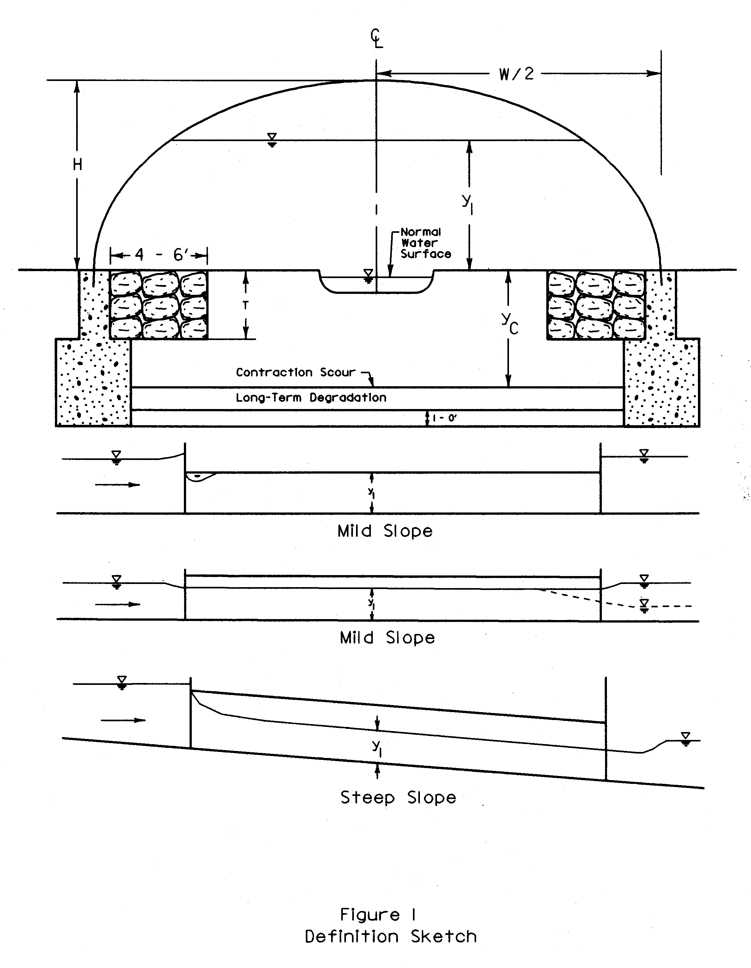

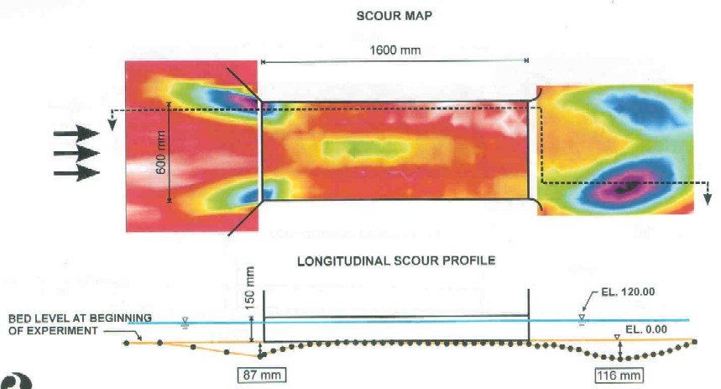

Figure 2
Scour Pattern at a Bottomless Culvert

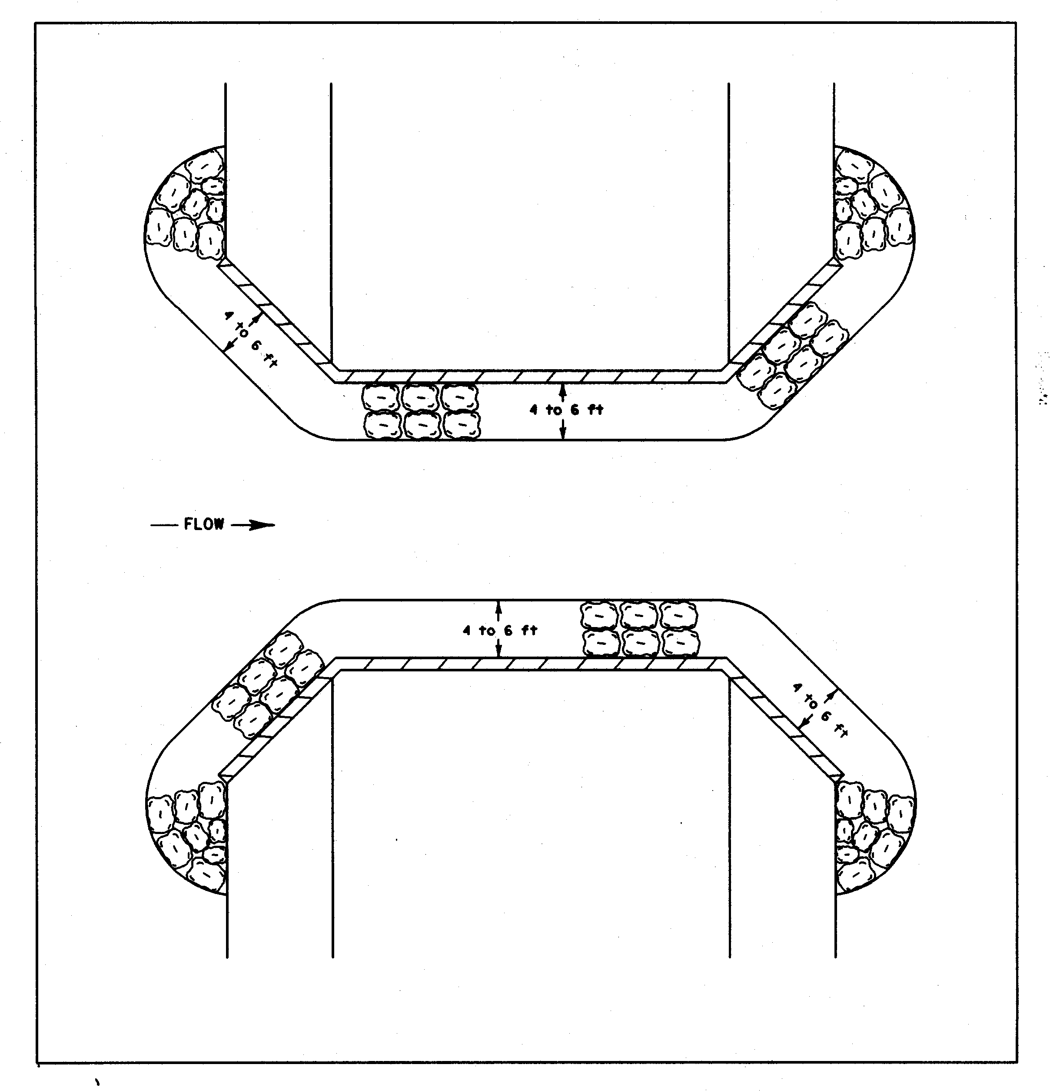
Figure 3
Plan View of Riprap Scour Protection for a Bottomless Culvert

Small streams in Maryland generally have well vegetated overbank areas. For worst case scour conditions, a significant portion of the flood flow conveyed to the culvert may come from these overbank areas. Because of the vegetative cover and the low velocities in the upstream reach, the bed load delivered to the culvert from overbank flow may be small. For such cases, it may be reasonable to assume a clear-water scour condition for the analysis. Estimated scour depths are typically on the conservative side as compared with live bed scour.

For clear water scour, the bed material in the bottomless culvert will be scoured by the higher flow velocity. As the scour progresses, the cross sectional area of the flow increases and the flow velocity correspondingly decreases. This process continues until the flow velocity is reduced to the critical (or competent) velocity where the particles on the bed cease to move.

The Bottomless Culvert Module in ABSCOUR (12) can be used to evaluate either clear water or live bed scour. The user is encouraged to consider both conditions and then decide which type of scour is most appropriate for a given site condition.

There are three important considerations for the user to keep in mind when using the clear water scour equations in the ABSCOUR program:

- It is important that the user select the particle size that will be typical of the material in the bottom of the scour hole.
- There is very little information available regarding the critical velocity of particles with a D50 size smaller than 0.001 ft. or 0.3 mm. Use of the clear water equations for this material must be tempered with the user’s judgment.
- Special studies and engineering judgment will be needed to determine the critical shear stress and/or critical velocity of cohesive soils.

When rock is present, an evaluation needs to be made as to whether it is erodible or scour resistant. FHWA guidelines advise that rock with an RQD of less than 50% is considered as erodible. Generally, the SHA follows the criteria of considering the threshold for scour resistant rock as an RQD value of 75% or greater. There is considerable variation in the erodiblity of different types of rock and rock formations in this threshold range between 50 to 75 percent RQD values. For this reason, it is standard practice to consult with representatives of the SHA Office of Materials and Technology when evaluating the erodibility of rock. SHA is also using the Erodibility Index Method (See the Utilities Module in the ABSCOUR Program) as a guide in evaluating scour in erodible rock.
The need for a full scour evaluation for footings on rock will be determined on a case by case basis.

Conditions at the culvert outlet and downstream channel should be assessed. If the downstream channel is unstable and degrading, or if a headcut is migrating upstream towards the culvert, the foundations may be vulnerable to undermining. The ABSCOUR analysis is not appropriate for the analysis of this condition.

Placement of stream bed controls (cross vanes, etc,) or other means of channel stabilization may serve to mitigate potential problems with scour and degradation (11).

C. DESIGN PROCEDURE

C.1 Select the typical channel cross-section at the culvert location.
Select a representative cross-section of the channel and overbank area within the limits of the proposed culvert. For preliminary design of shallow channels, select an average elevation as representative of the channel and overbank sections

C.2 Select a Preliminary Culvert Size
Figure 4 presents a nomograph which can be used as a preliminary design aid in selecting a size of culvert that will limit the contraction scour to tolerable depths. (See Example problem on page 9). A trial and error approach is suggested in arriving at a preliminary culvert size. Once a reasonable culvert size is determined, the design computations can be made as outlined below:

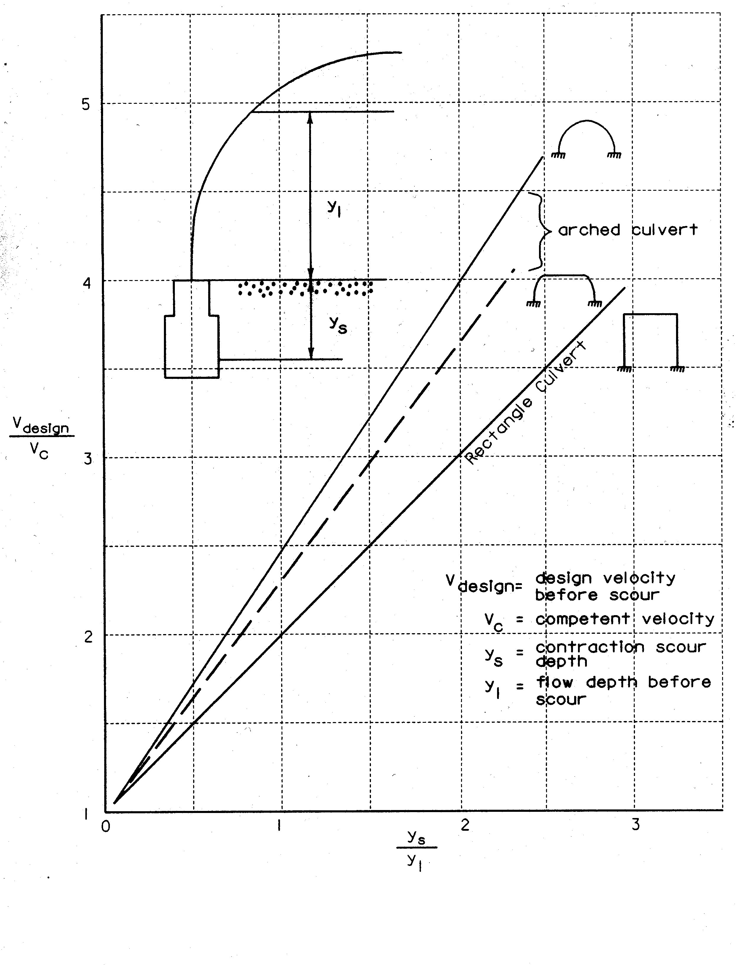Figure 4
Plot for Preliminary Selection of Culvert Type and Size
An illustrative example of the use of Figure 4 is presented in Attachment 1.

C.3 Use the HEC-RAS Program (13) to compute water surface profiles.
Evaluate the 100-year, 500-year and Overtopping floods as appropriate.

C.4 Compute Contraction Scour and Culvert Wall (Abutment) Scour using the Bottomless Culvert Module in the ABSCOUR Program.
Detailed guidance on the use of the ABSCOUR Program is contained in the Users Manual (Appendix A of Chapter 11) as well as in the Help Screens in the ABSCOUR Program.

C.5 Evaluate the potential for long term degradation, headcutting and channel migration
Refer to the procedures in the OBD Manual of Hydrologic and Hydraulic Design, including Chapter 14, Stream Morphology, for assessing concerns with channel instability.

C.6 Design the Culvert Footing
Place the bottom of the footing at least one foot below the combined depth of channel contraction scour and any estimated long term degradation. As a minimum, the footings on the upstream headwall and downstream endwall should be designed to the same elevation as the culvert footings and protected in a similar manner with riprap. As depicted in Figure 2, the deepest scour can be expected near the culvert headwall. In some cases where the abutment scour is severe, it may be prudent to increase the depth of the footings for the headwall.

Please note that for some installations, it may be cost effective to place the structural footing on a non-erodible base that extends to a depth of one-foot below channel contraction scour plus long term degradation. This type of design should be approved by the structural engineer.

C.7 Select the Scour Countermeasure.
Procedures for selecting the appropriate size of riprap are contained in the Utility Module of the ABSCOUR Program. These procedures are based on the guidance contained in the FHWA HEC-23, Bridge Scour and Stream Instability Countermeasures. (14) Design the width and thickness of the riprap wall protection to keep the contraction scour away from the wall footings, keeping in mind the minimum blanket dimensions indicated in Figure 1. Deeper and wider riprap blankets should be considered where the contraction scour exceeds the depth of the riprap. Prior approval should be obtained from the SHA for use of scour countermeasures other than riprap.

C.8 Evaluate the Trial Design
The objective here is to select the appropriate combination of (1) the culvert cross-sectional area and (2) the footing design so as to achieve a cost effective structure that is compatible with the stream morphology. Where moderate flow velocities are present, achieving a cost-effective design should not be a problem. As culvert velocities increase, however, scour can be expected to increase. Culvert foundation costs will also increase to accommodate the need for deeper footing depths, increased excavation quantities, more extensive riprap installations and more complex stream diversion measures. These factors may also create more disturbance to the stream during and after construction.
For very long culverts, the wall or abutment scour component decreases and the risk of undermining the wall also decreases. For these long culverts, it may be reasonable to reduce the size of the riprap blanket at a point well beyond the culvert entrance. However, such design modifications should be made on a case by case basis, subject to SHA approval.

If the selected culvert size results in deep scour depths, the engineer should consider increasing the culvert size to reduce culvert velocities and scour. If increasing the culvert size is not feasible, there are various countermeasures that can be used to protect the culvert from scour:
- Use of a larger D50 riprap size and a wider, deeper riprap installation,
- Lining the entire channel bottom with riprap, concrete, etc. or
- Placement of the culvert foundation on piles.

In some cases where scour is severe, consideration should also be given to use of an alternative design.

D. SPECIAL DESIGN CONSIDERATIONS.
D.1 Pier Scour

It is advantageous to use a single cell bottomless arch culvert, whenever practical, to span the stream. This approach can often serve to minimize obstructions to bankfull flow, thereby minimizing changes to sediment transport and stream morphology. In the event that a multiple cell structure is to be designed, the following guidance is offered with respect to computing scour for the embankment section located between adjacent culvert cells. This guidance applies when the spacing between the adjacent culvert walls is small, being on the order of the dimensions of a pier.
- Treat the area between adjacent culvert walls as a pier
- Calculate local pier scour using the Pier Scour Module in the ABSCOUR Program. Use the depth of flow, y2 (the total flow depth after contraction scour has taken place). Determine the corresponding values for the velocity of flow and the Froude Number at the entrance to the culvert. Measure the local pier scour from the contracted scour depth as determined by the value of y2.

This approach is reasonable for designs where the culvert cell walls of adjacent culverts are close together. It becomes less valid as the intervening space between the culvert cells increases. Judgment is needed in applying this concept to a particular site installation.

D.2 Unstable Channels

For unstable streams, the engineer is encouraged to consider the use of cross-vanes or other stream controls to establish a stable stream channel in the reach of the highway crossing. Reference is made to Chapter 14, Stream Morphology, for a discussion on conducting stream stability studies.

4. REFERENCES

- FHWA, “Evaluating Scour at Bridges,” HEC No. 18, Fourth Edition, May 2001.

- Vanoni, Vito A., Manual on Sedimentation, Sedimentation Engineering, ASCE Hydraulic Division, 1975.

- Kirchhoff, Robert H., Potential Flows, Computer Graphic Solutions, Marcel Dekker, Inc. New York, 1985.

- Milne-Thomson, L. M., Theoretical Aerodynamics, Fourth Edition, Macmillan, London, 1968.

- Palaviccini, M., “Scour Predictor Model at Bridge Abutments,” Doctor of Engineering Dissertation, The Catholic University of America, Washington, D.C., 1993.

- Chang, Fred, “Analysis of Pressure Scour,” Unpublished Research Report, 1995.

- Maynord, Steven T., Toe Scour Estimation in Stabilized Bendways, Technical Note, ASCE Journal of Hydraulic Engineering, August 1996.

- Maryland State Highway Administration, Office of Bridge Development, H&H Interim Manual for Hydrologic and Hydraulic Design.

- Maryland State Highway Administration and Federal Highway Administration, “Scour in Bottomless Culverts”, Hydraulic Laboratory Studies, 1999 and 2002.

- Letter from Earle S. Freedman, Deputy Chief Engineer, Office of Bridge Development, SHA to All County Engineers on the subject of scour in bottomless culverts dated September 17, 1997.

- Rosgen, Dave, Applied River Morphology, Wildland Hydrology, Pagosa Springs, CO. 1996

- Maryland SHA Bridge Scour Program (ABSCOUR), May 2003

- HEC-RAS River Analysis System, U.S. Army Corps of Engineers, Hydrologic Engineering Center, Version 3.11 dated May 2003.

- FHWA HEC-23, Bridge Scour and Stream Instability Countermeasures, March 2001

- C.R. Neill, Guide to Bridge Hydraulics, Transportation Association of Canada, June 2001.
ATTACHMENT 1

EXAMPLE PROBLEM TO ILLUSTRATE USE OF THE NOMOGRAPH FOR PRELIMINARY CULVERT SELECTION

Given: An arch culvert with a shape similar to the middle or dotted line in the nomograph in Figure 2. From a hydraulic analysis, the average flow depth is 9 feet and the average flow velocity is 8 feet per second. The channel bed is composed of gravel with a D50 of 1.8 mm.

Trial run no. 1

For a flow depth of 9 feet and a D50 gravel size of 1.8 mm, the competent or critical velocity (determined from Neill’s competent velocity curves (15)) is 3.6 ft/sec. ( Please note that critical velocity using Neill’s method can be computed by using the procedure in the Utility Module of ABSCOUR)

Vdesign/Vc = 8/3.6 = 2.2.
From the nomograph, ys/y1 is approximately 0.90

The contraction scour depth is 0.9 times the flow depth of 9 feet or 8.1 feet. This contraction scour is considered to be too great for the given site conditions.

Trial run no. 2

A larger culvert is selected. The flow depth is reduced to 7.0 feet and the average velocity reduced to 6 ft/sec.

The competent or critical velocity for this condition is decreased to 3.5 fps
Vdesign/Vc = 6/3.5 = 1.7. From the nomograph, ys/y1 is approximately 0.5
The contraction scour depth is 0.5 times the flow depth of 7.0 feet or 3.5 feet. A contraction scour depth of 3.5 feet is considered acceptable for this site.

The culvert dimensions for trial run No. 2 can be used as a starting point for the scour evaluation.

ATTACHMENT 2
EXAMPLE PROBLEM USING THE BOTTOMLESS CULVERT MODULE
IN ABSCOUR

INPUT DATA
(Refer to the input menus for the bottomless culvert module in ABSCOUR)

1. PROJECT INFORMATION

Example Problem, Arch Culvert Alternative, Q-100 discharge = 590 cfs

2. APPROACH SECTION DATA FROM HEC-RAS
 | LEFT OVERBANK | CHANNEL | RIGHT OVERBANK
DISCHARGE cfs | 130 | 300 | 160
FLOW TOP WIDTH ft | 20 | 8 | 30
AVE. FLOW DEPTH ft | 6 | 8 | 6
MED. BED D₅₀ ft | 0.0059 | 0.0059 | 0.0059
AVE BANK SLOPE Z | 2 |  | 2
AVE ENERGY SLOPE |  | .002

3. CULVERT DATA
 | LEFT OVERBANK | CHANNEL | RIGHT OVERBANK
WATER SURFACE ELEV INSIDE CULVERT |  | 100
WATERWAY AREA A  (MEASURED FROM CULVERT X-SECTION) Ft² | 30.4 | 64 | 30.4
CULVERT FLOW WIDTH (W) ft | 8 | 8 | 8
ELEV CULVERT CROWN | 98.04 | 101 | 98.04
CULVERT TYPE |  | ARCHED
SETBACK FROM EDGE OF CHANNEL ft | 8 |  | 8
MED. BED D₅₀ ft | 0.0059 | 0.0059 | 0.0059
LONG TERM AGGRADATION OR DEGRADATION | 0 | 0 | 0
SAFETY FACTOR |  | 1.2

4. UPSTREAM CULVERT DATA
 | LEFT OVERBANK | CHANNEL | RIGHT OVERBANK
WATER SURFACE ELEV. UPSTREAM OF CULVERT |  | 100.8
DISCHARGE THAT OVERTOPS OR BY-PASSES ROADWAY | 0 | 0 | 0
ELEV CULVERT CROWN AT UPSTREAM SIDE | 99.4 | 102 | 99.4
EMBANKMENT SKEW ANGLE | 90 |  | 90
IS FUTURE LATERAL MIGRATION APT TO OCCUR? | NO | NO | NO

OUTPUT RESULTS

1: ****************************************************
2: * Maryland State Highway Administration *
3: * Bottomless Culvert Scour Program *
4: * Version 6 Build 1.15e, May 5, 2003 *
5: ****************************************************
6:
7: Time stamp: 07/14/2003 2:17:50 PM
8:
9: Input Data:
10:
11: Project information:
12: ------------------------------------------------------------------------------------------------------
13: Project name: bc2 Example problem
14: Project number:
15: Description: higher discharge
16:
17:
18: Project options:
19: Program calculates critical and boundary shear stresses at approach section
20: Program decides the scour type as either live bed or clear water scour
21: Program calculates the unit width discharge at the bridge section
22: Program calculates critical velocity at bridge section
23: Program calculates sediment transport parameter k2
24: Clear-water scour uses Neill's method
25: English Units
26:
27: Approach Section Data:
28: ------------------------------------------------------------------------------------------------------
29: Left Channel Right
30: ----------------------------------
31: Approach section discharge (cfs): 130 300 160
32: Approach section top width (ft): 20 8 30
33: Approach flow depth (hydraulic depth) (y1) (ft): 6 8 6
34: Approach median particle size, D50(ft): .0059 .0059 .0059
35: Bank slope (Z) in the vicinity of the bridge (Z H: 1 V): 2 2
36: Energy slope (S) at approach section: .002
37:
38: ABSCOUR Overrides
39:
40: Reserved for override
41: Reserved for override
42: Reserved for override
43: Reserved for override
44: Reserved for override
45: Reserved for override
46: Reserved for override
47:
48: Downstream Culvert Data:
49: ------------------------------------------------------------------------------------------------------
50: Downstream water surface elevation under culvert: 100 ft
51:
52: Left Channel Right
53: ----------------------------------
54: Waterway area (A) measured normal to flow (sf): 30.4 64 30.4
55: Culvert flow width (W) measured normal to flow (ft): 8 8 8
56: Hydraulic depth (A/W) (ft): 3.80 8.00 3.80
57: ABSCOUR X-Section elevation (#50-#56) (ft): 96.20 92.00 96.20
58: Culvert type: arched
59: Setback (- for an abutment in channel) (ft): 8 8
60: Low chord elevation downstream side of culvert (ft): 98.04 101 98.04
61: Correction factor for low chord submergence (#50-#60>0)(ft): 0.00 0.00 0.00
62: Median particle size under culvert, D50(ft): .0059 .0059 .0059
63: Estimated long-term aggradation(+) or degradation(-) (ft): 0 0 0
64: Safety factor (typical ranges 1.2 to 1.4): 1.2
65:
66: Upstream Culvert Data
67: ------------------------------------------------------------------------------------------------------
68: Water surface elevation upstream side of culvert: 100.8 ft
69:
70: Left Channel Right
71: ----------------------------------
72: Overtopping flow/Flow redistribution (cfs): 0 0 0
73: Water depth at upstream side of culvert (#68-#57) (ft): 4.60 8.80 4.60
74: Low chord elevation upstream side of culvert (ft): 99.04 102 99.04
75: Low chord height (#74-#57) (ft): 2.84 10.00 2.84
76: Pressure flow, Yes or NO: (Yes if #73>#75 at channel) No No No
77: Embankment skew angle (degrees): 90 90
78: Is future lateral migration of channel likely to occur?: no
79:
80: Output Computation And Results
81:
82: Approach Section:
83:
84: Total discharge (cfs): 590
85:
86: Left Channel Right
87: ----------------------------------
88: Approach average flow velocity (fps): 1.083 4.688 0.889
89: Approach unit width discharge (cfs/ft): 6.5 37.5 5.333
90: Approach section depth (ft): 6 8 6
91: Approach section Froude Number: 0.0779 0.2921 0.064
92: Approach section critical shear stress(psf): 0.0236 0.0236 0.0236
93: Approach boundary shear stress(psf): 0.7488 0.9984 0.7488
94: Approach sediment transport parameter (k2): 0.64 0.64 0.64
95: Scour type: Live Bed Live Bed Live Bed
96: Approach unit width discharge for computing Kv(cfs/ft): 11.667 9.118
97:
98: Downstream Culvert Computations:
99:
100: Left Channel Right
101: ----------------------------------
102: Method of computing flow velocity adjustment: Short Setback Short Setback
103: Flow velocity (fps): 4.728 4.728 4.728
104: Adjustment to hydraulic depth (y0)adj (ft): 4 8 4
105: Unit width discharge (#104*#103)(cfs/ft): 18.91 37.821 18.91
106: Unit width discharge for computing Kv (cfs/ft): 23.333 25.833
107: Critical velocity (fps): N/A N/A N/A
108:
109: Downstream Contraction Scour Computations:
110:
111: Left Channel Right
112: ----------------------------------
113: Clear water scour flow depth (y2)(ft): 5.517 9.252 5.517
114: Live bed scour flow depth (y2)(ft): 11.888 8.044 13.494
115: Interpolated scour flow depth (y2)(ft): 9.687 8.044 10.374
116: Pressure flow coefficient (Kp): 1 1 1
117: Adjusted scour flow depth (y2)adj (#116*#115(ft): 9.687 8.044 10.374
118: Contraction scour depth (ys) (#117-#104>0)(ft): 5.687 0.044 6.374
119: Final contraction scour depth (#118*#64)(ft): 6.825 0.052 7.649
120: Contraction scour elevation(#50-#104-#119-#61+#63)(ft): 89.175 91.948 88.351
121:
122: Total Culvert Scour At Side wall:
123:
124: Left Channel Right
125: ----------------------------------
126: Side wall local velocity factor (Kv): 1.283 1.168
127: Side wall spiral flow factor (Kf): 1 1
128: Pressure flow coefficient (Kp): 1 1
129: Scour depth at side wall (y2a)adj (#115*#127*#126^94*#128)(ft) 11.363 11.457
130: Initial side wall scour depth (ysa)(#129-#104>0)(ft): 7.363 7.457
131: Coefficient for side wall shape factor (Kt): 1 1
132: Coefficient for embankment angle (Ke): 1 1
133:
134: Final side wall scour depth (ysa)adj(#130*#131*#132*#64)(ft): 8.835 8.948
135: Side wall scour elevation(#50-#104-#134-#61+#63)(ft): 87.165 87.052

ATTACHMENT 3 CLEAR WATER SCOUR EQUATIONS

The ABSCOUR Program computes contraction and abutment scour as described in the Users Manual (Appendix A) of Chapter 11. This procedure is modified slightly for culverts to account for the difference in the shapes between bridges and culverts. The logic of the ABSCOUR program is outlined below.

Obtain the following information for the culvert (See Figure 1):

Q = discharge per culvert barrel, cfs
W = nominal width of culvert (at the spring line), ft
q = discharge per unit width = Q/W, ft2/s
y1 = average depth of flow inside the culvert (not at the culvert inlet or outlet) ft.
V = average flow velocity inside the culvert (not at the culvert inlet or outlet) ft/sec.
D50 = average soil particle sizes for the channel and overbank areas inside the culvert. For live bed scour, the D50 size can be obtained from pebble counts or other sampling techniques. For clear water scour, the D50 particle size should be representative of the soils at the estimated depth of contraction scour, ft.
H = rise of the arch from the stream bed to the crown of the arch (ft.). For pressure flow conditions, assume that the flow depth y1 is equal to H, the crown of the culvert

CLEAR WATER CONTRACTION SCOUR IN RECTANGULAR CULVERTS

The equations below are based on the competent velocity curves contained in Neill’s Guide to Bridge Hydraulics, Reference 7:
y2 = y1 + ys (1)
Where

y2 = average depth of flow inside the culvert after scour has taken place.

y1 = average depth of flow inside the culvert before scour has taken place.

ys = depth of scour

The following equations are used to solve for y2.

For D₅₀ ≤ 0.001 ft.

y₂ = (q/ (2.84 (D₅₀)^{0.15}))^{0.67} (2)

For 0.1> D₅₀> 0.001 ft.

y₂=[q/(11.5D₅₀^{.35})]^{x} (3)

Where x = 1/[1+(0.123/D₅₀^{0.20})]

For D₅₀ ≥ 0.1 ft.

y₂ = [q/(11.5D₅₀^{0.33})]^{0.86} (4)

CLEAR WATER CONTRACTION SCOUR IN SIMPLE ARCHED CULVERTS

Most bottomless culverts have the shape of an arch and therefore have less capacity than a structure with vertical walls for the same height and width. The following equations apply for computing contraction scour in arched culverts. Solution of the equations requires either a trial and error approach or plotting of the q Vs y2 relationship. A trial and error approach is used for the ABSCOUR program.

For D₅₀ ≤ 0.001 ft.

q = 2.84 y₂^{0.5} D₅₀^{.0.15} (y₂ – 1/3 (y₁/H)² y₁ ). (5)

For 0.1> D₅₀> 0.001 ft.

q = 11.5 y₂^{x} D₅₀^{0.35} (y₂ – 1/3 (y₁/H)² y₁ ) (6)

Where x = 0.123/ D₅₀^{0.2}

For D₅₀ ≥ 0.1 ft.

q = 11.5 y₂^{0.167} D₅₀^{0.333} (y₂ – 1/3 (y₁/H)² y₁) (7)

COMPUTATION OF WALL OR ABUTMENT SCOUR AT THE CULVERT ENTRANCE

The ABSCOUR Program computes abutment or wall scour. In the manner presented below.

The scour depth y2 in equations 1-4 above is defined as the uniform contraction scour depth across the width of the channel inside the culvert. It is measured from the water surface to the channel bottom, taking into account that contraction scour has taken place.

At the entrance to the culvert, however, there will be additional turbulence and resulting scour at the culvert footings as the flow transitions from the flood plain into the culvert.

For a single barrel bottomless culvert, the footings should be treated in the same manner as bridge abutments for purposes of estimating scour. The wall area at the culvert inlet is a region of higher velocity flow due to the rapidly contracting flow and the resulting vortex action. This is similar to the flow at a vertical wall abutment, resulting in localized scour that is deeper than the contraction scour in the channel. The SHA abutment scour equations can be used to estimate the scour depth at the culvert wall near the culvert entrance. This is accomplished as follows: the contraction scour depth y2 computed above is multiplied by the correction factors, Kv and Kf to account for higher velocity and vortex flow, respectively, near the culvert wall. These correction factors are computed by Equations 8 and 9 (See also the Users Manual, App. A of Chapter 11):

K_{v} = 0.8(q_{1’ ave}/q_{2’ ave}) ^{1.5} + 1 (8)

K_{f} = 0.1 + 4.5F for clear water scour (9)

Where

q_{1’ ave} = average unit flow in the approach channel, ft
q_{2’ ave} = average unit flow in the culvert ft
F = Froude Number of approach flow: F= V/ (gy) ^{0.5}
V = Velocity of Flow, ft/s
y = flow depth, ft
g = 32.2 ft/sec²

The term Kv is related to the effect of the higher flow velocity which occurs near the culvert wall.

The term Kf is related to the effect of vortex flow on scour at the corner of the culvert. The limits of the Kf value range from 1.0 to 3.2. If the value computed by Equation 9 is less than 1.0, use a value of 1.0. If the value computed by Equation 9 is greater than 3.2, use a value of 3.2.

The scour depth at the culvert walls, y_{w} can be written as:

Scour depth, y_{w} = K_{f} * (K_{v} ^{0.857} ) * y₂ (10)

Where
y_{w} = total water depth at the culvert wall measured from water surface to the channel bed after scour has taken place.
y₂ = total water depth at the center of the culvert measured from water surface to the channel bed after scour has taken place. If the culvert is operating under pressure flow conditions, the program will compute a pressure scour coefficient, k_{p}, to apply to the contraction scour as explained in the Users Manual, Appendix A.

For multiple barrel culverts, typically two cell culverts, the center footings should be treated as a pier for purposes of estimating local pier scour. The local pier scour should be added to the contraction scour to obtain the total scour for the middle footing.

