ACTIVITY 1- PORTRAITURE
GOALS:
- Students will sharpen observation skills and learn the basic proportions of the human head in order to draw a portrait.
- Portraiture builds on mathematical proportions of the human head and on observation skills. Understanding the process is invaluable in appreciating the creative thinking and choices that an artist constantly makes.

Supports NH Curriculum Framework for the Arts Standard #2, especially: create works that use the elements of art and principles of design to solve specific visual arts problems (Grade 12), p.39; and Standard #6,especially: use knowledge of other subject matter to enhance their art work (Grades 9-12), p. 42.

MATERIALS: handout, paper
GLOSSARY:
full-face
medium
portrait
profile

DURATION: 1 class period

LOCATION: Art, Math or Language Arts class

BACKGROUND INFORMATION:
Review with your students that the art of portraiture was important to the Gilded Age and was a typical art form of the American Renaissance, a period in which Americans looked back to the ideals of the classical past. A portrait may be done in any medium including drawing, painting, clay and/or photography, which is most common today. A portrait was a visible sign of success.

Some of the Cornish artists who were especially known for their portraiture include Herbert Adams (sculpture), Louise Cox (painting), Thomas Dewing (painting), Frances Houston (painting) and Augustus Saint-Gaudens (sculpture). The bas-relief portraits of Saint-Gaudens were in great demand and became marks of social distinction. A portrait may also be done in any size ranging from a miniature, which were very popular during the Gilded Age, (see Lucia Fairchild Fuller and Carlota Saint Gaudens) to a life-size rendition.
Explore the CD-ROM to find more about all underlined names in this reading.

INSTRUCTIONAL STRATEGIES:

- Discuss the relationships between features using the "Mathematical Proportions of the Human Head" worksheet.

- Discuss how individual characteristics (shape and size of eyes, nose, mouth, ears, etc.) describe a person's unique features and identity.

- Have students to work in pairs. With their chosen medium, ask them to observe their partner and draw exactly what they see, following the basic rules of proportion. (They should choose a profile or full-face view and begin by very faintly indicating the proportion guidelines on their paper.)

- Arrange the finished portraits around the room and ask students to identify who they represent.

ACTIVITY 2- LANDSCAPE DESIGN
GOALS:
- Students will learn to "read" a site plan, identify standard architectural symbols and understand and explain what is meant by a "built landscape."
- Students will use the Landscape Design Worksheet to color architectural elements.
- Students will learn about the characteristics of a formal garden design based on underlying geometric shapes.
- Students will assume the role of a landscape designer to create their own landscape plan using standard architectural symbols and a mathematical scale. They will use Charles Platt's strategies to integrate their home into the space and take advantage of geographic features.

Supports NH Curriculum Framework for the Arts Standard #4, especially:  create a work of art that reflects historical and/or cultural context (Grade 8), p.40 and Standard #6, esp.  use knowledge of other subject matter to enhance their art work (Grades 9-12), p.42.

MATERIALS:
GLOSSARY:
balustrade
exedra
loggia
pergola

- Sets of colored pencils
- Landscape Design Symbols and Charles Platt's site plan worksheets for students
- Compass, pencils, erasers, rulers with 1/16" divisions
- A large piece of paper for each student, at least 11" x 17" (vellum tracing paper is ideal)

DURATION: 1.5 to 2 hours LOCATION: Art or Math class

BACKGROUND INFORMATION:
Landscape design is an art form in itself. Remind students that beautiful landscaped gardens don't "just happen.” Instead, a great deal of planning and thought process goes into creating a good design.

Students may wish to review some of the Colony members who were well known for their gardens such as the Dewings, the Saint-Gaudens family, Stephen Parrish and the architect/landscape designer Charles Platt.

This activity is presented in cooperation with the Hood Museum of Art, Dartmouth College, Hanover, NH education department and with assistance from Haynes & Garthwaite Architects, Norwich, VT.
Platt became a well-known architect whose influence was largely responsible for a new interest in formal gardening in America. Stress the fact that Platt controlled or "built" the landscape using carefully selected features like paths, terraces, stairways, balustrades, walls, and gates to lead the eye along. His special talent was to unite a house with its topographic site.
Explore the CD-ROM to find more about all underlined names in this reading.
The gardens of Cornish became known throughout the country due in large part to articles published in national magazines such as House Beautiful and Century Magazine. Two other colony members, Rose Nichols and Ellen Shipman, became nationally famous landscape designers.

INSTRUCTIONAL STRATEGIES:

- Students should become familiar with the design symbols used by landscape architects to draw a site plan.

- Instruct students to locate north, south, east and west on their paper and indicate any significant features (i.e. vistas, specimen trees, boulders, etc.)

- Students will then outline the shape of the property.

- Using the scale of 1/4" = 1', students will design their property using standard symbols. Be as creative as possible. Begin by locating the house and any outbuildings. Then develop the plan by including courtyards, paths, fountains, terraces, walls, benches, trees, gardens, pools, etc.

- Students may wish to give a name to their "property" based on a person, the location, or after a prominent feature (some Cornish Colony properties were called "Butternuts," "High Court," "Crossways," and "Northcôte").

Activity 2- Landscape Design Symbols
These symbols are used by architects and landscape architects to draw up site plans.

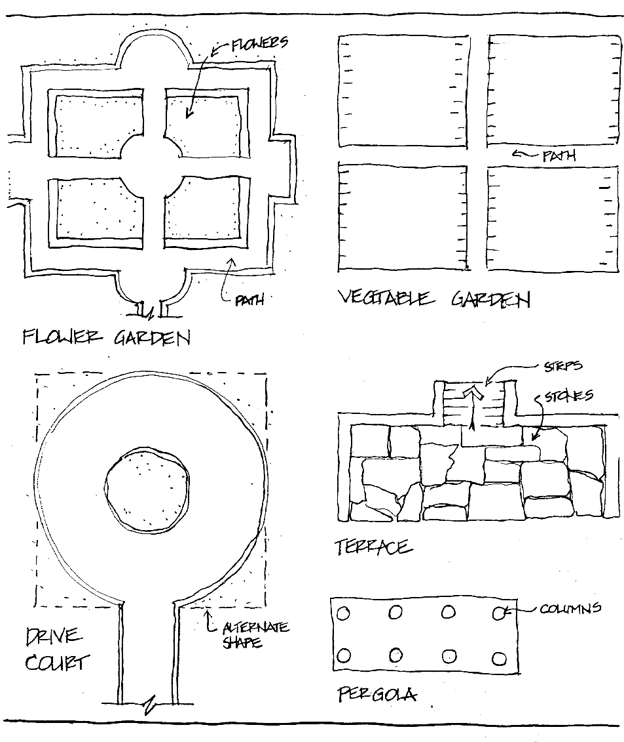

Landscape design symbols provided by Byron Haynes of Haynes & Garthwaite Architects, Norwich, VT

Activity 2- Landscape Design Symbols continued
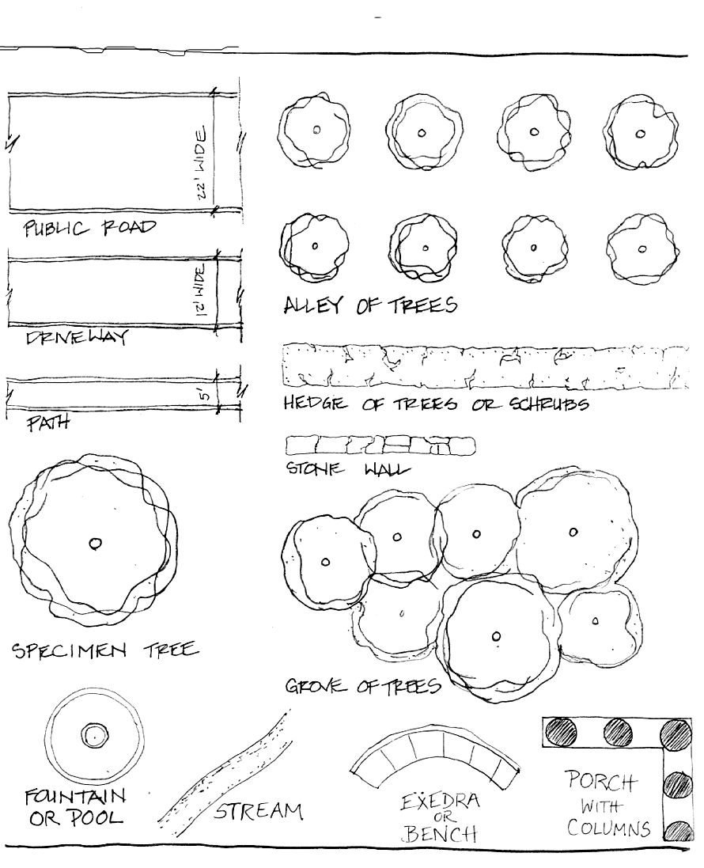

Activity 2- Landscape Design Worksheet
This is a site plan for Charles Platt’s home, studio and gardens in Cornish, New Hampshire.

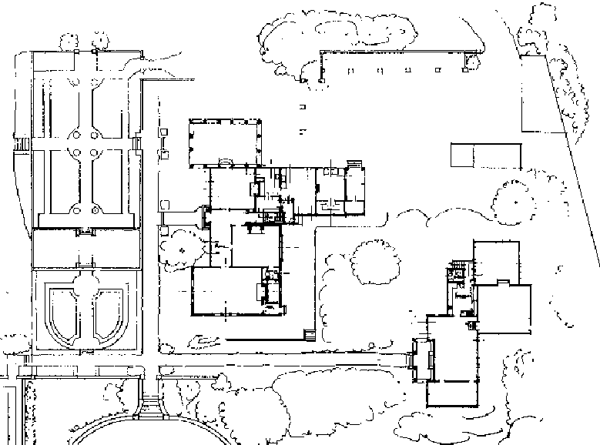
Use colored pencils to color code the following parts of the site plan:

- Dark blue for the house, studio and outbuildings
- Pale blue for the loggias (there are two)
- Grey for the driveway
- Red for the paths and dark red for the stairways
- Different shades of green for the plantings, trees and flowerbeds
- Black for the retaining walls
- Yellow for the planted urns and containers
↓ ice shed
carpenter’s shop →
↑ wood
studio
drafting
room
office
drive
living room
studio
den/
playroom
hall
dining
room
loggia
kitchen ↓
↑ flower gardens ↓

ACTIVITY 3- TABLEAUX VIVANTS
GOAL:
- Students will work in groups to choose and recreate a picture from the Old Masters. This will involve co-operative learning skills as the students select their picture and plan how to costume and stage their work.

Supports NH Curriculum Framework for the Arts Standard 7: Students will analyze, critique and construct meanings from works of theater, and especially  constructively evaluate their own and other's collaborative efforts and artistic choices in informal and formal productions (Grade 12), p.33.
GLOSSARY: tableaux vivant
MATERIALS:
- Several art books (or enclosed postcards) from which to choose a painting
- Costume material from the drama department or home
- Cardboard- enough to make a "picture frame" to frame the action groups
- A sheet or material mounted against the wall for background
DURATION: 1 class period to prepare and 1 class period to perform. If this activity does not take up a full period, a game of charades can be played.

LOCATION: Homeroom, with help from the Drama Department

BACKGROUND INFORMATION:
Review with students that lacking radio or television, the Cornish families had to create their own forms of entertainment. Friends would gather in parlors for board games, recitations, musical duets or charades. Another popular diversion was to create tableaux vivants (living pictures). The goal was to reproduce a work of art as close to the original as possible using costumes, gestures and sets.
Explore the CD-ROM to find more about all underlined names in this reading.

Reading for further interest:
- “The Pageant of the Masters,” Life Magazine, July 1997.

INSTRUCTIONAL STATEGIES:

- Groups will use books or postcards to choose a masterpiece. Pieces with several figures work best.

- Construct a rectangular picture frame, behind which the tableaux will occur.

- Each group will present its tableaux and the rest of the class will judge how closely the group has reproduced the masterpiece.
ACTIVITY 4- SCULPTURE IN THE ROUND
GOALS:
- Students will create a sculpture in clay using an additive modeling process. They will learn how to prepare the clay (wedge) and join pieces by scoring and using slip.
- Students will model figures engaged in a physical action or expressing an emotion. Students will work in pairs, one serving as the model. Change roles. The sculptors should pay special attention to body proportions and to weight distribution in the action pose. Have students to look at their figure from many angles.

Supports NH Curriculum Framework for the Arts Standard 1, especially  create works of visual art that demonstrate a connection between personal expression and the intentional use of art materials, techniques and processes (Grade 12), p.38.

MATERIALS:
- Materials are often available from local art stores or pottery supply stores.
Or they may be ordered from the Sculpture House, (212) 645-9430 ext. 155,
West 26th St., New York, NY 10001.
GLOSSARY:
additive process
bisque.
freestanding
greenware
in the round
kiln
wedging
scoring the clay
slip
three-dimensional

- Clay: 1-2 lbs. per student. If there is no kiln, self-hardening clay may by used. Plastocine, an oil based clay, maintains its consistency without water, and does not dry out. It may be reused, but it is more expensive
- 12" square masonite boards provide a good surface on which to model (may also use a piece of cardboard)
- Simple clay tools, sponges, atomizer, plastic bags to keep work moist until final shape is achieved
- Shellac or acrylic polymer medium to finish non-glazed sculptures

DURATION: At least 2 class periods

LOCATION: Any room with access to clay, water and storage

BACKGROUND INFORMATION:
Clay is one of the most forgiving materials. It can be reworked until the desired shape is obtained, but, if using water-based clay, it must be kept moist. When it is dry it is called greenware and is very fragile. It will then be fired in a kiln and the resulting piece is called bisque.

Saint-Gaudens was one of the most popular sculptors during the late 19th century for his public and privately commissioned works. He kept several studios in simultaneous operation and employed many assistants to carry out his designs.
Explore the CD-ROM to find more about all underlined names in this reading.
Looking at the list of Cornish Colony visual artists, review some of the names: Herbert Adams, Frances Grimes, Henry Hering, James Earle Fraser, Paul Manship, William Zorach, etc.

INSTRUCTIONAL STRATEGIES:
- Have students wedge (like kneading bread) a ball of clay. This process forces out air bubbles that could make the piece explode during firing.

- There are many ways to shape a figure. We suggest the following:
  - Divide the clay into 3 pieces: small, medium and large.
  - Shape the small piece into a ball for the head.
  - Roll coils approx. thumb size with the other 2 pieces.
  - Join the pieces together by scoring and using slip (a slurry of clay.) Then smooth the joint.

- Now the figure is ready to be bent and positioned. Pay special attention to where the body weight is as this helps to emphasize the gesture. Students may use wads of newspaper to help support heads, arms or legs until the clay hardens.

- Texture and details (clothing) should be added from extra scraps of clay.

- If the clay starts to crack, it is becoming too dry. Students should mist or wet their clay with a damp sponge.

- Attach the figures to a base for stability. If the figures are very thick, carefully hollow out from the bottom so they will dry better.

- Dry all sculptures slowly. When the clay is dry, it is in the most fragile stage called greenware. The work is now ready for the bisque firing which fuses the clay together into a permanent state.

- To finish sculptures without a second firing, do either of the following:
  - Apply clear shellac with brushes. Clean with shellac thinner. This will deepen the color of the clay. A well-ventilated space is essential because fumes may be dangerous.
  - Apply clear, glossy acrylic polymer medium. You may add acrylic paint to the medium if color is desired. Clean with water.

ACTIVITY 5- BAS RELIEF SCULPTURE
GOAL:
- Students will demonstrate an understanding of the bas-relief sculpture process by modeling from an original drawing. Subjects could be a portrait, a pet, scenes from daily life, an historical event or an episode from a story.

Supports NH Curriculum Framework for the Arts Standard 1, especially  create works of visual art that demonstrate a connection between personal expression and the intentional use of art materials, techniques and processes (Grade 12), p.38.

MATERIALS:
- Clay - approximately 1-2 lb. per student (if there is no kiln, use a self- hardening clay)
GLOSSARY: bas-relief
frieze
high relief

- A 12" square piece of masonite/cardboard on which to work
- Simple clay tools
- A rolling pin
- Atomizers or sponges

DURATION: 1 period

LOCATION: Any room with access to clay, water and storage

BACKGROUND INFORMATION:
Review with students the term relief sculpture. Talk about the differences between bas-relief and high relief. Low relief is "making a picture in clay in which the design is raised from the background, yet is attached to it."

Saint-Gaudens did many portraits using the bas-relief technique. Some of his work is so delicate that the figure is modeled only 1/8" above the background. A relief gives the impression of a full figure, however, because the artist employs very
Explore the CD-ROM to find more about all underlined names in this reading.
subtle foreshortening of his shapes. Relief is the most difficult type of sculpture! One of the most familiar reliefs is the frieze around the Parthenon in Athens, Greece. A reproduction of this frieze is mounted on the south wall of Saint-Gaudens' studio.

INSTRUCTIONAL STRATEGIES:
- Students will sketch a design on paper using the dimensions of the planned relief.

- Wedge clay to prepare for modeling.

- Students will divide their clay in half and either roll or press out a slab about 3/4" thickness. Students should flip the slab while it is being shaped so that it will not stick to the work board.

- Lightly sketch the design onto the slab. Now using the other half of the clay, begin to model the drawing using fingers and tools. You are working for 3 levels of relief. Remember that the background will be the lowest relief and the foreground (those shapes closest to you) will be the highest. This will take practice. If the clay begins to dry out, dampen it with the sponge or atomizer. Clay not being used should always be covered with plastic or a damp cloth to keep it moist.

- Textures can be modeled with fingers and/or tools for an interesting surface.

- If this relief is to become a wall plaque, make a hole approximately 1/2" from the top. Clay shrinks as it dries, so make the hole larger than you might expect.

- Finishing: after clay is fired, the bisque ware can be given a coat of shellac or acrylic polymer medium as described in Activity 4: Sculpture in the Round.

ACTIVITY 6- DESIGN A MEDAL OR COIN
GOAL:
- Students will select a theme and design a medal commemorating a person, event or favorite sport using the bas-relief technique. The challenge is to fit the design harmoniously into the chosen shape. (For examples, see the Xerox sheet.) Both sides, the obverse and reverse, should relate thematically.

Supports NH Curriculum Framework for the Arts Standard 1, especially  create works of visual art that demonstrate a connection between personal expression and the intentional use of art materials, techniques and processes (Grade 12) p.38.

MATERIALS:
- Soft pencil, paper, compass
GLOSSARY: commission
obverse
reverse
- If clay is chosen, see Materials in Activity 5- Bas-relief
- Copy for each student the “Medal Design” handout

DURATION: 1 or 2 class periods.

LOCATION: The Art, Language Arts or Social Studies room.

BACKGROUND INFORMATION:
Review with your students that Saint-Gaudens was commissioned by President Theodore Roosevelt to design the $10 and $20 gold coins known as the Eagle and Double Eagle respectively. They have been called the most beautiful American coins. Due to illness, however, Saint-Gaudens was unable to complete the commission. He asked Henry Hering, one of his most talented assistants to carry through with the project. Unfortunately Saint-Gaudens did not live to see the coins struck, which were minted in late 1907.

Other Cornish Colony sculptors were later commissioned to produce coins: James Earle Fraser designed the Buffalo nickel and Adolph Weinman designed the Winged Liberty dime. From a design point of view, medals are like coins in that the relief modeling must be compressed into the shape
Explore the CD-ROM to find more about all underlined names in this reading.
of the medal. Many other Cornish Colony artists became involved in designing medals including Louis St. Gaudens, Herbert Adams, Frederick MacMonnies, Paul Manship, and Bessie Potter Vonnoh.

Some of the most familiar medals used today are the gold, silver and bronze awards given to athletes competing in the Olympics. There are two sides to a coin or medal: the obverse (front) and the reverse (back).
Reading for further interest:
Coin collecting has become a popular hobby for many people. Students may enjoy the anecdotal history of U.S. coinage in:

- Twisted Tails: Sifted Fact, Fantasy and Fiction from U.S. Coin History, by Robert R. Van Ryzin.

INSTRUCTIONAL STRATEGIES:
- The video Medal Maker can be shown to students before starting their medal designs.

- Students may want to bring examples of coins or medals to class.

- Instruct students to design 2 sides, obverse and reverse, to their medal. Both sides must have a common theme. We suggest modeling to an 8"-9" shape. Explain that this is a workable size used by sculptors and that the final piece would later be reduced by a mechanical process.

- Students may want to include an inscription.

- As they draw, students should pay special attention to adapting their design to the overall shape of the medal and should consider symmetry and balance. Teachers may want to remind the class that a simple design is often more effective than a busy, complicated one.

- The designs may now be translated into clay, if desired.

- Students should show their medals to the class for a constructive discussion. Have them describe how well the design conveys the intention, conforms to the shape, etc.

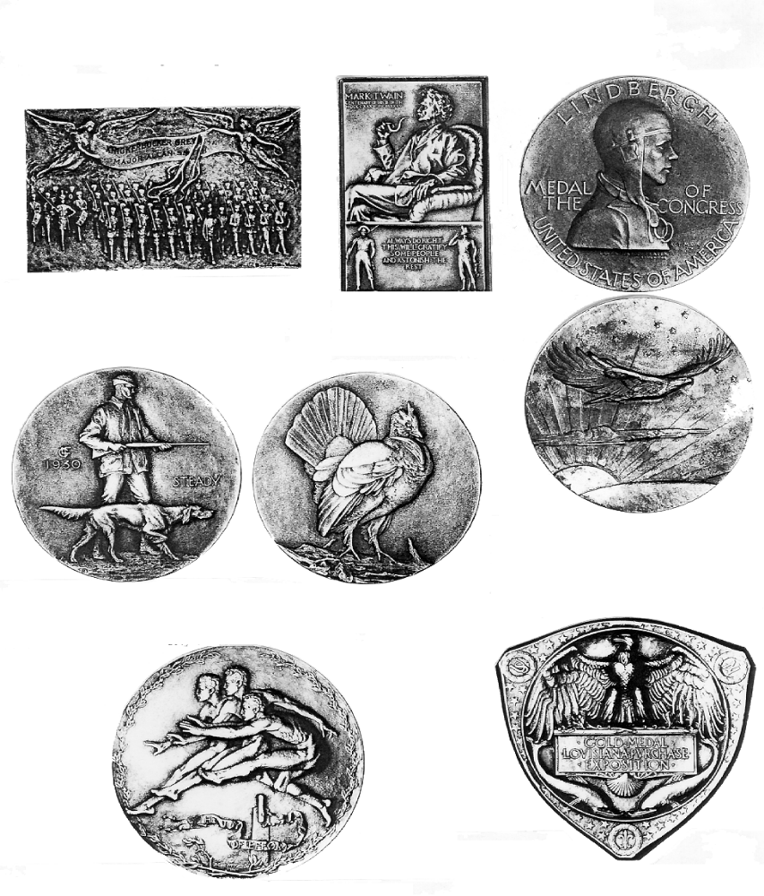
- Besides currency, medals have been a popular sculpture art form issued to commemorate famous people, organizations and events. They were also awarded as prizes in competitions. Below are some examples of medals by several artists, many who were associated with Saint-Gaudens.
- Notice the variety of themes and how the design conforms to the shape.
Bessie Potter Vonnoh
Obverse: "Knickerbocker Grays," 1931,
Medal in rectangular shape (1 7/8" x 3").
Laura Gardin Fraser
Obverse: "The Hunter” Reverse: "Ruffed Grouse"
This medal was created for the society of medallists in 1930.
Laura Gardin Fraser
"Lindbergh Medal," 1928 (2 3/4").
Obverse: Profile portrait in flight cap.
Reverse: Lone eagle over clouds and earth.
Adolf Weinman
Obverse: "Louisiana Purchase Exposition," 1904.
Awarded as the Grand Prize. Note unusual shape of shield.
John Flanagan
Obverse: "Mark Twain Centennial Plaquette," 1935 (3 1/2" x 2 14").
Robert Tait McKenzie
Obverse: "Three youths clearing a hurdle" (3").
A sports theme, this "Joy of Effort Medal" was struck in 1932-33.

