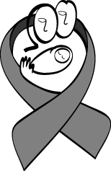

TModule 1T Introduction to HIV/AIDS

TSESSION 1T Scope of the HIV/AIDS Pandemic
TSession 2T Natural History and Transmission of HIV

After completing the module, the participant will be able to:
- Describe the global and local impact of the epidemic.
- Answer basic questions about HIV/AIDS in women, children, and families.
- Discuss the natural history of HIV infection.
- Present information about HIV transmission.

Relevant Policies for Inclusion in National Curriculum
Session 1
- Brief summary of local/national/regional epidemiology of HIV
- If available, a graph illustrating HIV prevalence among pregnant women at antenatal clinics (a local variation on Figure 1.2)

SESSION 1 Scope of the HIV/AIDS Pandemic

Figure 1.1 Worldwide epidemiology of HIV/AIDS

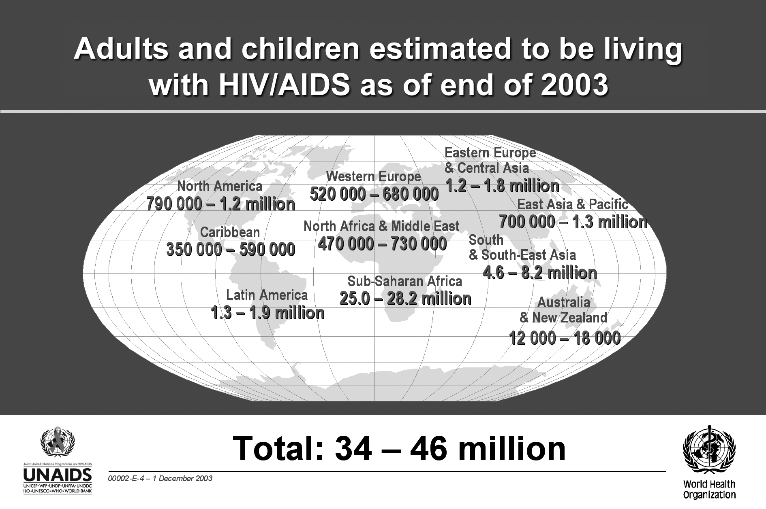

HIV in children, 2003
UNAIDS estimates that at the end of 2003:
- 40 million people worldwide were living with HIV/AIDS
- 2.5 million people with HIV/AIDS were children younger than 15 years old
- 90% of the children living with HIV/AIDS were from sub-Saharan Africa
- 700,000 children worldwide were newly infected in 2003
- 500,000 child deaths are estimated to have occurred from HIV/AIDS during 2003
New infections, 2003
According to UNAIDS, about 14,000 new infections occurred each day in 2003. Of these new infections
- About 6,000 each day were among persons 15 to 24 years old.
- Almost 2,000 each day were in children younger than 15 years old.
- Most of the infections in children younger than 15 years old occurred through mother-to-child transmission (MTCT) of HIV.

Table 1.1 Regional HIV/AIDS statistics and features, through 2003
Region | Adults and Children Living with HIV/AIDS | Adults and Children Newly Infected with HIV | Prevalence  In Adults* | Adult and Child  Deaths Due to AIDS
Sub-Saharan Africa | 25.0–28.2 million | 3.0–3.4 million | 7.5–8.5 | 2.2–2.4 million
North Africa and Middle East | 470,000–730,000 | 43,000–67,000 | 0.2–0.4 | 35,000–50,000
South and Southeast Asia | 4.6–8.2 million | 610,000–1.1million | 0.4–0.8 | 330,000–590,000
East Asia and Pacific | 700,000–1.3 million | 150,000–270,000 | 0.1–0.1 | 32,000–58,000
Latin America | 1.3–1.9 million | 120,000–180,000 | 0.5–0.7 | 49,000–70,000
Caribbean | 350,000–590,000 | 45,000–80,000 | 1.9–3.1 | 30,000–50,000
Eastern Europe and Central Asia | 1.2–1.8 million | 180,000–280,000 | 0.5–0.9 | 23,000–37,000
Western Europe | 520,000–680,000 | 30,000–40,000 | 0.3–0.3 | 2,600–3,400
North America | 790,000–1.2 million | 36,000–54,000 | 0.5–0.7 | 12,000–18,000
Australia and New Zealand | 12,000–18,000 | 700–1,000 | 0.1–0.1 | <100
Total | 40 million  (34–46 million) | 5 million  (4.2–5.8 million) | 1.1  (0.9–1.3) | 3 million  (2.5–3.5 million)
* Percentage of adults age 15 to 49 years living with HIV/AIDS in 2003, using 2003 population data
The ranges in this table are based on the best available information. These ranges are more precise than in previous years, and work is under way to further improve the precision of the estimates to be published in mid-2004.

Figure 1.2 HIV prevalence: Pregnant women in South Africa, 1991–2002

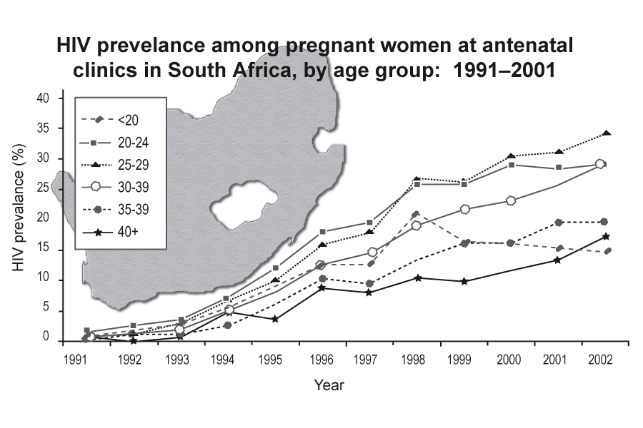
Most of these estimates are based on surveillance systems that focus on pregnant women who attend selected antenatal clinics. This method assumes that HIV prevalence among pregnant women is a good approximation of prevalence among the adult population (aged 15–49 years). A direct comparison of HIV prevalence among pregnant women at antenatal clinics and the adult population in the same community in a number of African communities has provided evidence for this method of estimating HIV prevalence.

Global impact of HIV
The global impact of the HIV/AIDS pandemic is especially severe in resource-constrained settings and results in the following:
- Negative impact on countries’ economic development
- Overwhelmed healthcare systems
- Decreasing life expectancy in many countries
- Deteriorating child survival rates
- Increasing number of orphans

Effects of the HIV/AIDS pandemic on individuals include the following:
- Illness and suffering
- Shortened life span
- Loss of work and income
- Death of family members, grief, poverty, and despair
- Barriers to healthcare related to stigma and discrimination
- Deteriorating child health and survival
- Weakened integrity and support structure of the family unit

Exercise 1.1 Hope exercise: group discussion
Purpose | To begin the PMTCT training with optimism despite the devastation left by decades of HIV.
Duration | 20 minutes
Instructions | - Think for a few moments about positive responses to the HIV/AIDS pandemic in your country.  - Record your responses on paper and share in the large group discussion.  Examples:  Groups in the community that have never worked together before have connected with each other to address HIV/AIDS.  The global community has allocated increased funding for healthcare systems in the developing world, especially HIV/AIDS care systems.  The Ministry of Health in many countries has become a stronger advocate for the healthcare needs of people in all sectors of society.  The global community has become more attentive to TB because of its connection to HIV.  There is increased awareness of safer sex practices that protect people from HIV and STIs.
Overview of HIV and AIDS

 | Refer to Pocket Guide

Definitions of HIV and AIDS
HIV stands for human immunodeficiency virus, the virus that causes AIDS.
H: Human
I: Immunodeficiency
V: Virus
- HIV breaks down the body's defence against infection and disease—the body's immune system—by infecting specific white blood cells, leading to a weakened immune system.
- When the immune system becomes weak or compromised, the body loses its protection against illness.
- As time passes, the immune system is unable to fight the HIV infection and the person may develop serious and deadly diseases, including other infections and some types of cancer.
When a person is infected with HIV, the person is known as “HIV-infected.”
“HIV-positive” is when person who is HIV-infected has tested positive for HIV.

AIDS is an acronym for acquired immunodeficiency syndrome and refers to the most advanced stage of HIV infection.

A: Acquired, (not inherited) to differentiate from a genetic or inherited condition that causes immune dysfunction
I: Immuno-, because it attacks the immune system and increases susceptibility to infection
D: Deficiency of certain white blood cells in the immune system
S: Syndrome, meaning a group of symptoms or illnesses that result from the HIV infection

Differences between HIV, HIV infection, and AIDS
- HIV is the virus that causes infection.
- The person who is HIV-infected may have no signs of illness but can still infect others.
- Most people who are HIV-infected will develop AIDS after a period of time, which may be several months to more than 15 years.
- AIDS is a group of serious illnesses and opportunistic infections that develop after being infected with HIV for a long period of time.
- A diagnosis of AIDS is based on specific clinical criteria and laboratory test results.

(See Appendix 1-A for information about the World Health Organization (WHO) staging systems for HIV infection and Disease and Appendix 1-B for the U.S. Centers for Disease Control and Prevention (CDC) AIDS Surveillance Case Definitions.)

Types of HIV
HIV-1 and HIV-2 are types of HIV. Both types are transmitted the same way, and both are associated with similar opportunistic infections and AIDS. HIV-1 is more common worldwide. HIV-2 is found predominantly in West Africa, Angola, and Mozambique.

Differences between HIV-1 and HIV-2
HIV-2 is less easily transmitted than is HIV-1, and it is less pathogenic, meaning that the period between initial infection and illness is longer. In some areas, a person may be infected with both HIV-1 and HIV-2. While HIV-2 can be transmitted from an infected mother to her child, this appears to be rare (0% to 5% transmission rate in breastfed infants in the absence of any interventions).

A discussion of preventing mother-to-child-transmission (PMTCT) from women who are infected with HIV-2 to their infants is included in Module 2, Overview of HIV Prevention in Mothers, Infants, and Young Children, Appendix 2-A. Women who are infected with both HIV-1 and HIV-2 should follow all PMTCT recommendations for HIV-1-infected women.
SESSION 2 Natural History and Transmission of HIV

Background information on CD4 count and viral load
Figure 1.3 Characteristic viral load and CD4 changes over time in HIV/AIDS
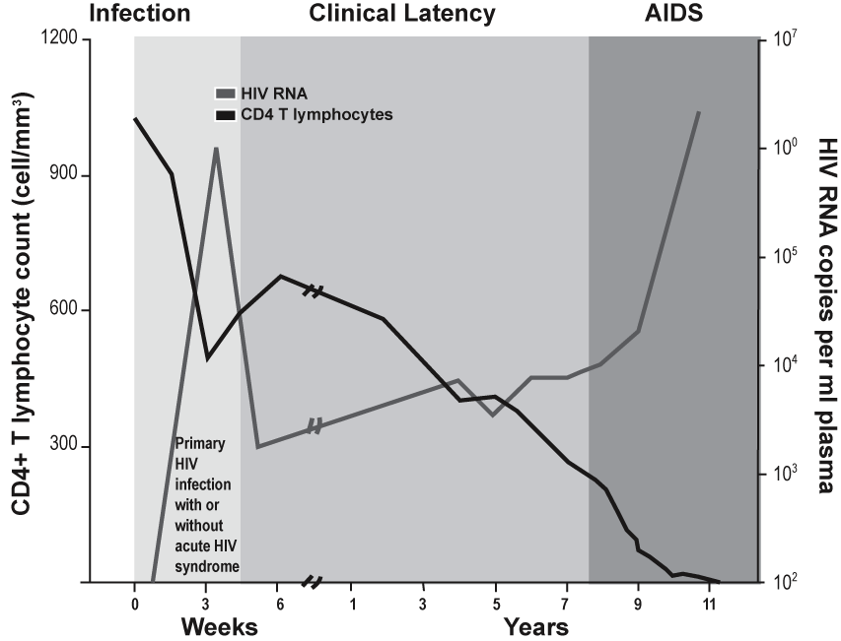
The CD4 count and viral load are two measures of the progression of HIV. When HIV actively multiplies, it infects and kills CD4 T cells—a specific type of white blood cell—that are the immune system's key infection fighters. The effects of HIV are measured by the decline in the number of CD4 cells.

The CD4 count is the number of CD4 cells in the blood and reflects the state of the immune system. The normal count in a healthy adult is between 600 and 1,200 cells/mmP^{3P}. When the CD4 count of an adult falls below 200 cells/mmP^{3P}, the risk of opportunistic and serious infection is high.

Viral load is the amount of HIV virus in the blood. It can be measured by the HIV ribonucleic acid polymerase chain reaction blood test (HIV-RNA PCR). The test is used as a marker of response to antiretroviral (ARV) treatment.

The viral load is very high shortly after primary HIV infection. It falls steeply when the body develops antibodies and rises again after a number of years as the CD4 count drops. High viral load leads to higher transmission risk. Most often, after a number of years, high viral load is also a sign of more severe disease as people develop AIDS (Figure 1.3).

Natural history (or course) of HIV infection
Seroconversion

People infected with HIV usually develop antibodies 4 to 6 weeks after being infected, but it may take as long as 3 months for antibodies to develop. The period of time between when a person is infected with HIV and when the antibody test result is positive is called the "window period."

Unlike for most diseases, having antibodies for HIV does not indicate protection but indicates infection.

When a recently infected person develops antibodies that can be measured using a laboratory test, seroconversion is occurring. Some people may experience a glandular illness (fever, rash, joint pains, and enlarged lymph nodes) at the time of seroconversion.

HIV testing detects antibodies or antigens associated with HIV in whole blood, saliva, or urine.

A person whose blood test results show HIV infection is said to be seropositive or HIV-positive.

A person whose blood test results do not show HIV infection is said to be seronegative or HIV-negative.

A person who tests HIV-negative but who has engaged in behaviour within the past 3 months that places him or her at risk for HIV should be tested again in 3 months.

Asymptomatic HIV infection
A person who is HIV-infected but looks and feels healthy is asymptomatic. None of the physical signs or symptoms that indicate HIV infection are present.

Whether they have symptoms or not, people who are HIV-positive can still pass the virus to others.

The duration of the asymptomatic phase varies greatly from person to person. Some adults may develop symptoms of HIV as quickly as a few months after primary infection; others may take as long as 15 years or more to develop symptoms.

For children infected with HIV through MTCT, during pregnancy, labour and delivery, and breastfeeding, the asymptomatic phase is shorter. A few infants who are HIV-positive will become ill within the first weeks of life. Most children start to develop symptoms before they are 2 years old; a few remain well for several years.

Symptomatic HIV infection
A person who has developed physical signs of HIV and reports symptoms related to HIV is symptomatic.

The immune system weakens and CD4 count decreases during this phase.

The progression of HIV depends on the type of virus and specific host characteristics including general health, nutritional, and immune status.

AIDS
Almost all people who are HIV-positive will ultimately develop HIV-related disease and AIDS, the end stage of HIV infection. As HIV infection progresses, the CD4 count continues to decrease and the infected person becomes susceptible to opportunistic infections.

An opportunistic infection is an illness caused by a germ that might not cause illness in a healthy person, but will cause illness in a person who has a weakened immune system. For example, co-infection with tuberculosis (TB) is very common in people infected with HIV.

People living with advanced HIV infection suffer from opportunistic infections of the lung, brain, eyes, and other organs. Other common opportunistic infections in persons diagnosed with AIDS are pneumocystis carinii pneumonia (PCP); cryptosporidiosis; histoplasmosis; other parasitic, viral and fungal infections; and some types of cancers, such as Kaposi's sarcoma.

ARV treatment and prophylaxis and treatment of opportunistic infections help preserve the CD4 cells, lower viral load, and prolong the time it takes for HIV to progress to the symptomatic phase and, ultimately, to AIDS.

Staging systems for HIV
Staging systems for HIV can:
- Contribute to the care of individuals who are HIV-infected
- Provide a framework for follow-up and management
- Help define prognosis and guide patient counselling
- Be used to help evaluate new treatments

World Health Organization (WHO) staging system for HIV
The WHO staging system groups HIV progression into four clinically relevant stages—Stages I to IV—that correspond to the natural history of HIV. (See Appendix 1-A.)

The staging system for HIV infection in children is scheduled to be revised by WHO in consultation with paediatric experts in 2004. In the interim, using the WHO staging system can help define parameters for initiating treatment in resource-constrained settings.

However, adapting the staging system at the country programme level may be appropriate.

U.S. Centers for Disease Control and Prevention (CDC) surveillance case definition
The CDC AIDS Surveillance Case Definitions include clinical and immunologic categories. (See Appendix 1-B.) This system uses a combination of symptoms and CD4 count levels to establish criteria for AIDS.

Routes of HIV transmission
HIV can be transmitted through blood, sexual contact, or injection drug use, and from mother to child (also known as perinatal or vertical transmission).

The most common route of HIV transmission is through sexual contact, especially heterosexual intercourse.

Blood-to-blood transmission
- Transfusion with HIV-infected blood
- Direct contact with HIV-infected blood

Sexual contact
- Unprotected sexual intercourse (vaginal, oral, or anal)
- Direct contact with HIV-infected body fluids such as semen and cervical and vaginal secretions

Women of childbearing age are at particular risk for acquiring HIV. The main behaviour that places them at risk is unprotected sex with an infected male partner.

Drug use
- Injection of drugs with needles or syringes contaminated with HIV

Perinatal transmission (MTCT)
- From mothers who are HIV-positive to their infants during pregnancy, labour, delivery, and breastfeeding

HIV cannot be transmitted by:
- Coughing or sneezing
- Being bitten by an insect
- Touching or hugging
- Kissing
- Going to a public bath/pool
- Using a public toilet
- Shaking hands
- Working or going to school with a person who is HIV-infected
- Using telephones
- Drinking water or preparing or eating food
- Sharing cups, glasses, plates, or other utensils

Public health strategies to prevent HIV infection
Blood-to-blood transmission
- Screen all blood and blood products for HIV.
- Follow universal precautions which include:
- Use of protective equipment
- Safe use and disposal of sharps
- Sterilisation of equipment
- Safe disposal of contaminated waste products

Sexual contact
- Promote abstinence or being faithful to one uninfected partner.
- Provide instruction on the consistent and correct use of barrier methods.
- Male or female condoms for vaginal intercourse
- Non-lubricated condoms for oral intercourse on a male
- Dental dams, plastic wrap, or latex panties for oral intercourse on a female
- Condoms for anal intercourse
- Prevent, identify, and provide early treatment for sexually transmitted infections (STIs).
- Provide access to HIV testing and counselling.

Condoms provide protection from HIV transmission as well as other sexually transmitted infections (STIs) when used correctly and consistently.

Drug use
- Educate about the risks of infection through drug use with contaminated needles and syringes.
- Provide referral for treatment of drug dependence.

Drug use in any form may increase the risk of HIV infection by limiting judgment and facilitating engagement in risky behaviours. Even occasional use of alcohol, marijuana, and other “recreational” drugs may increase risk of HIV infection.

Perinatal transmission from mothers who are HIV-positive
- Provide ARV treatment when indicated and available.
- Provide ARV prophylaxis during labour and delivery.
- Provide appropriate ARV prophylaxis to the infant.
- Offer elective caesarean section when safe and feasible.
- Follow safer delivery practices.
- Provide linkages to treatment, care and social support for mothers and families with HIV infection.
- Provide infant-feeding counselling.

(Module 2, Overview of HIV Prevention in Mothers, Infants and Young Children contains detailed information on a comprehensive PMTCT approach.)

Module 1: Key Points

- HIV is a global pandemic.
- The number of people living with HIV worldwide continues to increase.
- The HIV epidemic is especially severe in many resource-constrained countries.
- HIV is a virus that destroys the immune system, leading to opportunistic infections.
- The progression from initial infection with HIV to end-stage AIDS varies from person to person and can take more than 15 years.
- The most common route of HIV transmission worldwide is heterosexual transmission.
- Women of childbearing age are at particular risk for acquiring HIV. The main behaviour that places them at risk is unprotected sex with an infected male partner.
- Pregnant women who are HIV-infected are at risk of passing HIV infection to their newborn.
- Risk of HIV transmission from mother-to-child can be greatly reduced through effective PMTCT programmes.

Exercise 1.2 HIV 1, 2, 3 Knowledge interactive game
Purpose | To provide an interesting, challenging way to review basic HIV/AIDS information and to present advanced HIV/AIDS information.
Duration | 60 minutes
Instructions | - Review the HIV/AIDS-related questions in Exercise 1.2 (located after the appendices).  - Select one member of your team to record the group’s answers on the question sheet provided.  - You will be asked to choose a question from one of the categories above and answer it in 10 seconds. If the answer is correct, your team will be credited for a proper response. If the answer is not correct, the question will be passed on to the next team.  - You cannot choose a question that has already been answered.  - The first team to correctly answer 6 questions from 6 different categories wins.  - The winning team will receive a prize.

APPENDIX 1-A WHO staging systems for HIV infection and disease in adults, adolescents, and children

WHO staging system for HIV infection and disease in adults

Clinical stage I
- Asymptomatic
- Generalised lymphadenopathy
Performance Scale 1: asymptomatic, normal activity
Clinical Stage II
- Weight loss of less than 10% of body weight
- Minor mucocutaneous manifestations (seborrhoeic dermatitis, prurigo, fungal nail infections, recurrent oral ulcerations, angular cheilitis)
- Herpes zoster within the last 5 years
- Recurrent upper respiratory tract infections (e.g., bacterial sinusitis)
And/or Performance Scale 2: symptomatic, normal activity
Clinical Stage III
- Weight loss of more than 10% of body weight
- Unexplained chronic diarrhoea lasting for more than 1 month
- Unexplained prolonged fever (intermittent or constant) lasting for more than 1 month
- Oral candidiasis (thrush)
- Oral hairy leukoplakia
- Pulmonary tuberculosis
- Severe bacterial infections (e.g., pneumonia, pyomyositis)
And/or Performance Scale 3: bedridden less than 50% of the day during the past month

Clinical Stage IV
- HIV wasting syndromeP^{aP}  - Pneumocystis carinii pneumonia  - Toxoplasmosis of the brain  - Cryptosporidiosis with diarrhoea lasting more than 1 month  - Cryptococcosis, extrapulmonary  - Cytomegalovirus (CMV) disease of an organ other than liver, spleen or lymph node (e.g., retinitis)  - Herpes simplex virus (HSV) infection, mucocutaneous (lasting for more than 1 month), or visceral  - Progressive multifocal leukoencephalopathy (PML)  - Any disseminated endemic mycosis | - Candidiasis of the oesophagus, trachea, bronchi  - Atypical mycobacteriosis, disseminated or pulmonary  - Non-typhoid salmonella septicaemia  - Extrapulmonary tuberculosis  - Lymphoma  - Kaposi's sarcoma (KS)  - HIV encephalopathyP^{bP}
And/or Performance Scale 4: bedridden more than 50% of the day during the last month
^{Pa} ^{P}HIV wasting syndrome: weight loss of more than 10% body weight, plus either unexplained chronic diarrhoea (lasting longer than 1 month) or chronic weakness and unexplained prolonged fever (lasting longer than 1 month)
^{Pb} ^{P}HIV encephalopathy: clinical findings of disabling cognitive and/or motor dysfunction interfering with activities of daily living progressing over weeks to months, in the absence of a concurrent illness or condition other than HIV infection that could explain the findings

Source: World Health Organization (WHO). 2004. Scaling up antiretroviral therapy in resource-limited settings: Treatment guidelines for a public health approach, 2003 Revision, Appendix D: WHO staging system for HIV infection and disease in adults and adolescents, p. 42

APPENDIX 1-A WHO staging systems for HIV infection and disease in adults, adolescents, and children (continued)

WHO staging system for HIV infection and disease in children

Clinical Stage I
- Asymptomatic
- Generalised lymphadenopathy
Clinical Stage II
- Chronic diarrhoea lasting more than 30 days in the absence of known etiology
- Severe persistent or recurrent candidiasis outside the neonatal period
- Weight loss or failure to thrive in the absence of known etiology
- Persistent fever lasting longer than 30 days in the absence of known etiology
- Recurrent severe bacterial infections other than septicaemia or meningitis (eg, osteomyelitis, bacterial (non-TB) pneumonia, abscesses)
Clinical Stage III
- AIDS-defining opportunistic infections
- Severe failure to thrive (wasting) in the absence of known etiologyP^{aP}
- Progressive encephalopathy
- Malignancy
- Recurrent septicaemia or meningitis
^{PaP} Persistent weight loss of more than 10% of baseline or less than 5P^{thP} percentile on weight for height chart on 2 consecutive measurements more than 1 month apart in the absence of another etiology or concurrent illness.

Source: World Health Organization (WHO). 2004. Scaling up antiretroviral therapy in resource-limited settings: Treatment guidelines for a public health approach, 2003 Revision, Appendix E: WHO staging system for HIV infection and disease in children, p. 44
APPENDIX 1-B CDC AIDS surveillance case definitions for adolescents, adults, and children

I. CDC AIDS surveillance case definition for adolescents and adults
Clinical Categories

CD4 Cell Categories | A | B | C*
mmP^{3P}(%) | Asymptomatic, PGL or Acute HIV Infection | Symptomatic**  (not A or C) | AIDS Indicator Condition (1987)
1 >500/mmP^{3P}  (U>U29%) | A1 | B1 | C1
2 200 – 499/mmP^{3P}  (14–28%) | A2 | B2 | C2
3 <200/mmP^{3P}  (<14%) | A3 | B3 | C3
* All patients in categories A3, B3 and C1-3 are defined as having AIDS, based on the presence of an AIDS-indicator condition (see the following table) and/or a CD4 cell count of less than 200/mmP^{3P}.
** Symptomatic conditions not included in Category C that are: a) attributed to HIV infection or indicative of a defect in cell-mediated immunity or b) considered to have a clinical course or management that is complicated by HIV infection. Examples of B conditions include but are not limited to bacillary angiomatosis; thrush; vulvovaginal candidiasis that is persistent, frequent or poorly responsive to therapy; cervical dysplasia (moderate or severe); cervical carcinoma in situ; constitutional symptoms such as fever (38.5º C) or diarrhoea lasting longer than 1 month; oral hairy leukoplakia; herpes zoster involving two episodes or more than 1 dermatome; idiopathic thrombocytopoenic purpura (ITP); listeriosis; pelvic inflammatory disease (PID) (especially if complicated by a tubo-ovarian abscess); and peripheral neuropathy.

Source: U.S. Centers for Disease Control and Prevention. 1992. 1993 Revised classification system for HIV infection and expanded surveillance case definition for AIDS among adolescents and adults. MMWR 41(RR-17) http://www.cdc.gov/mmwr/preview/mmwrhtml/00018179.htm

II. CDC AIDS case surveillance definition for infants and children
CDC immunologic categories based on age-specific CD4 counts and percent of total lymphocytes
Immunologic category | <12 mos | 1–5 yrs | 6–12 yrs
 | mmP^{3P} (%) | mmP^{3P} (%) | mmP^{3P} (%)
Category 1: No evidence of suppression | U>U 1,500 (> 25) | U>U1,000 (> 25) | U>U 500 (> 25)
Category 2: Evidence of moderate suppression | 750–1,499 (15–24) | 500–999 (15–24) | 200–499 (15–24)
Category 3: Severe suppression | < 750 (<15) | < 500 (<15) | < 200 (<15)

APPENDIX 1-B CDC AIDS surveillance case definitions for adolescents, adults, and children (continued)

Clinical categories for children with HIV
CATEGORY N: NOT SYMPTOMATIC
Children who have no signs or symptoms considered to be the result of HIV infection or who have only one of the conditions listed in Category A.
CATEGORY A: MILDLY SYMPTOMATIC
Children with two or more of the conditions listed below but none of the conditions listed in Categories B and C.
- Lymphadenopathy (U>U 0.5 cm at more than two sites; bilateral = one site)
- Hepatomegaly
- Splenomegaly
- Dermatitis
- Parotitis
- Recurrent or persistent upper respiratory infection, sinusitis, or otitis media
CATEGORY B: MODERATELY SYMPTOMATIC
Children who have symptomatic conditions other than those listed for Category A or C that are attributed to HIV infection.
Examples of conditions in clinical Category B include but are not limited to:
- Anemia (<8 gm/dL), neutropenia (<1,000/mmP^{3P}), or thrombocytopenia (<100,000/mmP^{3P}) persisting U>U 30 days
- Bacterial meningitis, pneumonia, or sepsis (single episode)
- Candidiasis, oropharyngeal (thrush), persisting (>2 months) in children >6 months of age
- Cardiomyopathy
- Cytomegalovirus infection, with onset before 1 month of age
- Diarrhea, recurrent or chronic
- Hepatitis
- Herpes simplex virus (HSV) stomatitis, recurrent (more than two episodes within 1 year)
- HSV bronchitis, pneumonitis, or esophagitis with onset before 1 month of age
- Herpes zoster (shingles) involving at least two distinct episodes or more than one dermatome
- Leiomyosarcoma
- Lymphoid interstitial pneumonia (LIP) or pulmonary lymphoid hyperplasia complex
- Nephropathy
- Nocardiosis
- Persistent fever (lasting >1 month)
- Toxoplasmosis, onset before 1 month of age
- Varicella, disseminated (complicated chickenpox)

APPENDIX 1-B CDC AIDS surveillance case definitions for adolescents, adults, and children (continued)

CATEGORY C: SEVERELY SYMPTOMATIC
- Serious bacterial infections, multiple or recurrent (i.e., any combination of at least two culture-confirmed infections within a 2-year period), of the following types: septicemia, pneumonia, meningitis, bone or joint infection, or abscess of an internal organ or body cavity (excluding otitis media, superficial skin or mucosal abscesses, and indwelling catheter-related infections)
- Candidiasis, esophageal or pulmonary (bronchi, trachea, lungs)
- Coccidioidomycosis, disseminated (at site other than or in addition to lungs or cervical or hilar lymph nodes)
- Cryptococcosis, extrapulmonary
- Cryptosporidiosis or isosporiasis with diarrhea persisting >1 month
- Cytomegalovirus disease with onset of symptoms at age >1 month (at a site other than liver, spleen, or lymph nodes)
- Encephalopathy (at least one of the following progressive findings present for at least 2 months in the absence of a concurrent illness other than HIV infection that could explain the findings): a) failure to attain or loss of developmental milestones or loss of intellectual ability, verified by standard developmental scale or neuropsychological tests; b) impaired brain growth or acquired microcephaly demonstrated by head circumference measurements or brain atrophy demonstrated by computerized tomography or magnetic resonance imaging (serial imaging is required for children <2 years of age); c) acquired symmetric motor deficit manifested by two or more of the following: paresis, pathologic reflexes, ataxia, or gait disturbance
- Herpes simplex virus infection causing a mucocutaneous ulcer that persists for >1 month; or bronchitis, pneumonitis, or esophagitis for any duration affecting a child >1 month of age
- Histoplasmosis, disseminated (at a site other than or in addition to lungs or cervical or hilar lymph nodes)
- Kaposi’s sarcoma
- Lymphoma, primary, in brain
- Lymphoma, small, noncleaved cell (Burkett’s), or immunoblastic or large cell lymphoma of B-cell or unknown immunologic phenotype
- Mycobacterium tuberculosis, disseminated or extrapulmonary
- Mycobacterium, other species or unidentified species, disseminated (at a site other than or in addition to lungs, skin, or cervical or hilar lymph nodes)
- Mycobacterium avium complex or Mycobacterium kansasii, disseminated (at site other than or in addition to lungs, skin, or cervical or hilar lymph nodes)
- Pneumocystis carinii pneumonia
- Progressive multifocal leukoencephalopathy
- Salmonella (nontyphoid) septicemia, recurrent
- Toxoplasmosis of the brain with onset at >1 month of age
- Wasting syndrome in the absence of a concurrent illness other than HIV infection that could explain the following findings: a) persistent weight loss >10% of baseline OR b) downward crossing of at least two of the following percentile lines on the weight-for-age chart (e.g., 95th, 75th, 50th, 25th, 5th) in a child U>U 1 year of age OR c) <5th percentile on weight-for-height chart on two consecutive measurements, >=30 days apart PLUS a) chronic diarrhea (i.e., at least two loose stools per day for >30 days) OR b) documented fever (for U>U 30 days, intermittent or constant)
Adapted from: US Centers for Disease Control and Prevention. 1994. Revised classification system for human immunodeficiency virus infection in children less than 13 years of age. MMWR (RR–22).
MODULE 1 Participant exercise

Exercise 1.2 HIV 1, 2, 3 Knowledge interactive game

Category 1: HIV/AIDS Transmission
Question | Answer
List at least three ways in which HIV infection is transmitted.
Name the two types of HIV.
What body fluids contain high concentrations of HIV?
What is the major route of HIV transmission worldwide?
What specific part of the human body does HIV attack and what does this cause?

Category 2: Prevention
Question | Answer
What are the ABCs of prevention (on an individual level)?
Universal precautions are a set of practices designed to protect health workers and patients from infection. Name at least four interventions that are universal precautions.

Category 3: Infant Feeding
Question | Answer
Exclusive breastfeeding is defined by WHO as giving an infant only breastmilk (including expressed breastmilk), with the exception of ____________ (fill in the blank).
List two reasons why cup feeding is preferred over bottle feeding when the mother chooses replacement feeds (rather than breastfeeding).
At what age does WHO recommend starting a child on complementary foods (food in addition to milk)?
Name two reasons why a woman may choose to breastfeed rather than give a breastmilk substitute to her infant.
MODULE 1 Participant exercise (continued)

Category 4: Testing
Question | Answer
What is specifically measured when an HIV screening test is done?
With regard to HIV testing, what does the "window period" mean?
Name two advantages of the HIV rapid test (compared with the traditional ELISA test).

Category 5: Mother-to-Child Transmission
Question | Answer
If 100 women who were HIV-infected gave birth to 100 infants, how many of the infants will typically become infected during pregnancy?
If 100 women who were HIV-infected gave birth to 100 infants, how many of these infants will typically become infected during labour and delivery?
Name two maternal factors that may increase the risk of HIV transmission during pregnancy.
Name two factors that may increase the risk of HIV transmission during breastfeeding.

Category 6: Linkages to Treatment, Care and Social Support
Question | Answer
Name at least two activities that should be included in the 6-week postnatal visit for the woman who is HIV- infected.
Name one test that will tell you if an infant is infected with HIV.
Name one of the more common symptoms associated with HIV infection in the infant or child.

MODULE 1 Participant exercise continued

Category 7: Prevention in Healthcare Settings
Question | Answer
Name one disinfectant that is capable of inactivating HIV.
If a healthcare provider accidentally got stuck with a needle that had previously been used on a patient with HIV (and not cleaned), what is the chance that he or she would become HIV-infected?
  - 1%
  - 5%
C. 3%
D. 20%
List two things that you can do when attending to a client in obstetrics to reduce risk of occupational exposure to HIV.

Category 8: Wild Card
Question | Answer
AIDS is the ________ (choose number) cause of death in Africa?
A. Number 1
B. Number 2
C. Number 3
D. Number 4

The HIV/AIDS epidemic is growing fastest in what region of the world?
In sub-Saharan Africa, women represent what percentage of all people living with HIV/AIDS?
A. 78%
B. 72%
C. 58%
D. 48%
What is the difference between stigma and discrimination?
What is the difference between monitoring and evaluation?

