Measurement of Depositing and Bombarding Species Involved in the Plasma Production of Amorphous Silicon and Silicon/Germanium Solar Cells

Annual Technical Report
June 1, 2002 – Aug. 31, 2003

DOE Interagency Agreement De-AC36-02G010244

Principal investigator: Alan Gallagher
Contributors: Karoly Rozsa, Peter Horvath, Damir Kujundcik

DOE Program Officer: Ms. Lizana Pierce
NREL Technical monitor: Dr. Bolko Von Roedern

The technical approach to this project is to utilize mass spectrometry to measure radical and ion species that arrive at the substrate of a plasma-enhanced-chemical-vapor-deposition (PECVD) reactor. A small-scale reactor mimics those used to produce hydrogenated amorphous (a-Si:H) and microcrystalline (μc-Si) silicon and silicon/germanium (a-Si:Ge:H) solar cells. Radio frequency (RF) and high frequency (HF) discharges will normally be studied, and the reactor utilizes a similar electrode gap (2-3 cm), substrate temperature (20-250 °C), gas pressures (0.1-5 Torr), gas mixtures and discharge power density to that used in an industrial reactor.

All of the apparatus has now been constructed, assembled and all leaks have been sealed. In addition to improvements in the welded stainless steel high vacuum apparatus, this required some work on the rough lines due to the silane pyrolysis method used. This pyrolysis method utilizes a 950 °C, stainless steel tube placed in the roughing line to break up the silane (and/or germane) into hydrogen gas and solid. The pyrolysis produces a dense, loose layer of Si-metal alloy flakes over a period of a year or two, and we must prevent small flakes from backstreaming from the pyrolyser into turbo molecular pump bearings when the system is brought up to air. For this reason the pyrolyser has been placed after two rough pumps that evacuate the three turbo pumps. But one must also prevent air backstreaming into the pyrolyser, so a third (small) rough pump evacuates it. Most rough pumps are not designed for vacuum integrity at the outlet side, so this required modifying the first two rough pumps to achieve an outlet vacuum. This extra effort is the disadvantage of this approach, but the advantage of this pyrolysis method is that it is reliable, inexpensive and effective; it is obvious if a rough pump is not working, and no silane fires or explosion problems have occurred in connection with its use for > 20 years. However, some turbo-pump bearing have failed due to the aforementioned flake problem, and this new design should overcome this problem. This new pyrolysis system is now completed and working, and the inlet gas-handling system has also been constructed, assembled and evacuated, and is connected to silane, hydrogen and argon gases.

We are utilizing a Dycor/Amatec quadrupole mass spectromerter (QMS) for the radical detection, with the ionizer and ion collection portions modified for use in threshold ionization mass spectrometry (TIMS). The discharge and TIMS regions are connected by two small orifices and three stages of differential pumping, an arrangement shown diagrammatically and explained in the previous quarterly reports. We find the QMS electronics very unreliable, obscure and ill suited for our need to average weak ion signals during ionizing electron energy (E_{el}) scans under computer control. Thus, we are now engaged in producing our own QMS electronics. This requires generating a fixed RF frequency and precisely controlling its amplitude (A) on the QMS rods, since A determines the transmitted mass. The DC rod voltages (V_{DC}) must reach hundreds of Volts (RMS) and be independently controlled, as this determines the transmission and mass resolution. The correlated A and V_{DC} are scanned under computer control to scan mass, or fixed during an E_{el} scan. A simple, inexpensive and reliable set of electronics now provides these voltages under computer control, providing for computer control that can be reproduced for other experiments. However, the QMS operation has not yet to been tested using this new electronics. The QMS RF frequency varies from 2-5 MHz, as needed for various mass ranges, and using a similar method to produce a well controlled 13.5 MHz discharge voltage is attractive and being evaluated.

Continuing studies of the TIMS apparatus, being carried out in a separate vacuum chamber, indicate that the ion collection efficiency of the ion-optics and QMS may be as little as a few percent of total radical ionization. This is attributed primarily to a very small diameter of the QMS inlet that achieves ion transmission. This makes data collection slower than expected, but does not preclude the desired radical observations. Nonetheless, we are continuing to study this, and to try various schemes to improve this ion collection efficiency

The next step in the experiment is to test the efficiency of the differential pumping through the several chambers used to separate background gas while transmitting radical flux. The next step is to test discharge operation, diagnosing optical emission through small side windows and mass spectrometer signals through an on-axis orifice, using the normal stable-molecule detection mode. The former observations diagnose discharge uniformity and purity, while the latter establishes the silane depletion fraction, and thereby the power dissipation within the discharge. Then we will evaluate the TIMS-QMS system for its ability to detect neutral radicals from the discharge.

The following photographs show the completed vacuum apparatus, that encompasses the discharge chamber, differential pumping chambers, mass spectrometer, three turbo pumps, three rough pumps, inlet control valves and the pyrolyser. The QMS is mounted inside the left flange in Photograph 1, and the discharge chamber is to the right. The discharge region ~ 6 cm diameter, with an adjustable gap currently at ~ 2.5 cm. Photograph 2 shows the 6′′ flange to which the discharge chamber is attached, including a capacitance manometer that measures the discharge pressure, an RF connector and gas inlet valves. Photograph 3 shows the pyrolyser and rough pumps in detail. The pyrolyser is a ~ 2′ long, 2′′ diameter stainless tube, with three smaller stainless tubes pressed inside to assure gas contact with a hot surfaces and to strengthen the outer tube, which weakens as it alloys with silicon. This is externally heated to 900-950 °C, by heaters enclosed in insulating alumina wool and then aluminum foil. The tube is water cooled at the ends to protect the vacuum flanges.

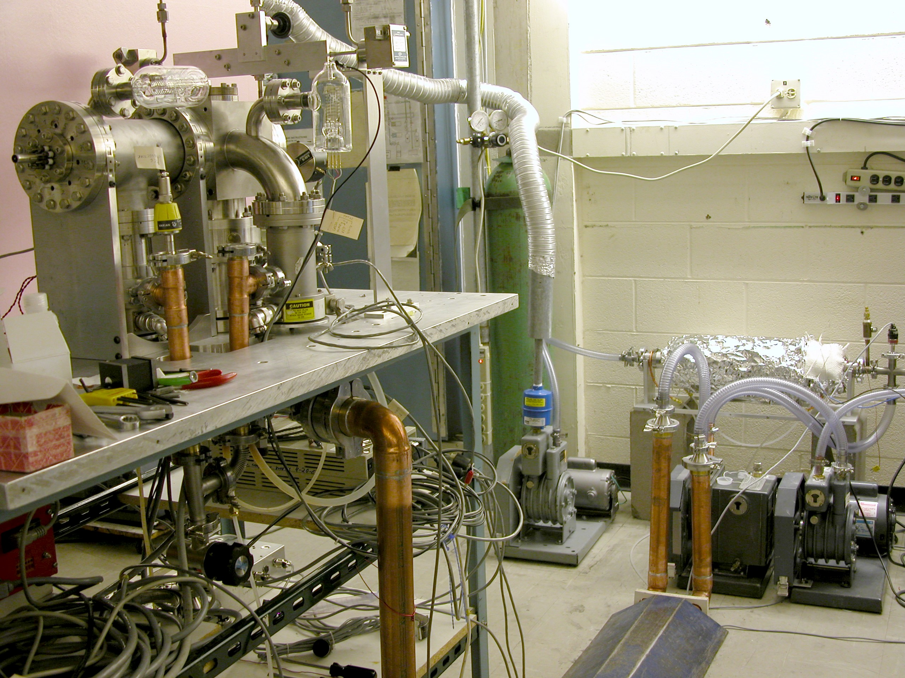

Photograph 1. Complete apparatus, with the mass spectrometer flange at the upper left and the rough pumps and pyrolyser at the lower right. The hydrogen gas that exits the pyrolyser is vented out the top of the building through the flexible aluminum tube in the middle of the photograph.
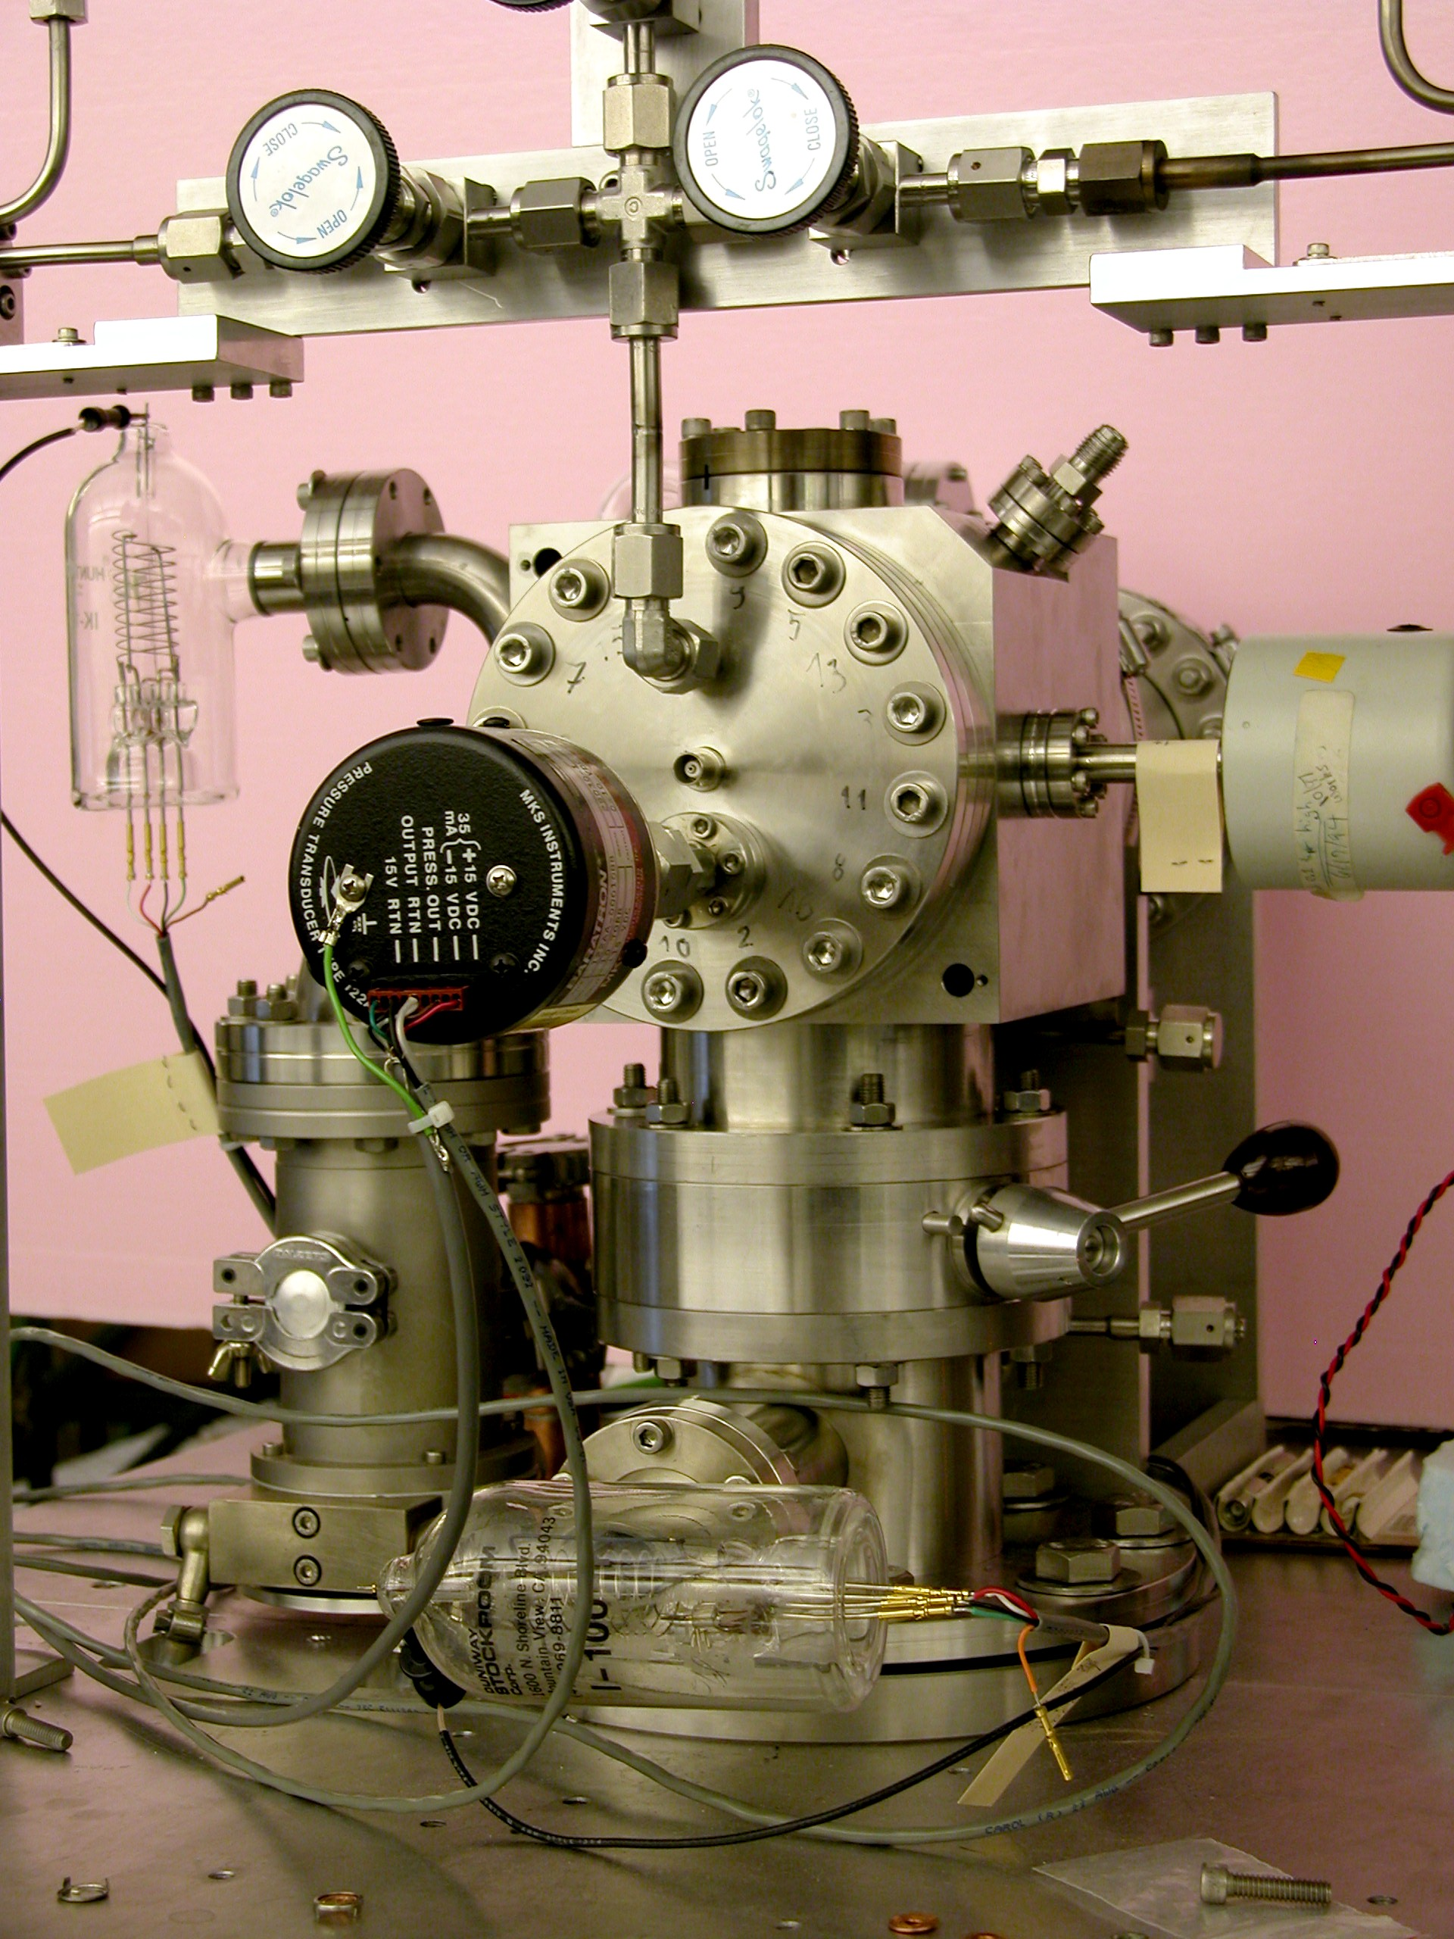

Photograph 2. The discharge-chamber side of the apparatus. The inlet flange of the 300 L/s turbo pump that handles the primary gas flow rests on the table surface, directly below the discharge chamber. The 50 L/s turbo pump seen to the left exhausts the first differential-pumping chamber between the discharge and the mass spectrometer. The capacitance manometers measure the pressure in these two chambers.

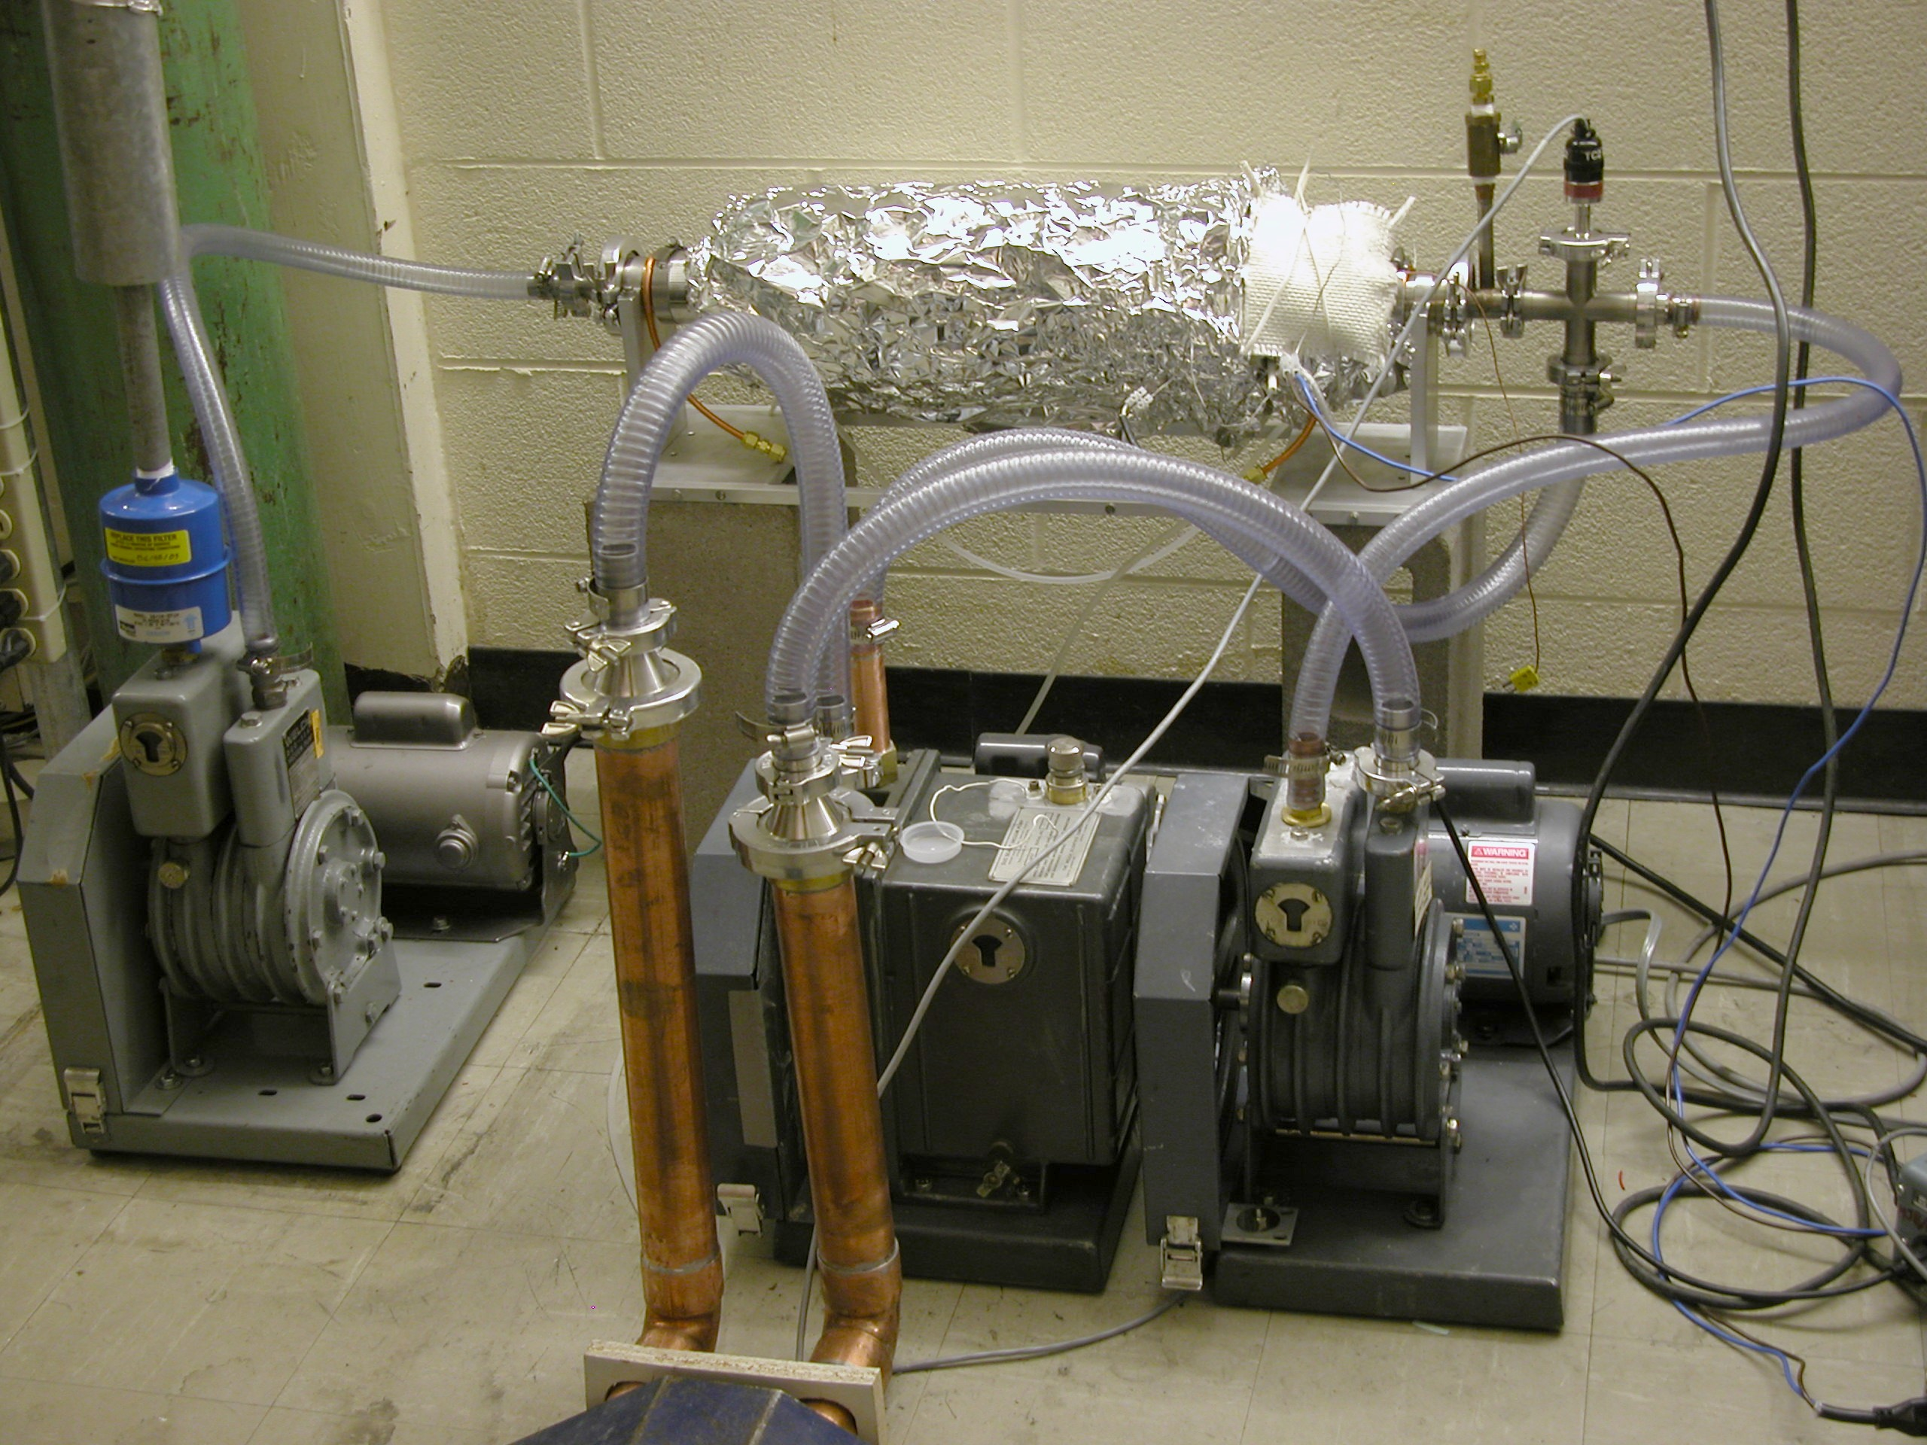

Photograph 3. Photograph of the rough pumps and pyrolyser. The larger, middle rough pump, center, exhausts the discharge-chamber turbo, and the smaller pump, right, exhausts the differential-pumping and mass-spectrometer turbos. This separation is necessary to avoid hydrogen backstreaming into the mass spectrometer chamber, since turbo pumps have low compression ratios for hydrogen. The third rough pump, left, exhausts the pyrolyser, seen at the center top of the photo.

