The NASA Human Space Flight Supply Chain, Current and Future

Edgar Zapata
National Aeronautics and Space Administration, Kennedy Space Center
edgar.zapata-1@nasa.gov

Abstract

The current NASA Human Space Flight transportation system, the Space Shuttle, is scheduled for final flight in 2010. The Exploration initiative will create a new capability with a combination of existing systems and new flight and ground elements. To fully understand and act on the implications of such change it is necessary to understand what, how, when and where such changes occur and more importantly, how all these interact. This paper presents Human Space Flight, with an emphasis on KSC Launch and Landing, as a Supply Chain of both information and materials. A supply chain methodology for understanding the flow of information and materials is presented. Further, modeling and simulation projects funded by the Exploration initiative to understand the NASA Exploration Supply Chain are explained. Key concepts and their purpose, including the Enterprise, Locations, Physical and Organizational Functional Units, Products, and Resources, are explained. It is shown that the art, science and perspective of Supply Chain Management is not only applicable to such a government & contractor operation, it is also an invaluable approach for understanding, focusing improvement and growth. It is shown that such commercial practice applies to Human Space Flight and is invaluable towards one day creating routine, affordable access to and from space.

1. Introduction

In a world of complex systems, understanding first requires successful communication, such as by conveying clear definitions. The “operations” of one person may be called the “logistics” of another (as is common in Department of Defense circles). Even with NASA the term “operations” may be used commonly in distinct ways, referring to processing for flight if you are at Kennedy Space Center but used commonly only in reference to actual flight time and the “mission” if you are at Johnson Space Center. The introduction of a new term, the “supply chain” may as well be interpreted narrowly, as referring only to the process of getting parts or materials to a given site of interest, or as broadly as all the outward and inward facing processes that are required to produce a final product for a customer.

Human Space Flight incurs a large portion of both time and cost in the movement of information as well as materials, so the term “supply chain” as it used throughout this paper is the more expansive of the possible definitions. That is, the supply chain is all of the processes, direct and in-direct, that extend out as links in a chain to create a product, hence meeting the customer requirement. As Human Space Flight would fall into the realm of a “developing” market [1], as measured by final outcomes such as launch rates (but not necessarily intermediate products), this more expansive definition captures the labor and service oriented dominance of the components that go into creating a launch.

Specifically, we define an Exploration Supply Chain as:

“The integration of NASA centers, facilities, third party enterprises, orbital entities, space locations, and space carriers that network/partner together to plan, execute, and enable an Exploration mission that will deliver an Exploration product (crew, supplies, data, information, knowledge, and physical samples) and to provide the after delivery support, services, and returns that may be requested by the customer.”

2. The NASA Human Space Flight Space Transportation Supply Chain as an Enterprise Level Network

The first shift in perspective asked by a supply chain methodology for understanding complex systems is to define one’s reason for existence - the customer. In this perspective the Space Shuttle does not launch merely because it can, or to meet a manifest from a program management office within the Shuttle program at Johnson Space Center (JSC). This would be analogous to believing General Motors manufactures cars for dealerships. Actually, dealerships are simply the means (and not the only one) by which customer requirements are conveyed to the plant. The customer is the purchaser of the car.

The Human Space Flight customers include:

Current Customer: The International Space Station program at JSC.
Future Customers: The prior ISS (near term through 2017+) as well as the Exploration customer to be defined, requiring Lunar sorties and extended missions and so on (mid-term 2018+) and Mars exploration missions (long term ~2020+).

One may represent this network of relationships among Enterprise level, relatively independent, members of the Human Space Flight supply chain as shown in Figure 1. Note the new additions for the Lockheed-Martin awarded CEV and that a complete analog is very similar in network structure to Space Shuttle operations.

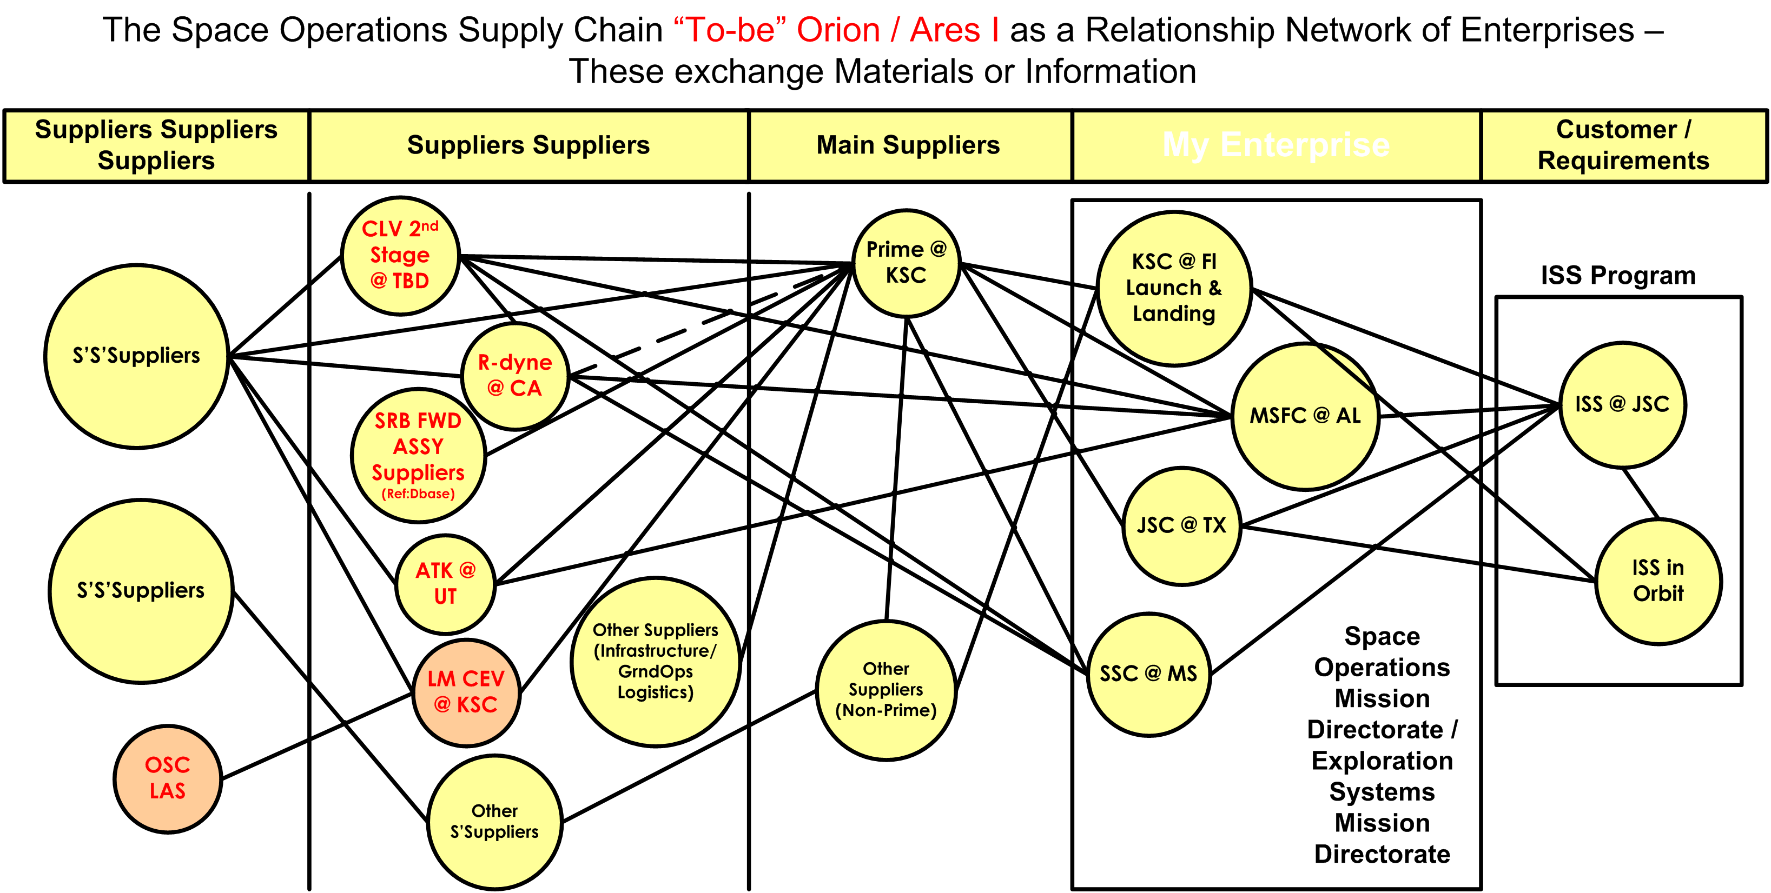
Figure 1

3. Why Supply Chain Management? Why Now?

It may be asked if “supply chain management” as an evolving science, or even in its mature, practiced forms to be discussed further ahead, applies to Human Space Flight (HSF)? As a developing market, HSF volume is low as measured by the number of launches per year (nationally or globally, even including un-crewed launches), so how can one apply concepts engendered to move lots of product to lots of customers – fast?

Three key concepts speak to “how” to apply supply chain management methods to Human Space Flight:

  - How: By treating information flows (sustaining, requirements management, configuration control, scheduling, planning, administrative, financial, etc.) as integral to material logistics flows (flight & ground hardware for processing, assembly and launch, and return for refurbishment, reuse, and disposition, commodities, payloads, flight crew equipment, etc).
  - How: By taking advantage of capabilities that exist to capture the relationships of material and information via Supply Chain Advances such as the Supply Chain Council SCOR [2] and already defined methodologies in defining such flows.
  - How: By taking advantage of capabilities that exist to create simulations automatically that can relate information and material flows within a supply chain from the enterprise level on down to the physical operations concept level and downward to the level of resources and processes.

A natural progression is to ask “why” Human Space Flight is still a developing field in the human enterprise as we advance to becoming a space-faring civilization. This question may be asked in various layers recursively (“ask why 5 times”) to derive an understanding that goes beyond “how”. The beginning of understanding is to measure out the current Human Space Flight Supply Chain - that which produces a Human / Crew in Space, at the International Space Station, and back safely – in more tangible terms. This is shown in Figure 2.

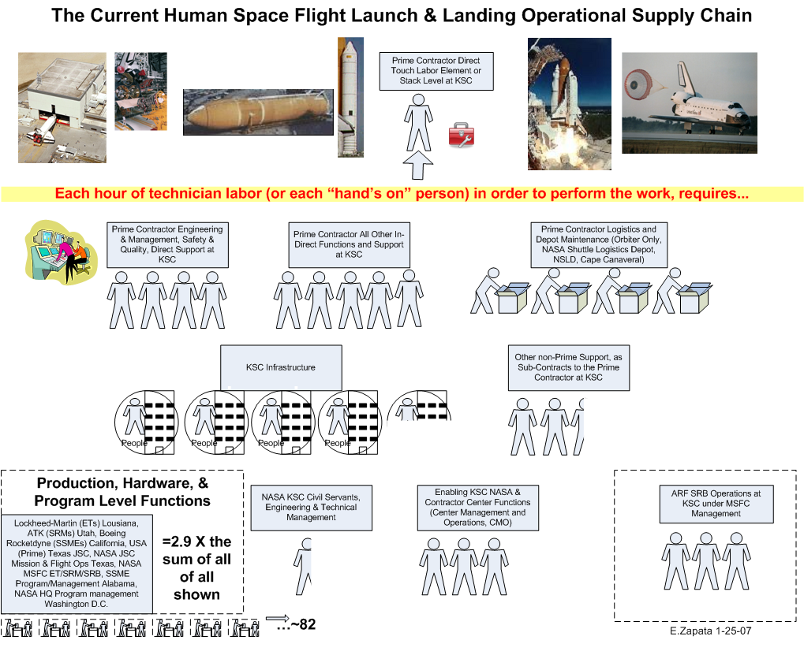
Figure 2

One can see from that the tasks we see in a more visible light internally as the work of preparing a spaceship and which the public sees as a launch is but a small component of the entire picture (by cost ~10% of Launch and Landing). Every hour spent by a technician to prepare human space flight hardware for launch is represented in as the lone stick figure at the top of the diagram. Each of the other icons, such as 4 people and materials in “Prime Contractor Logistics” represents 4 times as much (labor and materials) by cost relation. Areas dominated by labor such as “Prime Contractor All Other In-Direct Functions” are represented by only “people” icons. The cut icons are portions thereof for that category. For example KSC Infrastructure would add roughly 4 and ½ hours to match the original hour. This Launch and Landing emphasis would not be complete without reference to the rest of the program elements around the country, whereby due to production of hardware, program management and such another 82 “units of work” would match the original unit of work. This vaguely defines relationships of cost to hours, albeit loosely, as the actual data relationships used in developing are costs and by necessity this includes labor and materials. The strictest relationships where cost and labor-hours are near identical for are for those icons showing only people, areas dominated by labor as a service or function. For example, every hour of labor by the lone top stick figure is actually matched by a need for 4 more hours in prime engineering and 5 in prime in-direct, i.e. another 9 hours.

Of note, the common term in business of “overhead” by a reasonable categorization for direct Prime and direct NASA functions shows that the business support functions are roughly 100% in EACH case, government or contractor. For example, note that the sum is “5” units of Prime In-direct to the sum (also 5) of Prime technicians (1) and engineering / technical management (4) - the more visible items of work.

4. Locations, Physical Functional Units

Having introduced the concept of the Enterprise previously, the independent entities that network together to bring about a product, the next steps in applying a supply chain perspective are to establish locations and physical functional units.

Locations are exactly as they sound, the geographical place an activity takes place or through which, to or from, the material or information flows. Physical functional units have a semblance to things physical such as buildings, a Spaceports processing, logistics, and launch facilities.

For the 1st Exploration system to be developed, the Crew Exploration Vehicle (CEV, the launch abort system, capsule, service module and adapter portion) and the Crew Launch Vehicle (CLV, the Reusable Solid Rocket Motors and Assemblies, and the 2nd Stage) a diagram capturing relationships among physical functional units would be as shown in Figure 3.

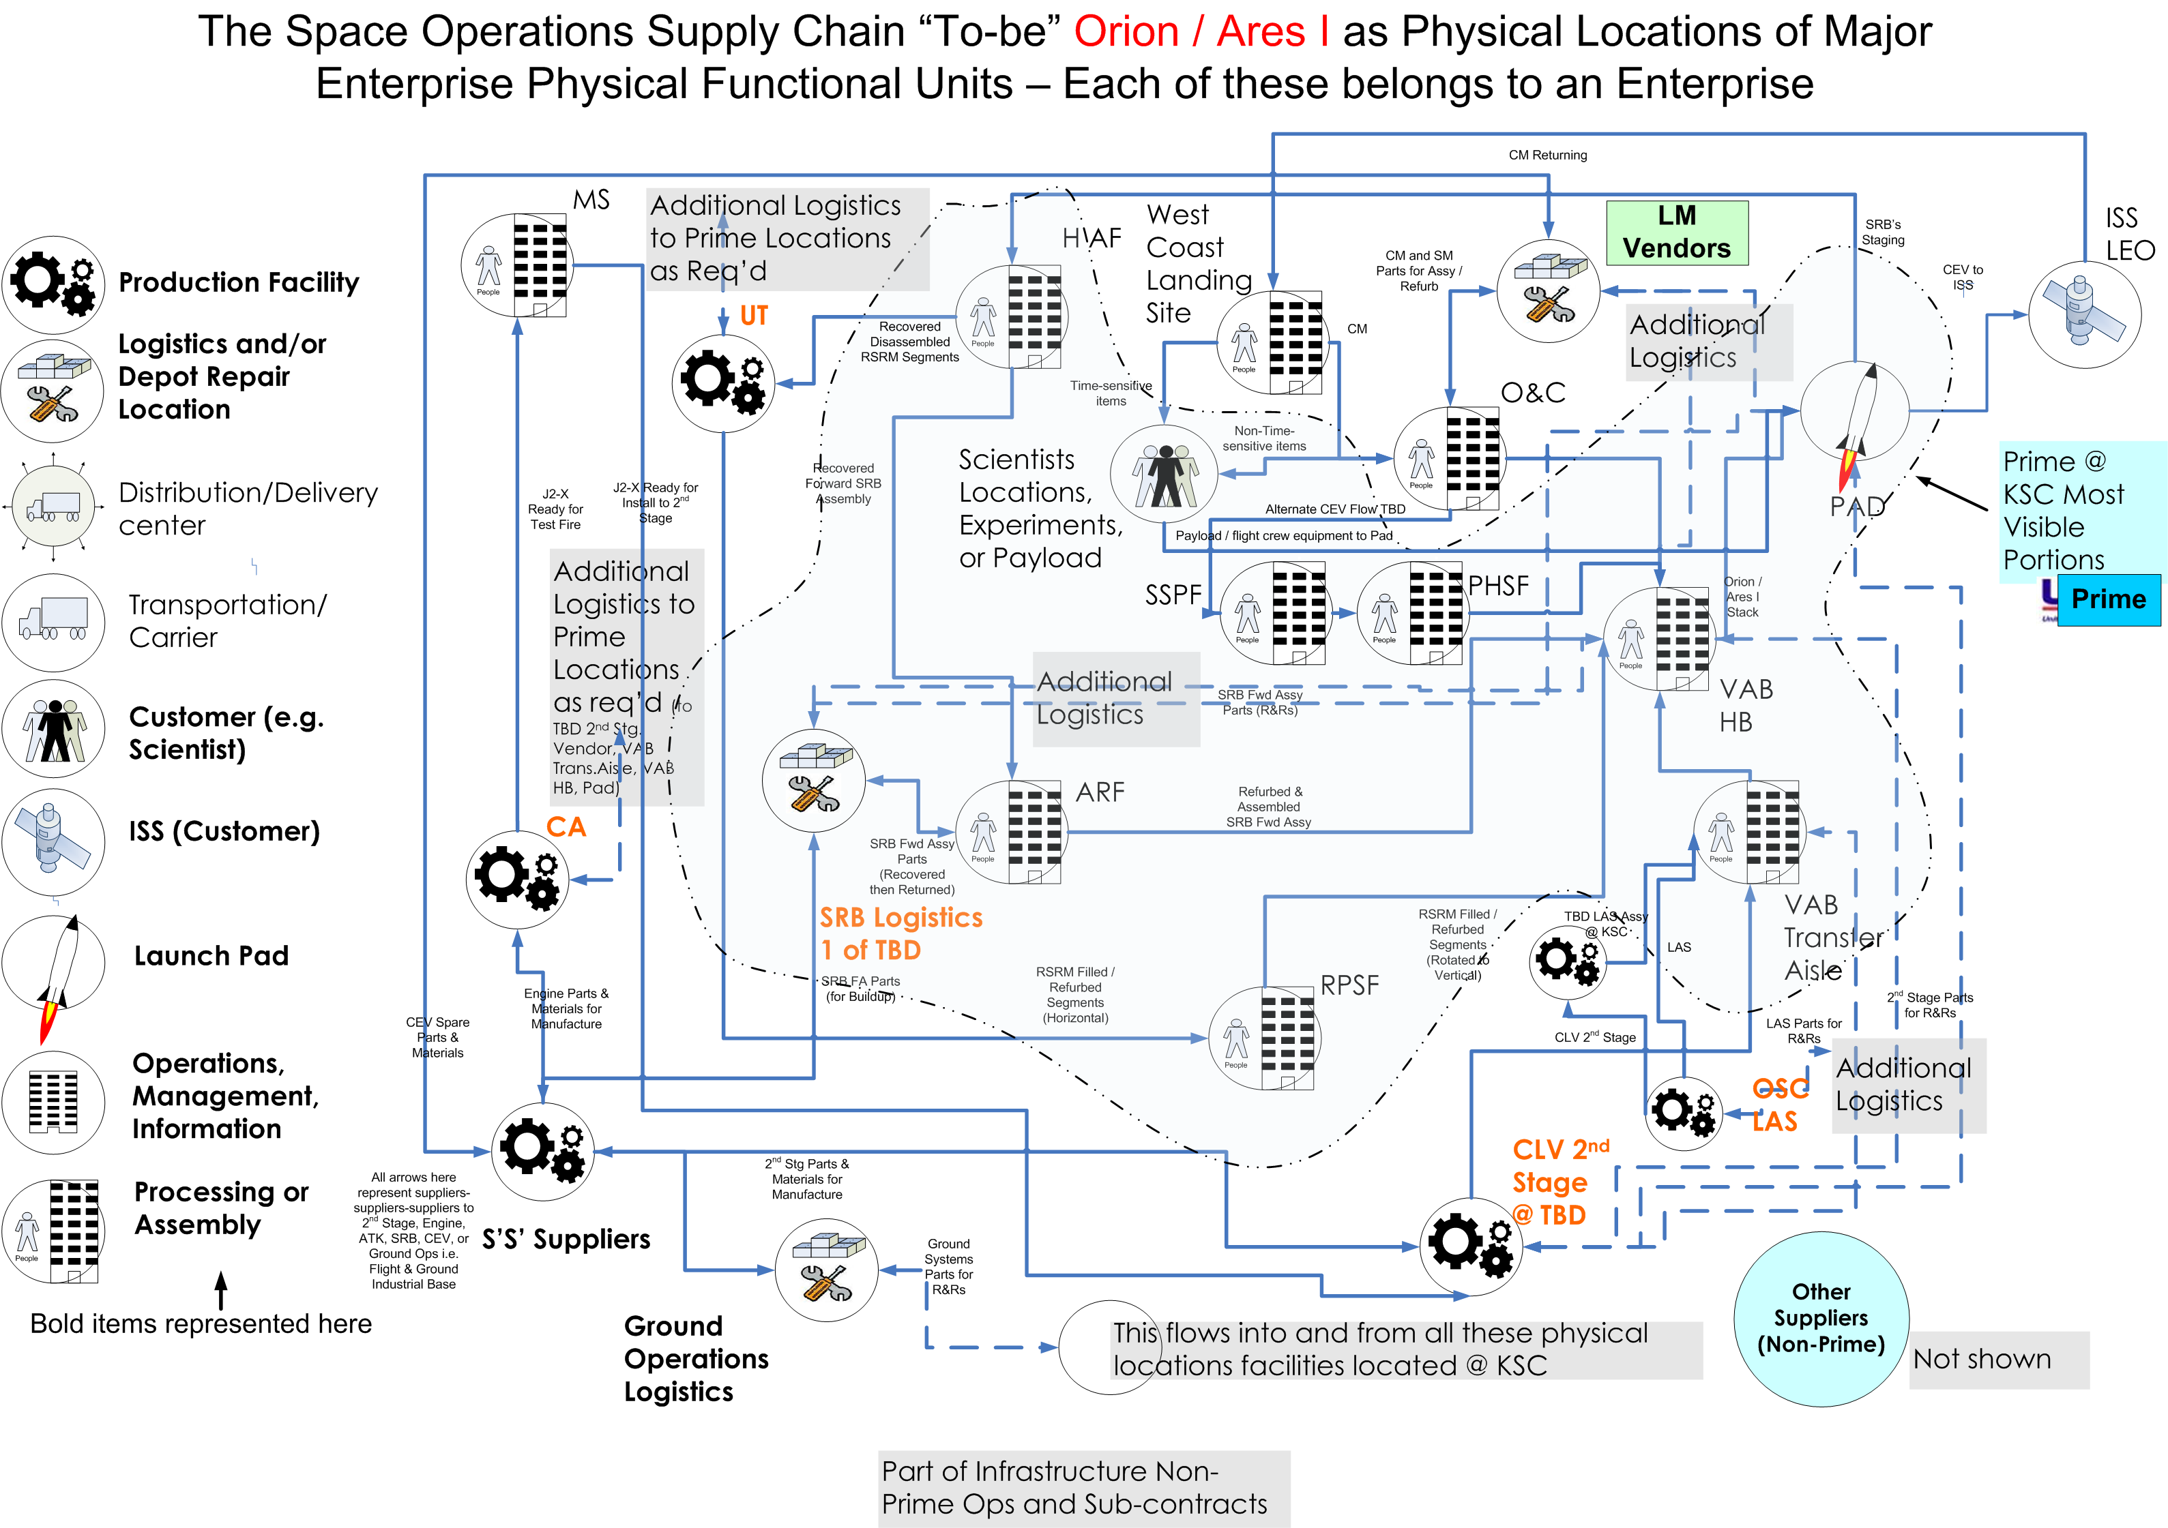
Figure 3

5. Products and Transformation

The flow of material, weather parts, a sub-element such as a Launch Abort System (LAS), or a higher level element such as a CEV, or an integrated stack, introduces the key concept of product. Semantically, in summery:

- Enterprise: An independent entity networked with others to produce, meet a customer requirement, or add value.
- Location: the place the Enterprise resides, either as operations, production, logistics, warehouses, office buildings, etc in certain state such as Florida, California, and Texas etc.
- Physical Functional Units: A building, facility and/or the equipment, such as Ground Support Equipment that is a required resource at the location.

Transformation occurs as value is added in any step of the supply chain (or not, leading to discovery and improvement).

6. Organizational Functional Units and Enabling Functional Units

A distinction in supply chain methodology that is extremely useful in the Human Space Flight supply chain is that difference between an organizational function that can hold up material flow and those functions that, for simplification purposes, are safely assumed not to be able to hold up material flow. The later are enabling. As shown in Figure 5, enabling functions flow into the physical functional units, with applied resources, but do not necessarily have to be viewed as capable of holding up the material product (such as a rollout, or launch).
On the contrary, organizational functions capable of holding up material flow, as they must add information to proceed or not, such as a Flight Readiness Review, behave quite differently from a supply chain perspective.
Organizational functions that are required to be performed to receive items, to assemble them into a product, to deliver and so forth can be represented visually as shown in Figure 4.

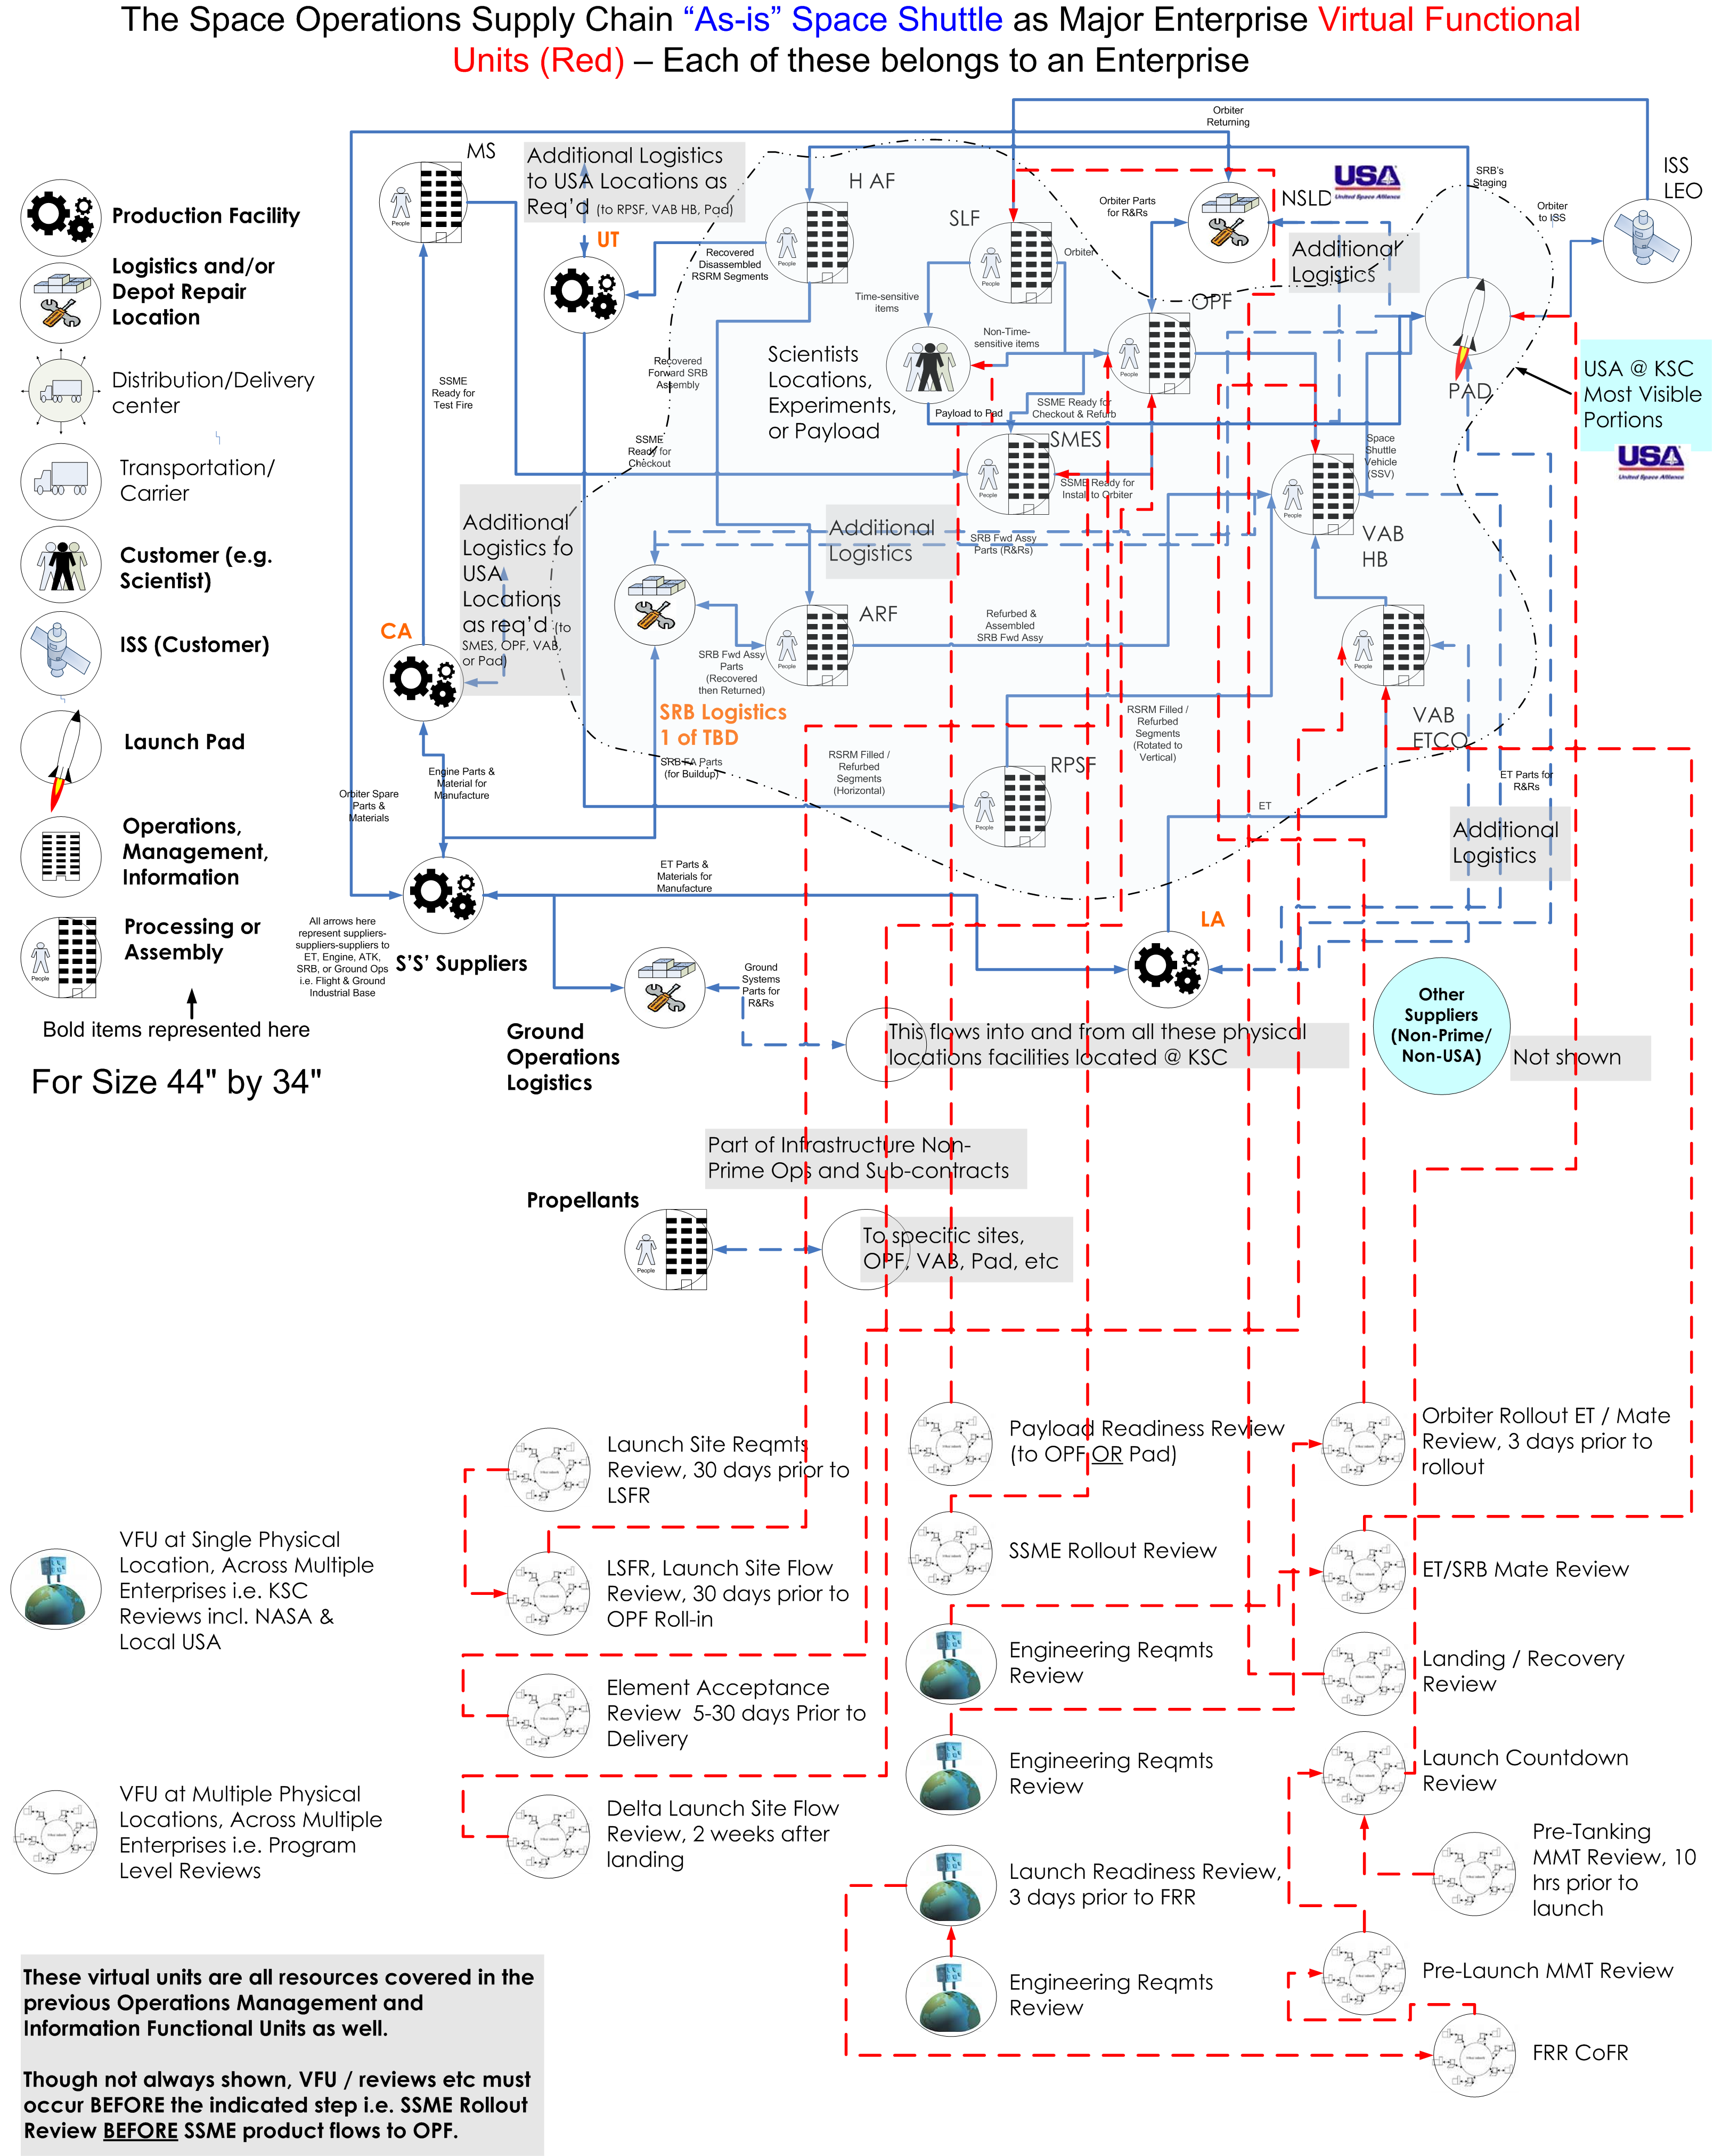
Figure 4

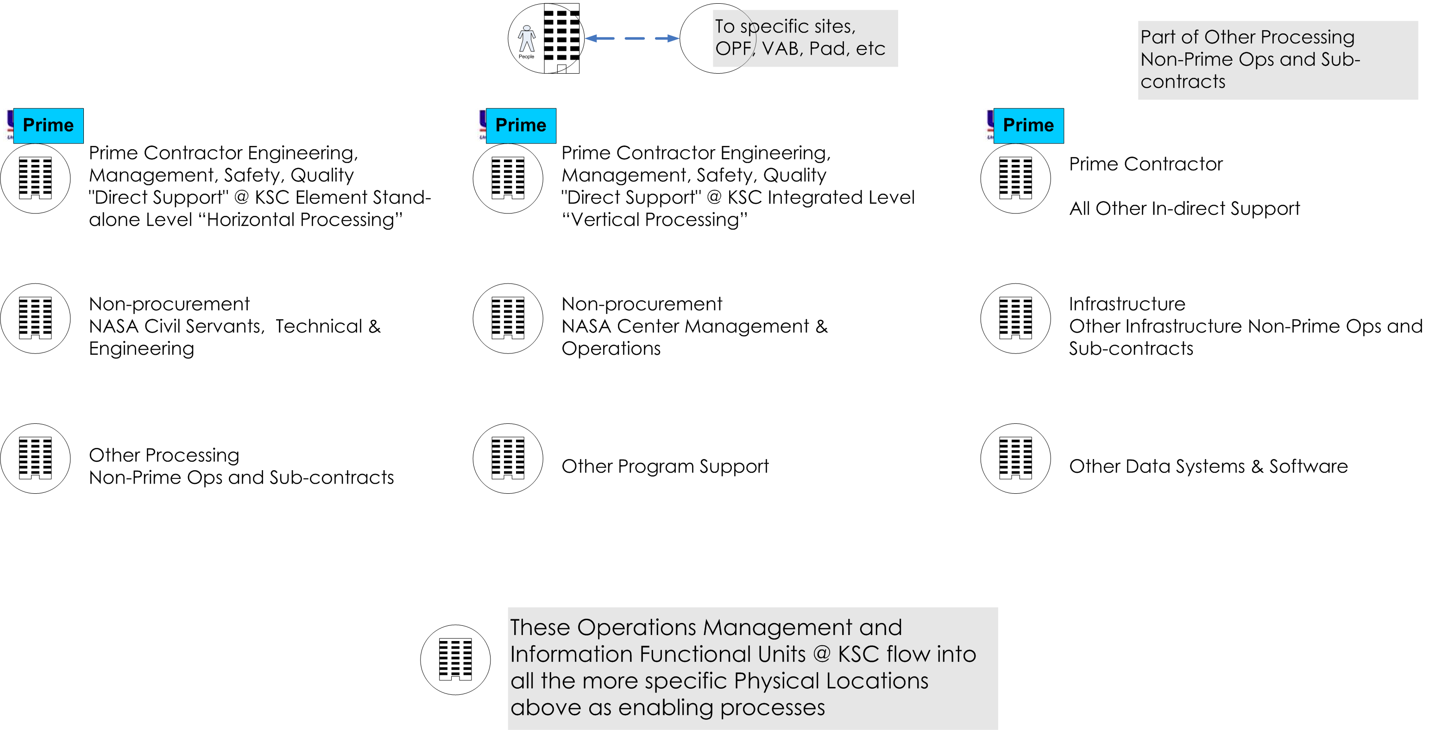
Figure 5

7. Human Space Flight and Supply Chain Management Implications and Future Opportunities

Various logical questions arise from data about a given supply chain, as shown previously for Human Space Flight. The following data can be discovered within Shuttle, albeit after many years of assembling data in a form analogous to assembling a jig-saw puzzle (or a brain teaser [3]):

Dollars: As shown in Figure 2, and associated more detailed data, data exists on cost, very often as dollars and at times as workforce size, of the numerous functions of the Human Space Flight program, in it’s current rendition as the Space Shuttle operation.
Time: The amount of time to create the product, in this case a launch, corresponding to the hands-on activities in Figure 2 or the flow of large flight hardware elements across Physical Functional Units is also relatively well known (at a high level, such as “historical SRB stacking times”).

Logical questions arising from such past data and research, or in attempting to derive and assemble an understanding of underlying relationships among departments, organizations, and enterprises, or in a desire to understand drivers would include:

- Inter-relationships of Size and Scope: What is the inter-relationship in size between function A and B? More tangibly by way of example, why is the ratio of technical support (engineering et al) to hands-on 4:1? By way of another example, why are Center Management and Operations (CMO) as charged to Human Space Flight about 29% of the other functions being performed (by cost)?
- Drivers of Cost: In a given function, what drives size? That is, without resort to external factors (holding these constant), what factors internal to each category drive the size of the function? By way of example, what internal factors drive the Civil Service technical workforce size (as charged to a specific program). By way of another example, within Prime In-direct functions, what internal factors drive the work effort required in work control and document creation?
- Inter-relationships of Time: How do time delays in in-direct functions contribute to the delivery of product? By way of example, the time to process a Space Shuttle from the official start of a flow to launch may be counted in months (perhaps ~5 months). However, the specific request to “launch” on X date with Y configuration from a customer has been in flow for some time, on the order of years, only the last 5 months of which we see as the more visible movement of product. In this “supply chain / customer time” the request is what requires action, and the day it arrives the counter starts. The clock ends when the Crew and goods return safely from the ISS.
- Drivers of Productivity: In a given function as shown in Figure 2, direct or in-direct, what factors internal to the function drive the time to prepare product? By way of example, what drives how long sourcing a product takes within the procurement function?

8. Gaining Understanding of Inter-relationships and Drivers

By delving into data on the functions shown in Figure 2, and within the limits of subject matter expertise, past reports, etc, a preliminary set of relationships can be determined among components of information and materials on the Launch and Landing supply chain, extending outward to suppliers and customers. Various projects at KSC funded by the Exploration initiative and the Constellation program tasked with developing the Shuttle replacement system are developing supply chain analysis capabilities along these lines.

Three such projects include:

- The Exploration Systems Analysis and Technology Assessment Model for Exploration, Launch and Landing Effects Ground Operations (LLEGO) model
- The Earth-to-Orbit Supply Chain Simulation for Exploration (E2O Sim)
- The Inter-planetary Supply Chain Management / Logistics Project (SpaceNet)

The relationship of these projects to gaining knowledge, providing useful and actionable analysis, and to each other is as shown in Figure 6.

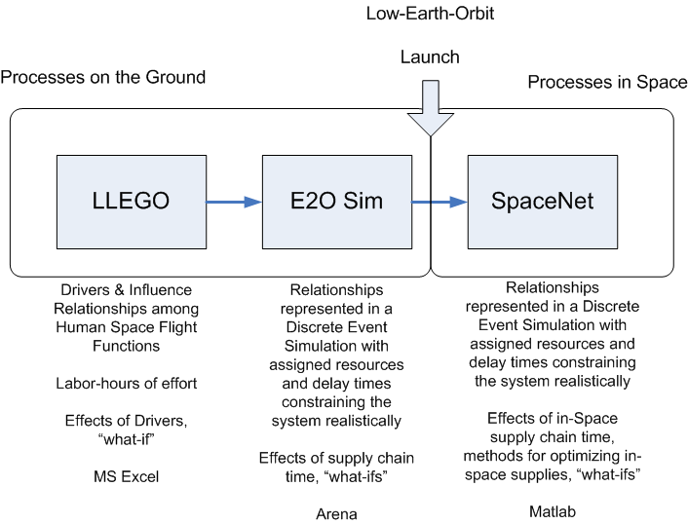
Figure 6

9. Opportunities

The term “supply chain management” brings with it an assortment of semantic confusions, typically associated with the expansiveness or not of the term and with a sense that it may be just another term (or fad) for logistics management. It may even be said that the term “operations” – the getting of product to customers – is the actual older term. Various key differences occur in SCM practice that make the new term justifiable as a new type of practice. These new uses point the way to opportunities through the perspective gained in “thinking supply chain management”.

- Material flow is understood within a context that information is integral and important to satisfying the customer. In aerospace it is particularly applicable that the item has the necessary documentation, typical in a low volume sector with high priced goods.
- Information makes or breaks the Enterprise, and much of the flow of information that relates to a product occurs outside of organizations designated “logistics” per se. As example, organizations designated “logistics” at KSC (such as NSLD, SRB Logistics or Ground Ops Logistics for facilities) comprise in sum less than 20% of the total cost of KSC operations.
- Understanding activity functions, value added (or not) steps in the process invariably will lead to a link in the chain to the more visible functions of the organization delivering product. Logistics departments alone will not do this. Operations alone will not do this. SCM allows the integrated organization of logistics, operations, support functions and business functions to be attacked as a whole that delivers product.

Opportunities can be seen in relationships among elements and functions of each as shown in Figure 7.

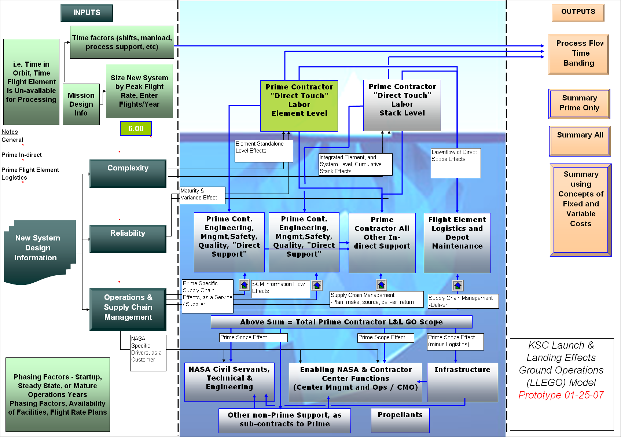
Figure 7

Specific Opportunities:

- Prime Contractor In-direct: Currently half the basic Prime workforce in the subject area of:

-Program interfaces / coordination, rules management (LCC, OMRS, etc)
-Requirements management and flow-down
-Generate work documents
-Configuration management
-Documentation, authorization, tracking
-Work control
-Scheduling
-Interface tasks into master scheduling and manifest and schedule daily work
-Dedicated ground systems support, design, planning, and operations and maintenance (O&M)
-Internal facing business functions

- Engineering & Technical Management, both Contractor and NASA: Given that engineering be it NASA or prime provide finalized forms of information, such as technical instruction / work documents, forward into the configuration control systems, and that such an area is likely to relate in scope not just to the labor to be performed but also to the means by which these organizations receive and process information, this area is ripe for improvements. Such may take the form of improved drawing systems, access to these, and usability. Alternately requirements being conveyed, turned into plans, and instructions, and quick but correct decisions are improved anytime antiquated processes, information systems, or over-staffed approval processes can be automated, streamlined or otherwise simplified through more inter-operable systems across NASA, contractors, sub-contractors and customers. An analog example from the financial aspect is the realization of the NASA Integrated Financial Management Program (IFMP) whereby dozens of NASA systems that were not inter-operable were replaced with a single integrated system (SAP software). Ultimately the NASA Shared Services Center (NSSC), again as analog, is another realization consolidating (eventually) physically in one location many of the functions of NASA procurement and finance.

- Logistics – Integration: Interoperable systems between operations engineering, logistics, work control and scheduling, across prime and NASA, would flow information electronically across compatible systems from suppliers through to customers. Today only a fraction of that vision has been put to practice. This area is especially prone to controversy as it introduces the issue of links in the supply chain seeking to benefit themselves rather than the system as a whole by access to “other peoples systems”. This is the “Walmart / Proctor & Gamble (P&G)” issue for short. For example, in integrating P&G and Walmart Supply Chain information systems one can envision that P&G seeing stock levels drop in certain Walmarts would seize the chance to increase the price at that opportune moment when new orders arrive. Inversely, Walmart seeing through integrated information technology systems (I/T) that P&G has a glut of product at the plants may be tempted to bargain P&G down that month. Yet such supply chains have been integrated based on the premise of mutual benefit. Hence the opportunity to design improved I/T systems in this area is not only necessary but inevitable.

10. By Design

Figure 7 visualizes drivers on the left which are encompassing of that a product has a certain complexity, it may fail or not in use, test or in preparation for use, characterizing it’s reliability, and it is an object that is acted upon within a set of human, technological and organizational processes, the operations & supply chain drivers. More tangibly by way of example, a 2nd stage may have many engines or few (complexity). These may fail or not during a test or inspection (reliability). The engines may be difficult to access due to many other parts overlying the engine and propulsion or due to poor access (again complexity, as parts count). It may be decided to verify many checks with the engine installed, and horizontal, versus upon receipt and after vertical, taking X days and resources versus Y days and resources (operations method as driver). The resolution of the issue may be scheduled and documented for the operations team in 3 hours (supply chain management, information technology) or 3 days (if a poor system for information flow). Lastly the part may take 10 days to order as information winds through the various systems in procurement, or logistics, or both, and finance. Or it may arrive the next day (supply chain management as a driver). Lastly, actual installation after access is achieved may take days or hours (operations) as the decided steps are performed on the shop floor.

As key drivers documented in many an instance, the right operation “by design” will naturally include the right vehicle, facility and ground support equipment, and the right supply chain processes and operational steps. It is the premise of this perspective that all aspects are integral to improving Human Space Flight.

- Reduce system and sub-system complexity as measured by parts count, number of different fluids, number of toxic fluids, number of distinct tanks, number of distinct avionics, controllers and devices.
- Improve reliability, especially as to reduce fault-legs (i.e. quad can be triple, triple can be dual) but still to maintain or exceed past system level reliability and safety. This is an area neglected in product development focused narrowly on reducing weight and margin/robustness.
- Improve operations through data collection of tasks, steps, times and resource needs. Lead to actionable technology, systems, I/T and practices
- Improve supply chain management through data collection of department/organizational functions, products, times, resource needs and integration across key information systems. Lead to actionable technology, systems, I/T and practices.

11. In Closing

Tools are in development or capabilities exist at a usable level of maturity, especially organizationally, that offer a path to realizing the gains (cost, time) being advertised for future systems such as envisioned in the Exploration initiative. Data of assorted types exists after decades of Shuttle operations that is indicative of directions for improvement (what) as well as specific methods (how) due to emerging insight into functions as relate to product (why).

It is expected that the various projects described here will all be complete by mid-2007. As shown in Figure 8, as one example, the E2O Sim, a view of “Orion Ares I” will emerge that can offer valuable insight into the path forward.

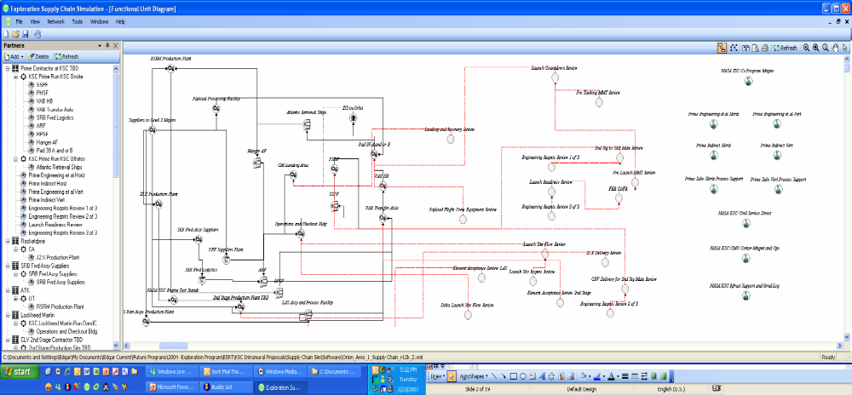
Figure 8 Screen-shot of The Earth-to-Orbit Supply Chain Simulation

12. Acknowledgments

The author gratefully wishes to acknowledge the contributions to the work described of:

- Mike Galluzzi, Space Shuttle Program Office, Supply Chain Guru, NASA KSC
- Cary Peaden and Steve Kyramarios, NASA KSC, Phase 1 & 2 Project Managers
- The team at Productivity Apex Inc.
  - Mr. Mike Callinan, President, Mansooreh Mollaghasemi, Ph.D. Senior Scientist, Sam Fayez, Ph.D. Supply Chain Scientist, Dayana Cope, Simulation Engineer, Assem Kaylani, Software Engineer, Nathan Rychlik, Cost Analyst
- The team at Blue Frog Technologies Inc.
  - Alex Ruiz-Torres, Ph.D. Lead Investigator and Integrator
- Russel Rhodes & Carey McCleskey, NASA KSC, Systems Engineering and Integration, for valuable insight, data and operations & engineering expertise
- Martin Steele, Ph.D, NASA KSC, for continued collaboration as lead of the Inter-planetary Supply Chain and Logistics project
- Doug Craig of the Exploration Systems Mission Directorate, NASA HQ, sponsor of the E2O project
- Don Monell, of the JSC Constellation Systems Engineering and Integration Office, sponsor of the E2O sim project.
- Pat Troutman and Bill Cirillo of the NASA Langley Research Center, sponsors of the ESATA operations model project.

13. References

[1] Hugos, M., Essentials of Supply Chain Management, Wiley & Sons Inc. Publications, Hoboken, New Jersey, 2003.

[2] Supply Chain Council, Supply Chain Operations Reference Model (SCOR), The Supply Chain Council, online at: http://www.supplychain.org/page.ww?section=SCOR+Model&name=SCOR+Model viewed on 1/25/07.

[3] General Accounting Office, report to the Subcommittee on Space and Aeronautics, Committee on Science, House of Representatives, GAO, GAO Government Publication, Washington D.C. May 2004

[4] Cooper, M., Lambert, D., Pagh, J., Supply Chain Management: More Than a New Name for Logistics, The International Journal of Logistics Management, Volume 8, MCB UP Ltd, Oxfordshire, England, 1997.

