Report to Congress

on the

International Trade Data System (ITDS)

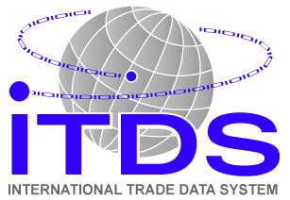

November 2007

Table of Contents

Legislative Requirement 5
Executive Summary and Recommendations 6
Overview 6
Agency Participation 6
Status of ITDS Program 6
Status of Implementation of ITDS Functions in ACE 7
Budget Issues 8
Introduction 9
Overview 9
The Current Trade Reporting Environment: the Problem ITDS Is Intended to Fix 10
How ITDS Can Fix Trade Reporting 10
Benefits from the Single Window 10
Benefits of Shared Electronic Access to Data 11
“New” Access to Data 11
Enhanced Risk Analysis 11
Import Safety Benefits 12
Export Data 12
Benefits from Adopting International Standards 12
World Customs Organization (WCO) Data Model 12
Status of Implementation of ITDS Program 14
Extent of Participation in ITDS by Federal Agencies 14
Safe Port Act 14
Quality of Participation 14
Import Safety Working Group Recommendations 14
OMB Directives 15
Preparing Agencies to Use ITDS 15
Data Harmonization 15
Concept of Operations 16
Memoranda of Understanding 16
Status of Implementation of ITDS Functions within ACE 18
Agency Use of ACE Portal 18
Security Architecture for Differentiated Access to Information 20
Computer to Computer Connections 20
Implementation of WCO Data Model Standards 20
Implementation of Single Window 21
Electronic Collection of Data Currently Reported on Paper 21
Edits and Validations 22
Delivery Schedule 22
Budget Issues 23
Cost Sharing and Allocation 23
Funding for ITDS Work within ACE (ITDS Project Team and Shared) 23
Agency Resource Requirements 24
AGENCY PLANS AND STATUS 28
Agricultural Marketing Service (AMS) - USDA 28
Animal and Plant Health Inspection Service (APHIS) - USDA 30
Foreign Agricultural Service (FAS) - USDA 32
Food Safety and Inspection Service (FSIS) - USDA 33
Grain Inspection, Packers, and Stockyards Administration (GIPSA) - USDA 35
Bureau of Industry and Security (BIS) - Commerce 36
Census Bureau - Commerce 37
Foreign-Trade Zones Board (FTZB) - Commerce 38
Import Administration (IA) - Commerce 39
National Marine Fisheries Service (NMFS) - Commerce 40
U.S. Army Corps of Engineers (USACE) - Defense 41
Office of Fossil Energy (OFE) - Energy 42
U.S. Fish and Wildlife Service (FWS) - Interior 43
Bureau Alcohol, Tobacco, Firearms, and Explosives (ATF) - Justice 44
Drug Enforcement Administration (DEA) - Justice 45
Bureau of Labor Statistics (BLS) - Labor 46
Centers for Disease Control and Prevention (CDC) - HHS 47
Food and Drug Administration (FDA) - HHS 48
Transportation Security Administration (TSA) - DHS 50
Bureau Oceans and International Environmental and Scientific Affairs (OES)-State 51
Office of Foreign Missions (OFM) - State 52
Directorate of Defense Trade Controls (DDTC) - State 53
Department of Transportation 54
Bureau of Transportation Statistics (BTS) 54
Federal Aviation Administration (FAA) 55
Federal Highway Administration (FHWA) 55
Maritime Administration (MARAD) 55
National Highway Traffic Safety Administration (NHTSA) 56
Pipeline and Hazardous Materials Safety Administration (PHMSA) 56
Federal Motor Carrier Safety Administration (FMCSA) 57
Internal Revenue Service (IRS) - Treasury 59
Office of Foreign Assets Control (OFAC) - Treasury 60
Alcohol and Tobacco Tax and Trade Bureau (TTB) - Treasury 61
U.S. Consumer Product Safety Commission (CPSC) 62
Environmental Protection Agency (EPA) 63
Federal Communications Commission (FCC) 64
Federal Maritime Commission (FMC) 65
International Trade Commission (ITC) 66
Nuclear Regulatory Commission (NRC) 67
Office of the United States Trade Representative (USTR) 68
PGA Integration Schedules 71
Appendix A.1: List of ITDS Agencies – Alphabetical by Department 94
Appendix A.2: List of Agencies – Alphabetical by Agency Name 95
Appendix B: Agency Board Members and Contacts 96
Appendix C: Safe Port Agencies 97
Appendix D: ACE Portal USERS 98
Appendix E: Safe Port Act Text 99
Appendix F: Working Group on Import Safety Immediate Actions 101
Appendix G: Memoranda from OMB 102
APPENDIX H: HISTORY OF ITDS 106
APPENDIX I: STATUS OF MOUs 109
APPENDIX J: AGENCY CONCEPT OF OPERATIONS STATUS 111

Legislative Requirement

Section 405 of the “Security and Accountability for Every Port Act of 2006” (P.L. 109-347) (SAFE Port Act) requires the Secretary of the Treasury to oversee an interagency initiative to establish a “single portal system,” to be known as the” International Trade Data System” (ITDS). This unified data system will electronically collect and distribute import and export data required by government agencies that license or clear the import or export of goods. The Act requires the President to submit a report on the ITDS at the end of each fiscal year to the Committee on Finance of the U.S. Senate and the Committee on Ways and Means of the House of the Representatives. The report is to include:

- the status of the ITDS implementation;
- the extent of participation in the ITDS by Federal agencies;
- the remaining barriers to any agency’s participation;
- the consistency of the ITDS with applicable standards established by the World Customs Organization and the World Trade Organization;
- recommendations for technological and other improvements to the ITDS; and
- the status of the development, implementation, and management of the Automated Commercial Environment within the United States Customs and Border Protection.

Executive Summary and Recommendations

Overview

The International Trade Data System (ITDS) is a “single-window” system for electronic filing of import and export documentation. ITDS is not a separate computer system, but a suite of functions to be provided through the Automated Commercial Environment (ACE), the new trade processing system of Customs and Border Protection (CBP). ITDS is being developed and will be operated by CBP with the collaboration of 40 other government agencies represented by the ITDS Board of Directors.

Importers, exporters, and transport companies face numerous and often redundant reporting requirements, both paper and electronic, from multiple Federal agencies. The ITDS “single-window” will provide for a single electronic filing rather than separate filings to multiple agencies. ITDS will also help the government provide international trade data that are more accurate, complete, and timely.

ITDS will enhance Federal agencies’ ability to target risky cargo, persons, and conveyances. ITDS can particularly enhance the effectiveness of agencies with an import safety mission.

Agency Participation

Agency participation in ITDS has been uneven, but several new agencies joined ITDS after the SAFE Port Act became law in October 2006. The recommendations and recognition from the Interagency Working Group on Import Safety and from OMB Directives on ITDS participation have also significantly accelerated agency activity.

ITDS is already partly operational. ITDS agencies are able to obtain detailed import information through the ACE Portal, a secure web-based interface. However, not all agencies are taking full advantage of that information.

Recommendation 1: Agencies, particularly those with an import safety mission, should accelerate development of plans for their participation in ITDS in order to take full advantage of ITDS capabilities.

Status of ITDS Program

Work on harmonizing data among agencies, which is critical for eliminating redundant data demands, is not complete but has accelerated.

Recommendation 2: The ITDS Board should ensure that a Standard ITDS Data Set is established by January 1, 2008.

For an agency to take full advantage of the possible new ways of doing business that ITDS offers, the responsible policy, IT, operational, and legal offices must be fully involved. In many circumstances, agencies look to the ITDS Project Team to take the lead in developing business plans for fully electronic operations and for interagency cooperation. While the ITDS Project Team has the expertise to make helpful recommendations, their efforts should not be substituted for that of the appropriate offices and the Project team should not be diverted from its primary task, developing the ITDS IT infrastructure.

Recommendation 3: Development of the ITDS program requires the involvement of the appropriate policy and operational offices of all agencies. Agencies may need to realign resources to accommodate the increasing ITDS workload. The ITDS Board and OMB should take steps to ensure that agency participation is adequate and that Project Team resources are focused on the development of the ITDS IT infrastructure.

Recommendation 4: Agency legal offices must engage in drafting Memoranda of Understanding between agencies which provide the necessary legal foundation for a shared data system, and highlight critical policy and operational issues. Work on MOUs should be accelerated.

Status of Implementation of ITDS Functions in ACE

ITDS agencies are already able to obtain detailed import information through the ACE Portal, but agencies are unable to access some data already collected electronically because the data either 1) has not yet been added to the ACE Data Warehouse, or 2) because software for retrieving that data is not fully operational.

This data could be made quickly available but that would involve changing the current ACE development schedule and must be balanced with other priorities. Making this data available could have immediate benefits (particularly with regard to import safety) and would also accelerate agency plans to fully utilize ITDS.

Recommendation 5: Accelerate plans to add to the ACE Data Warehouse all import information currently reported electronically to CBP so that it can be accessed by agencies through the ACE Portal.

The data exchange architecture intended to provide variable levels of access (limiting users to specified classes of data) has not yet been implemented. As a result, agency users can be required to have higher-level background checks and security clearances, the cost of which discourages use of the information available.

Recommendation 6: Implementation of “Access Filters” should be accelerated.

ITDS is aligning agency data requirements with the World Customs Organization standards for transmitting data from traders to governments. Adoption of standardized reporting formats can relieve traders from the cost of adapting to countries’ different reporting and software requirements.

International standardization also facilitates information sharing between governments, which can provide advance notice of risky shipments, effectively extending our enforcement perimeter beyond the border.

Recommendation 7: Accelerate implementation of World Customs Organization Data Model messages (new international standard for customs reporting) in order to:
- Reduce computer processing costs for traders by providing a single international format for communicating import and export information to governments rather than requiring traders to adjust to each country’s different reporting and electronic communication protocols.
- Allow rapid and accurate exchange of data between authorities to facilitate international enforcement cooperation and extend our enforcement perimeter beyond our border.

CBP is considering whether to incorporate in ACE all “edits” now used in current CBP trade processing system. (Edits identify errors in data submitted.) This evaluation is fact-specific: some edits are critical, others may be less useful. ITDS agencies and CBP, however, may evaluate particular edits differently.

Recommendation 8: ITDS Agencies should determine which edits are critical for their purposes and provide timely input to the ACE development team.

Some features to be used by ITDS agencies that were scheduled to be implemented have been delayed. Schedule slips are not unusual in a large IT project, but to ensure that ITDS interests represented in the decision process, the ITDS Board should be represented in the body or bodies making decisions regarding the ACE Schedule.

Recommendation 9: To ensure that ITDS equities and interests are represented the ITDS Board should be represented in the ACE decision making process.

Budget Issues

Implementation of ITDS requires CBP funding for development within ACE (ITDS Project team), and other agency funding for hardware and software specific to that agency.

Recommendation 10: The ITDS Board of Directors should continue to closely track program expenditures to ensure charges lead directly to delivery IT capabilities, and that those capabilities are delivered on schedule.

Recommendation 11: Agencies participating in ITDS should ensure their capital planning and investment control processes incorporate plans for utilizing ITDS.

Introduction

Overview

The International Trade Data System (ITDS) is a “single-window” system for electronic filing of import and export documentation. Currently importers, exporters, and carriers must file separately (often on paper) with the various agencies that regulate a particular good or means of transport. With a “single-window,” a single electronic filing is made and the relevant information is then distributed to the appropriate agencies. ITDS will eliminate redundant reporting and systems: it will also provide agencies with access to information and processing capability that they do not now have.

Contrary to what the name may suggest, ITDS is not a separate computer system. ITDS is a feature of ACE (Automated Commercial Environment), the new automated system for processing imports and exports that is being built by Customs and Border Protection (CBP). ITDS is being developed and will be operated by CBP with the collaboration of 40 other government agencies working through the ITDS Board of Directors, which is comprised of representatives of those agencies, and chaired by the Treasury Department. Board members and other agency representatives work closely with a number of CBP offices, but particularly CBP’s Office of Information Technology, and with the ACE Support Team (AST), the consortium of contractors hired by CBP to help implement ACE and administer the ITDS program.

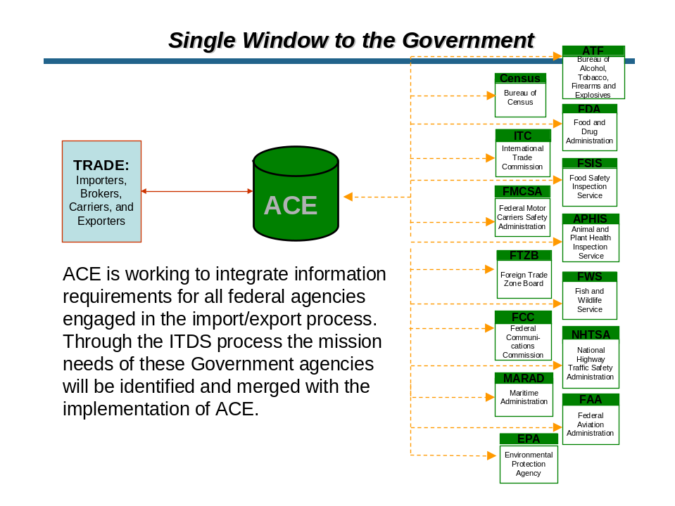

The Current Trade Reporting Environment: the Problem ITDS Is Intended to Fix

Today, international traders are confronted with duplicative and non-uniform reporting requirements, both paper and electronic. A number of Federal agencies maintain separate international trade reporting systems. Other agency processes are not automated at all, requiring traders to present CBP officials with paper documentation before their goods are allowed to enter or depart the United States.

Because international trade is important to our economy, the cost of redundant reporting requirements burdens not only importers and exporters but also the performance of the economy as a whole. These requirements are not, of course, intended to burden traders or the economy, but to protect consumers, the environment, health and safety; to collect information for accurate taxation and for trade statistics; and for numerous other reasons. But the multiple reporting schemes associated with each of these goals have been superimposed one on top of another, despite efforts to limit the cumulative burden.

Separate, redundant collection systems are not only costly; their very separateness limits their effectiveness. Agencies do not necessarily have access to information that other agencies collect, or know what actions other agencies have taken in response to that information. They act in isolation rather than together.

Finally, and of critical importance, international trade transactions are reported not only to U.S. authorities, but also to other nations with their own electronic reporting formats. Firms operating in multiple countries must report to each country in the unique formats each requires. The failure to adopt internationally standardized not only creates costs for traders, but also hinders collaboration among governments to identify, track, and apprehend dangerous shipments, a matter of great importance today.

How ITDS Can Fix Trade Reporting

The ITDS “single-window” can eliminate redundant filings, enable agencies to work collaboratively, and by incorporating international reporting standards facilitate data sharing and enforcement cooperation among governments.

Benefits from the Single Window

ITDS will:
- Reduce the burden on business and increase the efficiency of the government’s collection of international trade transaction data by substituting standard electronic messages for the redundant reporting – often on paper forms – that occurs today.
- Enhance the ability of CBP and other agencies to target risky cargo, persons, and conveyances.
- Extend the capabilities of ACE by bringing together critical security, public health, public safety, and environmental protection agencies through a common platform.
- Reduce the technical barriers to authorized sharing of data with other governments by accepting electronic filings reported using international standards for trade reporting (World Customs Organization standards).
- Improve compliance with laws and regulations that apply to
  - Carriers -- for example, highway safety and vessel clearance requirements,
  - People -- for example, immigration requirements for drivers and crews of commercial conveyances, and
  - Goods – which consist of several hundred laws including those addressing public health and safety, animal and plant health, consumer protection, and enforcement of trade agreements.
- Provide convenient access to data on international trade that are more accurate, complete, and timely for Federal agencies with a statistical mission.
- Provide a single billing and collection point for the variety of taxes and fees incurred by traders.

Benefits of Shared Electronic Access to Data

ACE/ITDS will serve as a custodian of records on international trade transactions, providing Federal agencies with a convenient, single point of access to data on trade transactions, with each agency having its own, and appropriate, level of access.

“New” Access to Data

ITDS already provides agencies, near-real- time access to the import information that CBP currently collects (subject to limitations pursuant to statute). This is information that agencies have not had in the past.

CBP collects a significant amount of electronic data about individual import and export transactions and the means of transportation involved. Some agencies currently receive a real-time feed of specified data for specific types of transactions. Other agencies may receive periodic reports of specified data delivered on tape or disc. A number of agencies receive information through paper forms that are collected by CBP on behalf of the agencies. Several agencies purchase information from the Census Bureau which edits and compiles raw data it receives via a direct connection with CBP computer systems.

Other agencies have little knowledge about specific shipments falling under their jurisdiction. Participation in ITDS provides agencies with access to data soon after it is reported (and in the future, as it is reported) allowing agencies to take timely action. In addition, data to be collected electronically in the future can then also be shared among authorized agencies.

Enhanced Risk Analysis

Agencies that utilize ACE by participating in the ITDS program will enhance their ability to use risk analysis by:

- Making data available electronically so it can be used more flexibly and less expensively,
- Making more data available more quickly than in the past,
- Allowing CBP and other agencies to share targetting or risk analysis results, and
- Providing capacity to easily aggregate and analyze data.

Import Safety Benefits

Timely access to information on imports can dramatically enhance the effectiveness of agencies with an import safety mission. For example, USDA’s Food Safety Inspection Service (FSIS) was able to increase the amount of ineligible product detected, detained, and removed from commerce and the food supply from 36,000 to 1.6 million pounds (44-fold) in one year (FY 2005 to FY 2006), as a result of information obtained through the ACE Portal. Other recent examples of the use of import data include CBP’s use of import data to select shipments of pet food and toys for examination for compliance with US safety standards.

Export Data

Much export information that CBP collects is collected under Census Bureau authority. That data can be shared with other agencies with Census Bureau permission, subject to statutory limitations. Export capabilities are currently scheduled for the later stages of ACE and ITDS implementation.

Benefits from Adopting International Standards

World Customs Organization (WCO) Data Model

ITDS is also aligning agency data requirements with the World Customs Organization (WCO) Data Model’s internationally standardized electronic reporting formats, which consist of standardized data requirements (with standard definitions and reporting codes) and standard “messages” for transmitting data from importers, exporters, and carriers to governments.

International standardization was first intended to relieve traders from having to adapt to each country’s individual reporting regime and invest in different software for each country. In the current environment, however, the greatest potential benefit of adopting international standards may be to enhance enforcement capabilities by providing the platform for customs administrations to share information. This information sharing can provide advance notice of risky shipments and facilitate further international enforcement cooperation, effectively extending our enforcement perimeter beyond the border.

At present, all countries have different data requirements and data formats for essentially similar customs processes. Moreover, most countries routinely require much of this information to be submitted on paper. The WCO model standardizes electronic customs reporting to reduce the data required for such reporting and to promote paperless customs processing. Standardizing electronic reporting requirements and formats will reduce costs for traders, who now must use a different format for each country with which they trade.

Features of the WCO Data Model Messages –
- Common electronic transmission protocol, based on UN/EDIFACT.
- Data elements required for export are identical to those used for import reporting, whenever practicable.
- Common coding to designate places, parties, conveyances, etc.

Synergies from International Standardization

In addition to the obvious cost savings from eliminating differing reporting standards, harmonization of electronic reporting formats provides a common platform that can support joint procedures and further reduce the burden of customs compliance. For example, the WCO standard format for the import manifest (the carriers transport declaration) provides a common format that could be used by any country for a manifest report.

One feature of the WCO standard messages is that the data and format for import and export reports are, to the extent possible, the same. This standardization allows importers to avoid preparing duplicative reports in differing formats and facilitates sharing of data between customs authorities, promoting cooperative enforcement efforts. Just as important, such standardization will facilitate international cooperation on trade enforcement and tax collection, and help uncover fraud, corruption, and illicit trade terrorist threats. Currently, governments that share information must devote resources to “translating” data flows to make them intelligible to the receiving government.

Status of Implementation of ITDS Program

Extent of Participation in ITDS by Federal Agencies

In the dozen years since the beginning of the ITDS program, agency participation has been uneven. In the past year, several additional agencies joined ITDS after the SAFE Port Act became law. New attention brought by recommendations and recognition from the Import Safety Working Group and from OMB Directives on ITDS participation has accelerated agency activity.

Safe Port Act

The SAFE Port Act (P.L. 109-347, October 13, 2006) formally established ITDS (a detailed history of ITDS can be found in the Appendices to this report). The Act directed the Secretary of the Treasury to coordinate interagency participation in ITDS in consultation with an interagency committee consisting of the agencies participating in ITDS and OMB. Significantly, the Act requires all “agencies that require documentation for clearing or licensing the importation and exportation of cargo” to participate in ITDS.

Currently, 41 agencies are participating in the ITDS program. Before passage of the SAFE Port Act, 31 agencies were participating. At that time, ten additional agencies were identified as requiring documentation for clearing or licensing cargo. Nine of those agencies have since joined ITDS. The Coast Guard and CBP continue to discuss sharing information to be collected through ACE. OMB has also recently joined the ITDS Board of Directors. This accounts for all agencies that might be required to participate in ITDS by the SAFE Port Act.

Quality of Participation

The degree of participation by agencies has been uneven. Some agencies have fully specified their requirements for automating their business processes and have completed preparations to receive and use data. Other agencies are at an earlier stage of integration. In some cases, that is because the agency has only just joined ITDS. Others may have only a statistical mission and rely heavily on the data provided by the Census Bureau. Still others may be unclear about how ITDS will support their mission or what resources it will require. Finally, some agencies have been reluctant to commit budget and staff resources to an approach that involves a complex and expensive IT system that is only beginning to come on line and a continued reliance on factors and resources outside the control of the agency.

A capsule presentation of each agency’s planned and present involvement in ITDS can be found in the section “Agency Plans and Participation.” Timetables for delivering various capabilities to agencies are presented graphically in the section “Agency Integration Schedules.”

Import Safety Working Group Recommendations

On July 18, 2007, Presidential Executive Order 13439 created the cabinet-level Interagency Working Group on Import Safety to study the various facets of import safety processes, and tasked the group to report on the necessary steps to enhance the safety of imported products. That report was delivered to the President on September 10, 2007. The Working Group report recognized ITDS as a “key component to improve systems interoperability” in the effort to improve import safety. In addition, the Working Group recommended accelerating implementation of ITDS and particularly urged that:
- Information currently reported by importers and carriers to CBP be included in the ACE Data Warehouse, where it can be accessed by other agencies, and,
- The World Customs Organization Data Model messages (new international standard for customs reporting) be implemented in order to provide a platform for electronic reporting of health and safety information in advance of the current ITDS production schedule.

Recommendation 1: Agencies, particularly those with an import safety mission, should accelerate development of plans for their participation in ITDS in order to take full advantage of ITDS capabilities.

OMB Directives

Following up on the SAFE Port Act and the recommendations of the Import Safety Working Group (ISWG), OMB Deputy Director Clay Johnson issued a policy memorandum (M-07-23) requiring each agency involved in clearing and licensing cargo to designate a senior executive to participate in the ITDS interagency team and to prepare a plan, to be completed by November 12, 2007, outlining the agency’s plan for utilizing ITDS, including any necessary rulemaking or acquisitions. A subsequent OMB memorandum, issued on September 28, 2007, by Karen Evans, OMB’s Administrator for E-Government and Information Technology, incorporated further ISWG recommendations with regard to ITDS and elaborated on the information required for the plans required by the Johnson memo. (The OMB memos can be found in the Appendices to this report.)

In response to the interest generated by the Import Safety Working Group and the mandate from the OMB instructions, the ITDS Project Team quickly developed a template for the report, and instituted an outreach program to help agencies meet the OMB timetable.

Preparing Agencies to Use ITDS

Three important early steps in participation in ITDS are harmonizing data, development of a “Concept of Operations” (Conops), and preparing draft Memoranda of Understanding (MOUs) between CBP and each agency participating in ITDS. Each of these steps can provide agencies insight into how they can utilize ITDS capabilities. Whether or not these steps have been completed can also be seen as a measure of how ready an agency is to use ITDS capabilities.

Data Harmonization

A first step in implementing a completed single window is to harmonize data requirements among agencies. In addition to the duplicative requirements for any given transaction, agencies often ask for the same basic information (e.g., value of goods, identity of importer, and origin of goods) but require it to be reported in different ways or may define that data element slightly differently. To eliminate redundancies and any unnecessary idiosyncratic definitions, all agencies participating in ITDS try to harmonize their trade data requirements.

In addition, by specifying what, when, how, and by whom data are reported, the data harmonization effort established the fundamental parameters for reporting messages and for data storage and use within the system. It is the most fundamental part of the ITDS program. Moreover, as part of the harmonization work, the ITDS standard data requirements are being aligned with data standards of the World Customs Organization Data Model.

Work in this area is not as advanced as it should be, but changes over the past year and a half have accelerated the effort. It is imperative that this work remain the primary focus of the ITDS project team.

Recommendation 2: The ITDS Board should ensure that a Standard ITDS Data Set is established by January 1, 2008.

Concept of Operations

With technical assistance from the ACE Support Team, each agency prepares its Concept of Operations paper (ConOps) describing the agency’s ITDS-related mission, the agency’s current mode of operation, and how the agency envisions operating in the future when ITDS is implemented. The description of future operations should describe the data the agency expects to receive through ITDS, any communications the agency expects to make through ACE/ITDS with importers, exporters, carriers, CBP, or other agencies, and the joint or cooperative operations with CBP that the agency envisions. Those “Concept of Operation” documents are to be reviewed and agreed to by both CBP and the agency participating in ITDS.

“Concept of Operations” documents are not yet complete and not all Concept of Operations documents that have been prepared have been agreed to by CBP and the subject agency.

Memoranda of Understanding

Memoranda of Understanding (MOU) lay out the relationship between CBP and each agency participating in the ITDS program. Each MOU is intended to specify in detail the information that an agency expects to receive through ACE/ITDS, which parties are to report that information, when that information is to be reported, and in which messages (e.g., manifest, entry, entry summary). The MOU should also lay out how those data are to be transmitted to the agency (file format, detailed format for each data element, method of transmission). MOUs will specify the legal conditions under which any data is shared, including any restrictions that the agency with authority to collect certain data may place on the use or further dissemination of those data by an agency with which those data are shared. Completion of an MOU will also often depend on completion of a Systems of Record Notice (SORN) and a Privacy Impact Assessment (PIA) by the agency receiving the data. Finally, the MOU will lay out details for any cooperative or joint operations between CBP and the agency. For agencies whose access to data through ACE/ITDS is only statistical, this is a relatively simple issue. For agencies with an inspection or enforcement role at the border, working out the details can be a lengthy and involved process.

CBP has signed MOUs with the Census Bureau and the International Trade Commission. (A table outlining the status of work on each MOU can be found in the Appendices to this report.)

The primary task of the ITDS Project team is developing the ITDS IT infrastructure. At times, however, the ITDS team is diverted from their primary task and drawn into work involving reaching agreement on MOUs or ConOps that are divorced from information technology concerns.

Recommendation 3: Development of the ITDS program requires the involvement of the appropriate policy and operational offices of all agencies. Agencies may need to realign resources to accommodate the increasing ITDS workload. The ITDS Board and OMB should take steps to ensure that agency participation is adequate and that Project Team resources are focused on the development of the ITDS IT infrastructure.

Recommendation 4: Memoranda of Understanding between agencies provide the legal foundation required for a shared data system and shared operations, as well as highlight critical policy issues. Work on MOUs should be accelerated.

Status of Implementation of ITDS Functions within ACE

Agencies will require a wide variety of IT processing capabilities to be incorporated within ACE, from accessing data through a web based interface (ACE Portal), to tracking and decrementing licenses, to downloading data for analysis. This report focuses on implementation of a few key capabilities. The Table “ITDS Agency Functional Requirements” (following page) lists many of those capabilities, the agencies that are expected to use them, and their stage of implementation.

Agency Use of ACE Portal

Some ITDS functions are already partly operational. ITDS agencies are already able to obtain, in near real time, detailed information about any importation reported through an electronic filing. Most information currently required by CBP from importers (entry summary data) is transferred daily from CBP’s current processing system to the ACE “Data Warehouse,” which ITDS agencies can access through the ACE Portal, a secure web-based interface. For example, an agency analyst could log onto the ACE portal at his desk and identify all imports (which were reported electronically) of toys, dog food, or shrimp for any given month, day, port, or importer over the past 3 years. Twenty-four of the agencies participating in ITDS already have access to data on import transactions through the Web-based ACE portal.

Agencies have already been able to put this information-processing power to work. For example, as a result of information obtained through ACE/ITDS, the Food Safety Inspection Service increased the amount of ineligible product it removed from commerce 44-fold in one year (36,000 to 1.6 million pounds-FY 05-06). Access to the ACE Portal has also allowed agencies to eliminate redundant paperwork requirements. Before obtaining access to the ACE Portal, Treasury’s Alcohol and Tobacco Tax and Trade Bureau required importers of industrial alcohol to file a paper certification that the product was to be used for non-beverage purposes. The import information available through the ACE Portal has allowed the agency to eliminate that requirement.

However, a number of agencies currently with ACE Portal access (or which could have Portal access) are probably not taking full advantage of the information available through ACE because they have not fully explored the information available or because taking advantage of the information requires changing the way an agency does business.

Other agencies are unable to access data that are currently collected electronically because the data (1) have not yet been added to the ACE Data Warehouse, or (2) have been added to the ACE Data Warehouse, but software for retrieving of that particular data has not yet been perfected.

A change to the current ACE development schedule could make additional data available through the ACE Portal on an earlier time-frame – and access to this data could immediately improve agencies’ ability to interdict suspicious shipments – but, this must be balanced against other priorities. Equally important, access to more data could put some additional agencies in the position of being able to test new ways of doing business.

Recommendation 5: Accelerate plans to add to the ACE Data Warehouse all import information currently reported electronically to CBP so that it can be accessed by other agencies through the ACE Portal.

Table: ITDS Agency Functional Requirements

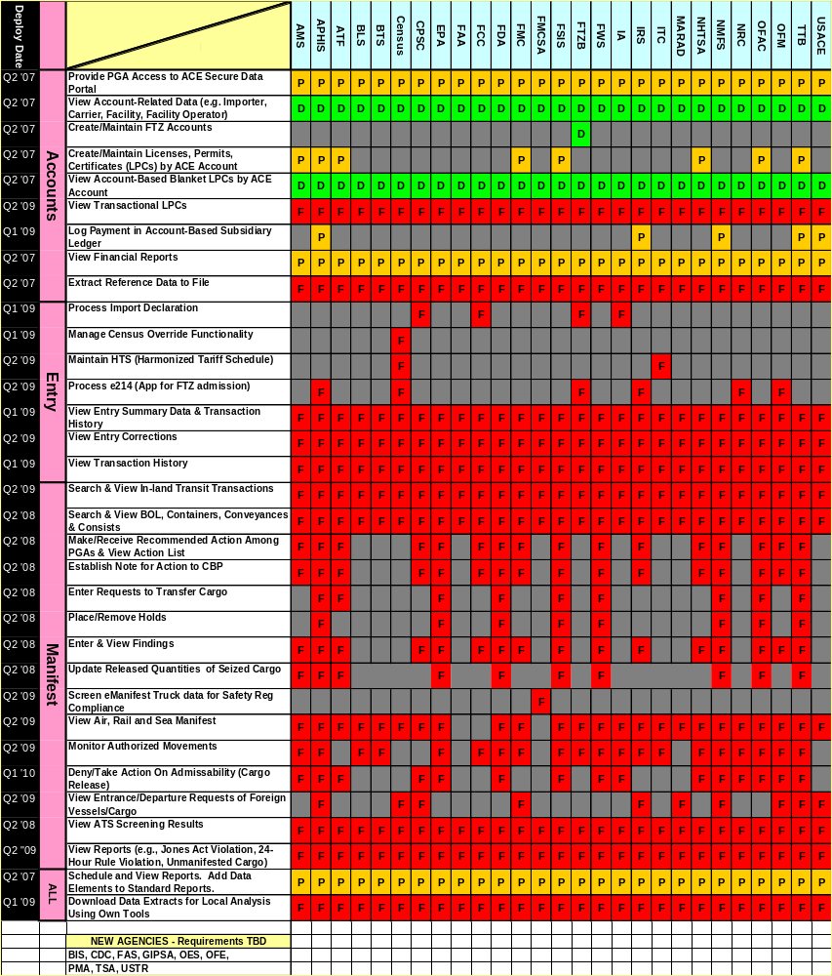

Security Architecture for Differentiated Access to Information

The ACE Portal is intended to have “access filters” to limit users and/or agencies to the particular data in which they are particularly interested. Some agencies would like to have different levels of access for different employees. The data exchange architecture intended to provide variable levels of access has not yet been implemented. In the current “test stage,” access is available but unfiltered and, as a result, agency users will be required to have extensive background checks and security clearances, often of a level beyond that normally required for their positions, for access to the data in which they are interested. Absence of filters can result in added costs for security clearances for agencies and also discourages use of the information available through the Portal.

Recommendation 6: Implementation of “Access Filters” should be accelerated.

Computer to Computer Connections

Some agencies have developed plans that will require their systems to be linked to ACE via a computer–to-computer connection (in contrast with those agencies that will access data through the ACE Portal) and receive real-time information on shipments reported to CBP. (Some agencies already have this type of connection with CBP.)

One agency that will have such a connection is the Federal Motor Carrier Safety Administration (FMCSA) of the Department of Transportation. FMCSA will receive, as soon as it is reported to CBP, information on commercial vehicles entering the United States. The information will be reported to an FMCSA automated system, Query Central, which will use that information to identify potential vehicle and driver safety issues, and determine whether action is required. That decision will be communicated to CBP (and in some cases to the carrier involved) through ACE/ITDS.

Although some agencies already have such connections with CBP, no new computer-to-computer connections have been completed through the ITDS program. The link to the FMCSA system is currently being tested.

Implementation of WCO Data Model Standards

Implementation of the WCO data standards involves ensuring that data collected through ITDS conform to WCO definitions, data formats, and reporting codes and offering the trader the option of reporting using WCO standard messages.

The ITDS harmonized data requirements will fully incorporate WCO standards. No concrete steps have yet been taken to implement the WCO standard messages. Implementation has been notionally considered as a second reporting option to be developed after other ACE functions are completed.

Implementation of Single Window

Although the “single window” for reporting by importers, exporters, and carriers does not yet exist, several agencies have for several years already helped to reduce the reporting burden on international traders by using data filed through CBP. For example, information used by the Census Bureau to compile national import statistics has long been collected jointly and electronically through filings with CBP. Information used by the FDA has also been collected through electronic filings with CBP.

ACE functions are being provided in a series of releases. Complete implementation of a completed single window – guaranteeing importers, exporters, and carriers the ability to make a single filing for each transaction rather than separate filings for each agency and providing the facility to collect data not currently collected electronically – is therefore currently scheduled to be available only at the completion of the ACE program in 2011 or beyond.

Electronic Collection of Data Currently Reported on Paper

For many agencies, much of the data in which they are interested are not yet collected electronically, pending the development of expanded reporting messages in subsequent ACE releases. Accelerating the schedule for collecting those data electronically could provide immediate benefits by allowing traders to report electronically and by providing agencies access to data that could enhance their ability to interdict shipments. Access to those data may also allow agencies to explore new ways of doing business and better specify the functions they ultimately want.

Under the current ACE schedule, the reporting messages (entry, entry summary, etc.) are not scheduled to be released until the corresponding functions (accounting, evaluation of admissibility, etc.) is also developed. It is possible, however, to collect data before developing the full suite of corresponding functions. The WCO Data Model messages are already developed and could provide a vehicle for collecting data not currently collected in advance of the current ACE production schedule.

Recommendation 7: Accelerate implementation of World Customs Organization Data Model messages (international standard for customs reporting) in order to:
- Reduce computer processing costs for traders by providing a single international format for communicating import and export information to governments rather than requiring traders to adjust to each country’s different reporting and electronic communication protocols.
- Allow rapid and accurate exchange of data between authorities to facilitate international enforcement cooperation and extend our enforcement perimeter beyond our border.
- Collect data not currently electronically collected in advance of the current ACE production schedule. Electronic collection alone is an immediate benefit and can also spur work to develop “value-added” uses of the data.

Edits and Validations

Automated “edits” identify errors in data submitted. Error identification can range from identifying data input (typographical) errors to checking for arithmetical errors to implementing more sophisticated algorithms to evaluate eligibility for reduced duty liability. Prompted in part by an effort to meet production schedules, CBP is presently evaluating the necessity of incorporating in ACE all edits currently used in the existing CBP trade processing system. This evaluation is necessarily fact-specific: some edits are critical to useful automated processing, while others may be less useful. Agencies participating in ITDS, however, may evaluate the usefulness of a particular edit or validation routine differently from CBP. These are issues that may be of particular concern to the Commerce Department and the International Trade Commission.

Recommendation 8: ITDS Agencies should conduct their own analysis with regard to edits and validations and provide timely input to the ACE development team.

Delivery Schedule

To date, ACE development has focused on implementing functions required by CBP. This year, some features to be used by ITDS agencies that were scheduled to be implemented were not. For example, functions for Census statistical purposes, Foreign Trade Zone controls, and management of licenses and permits were not implemented either due to software problems or other complications. Schedule slips are not unusual in a large IT project and in these instances the decision to delay implementation was correct. Nevertheless, to ensure that ITDS interests and equities are fully represented in the decision process, the ITDS Board should be represented in the appropriate body or bodies making decisions regarding the ACE Schedule.

Recommendation 9: To ensure that ITDS equities and interests are represented the ITDS Board should be represented in the ACE decision making process.

More information on the status of the entire ACE Project is available in the ACE Quarterly Reports at: http://www.cbp.gov/xp/cgov/toolbox/about/modernization/ace/quarterly_reports/

Budget Issues

There are two sources of funding for ITDS: funding for ITDS development within ACE (ITDS Project team), and funding that agencies participating in ITDS must commit to in order to implement automated operations through ITDS.

Cost Sharing and Allocation

Since FY 2002, the ITDS work within ACE has been funded as a distinct part of the ACE development program. As with any joint agency project, the question of who pays for what. Costs for delivery of “ITDS functions” have been allocated and shared based on the following funding assumptions:
- If agency functions are contained within that required by CBP from ACE, then those functions are provided to ITDS agencies without cost to the ITDS program or to the agency.
- If functions are shared by more than one agency, the cost of that shared functions will be born by the ITDS project.
- The cost of any unique agency function is to be born by the agency.

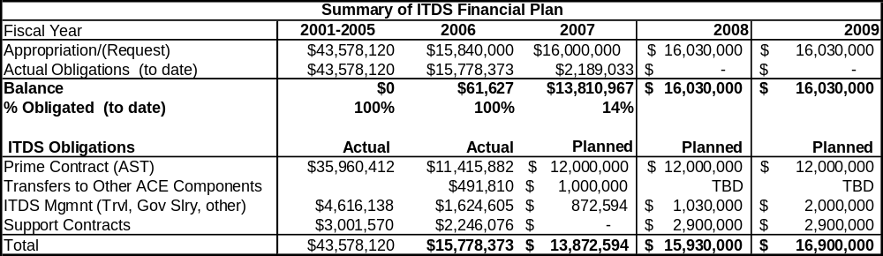

Funding for ITDS Work within ACE (ITDS Project Team and Shared)

ITDS funding levels support the work of the ITDS Project team and any shared function. In addition, while ITDS “requirements” are developed by the ITDS team and paid for by the ITDS budget; the actual hardware and software that delivers the “requirement” is built by other ACE teams, which are to be reimbursed for “shared function ” (2nd funding assumption - above). Additionally, CBP’s Cargo Systems Program Office (the CBP office within the ACE program with responsibility for managing the ACE and ACE/ITDS programs) is refining the process to estimate the appropriate ITDS “cost share” for “shared functions” within ACE development.

Recommendation 10: The ITDS Board of Directors should continue to closely track program expenditures to ensure charges lead directly to delivery IT capabilities, and that those capabilities are delivered on schedule.

Agency Resource Requirements

While it is expected that agencies will have to pay for unique functions, no agency has yet been asked to pay for any unique function.

In addition, individual agencies are now outlining their resource requirements in their individual ITDS implementation plans. Agencies should include within their respective budget and staffing plans the resources that they will need to participate in ITDS. In the early stages, this is likely to be mostly staff time to analyze and describe the agency’s mission so that ITDS requirements can be identified, and to handle the tasks of drafting the necessary supporting documents. Agencies will have to devote additional staff time and perhaps obtain outside expertise to develop plans for utilizing ITDS functions. Longstanding agency procedures may need to be reconsidered and modified, significantly in some instances. Hardware and software to support the agency’s trade related activities may have to be retired or upgraded. While the costs of ITDS integration for some agencies may be very modest, and over the long-term agencies may experience cost savings, in the near-term all agencies should expect to have some incremental costs.

Recommendation 11: Agencies participating in ITDS should ensure their capital planning and investment control processes incorporate plans for utilizing ITDS.

Agency Plans and Status

Agency Plans and Status Table of Contents

AGENCY PLANS AND STATUS 27
Agricultural Marketing Service (AMS) - USDA 27
Animal and Plant Health Inspection Service (APHIS) - USDA 29
Foreign Agricultural Service (FAS) - USDA 31
Food Safety and Inspection Service (FSIS) - USDA 32
Grain Inspection, Packers, and Stockyards Administration (GIPSA) - USDA 34
Bureau of Industry and Security (BIS) - Commerce 35
Census Bureau - Commerce 36
Foreign-Trade Zones Board (FTZB) - Commerce 37
Import Administration (IA) - Commerce 38
National Marine Fisheries Service (NMFS) - Commerce 39
U.S. Army Corps of Engineers (USACE) - Defense 40
Office of Fossil Energy (OFE) - Energy 41
U.S. Fish and Wildlife Service (FWS) - Interior 42
Bureau Alcohol, Tobacco, Firearms, and Explosives (ATF) - Justice 43
Drug Enforcement Administration (DEA) - Justice 44
Bureau of Labor Statistics (BLS) - Labor 45
Centers for Disease Control and Prevention (CDC) - HHS 46
Food and Drug Administration (FDA) - HHS 47
Transportation Security Administration (TSA) - DHS 49
Bureau Oceans and International Environmental and Scientific Affairs (OES)-State 50
Office of Foreign Missions (OFM) - State 51
Directorate of Defense Trade Controls (DDTC) - State 52
Department of Transportation 53
Bureau of Transportation Statistics (BTS) 53
Federal Aviation Administration (FAA) 53
Federal Highway Administration (FHWA) 54
Maritime Administration (MARAD) 54
National Highway Traffic Safety Administration (NHTSA) 55
Pipeline and Hazardous Materials Safety Administration (PHMSA) 55
Federal Motor Carrier Safety Administration (FMCSA) 56
Internal Revenue Service (IRS) - Treasury 58
Office of Foreign Assets Control (OFAC) - Treasury 59
Alcohol and Tobacco Tax and Trade Bureau (TTB) - Treasury 60
U.S. Consumer Product Safety Commission (CPSC) 61
Environmental Protection Agency (EPA) 62
Federal Communications Commission (FCC) 63
Federal Maritime Commission (FMC) 64
International Trade Commission (ITC) 65
Nuclear Regulatory Commission (NRC) 66
Office of the United States Trade Representative (USTR) 67

AGENCY PLANS AND STATUS

Agricultural Marketing Service (AMS) - USDA

ITDS Related Mission
The Agricultural Marketing Service (AMS) inspects certain imported fresh and processed fruits and vegetables, poultry, and tobacco products to verify that they meet the same quality and condition requirements as domestic products. Importers of fruits and vegetables that fail to meet quality and condition requirements are subject to AMS penalties.
Under an MOU with FDA, AMS also inspects certain processed products to verify that contaminants in foods are within FDA tolerances.
AMS tracks and publishes current information on agricultural imports and exports by commodity.
AMS assesses fees that CBP collects on imported products that are covered by Federal research and promotion programs.
Planned Data Exchange
Based on current plans, by June 2009 ACE deployment:
- ACE will notify AMS prior to release of commodities subject to AMS inspection in order to allow AMS to schedule inspections.
- ACE will notify AMS of CBP release of shipments requiring AMS inspection, the inspection location chosen by the importer, and relevant admissibility decision of other agencies (e.g. FDA, APHIS and FSIS determine admissibility before AMS inspects.)
- AMS will provide inspection results directly from AMS access databases and Excel files to ACE via portal batch upload that will allow CBP to liquidate the entries.
- AMS will generate ACE Portal reports on AMS-regulated commodities released by CBP to verify that shipments were presented to AMS for required inspections.
- AMS will also use the ACE Portal to obtain information from importers (entry summary data) including prices, volume, quality, and condition in order to generate data for statistical purposes, license dealers, and enforce quality requirements.
- Importers will use ACE to request exemption from AMS inspection and from research and promotion fees. AMS will provide ACE with permit information for exempted commodities and notify CBP which shipments are exempt from inspection or from research and promotion fees.

Status

AMS currently uses the ACE Portal to collect information on agricultural imports to determine compliance with AMS inspection requirements. AMS has 21 people who have access to the ACE Portal

The AMS ConOps has been updated and awaits CBP approval. AMS has drafted an MOU and met with a CBP attorney to discuss it. Further progress on the MOU awaits ConOps approval.

Animal and Plant Health Inspection Service (APHIS) - USDA

ITDS Related Mission

The Animal and Plant Health Inspection Service (APHIS) regulates the import and export of animals, plants, or their products. It conducts pre-clearance, arrival and export inspections, and can quarantine products. APHIS certifies foreign processing establishments, and oversees treatments such as fumigation and refrigeration.

APHIS can prohibit entry of animals, plants, or their products that:
- do not meet health or phytosanitary standards,
- do not have appropriate import permits from APHIS, or
- do not have foreign government health or phytosanitary certifications.

APHIS establishes policy for and provides guidance to CBP Officers and CBP Agriculture Specialists in their effort to prevent the entry of potential threats to American agriculture.

Planned Data Exchange

Currently, APHIS acquires data through direct access to CBP systems and requests CBP to hold shipments when APHIS determines it appropriate to do so.
APHIS has developed its “ePermits” system, a web based tool through which traders may apply (and receive approval) on-line for more than a dozen APHIS permits, both plant and animal. Permit information is stored in databases that will provide information to ACE to support decision making when determining the admissibility of APHIS regulated commodities.

APHIS plans to use data supplied by carriers (manifest) and importers (entry/entry summary) from ACE to:

- select shipments for examination,
- confirm that import and export permits and certificates are valid,
- determine admissibility of regulated commodities,
- monitor collection of user fees,
- monitor movement of regulated shipments to approved processing facilities or to a port of export, and
- manage risk through research and analysis of the ACE data warehouse.

Many of these functions will be implemented through system-to-system interfaces between ACE and existing or planned APHIS systems. ACE will thus provide both real-time information to APHIS and the capability for APHIS to communicate to CBP border control personnel. APHIS will also have access to stored information via the ACE Portal.
October 2008 – APHIS will upload blanket permit information via system-to-system interfaces. APHIS will have the capability to monitor payment of Agricultural Quarantine Inspection user fees.

October 2008 – APHIS will be able to request that suspect shipments be held on the basis of rail or sea manifest information; it will also monitor authorized movements of APHIS regulated commodities.

June 2009 – Aphis will use ACE to identify and monitor:
- imports that are regulated by APHIS,
- imports that originate from restricted countries, and
- expired or otherwise improperly used import permits.

July 2010 – APHIS will access export information to monitor regulatory compliance with export shipment requirements.

Status

APHIS has completed and submitted to CBP its Concept of Operations and a Memorandum of Understanding between APHIS and CBP is being drafted. APHIS has 55 people who have access to entry/entry summary data through the ACE Portal reporting capabilities.

Foreign Agricultural Service (FAS) - USDA

ITDS Related Mission

The Foreign Agricultural Service (FAS) administers Tariff Rate Quotas (TRQ) for sugar and dairy imports. FAS issues import licenses for sugar and dairy products. The dairy licenses are processed electronically through FAS’s Dairy Accelerated Importer Retrieval and Information Exchange System (DAIRIES) and the sugar licenses through the Sugar Users Group Accounting and Reporting System (SUGARS). Sugar tariff-rate quota entries are processed via paper forms. FAS administers HTS General Note 15 letters of waiver from agricultural import quotas, an export sales reporting program for certain agricultural commodities, and economic safeguards for imports of agricultural products.

FAS currently has access to ACS to edit TRQ data.

Planned Data Exchange

A plan for data exchange has not been developed.

Status

The FAS joined ITDS in May 2007.

Food Safety and Inspection Service (FSIS) - USDA

ITDS Related Mission

The Food Safety and Inspection Service (FSIS) regulates the import and export of meat, poultry, and egg products, performing four primary functions that affect international trade:
  - Determines equivalence of foreign food safety and inspection programs as a condition of eligibility to export meat, poultry, and egg products to the United States, which includes acceptance of the foreign governments’ certification for foreign establishments that comply with U.S. requirements,
  - Performs periodic audits of eligible foreign inspection systems,
  - Inspects imported meat, poultry, and egg products at U.S. ports of entry, and
  - Certifies U.S. meat, poultry, and egg products for export from the United States.
Planned Data Exchange

Based on current plans, by June 2009, ACE will provide real-time data and establish the ability for FSIS to communicate effectively and efficiently with CBP and other regulatory agencies to ensure adequate control of shipments. Specifically, ACE will:
- Provide FSIS electronic prior notification of arriving shipments of imported meat, poultry, and egg products,
- Provide FSIS online access to Customs entry data for arriving shipments in order to verify that shipments are presented for FSIS reinspection immediately after clearing the Customs entry process,
- Automate verification of entries with APHIS and FSIS inspection decisions so that CBP does not release any shipments from bond without first verifying the completion of required regulatory inspections, and
- Establish a regulatory chain of custody to ensure that shipments are routed to the appropriate regulatory agencies for inspection to ensure all sequential regulatory clearances prior to release of product.
On an interim basis, FSIS will continue to use the ACE Portal (entry summary data) to monitor shipments under its jurisdiction.

Status

FSIS relies on access to ACE Portal reports to determine:
- Whether shipments subject to FSIS jurisdiction have entered from ineligible countries or establishments
- Ports-of-entry of noncompliant shipments
- Importer of Record and Consignee for noncompliant shipments
- Detention action taken by FSIS or redelivery actions taken by CBP
As a result of ACE Portal access, the amount of ineligible product detected, detained, and either removed from commerce or returned to FSIS for reinspection increased from 36,000 to 1.6 million pounds between FY 2005 and FY 2006.

During the first 8 months of FY 2007, FSIS has removed almost 2.0 million pounds of ineligible products from commerce.

The FSIS ConOps is being updated after review by CBP’s Office of Trade and Office of Field Operations. FSIS has drafted an MOU and met with a CBP attorney to discuss it. Further progress on the MOU awaits CBP ConOps approval.

FSIS has 37 staff members with access to the ACE Portal.

Grain Inspection, Packers, and Stockyards Administration (GIPSA) - USDA

ITDS Related Mission

The Grain Inspection, Packers, and Stockyards Administration (GIPSA) inspects grain exports.

GIPSA requires grain exporters to register with them. Exporters may register online or fill out a paper form and mail it to GIPSA.

GIPSA (or entity authorized by GIPSA) inspects grain exports at the port and issues post-inspection certificates to the exporters.

Planned Data Exchange

A plan for data exchange has not been developed.

Status

GIPSA joined ITDS in June 2007.

Bureau of Industry and Security (BIS) - Commerce

ITDS Related Mission

The Bureau of Industry and Security (BIS) regulates the export of sensitive goods and technologies, especially “dual use” items (goods that have both military and commercial application).

BIS maintains the Export Control Classification Numbers (ECCN) on the Commerce Control List (CCL). This number helps exporters understand whether their exports require licensing.

BIS issues export licenses (valid for 2 years) for select items on the CCL.

Exporters apply for a license using either the BIS online system (Simplified Network Application Process Redesign (SNAP-R)) or a paper form (BIS 748P).

Planned Data Exchange

A plan for data exchange has not been developed.

Status

The BIS joined ITDS in May 2007.

Census Bureau - Commerce

ITDS Related Mission

The Census Bureau collects merchandise import and export data from various sources in order to compile the official U.S. merchandise trade statistics. The data are used for research and planning, economic analysis, analysis of trade and transportation flows and trends, and transportation infrastructure planning, as well as for assessing the effectiveness of U.S. trade policies and agreements. The Census Bureau also currently maintains the algorithms that “validate” data in the Automated Export System (AES) and the Automated Broker Interface (ABI) to ensure that the data are accurate and complete and will continue to perform this function after the transition to ACE. For example, the Census Bureau will check to ensure that reported information is reasonable (for example, by confirming that prices are within reasonable ranges).

Planned Data Exchange

The Census Bureau will have access to data filed by importers (entry/entry summary data), exporters (AES data), carriers (manifest data), and data on admissions to Foreign Trade Zones, all of which it will use to compile foreign trade statistics. The Census Bureau will maintain automated data validations in ACE. The Census Bureau will have a system-to-system interface for sending and receiving large data and reference files. The Census Bureau will also use ACE to create customized reports.

October 2007 (originally scheduled) – The Census Bureau will supply validation parameters for the Harmonized Tariff Schedule through ACE. The Census Bureau will also be able to create customized reports essential to its statistical mission.

October 2008 – Importers will have the ability to proactively provide override codes to prevent or respond to Census Bureau entry summary warnings. ACE will implement Census Bureau validations for entry summary filings. ACE will implement Census Bureau validations for Foreign Trade Zone admission filings.

June 2009 – The Census Bureau will have access to manifest and entry data for research and analysis.

July 2010 – Because the Census Bureau is the agency with primary authority to collect much of the export data collected, it will play a critical role in shaping requirements for the export module of ACE.
Status

- Revised Census Bureau Concept of Operations sent to CBP for review.
- The current Census Bureau MOU is sufficient for implementing the Census Bureau’s validation parameters (August 2007), but amendments to the existing MOU may be required to address security requirements.
- The Census Bureau has 44 staff with access to the ACE Portal.
- The Census Bureau currently uses ACE to run reports on the imports of specific commodities.

Foreign-Trade Zones Board (FTZB) - Commerce

ITDS Related Mission

The Foreign-Trade Zones Board (FTZB) licenses, regulates, and monitors the activity of foreign-trade zones (FTZ) in the United States. FTZs are designated sites authorized under the Foreign Trade Zone Act where certain customs procedures apply which may result in avoidance, deferral, or reduction of duties. The FTZ Board must approve a zone before CBP activates a zone (i.e., permits FTZ procedures).

The FTZ Board will monitor zone activity and also must report to Congress annually on zone operations. CBP enforces the provisions of the FTZ Act.

Planned Data Exchange

The FTZ Board will maintain in ACE, using the ACE Portal, files on zones including name, zone number, associated CBP port details about the site, details about permitted activities in the zone, date of FTZ Board approval, and information about zone grantees. CBP officers will access this information through the ACE Portal and will then be able to activate a zone, subzone, or site through ACE. Some of this information will also be available (through the ACE Portal) to members of the trade community and other government agencies. Key fields of these data such as the zone number will be used in ACE to corroborate data reported in various electronic customs transactions.

FTZ Board staff will also use the ACE Portal to monitor zone activity to compile reports that will include data on zone admissions, entries from zones, exportations from zones, and in-transit movements.

Status

The FTZ Board Concept of Operations has been agreed to by CBP. The FTZ Board and CBP are discussing a draft MOU. FTZ Board has been involved in the design, development, and testing of the ACE Portal, which FTZ Board staff use to manage the FTZ information on they will maintain in ACE. FTZ Board has two staff members with access to the ACE Portal.

September 2007 – FTZ Board began entering zone, subzone, and site account information via the ACE Portal for CBP and the business community to use as a reference. This information will also be used for future validation of zone numbers reported in transactions.

October 2008 – FTZ Board will be able to monitor entry summary information filed for merchandise moving into U.S. consumption from an FTZ in order to monitor zone activity.

October 2008 – FTZ Board will have access to zone admission data to monitor zone activity.

Import Administration (IA) - Commerce

ITDS Related Mission

The Import Administration (IA) administers laws involving antidumping and countervailing duties (AD/CVD). As part of this responsibility, IA sets AD/CVD duty rates and provides CBP with liquidation instructions on entries subject to AD/CVD.

IA also develops and implements other trade programs including sector-specific agreements and programs. IA sets absolute and tariff rate quotas as part of the Textiles and Apparel Program.

Planned Data Exchange

IA will continue to provide instructions to CBP regarding duty rates and liquidation instructions related to AD/CVD cases. IA will maintain a database in ACE of AD/CVD duty rates by country, manufacturer, and product. IA will also maintain tables of licenses for specific transactions in ACE. ACE will allow CBP to refer AD/CVD protests to IA for a decision. IA anticipates that it will need to extract large volumes of data (particularly entry summary data) from ACE on occasion; the specific means for receiving the data have not been determined.

August 2007 (originally scheduled) – IA will use the ACE Portal to obtain name and address information about importers and other parties to transactions, including foreign manufacturers.

October 2008 – IA will use the ACE Portal to maintain a database of AD/CVD duties, reduced tariff programs, and tariff rate quotas. IA will have access to entry summary transaction information for research and analysis. IA will have access to rail and sea manifests, FTZ admissions, and in-bond shipment data through the ACE Portal.

June 2009 – IA will use ACE to maintain IA licenses and certificates. ACE will use these licenses and certificates to make admissibility determinations.

Status

The IA CONOPS draft is currently being reviewed by CBP. The current MOU with CBP is being evaluated to determine if it is sufficient to cover operations with ITDS. Fourteen IA staff members have access to the ACE Portal.

National Marine Fisheries Service (NMFS) - Commerce

ITDS Related Mission

The National Marine Fisheries Service (NMFS) regulates the importation and exportation of certain fish such as swordfish, tooth fish, and tuna in order to promote the management, conservation and protection of marine resources.

NMFS uses information on imports to identify illegal importations or exportations of fish, and to assist in its investigations of illegal fishing or related violations.

Planned Data Exchange

NMFS will access data, through the ACE Portal, related to the importation and exportation of the products it regulates. NMFS plans to provide ACE with data related to the import and export permits that the agency issues and to the fishery commodities that the agency monitors. CBP will use these data to ensure that importers and exporters are importing or exporting these products only as permitted by law or regulation, and to help NMFS determine if shipments require further inspection or other actions.

NMFS currently uses the ACE Portal to research import information to identify instances of illegal importations, and to verify that reports on imports and exports of regulated fishery commodities have been properly filed.

Status

NMFS has been participating in ACE development since February 2006. The agency’s international trade-related business processes, either as they exist today or as they will exist under ACE, have not yet been identified and documented for ACE development.

NMFS has 15 staff with access to the ACE Portal.

U.S. Army Corps of Engineers (USACE) - Defense

ITDS Related Mission

The U.S. Army Corps of Engineers (USACE) maintains databases and statistics pertaining to waterborne commodity and vessel movements and domestic commercial vessel characteristics, which it uses for determining the need for building, improving, or rehabilitating port and waterway facilities, lock facilities, lock operations, and navigation dredging projects.

Planned Data Exchange

Based on current plans, ACE will:

- Provide the Corps of Engineers with a monthly Harbor Maintenance Fee Report, displaying aggregate totals of the HMF fees collected sorted and summarized by port, vessel type, and commodity. The Corps of Engineers will maintain the Schedule “K” (Foreign Port Codes) and the “Classification of Ships by Type” code tables in ACE.
- Allow the Corps of Engineers the ability to use the ACE Portal to obtain product and commodity information reported from importers that identifies which commodities are shipped on which vessels to which ports.
- Provide a correlated entry summary, manifest, and vessel entrance data report, by correlating various ACE vessel entrance and clearance data into one record per vessel movement or cargo shipment.
- Provide the Corps of Engineers with carrier contact information through the ACE Portal (already available).

Status

The Corps of Engineers ConOps received final CBP approval in February 2007. No Corps of Engineers staff has taken portal training.

October 2008 – Harbor Maintenance Fee Reports will be available via the ACE Portal; the Corps of Engineers will receive information reported by carriers on incoming vessels and trains (manifest reports) as well as carrier entrances and clearances.

June 2009 – The Corps of Engineers will obtain data through the ACE Portal on shipments filed by importers (entry/entry summary data) correlated with manifest information filed by carriers.

July 2010 – The Corps of Engineers will receive outbound vessel manifest information through ACE.

Office of Fossil Energy (OFE) - Energy

ITDS Related Mission

The Department of Energy’s Office of Fossil Energy (OFE) regulates Natural Gas imports and exports. OFE issues “blanket” authorizations of up to two years and long-term authorizations greater than 2 years to import and export natural gas. There is no standard application form; OFE provides guidelines on how to write the application

Applicants may apply for blanket authorization online on OFE’s website. Longer applications must be mailed to OFE.

Authorized importers and exporters are required to send a quarterly report to OFE of all their natural gas imports and exports.

Planned Data Exchange

A plan for data exchange has not been developed.

Status

OFE joined ITDS in August 2007.

U.S. Fish and Wildlife Service (FWS) - Interior

ITDS Related Mission

The U.S. Fish and Wildlife Service (FWS) determines the admissibility and controls the export of most wildlife and wildlife products.

To perform these functions, FWS:
- Issues licenses and permits to import or export wildlife and wildlife products, and
- Stations wildlife inspectors at U.S. port locations to inspect wildlife and wildlife products to ensure they are properly documented and to prevent the illegal import or export of wildlife.
Planned Data Exchange
Based on current plans, by June 2009 ACE deployment, FWS will:
- Download to ACE data on approved permits and licenses for ACE to verify entries requiring the permits or licenses for admissibility.
- Use an ACE system-to-system interface to receive the FWS data and related images for a “Declaration for the Importation or Exportation of Fish or Wildlife” entry and manifest information.
- Notify CBP of FWS decisions to admit or deny entry, since FWS must complete its admissibility decision before CBP processes the shipment.
- Use the ACE Portal to view and place holds on shipments arriving via rail and sea while FWS is investigating and to remove the hold upon completion of the investigation.
- Use the ACE Portal to track all movements of cargo under CBP control, including cargo in an FTZ, customs bonded warehouse, or in-transit.
FWS also plans to use the ACE Portal for remote clearing of shipments and to produce reports on shipments cleared.
Status

The FWS ConOps is being revised and updated. Progress on the MOU awaits CBP ConOps approval.

Bureau Alcohol, Tobacco, Firearms, and Explosives (ATF) - Justice

ITDS Related Mission

The Bureau of Alcohol, Tobacco, Firearms and Explosives (ATF) regulates the importation and exportation of arms, ammunition, implements of war, destructive devices, and explosives. ATF requires importers and exporters of these products to have permits and requires individual import and export shipments to be licensed. ATF conducts investigations into crimes involving the import or export of firearms, explosives, alcohol, and tobacco.

Planned Data Exchange

ATF plans to automate its paper-intensive license and registration process for importation and exportation of firearms and explosives and will use ACE in these processes.

ATF will utilize ACE functionality to request CBP to place holds on import shipments. ACE will identify shipments which require permits and for which the importer or exporter must be licensed and report to ATF. ATF will use these data to update files in its own system and to track use of permits. ATF will also maintain tables in ACE with the same updated information.

Status

The ATF Concept of Operations was revised in January 2007 and is being reviewed by CBP. ATF drafted an MOU and submitted it to CBP in August 2006. CBP agreement to the MOU is pending.

ATF has 25 staff members with access to the ACE Portal. They use the ACE Portal to determine when licensee/permittees have imported firearms or explosives. These data are used to help ensure that licensees/permittees are properly accounting for the imported products.

Drug Enforcement Administration (DEA) - Justice

ITDS Related Mission

The Drug Enforcement Administration (DEA) regulates the import and export of controlled substances and listed chemicals that may be used to manufacture controlled substances.

The DEA issues import and export permits for certain controlled substances and monitors those movements. The DEA also establishes and monitors import quotas for Ephedrine, Pseudoephedrine, and Phenylpropanolamine.

CBP and DEA share information related to drug smuggling and trafficking, including information related to verification of DEA permits.

Planned Data Exchange

A plan for data exchange has not been developed.

Status

The DEA joined ITDS in February 2007.

Bureau of Labor Statistics (BLS) - Labor
ITDS Related Mission

The Bureau of Labor Statistics (BLS) compiles and publishes statistics and price indices on internationally-traded goods and services to users that include the U.S. Congress, international statistical organizations, Federal agencies, and the public. BLS import and export price indices are used to adjust import and export trade values for inflation. BLS obtains entry summary data and importer names and addresses from CBP to compile import and export price indices for goods and services.
Planned Data Exchange

BLS plans to use the ACE Portal to access name and address information on importers and exporters, entry summary information, and exporter transaction information. In addition, the BLS will use the ACE Portal to access data on Foreign Trade Zone (FTZ) admission and warehouse withdrawal data.
Status
The BLS Concept of Operations was approved by BLS and CBP in October 2006. A draft MOU was submitted to the CBP Office of Rules and Regulations (OR&R) in March 2007 and is awaiting approval.

BLS has four staff members with access to the ACE Portal.

Centers for Disease Control and Prevention (CDC) - HHS

ITDS Related Mission

The Centers for Disease Control and Prevention (CDC) regulates imports that can potentially cause disease in humans or animals.

CDC requires import permits for etiologic (disease-causing) agents, biological materials, and certain animals.

Importers are required to register with CDC prior to requesting a permit to import such products.

Planned Data Exchange

A plan for data exchange has not been developed.

Status

CDC joined ITDS in June 2007.

Food and Drug Administration (FDA) - HHS

ITDS Related Mission

The Food and Drug Administration (FDA) authorities encompass importation of food, drugs, cosmetics, devices, biologics, and radiation-emitting products.
- The FDA requires registration of foreign food and drug processing facilities and foreign medical device manufacturers
- The FDA requires permits, licenses, and/or certifications for the import of certain commodities over which it has jurisdiction.
- The FDA requires that importers of all FDA-regulated products file an FDA notice of entry with CBP for screening and subsequent processing on the FDA OASIS system.
- Importers of merchandise subject to the Bio-Terrorism Act must file a notice with the FDA prior to importation.
- Regulated commodities are also subject to examination by the FDA to ensure compliance with FDA regulations.

Planned Data Exchange

There is currently a direct interface between the FDA’s OASIS system and CBP’s ACS system. All current interface functionality will be transferred from ACS to ACE. The FDA currently uses both ACS and ACE to screen and target shipments of regulated commodities arriving in the United States by truck.

Based on current plans, by June 2009, the FDA will use ACE to:
- Receive FDA prior notice data, entry data, and FDA registration and permit data (functionality currently existing in ACS);
- Identify imports of commodities under FDA jurisdiction;
- Transmit admissibility decisions via OASIS through ACE to appropriate CBP officials;
- Screen shipments for potential Bioterrorism Act violations;
- Review information related to regulated imports to make decisions on whether to inspect or take enforcement actions.

It is projected that FDA will use ACE to monitor export shipments for compliance by mid-2010.

Status

The FDA has completed its Concept of Operations and submitted it to CBP for review. The FDA and CBP have initiated discussion regarding an MOU for ACE. The FDA has one staff member with access to the ACE Portal.

April 2005 – FDA release for truck was implemented and rolled out with the truck e-manifest.

August 2007 (originally scheduled) – The FDA will have access to the ACE Portal to access additional account and reference data.

October 2008 – The FDA will have access to FTZ admission and in-bond shipment data to ensure prior notice requirements have been met.

June 2009 – The FDA will use ACE to receive FDA prior notice data, entry data, and FDA license/permit/registration/certification data to determine FDA jurisdiction, make admissibility determinations, screen shipments under the BTA, identify shipments to examine, and record dispositions related to the shipment.

July 2010 – The FDA will have access to export transaction information to monitor export shipment compliance with FDA export-related regulations.

Transportation Security Administration (TSA) - DHS

Border Mission

The Transportation Security Administration (TSA) is responsible for security relating to civil aviation, maritime, and all other modes of transportation, including transportation facilities such as airports and ports, and on the nation’s railroads, highways, and public transit systems.

Along with CBP and the U.S. Coast Guard, TSA works to secure the maritime transportation mode of the transportation system. TSA’s Maritime Security Division is involved in credentialing as well as passenger and vehicle screening techniques and procedures.

Planned Data Exchange and Status

A plan for data exchange has not been developed.

Bureau of Oceans and International Environmental and Scientific Affairs (OES) - State
ITDS Related Mission

The State Department’s Office of Marine Conservation (OMC) focuses on international fisheries matters and related problems. OMC is part of the Oceans and Fisheries Directorate, which is part of the Bureau of Oceans and International Environmental and Scientific Affairs (OES).

There is a prohibition on the importation of shrimp harvested in ways harmful to sea turtles unless the DOS certifies that the harvesting nation either has a sea turtle protection program comparable to that of the U.S. or has a fishing environment that does not pose a threat to sea turtles. The DOS is the principal implementing agency for this law, and NOAA Fisheries serves as technical advisor.

OMC provides a list of certified shrimp importers to CBP and Capitol Hill yearly.

If an importer is not on the certified list, CBP may ask to see Form DS-2031, which provides for a foreign government official with direct knowledge of harvesting techniques to certify that the specific shipment meets sea turtle conservation requirements.

Planned Data Exchange and Status

The OES has not yet joined ITDS.

Office of Foreign Missions (OFM) - State

ITDS Related Mission

The Office of Foreign Missions (OFM) authorizes duty-free treatment for shipments consigned to foreign missions, international organizations and their members. All shipments to foreign diplomats and missions must be cleared using the diplomatic customs clearance procedure, currently via Department of State entry form DS-1504 (Request for Customs Clearance and Merchandise).

Planned Data Exchange

OFM is currently automating its paper-intensive certification process for shipments imported by the diplomatic community. OFM plans to integrate its planned system with ACE to achieve a paperless certification and CBP release process. OFM will view manifests, Foreign Trade Zone (FTZ) admissions, and CBP Bonded Warehouse entries and withdrawals through the ACE Portal.

Status

OFM joined ITDS in June 2006 and is currently in the initial stages of developing a Concept of Operations.

OFM has nine staff members with access to the ACE Portal. OFM currently uses ACE to identify diplomatic shipments that have not entered using the diplomatic customs clearance procedure.

Directorate of Defense Trade Controls (DDTC) - State

ITDS Related Mission

The Directorate of Defense Trade Controls (DDTC) is part of the Bureau of Political Military Affairs (PMA) in the Department of State.

DDTC is charged with controlling the export and temporary import of defense articles and defense services covered by the United States Munitions List. It licenses exports of defense articles and services.

DDTC works closely with CBP in the review of defense industry registrations and in the areas of the performance of defense export end-use checks, investigations, and civil penalties.

Planned Data Exchange

A plan for data exchange has not been developed.

Status

The DDTC has not yet joined as an ITDS participant.

Department of Transportation

International Freight Data System (IFDS)

Seven Department of Transportation (DOT) agencies will obtain data collected by CBP through a system-to-system interface between ACE and DOT’s planned International Freight Data System. The Research and Innovative Technology Administration is the primary agency engaged in creating and managing IFDS. The agencies that will use IFDS to access data collected through ACE are:

- Bureau of Transportation Statistics (BTS)
- Federal Aviation Administration (FAA)
- Maritime Administration (MARAD)
- National Highway Traffic Safety Administration (NHTSA)
- Federal Highway Administration (FHWA)
- Pipeline and Hazardous Materials Safety Administration
- Federal Motor Carriers Safety Administration

Initial design work on IFDS began in 2006 and formal design will begin later this calendar year. IFDS is scheduled to be deployed in coordination with ACE Release M2.3 currently set for late 2009 or early 2010. The DOT estimates that IFDS will cost $1 million to build, design, test, and deploy.

DOT has drafted a Concept of Operations paper. CBP has requested more information.

Bureau of Transportation Statistics (BTS)

ITDS Related Mission

The BTA, within the Research and Innovative Technology Administration (RITA) of DOT, collects, compiles, and publishes comprehensive monthly and annual transportation statistics covering all modes of transportation. BTS performs research and prepares statistics and reports on the volume and geography of international trade on the Nation’s transportation systems.

Planned Data Exchange

BTS currently receives import and export summary data from the Bureau of the Census on a monthly basis and border crossing data from CBP on a periodic basis. BTS plans to use transaction data downloaded from ACE into IFDS, including entry/entry summary reports from importers, manifest reports from carriers and name and address information for carriers from ACE carrier account files. This information can be sorted by the location where the shipment was loaded on the conveyance that arrives in the United States, port of arrival, location of consignee, and conveyance.

Status

BTS has two staff members with access to the ACE Portal.

Federal Aviation Administration (FAA)

ITDS Related Mission

The FAA enforces regulations governing the transportation of hazardous materials by air.

Planned Data Exchange

FAA has an interest in obtaining data about hazardous material shipments supplied by carriers (air manifest data) and supplied by importers (entry/entry summary data). FAA could use this information to analyze international hazardous materials transportation flows and to enhance the effectiveness of their existing enforcement programs. Exact details of this data have not been specified.

Status

FAA has no one with ACE Portal access.

Federal Highway Administration (FHWA)

ITDS Related Mission

The FHWA conducts research on international commodity flows and related freight transportation activities, develops analytical tools, including freight models, to measure the transportation system and examine the relationship between freight transportation improvements and the U.S. economy.
Planned Data Exchange

FHWA will access entry/entry summary and manifest data through the DOT International Freight Data System to analyze cargo and conveyance movements in order to better allocate resources among states.
Status

FHWA has no plans to use the ACE Portal.

Maritime Administration (MARAD)

ITDS Related Mission

The MARAD ensures that certain percentages of U.S. Government cargo are transported on U.S. flag commercial vessels. To do this, MARAD collects and analyzes information from the Customs and Border Protection (CBP) Vessel Management System (VMS), bills of lading collected from carriers and the Department of Defense, USDA, and USAID, and receives export data electronically from the Bureau of the Census. MARAD also investigates and keeps records of cargo and vessel movement data.

Planned Data Exchange

MARAD will use IFDS to access linked import and export cargo shipment data, manifest data, and conveyance information.

Status

MARAD has one staff member with access to the ACE Portal.

National Highway Traffic Safety Administration (NHTSA)

ITDS Related Mission

The NHTSA ensures that imported vehicles comply with Federal motor vehicle safety standards (FMVSS). NHTSA currently requires an “HS-7 Declaration” for each importation of motor vehicles and motor vehicle equipment, (which currently can be filed electronically in the existing CBP system, the Automated Commercial System, and is provided to NHTSA via a system-to-system interface). NHTSA also licenses importers to bring non-conforming vehicles into conformance with the FMVSS. NHTSA also requires importers of non-conforming vehicles to secure a specific bond (separate from the general obligation importer’s bond) to ensure that the vehicle is brought into conformity.

Planned Data Exchange

NHTSA will maintain a file in ACE, using the ACE Portal, of persons and businesses licensed to import non-conforming vehicles.

NHTSA will use IFDS to monitor “HS-7” and other data filed by importers of vehicles (entry/entry summary data). CBP currently provides entry/entry summary transactional information to NHTSA’s Motor Vehicle Importation Information (MVII) database on a daily basis through a system-to system interface. It is planned that the IFDS will feed data to the MVII when fully functional.

Status

CBP and NHTSA have an existing Memorandum of Understanding (MOU) that allows CBP to act on NHTSA’s behalf with regard to the “HS-7” requirements.

NHTSA has one staff member who has received training for the ACE Portal.

Pipeline and Hazardous Materials Safety Administration (PHMSA)

ITDS Related Mission

The PHMSA formulates and issues Federal rules for international hazardous material shipments covering:
- definitions and classifications,
- shipper and carrier operations, and
- packaging and container specifications.
It is the task of PHMSA's inspection and enforcement staff to determine compliance with safety and training standards by inspecting entities that offer hazardous materials for transportation; and that manufacture, requalify, rebuild, repair, recondition, or retest packaging (other than cargo tanks and tank cars) used to transport hazardous materials. PHMSA focuses its enforcement efforts on packaging manufacturers and multimodal shippers of hazardous materials. PHMSA requires individuals who transport or offer for transportation certain types or quantities of hazardous materials to register annually with DOT.
PHMSA will also use data reported through ACE/ITDS to develop models to help make transport of hazardous materials safer.
Planned Data Exchange

PHMSA will access entry/entry summary and manifest data through the DOT International Freight Data System.

Status

PHMSA joined ITDS in August 2007.

Federal Motor Carrier Safety Administration (FMCSA)

ITDS Related Mission Using IFDS

The FMCSA will access data through IFDS to analyze the flow of international truck freight across the nation, in order to improve staffing and related enforcement activities at the U.S. borders, and inform the allocation of Federal resources to state motor carrier safety partners.

Planned Data Exchange

FMCSA will access entry/entry summary and manifest data through the DOT International Freight Data System to analyze cargo and conveyance movements and to better allocate resources among states.

Status

At this time, FMCSA has no one with ACE Portal access.
ITDS Related Mission Using Query Central

FMCSA will also have a direct interface with ACE for screening trucks entering the United States.

FMCSA enforces safety standards for commercial motor vehicles entering the United States. Under the ITDS program, FMCSA will receive information about commercial motor vehicles and drivers reported in manifest declarations that are electronically submitted to CBP by carriers or their agents in advance of cargo arriving at the border. FMCSA will use this advance information to identify vehicle and driver safety compliance issues and determine whether an inspection is required. The FMCSA screening results will also be transmitted, via ACE, to carriers to provide an opportunity to correct problems before arrival at the border. Vehicle and driver inspections may be performed by either FMCSA inspectors or by state authorities.

Planned Data Exchange

When an electronic truck manifest is validated by CBP, information related to commercial motor vehicle and driver entering the United States will automatically be transmitted via a secure Virtual Private Network connection over the internet to the FMCSA system, Query Central. Query Central will use the data to verify the operating authority, insurance, Commercial Drivers License, Hazardous Materials endorsement, and vehicle safety score. The screening results will be transmitted back to CBP and the carriers or their agents within approximately eight seconds of manifest submission.

Under the ITDS program, FMCSA and CBP are developing an interface between the FMCSA data system, Query Central, and ACE, to allow the pre-screening of commercial motor carriers and their drivers and equipment prior to their arrival at U.S. border ports of entry. FMCSA will receive information about commercial motor carriers, vehicles, and drivers reported in manifest declarations that are electronically submitted by carriers or their agents in advance of cargo arriving at the border. FMCSA will use this advance information to identify potential vehicle and driver safety compliance issues and determine whether an inspection is required. The FMCSA screening results will be transmitted, via ACE, back to the carriers or their agents to provide the carrier an opportunity to correct problems before arrival at the border. Vehicle and driver inspections may be performed by either FMCSA inspectors or by state authorities.

Status

The interface between CBP and FMCSA is currently being tested with actual carrier data. The purpose of this test is to analyze the volume of screening issues and system screening performance.

Over the next two years, various functions will be phased in. The first phase, which was targeted for deployment nationwide in September 2007, includes FMCSA screening of manifest information as well as notification to carriers or their agents of FMCSA-related issues. FMCSA will develop an enforcement strategy to address safety compliance issues identified by this data exchange. With the second phase, FMCSA-related manifest issues will display a warning for CBP officers to refer the vehicle in question to an FMCSA inspection facility located outside the CBP compound. The third phase will be deployed at ports where FMCSA is operating within the CBP compound, and will require FMCSA issues to be closed prior to the vehicle exiting the port. With the deployment of the fourth and final phase, critical FMCSA issues will result in CBP rejection of the manifest.

Internal Revenue Service (IRS) - Treasury

ITDS Related Mission

The Internal Revenue Service (IRS) collects excise taxes on certain imports and on foreign trucks subject to the Heavy Highway Vehicle Use (HHVU) tax. The IRS monitors information reported by importers (entry summary) to ensure payment of excise taxes on goods.

Planned Data Exchange

The IRS will obtain information reported by importers (entry summary data) and Foreign Trade Zone admissions data through the ACE Portal and via a system-to-system interface to identify imports of commodities that are subject to excise taxes and to determine if applicable excise taxes have been appropriately remitted. The IRS will provide ACE with updated information pertaining to registrations to ensure collection of taxes at the time of entry when appropriate. The IRS will provide ACE with Vehicle Identification Numbers (VINs) and other information to enable ACE to identify those Heavy Highway Vehicles entering the United States that have not filed the appropriate tax returns. IRS staff will also access/download pertinent data related to the importation of commodities subject to excise tax via the ACE Portal. The IRS will also monitor information reported by carriers (manifest data) to ensure that excise taxes on imported fuel are paid and that HHVU taxes are paid for foreign licensed vehicles entering the United States.

The IRS will transmit to CBP through ACE updated Employer Identification Number (EIN) data (which can be used to identify parties to a transaction) to allow ACE to verify the accuracy of information submitted to CBP.

August 2007 (originally scheduled) – The IRS will have the capability to view name, address, and contact information for importers, brokers, and carriers.

October 2008 – The IRS will have the capability to view rail and sea manifests and FTZ admissions through the ACE Portal.

June 2009 – The IRS will use ACE to determine if importers/consignees of taxable commodities are registered.

June 2009 – The IRS will use ACE to correlate manifest and entry data in order to link specific shipments and modes of transportation.

Late 2009 – ACE will provide importers with the potential to pay certain excise taxes with the entry summary. The IRS will have access to entry summary information on taxable commodities through the ACE Portal.

Status

The IRS has had a draft ConOps but has not yet delivered it to CBP. The IRS has discussed an MOU with CBP attorneys. The IRS has two people with access to the ACE Portal.

Office of Foreign Assets Control (OFAC) - Treasury

ITDS Related Mission

The Office of Foreign Assets Control (OFAC) administers and enforces economic and trade sanctions. OFAC administers country sanctions by providing written instructions and copies of OFAC licenses in letter form to CBP for use in the ports to determine the admissibility of shipments within OFAC’s jurisdiction. OFAC also designates persons and organizations (Specially Designated Nationals and Blocked Persons (SDN List)) with whom U.S. persons may not trade. Any assets or property of SDN designees that come into U.S. jurisdiction are placed under U.S. government control.

Planned Data Exchange

Country sanction lists and license data provided to ACE by OFAC will be used to determine admissibility of imports and exports. OFAC will also use the ACE Portal to update and maintain the SDN list in ACE. In addition, OFAC will use the ACE Portal to retrieve entry summary information and additional account and reference information for research and analysis.

Status

The OFAC Concept of Operations was approved by OFAC and CBP in November 2006. The draft MOU is currently being reviewed by CBP Office of Rules and Regulations.

OFAC has 10 staff members with access to the ACE Portal.

Alcohol and Tobacco Tax and Trade Bureau (TTB) - Treasury

ITDS Related Mission

The Alcohol and Tobacco Tax and Trade Bureau (TTB) licenses importers of alcohol or tobacco. Without a TTB permit, a person may not import alcohol or tobacco. TTB also approves labels for alcoholic beverages imported into the United States. Alcoholic beverages may not be entered unless their labels have been approved by TTB. CBP enforces both of these requirements for imports through selective examination.

TTB monitors alcohol imports and exports to ensure license, label, and tax requirements are being met, and also monitors imports in case of threats to public health. Typically, the information that TTB will monitor will be reported to CBP through entry/entry summary messages filed by importers or their agents, or export data filed by exporters.

Planned Data Exchange

TTB will review entry/entry summary data for importations of alcohol through the ACE Portal. TTB will likely update databases of importer licenses and label approval numbers within ACE, but that remains to be decided. ACE will validate the importer license information and validate the label approval number filed by importers. TTB will provide CBP access to its data base of approved alcohol labels (COLAS on Line) via a system-to-system interface or an upload to ACE, which will enable CBP officials to compare the approved label with the actual label on the imported product.

When pursuing an investigation, TTB will have access, through the ACE Portal, to all information collected under CBP authority and other information that CBP has been authorized to share with TTB.

August 2007 (originally scheduled) – TTB will use the ACE Portal to add license and permit information to ACE importer account files for CBP to use as a reference that eventually will allow ACE to automatically validate license numbers submitted by importers (June 2009).

October 2008 – TTB will access entry summary and collection information to monitor for compliance. TTB will participate in making recommendations for holds on cargo.

June 2009 – TTB will access ACE to generate reports on manifest and entry. ACE will use license and permit information maintained by TTB in ACE to make admissibility determinations.

July 2010 – TTB will access export transaction information to monitor for export shipment compliance.

Status

A draft Concept of Operations has been prepared and is being reviewed by CBP’s. An MOU between TTB and CBP has not been prepared. TTB has access now through the ACE Portal to data filed by importers (entry/entry summary data). Databases of importer licenses and label approval numbers were originally scheduled to be established within ACE by fall of 2007. TTB has 11 staff with access to the ACE Portal.

U.S. Consumer Product Safety Commission (CPSC)

ITDS Related Mission

The U.S. Consumer Product Safety Commission (CPSC) protects the public from harm from more than 15,000 types of consumer products under the agency’s jurisdiction. CPSC has the authority to ban the importation of products that do not comply with CPSC regulations and to order recalls of unsafe products. Products under CPSC’s jurisdiction include cribs, toys, coffee makers, hair dryers, lawn mowers, chain saws, furnaces, water heaters, bicycle helmets, and household chemicals. (Specific items that are excluded from CPSC’s authority are food, drugs, cosmetics, medical devices, tobacco products, firearms and ammunition, motor vehicles, pesticides, aircraft, boats, and fixed site amusement rides.)

CPSC is currently using the ACE Portal to identify imported shipments of potentially non-complying or otherwise unsafe products. The agency directs Customs and Border Protection (CBP) to hold, or detain suspect cargo to allow time for CPSC field inspectors to conduct on-site examinations.

Planned Data Exchange

CPSC already has access through the ACE Portal to import profiles, data on shipments filed by importers, and contact information for importers. Other areas of interest to the agency are streamlining communication with CBP and importers on:
  - CPSC decisions to hold/release shipments.
  - Products under heightened scrutiny or “alert.”
  - Notifications to CBP and the trade during the import process (e.g., Notice of Sample Collection and Conditional Release of Product.)

Status

CPSC began participating in ITDS in February 2007. Seven staff members have access to data on imports through the ACE Portal.

Environmental Protection Agency (EPA)

ITDS Related Mission

The Environmental Protection Agency (EPA) regulates importation of pesticides, ozone depleting substances, certain industrial chemical substances and mixtures, vehicles and engines, and hazardous wastes. Exports are regulated to a lesser extent. Currently, CBP collects import documentation required by EPA such as the EPA Importation Declaration Forms for vehicles and engines and Toxic Substances Control Act (TSCA) certification statements. EPA performs follow-up inspections and investigative activities and takes enforcement actions.

Planned Data Exchange

EPA is considering how to use ACE to administer:
- Importation Declaration Forms for motor vehicles and engines,
- Consents to import hazardous waste,
- Notices of Arrival for pesticides,
- TSCA import requirements, including import certifications, for certain industrial chemicals substances and mixtures, and
- Import allocations for ozone depleting substances.
EPA is considering how to use ACE to:
- Be notified of an importation of regulated products.
- Use entry data reported through ACE to make admissibility decisions.
- Review imports of regulated products and decide whether or not to inspect or to take enforcement actions.
- Obtain general commodity, importer, and broker import data to review importer compliance and to prepare for facility inspections.
Status

EPA currently uses the ACE Portal to track shipments of ozone depleting substances, vehicles or engines that have not been certified to meet Clean Air Act standards, pesticides, and chemicals regulated under TSCA. Numerous cases of noncompliant or illegal imports have been identified.

EPA has eight staff members with access to the ACE Portal.

The EPA Concept of Operations is being revised. Regulatory changes may be required to implement the planned data exchanges noted above.

Federal Communications Commission (FCC)

ITDS Related Mission

The Federal Communications Commission (FCC) prohibits unauthorized electronic radio frequency (RF) devices from entering the United States. The FCC ensures that finished products, as well as products assembled from parts shipped into the Unites States, conform to FCC-prescribed emissions parameters to ensure that these products do not interfere with licensed radio communications. The FCC analyzes entry summary data provided by CBP in order to ensure that importers of certain RF devices have reported to the FCC the information that the FCC requires regarding the importation of radio frequency devices capable of causing harmful interference. Currently, the FCC requires importers to complete FCC Form 740 (Statement regarding the Importation of Radio Frequency Devices Capable of Causing Harmful Interference) or file equivalent information as part of an electronic submission of entry summary data.

Planned Data Exchange

The FCC will use ACE to view and extract data on FCC-regulated shipments. In addition, the FCC will use ACE to view corrections of this data made by the importer after completion of the entry process. ACE will also enable the FCC to access entry summary data on an as needed basis in order to enforce RF import requirements. Filing of Form 740 information as part of the entry summary will continue.

Status

The FCC Concept of Operations was approved by the FCC and CBP in February 2007. FCC legal counsel is drafting an MOU agreement.

The FCC has five staff members with access to the ACE Portal.

Federal Maritime Commission (FMC)

ITDS Related Mission

The Federal Maritime Commission (FMC) registers and issues licenses to Ocean Transportation Intermediaries (OTIs) (a/k/a freight forwarders and non-vessel operating common carriers) and issues certificates of financial responsibility to Passenger Vessel Operators (PVOs). FMC also publishes quarterly and annual reports on current maritime trading conditions based upon information from CBP, Census, MARAD, USACE, and other sources (these reports are used for monitoring purposes only).

Planned Data Exchange

FMC currently uses the CBP system, the Automated Commercial System (ACS), to obtain data filed by importers and carriers.

ACE will give FMC the ability to receive vessel movement data directly instead of through multiple agencies and commercial database sources. FMC will have real-time access to entry summary data filed by importers and manifest and vessel movement data filed by carriers and will be able to run data extracts and queries as needed. The improved timeliness of data accessibility represents a major advancement over current commercial database systems. FMC will have access to entry, entry summary, manifest, and vessel movement data captured in ACE.

FMC will also use online, interactive access to ACE to input license information for those licenses issued by FMC. These licenses will be used to validate carrier and shipment information.

August 2007 (originally scheduled) – FMC will be able to attach OTI and PVO LPCOs to carrier accounts. (FMC plans to key in several thousand account-based blanket LPCOs.)

October 2008 – FMC will be able to have sea manifest information validated against their list of registered OTIs so that FMC will be able to identify unregistered OTI operators as well as monitor the operation of licensed OTIs and those carriers with whom they do business.

June 2009 – FMC will be able to have vessel entrance and clearance information validated against its list of registered PVOs and their vessels so that FMC can identify unregistered operators and monitor the operation of licensed PVOs and their vessels.

Status

FMC has seven staff with access to the ACE Portal. The FMC ConOps was submitted to CBP in April 2006. CBP and FMC have met to discuss open issues that remain for final resolution. FMC has also submitted a draft MOU to CBP but the final agreement awaits approval of their ConOps.

International Trade Commission (ITC)

ITDS Related Mission

The International Trade Commission (ITC) responds to requests from the President, the USTR, and Congress for reports and analysis on matters of international trade.

ITC conducts research and makes determinations concerning unfair trade practices with regard to antidumping and countervailing duty investigations.

ITC also is responsible for maintaining the Harmonized Tariff Schedule of the United States Annotated (HTSUSA). The HTSA provides the applicable tariff rates and statistical categories for all merchandise imported into the United States.

Planned Data Exchange

ITC is currently able to obtain entry summary import data through the ACE Portal.

ITC is providing electronic files of the HTSUS manual for use though the ACE Portal as a reference file for ACE users.

October 2007 (originally scheduled) – ITC will provide detailed formatted data files electronically to CBP (with such items as staged-rate duty reduction and trade agreement data) to be used to update the HTSUS file used for processing entry summaries. ITC is currently providing HTSUS data to CBP for testing.

October 2007 (originally scheduled) – A unique user role, titled “ITC HTS Administrator,” will provide ITC the capability to view and validate the HTSUS updates that CBP makes.

October 2008 – ITC will receive an extract of entry summary data and importer and foreign manufacturer information to use as a primary source of information for ITC investigations and certain reports.

Status

The ITC ConOps has been approved by CBP. An MOU has been agreed to, but subsequent deliveries may require an updated MOU between ITC and CBP.

Currently six ITC staff members have access to the ACE Portal.

Nuclear Regulatory Commission (NRC)

ITDS Related Mission

The Nuclear Regulatory Commission (NRC) issues import and export licenses for certain nuclear material, components and commodities. In some instances, prior consent to import radioactive by-product material is required and must be received by the importing country’s regulatory authority, at least 24 hours in advance of the shipment. The NRC currently relays that notice to CBP via email. The NRC has authority to deny entry but its priority is the safe disposition of cargo, and works with CBP, to ensure that happens.

Planned Data Exchange

The planned data exchange with ACE has not yet been determined.

Status

The NRC joined ITDS in January 2007.

Office of the United States Trade Representative (USTR)

ITDS Related Mission

The Office of the United States Trade Representative (USTR) is responsible for developing and coordinating U.S. international trade, commodity, and direct investment policy, and overseeing negotiations with other countries.

Planned Data Exchange and Status

A plan for data exchange has not been developed.

ITDS PGA Integration Schedules

PGA Integration Schedules

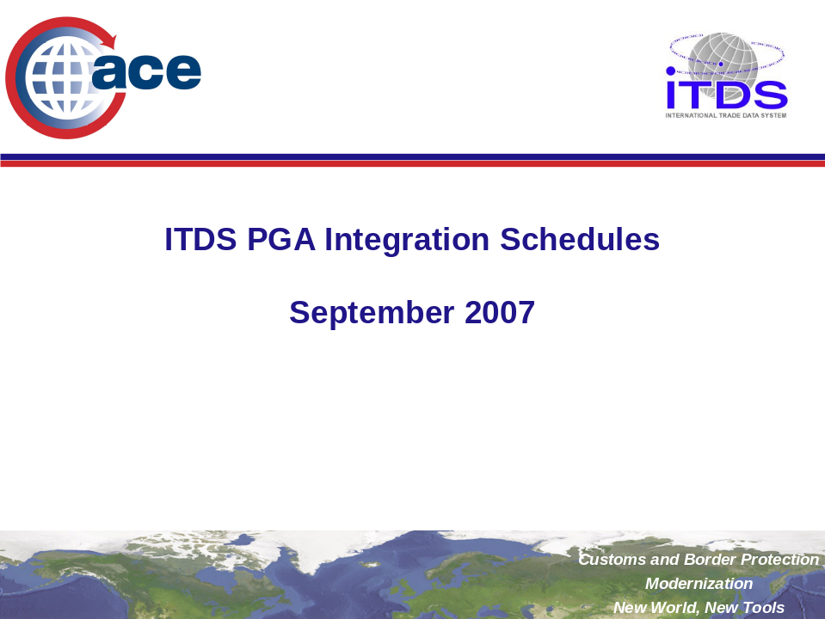

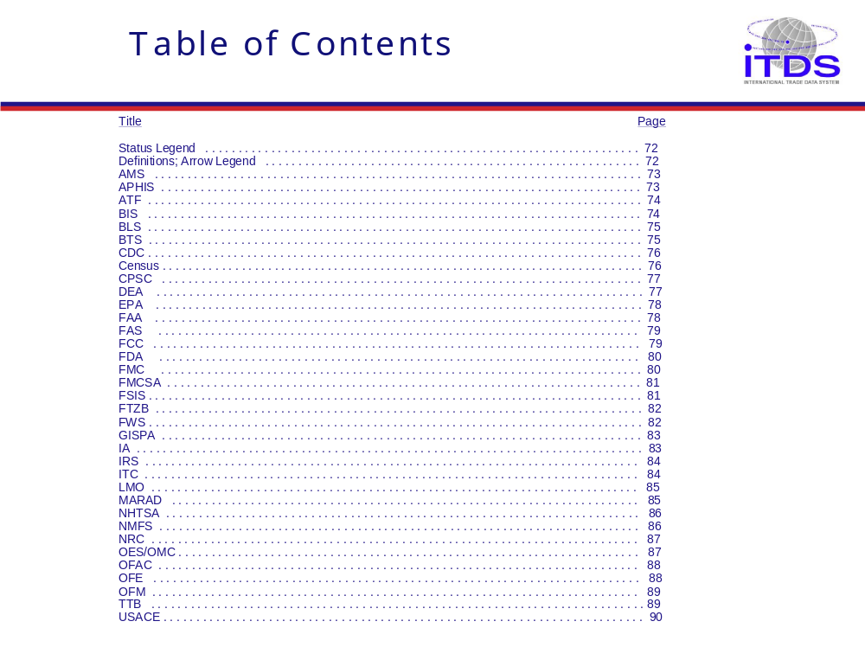
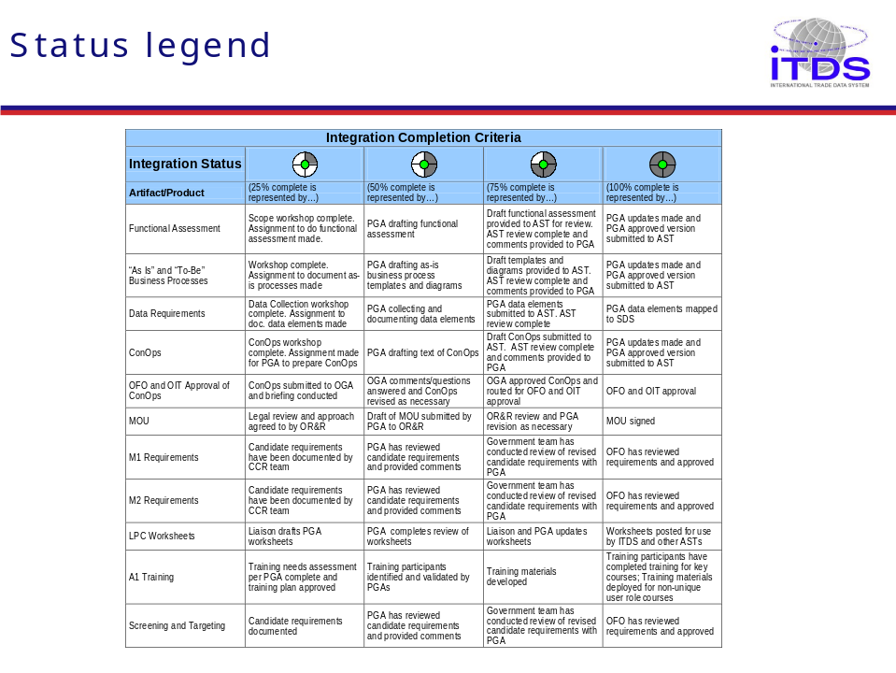

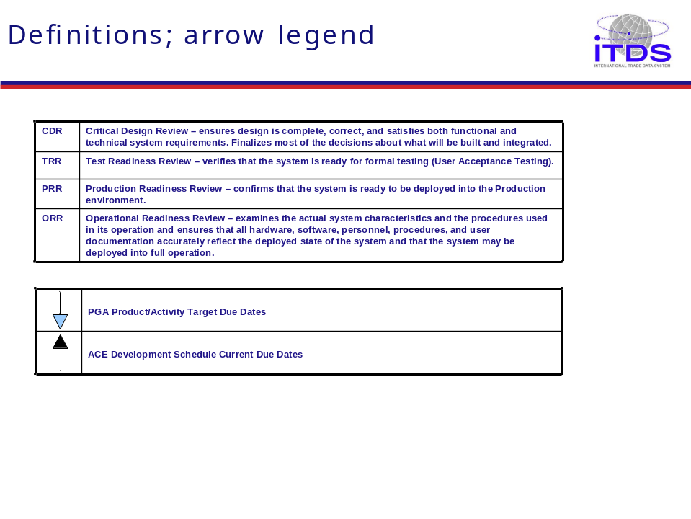
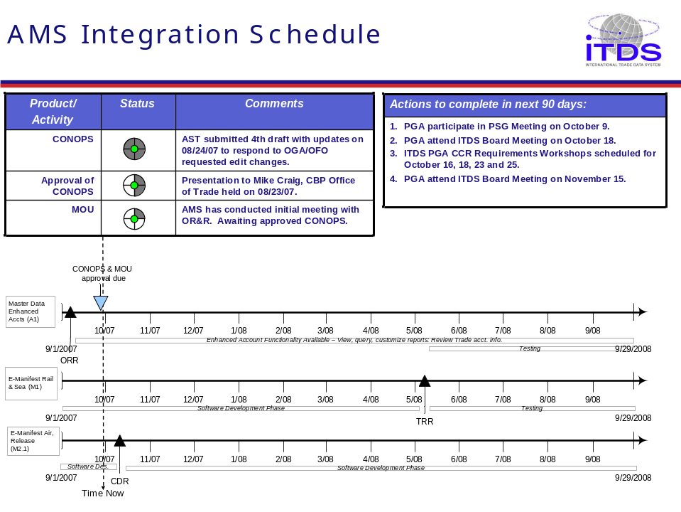

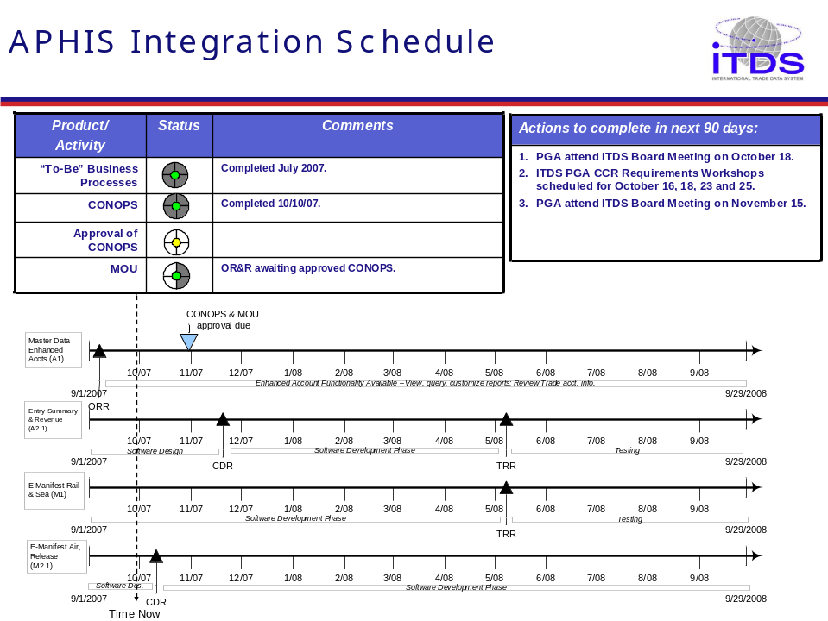
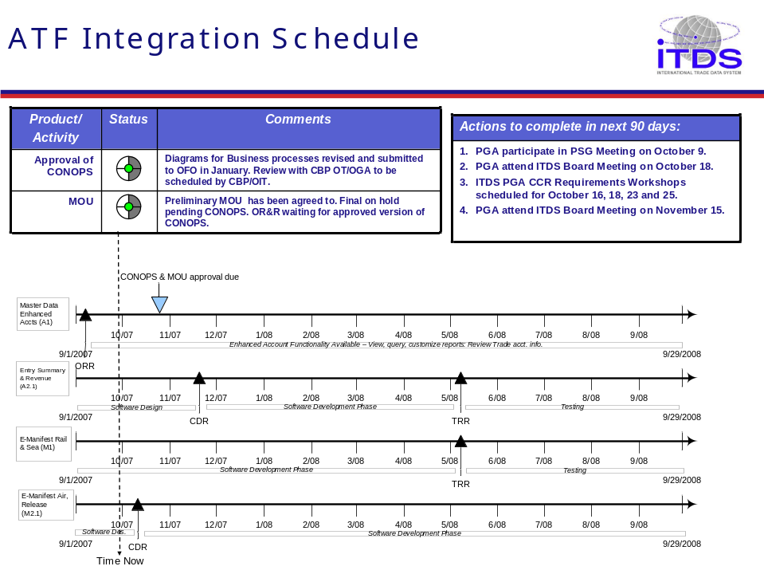

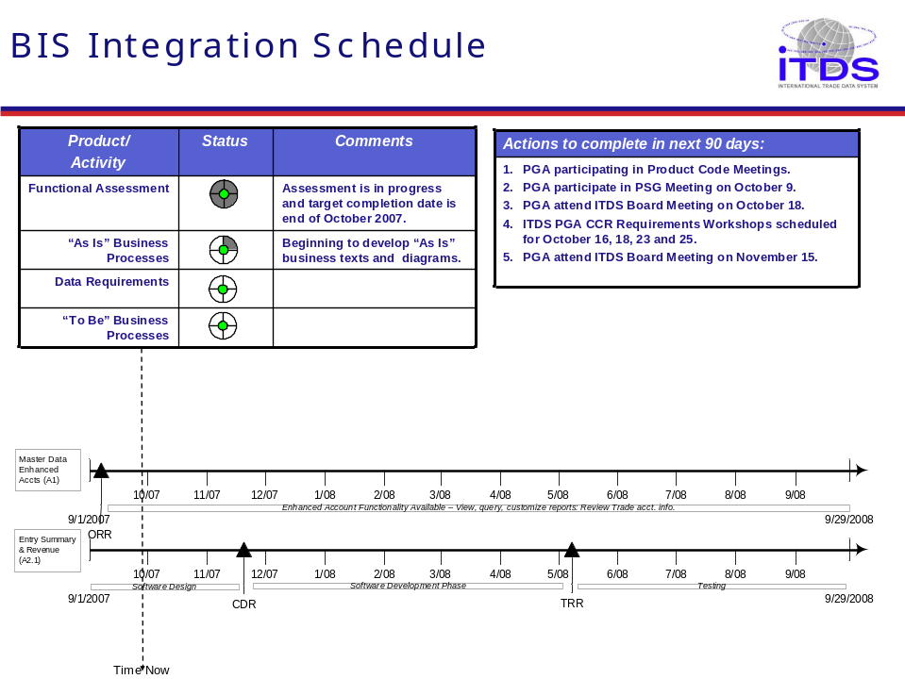
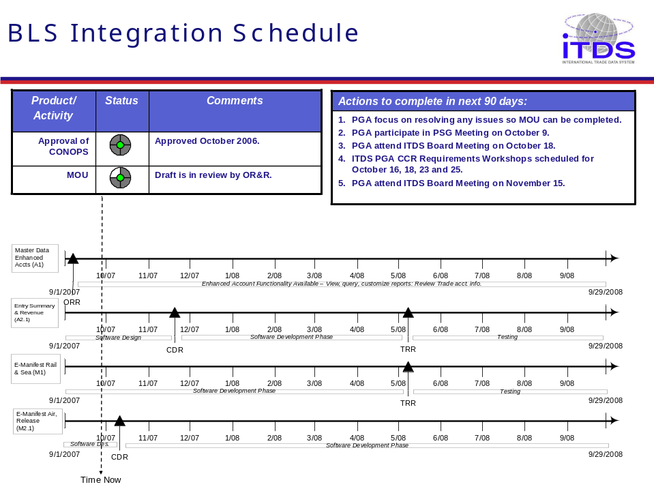

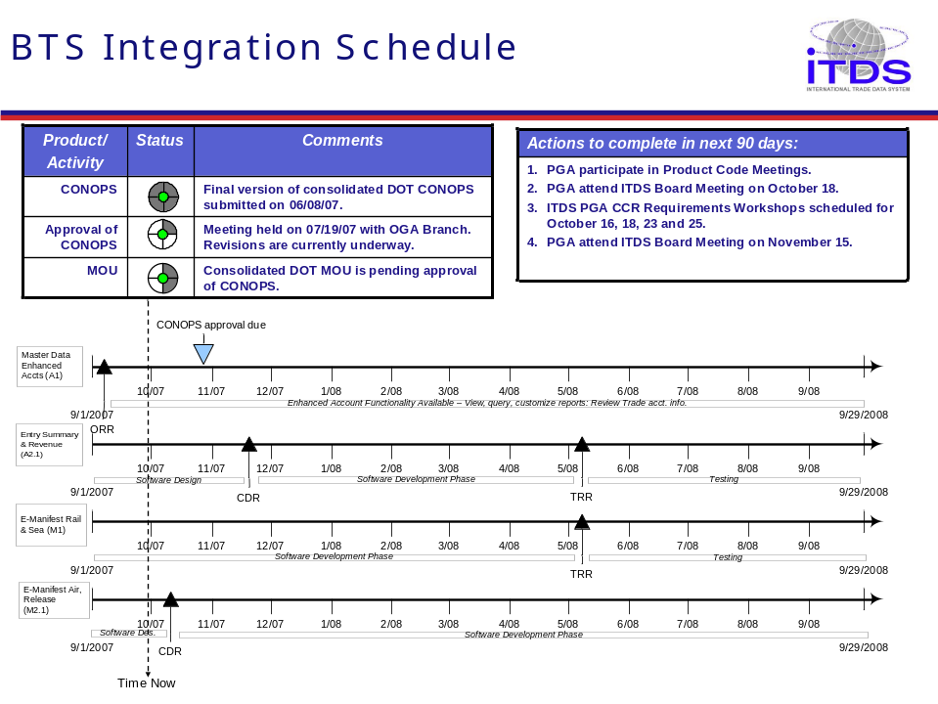
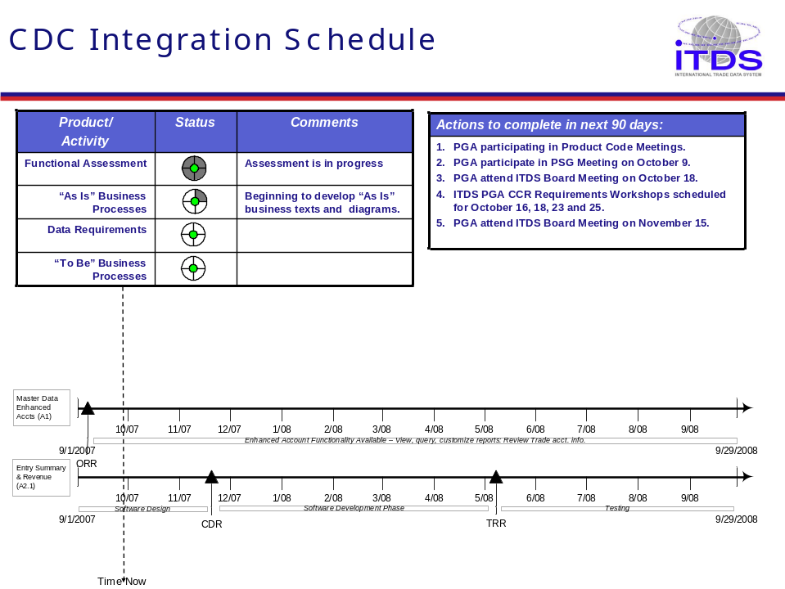

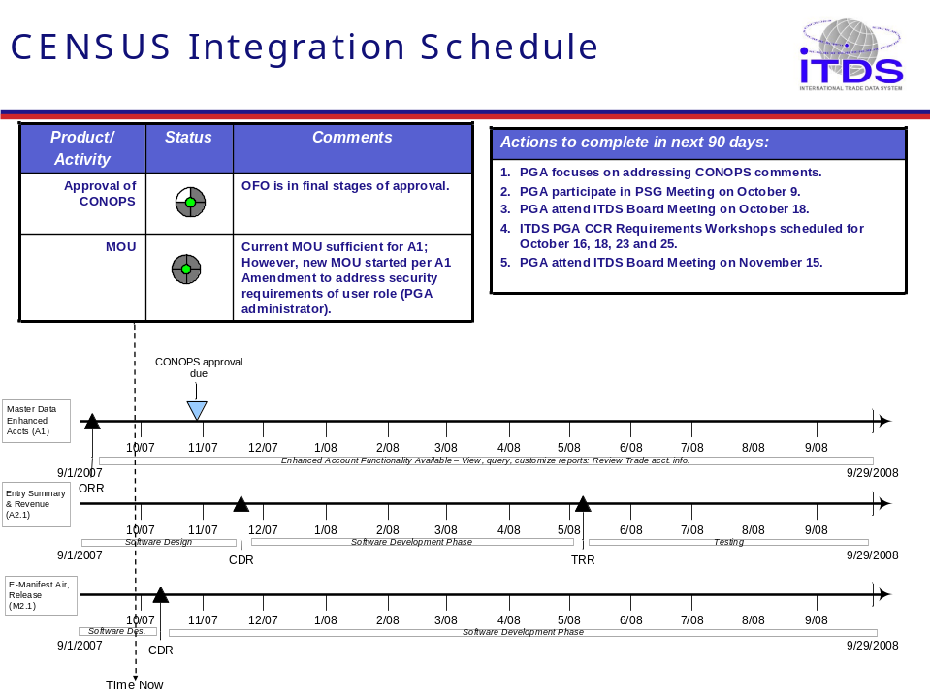
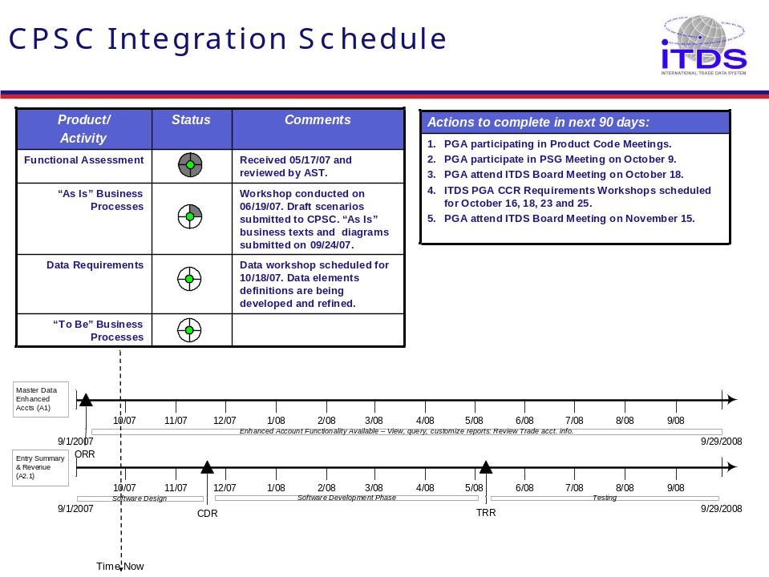

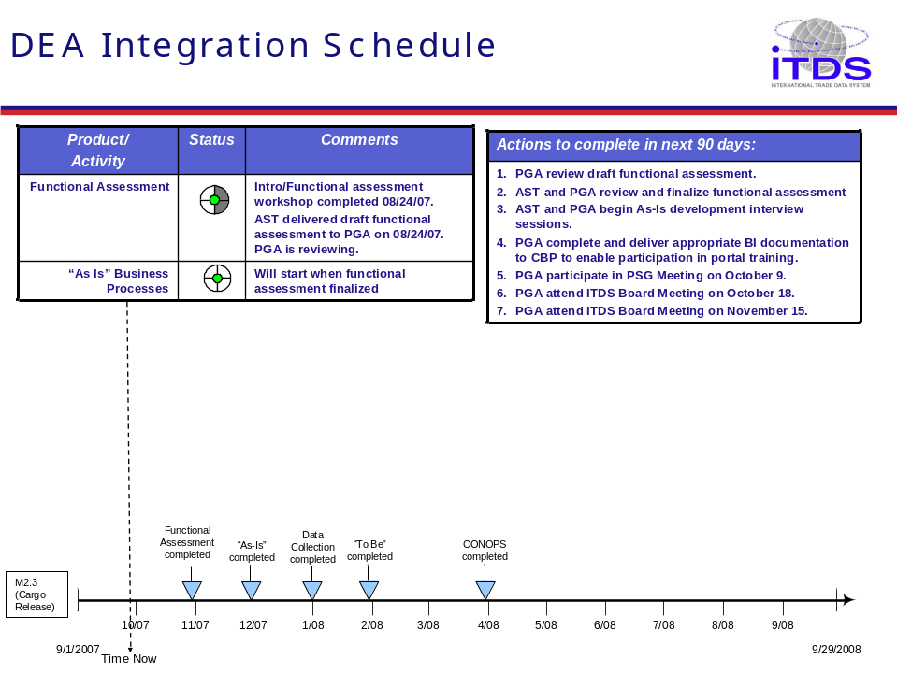
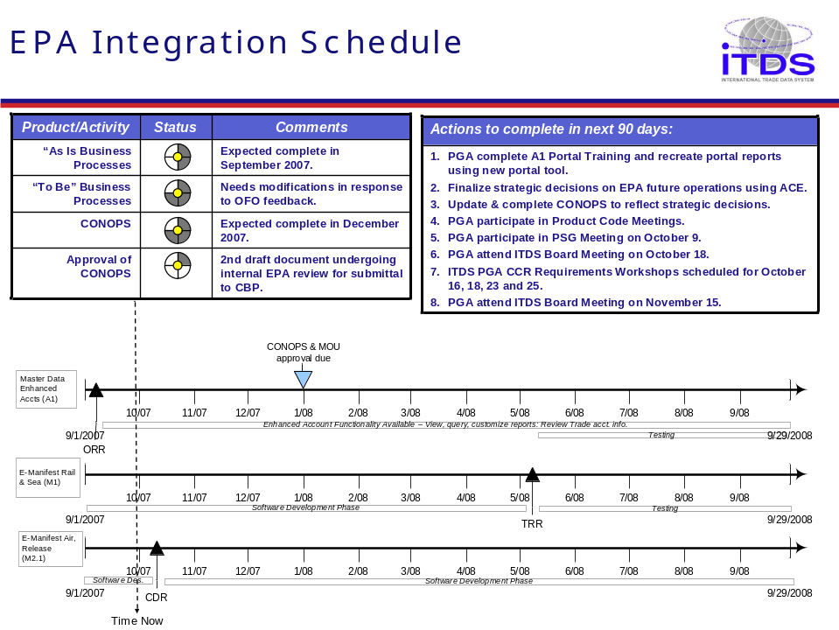

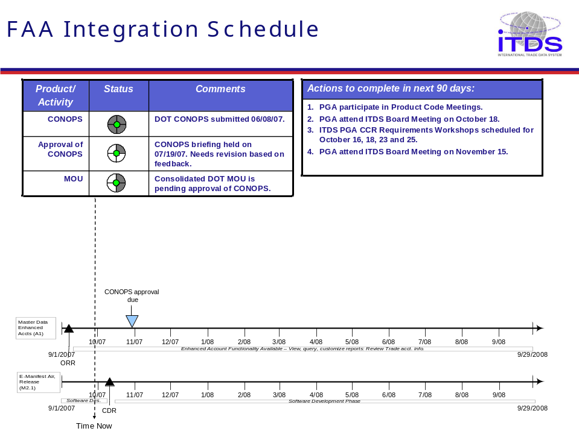
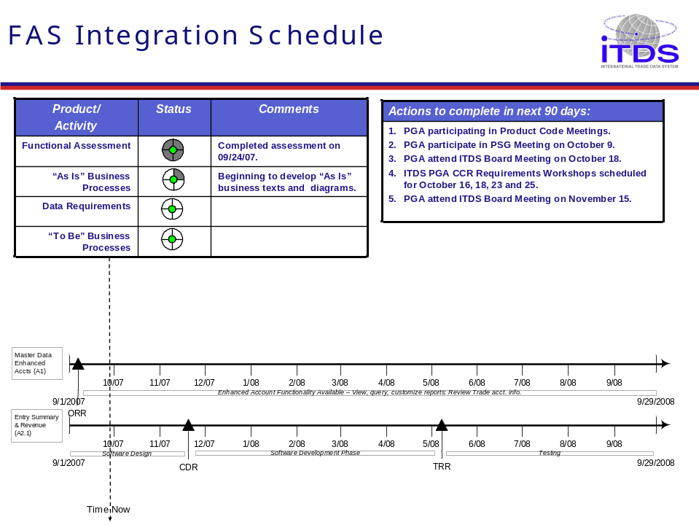

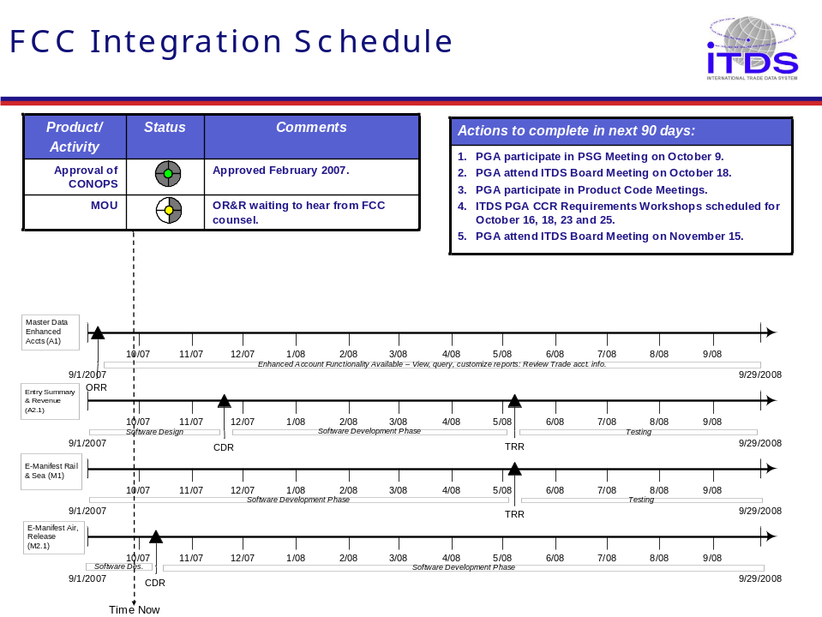
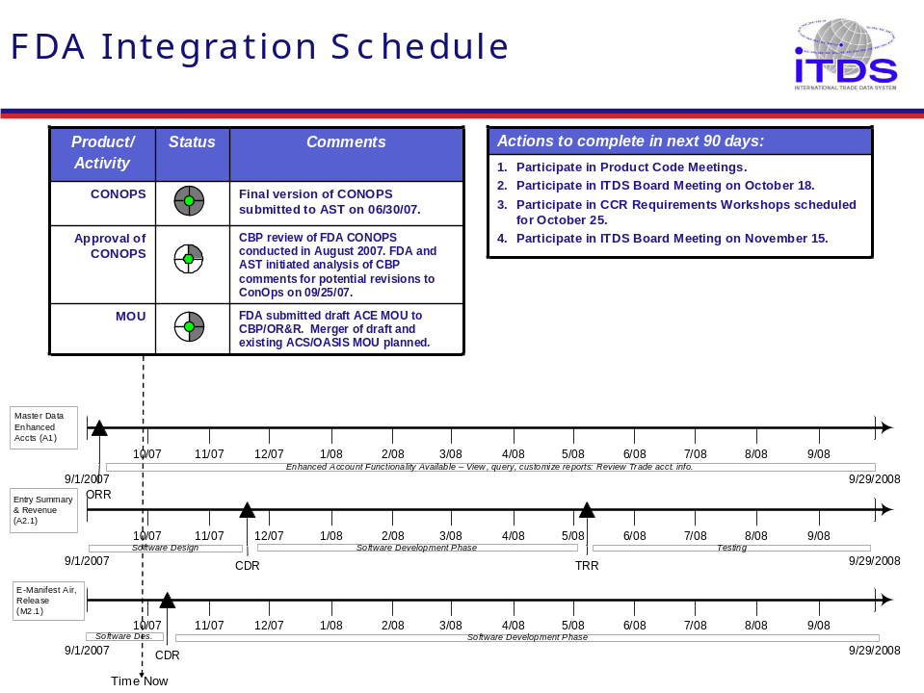

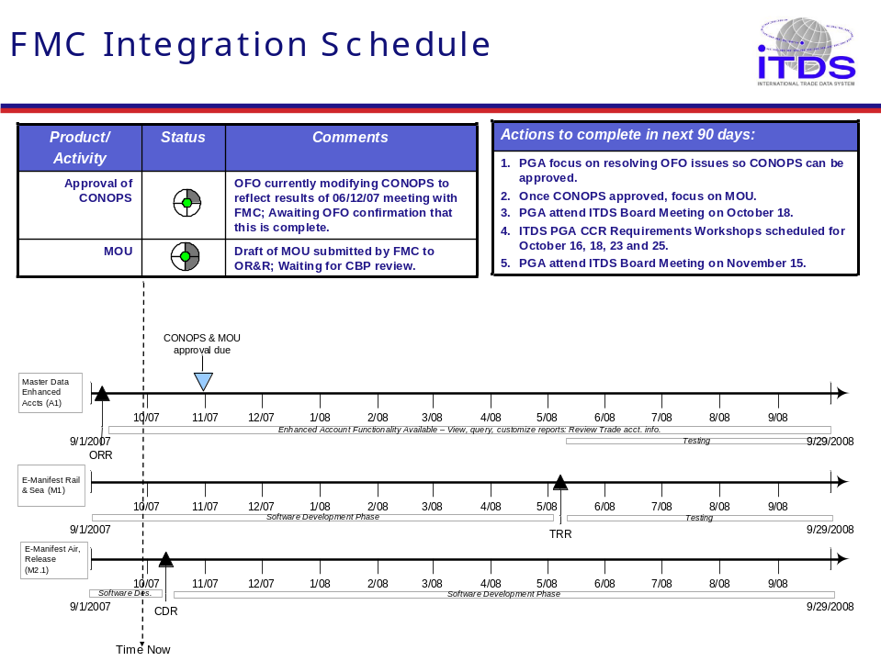
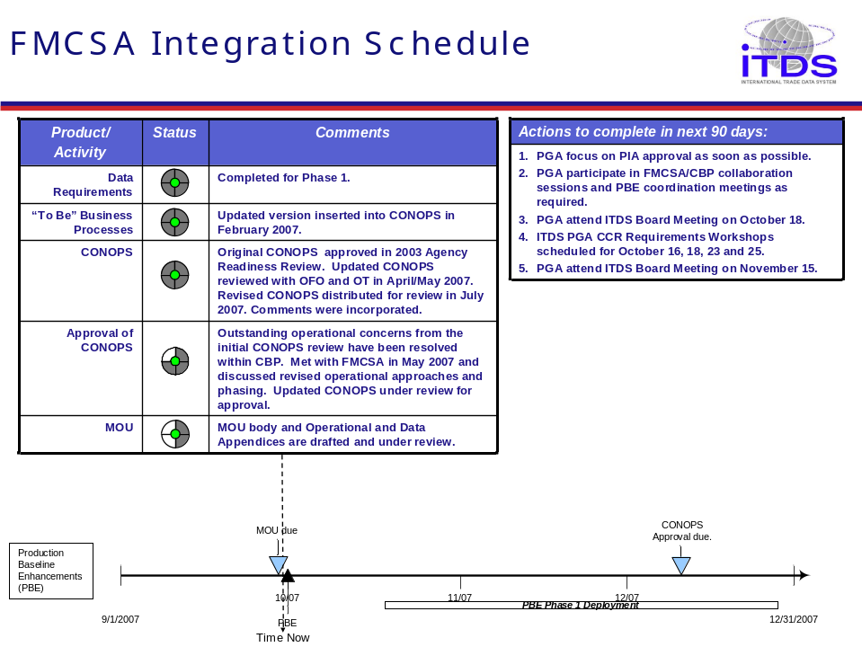

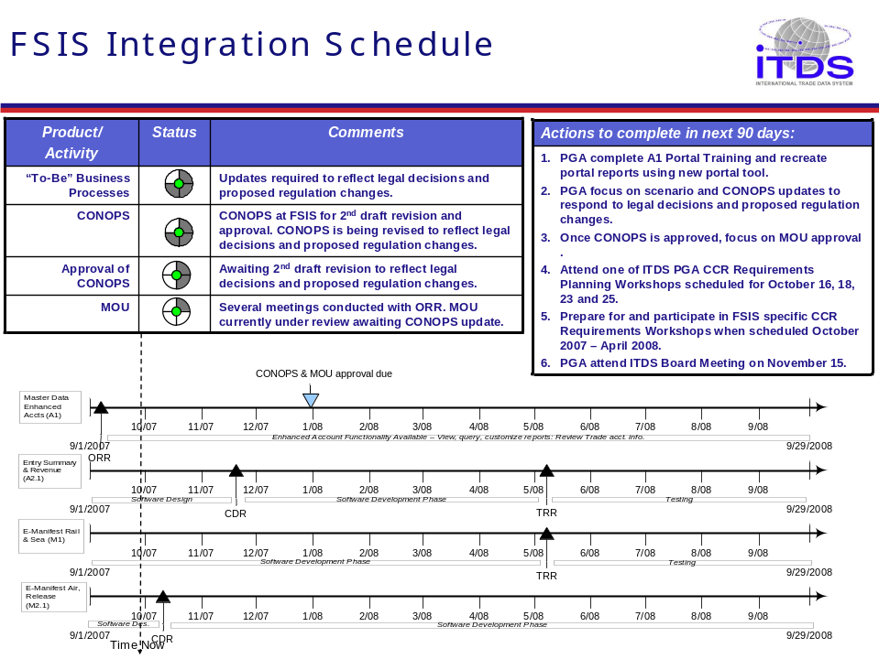
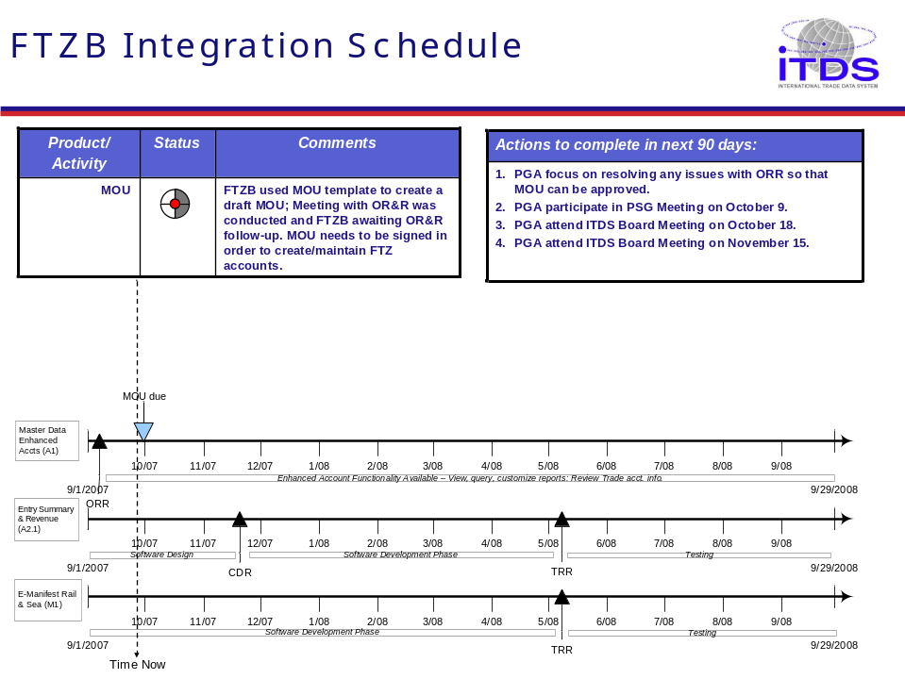

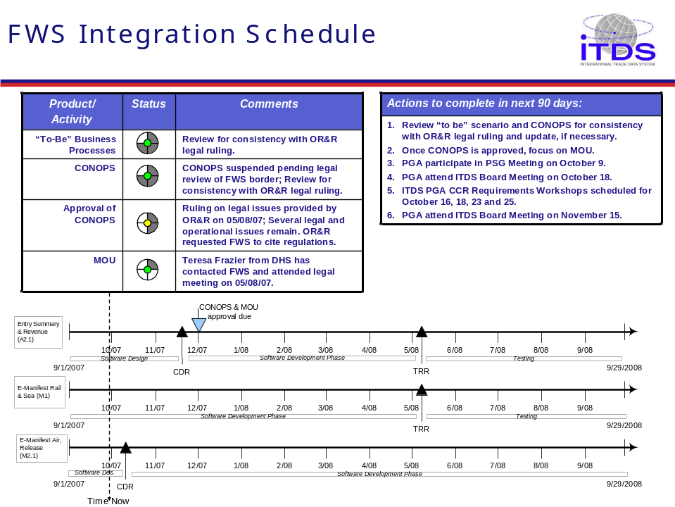
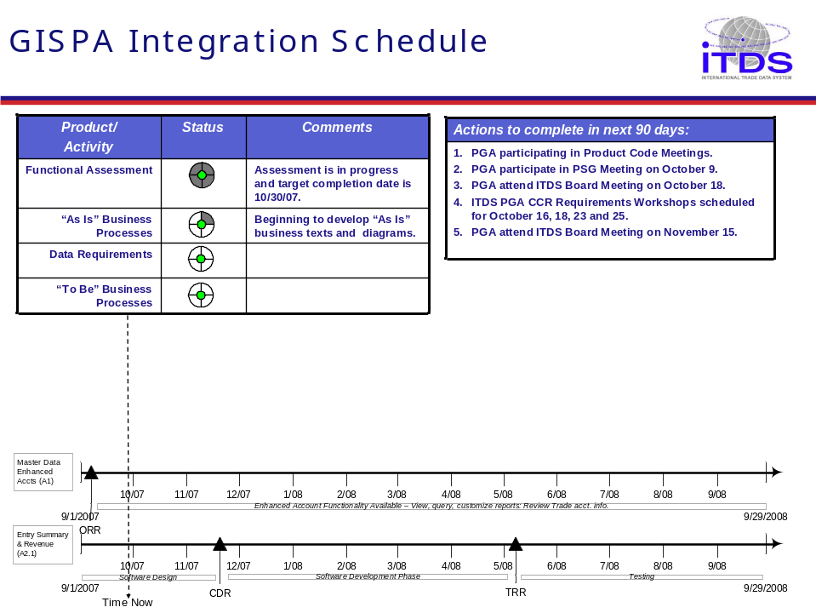

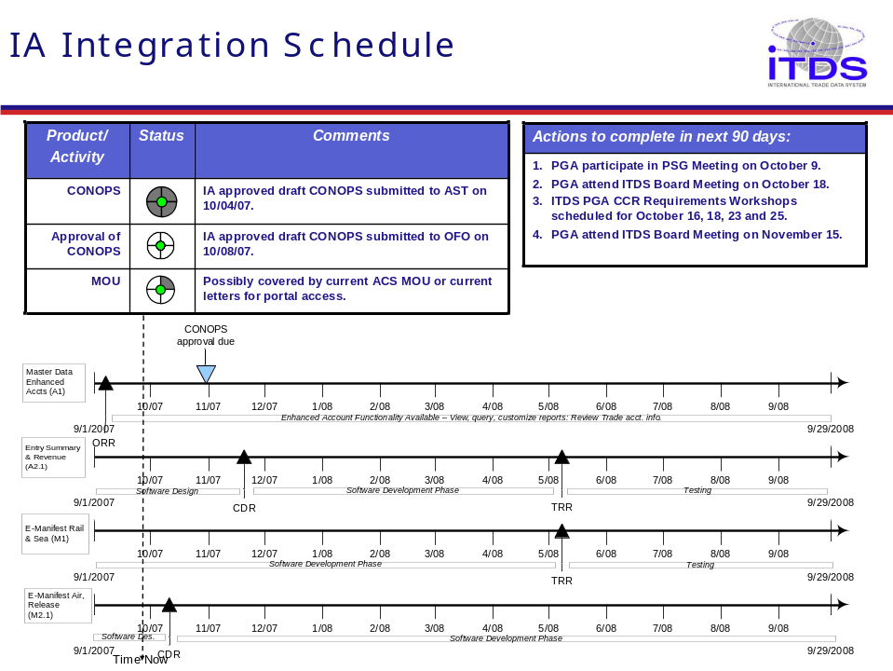
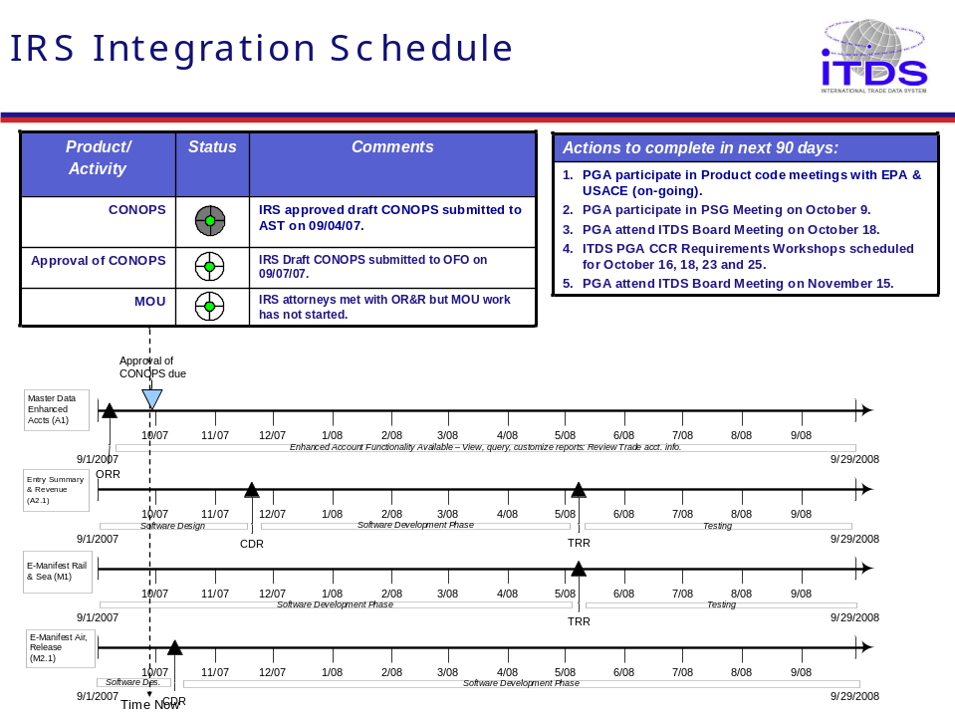

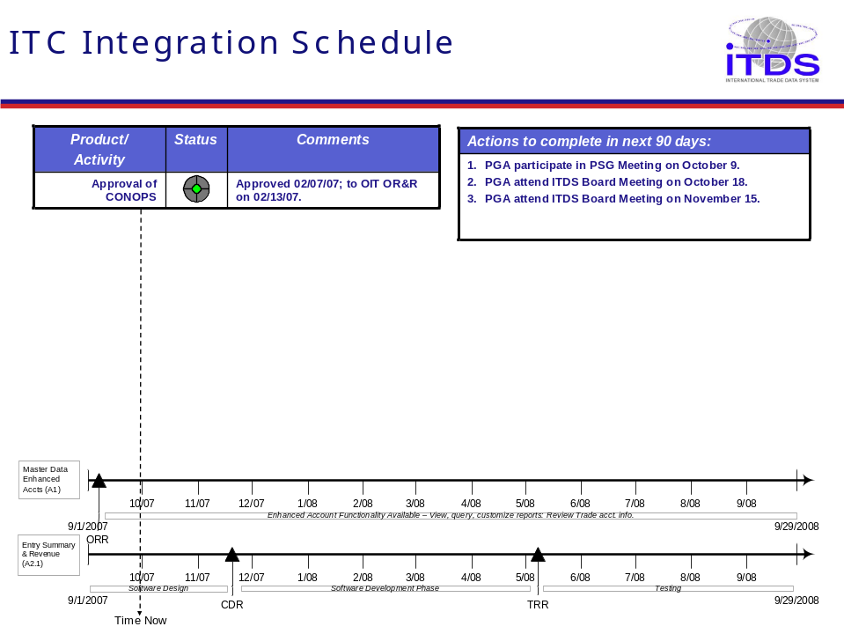
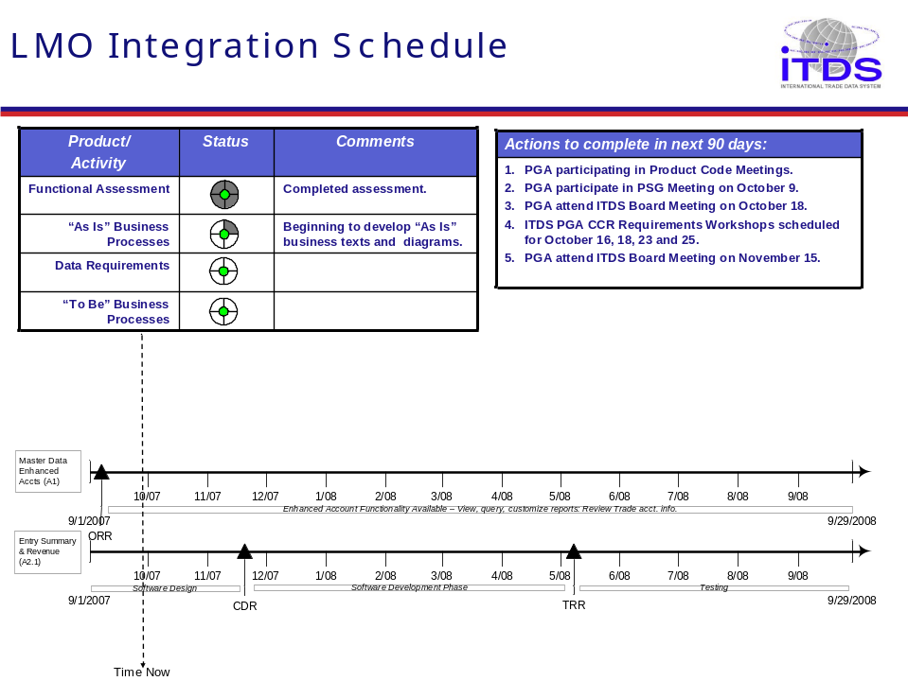

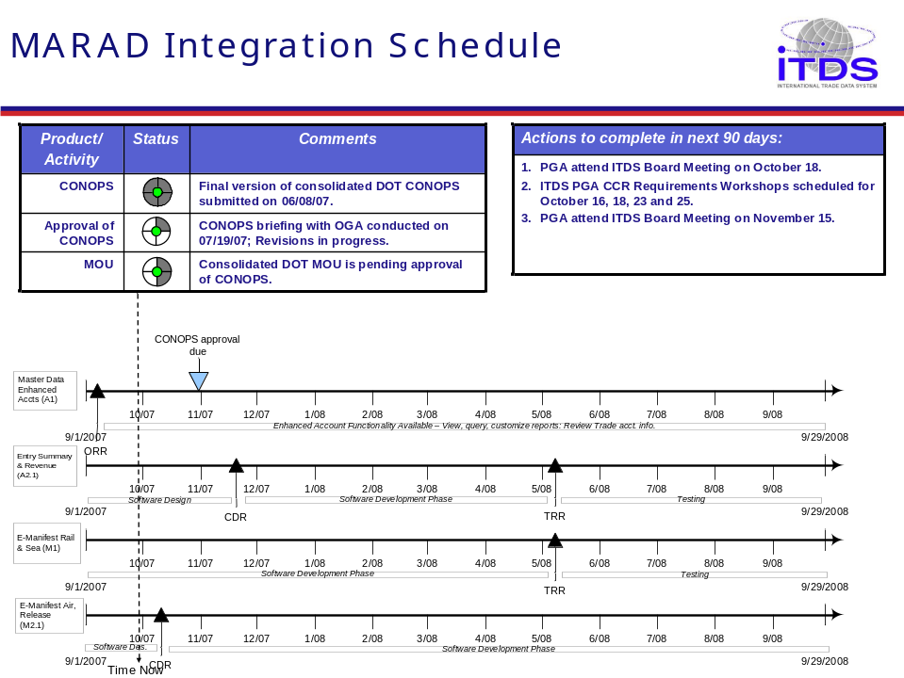
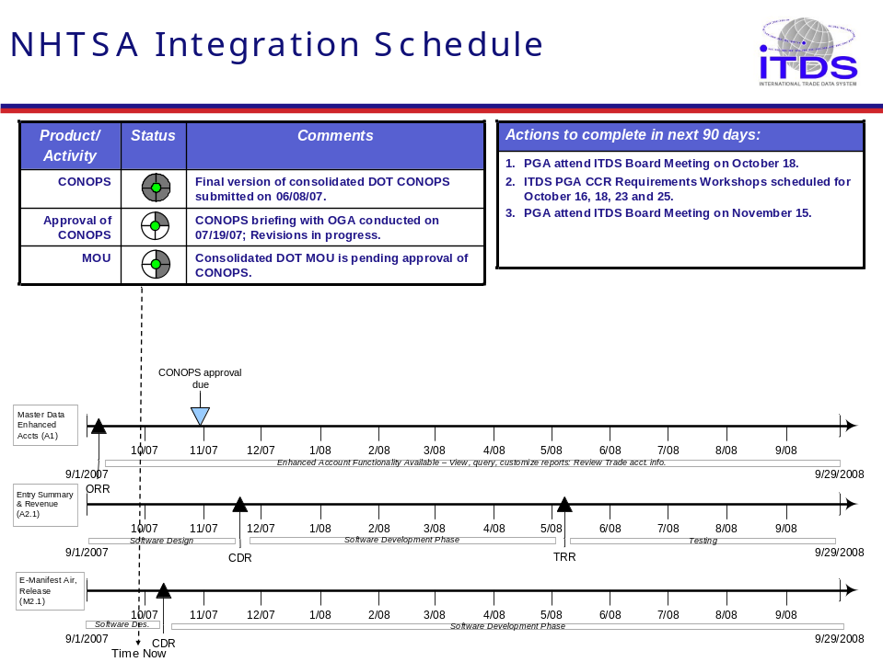

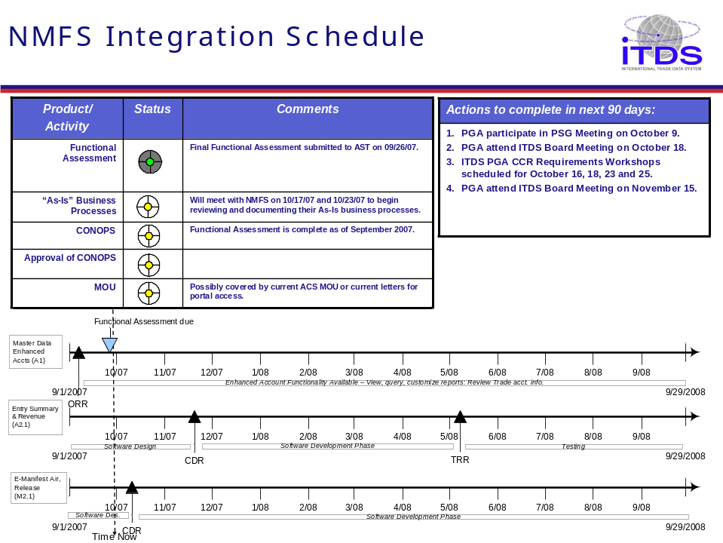
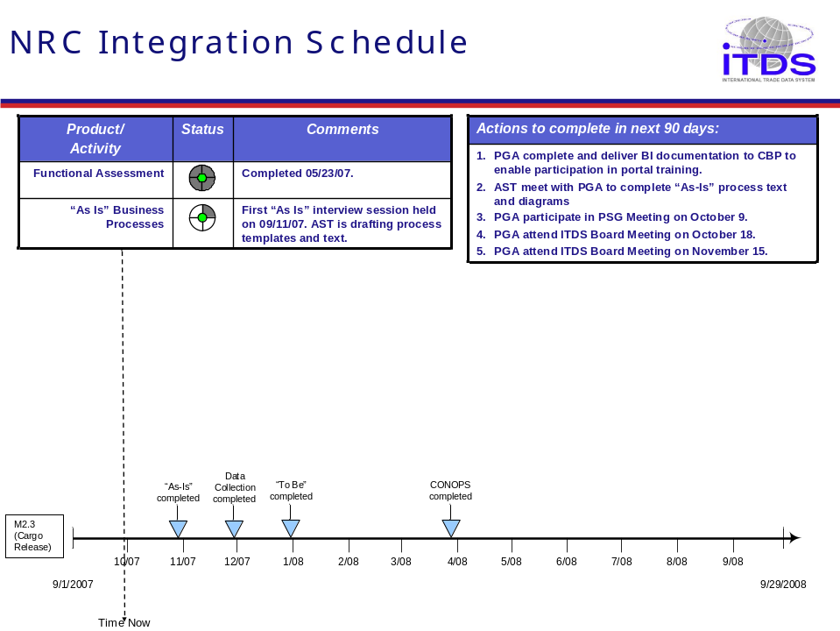

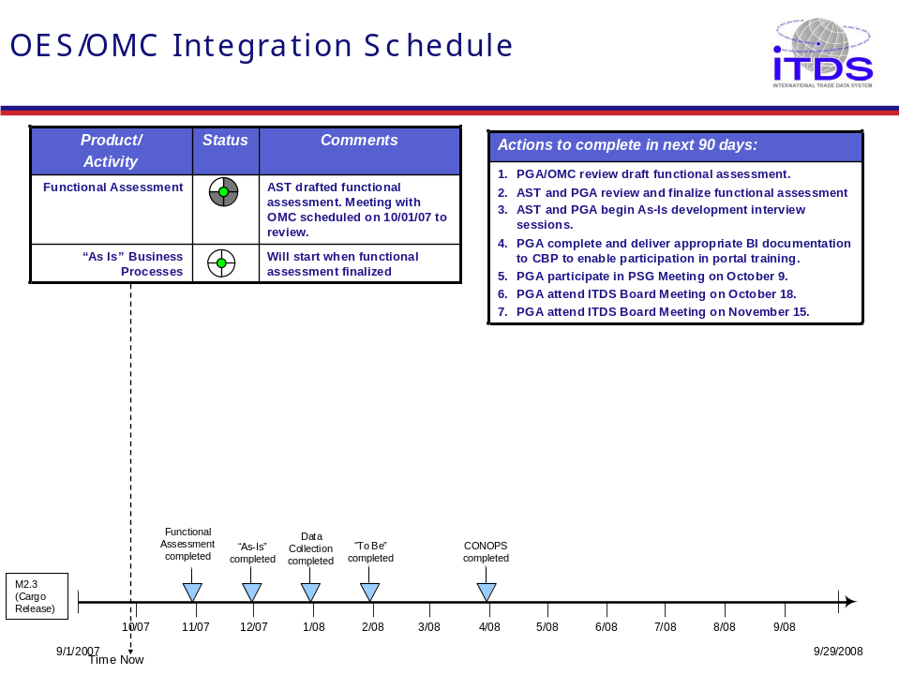
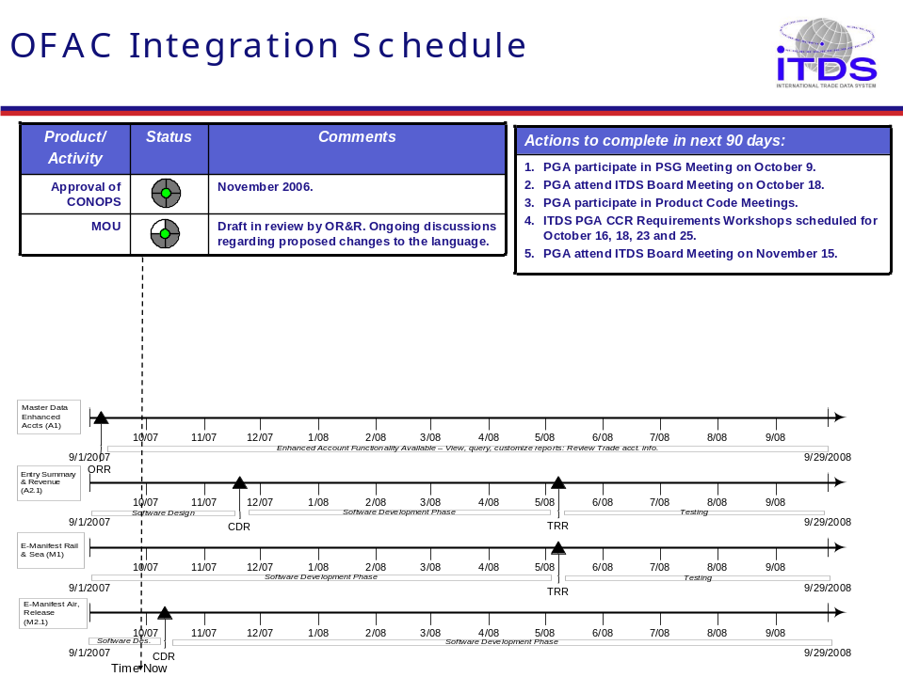

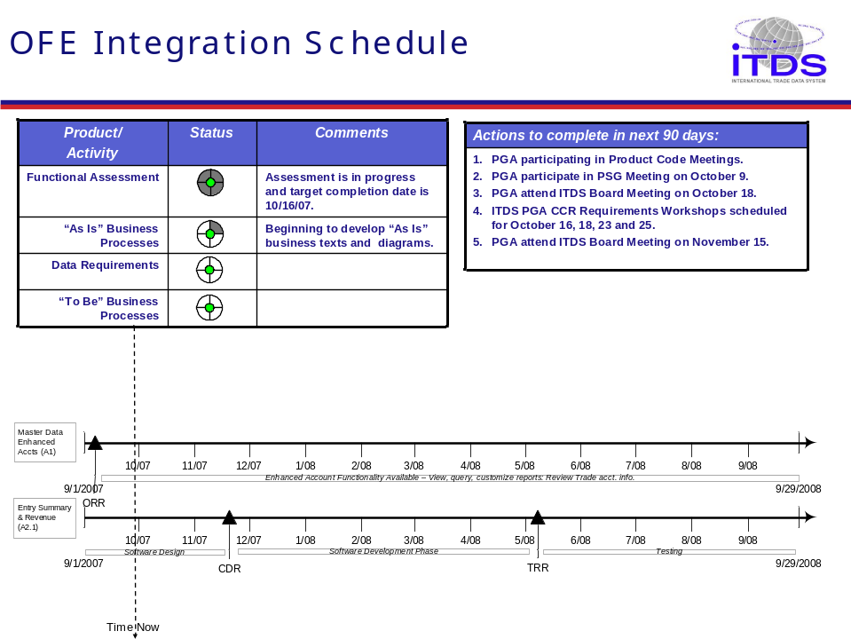
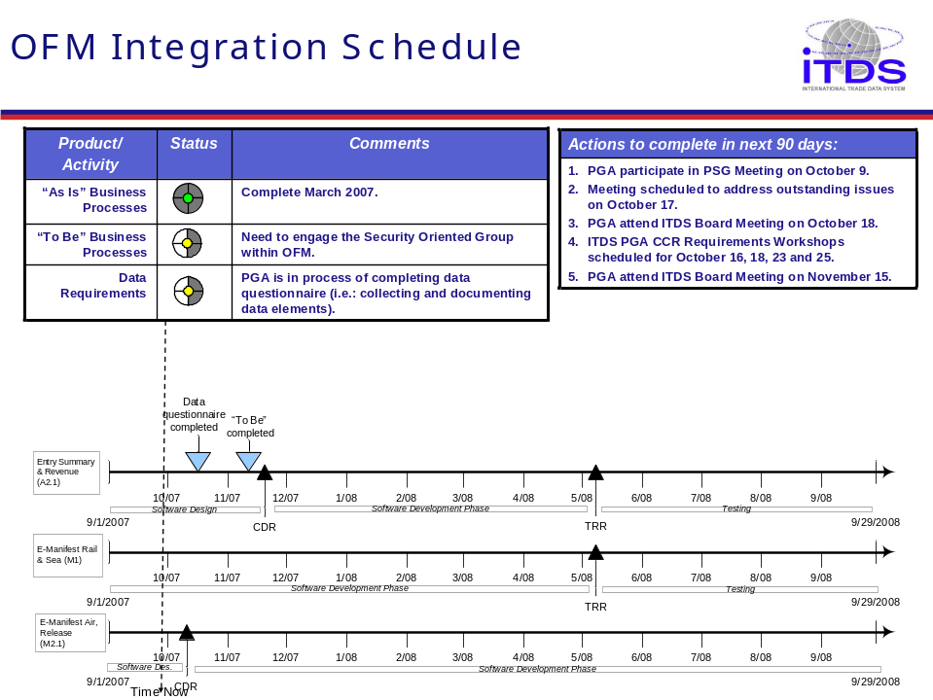

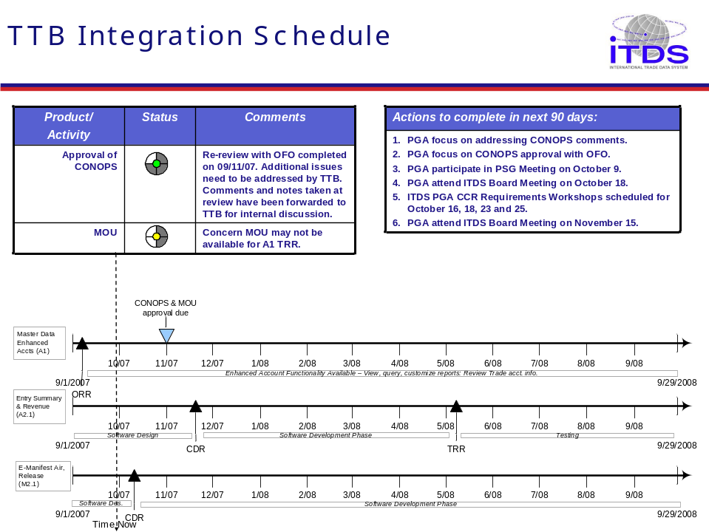
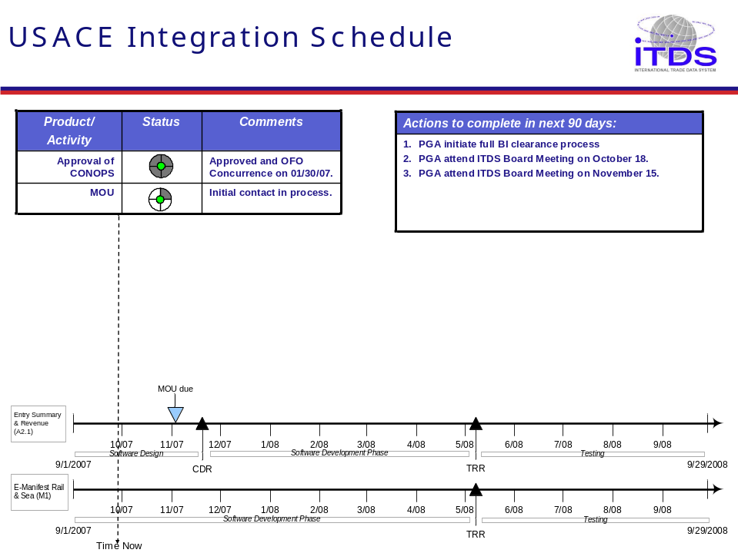

Appendices

Appendices Table of Contents

Appendix A.1: List of ITDS Agencies – Alphabetical by Department 93
Appendix A.2: List of Agencies – Alphabetical by Agency Name 94
Appendix B: Agency Board Members and Contacts 95
Appendix C: Safe Port Agencies 96
Appendix D: ACE Portal USERS 97
Appendix E: Safe Port Act Text 98
Appendix F: Working Group on Import Safety Immediate Actions 100
Appendix G: Memoranda from OMB 101
APPENDIX H: HISTORY OF ITDS 105
APPENDIX I: STATUS OF MOUs 108
APPENDIX J: AGENCY CONCEPT OF OPERATIONS STATUS 110

Appendix A.1: List of ITDS Agencies – Alphabetical by Department
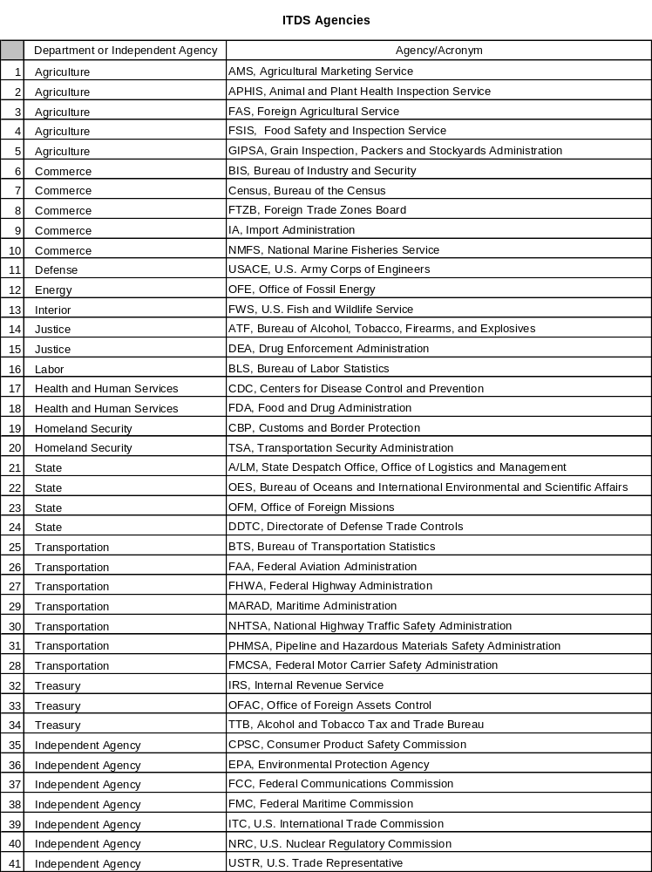

Appendix A.2: List of Agencies – Alphabetical by Agency Name
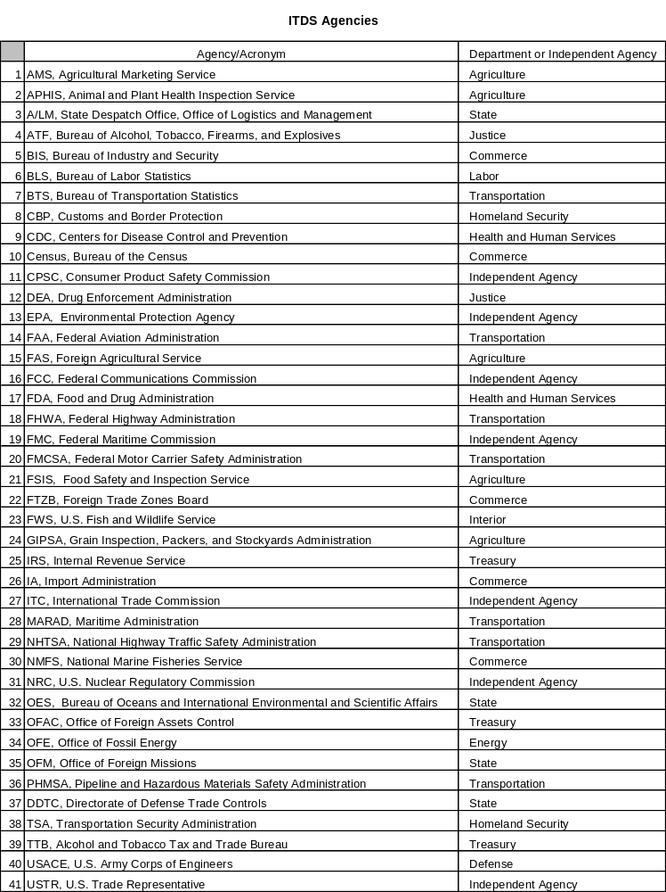

Appendix B: Agency Board Members and Contacts

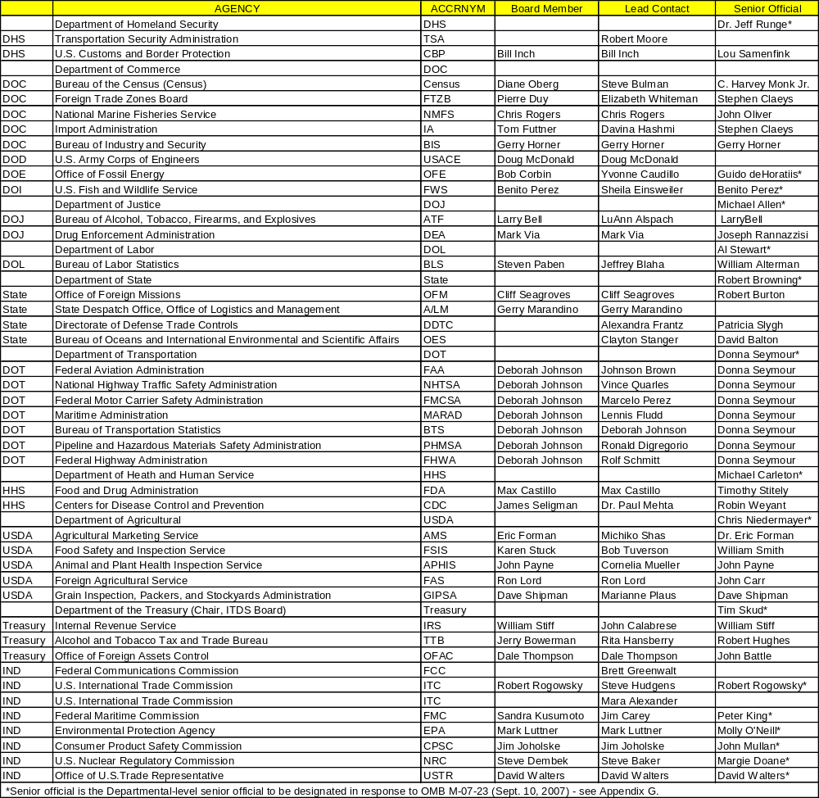

Appendix C: Safe Port Agencies

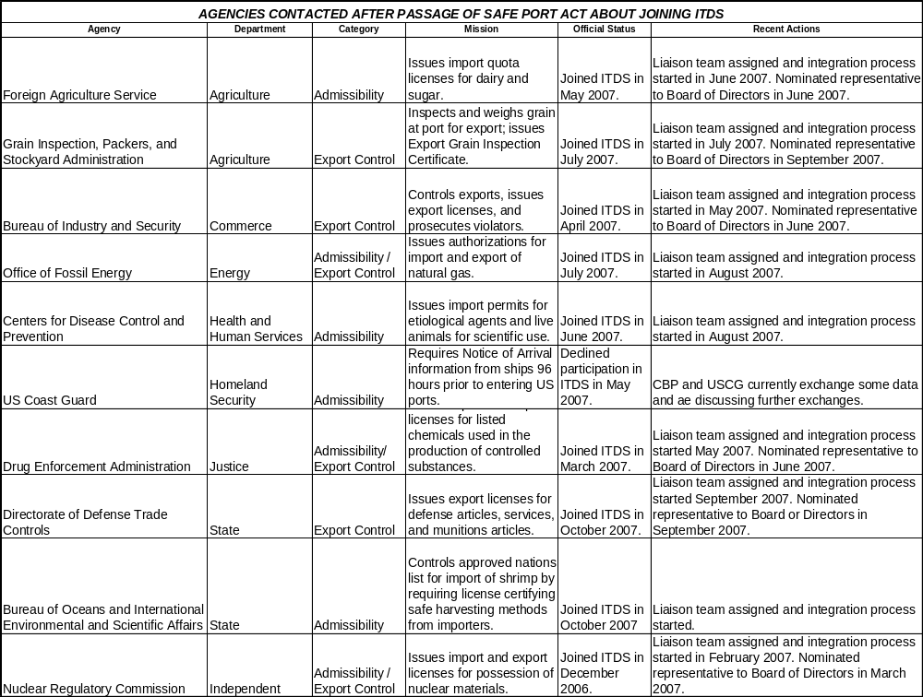

Appendix D: ACE Portal USERS

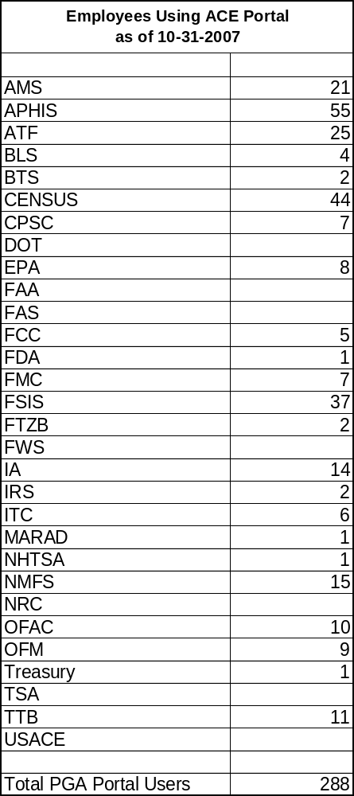

Appendix E: Safe Port Act Text
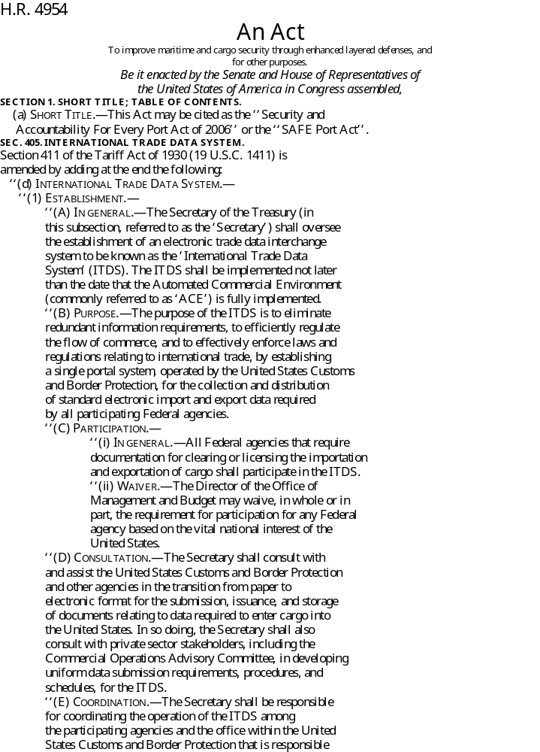
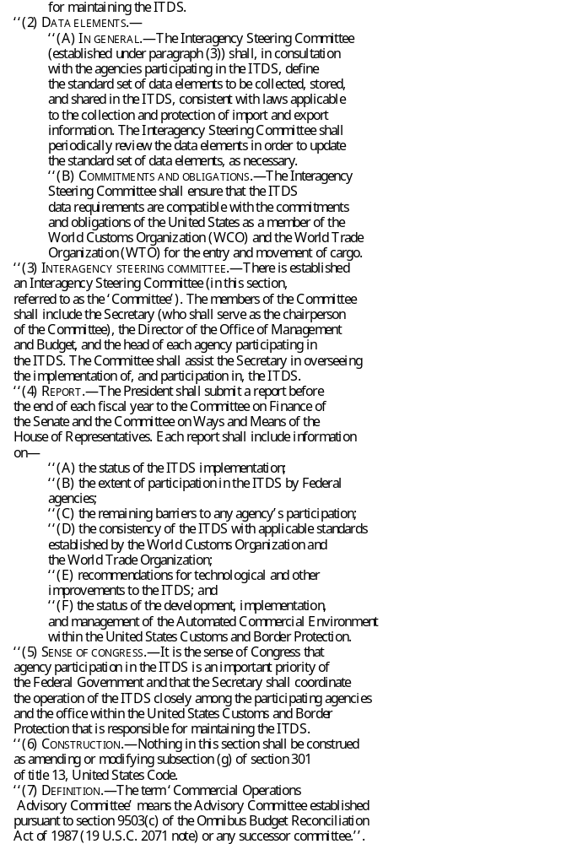

Appendix F: Working Group on Import Safety Immediate Actions
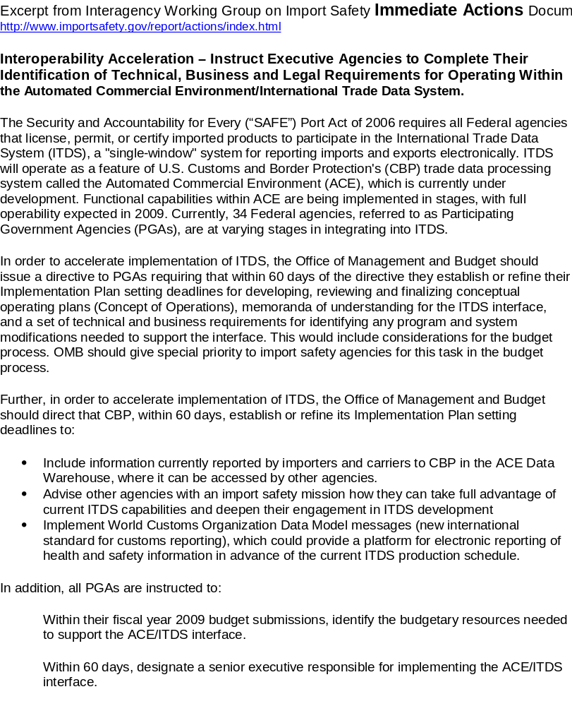

Appendix G: Memoranda from OMB

APPENDIX H: HISTORY OF ITDS
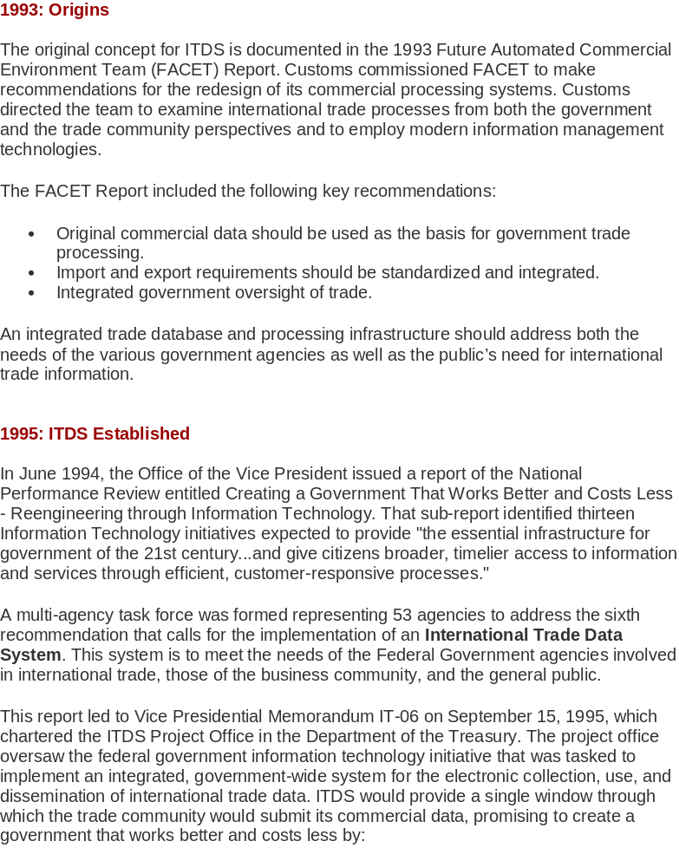
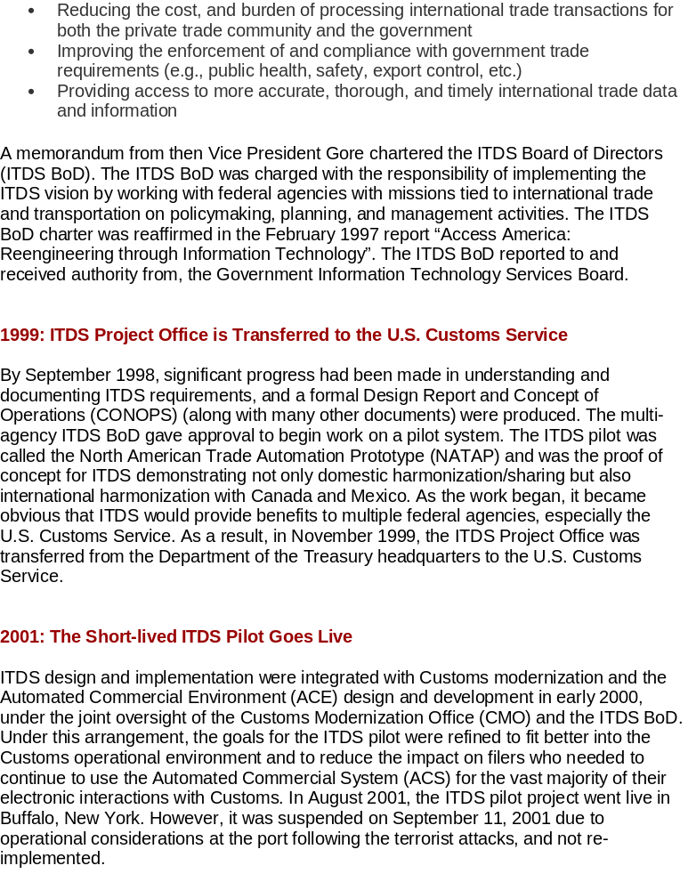
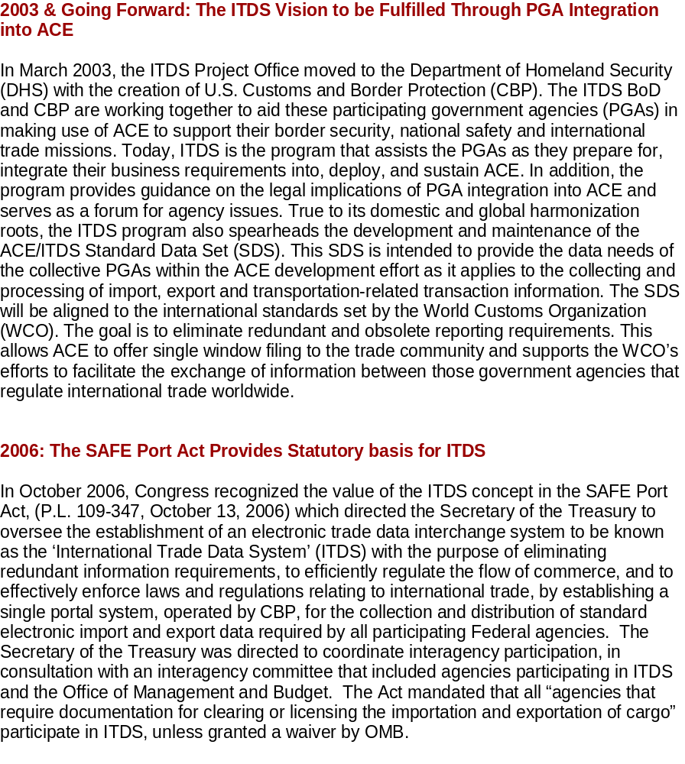

APPENDIX I: STATUS OF MOUs

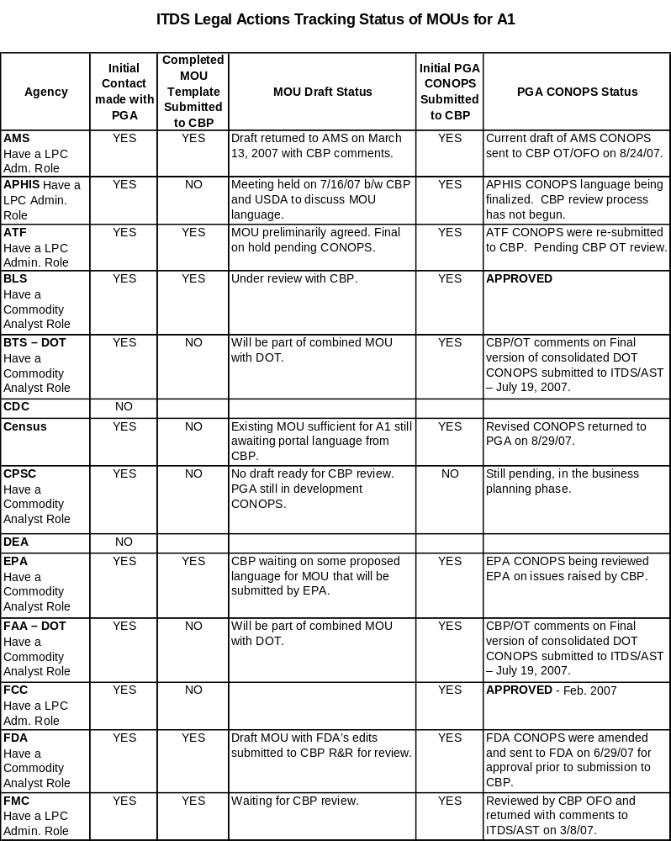

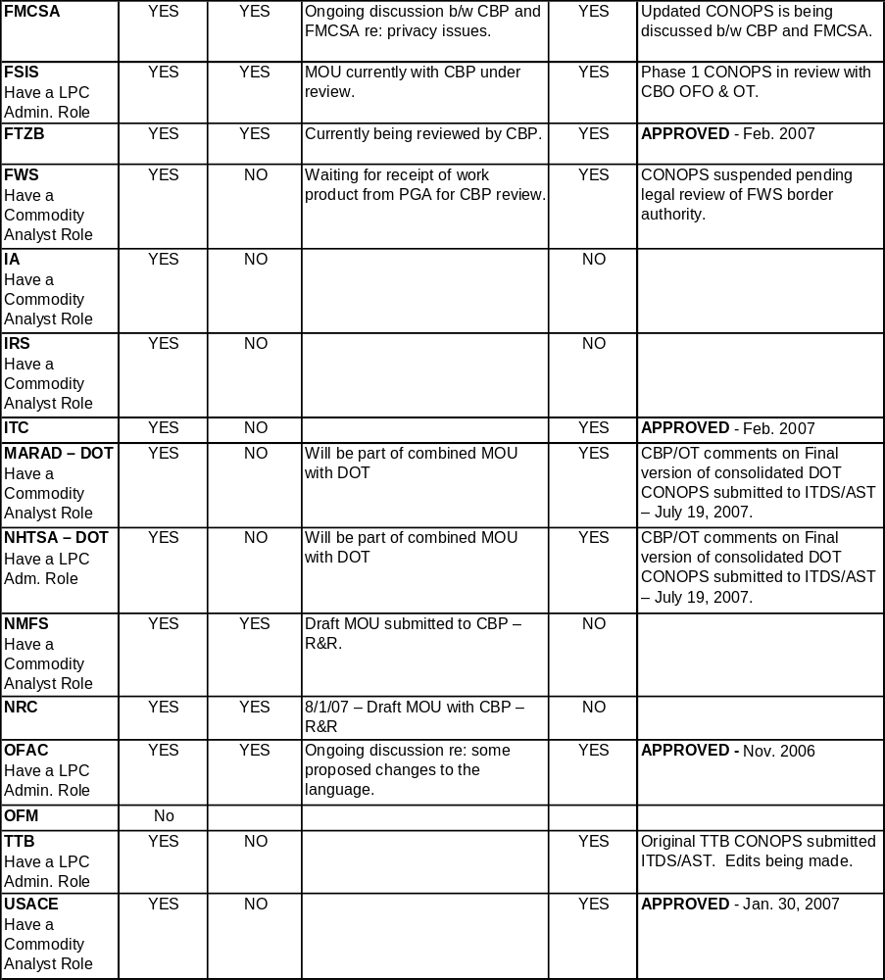

APPENDIX J: AGENCY CONCEPT OF OPERATIONS STATUS

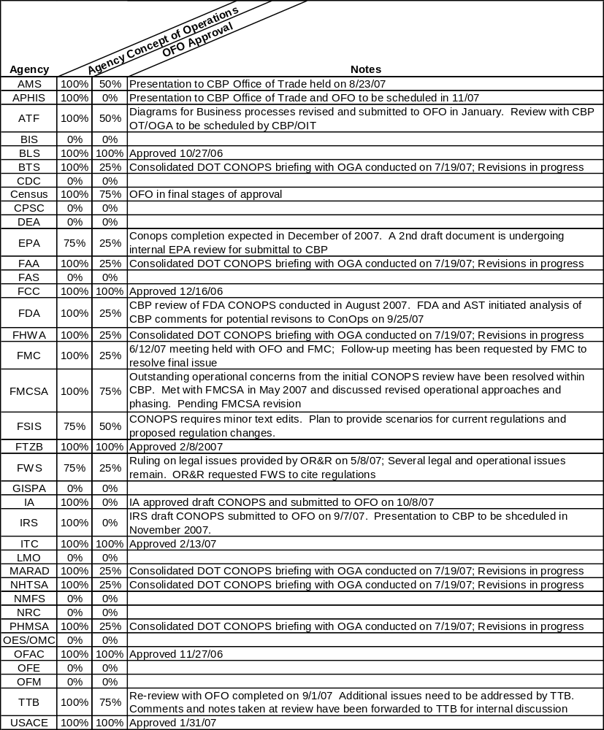

In most instances (99%) information reported by importers (entry/entry summary data are reported electronically. Of the information reported by carriers (import manifest information), 98% of truck manifests, 100% of vessel manifests, and 100% of air manifests are reported electronically. On the export side, 97% of the reports of export shipments (shippers export declaration) are reported electronically. For export reporting by carriers (export manifest data) 0% of truck manifests, 0% of air manifests, and a small percentage of vessel manifests are reported electronically.
“Reporting Codes” relate to the reporting of particular data or information. For example, when the country of export is reported, the reporting code might be UK or MX.
The WCO messages are a particular implementation of the UN/EDIFACT Customs messages (CUSCAR, CUSDEC, etc.) which are the functional equivalent of the entry, entry summary, and manifest messages currently required by CBP. The WCO messages have been agreed to by the WCO member countries, including the United States. The United States has committed to implement the WCO messages in both the WCO Framework Agreement and in G-7 communiqués.
“Requirements essential to ACE core functionality, including CBP-specific requirements, requirements shared by CBP and other agencies, and the common user interface for ITDS, are funded directly by the CBP Modernization program. The requirements that are common to multiple agencies, but are not specifically CBP requirements will be funded by the ITDS Board using CBP Modernization Automation funding earmarked for ITDS. Finally, agencies will fund any modifications to agency systems or processes undertaken to integrate with ITDS, as well as the cost of any agency-unique requirements in ACE.” FY 07 OMB 300 for ITDS.

