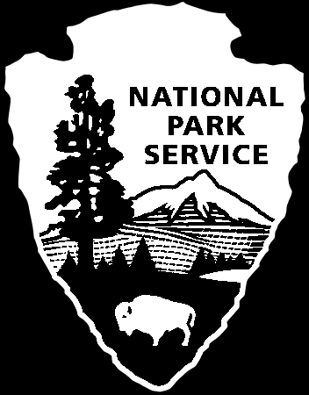
National Park Service
U.S. Department of the Interior
Rivers, Trails and Conservation Assistance Program
National Park Service Celebrates
16th Annual National Trails Day with Events Nationwide

Organized by the American Hiking Society and now in its sixteenth year, National Trails Day — the largest annual single-day trails and outdoor celebration in the country — consists of activities including hiking, biking, horseback riding, paddling, trail dedications, instructional workshops, park clean-ups, trail work projects, and much more.

Every year on the first Saturday in June, thousands of hikers, bikers, equestrians, paddlers, and other trail users flock to their favorite trails to discover, celebrate, and learn about trails as part of National Trails Day. This year, the Rivers, Trails, and Conservation Assistance Program of the National Park Service (NPS) is participating in numerous National Trails Day events nationwide. Through the Rivers, Trails, and Conservation Assistance (RTCA) Program, the National Park Service provides technical assistance to community groups and local, State, and federal government agencies so they can conserve rivers, preserve open space, and develop trails and greenways.

The NPS RTCA Program will assist with community events in Alabama, Idaho, Illinois, Maine, New Hampshire, Pennsylvania, and Washington. Events include new trail dedications, educational exhibits, water trail paddling, trail restoration and maintenance, and guided hikes on America’s favorite trails.

RTCA staff will celebrate National Trails Day (NTD) with communities across the country. Events include:
- Alabama (Montgomery's Downtown Riverwalk): The grand opening of the Alabama
Scenic River Trail. This landmark event celebrates the opening of the nation's longest single-state water trail and its new designation as a National Recreation Trail. The NRT plaque will be presented to the Alabama Scenic River Trail Association by NPS representative, Jeff Duncan. At 631 miles, the ASRT stretches from the border of Georgia and Alabama to the Gulf of Mexico. Contact: Jeff Duncan
- Idaho (City Park, Aberdeen): Promotion of community trails at the Aberdeen Daze (the
third weekend in June) starting with a 5K run and a 2.5K walk, and free breakfast in the park. The route selected for the "dash" is one segment of the three trails proposed in Aberdeen's draft trail plan. Contact: Alexandra Stone
- Illinois (Northeastern region): The Northeastern Illinois Water Trails “Paddle-A
Trail,” held throughout the month of June. Paddlers from all over the region will participate in the inventory of watertrails to create the very first paddler-written on-line guide to our region's waterways. Contact: Diane Banta
- Maine (South Portland): Two events sponsored by the West End Trails committee of the South Portland Land Trust. In the morning, the City Arborist and local historian will lead a walk through Barberry Creek Woods, the future site of public trails. In the afternoon, volunteers will gather for a bag lunch along the brook and then clear the first section of the Red Brook Trail, connecting to last year's new trail around Clark's Pond. Contact: Julie Isbill
- Nationwide: The Tennessee Walking Horse Breeders and Exhibitors Association will be holding trail events at National Parks and U.S. Forest Service lands throughout the country. Many of these events are a result of the current partnership with NPS. See http://www.twhbea.com/pdf/TrailYouthDayFlyer.pdf for more information. Contact: Mary Hanson
- New Hampshire (Mink Brook in Hanover): A work day on the Mink Brook Preserve (with the Hanover Conservation Council) to include modest trail improvements, such as trail blazing, brush clearing, and invasive remediation. Contact: Lelia Mellen
- Pennsylvania (Bristol and New Hope): A dedication event to celebrate the 20th Anniversary of the Delaware & Lehigh National Heritage Corridor. Contact: Joe DiBello
- Washington (Trustland Trails, Whidbey Island): A showcase of the new 200-acre woodlands including a nature scavenger hunt with prizes, guided walks with local birding experts, wildlife scientists, nature artists, and trail rides on horseback. A volunteer trail construction workshop will be led by the NPS Trails Maintenance Supervisor from North Cascades National Park. Contact: Alexandra Stone

NPS RTCA staff assist with approximately 300 projects each year and have worked in all 50 states. For more details on the RTCA Program and contact information, visit www.nps.gov/rtca/ or call (202) 354-6900. For more information about National Trails Day, visit www.americanhiking.org or call (301) 565-6704.

