A TECHNIQUE FOR ASSESSING THE MOISTURE RESISTANCE OF PEMs USING MOS TEST STRUCTURES.

Alexander Teverovsky, Ph.D.
UNISYS / Goddard operations
Alexander.A.Teverovsky.1@gsfc.nasa.gov

ABSTRACT
A new technique for assessing the moisture resistance of PEMs is based on measurements of a time-varying capacitance of an MOS-structure with a large perimeter-to-area ratio of the metal electrode. When an inversion voltage is applied, the capacitance of the structure will increase with time due to lateral charge spreading. The rate of the charge redistribution and the magnitude of the change in capacitance depend on the moisture content on the die surface and on some special features of the molding compound - die interaction. These conditions can be characterized by measuring the specific resistivity of the die-molding compound interface, ρ_{s}. The C(t) technique extends the limit of ρ_{s} measurements up to 10²¹ ohms. Experiments with different encapsulating materials proved the effectiveness of this technique for packaging evaluations. A good correlation between ρ_{s} and median time-to-corrosion failures was shown.

INTRODUCTION
Due to moisture permeability of polymeric materials, Plastic Encapsulated Microcircuits (PEMs) always have a certain moisture content on the die surface. The mechanisms of PEMs’ degradation due to moisture absorption (such as corrosion, leakage current, charge instability, etc.) strongly depend on the quality of the die-package interface and its ability to prevent excessive moisture adsorption. Debonding between molding compound and die is considered as a major reliability concern for PEMs used in surface mount applications. Different types of comb pattern sensors have been commonly used since the 1970s to measure the surface specific resistivity, ρ_{S,} of oxide films and to find its relation to corrosion processes [1-3]. Use of this technique for PEMs is hindered due to the surface conductivity of the package and the volume conductivity of a molding compound which contains moisture. Normally, leakage currents in plastic packages would not exceed 10⁻¹² A at 10 V, but, in some cases, these can be much higher [4]. Typically, during ρ_{S} measurements, a low current sensitivity is 10⁻¹² A, an equivalent pattern size is 10 μm of width and 100 mm of length, and an applied voltage does not exceed 100V. With these parameters, the technique is limited to a maximum sensitivity of 10¹⁸ ohms for ρ_{S}. A low frequency capacitance measurement technique developed by Merrett, Sim, and Bryan [5], is capable of being used directly with some types of microcircuits but is limited to a sensitivity of 10¹⁴ ohms. Besides, changes in the frequency dependence of the dielectric permittivity of the molding compound (and changes in the capacitance between the package leads) during humid testing, may introduce errors in the calculation of ρ_{S}
Moisture resistance and reliability of PEMs have been significantly increased over the last decade. The current trend is toward use of PEMs in highly reliable applications (military and aerospace) and in a harsh environments. New packaging systems require a more sensitive technique for assessing moisture resistance. A new technique, described in this article, is based on a lateral charge spreading phenomenon and employs a metal-oxide-silicon (MOS) structure with a large perimeter-to-area ratio. The charge spreading process had been well known since 70th [6] and was one of the major cause of excessive leakage currents and failures of the first semiconductor devices and microcircuits encapsulated in polymers.
When an inversion voltage is applied to an MOS structure, the capacitance will increase with time due to a lateral spreading of the inversion layer area. The rate of this process depends on the rate of charging of the distributed oxide capacitance and is controlled by the surface resistivity. This allows one to calculate ρ_{s} using C(t) measurements. The technique uses integration of the surface current on the distributed oxide capacitance which allows extending the limit of ρ_{s} measurements to 10²¹ ohms. Experiments with different encapsulating materials proved the effectiveness of the technique for packaging quality evaluation. A good correlation between ρ_{s} and median time to corrosion failure was shown.

TECHNIQUE
Let us consider an MOS structure which is formed on n-type silicon with a strip metal electrode of the width d (see Figure 1).
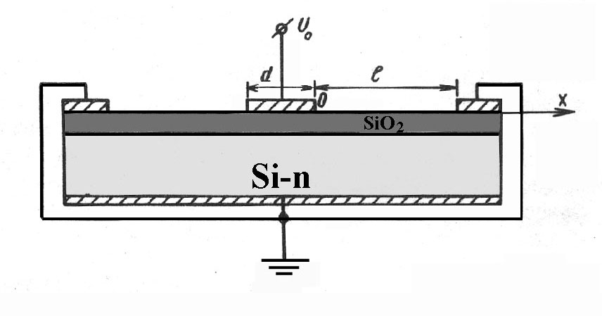
Figure 1. MOS-structure with a strip metal electrode.
A second electrode on the oxide surface is placed equidistantly at both sides from the first at a distance l and is connected to the substrate. Capacitance of this structure as a function of applied voltage (C-V characteristic) is shown in Figure 2. Let V₀ be a negative voltage which is applied to the first electrode. V₀<V_{i}, whereV_{i} is the potential which causes formation of an inversion layer. Due to some conductivity of the oxide surface, the oxide areas around the first electrode will charge with time to a potential -V(x,t). When -V(x,t) > -V_{i}, the depletion and inversion layers expand thus resulting in an increase in capacitance (see Figure 3).
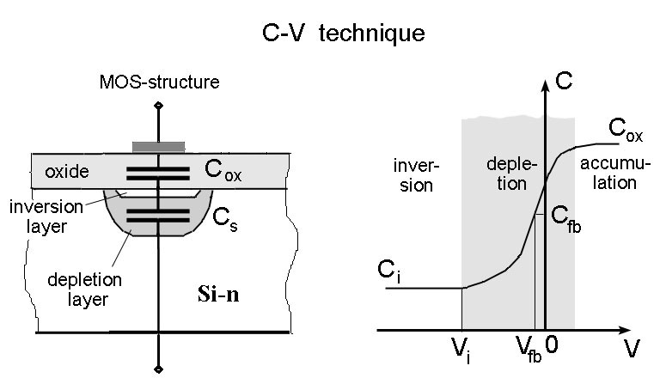
Figure 2. MOS-capacitance diagram (a) and capacitance variation with voltage (b). The flat band capacitance C_{fb} and the corresponding voltage V_{fb} which are used in C-V technique to calculate the value of the oxide charge can be used to calculate the inversion voltage V_{i}.
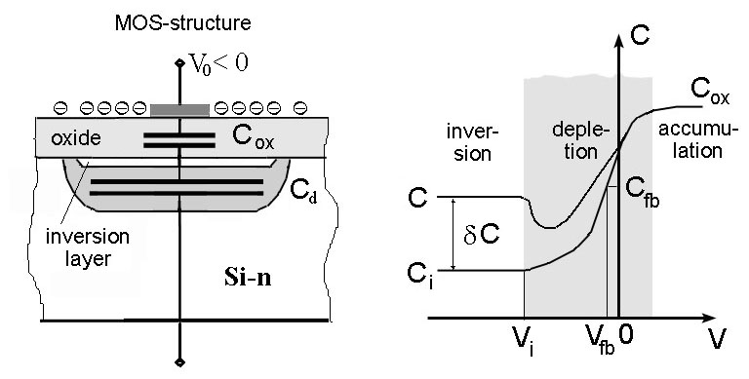
Figure 3. MOS capacitance after charge spreading.
Potential distribution along the surface of the MOS-structure, V(x,t), can be calculated with the help of an equivalent diagram (see Figure 4) which is represented as an R-C-G chain, where R is the surface resistance, C is the capacitance of the oxide film, and G is the volumetric conductivity of the oxide. Normally, oxide films have very low volumetric conductivities and can be neglected. Therefore, the potential distribution can be described by a simple telegraph equation:
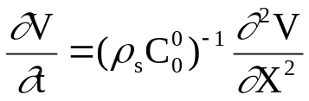, (1)
where C₀⁰ is the specific (per unit area) capacitance of the oxide.
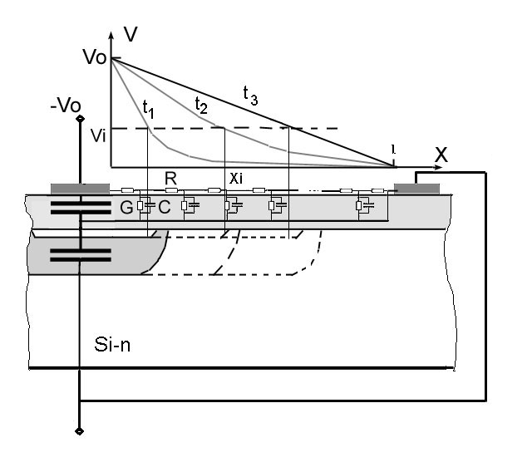
Figure 4. Equivalent diagram of a MOS-structure.
Using dimensionless coordinates: 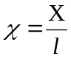, 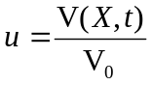, and 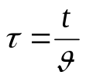, where 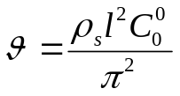, equation (1) can be simplified as follows:
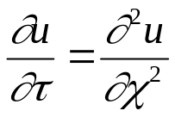 (2)
The initial and boundary conditions are:
u(χ,0) = 0 at 0 < χ < l
u(0, τ) = 1 (3)
u(1, τ) = 0
The solution for (2), (3) is:
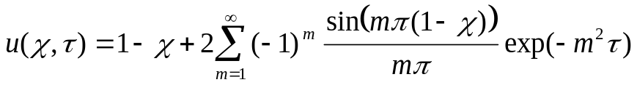 (4)
Figure 5 shows potential distributions calculated at different τ. At τ ≥ 3, a steady-state condition exists and θ is the characteristic time of this process. Using the plot in Figure 5, the dependence of the inversion area size on time, X_{i}(t), can be obtained from the following equation:
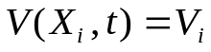 (5)
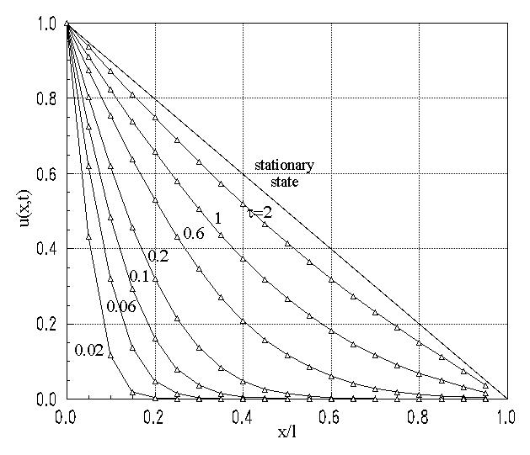
Figure 5. Calculated potential distribution along the surface of an MOS-structure.
An increase in inversion area, X_{i,} results in an increase in the capacitance of the MOS-structure, C. In the frequency range of 100 Hz to 100 KHz, the resistance of the inversion layer is negligible compared with the capacitance impedance [7]. In this case, the capacitance will depend only on the size of the inversion area:
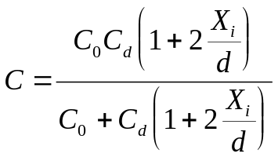, (6)
where 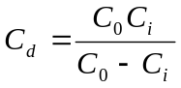 is the capacitance of the depletion layer.
This equation allows one to calculate the size of the inversion area using the capacitance measurements:
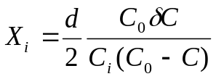, (7)
where δC=C-C_{i} (see Figure 3).
The MOS capacitance parameters, C₀ and C_{i}, as well as the potential of inversion V_{i}, can be found from the initial C-V characteristic (see Figure 2) or from measurements of an additional MOS capacitance structure with a low perimeter-to-area ratio.
Using the plot of u(χ,τ), which is shown in Figure 5, and the size of inversion area, X_{i} , which may be calculated using Eq.(7), one can then determine the corresponding rated time, τ, and calculate the surface resistivity as follows:
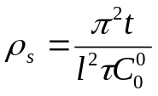 (8)
To illustrate, Figure 6 displays the relationship of ρ_{s} and δC for different values of u_{i}, where u_{i} = V_{i}/V₀. Calculations have been made for an MOS-structure consisting of n-type of silicon with 20 ohm-cm resistivity and an 1100Å film of thermally grown oxide. This MOS structure featured the following parameters: d = 10 μm, l = 60 μm, C₀ = 100 pF, C_{i} = 17 pF, V_{i} = -1.5 V. The measurement time, t, was 10 minutes.
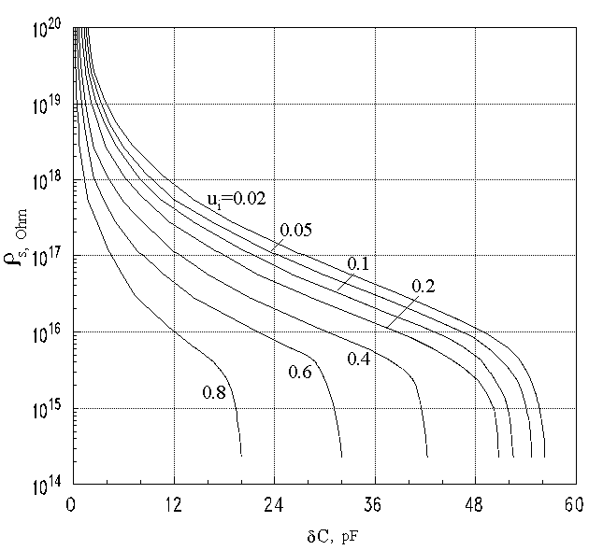
Figure 6. Surface resistivity-capacitance relationship as a function of the rated inversion potential u_{i}.
As can be seen, capacitance changes of several tenths of picofarads correspond to a ρ_{s} of more than 10²⁰ ohms. Similar changes can be reliably measured using a digital R-C-L bridge. When applied to MOS structures with larger perimeter-to-area ratios and thinner oxides, the sensitivity of this technique can be increased to more than 10²¹ ohms. A software routine has been developed which allows calculation of the specific resistivity of a silicon oxide-molding compound interface using the above-described capacitance variance measurements. It allows calculation of ρ_{s} for any measurement time and for MOS structures with various dimentional and electrical parameters.
To check how the developed model correlates with experimental data, measurements, at room ambient conditions (T=22°C, RH=43%), were taken for unencapsulated MOS structures. These structures had the following characteristics: d = 15 μm, l =60 μm. C₀=85 pF, C_{i}= 23 pF, V_{i}=-2V, and V₀=-5V. Experimental and calculated C(t) curves were observed to be very similar (see Figure 7) conforming the validity of the model used.
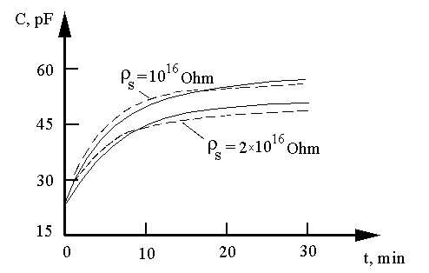
Figure 7. Experimental (solid lines) and calculated (dash lines) C(t) relationships for
two MOS structures (22°C and 43% RH).
The results obtained using this technique were also compared with calculations of surface resistivity using leakage current measurements. Leakage currents usually decrease slowly with time due to charging of the distributed capacitance and due to polarization of electrodes and oxide. To decrease the error caused by polarization, measurements were made at a steady-state condition after the voltage (5V) had been applied for 30 minutes. Three groups of samples, each of which was manufactured at a different time, were tested using both techniques. Results (see Table 1) were fairly consistent for each sample in which ρ_{s} was less than 1×10¹⁶ ohms. For larger resistivities, the C(t) technique resulted in surface resistivities with values which were 3 to 8 times higher. This was likely due to the presence of parasitic leakage currents during the measurements.
Table 1. Comparison Between ρ_{s} Measurements Using C(t)
and Leakage Current Techniques
Group | Sample | ρ_{s} , ohms  [C(t)] | ρ_{s} , ohms  [leakage current]
 | 1 | 1.5×10¹⁵ | 2×10¹⁵
I | 2 | 2×10¹⁵ | 2.2×10¹⁵
 | 3 | 3×10¹⁵ | 2.6×10¹⁵
 | 1 | 12×10¹⁵ | 7.5×10¹⁵
II | 2 | 7×10¹⁵ | 6×10¹⁵
 | 3 | 7×10¹⁵ | 5×10¹⁵
 | 1 | 1×10¹⁷ | 0.3×10¹⁷
III | 2 | 2.5×10¹⁷ | 0.3×10¹⁷
 | 3 | 0.8×10¹⁷ | 0.15×10¹⁷

EXPERIMENT
The C(t) measurement technique was used to evaluate the quality of four epoxy novolac molding compounds (EN-E11, EN-E91, EN-MP, and EN-HC) which were obtained from two Japanese manufactures. A layout of the used test vehicle which was used is shown in Figure 8. The structure contained two types of MOS capacitors: a test capacitor with a large perimeter-to-area ratio and a reference capacitor with a small perimeter-to-area ratio. Aluminum lines were used for corrosion measurements. Thensoresistors, which can be used to evaluate mechanical stresses, were olso included in this vehicle, however, these were not used in this experiment. The test capacitor featured a multiple-fingered electrode with a perimeter of 76 mm and an overall area of 0.65 mm². The reference capacitor featured a rectangular electrode of the same area and was used to extrapolate C₀, C_{i}, and V_{i} parameter values for the MOS structure. Meandering aluminum lines were used to evaluate materials’ corrosivity. All test vehicles were encapsulated in 16-lead DIP packages.
Ten samples with each type of encapsulating material were subjected to pressure cooker testing (PCT) at 121°C and 100% RH. Additionally, the samples encapsulated with EN-H were stored at 100% RH and at temperatures of 20°C, 85°C, and 100°C to check temperature effects on the interface resistivities. Periodically, the resistances of the aluminum lines and ρ_{s} values (using C(t) technique) were measured at room temperature. Resistance changes of more than 10% in the aluminum lines were considered to be failures. Resistance to corrosion was evaluated by calculating the median time to corrosion failures using log-normal plots.

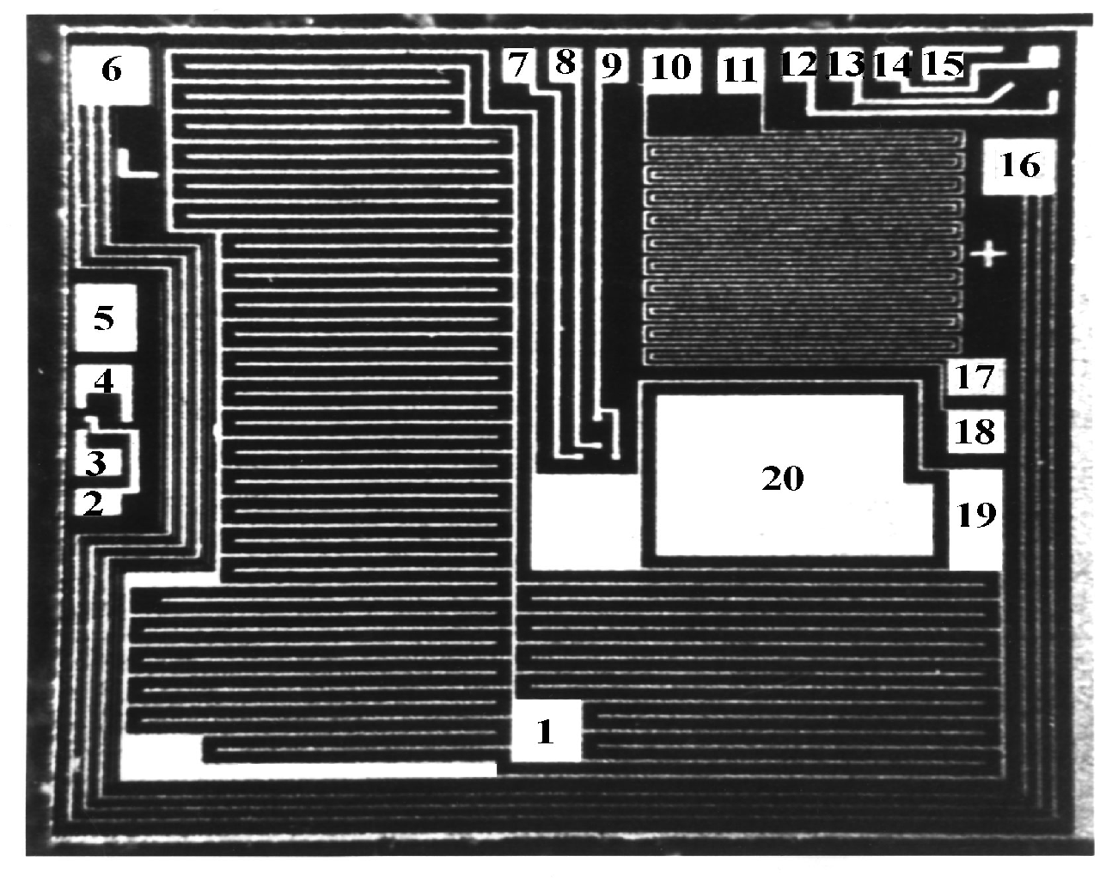
Figure 8. Test structure layout.
1 - MOS capacitance structure with large perimeter-to-area ratio; 19 - equidistant electrode connected to the substrate (5); 20 - a reference MOS capacitor;
6-16, 10-18, and 11-17 - aluminum lines;
2-3-4, 7-8-9, and 12-13-14-15 - groups of thensoresistors (were not used during the experiment).
Figure 9 shows the time dependence of the interface resistivity during humidity aging at different temperatures. At all temperatures, ρ_{s} initially remains high, but then drops approximately 5 to 6 orders of magnitude. The approximate times, τ_{r}, until ρ_{s} drops dramatically, are shown in Table 2. Calculated times, τ_{d}, which are required for moisture to diffuse to the die surface, are also displayed. τ_{d} =4L²/π²D where D is the diffusion coefficient and L is the molding compound thickness above the die. As shown, τ_{r} and τ_{d} are in reasonably good agreement suggesting that no moisture penetration along the lead-encapsulating material intrerface occurred.
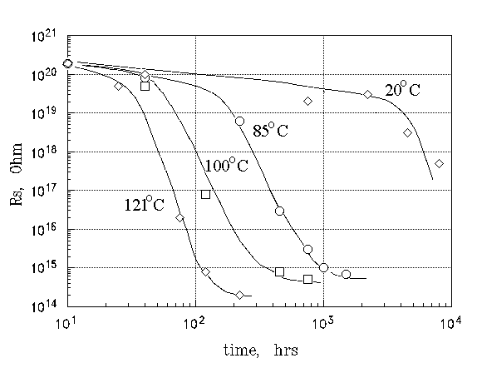
Figure 9. Effect of temperature on the interface resistivity during humidity aging
at 100%RH.

Table 2. Comparison of the times τ_{r} and τ_{d} (hours) for 16-lead DIP packages.
Parameter | Temperature, °C
 | 20 | 85 | 100 | 120
τ_{r} | 10,000 | 400 | 120 | 50
τ_{d} | 4500 | 350 | 95 | 35

Figure 10 shows changes in the interface resistivities obtained for different encapsulating materials during PCT. All encapsulating materials initially exhibited similar and high (>5×10¹⁹ ohms) values of ρ_{s} which then dropped after approximately 35-70 hours. This suggests that all materials had similar diffusivity coefficients. However, the interface resistivities of these materials, under steady-state conditions, differed by approximately three orders of value. This indicates essential differences in conditions at the die-molding compound interfaces and results in significant differences in the corrosion resistance of aluminum metallization.
Figure 11 shows the correlation between the median time to corrosion failures τ₅₀ and the interface resistivities for those materials mentioned above, together with some other materials which were investigated using the same technique.
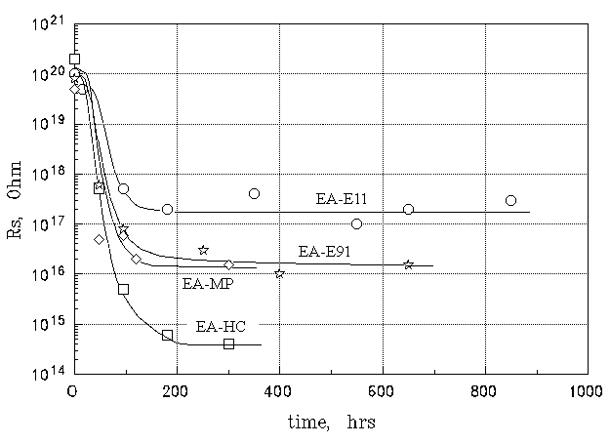
Figure 10. Effect of molding compound on the interface resistivity.
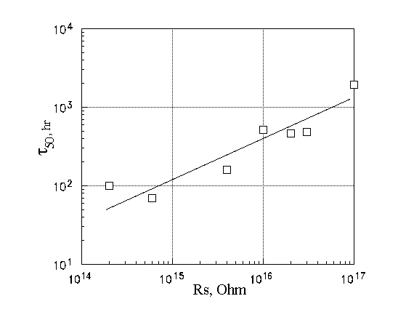
Figure 11. Median life for aluminum corrosion vs. interface resistivity during PCT at 121°C and 100% RH.
CONCLUSION
- A C(t) technique for measuring the specific resistivity of die-molding compound interfaces has been described. This technique utilizes an MOS capacitance structure with a large perimeter-to-area ratio as a sensor and is based on the lateral spread charging phenomenon.
- A simple R-C equivalent circuit has been shown to be adequate to describe this lateral charge spreading phenomenon and the associated capacitance changes in the MOS structure. Calculations and experiments have shown that the technique allows calculation of specific resistivities up to 10²¹ ohms.
- Different types of molding compounds exhibited similar times (35-70 hours) for moisture to penetrate to the die surface during PCT at 121°C/100%RH. However, these molding compounds exhibited die-molding compound interfaces with different specific resistivities ρ_{s} (4×10¹⁴ ohms to 2×10¹⁷ ohms). The results of ρ_{s} calculations correlated well with the median life time of aluminum corrosion.

REFERENCES
1. K.Tsubosaki, Y.Wakashima, N.Nagasima, “Rate-determining factor of aluminum corrosion and a rapid method of assessing the moisture resistance of plastic encapsulated LSI”, 21st Ann. Proc. Reliab. Phys., pp. 83 - 89, 1983.
2. R.B.Comizzoli, L.K.White, W.Kern, G.L.Schnable, D.A.Peters, C.E.Tracy and R.D.Vibronek, “Corrosion of aluminum IC metallization with defective surface passivation layer’, 18st Ann. Proc. Reliab. Phys., pp. 282 - 292, 1980.
3. S.P.Sim and R.W.Lawson, “The influence of plastic encapsulants and passivation layers on the corrosion of thin aluminum films subjected to humidity stress”, 17st Ann. Proc. Reliab. Phys., pp. 103 - 112, 1979
4. A.Teverovsky, “Degradation of encapsulating materials and plastic packages for microcircuits under moisture environments”, 6th International workshop on moisture in microelectronics, NIST, 1996.
5. R.P.Merrett, J.P.Bryant, and R.Studd, “An appraisal of high temperature humidity stress tests for assessing plastic encapsulated semiconductor components’, 21st Ann. Proc. Reliab. Phys., pp. 71 - 82, 1983.
6. E.R.Schlegel, G.L.Schnable, R.F.Schwarz, “Behaviour of surface ions on semiconductor devices”, IEEE Trans. on ED, v. ED-15, N12, p.973, 1968.
7. A.Teverovsky, B.Omarov, T.Volkova, “Frequency dependence of the inversion layer channels in MOS-structures”, “Electrical relaxation in microcircuits”, pp. 30-34., MIEM, Moscow, 1988.

