Tram-trains for the Changing Metropolitans

In US and around the world, there has been an increasing demand for a seamless passenger rail system in large metropolitan areas. With aging population, increased migration to these areas, traffic congestion, high cost of gas and infrastructure, the need for an efficient rapid rail transit system becomes increasingly clear. One innovation is a shared-use light rail system or tram-train, which could provide large-capacity rapid transit using existing rail infrastructures. Unlike a new rail corridor that requires extensive land for its right-of-way, this service can use existing rail network from downtown to the suburbs and even to cities 50 miles or farther. To hasten such systems, we need a supportive public policy and detailed risk assessment method that will demonstrate the true economic and environment benefits of this innovative system compared with other modes of surface transportation, such as highways and conventional commuter and rapid rail systems.
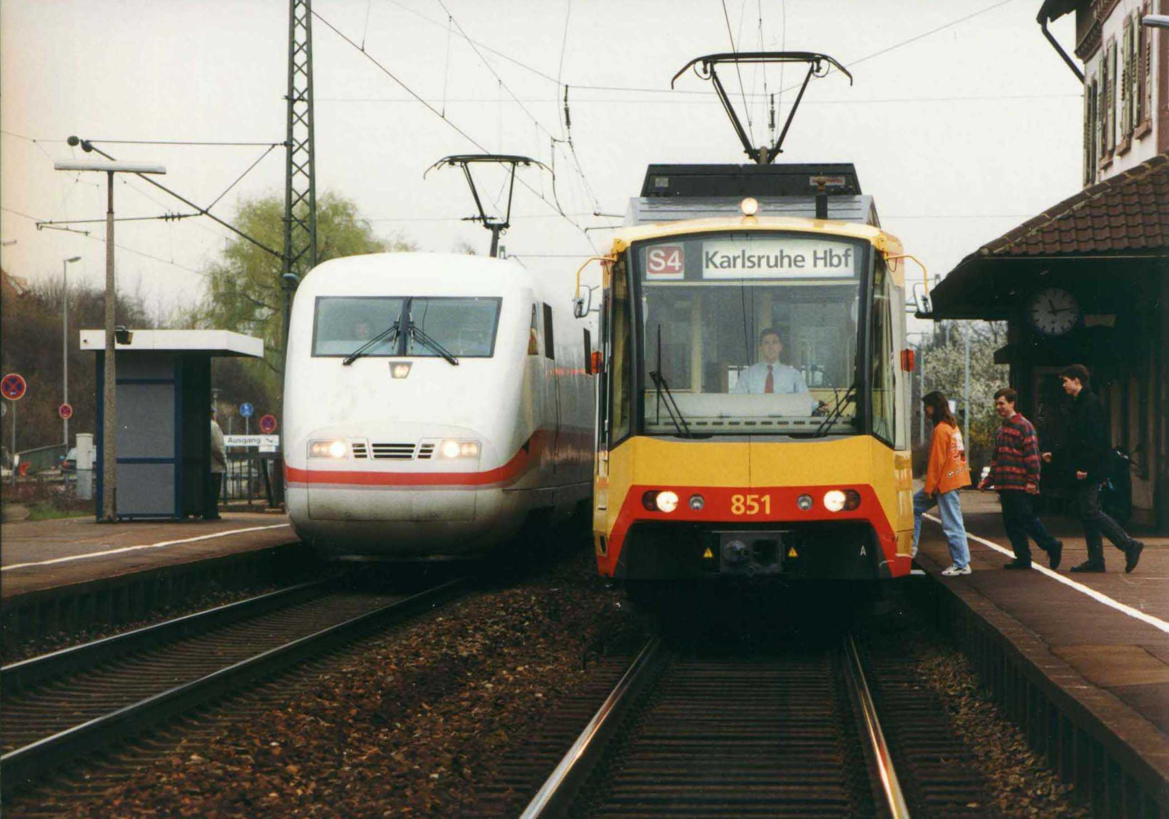
Here is a tram-train alongside a high-speed train in Germany.
INTRODUCTION
In August 2008, the U.S. Census Bureau released projections that the United States will be more diverse racially and ethnically, and much older, by mid-century. Minorities, now about a third of the population, will exceed 50 percent in 2042, and will constitute 54 percent of the population in 2050. In 2030, when the baby boomers will be 65 years old or older, nearly one in five U.S. residents will be 65 or older. This age group will increase to 88.5 million in 2050, more than double its 38.7 million in 2008. Similarly, those 85 years old and older will more than triple, from 5.4 million to 19 million between 2008 and 2050. By 2050, the minority population, that is everyone except non-Hispanic, single-race whites, will constitute 235.7 million out of the total population of 439 million.
At about the same time, the Transit Vision 2050 of the American Public Transportation Association (APTA), projects that the 83 percent of the U.S. population living in the top 100 metropolitan areas today will increase to about 90 percent in 2030. Also, population has increased in several parts of the United States and Canada showing the emergence of very high population clustering, accompanied by integrated regional labor markets, infrastructure, and cultural and land-use patterns. Just as metropolitan regions grew from the cities of the 20th Century, the mega-regions will take over that role in the 21st Century. While the transportation vision of the second half of the 20th century transportation was to build a network of high-speed interstate highways to connect the nation, the first half of the 21st Century requires a new transportation policy to make our metropolitan regions mobile, efficient, economically strong, and connected with one another and with heartland areas.
In a U.S. Department of Transportation (USDOT) program plan entitled “Refocus. Reform. Renew.- A New Transportation Approach for America”(Plan), also released in August, 2008, “Reducing congestion in major metropolitan areas” is one of its primary objectives. The Plan said that, according to the Brookings Institution, the 100 largest metropolitan areas in the U.S. are home to 65% of the nation’s population and 68% of the nation’s jobs, and generate 75% of the country’s economic output, and in 2005, 95% of the nation’s trade moved through these metro areas. Unfortunately, these same cities are experiencing a growing crisis of congestion and metropolitan mobility. According to the Texas Transportation Institute, on highways in major U.S. metropolitan areas, between 1982 and 2005, hours of delay per traveler nearly tripled and total delay and wasted fuel increased by more than four-fold. Congestion not only limits mobility but also impedes efforts to improve air quality and reduce transportation’s share of greenhouse gas emissions. Thus, it is clear that effective congestion relief strategies must be pursued. It also said in part that targeted incentives to use rail as an alternative mode to highway movement can help to relieve congestion and lower the amount of highway maintenance.

Anticipating the needs of our metropolitan areas due to this coming demographic change, the transportation community has searched for innovative options over the last decade. Among all options studied, the shared-use light rail or tram-train service has shown to be a seamless passenger service suitable to meet the transportation need in emerging metropolitan corridors without existing rapid rail services. This system with light rail or diesel multiple unit(DMU) equipment could run on the street as well as on mainline existing tracks used by conventional freight and passenger trains (1, 2, 3, 4). . It could provide direct rail links from suburban to downtown business districts. Two recent research projects sponsored by the USDOT have shown the benefits of this innovative rail service. Proposed demonstration projects, if funded, could further prove its business viability.

However, the current federal safety regulations, developed for conventional rail equipment, would require a risk assessment using the criteria of “equivalent safety”, sometimes create an unfavorable burden to any innovations. Since the objective of the Plan is to reduce congestion of our highways around the metropolitan areas, a safety-and-benefit analysis should include all comparable ground transportation systems to reach a valid and balanced comparison of true benefits and safety.

This paper will summarize the present status of tram-train development and proposed approaches. In the next section, it will describe the tram-train here and abroad and the associated safety analysis method being used today. Afterwards, it will propose an analysis method and conclude with some recommendations.

DEVELOPMENT OF TRAM-TRAINS

Mixed use of light rail and conventional rail vehicles on common tracks or corridors is not new in the United States. But it was discarded in the 1960’s along with numerous urban rail infrastructures. The modern tram-train system begins with the conversion of the light rail system in Karlsruhe, Germany, in 1992, on the Karlsruhe-Bretten-Gölhausen line, with a total length of 30.2 km. (Figure 1). The success of the system led to its extension to other lines around Karlsruhe.

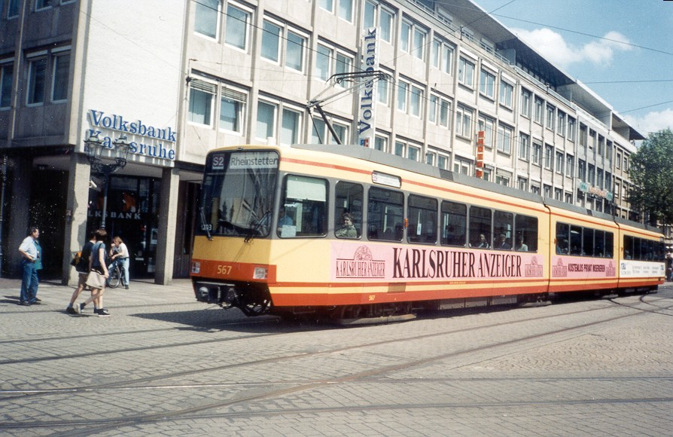
Figure 1 Tram-train of Karlsruhe, Germany

Several cities in Europe and the United States have found it advantageous and irresistible to use light rail vehicles (Figures 2 and 3) or diesel tram-train (Figure 4) to extend rail service from city center to suburbia via existing conventional railroad. This seamless mode of transportation offers the most attractive and cost-effective service to move large numbers of people through metropolitan areas directly from homes to business centers without the need of transfer stations, such as those between commuter rail and subway services.
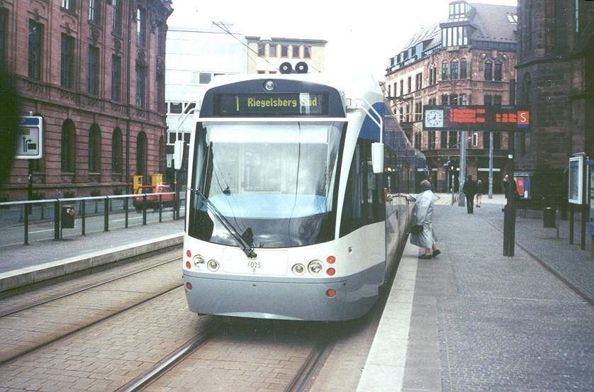
Figure 2 Tram-train of Saarbrucken, Germany

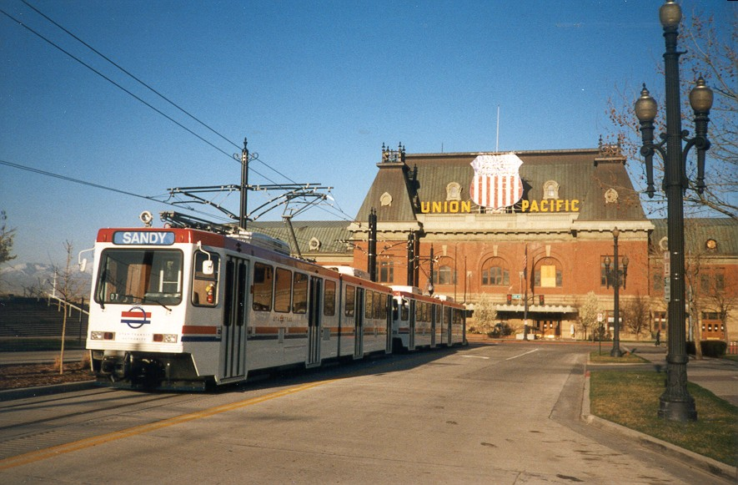
Figure 3 Tram-train of Salt Lake City
Using the rail network of French National Railways, the Saarbrucken light rail system became the first international light rail operation. As a result, more cross-border operations are being planned to integrate the routes of four operators: Saarbahn, DB, SNCF, and Luxembourg Railways. Other track sharing tram-train systems, which use diesel as well as electric vehicles under various stages of operation and planning, include those of Cologne and Kassel in Germany, Sunderland in England, and small to mid-sized cities like Dueren, Germany which utilized diesel vehicle technology. Similar tram-train services that have been in place or planned for many other cities in Europe, Asia, and the United States are part of a survey in a technical report on Intelligent Transportation Systems (ITS) Technologies for Integrated Rail Corridors that the Federal Railroad Administration (FRA) will publish soon. The latest addition to those in service is the MetroRail of Austin, Texas that will start operation in October this year. It will employ DMU rail cars to serve downtown Austin that has not seen rail service over a century.

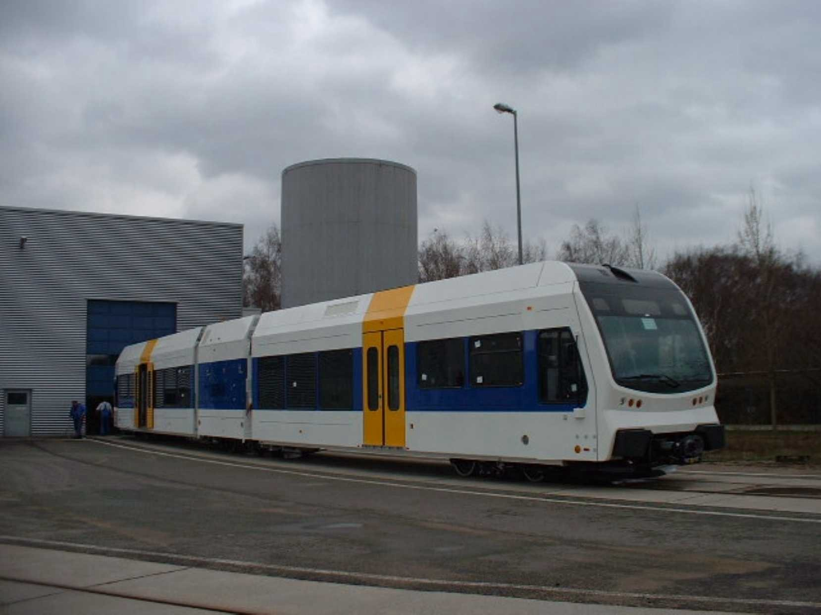
Figure 4 Diesel Tram-train in River Line, New Jersey.

SAFETY ASSESSMENTS

The safety of tram-trains services in Europe is normally assured by following national and regional regulations on railroads and street cars. Such services may also be subjected to additional requirements for vehicle design and operational control, such as speed, separation distance, and braking performance.

In the U.S. the FRA, who has authority over all railroad safety issues, has yet to establish the requirements for tram-train services, other than a wavier process and a public policy statement jointly developed with the Federal Transit Administration (FTA) which usually funds all transit services in the metropolitan areas. All the existing or planned tram-train services are using light rail or DMU vehicles that are non-FRA-complaint equipment which means that they do not meet current FRA safety regulations, particularly in its structural and glazing strength requirements. Under the joint policy, details of proposed plant, equipment, and operations must be submitted to the FRA in a waiver request. To date, the FRA has only granted waivers for operations where the passenger and freight services are subject to strict time-of-day separation. As part of the wavier request, a safety assessment is required to show the “equivalent safety” of the tram-train service. Although no specific basic systems, or baseline safety criteria is mentioned, it is assumed that any proposed new rail equipment should be as safe as a similar service provided by a FRA-compliant or conventional passenger rail equipment.

Based on previous safety assessments performed for some high-speed trains and the Spanish Talgo train set, a typical safety analysis approach was developed for non-compliant equipment (6). A similar version of this method was also used to assess the safety of tram-train services in a TRB/Transit Cooperative Research Project (TCRP), entitled, Shared Use of Railroad Infrastructure with Non-compliant Public Transit Rail Vehicles, for which a final report will be published early next year. A simplified flow chart of such analysis is shown in Figure 5.

The results of safety assessment using this method with several operational assumptions or options of a representative tram-train service have shown that, given an adequate train control system, simplified crash analysis, other reasonable risk mitigation measures, and limited conventional freight services on the same track, such tram-train operation could be as safe as a conventional passenger rail service. When published, the aforementioned FRA and TCRP reports will present details of the analysis and results, an established business model, and some proposals for a tram-train demonstration project.

Route and Operations Characteristics
Figure 5 Flow Chart for Safety Analysis of Non-FRA-compliant Rail Equipment
Calculate Safety Performance for Each Case
Past Experience, Accident History
Design Data
Accident Data
Sensitivity Analyses

Results
Identify Hazards and Accident Scenarios
Characterize Accident Scenarios
Compare:
With/Without Conventional Operations.
With/Without Risk Mitigation

Establish Basis of Comparison
Case
Studies

A NEW APPROACH FOR TRAM-TRAIN ASSESSMENT

The proposed USDOT program plan “Refocus. Reform. Renew: A New Transportation Approach for America,” released in August, 2008, called for a new approach for surface transportation. Among other things, it called for a data- and technology-driven approach to safety to: (a) strengthen the effectiveness and efficiency of Federal surface transportation safety programs, (b) emphasize the importance of risk-based, data and technology driven approaches that recognize the diversity of safety challenges across the nation, (c) replace a variety of narrowly-focused safety programs with an integrated safety grant program that builds on the successes of the existing Strategic Highway Safety Plans, and (d) encourage the use of crash-avoidance technologies.

The Plan also called for the use of benefit-cost analysis (“BCA”) in the selection of transportation projects with the highest return to each dollar invested in our transportation systems. It aimed to help agencies to organize and document their decision processes and to identify risks and the most cost-effective means to mitigate them. Benefits typically measured and monetized in BCA should include reductions in travel time and vehicle operating costs as well as improved safety, reliability, convenience, and passenger comfort.

The Plan noted that existing Federal transportation programs are ill-suited to respond to the growing crisis of metropolitan transportation congestion. Thus, many metropolitan areas have been slow to adopt innovative transportation policies, technologies, and financial arrangements. To this end, the Plan proposed a Metropolitan Mobility (MM) program that would address these issues by providing substantial amounts of performance-based transportation funding directly to metropolitan areas with populations greater than 500,000. The Plan would allow recipients broad multi-modal flexibility in selecting projects for the movement of people and goods to reduce highway fatalities and congestion with improved environment. The Plan also proposed a performance-oriented pilot (POP) that would help innovative projects like the tram-train.

In view of the new approach proposed to address the transportation problems of metropolitan areas generated by the demographic transition to an increasing aging population and a greater concentration of new immigration internally and from abroad, an innovative system like the tram-train service should be evaluated, not only by the “equivalent safety” wavier process of FRA, but also by a BCA for its contribution to the safety, congestion and environment benefits of the entire region.

Even the safety performance of such system should not only be compared to that of an equivalent conventional rail service but to all other surface transportation systems SERVING the same corridor because most of the passengers who woould ride the tram-train would come from the automobiles. Such a safety assessment approach was included in the evaluation of the maglev system (7) by the USDOT to account the lives saved as a result of diverting trips from highway to maglev service. In addition, recent studies of the National Safety Council, as reported in their 2005-2006 Injury Facts, showed that transit rail riders are 14 times safer than those traveling by car. Only by comparing the safety of all surface transportation services, can a fair BCA be conducted.

CONCLUDING REMARKS

The great success of the tram-train concept has been reflected in a large increase in the number of passengers. One of the main advantages of the tram-train concept is the reduction of the door-to-door travel time while making use of the older rail networks with advanced light rail vehicles. Unlike the old street cars, the tram-train would provide a truly integrated rail system to compete effectively with private cars, but with less investment and with a lower impact on the environment than a rapid rail system with completely new lines. In short, this type of service offers a number of advantages such as:

Existing traditional railway infrastructure can be used, thereby reducing the amount of investment necessary in new lines.
With additional stations, better equipment and shorter transient time, more people will use the system.
With shared operations and crew, this system will be more efficient than conventional systems, thus, it will reduce cost of operations and equipment.
With direct access from the region to the main business and shopping centers, it will help revitalize downtown areas and provide a better quality of life for residents in general.

This service should help address the transportation problems of metropolitan areas due to our aging population and greater concentration of immigrants. To make this tram-train and similar innovative systems viable, it should be evaluated, not only under FRA’s “equivalent safety” waiver process, but also under a benefit-cost analysis for its contribution to the safety, congestion, and environmental benefits of the entire region.

As our transportation infrastructure matures and demographic changes accelerate toward more and larger metropolitan areas, it is clear that tram-train services will be an attractive option. While the commingling of different rail equipment is not new, it is crucial that transportation planners are aware of this option and that they take a proactive approach to regulations, physical plants, equipment, procedures, and public policies to ensure excellent transportation services for our nation.

To this end, a research project or pilot demonstration project with detailed anaylsis and comparison of various acceptable criteria of the safety assessment is recommended, in addition to the apparent acceptability of “equivalent safety”.

REFERENCES

1. Tsai, T., Tram-Train: Mixed Use of Rail Corridors; Paper IMECE33252, International Mechanical Engineering Congress and Exposition, New Orleans, LA, November 2002

2. Phraner, S.D. et al, Joint Operation of Light Rail Transit or Diesel Multiple Unit Vehicles with Railroads, Transportation Research Board, TCRP Report 52, 1999; and TRB Supplementing and updating TCRP Report #52, June 2001

3. “Germany’s Track-Sharing Experience: Mixed use of rail corridors” TCRP Research Results Digest 47, March 2002

4. Novales, M., A. Orro and M. Bugarin, “The Tram-Train: A New Public Transport System”, TRB 81st Annual Meeting, Washington, D.C. January 2002

5. Resor, R., Catalog of “Common Use” Rail Corridors, Report DOT/FRA/ORD-03/16, April 2003

6. Bing, A., et al, Safety of Non-compliant Passenger Rail Vehicles, APTA/TRB Joint Light Rail Transit Conference, St. Louis, MO, April, 2006

7. The National Maglev Initiative, Final report, DOT/FRA/NMI-93/03, September, 1993

DRAFT 9/22/08

