MODULE 4

Facilities: Necessary Safeguards to Protect the Work Environment and Equipment

Training Notes
- Display: Module 4, PowerPoint slide 1.
- In the previous modules we have addressed the threats technology poses, the importance of personnel, and how we need to protect the child support data. Now, let's look at how to protect the work environment.

facilities: necessary safeguards to protect the work ENVIRONMENT and equipment
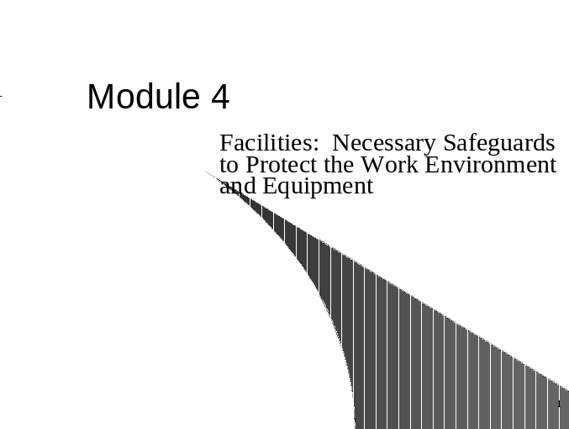
training notes
- Display: Module 4, PowerPoint slide 2 and explain bullet points.

Module Objectives

The learning goals for this module are for participants to be able to:

- Describe appropriate actions that will assist in providing protection of personnel.
- Define appropriate physical protections to safeguard the building and physical working environment.
- Explain what biometric protections are available and which may be appropriate for the child support environment.

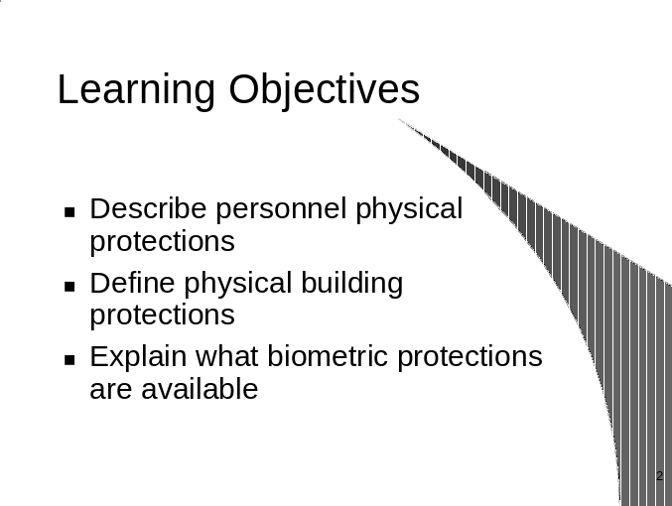

Training Notes
- In the previous modules we have discussed the threats that face the child support program today, how we can reduce risks by hiring appropriate personnel, and how we can protect the child support data.
- Now, let's look at safeguarding our environment.
- Display: Module 4, PowerPoint slide 3 and explain the bullet points.
- Have you ever heard of the term “Open Government”? Not in the sense that it was open in May 2000. A group of agents working for Congress’s General Accounting Office managed to wheedle their way into 19 of the federal government’s most “secure” buildings and two high-traffic airports, leaving red-faced security officers sputtering in their wake. The men, who were clutching briefcases and even told guards that they were armed (though in actuality they were not), carried forged credentials from the New York Police Department and the U.S. Drug Enforcement Agency and talked themselves through checkpoints without anyone raising a finger to search them. The agents were allowed to roam freely through the offices of Attorney General Janet Reno and Secretary of State Madeline Albright. Predictably, federal security officials claim that reports of breaches have already sparked intensive procedural reviews, adding that nay future tests would be met with a more vigorous line of defense.

Introduction
Child support offices can be targets for theft, unauthorized entry and access, threats, and physical abuse and harm. Effective barriers, both physical and psychological, can reduce the likelihood of these threats.
Many crimes are directed toward individuals or offices, which have little or no security planning in place. Take stock of your present measures and possible weak points. Remember that we need to be proactive in security, of all types!
This module will help you analyze your office and suggest measures to reduce potential harm.
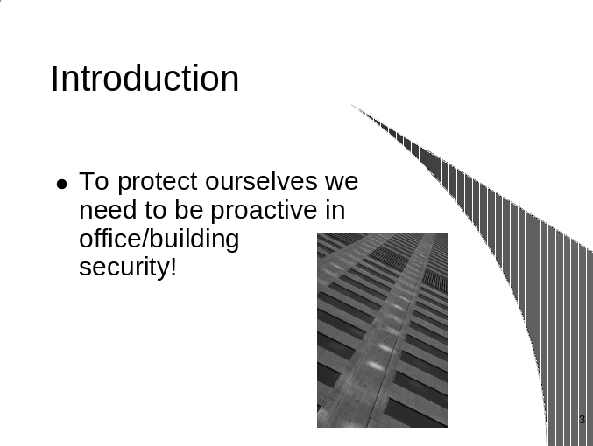
Training Notes
- Display: Module 4, PowerPoint slide 4 and explain the bullet points.
- As we discussed in Module 2, it is very important that your agency have dedicated staff and resources (especially a budget) for security measures.
- Security awareness should be built on a broad base, which begins at home, continues on the street and public transportation and culminates with sound security planning and practices in the employees' work areas.

How do we ensure personnel security?
Generally speaking, employees will tend to engage in those behavior patterns and carry out those tasks they believe respond to management requirements.
Management’s day-to-day practice of the security policies and procedures they have mandated is far more effective and convincing than being presented in a talk or through written communication.
- Management needs to make security a personal issue for each and every employee. Everyone needs to clearly understand his/her stake in security initiatives.
- Think Security. Each person is a "deputy" in the effort to maintain proper security. Good security practice flows down from top management. It is important for administrators to share security information with their staffs to increase the security consciousness of the entire organization. The key point is to recognize unusual activity.

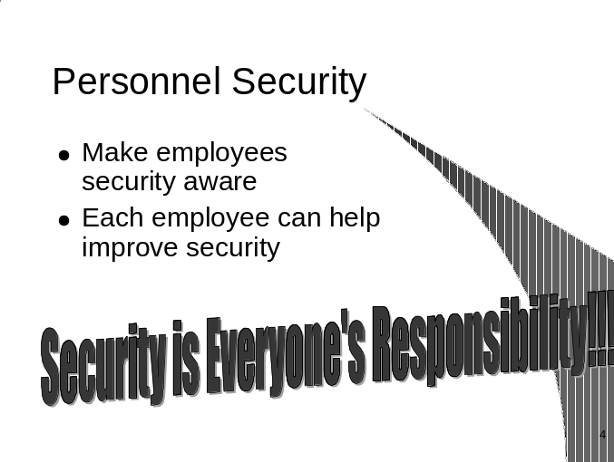
training notes
- Display: Module 4, PowerPoint slide 5 and explain the bullet points.
- Many people’s stature or dress is intimidating. There have been occasions when visitors have been let through locked, secure doors because they “look” responsible or have the appearance of being a professional. In a Maryland child support office an employee held the secure door open for a well-dressed man who appeared on a mission and to know where he was going. The employee did not ask the man who he was going to see or if he had checked in. The man found his way to the conference room where an employee staff meeting was being conducted. The well-dressed man spoke loudly and harshly to get everyone’s attention and opened his coat and displayed a wealth of firearms (guns, knives, etc). This turned out to be a planned security drill, but it could have very easily been a real disaster. The man was able to gain access, wander through the secure building, and carry firearms with no challenge. Have you ever passed someone in the hall and wondered who that was? ASK!
- All employees should have photo identification cards. Such cards make identification of non-employees immediate by their absence, and questions of identity are easily settled by producing the cards. Visitors should be issued a temporary identification badge.
- A security desk should be set up in the main lobby of each building which has an open-access or open-door policy. A sign-in/out log book, supervised by an employee who validates identification prior to allowing visitors to proceed into the building, is highly advisable.

Personal Physical Security
Management must ensure that employees are aware of all security policies and procedures. Appropriate policies should require that:
- All staff should wear ID badges.
- All staff should be vigilant and always leave an escape route when interviewing the NCP or CP.
- All staff should challenge wandering or “lost” visitors and escort them to the right office. Watch for “head popper” who opens wrong doors—ask who they are here to see and escort them appropriately.
- Personnel are educated on appropriate reactions to threats. (Including phone, physical, viral and bacterial).

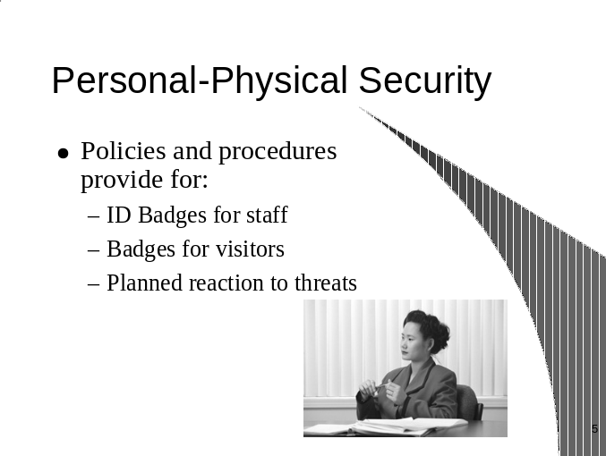

training notes
- Display: Module 4, PowerPoint slide 6 and explain the bullet points
- The value of adequate lighting as a deterrent to crime cannot be overemphasized. Adequate lighting is a cost-effective line of defense in preventing crime. All sides and approaches to the facility should be illuminated. Lighting should be directed downward and away from the facility and away from personnel assigned to patrol the facility. The goal is to create as few shadows as possible. Perimeter lights should be installed so the cones of illumination overlap, eliminating areas of total darkness if any one fails to light.
- Is the receptionist equipped with a panic button for emergencies? Or is there a camera with a monitor at another employee's desk? Is there a lock on the front door that can be controlled? Is the receptionist protected with bulletproof glass?
- Closed-circuit television such as systems that permit surveillance of exterior exits and interior halls by a trained security officer at a master console.
- An SOS button or silent alarm transmitter device should be located so that it can be activated without any unnatural or sudden movements. Such movements can be very dangerous when facing an emotionally disturbed or angry person.
- Key control for all doors should be strictly maintained. Key possession should be limited to a "must have" basis or one of "demonstrated need." If a key-holder leaves the institution or changes position, and no longer requires a key, the cylinder should be changed and all keys reissued.
- In evaluating your security posture you may require professional assistance. Start by contacting your local law enforcement agency and request help from the Crime Prevention, Crime Resistance, or Burglary Prevention Officers. These specially trained officers can offer expert guidance. Keep in mind that the officer is not selling a product or system but is there to help you.
- Remind participants that protections such as panic buttons or SOS buttons must be accompanied by proper procedures for staff to know who is responsible for what, what to do and how to react when the button is utilized.

Building protections
The security procedures should address the establishment or use of:
- Armed security guards who control access to the building, prohibit firearms or take them before allowing access to premises.
- Reception personnel are protected with bulletproof glass.
- Secure access to include door codes (cypher locks and procedures for regular updating of code).
- The physical arrangement of furniture in interview rooms and offices. This should include constructing “natural” barriers to separate employee from customers and visitors (e.g., desks, countertops, partitions).
- Closed-circuit television or video cameras should scan all areas for public and employee safety.
- Interview rooms should be supplied with panic buttons.
- Make sure to close and lock all windows, activate alarms if present.
- Lock all offices, conference rooms, or storage rooms.
- Exterior lighting is sufficient for parking lots and sidewalks.
- State or local police departments provide periodic security assessments.
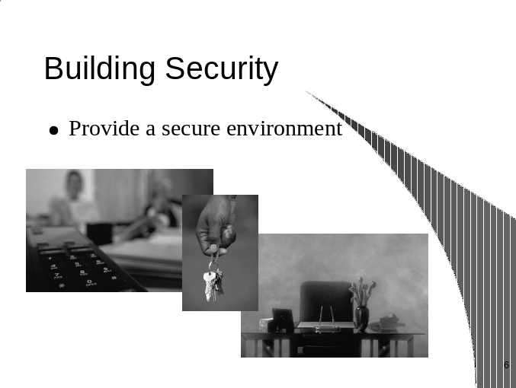
training notes
- Display: Module 4, PowerPoint slide 7 and explain the bullet points
- Windows should provide light, ventilation and visibility, but not easy access. Glass bricks can be used to seal a window, allowing a continued light source while providing increased security, although visibility and ventilation will be lost. Gates and expanded steel screening, while often unattractive, will provide a high degree of security. Local building codes and fire safety regulations should be consulted prior to all such installations to avoid costly violations.
- Ideally, an agency should have a single entrance monitored by a staff person, and equipped with an intercom system for communicating with anyone who comes to the door. External barriers may also be considered.

Protections to consider
Management should also consider the following protections:
- Move child support office to a higher floor.
- A single public entrance to customer service area.
- Window in supervisor’s office from which the supervisor can view customer service area.
- Block or secure first floor windows to prevent break-ins and/or harassment through the window.
- Place planters and concrete barriers in front of the building entrances to prevent vehicles from gaining close proximity to the building.
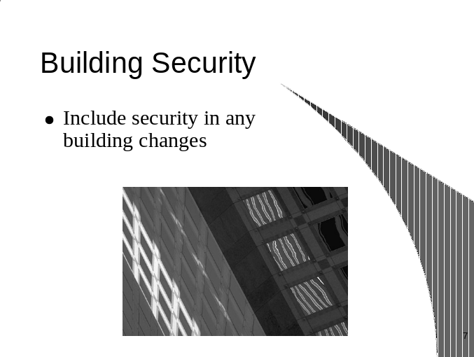
training notes
- Display: Module 4, PowerPoint slide 8 and explain the bullet points
- Fingerprint scans to get into the office. A thermal readout of facial features to log onto a PC. That's the stuff of sci-fi movies, right? Not anymore. Biometrics—the measurement of a distinctive biological trait used to control access—is already being used in hospitals, airports and laboratories worldwide. As new systems are developed and prices start to fall, the ID verification industry will be taking biometrics into the mainstream.
- A new wave is washing over ID verification systems, leaving more secure systems in its wake. Biometric technology solves problems that have plagued password systems and ID checks—forgotten passwords and lost or stolen IDs.
- Florida State officials recently released an proposal for their planned “Medicaid Biometrics Authorization System”(MBAS). The purpose is to reduce Medicaid fraud in Florida. The MBAS will ensure that a person can have only one identity record in the system.

Futuristic Protections (Biometrics)
Biometrics is the next wave of network security. Currently a $25 million a year industry, biometrics will, by some estimates, expand into the billions in the 2000’s. Some predict the rush to install biometrics security systems will replace the Year 2000 (Y2K) computer crisis as the most pressing high-tech project now that the Y2K crises has passed.
Biometric identification refers to a technology that uses a measurable physical characteristic to recognize the identity, or verify the claimed identity. Automated identification systems use scanned graphical information from many sources for evaluation and identification purposes.
The idea of using your physical attributes—fingerprints, a voiceprint, or any of several other characteristics—to prove identity has a lot of appeal. Passwords and personal identification numbers (PINs) are fraught with problems. Biometrics offers solutions. Applications that are preparing to accept biometric data include computer networks, ATMs, cars, cellular phones, and dozens of other types of embedded systems.
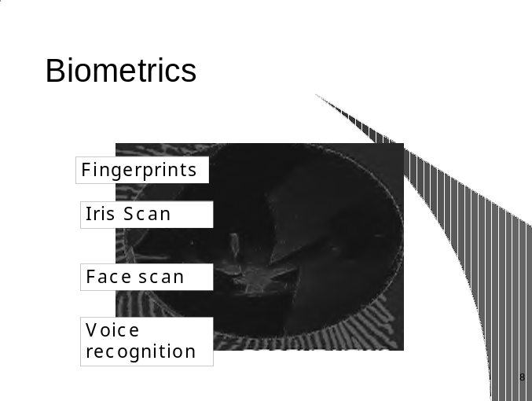
Training Notes
- Display: Module 4, PowerPoint slide 9 and explain the bullet points.
- Ask participants to discuss any ideas for new and innovative security measures they’ve heard about.
- Connecticut Department of Social Services uses fingerprint biometrics to eliminate welfare fraud. Biometrics identification deters fraud by indicating that a new enrollee is someone already in the database, based on matching a biometrics template. Negative information indicates that the enrollee is not someone known to the database.
- Windows 2000 will introduce new levels of security using fingerprinted- based computer security. Biologon for Windows 2000 will demonstrate services to raise awareness about the user convenience and security of biometrics authentication.
- Smith and Wesson is working on a “Smart Gun” intended to prevent anyone other than the authorized users from shooting the weapon. The technology involves a scanner on the gun handle that reads the fingerprint. Within milliseconds, the scanner checks the fingerprint against an authorized one stored inside. If it matches, the gun unlocks and can be fired.

Biometrics
Biometrics are methods of using the human body (including iris scan, retina scan, finger scan, hand geometry, facial recognition, voice verification, and dynamic signature verification) to identify or verify an individual. Applications include data security, physical access and customer identification.

Types of Biometrics
    - Electronic Fingerprint Scans
- Electronic Fingerprint—One company this year lowered its price for an electronic fingerprint reader to under $100, a level that analysts said could help broaden the market for this device. About the size of a mouse, a user just presses down a finger for a second on the scanner’s window. To make sure no one can steal the image and use it to gain access, the equipment subsequently encrypts it and sends a special code based on your fingerprint.

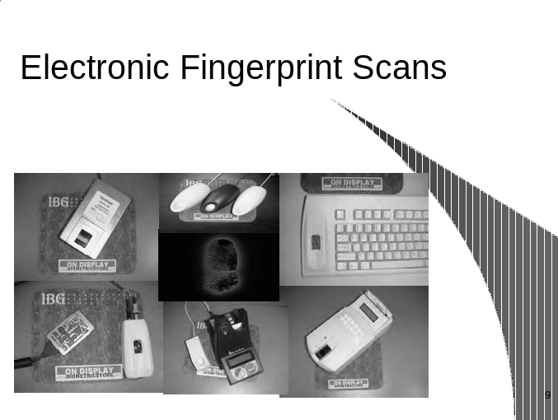
training notes
- Display: Module 4, PowerPoint slide 10 and explain the bullet points.
- A developer that works with the “Palm” developer community (Palm-pilot, etc.) has developed an application that allows the addition of real-time signature captures including verification as well as ink display and encryption technologies. This is a fundamental step to expand e-commerce through biometric devices on future generations of Palm devices.
- Bank United is the first bank in the country to pilot an iris scanning ATM.
- A human resource tracking system is being developed, which tracks employees’ time and attendance using the human hand as the information source.
- Polaroid Corporation announced its Identification Systems business unit will incorporate the latest Faceit® technology (the facial recognition component) in the West Virginia driver license program.

- Eye Scans
- Hardware and software is for sale that profiles your iris from about a foot away, matching its unique characteristics with an already stored version.
- Face Geometry
- A company has a product that looks at nearly the complete face to make sure the right user logs on. Using a camera perched atop the PC, the Face It technology matches key characteristics of a person’s face against a pre-stored image.
- Hand Finger Geometry
- Scans the whole hand and fingers
- Key Stroke Dynamics
- Every person’s typing habits are unique—how hard or soft they press the keys.
- Signature Verification
- Voice Recognition
- Iris Identification

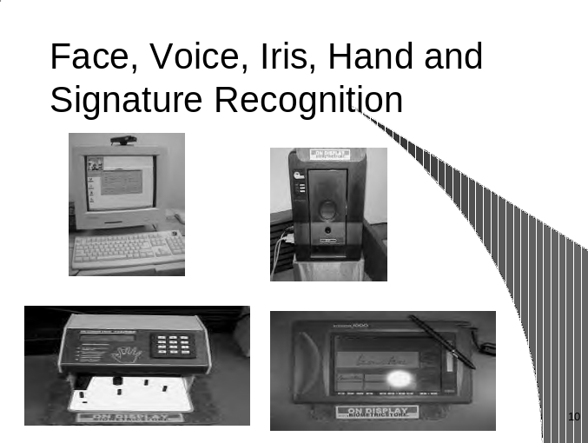
training notes
- The Federal government is getting into smart cards in a big way. The General Services Administration is launching a $1.5 billion, 5-year project, to implement smart cards, with biometrics capability as ID for a large number of government employees. Smart cards store personal data about the individual holding the smart card.
- Storage of one’s biometric data on a smart card does mean that one of the great features of biometrics, that you cannot forget them, no longer applies. If you leave your smart card at home, there is no way to verify unless your template is also stored in a local database.
- A smart card that can verify its owner through fingerprint verification or iris recognition has been developed. The smart card, called e-purse, has been developed as a way to combat fraud and other security issues. The cardholder biography is stored within the smart card chip, which supplies the highest level of security for home banking and e-commerce. Imposters cannot duplicate the card.
- While today you might fatten you wallet carrying multiple cards for debit, insurance, telephone numbers, and frequent flyer information, Windows for Smart Cards could store all the data on a single card. And you could add you medical history. Besides data storage, smart cards with a PIN could be used to access a corporate network rather than typing in a USERID and password.
- Biometrically secured debit cards. SELF-SERVE checkout systems— you scan it, you bag it, you pay for it—are popping up at supermarkets around the nation. Utah has U-Check stores. U-Check card is a “magstripe” card containing personal banking data, cross-referenced with the person’s three-dimensional fingerprint. Kroger has U-Scan Express machines in more than 200 stores. Harris Teeter, Winn-Dixie, Wal-Mart and smaller grocery chains have experimented with the systems. The systems, introduced by Montreal-based Optimal Robotics Corp. in1995, have grown incredibly popular in the past 18 months, the company reports. Revenues for Optimal Robotics shot up 427 percent last year, to $29.6 million.

Smart Cards
A smart card is a plastic card with an embedded integrated circuit that stores and or transacts data. Smart cards and biometrics are linked at one specific point—the storage of the biometric template. Physiological aspects of the face, iris, hand, or fingerprint are converted into templates for ease of use. The following can easily be stored on a Smart Card:
- Finger scan
- Facial scan
- Iris recognition
- Hand geometry

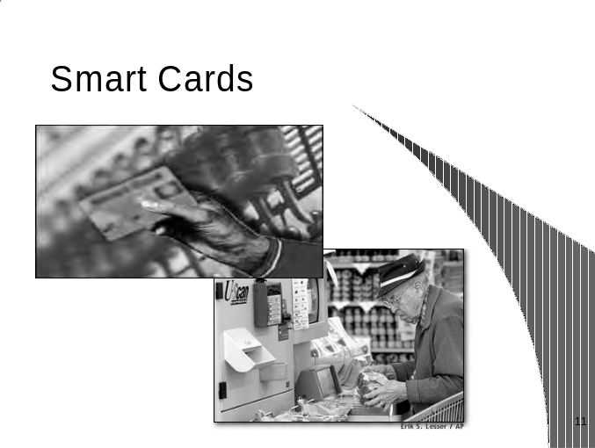
Training Notes
- Summarize the information we have gone over in this module.
- This wraps us this module. Ask participants if they know of any other physical security measures that we have not addressed.
- What strategies have you used successfully to get upper management buy-in?
- Tell participants that they need to talk to their staff about security. Front line workers are concerned about their physical safety. Management must acknowledge their concerns and fears and take proactive security action.

summary
In this module we discussed:

- Identifying personnel protections
- Suggestions for physical building protections
- Defined biometric protections
- Explained smart card technology
- Emphasized security is a priority

training notes
- Display: Module 4, PowerPoint slide 12.
- Tell participants that we are now going to do a short assessment of their contingency planning practices. This should be done individually. Participants should take an honest look at their respective physical security procedures.
- This physical security assessment tool is designed to help you assess your strengths and weaknesses with respect to physical security protection issues. Please evaluate each area carefully. As we go through the next module we will focus on each area and give you information that will help you to prepare, implement, modify, or improve on your contingency planning procedures.
- Make sure participants understand that this will not be collected but is to be used as an evaluation piece to see where their security measures may need improvements.
- Allow about 5 minutes for participants to complete this assessment.
- Advise participants that this leads us into Module 5: Evaluating Your Strengths and Weaknesses and Formulating a Plan.
- Advise participants that we will go through the assessment and see if there are other areas that should be covered at the end of module 5.

assessment tool

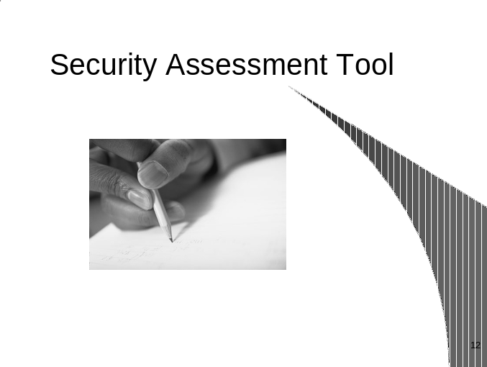

training notes

SECURITY ASSESSMENT TOOL
Rating Scale

1 = Fully Implemented
2 = Implementation Planned
3 = Non-Existent

Contingency Plans | 1 2 3
- Contingency plans are in place in the event of loss of personnel (strike, etc.), disasters, and emergencies. | ❍  
- Contingency plans specify who will (and how to) notify customers and staff in the event that the office is inoperable. | ❍  
- Contingency plans assign individual and team responsibilities in order to expedite mobilization of personnel. | ❍  
- Contingency plans are available that address back-up and recovery procedures. | ❍  
- Contingency plans have been tested and measured for effectiveness. | ❍  
TOTAL = | ❑  

training notes

Scoring

Total this section adding the value from each column (1=1, 2=2, 3=3)

If you scored:

4-6 = No action necessary.

7-15 = Your contingency plans may need to be reviewed to ensure ongoing operations. Review the Contingency Plans section and carefully evaluate any answers that are marked 2 or 3.

