U. S. DEPARTMENT OF THE INTERIOR
U. S. GEOLOGICAL SURVEY

Bulk Densities and Porosities of Cenozoic and Cretaceous Basin-Filling Strata
and Cretaceous and Older Basement Rocks, Los Angeles Basin, California,
Determined from Measurements of Core Samples

by
L. A. Beyer1 and T. H. McCulloh2
1998

Open-File Report 98-788

This report is preliminary and has not been reviewed for conformity with U. S. Geological Survey editorial standards or with the North American Stratigraphic Code. Any use of trade, firm or product names is for descriptive purposes only and does not imply endorsement by the U. S. Government.

1U. S. Geological Survey, MS 977, 345 Middlefield Road, Menlo Park, CA 94025-3591
27136 Aberdeen Avenue, Dallas, TX 75230-5407
ABSTRACT

This report describes and provides a digital data file of selected bulk properties of subsurface rocks sampled in and around Los Angeles basin, California. Selected properties include measured dry bulk density (range 0.78 to 3.01 g/cm3), measured or estimated grain (matrix) density, calculated water saturated bulk density (range 1.47 to 3.01 g/cm3), calculated total porosity (range 0 to 69 porosity percent), geologic age, and lithology. Most of the rocks are conventional core samples taken from wells drilled by the petroleum industry. A small percentage of the core samples are from shallow borings. Rocks studied range in age from pre-Cambrian (?) to Recent and include sedimentary (98.8%), and volcanic, metamorphic and intrusive (1.2%) samples. Core samples studied were taken from measured drillhole depths that range from 35 to 20,234 ft (11 to 6,167 m). Version 1.0 of the data base (dated June 1998) contains information for 7378 samples from 234 wells, including two redrilled wells. This report/data base can be accessed on U. S. Geological Survey servers at http://geopubs.wr.usgs.gov/open-file/of98-788. Periodic additions to the on-line data base will be provided as new data is gathered.
TABLE OF CONTENTS

Introduction 4
Previous work 5
Well descriptions and locations 6
Summary of data base 6
Bulk density and porosity equations 19
Methods 19
Sample selection, preparation and weighing 19
Grain volume measurements 20
Bulk volume measurements 20
Reliability of measurements 21
Grain density 21
Dry bulk density 21
Total porosity 22
Saturated bulk density 22
Discussion 23
Industrial data 23
Stratigraphic designations and age assignments 24
Lithologic descriptors 24
Estimates of overburden removed 25
Acknowledgements 25
References 27
Appendix 1: Explanation of core sample data base 29-32
Appendix 2: Core sample data base 32-33
TABLE 1: Well descriptions 7
FIGURES 1 to 11: Well locations 8-18
INTRODUCTION

Motivated by the specific need to prepare a meaningful density model of the Los Angeles basin, California, for quantitative gravimetric calculations of the basin and some of its parts, we have collected density data of several kinds. The basic foundation of our modeling effort is a collection of laboratory measurements of 7,378 subsurface rock samples, most of which are selected representative samples of conventional core from wells drilled for petroleum. A description of this collection, together with explanatory notes and comments, is the subject of this report.
The bulk density, grain density and porosity of rocks significantly influence gravitational, magnetic, thermal and electrical fields as well as acoustical and mechanical properties, and thus are important parameters to the interpretation of a variety of geophysical data. Certain mass properties are also crucial to the practical evaluation of rocks that act as reservoirs for petroleum or water resources or as conduits for fluid movements. Lastly, selected mass properties, combined with geologic and lithologic descriptors, provide information about the burial history, particularly of sedimentary rock sequences.
Bulk density, grain density and porosity of sedimentary and some volcanic rocks are the result of many factors: (1) Constituent composition (provenance); (2) depositional environment that exerts control on original grain size, texture, sorting and, in some instances, organic content; (3) post-depositional influences, such as temperature, pressure, and pore-fluid histories (including fluid chemistry and circulation rate) that, together with sediment composition and texture, control diagenesis; (4) deformational history; and (5) associated rocks that influence the chemical nature and flow rate of available pore fluids. Bulk density, grain density and porosity of intrusive, metamorphic and wholly or partly crystalline volcanic rocks are controlled primarily by mineral composition, texture and burial history that influence chemical alteration and deformational history. A wide range of these factors are present in this data set. Thus summary plots and tables are misleading and are omitted in this introductory presentation.
PREVIOUS WORK

An empirical basis for understanding the processes by which clay-rich sedimentary rocks ("shales") increase in density with increasing burial depths began with the pioneering work of Athy (1930) and Hedberg (1936), followed closely by related contributions from Haskell (1941) and Faust (1950), and augmented later by notable results of many others (for example, Dickinson, 1953; Hamilton and Menard, 1956; Dallmus, 1958; and Storer, 1959). Most of this early work depended in varying degrees on laboratory measurements of samples of rock cut from conventional cores from wells. These efforts took place in parallel with a vastly larger body of work focused on pore volumes of petroleum reservoir rocks, especially sandstones and carbonates.
During this period, basic questions about how well laboratory measurements of core samples match underground rock densities undisturbed by drilling continued as topics for debate (especially among geophysicists) until 1965 when an underground density profile based on gravity measurements in a vertical shaft was shown to validate a density profile based on accurate laboratory measurements of core samples (McCulloh, 1965). Multiple subsequent intercomparisons have demonstrated that conventional cores of even very soft, high porosity mudrocks or friable sandstones, low density diatomites, or fractured cherty rocks, yield valid laboratory measurements if core recovery is good, sampling is representative, laboratory measurement methods are not biased, and borehole gravity measurements are corrected for significant anomalous vertical gravity gradients (McCulloh, 1967a; McCulloh and others, 1967; McCulloh and others, 1968; Beyer, 1971; Beyer, 1987; Beyer and Clutsom, 1989).
In the interim, a very large number of different suggested porosity versus depth relationships were added to those mentioned above (Hermanrud, 1993, Figure 1 and accompanying text). This body of data and relationships between its parts suggest that porosity (or density) versus depth functions are subject to large method-dependent errors or that fundamentally diverse geological factors are at play, or both.

WELL DESCRIPTIONS

Descriptive information for wells from which cores were studied is given in Table 1. Locations of these wells are shown Figures 1 through 11 which are ordered first by increasing longitude and then by increasing latitude. Most location figures are groupings of four 7 1/2-minute U. S. Geological Survey quadrangles.

SUMMARY OF DATA BASE

Rock properties in the data base include measured dry bulk density, estimated or measured grain (matrix) density, calculated total porosity and calculated water saturated ("natural") bulk density. Geologic descriptors include lithology, age, presence or absence of oil staining, and drillhole position of sample relative to observed shallowest occurrence in a well of the zeolite mineral laumontite (where present). Estimated thickness of overburden removed by erosion from a drillhole site is included (where reliably available) as an indicator of prior maximum burial depth in instances where complications of subsurface erosional unconformities are not present. (There are sample sets from drillholes at locations where overburden removed is significant but is not estimated.)
Geographic descriptors include elevation, latitude and longitude of drillhole wellhead. Depth of sample is expressed as (1) measured well depth below ground surface, derrick floor or kelly bushing (undifferentiated) and (2) vertical subsea level depth. Corrected vertical subsea depth is given for samples from wells significantly deviated from the vertical (but geographic position is not adjusted except for drillholes in the Long Beach Unit of the Wilmington oil field). Drillholes are identified by the state, county/area and well numbering system of the American Petroleum Institute (API).
Table 1: Well Descriptions

Table 1 is in a separate spreadsheet in Microsoft Excel 2000 format, available from the website for the this report (OFR 98-788):

http://geopubs.wr.usgs.gov/open-file/of98-788

The URL for Table 1 itself is:

http://geopubs.wr.usgs.gov/open-file/of98-788/OFR98-788Table1.xls
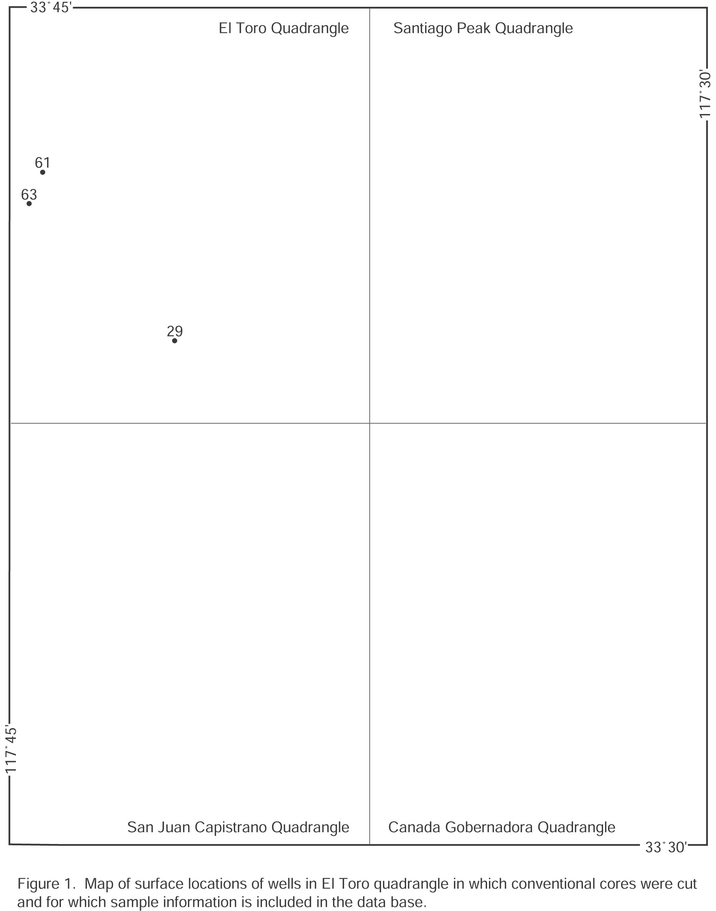
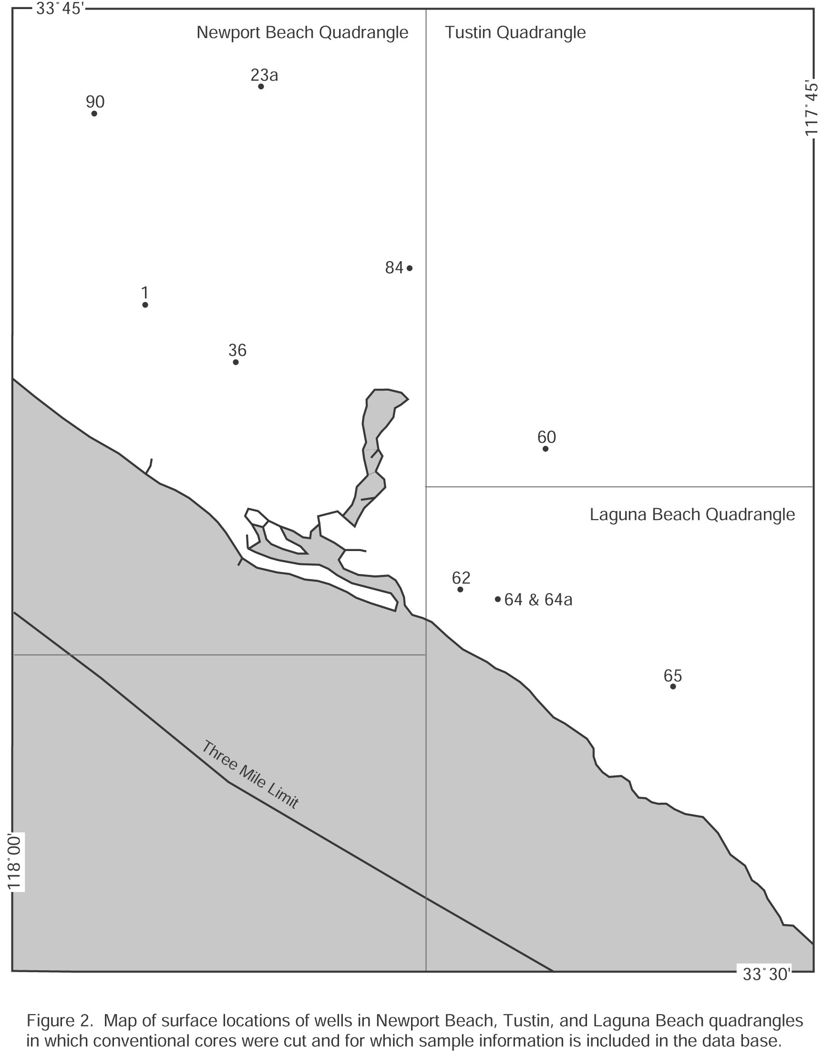
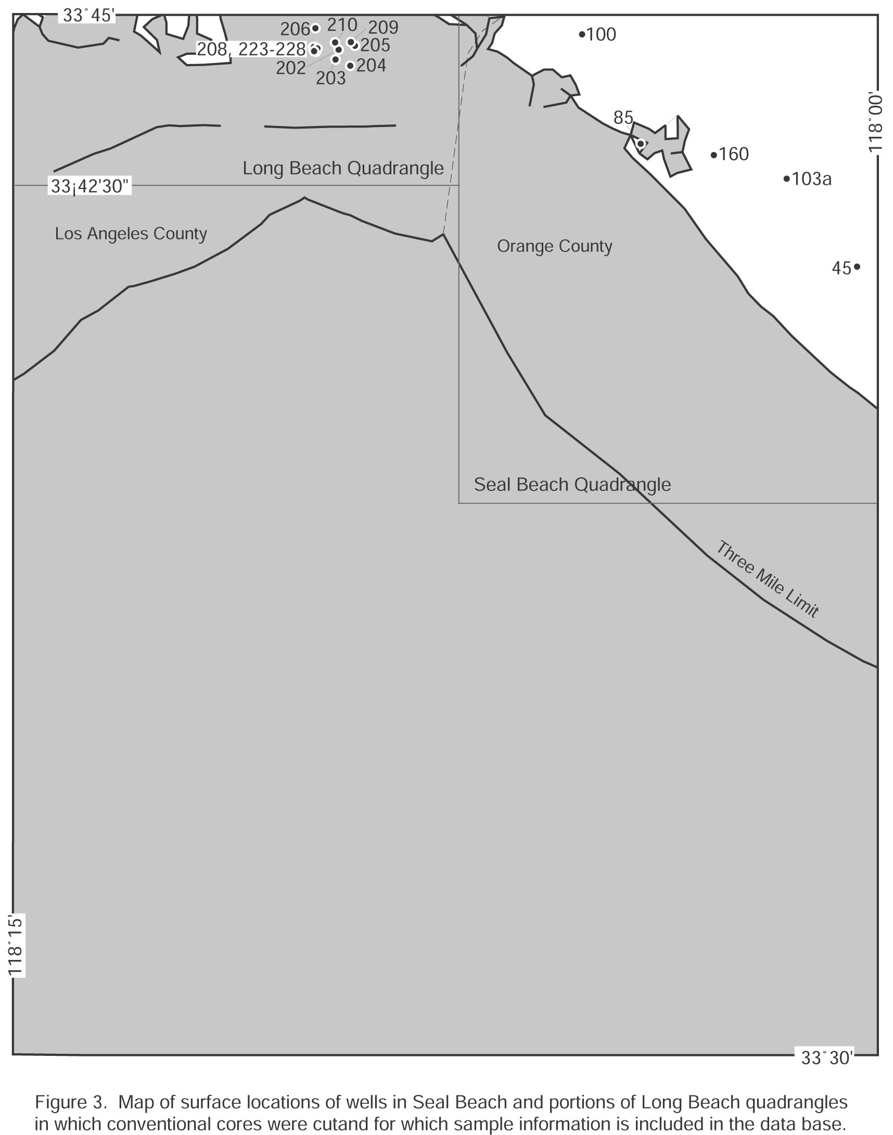
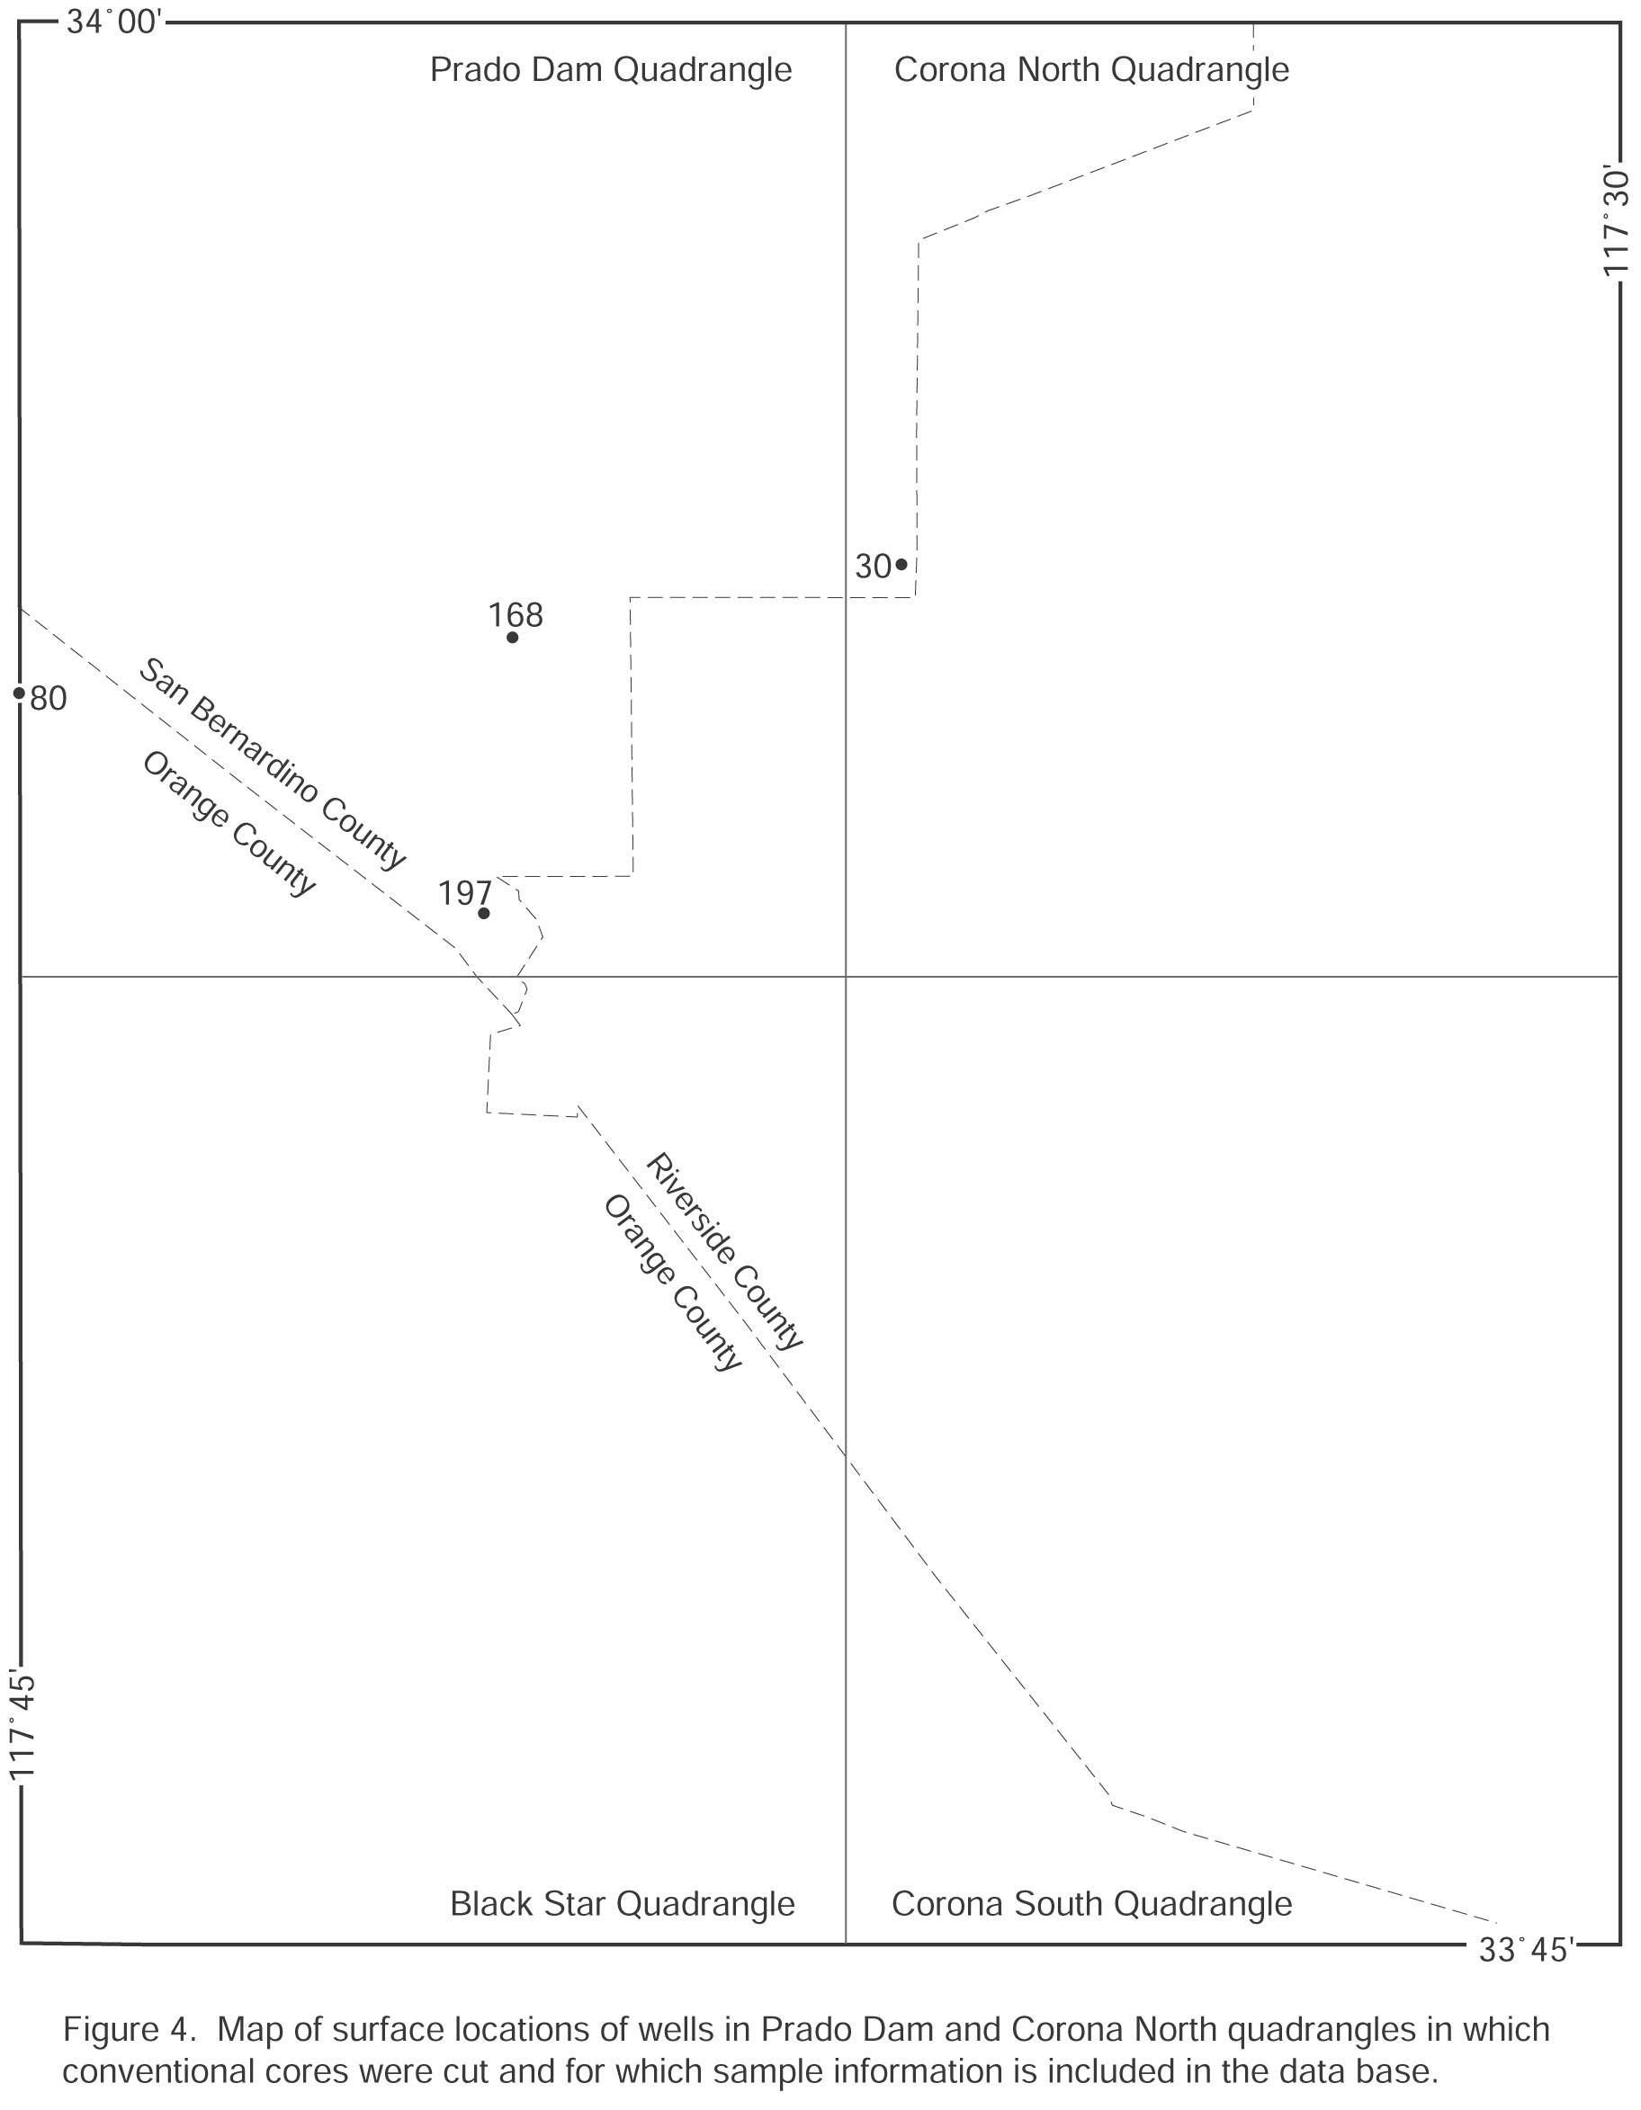
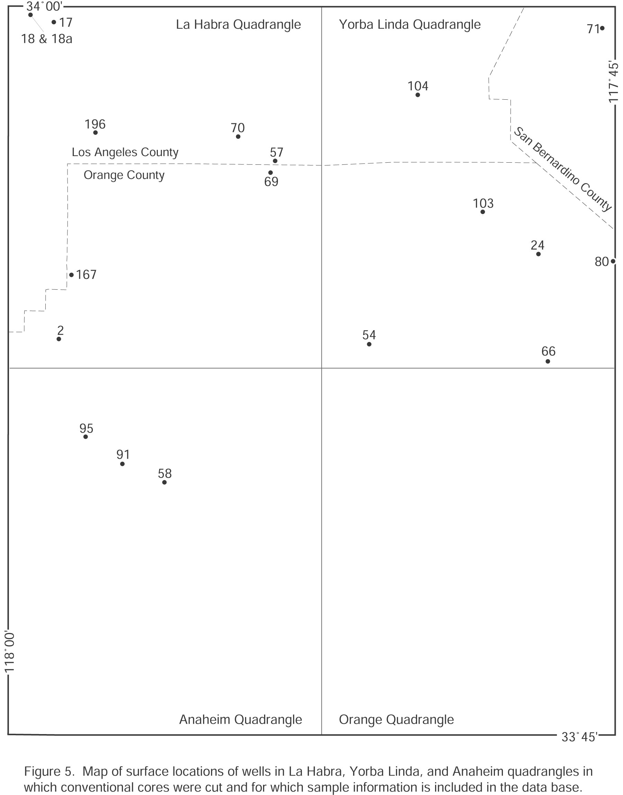
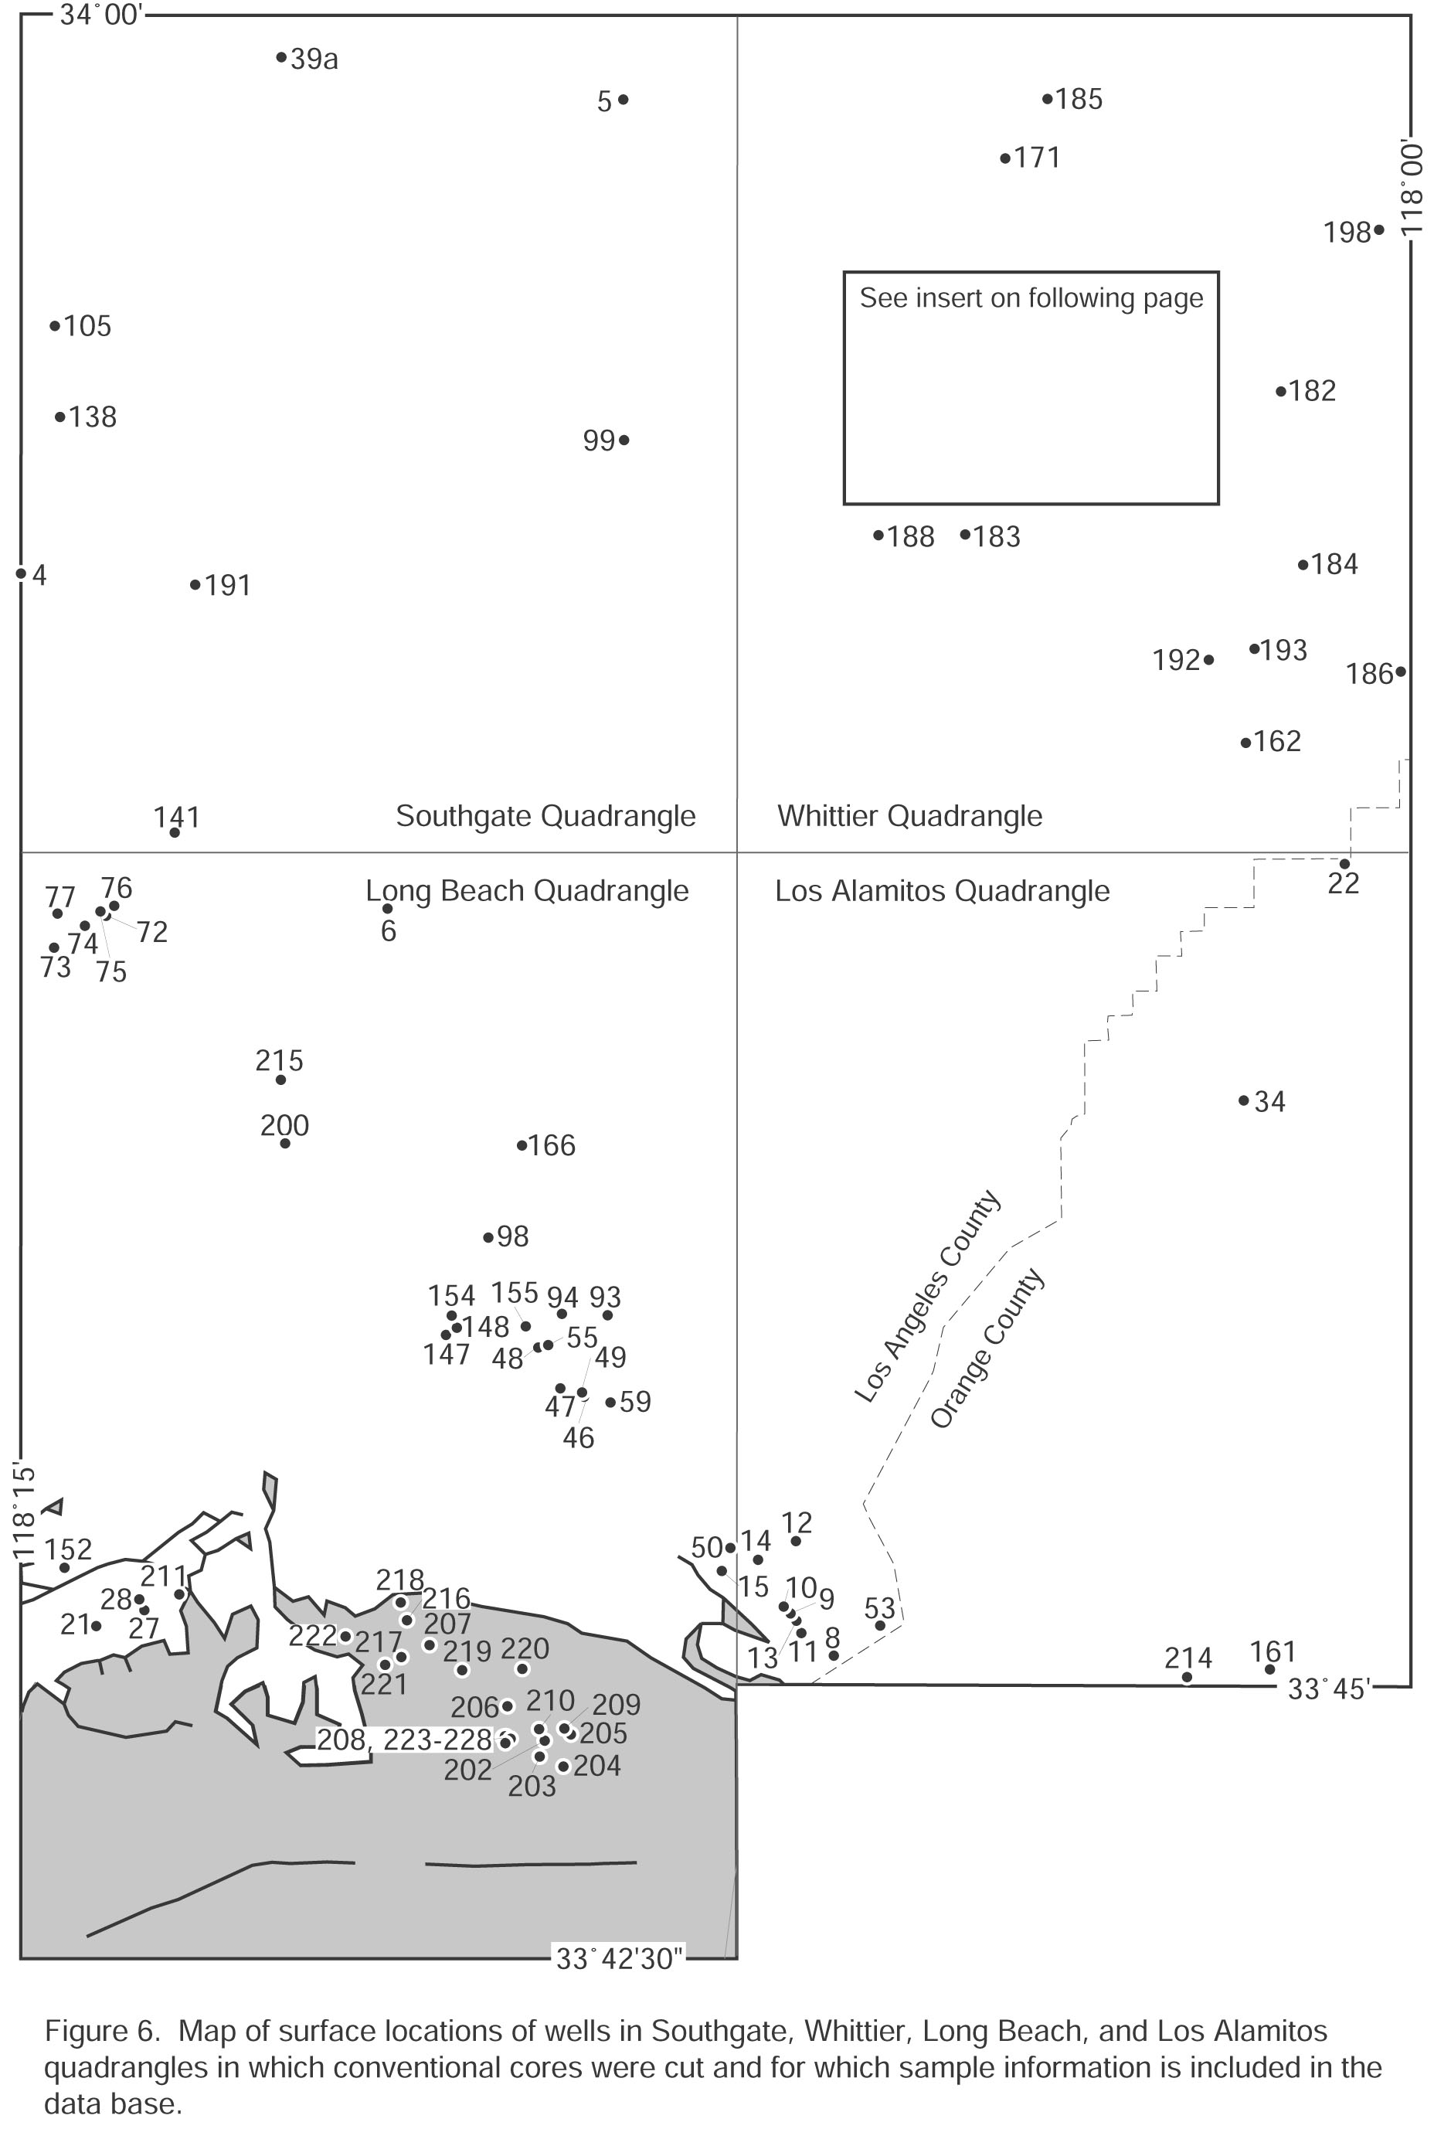
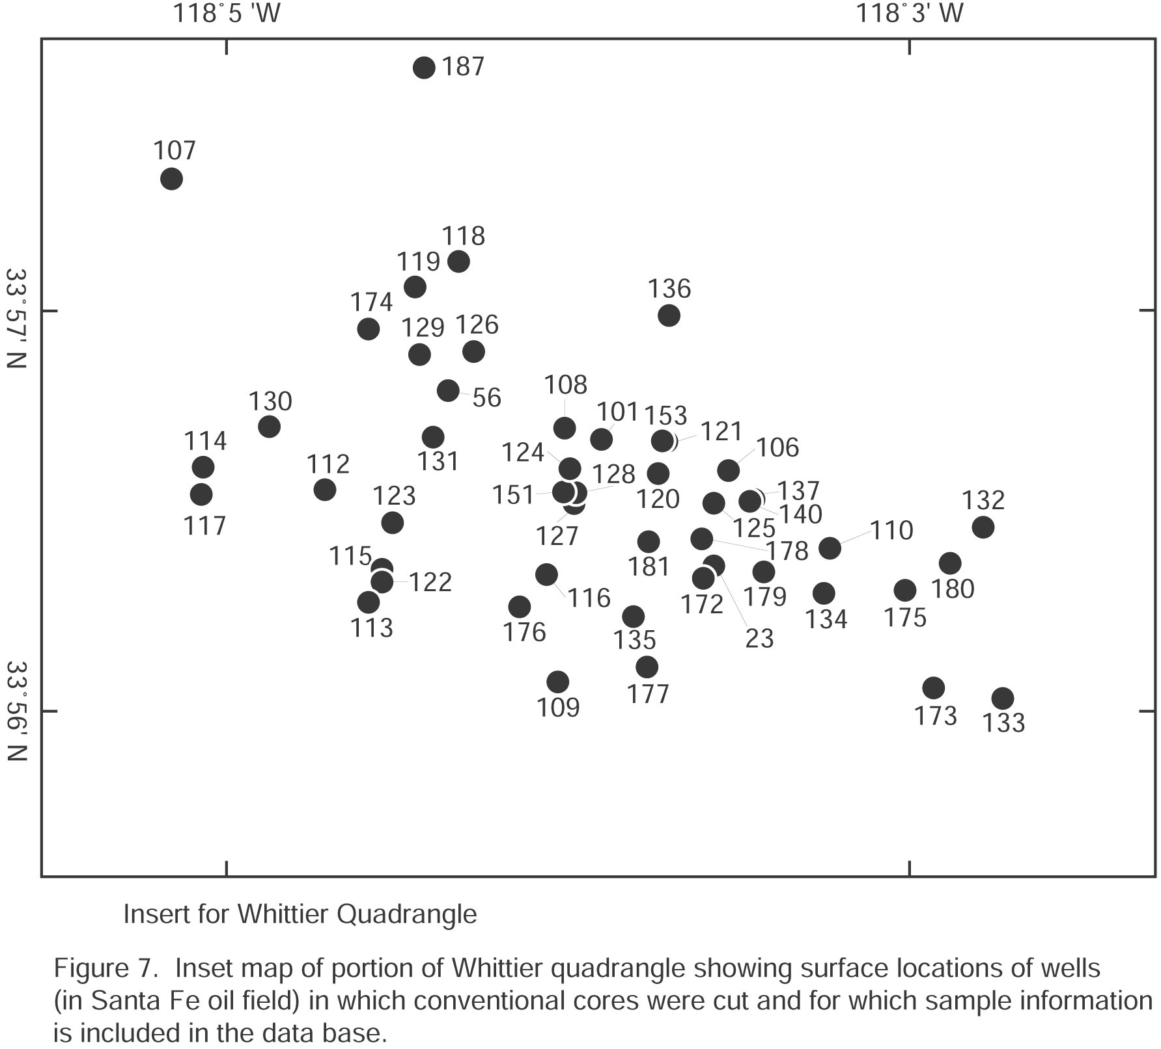
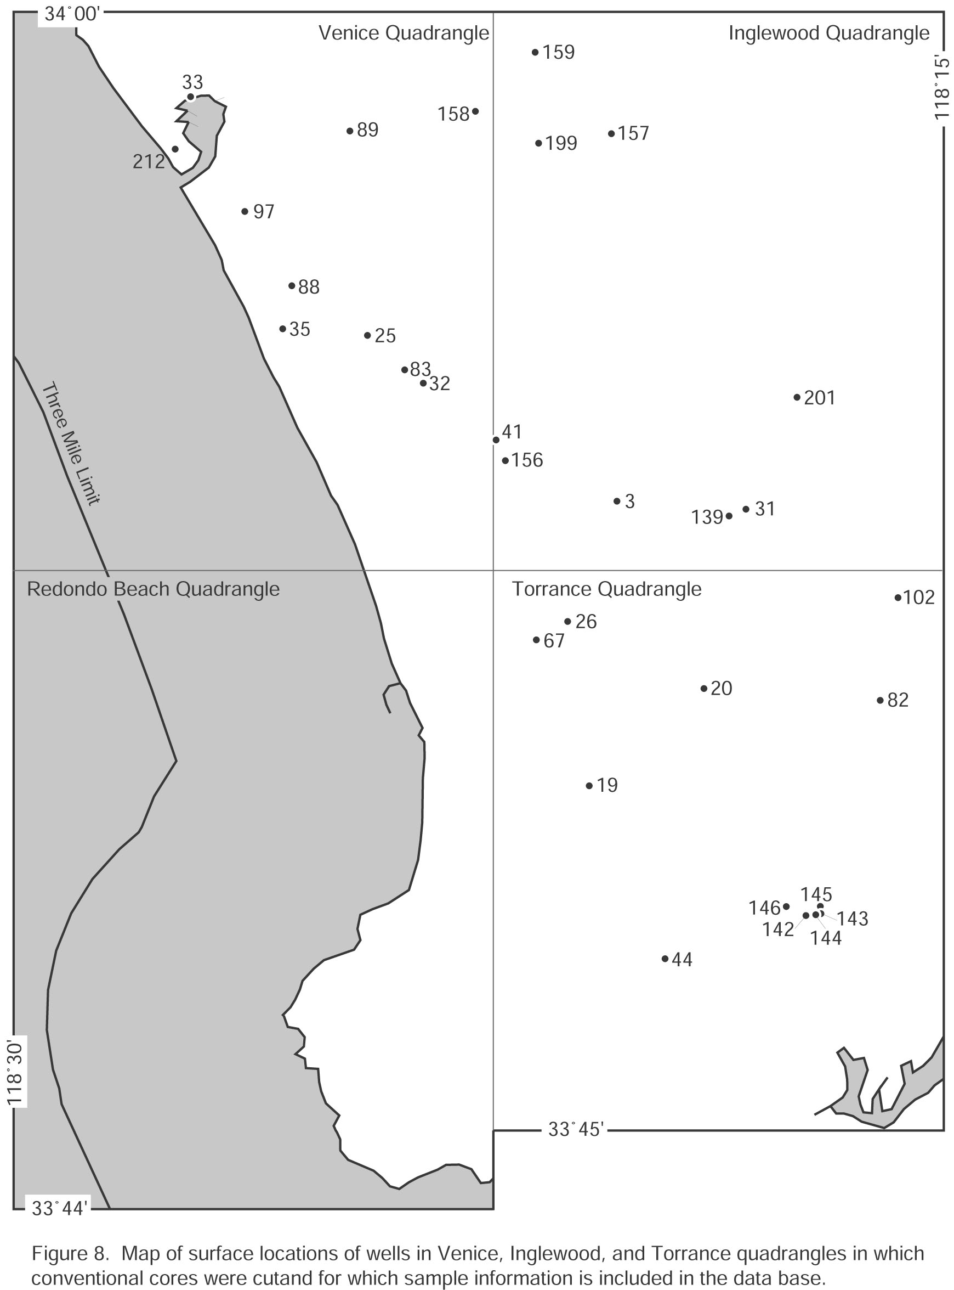

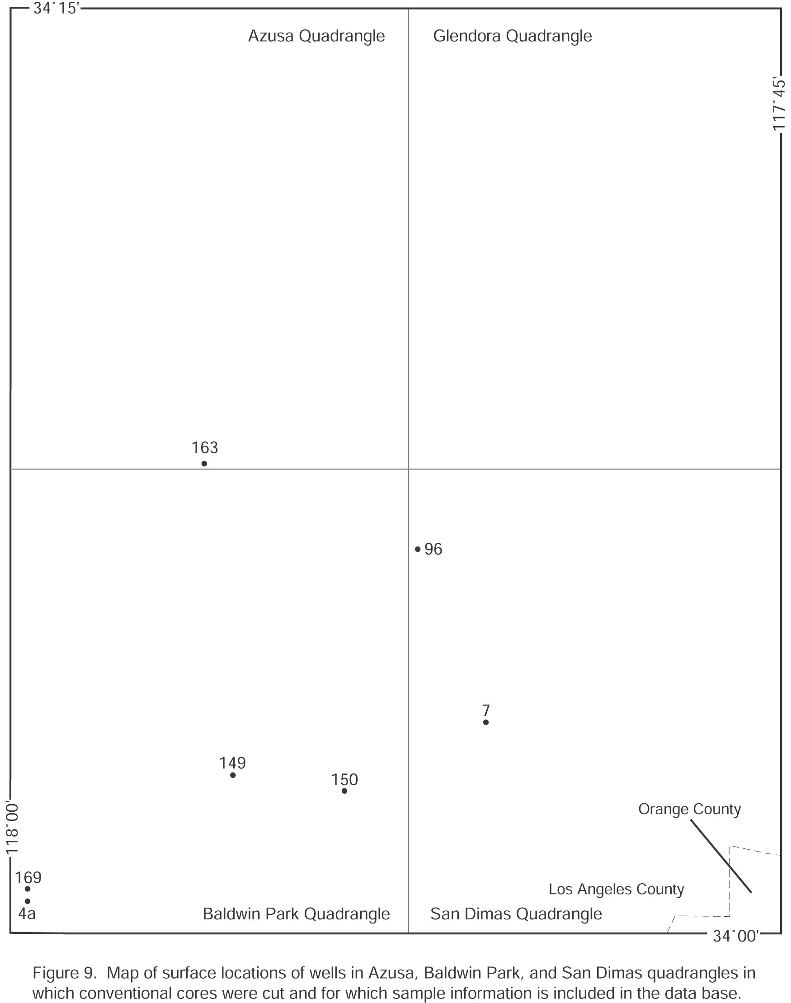

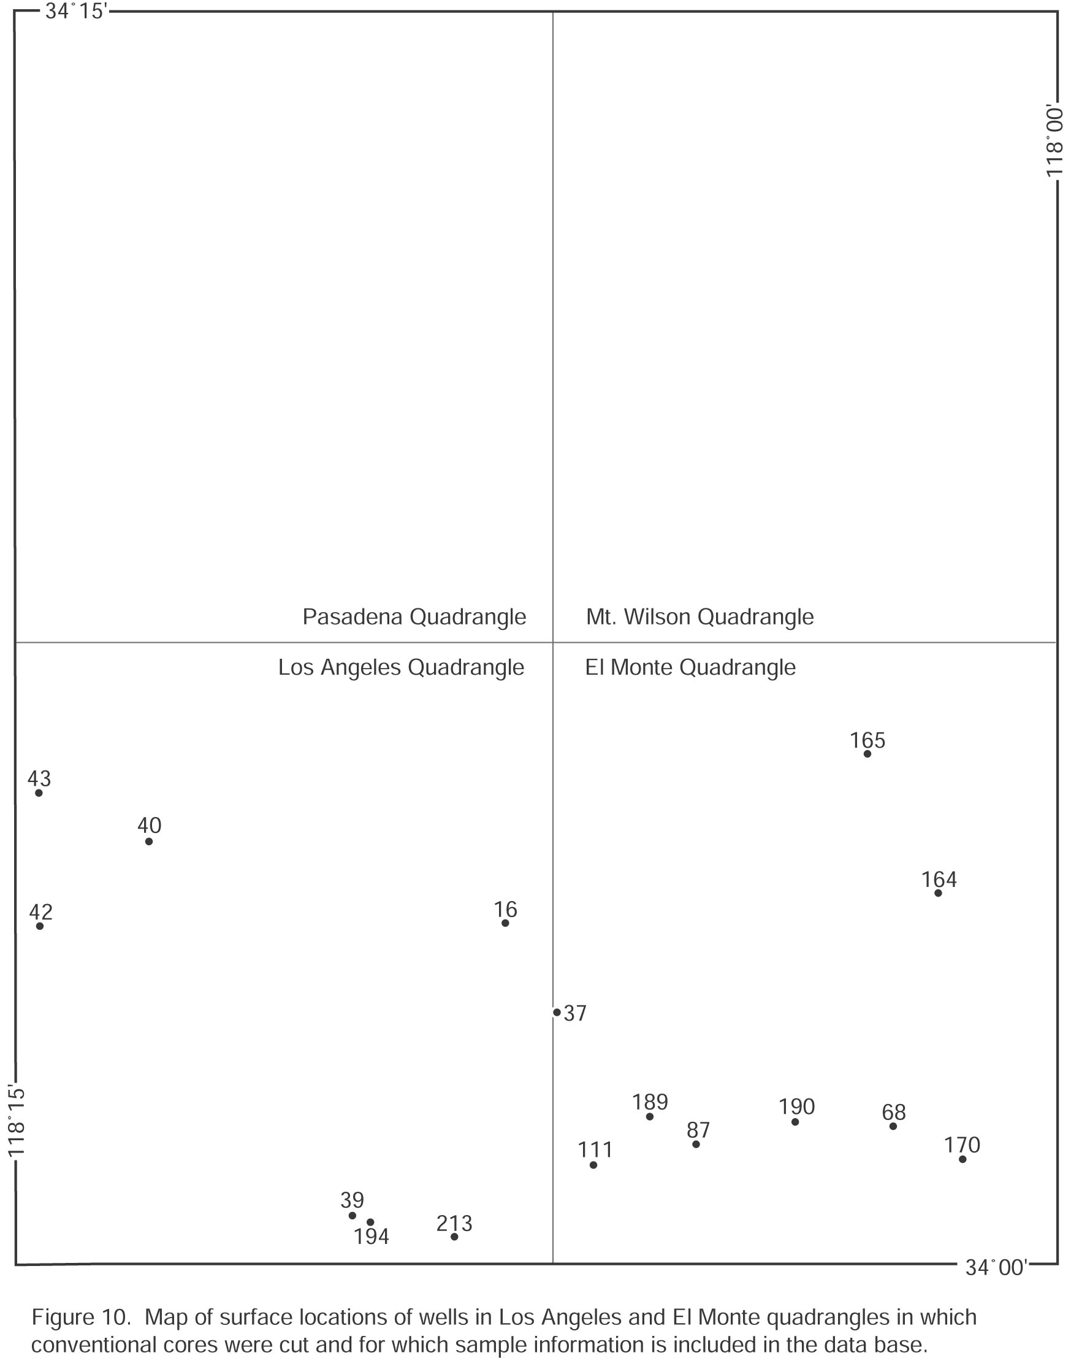

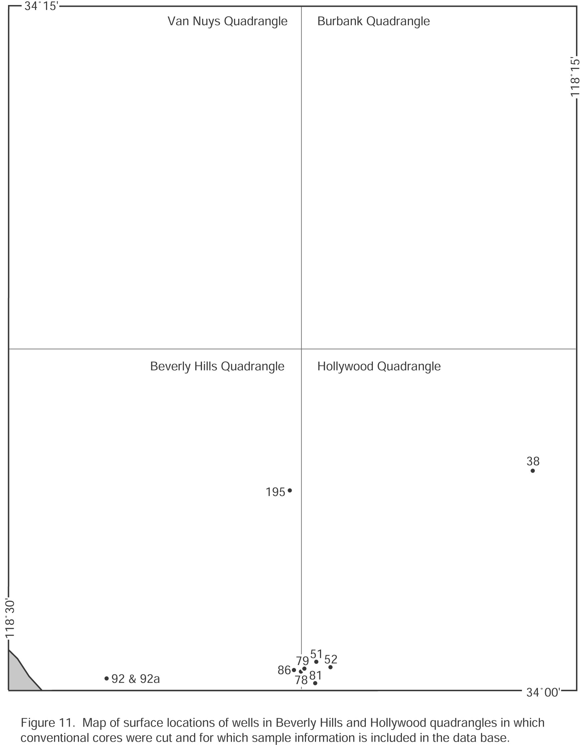

BULK DENSITY AND POROSITY EQUATIONS

Dry bulk density, grain (matrix) density, total porosity, and water saturated bulk density reported here are defined by the following equations:

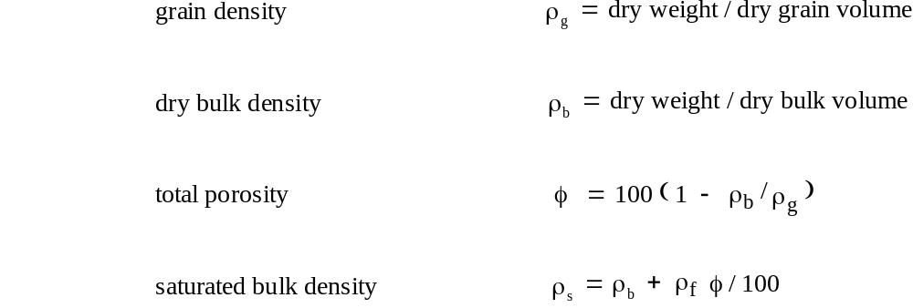

Density and total porosity are reported in g/cm3 and percent, respectively. Saturated bulk density is calculated by assuming a pore-fluid density (ρf) of 1.00 g/cm3 because most Los Angeles basin formation waters have salinities considerably less than that of seawater.

METHODS
Sample Selection, Preparation, and Weighing
Most core materials studied by the Geological Survey were gathered from spot-sampled collections of pieces of conventional core and therefore contain possible biases due to uncertainties about core recovery rates and representativeness of prior spot sampling of recovered cores. Sampling procedures generally sought to characterize the range of lithologies and the maximum, mean, and minimum bulk densities present in the spot sampled collections. Core chips that visually showed evidence of alteration by drilling fluids generally were not sampled. Cores analyzed by petroleum companies usually were sampled at regular intervals, commonly (though not always) at 1-foot spacing.
Core chips prepared by the Geological Survey were cut, usually with a dry saw or, in the case of extremely hard samples, with a saw lubricated with free flowing water, to (1) remove surfaces previously exposed to drilling fluids or long exposed to the atmosphere, (2) remove rough surfaces capable of trapping bubbles during immersion in mercury, and (3) size samples to fit the helium and mercury pycnometers. Samples cut for weight and volume measurements were dried in a pre-heated oven for 24 hours at about 105 ∞C to drive off H2O- (adsorbed water) (e. g., Breger and Chandler, 1969). Amounts of unbound H2O- that remained probably are negligible to less than 1 weight percent.
Samples were cooled in a desiccator after drying, weighed to the nearest 0.001 g and stored in the desiccator until bulk volume or grain volume measurements were made with a mercury or helium pycnometer. Sample weights ranged from about 15 to 90 g.
Grain Volume Measurements
Where grain density was measured, grain volume in most cases was determined by the gas displacement-Boyle's law method with a Beckman Model B5 Air Comparison Pycnometer operated with helium (e.g., McIntyre and others, 1965). Helium injection pressure into sample pores was 4 psi. Repeated zero or reference readings to within 0.02 cm3 without a sample in the pycnometer, before and after sample measurements, was the criterion for acceptance of a sample volume measurement. Sample volume measurements were also made until values repeated to within 0.02 cm3. The Beckman pycnometer was calibrated with volume standards provided by the manufacturer.
Bulk Volume Measurements
Bulk volumes of core samples were measured by the mercury displacement method using a mercury pycnometer slightly modified from that described and illustrated by McCulloh (1965). This vacuum-equipped mercury immersion bulk-volume pycnometer is designed to minimize bubble entrapment against the sample surface and to minimize and permit evaluation of the amount of mercury lost to pore spaces and natural or artificial cracks during immersion. All measured volumes of samples were corrected for mercury lost to pore spaces or artificial cracks.
The accuracy and precision of bulk volume measurements depends on the reading resolution and the precision of the mercury pycnometer, the accuracy of the pycnometer calibration and the sample volume. A skilled operator can read the burette tube to 0.02 cm3 and repeat volume measurements of non-porous test samples to 0.05 cm3 or better. Measured bulk volumes of our samples range from about 5 to 40 cm3 but generally are between 10 and 30 cm3.
Pycnometers were calibrated by adding to the burette tube known weights of mercury at known temperatures. Incremental mercury volumes, calculated from weight and temperature data, were compared to burette volume readings. The calibration was checked by determining the bulk density of large, transparent quartz crystals; these measured bulk densities were within 0.002 g/cm3 of accepted values after correction for temperature.

RELIABILITY OF MEASUREMENTS
Grain Density
Grain densities for the majority of the data base were estimated. The estimates were made from knowledge of the mineralogy of the various sample lithologies (Davis, 1954). Errors in estimated grain density are believed to be about 0.03 g/cm3. In the case of measured grain densities, the error equation assumes negligible errors in weight measurements and a precision of 0.02 cm3 in the helium pycnometer grain volume measurement.

Using eq. 1, the error in measured grain density is 0.004 g/cm3 for an estimated average value of 15 cm3 for grain volume measurements and a sample of grain density 2.65 g/cm3. For all reasonable values of grain volume and grain density, the error in measured grain density will be less than 0.011 g/cm3.
Dry Bulk Density
The error equation for dry bulk density also assumes negligible errors in weight measurements and a precision in the mercury pycnometer bulk volume measurement of 0.05 cm3.

Using eq. 2, errors in calculated dry bulk density of rocks in the data base range from 0.002 to 0.014 g/cm3 for measured bulk volumes between 10 and 30 cm3 and dry bulk density values between 1.0 and 2.8 g/cm3.
Total Porosity
Assuming additive errors due to uncertainties in grain density and dry bulk density (the worst case), the error equation for calculated total porosity is given by

Using eq. (3), errors in calculated total porosity of rocks in the data base range from 0.5 to 1.7 porosity percent if an average grain density of 2.65 g/cm3 and an estimated grain density error of 0.03 g/cm3 are assumed, and errors in dry bulk density range from 0.002 to 0.014 g/cm3 and dry bulk density values range from 1.0 and 2.8 g/cm3.
Saturated Bulk Density
Assuming additive errors due to uncertainties in calculated dry bulk density and total porosity (the worst case), the error equation for saturated bulk density is given by

Using eq. (4), errors in calculated saturated bulk density of rocks in the data base range from 0.007 to 0.031 g/cm3 for the ranges of errors given above for calculated dry bulk density and total porosity.

Discussion
For the vast majority of samples in the data base, errors in calculated dry bulk density, total porosity and saturated bulk density lie in the middle parts of the ranges given in preceding sections. There are other reasons why the bulk densities and porosities reported here may not accurately represent equivalent in situ values of the strata from which the cores were taken (McCulloh, 1967b; Beyer 1971). These include large scale irregular porosity (such as fractures) not represented in small pieces of core, possible pore and bulk volume expansion due to removal of confining stresses and, for calculated saturated bulk density, presence in situ of pore fluids whose densities differ from 1.00 g/cm3. The effects of these factors will be discussed in a later paper that compares and integrates the various types of density data assembled for Los Angeles basin.

INDUSTRIAL DATA

Approximately 56 percent of the data base is from petroleum industry files released to the Geological Survey and is indicated by a lithology code of "50". Most industrial data were provided as porosities, in which case grain density was estimated and dry and saturated bulk densities were back-calculated. The remainder of the industry data were given as bulk density, in which case porosity was calculated after estimating grain density. The reliability of these industry data generally can not be directly evaluated. An indirect measure of their reliability is provided in some cases by interpersed data from Geological Survey measurements of core chips from the same set of well samples.
STRATIGRAPHIC DESIGNATIONS AND AGE ASSIGNMENTS

Biostratigraphy is the fundamental basis for the stratigraphic subdivisions, correlations and age assignments of most of the sedimentary rock samples. Marine, mostly benthic foraminiferal, faunas are widely used throughout the basin to subdivide most of the clastic sequence (Wissler, 1943, 1958; Natland, 1952; Blake, 1991). In local areas, especially in a few outcrop sections, molluscan faunas have also been used. For a few non-marine units of more-or-less local occurrence, distinctive volcanogenic or red-bed lithologies, weathering horizons, or aquifer characteristics are the basis for identification and correlation. Although fossils are the main fundamental basis for subdivision, identification and correlation, local correlations and assignments depend heavily on interpretation of well log characteristics and distinctive lithologies or lithologic sequences or unconformities. All of these approaches have been used in assigning formation names or faunal zone designations to the samples reported here. In a few cases that involve pre-sedimentary "basement" rocks, distinctive petrographic and geochronologic characteristics also influenced formation assignments.

LITHOLOGIC DESCRIPTORS

Most of the samples in our compilation have been given lithologic descriptors on the basis of hand lens examination (almost entirely by the second author). Some of these (many in the case of samples of "basement" rock units, volcanogenic samples and zeolitized sedimentary rocks) have been augmented through thin section petrography. Lithologic descriptors of a few of the more organic-rich, petroleum source rocks have been augmented also by organic geochemical assay data. The reliability or accuracy of the descriptors is greatest for coarser grained rocks (conglomerates, sandstones or crystalline "basement" rocks), and probably is least for fine-grained strata and highly altered volcanogenic lithologies. Small numbers of cherts and dolomitic rocks (and possibly some diatomaceous mudstones) may have been misidentified in particular.
ESTIMATES OF OVERBURDEN REMOVED

Estimates of overburden removed are based on objective criteria and are conservative. Geologic cross sections have been drawn through wells where evidence is clear that erosion of surface strata followed maximum burial. Reconstruction of the eroded overburden was estimated by projecting measurable thicknesses to the eroded site, making allowance in many cases for the fact that depositional sequences thin toward basin margins or onto high tracts. Where data are insufficient to permit such interpretive reconstructions, no estimate of removed overburden is given. Likewise, where a subsurface unconformity indicates a now-buried erosional episode, no estimate has been made of the amount of eroded paleo-overburden.

ACKNOWLEDGEMENTS

Most of these data were gathered over 40 years of intermittent work by one author (McCulloh). The remainder of the data was released to the Geological Survey by various petroleum companies or gathered by other investigators and the senior author. A very large number of organizations and individuals contributed material or information contained in the data base described by this report. Individuals who were particularly influential include J. E. Schoellhamer, L. J. Simon (deceased), W. R. White, R. C. Clawson, B. K. Johnson, T. L. Donovan, E. L. Christenson, H. E. Stark, and G. C. Brown. Companies that were especially helpful at various stages of the work include Standard Oil Co. of California (Chevron USA Inc.), Richfield Oil Co. (ARCO), Texaco, Union Oil Co. of California (Unocal), Shell Oil Co., and The Ohio Oil Co. (Marathon Oil Co.). Special thanks are due to the California Well Sample Repository of the California State University at Bakersfield and to J. C. Beyer who, with uncommon accuracy, encoded the data from a variety of records. Assembly of this report and data base was supported by the Southern California Areal Mapping Project of the National Cooperative Geologic Mapping Team and figures were prepared by C. L. Powell.
REFERENCES

Athy, L. F., 1930, Density, porosity, and compaction of sedimentary rocks: American Association of Petroleum Geologists Bulletin, v. 14, p. 1-14.

Beyer, L. A., 1971, The vertical gradient of gravity in vertical and near-vertical boreholes: U. S. Geological Survey Open-File Report 71-42, 229 p.

Beyer, L. A., 1987, Porosity of unconsolidated sand, diatomite and fractured shale reservoirs, South Belridge and West Cat Canyon oil fields, Califonia, in Meyer, R. J., ed., Exploration for heavy crude oil and natural bitumen: American Association of Petroleum Geologists Studies in Geology No. 25, p.395-413.

Beyer, L. A. and Clutsom, F. G., 1989, Basic data and preliminary density and porosity profiles from three borehole gravity surveys made in the Kuparuk River and Prudhoe Bay oil fields, Alaska: U. S. Geological Survey Open-File Report 89-369, 26 p.

Blake, G. H., 1991, Review of the Neogene biostratigraphy and stratigraphy of the Los Angeles basin and implications for basin evolution, in Biddle, K. T., ed., Active Margin Basins: American Association of Petroleum Geologists Memoir 52, p. 135-184.

Breger, I. A., and Chandler, J. C., 1969, Determination of fixed water in rocks by infrared absorption: Analytical Chemistry, v. 41, no. 3, p. 506-510.

Dallmus, K. F., 1958, Mechanics of basin evolution and its relation to the habitat of oil in the basin, in Weeks, L. G., ed., Habitat of oil--a symposium: American Association of Petroleum Geologists, Tulsa, Oklahoma, p. 883-931.

Dickinson, George, 1953, Geological aspects of abnormal reservoir pressures in Gulf Coast Louisiana: American Association of Petroleum Geologists Bulletin, v. 37, p. 410-432.

Eckis, Rollin, 1934, South coastal basin investigation--Geology and ground water storage capacity of valley fill: California Department of Public Works, Division of Water Resources Bulletin No. 45, 279 p.

Faust, L. Y., 1950, Seismic velocity as a function of depth and geologic time: Geophysics, v. 16, p. 192-206.

Hamilton, E. L., and Menard, H. W., 1956, Density and porosity of sea-floor surface sediments off San Diego, California: American Association of Petroleum Geologists Bulletin, v. 40, p. 754-761.

Haskell, N. A., 1941, The relation between depth, lithology, and seismic wave velocity in Tertiary sandstones and shales: Geophysics, v. 6, p. 318-326.

Hedberg, H. D., 1936, Gravitational compaction of clays and shales: American Journal Science, 5th serial, vo. 31, n. 184, p. 241-287.

Hermanrud, Christian, 1993, Basin modelling techniques--an overview, in Dore′, A. G., ed., Basin modelling: advances and applications: Norwegian Petroleum Society (NPF), Special Publication No. 3, p. 1-34.

McCulloh, T. H., 1965, A confirmation by gravity measurements of an underground density profile based on core densities: Geophysics, v. 30, p. 1108-1132.

McCulloh, T. H., 1967a, Borehole gravimetry: New developments and applications: Seventh World Petroleum Congress, Mexico City, 1967, Proceedings, v. IIb, p. 735-744.

McCulloh, T. H., 1967b, Mass properties of sedimentary rocks and gravimetric effects of petroleum and natural gas reservoirs: U. S. Geological Survey Professiona Paper 528-A, 50 p.

McCulloh, T. H., Schoellhamer, J. E., Pampeyan, E. H., and Parks, H. B, 1967, The U. S. Geological Survey-LaCoste and Romberg precise borehole gravimeter system--test results, in Geological survey research 1967: U. S. Geological Survey Professional Paper 575-D, p. D101-D112.

McCulloh, T. H., Kandle, J. R., and Schoellhamer, J. E., , 1968, Application of gravity measurements in wells to problems of reservoir evaluation: Society of Professional Well Log Analysts 9th Annual Logging Symposium Transactions, p. O1-O28.

McIntyre, D. B., Welday, E. E., and Baird, A. K., 1965, Geologic application of the air pycnometer: A study of the precision of measurements: Geological Society of America Bulletin, v. 76, p. 1055-1060.

Natland, M. L., 1952, Pleistocene and Pliocene stratigraphy of southern California: unpublished Ph. D. dissertation, University of California at Los Angeles, 350 p.

Schoellhamer, J. E., and Woodford, A. O., 1951, The floor of the Los Angeles basin, Los Angeles, Orange, and San Bernardino Counties, California: U. S. Geological Survey Oil and Gas
Investigation Map OM 117.

Storer, A., 1959, Costipamento dei sedimente argillosi nel bacino Padano, in I giacimenti gassiferi dell'Europa Occidentale: Acad. Nacionale dei Lincei, Roma, v. 2, p. 219-536.

Wissler, S. G.,1943, Stratigraphic formations (relations) of the producing zones of the Los Angeles basin oil fields: California Division of Mines Bulletin 118, p. 209-234.

Wissler, S. G., 1958, Correlation chart of producing zones of Los Angeles basin oil fields, in Higgins, J. W., ed., A guide to the geology and oil fields of the Los Angeles and Ventura regions: Pacific Section, American Association of Petroleum Geologists, p. 59-61.
APPENDIX 1: EXPLANATION OF CORE SAMPLE DATA BASE

The data base (Appendix 2) is constructed as a table or spread sheet in which each row provides data for one core sample. The following codes describe column entries from left to right.

MAP: One to three digit well code used in Table 1 and Figures 1through 11.

SC: Two-digit American Petroleum Institute (API) state code: 04 = California.

CC: API county/area code.

037 = Los Angeles County
059 = Orange County,
065 = Riverside County
071 = San Bernardino County
237 = State waters area offshore Los Angeles County
259 = State waters area offshore Orange County
312 = Federal waters Santa Catalina Area (east of longitude 119˚ W).

WN: Five-digit API well number.

RD: Redrill code: 1 = first redrill, 2 = second redrill, etc.

LAT: Latitude (decimal degrees).

LON: Longitude (decimal degrees).

ELEV: Depth reference elevation at wellhead such as Kelly bushing, derrick floor or, if not available, ground level elevation (feet).

UVSD: Upper vertical subsea depth of sample interval or vertical subsea depth of sample if specific depth given (feet). Minus numbers are feet above sea level.

UMD: Upper measured or drilled depth of sample interval or specific drill depth of sample (feet).

LVSD: Lower vertical subsea depth of sample interval (feet). Minus numbers are feet above sea level. Blank if specific sample depth given.

LMD: Lower measured or drilled depth of sample interval (feet). Blank if specific sample depth given.

LITH: Two-digit numerical code identifying lithology of core sample.

01 carbonaceous shale
02 bituminous shale
03 shale
04 claystone
05 phosphatic claystone
06 foraminiferal claystone
07 bituminous claystone
08 mudstone
09 silty mudstone
10 sandy mudstone
11 siltstone
12 silty sandstone
13 fine-grained sandstone
14 medium-grained sandstone
15 coarse-grained sandstone
16 pebbly sandstone
17 sandy conglomerate
18 conglomerate
19 sandstone and siltstone
20 sandstone and shale
21 diatomite, diatomaceous mudstone or shale (opal-A phase predominant)
22 chert or quartz phase predominant
23 tuff
24 volcanic breccia
25 volcanic rock (massive)
26 andesite
27 basalt
28 dacite
29 diabase
30 slate
31 schist
32 metavolcanic rock
33 metamorphic rock
34 metagabbro
35 foliated granitoid rock
36 granitoid rock
37 granodiorite
38 schist breccia
39 sheared granitoid rock
40 fractured shale
41 clay
42 silt
43 sand
44 gravel
50 sandstone, oil saturated (petroleum industry description; sample not examined by USGS).

PF: blank -- sample not oil stained

1 -- sample oil stained

2 -- not determined

DBD: Dry bulk density (g/cm3)

DS: Data source:

blank -- Dry bulk density determined by USGS by weighing dry sample and measuring its bulk volume with a mercury pycnometer.

1 -- Bulk density value and lithologic description published by Schoellhamer and
Woodford, 1951. Method of density determination unknown.

2 -- Bulk density or porosity value obtained from unpublished petroleum company reports. Various methods of measurement not documented.

GND: Grain density (g/cm3)

CD: blank -- assumed grain density value based on lithology.

1 -- grain density measured by air or He pycnometer.

2 -- grain density measured by liquid displacement method.

POR: Porosity (percent)

SC: blank -- porosity calculated from dry bulk density by assuming a value for grain density.

1 -- porosity calculated from dry bulk density by using a measured value of grain density.

2 -- porosity measured directly or determined by unknown method (may be effective porosity).

SBD: Saturated bulk density (g/cm3) calculated by assuming pore space is occupied with water of density 1.00 g/cm3.

LAU: blank -- sample shallower than first observed occurrence of laumontite.

1 -- sample deeper than first occurrence of laumontite observed in thin section.

OBR: Estimated or measured thickness of overburden removed from site of well by erosion since maximum burial of section (feet).

0 means overburden removed by erosion is insignificant.

minus 1 means overburden removed is significant but not quantifiable from available information.

minus 99 means that one or more erosional unconformities above sample depth
prevents estimation of overburden history.

AGE: Estimated or verified biostratigraphy or lithostratigraphy of core sample:

01 Pico and younger
02 Repettian
03 Delmontian A and B
04 Delmontian A
05 Delmontian B
06 Mohnian C and D
07 Mohnian C
08 Mohnian D
09 Mohnian E
10 Mohnian volcanic rocks
11 Topanga Group
12 Sespe and Vaqueros Formations
13 Silverado and Santiago Formations
14 Upper Cretaceous
15 Mesozoic and pre-Mesozoic crystalline rocks
16 Middle Miocene volcanic intrusive
17 Middle Miocene volcanic rocks
18 Oligocene volcanic intrusives
19 Age uncertain

APPENDIX 2. CORE SAMPLE DATA BASE (see Appendix 1 for explanation)

Appendix 2 is in a separate spreadsheet in Microsoft Excel 2000 format, available from the website for the this report (OFR 98-788):

http://geopubs.wr.usgs.gov/open-file/of98-788

The URL for Table 1 itself is:

http://geopubs.wr.usgs.gov/open-file/of98-788/OFR98-788Appendix2.xls

Notes pertaining to Release 1.0: GND does not appear for some measured samples but can be computed using DBD, POR and GND = DBD/(1 - POR) where POR is expressed as a decimal fraction instead of percent. Directional surveys have not been located for wells 69, 92a and 139 so that depth entries (UVSD, UMD, LVSD and/or LMD) are incomplete (47 samples). API well number (WN) is unknown for wells 49 and 51. Later releases will add additional sample measurements and may fill in data missing in Release 1.0.

