ARC WELDING PROCESS SIGNATURE VISUALIZATION AND ANALYSIS

C. Hsu*

ABSTRACT

Arc voltage-current population (histogram) density two dimensional color plots are generated for various arc welding processes, including CV spray, CV short-circuiting, pulsed MIG, AC submerged arc, tubular electrodes, Surface Tension Transfer® (STT®), and stick electrode in pipe welding.

Actual voltage and current signals are recorded at a sufficiently high sampling rate (50 KHz or higher). Each voltage-current data pair, or data in combination with its first order derivates (e.g. dv/dt, di/dt) is digitized to a pixel location on a raster image area. The occurrences of data pairs at each location are accumulated for a fixed weld time. Color models (e.g. RGB) are used to represent the histogram depth, based on normalized density, from "warm to cold", as a signature of each welding process. Attractors in the short region and the arc region are identified, and the transition between regions, such as between short and arc, is animated and analyzed statistically. Applications such as welding process stability and welding procedure optimization, derived from digital image processing techniques, are illustrated.

KEYWORDS

Arc Monitor, quality monitor, weld quality assurance, arc stability, stubbing, GMAW, GMAW-P, GMAW-S, SAW, SMAW, FCAW, STT, AC, CV, MIG, MAG, data acquisition, SPC, histogram, statistics, pulse welding, pipe welding, short circuiting, dip transfer, spatter, droplet transfer, digital signal processing, digital image processing

INTRODUCTION

Weld quality assurance is becoming an important consideration in manufacturing industry. Many process variations in production, such as poor part fit-up, arc blow, poor grounding or voltage sense connection, multiple arc interference, disturbed gas shielding, poor wire feeding, etc. can yield weld defects. A returned assembly from an automaker to its first tier supplier incriminates not only the welding process but also the quality inspection process. Therefore there is a growing demand for weld quality monitors, preferably based on simple signals, such as arc voltage and current, wire speed and gas flow rate.

Techniques using statistical process control (SPC) tools such as data trending, tolerance chart and sequential analysis are discussed by Cook et al. [1]. Statistical algorithms were developed by Quinn et al. in CV arc welding that flag out defective welds by comparison with a baseline of defect-free welds [2]. Power spectral density of arc signals is used to predict contact tip wear [3] and porosity and burn-through [4]. Fast Fourier Transform of the current waveform is used to determine stability of short-circuiting metal transfer [5].

The goal of a weld monitor is obviously to catch all faults determined by an application’s acceptance criteria without any false alarms. Common faults in manufacturing are burn-through, weld too cold or too small, porosity, undercut, wire stub sticking out of the weld, insufficient weld length, weld off joint, and weld simply missing. The foundation of an effective statistical weld monitor comprises of 1) all faulty welds will be accompanied by significant arc signal disturbances above the noise level; 2) an arc signal departing from the statistical norm will necessarily produce unacceptable weld faults. These are presumptions in the absolute sense. In practice it is a leap of faith from arc signal behavior to weld quality.

One commercial system based on statistical methods called ARCAgentTM from Impact Engineering is applied in semi-automatic applications [6] and another called ADM IVTM from Computer Weld Technology is used in hard automation and robotic applications. Fanuc’s Data Monitor option integrated in its R-J3 controller tracks statistics of up to 6 arc signals at 250 Hz maximum rate and reports error conditions, using Data Monitor Schedule to set upper, lower and time limits. These systems work well to identify gross weld defects in simple CV spray process. However, they have limitations arising from relatively low sampling rates (e.g. 10-1000 Hz) and may not be effective in pulse welding, short-circuiting welding or STT welding. The arc waveforms are commanded at a few hundred Hz with large swings in amplitude, which make it difficult to identify statistical anomalies. In many automotive applications, the welds may last one second or less, and 1 KHz sampling only captures 1,000 data points where a good fraction is spent in arc strike, run-in, crater fill and arc end transients.

One approach is to use the power source itself as both waveform generator and waveform monitor in synergic pulse welding and STT welding. This has the advantage of a priori knowledge of time segmented commanded signals [7]. For example, the background time and background current can be monitored and compared to programmed settings, when the power source is adjusting background time and current to adapt for stickout changes at a specific synergic wire speed. Fluctuation of background current or time would be indicative of process instability. Externally extracting peak current or monitoring average current would not be as useful or effective when the power source uses a fixed peak current at a given wire speed. The welder manufacturer can predetermine fault thresholds as part of the waveform development effort, to be adjusted for a given application if necessary.

Barborak and Conrardy used histograms of current, voltage, power and conductance to detect stickout, gas, and wire speed disruptions in short-circuiting welding [8]. Cross-plots, or scatter diagrams of voltage and current produce a graphical view of the short-circuiting process. Simpson applied chaos theory and drew his cross-plot on an adaptive scale to improve resolution in regions of interest, using arc voltage and an “artificial current” derived from the weighted time history of arc voltage [9]. A plot is generated every second with a 8 KHz sampling rate for online stability computation and fault detection, commercially known as WeldPrintTM.

This paper introduces a 2D color artificial image to represent a histogram of arc signals, using arc voltage, arc current and their time derivatives, to display and analyze the stability of many arc welding processes.

DATA ACQUISITION AND ANALYSIS SOFTWARE

Equipment

Arc current and voltage are acquired using a high-speed data acquisition device with channel-to-channel isolation, 14-bit measurement resolution, and 250 KHz aggregated sampling rate. Most of the data is collected at 50 KHz - 75 KHz per channel. Current is measured by an AEMC MR561 current probe. The data acquisition box streams data to the laptop hard disk through a USB connection. All instruments are NIST traceable.

Arc Caliper

Arc Caliper is a software program developed at the Lincoln Electric Company to analyze high-speed data acquisition files producing arc signal and wire feeding statistics, timing and synchronization statistics, arc start behavior, burn-back and arc ending characteristics. Optionally a 2nd order Butterworth low pass digital filter with 3dB cutoff set at 2500 Hz can be engaged. Ad hoc algorithms are developed to represent or estimate arc stability, spatter, heat input, fume, operating voltage etc. for welder, feeder, robot and consumable evaluation. It is written in Java for portability to non-Windows platforms such as PDA or mobile phone as part of an online user interface or as an embedded web page residing in the power source or robot, and for ease of factory networking.

One output of Arc Caliper is the so called voltage-current population density plot. Each voltage-current data pair is saved to a pixel location on a raster image area. The occurrence of data pairs at each location is accumulated for the entire weld (e.g. 20 seconds of welding). Color models (e.g. RGB or HSB) are used to represent the histogram depth, based on normalized density, from "warm to cold", as a signature of the welding process. The signals can be played back (animated) to reveal the dynamic behavior of a measured process and the results can be exported as a spreadsheet.

APPLICATIONS IN ARC WELDING PROCESSES

CV Spray transfer process

A stable CV spray process above the transition current is simply one blob in the VI density plot. The weld is done at about 22.5V and 365A using S-6 wire on an inverter. A sequence of white, yellow, red, pink, and blue is used to represent the decreasing levels of normalized frequency of digitized voltage-current pairs, or histogram density. Most of the data falls within the “hot zone” where the zone width corresponds to inverter ripple and the blue fringes may be explained by the voltage disturbances from “incipient” shorts when a droplet is stretched and may briefly kiss the puddle surface before being detached.
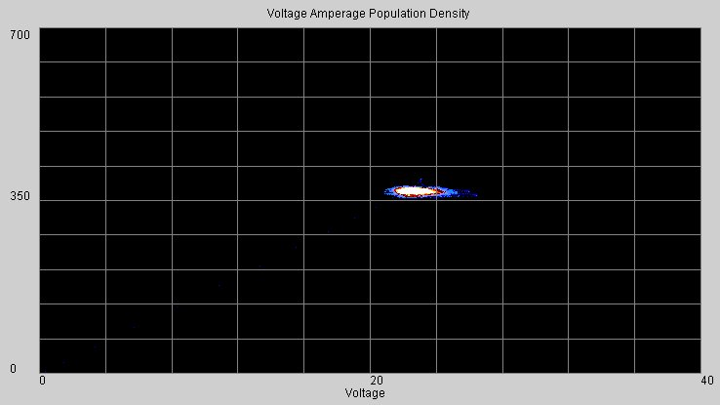
Figure 1: CV spray VI density plot from PowerWave 455, L-56 electrode, 90% Ar+10% CO₂

Pulsed spray process

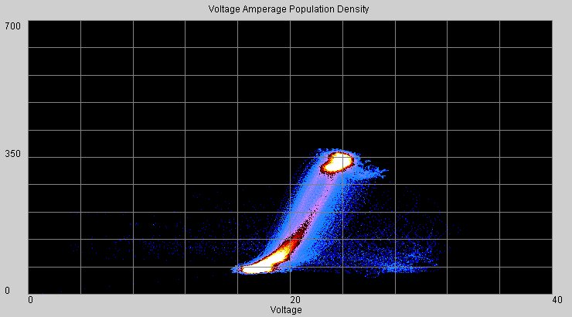
Figure 2: Pulsed spray transfer VI density plot from PowerWave 455, L-50 electrode, and 90% Ar+10% CO₂

Two distinctive “attractors” or hot zones appear in pulsed spray transfer process, corresponding to the high peak current and low background current and their transition behavior. Both zones are above 12V implying that a plasma is always present.

CV short-circuiting process

A typical CV short-circuiting process (see Figure 3) also has two zones, one at low voltage or in a short, and the other at high voltage 15-21V. During the short the current is slowly ramped up, applying pinch force to the liquid bridge, until it breaks into an arc, at which instant it snaps into the arc zone.
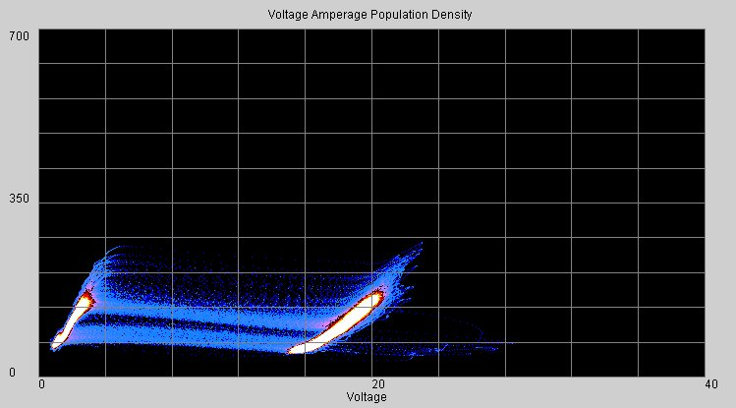
Figure 3: CV short-circuiting VI density plot from PowerMIG 300, L-50 electrode, 90% Ar+10% CO₂

STT controlled short-circuiting transfer process

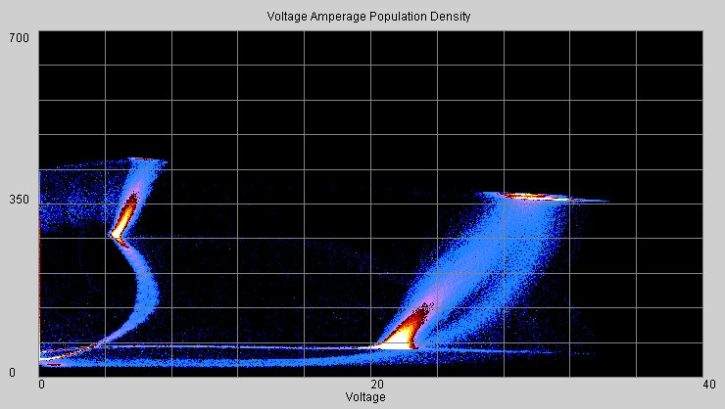
Figure 4: STT VI density plot from STT II, AutoWeld electrode, 75% Ar+25% CO₂

The low spatter STT process has four hot zones in Figure 4. A background current of 70 amps maintains the arc and contributes to plate heating at the right bottom corner. After the electrode initially shorts to the weld pool, it jumps to the low voltage-low current zone to ensure a solid short. Pinch current is then applied following the S-shaped curve to the top left zone. Molten metal is squeezed down and the derivative of voltage (dV/dt) is monitored. When the liquid bridge is about to break, dV/dt increases sharply and power source reacts by driving the process back to the low voltage-low current zone. Immediately following the arc establishment, it swings up to the high current-high voltage zone on the top right corner, to produce plasma force pushing down the weld pool. Finally it returns to the background zone and stays there until it shorts again.

AC submerged arc process

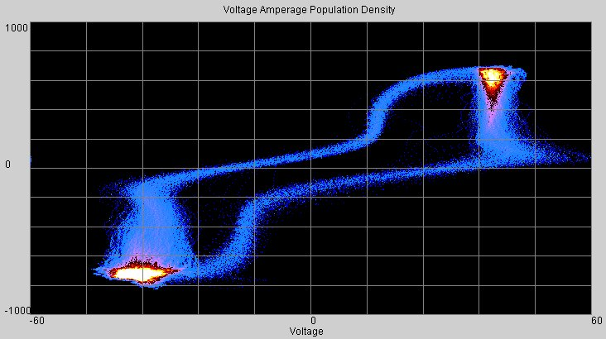
Figure 5: AC sub-arc VI density plot from PowerWave AC/DC with L-60 electrode and 860 flux

The AC submerged arc process circulates between a DC positive zone and a DC negative zone in a loop. One advantage of inverter based, computer controlled AC sub-arc equipment is exhibited in the transition between the two zones. The current is being reduced gradually so that zero-crossing occurs at low current in order to reduce stress applied to the power electronics. It also shows that the zero-crossing occurs rapidly with a large voltage swing from the center tap choke design that prevents arc outages.

CC process with stick electrode

Pipe welding using E6010 electrode on an electronically controlled engine welder is shown in Figure 6. The main hot zone is characterized by a constant current with voltage ranging from 18-34V. The stick electrode is being whipped back and forth, and shorting does occur as shown in the left hot zone. Transition dynamics in the VI plot from the shorting zone and arc zone are essential for puddle fluidity control in all position pipe welding.

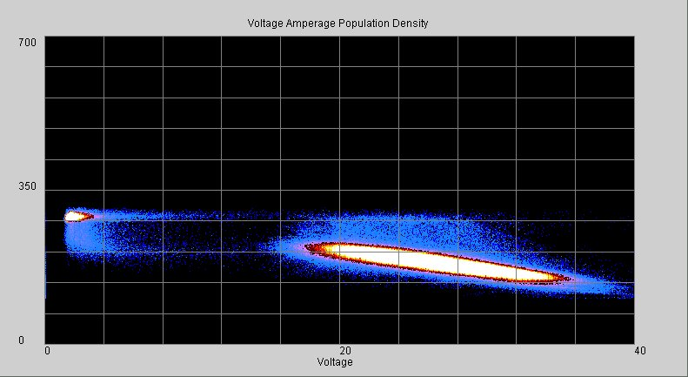
Figure 6: CC process VI density plot from Ranger 305G, Fleetweld® 5P+ electrode

Globular transfer process

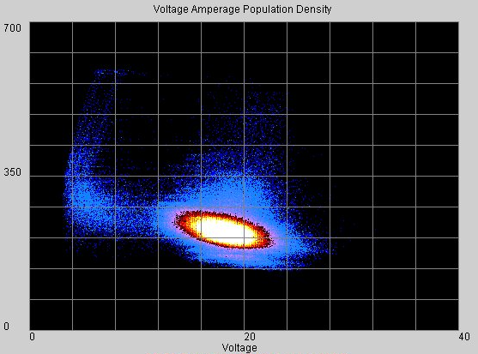
Figure 7: Globular transfer VI density plot from Invertec® V350, Innershield® electrode, no gas

Globular transfer is exhibited in an example of pipe cap pass welding by an inverter V350 and self-shielded flux cored electrode shown in Figure 7. The process stays mostly in the arc region above 13V building up a large droplet hanging at the bottom of the electrode, and occasionally it shorts briefly to transfer the molten ball to the puddle and returns to the arc region. The size and shape of the hot zone and its blue fringes usually indicate the equipment’s ability to hold a constant arc length.

Advanced cross-plots

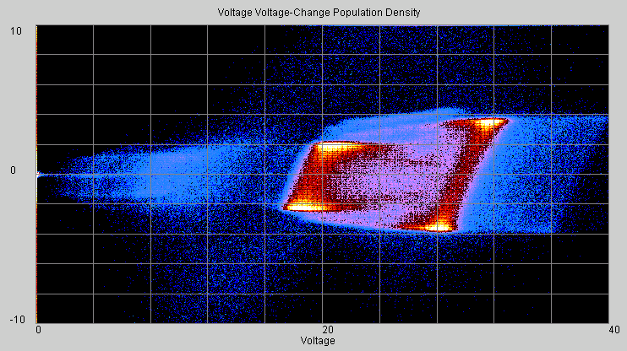
Figure 8: Pulsed spray transfer V-dV density plot from PowerWave 455, L-50 electrode, and 90% Ar+10% CO₂

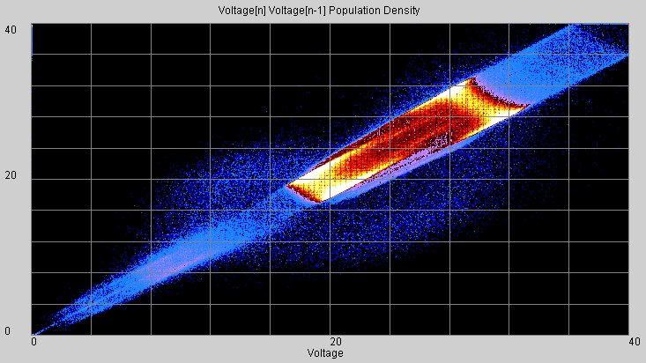
Figure 9: Pulsed spray transfer V(n) vs. V(n-1) density plot from PowerWave 455, L-50 electrode, and 90% Ar+10% CO₂

Figure 8 illustrates pulse welding in a voltage vs. time derivative of voltage image. Time derivate of voltage is useful in prediction of short-to-arc transition and droplet detachment. Figure 9 illustrates the same process in voltage vs. its immediate past. Comparing a signal to its past history can serve as a predictor of change. Figure 10 illustrates the same process in current vs. time triggered at 150A down-slope, where the fluctuation of the waveform including shorting response is clearly visible. Other graphs such as voltage-time graph, cyclical current period vs. voltage period can also provide insight into the arc welding process. Arc power, arc impedance and their time derivatives can also be used for plotting. In general, an arc signal passing through a digital filter with any transfer function, with IIR or FIR implementation in the Z domain, can be used as one axis or both axes in the plot. Digital image processing techniques can be applied to extract weld quality and arc stability. Unstable process tends to have an “out-of-focus” VI plot without high frequencies in its power spectrum. Segmentation, template matching and statistical pattern recognition can be used to distinguish a defective weld from an acceptable weld.

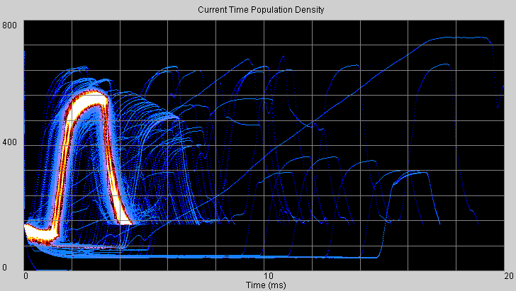

Figure 10: Pulsed spray transfer arc voltage vs. time density plot from PowerWave 455, L-50 electrode, and 90% Ar+10% CO₂

This paper is intended to provide an overview of using a voltage-current population density plot to characterize each arc welding process. Concepts for using this technique in analyzing process stability, power source and consumable dynamic performance characterization, procedure optimization, waveform development, weld defect identification, and fume and spatter estimation are evident but not explored in detail.

CONCLUSION

Voltage-current cross-plot histogram population densities of many arc welding processes are presented, including CV spray, CV short-circuiting, STT, pulsed spray, CC stick, AC sub-arc and globular transfer with tubular electrode. Image analysis tools can be employed to measure arc welding process stability from artificial image created by arc signals directly, their time derivates, or digitally filtered arc signals.

ACKNOWLEGEMENT

The author wishes to express his appreciation to James Hearn for conducting many experiments cited in this study.

REFERENCES

1. Cook, G.E. et al. 1997. Statistical Process Control Application to Weld Process. IEEE Transactions on Industry Applications. Vol. 33. No. 2.
2. Quinn, T.P. et al. 1999. Arc Sensing for Defects in Constant-Voltage Gas Metal Arc Welding. The Welding Journal. September 1999. 322s-328s.
3. Siewert et al. 1993. Sensing of Gas Metal Arc Welding Process Characteristics for Welding Process Control. United States Patent 5,221,825.
4. Crane, B.L.; Kilty, A.L.; Ludewig, H.W.; Jones, B.A. 2001. Method and apparatus for monitoring weld quality, United States Patent 6,184,491.
5. Lucas, W.; Tapp, J. 1998. Development of a PC based system for monitoring arc welding parameters. Research Report 88264.01/97/966.3. The Welding Institute.
6. Ivkovich, S.P., Noch, R.F. 2000. Automated Verification of Complex, Manually Welded Production Assemblies. Gas Metal Arc Welding for the 21st Century Proceedings
7. Hsu, C. 2002. Monitor for Electric Arc Welder. United States Patent 6,441,342.
- Barborak, D.; Conrardy, C. 1998. Monitoring of Weld Quality During Thin-Sheet GMA Welding. Cooperative Research Program Summary Report SR9806. Edison Welding Institute
- Simpson, S.W. 2001. Weld Quality Measurement. United States Patent 6,288,364.

* Engineering Manager, The David C. Lincoln Research and Development Center, The Lincoln Electric Company, 22801 St. Clair Avenue, Cleveland, Ohio 44117

