Particles Contributing to Turbidity

Introduction
To address turbidity removal during treatment processes, an understanding of the physical characteristics and properties of particles in raw water is required. This chapter provides an overview of the inorganic, organic and biotic particles, as well as particles created during typical treatment processes that contribute to turbidity. Because the stability of particles in water is dominated by the electrokinetic properties, a discussion of electrokinetic properties is included to provide information concerning how these properties affect the removal of particle contamination during the treatment process.

Characteristic Properties of Particles
Particles in a raw water supply may be composed of inorganic materials, pathogens, or toxic materials. These particles may also provide sorbent sites for pesticides and other synthetic organic chemicals and heavy metals. Particles are undesirable not only for the cloudy appearance they impart to finished water, but because they also have the ability to shelter microorganisms from inactivation by disinfectants. Consequently, a principal element in supplying quality drinking water is the maximum removal of particles. To establish or optimize a particle removal process, it is important to understand the physical properties of particles.
Particles suspended in water can be categorized into three classes based on their origin:
- Inorganic materials, such as silt or minerals;
- Living or dead organic matter; and
- Biotic material including algae, viruses and bacteria.

Due to the range of small sizes for common particles in water, it is common to find sizes termed in “microns” within the water industry. A micron, or micrometer, is equal to 1 x 10⁻⁶ meters, or 0.00004 inches. Generally, particulate contaminants to be removed from a raw water source range from the larger macro sized particles visible to the naked eye, to the ionic particles viewed only by scanning electron microscopes.
Figure 8-1 illustrates some common particles found in raw water sources and indicates where, within the size range, these particles would typically be detected.

Ionic

Molecular

Macro
Molecular

Micro

Macro

Red Blood
Sugar

Asbestos
Aqueous Salts

Sand
Yeast Cells
Pesticides
Herbicides
Colloidal
Silica
Cryptosporidium

Atomic Radius

Virus
Algae

Pollen
Endotoxin/
Pyrogen
Granular Activated Carbon
Bacteria

Metal
Ions
Hair
Colloids

Giardia
Molecules

SUSPENDED PARTICLES
DISSOLVED PARTICLES

Micron

Scale

1000
100
10
1
0.1
0.01
0.001
0.0001

Source: Osmonics, Inc., 1996; AWWA, 1990.

Figure 8-1. Particle Size Spectrum

Particle Settling
Particle settling, or sedimentation, may be described for a singular particle by the Newton equation for terminal settling velocity of a spherical particle. A knowledge of this velocity is basic in the design and performance of a sedimentation basin.
The rate at which discrete particles will settle in a fluid of constant temperature is given by the equation:
V = [(4g (ρ_{s} - ρ) d) \ (3 C_{d} ρ)] ^{0.5}

where V = terminal settling velocity
g = gravitational constant
ρ_{s} = mass density of the particle
ρ = mass density of the fluid
d = particle diameter
C_{d} = Coefficient of drag (dimensionless)

The terminal settling velocity is derived by equating the drag, buoyant, and gravitational forces acting on the particle. At low settling velocities, the equation is not dependent on the shape of the particle and most sedimentation processes are designed so as to remove small particles, ranging from 1.0 to 0.5 micron, which settle slowly. Larger particles settle at higher velocity and will be removed whether or not they follow Newton's law, or Stokes’ law, the governing equation when the drag coefficient is sufficiently small (0.5 or less) as is the case for colloidal products (McGhee, 1991).
Colloids are very fine solid particles, typically between 10 and 0.001 microns in diameter, which are suspended in solution. Colloidal particles are not visible even with the aid of high-powered microscopes (Sawyer and McCarty,1978). Colloids will not settle out by gravitational forces and may not be removed by conventional filtration alone. The removal of colloidal particles is typically achieved by coagulation to form larger particles, which then may be removed by sedimentation and/or filtration. Coagulation, as defined by Kawamura (1991), is the “destabilization of (the) charge on colloids and suspended solids, including bacteria and viruses,” and is further discussed in Section 8.7, “Electrokinetic Properties of Particles.”

Particle Density and Size Distribution
Typically, a large range of particle sizes will exist in the raw water supply. Type 1 settling is the designation given to discrete particles of various sizes, in a dilute suspension, which settle without flocculating. Dilute suspensions of flocculating particles, where heavier particles overtake and coalesce with smaller and lighter particles, are given the designation of Type 2. As there is no mathematical equation which can be applied to the relationships of Type 1 and 2 sedimentation, statistical analysis is applied to predict the settling velocities for particles in water having a broad range of size and density. Particle size distribution analysis (Type 1) or settling-column analysis (Type 1 or 2) is applied and a settling velocity cumulative frequency curve is obtained and used in settling basin design. An excellent resource for understanding the use of settling column analysis, and discrete particle settling is given by Gregory and Zabel (1990).
Type 3a and 3b, or hindered settling, occur when high densities of particles in suspension result in an interaction of particles. The displacement of water produced by the settling of one particle affects the relative velocities of its neighbors (McGhee, 1991). A zone is formed in which more rapidly-settling particles act as a group with a reduced settling velocity. However, even at fairly high concentrations, the reduction in settling velocity is not significant. The following equation from McGhee (1991) gives an estimate of the magnitude for hindered settling:

V_{h}/V = (1 - C_{v})^{4.65}

where V_{h} = hindered settling velocity
V = free settling velocity
C_{v} = volume of particles divided by total volume of the suspension.

Inorganic Particles
Inorganic particles in water are produced by the natural weathering of minerals, including both suspended and dissolved materials. Inorganic particles may consist of iron oxides, salts, sulfur, silts and clays such as bentonite or muscovite. Depending on the concentration of inorganic particles present in raw water sources, human health effects can vary from beneficial to toxic.

Naturally Occurring Minerals
Naturally occurring minerals find their way into raw water sources either naturally through the breakdown of minerals in rock, or through industrial process discharges which have contaminated a raw water source. Industrial contributors can include mining, smelting, coal burning power producers, oil and gas companies, and electroplating operations.
Clays, metal hydroxides, and other particles originating from mineral sources typically vary from several nanometers to several microns in diameter, with a continuous size distribution over this range. In surface waters, the majority of these particles are within a 0.1 to 1 micron size range. As a result of their settling characteristics, particles in this size range have the ability to remain in suspension in moving water. Particles of this size range scatter visible light efficiently, due to the larger surface areas which are created as particles decrease in size. This scattering gives the water a turbid, or cloudy, appearance at very low concentrations. However, Wiesner and Klute (1998) suggest that the real threat of these particles is the adsorptive properties. The large surface areas created by even a small mass concentration of the colloid particles provide abundant adsorption sites for natural and synthetic organic matter, metals, and other toxic substances. Bacteria and viruses can also attach to these particles, and there is some concern that inorganic particulate contamination has the ability to shield microorganisms from inactivation by disinfectants.
Dissolved inorganics known to have adverse health effects on humans when ingested include aluminum, arsenic, cadmium, copper, fluoride, lead, and mercury. The EPA has established maximum contaminant levels (MCLs) for a variety of inorganic contaminants and is in constant review of health advisories to determine the health effects from inorganics ingested in drinking water (Tate and Arnold, 1990). The inorganic materials for which MCLs have been established are toxic to humans in some form.

Organic Particles
Organic materials are compounds, natural or manmade, having a chemical structure based upon the carbon molecule. Millions of organic compounds containing carbon have been identified and named, including; hydrocarbons, wood, sugars, proteins, plastics, petroleum-based compounds, solvents, pesticides and herbicides.
Both naturally-occurring and synthetic organics are present in surface waters and typically originate from the following sources (Tate and Arnold, 1990):
- The decomposition of naturally occurring organic materials in the environment;
- Industrial, agricultural and domestic activities; and
- Reactions occurring during the treatment and distribution of drinking water.

Organics may have adverse human health impacts, such as toxicity, or as carcinogens when ingested. In addition, naturally occurring organics, most widely referred to as natural organic matter (NOM), can give raw water a characteristic color, taste, or odor. Furthermore, organics in water can be altered by treatment processes resulting in disinfection byproducts (DBPs). In the following sections, a description of the organic constituents in raw water is provided.

Synthetic Organics
Artificial organics, or synthetic organics, can infiltrate raw water supplies through overland flow of contaminated urban and agricultural rainwater; direct discharge from industries and wastewater treatment plants, and, as leachate from contaminated soils. Most contaminants found in water supplies that have adverse health effects are synthetic organics including: herbicides and pesticides; solvents; and, polychlorinated biphenyls commonly known as PCBs (Tate and Arnold, 1990). The EPA has set MCLs for many synthetic substances, both in industrial waste discharge and within the primary drinking water standards.

Natural Organic Matter (NOM)
In the majority of raw water sources, the largest fraction of all organic particles is due to NOM originating from the degradation of plant or animal materials (Wiesner and Klute, 1998). NOM is undesirable in raw water for a variety of reasons, ranging from undesirable color to providing adsorption site for toxic substances. NOM will also adsorb to inorganic particles present in raw water, reducing the settling properties of those particles. Aiken and Cotsaris (1995) recognized numerous studies supporting the importance of NOM in mobilization of hydrophobic organic species; of metals (lead, cadmium, copper, zinc, mercury, and chromium); and radionuclides through the treatment process. Elevated levels of certain NOM constituents require additional coagulation in order to destabilize the particles and remove them in sedimentation and/or filtration basins.
NOM is also present in raw water supplies as colloidal organic carbon in the form of humic materials. Humic substances have generated considerable attention due to their disinfection by-products (DBP) formation potential (Amirtharajah and O’Melia, 1990).

Total Organic Carbon (TOC)
TOC is a composite measure of the overall organic content, in a water sample. TOC is measured by the amount of carbon dioxide produced when a water sample is atomized in a combustion chamber (Standard Methods, 1985). Total organic halogen (TOX) indicates the presence of halogenated organics, and is a proper indication of synthetic chemical contamination. Either of these methods are more economical than testing for any, or all, individual organic compounds likely to be in a raw water supply.

Organic Disinfection By-products (DBPs)
The use of oxidants for disinfection, taste and odor removal, or for decreasing coagulant demand also produces undesirable organic by-products. These by-products are difficult to analyze and remove from the treatment process. Organic contaminants formed during water treatment include trihalomethanes (THMs) and haloacetonitriles. Surveys conducted since the mid-1970s have determined that chloroform and other THMs are the organic chemicals occurring most consistently, and at overall highest concentrations, of any organic contaminant in treated drinking water (Wiesner and Klute, 1998).
THMs are formed in water when chlorine being used as a disinfectant reacts with NOM, such as humic acids from decaying vegetation. Chloroform is one of the most common THMs formed in this type of reaction. The THMs include trichloromethane or chloroform; dibromochloromethane; dichlorobromomethane; and bromoform.
Water chlorination not only produces THMs, but also a variety of other organic compounds. Alternative disinfectants such as, chloramines, chlorine dioxide, and ozone can also react with source water organics to yield organic by-products. Exactly which compounds are formed, their formation pathways, and their health effects are not well known. To complicate matters, many of the DBPs are not susceptible to even highly sophisticated methods of extraction and analysis.

Particles of Biotic Origin
Four categories of waterborne microorganisms exist as particles contributing to the turbidity of raw water:
- Protozoans;
- Enteric viruses;
- Algae; and
- Bacteria.

Microorganisms are living organisms that are invisible or barely visible to the naked eye. While many microorganisms commonly found in source waters do not pose health risk to humans, others such as Cryptosporidium can be sources of infectious and communicable diseases.
Isolation and identification of a specific organism such as Cryptosporidium may prove difficult due to the volume and variety of other microorganisms in the sample. Most municipal water plant labs do not possess the equipment required for testing and identification of specific pathogens. Indicator organisms are frequently used to assess contamination by a biotic constituent. Total coliforms are the widely used indicator for pathogens. While the presence of coliforms is not proof that the water contains harmful pathogens, the absence of them is often used as evidence that it is free of pathogens.

Protozoans
Protozoans are organisms that can exist in colonies or as single cells. Some protozoans are capable of producing spores, a small reproductive body capable of reproducing the organism under favorable conditions. In water, most spores resist adverse conditions that would readily destroy the parent organism.
Of the tens of thousands of species of protozoa, the principal protozoan pathogens of concern in potable water are Cryptosporidium, Giardia lamblia, and E. histolytica. When these organisms are ingested by humans, they can cause symptoms including; stomach cramps, diarrhea, fever, vomiting, and dehydration. These parasites are typically more resistant to traditional chlorine disinfection than coliforms.
Cryptosporidium is a disease-causing protozoan housed in a hard-shelled oocyst (pronounced o-he-sist). The oocyst is typically 2 to 5 microns in diameter, round to egg shaped, colorless and nearly transparent. Human and animal feces are sources of Cryptosporidium in surface water. Normally, oocysts are found dormant in the environment. When ingested, the oocyst splits open to release sporozoites. In this new form, a complex reproductive cycle begins. Figure 8-2 describes the lifecycle of Cryptosporidium.
The sporozoites invade the lining of the gastrointestinal tract and can cause an illness called Cryptosporidiosis. The disease can be fatal to people with suppressed immune systems, including persons with acquired immune deficiency syndrome (AIDS), those undergoing chemotherapy, children and the elderly (Current and Garcia, 1991). Human Cryptosporidiosis was first reported in 1976, and outbreaks in public water systems have motivated numerous studies and regulatory attention on the effectiveness of filtration and chemical disinfection in the removal and inactivation of these protozoans. Limited data suggests that Cryptosporidium oocysts are resistant to disinfection at levels practiced in the U.S. at the time of IESWTR promulgation. While research is underway to identify more appropriate inactivation techniques, removal by filtration is currently the most effective means of dealing with Cryptosporidium.

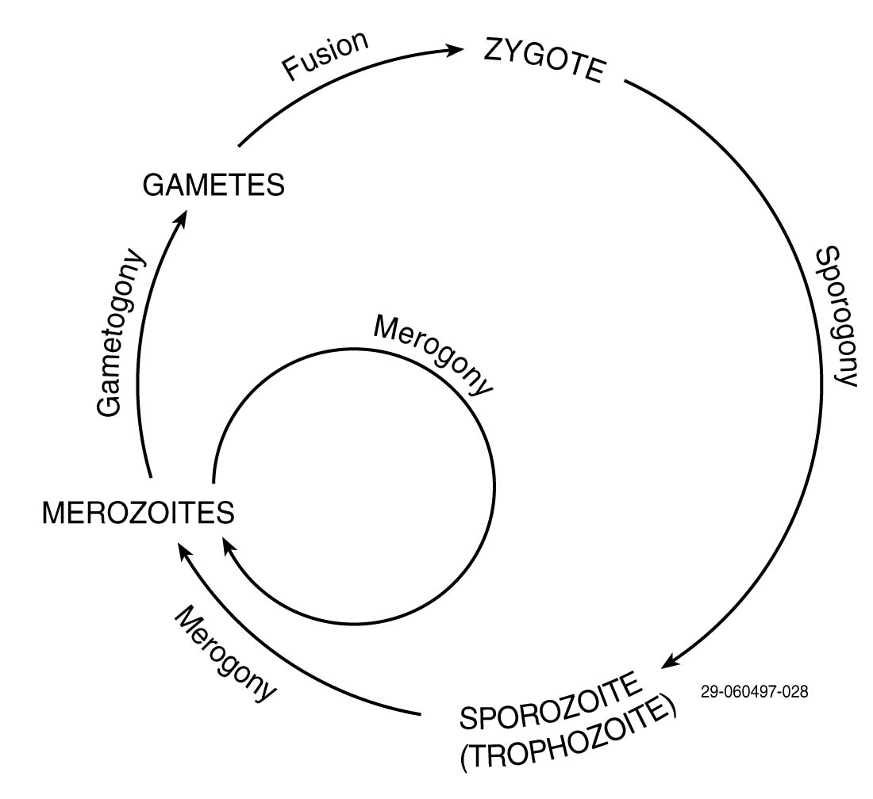
Source: Ewing, 1986.

Figure 8-2. Cryptosporidium Life Cycle

Human and animal feces are also sources of Giardia in surface waters. Giardia exists as either a flagellated trophozite of approximately 9 to 21 microns, or ovoid cysts, approximately 10 microns long and 6 microns wide. Cysts can survive in water from 1 to 3 months. Objects of this size are easily removed by packed bed filters, provided that coagulation and flocculation pretreatment are properly controlled.
Unlike Giardia and Cryptosporidium, mammals are not a source of E. histolytica to water supplies and potential contamination of surface water is considered to be low (Wiesner and Klute, 1998). The size range for the protozoan is 15 to 25 microns for a trophozite and 10 to 15 microns for the cyst, and are effectively removed by filtration. Additional information regarding Cryptosporidium may be found in Occurrence Assessment for the Interim Enhanced Surface Water Treatment Rule (USEPA, 1997).

Viruses
A virus is a parasitic, infectious microbe, composed almost entirely of protein and nucleic acids that can cause disease in humans and other living organisms. Viruses can reproduce only within living cells, and typically range from 0.004 to 0.1 micron in diameter. The principal viral pathogens of concern in potable water are the Enteric viruses: hepatitis A, Norwalk-type viruses, rotaviruses, adenoviruses, enteroviruses, and reoviruses. Enteric viruses infect the gastrointestinal tracts of humans and are transmitted through public water supplies. It appears that many viruses have an attraction for the surfaces of larger colloidal particles and, if aggregated, may increase the effective size of these pathogens to promote their removal (Wiesner and Klute, 1998).

Algae
Algae are common and normal inhabitants of surface waters and are encountered in every water supply that is exposed to sunlight (Tarzwell, undated). Algae typically range in size from 5 to 100 microns. Figure 8-3 presents common types of algae which can be found within source water and in the water treatment process.
Algae are not typically a threat to public health in a drinking water supply. Concerns in potable water treatment arising from the presence of algae include; the ability to create large quantities of organic matter; the production of turbidity, tastes and odors in source water, and; the physical impact on the water treatment plant processes. Some species of blue-green algae are known to produce endotoxins which may affect human health. Algae can clog filters, resulting in reduced run times and an increase in the volume of backwash water needed for cleaning. Examples of filter clogging algae are seen in Figure 8-4. In slow sand filters and biologically active filters, algae will produce oxygen for bacteria that actively degrade organic compounds. They may also release biopolymers that aid in the destabilization of fine colloidal materials (Wiesner and Klute, 1998).

Bacteria
Bacteria are single-celled organisms that lack well-defined nuclear membranes and other specialized functional cell parts. Bacterial cells typically range from 1 to 15 microns in length. They vary in shape from simple spheres to filamentous threads. Figure 8-5 presents various bacterial and fungal forms. Bacteria and fungi are decomposers that break down the wastes and bodies of dead organisms to make their components available for reuse. Bacteria can exist almost anywhere on earth and in almost any medium. Some are beneficial to man while others are harmful, or even fatal. The principal bacterial pathogens of concern in water treatment are the Salmonella, Shigella, Yersinia enterocolitica, enteropathogenic E. coli, Campylobacter jejuni, Legionella, Vibrio cholerae, and Mycobacterium.
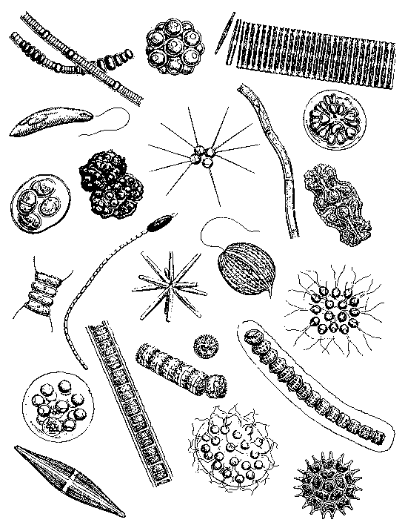
Nodularia
Coelastrum
Fragilaria
Euglena
Micractinium
Gomphosphaeria
Mougeotia
Euastrum
Botryococcus
Oocystis
Scenedesmus
Cylindrospermium
Actinastrium
Gonium
Desmidium
Phacus
Stephanodiscus
Eudorina
Pediastrum
Zygnema
Sphaerocystis
Stauroneis
Source: Standard Methods, 1985.

Figure 8-3. Plankton and Other Surface Water Algae

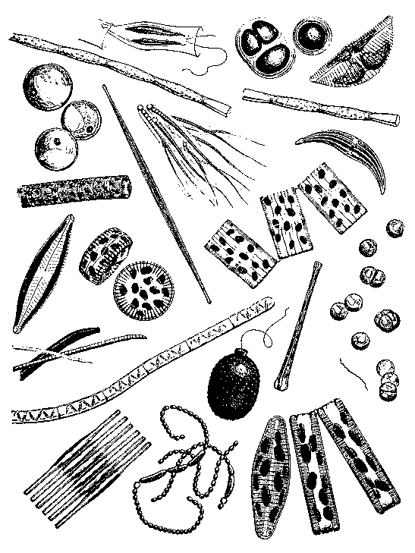
Dinobryon
Anacystis
Gymbella
Tribonema
Chlorella
Synedra
Rivularia
Melosira
Navicula
Cyclotella
Closterium
Tabellaria
Spirogyra
Oscillatoria
Trachelomonas
Asterionella
Palmella
Diatoma
Anabeana
Fragilaria
Source: Standard Methods, 1985.

Figure 8-4. Filter Clogging Algae

Bacteria Fungi

a) 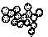 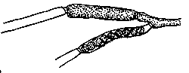
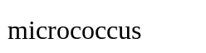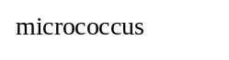

Leptomitus, showing zoospores and cellulin plugs (diameter 8.5-16μm)

b) 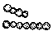 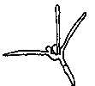
streptococcus
Tetracladium (diameter 2.5-3.5 μm)

c)  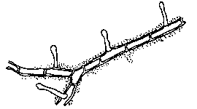
sarcina

Zoophagus, showing mycelial pegs

d) 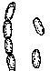 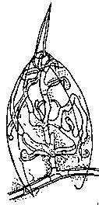
bacillus
Zoophagus, with rotifer impaled on mycelial peg (diameter 3 μm)

e) 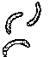 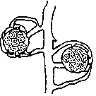
vibrio
Achlya, showing oospores

f) 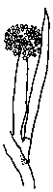
spirillum
Achlya, showing encysted zoospores (Oogonia 50-60μm, oospores 18.5-22 μm, encysted zoospores 3-5 μm)

Source: Standard Methods, 1985.

Figure 8-5. Examples of Bacteria and Fungi Forms

Particles Added or Created During Treatment
Several steps in the water treatment process may contribute to turbidity. As discussed in Section 10, water treatment is provided to remove undesirable constituents from raw water, and many of these processes are intended to remove suspended solids and reduce turbidity. However, this section identifies those chemicals and practices used in water treatment which are known to increase turbidity. Specifically, the addition of pretreatment chemicals for coagulation-flocculation-sedimentation or filter aids prior to filtration can substantially increase the particulate materials loading of sedimentation basins, filters and other processes used in water treatment. Moreover, increases in turbidity may occur when any aspect of the water treatment process fails.

Coagulants
The coagulation of water generally involves the chemical addition of either hydrolyzing electrolytes or organic polymers for the destabilization of colloids in suspension. Some common coagulants are those based on aluminum, such as aluminum sulfate and alum; and those based on iron, such as ferric and ferrous sulfate. The action of metallic coagulants is complex and is dependent on the fact that colloid particles are charged entities in water solution. More discussion of the electrokinetic properties of colloids is included in section 8-7. Additionally, the use of bentonite, and activated silica for coagulation enhancement will increase the particle loading in the treatment stream (Wiesner and Klute, 1998).

Polymers
Natural and synthetic coagulant aids are known as “polyelectrolytes,” because they have characteristics of both polymers and electrolyte. Polyelectrolytes are long-chain, high-molecular-weight molecules which bear a large number of charged groups. The net charge on the molecule may be positive, negative, or neutral. The chemical groups on the polymer are thought to combine with active sites on the colloid, combining them into a larger particles which will then settle by gravitational force. Both the molecular weight of the polymer and charge density influence the effectiveness of polyelectrolytes.
Polyelectrolytes may be used alone or in tandem with metallic coagulants. Optimal doses for polymeric coagulant are typically determined in bench scale or pilot scale plant testing utilizing source water. Use of quantities over the optimal dose will not increase coagulation and instead will create unnecessary loading of particles to be removed.

Lime
Lime is a calcinated chemical material used in lime or lime and soda ash water treatment processes to add alkalinity to the water and adjust the pH. Lime treatment has the incidental benefits to remove iron, aid in clarification of turbid waters, and minimal bactericidal benefit (Logsdon et al., 1994). Lime has a tendency to deposit solids at changes in directions and will precipitate out of solution at areas where velocity decreases or where changes in velocity occur. The precipitates formed in the lime-soda softening process consist principally of calcium carbonate and magnesium hydroxide with size ranges from 15 to 20 microns. If lime is dosed in quantities greater than the water supply requires, residual lime particles will increase the turbidity in treated water effluent.

Powdered Activated Carbon (PAC)
PAC adsorption is generally used for the removal of organics, radon, color, and taste and odor treatment. Activated carbon is produced from bituminous coal, or cellulose-based substances like wood or coconut shells, by a destructive distillation process that drives off the volatile components of the material. A highly porous, adsorbent material is created which possesses a large surface area per unit volume.
PAC is generally less than 0.075 millimeters in size and has an extremely high ratio of surface area to volume. Nonpolar compounds of high molecular weight are attracted and held, or adsorbed, to this surface. The effectiveness of organic removal by PAC is dependent on the pH, temperature, contaminant concentration, molecular weight of the particles to be adsorbed, type of PAC used, and the contact time of the PAC with the water.
The relative capacity of different carbons to attract and adsorb particles to their surfaces is best assessed by bench or pilot scale testing of the raw water supply. Therefore, the addition of PAC for the removal of organic materials, or to control tastes and odors, creates an additional loading of materials to the downstream processes, as it is slow to settle because of its small size and low density.

Recycle Flows
Filtration treatment processes require frequent, intermittent backwash cycles to remove particles from the media. The backwash water is a concentrate of particles and pretreatment chemicals added prior to the filters. Some plants capture and return this concentrate to a location in the treatment process as a recycled flow. The properties of the backwash concentrate depend on the type and quantity of particles present in the source water, and pretreatment chemicals and treatment processes used earlier in the treatment train. The practice of returning spent backwash water to the treatment system has become a concern due to the potential for returning pathogens to the treatment train.

Electrokinetic Properties of Particles
Colloidal particles comprise a large portion of the turbidity-producing substances in waters. Examples of colloidal particles include color compounds, clays, microscopic organisms and organic matter from decaying vegetation or municipal wastes. Colloidal
dispersions are stable in water, as they posses a large surface area relative to their weight. Therefore, gravitational forces alone will not remove colloids during sedimentation. Effective removal of these colloidal dispersions is greatly impacted by the electrokinetic properties on the surface of the colloids.
Each colloid carries a similar electrical charge that produces a force of mutual electrostatic repulsion between adjacent particles. If the charge is high enough, the colloids will remain discrete and in suspension. The addition of coagulants or polymers reduces or eliminates this charge and colloids will begin to agglomerate and settle out of suspension or form interconnected matrices which can then be removed during filtration. This agglomeration causes the characteristics of the suspension to change by creating new particle viscosity, settling rates and effective size properties for the colloids.
Colloids are classified as hydrophobic (resistant to water bonding) or hydrophilic (affinity for water bonding). Hydrophilic colloids are stable because their attraction to water molecules will overcome the slight charge characteristic they possess. This attraction makes hydrophilic colloids difficult to remove from suspension. Examples of hydrophilic colloids include soaps and detergents, soluble starches, soluble proteins and blood serum. On the other hand, hydrophobic particles are dependent on electrical charge for their stability in suspension. The bulk of inorganic and organic matter in a turbid raw water is of this type.

Electrical Potential
Most colloidal particles in water are negatively charged as a result of differences in electrical potential between the water and the particle phases. This charge is due to an unequal distribution of ions over the particle surface and the surrounding solution.
The charge on a colloidal particle can be controlled by modifying characteristics of the water which holds the particles in suspension. Modifications include changing the liquid's pH or changing the ionic species in solution. Another, more direct technique is to use surface-active agents, such as coagulants, that directly adsorb to the surface of the colloid and change its characteristics.

Electrical Double Layer Theory
The double layer model explains the ionic environment surrounding a charged colloid and explains how the repulsive forces are set up around a colloid. Figure 8-6 illustrates the resulting colloidal state.
A single negative colloid will initially attract some of the positive ions in the solution to form a firmly attached layer around the surface of the colloid, known as the Stern layer. Additional positive ions are still attracted by the negative colloid, but are also repelled by the Stern layer as well as by other positively charged ions trying to get close to the negatively charged colloid. This constant attraction and repulsion results in the formation of a diffuse layer of charged ions surrounding the colloid and Stern layers.
The diffuse layer can be visualized as a charged atmosphere surrounding the colloid. Together, the attached positively charged ions in the Stern layer and the charged atmosphere in the diffuse layer is referred to as the double layer. The charge is a
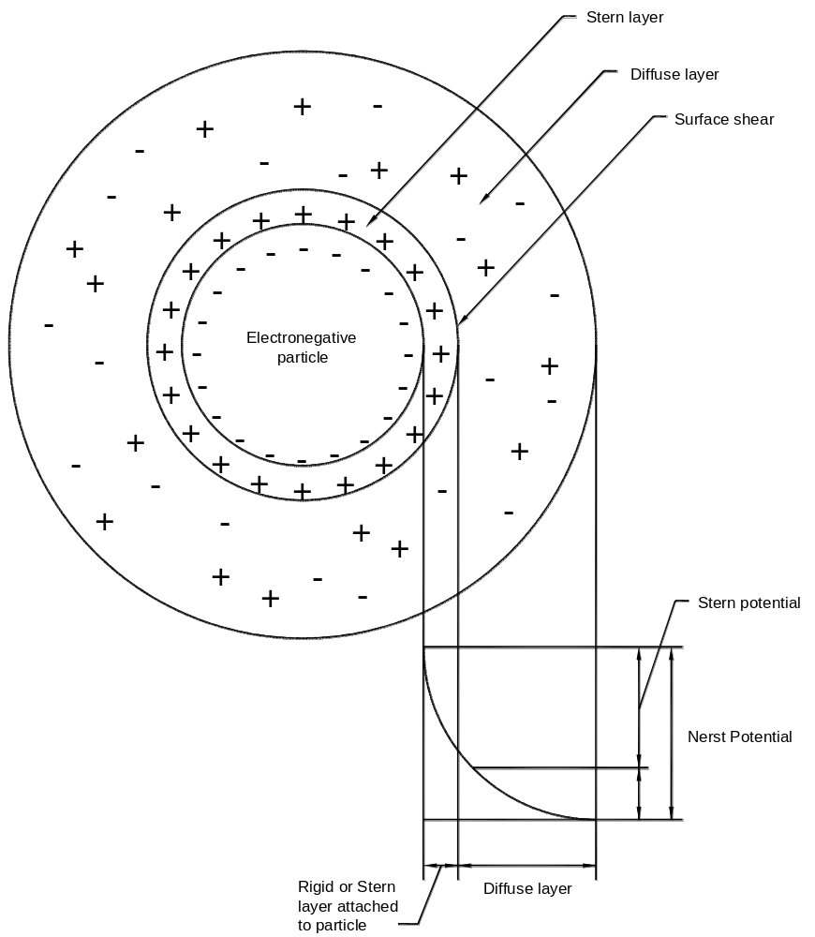
Source: McGhee,1991.

Figure 8-6. Double Layer Theory (Guoy-Stern Colloidal Model)

maximum at the particle surface and decreases with distance from the surface. The thickness of this layer depends on the type and concentration of ions in solution.
The DLVO Theory (for Derjaguin, Landau, Verwey and Overbeek) is the classic model which describes the balance of forces between charged colloid particles. Amirtharajah and O’Melia (1990) provide a thorough discussion of the electrostatic theory of colloidal stability from the DLVO model and other works.
When two similar colloidal particles with similar primary charge approach each other, their diffuse layers begin to interact. The similar primary charges they possess result in repulsive forces. The closer the particles approach, the stronger the repulsive forces. Repulsive forces which keep particles from aggregating are counteracted to some degree by an attractive force termed van der Waals attraction. All colloidal particles possess this attractive force regardless of charge and composition. As van der Waals forces tend to be relatively weak attractions, the force decreases rapidly with an increasing distance between particles.
The balance of the two opposing forces, electrostatic repulsion and van der Waals attraction, explains why some colloidal systems agglomerate while others do not. As particles with similar charge approach one another, the repulsive electrostatic forces increase to keep them separated. However, if they can be brought sufficiently close together to get past this energy barrier, the attractive van der Waals force will predominate, and the particles will remain together. The random motion of colloids caused by the constant collisions with water molecules, termed Brownian Movement, will bring particles in close proximity and aggregation may occur. However, the addition of coagulant and polymers is typically used to lower the energy barriers between particles and provide efficient agglomerations for settling.

Zeta Potential
The Stern layer is considered to be rigidly attached to the colloid, while the diffuse layer is a dynamic layer of charged particles. The Nernst Potential is the measurement of voltage (in the order of millivolts) in the diffuse layer. The potential is a maximum at the Stern layer and drops exponentially through the diffuse layer. The zeta potential is the electrical potential representing the difference in voltage between the surface of the diffuse layer and the water. It is important to know the magnitude of the zeta potential, as it represents the strength of the repulsion between colloid particles and the distance which must be overcome to bring the particles together.
The primary charge on a colloid cannot be measured directly. However, the zeta potential can be computed from measurements of particle movement within an electrical field (electrophoretic mobility). Therefore, the zeta potential, ζ, is defined by the equation:
ζ = 4πδq
D
where q = charge of the particle
δ = thickness of the zone of influence of the charge on the particle
D = dielectric constant of the liquid

Zeta potential measurements can be made using a high-quality stereoscopic microscope to observe colloidal particles inside an electrophoresis cell (Zeta-Meter 1998). An electric field is created across the cell and charged particles move within the field. Their velocity and direction are then related to the zeta potential. Measurements of zeta potential can give an indication of the effectiveness of added electrolytes in lowering the energy barrier between colloids, and can direct the optimization of coagulant dose in water treatment.
The destabilization of colloids is accomplished by the reduction of the zeta potential with coagulants such as alum, ferric chloride and/or cationic polymers. Once the charge is reduced or eliminated, no repulsive forces exist. Gentle agitation in a flocculation basin will cause numerous, successful colloid collisions. Chapter 10 further discusses the mechanics of coagulation and flocculation in the water treatment process.

Streaming Current
As discussed in the previous section, a charged particle will move with fixed velocity through a voltage field under the physical phenomenon known as electrophoresis. Streaming current is a measurable electric current that is generated when particles in water are temporarily immobilized and the bulk liquid is forced to flow past the particles. A streaming current monitor is a continuous, online sampling instrument which measures the charge on particles. A streaming current detector, or monitor, is a cylinder and piston. The up and downward motion of the piston draws a sample of water into the annular space between the piston and cylinder. An alternating current is read by the electrodes attached to the ends of the cylinder (Amirtharajah and O’Melia, 1990). Charged particles are temporarily immobilized by the piston and cylinder, and the motion of charged particles in the double layer passing these immobilized particles creates the streaming current (ChemTrac, 1997).

References
- Aiken, G. and C. Evangelo. “1995. Soil and Hydrology: their effect on NOM.” J. AWWA. 1:36-37.
- Amirtharajah, A. and C.R. O’Melia. 1990. “Coagulation Processes: Destabilization, Mixing, and Flocculation.” Water Quality and Treatment, A Handbook of Community Water Supplies. Fourth Edition. AWWA. F.W. Pontius, editor. McGraw-Hill, New York.
- AWWA. 1990. Water Quality and Treatment. Fourth Edition. McGraw-Hill, Inc., New York.
- Standard Methods. 1985. Standard Methods for the Examination of Water and Wastewater, Sixteenth Edition. Franson, M.H., Eaton, A.D., Clesceri, L.S., and Greenberg, A.E., (editors). American Public Health Association, AWWA, and Water Environment Federation. Port City Press, Baltimore, MD.
- ChemTrac Systems Inc. 1997. Optimizing Particle Removal with Streaming Current Monitors and Particle Counters. Atlanta, GA.
- Current, W.L. and L.S. Garcia. 1991. Cryptosporidiosis. Clinical Microbiological Reviews. 4(3):325.
- Ewing, R.B. 1986. Microbiological Reviews. American Society of Microbiology. 50:458.
- Gregory, R. and T.F. Zabel. 1990. “Sedimentation and Flotation. ” Water Quality and Treatment, A Handbook of Community Water Supplies. Fourth Edition. AWWA. Ed. F.W. Pontius, editor. McGraw-Hill, New York.
- Jancangelo, J.G., et al. 1992. Low Pressure Membrane Filtration for Particle Removal. AWWARF, Denver, CO.
- Kawamura, S. 1991. Integrated Design of Water Treatment Facilities. John Wiley & Sons, New York.
- Logsdon, G., M.M. Frey, T.D. Stefanich, S.L. Johnson, D.E. Feely, J.B. Rose, and M. Sobsey. 1994. “The Removal and Disinfection Efficiency of Lime Softening Processes for Giardia and Viruses.” AWWARF, Denver, CO.
- McGhee, T.J. 1991. Water Resources and Environmental Engineering. Sixth Edition. McGraw-Hill, New York.
- Sawyer, C.N. and P.L. McCarty. 1978. Chemistry for Environmental Engineering. Third Edition. McGraw-Hill, New York.
- Tarzwell, C.M, editor. undated. “Algae - Taste and Odor Control. WT-138.” Robert A. Taft Sanitary Engineering Center, Cincinnati, OH.
- Tate, C.H. and K.F. Arnold. 1990. Health and Aesthetic Aspects of Water Quality. Water Quality and Treatment, A Handbook of Community Water Supplies. Fourth Edition. F.W. Pontius, editor. AWWA, McGraw-Hill, New York.
- USEPA. 1997. Occurrence Assessment for the Interim Enhanced Surface Water Treatment Rule, Final Draft. Office of Ground Water and Drinking Water, Washington, D.C.
- Wiesner, M.R. and R. Klute. 1998. Properties and Measurements of Particulate Contaminants in Water. Treatment and Process Selection for Particle Removal. J.B. McEwen, editor. AWWARF and International Water Supply Association, Denver, CO.
- Zeta-Meter Inc., 1998. Zeta Potential: A Complete Course. Internet Access: www.zeta-meter.com.

THIS PAGE INTENTIONALLY LEFT BLANK

8. Particles Contributing to Turbidity 8-1
8.1 Introduction 8-1
8.2 Characteristic Properties of Particles 8-1
8.2.1 Particle Settling 8-2
8.2.2 Particle Density and Size Distribution 8-3
8.3 Inorganic Particles 8-4
8.3.1 Naturally Occurring Minerals 8-4
8.4 Organic Particles 8-5
8.4.1 Synthetic Organics 8-5
8.4.2 Natural Organic Matter (NOM) 8-5
8.4.3 Total Organic Carbon (TOC) 8-6
8.4.4 Organic Disinfection By-products (DBPs) 8-6
8.5 Particles of Biotic Origin 8-6
8.5.1 Protozoans 8-7
8.5.2 Viruses 8-8
8.5.3 Algae 8-9
8.5.4 Bacteria 8-9
8.6 Particles Added or Created During Treatment 8-13
8.6.1 Coagulants 8-13
8.6.2 Powdered Activated Carbon (PAC) 8-14
8.6.3 Recycle Flows 8-14
8.7 Electrokinetic Properties of Particles 8-14
8.7.1 Electrical Potential 8-15
8.7.2 Electrical Double Layer Theory 8-15
8.8 References 8-18

Figure 8-1. Particle Size Spectrum 8-2
Figure 8-2. Cryptosporidium Life Cycle 8-8
Figure 8-3. Plankton and Other Surface Water Algae 8-10
Figure 8-4. Filter Clogging Algae 8-11
Figure 8-5. Examples of Bacteria and Fungi Forms 8-12
Figure 8-6. Double Layer Theory (Guoy-Stern Colloidal Model) 8-16

