Testimony of

Jon C. Boothroyd, PhD, State Geologist
Rhode Island Geological Survey

Prepared for

Briefing on Global Warming’s Impact on Narragansett Bay

The United States Senate Committee on Environment and Public Works
University of Rhode Island, Bay Campus
Corless Auditorium
Thursday August 21, 2008
10:30am
Thank you for the opportunity to appear before the Committee. My name is Jon Boothroyd. I am a Professor of Quaternary Geology in the Department of Geosciences, College of the Environment and Life Sciences at the University of Rhode Island. My specialties are coastal and glacial geology, specifically coastal geologic hazards and aspects of glacial geology as it relates to climate change. I have 48 years of experience, including 33 years at the University of Rhode Island, in coastal and glacial field studies around the world. The Rhode island work has been carried out with the support of: Rhode Island Coastal Resources Management Council, Rhode Island Sea Grant, National Resources Conservation Service, US Army Corps of Engineers (New England District), Rhode island Geographic Information System, and the Coastal Institute at the University of Rhode Island. The importance of geologic field studies elsewhere to the topic today, “Global Warming’s Impact on Narragansett Bay”, is that the findings may serve as analogs to what could happen to Narragansett Bay and the southern shore of Rhode Island.

Coastal Geologic Hazards
Coastal geologic hazards in Rhode Island include the effects on people and infrastructure of processes resulting from:
- Hurricanes (tropical cyclones),
- Extratropical cyclones (“nor’easters”), and
- Sea-level rise.
The processes resulting from hurricanes, extratropical storms and sea-level rise are:
- Frontal erosion – from breaking waves and storm swash runup,
- Storm-surge overwash – water that penetrates inland from the shoreline resulting in elevated water levels on the landscape, and
- Elevated level of the mean higher high water (MHHW) stage of the tide at times into the future.
The scale of these coastal geologic processes for the Rhode Island shoreline is as follows:
- Breaking waves – 3 to 10 feet high at the shoreline, higher offshore,
- Storm-surge overwash – 1 to 10 foot water depth inland across the shore zone, and
- Sea-level rise – 0.13 inches per year at present, but could increase to 0.33 inches per year in the future.

Hayes and Boothroyd (1969, 1987) studied extratropical cyclones impacting the northeast Massachusetts shore and found that processes resulting from such storms were dependent on:
- Storm size and intensity – including areal extent and surface low pressure,
- Storm duration – this depends on the speed of forward movement,
- Tidal phase – spring or neap, timing of high and low tide,
- Time between storms – important for the recovery of the shore zone by sediment deposition, and
- Path of the storm with respect to the shoreline – winds blow counter-clockwise around low-pressure systems in the northern hemisphere.
Therefore, the severity of frontal erosion is dependent on storm size and frequency; the depth and inland penetration of storm-surge overwash is dependent on storm size and path of the storm with respect to the shoreline. An elevated MHHW level due to future storms is dependent on all of the above factors plus the rate of sea-level rise….and…time.

Frontal Erosion, an Ongoing Coastal Geologic Process
Recent studies completed for the Rhode Island Coastal Resources Management Council (CRMC) indicate that as much as 150 feet of shore has eroded since 1939, the first year that vertical aerial photographs were available that allowed quantitative assessment (Boothroyd and Hehre, 2007a, 207b). This means that the waterline, recognized in Rhode Island as the high tide line, a proxy for the mean high water line, has retreated landward converting dry land into now submerged land under State jurisdiction. Erosion occurs episodically during storm events; during non-storm periods, the shoreline accretes above the mean high water line. The same magnitude of erosion (150 feet since 1939) has occurred at exposed shore locations in Narragansett Bay, prompting the construction of shoreline protection structures.

Frontal erosion is often expressed as a rate, as in feet per year. We have done this in the past but have found that it may be confusing to most beach front home owners and some coastal-zone managers. The shoreline does not erode so many feet per year, it erodes during storms. No storms, no erosion. There is no such thing as “chronic yearly erosion”. An unanswered question is whether climate change with warming oceans will either contribute to increased storminess, or to increased storm intensity, or both. Either circumstance will lead to increased frontal erosion. Lastly, there is a common misconception that increased frontal erosion will result in the disappearance of beaches. Not true. The beaches will migrate inland with the retreating shoreline, unless a shoreline protection structure is in the way. As I have stated before, “there will always be a beach, it will just be in another place”.

Tide Gauges, Tidal Datums and Storm-Surge Elevations
Information on tide heights, including storm-surge elevations, is obtained for Rhode Island from the Newport and Providence tide gauges maintained by NOAA. The long-term water-level records are 78 and 70 years for Newport and Providence respectively. The Newport Gauge is considered by many scientists to be a more accurate gauge because the pier is set on bedrock. Tidal datums, more correctly data, are confusing to many, and one should consult the excellent glossary provided on a NOAA web site http://co-ops.nos.noaa.gov/publications/glossary2.pdf.

Spring tidal range at Newport is 3.85 feet, measured from mean lower low water (MLLW) to mean higher high water (MHHW) which is categorized as microtidal by coastal geologists. Mean sea level (MSL) for the current tidal epoch (1983-2001) measures 1.74 feet on the Newport gauge using elevations based on the North American Vertical Datum (NAVD) of 1988 <http://tidesandcurrents.noaa.gov/data_menu.shtml?stn=8452660%20Newport,%20RI&type=Tide%20Data><http://www.ngs.noaa.gov/newsys-cgi-bin/ngs_opsd.prl?PID=LW0493&EPOCH=1983-2001>. A superseded datum, the National Geodetic Vertical Datum (NGVD) of 1929, is still in use by many professionals and permitting agencies and most existing maps use this datum as a MSL. A major problem arises because sea-level has steadily risen since 1929, thus the old MSL and calculations based thereon, are obsolete. See some further explanation below.

Storm surge, the elevated water level produced by storm-wind shear across the open ocean surface and by lowered surface air pressure of the storm system allowing the ocean to bulge upward, is directed onto the land surface as the storm approaches the shoreline. The shoreline of Rhode Island trends east-west and faces south, with Narragansett Bay a funnel-shaped water body opening to the south. Storm winds rotate counter-clockwise around a central low pressure, thus the strongest winds are on the right-hand side of the storm system as it approaches a shoreline. Forward speed of the storm adds to the right-side wind speed of the approaching system. Because the Rhode Island shoreline faces south, storms passing to the west raise the highest storm surges for Rhode Island. In addition, Narragansett Bay funnels the surge northward where decreasing surface area amplifies the surge height.

The highest storm surges recorded at the Newport tide gauge were 9.45 feet and 6.76 feet above MHHW during the Great September Hurricane of 1938 and Hurricane Carol, August 1954, respectively, whereas, the Providence gauge recorded surges of 12.66 and 9.96 feet above MHHW respectively. Heights are reported here above MHHW because most people ask, “How high will the water be above high tide?”

Historic Sea-level Rise
The excellent record that can be obtained from the Newport tide gauge indicates that relative sea level at the Newport has risen 0.67 feet, or 20.5 cm since 1930. The rate of historic sea-level rise is 25.8 cm per 100 years (0.85 ft/100 yrs) <http://tidesandcurrents.noaa.gov/sltrends/sltrends_station.shtml?stnid=8452660%20Newport,%20RI>. Sea level has risen because: 1) the world ocean has warmed and seawater expands when heated, termed eustatic rise, 2) melting glaciers have added additional water to the ocean, also eustatic rise, and 3) the crust of the earth is thought to be subsiding in coastal New England due to relaxation after glacial rebound, called isostatic adjustment. The land surface was depressed under the weight of the Laurentide Ice Sheet and rebounded when the glacier ice load was removed. A persistent geologic problem has been how much relative sea-level rise to assign to melting glaciers plus warming (eustatic) and how much to assign to land subsidence (isostatic). Before 1990, it was generally accepted to assign 14 cm of rise to warming and glacier melt (eustatic) and 12 cm to subsidence (isostatic). But, since 1990 the pattern is less clear as explained below.

However, a major problem arises because sea-level has steadily risen since 1929 and the old MSL and calculations based thereon are obsolete as mentioned above. MSL for the 1983-2001 tidal epoch is 0.56 feet above NGVD, and the actual MSL for 2008 (Newport) is 0.67 feet above NGVD. All new maps produced for coastal-zone use need to reflect this reality. Regarding storm-surge flooding, if similar-sized storms, with the same storm track, were to occur this year, storm-surge heights would be 0.55 to 0.4 feet higher than 1938 and 1954 respectively. This increase in surge height with sea-level rise that has already occurred is very under appreciated by most people at risk along the shoreline.

Climate Change and Accelerated Sea-Level Rise
Sea level has been rising since the onset of global warming after the last glacial maximum (LGM) some 25,000 years ago (Fleming, et.al, 1998, Bard, et.al, 1990, Fairbanks, 1989). Glacial meltwater pulses resulted in sea-level rise rates of up to 10 feet per century against a more common rate of 3 feet per century up to 6-8,000 years ago, when rates slowed to much less than 1 foot per 100 years as glacial melting mostly ceased. Studies by the Intergovernmental Panel on Climate Change (IPCC), an international group of scientists that informs policy makers on the technical aspects of climate change, has found that humans are contributing to global warming which in turn contributes to eustatic sea-level rise of the world ocean (IPCC, 1996, 2001, 2007). Many climate scientists believe a faster rate of human-influenced sea-level rise began in the late 19th or earliest 20th century (Ruddiman, 2001).

IPCC scientists have made predictions of future sea-level rise, through 2100, using a series of climate models. Models of sea-level rise produced for the 2001 predictions (IPCC, 2001) included predictions of a melting land ice contribution whereas; the 2007 predictions do not (IPCC, 2007). I have chosen to use the 2001 predictions that include a land ice component because I believe that the scientific evidence supports a significant future contribution from the melting Greenland Ice Sheet. Sea-level in Rhode Island may rise as much as 4 feet above NGVD by the year 2100, using the historic sea-level rise information from the Newport tide gauge illustrated above, and the IPCC 2001 sea-level predictions. This accelerated sea-level rise could result in a MSL almost 3.5 feet higher than now (2008) by the year 2100, and is much greater than the past historic trend that would result in a MSL about 0.5 feet higher.

Evidence that accelerated sea-level rise is following the IPCC (2001) land-ice trend is found in the work of Rahmstorf et.al (2007) who compared the observed global sea-level rise rate of 3.3 cm per decade to the IPCC (2001) sea-level rise projection using the contribution of land ice and found a good match for the years 1990 to 2007. This has interesting implications for the contribution of land subsidence (isostatic change) to sea-level rise rate recorded by the Newport tide gauge.

An iconic image on the cover of Science magazine by Braithwaite (2002) of surface meltwater on the Greenland Ice Sheet disappearing down a moulin, to support a paper by Zwalley, et.al (2002) registered with many glacial geologists the profound changes global warming is having on large, cold-based glaciers. While the study by Zwalley et.al (2002) concentrated on the accelerated flow of Greenland outlet glaciers to the sea, hence contributing to eustatic sea-level rise, another message is that increased melting will result in increased meltwater flow to the ocean, also contributing to eustatic sea-level rise. Studies by Gustavson and Boothroyd (1987) used the large, piedmont Malaspina Glacier in Alaska as an analog for deglaciation of the Laurentide Ice Sheet in southern New England. It was clear that meltwater had flowed from beneath Laurentide ice to create the wealth of stratified glacial deposits found around and under Narragansett Bay, but the timing of deglaciation meant that the climate was very cold, somewhat similar to Greenland today. This cold climate argued against warm-based ice such as the Malaspina Glacier serving as a good analog for a cold-based Laurentide Ice Sheet margin. The Greenland studies show that the Greenland ice is becoming polythermal in part, cold on the surface much of the year but warming in the summer to allow meltwater to the base of the ice. The message is that future meltwater pulses from the Greenland Ice Sheet may be possible and thus contribute to accelerated sea-level rise.

Implications for the Future of the Rhode Island Shore
If global warming results in either increased storminess or increased storm intensity, then the rate of frontal erosion is expected to increase. The problem would be that setback distances from the waterline now mandated by the CRMC for infrastructure placement would become inadequate to allow for a freely migrating shoreline.

An accelerating rate of sea-level rise means that future storm surges will reach greater depths and penetrate further inland for any given sized storm, either extratropical cyclone or hurricane. A sea-level rise of 3 feet by 2100 is possible, sooner if glacial melting accelerates. A sea-level rise of 3 feet will mean that an extratropical storm such as Patriots Day, 2007 will have a surge elevation 2 feet greater than that of Hurricane Bob in 1991; a Hurricane Bob sized storm (category 1) will have a surge elevation equal to Hurricane Carol (1954, category 3) at Newport; a Hurricane Carol sized storm will have a surge elevation equal to the Great September Hurricane of 1938; and a 1938 sized event will have a surge elevation of almost 16 feet above MHHW in Providence. A surge elevation of 16 feet above MHHW would submerge much of Fields Point in Providence including part of the Narragansett Bay sewerage treatment facility and the Johnson and Wales Fields Point campus. The Providence hurricane barrier will be at its design limit, but could contain a surge of 16 feet above MHHW.

The CRMC has produced a new section on Climate Change and Sea-level Rise (CRMC, 1995, as amended, Section 145) which discusses many of the concerns reiterated throughout this testimony. The section should be used as a planning tool and guide for future planning on living and working in the coastal zone of Rhode Island in a world of accelerating sea-level rise.

References
Bard, E., B. Hamelin, R.G. Fairbanks, and A. Zindler, 1990, Comparison of ¹⁴C and Th ages obtained by mass spectrometry in corals from Barbados: Implications for the sea level during the last glacial cycle and for the production of ¹⁴C by cosmic rays during the last 30,000 years. Nature, 345, 405-410.

Boothroyd, J.C. and P.V. August, 2008, Geologic and contemporary landscapes of the Narragansett Bay ecosystem: in Desbonnet, A. and B.A. Costa-Pierce, eds., Science for Ecosystem-based Management: Narragansett Bay in the 21st Century, Springer-Verlag, New York, p. 1-34.

Boothroyd, J.C., Sirkin, Les, 2002, The Quaternary geology of Block Island and adjacent regions: in Paton, P. ed., The Ecology of Rhode Island’s Islands, with emphasis on Block Island: Rhode Island Natural History Survey, Kingston, RI.

Boothroyd J.C. and Hehre, R.E., 2007a, Shoreline change maps for Narragansett Bay, Rhode Island: Rhode Island Geological Survey Report 2007-1, (for RI Coastal Resources Management Council, 150 maps (scale: 1:2,000)).

Boothroyd J.C. and Hehre, R.E., 2007b, Shoreline change maps for the South Shore of Rhode Island: Rhode Island Geological Survey Map Folio 2007-2, (for RI Coastal Resources Management Council, 23 maps (scale: 1:2,000)).

Braithwaite, R. J. 2002. Glacier mass balance: the first 50 years of international monitoring. Progress in Physical Geography, v. 26, 1, 76-95.

Fairbanks, R. G., 1989, A 17,000 year glacio-eustatic sea level curve: influence of glacial melting rates on the Younger Dryas event and deep-ocean circulation. Nature v. 342, p. 637-642.

Fleming, Kevin, Paul Johnston, Dan Zwartz, Yusuke Yokoyama, Kurt Lambeck and John Chappell, 1998, Refining the eustatic sea-level curve since the Last Glacial Maximum using far- and intermediate-field sites, Earth and Planetary Science Letters, v. 163, p. 327-342.

Gustavson, T.C. and Boothroyd, J.C., 1987, A depositional model for outwash, sediment sources, and hydrologic characteristics, Malaspina Glacier, Alaska: A modern analog for the southeastern margin of the Laurentide Ice Sheet: Geological Society of America Bulletin, v. 99, p.187-200.

Hayes, M.O. and J.C. Boothroyd, 1987, Storms as modifying agents in the coastal environment: in Beaches and Nearshore Sediments and Processes (R.A. Davis, Jr., Ed.), SEPM, Tulsa, Okla., Reprint Series No. 12, pp. 25-39.

IPCC (Intergovernmental Panel on Climate Change), 1996, Climate Change 1995: The Science of Climate Change, Eds. J. T. Houghton et al., Cambridge University Press, Cambridge, U.K. 572 pp.

IPCC, 2001, Climate Change 2001: The Scientific Basis, Eds. J. T. Houghton, et al., Cambridge University Press, Cambridge, U.K. 881 pp.

IPCC, 2007, Climate Change 2007: The Physical Science Basis, S. Solomon, et al. Eds. Cambridge University Press. Cambridge, U. K., 996pp.

NOAA, Newport tide gauge sea-level trends, http://tidesandcurrents.noaa.gov/sltrends/sltrends_station.shtml?stnid=8452660%20Newport,%20RI

NOAA, Newport tide gauge elevation information, http://www.ngs.noaa.gov/newsys-cgi-bin/ngs_opsd.prl?PID=LW0493&EPOCH=1983-2001

NOAA, Newport tide gauge station information including tide heights, http://tidesandcurrents.noaa.gov/data_menu.shtml?stn=8452660%20Newport,%20RI&type=Tide%20Data

Hicks, S.D., Sillcox, R.I., Nichols, C.R., Via, B., McCray, E.C., 2000, Tide and current glossary, NOAA, National Ocean Service, http://co-ops.nos.noaa.gov/publications/glossary2.pdf

Rahmstorf, S., Cazenave, A., Church, J.A., Hansen, J.E., Keeling, R.F., Parker, D.E., Somerville, R.C.J., 2007, Recent climate observations compared to projections: Science, v. 316, p.709.

RI CRMC, 1995, as amended, RI Coastal Resources Management Plan.

Ruddiman, W.F., 2001, Earth's Climate: past and future, WH Freeman and Sons, New York.

U.S. Army Corps Engineers, 1988, Tidal flood survey, Narragansett Bay area: USACE, New England District, Waltham MA.

Zwalley, H.J., Abdalati, W., Herring, T., Larson, K., Saba, J., Steffen, K., 2002, Surface melt-induced acceleration of Greenland Ice-Sheet flow: Science, v. 297, p. 218-222.

Selected Figures Used in Testimony

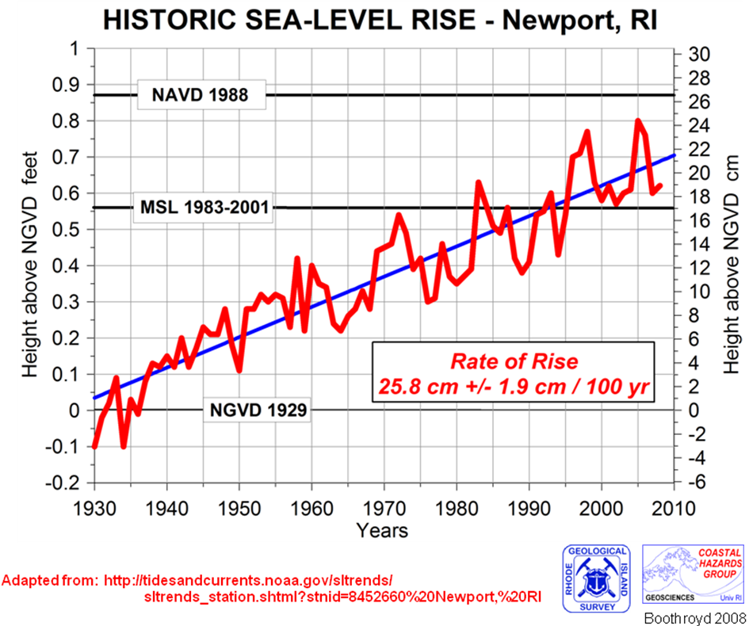

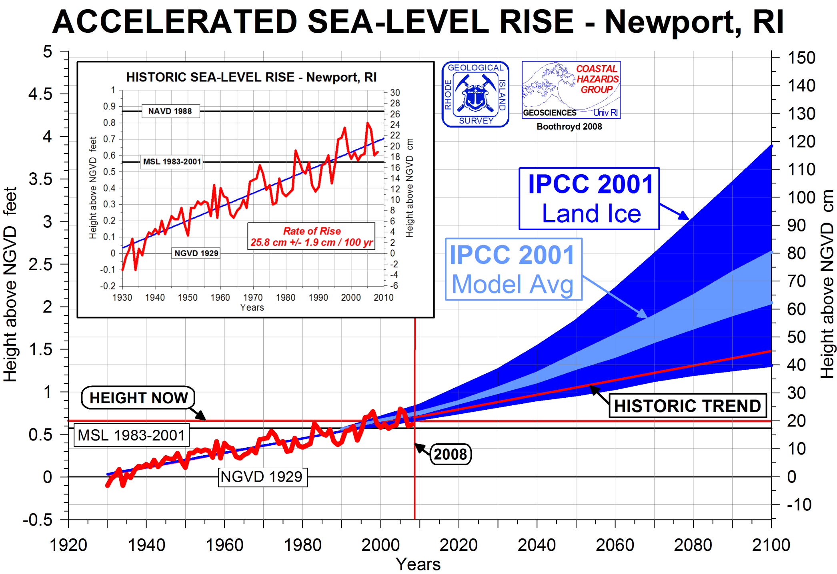

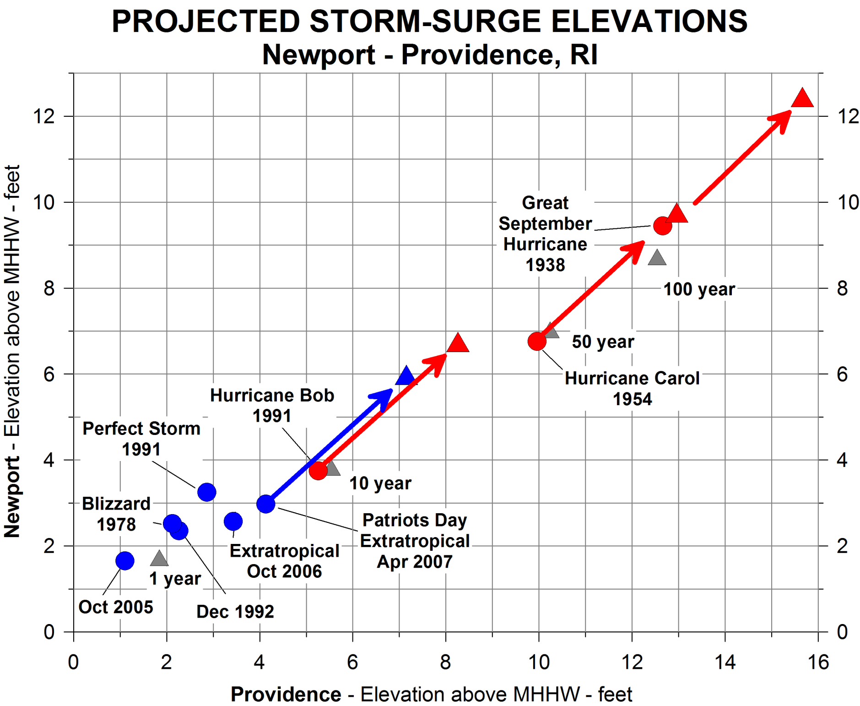

Adapted from NOAA (accessed 2007), USACE (1988) and Boothroyd and Hehre (2007a).

