

August 2005

www.rurdev.usda.gov/me

Michael W. Aube, State Director Emily J. Cannon, Public Affairs Specialist

An Informational Newsletter of Rural Development’s Rural Utilities Division

About the Utilities Programs

The mission of the Utilities Programs of USDA Rural Development is to help improve the quality of life
and promote economic development in rural America. Rural Development administers USDA’s Utilities Programs in a service-oriented, forward-looking, and financially responsible manner. These programs
have a long history of serving farm families and small communities.

The Utilities Programs direct the federal Electric, Telecommunications, and Water and Environmental programs. Along with Rural Development’s Housing Programs and Business and Cooperative Programs, the Utilities Programs work as a part of Rural Development’s mission area team to provide the tools rural Americans need to make a better life for themselves, their children, and their communities. The Utilities Programs also act as a catalyst for private sector investment in rural areas and promote rural America’s ability to succeed in the new century.
Acting Under Secretary Gilbert G. Gonzalez Speaks at Earth Day
Celebration Themed “Preserving the Penobscot River”

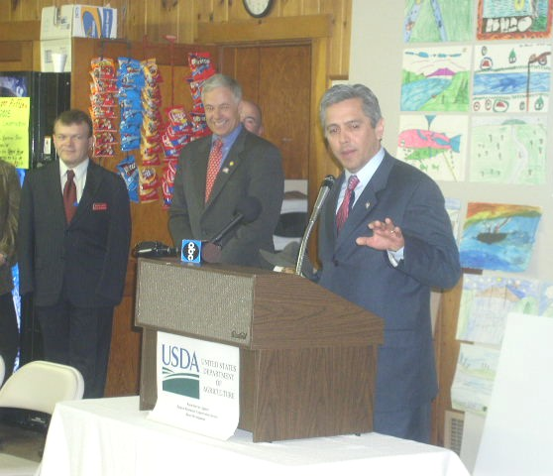



In This Issue
About Rural Utilities..............1
Acting Under Secretary
Gilbert G. Gonzalez Speaks
at Earth Day Celebration.......1
Rural Development Announces Funds to Town of Frenchville
..............................................2
Newport Water District Celebrates Commitment to Town.....................................3
Lewiston Area Office Welcomes New Area Director.................................3
An Update on Funding..........4

Acting Under Secretary Gonzalez announced over $7.6 million to preserve the Penobscot River for future generations as 130 children from the Washington Street School in Brewer; Eddington Elementary School in Eddington; and the Miles Lane School in Bucksport listened intently. Observing at far left is Michael Noyes, from the Office of Senator Susan M. Collins, and Congressman Michael H. Michaud.

On April 29, Agriculture Acting Under Secretary for Rural Development Gilbert Gonzalez
announced before a gathering of over 130 area school children, $7.6 million in funding to preserve the Penobscot River. USDA officials visited with students at the Penobscot County Conservation Association facility in Brewer where students learned about preservation and engaged in fun and educational activities involving the Penobscot River. Children from the Washington Street School, in Brewer, and Eddington Elementary School, in Eddington, were engaged by speakers from the Maine Discovery Museum, Atlantic Salmon Commission, U.S. Fish and Wildlife Service, and the Penobscot Nation. (continued on pg. 2)
“This exciting funding announcement is important to Maine’s environment, as it will support efforts to keep our rivers clean for future generations,” said Gonzalez. “The children who join us today are our future, and educating them about the importance of preservation is essential to maintaining a healthy earth tomorrow.” USDA Rural Development in Maine has invested over $20 million in preserving the Penobscot River since 2000 and is committed to the future of rural communities.

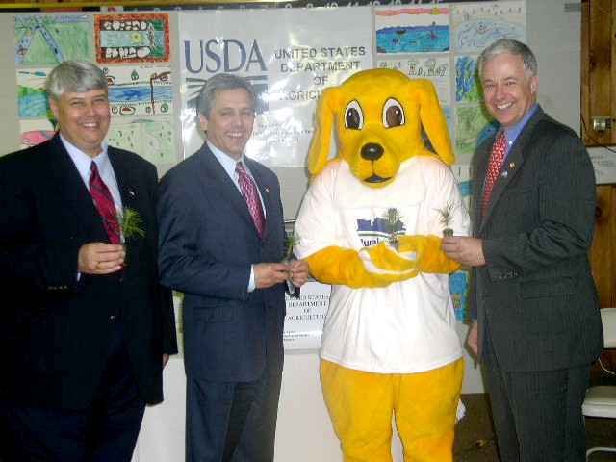
The event included a presentation on sun safety by Eddington Elementary’s third grade class; activities such as building a boat from recycled materials from the Maine Discovery Museum; Salmon migration from the Atlantic Salmon Commission and U.S. Fish and Wildlife Service; and a presentation on the history and culture of the Penobscot River by the Penobscot Nation. The children also engaged in an art contest entitled, “What a Clean River Means to Me.” The Grand Prize winner was Emma Nichols from Washington Street School in Brewer. Other winners included Abby Hallahan and Jake Qualheim,also from Washington Street School; Anna Boyle and Jebediah Murphy-Dulac from Miles Lane School in Bucksport; and Carli Poisson from the Eddington Elementary School. Seedlings donated by the International Paper Company were given to the children at the event.

The event was a joint effort of USDA’s Natural Resources Conservation Service, Farm Service Agency, and Rural Development. Each agency works diligently towards preserving the earth and environment in Maine through a variety of programs and mission areas.

USDA Rural Development funding of $7.6 million to preserve the river
was awarded to the City of Brewer in the amount of $2,488,000; Town
of Bucksport in the amount of $2,990,000; Lincoln Sanitary District in the amount of $610,000; and City of Old Town in the amount of $1,515,500.

Other USDA Rural Development investments in the environment included funds for the Town of Farmington in the amount of $343,000; Pleasant Point Passamaquoddy Reservation in the amount of $1,000,000; and Solid Waste Management Grants to Androscoggin Valley Council of Governments in the amount of $117,000; Hancock County Planning Commission in the amount of $44,600; Kennebec Valley Council of Governments in the amount of $67,500; and Northern Maine
Development Commission in the amount of $104,000.
From Left to Right: Rural Development State Director Michael W. Aube; Rural Development Acting Under Secretary Gilbert G. Gonzalez; Rural Development Mascot Rural Rover; and Congressman Michael H. Michaud hold seedlings at the event

Rural Development Announces
$534,000 to the Town of Frenchville

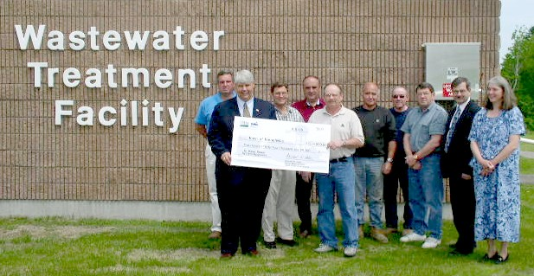

From Left to Right: Paul Bernier, Economic Development Director, Town of Frenchville;
Michael W. Aube, State Director, USDA Rural Development; Phil Levesque, Town Manager, Town of Frenchville; Gary Thibeault, Selectman, Town of Frenchville; Mike Dumais, Selectman, Town of Frenchville; Robert Chasse, Wastewater Treatment Facility Operator, Town of Frenchville; Bert Paradis, Selectman, Town of Frenchville; Andrew McQuarrie, Selectman, Town of Frenchville; Phil Bosse, State Office Representative, Office of Senator Susan M. Collins; and Marcia Gartley, District Representative, Office of Congressman Michael H. Michaud
On June 9, Rural Development State Director Michael W. Aube presented a big check to the Town of Frenchville for a $534,000 Water and Waste Disposal Loan and Grant combination used to make upgrades to the Town’s failing sewer system. The visit was part of an Aroostook County Funding Celebration tour, during which Rural Development announced over $1.5 million invested in Aroostook County.

Newport Water District Celebrates Commitment to Town

From left to right: Ronald C. Lambert, Jr., Community Programs Director, USDA Rural Development; Thomas Todd, Superintendent, Newport Water District; Alan Campbell, Vice Chair and Clerk, Newport Water District Board of Trustees; Donald Briggs, Treasurer, Newport Water District Board of Trustees; George Phelps, Trustee, Newport Water District Board of Trustees; Michael Noyes, Staff Assistant, Office of Senator Susan M. Collins; and Mark Kontio, Maine Staff Assistant, Office of Senator Olympia J. Snowe

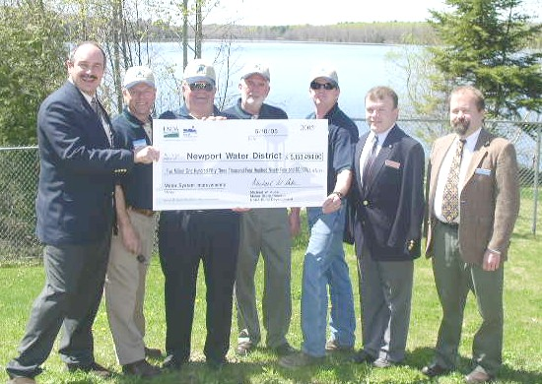
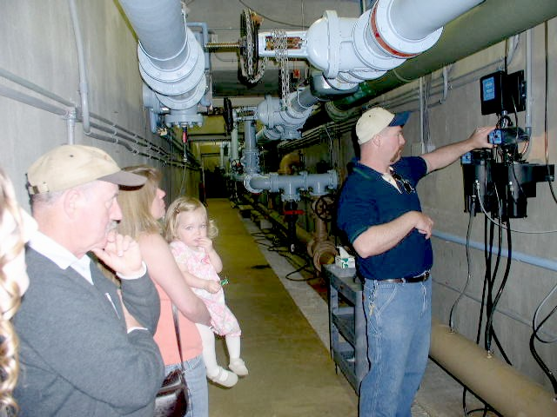
On May 10, USDA Rural Development staff, the Newport Town Manager, Newport Water District Trustees, Congressional staff, and the public gathered at Newport Water District’s Open House Celebration to celebrate clean water provided by the District.

“Most people just turn on the faucet without realizing all that goes into it,” said Aaron Newhall, Chief Operator of Newport Water District, who gave visitors a tour of the facility. It is obvious that much effort is needed to preserve the pristine condition of drinking water. The District monitors the water weekly for the presence of lead, chlorine, iron, and phosphates.
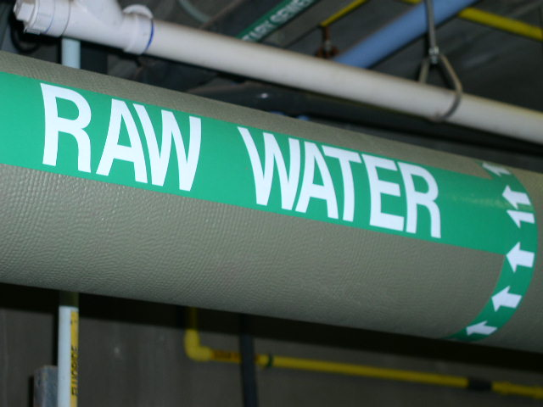
The water is treated using a technique called slow sand filtration. Comprised of a bed of sand which is supported by a layer of gravel, slow sand filtration is a process by which impurities are filtered out of water by using a top-down gravity process. The process is a form of natural, biological water treatment and removes solids, precipitates, and turbidity (muddiness) from the water. This effective process has been in use for over a century in Europe.

USDA Rural Development has invested over $5.1 million in the Newport Water District since
1984 for water system improvements.


Lewiston Area Office Welcomes
Janice M. Stroud, Area Director

Michael W. Aube, State Director of USDA Rural Development, has announced
that Janice M. Stroud, a resident of Casper, Wyoming, has joined the USDA Rural Development staff as the Area Director at the Lewiston Area Office. She will serve as a key member of the State Director's staff, participating fully in the planning, marketing, development, and implementation of Rural Development and its programs.

Janice previously worked as an Area Director for Rural Development in Wyoming. She is a 1986 graduate of North Carolina State University and holds
a Bachelor’s Degree in Agricultural Economics.

Janice M. Stroud, Area Director

$$ An Update on Funding To Date in FY 2005 $$

Obligation Date | Name | WW Direct | WW Grant | Project
4/4/2005 | Passamaquoddy Water District | $100,000 | $300,000 | replacement pump
4/12/2005 | Pleasant Point Passamaquoddy |  | $1,000,000 | three pump stations
4/27/2005 | Town of Frenchville | $134,000 | $400,000 | EZ/EC
6/24/2005 | Caribou Utilities | $500,000 | $1,210,597 | EZ/EC-water upgrade
8/12/2005 | Calais, City of | $600,000 | $400,000 | Phase III upgrades
3/16/2005 | Brewer, City of | $1,580,000 | $908,000 | Hardy Street
4/19/2005 | Town of Bucksport | $2,240,000 | $750,000 | CSO
4/28/2005 | Norridgewock Water District | $575,000 |  | replace water main
4/29/2005 | Old Town, City of | $914,000 | $601,500 | Blueberry Hill
5/4/2005 | Lincoln Sanitary District | $296,000 | $314,000 | upgrade 3 pumps
6/21/2005 | Town of Searsport | $175,000 | $175,000 | pump and sewer ext
6/30/2005 | Town of Franklin |  | $500,000 | ECWAG
8/9/2005 | Norridgewock Water District | $476,000 | $150,000 | replace water main
8/10/2005 | Dexter Utility District | $400,000 | $300,000 | upgrade water plant
8/10/2005 | Milford, Town of | $250,000 |  | replace pump station
2/4/2005 | Mt. Abram Chalet Association | $275,000 |  | new reservoir
2/11/2005 | Boothbay Region Water District | $391,000 | $280,000 | pump station
2/11/2005 | Paris Utility District |  | $15,000 | PPG
4/15/2005 | Farmington, Town of | $204,000 | $139,000 | relocation
5/9/2005 | Paris Utility District | $175,000 |  | rehab standpipe
6/6/2005 | Farmington, Town of | $215,000 | $90,000 | replace sewer mains
6/14/2005 | Town of Jay | $494,000 |  | replace sewer mains
7/14/2005 | Town of Rangeley | $415,000 | $135,000 | replace pump
7/22/2005 | West Paris Water District | $300,000 | $82,600 | install new pipe
3/2/2005 | Bowdoinham Water | $640,000 |  | new water tank
6/30/2005 | AVCOG |  | 117,000 | solid waste mgt grant
6/30/2005 | HCPC |  | 44,600 | solid waste mgt grant
6/30/2005 | KVCOG |  | 67,500 | solid waste mgt grant
6/30/2005 | NMDC |  | 104,000 | solid waste mgt grant
 | TOTALS | $11,349,000 | $8,083,797 | To Date: $19,432,797
* Funding does not include Water Circuit Rider Technical Assistance Grants funded through Rural Development’s National Office

As of August 17, Rural Development’s
Utilities Programs have invested $19,432,797 in the state of Maine in Fiscal Year 2005

Contact Information

To subscribe or unsubscribe to this newsletter please contact Emily Cannon at Emily.Cannon@me.usda.gov



State Office Staff
967 Illinois Avenue, Suite 4  P.O. Box 405  Bangor, ME 04402-0405 | Michael W. Aube  State Director  M.Aube@me.usda.gov | Ronald Lambert Jr.  Community Programs Director  Ronald.Lambert@me.usda.gov |  | Cheryl Stetson  Area Technician  Cheryl.Stetson@me.usda.gov | Gary Vanidestine  Utilities Programs Specialist Gary.Vanidestine@me.usda.gov
Phone: (207) 990-9121
Fax: (207) 990-9129
 | Scott Emery  Engineer  Scott.Emery@me.usda.gov | Darrin Dyer  Construction Analyst  Darrin.Dyer@me.usda.gov |  | Jeff Thurlow  Construction Analyst  Jeff.Thurlow@me.usda.gov | Conrad McAllister  Construction Analyst  Conrad.McAllister@me. usda.gov
Presque Isle Area Staff
99 Fort Fairfield Road  Presque Isle, Me 04769-5000 | Richard W. Ireland  Area Director  Richard.Ireland@me.usda.gov | Milton Ross, Jr.  Area Specialist  Milton.Ross@me.usda.gov |  | Alice Crouse  Area Technician  Alice.Crouse@me.usda.gov
Phone: (207) 764-4157
Fax #: (207) 762-2246
Bangor Area Staff
28 Gilman Plaza. Suite 3  Bangor, ME 04401-3550 | Raymond S. Roberts III  Area Director  Raymond.Roberts@me.usda. gov | Michael Rollins  Area Specialist  Michael.Rollins@me.usda.gov |  | Lewis Sirois  Area Specialist  Lewis.Sirois@me.usda,gov | Bonnie Hayes  Area Assistant  Bonnie.Hayes@me. usda.gov
Phone: (207) 990-3676  Fax #: (207) 990-5092 | Linda McBreairty  Area Technician  Linda.McBreairty @me.usda.gov
Lewiston Area Staff
P.O. Box 1938  Lewiston, ME 04240-1938 | Janice M. Stroud  Area Director  Janice.Stroud@me.usda.gov | Dennis G. Beaulieu  Area Specialist  Dennis.Beaulieu@me.usda.gov |  | Doris Thompson  Area Assistant  Doris.Thompson@me.usda.gov | Bobbi Arnold  Area Technician  Bobbi.Arnold@me.usda.gov
Phone: (207) 753-9400
Fax #: (207) 784-1335
Scarborough Area Staff
306 US Route 1, Suite B1  Scarborough, ME 04074-9774 | William F. Bailey, Jr.  Area Director  William.Bailey@me.usda.gov | Alton Wedberg  Area Specialist  Alton.Wedberg@me.usda.gov |  | Sally Blaisdell-Field  Area Specialist  Sally.Blaisdell-Field@me.usda.gov
Phone: (207) 883-0159
Fax #: (207) 883-2740
Maine USDA RD Web Site:
http://www.rurdev.usda.gov/me/

For USDA RD Forms/Regulations/Admin. Notices:
http://rdinit.usda.gov/regs

