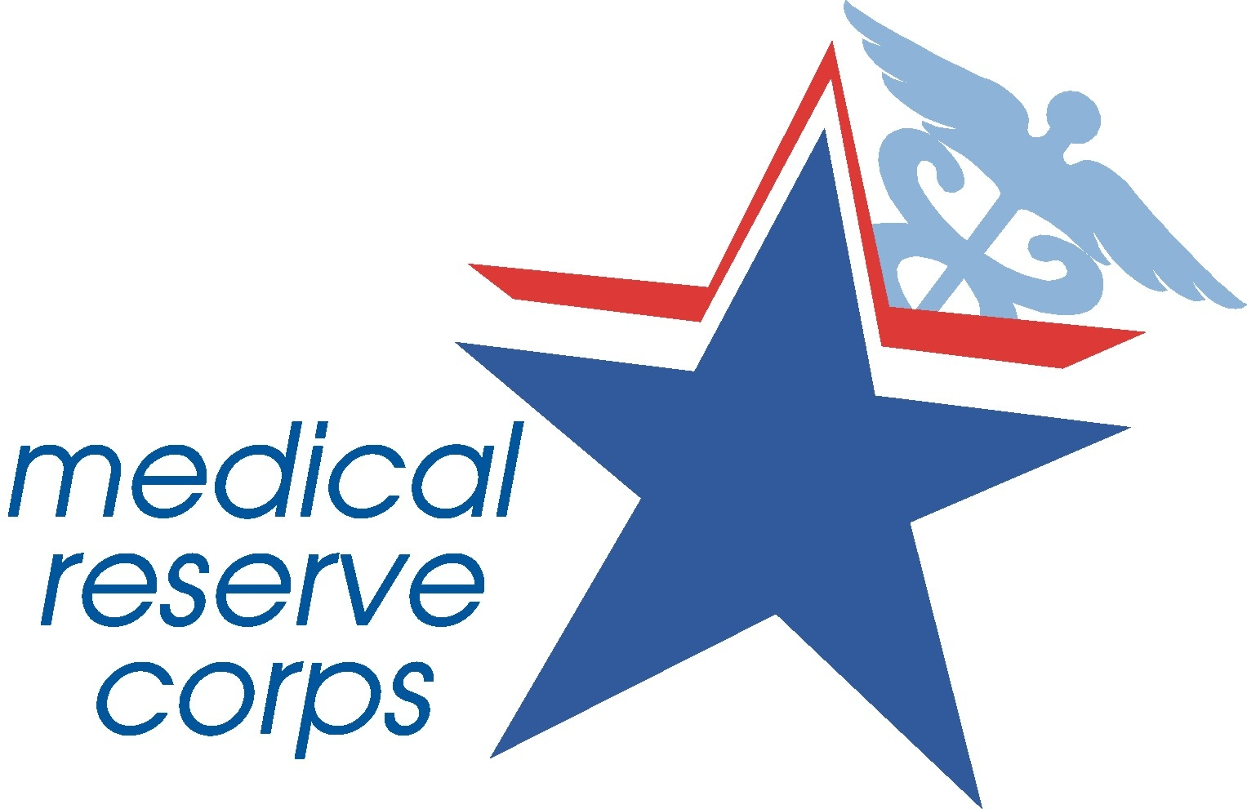  American Red Cross

MRC Activation in Support of ARC Disaster Operations

Training

Complete the online course Introduction to Disaster Services Course at http://www2.redcross.org/donate/volunteer/ as soon as possible.

Review the Two PowerPoint Orientations attached

Paperwork to Bring with You

Bring multiple copies of your Professional Licensure/Certification for credentialing purposes. NOTE: You will not be able to provide patient care without this documentation

Bring a valid photo ID and carry it with you at all times

Bring your copy of the Disaster Assignment Sheet and carry with you at all times

Packing for Deployment

Luggage should be sturdy and lockable. Do not pack more that you can carry by yourself, and keep one set of clothes, a snack, water, money, medications, and all professional equipment in your carry-on. Rolling clothes, instead of folding them, will save room.
Clothing
Bring enough clothes to last for the two week deployment. Shoes should be comfortable and broken in.

*Zip Loc Bags are great for keeping items dry in the event that your luggage is not. Try packing items in ziplocs and then packing them in your luggage.
Common Sense Disclaimer: This is not an exhaustive list. Keep some absolute essentials in a carry-on that will enable you to survive for a couple of days if your baggage gets lost.

Other Items
Soap, in plastic container | Rain gear/Poncho
Shampoo | Hand cream
Shaving Kit | Handkerchiefs/Bandanas
Deodorant, unscented | Lip balm
Band aids | Tissues (several small packs)
Insect Repellent | Toilet paper
Sunscreen | Toothpaste/brush/dental floss/mouthwash
Towel large and small. | Baby wipes, hand sanitizer, or alcohol rubbing pads
Comb/Hairbrush | Laundry bag
Prescription eyeglasses (not contacts) - and an extra pair if possible | Sunglasses
Flashlight (black or green) | Extra new batteries
1 to 3 days’ rations/food | 1 day’s water requirement
First aid kit and first aid manual. | Matches in a waterproof container.
Pens | Stethoscope, BP cuff (if Health care provider)

Health

- Immunizations: Tetanus and diphtheria toxoid (receipt of primary series, and Td booster within 10 years)
- Avoid eating food that has come in contact with local water sources.
- Only eat fruits and vegetables that can be peeled.
- Use bottled water or water treated with iodine tablets and/or boiling and purification.
- Maintain good hygiene and hand-washing techniques.
- Take skin wound care seriously in the tropics and use antibiotic ointments to avoid more serious infections.
- Avoid contact with animals, within reason for your assignment. If any animal bites you, seek immediate health care assistance.

For further information, see the following website: http://www.bt.cdc.gov/disasters/hurricanes/index.asp

