Current State-of-the-Art Anomalous Propagation

and Ground Clutter Mitigation Schemes:

Implications for next generation schemes within

The Weather and Radar Processor (WARP)

Christopher W. Porter

National Severe Storms Laboratory/Cooperative Institute for Mesoscale Meteorological Studies

TABLE OF CONTENTS

Chapter 1. Introduction……………………………………………………..…. 1

Chapter 2. AP mitigation efforts at MIT/Lincoln Labs……..……………….. 6
  - Multi-Sensor Approach within ITWS………………………...… 6
  - The Layered Composite Reflectivity Map – Anomalous…..…... 11
Propagation Removed Product

Chapter 3. Current WSR-88D Clutter Suppression and AP Removal……… 15
3.1 Clutter Suppression within the WSR-88D RDA…………..…… 15
3.2 AP removal within the Precipitation Processing Subsystem…... 19

Chapter 4. Quantitative Precipitation Estimation at NSSL………………..… 21

Chapter 5. Next Generation Clutter Suppression and AP Mitigation……..… 28

Chapter 6. University of Washington’s Mesoscale Group Radar Quality…... 41
Control Algorithm

Chapter 7. Goddard Space Flight Center Radar Quality Control Algorithm. 45

Chapter 8. Princeton University Testing of Radar Data Quality Control….... 47
Algorithm

Chapter 9. Importance of Radar Data Parameters in Removing AP/GC…... 52

Chapter 10. Summary and Implications for WARP’s AP Mitigation……….. 54
Technique

Chapter 11. References….………………………………………….………….. 62

1. Introduction

Radars receive power returns from both meteorological and non-meteorological objects. Non-meteorological signals can result from scatterers within the atmosphere such as dust, insects, and birds all of which can produce “clear-air” returns of up to 30 dBZ (Doviak and Zrnic 1993). Additionally, ground clutter can exist when the radar signal reflects from permanent structures such as buildings, trees, and the surface of the earth.

The vertical structure of the planetary boundary layer can also provide a favorable condition for non-meteorological returns when the radar beam is refracted back towards the earth resulting in significant reflectivity return when intercepting the ground. Electromagnetic waves in free space travel in straight lines at the speed of light because the dielectric permittivity ε_{o} and magnetic permeability μ_{o} are constants and related to the speed of light, c, by

c = (μ_{o}ε_{o}) ^{-1/2} (1)

However, when considering the earth’s atmosphere, the atmospheric permittivity, ε, is larger than ε_{o} and vertically stratified resulting in the bending or refraction of electromagnetic waves. This also reduces the velocity of propagation (v) within the earth’s atmosphere. The variation of the velocity of propagation with altitude, or the index of refraction, n, is defined as the velocity of propagation in free space to that in the medium of question (earth’s atmosphere),

n = c / v . (2)

The refractivity of the atmosphere (N) is defined to be

N = (n-1) * 10⁶ (3)

and within the Earth’s atmosphere can be expressed as a function of temperature (T), pressure (P) and the partial pressure of water vapor (e) (Skolnik 1980):

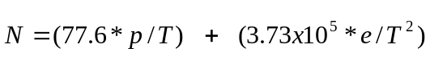 (4)

The refractivity of the atmosphere decreases with height. However, when
dN/dh < -157 km⁻¹ ,
trapping or ducting of electromagnetic beams occurs as energy propagating at shallow angles with respect to the earth’s surface is refracted back towards the surface of the earth. This condition is also referred to as anomalous propagation (AP). According to equation (4), AP is produced as a result of strong vertical temperature and moisture gradients. These conditions are met, for example, in regions of strong nocturnal temperature inversions, thunderstorm outflows, or when warm, dry air is advected over a cool, moist layer.

Attempts to remove non-meteorological returns have been underway for many years. Steiner and Smith (1996, Appendix B) presents an exhaustive overview of causes of anomalous propagation and ground clutter (AP/GC) and methods derived to remove radar echoes they produce. AP/GC can be removed in several different manners including placement of the radar site, choice of radar characteristics (wavelength, antenna, scan strategy, polarization), signal processing prior to data archiving, or through processing of archived data.

The Weather and Radar Processor (WARP) is the primary tool used by en route air traffic management personnel to obtain, process and display weather information. WARP will collect, generate and disseminate a mosaic of multiple WSR-88D images for display along with aircraft targets. WSR-88D images must be free of non-meteorological echoes that can obfuscate true atmospheric conditions resulting in confusing and muddled displays used by en route controllers. WARP will utilize narrowband, Level III WSR-88D radar data to produce mosaicked images. Therefore, within this study, AP/GC mitigation efforts that use archived radar data within operational applications similar to WARP will be examined. Strengths and weaknesses of these techniques are evaluated and techniques producing more effective and efficient results are noted. Additionally, an examination of techniques that will be available in the near future is also included.

Currently, several major efforts are being conducted to remedy problems associated with AP/GC returns that are relevant to the removal strategy used within WARP. AP/GC removal procedures exist at Massachusetts Institute of Technology/Lincoln Labs (MIT/LL), the Radar Operations Center (ROC) formerly known as the Operational Support Facility, the National Center for Atmospheric Research (NCAR), the National Severe Storms Laboratory (NSSL), the University of Washington (UW), Goddard Space Flight Center (GSFC), and Princeton University (PU).

MIT/LL has been involved with FAA-funded work throughout the 1990’s, and has developed two different schemes to remove AP/GC. One scheme has been incorporated in the Weather Surveillance Radar 1988 Doppler (WSR-88D) system as part of the Layered Composite Reflectivity Maximum - Anomalous Propagation Removal Product (LRM-APR) (section 2). The other technique has been incorporated into the Integrated Terminal Weather System (ITWS), which is designed to aid terminal air traffic controllers. In addition to the LRM-APR product, the ROC has a different AP mitigation scheme associated with the Precipitation Processing Subsystem (PPS), which is used to estimate rainfall amounts using the WSR-88D (section 3). NSSL has developed a Quantitative Precipitation Estimation and Segregation Using Multiple Sensors (QPE-SUMS) technique to accurately estimate precipitation types and rates, especially within the Intermountain West. QPE-SUMS contains an AP/GC removal scheme containing, in part, a method using satellite infrared temperature information (section 4). NCAR is currently being funded by the ROC to produce a next generation AP mitigation scheme. The NCAR system is a large and somewhat complex effort to provide a technique to automatically classify radar echoes and apply clutter filters and AP removal schemes without requiring interaction from a WSR-88D operator (section 5). The UW has produced an AP/GC automated technique designed to remove at least 95% of non-meteorological echoes from radar data that is routinely archived (section 6). GSFC uses a radar data quality control (QC) algorithm to remove unwanted radar echoes from the Tropical Rainfall Measuring Mission (TRMM) radar database in order to accurately provide radar rainfall estimates (section 7). PU has been involved in a comprehensive and longstanding effort not only to build a database of AP/GC contaminated cases that have been manually corrected but to also house multiple AP/GC removal schemes (section 8). The database allows for testing of different techniques by using common AP/GC cases. PU is also building a removal technique aimed at combining the strengths of previously formulated algorithms.

2. AP mitigation efforts at MIT/Lincoln Labs

2.1 Multi-Sensor Approach within ITWS

ITWS is a fully automated system designed to improve the safety, efficiency, and capacity of terminal area aviation operations. ITWS acquires data from FAA and National Weather Service (NWS) sensors as well as from aircraft in flight in the terminal area. ITWS is designed to provide Air Traffic personnel a suite of products that are immediately usable without further meteorological interpretation.

ITWS ingests radar data from three different types of radars: 1) the Airport Surveillance Radar (i.e., ASR-9 and ASR-11), 2) the Terminal Doppler Weather Radar (TDWR), and 3) the WSR-88D. Controllers use data from the ASR-9 to manage aircraft within the Terminal Radar Approach Control (TRACON) area. In addition to aircraft detection capabilities, the radar also has a weather channel that can provide information on the location and intensity of precipitation in the terminal area. The ASR-9 and ASR-11 radars are just as susceptible to AP problems as any other.

In an effort to mitigate AP for the ASR-9, MIT/LL uses a multiple radar approach employing precipitation products from the ASR-9 and WSR-88D radars. This multi-sensor approach can be advantageous since each radar can view radar echoes within the “cone of silence” of the other radars. Furthermore, AP regions within each radar’s reflectivity returns will not be co-located as long as the radar beams originate from different locations (i.e., the radars are not all co-located).

Within ITWS, a more conservative approach to AP removal is taken to protect against the chance that valid precipitation echoes may be reduced or removed altogether, which could present a safety hazard to aircraft. Thus, identification of AP is accomplished by comparing an ASR-9 reflectivity image to the WSR-88D Composite Maximum Reflectivity (comprefl) product. ASR-9 reflectivity data is given in Video Integrator Processor (VIP) Level 1-6 rather than a dBZ value, as in the WSR-88D. In order to compare the reflectivity values, a lookup table is used that equates VIP levels with dBZ values (Table 1). An AP mask is produced upon receipt of the comprefl product and is used to edit subsequent ASR-9 scans until a new comprefl is received.

ASR-9 data are collected as close as possible in time to the middle of the WSR-88D volume scan and are compared to the comprefl to create an AP mask. At first, the comprefl is searched to determine if any storms are present. If no contiguous area of 9 square kilometers containing at least 17 dBZ is found within the comprefl, then any corresponding radar echoes from the ASR-9 are considered non-meteorological in origin and removed. If precipitation exists within comprefl, a 7 km x 7 km region within the 88D data centered on each ASR-9 pixel is produced. If less than 10 pixels of reflectivity above the corresponding dBZ value relative to the ASR-9 VIP level are found, then the candidate ASR-9 pixel is considered AP. Once the target is considered AP, it receives an AP mask value (or VIP level) equivalent to the WSR-88D dBZ value.

It is important to note that ASR-9 radar echoes considered as AP are edited and not necessarily removed. The ASR-9 echoes are edited to make them agree with the comprefl product. The term “AP mask” is probably an unfortunate choice of words because an “AP mask” is created whenever comprefl and ASR-9 radar echoes values do not agree. Thus, an “AP mask” can be created when precipitation echoes from both products are not of the same value. When a true AP radar echo exists within the ASR-9 radar data, the magnitude of the AP echo is modified, not removed, in order to match the reflectivity magnitude of precipitation echoes within the comprefl. An underlying assumption is made that the comprefl product is devoid of AP echoes.

This AP mitigation scheme has been evaluated and performance metrics applied to three different types of cases: 1) All AP, 2) all weather, and 3) mixed AP and weather. An ASR-9 pixel has to be at least VIP Level 2 or greater to be scored (ITWS user’s group deemed VIP Level 1 to be operationally insignificant). The performance metrics for the AP-edit algorithm are PEAP (probability of editing AP) and PEW (probability of editing weather). PEAP is given by the number of AP pixels correctly edited divided by the total number of AP pixels. PEW is given by the number of weather pixels edited divided by the total number of weather pixels. The goal is to obtain a high PEAP and a low PEW. These statistics can be further categorized by the level of radar return (e.g., Level 3 and greater, Level 2 and greater).

ASR-9 VIP Level | WSR-88D Value (dBZ) | AP Mask Value
6 | ≥ 42 | 6
6 | ≥ 37 | 5
6 | ≥ 32 | 4
6 | ≥ 27 | 3
6 | ≥ 22 | 2
6 | ≥ 17 | 1
6 | < 17 | BADVAL
5 | ≥ 37 | 5
5 | ≥ 32 | 4
5 | ≥27 | 3
5 | ≥ 22 | 2
5 | ≥ 17 | 1
5 | < 17 | BADVAL
4 | ≥ 32 | 4
4 | ≥ 27 | 3
4 | ≥ 22 | 2
4 | ≥ 17 | 1
4 | < 17 | BADVAL
3 | ≥ 27 | 3
3 | ≥ 22 | 2
3 | ≥ 17 | 1
3 | < 17 | BADVAL
2 | ≥ 22 | 2
2 | ≥ 17 | 1
2 | < 17 | BADVAL
1 | ≥ 17 | 1
1 | < 17 | BADVAL
Table 1: ASR-9, WSR-88D, and AP Mask look-up table values used in the AP-edit algorithm within ITWS. Reproduce from Klingle-Wilson et al. (1995).

An analysis for 9 days in Memphis (6 hours from 3 all-AP days, 8 hours from 3 all-weather days, and 4 hours from 3 mixed days) in 1994 resulted in the correct modification of 97% of AP pixels for VIP Level 2 or greater. In mixed weather cases the number of correctly modified pixels drops to 80%. For VIP Level 3, the statistics are 98% and 91%, respectively. Only in the mixed case are any real meteorological returns edited. In this case, 1% of VIP Level 2 and above returns are incorrectly modified.

Boorman et al. (1999) changes the scoring system slightly to account for high reflectivity clear-air echoes greater than 17 dBZ within the WSR-88D. Because WSR-88D clear-air reflectivity values can exceed 17 dBZ, the possibility exists that some ASR-9 radar echoes are compared against clear air return rather than real VIP 1 Level precipitation. Thus, the WSR-88D values in Table 1 are all raised 5 dBZ so that VIP Level 1 corresponds to ≥22 dBZ. As a result, all ASR-9 VIP Level 1 returns are then compared against precipitation echoes and not clear air returns. In addition, the number of WSR-88D points required to have a certain threshold of reflectivity within a 7 square mile area centered on the ASR-9 pixel is increased. Both of these modifications improve the AP mitigation scheme’s ability to remove AP regions as identified by experienced radar meteorologists. Boorman et al. (1999) examined nine mixed weather cases where 97.6% of pixels containing AP were edited (VIP Level reduced) to some degree. And only 2.4% of the precipitation echo pixels were incorrectly modified.

2.2 The Layered Composite Reflectivity Map - Anomalous Propagation Removed Product

The multi-sensor approach to AP mitigation within the ITWS system can be successful as long as WSR-88D and ASR-9 radars are not co-located. If they are, then regions of AP/GC are likely to exist in the same regions of reflectivity return. In an effort to resolve this problem, MIT/LL developed and tested an algorithm to remove AP from the WSR-88D reflectivity data (Isaminger et al. 1997). This algorithm has since been added to the Layered Composite Reflectivity MaximumWSR-88D Level III product.

In this scheme, AP removal is made possible through the use of reflectivity, velocity, and spectrum width data. The technique separates the atmosphere surrounding a radar into three regions based on range and elevation scan (Figure 1). Within these different regions, different applications of the same AP removal technique are made (Figure 2). The first region is referred to as the “Omit All” volume located within 45 km of the radar and throughout the lowest 1 km above ground level. All meteorological returns are considered clutter within this region. The second region, “Accept If” is located from 45 to 103 km in range, at 0.5 degrees and below 3 km in altitude, and not within the “Omit All” region. A target within this region will only be accepted as a meteorological return if its velocity is 1.0 ms⁻¹ and its spectrum width is 0.5 ms⁻¹. A target in this region is still considered likely to be clutter. However, if it meets the velocity and spectrum width thresholds, it will be accepted as meteorological in origin. The third region is a “Reject if” region within 230 km of the radar and below 5 degrees in elevation while not being in the “Omit All” or

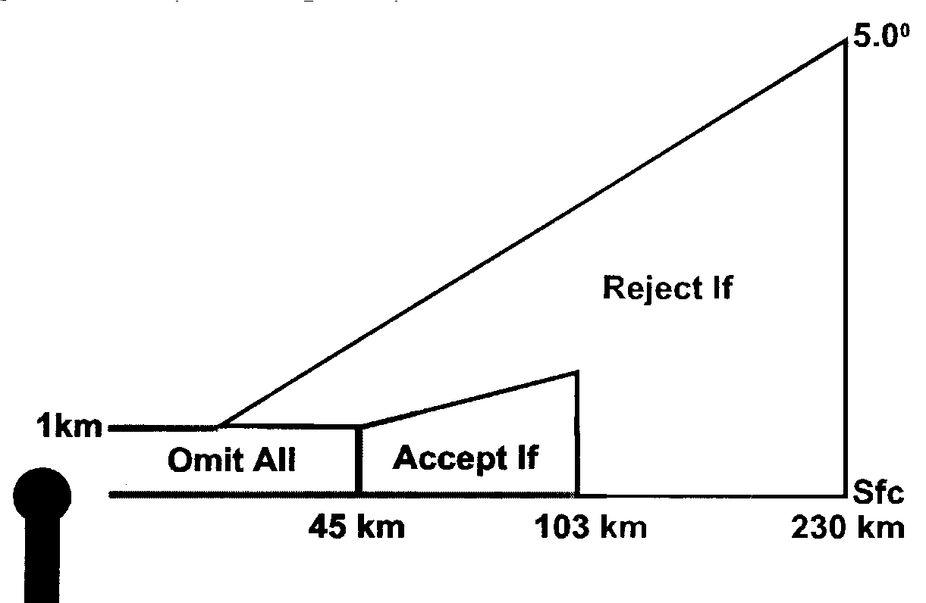
Figure 1: Regions of varying conditional thresholds used in the LRM-APR WSR-88D product. Reproduced from Isaminger et al. (1997).

“Accept If” regions. Targets within this region are considered meteorological returns if they possess a velocity 1.0 ms⁻¹ or a spectrum width 0.5 ms⁻¹.

This method of AP mitigation is scored identically to the AP removal scheme within ITWS. Isaminger et al. (1997) analyzed ten cases that either exhibited AP only, weather only, or a combination of both. Overall, this technique is able to properly edit 67.6% of the AP pixels while it only incorrectly edits 4.1% of weather echoes. Additional recommendations resulted from this work. One suggestion is to increase the spectrum width threshold to optimize the trade-off between PEAP and PEW scores. Another is to utilize a two-dimensional median filter on the data because the most frequent error for incorrect AP flagging in this scheme results from range folding problems. In addition, many times a majority of AP is removed from large AP regions, but a speckled map of

Is the radar echo within 45 km of the radar and below 1 km in height?

Yes (Echo in Omit All
Region) No

Remove echo

Is the radar echo above 5 degrees in elevation?

Yes
No

Keep echo

Is the radar echo between 45 and 103 km in range and at 0.5° elevation?

Yes (Echo in Accept If Region)

Is the radial velocity ≥1.0 ms⁻¹ AND it’s spectrum width ≥0.5 ms⁻¹

Yes No No
(Echo in
Keep echo Remove echo Reject If Region)

Is the radial velocity ≥1.0 ms⁻¹ OR it’s spectrum width ≥0.5 ms⁻¹

Yes No

Keep echo Remove echo

Figure 2. Flow chart for the LRM-APR technique for AP radar echo removal.

AP is left remaining. Using a median filter could alleviate the remaining speckled AP field by discarding values of reflectivity near zero dBZ.

If AP/GC regions can be sufficiently removed from a WSR-88D reflectivity field, the WSR-88D (using the comprefl product) could then be used in conjunction with an ASR-9 radar to remove AP more efficiently within a TRACON area. However, some concern has been given to the idea of specifying different sets of rules within pre-specified regions (i.e., “Omit All”, “Accept If”, “Reject If”) (personal communication, Tim
O’Bannon). Instead, it may be more useful to apply radial velocity and spectrum width thresholds throughout a radar domain without pre-conceived assumptions on where AP/GC may or may not exist.

3. Current WSR-88D Clutter Suppression and AP Removal.

Besides the LRM-APR product, two other AP/GC removal and suppression methods are contained within the WSR-88D system. A clutter suppression technique is currently incorporated within the Radar Data Acquisition (RDA) component of the WSR-88D system. The degree of clutter suppression can be controlled by the radar operator. Within the Radar Product Generator (RPG), the PPS product (O’Bannon 1998) contains an AP removal technique to improve the quality of rainfall estimates surrounding WSR-88Ds.

3.1 Clutter Suppression within the WSR-88D RDA

Ground clutter returns typically produce signals with near zero (i.e., typically less than 0.5 m s⁻¹) radial velocities and narrow (i.e., ≤1 m s⁻¹) spectrum widths (Doviak and Zrnic 1993). Thus, filters can be designed to remove or reduce power return from clutter and decrease its influence on reflectivity estimates.

All WSR-88Ds contain a clutter suppression technique that is implemented prior to the calculation of base data estimates. Clutter suppression filters are designed to reduce signal power from targets containing a radial velocity near 0 m s⁻¹. These filters reduce signal power within a “notch width” centered about the zero mean radial velocity value (Figure 3). Power returns from meteorological returns are not adjusted because only

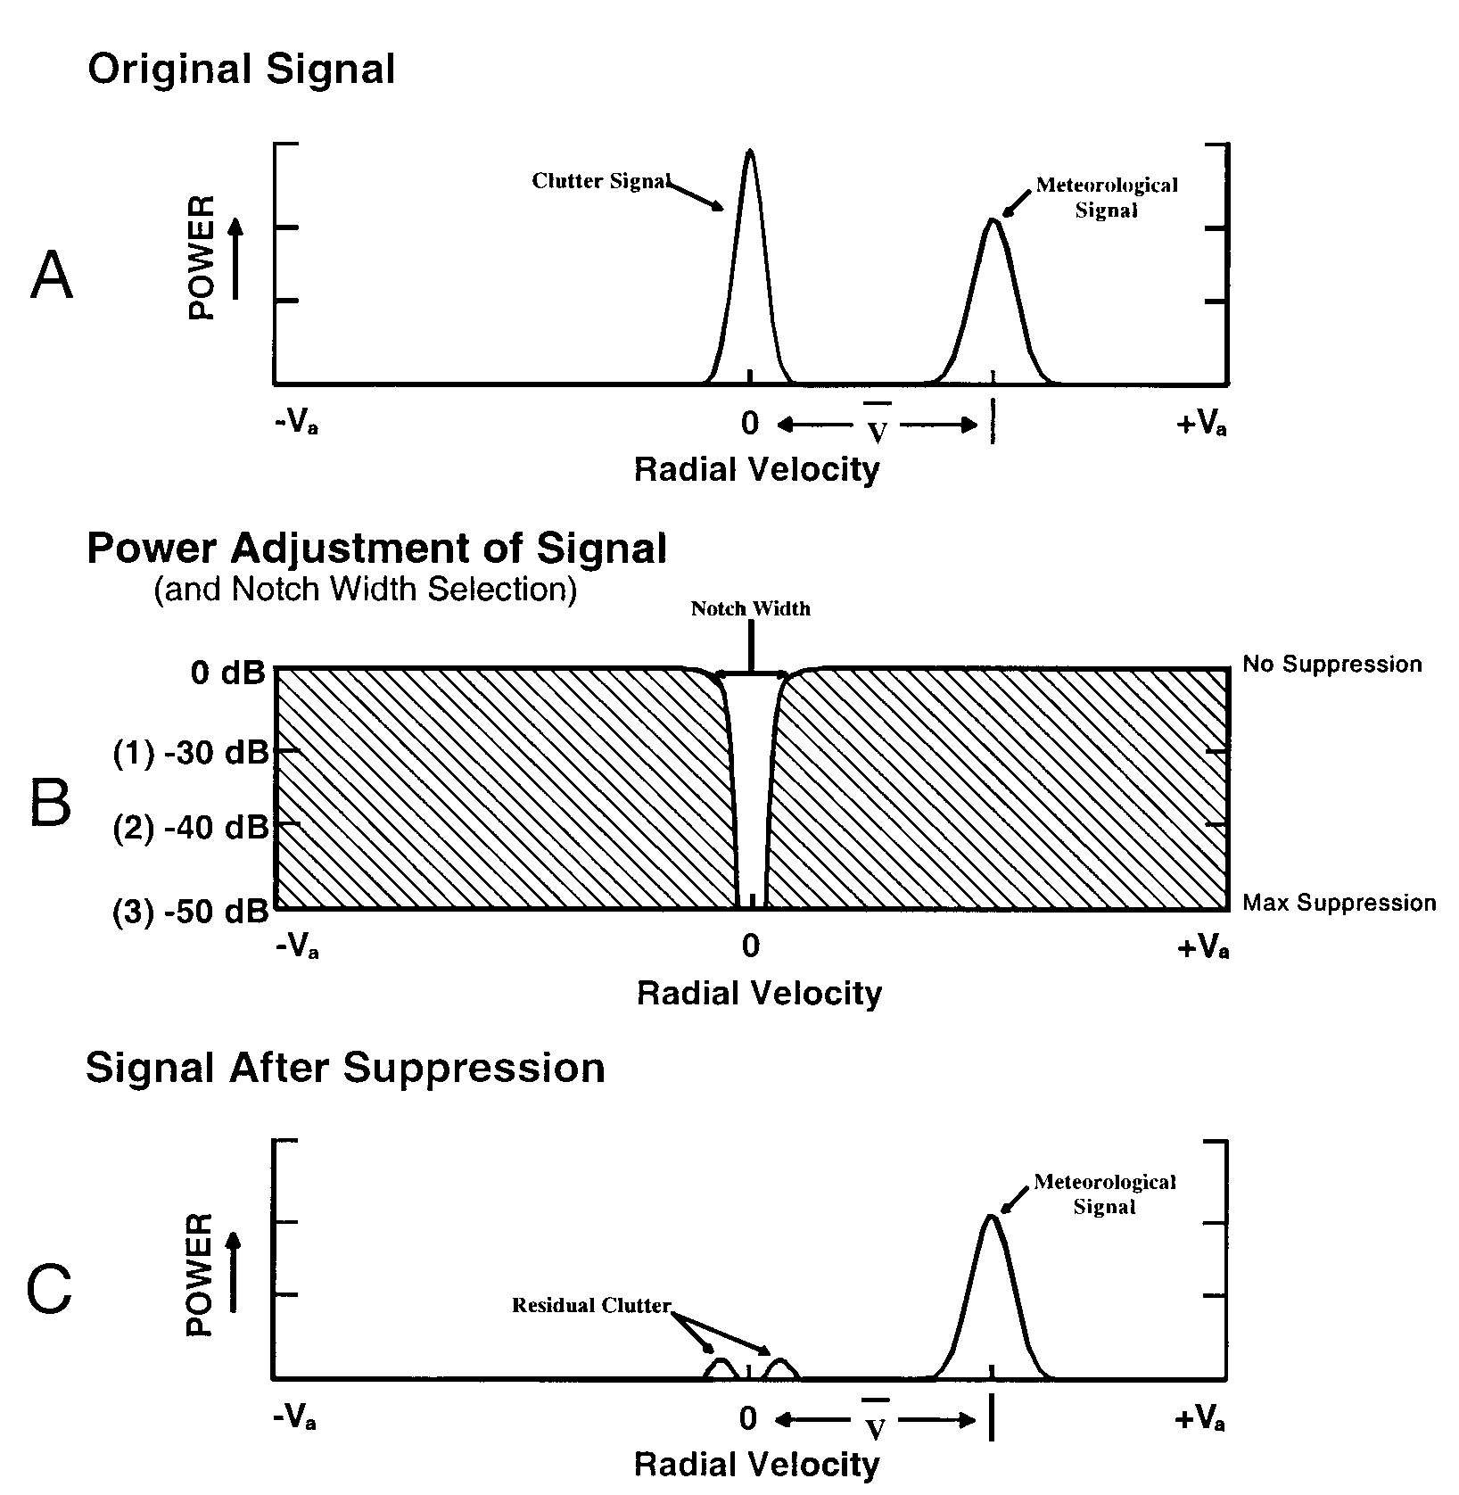
Figure 3. A) A depiction of the input power for a given range bin. The clutter signal has a radial velocity centered around zero and the meteorological signal is offset from zero due to its radial velocity. B) Representation of the clutter filter with a notch width centered on zero radial velocity. The scale represents the amount of power reduction, from 0 dB (no power reduction) to -50 dB (maximum power reduction), applied within the notch width. C) A diagram of the resulting power after the algebraic addition of the signal from A and the power reduction factor from B (A+B=C). Reproduced from Chrisman et al. (1995).
signal power from targets with a radial velocity that falls within the notch width is reduced.

Clutter suppression within the WSR-88D system is accomplished through a combination of processes. The signal processor uses the Bypass Map, Default Notch Width Map, and operator-defined Clutter Suppression Regions to determine where clutter suppression is needed. The Bypass Map supplies locations of known ground clutter return. The Default Notch Width Map reduces reflectivity values of clutter targets by 40 dB (Level 2 suppression) and velocity/spectrum width values by 50 db (Level 3 suppression) (Figure 3). The radar operator can control the application of the Notch Width Map producing additional clutter suppression across regions specified by beginning and ending ranges and azimuths if she does not want to use the Default Notch Width Map. The amount of signal reduction for identified clutter targets can be varied from 30 dB to 50 dB when using the Notch Width Map.

One obvious weakness of this clutter suppression technique is exposed when precipitation echoes that move perpendicular to the radar beam (i.e., radial velocity near zero) are suppressed. Figure 4 shows an example of this when the clutter suppression technique is used improperly. Reflectivities immediately northwest and southeast of the radar (Figure 4a) are reduced to near zero along the “zero-line” in the radial velocity field shown in gray (Figure 4b).

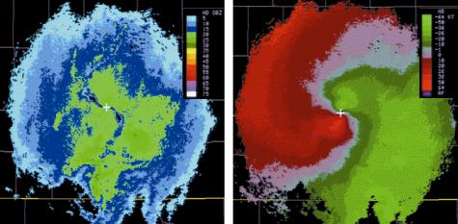

A

B
Figure 4. A) Reflectivity and B) radial wind fields after improper application of clutter suppression. The gray region in B) denotes radial velocities near zero.

Care has to be taken in the amount of suppression that can be applied. Too little suppression allows the base data estimates to be contaminated, which can lead to anomalously high rainfall estimates when high reflectivity AP is retained.

Contaminated radial velocity data can also result, leading to erroneous Velocity Azimuth Display Wind Profile estimates (Sanders and Vasiloff 1996). However, too much suppression can also severely impact rainfall estimation by reducing reflectivity estimates within precipitation regions, thereby reducing rainfall estimates (Margraf 1998; Story 2001). But, knowledgeable radar operators that can recognize and react to AP/GC situations should be able to accurately remove AP/GC in most cases (Margraf 1998; Goss and Chrisman, 1995).
3.2 AP removal within the Precipitation Processing Subsystem

Radar-derived rainfall estimates are provided through the Precipitation Processing Subsystem (PPS) product. The PPS employs a technique that keys on small, but high reflectivity regions indicative of AP/GC (O’Bannon 1998). Reflectivity values of 18 dBZ with no more than one surrounding reflectivity bin of equal or higher reflectivity are removed. A second threshold of 53 dBZ is used to remove hail contamination while maintaining high enough rainfall rates to identify flash flood events. In this case, any bin that exceeds the threshold is replaced with an average of the surrounding values if none of the surrounding bins are of equal reflectivity magnitude. Removal of hail contamination aids precipitation estimates, however, retaining this information would be beneficial for aviation users.

Although effective clutter suppression procedures can remove a majority of clutter, at times additional quality control procedures are required within the PPS (Fulton et al. 1998). Thus, an areal tilt test is used to remove additional anomalous propagation. If a decrease in total reflectivity echo area exceeds 75% from the first to the second elevation angles over an annular area between the range of 40 to 150 km, the algorithm removes reflectivity information from the lowest of the two elevation scans. Although primitive, this method of AP removal has proven very effective in cases where rainfall does not exist within range of the radar.

However, the tilt test can be very inefficient, particularly in regions where AP is embedded in precipitation (O’Bannon 1998). In addition, this test often classifies and then rejects regions of stratiform or orographic precipitation as AP, causing significant PPS rainfall under-estimates. Currently, the ROC is planning to replace the PPS AP removal technique with NCAR’s AP Mitigation Scheme discussed in Section 5.

4. Quantitative Precipitation Estimation at NSSL

The Quantitative Precipitation Estimation and Segregation Using Multiple Sensors (QPE-SUMS) technique has been developed at NSSL to accurately estimate precipitation types and rates using an optimal blend of radar, satellite, and rain gauge data that is physics-based. Obviously, when using radar reflectivities to provide rainfall estimation about a radar, it becomes very important to remove all non-meteorological radar echoes. Therefore, AP/GC problems can severely restrict the ability to estimate rainfall in remote areas that do not contain rain gauges.

In order for an AP/GC radar echo to be flagged for removal, two conditions must be met. First, the radial velocity of the radar echo must be ≤2.5 ms⁻¹. The second condition is a reflectivity rule containing two parts: 1) the reflectivity must be above a threshold (currently 30 dBZ) and 2) the vertical gradient in reflectivity must be ≥80% of the reflectivity in the lowest elevation scan. For example, if a radar echo contains a radial velocity less than 2.5 ms⁻¹ and has a reflectivity value of 30 dBZ, the reflectivity value in the vertically adjacent elevation scan scan must be 6 dBZ or less for the radar echo to be removed.

Radar echoes must meet both the radial velocity and reflectivity rules. Otherwise, valid precipitation radar echoes that move perpendicular to the radar beam, and do not contain a large vertical reflectivity gradient, would be removed. Likewise, new convective cells that may contain a large vertical reflectivity gradient but have radial velocities above 2.5 m s⁻¹ could be removed. In addition, the 30 dBZ rule allows for removal of embedded, high reflectivity AP/GC within large stratiform precipitation shields that typically contain reflectivity values below 30 dBZ (Figures 5 and 6). The 30 dBZ rule can be effective in situations where AP is contained within precipitation, which is considered one of the most difficult cases for AP removal.

QPE-SUMS has been tested primarily in Oklahoma, Texas, and Arizona. WSR-88D radar echoes in Arizona can sometimes provide a challenge to the AP/GC removal scheme when AP radar echoes result from chaff produced by military aircraft. Upon release, chaff will advect with the background environmental wind, which may be greater than 2.5 m s⁻¹. Also, many times chaff may extend through more than one elevation scan and not meet the vertical gradient of reflectivity condition for removal. Residual clutter represents another type of AP/GC that QPE-SUMS has difficulty in removing. After the clutter suppression technique within the WSR-88D system has been applied, low reflectivity residual clutter can still remain. Although residual clutter meets the radial velocity rule for removal, it does not meet the reflectivity rule of being at least 30 dBZ in magnitude.

Therefore, an additional method of AP/GC removal has been added that takes advantage of satellite information, which is part of the QPE-SUMS suite of sensors. Cloud top IR temperature is compared against either surface temperature observations or numerical weather prediction model surface temperature data directly below. If the difference
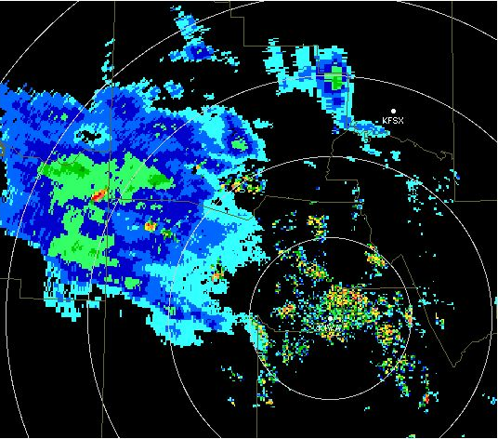

A
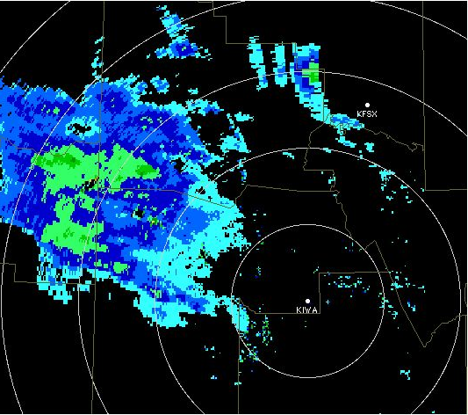

B
Figure 5. A) Reflectivity returns for the KIWA WSR-88D containing ground clutter immediately around the radar and embedded AP within a precipitation shield northwest of the radar. B) Ground clutter and AP are removed using the QPE-SUMS AP/GC Mitigation Scheme

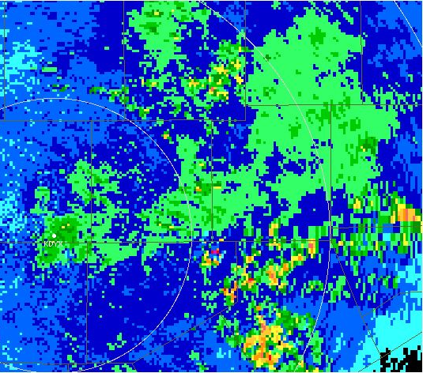

A

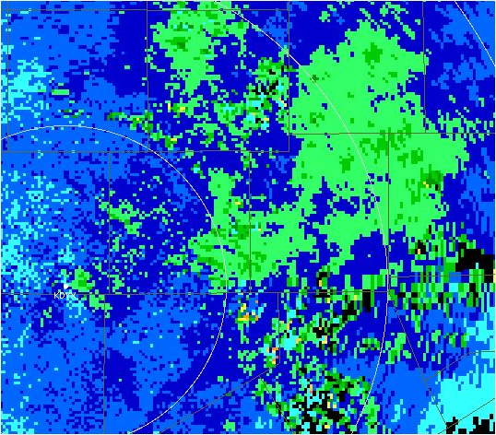

B
Figure 6. A) Reflectivity returns for the KDYS WSR-88D containing embedded AP within a precipitation shield southeast of the radar. B) Embedded AP is removed using the QPE-SUMS AP/GC Mitigation Scheme

between the two temperatures is ≤8 K below the radar echo in question, then the radar echo is considered to be within a clear-air region (i.e., no clouds are present since the two temperatures are so close in magnitude) and is removed (Figure 7). This method is particularly effective in the removal of chaff, residual clutter, and other clear-air echoes as long as clouds are not present.

In Figure 7a, a considerable amount of chaff and residual clutter exists across the state of Arizona. Figure 7b demonstrates the effectiveness of the satellite scheme in removing both chaff and residual clutter for this case where clouds are not located. Figure 8a shows the cloud top temperatures while Figure 8b is a plot of surface temperature. A cloud band exists across northeastern Arizona and temperature differences between cloud top and surface generally exceed 8 K. However, the southwestern half of Arizona is cloud free and satellite IR temperature and surface temperature differences are ≤8 K across this region. Therefore, all reflectivity returns are removed across southwestern Arizona, alleviating a majority of the chaff and residual clutter problem. Notice, however, that any chaff and residual clutter that exists across northeastern Arizona is not removed because conditions are cloudy, thereby making the satellite method ineffective.

Using a combination of radial velocity, reflectivity, and satellite data, QPE-SUMS is very efficient at removing AP/GC. The method has proven robust for removing chaff, residual clutter, clear-air echoes, and AP both separate from and embedded within precipitation.
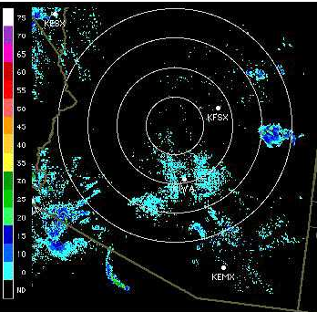

A
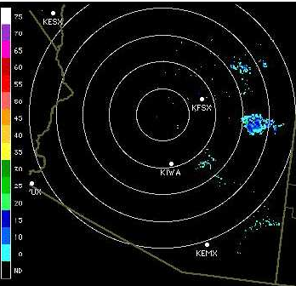

B
Figure 7. A) Reflectivity returns for a WSR-88D in Arizona that still contains chaff and residual ground clutter even after application of the QPE-SUMS AP/GC Mitigation Scheme. B) Resulting reflectivity returns when the satellite method of AP/GC removal is applied.

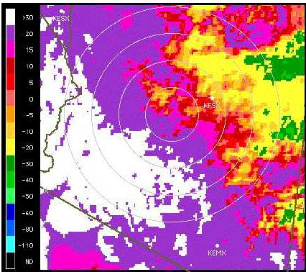

A

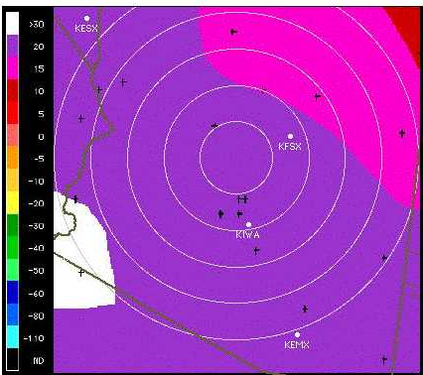

B
Figure 8. A) Satellite cloud top IR temperatures. B) Surface temperatures.

5. Next Generation Clutter Suppression and AP Mitigation

The most ambitious AP/clutter mitigation effort to date has been undertaken by NCAR’s Remote Sensing Facility as funded by the ROC through the WSR-88D Data Quality Optimization Program (Kessinger et al. 2000). The goals of this program are to improve the quality of the base data from the WSR-88D systems with special emphasis on the problem of ground clutter return due to AP conditions. The scheme will also be used to improve the performance of the WSR-88D PPS product. The AP clutter mitigation scheme will be included within the WSR-88D Open System (Saffle and Johnson 1998). Implementation of the AP Mitigation Scheme is currently planned first for the Open Radar Product Generator Build 2 and later for the Open Radar Data Acquisition systems.

NCAR’s AP clutter mitigation scheme consists of four components:
- radar echo classifier
- compensation of filtered reflectivity values
- clutter filter specification and control
- tracking of AP-affected areas

Currently, construction of only components 1) and 2) above has begun. Work on the radar echo classifier is near completion. One of the differences between the proposed clutter suppression in this scheme versus the current clutter suppression technique within WSR-88Ds is the ability to automatically apply ground clutter filters in regions of AP without the intervention of a WSR-88D operator. Before this can be automated, a classification technique that identifies various types of radar echoes is required. Hence, most of the work to date has centered around the radar echo classifier (REC) algorithm.

Within REC are three different detection algorithms: the AP Detection Algorithm (APDA), the Precipitation Detection Algorithm (PDA), and the Clear Air Detection Algorithm (CADA). The algorithms are based on fuzzy logic using derived radar fields. These fields are calculated from a radar’s base data of reflectivity (DBZ), radial velocity (V), and spectrum width (SW) and are computed over N data bins within a small region typically defined as two beams on either side of the current beam and +1 km (Doppler fields) or +2 km (reflectivity fields) in range from the current gate. The derived fields include the:

mean reflectivity (MDZ),
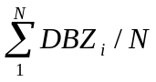,
mean radial velocity (MVE),
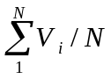,
mean spectrum width (MSW),
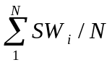,
the standard deviation of the radial velocity (SDVE),
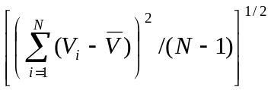,

the standard deviation of spectrum width (SDSW),
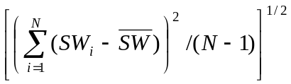,
the “texture” of the reflectivity field (TDBZ),
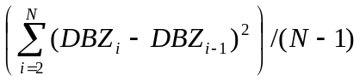,
the “texture” of the radial velocity field (TDVE),
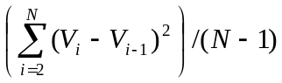,
the “spin” of a feature,
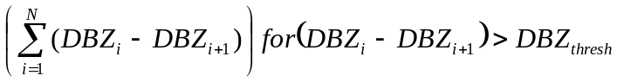,
and the “sign” of the feature,
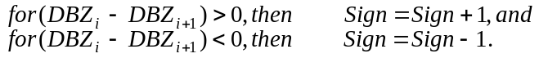

SPIN is expressed as the percentage (0-100%) of the maximum number of possible gate-to-gate differences in the reflectivity values. A threshold on the minimum difference is used in the numerator while the denominator uses all differences. The SIGN feature is similar to SPIN since it also computes a gate-to-gate difference in the reflectivity. However, no threshold is used and the values accumulated are either +1.0 or -1.0 depending on the sign of the gate-to-gate reflectivity difference, rather than the value of the difference. Where reflectivity values have large gate-to-gate changes over the local region, the SIGN value will approach 0; in nearly uniform reflectivity regions, SIGN will approach +1. Values for SIGN are generally between +1 and –1 but values beyond either endpoint are possible.

A "membership function" (Figures 9-11) is applied to the values of the derived fields to scale them so they match the characteristics of the echo type under consideration. Membership functions are stepwise linear functions that scale the derived fields to have values between 1.0 and -1.0. The membership value for a derived field is multiplied by a pre-determined, and empirically optimized, weight. This process is repeated for other membership functions that are summed to produce an aggregation value (Vivekanandan et al., 1999) for a particular algorithm (i.e., AP, precipitation, or clear-air). The membership functions used for each algorithm are given in Figures 9-11. The aggregation values or output fields from this process are termed "interest fields". Interest fields with a value of 1.0 indicate a high likelihood that the echo type matches the desired characteristic such as AP, clear-air, or precipitation. Likewise, an interest value of -1.0 indicates a high likelihood that the echo type does not match the desired characteristic.
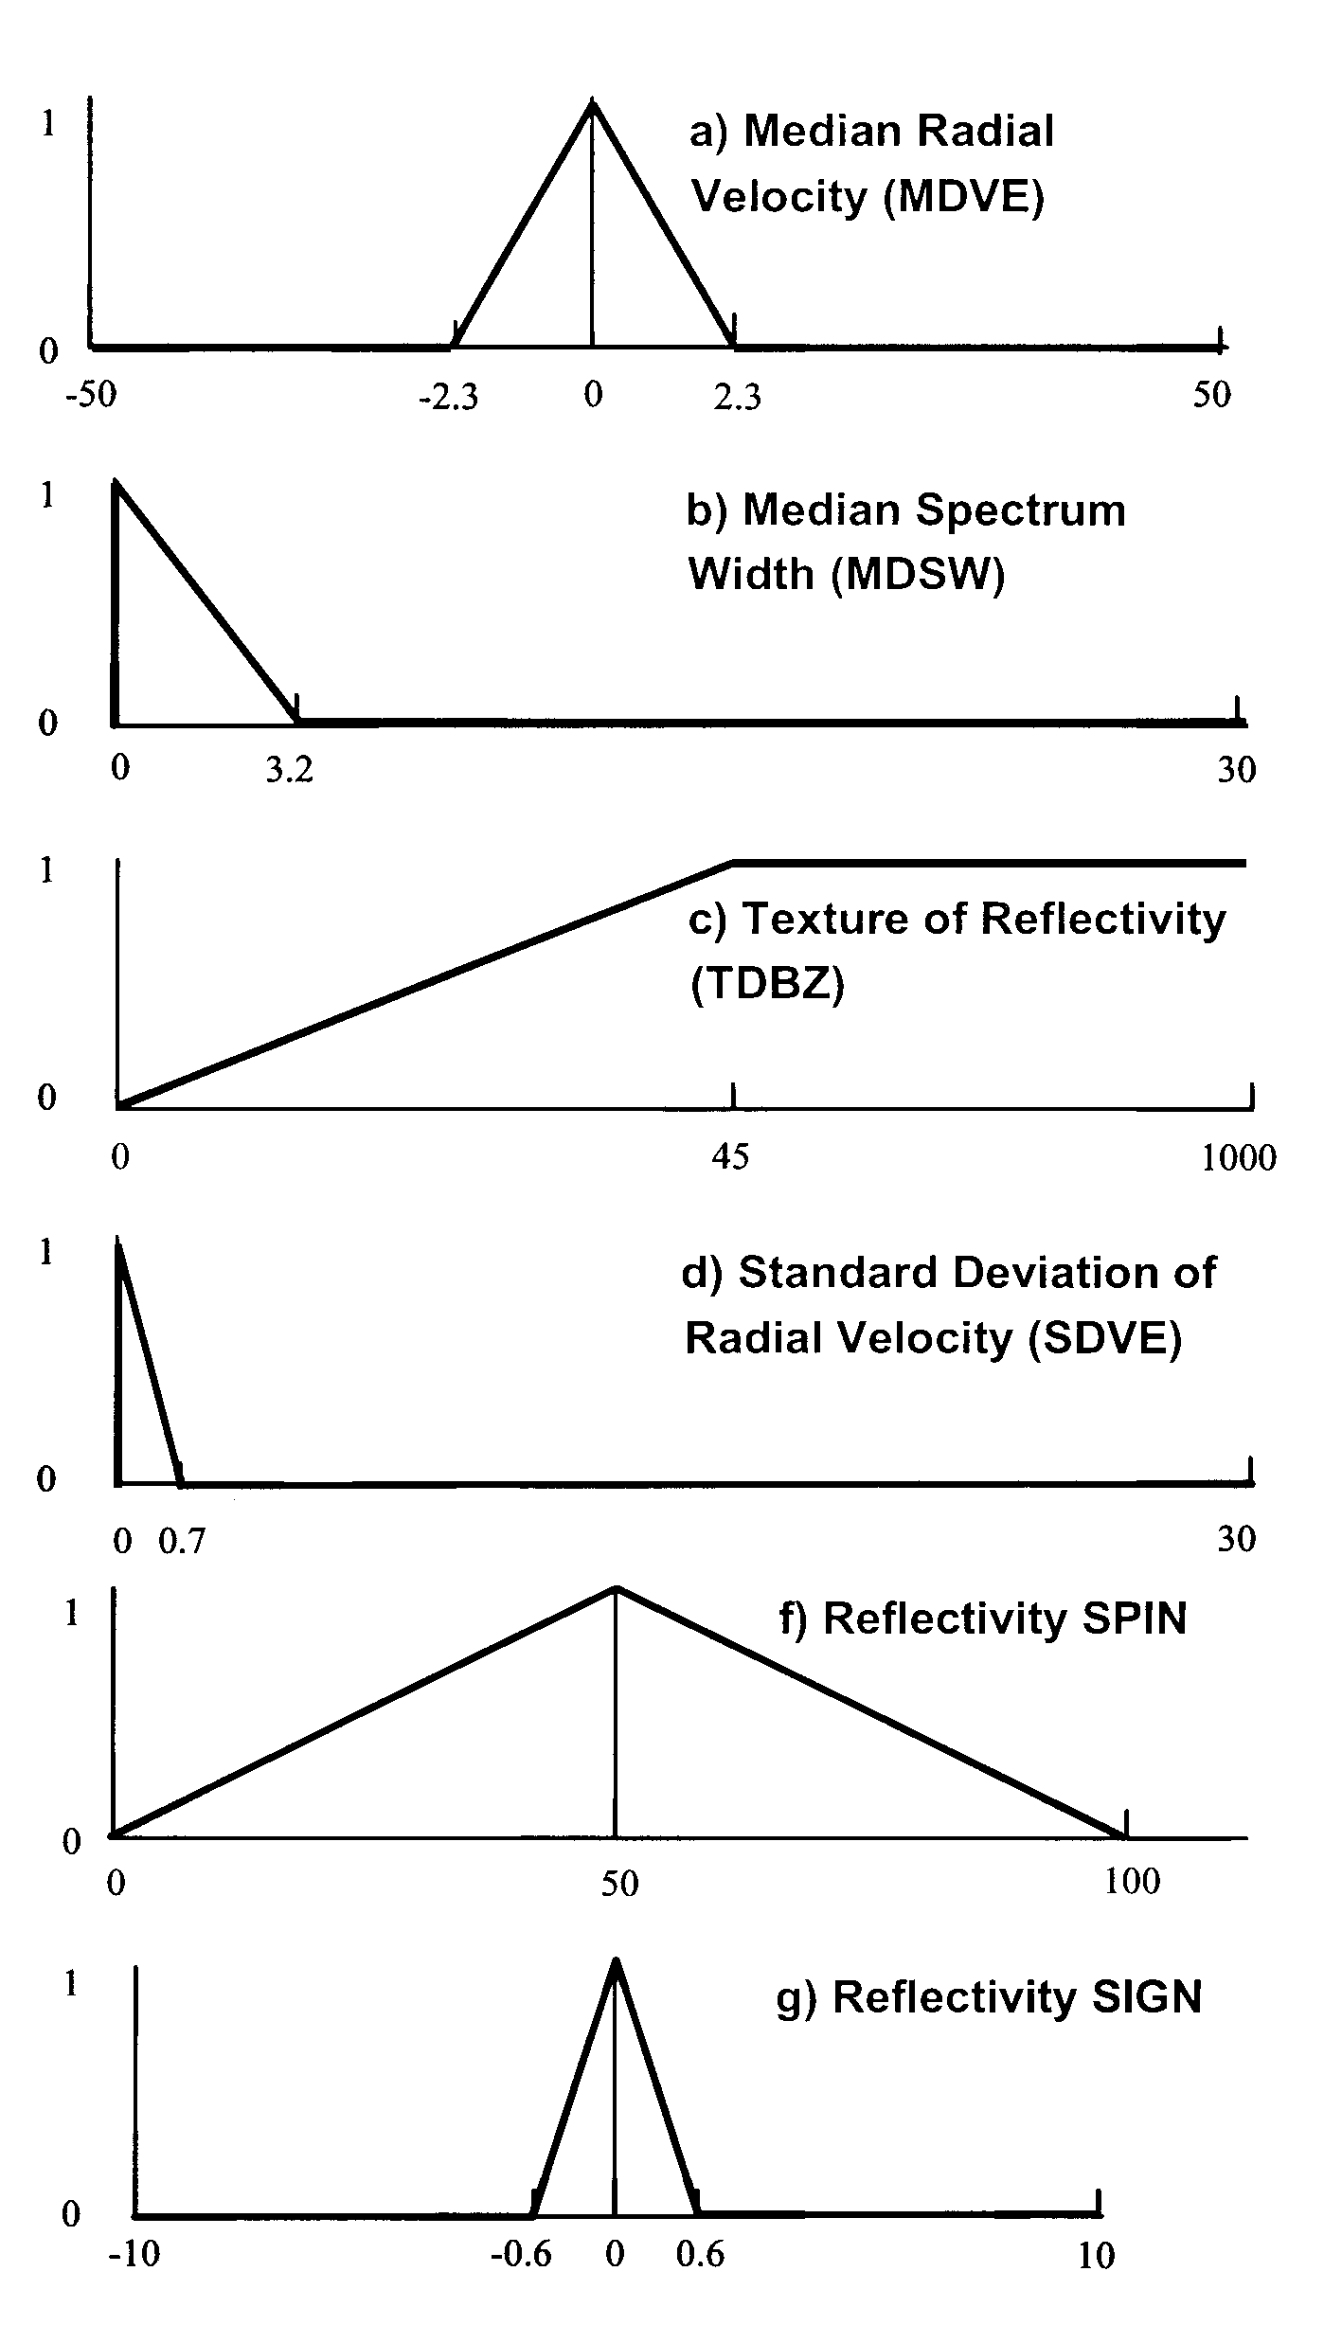
Figure 9: Membership functions for the APDA.
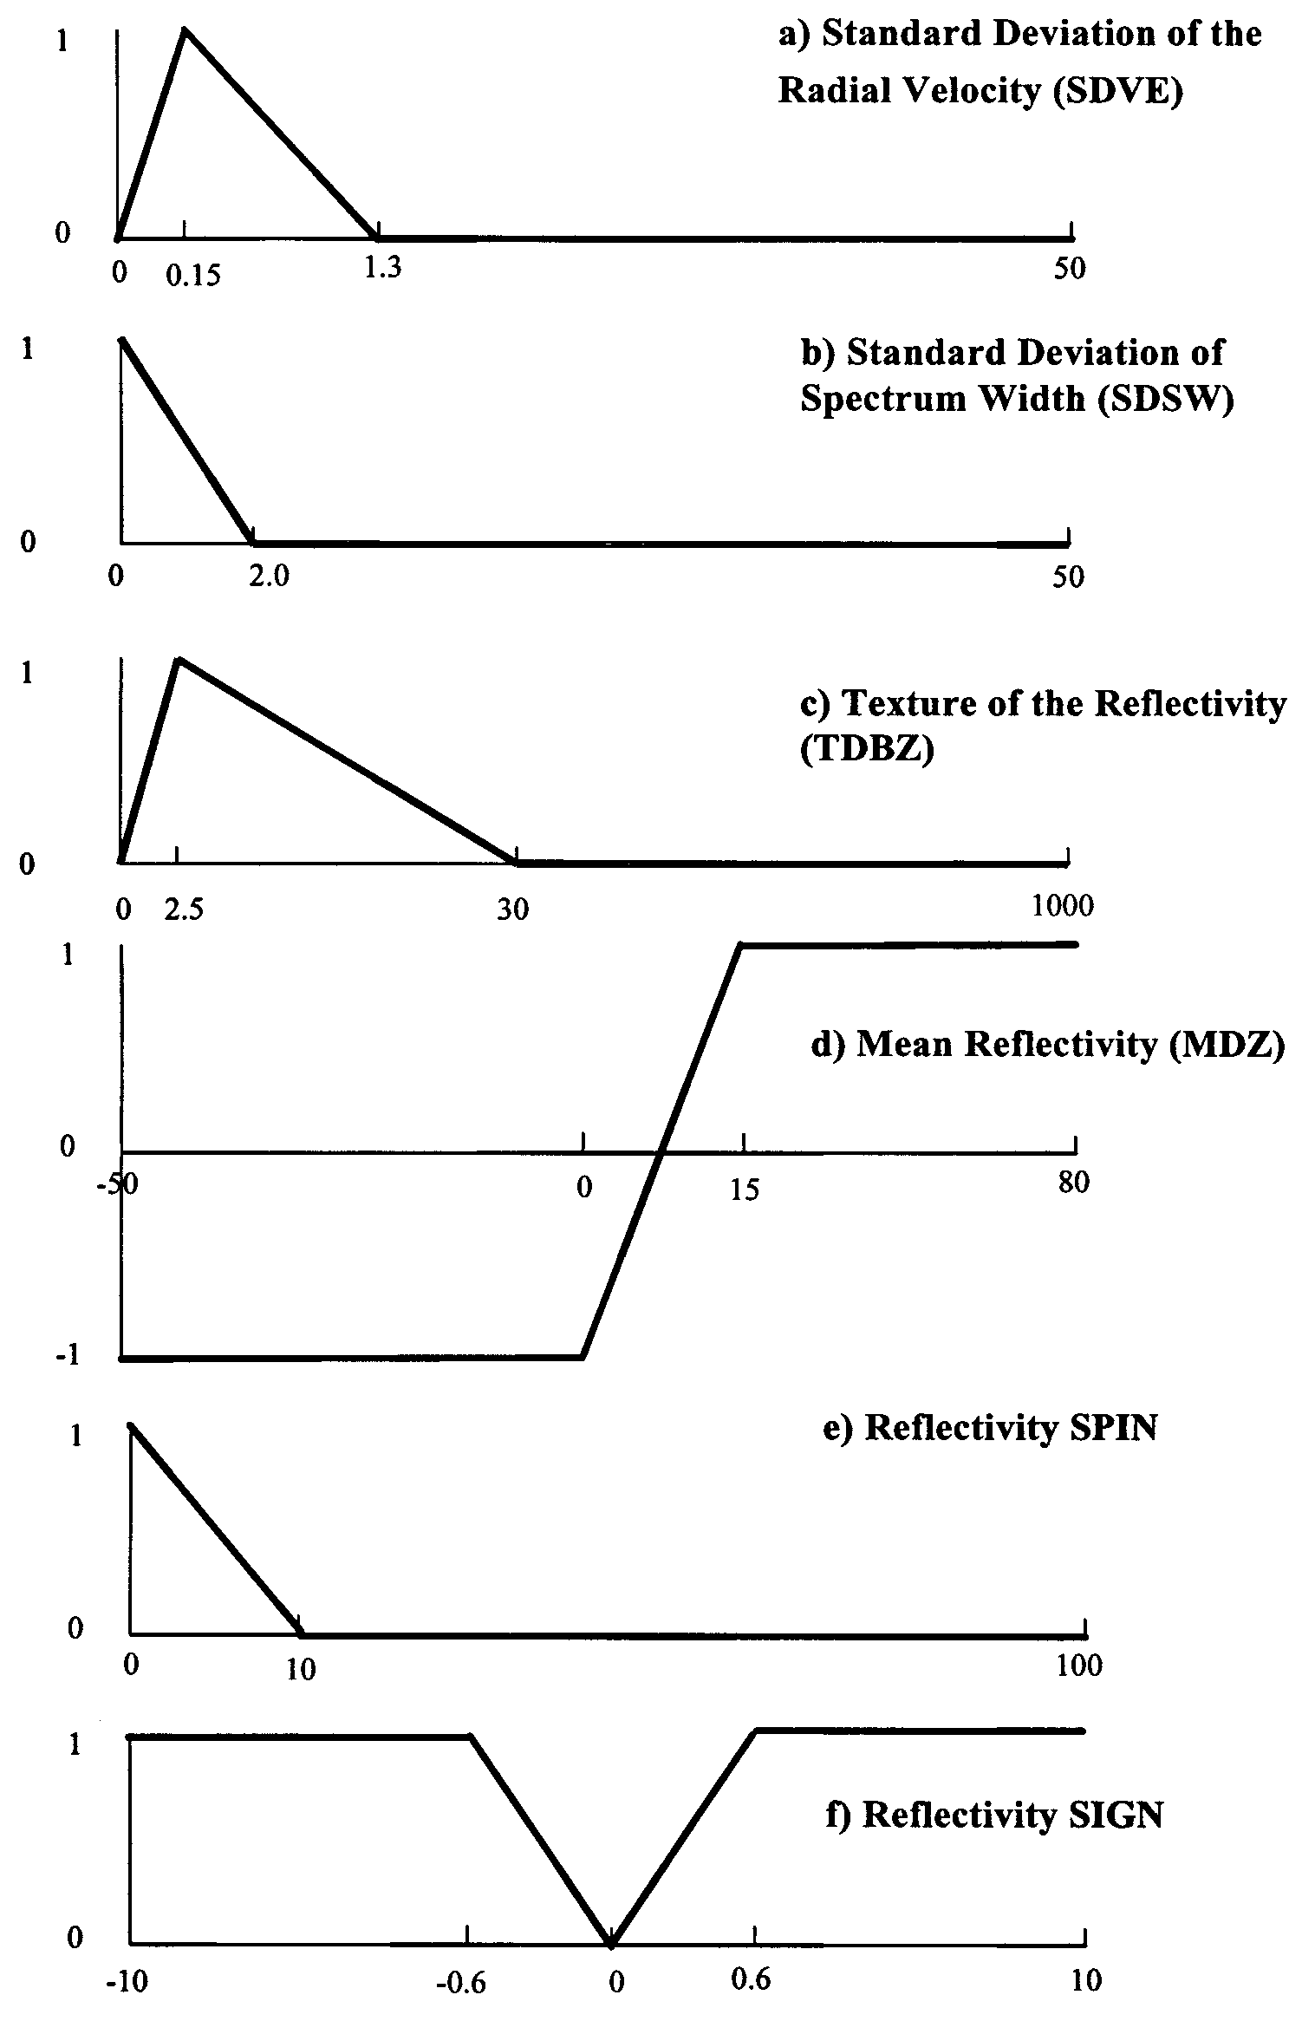
Figure 10: Membership functions for the PDA.

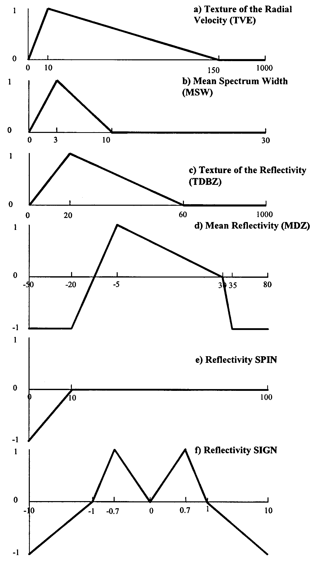
Figure 11: Membership functions for the CADA.

In order to score the various detection algorithms within REC, an objective truth field has been devised using NCAR S-Pol radar data. The polarimetric data are input into a fuzzy-logic, particle identification (PID) algorithm (Vivekanandan et al., 1999) to identify each echo type. Once the objective truth field is defined, the REC algorithms are run and re-evaluated against this new truth field. Additionally, the truth fields will be used to optimize the membership functions and set the appropriate weighting for each interest field within each algorithm.

A statistical analysis package is used to construct 2x2 contingency tables for evaluation of the statistical performance of the algorithms (Kessinger et al. 2000). The statistical indices calculated are Probability of Detection (POD), False Alarm Ratio (FAR), Critical Success Index (CSI), Percent Correct, and the Heidke Skill Score (HSS). Two baseline data sets, a 151-scan S-Pol data set from Brazil and a 60-scan WSR-88D data set, are used to develop these scores. To examine algorithm performance based on the type of weather occurring, each radar scan is placed into one of three categories. The first category is for precipitation echoes that are separated from any AP/GC; the second is for precipitation echoes that are mixed with AP/GC; and the third category is for no precipitation echoes while AP/GC may or may not be present. In all categories, clear-air returns may or may not be present. Preliminary results from the 171-scan Severe Thunderstorm Electrification and Precipitation Study (STEPS) data set is also available, but the scans have not yet been grouped by weather categories.

Using these datasets, the REC algorithm can be optimized through the proper setting of weights associated with each interest field. The proper setting of weights is obtained by aligning the peaks of the CSI and HSS skill curves to an interest threshold of 0.5 (Figure 12).

An example of how the REC identifies different regions of radar returns is shown in Figure 13. This event occurred July 13, 1993 at the WSR-88D KDDC radar and represents a precipitation echo separated from the clutter return case. A large southwest-northeast oriented squall line is moving eastward toward the radar with a preceding gust front. Clear air return is present ahead of the squall line out to about 80-km range. Individual algorithm results are shown in Figure 14. In this figure, results from both 1999 and 2000 versions of the REC are given. The 1999 version of the CADA algorithm is actually more accurate than the 2000 version. The APDA algorithm detects some of the true precipitation echo as AP, while the PDA algorithm is detecting some clear-air returns as precipitation. Overall, the PDA and APDA algorithms perform well, but additional optimizing of the weights associated with the membership functions is required to fine-tune the results, and should result in much more accurate depiction of the event.

Work has begun on the compensation of filtered reflectivity values; the third component of the four-component NCAR AP Mitigation Scheme. Reflectivity compensation is necessary in any AP mitigation scheme using clutter filtering. When the clutter filters

are used in weather echoes having low radial velocity, power is also removed from the weather echoes, resulting in a negative reflectivity bias. Furthermore, when strong clutter is suppressed, a residue may remain and cause a positive bias to the radar reflectivity. To obtain accurate radar-estimated rainfall amounts, the ground clutter contamination must be removed with clutter filters and the resulting precipitation reflectivity bias must be corrected.

In the near future, NCAR’s AP Mitigation Scheme will also use automated clutter suppression and AP Clutter Tracking techniques. Automation of WSR-88D clutter suppression through selective use of clutter filters is an ultimate goal of the WSR-88D Data Quality Optimization work. Automation will ease the clutter filter control task for the National Weather Service (NWS) staff and should provide a clutter filter control system for all WSR-88D radars. Automation will be achieved in real-time by using the output from the APDA to augment the clutter filter map defined for ground clutter (currently called the “bypass map”) such that clutter filters are enabled or disabled where appropriate for each volume coverage pattern.

6. University of Washington’s Mesoscale Group Radar Quality Control Algorithm

Over the past seven years, the Mesoscale Group within the University of Washington (UW) has developed a general QC algorithm to automate the removal of non-meteorological echoes for a large radar database (personal communication, Sandra Yuter). The goal of the QC algorithm is to remove approximately 95% of non-meteorological radar echoes. The algorithm uses only reflectivity and radial wind information and is designed to primarily remove land and sea clutter, second trip echoes, and biological targets. Sea clutter is simply AP returns immediately above the surface of the ocean and is transient since ocean waves propagate. UW’s radar database includes cases taken from ships, islands (over the ocean), and several continental locations, such as Seattle, WA, Eureka, CA, and over the state of Kansas. The UW algorithm is optimized relative to the geographical location of the radar by tuning the thresholds of algorithm parameters.

UW’s QC algorithm removes non-meteorological targets through a three-step process. The first step is primarily effective in removing clear-air echoes, especially those attributable to biological targets. The algorithm examines the homogeneity of reflectivity signatures within a 9-pixel x 9-pixel window. If the reflectivity field is both relatively homogeneous and does not exceed a reflectivity threshold (i.e., 18 dBZ, 12dBZ, and 10 dBZ for the lowest three elevation scans, respectively), then the reflectivity echoes are considered clear-air or biological in nature and are removed.

The second test within the algorithm examines the vertical continuity of echoes and assumes a vast majority of precipitation returns are typically present over multiple elevation scans. If a radar echo is not present over more than one elevation scan it is removed. A larger region within the higher elevation scan is checked relative to the areal extent of the radar echo in the lowest elevation scan in order to avoid removing precipitation echoes that are tilted in the vertical. The vertical gradient of reflectivity is examined as a third test. Any radar echo that decreases by 35 dBZ or more from one elevation scan to the next highest scan is considered AP and is removed.

Figure 15 demonstrates the application of UW’s radar quality control algorithm to a case in which only AP existed. The relatively homogenous regions of clear-air return extending northeast and southwest of the radar are removed by step one of the algorithm. The region of higher reflectivity AP northwest of the radar is removed by step two. The smaller areas of higher reflectivity are removed through step three so that all AP is removed from this case.

Figure 16 is a case of AP that coexists with precipitation and contains a small amount of precipitation embedded within a larger region of AP. UW’s scheme removes most of the AP region northwest of the radar while leaving the precipitation shield intact to the southeast. Furthermore, a true precipitation echo located 60 km from the radar near the 310º radial is not removed because the vertical gradient of reflectivity does not exceed 35 dBZ.

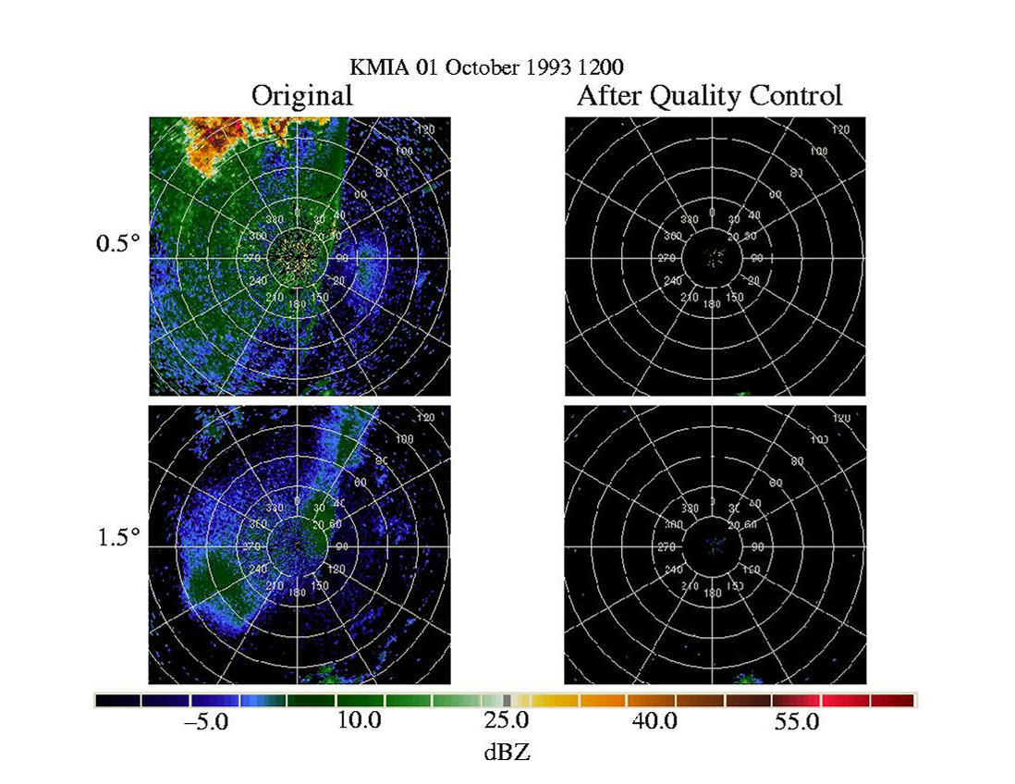
Figure 15. AP removal case using the UW QC algorithm at the KMIA WSR-88D. All radar echoes in this case are AP.

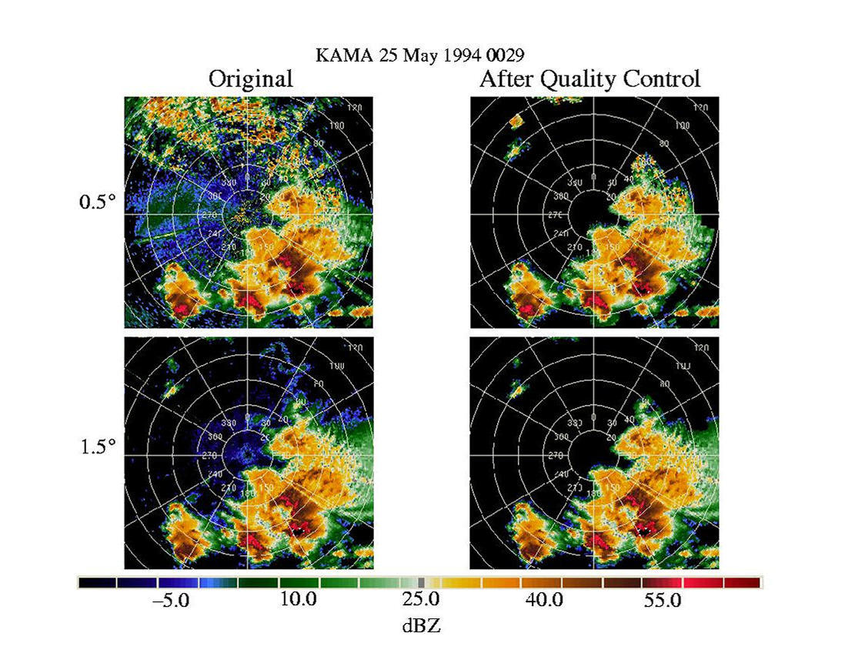
Figure 16. AP removal case using the UW QC algorithm at the KAMA WSR-88D. A mix of AP and precipitation echoes are present.

7. Goddard Space Flight Center Radar Quality Control Algorithm

The Goddard Space Flight Center (GSFC)/Joint Center for Earth Systems Technology (JCET) is currently engaged in a comprehensive Ground Validation (GV) program (Ciach et al. 1997) to analyze and QC meteorological ground-based radar data for TRMM (Kummerow et al. 2000).

JCET is tasked with collecting and processing data from four primary sites (Melbourne, FL; Houston, TX; Darwin, Australia; and Kwajalein Atoll, Republic of Marshall Islands) as part of an operational system. One job of the operational system is to remove non-meteorological radar echoes so that accurate rainfall estimates are possible.

JCET’s QC Algorithm is based on Rosenfeld et al. (1995), which employs eight adjustable threshold parameters to filter non-meteorological radar echoes. The thresholds are based on echo height and reflectivity. An echo is any radar return containing a reflectivity value above dBZ_{noise} which is 0 dBZ for all radar sites. Radar echoes are analyzed within a ~5x5 km² window in polar coordinates if any of the following four criteria are met:
- (Z_{top} < H₃ or Z₁Z_{max}(3km) <= Z₁) and (Z_{max}(H₁) < Z₃)
- Z_{top} < H₂
- Z_{max}(1.5 km) < Z₀;
- Z > dBZ_{noise} and Z₂Z in the lowest tilt,

Radar Location | H₁ | H₂ | H₃ | Z₀ | Z₁ | Z₂ | Z₃
Melbourne | 3.0 | 3.0 | 1.0 | 12.0 | 12.0 | 40.0 | 20.0
Houston | 1.7 | 1.5 | 1.5 | 13.0 | 13.0 | 30.0 | 20.0
Kwajalein | 2.2 | 3.0 | 3.0 | 12.0 | 12.0 | 15.0 | 20.0
Darwin | 3.0 | 2.0 | 3.0 | 13.0 | 13.0 | 18.0 | 20.0
Table 2: Current QC algorithm default parameters for the primary TRMM GV sites. Height thresholds are in units of km and reflectivity thresholds are in units of dBZ. (Reprinted from Kulie et al. 1999).

where Z_{top} is the echo top height and Z_{max} represents a maximum reflectivity value at a specified height. Echo height and reflectivity thresholds are given in Table 2.

Kulie et al. (1999) notes that a wide variety of AP/GC radar echoes can be removed because of the parameter flexibility. Specifically, the QC algorithm is effective in removing biological targets (e.g. birds), shallow, non-embedded AP and clutter specks, and light second-trip and clear-air echoes. Many moderate to strong false echoes located within 100 km of the radar can be removed, but the algorithm often has difficulty removing such echoes at longer ranges, especially when precipitation is present. The algorithm fails to remove non-meteorological radar echo when embedded in precipitation.

8. Princeton University Testing of Radar Data Quality Control Algorithms

Princeton University has been investigating the development and evaluation of Radar Data Quality Control (RDQC) algorithms for several years. The objectives of this work are to develop and evaluate algorithms for automated identification of radar echo patterns. Part of this effort involves close collaboration with JCET to improve the current operational quality control procedures used for radar data processing of TRMM.

Currently, tasks are centered around: (1) developing an improved RDQC algorithm, (2) evaluating different RDQC algorithms, (3) comparing their performance in specific case studies, (4) determining the feasibility of the algorithms for use in an operational processing environment through collaboration with JCET, and (5) evaluating the impact of alternative QC algorithms on rainfall estimates.

A database of AP/GC cases is being compiled at Princeton University facilitating comparison and development of AP/GC mitigation algorithms. The collected cases represent situations of (a) AP without precipitation, (b) AP separated from precipitation, (c) AP embedded in precipitation, and (d) other features such as clear air echoes, gust fronts, convergence lines, etc.

Robinson et al. (2001) conducted a comparison of six different RDQC algorithms. The RDQC algorithms are evaluated and compared based on their ability to remove AP without removing significant precipitation.

The six RDQC algorithms are:
- No QC – only raw radar data
- GSFC default – automated TRMM GV algorithm (Section 7).
- GSFC reprocessed – height and reflectivity echo removal parameters are manually tuned for specific QC concerns beyond the ability of GSFC default.
- WSR-88D PPS – AP removal scheme used within the PPS algorithm described in Section 3.2.
- PU – QC algorithm developed at Princeton University
- NCAR REC – NCAR’s Radar Echo Classifier technique as part of the overall AP Mitigation Scheme described in Section 5.

The Princeton University QC algorithm makes use of three-dimensional reflectivity structure (Steiner and Smith 2001). Radial velocity and spectrum width information are not used for four different reasons. First, radial velocity values will not be near zero for sea clutter since the clutter is moved along by the propagation of ocean waves. Second, there are instances when contamination of AP in the second-lowest elevation sweep may exhibit velocities similar to precipitation echoes even though the reflectivity signature indicates AP. Third, Steiner et al. (1999) notes that the distribution of spectrum width data values is significantly broader than radial velocities for AP echoes, and, thus, are less useful in identifying AP. Fourth, data processing is kept to a minimum if only reflectivity data is used. Hence, the PU algorithm uses three pieces of information utilizing reflectivity information; the vertical extent of radar echoes, the spatial variability of the reflectivity field, and the vertical gradient of reflectivity. One unique feature of the algorithm is the use of reflectivity data from vertically adjacent elevation scans to fill in gaps in rainfall echo areas left by the removal of AP.

All reflectivity data less than 5 dBZ are removed. A vertical continuity check removes all reflectivity echoes that exist only at the lowest elevation scan. Remaining radar echoes are then examined for reflectivity spatial variability. An 11 by 21 pixel window is created around the pixel of interest. A reflectivity increase or decrease in the radial direction within the window by more than 2 dBZ constitutes a spin change. The number of spin changes is normalized by all potential spin changes resulting in a percentage of possible spin changes. If this percentage is smaller than a “spin threshold”, the pixel is kept and considered a valid radar echo. The spin threshold is dependent upon the reflectivity of the pixel where,
SPIN THRESHOLD = 8 – (dBZ_{pixel} – 40)/15.
If the percentage is greater than the spin threshold, a vertical reflectivity gradient check is made for that pixel. The pixel is considered AP if the gradient exceeds 10 dBZ/deg.

The six algorithms examined in Robinson et al. (2001) are applied to AP/GC contaminated WSR-88D radar data from Amarillo, TX and St. Louis, MO. The Amarillo, TX AP contamination case occurred on May 24, 1995 when intense AP
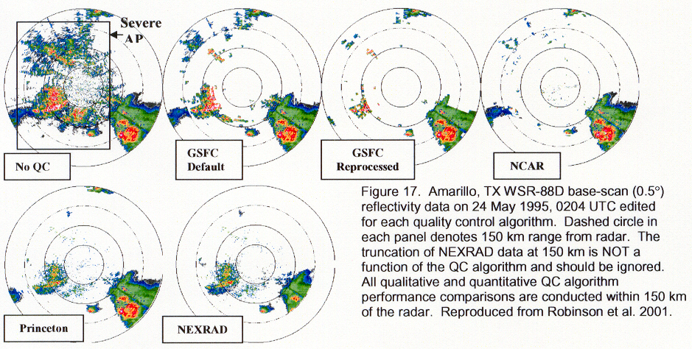

coexists with, but is not embedded within, legitimate precipitation (Figure 17). The GSFC algorithms, whether using fixed or tunable threshold parameters, have great
difficulty removing the more intense AP echoes while NCAR, PU, and WSR-88D PPS are more successful. NCAR greatly reduces the areal coverage of the intense AP leaving only widespread, isolated pixels of intense spurious returns. GSFC and PU algorithms are most effective in maintaining precipitation echoes. Within NCAR, precipitation returns are reduced as the RDQC algorithms occasionally remove echoes at the edge of convective cores, which is an artifact of using a fuzzy-logic based algorithm. WSR-88D accumulations are relatively low since higher tilt data and resultant weaker reflectivity returns are utilized when AP is detected.

On July 3, 1997, intense AP embedded within convection surrounded the St. Louis WSR-88D. In application to this case, the GSFC algorithms have no effect on embedded AP while NCAR REC is more successful in mitigating the adverse effects of embedded AP contamination. NCAR REC is able to remove large areas of intense AP but a significant number of strong spurious echo pixels still persist. The PU algorithm performs very well in this particular case by replacing contaminated base-scan data with higher-tilt information, while maintaining the overall integrity of the precipitation field.

Based upon the results of this study, evidence suggests that superior results are obtained from either of the automated NCAR REC or PU algorithms. Both of these algorithms may be a viable alternative to the current, labor-intensive GSFC technique as well as the WSR-88D PPS method. Both the NCAR REC and PU algorithms perform well in removing strong AP echoes while not removing true precipitation echoes.

9. Importance of Radar Data Parameters in Removing AP/GC

Steiner and Smith (1999a,b; 1997; 1996) of the Department of Civil Engineering and Operations Branch of Princeton University, have exhaustively reviewed the history of AP mitigation techniques. They have recently evaluated the performance of a variety of algorithms based on reflectivity alone, and in combination with radial velocity and spectrum width information.

Steiner and Smith (1999b; 1997) examine the importance of algorithm parameters based on a selection of cases that represent situations of (i) AP echoes without or separated from precipitation, (ii) AP echoes embedded in precipitation, (iii) precipitation, and (iv) other features such as clear air echoes, gust fronts, convergence lines, chaff, etc. The parameters studied are: reflectivity, vertical gradient of reflectivity, radar echo top height, radial velocity, spectrum width, texture and spin change of reflectivity as well as the mean and standard deviation of radial velocity.

As a result, they make the following conclusions:
- The information about reflectivity, radial velocity, or spectrum width at a given pixel, by itself, is of no value for echo type identification. However, when used in combination with other parameters, these three observations can be made useful. For example, in cases of AP embedded within precipitation, radial velocities near zero can identify AP as long as the motion of the surrounding precipitation is not primarily tangential to the radar beam.
- Large vertical gradients of reflectivity are indicative of non-raining echoes.
- High echo tops indicate precipitation, however, AP clutter may still be embedded.
- High spin change values appear to signal AP clutter; however this parameter alone may not result in clear AP clutter identification.
- The spatial (horizontal) variability or texture of the radar reflectivity field is a powerful indicator of ground clutter and AP echoes. This parameter alone may not result in clear AP clutter identification.
- The local variability of velocity or spectrum width is not helpful with echo type classification.
- AP clutter separated from precipitation can be identified based on information about the vertical gradient of reflectivity and echo top height if an appropriate radar scan strategy is used and AP exists at a particular range from the radar.
- When AP occurs embedded within precipitation, a combination of radial velocity, vertical gradient and spatial variability of reflectivity (spin change or texture) may provide enough information to guide automated identification.
- The worst AP case is sea clutter embedded within precipitation. Unfortunately, no combination of investigated parameters provided an ability to tackle this problem except possibly through the use of satellite information.

- Summary and Implications for WARP’s AP Mitigation Technique

AP/GC echoes can result from several processes including thunderstorm outflows, nocturnal temperature inversions, advection of warm, dry air over cool, moist air, ground clutter, clear-air, biological returns, residual clutter, and man-made chaff released into the atmosphere. AP/GC mitigation schemes typically use radar information such as reflectivity, radial wind, spectrum width or statistical measures thereof (i.e., mean and standard deviation) to remove non-meteorological echoes. In addition, some techniques utilize “tilt tests” that analyze vertical gradients of reflectivity or areal extent of reflectivity. Atmospheric observing platforms other than radar are now being utilized including satellite, surface observations, and numerical weather prediction model data. These new sources of data are applied assuming that meteorological targets do not exist in cloud-free regions of the atmosphere.

Some of the more common problems in removing AP occur in cases of clear-air echoes, AP embedded within precipitation, residual ground clutter, and chaff. AP is most difficult to remove when embedded within a precipitation shield. On the other hand, most AP/GC removal schemes are very successful when no precipitation is present. For instance, the AP mitigation technique used within ITWS can remove up to 98% of AP in precipitation-free cases (Klingle-Wilson 1995). However, that percentage drops to 80% in situations in which AP is embedded within precipitation.

Table 3 summarizes all the AP/GC mitigation techniques discussed in this study and the radar parameters each method used to remove the AP/GC. Table 4 lists different types of AP/GC that can produce non-meteorological radar echoes and the radar parameters that are most useful in removing a particular type of AP/GC. Some of the more important parameters that are used in several techniques, and deemed useful in removing different types of AP/GC, are radial velocity, spectrum width, vertical gradient of reflectivity, texture or spatial variability of the reflectivity field, and satellite cloud top IR temperatures.

Typically AP/GC echoes contain radial velocities and spectrum widths near zero. However, Steiner and Smith (1999b; 1997) point out that radial velocity and spectrum width thresholds should be used in combination with other parameters to effectively remove AP/GC. Otherwise, true precipitation echoes can be removed when moving tangentially with respect to the radar beam. This will impact rainfall estimates, but more importantly for WARP, meteorological echoes potentially hazardous to aviation could be removed, or spuriously attenuated. The vertical gradient of reflectivity is also a particularly useful parameter since AP typically contains a reflectivity maximum in the lowest elevation scans and a large vertical reflectivity gradient above. Meteorological radar echoes, except for thunderstorms that are in the formative stages of their life cycle, will typically contain vertical reflectivity gradients much less than AP/GC (Mueller and Sims 1975).

AP/GC Technique | Radar Parameters Used in Scheme
MIT/LL ITWS | dBZ comparison between 2 radars
WSR88D-PPS | VG of areal dBZ; dBZ thresholds
WSR88D-Clutter Suppression | RV and SW
WSR88D-LRM-APR | RV and SW over preset regions
PU | dBZ texture, VG, VC
UW | dBZ texture, VG, VC
GSFC | radar echo top height, dBZ thresholds
NSSL QPE-SUMS | RV, SW, VG, SAT
NCAR-REC | MDZ,MSW,MDVE,MDSW,SDVE,  SDSW, TDBZ,TVE,RS,RG
Table 3. Listing of AP/GC techniques discussed in this study along with the radar parameters used within the removal technique. The following is a key for acronyms within the table:

dBZ=reflectivity SDVE=standard deviation of radial velocity
VG=vertical gradient of reflectivity SDSW=standard deviation of spectrum width
RV=radial velocity TDBZ=texture of reflectivity
SW=spectrum width TVE=texture of radial velocity
VC=vertical continuity of reflectivity RS=reflectivity spin
MDZ=mean reflectivity RG=reflectivity sign
MSW=mean spectrum width SAT=satellite cloud-top IR temperatures
MDVE=median radial velocity
MDSW=median spectrum width

Examples of AP/GC | Useful Radar Parameters  needed to alleviate AP/GC
AP only | RV, SW, SAT
AP and Precipitation  (but not intermixed) | RV, SW, and VG
AP embedded within precipitation | RV, SW, VG, TDBZ, and possibly VC
Clear-air echoes  (e.g. biological targets) | TDBZ, SAT
Residual clutter | RV, SW, SAT
Boundary Layer Features  (e.g. gust front) | VG
Chaff | SAT
Table 4. Listing of atmospheric examples of AP/GC and the more useful radar parameters that are needed within AP mitigation techniques to remove the AP/GC. Same key is used as in Table 3.
A more complex radar parameter, the texture of the reflectivity field, can be used to accurately identify AP/GC regions. This parameter can be calculated by different methods and is a measure of the horizontal homogeneity of the reflectivity field. Within NCAR-REC, the texture of reflectivity is calculated as the average of the sum of least squared differences of reflectivity. Within the PU algorithm, reflectivity texture is calculated by identifying the number of 2 dBZ changes in the reflectivity field along several radials within a prescribed window. Reflectivity texture is useful because precipitation fields tend to be smoother (i.e., more continuous or homogenous) than either clear-air echoes or AP regions over a wide area.

The Weather and Radar Processor (WARP) program currently uses the WSR-88D LRM-APR product as truth data to correct for AP within the composite reflectivity or base reflectivity WSR-88D product. MIT/LL has developed this AP removal technique using radial velocity and spectrum width thresholds (Isaminger et al. 1997). One examination of ten cases that included AP only, weather only, and AP embedded within precipitation showed that 67.6% of AP is removed using this technique.

However, this method is applied differently over preset regions of the atmosphere surrounding a radar site (Figure 1). Thus, the scheme is not flexible enough to be applied over locations containing AP that may exist outside of the predetermined regions. In addition, this technique automatically excludes all radar echoes within 45 km of the radar that are below 1 km in height. Thus, in particular instances, very important precipitation echo information may be arbitrarily and incorrectly removed. Furthermore, this scheme uses radial velocity and spectrum width data only. Therefore, this method can fail by not properly identifying AP in cases such as thunderstorm outflows or fail by incorrectly removing precipitation echoes.

While WARP’s current AP/GC removal scheme has yet to be tested, it is likely that it can be improved upon in several different ways. One is to simply replace WARP’s current technique with another more accurate method. In the comparison of RDQC algorithms made by Robinson et al. (2001), NCAR’s REC performed very well relative to other algorithms. This scheme will be available through the WSR-88D ORPG within the next five years as it is currently slated for release within ORPG Build 2 (Kessinger and VanAndel 2001). Preparation should be made for the integration of NCAR’s AP Mitigation scheme (particularly the REC) within the WSR-88D system in order to take advantage of its superior ability to detect AP/GC radar echoes.

Until NCAR-REC is available, other alternatives to improving WARP’s AP removal technique could be examined. Unfortunately, there is very little that can be done to improve on the AP/GC mitigation technique through the use of the LRM-APR product since the LRM-APR product is calculated prior to being ingested within the WARP system. Rather than trying to determine an optimal method of editing the composite reflectivity or base data products using the LRM-APR product, a more judicious use of time could be realized in formulating a new AP/GC removal technique. This is not to imply that the current AP/GC mitigation technique within WARP will do a poor job at removing most non-meteorological echoes. However, if a new removal technique is found to be required, there is little that could be done to improve the quality of the current AP/GC mitigation technique. In order to improve it’s quality, the LRM-APR product would have to be reformulated or improved upon in some manner. By the time this could be done, the NCAR REC will become available and be the preferred product.

A simple, and potentially very effective, technique could be formulated using radial velocity, spectrum width, vertical gradient of reflectivity, and texture of reflectivity using data supplied through the real-time WSR-88D narrowband connection to each WARP system. For instance, UW, PU, and NCAR REC all show the importance of reflectivity texture analysis as being accurate in discerning clear-air echoes from precipitation. When a reflectivity texture parameter is used in conjunction with vertical gradient of reflectivity as well as radial velocity and spectrum width, the AP removal process can be fairly accurate. UW has shown cases where the vertical gradient and texture of reflectivity can aid the ability to remove AP that coexists with precipitation echoes (Figure 16). When both of those parameters are used in combination with radial velocity and spectrum width information, clear-air echoes and residual clutter can be removed in addition to AP only regions.

Three sources of AP that remain difficult to remove are chaff, clear-air echoes existing over multiple elevation scans in close proximity to the radar, and sea clutter. One effective means to remove these sources of AP includes the use of satellite cloud top IR temperature information as formulated within NSSL’s QPE-SUMS. Because WARP is already receiving satellite information, IR cloud-top temperature observations could be readily available. Tests with QPE-SUMS show the use of satellite can be particularly effective at removing residual ground clutter and chaff within cloud-free regions (Figures 7, 8).

Another future AP removal technique that has not been discussed, yet shows great potential, uses polarimetric radar data. Parameters such as the cross-correlation coefficient between horizontally and vertically polarized radar returns, the standard deviation of differential phase, and the specific differential phase can determine regions of AP very accurately (Ryzhkov and Zrnic 1998). However, the incorporation of polarimetric capabilities within the WSR-88D system will likely take place beyond the five year horizon.

A final consideration when using AP removal techniques is the amount of computational time required to execute the method. Each AP mitigation technique described has been implemented (or soon will be) in a real-time, operational system to provide users with immediate information. Software code for real-time applications has always been optimized to reduce CPU usage, and AP mitigation schemes are no different. For example, the ROC has already incorporated the NCAR REC method within the WSR-88D system for investigation. Preliminary testing shows, with the proper software coding, that the addition of the NCAR REC method only increases the overall computation time for the WSR-88D RPG by less than a minute (personal communication, Tim O’Bannon). Likewise, the AP Mitigation scheme used by NSSL’s QPE-SUMS takes only seconds to execute on a Silicon Graphics Origin 2000 workstation. Thus, most techniques that have been examined do not adversely increase computational loads.

- References

Boorman, Benjamin G., M.A. Isaminger, and E.B. Mann, 1999: Optimizing the ITWS algorithm designed to remove anomalous propagation ground clutter from the ASR-9 precipitation product. Preprints, 8th Conference on Aviation, Range, and Aerospace, AMS, Dallas.

Ciach, G.J., W.F. Krajewski, E.N. Anagnostou, M.L. Baeck, J.A. Smith, J.R. McCollum, A. Kruger, 1997: Radar rainfall estimation for ground validation studies of the Tropical Rainfall Measuring Mission. J. Appl. Meteor., 36, 735-747.

Doviak, Richard J. and D. Zrnic, 1993: Doppler Radar and Weather Observations. Second addtion, Academic Press, 562 pp.

Fulton, R.A., J.P. Breidenbach, D.-J. Seo, and D.A. Miller, 1998: The WSR-88D Rainfall Algorithm. Wea. Forecasting, 13, 377-395.

Goss, S.M. and J.N. Chrisman, 1995:An introduction to WSR-88D clutter suppression and some tips for effective suppression utilization, Radar Operations Center, Norman, OK., 16pp.

Isaminger, Mark. A., B.A. Crowe, B.G. Boorman, J.E. Evans, and R. Boldi, 1997: Performance characteristics of an algorithm used to remove anomalous propagation from the Nexrad data. Preprints, 28th Conference on Radar Meteorology, AMS, Austin, 317-319.

Kessinger, Cathy and J. VanAndel, 2001: The radar echo classifier for the WSR-88D. Preprints, 17th Conference on IIPS, 137-141.

Kessinger, Cathy, S. Ellis, J. VanAndel, D. Ferraro, and R.J. Keeler, 2000: Nexrad Data Quality Optimization. Annual Report for Fiscal Year 2000. 125 pp.

Klingle-Wilson, Diana, E. Mann, R. Boldi, 1995: An algorithm to remove anomalous propagation clutter returns from ASR-9 weather channel data using pencil beam radar data. Preprints, 6th Conference on Aviation Weather Systems, AMS, Dallas, 366-371.

Kulie, Mark S., M. Robinson, D.A. Marks, B.S. Ferrier, D. Rosenfeld, and D.B. Wolff, 1999: Operational processing of ground validation data for the Tropical Rainfall Measuring Mission. Preprints, 29th International Conference on Radar Meteorology, Montreal, 736-739.

Kummerow, C., J. Simpson, O. Thiele, W. Barnes, A.T.C. Chang, E. Stocker, R.F. Adler, A. Hou, R. Kakar, F. Wentz, P. Ashcroft, T. Kozu, Y. Hong, K. Okamot, T. Iguchi, H. Kuroiwa, E. Im, Z. Haddad, G. Huffman, B. Ferrier, W.S. Olson, E. Zipser, E.A. Smith, T.T. Wilheit, G. North, T. Krishnamurti, K. Nakamura, 2000: The status of the Tropical Rainfall Measuring Mission (TRMM) after two years in orbit. J. Appl. Meteor., 39, 1965-1982.

Margraf, M. K., 1998: Comparison of jackson, kentucky (kjkl) wsr-88d precipitation estimates with iflows automated rain gauge data for southeast kentucky. Applied Research Paper No. 20-07. Scientific Services Division, Kansas City, MO, 10pp.

Mueller, E.A., and A.L. Sims, 1975: Statistics of high radar reflectivity gradients. Preprints, 16th Radar Meteorology Conference, Houston, TX, Amer. Meteor. Soc., 401-403.

Robinson, Michael, M. Steiner, D.B. Wolff, C. Kessinger, and R.A. Fulton, 2001: Radar Data Quality Control: Evaluation of several algorithms based on accumulating rainfall statistics. Preprints 30th International Conference on Radar Meteorology, Munich, P7.6.

Rosenfeld D., E. Amitai, and D.B. Wolff, 1995: Classification of rain regimes by the three-dimensional properties of reflectivity fields. J. Appl. Meteor., 34, 198-211.

Saffle, R.E., and L.D. Johnson 1998: NEXRAD product improvement: An overview of the continuing program to evolve the WSR-88D system to an Open Systems Architecture, Prepints, 14th Int’l IIPS Conf., AMS, Phoenxi, 230-234.

Skolnik, M. I., 1980: Introduction to Radar Systems. 2nd ed. McGraw Hill, 581 pp.

Smith, J. A., M. L. Baeck, M. Steiner, B. Bauer-Messmer, W. Zhao, and A. Tapia, 1996: Hydrometeorological Assessments of the NEXRAD Rainfall Algorithms. Final Report to NOAA National Weather Service, Office of Hydrology - Hydrologic Research Laboratory, Silver Spring, Maryland.

Steiner, M. and J.A. Smith, 1997: Anomalous propagation of radar signals – challenges with clutter. Preprints, 28th Conference on Radar Meteorology, Montreal, 501-503.

Steiner, M. and J.A. Smith, 1999: Anomalous signal propagation – an assessment of its potential to occur and ways to mitigate the problem in operational radar data. Preprints, 13th Conference on Hydrology, Long Beach, 117-120.

Steiner, M. and J.A. Smith, 1999: Evaluation of algorithm parameters for radar data quality control. Preprints, 29th Conference on Radar Meteorology, Montreal, 582-585.

Steiner, M. and J.A. Smith, 2001: Use of three-dimensional reflectivity structure for automated radar data quality control. Submitted to J. Atmos. Oceanic Technol.

Story, G.J., 2001: Determining WSR-88D precipitation algorithm performance using the Stage III Precipitation Processing System. West Gulf River Forecast Center, Fort Worth, TX, 14pp.

Vivekanandan, J., D. S. Zrnic, S.M. Ellis, R. Oye, A. V. Ryzhkov, and J. Straka, 1999: Cloud microphysics retrieval using s-band dual-polarization radar measurements. Bull. Amer. Meteor. Soc., 80, 381-388.

Weber, M.E., M.L. Stone, and J.A. Cullen, 1993: Anomalous propagation associated with thunderstorm outflows. Preprints, 26th Conference on Radar Meteorology, AMS, Boston, 238-240.

