

January 12, 2006

US Environmental Protection Agency
Office of Air Quality Planning and Standards
Information Transfer & Program Integration Division
Mail Drop C339-04
Research Triangle Park, NC 27711

Table of Contents

Chapter 1 – Introduction 1—1
1.1 Purpose 1—1
1.2 Objectives 1—1
1.3 Help 1—1
Chapter 2 – Administration and Setup 2—1
2.1 Accounts, UserIDs, and Passwords 2—1
2.2 Installing AQS Software 2—1
2.3 Logging on to AQS 2—11
2.4 Completing your User Profile 2—14
2.5 Changing Passwords 2—16
2.6 Logging Off AQS 2—17
Chapter 3 – Batch Data Input for Raw Data 3—1
3.1 Overview 3—1
3.2 Batch Data Input Flowchart 3—5
3.3 Selecting a Screening Group 3—6
3.4 Using CDX 3—6
3.5 Loading your file into the AQS database 3—14
3.6 Reports from Load File step 3—16
3.7 Submitting Corrected Data 3—18
3.8 Running the Stats CR job 3—20
3.9 Reports from the Stats CR job 3—21
3.10 Modifying Pre-production Data 3—22
3.11 Posting data to Production status 3—23
3.12 Raw Data Inventory Report 3—27
Chapter 4 – Online Maintenance 4—1
4.1 Overview 4—1
4.2 Inserting a new site and MONITOR – Manual Entry 4—2
Manual Entry Step 1: Site Data 4—2
Manual Entry Step 2: Monitor Data 4—9
Manual Entry Step 3, optional: Duplicate Monitor 4—18
4.3 Insert a new site and monitor – create from an existing site or monitor 4—19
4.4 Modify an Existing Site or Monitor 4—20
4.5 Inserting a raw data value 4—20
4.6 Changing a sample value 4—23
4.7 Deleting Raw Data records 4—23
4.8 Deleting a site or monitor 4—24
4.9 Rollback a record 4—25
4.10 Browsing data 4—25
❖ Site/Monitor Browsing: 4—26
❖ Sample Value Data Browsing: 4—29
Chapter 5 – Data Retrieval 5—1
5.1 Retrieval Menu 5—1
5.2 AQS Standard Reports 5—2
5.3 Using the Standard Report Selection 5—3
Selections tabs 5—6
Sort Order tab 5—8
Report Option tab 5—8
Appendix A. Tips & Tricks A—1
Appendix B. Terminology B—5
Appendix C. Input Transaction Formats C-0
AA Basic Site Information C—1
AB Site Street Information C—2
AC Site Open Path Information C—2
MA Basic Monitor Information C—3
MB Monitor Sampling Periods C—3
MC Monitor Type Information C—4
MD Monitor Agency Role C—4
ME Monitoring Objective Information C—4
MF Monitor Sampling Schedule C—5
MG Monitor Tangent Roads C—5
MH Monitor Obstruction Information C—6
MI Monitor Regulatory Compliance C—6
MJ Monitor Collocation Period C—6
MK Monitor Protocol C—7
RC Composite Raw Data C—8
RD Hourly, Daily, and Sub Hourly Raw Data C—9
RA Accuracy Data C—10
RP Precision Data C—11
RS Annual Summary Data C—12
RB Blanks Data C—13
Appendix D. Transaction Requirements D—1

Introduction

What is the Air Quality System (AQS)? AQS is the system administered by the US Environmental Protection Agency (EPA) used to assess the status of the Nation’s air quality. The system includes a repository of ambient concentrations of air pollutants and associated meteorological data as well as the software used to add and maintain this data.

Purpose

This document explains the fundamental use of the web-enabled AQS system implemented in 2003. It does not cover the regulations that require the reporting of the data, nor the various monitoring equipment used. Details for coding data input are covered in the Data Coding manual. A Data Dictionary is also available with further definitions of the data used in the system.

AQS Web represents a major change in the way air quality data is reported to the EPA and improves the retrieval of such data once it is in the EPA's AQS database. Data submitters (state, local, and tribal agency personnel) now have more control over updates to their data. Those interested in analyzing the data have the benefits of a relational database, including the use of other database software, such as Oracle Discoverer, to analyze the information.

Objectives

There are at least two basic types of users of AQS: those who enter data into the system and those who use the data for analysis. Those in the “input” group will find the chapters on data input and maintenance the most useful; those in the “retrieval” group will want to concentrate on the chapters on browsing and retrievals. All users will need to refer to the Administration and Setup chapter.

Help

The AQS application includes online help. This User Guide and other user manuals is your first source for help. Appendix A of this User Guide includes screen prints of most menus, definitions of icons and a glossary of terms.

The AQS Helpdesk, a.k.a., the EPA Call Center, is available at 1-866-411-4EPA (4372) or via email at epacallcenter@epa.gov . Their hours are Monday-Friday 6:00am – 6:30pm Eastern Time. They will provide assistance with installation and password support for the AQS application. The helpdesk should also be your initial contact for any user problems. They will log and track your problem and contact you with a resolution or any other necessary follow-up. When calling the helpdesk, be sure to identify yourself as an “AQS user” because they support multiple applications.

If the problem relates directly to CDX, such as problems using the CDX Customer Retrieval Key, CDX mailbox issue or invalid/expired CDX password, you should contact CDX Help Desk at 1-888-890-1995 or via email at epacdx@csc.com. Their hours are Monday-Friday 8:00am – 6:00pm Eastern Time.

A user support network has been established for use by the AQS user community. Please feel free to use the user support network to make comments and suggestions. Your questions, comments and suggestions may help someone else with a similar problem as well as provide EPA with a better feel for problems in using the application.

You can access the user support network at http://groups.yahoo.com/group/AQSUsers/.
Instructions for use of the group are available from Yahoo. Please realize that the use of Yahoo for the group does not imply any endorsement of Yahoo by the US EPA. This group is un-moderated and EPA is not responsible and does not endorse information therein.

Emails containing AQS updates and information are periodically sent to all registered AQS users. Please remember to keep your contact information current. If you need to make changes or updates to your contact information, you would need to log into AQS to do so. Once logged into the AQS system, you select “Admin”, then “Security” from the toolbar.

The AQS website on EPA’s Technology Transfer Network (TTN) is an important resource. Many documents and manuals related to AQS are located there. The website is http://www.epa.gov/ttn/airs/airsaqs/.

Administration and Setup

Accounts, UserIDs, and Passwords

EPA security directives require each user needing access to EPA computer services be registered in accounts based on the type of access required. EPA Headquarters and Regional Offices establish these accounts using the TSSMS system for each agency in their region. These separate agency accounts also serve to provide security of the data for each agency.

As a result of the security requirements of both the EPA and the AQS application, AQS users who will perform updates to the AQS production database must be included on:
- AQS Oracle database (AQSProd)

Your Userid for each EPA account is the same 3-character id. Passwords for the AQS database (AQSProd), and the UNIX server (CDX) may be synchronized. Passwords must be changed every 90 days.

The TSSMS program at the EPA computer center automatically generates and mails each user a record of each account name, Userid and initial password for which the user is granted access via TSSMS. If 90 days or more have passed since you received your notice for CDX, you will need to call the Call Center to have your password reset prior to your first use of the AQS.

An AQS application manager assigns each user’s initial password for the AQS Oracle database (AQSProd). If more than 90 days pass before you access the AQSProd database, you will need to call the Call Center to have your AQSProd database password reset.

Installing AQS Software

System Requirements/Recommendations:
Hardware:
PC: IBM Compatible
Disk space: 180 MB
Additional space will be needed for data files
Processor: Pentium 600 MHz or better (120 MHz minimum)
Memory: 64MB RAM or more (32MB minimum)
Video Card: SVGA (800X600 resolution) or XGA (1024X768 resolution) or better
Display: 256 colors or better
Additional: Mouse
CD-ROM (if not downloading software)
Software:
Platforms: Windows 95, 98, ME, 2000, NT, XP
Connectivity: Microsoft Internet Explorer 5.5 and Internet access TCP/IP or EPA WAN
Additional: Adobe Acrobat Reader

Step 1: Log onto AQS Website

To run the setup for AQS, go to the following address:

http://www.epa.gov/ttn/airs/airsaqs/aqsweb/aqswebhome.htm

You may want to book mark this page, as it will be the starting point every time you access AQS Web

The following Screen will be displayed:

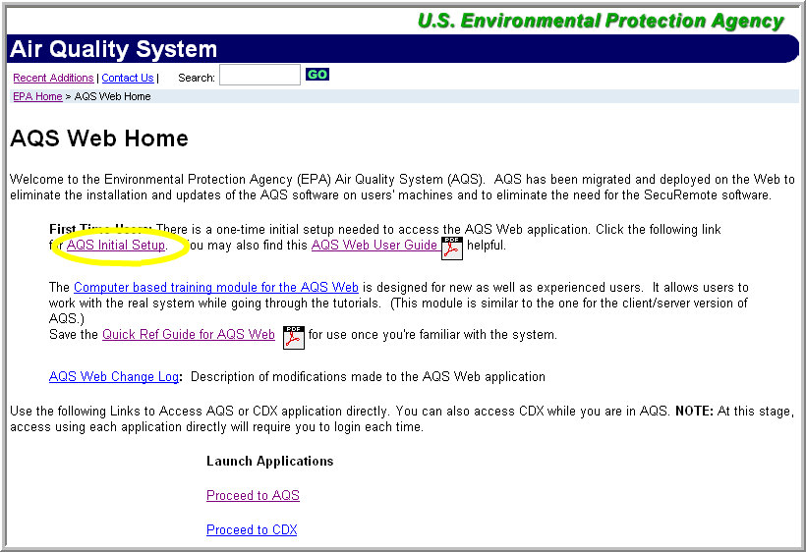

Figure 2-1
Step 2: Install

Click “AQS Initial Setup” (circled in yellow above) to begin installation.

The following Screen will be displayed (excluding the red text):
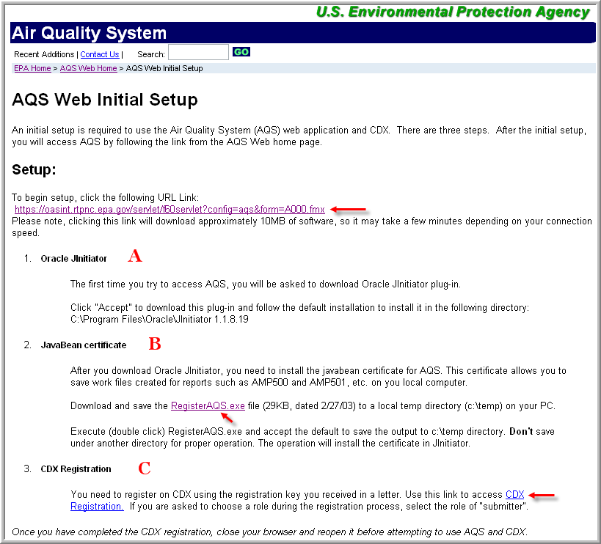
Figure 2-2
1.) Oracle Jinitiator
2.) The first time you access AQS, you would be asked to download Oracle Jinitiator plug-in. The version is expected to be 1.1.8.19 or 1.3.1.13. Note, approximately 10 MB of data is downloaded when you click on this link, so it may take a few moments.
Click on the URL: https://oasint.rtpnc.epa.gov/servlet/f60servlet?config=aqs&form=A000.fmx on the AQS Initial Setup screen (shown above) to start the Jinitiator process.

The following Screens will be displayed: (Your screens may look slightly different depending on the version of windows that you are running)
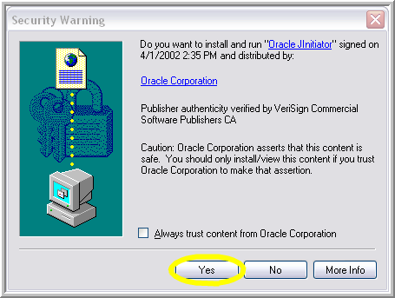
Figure 2-3
Respond “Yes” to the prompt

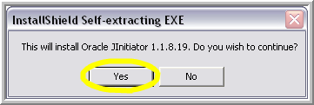
Figure 2-4
Respond “Yes” to the prompt

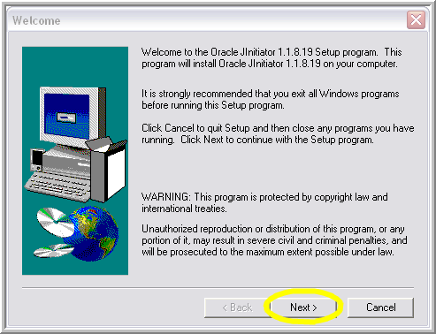
Figure 2-5
Click the “Next” prompt.
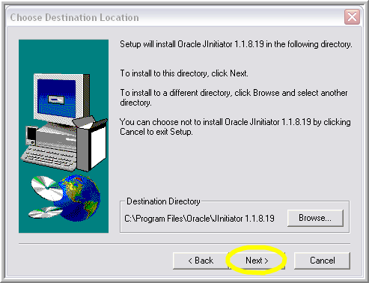
Figure 2-6
Click the “Next” prompt.

3.) JavaBean Certificate
After you download Oracle Jinitiator, you need to install the AQS certificates. These allow you access using HTTPS secure transmission and save work files outputs created for reports such as AMP500, AMP501, etc. on your local computer.

4.) Click on ‘RegisterAQS.exe’ on the AQS initial Setup screen (2nd screen shown above). The following screen will be displayed. If the screen isn’t displayed (you see a blank screen), return to the AQS Initial Setup screen and right-click on ‘RegisterAQS.exe’ and select ‘Save Target As… and save the file in your “c:\temp” directory.’.
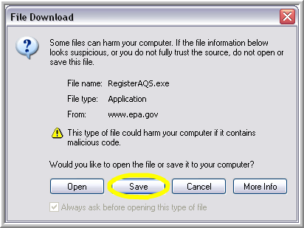
Figure 2-7Click the “Save” prompt.

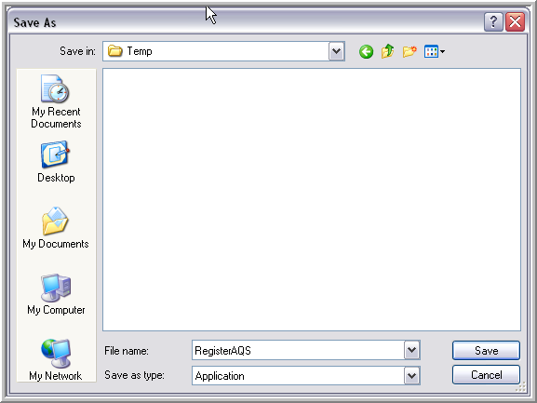
Figure 2-8

Navigate to the C:\temp directory and Click “Save”, and the file will be saved. You will be returned to the AQS Initial Setup screen.

Let’s take a moment to explain how the CDX registration works.

5.) Registering with CDX

A registration letter will be sent to you based on the e-mail address you provided when registering for AQS e-mail. The address can be verified and updated by accessing the Admin/Security screen within the AQS application. It is critical that your e-mail and phone number is correct.

The registration message that you receive from CDX will contain a “Customer Retrieval Key” or CRK. This CRK is used to complete the registration process with CDX – you will only need to register with CDX one time.

After receiving the letter, click on the “CDX Registration” link on the AQS Initial Setup screen.
If you do not need CDX, skip to section 2.3.

The following Screens will be displayed:

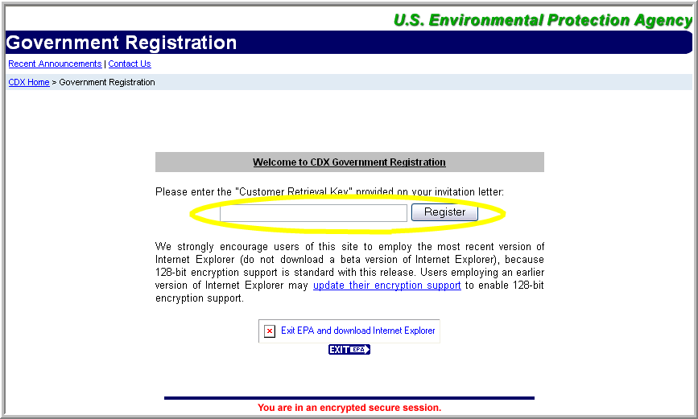
Figure 2-9

Enter the “Customer Retrieval Key” exactly as it appears in your letter and click “register”.

NOTE: The Customer Retrieval Key is case sensitive!
Read the Government Notice and “click here to continue”

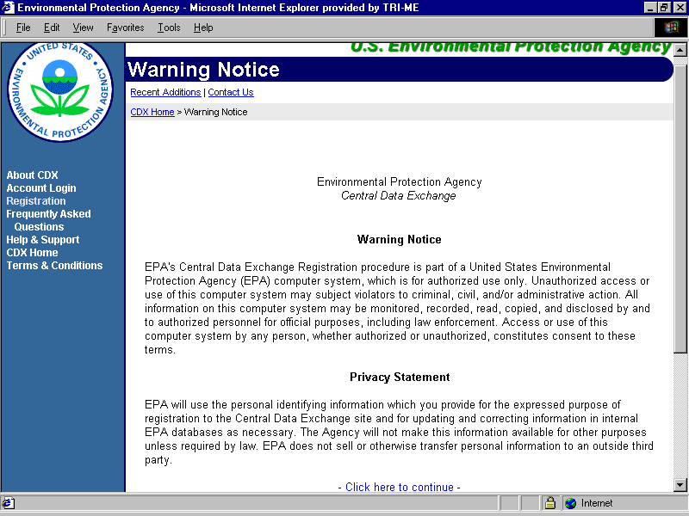
Figure 2-10
Read password rules and click “I Accept”
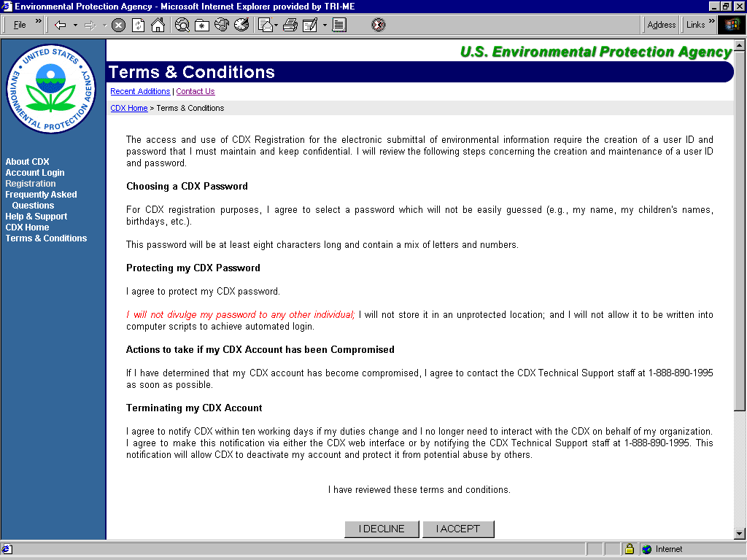
Figure 2-11

Enter preferred password, secret question and answer and click on “Next” at bottom.
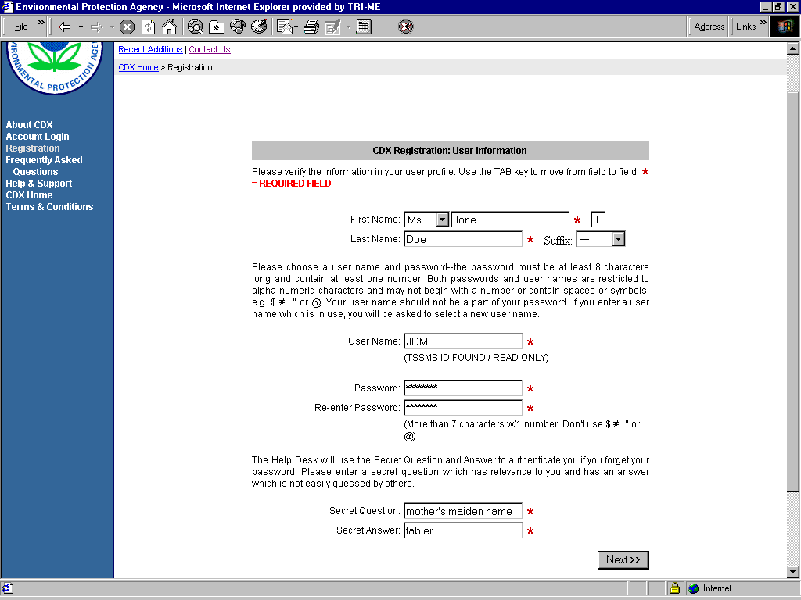
Figure 2-12

Review and revise as necessary pre-populated contact information and click on “Next” at bottom.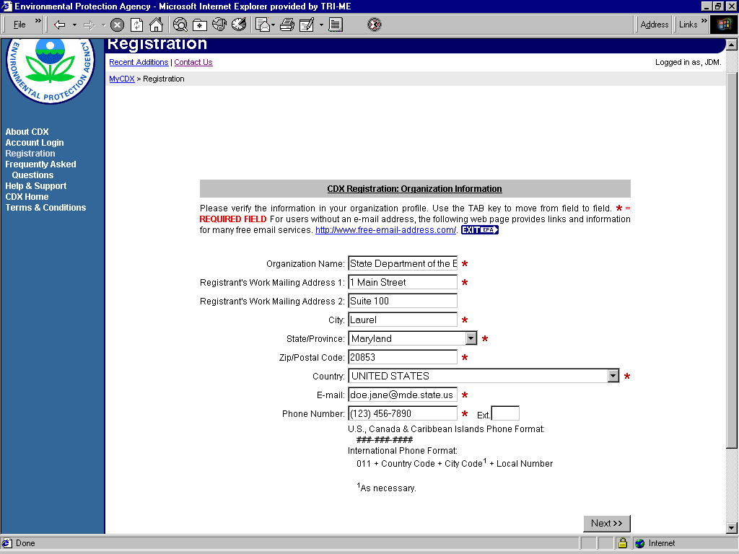Figure 2-13
Verify that you are being registered to the correct environmental data collection (AQS) and click on “Next”.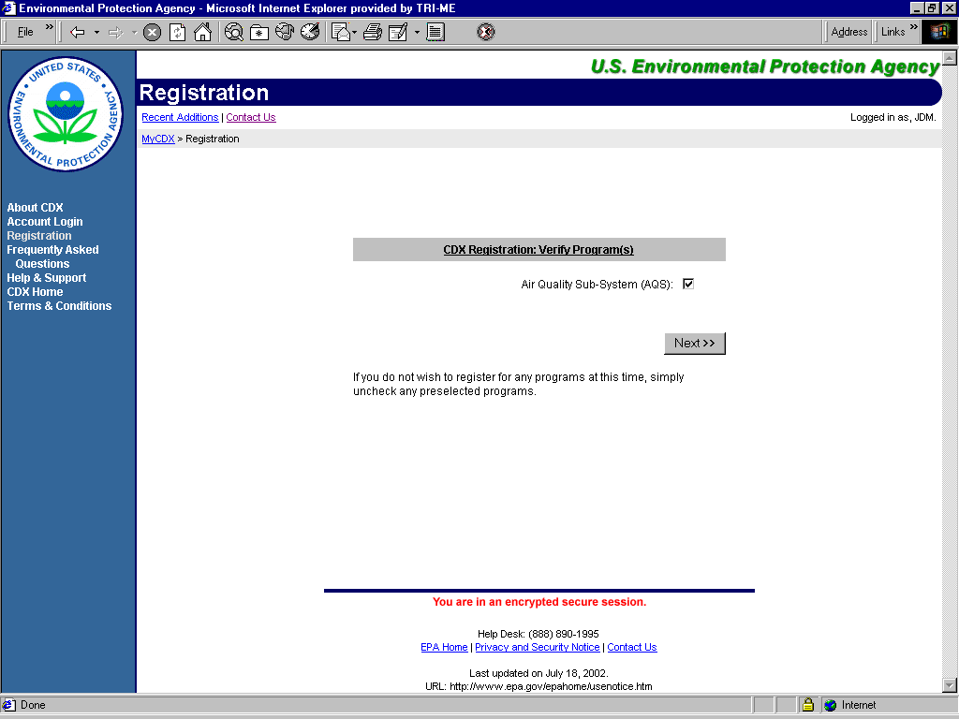Figure 2-14
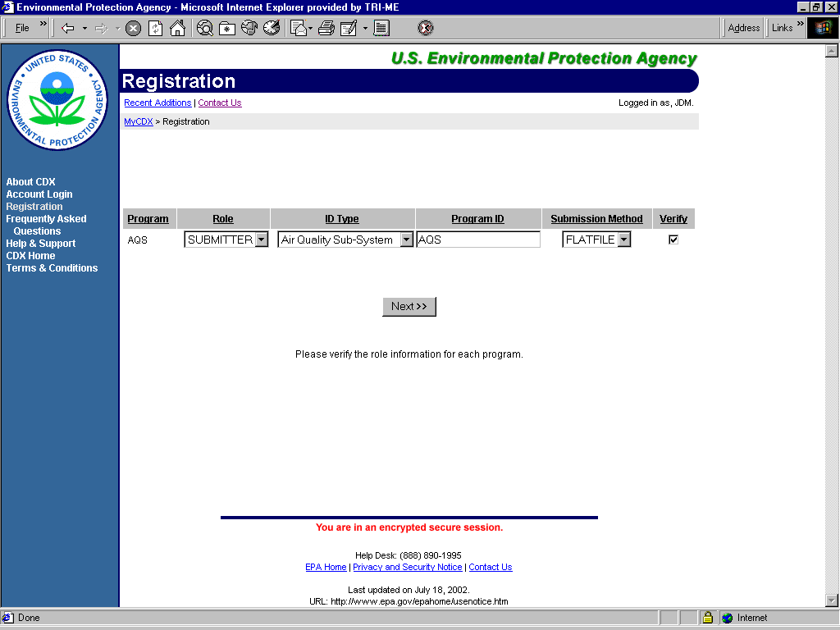
Figure 2-15

Verify your role (Retriever or Submitter) and click on “Next” to accept the default information provided. The role of Retriever means that you will be able to run reports in AQS but not submit data. The role of Submitter means that you will be able to submit data and run reports.
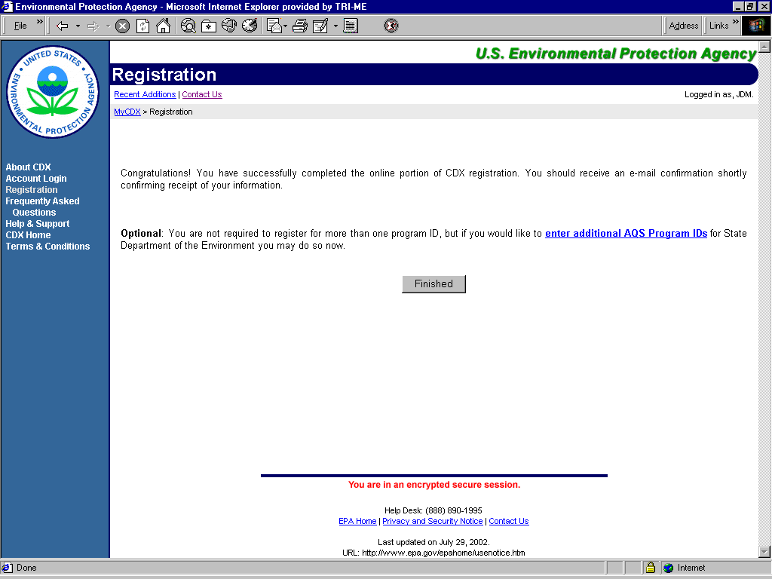 Figure 2-16
Click on “Finished”. You will receive an email confirmation that you successfully registered at EPA’s Central Data Exchange
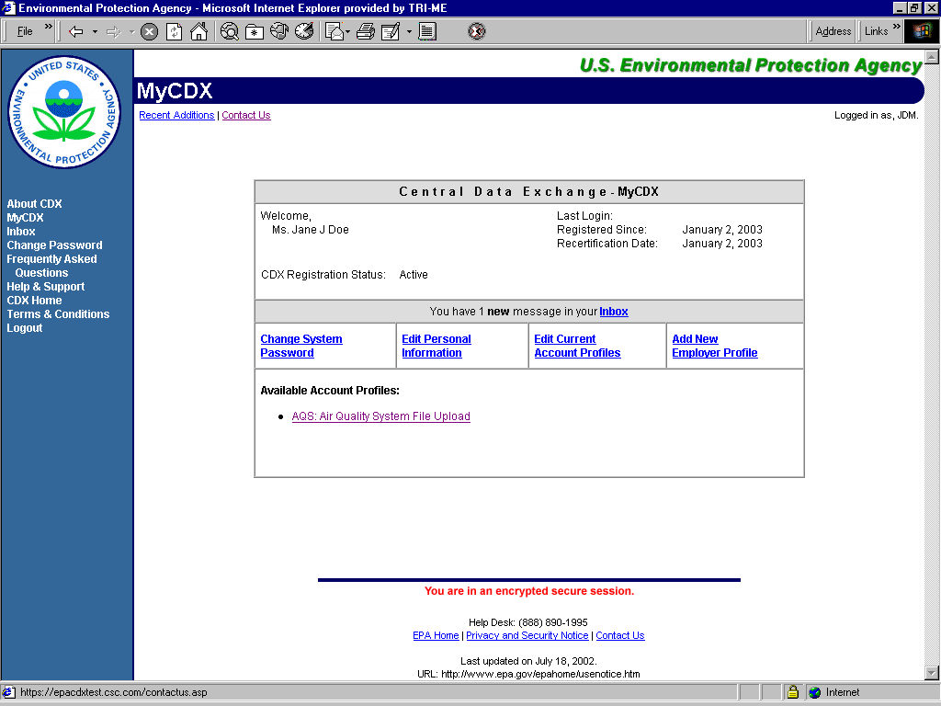 Figure 2-17

You have successfully completed the CDX registration process. If you would like to begin uploading files to AQS, click on “AQS: Air Quality System File Upload” link.

You are now ready to use the AQS Web!

Logging on to AQS

Log On To AQS Website

To log on to AQS, go to the following address:

http://www.epa.gov/ttn/airs/airsaqs/aqsweb/aqswebhome.htm

You may want to book mark this page, as it will be the starting point every time you access AQS Web

The following Screens will be displayed:

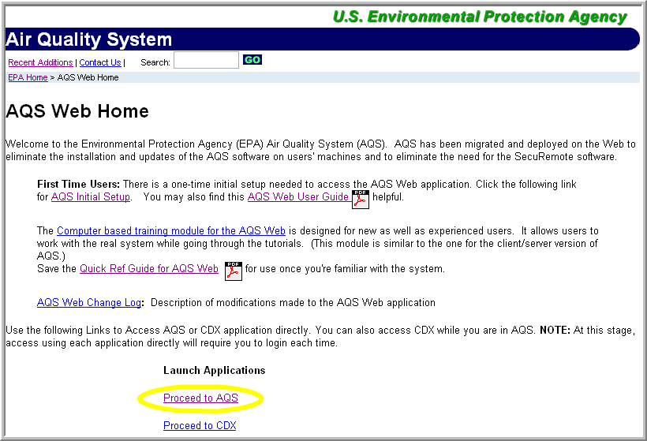
Figure 2-18

Click “Proceed to AQS”, to begin login process.

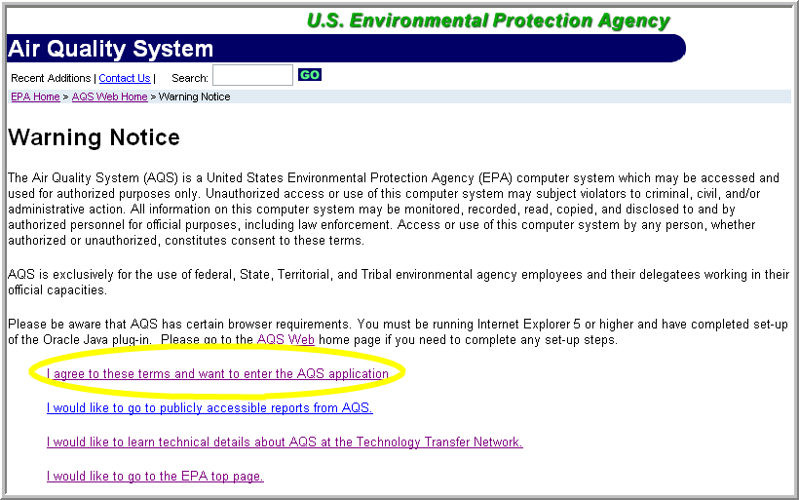
Figure 2-19

Click “I agree to these terms and want to enter the AQS application” if you accept the conditions on the warning page. EPA security policy requires that all web applications be entered through a warning page.

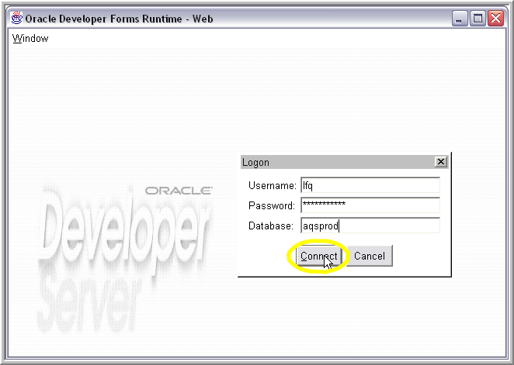
Figure 2-20

On the Logon window, enter your 3-character userid, your AQS password, and the database name: aqsprod. Press the Connect button.

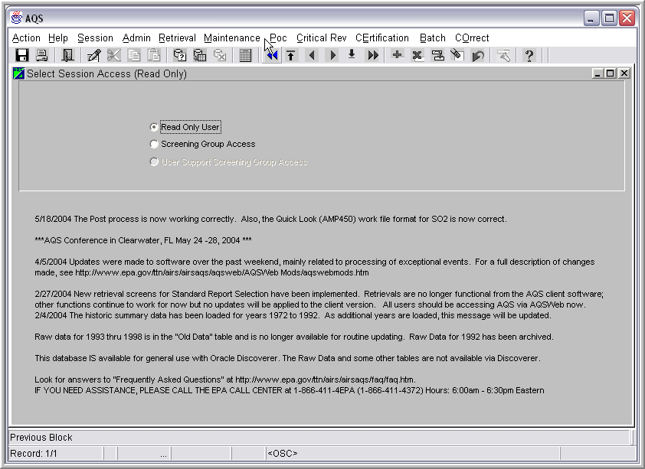
Figure 2-21

If the next screen appears as the one above, you have successfully connected to the AQS database.
Choose either “Read Only User” or “Screening Group Access” depending on what you wish to do during your session.

“Read Only User” allows browsing of all data in production status in the AQS database. It does NOT allow the user to view any data that is still being processed (i.e., “pre-production” data) or update any data. Users interested in retrievals/reports will probably want to select “Read Only User”.

“Screening Group Access” permits members of the selected screening group to view both production and pre-production data for monitors owned by that screening group. Only screening group members with update authority may insert, update, or delete data for the screening group. While using this mode, the user cannot view data owned by other screening groups.

Completing your User Profile

All users with access to the AQS have a user profile created by an AQS administrator. This information must be kept up-to-date.

From the Main Menu, select the Admin option and choose Security from its drop down menu. 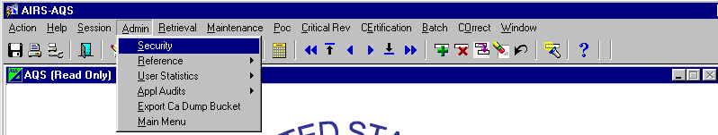
Figure 2-22
Wait while the system retrieves your user profile. You will only be able to see your own profile. Data in the top section of the Application Security screen is used to manage access and provide user feedback. Required fields are indicated by bolding and underlining of the field name. Verify that all required data is complete and correct. (Some fields on the User Profile tab may be completed only by an AQS administrator.) Be sure your email address is correct since AQS uses this address to send you results of batch jobs and downtime notifications. Remote printers have not been defined yet.

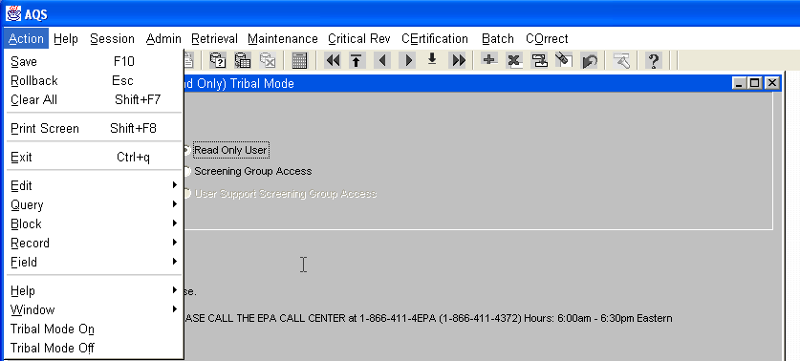
Figure 2-23

Another feature of the user profile screen is that users can click this on and off so that some users can operate both as tribal users, (i.e. be allowed to retrieve data using tribal codes), and non-tribal users, (i.e. retrieve data by state and county). You may also toggle this on and off by using the menu selection at the top of the screen. Users can select Action, then select Tribal Mode On or Tribal Mode Off. To determine if you are in Tribal Mode, look at the screen or form name and if it states Tribal Mode at the end of the screen name that will let you know which mode you are in.

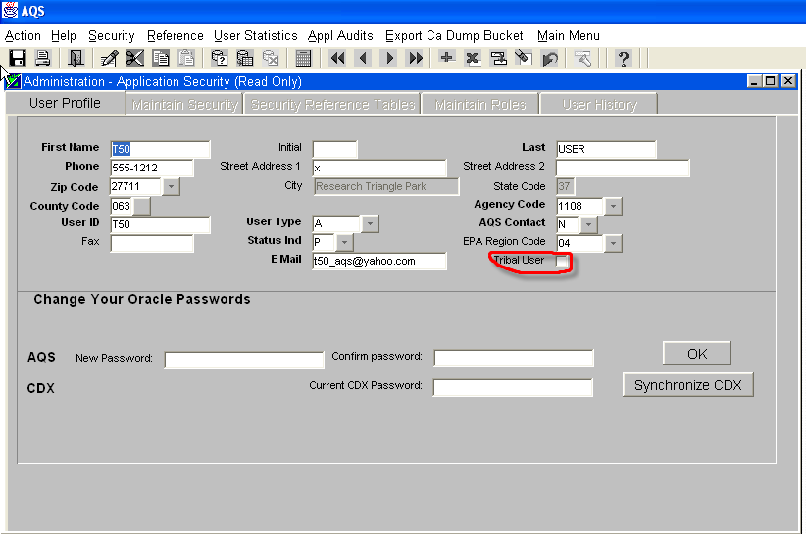

Figure 2-24

After any additions or corrections are made, Save the changes by clicking on the Save icon- (or Action then Save; or press F10). The remaining tabs on the “Administration – Application Security” window are only accessible to AQS administrators.

Changing Passwords
There are currently two passwords users must maintain for the AQS. Users manage these passwords from within the AQS application, on the Administration screen. The 2nd section of the User Profile tab provides a place to change your password for the AQSProd database and CDX.
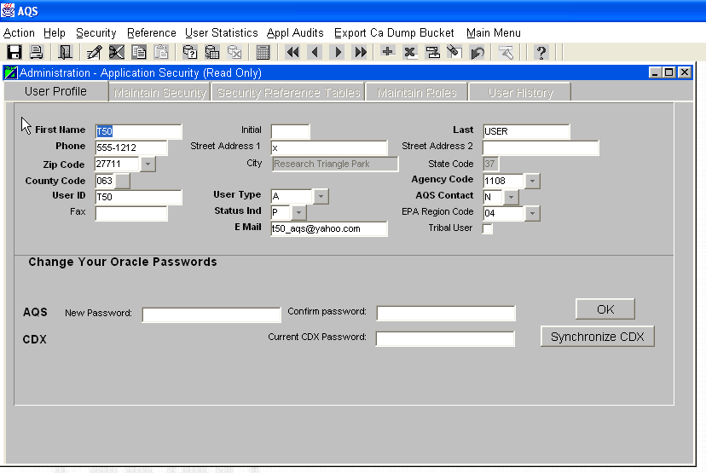
Figure 2-25
Users may only change one password at the time. Once you change your passwords, you are responsible for keeping up with them, keeping them secure, and changing/synchronizing them every 90 days. Note that you only click on the OK button when you are changing your AQS Oracle password. When you are just updating your User Profile, you make the changes in the upper section of the screen and click on the Save icon.

There are two key facts you need to remember about changing passwords:

- When you change your AQS password, you must log-out of AQS and log in again before synchronizing the CDX password.
- Passwords should be 9 characters long, include a number (but not in the first position), not be a word in the dictionary, and not include any special characters.

You may change your password for CDX when you log into the CDX screen. Passwords must be a minimum of 9 characters and contain at least 1 number. Passwords may only contain alpha-numeric characters and may not begin with a number or contain spaces. The system will prompt the user to type in the current password then the new password is to be typed in twice.

Select Main Menu from the menu bar when you have finished with this screen.

Logging Off AQS

As in most Windows-based applications, there are multiple ways to log out. For AQS, any of the following methods work:
On the toolbar, click on the Exit icon
On the main menu, click on Action, Exit
On the keyboard, press Ctrl + q
On the outer most AQS window, click on the Close icon

Batch Data Input for Raw Data

Overview

Subsequent sections of this chapter explain in detail how to load raw data in batch mode, starting in section 3.3. The batch load process is the series of steps you must perform to transfer a file of AQS transaction records at your location into the AQS database.

There are a number of steps used to load data from a text file into the AQS database. It is important to have a general understanding of the whole load process before going into the details. There are several formats that can be used. The available formats include the old AIRS/AQS format, the new AQS format that is listed in Appendix C, and also the XML schema with the following web address at http://www.exchangenetwork.net/exchanges/air/aqs.htm. The required steps depend on the kind of data involved, but in a very broad sense, you must:

- Transfer the file to the EPA using CDX
- Run a batch process to Load this data into the AQS database
- Post this data (make it “production” data)

Accomplishing the load process involves up to five processes and reports. Selecting the Batch option on the Main Menu leads you to the Batch Process screen

Following this section is a flowchart to help users determine the next course of action.
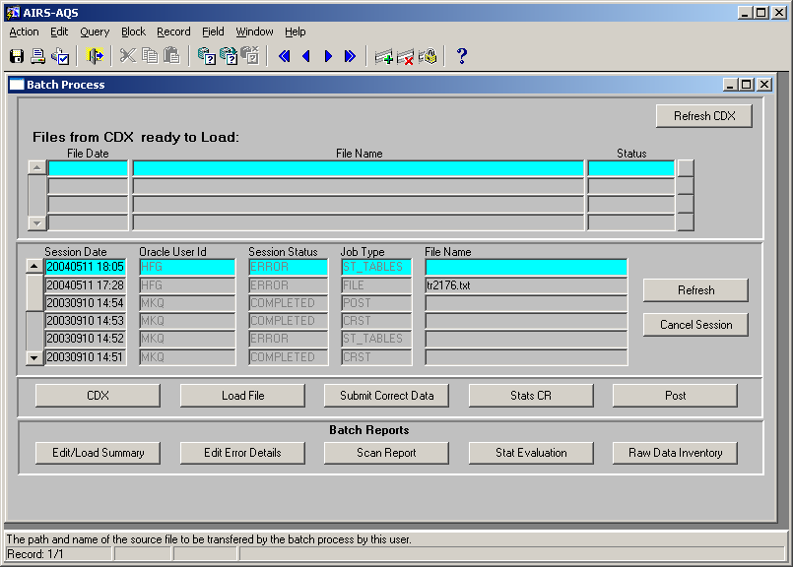
Figure 3-1

The Batch Load tab has five action buttons: CDX, Load File, Submit Correct Data, Stats CR, and Post. These actions will apply to the file information you supply in the top half of the window.

CDX: Central Data Exchange is the electronic front door to the Environmental Protection Agency and will be the mechanism that the user community uses to send and receive data from the EPA. In the cases of AQS, CDX replaced the FTP process for sending and receiving data from AQS. CDX will also be used to return batch reports to the user. CDX is a separate application from AQS, but is also web based and the two applications link back and forth between one another. Users will need to have a CDX user-id and password, which will be the same as your AQS user-id and password.

Load File: Load File attempts to load your data into the AQS database, i.e., insert, update, or delete data after performing basic edits on the data submitted. The basic edits include checking for valid data types for a field (e.g., numeric vs. alphabetic), valid codes where the code must exist in a reference table (e.g., state code), and duplicate transactions, and verifying that any required related records exist. Raw data with no basic errors are loaded into a pre-production status in the AQS production tables, so they can be further reviewed before going into production status. Records that do not pass the edits in this step are put into staging tables where they may be corrected online.

Note: If your file is corrupt (this includes having a record with an invalid transaction type), the whole file will be rejected. Rejected files must be fixed outside of the AQS application and be reintroduced to the AQS application

After running a Load File job, you should review the Edit/Load Summary and Edit Error Details reports using the Batch Reports.

Submit Correct Data: Data that failed the basic edits during the Load File step may be corrected through an online process called Correct. Once errors are corrected, the data may be resubmitted using the Submit Correct Data button.

After running a Submit Correct Data job, you should review the Edit/Load Summary and Edit Error Details batch reports again.

Stats CR: The Statistical and Critical Review job runs further checks on the data being loaded. Raw data must be run through the Stats CR job before it may be posted into production status in the AQS database. The Stats CR job creates the data used for the Scan Report, Statistical Evaluation and Critical Review reports for user review. It applies to raw data in pre-production status. (Pre-production status means data passed the edits done during the load process and is no longer considered to be in the screening stage.)

After running a Stats CR job, review the Scan, Critical review, and Stat Evaluation batch reports.

Post: The Post button starts the process of posting pre-production raw data to production status. (Reminder: Site, Monitor, Precision, Accuracy, and Blanks data go straight from the Load step to production status if there are no errors detected.)

After running a Post job, review the Raw Data Inventory batch report.

Figure 3-2 – Batch Load

The Batch Load tab has five report buttons: Edit/Load, Edit Error Detail, Scan Report, Stat Evaluation, and Raw Data Inventory. These reports will apply to the file information you supply in the top half of the window.

The five reports available are each the result of one of the Batch processing jobs.

Edit/Load Summary: This report provides summary results of the Load job or Submit Correct Data job. Counts of the number of Errors, Exclusions, Edits, Posts, and Totals are provided for each transaction type appearing in your data input file.

Edit Error Details: A detailed report of errors detected by the Load or Submit Correct Data job is provided by this report. The report identifies the site/monitor for the record in error, the table involved, the transaction as it appeared in the data input file, and attempts to identify the field or fields in error and a description of the error.

Scan Report: The Scan Report comes from the Stats CR job and provides information on maximum values and validity flags for raw data while it is still in pre-production status. Review of this information may alert you to possible errors in the data before you post it to production.

Stat Evaluation: The Statistical Evaluation report also comes from the Stats CR job. It compares pre-production data to existing production data using the Shewhart Test, Patterns Test, and the Gap Test. All records that failed one of these tests are listed with the Monitor ID and the date and time of the error.

Raw Data Inventory: This report comes from the Post job. It shows a summary of raw data posted to production. This option is provided for those that wish to keep a printed or electronic report of processed data in a summarized form. It is not a required step for loading data to production.

Batch Data Input Flowchart
The flow chart below may help guide you through the steps to get your data into the AQS database using batch mode. In addition to the steps, the broad colored bands indicate the location/status of the data.

CDX
Tables – Production Status
Legend
AQS Data Input Flowchart
Errors
Edit Error
Detail
Post
End
Correct
Raw
Edit/Load
Summary
Submit
Correct
Data
Load
File
Stats
CR
Post
Staging Tables
Production Tables - Preproduction Status
Y
N
Y
N
Stat
Eval
Scan
Report
Raw Data
Inventory
Batch
Report
Relational Status
Stat Analysis
Maintain
Raw
Y
N
Maintain
Online
Online

Figure 3.3

Selecting a Screening Group

You must be logged in to a screening group to input data. If you did not select a screening group when you initially logged on to AQS, choose Session from the Main Menu and select Screening Group Access instead of Read Only User.
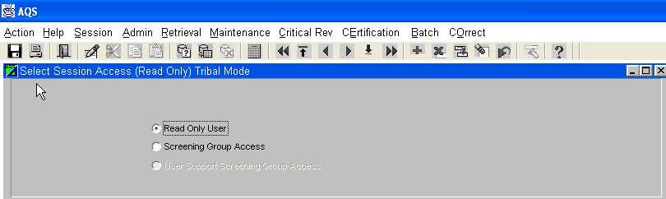
Figure 3-4
You may have access to more than one screening group, but only your screening groups should appear. If you have more than one screening group, be sure to select the one you intend to deal with. While in a screening group, you will not be able to process data that is not “owned” by that screening group.
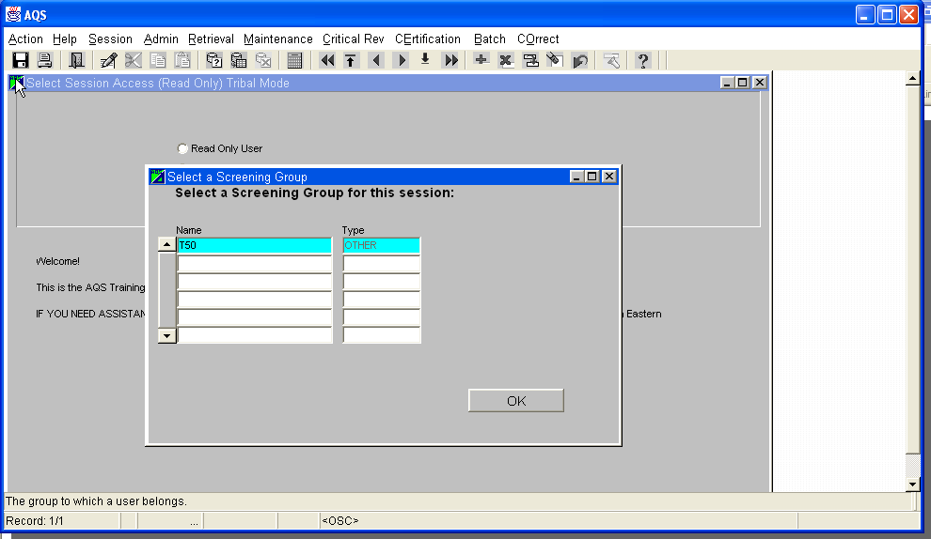
Figure 3-5
A user can determine the mode that they are operating in by the Session bar under the menu. When in tribal mode, it is indicated above.

Using CDX

The first step in loading your data is to transfer (CDX) your data file to your agency’s directory in AQS. CDX is a separate program and not part of the AQS application, so any values supplied on the AQS Batch Load screen are ignored.

Select Batch from the Main Menu.

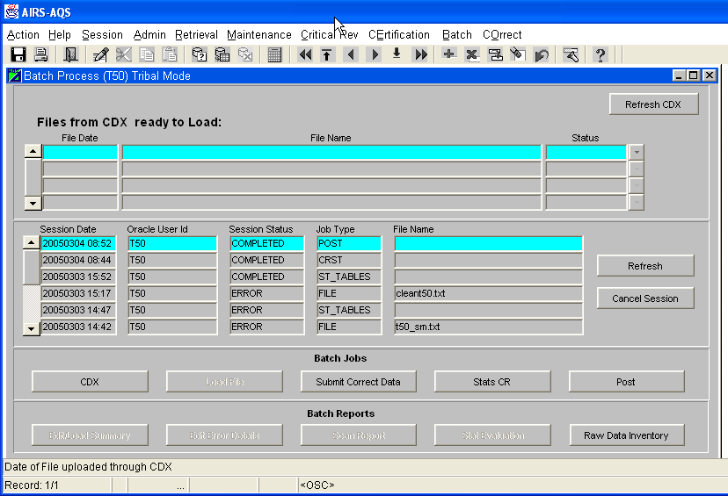
Figure 3-6

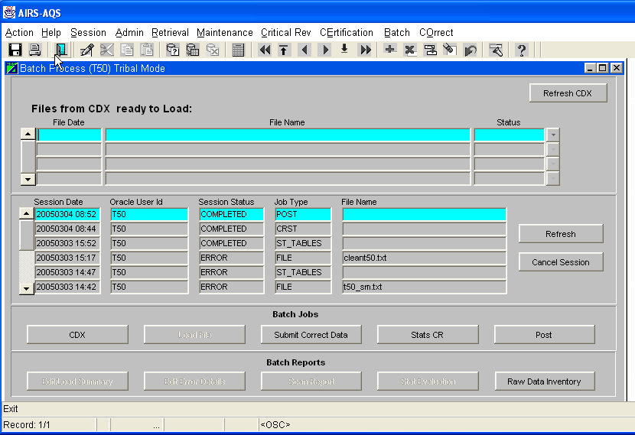

Figure 3-7

Click on CDX to go to the CDX log screen.
The following Screens will be displayed:

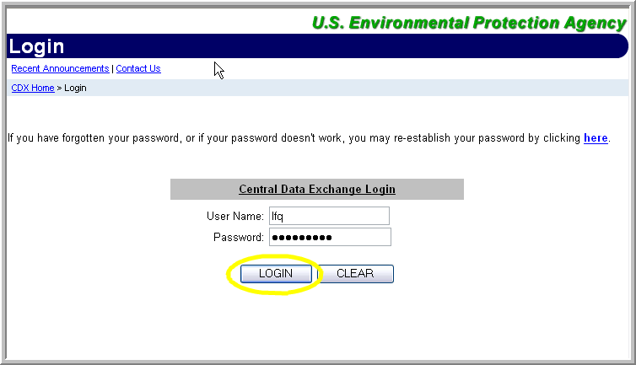 Figure 3-8

Enter your user name and password, and then click the “LOGIN” button.

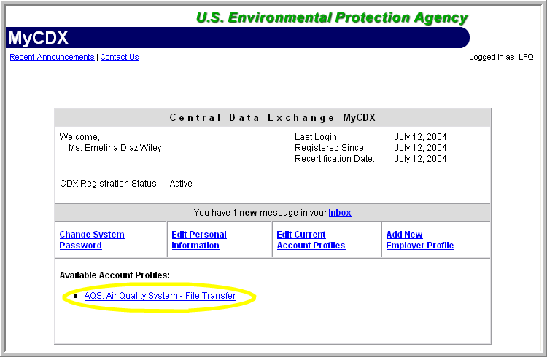
Figure 3-9

Click the “AQS: Air Quality System-File Transfer” button.

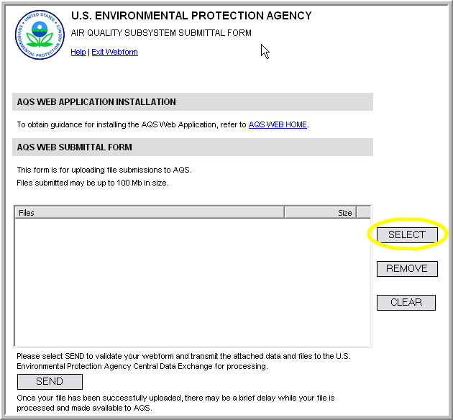 Figure 3-10

Click the “Select” button.

Select the file that you want to load. Click the “Open” button.

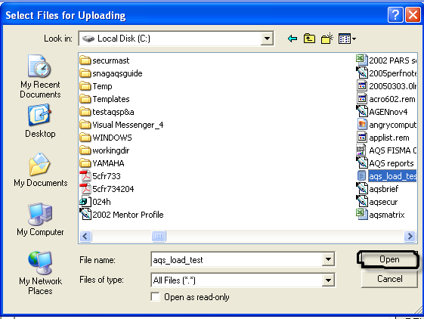
Figure 3-11

The file that you chose to load will be displayed. When you have selected all of your files to load click the “Send” button.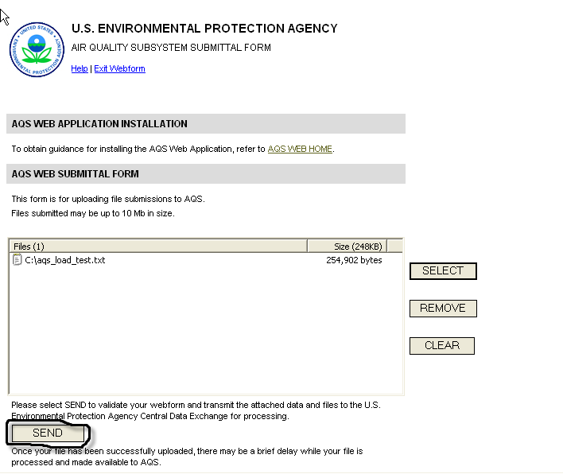
Figure 3-12

The following confirmation will appear if the load was successful.

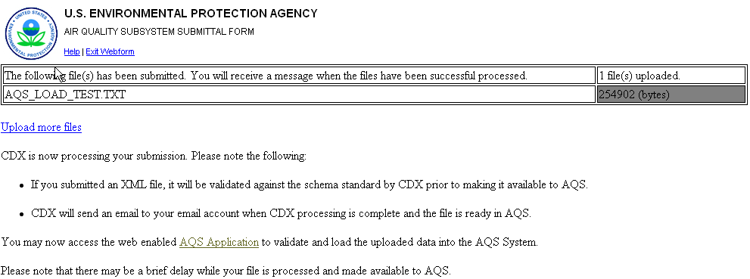

Figure 3-13

You will receive an email message when the files have been successfully transferred to AQS. You may either upload more files or proceed to AQS to validate and load the uploaded data. The filename will appear in the top of the page when available for loading. The highlighted file will be the one loaded.

Loading your file into the AQS database

Once your data file has been transferred to AQS, you are ready to Load the transaction into the database. Click on the Load File button is on the Batch Load screen. (If you’re not there, click on Main Menu then Batch.)

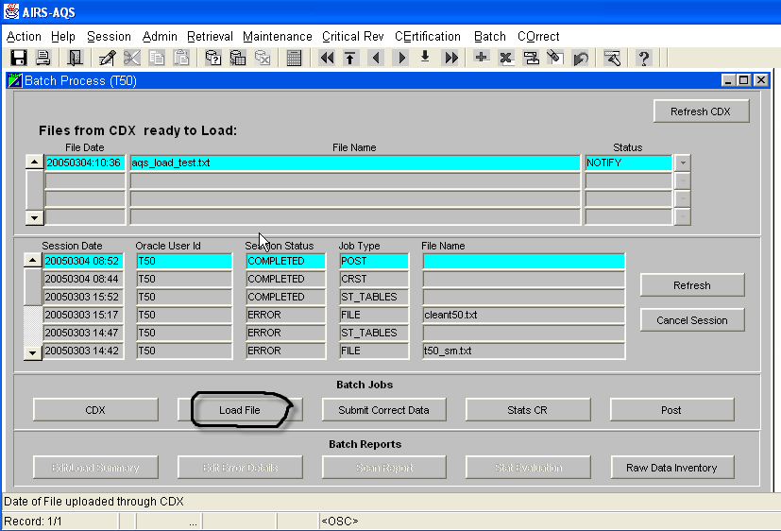

Figure 3-14
Wait for an informational window advising that your file has been submitted. Click OK.
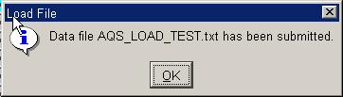
Figure 3-15

The middle section of the screen on the Batch Load tab provides information on each individual batch job submitted within the current screening group. You may not delete or modify the information presented there. Session records will be removed 15 days after the end of each calendar quarter.

Press the Refresh button to update the Session Status. The status for a submitted job will change to ACTIVE and later to COMPLETED or ERROR.

If your session status shows “ERROR” almost immediately, then your entire input file was probably rejected. Many times this is the result of an invalid transaction type. Review your input file on your PC, make any corrections necessary, then resend to CXD, and run the Load job again.

Note: You will also receive an email notifying you that your job has ended and possibly providing detailed information about the job. Generally, you may ignore everything in the log as long as the last message indicates success. If there are unexpected errors, keep the email. We may need you to forward it to us for debugging purposes. You do not have to wait for this email to proceed.

Reports from Load File step


Two reports are available following a Load File batch job: Edit/Load Summary and Edit Error Details. It is highlighted in the session identifying the batch job to be reviewed, then click on the Edit/Load Summary or Edit Error Details button to see the reports. (Load File jobs will show a Job Type of “File”.) The Edit/Load Summary report will always be available for any file processed. The Edit Error Details report will only represent the data from the last file uploaded.

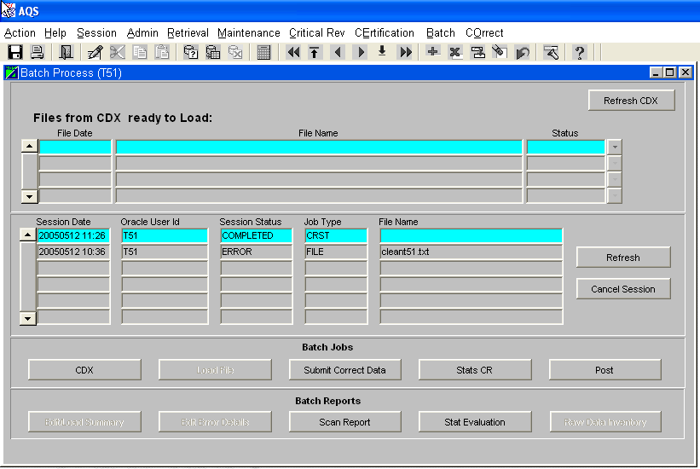

Figure 3-16

Once you request a report, it usually takes a few seconds for the report engine to start. The reports will be in PDF format. You will need Adobe Acrobat Reader to view the reports. Each report begins with a cover page similar to the one below. This page, which generally appears quickly, indicates that your request has actually connected with the database. A cover sheet will appear at the end of the report. When printing reports, you may wish to skip printing the first and last page (cover pages).

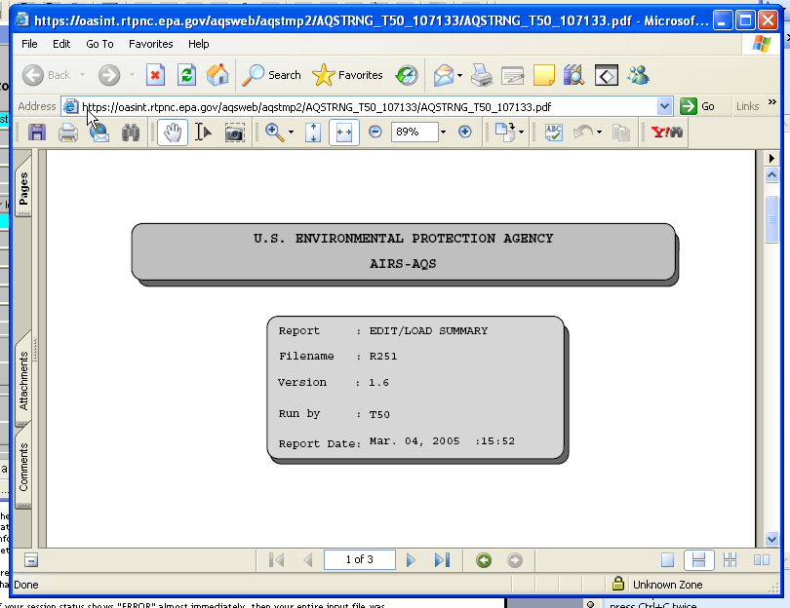

Figure 3-17
Edit/Load Summary: This report provides summary results of the job to load records to the database. Raw data records that have no format errors are counted in the Edits column. There are several more steps to be completed before raw data is posted into production on the database.

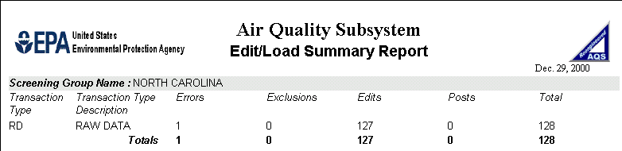
Figure 3-18

Edit Error Details: If any errors are shown in the summary report, the details for those errors are shown in the Edit Error Details Report. The sample report below shows the one record with the error. Records with errors are written to a separate group of tables called Staging Tables. These records may be fixed using the correct option from the Main Menu and then resubmitted with the Submit Correct Data from the Batch Load tab. The Correct option is covered in a later chapter.

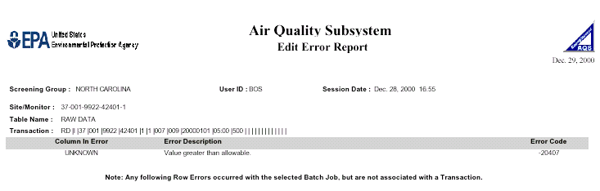
Figure 3-19
If no errors are shown in the Edit/Load Summary Report, skip to 3.8 Running the Stats CR job.

Submitting Corrected Data
Data in the staging tables will not be processed any further until it has been corrected and has passed the basic edits. The basic edits are run against data in the staging tables by using the Submit Correct Data button on the Batch Load tab. The processing behind the scenes is the same as with the Load File job, except only the records in the staging tables for the screening group are processed. (Rerunning the Load File job would result in duplicate records for all records that passed the basic edits during the initial load.)

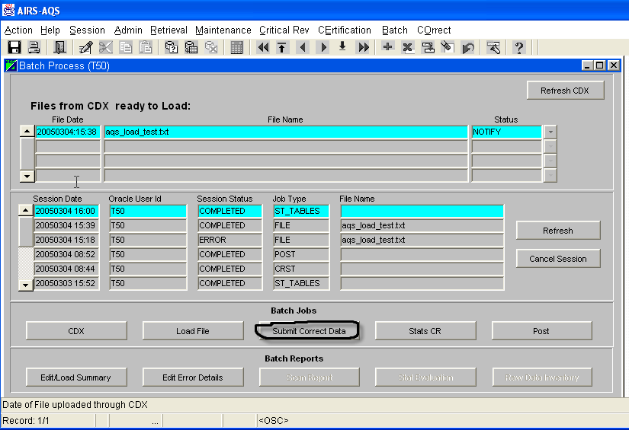
Figure 3-20
A job type of “ST_Table” is shown in the session area of the Batch Load screen when the Submit Correct Data job is submitted. When the status of the ST_Table job changes to Error or Completed, review the Edit Load Summary and Edit Error Details reports again. The summary counts will only include those records that were in the Staging Tables.
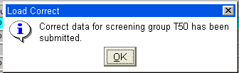

Figure 3-21

Running the Stats CR job

When there are no errors, or you wish to process data that passed the basic edits and ignore data that did not, the next step is to run the Stats CR job from the Batch Load tab. This job creates the data used for the Scan Report and Stat Evaluation and moves your data to the next step towards posting it into production status. All data for your screening group that is in pre-production status is used in the Stats CR job – including pre-production data input by any other members of your screening group.

Click on the Stats CR button. 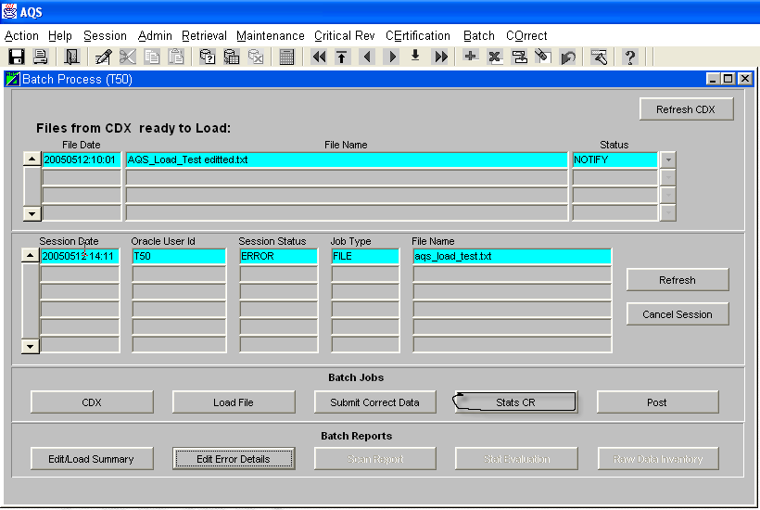

Figure 3-22
An informational window will advise you that the Stats CR has been started.

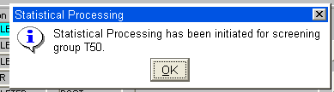

Figure 3-23

Wait for the Session Status to indicate the CRST job has completed before proceeding. Time required for this job varies depending on the number of records available for your screening group. (Press the Refresh button for updated session status.) You do not have to remain online while this process runs. An email will be sent to you when the job has finished.


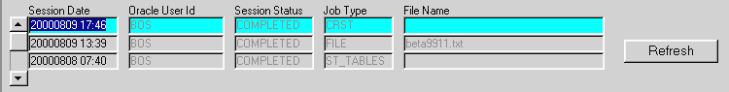
Figure 3-24

Reports from the Stats CR job

Two reports are available from the completed Stats CR job. Both reports show results from simulating the actual posting of the data to production status. These reports are important tools to assist agencies in assuring the quality of their data.

Scan Report: The Scan report shows the maximum values reported during a quarter for each monitor and indicates the existence of any validity flags for that data. If the value being shown is already in production status, a “D” (for database) appears under the Location (Loc) column.

The sample report below shows data was for two monitors: 37-001-9922-42401-1 and 37-001-9922-42601-1. For monitor 37-001-9922-42401-1, a 1st maximum value of .5ppm (Unit 007) for the 1st quarter of 2000 was recorded on January 1, 2000 at 5am (0500hrs), 2nd Max of .01 from 1/1/00 at 2am, etc. The 1st Max has a validity flag associated with it as indicated by the “*” in the VF column. All of the max values shown in this report came from the new data submitted since none of them have a “D” in the Loc column. (Sufficient data was not available for this monitor to provide a historical maximum – Hist Max - value.)

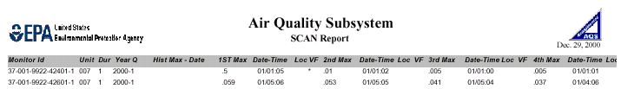
Figure 3-25

Statistical Evaluation Report: This report shows the result of the Shewhart, Edit-Pattern and Gap tests for the pre-production data as if it has been placed in production status. To fully analyze this report, you must also look at the raw data for the day in question.

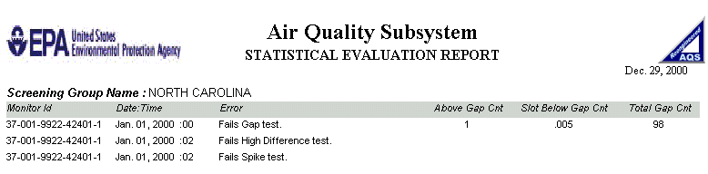
Figure 3-26


The Gap test identifies a gap in the frequency distribution of a month’s values. “Above Gap Cnt” is the number of values above the gap. “Slot Below Gap Cnt” is the value on the low end of the gap.

High Difference and Spike tests are pattern test failures. The value of “1” for 1/1/2000 at 2 a.m. is significantly higher than the values for 1 a.m. and 3 a.m. so it shows up as a high difference and a spike.

Modifying Pre-production Data

If your review of the Scan or Statistical Evaluation report identifies data with errors, use the Maintenance option from the Main Menu to modify this data online. If large numbers of records need modifying, it may be quicker to:

- create batch transactions to Update them

- Or -

- delete all the pre-production records, make the corrections in the data input file on your PC and start over with CDX file transfer.

Use of the Maintenance option is covered in a chapter 4.

Posting data to Production status

Once you are satisfied that your data is ready to go into production status on the AQS database, run the Post job.
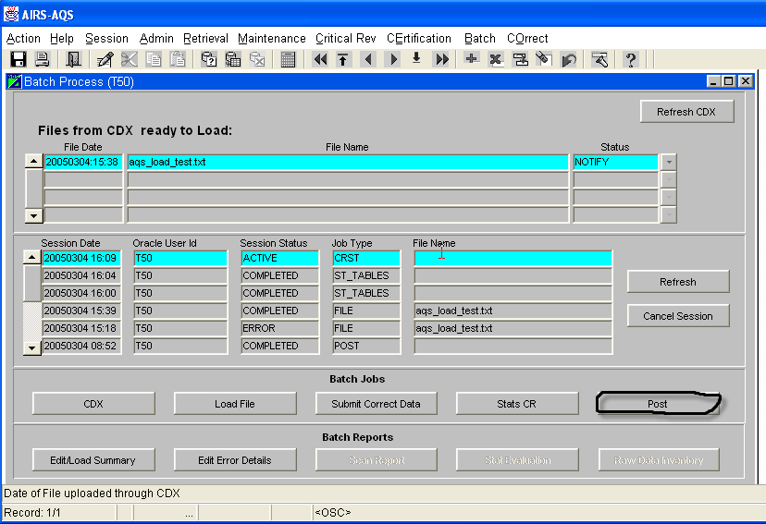

Figure 3-27

Unlike the other buttons on the batch load screen, Post does not immediately submit a batch job. After data is “posted”, it is available to all users of AQS. The extra screens included as part of the Post process allow you to verify that this is data to be posted and that all questionable values are correct.
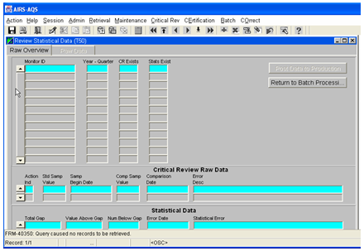
Figure 3-28

The “Post to Production” button may not be used to modify any data from this screen.
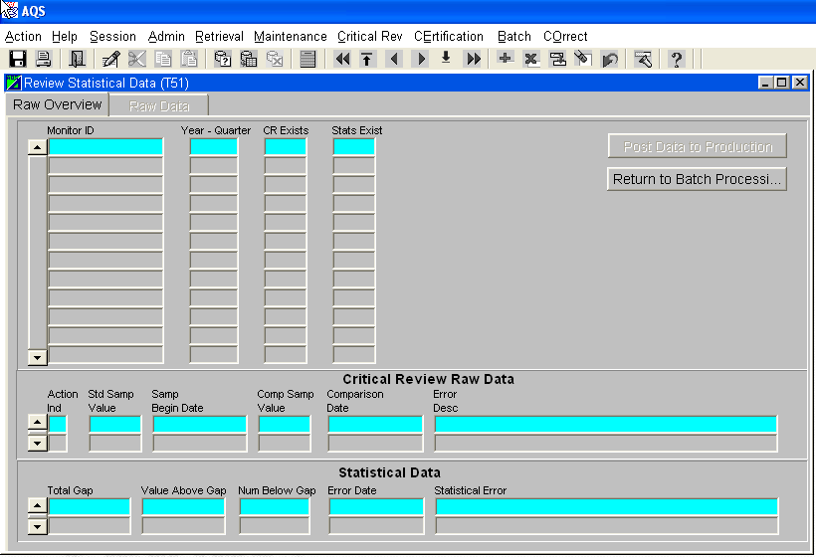
Figure 3-29



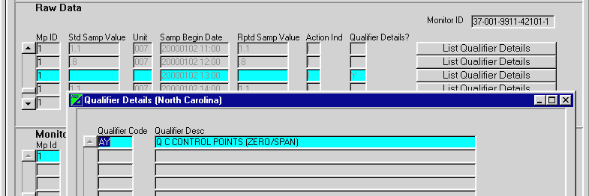Figure 3-30

To post your raw data to production status, click on the “Post Data to Production” button at the top of the screen.
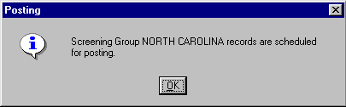

Wait for the confirmation window.

Figure 3-31
After the job is submitted, click “Return to Batch Processing” to monitor the progress of this “Post” job. 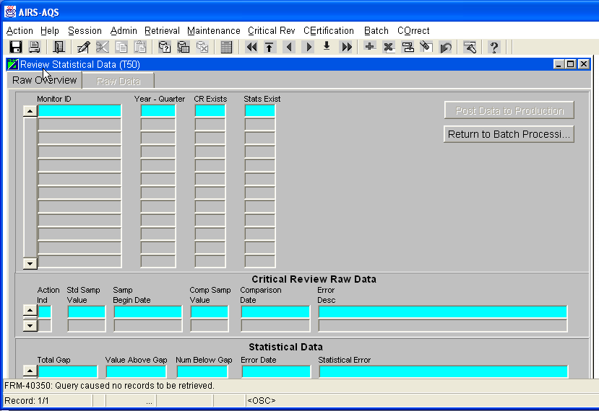

Figure 3-32
If the session status changes to “Completed”, your raw data records are in production on the database. If the job ran and any other status appears, wait for the confirming email to determine the reason for the job failure.
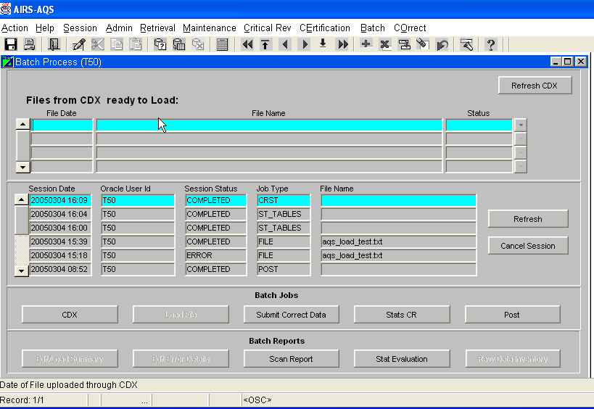
Figure 3-33

Raw Data Inventory Report

Raw Data Inventory: The final Batch report allows you to view and print a summary of raw data posted to production for the current batch of data. Running this report is not a requirement but is a way to verify data was posted on a summary basis.

Be sure the session highlighted is for a job type of “post” and the one of interest.

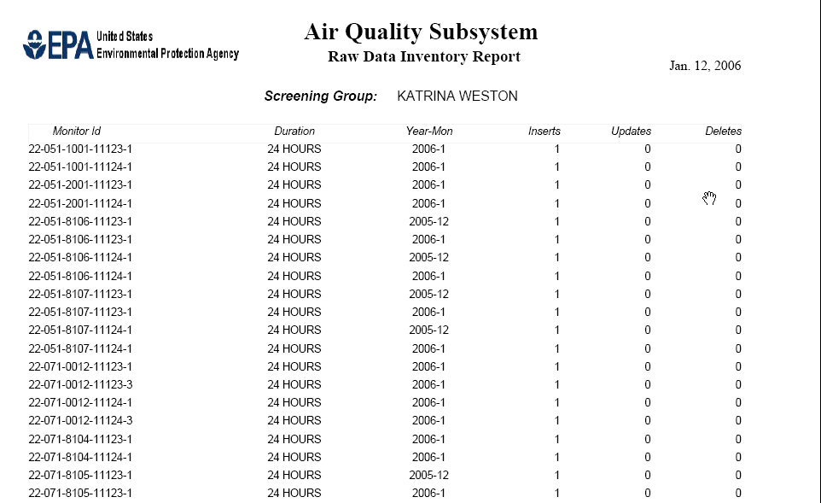

Figure 3-34 Raw Data Inventory

Online Maintenance

Overview

The Maintenance option on the Main Menu is used for browsing data and for relatively low volume inserts, updates, or deletes. You must be logged into a Screening Group to insert, update, or delete data with the Maintenance option since screening groups control the “ownership” of data.

If you are in a “Read Only” session, you may view all data in the database that is in production status. If you are logged into a Screening Group, you may view only data owned by that screening group, but that data may be in either production or pre-production status.

All data viewed through this option are in the production tables.

Transactions that do not pass the basic errors during the Load File batch job are placed in the staging tables. Those transactions stay in the staging tables until they are corrected and re-processed successfully, or deleted. Data in the staging tables are viewed with the correct option. You must be logged into a screening group to use the correct option.

Inserting a new site and MONITOR – Manual Entry

Maintenance is the primary method for adding new site and monitor data. Site and monitor data is validated as it is entered. Data passing all of the edits goes directly into production status in the production tables.

To add a new site, be sure you are logged into your Screening Group. Navigate to the Site Maintenance screen by selecting Maintenance, Site from the Main Menu.
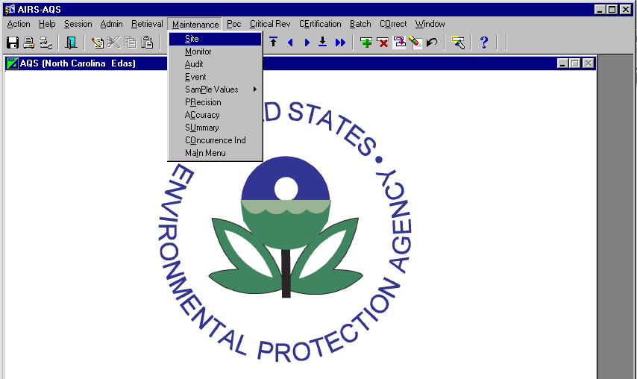
Figure 4-1
Manual Entry Step 1: Site Data

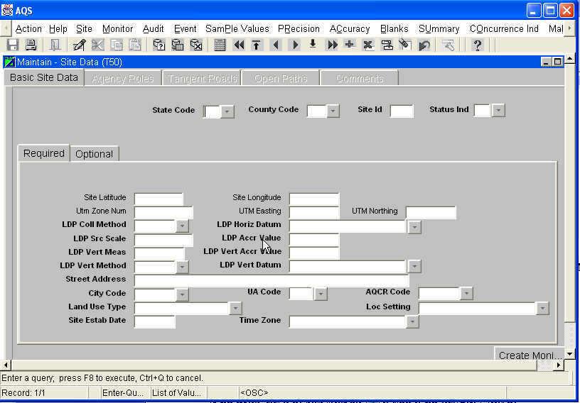
Figure 4-2
All Maintain screens open in Query mode and user must click on Cancel Query to enter data. (If data appears, click on the Insert Record icon () to switch to data entry mode.) Enter the appropriate State Code, County Code, and your chosen Site Id. (Use the tab key to quickly move from field to field.) You may enter the values for state and county directly, or select them from the LOV (). Using the LOV ensures the value is valid according to AQS.

In general, all fields on the Required tab of Basic Site Data are required. The exception is Latitude/Longitude or UTM data. Either Lat/Long OR UTM data must be entered, but not both. Choose which group of data you prefer to enter and type it in the appropriate box.

A Supporting Agency, entered on the Agency Roles tab, is also required for a new site.

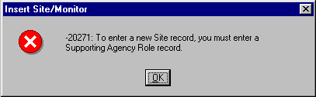
If you try to save a site record with missing required fields, you will receive an error message, such as this one.
Figure 4-3

Sample site data on Required tab.
Leave the Status Ind as F.
When you have finished the Required tab, go to the Optional tab for Basic Site Data and enter any appropriate data there.
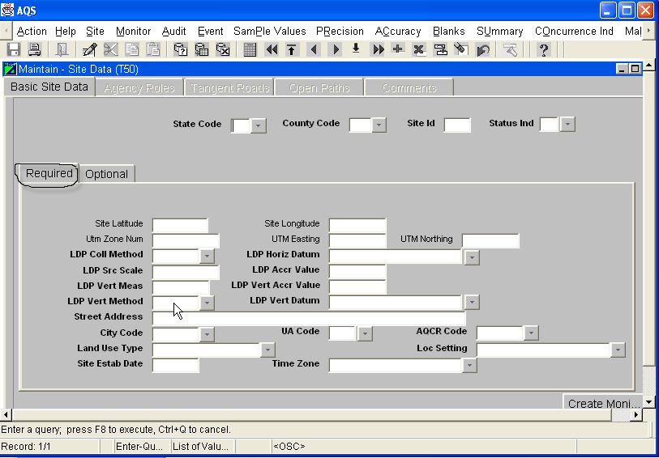
Figure 4-4

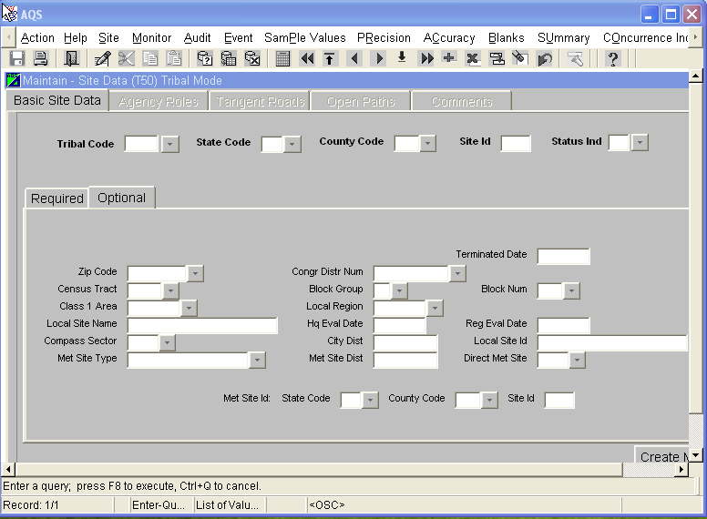
Figure 4-5

Enter optional data for the data fields when available. To terminate a site, enter the end data on this screen.
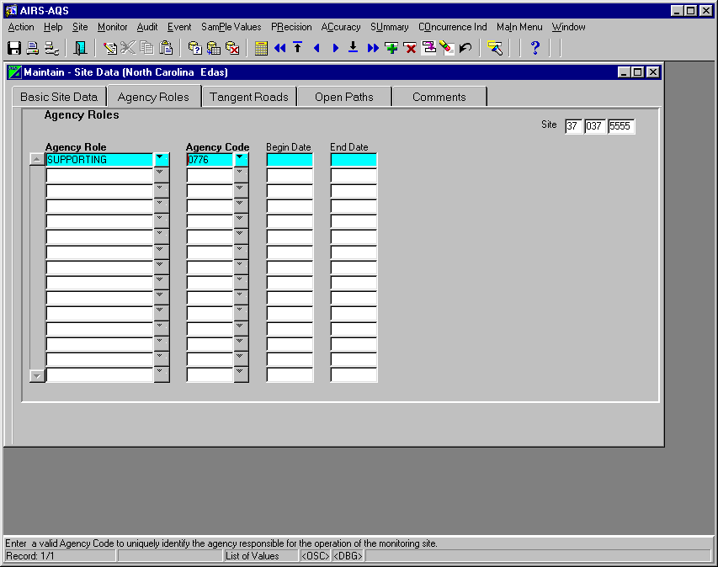Figure 4-6

Provide a Supporting Agency via the Agency Roles tab.

: 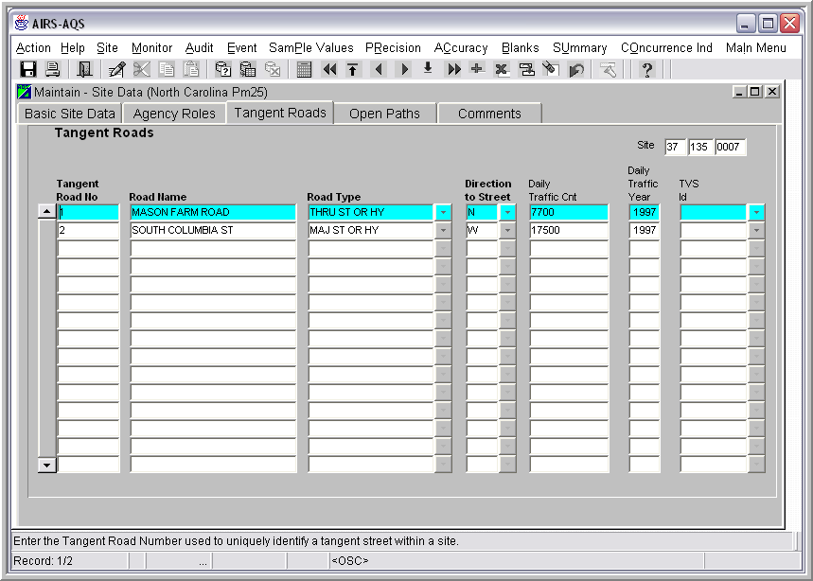
Figure 4-7
Sample Tangent Road data for a site
Complete applicable fields on any other tabs (Tangent Roads, Open Paths, and Comments) for Site Data.
Tangent Roads, Open Paths and Comments must be numbered within a site. It is generally recommended that you number each type sequentially, although this is not required. The number you assign at the site level may then be used on the monitor records for that site. (They will show up in the LOV for the field on the monitor record.)

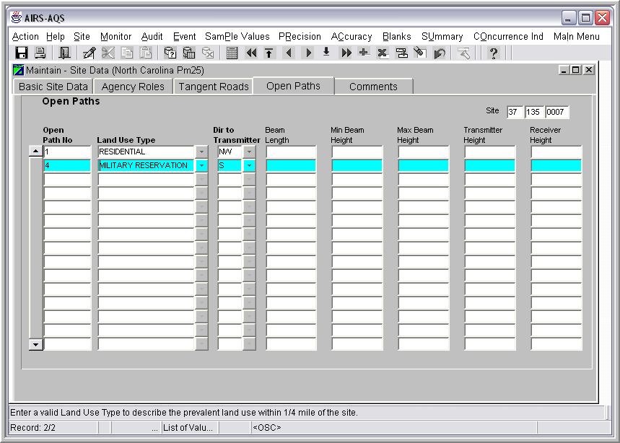
Figure 4-8
Sample Open Path data for a site:

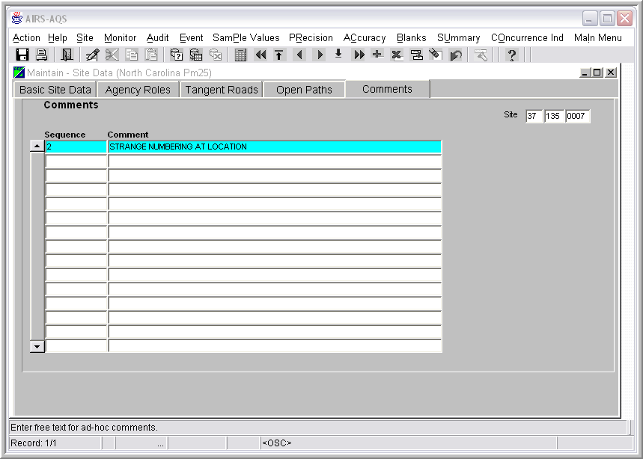
Figure 4-9
Sample Comments:
When you have entered all the data for a site, Save your data () or continue with Step 2.

Manual Entry Step 2: Monitor Data
If you have just created a new site, click on the Create Monitor button on the lower right portion of the Basic Site Data screen. If you haven’t yet saved your site data, you should see an informational screen (it’s informational even though it appears to be an error) indicating your site transaction is complete and records have been saved.

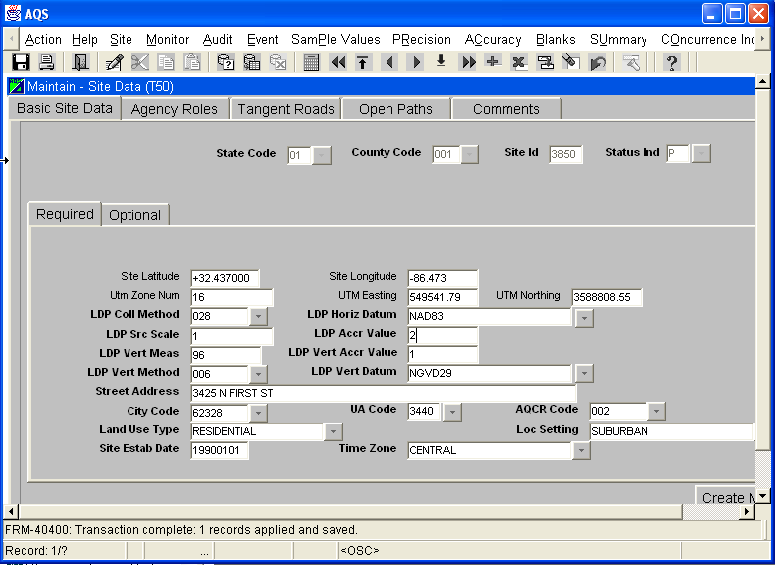

Figure 4-10
Click OK to move on to the entry screens for your first monitor at this site. The only required fields on the Monitor Basic tab are those in the top box and the only ones remaining blank here are the Parameter Code and POC. AQS “remembers” the site information from the previous screen.

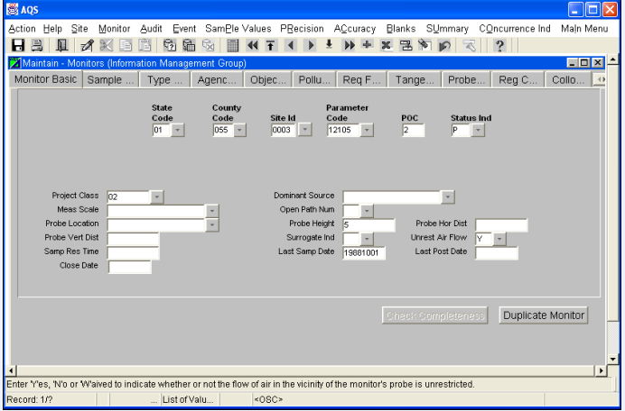

Figure 4-11

Complete all fields for which you have values. Monitor data encompasses up to 13 screens of data accessed by the screen tabs. Some fields are required; some are not. Some fields are required only if another field is valued. If you try to proceed without completing a required field, you will receive a warning about the missing field. For all monitors, at least one Sample Period Begin Date, Monitor Type with a Begin Date, and Monitoring Objective Type are required. PM, SLAMS, NAMS, and PAMS monitors require various additional fields. See Appendix D for site and monitor information.
Sample screens for each monitor tab are shown below for an existing NAMS monitor.
When you have completed the monitor screens, SAVE your data ().
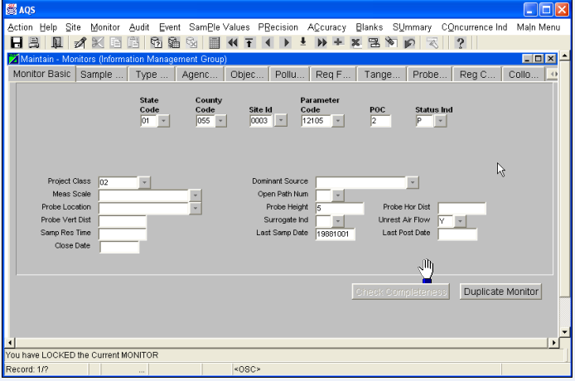
Figure 4-12
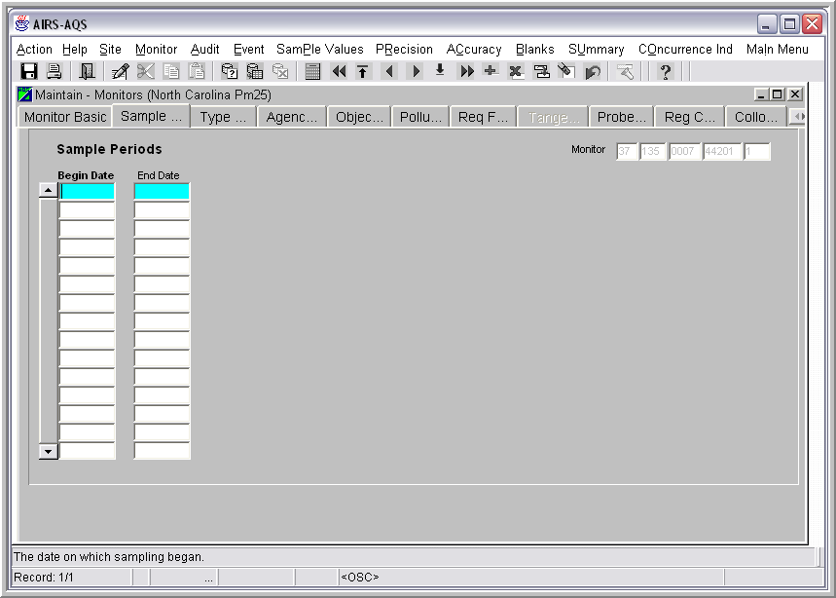
Figure 4-13
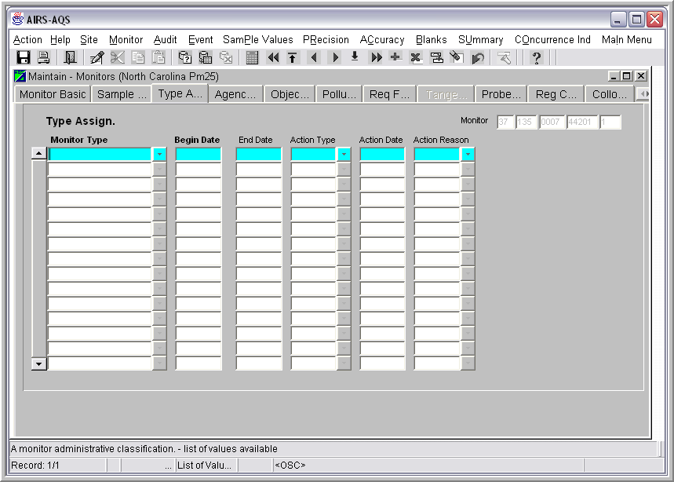
Figure 4-14
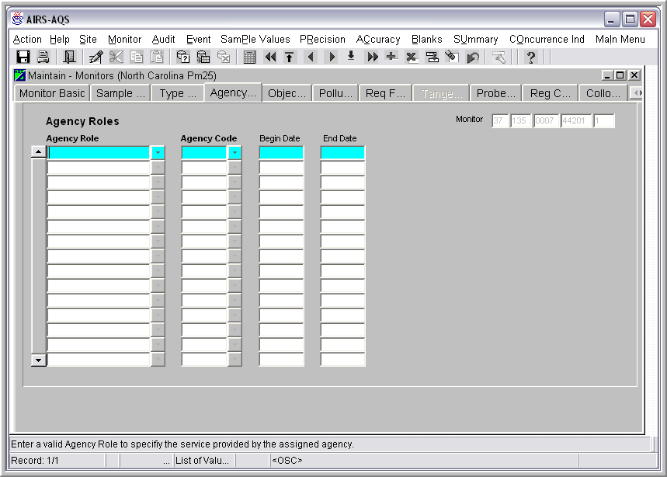
Figure 4-15
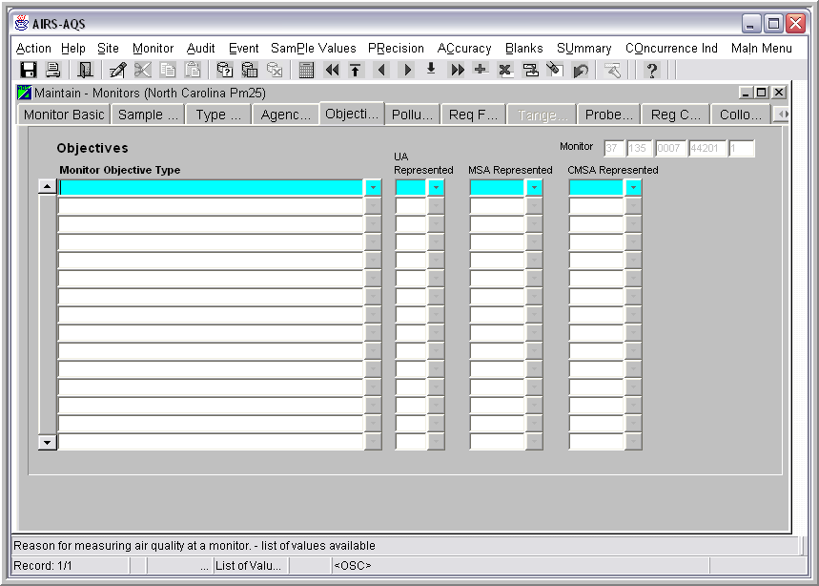
Figure 4-16
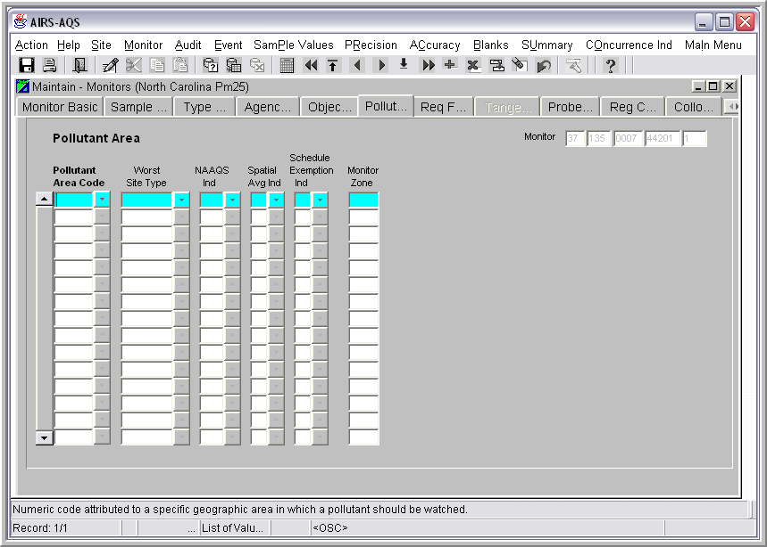
Figure 4-17
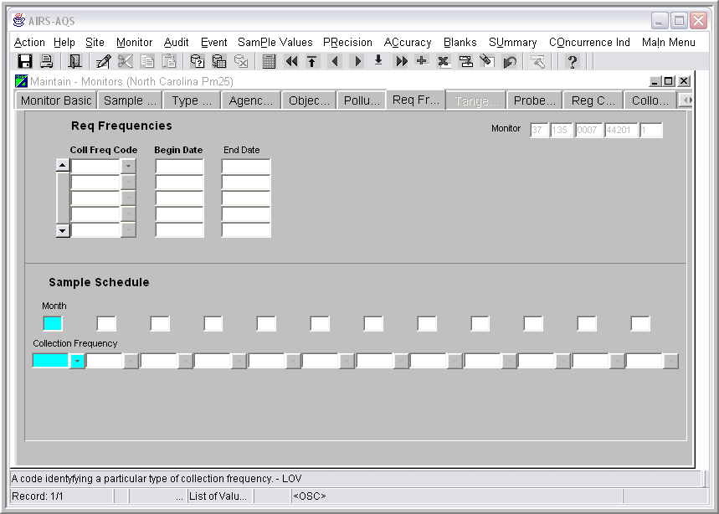
Figure 4-18
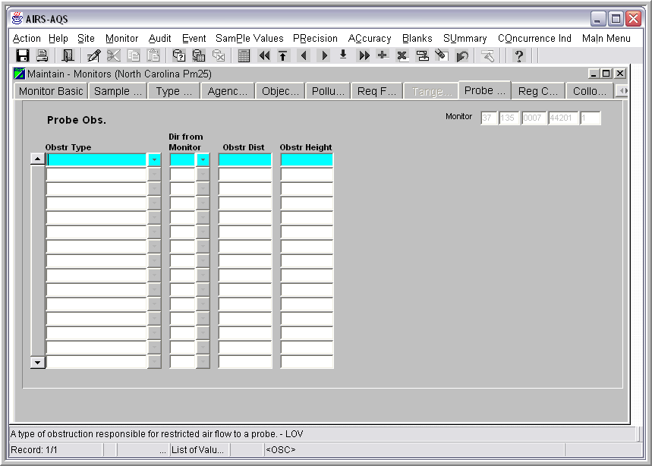
Figure 4-19
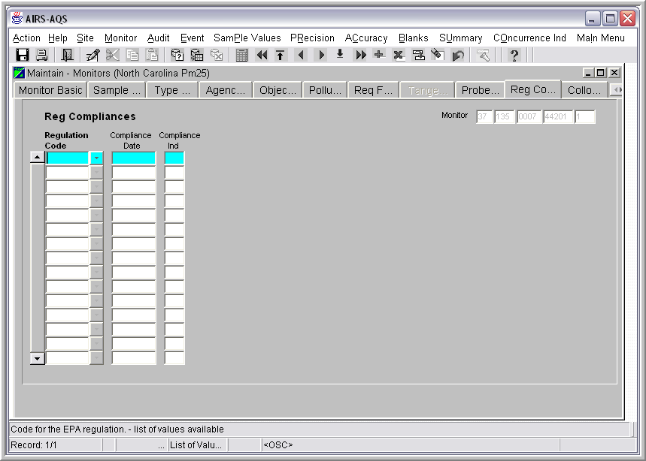
Figure 4-20
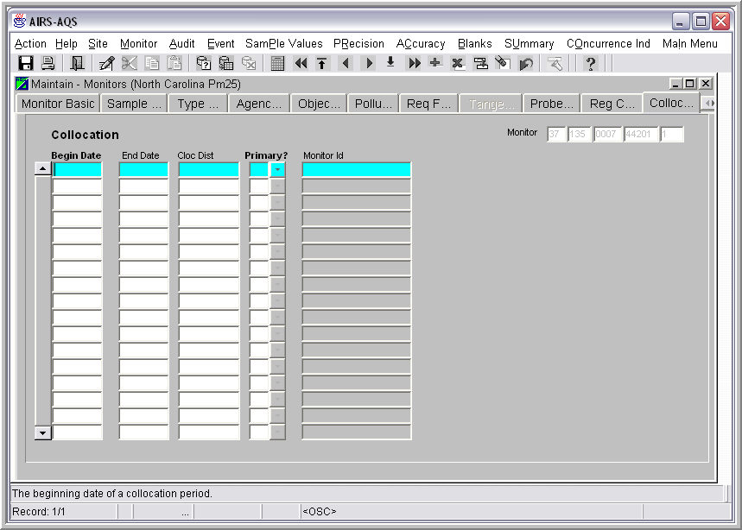
Figure 4-21

You will not need to create a Protocol for your monitor unless you wish to apply an alternate method detectable limit to your data. To create a new protocol set for a monitor, click on the Protocols tab, enter the appropriate data for the columns – except the MP Id. The system will assign a Monitor Protocol Id (MP Id). Once the MP Id has been assigned, you may use it to force a different protocol for raw data submitted for that monitor. If you do not include a MP Id in your raw data, the AQS will use the MP Id that has the matching Parameter Code, Method Code, Unit, and Duration Code or create one if none exists that matches.
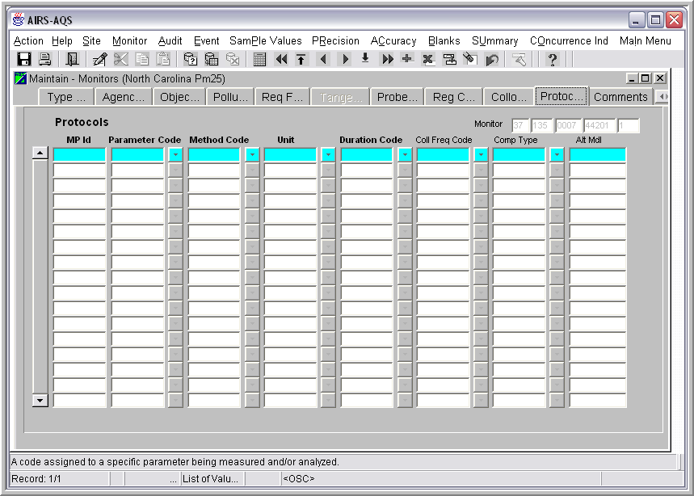
Figure 4-22
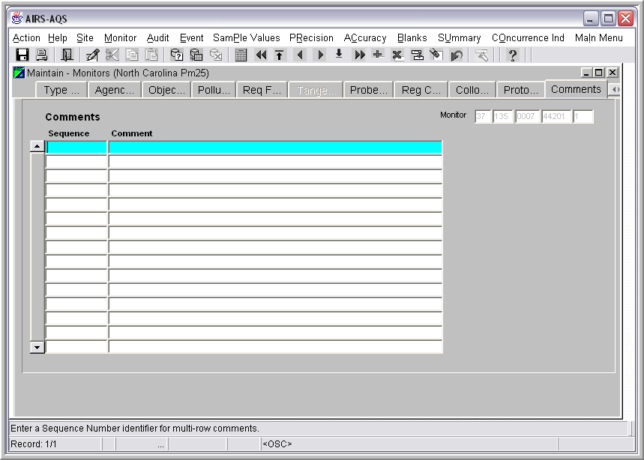
Figure 4-23
Note: Until you’ve entered and saved at least one monitor record, neither your site nor your monitor record is in production status on the database.

Manual Entry Step 3, optional: Duplicate Monitor

If you have another monitor for the same site, much of the information will be the same. Use the Duplicate Monitor button to speed entry of any remaining monitors at the same site. You are prompted for either a new parameter code or a new POC. If the new monitor is for the same parameter but a different POC, the system can automatically enter most of the data. You will be prompted for fields that are likely to differ from the original. If the next monitor at the site is for a different parameter, you must complete most of the monitor fields.
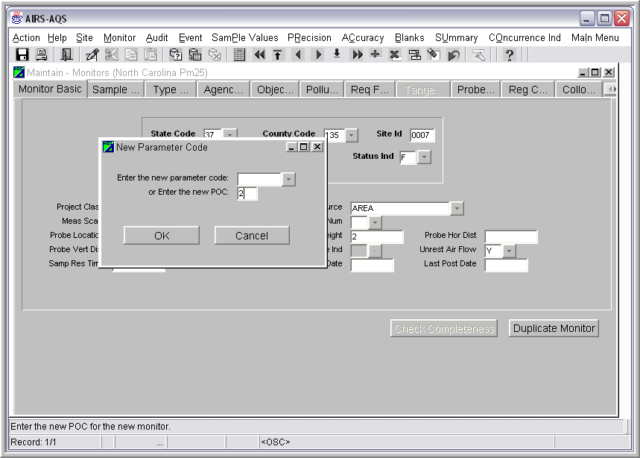
Figure 4-24

Insert a new site and monitor – create from an existing site or monitor

If you have a new site with data similar to an existing site ( Lat/Long, AQCR, dates, etc.), you can use the existing site to help create the new site. Here are the basic steps:

  - Use the Maintenance option to query for the existing similar site.
  - With that site visible on your screen, click on the Insert Record button (). A blank record (screen) should appear.
  - Click on the Duplicate Record () button. A copy of the site record last visible should appear. At the bottom of the screen, you should see a message: 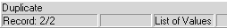.
  - Make the changes needed to differentiate your new site from the existing one on the Required and Optional tabs of the Basic Site tab.
  - Complete the remaining site tabs as needed which were not copied. You must at least provide a Supporting Agency on the Agency Roles tab.
  - Click on Create Monitor and insert the new monitor information as in Method 1.
  - Save your work.

Use the same general process to insert a new monitor based on data for an existing monitor.

Modify an Existing Site or Monitor

Modifying an existing site or monitor is an easy process. The tricky part is knowing which fields can be safely changed without affecting others in the database, including monitor and raw data.

Online Maintenance is the only way to delete a field value for sites and monitors. Batch updates can only update the value of field. There’s no way to indicate you wish to delete a particular field.

Use the Maintenance Option to query for the site or monitor to be modified.

Hint: Main Menu, Maintenance, Site, Type in your state/county/site, Execute Query.

Navigate to the field to be changed and change the value. Save your change(s).

Be sure to make any related changes. For example, if you change the site Land Use Type to “Forest”, does a Loc Setting of “Suburban” seem reasonable? The application can detect only basic errors, such as entering a value for a field with a LOV button that is not included in the list of values. (If a new value needs to be added to a LOV, contact EPA to request the addition.) It will also warn you about Lat/Long values not within the county for your site and the use of dates in the future.

Inserting a raw data value

Most raw data comes in an electronic form from a data logger. Occasionally, you may need to add a few values manually. You can do this with the Maintenance option, followed by running them through the batch jobs to run the Stats/CR and Post functions.

From the Main Menu, click on Maintenance, then Sample Values, Raw Data.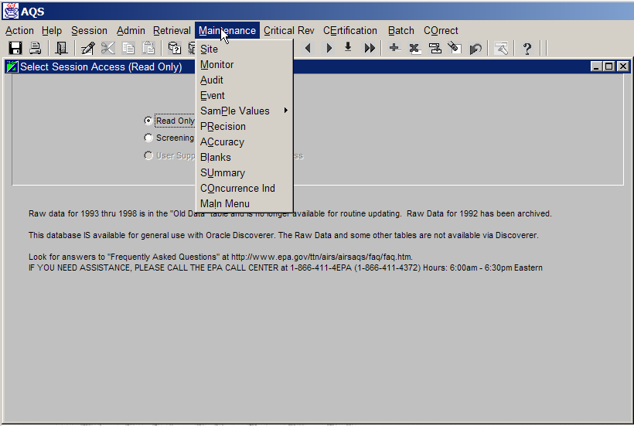

Figure 4-25
Enter the identifying monitor information and click on Execute Query.

The Raw Data tab displays the sample values for this monitor.

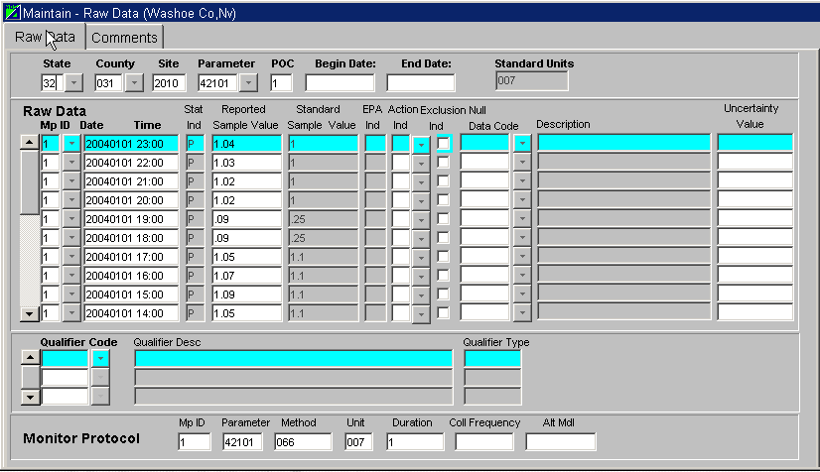
Figure 4-26
Click on the Insert Record button () to get an empty row for your new record and begin entering your new record. (Use the tab key to move from field to field.)

The value you use for Mp ID must already exist in the database as a valid protocol ID for the monitor parameter. If raw data already exists for the monitor, the currently valid Monitor protocol record is displayed for the highlighted data value in the bottom section of the screen. The Mp ID is only used as a way to refer to a particular combination of parameter, method code, unit, duration, collection frequency and alternate method detectable . Multiple protocols are needed only when Alternate Method Detectable Limits (Alt Mdl) are to be used in processing.

Notice that you are not allowed to enter values for all fields. The “Status Ind”, “Standard Samp Value”, and “Std Unit” will be completed by the application. Insertion of other fields is restricted to authorized personnel.

After you have inserted all the new records, you will need to process them through the Stats/CR and Post processes. Refer to the Chapter on Batch Load processing for instructions on completing these steps (beginning with Running the Stats CR job in section 3.8).

Changing a sample value

The steps to changing an existing sample value are very similar to those for adding a new value. Begin by executing a raw data query for the monitor and a date range. (Main Menu, Maintenance, Sample Values, Raw Data, Provide monitor id info, Execute Query.)

The Raw data screen displays the existing sample values. If there are lots of sample values for your monitor, you can reduce the number of records you have to scroll through by changing the date range to find the record you wish to change. Do this by clicking on the Enter Query button and reenter all query information. Enter as much of the information you have to restrict the query

Once you find the record for the sample value you wish to change or delete, take these steps:
- Click on the specific record to highlight it.
- Click on Insert Record to provide an empty row,
- Click on Duplicate record to create a new record for the date and time.
- Change the data in the record and select an Action Indicator.
- Click on the Save to update records in the group.

See the sample screen below. Notice that the Status Indicator is set to “R” by the application. This “R” status should remind you that you need to run the Batch jobs to do the statistical and critical review checks and then, assuming the data is ok, post that data to production. These are same steps you went through when adding a new sample value.

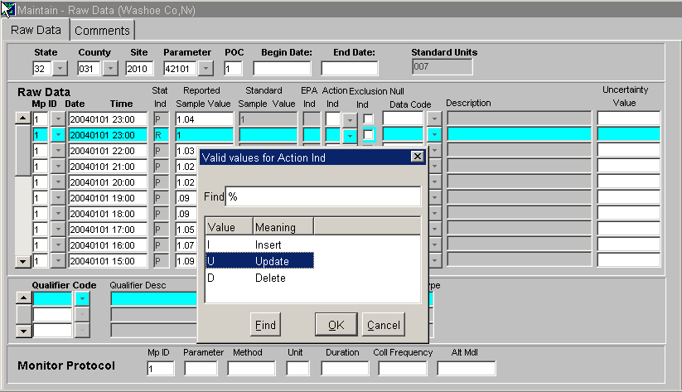
Figure 4-28

Deleting Raw Data records

There are some basic rules to understand before attempting to delete any records in production status.
- Has the record been certified? A Critical Review record will be created if the data has already been certified. If you continue with posting the data, the certification indicator is removed.
- When you’re deleting sample values (or composite values) in production status, you must create a transaction record for every record you wish to delete and use the Batch Option to process them (as described in the previous sections.) If there are a lot of them, you will want to let the system create a work file from a standard report called Extract Raw Data (AMP 501) (Retrievals are described in Chapter 5).
If the record is a sample value or composite value record in pre-production status, you may delete it by simply highlighting the record, clicking on the Delete button, and saving your changes.

If the record in is production status, the mechanics of deleting data are much like those for changing data:
- Run a raw data query to find the record to be deleted,
- Insert a record after it,
- Duplicate the existing record your new record, and
- Change the Action Indicator to “D – delete” instead of “U – update”. From that point on, follow the same steps, i.e., run Stats CR and Post (reviewing the appropriate reports and making any needed changes, of course!)
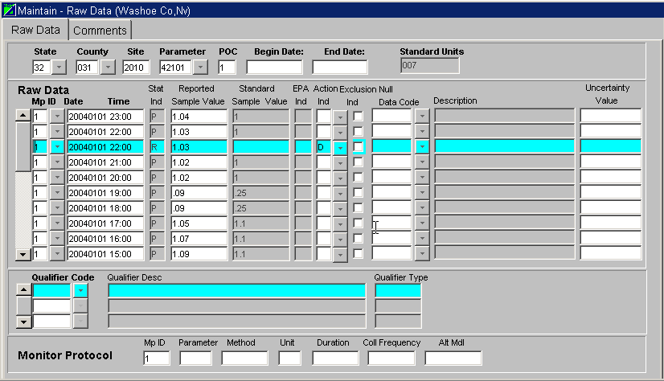
Figure 4-29

Deleting a site or monitor

Rule 1: All data for a monitor must be deleted before the monitor can be deleted.

Rule 2: When all sample values for all monitors have been deleted, the last monitor may not be deleted unless the site is deleted.

Query to find the monitor or monitors to be deleted. If there are no sample values for the monitor, click on the Remove Record icon (). If that monitor is not the last monitor at the site, the monitor record (including all it’s parts) is deleted when you then click on the Save icon. The record is not deleted until you have saved your change (i.e., saved your deletion).

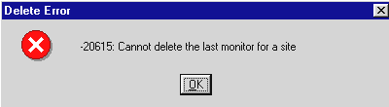
Figure 4-30

The only way to delete the last monitor at a site is to delete the site. The application will delete the site and it’s monitor(s), as long as there are no existing sample values for any of the monitors.

To delete a site, go to Maintenance, Site, query for the site, and while it is visible, click on the delete button. Save your change.

Go back and re-query on the site and the monitors to verify that the records are indeed gone.

Rollback a record
The Rollback button () is available to remove any insert/update/delete records you have entered and not yet saved. It’s important to realize that once you save your changes, there is nothing to “rollback”.

If you make changes but don’t save or rollback, you are prompted to decide whether or not to save your changes.
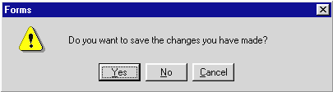

Figure 4-31

Browsing data

Browse is using the Maintenance screens to view (vs changing) data. Select the type of data you’re interested in and enter a query for it. The key point to remember when browsing data is to provide as much information as you can in the query, especially when information is raw data.

When you first enter the Maintenance option for any type of record, you are in Query mode. Many of the fields used in a record may be used in a query.

Site/Monitor Browsing:

Browse works the same for site and monitor data. Examples using site data are shown below.

Example 1: Browse all sites in a county. Enter the State code, County code. Execute Query.

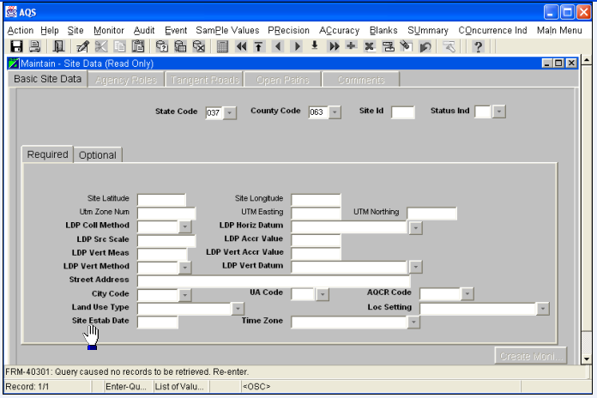
Figure 4-32

Resulting Query shows the 1st site in the selected state/county. Scroll through the remaining sites within the state/county, with the Next Record button.
Jump to the last site within the state/county by using the Last Record button. Once a site is found, the other site tabs (Agency Roles, Tangent Roads, etc.) are available.

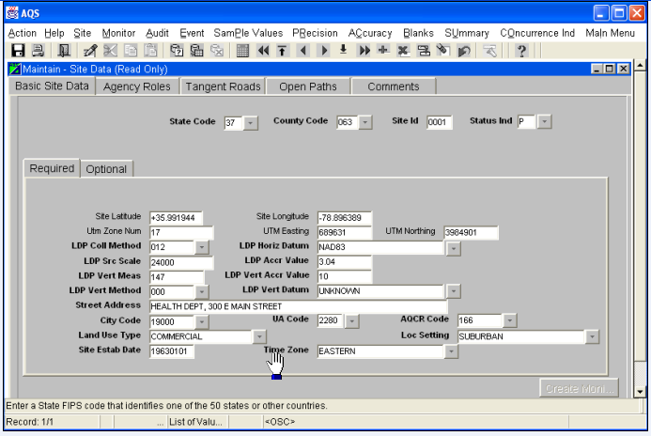
Figure 4-33
Example 2: Browse a specific site. Enter the State code, County Code, and Site Id. Execute query.

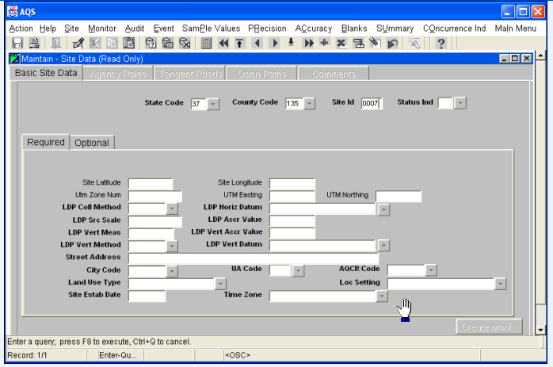

Figure 4-34

The resulting screen shows the selected site. The Next Record and Last Record buttons do not scroll to another site. 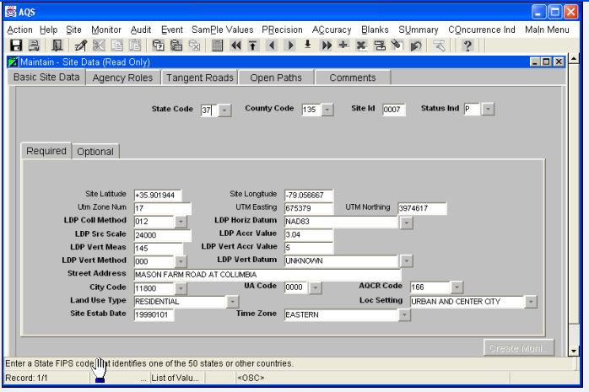
Figure 4-35

Sample Value Data Browsing:
Browsing sample values is similar to browsing site and monitor data, in that the first step is to provide the identifying information. You can enter some or all of the fields in the top section of the screen to identify the monitor. Enter the date as part of the query.
Enter state code, county code, site id, parameter code, and POC – or as much information as you have, recognizing that a more narrow search should respond more quickly.

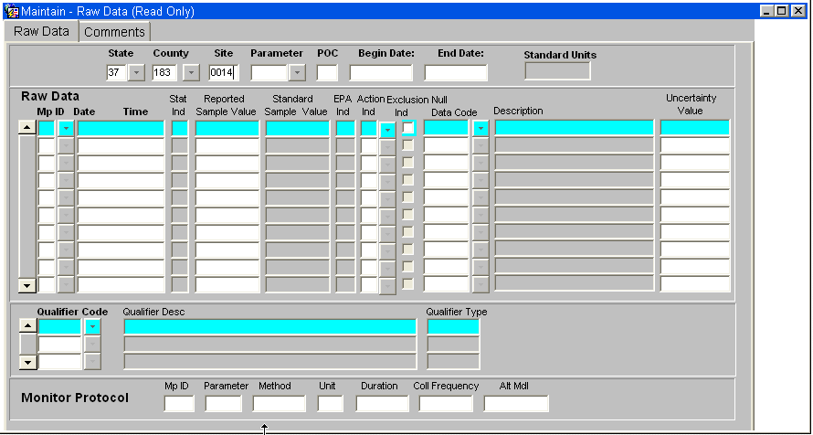
Figure 4-36
Query results show data for the 1st parameter and POC at that site and start with the earliest sample date that met the date selection.

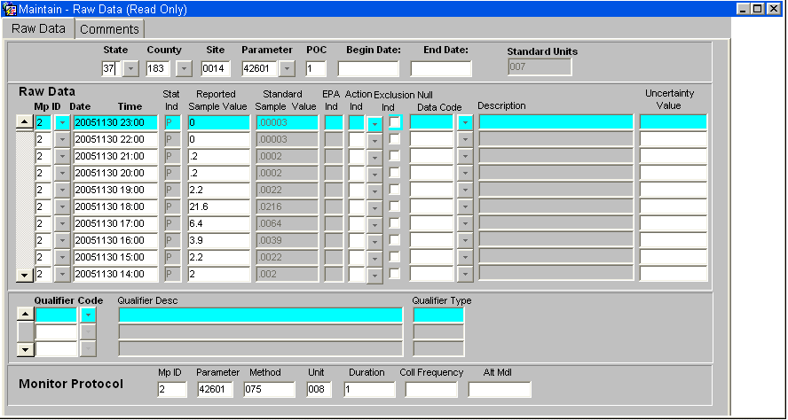
Figure 4-37
To skip to a particular date, click in the “Sample Begin Date” field, click on Enter Query while your cursor is in that field, enter the date of interest, and Execute Query. To start at a particular date and move forward, enter only enough of the date to indicate the beginning date.
For example, to see data for May 2002, enter “200205%” (without quotes). Be careful entering dates with the “%”. “20020501%” will yield records that match on May 1, 2002 and will show all records for all times on that day only, not that day and forward. To browse all data for the year 2002, enter just “2002%”.
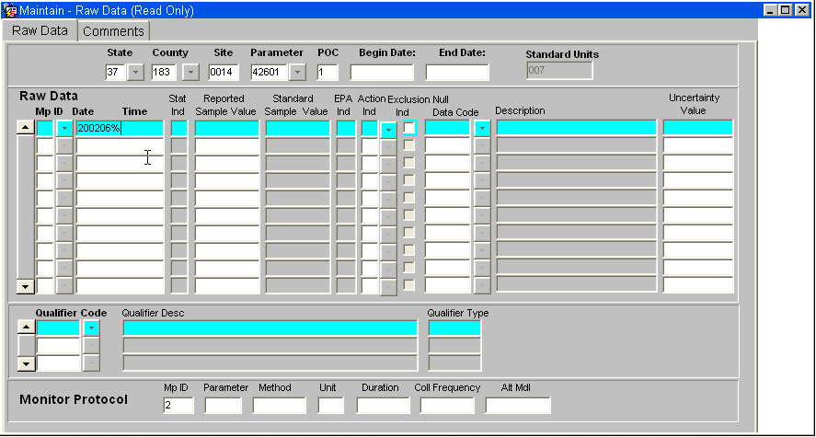

Figure 4-38

Execute the query to see the raw data.

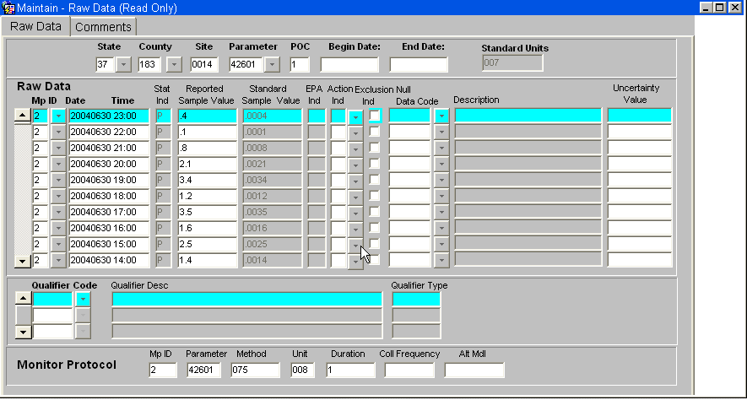

. Figure 4-39

Data Retrieval

Retrieval Menu

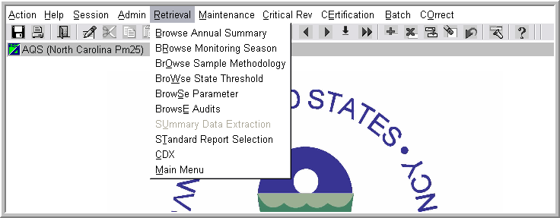
Figure 5-4
The Retrieval dropdown from the Main AQS Menu is shown in Figure 5.1. From here we can access many of the browse reports or select one of the formatted reports in AQS.
There are 6 different browse options on the Retrieval dropdown. Although all show different information, they are accessed in the same way. Here we will show how to use the Browse Monitoring Seasons option. Begin by clicking ‘Browse Monitoring Season’ on the Retrieval dropdown.

Figure 5.2 shows the Browse Monitoring Seasons screen.
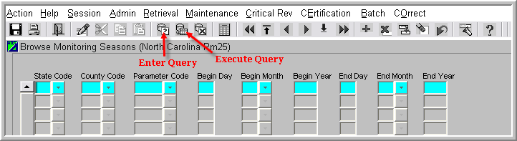
Figure 5-5

To query information in one of the Browse options:

1. Insert query information such as State Code, County Code etc…
2. Click the Execute Query button.

AQS Standard Reports

Standard reports are reports that have a pre-set format but which can be altered by providing different selection criteria. Criteria information is details such as geographical, pollutant, and date range. These reports provide various site, monitor or summary information.

The Standard Report Criteria Selection form is used to manage and specify report outputs and data selection criteria. It is designed to allow you to specify “ad-hoc” queries for standard report output.

How do I create a report in AQS – the short version:
- From the Main Menu, click Retrieval, Standard Reports Selection.
- On the Criteria Set tab of the form:
  - Chose a report code from the list of values displayed.
  - Chose output direction.
  - Chose Report Selection Mode.
- Enter selection criteria in one of the selection tabs of the form.
- Modify Sort Order and Report options as appropriate.
- Click Generate Report button.

Using the Standard Report Selection

This area is accessed from the Main AQS menu by selecting Retrieval, Standard Report Selection. This will take us to the Criteria Set tab (Figure 5.3) screen where we can begin to create formatted reports.
Generating a report is a matter of providing the necessary information on the Criteria Set tab, followed by the Selections tab screen etc until the Generate Report screen where the report is generated.

Criteria Set Tab

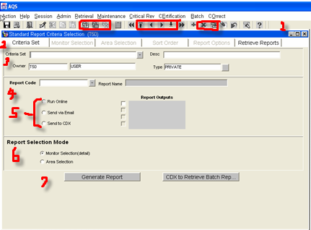

Figure 5-6

For our purposes, this screen can be broken into 7 areas (we do not need to use the top most line which begins with 'Action'):

The very top icon bar (1) is the standard Oracle icon display. The icons in the red boxes are the only ones that are used for Reports.

The next area (2) is the report criteria tabs. These tabs are used to help AQS determine what information to include on the report. These tabs will be covered individually.

The purpose of area (3) is to save the criteria used to create the report, or to retrieve a criteria set that was saved previously.

The Report Code drop-down (4) is used to select which report you want to generate.

Report output specification (5) is used to designate the form of report retrieval.
Report output can be directed in one of three different destinations:
1. To an online window on your desktop (default)
(If this option is selected a Report Progress popup will appear during report generation.)
2. To the Central Data Exchange (CDX) server for later download.
3. To your e-mail, which will give you a hyperlink to the report.

Large reports such as the Raw Data Report should most likely be run in batch mode where possible. Options for sending large reports are on-line, CDX or e-mail. Large reports should be sent to CDX or email. It's important to understand that once you start a large report there is no way to stop it, so make sure your criteria are correct.

The options for the print menu are as follows:
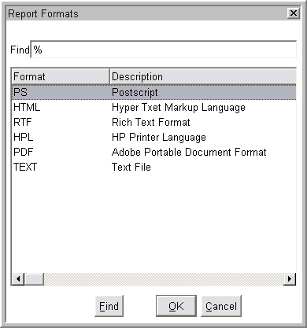 Figure 5-4

Report selection Mode (6) allows you to report data by Site-Monitor Criteria or by Geographical Area Criteria. The buttons on this tab will activate only one of the tabs at a time. You must return to the criteria set tab in order to change access to your selection tab. Data entered on one selection tab will not be used or transferred and may not be preserved when you change to the other tab. You will get a warning about this when you change active selection tabs. You will also get a warning when parameter groupings (such as HAP or CRITERIA) are changed.

The 'Report Code' area of the Criteria Set screen is used to specify which of the pre-formatted reports you want to produce. This is one of the few required fields on the report tabs and the only required field on this screen.

Use the drop-down triangle to display a list of all available reports. The Report Name will display the name of the report that is selected.

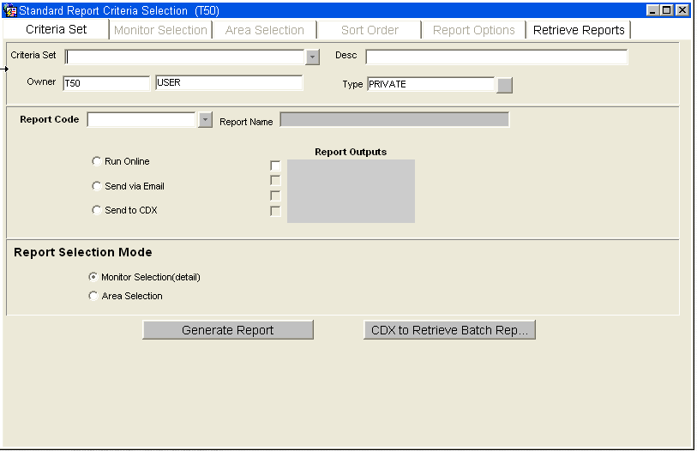
Figure 5-5

This is the section (3) of the Criteria Set tab screen used to save and retrieve criteria set information.

If the report you are creating is to be used one time only, there is no need to complete the information in this area. If however, you want to use this report in the future, you can save the criteria you entered on this and the other tabs. Saving the Criteria Set saves all the information entered on the tabs (Criteria Set, Selections…) so the next time you want to use the criteria to create a report you can retrieve the criteria set as opposed to typing the information in again. The type of the criteria set determines who can access it. “Public” criteria sets are available to all users while a “Private” criteria set is available to only the user that created it.

How to save, retrieve and transfer a Criteria Set is specified below.

Do not save the Criteria Set until you have entered all the information on all of the tabs and you are ready to generate the report. The last thing you should do, prior to generating the report, is to save the criteria set information

To save a Criteria Set:
Enter a unique name in the 'Criteria Set' field
Enter a description in the 'Desc' field.

To retrieve a previously created Criteria Set:
Click on Criteria Set drop-down.
Select Criteria Set to be retrieved.
Click 'Ok'.

To delete a Criteria Set:
Retrieve the Criteria Set as described above.
Click the Delete Criteria Set button.
Click ‘Yes’ to ‘Do you want to save the changes you have made’ prompt.

To transfer a Criteria Set to a user outside your screening group:
Retrieve the Criteria Set that is to be transferred (described above).
Click the “+” to create a blank criteria and Duplicate button.
In the ‘Enter New Criteria Set’ box provide a name, description and select Public for the type for the criteria.
Click the save button.
Notify the user that the criteria set has been saved as public with the name.

Selections tabs
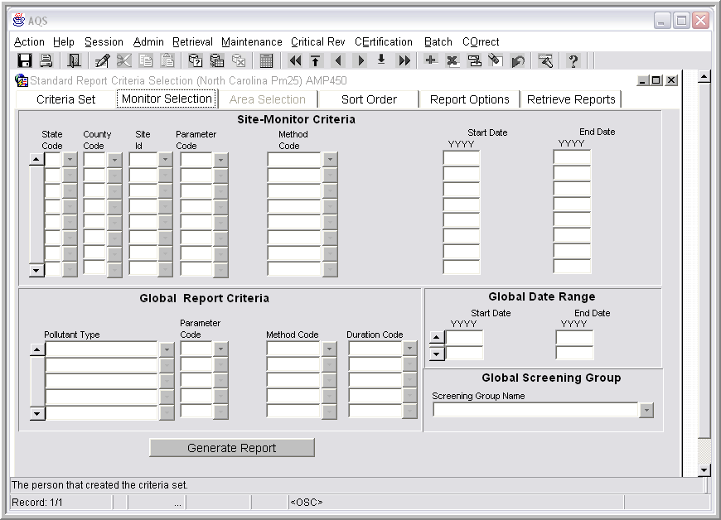
Figure 5-6

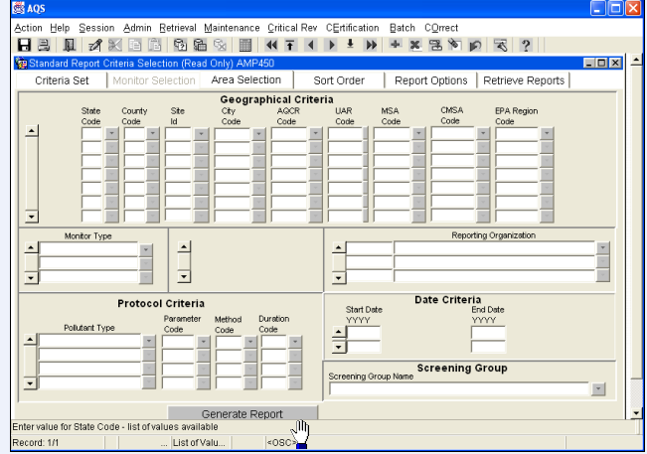

Figure 5-7

- Data can be selected from the AQS database either by Geographical Criteria (Area Selection tab) or by Site-Monitor Criteria (Monitor Selection tab). Selection only by State/County can be done from either form.
- After the Criteria Set tab information has been completed, the Selections tabs are used to narrow the information contained on the report to specific geographic, pollutant and time period information. This screen is accessed by clicking on the 'Selections' tab.
- The drop-down menu can be used to enter information, or it can be typed directly into the aqua colored areas. If more than one entry is to be made, use the down arrow on your keyboard to get to the next line.
- After an entry is made, use the Tab key to advance to the next field. When all entries have been made, click on the Sort Order or Report Options to enter more information.
- Although few fields on this screen are required, the more information that you provide, the more exact the report will be. When creating reports it is important to limit the criteria as much as possible, especially when using raw data. Creating a report of raw data by state and county over several years for example could create a report that was expensive, time consuming and not very useful in most cases.
- In most cases, you must specify a begin/end date as well as either a geographic criteria such as state or a pollutant parameter such as ozone. See Appendix A for details.
- The format of the date fields is divided into it three parts so only the required part is entered for each report.
- The fields contained on the Selection tab will differ depending on the report selected.

Sort Order tab
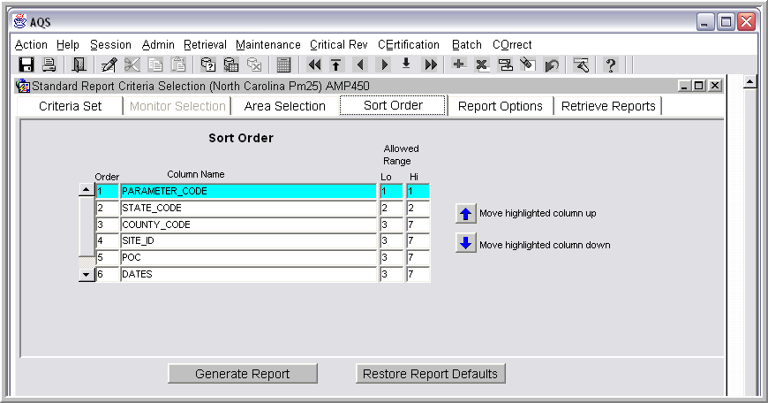
Figure 5-8

- In many cases, the Sort Order tab does not have to be used.
- The ascending/descending order can be changed for any of the fields listed on this page.

Report Option tab

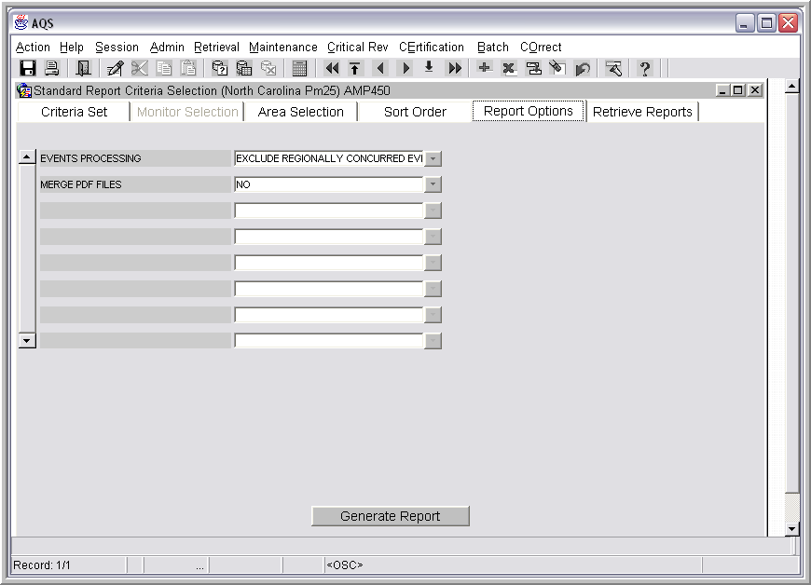
Figure 5-9

The information on the Report Options tab will differ from report to report. In many cases it may not be necessary to provide any information on this screen.
This tab is used to specify the report options. For most reports, this means specifying whether to include or exclude exceptional events.

What are exceptional events?
An exceptional event is something that happens in the environment that causes an abnormal monitor reading. Some examples would be earthquakes, tornados, volcanic eruptions, etc.

Retrieval Reports Tab

The “Retrieve Reports” tab allows users to manage and obtain information from any report that they have run in the past 15 days. The form displays the user id, report code, the mode in which the report was run, when the report was submitted, what the stage the report currently is, and the percent completeness of this stage.

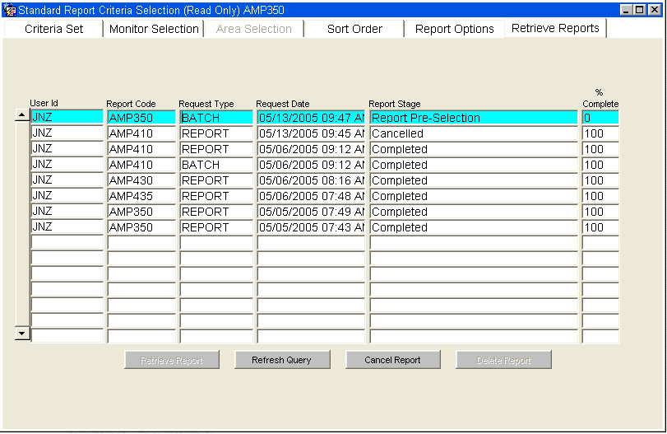
Figure 5-10

Users may perform any of the following functions for these reports:
- Retrieve Reports – This will allow the user to download the executed report for the highlighted row in the form. It is important to realize that this will return the actual report that was created at the original time the report was run. It does not re-execute the report to select the current data in the system.
- Refresh Query – This will update any of the information displayed on the form. Primarily used to see the current status of an executing report. The only columns that will change in a row may be the “Report Stage” and / or the “% Complete” columns.
- Cancel Report – This will terminate a currently running report that is highlighted. Once cancelled, the “Report Stage” will be updated to “Cancelled” (see the second line in the sample figure above). There are times when a report has progressed to the point where canceling the report is not possible. If the “Cancel Report” button is pressed while the highlighted row is in one of these stages, the following message will appear:

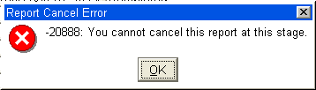

- Delete Report – This removes a report from the “Retrieve Reports” list. Once this function has been performed, the results of the report cannot be retrieved. To delete the row, highlight the row you wish to remove and press the “Delete Report” button. Once this is done, the following message appears in the status bar of the form:

NOTE: Since the record has been “applied and saved”, you cannot “undo” this step.
Excluding exceptional events mean that if one of these events was occurring when this data was created, this information would not be included in the report.
Another common report option is “Merge PDF Files”. Most reports include the actual selection criteria specified on the screens above and the formatted report of the selected data. These will appear in separate PDF files if the “No” option is selected or a single file if “Yes” is selected. The reports are clearer for the “No” option because the merge process degrades the PDF file.

Tips & Tricks

File names: Should contain only one period and cannot be more than 32 characters long.

Making the most of LOV's (List of values):
Whenever a button appears beside a field, you can click on the button to see a list of available values for the field. Here is the list of valid values for State Code. You may click on your choice and then click OK, or double click to have that value placed in the field for you.
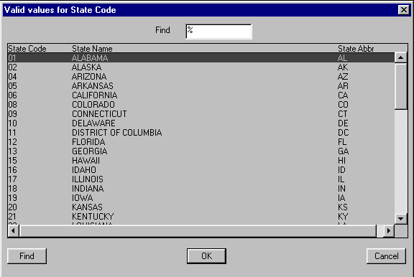
Figure A-1

That works fine when the list is a short one. When a long list is presented to you, type in the first few letters or numbers if you know them. That will bring you to a starting point much closer to the value you are looking for.

In the example below, we were looking for North Carolina and knew it was 3 something. When you're entering a starting value for the first column in a LOV, enter it in front of the "%". (In fact, if you just start typing, it will put it there. So, you don't have to move a mouse to get there.)
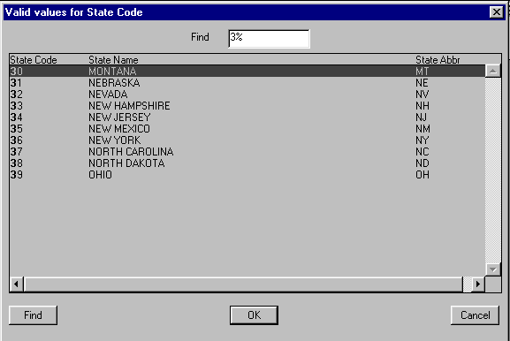
Figure A-2

If you don't know the first character(s), but know part of the name, type it in after the "%" in the Find box. Press Enter to see all state names that contain "north".

Getting brief help for a field:
Click your cursor within a field to see brief help for that field in the bottom portion of your screen.

Date fields:
Date fields are in the format yyyymmdd. Formats are displayed when you move your cursor into the field in question.

Is this thing running?
Sometimes it's difficult to tell whether the application is off doing something or not. Your first place to look is to the bottom of the screen at the status line. Sometimes it will say "working"; sometimes it won't. If you try to move to another menu option and there is no response, the application is most likely still working on your prior command.

Queries:
Provide as little or as much of the data as needed to search for the data you want.
Example: When updating data, to see all input transactions for your screening group that need correcting before posting, leave all fields blank and just click on the Execute Query button.

Options and shortcut keys:
Navigational options under the Action menu item have further options and shortcut keys as follows:

Edit: Query:
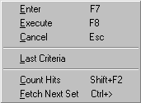

Block: Field shortcut keys:
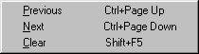
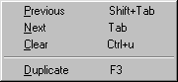

Record shortcut keys:
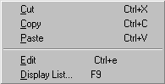
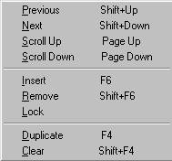

All Shortcut keys:
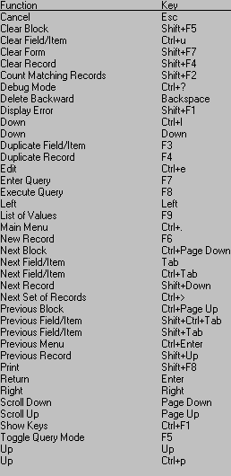

Icons
Save
Print Screen
Print Setup
Exit
Edit
Cut
Copy
Paste
Enter Query
Execute Query
Exit Query
Calendar
Previous Block
First Record
Previous Record
Next Record
Next Block
Last Record
Insert Record
Remove Record
Duplicate Record
Clear Record
Rollback Record
Search and Replace
Help
List of Values (LOV)
Paging Buttons (1st Page, Previous Page, Next Page, Last Page)

Terminology

Acct Num: See UNIX Account

Batch jobs vs Online processes: Much of the data for AQS is generated automatically by data loggers and consists of files with many records. The data from such files may be added to the AQS database through a batch job. When only a few records need to be added or changed, it may be simpler to use an online process to enter the data. In particular, site and monitor data is expected to be entered using an online process. In fact, “comment” information may only be entered in an online process.

Database name: AQSProd

“Flat” file: A file containing records that have no structured interrelationship. This term is commonly used to describe files that have only textual data viewable via a simple text editor such as Notepad or the MS DOS Edit command. In AQS, data loggers are typically used to create flat files containing records of sample values for a pollutant over a period of time.

Oracle AQS User ID: 3-character userid assigned by EPA (Same as UNIX ID)
production tables: Oracle database tables containing data that have passed the basic and relational edits of the AQS program.

Rollback: Reverts your data to its state on the database at the last SAVE.

Screening Groups: Groups designated by EPA to control update authority to specific sites and monitors. Users that initiate updates to AQS data are allowed to update only data owned by their Screening Group. Screening Groups are named based on the state or local agency that has update access for that group. For example, “NORTH CAROLINA” is the name of the screening group used by the North Carolina state agency; “FORSYTHE CO, NC” is the name of the screening group used by the Forsythe County local agency in North Carolina.

Staging Tables: Tables that hold data that has not passed the basic edits for its data type. Note that raw data that passes its basic edits goes into pre-production status on the production tables, not the staging tables. Such data must still undergo statistical edits before it may be marked as production data. Its status is shown as “R” to indicate it has passed the relational checks or “S” to indicate it has passed the statistical checks. (See Status Ind below.)

Status Ind: For Sample Values (a.k.a., raw data), the Status Indicator indicates the current status of the value. Users outside the screening group for the monitor will only see records that are in production status. Users within the screening group, may also see pre-production status indicators. The following table lists the valid status indicators for sample values:

P ➔ Production
S ➔ Statistical Analysis completed (a pre-production status)
R ➔ Relational and basic edits completed (a pre-production status)
I ➔ Inactive
F ➔ Being inserted via batch processing

Status info: The last line on the screen typically shows your status. It will say, “Enter query” when you’re in query mode. If you’ve already queried, it will show which record you are viewing of the batch it returned. “Record 1/?” means you’re viewing the first record and the system does not yet know how many records matched your request. (Queries would take longer if it counted all the records before displaying any of them.)
Tabs: Tabs provide access to additional data about the record(s) you are viewing. If a tab appears “grayed out”, then that information is either not yet available, does not exist, or you are not authorized to view it.

Input Transaction Formats

This document provides the format to process batch transactions for the Air Quality Subsystem. The first field of all input formats is the transaction type, which indicates the type of data in the record. (The valid transaction types are listed below.) The second field is the Action Indicator, which indicates the requested database manipulation action. The valid Action Indicators are: “I” for insert, “U” for update, and “D” for delete.

All transactions are pipe delimited (“|”). A delimiter does not need to follow the final field in a record, so there will always be one less delimiter than fields for the given transaction type. It is not essential that the proper number of delimiters be provided for a given transaction. So if you need to only update one column on the database with “Monitor Basic” information, you can ignore empty field delimiters in that row. If you need to report a given field as null, place two delimiters back to back (“||”). Text fields should not be enclosed with single or double quotation marks.

Other Notation: R - Field is required for any action
R(n) - Field is Required for action ‘n’ (R(I) means required for an Insert Action for example)
X(n) - Conditionally Required for action ‘n’

AA Basic Site Information C—1
AB Site Street Information C—2
AC Site Open Path Information C—2
MA Basic Monitor Information C—3
MB Monitor Sampling Periods C—3
MC Monitor Type Information C—4
MD Monitor Agency Role C—4
ME Monitoring Objective Information C—4
MF Monitor Sampling Schedule C—5
MG Monitor Tangent Roads C—5
MH Monitor Obstruction Information C—6
MI Monitor Regulatory Compliance C—6
MJ Monitor Collocation Period C—6
MK Monitor Protocol C—7
RC Composite Raw Data C—8
RD Hourly, Daily, and Sub Hourly Raw Data C—9
RA Accuracy Data C—10
RP Precision Data C—11
RS Annual Summary Data C—12
RB Blanks Data C—13

Please Note
The “Formatting Rules” described on the following pages are a “quick reference” and are not intended to illustrate the complete validation procedures that a particular piece of data will be subject to.
The AQS Data Dictionary fully describes the formatting requirements and data dependencies.
The AQS Data Coding Manual explains business rules and errors in detail.

The AQS Data Dictionary fully describes the formatting requirements and data dependencies.

AA Basic Site Information
Field Name Formatting Rule
Transaction Type ^{R} AA = Basic Site Info.
Action Indicator ^{R} Must = I, U, or D
State Code / Tribal Indicator^{R} Must exist in STATES Reference Table
County Code / Tribal Code^{R} Must exist in COUNTIES Reference Table
Site ID ^{R} Must exist in SITE table if Action Indicator is ‘U’ or ‘D’
Latitude ^{X(I)} Number - 2.6 signed
Longitude ^{X(I)} Number - 3.6 signed
UTM Zone ^{X(I)} Number - 2.0 format
UTM Easting ^{X(I)} Number - 8.2 format
UTM Northing ^{X(I)} Number - 8.2 format
Horizontal Collection Method ^{R(I)}Must exist in LDP_COLLECTION_METHODS Reference Table
Horizontal Datum ^{R(I)} Must exist in LDP_HORIZONTAL_DATA Reference Table
Source Scale ^{R(I)} Number - 12.0 format
Horizontal Accuracy ^{R(I)} Number - 8.2 format
Vertical Measure ^{R(I)} Number - 8.2 format
Time Zone Must exist in TIME_ZONES Reference Table, if supplied
Agency Code^{R(I)} Must exist in STATE_AGENCIES Reference Table
Street Address ^{R(I)} Text
City Code ^{R(I)} Must exist in CITIES Reference Table
Urban Area Code^{R(I)} Must exist in URBANIZED_AREAS Reference Table
AQCR ^{R(I)} Must exist in AQCRS Reference Table
Land Use Type ^{R(I)} Must exist in LAND_USE_TYPES Reference Table
Location Setting ^{R(I)} Must exist in LOCATION_SETTINGS Reference Table
Date Site Established ^{R(I)} Date - YYYYMMDD format
Date Site Terminated Date - YYYYMMDD format
Zip Code Must exist in ZIP_CODES Reference Table, if supplied
Congressional District Must exist in CONGRESSIONAL_DISTRICTS Reference Table, if supplied
Block Must exist in BLOCKS Reference Table, if supplied
Block Group Must exist in BLOCKS Reference Table, if supplied
Census Tract Must exist in BLOCKS Reference Table, if supplied
Class I Area Must exist in CLASS_ONE_AREAS Reference Table, if supplied
Local Region Must exist in LOCAL_REGIONS Reference Table, if supplied
Local Site Name Text
HQ Evaluation Date Date - YYYYMMDD format
EPA Region Evaluation Date Date - YYYYMMDD format
Direction from Central Business Must exist in COMPASS_SECTORS Reference Table
District to Site
Distance from Central Business Number - 8.2 format
District to Site
Meteorological Site Type Must exist in MET_SITE_TYPES Reference Table, if supplied
Meteorological Site ID Must exist in Reference Table, if supplied
Distance to Meteorological Site Number - 8.2 format
Direction to Meteorological Site Must exist in COMPASS_SECTORS Reference Table, if supplied
Local Site ID Text
Vertical Collection Method ^{R(I)} Must exist in LDP_VERTICAL_METHODS Reference Table
Vertical Datum ^{R(I)} Must exist in LDP_VERTICAL_DATA Reference Table
Vertical Accuracy ^{R(I)} Number

AB Site Street Information

Field Name Formatting Rule
Transaction Type ^{R} AB = Site Tangent Street Data
Action Indicator ^{R} Must = I, U, or D
State Code / Tribal Indicator^{R} Must exist in STATES Reference Table
County Code / Tribal Code^{R} Must exist in COUNTIES Reference Table
Site ID ^{R} Must exist in SITE table with the State Code and County Code
Tangent Street Number ^{R} Number - 2.0 format
Street Name ^{R(I)} Text
Road Type ^{R(I)} Must exist in ROAD_TYPES Reference Table
Traffic Count ^{R(I)} Number - 12.0 format
Year of Traffic Count ^{R(I)} Date - YYYY format
Direction from Site to Street ^{R(I)} Must exist in COMPASS_SECTORS Reference Table
Source of Traffic Count Must exist in TRAFFIC_VOLUME_SOURCES Reference Table, if supplied

AC Site Open Path Information

Field Name Formatting Rule
Transaction Type ^{R} AC = Site Open Path Data
Action Indicator ^{R} Must = I, U, or D
State Code / Tribal Indicator^{R} Must exist in STATES Reference Table
County Code / Tribal Code^{R} Must exist in COUNTIES Reference Table
Site ID ^{R} Must exist in SITE table with the State Code and County Code
Open Path Number ^{R} Number - 2.0 format
Direction from Receiver to Must exist in COMPASS_SECTORS Reference Table
Transmitter ^{R(I)}
Beam Length ^{R(I)} Number - 8.2 format
Height of Transmitter ^{R(I)} Number - 8.2 format
Height of Receiver ^{R(I)} Number - 8.2 format
Minimum Beam Height ^{R(I)} Number - 8.2 format
Maximum Beam Height ^{R(I)} Number - 8.2 format
Land Use Under Path ^{R(I)} Must exist in LAND_USE_TYPES Reference Table

MA Basic Monitor Information
Field Name Formatting Rule
Transaction Type ^{R} MA = Basic Monitor Information
Action Indicator ^{R} Must = I, U, or D
State Code /Tribal Indicator^{R} Must exist in STATES Reference Table
County Code / Tribal Code^{R} Must exist in COUNTIES Reference Table
Site ID ^{R} Must exist in SITES table with State Code and County Code
Parameter ^{R} Must exist in PARAMETERS Reference Table
POC ^{R} Must exist in MONITOR table if Action Indicator is ‘U’ or ‘D’
Project Class Must exist in PROJECT_TYPES Reference Table, if supplied
Dominant Source Must exist in DOMINANT_SOURCES Reference Table, if supplied
Measurement Scale Must exist in MEASUREMENT_SCALES Reference Table, if supplied
Open Path Number Must exist in Site Open Path Table, if supplied
Probe Location Code Must exist in PROBE_LOCATIONS Reference Table, if supplied
Probe Height Number - 8.2 format
Probe Horizontal Distance Number - 8.2 format
Probe Vertical Distance Number - 8.2 format
Surrogate Indicator ‘Y’ or ‘N’
Unrestricted Air Flow Indicator ‘Y’ or ‘N’
Sample Residence Time Number - 8.2 format
Worst Site Type Must exist in WORST_SITE_TYPES Reference Table, if supplied
Applicable NAAQS Indicator ‘S’, ‘A’, or ‘B’, if supplied
Spatial Average Indicator ‘Y’ or ‘N’, if supplied
Schedule Exemption Indicator ‘Y’ or ‘N’, if supplied
Community Monitoring Zone Number – 4.0 format
Pollutant Area Code – 1 Must exist in POLLUTANT_AREAS Reference Table, if supplied
Pollutant Area Code – 2 Must exist in POLLUTANT_AREAS Ref. Table, if supplied
Pollutant Area Code – 3 Must exist in POLLUTANT_AREAS Ref. Table, if supplied
Pollutant Area Code – 4 Must exist in POLLUTANT_AREAS Ref. Table, if supplied
Pollutant Area Code – 5 Must exist in POLLUTANT_AREAS Ref. Table, if supplied

MB Monitor Sampling Periods

Field Name Formatting Rule
Transaction Type ^{R} MB = Monitor Sampling Period
Action Indicator ^{R} Must = I, U, or D
State Code / Tribal Indicator^{R} Must exist in STATES Reference Table
County Code / Tribal Code^{R} Must exist in COUNTIES Reference Table
Site ID Must exist in SITES table with State Code and County Code
Parameter ^{R} Must exist in PARAMETERS Reference Table
POC ^{R} Must exist in MONITORS table with Parameter
Date Sampling Began ^{R} Date - YYYYMMDD
Date Sampling Ended Date - YYYYMMDD

MC Monitor Type Information

Field Name Formatting Rule
Transaction Type ^{R} MC = Monitor Type Assignment
Action Indicator ^{R} Must = I, U, or D
State Code / Tribal Indicator^{R} Must exist in STATES Reference Table
County Code / Tribal Code^{R} Must exist in COUNTIES Reference Table
Site ID ^{R} Must exist in SITES table with State Code and County Code
Parameter ^{R} Must exist in PARAMETERS Reference Table
POC ^{R} Must exist in MONITORS table with Parameter
Monitor Type ^{R} Must exist in MONITOR_TYPES Reference Table
Monitor Type Begin Date ^{R} Date - YYYYMMDD
Monitor Type End Date Date - YYYYMMDD

MD Monitor Agency Role

Field Name Formatting Rule
Transaction Type ^{R} MD = Monitor Agency Role
Action Indicator ^{R} Must = I, U, or D
State Code / Tribal Indicator^{R} Must exist in STATES Reference Table
County Code / Tribal Code^{R} Must exist in COUNTIES Reference Table
Site ID ^{R} Must exist in SITES table with State Code and County Code
Parameter ^{R} Must exist in PARAMETERS Reference Table
POC ^{R} Must exist in MONITORS table with Parameter
Agency Role Name ^{R(I)} Must exist in AGENCY_ROLES Reference Table
Agency Code ^{R} Must exist in STATE_AGENCIES Reference Table
Agency Role Begin Date ^{R(I)} Date - YYYYMMDD
Agency Role End Date Date - YYYYMMDD

ME Monitoring Objective Information

Field Name Formatting Rule
Transaction Type ^{R} ME = Monitor Objective
Action Indicator ^{R} Must = I, U, or D
State Code / Tribal Indicator^{R} Must exist in STATES Reference Table
County Code / Tribal Code^{R} Must exist in COUNTIES Reference Table
Site ID ^{R} Must exist in SITES table with State Code and County Code
Parameter ^{R} Must exist in PARAMETERS Reference Table
POC ^{R} Must exist in MONITORS table with Parameter
Monitor Objective Type ^{R} Must exist in MONITOR_OBJECTIVE_TYPES Reference Table
Urban Area Represented ^{X(I)} Must exist in URBANIZED_AREAS Reference Table, if supplied
MSA Represented ^{X(I)} Must exist in MSAS Reference Table, if supplied
CMSA Represented ^{X(I)} Must exist in CMSAS Reference Table, if supplied

MF Monitor Sampling Schedule

Field Name Formatting Rule
Transaction Type ^{R} MF = Monitor Sample Schedule
Action Indicator ^{R} Must = I, U, or D
State Code / Tribal Indicator^{R} Must exist in STATES Reference Table
County Code / Tribal Code^{R} Must exist in COUNTIES Reference Table
Site ID ^{R} Must exist in SITES table with State Code and County Code
Parameter ^{R} Must exist in PARAMETERS Reference Table
POC ^{R} Must exist in MONITORS table with Parameter
Required Collection Frequency Code ^{R} Must exist in COLLECTION_FREQUENCIES Reference Table
Required Collection Frequency Begin Date ^{R} Date - YYYYMMDD format
Required Collection Frequency End Date Date - YYYYMMDD format
Monthly Required Collection Frequency – Jan. Number – 12.0 format, if supplied
Monthly Required Collection Frequency – Feb Number – 12.0 format, if supplied
Monthly Required Collection Frequency – Mar Number – 12.0 format, if supplied
Monthly Required Collection Frequency – Apr Number – 12.0 format, if supplied
Monthly Required Collection Frequency – May Number – 12.0 format, if supplied
Monthly Required Collection Frequency – Jun Number – 12.0 format, if supplied
Monthly Required Collection Frequency – Jul Number – 12.0 format, if supplied
Monthly Required Collection Frequency – Aug Number – 12.0 format, if supplied
Monthly Required Collection Frequency – Sep Number – 12.0 format, if supplied
Monthly Required Collection Frequency – Oct Number – 12.0 format, if supplied
Monthly Required Collection Frequency – Nov Number – 12.0 format, if supplied
Monthly Required Collection Frequency – Dec Number – 12.0 format, if supplied

MG Monitor Tangent Roads

Field Name Formatting Rule
Transaction Type ^{R} MG = Monitor Tangent Road
Action Indicator ^{R} Must = I, U, or D
State Code / Tribal Indicator^{R} Must exist in STATES Reference Table
County Code / Tribal Code^{R} Must exist in COUNTIES Reference Table
Site ID ^{R} Must exist in SITES table with State Code and County Code
Parameter ^{R} Must exist in PARAMETERS Reference Table
POC ^{R} Must exist in MONITORS table with Parameter
Tangent Street Number ^{R} Must exist in Site Tangent Street Table
Distance from Monitor to Tangent Road ^{R(I, U)} Number - 8.2 format

MH Monitor Obstruction Information

Field Name Formatting Rule
Transaction Type ^{R} MH = Monitor Obstruction
Action Indicator ^{R} Must = I, U, or D
State Code / Tribal Indicator^{R} Must exist in STATES Reference Table
County Code / Tribal Code^{R} Must exist in COUNTIES Reference Table
Site ID ^{R} Must exist in SITES table with State Code and County Code
Parameter ^{R} Must exist in PARAMETERS Reference Table
POC ^{R} Must exist in MONITORS table with Parameter
Probe Obstruction Type^{R} Must exist in PROBE_OBSTRUCTION_TYPES Ref. Table
Direction from Monitor to Probe Must exist in COMPASS_SECTORS Reference Table
Obstruction ^{R}
Distance from Monitor to Probe Number - 8.2 format
Obstruction ^{R}
Probe Obstruction Height ^{R} Number - 8.2 format

MI Monitor Regulatory Compliance

Field Name Formatting Rule
Transaction Type ^{R} MI = Monitor Reg. Compliance
Action Indicator ^{R} Must = I, U, or D
State Code / Tribal Indicator^{R} Must exist in STATES Reference Table
County Code / Tribal Code^{R} Must exist in COUNTIES Reference Table
Site ID ^{R} Must exist in SITES table with State Code and County Code
Parameter ^{R} Must exist in PARAMETERS Reference Table
POC ^{R} Must exist in MONITORS table with Parameter
Regulation Code ^{R} Must exist in PARAMETER_REGULATIONS Reference Table
Compliance Indicator ‘Y’ or ‘N’
Compliance Date Date - YYYYMMDD format

MJ Monitor Collocation Period

Field Name Formatting Rule
Transaction Type ^{R} MJ = Monitor Collocation Period
Action Indicator ^{R} Must = I, U, or D
State Code / Tribal Indicator^{R} Must exist in STATES Reference Table
County Code / Tribal Code^{R} Must exist in COUNTIES Reference Table
Site ID ^{R} Must exist in SITES table with State Code and County Code
Parameter ^{R} Must exist in PARAMETERS Reference Table
POC ^{R} Must exist in MONITORS table with Parameter
Collocation Begin Date ^{R} Date - YYYYMMDD format
Collocation End Date Date - YYYYYMMDD format
Distance from Primary Sampler Number - 8.2 format
Primary Sampler Indicator ^{R} ‘Y’ or ‘N’

MK Monitor Protocol

Field Name Formatting Rule
Transaction Type ^{R} MK = Monitor Protocol
Action Indicator ^{R} Must = I, U, or D
State Code / Tribal Indicator^{R} Must exist in STATES Reference Table
County Code / Tribal Code^{R} Must exist in COUNTIES Reference Table
Site ID ^{R} Must exist in SITES table with State Code and County Code
Parameter ^{R} Must exist in PARAMETERS Reference Table
POC ^{R} Must exist in MONITORS table with Parameter
Monitor Protocol ID (MP ID) ^{R} Number - 2.0 format
Duration Code ^{R(I)} Must exist in SAMPLE_DURATIONS Reference Table
Reported Unit ^{R(I)} Must exist in UNITS Reference Table
Method Code ^{R(I)} Must exist in SAMPLING_METHODOLOGIES Reference Table
Collection Frequency Code Must exist in COLLECTION_FREQUENCIES Reference Table, if valued
Composite Type Must exist in COMPOSITE_TYPES Reference Table, if valued
Alternate Method Detectable Number - 5.5 format
Limit

RC Composite Raw Data

Field Name Formatting Rule
Transaction Type ^{R} RC = Composite Data Type
Action Indicator ^{R} Must = I, U, or D
State Code / Tribal Indicator^{R} Must exist in STATES Reference Table
County Code / Tribal Code^{R} Must exist in COUNTIES Reference Table
Site ID ^{R} Must exist in SITES table with State Code and County Code
Parameter ^{R} Must exist in PARAMETERS Reference Table
POC ^{R} Must exist in MONITORS table with Parameter
Reported Unit ^{R(I)} Must exist in UNITS Reference Table
Method Code ^{R(I)} Must exist in SAMPLING_METHODOLOGIES Reference Table
Composite Year ^{R} Date – YYYY format
Composite Period ^{R} Must exist in COMPOSITE_TYPES Reference Table for the Composite Type
Number of Samples ^{R(I)} Number – 10.0 format
Composite Type Must exist in COMPOSITE_TYPES Reference Table
Reported Sample Value ^{R (I)} Number - 5.5 format
Monitor Protocol ID (MP ID) Must exist in Monitor Protocols table for the monitor
Qualifier Code -1 Must exist in QUALIFIERS Reference Table, if valued
Qualifier Code -2 Must exist in QUALIFIERS Reference Table, if valued
Qualifier Code -3 Must exist in QUALIFIERS Reference Table, if valued
Qualifier Code -4 Must exist in QUALIFIERS Reference Table, if valued
Qualifier Code -5 Must exist in QUALIFIERS Reference Table, if valued
Qualifier Code -6 Must exist in QUALIFIERS Reference Table, if valued
Qualifier Code -7 Must exist in QUALIFIERS Reference Table, if valued
Qualifier Code -8 Must exist in QUALIFIERS Reference Table, if valued
Qualifier Code -9 Must exist in QUALIFIERS Reference Table, if valued
Qualifier Code -10 Must exist in QUALIFIERS Reference Table, if valued
Alternate Method Detectable Number - 5.5 format
Limit
Uncertainty Value Number - 6.5 format

RD Hourly, Daily, and Sub Hourly Raw Data

Field Name Formatting Rule
Transaction Type ^{R} RD = Raw Data Type
Action Indicator ^{R} Must = I, U, or D
State Code / Tribal Indicator^{R} Must exist in STATES Reference Table
County Code / Tribal Code^{R} Must exist in COUNTIES Reference Table
Site ID ^{R} Must exist in SITES table with State Code and County Code
Parameter ^{R} Must exist in PARAMETERS Reference Table
POC ^{R} Must exist in MONITOR table with Parameter
Duration Code ^{R(I)} Must exist in SAMPLE_DURATIONS Reference Table
Reported Unit ^{R(I)} Must exist in UNITS Reference Table
Method Code ^{R(I)} Must exist in SAMPLING_METHODOLOGIES Reference Table
Sample Date ^{R} YYYYMMDD format
Sample Time ^{R} hh:mm format
Reported Sample Value ^{X (I,U)} Number - 5.5 format
Qualifier Code - Null Data ^{X (I,U)} Must exist in QUALIFIERS Reference Table, if valued
Collection Frequency Code Must exist in COLLECTION_FREQUENCIES Reference Table, if valued
Monitor Protocol ID (MP ID) Must exist in Monitor Protocols Table for the Monitor
Qualifier Code -1 Must exist in QUALIFIERS Reference Table, if valued
Qualifier Code -2 Must exist in QUALIFIERS Reference Table, if valued
Qualifier Code -3 Must exist in QUALIFIERS Reference Table, if valued
Qualifier Code -4 Must exist in QUALIFIERS Reference Table, if valued
Qualifier Code -5 Must exist in QUALIFIERS Reference Table, if valued
Qualifier Code -6 Must exist in QUALIFIERS Reference Table, if valued
Qualifier Code -7 Must exist in QUALIFIERS Reference Table, if valued
Qualifier Code -8 Must exist in QUALIFIERS Reference Table, if valued
Qualifier Code -9 Must exist in QUALIFIERS Reference Table, if valued
Qualifier Code -10 Must exist in QUALIFIERS Reference Table, if valued
Alternate Method Detectable Number - 5.5 format
Limit
Uncertainty Value Number – 6.5 format

RA Accuracy Data

Field Name Formatting Rule
Transaction Type ^{R} RA = Raw Accuracy Data
Action Indicator ^{R} Must = I, U, or D
State Code / Tribal Indicator^{R} Must exist in STATES Reference Table
County Code / Tribal Code^{R} Must exist in COUNTIES Reference Table
Site ID ^{R} Must exist in SITES table with State Code and County Code
Parameter ^{R} Must exist in PARAMETERS Reference Table
POC ^{R} Must exist in MONITORS table with Parameter
Accuracy Audit ID Number Number - 2.0 format (Legacy “Sequence #”)
Duration Code ^{R(I,U)} Must exist in SAMPLE_DURATIONS Reference Table
Reported Unit ^{R(I,U)} Must exist in UNITS Reference Table
Method Code ^{R(I,U)} Must exist in SAMPLING_METHODOLOGIES Reference Table
Year Represented Date - YYYY format
Quarter Represented ‘Q1’, ‘Q2’, ‘Q3’, or ‘Q4’
Accuracy Date ^{R} Date – YYYYMMDD format
Audit Type ^{R (I)} Must exist in AUDIT_TYPES Reference Table
Local Primary Standard ^{R (I)} Must exist in LOCAL_PRIMARY_STANDARDS Reference Table
Audit Class ^{R (I)} Must exist in AUDIT_CALASES Reference Table
Accuracy Type ^{R (I)} Must exist in ACCURACY_TYPES Reference Table, if supplied
Audit Sample ID Text
Expiration Date Date - YYYYMMDD format
Audit Scheduled Date - YYYYMMDD format
Level 1 Actual Value ^{X (I,U)} Number - 5.5 format
Level 1 Indicated Value ^{X (I,U)} Number - 5.5 format
Level 2 Actual Value ^{X (I,U)} Number - 5.5 format
Level 2 Indicated Value ^{X (I,U)} Number - 5.5 format
Level 3 Actual Value ^{X (I,U)} Number - 5.5 format
Level 3 Indicated Value ^{X (I,U)} Number - 5.5 format
Level 4 Actual Value ^{X (I,U)} Number - 5.5 format
Level 4 Indicated Value ^{X (I,U)} Number - 5.5 format
Level 5 Actual Value ^{X (I,U)} Number - 5.5 format
Level 5 Indicated Value ^{X (I,U)} Number - 5.5 format
Zero Span Number - 5.5 format

RP Precision Data

Field Name Formatting Rule
Transaction Type ^{R} RP = Raw Precision Data
Action Indicator ^{R} Must = I, U, or D
State Code / Tribal Indicator^{R} Must exist in STATES Reference Table
County Code / Tribal Code^{R} Must exist in COUNTIES Reference Table
Site ID ^{R} Must exist in SITES table with State Code and County Code
Parameter ^{R} Must exist in PARAMETERS Reference Table
POC ^{R} Must exist in MONITORS table with Parameter
Precision ID ^{R} Number - 2.0 format
Duration Code ^{R(I,U)} Must exist in SAMPLE_DURATIONS Reference Table
Reported Unit ^{R(I,U)} Must exist in UNITS Reference Table
Actual Method ^{R(I,U)} Must exist in SAMPLING_METHODOLOGIES Reference Table
Precision Date ^{R} Date - YYYYMMDD format
Actual Value Number - 5.5 format
Indicated Method Must exist in SAMPLING_METHODOLOGIES Reference table
Indicated Value Number - 5.5 format
Collocated POC^{X(I)} Must exist in MONITOR Table (only for collocated data)
Precision Sample ID Text – Up to 10 characters
Agency Performing FRM Audit^{X(I)} Must exist with STATE_AGENCIES Table (only for FRM data)

RS Annual Summary Data

Field Name Formatting Rule
Transaction Type ^{R} Must exist in Reference Table (RS = Annual Summary)
Action Indicator ^{R} Must = I, U, or D
State Code / Tribal Indicator^{R} Must exist in STATES Reference Table
County Code / Tribal Code^{R} Must exist in COUNTIES Reference Table
Site ID ^{R} Must exist in SITES table with State Code and County Code
Parameter ^{R} Must exist in PARAMETERS Reference Table
POC ^{R} Must exist in MONITORS table with Parameter
Duration Code ^{R(I,U)} Must exist in SAMPLE_DURATIONS Reference Table
Reported Unit ^{R(I,U)} Must exist in UNITS Reference Table
Method Code ^{R(I,U)} Must exist in SAMPLING_METHODOLOGIES Reference Table
Summary Year ^{R} Date - YYYY format
Exceptional Data Type ID ^{R} ‘0’, ‘1’, ‘2’, ‘3’, ‘4’, ‘5’, ‘6’, or ‘7’
Count of Observations Number - 5.0 format
Count of Exceptional Events Number – 5.0 format
Maximum Value Number - 5.5 format
Maximum Value Date Date - YYYYMMDD Format
Maximum Value Time Date - hh:mm format
Maximum Value 2nd Highest Number - 5.5 format
Maximum Value Date 2nd Highest Date – YYYYMMDD format
Maximum Value Time 2nd Highest hh:mm format
Maximum Value 3rd Highest Number - 5.5 format
Maximum Value 4th Highest Number - 5.5 format
Maximum Value 5th Highest Number - 5.5 format
Minimum Sample Value Number - 5.5 format
At least one of these fields must be valued on an Insert or Update
Arithmetic Mean Number - 5.5 format
Arithmetic Standard Deviation Number - 5.5 format
Geometric Mean Number - 5.5 format
Geometric Standard Deviation Number - 5.5 format
Percentile Sample Value - 10th Number - 5.5 format
Percentile Sample Value - 25th Number - 5.5 format
Percentile Sample Value - 50th Number - 5.5 format
Percentile Sample Value - 75th Number - 5.5 format
Percentile Sample Value - 90th Number - 5.5 format
Percentile Sample Value - 95th Number - 5.5 format
Percentile Sample Value - 98th Number - 5.5 format
Percentile Sample Value - 99th Number - 5.5 format
Percent of Observations Number - 6.4 format
Count of Half-MDL Substitutions Number - 5.0 format

RB Blanks Data

Field Name Formatting Rule
Transaction Type ^{R} RB = Raw Blanks Type
Action Indicator ^{R} Must = I, U, or D
State Code / Tribal Indicator^{R} Must exist in STATES Reference Table
County Code / Tribal Code^{R} Must exist in COUNTIES Reference Table
Site ID ^{R} Must exist in SITES table (With State and County)
Parameter ^{R} Must exist in PARAMETERS Reference Table
POC ^{R} Must exist in MONITORS table (with Parameter)
Duration Code ^{R(I,U)} Must exist in SAMPLE_DURATIONS Reference Table
Reported Unit ^{R(I,U)} Must exist in UNITS Reference Table
Method Code ^{R(I,U)} Must exist in SAMPLING METHODOLOGIES Reference Table
Blank Type ^{R} Either ‘FIELD’ or ‘TRIP’
Blank Date ^{R} YYYYMMDD format
Blank Time ^{R} hh:mm format
Blank Value ^{X (I)} Number - 10.5 format
Qualifier Code - Null Data ^{X (I,U)} Must exist in QUALIFIERS Reference Table, if valued
Qualifier Code -1 Must exist in QUALIFIERS Reference Table, if valued
Qualifier Code -2 Must exist in QUALIFIERS Reference Table, if valued
Qualifier Code -3 Must exist in QUALIFIERS Reference Table, if valued
Qualifier Code -4 Must exist in QUALIFIERS Reference Table, if valued
Qualifier Code -5 Must exist in QUALIFIERS Reference Table, if valued
Qualifier Code -6 Must exist in QUALIFIERS Reference Table, if valued
Qualifier Code -7 Must exist in QUALIFIERS Reference Table, if valued
Qualifier Code -8 Must exist in QUALIFIERS Reference Table, if valued
Qualifier Code -9 Must exist in QUALIFIERS Reference Table, if valued
Qualifier Code -10 Must exist in QUALIFIERS Reference Table, if valued
Alternate Method Detectable Number - 5.5 format
Limit
Uncertainty Value Number – 6.5 format

Transaction Requirements

Entity | Transaction Name | Transaction Type | Minimum Requirement | Particulate Samplers | SLAMS | NAMS or  PAMS³
Site | Basic Site Information | AA |  |  |  | 
 | Street Information | AB |  |  |  ⁸ | 
 | Open Path | AC | ¹ | ¹ | ¹ | ¹
Monitor | Basic Information | MA |  |  |  | 
 | Sampling Period | MB |  |  |  | 
 | Type Information | MC |  |  |  | 
 | Agency Role | MD | ⁵ |  |  | 
 | Monitoring Objective | ME |  |  |  | 
 | Sampling Schedule | MF |  |  |  |  ⁶
 | Street Description | MG |  |  |  ⁸ | 
 | Obstruction | MH | ² | ² | ² | ²
 | Regulatory Compliance | MI |  |  |  ⁸ | 
 | Collocation Period | MJ |  |  ⁷
 | Protocol | MK | ⁴ | ⁴ | ⁴ | ⁴
- Open Path information is only required if the sampling technology is utilized.
- Obstruction Information is only required when "Unrestricted Air Flow Indicator" on the Basic Monitor Information is "N" or "W".
- The monitor can only be designated as a NAMS or PAMS by a headquarters person. Specific data must is required on these transactions before the monitor can be designated.
- Monitor Protocol is only required when the method MDL is different than the system default.
- Only required for criteria pollutants.
- Required only for PAMS.
- Not required but useful to evaluate QA data reporting from collocated monitors.
Information on these transactions must be reported before a SLAMS could be considered for NAMS or PAMS designation.

