Determine HIV Rapid Test
(For use with whole blood, serum, or plasma)
Store kit: 2 - 30° C

- Check kit before use. Use only items that have not expired or been damaged.
- Bring kit and previously stored specimens to room temperature prior to use.
- Always use universal safety precautions when handling specimens. Keep work areas clean and organized.

This outline is not intended to replace the product insert or your standard operating procedure (SOP).

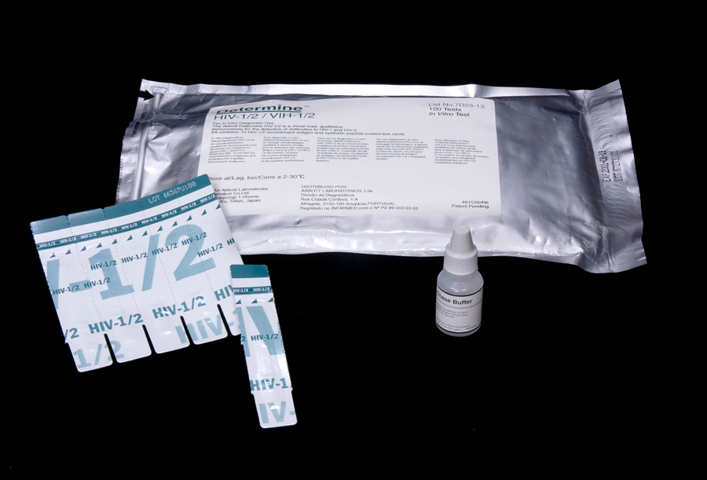 | 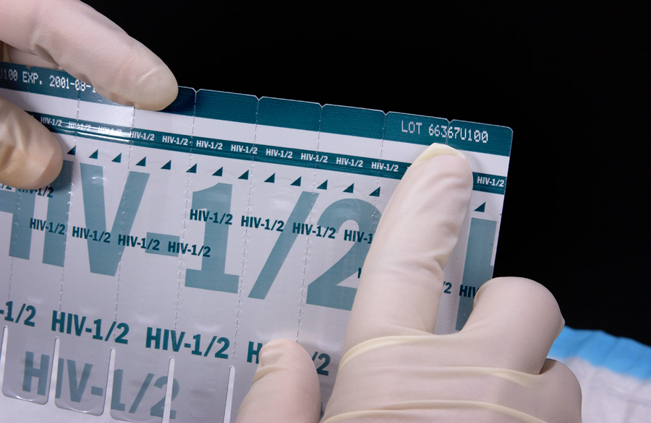 |  | 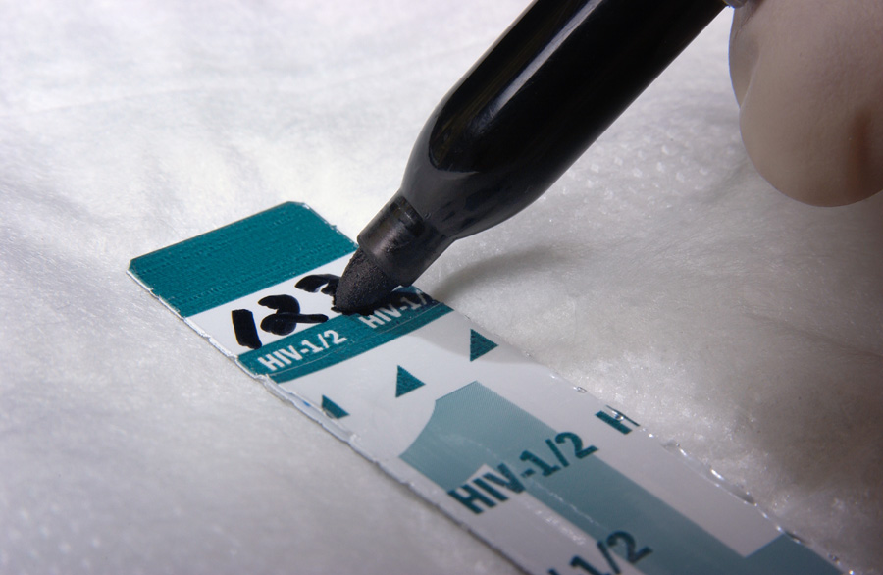
- Collect test items and other necessary lab supplies. | - Use 1 strip per test and be sure to preserve the lot number on the remaining packet of strips. |  | - Label the test strip with client identification number.
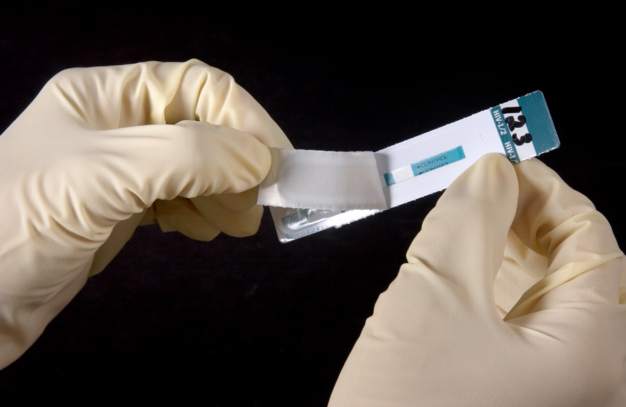 | 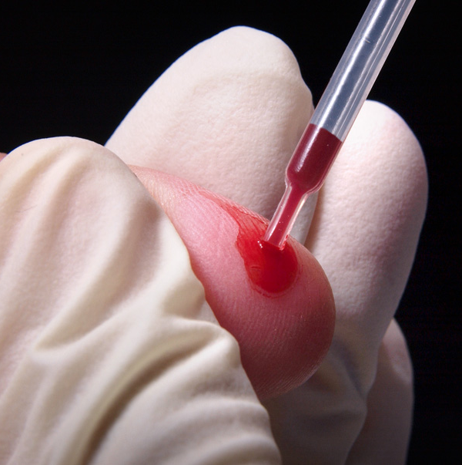 | 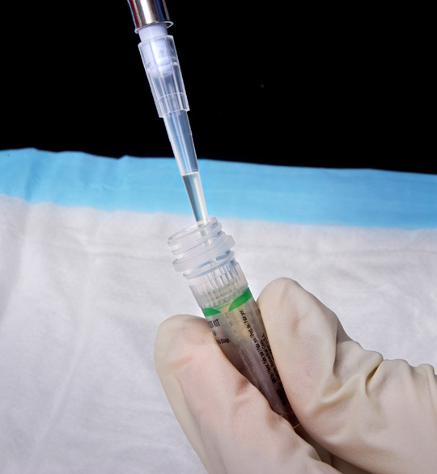 | 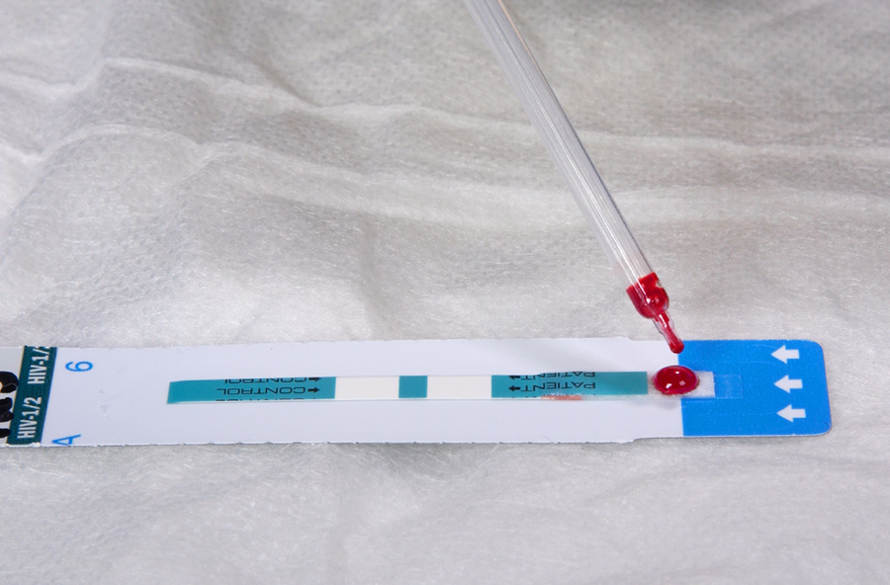
- Pull off the protective foil cover. | - Collect 50 µl of specimen using either a pasteur or precision pipette. |  | - Apply the specimen to the absorbent pad on the strip.
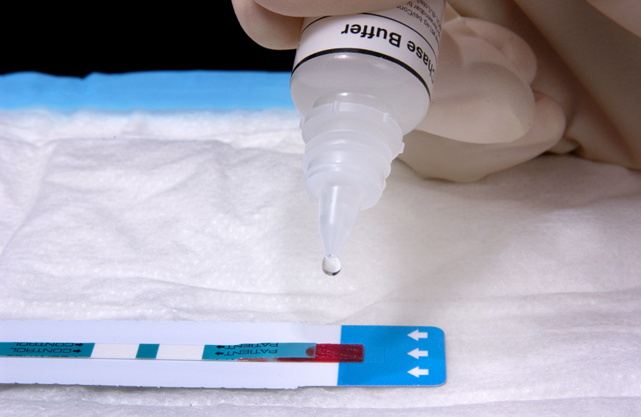 | 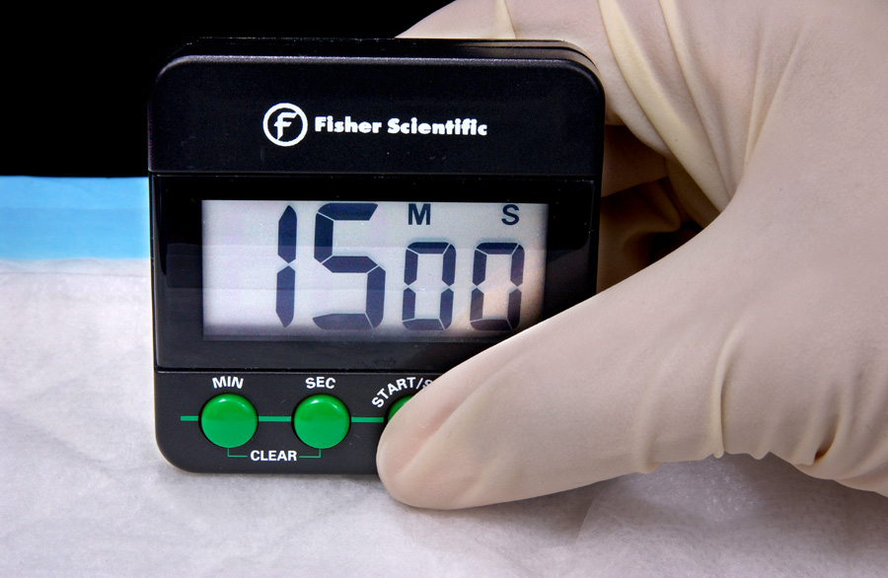 |  | 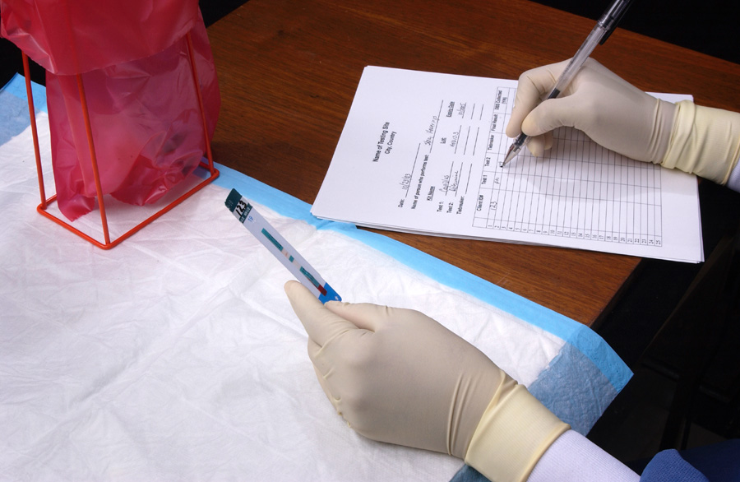
- For whole blood only add 1 drop of chase buffer to the specimen pad. | - Wait 15 minutes (no longer than 60 minutes) before reading the results. |  | - Read and record the results and other pertinent info on the worksheet.

Determine HIV Rapid Test Results
Reactive  2 lines of any intensity appear in  both the control and patient areas. | 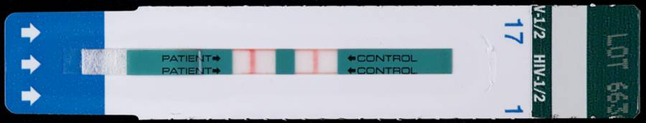
Non-reactive  1 line appears in the control area  and no line in the patient area. | 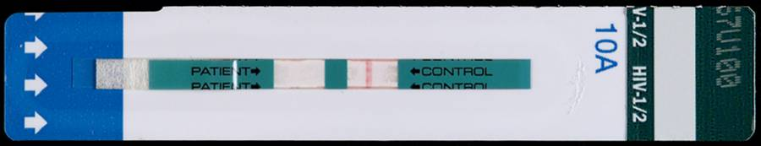
Invalid  No line appears in the control area.  Do not report invalid results. Repeat test  with a new test device even if a line  appears in the patient area. | 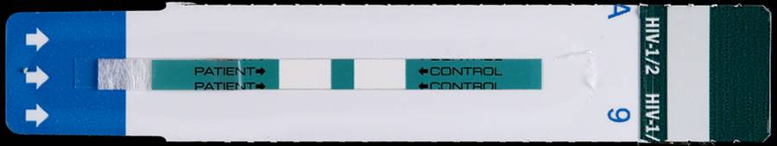

 | Use of trade names and commercial sources is for identification only and does not imply endorsement by WHO, the Public Health Service, or by the U.S. Department of Health and Human Services (2005). | 

