Stage 1 Components

5.1 Magnets

5.1.1 Introduction
The magnet system of the 20 TeV Stage-I VLHC is one of the main components of the collider, and has a strong influence on the total cost of machine. For these reasons, the general design goal is to reduce the cost per Tesla-meter of the collider. The arcs of VLHC-1 are based on warm-iron, combined function gradient dipole magnets[1-3], which are excited by a single turn 100 kA superconducting transmission line. A cross-section of the magnet, including the cryogenic service line and return bus, is shown in Figure 5.1. The flux lines surrounding the transmission line are shaped by an iron yoke, and two gaps in the yoke provide the apertures for the two beams. The 20 TeV bending field is 1.966 T. The magnets have a field gradient of ±4.73%/cm,
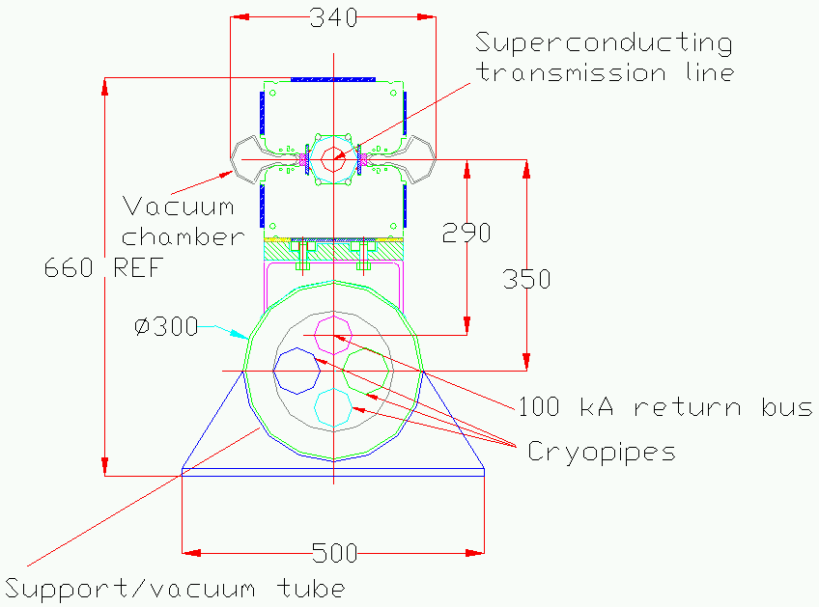

Figure 5.1. Cross-section of the gradient dipole magnet used in the arcs and dispersion suppressor of the Stage-1 VLHC.
which provides focusing and eliminates the need for separate quadrupoles. The 135.5 m long half-cell is made of two 65.75 m long gradient magnets.
At the end of each half-cell, where the beta function is maximum in one plane and minimum in the other, a 3.5 m long space is left open for correction coils. The transmission line is diverted into the cryogenic service pipe, near the return bus, allowing the use of conventional, room temperature, air cooled iron magnets, as shown in Figure 5.2. Three correctors are installed at each location: a vertically or horizontally steering dipole, a quadrupole and a sextupole corrector.
make white background:
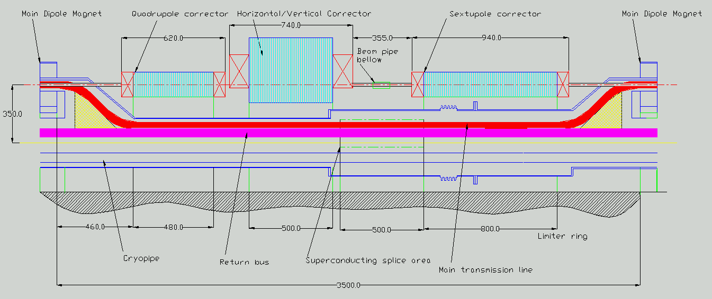

Figure 5.2. Correction coils placed at each half-cell.
The dispersion suppressor sections are made in a similar fashion. Here the 101.6 m long half-cell is made of two 48.81 m long dipoles, with a field at 20 TeV of 1.766 T and an increased gradient of ±9.449 %/cm. Correctors are employed at each half cell as in the arcs.
In the long straight sections, the space not occupied by the interaction regions or machine utilities are FODO channels made from conventional water cooled quadrupoles. Two 6.1 m long, 70 T/m quadrupoles make one half-cell. Special optics for the machine utilities – injection, abort, the RF system, and beam cleaning, are constructed using quadrupoles of the same design but with special lengths. The matching section for the low-beta insertions at the interaction regions are also constructed from the same quadrupoles. The low-beta triplets themselves utilize 300 T/m cos2θ superconducting quadrupoles made from Nb₃Sn cable. Special dipole magnets, similar in design to the gradient magnets in the arcs and excited by the transmission line, are used to bring the beams into collision at the interaction regions, to separate the beams to implement independent RF systems for the two beams, and to cross the beams over at two opposite points in the ring to ensure equal path lengths for the two beams.
Table 5.1 summarizes the main parameters of the magnets used in the VLHC-1 design.
The arc dipoles will clearly dominate the system cost. During the past three years, most of the R&D effort has concentrated on the dipole design, with considerable attention focused on the 100 kA superconducting transmission line cable. The arc dipole design has been refined through intense prototyping of the major magnet components, and various types of transmission line cables were tested at a 17m length superconducting test stand [4]. Several short magnet iron core configurations were tested, using a room temperature test stand [5]. Two 6 m magnet prototypes have now been manufactured to confirm the main technical decisions.
Section 5.1.2 describes the combined function arc and dispersion suppressor magnets in detail, including magnetic design, design of the 100 kA transmission line, and the mechanical and thermal designs. The correctors are described in section 5.1.3 and the interaction regions in section 5.1.4. Section 5.1.5 presents the various special magnets, including straight section quadrupoles; beam separation, recombination and cross-over dipoles; and injection and abort system magnets. Production of the 66 m long gradient dipoles and the testing and measuring of them are described in sections 5.1.6 and 5.1.7 respectively. Transport, installation and alignment methods are summarized in section 5.1.8.

Table 5.1. Main parameters of magnets in the Stage-1 VLHC.
Magnet Type | B_{nom} (T) | G_{nom} (T/m) | L_{mag} (m) | Number of elements | Notes
Gradient dipole (arc) | 1.97 | 9.73 | 65.75 | 3136
Gradient dipole (DS) | 1.80 | 16.88 | 48.81 | 160
Special dipoles | 1.95 |  | 25 - 35 | 52 | Separation, recombination, and cross-over
Straight sect quads |  | 70 | 4.8 - 6.8 | 464
Low β quadrupoles |  | 300 | 9.2 - 10.9 | 8
Correctors
Dipole (horiz.) | 1.0 |  | 0.50 | 1648
Dipole (vert.) | 1.0 |  | 0.50 | 1648
Quadrupole |  | 25 | 0.50 | 3296
Sextupole |  | 1750 | 0.80 | 3296 | Gradient in T/m²

5.1.2 Combined function Arc Magnets
The 20 TeV Stage-I VLHC is based on superferric (~2 Tesla), twin-aperture superconducting transmission line magnets [1-7], as shown in Figures 5.1 and 2.6. The low parts cost and simple manufacturing process for these magnets are expected to compensate for the cost of the long circumference of this machine. All bending magnets share a common single turn excitation transmission line winding. The return bus, located within the cryogenic service pipe, is 290 mm below the drive bus. There are several advantages of this the single turn winding system: simple construction, low cost, low field in the superconductor area, absence of turn to turn insulation, low magnetic forces and heat leak, high stability and simple quench protection. Nevertheless there are some negative effects associated with the external return bus: a non-negligible fringe field, asymmetric saturation of the lower and upper iron half-cores, and uncompensated magnetic forces on the drive and return busses. It is possible to optimize the magnet geometry and return bus position to minimize but not eliminate these effects.
Section 5.1.2.1 describes the magnetic design. The transmission line design is presented in section 5.1.2.2. The mechanical and thermal designs are described in section 5.1.2.3, including the magnet structure, the transmission line, the cryogenic service pipe and cryostat, and the beam pipe. The magnet ends, where space is provided for the correction magnets and interconnections from one magnet to the next are made, is described in section 5.1.2.4.
need more complete (anatomically correct) drawing

5.1.2.1 Magnetic design
The combined function gradient dipole is an iron-dominated magnet, in which the field quality is determined mainly by the shape of the yoke and the properties of the iron from which it is made. One of the challenges in this design is obtaining a high quality magnetic field magnet over a large range of field variations (0.1 - 2.0 T), in particular dealing with field distortions induced by strong saturation of the iron at high field. The saturation effects are controlled in the current design with a set of holes placed in the iron near the poles. Magnetic measurements have confirmed the attractiveness of the poles with holes technique.
Table 5.2 shows the main parameters of the dipole magnets. Both the main and dispersion suppressor magnets are excited by the common transmission line. Due to the larger gradient required in the dispersion suppressor magnets, the gap height at the nominal beam position must be opened somewhat, such that at the narrow edge of the tapered gap the separation is about the same as in the main magnets, so as to control the saturation effects. Consequently the operating field is decreased relative to the main dipoles.

Table 5.2. Main Parameters of Dipole Magnets
 |  | Main dipole | Dispersion Suppressor
Beam gaps (height x width) |  | 18 mm x 28 mm
Magnet air gap in the orbit center |  | 20 mm | 22.26 mm
Two beams separation |  | 150 mm
Magnet length |  | 65.74 m | 48.81 m
Half-cell length |  | 135.5 m | 101.6 m
Gradient |  | ± 4.73 %/cm | ± 9.449%/cm
Magnetic field: | injection | 0.1 T | 0.09 T
Magnetic field: | maximum | 1.966 T | 1.766 T
Good field diameter (0.02%): | injection | 20 mm
Good field diameter (0.02%): | maximum | 10mm
Maximum current |  | 90 kA
Magnetic field energy |  | 790 kJ | 473 kJ
Superconducting cable |  | Braided NbTi
Peak Operating Temp. |  | 6.5-7 K
Iron Core |  | Low carbon Steel (AISI 1008)

The crucial problem in the magnetic design is the control of iron saturation induced field errors at high field. This determines the strength of the correction system required to compensate these effects and sets the maximum field, and hence the maximum beam energy, that can be achieved. The parameters shown in Table 5.2 correspond to preliminary designs, which have not been fully optimized yet. To indicate the field quality that can be expected when the optimization is complete, an earlier, fully optimized design is presented here[6]. It has a smaller gradient of ±3%/cm, corresponding to an earlier lattice with 60°/cell phase advance, and a smaller spacing of 140 mm between beam apertures than the current value of 150 mm. It is anticipated that performance similar to that described here will be achieved for the current designs when their optimization is complete.
Figure 5.3 shows a detailed cross-section of the magnet, with an inset showing the dimensions and placement of the saturation control holes. The laminated core consists of upper and lower iron half cores, which are stamped from 1.5 mm thick low carbon steel. The upper and lower laminations are stacked and welded into 6 m long yoke blocks, which are then assembled into the complete yoke structure. The precise spacing between the two yoke halves is provided by non-magnetic 316L stainless steel spacer bars, and the two halves are welded together with non-magnetic steel plates at the inner radius. The weld is done inside a press, and the weld shrinkage provides the prestress necessary to assure precise and stable contact between all of the laminations and the spacer bar.
The return conductor is placed 290 mm below the drive conductor. This conductor generates a fringing field, which saturates the lower core more than the upper, which in turn decreases the field quality in the gaps and increases the magnetic force on the drive conductor. This can be countered by increasing the thickness of the lower half core, and it is possible to optimize this thickness and the position of the return bus, such that the magnetic force on both the drive and return conductors is zero when they are at their nominal position.
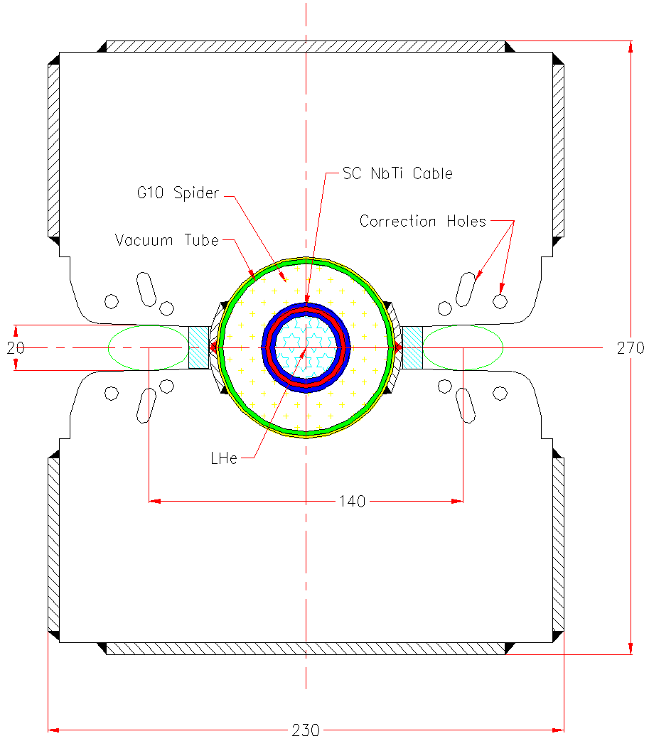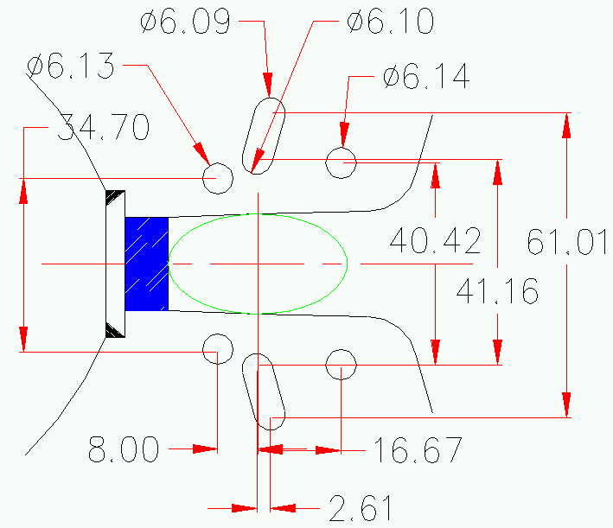

Figure 5.3. Cross-section of transmission line magnet showing yoke details.
The classic technique of correction holes in the pole tips was used to minimize saturation field distortions. Field quality optimization calls for a larger number of holes, while field strength and mechanical considerations favor a smaller number of holes. The combined optimum was found to be three holes per pole, as shown in Figure 5.3. The field optimization objective function was the integral field homogeneity around a circular aperture. The optimization process was carried out simultaneously for three field levels (1 T, 1.7 T and 2.0 T). The optimization was done using an ANSYS Subproblem Optimizer, and a large number of local minima were investigated. The best solution was tested by OPERA 2D and had ±0.02% field quality within a 20 mm diameter aperture for 0.1 ≤ B ≤ 0.8 T, 15 mm for 0.8 < B ≤ 1.5 T, and 10 mm for 1.5 T < B < 2.0 T. This shrinkage of good field region is acceptable since the beam is ~4x smaller at full energy than at injection.
Figure 5.4 shows the computed B versus I characteristic. The 20 TeV design field of 1.966 T is achieved at 98.4 kA. Figure 5.5 shows the effects of putting the correction holes in the pole laminations on the saturation of the sextupole. Figure 5.6 compares the calculated and measured shift in the quadrupole moment as a function of excitation for a prototype yoke stack. The quadrupole and sextupole errors are ±2 units in the field range 0.1T - 1.85T and both are about -8 units at 1.95T. The correction system described in section 5.1.3 is capable of compensating up to 4.8 and 5.4 units of quadrupole and sextupole error.
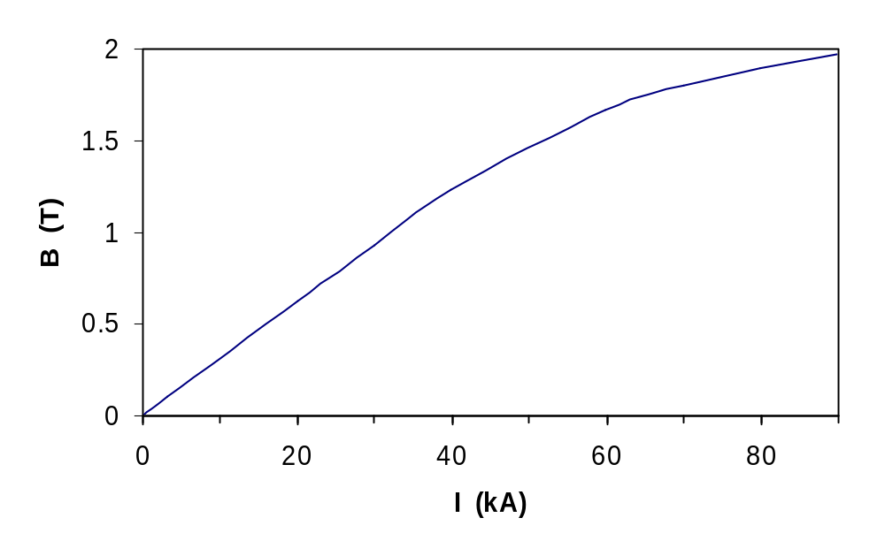

Figure 5.4. Calculated magnetic field strength as a function of transmission line current..

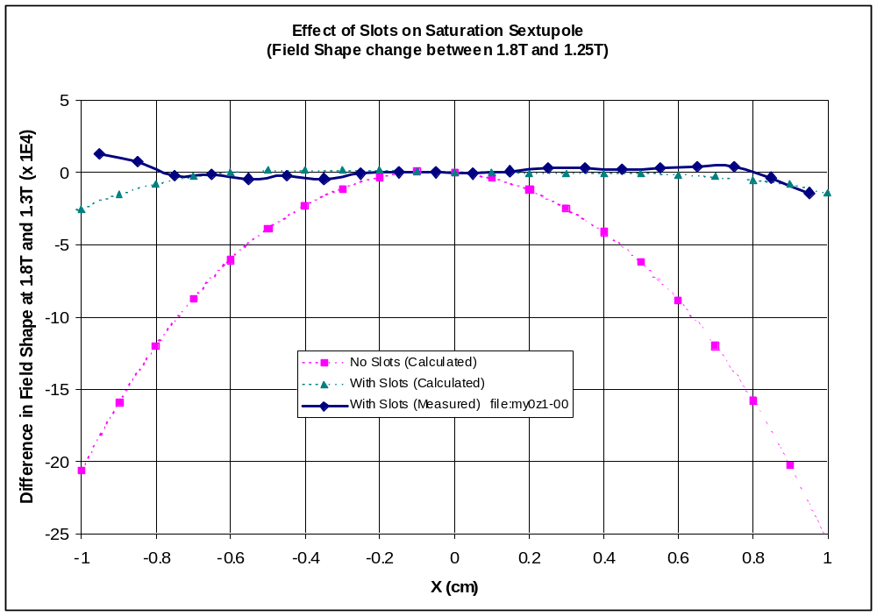

Figure 5.5. Effect of Slots in the Pole on Saturation Sextupole as a function of transverse position in the Transmission Line Magnet

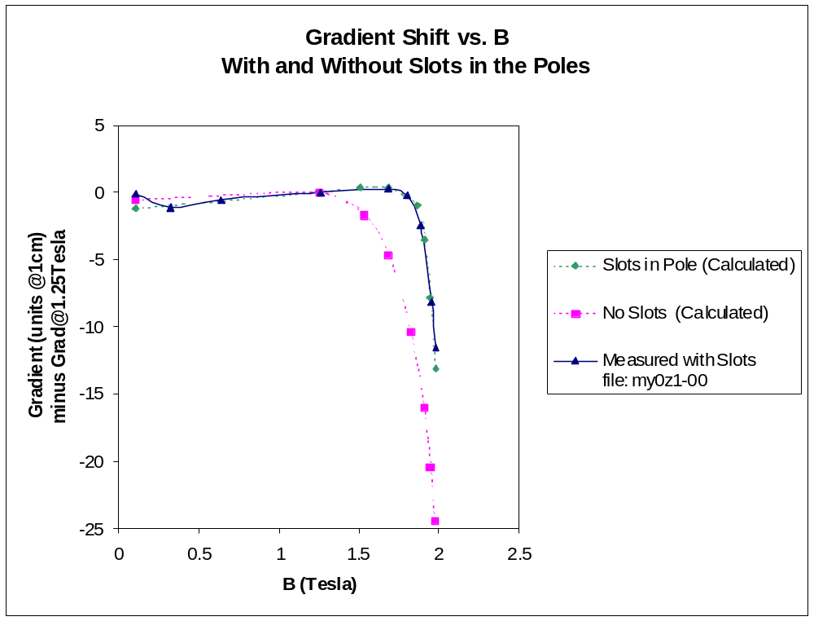

Figure 5.6. Effect of Slots in the Pole on the Gradient Shift in the Transmission Line Magnet

5.1.2.2 Superconducting Transmission Lines
The magnetic field in the superferric transmission line magnet is generated by a current carried in a drive conductor centrally positioned between the two stacks of iron laminations as shown in Figure 5.1. The transmission line consists of a cylindrical superconducting braid cooled by supercritical 4.5-6.0 K helium, which is placed inside a co-axial cryostat, which in turn is placed at the center of the room temperature iron yoke. A three dimensional view of a drive conductor transmission line is shown in Figure 5.7. The transmission line consists of (from inside out) a perforated invar tube, the conductor cable itself, the cold pipe support, a cryoshield, the superinsulation blanket, and the vacuum jacket. The cold pipe support sets conductor cable centrally to the vacuum jacket which in turn is placed centrally inside the magnet lamination. It also supports the cryoshield pipe which in turn supports the superinsulation blanket.
In order to suppress distant magnetic fringe fields and minimize the system inductance, a return conductor is placed outside the magnet laminations. At the mid point of the accelerator, the drive conductor returns back through the first half of the magnets (but outside the lamination stack). At the points where the beams cross each other – at the interaction regions and the beam cross-over insertions – the drive and return busses trade places. For the VLHC Stage 1 accelerator, the continuous length of the superconducting bus is about 464 km.
Three distinct transmission line designs are utilized. The transmission line that excites the dipole is optimized for minimum size consistent with operation at 100 kA in a ~1 T self-field. The return bus, which has essentially the same self-field as the drive conductor, is larger to provide a larger flow area. The cryogenic system (see section 5.2.1) is designed such that the maximum temperature is 6.0K in both the drive and the return bus. Where the drive conductor is diverted to make space for the correction magnets (see Figure 5.2), a special bus section is required for both the drive and return buses. Here, due to the proximity to the return bus, the peak field rises to 1.5 T, requiring more superconductor to carry the 100 kA current. A different design is also required due to the need to place pressure relief ports in this region. The main parameters of the three bus types are summarized in Table 5.3.
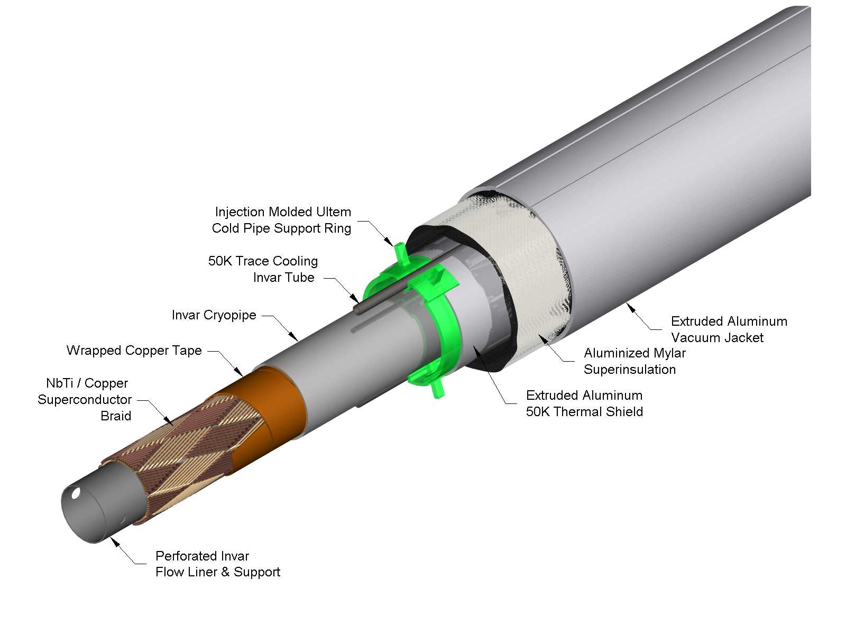

Figure 5.7. A 3D view of the drive conductor transmission line.
The superconductor for the drive and return busses are sandwiched between an inner perforated invar pipe, which serves as a liquid helium channel, and an outer invar pressure pipe which closes the helium space. The design is based on strands of the dimension of the SSC outer dipole layer design and current prototypes use actual SSC strand. For VLHC-1 it is planned to use a more cost effective wire optimized for the lower fields seen here and without the constraint of small filament size. A braided conductor is used for the main drive and return buses. It consists of 288 NbTi strands arranged in a pattern of two sets of 24 crossing bundles with opposite pitch angle about the tube. This yields a “tight” braid for the drive conductor, and a looser braid, with more void space for the return bus. Alternatively the return bus braid could be made of a larger number of smaller wires, which preserves the area of superconductor in the cross-section. There is also a copper braid placed underneath the conductors that provides an additional copper for carrying current during a quench. The conductor braid is secured in position by swaging the inner pipe against the outer one by drawing a series of carbide steel balls through the pipe.
For the bus in the corrector magnet space an assembly of 9 SSC inner dipole Rutherford cables is proposed. Cables are used here rather than braid to allow openings to be made for in the superconductor assembly for pressure relief ports, which are placed at every 4th half-cell (542 m). The cables are secured in place by welding the outer invar clam shell under pressure.
A cross-section of the drive conductor cryostat is shown in Figure 5.8. The support spider consists and injection molded ULTEM ring with two pairs of pegs pointing up and down, the direction of the magnetic force. The inner pair of pegs support the cold pipe, while the outer pegs contact the vacuum shell. The conductor must be placed precisely on the central line of the magnet to minimize the de-centering force. Offsets of the order of 0.5 mm, which can be expected due to part tolerances, lead to de-centering forces on the order of 100 kg/m. The supports must withstand 100,000 mechanical cycles during the accelerator lifetime. Laboratory tests these supports withstood 100,000 mechanical cycles of 300 kg/m force, three times that of the design requirement. Further design development, however, may be required to optimize the spider design with respect to axial motion, expected under thermal cycling. (See section 5.1.2.3.)
The cryo-shield is made of extruded aluminum pipe segments ~50 cm long, which slide over opposite ends of each support spider. The 6.4 mm diameter invar pipe that is used to provide the 50 K pressurized helium is “snapped in” to the cavities at the top and the bottom of both the shield and the supports once a magnet’s length of shield has been assembled. The shield pipe is wrapped with 40 layers of a dimpled superinsulation blanket. The vacuum jacket is made of extruded aluminum, and it is of a “squared” shape to firmly fix its position inside the iron laminations. This also helps to prevent potential rotation (and/or twist) of the cold pipe supports.

Table 5.3. Main parameters of the transmission line conductors.
 | Drive Bus | Return Bus | Bus in Corr. Space
Cu/SC ratio | 1.8 | 1.8 | 1.3
Diameter (mm) | 0.648 | 0.648 | 0.808
Cond.Type | Braid | Braid | 9 Rutherford Cables
Number of strands | 288 | 288 | 270
Cu Wire dia. (mm) | 0.64 | 0.64 | 0.64
Number of wires | 240 | 288 | 288
Inner Pipe ID .(mm) | 25.3 | 36.8 | 36.8
Outer Pipe OD (mm) | 38.1 | 47.1 | 50.1
Max working Pressure (bar) | 40 | 40 | 40

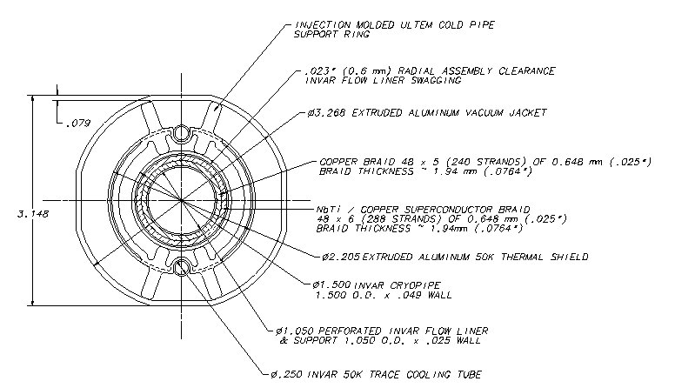

Figure 5.8. The details of the drive conductor cryostat.
The return conductor is located inside the cryogenic service pipe. Its is part of the cryostat that also includes the helium cooling lines, which is described in Section 5.2.2.
The critical temperature vs. current for the braided conductor is shown in Figure 5.9. The data point is the measured performance of the conductor used in the prototype, and the diagonal line is the computed performance using the properties of NbTi and the self-field as a function of current. At 90 kA current the critical temperatures is 6.8 K. The temperature margin of 0.7 K with respect to the maximum helium temperature of 6.1 K (see Section 5.2.1) is sufficient both for stability of the superconductor and for operational “head room.” The margin for the braided conductor, normalized to its higher self-field in the space between dipoles, is slightly larger than for the main conductor.
The quench propagation velocities were measured in a 17 m long conductor loop[4]. It was found that in a forced quench by a local heating of ~10 K, quench propagation velocity rises linearly with current, and it reaches about (10-12) m/s value at ~80 kA. Above this current, it rises exponentially reaching about (30-40) m/s value at 100 kA. This indicates that by applying a current dump circuit of a time constant of 1 s, the stored magnetic energy released in a quench would be at most that of a half length of a dipole magnet (34 m), thus not exceeding 1 MJ value. Detailed thermohydraulic simulations have also been performed on many quench scenarios with a number of different configurations of the transmission line[8]. The simulations use a 1 V quench detection threshold and a 1 second decay time constant (see Section 5.2.2.3) {is this the right section?}. The calculations demonstrate that, for conceivable worst-case scenarios, the peak temperature remains low (<60 K) and, with relief valves spaced every four half-cells, the peak pressure is below the 40 bar maximum for which the invar pipe is rated without taking credit for the increased strength at low temperature. The simulations also show that the additional copper stabilizer braid is essential. Without it the peak temperature can reach 250 K, and the higher temperature can result in peak pressure above 40 bar.
include words in this section on transmission line R&D results
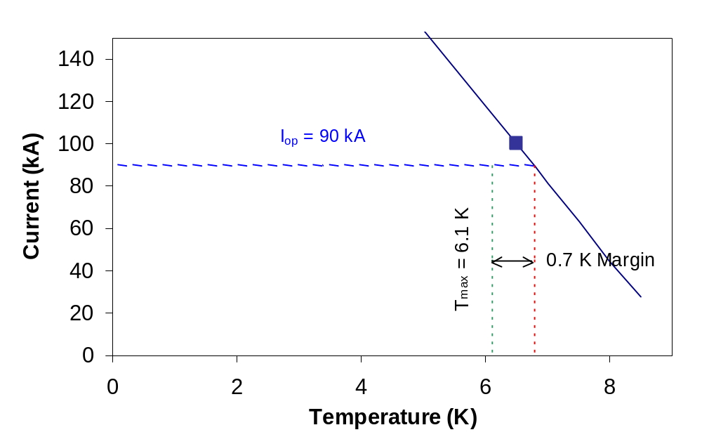
indicate line for current margin

Figure 5.9. The critical temperature vs. current for main drive and return conductors.

References {ed. note – for Secs 5.1.0 – 5.1.2.2}

[1] R.R. Wilson, Proceedings of Snowmass 1982.
[2] “The Pipetron: a Low-Field Approach to a Very Large Hadron Collider,” Snowmass ’96.
[3] G.W.Foster, “Transmission Line Magnet Status Report”, VLHC Information Packet for HEPAP Subpanel, Fermilab 1998.
[4] G.W.Foster, V.S.Kashikhin, E.Malamud, P.Mazur, H.Piekarz, J.Fuerst, R.Rabehl, P.Schlabach, J.Volk, “The 100 kA VLHC Transmission Line Magnet Superconducting Cable Test Facility,” MT-16, IEEE Trans. of Applied Superconductivity, Vol.10, No.1, March 2000, pp.318-321.
[5] J.DiMarco, G.W.Foster, V.Kashikhin, A.Makarov, P.Schlabach, “Measurements of a Crenellated Iron Pole Tip for the VLHC Transmission Line Magnet,” PAC 99, pp. 3327 – 3329.
[6] G.W.Foster, V.S.Kashikhin, I.Novitski, “Design of a 2 Tesla Transmission Line Magnet for the VLHC,” MT-16, IEEE Trans. of Applied Superconductivity, Vol.10, No.1,March 2000, pp.202-205.
[7] G.W. Foster, V.S.Kashikhin, V.V.Kashikhin, “Pole Profile Optimization of VLHC Transmission Line Magnet,” EPAC 98.
[8] N. A. Shatil, “Quench Simulation of VLHC Transmission Line Magnet (Final Report)”, TD-01-025, February, 1999; N. A. Shatil, “Quench Simulation of VLHC Transmission Line Magnet (Task 2)”, TD-01-026, October, 1999.

5.1.2.3 Mechanical and thermal design

5.1.2.3.1 Magnet structure

(a) Magnet support by cryogenic service pipe
The final assembly of the 67.75 m long magnet has two parts mounted as one unit, the magnet yoke with a conductor cryostat and the cryo-service line. The 300x5 mm tube of cryo-service line is made from A36 type steel and is a housing of all cryogenic pipelines and current return. The tube serves as a vacuum jacket and as a base for the iron core assembly. The magnet core is periodically (D=0.5m) welded to the tube to increase the vertical stiffness of the assembly and to reduce system deflection. The combined structure is rigid enough that supports every 6 m are sufficient to align the structure. Total magnet weight is ~ 33 tonne (~500 kg/m).

(b) Magnet yoke
The laminated magnet yoke consists of upper and lower iron half cores. Core laminations are stamped from 1.5-mm thick low carbon steel. The stack of laminations is pressed and welded into a block. Two blocks, upper and lower, separated by two steel spacer bars are welded to the stainless steel strips from the inside of the central hole. The welds provide a prestress no less than 5 tons/m to achieve high stability of the pole geometry near the beam gaps. The side gaps remain open for magnetic measurements and vacuum chamber installation. The conductor cryostat is positioned in the center of the core hole. All gaps between core and cryostat are filled by epoxy. Mechanically, the magnet core and the cryostat are a monolithic structure.

5.1.2.3.2 Transmission line mechanical analysis

(a) Vertical deflection and stress between support points
The magnet is installed on the vertical supports. A distance of 6 m was chosen between supports [1]. The maximal deflection of the magnet under weight load is 1.2 – 2.1 mm, depending on the final magnet design. In any case, if the magnet core will be connected with the lower vacuum tube by welds, the vertical sag is close to 1.2 mm and maximal stresses will not exceed 50 – 60 MPa.

(b) Force to introduce sagitta
The magnet horizontal sagitta is ~15 mm over its 67 m length. To estimate deformations of the straight magnet structure introduced by this sag during alignment in the tunnel, numerical 3D simulations were performing using a 12-m section model [2]. Over such a distance the sag is ~0.5 mm. Both model ends were restricted from motion. The model with a distributed weight was loaded by horizontal force applied to the central supports of the vacuum tube. The result shows the magnet block moves about 0.9 mm for 1 mm movement of the vacuum tube. The force needed for 1 mm motion is 450 kg. Difference in relative movement of the iron halves of the magnet can reach 30 μm.

(c) Magnetic forces on transmission line
In the ideal case, the magnetic forces equal zero because of the design symmetry of the two iron poles surrounding the transmission line. Nevertheless, the iron saturation effect and incorrect position of superconducting cable will cause uncompensated magnetic forces [3]. The magnet air gaps introduce force gradients of 228 kg/mm in the vertical direction and –100 kg/mm in the horizontal direction for 1 m length of drive conductor at 100 kA current. The return conductor has gradients an order of magnitude less in both directions. The magnetic forces between the transmission lines with 0.29 m vertical separation in the space between magnets are 700 kg/m and increase to ~4000 kg/m at 10 mm separation.

(d) Thermal stress and thermal forces
The conductor tubes in the transmission line magnet are made of invar and consist of continuously welded lines. The cool down shrinkage in this case will be minimized, but is 65 mm over 135 m distance with 67 MPa of thermal stress. Therefore, two invar conductor pipes give ~1400 kg tension force applied on the end of the pipe support at 5 K. The radial force on the invar pipe support for ring shrinkage compensation is small, ~0.12 kg/m.
All other cryo-lines are made of steel or aluminum and can not be continuously welded because of high thermal stress level. Table 5.4 describes the situation for different pipe materials after cool down to 5 K.

Table 5.4. Pipe at 5 K after cool down from 300 K
Material | ∫αdt,  mm/m | E(5K)  GPa | σ=E*∫αdt  MPa | σyield  MPa | σyield/σ | ΔL(mm)  L=135m
304 SS | 3 | 220 | 660 | 600-1200 | 0.9-1.8 | 405.0
6061 Alum | 4.1 | 80 | 328 | 380 | 1.15 | 553.5
Invar | 0.48 | 140 | 67 | 700-1000 | 10.4-14.9 | 64.8

If the steel pipes will be equipped with compensation bellows every ~33 m to reduce shrinkage to the level of ~100 mm, the convoluted length of the bellow is 100/0.25 = 400 mm. The force to expand the bellows by 50 mm is 300 kg for the bellows’ spring constant 6 kg/mm. The bellows’ stability problem is solved by using the internal tube liner and the outer protecting skin.

(e) Yoke deflection under magnetic forces
The dipole magnet at the maximum field of 2 T has 25 tonne/m magnetic force applied to the poles. The force is zero at injection field and rises during acceleration cycle. This force is taken across support spacers in the relatively small ~1 cm distance between the transmission line vacuum jacket and beam pipe. The yoke assembly has to be rigid enough to keep the air gap stable. Two welds inside the central bore of the magnet connect both half-cores together and provide pre-stress ~5 tons/m. The prestress removes all clearances between spacer bars and half-cores. The 1 m model with outer spacer bars was successfully tested at the room temperature test stand and no field gradient shift was measured up to 1.7 T [4].
The test of a short mechanical model with air gaps open on both sides showed that the left gap shrinks by 12 μm and the right gap by 6 μm vertically. The horizontal change was less than 4 μm. These changes were reproducible. They can only influence the dipole field component and can be compensated by magnet calibration.

(f) Mechanical analysis of support spider
Loads from transmission line magnetic forces are transmitted from the drive conductor to the pipe, through the supports (spiders) to the vacuum jacket, and to the magnet core. In the horizontal direction, the conducting cable is a self-centering system and does not need strong supports. However, the part of the conductor inside the magnet is at a point of unstable equilibrium in the vertical direction. The field gradient gives rise to an instability in which the current-carrying pipe bends into a sinuous curve with a period of twice the support distance. Therefore, the support interval 0.5 m has been optimized for lowest conductor displacement (0.5 mm) chosen for production accuracy and pipe tolerances [5].
Spiders made of ULTEM centrally position the conductor. Perfectly positioned pegs are under compression inside the cryostat. The compression depends on the leg over-sizing and on the variation in pipe diameter. A 0.5 mm tolerance is required on the roundness of both pipes. The pressure range is 20-40 kg. These numbers increase up to 70-100 kg at cold conditions and under action of magnetic force. For verification, the prototyped injection-molded supports were exposed to 100,000 mechanical cycles with a load force of 300 kg/m (three times that expected). Although a discoloration of the ULTEM was observed, the supports did not break.
The spider acts as a flexible membrane if the relative axial motion of the inner-cold conductor line and the outer-warm vacuum jacket tube occurs without sliding. This motion can cause high stress in the spider material [6]. We therefore have a strong requirement for a longitudinal anchoring system, since the relative pipe motion can be ~20 mm during magnet transportation or by temperature variation in the tunnel. The sliding range of the peg needs to be carefully verified. If it is insufficient, another sliding support system can be used [7,8,9].

5.1.2.3.3 Transmission line thermal analysis
Transmission line heat load estimates are divided into two components: the primary heat load on the 4.5 K system and the heat load to the 50 K shield system. The calculated heat loads are presented in Table 5.5-6 [10].

Table 5.5. Estimated Heat Loads into 50 K Shield System
(all values in W/m)
Transmission Line Shield | 0.578 | Shield Return Header | 0.471
Conductive Heat Load | 0.432 | Conductive Heat Load | 0.199
Longitudinal Anchor | 0.011 | Longitudinal Anchor | 0.011
MLI Heat Load /meter | 0.110 | MLI Heat Load /meter | 0.236
Instrumentation Leads  do these tables belong in Sec 5.2? | 0.020 | Instrumentation Leads | 0.020
Valve boxes | 0.005 | Valve boxes | 0.005

Table 5.6. Estimated Heat Loads in 5K at Transmission Line and Return Bus
(all values in W/m)
Transmission Line 5K Flow | 0.048 | Return Bus 5K Flow | 0.014
Conductive Heat Load | 0.040 | Conductive Heat Load | 0.006
Longitudinal Anchor | 0.0003 | Longitudinal Anchor | 0.0003
Radiation Heat Load | 2E-04 | Radiation Heat Load | 5E-04
Instrumentation Leads | 0.002 | Instrumentation Leads | 0.002
Valve boxes | 0.001 | Valve boxes | 0.001
Splice heat load | 0.004 | Splice heat load | 0.004

5.1.2.3.4 Interconnects, pipes, and bellows

(a) Axial anchoring for transmission line and return line
The magnet anchor system consists of the vacuum barriers, the force-anchors, the transportation locks and the vacuum jacket anchors, as shown in Figure 5.10.
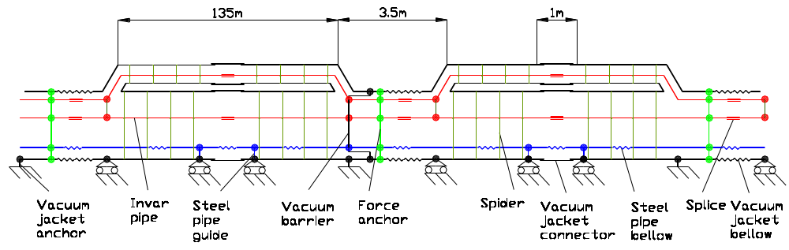
to be modified

Figure 5.10. Anchor system for the magnets
All magnet pipes will be physically constrained by vacuum barriers, or breaks, at the same location. The vacuum breaks are used to insulate subsystems in order to facilitate installation, troubleshooting, and repair. It provides a good vacuum in the transmission line ring section [11,12]. The vacuum barriers are designed to withstand a differential pressure of 0.15 MPa and to minimize the heat in-leak [13]. They are made of an all-welded construction of thin-wall stainless steel tubes. The barrier is electrically insulated from the invar conductor pipes by ceramic insulators. Distance between breaks is 270 m.
The pipe longitudinal anchor is located close to the vacuum barrier to prevent damage of the ceramic insulators. The pipe force anchor restrains thermal forces from invar pipe shrinkage and stainless steel bellows expansion (~3000 kg) during cool-down and warm-up. This anchor consists of carbon tie rods and a G-10 spider, and connects all the pipes to the vacuum jacket.
The vacuum jacket is connected to the ground by the jacket anchors at the end of the magnets. These points define an immovable magnet cross-section in case of accidental vacuum loss and jacket thermal contraction resulting from a cool down to about 250 K [14]. The jacket bellows at the interconnect region compensates for a length change.
The transportation lock is located on the opposite end of the magnet from the vacuum break. It is mounted in place during production and removed after magnet installation in the tunnel.

(b) Cryostat Interconnection
After magnet alignment, interconnection activities will take place. The magnet and the cryo-service line must be connected every ~67.75 m at the 3.5 m and 1 m interconnection regions, as shown in Figure 5.11.
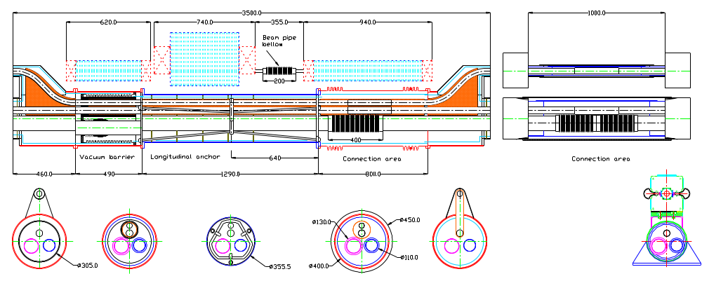

Figure 5.11. Magnet interconnections
Both conductors will be spliced at these areas. To compensate magnetic, thermal and hydraulic forces in the region where the transmission line conductors make a loop and are located close to each other, an additional set of special spacers and clamps will be used. The weld on the conductor line pipes can apparently take place directly over the copper/superconductor structure without damaging it [15].
Three cryo-service pipes having bellows will be orbital welded automatically. An aluminum thermo-shield made from two pieces will cover all the pipeline connections [16]. Multi-layer insulation blankets are mounted around the shield to reduce radiation heat load. The vacuum jacket is connected by a bellows in the 3.5 m region and by a thin steel skin in the 1 m region.
Beam pipes are connected by bellows every 135 m in the space between corrector magnets to compensate ~25 mm motion of the magnets from expected temperature excursions in the tunnel.

References { ed. note – for Sec. 5.1.2.3}
[1] V.Tsvetkov, “Transmission Line Magnet Mechanics”, TD TN XXXX 2001.
[2] V.Tsvetkov, “Alignment of the Transmission Line Magnet in the tunnel”, TD TN XXXX 2001
[3] V.S.Kashikhin, “Transmission Line Magnet for VLHC. Magnetic Forces and Magnet Deflection,” TD TN XXXX. February 2001.
[4] V.S.Kashikhin, “Mechanical model 2 test results”, TD TN XXXX. February 2001.
[5] M.McAshan, “Cryogenic System for the 3 TeV Injector Study”, Fermilab TN-XXXX,1997
[6] I.Novitski, “Analysis of the spider support”, TD TN XXXX 2001
[7] E.C.Quimby et al., “VJR/VJRR Design, Construction, Installation, and Performance,” ACE, vol 43, New York, 1998.
[8] G.Grygiel et al., “Status of the TTF Cryogenic System,” ACE vol.41, New York, 1996
[9] K.Hosoyama et al., “Development of a High Performance Transfer Line System”, ACE vol. 45, 2000
[10] G.W.Foster, “Transmission Line Magnet R&D”, Second Annual VLHC Meeting, Danfords, Port Jefferson Long Island, NY, Oct. 16-18, 2000
[11] V.Parma et al., “The Insulation Vacuum Barrier for the Large Hadron Collider Magnet Cryostats”, ICEC 18
[12] B.Jenny et al., “A Composite vacuum Barrier for the LHC Short Straight Section”, ACE vol.41, New York 1996
[13] “Technical Specification for a Compound Cryogenic Helium Distribution Line for the Large Hadron Collider (LHC)”, IT-2399/lhc/lhc, Geneva, Switzerland, December 1997.
[14] M. Chorowski, “Risk analysis of the LHC cryogenic system”, ACE 2000
[15] G.W.Foster, “Status Report on the Transmission Line Magnet”, Fermilab report, September 1997
[16] R.C.Niemann, “Model SSC Dipole Magnet Cryostat assembly at Fermilab”, Supercollider 1, New York 1989.
[17] I.Novitski “Beam pipe mechanical design” TD TN XXXX 2001.

5.1.3 Correctors
The purpose of the correction system is to correct the closed orbit. Sources of orbit distortions include dipole, gradient and sextupole field strength errors. Various factors and effects (main magnet manufacturing and installation, iron core saturation, fringing fields, residual fields, and magnet displacements with time) cause all these errors. The accelerator lattice design includes a space 3.5 m between combined function magnets at the end of each half-cell, and a 1 m space in the middle of the half-cell. Dipole, quadrupole and sextupole correctors will be placed there (see Figure 5.2). There are several ways to optimize corrector strengths. A rather promising approach is to optimize pole profiles and correction hole positions of the main dipoles for the minimum and maximum fields. In this case, correctors will work at full power for only a short period of time during the acceleration cycle. This will reduce the operational cost of the corrector power supplies and the ventilation system. At maximum field they will compensate residual effects after magnet calibrations.
The main design issue for the correction system is the high fringing field generated by the straight and return 100 kA conductors in the drift space between dipole magnets. This field has a level of 0.3 T in the vacuum chamber areas and causes large magnetic forces of 1000 kg/m on the superconducting cable. The distance between the outer shell of the superconducting transmission line and the vacuum chamber center is only 30 mm; it is a nontrivial task to form the needed correction field in this area. There are several options to solve this problem:
- Cold ferromagnetic screen with superconducting windings [need ref: TD Note N.Andreev]
- Room temperature horizontal and vertical dipole correctors with iron core as a ferromagnetic screen
- Nearly coaxial configuration of the transmission line and return bus in the space between magnets and room temperature air-cooled correctors (see below)
- Main dipole pole windings ( very effective at injection )
- Iron-dominated correctors ( low power, stepping motor drive)
- Permanent magnet correctors (rotational multipoles, stepping motor drive)

All of these options were investigated. From the point of view cost and operations, the most convenient magnets are conventional room temperature air-cooled magnets (Option 3 above). The other options may be used only if their total cost will be less than Option 3.
One of the options to eliminate the fringing field of the transmission lines is to bend the main transmission line and place it as close as possible to the return bus (see Figure 5.11). Electrical insulation capable of withstanding ~5 kV during quench should be applied in the space between the two lines. The collar around both lines should accommodate large magnetic forces. Conventional dipole and multipole correctors can be installed in the field free space between the main dipole magnets. For easy installation and replacement, all the correctors can be separated in the median plane. Correctors will dissipate power in the tunnel and will produce an extra heat load for the ventilation system. Magnets will have separate power supplies placed nearby to reduce the cost of cables and operational cost.

Table 5.7. Corrector Parameters
Corrector type | Horizontal  dipole | Vertical  dipole | Quadru-pole | Sextupole
Quantity | 3420 | 3136 | 3136 | 3136
Maximum magnet strength | 1.0 T | 1.0 T | 25 T/m | 1750 T/m²
Field quality, 18 mm diameter area, % | 1.0 | 1.0 | 1.0 | 1.0
Effective magnet field length, m | 0.5 | 0.5 | 0.5 | 0.8
Integrated field at r = 1 cm, T*m | 0.5 | 0.5 | 0.125 | 0.14
Half-cell integrated field at 1 cm, T*m | 260 | 260 | 260 | 260
Half-cell field correction at 1 cm, units | 19 | 19 | 4.8 | 5.4
Magnet core length, m | 0.48 | 0.48 | 0.5 | 0.5
Current, A | 25 | 25 | 1.0 | 1.0
Voltage, V | 23 | 23 | 140 | 175
Power, W | 600 | 600 | 150 | 200
Number of coils per magnet | 1 | 1 | 4 | 6
Number of turns per coil  ← does this symbol mean OD? | 640 | 640 | 1240 | 633
Copper conductor, mm | 5 x 5 | 5 x 5 | ǿ 1 | ǿ 1
Copper weight, kg | 250 | 250 | 40 | 50
Core weight, kg | 300 | 220 | 30 | 50

The bent sections of the transmission line at the arc magnet ends will be forced to the closest iron corrector cores. Longitudinal anchors should accommodate uncompensated forces. Cross-sections of the dipole, quadrupole and sextupole correctors are shown in Figure 5.12-13.
All the correctors can be installed and removed without breaking the beam pipe vacuum. The corrector assemblies installed in 3.5 m space will have the common support structure but separate position adjusting mechanics. Three correctors assembly will be transported into the tunnel as one unit with previously mounted beam pipes and installed when all the main dipole connections are made.
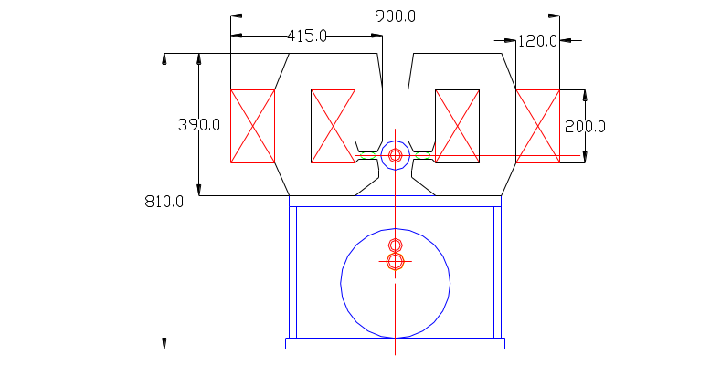

Figure 5.12. Horizontal dipole correctors
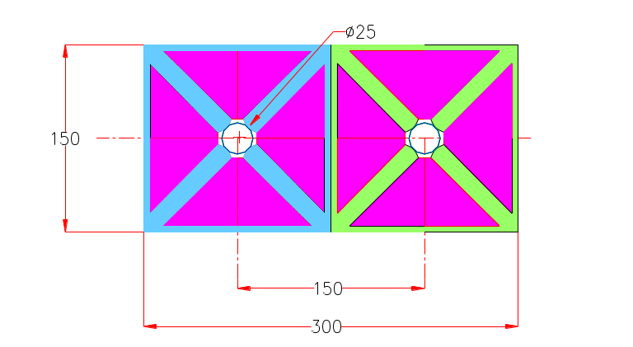
move these figures side by side if possible;
Can VK include more detailed line dwgs?

Figure 5.13. Quadrupole correctors.
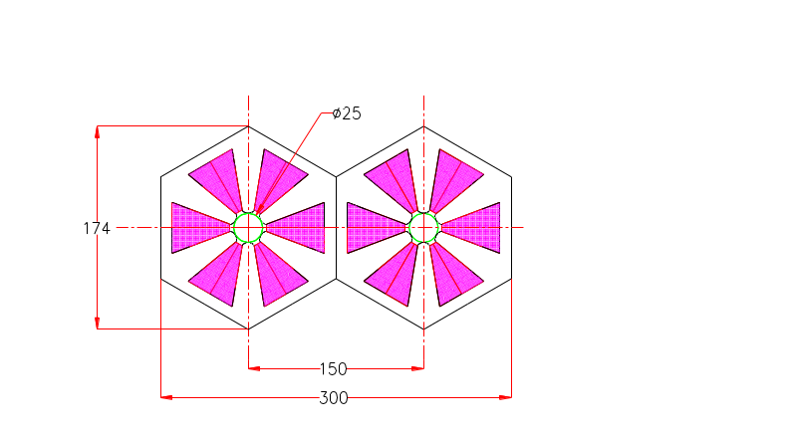

Figure 5.14. Sextupole correctors.

5.1.4 Interaction Regions
VLHC has provisions for two large colliding experiments located on the present Fermilab site. The beam interaction points will be located symmetrically from the two non-interaction beam crossing points. The closest crossing point is 13 half cells or 1700 meters from the interaction points.
A system of magnets on each side of the interaction regions is required to bring the beams into collision. With these magnets comes additional requirements for the accelerator including power supplies, beam absorbers to protect the magnets and prevent activation of the tunnel, and an alignment system for the magnetic elements. For the superconducting magnets there is quench protection system, cryogenics, and interconnects for room temperature to cold transitions of instrumentation and powering.
Figure 5.15 shows a schematic of the interaction regions magnetic elements. Each interaction region spans a space of 6 half cells, from 20 meter to approximately 810 meters from the interaction points. The interaction regions consist of four high gradient “inner triplet” quadrupoles, two separation dipole elements, and an outer system of lower gradient quadrupoles. There will also be orbit and local field corrector magnets. The separation dipoles, “outer” quadrupoles and correctors are used in other parts of the accelerator and are thus described in section 5.1.5. The high gradient inner triplet quadrupole is described below.
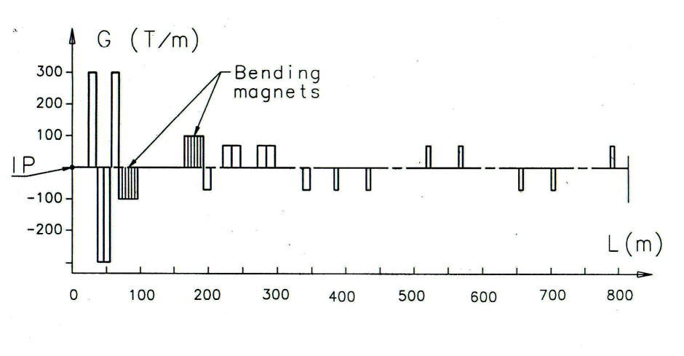

Figure 5.15. Principal magnetic elements for the VLHC-1 interaction region.

5.1.4.1 Low-beta IR quadrupoles
These magnets form the final focus at the two collision points. The required gradient is 300 T/m with a length of 10 meters and a single aperture of ~80 mm. The field quality must be very good because the beams could be separated by as much as 12.5 mm due to the crossing angle.
A design developed by INFN-LASA for a possible upgrade of the LHC low-β quadrupoles, with an aperture of 85 mm [1], can be used as a starting point to meet these requirements. The basic design as shown in Figure 5.16 has two Nb₃Sn layers in a cos (2Θ) geometry, wound using the cable described in Table 5.8. The cable has a target critical current density of 3000 A/mm² @ 4.2 K, 12 T [2]. Internal splices can be avoided using the double pancake technique. The main characteristics of the magnetic design are reported in Table 5.9. The field quality of the basic design (aperture = 85 mm) gives acceptably low values for the allowed harmonics. The value of the b6, b10 and b14 multipoles, normalized to the gradient and using a 10 mm reference radius are respectively 1.5 e-6, 1.6 e-8 and < 1.0 e-9. The relative field error is lower than 1.1 e-5, at 12.5 mm from the center on the midplane. Iron saturation effect has to be studied.

Table 5.8: Conductor characteristics
Superconductor | Nb₃Sn
Critical current non Cu (@ 4.2K 12T) | 3000 A/mm²
Strand diameter | 0.825 mm
α = Cu/nonCu | 1.3
Number of strands | 36
Cable dimension | 1.34 ÷ 1.60 x 15.0 mm²
Effective filament diameter | < 40 μm

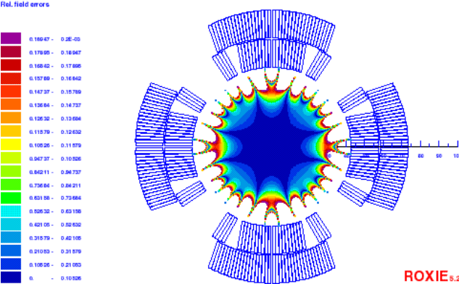

Figure 5.16. Basic design cross section with field quality at maximum gradient

Table 5.9: Magnetic design characteristics at short sample limit
Aperture | 85 mm
Gradient | 300 T/m
Current | 20218 A
Self inductance | 4 mH/m
Stored energy | 820 KJ/m
Horizontal Magnetic force (per octant) | 2.78 MN/m
Vertical Magnetic force (per octant) | 3.43 MN/m
Number of turns | 10 + 4 + 19
Collars thickness | 20 mm
Iron inner radius | 93.5 mm

The quench protection has been studied at an operating current corresponding to 93% of the short sample limit. Simulations were performed using a version of the QLASA code [3] modified at Fermilab [4] for the study of FNAL Nb₃Sn high field magnets. These studies show that full coil coverage by heaters on both layers is required, and the delay time between the spontaneous quench start and the beginning of the heater-induced quench must be very short. This solution has an impact on magnet technology, because if the insulation of the heaters between the inner and outer layers cannot withstand the conductor heat treatment, the double pancake technique must be abandoned. Furthermore, protection redundancy will not be possible (or at least very complicated) and fault scenarios have to be addressed. The short time delay necessary to avoid excessive hot spot temperature and the lack of protection redundancy should be the object of an appropriate R&D.
A possible solution for the mechanical design is the one proposed for the upgraded version of the LHC IR low-beta quadrupoles presented in [5]. It uses 20 mm thick stainless steel collars, which can provide part of the required prestress and magnetic force containment. The rest of prestress and support are provided by a thick skin. The yoke is only in contact with the collars close to the midplanes, in order to transfer the stress from the skin to the coils where it is most necessary. The effectiveness of this design for the higher forces developed in the VLHC IR quadrupoles is still under investigation. A finite element analysis of coils and collars, simulating the rest of the mechanical structure by use of an external load, showed that the maximum stress in the coil can be kept below 160 MPa. The design of yoke, skin and contact regions must still be optimized to provide the required support on the coils.
In summary, it can be concluded that a two layer design using Nb₃Sn at 4.2 K is a good candidate to meet the requirements for these magnets, if the critical current target is reached. Some design optimization will be required for the quench protection and mechanical design.

5.1.4.2 Interaction Region Subsystems
Most of the 800 meters of the interaction region will be in the standard VLHC tunnel. Since these magnets elements need to be “tunable” they require a special gallery to handle the power supply and electronics of these magnets. There will likely be a global alignment system that connects the experiments to the final focussing elements. Finally, the tunnel will need to be wider near the IP to accommodate the extra shielding and vacuum connections and instrumentation associated with the collision detection and IP interconnect.
Four independent power systems are required for each side of an interaction region: one for the inner triplet, one for each separation dipole and one for the outer quadrupoles. Additional quadruples in the IR region will likely be powered in series with other straight section quadrupoles in the accelerator and are not include here. The high gradient quadruples require a 25 kA, 10 Volt supply, the conventional separation dipoles require 1 kA, 100 Volt supplies while the conventional outer quadrupoles need a 7kA, 10 volt supply. Correctors will be powered independently with supplies comparable to the outer quadrupole conventional magnets.
Superconducting circuits will rely on quench heaters for protection. With the relatively small amount of stored energy (50 MJ) and small number of magnets/circuit (4 or less) it is not clear whether the complications of an extraction circuit and bypass diodes are worth the effort. Thus, in the event of a detected spontaneous quench, the circuit power converter will be phased off, all quench protection heaters on all the magnets in a circuit will be energized.
As stated, inner triplet quadruples will likely need protection levels comparable to or greater than a similarly sized LHC IR quadrupole magnet. Thus 4-8 quench heater circuits plus the requisite electronics are required for each magnet. The total space for power supplies and electronics required for each quench heater circuit is approximately 2 6U VME crates. Thus a space of approximately 70 6U crates are required for each side/IR.
LCW and electrical power will be required for the power supplies and conventional magnet. The LCW system will be required to deliver several hundred liters/minute per IR.
Superconducting magnets rely on 4.5 K helium. The estimated dynamic heat load/side/IP will be approximately 600 Watts or 2.4 kW for both interaction regions [6]. Local heating in the quadrupoles could be quite large due to the strong focusing elements (G.dl ~ 3000 T/m *m). This could be a non-negligible load on the Phase I cryogenic requirements.
This heat load, if taken directly by the 4.5 K helium will require approximately ½ of a VLHC-1 power plant. Thus the cryogenic plant located on site would have to be upsized. Since the IR temperature and pressures profiles and requirements will differ from the transmission lines, there will likely be a need to be a separate transfer line from the cryogenic system. The helium requirements might be reduced by carrying away some of the heat load by actively cooled absorbers in the 80 mm beam tubes.
A distribution box will be required in order to make a connection between the room temperature and cryogenic electrical elements, as well as supply the cryogens to the magnetic elements. Elements include voltage taps, strip heater leads, thermometry and other cryogenic instrumentation. 25-30 kA HTc leads would be used to supply the excitation currents.
A particle absorber system will be required to protect the IR magnets from the excessive radiation from particles produced from the interaction region. Using the LHC as a guide, the system will require a hadron and neutral particle absorber. The primary hadron absorber will be located on the IP side of the inner triplets. The size of the absorber will be comparable to the LHC absorber but will have significantly larger heat loads, estimated to be 2 kW per IR [7]. Thus an actively cooled absorber will likely be necessary. The neutral absorber, located between the separation dipoles would be necessary to protect the outer quadrupoles, possibly the transmission line magnets and the walls of the tunnel from activation. It, too, will likely need to be actively cooled. If water cooled the requirements would be modest and would be parasitic to the magnet and power supply LCW system.
Alignment tolerances are likely to be comparable to those of the LHC Interaction region. Transverse alignment tolerances will thus need to be on the order of 100-300 microns over both sides of the IP. Thus an alignment system will be required to tie together the two sides of the IR and the detector.

References {note – for sec. 5.1.4}

[1] G. Ambrosio et al. “Preliminary Proposal of a Nb3Sn Quadruple Model for the Low-beta Insertions of the LHC” INFN Report, INFN/TC-95/25, Sept. 13, 1995.
[2] R. Scanlan, “Conductor Development Program” Low Temperature Superconducting Workshop, Santa Rosa (CA), Nov. 8-10, 2000.
[3] M. Canali, L. Rossi, “DYNQUE: a computer code for quench simulation in adiabatic multicoil superconducting solenoids”, INFN Report, INFN/TC-93/06, 1993
[4] L. Imbasciati, G. Ambrosio, P. Bauer, V. Kashikhin, A. Zlobin, “Quench Protection of the Common Coil Racetrack (CCRT-1)-Results of Adiabatic Model Calculations”, TD-00-056, FNAL (Sept. 2000)
[5] G. Ambrosio, G. Bellomo and L. Rossi, “A 300 T/m Nb3Sn Quadrupole for the Low-beta Insertions of the LHC”, Proc. of EPAC96, Sitges (Barcelona), p. 2290.
[6] Nikolai Mokhov, private communication
[7] Bill Turner, private communication

5.1.5 Special Collider Ring Magnets
This section describes several different magnets installed in the straight sections of the ring. There are a total of 10 straight sections, 5 in each half of the ring. On the Fermilab site there are two Interaction Region straight sections, two Utility straight sections and one Beam Crossing straight section. The straight sections on the opposite side of the collider are basically the mirror reflection of what is on the Fermilab site, except that there are no IRs or utility equipment installed in this area. As a transition from an arc to a straight section, a matching dispersion suppression section cell is used, described in section 3.2 {check ref}.
Beam focusing in the straight sections is provided using a classical quadrupole triplet cell made of four quadrupoles of equal integrated strength of 422.93 T. The basic cell half-length is about 135.46 m. This is the amount of space that can be used to install the required equipment. The triplets quadrupoles are installed back-to-back in both rings, providing focusing in different directions for each ring. The basic beam-beam spacing of 150 mm and the required beam pipe size of 20 mm implies certain restrictions on the achievable quadrupole field gradient. The chosen reference gradient of 69.333 T/m results in the basic quadrupole length of 6.1 m. Taking into account this length and the space between the quadrupoles in the focusing cell, only a 100 m gap is available for the utility equipment. When this space is not enough, or when some special features are to be introduced into the beam optics, modifications of the focusing lattice are to be done.

5.1.5.1 Straight section quadrupole
The focusing quadrupole has been designed so that a pair of them can be installed back-to-back in both rings. This gives a certain flexibility when increased beam separation is used in the Utility section. The lens uses water-cooled windings. The preliminary magnetic design indicates that field quality is not going to be a problem for this lens: there is plenty of space to make the needed pole shaping. The magnetic field in the steel is acceptable, reaching 1.9 T at the pole base, but there are regions in the minimal pole separation area where the field exceeds 2.0 T at 70 T/m, so good quality low carbon steel must be used for lens fabrication. A cross-section of the quadrupole is shown in Figure 5.17. summarizes the quadrupole features.

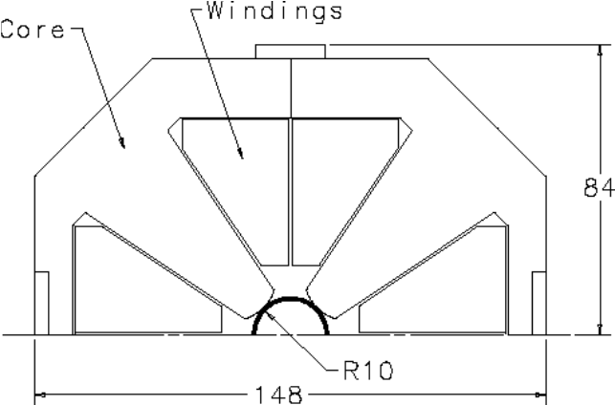

Figure 5.17. Straight section focusing quadrupole

Table 5.10. Parameter list of a conventional straight section quadrupole
Gradient, T/m | 70
Pole spacing, mm | 22
Length, m | 6.1
Width, mm | 148
Height, mm | 168
Number of coils per winding | 4
Number of turns per coil | 12
Conductor cross section area, mm² | 61.5
Resistance of the winding, Ohm | 0.18
Rated current, A | 285
Voltage drop, V | 53
Power consumption, kW | 15
Conductor hole diameter, mm | 5
Water temperature rise at 1 MPa (deg. C) | 12
Water flow per quadrupole (l/min) | 17
The number of quadrupoles required for each straight section depends on its design. For the Far End straight sections (except the Beam Crossing section), a total of 22 focusing cells are used that require 176 of the 6.1-m quadrupoles, equivalent to 1074 m of quadrupole length.
Conventional quadrupoles provide some flexibility and freedom in high radiation areas, where the use of superconducting magnets may be precluded. Nevertheless, superconducting quadrupoles have an advantage of higher gradient and can be used when appropriate or when space requirements become a critical issue [1].

5.1.5.2 Beam Cross-Over Section
The two beam cross-over regions in the collider are introduced to make the perimeters of the counter-rotating rings equal. To accommodate the magnets in the cross-over region, a short straight section is used that consists of a focusing cell that differs from the standard focusing cell. At the entrance to the cross-over region, the two beams are in the horizontal plane, separated by 150 mm. To make a cross-over, it is necessary to bring the beams together horizontally, separate them vertically before the crossing, and make the opposite transformation after the crossing. The vertical shift of each beam required to eliminate beam-beam interaction effects is 4.5 mm, which results in a beam-beam separation of 9 mm, more that 18 σ. To reduce the number of magnets required for beam manipulation, tilted dipoles are used to bend beams both horizontally and vertically. The cell layout is shown schematically in Figure 5.18.
{still need some refining of the text for the remainder of Sec. 5.1.5 from this point on.}
Magnet length L_{m} and tilt angle θ can be found based on nominal magnetic field and length of gaps between the magnets in the string. As it is in the arc dipoles, transmission line is used for magnet excitation. More over, because of the large required pole width of the magnet, return line is also used as active part of the magnet excitation wiring. To minimize iron core saturation effects, magnetic field B_{m}=1.95 T was chosen, as it was for the arc dipoles. With two-meter gaps introduced between the magnets to allow some space for repositioning of the transmission line, this results in magnet length of 34.95 m and tilt angle of θ = ± 6.84°.
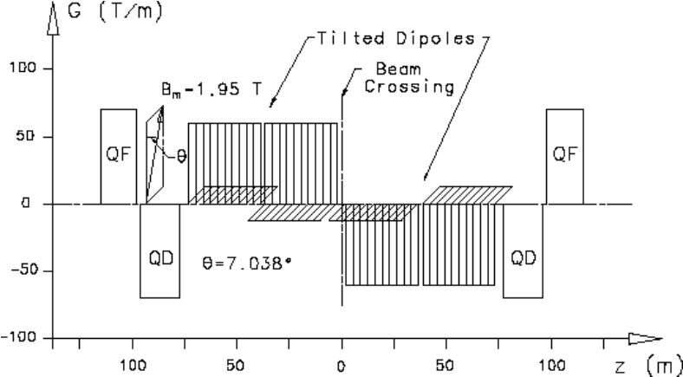

Figure 5.18. Cross-over straight section layout
The total length of the beam cross-over magnetic system is about 150 m. Magnet cross-section is shown in Figure 5.19. The dipole gap is 44 mm to accommodate (while tilted) the two beams with their vacuum pipes. Pole width provides good field region for beams separated by 150 mm. Because of big difference in the gap thickness for the pole and flux return regions, force applied to the cable is significant, up to 2000 kg/m for this magnet. Special measures must be undertaken to strengthen the cable "spider" to the needed level at this location.
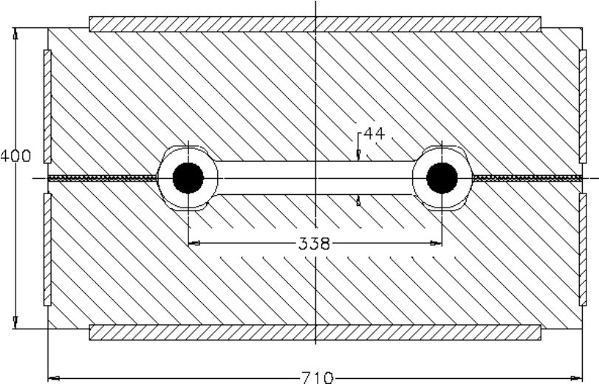

Figure 5.19. Beam crossing dipole
To allow 150-m gap for the tilted magnet installation, basic focusing cell was modified, that resulted in increased length of the cell quadrupoles: 18.96 m for each of the two inner quadrupoles and 16.94 m for each of the two outer quadrupoles. Significantly increasing the basic quadrupole length above 6 m would result in the increased cooling water temperature rise, so the total required focusing strength can be obtained mostly by increasing the number of quadrupoles. The total length of quadrupoles installed in the two rings for each of the two cross-over sections is 143.6 m.

5.1.5.3 Conventional Magnets for Interaction Region
As described in section 5.1.4, the IR straight section requires certain beam manipulation to allow using of low-beta high gradient quadrupoles. For this purpose, so called "separation/recombination" dipoles are used that bring the two beams together within the low-beta lens string region and place the beams onto the nominal orbits before they go into the regular part of the straight section (see Figure 5.15).
Like it was made in the cross-over section, existing transmission line cable is used for excitation of these magnets and 1.95 T maximal magnetic field in the dipoles has been chosen. As it follows from section 2.1.1, gap available for the bending magnets installation is about 125 meters. Leaving some space for the transfer line position manipulation, magnet length of 28 m was chosen that insure a 75-mm beam shift within the 120-m gap in the lattice. Beam displacement inside the dipole of the specified length is about 12 mm. This displacement must be taken into account when good field region of the dipoles is being specified.
To bring the beams together, the "recombination" dipole bends simultaneously the two beams separated by 150 mm. This requires one direction of bending field for both beams. "Separation" dipole separates beams moving in the opposite directions. Final beam separation at the outer edge of the magnet is 24 mm. To reduce force applied to the transmission line and to avoid field asymmetry, a symmetrical iron core configuration was chosen. The magnet cross-section is shown in Figure 5.20. Good field region area for this dipole is 35 x 20 mm, which is enough to accommodate the two shifted beams.
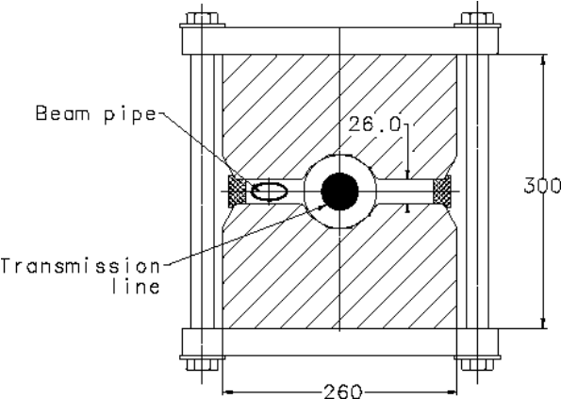

Figure 5.20. Separation dipole.
The double-channel separation dipole makes use of both arc dipole excitation line and return transmission line. As it was for the single aperture dipole, gap height is 26 mm. Maximal force applied to the superconducting cable is about 65 kg/m at maximal field strength. Magnet cross-section is similar to shown in Figure 5.19 above, except the pole gap and pole width are smaller resulting in a more compact magnet with 650 x 350 mm² cross-section. Good field area of the dipole is 185 x 20 mm², which is slightly larger than it is necessary for this dipole location. This allows using the dipole in the utility straight section where larger beam separation is required.
Besides the separation/recombination dipoles, each of the two IR sections requires a set of focusing quadrupoles similar to described in section 5.1.5.1. Required strength of these quadrupoles can be found in Table 5.9. The total length of 70 T/m quadrupoles for use in each of the two FNAL-site IR section is 445.1 m. Quadrupoles with lengths longer than 6.1 m will be composed using two quadrupoles.

5.1.5.4 Utility Section Conventional Magnets
Utility straight section is introduced into the ring lattice to provide needed space for various accelerator systems like RF accelerating station, injection, extraction, and abort system. In the utility sections, where RF sections are installed, required beam separation is 460 mm. To manipulate the beams, separation dipoles are used similar to that used in the IR sections. At the input and the output to the section, these dipoles have air gap width that accommodates both beams. In the middle of the section, individual separation dipoles are installed in both rings back-to-back. Cross-section of the dipole can be found above (Figure 5.19-Figure 5.20). Length of the dipoles in the utility section is 25 m, which allows shifting of each beam by 155 mm within the 242-m space as is shown in Figure 5.22 below.
Two types of quadrupoles are used in the Utility section. Most of the quadrupoles have nominal gradient of 70 T/m and do not differ from the straight section quadrupoles described earlier. Total length of this type of quadrupoles used in each of the two FNAL-site utility sections is 208,675 m. Quadrupole triplet installed between the abort system kicker and Lambertson requires more radial space to accommodate beam deflected by the kicker. In each of the two FNAL-site utility section, 58.9 meters of these quadrupoles, described below, are to be fabricated.
Because it provides needed interface with Tevatron, used as an injector, and with beam dump facility, it is relevant at this point to refresh injection/extraction scheme of the machine. As it was described in section 2, the Tevatron run bipolar is used to inject protons into the collider rings. Beams for both collider rings are extracted using two sets of equipment installed at B0 area. Two identical injection transfer lines end at the corresponding collider downstream utility section where injection lambertsons and kickers are installed (see Figure 5.21. ).
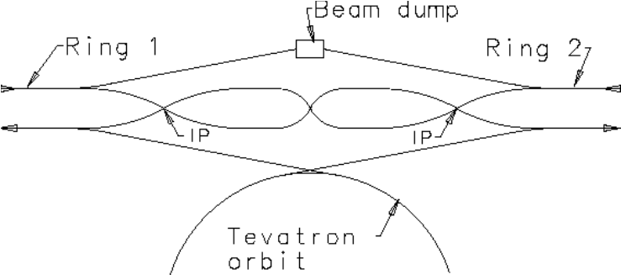

Figure 5.21. Injection and beam abort system scheme
At the end of the transfer channel, Lambertson and dipole magnets bring proton beam into position close to an appropriate ring where it moves almost parallel to the equilibrium orbit crossing it in the horizontal plane. At the location of the crossing, a kicker magnet adjusts injected beam propagation direction, so that it follows as close to the equilibrium orbit as reasonably possible. All these magnets belong to the injection system described below. The layout of the utility section that includes injection line elements is shown in Figure 5.22.
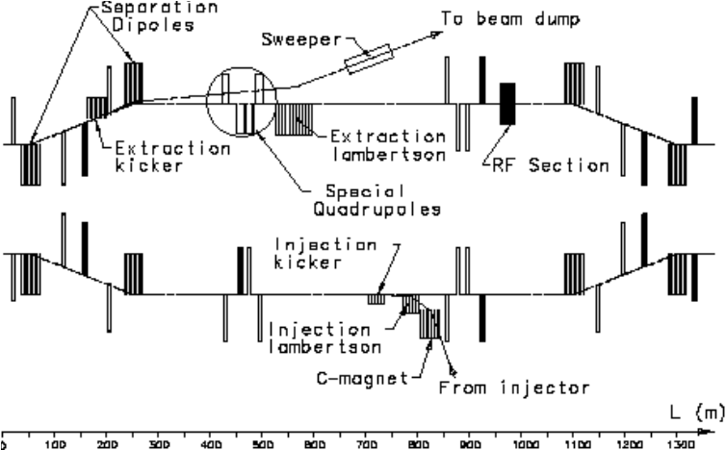

Figure 5.22. Utility straight section

5.1.5.4.1 Injection System
Thirty meters of pulsed kicker magnets with magnetic field 0.05 T provide the horizontal angular kick of 0.5 mrad to the injected beam. Horizontal beam displacement in the beginning of the kicker magnet string is 7.5 mm. The nearest lambertson with the 25-mm horizontal separation of the injected beam from the orbit is installed 35 meters before the kicker. With the magnetic field level of 0.8 T in the lambertsons, 20 m of magnets is required to achieve vertical beam separation of 53 mm. At this point, horizontal beam separation is 35 mm. Vertical angular kick provided by the lambertsons is 5.33 mrad. Beam displacement inside the lambertsons is 10 mm in the horizontal plane and 53 mm in the vertical plan. This displacement can be dealt using two types of an asymmetric lambertson configurations. Fifteen meters upstream of the lambertsons, vertical beam separation is 133 mm; this allows placing a set of dipoles with magnetic field of 0.8 T and total effective length of 36.26 m. These magnets bring beam angular kick up to 15 mrad with vertical separation 550 mm and horizontal separation 60 mm. This beam separation insures proper spacing for equipment installation. The total longitudinal space required to place injection magnets is about 135 m, that fits comfortably into the available space in the utility section. An additional set of dipoles with gap field of 0.8 T and total effective length of 56.25 m is installed to bring angular kick to the required 30 mrad value [3].
The duration of the kick provided to the injected beam is about 20 μsec and is defined by the length of the extracted from the Tevatron beam. Kicker magnetic field rise time is about 150 nsec; this defines time separation between the next two (of 72) injected batches. To allow a reasonable amount of time for the abort kicker current rise, a three-microsecond gap is arranged between the first and the last injected batches. This gap also sets requirement for the current decay time in the injection kicker. Because the kicker magnet must be rather fast, working in the MHz frequency range, it is difficult to use high magnetic field in this device. As a reliable reference field value, 0.05 T field strength is used for this study, close to that used for SSC injection system with similar pulse shape requirements [2]. The system is composed of 30 separate modules, each 1 m long. Each module is fed by an individual pulse forming network (PFN). A C-shaped magnet is made from ferrite blocks and with additional capacitors forms a twelve-cell lumped delay line with a characteristic impedance of 16.6 Ohm. The ceramic beam pipe has thin resistive coating on the inside surface, and conductive strips for image current on the outside. Table 5.11 lists the injection kicker system parameters. Equivalent PFN/kicker circuit does not differ much from the SSC [2].

Table 5.11. Injection kicker system parameters
Impedance (Ohm) | 16.6
Maximum field (T) | 0.05
Maximum current (kA) | 2.1
Maximum voltage (kV) | 70
Total length (m) | 30
Number of modules | 30
Rise time (0 to 100%) (nsec) | 150
Fall time (μsec) | 3
Injection system lambertson provides needed bending strength to steer the injected beam in the vicinity of the circulating beam. Two types of the magnets are used that differ by location of field free regions. Cross-section of one of them is shown in Figure 5.23. The magnet pole with the field free region is made of a solid piece of annealed, low carbon steel to reduce magnetic field in the field free region. To simplify vacuum problems, the pole is enclosed in a thin-wall stainless steel shell. The pole gap is fixed with the use of stainless steel spacers. For magnet excitation, conventional copper wire coils are used. Because injection cycle can be repeated not more often than about once a minute, water cooling can be omitted if injection channel magnets are on only for a short period of time. Five second cycle is accepted for this study. The main parameters of the Lambertson are summarized in Table 5.12 below.
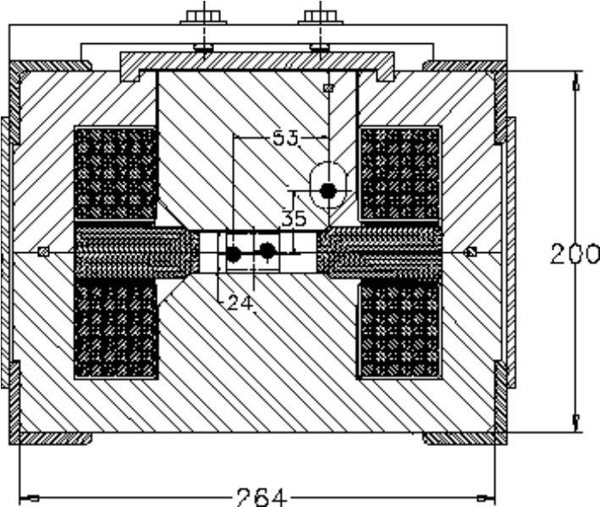

Figure 5.23. Injection Lambertson magnet

Table 5.12. Parameter list of an injection lambertson magnet
Magnetic field, T | 0.8
Pole spacing, mm | 25
Length, m | 4
Width, mm | 288
Height, mm | 260
Number of coils per winding | 2
Number of turns per coil | 42
Conductor cross section area, mm² | 42
Resistance of the winding, Ohm | 0.32
Rated current, A | 208
Voltage drop, V | 70
Maximal power consumption, kW | 15
Average power consumption, kW | 1.25
Magnet surface temperature rise, °C | 20
Transfer channel dipole magnets, that do not have field free region, have been designed using the same coil cross-section. Because pole width can be made significantly smaller, and because no vacuum shell is required for this magnet, it is even more compact, 180 x 180 mm² in cross-section, with pole gap of 25 mm and magnetic field reaching 0.8 T. The rest of the magnet parameters are very close to those shown in Table 5.12.
Besides vertically bending magnets, horizontal bending with total angle of 80 mrad (not completely justified at the moment) is required in the transfer channel. This bend can also be made using the magnets of the same type. Total magnet string length required for this bend in both transfer lines is about 300 m.
For this study, conventional magnets have been chosen to establish a reference point for a future research work with the goal of building the transfer channel using only permanent magnet based equipment. Although this technique is well studied during fabrication of the Fermilab Recycler Ring, requirement of having adjusted bending and focusing strength makes it difficult to use the system cost scaling without making first a thorough design study of this approach. An encouraging approach to this study has been undertaken in [3].
There are 86 quadrupoles installed in the transfer channels, most of them having integrated gradient of 40 T. With quadrupole gradient of 40 T/m, length of the quadrupoles is 1 m. Using design similar to described in chapter 5.1.5.1, and intermittent powering with only about 0.8 kW of maximal power per a lens, we can employ air cooling that results in about 10 °C of magnet surface temperature rise.

5.1.5.4.2 Beam Abort System
The abort magnet system consists of a kicker magnet, lambertson, and a beam sweeper. Beam normally goes through the field free area of the lambertson magnet. Whenever it is necessary to dump the beam, kicker magnet provides needed radial kick to beam, and the beam is bent by the lambertson in vertical direction into a beam dump channel equipped with a beam sweeper. At each moment, magnetic field of the kicker, lambertson and sweep-magnet must be related to the beam energy. On its way from the kicker to the Lambertson, the beam that must pass through the set of quadrupoles as shown in Figure 5.22, acquires a radial displacement of 17 mm, making it impossible to use a regular focusing quadrupole described earlier in section 5.1.5.1. Special quadrupole with enlarged horizontal aperture has been designed for this area. For this quadrupole, lower field gradient (of about 45 T/m) can be achieved, and longer quadrupole lengths are required for beam focusing. A longer quadrupole results in higher power consumption and cooling water temperature rise. Using two 5-meter quadrupoles instead of one 10-meter, it is possible to have a lower water temperature rise at the expense of higher total water flux. Table 5.13 summarizes the major abort quadrupole parameters.

Table 5.13. Main Parameters of the special quadrupole
Gradient, T/m | 45
Aperture radius, mm | 20
Quadrupole width, mm | 260
Quadrupole height, mm | 260
Length, m | 5
Number of coils per winding | 4
Number of turns per coil | 12
Conductor size, mm | 11.7x11.7
Conductor cross section area, mm² | 104
Resistance of the winding, ohms | 0.091
Rated current, A | 625
Voltage drop, V | 61
Power consumption, kW | 38
Hole diameter, mm | 6.35
Water pressure drop, MPa | 1
Cooling circuits per winding | 8
Water temperature rise (deg. C) | 16
Water flow per magnet (l/min) | 35
Eight 5-meter quadrupoles are then to be installed in each of the two abort sections.
Kicker magnet switches the beam between the ring orbit and the abort channel; its strength is chosen to provide needed beam separation of 17 mm at the entrance to the abort lambertson located 300 m downstream. Assuming kicker field strength of 0.2 T, required length of a kicker is 30 m. Cross-section of the kicker is shown in Figure 5.24.

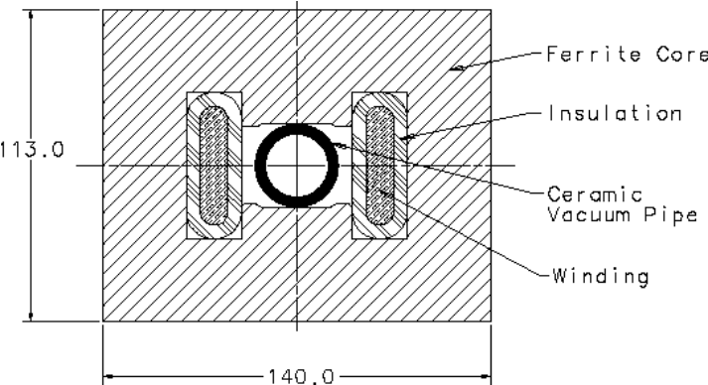

Figure 5.24. Abort System Kicker Magnet
Current rise time of injection kicker is about 3 μsec, so a beam abort gap in the ring beam of about 3 μsec is needed. This requirement results in using a high frequency magnetic material for magnet core fabrication. Mn-Zn MN8CX (Ceramic Magnetics) ferrite was chosen for this study. The core is made of ferrite blocks and assembled using epoxy bonding after windings and ceramic vacuum pipe are installed inside. At nominal field of 0.2 T, windings current is 2410 A. Maximal field in the core is about 0.45 T, which is below the material saturation level. Pole width was optimized using pole profiling by attaching 1-mm ferrite stripes near the pole wedges. With this shaping, field uniformity in the entire vacuum pipe region is within 0.1 %, which is good enough for this device. In the configuration shown, magnet inductance is 2.5 μH/m. Ten 3-m sections are used, installed one following another, with each section having 7.5 μH inductance and 2.5 ohm resistance. Each section is fed independently by its own pulser.
The abort kicker pulser uses a two-stage scheme. The first stage delivers high voltage for a fast current rise time. Capacitor discharge is used at this stage. Then, in the second stage, a long SCR-regulated pulse with much lower voltage is used to support needed flat top level. For the three-meter section, discharge capacitor with C = 0.5 μF insures needed current rise rate. This results in the maximal voltage at the first stage of 9600 V. Energy stored in the capacitor bank or in the magnetic field is about 25 J. Flat top length for the abort kicker magnet is defined by the ring circumference and is about 800 μsec. To have this long pulse shape, a separate power source must be switched on when current in the primary circuit starts to decay. Because this is a typical long-pulse pulser implementation (see, for example, [2]), we will not go into further details.
Lambertson magnet uses superconducting transmission line as an excitation winding. This ensures that at each moment magnetic field is proportional to the beam energy. The magnet cross-section is shown in Figure 5.25. The magnet part that includes field free beam channels is placed inside a stainless steel vacuum box. Only one field free channel is used in this device; another channel has been added to obtain needed symmetry. Magnetic field in the field free area limits the maximum field in Lambertson magnet. The deflecting gap field value of 0.8 T was chosen to have field in the field free region on the level of 20 Gauss. The 67 m total length of the Lambertson gives the beam a kick of 0.8 mrad that results in at least 200 mm of beam separation at the location of the RF cavities. Force applied to the transmission line is about 25 kg/m for this magnet.
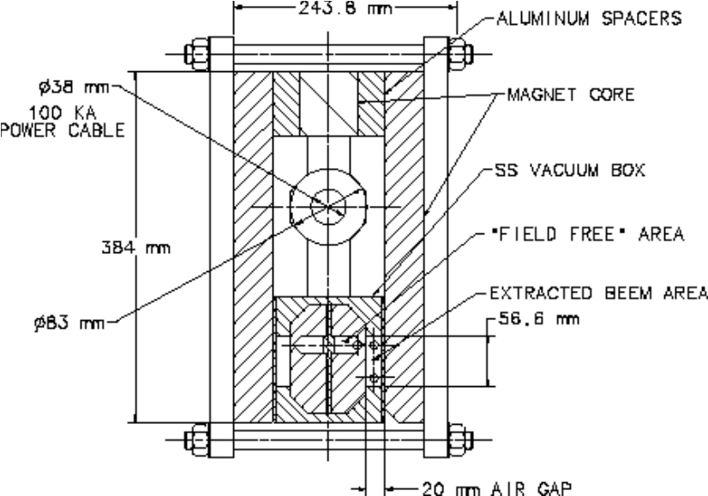

Figure 5.25. Lambertson magnet

Main parameters of the Lambertson are summarized in Table 5.14 below.

Table 5.14. Main Parameters of abort system Lambertson Magnet
Maximum field, T | 0.8
Total length, m | 67
Air gap, mm | 20
Field homogeneity, % | 0.1
Maximum field in the hole, Gauss | 20
Maximum current, kA | 100
Weight, kg/m | 330
Sweeping system is introduced to reduce heating of the dump block by distribution of beam energy through a larger dump surface area. Although reliability of this sweeping system must be high, the field quality requirements for sweeping magnets can be quite modest, allowing about 10% of field uniformity in the sweeping magnets. Sweeping magnets deflect beam in X and Y direction with amplitude that corresponds to beam striking the dump block at a location close to its radial dimension. If phase difference between X and Y oscillations is 90°, beam projection on the dump surface will move along a circular path. The velocity of this movement must be high enough to allow beam circling around the block at least twice during the extraction time, ~800 μsec. This requires about 2 kHz of beam oscillation frequency. Required magnetic strength of the sweeping magnets must be about 12 T⋅m in each direction. 0.3 T of field strength was chosen for this device, resulting in 40 m magnet. Taking into account possible steering mistakes due to kicker malfunction and larger beam size in cases of emergency extraction, required aperure must be about 50 mm. To make the system simple and reliable, the two steering systems are combined in a single unit, as shown in Figure 5.26. Field uniformity in this magnet is at an acceptable level of about 5% at reference radius of 15 mm. Positive sextupole component in the whole aperture results in additional beam defocusing on the target. Magnet yoke is made of standard toroidal iron powder cores T520-40D by Micrometals. Core effective permeability is 60 to 150 in the frequency range up to 100 kHz and in the flux density range up to 1 T.
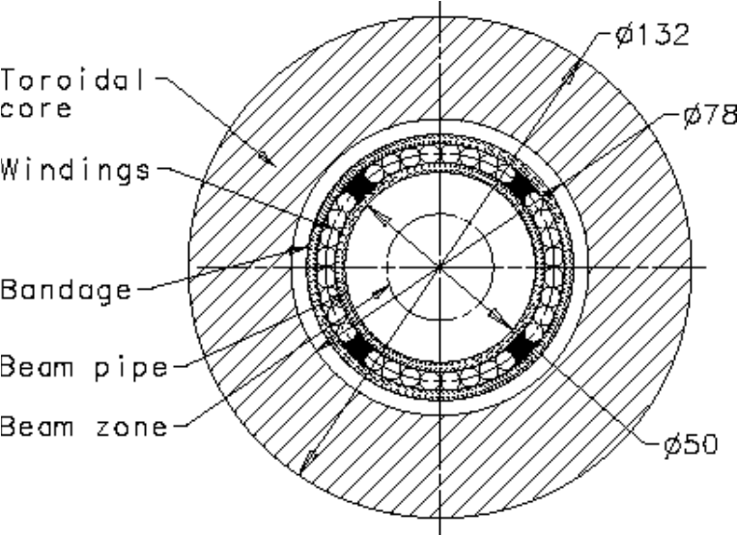

Figure 5.26. Sweeping magnet cross-section.
Main parameters of the magnet are summarized in Table 5.15.

Table 5.15. Sweeping Magnet Parameters
Parameter | Unit | Value
Magnetic field | T | 0.3
Magnet length | m | 40
Maximum field in the core | T | 0.45
Stored energy / meter | J/m | 160
Number of turns |  | 2 x 8
Wire diameter | mm | 5
Maximum current | A | 2000
Inductance | μH | 2 x 80
For safety reason, sweeping magnet is made of 10 separate 4-m sections powered by independent pulsers. Simultaneous failure of two sections, which is a very low probability event, does not compromize safety of the unit. For each section, current in the magnet windings is supplied by a simple pulser that utilizes capacitor bank discharge onto the windings. For each 4-meter section, capacitance required to have oscillation frequency of 2000 Hz is about 20 μF. With circuit impedance of 4 Ohm and resistance of windings at 2000 Hz of about 0.1 Ohm, one can expect periodic discharge with a rather low rate of current decay. Adding some resistance to the circuit, it is possible to adjust decay rate to a desirable value to ensure a better beam current distribution through the dump block surface. Maximal voltage is about 8000 V, requiring about 12000 V of windings and capacitor bank insulation rating because high reliability of the system is required. This voltage and current level, and also relatively low frequency, allow using very reliable semiconducting switching devices like SCRs, and besides can allow a reserve.
Depending on the final dump block position, certain amount of vertically and horizontally bending dipoles located between the lambertson and the sweeping magnet may be wanted. Because the magnetic field of these magnets must follow particle energy, conventional dipoles must be considered for this purpose with maximal gap field of about 1.5 T. For each 1 mrad of bending, 45 meters of dipoles are required then. That's why nominal position of the dump must be chosed to avoid an additional beam stearing, after the beam is out of the lambertson magnet string.
Summary.
- Lattice arrangements in straight sections allow placement of sets of magnets for beam injection, abort, IR, and cross-over systems;
- Feasible design solutions have been found for major systems;
- Magnets located in straight sections can be made using conventional magnet fabrication technology.

References: { note—for Sec. 5.1.5 }
[1] V.V. Kashikhin, I. Terechkine. "Superconducting straight section quadrupole magnet for low-field VLHC", FNAL, TD-01-008, Feb. 2001.
[2] Conceptual design of the Superconducting Super Collider. SSC-SR-2020, DE93 007234.
[3] J. Volk, Injection transfer line magnets. TD note # TD-01-027, FNAL, 2001

5.1.6 Magnet Production
Construction of the VLHC Stage 1 accelerator will require the fabrication of several thousand magnets. The largest and most numerous of these are the combined function arc magnets. They, along with the dispersion suppressor dipoles, represent the majority of magnet costs. They are also the most technically challenging as they are a significant departure from existing magnet technology and, because of their extreme length, require unique assembly procedures and facilities. All of the other required magnets are variations of magnets previously produced for other accelerators. They do not present any significant technical challenge, as fabrication methods are well understood and a broad experience base exists at various facilities within the labs and in private industry. A breakdown of magnet type and quantities is shown in Table 5.16.

Table 5.16. Magnets required for the VLHC Stage 1.
Magnet Type | Physical Length, m | Quantity Required
Main Arc Dipole | 67.75 | 3136
Dispersion Suppressor Dipole | 48.8 | 160
Straight Section Quadrupole | 6.0 | 464
Quadrupole, Large Aperture | 10.0 | 10
Low Beta Quadrupole | 10.0 | 8
Special Magnets | Various | Various
Dipole Corrector | 0.7 | 3296
Quadrupole Corrector | 0.7 | 3296
Sextupole Corrector | 1.0 | 3296
The extreme length of the combined function and dispersion suppressor dipole magnets makes the fabrication process unique. The obvious problems associated with the transport of these long devices make it necessary to assemble the magnets on site at assembly facilities strategically located to facilitate delivery of the completed and tested magnets directly to the accelerator tunnel. Two production facilities are envisioned. One facility will be located adjacent to the injection transfer line with the other remotely located on the opposite side of the ring.
The facilities are considered assembly centers rather than manufacturing sites. The magnet components will be fabricated off site at subcontractor facilities to the highest level of completeness (value added) possible, considering that the components will need to be transported to the final assembly site. Constraints have been applied to the maximum length of component parts and subassemblies so as not to prohibit fabrication at remote locations around the country or overseas. Twelve meters was chosen, as it is the standard for shipboard containers and can easily be trucked over roadways without the need for special permits and vehicles. The on site assembly facilities will do only that work that cannot be done off site given the above constraints. Magnet fabrication is projected to take place over approximately six-years.
In any large-scale production program, a thorough quality assurance program must be carried out during all stages of manufacture. Inspection of parts upon receipt, testing of components where needed, and statistical sampling techniques will be employed to ensure that specifications are met. Warm magnetic measurements will be performed on all magnets as part of the QA program. Cold tests will be performed on all of the initial, low rate arc dipole production magnets and will continue during full production at rates determined by the test capacity. A discussion of magnet measurement and testing can be found in section 5.1.7.
In this section we will concentrate on fabrication of the arc dipoles: they are a cost driver and present some unique requirements, including the superconducting transmission line. The facilities design, dominated by the 65m length of the final magnet assemblies, is discussed first. Factory throughput, labor required, and fabrication details associated with the arc dipole magnet are then proposed. Fabrication of the iron and structural assembly is discussed as well. Costs and schedules are covered elsewhere.

5.1.6.1 Production Facilities
The fabrication of the transmission line magnets (combined function and dispersion suppressor dipole) takes place in two separate custom facilities each with an approximate size of 210 meters by 140 meters. A floor plan of the building is shown in Figure 5.27. Each facility has three distinct areas; 1) component storage, 2) assembly and test, 3) storage and staging into tunnel.
Component storage: The facility will be used as the terminus for components fabricated off site. These components range from 12-meter long iron core subassemblies to individual small parts. The space is sufficient to house stock for at least three months of production. In addition to bulk storage, space is allocated for staging (kitting) components at the various assembly area stations.
Assembly and test area: The bulk of the facility is dedicated to magnet assembly. There are fourteen “areas”, each devoted to a specific step in the fabrication process. Each fabrication area includes one or more stations needed to achieve the required throughput for specific operation. Each area will work autonomously and have the capability of locally storing one week’s production. The facility will be manned 24 hours per day (three shifts) five days per week. Two shifts (shifts 2 and 3) will do production at the assembly stations. One shift (shift 1) will be used exclusively to move product between the various stations, stage components at the stations and provide routine maintenance. The output of each facility is one magnet per day. Table 5.17 lists each area, its function, number of stations required, and a list of the tooling necessary to accomplish the stated function. A more detailed description of the tooling necessary is included in reference [1].
The factory will have special handling requirements. Since the magnets and their subassemblies are 65 meters long, and will need to be transported laterally between areas, no columns can be located within the primary assembly area. A custom hoist system is required to lift and transport the long subassemblies between the various assembly area stations. Storage areas, associated with each assembly area, will be needed to house finished subassemblies before moving to the next higher-level assembly area. Most stations will require a staging area where the various component parts for the day’s production are marshaled. Figure 5.28 shows, schematically, an elevation of a section of the plant, showing the workstations in nine areas.

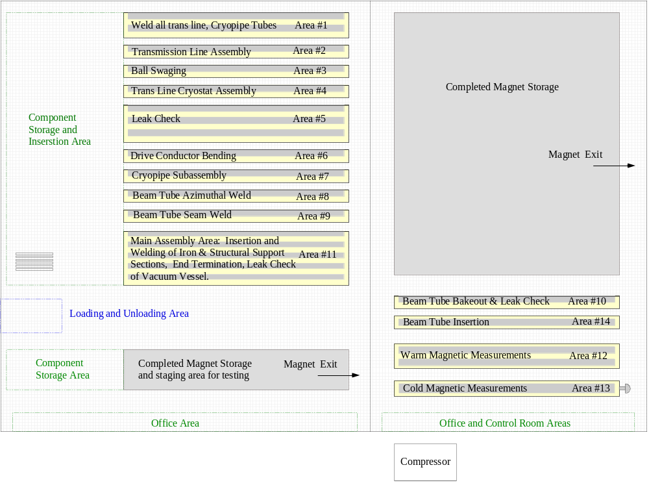

Figure 5.27. Transmission Line Magnet Assembly Factory Floor Plan
Storing and staging into tunnel: the completed and tested magnets will be stored until they need to be transported into the tunnel. Magnet installation in the tunnel is expected to take place at a peak rate of 4 magnets per day, significantly faster rate than the production rate. Consequently, space has been allocated to allow a sufficient number of completed magnets to be stored in preparation for installation. Support stands will allow the magnets to be stacked vertically. A custom hoist system (described previously under assembly and test area) will move the magnets from the test stand to the storage space. An area is provided to allow transfer from the storage area to a specially built transporter rig (see section 5.1.8).

Table 5.17. Assembly area and tooling summary
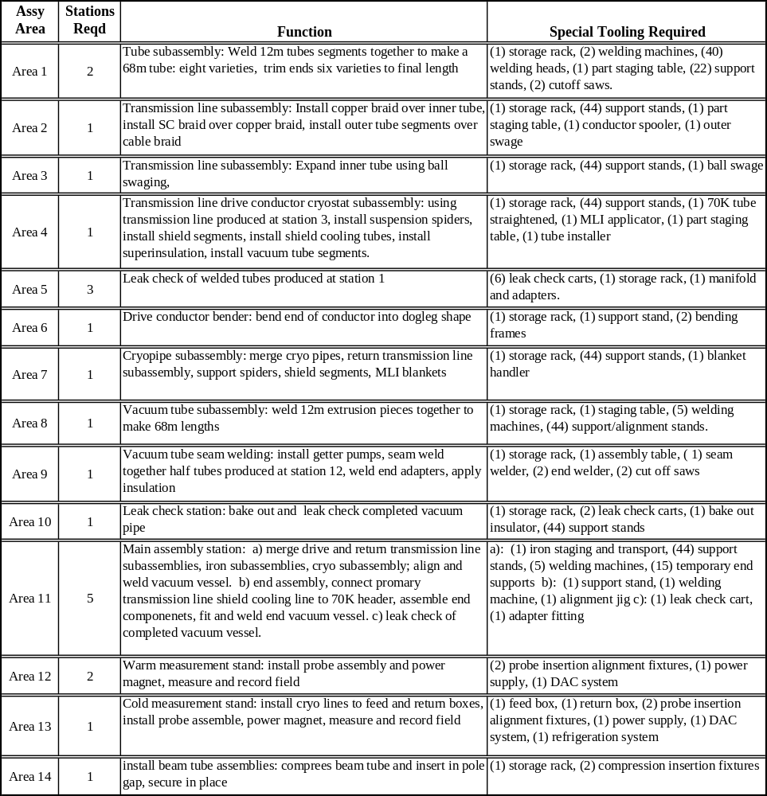

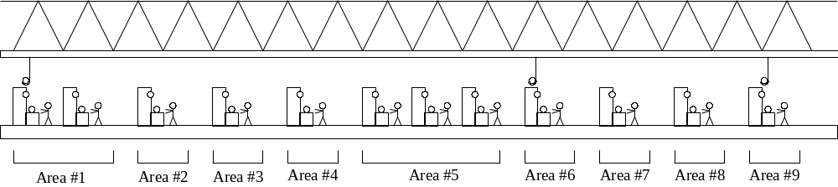

Figure 5.28. Transmission Line Magnet Assembly Factory Elevation

5.1.6.2 Factory Throughput
Each magnet construction factory is designed to produce one magnet per day, accomplished in approximately 2 shifts. As with any normal production scenario, initial throughput would be much lower than one magnet per day, with the schedule eventually increasing to reach the peak production levels.
Table 5.18 lists, for each area, the number of technicians and times necessary to accomplish each operation, the number of technician-hours required per day to manufacture one magnet, and the number of stations needed in each area to complete the required tasks. All activities shown in Table 5.18 are accomplished in two, 8 hour shifts per day.
Reference [2] shows detailed schedules for each sub-assembly manufactured for the transmission line magnet, with a breakdown of times elapsed for each individual operation described in section 5.1.6.3. “Throughput” schedules for each work area are also shown.

Table 5.18. Technician resources required to produce one magnet per day.
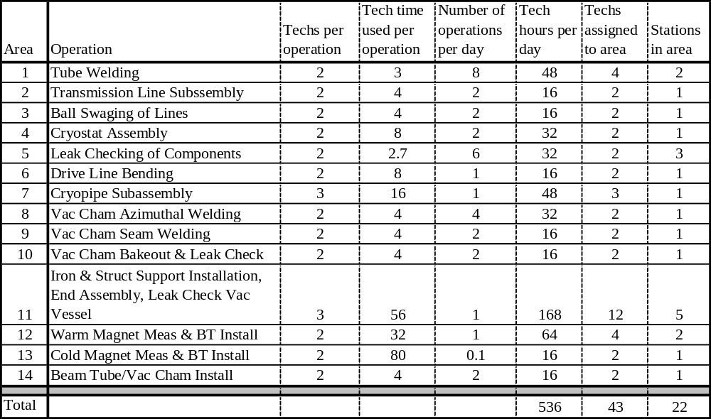

At the end of each day, enough components or subassemblies are completed in each area to produce one magnet. The subassemblies are stored on a rack near each station after they are completed. A third shift is used to move the components to the appropriate area of operation for the next day’s work. Maintenance of tooling is also done on the third shift or weekends. Table 5.18 does not include these third shift activities.

5.1.6.3 Magnet Assembly
Assembly of the arc dipole magnet for the VLHC Stage 1 accelerator is summarized in this section. It is described in more detail in reference [1].

A. Assembly of Drive Transmission Line for Stage 1. VLHC
The transmission line consists of four components made by outside vendors: inner tube sections, a superconducting braid, a copper braid, and outer tube sections.
Mount 6, 12-meter long invar pipes together into one continuous section at Area #1. Weld using automatic rotary welding heads, and inspect mechanically. Tooling pulls the copper and superconducting braids over the invar tube at Area #2. The outer tube is fed, in 12-meter sections, over the assembly, then returned to Area #1 to be welded, then leak checked at Area #5. The welded transmission line is moved to Area #3 for ball swaging. 3 carbide balls, each of increasing diameter, are pulled through the inner tube, swaging out the diameter and compressing the braid between the two tubes. The line is moved to Area #4 for the cryostat assembly. Support rings and aluminum thermal shield sections are automatically fed onto the transmission line from the end. Trace tubes for 60K helium are installed on the sides. 30 layers of superinsulation are individually spiral wrapped onto the shield, while the cryostat rotates on the assembly table. Tooling punches holes in the insulation as it is being wrapped, to accept the penetrations from the support rings. The extruded aluminum vacuum jacket is then fed over the insulated assembly in 12-meter sections, returned to Area #1 and welded, then leak checked at Area #5. The end of the drive conductor is bent into a dogleg shape at Area #6. It is then moved to storage to wait for installation into the iron at Area #11.
Assembly of the transmission line will require somewhat complex tooling, which must perform seven types of automatic processes; automatic rotary welding, feeding parts longitudinally onto pipes, pulling copper and superconducting braid onto pipes, installing trace tubes, pulling carbide balls through the assembly to swage the inside diameter, and bending the line into the dogleg shape. Pictorial representations of each of these processes are shown in reference [1].

B. Assembly of the Return Transmission Line
The return transmission line design is similar to the drive transmission line, except a slightly larger size. The return transmission line is not surrounded by an individual cryostat, as was the drive line. Instead, it is included in the cryopipe assembly. Fabrication scenario is identical to that given for the drive assembly, excluding the cryostat.

C. Fabrication of Cryopipe Assembly
Weld the 6.5K flow return pipes, the 40K shield supply header, and the 70K shield return header pipes together longitudinally in Area #1, and leak check in Area #5. Transport the three pipes, together with the Return Transmission line, to the assembly station Area #7 [1]. Mount and align the four pipes. Feed 34 spiders over the pipes, spaced every two meters. Attach shield sections. They are each two meters long, and will clip on between each spider. Attach braids to intercepts from 4.5K with connection to 6.5K. Apply superinsulation. Inspect, and transport to storage area.

D. Installation of iron and structural support over the cryopipe assembly and transmission lines.
At Area #11 the Transport Drive Transmission Line and Cryopipe Assembly are positioned in space using special tooling. The 12 meter long Iron and Structural support subassemblies slide over the prepositioned drive line and cryopipe assemblies, are positioned and attached.
When installed, the transmission line, complete with cryostat, needs to be positioned with an accuracy of +/- ½ mm with respect to the iron laminations. This will be accomplished by using a series of steel balls, which will contact the outside surface of the transmission line cryostat and fit into pockets stamped into the iron laminations. The balls, cryostat, and iron laminations can easily be manufactured to a tolerance acceptable to accomplish the accuracy necessary between the transmission line and the iron. The specific tooling and procedure still need to be developed, since this process was not used on the initial prototype.
Welds are then made at each junction between the magnet support tubes (vacuum vessel). The vacuum vessel is leak checked, and the entire assembly is inspected.

It is presumed that the iron and structural support subassembly, including vacuum vessel, will be prefabricated in industry and supplied to the final assembly site for assembly in the 65M long magnet. As the accuracy of lamination profile and stackup are paramount in achieving the design parameters some discussion is warranted.
The pole tip profile is required to be reproducible to within 20 microns. This tolerance is certainly not achievable for all features of the stamped laminations. Manufacturing experience indicates, however, that it is possible for the limited range over which the pole is defined. The laminations are to be stacked directly on the base datum feature for the profile. This minimizes the tolerance buildup due to the stacking operation. The design of the core assembly tie bars and welding of the spacer bars to the laminations draw the laminations toward the reference datum from which the profile is defined, assuring that the basic dimension is maintained accurately.

The internal welding of the spacer bars to the laminations poses some unique problems associated with physically fitting the required automated welding equipment within the small space. Equipment will need to be designed that fits within the limited space. A properly designed apparatus will produce very repeatable results.

E. End Assembly
Still at Area #11, connect drive transmission line shield cooling line to 70K header. Assemble end components. Fit up and weld end vacuum vessel. Leak check completed vacuum vessel.

F. Assembly of the beam tube and vacuum pumping chamber
Start at Area #8. Beam Tube sections are received in 12-meter long extrusions. Two pieces must be seam welded together to make the final assembly [1]. Inner and outer pieces are butt welded together into 68-meter long sections. Welds and interior surface quality is inspected, while the assembly is still in two pieces. Getter pumps are installed into outer piece. Then beam tube halves are connected and seam welded longitudinally at Area #9. Leak check and beam tube bake out takes place at Area #10.

G. Measurement of the magnetic field of the assembly.
All magnets are measured magnetically: warm measurements will be performed on all magnets while cold testing will be limited to a fraction of the total production. Measurements must be done before the beam tube and vacuum pumping chamber is installed, because the test probe must be placed in the area occupied by the beam tube. Separate stations are used for warm and cold testing and appropriate space has been allocated in the facilities layout. A key concern is isolation of the measurement area from sources of electrical noise which are typically welding, electric motors, etc. The testing operation takes approximately 30 hours for a warm test and 70-80 hours for a cold test. More details on measurements and testing follow in Section 5.1.7.

H. Installation of the beam tube and vacuum pumping chamber
Beam Tube Assemblies are mounted onto Structural Support and installed from the sides at Area #14. On half the assemblies, the beam tube must be “sprung” into position, but then will stay in position after being installed. On the other half, they will slide into position easily, but will need to be secured afterward. The completed magnet is then transported to the storage area to await installation into the tunnel.

References
[1] J. Carson, R. Bossert, "A Proposed Production Procedure for Stage 1 Transmission Line Magnets", TD-01-028, 2001.
[2] J. Carson, R. Bossert, "Throughput for Stage 1 Transmission Line Factory", TD-01-029, 2001.

5.1.7 Magnetic Measurements and Testing
In this section, we focus discussion on testing of the combined function magnets during production since these magnets are the dominant element of the Stage 1 machine. No doubt measurement and testing of other magnetic elements in the ring are necessary, but most of these are of more conventional design which can be accommodated by existing equipment and approaches. Also because of their length and small bore, the combined function magnets are the most difficult to measure.
Unlike ‘conventional’ superconducting magnets, the conductor of the combined function magnets (transmission line) is not in a high field region and quench ‘training’ is not a significant issue for magnet performance. Thus magnetic field measurements dominate the magnet testing process, both as a quality control measure and as characterization necessary for machine operation.
Field measurements will be performed on all magnets. This must be done before the beam tube and vacuum pumping chamber is installed, because the test probe must be placed in the area occupied by the beam tube. Roughly 10% of magnets will be measured with the transmission line cooled to cryogenic temperatures allowing characterization of the field to full current. The remainder will be measured with the transmission line at room temperature. During initial stages of production when the fabrication rate is lower, we will cold test all magnets. As rates approach one magnet per day, the fraction of total magnets cold tested will be determined by test facility capacity and test needs as indicated by initial results.

We first discuss a conceptual design for a measurement system to be used for the combined function magnets. We then follow with a brief overview of the approach to cold testing and conclude with a few remarks on other test and measurement considerations.

5.1.7.1 Measurement System
As described above, magnetic measurements are the primary concern of the test program. While one would also expect to perform an extensive series of measurements, possibly using several measurement techniques, during the R&D phase of magnet development, here we have chosen to present one concept for measurements of production magnets. This concept utilizes a rotating coil. We try to define the most important issues related to this concept and examine the consequences. A brief discussion of other approaches follows.
The main parameters of the arc dipole magnets are ~2 T field, ≤12% horizontal gradient, 65 m length, and 20 mm gap. Measurement of the integrated dipole field is needed with an accuracy of a few parts in 10⁴. Desired measurement accuracy for the higher order harmonics is 0.1 units. We begin by examining the implications of requirements for field strength measurements. Based on this discussion we present a concept for a measurement system. Given this system we then address the issue of measurement of field harmonics.
With respect to measurement of the integrated field strength, there are two issues. The fractional accuracy of the measured field goes as ΔR/R where R is the radius of the rotating coil [1]. This requires that the radius of the probe be known with high accuracy. Typical manufacturing and measurement uncertainty for magnetic measurement apparatus is ~0.001 inch (25 μm) which translates into a field error of 3e-3 for a probe of 10 mm maximum radius. At least an order of magnitude greater precision (3e-4 strength error) is required. This level of precision can only be achieved using a calibration magnet in which the strength is known at least as well as one need know it in the subject magnets. The second issue is unique to measurement of combined function magnets. Due to the horizontal field gradient, an error in the horizontal position of the probe translates into an error in measured field strength. In a magnet with 10% gradient, measurement of the strength to 1 part in 10⁴ requires positioning the probe with 0.1 mm accuracy. Although difficult, this can be achieved using mechanical fixtures referencing to the magnet laminations. Vertical placement of the probe is not as critical.
The main conclusions from the preceding discussion are that (1) a rotating coil of the size we are considering can be calibrated with sufficient precision, and (2) that the horizontal position of the probe can be set with mechanical fixtures. For reasons we list below, we choose to insert the rotating probe into the aperture from the side rather than from the end. The probe is supported on a frame attached to the magnet as shown in Figure 5.29. Principle elements of the design are the following:
- The probe body is clamped to a precisely machined fixture (‘strong-back’) on an edge which describes the magnet sagitta.
- The strong-back slides horizontally in a series of guide brackets (‘jaws ’) attached to the vertical member of the frame. The strong-back is spring loaded so that it and the probe are forced against the magnet laminations at the edge of the magnet gap, referencing the horizontal probe position with respect to the laminations.
- The vertical position of the probe is defined by the precision with which the frame is attached to the magnet and the precision of the jaws relative to the vertical member of the frame and the horizontal surfaces of the strong-back. A tilt sensor is mounted on the strong-back to monitor its alignment.
- The motor for rotation and encoder for probe angle readout are mounted on the frame and connected to the probe by a mechanism such as a toothed belt or right angle drive. Other drive components could also be mounted outside the magnet bore (e.g. gearboxes).
- Development of slip rings small enough to fit the probe bore is assumed although one might choose to digitize and transmit the signals from inside the bore. A pre-amplifier circuit sized to fit the bore is also assumed allowing a boost in signal size.

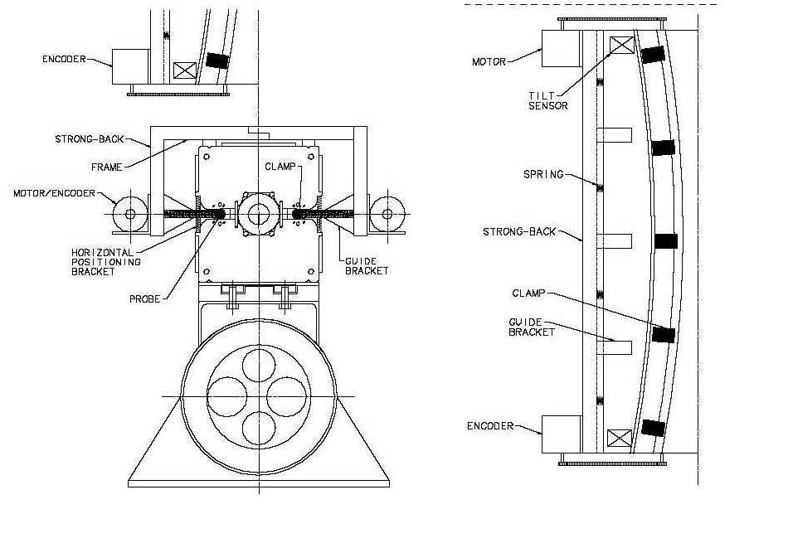

Figure 5.29. Measurement Fixture. Note that the magnet sagitta is highly exaggerated.
A consequence of insertion from the side is that one loses a few extra mm of probe radius due to the reduction in gap at the magnet edge of the focusing magnet. One also needs to allow space for the clamps holding the probe to the strong-back and for clearance during insertion.
Given a probe radius, we need to examine the accuracy of the measurement of field harmonics. From [1] we see that probe calibration matters little in measuring harmonics. Accuracy of 10% or so is adequate. This requires knowing the probe radius to 10e-3. What is of greater interest is the evaluation of the interplay of signal size with harmonic measurement. This has implications for the required level of excitation current during test. For a reasonable set of probe parameters, pre-amplifier gain of 100, measurement accuracy of 0.1 unit through n=9 requires at least 200 A excitation current [1]. This should be possible for room temperature measurements. We would no doubt increase the gain and run at the highest tolerable current for increased accuracy.
A probe length of 6.5 m was assumed above. Ten measurements are then required to construct the integral field. The time required for measurement is estimated as 2.5 hours with 2 crews of 3 technicians using 4 sets of measurement apparatus [1]. This certainly allows for the required production throughput. Automation and optimization of procedures will reduce the time required. We also note that the apparatus described could be used for either warm or cold measurements. The only special consideration for cold measurements would be to construct the strong-back of a nonmetallic material to prevent the formation of eddy currents during ramping.
We have chosen a probe inserted in the magnet bore from the side and supported by an external frame. An alternative approach would be a "mole", such as have been developed for measurements of SSC [2] and LHC magnets [3] which are probes with drive and angular alignment systems built in. The obvious advantage of this approach is that the probe can be larger by as much as 25% as insertion is from the magnet end rather than the side. A larger probe produces larger signals. However, development of drive apparatus operating in a strong magnetic field is neither trivial nor cheap. We have no doubt that this could be done; however, we have chosen a simpler approach that removes elements of the measurement system other than slip rings and pre-amplifiers from the bore accepting as a consequence somewhat smaller signals.

5.1.7.2 Cold Testing
As a quality control measure and to characterize the magnetic field of a sample of the magnets to full current, we plan to cold test at least 10% of produced magnets. The peak rate of 2 magnets built per day requires 1 magnet cold test per week. As discussed in the introduction, quench training is not a significant issue for the superferric design employed. However, it is important to have a full set of field measurements of magnets produced early in the program to check the overall design, iron saturation, yoke fabrication, and related effects on the field quality and transfer function. This increased testing also produces a statistically significant warm-cold correlation for the field harmonics. As the production rate rises, measurements check mechanical properties of the magnets as well as properties of the materials used to build them; and the set of measurements can be reduced to those necessary for quality assurance.
The cold parts of the magnet are the transmission line and return bus and their relatively small cryostat. Refrigeration requirements are modest; cool down and warm up times, short. The associated test equipment – cryogenic end boxes, transfer lines, pumps, and refrigerators – is simple and inexpensive when compared to facilities developed for testing ‘conventional’ superconducting magnets. Cold testing can be done in a small area in the production facility in conjunction with warm measurements rather than in a large, separate cold test laboratory. The actual time spent in hooking up, cooling down, testing, warming up, and disconnecting the magnet is small when compared with conventional superconducting magnets. A peak production cold test cycle occupying the test stand for one five day week would allocate a two shift day to each of these tasks: installation and connection of the magnet on the stand, cool down, testing, warm up, removal.

5.1.7.3 Other Testing Considerations
One of the difficult issues in design and construction of a magnet system of the scale proposed is the understanding of its overall reliability. Failure rates for the magnets must be very small if collider availability is to be kept at the level necessary to carry out the physics program. Determining failure rate is itself a difficult task as it is unrealistic to plan for the number of tests necessary to ‘prove’ that the magnets as constructed will meet the lifetime reliability requirements for the collider (even assuming that we could agree on a ‘proof’.) However, since the iron yoke design and peak fields are similar to conventional magnet designs in use for decades, we do not envision reliability problems here. Key components will be subjected to ‘lifetime’ testing – equivalent magnetic and thermal cycles (if appropriate) –to verify that they meet requirements. While it is impossible to argue the statistical validity of a small sample of test magnets, accelerated life testing of a few early magnets will be used to validate design and provide feedback early in production should any degradation in performance be detected.

References {note – for sec. 5.1.7}
[1] P. Schlabach, "Magnetic Measurements during Production of VLHC Low Field Combined Function Magnets" TD-01-007, 2001.
[2] G. Ganetis, et al., "Field Measuring Probe for SSC Magnets", Particle Accelerator Conference, 1987.
[3] L. Walkiers, "Measurements for the Acceptance Tests of the LHC Superconducting Magnets', Eleventh International Magnet Measurement Workshop, 1999.

5.1.8 Magnet Installation
More than three thousand 67.75-m super-ferric magnets must be installed in the arcs of the two 240-km accelerator rings. Besides, about 1000 conventional magnets are to be installed in the 10 straight sections and in the two transfer channels (see part 5.1.5) The scale of this work will require technique that ensures high quality of the installation resulting in high reliability of the accelerators' magnetic system. The next baseline scenario was accepted for the magnet installation:
- transmission line and vacuum pipe are embedded into each magnet at the fabrication stage;
- magnets are transported into the accelerator tunnel one-by-one and installed onto aligned adjustable support stands;
- needed interconnections are made for transmission line, cryo-pipes, and for the beam pipes;
- electric network cross-check, high-pot test, and vacuum leak check are performed after each half-cell is assembled;
- cryo-check and current load test is performed after each 20-km magnet string is assembled;
- corrector magnets are installed and needed beam pipe interconnections are made;
- final magnet alignment is performed.
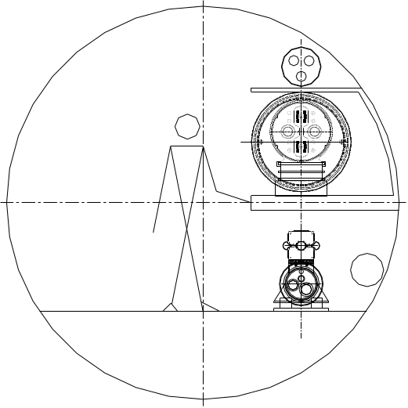
Tunnel (or tunnel section) construction is considered completed when no mud removal traffic is going through the tunnel section, when finished, dry and ventilated tunnel allows transport vehicles traffic, when escape egresses are available, and when light, environmental safety monitor, and power lines for transport vehicles are mounted. Because at the second stage High Field Ring will modify tunnel layout, while planning all of the mentioned above works, we must consider this future collider upgrade so that installed equipment wouldn't make this upgrade too complicated. Tunnel cross section with both Low Field and High Field accelerators installed is shown in Figure 5.30.

Figure 5.30. Tunnel cross-section after the stage-2 upgrade.
Before magnet installation, cable and LCW racks must be mounted, and needed cabling completed. For magnet installation, horizontal and vertical survey monuments must be embedded into the tunnel wall and concrete floor to the predetermined accuracy, and magnet support stands installed and aligned to the accuracy of ± 1 mm in vertical direction and in horizontal plane.
Magnet installation schedule, number of working crews and number of members in each crew will be defined to accomplish the job during the 3-4 year term. At least two access points at the opposite sides of the ring are required. The simplest magnet delivery scenario can be realized when assembly starts from the middles of the half-arcs connecting Fermilab site and Far End site and goes to four direction simultaneously. If magnet replacement is required after the magnet string is installed, more complicated scheme must be used. In this case magnet traffic will go down the tunnel with already installed magnets, and additional measures must be taken to allow parallel work of an assembly crew. The magnet installation procedure in this case also is more complicated because it requires magnet movement across the tunnel.
During installation, the magnet is bent in the horizontal plane to the radial position predefined by the pre-aligned support stands. It is assumed that support stand rough alignment is done with the help of a semi-automated surveying system using available survey monuments in the tunnel.
Because of an unprecedented magnet length and relative weakness, strong attention must be devoted to their transportation to the place of installation in the tunnel. Magnets will be delivered using specially designed tooling to prevent any undesirable events from happening. Even using this kind of fixture, magnet transportation speed will be quite moderate, about 5 km/h to reduce dynamic loading of the magnet and prevent any plastic deformations. Because of a high average magnet transportation length inside the tunnel (about 30 km!), only one magnet per day can be installed by each installation crew. Several crews must work simultaneously to make installation time acceptable. Connection of the installed magnets in a string can be made simultaneously for several magnets. Automatic welding machines will produce high quality vacuum tight connections of all helium pipes. Appropriate fixture for the 100-kA conductor splicing between the magnets must be designed and thoroughly tested to guaranty 100% reliability for these connections. Magnet interconnection appears to be the most time consuming procedure in the process of magnet installation, so some R&D must be devoted to making this procedure simple. High voltage test (5kV) to ground is to be made for each magnet before final closing of the external vacuum jackets of the interconnecting boxes.
Cryogenic and power test must be done after interconnection procedure is completed for any 20-km string of magnets. Connection to the cryogenic system and to a current supply will be required at this point. Any possible vacuum leaks could be detected at this point. If any malfunction can be taken care of after warming up of the magnets string.
Beam pipe is interconnected after the cryo-test shows an acceptable magnet string quality and correction magnet block is installed. After the beam pipe interconnections are made, it will be checked for vacuum separately for each half-cell.
Magnet transportation is one of the most critical issues in magnet installation procedure. Table 5.19 below gives an idea of what is an allowable range of magnet displacement during handling. In all the three cases in the table, it was considered that magnet position was fixed in the two cross-sections separated by 12 m and force (or force couple) is applied between these two sections. It corresponds to the distance of about six meters between the magnet support stands.

Table 5.19. Limits of relative displacement of magnet parts
Mode | Allowable range | Limitation type
Horizontal | ± 3 mm | Relative displacement of upper and power magnet halves is more than 100 μm
Vertical | ± 4 mm | Stress in magnet structural elements exceeds yield limit
Twist | ± 16 mrad | Stress in magnet structural elements exceeds yield limit

The magnet structure is quite flexible taking into account its length. Just due to its own weight, vertical sag can exceed the limits from the table if one of the supports is removed. During transportation and installation, it is necessary to monitor and correct relative displacement of magnet parts to the limits well below those shown in the table. To significantly reduce a risk of magnet damage during transportation, a 60m long aluminum frame is used at this stage. The frame increases assembly rigidity and preserves magnet from the vertical bending damage. Picture in Figure 5.31 shows the frame moving inside the tunnel.

Figure 5.31. Magnet transportation frame.
During transportation, dynamic loading effects increase stress level in magnet structural elements, especially when the transportation vehicle leaves an entrance ramp having the inclination of about 4° and goes into the horizontal collider tunnel. To significantly reduce the undesirable and potentially dangerous relative movement of the frame (and magnet) parts and to eliminate a possibility of any magnet damage during transportation, an active shock absorber system is used. Several four-wheel carts installed along the frame use position controlled hydraulic cylinders to support the frame with the magnet inside during transportation. Inclinometers installed on the carts provide needed information to a feedback system about relative position of the neighboring carts. Accelerometers installed near critical points on the magnet detect any mechanical oscillations and slow down or stop transportation if any danger to magnet is suspected. Through the coordinated action of the cylinders it is possible to lower the magnet to its final destination in a controlled manner.
Two motorized vehicles on both sides of the frame, each with engine power of 60 kW, pull the frame during transportation from production facility to the designated location in the tunnel. As a major power supply, a 480 V bus protected against easy human access is to be installed in the tunnel. Besides, the vehicles will have sufficient battery power to move to a nearest egress without being hooked to the power bus as it is needed in a case of a major power failure.
To insure smooth automated movement of a magnet delivery train, a positioning system must be used. This system can use the bus as a reference base, or other solution can be used. For example, parallel slots in the floor can define distinct pathway(s) for the transport traffic. As another option, it is possible to use magnetic field of a wire placed in a groove in the floor and carrying current to define a direction for all vehicles to follow.
Installation scheme shown by the cartoon in Figure 5.32 corresponds to the case when magnet installation starts from the middle of the arcs. A guide groove in the floor under the beam line or other technique can be used to guide transportation vehicle (Figure 5.32a). Magnets are delivered to their location and put on the support blocks without any transverse movement (b). Unloaded frames are then moved back along a parallel pathway (c). In this case, each next magnet can start its movement to the assembly place without waiting for the unloaded frame and the transport vehicles. Two magnet transport vehicles and an escape or a crew delivery vehicle can move in the tunnel simultaneously and independently. This scenario suggests a lot of flexibility for organizing optimal delivery traffic.

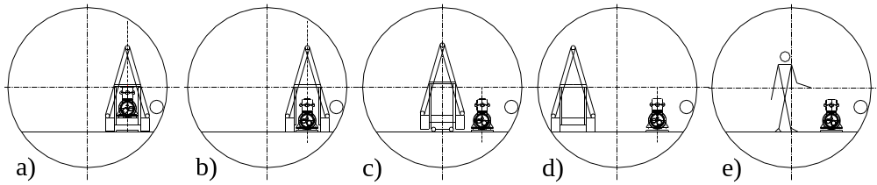
Figure 5.32. First installation scheme
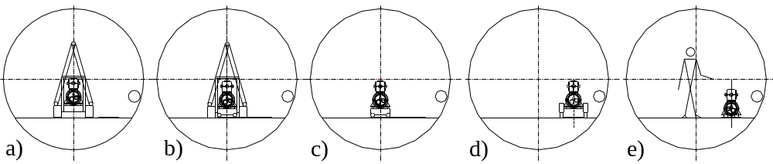
A need to replace a magnet after it is installed will require another magnet installation scenario. In this case the magnet will be transported along the magnets that have already been installed (Figure 5.33a; installed magnets are not shown). Using hydraulic and control system of transportation trailers, the magnet will be lowered down to temporary support stands installed beneath the carts (Figure 5.33b). After the frame is removed (Figure 5.33c), the magnet is to be shifted horizontally and placed on the permanent stands with the use of a specially designed hydraulic pulling system based on the permanent support blocks (Figure 5.33d, e). Control equipment similar to used during transportation will synchronize the system during this operation.

Figure 5.33. Magnet replacement scheme
Interconnections of several different types are to be made after magnets are installed. First, the two magnets in each half-cell must be connected to form common electrical, cryogenic and vacuum system. There is a 1-m space available for this interconnection. Second, between half-cells active superconducting transmission line must be moved into the return line enclosure to clear a 3.5-m space for conventional correction magnets. Finally, in the straight sections where special magnets are installed there is need for several modes of transmission line positioning. The interconnection scheme does not differ much for all these cases; it is thoroughly described in section 5.1.2.3.4. The basic steps of this procedure are listed below:
- connection of the transmission line inner invar pipes for both active and return lines;
- splicing of superconducting cables;
- installation of electrical insulation and performing a high-pot test;
- connection of cryogenic piping;
- installation of a 50 K screen;
- installation of a super-insulation and closing the area of the high pressure pipe;
- checking for a vacuum leak and repairing if needed;
The described procedure will ensure interconnections of a high quality; nevertheless, after each 20-km magnet string assembly is completed, a cryo-test must be performed. This cryo-test will involve pressure test, relieve valve setting tests, magnet string cooling down, heat leakage test, and transmission line current test. The cryogenic plant performance and magnet string quench test will be also conducted.
If there is a need to replace a magnet, the following replacement procedure can be used that utilizes the magnet repair magnet delivery scenario described above:
- cut off beam pipes of the replaced magnet;
- open the connection space;
- remove super-insulation;
- cut all the cryo-pipes and transmission lines of a the magnet to replace;
- remove replaced magnet moving it horizontally out of the magnet string;
- install new magnet following the repair scenario of magnet installation;
- make interconnections as described above;
The goal for a replacement procedure is to complete it during one 8-hour shift of multi-crew work.
Corrector magnets can be installed after the cryo-test is successfully completed. Six air-cooled correctors occupy the 3.5-m gap between arc half-cells. All these magnets are factory assembled on common support structure, with beam pipes installed in magnet gaps. Description of the correctors can be found in 5.1.3. Totally 1568 corrector blocks will be transported and installed. A two-ton load capacity crane or hydraulic fixture will be used to install the corrector magnet blocks on their support stands. All corrector coils will be electrically tested and connected to the power supply leads. Then beam pipe interconnections can be made following by a vacuum leak test.
Arc magnets are ready for final alignment after correction magnets are installed and vacuum pipe interconnections are made. Each magnet must be installed so that magnet reference center is within ± 0.25 mm from the nominal orbit position. For each magnet, an acceptable roll angles are less than 1 mrad. Conventional optical techniques (theodolites and laser trackers) for alignment will have angular errors in the range of 10 microns per meter, corresponding to ± 300 microns at the magnet ends from a setup at the center of the magnet. This would be marginally adequate to meet the magnet alignment specification of 250 microns RMS over the length of the magnet. However this accuracy can be exceeded using the hydrostatic leveling and stretched wire techniques described below.
For each magnet there will be a support every 6 meters with horizontal, vertical and roll adjustment capability. The magnets will be built “laser straight” in the factory. The magnets will be installed in the tunnel with a 15.57-mm sagitta over the 65-meter length. The stiffness of the magnet will allow an independent range of motion of approximately
± 2mm horizontally or vertically at each adjuster. Motions outside this range will require coordinated movements of nearby adjusters. The magnet position will be roughed in using optical techniques along the beam line relative to the internal tunnel network. At each of the support stands there will be a hydrostatic leveling pot for vertical alignment, capacitive stretched wire pick up for horizontal alignment, and an electronic gravity sensor for roll. As the adjustment screws are turned there will be real time readout of both systems to allow for the positioning of each segment of the magnet. A ± 3cm range of the adjusting screws will be sufficient to put in the sagitta and to compensate for installation errors in the magnet stands as well as drift and settling of the tunnel (± 1cm maximum) over a 20-year lifetime.
Vertical alignment can be made using a hydrostatic leveling technique, that make use of fluid-filled containers with capacitive readouts. This technique allows vertical alignment within ± 100 μm for each magnet. For larger scale, corrections taking into the account non-uniformity in Earth gravitation field must be made. This will require careful study of the Geoid and the change in the density of the earth in the region of the machine. Corrections to the vertical can then be imposed on each magnet.
Magnet roll can be adjusted using the technique similar to used during leveling of the magnets. It can help to establish a real time display of the roll of the magnet at each adjustment station. Given a base support of 500 mm and a resolution of 2 microns for the hydrostatic levels a roll angle of ±4 micro-radians is achievable. This exceeds the 1 mrad requirement for acceptable vertical closed-orbit distortion.
Horizontal alignment is done using the stretched wire technique. A small diameter (less than 1 mm) copper beryllium wire mechanically attached to both ends of the magnet forms the reference base. Two wires separated vertically can be used to increase the signal to noise ratio. Using capacitive pickup electrodes at each support stand, it will be possible to adjust horizontal position of each magnet to a needed accuracy. Alignment of the entire 66-meter magnet to within ±100 microns should be possible. To set the sagitta of 15.6 mm for the magnet all the adjustments must be made at the same time. Starting with optical tooling the rough sagitta can be set to an accuracy of ±300 microns. Once this is done the stretched wire system can be installed. Each capacitive pick up will have a different offset from the magnet to account for the saggita. The final adjustment will involve moving all adjusters at the same time.
A varying degree of automation is possible. The simplest approach is for the person at the central display of magnet alignment data to give directions to one or more workers with wrenches. A more sophisticated alternative is to manually place motorized wrenches at each of the adjusters, then run automated software procedures to bring the entire magnet into alignment. If these systems were permanently installed and coupled with motorized adjustment stands they could be used as an active alignment that continually aligns the magnets as the machine runs. Beam position monitor information could also be used.
Special magnets of several types are to be installed in the ten straight sections and two beam injection lines (see 5.1.5). Straight section focusing quadrupoles and injection line dipole and lambertson magnets are conventional magnets. Maximal weight of these magnets does not exceed 5 tons and their length is less than 6 meters, so they are installed on their support stands using conventional technique.
Separation/recombination dipoles and abort lambertson use transmission line for excitation. Installation technique for theses magnets is similar to that used for the arc dipole magnets except they are made of pieces with length that do not exceed 6 meters and weight less than 5 ton. To avoid time spending related to interconnections, these magnets are assembled around preinstalled transmission line and vacuum pipes. Because none of the straight section dipole magnets is of combined function, alignment procedure for these magnets is straightforward.
The third type of magnets is pulsed injection and abort kicker magnets and abort sweep-magnet. These magnets are of dipole type, so installation and alignment procedures for these magnets are straightforward.
Finally there are eight 10-meter, superconducting, high gradient, low-beta IR quadrupoles described in 5.1.4. Each quadrupoles will weigh about 25 ton and is rigid enough to be transported to the place of installation using two high load trailers and two transport vehicles of the type used for the arc magnet transportation. Alignment requirement for these quadrupoles installation is ±100 μm, so two adjustable support stands will be used, and alignment procedure is going to be similar to described above for arc dipoles.
Because sections that use special magnets are located closer to the Fermilab and Far End sites than accelerator's arcs, installation of these magnet can be done quite independently of the installation of arc magnets, even allowing injection line testing while arc magnet installation is still in process.

5.2 Accelerator Systems
The systems are distributed around the ring circumference include cryogenics, arc instrumentation, corrector power supplies, and beam vacuum systems. The “once per turn” systems are located primarily in the straight sections on the Fermilab site. These include RF, injection and extraction, and once-per-turn instrumentation.
A completely conventional approach is taken to the standard utilities in the straight sections. Warm iron/copper magnets use LCW cooling and standard power supplies. Electronics and major power supplies are located in underground shielded instrumentation rooms that are accessible with beam on. A larger tunnel, conventional power systems, and generous cable trays provide the infrastructure for RF systems, injection and extraction kickers and Lambertsons, beam crossovers, beam halo scraping, beam current and beam profile monitoring, etc. Concentration of these major subsystems at the Fermilab site makes maintenance and accessibility requirements similar to other Fermilab accelerators. These systems are modeled on existing designs from recent projects for which the specifications and costs are well known.
Four systems contain notable new features which will be described in some detail: the cryogenic system which is smaller and simpler than comparable systems, the beam stop which must deal with the large kinetic energy in the beam, the arc instrumentation which is distributed as electronics modules in “holes in the wall” at each quad location, and the beam damper system which is distributed around the ring circumference.

5.2.1 Cryogenic System

5.2.1.1 Cryogenic System Description
The magnet’s super conducting transmission line is cooled by pressurized supercritical helium at 4.5-6.0 K. The heat load of the magnet system is removed by the sensible heat of the supercritical helium stream. The fluid operates just outside the critical region expanding the helium stream as it passes through the transmission line producing a large effective heat capacity.

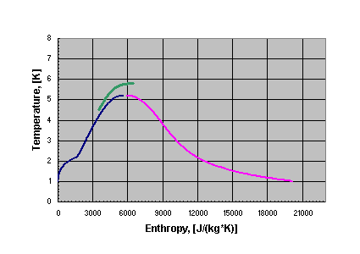

Figure 5.34. VLHC transmission line temperature profile.
Cryogens are fed from six (6) refrigerator plants spaced at 38 km intervals around the ring. For efficiency reasons, refrigeration is provided at two (2) temperature levels. Refrigeration at a higher temperature (40K) provides cooling for a heat shield that is used to intercept much of the heat that would otherwise be absorbed by the lower temperature superconductor. Each plant provides refrigeration for upstream and downstream magnet streams. Each string is sub-divided into two (2) loops, referred to as “near” and “far” loops.

5.2.1.1.1 Helium Distribution System
The helium distribution system is designed to distribute refrigeration to the magnet system with a minimal temperature variation. The distribution system consists of cryogenic valve boxes, transfer lines, and warm helium header.

(a) Cryogenic Valve Boxes
Cryogenic valve boxes are used to redistribute the helium between the conductor loops for steady-state operation and perform various transient state operations. These boxes are located every 9.5 km and house the control valves and instrumentation required for each circuit. Boxes vary in configuration dependent upon location in the magnet string. These boxes are relatively simple devices mainly providing a transition for flow redistribution.

(b) Transfer Lines
Transfer lines are a part of the magnet assembly. A line contains five (5) circuits: 4.5 K superconductor supply line (near loop only), 6.0 K superconductor return line, 40 K shield supply line, 70 K shield return line, and a vacuum circuit. Each section of transfer line is equal in length to a magnet (67.5 meters) and is attached to the magnet assembly via a structural anchor at the midpoint of the magnet.
- The 70 K return line is 0.102 m OD stainless steel pipe is connected to an extruded aluminum shield that surrounds all the inner lines. The shield is wrapped with a double-sided aluminized mylar (dimpled and perforated). The longitudinal contraction of the line is compensated with guided formed bellows in the inner connect. During this shrinkage, the G10 support structure is allowed to move within the vacuum space.
- The 40 K shield supply line is a 0.089 m OD stainless steel pipe supported on the G10 spiders from the aluminum shield. Bellows are used at the end of each 67.5 m module to compensate for thermal contraction and expansion.
- The 4.5 K supply – near loop only – and 6.0K super conductor return line is Invar tubes which are also anchored at the midpoint of the module. These lines are of concentric design. The 6.0K helium flows between two (2) concentric Invar tubes
- The 4.5K supply line is suspended via G10 spiders from a 6.0K inner line.

5.2.1.1.2 Helium Pressure Relief and Venting System
Relief valves for each of the five (5) circuits are located every 540 meters. These valves will vent into the warm helium header that is itself protected every 1 km at 3 MPa (30 bar) from over pressurizing. Each relief is conventional in nature and set to the MAWP of its given circuit. The primary need for these reliefs are for trapped volume and loss of insulating vacuum scenarios. The warm header is further protected at the refrigerator (above ground) at a set pressure of 0.2 MPa (2 bar), venting to atmosphere.
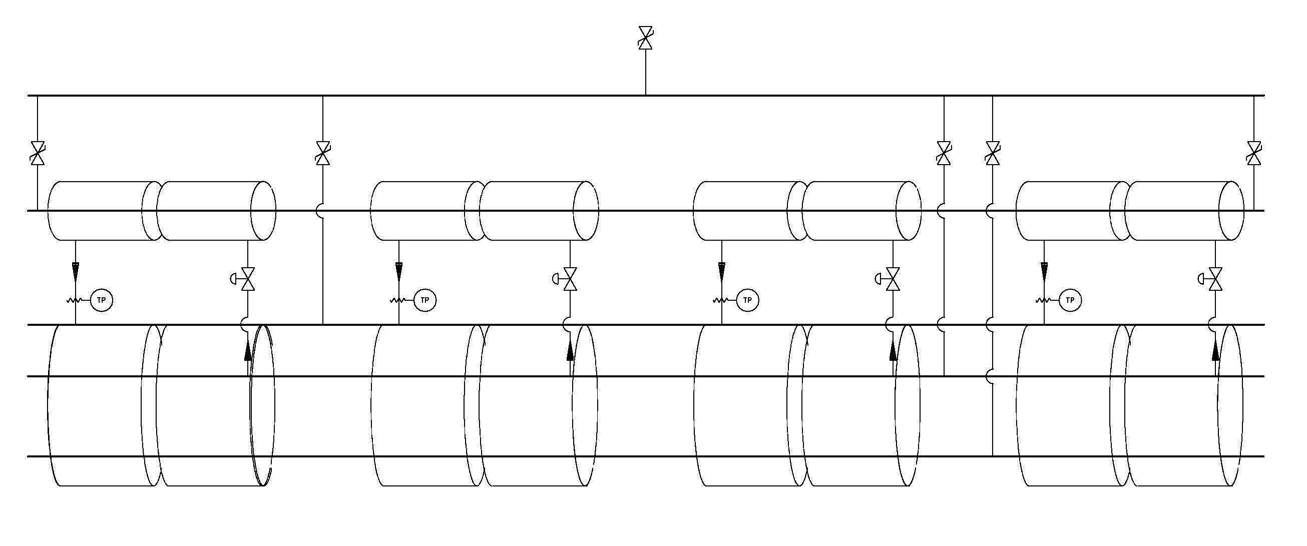

Figure 5.35. Helium pressure relief valves.
Quench protection of the transmission line is discussed in [Koepke et. al. & DR doc]. The 100kA transmission line conductor contains enough copper that it can be safely shut down with a 1 second time constant following a quench. A number of detailed quench simulations have been performed [N. Shatil final report]. The peak temperature is ~250K. The worst-case peak pressure comes from a situation in which a mis-steered beam (kicker misfire) causes the beam to oscillate side-to-side in the beam pipe and scrape heavily in a series of locations separated by a half-betatron wavelength. In this case the peak temperature is unaffected, but a worst-case pressure occurs when the hydrodynamic shock waves from two adjacent quenches collide at the midpoint between quenches. The peak pressure is below the 4 MPa (40 Bar) pressure rating of the transmission line. Thus no helium needs be vented anywhere, even for a long period following the quench. The pressure burst from the hydrodynamic shock wave, as registered on pressure sensors along the transmission line could provide a convenient method of identifying where the quench occurred.

5.2.1.1.3 Heat Shield Cooling System
Pressurized 40K helium is used to intercept the radiation and conduction heat leak to the transmission line. Helium is supplied from the refrigerator at 1.7 MPa (17 bar) and returns at less then 70K and 1.3 MPa (13 bar). Flow is supplied via a 0.089 m O.D. tube and distributed via a pair of 6E-3 m OD lines every 270 meters carrying 2.0 g/sec. This scheme provides shield cooling for every two magnets. Control valves and temperature sensors are included every 270 meters for heat shield flow control based on temperature requirements.

5.2.1.1.4 Transmission Line Heat Load Estimates
Transmission line heat load estimates are divided into two (2) components: the primary heat load on the 4.5K system and the heat load to the 40K shield system. The calculated heat loads are presented in Table 5.20.

Table 5.20. VLHC Design Study Calculated Transmission Line Heat Loads
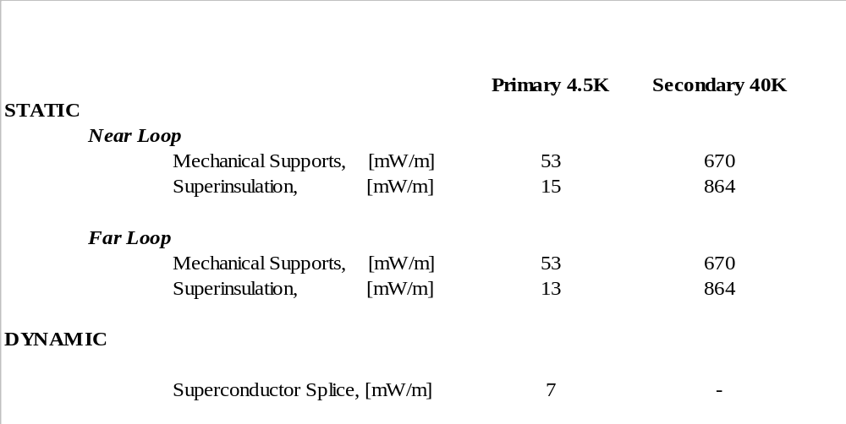

5.2.1.1.5 Power Lead Cooling
Due to its low inductance (3uH/m) and low stored energy (15kJ/m), the transmission line magnets require only a single 50V power supply and a single set of 100kA current leads for the entire machine. The helium consumption for these leads is estimated to be 5g/s for each lead. If desired, this power requirement can be reduced by a factor of 4~5 with the use of High Temperature Superconductor (HTS) current leads.

5.2.1.1.6 Refrigeration System
The refrigeration system is composed of six (6), 4.5kW @ 4.5K capacity facilities equally spaced around the ring. Each plant will also provide 100kW of 40K refrigeration used in the shielding of the magnet system.
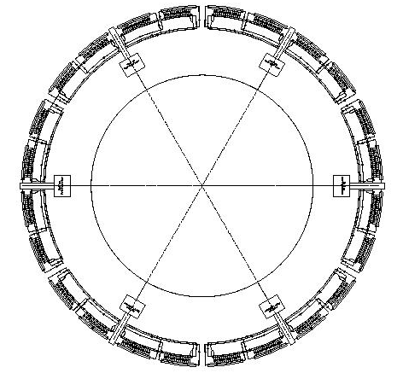

Figure 5.36. need figure caption.
This provides approximately a 50% margin above predicted steady state requirements. This margin is required to ensure continued operation when the heat load increases either due to events such as a magnet quench or vacuum leak, or because refrigeration capacity falls below its intended design value (i.e. decreasing machine efficiency or inefficient heat transfer due to contamination). With this scheme, all six refrigerators must be operational for the accelerator to function. No plant redundancy is built into this design.

Table 5.21. Predicted power requirements
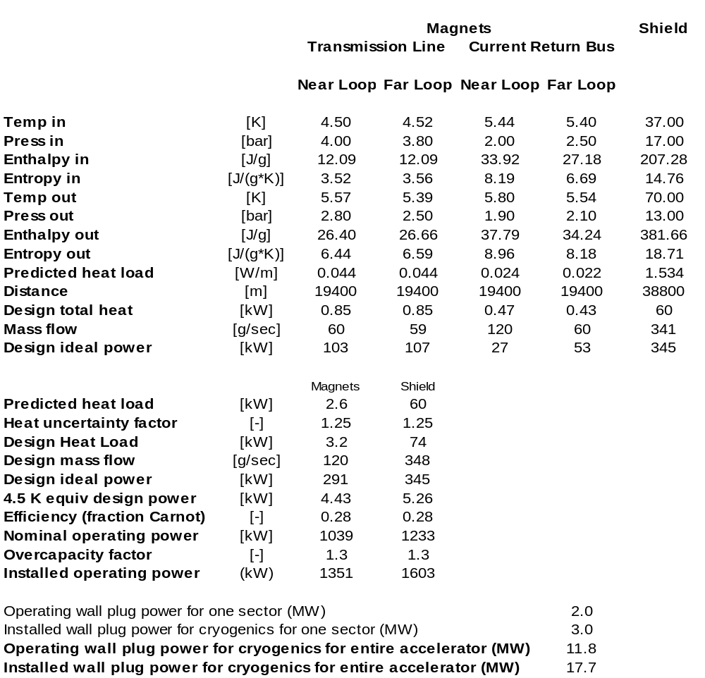
The process helium is compressed from suction pressure of 0.101 MPa (1.01 bar) up to an intermediate pressure of 0.4 MPa (4.0 bar) by means of first stage compressor discharging into a second stage, which compresses the helium to 1.85 MPa (18.5 bar). Turbo machinery is used for the refrigeration plants while reciprocating machines comprise the compressor system. There are two cold boxes: the upper and lower cold boxes. Each cold box contains five (5) plate-and-fin type heat exchangers and three expanders. To avoid return helium gas instabilities due to the elevation change from the tunnel to the surface, the lower cold box will be located at the tunnel level. This requires a dedicated space of 432 m³ (6 m along the beam by 6 m transverse by 12 m high) located near the accelerator tunnel.
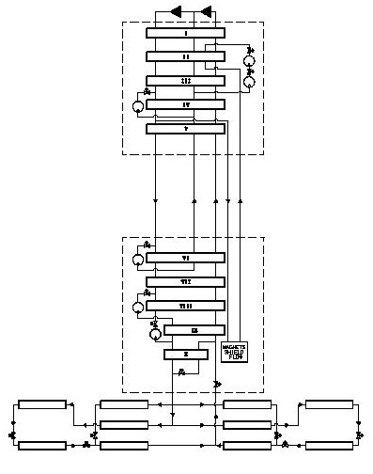

Figure 5.37. need figure caption
Discussed plants are well within the existing commercial vendor capabilities. These plants contain no nitrogen pre-cooling. The cold box configuration is a horizontal carbon steel shell enclosure housing all heat exchangers, piping, valves, cold end of turbo expanders and vessels operating at cryogenic temperatures. The equipment within the cold box and the inner face of the vacuum jacket are covered by multi layer aluminized Mylar. The cold boxes are designed to withstand the outside atmospheric pressure while they are evacuated and are also protected against overpressure by safety valves. All internal valves, filters, turbo expanders, bayonets and major pipe connections are fixed at the top plate and are accessible from a structural steel platform along the length of the cold box. The turbo expanders are self activated gas bearing superior in their performance to oil bearing turbines. Each turbo expander is a small single-stage centrifugal turbine braked by a direct-coupled, single stage centrifugal compressor. The turbine housing is vertically mounted to a plate at the cold box top, projecting into its vacuum space. Within the cold box are brazed aluminum heat exchangers, pressure vessels containing and adsorbent to remove impurities and the cold end of gas bearing turbo expanders. Part of the outer shell cover is flanged and has an O ring seal, and is removable, for complete access to all cold box internal components and piping. Two panels will be mounted on the structural steel platform next to the cold box. One containing all instrument terminations and transmitters, and the other an assembly of purge and defrost valves. Provisions for purification of the process helium is provided at each plant as well as oil removal systems. A commercial control system package will permit the unattended operation of these plants.

5.2.1.1.7 Helium Compressor System
The compression package will consist of three oil flooded rotating screw compressors. One compressor will compress from 0.11 MPa (1.1 bar) to 0.4 MPa (4.0 bar), and the two other will compress in parallel from 0.4 MPa (4.0 bar) to 1.85 MPa (18.5 bar). The first stage compressor is smaller than the two (2) second stage machines. Each compressor skid contains the compressor, main drive motor, oil reservoir/separator vessel, and lubrication system mounted on a common rigid skid base. The base plate provided is suitable for installation on a flat pad without grouting. The helium enters the compressor and is compressed through the rotating screw compressor, also flooded with oil. The oil seals the rotor and absorbs some heat of compression. The compressed warm helium passes through a water-cooled heat exchanger and then into a bulk oil separator. The oil is also passed through a separate water-cooled heat exchanger. Each compressor is direct driven by an electric induction electric motor. The compressor assemblies are equipped with automatic inlet and outlet block valves and automatic recycle valves.
The high-pressure helium from the compressors passes through a skid mounted oil removal system. The oil removal system consists of three stages of coalescing filter housings followed by a vessel containing activated carbon. All entrained oil is filtered out of the gas stream by the three stages of filters. The small amount of oil in the vapor phase is removed by the activated carbon. The total amount of oil contained in the helium leaving the oil removal assembly is less than 10 ppb .

5.2.1.1.8 Helium Liquid and Gas Storage and Inventory Management
The inventory for the entire cryogenic system is estimated to be 75 tons of liquid helium, which is twenty (20) times the Tevatron inventory. Each cryogenic plant will have three (3) 37.8 [m3] liquid helium storage dewars, and fifteen (15) gas tanks capacity of 113.6 [m3]. This will provide 143 percent of the total helium inventory. The gas storage serves as make-up/kick back during normal operations, and as a buffer/storage during quenches and warm up of a single loop. The liquid storage station will have pumps and heat exchangers necessary to liquefy/warm up cold gas during upset conditions. During the planned warm-up of the entire ring, the inventory will be liquefied into the dewars. In case of one sector warm, the inventory can be distributed between five sectors gas/liquid storages via the cooldown header. The tunnel transfer line and the cooldown header can be used to hold up to 40% of inventory at pressure below MAWP of any component in the system

5.2.1.1.9 Cryogenic Control System
A well-proven process control system will be used. The cryogenic system in each sector will be controlled by a commercially available distributed control system (DCS). Commercial program logic controllers will be used for a local control of the cryogenic hardware in the event that high-speed network connection is unavailable. The cryogenic control system will provide full automation of any operation mode, including transient modes. The accelerator high-speed network will be used for communication and data exchange between sectors.

5.2.1.2 Design Operating Conditions

5.2.1.2.1 Steady State
Helium is supplied from a refrigerator at 4.5 K, 0.4 MPa (4 bar) and returned at 5.8 K, 0.19 MPa (1.9 bar). Supercritical supply helium is fed from the helium plant to four parallel loops. Each loop is comprised of 9.5 km of magnet and transmission line. There are cryogenic connecting boxes at the beginning and end of each 9.5 km section. At the exit of the refrigerator the helium process is split into four (4) paths. There are upstream and downstream magnet strings that are mirror images of each other. The typical flow schematic of a magnet string is shown in Figure 5.38.
Refrigerator
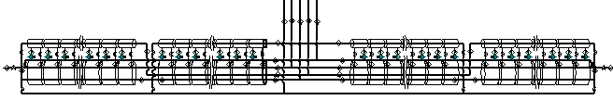

Figure 5.38. need figure caption
As helium enters the upstream or downstream magnet strings the flow is split into two parts: half enters the 4.5 K transmission line circuit (for the near loop) and half enters the 4.5 K current return circuit contained in the magnet (for the far loop). There is expected to be an approximately 1 K gradient across each loop. These loop flows are then re-distributed at valve boxes and become the return 6.0 K shield flow.
The cooling scheme relies on a balance between heat leak and pressure drop. Any scenario causing an upset in the heat load (i.e. vacuum degradation) can be compensated by increasing the helium flow rate and supply pressure for the proper loop. The refrigerator has been oversized by 50% to compensate for these types of upset conditions.

5.2.1.2.2 System-Wide Purification
Purification of this machine will be done in two (2) steps. First each sector will be pumped and backfilled five (5) times to 25 inches of mercury via pump outs on every helium circuit at each valve box located every 10 km. This method has been proven to work in the Tevatron. Levels of contamination less than 100 ppmv are achieved with this first step by using roughing pumps. The second step is dilution purification. A purifier with a nitrogen cooled charcoal bed will be located at each refrigeration plant. The discharge gas of the compressor system will be circulated through this purifier and then will be distributed to the magnet/transmission line system. Contamination instrumentation, such as arc cells used on the Tevatron, will be used to monitor the ppmv levels in each sector. The system will be ready for cool down when contamination levels are < 5ppm. It is estimated that the purification for a sector in the VLHC will be 72 hours.

5.2.1.2.3 System-Wide Cool down
Cool down of the VLHC will be done in three (3) stages. The first stage involves the cool down of the helium plants. The second stage is the cool down of the transmission line to 40K. Finally the transmission line will be cooled done to operating temperatures.
In the first stage, cooling is provided by turbines and should not take more than 24 hours per plant. In the second stage, the plant is setup in the liquefaction mode and 40K gas at 0.4 MPa (4 bar) is sent via cool down valves located at each valve box back to the compressor suction warm gas header located in the tunnel. Gas flows from the refrigerator into the warm header through the near loop transmission line, the 6.5K return, and the current return circuits. When the temperature at the end of the “near” loop (measured at the valve box) is 70K the flow is then re-directed to the “far” loop and into the return header. As the “far” loop temperature reaches 70K the second cooldown stage can be started.
During the second cool down stage the plant is re-tuned for an outlet temperature of 4.5K. The flow pattern for the second stage is the same as the first stage. As the temperature for each loop is at 7K the cool down valves can be closed and the flow will be looped back in refrigerator mode. Total cool down time is expected to be on the order of 10 days.

5.2.2 Magnet Power Supplies, Current Leads, and Quench Protection
Stage 1 power supplies are summarized in Table 5.22 below. The major item is the single 100kA supply for the transmission line magnets. The Interaction Region power supplies, current leads and quench protection are discussed in sect 5.1.4. Total Stage 1 power supply requirements (both ramping and steady state) are about a third of the Fermilab Main Injector.

Table 5.22. Power Supply, Current Leads and Quench Protection Summary for Stage 1 Machine
 | Transmission Line Power Supply | IR Quadrupole Power Supplies (sect 5.1.4) | Straight section Warm Magnet Power Supplies | Corrector Magnets (warm copper)
Number | 1 | 2 | 16 approx. | 12,000
Location | FNAL | at Experiments | Straights | Quad locations
Voltage per supply | 62 | 10V typ. | 1000V typ. | 100 Typ
Current per supply | 100kA | 25kA | 200A typ | 2A typ
Ramping MVA (tot) | 6.2 MVA | 1 MVA | - | -
DC Power (total) | 0.4 MW | 0.6 MW | 7.4 MW | 2.1 MW
LCW Consumption | - | - | 150 liters/sec | (air cooled)
Quench Detection | 1 Circuit at PS | 2 circuits/quad | - | -
Quench Protection | Dumps @ 20km | 4 heaters/quad | - | -
SC Current leads | 100kA-pair | 60kA-pair | - | -
Peak Ramping Supply Power | 17.7 MW
Total Power Supply  Power in Collision | 10.5 MW

5.2.2.1 Main Transmission Line Power Supply
The low inductance (3uH/m, 0.6H ring total) and low stored energy (10kJ/m, 3GJ total) of the single-turn transmission line magnet allow the entire ring to be powered from a single supply [1]. See Figure 5.39. A voltage of ±62V ramps the machine up or down in 1000 seconds. The design current of 100kA at flattop exceeds the 90kA required for the transmission line magnet to reach its design field. The supply will be located on site at Fermilab in a shielded underground room approximately 25’ x 50’ TBD in size. The ramping power and footprint of the power supply is comparable to one of the six Main Injector power supply buildings. Superconducting current leads will be located immediately adjacent to the supply to minimize power loss in warm buswork. Superconducting buswork will carry the current through a short connecting conduit to the transmission line magnets in a manner identical to the MS6 test string [2].
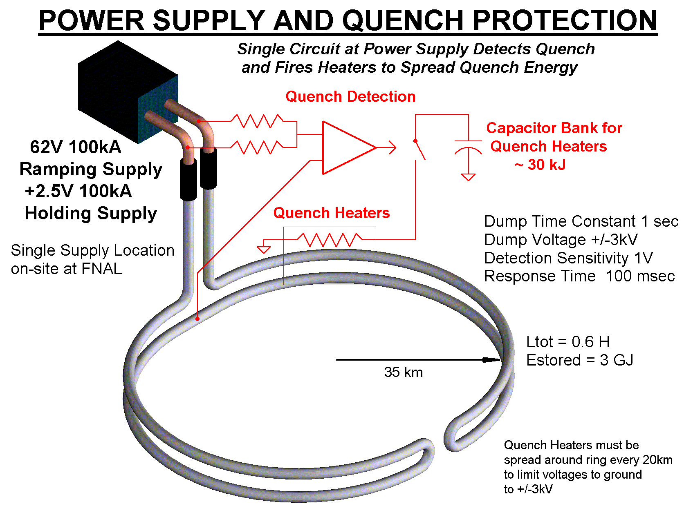

Figure 5.39. 100kA Power Supply and Quench Protection For Transmission Line Magnets
The power supply is actually two supplies in series. The main ramping supply generates the positive or negative voltage to transfers the inductive energy into and out of the magnets. It is not used when the magnet is at constant current. The second “holding” supply maintains the current during long periods at flat top and injection, and provides only the voltage necessary to overcome resistive losses in the current leads, warm busswork, superconducting splices, and the shorting SCR switch across the ramping supply. This approach minimizes the cost of the ramping supply, simplifies the power distribution system, and moves the tightest regulation and ripple requirements to the precision holding supply.
The Main Ramping Supply design (Figure 5.40) is based on paralleling 8500A modules of design similar to Main Injector supplies. This approach permits spare modules to be taken off line for repair, and allows the use of commercially available 10kA DCCTs for current regulation. A 2-quadrant 12-phase SCR bridge returns inductive power to FNAL as the magnets ramp down. Ramping systems are designed to have RMS power sized to be halfway between the peak (6.2MVA) and the RMS (3.1 MVA). This has proven to be a reliable design methodology for similar supplies at Fermilab. The RMS feeder load of 4,800KVA is less than one feeder cable for the source.
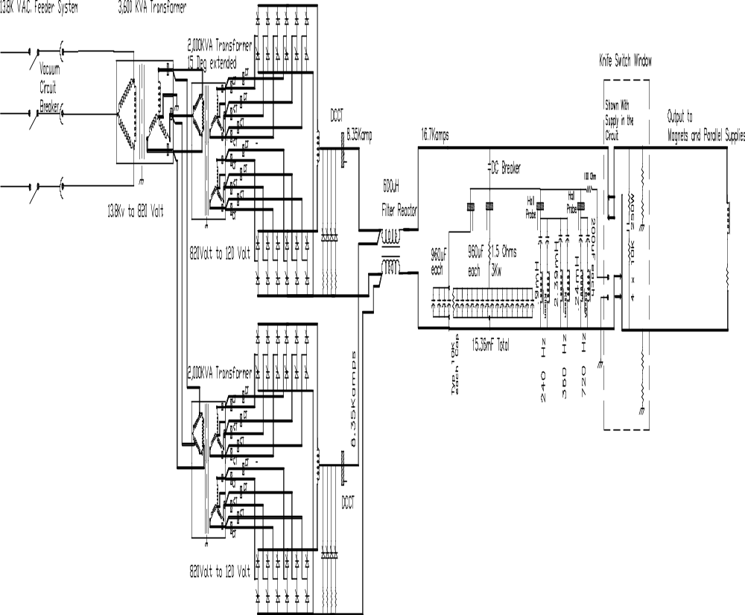

Figure 5.40. 100kA Ramping Supply Schematic (one 2 x 8.5kA module shown)
The +2.5V holding supply is essentially a copy of the 100kA switching converter [3] constructed for the R&D magnet test. The device consists of a 450VDC 500kW bulk supply followed by ten 10kA DC-DC converter modules in parallel. This two-stage regulation scheme provides immunity to variations in input line voltage. The modules use tape-wound cores and Schottky power diodes. The switching frequency is ~2 kHz. To minimize output ripple the 10 modules will be phased to switch sequentially. This pushes the fundamental ripple frequency up to 10x the switching frequency or ~20kHz. The switching will be phase locked to the revolution frequency so that beam emittance growth due to power supply ripple will be negligible. The control system for this switcher will be integrated into that of the main ramping supply to simplify regulation and load hand-off.

5.2.2.2 Current Leads
Superconducting current leads are required for both the main Transmission Line and for the IR quadrupoles. IR quadrupoles can use commercially available High-Temperature Superconductor (HTS) leads similar to the LHC. The total current leads requirement for the Stage 1 machine is about 150kA-pair, or about 1/10 of the leads required by the LHC [3.5MA from Lynn Evans’ stump speech].
A single pair of 100kA current leads is required for powering the transmission line. These could either be conventional copper leads identical to the leads developed for the MS6 transmission line test facility [2], or could be a specially built HTS version using the 50K transmission line shield flow as the inter-stage temperature. The cryogenic wall power associated with the conventional 100kA leads is approximately 300kW. This could be reduced by a factor of 4 with HTS leads [4]. Payback time for the electrical cost savings from HTS leads is approximately 3 years.
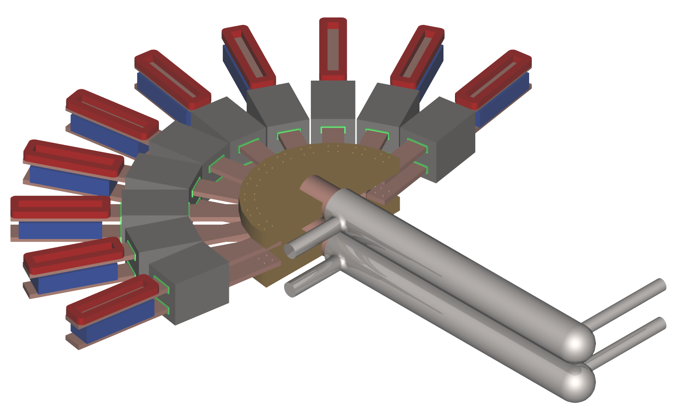

Figure 5.41. 100kA Superconducting Current Leads and switching converters developed for the MS6 test string. A more compact arrangement of the leads and power converter will be small enough to be placed in the tunnel to be used for partial-ring commissioning.

5.2.2.3 Quench Protection
The only superconducting magnets of the Phase I collider are the transmission line magnets and the IR Quadrupoles. Protection of the IR quads with heaters is described in section 5.1.4.
The low inductance and low stored energy of the transmission line magnet allows a simple and inexpensive quench protection system. The magnets themselves require no internal quench detection or protection circuitry. Ring-wide quench detection is performed by a single circuit located at the power supply terminals (Figure 5.42). Quenches are detected by a voltage imbalance at the power supply (Figure 5.39). When a quench is detected, magnetic energy is extracted with a 1-second L/R time constant by cryogenic “dump resistors” spaced at 20km intervals around the ring. This keeps the peak temperature and pressure in the quenched section of the conductor at acceptable levels as described in section 5.1 Quench protection system parameters are given in Table 5.23. The theory of operation is explained [5] and a detailed write-up is given in [6].
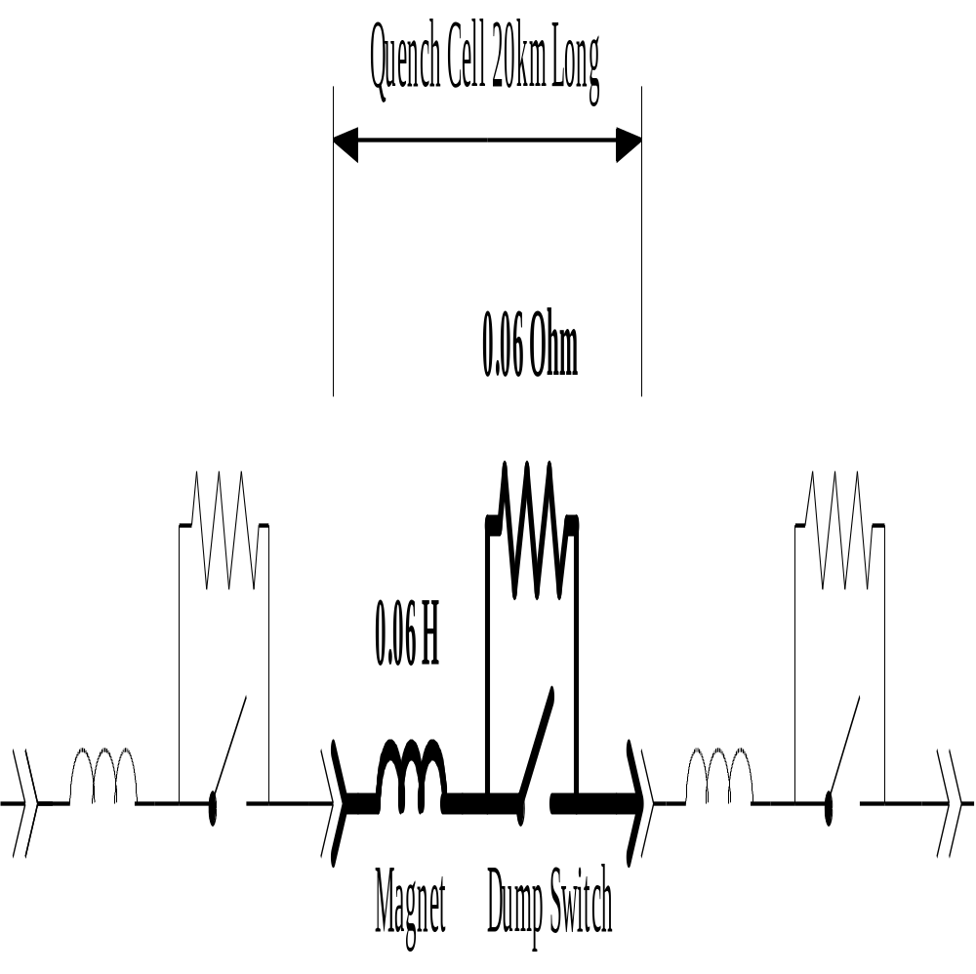

Figure 5.42. Quench Protection Cell of the Transmission Line Magnet
The “dump switches” are deliberately quenched sections of transmission line conductor built with Cu-Ni stabilized NbTi “switch wire”[7] which is designed to have a high normal state resistance. Current is transferred to a thick-walled Invar pipe which provides thermal mass. These dumps are efficiently recooled using helium from the cryogenic shield flows and transmission line flows, with the warm gas vented into the return header.
The protection circuit for the 100kA current leads and power supply is integrated into the quench protection system. When an overtemperature or overvoltage is detected in the current leads, nearby copper buswork, or power supply components, the power supplies are shut off and a ring wide dump is forced. The required response time is equal to the thermal time constant of the leads or approximately 100 seconds.

Table 5.23. Stage 1 Quench Detection and Protection Parameters
Transmission Line Current | 100 kA
Magnetic Stored Energy @100kA | 10 kJ/meter, 2100 MJ/ring
Magnet Inductance at low field | 3uH/m 600mH/ring
Energy Dump Time Constant | 1 second
Peak Voltage To Ground during Dump | ± 3 kV
I²t during dump | 5 x 10⁹ Amp²Seconds
Peak Temperature of Conductor During Quench | 250K
Peak Pressure of Helium During Quench | 35 Bar
Pressure relief during quench | Every 2 cells (500m)
Effective Copper Cross Section of Conductor | 3cm²
Quench Detection Threshold | 1 Volt
Quench Detection Method (primary) | Analog bucking with midpoint of current return bus
Quench Detection Method (backup) | Deviation from V=LdI/dt at power supply terminals
Energy Dump Resistance | 60 mΩ per location,
Dump Switch Locations | at cryoplants and midpoint of arc (20km spacing)
Dump Switches | Quenched superconducting cables 65m long
Superconducting Dump Switch Conductor | 1:1 CuNi:NbTi “Switch Wire”
Cryogenic Dump Resistor Thermal Mass | 65m long x 20cm2 Thick Wall Invar pipe
Final Dump Temperature after Dump from 100kA | 325K
LHe Required for recovery after Dump from 100kA | 1600 liters (less if shield flow used for pre-cooling)

It is instructive to compare this quench protection system to those of other accelerators. The LHC for example [8] requires a crate of quench detection electronics in the tunnel underneath each dipole in the tunnel. Each LHC magnet has more than 10 voltage taps and instrumentation feed-throughs. The LHC also requires a much larger array of energy dump resistors, dump switches, and current leads around the circumference of the ring. Despite the larger machine circumference, the quench protection system of the Stage 1 magnet is far simpler and should be more reliable.

5.2.2.4 Straight Section (Warm Magnet) Power Supplies
The straight sections use warm iron/copper quadrupoles and a small number of other magnets. In each straight section all F and D quadrupoles are powered in series by a single supply. The IR straight sections have a larger number of independently programmable “tuning quads” but the total power and LCW usage is approximately the same as a normal straight section. The power supplies are located in shielded rooms (one per straight section) which contain ~500kW of power supplies and are accessible with beam on. These are single quadrant supplies. Given the limited scope of these supplies it is desirable to make them fully redundant, especially those at the far side of the ring from FNAL. A detailed breakdown is given in [Terechkine note].
Dipoles and quad correctors magnets identical to the arcs are provided at each quad location. Dipole magnets used to separate and cross over the beams are powered by the 100 kA transmission line and require no separate supplies.

Table 5.24. LCW and Power Dissipation Summary for Stage 1
 | Heat Load | Total Loads | Total kW | LCW Flow (l/min)
On-Site  Straight  Sections | Resistive Magnets | 188 | 4480 | 3200
On-Site  Straight  Sections | Power Supply Cooling | 22 | 500 | 600
On-Site  Straight  Sections | RF Klystrons | 16 | 3760 | 6400
On-Site  Straight  Sections | RF Loads & Recirculators | 16 | 5600 | 4500
On-Site  Straight  Sections | Beam Stop | 1 | 500 | 600
On-Site  Straight  Sections | Total (on-site) | 227 | 14840 | 15300
Far Side  Straight  Sections | Resistive Magnets | 176 | 3320 | 3500
Far Side  Straight  Sections | Power Supply Cooling | 9 | 550 | 600
Far Side  Straight  Sections | Beam Collimation | - | 40 | 50
Far Side  Straight  Sections | Total (far side) | 185 | 3910 | 4150
 | LCW Systems Total | 412 | 18750 | 19150

5.2.2.5 Water Cooling (LCW) System
The “on-site” and “far side” straight sections require LCW systems. No LCW system exists in the arcs. Major heat loads are the resistive magnets, power supplies, and the RF klystrons. Loads are are detailed in [Terechkine note] and summarized in Table 5.24. The overall scope of the onsite LCW system is comparable to the MI-60 LCW system of the Fermilab Main Injector. The far site LCW system is about half that size.
The layout of the LCW system is sketched in Figure 5.43. The on-site straight section is connected to the Main Ring LCW system and can use the FNAL infrastrucure for filling and makeup. Existing (unused) Main Ring ponds exceed requirements for power dissipation. New ponds and purification systems are required at the far side sites. The vertical drop generates a 150 PSI pressure head which is overcome by locating the circulation pumps at tunnel elevation and pumping the return flow upwards. The beam stop and beam collimation cooling systems require separate pumped loops for radioactive water (RAW) which will be heat exchanged with the main cooling water flow to maintain isolation.
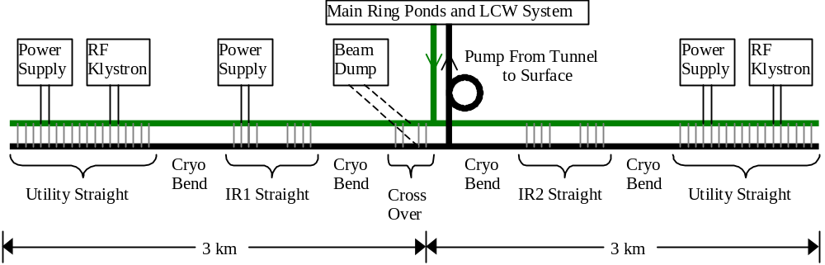

Figure 5.43. LCW System Layout for on-site Straight Section. The far side LCW system is similar except that the RF loads are absent, the Beam Dump load is replaced by the smaller load from the Beam Collimation System, and an independent system of ponds and makeup water is needed.

References {ed note—for sec. 5.2.2}
[1] Steve Hays, “100kA Power Supply Options for the VLHC”, internal note (unpublished).
[2] H. Piekarz et. al., “Summary of Transmission Line Magnet R&D Activities at MS-6”
[3] G.W. Foster, S. Hays, H. Pfeffer, “Design of a Compact 100kA Switching Power Supply for Superconducting Magnet Tests”
[4] J. G. Weisand (ed.), Handbook of Cryogenic Engineering, P.411
[5] Koepke/Mazur/Zlobin Snowmass ‘96
[6] GWF/Piekarz “Quench Protection of the Transmission Line Magnet”, VLHC note (unpublished)
[7] Switch wire is uses on persistent-current MRI magnets. Multiple commercial sources include Oxford Instruments and Supercon.
[8] See the LHC PAC ’99 papers. See also the proceeding of the workshop on powering the LHC, http://lhcp.web.cern.ch/lhcp/TCC/PLANNING/TCC/Power2000/welcome.htm

5.2.3 Arc Instrumentation and Power Distribution

5.2.3.1 Reliability and Maintenance Considerations in the Arcs
The long arcs of bending magnets the have specialized and limited requirements. The once-per-turn subsystems and their cabling, power and cooling requirements are absent. No LCW system is required. Only the repetitive instrumentation and corrector power supplies at each of the 1760 “quad locations” (every 135m around the ring at the location of beta-max in each half-cell) are required. Infrastructure for power and communications occurs at alcoves at 10 km intervals.
Reliability is at a premium for the arc instrumentation due to the large size of the machine. Repair technicians at a centrally located facility require a 20 mile drive to reach the surface facility and begin the access into the tunnel. Travel time will not be small compared to the 1.5 hour time needed to refill the machine and reaccelerate the beams. For this reason fully redundant capability is provided for all mission-critical subsystems in the arcs. Power distribution is provided to each module by two independent loop feeders with auto-resetting circuit breakers and remote disconnects. Two independent power supplies are provided for each corrector magnet and control function. Redundant network connections to each module are provided. The critical function of beam loss monitoring is provided by redundant sensors read out from alternate quadrupoles modules. The system design is such that even the death of a handful of quad electronics modules will not require immediate maintenance.
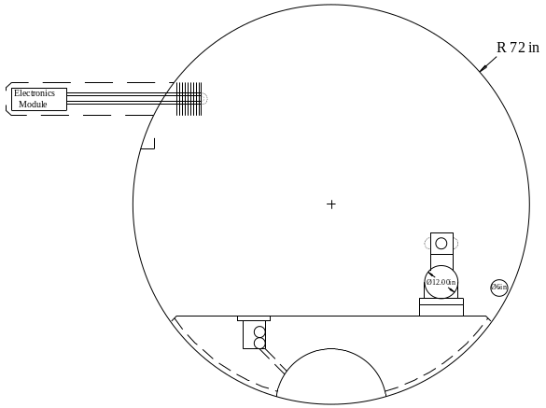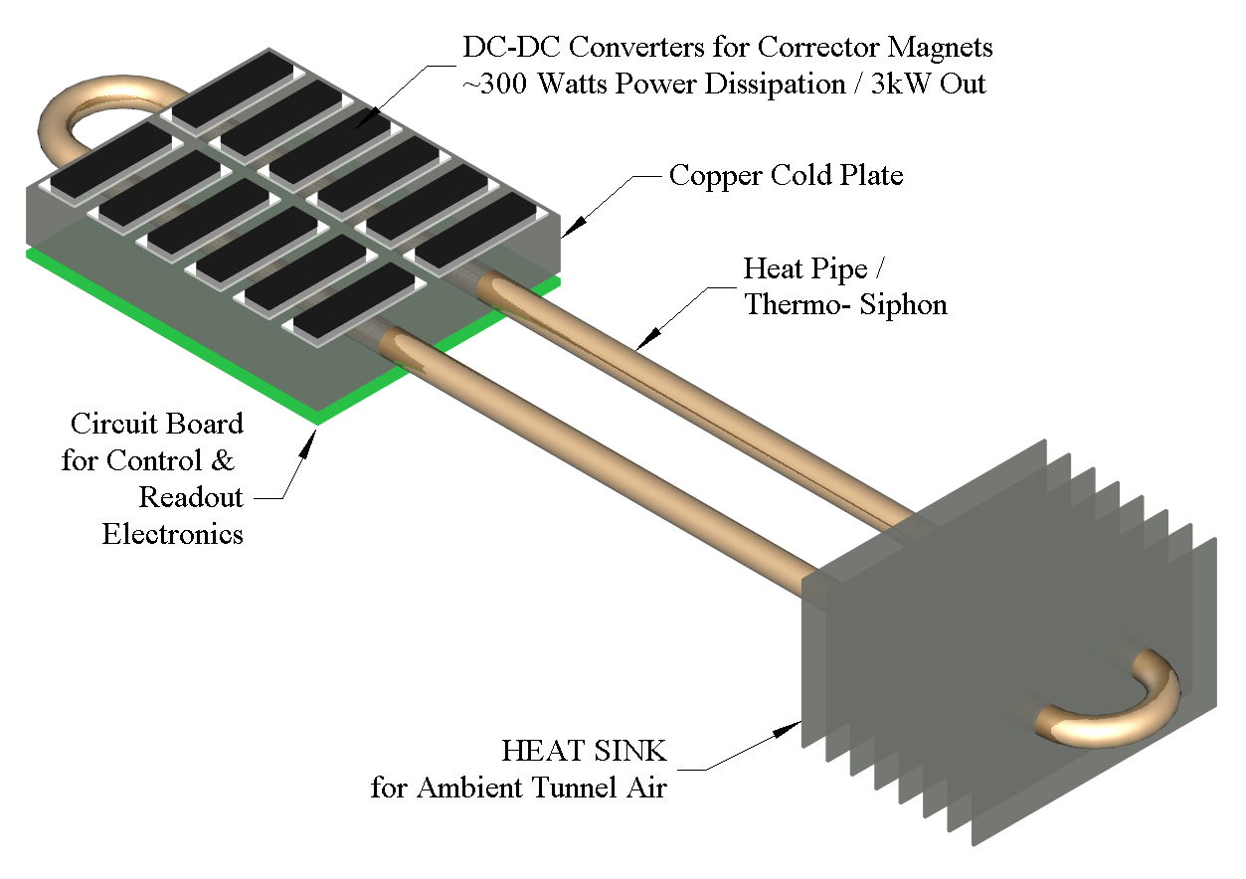

Figure 5.44. Electronics module at each quad location (every 135m) contains beam instrumentation and DC-DC Power Converters for corrector supplies. Modules are in a radiation-shielded “hole in the wall” and dissipate their power in the ambient tunnel air via a heat pipe/thermosiphon and heat sink.

These electronics are located in a radiation-shielded modules buried in “holes-in-the-wall” at each quad location. All cables for instrumentation and corrector magnets are pre-assembled on the magnet and factory tested before installation. Every other quad location (270m) cryogenic thermometry and a valve controller are used to regulate the 50K shield flow. Every 10km there is a walk-in alcove associated with a tunnel egress point that contains conventional electronics racks and provides network connection, tunnel safety systems, bulk DC power for the instrumentation modules, and cryogenic instrumentation for the cooldown valve box. Average power dissipation is approximately 15 W per meter of tunnel, which can be air cooled.

5.2.3.2 Cabling in the Arcs
At the Fermilab Main Injector the cable tray to each service building contains 316 cables with a total cable cross sectional area of 180cm² [1]. Over 95% of these cables service Beam Position Monitors (BPMs), Beam Loss Monitors (BLMs), ion pumps, corrector magnets, and temperature and vacuum monitoring. The superconducting Tevatron also has a large cable plant associated with quench protection and cryogenic monitoring and controls. The installation, termination, and testing of these cables are a significant cost and schedule item.
The Stage 1 design eliminates most cabling costs by multiplexing the signals to a local electronics module (Figure 5.44) at each halfcell boundary or “quad location”. Signals are digitized locally and sent to the control room via network fiberoptics. Instrumentation and corrector magnets are clustered at the quad location and cable runs are typically 5 meters. Cable harnesses are prefabricated by outside vendors and mounted on the magnets and tested in the factory.
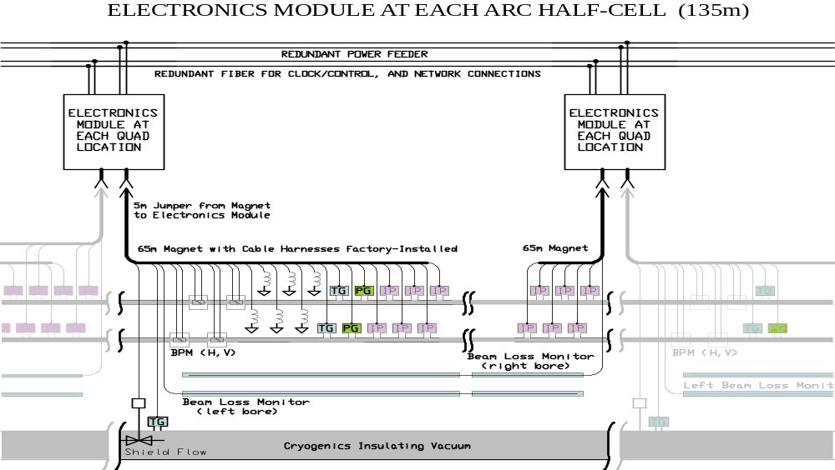

Figure 5.45. Cabling Layout on the Transmission Line Magnet. Cables and instrumentation are preinstalled and factory-tested on the 65m magnets. Each magnet has a 5m “extension cord” which jumpers to an electronics module located in a hole in the wall at each quad location (135m spacing).

5.2.3.3 Corrector Power Supplies
The warm (air-cooled copper) correction magnets [sect 5.1.3] dominate the power consumption in the arcs. The electronics module at each quad location has 6-8 corrector magnet loads with a maximum installed power of approximately 1400W. Average corrector power is < 1000W in a realistic operating scenario. At maximum current approximately 90% of the power is dissipated in the magnets themselves with the remaining 10% (~150W) in the power supply converters. Instrumentation and control power at each quad location is estimated to be ~100W for a total of 250W dissipated in the module. Power at this level can be passively carried away from the electronics (Figure 5.44) via a heat pipe [2] and removed by the tunnel airflow of ~1m/sec.

5.2.3.4 Power Distribution in the Arcs
Redundant DC-DC power converters are provided both for module control power and for each trim magnet. Power can be drawn from either of two redundant 1kVDC feeders that loop the ring (see Figure 5.46). Power supplies are connected in parallel at each load. Under normal circumstances the load is shared and each power supply operates at < 50% of rated load, encouraging long lifetimes. Under failure conditions the load is taken over by a single supply which operates near its design rating (or less, if the corrector magnet setting is below 100%).
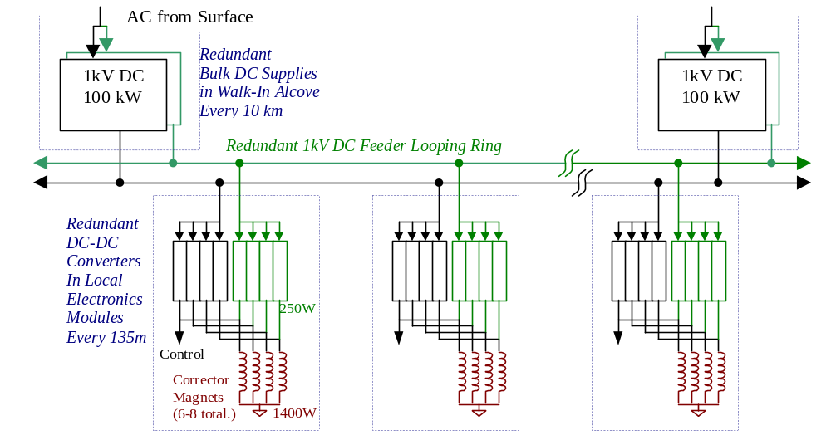

Figure 5.46. DC Power Distribution Scheme in Arcs. Redundant Bulk DC supplies in walk-in alcoves every 10km supply a redundant Loop Feeder. Each local electronics module contains two DC-DC converters for each load. Under normal conditions all supplies share loads and run at less than 50% of rated capacity. By means of auto-resetting circuit breakers (not shown), the system can tolerate short or open circuits on the loop feeders, a failure of one or both bulk supplies at any alcove, a failure of the AC surface feed to any single alcove, and individual failures on many corrector supplies.
Medium-voltage 1kV DC is chosen for power distribution to the electronics modules at each quad location. The DC is provided by 100A bulk supplies every 10km located in racks of electronics in walk-in alcoves. Two redundant bulk supplies are provided at each location, and two independent distribution loops are provided to route the power to the modules. Under normal conditions 25A is sourced in either direction onto each of the 500 MCM loop feeders, and less than 3% of the power is lost in the distribution cabling. Under fault conditions one or both of the bulk supplies at one of the 10km locations can fail, with the slack being taken up by adjacent supplies in the loop feeders. A short-circuit fault in one segment of the loop feeders can be tolerated by letting its circuit breaker trip and relying on the remaining loop feeder. Each module is protected with fault current limiting via automatically resetting “solid-state fuses”[3] .
The advantages of DC power in this application are as follows. The main power consumption is due to corrector power supplies that naturally operate as DC-DC converters. These are more compact than line-transformer based supplies, an important consideration for the quad electronics modules. Modern DC-DC converters [4] have the following parameters: power density 200W/in³, efficiency ~90%, cost ~$0.35/watt. In fact, essentially all modern AC devices (fluorescent light ballasts, computers, high current welders, motor controllers…) rectify the AC line power then chop the signal using DC-DC techniques. Rectification requires bulky capacitors and produces current spikes with power factor and noise problems that complicate AC distribution. DC power distribution makes the most efficient use of the copper in distribution cables, which is a major cost component in power distribution. DC power also simplifies the design of loop feeders, which may be powered from separate segments of the power grid without regard to the relative phase of the incoming AC power. Finally, by phase-locking the switching frequencies of the DC-DC converters to a frequency near the revolution frequency of the machine, noise effects on emittance growth can be essentially eliminated as discussed in section 5.2.xxx.

5.2.3.5 Beam Position Monitors (BPMs)
Both X and Y BPMs (Figure 5.47) will be provided at each “quad location” at half-cell boundaries between corrector magnets. This is twice the number used in the Main Injector where it was determined that measurement of the second coordinate only improved the closed-orbit distortion by 10% [5] and only a single coordinate readout per quad location was provided. However the added redundancy obtained by an independent readout of both coordinates every half-cell will be beneficial given the small aperture and the travel distance to repair failed BPMs.
Button style beam pickups similar to those used on electron machines and the LHC are adequate. These devices are nonlinear outside the central 30% of their aperture. Given anticipated closed orbit distortions <1mm this is not a problem. In a few special locations near beam transfers where multiple off-axis orbits must be measured, split-plate BPMs with better linearity will be used.
BPM readouts using either AM/PM or Log Amp electronics are acceptable. In the case of Log-Amp readout both log(A/B) and log(A)+log(B) would be digitized to provide both position and intensity readout. In the case of AM/PM conversion a separate channel (possibly a log amp) is required to provide intensity information. In either case an in-situ calibration is desirable. The calibration circuit injects equal signals of adjustable amplitude into both channels to accurately determine the zero-offset response at different input strengths. A recent example of log-amp readout made for the SLAC B-factory fit on a 2.7” x 4.7” board which also included calibration circuitry [6].
Digitization bandwidth is determined by the first turn and transient response desired. A digitization rate >25MHz can be supported by the DMA channels of today’s DSPs, with no external components other than the flash ADC. A 10-bit digitization of log(A/B) would provide 20μm least count resolution. Power dissipation for 4 channels of 10-bit 40 MHz digitization would be 300mW total [6].
The cable run from the BPM to the quad electronics module is about 5m. This is long enough that the signal must be terminated but short enough that normal RG-58 can be used. The cable runs are short enough that no cable trimming for phase matching is required if AM/PM electronics are selected.

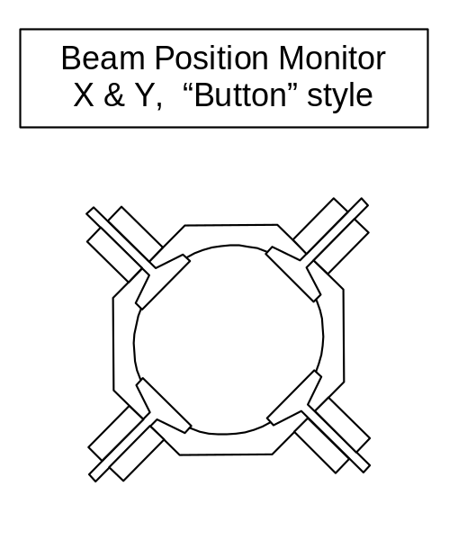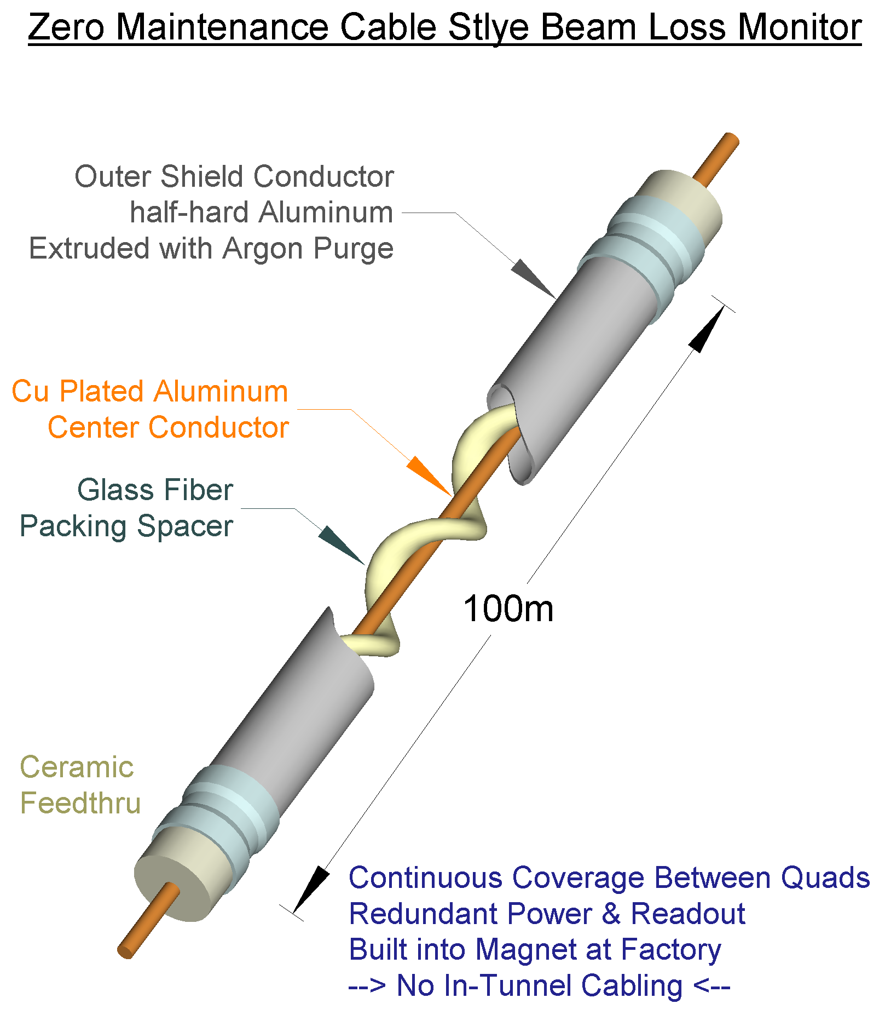

Figure 5.47. Beam Position Monitor (BPM) and Beam Loss Monitor(BLM) for Stage 1 magnets. The BPM is a capacitive “button” style typically found on small aperture beam pipes. The X&Y pickups are rotated by 45-degrees to avoid the synchrotron radiation (this is common at light sources). The BLM is a permanently sealed Argon filled cable-style ionization chamber. Two redundant BLMs run the full length of the magnet. It features all metal and ceramic construction similar to the Tevatron BLMs to allow the device to operate unattended for years (no gas bottle to change).

5.2.3.6 Beam Loss Monitors (BLMs)
The BLM function in the arcs is mission-critical in that no blind spots may exist which might allow chronic beam loss to go undetected. We therefore choose a cable style BLM which is essentially a long ionization chamber that can provide complete coverage along the length of the magnet. The cable will be all metal/ceramic construction (Figure 5.47) so that no gas-bottle changing will be required. For redundancy, two independent cable BLMs are provided. Each runs the full length of the magnet but they are read out at alternate quad locations. These provide complete coverage even when the electronics module at a single location goes incommunicado. Separate BLMs on each side of the magnet provide some differential sensitivity to beam losses in each bore. Electronics required include a 2kV/100μA Cockroft-Walton DC-DC converter module, an op-amp integrator, and a medium bandwidth ~100kHz 14-bit ADC. Power dissipation should be <2W.

5.2.3.7 Ion Pump Power Supplies & Vacuum Gauges
The electronics module for each 135m half-cell requires 12 ion pumps (22.5m pump spacing in each bore). These are powered from the electronics module. Each pump requires a 5kV supply with a starting current of up to 30mA but an operating current less than 0.1mA. The power for all 12 pumps is provided by single transformerless bulk supply (a 5-stage Cockroft-Walton converter operating from the 1kVDC feeder). High voltage DC relays (Cotto 5501) isolate each pump and give the capability of providing the full starting current sequentially to each supply. Individual current readback on each pump is provided via an array of V/F converters operating at HV with an optically isolated data link to the DSP.
Failure of the bulk supply shuts down all ion pumps in a 135m half-cell. Pumping from the NEG strip remains intact. This results in a 50x rise in the pressure of a single gas species (CH4) over the length of one half cell, equivalent to a 3% rise in the average pressure of CH4 in the ring. Redundancy in the ion pump power supplies is therefore unnecessary.

5.2.3.8 Network & Clock Connections
The electronics module at each quad location contains a Digital Signal Processor (DSP) computer with an optical fiber connection running a network protocol stack. This CPU can store, average, spectrum analyze, and data-compress all digitized information before transmitting over a conventional fiber network. A separate dedicated fiber handles the FNAL-specific real time signals such as clock, event triggers, and beam abort heartbeat signals. This will be handled in hardware logic by a PLD in the electronics module.
A minimal set of fiber connection to each module consists of one network connection plus one dedicated fiber for delivering Fermilab-specific clock, event, and safety system signals. For cost estimation purpose we have assumed four direct point-to-point fiber connections between each quad location and redundant network hubs at located in the 10km alcoves. The fiber cable will be a pre-assembled harness 5km long with 4-fiber breakouts at quad locations every 135m. Installation will consist of laying the fiber harness in the cable tray immediately below the electronics modules (Figure 5.48) and plugging the breakout into each electronics module.
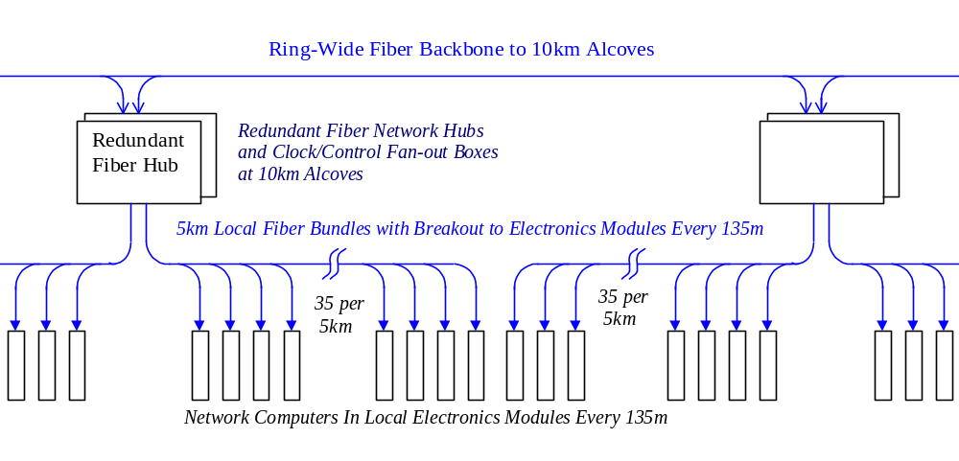

Figure 5.48. Fiberoptic Clock and Network Connections in the tunnel including redundant hubs & clock fanouts at 10km alcoves.
The long-haul fiber backbone interconnecting the 10km alcoves around the ring will be buried with the power duct in the invert. This provides additional radiation shielding to compensate for the longer distance of the backbone fiber runs.

5.2.3.9 Quad Electronics Module Miscellaneous Functions
The networked DSP at each quad location provides the infrastructure for additional features to be added at relatively low cost. In many cases this requires adding only an interface IC, transducer and software to the quad electronics module. The engineering effort for this is not unreasonable given the large quantity of quad electronics modules. Some possibilites:
- Tunnel temperature, humidity, and airflow transducers.
- Integrated radiation dose monitor for the electronics module (FET + resistor).
- RF modules to communicate with the cell phones and PDAs of tunnel crews.
- Microphones for detecting quenches, tunnel dripping, and goofing-off crews.
- Speakers to communicate with the above.
- Cryogenic sensors and valve controls (presently estimated as a separate system)
- Vacuum valve controls (presently estimated as a separate system)

References {ed note—for sec. 5.2.3}
[1] Fermilab Main Injector Technical Design Report, table 3.9.1.
[2] Your {mine? I don’t have one} laptop computer probably has a heat pipe in it. See http://www.thermacore.com/papers.htm
[3] Auto-resetting fuses are sold (for example) by: http://www.circuitprotection.com
[4] Specifications quoted are single-quadrant DC-DC converters from Vicor inc. www.Vicr.com
[5] Fermilab Main Injector Note #MI-75
[6] Medvenko & Smith, Beam Instrumentation Workshop 2000, p.503
[7] Specifications quoted are from http://products.analog.com/products/info.asp?product=AD9203

5.2.4 Beam Vacuum System
The beam vacuum system is divided into two sections. In the 225km of transmission line magnets an extruded-aluminum warm vacuum system similar to LEP and electron storage rings is used. In the 8km of straight sections synchrotron radiation is absent and the vacuum system will be a conventional stainless steel system similar to those commonly used at Fermilab.
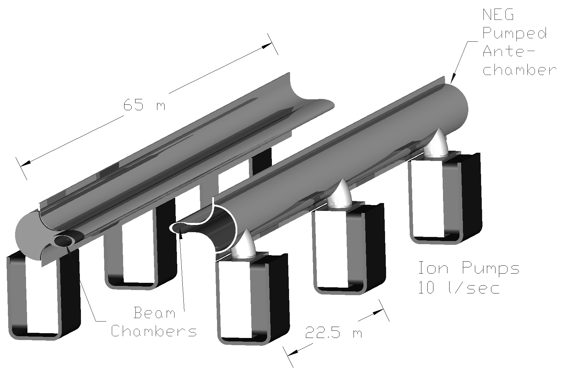

Figure 5.49. Extruded Aluminum beam vacuum system in the transmission line magnets.

5.2.4.1 Arc Magnet Vacuum System
An extruded aluminum vacuum system (Figure 5.49) is used for the 225 km of arc magnets (450 km of beam pipe) . The design of this system is driven by vacuum desorption from synchrotron radiation, the small aperture of the magnet gap, beam impedance and cost. Aluminum is chosen for reasons of economy and beam impedance. The system is pumped by a non-evaporable getter (NEG) strip located in an antechamber of the extrusion. Methane and noble gasses are pumped by 10 l/s sputter-ion pumps spaced every 22.5m. The antechamber dimensions are chosen to provide adequate vacuum conductance to transport synchrotron-desorbed methane to the ion pumps. Pump power and vacuum gauges are discussed in 5.2.3.7.
The parameters and performance of this system have been analyzed by [1,2]. Inputs to the calculation included: 1) the measured synchrotron-induced desorbtion of major gas species from aluminum [3] as a function of the integrated dose of E_{CRIT} = 86 MeV photons, 2) the measured pumping speeds for NEG strip as a function of absorbed gas [4], 3) calculated conductances of the extrusion antechamber, 4) ion pump speeds for methane, and 5) scattering cross sections for the relevant gas species. This approach has given good agreement with the measured performace of LEP [5]. The result of the calculation (Figure 5.50) is that a beam lifetime greater than 200 hours will be achieved after approximately one week of operation. During the “beam cleaning” period the beam current will be increased from an initial 50 mA to the design value of 190 mA in five successive fills. The beam power scattered into the cryogenic system (sect 5.3.3) will not be a limiting factor during this time period.
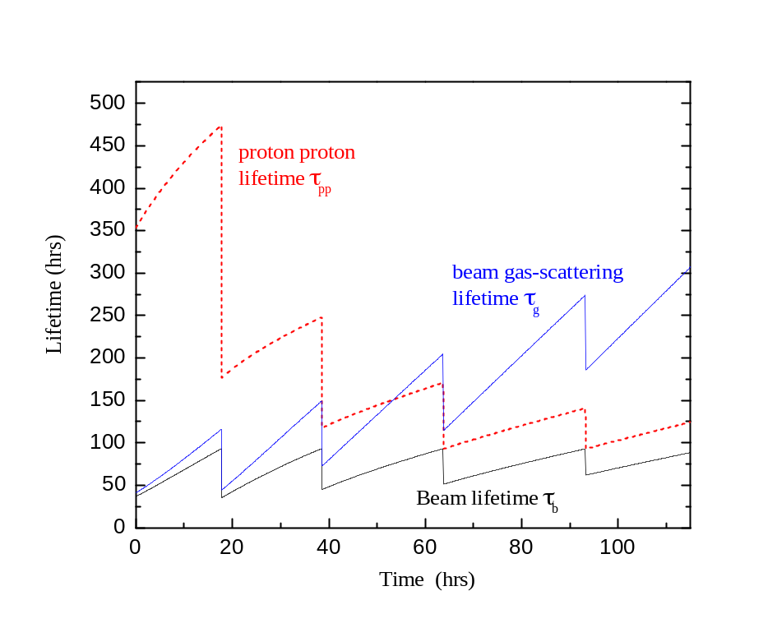

Figure 5.50. Beam Scrubbing Scenario for Stage 1 Aluminum Vacuum Chamber. During the first 5 fills the beam current is increased from 50mA to the design value of 190mA. As synchrotron radiation desorbtion cleans the walls of the beam chamber the vacuum lifetime increases to >200 hours.
Production of the aluminum vacuum system will be integrated into the magnet factory. Tunnel labor is minimized by pre-assembling 65m lengths of extruded pipe which are installed in the magnets, cabled, and tested at the factory. Beam pipe extrusions 12m in length will be received, inspected, and cleaned using an enviromentally safe alkaline cleaning procedure developed at the APS and used on the Fermilab Recycler [6]. The sections will be welded together to form 65m lengths which includes the Ion Pumps, NEG strips and feedthroughs, and end transition sections. The assembly will be selaed, pumped and baked at 200°C for 12 hours in a 65m long vacuum oven similar to the one built for the Recycler beam pipes.
The vacuum pipe assembly is then snapped into the C-magnet gap (Figure 5.51) in such a way that the beam chamber is pre-loaded against the magnet laminations. The preload prevents any possible loss of vertical aperture inside the magnet. The beam pipe has to be deformed slightly to get it inside of the horizontally focussing gradient magnet. This has been analyzed [7] in ANSYS and stresses are acceptable even for annealed aluminum.
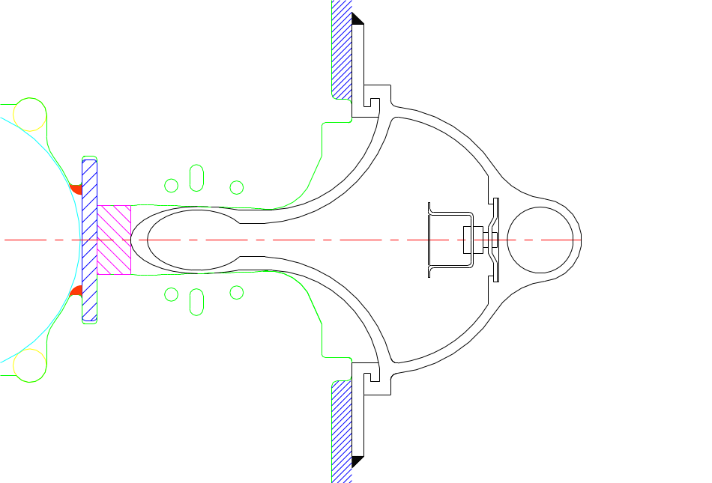

Figure 5.51. Cross section of beam pipe extrusion inserted into the magnet. During insertion the beam pipe is elastically deformed to fit it into the gradient magnet.
The design does not provide for an in-situ bakeout. After factory bakeout the magnets will be stored and transported with the beam pipes capped off and under vaccum, and the beam pipes will be let up to dry nitrogen and the caps cut off to make the field joints in the tunnel. Under these circumstances an in-situ bakeout gains about a factor of 2 in initial dynamic outgassing [8], and gains very little after the beam scrubbing has completed [9]. A similar conclusion has been reached at the ELETRA light source [10]. Our R&D program should verify this.

5.2.4.2 Straight Section Vacuum System
Synchrotron radiation is absent or reduced in most of the 8km of straight sections and the vacuum system will be a conventional baked stainless steel / ion pump system similar to those commonly used at Fermilab. The 10 cm aperture of the 135 m stainless steel pipes between quadrupole locations is large enough that the beam impedance and vacuum conductance are not a problem. The reduced apertures at the the quadrupoles and corrector locations will be handled with 30 cm funnel transitions which may be copper-plated stainless or aluminum.

References {ed note—for sec. 5.2.4}
[1] W. Turner “Beam Tube Vacuum in Low Field and High Field Very Large Hadron Collider”, LBNL-39482, UC414, presented at the Snowmass Conference, CO, October 1996.
[2] M. Pivi and W.C. Turner , “Beam Tube Vacuum in a Very Large Hadron Collider Stage 1”, Version 2.1, 12 Aprill 2001
[3] J. Gomez-Goni, O. Gröbner and A.G. Mathewson “Exposure of a baked Al lined stainless steel chamber to photons”, CERN, Vacuum Technical Note 94-10 pg. 9, AT-VA/JGG.
[4] C. Benvenuti, “Molecular Surface pumping: the getter pumps”, CAS CERN Accelerator School - Vacuum Technology, CERN Yellow book, pg. 48.
[5] J.C. Billy, J.P. Bojon, O. Gröbner, N. Hilleret, M. Jimenez, I. Laugier, P. Strubin, “The LEP Vacuum System: a summary of 10 Years of Successful Operation”, Proc. EPAC 2000.
[6] G.P.Jackson, “The Fermilab Recycler Technical Design Report”, FNAL-TM-1991
[7] Tsvetkov VLHC note note on vacuum pipe stresses.
[8] A. Chao and Tigner, “Handbook of Accelerator Physics and Engineering”, pg.225
[9] Oswald Grobner pvt. comm.
[10] A. Gambitta and et.,”Experience with Aluminum Vacuum Chambers at ELETTRA”,EPAC 2000, Vienna, Austria, and J. Miertusova et. al. “How to Save Money Designing a Vacuum System for a Third Genertion Synchrotron Light Source”, EPAC 1996.

5.2.5 Once-per-Turn Instrumentation
A number of standard instrumentation systems occur only once per ring. In general these can be copied from existing systems in the Tevatron and/or Main Injector. The 53 MHz bunch structure and modest beam currents (~1/3 of Tevatron fixed target) provide no special challenges. Readout electronics for these systems is located in shielded rooms at the Utility Straight Sections. A warm beam pipe is used everywhere except the IR triplet and superconducting RF cavities, so the instrumentation interface is simple. Physical layout of these systems is not heavily constrained since quadrupole spacing is typically 150m, the beam pipes are separated by ~45cm for much of the utility straight sections, and the transmission line and current return have been moved away from the beam to reduce fringe field.

Table 5.25. Once-per-Turn Instrumentation Parameters
FUNCTIONOccurances | Readout Frequency | Comments
Tune Measurement | a few/ring | 10 Hz | Use Arc Module DSP’s for FFT?
Beam Current Toroids | 1/ring |  | Also on injection lines
Sampled Bunch Display | 1/ring | 1 Hz
Fast Bunch Integrator | 1/ring | 1 Hz
Synchrotron Light Monitor | 1/ring | 1 Hz
Ion Profile Monitor | 2/ring | .1 Hz | Small beam size may be challenging
Flying Wires | 1/ring | ~few per store

These are discussed more fully in: http://www-linac.fnal.gov/~mccrory/papers/VLHC_Controls.

5.2.6 Radiofrequency Systems
Either superconducting or warm copper cavities produce workable RF acceleration systems for the stage 1 machine [1]. During the design study acceptable parameters and costs based on the B-factory RF systems were developed [2]. The system described here is based on superconducting RF (SCRF). The advantages of SCRF are a higher energy efficiency during the long periods at storage flattop, and more flexibility to produce RF overvoltage to control beam instabilities if this proves to be an advantage.
The RF system parameters and some RF relevant machine parameters are summarized in Table 5.26. The RF frequency is 371.7 MHz, the seventh harmonic of 53.1 MHz. Overall the VLHC RF system is similar to the LHC RF [3,4], but with somewhat relaxed requirements to higher-order mode damping due to lower total beam current. The superconducting cavities are manufactured using niobium on copper technology developed at CERN. As in the case of LHC, there will be separate RF systems for counter-rotating beams. The beam separation in LHC is 420 mm. If we just scale cryomodule dimensions with RF frequency, we get beam separation of 453 mm.
To minimize the effect of the transient beam loading, cavities with high stored energy are preferred. The LEPII RF system experience [5] and tests of LHC [4] and SOLEIL [6] cavities show that it is reasonable to expect operating gradients as high as 8 MV/m. For VLHC we chose gradient of 7.75 MV/m (3.125 MV per cell). Sixteen single-cell superconducting cavities are needed for each beam in Stage 1 machine and 64 cavities are needed for each beam in Stage 2 machine. The low R/Q of the LHC cavity helps to increase its stored energy. Still the large (10%) beam gap will produce very strong periodic modulation of RF phase of 27° for stage 1 and 10° for stage 2. This modulation is bigger than at LHC. Special RF feedback loop around the amplifier-cavity system assisted by the programmed phase modulation a la LHC [7] will be necessary to suppress this effect.
Each cryomodule will accommodate four single-cell cavities with cell-to-cell distance of 3λ/2. The overall length of the cryomodule is approximately 5.6 m. Static heat leak of cryomodule is 60 W, RF cavity wall losses is 55 W, which give us total cryogenic load of 280 per cryomodule. Overall cryogenic heat load (without losses in cryogen distribution system) is 2.24 kW for stage 1 and 8.96 kW for stage 2.
Due to rather small RF power per cavity we propose to use 500 kW klystrons with 2 cavities per klystron in stage 1 and 8 cavities per klystron in stage 2. The number of klystrons required is 16 for each stage. A 500 kW CW klystron was developed and constructed recently jointly by CERN and SLAC for testing LHC cavities [8]. The klystron has high efficiency of 68% and thus required AC power is 735 kW to generate RF output power of 500 kW. Then the maximum total wall-plug AC power for klystrons is 11.76 MW per ring.
The klystron collector cooling water flow of ≥ 400 l/min gives us the total amount of cooling water required to cool klystrons is 6400 l/min. RF water loads will need additional 4000 l/min (during beam deceleration) and ferrite circulators will consume 480 l/min. Thus the total amount of de-ionized water required for RF system is 10,880 l/min per ring.
To estimate cost of stage 1 cryomodules we will use formula [9]
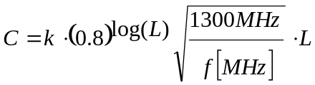
Here L is the active length of accelerating structure, k = 200 k$/m is the cost factor. As one can see, the cryomodule cost scales approximately linearly with total length of the RF structure. The total cost of cryomodules for stage 1 is then equal to 4.2M$. The RF chain cost (including klystrons, high voltage power supplies, low level electronics, and RF distribution) is $1/W and totals to 8M$.
VLHC RF system would greatly benefit from R&D on improving technology of sputtering niobium on copper with the goal to decrease if not completely eliminate phenomenon of the Q slope. Special efforts should be devoted to understanding the nature of this effect. Success of this R&D would allow increase of accelerating gradient without taking serious punishment in the cryogenic heat load. Also, R&D program is required to develop RF controls for heavy beam loading. Careful analysis of transients during injection, acceleration and beam storing is necessary and may necessitate having an individual klystron for each cavity [4].

Table 5.26. Summary of RF System Parameters
 | Stage 1 |  |  | Stage 2
 | Acceleration | Storage |  | Acceleration | Storage
Beam current | 190 mA |  |  | 68.9 mA
Beam energy | 0.9 – 20 TeV |  | 20 TeV | 10 – 87.5 TeV | 87.5 TeV
Acceleration time | 1000 sec |  |  | 2000 sec
Acceleration per turn | 14.8 MV |  |  | 39.4 – 18.15 MV  (30.0 MV av.)
Acceleration power (2 beams) | 5.62 MW |  |  | 4.134 MW
Synch. rad. loss per turn |  |  | 0.03 MeV |  | 12.37 MeV
Total s.r. power (2 beams) |  |  | 13 kW |  | 2.1 MW
Revolution frequency | 1286.5 Hz
Bunch length, rms | 142 mm |  | 66 mm | 81.9 mm | 33.7 mm
Synchrotron tune | 0.00845 |  | 0.00179 | .00280 | .00189
Synchrotron frequency | 10.87 Hz |  | 2.30 Hz | 3.60 Hz | 2.43 Hz
Bunch frequency | 53.1 MHz
Number of buckets | 41280
Bunch spacing | 5.646 m, 18.8 ns
RF harmonic number | 288960
RF frequency (7×53.1) | 371.7 MHz
RF wavelength | 80.65 cm
RF voltage | 50 MV |  | 50 MV | 50 MV | 200 MV
Accelerating gradient | 7.75 MV/m
Voltage per cavity | 3.125 MV
R/Q | 89 Ohm
Q factor at 8 MV/m | 2×10⁹
Number of cavities | 32 (16+16) |  |  | 128 (64+64)
Cavities per cryostat | 4
RF cavity wall losses | 55 W
Cryostat static heat leak | 60 W
Total cryogenic heat load | 2.24 kW |  |  | 8.96 kW
Beam power per cavity | 176 kW |  | 0.406 kW | 42.4 kW peak | 16.4 kW
Number of 500 kW klystrons | 16 (8+8) |  |  | 16 (8+8)
Number of cavities per klystron | 2 |  |  | 8

References {ed note—for sec. 5.2.6}
- V. Shiltsev, “Summary of the Working Group II \RF, Instabilities and Feedback Systems”, VLHC Accelerator Technology Workshop, TJNAF, Feb.1999. http://www.vlhc.org/tjef/wg2_summary.pdf
- A. Jackson, contribution to the VLHC Design Study, unpublished.
- The LHC Study Group, “The Large Hadron Collider – Conceptual Design Report”, CERN/AC/95-05 (LHC) (1995).
- D. Boussard and T. Linnecar, “The LHC Superconducting RF System,” Proceedings of the 1999 Cryogenic Engineering and International Cryogenic Material Conference (CEC-ICM’99), 12-16 July 1999, Montreal, Canada.
- P. Brown, et al., “Performance of the LEP200 Superconducting RF System,” Proceedings of the 9th Workshop on RF Superconductivity, 1-5 November 1999, Santa Fe, NM, USA.
- P. Bosland, et al., Completion of the SOLEIL Cryomodule,” Proceedings of the 9th Workshop on RF Superconductivity, 1-5 November 1999, Santa Fe, NM, USA.
- D. Boussard, “RF Power Requirements for a High Intensity Proton Collider,” Proceedings of the 1991 Particle Accelerator Conference, pp. 2447-2449.
- H. Frischholz, W.R. Fowkes and C. Pearson, “Design and Construction of a 500 kW CW, 400 MHz Klystron to be Used as RF Power Source for LHC/RF Component Tests,” Proceedings of the 1997 Particle Accelerator Conference, pp. 2911-2913.
- H. Padamsee, “SRF for Muon Colliders,” Proceedings of the 9th Workshop on RF Superconductivity, 1-5 November 1999, Santa Fe, NM, USA.

5.2.7 Beam Dampers
In the last 30 years high intensity storage rings have become absolutely dependent on beam damper circuits. The Tevatron in fixed-target mode, the Booster, and the LHC will not operate anywhere near design intensity without them. At synchrotron light sources and B-factories the beams are lost within milliseconds without dampers. It is thus not surprising that the VLHC requires damper circuits to reach design luminosity for both Stage 1 and Stage 2 operation. Fortunately this technology is well developed. One new element which does occur in the Stage 1 VLHC is the necessity to distribute the dampers for one type of instability (the coupled-bunch resistive-wall instability) around the large circumference of the ring. While this provides some level of redundancy (since the beam is stable even if one of the distributed circuits fails) it is a new element which will be described below. Other dampers are conventional.

5.2.7.1 Distributed Transverse Dampers for Resistive-Wall Stability
Growth of transverse motions of bunches in the LF ring will be suppressed with active feedback systems. The strongest beam impedance arises from resistive-wall. At the frequency of the first lower-sideband coupled-bunch mode, which is (1-0.235)f₀ = 0.99 kHz, the transverse beam impedance is (7.84+1.27j)10¹⁰ ohm/meter. This causes an exponential growth rate of 2.53 x 10³ per second for a fully filled machine. Prompt cancellation of this growth is provided by six localized feedback stations spaced around the ring circumference. At each station, radial and axial damping are the same and for each there are two feedback systems displaced azimuthally by 270 degrees in betatron phase to address both ‘sine’ and ‘cosine’ phases of the oscillation; this makes the damping tolerant of changes of tune that might be desired.
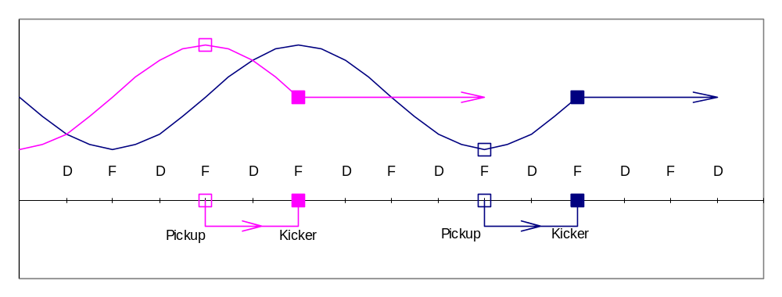

Figure 5.52. Layout of Pickup and Kicker positions for the horizontal coordinate at one station. Incoming beams with sine-like or cosine-like oscillations have their positions sensed by pickups at cell boundaries (F- locations) and are kicked back towards the design orbit after one-quarter betatron oscillation. An identical set of vertical pickups and kickers operates at D-locations. Six identical stations are distributed around the ring, one at each stage 1 cryoplant location.
In localized feedback, a kicker is located downstream from the pickup by 90 degrees in betatron phase (one lattice cell) and the signal is transmitted promptly from pickup to kicker through foam-insulated coax to minimize delay. Delay in the 271 meters of cable is 180 nanosec. to which one adds about 50 ns. for electronic processing and amplification. Although with this delay the signal from one bunch is delivered to the 12th following bunch, the phase delay at 1 kHz is a negligible 1.5 milliradian. For higher-frequency sidebands the phase delay increases, becoming a significant 1/8-oscillation at 550 kHz. The localized feedback systems will be used up to 500 kHz; at that frequency the impedance has become small enough to be controlled by a conventional one-turn bunch-by-bunch system that extends up to the needed 26.5 MHz bandwidth of coupled-bunch modes.
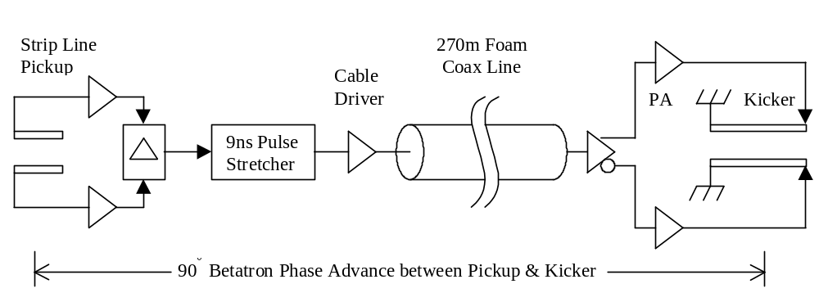

Figure 5.53. Electronic Elements of the Coupled-Bunch Feedback System.
The hardware in a local feedback system consists of (1) a pair of capacitive pickup plates, (2) electronics and cable to the kicker, and (3) a 4-meter long stripline-pair kicker. The pickup strips are 25 cm long and connect to high-impedance amplifiers. The signals are then differenced and the unipolar pulses are stretched to half the interval between bunches to give a baseband signal for the kicker. At the lowest, strongest mode, the required feedback loop-gain is G = 0.287 and to damp injection errors of 0.1 mm calls for a transverse kick of 83.3 kV. The kicker delivers this with a power input of 1.10 kW. Injection in bunch trains separated by 2 seconds produces unwanted transients, especially if there is closed-orbit offset. Bunch signals will be recorded and analyzed to generate a correction for the local closed–orbit corrector; this will zero the closed-orbit well before the second train of bunches is injected. After the ring is filled, additional rejection of very low frequency excursions will be made by the low-frequency cutoff of the feedback electronics; this is possible with baseband operation as we have here. For damping both radial and axial motions at 6 stations, 24 systems are required for each circulating beam.
Pickup and kicker are located at points of maximum betatron amplitude in slightly modified standard arc cells. The modifications [1] involve removing 5m of magnet iron at the boundaries of 8 successive half-cells. An additional quadrupole corrector is used at each location to repair damage to the β-functions caused by the missing focusing. The ~10% dispersion wave generated by the missing bend automatically cancels outside the insertion by virtue of the 360° phase advance across the 8 half-cells. The damper system uses at most 6 of the 8 available free spaces. Placing the damper pickups and kickers where the dispersion is nonzero is not believed to cause difficulties although this is will be the subject of continuing study.
At the coupled-bunch mode frequency of 500 kHz, the growth rate has reduced to 57 per second or 0.044 per turn. This and all higher coupled-bunch modes are suppressed by the one-turn bunch-by-bunch feedback system that operates over the range 53.1±26.5 MHz. The kicker is a quarter-wavelength long at this frequency, 1.41 meter. The required kick for 0.1 mm excursion is 26.4 kV and power is 513 watt. Power amplifiers for this application are commercially available. The pickup is the same length as the kicker and feedback gain is 0.108. Radial and axial systems are similar.
One can ask if electronic noise in these dampers will add emittance during a long collision time. Fortunately, although the loop gains are high, the small aperture and peak bunch current of 8.4 ampere make the pickup signal strong and large electronic gain is not needed. The peak current gives a pickup sensitivity 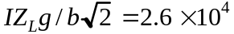 volt/meter. Input thermal power with an amplifier noise figure of 1 dB is 1.2kTB =5.2x10⁻²¹B where B is the bandwidth. Equating this to the pickup signal power with equivalent rms noise amplitude X_{N} gives 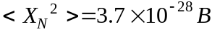. The higher energy at collision reduces the gain to G =0.013. The 12 feedback systems would then cause an emittance growth rate, without allowing for damping, of
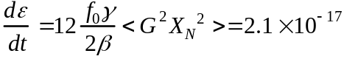 m/sec
Nominal emittance is 1.7x10⁻⁶, thus this dilution rate is of no concern and would actually be smaller because of damping by the feedback. The broadband system produces a similarly negligible emittance growth.

References {ed note—for sec. 5.2.7}
[1] J. Johnstone, Presentation to VLHC workshop in Lake Geneva, WI Jan 2001.

5.2.8 Injection
The magnets and optics needed for 900 GeV beam injection are described in section 5.1.5.4. An important design specification (not often taken at Fermilab) is that the injection and extraction devices not present any aperture limitaton smaller than the arc magnets. This requires full-aperture kickers and special large aperture copper/iron quadrupoles in the vicinity of the Lambertsons. A high beta insertion minimizes the strength of standard kickers required. The large aperture quadrupole is described in section The magnet designs and layout in section 5.1.5.4 (for both injection and abort) meet that goal.
Transfer line magnet parameters based on both air-cooled copper and permanet magnets have been developed. Either solution will require one corrector magnet per quad location, with the power supply and instrumentation in local modules similar to the arcs.
Beam is injected near the midpoint of the Utility straight section. Downstream of this it will be convenient to have an internal beam absorber for transfer line commisioning and tests independent of the arc magnets. The injected beam, after passing through two quad locations to maesure position and steering errors, will be deflected 5-10 cm onto the absorber by a standard corrector magnet. The scope of absorber will be comparable to the Tevatron collider-mode abort. With reasonable administrative intensity limits air-cooling should be sufficient. A few bunches of 10⁹ protons are sufficient for a good BPM measurement.

5.3 Radiation, Machine Protection, and Beam Abort

5.3.1 Overview
The 2.8 GJ of kinetic beam energy in the Stage 1 machine is approximately eight times that of the LHC. Under normal circumstances roughly 50% of this energy is gradually dissipated in beam-beam collisions at the IRs and 5-10% is lost diffusely due to beam–gas collisions around the circumference of the ring. Another 5-10% may be intercepted at beam collimation inserts which scrape away beam halo particles. The rest of the energy is disssipated in the RF loads as the beam is decelerated and deposited in the beam absorber when the decelerated beam is ejected.
A very small fraction of the machine circumference exceeds the limit (~ 1 W/m of beam losses) for normal “hands-on” maintenance [1]. These regions include the small-angle regions of the IR’s, the beam collimation system, and a small region or arc magnets downstream of the beam collimation system. The average radiation load in these components is a few times higher than the LHC, and the shielding and handling requirements comparable. LHC experience will be useful in optimizing these designs.
Under accidental conditions there is enough energy to cause severe damage to the magnet and surrounding environment. This is not a new situation for high energy colliders. The ISR beams had enough energy to repeatedly burn holes in the machine [2]. The magnitude of the problem has increased however. The beams of the Stage 1 machine carry enough energy that in principle they could liquefy 400 liters of stainless steel (whereas the LHC beams can only liquefy 50 liters).
Under worst-case accident assumptions the beam will leave the machine and strike the tunnel wall. We have begun to study the mechanical and radiological consequences. See section 5.3.3. A single shot beam accident releases beam energy equivalent to losing the Main Injector beam at one place for about an hour. This is not outside the scope of existing shielding requirements at Fermilab, and should not be major problem for a tunnel in deep bedrock.
Tunnel groundwater activation from single-pulse accidents appears not to be a concern. A preliminary calculation indicates that it would be possible to lose the beam in a single spot, immediately transfer the activation into the tunnel water sump pit, and pump out the activated water without violating applicable federal guidelines. Another way of saying this is that you could dump the beam into the tunnel sump cistern and the water would still be safe to drink. (This is of course an absurdly pessimistic scenario, since it will take days or weeks for the groundwater to collect in the sump, by which time most of the radioactivity will have vanished).
Effective strategies have evolved to deal with machine protection issues culminating with the Tevatron, SSC, and LHC. These issues have been revisted for VLHC energies [3,4] and the results are summarized here.
Firstly, a robust and redundant extraction system removes the beam whenever the position becomes unstable or anomalous losses are detected. This protects the machine from anything which happens “slowly” (in miliseconds to seconds) such as magnet quenches, RF or power supply failures, vacuum failures or corrector magnet trips. Such a system has prevented the Tevatron (so far) from having a hole burned through it. This is a standard feature which continues to be essential at VLHC energies.
The one credible accident which occurs on a rapid time scale involves an abort kicker module misfire. The incompletely extracted beam will rattle around the machine and hit various well-defined limiting apertures such as extraction septa, IR quadrupoles, beam collimators, and (god willing) the silicon detectors. The probablity of this will be reduced in the LHC by replacing Thyratrons with solid-state kicker power supplies, and appropriate fail-safe logic which in principle prevents a single module misfiring (“a partial-beam abortion”?). Since the probability of this cannot be reduced to zero, a set of “sacrificial collimators” are placed upstream of the vulnerable components. These are replaceable graphite structures which absorb and diffuse the beam energy at great personal cost. This strategy is essential at the SSC/LHC and will be necessary and sufficient for the VLHC.
Three qualitiatively new features emerged while reviewing the machine protection situation at VLHC energies. First, the graphite core of the beam absorber may be damaged by a single pulse in the case of a sweeper magnet failure. The core must be protected (sect 5.2.7.1) with a replaceable sacrificial collimator immediately upstream. Secondly, in the case of a sweeper magnet failure the beam window in the extraction channel will have a hole melted in it. This is not a safety issue, but in this accident scenario the beam vacuum must protected with an automatically closing gate valve and the window must be replaced. Finally, the beam collimation system (sect 5.2.7.2) will require water cooling for the jaws of the secondary collimators.

5.3.2 Beam Abort System

5.3.1.1 Extraction
It turns out to be quite straight forward to kick the beams out of the machine towards absorbers. The magnet parameters and layout are discussed in section 5.1.5.4.2. Like the Tevatron, SSC and LHC abort systems, we use fast kicker magnets to switch the circulating beam into the other aperture of Lambertson magnets. The circulating beam goes through the field-free hole in the Lambertson magnets, and the extracted beam is bent upward in the Lambertson magnets so as to clear the first quadrupole in the downstream half of the straight section. A full aperture extraction kick is used and the separation of the circulating and extracted beams is 25 mm at the entrance to the Lambertson magnets. Thus any beam which is circulating anywhere in the physical aperture will be extracted. Special large-aperture warm-iron-and-copper quadrupoles are used near the Lambertsons so that no aperture restriction is presented to the circulating beam.
Normally the beam extraction is synchronized with an “abort gap” in the beam which is equal to the rise time of the extraction kicker. During certain control system failures it may be necessary to unconditionally extract the beam. This sweeps the beam across the extraction septum which must survive without damage. For the VLHC the stress on the extraction septum is roughly equal to the LHC (since the beam energy per unit time is similar) and does no damage.
The requirements for the reliability of a one-turn extraction mechanism are comparable to the SSC [5] and LHC [6]. The extraction kicker is broken into 10 independent modules, with any 7 out of 10 sufficient for a safe abort. Solid-state pulsers (as opposed to Thyratrons) will be used to minimize accidental prefires. Three Musketeer logic (“All-for-one, and one-for-all!”) guarantees that any single module firing will automatically trigger the rest of the modules.

Figure 5.54. Schematic layout of Beam Abort channel including kickers, Lambertson septa, extraction beam sweeping, beam defocussing, beam window, sacrificial rod, and 4-in-1 Beam Absorber. Under normal circumstances the extracted beam is swept in a spiral pattern to spread the energy across the graphite dump. If the sweeper magnet fails, the beam travels straight ahead into a sacrificial graphite rod which takes the damage and must be replaced.

5.3.2.2 Beam Absorber
For TeV beams, the natural choice for the absorber is graphite, as at the Tevatron, SSC and LHC. The major difficulty lies in making the beams big enough that they will not crack a graphite absorber. A standard absorber consists of a graphite core, contained in an aluminum jacket with water cooling, followed by adequate steel and cement to protect ground water. The graphite core is rectangular, with dimensions 10 ×1.2 ×1.2 m. The thickness of steel shielding around the aluminum container is about 1.3 m on each side and extends about 3 m downstream. At present we consider a “4-in-1” design where extracted beams from both directions hit absorber cores in a common sarcophagus. The Stage 1 and Stage 2 machines share a common absorber for each direction.
Activation and cooling water considerations are driven by the average beam power on the target. The 500kW average power (corresponding to one full-energy abort of both beams every 12 hours) is comparable to the 300kW design value for the Main Injector beam absorber. The overall design is patterned on the Main Injector absorber which has proven satisfactory and meets ES&H requirements for this power level.
The graphite dimensions and beam size necessary to contain the showers without cracking the graphite were found by detailed simulations with the MARS14 code. The design goal was to keep the maximum temperature rise at the axis of the graphite core per spill below 1300-1500°C (from successful Tevatron dump experience and theoretical shockwave considerations). For a purely Gaussian beam with a spill that is stationary in transverse position, the beam sigma would need to be 19 cm in both x and y for the maximum temperature rise in the core of 1330°C. Expanding the beams to this size with defocussing quadrupoles is out of the question.

5.3.2.3 Beam Sweeping System
A spiral beam sweeping scheme similar to the SSC and LHC is adopted to spread the beam energy across the absorber core. Magnets are described in 5.1.5.4.2. A horizontal and a vertical sweeper, 90° out of phase, both oscillate with decaying amplitudes. Ideally the frequency should increase as the radius of the spiral decreases in order to keep the temperature rise constant. Since this is electrically difficult a suitable compromise is to limit the inner radius of the spiral to half that of the outer radius and accept a factor two higher temperature rise at the inner radius. An estimation indicates that an outer radius of 30 cm would be adequate to keep the temperature below 1500°C. If the beam sigma was 0.5 cm in both planes, the frequency of these sweepers would be 9.7 kHz.
In the case of a failure of both coordinates of the sweeper system the beam would damage the graphite absorber core [7]. To prevent this a sacrificial graphite rod 5 cm in diameter and 4 m long is positioned on the beam axis immediately upstream of the main absorber. See Figure 5.54. Normally the extracted beams will spiral around this rod without hitting it. If the beam is extracted with all sweeping magnets off, the beam damage will be confined to the sacrificial rod. The rod will be housed in a metal box to prevent the spread of radioactive debris.
A beam window will not be protected in case of sweeping system (or defocussing quadrupole) failure, if the effective beam sigma on the window is less than 0.5 cm. The ring vacuum can be preserved by rapid-acting gate valves and/or multiple windows in series. Each window gets a small hole drilled in it when the sweepers fail, and pumping between the windows isolates ring vacuum until a slow gate valve closes. Alternatively, differential pumping with several wire meshes would do the same job.

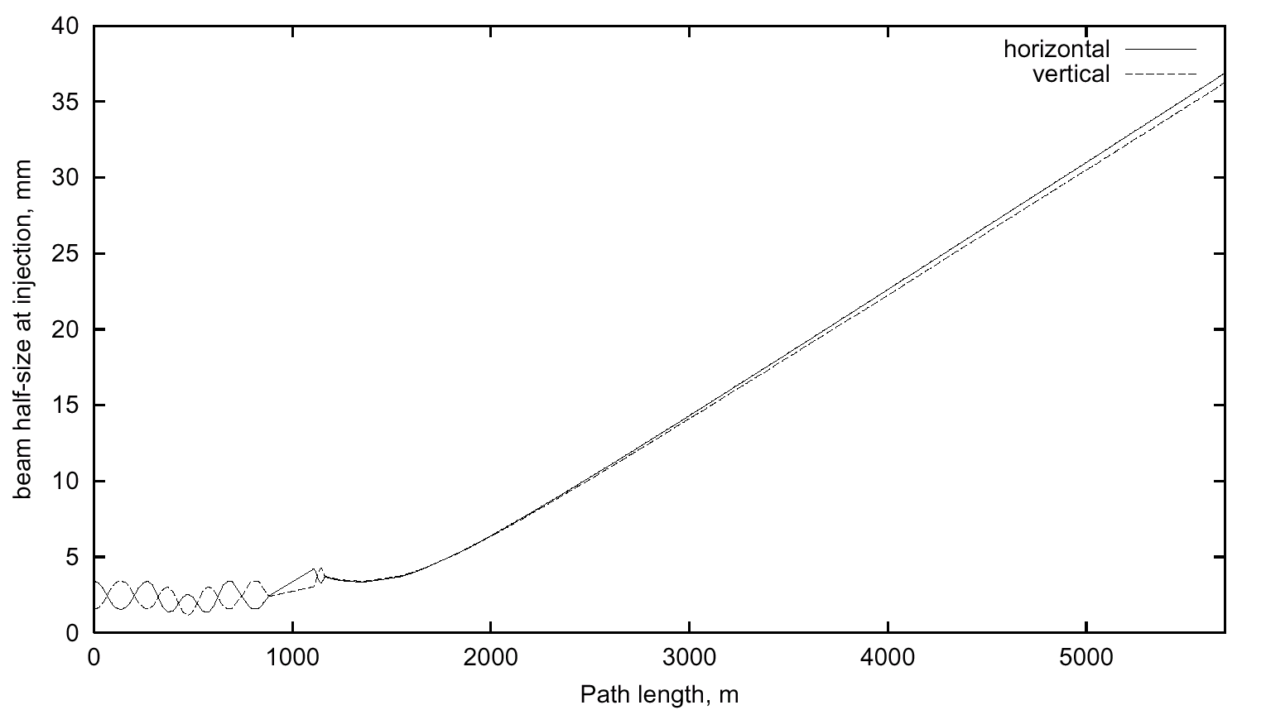

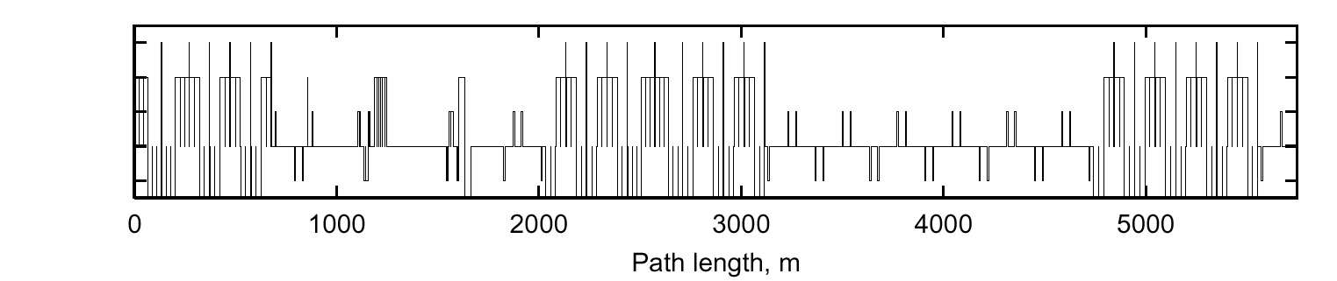

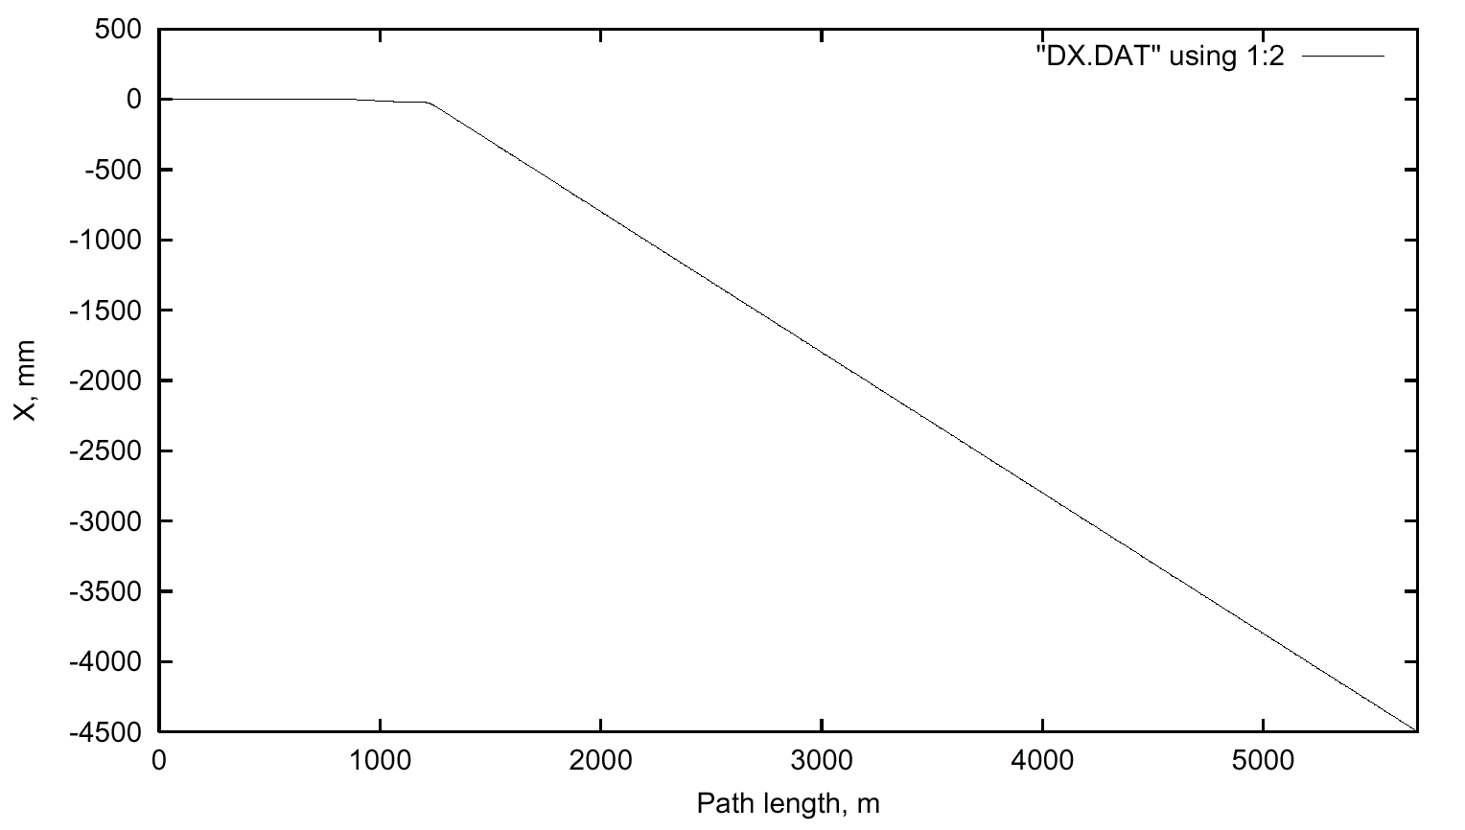
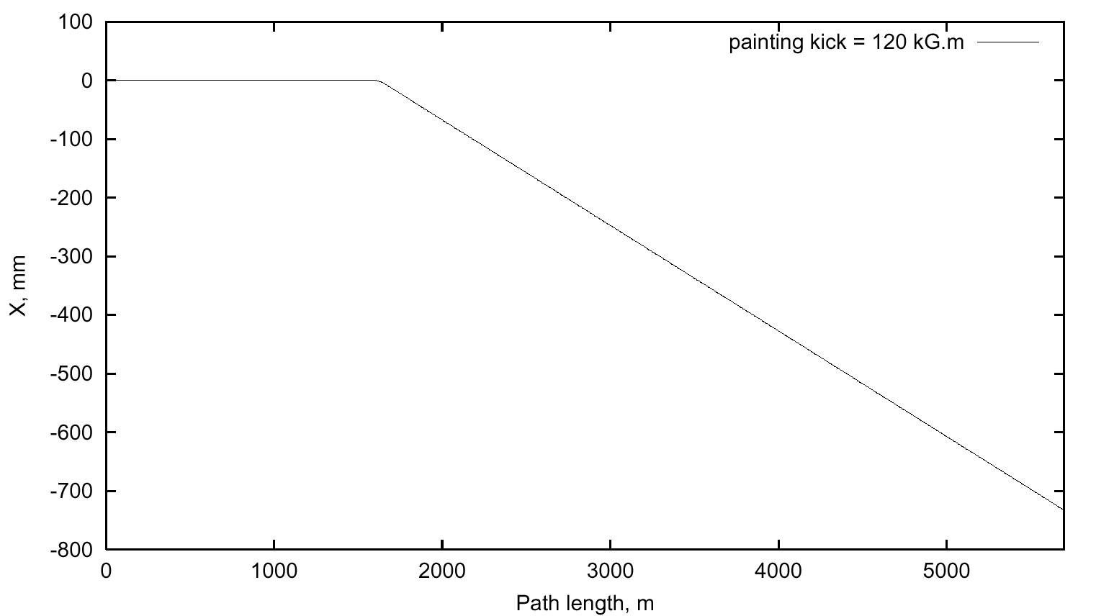

Figure 5.55. Beam sweeping system optics. Left: 3-sigma beam half-size at 1 TeV injection (beam size at 20 TeV is 4.5x smaller), and beam line layout. Right: beam displacement with respect to the direction of extraction straight section and maximum sweeping kick in the horizontal or vertical plane.

5.3.3 Radiation and Beam Loss

5.3.3.1 Quenches from Beam Loss in Transmission Line Magnets
The warm-iron design of the Transmission line magnet is less sensitive to radiation-induced quenches than ordinary superonducting magnets. To determine tolerable beam loss in the arcs, MARS14 simulations are done in the lattice both at injection (1 TeV, σx,y = 1.4 mm, α_{inc} = 0.7 mrad) and top energy (20 TeV, σx,y = 0.3 mm, α_{inc} =0.15 mrad). Corresponding materials and magnetic field distributions have been implemented into a 3-D model. Inward and outward beam losses were considered both for inner and outer beam pipes (see Figure 5.56).
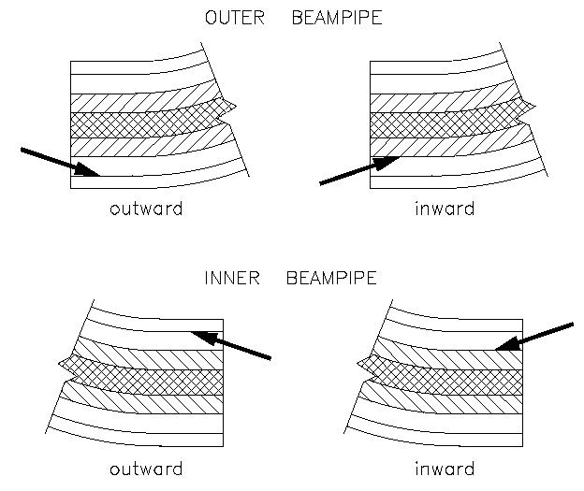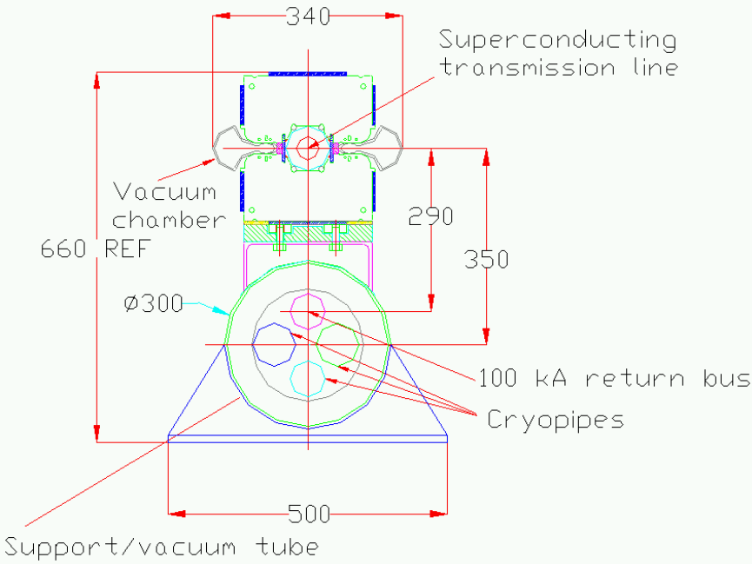

Figure 5.56. Beam loss geometries simulated in the Stage 1 VLHC magnets.

Simulations show that the superconductor in the transmission line magnets is rather well protected radially by warm iron. The distance from the hottest spots in showers started by protons hitting the beam pipe, peak energy deposition density is relatively low. Therefore, the tolerable beam loss is significantly higher than in a conventional cosine-theta type magnets. Table 5.27 shows fast (1 msec) and slow (0.1 sec) beam loss rates needed to initiate a SC magnet quench—assuming the same quench limits as in the Tevatron SC dipoles — at injection and top energy in the Stage I ring. For comparison, the values for the Tevatron at 0.9 TeV are shown. The assumption that the temperature needed to incite a quench in both magnets is identical is probably pessimistic since the braided cable of the VLHC can re-route the current around a quenched region on the magnet midplane and a cosine-theta magnet cannot.

Table 5.27. Quench-Inducing Loss Thresholds for the VLHC Stage 1 and Tevatron
 | Fast Loss Protons/pulse | Slow Loss Protons/sec
0.9 TeV | 9 ×10 ⁸ | 3 ×10 ⁹
20 TeV | 2.5 ×10 ⁷ | 7.5 ×10 ⁷
Tevatron | 4 ×10 ⁷ | 3 ×10 ⁸

5.3.3.2 Cryogenic Heat Load from Beam Losses
Heat load from beam-beam interaction debris in the IR quads is included explicitly in the discussion in section 5.2. The cryogenic heat load from beam loses in the arcs is also a potential concern. At 20 TeV roughly 5% of the energy from beam losses is estimated to be absorbed in the cryogenic transmission line. If 1% per hour of the (3+3) GJ of beam energy were lost uniformly in the arcs, this amounts to a total heat load of 800 W (3.5mW/m average) which is a 5% perturbation on the 5K heat load. The collimation system (section 5.3.4) is expected to localize essentially all beam halo losses into collimators in warm sections, thereby eliminating that heat load from the cryo system.
The collimation system will be ineffective against losses from inelastic beam-gas scattering. With the expected vacuum lifetime (sect 5.2.4.1) of >200 hours, the cryogeninc heat load will be < 2mW/m, less than 3% of the 4.5K heat load. If continued R&D reduces the 4.5K heat leak this will become an increasingly important part of the total.

5.3.3.2 Radiation Damage to Tunnel Electronics
The Section 5.2.3 describes electronics housed in small enclosures (“holes in the wall”) at each quad location. This approach was studies at UNK [8] and the electronics was found to survive under rather conservative assumptions about their radiation hardness. A recent interesting development [9] is that modern CMOS is found to be intrinsically rad-hard due to the absence of long-term charge trapping at the gate oxide layer in sub-micron devices. The LHC is apparently contemplating placing unshielded electronics under each dipole, and is initiating a study of the radiation hardness of commercially available electronics [10]. Depending on LHC operational experience, the rather modest costs of the module enclosures might be saved by eliminating the enclosures. Or not.
Radiation damage to fiber optics placed in the tunnel is was studied at the SSC [11]. It was found that placing the fibers into the trough in the invert guaranteed their survival even for upgrades to 10x the SSC luminosity. We have followed this approach (section 5.2.3.8).

5.3.4 Beam Collimation System
Even in good operational conditions, a finite fraction of the beam will leave the stable central area of accelerator because of beam-gas interactions everywhere along the accelerator, intra-beam scattering, collisions in the IPs, RF noise, ground motion and resonances excited by the accelerator imperfections continuously produce a beam halo. As a result of beam halo interactions with limiting apertures, hadronic and electromagnetic showers are induced in accelerator and detector components will cause accelerator related background in the detectors, magnet heating and accelerator and environmental irradiation. The design strategy of the VLHC is that the beam losses are controlled as much as possible by localizing them in a dedicated beam collimation system. This minimizes losses in cryogenic parts of the accelerator, and drastically reduces the source term for radiation hazard analysis in the rest of the lattice. The technology for these systems has been well developed for the Tevatron, SSC, and LHC.
For the VLHC a complete beam cleaning system which provides for both betatron and momentum scraping has been designed and simulated [11,12]. The three-stage beam collimation system consists of 5 mm thick primary tungsten collimators placed at 7σ_{x,y} and 3 m long copper secondary collimators located in an optimal phase advance at 9.2σ_{x,y} and aligned parallel to the circulating beam envelope. Two more supplementary collimators are placed in the next long straight section to decrease particle losses in the low-β quadrupoles and in the accelerator arc. They are located at 14σ _{x,y} to intercept only particles scattered out from the secondary collimators.

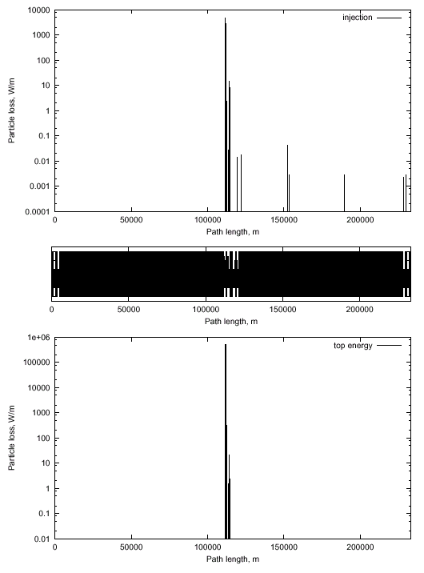

Figure 5.57. Beam loss distribution along the accelerator at injection (top) and at collisions (bottom).
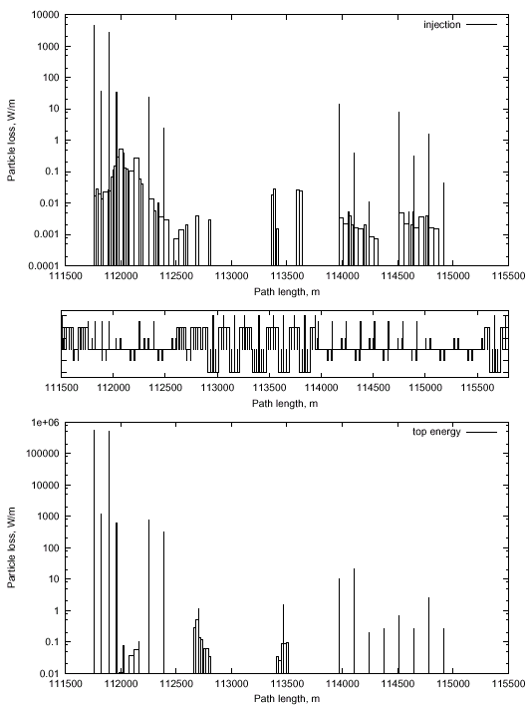

Figure 5.58. Beam loss distributions in the collimation section at injection (top) and at collisions (bottom).

The simulated performance of the system meets the goal of essentially eliminating losses away from the cleaning insert. A main reason for this excellent performance is that the system uses a purpose-built lattice insert rather than a something which has been retrofit into an existing machine such as the Tevatron. The maximum beam loss in the arc section behind the collimation region () is 1 W/m in two 21.5 m long dipoles and one 6 m long quadrupole, and 0 .2 W/m in two 21.9 m long gradient magnets.
The effect of beam cleaning system operation on the particle loss distribution in the entire machine was design and calculated with emphasis on reducing losses and detector backgrounds near the high luminosity insertions. But in our calculations, with 6 ·10⁴ particles lost in the collimators, we did not see any loses in the vicinity of interaction point. Farther investigations should be done to determine particle backgrounds in the IP from the collimation system.
The primary collimation insert will be located in a far side straight sections conjugate to the on-site Utility Straight Sections. Secondary collimators will be located in this section as well as in special locations near the IR’s. The secondary collimator will absorb approximately 20kW of beam power and will require water cooling, probably thorough an isolated RAW (radiaoactive water) loop heat exchanged with the LCW flow. Shielding of the collimators will require approximately 1m of radial iron followed by 50cm of radial concrete over a length along the beam line of ~15m to allow free passage of rad-trained personnel. This will require locally enlarging the tunnel cross section but should not require a bypass tunnel.

References {ed note—for sec. 5.3.4}
[1] proc. Beam Halo workshop
[2] Bryant & Johnsen, “Circular Accelerators and Storage Rings”, p.308
[3] A.I. Drozhdin and N.V. Mokhov, “Energy Deposition Issues in the Very Large Hadron Collider”, Workshop on VLHC, Fontana, Wisconsin, February 22-25, 1999.
[4] A.I. Drozhdin , N.V. Mokhov, C.T. Murphy, S. Pruss, “Beam Abort For a 50X50 TEV Hadron Collider”, http://fnalpubs.fnal.gov/archive/vlhc/VLHCPub-51.ps
[5] Baishev, I.S., Drozhdin, A.I., Mokhov, N.V., Parker, B., Richardson, R.D., Zhou, J. “Dealing with Abort Kicker Prefire in the Superconducting Super Collider“,PAC 93, Washington, DC, May 1993
[6] The Large Hadron Collider, Conceptual Design, CERN/AC/95-05(LHC) October 20, 1995..1.5
[7] A legendary SSC video contains a visualization of the extracted SSC beam drilling a hole in the absorber block when the sweeping magnet system fails. We should put this online.
[8] N. Mokhov, pvt. comm.
[9] R. Yarema, pvt comm.
[10] LHC Talk at Beam Instrumentation Workshop ’00
[11] SSC Note #
[11] Drozhdin et. al., “The VLHC Beam Collimation System”,VLHC design study note
[12] A.I. Drozhdin, N.V. Mokhov and A.A. Sery, “The Very Large Hadron Collider Beam Collimation System”, Workshop on VLHC, Fontana, Wisconsin, February 22-25, 1999.

5.3.5 IR Protection
A sophisticated system must be designed to protect the IR SC magnets, particularly from kicker misfires. As in the LHC, it will consist of a front collimator, inner and intermediate absorbers in the inner triplet, and of a neutral beam dump and several collimators in the outer triplet. The similarity of the Stage 1 IR layout to the LHC makes it likely that a similar protection layout would be workable. The length of these sacrificial collimators will likely have to be increased reflecting the increased energy and decreased beam spot size of the VLHC beams.

5.3.5 Worst-Case Beam Acccidents
Work has begun on understanding the implications of a “worst-case” beam accident in the VLHC. The assumption is that some unspecified agent causes the beam to be kicked out of the machine with a rise time fast compared to the revolution frequency, so that the normal beam abort does not have time to act. This agent is also assumed to possess a “kicker flat top” accurate enough (<1%) that then beam is effectively held in one place for the duration of the accident. Under these assumptions the beam will rapidly melt a hole in the magnet and impact the tunnel wall at near grazing incidence (3-5mrad).
A preliminary observation is that the nearby cryogenic piping would explode due to the instantaneous temperature rise. This would also be true of the Tevatron, HERA, and the LHC so it is important to keep this mysterious agent out of these machines as well. The cryo piping is contained inside carbon-steel structures (vacuum jackets and magnet iron) which would limit collateral damage. It would probably not even be noticed from the outside of the magnet. This is not our biggest problem.
A second observation is that the “beam drilling” scenario (in which a stable beam vaporizes a small channel deep into the target) is impossible at grazing incidence, even if the beam were perfectly extracted on a single trajectory. This beam drilling scenario is expected when the beam is normally incident onto a semi-infinite slab of material such as a beam absorber block. However at grazing incidence, the imbalance of the mechanical forces near the beam impact point (due to local heating of the rock) will cause a rock chip to “spall”out from the tunnel wall. This spalling behavior has been observed during rock excavation tests with electron beams [ ] and follows this simple mechanical model. This spalling effectively sweeps the beam and guarantees that fresh (i.e. non-vaporized) material will be available to initiate the shower even if the beam is extracted perfectly. So the pattern of energy deposition can be calculated accurately enough that the shower intiates at a more-or-less fixed position near the point of grazing incidence.

A MARS calculation has been performed (Figure 5.59) to evaluate the energy depostition under the assumption that both the rock and beam position remain fixed. The simulation indicates that a region 8 metres long and about 15cm in radius are heated to the melting point of Dolomite. Obviously the lava will splatter to the floor. The next step in the calculation (in progress) is to use ANSYS to evaluate the thermal stresses in the surrounding rock and estimate the amount of rock which breaks off from thermal stress. The rise time of the heat pulse (1 machine revolution or about 0.8 msec) allow the mechanical stresses to relieve themselves on the scale of a couple of meters, so a static mechanical analysis is approximately valid.
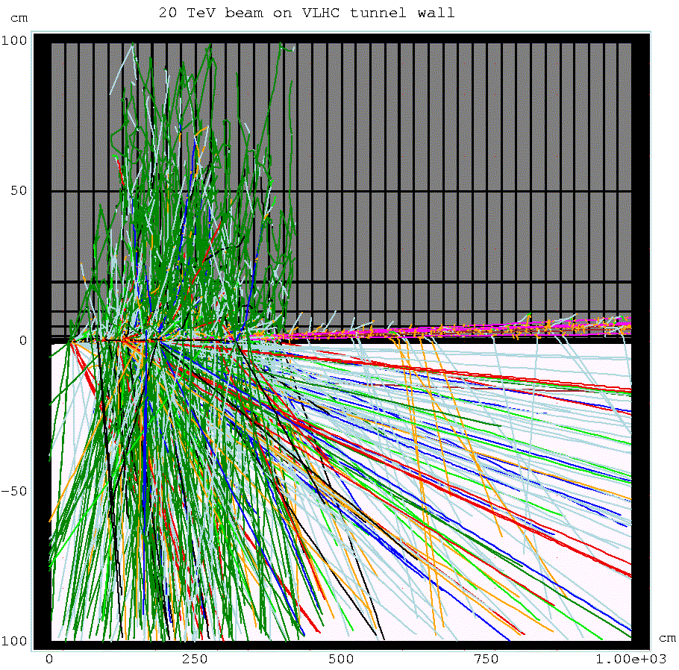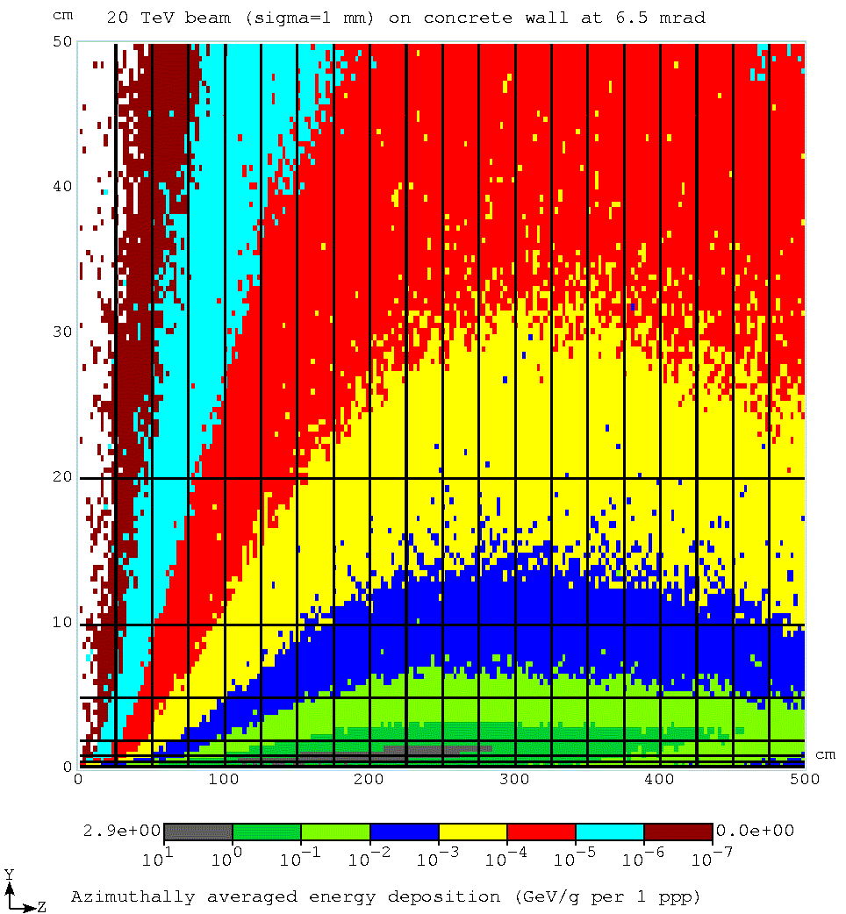

Figure 5.60. VLHC Stage 1 beam at 6.5mrad grazing incidence on tunnel wall.
A more realistic situation in which angle of the beam angle sweeps by even a few milliradians during extraction the changes the situation signficantly. In this case the heating is distributed into a large enough rock mass that the only a very small region (of order a centimeter wide) is taken near the melting point. The picture becomes that of a destroyed magnet, a centimeter-wide scar on the tunnel wall, and an amount or residual radiation comparble to that of a 1-hour continuous beam loss of the Fermilab Main Injector.

5.3.6 General ES&H Considerations
{ed. note: this section will be derived from the following material provided by Don Cossairt}

Potential Environmental, Safety, and Health Issues

Environment, Safety, and Health Considerations for a New Accelerator Facility

I. Introduction

All of the possible future accelerators under study present a number of considerations in the general area of environment, safety, and health. It is the intent of this chapter to identify the character of these challenges in a general way. The environment, safety, and health issues peculiar to a particular possible accelerator are discussed in the chapters related to that technology. Some of the considerations which much be taken into account are very similar to those that have been encountered and solved during the construction and operation of other facilities at Fermilab and at similar laboratories elsewhere in the United States and worldwide. Other considerations have not been encountered on the same scale previously in connection with the construction and operation of accelerator laboratories. These novel issues will require particular attention as such a project proceeds to assure their timely resolution in a manner that is cost-effective and that meets the approval of the public. In this chapter, both the conventional and the novel issues are discussed, with perhaps more emphasis devoted to the latter. It is concluded here that with adequate planning in the conceptual design stages, these problems can be adequately addressed in a manner that merits the support of the Laboratory, the Department of Energy, and the public.

II. Procedural/Regulatory Matters

The actual design, construction, and operation of any future accelerator will have to meet a number of procedural/regulatory milestones in the area of environment, safety, and health to assure timely and continued support of this project by the public and by the Department of Energy. The devotion of early attention to these issues is likely the best way to enhance public support of any chosen accelerator technology. Requirements in environment, safety and health are currently set forth as a part of Fermilab's Work Smart Standards in Environment, Safety, and Health that are incorporated in the current version of the contract between Universities Research Association and DOE. Currently, the Work Smart Standards are reviewed annually to assure that they adequately address the hazards of the laboratory, including those of any new facility. If changes are necessary they are negotiated with the DOE-FRMI Group and the URA-DOE contract is revised accordingly. These standards include listings of applicable Federal and State Regulations as well as internally developed policies and national standards (WSS 99). Of course, the contract under which Fermilab or a future accelerator might operate in the future is likely to change in ways that could modify the applicable requirements.

A. Environmental Protection Procedural/Regulatory Matters

All DOE activities are subject to the requirements of DOE's regulations for implementing the National Environmental Policy Act (NEPA) (CFR 97). First, any new project of the magnitude of those under consideration in this report will be the subject of an Environmental Assessment (EA). A review will be done of all possible impacts of this project on the environment and the public. The required analysis is broad in scope and includes societal impacts along with those topics that are more generally associated with environmental protection such as the discharges of pollutants, effects upon wetlands and floodplains, and exposures of people to chemicals and radioactive materials. It will include a review of the alternatives of carrying out the project elsewhere or not at all. This process is centered on the production of a comprehensive document but also includes the participation of the public by methods that will be chosen by DOE. As a result of the environmental assessment process DOE will either issue a Finding of No Significant Impact (FONSI) or conclude that that the preparation of an Environmental Impact Statement (EIS) is necessary. An EIS may well be required due to the size, scope, cost, or impact on the human environment of the project. For example, it is likely that an EIS will be required for any new facility that extends beyond the present boundary of the Fermilab site. The completion of the EIS process results in the issue of a formal public notice called a Record of Decision (ROD). The EIS process is generally considered to be an arduous one, but one that can be followed to a successful conclusion stated in the ROD. The preparation of an EIS is certain to be a large task having significant cost, customarily accomplished using external resources. Regardless of the eventual path of the NEPA process, project funds cannot be issued to support such a Congressional "line item" project beyond the early conceptual stage prior to the successful completion of the NEPA process. It is thus crucial that this process be conducted in a manner that is honest and which comprehensively addresses the potential concerns of members of the public. A good working relationship with the Department of Energy is also a necessity to a successful result.

Other procedural requirements apply in the area of environmental protection. These will be more certainly identified as a part of the NEPA process but early planning may well serve to avert problems later. DOE facilities are generally subject to Federal and State environmental protection regulations promulgated chiefly by the U. S. Environmental Protection Agency (USEPA) and the Illinois Environmental Protection Agency (IEPA), respectively. There are environmental permits to obtain from both state and federal authorities that are likely to be found to apply to any of the possible facilities. Some of these apply during the construction stages, others apply during operations, and some apply during both stages. Permits are likely to be required to cover such topics as storm water discharges, discharges of cooling water, wetlands mitigation, releases of air pollutants for both non-radioactive pollutants and for radionuclides, and construction in any floodplains. Archaeological sites are also located in the region that might need further investigation and study prior to the commencement of construction. The preparation of the applications for these permits and approvals is generally straightforward, but must be accomplished with the long lead times, typically 180 days, required by the issuing agencies. Early coordination with the project design team should greatly facilitate completion of the associated milestones. Any chose accelerator is likely to be initially viewed by the public and by Federal and State regulators as a poorly understood, esoteric technology. In recognition this and also of the fact that any of the chosen accelerators will involve some sort of impact beyond the geographical boundaries of the present Fermilab site, early coordination with the Federal and State regulatory agencies is recommended as a vehicle to promote enhanced understanding of the nature and impact of the chosen facility.

B. Safety and Health Procedural/Regulatory Matters

In accordance with the Fermilab's Work Smart Standards, the Laboratory will be required to prepare an assessment of the environment, safety, and health issues associated with this project in the form of a Safety Assessment Document (SAD). Given the size, scope, cost, and novelty of any of the candidate facilities, the preparation of a first stage document called a Preliminary Safety Assessment Document (PSAD) is needed. The purpose of the PSAD is to identify the relevant environmental, safety, and health issues at an early stage and propose how they might be mitigated. A final Safety Assessment Document (SAD), then, documents the resolution of all the pertinent issues raised by the PSAD. Environmental issues are customarily integrated into the PSAD/SAD process to promote program cohesiveness. Given the scope of any of the candidate projects discussed elsewhere in this report, it is nearly certain that DOE will choose to review these safety documents by utilizing an external review team composed of both DOE staff and representatives from other DOE facilities. Just prior to facility operation, a readiness review will be conducted in similar fashion using an external review team. DOE has specified a somewhat more rigorous procedure for the conduct of this safety review process in its Orders. The details of the procedures to be followed in the safety review process will be determined by the terms of the contract under which the Laboratory is operated at the time the project might proceed. Unlike NEPA assessment activities, PSAD/SAD activities generally begin after funds are issued. Nevertheless, careful consideration of PSAD/SAD in the design can only result in beneficial results. Efforts should be taken at early stages to promote consistency between the conclusions of the NEPA assessment and the safety and health documentation.

DOE is presently "self-regulating" in the areas of industrial safety and occupational radiation protection. There is a possibility that during the development of the next accelerator facility, DOE activities might become subject to "external" regulation in these areas, as well as in occupational radiation protection. It is difficult at this time to anticipate the form such external regulation might take or which agencies might be involved. Fermilab staff and DOE continue to monitor the status of DOE self-regulation in order to identify new requirements or procedures that might apply to Laboratory activities.

III. Occupational Safety During Construction

Any of the accelerators under consideration will involve a great deal of construction. In regions where the standard "cut and fill" method used elsewhere successfully at Fermilab for many years, the standard practices embodied in the Occupational Safety and Health Administration's (OSHA's) regulations on the safety of construction activities will be followed (see WSS 99). Particular requirements that address excavations, the provision of applicable personnel protective equipment, coordination of emergency response measures, fire safety, chemical safety, and electrical safety would apply as they have for many years to other civil construction projects on the Fermilab site. Adequate means of egress of construction workers would need to be provided. Given the nature of the candidate facilities, somewhat unlike present facilities, significant slopes may be involved in some locations. Well-thought means of prevent of accidents due to heavy objects moving downhill should be included in the design.

The candidate facilities all involve a considerable amount of tunneling in bedrock units, some of it horizontal and others with slopes. In addition to the safety requirements pertaining to construction activities, Federal regulations pertaining to underground operations (e.g., "mining" activities) come into play. Solutions to these issues are being developed to address challenges of this type encountered in the excavation for the NuMI project. These include the standard concerns about tunneling safety and material movement as the tunneling proceeds. The choice of construction methods between the use of Tunnel Boring Machines (TBMs) or the employment of drilling and blasting methods will most likely be one of economics or availability. However, either alternative has associated occupational safety considerations. Provisions for emergency response including underground rescues will be needed. Again, egress issues relevant to protection of the construction workers will be of paramount importance.

Given the location within several major aquifers, and the existence for some facilities of downward slopes at certain locations, it is clear that stringent measures must be taken to prevent flooding both during the construction period and thereafter. This problem must be addressed in harmony with the related environmental protection concerns (see Section IV). Likewise, any downward slopes in the bedrock units will require the same attention to the prevention of uncontrolled movements of heavy objects downhill as in the "cut and fill" zone. While such control measures are well within those encountered in mining operations elsewhere, they are novel at accelerator laboratories. The existence of any steep slopes also needs to be carefully considered in planning for emergency rescue operations that conceivably could be needed during construction.

During project construction, industrial radiography, a tool commonly used in general industry, is likely to be employed to assure the quality if pipe welds, etc. Such radiographic operations, which typically use radioactive sources of high activity and relatively hazardous compared with the sources commonly used in particle physics experiments, would need to be conducted in compliance with the pertinent requirements of the State of Illinois in order to control the hazard to personnel of these intense radioactive sources. In the course of construction, other radiation-generating devices such as soil density gauges and media water-content probes might also need to be used. Standard procedures pertaining to such activities should be applied.

IV. Environmental Protection During the Construction

All of the candidate facilities will be placed in whole or in part underground. Some portions will be located near the surface, in the glacial till, while others will be located underground in the various rock strata. For the portions near the surface, construction may proceed by cut and fill techniques similar to those employed to build most of the present facilities at Fermilab. Erosion control measures similar to those in practice for a number of years will be employed in accordance with good engineering practice and Federal and State regulations. Dust from any spoil piles must be kept under control. Likewise, a storm water management plan will need to be developed. If 5 acres (2.0 hectares) or more of land surface are impacted by the construction, a National Pollutant Discharge Elimination System (NPDES) Stormwater Permit for construction will be needed which will include specific actions which must be followed during the construction period. The usual precautions to prevent pollution from spills of regulated chemicals from the construction equipment will need to be taken. Noise from construction activities is not expected to be significantly larger than that associated with normal civil construction activities in the vicinity of Fermilab.

The NEPA process described in Section II.A should result in a determination of the impact of the project on wetlands and or floodplains. A general description of how any identified effects will be mitigated will have been developed. For example, if more than 3 acres of wetlands are identified, it may be necessary for compensatory man-made wetlands to be created. Rearrangement/enlargement of the Fermilab pond system might prove to be necessary to compensate for possible interference with floodplains. It may be especially important to demonstrate adequate care for floodplains due to significant local public concerns about flood prevention.

Tunneling in the bedrock units will result in the removal of a considerable volume of rock, dependent upon project details. The management of the spoil is a major issue that must be addressed and provisions for its proper stockpiling provided. In particular, concerns about dust may be more severe for this material, largely pulverized rock. The duration of this storage may be temporary for the spoil that is of marketable quality and longer for that requires reuse at Fermilab or disposal. This should be carefully planned in accordance with Fermilab's longstanding tradition of placing high importance on aesthetic issues. The management of spoil materials will need especially vigorous attention if its removal at any off site locations is needed. The placement of such a project in any aquifers results in the need to protect drinking water resources from contamination during construction. Also, the "dewatering" of tunnels as the construction proceeds will require measure to be developed to prevent the depletion of wells and also to manage effectively any additional water discharges from this source.

The storm water management plan will need to take into account any releases of groundwater generated in the course of "dewatering" the tunnel. Careful hydrogeologic studies need to be performed to understand the interplay of the construction of the project with the various aquifers. This must be done to establish with certainty that the construction activities will not cause significant perturbations of the local individual and municipal water supplies, either in quality or in quantity. It should be mentioned that the exact depth of the various aquifers are not known in detail at all locations involved in the proposals discussed in this report. Accurate measurements will be needed, through geological investigations over the entirety of the affected region. The results can be used to plan a strategy for preventing the tunnel from serving as a possible path of cross-contamination from one aquifer to another. During construction activities, precautions are needed to guarantee that spills of chemicals, including lubricants and fuels from the construction equipment, are captured before they enter the groundwater. The presence of any downward slopes presents special considerations in this regard that should be addressed.

Tunneling activities can generate considerable noise and vibration. Should blasting techniques be used, quantitative standards apply to the amplitude of the vibrations that are allowable at the surface. Noise exposure, both occupational and to the public at the site boundary and at off site locations will be an issue that needs to be addressed.

V. Occupational Safety During the Operations

A. "Ordinary" Occupational Safety Hazards

The occupational safety hazards encountered at all other large particle accelerator facilities will be found in all of the candidate facilities. In this section, the focus is on the issues that have been successfully addressed before, at Fermilab and elsewhere. These have been successfully addressed by well-known techniques and are simply listed here, along with the corresponding safety and health needs, for completeness:

- The facility will use high current electrical circuits on a large scale. Present techniques in managing power distribution and providing means to effectively lock out supplies should be adequate to address the electrical hazard.
- Radiofrequency (RF) generation and distribution equipment will be used extensively. Present techniques for controlling possible exposures to non-ionizing radiation should be sufficient.
- Large amounts of cables in cable trays will be installed. Current methods for addressing fire protection concerns should be adequate.
- Long tunnels will be present. There is a need to adequately address Life Safety Code/fire protection issues to assure adequate provisions for egress and adequate means of prevention of and response to fires.
- There will be movements and alignment of large, heavy components. There is a need to include considerations in the design related to ease of movement of equipment to facilitate the prevention of injuries.

All of these issues can be readily addressed by applying the present collective experience to the design at an early stage.

B. Novel Occupational Safety Hazards

This section is directed to those occupational safety hazards that are not generally encountered at accelerator facilities. These will all require consideration in the early planning stages in order to be addressed in an efficient manner.

i. Large Scale Use of Cryogens

This facility requires the extensive use of superconducting materials and cryogenics in both magnets and RF structures. While these technologies are relatively new, a number of accelerators world-wide have developed techniques adequate for addressing them. Provisions will need to be made for the safe release of cryogens to the surface both during normal operations and in the event of quenches. Current accelerator facilities have developed mechanisms for using skilled engineers to independently review such systems for safety during the design and commissioning stages. The result has been the development of a number of standard engineering practices to mitigate both direct cryogenic hazards and the accompanying oxygen deficiency hazards (ODH). This general approach, if taken, should adequately address these.

ii. Ionization Cooling Technology

Some concepts involve the use ionization cooling, a choice that presents some novel hazards. The use of liquid hydrogen (LH₂) is being considered as a possibility preferable to hazardous or toxic materials. While this choice may be preferred from environmental protection and industrial hygiene standpoints due to the lack of the potential for spills or exposures to hazardous or toxic materials, the fire/explosion hazard represents an important consideration. In an ionization cooling system, the LH₂ cells will be interleaved with RF structures and magnets that apply a great deal of electrical energy. The impact of the absorption of energy from the particle beams is also a consideration. In view of these considerations, a recommended approach would be to convene a review committee of qualified individuals at the earliest reasonable state in the design of any facility chosen which incorporates this technology to assure adequate, cost-effective solutions.

iii. Life Safety-Egress Considerations

As during construction, the strong desire to minimize the number of exit points will render adequate design and engineering with respect to the Life Safety Code imperative. It is likely that special means of communication underground will need to be provided, "refuge" locations incorporated into the design, and adequate means of transport of personnel, both healthy and injured, to the surface established. These provisions will need to incorporate recommendations of a qualified fire protection professional at the time of the development of the conceptual design in order to assure adequate allowances for their costs. Later involvement of fire protection engineering will also be needed as the detailed design proceeds.

VI. Ionizing Radiation Safety During Operations

A. Prompt Radiation Shielding

All of the possible choices of the future accelerator will likely require significant amounts of passive shielding to attenuate prompt radiation to levels acceptable to the members of the public. Indeed, this fact is implicitly recognized by the proposed siting of these facilities deep underground. The shielding demands of proton accelerators are generally recognized to greatly exceed those of electron machines especially with regard to attenuating the neutrons produced at large angles. At the forward angles, given the copious production of muons, and the increased importance of range-energy straggling at high energies (Va87), the shielding requirements of any of the new machines increase rapidly with energy and must be well-understand at the earliest possible stage in the design and in the NEPA process.

Some detailed understanding of the pertinent requirements must preface further discussion. Current Department of Energy requirements are not well-matched to discussions of radiation fields that exist beyond the boundaries of DOE sites. DOE has specified the annual limits on the radiation dose equivalent that can be received by occupational workers and members of the public (see Regulation 10 CFR 835 in WSS 99 and DOE 93). These limits, in all situations expressed to date, pertain to the dose equivalent delivered to people or to locations where people could reasonably be. For individual members of the public, the primary limit is 100 mrem (1 mSv) in a year, not including man-made, medical, or enhanced natural radioactivity. This limit is intended to apply to all sources of radiation exposure that a person might receive, even from non-DOE manmade sources. Special reporting requirements apply when the annual dose equivalent received by an individual exceeds 10 mrem (0.1 mSv) in a year. DOE has expressed the view that nonoccupational annual doses to real members of the public are not expected to exceed a few mrem in a year. In light of public concerns about radiation exposures, any new facility should be designed to keep the dose that could be reasonably received by actual members of the public to as small a value as possible. Higher annual dose equivalents at underground locations inaccessible to people but beyond the control of host laboratory might well be allowable. These criteria should be selected early in the NEPA process with the support of DOE secured. As a convenient reference point, the average annual radiation dose equivalent received by individuals living in the United States is about 360 mrem (3600 microSv). Of this exposure, about 300 mrem (3000 microSv) is due to natural sources, including exposure to radon indoors (NCRP 87).

While the proper shielding against hadrons (mostly neutrons) and electrons at high energy accelerators is quite well understood, several new problems must be successfully solved for most of the facilities under consideration. The likely large dimensions of the facility coupled with the long ionization ranges and the increased importance of the range-straggling phenomenon of muons in any new regime of higher energy will require that the curvature and profile of the earth's surface be taken into account to assure valid shielding calculations. Also, for some facilities prompt radiation dose due to neutrinos may arise as a significant consideration for the first time (Mo 99). Both of these problems have considerable impact upon the selection of the "footprint" of controlled, and uncontrolled property that is needed for or impacted by the facility.

B. Residual Radioactivity of Components

Several of the accelerators under study will have portions that must handle beam powers of unprecedented magnitude. As is well known, in the high energy region, most, but not all, of the radiation effects scale roughly with the beam power for either accelerated electrons or protons. In particular the effects of high residual activity levels should be carefully taken into count at early stages of design of collimation systems, targets, ionization cooling apparatus and other locations of possible high losses of beam. The usage of materials in the target stations of high atomic number and which might not be solids at their operational temperature merit significant, early attention as plans proceed and choices are made. Doses that might be received by workers are an important subject that must be assessed as a part of the NEPA process. The need to minimize the generation of radioactive wastes and to eliminate the creation of wastes that contain materials that are both toxic or hazardous and which contain radioactive is an important concern at all points during the design effort.

C. Airborne Radioactivity

The production of airborne radioactivity at a future accelerator needs careful consideration. Federal Regulations promulgated by the U. S. Environmental Protection Agency (EPA) have established an annual limit on dose equivalent of 10 mrem (100 microSv) to any member of the public that can be received as a result of operations of DOE facilities such as accelerators (CFR 89). Further, the same regulations impose stringent continuous monitoring requirements if the annual dose equivalent to any member of the public is to exceed 0.1 mrem (1 microSv) in one year. In addition, if the level of 0.1 mrem in one year is to be exceeded, then an application for approval to construct and a notification of startup must both, in proper sequence, be submitted to the U. S. Environmental Protection Agency. Given the nature of the proposed facilities and their extent beyond the present boundaries of the Fermilab site, careful attention must be paid to the production of airborne radioactivity. The high beam power of any of the possible machines can lead to the production of airborne radionuclides that, while generally of short half-life, have the potential to deliver annual doses above allowable levels in areas accessible to the public. Care in design should be able to mitigate these releases.

D. Radioactivity in Soil and Groundwater

The placement of any of the future facilities in both the glacial till and the underlying bedrock requires that the production of radioactivity in these hydrogeologic units be given careful attention. Again the anticipated beam powers require careful consideration of such radioactivity. Before the exact footprint of any chosen facility is irrevocably determined, detailed hydrogeologic studies should be conducted to determine the relevant parameters precisely, as they are known to vary significant in the vicinity of the Fermilab site. It is clear that protection of groundwater against contamination with radioactivity merits early, detailed attention in project design to assure satisfaction of likely public concerns. It may well be that the most prudent choice of design objectives might be far below present regulatory standards for drinking water.

VII. Non-Radiological Environmental Protection Issues During Operations

Operations of the facility should be planned in a way that incorporates proper measures to control the generation of non-radioactive wastes. Further, there is a need to address potential spills of hazardous or toxic materials in a way that fully protects members of the public and of environmental resources. The detailed attention to these issues will be required as part of the NEPA process and the designs should provide information of the quality needed to support all required permit applications to State and Federal environmental regulatory agencies. For the operational facility, in any enclosures located deep underground the cross-contamination of the various aquifers must be prevented and any dewatering operations must assure that local community or individual drinking water supplies are not perturbed.

VIII. Summary

All of the candidate facilities result in a number of challenges in the area of environment, safety, and health. Many of these have been encountered, and effectively addressed, at other accelerator facilities. Some of the problems are common to other recent projects undertaken at Fermilab and elsewhere that have resulted in the need to develop new methods to address them. Given the new scale of any of the candidates, and their nature, some of these issues may have a greater importance than found in the present experience. It is concluded here that with adequate planning in the design stages, these problems can be adequately addressed in a manner that merits the support of the Laboratory, the Department of Energy, and the public.

References

CFR 89 United States Code of Federal Regulations, Title 40, Part 61, Subpart H, "National Emissions Standard for Hazardous Air Pollutants (NESHAP) for the Emission of Radionuclides other than Radon from Department of Energy Facilities", 1989.

CFR 97 United States Code of Federal Regulations, Title 10, Part 1021, "[Department of Energy} National Environmental Policy Act Implementation Procedures", 1997.

DOE 93 U. S. Department of Energy, "Radiation Protection of the Public and the Environment", DOE Order 5400.5, January 7, 1993.

Mo 99 N. V. Mokhov and A. Van Ginneken, "Neutrino Induced Radiation at Muon Colliders", presented at the 1999 Particle Accelerator Conference, New York, New York, Marcy 19-April 2, 1999, FERMILAB-Conf-99/067.

NCRP 87 National Council on Radiation Protection and Measurements, Ionizing radiation Exposure of the Population of the United State and Canada from Natural Background Radiation, NCRP Report No. 94, December 1987.

Va 87 A. Van Ginneken, P. Yurista, and C. Yamaguchi, "Shielding calculations for multi-TeV hadron colliders", Fermilab Report FN-447 (1987).

WSS 99 "Fermilab Work Smart Standards Set", Fermi National Accelerator Laboratory, http://www-lib.fnal.gov/library/protect/worksmart.html, November 15, 1999.

One unit is 10⁴ • the harmonic normalized to the main field.
Calibration in both a dipole and quadrupole magnet are required due to the large gradient which we want to measure with high accuracy.

