Report on Worldwide Linear Collider Test Beam Effort

Worldwide LC Test Beam Working Group
July 30, 2004

Abstract
This report summarizes the needs for the test beam facilities to satisfy current beam instrumentation and detector R&D developments efforts in the world-wide LC community. The document includes brief descriptions of the various R&D efforts and rough estimates of their time scales. Given the small number of facilities worldwide providing test beams, the document also spells out how we, as a combined community of Linear Collider detector R&D groups, organize ourselves for a concerted effort. It is hope that the information presented here will be useful to lab directors in scheduling their test beam programs.

- Introduction
In order to meet the physics requirements at the linear collider (LC), hadronic jets need to be reconstructed with an energy resolution at the level of . Such a resolution enables the distinction of W and Z bosons from the jet-jet invariant mass distribution and is expected to be achieved through the application of Particle Flow Algorithms (PFAs) [1]. Optimizing for PFAs leads to a detector design with an excellent charged particle tracking system and a calorimeter with unprecedented fine granularity. As outlined below, several different approaches based on novel technologies are being explored to meet the ambitious detector design goals for LC.
Given the novelty of the technologies investigated and the necessity for detailed algorithm developments, it is imperative to develop test beam plans now with the goal of initiating the test beam program in 2005 or 2006.
Several groups have already started to test prototypes with particle beams or are preparing for large-scale test beam programs to start in 2004. However, most of the detector development activities have not yet reached this stage. In order to coordinate the test beam activities for all Linear Collider detector R&D groups, we summarize in this document both the necessity of test beams and the information on the availability of test beam facilities at the various laboratories.
- Physics Justification
Linear Colliders can provide an ideal environment for high-precision physics programs by virtue of the unambiguous initial state and clean background situation. It also enables high sensitivity for discovery of new physics or new particles. These physics goals will profit from advances in the detector technology, which realizes excellent measurements of quark flavor, jet-mass, and track momentum. Several requirements exceed the current state-of-the-art in detectors, even though a huge progress has been achieved in detector development for the LHC program. The challenges are such as [2]:
- high-precision cascade-decay vertex measurement with the thinnest vertex detector,
- fine-granularity calorimeter to enable high-precision di-jet mass reconstruction,
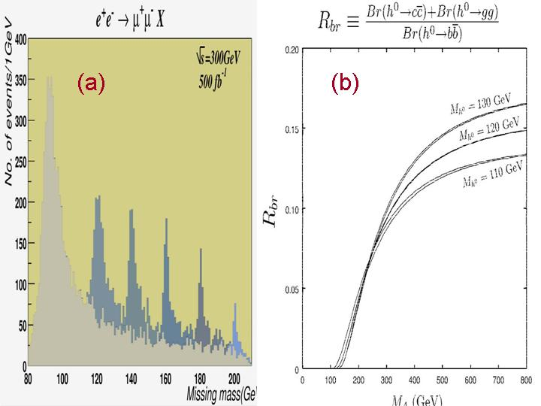
- high-precision momentum measurement with the least-mass tracker.
Figure 1 a) A result of full-simulation on missing mass of a muon pair in the reaction at . b) Higgs branching ratio as a function of a SUSY parameter (CP-odd Higgs mass).

Figure 1.a shows a result of full-simulation on recoil mass of a muon pair in the reaction at [3]. Momentum resolution of for the tracking is necessary to achieve this level of mass resolution. Figure 1.b shows how higgs branching ratio changes as a SUSY parameter (CP-odd higgs mass) changes [4]. Clearly known is essential importance to separately measure b- and c-quarks to examine SUSY scenario of the higgs [5].
Extensive detector R&Ds are required to accomplish these goals, with validation by test beam programs at each important step of the development. Availability of test beam facilities is of essential importance in development of detectors for linear colliders [6].

3. Needs for Test Beam
This section includes the followings from each R&D group:
- Goals to be accomplished from test beam activities
- Test beam detector requirements
- Contact persons for each R&D group
- Facility requirements
- Real estate required for the tests (beam line space, assembly space, desk space);
- Beam conditions wanted/needed (particle types, energies, intensity, spill conditions, etc.)
- Instrumentation, cables and DAQ system that you anticipate using
- Dates when beam is needed, dates when you want to be in the beamline
- Other special requirements?
  - Cerenkov counters
  - beam hodoscopes
  - momentum measurement wire chamber and magnet system,
  - e or μ identifiers, etc.
3.1 Beam Instrumentation and Very Forward Detector R&D
Precise knowledge of the initial state is a distinct advantage for an e⁺e⁻ collider for making precision measurements and for uncovering new physics. This advantage can only be realized, however, if there is adequate instrumentation available to measure the beam properties at the interaction point (IP). A significant complication at the LC is the large beam disruption and beamsstrahlung resulting from the intense electromagnetic fields during collision. The luminosity-weighted beam parameters (ex. energy and polarization) can differ significantly from the average beam parameters measured by the beam instrumentation (BI). At the SLC, about 0.1% of the incoming beam energy was lost to beamsstrahlung photons, while for the baseline LC-500 designs this loss is ~5% per beam. While the magnitude of this energy loss is comparable to initial state radiation, unlike ISR this process depends critically on the geometry and alignment of the incoming beams which are not known a priori and may change with beam conditions. While the effects of ISR can be predicted to very high accuracy by applying QED, the effects of beamsstrahlung must be directly measured. The primary method envisioned to measure the luminosity spectrum is to consider the acolinearity of Bhabha events produced at the IP [7, 8]. However, there are significant complications to extracting the full dL/dE spectrum from simply considering the acolinearity angle alone. It is likely that additional information from direct beam measurements will be necessary [9].
The primary IPBI Detectors fall into 4 categories, which we discuss in more detail below:
- Luminosity and Luminosity spectrum
- Energy and Energy spread
- Polarization
- Electron id for 2-photon veto at very forward polar angles of 5-40 mrad

There are significant R&D efforts underway and planned in Asia [10], Europe [11] and North America [12] to design and develop IPBI Detectors for the LC. Currently, these efforts are mostly focused on simulations, with some detector development and beam tests taking place. This work is evolving to the need for significantly more beam tests.

3.1.1 Luminosity and Luminosity spectrum measurements
Detectors to measure absolute luminosity to 0.1% accuracy (or better) are required for the LC physics program. This requires good tracking and calorimetry in the forward regions with polar angle coverage between ~40-120 mrad to measure the absolute rate of Bhabha events [13]. Higher rate luminosity detectors at smaller polar angle would be very useful for accelerator operations for optimizing and maintaining luminosity. Such detectors would be pair [14, 15] and radiative Bhabha (and possibly beamsstrahlung [16, 17]) detectors at smaller polar angles. In addition to luminosity measurements, these detectors can also be used to infer parameters of the colliding beams (spot sizes, bunch lengths, offsets). Additionally, fast intra-train feedbacks to stabilize the colliding e⁺e⁻ beams at the nanometer level are envisioned. Two R&D programs have been launched to pursue this: FONT (Feedback On Nanosecond Timescales) [18] and FEATHER (FEedback AT High Energy Region) [19] would utilize fast BPMs ~ 3 meters downstream of the IP to measure the deflection angle of the outgoing beam at the head of a train, and then employ fast kickers to center the colliding beams for the following train buckets. FONT/FEATHER may be needed to correct residual beam offsets at the 5-10 nanometer level. In the TESLA design [20], FONT/FEATHER is considered essential though it can be much slower because of the 337-ns bunch spacing compared to 1.4 ns at NLC [21] / GLC [22]. For both warm and cold machines, extraction line BPMs to measure deflection angles are required for slower feedbacks to center the colliding trains (5Hz train collision rate for TESLA and 120Hz/150Hz for NLC/GLC).
The following beam tests for luminosity and luminosity spectra measurements are desired:
- Measure resolutions (spatial, angular, energy) of tracking and calorimeter detectors to be used for Bhabha rate (absolute luminosity) and Bhabha acolinearity (luminosity spectrum) using high energy electron beams. Measure their sensitivity to low energy backgrounds from beam-beam effects.
- Test high rate luminosity detectors for real-time optimization of luminosity (pair and radiative Bhabha detectors).
- Measure performance of detectors to be used at 5-40 mrad for measuring the angular distribution of low energy pairs (beam parameter determination).
- Test BPM performance in the presence of beamsstrahlung and disrupted beams, mimicking these beam-beam effects with bremsstrahlung and multiple scattering in a thick (~5% X₀) target.
- For a warm LC, test the temporal performance of these detectors over the length of a train (300-ns NLC/GLC train).

3.1.2 Energy and Energy Spread Measurements
Precise knowledge of the collision energy $\sqrt{s}$has always been a tremendous advantage of e⁺e⁻ colliders for doing precision measurements, particularly of particle masses. At LEP, for example, the precision energy determination using resonant depolarization allowed an exquisite measurement of the Z boson mass to a precision of 2 MeV or 23 ppm. Life will not be nearly as easy at a future LC, however, as the resonant depolarization technique used in storage rings cannot be applied. The precision necessary for the energy range $2m_{t}≺\sqrt{s}≺\text{1 TeV}$ is much more modest than the LEP energy scale, and a relative precision of 10⁻⁴ or 100 ppm appears to be adequate for the baseline program [23], in particular for the top mass [24]. As outlined below, this level of precision is the goal for beam-based spectrometers of two different designs, potentially using the Z-pole resonance as a cross check. Physics analyses using radiative return events $e^{+}e^{−}→Z^{0}γ$ or W-pair production also have potential for measurements of the beam energy and are being studied, though they do not replace the need for real-time energy measurements. In addition to measuring the absolute energy scale, there is a strong need to make measurements of the energy spread of the incoming beams to facilitate determinations of the luminosity spectrum and the luminosity-weighted beam energy. Unlike in a storage ring, at a linear collider the incoming energy spectrum can be non-Gaussian and highly dynamic, particularly in the NLC/GLC baseline designs where the RMS energy spread of the beam is expected to be 0.3%. Good knowledge of this energy distribution is a necessary component of any luminosity spectrum, L(E), analysis. The Bhabha acolinearity used in the L(E) analysis should have the capability to extract from the physics data. But that analysis will benefit from direct, real-time measurements of the incoming beam energy spread.
The deflection of a charged particle traversing a magnetic field is a well established method for measuring a particle's momentum. Two types of energy spectrometers, each potentially capable of 100ppm accuracy, are under development for the LC. The first is a BPM-based spectrometer located upstream of the primary IP using a chicane layout and RF BPMs. The second is a SLC-style WISRD spectrometer located in the extraction line from the IP.
An inline BPM spectrometer using button BPMs was successfully operated at LEPII to cross check the energy scale for the W mass measurement to a precision of 200ppm[25]. At a future LC, this device would use RF BPMs which can potentially achieve precisions on the transverse beam position approaching 10nm [26]. Fast (ideally bunch-by-bunch) measurements within a train from these BPMs is also desirable to resolve energy variations within the train.
At the SLC, the WISRD spectrometer was successfully used to make beam energy measurements at 120Hz with a precision of 250ppm at E_{beam} = 45 GeV [27,28]. The SLC WISRD consisted of a strong vertical analyzing dipole flanked by two weaker horizontal dipole magnets. The synchrotron radiation (SR) stripes produced by these two weaker dipoles were detected downstream on wire arrays, such that the deflection angle of the beam in the analyzing magnet could be directly monitored. A WISRD-style energy spectrometer provides the possibility of bunch-by-bunch measurements. The location of the WISRD in the extraction line also allows the possibility to directly measure the energy distribution of the disrupted beam which could be used as a real-time monitor of the luminosity spectrum.
Additional beam instrumentation is also being pursued for beam energy spread measurements, in particular utilizing a laser-wire in the extraction line [29].
The following beam tests for LC energy and energy spread measurements are needed:
- commission individual components of a BPM-based spectrometer, demonstrating the required BPM resolution, stability, accuracy and alignment.
- commission individual components of a synchrotron-stripe spectrometer, measuring for example the detector’s response to SR and ability to resolve the beam energy spread and the disrupted energy spectrum. A measurement of the bremsstrahlung spectrum downstream of a fixed target is desirable.
- commission a BPM-based energy spectrometer and a synchrotron-stripe energy spectrometer, and compare their beam energy measurements.
- measure energy jitter with the new spectrometers
- perform laser wire tests to demonstrate capabilities needed for energy spread measurements
- for the warm LC, measure the temporal profile of the beam energy during a 300-ns train with the spectrometers. Also measure the temporal profiles during the train of the energy spread and energy jitter.
3.1.3 Polarization Measurements
A polarized electron beam was an essential feature of the SLD physics program at the SLC, allowing many precise measurements of parity-violating asymmetries. SLD made the world's most precise measurement of the weak mixing angle and provided key data for predictions of the Higgs mass [30]. Similarly, polarization is expected to play a key role at a future LC for interpreting new physics signals and for making precision measurements [31, 32]. The baseline designs for the LC provide for polarized electron beams with $P\text{\sim }(\text{80}−\text{90})\text{\%}$ expected. Initially the positron beams will be unpolarized, although there is significant interest and physics motivation for realizing polarized positron beams in future upgrades.
For most of the physics analyses at the LC which utilize beam polarization, accuracy in the polarization determination of 1% should suffice due to the small cross sections involved. Precise measurements of Standard Model asymmetries, particularly in hadronic final states, will require a polarization determination to 0.5% or better [33, 34]. High statistics Giga-Z running at the Z-pole would benefit from polarimetry at the 0.1% level [35].
SLD’s Compton polarimeter achieved a precision of 0.5%. At the LC, Compton polarimeter designs are being developed both upstream of the IP [36] and in the extraction line downstream from the IP [9, 37]. An accuracy of ΔP/P = 0.25% should be achievable, extrapolating from experience with the SLD polarimeter. The following beam tests for LC polarimetry are desirable:
- Commission and measure performance of individual polarimeter components, in particular measuring the energy and spatial response of the detectors to high energy electron and photon beams.
- Install a Compton polarimeter and make detailed measurements to demonstrate 0.25% polarimetry, making redundant measurements with complementary detectors to determine the systematic error.

3.1.4 Electron ID and 2-Photon Veto
Recent studies [38, 39] have highlighted the importance of very efficient Electron ID in the Very Forward Detector Region with 5-40 mrad polar angle. This is necessary to allow rejection of the large background rate of 2-photon events, which is particularly important for certain SUSY scenarios of interest that may be relevant for determining the amount of dark matter. Detectors in this region have to be radiation hard, with expected dose rates up to 100 MRad per year. They see a large flux of low energy pair electrons which total energy in the range of 20-30 TeV each bunch crossing. In the presence of this large pair background, they need to very efficiently identify a high energy (>200 GeV) electron. Additionally, for the warm LC the detectors need to be very fast to avoid pileup. The following beam tests for these detectors are desirable:
- Measure the detector response to a low energy secondary beam with similar energy and flux density as expected from the pair background. Use test beam data and Monte Carlo simulation to determine efficiency of detector to a high energy (>200 GeV) electron.
- Measure the radiation hardness for this detector.
- For the warm LC, measure the time response to determine sensitivity to pileup effects.

3.1.5 Test Beam Programs
In Asia, there is an active program of beam instrumentation R&D for the Linear Collider at ATF, KEK in Japan. Within this program, laser wire [40], cavity BPM [41] and fast intra-bunch feedback (FEATHER) [14] are particularly important for the IP instrumentation. At the LCWS2004, K. Kubo (KEK) showed a laser wire can generate enough signal for measurements of the beam energy distribution per bunch with an energy accuracy of less than 0.025% at GLC [29]. In his estimates, the laser wire was assumed to have 10MW (0.1mJ, 10ps) power and the diameter of 10 um. Such a laser wire will be investigated by an international collaboration at ATF [42]. The cavity BPM R&D has been carried out in order to demonstrate the beam position resolution at the nanometer level by an international (Nano BPM) collaboration, too. The nanometer resolution should be invaluable for stable collisions between nanometer beams at the IP, though such a high resolution BPM is not assumed in the baseline design of NLC/GLC. FEATHER is an Asian collaboration in the framework of the ACFA-LC working group. In the near future, FEATHER and FONT will be integrated into an international collaboration to realize the fast feedback system at the ATF.
In Europe, 27 institutes proposed the European Design Study Towards a Global TeV Linear Collider (EUROTeV [43]) and prepared a bid to the 6th Framework of the EU for funding. The Design Study consists of 8 work packages which address high ranking issues identified by the ILC-TRC and which are independent of the choice of the acceleration technology. Among those is a dedicated work package for diagnostics that includes polarimetry, energy and fast luminosity measurement. EUROTeV recently received recommendations for funding and will (if eventually funded) create a significant need for test-beams inside and outside Europe. In the UK, a program of accelerator-related R&D [44] is currently underway, with strong emphasis on the beam delivery system. In addition to the FONT and BPM spectrometry projects described above, projects that require test-beams include the laser-wire, bunch longitudinal profile measurement, helical undulator design, polarimetry, and collimation system design. Some of these projects are also part of the EUROTeV Design Study.
In the U.S., a Letter-of-Intent has been submitted to SLAC’s EPAC to use End Station A for LC beam instrumentation tests. The LOI [45] was an outcome of DOE- and NSF-sponsored programs for university-based R&D efforts on the Linear Collider [46], and included 27 physicists from 10 institutions. It received a strong endorsement from the EPAC and detailed proposals for individual tests are being developed and submitted. So far 3 Test Beam Requests have been submitted: one to investigate the performance and components of a BPM-based energy spectrometer [47], one to investigate the performance and components of a SR-stripe energy spectrometer [48], and one to investigate the performance of Si detectors for the very forward LC Detector region at 5-40 mrad polar angle [49]. In addition to U.S. collaborators, these 3 test beam requests also have collaborators from Japan, the UK and CERN. Further test beam requests, with increased international participation, are also being developed. These beam tests are envisioned to be part of a program of IPBI beam tests to be carried out over the next 5 years during the LC Engineering Design Phase.
Table 1 compares some of the primary beam parameters possible at the ATF at KEK and End Station A at SLAC, with the design parameters at NLC/GLC and TESLA. More conventional test beams with single high energy electrons and photons in the
Table 1 Comparison of (primary) beam parameters achievable at KEK ATF and SLAC ESA, together with (design) beam parameters for NLC/GLC and TESLA.
Parameter | KEK ATF | SLAC ESA | NLC/GLC | TESLA
Charge/Bunch | 1.0 x 10¹⁰ | (0.75 -2.0) x 10¹⁰ | 0.75 x 10¹⁰ | 2.0 x 10¹⁰
Energy | 1.3 GeV | 28.5 GeV | 250 GeV | 250 GeV
Energy Spread | 0.1% | 0.15% | 0.3% | 0.1%
Bunch Length | 7 mm | (100-1000) μm | 110 μm | 300 μm
Trains of Bunches:  Bunches per train  Bunch spacing  Train rep rate | 20  2.8 ns  1.56 Hz  (6.25 Hz max) | Several possibilities exist from single bunches to 300-ns long trains with total charge of 5 x 10¹¹ | 192  1.4 ns  120/150 Hz | 2820  337 ns  5 Hz
energy range 1-25 GeV (or higher) are also needed for some of the detector tests described above.

3.2 Vertex Detector R&D
The activities in Vertex research working group do not seem to require significant test beam activities at present.

3.3 Tracking Detector R&D
Current tracking R\&D falls within two primary thrusts. There is a large-scale, global effort to optimize the design of the Time Projection Chamber (TPC) for use at the high-energy electron-positron Linear Collider (LC). A somewhat smaller but quite active global consortium (SiLC) is working towards the design of silicon tracking systems for the various LC detector concepts. Within this larger group, there are institutions focusing on the optimization of silicon-strip detector readout, on the development of refined sensor technologies, and on mechanical support and alignment systems. Much of this development work will require the use of test beams to assess the success of various R\&D threads.
Projections presented for the North American groups represent the results of a fairly comprehensive poll taken in the fall of 2002. While relatively thorough, these results are now somewhat out of date. Results for the other two regions (Asia and Europe) are the result of somewhat spotty exchanges that took place in the weeks preceded the Paris LCWS conference. So, while somewhat hit-or-miss, these latter requests are more up-to-date.
The refinement of silicon sensor technology is being sponsored primarily by Korean groups. These groups foresee the need for approximately three months of test beam running in calendar year 2005, making use of test beams available at KEK, FNAL, and CERN. To this point, these groups have not had a chance to specify their needs to any greater degree.
The test beam needs for the broad gaseous tracking (TPC) effort have been complied separately for the Asian/European effort and the North American effort. Roughly five Asian/European groups plan to seek test beam runs within the next year or so. These groups envision using existing test beam facilities at CERN, DESY, and KEK. The groups expect that hadrons in the few GeV range will be required; several of the groups also expect to make use of electrons in the same energy range. One group (Matsuda at KEK)
Table 2 Anticipated number of weeks of test beam running for tracking detector R&D.
YEAR | ANTICIPATE WEEKS OF RUNNING
2004 | 0
2005 | 16
2006 | 24
requires a magnetic field, although they have not specified the strength of the field they'll need.
European efforts on silicon tracking R&D (within the SiLC group) are just getting underway. No projections of test beam needs were yet available from the European silicon-tracking groups, although a significant demand will arise as these groups begin their work in earnest.
The poll of North American tracking groups generated a three-year working projection of test beam needs through 2006. Although no test beam needs were anticipated for 2004, the program expects to ramp up beginning in 2005, using a total of approximately 40 weeks of facility time in 2005-6. The expected breakdown by calendar year (as a rough guide only) is shown in Table 2.
North American groups uniformly requested two-week run periods, assuming one week of setup and one week of actual running. Requests varied from once per year to several times per year, with the intervening time being used to analyze the data.
The response of the North American groups showed consistent interest in a number of attributes for the test beam facilities: a fast trigger to define usable beam pulses, a spectrometer to measure individual particle energies, particle identification, external trajectory definition (combine Si/TPC tests?), and gas supply and servicing.
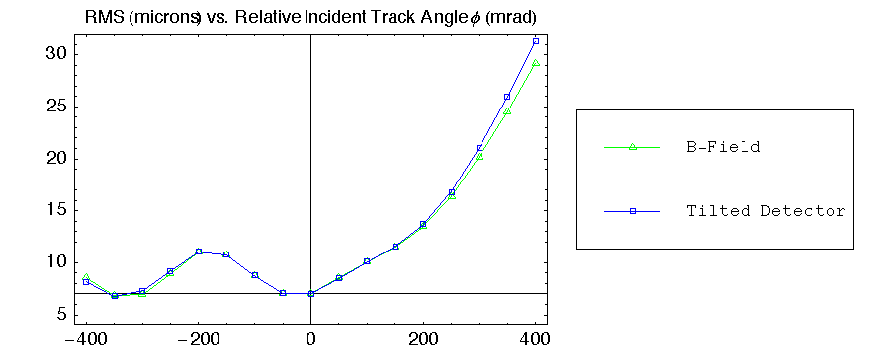
The Linear Collider detector designs employ large magnetic fields, as high as 5T in the case of the `SD' (all-silicon-tracker-based) design. Nominally, then, it would be preferable to have a large-bore, high-field magnet mounted at a test beam facility. However, given the difficulty in arranging this (the large-bore magnet at DESY can not easily be mounted in a beamline), the question of whether such a facility is necessary must be examined more closely.
Figure 2 A comparison of expected resolution vs. incident track angle (relative to incidence normal to the plane of the detector) for a tilted detector and for a detector in a 5T magnetic field.

The SCIPP group has used a simulation developed to study pulse development in silicon strip detectors to explore this questions. The primary effect of the magnetic field is to introduce a Lorentz angle of 36 mrad per Tesla of magnetic field. One might conjecture that one could reproduce this effect in a test beam by simply tilting the detector by this amount. Figure 2 shows a comparison of expected resolution vs. incident track angle (relative to incidence normal to the plane of the detector) for a tilted detector and for a detector in a 5T magnetic field. The tilt is seen to very effectively reproduce the effect of the magnetic field. Thus, it is probably not necessary to develop a high-field test beam for the purpose of qualifying silicon-based detector prototypes.

3.4 Calorimetery R&D
3.4.1 Description of hardware
The calorimeter of the Linear Collider Detector will consist of three parts: an electromagnetic calorimeter, a hadronic calorimeter and a tail catcher. Various efforts worldwide aim at developing a viable design for each of these parts. An overview of these efforts is given in Table 3.

3.4.2 Goals of the calorimeter test beam effort
The main goals of the test beam activities of the calorimeter groups are to:
- Test the performance of the various technological choices, such as Silicon based electromagnetic calorimeters and hadron calorimeters based on GEMs, RPCs or Scintillator.
- Test the performance of the electronic readout systems. The large number of readout channels of both the electromagnetic and the hadronic parts of the calorimeter pose a particular challenge.
- Measure and compare the performance of the different technical approaches to the design of the electromagnetic calorimeter
- Measure and compare the performance of the analog and digital implementations of the hadron calorimeter
- Measure the spatial development of hadronic showers with unprecedented resolution
Year | Calorimeter | Beam time request
2005 | ECAL (CALICE) | 3 weeks (electrons)
2005 | Analog HCAL | 4 weeks (hadrons, muons)
2006 | Digital HCAL (RPCs) | 4 weeks (hadrons, muons)
2006 | ECAL + Analog HCAL + Tail catcher | 5 weeks (hadrons)
2006 | ECAL + Digital HCAL + Tail catcher | 5 weeks (hadrons)
2006 | ECAL (US) | 3 weeks (electrons)
2007 | ECAL + Analog HCAL + Tail catcher | 5 weeks (hadrons)
2007 | ECAL + Digital HCAL + Tail catcher | 5 weeks (hadrons)
2007 | HCAL (different active media) | 8 weeks (hadrons, muons)
2008 | ECAL +HCAL + Tail catcher | 5 weeks (hadrons, muons)
- Validate the simulation of hadronic showers as provided by the various Monte
Table 4. Summary of world-wide calorimeter R&D groups and contact persons.
Calorimeter | Technology | Groups | Contact Person
Electromagnetic | Silicon-Tungsten | BNL, Oregon, SLAC | Ray Frey (Oregon)
Electromagnetic | Silicon-Tungsten | Britain, Czech, France, Korea, Russia | Jean-Claude Brient (Ecole Polytechnique)
Electromagnetic | Silicon-Tungsten | KNU, EWA | Il-Heung Park (EWA), H. Park (KNU)
Electromagnetic | Scintillator/Silicon-Lead | ANF, Padova | Paolo Checchia
Electromagnetic | Scintillator/Silicon-Tungsten | Kansas, Kansas State | Graham Wilson (Kansas)
Electromagnetic | Scintillator-Lead | KEK, Kobe, Konan, Niigata, Shinshu, Tsukuba | Kiyotomo Kawagoe (Kobe)
Electromagnetic | Scintillator-Tungsten | Colorado | Uriel Nauenberg (Colorado)
Hadronic (analog) | Scintillator-Steel* | DESY, Czech, France, Russia, UK, US | Volker Korbel (DESY)
Hadronic (analog) | Scintillator-Lead | KEK, Kobe, Konan, Niigata, Shinshu, Tsukuba | Kiyotomo Kawagoe (Kobe)
Hadronic (digital) | Gas Electron Multipliers-Steel | UTA | Andy White (UTA)
Hadronic (digital) | Scintillator-Steel | NICADD | Dhiman Chakraborty(NICADD)
Hadronic (digital) | Resistive Plate Chambers-Steel | IHEP (Russia), JINR | Vladimir Ammosov (IHEP, Protvino)
Hadronic (digital) | Resistive Plate Chambers-Steel | ANL, Boston, Chicago, FNAL | José Repond (ANL)
Tail catcher | Scintillator-Steel | FNAL, NICADD DESY | Gene Fisk (FNAL)
Tail catcher | Resistive Plate Chambers-Steel | INFN | Marcello Piccolo (Frascati)
- Carlo programs currently available
3.4.2 Requirements for test beams
The different prototypes of the electromagnetic calorimeters will be tested first with electrons of varying energy, ideally between 1 and 100 GeV. First results from tests with the Scintillator/Silicon-Lead (Italy) [50] and Scintillator-Lead (Japan) [51] prototypes are already available. The momentum resolution required be of the order of 1% or better at the higher energies. Standalone tests of the different implementations of the hadron calorimeter are also envisaged. Here, pions and muons with momenta between 1 and 100 GeV/c are required, with a momentum resolution not to exceed the few % level. First tests of a small size hadron calorimeter section using scintillator as active medium have already been carried out.
Tests of the electromagnetic and hadronic calorimeters together with the tail catcher will be performed with electrons, pions and muons, again within a momentum range of 1
to 100 GeV/c [52]. Due to the long recharging time of Resistive Plate Chambers (RPC) [53], it is requested that the beam intensity can be reduced to below 1 kHz. The lateral space available for the test modules should be at least 4 meters.
We foresee an extensive test program for the various calorimeter prototypes requiring beams for several weeks per year during the period of 2005 through 2008. A possible schedule including specific beam time requests is presented in Table 3. Given the uncertainties in funding and in readiness of the various R&D prototype calorimeters, Table 3 should only be taken as a rough guideline.
For completeness, Table 4 lists the different calorimeter projects and their corresponding contact persons. CALICE Tile HCAL group (V. Korbel et. al.) performed a beam test at DESY e⁻ beam using a small scale prototype, mini-cal, in the middle of 2003.

3.5 Muon Detector R&D
The ALC muon detector studies and R&D effort involve simulation of physics processes, muon identification algorithms based on detector descriptions, and detector development. While the Fermilab MTest beam [54] is primarily important for understanding detector response for prototype hardware, it is also true that there are many aspects of online and offline software that need to be tested with beam.
Present plans call for the deployment of seven prototype planes of scintillator strips that are approximately 2.5 m (H) x 5.0 m (W) x 2 cm (T). Each plane will have 43 u or v strips, oriented at 45º. The long strips are 3.5 m and there are an equivalent number of shorter strips all of which are readout via fibers and multi-anode PMTs (MAPMT). Alternate planes will be flipped about a vertical line through the middle of the planes, to provide alternate u and v coordinates. Clear fibers will be routed to one corner of a module and then to the MAPMTs.

3.5.1 Setup

The planes, which weigh approximately 300 pounds each should be installed downstream of LC calorimetry in a manner similar to what is expected in the LC experiment. We expect to insert 10 cm thick Fe plates between scintillator planes. To

save on cost and engineering the plates do not have to be larger than approximately 1.5 m square (2T each; approximately 15T total). A cart that holds the Fe plates and scintillator planes will need to be designed and built to satisfy Fermilab and various other mechanical safety criteria. The light pulses will be digitized and then read with a LINUX based DAQ system that will be debugged in a cosmic ray setup of the equipment in the Fermilab Village before installation at the MTest area.
We want to be able to check the preliminary calibration of the strips by either moving the beam and/or the cart to cover a significant fraction of the area of the modules. We can guess this is not a trivial request and something that will require future discussions and work.

3.5.2 Objectives
At the test beam we will need to establish beam instrumentation and triggers, which are expected to be routine when we run. We will need to establish DAQ connections between the test beam and our DAQ system. And we will need to re-establish pulser operations that indicate our equipment is working to first order.
For muons we will check timing, establish pedestals for pulse height, measure pulse heights, do minimum ionizing particle maps of the counters, measure counter efficiencies and scintillator edge effects, establish tracking and test event display software, etc. We will also want to measure the ability to detect two tracks in a single scintillator, which may require some running without upstream calorimetry modules.
For hadrons we will want to measure the response of the scintillator planes to showers that leak into the muon modules. This “tail catcher” function may be an advantage to the calorimetry tests that are going on upstream. We will want some dedicated running in collaboration with the calorimeters. It is important to experimentally measure the efficacy of using the muon system as backup calorimetry. The question is: To what extent is the muon system useful in the measurement of hadronic energy? It is also important to establish experimentally the level of hadronic punch-through as a function of momentum.

3.5.3 Beam Conditions
We will want hadrons, electrons and muons. Some low energy running with muons is desirable to see that they can be identified. Hadrons starting at 10GeV/c and going to 120 GeV/c are desired. We will accept electrons if they are tagged and there are no upstream calorimeters. Beam rates from a few kHz to about one MHz are acceptable. We will want to steer the beam across strips and over much of the extent of the modules with help from our movable cart that contains the planes.

3.5.4 Dates and Running Time
The earliest time we expect to setup our modules for beam is late 2005. So running in early 2006 is our present best guess and this date is dependent on materials and manpower being available to do the necessary R&D, design of electronics and tooling, assembly setup, prototype production of electronics and planes, do tests with cosmic rays, and make necessary changes and adjustments. All of this argues that this guess at a schedule may be too optimistic.
Because there are many strips in a given module we will want to rather carefully map two modules. These mappings could eat up a lot of beam time, although some it can be parasitic to calorimeter tests, as long as the calorimeter testers do not want to fully control the use of our planes. As previously stated we want significant running time in common with calorimetry. We think we will want to be in the MTest beam line for about 6 months with a duty factor of about 1/3. This must be taken as a first estimate.

3.5.5 Personnel
At present the ALC muon detector R&D effort is a collaboration of physicists from UC Davis, Northern Illinois University, University of Notre Dame, University of Texas at Austin, Wayne State University, and Fermilab. It is expected that some of the other institutions that have expressed interest in the LC muon detector will join this effort and the LC muon detector groups from Europe and Asia who have hardware to test may also join this effort.
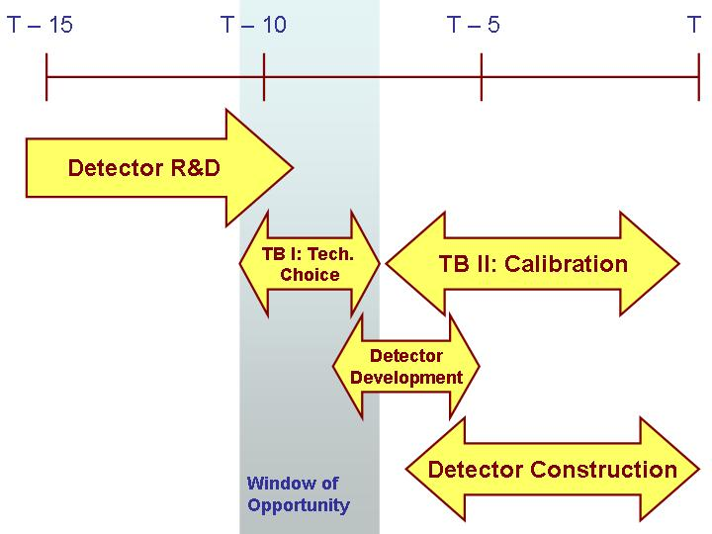
Figure 3 Time scale for a Linear Collider. Time T specifies the year for the completion of a linear collider.
3.6 Other Detector Developments
There are a few detector R&D activities other than the ones covered in this report throughout the community. However, the information on these efforts is insufficient to include in the report at this time.

3.7 Summary of Facility Requirements
Table 5 Summary of estimated beam time need for detector R&D groups.
Detector R&D Groups | Number of Groups | Estimated beam time needs
Interaction Point and Beam Instrumentation | 9 | 2 weeks at a time, several times (over 50 weeks total)
Tracking | 7 | 16 weeks in 2005  24 weeks in 2006
Calorimeter | 6 ECAL  2 analog HCAL  4 digital HCAL  2 Tail catcher | 7 weeks in 2005  17 weeks in 2006  18 weeks in 2007  5 weeks in 2008
Muon | 2 – 3 | 6 months total
Given the time scale for a linear collider and the appropriate detector development, as shown in Fig. 3, most the detector groups require test beam facilities in 2005 – 2008 time scale (for T=2015). The first test beam period covers most the goals for the current detector R&D groups’ needs, described in this report. Table 5 summarizes the current estimate of beam time request for all detector groups. Some detectors, such as electromagnetic and hadronic calorimeters, tail catchers and muon detectors, can utilize the beam concurrently. However each detector group does require standalone beam time to perform undisrupted beams for performance testing. These estimate in do not include the time for test beam setup. Table 6 summarizes the current need for the facilities.
Other important factors that might require additional resources at the test beam facilities are space constraints and, special requests, such as particle ID devices and converters, or large bore magnets with high magnetic field strength. A study carried out by the ALC tracking group [55] to determine what the impact of such magnet is in test beam is presented in section 3.3 of this report. Calorimeter group [56] has determined it dose not need such magnets for the purpose of their test beam activities [52].

4. Available and Planned Test Beam Facilities
 | R&D Groups | Apparatus | Beam Conditions | When/Where
1 | CALICE  J.-C. Brient/P. Dauncy et al | E_Cal/H_Cal  E-flow Tests | e, μ, π, p  1 - 100 GeV | Mid 2004 – 2005  Setup; DESY/CERN  Fermilab/Protvino?
2 | LC-Cal (Europe) – P. Checchia, S. Miscetti |  | Electrons | Mar/Apr 2003, Frascati
2 | LC-Cal (Europe) – P. Checchia, S. Miscetti |  | e , π, p <10GeV | June 2003, CERN PS
2 | LC-Cal (Europe) – P. Checchia, S. Miscetti |  | e , π, p <100GeV | Aug. 2003, CERN PS
3 | GLC-Cal – Y. Fujii et al | EM & H Cal  Prototypes | e, μ, π, p  2 - 200 GeV | KEK/2004  US/Europe 2004 - 08
4 | LC- Cal – R. Frey et al | E_Cal  H_Cal Prototypes | e to 10 GeV  e, μ, π, p =>120 | E_Cal at SLAC ‘04;  E & H_Cal @ FNAL
5 | HCal -CALICE US DHCAL (ANL, NIU, UTA), et al. | H_Cal Prototypes | e, μ, π, p =>120 | Fermilab – 2005-‘06
6 | LAT Cal-Forward – W. Lohman, A. Stahl | Rad hard studies |  | 2004 – 2005
7 | IP Instrumentation  Woods/Torrence et al | Gas Č counter/cal  Quartz fiber cal  Sec. Emission det.  W. angle, vis light beamstrahlung  Synchrotron rad  BPM E spectrometer | e/γ to 100 GeV;  LINX for beamstrahlung;  Polarized e’s | Various
8 | IP Instrumentation and Calorimetry  Onel/Winn et al | Compton polar. w/  quartz fiber cal;  Sec. Emission det.  Č compensated cal | e, π, p =>120  < 20, < 300 GeV | Fermilab  CERN PS & SPS
9 | Tile/fiber Tests  R. Ruchti | Detector prototypes, timing, | e, μ, π  10 – 100 GeV | Fermilab
10 | Muon Prototype Detectors  ALC | RPCs and  Scintillator based | e’s 50-750 MeV  e, μ, π 10-120GeV | Frascati 2004  Fermilab 2005
11 | VTX (Winter) | CMOS Sensors |  | Start testing in 2006
12 | Other Developments (Savoy-Navarro) | Si Envelop |  | Start testing in 2006
This section provides summary of existing and planned test beam facilities. This section also includes the summary of what is lacking in the current facilities.
Table 6 Summary of current needs for test beam facilities.
4.1 Asia
4.1.1 KEK
KEK [57] has two beam lines for beam tests associated with 12GeV proton synchrotron; pi2 and T1. Due to the construction of J-PARC facility [58], they are supposed to be terminated by the end of 2004. Discussions are on-going, however, about extending the operation because of strong requests on test beam facility.
The beam parameters and equipments of T1 and pi2 are summarized in the list at the last of this chapter. They can provide low-momentum (up to 4GeV) beam with quite
suitable properties for detector tests. Important equipments such as Cerenkov counters, an analyzing magnet for better momentum definition, large-gap magnet for test with magnetic field are also available. Proposals are discussed at PAC held quarterly. Related documents are found at http://www-ps.kek.jp/kekps/pac/index.html.
In order to provide test beams after PS shut-down, a new test beam facility is under design at an end-station of 8GeV electron LINAC. Beam parameters and equipments currently postulated are listed in Table 7. The LINAC need to inject most of its bunches to KEKB rings. Therefore beam intensity for the test beam lines is quite limited. In order to reduce construction cost, magnets and power supplies will be brought from the PS beam lines. The maximum momentum will be limited by the power supplies, which is now planned to be brought from pi2 beam line, to be 4GeV. Though capability is limited, this facility will provide precious opportunity for test beam programs for the period between PS shut-down and J-PARC completion.
Support by KEK is fairly excellent. Electronics and long-cable pools, and assistance of technicians for setup are available. However in many cases, one faces to difficulties in language. Therefore collaborators of KEK researchers are practically mandatory. There are inexpensive dormitory and apartment houses on site, as well as a cafeteria, restaurants, a store, a book shop, even a barber. Public transportation is not excellent, but does exist. One can have fairly comfortable life.

4.1.2 J-PARC
J-PARC is a proton accelerator complex for material science, nuclear physics, high energy physics, and nuclear power reactor research, being under construction as a joint project of KEK and JAERI (Japan Atomic Energy Research Institute) [59]. Total project will be built in two phases; the 1st phase will be completed in 2008, and the 2nd would be completed around 2012. Detail of the project can be found at the URL http://j-parc.jp/Home.files/overview.html. A proposal to build a test beam facility attached to the 50GeV proton synchrotron has been submitted. The proposed facility may be partially realized in the 1st phase, while full construction at the
2nd phase is yet unknown.
The parameters and equipments of the proposed facility are listed in the Table 7. It is planned to have similar characteristics as the pi2 at KEK-PS, with higher momentum up to 10GeV. Detail can be found in the proposal at http://www-ps.kek.jp/jhf-np/LOIlist/pdf/L02.pdf. User-support system and facility are unclear at present.

 | KEK – PS | KEK – LINAC | J – PARC | IHEP – BEPC
Beam Momentum (GeV) | 0.2 – 0.4 | 0.1 – 4.0 | 0.2 – 10 | 0.2 – 1.2
Momentum Bite (Δp)
Particle Species | e, μ, π, K, p, ‾p | e, μ, π, K | e, μ, π, K, p, ‾p | e, π, p
Intensity | Inclusive: Several kHz  e, μ: a few Hz to 1kHz | 10Hz | >1kHz | 1 Hz
Time structure | 1.5s-spill/4s cycle | 10Hz pulse |  | 1Hz pulse
Equipments etc | crane, stage, Cerenkov, analyzing magnet | crane, stage, Cerenkov, |  | crane,stage, Trigger,MWPC, Cerenkov
4.1.3 IHEP, Beijing
Table 7 Summary of Asian Test Beam facilities. J-PARC is a future facility.
BEPC [60] at IHEP [61] has two test beam lines at E3 experimental area. The Hall-1 is provided a direct electron beam from the LINAC. Therefore the beam energy is fixed to 1.2Gev, and repetition rate is 50Hz. Secondary beam is guided to the Hall-2. The parameters of the beam are listed in Table.7. Trigger counters, a Cerenkov counter, 3 MWPCs for tracking, and a moving stage exists at the hall. Details can be found at http://www.ihep.ac.cn/english/nianbao-e/02-E/Chapter1-Experiments.pdf.

4.2 European test beam facilities
This section summarizes available test beam facilities in Europe.
4.2.1 CERN test beam facilities
CERN [62] test beam facilities are associated mainly with two machines of the CERN accelerator complex: Proton Synchrotron (PS) [63] and Super PS (SPS) [64].
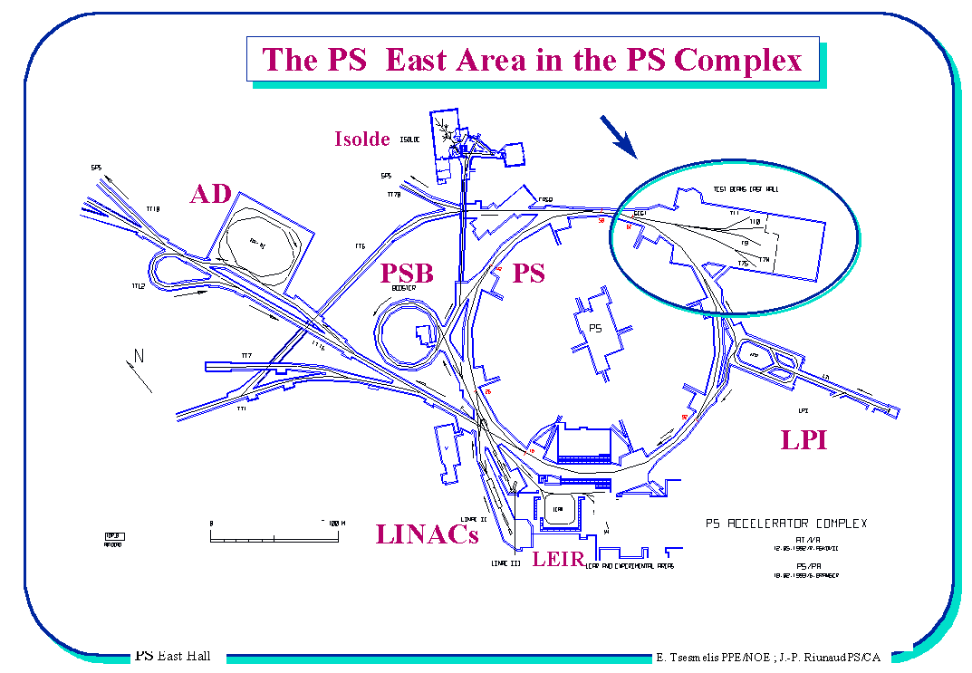
- PS Test Beam Area
PS in the CERN accelerator complex together with East Hall, where is situated the PS test beam area is shown on Fig. 4.
Figure 4 Proton Synchrotron schematics in the CERN accelerator complex.

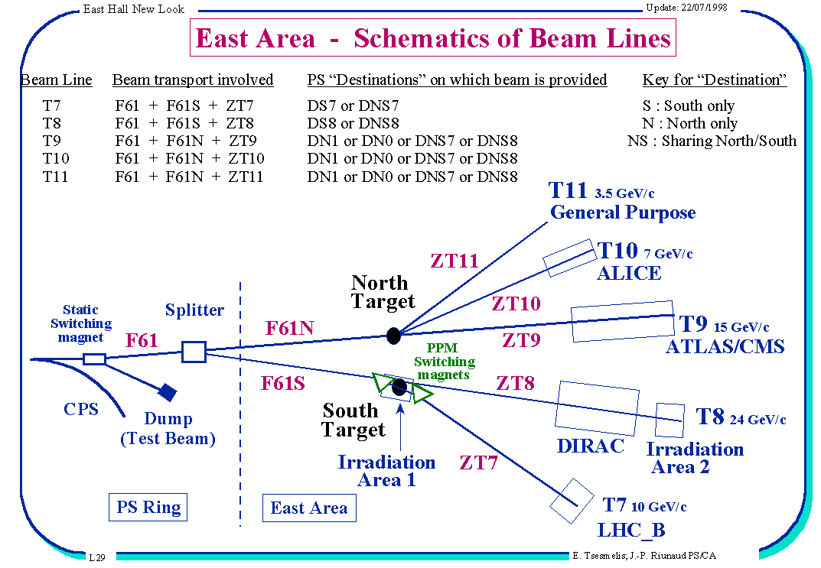
Figure 5. Schematic layout of PS test beam lines in the East Hall.

In the East Hall are in disposal four secondary test beam lines: T7, T9, T10 (ALICE) and T11 generated by primary 24 GeV/C protons from PS. The dislocation of beams is shown in the Fig. 5. The primary beam line T8 is currently used for experiment Dirac and also for radiation hardening studies with neutrons. The momentum of beams T7, T9, T10 and T11 starts at about 1 GeV/c and reaches values of 10 GeV/c, 15 GeV/c, 7.5 GeV/c and 3.5 GeV/c, respectively. They provide wide portfolio of particles: π⁺, π⁻, K⁺, K⁻, p⁺, p⁻, e⁺, e⁻. The beam composition of T9, T10 and T11 are close correlated since they use the same target (North Target) and the use of these beams should be coordinated. The line T7 can transmit either primary 24 GeV/C protons (irradiation area T7a) which can be used for radiation hardening studies, but not for standard test beam tasks due to the large radiation intensity, or can provide secondary particles using a target. The line T10 is full time allocated for the ALICE experiment [65].
Maximal intensity of extracted protons is about 1-2 x 10⁶ protons per spill; the typical value is 10³-10⁴ protons per spill. The spill duration is 400ms with the repetition time of 16.8s. East Hall usually gets 2 spills; to get more spills a special request is needed.

Services provided by CERN during the test beam:
- assistance during the tuning and operation of the beam;
- provision of (threshold) Cerenkov counter (can be 2, more – should be discussed);
- provision of beam position monitors;
- crane with operator;
- computer network connection;
- basic installation support.
These services are provided free of charge by CERN.

- SPS Test Beam Area
With the SPS accelerator are associated two test beam sites: the West Area and the North Area. The West Area will finish operating for test beams in the end of 2004 and therefore Figure 6. SPS in the CERN accelerator complex and schematic layout of secondary test beam lines in the North Area of SPS.
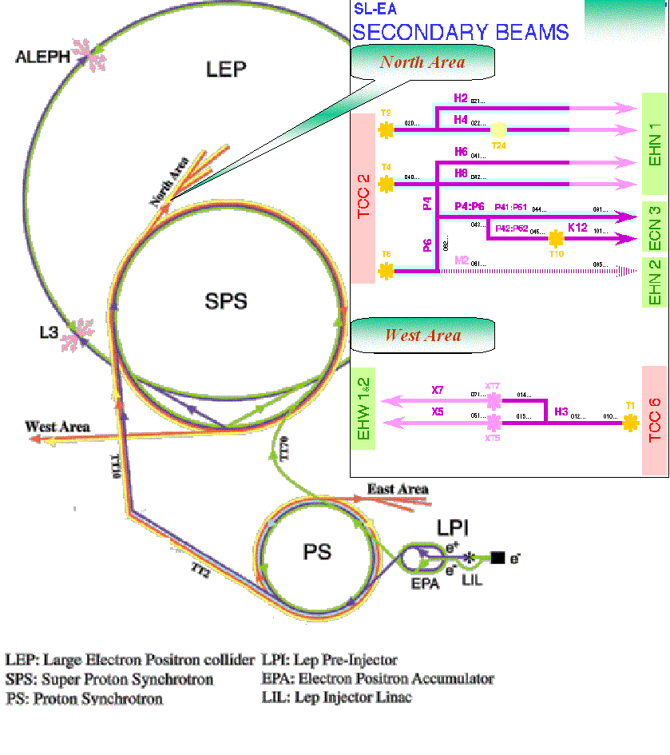
it will be not described here. It will be completely dismantled as the extraction of the West Area beam is in conflict with the extraction to LHC.
The North Area as shown in Fig. 6 has four test beams H2, H4, H6 and H8 which form two couples (H2+H4, H6+H8) which use the same target. The running regimes in beam lines which use the same target are correlated namely what concerns the beam composition and the particle charge – the latter must be opposite in H2 and H4. Due to the beam optics the particle momenta in H6 and H8 are related as P_{H6} ≈ P_{H8}/2. The momentum of beams H2, H4 and H8 starts at about 10 GeV/c and reaches values of 350 GeV/c, for H6 the maximal momentum is 200 GeV/c.
The following beams of particles are available: π⁺, π⁻, p⁺,p⁻, e⁺, e⁻. Intensity is about 10⁶-10⁷ particles per spill and depends on energy and sort of particles. The spill duration is 4.8s with the repetition time of 16.8s.
Present occupation of test beam areas is as follows:
- H2 – part time reserved for CMS (HCal), H4 – fully booked for CMS (especially in 2006), H6 – partly for ATLAS (some space for external users), H8 – exclusively for ATLAS.
- On H2 and H8 are possible also tertiary beams with the momentum in limits P_{min} = 1 GeV/c and P_{max} = 8 GeV/c.
- The West Area enables to work on one line with two or three setups – i.e. one or two in the parasitic mode. Intensity of muons obtained in the parasitic mode is 100-1000 particles per spill.

Services provided by CERN during the test beam:
- assistance during the tuning and operation of the beam;
- provision of threshold or differential Cerenkov counter(s) (can be 2, more – should be specially requested);
- provision of beam position monitors(of better resolution and sensitivity than that ones at PS);
- crane with operator;
- computer network connection;
- basic installation support.
All this is provided free of charge.

- Miscellanies information
CERN PS and SPS test beam facilities will be operating to the end of 2004. For 2005 they will be stopped and will be again in operation from 2006 and beyond with exception of the West Area.
The information about CERN test beam facilities schedules can be found on web:
PS: http://ps-schedule.web.cern.ch/ps-schedule/
SPS: http://sps-schedule.web.cern.ch/sps-schedule/
Condition for the use of CERN TB facilities:
An external user can get 2 weeks (can be split) at PS and/or 1 week time at SPS test beam per year and per group. Extra test beam time can only be requested by submitting a proposal to the relevant CERN scientific committee (SPCS). For external users there are not granted offices, assembly space etc. To get more rights (assembly space, offices, etc.) the project should become co-called CERN recognized experiment (to be listed in the Grey Book http://greybook.cern.ch/).
To be considered in the beam schedule the group should submit a request till October of the foregoing year to the SPS/PS physics coordinator SPS.Coordinator@cern.ch (present coordinator: Michael Hauschild).

4.2.2 DESY test beam facility
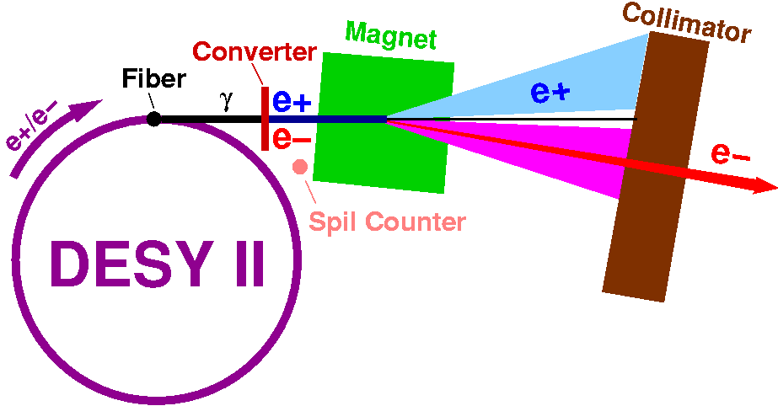
DESY [66] provides three test beam lines (21, 22 and 24). These electron and positron beams are converted bremsstrahlung beams from carbon fiber targets in the lepton synchrotron DESY II [67] with up to 1000 particles per cm² and second, energies from 1 to 7 GeV and energy spread of ~5%. The scheme of the set-up is on Fig. 7.
Figure 7. DESY test beam facility beam generation scheme.
The test beam areas are shown on Fig. 8. For the test beam line “Strahl 21” one has intensity of 1000 particles per second with energy 3 GeV, at energy of 7 GeV the intensity is about 1 particle per second. The spill structure: 1 MHz in 80 msec periods, repetition rate is 12.5 MHz.
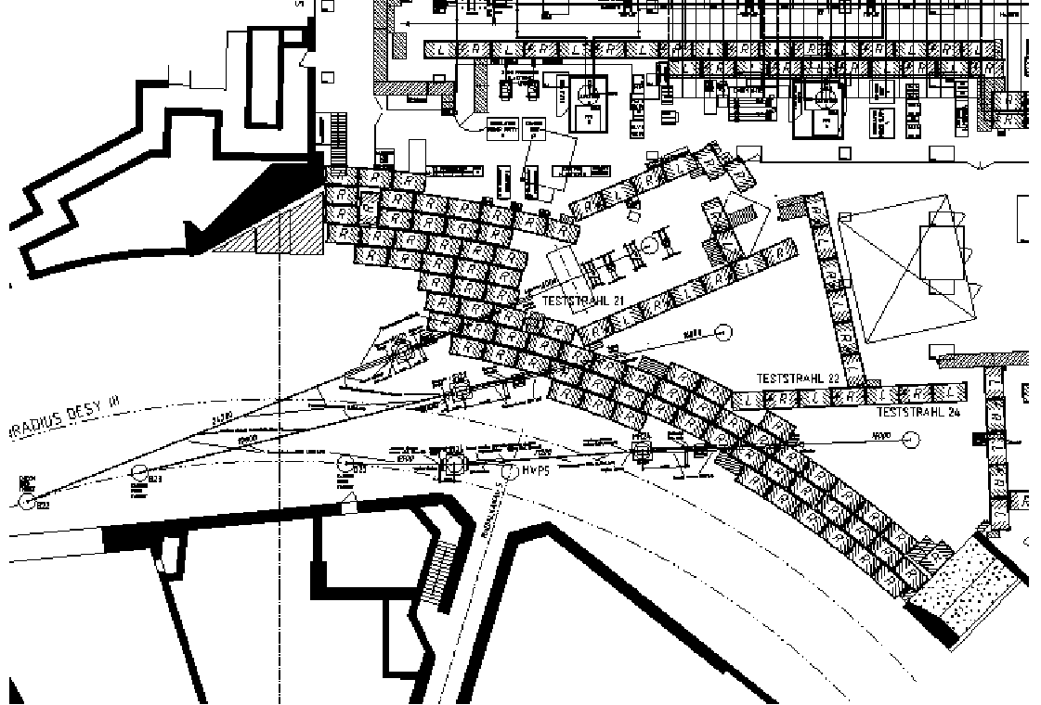
The facility will be operational in 2004/2005/2006. The information about DESY test beam facilities can be found in Ref. [68].

4.2.3 IHEP-Protvino test beam facility
Figure 8. DESY Sthral 21, 22 and 24 testbeam areas.
Test beam facility in the Institute of High Energy Physics (IHEP) in Protvino (near Serpukhov) [69] is associated to the proton synchrotron U70 with following basic parameters: proton energy = 70 GeV, cycle time = 10s, spill time 1.8s, intensity = 1x10¹³ protons/cycle, bunch length = 40ns, bunch spacing = 160ns.
Test beam facilities in the Institute of High Energy Physics in Protvino provide all important particle beams in wide interval of energies as summarized in Table 8.
Table 8. Particle types and their energies at IHEP test beam facility.
Particle type | Electron Beam Range (GeV/c) | Hadron Beam Range (GeV/c)
e⁻ | 1 – 45 | -
h⁻ | 1 – 45 | 33 – 55
μ⁻ | 1 – 45 | 33 – 55

Electron beam
The beam line uses internal target and extracts negative beam in the range of energies 1 – 45 GeV. The precision of the beam energy varies from about 6% @5GeV to 1%@45GeV, what is not sufficient e.g. for calorimetric studies. Significant improvement can be obtained using the beam tagging system (BTS) [70] developed in IHEP. Results of that method are summarized in Table 9. The size of the beam is about 3 cm in diameter.
Energy (GeV) | Beam Resol. (%) | ECAL Resol. (%) | BTS Resol. (%)
1 | 4.3 | 11.0 | 2.05
2 | 5.5 | 7.8 | 1.03
5 | 5.6 | 4.9 | 0.43
10 | 3.8 | 3.5 | 0.24
27 | 1.2 | 2.1 | 0.15
45 | 1.0 | 1.6 | 0.13
Composition of the electron beam for different momenta is shown in Table 10. The admixture of charged hadrons and muons can be tagged using Cerenkov counters, which are available on site.
Table 9. IHEP Protvino beam purity and energy prevision improvement using BTS.
Table 10. Composition of the electron beam and its improvement using BTS at IHEP TB facility.
Energy (GeV) | Intensity in spill on 10¹² POT | Content
Energy (GeV) | Intensity in spill on 10¹² POT | e (%) | μ (%) | h (%)
1 |  | 82 | 10 | 5
2 |  | 77 | 15 | 8
5 |  | 50 | 32 | 18
10 |  | 34 | 35 | 30
27 |  | 77 | 9 | 13
45 |  | 91 | 4 | 5
Hadron beam
Composition of the hadron beam in the momentum range 33 – 55 GeV/c is shown in Table 11. Number of hadrons per spill is about 10⁶.
Table 11. Composition of the hadron beam at IHEP-Protvino.
Particle Type | Content (%)
 | 96.4
 | 1.0
 | 2.3
 | 0.3
Miscellanies information
Table 12 summarizes various additional items the IHEP-Protvino facility provides. Currently, the Protvino test beam facility will be operational from 2004 and beyond.
Table 12. Other items for test beam experiments at IHEP-Protvino.
Item | Remark
Beam line | Exists
Beam Detector System | Exists
e-beam tagging system | Exists for BTeV
Experimental house | Exists
Movable platform & supports | Do not exist
DAQ | Tasks for the requesting collaboration
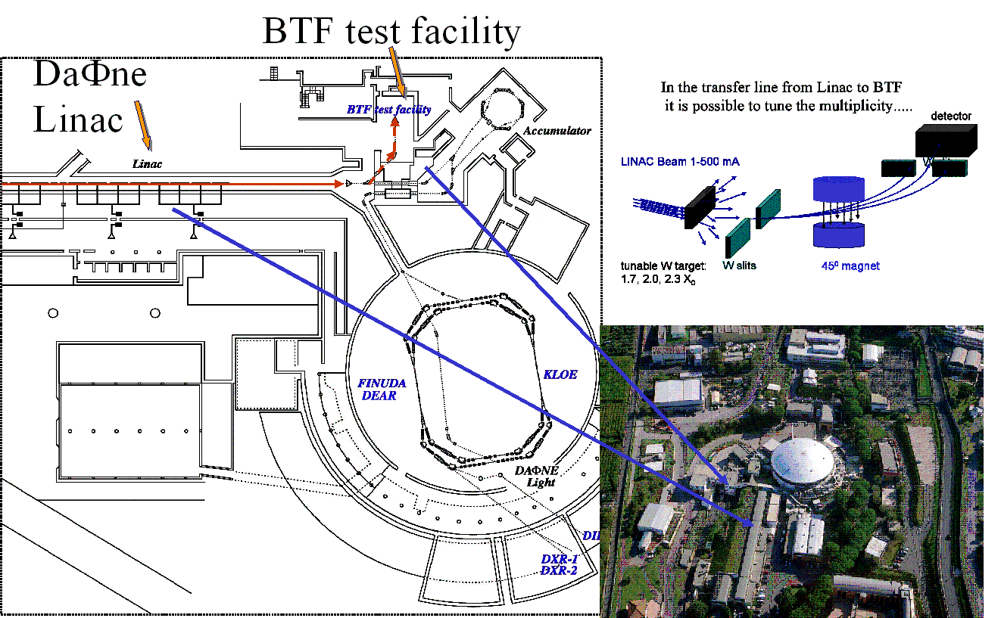
4.2.4 Frascati test beam facility
Figure 9. The Frascati Test beam Facility
The layout of Frascati [71] test beam Facility (TBF) [72] is shown in Fig. 9. The facility can provide electrons and positrons with energy ranging from 50 to 850 MeV with the intensity which can be tuned for values from 1 to 1000 particles per second (after upgrade it will be up to 10¹⁰ electrons per second). The pulse time is 10 ns (1.5 ns) with the repetition frequency 24 Hz (29 Hz). Large experimental hall of area 100 m² is available.

4.3 Facilities in Americas
4.3.1 SLAC – ESA
A possibility for test beams at SLAC [73] exists in the ”End Station A” beam line [74] which is operated as a secondary line at a repetition rate of 10 Hz, parasitic on PEP [75] operation for BaBar [76]. In addition the Final Focus Test Beam (FFTB) with its 28.5 GeV electron line is in principal available for experiments. Unfortunately this facility is currently oversubscribed with running experiments, and will be dismantled in 2006 for the construction of the Linac Coherent Light Source (LCLS), a X-ray free electron laser.
The following primary beam is available in ESA:
Electrons of 28.5GeV parasitic to PEP/BaBar running. The typical momentum width is ±0.5%, controlled by beam collimators. The flux could be from a few per pulse up to 2x10¹⁰. Bunch length is variable between 100μm and 1mm; the beam radius is approximately 1.5mm. Positrons at a somewhat lower energy and lower maximal flux are available also. Figure 10 shows the typical particle yield as a function of particle energy at ESA for a 30GeV primary beam.
This primary beam can be used to produce a secondary beam of positrons, electrons or hadrons via a beryllium conversion target at the end of the linac. The beam line leading to the End Station A serves as a spectrometer. The flux is typically 1 particle per pulse. The spot size is 1.5 inches in diameter. Below plot shows typical particle yields depending on the particles’ energy. A ToF system and Cerenkov counters are used for particle identification.
This facility can provide a spray beam of electrons or positrons in the range of 2-20GeV with a flux density from 0.1/cm² to 10,000/cm² and a spot size of 1.5 inches. A gamma beam from positron bremsstrahlung through a target can be provided with some significant effort from SLAC’s side. The rate can be adjusted to 1 gamma per pulse. A tagging system must be provided by the experimenter.
The End Station A facility has a 50 ton crane. Cerenkov counters for limited particle identification and scintillator hodoscopes for ToF measurements and triggering can be made available.
Services provided by SLAC during the test beam:
- assistance during the tuning and operation of the beam;
- provision of (threshold) Cerenkov counters;
- provision of beam position monitors;
- crane with operator;
- computer network connection;
- basic installation support.
More detailed information can be obtained from Carsten Hast hast@slac.stanford.edu. Test beam request forms are available at http://www.slac.stanford.edu/grp/efd/TBBlank.pdf with additional information available from the Test Beam Coordinator Ted Fieguth fieguth@slac.stanford.edu.
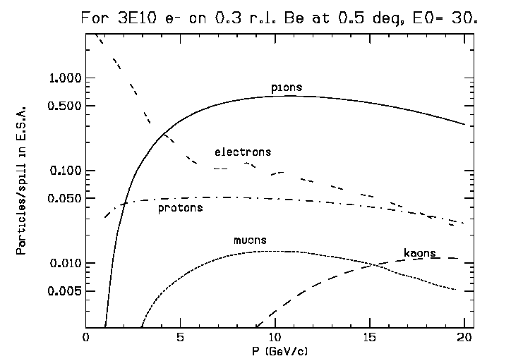
4.3.2 Brookhaeven National Laboratory – AGS
Figure 10. Typical particle yield as a function of momentum at ESA for a 30 GeV primary beam.
BNL [77] has a long history of providing HEP community with test beam for detector research and development. The test beam facility is located in area B of AGS [78]. A complete description of the facility can be found at http://server.c-ad.bnl.gov/esfd/ under Experimental Information → Beam Experiments → B2.
Features of the B2 beam line include: Cerenkov counters for limited particle identification scintillator hodoscopes for triggering and a controllable table with a 2.5 ton capacity. The beamline can be tuned for momenta from 300 MeV/c to 9 GeV/c. The nominal momentum bite is 5% FWHM. This can likely be reduced with a corresponding loss of flux if necessary.
The maximum flux is limited by safety constraints to 2 × 10⁵ particles/sec. From High proton and pion fluxes are available up to 9 GeV. The electron rate falls off sharply above 1 GeV but remains significant up to 3 GeV. It should be noted that these results correspond to operation with a Pb converter than can be positioned in the beamline to increase the electron flux. It would appear that the BNL test beam facility is well suited for linear collider calorimeter research and development. The main issue is funding for operation of the facility.
Currently, the facility is not supported within the AGS budget and only operates under contractual agreement with users. Marginal operating costs are highly dependent on future operating scenarios. The RSVP [79] proposal will provide funding for baseline support of the AGS HEP program. During the summer of 2004 operation of beamline D6 (2 GeV separated) is foreseen for RSVP beam studies. Similar running, with the schedule dictated by RHIC running, is expected in summer of 2005. The incremental cost of operating D6 for Linear Collider studies will be substantially lower than would have been otherwise. It is not clear at present whether D6 would satisfy the full requirements
for LC studies. This has to be investigated.
While it remains unlikely that DOE/NSF would directly fund BNL to operate the B2 test beam, it remains feasible for the research consortia to request explicit funding for test beam and sub-contract to BNL. The level of required funding will be substantially reduced by the NSF base-line support of RSVP.
4.3.3 TRIUMF
TRIUMF in British Columbia also provides test beam facilities. The primary beam is a high intensity protons with the energy of 500 MeV. There are several secondary beamlines that can provide particles with various energies.
4.3.4 Fermi National Accelerator Laboratory – MTBF
Fermilab's Main Injector (MI) [80] provides an excellent opportunity for simultaneous running of the Tevatron collider and fixed target programs. Taking advantage of this feature, Fermilab has constructed a dedicated test beam facility, the Meson Test Beam Facility (MTBF) [54], on the MTest beamline. MTBF uses 120 GeV protons from MI as the primary beam. These protons impinge on an aluminum target so that secondary particles can also be selected for. Momentum for the beam can be chosen to be either 120 GeV primary protons or for secondary particles in the range of 5 – 66 GeV. There are two large size rooms with a total of six labeled small areas for simultaneous test setups. Experiments can occupy contiguous areas if need be. Two of these areas have environmental controlled rooms around them. A 20 ton building crane for transport is available and access to the beamline is quite easy. The facility has two control rooms and an electronics room for DAQ and online monitoring. There are 3 empty rooms for general storage or electronics debugging. Figure 11 shows the layout of the MTBF experimental area.
The facility provides converters and sweepers for producing low intensity electron beams, two beamline Cerenkov counters for particle ID, and wire chambers and silicon trackers for beam position measurement. MTBF is safety approved to take 700,000 particles per spill, which can vary from a few microseconds to on the order of 0.5 sec. It is approved for at least one such spill a minute, for times where shots to the Tevatron are not occurring. Intensities for energies other than 120 GeV will be lower. Beam sizes are on the order of 1 cm, although quadrupoles exist which can possibly be used to focus the beam further.
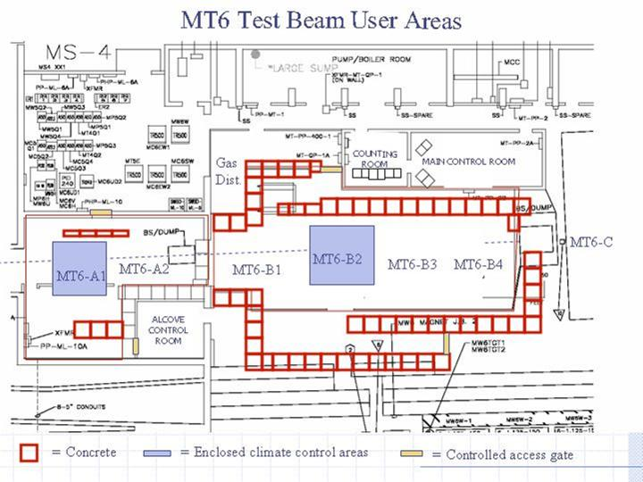
A longer term (2 - 3 years) stay at MTBF can be approved, but will depend strongly on what other programs are approved to run at the same time. If the activity requires a continuous dedicated beam, then a lengthy stay would be less feasible than running parasitically or sharing the space with other activities. The process by which users are approved for time in the test beam is through a Memorandum of Understanding (MOU) with Fermilab. This MOU is signed by the division heads and the directorate and spells out the agreement for how much time and space in the beamline each experiment is approved for. If support from the laboratory is needed, then the Technical, Particle Physics or Computing Divisions should be approached early to determine the level of support that can be found at the laboratory. The MOU will spell out any agreed upon support.
Figure 11. A schematic diagram of the layout in FNAL’s MTBF experimental hall.
Currently eight MOU's have been approved for running, and four are installed and taking data. The Accelerator Division has tuned for 33, 66 and 120 GeV. A low intensity muon beam (~100 Hz) has been delivered to the MT6B area. Erik Ramberg (630-840-5731, ramberg@fnal.gov) is currently in charge of the facility. A web page has been created with a significant amount of information on this beamline, including a form for requesting beam time. This web page is at: http://www-ppd.fnal.gov/MTBF-w/. The directorate has indicated that the laboratory will support this program for the foreseeable future. However, to minimize costs for the program, they wish to see users share beam
Facilities | Particles | p-ranges | Availability | Contact
FNAL MTBF | π, K, p, μ, e | E_{π} = 5 – 80 GeV  E_{p}< 120 GeV | From 2004 | E. Ramberg
SLAC–ESA | γ, e⁺, hadrons | E_{e}< 45 GeV  E_{h}< 13 GeV | Available from 2003 | T. Fieguth
BNL-AGSB2 | π, K, p, μ, e | <10GeV | Dependent on AGS Status
JLab |  |  | N/A 2007-8 due to upgrade
TRIUMF |  | <500 MeV |  | Blackmon
CERN (PS/SPS) |  |  | Pessimistic after 2004 | Michael Hauschild
DESY | e⁺, e⁻ | 0.5 – 7 GeV | 2003 and onwards | N. Meyners
Frascati | e⁻ | 50 – 750 MeV | Available now | M. Piccolo
KEK-PS | π, K, p, μ, e | 0.5 – 4 GeV | By Summer 2004 | Koji Yoshimura
KEK-LINAC | μ, e, π (p?) | 0.1 – 5 (?) GeV | Currently under design. Available in 2006. | Toshifumi Tsukamoto
IHEP, China | e, π, p | 0.2 – 1.2 GeV | Currently available | Junguang Lu
time and make coordinated efforts for best use of the beam. The MOU needs to be signed only by the PI of the proposal in order to facilitate systematic communication[81].
Table 13. Summary of world-wide test beam facilities, their availabilities and contact persons as of July 2004.

4.4 Status of Facility Supply and Demand
As it has been pointed out previously, most the detector R&D groups throughout the world would need access to test beam in the time scale of 2005 – 2008. Given the requirements of beam conditions, such as hadronic calorimeter groups’ requirements in particle species, the number of facilities that meet the requirements is rather limited. For hadronic calorimeter R&D groups, there are only three or so facilities that can provide varieties of particles, especially hadrons, to a wide range of momentum. Table 13 summarizes test beam facilities in the world with the contact persons.
5. Test Beam Software and Monte Carlo Needs and Efforts
Over the next few years a wide variety of studies will be performed in different test beams. The main goals of these studies are to:
- study the different technologies under discussion for different detector components;
- characterize the prototypes.
Two types of software exist and are needed for test experiments: data acquisition software and simulation / reconstruction / analysis software. One of the main goals of these test beam studies is to accumulate a body of data which will allow the comparison of simulation and actual data. This is of particular importance for the calorimeter tests, but also interesting for other detectors.
In the area of calorimeter studies the detailed development of showers both in the electromagnetic and in the hadronic mode will need to be studied and compared in detail
to the simulation. The prediction of the behavior of a highly segmented calorimeter will have to rely heavily on the simulation, thus making a validation of the programs used essential.
A wide variety of programs is currently under development and they are being used in different test beam activities for different detector components. It is not expected that within the next few years common test beam software will be developed. However to make the exchange of information between participating groups easier it is proposed that all groups agree on a common persistency framework for their final stored data. The proposed format is LCIO (Linear Collider Input Output) [82], which has been developed for the offline simulation and reconstruction software. Extensions to the currently available version of LCIO will need to be agreed upon to allow the easy storage of calibration and other data needed for actual test experiments.
The data acquisition needs of a test beam experiment typically are rather small. Currently no central planning is foreseen. However within some of the larger R&D groups (e.g. CALICE [83]) efforts are underway to develop common software solutions shared by all members of the R&D groups.
5.1 What exists now?
The simulation tools currently available are GEANT3 [84], FLUKA [85] or GEANT4[86] based. In Europe BRAHMS [87] has been developed as the central GEANT3 tool. Its development is basically frozen, and it is not planned to be used extensively in the prototype studies. MOKKA [88], based on GEANT4, which has a more flexible geometry definition system already has some implementations of calorimeter prototypes. It will be the main tool within the CALICE group for simulation studies of the test experiments. MOKKA is also used within part of the tracking community for simulation studies. In the Americas GEANT4 tools are under development as well. Currently an effort is ongoing to merge the American and the European developments into a common simulation framework. Both regions however have agreed on a standard LCIO persistency format, which will make the exchange of simulated data easy between the regions. In Asia, GEANT3-based full simulator (JIM) [89] has been used for detector performance validation. Recently GEANT4-base full simulation (Jupiter) [90] has been developed.
Due to the desire to move to a full GEANT4 environment, extensive tests, in particular of the hadronic physics model in GEANT4 are needed. Comparisons to the physics models in GEANT4 will have to be done in the near future. Test beam data will provide significant input to these comparisons, and help in tuning the hadronic physics models in GEANT4.
Reconstruction and analysis software is under development in many different packages and languages individually for different test beam activities. We would like to stress the importance of basing these reconstruction programs on the common LCIO data format. In this way no decision needs to be taken on the analysis system used – PAW[91], ROOT [92], JAS[93], etc. can all be used, as long as an interface to LCIO exists.
5.2 Software Recommendations
- Groups involved in LC test beam activities should be strongly encouraged to base their systems on the LCIO persistency framework.
- To avoid duplication of effort every attempt should be made to agree on a common simulation and reconstruction framework for all studies.
- The different groups are encouraged to join forces in providing input to tune the physics models in the GEANT4 simulation package.
- To ease the exchange of code and algorithms a central depository (e.g. a CVS repository) of reconstruction and analysis code should be created.

6. Test Beam Coordination
Given the large number of world-wide linear collider detector and accelerator R&D groups and the fact that they expect the test beam activities to occur about the same time scale (2005 – 2008) and the fact that there are limited number of facilities that can provide sufficient level of beams, it is necessary for the world-wide test beam activities to coordinate to facilitate:
- Effective use of limited test beam facilities
- Joint activities to avoid unnecessary competitions between the R&D groups
- Cost saving common efforts
  - Common Simulation framework: It is in progress at NICADD in Northern Illinois University, at DESY and in Paris.
  - Common reconstruction and analysis framework, as described in the previous section.
In order to facilitate effective coordination of world-wide linear collider R&D test beam activities and to avoid unnecessary competition between the groups, a group of regional
Groups | Americas | Asia | Europe
Overall | H. E. Fisk, J. Yu | N. Delerue | V. Vrba
Calorimeter | J. Repond,  S. Magill | K. Kawagoe | J. C. Brient, V. Vrba,  P. Dauncey, V. Korbel, P. Checchia, S. Miscetti, W. Lohmann, A. Stahl
Vertex &  Tracking | D. Karlen | Y. Sugimoto, T. Matsuda,  H. Park | C. Damerell, M. Winter, V. Lepeltie, P. Colas, R. Settles
Muon | H. E. Fisk | Y. Zhu, K. Kawagoe | M. Piccolo
Beam Instrumentation & IP | M. Woods | T. Tauchi, H. Yamamoto,  T. Takahashi | P. Bambade, G. Blair, K. Guesser, N. Walker, D. Miller, P. Burrow, Doucas, W. Lohmann, A. Stahl
Other |  | I. Park (Korean Si detectors) | A. Savoy-Navarro
representatives, N. Delerue (Asia), V. Vrba (Europe), G. Fisk (US) and J. Yu (US), have decided to meet regularly once every quarter via video conferencing. We also plan to meet at world-wide linear collider workshops. In addition to the board of regional representatives, each region has contact persons for each detector R&D activities and to disseminate information for facilities and coordination. Table 14 summarizes the list of contact persons for detector groups in the three regions.

9. Recommendations and Conclusions
In conclusion, based on detector groups’ R&D activities and their progress along with the anticipated time scale of a linear collider, test beam needs arise rapidly. The number of groups anticipating some test beam activities within the next 2 – 3 years grows rapidly. On the other hand, due to the start of LHC experiment and other activities for accelerator facility upgrades and to the funding situation, the number of available test beam facilities is not expected to increase but to decrease. Given the anticipated disparity between supply and demand for test beam, it is necessary to coordinate test beam activities world-wide and to provide necessary information to the relevant responsible parties (or the facility directors) to, if possible, redirect some part of resources and to coordinate with various funding agencies to accommodate all the needs that arise as detector R&D matures in a timely manner.
Table 14. Summary of Worldwide LC Test Beam Contact Persons.

Acknowledgements. The primary authors of this report are grateful for all the contributions from various R&D group representatives and from the representatives of test beam facilities. Especially, one of the authors of this report (V.V.) is grateful to M Hauschild, V.Korbel, V.Ammosov and S.Miscetti for consulting materials about test beam facilities at CERN, DESY, Protvino and Frascati, respectively.
11. Bibliography
- ALEPH Collaboration, Nucl. Inst. Meth. A360, 441 (1995)
- International Linear Collider Detector R&D Group;
http://blueox.uoregon.edu/~lc/randd.pdf
- ACFA Linear Collider Working Group Report, “Particle Physics Experiments at JLC,” KEK Report 2001-11, HEP-ph/0109166 (2001); http://arxiv.org/PS_cache/hep-ph/pdf/0109/0109166.pdf
- J. Kamoshita, Y. Okada, M. Tanaka, Phys. Lett. B391, 124 (1997); “HIGGS PHYSICS AT LEP-2,” in CERN LEP-2 yellow report vol.1, CERN-96-01, hep-ph/9602250; W. Kilian, M. Kramer, P.M. Zerwas, Phys. Lett. B373, 135 (1996).
- The Next Linear Collider, http://www-project.slac.stanford.edu/nlc/home.html; Global Linear Collider (GLC) Project, http://www-jlc.kek.jp/index-20031009.html; TESLA, The International Linear Collider and X-Ray Laser Project; http://tesla.desy.de/
- M. N. Frary and D. J. Miller, DESY-92-123A, p379;
http://www.hep.ucl.ac.uk/lc/documents/frarymiller.pdf
- N. Toomi et al., Phys. Lett. B429, 162 (1998).
- “Status of Linear Collider Beam Instrumentation Design,” D. Cinabro, E. Torrence and M. Woods, ALCPG-2003-0001 (2003);
http://www.slac.stanford.edu/xorg/lcd/ipbi/notes/white.pdf
10.ACFA FFIR Working Group activities are described at http://acfahep.kek.jp/subg/ir/
11.ECFA BDIR Working Group activities are described at
http://www-flc.desy.de/bdir/BDIRtop.html ; TESLA Collaboration R&D activities for the Very Forward Detector Region are described at
http://www-zeuthen.desy.de/~astahl/Collaboration.html .
12. ALCPG IPBI Working Group activities are described at
http://www.slac.stanford.edu/xorg/lcd/ipbi/
- K. Buesser and M. Paganoni, “The Measurement of Luminosity at TESLA,” LC-DET-2001-044 (2001).
- G. Alimonti, “Pair Monitor for Linear Collider,” LCWS 2000 proceedings, p. 748.
- T. Tauchi and K. Yokoya, “Nanometer Beam Size Measurement during collisions at Linear Colliders,” Phys. Rev. E51 (1995) 6119.
- G. Bonvicini and N. Powell, “Beamstrahlung at the NLC,” e-Print Archive: hep-ex/0304004 (2003).
- J.H. Norem and J.E. Spencer, “Pin-Hole Luminosity Monitor with Feedback,” SLAC-PUB-10447 (2004).
- See http://hepwww.ph.qmul.ac.uk/~white/FONT/default.htm
- See http://acfahep.kek.jp/subg/ir/feather/index.html
- Edited by R. Brinkman et al., TESLA Technical Design Report Part-II, “The Accelerator,”
- Next Linear Collider Design Group, “Zeroth-Order Design Report for the Next Linear Collider,” LBNL-Pub-5424, SLAC-Report 474, UCRL-ID-12416, Unpublished (1996); http://www.slac.stanford.edu/accel/nlc/zdr/Snowmass96/ZDRTITLE.PDF
- GLC Project, KEK Report 2003-7, September 2003. Formerly called JLC Project, see for example: N. Akasaka et al., JLC DESIGN STUDY, KEK-REPORT-97-1, 617 (1997); JLC Group, JLC-I (the green book), KEK-REPORT-92-16 (1992); http://www-jlc.kek.jp/
- The precision required for energy measurements is discussed in detail in Reference [8]. Improved energy measurement precision to 50ppm or better would be needed to fully exploit the statistical precision that could be achieved for a precise measurement of the W mass or for a very precise weak mixing angle measurement at a Giga-Z program.
- S. Heinemeyer et al., published in JHEP 0309:075 (2003); hep-ph/0306181.
- LEP Energy Working Group; in preparation
- M. Hildreth, private communication.
- J. Kent et al., SLAC-PUB-4922 (1989).
- “Beam energy measurement at a linear collider with an SLC style energy spectrometer,'' S. Hertzbach, published in *Batavia 2000, Physics and experiments with future linear e+ e- colliders* pp. 740-743 (2000).
- See talk by K. Kubo at LCWS 2004,
http://agenda.cern.ch/fullAgenda.php?ida=a04172#s63
- SLD Collaboration, Phys. Rev. Lett. 86 (2001) 1162.
- Linear Collider Physics Resource Book for Snowmass 2001, SLAC-Report-570 (2001).
- G. Moortgat-Pick, H. M. Steiner, Int. J. Mod. Phys. A15 (2000) 2529. (hep-ex/0004004)
- M. Woods, Int. J. Mod. Phys. A15 (2000) 2529. (hep-ex/0004004)
- P. C. Rowson and M. Woods, SLAC-PUB-8745 (1999). (hep-ex/0012055)
- R. Hawkings and K. Monig, DESY 99-157 (1999).
- V. Gharibyan, N. Meyners and P. Schuler, “The TESLA Compton Polarimeter,” LC-DET-2001-047 (2001); http://www.desy.de/~lcnotes/2001/047/polnote_v5.ps.gz
- M. Woods, A. Florimonte, K.C. Moffeit, T.O. Raubenheimer, A. Seryi, and C. Sramek , SLAC-PUB-10353 (2004). (e-Print Archive: physics/0403037)
- T. Kamon, R. Arnowitt, B. Dutta and V. Khotilovich, “Probing mSUGRA models at linear colliders,” hep-ph/0302249.
- P. Bambade et al., hep-ph/0406010.
- Y.Honda et al., "Performance studies of a laser wire beam profile monitor", Jpn. J. Appl. Phys. 41 (2002) 6398, and "Measurement of a small vertical emittance with a laser wire beam profile monitor", Phys. Rev. Special Topics-Accelerator and Beams, 5 122801 (2002).
- Nano BPM collaboration, http://acfahep.kek.jp/subg/ir/nanoBPM/index.html and
http://www-project.slac.stanford.edu/lc/local/nanoBPM/nanoBPM.htm .
- Homepage of a laser wire collaboration will be prepared soon by Graham Blair, Royal Holloway, Univ. of London, UK.
- EUROTeV Proposal: see http://www-flc.desy.de/eurotev/ .
- The UK PPARC R&D funding for Linear Collider Accelerator Beam Delivery (LC-ABD) is described at http://www.pparc.ac.uk/Nw/accelerators.asp .
- SLAC Letter-of-Intent for BI Tests in End Station A,
http://www.slac.stanford.edu/grp/rd/epac/LOI/LOI-2003.2.pdf
- The U.S. University R&D efforts funded by the DOE (LCRD) and NSF (UCLC) are described at these web links: http://www.hep.uiuc.edu/LCRD/html_files/index.html, http://www.lns.cornell.edu/public/LC/UCLC/
- M. Hildreth et al., http://www.slac.stanford.edu/xorg/lcd/ipbi/notes/energybpm_T474.pdf
- E. Torrence, http://www.slac.stanford.edu/xorg/lcd/ipbi/notes/syncspec_T475.pdf
- C. Kenney et al., http://www.slac.stanford.edu/xorg/lcd/ipbi/notes/forward_Si_T476.pdf
- P. Checchia, “Si-Scintillator Hybrid Technique for ECAL,” LCWS 2004, Paris (2004)
- JLC-I; Detector, JLC Group, http://www-jlc.kek.jp/general/DOC/JLC-I/ch3.ps
- S. Magill, J. Repond, A. Turcot and J. Yu, “Linear Collider Calorimeter Test Beam Study Group Report,” UTA-HEP/LC-0003, Unpublished (2003); http://www-hep.uta.edu/hep_notes/linear-collider.html
- R. Bellazzini, C. Betti, A. Brez, E. Carboni, M.M. Massai, and M.R. Torquati, “A Novel Type of Parallel Plate Chamber with A Resistive Germanium Anode and A Two-Dimensional Readout,” Nucl. Instrum. Meth. A247, 445 (1986)
- Fermi National Accelerator Laboratory Meson Test Beam Facility, http://www-ppd.fnal.gov/MTBF-w/
- D. Karlen et al., The North American Working Group of Linear Collider Tracking Detector; http://scipp.ucsc.edu/LCTrack/
- D. Chakraborty et al., The American Working Group on Linear Collider Calorimetery; http://www.slac.stanford.edu/xorg/lcd/calorimeter/
- KEK, High Energy Physics Accelerator Research Organization;
http://www.kek.jp/intra.html
- Japan Proton Accelerator Research Complex, J-PARC; http://j-parc.jp/
- Japan Atomic Energy Research Institute, JAERI; http://www.jaeri.go.jp/
- Beijing Electron Positron Collider, BEPC; http://www.ihep.ac.cn/english/E-Bepc/
- Institute of High Energy Physics (IHEP), Chinese Academy of Science; http://www.ihep.ac.cn/english/index.htm
- The European Organization for Nuclear Research, CERN; http://www.cern.ch/
- CERN Proton Synchrotron Facility; http://ab-div-op-ps.web.cern.ch/ab-div-op-ps/; http://greybook.cern.ch/programmes/PS.html
- CERN Super Proton Synchrotron Facility; http://ab-div-op-sps.web.cern.ch/ab-div-op-sps/; http://greybook.cern.ch/programmes/SPS.html
- A Large Ion Collider Experiment, ALICE;
http://greybook.cern.ch/programmes/ experiments/ALICE.html
- Deutsches Elektronen-Synchrotron, DESY; http://www.desy.de/html/home/
- G. Hemmie, “A New Injector for the DESY Storage Rings PETRA and DORIS”, IEEE NS-30 (1983); G. Hemmie et al., “Status Report on the DESY II Synchrotron”, IEEE NS-32 (1985); http://desyntwww.desy.de/~minty/default_desy2.htm
- DESY Test Beam http://desyntwww.desy.de/~testbeam/welcome.html
- State Research Center of Russian Federation Institute for High Energy Phytsics, IHEP; http://www.ihep.su/
- B.A. Batarin et al., “Development of a Momentum Determined Electron Beam in the 1 -45 GeV Range,” hep-ex/0208012, Nucl. Instrum. Meth. A510, 211-218 (2003)
- Laboratori Nazionali di Frascati (LNF); http://www.lnf.infn.it/
- The DAFNE Beam Test Facility (BTF); http://www.lnf.infn.it/acceleratori/btf/
- Stanford Linear Accelerator Center (SLAC); http://www.slac.stanford.edu/
- SLAC End Station A (ESA) Beam Facility;
http://www2.slac.stanford.edu/vvc/ experiments/esa.html
- SLAC Positron Electron Project (PEP);
http://www2.slac.stanford.edu/vvc/ experiments/pep.html
- Babar Collaboration; http://www.slac.stanford.edu/BFROOT/
- BNL Experiment Support and Facilities Division, http://server.c-ad.bnl.gov/esfd
- BNL Alternating Gradient Synchrotron (AGS);
http://www.bnl.gov/bnlweb/facilities/ AGS.html
- Rare Symmetry Violating Processes, RSVP, experiment, http://www.bnl.gov/rsvp/
- Private communication with Erik Ramberg by Jae Yu in July 2004 to clarify the confusion arose at the Paris LCWS 2004.
- FNAL MI T. Kobilarcik, “Main Injector Beam to the New Muon and Meson Areas,” Fermilab-TM-2105, unpublished (2000)
- Linear Collider Persistent Data Format (LCIO); http://www-it.desy.de/physics/projects/simsoft/lcio/
- The CALICE Collaboration, http://www.calice.cern.ch
- Detector Description and Simulation Tool, GEANT;
http://wwwasd.web.cern.ch/wwwasd/geant/
- A. Fasso, A. Farrari, J. Ranft and P. Sala, “Fully Integrated Particle Physics Monte Carlo Simulation Package, FLUKA”; http://www.fluka.org/
- Object Oriented Detector Description and Simulation Toolkit; GEANT4; http://wwwasd.web.cern.ch/wwwasd/geant4/geant4.html
- T. Behnke et al., Beph Reconstruction and Analysis Helpful Montecarlo Software, BRAHMS; http://www-zeuthen.desy.de/lc_repository/detector_simulation/dev/BRAHMS/tex/brahms_308_html/index.html
- MOKKA – A Detailed GEANT4 Simulation for Future Linear Collider; http://polywww.in2p3.fr/geant4/tesla/www/mokka/mokka.html
- Full Detector Simulation Program for JLC Physics Analysis, JIM; http://www-jlc.kek.jp/subg/offl/www-jlcsim/index.html
- JLC Unified Particle Interaction and Tracking Emulator, Jupiter; http://acfahep.kek.jp/acfareport/node303.html
- The Physics Analysis Workstation, PAW; http://wwwasd.web.cern.ch/wwwasd/paw/
- Rene Brun and Fons Rademakers, ROOT, Nucl. Inst. & Meth. in Phys. Res. A 389, 81 – 86 (1997); http://root.cern.ch/
- Java Analysis Studio, JAS; http://jas.freehep.org/

