The Use of Satellite Fields in 0-1 Hour Convective Initiation Forecasts
A Benchmark Report for Aviation Applications
Version 5.0
31 October 2006

John R. Mecikalski†, Kristopher M. Bedka* and David B. Johnson^{Ø}

†University of Alabama, Huntsville
*Cooperative Institute for Meteorological Satellite Studies, University of Wisconsin–Madison
^{Ø}NCAR, Research Applications Laboratory, Boulder, Colorado

1. Motivation
This report summarizes the current status of efforts conducted as part of the Advanced Satellite Aviation-Weather Products (ASAP) Program via the National Aeronautic and Space Administration (NASA) and the Federal Aviation Administration (FAA) Aviation Weather Research Program (AWRP) to enhance and extend the use of satellite data sets for applications in aviation weather. Convective weather, and specifically convective initiation (CI), is currently one of the main focus areas of the ASAP project, working in conjunction with the FAA’s Convective Weather Product Development Team (PDT).
The AWRP focuses on developing and enhancing aviation weather products that respond to the needs of users and FAA priorities. All new weather products developed by the AWRP’s Product Development Teams (PDTs) go through extensive testing and evaluation, culminating in a formal review by a joint FAA and NWS Aviation Weather Technology Transfer Board (AWTT) before they are declared operational and made available to the public. The AWTT review process puts an equal emphasis on high accuracy and low false alarm rates.
Thunderstorms account for most of the air traffic delays in the U.S. and cost the aviation industry many millions of dollars annually in lost time, fuel and efficiency through delayed, cancelled and rerouted flights (Kaplan et al. 1999; Murray 2002). In response to this need, the FAA’s Convective Weather Product Development Team is working to develop reliable 0-8 hour probability forecasts of convective weather and automated 0-2 hour high-resolution deterministic forecasts over the continental United States (Mecikalski et al. 2006).
Historically, much of the Convective Weather PDT’s work has centered on the use of weather radars to monitor convective storm development. Radars, however, do not see the early stages of convective cloud formation and growth. The ASAP team is currently working with the FAA Convective Weather PDT to develop and transfer satellite-based techniques for detecting, tracking, and monitoring the early development of small cumulus in order to improve thunderstorm initiation forecasts.
Currently the AWRP is reexamining its priorities and approach to thunderstorms and convective weather. Specifically, there is some concern about the large number of different convective products that have evolved over time in response to specific users’ needs. A reorganization and design review in now considering ways to consolidate and unify the various products now being generated and ensure that all FAA products are consistent and provide a common shared awareness among all users. The ultimate result will be a Consolidated Storm Prediction for Aviation (CoSPA) product based on gridded data sets and providing a common core of observational analysis, forecaster input, and numerical models that can be used to create individual products for specific applications. This approach will benefit ASAP efforts by ensuring that our contributions will be transferred to broad-scale use, rather than restricted to a single product or application.

- Background
a) Satellite Contributions
In the context of this discussion, convective initiation (CI) can be defined as the first appearance of a radar echo ≥35 dBZ within a growing cumulus (Roberts and Rutledge 2003; Mecikalski and Bedka 2006). The Mecikalski and Bedka (2006) CI methodology offers a sophisticated, satellite-based approach for real-time detection and monitoring of early convection of scales ≥1 km over large geographical regions (e.g., the CONUS portion of a GOES-12 scan, with possible extension to cover the entire Gulf of Mexico). The ASAP project leverages nearly five years of previously funded CI research, as well as the expanding archive of half-hourly CI datasets that describe cumulus cloud growth via eight infrared (IR) and visible (VIS) GOES and two MODIS IR fields. Results to date show considerable skill (~60-70%) in the 30 min–1 hour identification of first-time thunderstorm development using this CI algorithm.
The Mecikalski and Bedka (2006) methodology makes use of a number of separate, satellite-based “interest fields” that are combined into a single, integrated, CI indicator. In this method, cumulus clouds are identified and tracked, using satellite-based atmospheric motion vectors designed to capture mesoscale flows (Bedka and Mecikalski 2005), while the IR characteristics of the clouds are monitored [e.g., the 10.7 μm temperature (T_{B}) and the 6.5–10.7 μm T_{B} differences]. Clouds of various types are identified using a statistical clustering methodology (Nair et al. 1998), as well as a separate “cumulus cloud mask” (CCM), which allows only cumulus to be monitored within the CI algorithm. Ultimately, cumuli meeting several cloud-top cooling and growth criteria are identified as being likely to produce a ≥35 dBZ radar echo over the next 30-60 minutes. Figure 1 shows the eight interest fields currently used from GOES, and the criteria that define a “score” on the 1-km pixel scale. The Mecikalski and Bedka algorithm has been given the name: SATellite Convection AnalySis and Tracking (SATCAST) System, highlighting its unique dependence on high-resolution satellite observations and analysis. As of Spring 2006, this SATCAST CI algorithm is being run on a real-time basis over the Midwest U.S., the Southeastern quarter of the U.S., and over all of Central America.
Figure 2 shows an early example of this method's predictive skill for one case example (6 July 2004).
Recent research demonstrates via principal component analysis (PCA) that all eight IR indicators (Figure 1-right) contain important information for nowcasting CI using GOES. Use of linear discriminant analysis (LDA) has led to both improved accuracy of the CI nowcasts (to ~65% POD), as well as provides forecasts of the increase in rainfall intensity over the next 1 hour. This later development extends the CI algorithm toward quantitative precipitation estimate (QPE) nowcasting in the 0-1 hour timeframe (Mecikalski et al. 2006).
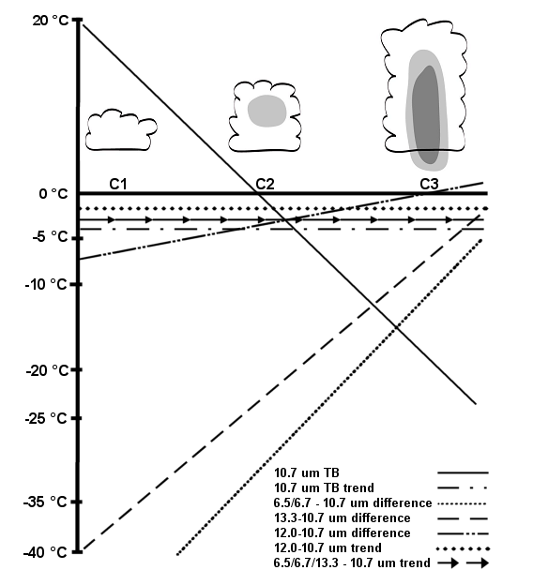
CI Interest Field | Critical Value
[1] 10.7 µm T_{B} | < 0° C
[2] 10.7 µm T_{B} Time Trend | < –4° C/15 mins  ∆T_{B}/30 min < ∆T_{B}/15 min
[1] 10.7 µm T_{B} drop to <0° C | Within prior 30 mins
[1] 6.5 – 10.7 µm difference | –35° C to –10° C
[1] 13.3 – 10.7 µm difference | –25° C to –5° C
[1] 6.5 – 10.7 µm Time Trend | > 3° C/15 mins
[1] 13.3 – 10.7 µm Trend | > 3° C/15 mins
[8] CI Indicators | GOES
[1] 3.75 – 11 µm difference | >0° C
[1] 8.55– 11 µm difference | >0° C
[2] CI Indicators | MODIS

Figure 1: Tendencies and values 8 CI interest fields (bracketed numbers) used for GOES and MODIS data within the Mecikalski and Bedka (2006) algorithm. The Table (right) lists the critical values for evaluating CI within IR data.

The UAH/CIMSS team is also making significant progress toward nighttime CI forecasting as an extension of current capabilities, an important prelude to nighttime CI forecasting. Understanding the mesoscale dynamic forcing that maintains thunderstorm development when solar heating is absent is critical. These include low-level jets, decoupled atmospheric boundary layers, outflow boundaries, and moisture transport (e.g., Raymond 1978; Kessler 1987). Evolving the daytime CI satellite-based algorithm to a full 24-hour analysis system is underway involving one of the PI’s M.S. students. Satellite analysis of a number of nighttime CI events, coupled with NWP simulations (using the MM5) has been performed, and is demonstrating the importance of the 3.9 μm information (Mackenzie and Mecikalski 2005; 2006).
For nighttime CI and new lightning initiation (LI), research is beginning to use of the 3.7-3.9 μm channels over land, as well as the 3.75/3.9–11/10.7 μm channel difference (Nelson and Ellrod 1996), on GOES and MODIS (which suffers from surface emissivity and visible light interference problems during daytime). For the nighttime and daytime CI, several of the ~27 IR MODIS channels (1.2, 1.37, 1.6, 2.1, 3.7-4.1, 6.7, 7.32, 8.55 and 11-14.2 μm) will be considered, in conjunction with those from GOES, to enhance the current IR indicators of convective cloud development. MODIS IR data are spectrally much narrower that those from GOES, and are available at 1 km resolution. For guiding LI prediction, we are challenged to use MODIS to help isolate a ~1-2 km-thick portion of a cumulus cloud that occurs below –10º C based on cloud-top microphysical indicators, e.g., cold cloud growth leading to the formation of a 30-35 dBZ echo through the –10º level (cf. Petersen et al. 1996). Estimating cumulus mass flux from GOES cloud-top cooling rates is an important component that will be developed along with the MODIS microphysical information toward inferred LI. Collaboration with other UAH and CIMSS scientists well versed in satellite microphysical retrievals will assist in this component of the project, as discussed below (e.g., Greenwald and Christopher 2000).
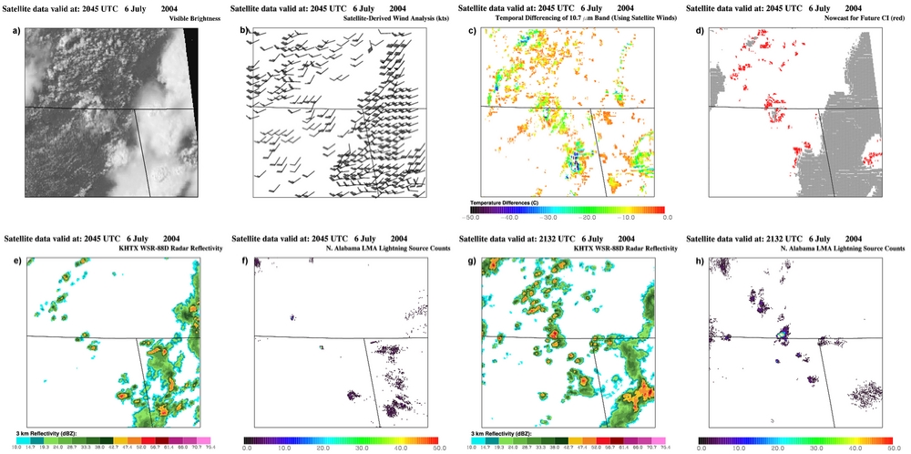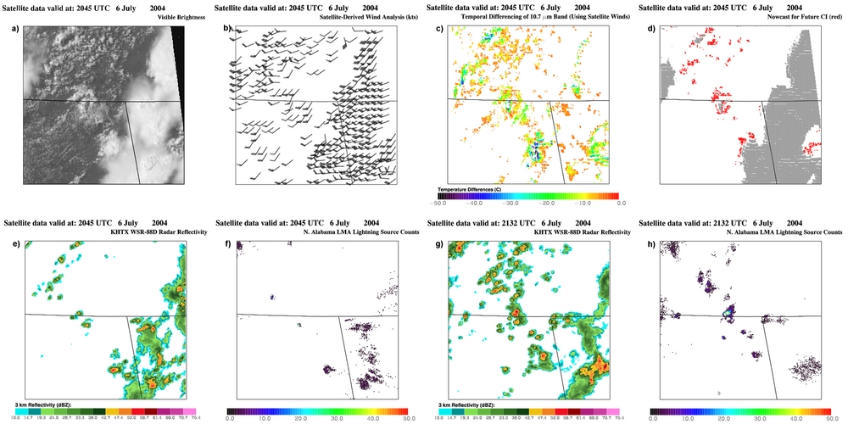
a
b
c
d

Figure 2: GOES visible imagery (a), cloud-motion tracking vectors (b), GOES infrared cloud-top cooling rates [∂(10.7 μm T_{B})/∂t] (c), and thunderstorm echoes (d) at 20:45 UTC. See Figures 2(e-h) for additional discussion.
The main limitations to the GOES and MODIS CI methodology lie in (1) accurate cumulus cloud tracking, and (2) the 1 km-resolution of the GOES sensor (i.e. cumulus with scale <1 km are not well tracked or observed by GOES VIS and IR sensors).
As of summer 2006, the CI algorithm is being run every 15-30 min during the day and night over the Upper Midwest, and over the Southern through Southeastern U.S. and across Florida (at UW-CIMSS and UAH; see nsstc.uah.edu/johnm/ci_studies.html and biscayne.ssec.wisc.edu/~johnm/CI_home/), and over Central America and the Caribbean. In addition, we are collaborating with NOAA and the National Weather Service (NWS)
f
e
h
g
Figure 2 (cont.): CI forecast made at 20:45 UTC valid at ~21:30 UTC (e) and thunderstorm development (≥35 dBZ echoes) at the 21:32 UTC validation time. Panels (g) and (h) show the corresponding 5 minute integrated lightning source counts at 20:45 UTC and 21:30 UTC, independent data sets showing the initial growth of small thunderstorms in this time period.

by using this algorithm over the NOAA Storm Prediction Center’s severe weather risk regions (www.ssec.wisc.edu/~krisb/ConvInit/ConvInit.html). And displaying the CI fields on the NWS Advanced Weather Information Processing System (AWIPS) system, of the National Weather Service (NWS) in Huntsville, Alabama, which is co-located in the same building as the Atmospheric Science Department of UAH (see Figure 3).

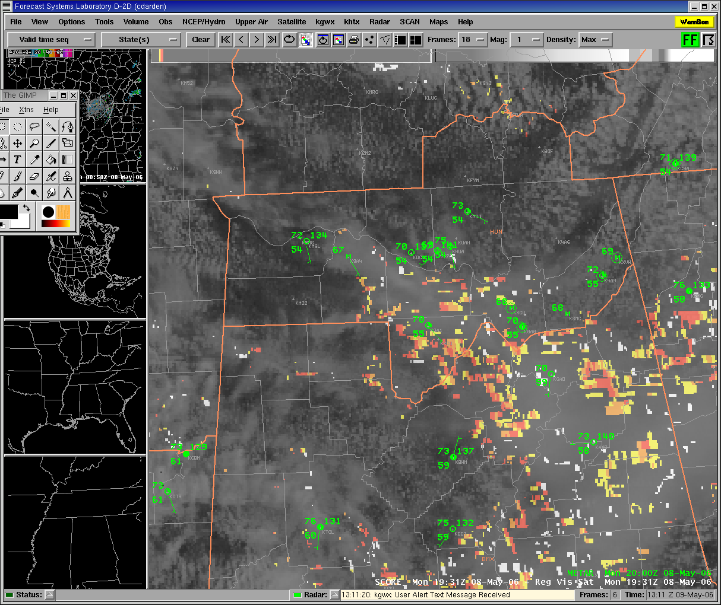
Figure 3: GOES CI field within the AWIPS: 30-min cloud-top cooling rates (ºC), overlaid with GOES 1-km resolution brightness. These fields are routinely provided to the NWS in Huntsville, Alabama.

b) AutoNowcaster Overview
The NCAR Auto-Nowcast System (ANC) is a software system that produces time- and space-specific 0-2 hour nowcasts of convective storm location and intensity (Mueller, et al., 2003). ANC combines meteorological observations, a numerical boundary layer model, forecaster input (“forecaster in the loop”), and feature detection algorithms to provide routine nowcasts of thunderstorm position.
In addition to routine demonstrations in the U.S. for the FAA and the National Weather Service, the NCAR Auto-Nowcast System has also been demonstrated at the Sydney 2000 Summer Olympic Games and is in the process of being transferred to the Bureau of Meteorology in China for use during the 2008 Olympics in Beijing.
Early nowcasting techniques relied on the simple extrapolation of storm positions. Even for periods of less than 60 minutes, extrapolation nowcasts are often not useful because they fail to take into account storm initiation, growth and dissipation. The ANC is designed to address these needs.
A primary component of ANC is the ability to identify and characterize boundary lkayer convergence lines. Feature detection algorithms algorithms and variational Doppler radar analysis techniques are used to monitor and nowcast boundary layer structures. The importance of the boundary layer in thunderstorm development was first shown by the Thunderstorm Project (Byers and Braham, 1949). They found that boundary layer mesoscale convergence was a common precursor to convective storm development. While some attention was paid to monitoring cloud lines from satellite data, most of the subsequent development work for thunderstorm nowcasting was focused on radar-detected clear-air “boundaries” (Wilson and Carbone, 1984). In this context, “boundaries” are defined as narrow zones of boundary layer convergence associated with weather phenomena such as gust fronts, sea-breeze circulations, terrain-induced circulations, horizontal convective rolls, and synoptic-scale fronts.
The ANC attempts to mimic much of what is normally done by the experienced forecaster. It uses a data fusion system to assimilate a variety of datasets, including forecaster input, to create nowcasts that are updated at regular intervals, typically every 5 minutes. The ANC uses a fuzzy logic system that provided an efficient approach to the combination of datasets through the use of conceptual models. Datasets are not just thrown into the system, but rather require at least a qualitative understanding of the specific role of the importance of the observation. Observational datasets most frequently used in the ANC system include full resolution radar (generally WSR-88G), satellite, surface stations, lightning, profilers, numerical models, and radiosondes. These data are input into analysis algorithms to calculate predictor fields. The relevant analysis algorithms are specifically developed for each dataset and include data quality control routines and feature detection algorithms as well as additional observation-specific procedures. The fuzzy logic approach uses membership function to map the predictor fields to the likelihood of storms. Fourteen or more predictors are used in the ANC, including some that are based on satellite observations. ASAP collaboration with the NCAR ANC development team has been focused on upgrading and improving these satellite predictor fields.

3. Results: SATCAST (Satellite) Interest Fields within the Auto-Nowcast System
In 2004, ASAP investigators at the University of Wisconsin, CIMSS, began collaboration with the NCAR members of the FAA’s Convective Weather Product Development Team, beginning to incorporate and test advanced satellite data sets into the Auto-Nowcast System. The promise was to begin evaluating the value of the new satellite fields within the ANC and other FAA-supported nowcasting systems. This initial work was motivated by the NASA ASAP Summary document, Mecikalski et al. (2003).
Collaboration with the Convective Weather Development Team began in Fall 2004, and continued throughout 2005. At the 2005 ASAP Science Meeting held in Boulder, Huaqing Cai and Cindy Mueller showed some initial results of their explorations with ASAP satellite-based CI fields in the Auto-Nowcast System. The key issues in this initial collaborative work were to identify how best to incorporate the new satellite-based convective observations into the existing structure of the ANC. The integrated ASAP CI product fields, for example, were difficult to interpret in terms of quality control and feature identification and the NCAR team decided to work more with the component fields that are used to generate the ASAP CI product. This follows their general approach of using individual observational fields instead of integrated summaries, letting the final fuzzy logic integration do the combination of all interest fields in a single step.
The ASAP satellite interest fields that were most directly compatible with the existing ANC internal structures were satellite cloud type (cloud mask), including a separate field for cloud free regions, and the cloud-top cooling rate. The ASAP products showed more detail than the lower resolution satellite fields previously used with the ANC and promised more detailed identification of early cloud development. Figure 4 shows the 15-minute ASAP cloud-top IR cooling observation, the corresponding ANC “interest field” and the older interest field based on the pre-ASAP satellite data sets previously available to the ANC development team. The new, higher resolution fields were found to provid more detailed and smoother features in the interest field.

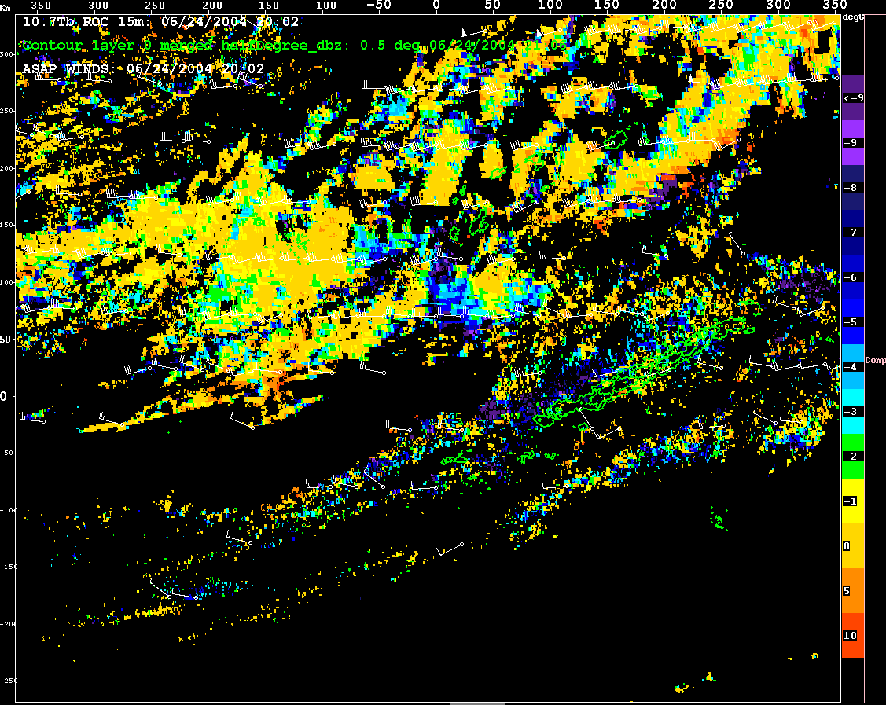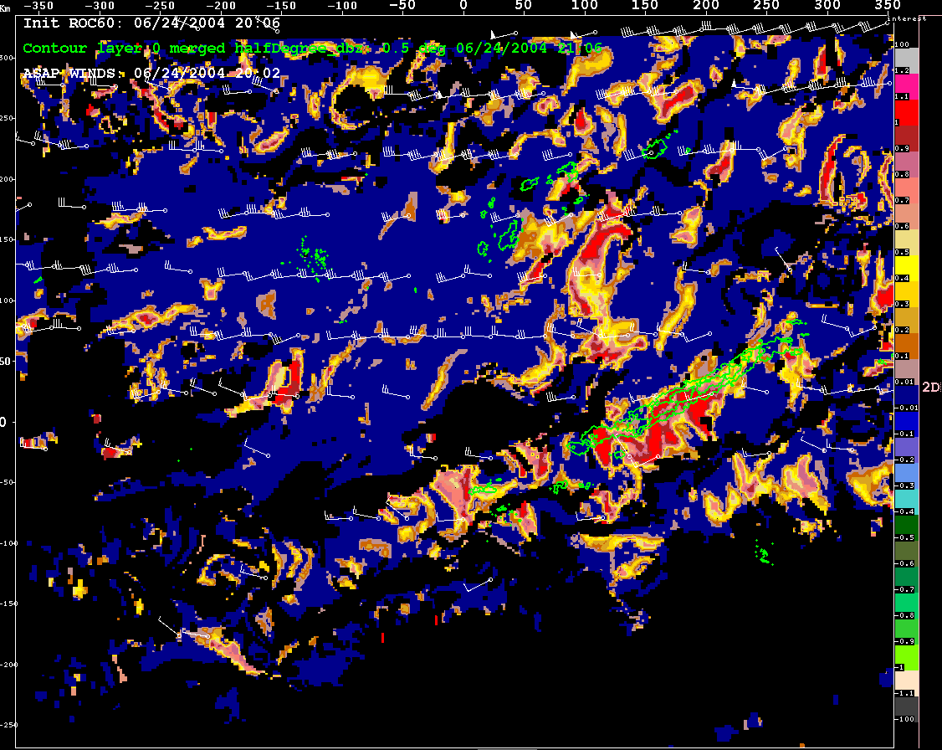
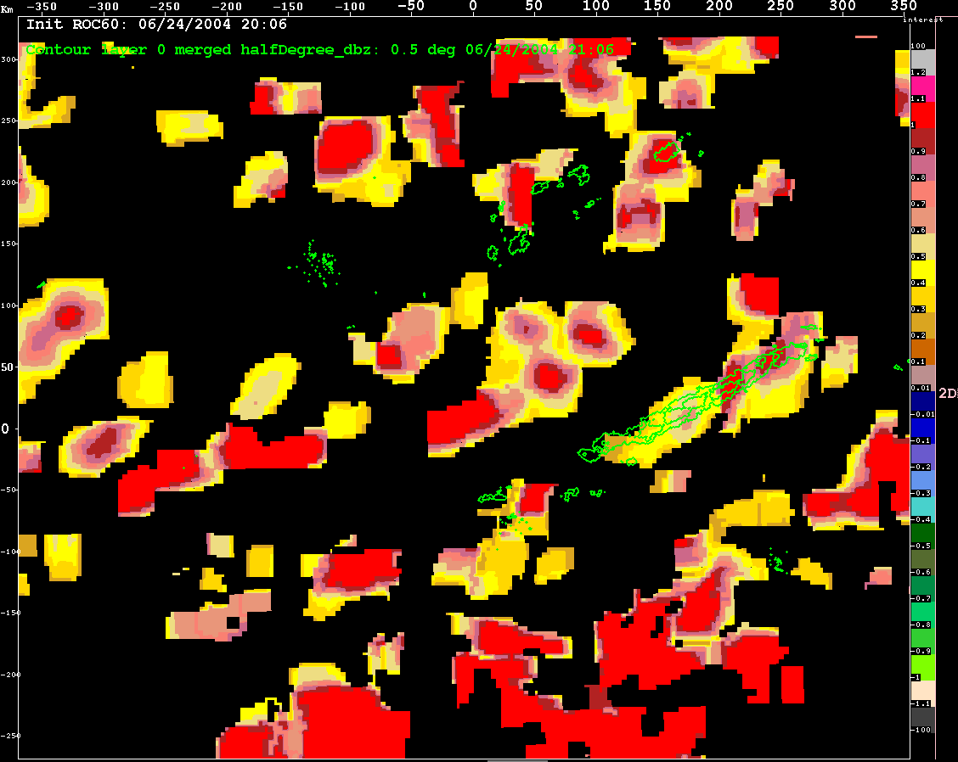
Figure 4. Fifteen-minute IR cooling rates. Upper left panel, high-resolution ASAP analysis field. Upper-right panel, ASAP analysis field converted into an ANC interest field. Lower-left panel, original (pre-ASAP) IR cooling interest field. All fields were derived from the same satellite imagery, valid at 2006 UTC 24 June 2004.

In addition to examining the cloud-top cooling rates, NCAR conducted a series of comparison tests examining the features and performance of the UAH/ASAP cloud mask field and the cloud mask that was developed by the Navy Research Laboratory satellite group in Monterey, California. The Navy mask included a more detailed breakdown of cloud type, and seemed to perform better using its cumulus congestus classification as a predictor of subsequent development than the more general cumulus category of the ASAP product (see Figure 5). The FAA Convective Weather Team has extended the use of convective cloud typing within the ANC and other systems.
On the basis of this comparison, in part, the ASAP CI development group has reexamined their cloud mask, and has formulated a clustering-based approach (Figure 6). The Standard Deviation Limited Adaptive Clustering (SDLAC) technique is an iterative, statistically based method that combines aspects of k-means ISODATA and agglomerative hierarchical clustering (Berendes et al. 2006). However, unlike most clustering methods, SDLAC does not require initial cluster estimates. The SDLAC method has been applied successfully for detection and classification purposes. A convective cloud mask has been created using GOES data. SDLAC is extremely flexible, and has been used on MODIS to detect volcanic ash plumes for example.
Figures 7 through 10 show an example of the contribution of improved early cloud satellite observations can make in concentrating and condensing the ANC predictions based on boundary analysis. In these figures the early cloud observations are used to reduce the estimated probability of convective initiation in areas that aren’t showing early cloud development, and to increase the probability of convective growth in areas that show clear signs of early development.

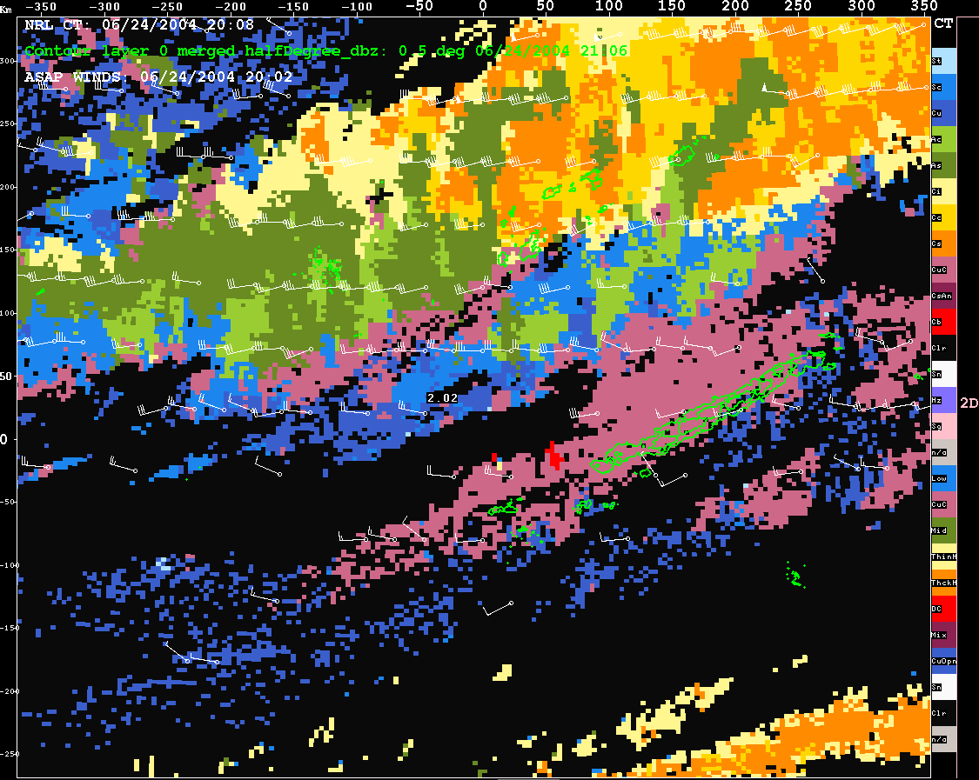
Figure 5: NRL cloud clas-sifications. Field valid at 2006 UTC 24 June 2004.

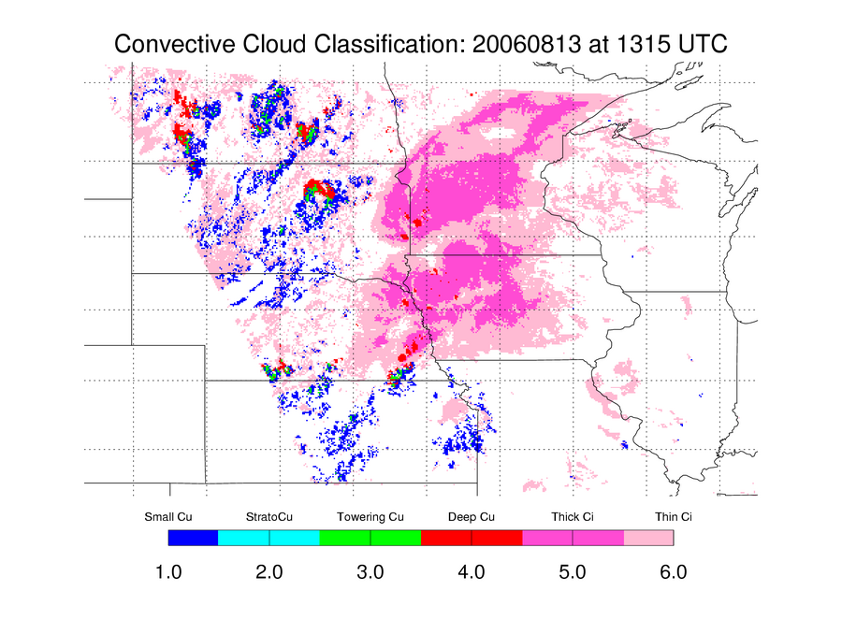
Figure 6: Subsequently developed and improved ASAP clustering-based cloud typing algorithm, as being evaluated in CoSPA.

Figure 7 shows the initial cloud field (visible image), with the ANC predicted boundary for preferential development shown in purple. The region highlighted is over the state of Indiana. The outlines of the subsequent areas of significant radar echo 60 minutes later are outlined in black. Figure 8 shows the corresponding radar reflectivity field showing little of no initial development. Figure 9 shows the IR cloud-top cooling field, which clearly suggests preferential development along the eastern end of the anticipated boundary feature.
The resultant, combined ANC prediction shown in Figure 10 successfully identifies the location of the convective build up (indicated by the purple, pink, and maroon contours), as compared with the subsequent radar echo position boundaries (now show in white).
In summary: the results look very promising, and suggest that incorporation of improved satellite observations may be able to enhance ANC performance by providing a detailed analysis of the locations and early growth of non-precipitating convective clouds.

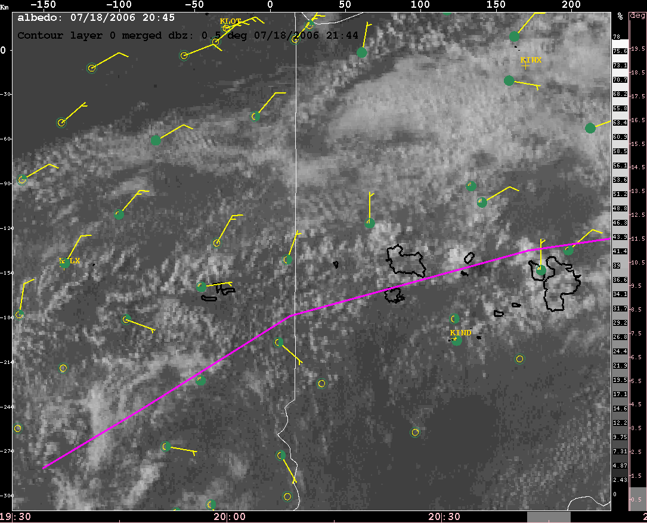
Figure 7: Visible (GOES) satellite data for 2045 UTC 18 July 2006.
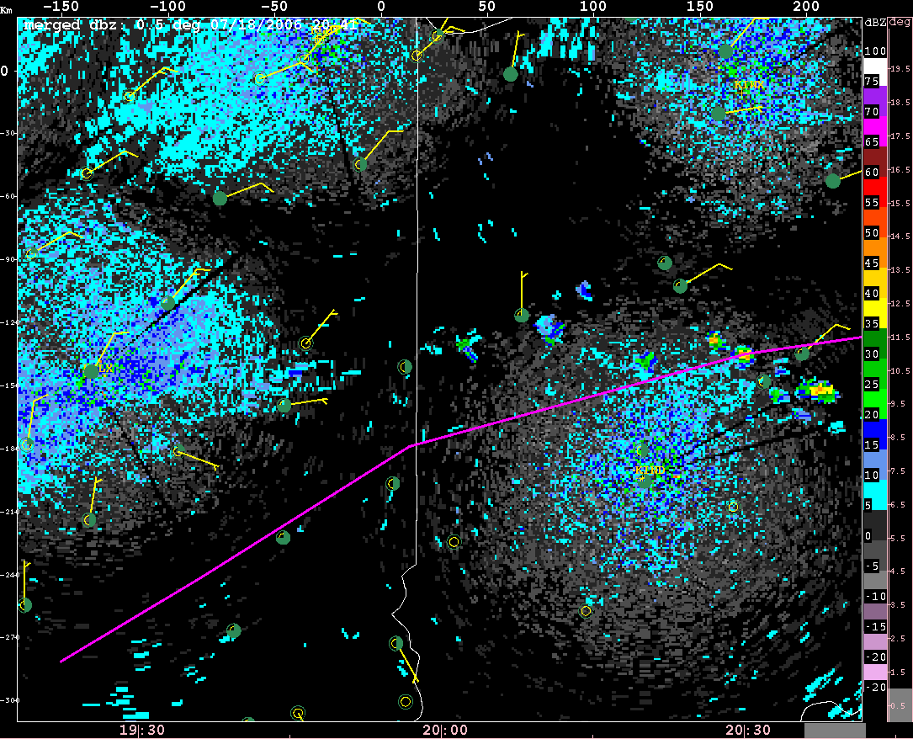
Figure 8: Radar (composite NEXRAD) data for 2042 UTC 18 July 2006.

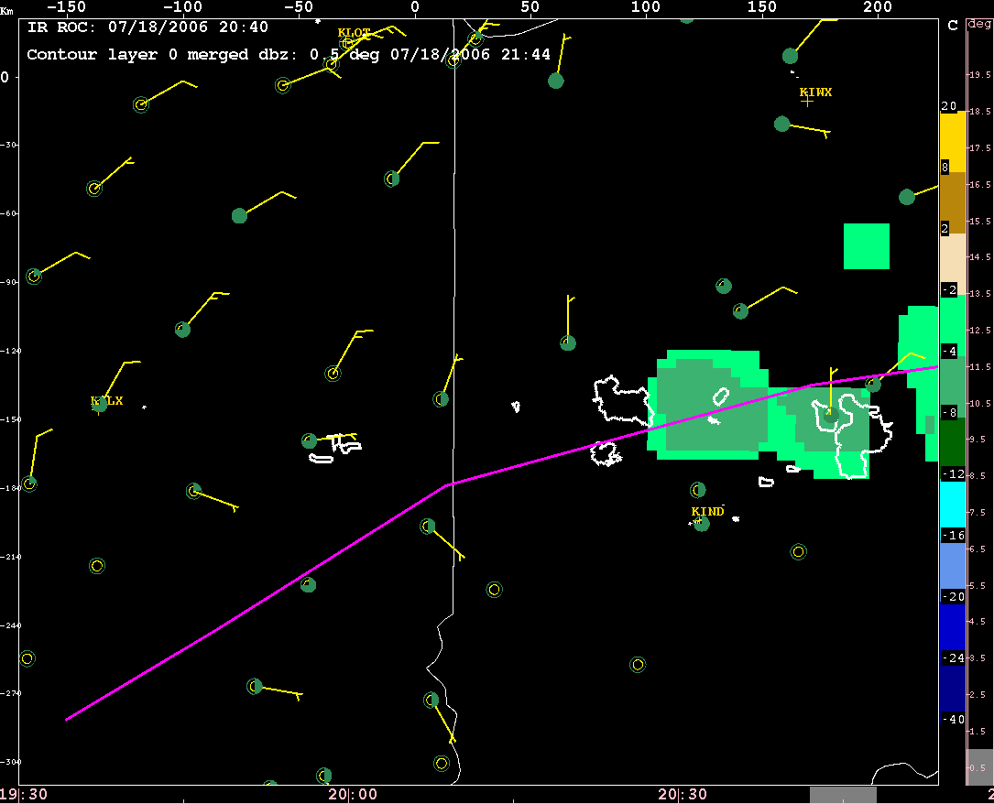
Figure 9: GOES IR cloud-top cooling field for 2042 UTC 18 July 2006.
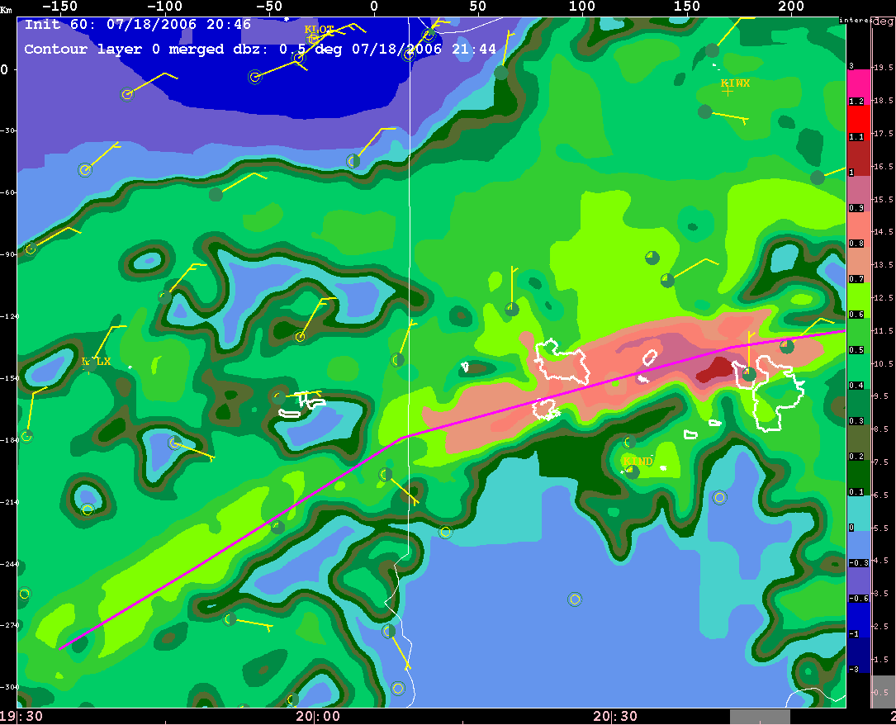
Figure 10: ANC-produced interest field for CI for 2042 UTC 18 July 2006, based on integrating the ASAP cloud observations with the traditional ANC data fields.

Outward from this initial test has been the need to extensively validate the CI IR interest fields, cloud mask and winds. This will be expanded on below. Because of the critical nature of cumulus cloud tracking in the ANC (as well as in SATCAST, which provides fields for the ANC), mesoscale atmospheric motion vectors (AMVs) have been enhanced by the ASAP team since 2005. Figure 11 presents some accuracy statistics for these AMV fields.

4. Current Status, Lessons Learned and Recent Progress
Recent research done to incorporate and utilize the SATCAST GOES VIS and IR interest fields within the ANC and subsequent work demonstrating SATCAST products for NOAA and the NWS has lead to considerable new developments. This section summarizes the highlights of this work since 2005.
In particular, satellite-derived CI interest fields and radar reflectivity data (as a verification field to evaluate satellite-based predictions) from several CI events were used to (a) estimate the relative importance of each IR interest field as well as the confidence we have that a given interest field is useful to nowcasting CI, (b) evaluate the skill in the SATCAST algorithm, and (c) serve as a training data set for new approaches for integrating the eight CI interest fields, such as linear discrimenant analysis (LDA) and other non-linear models.

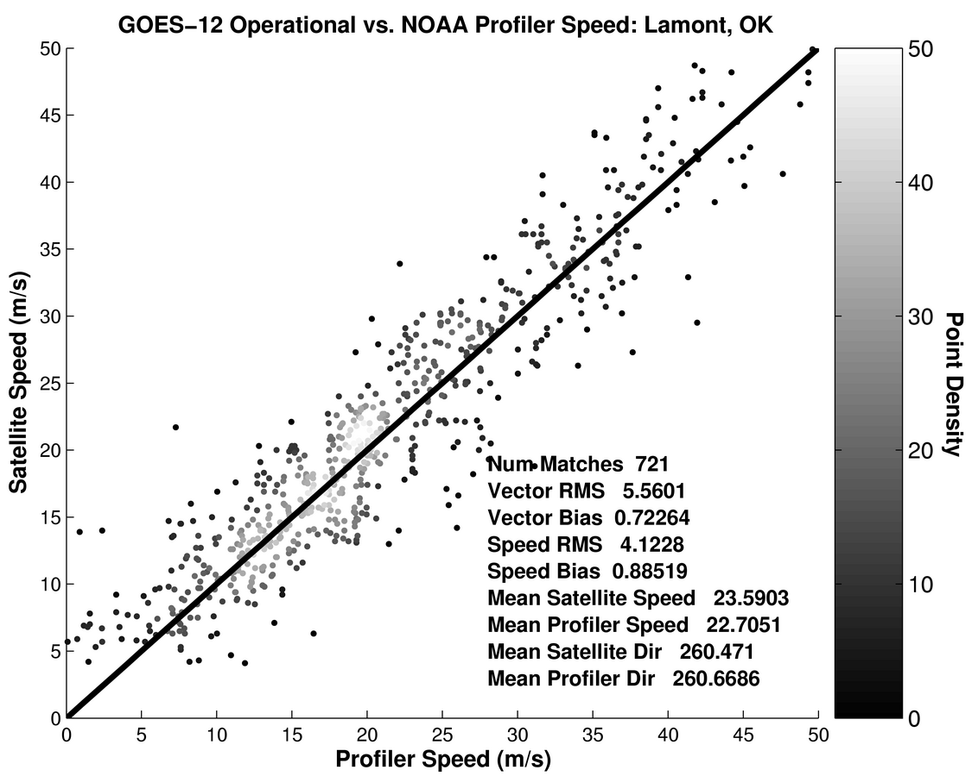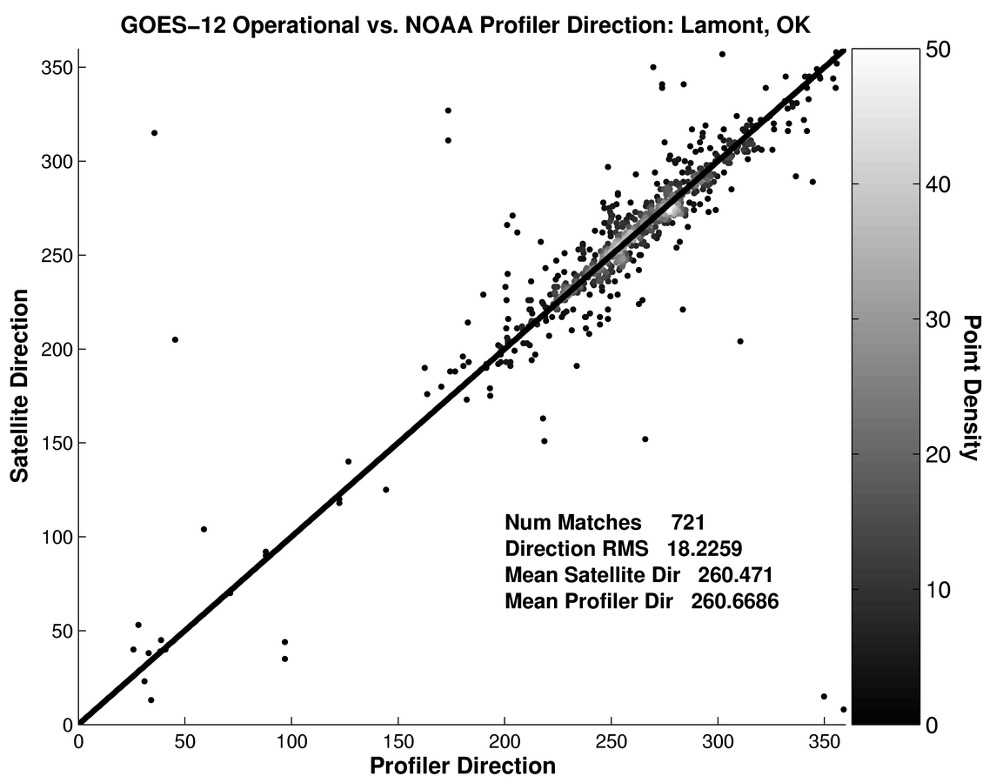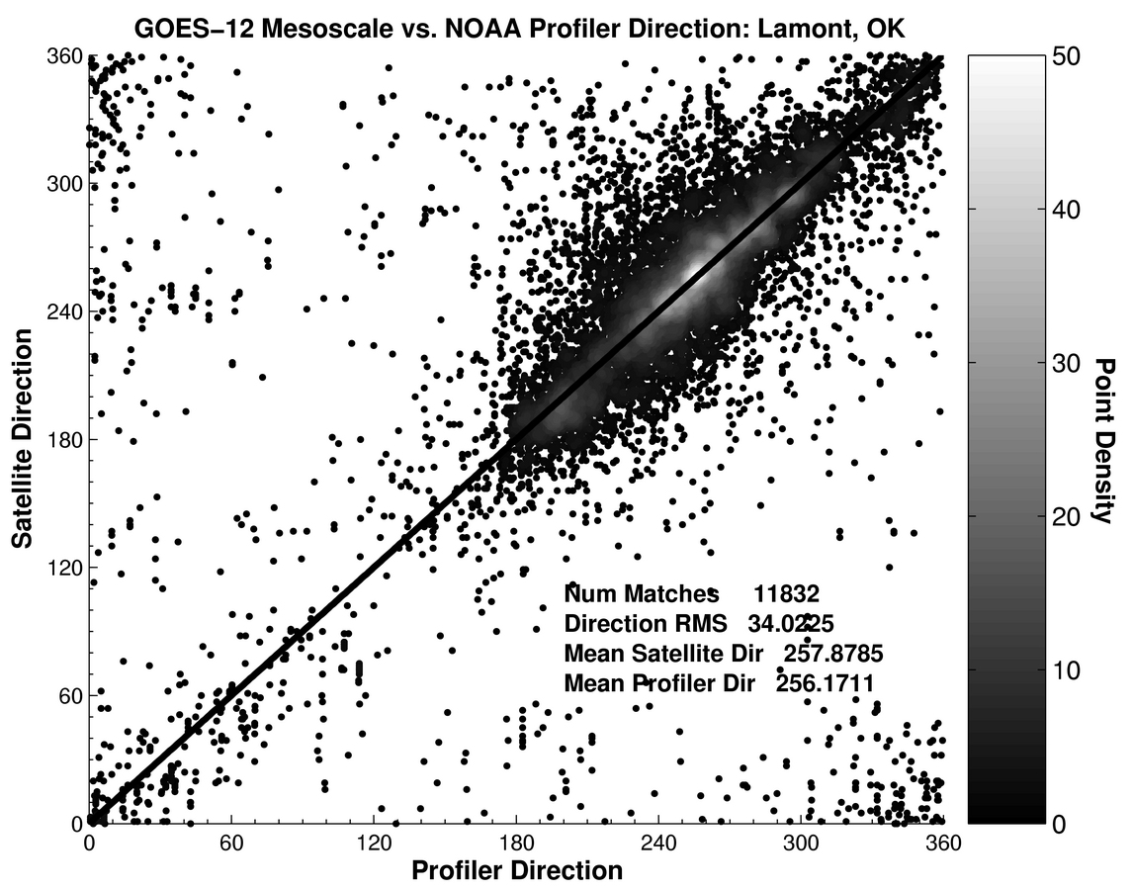
Figure 11: A comparison of OPER AMV wind speed (left), and direction (middle-left), and MESO AMV wind speed (middle-right), and direction (right) to NOAA Wind Profiler observations over the one-year study period. Regions of higher scatterpoint density are colored by lighter greyscale tones

a) Principal component analysis (PCA)
Principal component analysis (PCA) can be used to discern the relative amount of information within the IR data of a GOES pixel (i.e. within each of the eight CI interest fields). Also known as empirical orthogonal function (EOF) analysis, PCA is a common method used to reduce a data set from a large number of variables to one in which only a few new variable are required to describe the necessary and important information (Wilks 2006). Because of the commonness of use of PCA within atmospheric analysis, we refer the reader to Wilks (2006), as well as more classical treatments by Jolliffe (1986) and Preisendorfer (1988), for an overview of this technique.
The primary focus of this analysis is to determine which of the eight interest fields contain a relative amount of important information in comparison to others, or, which combination of indicators is important; it is likely that not all of the eight fields contain the same level of information on future CI, with some likely containing redundant information. Table 1 presents the 8 IR fields, while Table 2 presents the PCA results.
Unique
Cloud-top cooling rates
10.7 µm Temporal Trend
Unique
Cumulus cloud tracking for temporal trend assessment
Visible and Infrared Winds
Unique
Time changes in cloud top height
13.3–10.7 µm Temporal Trend
Unique
Time changes in cloud height relative to the tropopause
6.5–10.7 µm Temporal Trend
Not Used
Time changes; cloud-top microphysics
3.9–10.7 µm Temporal Trend
Redundant
3.9, 6.5, 13.3 µm Temporal Trend
Unique
Cloud-top height changes
13.3–10.7 μm Difference
Unique
Cloud-top height relative to tropopause
6.5–10.7 μm Difference
Not Used
Cloud-top microphysical assessment. Not used due to effect of solar zenith angle on 3.9 µm band
3.9–10.7 µm Difference
Redundant
3.9, 6.5, 13.3 µm T_{B}
Unique
Convective cloud mask and cloud-top temperature assessment
10.7 µm T_{B}
Unique
Convective Cloud Mask
Visible Brightness Counts
Uniqueness
Contribution
GOES-12 Derived Field

Table 1: The information the GOES-12 satellite can provide to the CI nowcast algorithm, and their individual contributions in terms of uniqueness for assessing CI. For GOES satellites prior to GOES-12, similar statements can be made when comparing 6.7 versus 6.5 µm, and 12.0 versus 13.3 µm channels.

Assessment of the principal components and explained variance tables provides and interesting conclusion: (1) Principal component 1 alone describes 67.64% of the variance for forecasting CI from these data, with component 2 adding another 20.83% (totaling 88.47%) and component 3 adding another 7.26% (totaling 95.73%). (2) If principal components 1-3 are considered valuable together, then analysis of the explained variances between all interest fields shows that all of the seven fields contribute some level of useful information to CI nowcasting. This implies that use of fewer that seven interest fields will not provide more accurate or optimal CI predictions and lends credence to the scoring approach used in Mecikalski and Bedka (2006). This scoring approach, however, suffers some in terms of POD accuracy as compared to an LDA-based method for using the GOES IR data, as shown below.

Correlations | IF1 | IF2 | IF3 | IF5 | IF6 | IF7 | IF8
IF1 | 1.000 | — | — | — | — | — | —
IF2 | 0.8581 | 1.000 | — | — | — | — | —
IF3 | -0.9388 | -0.8690 | 1.000 | — | — | — | —
IF5 | -0.2411 | -0.3304 | 0.2818 | 1.000 | — | — | —
IF6 | -0.4403 | -0.4989 | 0.5143 | 0.5976 | 1.000 | — | —
IF7 | 0.1405 | 0.2246 | -0.1358 | -0.9323 | -0.5029 | 1.000 | —
IF8 | 0.0914 | 0.3405 | -0.0892 | -0.7743 | -0.3654 | 0.7826 | 1.000
ExVar
PC#1 | 23.745 | 12.318 | -33.025 | -7.552 | -16.327 | 4.048 | 2.986
PC#2 | 10.425 | 1.758 | -11.616 | 22.017 | 22.970 | -17.277 | -13.936
PC#3 | 7.712 | 5.807 | -1.729 | -17.353 | 34.192 | 15.330 | 17.877
PC#4 | -1.057 | -28.687 | -11.201 | -17.045 | 5.090 | 10.407 | -26.514
PC#5 | -39.710 | 6.427 | -28.009 | -4.775 | 4.812 | -9.567 | 6.700
PC#6 | -6.859 | 34.038 | 7.016 | -5.932 | 2.323 | 14.112 | -29.721
PC#7 | -7.123 | -5.950 | -9.345 | 33.245 | -0.824 | 39.048 | 4.465

PC | Eigenvalue | % Variance
1 | 396.87 | 67.64
2 | 122.21 | 20.83
3 | 42.57 | 7.26
4 | 11.59 | 1.98
5 | 8.93 | 1.52
6 | 2.66 | 0.454
7 | 1.89 | 0.322

Table 2: Principal component analysis (PCA) results for eight CI interest fields. Shown (top) is the correlation matrix as a lower-triangular matrix. For this analysis, because IF4 was a binary (yes/no) condition, we could not use it within PCA. Based on the analysis (bottom table), PC 1-3 are considered to contain useful information, and more importantly, non of the seven CI interest fields contain a significant amount of redundant information on forecasting the occurrence of CI using GOES IR data. Here, “ExVar” is explained variance.

b) Skill Assessment: POD and FAR Statistics
A simple statistical analysis was performed as a means of assessing the accuracy of te CI nowcasts from SATCAST, as a function of IR interest field. Here we determine measures of accuracy, false alarm rates, probability of detection and uncertainty in the GOES CI methodology. This analysis consisted of determining for all CI pixels the maximum probability of detection (POD) and minimum false alarm rate (FAR) as a function of ≤ 8 interest fields. For this project, POD is defined as in Wilks (2006), namely POD=a/(a+c); FAR is defined similarly as FAR=b/(a+b). In these, POD is the fraction of those occasions when the forecast event (CI in this case) occurred when it was also forecast to occur (a) compared to all forecasts (a+c). FAR is the fraction of ‘yes’ forecasts that turned out to be incorrect (b) compared to all non-events (b+c). Here, c is the number of event that where not forecasted but that were observed.

Interest Field | IF1 | IF2 | IF3 | IF4 | IF5 | IF6 | IF7 | IF8 | Mean
IF1 | 0.683 | 0.627 | 0.421 | 0.451 | 0.444 | 0.537 | 0.454 | 0.371 | 49.83%
IF2 | 0.627 | 0.843 | 0.409 | 0.507 | 0.484 | 0.656 | 0.500 | 0.382 | 55.09%
IF3 | 0.421 | 0.409 | 0.428 | 0.380 | 0.289 | 0.345 | 0.296 | 0.235 | 35.03%
IF4 | 0.451 | 0.507 | 0.380 | 0.655 | 0.450 | 0.560 | 0.432 | 0.339 | 47.18%
IF5 | 0.444 | 0.484 | 0.289 | 0.450 | 0.595 | 0.445 | 0.552 | 0.429 | 46.10%
IF6 | 0.537 | 0.656 | 0.345 | 0.560 | 0.445 | 0.793 | 0.446 | 0.345 | 51.58%
IF7 | 0.454 | 0.500 | 0.296 | 0.432 | 0.552 | 0.446 | 0.598 | 0.428 | 46.33%
IF8 | 0.371 | 0.382 | 0.235 | 0.339 | 0.429 | 0.345 | 0.428 | 0.471 | 37.51%
 |  |  |  |  |  |  |  | Minimum: | 35.03%

Table 3: Preliminary, conditional POD scores as a function of interest field usage. For example, if the top line is considered, interest field “1” (IF1 from Table 1) fell within its critical range 68.3% when CI occurred. When IF1 was within range, IF2 was within its critical range 62.7% of the time, etc. The sum on the far right denotes the mean of all percentages per row. The shaded diagonal elements provide the single-field POD scores (e.g., IF2 used alone gives an 84.3% POD for CI, which falls to 55.09% when all subsequent fields are considered).

Interest Field | IF1 | IF2 | IF3 | IF4 | IF5 | IF6 | IF7 | IF8 | Mean
IF1 | 0.676 | 0.619 | 0.403 | 0.428 | 0.365 | 0.497 | 0.366 | 0.283 | 45.48%
IF2 | 0.619 | 0.804 | 0.395 | 0.481 | 0.392 | 0.596 | 0.399 | 0.288 | 49.68%
IF3 | 0.403 | 0.395 | 0.411 | 0.322 | 0.219 | 0.295 | 0.219 | 0.172 | 30.46%
IF4 | 0.428 | 0.481 | 0.322 | 0.66 | 0.405 | 0.565 | 0.384 | 0.298 | 44.30%
IF5 | 0.365 | 0.392 | 0.219 | 0.405 | 0.512 | 0.385 | 0.468 | 0.352 | 38.73%
IF6 | 0.497 | 0.596 | 0.295 | 0.565 | 0.385 | 0.770 | 0.379 | 0.289 | 47.20%
IF7 | 0.366 | 0.399 | 0.219 | 0.384 | 0.468 | 0.379 | 0.505 | 0.346 | 38.34%
IF8 | 0.283 | 0.288 | 0.172 | 0.298 | 0.352 | 0.289 | 0.346 | 0.392 | 30.25%
 |  |  |  |  |  |  |  | Maximum: | 49.68%

Table 4: Preliminary, conditional FAR scores as a function of interest field usage. Table 4 description is the same as for Table 3, except that the shaded diagonal elements provide the single-field FAR scores.

Table 3 presents these results, and shows that use of the instantaneous 13.3-10.7 µm channel difference provides the highest POD at 84.3%. Stated another way, when this channel difference is within the –25 to –5 K range, there is an 84.3% probability that CI (as we’ve defined it) will occur within the following 30 minutes for the moving cumulus as observed by GOES. The POD falls to 74.9% when the instantaneous 13.3–10.7 µm channel difference is used together with the pixel’s 30 minute 10.7 µm (cloud top) T_{B} time trend. Continuing, we see that use of interest fields 2, 6, 1, 4 and 7 together (see Table 3) limits the POD for CI to 62.7%. In contrast, Table 4 shows that FAR scores are minimized at 39.2% when interest field 8 is used alone (the time trend of the 13.3–10.7 µm T_{B} difference at a pixel). When interest field 8 is used in together with fields 5, 7, 4 and 6, the FAR decreases slightly to 33.5%.
The relationship of these results to physical cumulus cloud behavior observed by GOES suggests the following: (1) Incorporation of the 8 km resolution 13.3 µm channel (as interpolated to the 1 km radar data resolution for this application) provides high value in detecting and observing cloud growth of the larger cumulus clouds, i.e., the larger updrafts. In other words, when a cumulus cloud produces a strong signal in the 13.3 µm channel it implies an updraft of considerable size—between 4 and 8 km in width. We surmise then that as updraft widths increase there is increased likelihood of CI over the next hour (larger updrafts are more likely to persist for longer time periods). (2) Cloud-top cooling rates (15- and 30-min 10.7 µm IR T_{B} trends) are important for monitoring in-cloud updrafts toward the occurrence of CI. This was anticipated given the results of Roberts and Rutledge (2003). (3) The 6.5–10.7 µm IR channel difference seems to provide redundant information to the 13.3–10.7 µm T_{B} difference and 10.7 µm time trend information given that it appears as the third most important field for high POD and low FAR. (4) The interest field denoting the transition from above to below 273° K, and especially the actual cloud-top T_{B} field appears to add limited and nearly no information, respectively, to the 0-1 hour CI nowcasting capability from GOES-12.
The POD and FAR results suggest then the following hierarchy of interest field value for nowcasting the occurrence of a >35 dBZ radar echo given information from the GOES-12 instruments: (1) 13.3–10.7 µm TB and its time trend, (2) cloud-top cooling rate measured through the 10.7 µm channel values, (3) 6.5–10.7 µm T_{B} and time trend, (4) the transition from above to below 273 K as measured by the 10.7 µm channel, and (5) the instantaneous 10.7 µm T_{B}. These analyses do show the need however to incorporate multiple interest fields toward maximizing POD and minimizing FAR scores, with all but one (the instantaneous 10.7 µm T_{B}) providing some value. There is no indication that using interest fields that have little value negatively affects the results, they just do not help. This is demonstrated in the LDA analysis to follow in which the best answers (LDA-determined CI versus actual CI for 10,820 pixels) are obtained when all eight-interest fields are combined.
The ASAP CI nowcasting method involves a simple summation of the number of interest fields satisfied per pixel. This differs from the conditional methodology described above where a selected interest field must meet the CI criteria before other interest fields are evaluated. Thus, we assume that the POD and FAR for the MB06 method corresponds to the smallest POD and largest FAR values from Tables 3 and 4. Thus, the POD for the MB06 method is 35 % and the FAR is 49.7%.
Beyond these simple statistics, it is of greater importance to provide the users of the satellite CI indicators measures of the uncertainty and confidence.

c) New Approaches
The primary motivation for the LDA is to recognize and isolate satellite-observed cloud-top diagnostics and time trends associated with cumulus clouds that lead to an enhancement in radar-observed precipitation at a future time. Thus, the location of a cumulus cloud pixel must be identified within imagery at times t–15 and t–30 minutes such that cloud-top cooling and channel differencing trends can be computed, and at time t+30 minutes to identify how the precipitation intensity has changed in response to this satellite-observed cloud trends.
At this point in the process, the satellite CI interest fields and current/future radar reflectivity information are known, assuming satellite/radar data were properly tracking both backward and forward in time. When these techniques are applied to the six cases mentioned above, a total of 30,567 1 km² GOES pixels co-located with WSR-88D level II radar data were compiled, with each pixel possessing all eight CI interest fields, as well as current and future radar reflectivity information.
A total of 10,820 of these 30,567 pixels are defined as “CI pixels” in the 6-event training data set given that the observed reflectivity values increased from less than to greater than 35 dBZ in a 30 minute period. Including the remaining 19,747 “non-CI pixels” was obviously necessary if we are to evaluate the skill of the LDA-based nowcasting method in capturing null events. This 10,820-pixel data set represents then the number of CI pixels that our methods (i.e. the original ASAP “scoring” versus new LDA-based methods) were challenged to provide a correct CI nowcast.
For this effort, LDA provides an ability to: (a) translate all eight interest fields per pixel into one number L (via a regression-like equation), that will range between a minimum (lowest CI potential) to a maximum (highest CI potential), and (b) use this L score then to delineate the likelihood of CI per pixel, and in effect, have the ability to estimate the confidence in this prediction (described below). The LDA method in-turn provides us with a more robust measure of per-pixel CI (a score and confidence) compared to the original MB06 CI-scoring system, and as will be shown, results in significantly lower FAR and higher POD scores within the 0-1 h CI nowcasts.
Confidence in a given pixel’s objective discrimination can then be subsequently measured as the numerical distance from the mid-point of all CI scores provided by Eq. (1), or from some average of all “yes” or “no” events provided a priori knowledge. Figure 1 illustrates the means for determining confidence in a “yes” LDA event prediction, in this example normalized between 0 and 1, as the difference between 5 and 7.5 (the a priori determined optimal score for “yes” events). Likewise, confidence in a “no” LDA event prediction can be determined in a similar manner, using 2.5 in this example.
For the LDA training analysis described above, a N-pixel “training” data set has been developed. This consists of GOES-12 pixels for which 8 of the eight CI interest fields are indicative of CI (based on Table 1) and the radar-observed dBZ values indeed increase from below to above 35 dBZ within the 1-hour period of actual CI occurrence. Outward of this analysis, a set of coefficients (c’s and F’s) is formed that populates Eq. (1) for delineating a L_{yes} and an L_{no} equation. These coefficients are listed in and are used to predict CI from the GOES data.
An additional training set consisting of N “yes” and “no” 1 km GOES pixels for using LDA to nowcast the increase in dBZ echoes over the coming 1 hour. This “yes” pixel set consists of GOES pixels for which the IR data measured cumulus that subsequently produced rainfall that increased their echo intensity (e) from e₁≥10 dBZ to e₂=e₁+35 dBZ, where e₂ is 30-minute later than that at e₁. We will use this LDA equation to evaluate the rainfall intensity nowcast potential from GOES over the next 30-60 minutes.

5. Conclusions
This ASAP Convective Benchmark Report outlines the initial efforts, during 2005 and 2006, to evaluate satellite-derived convective initiation interest fields within existing nowcasting systems under development by the FAA’s Convective Weather Development Team.
Results show promise in the continued use and improvement of satellite IR fields for nowcasting CI in the 0-1 h time frame. Work with the CoSPA in 2007 and 2008 has been initiated.

6. References

Bedka, K. M., and J. R. Mecikalski, 2005: Application of satellite winds to mesoscale phenomena and nowcasting, J. Appl. Meteor., 44, 1761-1772.
Berendes, T. A., J. R. Mecikalski, K. M. Bedka, and U. S. Nair, 2006: Convective cloud identification and classification in daytime satellite imagery using standard deviation limited adaptive clustering. In preparation. J. Geophys. Res.
Byers, H.R., and R.R. Braham Jr., 1949: The Thunderstorm. U.S. Govt. Printing Office, Washington D.C., 187 pp.
Mecikalski, J. R., and K. M. Bedka, 2006: Forecasting convective initiation by monitoring the evolution of moving convection in daytime GOES imagery. Accepted. Mon. Wea. Rev., IHOP_2002 Special Issue, 134, 49-78.
Mecikalski, J. R., K. M. Bedka, and S. J. Paech, 2005: Correlating satellite infrared trends, total lightning, and rainfall with convective initiation and development. Bull. Amer. Meteor Soc., NOWCAST: Conference Notebook section, 86, 21-22.
Mecikalski, J. R., and K. M. Bedka, 2006: Forecasting convective initiation by monitoring the evolution of moving convection in daytime GOES imagery. Mon. Wea. Rev. 134, 49-78.
Mecikalski, J. R., J. J. Murray, W. F. Feltz, D. B. Johnson, K. M. Bedka, S. M. Bedka, others, 2006: Aviation applications for satellite-based observations of cloud properties, convective initiation, in-flight icing, turbulence and volcanic ash. Bull. Amer. Meteor. Soc. Submitted.
Mecikalski, J. R., D. B. Johnson, J. J. Murray, and many others at UW-CIMSS and NCAR, 2002: NASA Advanced Satellite Aviation-weather Products (ASAP) Study Report, NASA Technical Report, 65 pp. [Available from the Schwerdtferger Library, 1225 West Dayton Street, Univ. of Wisconsin-Madison, Madison, WI 53706.]
Mueller, C., T. Saxen, R. Roberts, J. Wilson, T. Bentancourt, S. Dettling, N. Oien, and J. Yee, 2003: NCAR Auto-Nowcast System, Weather and Forecasting, 18, 545-561.
Wilson, J.W., and R. Carbone, 1984: Nowcasting with Doppler radar: The forecaster-computer relationship. Nowcasting II, K. Browning, Ed., European Space Agency. 177-186.

