Beam Heating in the Accumulator

Valeri Lebedev

FNAL, May 13, 2002.

Contents
- Heating mechanisms
- Review of gas scattering
- Review of IBS theory
- Comparison of the theory with experimental data
- Conclusions

Heating Mechanisms

  - Scattering on residual gas
    - Dominates at small beam current
  - Intrabeam scattering (IBS)
    - Presently is major heating mechanism at high current (~100 mA)
  - Non-linear resonances
    - Tunes should not be to close to resonances. Harmful effects of resonances (up to 18-th order) have been observed
  - Instabilities
    - An instability driven by ions originated from the residual gas heats the beam at currents above ~20 mA
  - Noise on electrodes
    - We do not have any evidence of beam heating due to noise on electrodes

Scattering on the residual gas

Beam lifetime
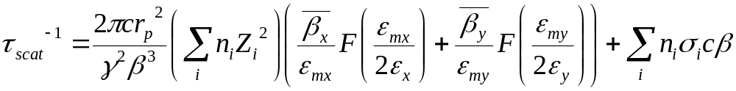
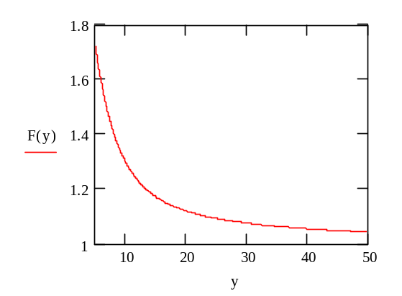

where 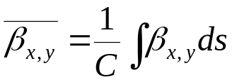
- Total beam lime time measured with low intensity protons ~1400 hour
- Coulomb scattering ~2800 hour
- Nuclear absorption ~2700 hour
Emittance growth rate is closely related to the beam life time
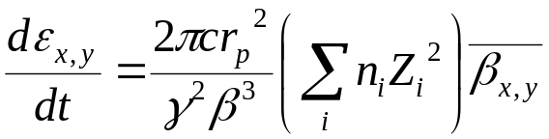
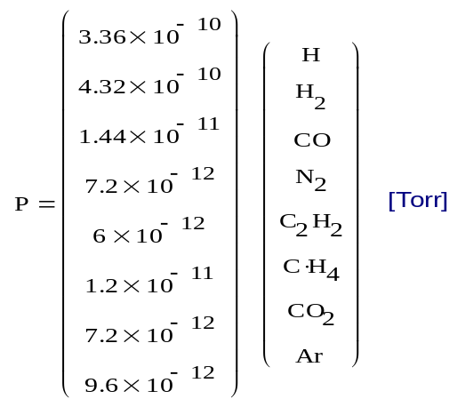
Presuming that the relative gas composition is proportional to a single point measurement performed 2 years ago we obtain the vacuum and the emittance growth rates
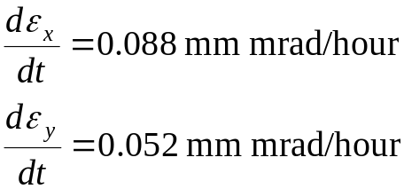
- Measured minimum vertical emittance growth time coincides well with the calculations
- The horizontal one is usually above predictions and grows fast with beam current
Twiss parameters for the old and new accumulator lattices
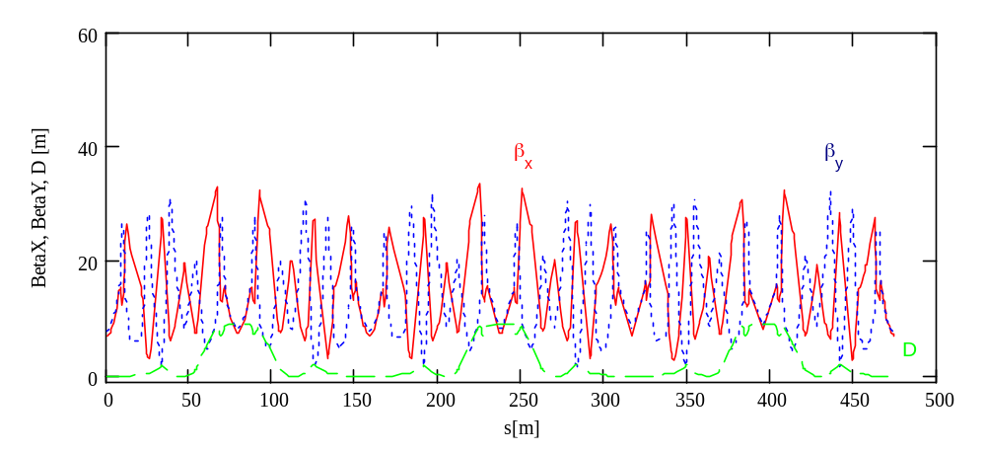
 | Old | New
β_{x}[m] | 15.3 | 20.9
β_{y}[m] | 13.4 | 12.5

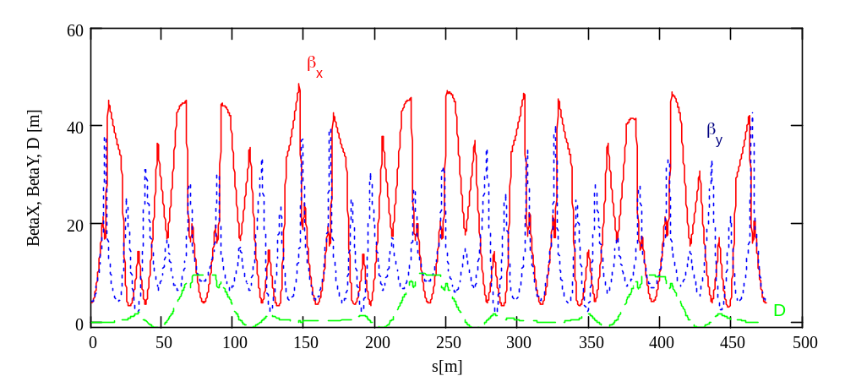

Intrabeam scattering theory

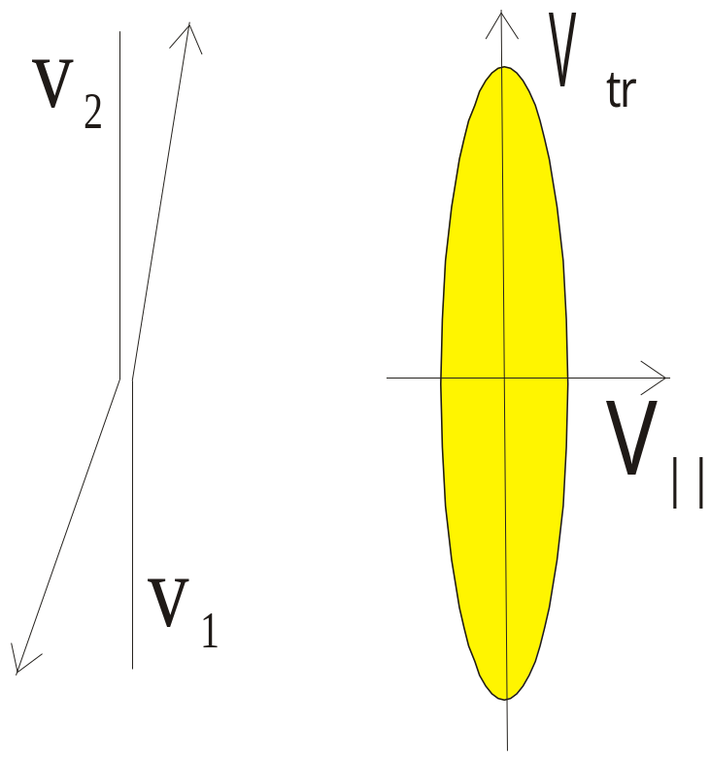

If in the beam frame the longitudinal momentum spread is much less than the transverse one the IBS formulas can be significantly simplified

The IBS growth rate for longitudinal degree of freedom
- IBS transfers the energy from the transverse degrees of freedom to the longitudinal one and the growth rate can be approximated by the following formula
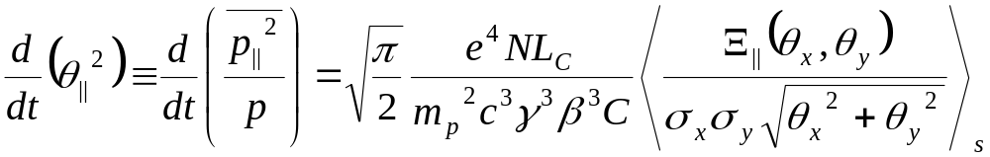 ,
where averaging is performed along the beam orbit,
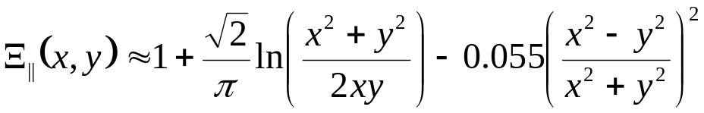,
L_{c} - is the Coulomb logarithm,
C – is the ring circumference,
the beam sizes and local angular spreads along the ring are determined by
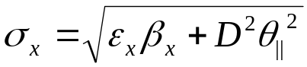
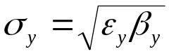
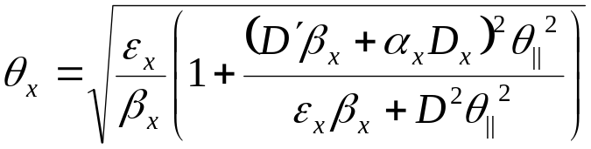
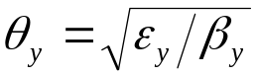
and
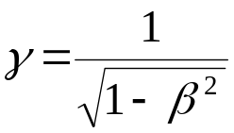

The IBS growth rate for transverse degree of freedom
- The heating of the longitudinal degree of freedom causes cooling for both transverse degrees of freedom;
- Additional mechanism heats the horizontal degree of freedom
  - At regions with non-zero dispersion, changes in the longitudinal momentum change the particles reference orbits, which additionally excites the horizontal betatron motion,
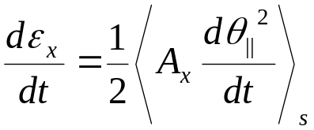 ,
where 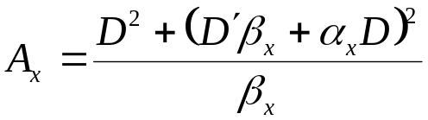
Coefficient ½ is related to the fact that the beam is unbunched
- Finally, one can write for the emittance growth rates
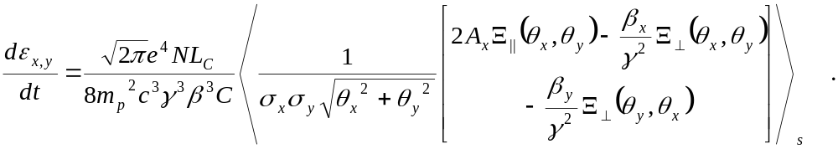
where
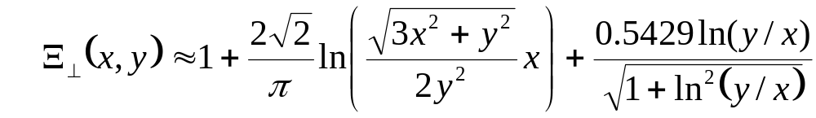 .
Comparison of the old and new accumulator lattices from the horizontal emittance growth rate due to IBS
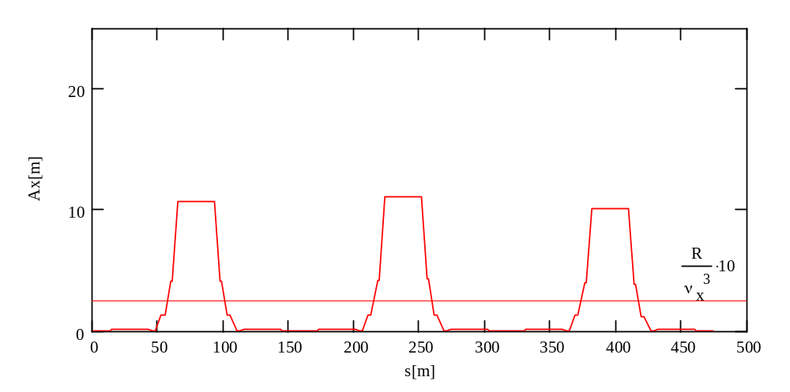
- Both lattices are not designed to have small IBS
- New lattice amplifies IBS by more than factor of two in comparison with the old one

Old lattice
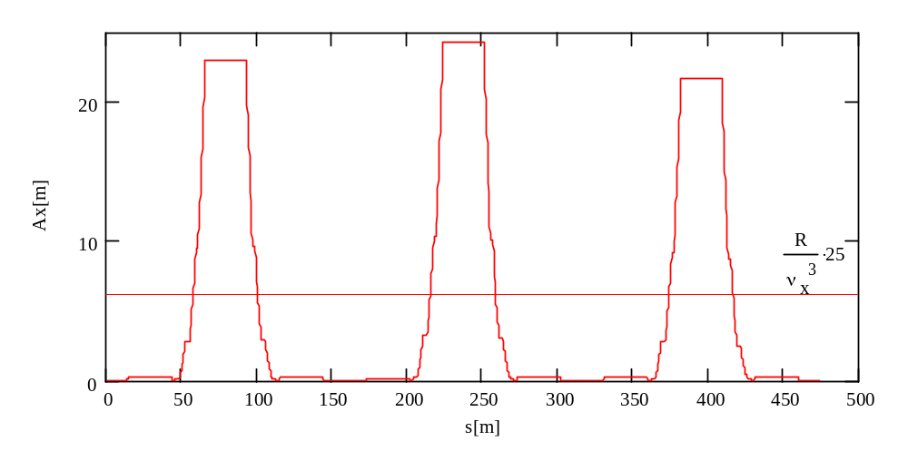
New lattice

Comparison with experiment
Protons, I._{beam}=13.5 mA, Lifetime = 1400 hour, beam is scraped from 100 mA, Apr.30.02
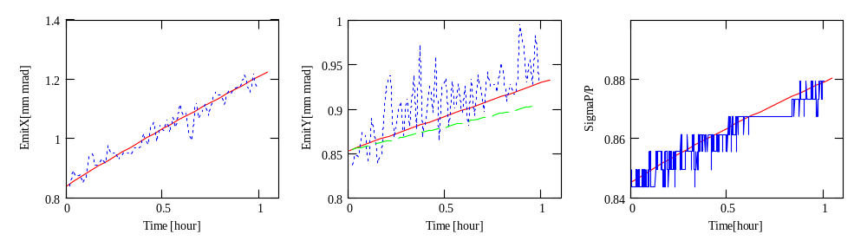
Antiprotons, I._{beam}=12.1 mA, Lifetime=900 hour, beam is scraped from 24 mA,Apr.30.02
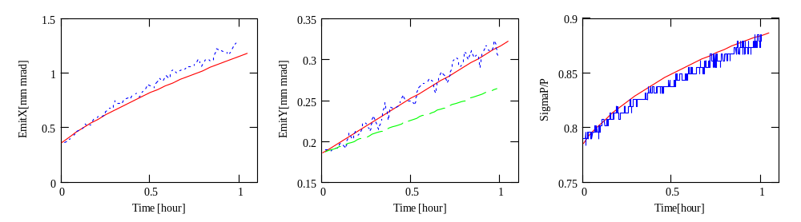
- Green line shows the emittance growth from the gas scattering only
- X-Y coupling causes additional growth for vertical emittance, κ = 0.04
- Beam scraping makes distribution non-Gaussian. It affects the growth rates but we do not have a clear answer how much
Protons, I._{beam}=48.2 mA, Lifetime = 800 hour, Mar.26.02
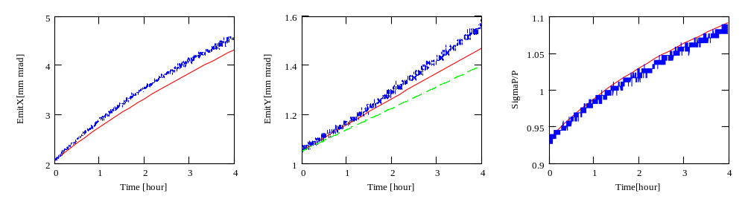
Antiprotons, I._{beam}=50.8 mA, Lifetime = 650 hour, Mar.27.02
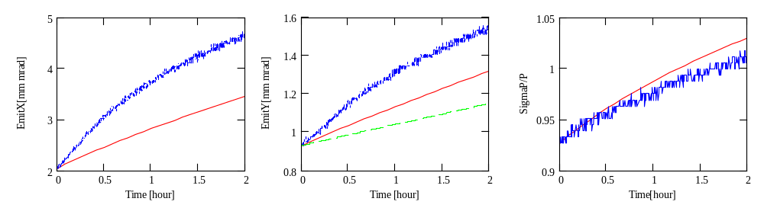
- Green line shows the emittance growth from the gas scattering only
- X-Y coupling causes additional growth for vertical emittance, κ = 0.04
- Presence of ions in the antiproton beam causes decrease of beam lifetime due to worsening of the effective vacuum and drives additional emittance growth due to ion instability

Antiprotons, I._{beam}=100 mA, Lifetime = 550 hour, Mar.27.02
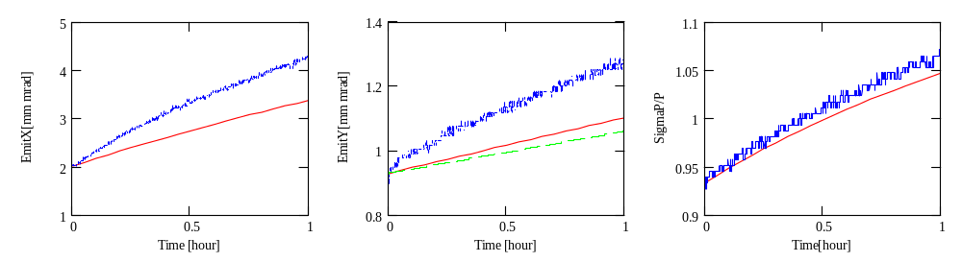
Remarks about measurements and theory
- Both IBS and residual scattering are taken into account in the theoretical model
  - Both models have logarithmic accuracy with expected accuracy of about 10%
- IBS theoretical model is build for the Gaussian distribution function
  - It is not quite accurate for the proton beam and not always true for the antiproton beam
  - That brings additional uncertainty but it is difficult to say how much
- Longitudinal momentum spread for all presented date sets was fudged by factor of 1.15 to get coincidence between theory and measurements for the momentum spread growth rate.
  - Momentum spreads reported by A:SIGMAP and A:FRWDTH is different by ~40% and the are not always proportional to each other in the both cases of proton and antiproton beams
  - We need to investigate the reason of this discrepancies
Conclusions
- Vacuum lifetime in the Accumulator is about 1400 hours
  - Single intrabeam scattering (Touschek effect) affects the lifetime for both proton and antiproton beams
  - Ions stored in the antiproton beam cause additional drop of the antiproton lifetime
- In the absence of ion instability summed effects of the residual gas scattering and the IBS describe well the observed emittance growth rates
- In the case of antiproton beam the ions cause the two stream (ion-antiproton) instability above ~20 mA beam current.
  - The instability can be monitored at lowest (1-Q) betatron sideband.
  - This instability causes additional emittance growth comparable to the growth rate due to IBS
- We do not have any indications of the external noise causing the emittance growth
- We plan to change operation of the accumulator.
  - After stacking is completed the present optics (optimized for stacking) will be dynamically changed to the “low IBS optics”.
  - After about 30 min cooling the beam will be ready for extraction
- This optics change will bring
A decrease of the horizontal heating by more than two times, which, consequently, yields smaller beam emittances. Together with the core cooling upgrade we expect the emittance decrease by
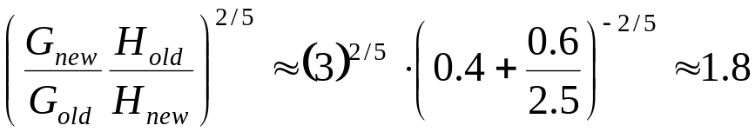
  - Decreasing of beta-functions in the extraction aria additionally decreases beam size of the extracted beam and will prevent scraping at the beam extraction. Presently, we lose 5-10% at the beginning of the accumulator-to-MI beam line
- Ion instability is expected to be the major heating mechanism after new optics is introduced

