MINOS environmental monitors in the Sudan cavern
Christos Velissaris, University of Wisconsin
- Introduction
In the Sudan MINOS cavern, environmental monitoring consists of monitoring the atmospheric temperature, pressure, humidity as well as radon levels. Our group will also monitor the temperature on selected places of the detector steel and phototubes via thermocouples.
In this document we describe the instruments selected, their respective location as well as how the system is assembled. We also describe how to configure the iFix database to recognize and start monitoring the system. Finally, with this document, we include vendor specific literature for each instrument we use.
- Instrumentation
Novalynx Relative Humidity and Temperature sensor. Model 225-050Y
Temperature ratings -40 to +60 C, accuracy 0.5%. Relative humidity (RH) 0-100%, accuracy +-3%. Supply voltage +12Vdc. Output signals 0-1Vdc.
(www.novalynx.com)
Omega barometric pressure transducer. Model PX2760-20A5V. Pressure ratings 0-1034mm-Hg. Excitation: 12Vdc. Output signal 0-5Vdc. (www.omega.com)
Acopian power supply. Model A12TN110. Output +12Vdc, current 1Amp. (www.acopian.com)
Aware Radon Monitor with fan. Model RM-80.
National Instruments Fieldpoint DAQ system. It consists of the following modules:
Ethernet controller, model FP-1600. ADC, model FP-AI-110. Pulse counter model, FP-CTR-502. Thermocouple readout unit, model FP-TC-120.
- Location
There are two environmental readout clusters in the MINOS Far (Soudan) cavern. Each cluster consists of a radon monitor, a temperature-humidity probe, a barometric pressure probe and a Fieldpoint readout system connected to Ethernet. Readout is via iFix the official DCS DAQ software.
The first environmental cluster is located at the Southwest corner of the MINOS detector. The Fieldpoint DAQ system is attached at the bottom of the first MUX-box rack on the ground level (southwest side). Attached on the rack are also, the pressure transducer the 12Vdc power supply and the radon monitor. The temperature-humidity probe is located on the first level, in front of the south side of the MINOS detector attached under the cable tray.
The second environmental cluster is located at the Northwest corner of the MINOS detector. The Fieldpoint DAQ system is attached at the bottom of the last MUX-box rack on the ground level (northwest side). The 12Vdc power supply, the barometric pressure and the temperature-humidity transducers are located nearby. The radon monitor is located on the second floor exactly above the Fieldpoint system.
Figure 1 shows a sketch of the MINOS hall and the location of the environmental monitors.
- Assembly
Word of caution: the environmental detectors are not protected from miscabling and/or over-voltages. Caution is necessary for the correct assembly and wiring before applying any bias voltage.
The readout of the barometric pressure and temperature-humidity probes is being done via the Fieldpoint ADC. These probes output an analog voltage proportional to the parameter they monitor. They are factory calibrated and the readout voltage can easily be converted into temperature, humidity or barometric pressure.
The first channel of the FP-AI-110 Fieldpoint ADC is reading the ambient temperature, the second the relative humidity and the third the barometric pressure. Readings are in Volts and the DAQ software (iFix) converts them into physical quantities.
- National Instruments OPC server configuration
The Fieldpoint Ethernet module FP-1600 can be remotely configured and controlled by means of an (iFix compatible) OPC server. It comes from National Instruments with the name Fieldpoint Explorer. It can control and monitor the Fieldpoint system either standalone or as part of the iFix database. Here is how the Fieldpoint Explorer is used to find, monitor and configure the Fieldpoint system. The whole process is shown pictorially in Figure 2.
The discussion assumes that the Fieldpoint Ethernet module FP-1600 has already assigned with an IP address, and the user either wants to create a convenient configuration file or he wants to re-open an old configuration file. For further information on the FP-1600 controller one may look in the manual accompanying this document.
Creating a Fieldpoint configuration file (.iak):
1. Double click the Fieldpoint explorer icon and under File choose New. On the left side of the window you can see + IA server with OPC appearing. Expand by clicking the + sign.
2. Right click the Fieldpoint and choose: add a comm resource to the server. A GUI will pop asking for Fieldpoint information.
3. Choose Ethernet (instead of RS-232) from the appropriate menu.
4. Enter the IP address of the FP-1600 controller at the Ethernet address box that pops up. One can also make use of the Find Devices or Browse buttons, instead of manually entering the IP address.
5. If the search is successful the message IAK operation successful appears as well as a +FP Res item under the Fieldpoint one, on the left side of the original Fieldpoint Explorer window. By expanding the + sign, a list of all the Fieldpoint modules appears. By expanding any of these modules (by clicking the + sign of the module), a list of all the module's channels appears. By selecting (left click) any of the Fieldpoint modules, a list of all the module's channels appears on the right side of the Fieldpoint Explorer window.
6. Click the Start Monitoring button (the one with the right pointing arrow). On the right side of the window the current value of each of Fieldpoint modules appears, updating itself periodically. The monitoring process can be terminated, by clicking the Stop Monitoring button (the one with the square on it).
7. Save the configuration file. Under File choose Save As. The file is saved with the extension .iak. The next time one opens the Fieldpoint explorer instead of opening a new file, opens the old saved .iak and finds the old configuration.
IFix configuration
In this section we describe the way the iFix database is configured to continuously monitor the Fieldpoint channels of our selection.
Preliminaries:
1. The iFix database communicates with the devices it monitors via OPC servers. The device internals are being hidden inside the OPC server. That role, in the Fieldpoint case, is played by the Fieldpoint Explorer. Prior the operation of iFix, it is not necessary to open and start the Fieldpoint Explorer. It is done automatically by Windows.
2. The part of the iFix database that communicates with the OPC server is the OPC Powertool software package. It is the OPC client, a standalone program that has to be configured to recognize the particular Fieldpoint system and monitor the channels of our choice. The configuration file is saved with the extension .OPC and can be opened any time later.
3. Before the operation of iFix the OPC Powertool must be opened along with the proper configuration file. Monitoring also must start.
4. Finally the iFix database itself must be configured to monitor and display values from the OPC client (Powertool). This involves entering the proper tags for the channels to be monitored.
Configuring the Powertool utility (OPC client):
1. Start the OPC Powertool. This is done either by double clicking the OPC Powertool icon on the desktop, or by running the executable OPCDidw.exe in the iFix directory.
The OPC Powertool can also be started after we open the iFix database by clicking the SCADA configuration button. After clicking the SCADA configuration button of the SCU utility anew window pops where SCADA support enabled must be checked and OPC-OLE for process control client must appear at the configured I/O drivers area. If not, the ? of the I/O driver name area should be clicked the OPC-OLE for process control selected and the Add button clicked. Then click the Ok button.The process is shown in Figure 3. Starting the Powertool via System Configuration Utility (SCU).
The GUI sequence afterwards is the same regardless the way chosen to start the OPC client.
2. Choose the connection type (local or remote). A window named I/O server connection appears. Check Use Local Server and click Connect. The process is illustrated in Figure 4.
3. Add a new OPC server. A window named untitled.opc appears. It is going to represent the OPC client configuration. It can be saved and re-opened later. At the bottom of the window 4 buttons appear where only the first is activated. It is the Add a new OPC server button. When clicked a menu select an OPC driver appears from where the National Instruments .OPC Fieldpoint must be selected. Click Ok. The list of OPC servers comes from the Windows registry. Figure 5 shows the process.on the left part of the untitled.opc window the +OPC if expanded will show the newly added server as Server1. The name can be changed. Server1 represents the whole Fieldpoint setup, the ethernet controller. Leftclick Server1 and check the Enable checkbox. As many OPC servers as necessary may be added. See Figure 5.
4. Add a group to the chosen server. At the bottom of the untitled.opc window click the newly enabled Add a new group button (next to the Add a new OPC server button). Under Server1 (if expanded) Group1 appears. The name Group1 can be also changed. Group1 represents a particular Fieldpoint module. Under each server (fieldpoint ethernet controller) as many groups (modules) as necessary may be added (monitored). Check the Enable checkbox if necessary. See Figure 6.
5. Add an item to the group. At the bottom of the untitled.opc window click the now enabled Add a new item button. Under group1 the item1 (changeable name) appears. Item1 represents the particular Fieldpoint channel of the module group1 to be monitored. Check the Enable checkbox if necessary. Under each group as many items as necessary may be added. See Figure 7.
6. Configure the item. The Item ID and the Requested Datatype values must be correctly entered. As requested datatype we choose the value Server except Long for the radon monitor. As Item ID FP Res\FP-aaa-xxx @x\Channel x. FP-aaa-xxx is the identification of the particular Fieldpoint module at position @x in the Fieldpoint bus and channel x is the channel number monitored. FP Res is the name of the particular OPC server configuration, which communicates with the specific ethernet controller. FP Res is the default name (it can be changed) appearing at the Fieldpoint Explorer configuration window (See Figure1). Moreover, if one clicks the Browse Server button, expands the Item ID list and left clicks a channel, can get the Item ID a simpler way. See Figure 8.
7. Start Monitoring. On the toolbar it is the button with the right arrow picture. It instructs the client to start communicating with the server and collecting data. The button with the square on it is the Stop Monitoring button.
8. See the data. Up to now the Configuration button (a button with a hammer picture) was supposed to be active. By clicking the statistics button (the one with the statistical bars on it) the success of the connection can be verified and actual data can be seen. The Readdata box displays the data from the server. The Data Quality box displays the connection quality (it should display Good). The OPC client now is
is successfully configured. See Figure 9.
9. Save the Configuration file. Under File → Save As allows the configuration to be saved in the file of our choice with the extension .opc (for example as minosdcs.opc)
Configuring the iFix database.
The general method of configuring the iFix database to receive and analyze data from the OPC client (Powertool) is described in an iFix manual. Here the point of interest is the I/O address of the Fieldpoint channel we monitor. Figure 10 shows an example of Fieldpoint channels monitored by the iFix database. The general rule is that the I/O address is:
OPC Server Name;Group Name; Item ID Name.
These are the names appearing in the .OPC Powertool configuration file representing the particular server's, group's and Item's names. This process is described in the section Configuring the Powertool.

- Accompanying manuals.
1. OMEGA PX2760 pressure transducer manual.
2. NOVALYNX model 225-050Y Relative Humidity and Temperature sensor.
3. Aware RM-80 Radon monitor.
4. Fieldpoint manuals for the modules:
FP-1600 Ethernet controller.
FP-AI-110 Analog input module
FP-CTR-502 Counter module
FP-TC-120 Thermocouple readout module.

Figure 1. Location of the Environmental probes and Fieldpoint data acquisition units in the MINOS Soudan cavern.

Figure 1.1 Cabling connections of the environmental transducers with the Fieldpoint ADC.

Figure 1.2 Aware radon monitor, and Fieldpoint FP-CTR-502 counter equivalent circuits. The connections are also indicated.

Figure 1.3 Aware radon monitor RS-232 connector pin assignments and their cabling, to be interfaced to FP-CTR-502 counter.

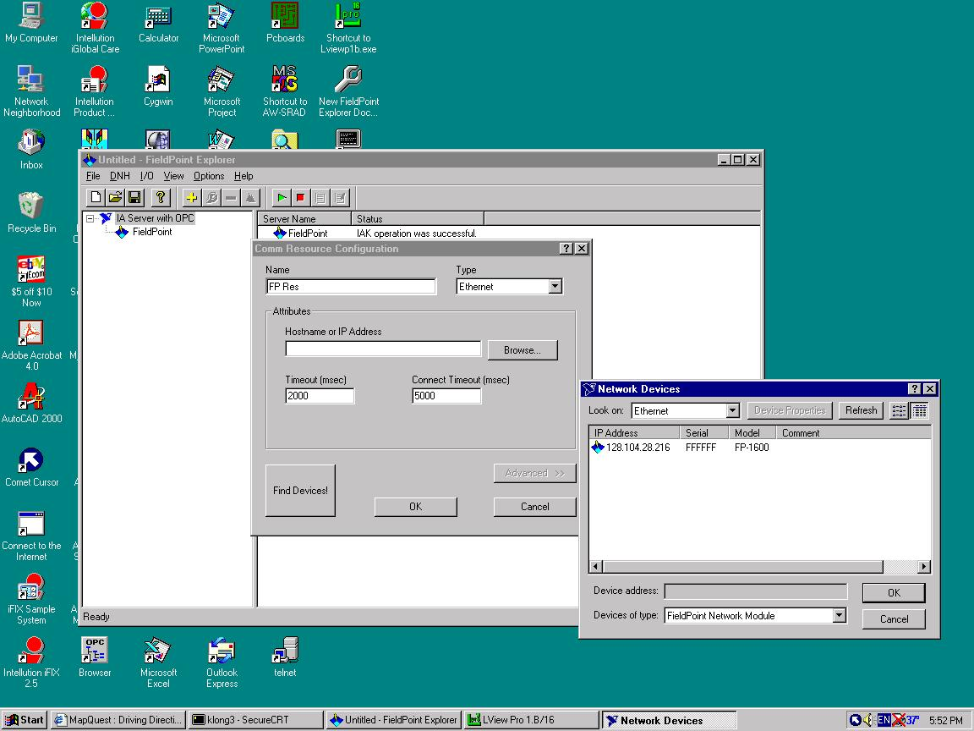
Figure 2. Configuration of the Fieldpoint Explorer. (OPC server for the Fieldpoint setup)

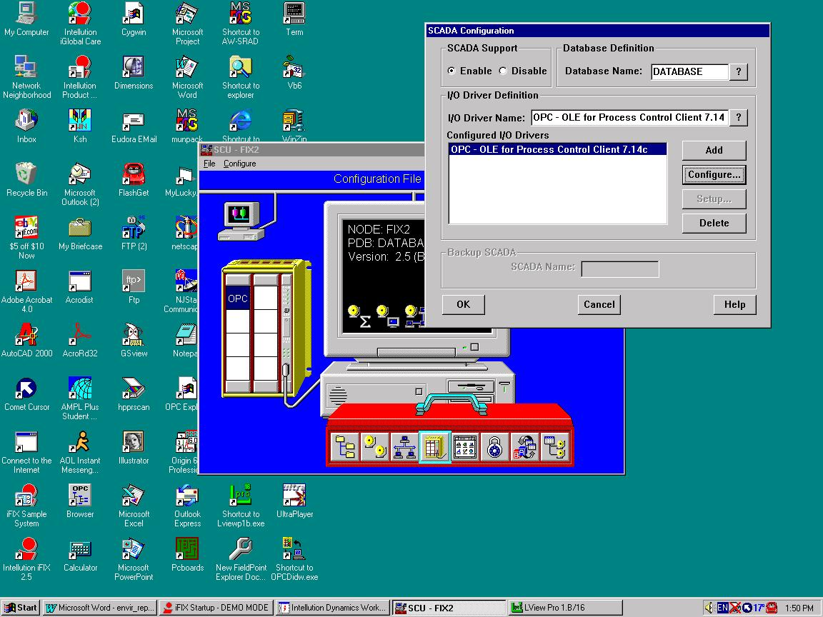

Figure 3. Starting Powertool via System Configuration Utility (SCU)

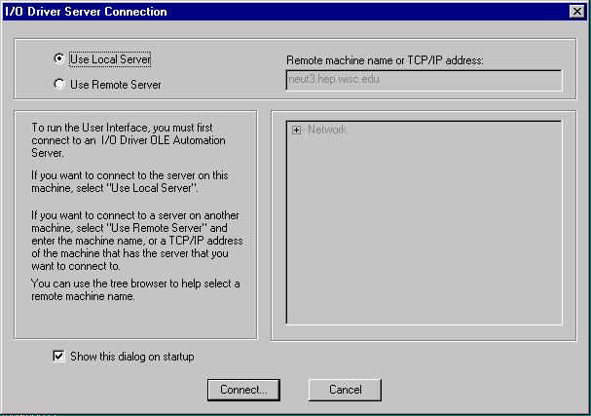
Figure 4. Connection with a local OPC server
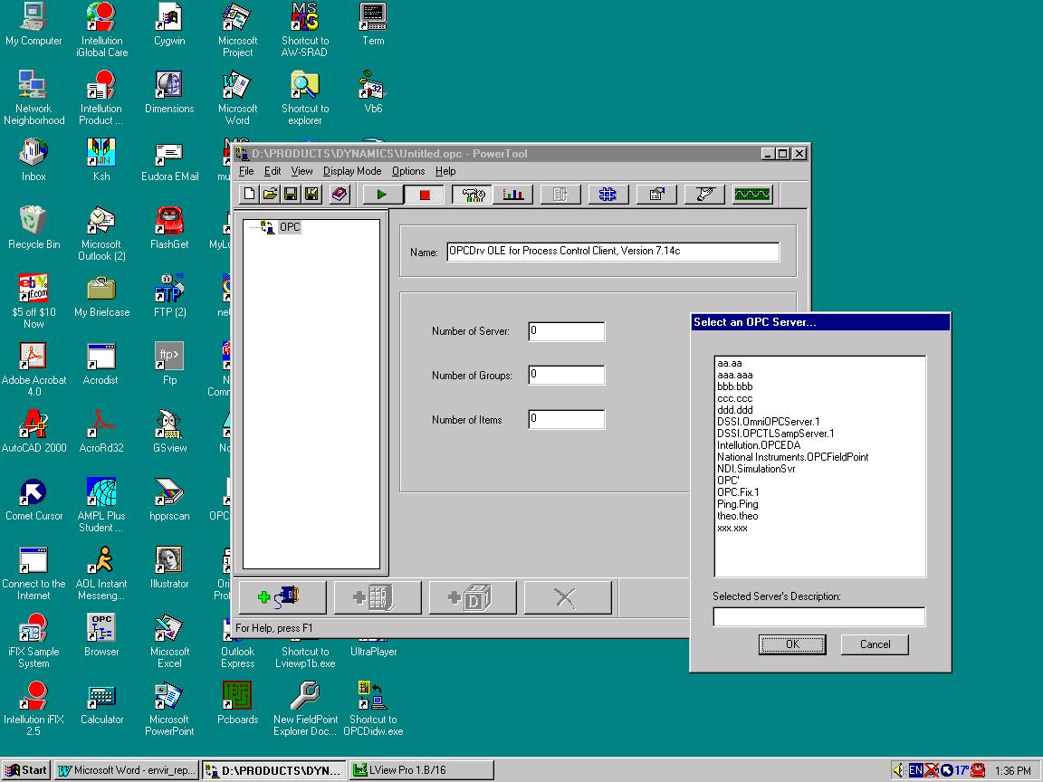

Figure 5. Choice of the OPC server (National Instruments.OPCFieldpoint).
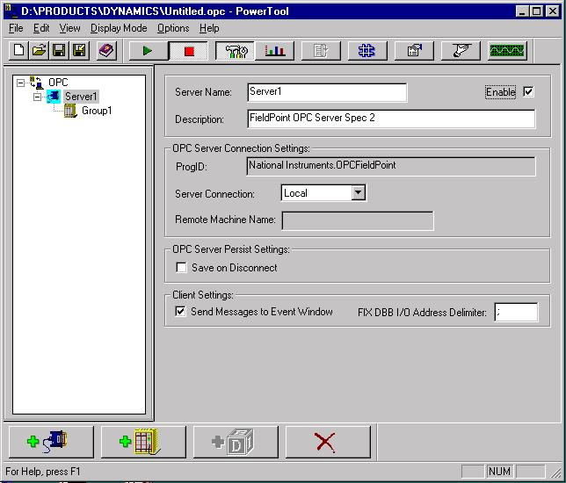
Figure 6. Adding new Group to a newly created Server. OPC Powertool configuration.
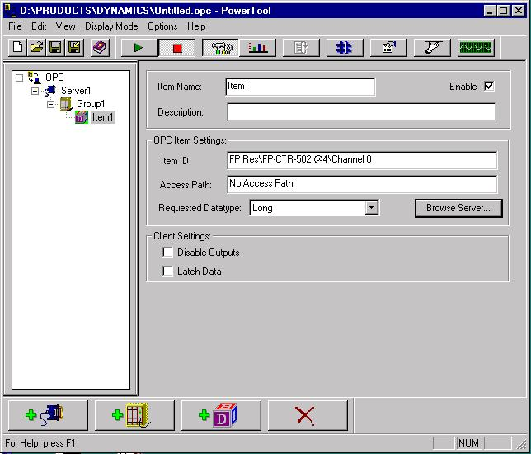

Figure 7. Adding a new item to a newly created group. OPC Powertool configuration
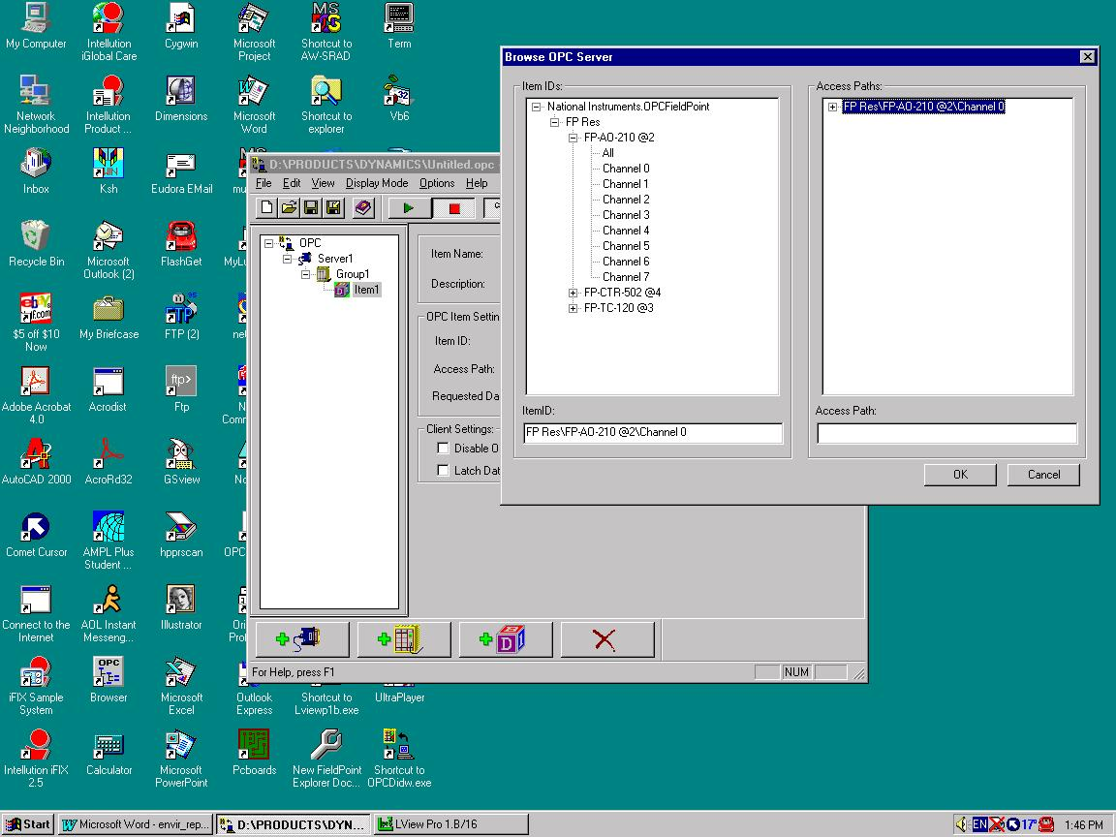
Figure8. Item ID configuration. OPC Powertool configuration.

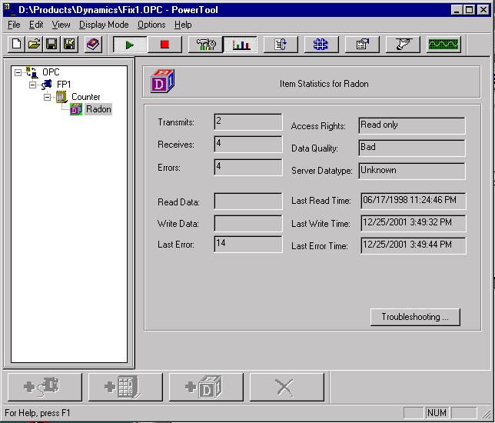
Figure 9. Checking the data and the connection with an OPC server.

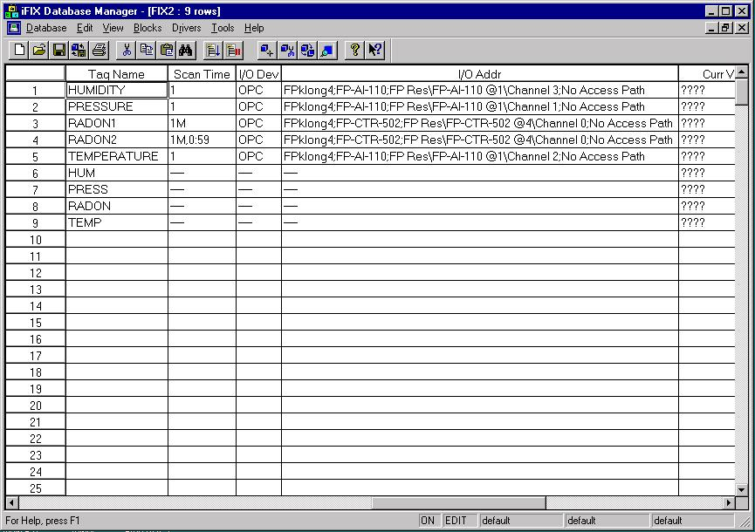

Figure 10. iFix database configuration for Fieldpoint. The general rule is:
OPC Server;Group;ItemID as it appears in the Powertool configuration file.

