SOP 26

Standard Operating Procedure for
Calibration of Dynamic Small Volume Provers by the Water Draw Method

1.0 Introduction

1.1 Purpose of Test

This procedure may be used to calibrate dynamic small volume prover systems such as those used to conduct liquid metering device (e.g., Positive Displacement, Turbine) provings at wholesale marketing terminals. A volumetric water draw process is used.

1.2 Prerequisites

1.2.1 Verify that the standards used have been calibrated and that a valid certificate is available. The standard calibration should include a neck scale calibration as recommended in SOP 18 or SOP 19.

1.2.2 Verify the cleanliness of the water to be used.

1.2.3 Verify that the person performing the calibrations is trained and proficient in carrying out this test procedure and related liquid calibration procedures.

1.2.4 The water draw location should provide for a stable ambient temperature. Direct sunlight must be avoided. An enclosed shelter is preferred.

2.0 Methodology

2.1 Scope, Precision, Accuracy

This procedure is applicable for the calibration of a dynamic small volume prover (SVP) system within the limitations of the standards available. The precision attainable will depend directly on the care used in the various procedures required for this test. Strict observance of drainage times, internal cleanliness of vessels used, careful volumetric readings (menisci) and the adherence to the sequence of events outlined in this procedure are essential.

2.2 Summary

The small volume prover system (SVP) must be filled with clean water and purged of all entrapped air. Using an external pressure source (pump, head tank), the calibrated volume section of the SVP is discharged into a calibrated "wet-down" vessel while the SVP system remains packed with clean water. This "water-draw" process is repeated three times for each calibrated volume section within the SVP system. The calibrated vessel volume and SVP volume are corrected for the effects of temperature and pressure to establish a volume at standard reference conditions. The established SVP calibrated volume is programmed and sealed into the SVP control electronics console to establish the reference for dynamic liquid measurement device proving.

2.3 Equipment

2.3.1 A graduated neck stainless steel calibrated vessel (including neck scale calibration) whose volume is equivalent to the SVP calibrated section. The water draw procedure may also be implemented using multiple smaller calibrated vessel readings (e.g., 15 gal SVP water drawn using three readings of a 5 gal calibrated vessel also having had a neck scale calibration).

2.3.2 Supply of clean pressurized water (minimum 15 psi). If a pump system is used, care should be taken to provide a bypass loop to prevent excessive liquid heating during dead-ended conditions.

2.3.3 Auxiliary piping and valves required to direct the water from the SVP to the calibrated vessel to perform the water draw. This is a vendor supplied kit or accessory option and is necessary to perform the water draw test.

2.3.4 Three temperature sensing devices with a resolution of 0.1 ºF or better are required to measure inlet water, outlet water and position sensor mounting temperature. In order to properly measure inlet and outlet temperatures, an adequate thermometer well must be available in the plumbing and filled with a suitable liquid medium.

2.4 Procedure

2.4.1 Cleanliness Verification

Fill and drain the calibrated standard vessel and check for any soiling that would affect drainage, as evidenced by clinging droplets or greasy films. Fill and circulate clean water through the SVP. Check for any foreign material in the discharge stream. Circulate until discharge is clean. Discharge water should be handled in an environmentally safe manner since the SVP system may have previously filled with petroleum products. A thorough cleaning of the internals of the SVP system is required prior to the set-up for the water draw process.

2.4.2 Air Purge and Temperature Stabilization

All air must be purged from the SVP system to implement a successful water draw. Vent the SVP system from the highest possible point with the pressurized water source attached. Cycle the SVP Displacer several times in both directions to help release any trapped air pockets. Continue to circulate clean water through the system until the SVP system temperature is stabilized. This will help minimize variability and uncertainty in the procedure.

2.4.3 Leak Detection

SVP systems have some form of elastomeric or fluoropolymer seals between the displacer and the wall of the calibrated pipe section. A leak past one of these seals will cause an inaccurate water draw. It is prudent to conduct a leak detection test as defined by the SVP vendor prior to the water draw process. A typical leak check procedure is illustrated in Appendix A.

2.4.4 Downstream Volume Calibration

2.4.4.1 Return the SVP displacer to the upstream park position. Adjust water inlet/outlet valves to permit displacer travel downstream. Move the displacer downstream to the first sensor position and with the calibrated standard vessel filled.

2.4.4.2 With the SVP displacer automatically stopped at the first sensor position, empty the contents of the standard vessel. Use a 30 s drain after cessation of flow on bottom drain type standards or a 30 s pour/10 s drain on neck drain type standards, touching off any adhering drops from the neck to complete the drain. This constitutes the "wet-down" condition.

2.4.4.3 Start the movement of the SVP displacer downstream discharging the water into the standard vessel. While the standard vessel is filling the following data should be recorded on Form-A (downstream section):

Inlet Water Temperature - T₁ (± 0.1 ºF)
Outlet Water Temperature - T₂ (± 0.1 ºF)
Position Sensor Mounting Temperature (Ambient) - T_{d} (± 0.5 ºF)
Outlet Water Pressure - P (± 1.0 psi)

The displacer movement should stop automatically at the final sensor position using the vendor supplied water draw apparatus. The easiest method is to use a standard vessel that is the same nominal volume of the SVP system. This permits direct comparison of the standard vessel volume to the SVP volume with a single scale reading. Multiple readings of a smaller standard vessel can be used (i.e., a 5 gal standard vessel can be filled three times to calibrate a 15 gal SVP) but will increase uncertainty of measurement. The process is more complicated since only the last fill of the standard vessel can be stopped automatically. The previous fillings must be stopped manually by the operator and does not duplicate SVP use in field.

2.4.4.4 Read and record the standard vessel scale reading on Form-A. Measure and record the average temperature of the standard vessel water (T_{m}) by submersion of the thermometer into the fluid. Average these temperature readings if using multiple readings from standard vessels smaller than the nominal value of the SVP. After the final standard vessel water temperature reading is taken, move the SVP displacer downstream past the final sensor position.

2.4.5 Upstream Volume Calibration

2.4.5.1 Adjust the water inlet/outlet valves to permit displacer travel upstream. Move the SVP displacer to the final sensor position filling the standard vessel.

2.4.5.2 With the SVP displacer stopped at the first sensor position, dump the contents of the standard vessel. Use a 30 s drain after cessation of flow on bottom drain type standards or a 30 s pour/10 s drain on neck drain type standards, touching off any adhering drops from the neck to complete the drain. This constitutes the "wet-down" condition.

2.4.5.3 Start the movement of the SVP displacer upstream discharging the water into the standard vessel. While the standard vessel is filling the following data should be recorded on Form A (upstream section):

Inlet Water Temperature - T₁ (± 0.1 º F)
Outlet Water Temperature - T₂ (± 0.1 º F)
Sensor Mounting Temperature (Ambient) - T_{d} (± 0.5 º F)
Outlet Water Pressure - P (± 1.0 psi)

The displacer movement should stop automatically at the final sensor position using the vendor supplied water draw apparatus. The easiest method is to use a standard vessel that is the same nominal volume of the SVP system. This permits direct comparison of the standard vessel volume to the SVP volume with a single scale reading. Multiple readings of a smaller standard vessel can be used (i.e., a 5 gal standard vessel can be filled three times to calibrate a 15 gal SVP). The process is more complicated since only the last fill of the standard vessel can be stopped automatically. The previous fillings must be stopped manually by the operator.

2.4.5.4 Read and record the standard vessel scale reading on Form A. Measure and record the average temperature of the standard vessel water (T_{m}) by submersion of the thermometer into the fluid. Average these temperature readings if using multiple readings from standard vessels smaller than the nominal value of the SVP. After the final standard vessel water temperature reading is taken, move the SVP displacer upstream past the first sensor position.

2.4.6 Repeated Runs

Sections 2.4.4 and 2.4.5 should be completed at least two more times each. A minimum of three runs should be completed for each calibrated volume section of the SVP system. In some SVP systems the downstream and upstream volumes are not equal due to internal displacer geometry. It should be noted that some SVP systems have more than one calibrated volume section. Each volume section must be water drawn independently.

- Calculations

A summary of the water draw calculations is provided in Form B (Small Volume Prover - Water Draw Calculations.) Form B provides the necessary calculations for each calibrated section of the SVP in one direction. The result obtained from Form B will be the net SVP volume corrected for 60 ºF and 0 psig. The new net volume value, V_{tp}, must be entered into the SVP control electronics for use during dynamic operation of the SVP system.

The net SVP volume corrected to 60 ºF & 0 psig is determined using the equation:

$V_{\text{tp}}=V_{m}∗T_{\text{mp}}∗C_{\text{ts}}∗C_{\text{pl}}∗C_{\text{ps}}$ Eqn. 1
where:

V_{tp} | Volume, corrected for temperature and pressure
V_{m} | Volume in the measure (uncorrected)
T_{mp} | Correction for the difference in the temperature between test measure and the small volume prover, SVP
C_{ts} | Correction for the effect of temperature on the prover
C_{pl} | Correction for compressibility of the prover liquid
C_{ps} | Correction for the pressure on the standard prover

During the water draw process the SVP system is pressurized, therefore a pressure correction must be applied. The C_{pl} factor corrects for the compressibility of the water in the SVP and the C_{ps} factor corrects for the effects of pressure on the SVP tube.

The temperature effects on both the test measure and the SVP materials are corrected for with the C_{ts} factor. The calibrated section of the SVP is a tube, thus the temperature compensation is applied only in two dimensions. A two-dimension thermal coefficient of expansion is used for the SVP tube material (i.e., two times the linear coefficient of thermal expansion). The temperature effects in the third dimension are corrected using a linear thermal coefficient of expansion for the position sensor mounting material.

The final factor, T_{mp}, corrects for the difference in water temperature between the test measure and the SVP system. This correction factor can be obtained from the table available in API Chapter 11.2.3 - "Water Calibration of Volumetric Provers". This table of correction factors is derived using the Wagenbreth equation for density of water at a given temperature (ρ_{w}). The correction factor, C_{tdw}, is determined by solving the equation:

$C_{\text{tdw}}=\frac{ρ_{\text{tm}}}{ρ_{\text{tp}}}=\frac{V_{p}}{V_{m}}$ Eqn. 2
where

C_{tdw} | Correction for the liquid thermal expansion of water
ρ_{tm} | Density of the water in the test measure
ρ_{tp} | Density of the water in the prover
V_{P} | Volume in the prover
V_{m} | Volume in the test measure

- Measurement Assurance
4.1 If a check standard is used (See SOP 20, SOP 30), repeat the process for the unknown artifact on the check standard, without adjustments.

4.2 Plot the check standard volume and verify it is within established limits. Alternatively a t-test may be incorporated to check the observed value against thean accepted value.

  - The mean of the check standard values is used to evaluate bias and drift over time.

  - Check standard values are used to calculate the standard deviation of the measurement process.

  - When a check standard is not used, a range chart may be used to monitor repeatability and estimate the standard deviation of the measurement process using the equation:
$s_{p}=\frac{\overline{R}}{d_{2}^{}}$ Eqn. 3
- 5 Assignment of Uncertainty

  - The limits of expanded uncertainty, U, include estimates of the standard uncertainty of the laboratory volumetric standards used, u_{s}, plus the standard deviation of the process, s_{p}, at the 95 % level of confidence. See SOP 29 for the complete standard operating procedure for calculating the uncertainty.

  - The standard uncertainty for the standard, u_{s}, is obtained from the calibration report. The combined standard uncertainty, u_{c}, is used and not the expanded uncertainty, U, therefore the reported uncertainty for the standard will usually need to be divided by the coverage factor k. For multiple use of the same standard, uncertainty is additive.

  - The standard deviation of the measurement process from control chart performance (See SOP No. 20 and SOP 30).

5.4.1. The value for the standard deviation of the process, s_{p}, is obtained from the control chart data of the check standard, or may be estimated using the range from the control chart, using large volume transfer procedures.

5.5 Other standard uncertainties usually included at this calibration level include uncertainties associated with the ability to read the meniscus, only part of which is included in the process variability, the thermal coefficients of expansion for both the standard and the prover under test, use of proper temperature corrections, the accuracy of temperature measurements, water density equation, round robin data showing reproducibility, environmental variations over time, positioning of the prover sensor at the start and stop swiches, or alternatively the diverter errors of flow direction valves, the modulus of elasticity for pressure corrections to volume, and bias or drift of the standard.

- References

  - Manual of Petroleum Measurement Standards; Chapter 11.2.3 - Water Calibration of Volumetric Provers; First Edition, August 1984.

Appendix A - Typical Leak Detection Procedure

All Small Volume Prover systems have some form of displacer that travels with the liquid through the calibrated tube section. In addition there is some type of valve that is used to control the direction of the displacer to make a calibration run. The displacer and direction valve contain dynamic elastomeric seals. A leak past these seals will cause inaccurate dynamic performance and cause a false water draw measurement. The integrity of these seals must be verified before a water draw test can be considered valid.

Typically a SVP leak check is similar to that described below. Specific instructions and measurement equipment to be followed for each SVP model must be supplied by the vendor.

a) Block the SVP inlet and outlet using a blind flange or double/block and bleed valve (bubble tight shut off).

b) Fill the SVP with water and bleed all air from the system.

c) Launch the displacer down the flow tube.

d) Attach a dial indicator as illustrated below to measure the movement of optical switch shaft. A downstream movement of 0.004 in or less in 5 min indicates the system is leak free. An indicator movement of greater then 0.004 in indicates that a system leak is present and displacer/valve seals should be inspected or replaced.
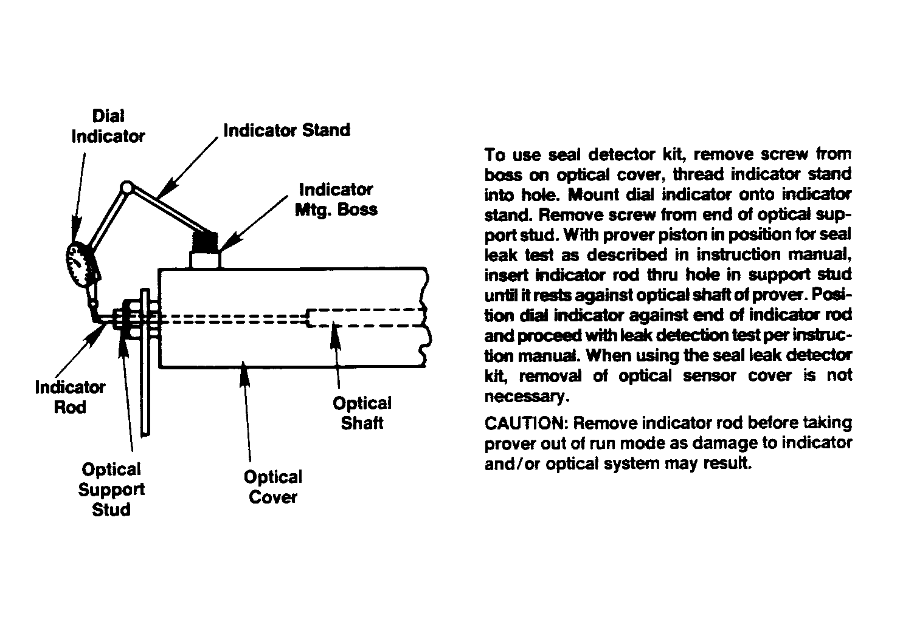
Small Volume Prover
Water Draw Data Summary
Form A
Customer: _____________________________  Address: _______________________________  _______________________________  Serial No.: _____________________________  Model No.: _____________________________ | Date: __________________________________  Time: _________________________________  Calibrator: _____________________________  Standard I.D.: __________________________  __________________________

Draw  No. | Inlet  Water Temp(T₁) |  |  | Outlet  Water  Temp(T₂) |  |  | Prover  Temp  (T_{p}) |  |  | Test  Measure  Temp(T_{m}) |  | Sensor  Mounting  Temp(T_{d}) |  |  | Water  Press.  (P) |  |  | Test  Measure  Scale (in3)
Downstream Volume
1

3

5

7

9

11

Upstream Volume
2

4

6

8

10

12

T_{p} = SVP water temperature, Average of T1 and T2
T_{m} = Temperature of water in Test Measure
P = Water pressure during test draw
T_{d} = Temperature of displacer position sensors
Small Volume Prover - Water Draw Calculations
Form B
Customer: _____________________________  Serial No.: _____________________________  Model No.: _____________________________ | Volume: Downstream _____ Upstream _____  SVP Tube Inside Diameter (D): __________ inches  SVP Tube Wall Thickness (t): ___________inches

V_{tp} = Net Volume Corrected for 60 ºF & 0 psig  = V_{m} * T_{mp} * C_{ts} * C_{pl} * C_{ps} | T_{p} = SVP Temperature  T_{d} = SVP Sensor Temperature  T_{m} = Test Measure Temperature
T_{mp} = Temperature differential factor for water  from API Chapter 11.2.3 | P = Water pressure during test draw  Emod = Modulus of elasticity of the SVP tube  material
C_{ts} = Correction factor for temperature of the  test measure, SVP tube and sensor  mounting material  = 1 + (T_{m} - 60) * ALPHAtm .  [1 + (Tp - 60) * ALPHAsvp] [1+ (Td - 60) * ALPHAsens] | = [_________________]  C_{pl} = Correction for the compressibility of  water  = 1 - (0.0000032 * P)
ALPHAtm = Cubical Thermal Coefficient for test measure material  = [_________________]  ALPHAsvp = Square Thermal Coefficient for SVP tube material  = [_________________]  ALPHAsens = Linear Thermal Coefficient for the SVP sensor  mounting material  = [________________] | C_{ps} = Correction for pressure on the SVP  tube  = 1 .  1 + P * D .  (Emod) * t

Test  Measure  Volume  ( in3) | Scale  Vol +  (in3) | Reading  Vol -  (in3) | Actual  Volume V_{m}  (in3) | SVP  Temp  T_{p} | Test  Measure  Temp  T_{m} | Temp  Diff. | Diff.  Temp.  Factor  T_{mp} | SVP  Sensor  Temp  T_{d} | Material  Correct.  Factor  C_{ts} | Volume  Adjusted to  60 oF  Vm * T_{mp} * C_{ts}

Repeatibiliy Verification: Max. Adjusted Volume - Min. Adjusted Volume  Min. Adjusted Volume * 100 | %
A) Average of Consecutive runs Repeating within 0.02% | in3
B) C_{pl} = 1 - (0.0000032 * P) = 1 - (0.0000032 * ________ ) =

C) C_{ps} = 1 .
1 + ( ) * ( )
( ) * ( )
V_{tp} = Lines A * B * C = | in3
Convert to Gallons (divide by 231) | gal

Certain commercial equipment, instruments, or materials are identified in this publication in order to specify the experimental procedure adequately. Such identification is not intended to imply recommendation or endorsement by the National Institute of Standards and Technology, nor is it intended to imply that the materials or equipment identified are necessarily the best available for the purpose.
Non-SI units are predominately in common use in State legal metrology laboratories, and/or the petroleum industry for many volumetric measurements, therefore non-SI units have been used to reflect the practical needs of the laboratories performing these measurements as appropriate.

