5.3 Vacuum Vessel

5.3.1 Introduction

The vacuum vessel, shown in Fig. 5.3.1-1, provides the vacuum environment for the plasma as well as the first confinement barrier for radioactive materials. The vessel also serves as the support structure for all in-vessel components, provides the first level of nuclear shielding, and helps provide for the passive stabilization of the plasma. The vessel system includes the torus, the ports and port extensions, the gravity supports, the supports for internal components, the passive stability plates, the internal control coils, and the integrated coolant/bake-out lines.
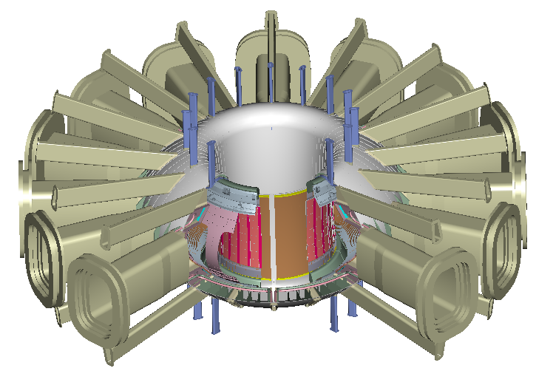

Figure 5.3.1-1 Vacuum vessel with port extensions and internal components
5.3.2 Vessel Concept

The vessel torus is a double wall sandwich structure consisting of 15 mm thick inner and outer face-sheets attached to poloidal ribs. The space between the face-sheets, which varies from 20 mm on the inboard side to 540 mm on the outboard side, is filled with radiation shielding material and coolant. Water at 20-50 C and 1 MPa is used to remove nuclear heating during normal operation. The water temperature is raised to 150C for heating the vessel and internals during bake-out. The shielding material can be single sized stainless steel balls with a packing fraction of about 60% or stacked plates with a similar packing fraction. The vessel parameters are summarized in Table 5.3.2-1.
Table 5.3.2-1 Vacuum Vessel Parameters

Dimensions and Weights
Vol. of torus interior | 35 m³
Surf. area of torus interior | 89 m²
Facesheet thickness | 15 mm
Rib thickness | 15 to 30 mm
Wt. of structure , incl ports | 50 tonnes
Wt. of torus shielding | 80 tonnes

Power
Direct neutron heating: | ~200 MW
Indirect first wall load | < 40 MW

Cooling
Coolant | Water
Pressure | ~ 1 Mpa
Normal oper. temp. Bake-out temp. | < 100C ~150C

Materials
Torus, ports and structure | 316L ss
Shielding | 304L ss (tentative)

The primary advantages of the double wall structure include higher bending stiffness (for a given total material thickness) and better integration of cooling and shielding. Most vacuum vessel designs in use (JET, JT60, DIII-D) and most designs on the drawing board (ITER, KSTAR) use full or partial double wall vacuum vessels. Figure 5.3.2-2 shows a cutaway of the vessel and pertinent dimensions.

There are 16 sets of access ports around the torus, which are used for RF heating, remote maintenance, diagnostics, internal cooling, fueling, and pumping. There are large, 1.3 x 0.7 m midplane ports, upper and lower trapezoidal ports approximately 0.15 x 0.5 m, and upper and lower oblong vertical ports approximately .08 x 0.15 m in size. The sets of port openings are identical at each toroidal location to provide structural and design symmetry, but the port extensions may be varied to match their specific purpose. The port extensions are required to extend the vacuum boundary past the TF coil legs and through the cryostat region.

Figure 5.3.2-2 Vessel and port dimensions

5.3.3 Vessel loading and analysis

The vessel is subjected to large gravity, seismic and electromagnetic loads, as summarized in Table 5.3.3-1. The total vertical load is estimated to be about 20 MN, while the net lateral load is about 7 MN. To react these loads, the vessel is supported near the midplane on the outboard side via vertical and lateral links to the TF coil structure. The vertical links are attached to the radial ribs to spread the applied loads vertically into the vessel. This minimizes the local bending stresses in the vessel and provides a means for adjusting the vessel location globally relative to the TF coils. Lateral supports are located near the vertical links, and are tied to the top of the midplane ports.
Table 5.3.3-1Vacuum Vessel Loading Conditions

Load | Value | Unit | Comment
Gravity load | ~ 3.5 | MN | Vacuum vessel = ~130 tons  FW tiles and divertor= ~35 ton  Port mounted equip = ~100 - 150 tons
VDE load  Vertical  Lateral, net | 16-32  6-11 | MN  MN | [ref. J. Wesley, “Disruption, VDE, and runaway electron conversion: physics basis and issues for FIRE”, May 1, 2000]
Seismic load  Vertical acceleration.  Lateral acceleration | 0.2 (tbd)  0.2 (tbd) | g  g
Max total vertical load | ~ 22 - 42 | MN | Gravity + VDE*1.2 dyn. factor
Max total lateral load | ~ 8 - 14 | MN | VDE*1.2 dyn factor + seismic
Max local EM load  Local pressure on vv  From internal components | ~ 4 - 7 | MPa | Local pressure on inboard wall due to halo currents, peaking factor ~ .75 Ip
EM load from TF field ramp | ~ 0.75 | MPa | Assumes 20 s ramp to or from full field  Max load at inboard midplane
Coolant pressure  Normal operation  Bake-out | < 10  < 10 | atm  atm | Water assumed as coolant  and for bake-out

The vessel must support all internal components, including the divertor assemblies, the passive stability structure, and the first wall tiles. The outboard divertor modules are actively cooled via pipes at each of the upper and lower auxiliary ports. The passive stabilizing structure is actively cooled with imbedded cooling tubes. The first wall tiles and inboard divertor are cooled by conduction to the passive structure. All components must have robust supports to react the electromagnetic loads from a plasma disruption.

Preliminary structural analysis of the vessel indicates that the present dimensions are acceptable to support the various loads. A finite element model was developed for an earlier version of the vessel geometry, and the stresses and deflections obtained are summarized in Table 5.3.3-2. As seen in the table, there are some peak stresses around the divertor supports at the top of the vessel that must be mitigated with additional structure. Details of the stress and deflection analysis are contained in Appendix D of this report.

Table 5.3.3-2 Preliminary Stress Analysis Summary for the FIRE Vacuum Vessel
 | Torus and support points |  | Ports and (Support points)
Load condition | General stressa (allowable stress = 195 MPa) | Peak local stressa (allowable = 390 MPa) | General stress (allowable = 195 MPa) | Peak local stressa (allowable = 260 MPa)
1. Gravity  (w/ internals) | 15 | 23 | (24) | (45)
2. Vacuum load | ~10 | ~25 | TBD | TBD
3. Coolant pressureb (1 MPa) | ~100 | ~230 | TBD | TBD
4. Simulated VDEc | <100 | ~240 | (~ 300) | (~400)
5. Halo Loads on divertor | 120 | 170 | (~150) | (>400)
6. Thermal stress from nuclear heatingd | 170 | 300 | <200 | ~330
7. TF ramp-upe | ~ 25 | ~ 32 | TBD | TBD
Combined, 1,2,3,7 | 83 | 124
Combined 1,2,3,6 |  | 240 |  | 400
aEstimated demarcation between general and peak local stress, peak primary + secondary = 3 × S_{m}.
bStress values estimated from previous analysis.
cVDE loads applied in simplified manner as body force, supports on outside.
dTemperature gradient of ~90°C based on 20-s full-power pulse, simulated temperature distribution.
eStress estimate based on 20 s current ramps in TF coils.

5.3.4 Passive plates and internal coils

As indicated in Section 2, Physics, a system of highly conducting and actively cooled passive plates and a set of internal control coils must be incorporated into the vacuum vessel. The passive plates consist of 25 mm thick copper sheets that are bonded directly to the surface of the vacuum vessel. The sheets are actively cooled via
internal water passages connected

through manifolds into the vessel cooling system. A bonded connection is thought to be the most straightforward approach, since cooling can be provided directly by the copper plates to both the
Figure 5.3.4-1 Active control coils and passive stabilizing system
first wall tiles and the vessel, and continuous structural support can be provided to the passive plates by the vessel. The method of bonding has not been decided, but hot isostatic pressing (hipping) is one possibility. The geometry of the passive plate system is shown in Figure 5.3.4-1.

In addition to the passive plates there are a pair of control coils located between the outboard walls of the vessel above and below the midplane ports. Multiple turns of conductors are run in permanent pairs of conduits that are routed directly through the outboard wall. The conductor will receive a moderately high radiation dose (>10⁹ Rad) and will be insulated with either MgO or a polyimide insulation system. Redundant turns are being considered to mitigate one of the failure modes. Each coil is designed to carry up to 75 kA.

5.3.5 Fabrication and assembly

The vessel is fabricated in octants, as shown in Figure 5.3.5-1. Each octant consists of the torus, associated gravity and internal supports, short reinforcing stubs around the major port openings and the active and passive stabilizer systems. At assembly, each vessel octant is rotated into the bore of a pre-assembled TF coil pair and connected via the support links. The TF/VV subassemblies are then positioned relative to each other with the mating joints located at radial planes between TF coils, through the center of the ports.

When all the octants are in place and positioned, they are welded together from the plasma side of the torus. The field joint for the double wall structure uses splice plates on the plasma side to provide a means for accessing the coil-side facesheet from the plasma side of the torus. This type of joint has undergone significant, full scale testing using remote welding equipment as part of the ITER R&D program. After the vessel is welded, the gaps in the passive stabilizers are filled with plasma sprayed copper to complete the upper and lower stabilizing circuits. After the torus is welded, the port extensions are fitted and welded to the port stubs. This completes the vessel assembly.

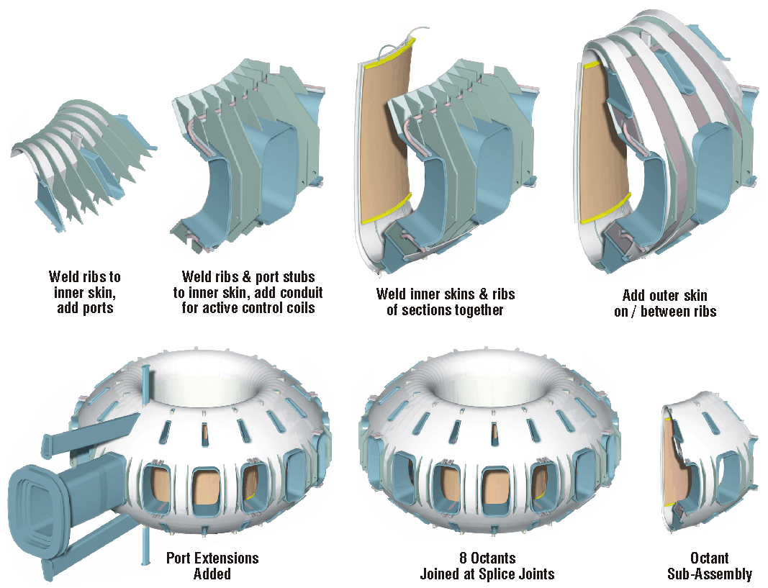

Figure 5.3.5-1 Vacuum Vessel Assembly Via TF/VV Octants

