Observations of Cloud, Radiation, and Surface Forcing in the Equatorial Eastern Pacific

C.W. Fairall, Taneil Uttal, Duane Hazen
NOAA Earth System Research Laboratory
Boulder, Colorado

Jeffrey Hare
Cooperative Institute for Research in Environmental Sciences
University of Colorado and NOAA Environmental Technology Laboratory
Boulder, Colorado

Meghan F. Cronin
NOAA Pacific Marine Environmental Laboratory
Seattle, Washington

Nicholas Bond
Joint Institute for the Study of the Atmosphere and Oceans
University of Washington and NOAA Pacific Marine Environmental Laboratory
Seattle, Washington

Dana E. Veron
College of Marine and Earth Studies, University of Delaware
Newark, Delaware

October 30, 2006

Corresponding author address: C.W. Fairall, Physical Science Division, NOAA ESRL, 325 Broadway, Boulder, CO 80305, chris.fairall@noaa.gov
ABSTRACT

In this paper we report on a study of cloud and surface flux processes in the tropical eastern Pacific Ocean based on a series of ship-based cloud and flux measurements program made during fall (1999–2002) and spring (2000–2002) maintenance cruises along the 95W and 110W TAO buoy lines. The year-to-year and seasonal variabilities of many of the meteorological and oceanic means are relatively small. However, we find notable seasonal variability in the northern branch of the Inter-Tropical Convergence Zone, the north-south sea surface temperature gradient, and heat fluxes north of the equator. In the fall, the strengthening of the north-south SST contrast enhances convective activity (more and deeper clouds, precipitation, southerly inflow) in the area around 6N, 95W; diurnal variations of low cloud fraction were weak. Spring clouds varied significantly over the diurnal cycle with substantially lower cloud fraction during the day south of 5N. Relatively low average cloud base heights around the equator are due to chilling of the marine boundary layer over the cold tongue.
Cloud radiative forcing strongly correlates with cloud fraction; clouds in the eastern equatorial Pacific cool the surface by about 40 Wm⁻² in both seasons. Cloud forcing estimates from the ship data, the TAO buoys, and International Satellite Cloud Climatology Project (ISCCP) products were combined to form a consensus observation dataset which is compared with the NCEP Reanalysis-2 (NCEP2) and 40-yr ECMWF Re-Analysis (ERA-40) cloud forcing values. The Reanalysis products were within 10 Wm⁻² of the observations for IR cloud forcing but substantially overestimated the solar cloud forcing, particularly in spring.
1. Introduction
It is generally understood that a substantial part of atmospheric predictability on seasonal and longer time scales is linked to the predictability of the oceans and, in particular, sea surface temperatures (SSTs) and that the tropics are the key region. Coupled modeling of the mean state and the variability of the climate is prone to biases and the tropical oceans are the most troublesome region (Gleckler et al., 2006). Eastern Pacific examples of modeling challenges include the cold bias and westward shift of SST in the equatorial cold tongue, the "double intertropical convergence zone (ITCZ)" with too much precipitation in the southern ITCZ, the misrepresentation of El Nino/Southern Oscillation (ENSO) variability, and persistent problems in the South American coastal upwelling zone and its associated stratocumulus clouds. These biases are partly the result of poorly resolved and poorly parameterized physics in coupled models (Ma et al. 1996; Philander et al. 1996). The importance of the turbulent fluxes can be profoundly illustrated in the investigation of Miller et al. (1992), where a small change in the bulk flux parameterization in the European Center for Medium-Range Weather Forecasts (ECMWF) model completely changed the modeled climate of the tropics. Recent studies with the Community Climate Model (CCM3) have shown the clear need for improvements in the representation of turbulent (Collins et al. 1997) and radiative fluxes (Wild et al. 1995; Garratt and Prata 1996). Of course, the variability of radiative fluxes at the surface is dominated by clouds, and a major source of uncertainty in General Circulation Models (GCM) is the representation of clouds and their interactions with the surface radiative field (Browning 1994;Cess et al. 1995; Menon et al. 2002; Siebesma et al., 2004).

The tropical eastern Pacific is a crucial component of the global climate system, especially as related to its variability in association with ENSO. Coupled model studies (Philander et al. 1996; Li and Philander 1996; Delecluse et al. 1998; Phillips et al. 2006) indicate that SST distributions in this region are sensitive to the radiative effects of MBL clouds. This includes the classical subtropical stratocumulus regimes off the coasts of California and Peru and the equatorial stratocumulus occurring in the region of strong north-south sea surface temperature (SST) gradient around latitudes 85–110W. Except for some notable exceptions (Bond et al. 1992; Yuter et al. 2000; Hashizume et al. 2003, deSzoeke et al. 2005), direct observations of air-sea interaction processes in this region are rare. For example the recent cloud GCM study by Siebesma et al. (2004) relied principally on satellite data products because ‘no reliable observations of fluxes are available’.
Air-sea fluxes, clouds, and other MBL processes that influence flux variability are a major focus of the US Climate Variations (CLIVAR) program (Weller 1998; Esbensen et al. 2002; Raymond et al. 2003; Bretherton et al. 2003) Pan American Climate Studies (PACS) and the Eastern Pacific Investigation of Climate Processes in the Coupled Ocean-Atmosphere System (EPIC). As one aspect of this effort, Tropical Ocean Atmosphere (TAO) buoy observations were supplemented with additional sites ands suites of sensors, as well as an enhanced monitoring program of high-quality flux, cloud, and profile measurements (Cronin et al. 2002, 2006a, 2006b) from the twice-yearly research vessel cruises that service the 95 and 110W buoy lines (see Figure 1).
In this paper we present an analysis of the first four years (1999-2002) of measurements from the ship-based component of the enhanced monitoring program which was jointly implemented by the NOAA Earth Science Research Laboratory (ESRL) and the NOAA Pacific Marine Environmental Laboratory (PMEL). This paper complements two recent papers featuring analysis of the TAO buoy observations along 95 and 110W: studies of the annual cycle of cloud radiative forcing at the surface (Cronin et al. 2006a) and the annual cycle of sensible and latent heat fluxes (Cronin et al. 2006b). The first paper found disagreements as large as 100 Wm⁻² between buoy observations and NWP Reanalysis values; the second paper found disagreements of the same order for latent heat flux. The disagreements tended to be largest in spring and fall which conveniently corresponds to the ship-based observations. The buoy data contain no direct observations of clouds although some information can be obtained indirectly via the cloud forcing phase diagram (see section 5). The ship data include lidar ceilometer, microwave radiometer, and radar observations of clouds which provide an additional basis for analysis of cloud forcing.
The remainder of this paper is organized as follows. Details on the ship-based flux and cloud property measurements are given in section 2. The emphasis of the present analysis is on cross-equatorial variability of the mean surface fluxes, the near-surface meteorology, and simple cloud properties (section 3), contrasting the spring and fall seasons. Following a discussion of cloud radiative forcing (section 4), we present a similar cross-equatorial analysis of mean cloud properties and cloud forcing (section 5) and compare in situ cloud forcing with satellite and NWP products (section 6). Conclusions are given in section 7.

2. The PACS/EPIC enhanced monitoring cruises

During the twice-yearly maintenance cruises along the 95W and 110W TAO buoy lines, we implemented a ship-based cloud and flux measurement program to obtain statistics on a critical set of surface, MBL, and low-cloud macrophysical, microphysical, and radiative properties. Deployments on the NOAA Ships Ka’imimoana and Ronald H. Brown serve to enhance the monitoring measurements from the TAO buoys. These comprehensive data are expected to be useful for coupled ocean-atmosphere modeling efforts, for MBL and cloud modeling, and to improve satellite retrieval methods for deducing MBL and cloud properties on larger spatial and temporal scales.
The southern end of the 95W line is in the subtropical stratocumulus belt off the west coast of South America, and the 110W line is at the western edge of the PACS region. The northern and southern branches of the Inter-Tropical Convergence Zones (ITCZ) cross the TAO buoy lines at approximately 8-10N and 5-8S latitudes, respectively. During the Northern Hemisphere spring (from hereon, reference to seasons will be for the Northern Hemisphere), the southern branch of the ITCZ is much weaker than the northern arm and is essentially nonexistent in the fall. For example, examination of the rainfall displayed in Figure 2 reveals the branched structure of the ITCZ in the spring and also shows the distinct change in rainfall climatology between the seasons. The equatorial cold tongue is well developed at both longitudes, and persistent low stratocumulus and occasional fog are encountered in this area.

a. Methodology
Two portable flux measurement packages have been developed that can be installed on either ship. The systems include instruments capable of making observations of air-sea turbulent and radiative fluxes, along with ceilometer measurements of cloud base, and rawinsonde profiles of wind, temperature, and humidity. All cruises in this analysis included the ESRL flux system and a basic cloud monitoring package, GPS rawinsondes, a cloud ceilometer, and an automated two-channel microwave radiometer (White et al. 1995; Fairall et al. 1997). On two cruises we also fielded the NOAA Portable Cloud Observatory (NPCO), which features the 35-GHz cloud radar (Moran et al. 1998), a two-channel microwave radiometer (Snider and Hazen 1998), and an upward- looking IR radiometer. A list of the instruments is shown in Table 1, where items 11–13 constitute the NPCO. More information on measurement systems and accuracies can be found in Fairall et al. (1997) and Hare et al. (2005).
We completed seven measurement missions between fall 1999 and fall 2003. The fall 2001 period included the regular TAO-PACS measurement deployment plus the EPIC2001 field program (Raymond et al. 2004). Each mission includes transects of the 95W and 110W buoy lines between 8S and 12N, along with transit legs to and from the experimental area.

b. Database

For the analysis presented in this paper, data time series from the flux system, cloud ceilometer, and microwave radiometer are processed to 10-minute time resolution and integrated to a common time format. The flux database includes turbulent and radiative fluxes and all relevant near-surface bulk meteorological variables. The ceilometer cloud base height information is processed to 10-min cloud statistics including vertical cloud fraction and 15%, 50% (median), and 85% heights for the cloud base cumulative distribution. The microwave radiometer data include column integrated water vapor (IV) and integrated cloud liquid water content (W). We have created a web-accessible database for our PACS collaborators and other EPIC investigators. Data are archived for public use at ftp://ftp.etl.noaa.gov/user/cfairall/EPIC/epicmonitor/.

3. Cross-equatorial and seasonal dependence of ocean forcing and cloud properties

In this section, we examine the processed datasets from the first seven cruises in the PACS region. By definition, a “climatology/monitoring” project implies multiple measurements in the same region to evaluate variability. In this region, the long term environmental variability is dominated by El Niño/La Niña cycles, but in three years of investigations reported here, it is possible to observe only a portion of one cycle. There are significant seasonal differences between our spring and fall cruises. There is also some difference between the 110W and 95W transects. Finally, there is short-term variability associated with the Madden-Julian oscillation, synoptic-scale fluctuations such as easterly waves, and the Tropical Instability Waves (TIW) in the ocean that cause latitudinal displacements of the SST fronts. An example of the SST and wind fields obtained from the satellite observations for both seasons is shown in Figure 1. In the remainder of this section we will show various quantities of interest computed as one-day averages and averaged further in latitude bins. One-day averages are chosen as a convenience that removes the diurnal cycle and reduces much of the sampling variability. There are some differences in the average properties at 95W and 110W, but the seasonal variations dominate. As a result, we have combined 95W and 110W data in the following presentation.

a. Meteorological variables and fluxes

In Figure 3a, we show an example of the wind components for each cruise to illustrate the variability at daily time scales. Figure 3b shows the same data averaged by season: strong southeasterly winds occur south of the equator with a minimum in the easterly component well north of the equator and a clear strengthening of the northerly component approaching the ITCZ in the fall. Wind speed is a maximum (about 7 ms⁻¹) at the southern end of the study area with a tendency for the spring winds to be stronger.
We have computed the standard deviations of the ensemble daily averages of the environmental variables within each latitude/seasonal bin. The results show small latitudinal variations, which we have summarized in Table 2. The sampling uncertainty at a given bin/season is the standard deviation divided by the square root number of samples (typically 5–10). Thus, the uncertainties in the individual mean values shown in Figure. 3b and the related plots to follow are the standard deviations given in Table 2 multiplied by approximately one-third.
The seasonal SST cycle is strongest (about 6 C) at the equator and further south, and becomes negligible to the north at about 10N. The strong seasonal variation in SST is not mirrored in the latitudinally-averaged sea-air temperature difference, which is an indication of the boundary layer adjustment processes. There is a slightly positive minimum in sea-air temperature difference (T_{s}-T_{a}) at or just south of the equator. The maximum in T_{s}-T_{a} (about 2.0 C in the fall) occurs at 5N, which is well downwind of the prevalent SST front around 2–3N. A relatively strong residual T_{s}-T_{a} exists in the fall, which indicates that the surface forcing is greater in the fall, and that the MBL response to the surface forcing is not rapid enough to reduce the sea-air temperature difference such as is seen in the spring. Because T_{s}-T_{a} is the result of a dynamic balance between surface fluxes, entrainment, and radiative fluxes, it is difficult to explain this response quantitatively without a detailed model study. The boundary layer moisture pattern (as defined by specific humidity and column water vapor) is closely coupled to SST. Total column water vapor actually shows a much stronger seasonal variation (i.e., a factor of 2 versus about 30% for MBL moisture). The upper air is much drier south of about 2N during the fall, presumably because of the overpowering influence of deep convection in the northern ITCZ. This has important implications for cloud top IR radiative cooling.
The latitudinal means of surface sensible and latent heat fluxes are shown in Figure 4. The turbulent fluxes have minima at, or just south of, the equator, with significantly lower sensible heat fluxes occurring during the spring. Negative sensible heat fluxes are observed episodically, but the overall average is slightly positive. The strong MBL response north of the equator in the fall is the combined result of the greater sea-air temperature difference, accelerating winds, and the large change in hydrostatic stability. A similar latitudinal signal in the fluxes is reported by deSzoeke et al. (@005) based on EPIC data from fall 2001. Solar flux (Figure 5) is stronger north of the equator in the spring (approaching summer) and south of the equator in the fall (approaching winter). The normal latitudinal solar zenith angle variation is somewhat masked by the relatively large cloud forcing effects (see section 6). The northern ITCZ is readily apparent as decreased net solar and increased net IR flux around 5–8N during the fall season. The precipitation is most likely undersampled due to the effects of ship flow distortion on the in situ sensor catchment (Yuter and Parker 2001), but the strong northern ITCZ in fall (north of 6N) and the double ITCZ structure in the spring (at approximately 4N and 4S) are apparent. The peak values correspond roughly to the TRMM maps in Figure 2. However, the TRMM fall map puts the precipitation maximum around 8N, which corresponds more closely with the radiative flux than the precipitation measured on the ship.

b. Cloud properties

The low cloud fraction (Figure 6) data show the large convective cloud masses in the fall associated with the most active phase of the ITCZ, and the location of the peak corresponds well with the radiative results in Figure 5. The southern ITCZ in spring is also clearly seen at 5S, but there seems to be little evidence near 8S of the expected fall increase in cloudiness associated with the edge of the Peruvian stratocumulus region (Norris and Leovy 1994). As displayed in Figure 6, the 12-hr (daytime) and 24-hr cloud fraction are plotted separately as a simple indication of regions with diurnal variation in cloud fraction. Stratocumulus MBL clouds tend to decrease in the local afternoon in response to solar heating, while trade cumulus clouds tend to increase in response to strong surface evaporation and instability. The results in Figure 6 are somewhat unanticipated, with only the spring data away from the southern branch of the ITCZ showing significant daytime suppression of marine clouds. This suggests that in the spring the clouds outside the ITCZ are more stratocumulus-like or that the subsidence in those regions has a strong diurnal cycle with an afternoon maximum.
Fair weather broken cumulus clouds are nearly ubiquitous in the undisturbed tropical MBL, and they appear to be part of a self-regulating system that produces low cloud base heights around 600 m with astoundingly little variation. However, averaging cloud base heights can disguise this, as when tilted trade cumulus clouds are present in the field. In this case, the ceilometer may return high-biased values for “cloud base” which are actually the tilted sides of the clouds. Also, in the presence of deep convection there are often outflow clouds at intermediate heights. Thus, a simple average of ceilometer readings tends to be biased toward higher values than the actual MBL cloud bases. Our initial approach to improve the cloud base height characterization was based on the cumulative height probability distribution of the samples in a 10-min time window. The 50% point of the cumulative distributions is the median cloud height (i.e., 50% of the observations have lower cloud base height and 30&=% have higher). Similarly, the 15% point of the distribution defines the height where 15% of the observed cloud heights are lower and 75% are higher. We find that the 15% distribution height tends to reduce the influence of tilted clouds and gives a better estimate of the local BL cloud base height. These data suggest seasonal differences only in the northern region. Another approach is to examine the probability distribution of base heights and look for the peak. In this case, we find a peak at 600 m for most latitudes during both spring and fall seasons. There is typically a secondary peak between 1000–1500 m caused by convective cloud top horizontal spreading at the height of the inversion. Exceptions to the common 600 m warm convective cloud base arise for cloud base heights at about 500–550 m in the core of the ITCZ and when double-peaked distributions (450 and 600 m) occur within 2 degrees of the equator. The additional lower bases near the equator are caused by increased stratification associated with the atmospheric flow over the cold tongue. In the case of the equator during fall, the cloud base height distribution has no dominant peak, but instead is essentially flat from 100 to 800 m. The very low-based clouds are consistent with surface cooling or “advection fog”, while the relatively high-based clouds appear to often originate south of the equator, and be associated with a decoupled boundary layer.
Measurements of time-averaged cloud liquid water path are shown in Table 3. Dividing these values by cloud fraction (Figure 6) gives us the mean W when clouds are present, which provides a clearer representation similar to the “cloudy pixel liquid water” in satellite W retrievals. The higher W values (300 gm⁻²) associated with the northern ITCZ are similar to those given by Weng et al. (1997). South of 3N we see the much lower W values (20–120 gm⁻²) for stratocumulus/tradecumulus clouds. The average for fall is 45 gm⁻², and for spring it is 70 gm⁻².

4. Cloud radiative forcing

Cloud forcing (CF) provides an indication of the impact of clouds on the energy budget, and this analysis demonstrates the particular emphasis of our observations in the PACS/EPIC region. Cloud forcing is the difference in the observed mean radiative flux versus what the flux would be in the absence of clouds:
${\text{CF}}_{x}\text{=<}R_{x}>−R_{x0}>$, (1)

where R is the radiative flux, the subscript x = s for solar or x = l for longwave (IR), and the subscript 0 refers to the clear-sky flux. The enhanced monitoring provided direct measurement of clearsky radiation. From these measurements, clear-sky flux algorithms were tested and tuned for the seasonal variations observed in these regions (see Appendix A). A related variable that is often used is the maximum cloud forcing, which is the conditional change in the flux when a cloud is actually present:
${\text{MCF}}_{x} = <R_{x1}>−R_{x0}> ≈\frac{ {\text{CF}}_{x}}{f}$ , (2)

where R_{x1} is the radiative flux for overcast conditions and f is cloud fraction. CF averages clear and cloudy periods, but MCF is the difference between overcast (cloud fraction, f = 1.0) and clear (f = 0) conditions. MCF is related to the radiative properties of individual clouds and can, in principle, be directly computed from microphysical and radiative variables, while CF is strongly dependent on whether it is cloudy or not. MCF also is applied in simple models that use cloud fraction to estimate cloud effects on radiative fluxes (see section 5). For this paper, we will use the CF of the net surface flux (SCF), which is the quantity most relevant to the surface heat balance of the ocean. Net SCF is downward flux multiplied by 1- α (where α is albedo, and is estimated at 0.945 for solar wavelengths over the sea) or multiplied by the broadband IR emissivity (ε) of seawater (estimated as 0.97; Fairall et al. 1996a).
CF has seen extensive application as an index of the importance of clouds for the global heat balance (e.g., Ramanathan et al. 1995 for the Tropics; Walsh and Chapman 1998 for the Arctic). This variable yields valuable information about cloud dynamics (Pincus et al. 1997) and is an important tool for diagnosing GCM treatments of cloud/radiative processes. Ramanathan et al. (1995) showed a direct link between surface cloud forcing and oceanic dynamics. Furthermore, Tian and Ramanathan (2002) have shown that CF is much more directly linked to atmospheric regional dynamics and moisture transports than surface turbulent fluxes.
Cloud forcing can be inferred globally using satellite data at the top of the atmosphere (TOA, Ramanathan et al. 1989), and it can be determined more indirectly from surface data. For SCF, the surface-based methods are more direct and more accurate, but provide limited sampling. Previous studies in the tropics have shown that the heavy water vapor burden in the boundary layer partially masks the longwave (LW) signal from clouds, and SCF is dominated by the solar flux, as LW SCF is about 5 to15 Wm⁻² while shortwave (SW) SCF ranges from -50 to -90 Wm⁻² (Stephens and Webster 1981). In subtropical stratocumulus regimes, the solar component is more nearly balanced by the LW component and the total SCF is perhaps closer to -30 Wm⁻².
This SW versus LW compensating effect depends strongly on latitude and season. Tropical regions have the strongest solar cloud forcing, while polar areas tend to have the strongest relative IR cloud forcing. In the upper midlatitude storm track, total SCF tends to be small because the solar and IR components approximately cancel.

5. Cloud forcing analysis

In this section we will examine two aspects of SCF in the eastern equatorial Pacific: the seasonality of SCF (similar to the other atmospheric properties presented in section 3) and the mean dependence of SCF on cloud fraction.
The latitudinal dependence of clear-sky net fluxes is shown in Figure 7. The counterintuitive asymmetry about the equator for the clear-sky solar flux is caused by the time of year of the observations (see comment about seasonal variations in column water vapor in section 4). The more negative clear-sky net IR flux in the fall is caused by the lower atmospheric water vapor during that season. The slightly stronger latitudinal variation of net IR flux in the fall is associated with stronger variations in atmospheric temperature and water vapor. The average of the two seasonal curves gives a net solar clear-sky flux of about 300 Wm⁻² and a net IR clear-sky flux of -68 Wm⁻² north and -78 Wm⁻² south of the equator. Based on Earth Radiation Budget Experiment (ERBE) data, Tian and Ramanathan (2002) report annual averages for solar flux in the range 270–275 Wm⁻² and IR flux of about -60 Wm⁻² in the north and -80 Wm⁻² in the south. Our results are not annual averages, so the significance of the similarities is limited without further study.
The mean SCF for both solar and IR is shown in Figure 8 for both SW and LW fluxes; the most obvious seasonal SCF difference is the larger magnitudes associated with greater cloudiness in the northern ITCZ. Using the cloud fraction from Figure 6, we have computed the maximum surface cloud forcing (MSCF), and this is illustrated in Figure 9. Here we used the 24-hr cloud fraction for IR flux and the clear-sky solar flux-weighted cloud fraction for solar flux. The 24-hr cloud fraction does not correlate well with daily SW SCF and, in the case of the mean day-night differences in f, may lead to biases in solar MSFC. Because the daily average solar flux is relatively sensitive to cloudiness around local noon, we find that the clear-sky solar-weighted cloud fraction provides a better representation than the daytime f. For all latitudes, the IR MSCF is about 15 Wm⁻² lower in spring than in fall. The daily values plotted on the SCF phase diagram (Figure 10) provide a striking contrast to the typical behavior in most of ESRL’s 11 other tropical cruises (Fairall et al. 2003; Hare et al. 2005). Rather than tending to lie near a single characteristic line, the PACS/EPIC data are scattered from tropical to storm track lines. This clearly indicates that all three principal climate zones (tropical, trade wind, and stratocumulus) are encountered within 10 degrees of the equator in the eastern Pacific. From this figure, we interpret that the spring has a more tropical signature while the fall period is biased toward trade wind and stratocumulus behavior. The deep convective events in the fall often have very strong cold-air downdrafts that lead to sharp reductions in the near surface air temperature which might invalidate the simplistic representation of the IR clear-sky flux.
Of course, cloud forcing depends on cloud fraction. In the simplest case, each cloud’s radiative properties are similar to all others, and then CF depends upon the number of clouds in the field. Thus, the radiative flux at the surface can be written

$R_{x} = R_{x_{0}} + f ∗ {\text{MCF}}_{x} = (1 − f)R_{x_{0}} + {\text{fR}}_{x_{1}}$. (7)

This approach forms the basis for simple treatments of fractional cloudiness (Hartmann et al. 1992). For solar flux, nonlinear dependencies on vertical f are common (Katsaros 1990; Grant and Hignett 1998). In addition, hemispherically-averaged cloud fraction or cloud fraction at the solar zenith angle (White et al. 1996) have also been used. Thus, a linear dependence of CF on cloud fraction implies that such simple models are applicable. Here, we illustrate this dependence using the daily-averaged solar and IR fluxes with a 24-hr averaged (for IR) or daytime averaged (for solar) cloud fraction (Figure 11). For IR flux, a linear regression gives MSFC_{l} = 50 Wm⁻². However, a 2nd-order fit gives a linear term of 33 Wm⁻² and a quadratic coefficient of 20 Wm⁻². Thus, for low cloud fractions IR MSFC is less than for high cloud fractions (i.e., 33 vs. 53 Wm⁻²). For solar flux, the data are too scattered to determine nonlinearity, but a linear regression results in MSFC_{s} = -135 Wm⁻².
Figure 12 shows the results of averaging the daily values into bins of cloud fraction where we separate spring (74 days) and fall (86 days) cruises. This figure clearly shows lower LW SFC in the spring than in the fall. For cloud fraction less than 0.5, the fall SW SFC values are smaller in magnitude, but slightly larger for high cloud fractions (greater than 0.7). This is qualitatively consistent with the lower cloudy liquid water path values found south of 3N and the larger values north of 6N in fall versus spring (see the discussion at the end of section 5). Therefore, for solar SCF there are some small seasonal differences that are not attributable to cloud fraction but are probably associated with the actual liquid water content of the clouds. Linear regressions to these data imply IR MSFC of 53 Wm⁻² in fall and 40 Wm⁻² in spring, with solar MSFC values of -141 Wm⁻² in fall and -127 Wm⁻² in the spring. Averaging in this form has removed much of the apparent nonlinearity from Figure 11, suggesting that it was partly caused by mixing spring and fall data.

6. Intercomparsions of In Situ Radiative Fluxes with NWP and Satellite values.

In this section we examine different sources of data for estimating solar and IR cloud forcing of net radiation at the surface. Three sources of data are used: ESRL direct measurements from the ship, NOAA/PMEL direct measurements from the TAO buoys, and satellite estimates from the International Satellite Cloud Climatology Project (ISCCP). These have been compared to ERA-40 and NCEP2 reanalysis products. Details on the TAO, ISCCP, and reanalysis products are given in Cronin et al. (2005b). The ESRL radiative flux instruments are tended daily and are considered to have the best absolute accuracy. However, their temporal sampling is poor (a few days at each latitude bin each transect). Averaging over multiple cruises reduces the sampling errors, but the TAO buoys are still superior in this respect. Because the buoy sensors are unattended for six month intervals, their absolute calibration is more problematic. The accuracy of the buoy measurements has been assessed by comparing with the ESRL measurements in Cronin et al. (2006b). Paradoxically, the practicalities of replacing the buoys results in very little direct intercomparison with ship-based sensors while the ship is close to the buoy (proximity is critical for radiative flux comparisons). The satellite data has good temporal sampling (essentially continuous), but must be considered an indirect measurement.
The result of a comparison of these data is shown in Figure 13. The ‘measurements’ are indicated with thin dotted lines and the two NWP products with heavy dashed lines. A consensus estimate based on the three measurement sets is indicated by the dark red line. The fall data show a strong ITCZ at about 6 N; the spring has a weaker double ITCZ signature. The buoy solar SFC tends to be about 20 Wm⁻² more negative than the ESRL and ISCCP data, but the significance is unknown so we have treated the three sets as equivalent. The standard deviations of the individual measurement sets (after averaging over latitude) from the consensus is 3 Wm⁻² for IR and 11 Wm⁻² for solar SFC. Solar SFC is about three times greater than IR, which is consistent with the larger standard deviation.
With the possible exception of spring NCEP2, the NWP and observational data are essentially indistinguishable, on average, for IR SFC. Neither NWP product diagnoses the observed enhancement in IR SFC at the ITCZ, with the exception of the ERA-40 for the ITCZ north of the equator in spring. For solar SFC, both NWP products have errors exceeding 30 Wm⁻². In spring the latitude-averaged bias is 32 Wm⁻² for ERA-40 and 60 Wm⁻² for NCEP-2 (i.e., the NWP products have too much cloud or their clouds are too dark). ERA-40 overemphasizes the ITCZ; NCEP-2 gets the latitudinal structure completely wrong. In fall the latitude-averaged bias is 8 Wm⁻² for ERA-40 and 45 Wm⁻² for NCEP-2. Here ERA-40 is better, but still gets too much SFC in the ITCZ. It is puzzling that the latitudinal structures in the NWP products are so much more prominent in the solar SFC than in the IR SFC. The implication is that they are handling the deep clouds in the ITCZ considerably better than the MBL clouds, since higher clouds don’t affect the IR SFC.

7. Conclusions

We analyzed air-sea flux and cloud measurements from a series of seven cruises made in the eastern equatorial Pacific between fall 1999 and fall 2002. These cruises were transects along the enhanced TAO buoy lines along 95W and 110W longitudes and afforded multiple sampling of the equatorial cold tongue and ITCZ. Our analysis has emphasized the statistical properties (mean, variance, probability distribution functions) as a function of latitude contrasting the Northern Hemisphere fall and spring seasons. Seven cruises do not constitute a comprehensive climatology, of course, but many of the mean variables show consistent structures. For most quantities, the variability from year to year during the same season and at the same latitude is quite small (see Table 2), and, with a few exceptions, there was little difference between the two seasons.
The most obvious seasonal differences are the stronger Northern Hemisphere ITCZ and stronger north-south SST difference in the fall periods. We also see much stronger turbulent heat fluxes in the SST frontal region north of the equator in the fall. These stronger fluxes drive the rapid MBL adjustment to the changing SST associated with the cross-equatorial air flow. Thus, the colder water south of the equator in fall exerts a strong cooling influence on the ocean north of the equator (an additional 60 Wm⁻² compared to spring). The well-defined ITCZ region north of the equator in the fall also produces much more cloudiness, precipitation, southerly winds, and solar cloud forcing in the region around 6N.
We examined cloud fraction, cloud base height statistics, and cloudy liquid water path. The fall period was much cloudier north of the equator, with mean cloud fraction about 90% at 6N. The spring clouds showed a strong diurnal variation with substantially lower cloud fraction during the day south of 5N (except in the southern ITCZ region at 4S). This may be a result of greater subsidence or surface heating during the day. Simple averages of cloud base heights were presented, and, through consideration of the peak in the distribution (i.e., the most probable cloud base height), we demonstrated the significant effects on clouds near the equator. The lower cloud bases there reflect cooling as air from south of the equator flows over the cold tongue, thereby stabilizing the lower MBL and decoupling the upper MBL from the surface. The equatorial effects were more dramatic in the fall when the cold tongue is much colder. At the equator, very low clouds were occasionally observed with a fairly even distribution of cloud bases.
Surface cloud radiative forcing is defined as the difference in mean observed net radiative flux and that flux which would be observed in the absence of clouds. To investigate this, we first estimated the clear-sky radiative fluxes, and we employed two simple models requiring near-surface temperature, humidity, and estimates of column water vapor and aerosol optical depth. The model parameters were tuned for a best fit to the radiative fluxes observed during clear periods. By turning the models to the data, we are able to produce estimates of SFC within 5–7 Wm⁻² for daily-averaged radiative fluxes. The models are intended to be applicable for buoys and ships where column water vapor measurements are not available, although regional accuracy will be compromised without specific tuning.
For IR fluxes, SFC strongly correlates with cloud fraction. There are substantial seasonal differences in IR SFC but relatively modest seasonal differences in MSFC (53 Wm⁻² in the fall versus 40 Wm⁻² in spring). For solar fluxes, MSFC is about -135 Wm⁻² ; MSFC_{s} is stronger in the spring between 3S and 6N with values around -250 Wm⁻² at and just south of the equator (Figure 9). However, these unusual spring values are actually realized in regions with low daytime cloud fraction, so the significance is uncertain. When averaged in cloud fraction bins, the fall versus spring differences are fairly small (Figure 12). There is some evidence for lower liquid water leading to lower solar MSFC for broken clouds in the fall, but these differences are near the sampling resolution of the averages. The ratio of solar to IR MSFC (-135/53 = -2.5) implies that clouds in this region strongly cool the surface. However, the IR SFC is significantly greater than the observations for a typical ESRL tropical cruise (see Figure 10), so the net cooling effect is less than that of the tropical western Pacific.
SCF was examined further by comparing observations with NWP reanalysis. The ESRL means were combined with buoy and satellite monthly averages of SFC for fall and spring to obtain a consensus estimate based on measurements. The individual data sources agreed within about 10 Wm⁻² with the consensus values. The Reanalysis products were within 10Wm⁻² of the observations for IR SCF but substantially overestimated the solar SFC, particularly in spring. The inconsistent behavior of the Reanalysis products (IR versus Solar) suggests the models are generating incorrect distributions of cloud types (see Cronin et al. 2006a for further discussion).

Finally, the contributions of clouds to the net surface heat budget are shown in Figure 14. The net heat flux (upper panel) shows a striking symmetry difference between the spring and fall. The spring net heat flux is nearly symmetrical about the equator with a maximum (175 Wm⁻²) at the equator decreasing to about 100 Wm⁻² at 10N and 8S. The equatorial maximum is associated with lower turbulent fluxes and modestly lower cloudiness at the equator. In the fall, the maximum net heat flux (180 Wm⁻²) is at 2S and the minimum (essentially 0) is at 6N. There is also a significant asymmetry away from the equator (125 Wm⁻² at 8S versus 75 Wm⁻² at 10N). Clearly, the minimum SFC at 6N is primarily associated with strong solar SFC (lower panel in Figure 13) associated with the ITCZ. The maximum just south of the equator is associated with much weak turbulent cooling (Figure 4) and weak solar SFC. Solar SFC is also much more equatorially asymmetric in the fall (Figure 14).
We have described the statistical properties of the MBL and surface forcing of the eastern equatorial Pacific ITCZ/Cold Tongue complex twice a year at times near the maximum seasonal contrast. We have attempted to not only characterize the variability but also to isolate the role of cloud radiative forcing in that variability, and this includes providing information on cloud properties. Because our measurements do not include a strong El Niño event, this study cannot be considered a complete characterization of the statistics, but does provide significant detail to establish basic characterization for non-El Niño conditions. Soundings from these cruises have already formed the basis of an analysis of MBL evolution in the vicinity of the strong SST gradient in fall (Pyatt et al. 2005) and a study of parameterizations of MBL depth in climate models (Zeng et al. 2004). A much more complete investigation of the annual cycle and inter-annual variability is underway using data from the TAO buoys in this region (Cronin et al. 2002). In addition, an analysis of C-band radar characterizations of deep convection is presently under way. In 2003, we inaugurated a related study during an annual fall cruise to the WHOI Stratus buoy at 20S 95W (http://uop.whoi.edu/stratus/). This buoy is located in the heart of the South Pacific stratocumulus belt off South America (Hartmann et al. 1992).

Acknowledgments. This work was supported by the NOAA Office of Global Programs, ONR Marine Meteorology program, the DOE Atmospheric Radiation Measurement program, and the National Science Foundation Climate Dynamics program. The authors especially thank Scott Abbott, Dave Costa, Mike Falls, Dan Gottas, Jim Jordan, Jesse Leach, Brenda Mulac, Jeff Otten, Bill Otto, Sergio Pezoa, Michelle Ratterree, Cat Russell, Kara Sterling, and Dan Wolfe for work, dedication, and personal sacrifice in doing the field work. The contributions and help of the crews of the NOAA ships Ronald H. Brown and Ka’imimoana is greatly appreciated.
Appendix A. Clear-sky radiative flux parameterizations

For the study of SCF, the realization of the fluxes at the air-surface interface can be handled effectively by simple methods (e.g., Lind and Katsaros 1984, Katsaros 1990; Key et al. 1996). For one thing, we only require estimates of clear-sky flux because the all-sky flux is directly measured. Furthermore, we can accommodate regional and seasonal variability by tuning the model to fit the observations during clear periods. For this approach, the challenge is to plainly identify the clear periods. To do that, we use estimates of the vertical cloud fraction from the ceilometer data. More detail on this process can be found in Hare et al. (2005).

a. IR flux

Most IR parameterizations estimate the flux in terms of near-surface parameters such as air temperature ,T_{a}:

$R_{\text{ld}} = ε_{e}{σT}_{a}^{4}$ , (A1)

where ε_{e} is an effective total sky emissivity that, when combined with the air temperature, yields an estimate of the IR flux. For clear-sky conditions, ε_{e} is an empirical function of atmospheric water vapor content — either local humidity, q_{a}, or the total integrated column water vapor, IV. Josey et al., 2003 offer a variation using T_{a} and dewpoint temperature depression, and Garratt (2001) presents another utilizing T_{a} and IV (see Table 2 for units of these variables).
We have chosen the Brunt (1932) form for the parameterization of effective emissivity for clear skies, ε_{e0}:

$ε_{e0} = A + B\sqrt{q_{a}}$ . (A2)

Using the ESRL ship-based radiative flux observations from 15 campaigns (Fairall et al. 2003), we have previously determined the A and B coefficients as simple linear functions of latitude. This fit is based on data obtained between the equator and 60N, but the majority of the data were obtained within 15 degrees of the equator. For this study, we optimized the fit using only data from the PACS cruises within 15 degrees of the equator. This gives a result:

$A = 0\text{.}\text{50} + \frac{0\text{.}\text{13}}{\text{60}}\text{abs}(\text{latitude}) ; B = 0\text{.}\text{091} − \frac{0\text{.}\text{03}}{\text{60}}\text{abs}(\text{latitude})$. (A3)

We also added IV for a three-parameter fit. The IV was obtained through retrieval of surface-based microwave radiance. Adding the column water vapor gives a fit of the form:

$ε_{e_{0}} = A + B\sqrt{q_{a}} − 0\text{.}\text{0188} + 0\text{.}\text{0063} \text{IV}$. (A4)
Slight adjustments in the latitude dependences are required to provide a better fit when using column water vapor in this expression. The fits are based on approximately 2300 10-min observations (out of a total of 22,127 observations within 15 degrees of the equator with simultaneous column water vapor measurements). Clear skies were diagnosed by requiring zero cloud fraction from 25-min before to 25-min after the observation time.
Figure A1 shows measurements and two-parameter model values of downward IR flux for periods when the ceilometer-measured cloud fraction is 0 for a continuous 60- min time period. Individual points well above the line are caused by clouds in the field of view of the PIR but are not directly above the ceilometer. We also computed the residuals between the measured data and the model as a function of the column water vapor. A linear fit of these residuals (with a few small adjustments to A and B) was used to obtain the three-parameter model. The two-parameter fit has a bias of -1.8 Wm⁻² and a standard deviation of 7 Wm⁻², whereas the three-parameter fit has a bias of -0.9 Wm⁻² and a standard deviation of 5.7 Wm⁻².

b. Solar flux

We are using the solar flux parameterization from Iqbal (1998) which contains components to track the angular position of the sun as a function of day of the year, time of day, and latitude. The solar flux constant at the top of the atmosphere is set to 1367 Wm⁻², and the transmission coefficient of the atmosphere is estimated from specifications of total column ozone, aerosol optical thickness in two wave bands, and the column integrated water vapor IV as above. We then tune the model by plotting the time series of measured R_{sd}, and comparing it to computed clear-sky values from the algorithm. The aerosol values are then adjusted to fit the peak solar flux for clear days on a cruise-by-cruise basis. We find that slightly different aerosol coefficients are required in the fall versus the spring.
We have examined the accuracy of this method by computing the probability distribution of the measured-modeled difference in solar flux for cases where the solar zenith angle is less than 20 degrees and cloud fraction is zero (471 samples meet these conditions). The peak of this distribution occurs at 0 Wm⁻² (i.e., no model bias), and it has a half-width at half-maximum (an estimate of the standard deviation) of 20 Wm⁻². Because some of this width is caused by cloud reflections and random variability in the m`easurements, we estimate the standard deviation of the model near the solar peak to be 15 Wm⁻² with a model bias of about -5 Wm⁻². For daily average solar fluxes where measurements of column water vapor are available, these values correspond to a model bias of -2 Wm⁻² and a standard deviation of 5 Wm⁻².
The bias and variability quoted for the clear-sky models are not absolute accuracies, but are computed relative to the data from which they are tuned. We are concerned with the mean measured flux minus the mean clear-sky modeled flux. Because we have tuned the model to the data we are analyzing, biases in the measurements will, to first order, cancel in the computation of SCF. For daily average values, the uncertainty in SCF will be about 5–7 Wm⁻² for both IR and solar fluxes.

REFERENCES

Bond, N.A., 1992: Observations of planetary boundary-layer structure in the eastern equatorial Pacific. J. Climate, 5, 699–706.

Bretherton, C.S., T. Uttal, C.W. Fairall, S.E. Yuter, R.A. Weller, D. Baumgardner, K. Comstock, and R. Wood, 2004: The EPIC 2001 Stratocumulus Study. Bull. Amer. Meteor. Soc., to appear.

Browning, K.A., 1994: Survey of perceived priority issues in the parameterizations of cloud-related processes in GCMs. Quart. J. Roy. Meteor. Soc., 129, 483–487.

Brunt, D., 1932: Notes on radiation in the atmosphere. Quart. J. Roy. Meteor. Soc., 58, 389–420.

Cess, R.D., M.H. Zhang, P. Minnis, L. Corsetti, E.G. Dutton, B.W. Forgan, D.P. Garber, W.L. Gates, J.J. Hack, E.F. Harrison, X. Jing, J.T. Kiehl, C.N. Long, J.-J. Morecrette, G.L. Potter, V. Ramanathan, B. Subasilar, C.H. Whitlock, D.F. Young, and Y. Zhou, 1995: Absorption of solar radiation by clouds: Observations versus models. Science, 267, 496–499.

Collins, W.D., J. Wang, J.T. Keihl, G.J. Zhang, D.I. Cooper, and W.E. Echinger, 1997: Comparions of tropical ocean-atmosphere fluxes with the NCAR community model CCM3. J. Climate, 10, 3047–3058.

Cronin, M.F., N. Bond, C.W. Fairall, J.E. Hare, M.J. McPhaden, and R.A. Weller, 2002: Enhanced oceanic and atmospheric monitoring for the Eastern Pacific Investigation of Climate Processes (EPIC) experiment. EOS, Trans. AGU, 83, 205–211.

Cronin, M. F., N. Bond, C. W. Fairall, and R. A. Weller, 2006a: Surface cloud forcing in the Eastern Tropical Pacific. J. Clim., 19, 392-409.

Cronin, M., C. W. Fairall, and M. J. McPhaden, 2006b: An assessment of buoy-derived and numerical weather prediction surface heat fluxes in the tropical Pacific. J. Geophys. Res., 111, C06038, doi:10.1029/2005JC003324.

Delecluse, P., M.K. Davey, Y. Kitamura, S.G.H. Philander, M. Suarez, and L. Bengtsson, 1998: Coupled general circulation modeling of the tropical Pacific. J. Geophys. Res., 103, 14 357–14 373.

deSzoeke, S.P., C.S. Bretherton, N.A. Bond, M.F. Cronin, B.M. Morley, 2005: EPIC 95W observations of the eastern Pacific atmospheric boundary layer from the cold tongue to the ITCZ. J. Atmos. Sci., 62, 426-442.

Esbensen, S., T. Mitchell, and C. Gudmundson, 2002: U. S. CLIVAR Pan American Research: A scientific prospectus and implementation plan. U.S. CLIVAR OFFICE, Washington, D.C., 58 pp.

Fairall, C. W., E. F. Bradley, J.S. Godfrey, G.A. Wick, J.B. Edson, and G.S. Young, 1996a: Cool-skin and warm-layer effects on sea surface temperature. J. Geophys. Res., 101, 1295–1308.

—————, —————, D.P. Rogers, J.B. Edson, and G.S. Young, 1996b: Bulk parameterization of air-sea fluxes for Tropical Ocean - Global Atmosphere Coupled-Ocean Atmosphere Response Experiment. J. Geophys. Res., 101, 3747–3764.

—————, J.B. Edson, and J.E. Hare, 1997: Integrated shipboard measurements of the marine boundary layer. J. Atmos. Oceanic Tech., 14,338–359.

—————, E.F. Bradley, J.E. Hare, A.A. Grachev, and J.B. Edson, 2003: Bulk parameterization of air-sea fluxes: Updates and verification for the COARE algorithm. J. Climate, 16, 571–591.

Garratt, J.R., 2001: Clear-sky longwave irradiance at the Earth’s surface - Evaluation of climate models. J. Climate, 14, 1647–1670.

————— and A.J. Prata, 1996: Downwelling longwave fluxes at continental surfaces - A comparison of observations with GCM simulations and implications for the Global Land-Surface Radiation Budget. J. Climate, 9, 646–655.

Gleckler, P. J., K. R. Sperber, and K. Achuta Rao, 2006: Annual cycle of global ocean heat content: Observed and simulated. J. Geophys. Res., 111, C06008, doi:10.1029/2005JC003223.

Grant, A.L.M., and P. Hignett, 1998: Aircraft observations of the surface energy balance in TOGA-COARE. Quart. J. Roy. Meteor. Soc., 124, 101–122.

Hare, J. E., C. W. Fairall, T. Uttal, D. Hazen, Meghan Cronin, Nicholas A. Bond, and Dana Veron, 2005: A seven-cruise sample of clouds, radiation, and surface forcing in the Equatorial Eastern Pacific. NOAA Tech. Memo OAR-PSD 307, NOAA ESRL, Boulder, Colo., pp. 64 [Available at ftp://ftp.etl.noaa.gov/user/cfairall/EPIC/epicmonitor/techmemo/].

Hartmann, D.L., M.E. Ockert-Bell, and M.L. Michelsen, 1992: The effect of cloud type on Earth’s energy balance: Global analysis. J. Climate, 5, 1281–1304.

Hashizume, H., S.-P. Xie, M. Fuijiwara, M. Shiotani, T. Watanabe, Y. Tanimoto, W.T. Liu, and K. Takeuchi, 2003. Direct observations of atmospheric boundary layer response to SST variations associated with tropical instability waves over the Eastern Equatorial Pacific. J. Climate, 15, 3379–3393.

Iqbal, M., 1998: Spectral and total sun radiance under cloudless skies. Physical Climatology for Solar and Wind Energy, R. Guzzi and C. G. Justus, Eds., World Scientific, 196–242.

Jones, C., P. Peterson, C. Gautier, and W.T. Liu, 2001: Satellite observations of latent and sensible heat fluxes in the tropical Pacific Ocean. Proc. WCRP/SCOR Workshop on Intercomparison and Validation of Ocean-Atmosphere Flux Fields. Potomac, MD, 21-24 May, WCRP Report #115, 209–214.

—————, P.W. Pascal, P.K. Taylor, and M.J. Yelland, 2003: A new formula for determining the atmospheric longwave flux at the ocean surface at mid-high latitudes. J. Geophys. Res., 108, 3108, doi:10.1029/2002JC001418, 5–1 to 5–16.

Katsaros, K.B., 1990: Parameterization schemes and models for estimating the surface radiation budget. Surface Waves and Fluxes, Vol. II. G.L. Geernaert and W.J. Plant, Eds., Kluwer Academic Publishers, 339–368.

Key, J.R., R.A. Silcox, and R.S. Stone, 1996: Evaluation of surface flux radiative flux parameterizations for use in sea ice models. J. Geophys. Res., 101, 3839–3849.

Li, T. and S.G.H. Philander, 1996: On the annual cycle of the eastern equatorial Pacific. J. Climate, 9, 2986–2998.

Lind, R.J. and K.B. Katsaros, 1984: Radiation budget components and their parameterization in JASIN. Quart. J. Roy. Meteor. Soc., 110, 1061–1071.

Menon, S., A.D. DelGenio, D. Koch, and G. Tselioudis, 2002: GCM simulations of the aerosol indirect effect: Sensitivity to cloud parameterization and aerosol burden. J. Atmos. Sci., 59, 692–713.

Miller, M.J., A.C.M. Beljaars, and T.N. Palmer, 1992: The sensitivity of the ECMWF model to the parameterization of evaporation from the tropical oceans. J. Climate, 5, 418–434.

Moran, K.P., B.E. Martner, M.J. Post, R.A. Kropfli, D.C. Welsh, and K.B. Widener, 1998: An unattended cloud-profiling radar for use in climate research. Bull. Amer. Meteor. Soc., 79, 443–455.

Norris, J.R. and C.B. Leovy, 1994: Interannual variability in stratiform cloudiness and sea surface temperature. J. Climate, 7, 1915–1925.

Philander, S.G.H., D. Gu, D. Halpern, G. Lambert, N.-C. Lau, T. Li, and R.C. Pacanowski 1996: Why the ITCZ is mostly north of the equator. J. Climate, 9, 2958–2972.

Phillips, T. J., and 8 coauthors, 2006: Coupled climate model appraisal: A benchmark for future studies. EOS, Transactions of AGU, 87, 185-191.

Pincus, R., M.B. Baker, and C.S. Bretherton, 1997: What controls stratocumulus radiative properties? Lagrangian observations of cloud evolution. J. Atmos. Sci., 54, 2215–2236.

Pyatt, H.E., B.A. Albrecht, C.F. Fairall, J.E. Hare, N.A. Bond, P. Minnis, J.K. Ayers, 2005: Evolution of marine atmospheric boundary layer structure across the cold tongue-ITCZ complex. J. Climate, 18, 737-753.

Ramanathan, V., R.D. Cess, E.F. Harrison, P. Minnis, B.R. Barkstrom, E. Ahmad, and D. Hartman, 1989: Cloud-radiative forcing and climate: Results for the Earth Radiation Budget Experiment. Science, 243, 57–63.

—————, B. Subasilar, G.J. Zhang, W. Conant, R.D. Cess, J.T. Kiehl, H. Grassl, and L. Shi, 1995: Warm pool heat budget nd shortwave cloud forcing: A missing physics? Science, 267, 499–503.

Raymond, D., J. Esbensen, M. Gregg, and N. Shay, 1999: EPIC2001: Overview and implementation plan. See ftp://kestrel.nmt.edu/pub/raymond/epic2001/overview.pdf.

—————, S.K. Esbensen, M. Gregg, C.S. Bretherton, L.K. Shay, T. Uttal, and P. Zuidema, 2004: EPIC2001 and the coupled ocean-atmosphere system of the tropical East Pacific. Bull. Amer. Meteor. Soc., 85, 1341-1354..

Snider, J.B. and D.A. Hazen, 1998: Surface-based radiometric observations of water vapor and cloud liquid water in the temperature zone and in the tropics. Radio Sci., 33, 421–432.

Stephens, G.L. and P.J. Webster, 1981: Clouds and climate: Sensitivity of simple systems. J. Atmos. Sci., 38, 235–247.

Tian, B. and V. Ramanathan, 2002: Role of tropical clouds in surface and atmospheric energy budget. J. Climate, 59, 296–305.

Walsh, J.E. and W.L. Chapman, 1998: Arctic cloud-radiation-temperature associations in observational data and atmospheric reanalyses, J. Climate, 11, 3030–3044.

Weller, R., B. Albrecht, S. Esbensen, C. Eriksen, A. Kumar, R. Mechoso, D. Raymond, D. Rogers, and D. Rudnick, 1998: A science and implementation plan for EPIC: An eastern Pacific investigation of climate processes in the coupled ocean-atmosphere system. See http:://www.atmos.washington.edu/gcf/EPIC/.

White, A.B., C.W. Fairall, and J.B. Snider, 1995: Surface-based remote sensing of marine boundary-layer cloud properties. J. Atmos. Sci., 52, 2827–2838.

—————, —————, A.S. Frisch, B.W. Orr, and J.B. Snider, 1996: Recent radar measurements of turbulence and microphysical properties in clouds. Atmos. Res., 90, 117–121.

Wild, M., A. Ohmura, H. Gilgen, and E. Roeckner, 1995: Validation of General Circulation Model radiative fluxes using surface observations. J. Climate, 8, 1309–1324.

Yuter, S.E. and R.A. Houze, 2000: The 1997 Pan American Climate Studies Tropical Eastern Pacific Process Study. Part I: ITCZ region. Bull. Amer. Meteor. Soc. 81, 451–482.

————— and W.S. Parker, 2001: Rainfall measurement on ship revisited: The 1997 PACS TEPPS cruise. J. Appl. Meteorol., 40, 1003–1018.

Zeng, X., M.A. Brunke, M. Zhou, C.W. Fairall, N.A. Bond, and D.H. Lenschow, 2004: Marine atmospheric boundary layer height over the Eastern Pacific: Data analysis and model evaluation. J. Clim., 17, 4159-4170.

List of Tables

Table 1. Instruments deployed and measurements by ESRL for the ship-based cloud/MBL monitoring project.

Table 2. Standard deviation of selected variables, computed for all three years of cruise data during each season (spring or fall) within a single latitude bin. The values presented are the average variance of all latitude bins.

Table 3a. Mean ESRL observations along 95 and 110 W longitude for fall 1999-2002.

Table 3b. Mean ESRL observations along 95 and 110 W longitude for spring 2000-2002.
List of Figures

Figure 1. The EPIC mooring array is shown in relation to the September 1998 TRMM Microwave Imager SST and QuickSCAT wind fields. Diamonds indicate the locations of TAO buoys.

Figure 2. One-month rainfall accumulations from the TRMM 3B42 rainfall product for spring (a) and fall (b) 2000 cruises.

Figure 3. Wind components (northerly — upper panel; easterly — lower panel) from seven EPIC cruises. (a) Daily-averaged values, with each symbol representing a single cruise and includes both 110W and 95W longitudinal portions. (b) Latitude average values. Circle — fall; diamond — spring.

Figure 4. Latitude-averaged turbulent heat fluxes. Upper panel — sensible heat; lower panel — latent heat. Circles — fall; diamonds — spring.

Figure 5. Latitude-averaged net radiative heat fluxes. Upper panel — solar flux; lower panel — IR flux. Circles — fall; diamonds — spring.

Figure 6. Latitude-averaged low cloud fraction. Circles — fall; diamonds — spring. Solid line — 24-hr average cloud fraction; dashed line — daytime average cloud fraction.

Figure 7. Latitude-averaged net clear-sky radiative heat fluxes using the models described in Appendix A. Upper panel — solar flux; lower panel — IR flux; circles — fall; diamonds — spring. The strange bump at 10N in the fall is caused by observations in the EPIC2001 project which occurred almost two months earlier than the typical fall monitoring cruise.

Figure 8. Latitude-averaged radiative surface SFC. x — fall IR flux; closed circles — spring IR flux; open circles — fall solar flux; diamonds — spring solar flux.

Figure 9. Latitude-averaged radiative surface maximum SFC computed via Eq. 2. x — fall IR flux; closed circles — spring IR flux; open circles — fall solar flux; diamonds — spring solar flux.

Figure 10. Cloud forcing phase diagram showing the balance of solar and IR SCF in different climate zones. An ensemble of individual days in a particular region tend to lie along a line where values near zero from small cloud fraction and values near the maximum are for cloud fraction near 1.0. Symbols are for the data from this analysis: Circle — fall; x — spring.

Figure 11. Daily-averaged SFC as a function of cloud fraction. Circle — IR; x — solar. The solid lines represent nominal MSFC values of 50 Wm⁻² for IR and -150 Wm⁻² for solar fluxes.

Figure 12. As in Figure 11, but the daily data have been averaged in bins of cloud fraction. Circles — spring IR; plus — fall IR; diamonds — spring solar; x — fall solar.

Figure 13. Cloud forcing as a function of latitude averaged of the spring and fall PACS cruises near the equator in the East Pacific: a) Fall Solar SCF, b) Fall IR SCF, c) Spring Solar SCF, and d) Spring IR SCF.. The symbols for measurements are: TAO buoys – circle, ESRL ship data – square, ISCCP – right pointing open triangle, mean of these three – heavy solid line. The symbols for the reanalysis products are: NCEP2 – left pointing triangle, and ERA40 – star. ESRL data are computed from cruise averages; buoy, satellite, and NWP are computed from monthly averages in the cruise season window.

Figure 14. Latitude-averaged surface fluxes. Upper panel — net heat flux into the ocean; lower panel — contribution to the net heat flux accounted for by SCF. Circles —fall; diamonds — spring.

Figure A1. Comparison of clear-sky IR fluxes using model (x-axis) from Eqs. 4–5 and measurements (y-axis) for 60-min cloud free periods.

Table 1. Instruments deployed and measurements by ESRL for the ship-based cloud/MBL monitoring project.
Item | System | Measurement
1 | Motion/navigation package | Motion correction for turbulence
2 | Sonic anemometer/thermometer | Direct covariance turbulent fluxes
3 | IR fast H₂O/CO₂ sensor | Direct covariance moisture/CO₂ fluxes
4 | Mean SST, air temperature/RH | Bulk turbulent fluxes
5 | Pyranometer/Pyrgeometer | Downward solar and IR radiative flux
6 | Ceilometer | Cloud base height
7 | 0.92 or 3 GHz Doppler radar profiler | Cloud top height, MBL microturbulence
8 | Rawinsonde | MBL wind, temperature, humidity profiles
9 | 23, 31 GHz :wave radiometer (ARM type - MAILBOX) | Integrated cloud liquid water  Integrated total water vapor
10 | BNL rotating shadowband radiometer | Direct/diffuse solar
11 | 35 GHz Doppler cloud radar | Cloud microphysical properties
12 | 20, 31, 90 GHz :wave radiometer (ESRL) | Integrated cloud liquid water  Integrated total water vapor
13 | Upward pointed IR thermometer | Cloud base radiative temperature
14 | Ronald H. Brown C-band radar | Precipitation spatial structure

Table 2. Standard deviation of selected variables, computed for all three years of cruise data during each season (spring or fall) within a single latitude bin. The values presented are the average variance of all latitude bins.

Variable | Symbol | Units | Fall σ | Spring σ | Measurement Height
Wind speed | S | ms⁻¹ | 2.5 | 2.5 | 17.5 (RB) / 16.5 (KA) m
N. wind component | U_{n} | ms⁻¹ | 1.5 | 1.4 | 17.5 (RB) / 16.5 (KA) m
E. wind component | U_{e} | ms⁻¹ | 2 | 2 | 17.5 (RB) / 16.5 (KA) m
Air temperature | T_{a} | C | 0.77 | 0.42 | 14.8 m
SST | T_{s} | C | 0.92 | 0.57 | -20 cm
Specific humidity | q | g kg⁻¹ | 0.65 | 0.7 | 14.8 m
Downward solar flux | R_{sd} | Wm⁻² | 56 | 27 | N/A
Downward IR flux | R_{ld} | Wm⁻² | 14 | 9.3 | N/A
Clear sky solar flux | R_{scl} | Wm⁻² | 14 | 14 | --
Clear sky solar flux | R_{lcl} | Wm⁻² | 6.5 | 3.8 | --
Sensible heat flux | H_{s} | Wm⁻² | 2.8 | 3.5 | 17.5 (RB) / 16.5 (KA) m
Latent heat flux | H_{l} | Wm⁻² | 24 | 20 | 17.5 (RB) / 16.5 (KA) m
Cloud fraction | f | - | 0.2 | 0.14 | N/A
Cloud base height | z_{b} | m | 190 | 180 | N/A
Precipitable water | IV | cm | 0.89 | 0.61 | N/A

Table 3a. Mean ESRL observations along 95 and 110 W longitude for fall 1999-2002.
lat | Deg | -8.0 | -6.0 | -4.0 | -2.0 | 0.0 | 2.0 | 4.0 | 6.0 | 8.0 | 10.0
Un | m s⁻¹ | -2.9 | -3.6 | -3.2 | -2.7 | -3.7 | -5.4 | -6.8 | -5.9 | -1.0 | -0.2
Ue | m s⁻¹ | 5.9 | 5.3 | 5.1 | 2.7 | 3.7 | 4.2 | 0.8 | 0.3 | 2.6 | -0.2
Ts | C | 22.8 | 22.2 | 22.4 | 21.9 | 21.8 | 24.4 | 26.0 | 27.0 | 27.5 | 28.6
Ta | C | 21.7 | 21.4 | 21.8 | 21.2 | 21.3 | 22.5 | 23.9 | 24.7 | 25.7 | 26.7
qa | g kg⁻¹ | 12.1 | 13.4 | 13.1 | 13.8 | 13.7 | 13.9 | 15.2 | 16.3 | 17.8 | 18.0
IV | cm | 2.3 | 2.6 | 2.7 | 3.5 | 3.7 | 4.0 | 4.9 | 5.5 | 5.9 | 6.2
rain | mm d⁻¹ | 0.1 | 0.4 | 0.2 | 0.2 | 0.2 | 0.2 | 1.3 | 0.6 | 13.5 | 8.1
Hs | Wm⁻² | 5.3 | 3.8 | 1.9 | 1.4 | 2.1 | 16.8 | 16.4 | 15.2 | 6.0 | 9.6
Hl | Wm⁻² | 109 | 89 | 70 | 37 | 32 | 121 | 128 | 114 | 69 | 89
Rsd | Wm⁻² | 313 | 267 | 271 | 273 | 262 | 243 | 218 | 173 | 207 | 252
Rld | Wm⁻² | 375 | 392 | 389 | 389 | 385 | 399 | 421 | 431 | 426 | 422
Rlnet | Wm⁻² | -60 | -41 | -44 | -42 | -43 | -40 | -30 | -25 | -37 | -50
Rsclr | Wm⁻² | 351 | 340 | 345 | 331 | 323 | 318 | 306 | 302 | 291 | 326
Rlclr | Wm⁻² | 348 | 362 | 354 | 355 | 357 | 366 | 380 | 395 | 404 | 412
Zb 15% | m | 887 | 893 | 941 | 674 | 888 | 780 | 809 | 825 | 951 | 730
Zb peak | m | 700 | 650 | 550 | 600 | 400 | 450 | 600 | 700 | 600 | 500
cloud f |  | 0.42 | 0.58 | 0.57 | 0.49 | 0.58 | 0.69 | 0.84 | 0.89 | 0.58 | 0.25
cloud_s f |  | 0.31 | 0.59 | 0.52 | 0.56 | 0.61 | 0.62 | 0.72 | 0.91 | 0.50 | 0.27
Trans_sol |  | 0.89 | 0.79 | 0.79 | 0.83 | 0.81 | 0.76 | 0.71 | 0.57 | 0.71 | 0.77
W | gm⁻² | 32 | 58 | 33 | 39 | 44 | 54 | 74 | 106 | 176 | 60
W_cld | gm⁻² | 45 | 84 | 60 | 55 | 62 | 135 | 85 | 135 | 220 | 54
W_cld_s | gm⁻² | 35 | 89 | 50 | 39 | 48 | 159 | 81 | 144 | 222 | 60
CFsl | Wm⁻² | -37 | -69 | -70 | -55 | -58 | -71 | -84 | -123 | -79 | -70
MCFsl | Wm⁻² | -118 | -116 | -133 | -98 | -94 | -114 | -117 | -135 | -160 | -257
CFir | Wm⁻² | 26 | 30 | 33 | 32 | 27 | 32 | 40 | 35 | 21 | 10
MCfir | Wm⁻² | 63 | 51 | 58 | 67 | 46 | 47 | 47 | 40 | 37 | 39

Table 3b. Mean ESRL observations along 95 and 110 W longitude for spring 2000-2002.
Lat | Deg | -8.0 | -6.0 | -4.0 | -2.0 | 0.0 | 2.0 | 4.0 | 6.0 | 8.0 | 10.0
Un | m s⁻¹ | -4.6 | -4.6 | -4.3 | -1.9 | -1.1 | -0.1 | 1.3 | 2.7 | 3.0 | 1.2
Ue | m s⁻¹ | 7.2 | 5.9 | 4.1 | 2.5 | 2.3 | 0.7 | 1.1 | 3.8 | 5.5 | 5.0
Ts | C | 26.9 | 27.1 | 27.1 | 27.4 | 26.7 | 27.9 | 29.0 | 28.8 | 28.3 | 28.6
Ta | C | 25.9 | 26.4 | 26.0 | 26.5 | 25.9 | 26.8 | 27.7 | 27.3 | 27.5 | 27.7
qa | g kg⁻¹ | 16.6 | 17.0 | 17.1 | 17.9 | 18.1 | 17.9 | 18.0 | 18.6 | 17.7 | 17.8
IV | cm | 4.0 | 5.0 | 5.0 | 5.6 | 5.3 | 5.6 | 5.4 | 5.2 | 4.1 | 4.2
rain | mm d⁻¹ | 2.7 | 1.0 | 4.8 | 1.2 | 0.8 | 1.9 | 4.3 | 1.7 | 0.5 | 0.3
Hs | Wm⁻² | 7.3 | 5.2 | 6.6 | 4.2 | 3.1 | 4.9 | 6.1 | 7.6 | 3.5 | 4.1
Hl | Wm⁻² | 131 | 118 | 98 | 72 | 43 | 78 | 100 | 108 | 121 | 114
Rsd | Wm⁻² | 245 | 276 | 226 | 248 | 277 | 275 | 265 | 272 | 280 | 283
Rld | Wm⁻² | 418 | 415 | 431 | 423 | 416 | 427 | 422 | 422 | 411 | 418
Rlnet | Wm⁻² | -39 | -42 | -29 | -36 | -40 | -40 | -48 | -46 | -54 | -51
Rsclr | Wm⁻² | 297 | 312 | 308 | 310 | 319 | 319 | 319 | 322 | 326 | 328
Rlclr | Wm⁻² | 400 | 404 | 403 | 408 | 405 | 409 | 416 | 416 | 410 | 413
Zb 15% | m | 906 | 936 | 901 | 827 | 808 | 871 | 757 | 598 | 591 | 707
Zb peak | m | 600 | 600 | 600 | 500 | 350 | 450 | 600 | 600 | 500 | 600
cloud f |  | 0.53 | 0.41 | 0.74 | 0.32 | 0.30 | 0.45 | 0.31 | 0.30 | 0.23 | 0.20
cloud_s f |  | 0.52 | 0.15 | 0.73 | 0.22 | 0.20 | 0.27 | 0.29 | 0.32 | 0.23 | 0.21
Trans_sol |  | 0.83 | 0.88 | 0.73 | 0.80 | 0.87 | 0.86 | 0.83 | 0.84 | 0.86 | 0.86
W | gm⁻² | 62 | 45 | 40 | 36 | 27 | 34 | 35 | 35 | 36 | 28
W_cld | gm⁻² | 124 | 123 | 67 | 137 | 37 | 73 | 70 | 64 | 123 | 38
W_cld_s | gm⁻² | 107 | 61 | 75 | 178 | 42 | 95 | 197 | 146 | 205 | 168
CFsl | Wm⁻² | -49 | -35 | -78 | -52 | -50 | -46 | -52 | -48 | -44 | -43
MCFsl | Wm⁻² | -94 | -225 | -107 | -236 | -250 | -156 | -180 | -149 | -188 | -202
CFir | Wm⁻² | 18 | 11 | 28 | 15 | 11 | 18 | 6 | 6 | 1 | 4
MCfir | Wm⁻² | 34 | 27 | 38 | 48 | 38 | 39 | 19 | 19 | 5 | 22

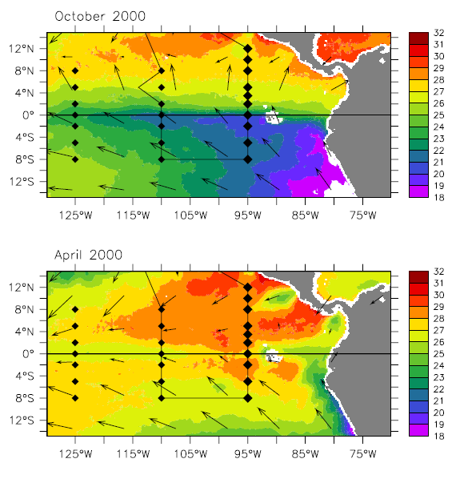

Figure 1. The EPIC mooring array is shown in relation to the September 1998 TRMM Microwave Imager SST and QuickSCAT wind fields. Diamonds indicate the locations of TAO buoys.

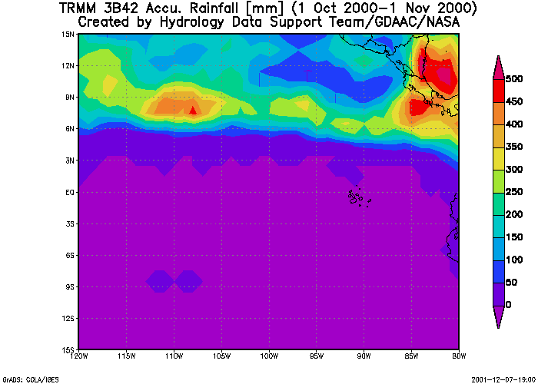
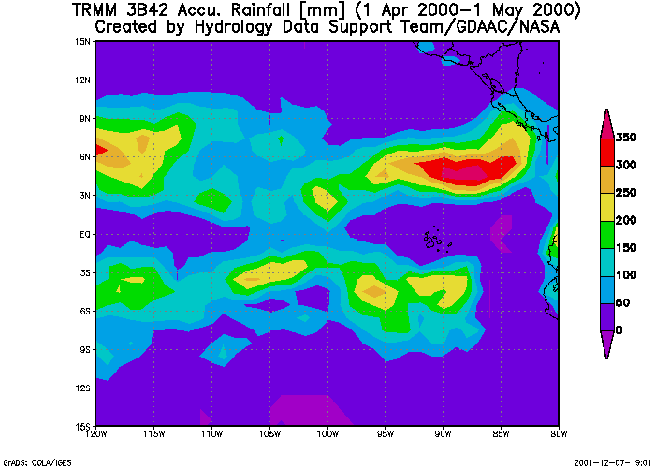

Figure 2. One-month rainfall accumulations from the TRMM 3B42 rainfall product for spring (a) and fall (b) 2000 cruises.
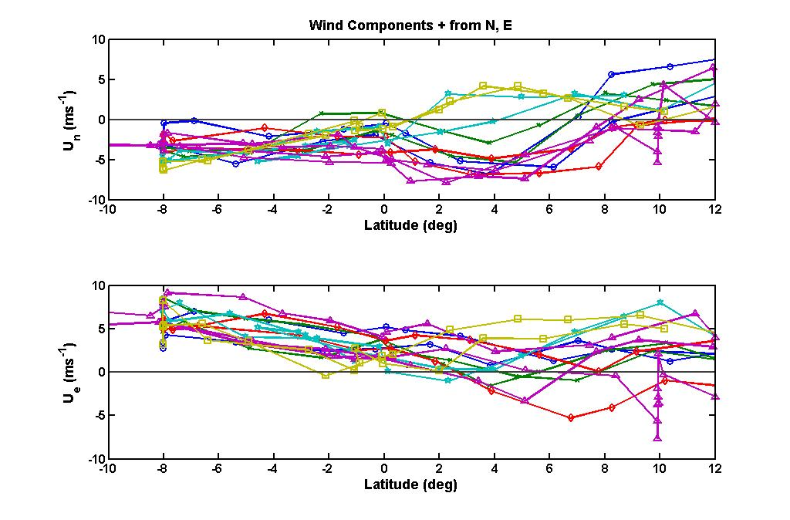
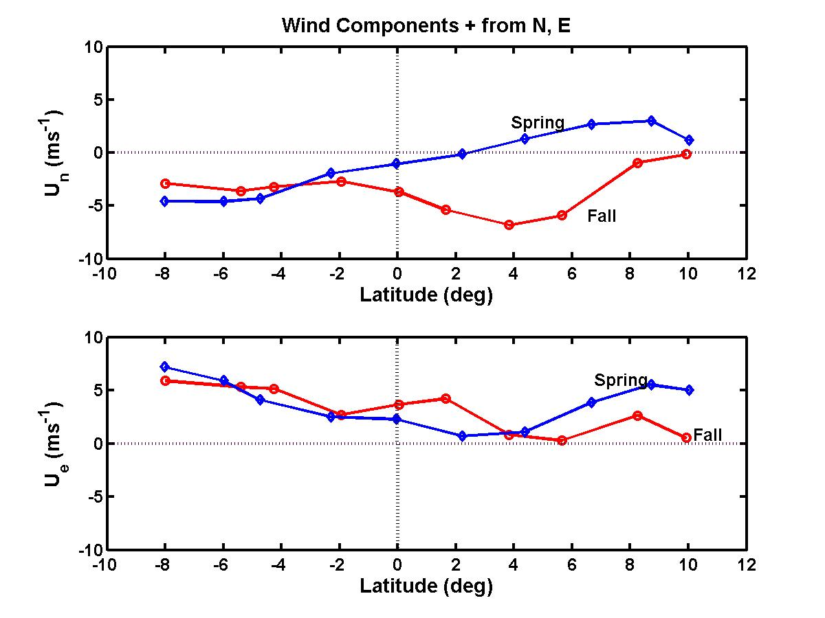
Figure 3. Wind components (northerly — upper panel; easterly — lower panel) from seven EPIC cruises. (a) Daily-averaged values, with each symbol representing a single cruise and includes both 110W and 95W longitudinal portions. (b) Latitude average values. Circle — fall; diamond — spring.
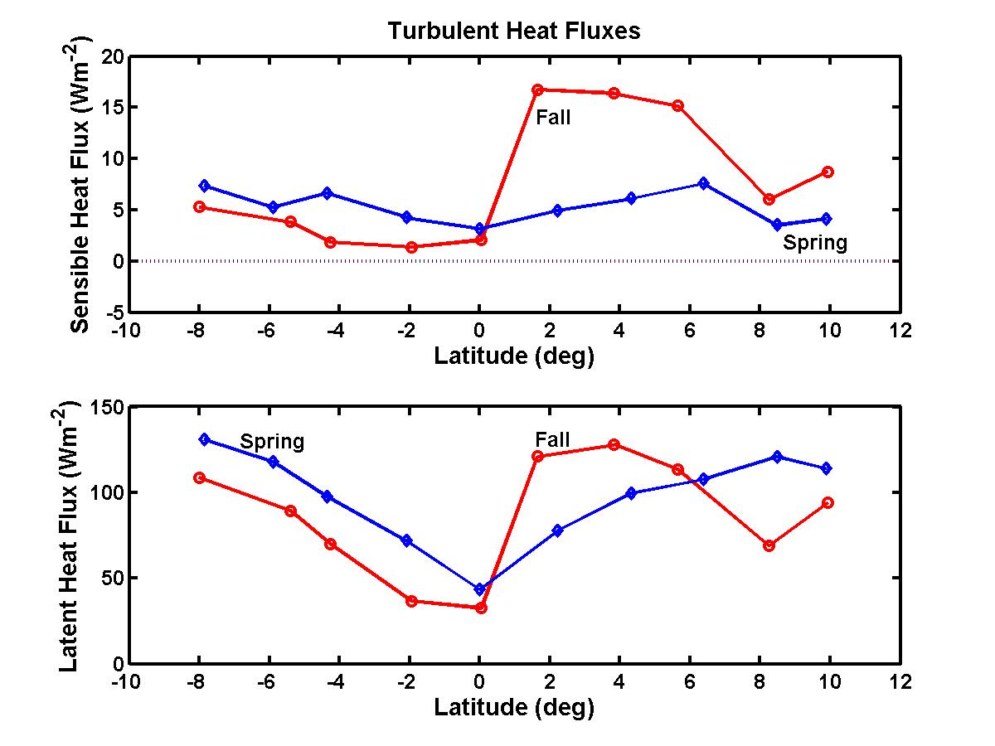
Figure 4. Latitude-averaged turbulent heat fluxes. Upper panel — sensible heat; lower panel — latent heat. Circles — fall; diamonds — spring.

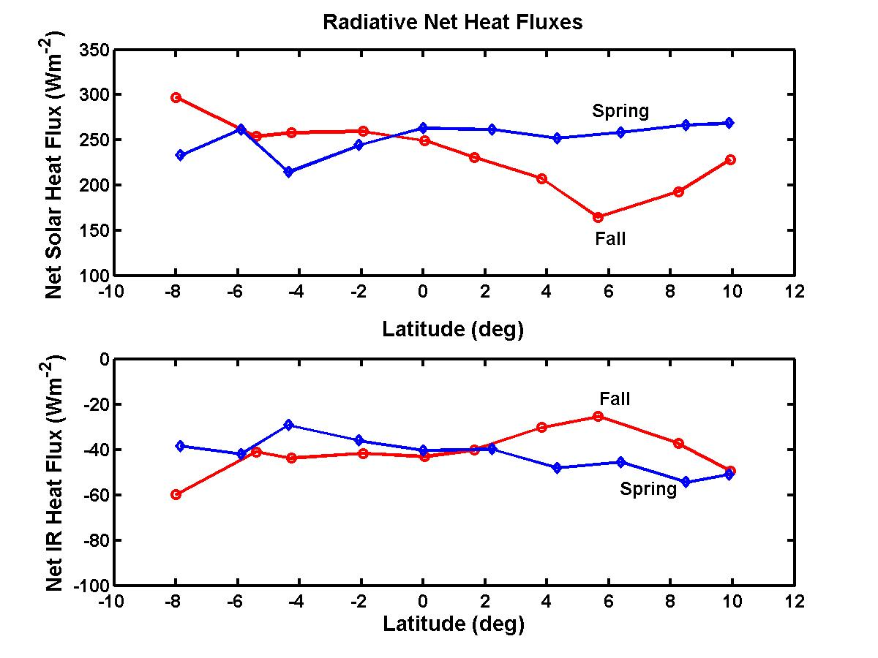
Figure 5. Latitude-averaged net radiative heat fluxes. Upper panel — solar flux; lower panel — IR flux. Circles — fall; diamonds — spring.

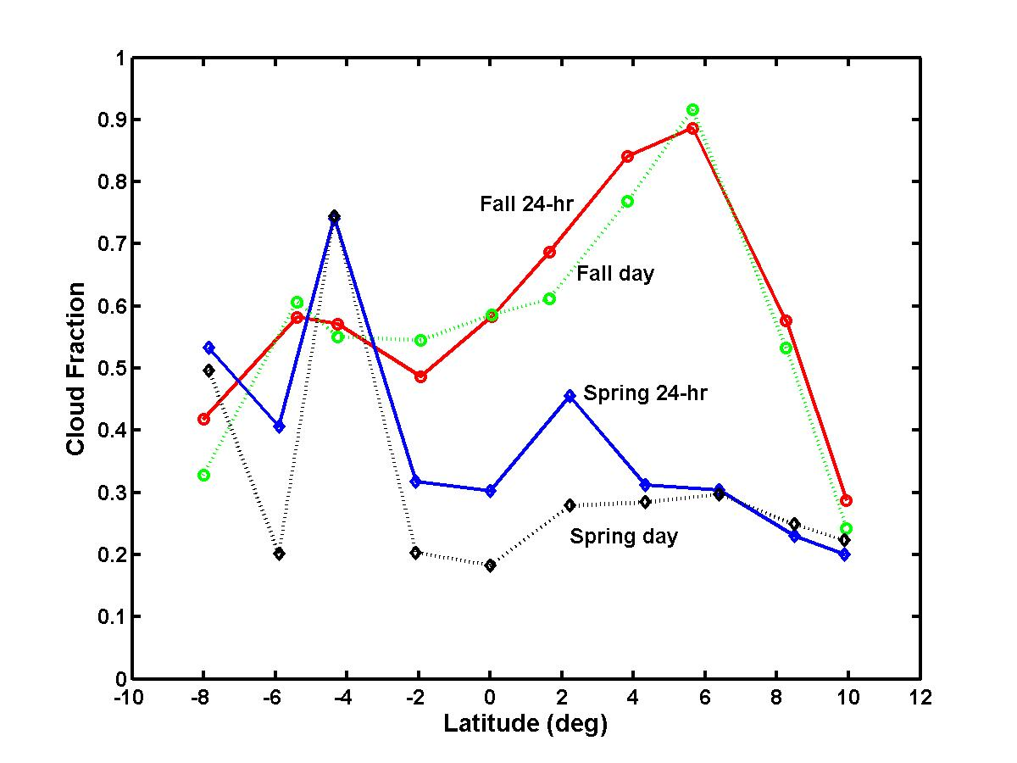
Figure 6. Latitude-averaged low cloud fraction. Circles — fall; diamonds — spring. Solid line — 24-hr average cloud fraction; dashed line — daytime average cloud fraction.

Figure 7. Latitude-averaged net clear-sky radiative heat fluxes using the models described in Appendix A. Upper panel — solar flux; lower panel — IR flux; circles — fall; diamonds — spring. The strange bump at 10N in the fall is caused by observations in the EPIC2001 project which occurred almost two months earlier than the typical fall monitoring cruise.
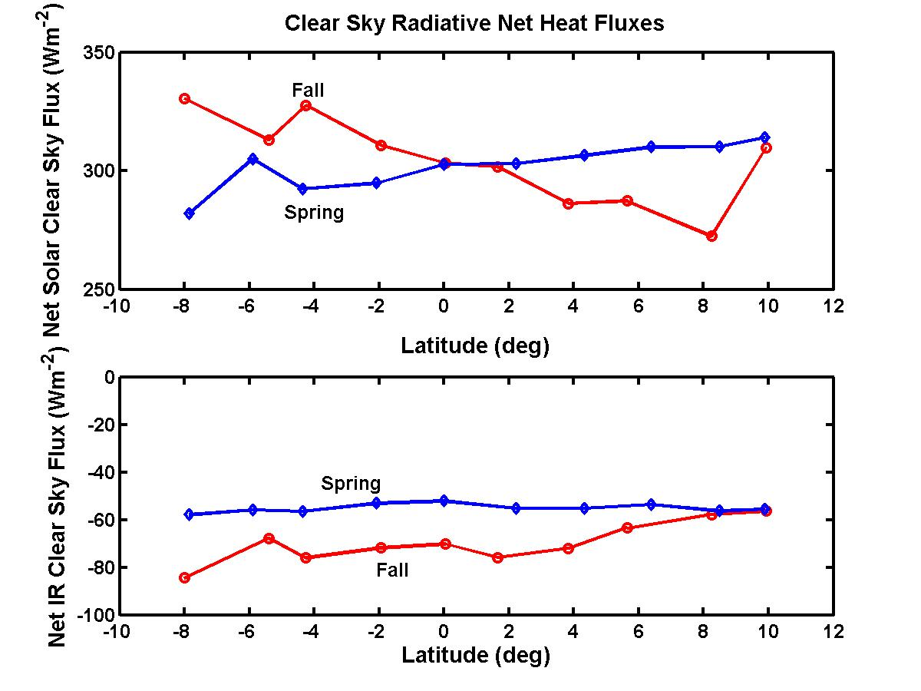
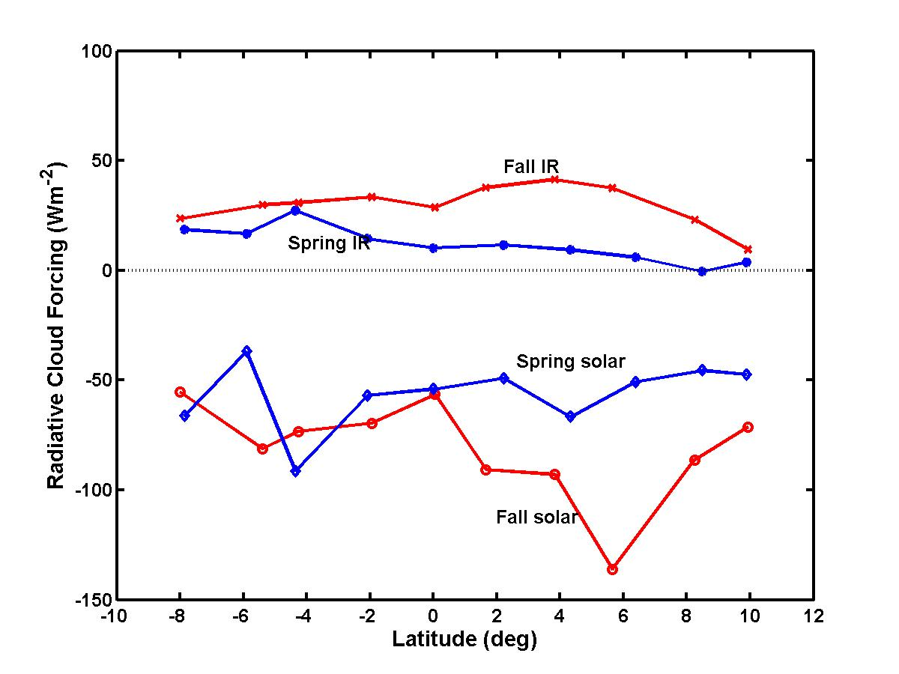
Figure 8. Latitude-averaged radiative surface SFC. x — fall IR flux; closed circles — spring IR flux; open circles — fall solar flux; diamonds — spring solar flux.

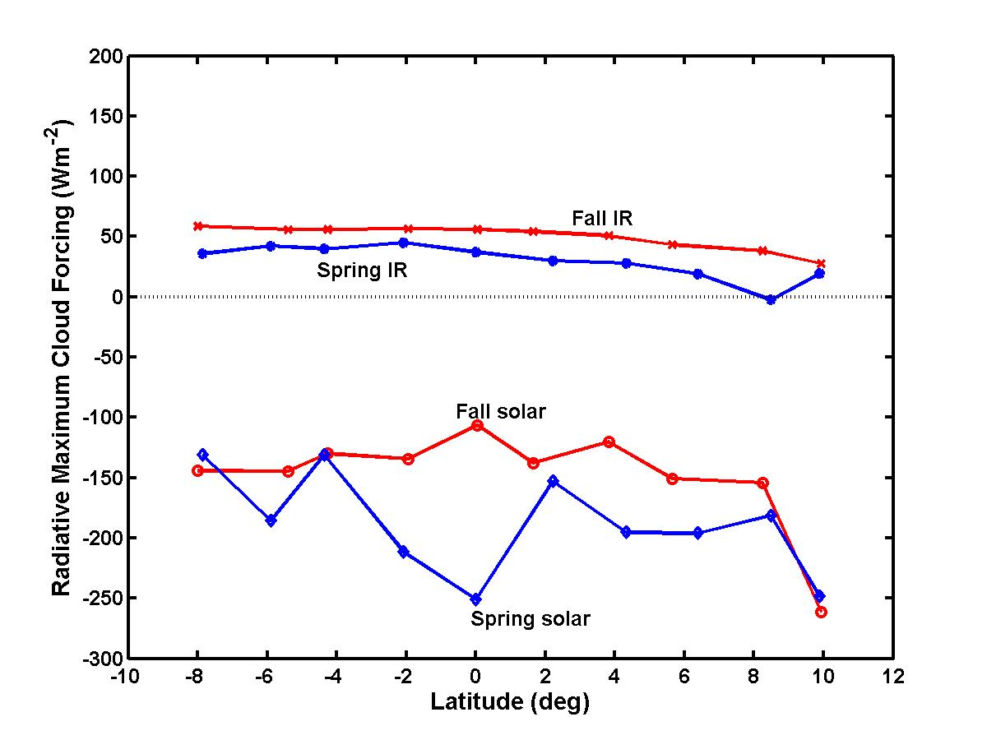
Figure 9. Latitude-averaged radiative surface maximum SFC computed via Eq. 2. x — fall IR flux; closed circles — spring IR flux; open circles — fall solar flux; diamonds — spring solar flux.

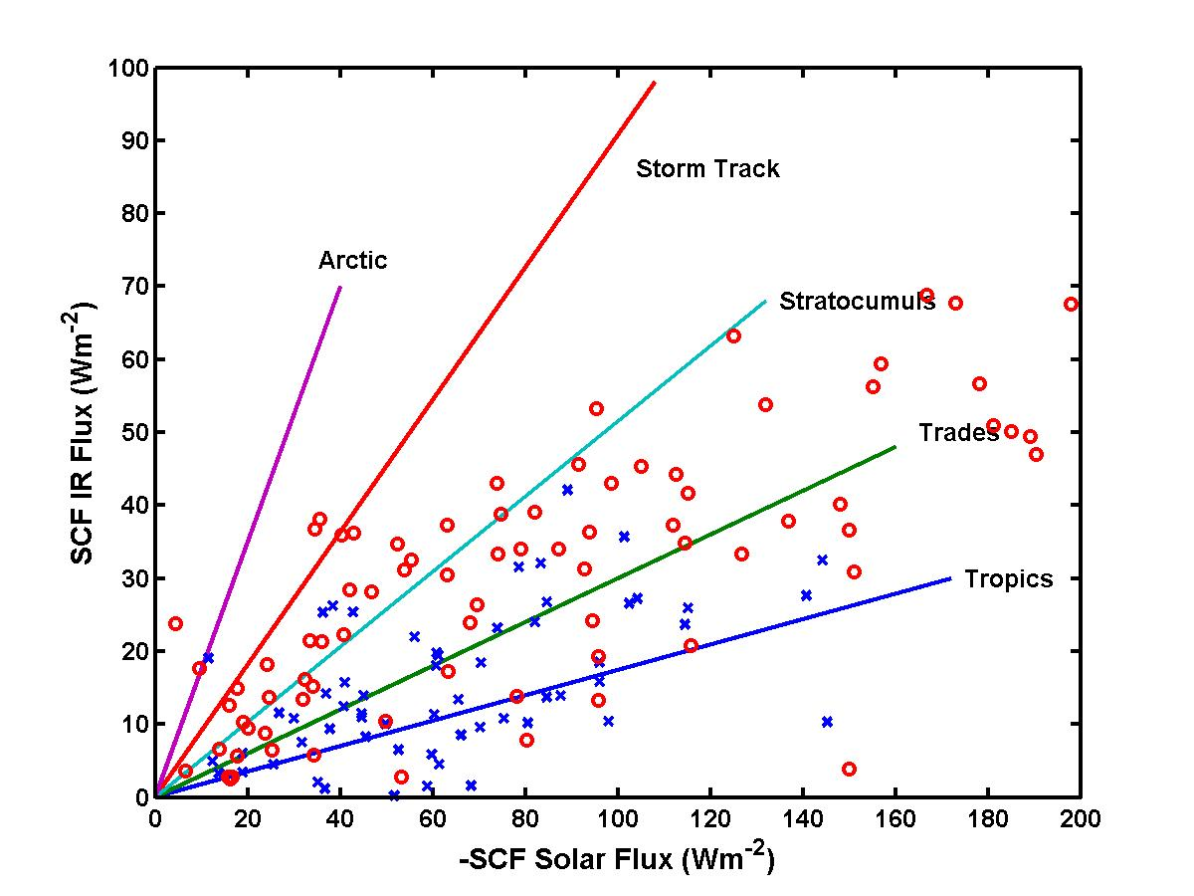
Figure 10. Cloud forcing phase diagram showing the balance of solar and IR SCF in different climate zones. An ensemble of individual days in a particular region tend to lie along a line where values near zero from small cloud fraction and values near the maximum are for cloud fraction near 1.0. Symbols are for the data from this analysis: Circle — fall; x — spring.
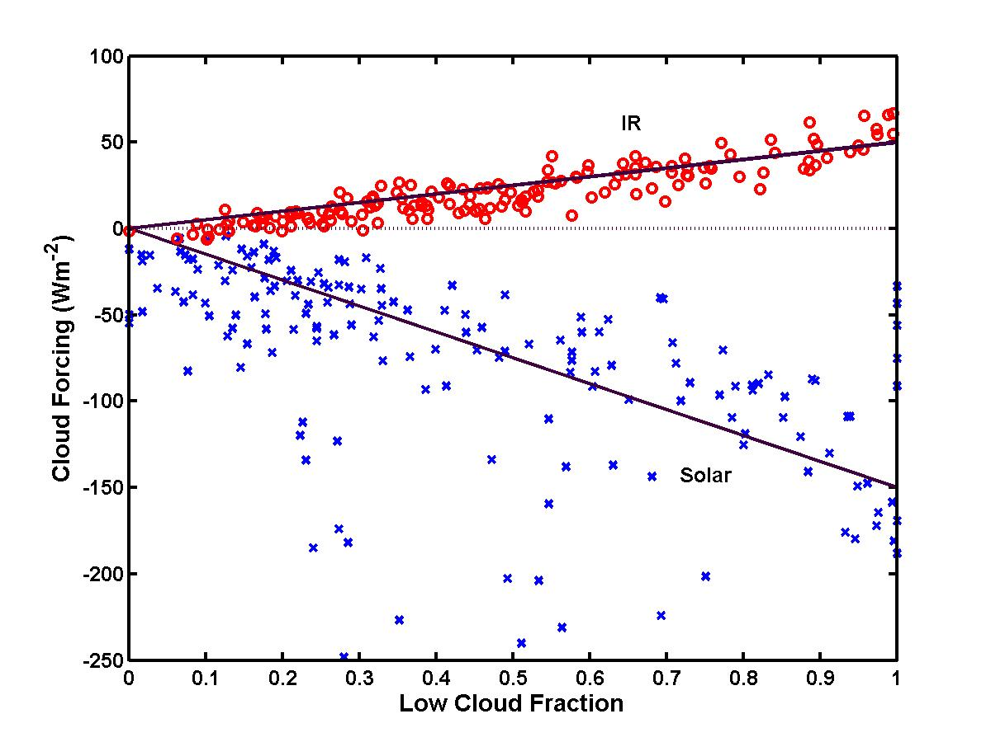
Figure 11. Daily-averaged SFC as a function of cloud fraction. Circle — IR; x — solar. The solid lines represent nominal MSFC values of 50 Wm⁻² for IR and -150 Wm⁻² for solar fluxes.

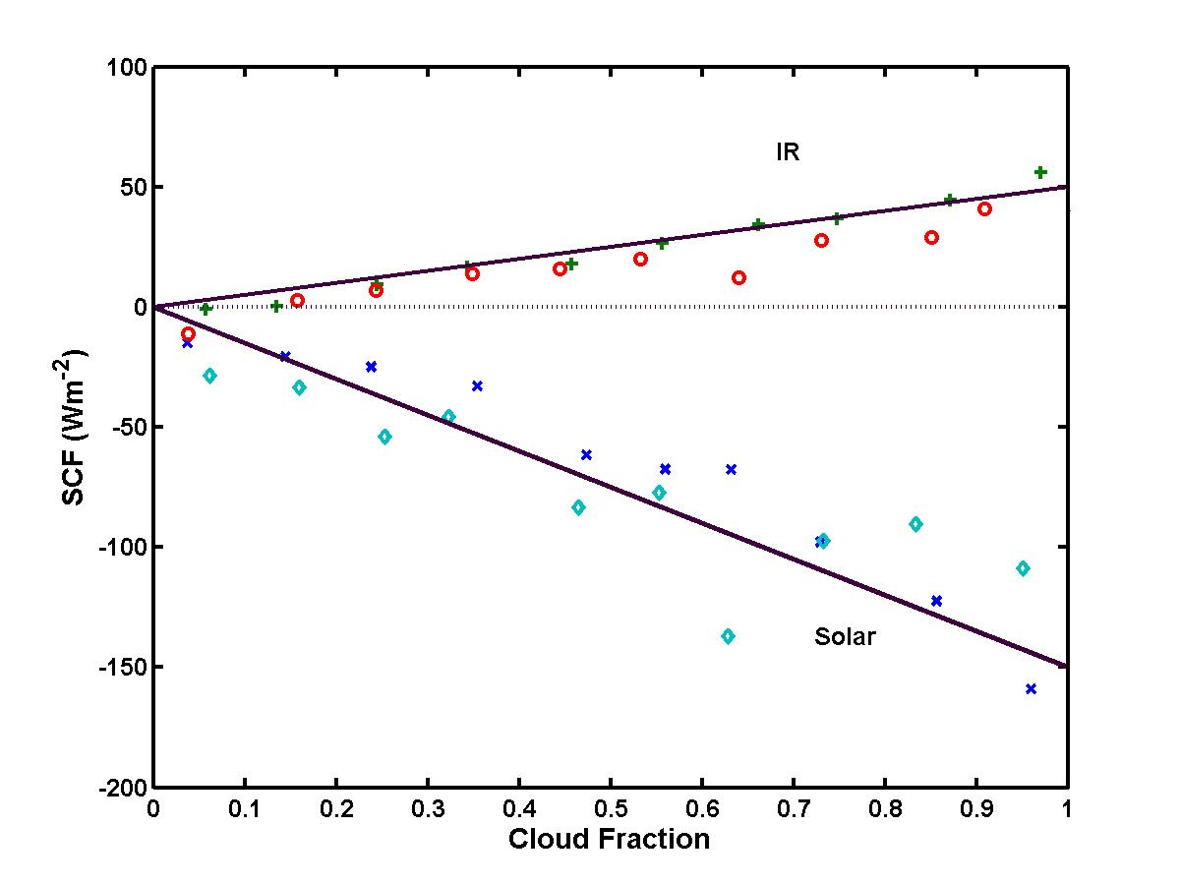
Figure 12. As in Figure 11, but the daily data have been averaged in bins of cloud fraction. Circles — spring IR; plus — fall IR; diamonds — spring solar; x — fall solar.

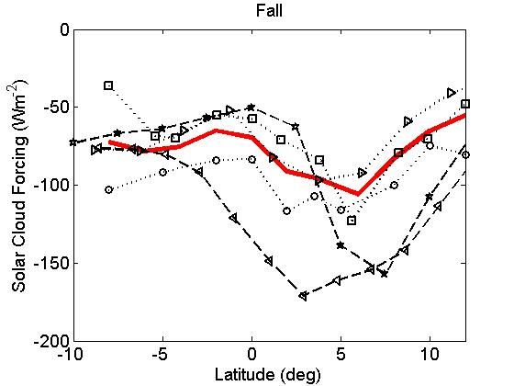
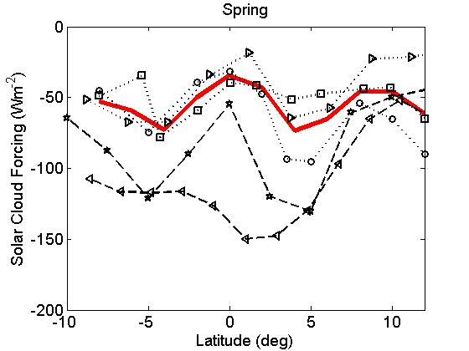
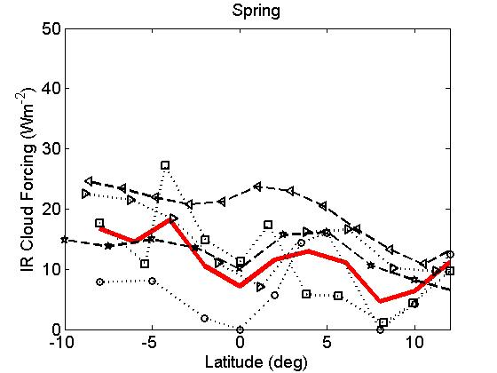
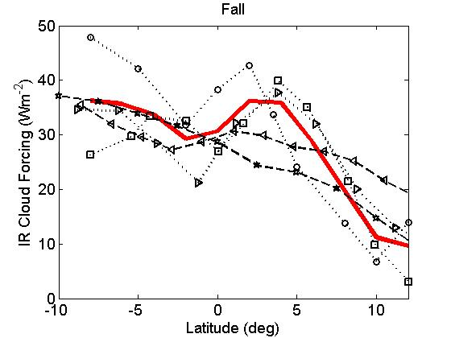

Figure 13. Cloud forcing as a function of latitude averaged of the spring and fall PACS cruises near the equator in the East Pacific: a) Fall Solar SCF, b) Fall IR SCF, c) Spring Solar SCF, and d) Spring IR SCF. The symbols for measurements are: TAO buoys – circle, ESRL ship data – square, ISCCP – right pointing open triangle, mean of these three – heavy solid line. The symbols for the reanalysis products are: NCEP2 – left pointing triangle, and ERA40 – star. ESRL data are computed from cruise averages; buoy, satellite, and NWP are computed from monthly averages in the cruise season window.

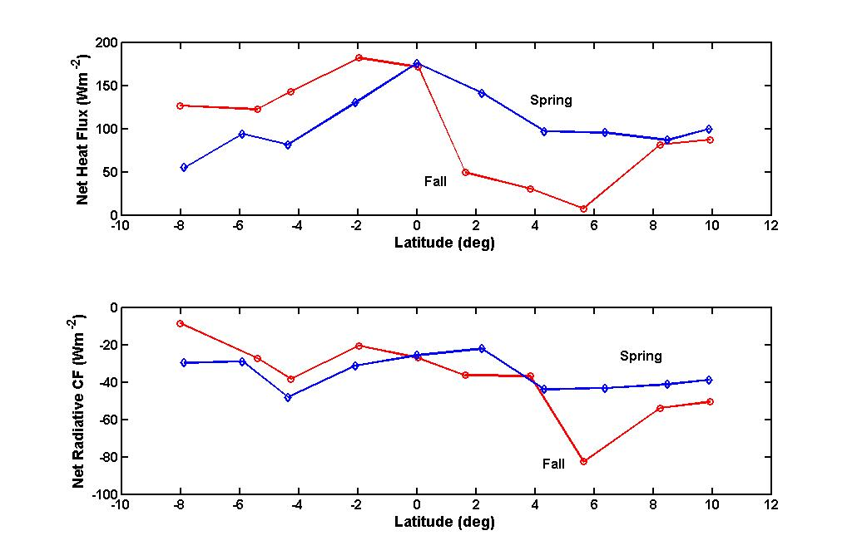
Figure 14. Latitude-averaged surface fluxes. Upper panel — net heat flux into the ocean; lower panel — contribution to the net heat flux accounted for by SCF. Circles —fall; diamonds — spring.
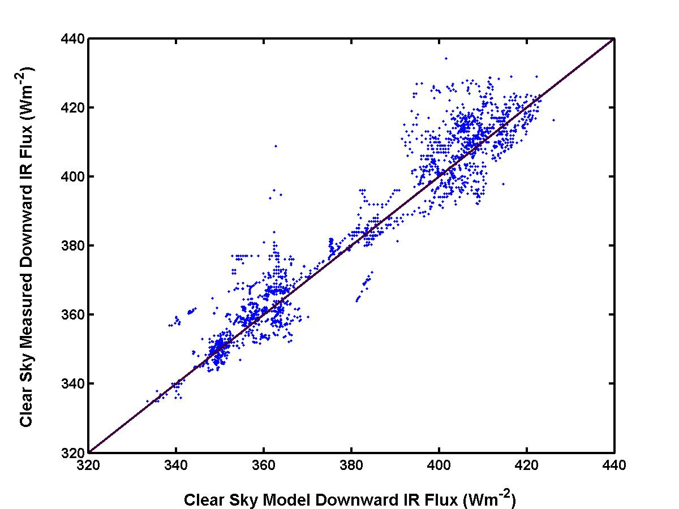

Figure A1. Comparison of clear-sky IR fluxes using model (x-axis) from Eqs. 4–5 and measurements (y-axis) for 60-min cloud free periods.

