


CONTENTS

- Instructor Planning Guide
- Enclosure 1: Instructor Planning Checklists
- PCMS Cardholder Course Pacing Guide
- Lesson 1: Introduction
- Lesson 2: Accessing and Navigating PCMS
- Lesson 3: Accounts and Profile Accounting
- Lesson 4: Reconciling Transactions
- Lesson 5: Reporting
- Final Assessment
- Report
- Quick Guides
- Micro-Purchase Guide

- PCMS User Guide

CONTENTS

- PCMS Cardholder Course Pacing Guide
- Lesson 1: Introduction
- Lesson 2: Accessing and Navigating PCMS
- Lesson 3: Accounts and Profile Accounting
- Lesson 4: Reconciling Transactions
- Lesson 5: Reporting
- Final Assessment
- Quick Guides
- Micro-Purchase Guide

- PCMS User Guide



Pacing Guide - PCMS Cardholder Training

The table below contains a Pacing Guide for delivery of the PCMS Cardholder Course using the materials provided. This Guide is intended to serve as a planning tool for instructors, and is not proscriptive in nature. It is constructed around an 8-hour training day, including breaks and a meal hour. Instructors should alter time intervals to accommodate students, facility limitations or any other relevant factors.

Topic / Event | Duration | Begin | End
Course Introduction & Orientation | :10 | 9:00 | 9:10
Ice Breaker | :20 | 9:10 | 9:30
Lesson 1 | :50 | 9:30 | 10:20
Break | :10 | 10:20 | 10:30
Lesson 2 | :70 | 10:30 | 11:40
Lesson 3 | :50 | 11:40 | 12:30
Lunch | :60 | 12:30 | 1:30
Lesson 4 | :90 | 1:30 | 3:00
Break | :10 | 3:00 | 3:10
Lesson 5 | :30 | 3:10 | 3:40
Final Assessment | :30 | 3:40 | 4:10



Lesson 1: PCMS Introduction

Lesson Description

The Introductory lesson is intended to provide PCMS Cardholders with background information regarding PCMS processes, so they understand how their role contributes in the procurement workflow, as well knowing what is expected of them as a cardholder and how to identify sources of help if necessary. This lesson will establish the basis of knowledge on which to build in subsequent lessons.

Training Objectives

At the conclusion of this lesson, PCMS Cardholders will be able to:

- To describe how cardholder responsibilities contribute to the Purchase Card Management workflow.
- To state the consequences of misuse of the card.
- To discuss in broad terms the functions a cardholder performs.
- To list proper and improper use of purchase cards and convenience checks.
- Identify where self-help information is located.

Methodology

This lesson will be delivered using a combination of lecture and presentation, and discussion. Group discussion and trainee interaction will be used to stimulate recall of policy information and establish a knowledge base on which to build in subsequent lessons.

References

- Departmental Regulation (DR) 5013-6, USDA\OPPM, September 2002;

Enclosures

(1) Cardholder PCMS User’s Guide, USDA\PSD, September 2005;
- PCMS\Micro-Purchase Guide, USDA\PMT, January 2003;
- Purchase Card Quick Guide to Proper Use of the Card and Convenience Checks, USDA\PMT, January 2003;
- PCMS Quick Guide to Understanding the Relationship Between 1099’s Tax Identification Numbers (TIN’s), and Budget Object Classification Codes (BOCC’s), USDA\PSD, January 2003;
- Cardholder PCMS Quick Guide for Reconciling Purchase Card Transactions, USDA\PSD, September 2001;

- Overview of PCMS
  - What is PCMS?
The Purchase Card Management System (PCMS) is the application through which the Bank of America and the USDA communicate to reconcile, manage and pay procurement transactions. The Bank of America is authorized by GSA to issue purchase cards and convenience checks to designated USDA personnel, called Cardholders, to make purchasing a more streamlined process.

ACFO\FS downloads purchase card transaction data from the bank. Automated transaction transfers are made to the Federal Foundation Information System (FFIS), where the payment process commences by processing account information. Payment files are then sent from FFIS to the Treasury, from which payments are made to the Bank for purchases billed. The cardholder reconciles transactions through PCMS.

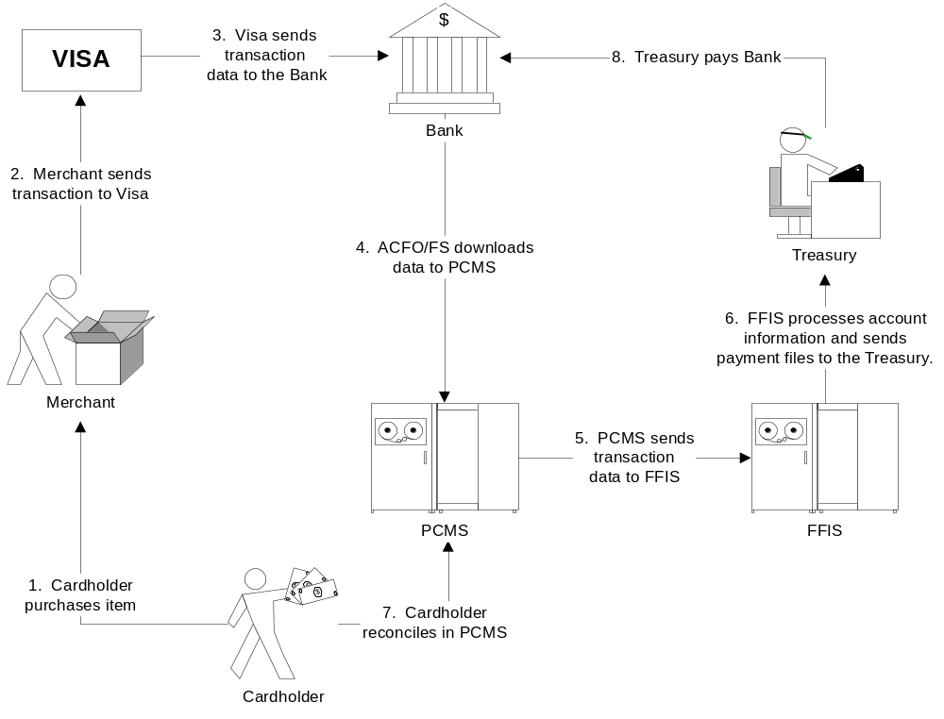

  - Purchase Card Program Hierarchal Structure

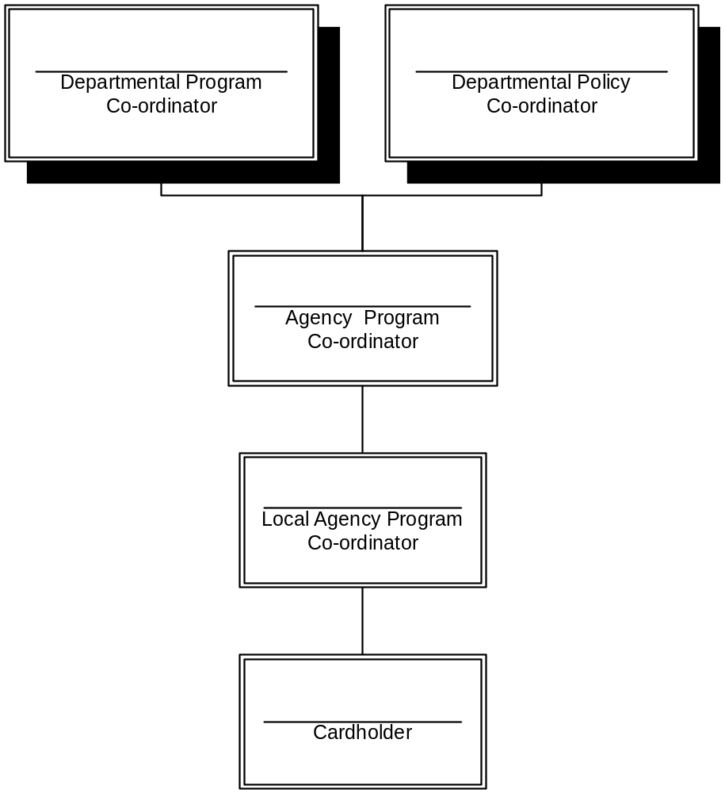
DPC – The Program Co-ordinator manages the USDA Purchase Card Management system. Establish APC’s and provide training and guidance. The Policy Co-ordinator manages Purchase Card policy issues.
APC – Oversee PCMS operations and establishes procedures and policies at the Agency level. Establish LAPC’s. Liaison with the DPC.
LAPC - Maintains PCMS daily operation and ensures cardholders adhere to policy. Facilitates establishment of Cardholders, and provides training and guidance within their designated area.
CH – Purchases authorized items for UDSA and Reconciles transactions in PCMS.

- Roles and Responsibilities

  - Workflow
Below is a depiction of the procurement workflow as it involves the Cardholder.

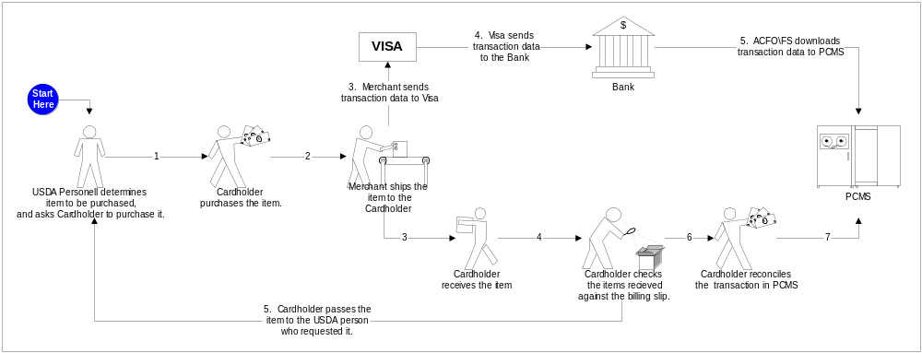

  - Cardholder Benefits and Responsibilities
The Cardholder's role is simply to purchase items on behalf of USDA personnel and ensure that all items have been received and the funds used for payment have been allocated correctly.

The benefits a cardholder provides to the team are:
- Ability to purchase requested items immediately
- Simplified procedure for those requiring the items
- Increased efficiency

The responsibilities of the cardholder are:
- Use the card within spending limits and Agency \ Departmental policies
- Keep the purchase card, checks and PCMS password secure
- Maintain documentation of purchases made
- Reconcile transactions in a timely manner and ensure all account information is correct
- Obtain all required information from the merchant at the time of making the purchase
- Investigate and resolve questionable or disputed transactions
- Return the purchase card and convenience checks to the LAPC when leaving their position
- Provide their Supervisor with periodic reports of purchase card and convenience check transactions. Supervisors shall review reports quarterly (or more frequently if required by agency procedures).

  - Proper and improper use of Purchase Cards and Checks

DO’s | DON’T’s
- Make purchases for official purposes only. | - Exceed your single or monthly purchase limits.
- Keep your card, checks and PCMS password secure. | - Split transactions.
- Reconcile transactions frequently (minimum of every 30 days). | - Use the card or check to make personal purchases.
- Pay sales tax if requested by Merchant. First, inform the Merchant the purchase is for the USDA and provide a tax exemption letter available at www.fss.gsa.gov/services/gsa-smartpay/taxletter | - Use it to provide salary payments.
- If using convenience checks to make a purchase, obtain the Merchant’s TIN or USDA employee’s number. | - Use it to make cash and\or travel advances.
- Use the Purchase card first, and use checks only when the card is not accepted. | - Use it to make cash awards.
- Immediately notify the Bank of a lost or stolen card.

Notes:

  - Cards v. Checks
- Convenience checks are authorized for use only:
  - When a merchant will not accept a purchase card
  - Emergencies where the card is not a viable solution
  - At least one of the Debt Collection Improvement Act (DCIA) waivers are satisfied
- The Cardholder must obtain a Merchant’s Tax ID Number (TIN) when using a check, this must be entered into PCMS when reconciling the transaction
- Convenience check transactions are reconciled using the same process as transactions made using a Purchase Card, but cannot be disputed

Notes:

  - LAPC Role
What can you expect from your LAPC?
        - Training, guidance and support
        - They will work with you, and the APC to resolve transaction issues
        - Monitoring of PCMS transactions at the end of the month to ensure they have reconciled at least every 30 days by cardholders
        - They will perform audits on transactions if they receive notification of possible incorrect or inappropriate use of a purchasing card
        - They will change your single or monthly purchase limit if necessary
        - The will remove Cardholder privileges if transactions are not reconciled within 30days

Notes:

- Information Sources

  - User manual
The PCMS Cardholder User Manual is available for download on the USDA website at:
http://www.usda.gov/procurement/card/pcms/training.htm#chtraining under the ‘Cardholder Training Materials’ section.

  - Quick guides
Quick guides to assist the cardholder with specific PCMS issues are available for download on the USDA website at:
http://www.usda.gov/procurement/card/pcms/training.htm#chquick under the ‘Cardholder Quick Guides’ section.

  - DR 5013-6
The Departmental Regulation regarding Micro-Purchase policy is available for download at:
http://www.usda.gov/procurement/card/pcms/training.htm#chreference under the ‘Cardholder Reference Materials’ section.

  - Micro-Purchase Guide
The PCMS Cardholder policy guide is available for download on the USDA website at:
http://www.usda.gov/procurement/card/pcms/training.htm#chreference under the ‘Cardholder Reference Materials’ section.

  - FAQ’s
Purchase card frequently asked questions and answers can be found on the USDA website at:
http://www.usda.gov/procurement/card/pcms/faqs.htm

  - LAPC
Your LAPC should always be your first point of contact. They will escalate an issue to the APC if necessary, who will in turn contact the helpdesk if required.

Your area LAPC is:
Contact details:

- Summary and Review.


Please turn off your monitor and give your attention to the instructor.


Lesson 2: Accessing and Navigating PCMS

Lesson Description

Lesson 2 will equip Cardholders with knowledge and information necessary to successfully access PCMS, navigate the menus and screens. Becoming familiar with the PCMS screens and layout will provide the Cardholder with a foundation on which to build specific knowledge in subsequent lessons.

Training Objectives

At the conclusion of this lesson, PCMS Cardholders will be able to:

      - Demonstrate accessing PCMS and maintaining passwords.
      - Navigate PCMS using menus and tools.

Methodology

This lesson will be delivered using a combination of lecture, demonstration and Instructor-led exercises. Practical exercises and testing will be utilized to measure the level of individual and group achievement of the Training Objectives outlined above, and the overall effectiveness of this training program.

References

None.

Enclosures

- Cardholder PCMS User’s Guide, USDA\PSD, September 2005;
- Cardholder PCMS Quick Guide for Reconciling Purchase Card Transactions, USDA\PSD, September 2001;

  - Logging On\Off PCMS

Please turn off your monitor and give your attention to the instructor.

  - Opening the PCMS Application
The PCMS application is web based. To open the application, open an Internet Explorer browser and access the USDA PCMS web page at http://www.nfc.usda.gov/corporate/PCMS.htm.

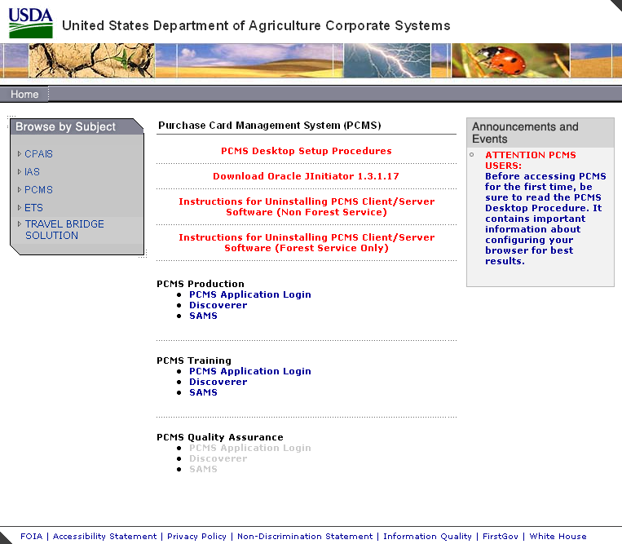

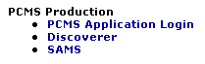
            - Click on the active PCMS Application Login link under

the PCMS Production heading..

An Oracle Forms Runtime window will open in another browser.
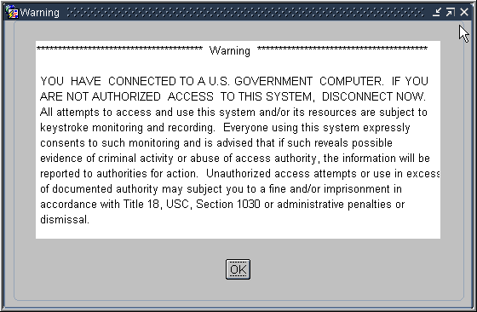
            - Click on the security message.

The Logon dialog box opens.

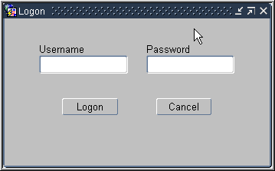


In production you will use the PCMSv5 Prod database. In training you will use the PCMSv5 Training Database.

You must be logged onto the network to access the transaction data on the server.

If the application cannot be opened:
      - Contact the PCMS Helpdesk
      - Inform your LAPC

  - Logging ON
A PCMS UserID and Password will be provided by your LAPC at the completion of Cardholder training, to enable access to the Production Database. For training purposes please use the training ID and password provided by your instructor to log on to the training database.

            - Enter your username and password in the logon dialog box and click .

The Main Window opens.

If you experience problems logging on to PCMS:
      - Check your UserID and Password are correct
      - Contact your LAPC

  - Logging OFF
To exit PCMS, click .
or
Click the ‘X’ in the top right hand corner of Internet Explorer browser.

Clicking the ‘X’ on the main window will not close the application.

Notes:

  - Passwords

Please turn off your monitor and give your attention to the instructor.

- How to change a system password.
Click Change Password on the PCMS main menu at the top of the screen. The change password dialog box opens with your username displayed.

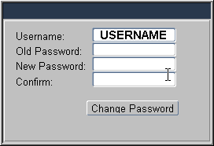

Type your old password and then your new one. Type the new password once again to confirm you've entered it correctly. Note that the passwords will appear as asterisks. Click . Your new password will be in effect the next time you log on to PCMS.

The following are password requirements:
- A password must be at least 6 alphanumeric characters in length
- Must start with a letter
- Must include at least one number
- Cannot contain spaces
- Must be different by at least 3 characters from the previous password

Every 90 days your password expires and must be changed. If your password is within five days of expiring, a notification message will appear every time you log in to PCMS until the expiration date.

- Troubleshooting tips.
If you experience problems logging on please refer to the troubleshooting tips below to try to determine the cause and contact your LAPC.

Error Message | Explanation | Resolution
Password must be at least 6 characters and include one numeric value. | - UserID or Password may have been entered incorrectly.  - May be a problem with your user account | a. Check you have entered the information correctly. Re-enter details and try to log on again.  b. Contact your LAPC to determine if there is a problem with the account.
Please enter a valid UserID\password. | - Username and password entered three times unsuccessfully, as a result the account has been locked out.  - The PCMS system is down. | - Contact your LAPC to remove the locked status. .  - Contact your LAPC.
Password not changed. | The 90 days has expired and you didn't change your password. You will not be able to log onto the system as your old password is no longer valid | Contact your LAPC to reset your password.
Password cannot be reused. | The new password is the same as the previous password. | a. Try to change the password again ensuring the new password has at least 3 characters different from the previous password.  b. Contact your LAPC to determine if there is a problem with the account.

- Password Security
          - Select a password you will remember and keep it secure
          - DO NOT give your PCMS password to any other person
          - If you suspect someone may have access to your password then change it
          - Account lockouts occur to prevent people from trying to guess your password
          - Unique passwords are required to keep your password more secure

Notes:


PRACTICAL EXERCISE

1. Log on to PCMS Training Database using the trainee UserID and Password provided to you by your instructor.

2. After logging change your password to: trainee

3. Log out of PCMS.

- Log on to PCMS again using your new password.

  - Menus

Please turn off your monitor and give your attention to the instructor.

- Main Window

This is the main window in PCMS. The Bulletin Board located in the center of the window provides up to date news about PCMS. For example, this message indicates which database you are connected to.

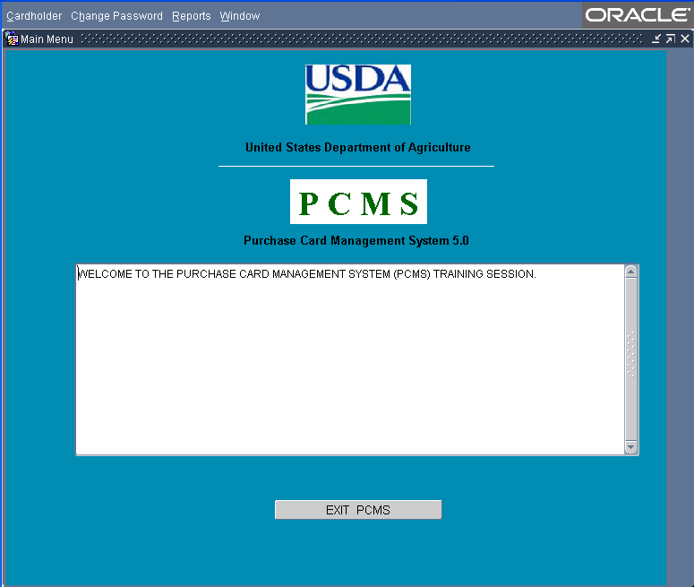

The Procurement Systems Division (PSD) uses this area to distribute system information such as upgrades, downtime, or notification of specific system problems.
It is important to read these messages.

- Main Menu

The main menu provides access to the major functions of PCMS.

Cardholder | 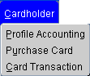 | Provides options for PCMS Cardholders to reconcile accounts and perform related functions.
Change Password | 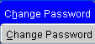 | Change PCMS passwords.
Reports | 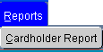 | Generate Cardholder reports.
Window | 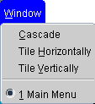 | Customize the Window display. Navigate between open PCMS windows.

Notes:

- Navigation Quick Guide

Main Window
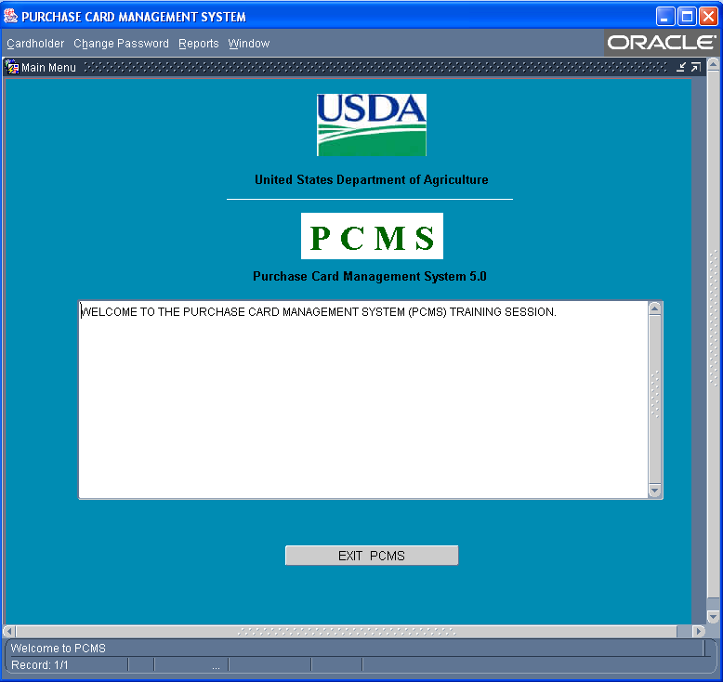
Main Menu. Provides access to main functions in PCMS.
Figure 1 Main Window

Bulletin Board. Displays news and messages about PCMS.

Exit Button. Closes application

Status Bar. Displays messages about the status of the current window.

Form Window
Form Sub-Menu. Appears when you open a window from the main menu.
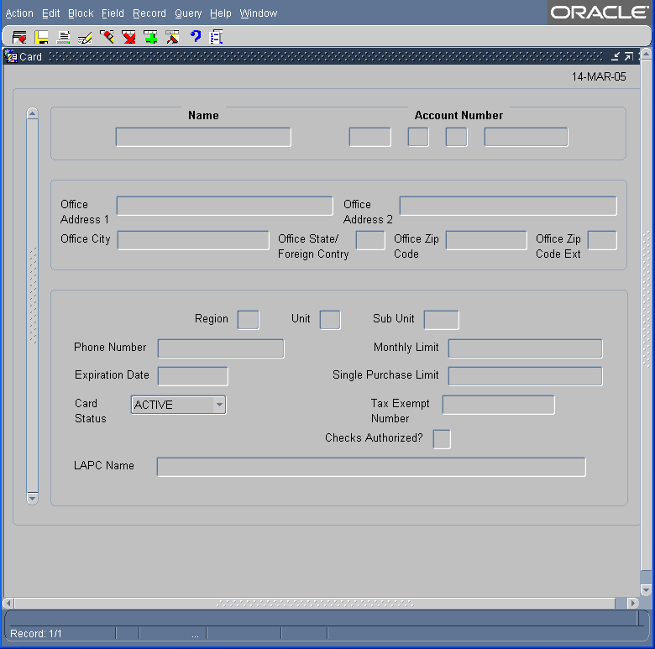
Busy Signal. Line scrolls across the right side of the status bar when the system is retrieving data.
Command Bar. Provides buttons to initialize or confirm actions.
Status Bar. Provides messages about the status of the current window.

Figure 2 Form Window

  - Sub-Menu

The sub-menu appears when you select one of the options from the Cardholder menu. This menu provides options for performing data query and data entry functions.

Action | 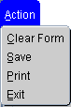 | Options to take action on a transaction, such as save data or print.
Edit |  | Options to edit text in the selected field.
Block | 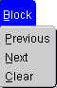 | Options to move between major sections of the window.
Field | 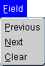 | Options to move the cursor between fields.
Record | 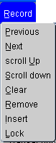 | Options to navigate and manipulate transactions.
Query | 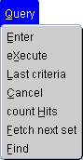 | Options to query the data and find records matching search criteria
Help | 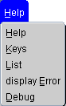 | Options for help and program shortcuts.  Note: The Help function is not available at this time.
Window | 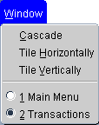 | Options to change how the windows are displayed.

Notes:

    - Tools

- Command Bar

The command bar appears on every window for the Cardholder menu options. The command bar contains a row of command buttons that are used to initialize or confirm actions in PCMS.

Clear Form |  | Clears all data in the form.
Save |  | Saves changes to the database.
Print |  | Prints the screen.
Edit |  | Edit a field.
Clear |  | Removes the transaction information from the screen. Any unsaved changes will be lost. A cleared record is not deleted from the database.
Remove |  | Removes a line of accounting in the Profile Accounting screen.
Insert |  | Inserts a new record after the current record.
Find |  | Search functions.
Help |  | Displays a brief message about the current field.  Note: The Help function is not available at this time.
List |  | Opens a dialog box for selecting valid field entries. The text, “List of Values” appears in the status bar at the bottom of the screen when your cursor is in a field that accepts list values.

- Navigation

There are several options for navigating through information in the PCMS windows.

Moving From Record to Record:
- Click Record on the main menu and select Next or Previous to move between records
- Use the scroll bar on the left of the screen.
- Scrollbars only become active when there is more information than the field can display.

Moving From Field to Field:
- Click Field on the main menu and select Next or Previous
- Use the Tab button on your keyboard
- Click in the field using the mouse

- Executing a Query

Retrieving information from the database is called executing a query. You can enter a query using the steps described below.

Retrieving All Records:
- Click on the Command bar twice to query all records attached to the current user ID

Retrieving Specific Records:
- Click on the Command bar once
- Type the values you want to match in the appropriate fields
- Click again
- Follow instructions above to navigate through records and fields

Wildcard (%):

The wildcard allows you to search for a partial value. For instance, if you are not certain how a name is spelled when searching on Merchant Name, use the wild card to replace single or multiple letters or numbers.

For example, when searching for the Merchant Name “Toshiba” replace “oshiba” with the % to return all records beginning with “T”. You can query with the wildcard three different ways, for example: %oshiba, Tos%, or %osh%. The window will populate with all records matching your search criteria.

- Lists
Some fields in the PCMS entry windows have lists from which the user may select valid field entries. If <List of Values> is displayed in the status bar at the bottom of the window, a list of values is available for the current field. To access the list, click on the command bar. A dialog box opens displaying the choices for the specific field. Scroll to highlight the item you want to select and click . The dialog box closes and the value appears in the applicable field.

Notes:

- System Edits
The following questions are to be answered in an instructor led group exercise and review session:

Please turn off your monitor and give your attention to the instructor.

If data is entered incorrectly, or an attempted function is not allowed, the system will generate an error message. Error messages appear in dialog boxes and provide information that will help you determine how to proceed.

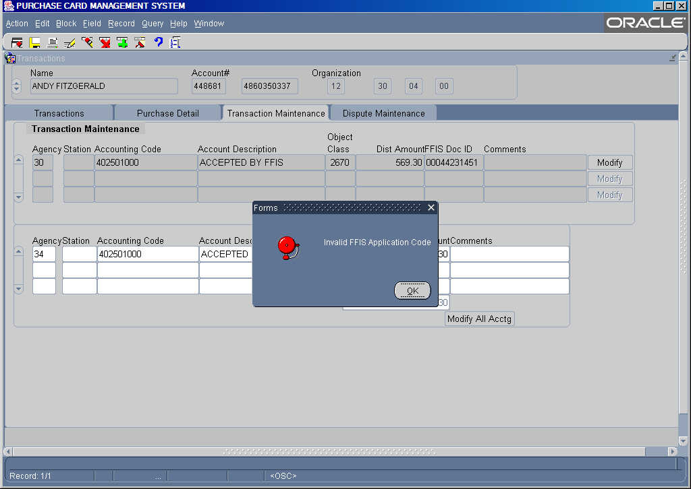
For Example, when an incorrect account code is entered in the Card Transactions screen the following error message is generated:

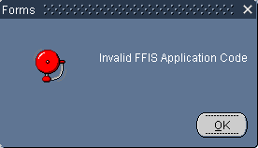

Click OK to close the error message.
In this example, the error message indicates that data entered in a field is not recognized by the PCMS system and needs to be corrected.

- Summary and Review
The following questions are to be answered in an instructor led group exercise and review session:

Please turn off your monitor and give your attention to the instructor.

      - Which menu is used to customize the window display?

      - What are the steps to changing a password? (Class walks the instructor through the steps)

      - Where can you query card transactions? (Class walks the instructor through the steps)

      - Where are print options located if I want to print a screen? (Class walks the instructor through the steps)

      - You receive an error message when reconciling a transaction:

What is the likely cause of the problem and what steps do you need to take to resolve it? (Walk the instructor through the steps)

- How does the DPC distribute system information, such as system upgrades, to the cardholders?

