 |  |  | Proposal Cover Page  Date: 4/29/2002 |  |  |  |  | NRA-02-OES-02  Proposal Number:  (Leave blank for NASA use)
Name of Submitting Institution: |  |  |  | NASA Ames Research Center |  | Congressional District: |  | California #14
Proposal Title: | Airborne Sunphotometry in the Second SAGE III Ozone Loss & Validation Experiment (SOLVE-2)

Certification of Compliance with Applicable Executive Orders and US Code
By submitting the proposal identified in this Cover Sheet/Proposal Summary in response to this Research Announcement, the Authorizing Official of the proposing institution (or the individual proposer if there is no proposing institution) as identified below:
- certifies that the statements made in this proposal are true and complete to the best of his/her knowledge;
- agrees to accept the obligations to comply with NASA award terms and conditions if an award is made as a result of this proposal; and
- confirms compliance with all provisions, rules, and stipulations set forth in the two Certifications contained in this NRA [namely, (i) Assurance of Compliance with the NASA Regulations Pursuant to Nondiscrimination in Federally Assisted Programs, and (ii) Certifications, Disclosures, And Assurances Regarding Lobbying and Debarment & Suspension].
Willful provision of false information in this proposal and/or its supporting documents, or in reports required under an ensuing award, is a criminal offense (U.S. Code, Title 18, Section 1001).

NASA PROCEDURE FOR HANDLING PROPOSALS
This proposal shall be used and disclosed for evaluation purposes only, and a copy of this Government notice shall be applied to any reproduction or abstract thereof. Any authorized restrictive notices that the submitter places on this proposal shall also be strictly complied with. Disclosure of this proposal for any reason outside the Government evaluation purposes shall be made only to the extent authorized by the
Principal  Investigator Name: |  | Philip B. Russell |  |  | Authorized Institutional Official Name: |  | David L. Peterson
Organization: |  | NASA Ames Research Center |  |  | Organization: |  | NASA Ames Research Center
Department: |  | Atmospheric Chemistry and Dynamics Branch |  |  | Department |  | Earth Science Division
Mailing Address: |  | MS 245-5 |  |  | Mailing Address: |  | MS 245-4
City, State Zip: |  | Moffett Field, CA 94035-1000 |  |  | City, State Zip: |  | Moffett Field, CA 94035-1000
Telephone Number: |  | 650-604-5404 |  |  | Telephone Number: |  | 650-604-5899
Fax Number: |  | 650-604-6779 |  |  | Fax Number: |  | 650-604-3625
Email Address: |  | prussell@mail.arc.nasa.gov |  |  | Email Address: |  | dpeterson@mail.arc.nasa.gov
Principal Investigator Signature: |  |  |  |  | Authorized Institutional Official Signature:
Date: |  |  |  |  | Date:

Co-Investigators:
Name | Telephone |  |  | Email | Institution | Address
Beat Schmid | 650-604-5933 |  |  | bschmid@mail.arc.nasa.gov | Bay Area Environmental Research Institute | Sonoma, CA 95476
John M. Livingston | 650-859-4174 |  |  | jlivingston@mail.arc.nasa.gov | SRI International | Menlo Park, CA 94025
Jens Redemann | 805-658-2637 |  |  | jredemann@mail.arc.nasa.gov | Bay Area Environmental Research Institute | Sonoma, CA 95476
Budget: |  |  | (Cost reductions are possible depending on availability of: (1) extra seats and/or shipping boxes on DC-8 transit flights, and/or (2) military or special housing at Edwards and deployment locations.)
Year 1: $171.0K
(FY02: 15.4K, FY03: 155.6K)
Total: $171.0K

TABLE OF CONTENTS
Page
ABSTRACT 1
1 OBJECTIVES AND JUSTIFICATION 1
2 AIRBORNE SUNPHOTOMETER AND SAGE MEASUREMENTS AND ANALYSES 3
2.1 SAGE and Sunphotometer Aerosol and Thin Cloud Measurements And Analyses 4
2.2 SAGE and Sunphotometer Water Vapor Measurements And Analyses 6
2.3 SAGE and Sunphotometer Ozone Measurements And Analyses 8
2.4 Sunphotometer Error Analyses, Simulations, and Calibrations 9
3 PROPOSED RESEARCH AND MANAGEMENT PLAN 13
3.1 Staffing and Management 13
3.2 Proposed Tasks 13
3.3 Schedule 14
4 REFERENCES 14
5 BUDGET 18
6 VITAE 20
7 CURRENT SUPPORT 26
8 ILLUSTRATIONS 28
APPENDIX: Ames Airborne Tracking Sunphotometers, AATS-6 and AATS-14 A1

Airborne Sunphotometry in the Second SAGE III Ozone Loss & Validation Experiment (SOLVE-2)

ABSTRACT: We propose to participate in SOLVE-2 using the 14-channel Ames Airborne Tracking Sunphotometer (AATS-14) on the NASA DC-8. AATS-14 has channels matched to many SAGE III wavelengths from 380 to 1558 nm. It can measure optical depths of aerosols and polar stratospheric clouds (PSCs), plus column contents of water vapor and ozone, by viewing the sun on paths matched to those viewed by SAGE III. In aircraft vertical profiles AATS-14 can derive profiles of aerosol extinction and water vapor and ozone concentrations by vertically differentiating the corresponding profiles of optical depth and column content. AATS-14 has been integrated and test-flown on the DC-8. Hence AATS-14 is ideally suited to the objectives of SOLVE-2. Its use in SOLVE-2 would benefit from our experience in flying its predecessor, AATS-6, on the DC-8 in the second Airborne Arctic Stratospheric Expedition (AASE-II), and from our long experience in the validation and scientific use of SAM II, SAGE, and SAGE II.

A key issue is the ability of AATS-14 to measure the very small optical depths of background stratospheric aerosols, as well as PSCs. Simulations made for this proposal indicate AATS-14 retrieval uncertainties of <25% for midvisible optical depths of background stratospheric aerosols (τ(500 nm)=0.004) and <5% for PSCs (τ(500 nm)=0.02), assuming accurate airmasses and high-latitude DC-8 measurements during the SOLVE-2 period (January-mid-February). For the funding requested here we propose to: (1a) Conduct further pre-campaign simulations and tests to determine expected sunphotometer retrieval uncertainties for aerosols, PSCs, ozone, and water vapor for the specific conditions and aircraft paths expected in SOLVE-2. (1b) Combine simulation results with campaign objectives to determine the flight plans likely to have the highest overall payoff. (2) Perform necessary pre- and post-campaign calibrations. (3) Re-integrate AATS-14 on the NASA DC-8. (4) Make measurements in SOLVE-2 deployments of aerosol and PSC optical depth spectra, ozone and water vapor column amounts. (5) Provide postflight preliminary data sets for exchange and flight planning. (6) Derive preliminary vertical profiles of aerosol and cloud extinction spectra, plus ozone and water vapor concentrations, by differentiating column values measured in DC-8 ascents and descents. (7) Perform preliminary comparisons of sunphotometer-derived aerosol, PSC, and trace gas results to those retrieved from corresponding SAGE III measurements and provided by other SOLVE-2 measurements. (8) Submit final data and documentation to a central data facility ~6 months following mission completion.

- OBJECTIVES AND JUSTIFICATION

The overall goals of the proposed research are to (1) produce a data set suitable for making quantitative assessments of the accuracy of SAGE III archived data products (including archived error bars), and (2) make preliminary comparisons of airborne sunphotometer-derived aerosol, PSC, and trace gas results (best estimates and uncertainties) to those retrieved from corresponding SAGE III measurements and provided by other SOLVE-2 measurements. Subsidiary objectives are to:

- Conduct pre-campaign analyses and tests to determine expected retrieval uncertainties for 14-channel Ames Airborne Tracking Sunphotometer (AATS-14) and help judge what flight plans are likely to have the highest overall payoff.

Perform necessary pre- and post-campaign AATS-14 calibrations.

3. Re-integrate AATS-14 on the NASA DC-8

- Participate in SOLVE-2 by measuring aerosol and PSC optical depth spectra (354-2138 nm), ozone and water vapor column amounts.

Provide at the end of each flight a preliminary data set for exchange with SOLVE-2 investigators and managers for flight planning,

Derive preliminary vertical profiles of aerosol and cloud extinction spectra, plus ozone and water vapor concentrations, by differentiating column values measured in DC-8 ascents and descents,

Make preliminary comparisons of sunphotometer-derived aerosol, PSC, and trace gas results (best estimates and uncertainties) to those retrieved from corresponding SAGE III measurements and provided by other SOLVE-2 measurements,

Submit final data, with supporting documentation, to a central data facility about six months following mission completion.

Table 1 (from SAGE III ATBD Team, 2000) lists SAGE III standard data products that will be retrieved from SAGE III signals and archived at the NASA Langley Atmospheric Sciences Data Center. Of the

Table 1. SAGE III Standard Data Products

PRODUCT NAME | ACCU-RACY Absolute :: Relative | TEMPORAL RESOLUTION | HORIZONTAL Resolution :: Coverage | VERTICAL Resolution :: Coverage
Level 1B Transmission (≤80 wavelengths) Solar Events | 0.05% :: 0.05% | 1/(2 minutes), 30/day | <2 x <1 deg :: Global | 0.5 km :: 0-100 km
Aerosol Extinction & Stratospheric Optical Depth (at 9 wavelengths), Aerosol to molecular extinction ratio at 1020 nm (solar only) | 5% :: 5% | 1/(2 minutes), 30/day | <2 x <1 deg :: Global | 0.5 km :: 0-40 km
H₂0  Concentration (Alt.)  Mixing Ratio (Pressure) | 10% :: 15% | 1/(2 minutes), 30/day | <2 x <1 deg :: Global | 0.5 km :: 0-50 km  24 levels/decade :: 1000-0.8 hPa
NO₂  Concentration (Alt.)  Mixing Ratio (Pressure)  Slant Path Col. Amt. (Alt.) | 10% :: 15% | 1/(2 minutes), 30/day | <2 x <1 deg :: Global | 0.5 km :: 10-50 km  24 levels/decade ::  250-0.8 hPa  0.5 km :: 10-50 km
NO₃ (Lunar Only)  Concentration (Alt.)  Mixing Ratio (Pressure) | 10% :: 10% | 1/(2 minutes), ≤30/day | <2 x <1 deg :: Global | 0.5 km :: 20-55 km  24 levels/decade :: 50-0.4 hPa
O₃  Concentration (Alt.)  Mixing Ratio (Pressure)  Slant Path Col. Amt. (Alt.) | 6% :: 5% | 1/(2 minutes), 30/day | <2 x <1 deg :: Global | 0.5 km :: 5-85 km  24 levels/decade :: 0.5 km :: 50-85 km
OClO (Lunar Only)  Concentration (Alt.)  Mixing Ratio (Pressure) | 25% :: 20% | 1/(2 minutes), ≤30/day | <2 x <1 deg :: Global | 0.5 km :: 15-25 km 24 levels/decade :: 121-25 hPa
Pressure | 2% :: 2% | 1/(2 minutes), 30/day | <2 x <1 deg :: Global | 0.5 km :: 0-85 km
Temperature Profile (solar only) | 2K :: 2K | 1/(2 minutes), 30/day | <2 x <1 deg :: Global | 0.5 km :: 0-85 km  24 levels/decade: 1000-0.004 hPa
Cloud Presence | N/A | 1/(2 minutes), 30/day | <2 x <1 deg :: Global | 0.5 km :: 6-30 km

products listed, this proposal addresses three: (1) aerosol extinction and optical depth at 9 wavelengths (including thin clouds such as cirrus and Polar Stratospheric Clouds (PSCs)), (2) H₂O concentration and column, and (3) O₃ column.

As noted by the NRA, it is critically important to assess the accuracy of SAGE III archived data products (including uncertainty estimates) by comparing archived products to those determined by other means. We propose to address this need by making measurements of aerosols, PSCs, ozone, and water vapor using AATS-14. AATS-14 has channels matched to many SAGE III wavelengths, has been integrated and test-flown on the DC-8, and can view the sun on paths chosen to match SAGE III viewing paths. Hence it is very well suited to the SOLVE-2 objectives. The following sections expand on the AATS-14 and SAGE III measurement commonalities and differences, and they summarize our previous relevant experience. This experience includes flying AATS-14’s predecessor, AATS-6, on the DC-8 in the second Airborne Arctic Stratospheric Expedition (AASE-II) [Russell et al., 1993a; Toon et al., 1993], many investigations devoted to the validation and scientific use of SAM II, SAGE, and SAGE II (e.g., Russell and McCormick, 1989; Russell et al., 1984, 1986,1996a,b; Bauman and Russell, 2000; Bauman et al., 2002a,b,c), and the development and investigation of retrieval algorithms and validation plans for SAGE III [e.g., Russell et al., 1996b; SAGE III ATBD Team, 2000].

As further noted by the NRA, investigations selected for the SAGE III validation campaign will mostly be one-year investigations with very limited support beyond the time frame of the campaign. Therefore, this proposal does not request support for in-depth validation studies using SOLVE-2 data. We will propose such studies as part of a Solar Occultation Satellite Science Team (SOSST) proposal to be submitted by May 30, 2002. Our SOSST proposal will include applying data from AATS-14, SAGE III, SAGE II, and other satellites to answering the scientific questions in the NRA. This will include deriving best estimates and uncertainties for aerosol and PSC particle size distributions, surface areas and volumes, for use in studies of the heterogeneous chemical processes that control ozone concentrations over the course of the winter.

2. AIRBORNE SUNPHOTOMETER AND SAGE MEASUREMENTS AND ANALYSES

NASA Ames has been flying airborne sunphotometers in a wide variety of research missions since 1985. The original 6-channel Ames Airborne Tracking Sunphotometer (AATS-6) and the new 14-channel unit (AATS-14) are described in the Appendix, which also lists the types of studies performed and representative publications resulting from those studies. Of particular interest to this proposal are the first mission flown by AATS-6 on the NASA CV-990 in April 1985 as part of a SAGE correlative campaign (Russell et al., 1986; Livingston and Russell, 1989), and subsequent missions flown by AATS-6 on the NASA DC-8 in 1991 as part of the Second Airborne Arctic Stratospheric Expedition (AASE II) and SAGE II correlative missions (Russell et al., 1993a,b, 1996a). In addition to those AATS-6 missions focused on stratospheric aerosols, AATS-14 has been integrated on the DC-8 and made five test flights in June 1999 using the mounting hardware (“stovepipe,” fairing, etc.) that was developed for AATS-6 in AASE II. AATS-14 has also flown extensively on other aircraft (Pelican, CV-580, Twin Otter) in 1996-2001 as part of five major studies of tropospheric aerosols (TARFOX, ACE-2, SAFARI-2000, ACE-Asia, and CLAMS).

The wavelengths of AATS-14 were chosen with four broad goals in mind: (1) match many of the SAGE III wavelengths, (2) increase the number and range of aerosol measurement wavelengths beyond the number and range of AATS-6, (3) enable ozone measurements, and (4) preserve or improve the quality of AATS-6 water vapor measurements. Table 2 compares the channels of SAGE III and of AATS-14. Figure 1 shows the wavelengths of SAGE III, AATS-6, and AATS-14 in relation to atmospheric spectra. The following sections review aspects of airborne sunphotometer aerosol, water vapor, and ozone measurements, as well as uncertainty analyses, of particular interest to SAGE III validation.

2.1 SAGE and Sunphotometer Aerosol Measurements and Analyses

SAGE III will measure aerosol extinction and optical depth in both stratosphere and troposphere. The tropospheric aerosol measurements will be aided by SAGE III’s addition (relative to SAGE II) of measurements at wavelength 1540 nm. This longest SAGE III wavelength will both help to characterize the larger particles in size distributions and will have improved penetration into the greater extinction (gas and particle) of the troposphere.

Table 2. Science Detector Channels of SAGE III and the 14-Channel Ames Airborne Tracking Sunphotometer (AATS-14)

SAGE III†† |  |  |  |  | AATS-14
Channel* | Wavelength (nm) | Products | Altitude† (km) |  | Wavelength (nm)** | Products
S1 | 290 | O₃ | 50-85 |  | 354 | Aerosol
S2 | 385 | Aerosol | 15-40 |  | 380 | Aerosol
L1 | 380-420 | OClO | 15-25
S3/L1 | 433-450 | NO₂, Aerosol | 10-50,  10-40 |  | 449 | Aerosol
L1 | 470-490 | O₃ | 16-35
 |  |  |  |  | 499 | Aerosol
S4 | 521 | Aerosol, Cloud | 6-40 |  | 525 | Aerosol
S5 | 563-622 | O₃, Aerosol | 6-60 |  | 606 | O₃, Aerosol
L1 | 640-680 | NO₃ | 20-55
S6 | 676 | Aerosol | 3-40 |  | 675 | Aerosol
S7 | 758 | Aerosol | 3-40 |  | 778 | Aerosol
S8/L2 | 759-771 | Pressure, Temperature | 0-85
S9 | 869 | Aerosol | 0-40 |  | 864 | Aerosol
S10/L3 | 933-960 | H₂O | 0-50 |  | 940 | H₂O
S11 | 1020 | Aerosol, Cloud | 0-40 |  | 1019 | Aerosol
 |  |  |  |  | 1240 | Aerosol
S12 | 1540 | Aerosol, Cloud | 0-40 |  | 1558  2138 | Aerosol  Aerosol
*L=Lunar occultation; S=Solar occultation
†Lowest altitude is determined by cloud top height
**Sunphotometer channel Full Width at Half Maximum (FWHM) is 5 nm for all channels except 354 nm, 449 nm and 2138 nm which have FWHM 2, 1 and 15 nm, respectively.
††SAGE III wavelengths are from Table 3.2.1 and following text in SAGE III ATBD Team (2000).
A major goal of the proposed research will be to acquire airborne sunphotometer optical depth data in both troposphere and stratosphere to compare to SAGE III extinction and optical depth values. Figures 2 and 3 show examples of both stratospheric and tropospheric aerosol optical depths measured with AATS-6. Latitude transects, spectra versus wavelength, and vertical profiles are shown to illustrate the types of data and presentation possible. Figure 4 shows profiles of multiwavelength optical depth measured by AATS-14 in April 2001 on flights of the Twin Otter aircraft in the Asian Pacific Regional Aerosol Characterization Experiment (ACE-Asia). An earlier intercomparison and calibration of AATS-14, using the Langley-plot method (e.g., Russell et al., 1993b; Schmid and Wehrli, 1995) was conducted in October 1996 at the Zugspitze in Germany (2.7 km ASL) as part of activities preparing for the Second Aerosol Characterization Experiment (ACE-2; Raes et al., 2000). Figure 5 shows a comparison of optical depth spectra acquired there by three instruments. The 18-channel unit of the University of Bern is a ground-based instrument described by Schmid and Wehrli (1995) and Schmid et al. (1995, 1997, 1998). The significance and derivation of the error bars in these plots is discussed in Section 2.4. Figure 6 shows an example of optical depth and extinction profiles obtained by AATS-14 on a flight of the Pelican in ACE-2 in July 1997.

Optical depth spectra like those in Figures 2 and 5 contain information on the overlying aerosol size distribution. Hence, spatial and temporal changes in column particle size distributions can be documented by inverting optical depth spectra to obtain size distribution estimates (e.g., King et al., 1978; Spinhirne and King, 1985; Russell et al., 1979, 1993b, 1996a; Wang et al., 1989; Yue et al., 1995; Schmid et al., 1997), as illustrated in Figure 7. Figure 7(a) shows optical spectra measured at Mauna Loa Observatory before and after the Pinatubo volcanic eruption, and Fig. 7(b) shows the corresponding size distribution retrievals. Note that the near-power-law optical depth spectrum measured in mid-July 1991 (Fig. 7a), one month after the eruption, inverts to a particle size distribution (Fig. 7b) that is relatively rich in both small, freshly nucleated particles (r<0.2 μm) and large particles (r>0.6 μm, shown by other measurements to be coated ash). The optical depth spectra for August-September 1991 and July 1992 (2.5 and 13 months after the eruption) peak at progressively longer wavelengths (Fig. 7a) and produce retrieved size distributions (Fig. 7b) with progressively larger effective (area-weighted) radii and smaller widths than the July 1991 distribution. These changes reflect the growth of small particles through condensation and coagulation, plus the loss of the largest particles through fallout. Such an evolution in particle size has been shown to be consistent with results of in situ measurements and with model calculations of size changes resulting from condensation and coagulation (Russell et al., 1996a).

When measured on a climbing or descending aircraft (as in Figures 2, 3, 4 and 6), the optical depth spectra can be differentiated to yield vertical profiles or layer averages of extinction coefficient. The right frames of Figures 4 and 6 illustrate this. Such extinction spectra can be compared to those calculated from in-situ particle size, shape, and composition measurements, or to those measured by in situ nephelometry and absorption photometry. In the proposed research, analyses like those in Figs. 2-7 will be able to track the evolution of the overlying column particle size distribution while underflying an aerosol or PSC layer of interest. Obtaining such a large set of column size distributions by in situ measurements would require flying numerous vertical profiles (hence many more flight hours), and moreover would be subject to measurement errors caused by evaporative shrinkage or losses of sampled particles, or by inability to sample aerosol layers above the aircraft ceiling.

Figure 8 shows aerosol mass, surface area, and effective radius values derived from optical depth spectra measured by AATS-6 on the DC-8 in AASE II. These values describe the Pinatubo volcanic aerosol layer above the DC-8, which was probed by lidar but not sampled in situ (Toon et al., 1993). The lidar was used to determine the vertical extent of the aerosol layer, and the sunphotometer provided the best available information on aerosol mass, surface area, and effective radius in the layer. These values, which were provided over an extensive longitude transect (cf. Figures 2 and 8) were essential in analyzing the heterogeneous chemical processes occurring in the layer. They led to the conclusion that heterogeneous loss of HCl could be substantial even for background sulfuric acid particles and hence be important for polar ozone loss (Toon et al., 1993). In SOLVE-2, SAGE III itself will provide optical depth spectra, analyzable for surface area, mass, and effective radius, but only at the occultation profile locations (spaced 24 degrees and ~1 hour apart). DC-8 sunphotometer measurements could provide continuous longitude transects of this information, revealing spatial structure not resolvable by SAGE III but of potential importance to the scientific questions being addressed by SOLVE-2.

Our sunphotometer data analysis methods (Russell et al., 1979, 1993b) include an end-to-end error analysis that yields an error bar on representative data points (see examples in Figures 2, 5 and 7). Comparisons to other sunphotometer measurements (e. g., Figure 5) are made periodically as a means of checking instrument performance and the validity of error bars. Error analyses are discussed further in Section 2.4

2.2 SAGE and Sunphotometer Water Vapor Measurements and Analyses

Like SAGE II, SAGE III will determine water vapor by using transmission measurements in the 940-nm absorption band (e.g., Chu et al., 1993; Rind et al., 1993, 1996, SAGE III ATBD Team, 2000). However, SAGE III will have the advantage of measuring transmission in ~20 adjacent channels between 933 and 960 nm (cf. Table 2 and Figure 1). The resulting spectral resolution and range, together with the available water vapor spectroscopic data (reviewed in Appendix D of SAGE III ATBD Team, 2000) will aid in separating water vapor extinction from that by aerosol and ozone. SAGE III water vapor-aerosol separation also benefits from the number and proximity of aerosol channels compared to SAGE II (cf. Figure 1). In contrast, SAGE II has only a single water vapor channel at 940 nm, and the nearest aerosol channels are at 1020 and 525 nm. The NASA SAGE II retrieval algorithm (Chu et al., 1993; Rind et al., 1993) uses the 940-nm channel together with aerosol channels at 1020 and 525 nm, plus the ozone channel at 600 nm, to separate water vapor, aerosol, and ozone components of extinction. To determine water vapor mixing ratios from water vapor extinction, the NASA SAGE II and SAGE III algorithms uses the Emissivity Growth Approximation (Gordley and Russell, 1980), which accounts for the temperature and pressure dependences of the water vapor absorption signatures. An alternate inversion algorithm applied to SAGE II data by Pruvost et al. (1993) uses aerosol extinction in four channels (1020, 525, 453, 385 nm) to derive the aerosol contribution at 940 nm, and it uses the Mill (1977) method to obtain vertical profiles from limb transmissions. It uses the NASA algorithm (Chu et al., 1993) for the transmission model of water vapor.

Differential solar transmission in and near the 940 nm water vapor absorption band has also been used in ground-based applications by many investigators to retrieve columnar water vapor. The relationship between water vapor amount and transmittance is well known qualitatively, but it is difficult to quantify. Thome et al. [1992] give an excellent review of historic attempts to quantify this relationship, most of them relying on an empirical fitting of the data to columnar water vapor measurements from other instruments. To avoid the time-consuming nature of empirical methods, the relationship between water vapor amount and transmittance must be determined from theoretical models.

This approach was chosen by many investigators using a variety of models (see Ingold et al., 2000; and references therein). Models used include various versions of LOWTRAN and MODTRAN [Kneizys et al., 1996], the French 5S code [Tanré et al., 1990], and FASCODE and its successor LBLRTM [Clough, and Iacono, 1995]. Virtually all of these models rely on the HITRAN spectroscopy data base [Rothman et al., 1992 and 1998]. Recent findings that the H₂O line intensities in the visible and near infrared portion of the widely used HITRAN-96 database were in error [Giver et al., 2000] have sparked renewed discussion of the accurate conversion of measured water-vapor transmittance into amounts of water vapor.

Accurate implementation of the sunphotometer water vapor retrieval procedure involves two critical steps. The first is calibration of the sunphotometer to establish the zero-airmass voltage output for the water vapor channel, which permits determination of the water vapor transmittance. Calibration can be done by applying the modified Langley plot technique as first proposed by Reagan et al. (1987a,b) to sunphotometer measurements made under conditions where the CWV remains sufficiently steady during at least 1.5-2 hours. The second step is to apply an appropriate model (see above) to retrieve the water vapor amount from the experimentally derived water vapor transmittance. Unfortunately the two steps are linked to each other due to the fact that the model has to be used to derive an extra coefficient used in the modified Langley plot technique (Schmid et al. 1998, 2001).

All techniques for extracting the water vapor transmittance from the sunphotometer measurements require correcting for or removing the effect of aerosol extinction in the water vapor channel. This can be done by (1) a two-channel plus modeling approach (Reagan et al., 1992), (2) a 3-channel method where the aerosol water vapor channel optical depth is interpolated from optical depths measured at wavelengths on each side of the water vapor channel (Thome et al., 1994), or (3) methods that use all window channels (e.g. Pruvost et al., 1993; Michalsky et al., 1995; Schmid et al., 1996, 2001). Each of these approaches can yield fairly accurate correction of aerosol effects, but the use of 3 or more channels, especially with 2 near and on either side the 940-nm channel, is particularly well suited to deal with high aerosol optical depth situations.

The solar absorption techniques are affected by ongoing significant changes in the H₂O spectroscopy, such that currently at least three equally plausible different spectroscopic databases are available (HITRAN96 corrected according to Giver et al., 2000; HITRAN 2000, which uses Brown et al., 2002 in the 940 nm band; and the ESA database, e.g., Belmiloud et al., 2000, Schermaul et al., 2001).

We have participated with AATS-6 in the second and third DOE ARM Water Vapor Intensive Observation Period (Fall 1997 and Fall 2000) and have been comparing our results to other sunphotometers, radiosondes, lidar, Global Positioning System retrievals, and microwave radiometers. It appears when using HITRAN96 (corrected according to Giver et al., 2000) that AATS-6 overestimates the standard ARM microwave results by 5% in both campaigns (Schmid et al., 2001a, Schmid et al., 2001b, Revercomb et al., 200, see Fig. 9a). Using the ESA database leads to an overestimate of roughly 11%. However using the same model and spectroscopy for an AERONET Cimel and AATS-6 lead to agreement within 3% (Fig 9b).

We will closely follow the developments of H₂O spectroscopy in the 940 nm band. Beat Schmid remains heavily involved in DOE ARM’s efforts to establish the absolute calibration of water vapor retrievals. He is co-leading a working group that includes all ARM systems that measure the total column of water vapor.

Since the 940-nm filter in the new AATS-14 instrument has about the same spectral characteristics as the corresponding AATS-6 filter, we are confident that we will be able to retrieve CWV with AATS-14 to the same level of accuracy.

The above described measurement and modeling procedures will be applied to airborne measurements made in SOLVE-2 by AATS-14 to retrieve columnar water vapor for the column above the aircraft. The changing flight altitude imposes some additional difficulties in modeling the water vapor transmittance. On the other hand, differentiation of CWV profiles allows estimation of the water vapor density profile and comparison with profiles from radiosondes, lidar, or in situ humidity sensors aboard the aircraft (Schmid et al. 2000, Schmid et al., 2001). An example of such a comparison is shown in Figure 10.

2.3 SAGE and Sunphotometer Ozone Measurements and Analyses

SAGE III will retrieve ozone in the mesosphere between 65 and 85 km using differential absorption between the 290 and 385-nm channels (cf. Table 2 and Figure 1). At lower altitudes SAGE III will retrieve ozone by a multiple linear regression (MLR) technique that derives NO₂ and O₃ simultaneously using all channels from 400-650 nm (SAGE III ATBD Team, 2000; cf. Table 2). The MLR technique uses the fine spectral resolution (~2 nm) available in the 430-450 and 560-616 nm channels, together with the fine spectral structure of NO₂ and O₃ there (cf. Figure 1). Hence, the MLR technique can be used with SAGE III, but not with SAGE II or with conventional sunphotometers (i. e. those without detector arrays or other techniques permitting fine spectral resolution). The latter instruments can use a least-squares technique, which does not require such fine spectral resolution. In fact, SAGE II uses a least-squares technique to derive ozone products (Chu et al., 1989).

As a part of SAGE III Science Team research, we recently compared two algorithms for ozone-aerosol separation by using tropospheric data sets acquired with AATS-14 in the ACE-2 field campaign (Schmid et al., 2000). The algorithms were compared for a range of aerosol optical depths (0.008 < τ_{a}(500 nm) < to 0.4), sampled by flying AATS-14 at altitudes from sea level to 3.6 km. Ozone column amounts were about 300 Dobson Units (DU), which produced an ozone optical depth of about 0.04 at the Chappuis peak near 600 nm. The two algorithms compared were a SAGE II-like least squares technique (Russell et al., 1996b; Cunnold et al., 1996) and a quadratic fitting technique described by King and Byrne (1976) and applied in 1995-97 by one of us (B. Schmid) to the University of Bern (Switzerland) 18-Channel Tracking Sunphotometer. The least-squares technique uses a matrix-inversion structure like that used for SAGE II [i.e., Eqs. (17)-(19) of Chu et al. (1989)], with transmissions measured at AATS-14 wavelengths 380, 453, 500, 525, 605, 667, 779, 864, and 1558 nm (see Table 2). (In contrast, the wavelengths used in the SAGE II least-squares technique are 453, 525, 600, and 1020 nm.) Results to date show that the two algorithms produce ozone values that agree within about 5 DU for τ_{a}(500) < 0.01 and within 10 DU for 0.01 <τ_{a}(500) < to 0.07. However, differences can approach or exceed 100 DU when τ_{a}(500) > 0.3.

Steele and Turco (1997) and Cox (1998) have shown that the accuracy of ozone-aerosol separation via least-squares techniques can be sensitive to the coefficients used to express aerosol extinction at an ozone-sensitive wavelength (e.g., 600 nm) in terms of aerosol extinction at ozone-insensitive or less-sensitive wavelengths (e.g., 1020 and 453 nm). They show how different choices of these coefficients are more or less appropriate depending on the typical range of aerosol size distributions present during the measurements (e.g., they consider a wide range of prevolcanic and postvolcanic stratospheric sulfate aerosols). However, it is also important to consider the sensitivity of derived ozone and aerosol products to measurement error. This sensitivity is also dependent on the choice of the above coefficients (H. Steele, L. Thomason, W. Chu, D. Cunnold, personal communications). Thus the choice of the “best” coefficients must carefully consider both typical measurement errors at each wavelength and the typical range of aerosol characteristics (e.g., size distributions and compositions) likely to be encountered. This range is considerably wider in the troposphere than in the stratosphere.

In the proposed research we will use both tropospheric and stratospheric measurements on the DC-8 in SOLVE-2 to retrieve ozone from AATS-14 using the above algorithms, and we will make preliminary comparisons to results from SAGE III and other SOLVE-2 ozone measurements. We also plan to propose more extensive ozone studies in the SOSST proposal we will submit by May 30. Our proposed SOSST studies will investigate the best forms of least-squares techniques for separating ozone and aerosols in AATS-14 data sets, and they will include more extensive SAGE III ozone validation analyses. Tropospheric data sets will include those acquired on the DC-8 in SOLVE-2 and on other aircraft in recent experiments where we used AATS-14 (e.g., ACE-2 and ACE-Asia) at altitudes from sea level to 4 km and at mountaintop observatories (2.7 and 3.4 km). Stratospheric data sets will include those acquired on the DC-8 in SOLVE-2. (The DC-8 ceiling of ~12 km is well within the stratosphere at high latitudes.) The investigations will combine these AATS-14 data sets with information on aerosol size/composition distributions, both measured simultaneously with the sunphotometer data (as done in ACE-2 and SOLVE) and measured elsewhere. The latter will be used to try to characterize typical ranges encountered by SAGE III in the troposphere. One goal of this research will be to investigate how far SAGE III ozone retrievals can be extended downward from the stratosphere into the troposphere.

A primary determinant of the accuracy of ozone-aerosol separation in the vicinity of 600 nm is the relative size of ozone and aerosol line-of-sight optical depths there. As an example, the ozone and aerosol optical depth spectra shown in Figure 1 are for measurements from the surface with a spring-summer aerosol model that has 600-nm vertical optical depth ~0.3. Because the corresponding ozone optical depth is only ~0.05, retrieved ozone amounts will be very sensitive to aerosol extinction estimated at 600 nm from other wavelengths; consequently, retrieved ozone amounts will have large uncertainties. Flying the sunphotometer to higher altitudes can markedly reduce these uncertainties. In nonvolcanic, cloud-free conditions, flying above several km will typically reduce 600-nm aerosol optical depths to 0.05 or considerably less (cf. Figures 3-6), while the ozone optical depth, which resides primarily in the stratosphere, is reduced very little. For such conditions and altitudes, the uncertainty of aerosol optical depth at 600 nm as estimated from other wavelengths will be small compared to the ozone optical depth, and hence constitute a small source of error in retrieved ozone. Successful acquisition of airborne Langley plots (see next section) will greatly reduce the uncertainty in O₃ retrieval.

2.4 Sunphotometer Error Analyses, Simulations, and Calibrations

A key issue is assessing the ability of AATS-14 to measure the very small optical depths of background stratospheric aerosols, as well as PSCs. This assessment entails quantitative analyses of AATS-14 measurement and retrieval uncertainties and their relationship to SAGE III uncertainties. Over the past two decades, our group has devoted considerable effort to understanding and quantifying the errors in sunphotometer measurements and analyses. We have updated the error-bar expression derived in conjunction with the Sutro Tower Aerosol and Radiation Study (Russell et al., 1979) to include effects of (1) diffuse skylight entering the sunphotometer channel field of view and (2) species-dependent airmass factors that result from measurements at low solar elevation with differing species vertical profiles. The result (Russell et al., 1993b) for the uncertainty δτ_{p}(λ) in particle optical depth at wavelength λ is

, (1)

where F is a diffuse-light correction factor (dependent on instrument field of view and particle size distribution, among other factors); τ, τ_{R}, τ₃, and τ₂ are total, Rayleigh, ozone, and NO₂ optical depth respectively; m_{x} is airmass for species x; V is channel output voltage; and V₀ is the voltage that would be measured above the atmosphere. This expression was used to compute the error bars shown in Figures 2, 5, and 7. (As explained in more detail by the Appendix of Russell et al. (1993b), the δm/m term of (1) is both a shorthand and an upper bound for a more complicated term that includes the airmasses for separate constituents and their cross correlations.)

Because the δV₀ term in (1) is independent of τ_{p}, its relative importance increases as τ_{p} decreases. The δV₀ term is in fact a major reason that the relative error bars in Figures 4a,b and 7 increase as τ_{p} decreases. Typical values for δV₀/V₀ are 0.005 to 0.01, and sometimes larger. Uncertainties δV₀ can be caused by drifts in detector response, filter transmission, or electronic gain between mountaintop calibrations, by dirt deposition on the sunphotometer front window, and by tracking at a point in a channel’s field-of-view (FOV) response curve that differs from the calibration tracking point. Values for δV₀/V₀ of 0.005 to 0.01yield relatively small percentage values of δτ_{p}/τ_{p} (i.e., <10%) for τ_{p} >0.1, but they yield relatively large δτ_{p}/τ_{p} (i.e., >50%) for τ_{p} <0.01 and m=1. Thus, δτ_{p}/τ_{p} can be made relatively small for many boundary-layer and volcanic stratospheric aerosols (which can have τ_{p} >0.1), but δτ_{p}/τ_{p} can become unacceptably large for nonvolcanic stratospheric and free tropospheric aerosols (which can have τ_{p} <0.01).

Inspection of (1) shows that a way to reduce the impact of δV₀/V₀ on δτ_{p}/τ_{p} is to increase the particle airmass m_{p}--i.e. to make measurements with the sun close to the horizon. This is usually not recommended for surface-based sunphotometers, because spatial inhomogeneity in atmospheric refraction and aerosol content, plus timing errors, can introduce other large errors, e.g. through the δm/m term of (1). Nevertheless, it can produce satisfactory results for airborne measurements in or near the stratosphere, where both refraction and inhomogeneities are much smaller than at the surface (e.g., Russell et al., 1993a). In our Airborne Arctic Stratospheric Expedition measurements with AATS-6 (Russell et al., 1993a), the DC-8 was in fact flown along paths (called sun runs) specially chosen to maintain such large airmasses for hours at a time. Results from such a sun run are shown in Figure 5 of Russell et al. (1993a). The primary reason for flying such paths was to enable long-path absorption measurements of stratospheric trace gases (e.g., HF, HCl, HNO₃, NO₂) by Fourier-transform infrared (FTIR) spectrometers; however, the sun runs also benefited the sunphotometer aerosol measurements. Such twilight sun runs can be sustained for hours on the DC-8 when local daylight is short (i.e. in and near winter), which will be the case for SOLVE-2.

Figure 11 illustrates some of the preceding points. Shown is an example of an analysis performed with an airborne sunphotometer simulation/error analysis code adapted from one developed for NASA Ames by the University of Arizona (Reagan et al., 1991). Frames 11a and 11b show model multiwavelength profiles of stratospheric and tropospheric aerosol extinction and optical depth. These are based on stratospheric measurements by SAGE II at 50N in February 1998, plus tropospheric measurements by AATS-14 in ACE-Asia. In an effort to estimate stratospheric extinction expected in the Kiruna vicinity in January-February 2003, the 1998 SAGE-measured stratospheric extinction values have been reduced by about 30%, yielding a stratospheric aerosol optical depth of 0.004 at wavelength 500 nm and altitude 12 km. (This optical depth is obtained from an analysis of both POAM and SAGE II extinction profiles inside and outside the northern polar vortex over the years 1988-2001 (L. Thomason, A. Strawa, A. Tabazadeh, personal communications).) Frame 11c shows the altitude-vs-time profile of a simulated DC-8 flight at 68N, 20E in February, taking off before midday and flying at 12 km from ~1000 to 1300 UTC, including local sunset. Also shown are the corresponding airmass values for Rayleigh scattering (labelled “uniform”), ozone, aerosol, water vapor, and nitrogen dioxide. They differ because of their different vertical profiles, as explained above. Frame 11d compares simulated measurements of optical depth spectra (dashed lines and symbols with error bars) to the model spectra (solid lines) from which they were computed. For purposes of illustration, this simulation assumes identical relative calibration errors, δV₀/V₀, of +1% in each wavelength channel, and it assumes that constituent airmasses, m_{x}, are known accurately, i.e., that the δm/m term of Eq. (1) is zero (see discussion of airmass errors below). The simulation results in Frame 11d show how these calibration errors produce small relative errors (<5 %) in retrieved optical depth in the lower troposphere, how those optical depth relative errors increase as optical depths decrease when the DC-8 ascends toward and into the stratosphere (with aerosol airmasses m_{aer} ≤21; see Frame 11c), and how the optical depth relative errors then decrease (to 5 to 23%) as the solar elevation decreases (and aerosol airmass m_{aer} increases to ~40) while the DC-8 stays at 12 km.

During AASE II “sun runs”, the DC-8 was flown westward during twilight, so as to maintain solar zenith angles of 87 to 89 degrees for hours at a time. If the stratospheric aerosol is at or near nonvolcanic levels during SOLVE-2 (as is likely, and as exemplified in Figure 11a,b), we will seek to have the DC-8 fly twilight sun runs to produce large m and reduced δτ_{p}/τ_{p} according to (1).

Figure 12 shows analogous simulation results for a PSC case. The PSC extinction profiles in Frame 12a are from a POAM measurement made at 66.59°N, 15.2°E on 5 February 2000. The PSC optical depth (Frame 12b) at wavelength 1 μm is 0.02, which is somewhat less than the average for Arctic PSCs (0.025±0.014) found from an analysis of SAM II, SAGE II, and POAM data over many northern winters (Fromm et al., 1999; Tabazadeh et al., 2002). The PSC extinction wavelength dependence is based on POAM and SAGE II measurements described by Strawa et al. (2002). Comparing Frames 12d and 11d shows how the increased optical depth of the PSC reduces the relative uncertainty in sunphotometer-retrieved optical depth (to <5% at 500 nm). In the proposed research, analyses like these will be used to investigate other sources of error (including signal instabilities, airmass errors, and tracking errors) and to recommend DC-8 flight profiles that minimize them while satisfying other SOLVE-2 objectives.

As noted above, the δm/m term of Eq. (1) was set to zero in the simulations of Figures 11 and 12. However, in measurements at low solar elevation, determining airmasses m_{x} accurately is an important issue, because then airmass is sensitive to the vertical distributions of attenuating substances (and hence is different for different substances), as well as to photometer altitude. This is illustrated in Figure 13a, which shows values of airmass m_{x} as a function of solar zenith angle calculated for several constituents encountered in AASE II; Figure 13b shows the corresponding constituent vertical profiles. Under such circumstances, we use measured vertical distributions of attenuating substances (obtained, e.g., by aerosol, ozone, and water vapor lidars on the DC-8) to calculate the airmass for each substance (e.g. Thomason et al., 1983; Russell et al., 1993b) and thereby keep the δm/m term of (1) as small as possible. Inspection of the data in Figure 13 suggests that knowing the peak altitude of the aerosol profile to ±1km permits deriving m_{aer} to ±5% or better for solar elevation ≥1° (solar zenith ≤89°). This issue will be investigated more thoroughly in our proposed pre-mission analyses (Task 3.2.1, Section 3).

The above discussion also implies the need to reduce the uncertainty in top-of-atmosphere output voltages V₀ to the extent possible. Pre- and post-mission calibrations at a mountaintop observatory are the preferred method for determining sunphotometer V₀ (e.g., Russell and Shaw, 1975; Russell et al., 1993a,b; Reagan et al., 1992, 1995; Schmid and Wehrli, 1995; Schmid et al., 1998). For aerosol channels, the mountain calibrations use the Langley-plot method, in which the logarithm of each channel's output voltage is plotted vs. airmass (the ratio of slant to vertical optical depth). Water vapor calibrations use the modified Langley-plot method (Reagan et al., 1992, 1995; Schmid et al., 1996) mentioned above. The fundamental assumption of both methods is that the atmospheric vertical transmission in each channel is invariant during the time required to span the necessary range of airmasses (typically about 2.5 hours, starting about one-half hour after sunrise or ending about one-half hour before sunset). Mountain observatories have a greater frequency of the required invariant transmission conditions than do lower-altitude sites. They also have the advantage of permitting comparisons to other sunphotometers with well established calibration histories (see Figure 5).

In addition to the mountaintop pre- and post-mission calibrations, we will include an emphasis in SOLVE-2 on acquiring airborne Langley plots, to check for any potential calibration changes between ground and airborne operations. (Potential sources of such airborne calibration changes include window contamination, temperature extremes not controlled by our heaters and detector coolers, electromagnetic interference, tracking at a different point in a channel’s FOV-response curve than during calibration.) Our previous measurements have shown that such in-flight changes might induce optical depth errors of order 0.01 to 0.02 at high sun elevation angles, and progressively less at lower sun elevation (errors proportional to 1/m_{p}, cf. Eq. (1)). Hence, they are of little concern for measurements of the volcanically perturbed stratosphere or of the full atmospheric column in urban-coastal environments (optical depths typically 0.1 or larger). They are of concern for measuring free tropospheric or background stratospheric aerosol optical depths, or for obtaining fine vertical resolution in optical depths measured in aircraft descents and ascents.

Successful acquisition of airborne Langley plots requires flights at constant (preferably maximum) altitude, under conditions of constant expected overlying optical depth, for a period of about 2.5 hours, starting about one-half hour after sunrise or ending about one-half hour before sunset. The condition of constant overlying optical depth excludes the occurrence of even subvisible clouds above the aircraft. Acquisition of airborne Langley plot data has been an elusive goal in many previous missions flown by AATS-6 and AATS-14, because of the stringent requirements on atmospheric conditions and sun angles, coupled with competing desires for different flight trajectories by other investigators. Nevertheless, with favorable atmospheric conditions, flight planning, and prioritization, successful airborne Langley plots were acquired by AATS-14 on the Pelican aircraft in ACE-2.

In the proposed research, pre-campaign uncertainty analyses will be conducted to determine expected sunphotometer retrieval uncertainties for aerosol, ozone, and water vapor for the specific conditions (e.g. stratospheric vs. tropospheric, volcanic vs. nonvolcanic, background aerosol vs. PSC, low vs. high sun) and aircraft paths expected in each campaign. These analyses will use Eq. (1) or appropriate variants for aerosol and PSC retrievals and related equations for sunphotometer ozone and water vapor retrievals. In addition, the SAGE III uncertainty equations [Eqs. (3.2.4.1-5) of Russell et al., 1996b, based on Chu et al., 1989], which account explicitly for the coupling of errors from interfering species determined by a single instrument, will be analyzed for their applicability to the sunphotometer measurements. These analyses will be used with the SOLVE-2 scientific objectives to determine what flight plans are expected to have the highest overall payoff for validation and science goals.

Finally, we note that the proposed SOLVE validation measurements and analyses will benefit from our extensive previous experience in validating the SAM II, SAGE, and SAGE II measurements (e.g., Russell et al., 1984; Russell and McCormick, 1989).

PROPOSED RESEARCH AND MANAGEMENT PLAN

3.1 Staffing and Management

Dr. Philip B. Russell will be Principal Investigator of the proposed research. As such, he will be responsible for supervision of the work and will participate in the conduct of the research, including the planning, AATS-14 tests, field measurements, and analyses, as well as selected presentations and publications. He will be responsible for completion of the work within budget and schedule. Drs. Beat Schmid, Jens Redemann, and John Livingston will participate in tests, calibrations, field measurements, data analyses, presentations, and publications. James Eilers will be the lead engineer for the AATS-14 preparations, tests, DC-8 integration and operation in the field. Ames will furnish additional engineering and technical personnel necessary to maintain, operate, and repair the instrumentation before, during, and after the calibrations and field measurements.

Vitae of key personnel are in Section 6.

3.2 Proposed Tasks.

For the funding requested in Section 5 we will provide the necessary personnel, equipment, and facilities, and will perform the following tasks.

3.2.1 SOLVE-2 planning and pre-mission analyses. We will participate in all necessary SOLVE-2 planning, including definition of scientific objectives, flight plans, and schedules for the DC-8 deployment. Pre-campaign uncertainty analyses, using the methods described in Section 2.4, will be used to determine expected sunphotometer retrieval uncertainties for aerosol, ozone, and water vapor for the specific conditions (e.g. stratospheric vs. tropospheric, background aerosol vs PSC or volcanic, low vs. high sun), aircraft paths, and AATS-14 performance parameters (e.g., detector temperature stability, output stability, tracking error) expected in each deployment. These analyses will be used with the SOLVE scientific objectives to determine what flight plans are expected to have the highest overall payoff for SOLVE-2 goals.

3.2.2 Pre- and post-campaign calibrations. We will perform necessary pre- and post-campaign sunphotometer calibrations for aerosol, ozone, and water vapor at Mauna Loa Observatory.

3.2.3 DC-8 re-integration. We will support the integration of AATS-14 on the NASA DC-8 aircraft. Our cost estimate assumes that, for SOLVE-2, AATS-14 will fly in the same port as in the June 1999 test flights (62° Port #1, on the forward left hand side of the aircraft). If it is necessary to move AATS-14 to another port we will provide a revised estimate of costs for the AATS-14 team.

3.2.4 SOLVE-2 measurements, calibrations, and data submissions. We will participate in SOLVE-2 by measuring aerosol and PSC optical depth spectra, ozone and water vapor column amounts.

3.2.5 End-of-flight data sets. As specified in Appendix A Section C of the NRA, we will produce a preliminary data set at the end of each DC-8 flight for exchange with other measurement investigators and SOLVE-2 managers for flight planning. We will use procedures and formats similar to those used when we flew AATS-6 on the DC-8 in AASE-2.

3.2.6 Vertical profile data. We will derive preliminary vertical profiles of aerosol and cloud extinction spectra, plus ozone and water vapor concentrations, by differentiating column values measured in DC-8 ascents and descents,

3.2.7 Preliminary comparison to SAGE III and other measurements. We will make preliminary comparisons of sunphotometer-derived aerosol, PSC, and trace gas results (best estimates and uncertainties) to those retrieved from corresponding SAGE III measurements and provided by other SOLVE-2 measurements. As noted above, we will propose more extensive validation analyses as part of our SOSST proposal, to be submitted by 30 May.

3.2.8 Final data submission. We will submit final data in the required format, along with supporting documentation, to a central data facility approximately six months following completion of the mission, per Appendix A Section C of the NRA.

3.3. Schedule

CY |  | FY
2002 | SOLVE-2 selected proposals announced (Jun) | 2002
 | AATS-14 Tests and Simulations (Jul-Sep)
 | AATS-14 Tests and Simulations (Oct) | 2003
 | SOLVE-2 Initial Science Team Meeting (~Oct)
 | Pre-SOLVE-2 AATS-14 Aerosol/Ozone/Water Vapor Calibration, Mauna Loa Observatory (10 days, Oct)
 | SOLVE-2 DC-8 Integration & Test/Science Flights, NASA Dryden (Nov-Dec)
2003 | SOLVE-2 DC-8 Deployment (3-4 weeks, 1 Jan-15 Feb 2003)
 | Preliminary Analyses and Intercomparisons (Jan-Sep)
 | Post-Campaign Sunphotometer Aerosol/Ozone/Water Vapor Calibration, Mauna Loa Observatory (10 days, Feb-Mar)
 | SOLVE/SAGE III Science Team Meeting (~May?)
 | Final data submission (Aug?)
 | Science Conference (May? Dec?)

4. REFERENCES

Bauman, J.J., and P.B. Russell, Aerosol retrieval algorithm for satellite solar occultation and infrared emission measurements: Theory and 3-D analysis. Chemistry and Radiation Changes in the Ozone Layer, pp. 349-361, C. Zerefos Ed.. Kluwer Academic Publishers, 2000.
Bauman, J.J., P.B. Russell, M. A. Geller, and P. Hamill, A Climatology of the Stratospheric Aerosol from SAGE II and CLAES Measurements I: Methodology, J. Geophys. Res., submitted, 2002a.
Bauman, J.J., P.B. Russell, M. A. Geller, and P. Hamill, A Climatology of the Stratospheric Aerosol from SAGE II and CLAES Measurements II: Results, J. Geophys. Res., submitted, 2002b.
Bauman, J.J., P.B. Russell, M. A. Geller, and P. Hamill, A Stratospheric Aerosol Climatology, Part III:Comparisons J. Geophys. Res., submitted, 2002c.
Belmiloud, D., Schermaul R., Smith K. M., Zobov, N. F., Brault, J. W., Learner, R. C. M, Newnham, D. A., and Tennyson, J. New Studies of the Visible and Near-Infrared Absorption by Water Vapour and Some Problems with the HITRAN Database. Geophys. Res. Lett. Vol. 27, No. 22, 3703-3706, 2000
Brown, L. R., R. A. Toth, and M. Dulick, 2001: Line Parameters of Water from 9600 to 11400 cm⁻¹ . J. Mol. Spectrosc, 2000, in press
Chu, W. P., M. P. McCormick, J. Lenoble, C. Brogniez, and P. Pruvost, SAGE II Inversion Algorithm, J. Geophys. Res., 94, 8339-8351, 1989.
Chu, W. P., E.-W. Chiou, J. C. Larsen, L. W. Thomason, D. Rind, J. J. Buglia, S. Oltmans, M. P. McCormick, and L. R. McMaster, Algorithms and sensitivity analyses for Stratospheric Aerosol and Gas Experiment II water vapor retrieval, J. Geophys. Res., 98, 4857-4866, 1993.
Clough, S. A., and M. J. Iacono, “Line-by-Line Calculations of Atmospheric Fluxes and Cooling Rates II: Application to Carbon Dioxide, Ozone, Methane, Nitrous Oxide, and the Halocarbons,” J. Geophys. Res. 100, 16,519-16,535 (1995).
Cox [formerly Steele], H. M., Information Retrieval from Solar Occultation Experiments, Ph.D. Thesis, Department of Atmospheric Sciences, University of California at Los Angeles, 1998.
Cunnold, D. M., M. P. McCormick, and the SAGE III Ozone ATBD Team, SAGE III Algorithm Theoretical Basis Document (ATBD): Ozone Data Products, Version 1.0, NASA Langley Research Center, Hampton, VA, November 15, 1996.
Fromm, M. D., R. M. Bevilacqua, J. Hornstein, E. Shettle, K. Hoppel, and J. D. Lumpe, An analysis of Polar Ozone and Aerosol Measurement (POAM) II Arctic polar stratospheric cloud observations, 1993-1996, J. Geophys. Res., 104, 24,341-24,357, 1999.
Giver, L. P., C. Chackerian Jr., and P Varanasi, “Visible and near-infrared H₂¹⁶O line intensity corrections for HITRAN-96,” J. Quant. Spectr. Rad. Transf., 66, 101-105 (2000).
Gordley, L. L., and J. M. Russell, A fast and accurate radiance algorithm for applications to inversion of limb measurements, in Remote Sensing of Atmospheres and Oceans, edited by A. Deepak, 591 pp., Academic, San Diego, Calif., 1980.
Halthore, R. N., T. F. Eck, B. N. Holben, and B. L. Markham, Sun photometric measurements of atmospheric water vapor column abundance in the 940-nm band, J. Geophys. Res., 102, 4343-4352, 1997.
Ingold, T., B. Schmid, C. Mätzler, P. Demoulin, and N. Kämpfer, Modeled and Empirical Approaches for Retrieving Columnar Water Vapor from Solar Transmittance Measurements in the 0.72, 0.82 and 0.94-m Absorption Bands. J. Geophys. Res., 105(D19), 24327-24343, 2000.
King M. D. and D. M. Byrne, A method for inferring total ozone content from the spectral variation of total optical depth obtained with a solar radiometer. J. Atmos. Sci., 33, 2242-2251, 1976.
King, M. D., D. M. Byrne, B. M. Herman, and J. A. Reagan. "Aerosol Size Distributions Obtained by Inversion of Spectral Optical Depth Measurements." J. Atmos. Sci., 35, 2153–2167, 1978.
Kneizys F.X., L.W. Abreu, G. P. Anderson, J.H. Chetwynd, E.P. Shettle, A. Berk, L.S. Bernstein, D.C. Robertson, P. Acharaya, L.S. Rothmann, J.E.A. Selby, W.O. Gallery, and S.A. Clough, “The MODTRAN 2/3 Report and LOWTRAN 7 Model”, 11. Jan. 1996, Phillips Laboratory, Geophysics Directorate PL/GPOS, 29 Randolph Road, Hanscom AFB, MA 01731-3010.
Livingston, J.M. and P.B. Russell, Comparison of Satellite-Inferred (SAGE II) Aerosol Optical Depths with Corresponding Airborne Sun-Photometer Optical Depths, Preprint AIAA 27th Aerospace Sciences Meeting, Reno Nevada, January 9-12, 1989.
Matsumoto, T., P. Russell, C. Mina, W. Van Ark and V. Banta. "Airborne Tracking Sunphotometer." J. Atmos. Ocean. Tech., 4, 336–339, 1987.
Michalsky, J., C. Liljegren, and L. C. Harrison, A comparison of sunphotometer derivations of total column water vapor and ozone to standard measures of the same at the Southern Great Plains atmospheric radiation measurement site, J. Geophys. Res., 100, 25,995-26,003, 1995.
Mill, J. D., An efficient method for inverting limb radiance profiles with application to the fluorocarbons, Rep. 013624 Hael, Univ. of Mich., Ann Arbor, 1977.
Pruvost, P., J. Ovarlez, J. Lenoble, and W. P. Chu, Comparison of Stratospheric Gas and Aerosol Experiment II and balloon-borne stratospheric water vapor measurements, J. Geophys. Res, 98, 4889-4896, 1993.
Raes, F., Bates, T., Mcgovern, F., van Liedekerke, M., 2000. The Second Aerosol Characterization Experiment (ACE-2): general overview and main results. Tellus B, 111-125, 2000.
Reagan, J.A., K. Thome, B. Herman, and R. Gall, Water vapor measurements in the 0.94 micron absorption band: Calibration, measurements and data applications, in Proceedings of IGARSS '87 Symposium, pp. 63-67, IEEE Press, Piscataway N.J., 1987a.
Reagan, J. A., P. A. Pilewskie, I. C. Scott-Fleming, B. M. Herman and A. Ben-David, Extrapolation of Earth-Based Solar Irradiance Measurements to Exoatmospheric Levels for Broad-Band and Selected Absorption-Band Observations. IEEE Geosc. Rem. Sens., Vol. 25, No. 6, 647-653, 1987b
Reagan, J. A., A. Ehsani, and Q. Gao. "Conceptual Design and Simulation of a Spectral Sunphotometer for the ER-2 Aircraft." Final Report Part-II, Grant NAG 2-620, 12 August 1991.
Reagan, J. A., K. Thome, and B. Herman. "A Simple Instrument and Technique for Measuring Columnar Water Vapor Via Near-IR Differential Solar Transmission Measurements." IEEE Transactions Geosci. Remote Sensing, 30, 825–831, 1992.
Reagan, J., K. Thome, B. Herman, R. Stone, J. DeLuisi, and J. Snider. A comparison of columnar water vapor retrievals obtained with near-IR solar radiometer and microwave radiometer measurements. J. Appl. Meteor., 34, 1384-1391, 1995.
Revercomb H.E., D.D. Turner, D.C. Tobin, R.O. Knuteson, W.F. Feltz, B. Balsley, J. Barnard, J. Bösenberg, S. Clough, D. Cook, R. Ferrare, J. Goldsmith, S. Gutman, R. Halthore, B. Lesht, J. Liljegren, H. Linné, J. Michalsky, V. Morris, W. Porch, S. Richardson, B. Schmid, M. Splitt, T. Van Hove, E. Westwater, and D. Whiteman. The Atmospheric Radiation Measurement (ARM) Program’s Water Vapor Intensive Observation Periods: Overview, Accomplishments, and Future Challenges. Bull. Amer. Meteor. Soc. (submitted), 2001.
Rind, D., E.-W. Chiou, W. Chu, S. Oltmans, J. Lerner, J. Larsen, M. P. McCormick, and L. McMaster, Overview of the Stratospheric Aerosol and Gas Experiment II water vapor observations: method, validation, and data characteristics, J. Geophys. Res., 98, 4835-4856, 1993.
Rind, D., M. P. McCormick, and the SAGE III Water Vapor ATBD Team, SAGE III Algorithm Theoretical Basis Document (ATBD): Water Vapor Data Products, Version 1.0, NASA Langley Research Center, Hampton, VA, November 15, 1996.
Rothman, L. S., R. R. Gamache, R. H. Tipping, C. P. Rinsland, M. A. H. Smith, D. C. Benner, V. M. Devi, J.-M. Flaud, C. Camry-Peyret, A. Perrin, A. Goldman, S. T. Massie, L. R. Brown, and R. A. Toth, The HITRAN molecular database editions of 1991 and 1992, J. Quant. Spectrosc. Radiat. Transfer, 48, 469-507, 1992.
Rothman, L. S., C. P. Rinsland, A. Goldman, S. T. Massie, D. P. Edwards, J.-M. Flaud, A. Perrin, C. Camy-Peyret, V. Dana, J.-Y. Mandin, J. Schroeder, A. McCann, R. R. Gamache, R. B. Wattson, K. Yoshino, K. V. Chance, K. W. Jucks, L. R. Brown, V. Nemtchinov, and P. Varanasi, “The HITRAN Molecular Spectroscopic Database and HAWKS (HITRAN Atmospheric Workstation): 1996 Edition,” J. Quant. Spectr. Rad. Transf. 60, 665-710 (1998).
Russell, P. B. and M. P. McCormick. "SAGE II Aerosol Data Validation and Initial Data Use: An Introduction and Overview." J. Geophys. Res., 94, 8335–8338, 1989.
Russell, P. B., and G. E. Shaw. "Comments on 'The Precision and Accuracy of Volz Sunphotometry.' J. Appl. Metreorol., 14, 1206-1209, 1975.
Russell, P. B., et al., Measurements with an airborne, autotracking, external-head sunphotometer, Preprint Volume, Sixth Conference on Atmospheric Radiation, May 13-16, 1986, pp. 55-58, Amer. Meteor. Soc., Boston, MA, 1986.
Russell, P. B., J. M Livingston and E. E. Uthe. "Aerosol-Induced Albedo Change: Measurement and Modeling of an Incident." J. Atmos. Sci., 36, 1587–1608, 1979.
Russell, P. B., M. P. McCormick, T. J. Swissler, J. M. Rosen, D. J. Hofmann, and L. R. McMaster. "Satellite and Correlative Measurements of the Stratospheric Aerosol: III. Comparison of Measurements by SAM II, SAGE, Dustsondes, Filters, Impactors, and Lidar." J. Atmos. Sci., 41, 1791–1800, 1984.
Russell, P. B., J. M. Livingston, R. F. Pueschel, J. A. Reagan, E. V. Browell, G. C. Toon, P. A. Newman, M. R. Schoeberl, L. R. Lait, L. Pfister, Q. Gao and B. M. Herman. "Post-Pinatubo Optical Depth Spectra vs. Latitude and Vortex Structure: Airborne Tracking Sunphotometer Measurements in AASE II." Geophys. Res. Lett., 20, 2571–2574, 1993a.
Russell, P. B., J. M. Livingston, E. G. Dutton, R. F. Pueschel, J. A. Reagan, T. E. DeFoor, M. A. Box, D. Allen, P. Pilewskie, B. M. Herman, S. A. Kinne and D. J. Hofmann. "Pinatubo and Pre-Pinatubo Optical Depth Spectra: Mauna Loa Measurements, Comparisons, Inferred Particle Size Distributions, Radiative Effects, and Relationship to Lidar Data." J. Geophys. Res., 98, 22,969–22,985, 1993b.
Russell, P. B., J. M. Livingston, R. F. Pueschel, J. B. Pollack, S. L. Brooks, P. J. Hamill, J. J. Bauman, L. W. Thomason, L. L. Stowe, T. Deshler, E. G. Dutton, and R. W. Bergstrom. "Global to Microscale Evolution of the Pinatubo Volcanic Aerosol, Derived from Diverse Measurements and Analyses." J. Geophys. Res., 101, 18,745-18,763, 1996a.
Russell, P. B., M. P. McCormick, and the SAGE III Aerosol ATBD Team, SAGE III Algorithm Theoretical Basis Document (ATBD): Aerosol Data Products, Version 1.0, NASA Langley Research Center, Hampton, VA, (http://eospso.gsfc.nasa.gov/atbd/sagetables.html) November 15, 1996b.
SAGE III ATBD Team, SAGE III Algorithm Theoretical Basis Document (ATBD): Solar and Lunar Algorithm, LaRC 475-00-109, Version 2, NASA Langley Research Center, Hampton, VA, (http://eospso.gsfc.nasa.gov/ftp_ATBD/REVIEW/SAGE/atbd-sage-solar-lunar.pdf), 10 November 2000.
Schermaul, R., R.C.M. Learner, D.A. Newnham, R.G. Williams, J. Ballard, N.F. Zobov, D. Belmiloud, and J. Tennyson, The water vapor spectrum in the region 8600 - 15000 cm⁻¹: experimental and theoretical studies for a new spectral line database. II: Linelist construction, J. Mol. Spectrosc., 208, 43-50, 2001.
Schmid B., and C. Wehrli. "Comparison of Sun Photometer Calibration by Langley Technique and Standard Lamp". Appl. Opt., Vol. 34, No. 21, 4500-4512, 1995.
Schmid B., K. J. Thome, P. Demoulin, R. Peter, C. Mätzler, and J. Sekler. "Comparison of Modeled and Empirical Approaches for Retrieving Columnar Water Vapor from Solar Transmittance Measurements in the 0.94 Micron Region". Journal of Geophysical Research , 101, 9345-9358, 1996.
Schmid B., C. Mätzler, A. Heimo, and N. Kämpfer. "Retrieval of Optical Depth and Size Distribution of Tropospheric and Stratospheric Aerosols by Means of Sun Photometry". IEEE Transactions on Geoscience and Remote Sensing, 35, 172-182, 1997.
Schmid, B., P. Spyak, S. Biggar, C. Wehrli, J. Sekler, T. Ingold, C. Mätzler, and N. Kämpfer, 1996: Evaluation of the applicability of solar and lamp radiometric calibrations of a precision sunphotometer operating between 300 and 1025 nm, Appl. Opt., 37, 3923-3947, 1998.
Schmid, B., Livingston, J. M., Russell, P. B., Durkee, P. A., Collins, D. R., Flagan, R. C., Seinfeld, J. H., Gasso, S., Hegg, D. A., Ostrom, E., Noone, K. J., Welton, E. J., Voss, K., Gordon, H. R., Formenti, P., and Andreae, M. O. Clear sky closure studies of lower tropospheric aerosol and water vapor during ACE 2 using airborne sunphotometer, airborne in-situ, space-borne, and ground-based measurements. Tellus B 52, 568-593, 2000.
Schmid B., Eilers, J.A., McIntosh, D.M., Longo, K., Livingston, J.M., Redemann, J., Russell, P.B., Braun, J., and Rocken, C., Sunphotometric Measurement of Columnar H₂O and Aerosol Optical Depth During the 3rd Water Vapor IOP in Fall 2000 at the SGP ARM Site. Proceedings of the 11th ARM Program Science Team Meeting, Atlanta, Georgia. March 19 - 23, 2001a.
Schmid B., J. Michalsky, D. Slater, J. Barnard, R. Halthore, J. Liljegren, B. Holben, T. Eck, J. Livingston, P. Russell, T. Ingold, and I. Slutsker. Comparison of columnar water vapor measurements during the fall 1997 ARM Intensive Observation Period: solar transmittance methods. Applied Optics, Vol. 40, No. 12, 1886-1896 (2001b).
Schmid B., J. Redemann, P. B. Russell, P. V. Hobbs, D. L. Hlavka, M. J. McGill, B. N. Holben, E. J. Welton, J. Campbell, O. Torres, R. A. Kahn, D. J. Diner, M. C. Helmlinger, D. A. Chu, C. Robles Gonzalez, and G. de Leeuw, Coordinated airborne, spaceborne, and ground-based measurements of massive, thick aerosol layers during the dry season in Southern Africa, J. Geophys. Res., submitted, 2002.
Spinhirne, J. D., and M. L. King. "Latitudinal Variation of Spectral Optical Thickness and Columnar Size Distribution of the El Chichon Stratospheric Aerosol Layer, J. Geophys. Res., 90, 10,607–10,619, 1985.
Steele, H. M., and R. P. Turco, The measurement and prediction of aerosol extinction: implications for SAGE II ozone concentrations and trends, J. Geophys. Res., in press, 1997.
Strawa, A.W., K. Drdla, M. Fromm, R.F. Pueschel, K.W. Hoppel, E.V. Browell, P. Hamill, D. Dempsey, "Discriminating Type Ia and Ib Polar Stratospheric Clouds in POAM Satellite Data," J. Geophys. Res. accepted., to be published in the first SOLVE/THESEO Special Issue., 2002.
Tabazadeh, A., K. Drdla, M. R. Schoeberl, P. Hamill, and O. B. Toon, Arctic “ozone hole” in a cold volcanic stratosphere, Proc. Nat. Acad. Sci., 99, 2609-2612, 2002.
Tanré, D., Deroo, C., Duhaut, P., Herman M., Morcrette J. J., Perbos J. and P. Y. Deschamps, 1990: Description of a computer code to simulate the satellite signal in the solar spectrum: the 5S code. Int. J. Rem. Sens., Vol. 11, No. 4, 659-668
Thomason L. W., 1985: Extinction of near infrared solar radiation as a means for remote determination of atmospheric water vapor. Ph. D. dissertation, University of Arizona Tucson. pp. 122.
Thomason, L. W., B. M. Herman, and J. A. Reagan, The effect of atmospheric attenuators with structured vertical distributions on air mass determinations and Langley plot analyses, J. Atmos. Sci., 40, 1851-1854, 1983.
Thome, K. J., B. M. Herman and J. A. Reagan: "Determination of Precipitable Water from Solar Transmission". J. Appl. Meteor., Vol. 31, 157-165., 1992.
Thome, K. J., M. W. Smith, J. M. Palmer and J. A. Reagan. "Three-Channel Solar Radiometer for the Determination of Atmospheric Columnar Water Vapor." Appl. Opt., 33, 5811-5819, 1994.
Toon, O., E. Browell, B. Gary, L. Lait, J. Livingston, P. Newman, R. Pueschel, P. Russell, M. Schoeberl, G. Toon, W. Traub, F. P. J. Valero, H. Selkirk, and J. Jordan, Heterogeneous reaction probabilities, solubilities, and the physical state of cold volcanic aerosols, Science, 261, 1136-1140, 1993.
Trepte, C., Stratospheric Aerosol and Gas Experiment (SAGE) III Data Validation Plan, LaRC 475-00-020, Version 4.0, NASA Langley Research Center, Hampton, VA, (http://eospso.gsfc.nasa.gov/ftp_docs/validation/val_plan_sage_v4.pdf), November 2001.
Wang, J., R.C.Flagan, J.H.Seinfeld, H.H.Jonsson, D.R.Collins, P.B.Russell, B.Schmid, J.Redemann, J.M.Livingston, S.Gao, D.A.Hegg, E.J.Welton, and D.Bates, Clear-column radiative closure during ACE-Asia: Comparison of multiwavelength extinction derived from particle size and composition with results from sunphotometry J. Geophys. Res., submitted, 2002.
Wang, P.-H., M. P. McCormick, T. J. Swissler, M. T. Osborne, W. H. Fuller, and G. K. Yue, Inference of stratospheric aerosol composition and size distribution from SAGE II satellite measurements, J. Geophys. Res., 94, 8435-8446, 1989.
Yue, G. K., L. W. Thomason, L. R. Poole, P.-H. Wang, D. Baumgardner, and J. E. Dye, Aerosol surface areas deduced from early 1993 SAGE II data and comparisons with Stratospheric Photochemistry, Aerosols, and Dynamics Expedition measurements, Geophys. Res. Lett., 22, 2933-2936, 1995.

5. BUDGET
6. VITAE

(a) Philip B. Russell
Abbreviated Curriculum Vitae

B.A., Physics, Wesleyan University (1965, Magna cum Laude; Highest Honors). M.S. and Ph.D., Physics, Stanford University (1967 and 1971, Atomic Energy Commission Fellow). M.S., Management, Stanford University (1990, NASA Sloan Fellow).

Postdoctoral Appointee, National Center for Atmospheric Research (1971-72, at University of Chicago and NCAR). Physicist to Senior Physicist, Atmospheric Science Center, SRI International (1972-82). Chief, Atmospheric Experiments Branch (1982-89), Acting Chief, Earth System Science Division (1988-89), Chief, Atmospheric Chemistry and Dynamics Branch (1989-95), Research Scientist (1995-present), NASA Ames Research Center.

Currently, Member, Science Teams for NASA’s Earth Observing System Inter-Disciplinary Science (EOS-IDS) and the Asian Pacific Regional Aerosol Characterization Experiment (ACE-Asia).

Previously, NASA Ames Associate Fellow (1995-96, awarded for excellence in atmospheric research).

Previously, Member, Science Teams for SAGE II and SAGE III (satellite sensors of stratospheric aerosols, ozone, nitrogen dioxide, and water vapor). Primary responsibilities: analyses of volcanic and background aerosol properties and effects, development of the SAGE III Aerosol Algorithm Theoretical Basis Document (ATBD), and experiment design and data analyses to validate the satellite measurements. Member, Science Team for Global Aerosol Climatology Project (GACP; Investigation Title: Improved Exploitation of Field Data Sets to Address Aerosol Radiative-Climatic Effects and Development of a Global Aerosol Climatology).

Previously, Mission Scientist for ACE-Asia C-130 flights addressing aerosol-radiation interactions. Co-coordinator for the CLEARCOLUMN component of the Second Aerosol Characterization Experiment (ACE-2) of the International Global Atmospheric Chemistry (IGAC) Project. Coordinator for IGAC’s Tropospheric Aerosol Radiative Forcing Observational Experiment (TARFOX).

Previously, Editor-in-Chief (1994-95) and Editor (1993, 1996), Geophysical Research Letters; Chair, American Meteorological Society International Committee on Laser Atmospheric Studies (1979-82, Member, 1978-82). Member, National Research Council Committee on Army Basic Research (1979-81). Member, American Meteorological Society Committee on Radiation Energy (1979-81).

Previously, Project Scientist, Small High-Altitude Science Aircraft (SHASA) Project to develop the Perseus A Remotely Piloted Aircraft (RPA, 1992-94). Member, Science/Aeronautics Seam Team of NASA Ames Reorganization Team (1994). Member, Ad Hoc Committee on the NASA Environmental Research Aircraft and Sensor Technology (ERAST) Program (1993-4). Member, NASA Red Team on Remote Sensing and Environmental Monitoring of Planet Earth (1992-3). Leader, NASA Ames Earth Science Advanced Aircraft (ESAA) Team (1990-94). Member, National Aero-Space Plane (NASP) Committee on Natural Environment (1988-94).

NASA Exceptional Service Medal (1988, for managing Stratosphere-Troposphere Exchange Project). NASA Space Act Award (1989, for invention of Airborne Autotracking Sunphotometer). Member, Phi Beta Kappa and Sigma Xi.

SELECTED PUBLICATIONS (from 93 peer-reviewed papers)

Russell, P. B., J. Redemann, B. Schmid, R. W. Bergstrom, J. M. Livingston, et al., Comparison of aerosol single scattering albedos derived by diverse techniques in two North Atlantic experiments, J. Atmos. Sci., 59, 609-619, 2002.
Russell, P. B., and J. Heintzenberg, An overview of the ACE-2 Clear Sky Column Closure Experiment (CLEARCOLUMN), Tellus B 52, 463-483, 2000.
Bergstrom, R. W., and P. B. Russell, Estimation of aerosol radiative effects over the mid-latitude North Atlantic region from satellite and in situ measurements. Geophys. Res. Lett., 26, 1731-1734, 1999.
Russell, P. B., P. V. Hobbs, and L. L. Stowe, Aerosol properties and radiative effects in the United States Mid-Atlantic haze plume: An overview of the Tropospheric Aerosol Radiative Forcing Observational Experiment (TARFOX), J. Geophys. Res., 104, 2213-2222, 1999.
Russell, P. B., et al., Aerosol-induced radiative flux changes off the United States Mid-Atlantic coast: Comparison of values calculated from sunphotometer and in situ data with those measured by airborne pyranometer, J. Geophys. Res., 104, 2289-2307, 1999.
Russell, P. B., S. Kinne and R. Bergstrom, Aerosol climate effects: Local radiative forcing and column closure experiments, J. Geophys. Res., 102, 9397-9407, 1997.
Russell, P. B., J. M. Livingston, R. F. Pueschel, J. J. Bauman, J. B. Pollack, S. L. Brooks, P. Hamill, L. W. Thomason, L. L. Stowe, T. Deshler, E. G. Dutton, and R. W. Bergstrom. "Global to Microscale Evolution of the Pinatubo Volcanic Aerosol, Derived from Diverse Measurements and Analyses." J. Geophys. Res., 101, 18,745-18,763, 1996.
Russell, P.B., J. M. Livingston, R. F. Pueschel, J. A. Reagan, E.V. Browell, G. C. Toon, P.A. Newman, M.R. Schoeberl, L.R. Lait, L. Pfister, Q. Gao, and B. M. Herman. "Post-Pinatubo Optical Depth Spectra vs. Latitude and Vortex Structure: Airborne Tracking Sunphotometer Measurements in AASE II." Geophys. Res. Lett., 20, 2571-2574, 1993.
Russell, P.B., L. Pfister, and H.B. Selkirk. "The Tropical Experiment of the Stratosphere-Troposphere Exchange Project (STEP): Science Objectives, Operations, and Summary Findings." J. Geophys. Res., 98, 8563-8589, 1993.
Russell, P.B., and M.P. McCormick. "SAGE II Aerosol Data Validation and Initial Data Use: An Introduction and Overview." J. Geophys. Res., 94, 8335-8338, 1989.
Russell, P.B., M.P. McCormick, T.J. Swissler, J.M. Rosen, D.J. Hofmann, and L.R. McMaster. "Satellite and Correlative Measurements of the Stratospheric Aerosol: III. Comparison of Measurements by SAM II, SAGE, Dustsondes, Filters, Impactors, and Lidar." J. Atmos. Sci., 41, 1791-1800, 1984.
Russell, P.B., T.J. Swissler, M.P. McCormick, W.P. Chu, J.M. Livingston, and T.J. Pepin. "Satellite and Correlative Measurements of the Stratospheric Aerosol: I. An Optical Model for Data Conversions." J. Atmos. Sci., 38, 1270-1294, 1981.

(b) Beat Schmid
Bay Area Environmental Research Institute
645 Anthony Court
Sonoma, CA 95476

Education
M.S. |  | 1991 | Institute of Applied Physics, University of Bern, Switzerland
Ph.D. |  | 1995 | Institute of Applied Physics, University of Bern, Switzerland
Postdoctoral Fellowship | 1995-97 |  | Institute of Applied Physics, University of Bern, Switzerland

Professional Experience
Bay Area Environmental Research Institute, Sonoma, CA (1997-Present)
Senior Research Scientist

University of Arizona, Tucson, AZ (Oct. 1995 -Jan. 1996)
Visiting Scientist

University of Bern, Switzerland (1989-1997)
Research Assistant (1989-1995)
Postdoctoral Researcher (1995-1997)

Scientific Contributions
- 9 years of leading studies in ground-based and airborne sun photometry: instrument design and calibration, development and validation of algorithms to retrieve aerosol optical depth and size distribution, H₂O and O₃.
- Participated with the NASA Ames Airborne Sun photometers in ACE-2 (North Atlantic Regional Aerosol Characterization Experiment, 1997, Tenerife). Extensive comparison of results (closure studies) with other techniques: lidar, optical particle counters, nephelometers, and satellites.
- Participated with the NASA Ames Airborne Sun photometers in the US Dept. of Energy, Atmospheric Radiation Measurement (ARM) program integrated fall 1997 and fall 2000 intensive observation periods in Oklahoma. Lead sun photometer intercomparison. Extensive comparison of water vapor results with radiosondes, microwave radiometers, lidar, and Global Positioning System.
- Participated with the NASA Ames Airborne Sun photometers in SAFARI 2000 (Southern African Regional Science Initiative; August/September 2000). Validation of lidar and satellite retrievals.
- Participated with the NASA Ames Airborne Sun photometers in ACE-Asia (Asian Pacific Regional Aerosol Characterization Experiment; April 2001)
- Test of candidate methods for SAGE III satellite ozone/aerosol separation using airborne sunphotometer data.
- Application of NOAA/AVHRR satellite data to monitor vegetation growth in Switzerland

Scientific Societies/Committees
- Associate Editor, Journal Geophysical Research (2002- )
- American Geophysical Union
- American Meteorological Society

Publications Summary
19 (7 first-authored and 12 co-authored) scientific publications in various scientific journals (published or in press).
6 (1 first-authored and 5 co-authored) publications submitted recently to various scientific journals
64 (20 first-authored and 44 co-authored) conference publications
13 invited talks at conferences, workshops and seminars

List of publications

Schmid, B., and C. Wehrli, Comparison of Sun Photometer Calibration by Langley Technique and Standard Lamp. Appl. Opt., 34(21), 4500-4512, 1995.
Schmid, B., K. J. Thome, P. Demoulin, R. Peter, C. Mätzler, and J. Sekler, Comparison of Modeled and Empirical Approaches for Retrieving Columnar Water Vapor from Solar Transmittance Measurements in the 0.94 Micron Region. J. Geophys. Res., 101(D5), 9345-9358, 1996.
Schmid, B., C. Mätzler, A. Heimo, and N. Kämpfer, Retrieval of Optical Depth and Size Distribution of Tropospheric and Stratospheric Aerosols by Means of Sun Photometry. IEEE Geosci. Remote. Sens., 35(1), 172-182, 1997.
Schmid, B., P. R. Spyak, S. F. Biggar, C. Wehrli, J. Sekler, T. Ingold, C. Mätzler, and N. Kämpfer, Evaluation of the applicability of solar and lamp radiometric calibrations of a precision Sun photometer operating between 300 and 1025 nm. Appl. Opt., 37(18), 3923-3941, 1998.
Schmid B., J. Michalsky, R. Halthore, M. Beauharnois, L. Harrison, J. Livingston, P. Russell, B. Holben, T. Eck, and A. Smirnov, Comparison of Aerosol Optical Depth from Four Solar Radiometers During the Fall 1997 ARM Intensive Observation Period, Geophys. Res. Lett., 26(17), 2725-2728, 1999.
Pilewskie P., M. Rabette, R. Bergstrom, J. Marquez, B. Schmid, and P. B. Russell: The Discrepancy Between Measured and Modeled Downwelling Solar Irradiance at the Ground: Dependence on Water Vapor. Geophys. Res. Lett., 27(1),137-140, 2000.
Ferrare, R., S. Ismail, E. Browell, V. Brackett, M. Clayton, S. Kooi, S. H. Melfi, D. Whiteman, G. Schwemmer, K. Evans, P. Russell, J. Livingston, B. Schmid, B. Holben, L. Remer, A. Smirnov, P. Hobbs. Comparisons of aerosol optical properties and water vapor among ground and airborne lidars and sun photometers during TARFOX. J. Geophys. Res., 105(D8), 9917-9933, 2000.
Redemann, J., R. P. Turco, K. N. Liou, P. B. Russell, R. W. Bergstrom, B. Schmid, J. M. Livingston, P. V. Hobbs, W. S. Hartley, S. Ismail, R. A Ferrare, E. V. Browell, Retrieving the Vertical Structure of the Effective Aerosol Complex Index of Refraction From a Combination of Aerosol In Situ and Remote Sensing Measurements During TARFOX. J. Geophys. Res., 105(D8), 9949-9970, 2000.
Schmid, B., J. M. Livingston, P. B. Russell, P. A. Durkee, H. H. Jonsson, D. R. Collins, R. C. Flagan, J. H. Seinfeld, S. Gassó, D. A. Hegg, E. Öström, K. J. Noone, E. J. Welton, K. J. Voss, H. R. Gordon, P. Formenti, and M. O. Andreae, Clear sky closure studies of lower tropospheric aerosol and water vapor during ACE 2 using airborne sunphotometer, airborne in-situ, space-borne, and ground-based measurements, Tellus, B 52, 568-593, 2000.
Collins, D. R., H. H. Jonsson, J. H. Seinfeld, R.C. Flagan, S. Gassó, D. A. Hegg, B. Schmid, P. B. Russell, J. M. Livingston, E. Öström, K. J. Noone, L. M. Russell, and J. P. Putaud, In situ aerosol size distributions and clear column radiative closure during ACE-2. Tellus, B 52, 498-525, 2000.
Durkee, P. A., K. E. Nielsen, P. J. Smith, P. B. Russell, B. Schmid, J. M. Livingston, B. N. Holben, D. R. Collins, R. C. Flagan, J. H. Seinfeld, K. J. Noone, E. Öström, S. Gassó, D. A. Hegg, L. M. Russell, T. S. Bates, and P. K. Quinn. Regional aerosol properties from satellite observations: ACE-1, TARFOX and ACE-2 results. Tellus, B 52, 484-497, 2000.
Gassó, S., D. A. Hegg, K. J. Noone, D. S. Covert, B. Schmid, P. B. Russell, J. M. Livingston, P. A. Durkee, and H. H. Jonsson, Influence of humidity on the aerosol scattering coefficient and its effect on the upwelling radiance during ACE2. Tellus, B 52, 546-567, 2000.
Livingston, J. M., V. Kapustin, B. Schmid, P. B. Russell, P. K. Quinn, T. S. Bates, P. A. Durkee, P. J. Smith, V. Freudenthaler, D. S. Covert, S. Gassó, D. A. Hegg, D. R. Collins, R. C. Flagan, J. H. Seinfeld, V. Vitale, and C. Tomasi, Shipboard sunphotometer measurements of aerosol optical depth spectra and columnar water vapor during ACE 2 and comparison to selected land, ship, aircraft, and satellite measurements. Tellus, B 52, 594-619, 2000.
Welton, E. J., K. J. Voss, H. R. Gordon, H. Maring, A. Smirnov, B. N. Holben, B. Schmid, J. M. Livingston, P. B. Russell, P. A. Durkee, P. Formenti, M. O. Andreae, and O. Dubovik, Ground-based lidar measurements of aerosols during ACE-2: lidar description, results, and comparisons with other ground-based and airborne measurements. Tellus, B 52, 636-651, 2000.
Ingold, T., B. Schmid, C. Mätzler, P. Demoulin, and N. Kämpfer, Modeled and Empirical Approaches for Retrieving Columnar Water Vapor from Solar Transmittance Measurements in the 0.72, 0.82 and 0.94-μm Absorption Bands. J. Geophys. Res., 105(D19), 24327-24343, 2000.
Schmid B., J.J. Michalsky, D.W. Slater, J.C. Barnard, R.N. Halthore, J.C. Liljegren, B.N. Holben, T.F. Eck, J.M. Livingston, P.B. Russell, T. Ingold, and I. Slutsker. Comparison of columnar water-vapor measurements from solar transmittance methods. Applied Optics, Vol. 40, No. 12, 1886-1896 (2001).
Kiedron P., J. Michalsky, B. Schmid, D. Slater, J. Berndt, L. Harrison, P. Racette, E. Westwater, and Y. Han, A Robust Retrieval of Water Vapor Column in Dry Arctic Conditions Using the Rotating Shadowband Spectroradiometer. J. Geophys. Res. 106(D20), 24007-24016, 2001.
Russell P. B., J. Redemann, B. Schmid, R. W. Bergstrom, J. M. Livingston, D. M. McIntosh, S. Hartley, P. V. Hobbs, P. K. Quinn, C. M. Carrico, M. J. Rood, E. Öström, K. J. Noone, W. von Hoyningen-Huene, and L. Remer. Comparison of aerosol single scattering albedos derived by diverse techniques in two North Atlantic experiments. J. Aerosol Sci., Vol. 59, No. 3, 609-619, 2002.
McGill M., D. Hlavka, W. Hart, J. Spinhirne, S. Scott, and B. Schmid. The Cloud Physics Lidar: Instrument Description and Initial Measurement Results. Appl. Opt. 2002 (in press).
Revercomb H.E., D.D. Turner, D.C. Tobin, R.O. Knuteson, W.F. Feltz, B. Balsley, J. Barnard, J. Bösenberg, S. Clough, D. Cook, R. Ferrare, J. Goldsmith, S. Gutman, R. Halthore, B. Lesht, J. Liljegren, H. Linné, J. Michalsky, V. Morris, W. Porch, S. Richardson, B. Schmid, M. Splitt, T. Van Hove, E. Westwater, and D. Whiteman. The Atmospheric Radiation Measurement (ARM) Program’s Water Vapor Intensive Observation Periods: Overview, Accomplishments, and Future Challenges. Bull. Amer. Meteor. Soc. (submitted), 2001.
Schmid B., J. Redemann, P. B. Russell, P. V. Hobbs, D. L. Hlavka, M. J. McGill, B. N. Holben, E. J. Welton, J. Campbell, O. Torres, R. A. Kahn, D. J. Diner, M. C. Helmlinger, D. A. Chu, C. Robles Gonzalez, and G. de Leeuw, Coordinated airborne, spaceborne, and ground-based measurements of massive, thick aerosol layers during the dry season in Southern Africa, J. Geophys. Res., submitted, 2002.
Magi, B. I., P. V. Hobbs, B. Schmid, and J. Redemann, Vertical profiles of light scattering, light absorption and single scattering albedo during the dry, biomass burning season in southern Africa and comparisons of in situ and remote sensing measurements of aerosol optical depths, J. Geophys. Res., submitted, 2002.
Gatebe, C. K., M. D. King, S. Platnick, G. T. Arnold, E. F. Vermote, and B. Schmid, Airborne Spectral Measurements of Surface-Atmosphere Anisotropy for Several Surfaces and Ecosystem over Southern Africa, J. Geophys. Res., submitted, 2002.
Bergstrom, R.W., P. Pilewskie, B. Schmid, and P.B. Russell, Comparison of Measured and Predicted Aerosol Radiative Effects during SAFARI 2000, J. Geophys. Res., submitted, 2002.
Pilewskie, P., J. Pommier, R. Bergstrom, W. Gore, M. Rabbette, S. Howard, B. Schmid, and P.V. Hobbs, Solar Spectral Radiative Forcing During the South African Regional Science Initiative, J. Geophys. Res., submitted, 2002.

(c) John M. Livingston
SRI International
MS 306-42
333 Ravenswood Avenue
Menlo Park, CA 94025

Education
Notre Dame Year-in-Japan Program | 1971-72 | Sophia University, Tokyo, Japan
B.S., earth sciences | 1974 | University of Notre Dame, Notre Dame, IN
M.S., atmospheric sciences | 1977 | University of Arizona, Tucson, AZ
M.B.A. | 1992 | Santa Clara University, Santa Clara, CA

Professional Experience

SRI International (formerly Stanford Research Institute), Menlo Park, CA (1978-present)
- Senior Research Meteorologist, Applied Physical Sciences Laboratory

University of Arizona,Tucson, AZ (1974-1977)
- Research assistant, Institute of Atmospheric Physics
- NASA Kennedy Space Center (1975-1976): thunderstorm electrification studies

Scientific Contributions

- Acquisition and analysis of ground-based, airborne, and shipboard sunphotometer measurements in a variety of coordinated international field campaigns to study the radiative impact on climate of anthropogenic pollution, volcanic aerosol, and African and Asian dust
- Validation of satellite aerosol extinction measurements (SAM II, SAGE I, and SAGE II), and corresponding studies of the global distribution of stratospheric aerosols
- Analysis of in situ measurements of stratospheric and tropospheric aerosols
- Analysis of ground-based lidar measurements obtained at Sondrestrom, Greenland to retrieve atmospheric density and temperature profiles in the polar stratosphere and mesosphere and to characterize the physical properties of noctilucent clouds
- Acquisition, modeling and analysis of Differential Absorption Lidar measurements of tropospheric ozone
- Simulation of passive sensor radiance measurements to infer range to an absorbing gas
- Error analysis and simulation of lidar aerosol measurements
- Analysis of lidar propagation through fog, smoke, and dust clouds
- Weather forecasting for large-scale air pollution field study
- Testing and evaluation of an offshore coastal dispersion computer model
- Application of objective wind field/trajectory models to meteorological measurements

Honors and Awards

- 1997 NASA Ames Research Center Contractor of the Year

Scientific Societies
- American Geophysical Union

Publications
Over 45 scientific publications in various major atmospheric science journals

Selected publications:

Livingston, J. M., P. B. Russell, J. S. Reid, J. Redemann, B. Schmid, D. Allen, O. Torres, R. C. Levy, L. A. Remer, B. N. Holben, A. Smirnov, O. Dubovik, E. J. Welton, J. Campbell, S. A. Christopher, J. Wang, Airborne sunphotometer measurements of aerosol optical depth and columnar water vapor during the Puerto Rico Dust Experiment, and comparison with land, aircraft, and satellite measurements, J. Geophys. Res., submitted, 2002.

Livingston, J.M., V.N. Kapustin, B. Schmid, P.B. Russell, P.K. Quinn, T.S. Bates, P.A. Durkee, P.J. Smith, V. Freudenthaler, M. Wiegner, D.S. Covert, S. Gasso, D. Hegg, D.R. Collins, R.C. Flagan, J.H. Seinfeld, V. Vitale, and C. Tomasi, 2000: “Shipboard sunphotometer measurements of aerosol optical depth spectra and columnar water vapor during ACE-2 and comparison with selected land, ship, aircraft, and satellite measurements,” Tellus, 52B.

Livingston, J.M., and P.B. Russell, 1989: “Retrieval of Aerosol Size Distribution Moments from Multiwavelength Particulate Extinction Measurements,” J. Geophys. Res., 94, 8425-8433.

Livingston, J.M., and R.M. Endlich, 1988: “The Relationship of Satellite-Inferred Stratospheric Aerosol Extinction to the Position of the 50 mb North Polar Jet Stream,” J. Appl. Meteor., 27, 757-773.

Livingston, J.M., and E.P. Krider, 1978: “Electric Fields Produced by Florida Thunderstorms,” J. Atmos. Sci., 83, 385-401.

Ludwig, F.L., J.M. Livingston, and R.M. Endlich, 1991: “Use of Mass Conservation and Critical Dividing Streamline Concepts for Efficient Objective Analysis of Winds in Complex Terrain,” J. Appl. Meteor., 30, 1490-1499.

Oberbeck, V.R., J.M. Livingston, P.B. Russell, R.F. Pueschel, J.N. Rosen, M.T. Osborn, M.A. Kritz, K.G. Snetsinger, and G.V. Ferry, 1989: “SAGE II Aerosol Validation: Selected Altitude Measurements, Including Particle Micromeasurements,” J. Geophys. Res., 94, 8467-8380.

Pueschel, R.F., and J.M. Livingston, 1990: “Aerosol Spectral Optical Depths: Jet Fuel and Forest Fire Smokes,” J. Geophys. Res., 95, 22,417-22,422.

Russell, P.B., J.M. Livingston, P. Hignett, S. Kinne, J. Wong, A. Chien, R. Bergstrom, P. Durkee, and P.V. Hobbs, 1999: “Aerosol-induced radiative flux changes off the United States mid-Atlantic coast: Comparison of values calculated from sunphotometer and in situ data with those measured by airborne pyranometer,” J. Geophys. Res., 104, 2289-2307.

Russell, P.B., J.M. Livingston, R.F. Pueschel, J.A. Reagan, E.V. Browell, G.C. Toon, P.A. Newman, M.R. Schoeberl, L.R. Lait, L. Pfister, Q. Gao, and B.M. Herman, 1993: “Post-Pinatubo Optical Depth Spectra vs. Latitude and Vortex Structure: Airborne Tracking Sunphotometer Measurements in AASE II,” Geophys. Res. Lett., 20, 2571-2574.

Russell, P.B., J.M. Livingston, and E.E. Uthe, 1979: “Aerosol-Induced Albedo Change: Measurement and Modeling of an Incident,” J. Atmos. Sci., 36, 1587-1608.

Uthe, E.E., J.M. Livingston, and N.B. Nielsen, 1992: “Airborne Lidar Mapping of Ozone Concentrations During the Lake Michigan Ozone Study,” J. Air and Waste Management Assoc., 42, 1313-1318.

Uthe, E.E., and J.M. Livingston, 1986: “Lidar Extinction Methods Applied to Observations of Obscurant Events,” Appl. Opt., 25, 678-684.

(d) Jens Redemann
Abbreviated Curriculum Vitae

Research Scientist, Bay Area Environmental Research Institute
MS-245, NASA Ames Research Center, Moffett Field, CA 94035-1000
Phone: (650) 604-6259 Fax: (650) 604-3625, email: jredemann@mail.arc.nasa.gov

PROFESSIONAL EXPERIENCE
Research Scientist | April 1999 to present
Bay Area Environmental Research Institute, San Francisco.
Research Assistant | May 1995 to March 1999
University of California, Los Angeles, Department of Atmospheric Sciences.
Lecturer | Jan. 1999 to March 1999
University of California, Los Angeles, Department of Atmospheric Sciences.
Research Assistant | June 1994 to April 1995
Free University of Berlin, Germany. Department of Physics.

EDUCATION
Ph.D. in Atmospheric Sciences. | 1999
University of California, Los Angeles. Specialization: atmospheric physics and chemistry.
M.S. in Atmospheric Sciences. | 1997
University of California, Los Angeles. Specialization: atmospheric physics and chemistry.
M.S. in Physics. | 1995
Free University of Berlin, Germany. Specialization in experimental physics and mathematics.

RELEVANT RESEARCH EXPERIENCE
- Principal Investigator for the participation of AATS-14 in the CLAMS (Chesapeake Lighthouse Aerosol Measurements for Satellites) satellite validation study (July 2001). Responsible for proposal writing, experiment design and instrument integration. Member of CLAMS science team.
- Participated in the SAFARI-2000, ACE-Asia, and CLAMS field experiments aimed at investigating aerosol-climate interactions.
- Developed a coupled aerosol microphysics and chemistry model to study the dependence of aerosol absorption and single scattering albedo on ambient relative humidity.
- Related airborne measurements using a sunphotometer, a lidar (light detection and ranging) system and a spectral solar flux radiometer to in situ measurements of atmospheric (mineral dust) aerosols and gases and modeled the local radiative transfer in Earth’s atmosphere.
- Developed inversion algorithms (C and IDL) and data analysis tools for aircraft-based lidar and sunphotometer measurements during field experiments (PEM, TARFOX).
- Involved in the development of a multi-wavelength, ground-based lidar system at the Free University of Berlin, Germany.
- Specialized course work in atmospheric sciences, geophysical fluid dynamics, cloud physics, radiative transfer and remote sensing.

HONORS
Invited Speaker at the Atmospheric Chemistry Colloquium for Emerging Senior Scientists (ACCESS V). | June 1999
Outstanding Student Paper Award, American Geophysical Union - fall meeting. | 1998
NASA Global Change Research Fellowship Awards. | 1996-1998
UCLA Neiburger Award for excellence in the teaching of the atmospheric sciences. | 1997

ORGANIZATIONS
American Association for Aerosol Research, American Geophysical Union, Co-president of the UCLA - Atmospheric Sciences Graduate Student Group.

BIBLIOGRAPHY (selection is appended)
8 peer-reviewed (6 senior-authored + 2 junior-authored), +2 submitted junior-authored journal articles.
18 senior-authored (21 total) conference presentations (16 oral, 5 poster).

BIBLIOGRAPHY
Magi, B. I., P. V. Hobbs, B. Schmid, and J. Redemann, Vertical profiles of light scattering, light absorption and single-scattering albedo during the dry, biomass burning season in southern Africa and comparisons of insitu and remote sensing measurements of aerosol optical depths, submitted to the JGR special issue on SAFARI-2000, 2002.
Schmid, B., J. Redemann, P. B. Russell, P. V. Hobbs, D. L. Hlavka, M. McGill, W. Hart, B. N. Holben, E. J. Welton, J. Campbell, O. Torres, R. Kahn, D. Diner, M. Helmlinger, D. A. Chu, L. A. Remer, C. Robles Gonzalez, G. de Leeuw, Coordinated airborne, space borne, and ground based measurements of massive, thick aerosol layers during the SAFARI-2000 Dry Season Campaign, submitted to the JGR special issue on SAFARI-2000, 2002.
#Russell, P.B., J. Redemann, B. Schmid, R.W. Bergstrom, J.M. Livingston, D.M. McIntosh, S. Hartley, P.V. Hobbs, P.K. Quinn, C.M. Carrico, M.J. Rood, E. Öström, K.J. Noone, W. von Hoyningen-Huene, and L. Remer, Comparison of aerosol single scattering albedos derived by diverse techniques in two North Atlantic experiments, J. Atmos. Sci., 59, 609-619, 2002.
#Redemann, J., P.B. Russell, and P. Hamill, Dependence of aerosol light absorption and single scattering albedo on ambient relative humidity for sulfate aerosols with black carbon cores, J. Geophys. Res., 106, 27,485-27,495, 2001.
#Redemann, J., P.B. Russell, M.P. McCormick, D.M. Winker, On the feasibility of studying shortwave aerosol radiative forcing of climate using dual-wavelength lidar-derived aerosol backscatter data, Presented at the 20th International Laser Radar Conference, Vichy, France, Proceedings, July 2000.
Redemann, J., Combining Remote Sensing and In Situ Aerosol Measurements for the Determination of Aerosol Optical Properties and Radiative Effects, Invited Presentation at Stanford University, February, 2000.
#Redemann, J., R.P. Turco, K.N. Liou, P.B. Russell, R.W. Bergstrom, B. Schmid, J.M. Livingston, P.V. Hobbs, W.S. Hartley, S. Ismail, R.A Ferrare, E.V. Browell, Retrieving the vertical structure of the effective aerosol complex index of refraction from a combination of aerosol in situ and remote sensing measurements during TARFOX, J. Geophys. Res. , 105, 9949-9970, 2000.
#Redemann, J., R.P. Turco, K.N. Liou, P.V. Hobbs, W.S. Hartley, R.W. Bergstrom, E.V. Browell, and P.B. Russell, Case studies of the vertical structure of the direct shortwave aerosol radiative forcing during TARFOX, J. Geophys. Res., 105, 9971-9979, 2000.
#Redemann, J., R.P. Turco, R.F. Pueschel, M.A. Fenn, E.V. Browell and W.B. Grant. A Multi-Instrument Approach for Characterizing the Vertical Structure of Aerosol Properties: Case Studies in the Pacific Basin Troposphere, J. Geophys. Res., 103, 23,287 - 23,298, 1998.
#Redemann, J., R.P. Turco, R.F. Pueschel, E.V. Browell, W.B. Grant. Comparison of Aerosol Measurements by Lidar and In Situ Methods in the Pacific Basin Troposphere, in ‘Advances in Atmospheric Remote Sensing with Lidar’, A. Ansmann, R. Neuber, P. Rairoux, U. Wandinger (eds.), pp.55-58, Springer, Berlin, 1996.
#Pueschel, R.F.; D.A. Allen, C. Black, S. Faisant, G.V. Ferry, S.D. Howard, J.M. Livingston, J. Redemann, C.E. Sorensen, S. Verma, Condensed Water in Tropical Cyclone “Oliver”, 8 February 1993, Atmospheric Research, 38, pp.297-313, 1995.

# indicates a peer-reviewed publication

7. CURRENT SUPPORT

As specified in Appendix B of the NRA, other projects being conducted by the Principal Investigator (PI) are identified by title, sponsoring agency, and ending date.

NASA RTOP 621-60-02-10, PI P. Russell. $105,000 (bridge funding) in FY02, 10/95-9/02, 2 person-months/17% LoE per year. “SAGE III Science Team Activities.” Principal activities include contributing to the SAGE III Aerosol Algorithm Theoretical Basis Document (ATBD), planning and preparing for validation/correlative measurements, using the AATS-14 sunphotometer as a test-bed for SAGE III algorithm development, and investigating retrieval algorithms for aerosol particle surface area, volume, and effective radius.

NASA RTOP 621-45-51-10, PI P. Russell. $20,000 (bridge funding) in FY02, 10/95-9/02, 1 person-month/8% LoE per year. “Composite Data Analyses for Stratospheric Aerosols.” The principal activity is seeing three papers based on the SAGE II-CLAES climatological analyses of Dr. Jill Bauman (SUNY Stony Brook PhD dissertation) through the review and publication process. The papers, describing a 1984-99 stratospheric aerosol climatology, were submitted in early 2002.

NASA RTOP 291-01-91-45, PI P. Russell. $236,300 in F02, 2/00-1/03, 3 person-months/25% LoE per year. “Satellite-Sunphotometer Studies of Aerosol, Water Vapor and Ozone.”

NASA RTOP 622-44-75-10, PI P. Russell. $175,000 (bridge funding) in F02, 2/99-1/03, 2 person-months/17% LoE per year. “Improved Exploitation of Field Data Sets in GACP.”

NOAA Interagency Transfer of Funds NAO2AANRG0129, PI P. Russell. $159,500 in FY02, 5/00-3/03, 3 person-months/25% LoE per year. “ACE-2 and ACE-Asia Aerosol Radiative Effect Studies Using Satellite, Sunphotometer, and in-situ Measurements.”

ONR Contract/Order N00014-01-F-0404, PI P. Russell. $63,900 in FY02, 3/01-9/02, 1 person-month/8% LoE per year. “AATS-14 Measurements and Analyses in ACE-Asia.”

- ILLUSTRATIONS

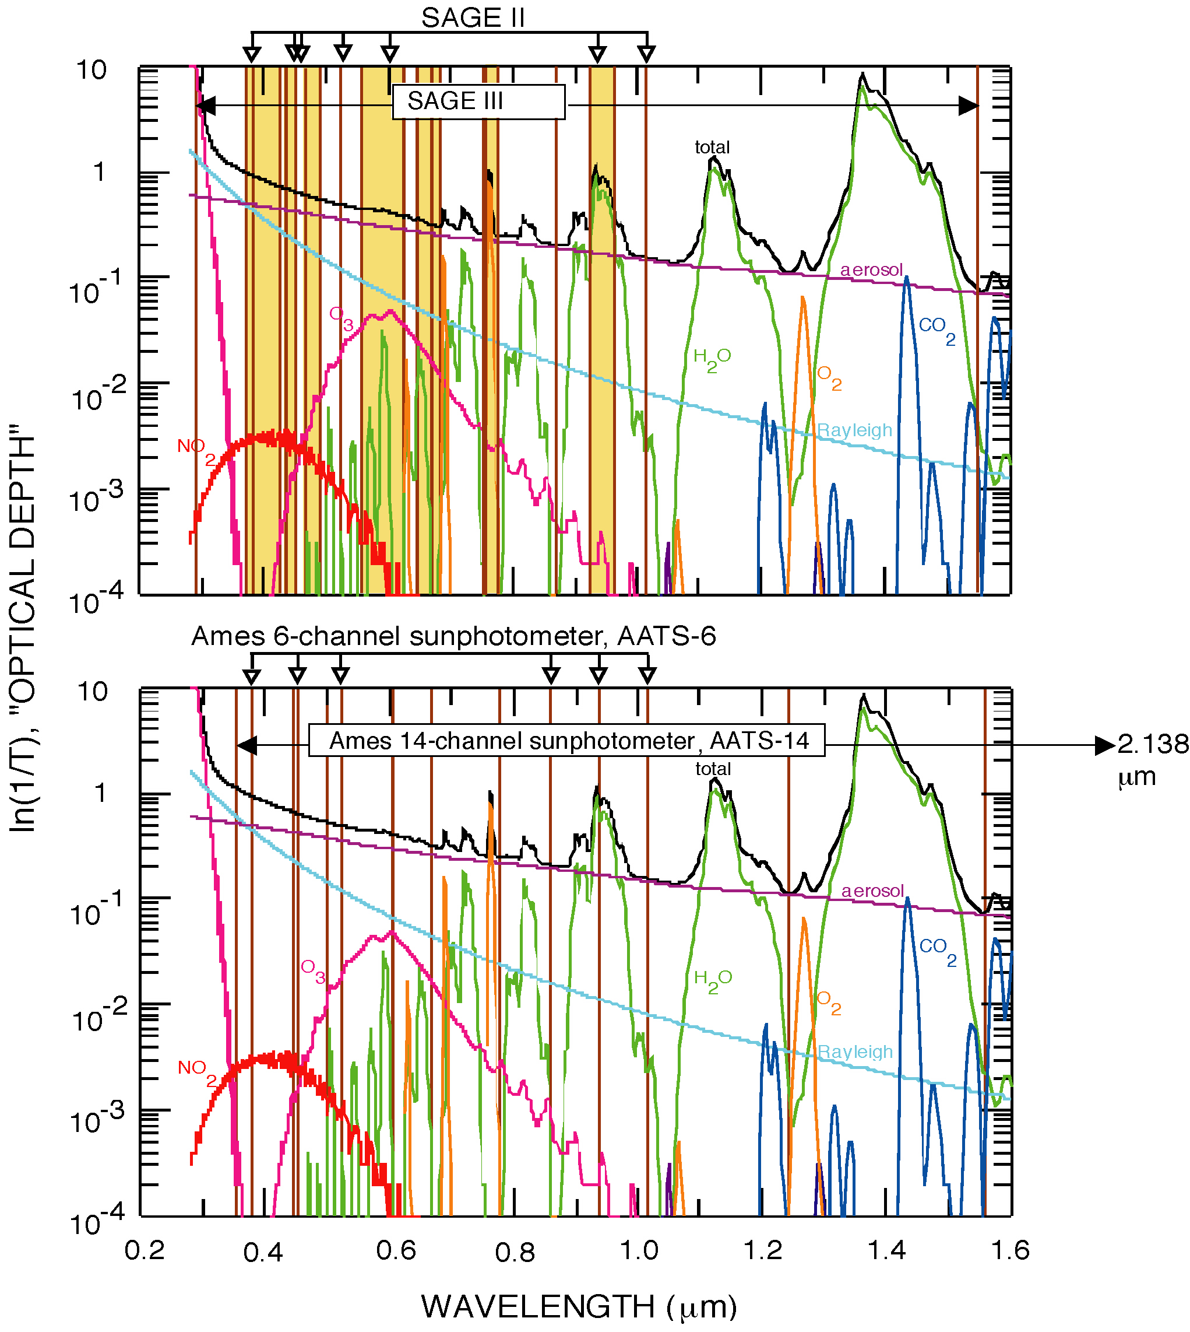
Fig. 1. Instrument channel wavelengths (vertical lines or shaded bars) in relation to atmospheric spectra. Top: SAGE III (shaded vertical bars indicate contiguous detector elements). Bottom: AATS-14 (2138 nm channel not shown). Arrows above each frame show predecessor instrument wavelengths. Spectra of ln(1/T) are calculated for transmission T of the direct solar beam at sea level using MODTRAN-3/Version 1.2, a US Standard atmosphere, a spring-summer tropospheric aerosol model, and sun at the zenith.
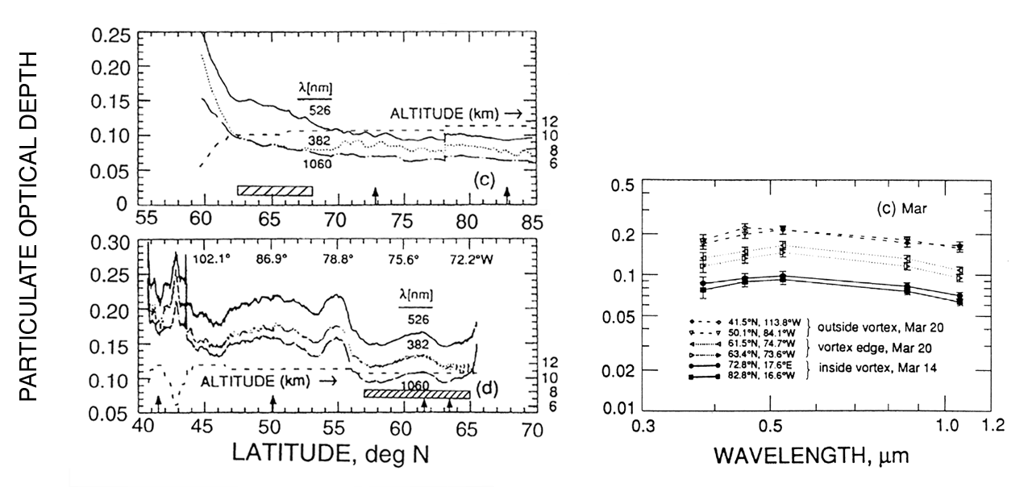
Fig. 2. (a, b) Latitude transects of particle optical depth measured by AATS-6 on the DC-8 in the second Airborne Arctic Stratospheric Expedition (AASE II). Crosshatched bars mark vortex transition as determined from lidar profiles. (c) Optical depth spectra for locations marked by arrows in (a,b). (Russell et al., 1993a)
(a)
(b)

Fig. 3. Aerosol optical depths (λ=380, 451, 525, 1021 nm) measured by AATS-6 on the UW C-131A in the Tropospheric Aerosol Radiative Forcing Observational Experiment (TARFOX). (a) Latitude transect. (b) Vertical profile.

Figure 4: Left panel: Aerosol optical depth profiles at 13 wavelengths from 354 to 1558 nm calculated from AATS-14 measurements acquired during an aircraft ascent south of Hiroshima, Japan on 2 April 2001 during ACE-Asia. Right panel: Corresponding aerosol extinction profiles derived by differentiating spline fits (dashed lines in left panel) to the optical depth profiles.

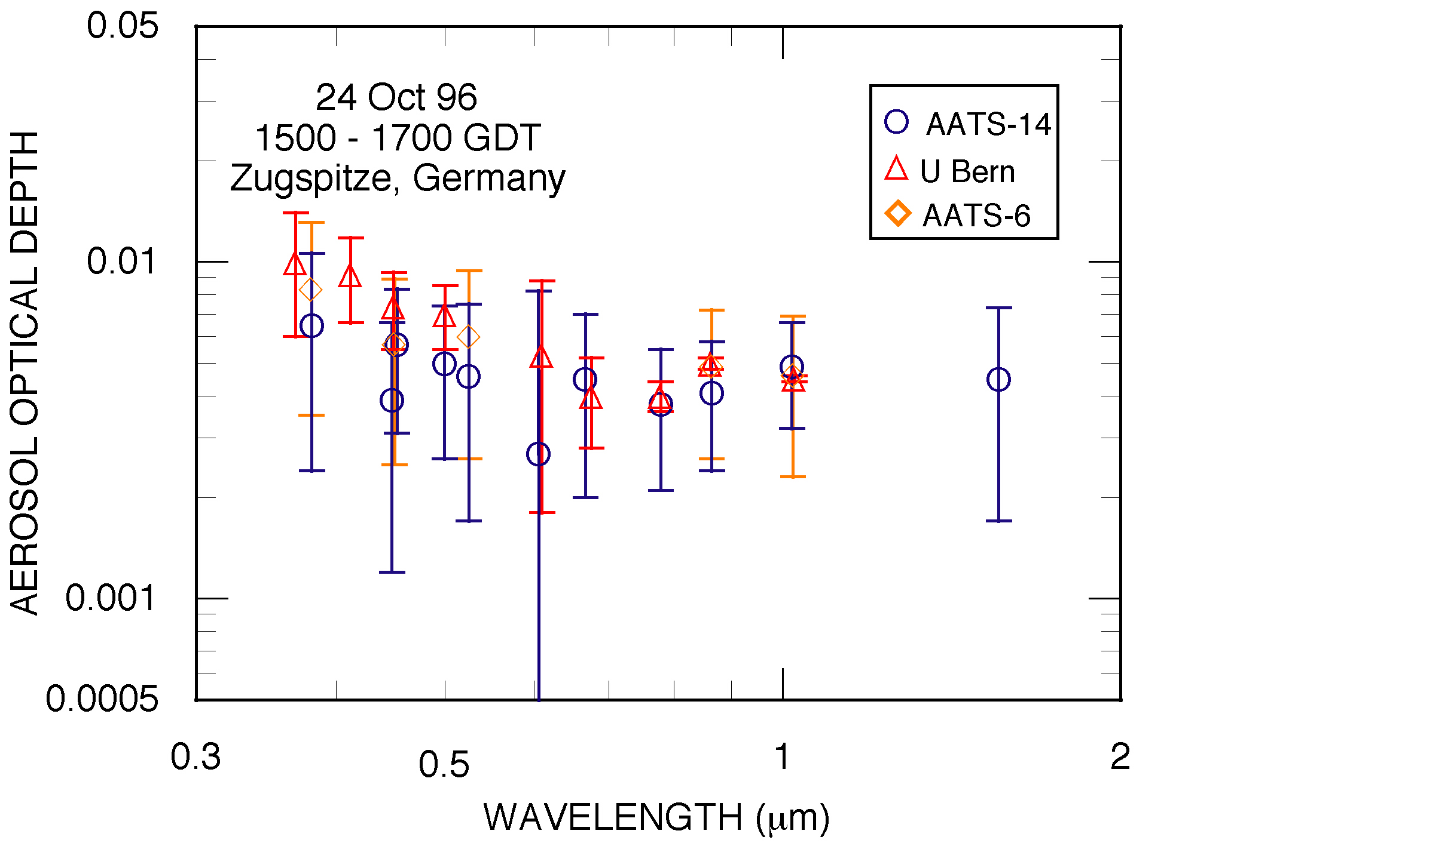
Fig. 5. Comparison of aerosol optical depths measured by three sunphotometers, Zugspitze, Germany (2.7 km ASL), 23 Oct 1996. Diamonds: AATS-6. Circles: AATS-14. Triangles: U. Bern 18-channel.
Figure 6. Left panel: Profiles of aerosol optical depth at four selected AATS-14 wavelengths (380, 500, 864 and 1558 nm) measured in ACE-2 south of the coast of Tenerife. Right panel: Aerosol extinction profiles derived by differentiating the profiles in the left panel. (Schmid et al., 2000b)

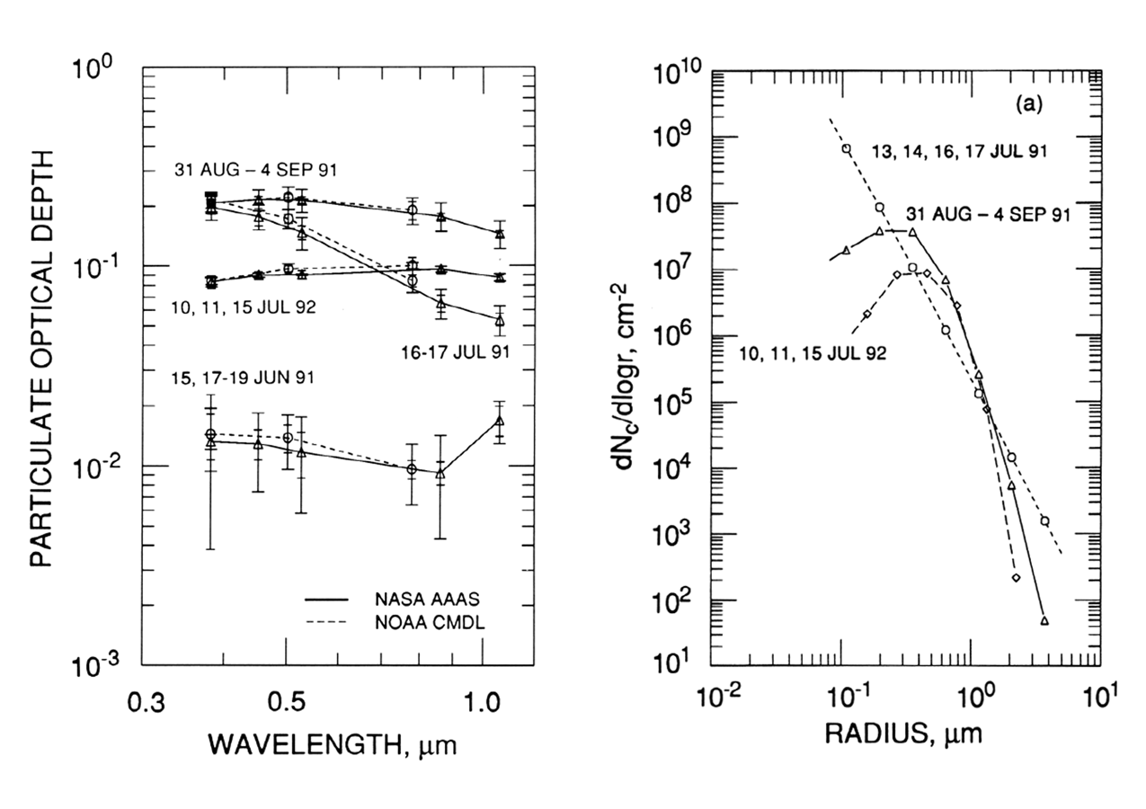
(a)
(b)
Fig. 7. (a) Optical depth spectra measured by the Ames and NOAA tracking sunphotometers at Mauna Loa Observatory (19.5 N, 155.6 W, 3.4 km ASL). (b) Stratospheric column particle size distributions derived from the Ames optical depth spectra in (a). Optical depth spectra computed from the size distributions in (b) all give good fits to the corresponding measurement data points and error bars in (a). (Russell et al., 1993b)

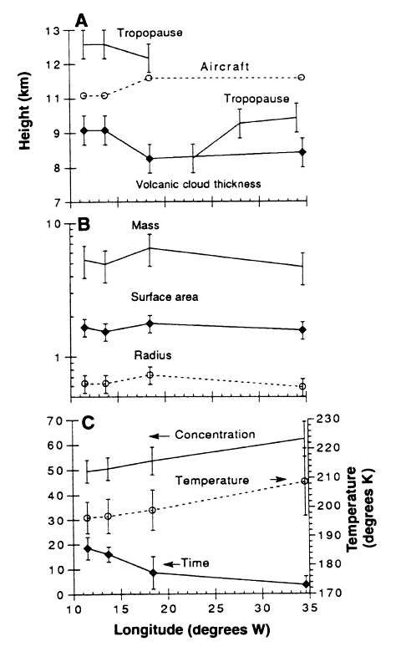
Fig. 8. (A) DC-8 altitude, tropopause altitude, and thickness of Pinatubo volcanic aerosol layer measured by DC-8 lidar. (B) Aerosol column mass (μg cm⁻²), column surface area (μm² cm⁻² I 10⁷) and particle effective radius (μm), all determined from DC-8 sunphotometer optical depth spectra. (C) Particle sulfuric acid concentration W (% by weight), temperature (K) vertical average above the aircraft, and time (h) spent on trajectories with W<60%. Error bars denote extreme values over the altitude region of the volcanic aerosol layer (Toon et al., 1993).

Fig. 9a. Comparison of CWV from AATS-6 (using LBLRTM 5.10) with the DOE ARM microwave radiometer at SGP in fall 1997 (from Schmid et al. 2001)

Fig. 9b. Comparison of CWV from AATS-6 (using LBLRTM 5.10) with AERONET Cimel at SGP in fall 1997 (from Schmid et al. 2001).

Fig. 10. Left panel: Profile of the columnar water vapor above the Pelican aircraft measured in ACE-2 south of the coast of Tenerife. Right panel: Water vapor density derived by differentiating the profile in the left panel. Also shown for comparison is the profile obtained by combining readings of a humidograph and outside temperature on Pelican (humidograph data courtesy of S. Gasso, University of Washington). (Schmid et al., 2000)

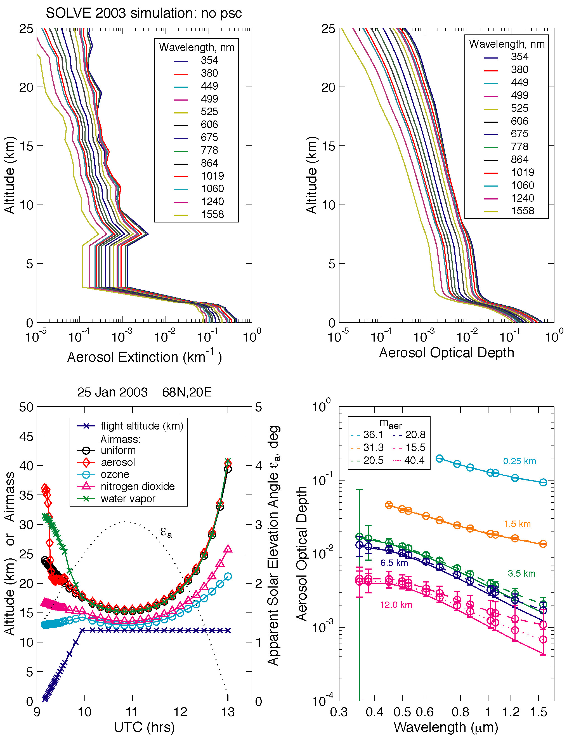
(a)
(b)
(c)
(d)
Fig. 11.(a,b) Model profiles of stratospheric and tropospheric aerosol extinction and optical depth based on SAGE II and AATS-14 measurements. (c) Profile of a simulated flight at 68N, 20E on January 25, 2003 with corresponding airmass values for Rayleigh, ozone, aerosol, water vapor, and NO₂. (d) Simulated measurements of optical depth spectra (dashed lines and symbols with error bars) with the model spectra (solid lines) used to compute them.
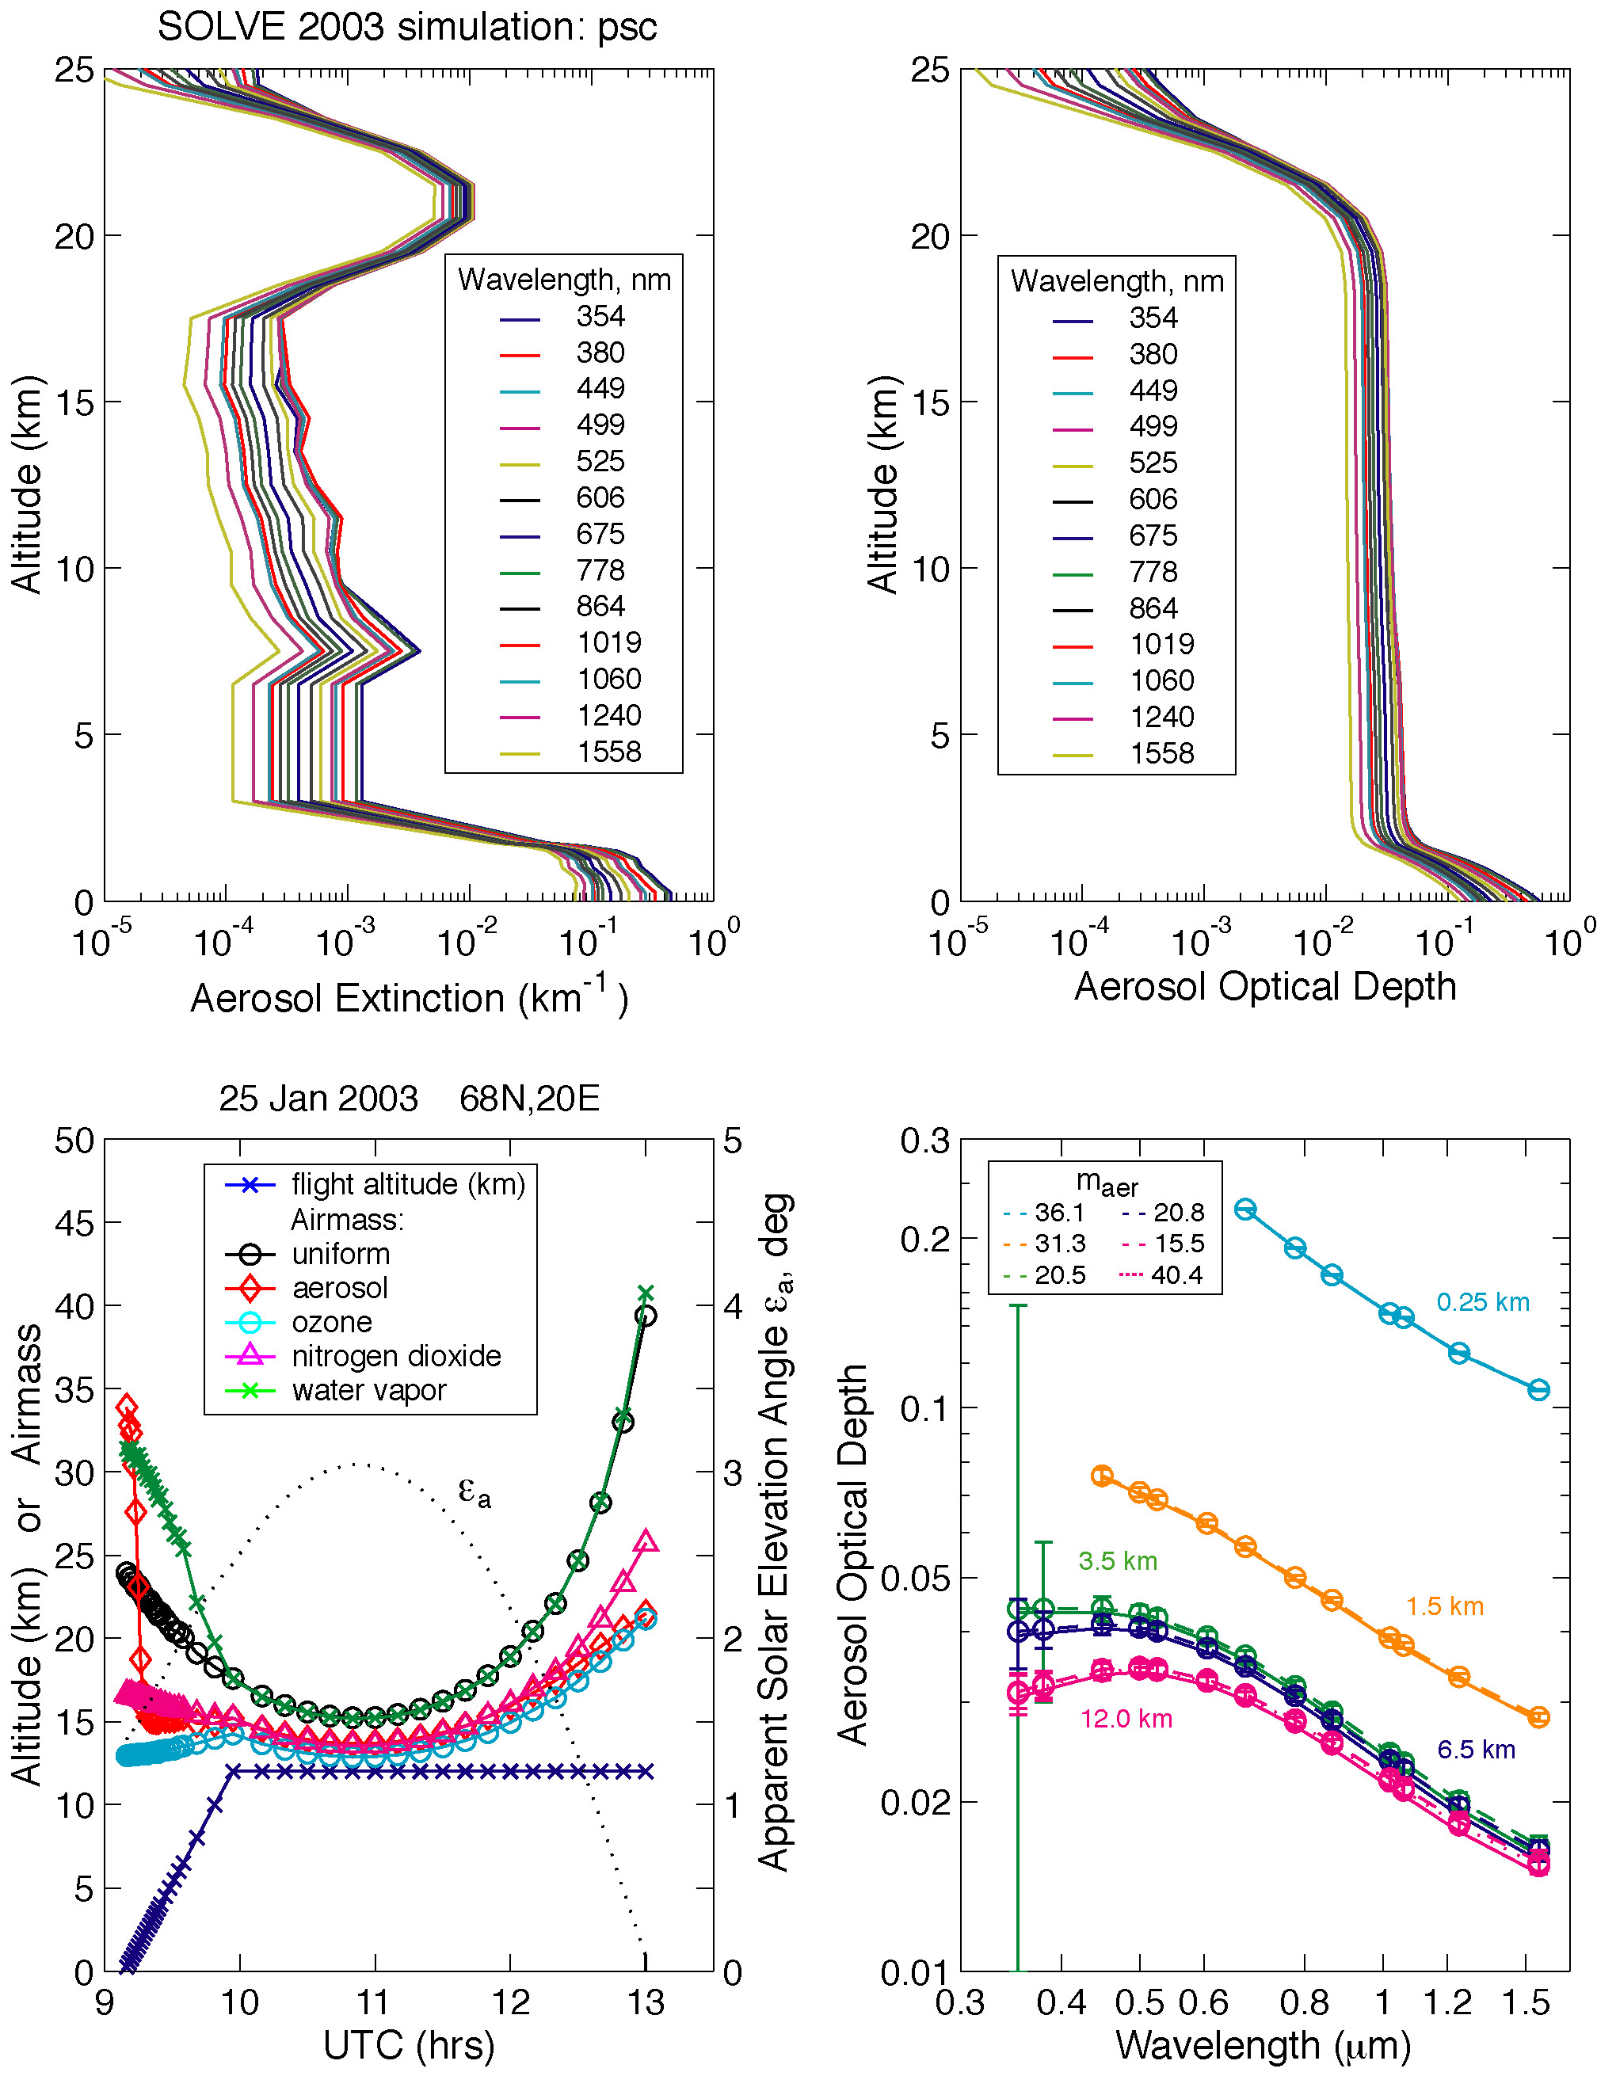
Fig. 12. Measurement simulation analogous to Fig. 11, but for a POAM-measured PSC with τ(500 nm)=0.02.
(a)
(b)
(c)
(d)
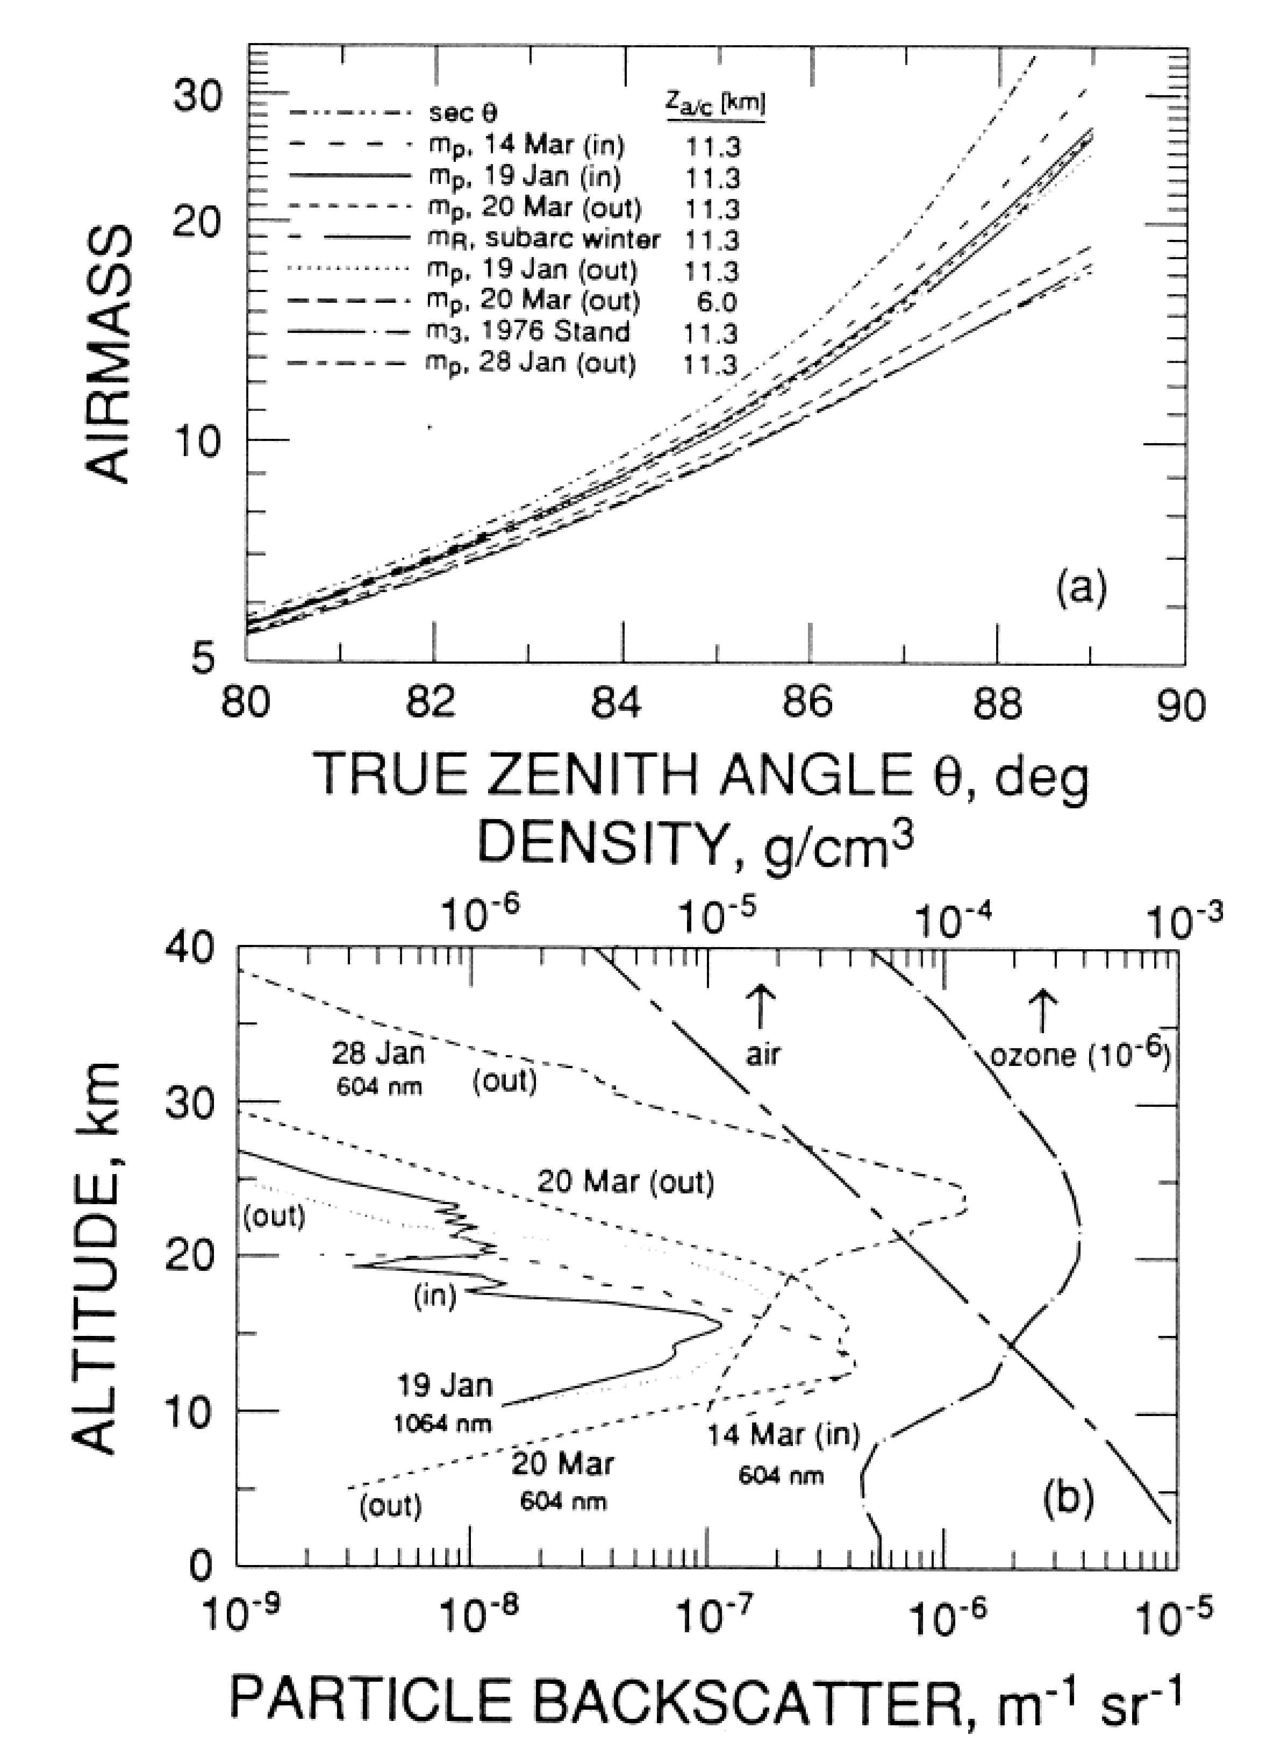
Fig. 13. (a) Airmass factors for representative Pinatubo aerosol, ozone, and air vertical profiles and photometer altitudes. (b) The vertical distributions used in computing results for (a). “In” and “Out” are relative to the northern polar vortex (Russell et al., 1993a).

Appendix: Ames Airborne Tracking Sunphotometers, AATS-6 and AATS-14

Philip B. Russell, John M. Livingston, Beat Schmid, and James A. Eilers
NASA Ames Research Center, Moffett Field, CA 94035-1000
prussell@mail.arc.nasa.gov

1. Introduction

The NASA Ames Airborne Tracking Sunphotometers (AATS-6 and AATS-14) measure the transmission of the solar beam in six and 14 spectral channels, respectively. Azimuth and elevation motors controlled by differential sun sensors rotate a tracking head so as to lock on to the solar beam and keep detectors normal to it. The tracking head of each instrument mounts external to the aircraft skin, to minimize blockage by aircraft structures and also to avoid data contamination by aircraft-window effects. Each channel consists of a baffled entrance path, interference filter, photodiode detector, and integral preamplifier. The filter/detector/preamp sets are temperature-controlled to avoid thermally-induced calibration changes. Each instrument includes an entrance-window defogging system to prevent condensation (a problem otherwise common in aircraft descents). In general, sun tracking is achieved continuously, independent of aircraft pitch, roll, and yaw, provided rates do not exceed ~8° s⁻¹ and the sun is above aircraft horizon and unblocked by clouds or aircraft obstructions (e.g., tail, antennas). Data are digitized and recorded by an onboard data acquisition and control system. Realtime data processing and color display are routinely provided. The science data set includes the detector signals, derived optical depths and water vapor column content, detector temperature, sun tracker azimuth and elevation angles, tracking errors, and time. Radiometric calibration is determined via Langley plots, either at high-mountain observatories or on specially designed flights. Repeated calibrations show that the instruments maintain their calibration (including window and filter transmittance, detector responsivity and electronic gain) to within 1% in most spectral channels for periods of several months to a year.

2. Six-Channel Tracking Sunphotometer (AATS-6)

The six-channel instrument [Fig. 1, Matsumoto et al., 1987] uses a differential-shadowing sun sensor to drive the azimuth and elevation tracking motors. The window-defogging system uses bottled dry nitrogen, which also aids in overall instrument thermal control. The six filter/detector/preamp sets are mounted in a common heat sink maintained at 45 ±1 °C. Filter wavelengths are shown in Fig. 2. Filter full widths at half-maximum (FWHM) are 5 nm. Data are digitized and recorded by a laptop computer-based data acquisition and control system, with realtime, onboard processing and color display.
AATS-6 has flown on a variety of aircraft, including the NASA CV-990, C-130, and DC-8, the Sandia National Laboratories Twin Otter, and the University of Washington C-131A. These measurements have been compared with SAGE II measurements of free-tropospheric and stratospheric aerosols [Russell et al., 1986; Livingston and Russell, 1989] and used to characterize the spectral optical depth of oil- and forest-fire smokes and thin clouds [Pueschel et al., 1988; Pueschel and Livingston, 1990], to measure tropospheric haze aerosols and their impact on atmospheric radiation and on remote measurements of the Earth's surface [Spanner et al., 1990; Wrigley et al., 1992; Russell et al., 1999], and to document the effect of the 1991 Pinatubo volcanic eruption on global-scale stratospheric aerosol optical depth spectra [Russell et al., 1993a,b; 1996; Toon et al., 1993]. In addition, AATS-6 operated successfully on the ship R/V Vodyanitsky in the second Aerosol Characterization Experiment (ACE-2), making measurements of marine, European, and African aerosol optical depth spectra, as well as water vapor columns [Livingston et al., 1997].
Figure 1. Six-channel Ames Airborne Tracking Sunphotometer (AATS-6).

Figure 2. Sunphotometer channel wavelengths (vertical lines with arrows) in relation to atmospheric spectra. The spectra of transmittance T of the direct solar beam at sea level were calculated using MODTRAN-3.7/Version 1.0 with a Midlatitude Summer atmosphere, a rural spring-summer tropospheric aerosol model (Vis = 23 km), and the sun at the zenith. Current center wavelengths of channel filters are 354, 380, 449, 454, 500, 525, 606, 675, 779, 864, 940,1019, 1240, 1558 nm for AATS-14 and 380, 451, 525, 864, 941, 1021 nm for AATS-6. Filter full widths at half-maximum (FWHM) are 5 nm, except for the 449 and 454 nm channels, which have FWHM 0.94 and 2.17 nm, respectively.

3. Fourteen-Channel Tracking Sunphotometer (AATS-14)

AATS-14 (Fig. 3) was developed under the NASA Environmental Research Aircraft and Sensor Technology (ERAST) Program. It provides 14 spectral channels in the same tracking-head size as the six-channel instrument, with a more compact and automated data/control system. AATS-14 is designed to operate on a variety of aircraft, some of which may be remotely piloted or autonomous. Hence it can locate and track the sun without input from an operator and record data in a self contained data system. In addition, it must interface to an aircraft-provided telemetry system, so as to receive and execute commands from a remote operator station, and transmit science and instrument-status data to that station.
AATS-14 uses a quad-cell photodiode to derive azimuth and elevation tracking-error signals. Window defogging is achieved by a foil heater. Channel filters are at wavelengths from 354 to 1558 nm (Fig. 2), chosen to allow separation of aerosol, water vapor, ozone, and nitrogen dioxide transmission. Detectors in the two longest-wavelength channels incorporate thermoelectric coolers. The other 12 channels are maintained at an elevated temperature by a foil heater or a liquid-loop/thermoelectric heater/cooler system.
AATS-14 made its first science flights on the Pelican (modified Cessna) aircraft of the Center for Interdisciplinary Remotely Piloted Aircraft Studies (CIRPAS) during the Tropospheric Aerosol Radiative Forcing Observational Experiment (TARFOX) in July 1996 [Russell et al., 1999]. More extensive flights on Pelican were made in the second Aerosol Characterization Experiment (ACE-2), providing many measurements of marine, European, and African aerosol optical depth spectra, as well as water vapor columns [Schmid et al., 2000].
AATS-14 completed its first operations on a pressurized aircraft in June 1999, when it made five test flights on the NASA DC-8. Operations included autonomous sun finding, tracking and data acquisition with external temperatures as low as –62 C and sun angles from ~10° off aircraft zenith to local horizontal.

Figure 3. Fourteen-channel Ames Airborne Tracking Sunphotometer (AATS-14). Dimensions are in inches.

References

Livingston, J.M. and P.B. Russell, Comparison of satellite-inferred (SAGE II) aerosol optical depths with corresponding airborne sun-photometer optical depths, Preprint AIAA 27th Aerospace Sciences Meeting, January 9-12, 1989, Reno Nevada.
Livingston, J. M., V. N. Kapustin, B. Schmid, P. B. Russell, P. K. Quinn, T. S. Bates, P. A. Durkee, and V. Freudenthaler, Shipboard sunphotometer measurements of aerosol optical depth spectra and columnar water vapor during ACE 2. Tellus B 52, 594-619, 2000.
Matsumoto, T., P. B. Russell, C. Mina,, W. Van Ark, and V. Banta, Airborne tracking sunphotometer. J. Atmos. Ocean. Tech. 4, 336-339, 1987.
Pueschel, R.F., J.M. Livingston, P.B. Russell, D.A. Colburn, T.P. Ackerman, D.A. Allen, B.D. Zak and W. Einfeld: Smoke optical depths: magnitude, variability and wavelength dependence, J. Geophys. Res., 93, 8388-8402, 1988.
Pueschel, R.F. and J.M. Livingston, Aerosol spectral optical depths: Jet fuel and forest fire smokes, J. Geophys. Res., 95, 22,417-22,422, 1990.
Pueschel, R. F., S. A. Kinne, P. B. Russell, K. G. Snetsinger, and J. M. Livingston, Effects of the 1991 Pinatubo volcanic eruption on the physical and radiative properties of stratospheric aerosols, Current Problems in Atmospheric Radiation (Proc. IRS '92), S. Keevallik, ed., A. Deepak Press, 1992.
Pueschel, R.F., J.M. Livingston, P.B. Russell, and S. Verma, Physical and optical properties of the Pinatubo volcanic aerosol: aircraft observations with impactors and a suntracking photometer, J. Geophys. Res., 99, 12,915-12,922, 1994.
Russell, P. B., et al., Measurements with an airborne, autotracking, external-head sunphotometer, Preprint Volume, Sixth Conference on Atmospheric Radiation, May 13-16, 1986, pp. 55-58, Amer. Meteor. Soc., Boston, MA, 1986.
Russell, P.B. et al., Pinatubo and pre-Pinatubo optical depth spectra: Mauna Loa measurements, comparisons, inferred particle size distributions, radiative effects, and relationship to lidar data. J. Geophys. Res, 98, 22, 969-22,985, 1993a.
Russell, P.B., J.M. Livingston, R.F. Pueschel, J.A. Reagan, E.V. Browell, G.C. Toon, P.A. Newman, M.R. Schoeberl, L.R. Lait, L. Pfister, Q. Gao, and B.M. Herman, Post-Pinatubo optical depth spectra vs. latitude and vortex structure: Airborne tracking sunphotometer measurements in AASE II. Geophys Res. Lett, 20, 2571-2574, 1993b.
Russell, P. B., J. M. Livingston, R. F. Pueschel, J. B. Pollack, S. L. Brooks, P. J. Hamill, J. J. Hughes, L. W. Thomason, L. L. Stowe, T. Deshler, E. G. Dutton, and R. W. Bergstrom. Global to microscale evolution of the Pinatubo volcanic aerosol, derived from diverse measurements and analyses. J. Geophys. Res., 101, 18,745-18,763, 1996.
Russell, P. B., J. M. Livingston, P. Hignett, S. Kinne, J. Wong, and P. V. Hobbs, Aerosol-induced radiative flux changes off the United States Mid-Atlantic coast: Comparison of values calculated from sunphotometer and in situ data with those measured by airborne pyranometer, J. Geophys. Res., 104, 2289-2307, 1999.
Schmid, B., Livingston, J. M., Russell, P. B., Durkee, P. A., Collins, D. R., Flagan, R. C., Seinfeld, J. H., Gassó, S., Hegg, D. A., Öström, E., Noone, K. J., Welton, E. J., Voss, K., Gordon, H. R., Formenti, P., and Andreae, M. O.. Clear sky closure studies of lower tropospheric aerosol and water vapor during ACE-2 using airborne sunphotometer, airborne in-situ, space-borne, and ground-based measurements. Tellus B 52, 568-593, 2000.
Spanner, M.A., R.C. Wrigley, R.F. Pueschel, J.M. Livingston and D.S. Colburn, Determination of atmospheric optical properties during the first international satellite land surface climatology project field experiment. J. Spacecraft and Rockets,
27, 373-379, 1990.
Toon, O., E. Browell, B. Gary, L. Lait, J. Livingston, P. Newman, R. Pueschel, P. Russell, M. Schoeberl, G. Toon, W. Traub, F.P.J. Valero, H. Selkirk, J. Jordan, Heterogeneous reaction probabilities, solubilities, and the physical state of cold volcanic aerosols, Science, 261, 1136-1140, 1993.
Wrigley, R.C., M.A. Spanner, R.E.. Sly, R.F. Pueschel, and H.R. Aggarwal, Atmospheric correction of remotely sensed image data by a simplified model. J. Geophys. Res., 97, 18797-18814, 1992.

Weight, Power, Size, and Related Information

1. Six-Channel Ames Airborne Tracking Sunphotometer (AATS-6):
Part | Weight | Size  (19" panel or other) | Power Required  (watts, amps) | Type of Power  (V, Hz) | External Sensor Location
a. Sunphotometer telescope | 62 lb. (Includes  27-lb head,  1-lb bearing,  5-lb isolator,  1-lb reinforc. ring,  1 lb mounting bolts, 27-lb cable) | Telescope dome 8" OD, Cylinder flange 10" OD Overall telescope height ~15" w/o. bottom cable connector. Extends ~6" above A/C skin, 9" below. Mounted in Zenith port. | See (b.) | See (b.) | Zenith or near-zenith port  (See note.)
b. Data/control system | 39 lb. (Includes 27-lb control box; 5-lb laptop w/ 2-lb charger and 5-lb rack tray) | 13" total rack height in 19” rack mount panel. (Includes 9” high control box and 4” high laptop tray) | 3.1 A control box plus 0.8 A laptop | 120VAC, 60Hz | N/A
c. N₂ gas bottle | 30 lb | 7.5” Dia x 21” H | N/A | N/A | N/A
d. *Optional | 45-lb 13” diagonal color monitor (needs rack tray).  4-lb printer w/ charger | 15" rack height in 19” panel | 1.3A | 120VAC, 60Hz | N/A

2. Fourteen-Channel Ames Airborne Tracking Sunphotometer (AATS-14):
Part | Weight | Size  (19" panel or other) | Power Required  (watts, amps) | Type of Power  (V, Hz) | External Sensor Location
a. Telescope head w electronics/data system cylinder | 131.6 lb. (Includes  121-lb head w/elec.,  3.5-lb isolator,  1-lb reinforc. ring,  0.4-lb torque link,  0.7-lb mount bolts,  5-lb cable bundle. | Outside A/C: 8" OD dome (hemisphere) atop 5" H pedestal. (Total H: 9" above A/C skin)  Inside A/C: 12" D x 18" H cylinder.  (+ laptop computer for checkout and test flights) | 5.5A 154 W peak  or  4.2 A @ 500 W peak | 28 VDC  or  120VAC, 50-400 Hz with additional 55-lb power supply. | Top of cabin, nose, wing, or pod.  9" D port (See note.)
b. Operator station (laptop computer) | 6-lb laptop & cable,  15-lb tray w/slides. | Laptop computer. Optional  tray mounts in 19” rack. | ~0.8 A  92 Watts | 120 V, 60 Hz | N/A
c. N₂ gas bottle | 30 lb | 7.5” Dia x 21” H | N/A | N/A | N/A
Note: Telescope dome needs to be mounted as far as possible from viewing obstructions such as A/C tail and antennas.

