POLAR Spacecraft Status As of: Tues, 3 Feb 04 16:00 EST
changes from last week in bold border)
Subsystem/  Component | NOAA-11H  Standby PM  STIP data only | NOAA-12D  Standby AM  STIP data only | NOAA-14J  Standby AM  STIP data only | NOAA-15K  BACKUP AM  GAC data only | NOAA-16L  PRIMARY PM  GAC&LAC data | NOAA-17M  PRIMARY AM  GAC&LAC data
LAUNCHED | 09/23/88 | 05/14/91 | 12/30/94 | 05/13/98 | 09/21/00 | 6/24/02
CNTL OBP | OBP2 | OBP2 | OBP2  OBP1 inoperative | OBP2 | OBP2 | OBP2  CPUError TOAR434
BUS | A-BUS  XSU-1 | B-BUS  XSU-1 | B-BUS  XSU2 (XSU1 inop) | B-BUS  XSU-1 | B-BUS  XSU-1 | B-BUS  XSU-1
BUS VETO | NO | NO | NO | NO | NO | NO
ADACS | RGYRO Mode  (Y, Z-Gyros Failed) Reduced Gyro S/W.  X &S gyros only | YGC Mode  Gyro chans=XYZ  Yaw updates disabled 10/1/03  RGmode=Monitor | Nominal Mode  Rgmode=Disabled  Gyro chans=XYZ  SS check Disabled when mode=YGC | Nominal Mode  Rgmode=Monitor  Gyro-3 Off/Anom  Gyro chans=AAB | Nominal Mode  Rgmode=Disabled  Gyro chans=AAA  Gyro3 deselected  Gyro3 TOAR 427 | Nominal Mode  Rgmode=Disabled  Gyro chans=BBB
RXO | PRI  BU random enables  daily bias +70mSec (control side only) | PRI  BU random enables  daily bias+6.5 mS  Autonomous -500 mSecs on 17 Jan | PRI  BU random enables daily bias–7.0 mS  Minus 50 mS 12/23 | PRI  daily bias -8 mSec | PRI  Daily Bias –5.5 mS  Minus 100 mS on on 12/23/03 | PRI  Daily Bias –3 mSec  Minus 100 mS on 12/23/03
CLOCK DIV | 2 | 2 | 2 | 2 | 2 | 2
MIRP | ON | External Synch  Rephase Enabled | External Synch  Rephase Daily | External Synch Rephase Daily. | External Sync  Rephase Daily | Internal Synch  Rephase Enabled
TIP SIDE | 1 | 1 | 1 | 2  Since 4/24/03  Channels 224 -227 invalid TOAR 432 | 1  Analog telem drifting | 1
DTRs | 1A, 2B, 3, 4A Safestate - 2B, | 1, 3, 4, 5B  Safestate- 1B | 1, 2B, 3A, 5 Safestate- 1B | 1, 2, 3, 4 Safestate 1B EOT | 1,2,3,4A  Safestate 3A  4B TOAR 418  (STIP only) | 1,2,3,4  Safestate=1B  DTR2-SSR  DTR5 TOAR 420
VTX  (APT data) | OFF | #1 ON  137.50 MHZ | OFF  Since 8/14/02 | #1 ON  137.50 MHZ | INOP  OFF since 11/15/00 | #2 ON  137.62 MHZ
BTX | #2  137.77 MHZ | #1  136.77 MHZ | #2  137.77 MHZ | #1  137.35 MHZ | #1  137.35 MHZ | #2  137.77 MHZ
STX  #1=1698.0 mhz  #2=1702.5 mhz  #3=1707.0 mhz  #4=2247.5 mhz | 3 – TIP  1,2 - Playback | 1 – HRPT;  2,3 - Playback | 3 – HRPT  2, 1 – Playback | 1, 2, 3 - degraded;  2 Omni–HRPT;  4- Playback | 1 – HRPT;  2– Playback;  4 – Playback  3 low power unused | 3 – HRPT  TOAR424 low power  1&2 Playback  4 – TIP
POWER  (Array offset, charge and eclipse states, sun angle) | Array Off -30  Since 6/19/02  Eclipse all year  Sun angle 72  Steady trend  Batts1,2,3=LRC  VT1,2=6/8  VT3 = 8/11  Charge state safe  trip disabled | ArrayOff -60  since 7/30/03  FULL SUN  Sun Angle at 24 steady trend .  Sun sensor shading  possible until 4/04  Batts 1&2=LRC  V/T=4 | Array Off -55  Since 8/21/03  FULL SUN  Sun Angle at 22  Downtrend to 20  Batts 1-3= LRC  Batts 1&3V/T=8/11  Batt2 VT=9/11 )  Shunt Degraded | Array Off -45  Since 1/25/01  FULL SUN  Sun Angle 11 down trend to 6 degs late Feb  Batts 1-3= LRC  V/T=7/9 | Array Off -40  Since 7/16/02  Eclipse all year  Sun Angle 58  UpTrend to 59 in early Feb 04  Batts 1-3= LRC  V/T=4/8 | Array Off. –40  Since 1/29/04  Eclipse all year  Sun Angle at 62  Down trend to 60 early Feb 04  Batts 1-3= LRC  V/T= 4/8  High shunt temps
AVHRR | INOP  Failed power supply. Off since 1994 | Nominal | DEGRADED  Scan motor erratic performance STATUS=RED | Nominal  Rare Scan motor surges. Last  Incident 8/9/03 | Improved Scan motor current & synch delta improved image barcodes eliminated.  TCE24on 1/16/04  Chan 3B only. | Nominal  3A-B switch enabled
AMSU-A1 |  |  |  | ON  Ch14 inoperative  Ch11 inoperative | ON  TOAR 415 on primary PLLO chans 9-14 bias shift.  TOAR 417 on Backup PLLO inop | OFF/INOP  Since 10/30/03  Inoperable Red in status. Survival heat on. TOAR 431
AMSU-A2 |  |  |  | ON | ON  Space Position-2 | ON
AMSU-B |  |  |  | ON  Bias in All Chans.  Motor current surges, most recent 12/25/03 | ON  Space Position-3 | ON
HIRS | OFF  Filter Wheel Failed | INOP  Filter Wheel turned OFF 10/17/02. Electronics On | ON  Operational | Recovering  FW mode=Hi Powr  FW current erratic  FW Heaters off  FW Synch&Period Monitor nominal | ON  Nominal | ON  1 Pixel cross track misalignment .
MSU | INOP  OFF, Antenna Failed | INOP  Scan Motor OFF since 3/12/03  Electronics ON. | ON  Scan motor and antenna problems
SSU | ON |  | ON
DCS | ON | ON | ON | ON | ON  Nominal | ON  Nominal
SARR | ON  Low signal |  | ON | ON-A  All AGC Mode  Intermittent failures for 243MHz A&B | ON-A  All AGC Mode  (B-side in FG mode)  243 MhZ INOPERATIVE. | ON-A  Nominal  All AGC Mode
SARP | ON  Nominal |  | OFF  Failed Power Supply | ON  Nominal  RCVR B/W = 2 | ON  Nominal  RCVR B/W = 2 | ON  Nominal
SEM |  | ON  Elec-CH-HVPS=4  Prot-CH-HVPS=0 | ON  Elec-CH-HVPS=0  Prot-CH-HVPS=0  1 of 4 Telescopes inoperative  Autonomous reset and commanded recovery 12/16/03 | ON  Nominal  E-CDEM-HVPS=2  P-CDEM-HVPS=0 | ON  Nominal  E-CDEM-HVPS=5  P-CDEM-HVPS=4 | ON  Nominal  E-CDEM-HVPS=2  P-CDEM-HVPS=3
SBUV | INOP  Grating motor OFF since 5/29/03  Electronics and Heater remain ON |  | Recovering  Flex memory 3 (giant step) ops suspended indefinitely on 12/2/03  Reduced operations started 6/5/03 |  | ON  Status Changed to YELLOW  Ozone data degradation reported TOAR 435  Back to Primary Diffuser 12/19/03  Primary diffuser =TOAR 426  Backup Diffuser  =TOAR  Both have Antenna deploy problems  AMSU EMI causing erratic Behavior in PMT cathod, range 3 | ON  Nominal  Anode Mode
SADPOS |  |  |  | N/A | ON  ENABLED  MFactor =50% | ON  ENABLED
THERMAL  Heaters, louvers  TCE’s | Nominal | Nominal | Nominal | TCE26 & 15H  Telem invalid since 12/23/03  TOAR 432  HIRS FW Heat Off  TCE24L&25L (HIRS & AVHRR) failed 5/13/98  RCE thermostat failed 5/13/98  Cold season ended, trend reversed | Nominal  TCE24 turned ON (AVHRR H&L) 1/16/04  AVHRR temps immediately dropped 4 degs C | TCE3H Batt 2A heater failed ON, turned off 8/26/03 TOAR 428  AMSU-A1 survival heaters on 10/29/03
 | N11 | N12 | N14 | N15 | N16 | N17
COMMENTS/CHANGES:

NOAA-11 No change since previous report. No plans have yet been submitted for decommissioning N12 and no schedule for this
operation is yet determined although discussions continue. Discussions regarding requests for end of life EPS testing
currently being conducted although no decision on whether to perform such testing has yet been made.

NOAA-12. No changes since previous report. Clock stable after 500 mSec jump last week. The Spacecraft remains in YGC
attitude control mode with yaw updates disabled and no immediate plans to switch back to Nominal mode with Yaw updates enabled until April.

Reports of yaw offsets in some IPD products being reported but cannot be verified by spacecraft telemetry. EMOSS engineer Jim Sheperd has been investigating this concern from IPD personnel that N12 has been exhibiting a yaw error of magnitude +0.3 degrees since 21 Jan 04. In analyzing trend data over the last six weeks where we have been able to get accurate yaw updates from the spacecraft, Jim has noticed that the trend of these updates is a positive shift of about 0.2 degrees compared with the trend for the nominal attitude mode. However, Jim also noted that there was no indication of a sudden shift of yaw pointing around Jan. 21 as IPD has specified. In his analysis, the yaw error has been there for much longer. Since the spacecraft has been in YGC mode (with yaw updates ignored) since 12 Sept 2003 it is possible that the problem originated at around that time rather than just 2 weeks ago. The investigation continues.

NOAA-14: N14 AVHRR Scan motor current continues to slowly improve although it still has far to go before returning to what
previously had resulted in nominal imagery (illustration 1). HIRS remained stable during the past reporting period with no loss of filter wheel synch. Finally, the N14 bus and shunt voltage were nominal throughout the week.

NOAA-15: The N15 AVHRR and AMSU-B scan motors were nominal throughout the past reporting period while the HIRS filter
motor current continues to show less than stable performance. As it has in the past two months, the filter motor again spent much of its time in the last week either experiencing or recovering from minor current and temperature surge events. On the positive side, the period monitor value appear and filter wheel synch remained nominal and there were no reports of imagery degradation received by EMOSS engineers. (Illustration 2 and 3).

There is no change to the 3 analog telemetry items that failed several weeks ago. TCE26H (Channel 224) TCE15H (Channel 226) and N2 Low Pressure (Channel 227) values all remain “flatlined”. Analysis of peripheral values that would be influenced by these failures remain nominal (illustration). Each of the “flatlined” items physically reside as sequential channel connections on a single mux chip in the spacecraft. Among the other channels on this mux that are not applicable to this problem are 225 which is not used and 228 which is DTR5 Pressure. (DTR 5 is non-operational/failed recorder and so will always read zero.) Among other used channels on this mux are channel 229 (Thruster 11 temp), 230 (SEM High Power Supply) and 231 (HIRS Patch Temp). Analysis by EMOSS engineers show that these three channels remain completely nominal (illustration 4 and 5)

TheN15 spacecraft is currently approaching a record low sun angle which is causing many subsystem temperatures to flag low. Primary among these subsystems is AMSU-B which has had numerous thermal low flags detected in recent days (illustration 6,7,8). EMOSS engineers expect that these temperatures will continue to decline for the next week to 10 days as the sun angle bottoms out around the third week of February. The current consensus among EMOSS engineers is that these temperatures do not constitute a threat to spacecraft health but close vigilance of subsystem performance will be maintained as a result of this situation. Andy Miller and Will Kent are EMOSS POC’s for this situation.

NOAA-16: The AVHRR continued to improve during the past week with the scan motor current slowly declining and no images
displaying the bar code pattern (although all images continue to show the wave pattern. (See illustration 9). The synch delta values are once again stable and apparently can go from one daily rephase to another without ever approaching “pegged status” which had not been the case just one week earlier (illustration 10). In addition, all AVHRR temperatures are stable (illustration 11). One item of interest in the EMOSS investigation of this anomaly was that on 23 Jan, the same day that the image bar codes disappeared, a large drop in N16’s AVHRR Patch Power occurred which then went back to a more stable value (illustration 12). Since that drop, the images have experienced no bar codes and, while there may be no cause/effect relationship between these two occurrences, in looking for coincidences and correlations into the AVHRR anomaly, this is one that might bear some scrutiny. Will Kent is investigating for EMOSS.

Another positive development on N16 is that the HIRS filter motor current and temperature, which were registering “record high” readings in the recent past, continue to very slowly trend downward in response to the cool down in the AVHRR component temperatures (illustration 13). EMOSS engineers expect that this trend will slowly continue for several weeks as long as the TCE24 remains powered on which is what the current plan calls for.

There was no change in the SBUV ozone data degradation situation in the past week. However, since this data is the primary source of SBUV investigations and the fact that both the primary and backup diffusers are anomaolous, NOAA management has decided to downgrade the N16 SBUV to YELLOW status.

N16 yaw control was nominal and during the past reporting period (illustration 14).

NOAA-17: The N17 Solar Array was moved on Thursday, 29 Jan at 15:30Z to a –40 degree offset (from –35). This move was in
response to the excess power generation that has occurred on N17 ever since the AMSU-A1 failed in October of 2003. The result of turning off the AMSU was record high shunt temperatures caused by excess power dissipation requirements. Initial analysis of the results of this move show that it had the desired effect of reducing the solar patch current and reducing shunt temperature (illustration 15 & 16). Peripheral effects of the move were minimal with only several ADACS and no payload components showing any thermal reactions to the move (illustration 17) Bus voltage also remained completely stable. . EMOSS power engineer Andy Miller was POC for this move.

NOAA-N The end to end test has been rescheduled for 9 Feb, EMOSS engineers are supporting preparations for this test. The
NOAA-N data base was delivered on 3 Feb. Azi Dianat was POC for this delivery.’

MISC: Jon Woodward and Kim Kolb continue providing consultative support to the SOCC CWS integration. EMOSS
engineers are attempting to integrate ABE into the daily engineering routine.

Meetings supported by EMOSS engineers included the MOWG, TOAR Board, N11 Decommissioning Status Meeting, Rgyro TIM

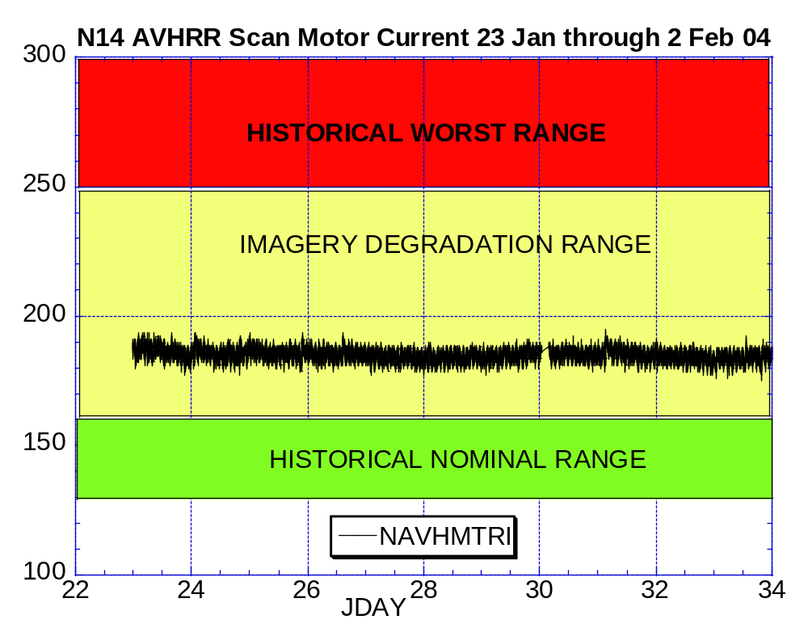
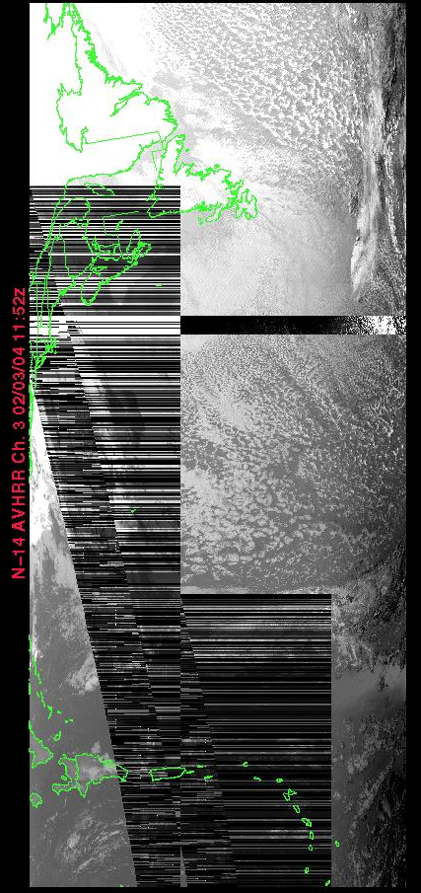
Illustration 1: N14 AVHRR Health Analysis.
(Improved a little last week but still a way to go.)

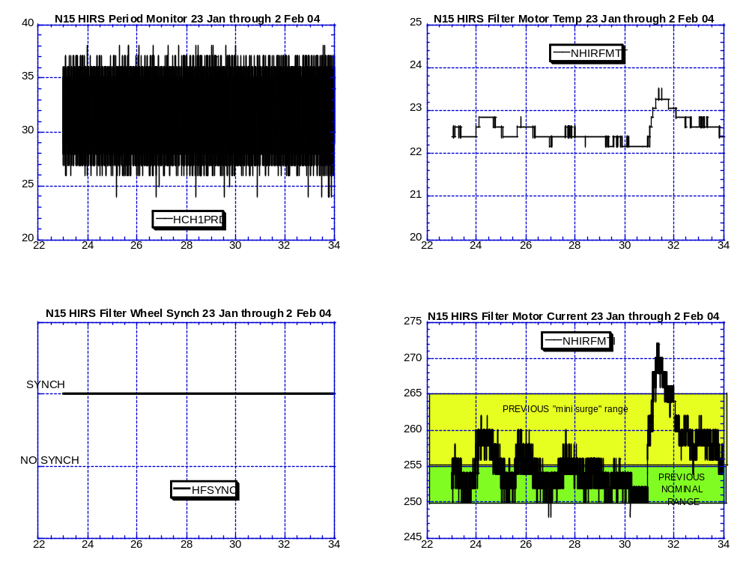

Illustration 2: N15 HIRS Health. (Erratic filter motor performance continues but as yet no reported or apparent effect on imagery)

N15 HIRS operating in high power mode with filter wheel heater currently OFF.
(Note: previous “mini” surges usually did not reach beyond 260-265 mAmps

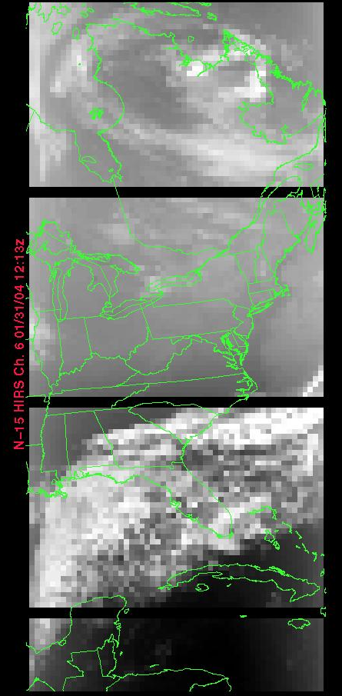
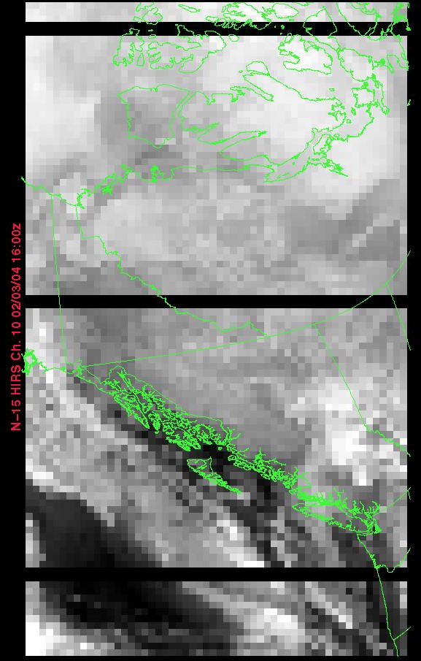

31 Jan 04 at 12:15Z 3 Feb 04 at 16:00Z
Peak Surge on 31 Jan no surge/latest

ILLUSTRATION 3: N15 HIRS Imagery Analysis

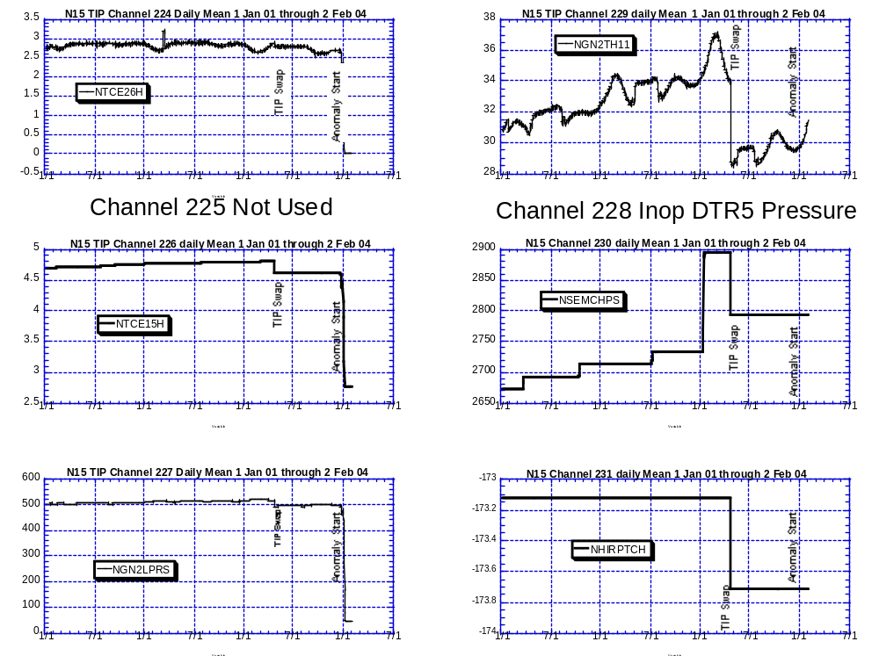
FAILED CHANNELS NOMINAL CHANNELS

Illustration 4: N15 Common Mux Channel Comparison.
Some nominal, some failed, some not used

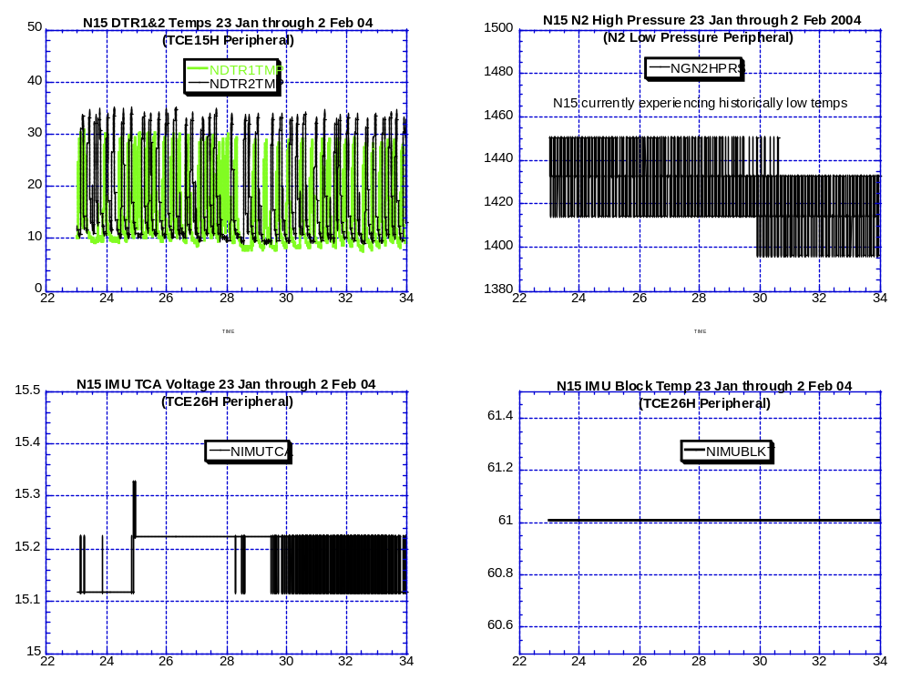

Illustration 5: N15 “Flatlined” Item peripheral components analysis.
No changes from last week, no responses from toggling TCE15 off then back on. No concerns for these components…at this time

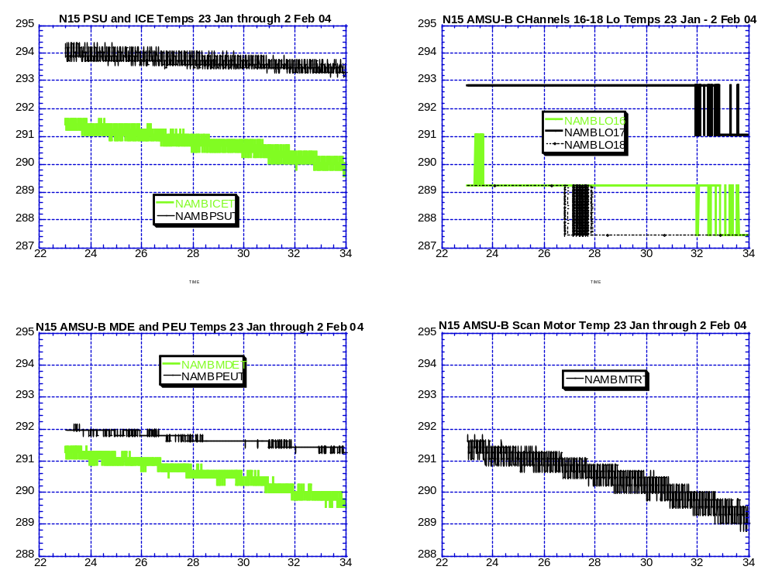

Illustration 6: N15 AMSU-B Cooling Trend Deepens
(Numerous Lim Proc’d items for this subsystem, no health concerns at the present time.)

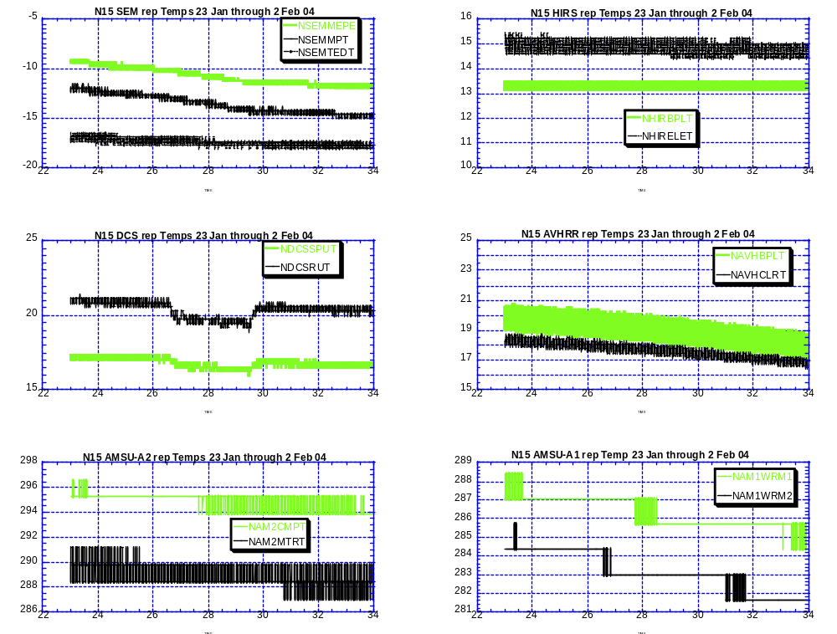

Illustration 7: N15 Cooling Trend relative to other Payloads
(Representative (rep) samples of various payload component temperatures. No health concerns at the current time.

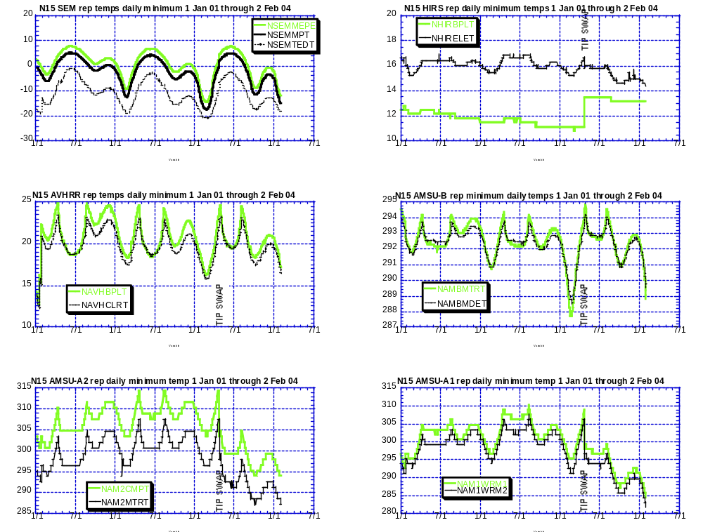

Illustration 8: N15 Cooling trend, the long view
(3+ years of trend data on selected payload components).
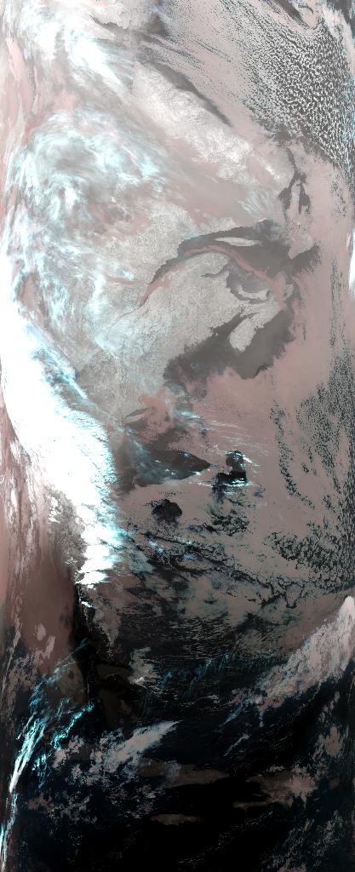
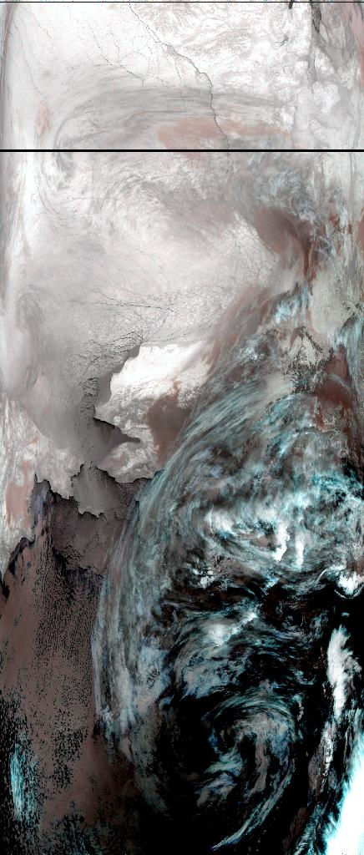
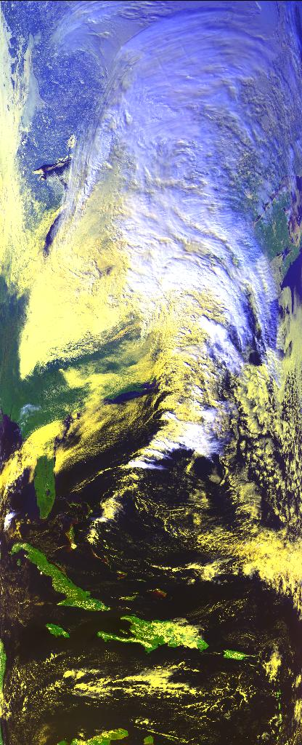
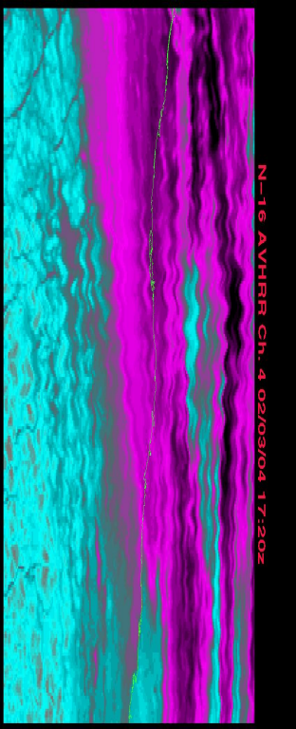

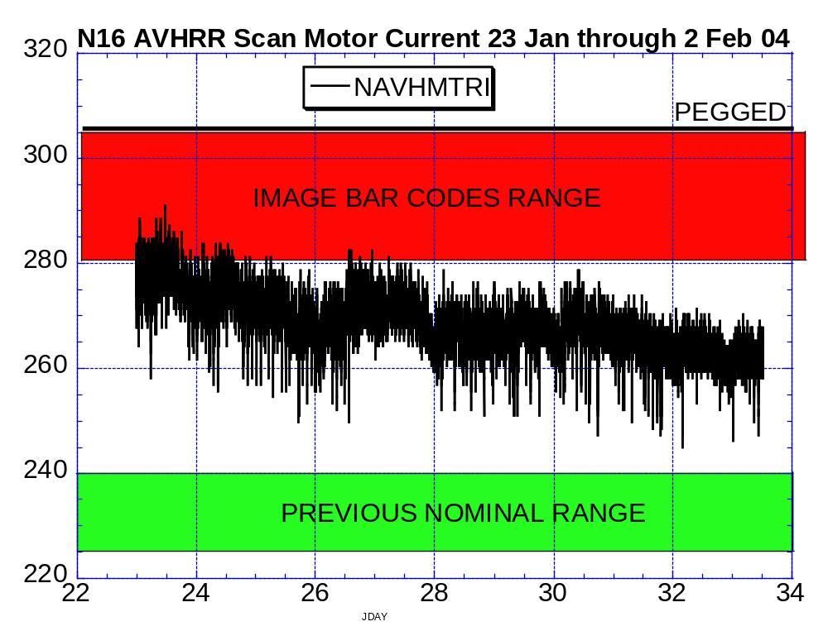
3 Feb 07:20Z 3 Feb 14:00Z 3 Feb 18:45Z WAVES
32Z Zoom
Illustration 9: N16 AVHRR Scan Motor and Imagery Analysis
All Images from today; 3 Feb 04
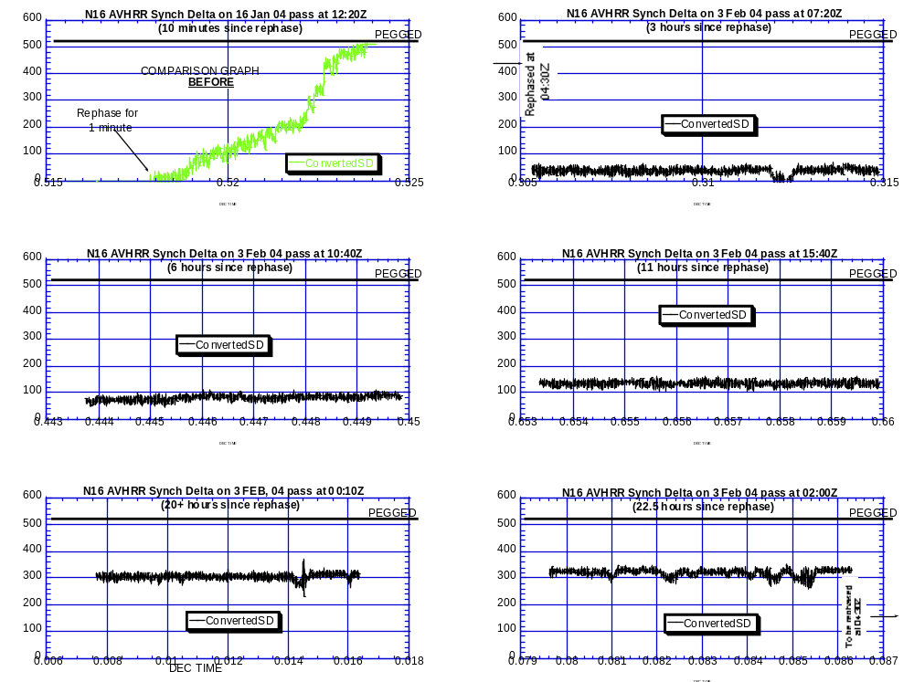

Illustration 10: N16 AVHRR Synch Delta Value Analysis 3 Feb (compared to Synch Delta performance on 16 Jan)

,
Taken on five successive passes (each graph represents N16 AVHRR synch delta performance over a 12 minute period). Notice how even after 22.5 hours without a rephase, (lower right) the synch delta remains stable. Each graph shows the relative stability of the synch delta value on 3 Feb which is greatly improved from even last week. Compare these 3 Feb graphs with the graph of 16 Jan 04 (upper left) which was rephased and then pegged all within the same 12 minute pass.

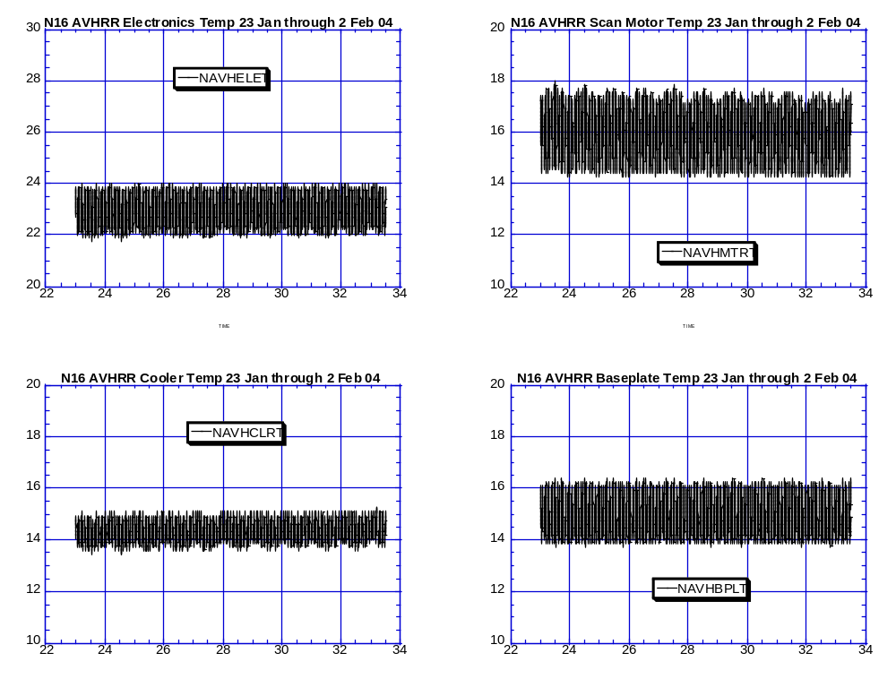

Illustration 11: N16 AVHRR Thermal Analysis.
The picture of stability

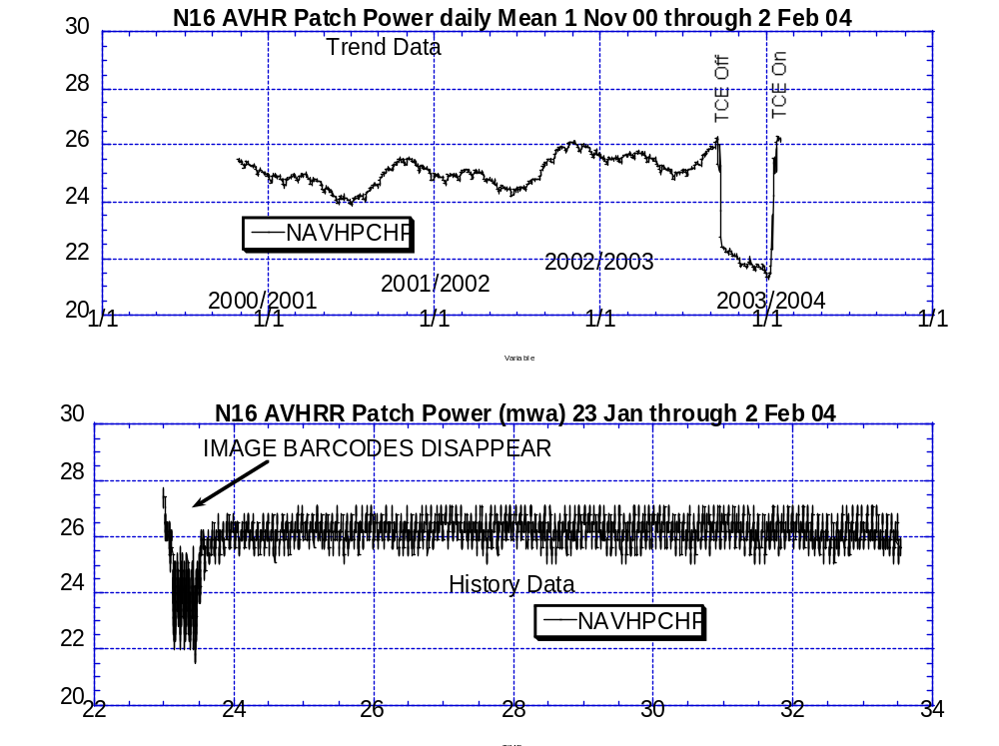

Illustration 12: N16 AVHRR Patch Power “Coincidence”.

On the same day that images stopped displaying barcode patterns, this value had a significant drop (bottom graph). The top graph is just to put this value in perspective with itself. However, in the never ending search for correlation, this is one data point that appears relevant. Whether it is or not has yet to be determined.

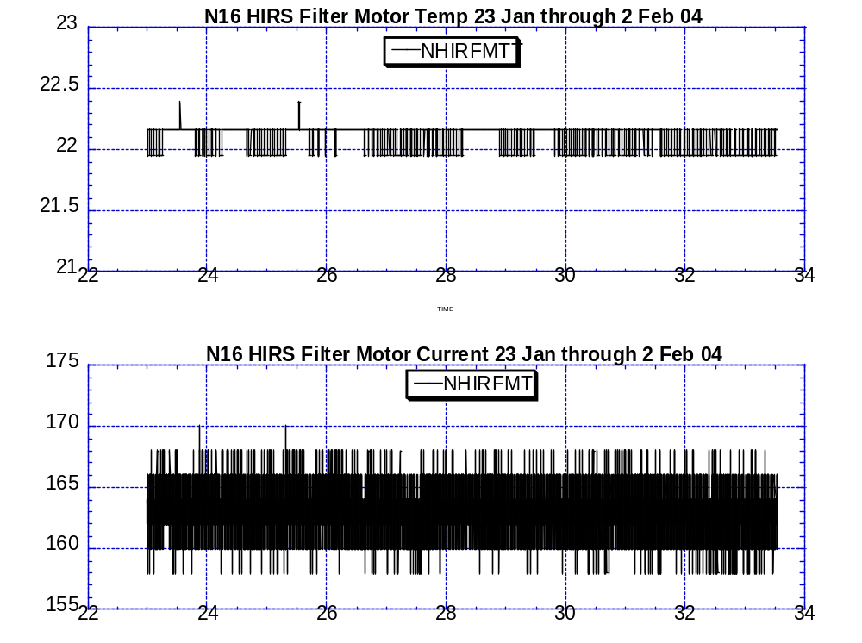

Illustration 13: N16 HIRS filter wheel operating profile during the past reporting period. (Retreating, as desired)

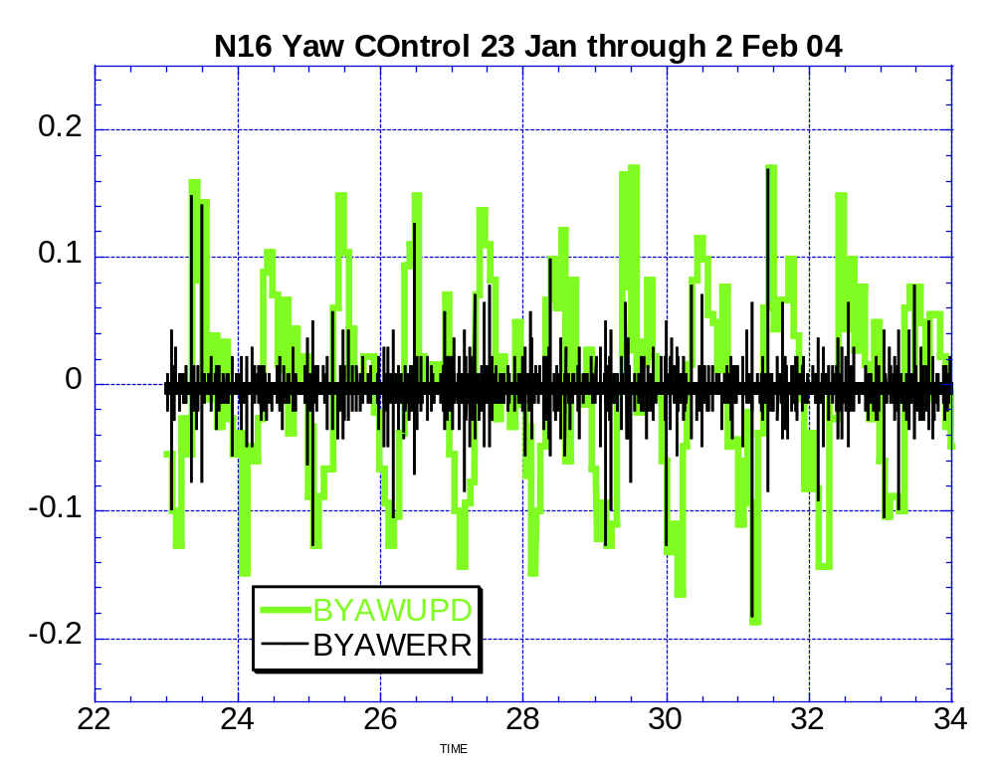

Illustration 14: N16 Yaw Control Analysis
So far, so good
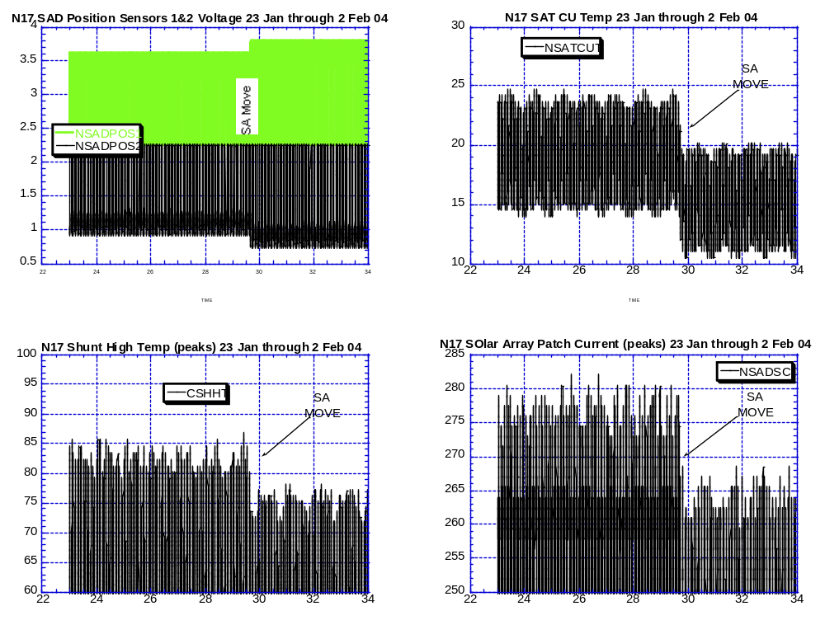

Illustration 15: N17 Solar Array Move Effects Analysis
Objective accomplished

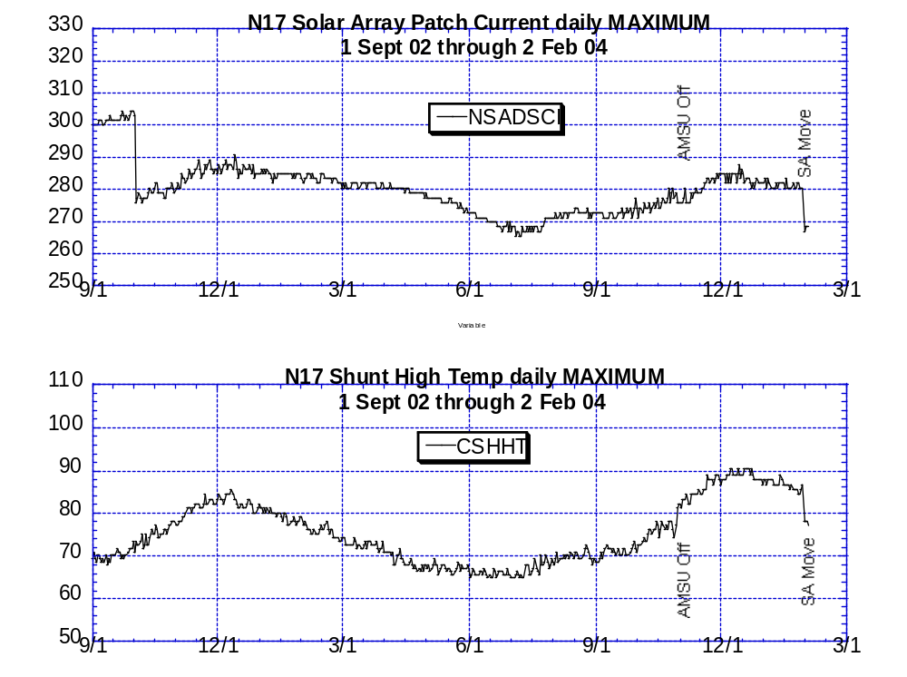
Illustration 16: N17 Solar Array Move Assessment; The Long View

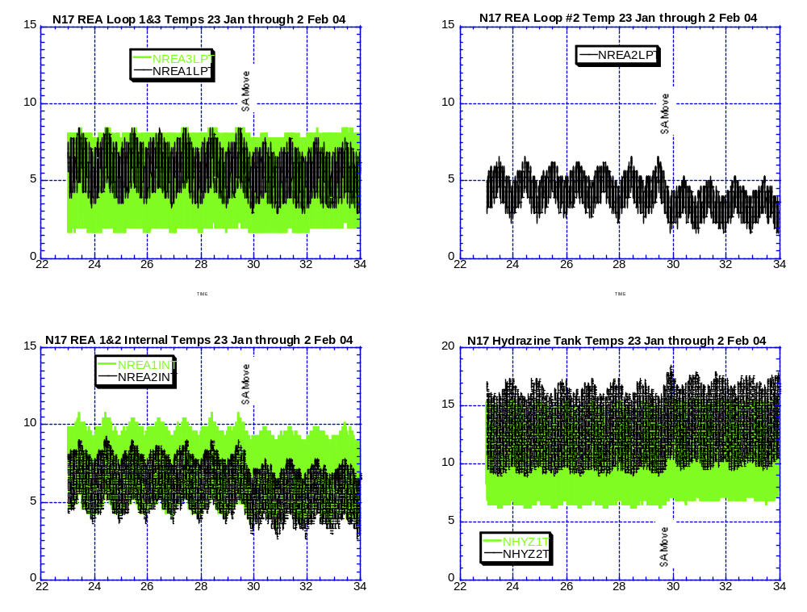
Illustration 17: N17 Solar Array Move: The peripheral effects
Nothing of note and nothing with payloads

POLAR SPACECRAFT TIP CLOCK ERROR

WEEK ENDING January 30, 2004
DAY/DATE | NOAA-11 | NOAA-12 | NOAA-14 | NOAA-15 | NOAA-16 | NOAA-17
FRI. 01/23 | -1806 msec | -537 msec | +014 msec | +024 msec | -030 msec | -051 msec
SAT. 01/24 | -1736 msec | -536 msec | +014 msec | +023 msec | -029 msec | -052 msec
SUN. 01/25 | -1666 msec | -539 msec | +015 msec | +022 msec | -031 msec | -051 msec
MON. 01/26 | -1896 msec | -535 msec | +015 msec | +024 msec | -030 msec | -052 msec
TUE. 01/27 | -1725 msec | -536 msec | +016 msec | +025 msec | -031 msec | -053 msec
WED. 01/28 | -1555 msec | -537 msec | +017 msec | +025 msec | -027 msec | -055 msec
THU. 01/29 | -1885 msec | -535 msec | + 014 msec | +024 msec | -026 msec | -055 msec
EMOSS POC for this chart is JIM SHEPHERD

NOAA-11 As of 09/03/02 the Control Side TIP clock is corrected daily by +70 msec to compensate for drift.
As of 11/03/03 Non control side clock is no longer supported
NOAA-12 ADDED 1000 mSecs to spacecraft command clock on 10/17/03.
Daily ETCUP bias of +6.5 mSec started on 12/10/03. Offset fell 500mSecs on 17 Jan
NOAA-14: As of 1223/03 the TIP clock is corrected daily by –-7.0 msec to compensate for drift.
Subtracted 50 msec from spacecraft command on 23 Dec 03.
NOAA-15: As of 04/23/03 the TIP clock is corrected daily by –-8 msec to compensate for drift.
ADDED 100 msec to spacecraft command clock on 10 June 03.
NOAA-16: As of 12/23/03 the TIP clock is corrected daily by –5.5 msec to compensate for drift.
Subtracted 100 msec from spacecraft command clock on 23 Dec 03.
NOAA-17: As of 12/23/03 the TIP clock is corrected daily by –3 msec to compensate for drift.
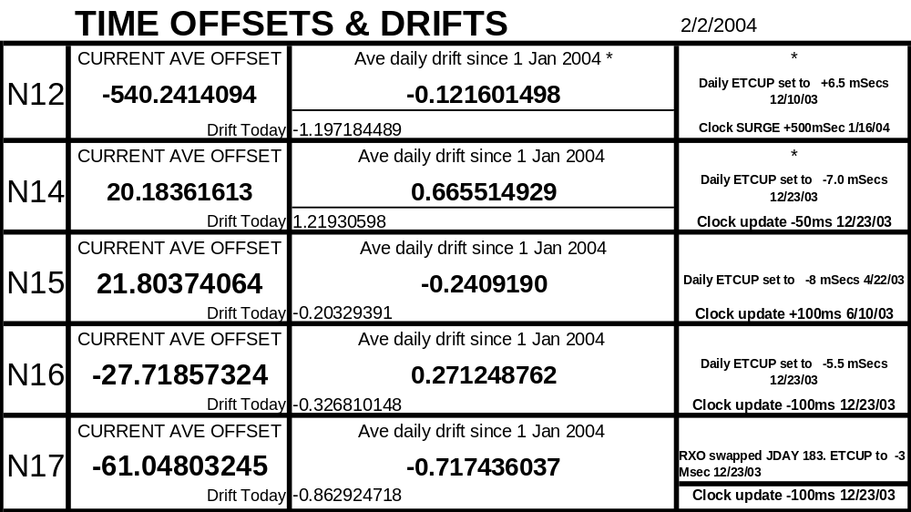
Subtracted 100 msec from spacecraft command clock on 23 Dec 03.

Weekly N17 CPU Error Scrubs

* On 22 Dec between 18:24 and 19:01Z CPU errors were reported by telemetry at a substantially higher number (numbered in the hundreds) than appears above. For purposes of brevity only the first and last errors during this possible anomalous situation are being reported. A TOAR was submitted in response to this event. No effect on the spacecraft was readily apparent and this large number will not be included in future reporting on CPU errors..
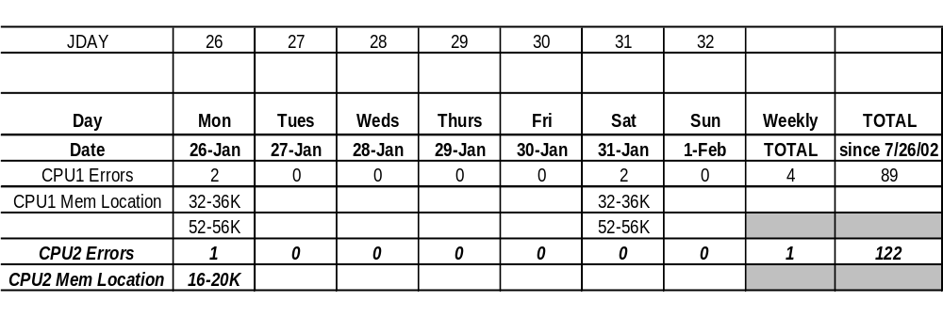

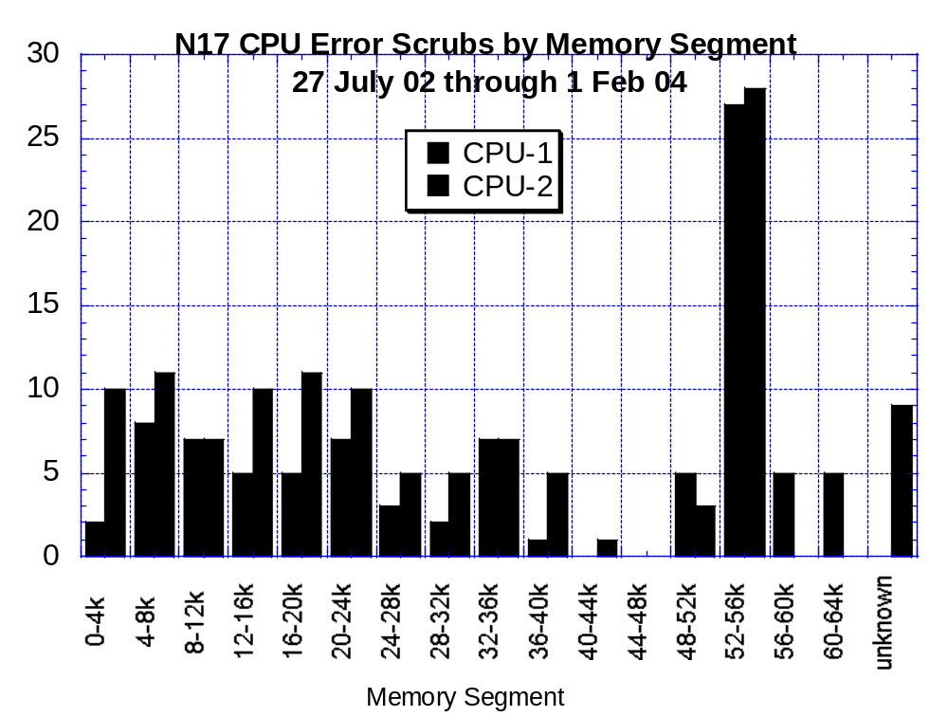

From 26 Jan 2004 through 2 Feb 04:
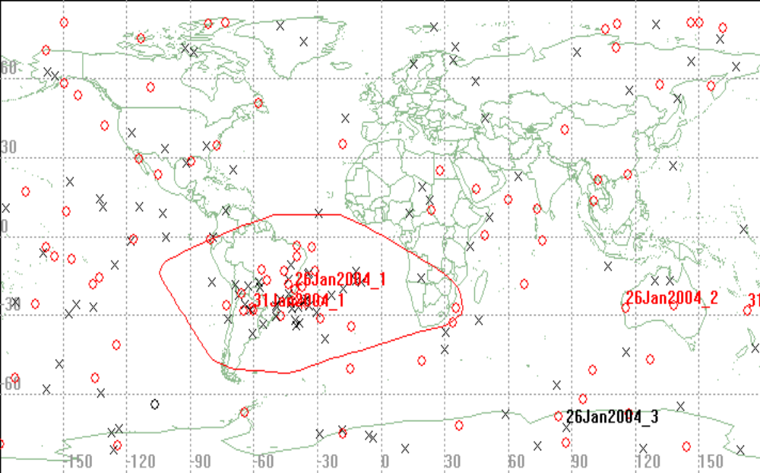

Red/Circle = CPU#1
Black/X = CPU#2

(NOTE: These statistics DO NOT include the multitude of errors reported on CPU-1 on 22 Dec

PACS DATA AVAILABILITY (%)
January 23, 2004 through January 29, 2004
JDAY 023-029

 |  |  | NOAA15 | NOAA14 | NOAA11 | NOAA16 | NOAA17
Friday | 01/23 | 023 | 100.0 | 100.0 | 83.5(a) | 100.0 | 100.0
Saturday | 01/24 | 024 | 100.0 | 100.0 | 85.5(b) | 100.0 | 100.0
Sunday | 01/25 | 025 | 100.0 | 100.0 | 93.0(c) | 100.0 | 100.0
Monday | 01/26 | 026 | 100.0 | 100.0 | 87.6(d) | 100.0 | 100.0
Tuesday | 01/27 | 027 | 100.0 | 100.0 | 100.0 | 100.0 | 100.0
Wednesday | 01/28 | 028 | 100.0 | 100.0 | 100.0 | 100.0 | 100.0
Thursday | 01/29 | 029 | 100.0 | 100.0 | 100.0 | 100.0 | 100.0

Comments:

- Rev 79067/W: S1A noisy; 32% recovered 10DL 9PE.
- Rev 79092/F: S1A noisy; 98.1% recovered 1DL.
- Rev 79104/W: S1A noisy; 94.7% recovered 9DL.
- Rev 79120/W: S1A noisy; 97.7% recovered.

EMOSS POC For This Chart: Angelique Riley

DTR Inf. (*):
NOAA-11 DTR 1B -Inoperative.
DTR 2A/B -Frequently noisy
DTR 4B -Frequently noisy
DTR 5A/B -Inoperative
NOAA-12 DTR 5A -Inoperative.
DTR 2B -Occasionally noisy and short
NOAA-14 DTR 4A/B -Inoperative.
DTR 3B -Unreliable playbacks, Removed from operations.
DTR 2A -Inoperative, DOY/200
NOAA-15 DTR 5A/B - Inoperative
NOAA-16 DTR 5A/B -Inoperative
DTR 3A -safe state change 1B
DTR 4B –Inoperative 1/12/03
NOAA-17 DTR 5A/B-Inoperative 2/16/03 Anomaly

Acronyms:
DL – Drop lock(s) PE - Parity Error(s) DQR - Data Quality Report
BE - Bit Error(s) DAR - Data Accountability Report MFR - Multi-Function Receiver

