Optic Measurements and Optics Correction in Tevatron

Valeri Lebedev

FNAL, September 18, 2003

Contents

- Differential optics measurements
- Formalism for X-Y coupled betatron motion
- On-line optics measurements and correction
- Emittance growth due to coupling and optics mismatch
- Conclusions

1. Differential optics measurements
- Presently, the only optics measurements for the entire machine have been performed with the differential orbits measurements
- Counsel application (P163)
  - Tevatron, MI, Accumulator and all transfer lines with exception of MI-8, and MI-to-Recycler
    - Four correctors (two horizontal and two vertical) and energy change
  - For Tevatron
    - Correctors: HE42, HE44, VE45, VE47
50 μrad excites ~ ±3 mm betatron wave
    - Energy change
80 Hz in T:VFKNOB corresponds to Δp/p ≈ –4.8⋅10⁻⁴
    - The measurements are fast (~5 minutes) and can be easily acquired during shot setup or whenever it is necessary.
- Tedious analysis
  - Manual fitting of differential orbits
    - It requires an experienced person, and it takes ~2 days for the entire Tevatron.
  - Fitting differential orbits in the model allows one to determine linear optics and dispersions with X-Y coupling taken into account.
    - The accuracy is about 10-15% for both the beta-functions and the dispersions.
  - Presently, we acquired data at
      - Injection energy – analysis is done for many different measurements
      - Flat top – single measurement, analyzed
      - Low beta – single measurement, analysis is not finished
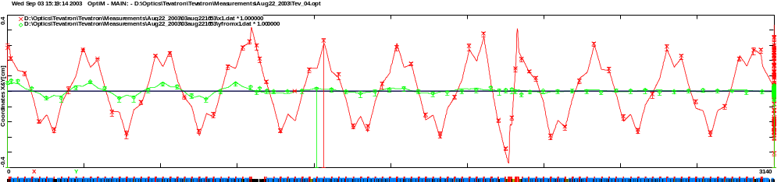
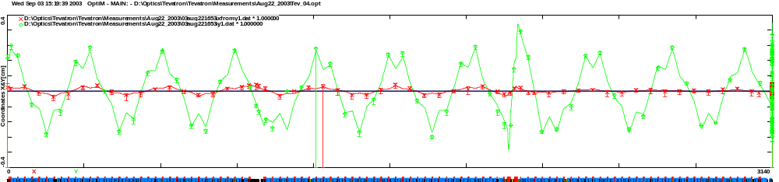
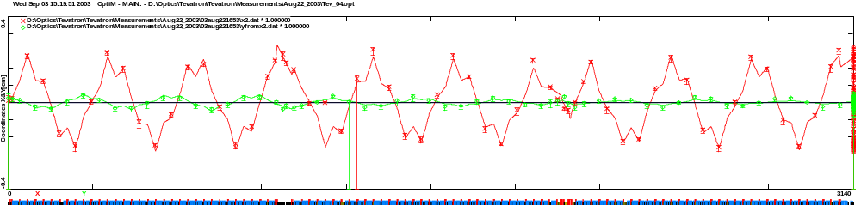
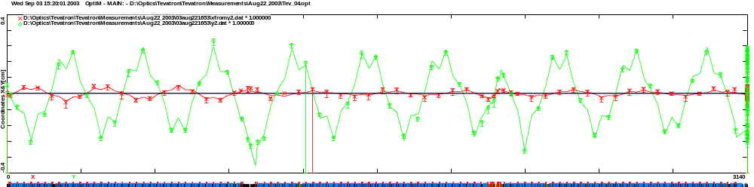
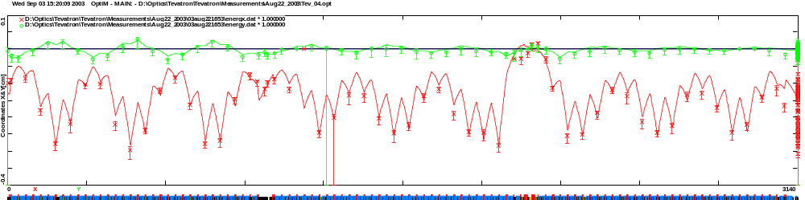
F0 A0 B0 C0
Differential orbits for the first Tevatron half after Tevatron optics correction
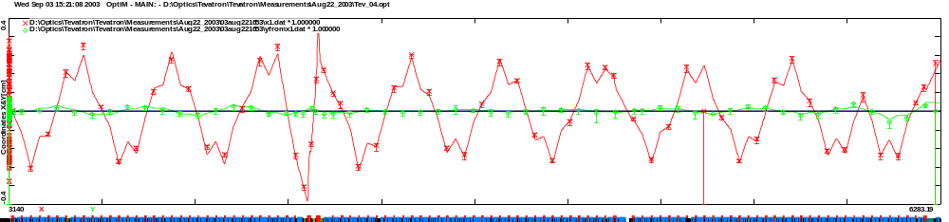
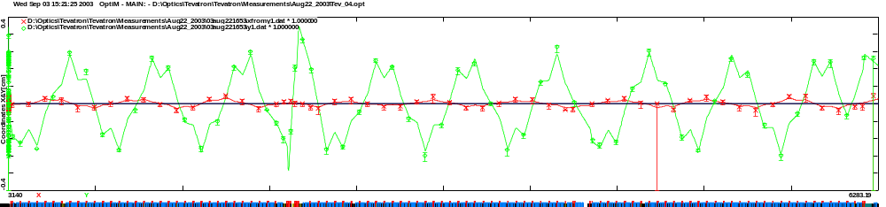
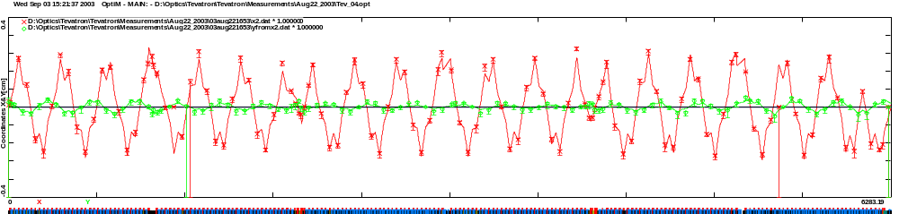
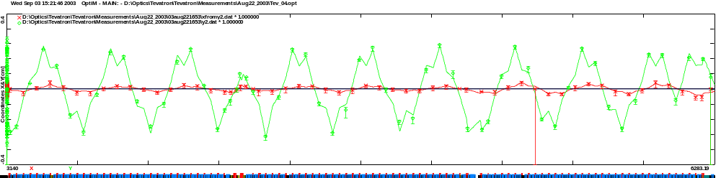
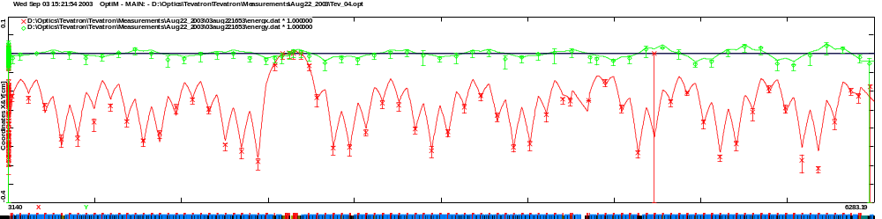
C0 D0 E0 F0
Differential orbits for the second Tevatron half after Tevatron optics correction

Findings
- BPMs
  - HA34 had wrong polarity and was fixed
  - In average the measured beam displacement is about 8% below the actual one
  - There is a number of BPMs which differential responses are up to 10-20% different from the average
- Correctors
  - Correctors used for measurements are tilted up to a few degrees
- Dipoles
  - Edge focusing correction
    - 0.057 units (0.039 deg edge focusing) at injection energy
    - -0.033 units (0.023 deg edge focusing) at top energy
  - Coherent skew-quadrupole term in all dipoles
    - A₁ ≈ 1.4 unit at injection energy
    - A₁ ≈ 2 unit at top energy
- Quadrupoles
  - Focusing correction for quads on the main bus
    - 0.177% at injection energy
    - 0.261% at top energy
  - To fit the measurements ~30 focusing corrections need to be applied
    - Single correction can be as large as 2.5%
    - Quadrupole and skew-quadrupole corrections are of the same order
    - For most of the errors the origin is not understood
          - Measurements taken at different times (separated by a few weeks) require quite different corrections to be applied
          - Orbit effect ???
            - 2% focus. error corresponds to ~1 cm offset in a chrom. sext.
            - For many dipoles non-linearity is worse than for sextupoles
    - Errors in focusing at S6 family feeddown sextupoles were well visible before its current was reduced from ~20 A to ~7 A
            - Optics correction for 1 mm displacement in S6 sextupole
              - 1% before current reduction
              - 0.35% after current reduction

Point optics corrections for August 22 & 29
Corrections for the regular quads*
Name** | Value, kG | B42 | 1
A11s | 3.5 | B42s | -2
A13 | 1 | B44 | 5
A15 | 4 | C13 | 1
A17 | -3 | C13s | 5
A28 | -2 | C17 | -2
A32 | 1 | C17s | -1
A34 | 2 | C45 | 2
A42s | -4 | C46s | 1
A42 | -2 | D16s | -5
A44 | 1 | D45 | 4
A46 | 1 | Corrections for the final focus quads
A46s | -3
B15 | -1 | Name | value
B15s | -2 | F_B0Q3 | 0.6%
B17s | -2 | Roll_B0Q3D | -0.05 deg
B23 | 2 | Roll_B0Q3F | -0.02 deg
B28 | -1 | F_D0Q3 | 0.7%
B38s | 1
* Integral strength of regular quad at 150 is 191.2 kG
** Character “s” at the name end denotes skew-quad

There is no optics corrections in E and F sectors !!!

Problems with differential orbit measurements and plans for the future
- There is no sufficient data redundancy in the present differential orbit measurements and therefore the manual data analysis is preferable
  - Measured points 5*236 = 1180 (236 BPMs, 5 measurements)
  - Unknowns 3*236+5 =713 (skew & normal quad errors, BPM dif. resp.)
- In collaboration with ANL we began building more advanced software for differential orbit data taking
  - More differential orbits will be acquired
    - 20 to 50 instead of 5
    - Measurement time will grow up from ~5 min to 15-30 min
  - Software will compute
    - Quad focusing errors and rotations
    - Differential responses for BPMs
    - Rotation and strength of the correctors used for excitation
  - First tests are expected to start at the beginning 2004

2. Formalism for X-Y coupled betatron motion
Eigen-vectors for uncoupled betatron motion
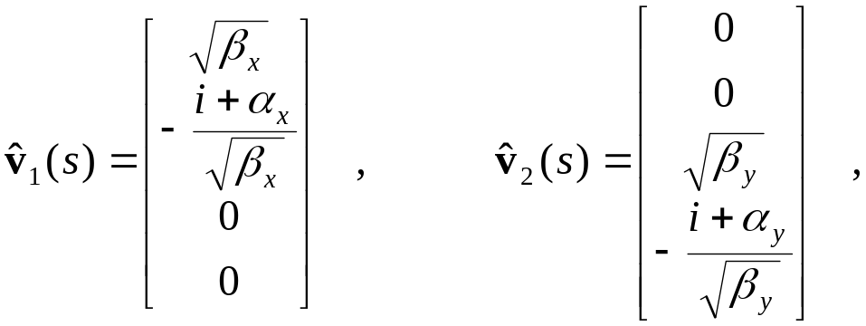
Development of Mais-Ripken representation
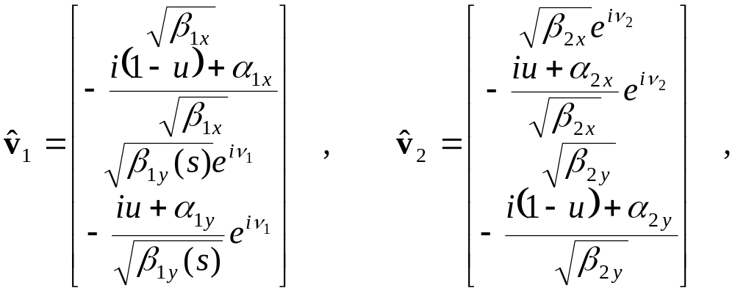
- 11 optics functions but only 8 of them are independent because of symplecticity.
- 3 symplecticity conditions were already used to bind up terms proportional to i.

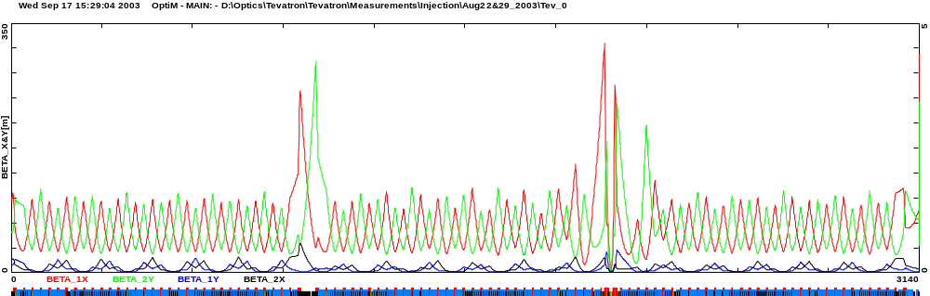
F0 A0 B0 C0
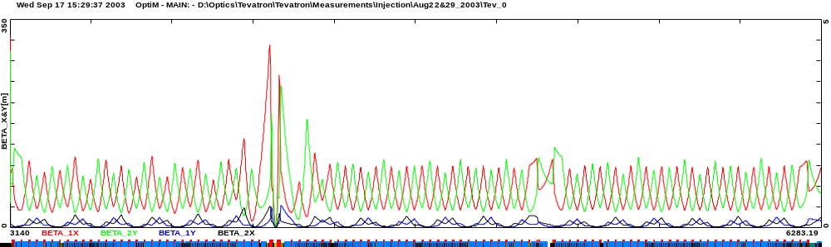
C0 D0 E0 F0
β-functions computed from differential orbit measurements of Aug. 22 and 29, 2003; central orbit, corrected optics

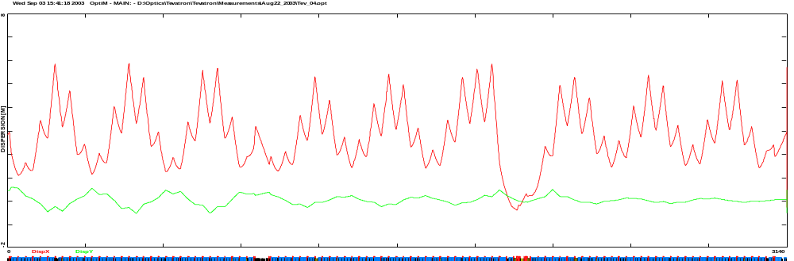
F0 A0 B0 C0
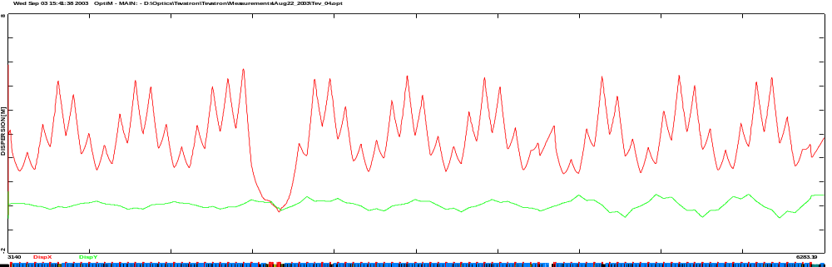
C0 D0 E0 F0
Dispersions restored from differential orbit measurements; central orbit, corrected optics

3. On-line optics measurements and correction
- Differential orbit measurements results
  - There are no single strong source of optics discrepancy
  - There is no point corrections in vicinity of inj. point (E and F sectors)
  - Overall betatron mismatch is reasonably small
      - Before correction in E and F sectors
                - Vertically - Δβ_{y}/β _{y} ~±15%
                - Horizontally - Δβ _{x}/β _{x} ~±5%
  - Horizontal mismatch is significantly smaller
- The aim of optics correction
  - To minimize emittance growth at transfers
- Optics correction method
  - The tunes are close to high integer and therefore there is a resonant amplification of beta-function mismatch
  - Correcting betatron wave in E and F sectors reduce optics mismatch through entire machine
    - It also slightly improves helical beam separation
  - 2 orthogonal quads in each plane anywhere in the ring will do the job
  - 4 quads around D0 interaction point were chosen
    - D0 is the place of strongest optics distortions

- On-line optics measurements in E and F sectors
  - Courant –Snyder invariants built from differential orbit measurements
    - 2 correctors orthogonal in betatron phase space for each plane
  - Tune shifts due to focusing change in a single quadrupole
    - 2 quads orthogonal in betatron phase space for each plane

Optics measurements and optics corrections performed at August 22
 |  | Initial | 1st iter(delta) | 2nd iter
Optics corrections | C:CQ9 [A] | 63.92 | 45.9(-18) | 63.92(0)
Optics corrections | C:CQ7 [A] | 98.07 | 125.1(27) | 98.07(0)
Optics corrections | C:DQ7 [A] | 99.65 | 117.6(18) | 108.65(9)
Optics corrections | C:DQ9 [A] | 89.65 | 64.6(-25) | 76.79(-12.86)
Optics corrections | T:SQ [A] | -2.827 | -3.023 | -2.852(-.025)
Optics corrections | T:SQA0 [A] | 4.185 | 6.680 | 4.361(0.176)
Optics corrections | QY(set) | 20.568 | 20.551 | 20.55514
Optics corrections | QX(set) | 20.605 | 20.58315 | 20.6096
Measured tunes | QY(meas) | .575 | .5752 | .5756
Measured tunes | QX(meas) | .583 | .5831 | .5831
Optics meas. by 10 A quad current change,  ΔQx/ΔQy | QE17 | .0213/-.0075 | .0249/-.0061 | .0208/-.0071
Optics meas. by 10 A quad current change,  ΔQx/ΔQy | QE19 | .0207/-.0076 | .0187/-.0080 | .0208/-.0067
Optics meas. by 10 A quad current change,  ΔQx/ΔQy | QE47 | .0065/-.0255 | .0068/-.0310 | .0061/-.0287
Optics meas. by 10 A quad current change,  ΔQx/ΔQy | QF33 | .0059/-.0310 | .0072/-.0239 | .0059/-.0275
ΔQx/ΔQy for ΔI=10 A predi-cted by model* | QE17 |  |  | .0225/-.0077
ΔQx/ΔQy for ΔI=10 A predi-cted by model* | QE19 |  |  | .0210/-.0079
ΔQx/ΔQy for ΔI=10 A predi-cted by model* | QE47 |  |  | .0070/-.0287
ΔQx/ΔQy for ΔI=10 A predi-cted by model* | QF33 |  |  | .0069/-.0290
* The model uses periodic beta-functions in E and F sectors with coupling taken into account
 |  | Initial | 1st iter(delta) | 2nd iter
Optics meas. with C.-S. invariants | Ax1 | 0.75 | 0.72 | 0.76
Optics meas. with C.-S. invariants | Ax2 | 0.77 (+0.02) | 0.79 | 0.77 (+0.01)
Optics meas. with C.-S. invariants | Ay1 | 0.73 | 0.80 | 0.74
Optics meas. with C.-S. invariants | Ay2 | 0.79 (+0.06) | 0.74 | 0.77 (+0.03)
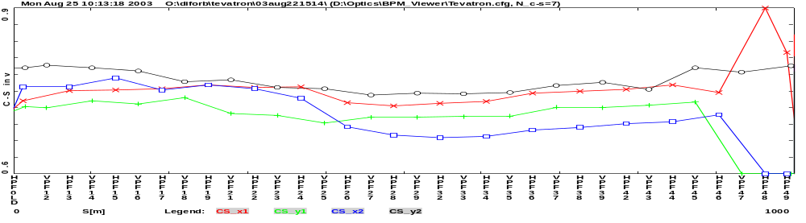

Initial

First iteration

Second iteration
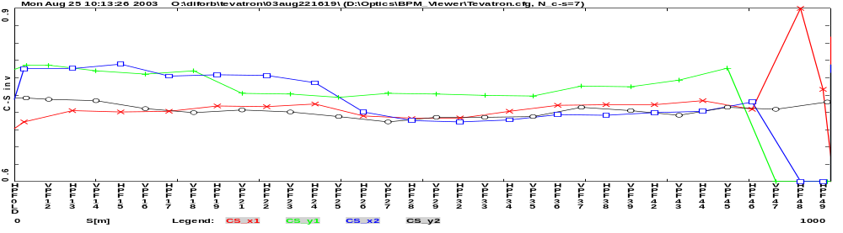
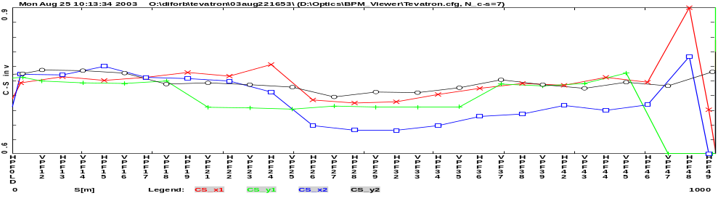

4. Emittance growth due to coupling and optics mismatches
a) Emittance growth due to betatron and dispersion mismatch from a lattice with β₁, α₁, D₁ and 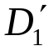 to a lattice with β₂, α₂, D₂ and 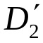 is

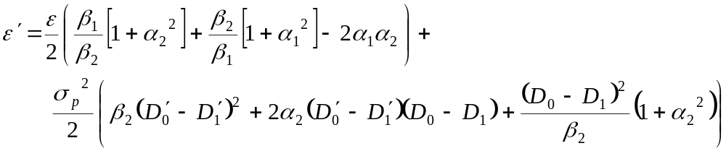
⇒ 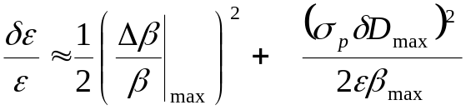
b) Emittance growth for beam transfer from an uncoupled lattice with β_{x}, α_{x}, β_{y} and α_{y}, to a coupled lattice described by β_{1x}, α_{1x}, β_{1y}, α_{1y}, β_{2x}, α_{2x}, β_{2y} and α_{2y} with the eigen-vectors
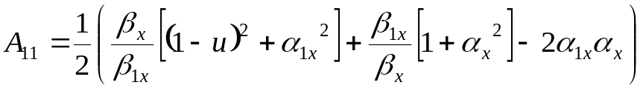
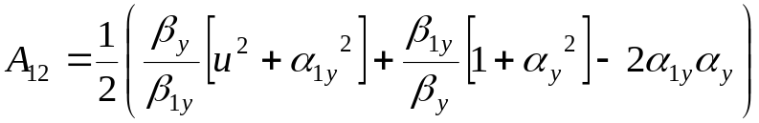
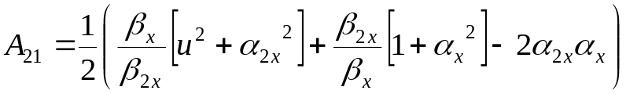
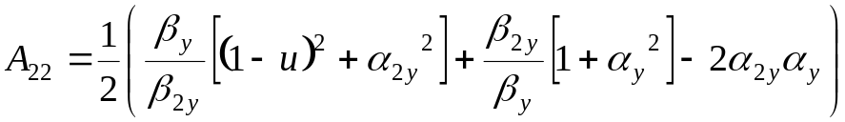
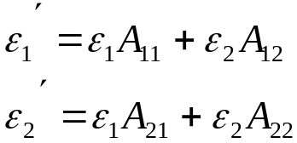

Requirements for dispersion mismatch for MI to Tevatron transfer
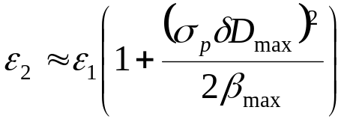
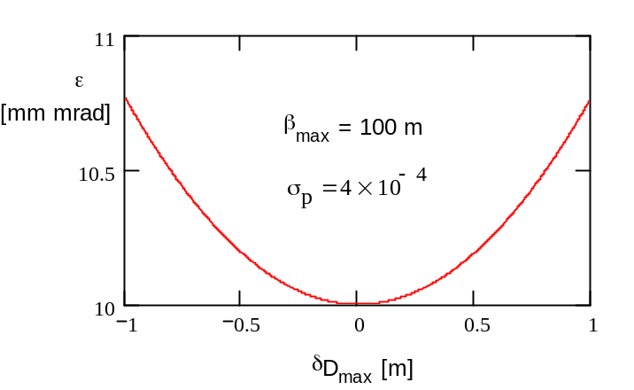
- Dispersion mismatch below about 0.5 m does not produce significant emittance growth
Emit. growth due single quad focusing error at D=0
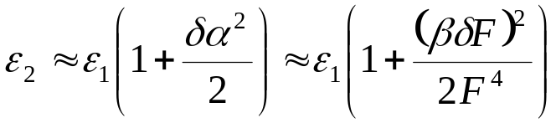
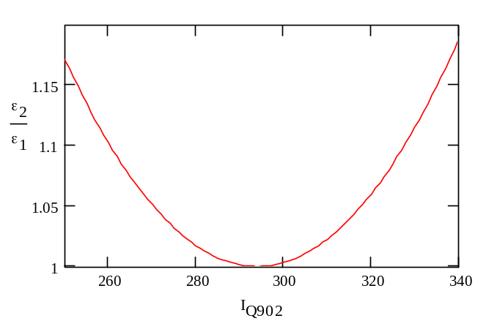
- Differential orbit measurements allow seeing focusing errors of 1-2%.
  - It is sufficient to tune the line focusing so that the emittance growth would be below 10%.
  - Further improvement is expected from online tuning with orthogonal quads.

- Measurements of P1 and A1 lines performed at the end of 2002 could not explain the reason of large emittance growth in the round trip emittance measurements
- Tevatron optics distortions were most probable reason
  - but there were not clear understanding how
  - and what particular phenomenon is responsible for this

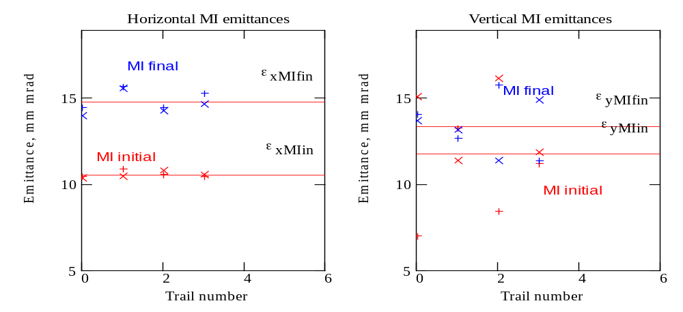

Red - MI before extraction to Tevatron

Blue - beam coming back from Tevatron to MI,

Green – emittance measured in Tevatron

x – first fly data
+ - second fly data.

Measured round trip emittances before optics correction
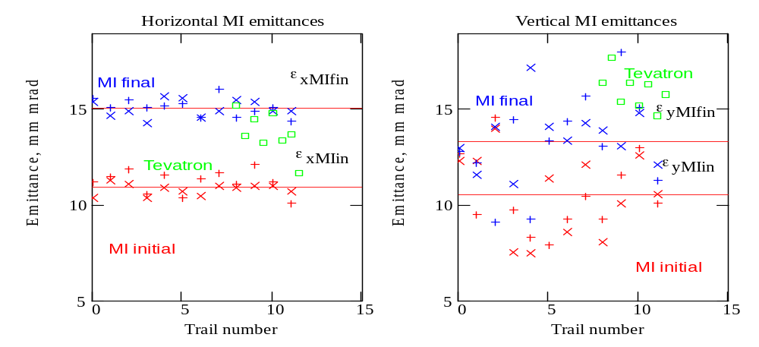
Measured round trip emittances after optics correction
Measured and computed* round trip emittance growth
 | Uncorrected (old) Tevatron optics |  | Corrected (old) Tevatron optics
 | Measured | Computed | Measured | Computed
δε_{x} [mm, mrad] | 4.22±0.21 | 2.54 | 4.07±0.12 | 3.08
δε_{y} [mm, mrad] | 1.58±1.47 | 3.40 | 2.83±0.61 | 2.98
(δε_{x} + δε_{y} )/2,  [mm, mrad] | 2.9 | 2.97 | 3.45 | 3.03
* Computations were carried out for equal horiz. and vert. emittances of 11 mm mrad.

- Careful Tevatron tuning reduced emittance growth in comparison with the end of 2002 measurements
    - Δε_{x} ≈ 7 mm mrad ⇒ Δε_{x} = 4 mm mrad
    - Δε_{y} ≈ 4 mm mrad ⇒ Δε_{y} = 3 mm mrad
- Tevatron optics correction made barely visible improvement for transfers
- Strong coupling in Tevatron is found to be the major offender
    - ∼14% emittance growth in each plane per transfer
- Model prediction of machine optics on helices is not sufficiently accurate
  - It yields a discrepancy between measurement and predictions
  - There is no reliable information about machine non-linearities
    - The model uses uniform distribution of dipole non-linearities

Tevatron Emittance monitors

Tevatron emittance measurements were carried out after optics correction

The machine beta-functions should be close to the design beta-functions

Horizontal emittance monitor is consistent with MI emittance monitor

Vertical emittance monitor reports 16 mm mrad emittance versus 12 mm mrad following from MI measurements (1.33 times higher)

There was scraping on the level of 2-3% when helix was open
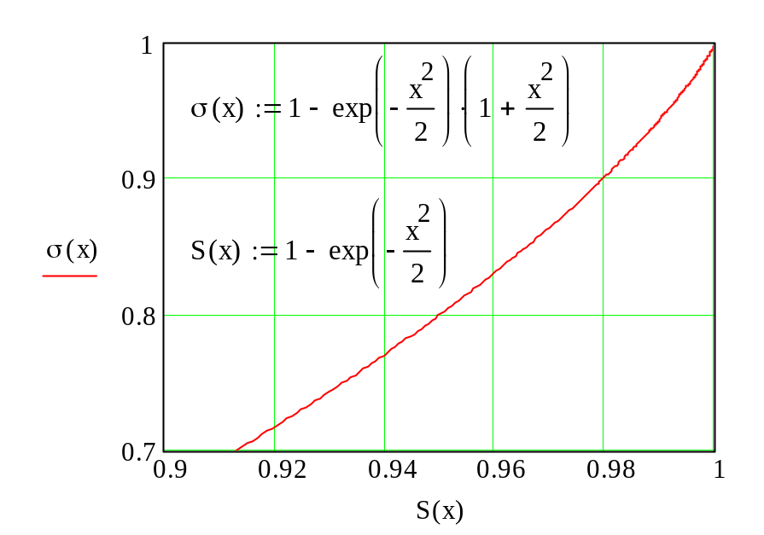

It could reduce the emittance of the beam coming back to MI by 1-1.5 mm mrad. That takes out less than 1 mm mrad out of 4 mm mad discrepancy!!!

The question is open

Correction of A1 for 106 Tevatron dipoles
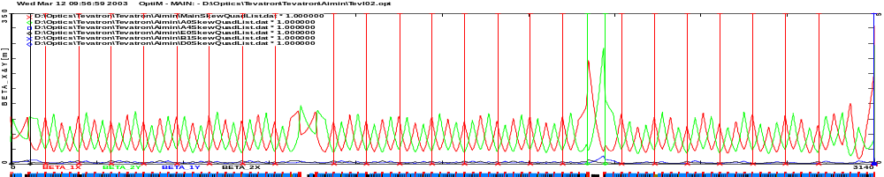
E0 F0 A0
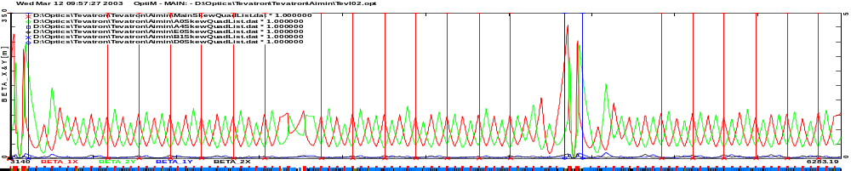
B0 C0 D0
4D beta-functions and positions of skew-quads
- Presently, there are many dipoles, which do not have nearby skew-quads
  - That prevents suppression of coupling to sufficiently small level
    - Small tune split does not automatically mean small coupling
- Compensation of skew-quadrupole term in 106 of 774 Tevatron dipoles will allow significantly decrease coupling
  - Dipoles are located around B0 and D0 IPs (A44-B19 and C44-D19)

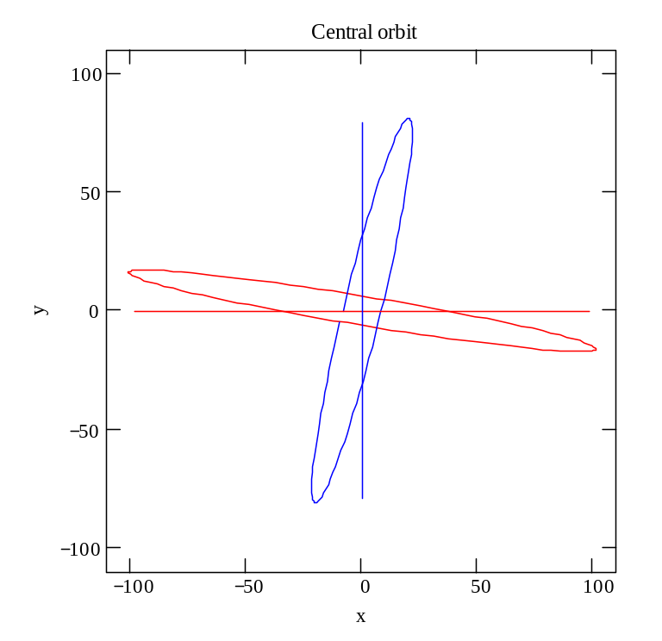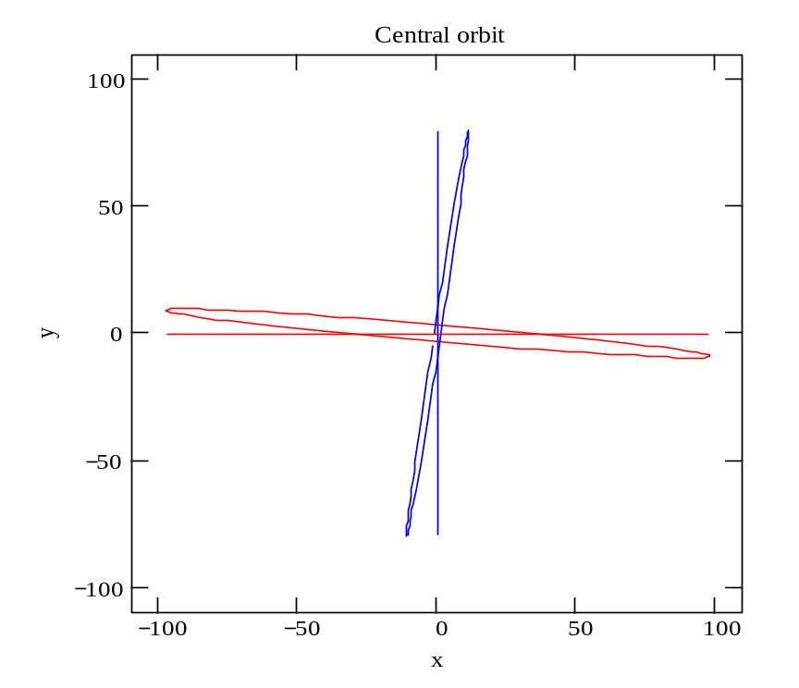
Projections of betatron modes to X-Y plan at proton injection point for present Tevatron (left) and after correction of skew-quadrupole component (right).

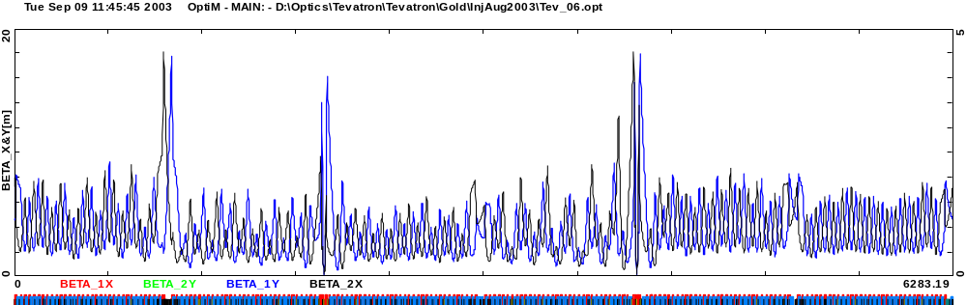
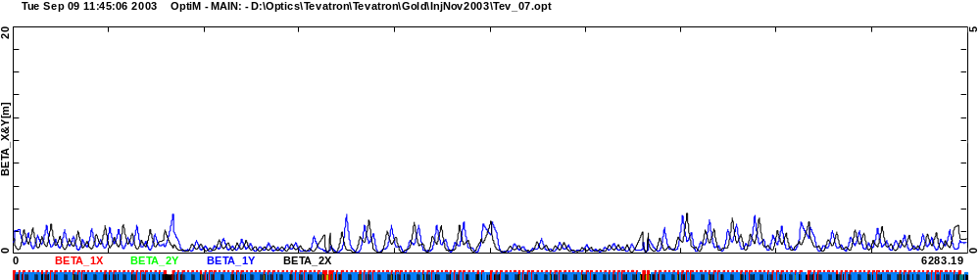
Projections of betatron functions to orthogonal plan for present Tevatron (top) and after correction of skew-quadrupole component (bottom).

Conclusions
- Measured and predicted round trip emittance growths are in good agreement
  - Coupling makes major contribution: Δε ≈ 1.5 mm mrad per transfer for ε = 11 mm mrad
  - Simulations predict that there is no significant difference for transfers to the central orbit and p-bar helix
- Correction of skew-quadrupole term in 106 Tevatron dipoles reduces the emittance growth related to coupling from 13% to 3% per transfer. That will yield:
  - ~ 1 mm mrad improvement for pbars
  - ~ 2 mm mrad improvement for protons
    - ~ 10% luminosity increase due to smaller beam emit, and ~5% due to loss
- There is a difference of 4 mm mrad between vertical MI and Tevatron flying wires
  - Instrumental error needs to be understood and fixed
- Preliminary results for the differential orbit measurements at Flat top
  - Skew-quad field grows from ~1.5 units to ~2 units
  - Optics discrepancies are of the same order as at the injection
- There is an evidence that B11V high voltage separator deflects the beam by 8% more than its computed strength
- Shots after optics correction exhibited higher gain in luminosity than it predicted
  - Possible reason can be that there are other discrepancies not taken into account in the model (MI, transfer lines, etc.). Then we have been far away from the optimum where sensitivity to errors is mach higher.

