
November 2006

Volume 7 Number 3
NASA Announces Discovery Program Selections

A Note From the Program Manager

November 20th marked an exciting day in the Discovery Program. The Concept Study Kickoff Meeting was held in Washington D.C. with the new missions recently selected to enter Phase A (see article at right for mission details).

Each of these candidates represents exciting new science for the Program to accomplish. They also clearly demonstrate that the science community is still rich in new ideas that can fit within the Program’s goals.

As part of the Kickoff meeting, I was asked to give an overview of the Program Office and how it interacts with projects in Phases B-E. It’s easy when asked this type of question to get lost in defining the Program Office function in terms of Program and Project classifications.

So how did I define the Program Office interaction? Yes, I mentioned some of the classification material (it’s in the book, so you have to). But what drives any Program Office interaction is the drive to achieve success. So what is success to the Discovery Program Office? Put simply:

Success is……
  - Delivering Mission Science to the PI
  - Ensuring the implementing organization’s success in delivering the spacecraft on cost and schedule
  - Meeting the Program launch frequency for Science Missions

The Program Office’s interaction with a mission is keyed to ensuring success in achieving science and in developing and operating the spacecraft.

Before I close, I want to acknowledge the achievements of the Stardust Team. The Stardust Mission was recently the recipient of the Popular Mechanics Breakthrough Award for Innovation and the Aviation Week Program Excellence Award. Both of these awards represent a very prominent recognition of what the Stardust team was able to accomplish. I anxiously await the publication of the initial science results in the December timeframe.

Finally, I wish everyone in the Discovery and New Frontiers Programs a happy and safe Holiday season, and look forward to another new and exciting year of Discovery.

- Paul Gilbert



New Discovery Selections…………….…………..………. 1
MESSENGER …………………………………………………. 2
New Horizons ………………………………….…………….. 3
Stardust …………………………………….………………….. 3
Deep Impact ……………………………….………………….. 4
Genesis …………………………….………………………… 5
Dawn …………..………..………..………..…………..………. 6
Kepler …………………………………………………………. 7
Juno …………..………..………..………..…………..………. 7
Students Contact ISS ……….……….……………..………. 8

http://discoverynewfrontiers.nasa.gov/

The next Discovery Program mission could return a sample of an asteroid, probe the chemistry of Venus' atmosphere or reveal the interior structure and history of the Earth's moon. On October 30, NASA announced it selected these three proposals for concept studies from approximately two dozen submitted in response to the Discovery Program 2006 Announcement of Opportunity in April.

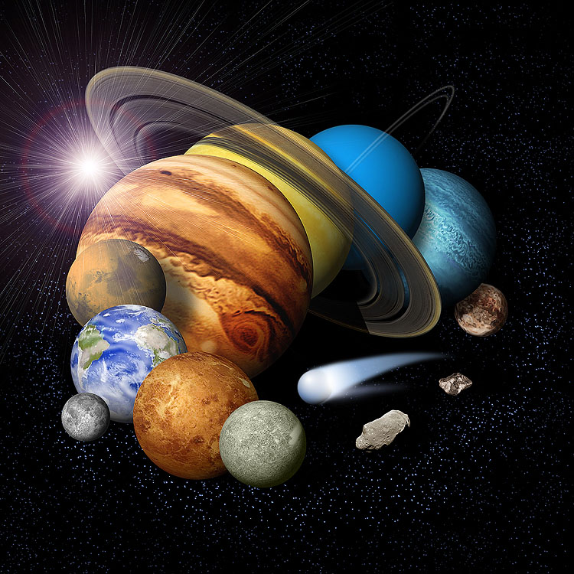

Also selected for further study are three “missions of opportunity” that would make new use of two NASA Discovery Program spacecraft, Deep Impact and Stardust, that have completed their primary mission science objectives. (Missions of opportunity propose scientific uses for existing spacecraft or build instrumentation for spacecraft of other space agencies.

Inside

The three complete mission concept studies selected are:

-- Origins Spectral Interpretation, Resource Identification and Security (OSIRIS) would survey an asteroid and provide the first return of asteroid surface material samples to Earth. Michael Drake of the University of Arizona, Tucson, is the principal investigator. NASA's Goddard Space Flight Center, Greenbelt, MD, would manage the project.

-- Vesper is a Venus chemistry and dynamics orbiter that would advance our knowledge of the planet's atmospheric composition and dynamics. Gordon Chin of Goddard is Vesper's principal investigator. Goddard would manage the project.

-- Gravity Recovery and Interior Laboratory (GRAIL) would use high-quality gravity field mapping of the moon to determine the moon's interior structure. Maria Zuber of the Massachusetts Institute of Technology, Cambridge, MA, is principal investigator. NASA's Jet Propulsion Laboratory, Pasadena, CA, would manage the project.

The three missions of opportunity selected for concept studies are:

-- Deep Impact eXtended Investigation of Comets (DIXI) would use the existing Deep Impact spacecraft for an extended flyby mission to a second comet to take pictures of its nucleus to increase our understanding of the diversity of comets. Michael A'Hearn of the University of Maryland, College Park, MD, is principal investigator.

-- Extrasolar Planet Observations and Characterization (EPOCh) would use the high-resolution camera on the Deep Impact spacecraft to search for the first Earth-sized planets detected around other stars. L. Drake Deming of Goddard is principal investigator.

-- Stardust NExT would use the existing Stardust spacecraft to flyby comet Tempel 1 and observe changes since the Deep Impact encounter in July 2005 and since Tempel 1 made its closest approach to the sun shortly thereafter, possibly changing the surface of the comet. Joseph Veverka of Cornell University, Ithaca, NY, is principal investigator.

"The science community astounded us with the creativity of their proposals," said NASA's Science Mission Directorate Associate Administrator Mary Cleave. "We look forward to the new knowledge of our solar system that these concepts may provide."

The newly selected missions will receive $1.2 million to conduct concept studies. NASA may select one or more investigations to proceed into development next year, after detailed review of the concept studies. If selected to continue, each project must complete its mission, including archiving and analyzing data, for less than $425 million.

Missions of opportunity will receive $250,000 for concept studies. If selected to continue, each mission of opportunity must complete its project for less than $35 million.
MESSENGER Flies By Venus
The Mercury-bound MESSENGER spacecraft came within 2,990 kilometers (1,860 miles) of the surface of Venus early on the morning of Oct. 24. The primary goal of the flyby of Venus was to receive a gravity assist that put MESSENGER on course to its final destination: Mercury.

None of the science instruments were powered on near the time of closest approach, because Venus was on the opposite side of the Sun from the Earth. The spacecraft will be out of direct communication for approximately three weeks.

MESSENGER will fly by Venus a second time, on June 6, 2007, and during that time all payload instruments will be trained on the planet before, during, and after closest approach. The MESSENGER team is working closely with the team operating Europe’s Venus Express mission to take advantage of the two spacecraft being in the vicinity of Venus at the same time. A range of coordinated observations of Venus is being planned. This will enable scientists to make multiple observations from both spacecraft and learn more than they would from either one alone.

(The European Space Agency (ESA) launched the Venus Express mission in November 2005; the spacecraft entered Venus orbit in April and in June began its primary science mission to unveil the source of the planet’s dense, turbulent and toxic atmosphere.)

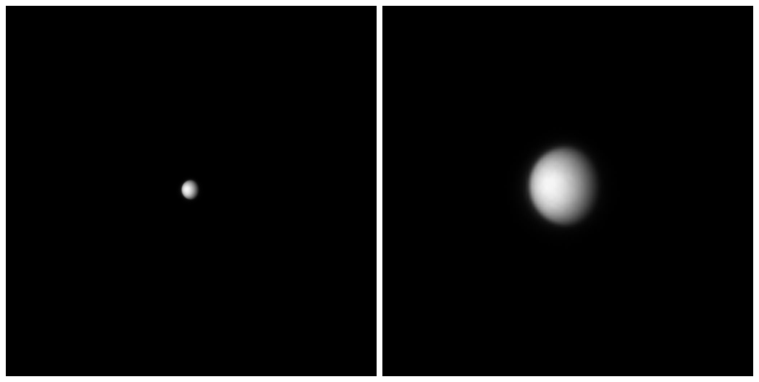 Venus captured by the MDIS as MESSENGER approached the planet.

Earlier in November, the MESSENGER Dual Imaging System (MDIS) snapped pictures of Venus from a distance of about 16.5 million kilometers (10.3 million miles). Despite the low resolution of the images, it’s possible to see that Venus is shrouded in a thick blanket of clouds that hides its surface. Also available online are updated animations, one showing Venus from the spacecraft from 90 minutes before to 90 minutes after the flyby, including the time of the eclipse. See them at: http://messenger.jhuapl.edu/the_mission/movies.html

Education and Public Outreach Highlights

MESSENGER participated in a variety of activities during the recent Mercury transit on November 8. They were a partner with NASA’s Sun-Earth Connection Education Forum for their webcast on the event. Deputy project scientist Deborah Domingue participated in a NASA Digital Learning Network webcast during the transit, discussing Mercury, the MESSENGER mission, and answering questions from students in two NASA Explorer Schools. The webcast will be rebroadcast in the spring as part of 2007 Sun-Earth Day.

MESSENGER also supported the Mercury Transit Hawaii Style webcast, providing materials to Dr. Dave Blewett of NovaSol who discussed Mercury and the MESSENGER mission. MESSENGER provided posters to Solar System/New Horizons Educator Ken Brandt for a transit event at University of North Carolina-Pembroke.
The AAAS/MESSENGER book "Exploring the Inner Solar System" was printed and copies have been distributed to the MESSENGER Fellows for distribution in educator workshops. The Girl Scouts of the USA have indicated they are interested in providing the books to their core trainers as part of a Lunar Robotics workshop at NASA’s Johnson Space Center in Houston in summer 2007.
New Horizons Continues Towards Pluto
Blazing along its path to Pluto, the New Horizons spacecraft is getting closer to Jupiter. The first picture of the giant planet from the spacecraft's Long Range Reconnaissance Imager (LORRI), taken Sept. 4, 2006, is a teaser of what's to come when New Horizons flies through the Jupiter system early next year.

New Horizons was 291 million kilometers (nearly 181 million miles) away from Jupiter when LORRI took the photo. As New Horizons comes much closer in January and February, LORRI will take more detailed images.

LORRI snapped the image during a test sequence to help prepare for the Jupiter encounter observations. It was taken when the Sun was almost directly behind the camera, making Jupiter appear about 40 times brighter than Pluto will be for LORRI's observations when New Horizons encounters the Pluto system in 2015. To avoid saturation, the camera's exposure time was kept to 6 milliseconds. This image was, in part, a test to see how well LORRI would operate with such a short exposure time.

"LORRI's first Jupiter image is all we could have expected," says LORRI Principal Investigator, Andy Cheng, of APL. "We see belts, zones and large storms in Jupiter's atmosphere. We see the Jovian moons Io and Europa, as well as the shadows they cast on Jupiter.”

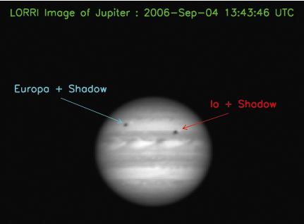
Stardust Science Results Presented, Honors Received

The mission team continues to complete important milestones as they prepare the spacecraft and instrument payload for the long journey ahead. As the spacecraft flies outward from the Sun at about 78,700 kilometers (48,600 miles) per hour, communications time is increasing rapidly. It's now about 1-1/2 hours round trip, at the speed of light. For that reason, the mission and payload operations team has been working to complete a series of activities that are best done before the communications time increases still further.

Since late September, they've completed these activities:
1. Loading and enabling the Guidance and Control flight software; 2. Completing initial calibrations and taking the first cruise science plasma data with the particles and fields instruments, PEPSSI and SWAP; 3. Calibrating Venetia, the student-built dust counter, to filter out noises on the spacecraft that mimic the dust particle impacts they are trying to study; and 4. Loading and activating Autonomy Flight Software that contains enhancements and bug fixes to the onboard fault detection and correction software.

In addition to these activities, the spacecraft team at the Applied Physics Lab and the navigation team at KinetX, Inc. have carefully compiled all available tracking data to show that the actual course is very close to the optimal trajectory to the Pluto aim point at Jupiter. As a result, the team has concluded that no corrections appear to be necessary on the way to Jupiter, allowing more time to work on planning for the most productive Jupiter encounter. Every activity planned — each imaging session, spectroscopic observation, plasma instrument activity — requires command sequences that must be designed, coded, tested and reviewed prior to being sent to the spacecraft.

During an intensive 10-day period around the Feb. 28, 2007, closest approach to Jupiter, the mission hopes to carry out approximately 100 observation sequences of Jupiter, its magnetosphere, and its four large moons. The highest priority of the flyby is to tighten the trajectory through the narrow Pluto gravity assist aim point that lies some 2.5 million kilometers to the right of Jupiter as seen from Earth. The second priority at Jupiter is to conduct a series of spacecraft encounter test observations and instrument calibrations, enhancing preparedness for the Pluto encounter. The third priority is a set of about 100 science observations with different areas of interest to follow up on discoveries made by ground-based observers and previous spacecraft missions.

The plans range from new studies of Jupiter's rings to compositional and atmospheric observations of Jupiter's Galilean satellites at resolutions that neither the Galileo nor Cassini missions achieved. They also want to investigate Jupiter's meteorology, the great and little red spots, its magnetosphere and dust streams.

The Jupiter science observations will begin in early January and stretch into late June, mimicking the Pluto encounter in length, data volume returned, and operational intensity. It is designed to prove out planning tools, simulation capabilities, the spacecraft and instrument sensors in a real-world encounter environment well before planning for the Pluto encounter begins.

Stardust principal investigator Don Brownlee was one of the plenary session speakers at the 38th annual meeting of the American Astronomical Society’s Division for Planetary Sciences (DPS) held October 8-13 in Pasadena, CA. Brownlee’s talk was titled, “Laboratory Studies of Comet Samples Returned by Stardust.”

He began by reminding his colleagues that he brought fortune cookies to the October 1995 DPS meeting in Kona, Hawaii, as he awaited NASA’s decision for Discovery mission #4. Before the year ended, Stardust was selected. Now, 11 years later, Brownlee beamed as he stated the mission was a total success. “I can’t believe it all worked!” he said, “And everything is in phenomenally good shape.”

Stardust collected thousands of solid particles from comet Wild 2 and returned them to Earth. Wild 2 is a Jupiter family comet that is believed to have formed in the Kuiper belt and resided there for nearly the full history of the solar system. The materials returned by Stardust provide the first laboratory samples from a known primitive solar system body. The presence of laboratory samples of a known comet and meteorites from asteroids provide a remarkable opportunity to compare the solid particles that existed in both the central regions and outer fringes of the solar nebula.

The sample studies are still in the preliminary stage, but a number of generalizations can be made. Most of the strong solid components larger than a micron are anhydrous silicates or sulfides. The most common minerals are forsterite, enstatite and pyrrhotite. A range of other minerals have also been found including refractory minerals rich in Ca, Al and Ti, characteristic phases in Calcium Aluminum Inclusions in primitive meteorites. The origin of all of these phases is a major focus of the study of the Stardust samples. Trace element contents, isotopic composition and other properties provide a very powerful means of distinguishing between suggested origins. This work will provide fundamental information on mixing in the solar nebula and the relative contribution of pre-solar and nebular materials in forming comets.

Science Team Gathers to Review Results

On November 3-5, “Stardust Workshop 7 - Wild 2 Samples” was convened by Peter Tsou and Don Brownlee to bring together science team members involved in analyzing the Wild 2 particles.
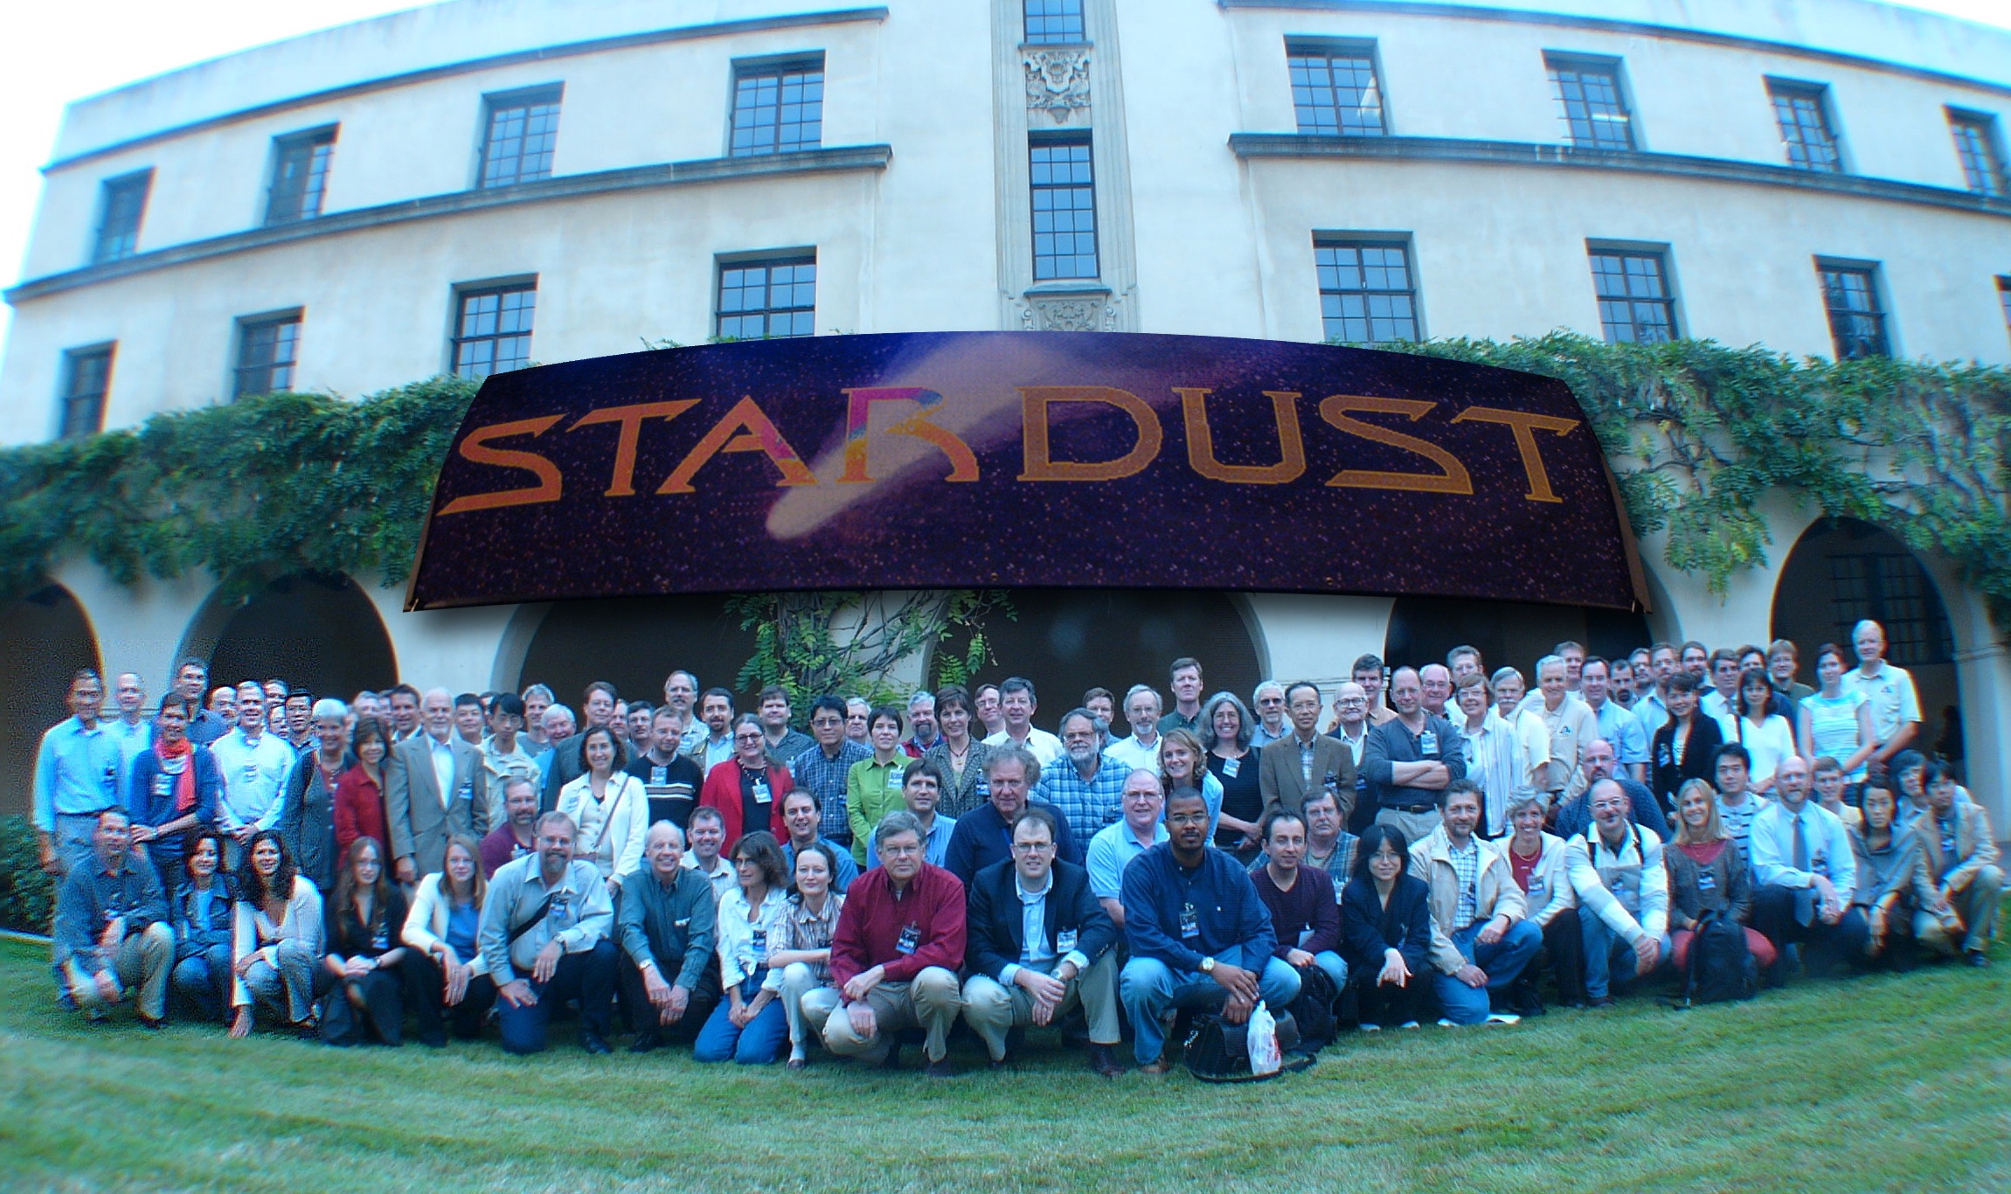
The Stardust science team during their three-day workshop at Caltech

About 120 participants gathered at Caltech in Pasadena, California. The main goals were to:
- highlight results obtained during the preliminary examination through oral and poster presentations;
- allow face-to-face interactions between participants, providing the opportunity to appreciate and understand individual findings within the perspective of all findings, offer focus to future analyses, and possibly explore other alternatives to the derived conclusions.

Papers describing the results so far will be published in the near future.

Tom Morgan, Stardust Program Scientist from NASA Headquarters, said, “In 12 years, Don Brownlee did what he said he would do, on budget and on schedule. This is what’s good in the Discovery Program. Stardust is a model for future sample return missions.”

Stardust Mission Receives Awards

In October, Stardust received Popular Mechanics' prestigious 2006 Breakthrough Award for Innovation for spacecraft design, mission planning and execution, and scientific achievement. The award recognized Donald Brownlee, principal investigator; Tom Duxbury, project manager at JPL; Joe Vellinga, program manager at Lockheed Martin; and Kenneth Williams, Navigation team Lead.

To win the award, an advance has to solve problems on a grand scale, expand horizons, engage the imagination of millions or set benchmarks in design and creativity.
The description of Stardust noted its mission was “to fly halfway to Jupiter to meet up with a 3-mile-wide comet, hurtle through its trailing cloud of dust and gas at 13,000 mph, and capture particle samples using a tennis racket-shaped screen of aerogel. Oh yeah, and then return to Earth without destroying the samples, which date back nearly 4.6 billion years to the dawn of the solar system. It all came to fruition on Jan. 15 of this year, when the Stardust return capsule slammed into the Utah salt flats-samples intact. In addition to bringing home the first comet and interstellar dust samples, Stardust made the record books as history's farthest out-and-back sample-return mission (2.9 billion miles in all) and for the fastest atmospheric re-entry (29,000 mph).”

Stardust was also honored with the Aviation Week and Space Technology (AW&ST) Program Excellence Award on November 14, 2006. AW&ST reviewed over 300 federal programs before selecting Stardust and Lockheed Martin's Atlas Launch Vehicle for the award.

What’s NExT for Stardust?

A proposal by the Stardust mission called NExT would use the existing Stardust spacecraft to flyby comet Tempel 1 in 2011 and observe changes to the comet since the Deep Impact encounter in 2005. NASA has selected the proposal as one of three Discovery Program Missions of Opportunity to receive funding for a concept study.
Deep Impact Presents Results

Eight members of the Deep Impact science team gave presentations during a 90-minute session called “Deep Impact Results and Interpretation” at the American Astronomical Society’s Division for Planetary Sciences (DPS) annual meeting held October 8-13 in Pasadena, CA.

Topics included: Layering and Smooth Flows: What Comet Nuclei are Really Like, Comparison of the Photometric Properties of Comet 9p/Tempel 1 with Other Asteroids and Comets, The Phase Function of the Nucleus of Comet 9P/Tempel 1, Gas and Dust Imaging of the Inner Coma of 9P/Tempel 1 Before and After Impact, Composition of the Ejecta from the Deep Impact Experiment, A Study of the Velocities of the Ejected Dust and of the Rotational Variability of Comet 9P/Tempel 1 around the Deep Impact Event, Study of Deep Impact Ejecta Using the Dust Colors Obtained from ESO Observations, and The Internal Structure of Jupiter Family Comet Nuclei: The Talps or Layered Pile Model.

The mission web site has an interactive flash animation that describes some of the science results published by Deep Impact team members as they continue to analyze data from the encounter in July 2005.

Education and Public Outreach Highlights

At the October DPS meeting, education team director and science team member Lucy McFadden was one of six scientists invited to speak to area educators during the “Solar System Seminars,” which were recorded for use in future distance learning opportunities through the University of Wisconsin-Madison. McFadden’s topic was “Asteroids and Comets.”

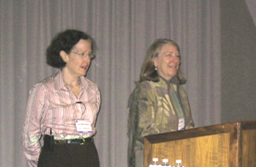
Lucy McFadden is introduced by Solar System Seminars organizer
Anita Sohus of JPL.

Also Deep Impact participated in DPS outreach to the local community. Nine tours for Pasadena Unified School District classes were arranged from Monday through Friday, with groups ranging from 65 to 200 students. Five interactive demonstrations were presented, and students had the opportunity to view exhibits, spacecraft models and posters. Both the students and their teachers expressed appreciation for the opportunity. One teacher told organizers ”the experience was exactly what I hoped for,” while a student commented, “This was the best field trip we've ever been on!"

Genesis principal investigator Don Burnett was a plenary session speaker at the 38th annual meeting of the American Astronomical Society’s Division for Planetary Sciences (DPS), held October 8-13 in Pasadena, CA. Burnett’s talk was titled, “Genesis Discovery Mission: Initial Results.”

Burnett described the mission, that collectors made of ultrapure materials were exposed to solar wind ions for 27 months and then returned to Earth for analysis.

The science objectives were to provide:
- Solar isotopic abundances to a level of precision required for planetary science purposes;
- A greatly improved knowledge of solar elemental abundances;
- A reservoir of solar matter to meet the needs of 21st century planetary science; and
- Elemental and isotopic data for the 3 different types (“regimes”) of solar wind.

Burnett reported that despite the crash of the sample return capsule, the science team is not giving up on any of their specific measurement objectives. Samples have been allocated to 16 different laboratories, and results are emerging (see below for one interesting conclusion recently published).
Burnett concluded his talk by noting that contamination is the biggest challenge, but optimism is justified because contamination is on the surface and solar wind is below the surface. With the samples back on Earth, all of contemporary science and technology is available to clean the surfaces without disturbing the implanted solar wind. With some luck, he believes the major effect will be a delay in obtaining results.

Genesis Findings Solve Apollo Lunar Soil Mystery

Ansgar Grimberg from ETH Institute of Astronomy in Zurich and coworkers analyzed the composition of neon in a metallic glass exposed on the Genesis mission. The team's findings are reported in a paper published in the Nov. 17, 2006, issue of the journal Science. Burnett is a co-author of the paper.

Scientists have been always been mystified by some of the moon rocks brought back to Earth by Apollo astronauts. Now one of the mysteries has been solved. Lunar soils have been thought to contain two solar noble gas components with distinct isotopic composition. One has been identified as implanted solar wind, the other as higher-energy solar particles. The latter was puzzling because its relative amounts were much too large compared with present-day fluxes, suggesting periodic, very high solar activity in the past.

In their paper, titled “Solar Wind Neon from Genesis: Implications for the Lunar Noble Gas Record,” Grimberg et al. show that the depth-dependent isotopic composition of neon in the Genesis metallic glass agrees with the expected depth profile for solar wind neon with uniform isotopic composition. The results strongly indicate that no extra high-energy component is required and that the solar neon isotope composition of lunar samples can be explained as implantation-fractionated solar wind.

Genesis Landing Site Monument Erected
Genesis Outlines Initial Results

On the morning of September 6, 2006, Genesis team members gathered at the Utah Test and Training Range for a dedication ceremony in honor of the two-year anniversary of the Genesis science capsule return to Earth. A permanent monument was erected to commemorate the significance of solar wind samples returned to Earth.

Within the obelisk-shaped monument, a time capsule containing print and media features that characterize the mission from inception to present day was installed. The monument and time capsule, which were made possible through private donations, are located on the exact spot of the capsule’s Earth return.

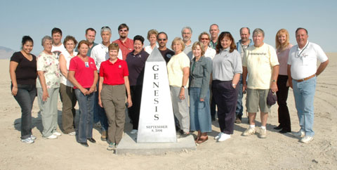
Genesis team members gather in Utah to dedicate a monument in recognition of the significance of the mission.
Education and Public Outreach Highlights

Project Manager Don Sweetnam traveled around Idaho during October, giving lectures on Genesis and discussing science results with faculty, students and the public throughout the state. At the University of Idaho, he gave lectures to an introductory astronomy class, a graduate seminar, and a graduate/faculty symposium. At the Discovery Center he spoke to the Boise Astronomical Society, while at the Bruneau Dunes Observatory his public talk was followed by a star party. He led a discussion of mission results at Craters of the Moon National Monument, and at Idaho State University he presented two lectures to the engineering department – one on general mission results and the second on engineering lessons learned from capsule mishap.

The Genesis web site has three new web animations showing an atom’s journey through the solar system, its encounter with Genesis, and processing through a mass spectrometer.

Dawn Undergoes Tests to Prepare for Launch
The Dawn project is deep into the testing phase of ATLO (Assembly, Test, and Launch Operations) with completion of all the Comprehensive Performance Tests demonstrating subsystem functionality, the successful completion of the Environmental Test Readiness Review (TRR), the Electromagnetic Interference/Compatibility TRR, and the Dynamics TRR. An end-to-end Science Data Flow Test was also completed.

The spacecraft will be shipped to the Naval Research Lab in Washington, DC, in late December or early January for one month of testing in a large thermal-vacuum chamber. This chamber is large enough to allow a test-firing of the ion thrusters. After thermo-vac testing, the spacecraft ships directly to Cape Canaveral for launch, in a 20-day window that opens June 20, 2007.

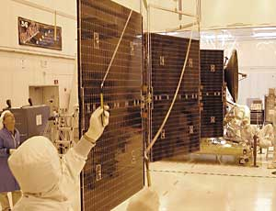
One of Dawn's two solar array wings being attached and tested in October.

The spacecraft is fully assembled except for the two outboard thrusters of the ion propulsion system, to be installed after dynamics testing and before thermo-vac, to avoid damage to these critical appendages. The center thruster has been installed in the spacecraft core, as well as the large high-gain antenna. The solar panels are currently being installed.

The Power Processing Units (PPUs) of the IPS system, that had been an item of concern a year ago, each underwent 500 hours of run-in testing before delivery to the spacecraft to certify their robustness against workmanship defects and early parts failures. After integration, the PPUs were exercised during IPS comprehensive performance testing and have operated trouble-free. There are no outstanding issues with the flight hardware, and the flight software needed for environmental testing has been delivered.

When the International Astronomical Union (IAU) voted to change the definition of "planet" was this summer, most of the attention was on Pluto. However, Dawn's second destination, Ceres, also was involved, as the adopted definition of "dwarf planet" includes Ceres, Pluto, Eris, and probably more bodies yet to be characterized. Ceres is the largest member of the asteroid belt, residing between Mars and Jupiter; the other dwarf planets are part of the Kuiper belt, spending most or all of their time beyond the most distant planet, Neptune.

To qualify as a dwarf planet, a body must orbit the Sun and have sufficient mass for its own gravity to make it nearly spherical. (Vesta, the first stop on Dawn's interplanetary itinerary, might satisfy the definition of dwarf planet, but not enough is known yet about its gravity and shape.) Unlike planets, however, dwarf planets are characterized by not having cleared away other objects from their part of the solar system through the effects of their gravity. This bars any resident of the asteroid belt or the Kuiper belt from membership in the planet club. (Another criterion, that the body not be a satellite, excludes some of the moons of planets from being designated as planets themselves.)

The definition is not widely accepted by the community of planetary scientists, and it remains to be seen how the definition might be changed. Ceres and Vesta were considered planets for half a century following their discoveries in 1801 and 1807, respectively. Whatever humans decide to call them, whether planets, asteroids, minor planets, protoplanets, or dwarf planets, they will continue to do what they’ve always done, and the Dawn mission team will continue to look forward to the wealth of information the spacecraft will return from its visits to these fascinating places.

Education and Public Outreach Highlights

More than 360,000 people submitted their names to journey with Dawn to the asteroid belt. A chip is currently being produced that will carry the names onboard the spacecraft when it launches in June of 2007.

The first Dawn education module, The History and Discovery of Asteroids, is now available. It is intended for middle and high school students who are studying Earth/space science, astronomy or social studies.

Dawn E/PO team members participated in the Denver Museum of Nature and Science Education Night on October 3rd and presented a public talk on the mission at the Little Thompson Observatory in Berthoud, CO, on Oct. 20.

Project engineer Marc Rayman has written five installments of the “Dawn Journal” on the mission web site, explaining the spacecraft engineering subsystems, current testing, the science instruments, and other interesting details about the mission from his unique perspective.
Deputy Principal Investigator Carol Raymond edits “Dawn’s Early Light,” an occasional newsletter on the web that gives an overview of the current mission status.

Successful completion of Kepler’s Mission Critical Design Review (CDR) in October was a significant milestone toward the planned Nov. 2008 launch. The team can now focus full attention on the manufacturing, integration and test phase of the project. While there have been problems with a number of the subsystems, they are being worked.

Other recent accomplishments include successful Science Operations Center and Science Office CDRs, formally released Data Management Center SW Build K1, the release of all Kepler Control Box and Local Detector Electronics for flight build, and the receipt of the Schmidt Corrector.

Nineteen members of the Kepler Science Team met Oct 26-27, 2006. Their next gathering will be in the spring.
Juno Ramping Up

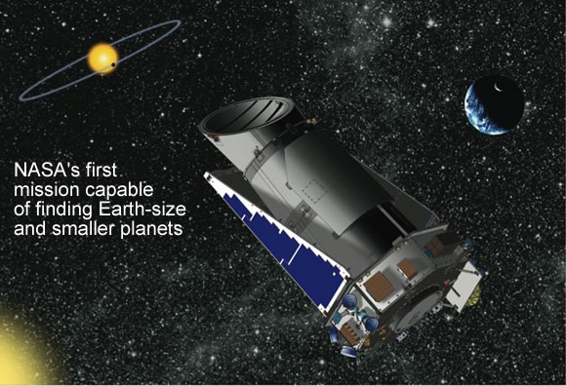

Education and Public Outreach Highlights

In August, E/PO team member Pamela Harman attended the NASA - Navajo Nation Sustainability Seminar and presented the GEMS core sequence, the Hands-On Universe module, the online lessons, and KeplerNet as opportunities for a sustained 'astronomy' relationship.

At the Western Alliance Conference of Planetariums, Lincoln, NE, in Sept, E/PO lead Alan Gould presented a workshop to on how to do audience participation programs, including material about the Kepler program. Also in Sept, at the AIAA conference in San Jose, CA, Kepler had an exhibit and stage presentation in the "Education Alley" sponsored by Lockheed Martin for teachers and students.

In October, Gould presented a workshop at the California Science Education Association (CSEA) meeting on Data Enhanced Learning Experiences that included a section on Kepler materials. The SETI Institute booth featured the Kepler LEGO orrery transit simulation/demonstration. Also at CSEA, "Earth's Place in the Universe" was co-taught by Dr. Jill Tarter (Kepler SWG) and Edna DeVore (Kepler Co-I for E/PO). The topics were cosmic and planetary evolution. The search for extrasolar planets and the Kepler Mission were included in the science content sessions of this 3-hour short course.

Geoff Marcy, science team member from UC-Berkeley, wrote an article for Astronomy Magazine’s October 2006 issue. It was the lead article, highlighted on the cover, featuring a paragraph on, and a picture of, the Kepler Mission.

The new Kepler ToolKit for amateur astronomers, Shadows and Silhouettes, was completed and distributed to clubs nationwide. It covers the topics of phases, eclipses, and transits and features the Kepler Mission. On Sept. 27 the Night Sky Network hosted a telecon featuring Fred Espenak, known to the amateur astronomy community as "Mr. Eclipse," to discuss using the toolkit, planet-finding using transits, and the upcoming celestial event, the November Mercury transit.
Kepler Moving Forward, Resolving Problems

Between Oct. 1 and Nov 25, 2006, amateur clubs in the Night Sky Network logged 172 outreach events using the Shadows and Silhouettes kit with an estimated total of 60,000 people at all the events. The clubs that used the kits provided very positive feedback on the materials, such as: “The materials covering moon phases and solar and lunar eclipses are some of the best and easiest ways to demonstrate these events that I have ever encountered.”

As a new mission continuing to ramp up, Juno has participated in many meetings and reviews during the past few months. The project has had bi-monthly management reviews, a launch vehicle coordination meeting at the Kennedy Space Center in Florida, its second quarterly presentation to NASA and JPL management, a coordination meeting between project and Goddard Space Flight Center (GSFC) management/engineering personnel to discuss technical and management interfaces (GSFC provides both the Juno Deputy PI as well as the Flux Gate Magnetometer instrument), and a Capabilities vs. Requirements Review held at Lockheed Martin-Denver.

The Payload Team is conducting a series of "roadshow" visits to Juno’s instrument partners. At the University of Iowa they reviewed the Waves instrument preliminary compliance to JPL's Flight Project Practices and Design Principles (FPPDP). At the Applied Physics Lab in Laurel, MD, they discussed FPPDP plus the interface design for the Jupiter Energetic-particles Detector Instrument (JEDI). A visit to Southwest Research Institute addressed FPPDP compliance as well as flight system/instrument interfaces for both the Jovian Auroral Distributions Experiment (JADE) and Ultraviolet Spectrometer (UVS) instruments.

In October, Juno Principal Investigator Scott Bolton hosted a Juno Science Team Meeting at the Southwest Research Institute facility which was attended by members of the Juno Science Team as well as the Juno Project Team. It featured presentations and discussions on project and flight system status, science requirements, payload developments, working groups, etc. The next science team meeting will be scheduled in the June-July 2007 time-frame.

Education and Public Outreach Highlights

In August Steve Levin from JPL gave a Juno presentation to a high school physics class at the Academy for Academic Excellence, Victorville, CA.

In September, E/PO lead Rosalyn Pertzborn at the University of Wisconsin - Madison gave Juno presentations to Chancellor's Minority Student Scholarship Recipients at UW-M and to teachers from American schools at the Belgian Institute for Space Aeronomy, Brussels, Belgium.

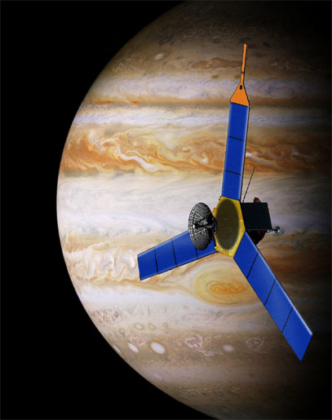
Artist’s conception of Juno at Jupiter

Team member Al Herzl from Lockheed Martin gave Juno presentations to the Mile High Optimist Club, Englewood, CO, to an Introductory Aerospace Class at Colorado University-Boulder, and to a local Optimists Club.

Rosalyn Pertzborn and Sanjay Limaye participated in a Goldstone-Apple Valley Radio Telescope (GAVRT) training at the Lewis Center for Educational Research, Victorville, CA

PI Scott Bolton and Fran Bagenal gave presentation at the DPS Solar System Seminars in October. Bolton’s topic was “The History of the Solar System,” with a portion devoted to the Juno mission, while Bagenal spoke about “Giant Planets.” Also Juno materials were handed out at the "Giant Worlds" and GAVRT booth.
Students Make Contact with ISS
On Monday, November 20, students from Madoc Public School and Centre Hastings Secondary School, small rural schools in Ontario, Canada, had a thrilling, once-in-a-lifetime opportunity to talk to astronauts in space, thanks to the Amateur Radio International Space Station (ARISS) program. The 10-minute contact was broadcast live over the Internet and can be listened to the school district’s web site.

Teacher assistant Elizabeth Allan, a big supporter of space science, found the Discovery Program web site last year, and Shari Asplund has sent her many educational materials from the Discovery and New Frontiers Programs and missions. Discovery became a strand in the grade 9 science curriculum, with students viewing the Discovery video, “Unlocking the Mysteries,” and being tested on their knowledge of the program. The ARISS Club students, selected to ask questions of the astronauts, will receive special Discovery and New Frontiers items as their rewards.

A very excited Ms. Allan wrote, “My ARISS students can't believe that they are the only kids in North America having contact with the ISS. Along with students in Germany and Belgium, they are the only thirty or so kids in the world having contact with this crew......I feel so special, the odds are like winning the lottery or getting hit by lightning!"

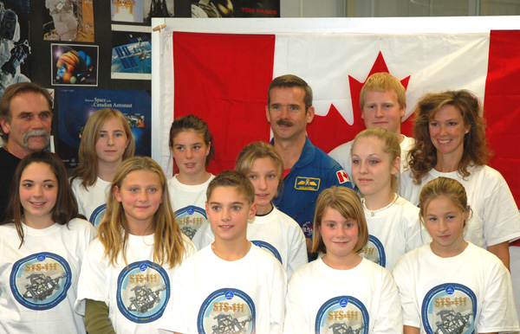
Students selected to talk to the ISS crew meet astronaut Chris Hadfield. Teacher assistant Liza Allan, who helped make it all happen, is in the top row, far right.

To prepare for the ARISS contact, the students had another remarkable experience when Canadian astronaut Chris Hadfield visited the school on October 26. It was the first time at ARISS group had an astronaut visit as a precursor to contact with the station, and something Ms. Allan believes the kids will remember for the rest of their lives.

Ms. Allan’s enthusiasm is such an asset to the students. She writes, “My resource room is dedicated to space, thanks to you. The lithographs are hanging from a mobile. On behalf of the students in grades 3, 6, 9 and space club who will receive the goodies on contact day - THANK YOU THANK YOU THANK YOU!”

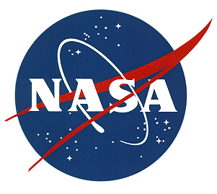


Discovery and New Frontiers News
National Aeronautics and Space Administration

Written and edited by:

Shari Asplund

Discovery & New Frontiers Programs Outreach Manager

Layout and production by:

Corinne Karpinski
JPL Informal Education Office
National Aeronautics and Space Administration

