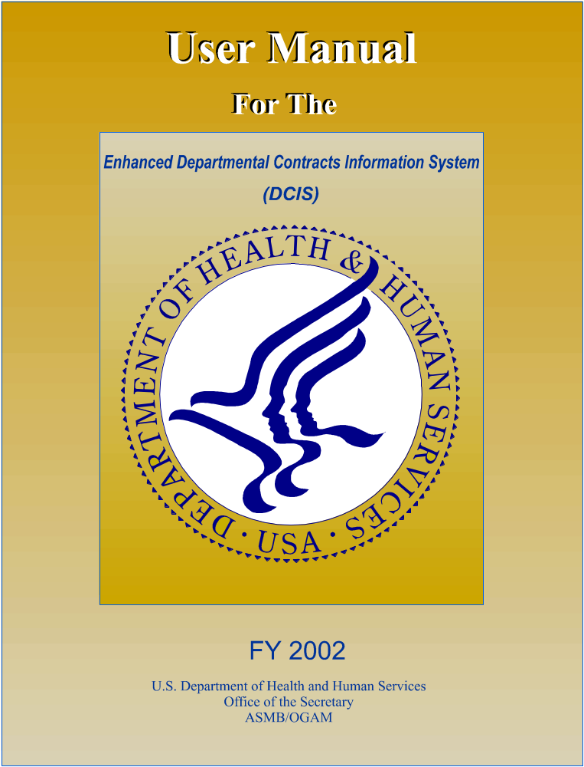 July 2007

FY 2007
U.S. Department of Health and Human Services
Office of the Secretary
ASAM/OAMP

TABLE OF CONTENTS

Page
1.0 INTRODUCTION 4
1.1 DCIS Mission 4
1.2 Scope 5
1.3 Applicability 5
1.4 Capabilities Implemented 5
1.5 Abbreviations and Acronyms 8
1.6 System Operations and Management Contact 8
2.0 SYSTEM OVERVIEW 9
2.1 System Architecture 9
2.1.1 Functional System Components 9
2.1.2 Software Architecture 10
2.2 Functional Components 13
2.2.1 DCIS Database 13
2.2.2 Audit File 15
2.2.3 Batch Processing (Obsolete) 15
2.2.4 Online Transaction Processing 16
2.2.5 Record Corrections and Changes 16
2.2.6 Standard Reports 16
2.3 Monthly FPDS Submission 17
3.0 ONLINE PROCESSING 18
3.1 Overview of Online Operations 18
3.2 Online Transactions 18
3.2.1 Report Procurement Actions 18
3.2.2 Record Corrections and Changes 18
3.2.3 Delete Transactions 19
3.2.4 Data Worksheet 19

- LIST OF FIGURES
Figure Page

1-1 DCIS Reporting Components 4
1-2 DCIS Capabilities 5
2-1 DCIS System Architecture 10
2-2 DCIS Functional Components 11
4-1 DCIS Online Processing Flow 19
APPENDICES
Page
APPENDIX A: REMOTE PROCESSING ENVIRONMENT A-1
APPENDIX B: DATA ELEMENT DESCRIPTION B-1
APPENDIX C: DATA FIELD EDIT SPECIFICATIONS C-1
APPENDIX D: DCIS REPORTING COMPONENT CODES D-1
APPENDIX E: DCIS ONLINE PROCESSING PROCEDURES E-1
APPENDIX F: ONLINE DATA COLLECTION WORKSHEET F-1
APPENDIX G: CONTRACTOR IDENTIFICATION NUMBER G-1
APPENDIX H: HISTORICALLY BLACK COLLEGES AND UNIVERSITIES & MINORITY INSTITUTIONS H-1
APPENDIX I: GLOSSARY OF DEFINITIONS AND ABBREVIATIONS I-1
APPENDIX J: DCIS CONTRACTING OFFICE CODES J-1
APPENDIX K: DCIS QUERY REPORTS K-1
APPENDIX L: DCIS Rules of Behavior L-1

INTRODUCTION

This document is the User Manual for the enhanced Departmental Contracts Information System (DCIS) for the Department of Health and Human Services (HHS). DCIS provides online and batch operations, both of which are described in this manual.
The DCIS operational structure, processing and user functions, and the data and data characteristics are implemented in accordance with the functional requirements and detailed design presented in two previous documents: the Functional Requirements for the Enhanced Departmental Contracts Information System, published in March 1994; and the Detailed Specifications for the Enhanced Departmental Contracts Information System, published in July 1994. The referenced documents provide a basis for understanding the content and operational characteristics of the enhanced DCIS.
This manual is part of a series of four life cycle documents produced for the DCIS user and operations community. These documents are defined as follows:

User Manual
Describes the batch and interactive data submission processes, and the specific reporting available with these processes.

Query and Report Manual
Describes the menu-driven and free-format reporting capability, and the standardized, periodic reports.

System Manager Manual
Describes the performance of batch processing, batch processing reports, user account initialization, audit trail capabilities, and other system management activities.

Configuration Manual
Describes the software, hardware, and communications configurations, and the database logical design for use by the system development and maintenance personnel.

DCIS Mission
The DCIS mission is to provide the data collection and reporting capabilities needed to enable HHS to comply with the reporting requirements mandated by Public Law 93-400 for the reporting of procurement actions. DCIS provides a single system capability within HHS that collects, edits and stores information on individual procurement and contracting actions executed by the Operating Divisions (OPDIVs) and other HHS offices. It creates a HHS-wide database of the collected information; forwards selected information about HHS procurement and contracting actions reportable under Public Law 93-400 to the Federal Procurement Data System (FPDS) operated by the Federal Procurement Data Center (FPDC) of the General Services Administration (GSA); and reports on selected contract actions and data to specified organizations within HHS.
The HHS organizations required to report to DCIS are the Administration for Children and Families (ACF), the Agency for Health Care Research & Quality (AHRQ), Centers for Disease Control & Prevention (CDC), Centers for Medicare and Medicaid Systems (CMS), Food and Drug Administration (FDA), Health Resources & Services Administration (HRSA), Indian Health Service (IHS), National Institutes of Health (NIH), Program Support Center (PSC), and Substance Abuse & Mental Health Services Administration (SAMHSA) (collectively referred to as the HHS Operating Divisions (OPDIVs)), and Office of Acquisition Management (OAM). “Reporting components” refers to the OPDIVs and OAM, as shown in Figure 1-1. “Reportable procurement actions” refers to procurement actions reportable to DCIS under Public Law 93-400.

Scope
These specifications and instructions describe the DCIS user interface. Batch and online access features are also presented. The online entry and batch submission of reportable actions is presented, as are procedures under both methods for the modification and correction of previously submitted data. The systems’ processing rules and requirements are presented. Data description, edit specifications, screen formats, and record formats are presented as appropriate. A knowledge of Windows and its terminology is necessary for using these DCIS procedures.

Applicability
The procedures and specifications in this manual are applicable to the reporting components. The data and transaction edit specifications and the system access and transaction submission procedures are applicable to all data submissions and processing actions, as appropriate.
The previous DCIS system ceased operations as of the acceptance and processing of reportable actions for FY97. Reportable procurement actions for FY98 and beyond are submitted to the enhanced DCIS in accordance with the procedures specified herein.

Capabilities Implemented
DCIS was implemented in two phases. Phase I provided users with the ability to submit and correct or update reportable actions under batch processing procedures. Transactions for batch processing are submitted electronically via file transfer. Authorized users with the appropriate terminal equipment, software, and communications capabilities can access DCIS interactively, to key in data (reportable actions), update or change previously submitted records, and/or correct records that were rejected in previous batch submissions and posted to the error file by the system. The capability to generate the standard fixed reports produced by the previous DCIS has been replicated in the current system. The current system generates the data files necessary to satisfy HHS’ SF279 reporting obligations to FPDS. Figure 1-2 presents the DCIS capability.
Phase II encompassed the development and implementation of enhanced system administration capabilities, the implementation of ad-hoc query and reporting capabilities, and a local printing capability for SF279 data.

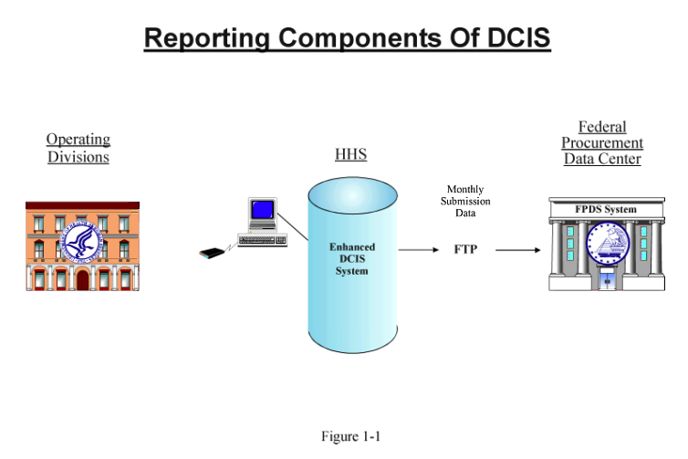

ACF
AHRQ
CDC
CMS
FDA
HRSA

IHS

NIH
OAM
PSC
SAMHSA
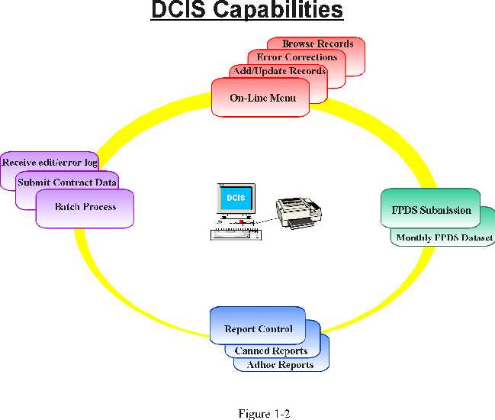

Abbreviations and Acronyms
These abbreviations and acronyms were used in preparing this document:
ACF Administration for Children and Families
C/S Client/Server
DBMS Database Management System
DCIS Departmental Contracts Information System
OAM Office of Acquisition Management
HHS Department of Health and Human Services
FPDS Federal Procurement Data System
GSA General Services Administration
LAN Local Area Network
OPDIV Operating Division
PHA Public Health Agencies
RDBMS Relational DBMS

System Operations and Management Contact
Questions regarding DCIS submissions, the operation of the system, or questions and comments regarding this manual should be directed to:

Mr. Fred Evans
Department of Health and Human Services
ASAM/OAMP
Room 336E #12
200 Independence Avenue
Washington, D.C. 20201

Telephone: (202) 690-8662

Fax: (202) 690-5698
Email ID: Fred.Evans@hhs.gov

Help Desk
Telephone: (301) 231-9898 ext. 174
Fax: (301) 231-7223
Email ID: DCISHelp@rnsolutions.com

SYSTEM OVERVIEW
The enhanced DCIS is implemented in a web server environment utilizing the Oracle Relational Database Management System (RDBMS) on a local area network (LAN). Relational database technology and software tools are used for data storage, application and data security, and online transaction processing. Programs for the editing and processing of transactions in batch files and the programs that generate the standardized batch reports are written in JAVA.
The system supports both batch and online modes of operation. Data may be input to the system via the uploading of transaction files for subsequent batch processing or the online entry and interactive processing of transactions. Both the batch and the online interactive modes have the capability to add valid records to the database; change or update selected fields in records in the database; post corrections to records in the error file; delete individual contract actions or entire contracts from the database; and trigger the preparation of standard reports. DCIS also provides an interactive browse and reporting capability.

System Architecture
The enhanced DCIS is deployed in a web server architecture, as shown in Figure 2-1. DCIS logical components are shown in Figure 2-2. The prior version of DCIS remains available for download to the desktop. It will remain available until the report module is fully implemented in the new architecture.

Functional System Components
The DCIS system architecture consists of the following integrated components:

Web Server
A micro- or mini-computer, which manages the application software and web pages accessed by system users. It has communications hardware and a network operating system, which can interface with the workstations through the Internet. The web server is running the Windows 2000 operating system and Oracle9i application server software.

Workstation
A micro-computer with communications hardware and an operating system compatible with the network. It requests and receives files from the server and executes applications internally. For the PSC LAN, the workstations are micro-computers running Windows 95, 98, 2000, or NT. MS Internet Explorer 5.0 or later version is also required for workstations. More complete workstation configuration definitions are in Section 2.1 and Appendix F, Paragraph F.2.

Communications Cabling
Connects the workstations, the file server(s), and the other components of the LAN. The PSC LAN is connected using EtherNet.

Database Server

A micro- or mini-computer running a multi-processing operating system and a database management system (DBMS) that can interface with the file server network operating system. It receives requests for data from the workstations, processes the requests, and returns the requested data to the workstations. The database server runs on a Sun SPARC workstation at HHS HQ using ORACLE RDBMS and Sun Solaris 2.5 as the operating system.

Gateway
Communications hardware and software that allow users on the LAN to access other LANs or computers that are not part of their own LAN.

Network Printer
A printer with communications hardware to which the network operating system sends print files. Workstations can share one or more printers and may also have locally attached printers.

Software Architecture
DCIS utilizes the following operating system and support software in addition to the customized DCIS application software.

Database Server Software

Solaris 2.5 with upgrades
Oracle SQL*Net (server)
Oracle SQL*Loader
Oracle Export and Import

Web Server Software

MS NT Server 4.0
Oracle 9i Application Server
JDBC Thin Driver for Oracle
DCIS Application

Browser

MS Internet Explorer 5.0 or above

Netscape 6.2 or above

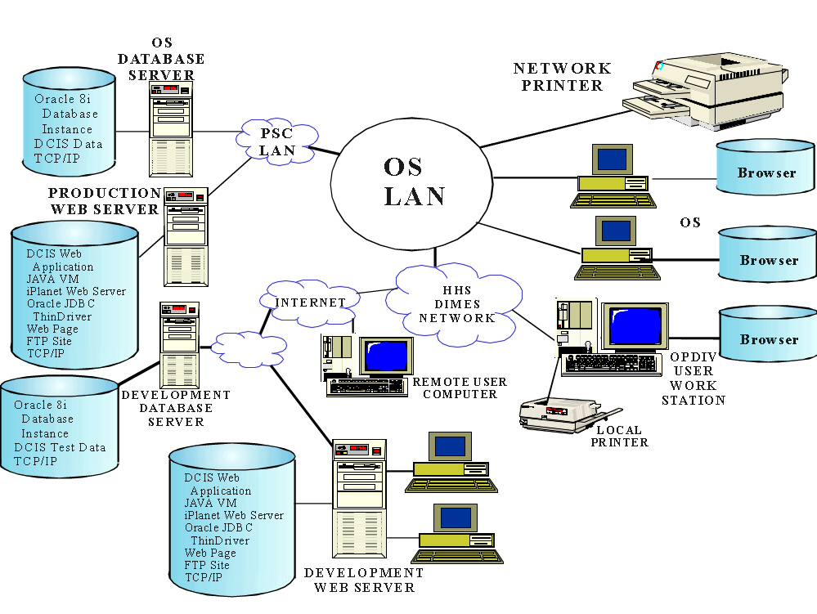

Figure 2-1
RNSolutions
LAN
DCIS System Architecture
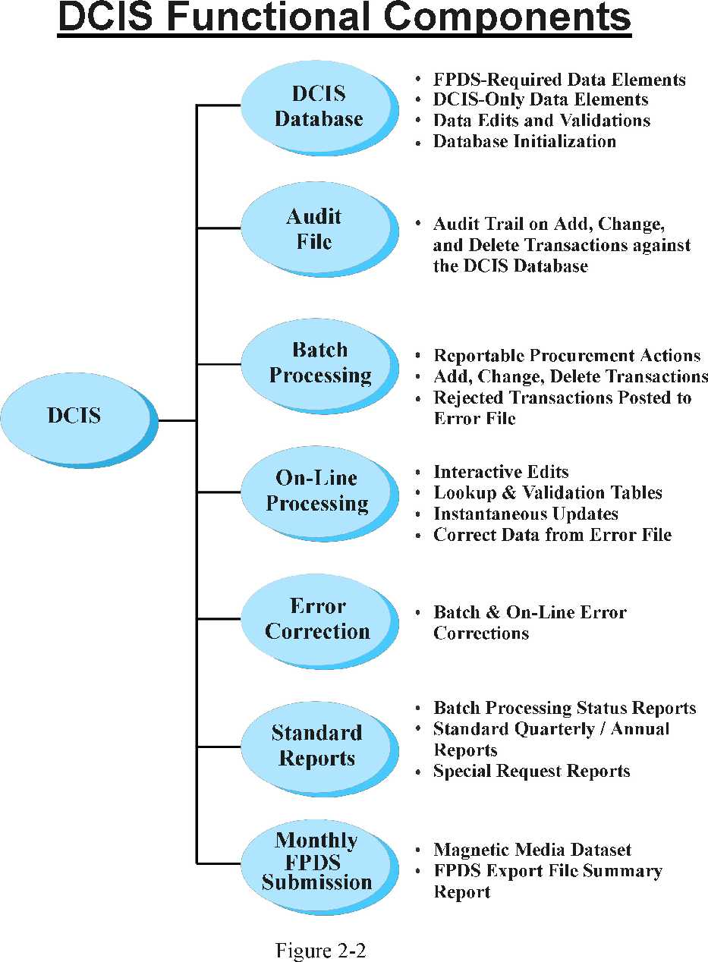

Developer Software

JAVA J2EE Standard
Oracle SQL*Plus (developer) for Windows

The complete DCIS application software is written in JAVA. The web page interface uses HTML, XML, JSP, and JAVASCRIPT.
The minimum PC requirements for the DCIS application are:
- Personal Computer with a Pentium 166MHz or higher processor running Microsoft Windows 95, 98, 2000, or NT Workstation Operating System.
- 32 MB of memory.
- SVGA monitor screen resolution (800x600 pixels).
- Internet Explorer 5.5

Functional Components
Figure 2-2 presented the logical components of the system. The following sections present a description of each of the systems’ logical components.

DCIS Database
The DCIS database has been developed and implemented with RDBMS technology and software. The database is constructed using a series of tables to organize and store individual data elements and keys in a row and column format. Table structures are designed to facilitate the storage of data and to optimize the system’s ability to locate and retrieve selected data elements based on defining logical relationships between data elements and tables.
The traditional approach of organizing data into records, and records into master files or structures of flat files and linked records, underlies hierarchical or network database management systems. Within the relational model in which DCIS is implemented, the term "record" is used to describe an aggregation of a specific set of data elements that comprise a specific logical entity stored in the database tables. DCIS record types are as follows:
- A reportable procurement action that has passed all system edits and has been posted to the database will be referred to as a “master record.”
- A reported procurement action that failed one or more edit checks and was posted to the error file will be referred to as an “error record.”
- Individual transactions that are reportable procurement actions, error correction data, record modification data to change database or error file records, or record delete actions to be processed by DCIS are referred to as “transactions” or “transaction records.”

The DCIS database contains two types of records: properly reported contract actions that have become accepted master records, which will be referred to as the "master file"; and rejected transactions, i.e., transactions that did not pass input and pre-posting edits which will be referred to as the “error file.”

Database Content
DCIS database records contain the FPDS-required data elements as represented by the SF279, augmented by a number of DCIS-specific items required by HHS. The DCIS database stores the FPDS-required items in the format required for the reportable procurement file periodically submitted to the FPDS. The DCIS-only data elements are stored in accordance with HHS requirements and specifications.

Data Element Edit and Validation
FPDS-required elements in transactions submitted to the DCIS master file are edited and stored in accordance with the edit specifications published by FPDS for SF279 data. The DCIS-only data elements (i.e., those required by HHS for internal management and analysis purposes) are edited in accordance with HHS edit requirements.

Database Initialization
The master file for the enhanced DCIS was initialized by converting selected records from the former DCIS master file for all reporting components, with the exception of PHS. For PHS, converting selected records from the master file maintained by the PHS Contracts Information System (PHSCIS) initialized the DCIS database. The data elements in the records converted from both sources were subjected to FPDS edits for those elements required by FPDS, and to HHS specified validation criteria for “DCIS only” data elements. The following conversion procedures and parameters were applied to both source master files.

1) The FY94 DCIS master files maintained by the original DCIS were frozen at the final submission of FY94 data to FPDS. Copies of these files were acquired for the conversion.
2) The PHSCIS master file was frozen at the point the final CIS submission for FY94 was made to DCIS. A copy of this file was acquired for conversion.
3) FY89 was established as the baseline period for the conversion of records to the enhanced DCIS.
4) All records for contracts that were initiated prior to FY89 were extracted if the contract was still open in FY89. All records for contracts initiated during FY89 and subsequent years were extracted.

5) Records for contracts closed prior to FY89 were not extracted and will be retained in a separate historical file in the format of the master file used by the previous DCIS. The historical file of records that was not converted is available for use as needed. However, since the format of the historical file is different from the master file in the enhanced DCIS, special programs and computer processing will be required to access, analyze and generate reports from the data in the historical file. The enhanced DCIS does not have the facilities or capabilities to extract and report on data in the historical file.
6) Data converted from the frozen FY94 file were edited and processed as follows:
a) Data elements previously reported to FPDS were edited under FPDS requirements to ensure they were not corrupted by subsequent edit or system problems in the previous DCIS, and to verify they were properly converted.
b) Data elements not reported to FPDS (i.e. DCIS-only data elements) were subjected to the standard HHS edit criterion specified for Form 670.
Extracted records that failed the conversion edits and could not be corrected or adjusted by the system manager without significantly corrupting the data integrity of the database, were not converted. Reporting components were notified of any extracted records that were not converted due to data integrity problems. Hard copy lists of rejected records were provided. Due to amendments issued by FPDS for FY 1998 through FY 2000 and DCIS User group meetings, the record format for FY 98 onwards has been modified. The new format is provided in Appendix B.

Audit File
DCIS maintains an audit file separate from the main DCIS database. The purpose of this file is to provide an audit trail for selected actions taken against the DCIS database. The audit file can be used for reconstruction and verifying certain actions. The following actions are recorded in the Audit File:
1) Records posted to the master file;
2) Each change made to records in the master file; and
3) Records deleted from the master file or from the error file by delete transactions.
All records in the Audit File are date and time stamped with the user ID of the person making the change. The retention period for the file is determined by the System Manager.

Batch Processing (Obsolete)
DCIS provides reporting components the option of fulfilling their DCIS reporting requirements through the submission of batch transaction files containing their reportable procurement actions. Batch submissions may contain transactions representing new reportable actions, changes, or deletions to be posted against the DCIS master file, or changes (corrections) and deletions to be posted against the error file.
Reporting components electing to report to DCIS via batch files of transactions are responsible for the data entry and related computer processing necessary to generate the batch file. The batch file and transaction records must be prepared and submitted in accordance with the record format and edit specifications provided in Appendices B, C, D, and E. The submitted file must contain an end-of-file mark.
Users wishing to submit batch files may do so by using file transfer protocol (FTP) to transmit (upload) their batch transaction file over the network to the DCIS FTP site. Once the DCIS System Manager has processed the submitted batch file, the user may repeat the procedure to download the processing and error report(s). A user may also hand-deliver or surface-mail a batch transaction file to the DCIS System Manager.
All batch files received by DCIS are processed in an identical manner, regardless of the method used to transfer them. Transactions submitted in batch are processed through the standard DCIS transaction edit parameters and against either the master file or the error file, as appropriate. Transactions that pass the edit and validation tests are posted to the DCIS master file as valid reported procurement actions. Those transactions that fail edit and validation tests will be rejected and posted to the error file or discarded as specified in the processing specifications for each transaction.

Online Transaction Processing
The online interactive processing mode will process the same types of transactions as those processed in the batch submission mode. Reporting components may use DCIS online capabilities to enter new reportable actions, post updates or changes to records in the master file, delete previously submitted actions, and post corrections to the error file. Data in transactions submitted interactively are subjected to the identical edit and validation tests used for batch submissions.
The only significant difference between the online and the batch processing mode is the online mode will not permit an invalid “Add” transaction to be posted to the error file, nor will it permit the online modification of a valid record in a manner creating errors. Online transactions will be processed and posted or disposed of immediately upon their submission. The system will notify the terminal operator of all errors and require that they be corrected or the transaction will be discarded.

Record Corrections and Changes
Reporting components using batch transaction procedures may correct their rejected actions by including the appropriate transactions in their next batch submission. Online error correction will be available in January 2002. All users may access their records in the master file to post changes to individual data elements, subject to the system’s edit and data validation criteria.

Standard Reports
Standard reports are available through the Report-Query module of the old application. These reports are in the process of being migrated to the new web server environment. Ad hoc reports may be requested through the help desk.

Batch Processing Status Reports
Each time a batch transaction submission is processed, the following status reports are created for the System Manager.
1) DCIS Detailed Processing Report
This report is created each time a batch transaction file is processed. One page will be printed for each input record that fails one or more of the system’s input edit checks. For each rejected record, the content of the record will be listed along with detailed messages identifying the reason(s) for rejection.
2) DCIS Processing Summary Report - Transactions Processed.
For each processed batch, the system generates a one page summary report that describes the disposition of all of the records in a processed batch.

Standard Quarterly/Annual Reports

DCIS generates a standard set of quarterly and annual statistical and status reports.

Special Request Reports

Special DCIS reporting requests are generated with JAVA, SQL Plus, and ORACLE Discoverer. Contact the help desk for assistance with special report requests.

Monthly FPDS Submission
At the close of processing for each FPDS reporting period, DCIS prepares a magnetic media file. This file contains the reportable procurement actions correctly reported to DCIS by HHS reporting components for the specified reporting period. Also included are any actions for prior periods that were not previously reported to FPDS. The latter consist of late submissions by the reporting components and transactions that were corrected and released from the DCIS error file.
As a by-product of preparing the FPDS submission, DCIS prepares an FPDS Export File Summary Report. This report lists by DCIS Reporting Component the total number of records extracted for submission, and the net action dollars represented by the extracted records.

ONLINE PROCESSING
This section provides a brief overview of DCIS capabilities for performing online interactive data entry, edit, and maintenance. Figure 4-1 presents the online data entry flow. Appendix G presents a detailed description, illustrated with actual menus of accessing DCIS, entering and editing data, correcting records on the error file, and posting changes to valid records.

Overview of Online Operations
The online interactive processing mode processes the same types of transactions as in the batch submission mode. The only significant differences are the online mode system (1) will not permit an invalid “Add” transaction to be posted to the error file, and (2) does not permit the interactive modification of a valid record in a manner that creates errors. Online transactions are processed and posted or disposed of immediately upon submission. DCIS notifies the user of any errors. If they are not corrected, the transaction is discarded.

Online Transactions
Reporting components may use DCIS online capabilities to enter new reportable actions, post updates or changes to records in the master file, delete previously submitted actions, and post corrections to the error file. Data in transactions submitted interactively are subjected to the same edit and validation tests as those used to process batch submissions.

Report Procurement Actions
DCIS online features and procedures may be used to enter initial actions for new procurements as well as all subsequent actions related to a contract or procurement previously established in the DCIS database. The system will not permit the input of a follow-on action if the base contract record is not present in the DCIS database as a valid record. A transaction attempting to add a follow-on action to the database is edited for its specific content, and also against previously posted related data actions.

Record Corrections and Changes
Online procedures may be used to modify or update valid procurement records in the DCIS database. When a record is interactively accessed and changed, it is subjected to the full range of input edits before it is posted back to the database. If the re-edit determines the modified data field is incorrect and/or the revised data causes the record to fail one or more relational edits, the modified record is not posted.
Reporting components submitting to DCIS via the batch interface may elect to correct rejected actions by interactively accessing the DCIS error file and posting corrections or changes to records in the error file. Records in the error file that are updated/corrected are fully re-edited using the same procedures as for an “Add” transaction. Modified records passing the re-edit are posted as valid records to the database. Those failing the re-edit are returned to the error file.

Delete Transactions
Online users may use “Delete” transactions to delete records from either the DCIS database or the error file. The “Delete” transaction may be used to delete any record except the base record for a procurement, when the database contains subsequent actions related to that specific contract. Base records can be deleted from the database only after all related actions are deleted.

Data Worksheet
Appendix H contains a worksheet that may be used to collect information about a reportable action in preparation for entering the data online. The worksheet is in the same format as the data entry screens for the “Add” transaction.
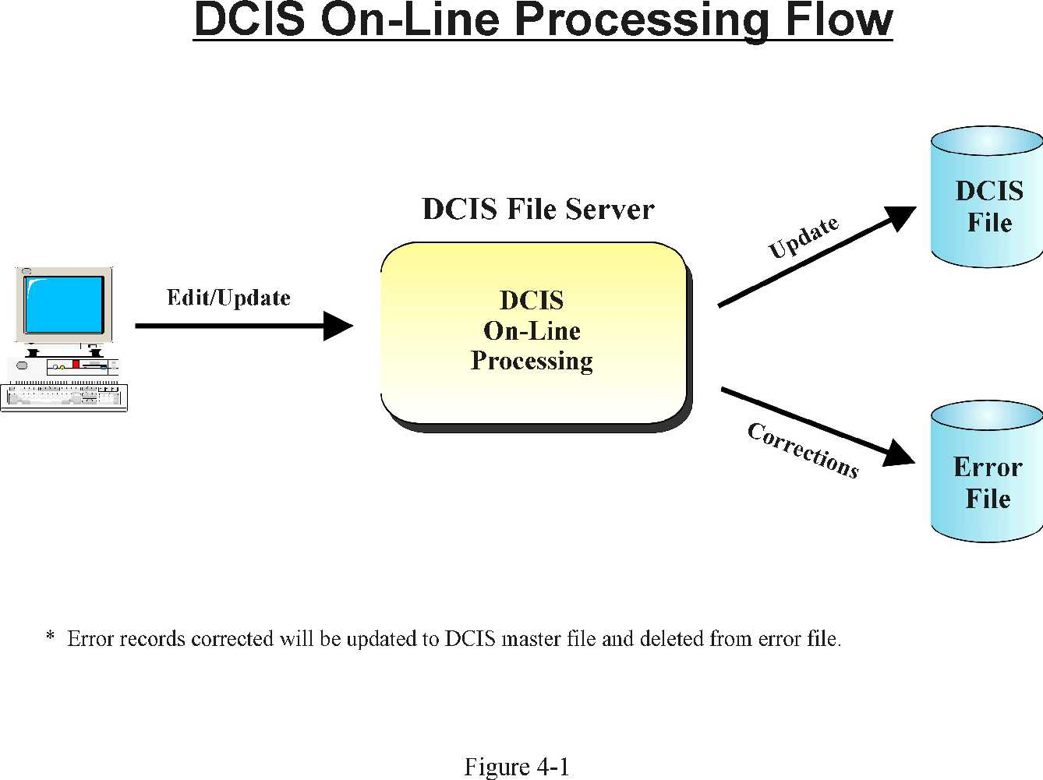

APPENDIX A: REMOTE PROCESSING ENVIRONMENT

This appendix provides the details of the Department of Health and Human Services Contract Award Reporting and overview diagrams of the DCIS remote processing environment. DCIS is implemented in a Web Server architecture. It may be accessed online from remote sites via the Internet. The submission and processing of batch transaction files is also supported.

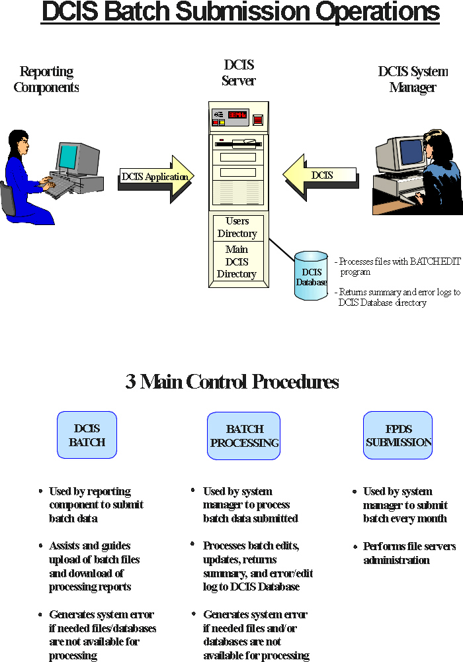
DEPARTMENT OF HEALTH AND HUMAN SERVICES (HHS)
CONTRACT AWARD REPORTING

1. HHS DEPARTMENTAL CONTRACTS INFORMATION SYSTEM GENERAL REPORTING REQUIREMENTS

All HHS Operating Divisions/Agencies shall report unclassified information on all contract actions for obligations/de-obligations of appropriated funds and other data as follows:

HHS Agencies

- Contract actions for awards (contracts, delivery orders, orders against basic ordering agreements, etc.) with an anticipated award value over $25,000, including modifications to those awards regardless of dollar amount, shall be reported in the Individual Contract Action Report (ICAR). Obligations and de-obligations between minus $500 and plus $500, when rounded to the nearest thousand dollars, would result in a zero entry.

- Contract actions for awards (contracts, purchase orders, delivery orders, orders against basic ordering agreements, etc.) with an anticipated award value of $25,000 or less, including modifications to those awards, may be reported in the Summary Contract Action Report ($25,000 or less) or in the Individual Contract Action Report, but not both.

Very Small Business Pilot Program

- Agencies shall report all actions on the Individual Contract Action Report (ICAR) for acquisitions between $2,500 and $50,000 under this pilot program.

2. REPORTABLE/NONREPORTABLE ACTIONS

a. Agencies shall report unclassified information on all contract actions using appropriated funds including those made:

- With stock and replenishing revolving funds;
- With appropriated funds transferred from one executive agency to another where the servicing agency contracts for the supplies or
services;
(3) With appropriated funds obligated pursuant to the provisions of Public Law 85-804;
- By one agency for another;
- For supplies and equipment;
- For all real property both leased and purchased;
- For construction, alteration or maintenance of real property;
(8) For services, including research and development;
(9) 8(a) Contract Award;
(10) Javtis-Wagner O’Day (JWOD) Nonprofit Agency (formerly referred to as a Sheltered Workshop award);
(11) Telecommunications from regulated carriers; and
(12) Federal Prison Industries, i.e. UNICOR, awards (orders from GSA for product UNICOR are not reportable – see Part III, C.3g).

- Agencies shall report all contract actions made with funds held in trust accounts for foreign governments or procurements for foreign governments regardless of the nature of the funds. (The term “foreign governments” includes international organizations.)

- Agencies shall not report the following actions:

- Procurement actions with an action date of five (5) years earlier than the current fiscal year;
- Assistance actions, such as grants, cooperative agreements, subsidies, and contributions;
- Imprest fund transactions, SF 44 purchases, training authorizations, and micro-purchases (purchases values at $2,500 or less) obtained through the use of a government purchase card. The term “micro-purchase” has the same meaning as set forth in FAR 2.101;
- Interagency agreements with other federal agencies (e.g., Tennessee Valley Authority), independent federal establishment ( e.g., Export/Import Bank of the U.S.), or federally chartered sources (e.g. Howard University or the Smithsonian Institution);
NOTE: 8(a) Contract Awards and UNICOR awards shall be reported

- Government Bills of Lading and Government Transportation Requests;
- Actions using predominantly non-appropriated funds, except pursuant to 2b. above;
- FEDSTRIP or MILSTRIP requisitions;
- Actions involving transfer of supplies within and among agencies and sub agencies; or
- Orders from GSA Stock and the GSA Consolidated Purchase Program

APPENDIX B: DATA ELEMENT DESCRIPTION
This appendix describes the data elements collected by the enhanced DCIS. All items, except those specified as (DCIS) are required by, and reported to FPDS. Elements identified as (DCIS) are DCIS-only data elements required by the TREASURY in addition to the FPDS required items. DCIS-only items are retained by DCIS for TREASURY use. The date fields are all in the eight (8) digit (YYYYMMDD) format.
ITEM 1A. PROCUREMENT INSTRUMENT IDENTIFIER (PIID)
The unique identifier for each contract, agreement or order.
Enter the Contract, Purchase Order, or Agreement number for the instant action. If you are reporting a delivery/task order, enter the order number. Proposed FAR 4.11 prescribes convention for numbering Contracts, Agreements and Orders.
ITEM 1B. MODIFICATION NUMBER
An identifier issued by an agency that uniquely identifies one modification for one contract, agreement, order, etc.
When reporting modifications to contracts, agreements, or orders, report the modification number assigned by the reporting contracting office. For any given PIID, all Modification Numbers must be unique.
ITEM 1C. REFERENCED PIID
When reporting orders under Indefinite Delivery Vehicles (IDV) such as a GWAC, IDC, FSS, BOA, or BPA, report the Procurement Instrument Identifier (Contract Number or Agreement Number) of the IDV. For the initial load of a BPA under a FSS, this is the FSS contract number. Note: BOAs and BPAs are with industry and not with other Federal Agencies.
Report the Contract or Agreement Number of the IDV against which the order is placed. When reporting the initial load of a BPA under a FSS, report the FSS contract number.
ITEM ID. TRANSACTION NUMBER
“Tie Breaker” for legal, unique transactions that would otherwise have the same key.
Assign a unique Transaction Number for each report when multiple reports are required for a single contracting action such as 1) actions that include both Foreign Military Sales and non-FMS requirements, 2) actions that include more than one contract type, 3) actions that combine DoD and civilian requirements, and 4) special situations for repetitive reports (requires special arrangement with FPDC).
ITEM 1E. SOLICITATION IDENTIFIER
Identifier used to link transactions in FPDS-NG to solicitation information.
Enter the Solicitation Identifier as in FedBizOpps.
ITEM 1f. AGENCY IDENTIFIER
Identifier used to link agency in FPDS-NG to award information.
Identifier used to link agency in FPDS-NG to award information.
ITEM 1G. referenced idv modification number
When reporting orders under Indefinite Delivery Vehicles (IDV) such as a GWAC, IDC, FSS, BOA, or BPA, report the Modification Number along with Procurement Instrument Identifier (Contract Number or Agreement Number) of the IDV. For the initial load of a BPA under a FSS, this is the FSS contract number. Note: BOAs and BPAs are with industry and not with other Federal Agencies
Report the Modification number of the IDV against which the order is placed. When reporting the initial load of a BPA under a FSS, report the modification number associated with FSS contract number. Leave blank if the base IDV is to be referenced.
ITEM 1H. referenced idv agency identifier
Identifier used to link agency in FPDS-NG to referenced IDV information.
Report the agency ID for the IDV against which the order is placed. When reporting the initial load of a BPA under a FSS, report the agency ID associated with FSS contract number. Leave blank if the IDV is unique, and agency ID is not required to uniquely identify the delivery vehicle.
ITEM 2A. DATE SIGNED (YYYYMMDD)
The date that a mutually binding agreement was reached.
The date signed by the Contracting Officer or the Contractor, whichever is later. Enter the date that the transaction was signed. For a bilateral transaction, this is the later of the date signed by the Contractor or the Contracting Officer. For a unilateral transaction, this is the date signed by the Contracting Officer.
ITEM 2B. EFFECTIVE DATE (YYYYMMDD)
The date that the parties agree will be the starting date for the contract’s requirements. Usually, this is the same as the date signed but may be different. For example, the effective date may be delayed to avoid major holidays or to coincide with the availability of funds; it may be “post dated” to recognize that the contractor started work before the formal agreement was signed. Enter the effective date agreed to by the parties, otherwise leave blank.
ITEM 2C. CURRENT COMPLETION DATE (YYYYMMDD)
The completion date of the base contract plus options that have been exercised.
Report the contract completion date based on the schedule in the contract. For an initial award, report the scheduled completion date for the base contract and for any options exercised at time of award. For modifications that exercise options, report the revised scheduled completion date for the base contract including exercised options.
ITEM 2D. ULTIMATE COMPLETION DATE (YYYYMMDD)
The estimated or scheduled completion date including the base contract or order and all options (if any) whether the options have been exercised or not.
Enter the mutually agreed upon contract completion date for the entire contract or order including all options or other modifications. For a delivery order, this refers to the delivery order completion only, not the referenced indefinite delivery vehicle.
ITEM 2E. INDEFINITE DELIVERY VEHICLE LAST DATE TO ORDER (YYYYMMDD)
Last date on which an order may be placed against this indefinite delivery vehicle.
Enter the last date to place an order. Otherwise leave blank.
ITEM 3A. BASE AND ALL OPTIONS VALUE
It is the mutually agreed upon total contract or order value including all options (if any). For Indefinite Delivery Vehicles, the estimated value for all orders expected to be placed against the vehicle. For modifications, the change (positive or negative, if any) in the mutually agreed upon total contract value.
For a new award: ‘Enter the mutually agreed upon total estimated contract or order value (in dollars and cents) including the base contract and all options (if any).’ For an indefinite delivery vehicle: ‘Enter the total estimated value (in dollars and cents) for all orders that are expected to be placed against this contract.’ For modifications: ‘Enter the CHANGE (positive or negative, if any) in the mutually agreed upon total contract value (in dollars and cents).’
ITEM 3B. BASE AND EXERCISED OPTIONS VALUE
The contract value for the base contract and any options that have been exercised.
For a new award: ‘Enter the total value (in dollars and cents) of the base contract plus all options (if any) that have been exercised at the time of award.’ For a modification: ‘Enter the CHANGE (positive or negative, if any) in the current contract value that result from this modification.
ITEM 3C. ACTION OBLIGATion

The amount that is obligated or de-obligated by this transaction.
Enter the net amount of funds (in dollars and cents) obligated or de-obligated by this transaction. If the net amount is zero, enter zero. If the net amount is a de-obligation, enter a minus sign in addition to the net amount.
ITEM 4A. CONTRACTING AGENCY CODE
The FIPS Pub. 95 code for the agency of the contracting office that executed or is otherwise responsible for the transaction.
Enter the code from FIPS Pub. 95 that identifies the agency of the contracting office. Must be a valid code from the FPDS-NG Agency Code Table.
ITEM 4B. CONTRACTING OFFICE CODE
The agency supplied code of the contracting office that executes the transaction. If the default code is not appropriate, enter the code for the contracting office that executed or is otherwise responsible for the transaction. Must be a valid code from the FPDS-NG Contracting Office Code Table.
ITEM 4C. PROGRAM/FUNDING AGENCY - CODE
The FIPS Pub. 95 code for the agency that provided the preponderance of the funds obligated by this transaction.
If funding for this transaction was provided by another agency, enter the code from FIPS Pub. 95 that identifies the agency that provided the preponderance of the obligated funds. Otherwise leave blank. Must be a valid code from the FPDS-NG Agency Code Table.
ITEM 4D. PROGRAM/FUNDING OFFICE - CODE
The funding agency provided code that identifies the office (or other organizational entity) that provided the preponderance of funds. If the Funding Agency is a non-DOD agency, the code is defined by the agency. If the Funding Agency is a DOD agency, the code is the DOD Activity Address Code (DODAAC). Obtain the code to report from the office (or other organizational entity) that is funding this transaction. Must be a valid code from the FPDS-NG Funding Office Code Table.
ITEM 4E. REASON FOR PURCHASE
A code that indicates why a civilian agency made a purchase for DoD.
When the contracting agency or the funding agency is DOD and this procurement is for computer hardware or services, select a value for the reason certified by the funding office.
Code A Convenience and Economy. Report this code if the Department of Defense program office has certified that the purchase was made under the Economy Act.
Code B Expertise. Report this code if the Department of Defense program office has certified that the servicing agency is better qualified to enter into and administer the contract due to capabilities or expertise at the servicing agency not found with the Department of Defense.
Code C Specifically Authorized. Report this code if the Department of Defense program office has certified that the servicing agency is specifically authorized by law or regulation to purchase the goods or services on behalf of other agencies.
Code D Authorized by Executive Order. Report this code if the Department of Defense program office has certified that the purchase is specifically authorized by Executive Order.
Code E Modification or Extension. Report this code if the Department of Defense program office has certified that the purchase is a modification or extension of an existing order under a multiple award contract and meets the criteria in FAR 16.505(b)(2).
Code F Other. Report this code if the Department of Defense program office has certified a reason not cited above.
ITEM 4F. CONTRACT FULL/PARTIALLY FUNDED BY FOREIGN GOVERNMENT OR INTERNATIONAL ORGANIZATION (Y, N)
Indicates that a foreign government, international organization, or foreign military organization bears some of the cost of the acquisition.
If a foreign government or international organization bears some of the cost of the acquisition (this includes Foreign Military Sales), enter Y. Otherwise enter N.
Y Yes Enter Y when the action is under a foreign military sales arrangement, or under any other arrangement when a foreign country or international organization is bearing the cost of the acquisition.
N No Enter N if Y does not apply.
ITEM 5A. WEB SITE URL
The web site URL for inter agency Indefinite Delivery Vehicles.
Enter the web site URL where users may go to get more information on the contract or program.
ITEM 5B. WHO CAN USE
Agencies that may place orders against this indefinite delivery vehicle.
For initial award of an IDV, enter one of the specified code words. Certain code words require a list of agencies that may order from the IDV.
“Only My Agency” Only the agency awarding the contract may place orders.
“All Agencies” All Federal Government agencies may place orders against the contract.
“Defense” Only Department of Defense agencies may place orders against the contract
“Civilian” Only civilian agencies may place orders against the contract.
“Codes:” Only the agencies with the FIPS 95 codes listed in a comma-separated list.
“Other:” Provide a text statement of which agencies may place orders against the contract.
ITEM 5C. MAXIMUM ORDER LIMIT
Maximum dollar amount that can be applied to a single order against the Indefinite Delivery Vehicle.
If this action is an initial load of an IDV, then enter the maximum dollar amount that can be applied to a single order against the IDV. If there is no maximum order limit, enter 0.00.
ITEM 5D. FEE FOR USE OF SERVICE
List of administrative fees charged for using an Indefinite Delivery Vehicle other than Federal Supply Schedule (FSS) Vehicle. The fees can be one of the following format: 1) Fixed, 2) Range - Varies by amount, and 3) Range - Varies by Other Factor.
FIX Fixed
RVA Range – Varies by Amount
RVO Range – Varies by Other Factor
NO No Fee
ITEM 5E. FIXED FEE VALUE
The value if “Fixed Fee” is chosen for Fee for Use of Service (5D).
ITEM 5F. FEE RANGE LOWER VALUE
The lower value if “Range” (RVA, RVO) is chosen for Fee for Use of Service (5D).
ITEM 5G. FEE RANGE UPPER VALUE
The upper value if “Range” is chosen for Fee for Use of Service (5D).
ITEM 5H. ORDERING PROCEDURE
For initial load of IDV, describe ordering procedures, unless included in the government website listed in the “Web Site URL” data element (5A).
ITEM 5J. FEE PAID FOR USE OF IDV
Actual fee paid in order to use the IDV.
Enter the fee paid (if any ) to the IDV Awarding Agency as a consequence of placing the order.
ITEM 6A. TYPE OF CONTRACT
The type of contract as defined in FAR Part 16 that applies to this procurement.
Enter the code that best describes the contract type.
The following apply to all Awards and IDVs:
A Fixed Price Redetermination
B Fixed Price Level of Effort
J Fixed Price
K Fixed Price with Economic Price Adjustment
L Fixed Price Incentive
M Fixed Price Award Fee
R Cost Plus Award Fee
S Cost No Fee
T Cost Sharing
U Cost Plus Fixed Fee
V Cost Plus Incentive
Y Time and Materials
Z Labor Hours
The following apply to IDVs only:
Order Dependent (IDV allows pricing arrangement to be determined separately for each order)
The following apply to Awards only:
2 Combination (Applies to Awards where two or more of the above apply)
3 Other (Applies to Awards where none of the above apply)
ITEM 6B. LETTER CONTRACT (Y, N)
Designates whether the award is a Letter Contract.
Enter Y if the award is a Letter Contract. Otherwise enter N.
Y Yes
N No
ITEM 6C. MULTIYEAR CONTRACT (Y, N)
A multi-year contract means a contract for the purchase of supplies or services for more than 1, but not more than 5, program years. Such contracts are issued under specific congressional authority for specific programs. A multi-year contract may provide that performance under the contract during the second and subsequent years of the contract is contingent upon the appropriation of funds, and (if it does so provide) may provide for a cancellation payment to be made to the contractor if appropriations are not made. The key distinguishing difference between multi-year contracts and multiple year contracts is that multi-year contracts buy more than 1 year's requirement (of a product or service) without establishing and having to exercise an option for each program year after the first.
Enter code Y when the definition for multiyear contract applies. Do not report contracts containing options as multiyear unless the definition above applies to the contract.
Y Yes Contract is a multiyear contract as defined by FAR 17.103
N No Contract is not a multiyear contract as defined by FAR 17.103
ITEM 6D. TYPE OF IDC
Identifies whether the IDC or Multi-Agency Contract is Indefinite Delivery/Requirements, Indefinite Delivery/Indefinite Quantity, or Indefinite Delivery/Definite Quantity.
A requirements contract provides for filling all actual purchase requirements of designated Government activities for supplies or services during a specified contract period, with deliveries or performance to be scheduled by placing orders with the contractor.
A Requirements IDC or Multi-Agency Contract is a contract for all of the agency’s requirement for the supplies or services specified, and effective for the period stated, in the IDC or Multi-Agency Contract. After award, the contract is a mandatory source for the agency for the supplies or services specified. The quantities of supplies or services specified in the IDC or Multi-Agency Contract are estimates only and are not purchased by this contract. Except as this contract may otherwise provide, if the Government's requirements do not result in orders in the quantities described as "estimated" or "maximum" in the Schedule, that fact shall not constitute the basis for an equitable price adjustment.
An indefinite-quantity contract provides for an indefinite quantity, within stated limits, of supplies or services during a fixed period. The Government places orders for individual requirements. Quantity limits may be stated as number of units or as dollar values.
An Indefinite-Quantity is a contract for the supplies or services specified, and effective for the period stated, in the IDC or Multi-Agency Contract. The quantities of supplies and services specified in the IDC or Multi-Agency Contract are estimates only and are not purchased by this contract.
A definite-quantity contract provides for delivery of a definite quantity of specific supplies or services for a fixed period, with deliveries or performance to be scheduled at designated locations upon order.
A Definite Quantity IDC or Multi-Agency Contract is a definite-quantity, indefinite-delivery contract for the supplies or services specified, and effective for the period stated, in the IDC or Multi-Agency Contract.
Enter the code from the list for the initial load of an Indefinite Delivery Contract (IDC) or Multi-Agency Contract, but not for Government-Wide Acquisition Contracts (GWACs). If this data element is completed, then users will be prompted to report the next two data elements.
A Indefinite Delivery / Requirements
B Indefinite Delivery / Indefinite Quantity
C Indefinite Delivery / Definite Quantity
ITEM 6E. MULTIPLE OR SINGLE AWARD IDC
Indicates whether the contract is one of many that resulted from a single solicitation, all of the contracts are for the same or similar items, and contracting officers are required to compare their requirements with the offerings under more than one contract or are required to acquire the requirement competitively among the awardees.
Enter the appropriate code from the list.
M Multiple Award Enter code M if the contract is one of several awarded under a single solicitation when contracting officers are required to compare or compete their requirements among several vendors.
S Single Award Enter code S when the contract does not meet the definition of a multiple award contract.
ITEM 6F. PERFORMANCE-BASED SERVICE CONTRACT
Indicates whether the contract is a PBSC as defined by FAR 37.601. A PBSC –
- Describes the requirements in terms of results required rather than the methods of performance of the work;
- Uses measurable performance standards (i.e., terms of quality, timeliness, quantity, etc.) and quality assurance surveillance plans (see 46.103(a) and 46.401(a));
- Specifies procedures for reductions of fee or for reductions to the price of a fixed-price contract when services are not performed or do not meet contract requirements (see 46.407); and
- Includes performance incentives where appropriate.
For FPDS reporting purposes, a minimum of 80% of the anticipated obligations under the procurement action must meet the above requirements.
Enter the appropriate code from the list.
Y This is a contract for services and 80% or more of the requirement is specified as a performance requirement.
N This is a contract for services and less than 80% of the requirement is specified as a performance requirement.
* Not Applicable
ITEM 6G. MAJOR PROGRAM
The agency determined code for a major program within the agency. For an Indefinite Delivery Vehicle, this may be the name of a GWAC (e.g., ITOPS or COMMITS).
If your agency has designated ‘Major Programs’ and this award is part of such a program, enter the code for the Major Program for this award.
Values: Established by Agencies
ITEM 6L. COST ACCOUNTING STANDARDS CLAUSE (Y, N)
Indicates whether the contract includes a Cost Accounting Standards clause.
Enter code Y if the contract includes a Cost Accounting Standards clause (see FAR Part 30). Otherwise, enter N.
Y Cost Accounting Standards clause is included in contract.
N Cost Accounting Standards clause is not included in contract.
ITEM 6M. DESCRIPTION OF REQUIREMENT
A brief description of the contract or award
Enter a brief description of the goods or services that you are buying or for an Indefinite Delivery Vehicle, a brief description of the goods or services available.
ITEM 6N. PURCHASE CARD AS PAYMENT METHOD (Y, N)
Indicates whether the method of payment under an award is the Purchase Card. Agencies may issue formal contract documents and make payment using the Purchase Card. It is also permitted that agencies may report Purchase Card purchases.
Enter Y if a Purchase Card was or will be used to pay the contractor. This does not apply to Indefinite Delivery Vehicles.
ITEM 6p. program acronym
The short name or title used for a GWAC or other contracting program. Examples include COMMITS, ITOPS, SEWP.
ITEM 6q. number of actions
The number input by the agency that identifies number of actions that are reported in one modification.
When reporting new contracts or modifications to contracts, agreements, or orders, report the number of actions that involved contract modifications for additional supplies or services.
ITEM 6R. nATIONAL INTEREST ACTION
A code that represents the national interest for which the contract is created.

Code | Short Description | Long Description
NONE | None | None
H05K | Hurricane Katrina | Hurricane Katrina
H05O | Hurricane Ophelia | Hurricane Ophelia
H05R | Hurricane Rita | Hurricane Rita
H05W | Hurricane Wilma | Hurricane Wilma

ITEM 7A. CLINGER-COHEN ACT PLANNING COMPLIANCE (Y, N)
A code indicating the funding office has certified that the information technology purchase meets the planning requirements in 40 USC 1422 and 1423.
When the contracting agency or the funding agency is DOD and this procurement is for computer hardware or services, select a value certified by the funding office as to whether the planning requirements have been met.
Y Yes Report this code if the funding office has certified that the information technology purchase meets the planning requirements in 40 USC 1422 and 1423.
N No Report this code if the funding office has not certified that the information technology purchase meets the planning requirements in 40 USC 1422 and 1423.
ITEM 7B. WALSH-HEALEY ACT (Y, N)
Indicates whether the transaction is subject to Walsh Healey Act.
Enter Yes, if the transaction is subject to Walsh Healy Act, otherwise enter No.
Y Yes Report this code if the transaction is subject to Walsh Healey Act.
N No Report this code if the transaction is not subject to Walsh Healey Act.
ITEM 7C. SERVICE CONTRACT ACT (Y, N)
Indicates whether the transaction is subject to Service Contract Act.
Enter Yes, if the transaction is subject to Service Contract Act, otherwise enter No.
Y Yes Report this code if the transaction is subject to Service Contract Act.
N No Report this code if the transaction is not subject to Service Contract Act.
ITEM 7D. DAVIS-BACON ACT (Y, N)
Indicates whether the transaction is subject to Davis Bacon Act.
Enter Yes, if the transaction is subject to Davis Bacon Act, otherwise enter No.
Y Yes Report this code if the transaction is subject to Davis Bacon Act.
N No Report this code if the transaction is not subject to Davis Bacon Act.
ITEM 7E. ECONOMY ACT (Y, N)
Indicates whether the transaction is subject to Economy Act.
For initial load of Multi-Agency Contract or other IDC, enter Yes, if the award is authorized pursuant to the Economy Act, otherwise enter No.
Y Yes Report this code if the transaction is subject to Economy Act.
N No Report this code if the transaction is not subject to Economy Act.
ITEM 7F. Other Statutory Authority
Indicates whether the transaction is subject to other statutory authority.
For initial load of Multi-Agency Contract or other IDC, enter the citation for the law, if the award is authorized pursuant to legislation other than the Economy Act.
ITEM 8A. PRODUCT OR SERVICE CODE
The code that best identifies the product or service procured. Codes are defined in the Product and Service Codes Manual.
Pick the code that best identifies the product or service procured. If more than one code applies, then report the code that represents most of the ultimate contract value.
Must be a valid code from the PSC manual
ITEM 8F. DOD CLAIMANT PROGRAM CODE
A claimant program number designates a grouping of supplies, construction, or other services.
Enter the appropriate code from the DoD Procurement Coding Manual Section III, DoD Claimant Program Number
ITEM 8G. NAICS
The North American Industry Classification System (NAICS) codes designate major sectors of the economies of Mexico, Canada, and the United States.
Report the code that was used in the solicitation.
Must be a valid code from the NAICS table.
ITEM 8H. INFORMATION TECHNOLOGY COMMERCIAL ITEM CATEGORY
A code that designates the commercial availability of an information technology product or service.
When the contracting agency or the funding agency is DOD and this procurement is for computer hardware or services, select a value certified by the funding office as to the commercial nature of the products or services.
- A Commercially Available
Report this code if the item meets the definition of commercial item in FAR 2.101, does not require any modifications and is available in the commercial marketplace.
- B Other Commercial Item
Report this code if the item meets the definition of commercial item in FAR 2.101, but requires minor modifications, or is not yet available in the commercial marketplace, but will be in time to meet our needs.
- C Non-developmental Item:
Report this code if the item meets the definition of a non-developmental item in FAR 2.101 ((1) any previously developed item of supply used exclusively for governmental Federal agency, purposes by a state or local government, or foreign government with which the United States has a mutual defense cooperation agreement, (2) is used as a paragraph (1) but requires only minor modifications or modifications of a type customarily available in the commercial market).
- D Non-Commercial Item
Report this code if the item does not meet the Definitions of commercial item or non-developmental item in FAR 2.101.
- E Commercial Service
Report this code if the item meets the definitions of commercial service in FAR 2.101 (services of a type offered and sold competitively in substantial quantities in the commercial marketplace based on established catalog or market prices for specific service performed).
- F Non-Commercial Service
Report this code for all other services.
- Z Not IT Products or Services
ITEM 8J. GFE/GFP (Y, N)
The contract uses equipment or property furnished by the government, pursuant to FAR 45.
Enter Y if the contract uses GFE or GFP. Otherwise enter N.
Y GFE or GFP is provided pursuant to FAR 45
N GFE or GFP is not provided
ITEM 8K. EPA-DESIGNATED PRODUCT(S)
The Resource Conservation and Recovery Act (RCRA), Section 6002 and Executive Order 13101 require the purchase of Environmental Protection Agency (EPA) EPA-designated products with a required minimum recovered material content as described in an agency’s Affirmative Procurement Program (APP). This list of EPA-designated products is available at http://www.epa.gov/cpg. This requirement applies to all contracts that require EPA-designated products.
When purchasing products on the EPA Designated Products List without the required minimum recovered material content, a written justification based on exception codes B, C, or D below is required by FAR 23.405(c). If more than one exception applies or more than one justification was completed, report the predominant exception code or the code for the highest cost EPA-designated item for which a justification was completed. Select the appropriate code.
- A Meets Requirements
EPA-designated product or products were purchased and all contained the required minimum recovered material content.
- B Justification – Time
EPA-designated product or products were purchased without the required minimum recovered material content and a justification was completed based on inability to acquire the product(s) competitively within a reasonable time (FAR 23.405(c)(1)).
- C Justification – Price
EPA-designated product or products were purchased without the required minimum recovered material content and a justification was completed based on inability to acquire the product(s) at a reasonable price (FAR 23.405(c)(2)).
- D Justification – Performance
EPA-designated product or products were purchased without the required minimum recovered material content and a justification was completed based on inability to acquire the product(s) to reasonable performance standards in the specifications (FAR 23.405(c)(3)).
- E Not Required No EPA-designated product(s) were required.
ITEM 8L. RECOVERED MATERIAL CLAUSES
Designates whether Recovered Material Certification and/or Estimate of Percentage of Recovered Material Content for EPA-Designated Products clauses were included in the contract.
When EPA-Designated Product(s) is coded A, B, C, or D, enter one of the following codes. Otherwise, leave Recovered Material Clauses blank.
- A FAR 52.223-4 Included
The solicitation included the provision at FAR 52.223-4, Recovered Material Certification.
- B FAR 52.223-4 and FAR 52.223-9 Included
The solicitation included the provision at FAR 52.223-4, Recovered Material Certification, and the contract includes the clause at FAR 52.223-9, Estimate of Percentage of Recovered Material Content for EPA-Designated Products.
- C No Clauses Included
Neither clause is included in the contract.
ITEM 8N. CONTRACT BUNDLING
Designates that the value of the contract, including all options, is expected to exceed $5M and the contracting officer determines this contract action is a result of consolidating two or more requirements previously solicited, provided or performed under separate small contracts into a solicitation for a single contract likely to be unsuitable for award to a small business concern.
Indicates the reason why the agency bundled contract requirements
Enter the code that best represents the agency’s reason for bundling contract requirements.
- A Mission Critical
Enter Code A if the agency has determined that the consolidated of requirements is critical to the agency’s mission, but the measurably substantial benefits do not meet the thresholds set forth in the FAR 7.107 to determine that the consolidation is necessary and justified.
- B OMB Circular A-76
Enter code B if the agency used the OMB Circular A-76 process to determine that the consolidation of the requirements is necessary and justified rather than applying the substantial benefits analysis required by FAR 7.107
- C Other
Enter Code C when the requirement is “bundled” and Codes A and B do not apply
- D Not a bundled requirement
ITEM 8p. consolidated contract
Indicates whether the contract is a consolidated contract. This is only required if the Funding Agency or the contracting agency is a DOD Agency.
If the contract is a consolidated contract, enter Y otherwise enter N.
ITEM 9A. DUNS NUMBER
The DUNS number of the contractor. Used as a key to CCR. Maps to the DUNS Number or DUNS + Four in CCR.
Report the DUNS number for the contractor location that received the award. NOTE: The contractor must be registered in the CCR.
Must be in CCR.
ITEM 9B. CONTRACTOR NAME FROM CONTRACT
The name of the contractor supplying the product or service as it appears on the contract.
Enter the name as it appears on the contract.
ITEM 9C. PRINCIPAL PLACE OF PERFORMANCE (STATE, CITY, COUNTRY)
The code from the FPDS-NG table (combined FIPS Pub. 10 and FIPS Pub. 55) that identifies the place where the work is being performed.
Select the appropriate code from the FPDS-NG list.
ITEM 9E. COUNTRY OF ORIGIN
Identifies the country of origin.
If the product being procured is a domestic end product, enter US. If the product is not a domestic end product, enter the FIPS Pub. 10 country code that designates the preponderance of the foreign content.
Value: FIPS 10 Code
ITEM 9F. CONGRESSIONAL DISTRICT – CONTRACTOR
Indicates the congressional district of the contractor.
ITEM 9G. CONGRESSIONAL DISTRICT – PLACE OF PERFORMANCE
For US Place of Performance, indicates the Congressional District if it can be determined. Otherwise indicates that multiple districts may be involved.
ITEM 9H. PLACE OF MANUFACTURE
When product has substantial foreign components or services are performed by foreign entities, this field indicates whether the contract is still technically a U.S. contract.
- A U.S.
The action is for (i) A foreign end product that is manufactured in the United States but still determined to be foreign because 50 percent or more of the cost of its components is not mined, produced, or manufactured inside the United States or inside qualifying countries; or (ii) Services performed in the United States by a foreign concern.
- B Foreign
The action is for (i) Any other foreign end product; or (ii) Services performed outside the United States by a foreign concern.
- C Not Applicable
Not Applicable
- D Mfg in U.S.
The action is predominantly for acquisition of manufactured end products that are manufactured in the United States
- E Mfg in outside U.S.
The foreign manufactured end products acquired are predominantly for use outside the United States (FAR 25.100).
- F Mfg outside U.S. – Resale
The foreign manufactured end products acquired are predominantly for resale (FAR 25.103(d).
- G Mfg outside U.S. - Trade Agreements
The foreign manufactured end products are predominantly eligible products acquired under Trade Agreements (FAR 25.402(a) (1)).
- H Mfg outside U.S. – Commercial information technology
The foreign manufactured end products are predominantly commercial information technology items (FAR 25.103(e)).
- I Mfg outside U.S -Public interest determination
The head of the agency has made a determination that domestic preferences would be inconsistent with the public interest (FAR 25.103(a)).
- J Mfg outside U.S. – Domestic non-availability
The foreign manufactured end products were predominantly not domestically available as shown by one of the following: (i) The item is listed at FAR 25.104 (FAR 25.103(b)(1). (ii) The agency
did an individual determination (FAR 25.103(b)(2)). (iii) No offer of a domestic end product was received, even though the acquisition was synopsized and conducted through full and open competition (FAR 25.103(b)(3).
- K Mfg outside U.S. - Unreasonable cost
The cost of the offered domestic end products was unreasonable (FAR 25.103(c), 25.105, and Subpart 25.5)
- L Mfg outside U.S. - Qualifying country (DOD only)
For DoD only, the foreign manufactured end products are predominantly qualifying country end products (DFARS 225.003 and 225.872-1)

ITEM 9J. CCR EXCEPTION
The reason a vendor/contractor not registered in the mandated CCR system may be used in a purchase
FAR 4.1102, Policies, require that prospective contractors be registered in CCR to be eligible for contract award.
There are seven exceptions:
- Purchases that use a government-wide commercial purchase card as both the purchasing and payment mechanism, as opposed to using the purchase card only as a payment method.
- Classified contracts (see 2.101) when registration in the CCR database, or use of CCR data, could compromise the safeguarding of classified information or national security.
- Deployed contracting officers in the course of military operations, including, but no limited to, contingency operations as defined in 10 U.S.C. 101(a)(13) or humanitarian or peacekeeping operations as defined in 10 U.S.C. 2302(7).
- Contracting Officers in the conduct of emergency operations, such as responses to natural or environmental disasters or national or civil emergencies, e.g., Robert T. Stafford Disaster Relief and Emergency Assistance Act (42 U.S.C. 5121).
- Contracts to support unusual or compelling needs.
- Awards made to foreign vendors for work performed outside the United States, if it is impractical to obtain CCR registration.
- Micro-purchases that do not use the electronic funds transfer (EFT) method for payment and are not required to be reported.
ITEM 9k. zip code – place of performance
For U.S. Place of Performance: indicates the ZIP Code. If the Place of
Performance is U.S, enter ZIP+4 code. Otherwise, enter the postal code available
for the foreign location.
ITEM 10A. EXTENT COMPETED
A code that represents the competitive nature of the contract.
- A Full and Open Competition
Report this code if the action resulted from an award pursuant to FAR 6.102(a) - sealed bid, FAR 6.102(b) – competitive proposal, FAR 6.102(c) - Combination, or any other competitive method that did not exclude sources of any type
- B Not Available for Competition
Select this code when the contract is not available for competition
- C Not Competed
Select this code when the contract is not available for competition
- D Full and Open Competition after exclusion of sources
Select this code when some sources are excluded before competition
- E^{Civ} Follow On To Competed Action
Select this code when the action is a follow on to an existing competed contract. FAR 6.302-1
- F^{Civ} Competed under SAT
Select this code when the action is competed under the Simplified Acquisition Threshold.
- G^{Civ} Not Competed under SAT
Select this code when the action is NOT competed under the Simplified Acquisition Threshold.
- CDO^{Civ} Competitive Delivery Order
Apply to Full and Open Competition pursuant to FAR 6.1 and only apply to Delivery Orders) Report this code if the IDV Type is a Federal Schedule. Report this code when the Order delivery/task order award was made pursuant to a process that permitted each contract awardee a fair opportunity to be considered. See FAR Part 16.505(b)(1). Report this code if the action is for the award of a multiple award schedule or an order against a multiple award schedule pursuant to FAR 6.102(d)(3) and the applicable provisions referenced there under.
- NDO^{Civ} Non-Competitive Delivery Order
Report this code when competitive procedures are not used in awarding the delivery order for a reason not included above (when the action was non-competitive).

ITEM 10C. REASON NOT COMPETED
The designator for solicitation procedures other than full and open competition pursuant to FAR 6.3.
Enter the code that most appropriately defines the reason the action was not competed.
Use these values as reason for other than full and open competition.

UNQ |  | Unique Source | Report this code if the action was justified pursuant to FAR 6.302-1(b)(1)
FOC |  | Follow-on contract | For a Stand Alone Contract, report this code if the action was justified pursuant to FAR 6.302-1(a)(2)(ii) or FAR 6.302-1(a)(2)(iii).
UR |  | Unsolicited Research Proposal | Report this code if the action was justified pursuant to FAR 6.302-1(a)(2)(i).
PDR |  | Patent/Data Rights | Report this code if the action was justified pursuant to FAR 6.302-1(b)(2).
UT | Utilities FAR 41.2 |  | Report this code if the action was justified pursuant to FAR 6.302-1(a)(2) and FAR 6.302-1(b)(3) and the source is a regulated utility for which no competition is available.
STD |  | Standardization | Report this code if the action was justified pursuant to FAR 6.302-1(b)(4).
ONE |  | Only One Source – Other | Report this code if the action was justified pursuant to FAR 6.302-1 situation other than the examples cited above.
URG |  | Urgency | Report this code if the action was justified pursuant to FAR 6.302-2.
MES |  | Particular Sources Mobilization, Essential R&D Capability or Expert Services | Report this code if the action was justified pursuant to FAR 6.302-3(a)(2).
IA |  | International Agreement | Report this code if the action was justified pursuant to FAR 6.302-4.
OTH | Authorized by Statute |  | Report this code if the action was justified pursuant to FAR 6.302-5 and a specific Not Listed Above program is not listed above.
RES | Authorized for Resale |  | Report this code if the action was justified pursuant to FAR 6.302-5(a)(2)(ii).
NS |  | National Security | Report this code if the action was justified pursuant to FAR 6.302-6.
PI |  | Public Interest | Report this code if the action was justified pursuant to FAR 6.302-7.
MPT |  | < Micro Purchase Threshold | Report this code if the action was justified pursuant to FAR 13.202
SP2 |  | Simplified Acquisition Procedures Non-Competitive | Report this code for a non-competitive acquisition when the simplified acquisition procedures in FAR 13.3 are used.
FPI |  | UNICOR | Report this code if the action was non-competitive)Contractor DUNS = 626627459 (UNICOR)
JWD |  | Directed to JWOD Nonprofit Agency | Report this code if the action was not available for competition)Report this code for an award directed to a non-profit agency employing people who are blind or severely disabled (referred to as a JWOD Participating Nonprofit Agency) pursuant to FAR 8.7 for an item(s) on the Procurement List. FAR 8.7 implements the Javits-Wagner-Day Act (JWOD). JWOD Nonprofit Agency was formerly referred to as a Sheltered Workshop.

ITEM 10D. NUMBER OF OFFERS RECEIVED
The number of actual offers/bids received in response to the solicitation.
Enter the actual number of offers received.
ITEM 10E. PRE-AWARD SYNOPSIS REQUIREMENT (Y, N)
A code that indicates whether the synopsis requirements of FAR Subpart 5.2 were followed.
Report one of the following codes based on the synopsis requirements of FAR Subpart 5.2.
Y Synopsized Synopsized in accordance with FAR 5.2
N Not Synopsized
ITEM 10F. SYNOPSIS WAIVER EXCEPTION (Y, N)
Y Not Synopsized under the SBA/OFPP Waiver Pilot Program
The agency is participating in the SBA/OFPP Pilot Program that allows for the waiver of the synopsis requirement in the FAR Subpart 5.2 when agencies acquire services with an anticipated value between $25,000 and $100,000 using small businesses set-asides. If the acquisition is subject to the Small Business Competitive Demonstration Test Program, then this code cannot be used.
N Not Applicable
ITEM 10G. ALTERNATIVE ADVERTISING (Y, N)
Indicates whether the contracting officer used methods to advertise the requirement other than the advertising that is required by FAR 5.201 (currently, by using FedBizOpps).
Enter Y if the contracting officer used methods in addition to or in place of those required by FAR 5.201 to advertise the requirement. Otherwise enter N.

Y Yes The contracting officer used methods to advertise the requirement other than the advertising that is required by FAR 5.201.
N No The contracting officer did not use methods to advertise the requirement other than the advertising that is required by FAR 5.201.
ITEM 10H. COMMERCIAL ITEM ACQUISITION PROCEDURES (Y, N)
Designates whether the solicitation used the special requirements for the acquisition of commercial items intended to more closely resemble those customarily used in the commercial marketplace as defined by FAR Part 12.
Report this code if the contract action is for a commercial item procured pursuant to the procedures in FAR Part 12 (Acquisition of Commercial Items) and clause 52.212-4 was included in the contract.
Y Yes Report this code if the procedures in FAR Part 12 were used in conjunction with FAR Part 13, FAR Part 14, or FAR Part 15.
N No Report this code if Y does not apply.
ITEM 10J. COMMERCIAL ITEM TEST PROGRAM (Y, N)
Designates whether the solicitation used Commercial Item Acquisition Procedures as defined by FAR Part 12 and Simplified Acquisition Procedures as defined by FAR Part 13.5 for acquisitions above the Simplified Acquisition Threshold and below $5,000,000.
Y Yes FPDS-NG will return Yes if (Competition Procedures = Simplified Acquisition Procedures - Competitive or Reason Not Competed = Simplified Acquisition Procedures - Non-Competitive) and Commercial Item Acquisition Procedures = Yes, and ((Ultimate Contract Value > $100,000 and Contingency, Humanitarian, or Peacekeeping Operation is blank) or (Ultimate Contract Value > $200,000 and Contingency, Humanitarian, or Peacekeeping Operation is not blank)) and Ultimate Contract Value <= $5,000,000.
N No FPDS-NG will return No if Yes does not apply.
ITEM 10K. SMALL BUSINESS COMPETITIVENESS DEMONSTRATION PROGRAM (Y, N)
Indicates whether the contract was awarded to a US business concern as a result of a solicitation issued on or after Jan 1, 1989 for the four designated industry groups or the ten targeted industry categories as part of the Small Business Competitiveness Program as defined by FAR Part 19.10.
Y Yes FPDS-NG will return Yes if Contracting Agency Code indicates a participating agency listed in FAR 19.1004 and NAICS indicates one of the Industry Groups listed in FAR 19.1005 and/or Agency-Specified Industry Categories and Referenced PIID does not point to an IDV for which IDV Type = FSS and Business Types does not indicate a governmental entity, or educational or non-profit organization and other provisions of FAR 19.10 are met.
N No FPDS-NG will return No if Yes does not apply.
ITEM 10L. A-76 (FAIR ACT) ACTION (Y, N)
Indicates whether the contract action resulted from an A-76/Fair Act competitive sourcing process.
Enter Y if the contract action resulted from an A-76/Fair Act competitive sourcing process, otherwise enter N.
Y Yes
N No
ITEM 10M. solicitation procedures
The designator for competitive solicitation procedures available.
Report this code for the type of solicitation procedure used.

NP | Negotiated Proposal /Quote | Report this code for contract award over $100K using negotiated procedures. FAR 12, FAR, 13, FAR 15
SB | Sealed Bid | Report this code for contract award over $100K using seal bidding procedures. FAR 14
TS | Two Step | Report this code for contract awards over $100K that uses a combination of sealed bids and negotiated procedures. FAR 6.102
SP1 | Simplified Acquisition | Report this code for a competitive acquisition when the Procedures –Competitive simplified acquisition procedures in FAR 13 are used
AE | Architect – Engineer FAR 6.102 | Report this code if the action resulted from selection of sources for architect-engineer contracts pursuant to FAR 6.102(d)(1).
BR | Basic Research | Report this code if the action resulted from competitive selection of basic research proposals pursuant to FAR 6.102(d)(2).
AS | Alternative Sources | Report this code if the action resulted from the use of procedures that provide for full and open competition after exclusion of sources to reduce overall costs pursuant to FAR 6.202(a)(1), to have a facility available for national defense or industrial mobilization pursuant to FAR 6.202(a)(2), to establish or maintain an essential engineering, research, or development capability pursuant to FAR 6.202(a)(3), to ensure the continuous availability of a reliable source of supply for such property or service pursuant to FAR 6.202(a)(4), to satisfy projected needs for such product or service based on a history of high demand pursuant to FAR 6.202(a)(5), to satisfy a critical need for medical, safety, or emergency supplies pursuant to FAR 6.202(a)(6).
SSS^{DoD} | Single Source Solicited | Report this code if no solicitation procedure was used in this action.
MAFO^{DoD} | Multiple Award Fair opportunity
None^{CIV} | No solicitation procedure used. | Report this code if no solicitation procedure was used in this action.

ITEM 10n. type set aside
The designator for type of set aside determined for the contract action.
Report this code when any of the following set-asides were used to award a contract.
NONE | No set aside used. | Report this code if the contract award was not a socio-economic program set-aside.
638 | 638 Contract | Report this code for 638 contract.
SBA | Small Business Set-Aside -- Total | Report this code for a small business set-aside (excluding Small Business Innovation Research (SBIR)) made pursuant to FAR 19.502-2.
8A | 8a Competed | Report this code for an 8a award pursuant to FAR 19.805-2
SBP | Small Business Set-Aside -- Partial | Report this code for a partial small business set aside made pursuant to FAR 19.502-3.
HMT | HBCU or MI Set-Aside -- Total | Report this code for an award directed to a Historically Black College/University or Minority Institution per DFARS 226.7003
HMP | HBCU or MI Set-Aside -- Partial | Report this code for contract awards directed to Historically Black College/University of Minority Institution per DFARS 235.016
VSB | Very Small Business Set Aside | Report this code if the acquisition is between $2,501 and $50,000 and was awarded to a very small business concern as a result of using set-aside procedures under the very small business pilot program set forth in FAR 19.9. (NOTE: Verify if expired)
ESB | Emerging Small Business Set-Aside | Enter this code if the action was an emerging small business reserve award (set-aside) within a designated industry group under the Small Business Competitiveness Demonstration Program (see FAR Subpart 19.10).
HZC | HUBZone Set-Aside | Report this code if the award was made to a HUBZone small business concern after being competed among only HUBZone small business concerns. See FAR 19.1305.
SDVOSBC | Service Disabled Veteran Owned Small Business Set-Aside | Report this code for contract awards exceeding the micro purchase threshold set-aside for competition restricted to service-disabled veteran-owned small business concerns. FAR.19.1405
BI | Buy Indian | Report this code if applicable. This code is authorized for use only by the Department of Interior and the Department of Health and Human Services (Indian Health Service).
HZS | HUBZone Sole Source | Report this code if the award was made through noncompetitive procedures to a HUBZone small business concern under the authority of FAR 19.1306.
SDVOSBS | SDVOSB Sole Source | Report this code for contract awards exceeding the micro purchase threshold set-aside for non competitive award to service-disabled veteran-owned small business concerns. FAR 19.1406
8AN | 8(a) Sole Source | Report this code for actions with the Small Business Administration pursuant to FAR 19.8, or directly with an 8(a) contractor pursuant to a memorandum of understanding between the SBA and the reporting agency per 219.811
RSB | Reserved for Small Business $2501 to 100K | Report this code if awards exceeds the micro-purchase threshold but does not exceed the simplified acquisition threshold. FAR 13
8AC | 8(a) SDB Set-Aside-(Will be depreciated in future) | Report this code for a small disadvantaged business award made under a competitive 8(a) preference program pursuant to FAR 19.800(d).
HS2 | Combination HUBZone and 8(a) -(Will be depreciated in future) | Report this code if the award was a combination HUBZone set-aside and 8(a) award.
HS3 | 8(a) with HUBZone Preference | Report this code when the primary preference program was 8(a) and priority was Priority given to the 8(a) concern that was also a HUBZone small business concern. See FAR 19.800(d).
ITEM 10p. evaluated preference
The designator for type of preference determined for the contract action.
Report this code when a contract was made pursuant to the socio economic program price evaluation preferences. FAR 19.11 and FAR 19.13 preference.

NONE | No Preference used | Report this code if no evaluation preference was used in this action
SDA | SDB Price Evaluation Adjustment | Report this code for an award made through full and open competition with award to a small disadvantaged business as a result of the application of a price evaluation adjustment pursuant to FAR 19.11.
SPS | SDB Preferential Consideration Partial SB Set Aside | Report this code if the award was made through Full and Open Competition after Exclusion of Sources pursuant to FAR 6.2. Enter this code if the action was a partial set-aside for small business and - Partial SB Set-Aside preferential consideration resulted in an award to an SDB.
HZE | HUBZone Price Evaluation Preference | Report this code if the award was made through full and open competition with award to a HUBZone small business concern as a result of the HUBZone price evaluation preference. See FAR 19.1307
HSD | Combined HUB/SDB Preference | Report this code if the award was made through full and open competition after the application of both the HUBZone Price Evaluation Adjustment Preference (FAR 19.13)and the Small Disadvantaged Business Price Evaluation Adjustment per FAR 19.11
ITEM 10q. Research
The designator for type of research determined for the contract action.
Report this code when you are awarding a contract for any of the values listed below.

SR1 | SBIR Program Phase I Action | Use this code if the award was related to a Phase I contract in support of the Small Business Innovation Research (SBIR) Program.
SR2 | SBIR Program Phase II Action | Use this code if the award was related to a Phase II contract in support of the Small Business Innovation Research (SBIR) Program.
SR3 | SBIR Program Phase III Action | Use this code if the award was related to a Phase III contract in support of the Small Business Innovation Research (SBIR) Program
ST1 | STTR Phase I | Use this code if the award was related to a Phase I contract in support of the Small Technology Transfer Research (STTR) Program
ST2 | STTR Phase II | Use this code if the award was related to a Phase I contract in support of the Small Technology Transfer Research (STTR) Program
ST3 | STTR Phase III | Use this code if the award was related to a Phase I contract in support of the Small Technology Transfer Research (STTR) Program
ITEM 10r. statutory exceptions to fair opportunity
The type of statutory exception to Fair Opportunity.
Report this code when awarding a non competitive task order or delivery order exceeding $2500.00 against an IDIQ contract.
URG | Urgency | Report this code if the action was justified pursuant to FAR 16.505 (B)(2)(i)
ONE | Only One Source – Other | Report this code if the action was justified pursuant FAR 16.505(B)(2)(ii)
FOO | Follow-on Delivery Order Following Competitive Initial Order  Economy & Efficiency | Report this code if the action was justified pursuant to FAR16.505(B)(2)(iii)
MG | Minimum Guarantee | Report this code when it was necessary to place an order to satisfy minimum amount guaranteed to the contractor. See FAR Part 16.505(b)(2)(iv).
OSA^{DoD} | Other Statutory Authority
FAIR^{DoD} | No Exception - Fair Opportunity given
ITEM 11A. CONTRACTING OFFICER’S DETERMINATION OF BUSINESS SIZE
The Contracting Officer’s determination of whether the selected contractor meets the small business size standard for award to a small business for the NAICS code that is applicable to the contract.
Report the Contracting Officer’s determination of whether the selected contractor is a small business for this contract.
S Small Business The Contracting Officer determines that the awardees is a small business for this procurement.
O Other than Small Business Enter O, if it is other than small business.
ITEM 11B. SUBCONTRACTING PLAN
Subcontracting plan requirement. (See FAR Part 19.702)
Report the code for the subcontracting requirement.
- A Plan Not Included - No Subcontracting Possibilities
A Subcontracting Plan was not included in the contract because subcontracting possibilities do not exist (FAR 19.705-2(c))
- B Plan Not Required
No Subcontracting Plan was required. (Ex. The action did not meet the dollar thresholds in FAR 19.702(a))
- C Plan Required - Incentive Not Included
Includes a Subcontracting Plan, but does not include additional incentives (FAR 19.702(a) and FAR 19.708(c))
- D Plan Required - Incentive Included
Includes a Subcontracting Plan and also includes additional incentives (FAR 19.702(a), FAR 19.708(c) and DFARS 219.708(c)))
- E Plan Required (Pre 2004)
Plan Required (Pre 2004)

ITEM 11C. PRICE EVALUATION ADJUSTMENT/PREFERENCE PERCENT DIFFERENCE (RANGE FROM 00 TO 20)
The percent difference between the award price and the lowest priced offer from a responsive, responsible non-HUBZone or non-SDB.
Report this percent difference for HUBZone and SDB Price Evaluation Adjustment Programs. Report the percent difference between the award price and the lowest priced offer from a responsive, responsible non-SDB or non-HUBZone business. Calculate the percentage by dividing the difference (award price minus the lowest priced non-small or HUBZone business) by the lowest priced offer from a non-small business and enter it as a two-digit number rounded to the nearest percent. If no premium was paid, enter two zeros (00).
ITEM 12A. IDV TYPE
The type of Indefinite Delivery Vehicle being (IDV) loaded by this transaction. IDV Types include Government-Wide Acquisition Contract (GWAC), Multi-Agency Contract, Other Indefinite Delivery Contract (IDC), Federal Supply Schedule (FSS), Basic Ordering Agreement (BOA), and Blanket Purchase Agreements (BPA).
Enter the code that identifies the type of IDV being loaded.
A GWAC Enter this code for the initial load of an IDV that is a Government-Wide Agency Contract (GWAC) approved by OMB.
B IDC Enter this code for the initial load of an IDV that is an Indefinite Delivery Contract (IDC) for use by a single agency or for use by multiple agencies but is not a GWAC. (May also be a “Multi-Agency Contract”)
C FSS Enter this code for the initial load of an IDV that is a GSA or VA Federal Supply Schedule (FSS)
D BOA Enter this code for the initial load of an IDV that is a Basic Ordering Agreement (BOA)
E BPA Enter this code for the initial load of an IDV that is a Blanket Purchase Agreement (BPA)
F Multi-Agency Contract This code is derived for reporting purposes only. This is for an IDV when IDV Type has value “B”, Multiple or Single Award IDC has value “M”, and Economy Act has value “Y”.
ITEM 12B. AWARD TYPE
The type of award being entered by this transaction. Types of awards include Purchase Orders (PO), Delivery Orders (DO), BPA Calls, and Stand-Alone Contracts (SAC).
Enter the code that describes.
A BPA Call Enter this code for an award that is a call against a BPA
B Purchase Order Enter this code for an award that is a Purchase Order (PO)
C Delivery Order Enter this code for an award that is a Delivery Order or Task Order under an IDV
D Stand Alone Contract (SAC) Enter this code for an award that is a definitive Stand-Alone Contract (SAC)
ITEM 12C. REASON FOR MODIFICATION
The type of modification to an award or IDV performed by this transaction.
Select the code that most accurately describes the reason this modification was awarded.
A Additional Work (new agreement, FAR part 6 applies)
B Supplemental Agreement for work within scope
C Funding Only Action
D Change Order
E Terminate for Default (complete or partial)
F Terminate for Convenience (complete or partial)
G Exercise an Option
H Definitize Letter Contract
J Novation Agreement
K Close Out
L Definitize Change Order
M Other Administrative Action
N Legal Contract Cancellation

ITEM 12D. RECORD TYPE
The type of record being entered by this transaction. Types of records include IDV (I), Award (A), Modification (M), Change (C), Delete (D), Void (V), Agency Office (G), and Offset Officer (O).
Enter the code that describes the type of the record.
I IDV Enter this code for adding an IDV Transaction
A Award Enter this code for adding an Award Transaction
M Modification Enter this code for adding a Modification Transaction
C Change Enter this code for Change Transaction
D Delete Enter this code for Delete Transaction
V Void Enter this code for Void Transaction
G Agency Office Enter this code for adding an Agency Office Transaction
O Offset Officer Enter this code for adding an Offset Officer Transaction
ITEM 13F. ORGANIZATIONAL TYPE
The type of the organization.

2J Sole Proprietorship / Individual
2K Partnership
2L Corporate Entity (Not Tax Exempt)
8H Corporate Entity (Tax Exempt)
CY Foreign Government
X6 International Organization
ZZ Other

ITEM 13I. LOCAL GOVERNMENT
List characteristic of the contractor such as whether the selected contractor is a Local Government Organization or not. It can be derived from the CCR data element, ‘Business Types’.

Y Local Government
N Other than Local Government
ITEM 13J. STATE GOVERNMENT
List characteristic of the contractor such as whether the selected contractor is a State Government Organization or not. It can be derived from the CCR data element, ‘Business Types’.
Y State Government
N Other than State Government
ITEM 13K. FEDERAL GOVERNMENT
List characteristic of the contractor such as whether the selected contractor is a Federal Government Organization or not. It can be derived from the CCR data element, ‘Business Types’.
Y Federal Government
N Other than Federal Government
ITEM 13L. TRIBAL GOVERNMENT
List characteristic of the contractor such as whether the selected contractor is a Tribal Government Organization or not. It can be derived from the CCR data element, ‘Business Types’.
Y Tribal Government
N Other than Tribal Government
ITEM 13M. EMERGING SMALL BUSINESS
List characteristic of the contractor such as whether the selected contractor is an Emerging Small Business Organization or not. It can be derived from the CCR data element, ‘Business Types’.
Y Emerging Small Business
N Other than Emerging Small Business
ITEM 13N. 8(A) PROGRAM PARTICIPANT
List characteristic of the contractor such as whether the selected contractor is a 8(a) Program Participant Organization or not. It can be derived from the CCR data element, ‘Business Types’.
Y 8(a) Program Participant
N Other than 8(a) Program Participant
ITEM 13O. HISTORICALLY UNDERUTILIZED BUSINESS ZONE (HUBZONE) FIRM
List characteristic of the contractor such as whether the selected contractor is a Historically Underutilized Business Zone (HUBZone) Firm or not. It can be derived from the CCR data element, ‘Business Types’.
Y Historically Underutilized Business Zone (HUBZone) Firm
N Other than Historically Underutilized Business Zone (HUBZone) Firm
ITEM 13P. SMALL DISADVANTAGED BUSINESS
List characteristic of the contractor such as whether the selected contractor is a Small Disadvantaged Business Organization or not. It can be derived from the CCR data element, ‘Business Types’.
Y Small Disadvantaged Business
N Other than Small Disadvantaged Business
ITEM 13Q. SHELTERED WORKSHOP (JWOD PROVIDER)
List characteristic of the contractor such as whether the selected contractor is a Sheltered Workshop (JWOD Provider) Organization or not. It can be derived from the CCR data element, ‘Business Types’.
Y Sheltered Workshop (JWOD Provider)
N Other than Sheltered Workshop (JWOD Provider)
ITEM 13R. HISTORICALLY BLACK COLLEGE OR UNIVERSITY
List characteristic of the contractor such as whether the selected contractor is a Historically Black College or University or not. It can be derived from the CCR data element, ‘Business Types’.
Y Historically Black College or University
N Other than Historically Black College or University
ITEM 13S. MINORITY INSTITUTION
List characteristic of the contractor such as whether the selected contractor is a Minority Institution or not. It can be derived from the CCR data element, ‘Business Types’.
Y Minority Institution
N Other than Minority Institution
ITEM 13T. EDUCATIONAL INSTITUTION
List characteristic of the contractor such as whether the selected contractor is an Educational Institution or not. It can be derived from the CCR data element, ‘Business Types’.
Y Educational Institution
N Other than Educational Institution
ITEM 13U. WOMAN OWNED BUSINESS
List characteristic of the contractor such as whether the selected contractor is a Woman Owned Business or not. It can be derived from the CCR data element, ‘Business Types’.
Y Woman Owned Business
N Other than Woman Owned Business
ITEM 13V. VETERAN OWNED BUSINESS
List characteristic of the contractor such as whether the selected contractor is a Veteran Owned Business or not. It can be derived from the CCR data element, ‘Business Types’.
Y Veteran Owned Business
N Other than Veteran Owned Business
ITEM 13W. SERVICE-RELATED DISABLED VETERAN OWNED BUSINESS
List characteristic of the contractor such as whether the selected contractor is a Service-Related Disabled Veteran Owned Business or not. It can be derived from the CCR data element, ‘Business Types’.
Y Service-Related Disabled Veteran Owned Business
N Other than Service-Related Disabled Veteran Owned Business
ITEM 13X. MINORITY OWNED BUSINESS
List characteristic of the contractor such as whether the selected contractor is a Minority Owned Business or not. It can be derived from the CCR data element, ‘Business Types’.
Y Minority Owned Business
N Other than Minority Owned Business
ITEM 13Y. AMERICAN INDIAN OWNED BUSINESS
List characteristic of the contractor such as whether the selected contractor is an American Indian Owned Business or not. It can be derived from the CCR data element, ‘Business Types’.
Y American Indian Owned Business
N Other than American Indian Owned Business
ITEM 13Z. ASIAN-PACIFIC AMERICAN OWNED BUSINESS
List characteristic of the contractor such as whether the selected contractor is an Asian-Pacific American Owned Business or not. It can be derived from the CCR data element, ‘Business Types’.
Y Asian-Pacific American Owned Business
N Other than Asian-Pacific American Owned Business
ITEM 13AA. BLACK AMERICAN OWNED BUSINESS
List characteristic of the contractor such as whether the selected contractor is a Black American Owned Business or not. It can be derived from the CCR data element, ‘Business Types’.
Y Black American Owned Business
N Other than Black American Owned Business
ITEM 13BB. HISPANIC AMERICAN OWNED BUSINESS
List characteristic of the contractor such as whether the selected contractor is a Hispanic American Owned Business or not. It can be derived from the CCR data element, ‘Business Types’.
Y Hispanic American Owned Business
N Other than Hispanic American Owned Business
ITEM 13CC. NATIVE AMERICAN OWNED BUSINESS
List characteristic of the contractor such as whether the selected contractor is a Native American Owned Business or not. It can be derived from the CCR data element, ‘Business Types’.
Y Native American Owned Business
N Other than Native American Owned Business
ITEM 13DD. SUBCONTINENT ASIAN (ASIAN-INDIAN) AMERICAN OWNED BUSINESS
List characteristic of the contractor such as whether the selected contractor is a Subcontinent Asian (Asian- Indian) American Owned Business or not. It can be derived from the CCR data element, ‘Business Types’.
Y Subcontinent Asian (Asian- Indian) American Owned Business
N Other than Subcontinent Asian (Asian- Indian) American Owned Business
ITEM 13EE. NONPROFIT ORGANIZATION
List characteristic of the contractor such as whether the selected contractor is a Nonprofit Organization or not. It can be derived from the CCR data element, ‘Business Types’.
Y Nonprofit Organization
N Other than Nonprofit Organization
ITEM 13GG. Vendor NAME
The name of the vendor supplying the product or service as it appears in CCR or as entered by the user if CCR exception is selected.
ITEM 13HH. Vendor DOING AS BUSINESS NAME
The doing as business name of the contractor address as it appears in CCR or as entered by the user if CCR exception is selected.
ITEM 13jj. Vendor ADDRESS LINE 1
The first line of the street address for a contractor. It can be derived from CCR unless CCR Exception is selected by the user.
ITEM 13KK. Vendor ADDRESS LINE 2
The second line of the street address for a contractor. It can be derived from CCR unless CCR Exception is selected by the user.
ITEM 13ll. Vendor ADDRESS LINE 3
The third line of the street address for a contractor. It can be derived from the third line of the address from CCR or data entered by the user in case of CCR exception.
ITEM 13mm. Vendor aDDRESS CITY
The city of the contractor address. It can be derived from CCR unless CCR Exception is selected by the user.
ITEM 13nn. Vendor ADDRESS STATE
The state of the contractor address. It can be derived from CCR unless CCR Exception is selected by the user.
ITEM 13pp. Vendor ZIP CODE
The zip code of the contractor address. It can be derived from CCR unless CCR Exception is selected by the user.
ITEM 13qq. Vendor COUNTRY CODE
The country code of the contractor address It can be derived from CCR unless CCR Exception is selected by the user.
ITEM 13RR. Vendor PHONE NUMBER
The phone number of the contractor. It can be derived from CCR unless CCR Exception is selected by the user.
ITEM 13SS. Vendor FAX NUMBER
The fax number of the contractor. It can be derived from CCR unless CCR Exception is selected by the user
ITEM 13TT. Vendor NUMBER OF EMPLOYEES
The number of employees from the CCR for the vendor. It can be derived from CCR unless CCR Exception is selected by the user.
ITEM 13UU. Vendor ANNUAL REVENUE
The annual revenue from the CCR for the vendor. It can be derived from CCR unless CCR Exception is selected by the user.
ITEM 13vv. hospital flag
List characteristic of the contractor such as whether the selected contractor is a Hospital or not. It can be derived from the CCR data element, ‘Business Types’
ITEM 18R. Email Address
The email address of the point of contact for an IDV, contractor, contracting agency, reporting agency, customer, or offset officer. It can be derived from CCR unless CCR Exception is selected by the user.
DEPARTMENTAL DATA
21a. CONTRACTOR KEY PERSONNEL (LAST NAME, FIRST NAME)
The name of the Project Manager/Principal Investigator or Contact person.
21B. CONTRACTOR KEY PERSONNEL Email
The email address of the Project Manager/Principal Investigator or Contact person.
22a. GOVERNMENT PROJECT OFFICER (LAST NAME, FIRST NAME)
The name of the Government Technical Representative responsible for interfacing and coordinating with procurement officials for the contract project and technical monitoring and evaluation of the contractor's performance.

22b. GOVERNMENT PROJECT OFFICER Email
The email address of the Government Technical Representative responsible for interfacing and coordinating with procurement officials for the contract project and technical monitoring and evaluation of the contractor's performance.
23a. GOVERNMENT CONTRACT SPECIALIST (LAST NAME, FIRST NAME)
The name of the Government Contract Representative responsible for contract administration.
23b. GOVERNMENT CONTRACT SPECIALIST Email
The email address of the Government Contract Representative responsible for contract administration.
24. RFC RECEIPT DATE (YYYYMMDD)
The date on which the request for contract action is received by the contracting office or the receipt date of any contract request, including unsolicited proposals and contract requests pursuant to the Indian Self-Determination Act. This item is required for those contract actions (new, mod, etc.) in which funds are obligated resulting from such requests.
25. Agency code
The FIPS Pub. 95 code for the agency of the contracting office that executed or is otherwise responsible for the transaction.
Enter the code from FIPS Pub. 95 that identifies the agency of the contracting office. Must be a valid code from the FPDS-NG Agency Code Table.
26. PROJECT TITLE DESCRIPTION
Report the title which is descriptive of the nature of purpose of the project award. The contents in this item must describe the Procurement being acquired not the type of action, e.g., exercise option.
27. CONTRACT STATUS CODE (A, B, C)
Report the appropriate code based on status of the contract.
- Code A Active. Use when contract is entered into the system initially.
- Code B Completed Physically. Use when performance has been completed but contract has not been closed.
- Code C Completed Administratively. Use when performance and closeout action have been completed.
To closeout an IDIQ contract, add a new Modification Number after the last one (the last Modification Number is the greatest Modification Number) and report code C. To closeout a regular contract, change Item 62 of the last Modification Number to C.
28. CENTER
29. INDIAN SELF-DETERMINATION (638) CONTRACTS

APPENDIX C: DATA FIELD EDIT SPECIFICATIONS

This appendix contains the detailed edit specifications applicable to the data elements reported to the DCIS. The specifications for the FPDS required items replicate the requirements specified by the Office of Management and Budget for the SF 279. The edit specifications for the DCIS-only data items have been defined by HHS.

DATA FIELD EDIT SPECIFICATIONS

Item # | Item Name | Edit Specifications
1 | Contract Identification Information
1A | Procurement Instrument Identifier (PIID) | PIID must be upper case alpha and numeric only with no embedded spaces or special characters. FPDS-NG will convert lowercase letters to uppercase, remove leading or trailing blank spaces, and remove hyphens before validation. All other non-alphanumeric characters return an error message to the user.  The first characters (length to be determined by coordination with FPDC) must be a valid Agency contract number prefix from the Agency Prefix table.  If the PIID exists, then the Use Case must be Modify, Change, Delete, or Void. If the PIID does not exist, then the Use Case must be Add IDV, Add Award, or Void.  For IDV, if the PIID exists, then the Source UserID must be authorized to operate on the PIID.
1B | Modification Number | Modification Number must be upper case alpha and numeric only with no embedded spaces or special characters. FPDS-NG will convert lowercase letters to uppercase, remove leading or trailing blank spaces, remove leading zeros, and remove hyphens before validation. All other non-alphanumeric characters return an error to the user.  Modification Number must be upper case alpha and numeric only with no embedded spaces or special characters.  Modification Number must not equal “Award” or “Basic” or all zeros, or any other “odd” /disallowed value.  If the Modification Number already exists, then Use Case must be Correct Change, Delete, or Void.  If Modification Number does not already exist, then Use Case must be Add or Modification.  For the PIID and the Modification Number submitted, uniqueness is required. When the PIID and Modification Number exist, an error is returned to the user.
1C | Referenced PIID | Referenced PIID must be an existing PIID or blank.  If Type of Award is Delivery Order or BPA Call, then Referenced PIID must have a value.  If Type of Award is Delivery Order, Referenced PIID may not refer to a BPA. If Type of Award is BPA Call, Referenced PIID must refer to a BPA.
1D | Transaction Number | Transaction Number must be an integer between 001 and 999 or must be blank. Requires specific agreement with FPDC. Only specific agencies submit transaction numbers.  Transaction Number must be unique within a PIID and Modification Number.
1E | Solicitation Identifier | Solicitation Identifier must be upper case alpha and numeric only with no embedded spaces or special characters. FPDS-NG will convert lower case letters to upper case, remove leading and trailing blank spaces, remove leading zeros, and remove hyphens before validation. All other non-alphanumeric characters return an error to the user.  If Pre-Award Solicitation Requirement = Yes, then Solicitation Identifier must be in FedBizOpps. (Note: Future functionality.)  If Pre-Award Solicitation Requirement = No, then Solicitation Identifier may be blank.
1F | Agency Identifier | - Agency Identifier must be in the FPDS-NG FIPS 95 Agencies/Sub-agency look-up table.
1G | Referenced IDV Modification Identifier
1H | Referenced IDV Agency Identifier | - Agency Identifier must be in the FPDS-NG FIPS 95 Agencies/Sub-agency look-up table.
2 | Dates
2A | Date Signed | Date Signed must be a valid date.  Date Signed cannot be later than today’s date.  Date Signed year cannot be prior to 5 years before the current fiscal year.
2B | Effective Date | Effective Date must be a valid date.  Effective Date year cannot be prior to 5 years before the current fiscal year.
2C | Current Completion Date | Current Completion Date must be a valid date.  Current Completion Date must be equal to or later than Effective Date, unless use case is modification.  Current Completion Date must be less than or equal to Ultimate Completion Date.
2D | Ultimate Completion Date | Ultimate Completion Date must be a valid date.  If Product or Service Code begins with ‘X’ (leases) or for Product or Service Code begins with ‘S’ (utilities), then Ultimate Completion Date may be later than 25 years after Effective Date of Award. Otherwise, Ultimate Completion Date must be less than or equal to 25 years after Effective Date of the Award.
2E | Indefinite Delivery Vehicle Last Date to Order | - IDV Last Date to Order must be a valid date.  - Last Date to Order must be equal to or later than Effective Date of the IDV.
3 | Dollar Values
3A | Base and All Options Value | - Ultimate Contract Value must be currency - US Dollars (Dollar value – numeric, optionally allowing $ symbol and comma. Decimal point is required before cents. Minus sign required for negative values).  - If use case is an Award Type then the sum of the Ultimate Contract Value for all transactions with the same PIID* must be greater than $0.00.  - If Type of Set Aside = Very Small Business Set-Aside, then the Ultimate Contract Value must be less than or equal to $50,000.  - If Type of Set Aside = Emerging Small Business Set-Aside, then the Ultimate Contract Value must be less than or equal to $25,000 for construction, refuse systems and related services and non-nuclear ship repair and $50,000 for architectural and engineering services per FAR 19.1002.  - If Type of Set Aside is Emerging Small Business, then the Ultimate Contract Value must be less than or equal to $25,000 for construction, refuse systems and related services, non-nuclear ship repair, landscaping and pest control services.  - If Type of Set Aside is Emerging Small Business, then the Ultimate Contract Value must be less than or equal to $50,000 for architectural and engineering services.
3B | Base and Exercised Options Value | - Current Contract Value must be currency - US Dollars. If use case is an Award Type, then Current Contract Value must be greater than or equal to $0.00.  - Current Contract Value must be less than or equal to Ultimate Contract Value.
3C | Action Obligation | - Dollars Obligated must be currency – US dollars.  - If Award Type has a value, then Dollars Obligated must be greater than or equal to $0.00.  - If Reason for Modification = Terminate for Default, then Dollars Obligated must be less than or equal to $0.00.  - The sum of Dollars Obligated for all transactions with the same PIID* must be less than or equal to the sum of Current Contract Value for the same transactions.  - If Dollars Obligated is less than $0.00, then the total of all dollars obligated for the same PIID must be greater than the amount of this transaction.
4 | Purchaser Information
4A | Contracting Agency Code | - Contracting Agency Code must be in the FPDS-NG FIPS 95 Agencies/Sub-agency look-up table.
4B | Contracting Office Code | - Contracting Office Code must be a valid contracting office code in the FPDS-NG Contracting Office/Funding Office Lookup Table for the agency.
4C | Program/Funding Agency – Code | - Program/Funding Agency Code must be in the FPDS-NG FIPS 95 Agencies/Sub-agency look-up table.
4D | Program/Funding Office – Code | - Program/Funding Office – Code must be blank or must be a valid funding office code in the FPDS-NG Contracting Office/Funding Office Lookup Table for agency.  - If Program/Funding Agency is DoD, then Program/Funding Office Code must have a value.
4E | Reason for Purchase | - Reason for Purchase must be a valid value from the FPDS-NG Data Dictionary.  - If Program/Funding Agency – Code is DoD and Product or Service Code begins with ‘70’, ‘D3’, ‘H170’, ‘H270’, ‘H370’, ‘H970’, ‘J070’, ‘K070’, ‘L070’, ‘N070’, ‘U012’ or ‘W070’, then Reason for Purchase must not be blank, else Reason for Purchase must be blank.  - The Reason for Interagency Contracting should be not applicable if the Contracting Agency and the Funding Agency (at the parent agency level) are the same..  - The Reason for Interagency Contracting should be mandatory if the Contracting Agency and the Funding Agency (at the parent agency level) are different.
4F | Contract Full/Partially Funded by Foreign Government or International Organization | - Contract Full/Partially Funded by Foreign Government or International Organization is a Boolean.
5 | Contract Marketing Data
5A | Web Site URL | - Web Site must be a web address.  - If Who Can Use = “Only My Agency”, can be blank.
5B | Who Can Use | - Who Can Use must be a valid value from the FPDS-NG Data Dictionary.  - Mandatory for initial load of an IDV.
5C | Maximum Order Limit | - Maximum Order Limit must be Currency – US dollars.  - Can be blank if Who Can Use = ‘Only My Agency”.
5D | Fee for Use of Service | - Fee for Use of Service must be a valid value from the FPDS-NG Data Dictionary.  - Can be blank if Who Can Use = “Only My Agency”.
5E | Fixed Fee Value | - Fixed Fee Value must be Percent.  - Can be blank if Fee for Use of Service <> FIX.
5F | Fee Range Lower Value | - Fee Range Lower Value must be Integer.  - Can be blank if Fee for Use of Service <> RVA or RVO.
5G | Fee Range Upper Value | - Fee Range Upper Value must be Integer.  - Can be blank if Fee for Use of Service <> RVA or RVO.
5H | Ordering Procedure | - Ordering Procedure must be String.  - Can be blank
5J | Fee Paid for Use of IDV | - Fee Paid for Use of IDV must be currency – US dollars (if any)
6 | Contract Information
6A | Type of Contract | - Type of Contract must be a valid entry from the FPDS-NG Data Dictionary when Use Case is an Award Type or an IDV Type.  - If Commercial Item Acquisition Procedures = Yes, then Type of Contract must = Fixed Price or Fixed Price with Economic Price Adjustment.
6B | Letter Contract | - Letter Contract is a Boolean.  - Mandatory for Stand Alone Contract.
6C | Multiyear Contract | - Multiyear Contract is a Boolean.  - If Competitive Procedures = Simplified Acquisition Procedures – Competitive or Reason Not Competed = Simplified Acquisition Procedures – Non-Competitive, then Multiyear Contract must = No.  - If Award Type = Delivery Order and Referenced PIID points to an IDV for which IDV Type = FSS, then Multiyear Contract must = No.  - If Solicitation Procedures = Simplified Acquisition Procedures then Multiyear Contract must = No.
6D | Type of IDC | - Type of IDC must be a valid value from the FPDS-NG Data Dictionary when Use Case is IDV/IDC (otherwise blank).
6E | Multiple or Single Award IDC | - Multiple or Single Award IDC must be a valid value from the FPDS-NG Data Dictionary when Use Case is IDV/IDC (otherwise blank).
6F | Performance-Based Service Contract | - Performance-Based Service Contract is a string of length one with valid values of ‘Y’, ‘N’, or ‘*’ (‘*’ will be deprecated in future).  - If IDV Type = FSS, then Performance-Based Service Contract must be ‘N’.  - If Product or Service Code begins with C (Architecture and Engineering), S1(Utilities), Y(Construction of Facilities), A**1- A**5, Q501- Q527, U005 or is numeric then Performance-Based Service Acquisition must be “Not Applicable”.  - If Product or Service Code is numeric or begins with C, S1, or 'Y' (This is a contract for services and 80% or more of the requirement is specified as a performance requirement.), then Performance-Based Service Acquisition must = 'N' (This is a contract for services and less than 80% of the requirement is specified as a performance requirement.). * (Not Applicable)  - If the Performance-Based Service Acquisition is any value other then Not Applicable, then the NAICS must not begin with 233, 234, 236, 237 except 233110, 237210.
6G | Major Program | - Major Program must be a value from agency maintained table or blank.
6L | Cost Accounting Standards Clause | - Cost Accounting Standards Clause is a Boolean.
6M | Description of Requirement | - Description of Requirement is free form text.
6N | Purchase Card as Payment Method | - Purchase Card as Payment Method is a Boolean.
6P | Program Acronym | - Program Acronym is a String.
6Q | Number Of Actions | - Number Of Actions is a non-Negative Integer
6R | National Interest Action | 1. National Interest Action must be a valid value from the FPDS-NG Data Dictionary.
7 | Legislative Mandates
7A | Clinger-Cohen Act Planning Compliance | - Clinger-Cohen Act Planning Compliance is a Boolean.  - If Program/Funding Agency – Code is DoD and Product or Service Code begins with ‘70’, ‘D3’, ‘H170’, ‘H270’, ‘H370’, ‘H970’, ‘J070’, ‘K070’, ‘L070’, ‘N070’, ‘U012’, or ‘W070’, then Clinger-Cohen Act Planning Compliance must not be blank, else Clinger-Cohen Act Planning Compliance must be blank not be selected.
7B | Walsh-Healey Act | - Walsh-Healey Act is a Boolean.  - If DUNS Number is the DUNS that represents Federal Prison Industries, i.e. UNICOR, then Walsh-Healey Act must = No.  - If Commercial Item Acquisition Procedures = Yes, then Walsh-Healey Act must = No.  - If Principle Place of Performance is not U.S., the Walsh-Healey Act must = No.
7C | Service Contract Act | - Service Contract Act is a Boolean.  - If DUNS Number is the DUNS that represents Federal Prison Industries, i.e., UNICOR, then Service Contract Act must = No.  - If Principle Place of Performance is not U.S., then Service Contract Act must = No.
7D | Davis-Bacon Act | - Davis-Bacon Act must be Boolean.  - If DUNS Number is the DUNS that represents Federal Prison Industries, i.e., UNICOR, then Davis-Bacon Act must = No.  - If Principle Place of Performance is not U.S., then Davis-Bacon Act must = No.
7E | Economy Act | - Economy Act is a Boolean.  - If Record Type is IDV and Other Statutory Authority (7F) is blank, Economy Act (7E) must not be blank.
7F | Other Statutory Authority | - Other Statutory Authority is a String.  - Must not be blank, if Economy Act (7E) is N.
8 | Product or Service Information
8A | Product or Service Code | Product or Service Code must be in the FPDS-NG Product or Service Code Look-up Table.  If Award Type = DO and Referenced PIID points to an IDV for which IDV Type = FSS, then position 1 of Product or Service Code cannot be “A” (Research and Development) and Product or Service Code cannot be S111, S112, S114, or S119 (Utilities other than telecom).  If Synopsis Waiver Exception = Yes, then Product or Service Code must begin with A through Z, except for E. (The SBA/OFPP Waiver Pilot exception can only be applied to services. It cannot be applied to purchases of structures and facilities.)  If Competitive Procedures = Basic Research or Reason Not Competed = “Unsolicited Research Proposal,” then Product or Service Code must begin with “A” (Research and Development), or Product or Service Code may be 9999 if DUNS Number=790238638 or 790238851.  If Competitive Procedures = SBIR Program Phase I Action or SBIR Program Phase II Action, then Product or Service Code must begin with “A” (Research and Development), or Product or Service Code may be 9999 if DUNS Number = 790238638 or 790238851.  If Competitive Procedures = Architect – Engineer, then Product or Service Code must begin with “C,” (Architect and Engineering Code).  If Competitive Procedures = SDB Set-Aside or Reason Not Competed = Non-Competitive 8(a), then Product or Service Code cannot start with “S1” (Utilities).  If Reason Not Competed = Utilities, then Product or Service Code must begin with “S1” (Utilities).  If Reason Not Competed = Authorized for Resale, then Product or Service Code must be for Supplies (position 1 of Product or Service Code must be numeric).  If Competitive Procedures = Emerging Small Business Set-Aside, then Product or Service Code must be any code starting with Y (Construction) or Z (Maintenance of Real Property) except Y216 or Z216 (Dredging), or C111, C112, C113, C114, C115, C116, C117, C118, C119, C121, C122, C123, C124, C129, C130, C211, C212, C213, C214, C215, C216, C219 (All Architect and Engineering Services), J998, J999 (Non-Nuclear Ship Repair), R404 (Surveying), S205 (Garbage Collection), T002, T004, T008, T009, T014 (Map Making), F015 (Well Drilling), P400 or P500 (Demolition).  If the Competitive Procedures/Reason not Competed = Emerging Small Business Set-Aside, then Product or Service Code must be any code starting with Y (Construction) or Z (Maintenance of Real Property) except Y216, Y217, Z216, Z217 (Dredging), or C111, C112, C113, C114, C115, C116, C117, C118, C119, C121, C122, C123, C124, C129, C130, C211, C212, C213, C214, C215, C216, C219 (All Architect and Engineering Services), J998, J999 (Non-Nuclear Ship Repair), R404 (Surveying), S205 (Garbage Collection), T002, T004, T008, T009, T014 (Map Making), F015 (Well Drilling), P400 or P500 (Demolition) or Product or Service Code may be 9999 if DUNS Number = 790238638 or 790238851.  If Service Contract Act = Yes, then position 1 of Product or Service Code must be alpha, or Product or Service Code may be 9999 if DUNS Number = 790238638 or 790238851.  If Davis-Bacon Act = Yes, then Product or Service Code must be construction (begin with “Y” or “Z”), well drilling (“F015”), or demolition (“P400” or “P500”). Product or Service Code may be miscellaneous (“9999”) if DUNS Number = 790238638 or 790238851.  Product or Service Code may be 9999 if DUNS Number=790238638 or 790238851.  If Competitive Procedures = STTR Program Phase I Action or STTR Program Phase II Action, then Product or Service Code must begin with “A” (Research and Development), or Product or Service Code may be 9999 if DUNS Number = 790238638 or 790238851.  If Solicitation Procedures = “Basic Research” or Reason Not Competed = “Unsolicited Research Proposal,” then the Product or Service Code must begin with “A” (Research and Development), or may be 9999 if DUNS Number=790238638 or 790238851.  If Research = “SBIR Program Phase I Action” or “SBIR Program Phase II Action” or “STTR Program Phase I Action” or “STTR Program Phase II Action,” then Product or Service Code must begin with “A” (Research and Development), or Product or Service Code may be 9999 if DUNS Number = 790238638 or 790238851. (for classified procurements only)  If Solicitation Procedures = “Architect – Engineer,” then Product or Service Code must begin with “C” (Architect and Engineering Code) or must be T002, T004, T008, T009, T014, R404 or Product or Service Code may be 9999 if DUNS Number = 790238638 or 790238851. (for classified procurements only)  If Type of Set Aside = “SDB Set-Aside” or “8(a) sole source,” then Product or Service Code cannot start with “S1” (Utilities) or Product or Service Code may be 9999 if DUNS Number = 790238638 or 790238851 (for classified procurements only).  If Type of Set Aside = “8(a) Competed” or “8(a) sole source,” then Product or Service Code cannot start with “S1” (Utilities) or Product or Service Code may be 9999 if DUNS Number = 790238638 or 790238851 (for classified procurements only).  If Reason Not Competed = “Utilities,” then Product or Service Code must begin with “S1” (Utilities) or Product or Service Code may be 9999 if DUNS Number = 790238638 or 790238851. (for classified procurements only)  If Type of Set Aside “= Emerging Small Business Set-Aside,” then Product or Service Code must be any code starting with Y (Construction) or Z (Maintenance of Real Property) except Y216, Y217, Z216, Z217 (Dredging), or C111, C112, C113, C114, C115, C116, C117, C118, C119, C121, C122, C123, C124, C129, C130, C211, C212, C213, C214, C215, C216, C219 (All Architect and Engineering Services), J998, J999 (Non-Nuclear Ship Repair), R404 (Surveying), S205 (Garbage Collection), T002, T004, T008, T009, T014 (Map Making), F015 (Well Drilling), P400 or P500 (Demolition) or Product or Service Code may be 9999 if DUNS Number = 790238638 or 790238851 (for classified procurements only).  If Product or Service Code = “S111,” “S112,” “S114” or “S119,” then (the Extent Competed must be Not Available for Competition and Reason Not Competed must = “Utilities”) or (Extent Competed can be Full & Open Competition and Reason Not Competed must be blank).
8F | DoD Claimant Program Code | - DoD Claimant Program Code is a String.  - Must be a valid code from the DoD Procurement Coding Manual Section III, DoD Claimant Program Number  - May be blank
8G | NAICS | - NAICS must be in the FPDS-NG NAICS Look-up Table.  - If Performance-Based Service Contract = ‘Y’, then the first three positions of NAICS must not be certain types of construction (may not begin with 233 [except 233110], 234 or 235).  - If Competitive Procedures = Emerging Small Business Set-Aside, then NAICS must be one of the following:  - Certain Construction (233110, 233210, 233220, 233310, 233320, 234110, 234120, 234910, 234920, 234930, 234990, 235110, 235210, 235310, 235410, 235420, 235430, 235510, 235520, 235610, 235710, 235810, 235910, 235920, 235930, 235940, 235950 or 235990  (233110, 233210, 233220, 233310, 233320, 234110, 234120, 234910, 234920, 234930, 234990, 235110, 235210, 235310, 235410, 235420, 235430, 235510, 235520, 235610, 235710, 235810, 235910, 235920, 235930, 235940, 235950 or 235990, 237210, 236115, 236117, 236118, 236116, 236220,236210, 237310, 237990,237110, 237120, 237130, 238210, 238910, 238220, 238320, 238140, 238310, 238340, 238130, 238350, 238330, 238160, 238170, 238390, 238990, 238110, 238190, 238120, 238150, 238290);  - Various Non-Hazardous Waste Services (562111,562119 or 562219);  - Architecture, Engineering, Surveying, Mapping (541310,541330, 541360 or 541370); or  - Ship Building or Repairing (336611).  - If the Type of Set Aside is Emerging Small Business Set-Aside, then NAICS must be one of the following:  - Certain Construction (237210, 236115, 236117, 236118, 236116, 36220,236210, 237310, 237990,237110, 237120, 237130, 238210, 238910, 239220, 238320, 238140, 238310, 238340, 238130, 238350, 238330, 238160, 238170, 238390, 238990, 238110, 238190, 238120, 238150, 238290, 562111, 562119, 562219, 336611); (233110, 233210, 233220, 233310, 233320, 234110, 234120, 234910, 234920, 234930, 234990, 235110, 235210, 235310, 235410, 235420, 235430, 235510, 235520, 235610, 235710, 235810, 235910, 235920, 235930, 235940, 235950 or 235990, 237210, 236115, 236117, 236118, 236116, 236220,236210, 237310, 237990,237110, 237120, 237130, 238210, 238910, 238220, 238320, 238140, 238310, 238340, 238130, 238350, 238330, 238160, 238170, 238390, 238990, 238110, 238190, 238120, 238150, 238290);  - Various Non-Hazardous Waste Services (562111,562119 or 562219);  - Architecture, Engineering, Surveying, Mapping (541310, 541330, 541360, or 541370); or  - Ship Building or Repairing (336611).
8H | Information Technology Commercial Item Category | - IT Commercial Item Category must be a valid value from the FPDS-NG Data Dictionary or blank.  - If Program/Funding Agency - Code is DoD and Product or Service Code is for IT Equipment or Services (begins with “70,” “D3,” “H170,” “H270,” “H370,” “H970,” “J070,” “K070,” “L070,” “N070,” “U012” or “W070”) and Simplified Acquisition Procedures were used (Competitive Procedures = Simplified Acquisition Procedures - Competitive or Reason Not Competed = Simplified Acquisition Procedures - Non-Competitive), then IT Commercial Item Category must have a value, otherwise must be blank.  - If Information Technology Commercial Item Category is A (Commercially Available Off-the-Shelf Item), B (Other Commercial Item of Supply), C (Non-developmental Item other than Commercial Item), or E (Commercial Service), then Commercial Item Acquisition Procedures must = Yes.  - If Information Technology Commercial Item Category is D (Other Noncommercial Item of Supply), or F (Noncommercial Service), then Commercial Item Acquisition Procedures must = No.  - If Program/Funding Agency - Code is DoD and Product or Service Code is for IT Equipment or Services (begins with “70,” “D3,” “H170,” “H270,” “H370,” “H970,” “J070,” “K070,” “L070,” “N070,” “U012” or “W070”) and Solicitation Procedure is “Simplified Acquisition Procedures” then IT Commercial Item Category must have a value, otherwise must be Z.  If Program/Funding Agency Code is DoD and Product or Service Code is for IT Equipment or Services (begins with “70”/“D3,” is equal to “H170”/“H270”/“H370”/“H970”/”J070”/“K070”/  “L070”/“N070”/“U012”/“W070”) then Info Tech Commercial  Item Category must be an IT related value.  If Program/Funding Agency Code is DoD and Product or Service Code is not for IT Equipment or Services (begins with “70”/“D3,” is equal to “H170”/“H270”/“H370”/“H970”/”J070”/“K070”/“L070”/“ N070”/“U012”/“W070”) then Info Tech Commercial Item Category must be a non-IT related value
8J | GFE/GFP | GFE/GFP is a Boolean..
8K | EPA-Designated Product(s) | EPA-Designated Product(s) must be a valid value from Data Dictionary or blank.
8L | Recovered Material Clauses | - Recovered Material Clauses must be a valid value from Data Dictionary or blank.  - If EPA-Designated Product(s) = Not Required, then Recovered Material Clauses must be blank “No Clauses Included”, else Recovered Material Clauses must have a value.
8N | Contract Bundling | Contract Bundling must be a valid value from the FPDS-NG Data Dictionary.  If Ultimate Contract Value is less than $5 million, then the Contract Bundling Bundled Contract must be “Not a Bundled Requirement.”
8P | Consolidated Contract | - Consolidated Contract is a Boolean  - May be blank
9 | Contractor Data
9A | DUNS Number | - DUNS Number must be in the CCR or be 790238638 or 790238851. May not be a Federal Government Entity.  - If state/country positions of Principal Place of Performance = “98,” then DUNS Number must = 790238638.  - If the country positions of Principal Place of Performance = “ZZ,” then DUNS Number must = 790238851.
9B | Contractor Name from Contract | Contractor Name from Contract must not be blank unless DUNS Number is 790238638 (Classified Domestic Contractors) or 790238851 (Classified Foreign Contractors). Fill with “Classified.”
9C | Principle Place of Performance (State, City, Country) | - Principal Place of Performance must be in the FPDS-NG FIPS 55/10 look-up table.  - If Country is U.S., State and City or Place must be completed, otherwise they must be left blank.  - If Place of Manufacture = Foreign, then Principal Place of Performance must be a valid foreign country code.
9E | Country of Origin | - Country of Origin must be blank or in the FPDS-NG FIPS 10 look-up table.  - If Award Type = DO and Referenced PIID points to an IDV for which IDV Type = FSS, then Country of Origin must be blank..  - If DUNS Number represents Federal Prison Industries, i.e., UNICOR, then Country of Origin must be US.
9F | Congressional District - Contractor | - Congressional District - Contractor must be a valid value from the FPDS-NG Data Dictionary or blank.
9G | Congressional District - Place of Performance | - Congressional District - Place of Performance  must be a valid value from the FPDS-NG Data Dictionary or blank.
9H | Place of Manufacture | - Place of Manufacture must be a valid value from the FPDS-NG Data Dictionary or blank.
9J | CCR Exception | - CCR Exception must be a valid value from the FPDS-NG Data Dictionary or blank.
9K | Zip Code – Place of Performance | - For U.S., The Place Of Performance ZIP Code must of the format ZIP+4 format (ddddd-dddd , where d is a numeric digit) and the last four digits cannot be '0000' or blank.  - For Place Of Performance Zip Code last 4 digits are missing
10 | Competition Information
10A | Extent Competed | - Extent Competed must be a valid value from the FPDS-NG Data Dictionary.  - If Extent Competed is “Full and Open Competition” then “Solicitation Procedures” except “No Solicitation Procedures Used” must be selected.  - If Award Type is a Delivery Order and the referenced IDV is a Multiple Award IDC then Extent Competed can only be “Not Competed” or “Full and Open Competition after Exclusion of Sources” (Full and Open Competition after Exclusion of Sources means Fair Opportunity Process)  - If Award Type is a Delivery Order and the referenced IDV is a Multiple Award IDC and Extent Competed is “Not Competed” then Statutory Exceptions to Fair Opportunity must be selected  If Award Type is a Delivery Order and the referenced IDV is a Multiple Award IDC and Extent Competed is Follow on to Competed Action, Not Available for Competition, Non-Competitive Delivery Order, Not Competed, or Not Competed Under SAT then Statutory Exceptions to Fair Opportunity must be selected.  - If Award Type is a Delivery Order and the referenced IDV is a Multiple Award IDC and Extent Competed is “Full and Open Competition after Exclusion of Sources” then Statutory Exceptions to Fair Opportunity cannot be selected  - If Extent Competed is “Full and Open Competition”, “Full and Open Competition after Exclusion of Sources” or “Competed under the SAT” then Reason Not Competed cannot be selected  - If Award Type is a Delivery Order and the referenced IDV is a Multiple Award IDC and Extent Competed is “Full and Open Competition after Exclusion of Sources” then Statutory Exceptions to Fair Opportunity cannot be selected  - If Extent Competed is “Full and Open Competition,” then Research cannot be selected  - If Extent Competed is “Full and Open Competition,” then Type Set Aside must be none  - If DUNS Number represents Federal Prison Industries, i.e., UNICOR, then Extent Competed is “Not Available for Competition.”  - If Extent Competed is “Not Competed” then Type Set Aside must be “None”  - If Award Type is a Delivery Order and the Referenced IDV is multiple award IDV then Extent Competed can only be Competitive Delivery Order or Non-Competitive Delivery Order.  - If Award Type is a Delivery Order and the referenced IDV is an FSS and Extent Competed is “Not Competed” or “Not Competed Under SAT” then Statutory Exceptions to Fair Opportunity must be selected  - If Award Type is a Delivery Order and the Reference IDV PIID is ‘GS00F0001K’ then extent competed must be “Not available for Competition  - If an IDV is a multiple Award IDC, then Extent Competed must be Full and Open Competition or Full and Open Competition after exclusion of sources  - If Extent Competed is “Not Competed” or “Not competed under SAT” then number of offers must be one. Note: Rule is not applicable for PO< $25,000
10C | Reason Not Competed | - Reason Not Competed must be a valid value from the FPDS-NG Data Dictionary.  - If Competitive Procedures is blank, then Reason Not Competed must not be blank.  - If DUNS Number is the DUNS that represents Federal Prison Industries, i.e., UNICOR, then Reason Not Competed must = UNICOR.  - If the Extent Competed is “Follow on to Competed Action,” “Not Available for Competition,” or “Not Competed,” a valid Reason Not Competed must be selected.  - If the Reason Not Competed is “Urgency” then the Extent Competed must be “Competed After Exclusion Of Sources” or “Not competed.”  - If the Extent Competed is “Competed After Exclusion Of Sources” and the Number Of Offers is more than one and no Type of Set-Aside is selected, the Reason Not Competed value must be “Follow on contract,” “Unsolicited Research Proposal,” “Patent or Data Rights,” “Standardization,” “Urgency,” “Particular Sources (Mobilization, Essential R&D)”,” “National Security,” or “Public Interest.”  - If Reason Not Competed is “Unique Source” or “Only One Source – Other,” then Extent Competed must be “Not Competed” or “Follow on to Competed Action.”  - If the Extent Competed is “Not Competed” or “Follow on to Competed Action” and the number of offers is one, then the Reason Not Competed must be “Unique Source”, “Follow on to Competed Action”, “Follow-on Contract”, “Unsolicited Research Proposal”, “Patent or Data Rights”, “Standardization”, “Only One Source-Other”, “Particular Sources (Mobilization , Essential R&D)”, “National Security” or “Public Interest.”  - If the Extent Competed is “Not Available For Competition,” then Reason Not Competed must be “Authorized by Statute,” “Utilities,” “International Agreement,” “Authorized Resale” or “UNICOR.”  - If the Extent Competed is “Not Available For Competition”, and CCR information for Vendor is “JWOD (Sheltered Workshop)” then Reason Not Competed must be “Directed to JWOD Nonprofit Agency”.  - If the Extent Competed is “Follow on to Competed Action,” “Not Available for Competition” or “Not Competed” and the action is not an order against a multi award contract, the Reason Not Competed must have a value.  - If the Reason Not Competed is “Authorized by Statute,” the Evaluated Preference must be “None.”
10D | Number of Offers Received | Number of Offers Received must be a number between 1 and 999.
10E | Pre-Award Synopsis Requirement | Pre-Award Synopsis Requirement is a Boolean.
10F | Synopsis Waiver Exception | - Synopsis Waiver Exception is a Boolean.  - If Synopsis Waiver Exception = Yes, then Contracting Officer’s Determination of Business Size must be Small.  - If Synopsis Waiver Exception = Yes, then Award Type must = Purchase Order and Competitive Procedures must = Simplified Acquisition Procedures - Competitive or Reason Not Competed must = Simplified Acquisition Procedures - Non-Competitive.  - If Small Business Competitiveness Demonstration Program = Yes, then Synopsis Waiver Exception must = No.  - If Synopsis Waiver Exception = Yes, then Ultimate Contract Value >= $25,000 and <= $100,000.
10G | Alternative Adverting | - Alternative Advertising is a Boolean.
10H | Commercial Item Acquisition Procedures | - Commercial Item Acquisition Procedures is a Boolean.
10J | Commercial Item Test Program | - Commercial Item Test Program is a Boolean.
10K | Small Business Competitiveness | - Small Business Competitiveness is a Boolean.
10L | A-76 (FAIR Act) Action | - A-76 (Fair Act) Action is a Boolean.
10M | Solicitation Procedure | - Solicitation Procedure must be a valid value from the FPDS-NG Data Dictionary.
10N | Type Set Aside | - Type Set Aside must be a valid value from the FPDS-NG Data Dictionary. A value from the list or “None” must be selected. Only one value may be selected. (Note: This will be handled by FPDS-NG Mandatory element and reference data validations.)  - If type of set aside is ‘Small Business Set Aside-Total’, ‘Small Business Set Aside-Partial’, ‘HBCU or MI Set Aside-Total’, ‘HBCU or MI Set Aside- Partial’, ‘ Very Small Business Set Aside’, ‘Emerging Small Business Set Aside’ , ‘HUBZone Set Aside’,‘Service Disabled Veteran Owned Small Business Set Aside’, ‘8(a) Competed’, ‘Buy Indian’, ‘8(a) with Hub Zone’ then Extent Competed must be Full and Open Competition after Exclusion of Sources.  - Type Set Aside = Reserved for Small Business $2501-100K then Extent Competed must be Competed Under SAT or Not Competed Under SAT  - If Award Type is a Stand Alone Contract or Purchase Order or IDV Type is FSS, GWAC, BPA, IDC or BOA and Type Set Aside= Small Business Set Aside - Total, Small Business Set Aside - Partial, 8(a) SDB Set-Aside, HBCU or MI Set Aside - Total, HBCU or MI Set Aside - Partial, Very Small Business Set Aside, Emerging Small Business Set Aside, HUBZone Set Aside, Service Disabled Veteran Owned Small Business Set Aside, Small Disadvantaged Business Set Aside, or $2501-100K, then “Statutory Exception to Fair Opportunity” cannot be selected.  - If Award Type is a Definitive Contract or Purchase Order or IDV Type is FSS, GWAC, BPA, IDC or BOA and Type Set Aside= Small Business Set Aside - Total, Small Business Set Aside - Partial, 8(a) Competed, HBCU or MI Set Aside - Total, HBCU or MI Set Aside - Partial, Very Small Business Set Aside, Emerging Small Business Set Aside, HUBZone Set Aside, Service Disabled Veteran Owned Small Business Set Aside, or $2501-100K, then “Statutory Exception to Fair Opportunity” cannot be selected.  - If Type of Set Aside is Small Business Set-Aside, Small Business Set-Aside -- Partial, SDB Set-Aside, HBCU Total, HBCU Partial, Very Small Business, Emerging Small Business, HUBZone Set-Aside, Service Disabled Veteran Owned Small Business Set-Aside Or Reserved for Small Business $2501 to 100K then Evaluated Preference must be "No preference used”  - If Type of Set Aside is Small Business Set-Aside, Small Business Set-Aside -- Partial, 8(a) Competed, HBCU Total, HBCU Partial, Very Small Business, Emerging Small Business, HUBZone Set-Aside, Service Disabled Veteran Owned Small Business Set-Aside Or Reserved for Small Business $2501 to 100K then Evaluated Preference must be "No preference used”  - If Type Set Aside= Small Business Set Aside - Total, Small Business Set Aside - Partial, 8(a) SDB Set-Aside, HBCU or MI Set Aside - Total, HBCU or MI Set Aside - Partial, Very Small Business Set Aside, Emerging Small Business Set Aside, HUBZone Set Aside, Service Disabled Veteran Owned Small Business Set Aside, Small Disadvantaged Business Set Aside, or $2501-100K then “Research” cannot be selected.  - If Type Set Aside= Small Business Set Aside - Total, Small Business Set Aside - Partial, 8(a) SDB Set-Aside, HBCU or MI Set Aside - Total, HBCU or MI Set Aside - Partial, Very Small Business Set Aside, Emerging Small Business Set Aside, HUBZone Set Aside, Service Disabled Veteran Owned Small Business Set Aside, Small Disadvantaged Business Set Aside, or $2501-100K, then “Reason Not Competed” cannot be selected.  - If Type of Set Aside = Small Business Set-Aside, Small Business Set-Aside -- Partial, 8(a) Competed, HBCU or MI Set Aside - Total, HBCU or MI Set Aside - Partial, Very Small Business, Emerging Small Business, HUBZone Set-Aside, Service Disabled Veteran Owned Small Business Set-Aside Or Reserved for Small Business $2501 to 100K then Reason Not Competed must not be selected  - If Type Set Aside= “8(a) Sole Source” or “HUBZone Sole Source” or “SDVOSB Sole Source” then Extent Competed must be “Not Available for Competition.”  - If Type Set Aside= “8(a) Sole Source” or “HUBZone Sole Source” or “SDVOSB Sole Source” then “Solicitation Procedures” must be selected.  - If Award Type is a Delivery Order and the referenced IDV is a Multiple Award IDC and Type Set Aside= “8(a) Sole Source” or “HUBZone Sole Source” or “SDVOSB Sole Source” then “Statutory Exception to Fair Opportunity” should be selected.  - If Type Set Aside= “8(a) Sole Source” or “HUBZone Sole Source” or “SDVOSB Sole Source” then “Evaluated Preference” should be selected as None.  - If Type Set Aside = “8(a) Sole Source” or “HUBZone Sole Source” or “SDVOSB Sole Source” then “Reason Not Competed” must be “Authorized by Statue.”  - If the Type Set Aside is “8(a) Sole Source” or “HUBZone Sole Source” or “SDVOSB Sole Source” and the Reason Not Competed is “Authorized by Statute” then the Extent Competed must be “Not Available for Competition.”  - If the Type of Set Aside is “8(a) Sole Source” or “HUBZone Sole Source” or “SDVOSB Sole Source,” the Solicitation Procedure cannot be “Sealed Bid” or “Two Step.”  - If Product or Service Code = “S111,” “S112,” “S114” or “S119,” then the Type of Set Aside must have a value other than “Small Business Set-Aside”  - If Type of Set Asides = “SDB Set-Aside,” “8(a) Set Aside,” or “8(a) sole source,” then Business Type must = “Small Disadvantaged Business” or “8(a) Firm.”  - If the Type of Set Aside = “Very Small Business Set-Aside,” and Date Signed is September 30, 2003 or prior then the Contracting Officer’s Determination of Business Size must be “Small Business.”  - If the Type of Set Aside = “Emerging Small Business Set-Aside,” then the Business Type must = “Emerging Small Business.”  - If the Type of Set Aside = “HBCU or MI Set-Aside,” then the Business Type must = “Historically Black College or University or Minority Institution.”  - If Contracting Officer’s Determination of Business Size is “Other than small,” then the Type of Set Aside and the Evaluated Preference must be “None.”  - If Contracting Officer's Determination of Business Size is "Other than small", then Evaluated Preference must be "No Preference Used".  - If Type of Set Aside is any of the 8(a) s, any of the HUB Zone, any of the Small Business, any of the SDVOSBs, Very Small, Emerging Small, Reserved Small then Contracting Officer's Business Size Determination must be 'Small'  - If Type of Set Aside is HBCU/MI Set Aside – Partial or HBCU/MI Set Aside – Total then Contracting Officer's Business Size Determination must be 'Other than Small Business'.
10P | Evaluated Preference | - Evaluated Preference must be a valid value from the FPDS-NG Data Dictionary.  - If the Evaluated Preferences is not “SDB Preferential Consideration – Partial SB Set Aside” then the Extent Competed must be “Full and Open Competition”  If the Evaluated Preferences is “Combined HUB/ SDB Preference, HUBZone Price Evaluation, SDB Price Evaluation” then the Extent Competed must be “Full and Open Competition”  If the Evaluated Preferences is “SDB Preferential Consideration – Partial SB Set Aside” then the Extent Competed must be “Competed after Exclusion of Sources”  - If Evaluated Preference is “SDB Price Evaluation” or “SDB preferential Consideration partial set aside” then vendor business type must be “SDB”.  If Evaluated Preference is “HUBZone Price Evaluation” then vendor business type must be “HUBZone”.  If Evaluated Preference is “Combined HUB/SDB Preference” then vendor business type must be “HUBZone” and “SDB”.
10Q | Research | Research must be a valid value from the FPDS-NG Data Dictionary.  If the Research is “SBIR Phase I Action,” “SBIR Phase II Action,” “STTR Phase I Action” or “STTR Phase II Action,” the Extent Competed value must be “Competed After Exclusion Of Sources”  If Research = “SBIR Program Phase I Action” or “SBIR Program Phase II Action” or “STTR Program Phase I Action” or “STTR Program Phase II Action” then Contracting Officer’s Determination of Business Size must equal “Small Business.”  If Research is selected then Solicitation Procedures must be “Negotiated Proposal.”  If Research is selected then Type of Set Aside must be Small Business Set Aside – Total  If award is not PO and if Research is selected then Solicitation Procedures must be Negotiated Proposal
10R | Statutory Exceptions to Fair Opportunity | - Statutory Exceptions to Fair Opportunity must be a valid value from the FPDS-NG Data Dictionary.
11 | Preference Programs
11A | Contracting Officer’s Determination of Business Size | - Contracting Officer’s Determination of Business Size must be a valid value from the FPDS-NG Data Dictionary.
11B | Subcontracting Plan | - Subcontracting Plan must be a valid value from the FPDS-NG Data Dictionary.  - If Contracting Officer’s Determination of Business Size = Small Business, then Subcontracting Plan must be Not Required.  - If Competitive Procedures = Simplified Acquisition Procedures – Competitive or Reason Not Competed = Simplified Acquisition Procedures – Non-Competitive, then Subcontracting Plan must be Not Required.  - If DUNS Number is the DUNS that represents Federal Prison Industries, i.e., UNICOR, then Subcontracting Plan must be Not Required.  - If Principal Place of Performance does not indicate U.S., then Subcontracting Plan must be Not Required.  - If Solicitation Procedures = “Simplified Acquisition Procedures,” then Subcontracting Plan must be “Not Required.”  The Subcontracting Plan value can not be Plan Required (Pre 2004) when Signed Date is after September 30th 2003
11C | Price Evaluation Adjustment/Preference Percent Difference | - Price Evaluation Adjustment/Preference Percent Difference must be a whole percent or blank or zero.  - If Competitive Procedures = SDB Price Evaluation Adjustment, HUBZone Price Evaluation Preference or SDB Preferential Consideration – Partial SB Set-Aside, then Price Evaluation Adjustment/Preference Percent Difference must be greater than 00% and less or equal to 10%. If Competitive Procedures = Combined HUBZone/Small Disadvantaged Business Price Adjustment, then Price Evaluation Adjustment/Preference Percent Difference must be greater than 00% and less than or equal to 20%.  - If Competitive Procedures/Reason Not Competed is SDB Price Evaluation, HUBZone price Evaluation, SDB Preferential Consideration - Partial SB Set-Aside, then Price Evaluation Adjustment/Preference Percent Difference must be greater than 00% and less or equal to 10%.  - If Competitive Procedures/Reason Not Competed is Combined HUBZone/Small Disadvantaged Business Price Adjustment), then Price Evaluation Adjustment/Preference Percent Difference must be greater than 00% and less or equal to 20%.
12 | Transaction Information
12A | IDV Type | - Must be a valid code from the FPDS-NG Data Dictionary or blank.  - Must be blank if Award Type or Reason for Modification is completed.
12B | Award Type | - Must be a valid code from the FPDS-NG Data Dictionary or blank.  - Must be blank if IDV Type or Reason for Modification is completed.
12C | Reason for Modification | - Must be a valid code from the FPDS-NG Data Dictionary or blank.  - Must be blank if IDV Type or Award Type is completed.
12D | Record Type | - Must be a valid code from the FPDS-NG Data Dictionary.
13 | Contractor Data
13F | Organizational Type | - Organizational Type is String. (See CCR Data Element Business Rules)
13I | Local Government | - Local Government is a Boolean. Can be derived from the CCR data element ‘Business Types’.
13J | State Government | - State Government is a Boolean. Can be derived from the CCR data element ‘Business Types’.
13K | Federal Government | - Federal Government is a Boolean. Can be derived from the CCR data element ‘Business Types’.
13L | Tribal Government | - Tribal Government is a Boolean. Can be derived from the CCR data element ‘Business Types’.
13M | Emerging Small Business | - Emerging Small Business is a Boolean. Can be derived from the CCR data element ‘Business Types’.
13N | 8(a) Program Participant | - 8(a) Program Participant is a Boolean. Can be derived from the CCR data element ‘Business Types’.
13O | Historically Underutilized Business Zone (HUBZone) Firm | - Historically Underutilized Business Zone (HUBZone) Firm is a Boolean. Can be derived from the CCR data element ‘Business Types’.
13P | Small Disadvantaged Business | - Small Disadvantaged Business is a Boolean. Can be derived from the CCR data element ‘Business Types’.
13Q | Sheltered Workshop (JWOD Provider) | - Sheltered Workshop (JWOD Provider) is a Boolean. Can be derived from the CCR data element ‘Business Types’.
13R | Historically Black College or University | - Historically Black College or University is a Boolean. Can be derived from the CCR data element ‘Business Types’.
13S | Minority Institution | - Minority Institution is a Boolean. Can be derived from the CCR data element ‘Business Types’.
13T | Educational Institution | - Educational Institution is a Boolean. Can be derived from the CCR data element ‘Business Types’.
13U | Woman Owned Business | - Woman Owned Business is a Boolean. Can be derived from the CCR data element ‘Business Types’.
13V | Veteran Owned Business | - Veteran Owned Business is a Boolean. Can be derived from the CCR data element ‘Business Types’.
13W | Service-Related Disabled Veteran Owned Business | - Service-Related Disabled Veteran Owned Business is a Boolean. Can be derived from the CCR data element ‘Business Types’.
13X | Minority Owned Business | - Minority Owned Business is a Boolean. Can be derived from the CCR data element ‘Business Types’.
13Y | American Indian Owned Business | - American Indian Owned Business is a Boolean. Can be derived from the CCR data element ‘Business Types’.
13Z | Asian-Pacific American Owned Business | - Asian-Pacific American Owned Business is a Boolean. Can be derived from the CCR data element ‘Business Types’.
13AA | Black American Owned Business | - Black American Owned Business is a Boolean. Can be derived from the CCR data element ‘Business Types’.
13BB | Hispanic American Owned Business | - Hispanic American Owned Business is a Boolean. Can be derived from the CCR data element ‘Business Types’.
13CC | Native American Owned Business | - Native American Owned Business is a Boolean. Can be derived from the CCR data element ‘Business Types’.
13DD | Subcontinent Asian (Asian-Indian) American Owned Business | - Subcontinent Asian (Asian-Indian) American Owned Business is a Boolean. Can be derived from the CCR data element ‘Business Types’.
13EE | Nonprofit Organization | - Nonprofit Organization is a Boolean. Can be derived from the CCR data element ‘Business Types’.
13GG | Vendor Name | - Vendor Name is String. (See CCR Data Element Business Types)
13HH | Vendor Doing As Business Name | - Vendor Doing As Business Name can be derived from the CCR data element ‘Business Types’.
13JJ | Vendor Address 1 | - Vendor Address 1 can be derived from the CCR data element ‘Business Types’.
13KK | Vendor Address 2 | - Vendor Address 2 can be derived from the CCR data element ‘Business Types’.
13LL | Vendor Address 3 | - Vendor Address 3 can be derived from the CCR data element ‘Business Types’.
13MM | Vendor Address City | - Vendor Address City can be derived from the CCR data element ‘Business Types’.
13NN | Vendor Address State | - Vendor Address State can be derived from the CCR data element ‘Business Types’.
13PP | Vendor Zip Code | - Vendor Zip Code can be derived from the CCR data element ‘Business Types’.
13QQ | Vendor Country Code | - Vendor Country Code can be derived from the CCR data element ‘Business Types’.
13RR | Vendor Phone Number | - Vendor Phone Number can be derived from the CCR data element ‘Business Types’.
13SS | Voice Fax Number | - Voice Fax Number can be derived from the CCR data element ‘Business Types’.
13TT | Vendor Number of Employees | - Vendor Number of Employees can be derived from the CCR data element ‘Business Types’.
13UU | Vendor Annual Revenue | - Vendor Annual Revenue can be derived from the CCR data element ‘Business Types’.
13VV | Hospital Flag | - Hospital Flag is a Boolean. Can be derived from the CCR data element ‘Business Types’.
18R | Email Address | - Email Address can be derived from the CCR data element ‘Business Types’.
 | Departmental Data
21A | Contractor Key Personnel (Last Name, First Name) | - Field must be in uppercase (LAST NAME, FIRST NAME).  - May be blank.  - Data element added in FY 1998.
21B | Contractor Key Personnel Email | - Must not be blank.
22A | Government Project Officer (Last Name, First Name) | - Field must be in uppercase (LAST NAME, FIRST NAME).  - Must not be blank.  - Data element added in FY 1998.
22B | Government Project Officer Email | - Must not be blank.
23A | Government Contract Specialist (Last Name, First Name) | - Field must be in uppercase (LAST NAME, FIRST NAME).  - Must not be blank.  - Data element added in FY 1998.
23B | Government Contract Specialist Email | 1. Must not be blank.
24. | RFC Receipt Date (YYYYMMDD) | - Must not be blank.  - Must be numeric.  - Month must be 01 through 12.  - Year must be 4-digit numeric.  - Must be less than or equal to Action Date (Item 6).  - Must enter (YYYYMMDD).
25. | Agency Code | - Agency Code must be in the FPDS-NG FIPS 95 Agencies/Sub-agency look-up table
26. | Project Title Description | - May be blank.  - Must be left-justified.  - Size increased to 300 characters.  - Data element added in FY 1998.
27. | Contract Status Code | 1. Must be 1 character alpha code.  2. Must be either A, B, or C.
28. | Center | - Must be a valid value from the Data Dictionary.  - May be blank.
29. | Indian Self-Determination (638) Contracts (Y, N) | 1. Indian Self-Determination (638) Contracts is a boolean  2. May be blank.

APPENDIX D: DCIS REPORTING COMPONENT CODES

This appendix contains the codes used by DCIS to identify the reporting components expected to submit procurement actions to DCIS.

REPORTING AGENCY CODES

COMPONENT | AGENCY CODE | NAME | FPDS CODE
OAM | DHAA | Office of the Secretary | 7501
OAM | DHAB | Office of Under Secretary | 7502
OAM | DHAE | Asst Sec for Plng & Evaluation | 7506
OAM | DHAF | Ofc of the Inspector General | 7504
OAM | DHAG | Office of the General Counsel | 7503
OAM | DHAH | Asst Sec for Personnel Admin | 7516
OAM | DHAL | Asst Secretary for Legislation | 7507
OAM | DHAM | Management and Budget Office | 7505
OAM | DHAP | Asst Sec for Public Affairs | 7508
OAM | DHAT | Office for Civil Rights | 7511
OAM | DHAW | Office of Consumer Affairs | 7510
OAM | DHAX | Executive Secretariat | 7500
OAM | DHCO | Office of Child Support Enforcement | 7537
OAM | DHCS | Office of Child Support Enf Serv | 7537
OAM | DHOO | Office of the Secretary | 7500
CMS | DHGA | Office of the Administrator | 7530
CMS | DHGB | Bureau of Health Insurance | 7530
CMS | DHGC | Bureau of Quality Assurance | 7530
CMS | DHGD | Medical Services Administrator | 7530
CMS | DHGE | Office of Long Term Care | 7530
CMS | DHGF | Ofc Dep Admin for Operations | 7530
CMS | DHGO | Health Care Finance Administration | 7530
ACF | DHMA | Ofc Asst Sec for Human Dev | 7540
ACF | DHMB | Ofc of Administration & Mgt | 7540
ACF | DHMC | Admin for Child Youth & Families | 7540
ACF | DHMG | Administration on Aging | 7540
ACF | DHMH | Rehab Services Administration | 7540
ACF | DHMN | Admin for Native Americans | 7540
ACF | DHMO | Ofc of Human Development | 7540
ACF | DHMS | Admin for Public Services | 7540
ACF | DHMU | Ofc Policy and Management Ctl | 7540
ACF | DHMV | Ofc Planning Research and Eval | 7540
PSC | DHRA | Ofc Asst Secretary for Health | 7555
CDC | DHRC | Centers for Disease Control & Prevention | 7523
FDA | DHRF | Food and Drug Administration | 7524
IHS | DHRI | Indian Health Services | 7527
SAMHSA | DHRM | Substance Abuse & Mental Health Admin | 7522
NIH | DHRN | National Institutes of Health | 7529
HRSA | DHRR | Health Resources & Services Admin | 7526
AHRQ | DHRS | Agency for Health Care Resrch & Quality | 7528

APPENDIX E: DCIS ONLINE PROCESSING PROCEDURES

This appendix describes the procedures reporting components used to interactively submit and post procurement actions to the DCIS database, modify or change records previously posted, and correct records in the Error File.

APPENDIX E: DCIS ONLINE PROCESSING PROCEDURES

TABLE OF CONTENTS
Page
E.1 General 4
E.2 PC Configuration Requirements 4
E.3 Login Procedures 4
SCREEN 1 - DCIS SECURITY ALERT 5
SCREEN 1A - RuleS Of Behavior ALERT 5
SCREEN 2 - DCIS LOGIN 6
SCREEN 3 - DCIS FUNCTION SELECTION 6
E.4 ICAR – New Records Processing 6
SCREEN 4 - New Contract Information Selection 7
SCREEN 5 - New Contract Information - CREATE 7
SCREEN 6 - New Contract Information DATA ENTRY 8
SCREEN 7 - New Contract Information - Form Validation 11
E.5 ICAR – Change Records Processing 11
SCREEN 8 - DCIS CHANGE CONTRACT 12
SCREEN 8A - DCIS CHANGE SEARCH CONTRACT 12
SCREEN 9 - DCIS EDITING A CONTRACT 13
SCREEN 10 - DCIS CONFIRM DATA 13
E.6 ICAR – Unfinished 13
SCREEN 11 - DCIS UNFINISHED CONTRACT INFORMATION 14
SCREEN 12 - DCIS UNFINISHED CONTRACT INFORMATION 14
E.7 Batch-Correct Records Processing (Obsolete) 15
SCREEN 13 - DCIS CORRECT CONTRACT SCREEN 15
SCREEN 13A - DCIS CORRECT CONTRACT SEARCH SCREEN 16
SCREEN 14 - DCIS CORRECT CONTRACT SCREEN 16
E.8 Batch – Batch Statistics (Obsolete) 17
screen 15 - batch submission statistics 17
Screen 16 - Batch Processing Reports 18
E.9 View Existing Contract 18
SCREEN 17 - DCIS VIEW CONTRACT INFORMATION - SEARCH 18
SCREEN 18 - DCIS VIEW CONTRACT INFORMATION SCREEN 19
E.10 View Contractor Information 19
SCREEN 19 - DCIS VIEW CONTRACTOR INFORMATION 19
SCREEN 20 - DCIS VIEW SEARCH RESULTS CONTRACTOR INFORMATION 20
E.11 User Profile – Change Password 20
SCREEN 21 - CHANGE PASSWORD 20
E.12 User Profile – Change Profile 20
SCREEN 22 - CHANGE PROFILE 21
E.13 Logout of DCIS 21

DCIS ONLINE PROCEDURES

E.1 General
This appendix describes the DCIS interactive data entry user procedures available in DCIS.
These procedures permit reporting components to submit procurement actions by keying them on-line. Records and data elements entered interactively are subjected to the same individual data field.

E.2 PC Configuration Requirements
These procedures will be used by reporting components submitting transactions interactively to DCIS. Prior to executing the procedures described herein for the first time, the user must:
1) Contact the DCIS system manager and request the establishment of a user account on the DCIS and host network. The setup of a user account will create the user ID, directories, files and work areas necessary to interface with the DCIS in a batch mode. The system manager will provide the Internet address for accessing DCIS.
2) Here are the minimum PC requirements for the Java DCIS application:
- Personal Computer with a Pentium 166MHz or higher processor running Microsoft Windows 95, 98, 2000, or NT Workstation Operating System.
- 32 MB of memory
- SVGA monitor screen resolution (800x600 pixels).
- Internet Explorer 5.0 or above.

E.3 Login Procedures
Opening your browser window and entering the following hyperlink in the address field begin the login procedure: https://dcis3.psc.gov/cis/dcis. The following screen is displayed.

SCREEN 1 will appear on the monitor screen. All users must read and agree to abide by the system Rules of Behavior. To obtain a copy, click on the hyperlink DCIS Rules of Behavior on this screen. DCIS Rules of Behavior are also included as Appendix L of this manual. To proceed with the login process, click the I AGREE button.
SCREEN 1 - RuleS Of Behavior ALERT
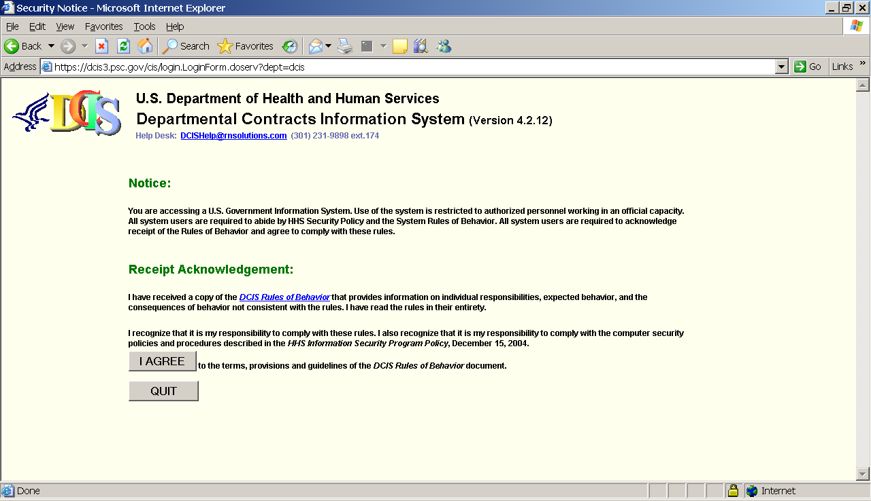

SCREEN 2 will appear on the monitor screen. To complete the login process, enter your username and password, and then click the LOGIN button.
SCREEN 2 - DCIS LOGIN
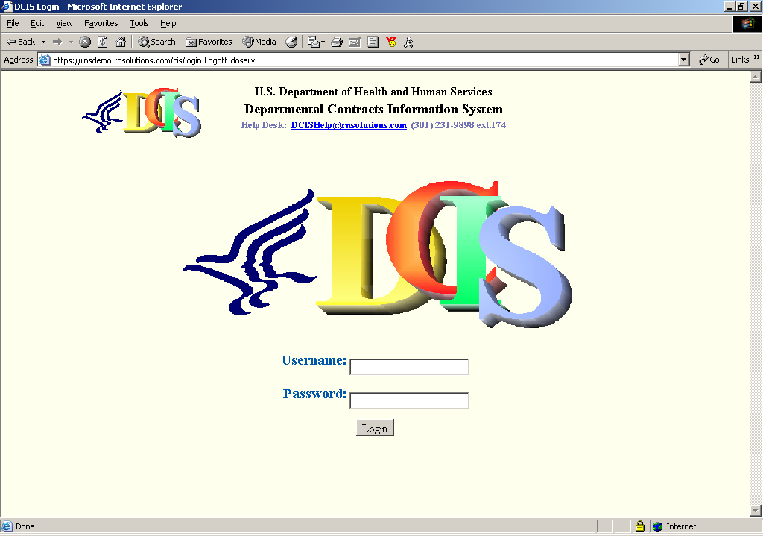

A successful login results in the display of SCREEN 3.

SCREEN 3 - DCIS FUNCTION SELECTION
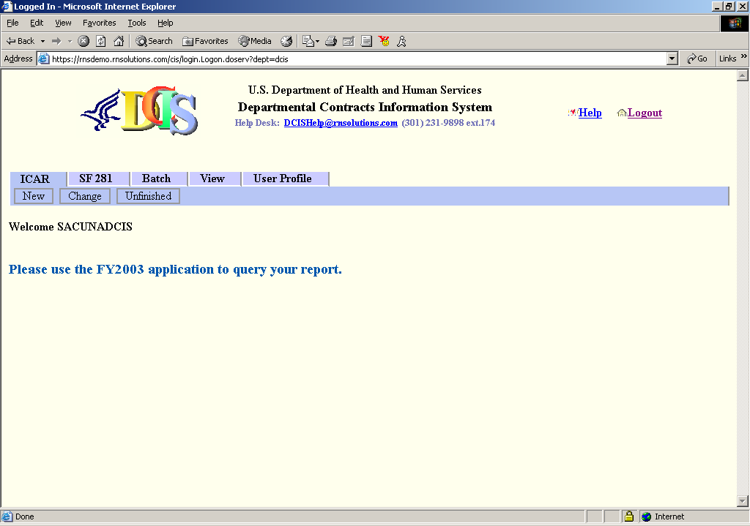
The system recognizes three types of users: Regular users, Officers, and Supervisors. Regular users can only access their records. Officers can access records originated by users within the officer’s operating Administration. Supervisors can access records originated by the users and Officers DOT-wide.

E.4 ICAR – New Records Processing
To create a new ICAR, click the ICAR tab and select the New link. The New Contract Information page will be displayed. You may create the following ICARs, shown in the dropdown list:
- IDV-IDC Indefinite Delivery Contract
- IDV-BOA Basic Ordering Agreement
- IDV – BPA Blanket Purchase Agreement
- IDV – BPA under FSS Blanket Purchase Agreement Under Federal Supply Schedule
- AWARD – PO <= $25K Purchase Order Less Than Or Equal To $25,000
- AWARD – PO > $25K Purchase Order Greater Than $25,000
- AWARD – DCA Definitive Contract Action
- AWARD – BPA Call
- AWARD – DO Delivery Order
- Modification

SCREEN 4 - New Contract Information Selection
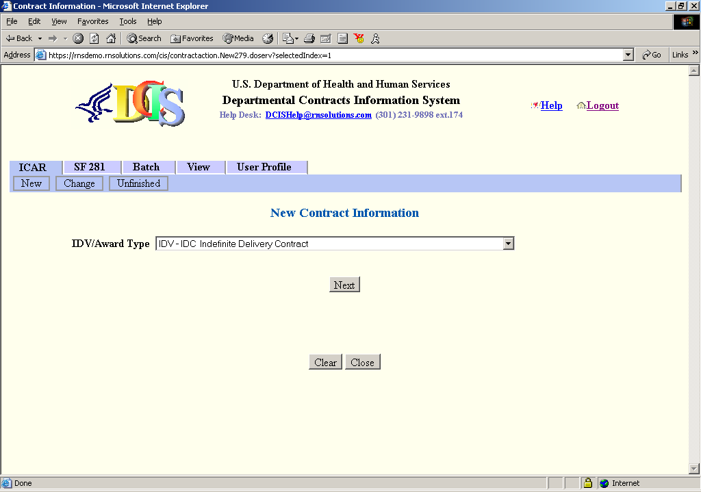
Click the NEXT button to proceed to the next screen:
SCREEN 5 - New Contract Information - CREATE
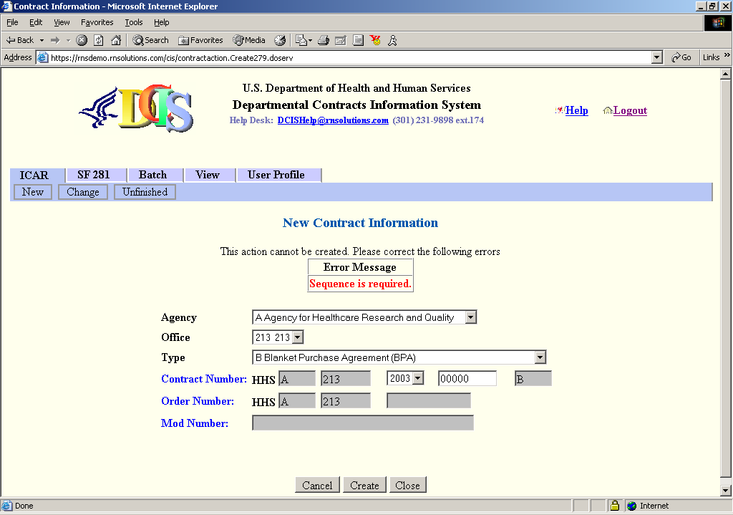
Make a selection from the Agency, Office, Type, and Contract Number fields. Click the CREATE button.
A long form will be displayed. This screen contains all the required data elements for the ICAR. Use the scroll bars at the right and bottom parts of the screen to navigate through the full form.

SCREEN 6 - New Contract Information DATA ENTRY
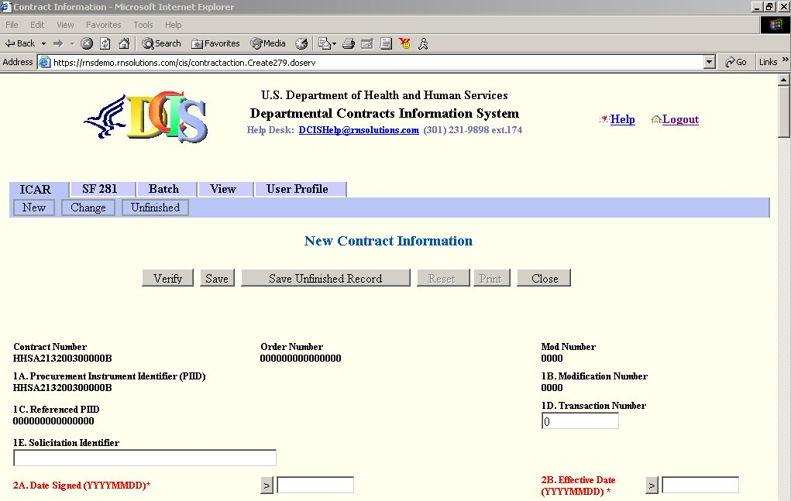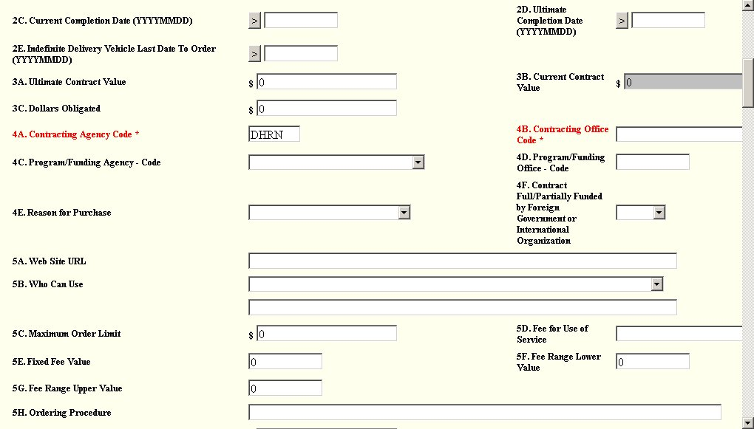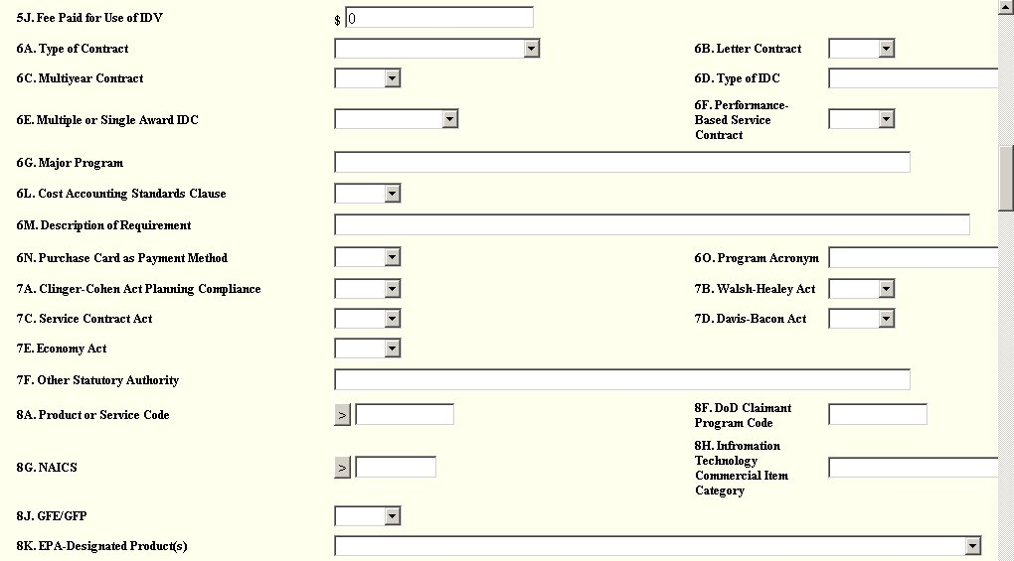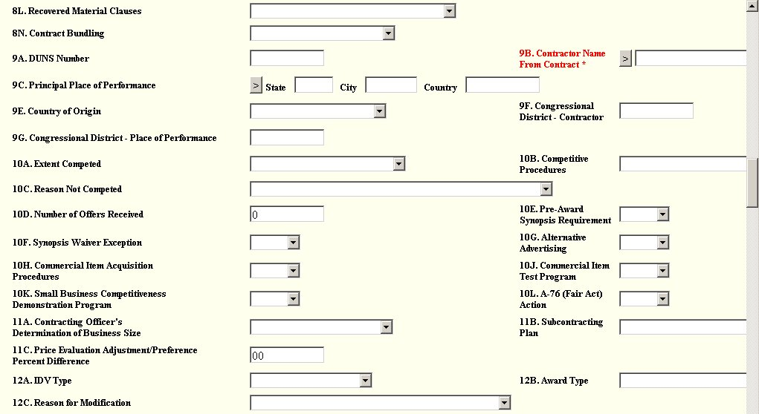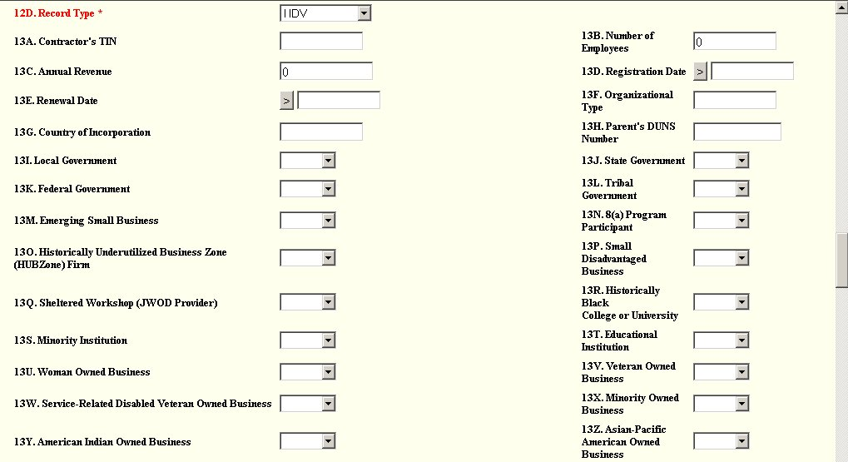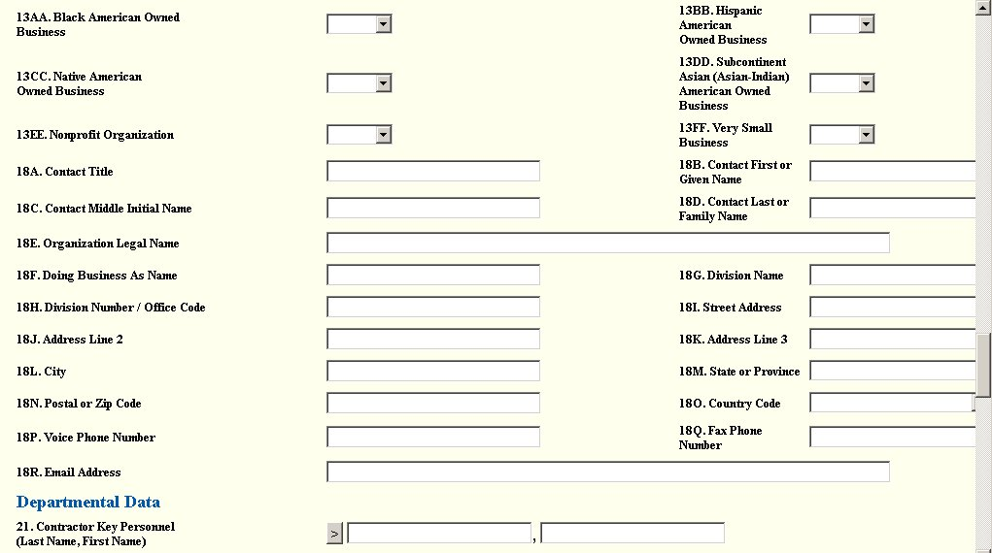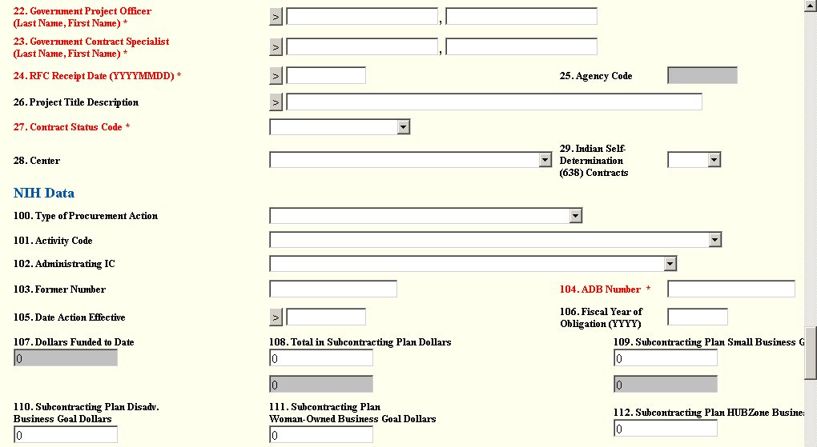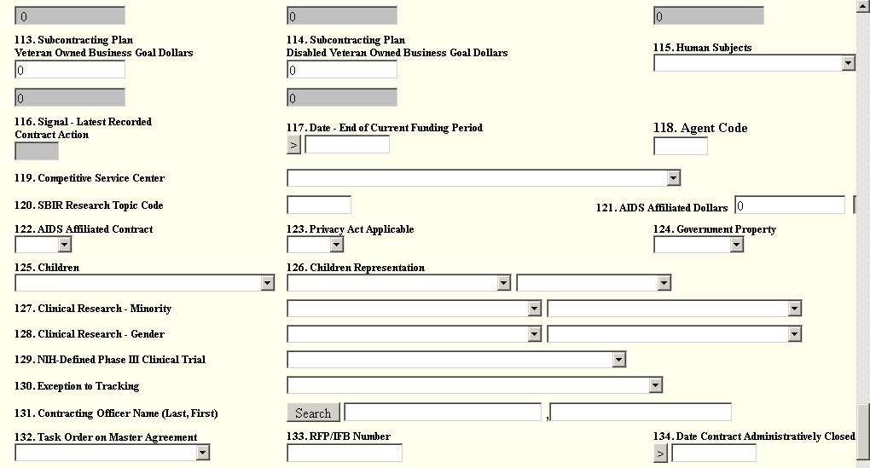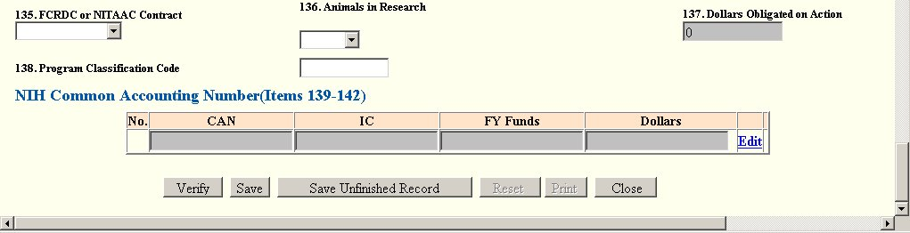

The text in red indicates it is a required field. To validate the form, click the VERIFY button. The system will inform you of data entry problems that will need to be resolved before a final save is performed.

SCREEN 7 - New Contract Information - Form Validation
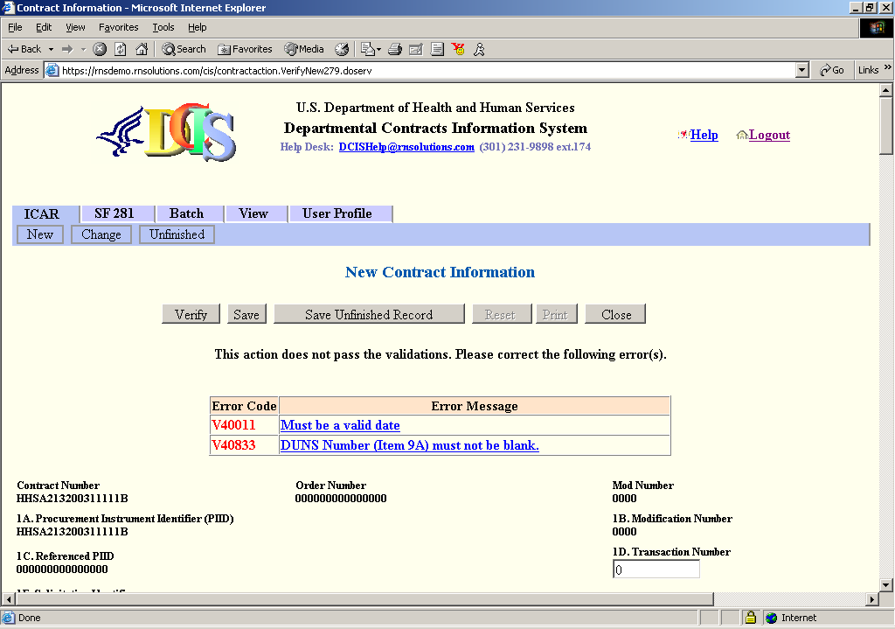
All issues must be resolved prior to a successful Save action. You may, however, choose to save the new contract information as an “Unfinished Record” by clicking the SAVE UNFINISHED RECORD button. When this button is clicked, the Update Unfinished Button is shown. To continue working on an unfinished record, see Section G.6 ICAR – Unfinished, below.

E.5 ICAR – Change Records Processing
Change processing is similar to New processing. After selecting the Change option from the ICAR menu, SCREEN 8 will be displayed. Enter search criteria and then click the SEARCH command button. If you wish to view all contract information, leave the search criteria empty and just click the SEARCH button.
SCREEN 8 - DCIS CHANGE CONTRACT
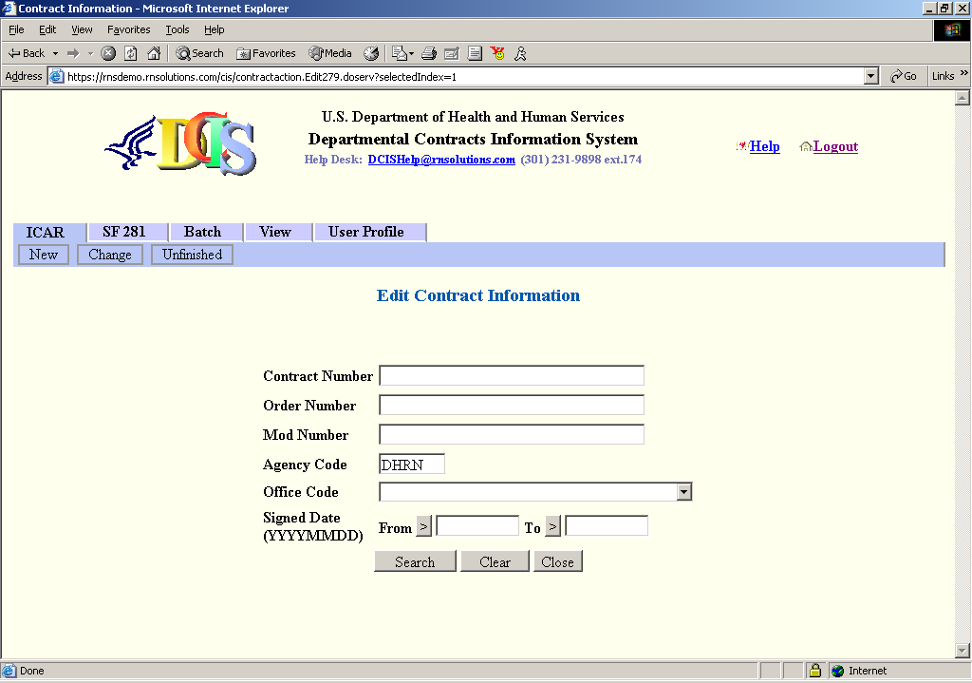
SCREEN 8A will display, showing the list of actions found in the database. Click on the blue highlighted contract number to be edited.
SCREEN 8A - DCIS CHANGE SEARCH CONTRACT
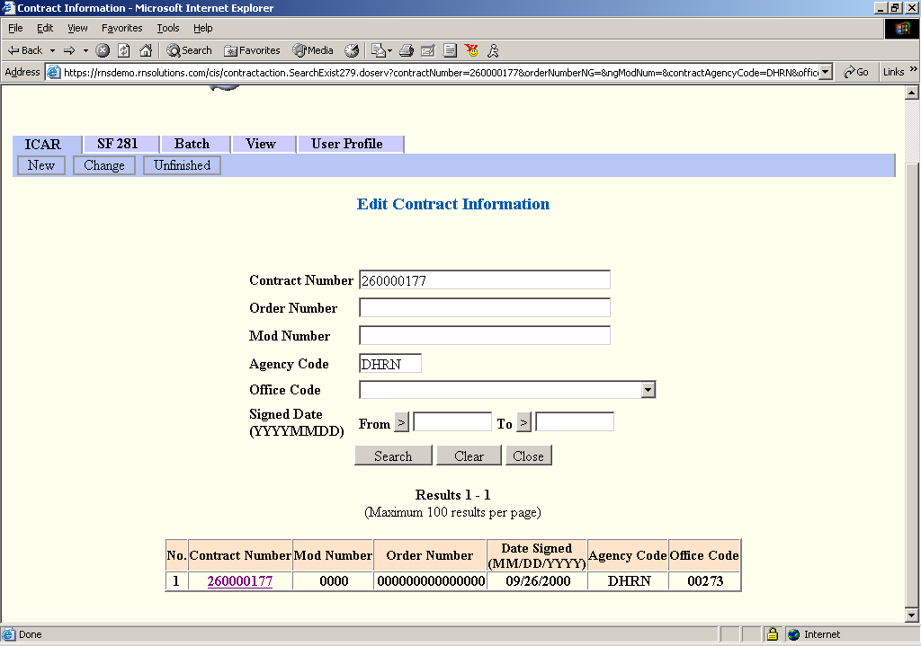

The record will be retrieved and displayed for editing, formatted as in .
SCREEN 9 will appear and navigation will be allowed to locate and change the desired field value(s). To check the changed record, click the VERIFY button. The data that was updated will go through validation. To save the data entered, click the UPDATE button. This function will also perform validation checks and if successful, will acknowledge that the data has been updated.
SCREEN 9 - DCIS EDITING A CONTRACT
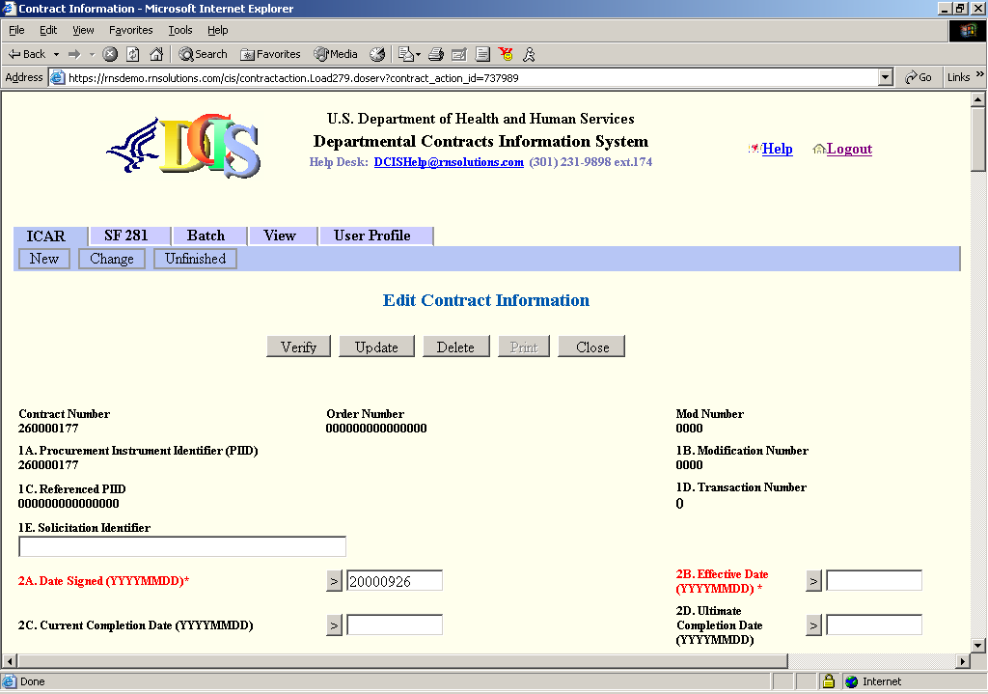
Clicking the CLOSE button will result in the display of confirmation SCREEN 10. Click the OK button to save changes or click the CANCEL button to return to SCREEN 9 without saving changes.
SCREEN 10 - DCIS CONFIRM DATA
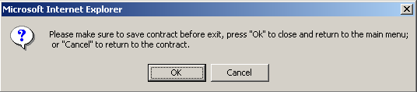

Clicking the DELETE button will automatically delete the contract record.

E.6 ICAR – Unfinished
To continue working on an unfinished ICAR, select ICAR from the main menu and click the Unfinished link. Enter criteria to narrow your search and click the SEARCH button. SCREEN 11 will be displayed.
SCREEN 11 - DCIS UNFINISHED CONTRACT INFORMATION
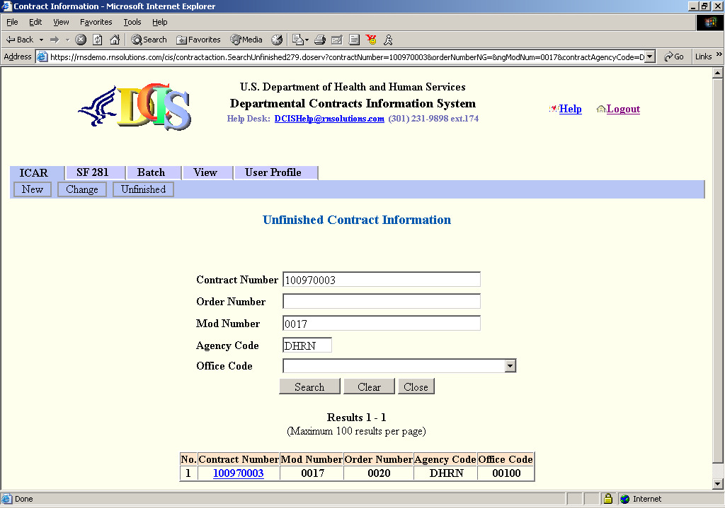
Click the Contract Number link to begin updating the unfinished record. SCREEN 12 will be displayed.
SCREEN 12 - DCIS UNFINISHED CONTRACT INFORMATION
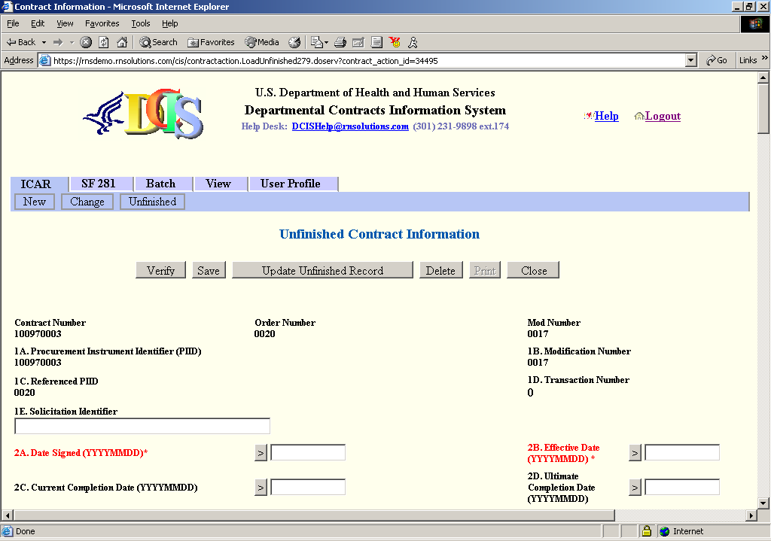
To validate the form, click the VERIFY button. The system will inform you of data entry problems that will need to be resolved before a final Save is performed. See for an example of the system performing data validation.
Clicking the UPDATE UNFINISHED RECORD button will automatically update the record with your changes.
Clicking the DELETE button will automatically delete the contract record.
Clicking the CLOSE button will result in the display of confirmation SCREEN 10. Click the OK button to save changes or click the CANCEL button to return to SCREEN 12 without saving changes.

E.7 Batch-Correct Records Processing (Obsolete)
Correct records processing is used only to correct errors in batch records. You may refer to section E.5 ICAR – Change Records Processing as Correct processing is similar to Change processing. After selecting Batch-Correct from the main menu SCREEN 13 will be displayed.
SCREEN 13 - DCIS CORRECT CONTRACT SCREEN
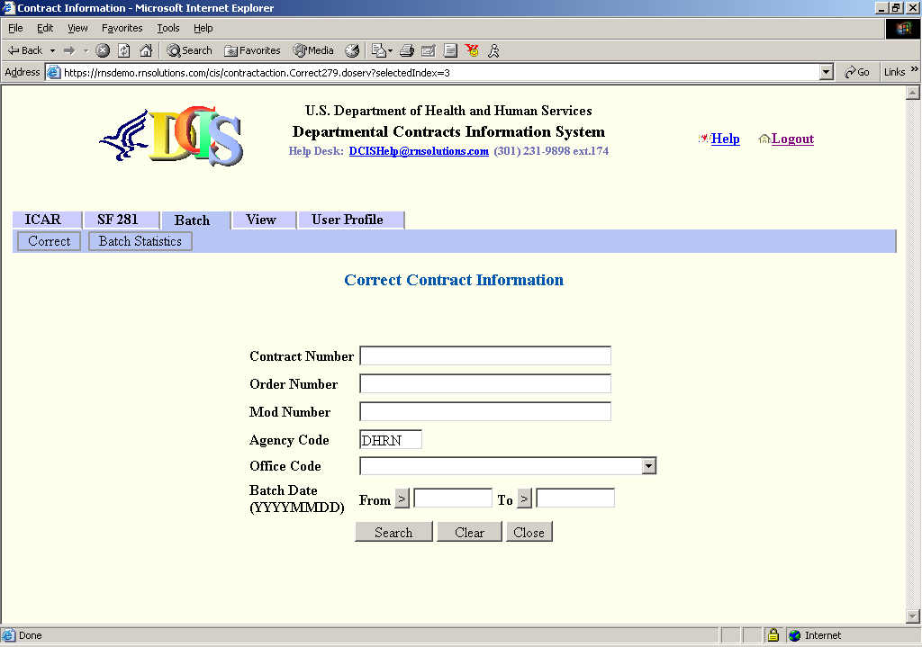
Enter criteria to narrow your search and click the SEARCH button. To search all records, leave the criteria fields blank and click the SEARCH button. The following screen will be displayed.
SCREEN 13A - DCIS CORRECT CONTRACT SEARCH SCREEN
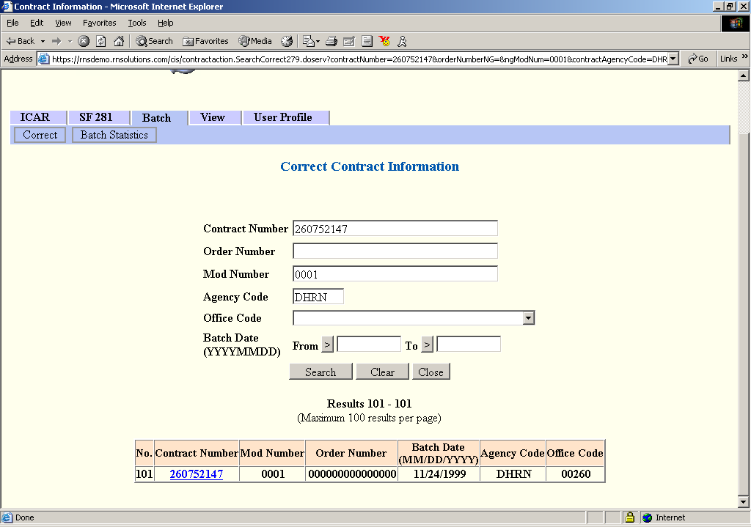
Click a contract number. SCREEN 14 will be displayed.
SCREEN 14 - DCIS CORRECT CONTRACT SCREEN
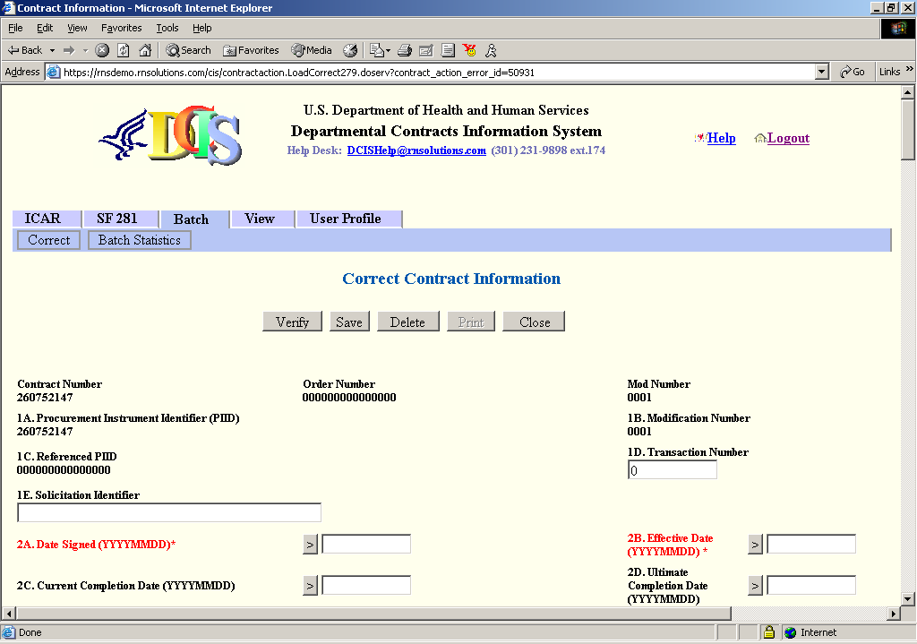

Clicking the CLOSE button will result in the display of confirmation SCREEN 10. Click the OK button to save changes or click the CLOSE button to return to SCREEN 14 without saving changes.
To delete the contract, click the DELETE button. The contract will automatically be deleted.
To validate the form, click the VERIFY button. The system will inform you of data entry problems that will need to be resolved before a final Save is performed. above shows an example of when validation was performed and errors were found in the data.
To save the data entered, click the SAVE button. This function will also perform validation checks and if successful, will acknowledge that the data has been corrected and saved.

E.8 Batch – Batch Statistics (Obsolete)
To see Batch Submission Statistics, select Batch from the menu and then the Batch Statistics link. The following screen will be displayed. To narrow your search, select from the Agency Code, Office Code, and Submission Date search criteria dropdown lists.
screen 15 - batch submission statistics
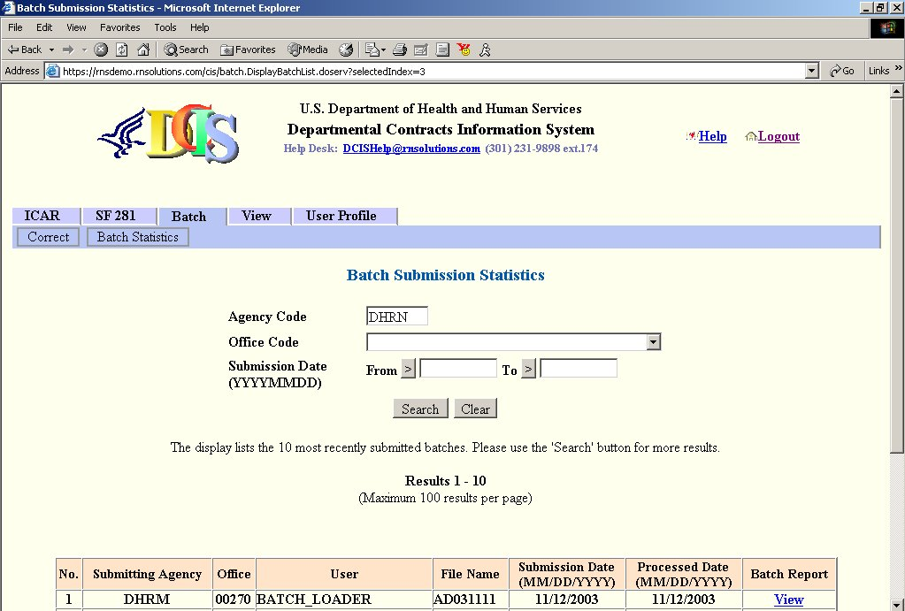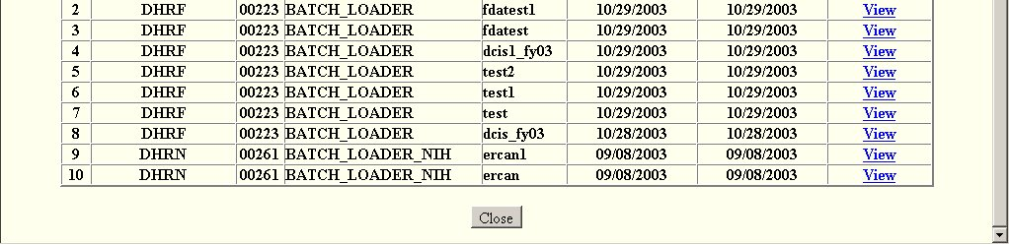
Click a View link to see a Batch Report. The Batch Processing Reports screen will be displayed – SCREEN 16 below. You may retrieve the following four batch reports by clicking on the corresponding tab:
- Summary Statistics
- Error Report
- Discard Actions
- Duplicate Actions

Screen 16 - Batch Processing Reports
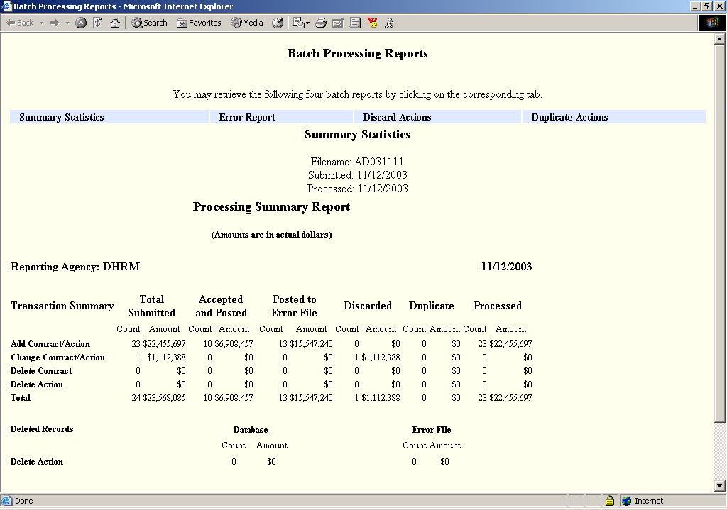

E.9 View Existing Contract
Click View from the main menu and then the Contract Information link. SCREEN 17, View Contract Information, will be displayed. Enter the requested contract identification data into the fields, and click the SEARCH button.
SCREEN 17 - DCIS VIEW CONTRACT INFORMATION - SEARCH

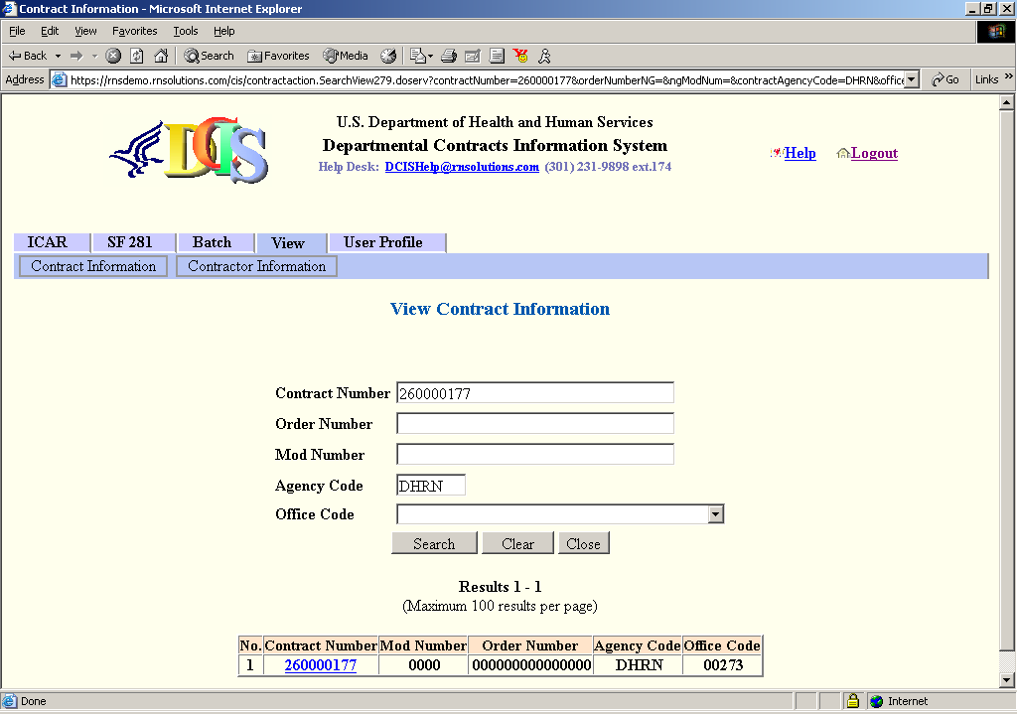

The page will show a list of contract actions found in the database. Click on the blue highlighted contract number to be viewed. SCREEN 18 will be displayed. Upon successful retrieval, contract information will be shown in read-only mode. Click on the scroll bars on the right and bottom of the screen to see the entire record. The contract record may be printed using the File-Print function of Internet Explorer.

SCREEN 18 - DCIS VIEW CONTRACT INFORMATION SCREEN

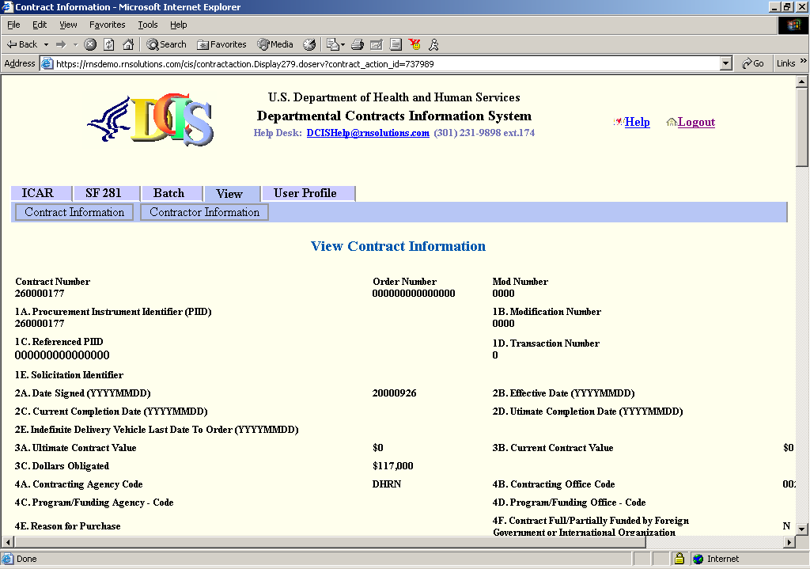

E.10 View Contractor Information
Click on VIEW-CONTRACTOR INFORMATION from the main menu. SCREEN 19 will be displayed. Enter the contractor search criteria into the fields, and click the SEARCH button. You must enter at least one search criteria field.
SCREEN 19 - DCIS VIEW CONTRACTOR INFORMATION
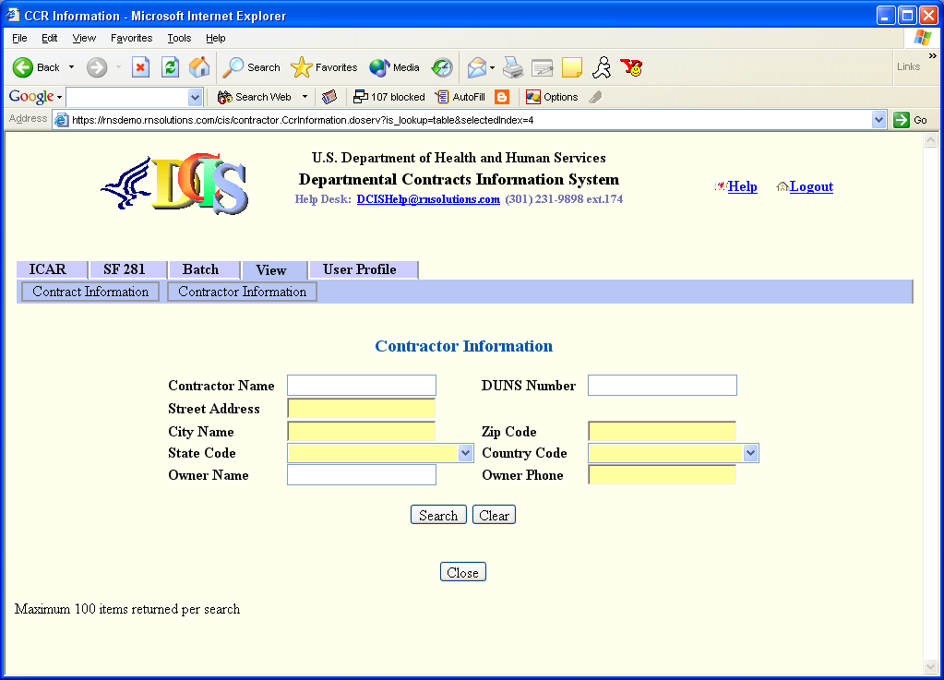
SCREEN 20 will be displayed, showing all records matching the search criteria. Click on the scroll bars on the right and bottom of the screen to see the entire list. The list may be printed using the File-Print function of Internet Explorer.

SCREEN 20 - DCIS VIEW SEARCH RESULTS CONTRACTOR INFORMATION
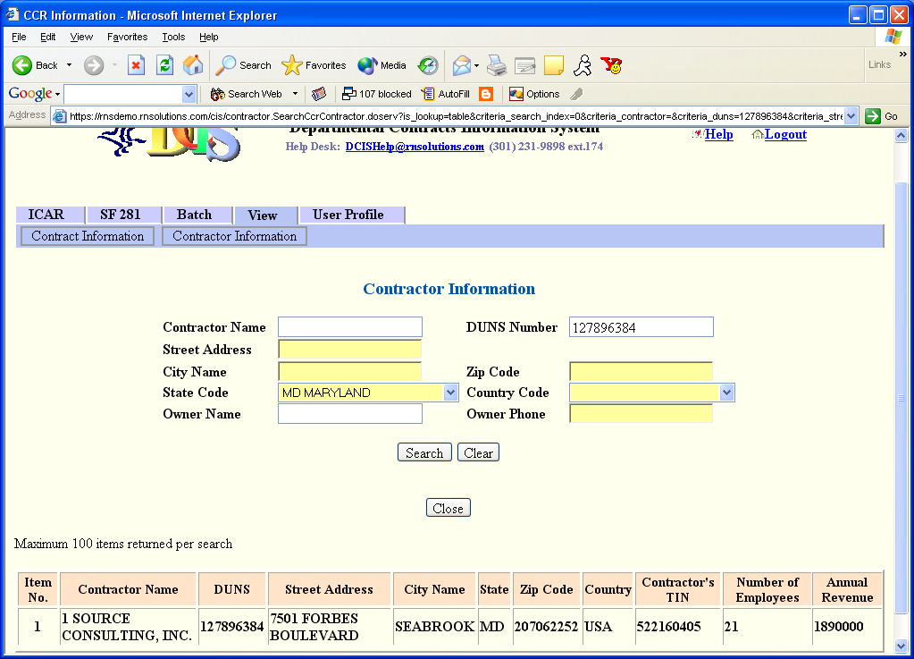

E.11 User Profile – Change Password
From the main menu, click User Profile and then the Change Password link. SCREEN 21 will be displayed. Review the password guidelines shown on the page. Enter your current password and your new password. Retype your new password to confirm and then click the SUBMIT button.
SCREEN 21 - CHANGE PASSWORD
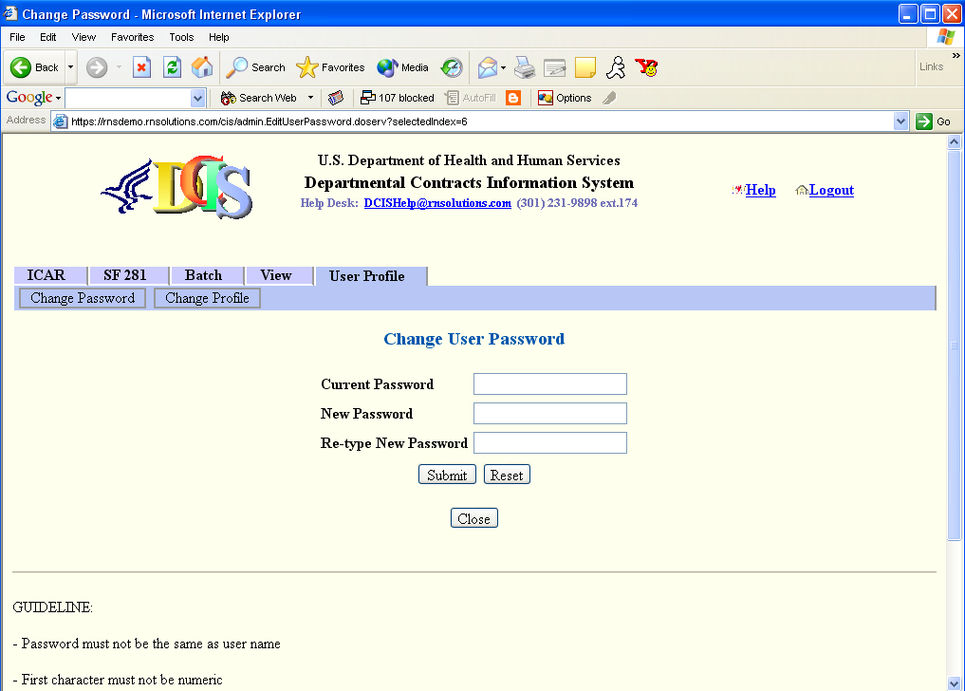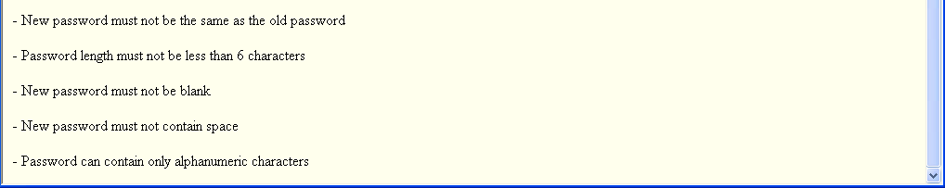

E.12 User Profile – Change Profile
From the main menu, click User Profile and then the Change Profile link. SCREEN 22 will be displayed. Review the password guidelines shown on the page. Enter your email address and your phone number and then click the SUBMIT button. Your profile will be updated.
SCREEN 22 - CHANGE PROFILE
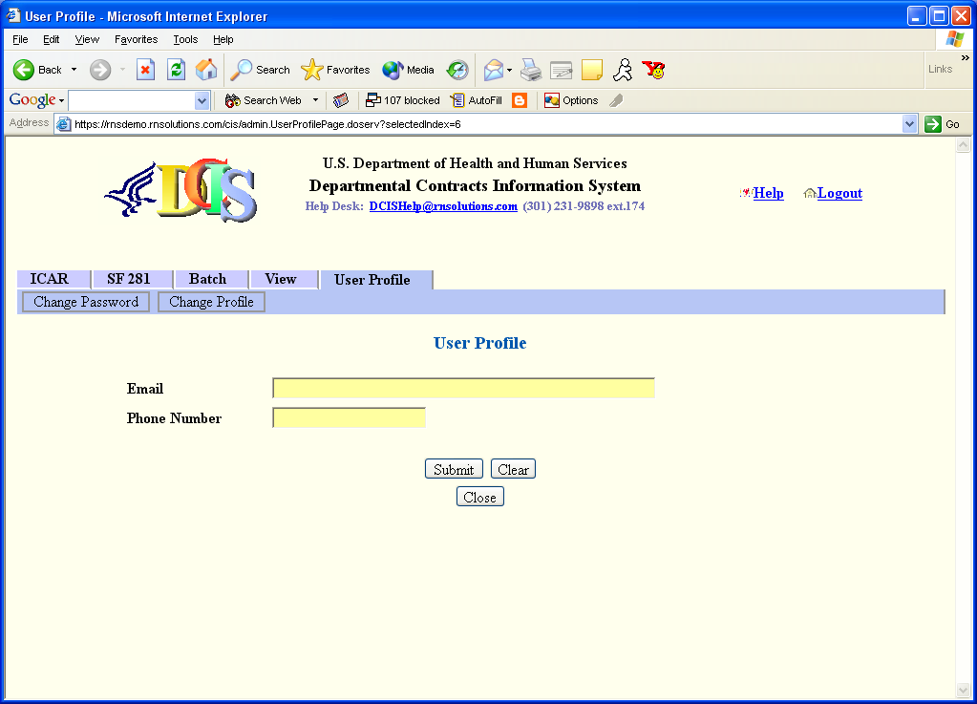

E.13 Logout of DCIS
To logout of the DCIS system, select the Logout link shown in the upper right corner of the screen. You will automatically be logged out of the system and returned to the main DCIS login page as shown in SCREEN 2.

APPENDIX F: ONLINE DATA COLLECTION WORKSHEET
The worksheet in this appendix may be used to collect data about a procurement action prior to entering it into the system.

Department of Health and Human Services
DCIS Data Collection Sheet - FY 2006

Item # | Item Name | Max Num of Chars | Value
1A | Procurement Instrument Identifier (PIID) | 50
1B | Modification Number | 25
1C | Referenced PIID | 50
1D | Transaction Number | 3
1E | Solicitation Identifier | 25
1F | Agency Identifier | 4
1G | Referenced IDV Modification Number | 25
1H | Referenced IDV Agency Identifier | 4
2A | Date Signed (YYYYMMDD) | 8
2B | Effective Date (YYYYMMDD) | 8
2C | Current Completion Date (YYYYMMDD) | 8
2D | Ultimate Completion Date (YYYYMMDD) | 8
2E | Indefinite Delivery Vehicle Last Date To Order (YYYYMMDD) | 8
3A | Base And All Options Value $ | 20
3B | Base And Exercised Options Value$ | 20
3C | Action Obligation $ | 20
4A | Contracting Agency Code | 4
4B | Contracting Office Code | 6
4C | Program/Funding Agency - Code | 4
4D | Program/Funding Office - Code | 6
4E | Reason for Purchase  A – Convenience and Economy  B – Expertise  C – Specifically Authorized  D – Authorized by Executive Order  E – Modification or Extension  F – Other | 1
4F | Contract Full/Partially Funded by Foreign Government or International Organization  (Y, N) | 1
5A | Web Site URL | 100
5B | Who Can Use  Only My Agency – Only the agency awarding the contract may place orders  All Agencies – All Federal Government agencies may place orders against the contract.  Defense – Only Department of Defense agencies may place orders against the contract  Civilian – Only civilian agencies may place orders against the contract.  Codes: – Only the agencies with the FIPS 95 codes listed in a comma-separated list.  Other: – Provide a text statement of which agencies may place orders against the contract. | 255
5C | Maximum Order Limit $ | 20
5D | Fee for Use of Service  FIX – Fixed  RVA – Range – Varies by Amount  RVO – Range – Varies by Other Factor  NO – No Fee | 3
5E | Fixed Fee Value | 4
5F | Fee Range Lower Value | 4
5G | Fee Range Upper Value | 4
5H | Ordering Procedure | 1000
5J | Fee Paid for Use of IDV $ | 20
6A | Type of Contract  The following apply to all Awards and IDVs:  A – Fixed Price Redetermination  B – Fixed Price Level of Effort  J – Fixed Price  K – Fixed Price with Economic Price Adjustment  L – Fixed Price Incentive  M – Fixed Price Award Fee  R – Cost Plus Award Fee  S – Cost No Fee  T – Cost Sharing  U – Cost Plus Fixed Fee  V – Cost Plus Incentive  Y – Time and Materials  Z – Labor Hours  The following apply to IDVs only:  1 – Order Dependent (IDV allows pricing arrangement to be determined separately for each order)  The following apply to Awards only:  2 – Combination (Applies to Awards where two or more of the above apply)  3 – Other (Applies to Awards where none of the above apply) | 1
6B | Letter Contract (Y, N) | 1
6C | Multiyear Contract (Y, N) | 1
6D | Type of IDC  A – Indefinite Delivery / Requirements  B – Indefinite Delivery / Indefinite Quantity  C – Indefinite Delivery / Definite Quantity | 1
6E | Multiple or Single Award IDC  M – Multiple Award  S – Single Award | 1
6F | Performance-Based Service Contract  (Y, N, *) | 1
6G | Major Program | 100
6L | Cost Accounting Standards Clause (Y, N) | 1
6M | Description of Requirement | 4000
6N | Purchase Card as Payment Method (Y, N) | 1
6P | Program Acronym | 25
6Q | Number of Actions | 4
6R | National Interest Action  NONE–None None  H05K –Hurricane Katrina Hurricane Katrina  H05O –Hurricane Ophelia Hurricane Ophelia  H05R –Hurricane Rita Hurricane Rita  H05W –Hurricane Wilma Hurricane Wilma | 4
7A | Clinger-Cohen Act Planning Compliance  (Y, N) | 1
7B | Walsh-Healey Act (Y, N) | 1
7C | Service Contract Act (Y, N) | 1
7D | Davis-Bacon Act (Y, N) | 1
7E | Economy Act (Y, N) | 1
7F | Other Statutory Authority | 1000
8A | Product or Service Code | 4
8F | DoD Claimant Program Code | 3
8G | NAICS | 6
8H | Information Technology Commercial Item Category  A – Commercially Available  B – Other Commercial Item  C – Non-developmental Item  D – Non-Commercial Item  E – Commercial Service  F – Non-Commercial Service  Blank – Not IT Products or Services | 1
8J | GFE/GFP (Y, N) | 1
8K | EPA-Designated Product(s)  A – Meets Requirements  B – Justification - Time  C – Justification - Price  D – Justification - Performance  E – Not Required | 1
8L | Recovered Material Clauses  A – FAR 52.223-4 Included  B – FAR 52.223-4 and FAR 52.223-9  C – No Clauses Included | 1
8N | Contracting Bundling  A – Mission Critical  B – OMB Circular A-76  C – Other  D – Not a bundled requirement | 1
8P | Consolidated Contract (Y, N) | 1
9A | DUNS Number | 9
9B | Contractor Name From Contract | 50
9C | Principal Place of Performance - State | 2
9C | Principal Place of Performance - City | 5
9C | Principal Place of Performance - Country | 2
9E | Country of Origin | 2
9F | Congressional District – Contractor | 6
9G | Congressional District - Place of Performance | 6
9H | Place of Manufacture  A –U.S. The action is for (i) A foreign end product  that is manufactured in the United States  but still determined to be foreign because  50 percent or more of the cost of its  components is not mined, produced, or  manufactured inside the United States or  inside qualifying countries; or (ii) Services  performed in the United States by a  foreign concern.  B– Foreign The action is for (i) Any other foreign end  product; or (ii) Services performed outside  the United States by a foreign concern.  C –Not Applicable Not Applicable | 1
9J | CCR Exception  1 – Purchases that use a government-wide commercial purchase card as both the purchasing and payment mechanism, as opposed to using the purchase card only as a payment method.  2 – Classified contracts (see 2.101) when registration in the CCR database, or use of CCR data, could compromise the safeguarding of classified information or national security.  3 – Deployed contracting officers in the course of military operations, including, but no limited to, contingency operations as defined in 10 U.S.C. 101(a)(13) or humanitarian or peacekeeping operations as defined in 10 U.S.C. 2302(7).  4 – Contracting Officers in the conduct of emergency operations, such as responses to natural or environmental disasters or national or civil emergencies, e.g., Robert T. Stafford Disaster Relief and Emergency Assistance Act (42 U.S.C. 5121).  5 – Contracts to support unusual or compelling needs (see 6.302-2.)  6 – Awards made to foreign vendors for work performed outside the United States, if it is impractical to obtain CCR registration.  7 – Micro-purchases that do not use the electronic funds transfer (EFT) method for payment and are not required to be reported (see subpart 4.6). | 1
9K | Zip Code - Place of Performance | 10
10A | Extent Competed  A – Full & Open Competition  B – Not Available for Competition  C – Not Competed  D – Full & Open Competition After Exclusion of Sources  E – Follow-on to Competed Action  F – Competed under Simplified Acquisition Threshold  G – Not Competed under Simplified Acquisition Threshold  CDO – Competitive Delivery Order  NDO – Non-Competitive Delivery Order | 3
10C | Reason Not Competed  UNQ – Unique Source  FOC – Follow-on contract  UR –Unsolicited Research  PDR – Patent/Data Rights  UT – Utilities FAR 41.2  STD – Standardization  ONE – Only One Source – Other  URG – Urgency  MES – Mobilization, Essential R&D Capability or Expert Services  IA – International Agreement  OTH – Authorized by Statute  RES – Authorized for Resale  NS – National Security  PI – Public Interest  MPT – Micro Purchase Threshold  SP2 – Simplified Acquisition Procedures Non-Competitive  FPI – UNICOR  JWD – Directed to JWOD Nonprofit | 3
10D | Number of Offers Received | 3
10E | Pre-Award Synopsis Requirement (Y, N) | 1
10F | Synopsis Waiver Exception (Y, N) | 1
10G | Alternative Advertising (Y, N) | 1
10H | Commercial Item Acquisition Procedures  (Y, N) | 1
10J | Commercial Item Test Program (Y, N) | 1
10K | Small Business Competitiveness Demonstration Program  (Y, N) | 1
10L | A-76 (Fair Act) Action (Y, N) | 1
10M | Solicitation Procedures  AS – Alternative Sources  AE – Architect – Engineer FAR 6.102  BR – Basic Research  NP – Negotiated Proposal Quote  NONE – No Solicitation Procedure Used  SB – Sealed Bid  SP1 – Simplified Acquisition  TS – Two Step  SSS Single Source Solicited  MAFO Multiple Award Fair opportunity | 5
10N | Type Set Aside  638 – 638 Contract  SBA – Small Business Set Aside – Total  8A – 8(a) Competed  SBP – Small Business Set Aside – Partial  NONE – No Set Aside used  HMT – HBCU or MI Set Aside – Total  HMP – HBCU or MI Set Aside – Partial  VSB – Very Small Business Set Aside  ESB – Emerging Small Business Set Aside  HZC – HUBZone Set Aside  SDVOSBC – Service Disabled Veteran Owned Small Business Set Aside  BI – Buy Indian  HZS – HUBZone Sole Source  SDVOSBS – Service Disabled Veteran Owned Small Business –Sole Source  8AN –8(a) Sole Source  RSB – Reserved for Small Business $2501 to $100K  8AC – SDB Set-Aside 8(a)- (Will be deprecated in future)  HS2 – Combination HUBZone Set Aside and 8(a)- (Will  be deprecated in future)  HS3 – 8(a) with HUBZone Preference | 10
10P | Evaluated Preference  SDA – SDB Price Evaluation Adjustment (moved from 10B)  SPS – SDB Preferential Consideration (Partial Set Aside)  HZE – HUBZone Price Evaluation Preference  HSD – Combined HUB/SDB Preference  NONE – No Preference Used | 6
10Q | Research  SR1 – SBIR Program Phase I Action  SR2 – SBIR Program Phase II Action  SR3 – SBIR Program Phase III Action  ST1 – STTR Phase I  ST2 – STTR Phase II  ST3 – STTR Phase III | 3
10R | Statutory Exceptions to Fair Opportunity  URG – Urgency  ONE – Only One Source – Other  MG – Minimum Guarantee  FOO – Follow-on Delivery Order Following Competitive Initial Order  OSA^{DoD} Other Statutory Authority  FAIR^{DoD} No Exception - Fair Opportunity given | 3
11A | Contracting Officer's Determination of Business Size  S – Small Business  O – Other than Small Business | 1
11B | Subcontracting Plan  A – Plan Not Included - No Subcontracting  B – Plan Not Required  C – Plan Required - Incentive Not Included  D – Plan Required - Incentive Included | 1
11C | Price Evaluation Adjustment/Preference Percent Difference  (Range from 00 to 20) | 2
12A | IDV Type  A – GWAC  B – IDC  D – BOA  E – BPA | 1
12B | Award Type  A – BPA Call  B – Purchase Order  C – Delivery Order  D – Definitive Contract | 1
12C | Reason for Modification  A – Additional Work (new agreement, FAR part 6 applies)  B – Supplemental Agreement for work within scope  C – Funding Only Action  D – Change Order  E – Terminate for Default (complete or partial)  F – Terminate for Convenience (complete or partial)  G – Exercise an Option  H – Definitize Letter Contract  J – Novation Agreement  K – Close Out  L – Definitize Change Order  M – Other Administrative Action | 1
12D | Record Type  I – IDV  A – Award  M – Modification | 1
13A | Contractor's TIN (From CCR) | 9
13B | Number of Employees (From CCR) | 15
13C | Annual Revenue (From CCR) | 15
13D | Registration Date (From CCR) | 8
13E | Renewal Date (From CCR) | 8
13F | Organizational Type (From CCR) | 2
13G | Country of Incorporation (From CCR) | 3
13H | Parent's DUNS Number (From CCR) | 9
13I | Local Government (From CCR) | 1
13J | State Government (From CCR) | 1
13K | Federal Government (From CCR) | 1
13L | Tribal Government (From CCR) | 1
13M | Emerging Small Business (From CCR) | 1
13N | 8(a) Program Participant (From CCR) | 1
13O | Historically Underutilized Business Zone (HUBZone) Firm (From CCR) | 1
13P | Small Disadvantaged Business (From CCR) | 1
13Q | Sheltered Workshop (JWOD Provider)  (From CCR) | 1
13R | Historically Black College or University  (From CCR) | 1
13S | Minority Institution (From CCR) | 1
13T | Educational Institution (From CCR) | 1
13U | Woman Owned Business (From CCR) | 1
13V | Veteran Owned Business (From CCR) | 1
13W | Service-Related Disabled Veteran Owned Business (From CCR) | 1
13X | Minority Owned Business (From CCR) | 1
13Y | American Indian Owned Business (From CCR) | 1
13Z | Asian-Pacific American Owned Business (From CCR) | 1
13AA | Black American Owned Business  (From CCR) | 1
13BB | Hispanic American Owned Business  (From CCR) | 1
13CC | Native American Owned Business  (From CCR) | 1
13DD | Subcontinent Asian (Asian-Indian) American Owned Business (From CCR) | 1
13EE | Nonprofit Organization (From CCR) | 1
13FF | Very Small Business (From CCR) | 1
13GG | Vendor Name | 100
13HH | Vendor Doing As Business Name | 60
13JJ | Vendor Address Line 1 | 35
13KK | Vendor Address Line 2 | 35
13LL | Vendor Address Line 3 | 35
13MM | Vendor Address City | 20
13NN | Vendor Address State | 2
13PP | Vendor Zip Code | 10
13QQ | Vendor Country Code | 3
13RR | Vendor Phone Number | 20
13SS | Vendor Fax Number | 20
13TT | Vendor Number of Employees | 20
13UU | Vendor Annual Revenue | 20
13VV | Hospital Flag | 1
18A | Contact Title (From CCR) | 25
18B | Contact First or Given Name (From CCR) | 25
18C | Contact Middle Initial or Name (From CCR) | 25
18D | Contact Last or Family Name (From CCR) | 25
18E | Organization Legal Name (From CCR) | 120
18F | Doing Business As Name (From CCR) | 60
18G | Division Name (From CCR) | 60
18H | Division Number / Office Code (From CCR) | 10
18I | Street Address (From CCR) | 55
18J | Address Line 2 (From CCR) | 55
18K | Address Line 3 (From CCR) | 55
18L | City (From CCR) | 35
18M | State or Province (From CCR) | 2
18N | Postal or Zip Code (From CCR) | 35
18O | Country Code (From CCR) | 3
18P | Voice Phone Number (From CCR) | 12
18Q | Fax Phone Number | 12
18R | Email Address | 80
21A | Contractor Key Personnel –  Last Name | 15
21A | Contractor Key Personnel –  First Name | 15
21B | Contractor Key Personnel - Email
22A | Government Project Officer –  Last Name | 15
22A | Government Project Officer –  First Name | 15
22B | Government Project Officer - Email
23A | Government Contract Specialist –  Last Name | 15
23A | Government Contract Specialist –  First Name | 15
23B | Government Contract Specialist - Email
24 | RFC Receipt Date (YYYYMMDD) | 8
25 | Agency Code | 4
26 | Project Title Description | 300
27 | Contract Status Code  A – Active  B – Completed Physically  C – Completed Administratively | 1
28 | Center | 1
29 | Indian Self-Determination (638) Contracts(Y, N) | 1

APPENDIX G: CONTRACTOR IDENTIFICATION NUMBER

This appendix provides the Contractor Identification Number (CIN) check digit algorithm for the nine (9) digit numeric DUNS number.

CONTRACTOR IDENTIFICATION NUMBER CHECK DIGIT ALGORITHM

Each 9 digit numeric DUNS number must pass the following check digit test:

9-digit code X X X X X X X X X
multiplied by: 1 2 1 2 1 2 1 2 1
X+ X+X+ X+ X+X+ X+ X+X+ X+ X+X+ X+ = XO or X5

Each of the nine (9) digits is multiplied in sequence by 1, 2, 1, 2, 1, etc.. The sum of each digit of the individual products is divisible by “5”.

Example of the check digit algorithm for the following Contractor Identification Number of “003265407”:

0 0 3 2 6 5 4 0 7
X 1 2 1 2 1 2 1 2 1
0 + 0 + 3 + 4 + 6 + 1+0 + 4 + 0 + 7 = 25, and the sum of the products added individually by each digit is divisible by five.

APPENDIX H: HISTORICALLY BLACK COLLEGES AND UNIVERSITIES & MINORITY INSTITUTIONS

This appendix contains lists of Historically Black Colleges and Universities (HBCUs) and U.S. Accredited Postsecondary Minority Institutions.

Historically Black Colleges and Universities

A current list of the Historically Black Colleges and Universities (HBUCs) and Minority Institutions (MIs) can be found on the Department of Education, Office of Civil Right’s web site. This listing of the 2001 U.S. Department of Education (DoE), accredited postsecondary minority institutions can be found at http://www.ed.gov/offices/OCR/minorityinst.html. The main DoE web site is http://www.ed.gov.

The Federal Procurement Data Center’s web site (http://fpds.gsa.gov) also has a list of current HBCUs and MIs and their associated DUNS number.

The following is a list of the HBCUs:

Alabama | Florida
Alabama A & M University | Bethune-Cookman College
Alabama State University | Edward Waters College
Bishop State Community College | Florida A & M University
Concordia College | Florida Memorial College
Gadsden State Community College
J. F. Drake State Technical College | Georgia
Lawson State Community College | Albany State University
Miles College | Clark Atlanta University
Oakwood College | Fort Valley State University
Selma University | Interdenominational Theological Center
Shelton State Community College | Morehouse College
Stillman College | Morehouse School of Medicine
Talladega College | Morris Brown College
Trenholm State Technical College | Paine College
Tuskegee University | Savannah State University
 | Spelman College
Arkansas
Arkansas Baptist College | Kentucky
Philander Smith College | Kentucky State University
Shorter College
University of Arkansas at Pine Bluff | Louisiana
 | Dillard University
Delaware | Grambling State University
Delaware State University | Southern University and A & M College
 | Southern University-New Orleans
District of Columbia | Southern University-Shreveport-Bossier City
Howard University | Xavier University
University of the District of Columbia
Maryland | South Carolina
Bowie State University | Allen University
Coppin State College | Benedict College
Morgan State University | Claflin College
University of Maryland-Eastern Shore | Clinton Junior College
 | Denmark Technical College
Michigan | Morris College
Lewis College of Business | South Carolina State University
 | Voorhees College
Mississippi
Alcorn State University | Tennessee
Coahoma Community College | Fisk University
Hinds Community College (Utica Campus) | Knoxville College
Jackson State University | Lane College
Mary Holmes College | Le Moyne-Owen College
Mississippi Valley State University | Meharry Medical College
Rust College | Tennessee State University
Tougaloo College
 | Texas
Missouri | Huston-Tillotson College
Harris-Stowe State College | Jarvis Christian College
Lincoln University | Paul Quinn College
 | Prairie View A & M University
North Carolina | Saint Philip's College
Barber-Scotia College | Southwestern Christian College
Bennett College | Texas College
Elizabeth City State University | Texas Southern University
Fayetteville State University | Wiley College
Johnson C. Smith University
Livingstone College | Virginia
North Carolina A & T State University | Hampton University
North Carolina Central University | Norfolk State University
Saint Augustine's College | Saint Paul's College
Shaw University | Virginia State University
Winston-Salem State University | Virginia Union University
Ohio | West Virginia
Central State University | Bluefield State College
Wilberforce University | West Virginia State University
Oklahoma | U.S. Virgin Islands
Langston University | University of the Virgin Islands (Saint Thomas
 | Campus)
Pennsylvania
Cheyney University of Pennsylvania
Lincoln University

The following is a list of the U.S. Accredited Postsecondary Minority Institutions:

INSTITUTION | STATE
ACADEMY OF MEDICAL CAREERS, LAS VEGAS |  |  | NV
ADAMS STATE COLLEGE, ALAMOSA |  | CO
AIMS COMMUNITY COLLEGE, GREELEY |  | CO
ALABAMA A & M UNIVERSITY, NORMAL |  | AL
ALABAMA STATE UNIVERSITY, MONTGOMERY |  | AL
ALBANY STATE UNIVERSITY, ALBANY |  | GA
ALBUQUERQUE TECHNICAL VOCATIONAL INSTITUTE, ALBUQUERQUE |  | NM
ALCORN STATE UNIVERSITY, ALCORN STATE |  | MS
ALLAN HANCOCK COLLEGE, SANTA MARIA |  | CA
ALLEN UNIVERSITY, COLUMBIA |  | SC
AL-MED ACADEMY, ST LOUIS |  | MO
AMERICAN ACADEMY MCALISTER INST OF FUNERAL SERV, NEW YORK |  | NY
AMERICAN BAPTIST SEMINARY OF THE WEST, BERKELEY |  | CA
AMERICAN COLLEGE OF ACUPUNCTURE AND ORIENTAL MED, HOUSTON |  | TX
AMERICAN INDIAN COLL OF THE ASSEMBLIES OF GOD INC, PHOENIX |  | AZ
AMERICAN SAMOA COMMUNITY COLLEGE, PAGO |  | AS
AMERICAN UNIVERSITY OF PUERTO RICO, BAYAMON |  | PR
AMERICAN UNIVERSITY OF PUERTO RICO, MANATI |  | PR
ANTONELLI COLLEGE, HATTIESBURG |  | MS
ANTONELLI COLLEGE, JACKSON |  | MS
ARIZONA INSTITUTE OF BUSINESS AND TECHNOLOGY, PHOENIX |  | AZ
ARIZONA WESTERN COLLEGE, YUMA |  | AZ
ARKANSAS BAPTIST COLLEGE, LITTLE ROCK |  | AR
ASHER SCHOOL OF BUSINESS EDUCATION CORPORATION, NORCROSS |  | GA
ATLANTA METROPOLITAN COLLEGE, ATLANTA |  | GA
ATLANTIC COLLEGE, GUAYNABO |  | PR
ATLANTIC UNION COLLEGE, SOUTH LANCASTER |  | MA
AUDREY COHEN COLLEGE, NEW YORK |  | NY
BACONE COLLEGE, MUSKOGEE |  | OK
BAKERSFIELD COLLEGE, BAKERSFIELD |  | CA
BALTIMORE CITY COMMUNITY COLLEGE, BALTIMORE |  | MD
BARBER-SCOTIA COLLEGE, CONCORD |  | NC
BARRY UNIVERSITY, MIAMI |  | FL
BAUDER COLLEGE, ATLANTA |  | GA
BAY MILLS COMMUNITY COLLEGE, BRIMLEY |  | MI
BAYAMON CENTRAL UNIVERSITY, BAYAMON |  | PR
BENEDICT COLLEGE, COLUMBIA |  | SC
BENNETT COLLEGE, GREENSBORO |  | NC
BETHUNE COOKMAN COLLEGE, DAYTONA BEACH |  | FL
BEULAH HEIGHTS BIBLE COLLEGE, ATLANTA |  | GA
BISHOP STATE COMMUNITY COLLEGE, MOBILE |  | AL
BLACKFEET COMMUNITY COLLEGE, BROWNING |  | MT
BLOOMFIELD COLLEGE, BLOOMFIELD |  | NJ
BLUEFIELD STATE COLLEGE, BLUEFIELD |  | WV
BORICUA COLLEGE, NEW YORK |  | NY
BOWIE STATE UNIVERSITY, BOWIE |  | MD
BRYANT AND STRATTON BUSINESS INSTITUTE-BUFFALO, BUFFALO |  | NY
BRYANT AND STRATTON COLLEGE, CLEVELAND |  | OH
BRYANT AND STRATTON COLLEGE, WILLOUGHBY HILLS |  | OH
BRYANT AND STRATTON COLLEGE-HAMPTON, HAMPTON |  | VA
BRYANT AND STRATTON COLLEGE-RICHMOND, RICHMOND |  | VA
BURDETT COLLEGE, BOSTON |  | MA
BYRANT AND STRATTON COLLEGE, MILWAUKEE |  | WI
CALIFORNIA COLLEGE FOR HEALTH SCIENCES, NATIONAL CITY |  | CA
CALIFORNIA DESIGN COLLEGE, LOS ANGELES |  | CA
CALIFORNIA STATE POLYTECHNIC UNIVERSITY-POMONA, POMONA |  | CA
CALIFORNIA STATE UNIVERSITY-BAKERSFIELD, BAKERSFIELD |  | CA
CALIFORNIA STATE UNIVERSITY-DOMINGUEZ HILLS, CARSON |  | CA
CALIFORNIA STATE UNIVERSITY-FRESNO, FRESNO |  | CA
CALIFORNIA STATE UNIVERSITY-LONG BEACH, LONG BEACH |  | CA
CALIFORNIA STATE UNIVERSITY-LOS ANGELES, LOS ANGELES |  | CA
CALIFORNIA STATE UNIVERSITY-MONTEREY BAY, MONTEREY BAY |  | CA
CALIFORNIA STATE UNIVERSITY-NORTHRIDGE, NORTHRIDGE |  | CA
CALIFORNIA STATE UNIVERSITY-SAN BERNARDINO, SAN BERNARDINO |  | CA
CALIFORNIA STATE UNIVERSITY-STANISLAUS, TURLOCK |  | CA
CAMELOT COLLEGE, BATON ROUGE |  | LA
CAMERON COLLEGE, NEW ORLEANS |  | LA
CANDESKA CIKANA COMMUNITY COLLEGE, FT TOTTEN |  | ND
CAPITAL COMMUNITY-TECHNICAL COLLEGE, HARTFORD |  | CT
CARIBBEAN CENTER FOR ADV STUDIES-MIAMI INST PSYCH, MIAMI-DADE |  | FL
CARIBBEAN CENTER FOR ADVANCED STUDIES, SAN JUAN |  | PR
CARIBBEAN UNIVERSITY-BAYAMON, BAYAMON |  | PR
CARIBBEAN UNIVERSITY-CAROLINA, CAROLINA |  | PR
CARIBBEAN UNIVERSITY-PONCE, PONCE |  | PR
CEDAR VALLEY COLLEGE, LANCASTER |  | TX
CENTER FOR ADVANCED LEGAL STUDIES, HOUSTON |  | TX
CENTRAL ARIZONA COLLEGE, COOLIDGE |  | AZ
CENTRAL STATE UNIVERSITY, WILBERFORCE |  | OH
CENTRAL TEXAS COLLEGE, KILEEN |  | TX
CERRITOS COLLEGE, NORWALK |  | CA
CHABOT COLLEGE, HAYWARD |  | CA
CHAFFEY COMMUNITY COLLEGE, RANCHO CUCAMONGA |  | CA
CHAMINADE UNIVERSITY OF HONOLULU, HONOLULU |  | HI
CHARLES R DREW UNIV OF MEDICINE AND SCIENCE, LOS ANGELES |  | CA
CHAUNCEY SPARKS STATE TECHNICAL COLLEGE, EUFAULA |  | AL
CHEYENNE RIVER COMMUNITY COLLEGE, EAGLE BUTTE |  | SD
CHEYNEY UNIVERSITY OF PENNSYLVANIA, CHEYNEY |  | PA
CHICAGO STATE UNIVERSITY, CHICAGO |  | IL
CITRUS COLLEGE, GLENDORA |  | CA
CITY COLLEGE OF SAN FRANCISCO, SAN FRANCISCO |  | CA
CITY COLLEGE, FT LAUDERDALE |  | FL
CITY COLLEGES OF CHICAGO-HAROLD WASHINGTON COLLEGE, CHICAGO |  | IL
CITY COLLEGES OF CHICAGO-HARRY S TRUMAN COLLEGE, CHICAGO |  | IL
CITY COLLEGES OF CHICAGO-KENNEDY-KING COLLEGE, CHICAGO |  | IL
CITY COLLEGES OF CHICAGO-MALCOLM X COLLEGE, CHICAGO |  | IL
CITY COLLEGES OF CHICAGO-OLIVE-HARVEY COLLEGE, CHICAGO |  | IL
CITY COLLEGES OF CHICAGO-RICHARD J DALEY COLLEGE, CHICAGO |  | IL
CITY COLLEGES OF CHICAGO-WILBUR WRIGHT COLLEGE, CHICAGO |  | IL
CLAFLIN COLLEGE, ORANGEBURG |  | SC
CLARK ATLANTA UNIVERSITY, ATLANTA |  | GA
CLINTON JUNIOR COLLEGE, ROCK HILL |  | SC
CLOVIS COMMUNITY COLLEGE, CLOVIS |  | NM
COAHOMA COMMUNITY COLLEGE, CLARKSDALE |  | MS
COASTAL BEND COLLEGE, BEEVILLE |  | TX
COCHISE COLLEGE, DOUGLAS |  | AZ
COLEGIO BIBLICO PENTECOSTAL DE PUERTO RICO, ST JUST |  | PR
COLEGIO TECNOLOGICO DEL MUNICIPIO DE SAN JUAN, HATO REY |  | PR
COLEGIO UNIVERSITARIO DEL ESTE, CAROLINA |  | PR
COLLEGE OF AERONAUTICS, FLUSHING |  | NY
COLLEGE OF ALAMEDA, ALAMEDA |  | CA
COLLEGE OF MICRONESIA-FSM CAMPUS-CHUUK, CHUUK |  | FM
COLLEGE OF MICRONESIA-FSM CAMPUS-KOSRAE, KOSRAE |  | FM
COLLEGE OF MICRONESIA-FSM CAMPUS-POHNPEI, POHNPEI |  | FM
COLLEGE OF MICRONESIA-FSM CAMPUS-YAP, YAP |  | FM
COLLEGE OF MOUNT SAINT VINCENT, BRONX |  | NY
COLLEGE OF THE DESERT, PALM DESERT |  | CA
COLLEGE OF THE MARSHALL ISLANDS, MAJURO |  | MH
COLLEGE OF THE MENOMINEE NATION, KESHENA |  | WI
COLLEGE OF THE SEQUOIAS, VISALIA |  | CA
COLUMBIA JUNIOR COLLEGE, COLUMBIA |  | SC
COLUMBIA UNION COLLEGE, TAKOMA PARK |  | MD
COLUMBUS TECHNICAL INSTITUTE, COLUMBUS |  | GA
COMMONWEALTH INSTITUTE OF FUNERAL SERVICE, HOUSTON |  | TX
COMMUNITY COLLEGE OF DENVER, DENVER |  | CO
COMMUNITY COLLEGE OF PHILADELPHIA, PHILADELPHIA |  | PA
COMPTON COMMUNITY COLLEGE, COMPTON |  | CA
COMPUTER LEARNING CENTER INC-PHILADELPHIA, PHILADELPHIA |  | PA
COMPUTER LEARNING CENTER, ALEXANDRIA |  | VA
CONCORDIA COLLEGE, SELMA |  | AL
CONSERVATORY OF MUSIC OF PUERTO RICO, SAN JUAN |  | PR
CONTRA COSTA COLLEGE, SAN PABLO |  | CA
COPPIN STATE COLLEGE, BALTIMORE |  | MD
CROWNPOINT INSTITUTE OF TECHNOLOGY, CROWNPOINT |  | NM
CUNY BERNARD M BARUCH COLLEGE, NEW YORK |  | NY
CUNY BOROUGH OF MANHATTAN COMMUNITY COLLEGE, NEW YORK |  | NY
CUNY BRONX COMMUNITY COLLEGE, BRONX |  | NY
CUNY CITY COLLEGE, NEW YORK |  | NY
CUNY HOSTOS COMMUNITY COLLEGE, BRONX |  | NY
CUNY HUNTER COLLEGE, NEW YORK |  | NY
CUNY JOHN JAY COLLEGE CRIMINAL JUSTICE, NEW YORK |  | NY
CUNY KINGSBOROUGH COMMUNITY COLLEGE, BROOKLYN |  | NY
CUNY LA GUARDIA COMMUNITY COLLEGE, LONG ISLAND CITY |  | NY
CUNY LEHMAN COLLEGE, BRONX |  | NY
CUNY MEDGAR EVERS COLLEGE, BROOKLYN |  | NY
CUNY NEW YORK CITY TECHNICAL COLLEGE, BROOKLYN |  | NY
CUNY QUEENSBOROUGH COMMUNITY COLLEGE, NEW YORK |  | NY
CUNY YORK COLLEGE, JAMAICA |  | NY
CYPRESS COLLEGE, CYPRESS |  | CA
DE ANZA COLLEGE, CUPERTINO |  | CA
DEKALB TECHNICAL INSTITUTE, CLARKSTON |  | GA
DEL MAR COLLEGE, CORPUS CHRISTI |  | TX
DELAWARE STATE UNIVERSITY, DOVER |  | DE
DENMARK TECHNICAL COLLEGE, DENMARK |  | SC
DETROIT COLLEGE OF BUSINESS-DEARBORN, DEARBORN |  | MI
DEVRY INSTITUTE OF TECHNOLOGY, CHICAGO |  | IL
DEVRY INSTITUTE OF TECHNOLOGY, DECATUR |  | GA
DEVRY INSTITUTE OF TECHNOLOGY, FREMONT |  | CA
DILLARD UNIVERSITY, NEW ORLEANS |  | LA
DIN-E COLLEGE, TSAILE |  | AZ
DIVINE WORD COLLEGE, EPWORTH |  | IA
DOMINICAN SCHOOL OF PHILOSOPHY AND THEOLOGY, BERKELEY |  | CA
DON BOSCO TECHNICAL INSTITUTE, ROSEMEAD |  | CA
DONGGUK ROYAL UNIVERSITY, LOS ANGELES |  | CA
DONNELLY COLLEGE, KANSAS CITY |  | KS
DOROTHEA HOPFER SCHOOL OF NURSING-MT VERNON HOSP, MT VERNON |  | NY
D-Q UNIVERSITY, DAVIS |  | CA
DULL KNIFE MEMORIAL COLLEGE, LAME DEER |  | MT
EAST LOS ANGELES COLLEGE, MONTEREY PARK |  | CA
EAST MISSISSIPPI COMMUNITY COLLEGE, SCOOBA |  | MS
EAST SAN GABRIEL VALLEY REG OCCUPATIONAL PROG, WEST COVINA |  | CA
EASTERN NEW MEXICO UNIVERSITY-PORTALES, PORTALES |  | NM
EASTERN NEW MEXICO UNIVERSITY-ROSWELL CAMPUS, ROSWELL |  | NM
EASTERN NEW MEXICO UNIVERSITY-RUIDOSO, RUIDOSO |  | NM
EAST-WEST UNIVERSITY, CHICAGO |  | IL
EDGECOMBE COMMUNITY COLLEGE, TARBORO |  | NC
EDUCATION AMERICA INC, HONOLULU |  | HI
EDUCATION AMERICA-DALLAS CAMPUS, GARLAND |  | TX
EDUCATION AMERICA-REMINGTON COLLEGE, CLEVELAND |  | OH
EDWARD WATERS COLLEGE, JACKSONVILLE |  | FL
EL CAMINO COLLEGE, TORRANCE |  | CA
EL CENTRO COLLEGE, DALLAS |  | TX
EL PASO COMMUNITY COLLEGE, EL PASO |  | TX
ELIZABETH CITY STATE UNIVERSITY, ELIZABETH CITY |  | NC
EMERY AVIATION COLLEGE, COLORADO SPRINGS |  | CO
ERIE COMMUNITY COLLEGE-CITY CAMPUS, BUFFALO |  | NY
ESCUELA DE ARTES PLASTICAS DE PUERTO RICO, SAN JUAN |  | PR
ESSEX COUNTY COLLEGE, NEWARK |  | NJ
ESTRELLA MOUNTAIN COMMUNITY COLLEGE, LITCHFIELD PARK |  | AZ
FASHION INSTITUTE OF DESIGN AND MERCH-LOS ANGELES |  | CA
FAYETTEVILLE STATE UNIVERSITY, FAYETTEVILLE |  | NC
FISK UNIVERSITY, NASHVILLE |  | TN
FLORIDA AGRICULTURAL AND MECHANICAL UNIVERSITY, TALLAHASSEE |  | FL
FLORIDA INTERNATIONAL UNIVERSITY, MIAMI |  | FL
FLORIDA MEMORIAL COLLEGE, MIAMI |  | FL
FLORIDA METROPOLITAN UNIVERSITY-TAMPA COLLEGE, TAMPA |  | FL
FOND DU LAC TRIBAL AND COMMUNITY COLLEGE, CLOQUET |  | MN
FORT BELKNAP COLLEGE, HARLEM |  | MT
FORT BERTHOLD COMMUNITY COLLEGE, NEW TOWN |  | ND
FORT PECK COMMUNITY COLLEGE, POPLAR |  | MT
FORT VALLEY STATE UNIVERSITY, FT VALLEY |  | GA
FRANKLIN INSTITUTE OF BOSTON, BOSTON |  | MA
FRESNO CITY COLLEGE, FRESNO |  | CA
FUGAZZI COLLEGE, LEXINGTON |  | KY
FULLERTON COLLEGE, FULLERTON |  | CA
GADSDEN STATE COMMUNITY COLLEGE, GADSDEN |  | AL
GAVILAN COLLEGE, GILROY |  | CA
GEORGIA MILITARY COLLEGE-FT BENNING CENTER, FT BENNING |  | GA
GEORGIA MILITARY COLLEGE-FT GORDON CENTER, FT GORDON |  | GA
GEORGIA MILITARY COLLEGE-FT MCPHERSON CENTER, FT MCPHERSON |  | GA
GRAMBLING STATE UNIVERSITY, GRAMBLING |  | LA
GUAM COMMUNITY COLLEGE, MANGILAO |  | GU
HAMPTON UNIVERSITY, HAMPTON |  | VA
HARRIS-STOWE STATE COLLEGE, ST LOUIS |  | MO
HARTNELL COLLEGE, SALINAS |  | CA
HASKELL INDIAN NATIONS UNIVERSITY, LAWRENCE |  | KS
HAWAII COMMUNITY COLLEGE, HILO |  | HI
HAWAII PACIFIC UNIVERSITY, HONOLULU |  | HI
HEALD COLLEGE SCHOOL OF BUSINESS AND TECHNOLOGY, FRESNO |  | CA
HEALD COLLEGE SCHOOL OF BUSINESS AND TECHNOLOGY, HONOLULU |  | HI
HEALD COLLEGE SCHOOL OF BUSINESS, CONCORD |  | CA
HEALD COLLEGE SCHOOL OF BUSINESS-SALINAS, SALINAS |  | CA
HEALD COLLEGE SCHOOL OF BUSINESS-STOCKTON, STOCKTON |  | CA
HEALD COLLEGE SCHOOL OF TECHNOLOGY, MILPITAS |  | CA
HEALD COLLEGE SCHOOLS OF BUS AND TECH-SAN FRANCISCO |  | CA
HEALD COLLEGE SCHOOLS OF BUSINESS AND TECH-HAYWARD, HAYWARD |  | CA
HEBREW COLLEGE, BROOKLINE |  | MA
HELENE FULD COLLEGE OF NURSING, NEW YORK |  | NY
HENRY J KUTSCH SCHOOL OF NURSING, CHICAGO |  | IL
HERITAGE COLLEGE, TOPPENISH |  | WA
HERZING COLLEGE, ATLANTA |  | GA
HIGH-TECH INSTITUTE, SACRAMENTO |  | CA
HINDS COMMUNITY COLLEGE, RAYMOND |  | MS
HONOLULU COMMUNITY COLLEGE, HONOLULU |  | HI
HOUSTON COMMUNITY COLLEGE SYSTEM, HOUSTON |  | TX
HOWARD UNIVERSITY, WASHINGTON |  | DC
HUDSON COUNTY COMMUNITY COLLEGE, JERSEY CITY |  | NJ
HUMACAO COMMUNITY COLLEGE, HUMACAO |  | PR
HUSTON-TILLOTSON COLLEGE, AUSTIN |  | TX
ILISAGVIK COLLEGE, BARROW |  | AK
IMPERIAL VALLEY COLLEGE, IMPERIAL |  | CA
INSTITUTE OF AMERICAN INDIAN ARTS, SANTA FE |  | NM
INSTITUTE OF CAREER EDUCATION, WEST PALM BEACH |  | FL
INSTITUTE OF COMPUTER TECHNOLOGY, LOS ANGELES |  | CA
INSTITUTE OF DESIGN AND CONSTRUCTION, BROOKLYN |  | NY
INTER AMERICAN UNIV PUERTO RICO, AGUADILLA |  | PR
INTER AMERICAN UNIV PUERTO RICO, ARECIBO |  | PR
INTER AMERICAN UNIV PUERTO RICO, BARRANQUITAS |  | PR
INTER AMERICAN UNIV PUERTO RICO, BAYAMON |  | PR
INTER AMERICAN UNIV PUERTO RICO, FAJARDO |  | PR
INTER AMERICAN UNIV PUERTO RICO, GUAYAMA |  | PR
INTER AMERICAN UNIV PUERTO RICO, METRO |  | PR
INTER AMERICAN UNIV PUERTO RICO, PONCE |  | PR
INTER AMERICAN UNIV PUERTO RICO, SAN GERMAN |  | PR
INTER AMERICAN UNIV PUERTO RICO, SCHL OF OPTOMETRY, HATO REY |  | PR
INTER AMERICAN UNIV PUERTO RICO, SCHOOL OF LAW, SAN JUAN |  | PR
INTERACTIVE COLLEGE OF TECHNOLOGY, CHAMBLEE |  | GA
INTERDENOMINATIONAL THEOLOGICAL CENTER, ATLANTA |  | GA
INTERNATIONAL COLLEGE AND GRADUATE SCHOOL, HONOLULU |  | HI
ITT TECHNICAL INSTITUTE, HAYWARD |  | CA
J F DRAKE STATE TECHNICAL COLLEGE, HUNTSVILLE |  | AL
JACKSON STATE UNIVERSITY, JACKSON |  | MS
JARVIS CHRISTIAN COLLEGE, HAWKINS |  | TX
JNA MARKETING, PHILADELPHIA |  | PA
JOHN M PATTERSON STATE TECHNICAL COLLEGE, MONTGOMERY |  | AL
JOHNSON & WALES UNIVERSITY-FLORIDA CAMPUS, NORTH MIAMI |  | FL
JOHNSON C SMITH UNIVERSITY, CHARLOTTE |  | NC
JONES COLLEGE-JACKSONVILLE, JACKSONVILLE |  | FL
KAPIOLANI COMMUNITY COLLEGE, HONOLULU |  | HI
KATHARINE GIBBS SCHOOL, MONTCLAIR |  | NJ
KAUAI COMMUNITY COLLEGE, LIHUE |  | HI
KELLER GRADUATE SCHOOL OF MANAGEMENT INC, DECATUR |  | GA
KELSEY-JENNEY COLLEGE, SAN DIEGO |  | CA
KENTUCKY STATE UNIVERSITY, FRANKFORT |  | KY
KNOXVILLE COLLEGE, KNOXVILLE |  | TN
LAC COURTE OREILLES OJIBWA COMMUNITY COLLEGE, HAYWARD |  | WI
LANE COLLEGE, JACKSON |  | TN
LANEY COLLEGE, OAKLAND |  | CA
LANGSTON UNIVERSITY, LANGSTON |  | OK
LAREDO COMMUNITY COLLEGE, LAREDO |  | TX
LAWSON STATE COMMUNITY COLLEGE, BIRMINGHAM |  | AL
LE MOYNE-OWEN COLLEGE, MEMPHIS |  | TN
LEECH LAKE TRIBAL COLLEGE, CASS LAKE |  | MN
LEEWARD COMMUNITY COLLEGE, PEARL CITY |  | HI
LEWIS COLLEGE OF BUSINESS, DETROIT |  | MI
LINCOLN UNIVERSITY, JEFFERSON CITY |  | MO
LINCOLN UNIVERSITY, LINCOLN UNIVERSITY |  | PA
LITTLE BIG HORN COLLEGE, CROW AGENCY |  | MT
LITTLE PRIEST TRIBAL COLLEGE, WINNEBAGO |  | NE
LIVINGSTONE COLLEGE, SALISBURY |  | NC
LONG BEACH CITY COLLEGE, LONG BEACH |  | CA
LONG ISLAND COLLEGE HOSPITAL SCHOOL OF NURSING, BROOKLYN |  | NY
LONG ISLAND UNIVERSITY-BROOKLYN CAMPUS, BROOKLYN |  | NY
LOS ANGELES CITY COLLEGE, LOS ANGELES |  | CA
LOS ANGELES COUNTY MED CENTER SCHL OF NURS, LOS ANGELES |  | CA
LOS ANGELES HARBOR COLLEGE, WILMINGTON |  | CA
LOS ANGELES MISSION COLLEGE, SAN FERNANDO |  | CA
LOS ANGELES SOUTHWEST COLLEGE, LOS ANGELES |  | CA
LOS ANGELES TRADE TECHNICAL COLLEGE, LOS ANGELES |  | CA
LOS ANGELES VALLEY COLLEGE, VAN NUYS |  | CA
LOUISIANA TECHNICAL COLLEGE-BATON ROUGE CAMPUS, BATON ROUGE |  | LA
LOUISIANA TECHNICAL COLLEGE-EVANGELINE CAMPUS,ST MARTINVILLE |  | LA
LOUISIANA TECHNICAL COLLEGE-FOLKES CAMPUS, JACKSON |  | LA
LOUISIANA TECHNICAL COLLEGE-JUMONVILLE MEMORIAL, NEW ROADS |  | LA
LOUISIANA TECHNICAL COLLEGE-MANSFIELD CAMPUS, MANSFIELD |  | LA
LOUISIANA TECHNICAL COLLEGE-NATCHITOCHES CAMPUS |  | LA
LOUISIANA TECHNICAL COLLEGE-SIDNEY N COLLIER, NEW ORLEANS |  | LA
LOUISIANA TECHNICAL COLLEGE-TALLULAH CAMPUS, TALLULAH |  | LA
LOUISIANA TECHNICAL COLLEGE-WEST JEFFERSON CAMPUS, HARVEY |  | LA
LUNA VOCATIONAL TECHNICAL INSTITUTE, LAS VEGAS |  | NM
MACHZIKEI HADATH RABBINICAL COLLEGE, BROOKLYN |  | NY
MACON TECHNICAL INSTITUTE, MACON |  | GA
MARTIN UNIVERSITY, INDIANAPOLIS |  | IN
MARY HOLMES COLLEGE, WEST POINT |  | MS
MASTERS INSTITUTE, SAN JOSE |  | CA
MAUI COMMUNITY COLLEGE, KAHULUI |  | HI
MEDICINE CREEK TRIBAL COLLEGE, TACOMA |  | WA
MEHARRY MEDICAL COLLEGE, NASHVILLE |  | TN
MERCED COLLEGE, MERCED |  | CA
MERCY COLLEGE-MAIN CAMPUS, DOBBS FERRY |  | NY
MERRITT COLLEGE, OAKLAND |  | CA
MESA TECHNICAL COLLEGE, TUCUMCARI |  | NM
MIAMI-DADE COMMUNITY COLLEGE, MIAMI |  | FL
MIDLAND COLLEGE, MIDLAND |  | TX
MID-SOUTH COMMUNITY COLLEGE, WEST MEMPHIS |  | AR
MILES COLLEGE, FAIRFIELD |  | AL
MISSION COLLEGE, SANTA CLARA |  | CA
MISSISSIPPI DELTA COMMUNITY COLLEGE, MOORHEAD |  | MS
MISSISSIPPI VALLEY STATE UNIVERSITY, ITTA BENA |  | MS
MONROE COLLEGE-NEW ROCHELLE, NEW ROCHELLE |  | NY
MONTGOMERY COLLEGE OF TAKOMA PARK, TAKOMA PARK |  | MD
MOREHOUSE COLLEGE, ATLANTA |  | GA
MOREHOUSE SCHOOL OF MEDICINE, ATLANTA |  | GA
MORGAN STATE UNIVERSITY, BALTIMORE |  | MD
MORRIS BROWN COLLEGE, ATLANTA |  | GA
MORRIS COLLEGE, SUMTER |  | SC
MORTON COLLEGE, CICERO |  | IL
MOUNT ANGEL SEMINARY, ST BENEDICT |  | OR
MOUNT SAINT MARYS COLLEGE, LOS ANGELES |  | CA
MOUNTAIN VIEW COLLEGE, DALLAS |  | TX
MT SAN ANTONIO COLLEGE, WALNUT |  | CA
MT SIERRA COLLEGE, PASADENA |  | CA
NATIONAL SCHOOL OF TECHNOLOGY INC, NORTH MIAMI BEACH |  | FL
NATIVE AMERICAN EDUCATIONAL SERVICES COLLEGE INC, CHICAGO |  | IL
NATIVE AMERICAN EDUCATIONAL SERVICES-FORT PECK, POPLAR |  | MT
NATIVE AMERICAN EDUCATIONAL SERVICES-MENOMINEE, KESHENA |  | WI
NATIVE AMERICAN EDUCATIONAL SVCS -TWIN CITIES, MINNEAPOLIS |  | MN
NAZARENE INDIAN BIBLE COLLEGE, ALBUQUERQUE |  | NM
NEBRASKA INDIAN COMMUNITY COLLEGE, MACY |  | NE
NEW BRUNSWICK THEOLOGICAL SEMINARY, NEW BRUNSWICK |  | NJ
NEW JERSEY CITY COLLEGE, JERSEY CITY |  | NJ
NEW MEXICO HIGHLANDS UNIVERSITY, LAS VEGAS |  | NM
NEW MEXICO JUNIOR COLLEGE, HOBBS |  | NM
NEW MEXICO STATE UNIVERSITY-ALAMOGORDO, ALAMOGORDO |  | NM
NEW MEXICO STATE UNIVERSITY-CARLSBAD, CARLSBAD |  | NM
NEW MEXICO STATE UNIVERSITY-DONA ANA, LAS CRUCES |  | NM
NEW MEXICO STATE UNIVERSITY-GRANTS, GRANTS |  | NM
NEW MEXICO STATE UNIVERSITY-MAIN CAMPUS, LAS CRUCES |  | NM
NEW YORK CAREER INSTITUTE, NEW YORK |  | NY
NEW YORK RESTAURANT SCHOOL, NEW YORK |  | NY
NIELSEN ELECTRONICS INSTITUTE, NORTH CHARLESTON |  | SC
NORFOLK STATE UNIVERSITY, NORFOLK |  | VA
NORTH CAROLINA AGRICULTURAL & TECHNICAL ST UNIV, GREENSBORO |  | NC
NORTH CAROLINA CENTRAL UNIVERSITY, DURHAM |  | NC
NORTHEASTERN ILLINOIS UNIVERSITY, CHICAGO |  | IL
NORTHERN MARIANAS COLLEGE, SAIPAN |  | MP
NORTHERN NEW MEXICO COMMUNITY COLLEGE, ESPANOLA |  | NM
NORTHROP-RICE AVIATION, INGLEWOOD |  | CA
NORTHWEST INDIAN COLLEGE, BELLINGHAM |  | WA
NORTHWESTERN BUSINESS COLLEGE- SW CAMPUS, HICKORY HILLS |  | IL
NORTHWOOD UNIVERSITY, CEDAR HILL |  | TX
OAKWOOD COLLEGE, HUNTSVILLE |  | AL
ODESSA COLLEGE, ODESSA |  | TX
OGLALA LAKOTA COLLEGE, KYLE |  | SD
OHLONE COLLEGE, FREMONT |  | CA
ORANGEBURG CALHOUN TECHNICAL COLLEGE, ORANGEBURG |  | SC
OTERO JUNIOR COLLEGE, LA JUNTA |  | CO
OUR LADY OF THE LAKE UNIVERSITY-SAN ANTONIO, SAN ANTONIO |  | TX
OXNARD COLLEGE, OXNARD |  | CA
PACIFIC OAKS COLLEGE, PASADENA |  | CA
PAINE COLLEGE, AUGUSTA |  | GA
PALAU COMMUNITY COLLEGE, KOROR |  | PW
PALO ALTO COLLEGE, SAN ANTONIO |  | TX
PALO VERDE COLLEGE, BLYTHE |  | CA
PASADENA CITY COLLEGE, PASADENA |  | CA
PASSAIC COUNTY COMMUNITY COLLEGE, PATERSON |  | NJ
PAUL QUINN COLLEGE, DALLAS |  | TX
PEIRCE COLLEGE, PHILADELPHIA |  | PA
PHILANDER SMITH COLLEGE, LITTLE ROCK |  | AR
PHILLIPS BETH ISRAEL SCHOOL OF NURSING, NEW YORK |  | NY
PHOENIX COLLEGE, PHOENIX |  | AZ
PIMA COMMUNITY COLLEGE, TUCSON |  | AZ
PONCE SCHOOL OF MEDICINE, PONCE |  | PR
PONTIFICAL CATHOLIC UNIV OF PUERTO RICO-ARECIBO, ARECIBO |  | PR
PONTIFICAL CATHOLIC UNIV OF PUERTO RICO-GUAYAMA, GUAYAMA |  | PR
PONTIFICAL CATHOLIC UNIV OF PUERTO RICO-MAYAGUEZ, MAYAGUEZ |  | PR
PONTIFICAL CATHOLIC UNIV OF PUERTO RICO-PONCE, PONCE |  | PR
PORTERVILLE COLLEGE, PORTERVILLE |  | CA
POTOMAC COLLEGE, WASHINGTON |  | DC
PRAIRIE VIEW A & M UNIVERSITY, PRAIRIE VIEW |  | TX
PRINCE GEORGES COMMUNITY COLLEGE, LARGO |  | MD
PUEBLO COMMUNITY COLLEGE, PUEBLO |  | CO
REEDLEY COLLEGE, REEDLEY |  | CA
REID STATE TECHNICAL COLLEGE, EVERGREEN |  | AL
RIO HONDO COLLEGE, WHITTIER |  | CA
ROANOKE-CHOWAN COMMUNITY COLLEGE, AHOSKIE |  | NC
ROBERT MORRIS COLLEGE, CHICAGO |  | IL
ROBESON COMMUNITY COLLEGE, LUMBERTON |  | NC
ROXBURY COMMUNITY COLLEGE, ROXBURY CROSSING |  | MA
RUST COLLEGE, HOLLY SPRINGS |  | MS
SACRAMENTO CITY COLLEGE, SACRAMENTO |  | CA
SAINT AUGUSTINE COLLEGE, CHICAGO |  | IL
SAINT AUGUSTINES COLLEGE, RALEIGH |  | NC
SAINT EDWARDS UNIVERSITY, AUSTIN |  | TX
SAINT JOHN VIANNEY COLLEGE SEMINARY, MIAMI |  | FL
SAINT JOHNS SEMINARY, CAMARILLO |  | CA
SAINT JOSEPHS COLLEGE-MAIN CAMPUS, BROOKLYN |  | NY
SAINT PAULS COLLEGE, LAWRENCEVILLE |  | VA
SAINT PETERS COLLEGE, JERSEY CITY |  | NJ
SAINT THOMAS UNIVERSITY, MIAMI |  | FL
SALISH KOOTENAI COLLEGE, PABLO |  | MT
SAN ANTONIO COLLEGE, SAN ANTONIO |  | TX
SAN BERNARDINO VALLEY COLLEGE, SAN BERNARDINO |  | CA
SAN DIEGO CITY COLLEGE, SAN DIEGO |  | CA
SAN DIEGO MIRAMAR COLLEGE, SAN DIEGO |  | CA
SAN FRANCISCO STATE UNIVERSITY |  | CA
SAN JACINTO COLLEGE-NORTH CAMPUS, HOUSTON |  | TX
SAN JOSE STATE UNIVERSITY, SAN JOSE |  | CA
SANTA ANA COLLEGE, SANTA ANA |  | CA
SANTA FE COMMUNITY COLLEGE, SANTA FE |  | NM
SANTA MONICA COLLEGE, SANTA MONICA |  | CA
SAVANNAH STATE UNIVERSITY, SAVANNAH |  | GA
SAVANNAH TECHNICAL INSTITUTE, SAVANNAH |  | GA
SCHOOL OF COMMUNICATIONS ELECTRONICS, SAN FRANCISCO |  | CA
SELMA UNIVERSITY, SELMA |  | AL
SEQUOIA INSTITUTE, FREMONT |  | CA
SEWARD COUNTY COMMUNITY COLLEGE, LIBERAL |  | KS
SHAW UNIVERSITY, RALEIGH |  | NC
SHELBY STATE COMMUNITY COLLEGE, MEMPHIS |  | TN
SHELTON STATE COMMUNITY COLLEGE |  | AL
SHORTER COLLEGE, NORTH LITTLE ROCK |  | AR
SINTE GLESKA UNIVERSITY, ROSEBUD |  | SD
SISSETON-WAHPETON COMMUNITY COLLEGE, AGENCY VILLAGE |  | SD
SITTING BULL COLLEGE, FT YATES |  | ND
SKYLINE COLLEGE, SAN BRUNO |  | CA
SOJOURNER-DOUGLAS COLLEGE, BALTIMORE |  | MD
SOUTH BAYLO UNIVERSITY, ANAHEIM |  | CA
SOUTH CAROLINA STATE UNIVERSITY, ORANGEBURG |  | SC
SOUTH COLLEGE, MONTGOMERY |  | AL
SOUTH MOUNTAIN COMMUNITY COLLEGE, PHOENIX |  | AZ
SOUTH PLAINS COLLEGE, LEVELLAND |  | TX
SOUTH SUBURBAN COLLEGE, SOUTH HOLLAND |  | IL
SOUTH TEXAS COMMUNITY COLLEGE, MCALLEN |  | TX
SOUTHEAST COLLEGE OF TECHNOLOGY, MEMPHIS |  | TN
SOUTHEASTERN UNIVERSITY, WASHINGTON |  | DC
SOUTHERN CALIFORNIA COLLEGE OF OPTOMETRY, FULLERTON |  | CA
SOUTHERN CALIFORNIA INSTITUTE OF TECHNOLOGY, ANAHEIM |  | CA
SOUTHERN UNIVERSITY AND A & M COLLEGE, BATON ROUGE |  | LA
SOUTHERN UNIVERSITY-NEW ORLEANS, NEW ORLEANS |  | LA
SOUTHERN UNIVERSITY-SHREVEPORT-BOSSIER CITY CAMPUS |  | LA
SOUTHWEST COLLEGE INSTITUTE FOR THE DEAF, BIG SPRING |  | TX
SOUTHWEST TEXAS JUNIOR COLLEGE, UVALDE |  | TX
SOUTHWESTERN CHRISTIAN COLLEGE, TERRELL |  | TX
SOUTHWESTERN COLLEGE, CHULA VISTA |  | CA
SOUTHWESTERN INDIAN POLYTECHNIC INSTITUTE, ALBUQUERQUE |  | NM
SPELMAN COLLEGE, ATLANTA |  | GA
ST MARYS UNIVERSITY, SAN ANTONIO |  | TX
ST PHILIPS COLLEGE, SAN ANTONIO |  | TX
STILLMAN COLLEGE, TUSCALOOSA |  | AL
STONE CHILD COLLEGE, BOX ELDER |  | MT
STRAYER UNIVERSITY-PRINCE GEORGES CAMPUS, SUITLAND |  | MD
STRAYER UNIVERSITY-TAKOMA PARK CAMPUS, WASHINGTON |  | DC
STRAYER UNIVERSITY-WASHINGTON CAMPUS, WASHINGTON |  | DC
SUL ROSS STATE UNIVERSITY, ALPINE |  | TX
TALLADEGA COLLEGE, TALLADEGA |  | AL
TAYLOR BUSINESS INSTITUTE, CHICAGO |  | IL
TENNESSEE STATE UNIVERSITY, NASHVILLE |  | TN
TEXAS A & M INTERNATIONAL UNIVERSITY, LAREDO |  | TX
TEXAS A & M UNIVERSITY-CORPUS CHRISTI, CORPUS CHRISTI |  | TX
TEXAS A & M UNIVERSITY-KINGSVILLE, KINGSVILLE |  | TX
TEXAS COLLEGE, TYLER |  | TX
TEXAS SOUTHERN UNIVERSITY, HOUSTON |  | TX
TEXAS STATE TECHNICAL COLLEGE-HARLINGEN, HARLINGEN |  | TX
THE NATIONAL HISPANIC UNIVERSITY, SAN JOSE |  | CA
THE UNIVERSITY OF TEXAS AT EL PASO, EL PASO |  | TX
THE UNIVERSITY OF TEXAS AT SAN ANTONIO, SAN ANTONIO |  | TX
THE UNIVERSITY OF TEXAS HEALTH SCIENCE-SAN ANTONIO, SAN ANTONIO |  | TX
THE UNIVERSITY OF TEXAS OF THE PERMIAN BASIN, ODESSA |  | TX
THE UNIVERSITY OF TEXAS-PAN AMERICAN, EDINBURG |  | TX
THE UNIVERSITY OF WEST LOS ANGELES, INGLEWOOD |  | CA
TOUGALOO COLLEGE, TOUGALOO |  | MS
TRENHOLM STATE TECHNICAL COLLEGE, MONTGOMERY |  | AL
TRINIDAD STATE JUNIOR COLLEGE, TRINIDAD |  | CO
TRINITY COLLEGE, WASHINGTON |  | DC
TRINITY INTERNATIONAL UNIVERSITY, MIAMI |  | FL
TURTLE MOUNTAIN COMMUNITY COLLEGE, BELCOURT |  | ND
TUSKEGEE UNIVERSITY, TUSKEGEE |  | AL
UNITED TRIBES TECHNICAL COLLEGE, BISMARCK |  | ND
UNIVERSIDAD ADVENTISTA DE LAS ANTILLAS, MAYAGUEZ |  | PR
UNIVERSIDAD CENTRAL DEL CARIBE, BAYAMON |  | PR
UNIVERSIDAD DEL TURABO, GURABO |  | PR
UNIVERSIDAD METROPOLITANA, RIO PIEDRAS |  | PR
UNIVERSIDAD POLITECNICA DE PUERTO RICO, SAN JUAN |  | PR
UNIVERSITY DISTRICT OF COLUMBIA SCH OF LAW, WASHINGTON |  | DC
UNIVERSITY OF ALASKA FAIRBANKS AT BRISTOL BAY |  | AK
UNIVERSITY OF ALASKA FAIRBANKS AT CHUKCHI |  | AK
UNIVERSITY OF ALASKA FAIRBANKS AT INTERIOR/ALEUTIANS |  | AK
UNIVERSITY OF ALASKA FAIRBANKS AT KUSKOKWIM |  | AK
UNIVERSITY OF ALASKA FAIRBANKS AT NORTHWEST-NOME |  | AK
UNIVERSITY OF ARKANSAS AT PINE BLUFF, PINE BLUFF |  | AR
UNIVERSITY OF CALIFORNIA-IRVINE, IRVINE |  | CA
UNIVERSITY OF CALIFORNIA-LOS ANGELES, LOS ANGELES |  | CA
UNIVERSITY OF CALIFORNIA-RIVERSIDE, RIVERSIDE |  | CA
UNIVERSITY OF GUAM, MANGILAO |  | GU
UNIVERSITY OF HAWAII AT HILO, HILO |  | HI
UNIVERSITY OF HAWAII AT MANOA, HONOLULU |  | HI
UNIVERSITY OF HAWAII-WEST OAHU, PEARL CITY |  | HI
UNIVERSITY OF HOUSTON-DOWNTOWN, HOUSTON |  | TX
UNIVERSITY OF LAVERNE, LAVERNE |  | CA
UNIVERSITY OF MARYLAND-EASTERN SHORE, PRINCESS ANNE |  | MD
UNIVERSITY OF MIAMI, CORAL GABLES |  | FL
UNIVERSITY OF NEW MEXICO-GALLUP CAMPUS, GALLUP |  | NM
UNIVERSITY OF NEW MEXICO-LOS ALAMOS CAMPUS, LOS ALAMOS |  | NM
UNIVERSITY OF NEW MEXICO-MAIN CAMPUS, ALBUQUERQUE |  | NM
UNIVERSITY OF NEW MEXICO-TAOS EDUCATION CENTER, TAOS |  | NM
UNIVERSITY OF NEW MEXICO-VALENCIA COUNTY BRANCH, LOS LUNAS |  | NM
UNIVERSITY OF PHOENIX-HAWAII, HONOLULU |  | HI
UNIVERSITY OF PHOENIX-MICHIGAN CAMPUS, SOUTHFIELD |  | MI
UNIVERSITY OF PUERTO RICO-AGUADILLA REGIONAL COLL, RAMEY |  | PR
UNIVERSITY OF PUERTO RICO-ARECIBO CAMPUS, ARECIBO |  | PR
UNIVERSITY OF PUERTO RICO-BAYAMON TECH UNIV COLL, BAYAMON |  | PR
UNIVERSITY OF PUERTO RICO-CAYEY UNIVERSITY COLLEGE, CAYEY |  | PR
UNIVERSITY OF PUERTO RICO-HUMACAO UNIVERSITY COLL, HUMACAO |  | PR
UNIVERSITY OF PUERTO RICO-LA MONTANA REGIONAL COLL, UTUADO |  | PR
UNIVERSITY OF PUERTO RICO-MAYAGUEZ, MAYAGUEZ |  | PR
UNIVERSITY OF PUERTO RICO-MEDICAL SCIENCES CAMPUS, SAN JUAN |  | PR
UNIVERSITY OF PUERTO RICO-PONCE UNIVERSITY COLLEGE, PONCE |  | PR
UNIVERSITY OF PUERTO RICO-RIO PIEDRAS CAMPUS, RIO PIEDRAS |  | PR
UNIVERSITY OF SACRED HEART, SANTURCE |  | PR
UNIVERSITY OF SAINT THOMAS, HOUSTON |  | TX
UNIVERSITY OF SOUTHERN COLORADO, PUEBLO |  | CO
UNIVERSITY OF TEXAS AT BROWNSVILLE, BROWNSVILLE |  | TX
UNIVERSITY OF THE DISTRICT OF COLUMBIA, WASHINGTON |  | DC
UNIVERSITY OF THE INCARNATE WORD, SAN ANTONIO |  | TX
UNIVERSITY OF THE VIRGIN ISLANDS, CHARLOTTE AMALIE |  | VI
UNIVERSITY OF THE VIRGIN ISLANDS-KINGSHILL, KINGSHILL |  | VI
URBAN COLLEGE OF BOSTON, BOSTON |  | MA
VANCE-GRANVILLE COMMUNITY COLLEGE, HENDERSON |  | NC
VENTURA COLLEGE, VENTURA |  | CA
VICTORIA COLLEGE, VICTORIA |  | TX
VIRGINIA STATE UNIVERSITY, PETERSBURG |  | VA
VIRGINIA UNION UNIVERSITY, RICHMOND |  | VA
VOORHEES COLLEGE, DENMARK |  | SC
WAYNE COUNTY COMMUNITY COLLEGE, DETROIT |  | MI
WEST HILLS COMMUNITY COLLEGE, COALINGA |  | CA
WEST LOS ANGELES COLLEGE, CULVER CITY |  | CA
WEST VIRGINIA STATE COLLEGE, INSTITUTE |  | WV
WESTERN CAREER COLLEGE, SAN LEANDRO |  | CA
WESTERN NEW MEXICO UNIVERSITY, SILVER CITY |  | NM
WESTWOOD COLLEGE OF TECHNOLOGY, DENVER |  | CO
WHITE EARTH TRIBAL AND COMMUNITY COLLEGE, MAHNOMEN |  | MN
WHITTIER COLLEGE, WHITTIER |  | CA
WILBERFORCE UNIVERSITY, WILBERFORCE |  | OH
WILEY COLLEGE, MARSHALL |  | TX
WILLIAM MOORE SCHOOL OF TECHNOLOGY, MEMPHIS |  | TN
WILLIAMSBURG TECHNICAL COLLEGE, KINGSTREE |  | SC
WINDWARD COMMUNITY COLLEGE, KANEOHE |  | HI
WINSTON SALEM STATE UNIVERSITY, WINSTON SALEM |  | NC
WOODBURY UNIVERSITY, BURBANK |  | CA
XAVIER UNIVERSITY OF LOUISIANA, NEW ORLEANS |  | LA

APPENDIX I: GLOSSARY OF DEFINITIONS AND ABBREVIATIONS

This appendix provides the Glossary of Definitions and Abbreviations used in the Manual.

GLOSSARY OF DEFINITIONS AND ABBREVIATIONS

1. Basic Ordering Agreement (BOA)
A Basic Ordering Agreement is not a contract. A Basic Ordering Agreement is a written instrument of understanding, negotiated between the government and contractor that contains (a) terms and clauses applicable to future contracts (orders) between the parties during its term; (b) a description, as specific as practicable, of supplies or services to be provided; and (c) methods for pricing, issuing and delivering future orders. Each order against a BOA is a separate contract. Federal schedule contracts are not Basic Ordering Agreements.

2. CICA - Competition in Contracting Act

3. Contract Action

Any contractual action to obtain supplies, services, or construction from sources outside the Federal Government which obligates or de-obligates funds including the award of contract; an order against an existing indefinite-delivery contract, Basic Ordering Agreement or Federal schedule contract; or a modification of a contract or order such as for additional work, funding action, change order, termination or cancellation. The establishment of tariff schedules for communications and shipping is not considered a contract action.

- Designated Industry Groups

The following designated industry groups are covered by the Small Business Competitiveness Demonstration Program:

- Construction under North American Industry Classification system (NAICS) codes that comprise:

- Subsector 233 (Building, Developing and General Contracting) (excluding 233110, Land Subdivision and Land Development),
- Subsector 234 (Heavy Construction), or
- Subsector 235 (Special Trade Contractors).

This excludes dredging – FPDS service codes Y216 and Z216.

- Refuse systems and related services under NAICS codes that comprise:

- Subsector 562111 (Solid Waste Collection);
- Subsector 562119 (Other Waste Collection); or
- Subsector 562219 (other Nonhazardous Waste Treatment and Disposal).

This is limited to FPDS service code S205.

- Architectural and Engineering (A&E) services (including surveying and mapping) under NAICS codes that comprise:

- Subsector 541310 (Architectural Services);
- Subsector 541330 (Engineering Services);
- Subsector 541360 (Geophysical Surveying and Mapping Services); or
- Subsector 541370 (Surveying and Mapping [except Geophysical] Services).

This is limited to FPDS service codes C111 through C216, C219, T002, T004, T008, T009, T014, and R404) awarded under the qualification-based selection procedures required by 40 U.S.C. 541 et seq (the Brooks A-E Act); and

- Non-nuclear ship repair - ship repair (including overhauls and conversions) performed on non-nuclear propelled and non-propelled ships under NAICS code:

- Subsector 336611 (Ship Building and Repairing).

This is limited to FPDS service codes J998 (repair performed east of the 108th meridian) and J999 (repair performed west of the 108th meridian).

5. Emerging Small Business

A small business whose size is no greater than 50 percent of the numerical size standard applicable to the NAICS code assigned to a contracting opportunity. The size standard for determining small businesses are set forth in FAR Part 19.

6. Emerging Small Business Reserve Awards

Contract awards with an estimated value greater than $2,500 but equal to or less than $25,000 (including actions under simplified acquisition procedures), or such higher amount as set by OFPP pursuant to Section 712(b)(2) of the Business Opportunity Development Reform Act of 1988 (P.L. 100-656) that are reserved for exclusive competition among emerging small business firms for the procurement of construction, A&E services (including surveying and mapping), refuse systems and related services, and non-nuclear ship repair. Modifications to contracts having an initial value over the reserve threshold do not fall within the emerging small business reserve program.

- Executive Agency

An executive department, military department, or independent establishment within the meaning of Sections 101, 102, and 104(1) of Title 5, United States Code, or a wholly owned Government corporation within the meaning of 31 USC 9101.
- Federal Schedule Contract

A simplified process of acquiring commonly used supplies and services (including automatic data processing equipment and services) in varying quantities at lower prices while obtaining discounts associated with volume buying. There are three types of federal schedule contracts: single award, multiple award, and new item introductory schedules. Although GSA awards most schedule contracts, GSA may authorize other agencies to award schedules; e.g., the Department of Veterans Affairs and the Office of Personnel Management.

- FIPS - Federal Information Processing Standards

- Follow–on Contract

A new procurement (whether by separate new contract or a modification outside the scope of the original contract) placed with a particular contractor to continue a specific program, where placement was necessitated by prior decisions. One example is when, by force of circumstances, additional work is awarded to a contractor who was just completing a research and development contract in the same program. Other examples include contracts for support equipment, maintenance support equipment, maintenance support, technical representatives, or spare parts that have been awarded without competition to the contractor who furnished the original equipment.

11. FPDC - Federal Procurement Data Center
12. FPDS - Federal Procurement Data System
- Historically Black Colleges and Universities
Historically black colleges and universities (HBCU) are defined as any historically black college or university that:
- Was established prior to 1964,
- Whose principal mission was, and is, the education of black Americans, and
- Is accredited by a nationally recognized accrediting agency or association determined by the Secretary of Education to be a reliable authority as to the quality of training offered or is, according to such an agency or association, making reasonable progress toward accreditation.

- Indefinite-Delivery Contracts (IDC)

There are three types of Indefinite- Delivery contracts: definite quantity contracts, indefinite quantity contracts, and requirement contracts.

(a) A definite quantity contract provides for a delivery of a definite quantity of supplies or services for a fixed period, with deliveries to be scheduled at designated locations upon order.

(b) A requirements contract provides for filling all purchase requirements of designated government activities for supplies or services during a specified contract period, with deliveries to be scheduled by placing orders with the contractor.

(c) An indefinite quantity contract provides for an indefinite quantity, within stated limits, of specific supplies or services to be furnished during a fixed period with deliveries to be scheduled by placing orders with the contractor. The contractor shall require the Government to order and the contractor to furnish at least a stated minimum quantity of supplies or services and, if ordered, the contractor to furnish any additional quantities not to exceed a stated maximum.

Indefinite quantity contracts are sometimes referred to as task order and delivery order contracts.

- A task order contract is a contract for services that does not procure or specify a firm quantity of services (other than a minimum or maximum quantity) and provides for an issuance of orders for the performance of tasks during the period of the contract.

- A delivery order contract is a contract for the delivery of supplies that does not procure or specify a firm quantity of supplies (other than a minimum or maximum quantity) and provides for the issuance of orders for the delivery of supplies during the period of the contract.

15. Key Fields

The data element fields on the SF 279 are used to locate specific records for the purpose of applying transactions against the file. These key fields for individually reported contract actions are:

Item 1. Reporting Agency
Item 2. Contract Number
Item 3. Modification Number
Item 4. Contracting Office Order Number
Item 5. Contracting Office
Item 6. Action Date

16. Micro-Purchases

Micro-purchases means an acquisition of services or supplies (except construction), the aggregate amount of which does not exceed $2,500. Micro-purchases for construction are limited to $2,000.

17. Minority Institution

A Minority Institution is an institution of higher education whose enrollment of a single minority or combination of minorities exceeds 50 per cent of the total enrollment. The term "minority" refers to American Indian, Alaskan Native, Black (not of Hispanic origin), Hispanic (including persons of Mexican, Puerto Rican, Cuban, and Central or South American origin), Pacific Islander or other ethnic group under-represented in science and engineering. Minority institutions also include Hispanic-serving institutions defined as an institution which (1) has enrollment of undergraduate full-time equivalent students that is at least 25 percent Hispanic students; and (2) provides assurances that not less than 50 percent of its Hispanic students are low-income individuals or first generation college students and another 25 percent of its Hispanic students are either low-income individuals or first generation college students. First generation college students are individuals whose parents did not complete a baccalaureate degree, or in the case of any individual who regularly resided with and received support from only one parent, on individual whose only such parent did not complete a baccalaureate degree. Low income individuals are individuals from a family whose taxable income for the preceding year did not exceed 150 percent of an amount equal to the poverty level, determined by using the criteria of poverty established by the Bureau of the Census.

18. Participating Agency

The Small Business Competitive Demonstration Program Act of 1988 (Title VII, PL 100-656) defiles participating agencies to include the Departments of Agriculture, Defense, Energy, Health and Human Resources, Interior, Transportation, and Veterans Affairs; Environmental Protection Agency; General Services Administration, and the National Aeronautics and Space Administration.

19. Targeted Industry Groups

Categories designated by the participating agency, in conjunction with the Small Business Administration, for enhanced participation by small business.

20. Transaction

A data record covering an individually reportable contract action to the FPDS. Transactions include original reports of contract actions, a correction to an already reported action, or the deletion of an already reported action.

21. Women Owned Business

Women-owned business is a business concern which is at least 51% owned by one or more women; or in the case of any publicly owned business, at least 51% of the stock of which is owned by one or more women, and whose management and daily business operations are controlled by one or more women. Controlled means exercising the power to make policy decisions. Operate means actively involved in the day-to-day management.

22. Women-Owned Small Business

A business that is at least 51% owned, controlled, and operated by women who are U.S. citizens and considered a small business under the criteria and size standards in CFR 121. Controlled means exercising the power to make policy decisions. Operate means actively involved in the day-to-day management.

APPENDIX J: DCIS CONTRACTING OFFICE CODES

This appendix lists contracting office codes for the DCIS.

AGENCY CONTRACTING OFFICE CODES, BY AGENCY
Agency | Contract Offices | Agency | Contract Offices
AHRQ | 213 | NIH | 292
 | 282 |  | 301
 | 290 |  | 302
 |  |  | 303
CDC | 200 |  | 304
 | 205 |  | 305
 | 210 |  | 306
 | 211 |  | 307
 | 212 |  | 308
 | 254 |  | 309
 | 282 |  | 310
 |  |  | 311
CMS | 240 |  | 312
 | 500 |  | 313
 | 504 |  | 314
 |  |  | 315
FDA | 220 |  | 316
 | 221
 | 222 | IHS | 102
 | 223 |  | 161
 | 226 |  | 235
 |  |  | 236
HRSA | 121 |  | 239
 | 161 |  | 241
 | 230 |  | 242
 | 231 |  | 243
 | 232 |  | 244
 | 240 |  | 245
 | 250 |  | 246
 | 258 |  | 247
 |  |  | 248
NIH | 260 |  | 249
 | 261 |  | 285
 | 263
 | 264 | PSC | 100
 | 265 |  | 105
 | 266 |  | 200
 | 267 |  | 213
 | 268 |  | 230
 | 269 |  | 232
 | 271 |  | 233
 | 272 |  | 282
 | 273 |  | 284
 | 274
 | 275 | SAMHSA | 270
 | 276 |  | 277
 | 278 |  | 280
 | 281 |  | 283
 | 291

APPENDIX K: DCIS QUERY REPORTS

This appendix contains report descriptions and instructions for running the reports. Reports are currently run through the DCIS Application Program, which may be downloaded from the web site.

APPENDIX K: DCIS QUERY REPORTS
TABLE OF CONTENTS
Page
INSTRUCTIONS FOR RUNNING REPORTS 6
SECONA (DCIS SOCIO-ECONOMIC PROCUREMENT REPORT) 9
SECONB (DCIS SMALL BUSINESSES GOALING REPORT) 10
DSP09 (CUMULATIVE QUARTERLY LISTING OF CONTRACT AWARDS) 10
DSP26 (DCIS RECONCILIATION REPORT) 11
DSP2X (DCIS CONTRACT FY DISPLAY-NAME FORMAT) 12
DSP3X (DSP3X) 13
DSP4X (DCIS CONTRACT DISPLAY IN AGENCY SEQUENCE) 14
FREE FORM (FREE FORM REPORT-OUTPUT COLUMN SELECTION) 16
TAB05 (DCIS CONTRACT TRENDS BY DCIS AGENCY AND CONTRACTING OFFICE) 19
MGMT14 (SMALL BUSINESS COMPETITIVENESS DEMONSTRATION PROGRAM FOR SELECTED SIC/NAICS CODES) 20
MGMT18 (DCIS TOP 100 CONTRACTS) 21
MGMTRE01 (SUMMARY STATISTICS FOR DCIS CONTRACT ACTIONS) 21
MGMTRE02 (DETAILED RECONCILIATION REPORT - DRAFT/FINAL RECORDS) 22
DISCOVERER REPORTS 24

INSTRUCTIONS FOR RUNNING REPORTS
- Click on Report from the DCIS Menu Bar.
- Select the Report type from the tab.
- The first tab if selected displays "Display Report List” as shown below (Figure 1).
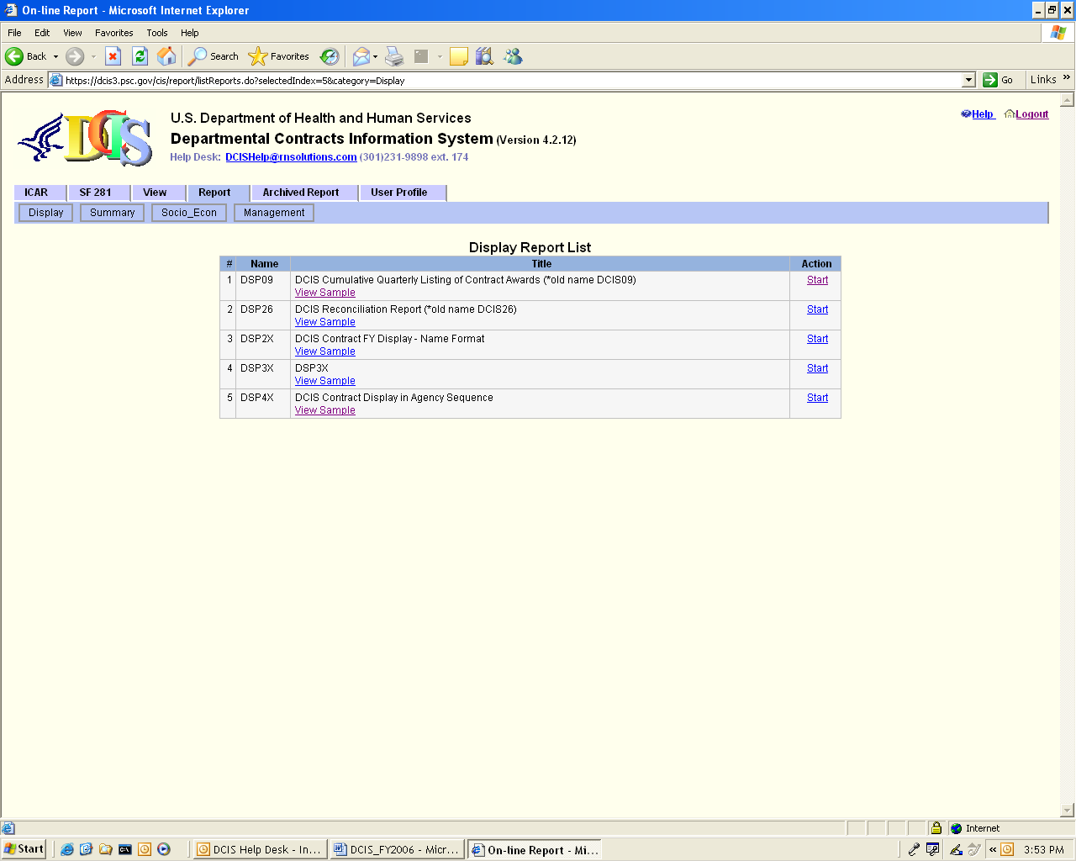
(Figure 1)
- Select the desired report from the list (Figure 1) and click on Start.
- The user enters the values for the search criteria and then clicks Submit. (Figure 2)
Note: Some of the criteria pull-down menus are 'grayed out' and not available for the selected report format, since those fields are not queried during the search.

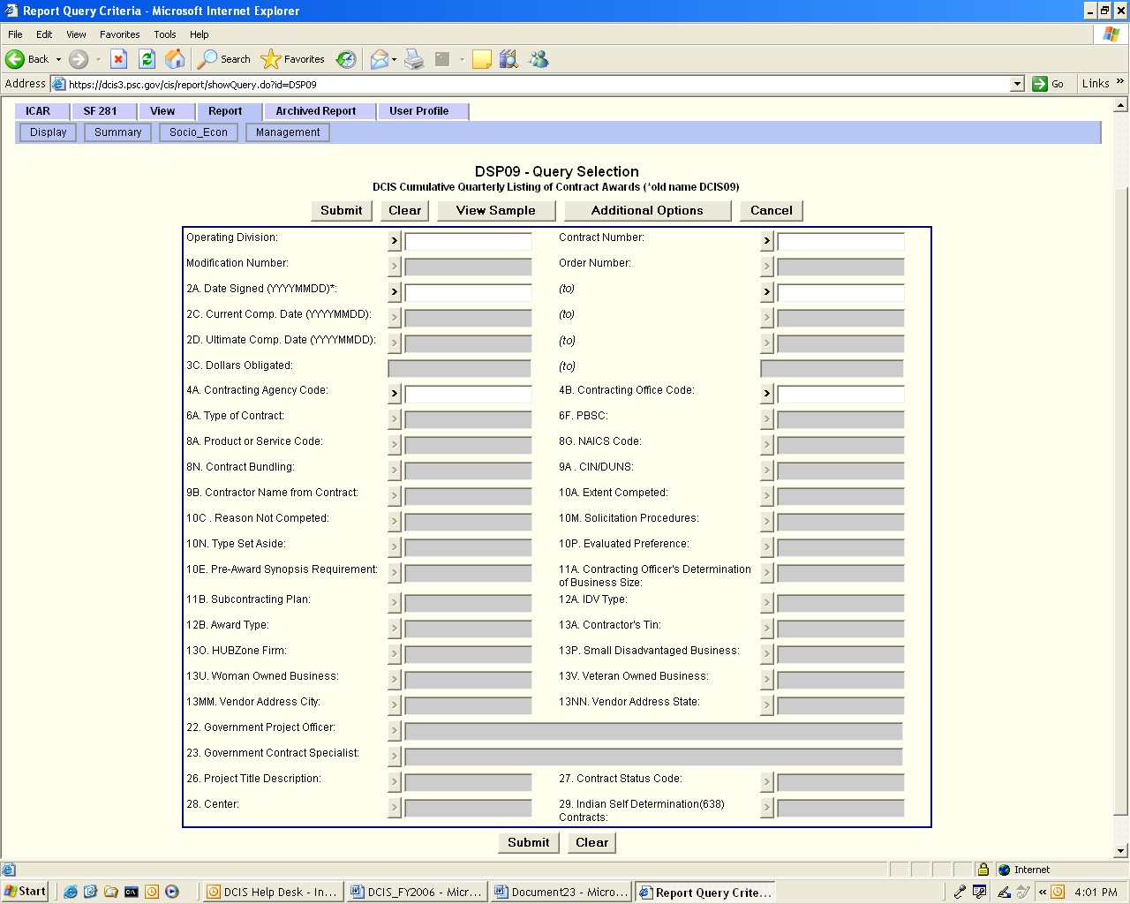
(Figure 2)
- After a few seconds, the report will display in a new window (Figure 3).
Note: Some reports (e.g. SECONA, contain numerous calculations, and may take a minute or two to display). Initially, the first page displays in the report window. The scrolling button may continue to move as the report delivery is completed.
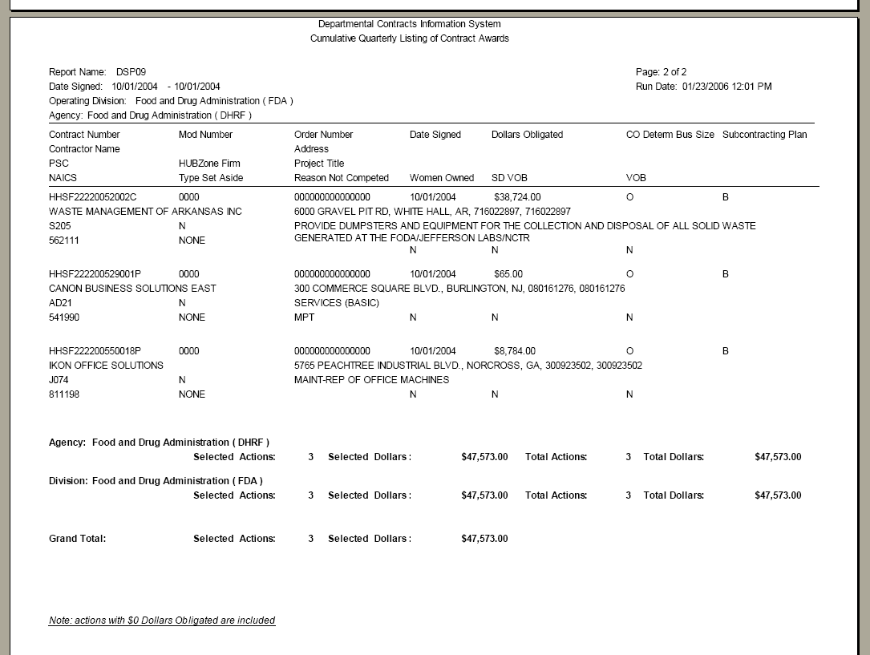
(Figure 3)
8. The window may be expanded by clicking on the 'maximize' button, located to the left of the X CLOSE button.
9. After the report display window completes the report delivery (the scroll button will stop moving), the report is ready for viewing and/or printing. To print, click on the Print button, and check your printer's dialog box for options, such as portrait or landscape orientation.
“Query” Report Descriptions

SECONA (DCIS SOCIO-ECONOMIC PROCUREMENT REPORT)
This report displays all ICAR and SF-281 actions and dollar amounts for the following categories: Total procurements (all actions), Small Business ((Item 30) = A (Small Disadvantaged Business) OR = B (Other Small Business)), 8(a) ((Item 33b) = A (8(A) Contract Award) OR = B (8(A) with HUBZone Priority)), Small Disadvantaged Business ((Item 30) = A (Small Disadvantaged Business)), Small Business Set-Aside ((Item 33c) = B (Small Business Set-Aside)), Woman-Owned ((Item 31) = Y, AND Item 30) = A (Small Disadvantaged Business) OR (Item 30) = B (Other Small Business)), HUBZone Business Awards ((Item 32) = Y (Yes)), Service Disabled Veteran-Owned Small Business (40=A), and Veteran-Owned Small Business (40=A+B). Actions and amounts are displayed for the current period selected, along with the cumulative actions and amounts year-to-date. Actions and amounts are further divided into two sub-categories of >$25,000 and <$25,000 (<$25,000 are combined SF-281 actions, plus ICAR actions <$25,000).
Note: To view a sample of the SECONA report, see Figure 4a below.
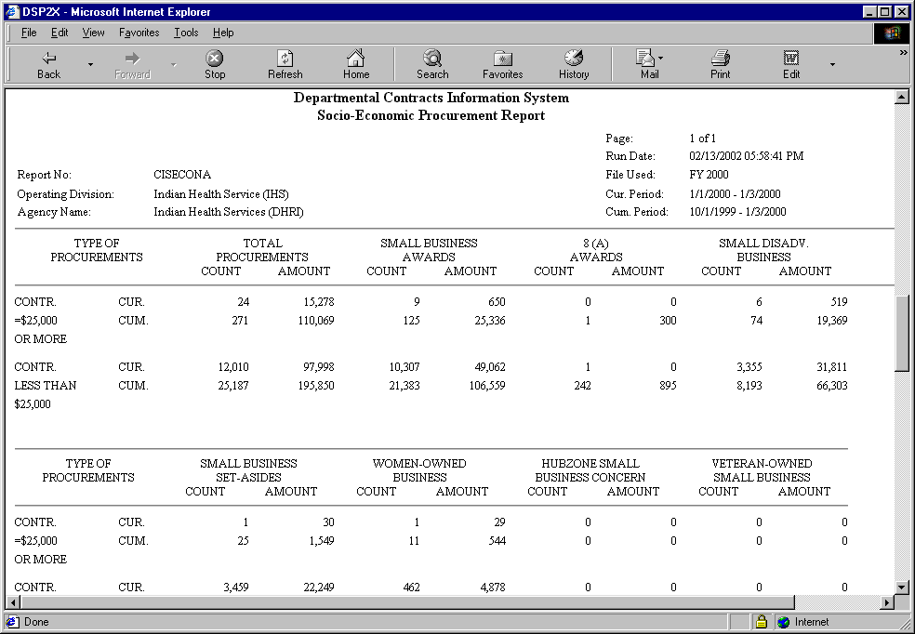
(Figure 4a)

SECONB (DCIS SMALL BUSINESSES GOALING REPORT)
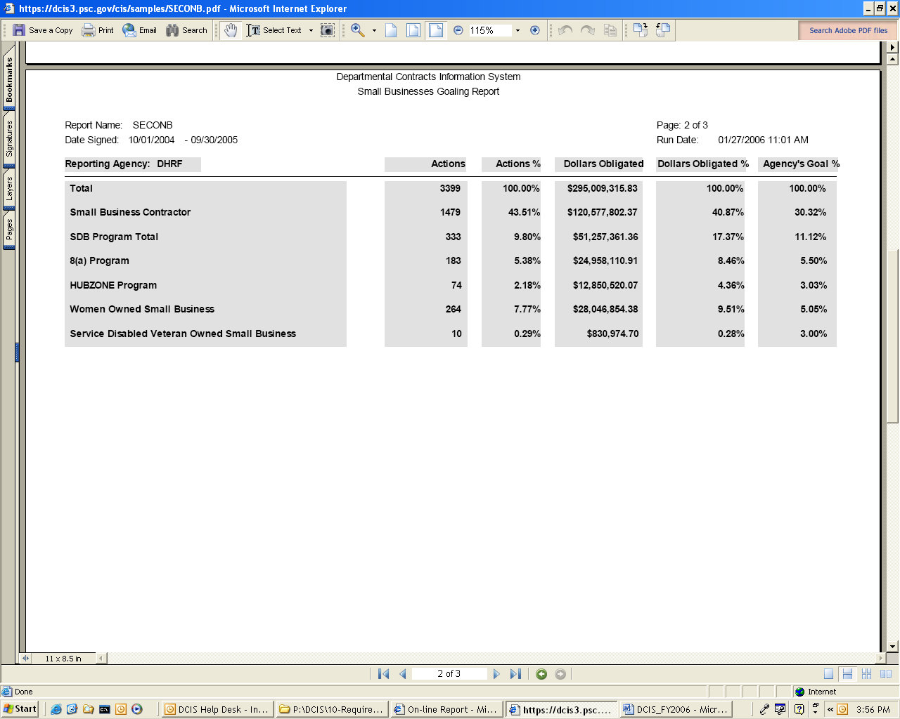
(Figure 4b)

DSP09 (CUMULATIVE QUARTERLY LISTING OF CONTRACT AWARDS)
This report displays all ICAR awards for a specified fiscal year quarter, with contractor name and address, contract number, award date, amount, Standard Industrial Classification (SIC), Product-Service Code (PSC), subcontracting plan requirement, and socio-economic data.
(Figure 5)

DSP26 (DCIS RECONCILIATION REPORT)
This report displays all ICAR awards for a specified period agency code, contract number, mod number, order number, date signed, award type, contract specialist last name and the grand total for that period.

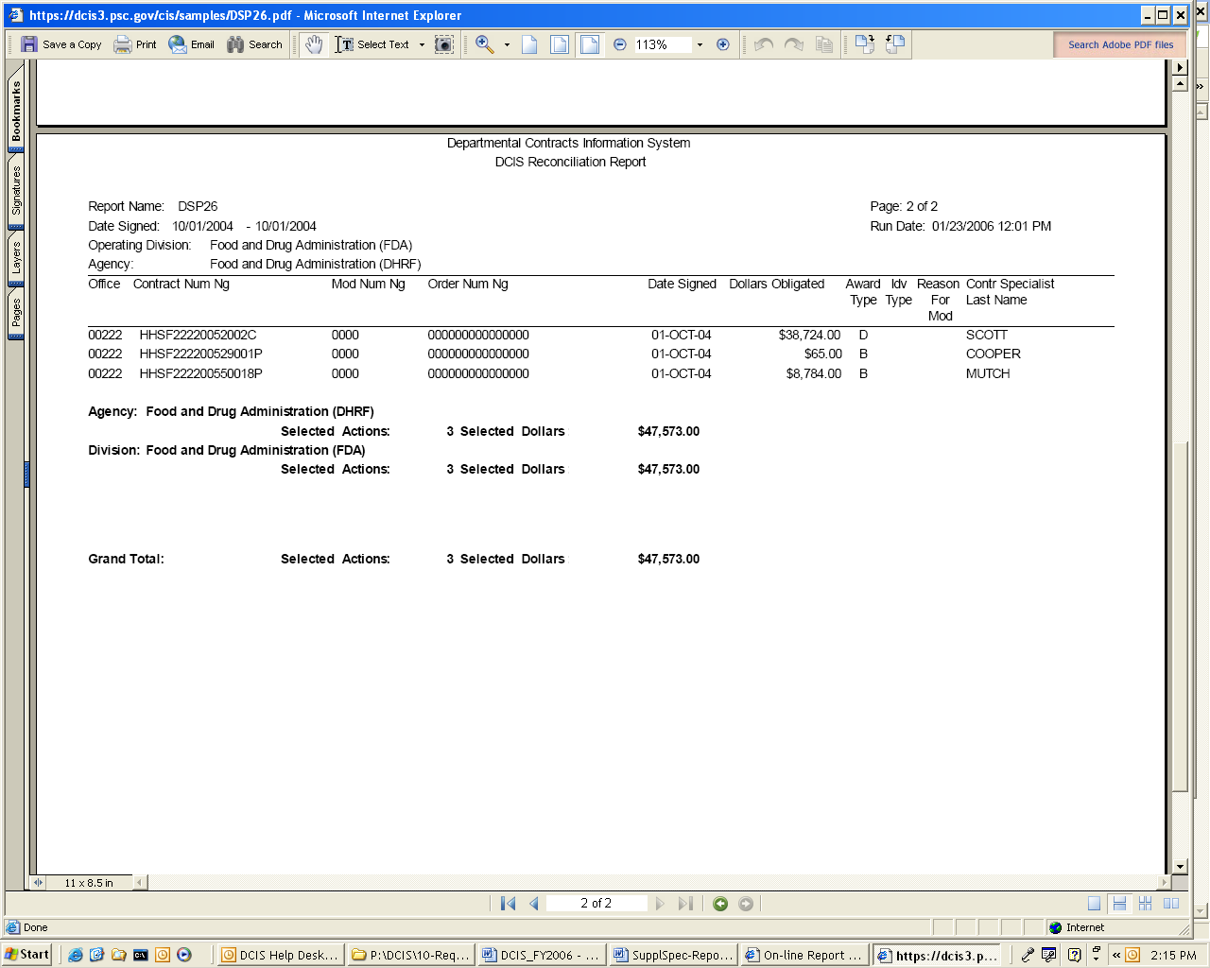
(Figure 6)

DSP2X (DCIS CONTRACT FY DISPLAY-NAME FORMAT)
This report displays cumulative and fiscal year selected ICAR actions by agency/contracting office with contractor name and address, contract number, amounts, award date, Standard Industrial Classification (SIC), Product-Service Code (PSC), competition and socio-economic data.
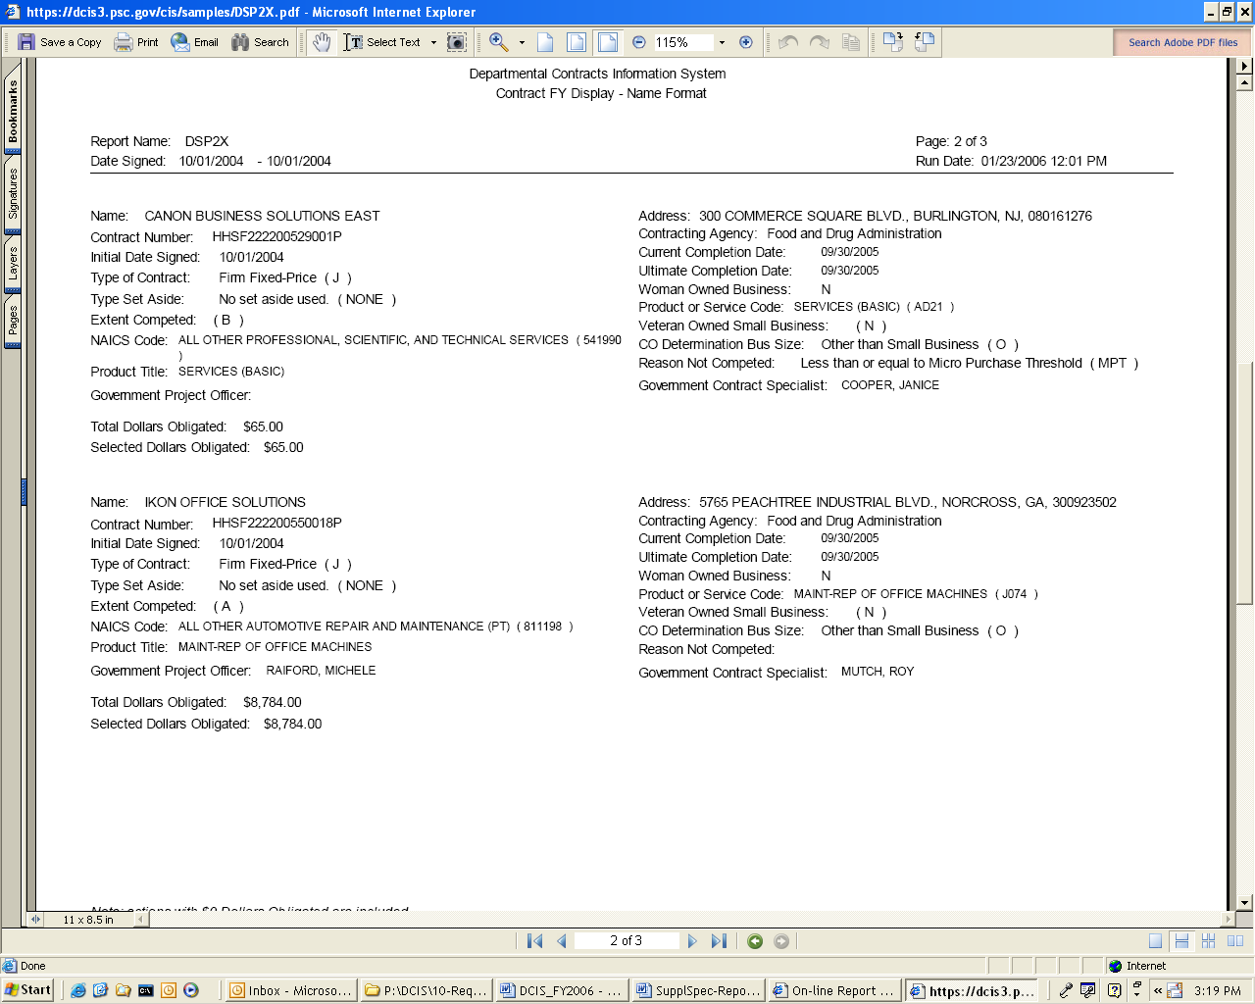
(Figure 7)

DSP3X (DSP3X)
This report displays cumulative and fiscal year selected ICAR actions by agency/contracting office with contractor name, contract number, action date, total dollars, business type, estimated completion date, Standard Industrial Classification (SIC), and Product-Service Code (PSC) information.

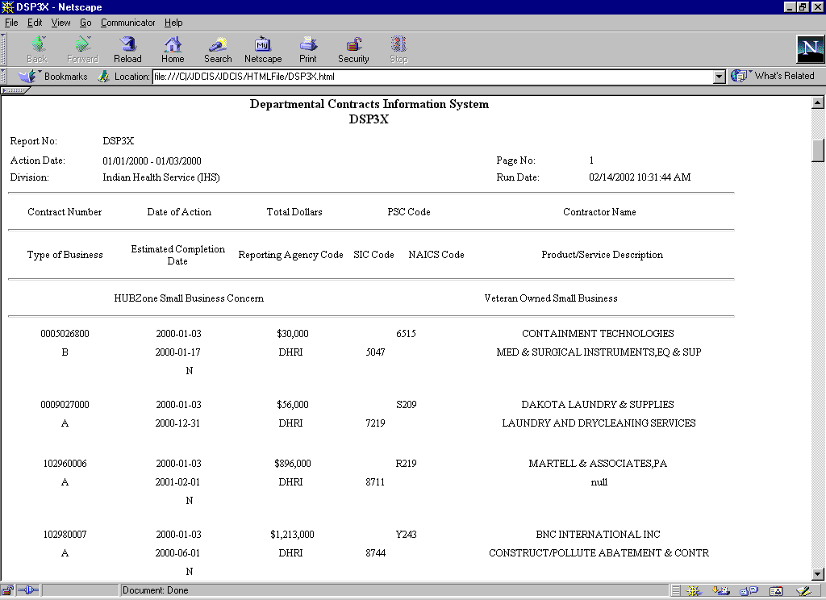
(Figure 8)
DSP4X (DCIS CONTRACT DISPLAY IN AGENCY SEQUENCE)
This report displays cumulative and fiscal year selected ICAR actions by agency/contracting office with contract number and type, contractor name and type business, CIN (Dun & Bradstreet number), TIN (Taxpayer Identification Number), performance period, Standard Industrial Classification (SIC), Product-Service Code (PSC) data, and competition information.
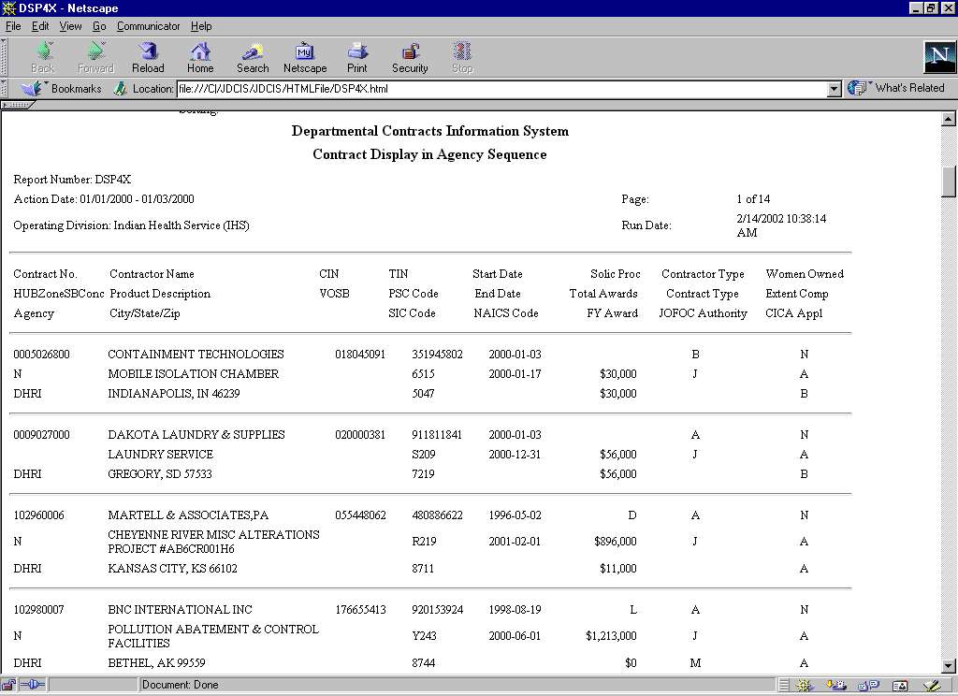
(Figure 9)

FREE FORM (FREE FORM REPORT-OUTPUT COLUMN SELECTION)
This report displays report in a free format style depending on the columns selected by the user. This report allows so much flexibility due to its output selection capability. The screen below displays the Output Column Selection page where the user can select the desired columns to be displayed in the report and in desired order …..1, 2, 3 …

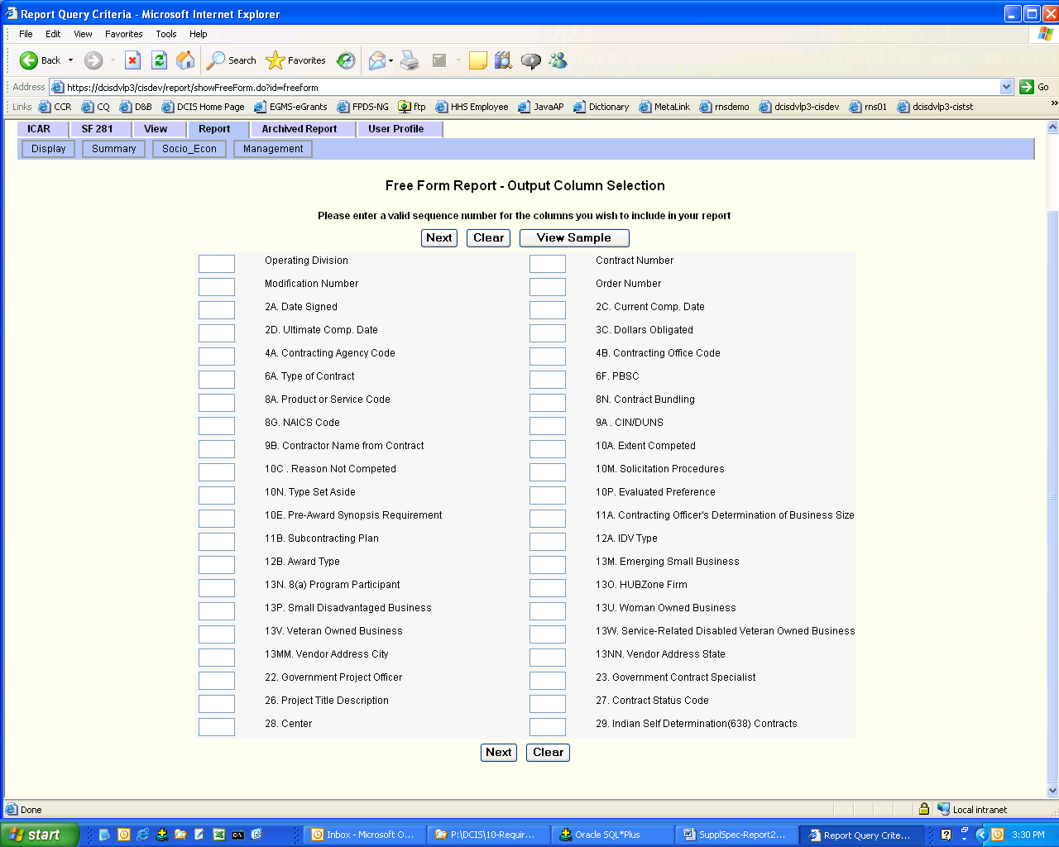
(Figure 10)

After the columns selection, click next to go to the Criteria selection page, shown below. This screen allows the user to choose the criteria to be used in the query selection.

Criteria Screen Layout (User Interface)
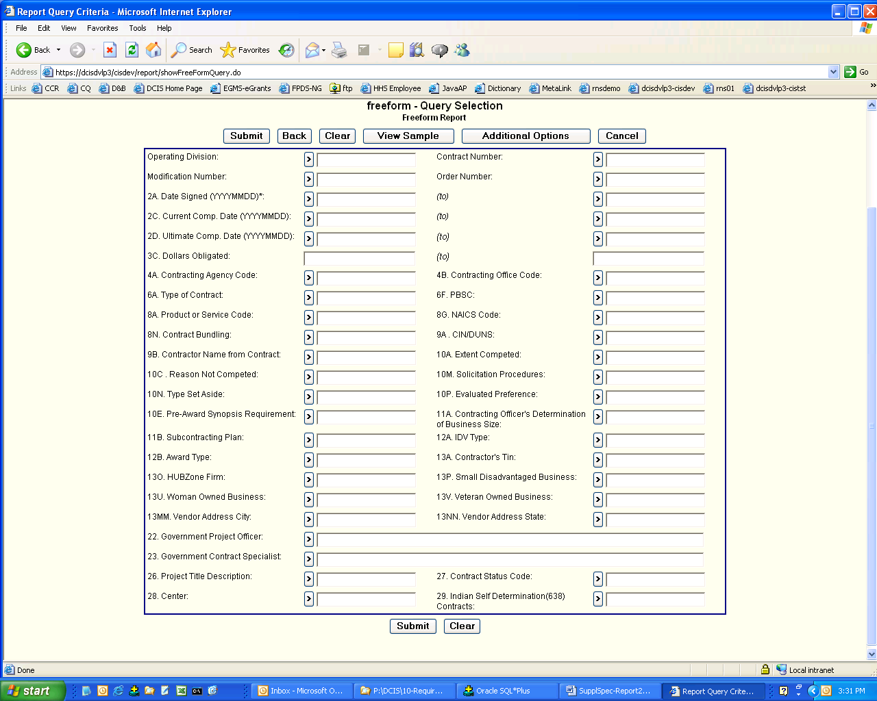
(Figure 11)

Select the criteria to be used in the report and click on Submit, the out put should be like the format shown below which is in HTML.

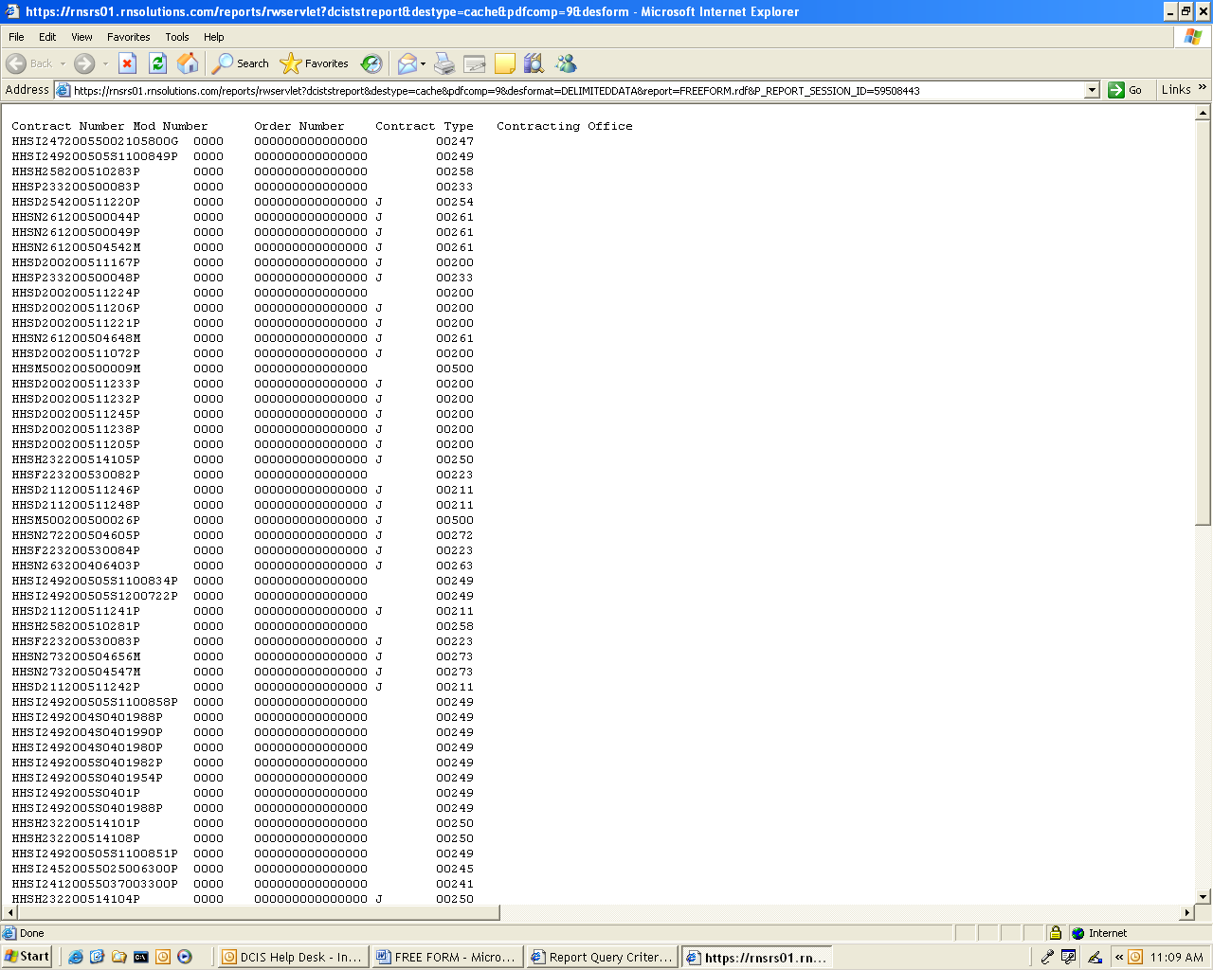
(Figure 12)

To make the report more readable, save the report as a text file on the desktop or any easily accessible directory.
Open up a new Excel Workbook and click on Open to locate the report file saved on the desktop (in this case). Ensure that the option selected for the Files of type in the Open window is text file. Click on the open button to select the report file. Follow the steps in the Text Import Wizard to format the file. Remember to select the text data format for Contract#, Order#, Mod#, Agency Code, which are text, but may have all numeric values and also the date format for date column (this is found in step 3 of the Import wizard). Click on finish when done and the result appears as shown below. The file can now be saved as an Excel file.

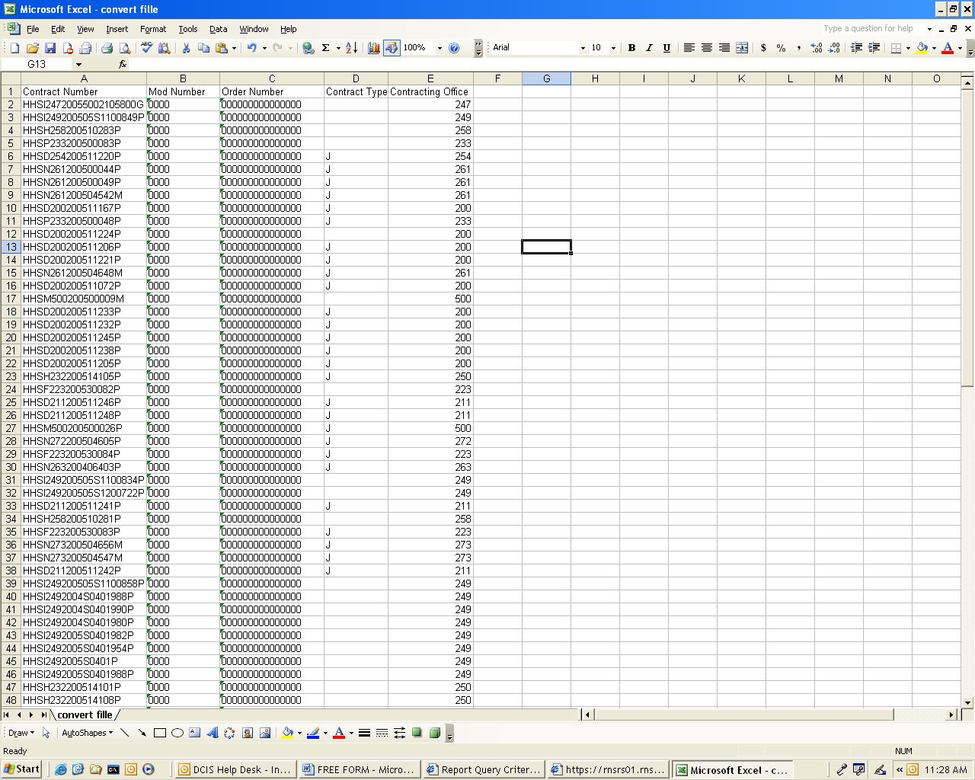

(Figure 13)

TAB05 (DCIS CONTRACT TRENDS BY DCIS AGENCY AND CONTRACTING OFFICE)
This report displays selected ICAR actions and dollar amounts by agency/contracting office for a selected action date period, with new contract awards, modifications, and “purchases” (simplified acquisition procedures – coded as type ‘D’, and GSA Schedule/BPA orders codes as ‘G’).

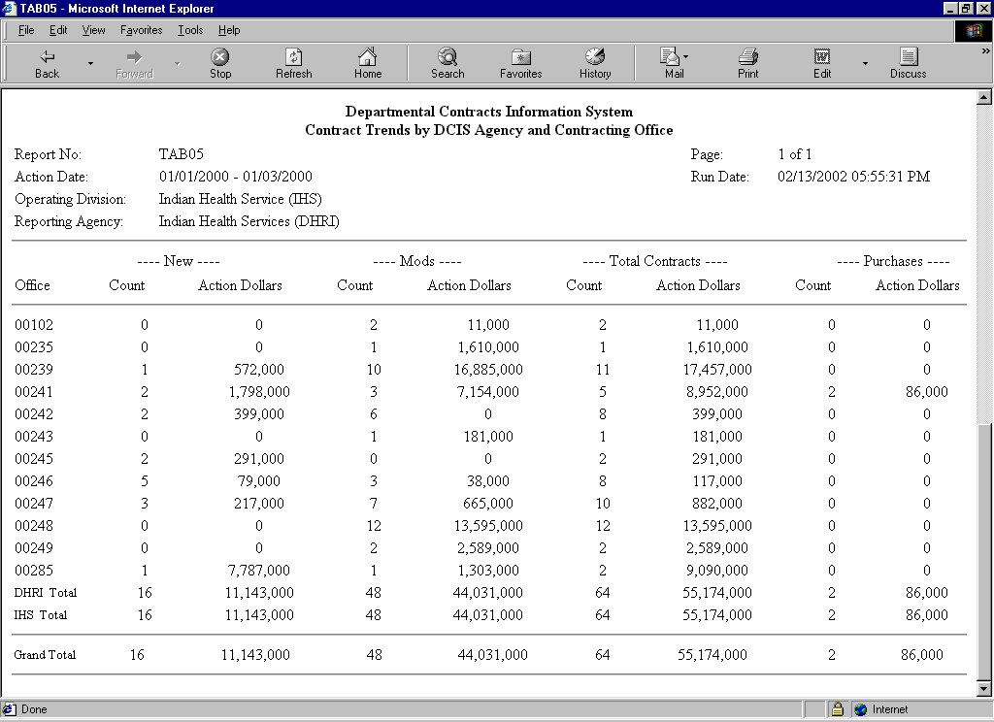
(Figure 14)

MGMT14 (SMALL BUSINESS COMPETITIVENESS DEMONSTRATION PROGRAM FOR SELECTED SIC/NAICS CODES)

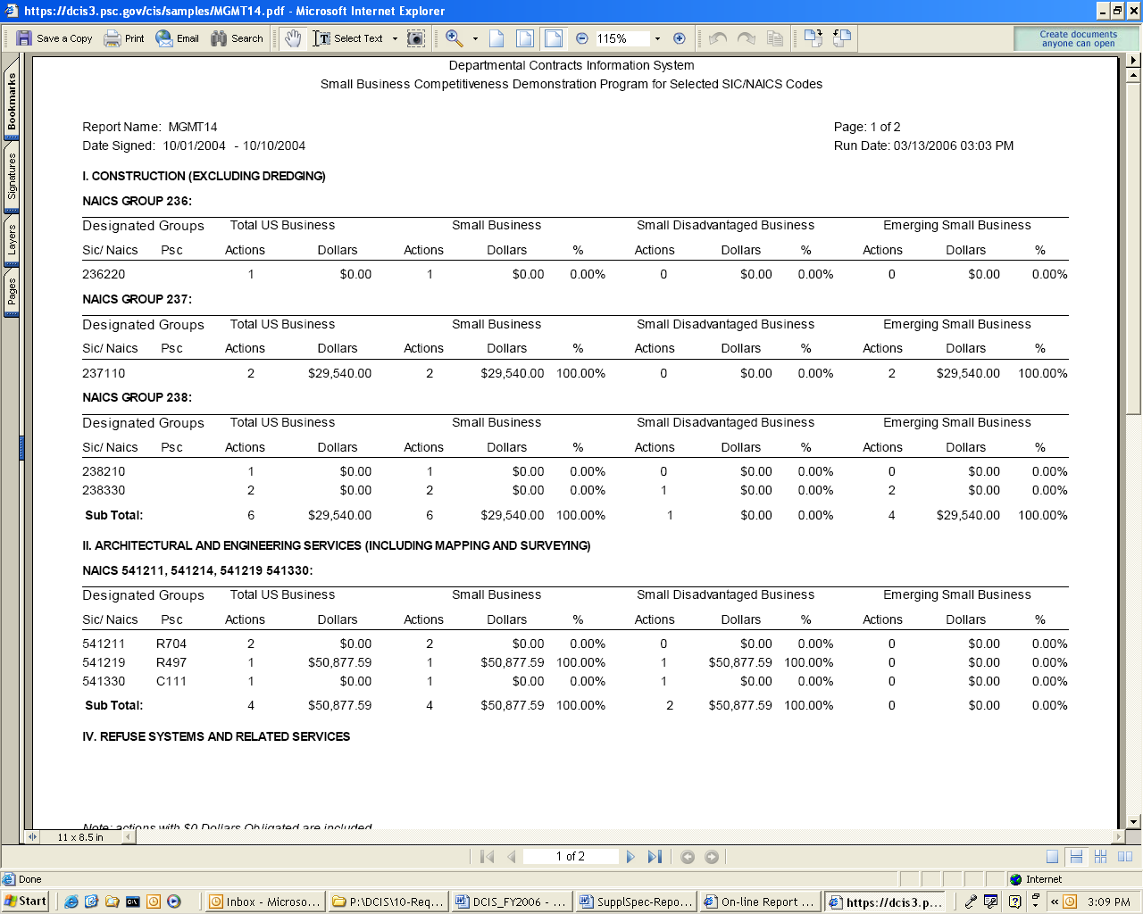
(Figure 15)

MGMT18 (DCIS TOP 100 CONTRACTS)
This report selects DCIS top 100 contract actions from the system. It retrieves data within the specified date signed range, orders by descending order of action dollars obligated.

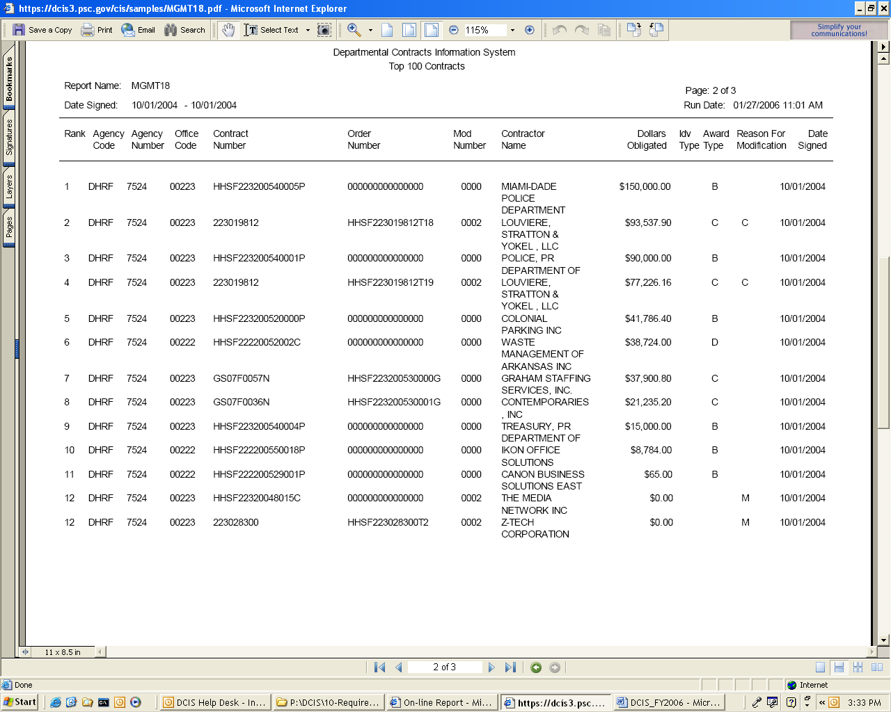
(Figure 16)

MGMTRE01 (SUMMARY STATISTICS FOR DCIS CONTRACT ACTIONS)
This report displays Total Number of Actions and Dollars Obligated for Unfinished, Accepted and Total Actions in DCIS for the given Operating Division, Contracting Agency Code, Contracting Office Code and Date Signed.
The last page of the report contains Summary for the Department, Operating Division and Contracting Agency.

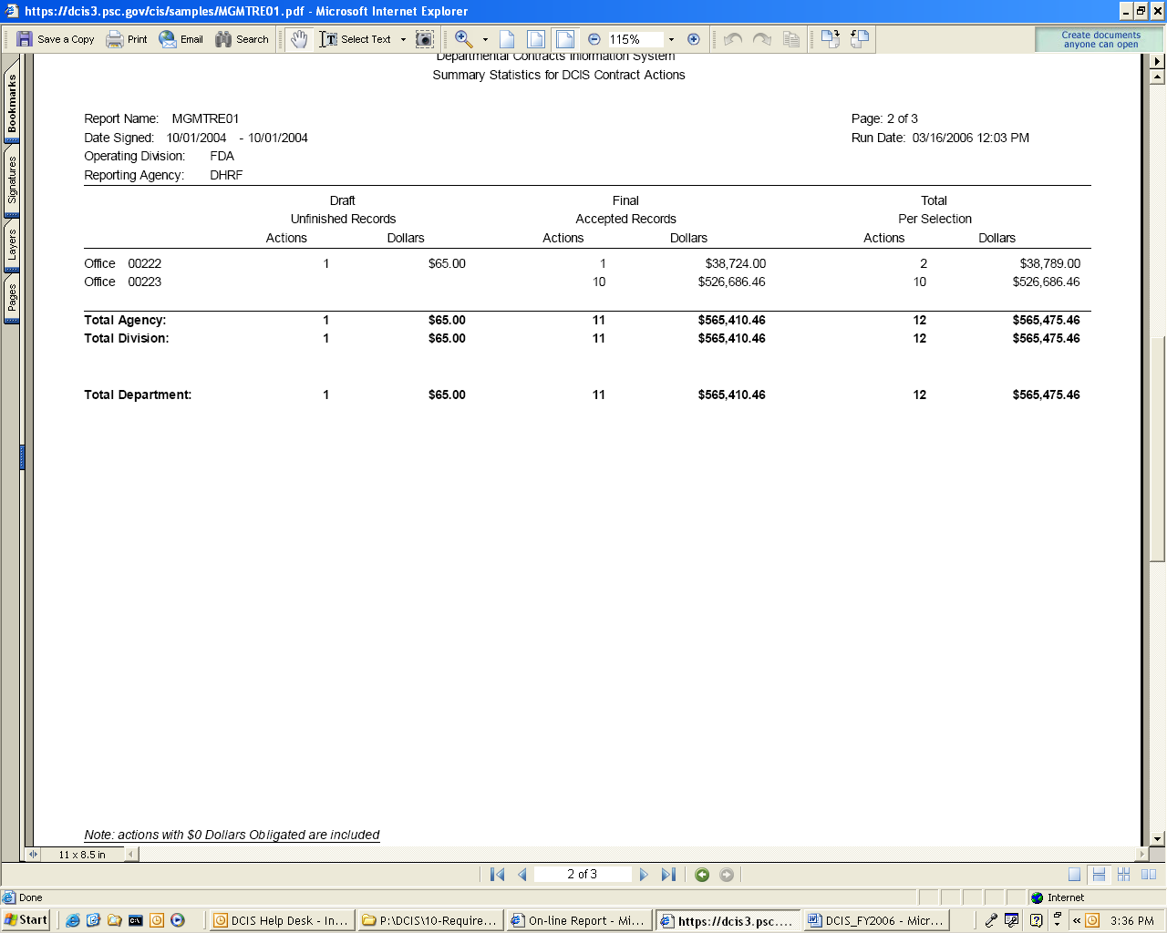
(Figure 17)

MGMTRE02 (DETAILED RECONCILIATION REPORT - DRAFT / FINAL RECORDS)
This report displays detailed data for Final or Unfinished actions in DCIS in DCIS for the given Operating Division, Contracting Agency Code, Contracting Office Code, Date Signed, Submitted Date and Record Status (Final or Draft).
The last page of the report contains Summary for the Department, Operating Division and Contracting Agency.

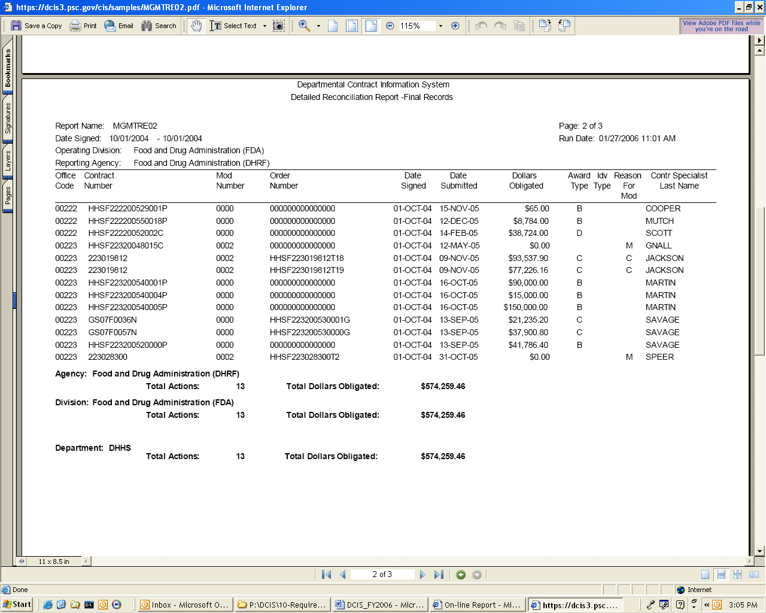

(Figure 18)

DISCOVERER REPORTS

This report can be found on DCIS Home page as shown in figure 19 below.

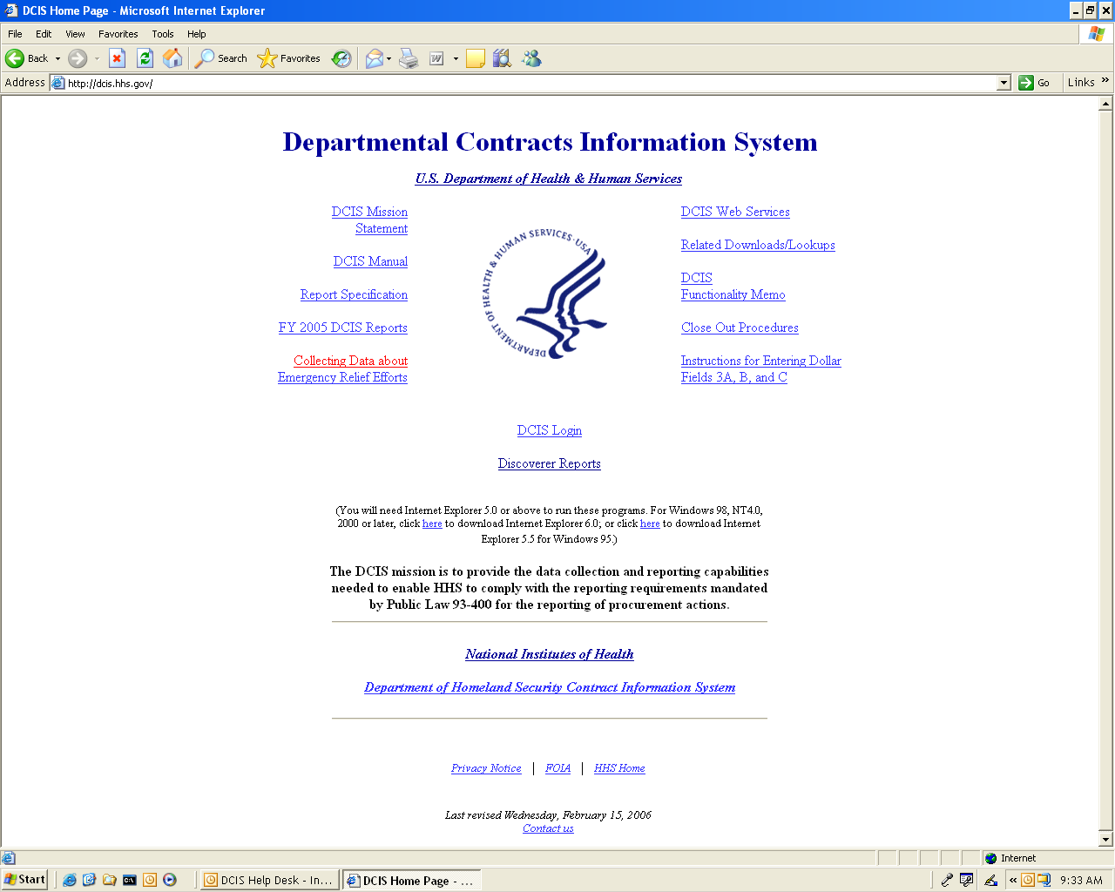

(Figure 19)

Click on the link, Discoverer Reports, this takes the user to the page below (Figure 20).

Select the required report from the list shown below (DHHS or DHS Report) by clicking on the desired report. The user is taken to the page shown on (Figure 21).

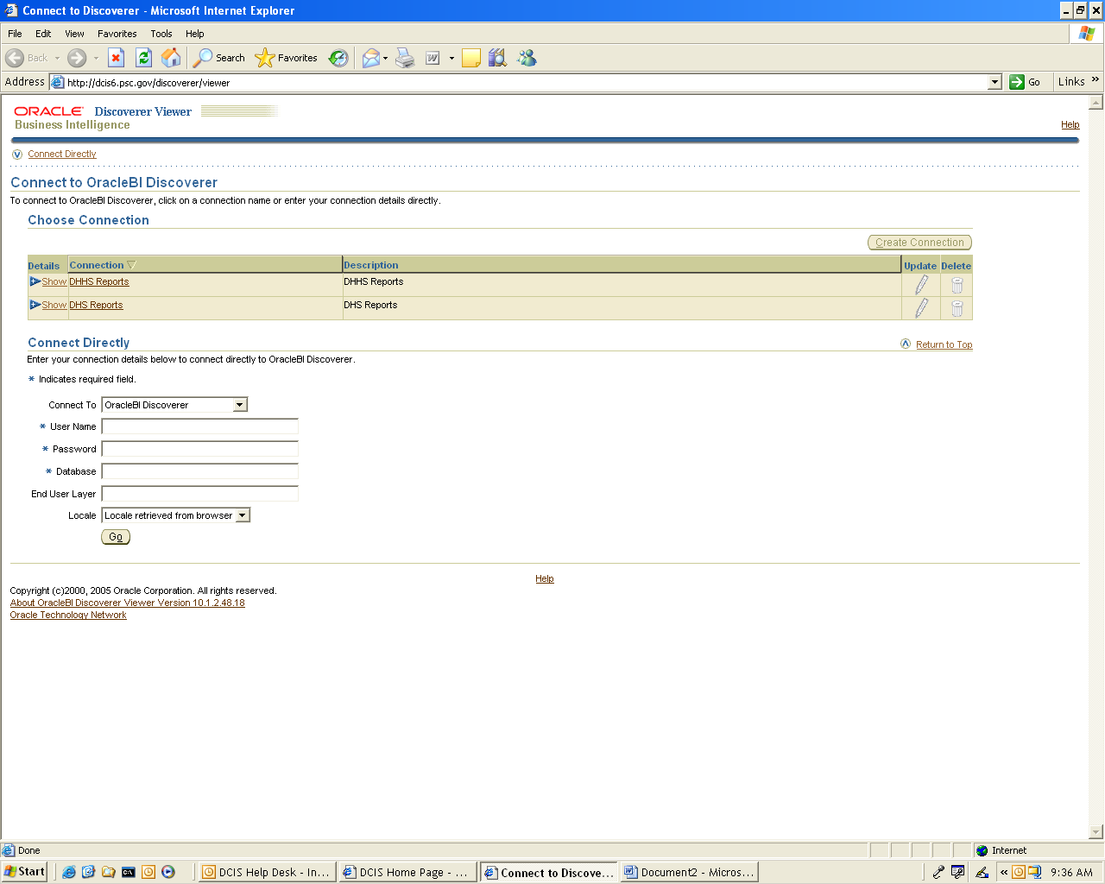

(Figure 20)

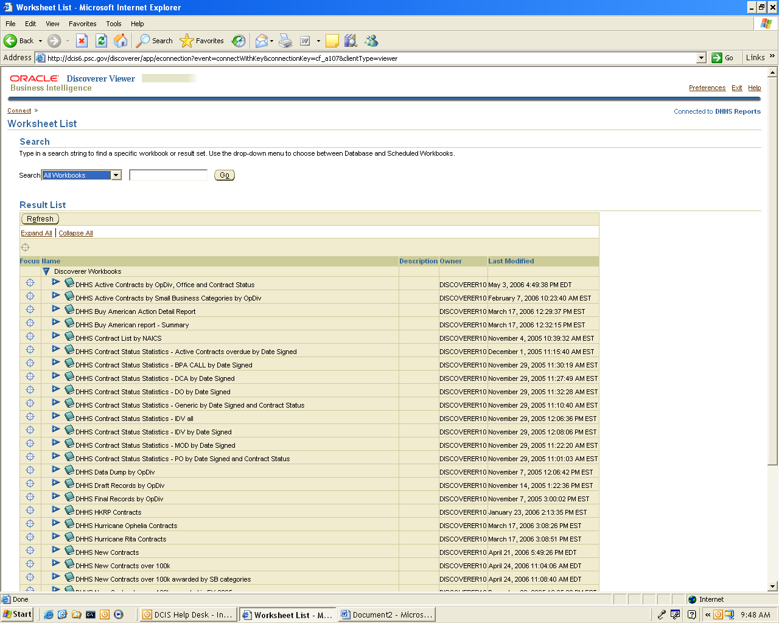

(Figure 21)

The Result List itemizes all the different DHHS reports that can be generated. The user can make a selection based on the criteria to be displayed in the report. To get an expanded view of each report, the user can click on the arrow button to display the sub-reports.
.
Selecting any of the sub-reports takes the user to the page below where the parameters are entered for the report. The flash-light shown on the right of each field helps to search for all the available options that could be entered into the field. (Figure 22).
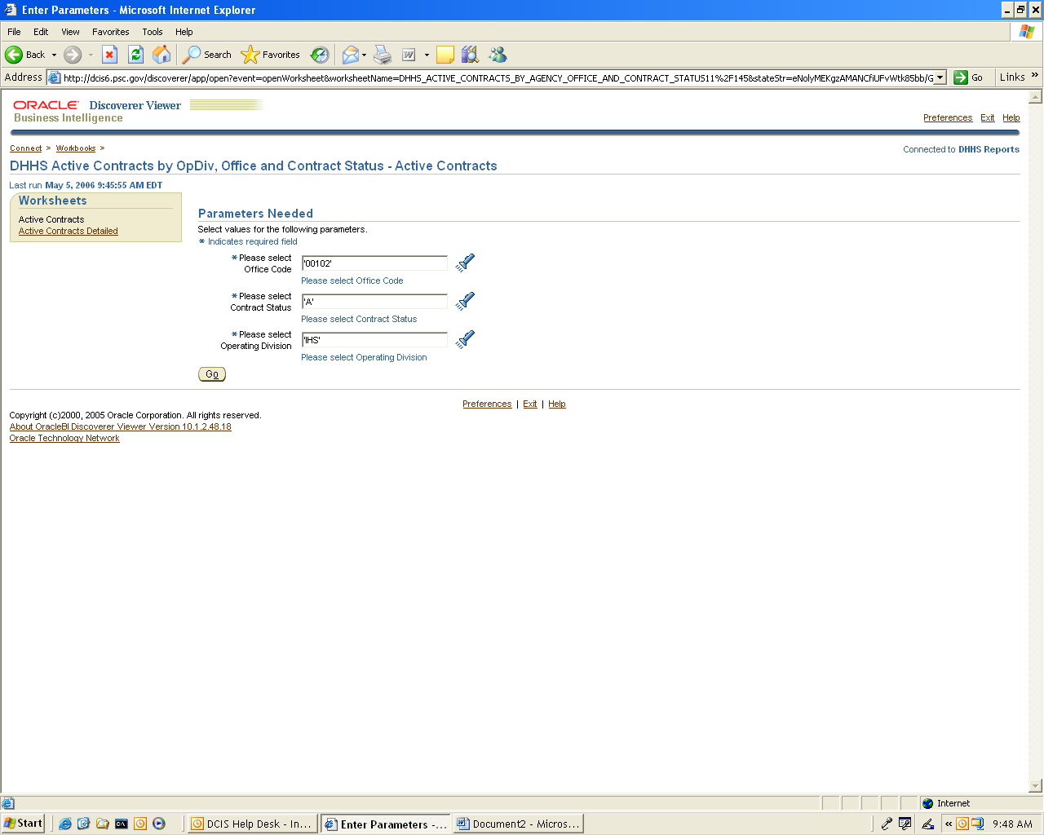

(Figure 22)

When the flash-light is clicked, the page displayed is as shown below in (Figure 23)

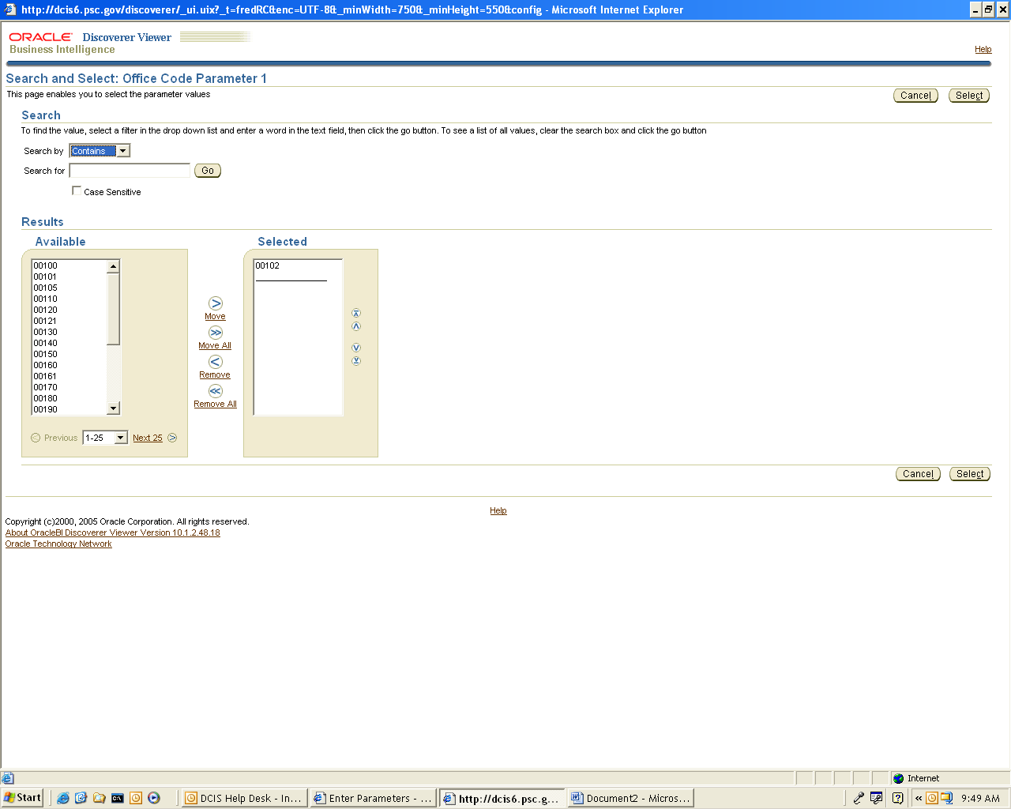

(Figure 23)

After selecting all the desired parameters, click on Select to proceed with the report generation. Then click Go. This takes the user to the page below.
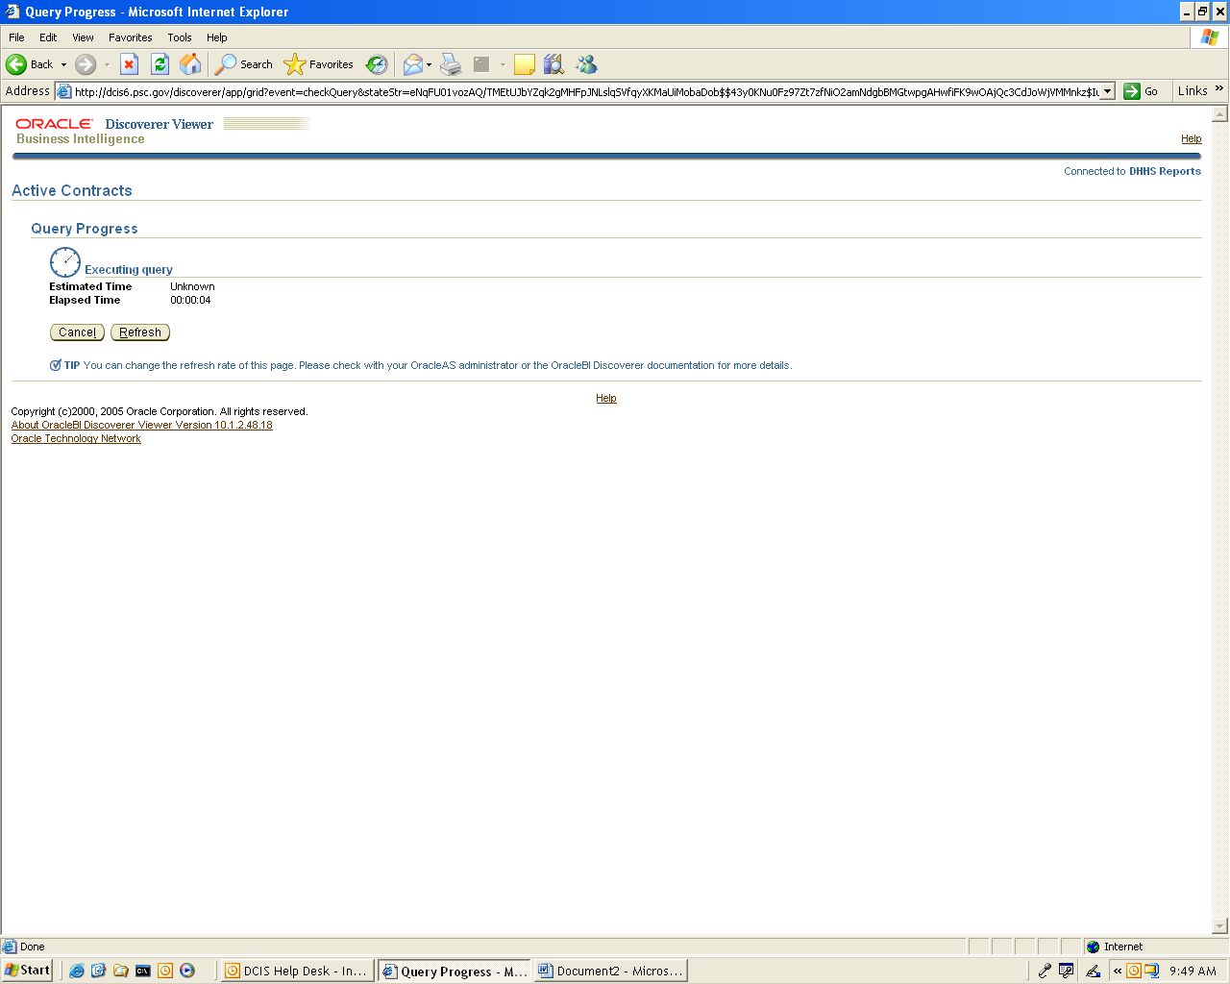

(Figure 24)

This might take a few seconds as shown on the second hand on the page.

The report generated is displayed below.
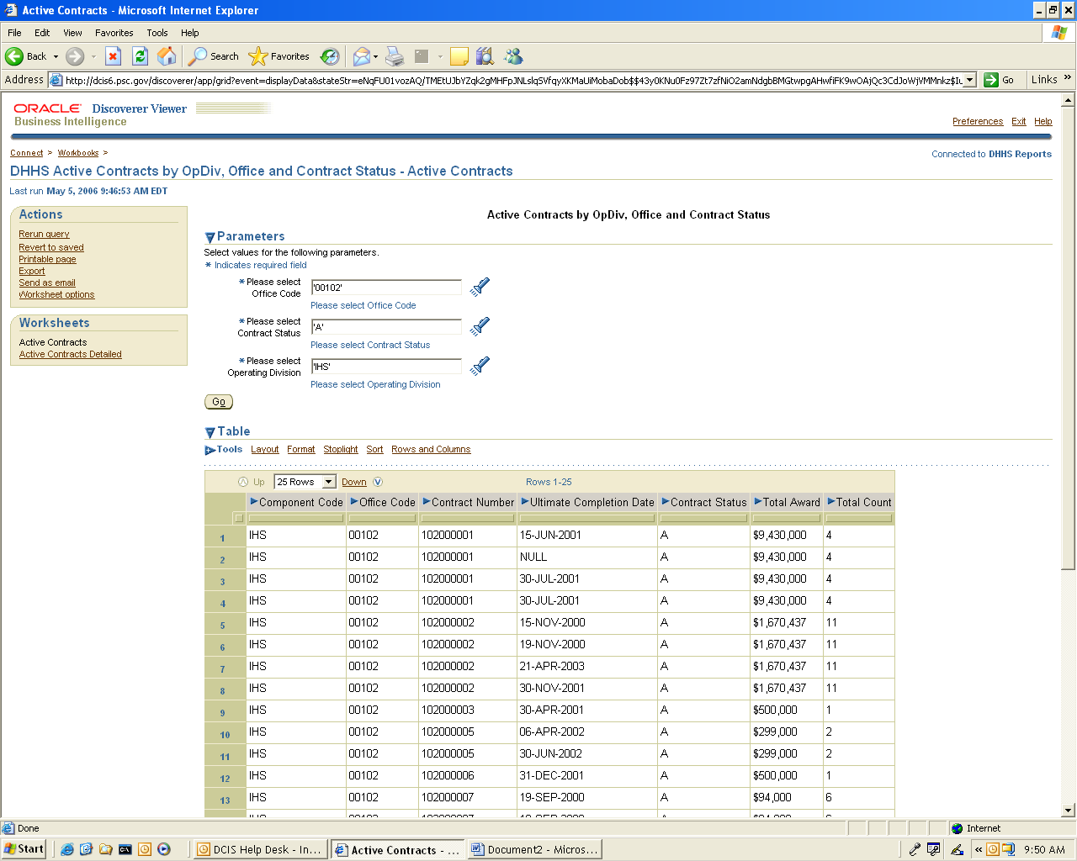

(Figure 25)

If the user wishes to export the report, select Export which is located on the top left hand corner of the page above (under Actions). Choose the export type by using the drop d-down list to specify the export file format. Then select Export.

Displayed below is an example of an exported file in Microsoft Excel Workbook. (Figure 26)

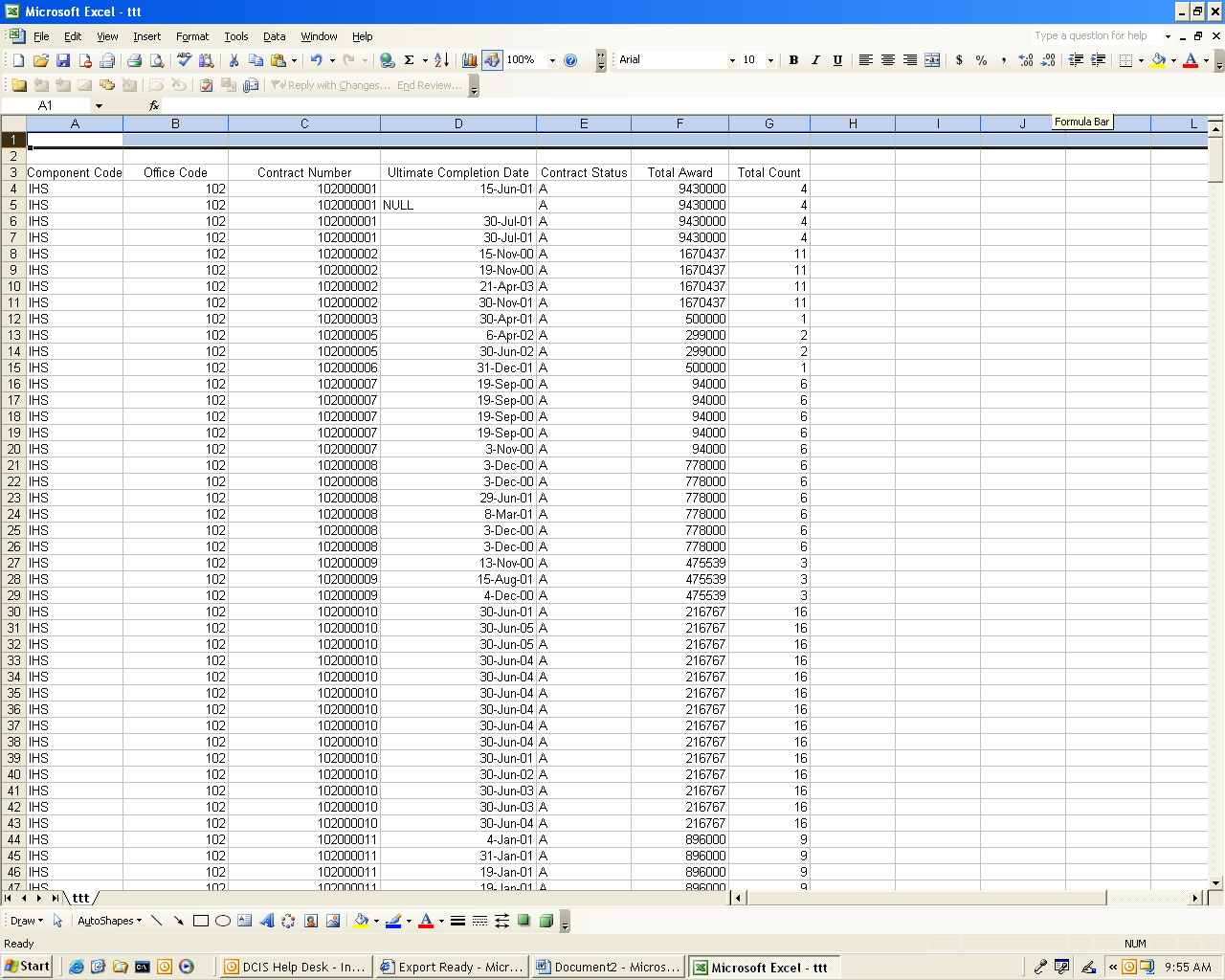

(Figure 26)

APPENDIX L: DCIS Rules of Behavior

This appendix contains the system rules of behavior. All users must read and agree to abide by the system rules of behavior, in order to obtain access to DCIS.

DCIS Rules of Behavior

  - Users
DCIS users are responsible for:
- Protecting their DCIS passwords and the DCIS information to which they have access;
- While logged onto DCIS, never leaving their workstation unattended for long periods without activating a screen protection;
- If locked out, notifying the DCIS System Owner for assistance;
- Reporting any unusual or suspicious DCIS activities to the DCIS System Owner;
- Ensuring the integrity of DCIS data created or modified.

- Expected Behavior
DCIS takes full advantage of the security controls implemented on the OS Network. Individuals accessing DCIS are expected to be familiar with the OS Network’s Rules of Behavior, including email, Internet usage, off-site computing, etc.

  - System Access Privileges
DCIS access will be issued, and used only by, authorized individuals. DCIS access is granted based on an official request from an authorizing official. Each DCIS user is given access to DCIS based on a need to perform specific work. Users are to work within the confines of the access allowed and are not to attempt access to which access has not been authorized.

  - Password Guidance
DCIS users are to use passwords of a mix of eight (8) alpha, numeric and special characters, with at least one uppercase letter, one lower case letter, and one number. Users will be required to change their passwords every 90 days. Users should keep their passwords confidential and not share them with anyone.

  - Individual Accountability
Each DCIS user will be held accountable for their actions on DCIS. Care should be taken to ensure the integrity of DCIS data created, accessed, or modified.

Each DCIS user should apply the necessary safeguards to protect DCIS data from unauthorized disclosure, alteration, and/or loss, including the protection of DCIS hard copy documents.

  - Protection of Copyright Licenses (Software)
The DCIS System Owner and the DCIS System Administrator comply with the DCIS copyright license requirements. DCIS users and supervisors are also responsible for complying with these requirements.

DCIS software will not be modified without the approval of the DCIS System Owner. DCIS users are not to download DCIS software, or deactivate DCIS security features or controls. Audit logs will be reviewed to determine whether unauthorized activity has been attempted.

