
Fjord Oceanographic Processes in
Glacier Bay, Alaska

Philip N. Hooge
and
Elizabeth Ross Hooge

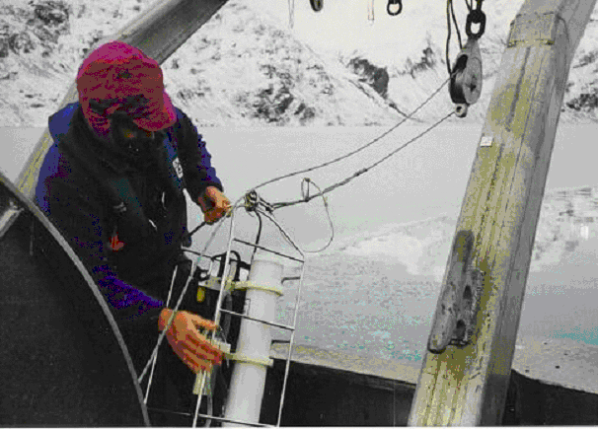

Prepared for the National Park Service, Glacier Bay National Park

USGS-Alaska Science Center
Glacier Bay Field Station
P.O. Box 140
Gustavus, AK 99826-0140

March 2002

Fjord Oceanographic Processes in
Glacier Bay, Alaska

Philip N. Hooge
Elizabeth Ross Hooge

Prepared for the National Park Service,
Glacier Bay National Park

USGS – Alaska Science Center
Glacier Bay Field Station
P.O. Box 140
Gustavus, AK 99826-0140

March 2002



Table of Contents
I. Executive Summary 3
II. Fjord Oceanography of Glacier Bay, Alaska 7
- Introduction 7
- Study Site and Methods 10
- Results 14
- Discussion 24
- Literature Cited 38
- Figures 44
III. Oceanographic Data Resources At Glacier Bay 83
IV. Resource Needs For An Oceanographic Monitoring Program At Glacier Bay 88
V. Proposed Future Oceanographic Research 91
- 1. Determine Hydraulic Flow Patterns at the Sitakaday Narrows Sill and Contraction 91
- 2. Determine the Presence and Pattern of Internal Waves in Glacier Bay 94
- 3. Determine Nutrient Availability In Glacier Bay 96
- 4. Determine Timing and Intensity of the Bloom In Glacier Bay 98
- 5. Determine Relationships of Weather Patterns and Broad-scale Oceanographic Patterns with Oceanographic Patterns at Glacier Bay 100
- 6. Determine the Validity of Extrapolating Cross-Bay Patterns from Center-channel Sampling 102
- 7. Determine the Patterns of and Processes Underlying the Head-of-Fjord Chlorophyll Anomaly 104
- 8. Determine the Temporal and Spatial Patterns of Phyto- and Zooplankton Species Assemblages 107
- 9. Determine the Source Waters for Intermediate and Deep Water Renewal in Glacier Bay 109
- 10. Determine the Relationship Between Chlorophyll-a Levels and True Primary Productivity at Glacier Bay 111
VI. A Selected Oceanographic Bibliography Relevant to Glacier Bay 114
VII. Acknowledgments 139
VIII. Index 140

I. Executive Summary

Oceanography describes one of the most fundamental physical aspects of a marine ecosystem. Glacier Bay exhibits a highly complex oceanographic regime within a small area. An understanding of many of the resourcse and research issues in Glacier Bay will not be possible without an understanding of the underlying oceanographic processes causing the large spatial and annual variation found within the Bay.
The Bay is a recently (beginning less than 300 years ago) deglaciated fjord located within Glacier Bay National Park in Southeast Alaska. It is a fjord estuarine system that has multiple sills. These sills are often associated with contractions and are backed by very deep basins with tidewater glaciers and many streams. Glacier Bay experiences a large amount of runoff, high sedimentation, and large tidal variations. Melting of glacial ice in contact with the ocean occurs year-round, which is thought to fuel estuarine circulation even through the winter. This runoff and the presence of tidewater glaciers make the waters of the Bay extremely cold. There are many small- and large-scale mixing and upwelling zones at sills, glacial faces, and streams. The complex topography and strong currents lead to highly variable salinity, temperature, sediment, productivity, light penetration, and current patterns within a small area. This complexity defies simple characterization or modeling based on other areas in Southeast Alaska. Several Bay-wide oceanographic studies have been conducted in Glacier Bay, but these studies are now over three decades old. In addition, they came to partially inconsistent conclusions and were of short duration and limited coverage, missing much of the spatial, seasonal, and annual variation. Furthermore, some assumptions based on past studies have been contradicted by recent results. The constantly changing nature of the Bay may contribute to contradictions among past studies and between recent and historical results.
The primary data used in this study (see the Fjord Oceanography Monitoring Handbook) were oceanographic surveys, made between 1992 and 2000, that sampled 24 central-channel stations from the mouth of the Bay to the heads of both the East and West Arms. An oceanographic instrument (a Conductivity-Temperature-Depth probe, or CTD) capable of recording depth, temperature, salinity, light penetration, amount of sediment, and amount of phytoplankton, was used to obtain measurements at one-meter intervals throughout the water column to a depth of 300m at each station. Surveys were conducted up to eight times a year in such a manner as to encompass the primary annual variation in oceanographic patterns.
Results from the current work, described in Section II, indicate several shifts in the dominant paradigm of oceanographic understanding for this area. One primary conclusion is that deep-water renewal, and with it increased nutrient availability, is not limited to the winter months, but can and probably does occur regularly in the spring, summer, and fall as well. Our results suggest that Glacier Bay is not a traditional silled fjord estuary, nor is it a plain fjord estuary like many estuaries in Southeast Alaska, but a combination of a stratified deep basin estuary and a tidally mixed estuary. Tidal mixing in Sitakaday Narrows results in a complete blockage of estuarine circulation at the mouth of the Bay; instead, mixing probably occurs principally by turbulent diffusion rather than by buoyancy-driven entrainment as seen in a traditional estuary. In addition, where this turbulent water meets the deep stratified basin, a tidally mixed front is created. This front provides conditions ideal for encouraging high primary productivity by phytoplankton.
Mixing phenomena were observed to be much more extensive in Glacier Bay than previously reported in the literature. This mixing, as with the increased deep-water renewal, almost certainly results in a system that is more nutrient-enhanced. The Bay is now known to exhibit phenomenally high levels of phytoplankton. Large standing crops of phytoplankton are sustained throughout the spring, summer, and fall, in sharp contrast to the extremely brief blooms in other interior waters of Southeast Alaska and in the adjoining shelf and oceanic areas. The limits on this productivity do not appear to be related to zooplankton grazing or nutrient limitation, but rather to light penetration. Light penetration in Glacier Bay is significantly reduced both by sediment load, a product of the many glaciers and the young nature of the terrestrial environment, as well as by the high density of the phytoplankton itself.
Water temperatures in Glacier Bay appear to have increased significantly since the early oceanographic work of the 1960s. This warming may be due to increased temperatures in the Gulf of Alaska, which are a result of a decadal shift in oceanic climate that occurred in the 1970s. The Bay’s warming trend, of up to 2ºC on average, may have contributed to the differences in patterns of mixing and renewal observed in this study. Such changes may be indicative of future trends that could occur with further global warming. In addition to these major changes in understanding, we have identified several new phenomena that will need further study to understand their nature and significance (see also Section V).
As a result of the oceanographic monitoring program and the synthesis effort funded by the NPS, there is now an extensive body of oceanographic and weather data integrated into the Glacier Bay information management system and available on CD-ROM. The Oceanographic Analyst Extension, a Geographic Information System (GIS) tool, has been created to allow viewing, analysis, and manipulation of these complex data in 3 and 4 dimensions. The ability of other studies in Glacier Bay to utilize oceanographic and weather data has been significantly enhanced. With this report and these data sets it is now possible for those with limited oceanographic background to integrate substantial oceanographic understanding into their studies. These data resources are described in Section III.
Section IV outlines the needs for maintaining an oceanographic program. The resources required are quite reasonable when compared to other oceanographic programs due to the efficiency of the methodology, equipment already available at Glacier Bay, and the data management and analysis system currently in place. However, while the methods and protocols for such a program are fully developed (see the Fjord Oceanography Monitoring Handbook), they require a high degree of technical competency and precision to implement correctly, as well as a firm understanding of oceanographic principles to correctly interpret the results.
Section V of this report provides brief overviews, potential methods, and desired products of some of the principal research needs that the current work has identified. Section VI of this report provides an extensive bibliography of all papers on oceanography at Glacier Bay, as well as a selected set of other publications useful for understanding oceanography at Glacier Bay.
Because of the importance of oceanography to understanding critical resource and research problems, the complexity of the Bay’s oceanographic system, as well as the limited and contradictory prior work, it is imperative that a sustained, rigorous, and complete monitoring program be developed and implemented. The Exxon Valdez Trustee Council has identified a strong oceanographic program as the cornerstone for a biotic monitoring program in Prince William Sound, Alaska. Oceanography’s importance in Glacier Bay is no less.

II. Fjord Oceanography of Glacier Bay, Alaska

Introduction

Glacier Bay represents a highly complex oceanographic system within a relatively small area (1,255 km²). It is a fjord estuarine system with multiple sills. These sills are often associated with contractions (channel narrowing), and are backed by very deep basins with tidewater glaciers and many streams. Glacier Bay experiences a large amount of freshwater discharge, high sedimentation, and large tidal variations. The presence of tidewater glaciers and their year-round melting causes a thermal gradient in the Bay’s waters from temperatures similar to those of the source waters at the mouth to near freezing at the head, even in summer. There are many small- and large-scale mixing and upwelling zones at sills, glacial faces, and streams. The complex topography and strong currents lead to highly variable salinity, temperature, sediment, productivity, light penetration, and current patterns. This complexity defies simple characterization or modeling based on previous research in other areas in Southeast Alaska.
While several Bay-wide oceanographic studies have been conducted in Glacier Bay (Pickard 1967, Sharma 1970, Matthews & Quinlan 1975, Matthews 1981), these studies are over three decades old and came to some inconsistent conclusions. Perhaps more importantly, they were of short duration and limited coverage, missing much of the spatial, seasonal, and annual variation. The constantly changing nature of the Bay due to glacial recession, terrestrial community succession, and erosion may contribute to contradictions among past studies and between recent and historical results. Many of Glacier Bay’s top-level marine predators, including seabirds, marine mammals, and commercially valuable fish and shellfish, not only exist at high densities in the Bay but also experience large fluctuations in productivity and/or population size (Streveler & Paige 1971, Dahlheim et al. 1992, Van Vliet 1993, Mathews & Pendleton 1997, Gabriele et al. 1999). Understanding the spatial and temporal oceanographic variability as well as the underlying processes is essential to evaluating marine populations and to determining the significance of anthropogenic disturbances within Glacier Bay.
Silled fjords occur at high latitudes in both the Atlantic and Pacific oceans, and are particularly common along the coasts of western Canada, southeastern Alaska, Chile, and Norway (Mann & Lazier 1996). They are formed when large glaciers that extend well below the sea surface retreat from their terminal moraines in their narrowly carved U-shaped valleys. When the ocean fills in behind a retreating glacier, the remnant of the terminal moraine creates a sill. This band of shallow water across the new fjord’s entrance profoundly affects the oceanographic dynamics within (Mann & Lazier 1996). The depth of the sill in conjunction with the region’s climate, the extent of freshwater runoff, the pattern and range of tidal variation, and the oceanographic characteristics of water outside the fjord determine the form and degree of estuarine circulation. In turn, the details of circulation affect the timing and occurrence of mid- and deep-water renewal in a silled fjord’s deep basins (Burrell 1986, Mann & Lazier 1996).
Glacier Bay, Alaska, is a young silled fjord in northern Southeast Alaska, USA. It was created by the recession of a large glacier from the Bay’s mouth northward approximately 100km to the multiple smaller tidewater glaciers that now head the bay. The deglaciation of Glacier Bay over the past ~225yr is the most rapid of the historical record, and the extent of glaciation has continued to change dramatically even within the past 30yr. The Bay’s entry sill is approximately 25m deep, and there are multiple other sills of varying depths within the Bay and its tributary arms where the Bay-filling glaciers paused in their retreat (Matthews 1981). Deep basins exist between these sills, with depths of up to 458m.
Circulation patterns within Glacier Bay and the East Arm, one of Glacier Bay’s two main branches, have previously been described based on data obtained during the mid-1960s (Pickard 1967, Matthews & Quinlan 1975, Matthews 1981). Oceanographic dynamics of these two bays are dominated by the cold freshwater influx from tidewater glaciers at the heads of the bays. In winter the water column is relatively homogeneous and well mixed due to reduced levels of both solar radiation and freshwater runoff, and possibly to increased intensity, duration, and frequency of wind events. With the advent of spring rains and warmer temperatures, a brackish surface water layer appears in the bay from runoff and ice melting. The warmer, fresher surface waters have been described as deepening until the pycnocline eventually reaches sill depth, “capping off” the denser waters at the bottom of the inner basins. Renewal of this deep water, therefore, was previously believed only to occur during the non-stratified winter months.
However, there are inconsistencies between and among the various interpretations of Glacier Bay’s oceanographic conditions (Pickard 1967, Sharma 1970, Matthews & Quinlan 1975, Matthews 1981). Several topographical features, particularly sill depths, were incorrectly described, yet played significant roles in the conclusions made regarding circulation processes. The source waters for Glacier Bay were conjectured to travel from the mouth of Chatham Strait (over 300km distant), despite the proximity of source waters from Cross Sound (40km away). The one drift-card study of current patterns in this region was flawed because cards were released only in Chatham Strait, east of Glacier Bay, with none released in Cross Sound to the west (Martin 1967). There have been no long-term studies in Glacier Bay that took consistent oceanographic measurements over both a broad spatial scale and throughout the year. In addition, there are no published evaluations of either phytoplankton or of the effects of water column characteristics on phytoplankton in Glacier Bay. Moreover, despite the huge sediment input proximal to glaciers (Hoskin & Burrell 1972, Mackiewicz et al. 1984, Powell & Molnia 1989, Cowan & Powell 1991), the effect of this discharge down the length of Glacier Bay has not been evaluated.
This paper describes a nine-year study of multiple oceanographic parameters (temperature, salinity, chlorophyll-a, turbidity, and photosynthetically active light penetration) along the principle axes of Glacier Bay and its two major tributary arms. Both AVHRR and Landsat satellite imagery were obtained and evaluated in order to elucidate oceanographic patterns in non-sampled areas. The data from this study will be evaluated for consistency with those of previous studies; previously proposed models of mixing and circulation will then be reassessed in the light of these new data. Patterns of turbidity throughout the Bay will be analyzed for their effects on light penetration. The effect of water column characteristics on the spatial and temporal patterns of phytoplankton will also be determined.

Study Site and Methods

This research was conducted in and near Glacier Bay (58°30’N, 136°00’W), at the northern end of Southeast Alaska, USA (Figures 1 and 2). Oceanographic surveys of 24 stations along the length of Glacier Bay were conducted multiple times annually from 1992 to September of 2000. While the exact timing varied each year, an attempt was made to obtain several samples during the rapidly changing late winter to early summer period, one sample during the heavy runoff of late summer or early fall, one late fall, and one winter sample. The first oceanographic station is located in Icy Strait, offshore from the mouth of Glacier Bay (Figure 1). Subsequent stations are spaced approximately every 9.3km (5 nautical miles) to the head of Tarr Inlet in the West Arm, to the head of Muir Inlet in the East Arm, and to the head of the tributary Geikie Inlet at mid-bay. Beginning in 2000, the four stations from the mouth of the Bay to north of Sitakaday Narrows (stations 00 – 03) were sampled both at slack and during peak flood currents because of highly variable conditions induced there by tide stage. The number of surveys and stations in each year varied from a low of two surveys and 21 stations to the most recent eight surveys and 24 stations. Figures 1 and 2 show the locations of survey stations and important bathymetric features mentioned in this paper.
A Sea-Bird SBE 19 SEACAT Profiler profiling conductivity-temperature-depth probe (CTD; Sea-Bird Electronics, Bellevue, Washington, USA) was used to acquire oceanographic data at each survey station. The instrument primarily used in this study had a Sea-Bird SBE 5-01 submersible pump, a LI-COR LI-192SA photosynthetically active radiation (PAR) sensor (LI-COR, Inc., Nebraska, USA), a D&A OBS-3 turbidity sensor (D&A Instrument Co., Port Townsend, Washington, USA) and a Sea-Tech (Corvallis, Oregon, USA) or WET Labs WETStar (WET Labs, Inc., Philomath, Oregon, USA) fluorometer, in addition to the standard temperature probe, conductivity cell, and pressure port. The CTD was deployed to 90% of water depth or a maximum of 335m. A Y-encrypted P-code Global Positioning System (GPS) receiver with an accuracy of ± 4m was used to precisely re-occupy the survey stations (PLGR+ Fed96 GPS, Rockwell Collins, Inc., Cedar Rapids, Iowa, USA).
SeaSoft software modules (Sea-Bird Electronics) were used for initial processing of the raw instrument data. The data were processed in six steps; these first converted the data to engineering units, then passed conductivity and pressure through low-pass filters. The temperature and conductivity measurements were then temporally aligned to compensate for the different response times of the respective sensors. Next, all scans in which reversed pressure indicated slowdowns or failure of a minimum velocity test (< 0.25m/sec) were removed. The derived variables salinity, density, and depth in saltwater were then calculated. Finally, the data were averaged into 1-meter depth bins (for detailed processing see Hooge et al. 2000)
In this paper, water column position was derived from pressure and is reported as depth in meters, temperature is presented in degrees Celsius (°C), salinity is reported in parts per thousand (ppt) and is derived from conductivity, density is presented as sigma-t (density anomaly) in kg/m³, and fluorescence is reported in mg/m³ of chlorophyll-a. The fluorometer was not calibrated for the in-situ phytoplankton assemblages of Glacier Bay; therefore chlorophyll-a densities are most appropriate for relative comparisons within this study and for coarse comparisons with other studies. The CTD reports optical backscatter (OBS) in millivolts, which can be recalculated into sediment density based on a calibration of the instrument to the sediments found suspended in the sampling area. The OBS sensor used in this study has only been calibrated for sediments found extremely proximal to Glacier Bay’s tidewater glacier faces; it has not yet been calibrated for the suspended sediments found at the oceanographic stations along the length of Glacier Bay. Therefore, sediment is principally reported in raw millivolts in this study, and the conversion of millivolts to mg/l should be viewed with caution. Once sediment samples are collected at several of the oceanographic stations along the Glacier Bay survey transects (expected in 2002), these voltages reported here will be accurately recalculated into sediment densities. Due to variations in the time of day and amount of cloud cover between casts and surveys, photosynthetically active radiation (PAR), which is measured in microeinsteins/sec/m², has been standardized as a proportion of the (maximum) surface value for each cast. This standardization allows comparisons of relative light penetration between casts and surveys, but does not provide an absolute measure of PAR. All values referred to as “surface” are averages of measurements taken within the top one meter of the water column; these can vary substantially from the “true” surface values (e.g. the surface values measured by satellite sensors).
The CTD cast data were integrated into a three-dimensional geographic information system (GIS) utilizing the Oceanographic Analyst Extension (Hooge & Hooge 2000) to ArcView GIS (ESRI 1998). This system accepts CTD instrument files and geographically references the data, creating XYZ points that can then be rotated in three dimensions to view the cast profiles. The program also interactively cuts a “slice” along a survey line and creates contours between the casts taken along the line. It is able to contour the values from depth profiles using multiple interpolation methods. The Oceanographic Analyst Extension (OAE) can also summarize three-dimensional cast data into two-dimensional data sets, and produce time-series contours to visualize seasonal and inter-annual patterns at a single location. The OAE is available from the authors at http://www.absc.usgs.gov/glba/gistools. In this paper, longitudinal “slices” were contoured between all the casts taken during each survey along the major axes of the West and East Arms (see Figures 1 and 2). Interpolation between casts was performed with fifth-order polynomial trend analysis (an ArcView GIS function) because this method created fewer incorrect contours between casts than Kriging, inverse distance weighting, splines, or lower-order trends, although it did tend to over-smooth the data in some cases by obscuring local (single cast) large differences. Subsamples of the casts were analyzed in locations with large change over a small spatial area in order to discern localized patterns that would otherwise be overwhelmed by Bay-wide trends.
Tidal heights, tidal ranges, and current speeds were obtained for the Glacier Bay area using the Tides & Currents program (Nautical Software, 1995). Tidal excursion (distance traveled by water due to tidal currents) between Cross Sound and Glacier Bay was modeled for an average flood current during a spring tide series. The predicted current speeds at three stations along the way (North Inian Pass, North Passage, and Sitakaday Narrows (see Figure 1) were each averaged into half-hour increments. A hypothesized parcel of water at the juncture of Cross Sound and Icy Strait was moved towards Glacier Bay from the beginning of the flood current using the calculated half-hour current speed increments. If the water parcel passed through one of the current stations during a particular half-hour increment, that station’s current speed was used for that half-hour. When the parcel was between current stations, its speed was assumed to be an average of the two stations’ speeds, weighted by the parcel’s relative distance between them. The parcel’s total distance was summed until the water flow reversed to an ebb current.
Satellite images of Glacier Bay taken between 1986 and 1998 were obtained, processed, and examined for the distribution and patterns of surface temperature, surface sediment load, and surface chlorophyll-a. Advanced Very High Resolution Radiometry (AVHRR) satellite images (Kidwell 1998, n = 6) were obtained for 1996 and 1998 to provide sea surface temperatures only. These images were geo-referenced to the UTM NAD27 Zone 8 projection and terrain-corrected, with 1km pixel resolution. AVHRR’s thermal Band 4 was used to evaluate surface temperature. Given cloud-free conditions, the precision of Band 4 sea surface temperature estimates is adequate for making relative thermal comparisons within images, such as identifying fronts and eddies, but accuracy of the estimates is confounded by atmospheric interactions. We evaluated methods designed to correct atmospheric effects in order to produce more accurate temperature estimates (McClain et al. 1985), but results often amplified noise among neighboring pixels and hindered interpretations of relative temperature distributions.
Landsat Thematic Mapper (TM) and Enhanced Thematic Mapper (ETM) satellite images (NASA 2002, n = 5) were obtained from 1986 to 1995 during periods with low cloud cover and within 10 days (n=4) of an oceanographic sampling survey in Glacier Bay. TM and ETM images were also geo-referenced to the UTM NAD27 Zone 8 projection with terrain-correction and 30m pixel resolution (60m resolution for Landsat’s thermal band). Landsat’s visible blue-wavelength Band 1 was used to evaluate turbidity, visible red-wavelength Band 2 was used for chlorophyll-a, and thermal Band 6 for temperature. Both the AVHRR and Landsat images were subjected to cloud masks. All images were collected during spring or summer, due to persistent cloud cover over Southeast Alaska in other seasons and the lack of utility of late winter images for landcover analysis.
The effects of chlorophyll-a and turbidity on photic depth were examined with two-tailed non-parametric tests for robustness against violating the assumptions of parametric tests (StatView, Abacus Concepts 1996). Means are reported ± one standard deviation.

Results

Influences on the Oceanography of Glacier Bay
Topography
The Bay is approximately 100km long from the heads of the East and West Arms to the mouth. Its width varies from 4 to 8km in the lower Bay, widens to approximately 15km in the mid-Bay, and then narrows again farther up-Bay. In addition to being an enclosed body of water with a single opening to the ocean, Glacier Bay has numerous other topographic and bathymetric features that also affect water movement into, out of, and within the Bay (Figure 2). There is a shallow entrance sill that traces a rough semicircle around the mouth at a depth of approximately 25m. Behind this entrance sill lies a series of deeper basins that constitute the Bay’s central trunk, two major tributary arms, and multiple smaller embayments. Shallower sills separate each basin from the one on either side (Figure 2). The East and West Arms are both deeper than 300m; the deepest basin is in the central West Arm, with a maximum depth of 458m. The shallowest sill along the two principal axes is at the Bay’s mouth, and the next most shallow is at the entrance to the East Arm at approximately 60m. The West Arm’s most shallow sill is approximately 240m deep, just southeast of Tarr Inlet.
In addition to its multiple sills and basins, Glacier Bay also has numerous contractions where the channel narrows and then widens again (Figure 2). These contractions are often, but not exclusively, associated with sills; the flow of water is particularly restricted where the two coincide. The Bay’s most significant contraction occurs at Sitakaday Narrows (see Figures 1 and 2), approximately 15km inside the entrance sill where depths are still shallow at 50-80m. The passageway there narrows to less than 4km at its most constricted point; the channel between the 50m isobaths is only slightly over 1km wide.
The distance between Icy Strait’s connection to Cross Sound (the west end of North Inian Pass) and the edge of Glacier Bay’s first deep basin (the north end of Sitakaday Narrows) is approximately 40km (see Figures 1 and 2).
The surface area of the intertidal zone within Glacier Bay is 56km², while the marine waters cover 1,255km². The ratio of intertidal to subtidal areas is therefore approximately 1:22, with intertidal area representing only about 4.4% of the total marine area.

Tidal Range and Currents
Glacier Bay experiences a very large tidal range. The tidal cycle is mixed semi-diurnal (two high and two low tides per day, of unequal heights), with a tidal range (difference between mean high and mean low tides) averaging from 3.7m at Bartlett Cove to 4.2m at locations approximately half-way up both the West and East Arms. The tidal range further up-Bay is even greater. During the largest spring tides, the difference between successive low and high tides can reach 7.3m at Bartlett Cove, and exceeds 7.8m in the upper arms. Computed maximum current velocities in Sitakaday Narrows average 2.6m/sec and 2.7m/sec during ebb and flood tidal currents respectively, and can reach 4.5m/sec during the most extreme spring tides.
The tidal excursion from Cross Sound into Glacier Bay during an average flood current in a spring tide series was estimated to be 43km.

Weather and Freshwater Discharge
The Bay is situated immediately inland of the Fairweather Range of the St. Elias Mountains (Figure 1), which reach heights of up to 4,600m and reduce the amount of precipitation experienced by the Bay (Streveler & Paige 1971). The climate during fall, winter, and spring is dominated by the strong Aleutian Low in the northern Gulf of Alaska, and by weak high pressure in the summer (Burrell 1986). As a result of these factors, Glacier Bay, like most of Southeast Alaska, experiences a wet and moderate maritime climate. The average annual precipitation at Bartlett Cove is 1.9m (Streveler & Paige 1971).

External Oceanography
Glacier Bay is connected to the eastern Gulf of Alaska (Pacific Ocean) through Icy Strait and Cross Sound (Figure 1). Icy Strait, another glacially carved fjord, enters Cross Sound through two narrow passages, North Inian Pass and South Inian Pass. Cross Sound opens to the Gulf with a 13km-wide opening and bottom depths of 225 to 350m, which directly connect to a canyon that slopes downwards and outwards through the coastal shelf to the shelf break. The coastal shelf though which this approach channel cuts is approximately 35km wide offshore of Cross Sound; beyond the shelf are the oceanic waters of the Gulf. The Alaska Coastal Current, an extension of the central Gulf’s counter-clockwise Alaskan Gyre, flows northward nearshore along the coast. The Gulf of Alaska’s surface waters are less saline than other oceanic bodies, averaging no more than 34ppt in the top 120m, due to the region’s reduced surface evaporation and large freshwater input (Burrell 1986).

Patterns of Salinity, Temperature, and Density

Spatial Variation
Detected salinities in Glacier Bay ranged from approximately 3.8 to 31.9ppt. The least saline waters were found in narrow surface lenses near tidewater glaciers, and the most saline were found at depth near and just outside the mouth of the Bay; salinity trends in general followed this same pattern, with overall salinity decreasing towards the heads of the fjord (Figures 3, 4, and 5). Although surface pan ice is common in the upper fjord in winter, detected water temperatures ranged from 1.9 to 12.2°C; they were generally coldest at the heads of the Bay’s two arms near glacial input and warmer near the Bay’s mouth (Figures 3, 4, and 6). The density of the waters sampled varied from 2.8 to 25.2kg/m³. Values of sigma-t usually closely followed salinity patterns, and were generally least within narrow surface lenses in front of tidewater glaciers. The densest water was located at the bottom of the bay’s deepest basins or at the Bay’s mouth (Figures 3, 4, and 7). Water density increased with depth except at a few high-current stations (stations 00–03) during certain stages of the tide when density was virtually homogenous throughout the water column (Figure 8).

Seasonal Variation
Salinities of deep basin waters varied less throughout the year than did shallow water salinities, usually varying between 31.25 - 31.50ppt in the spring and summer and less than 31.0ppt in the winter (Figures 3, 4, 9, and 10a). Surface waters were much less saline during summer and fall, when narrow surface lenses (up to 3m deep) near the glaciers were nearly fresh and the surface 10m of water was often below 30.0ppt (Figures 4, 9a, and 10a). In winter, the surface waters were of similar salinity as deeper waters, generally not below 30.0ppt (Figures 3, 9b, and 10a). However, there was substantial interannual variation; surface salinities remained low as late as January (Figure 9a) or freshened as early as March (see also seasonal variation in density, below).
Temperature also varied with season; depending on the year and location, surface waters warmed with greater insolation to over 10°C in the summer, then cooled again in fall and winter to 3.0-4.0°C (Figures 3, 4, 10, and 11). In winter, “pan” ice frequently formed on the surface of smaller embayments and of the upper 10-20km of Glacier Bay’s main arms (see cover photograph). Deep waters experienced less variation than did surface waters, but were still coldest in winter at 4.5-5.5°C, and warmest in summer at 5.0-5.75°C (Figures 3, 4, 10, and 11), although extreme bottom temperatures of up to 7.4°C have been observed (see circulation and mixing results). During late fall and winter, there was a mid-water temperature maximum resulting from the downward penetration of the previous summer’s warmth, overlain by winter surface cooling (Figures 10 and 12).
As a function of both salinity and temperature, water density was also most homogeneous throughout the water column and across the Bay during winter. In January and February, densities were usually greater than 24.5kg/m³ in the deep basin waters and greater than 24.0kg/m³ near the surface (Figures 3 and 13a). The difference between surface and deep-water density was usually less than 0.75kg/m³. In early spring, stratification began (Figure 13b) and persisted through the summer (Figure 14), with surface water often considerably less than 22.0kg/m³ and deep basin water greater than 24.25kg/m³ (Figures 4 and 14). Density differences between the Bay’s surface waters and outside waters were also greatest during the spring, summer, and fall when the Bay’s waters were least saline (Figures 4 and 14 – 15); however, the Bay’s intermediate and deeper water were fresher in late fall and early winter (Figures 9 – 10).

Interannual Variation
The onset of stratification varied considerably between years, beginning as early as February, and as late as April. For instance, in February of 1998, incipient stratification was apparent throughout the Bay (Figure 16), whereas in March of 1999 stratification was not yet evident (Figure 13a).

Circulation and Mixing
The depth of brackish isohalines generally shallowed with distance down-Bay during spring, summer, and early fall (Figure 5). Stratification was well established at the heads of both the East and West Arms during these times (Figure 14). There was no evidence for upwelling at the heads of the inlets as would be indicated by localized shallowing of the isopycnals or isohalines (Figure 17).
However, large freshwater discharge from tidewater glaciers directly into the Bay was apparent, in the form of rivers or streams flowing out from the glacial face below, at, and even above sea level (pers. obs.). Zones of apparently upwelling brown-colored water were also frequently observed immediately adjacent to active tidewater glacier faces throughout the Bay. This phenomenon was highly visible because the outward-flowing surface currents cleared away the brash ice from a large area, producing a circular “brown zone.” In addition, there were repeated instances of low-salinity spikes at the bottom of casts taken in the upper reaches of the fjord (Figure 18).
In the summer of 1998, an intrusion of warm saline water into Glacier Bay’s deep basins was observed during 26-28 June. Isopleths for salinity, temperature, and density all showed a body of warmer, saltier, and denser water extending from inside the entrance sill to the bottom of the first basin, and then continuing up-Bay. Despite its shallow entry sill, even the East Arm exhibited a temperature inversion, though it was not as pronounced as that in the main portion of the Bay (Figures 19 – 21).
Other high-density bodies of water were also regularly observed within the Bay’s entry sill. They were observed between stations 01 and 03, occasionally extending over the entry sill into Icy Strait (station 00). For example, in July of 1993, at station 01 a bolus of water was detected with a density of 24.7kg/m³, slightly greater than that exhibited by the deep water in the main basin of Glacier Bay (Figure 22). A similar phenomenon was observed in June of 1998, when warm saline water extended all the way from the entrance sill to the deep basin and beyond (Figures 19 – 21). Water masses of higher salinity, but not higher density, than the resident water were also observed within the Bay’s mouth. For instance, in July of 1997 the salinity at the bottom of station 01 was above 31.5ppt, slightly higher than the salinity of deep water at station 04. However, the temperature of the water at station 01 was 7.6°C, compared to 4.4°C at the bottom of station 04, rendering the saline bolus of water less dense than deep basin water (Figure 23).
To an observer on the surface, during peak ebb and flood tidal currents Sitakaday Narrows resembles a highly turbulent fast-flowing river, with standing waves, whirlpools, and roils. Similar surface phenomena are also visible during current flow in the mouth of Glacier Bay over the entrance sill and nearby. In nearly every oceanographic survey made from 1992 to 2000, the water column was fully mixed in at least one lower-Bay cast (between Icy Strait and the northern end of Sitakaday Narrows, Stations 00 - 03). Full mixing from the surface to the seafloor was inferred from casts showing no density stratification, which caused isopycnal contours to shallow to the surface (Figure 8).
Mixing in the vicinity of Sitakaday Narrows and the entrance sill was also evident from remotely sensed temperature data (Figures 24 – 26). Lower surface temperatures can indicate areas where upwelling or other mixing phenomena have brought deeper (and therefore colder) water to the surface. Most summer satellite images indicated colder sea surface temperatures extending from Cross Sound through western Icy Strait, and continuing into Glacier Bay past Sitakaday Narrows. Further paralleling the cast data, surface temperatures were also colder at the heads of Glacier Bay’s principle arms and near other glacial influences, as well as at or near other sills and constrictions. Although these temperature patterns were apparent in the AVHRR images (Figure 24), the smaller pixel size of the TM images permitted resolution of finer-scale features such as surface eddies and the edges of mixing zones (Figures 25 – 26). Some of these features varied across the Bay as well as along the longitudinal axes that were sampled by the oceanographic surveys.

Patterns of sediment and light penetration

Seasonal and Spatial Variation
Turbidity data were collected beginning in August of 1999 when the OBS sensor was first attached to the CTD. Sediment load varied both by location and by month (Figure 27). Background levels of at least 5-15mV were always apparent throughout the Bay and extended into Icy Strait. The highest turbidity was consistently detected immediately adjacent to tidewater glaciers in both the upper East and West Arms, where maximal OBS values reached 100-531mV. These high levels quickly attenuated, but values greater than 15mV extended a considerable distance away. Other locations such as the mouth of Geikie Inlet and the lower Bay also exhibited elevated sediment levels (15-30mV) in several surveys. The upper East Arm not only exhibited more turbidity (up to 531mV) than the upper West Arm (up to 233mV), but also had generally higher values along its length from multiple tidewater glacier sources. Seasonally, peak sediment discharges occurred in August and September. October through May exhibited the least sediment discharge (maximum levels between 20-60mV), with an intermediate level during June and July (maximum levels of 110-300mV in the East Arm, and 90mV for the West Arm). However, values greater than 15mV could be observed between October and March all the way to the lower Bay.
Sediment in the surface waters was also recorded by the Landsat TM images, and followed similar trends to the patterns observed in the OBS data (Figures 28 – 30). Surface sediment was most pronounced in the two tributary arms of Glacier Bay, with another peak in surface sediment in the lower Bay, extending from Sitakaday Narrows into Icy Strait and Cross Sound. As with the thermal data, small details are discernible in the TM images, such as eddies and the extent and boundaries of surface sediment transport. Some of these features exhibited variation across the Bay’s width, not solely along its principal length axes.
Photosynthetically active radiation decreased to 1% of surface values (1% photic zone depth) at depths that varied by season and location (Figure 31c). PAR generally penetrated to greater depths farther from tidewater glaciers, though high current areas (stations 00 – 03) also sometimes exhibited rapid light attenuation. In the summer, the 1% photic depth could be as shallow as 1m immediately adjacent to tidewater glaciers, but usually was between 8 and 15m in the central Bay. In winter, PAR penetrated to slightly greater depths, with the 1% photic depth usually between 15 and 20m (Figure 31c). Although light penetration was significantly influenced by the amount of both sediment and chlorophyll-a in the water column (Figure 32), there was a stronger relationship with the maximum OBS than with the maximum chlorophyll-a values (Spearman Rank Correlation N=167, r=0.24, p=0.002, and r=0.18, p=0.019 respectively). No 1% photic depth deeper than 11m was observed on any cast with a maximum OBS value of 35mV or more (Figure 32a). The depth-integrated OBS exhibited a similar pattern (Figure 32b). Very high levels of chlorophyll-a (>50mg/m³ maximum value within a cast, or >340mg/m² for the 15m-depth-integrated value) were also associated with reduced light penetration (1% photic depth shallower than 15m; Figures 32a and 32b).

Patterns of CHLOROPHYLL-A

Seasonal and Spatial Variation
Fluorescence values averaged by 1m depth bins ranged from 0.05 to 80.0mg/m³. Seasonally, the amount of chlorophyll-a reached a nadir in early winter, then peaked in March followed by slightly lower and generally decreasing levels through the summer into early fall (Figure 31a and 31b). Maximum fluorescence values were no greater than 2.0mg/m³ in winter and usually less than 1.0mg/m³; however, there was always some fluorescence at all times of year and at all stations (maximum values no less than 0.5mg/m³). During the March peak, depth-integrated chlorophyll-a (DIC) averaged 300mg/m² at 15m and 420mg/m² at 35m. However, maximum levels of chlorophyll-a greater than 50mg/m³ were observed for at least one station in all months between March and September. In addition, there was only a 60% difference between the highest and lowest average 15m DIC during this period. In 2000, a secondary peak of chlorophyll-a in June nearly reached the intensity of the first bloom, and was followed by one or more smaller peaks. In early spring through late fall, phytoplankton was principally confined to a narrow surface depth range, except for areas with no stratification of the water column (Figure 33). In most casts (for exceptions see circulation and mixing results), fluorescence showed a sub-surface maximum, at 5-10m, with little in the top 1m. Chlorophyll-a concentration rapidly decreased below the photic zone to less than 0.3mg/m³ below 50m. In winter, chlorophyll-a was more broadly dispersed through the water column. There was high variability both spatially and temporally in DIC (Figure 34). Although there was spatial and temporal autocorrelation, both neighboring stations and sequential surveys could differ greatly. The central Bay area exhibited the consistently highest phytoplankton standing stocks.

Circulation and Mixing
The June, 1998, deep-water intrusion of warm saline water (Figures 19 – 21) was also associated with increased levels of fluorescence at depth. At depths of 275 – 300m at stations 04 and 05, chlorophyll-a values ranged from 0.6 – 0.7mg/m³, much greater than the prevailing mid- and deep-water densities of 0.2mg/m³ that were present not only at shallower depths of those same two stations but also throughout the rest of Glacier Bay at all depths 50m and greater (Figure 35).
When the lower Bay stations exhibited no stratification, chlorophyll-a was also nearly fully mixed (Figure 33). At these fully-mixed stations, the total amount of chlorophyll-a throughout the entire water column was less than in adjacent stratified stations. For instance, during peak fluorescence in March 2000, station 02 had a 15m DIC of 196mg/m² during a period of stratification, while the adjacent but unstratified station 01 had a 15m DIC value of 51mg/m². The 35m DIC values varied similarly, at 328mg/m² and 124mg/m² respectively.
Another aberrant fluorescence pattern was periodically observed at the heads of the Bay’s two arms near glacial influences. In the West Arm, at stations 11, 12, and 21, and in the East Arm at stations 18, 19, and 20, fluorescence profiles taken on dates ranging from the end of June through early September demonstrated elevated levels of chlorophyll-a throughout the water column (Figures 36 – 37). In these instances, stratification was well-developed, with a lens of cold freshwater at the surface (Figure 38). Although the chlorophyll-a levels in the deep and middle portions of the water column were much lower than those at the sub-surface maximum, they were much higher than in nearby stations at the same depth. These stations furthermore frequently exhibited several peaks of fluorescence from the seafloor up (Figures 36 – 37). The chlorophyll-a levels at these periglacial stations were anomalous not only for their great depth and continuous distribution throughout the water column, but also for the absolute magnitude of phytoplankton that they represented. In July, 1999, three upper Bay stations exhibited the deep chlorophyll-a anomaly (Figure 36); DIC values in the West Arm at stations 21 and 12 (integrated to 193m, the depth of cast 21) reached 274 and 194 mg/m² respectively, compared to adjacent station 11 with only 82mg/m² for the 193m DIC. In the East Arm, station 20 and (non-anomalous) adjacent station 19 exhibited DIC values (integrated to 169m, the depth of cast 20) of 275 and 70mg/m², respectively.

Discussion

These data provide compelling evidence for high and sustained primary productivity in Glacier Bay, and for potential sources of that productivity. Glacier Bay can be described as a tidally mixed estuary leading into basins that stratify in summer, with the upper arms behaving as more traditional estuaries (Figure 39). The area is characterized by renewal and mixing events throughout the year. This new model provides a framework to understand the extraordinarily high and sustained levels of phytoplankton observed in the Bay.
We examined satellite imagery to determine the cross-channel accuracy of interpretations made from our central-channel CTD casts. Satellite images are difficult to obtain for Glacier Bay due to persistent cloud cover, and using data acquired only on these few clear days may result in some unknown bias. However, the concordance between patterns observed in the satellite data and those in the CTD casts was high. Sea surface temperatures were colder in the upper fjords near glaciers, as well as in the mouth and lower parts of Glacier Bay during the warm season. The latter result is consistent with the lower Bay CTD data because full mixing of the water column prevents a warm surface layer from developing despite increased summer insolation. Similarly, surface sediment loads were highest near glacial inputs and in the Sitakaday Narrows region, as also indicated by the OBS data from CTD casts.
Satellite images are extremely useful interpretive tools because they provide a synoptic view of features in the upper water column of Glacier Bay. In addition, because AVHRR images are collected several times per day, they can be used to examine questions at relatively fine temporal resolutions, such as the influence of tidal stage and tidal range. However, AVHRR imagery was found to have limited utility in Glacier Bay because the coarseness of the pixels combined with the narrowness of the fjords resulted in many spurious values due to the mixed influence of both land and water. This problem was exacerbated by a combination of the height and steepness of Glacier Bay’s terrain and the oblique angle at which many AVHRR images were acquired. In addition, the details of many of the oceanographic phenomena in Glacier Bay were obscured by the coarse nature of these data. Landsat TM imagery solved several of these problems. The satellite passes for Glacier Bay were almost directly overhead, and the pixels were of adequate size both to avoid land/water mixed values and to resolve small details of oceanographic patterns. The fine geographic resolution of the TM images was particularly useful for inferring surface currents from the combined patterns of sediment and temperature. With only one pass every 16 days, however, the ability to resolve issues of short temporal scale is limited; acquiring more Landsat images of Glacier Bay will therefore be an important future goal.

Circulation and Mixing Patterns
The lower part of Glacier Bay, from station 03 to 01 and extending out to Cross Sound, is an area of intense mixing and upwelling due to tidally induced currents. These currents commonly reach speeds of 3m/sec, can reach 4.5m/sec in lower Glacier Bay, and flow even faster near Cross Sound. The area is characterized by vertical isopycnals and cold sea surface temperatures, which at locations distant from glacial input during summer indicate mixing of deeper, colder water to the surface. Matthews and Quinlan (1975) and Matthews (1981) made cursory note of mixing at the mouth of Glacier Bay, but did not describe its extent or significance. This mixing occurs over a broad area at least four times a day, during both ebb and flood currents of all tidal cycles throughout the year; station 02 was rarely observed to exhibit any stratification at all. The importance of tidal mixing to other Southeast Alaskan silled fjords has previously been noted (Burrell 1986).
Such tidally induced mixing at or near a constricted sill is similar to that seen in Knight Inlet, British Columbia (Farmer & Smith 1980), Traitors Cove, Southeast Alaska (McLain 1966), and McBride Inlet, Glacier Bay (Cowan 1992). Supercritical (rapid and turbulent) flow over a sill with a contraction has been shown in Knight Inlet to generate high-frequency internal waves and hydraulic jets descending to great depths (Farmer & Smith 1980). Average current speeds in Sitakaday Narrows are nearly twice those of Knight Inlet. The sill and contraction in this area are thus ideal for the hydraulic processes that could result in deep-water injection and a subsequent hydraulic jump, similar to those observed in Knight Inlet (Farmer & Smith 1980). We hypothesize that supercritical flow and hydraulic jets occur regularly in Sitakaday Narrows and that they propagate internal waves such as those seen by Matthews (1981) in mid-Glacier Bay. Current measurements of the entire water column in Sitakaday as well as a time series of depth profiles in the mid-Bay will be necessary to confirm this hypothesis.
The general increase in salinity from the head to the mouth of Glacier Bay is expected in an estuary with a single entry to the open ocean and a great influx of fresh water at its head (Mann & Lazier 1996). This pattern is consistent with entrainment-driven estuarine circulation, in which freshwater (lower density water) discharged at the estuary’s head flows seaward on the surface, inducing a countercurrent of more saline (and therefore denser) external water to enter and flow into the estuary at depth. However, there was no evidence for strong classical estuarine flow in Glacier Bay. Neither arm exhibited any shallowing of density contours at its head near the largest fresh water discharges. In addition, the lower Bay clearly showed full mixing of the water column in at least one station in nearly all surveys. Vertical isohalines are typical of a tidally mixed estuary in which classic estuarine flow is blocked (Mann & Lazier 1996). Although weak estuarine circulation has been documented in McBride Inlet (Cowan 1992) and has been proposed both for the East Arm and for all of Glacier Bay (Matthews & Quinlan 1975, Matthews 1981), most Southeast Alaskan fjords show weak or no estuarine circulation (Burrell 1986). Moreover, though “brown zones” (Hartley & Dunbar 1938) and other obvious upwelling phenomena near the face of tidewater glaciers were visible, they did not propagate very far and are probably due to water injected from beneath the tidewater glaciers rather than to estuarine circulation (Mehlum 1984, Cowan 1992).
Renewal of Glacier Bay’s deep waters was previously thought only to occur during the homogeneous non-stratified conditions associated with winter (Matthews & Quinlan 1975, Matthews 1981). The sill at the mouth of the Bay was thought to be shallow enough to obstruct incoming estuarine flow during the summer. In contrast, our data show that mixing of the entire water column occurs year-round in the Sitakaday Narrows sill region. When full mixing occurs, estuarine flow is blocked, even in the winter. However, circulation still occurs, since in tidally mixed estuaries turbulent diffusion replaces buoyancy-driven flow as the primary method of transport throughout the estuary (Mann & Lazier 1996).
Water in lower Glacier Bay was observed to stratify quickly during near-slack currents due to the movement of stratified water masses into Sitakaday Narrows. Stratification was maintained because there was not enough current to cause turbulence and mixing. During these times, the sill height, though much shallower at 25m than the 69m previously reported (Matthews & Quinlan 1975, Matthews 1981), was nonetheless deep enough to permit the entry of outside water. Once such an incoming water mass has crossed the entry sill, it may experience turbulent mixing in Sitakaday Narrows, which will decrease its density. However, it appears that even when mixed, many of these water masses have a higher density than the surface waters of the mid-Bay. Thus, they can then flow out of the shallow lower Bay and sink into the first basin, replacing either intermediate or deep waters (Burrell 1986, de Young & Pond 1988). Although Glacier Bay’s entire shallow entry area is approximately 20km long, the shallowest part of the sill is closest to the source waters of Icy Strait. Dense water that passes the shallowest point is more likely to stay within the Bay than if the topography were reversed.
The estimated spring flood tidal excursion between Cross Sound and Glacier Bay is greater than the distance to the edge of the first deep basin, so a water mass could theoretically travel from Cross Sound past Sitakaday Narrows during one six-hour spring flood tide. Exchange associated with spring tide series has been observed in Rupert and Holberg Inlets, British Columbia (Drinkwater & Osborn 1975, Stucchi & Farmer 1976), where, like Glacier Bay, the tidal excursion was greater than the sill length. Thus, renewal of Glacier Bay’s subsurface waters by a Cross Sound source is possible even in the absence of both estuarine flow and dense source water in Icy Strait. Matthews’ (1981) speculation that source waters for Glacier Bay might travel over 300km from the mouth of Chatham Strait was predicated on the alleged existence of a 40m sill between Cross Sound and Icy Strait. Although the passage between Cross Sound and Glacier Bay is severely constricted by a series of islands, no such sill exists. In fact, deep Gulf of Alaska waters could sweep up through the submarine canyon that terminates in Cross Sound and thence directly into Icy Strait. Moreover, if a dense water mass were not able to traverse the entire 40km during a single flood tide, or even 20km past the critical shallowest part of the sill, it would be likely to sink into the deep basin immediately preceding Glacier Bay’s entrance, beneath lighter water flowing out of the Bay on the ebb. There it could act as source water during the next flood tide.
In sharp contrast to the lower Bay sill region, the mid-Bay area from Willoughby Island to the East Arm sill and from the lower West Arm to station 07 exhibits a strong pattern of stratification for much of the year. Stratification was previously described as usually starting in April and continuing through November (Matthews & Quinlan 1975, Matthews 1981). In contrast, we observed the initiation of weak stratification as early as February in some years, and by March in most years. Early stabilization of the water column is promoted by fresh water input (Thordardottir 1986, Mann & Lazier 1996). In Glacier Bay this early stratification appears to be established by fresh-water runoff rather than by increased insolation, as the winter mid-water temperature maximum is still evident beneath surface waters that remain cold.
The upper arms of Glacier Bay are colder year-round, and are characterized by a surface lens of less saline water from glacial melting. Although no evidence was found for strong estuarine circulation in the upper arms of the Bay, most intermediate and deep water in the West Arm was indistinguishable from that of the mid-Bay. The one notable exception was the farthest up-Bay basin of the West Arm, which consistently exhibited the greatest salinities seen within Glacier Bay proper. At a depth of 240m, that basin’s entry sill is well below the depth of any entrained water and thus does not prevent renewal per se. However, the slightly higher salinities observed behind it probably do indicate increased residence time in the basin. Periodic renewal events may deliver dense waters throughout sub-surface Glacier Bay; subsequent freshening of the central Bay’s intermediate and deep waters could then lead to reduced circulation over the sill, leaving the bottom of this basin temporarily saltier. In the East Arm there are three sills, of which the shallowest is 60m, probably deeper than the level of most entrained water. Although cast data indicated that these sills restricted some movements of water in the East Arm, renewal of the entire arm occurred throughout the year except for short periods. This pattern of circulation is the same as described by Matthews and Quinlan (1975) for this inlet.
Several phenomena may potentially lead to nutrient enrichment in Glacier Bay. The tidally mixed waters of Sitakaday Narrows come into contact with the stratified waters of the mid-Bay, necessarily creating a front. Tidal fronts such as this are commonly associated with nutrient enrichment of surface waters, as the turbulence brings nutrients up from below and any subsequent water column stabilization retains them there (Pingree et al. 1975, Perry et al. 1983, Sambrotto & Lorenzen 1986, Mann & Lazier 1996). The transport of significant amounts of nutrients into stratified waters may also occur through tidally induced internal waves (Shea & Broenkow 1982, New 1988). Matthews (1981) noted such internal waves in the mid-Bay, near our station 06. Water from outside Glacier Bay, once introduced over the sill as was frequently observed, would further enhance the ability of internal waves and a tidal front to deliver nutrients to the mid-Bay area. The hydraulic processes hypothesized for Sitakaday Narrows would create additional higher-frequency internal waves as well as directly inject water to considerable depths (Farmer & Smith 1980).
Glacier Bay has multiple sources of freshwater that principally derive from glacial discharge, including that from 12 tidewater glaciers. While freshwater runoff in British Columbia is considered nutrient-poor due to rainfall-induced leaching (Naiman & Sibert 1978), glacial systems, especially young ones like Glacier Bay, deliver significant amounts of nutrients to adjacent waters (Burrell 1986). Silicate is thought to be especially abundant in glacial fjords (Goering et al. 1973), and has previously been found at high concentrations in Glacier Bay (Sharma 1970, range 1.2 - 4.0ppm S_{i}O2). In Port Valdez, Alaska, glacial runoff was also found to be high in nitrates (Goering et al. 1973). The other commonly limiting nutrient is phosphorous. However, most nutrient uptake studies have demonstrated that nitrogen becomes limiting before phosphorous does, and coastal zones often have an excess of phosphorous derived from terrestrial sources (Mann 1982). Nutrients are thus probably not as limiting in Glacier Bay as in other locations. However, nitrogen and phosphorous levels would need to be measured in Glacier Bay to confirm this conclusion.
Temperatures and salinities were distinctly different than those observed in the mid-1960s in Glacier Bay (Pickard 1967, Sharma 1970, Matthews & Quinlan 1975, Matthews 1981). During both winter and summer, water temperatures were usually warmer by 2°C or more. Likewise, salinities of intermediate and deep water were fresher by 0.5-0.75ppt in the summer and by at least 0.25ppt in the winter. In this study there was also less seasonal variability in surface waters than in previous studies, a result of fresher surface waters in winter and more saline surface waters in summer. The increased water temperatures, overall fresher water, and sustained freshwater input in the winter are consistent with greater glacial melting in the winter. These differences may account for many of the circulation, mixing, and renewal differences noted in this study. For example, fresher, less dense water in Glacier Bay would increase the likelihood of deepwater renewal at all times of the year. Gulf of Alaska water temperatures, like those in Glacier Bay, have increased during this time (Ware 1995, Anderson & Piatt 1999), and conditions in Glacier Bay may represent either decadal climate shifts in this region (Ware 1995, Anderson & Piatt 1999) or larger global warming trends. If a decadal-period cooling shift occurs as postulated by Ware (1995) or if temperatures continue to increase due to global warming, then Glacier Bay could once again experience large changes in either circulation or productivity.

Sediment Patterns
Sedimentation rates in Glacier Bay are among the highest ever recorded (Hoskin & Burrell 1972, Syvitski et al. 1987, Cowan & Powell 1991). Our data, too, indicate high levels of sediment in Glacier Bay’s waters, though there was substantial seasonal variation in the OBS data, particularly in the middle to lower Bay. Large sediment plumes are evident in the Landsat TM images presented in this paper. Such plumes are characteristic of many tidewater glacier fjords (Burrell & Hoskin 1972). The East Arm had both the highest observed sediment loads as well as more glacial sources spaced along a greater proportion of its length. These factors resulted in higher average sediment density throughout the East Arm than the West Arm. Larger sediment particles settle quickly close to their source, but finer sediments were seen to travel throughout the Bay. These particles settled appreciably as they traveled down the Bay, but in the Sitakaday Narrows region they were re-suspended by tidally induced turbulent mixing as evidenced by both CTD data and satellite imagery. Levels of sediment may be as high as 50mg/l as far as 100 km down from the head of the fjord. In Bute Inlet, Burrell (1972) remarked on the high levels of sediment, at 1mg/l, found 50 km down-fjord. Suspended glacial sediment can have profound effects on marine biota by limiting the light available to photosynthesizing organisms (Larrance et al. 1977, Sambrotto & Lorenzen 1986), by inhibiting recruitment and survival of benthic organisms (Carney et al. 1999), and possibly by increasing settlement rates of phytoplankton (Cowan 1995).

Primary Productivity
Phytoplankton levels in Glacier Bay were found to be surprisingly high and sustained. The peak levels of depth-integrated chlorophyll-a, a proxy for primary productivity, were as high in Glacier Bay as the peaks of most years in Southeast Alaska’s Auke Bay (Ziemann et al. 1990). This pattern was observed despite the limited number of surveys made each year; our infrequent sampling could easily have missed much higher but short-lived peaks, which characterize all blooms in Alaskan fjords (Burrell 1986). In sharp contrast to Auke Bay and other Alaskan fjords (Burrell 1986, Sambrotto & Lorenzen 1986, Ziemann et al. 1990), Glacier Bay’s average phytoplankton standing crop was sustained at a high level throughout the spring, summer, and fall. The early onset and peak of phytoplankton abundance was in March, corresponding to the onset of stratification. Although this bloom was approximately one month earlier than in Auke Bay (Ziemann et al. 1990), the timing is not atypical for Southeast Alaskan fjords (Burrell 1986). More surprisingly, some of the first sites in the Bay to evidence a bloom were the central and upper arms, which were still experiencing very cold temperatures. Subsequently, average fluorescence values decreased, but not precipitously, and again reached levels close to the maximum later in mid-summer. In contrast, the typical Southeast Alaskan bloom lasts only a few weeks before nutrients are depleted and standing crop levels plummet (Burrell 1986, Sambrotto & Lorenzen 1986, Ziemann et al. 1990). Moreover, summer conditions elsewhere are characterized by general nutrient depletion and by only occasionally renewed phytoplankton growth driven by nutrient-enhancing events (Iverson et al. 1974). In the late summer or early fall a smaller secondary bloom may occur in Alaskan coastal waters, but heavily silted systems such as glacial fjords are thought to have suppressed fall blooms (Burrell 1986). In Glacier Bay there was neither a precipitous drop in the standing crop following the initial spring bloom nor suppression of high phytoplankton levels in fall. No other fjord system in Alaska has been documented with this type of sustained productivity (Burrell 1986), although a similar pattern has reportedly been observed in Kachemak Bay, an estuary in Cook Inlet, south-central Alaska (G. Drew, pers. comm.).
Phytoplankton production is especially important to consumers in Glacier Bay because of the limited potential for macrophytic algal growth, a limitation common to Southeast Alaskan fjords due to the steep-walled nature of the glacially carved bays (Burrell 1986). The vertical topography and the high sediment input together restrict the proportion of area with adequate light penetration to the bottom where macrophytic algae can grow.
Two possible reasons for the high and sustained phytoplankton standing crop are lack of zooplankton predators or persistently high nutrient availability. There are few data regarding zooplankton in Glacier Bay. However, at McBride Inlet in the upper East Arm, high densities of harpacticoid copepods, calanoid copepods, and other zooplankton were found even in the coldest, most brackish, and most turbid environment of Glacier Bay (Simenstad & Powell 1990). In addition, preliminary results from Bay-wide plankton tows conducted concurrently with this study indicate that zooplankton populations are not depauperate in numbers (J. Anson, pers. comm.). The cold temperatures of Glacier Bay may prevent zooplankton from responding as quickly as phytoplankton can grow, due to the decrease in efficiency of respiration as compared to photosynthesis at cold temperatures (Byron 1982). However, suppressed zooplankton respiration is probably not sufficient to fully explain the high and sustained phytoplankton levels found in Glacier Bay. Further research is needed into the interactions of zooplankton and phytoplankton, particularly in light of the oceanographic complexity of Glacier Bay, which may dramatically affect species’ metabolisms and temporal and spatial distributions.
The other possible explanation for high and sustained levels of phytoplankton is continual nutrient enhancement, which could result from several oceanographic processes as mentioned above. Foremost among these is the front that the confluence of the tidally mixed waters of lower Glacier Bay and the stratified waters of the central Bay must create. Such tidally mixed fronts are often associated not only with increased nutrient replenishment, but also with high and sustained primary production due to recently stratified (or frequently re-stratified) nutrient-rich surface waters (Pingree et al. 1975, Perry et al. 1983). In addition, deep-water renewal in Glacier Bay occurs much more frequently than previously thought; renewal ensures that deep and intermediate waters are not depleted of nutrients. When unstratified conditions occur (winter in Glacier Bay), surface waters are replenished from below with the nutrients lost due to phytoplankton uptake and subsequent settlement. However, year-round renewal of intermediate or deep water can only benefit summertime stratified near-surface waters if nutrients can diffuse upwards through the density gradient. The tidally induced internal waves observed once in Glacier Bay (Matthews 1981) and the hypothesized hydraulic instabilities associated with the Bay’s high-current constricted entry sill provide mechanisms to increase the diffusion of nutrients upwards without disturbing stratification, which is usually necessary for high phytoplankton production (Mann & Lazier 1996). Such enhancement of productivity by internal waves has been observed in several studies (e.g., Shea & Broenkow 1982, New 1988). Another possible contributing mechanism is wind-driven mixing; although there are no data for Glacier Bay, summer wind events followed by water column re-stratification lead to brief secondary peaks in primary productivity in Auke Bay (Iverson et al. 1974, Ziemann et al. 1990).
If these nutrient-enhancing events were the primary cause of high phytoplankton levels in Glacier Bay, the spatial pattern of productivity should reflect these phenomena. Phytoplankton levels were most consistently high in the central Bay and lower arms, where the strongest effects of tidally mixed fronts and internal waves would also be expected. The high average standing crop of phytoplankton in Glacier Bay did not represent universally high levels, though. While there was temporal and spatial clustering of high fluorescence values, there was also significant temporal and spatial variation between individual stations. One station could have very low phytoplankton levels during one survey and extremely high levels during the next; chlorophyll-a levels at stations only 5km apart could vary tremendously during a single survey. This pattern probably represents a series of sporadically depleted conditions relieved by frequent nutrient enhancing events.
Sediment load appears to play a significant role in reducing photic depth and therefore can act as a control on phytoplankton production. The deepest photic depths were associated with small sediment loads and the shallowest with high sediment loads, but both photic depth extremes were associated with low phytoplankton levels. The highest phytoplankton levels were associated with intermediate photic depths. Photic depth was significantly influenced by turbidity greater than 20mV, and by chlorophyll-a levels greater than 40mg/m³. However, while OBS values greater than 20mV were common throughout Glacier Bay, values of chlorophyll-a greater than 40mg/m³ were infrequent. Thus, although both phytoplankton standing crop and turbidity can reduce photic depth, sediment probably plays the greater role except for areas with very high phytoplankton levels. Despite the extremely high sediment loads throughout Glacier Bay and the clear role that turbidity played in determining photic depth, Glacier Bay nonetheless exhibited high chlorophyll-a levels; no broad-scale strong suppression of phytoplankton was observed during months with high sediment levels, as Burrell (1986) noted was common in heavily silted British Columbian and Alaskan glacial fjords.
The interaction between sediment and phytoplankton is not restricted to limitations on light penetration. During summer to early fall, a high level of chlorophyll-a was periodically observed throughout the water column at the heads of both arms. These levels, 0.5-1.5mg/m³ of chlorophyll-a, were as high as those seen in productive zones of the Gulf of Alaska (Sambrotto & Lorenzen 1986). Cowan (1995) has demonstrated that silt particles can interact with organic material to form flocculants that settle more rapidly than expected. Because the water column appeared stratified in each of the observations, unlike the lower Bay region where full mixing was responsible for vertically distributing fluorescence, the deep chlorophyll-a anomaly is unlikely to be caused by mixing. Instead, it probably represents extremely rapid phytoplankton settling rates that result from diatoms interacting with sediments to form larger flocculants. Rapid settlement of phytoplankton out of the photic zone can significantly decrease production (Atlas et al. 1983, Ziemann et al. 1990). The extremely localized and brief nature of this phenomenon limits its system-wide effects. However, the sediments in this area may be significantly carbon- and nutrient-enriched (Cowan 1995).
In summary, Glacier Bay exhibits extremely high levels of phytoplankton over a very extended season. This production appears to result from enhanced nutrient availability in Glacier Bay’s surface waters, which in turn probably results from tidal mixing and frequent deep-water renewal. High phytoplankton levels were maintained despite large amounts of sediment that extended throughout the Bay and often restricted light penetration. Rather than a traditional silled fjord estuary, Glacier Bay should be modeled as a tidally mixed estuary in the vicinity of its sill, backed by stratified basins, with more traditionally estuarine upper arms (Figure 39). Because the intertidal zone represents such a small percentage of the Bay’s waters, phytoplankton productivity must contribute the majority of carbon production to the marine environment. Glacier Bay hosts a high density and wide variety of secondary and tertiary consumers. It is now clear that Glacier Bay’s high phytoplankton levels are commensurate with these large predator populations. The seasonal variation in primary productivity and its interactions with broader-scale oceanographic events as well as with predator dynamics need to be examined if we are fully to understand the impacts of oceanography on the rest of Glacier Bay’s ecosystem. There were large differences between the results of this study and of those conducted in the 1960s. There is also a strong likelihood that further regional or global climatic changes could dramatically alter the primary production of Glacier Bay. A long-term program of oceanographic monitoring will be essential to understand these processes.

Literature Cited

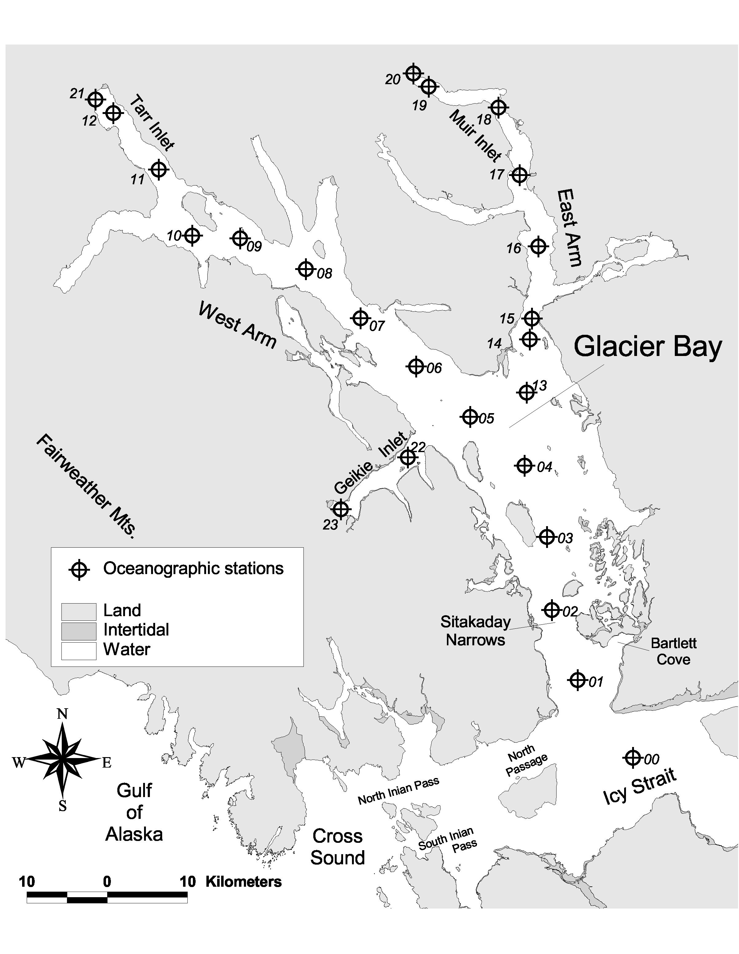
Figures

Figure 1. Glacier Bay and surrounding waters, and the oceanographic stations surveyed in this study (numbered).

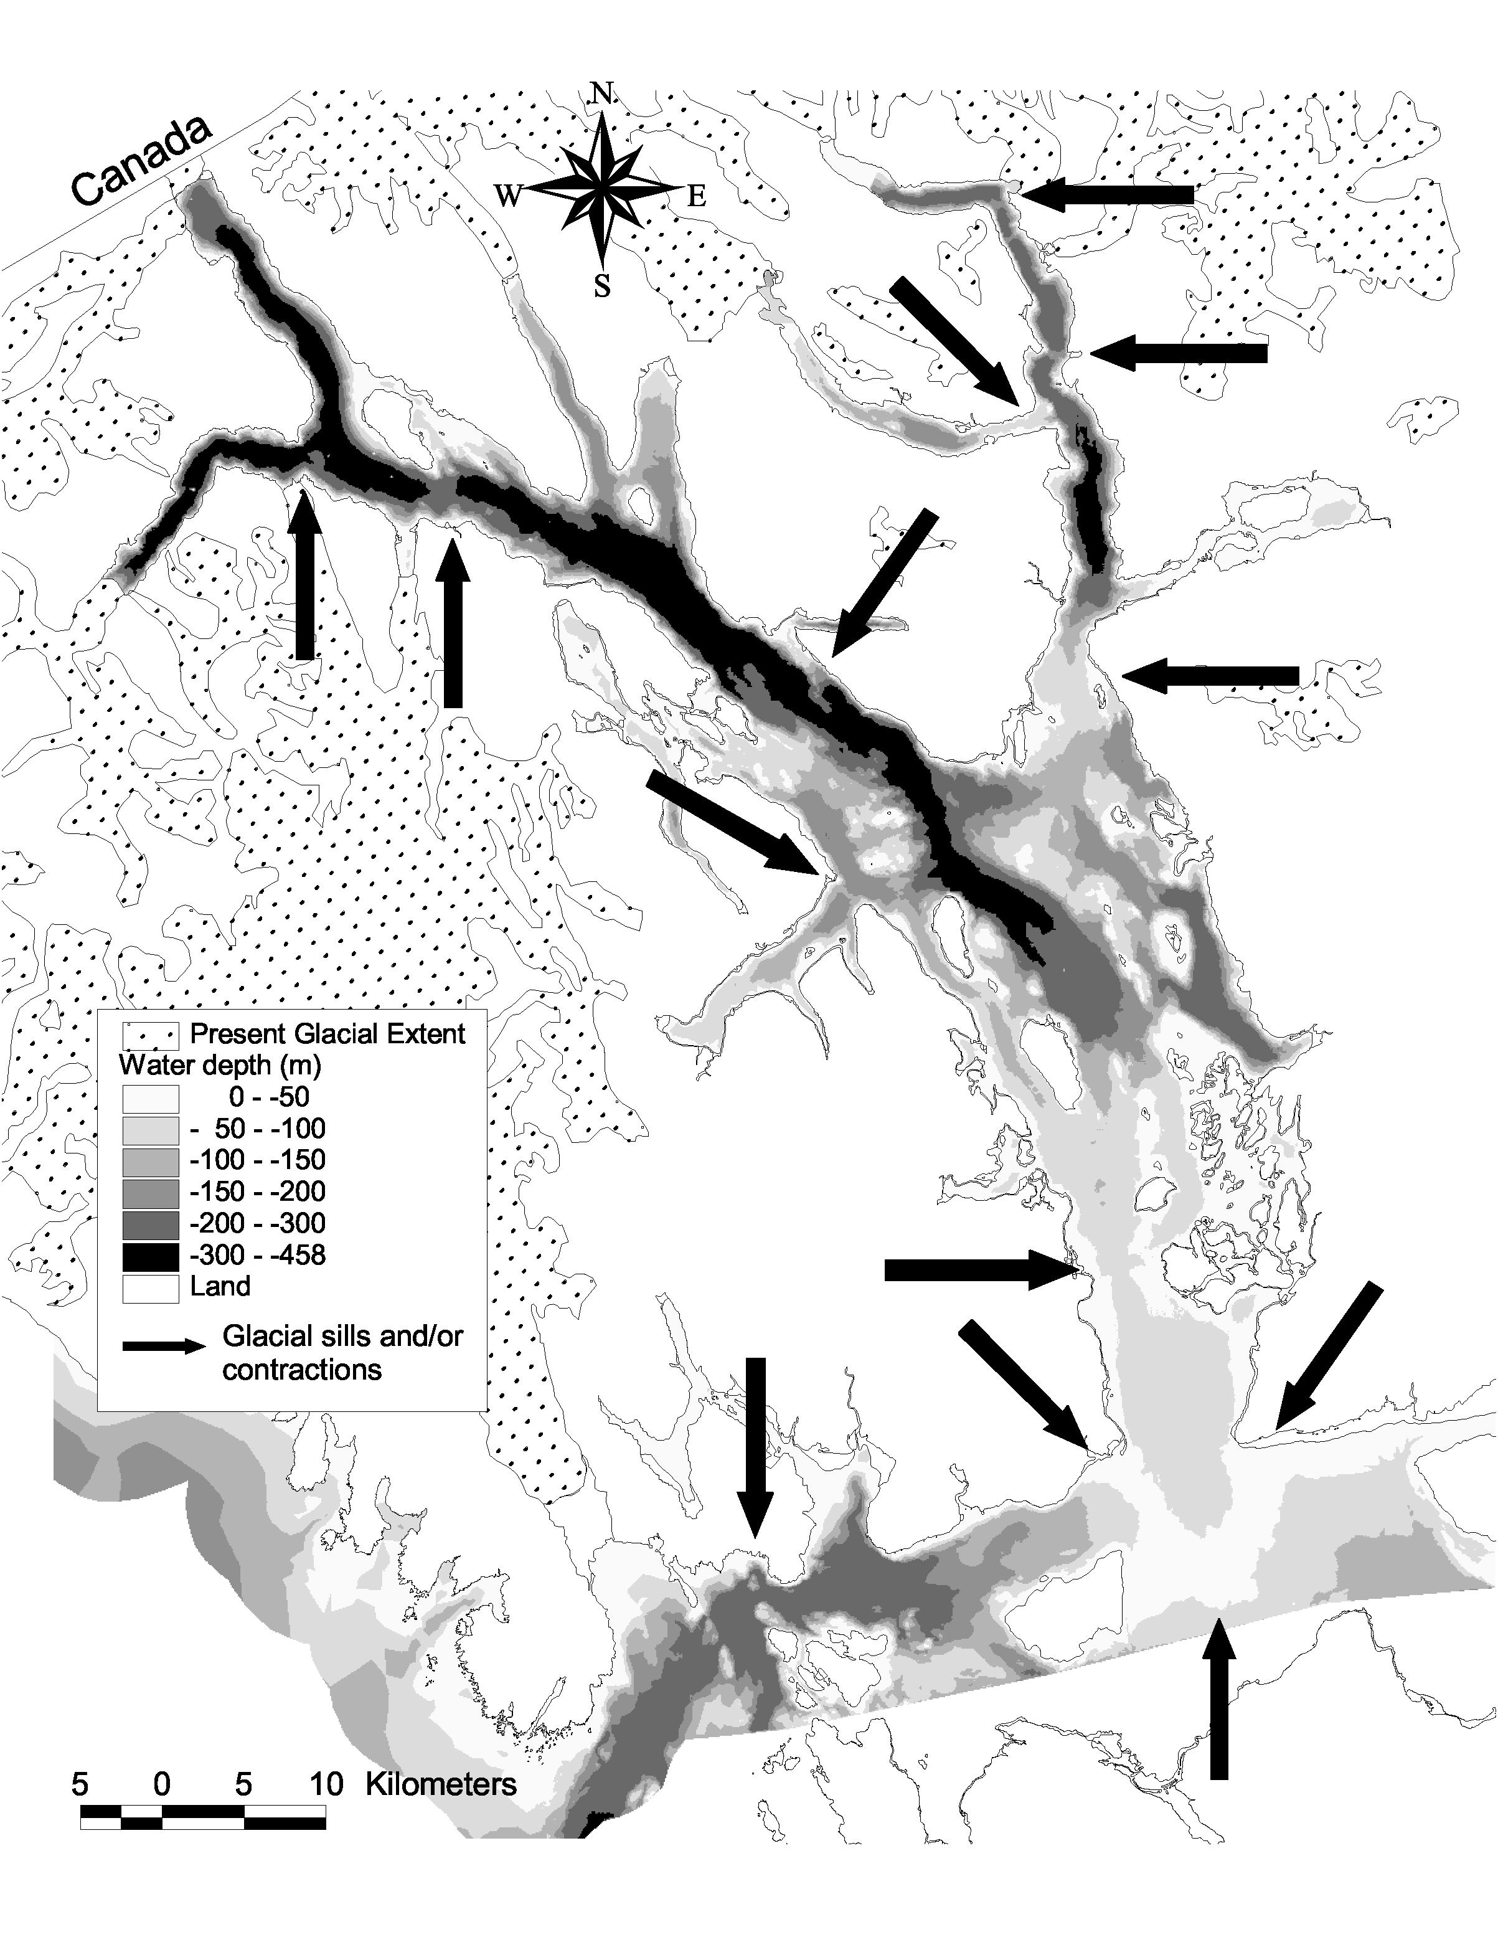
Figure 2. Bathymetry of Glacier Bay and adjacent waters, and present extent of glaciation. Numerous contractions and glacial sills are indicated.

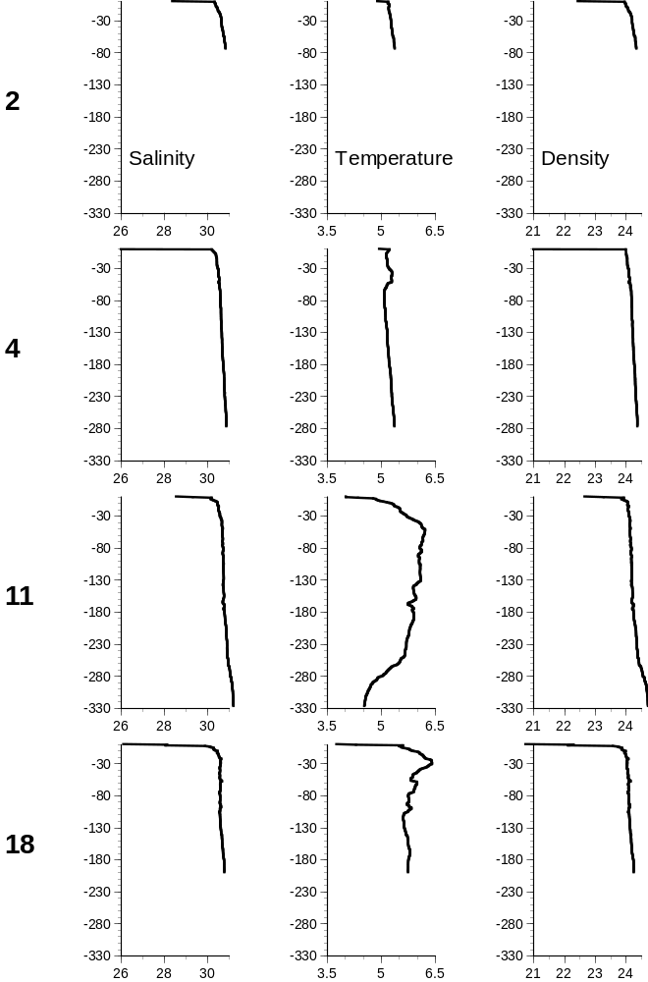

Figure 3. Depth profiles of salinity, temperature, and density at four oceanographic survey stations in Glacier Bay (numbered; see Figure 1 for station locations), showing winter oceanographic conditions (data taken 01-03 February, 1998). Salinity is presented in ppt, temperature in °C, and sigma-t (density) in kg/m³.

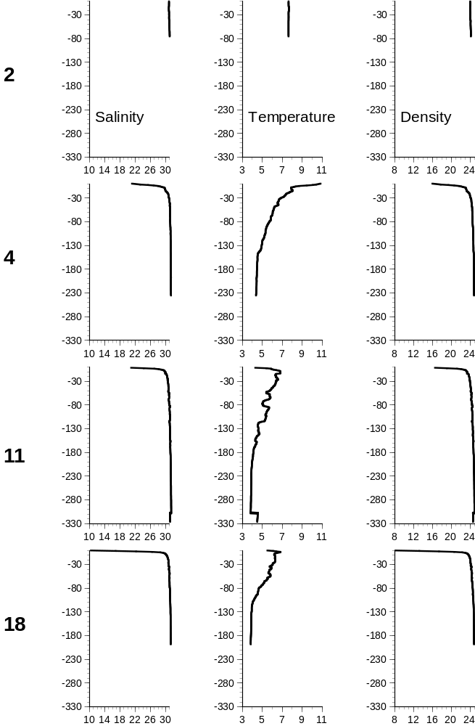
Figure 4. Depth profiles of salinity, temperature, and density at four oceanographic survey stations in Glacier Bay (numbered; see Figure 1 for station locations), showing summer oceanographic conditions (data taken 05-12 July, 1997). Salinity is presented in ppt, temperature in °C, and density as sigma-t in kg/m³.


00 01 02 03 04 05 06 07 08 09 10 11 12

Figure 5. A horizontal view of salinity profiles and contours within the water column along the longitudinal axis of Glacier Bay, from station 00 in Icy Strait (left edge) to station 12 at the head of Tarr Inlet (right edge). The bottom mask derives from the Bay’s bathymetry, with the 25m entry sill and Sitakaday Narrows to the left, and the central basin in the middle of the view. The isohalines along the main Glacier Bay-West Arm survey line on 16-18 May, 1997, slope downwards towards the head of the fjord (to the right). The cast profiles are numbered by oceanographic station, and salinity is contoured every 0.25ppt.

00 01 02 03 04 05 06 07 08 09 10 11 12

Figure 6. Temperature profiles and isopleths along the main Glacier Bay - West Arm survey line, 16-18 May, 1997. The isotherms slope downwards towards the mouth of the bay (left). The cast profiles are numbered by oceanographic station, and temperature values are contoured every 0.25°C.

00 01 02 03 04 05 06 07 08 09 10 11 12

Figure 7. Density profiles and contours along the main Glacier Bay - West Arm survey line, 16-18 May, 1997. The isopycnals slope downwards towards the head of the fjord (right). The cast profiles are numbered by oceanographic station, and density values are contoured every 0.25kg/m³.

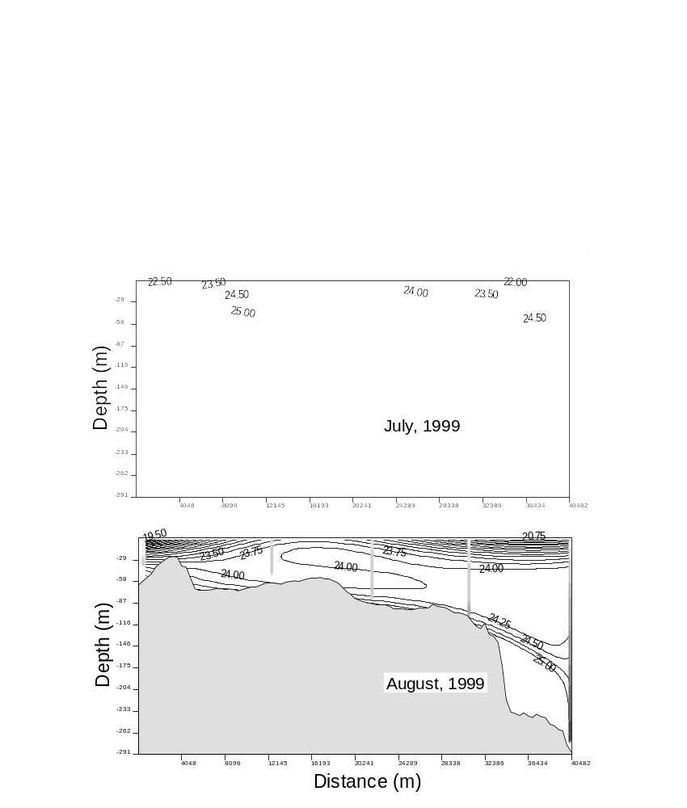
A
C
B
00 01 02 03 04

Figure 8. Density profiles and contours along the lower Bay survey line (stations 00 – 04) during three summer months of 1999: 09 & 15 June (A), 07 & 09 July (B), and 22-23 August (C). At least one station in each survey was fully mixed, with isopycnals that tended vertical and reached the surface. The cast profiles are numbered by oceanographic station, and density values are contoured every 0.25kg/m³ for June and August, every 0.50kg/m³ for July.

A
B
00 01 02 03 04 05 06 07 08 09 10 11 12 21

Figure 9. Salinity contours along the main Glacier Bay-West Arm oceanographic survey line during 05-07 January, 2000 (A), and 09-14 June, 2000 (B). Water in the top 10m is much fresher during summer, when the surface brackish layer is also much narrower and distinct (stratified). Salinities at the bottom of the basins do not change as much, although intermediate-depth waters are most saline during early spring and summer months (see Figure 10). The cast profiles are numbered by oceanographic station, and salinity values are contoured every 0.25ppt.

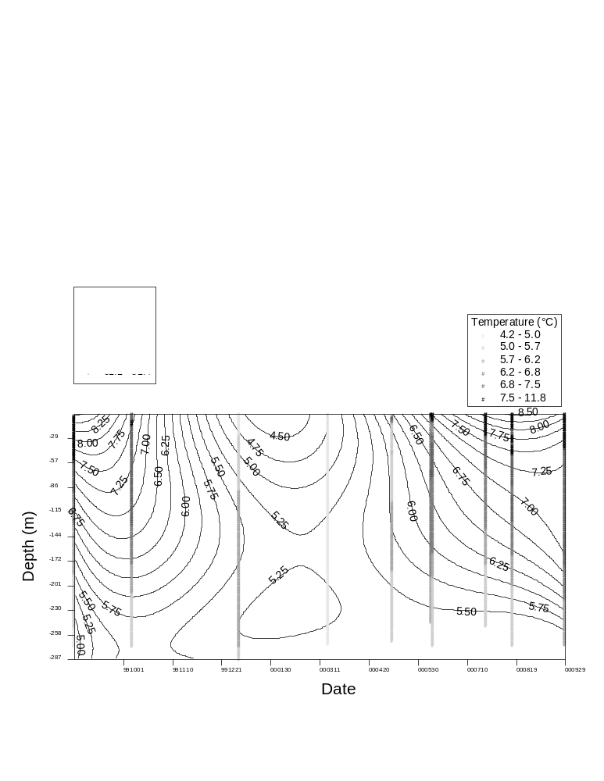
A
B

Figure 10. Time series of salinity (A) and temperature (B) profiles and contours at oceanographic survey station 04, from August, 1999 through September, 2000. Salinity is contoured every 0.25ppt, and temperature is contoured every 0.25°C. Due to smoothing, some contours do not intersect the profiles at precisely the correct value. Note that the color gradient for temperature is reversed from that in most other figures in this report (here, warmer is darker).

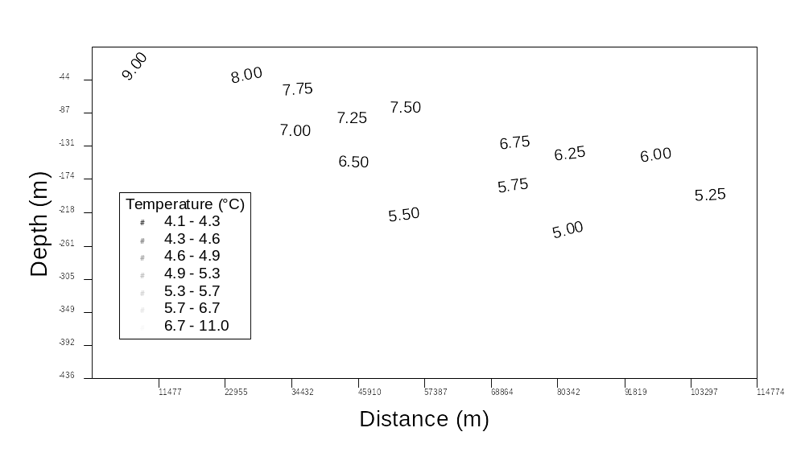
A
B
00 01 02 03 04 05 06 07 08 09 10 11 12 21

Figure 11. Temperature profiles and contours along the main Glacier Bay - West Arm oceanographic survey line during 16-23 March, 2000 (A), and 17-23 August, 2000 (B). Surface waters warm during the summer and cool in winter; deep waters follow the same pattern but with much less variation. As a result, there is a thermocline in summer that is nearly absent in winter, when the Bay’s waters are thermally homogenous. The contours in these graphs are not fine enough to resolve the double thermocline that often exists at the surface of the upper fjords due to cold freshwater glacial runoff (see Figure 4). The cast profiles are numbered by oceanographic station, and temperature values are contoured every 0.25°C.

00 01 02 03 04 05 06 07 08 09 10 11 12 21

Figure 12. Temperature profiles and contours along the main Glacier Bay - West Arm oceanographic survey line during 05-07 January, 2000. A mid-water temperature maximum is prominent in the mid- and upper Bay; this feature nearly disappears by late winter (see Figure 11A). The cast profiles are numbered by oceanographic station, and temperature values are contoured every 0.25°C.

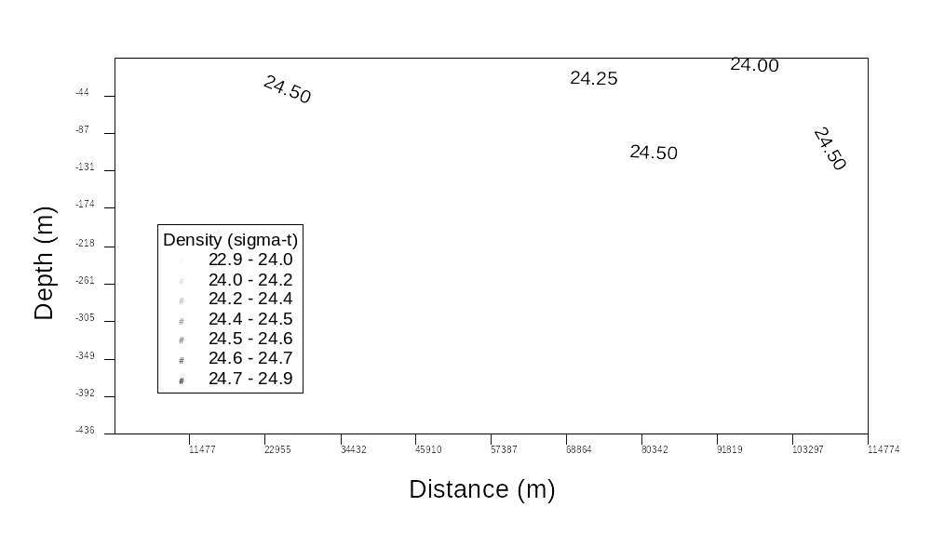
A
B
00 01 02 03 04 05 06 07 08 09 10 11 12 21

Figure 13. Density profiles and contours along the main Glacier Bay - West Arm oceanographic survey line during 10-11 March, 1999 (A), and 16-23 March, 2000 (B). By late winter each year, the water column was homogeneous and well mixed throughout the Bay, both vertically and longitudinally. Stratification developed earlier in the spring of 2000 than in 1999. The cast profiles are numbered by oceanographic station, and sigma-t is contoured every 0.25kg/m³.


A
B
C
00 01 02 03 04 05 06 07 08 09 10 11 12 21

Figure 14. Density profiles and contours along the main Glacier Bay - West Arm oceanographic survey line during 10-12 May, 2000 (A), 26-30 July, 2000 (B), and 29-30 September, 2000 (C). Stratification of the water column began in spring and continued through fall. Surface densities were less than in winter due to runoff. Icy Strait water was often much more saline and dense than the waters within Glacier Bay. Cast profiles are numbered by oceanographic station, and sigma-t is contoured every 0.25kg/m³.

00 01 02 03 04 05 06 07 08 09 10 11 12 21

Figure 15. Density profiles and contours along the main Glacier Bay – West Arm survey line during 08 and 10 December, 1998. As in summer (Figure 14), Icy Strait water is often much more dense and saline than waters within Glacier Bay. Density is greater in late winter and early spring than it is in late summer and early fall. The cast profiles are numbered by oceanographic station, and sigma-t is contoured every 0.25kg/m³.

00 01 02 03 04 05 06 07 08 09 10 11 12

Figure 16. Density profiles and contours along the main Glacier Bay - West Arm survey line during 02-03 February, 1998. Incipient stratification was already apparent in the Bay’s central basin. The cast profiles are numbered by oceanographic station, and sigma-t is contoured every 0.25kg/m³.

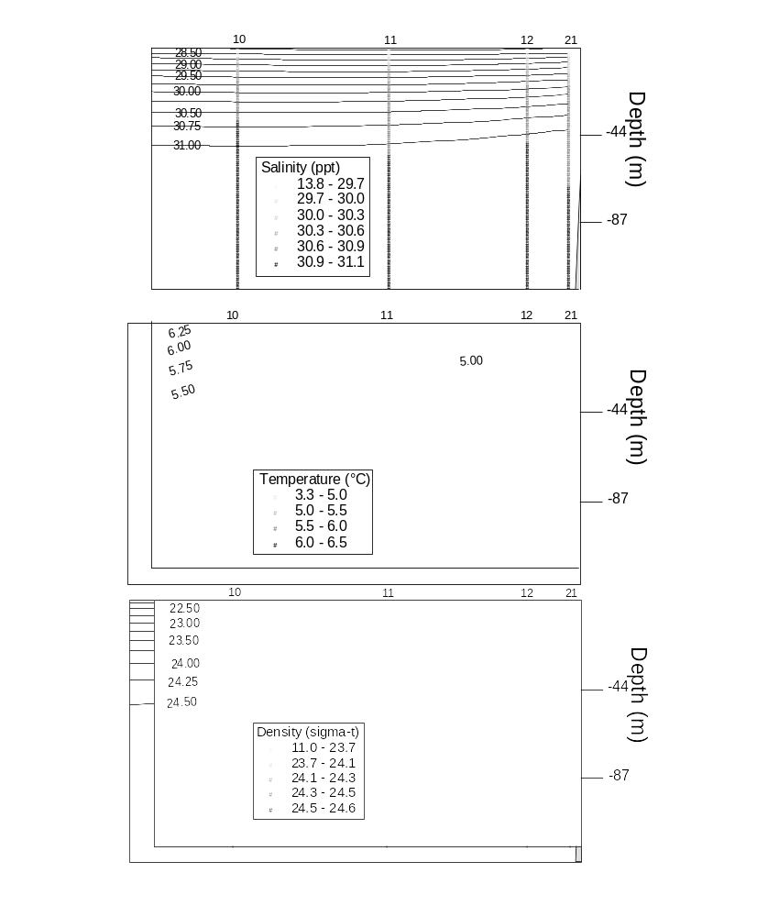
A
B
C

Figure 17. Cast profiles and isopleths for salinity (A), temperature (B), and density (C) in the top 120m of water at stations 10 – 12 and 21 on 14 June, 2000. Although water immediately adjacent to the two tidewater glaciers at the head of the West Arm was much colder (and exhibited a double thermocline), the water column was stratified all the way up the fjord. The cast profiles are numbered by oceanographic station; salinity, temperature, and sigma-t are contoured at intervals of 0.25 ppt, °C, and kg/m³, respectively. Note that the color gradient for temperature is reversed from other figures.

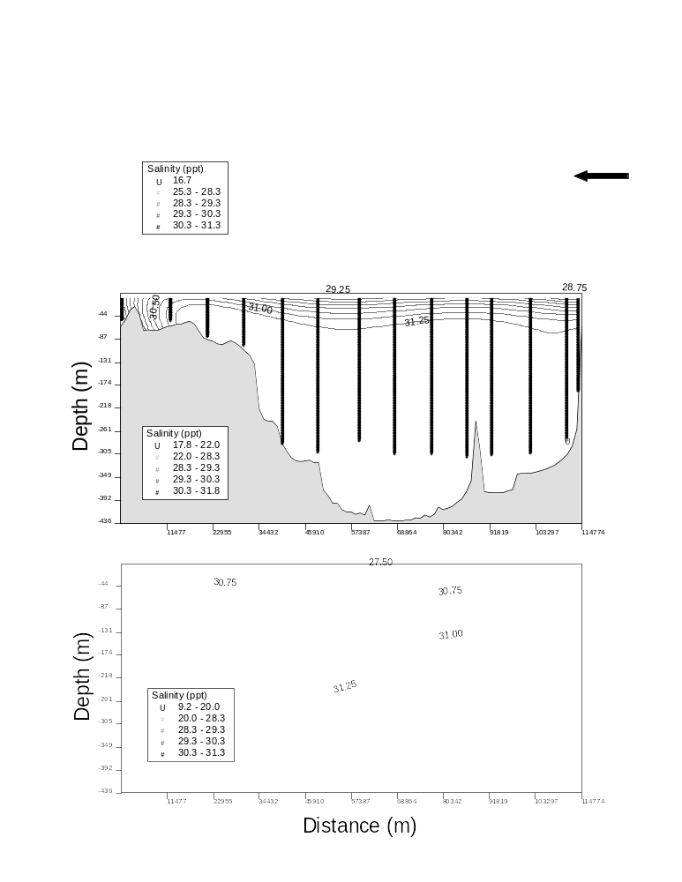
Figure 18. Salinity profiles and contours along the main Glacier Bay - West Arm survey line on 08-10 November, 1997 (A); 15-17 June, 1999 (B); and 20-23 August, 1999 (C). Low-salinity bodies of water were detected at the bottom of station 12 in each survey (arrows). Low-salinity water was also present in narrow surface lenses in the upper fjord. The cast profiles are numbered by oceanographic station, and salinity is contoured every 0.25ppt.
A
B
C
00 01 02 03 04 05 06 07 08 09 10 11 12 21

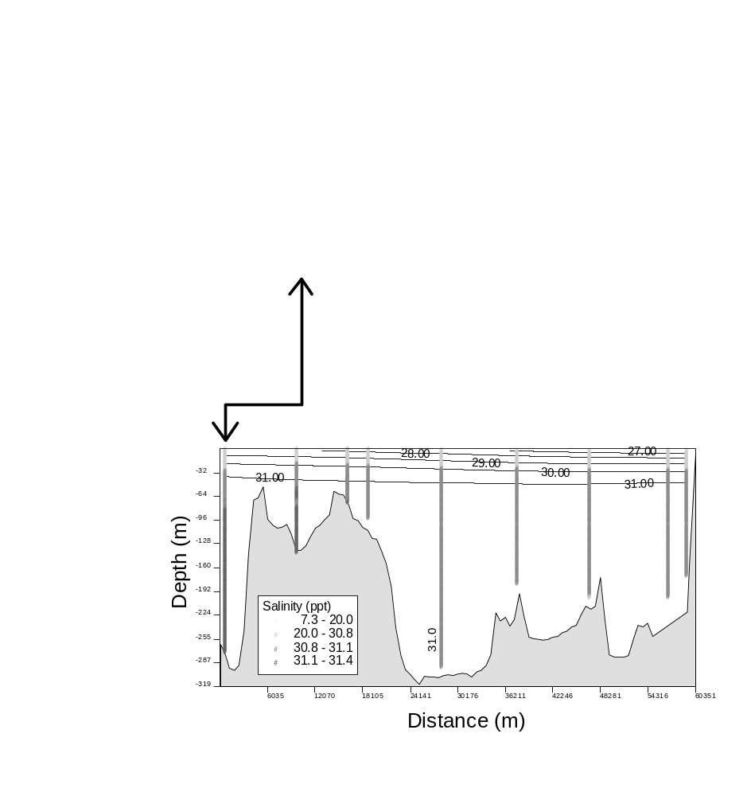
00 01 02 03 04 05 06 07 08 09 10 11 12
13 14 15 16 17 18 19 20
04
B
A

Figure 19. Salinity profiles and contours along both the main Glacier Bay - West Arm (A) and East Arm (B) survey lines during 26-28 June, 1998. The lower Bay exhibited higher salinity than the water at the bottom of the first basin. The cast profiles are numbered by oceanographic station, and salinity is contoured every 0.25ppt. The arrow indicates where the two survey lines join at station 04, which is included both in the main trunk of Glacier Bay and outside the mouth of the East Arm (see Figure 1 for station locations).

B
A
00 01 02 03 04 05 06 07 08 09 10 11 12
13 14 15 16 17 18 19 20
04

Figure 20. Temperature profiles and contours along both the main Glacier Bay - West Arm and East Arm survey lines during 26-28 June, 1998. Isotherms connect the water column in the lower Bay to the warm water at the bottom of the first deep basin. A temperature inversion is also apparent in the East Arm. The cast profiles are numbered by oceanographic station, and temperature is contoured every 0.25°C. The arrow indicates station 04 in both survey lines. Note that the color gradient for temperature is reversed from most other figures.

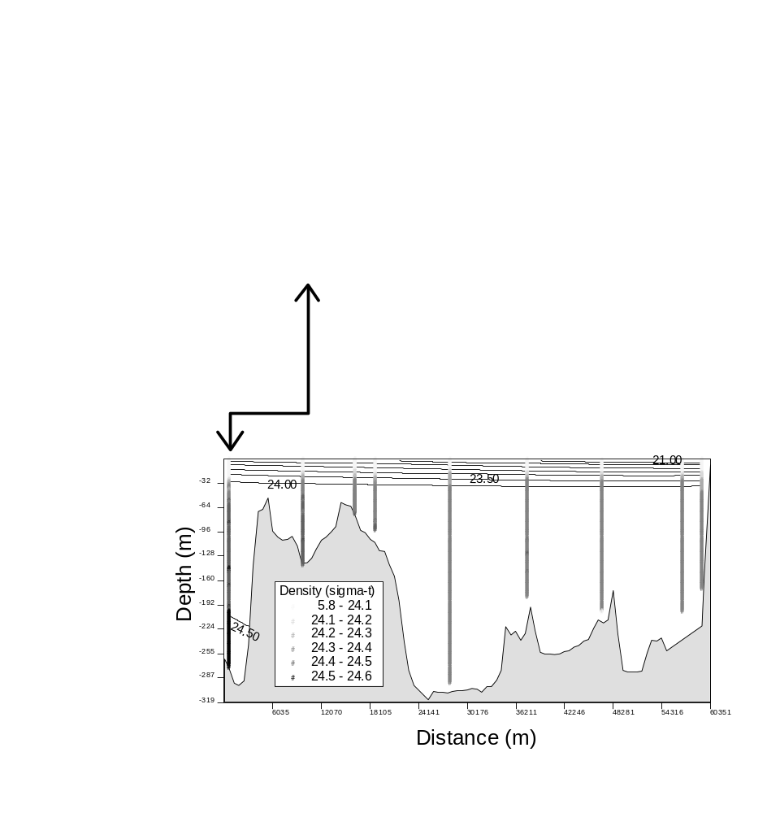
B
A
00 01 02 03 04 05 06 07 08 09 10 11 12
13 14 15 16 17 18 19 20
04

Figure 21. Density profiles and contours along both the main Glacier Bay - West Arm and East Arm survey lines during the warm-water intrusion event of 26-28 June, 1998. The cast profiles are numbered by oceanographic station, and sigma-t is contoured every 0.25kg/m³. The arrow indicates station 04 in both survey lines.

00 01 02 03 04

Figure 22. Density profiles and contours for the lower Bay survey line (stations 00 – 04), showing a dense water mass inside the entry sill, at the bottom of station 01, on 01 July, 1993. The cast profiles are numbered by oceanographic station, and sigma-t is contoured every 0.25kg/m³.

00 01 02 03 04

Figure 23. Salinity profiles and contours for the lower Bay survey line (stations 00 – 04) during 05-10 July, 1997. A saline water mass was detected inside the entry sill, at the bottom of station 01, on 08 July, 1997. The cast profiles are numbered by oceanographic station, and salinity is contoured every 0.25ppt.

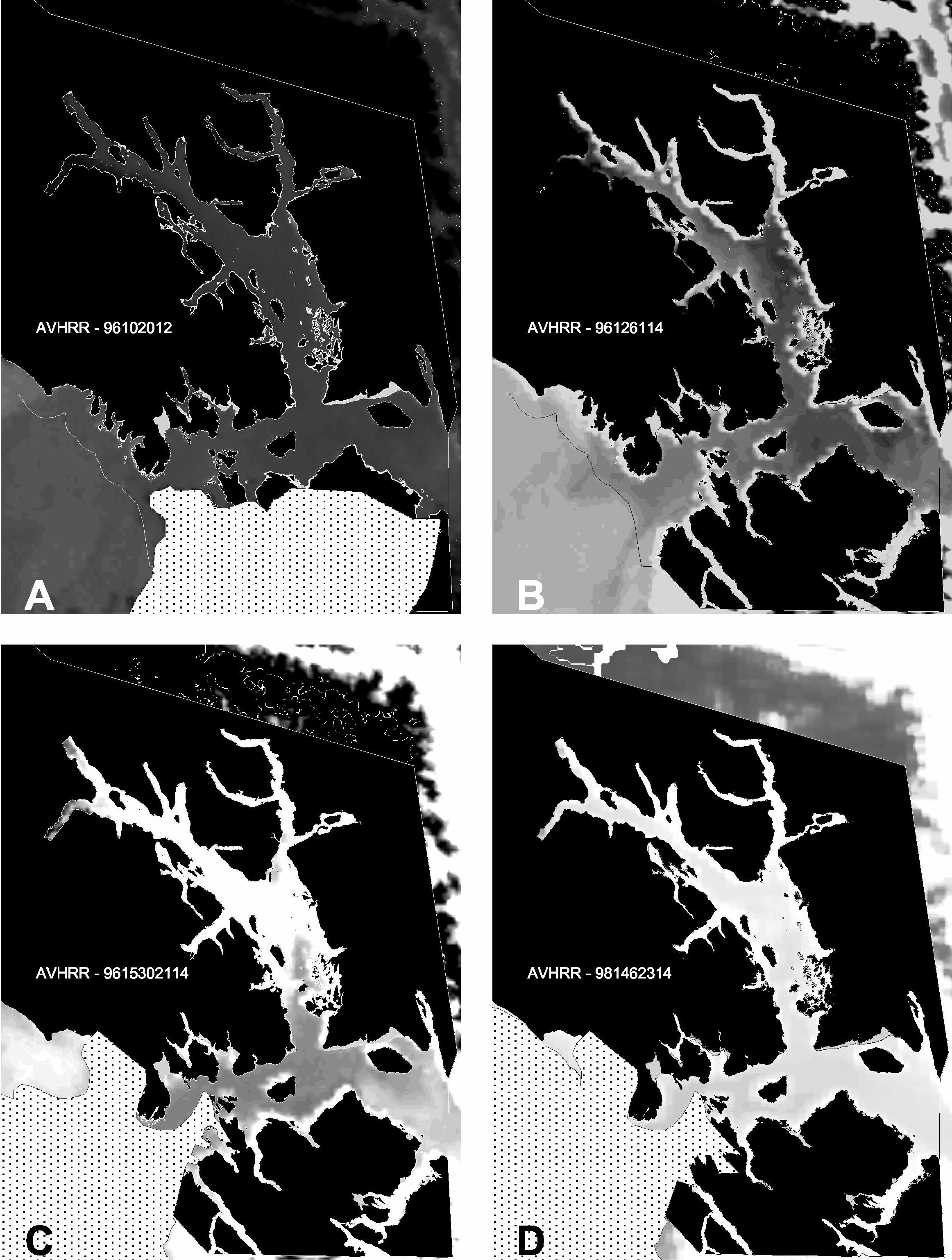

Figure 24 AVHRR thermal images (Band 4) showing relative sea surface temperatures with darker grays representing colder temperatures. Stippling masks clouds. A. April, cold surface waters throughout the area; B. May inland waters still cold, Gulf waters warming; C. June, central Bay warming, cold upwelling in the lower Bay during peak current; D. May 1998, slack tide and surface temperatures are warmer this year.

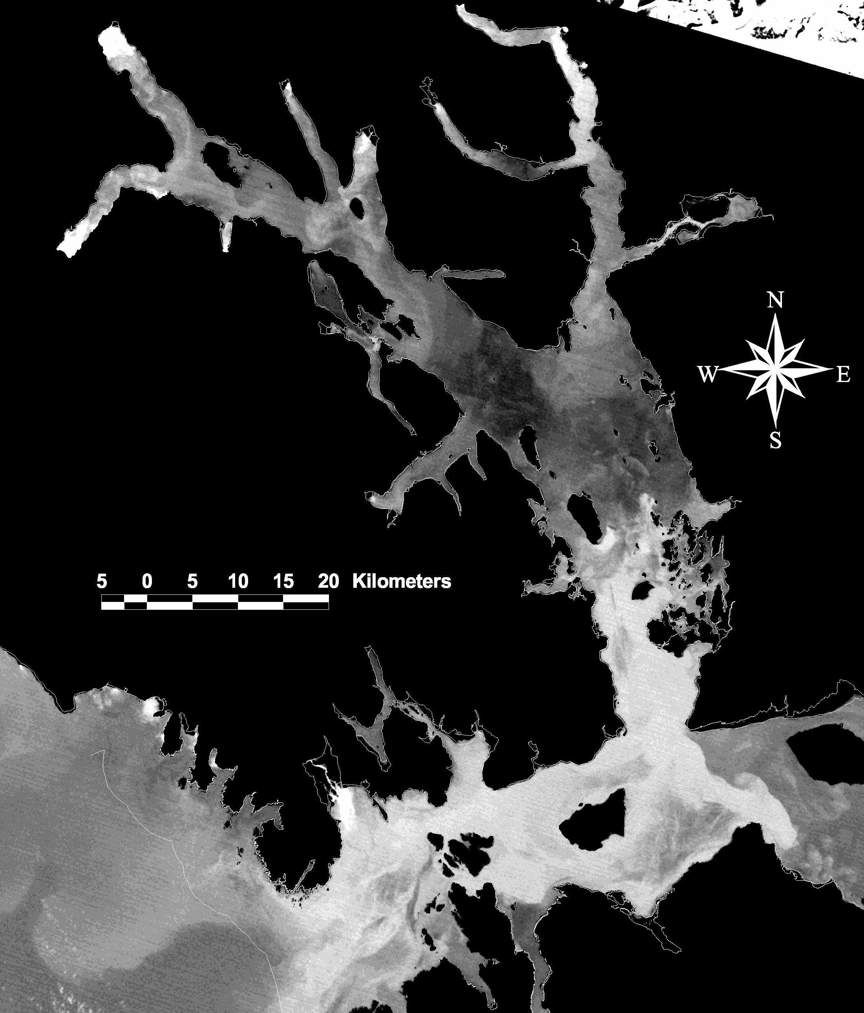

Figure 25. Landsat TM Band 6 thermal image, 07 June, 1995, showing temperature patterns throughout the Bay and adjacent waters. Darker grays represent warmer temperatures (n.b.: color scale is reversed from the previous image). Colder water due to upwelling is visible in Cross Sound, west Icy Strait, and lower Glacier Bay. Warmer water is seen in the central Bay and east Icy Strait. Cold water due to glacial freshwater discharge is apparent at the heads of both arms of the Bay.

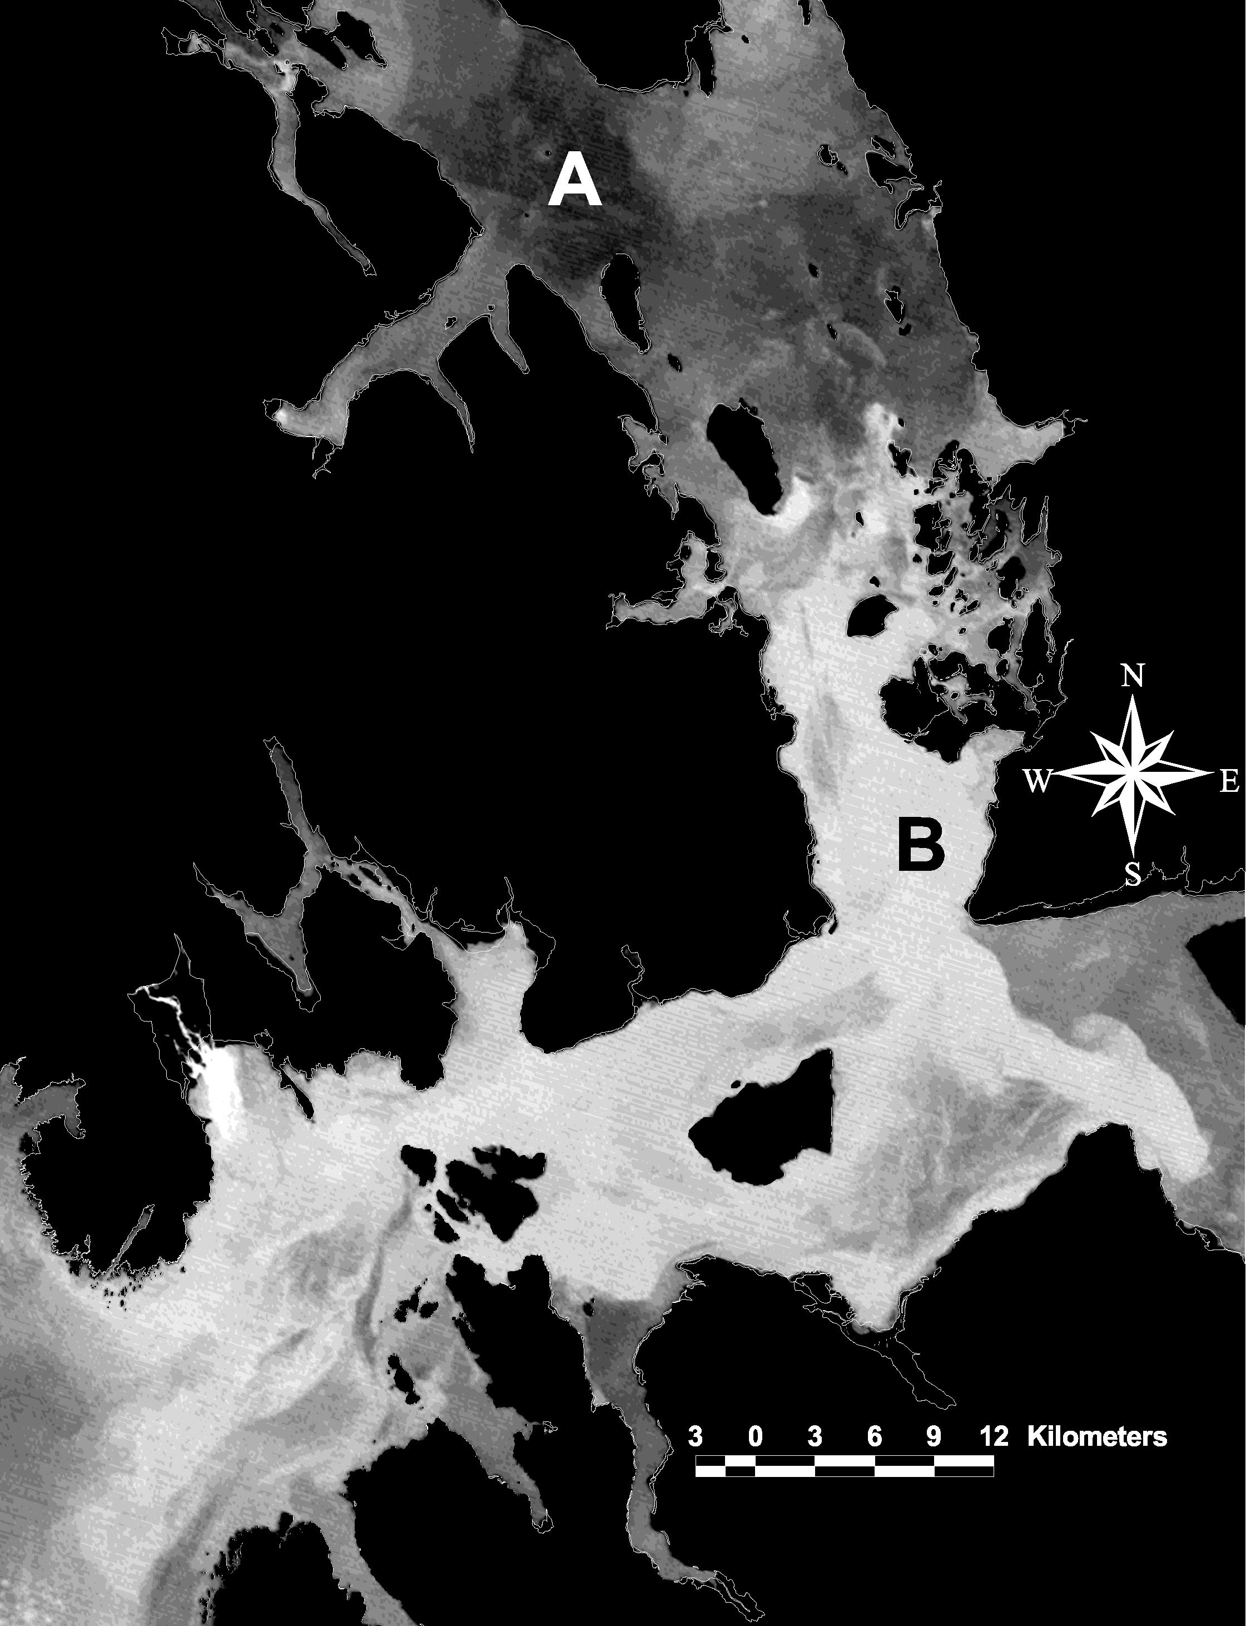
Figure 26. Close-up of Landsat TM Band 6 thermal image, 07 June, 1995, showing fine-scale details of warmer water (A) in the stratified mid-Bay and cold-water upwelling in the vicinity of the lower Bay (B). Darker grays represent warmer temperatures.

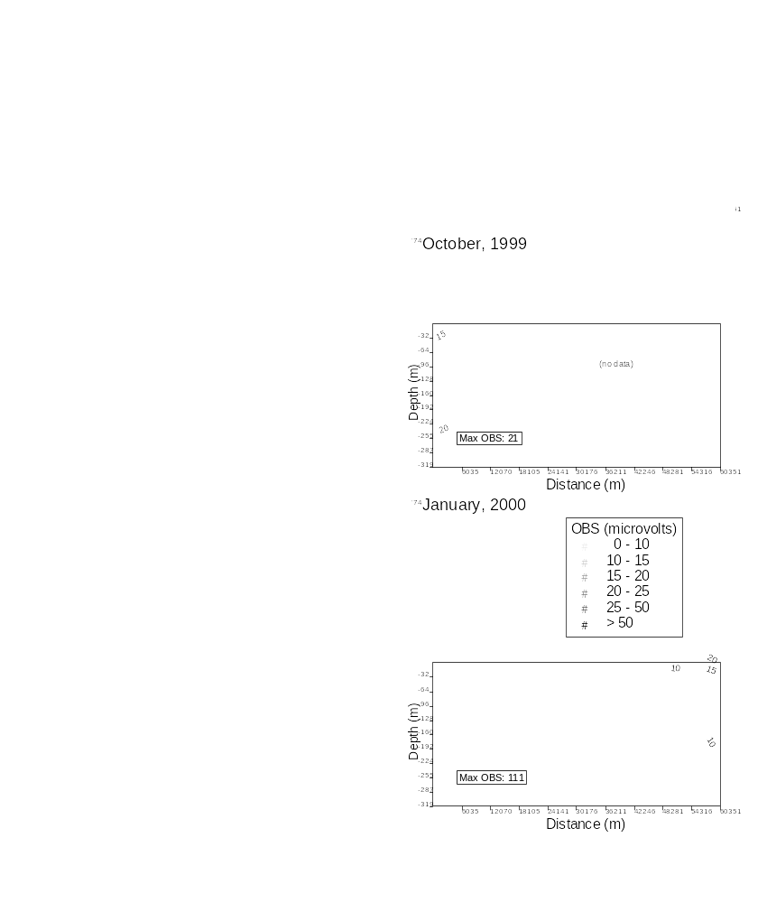
A
B
C
04
04
04
04
00 01 02 03 04 05 06 07 08 09 10 11 12 21
04 13 14 15 16 17 18 19 20

Figure 27. Optical backscatterance (OBS) profiles and contours along both the main Glacier Bay – West Arm and East Arm survey lines during three months: 09-10 October, 1999 (A); 05-07 January, 2000 (B); and 09-12 June, 2000 (C). Glacial sediment input was large during all surveys. Increased sediment load was also detected in both the central Bay and the lower Bay during many surveys. Sensor data are presented in uncalibrated millivolts and are contoured every 5mV. The cast profiles are numbered by oceanographic station in A, and station 04 (numbered in all graphs) is included in both survey lines.

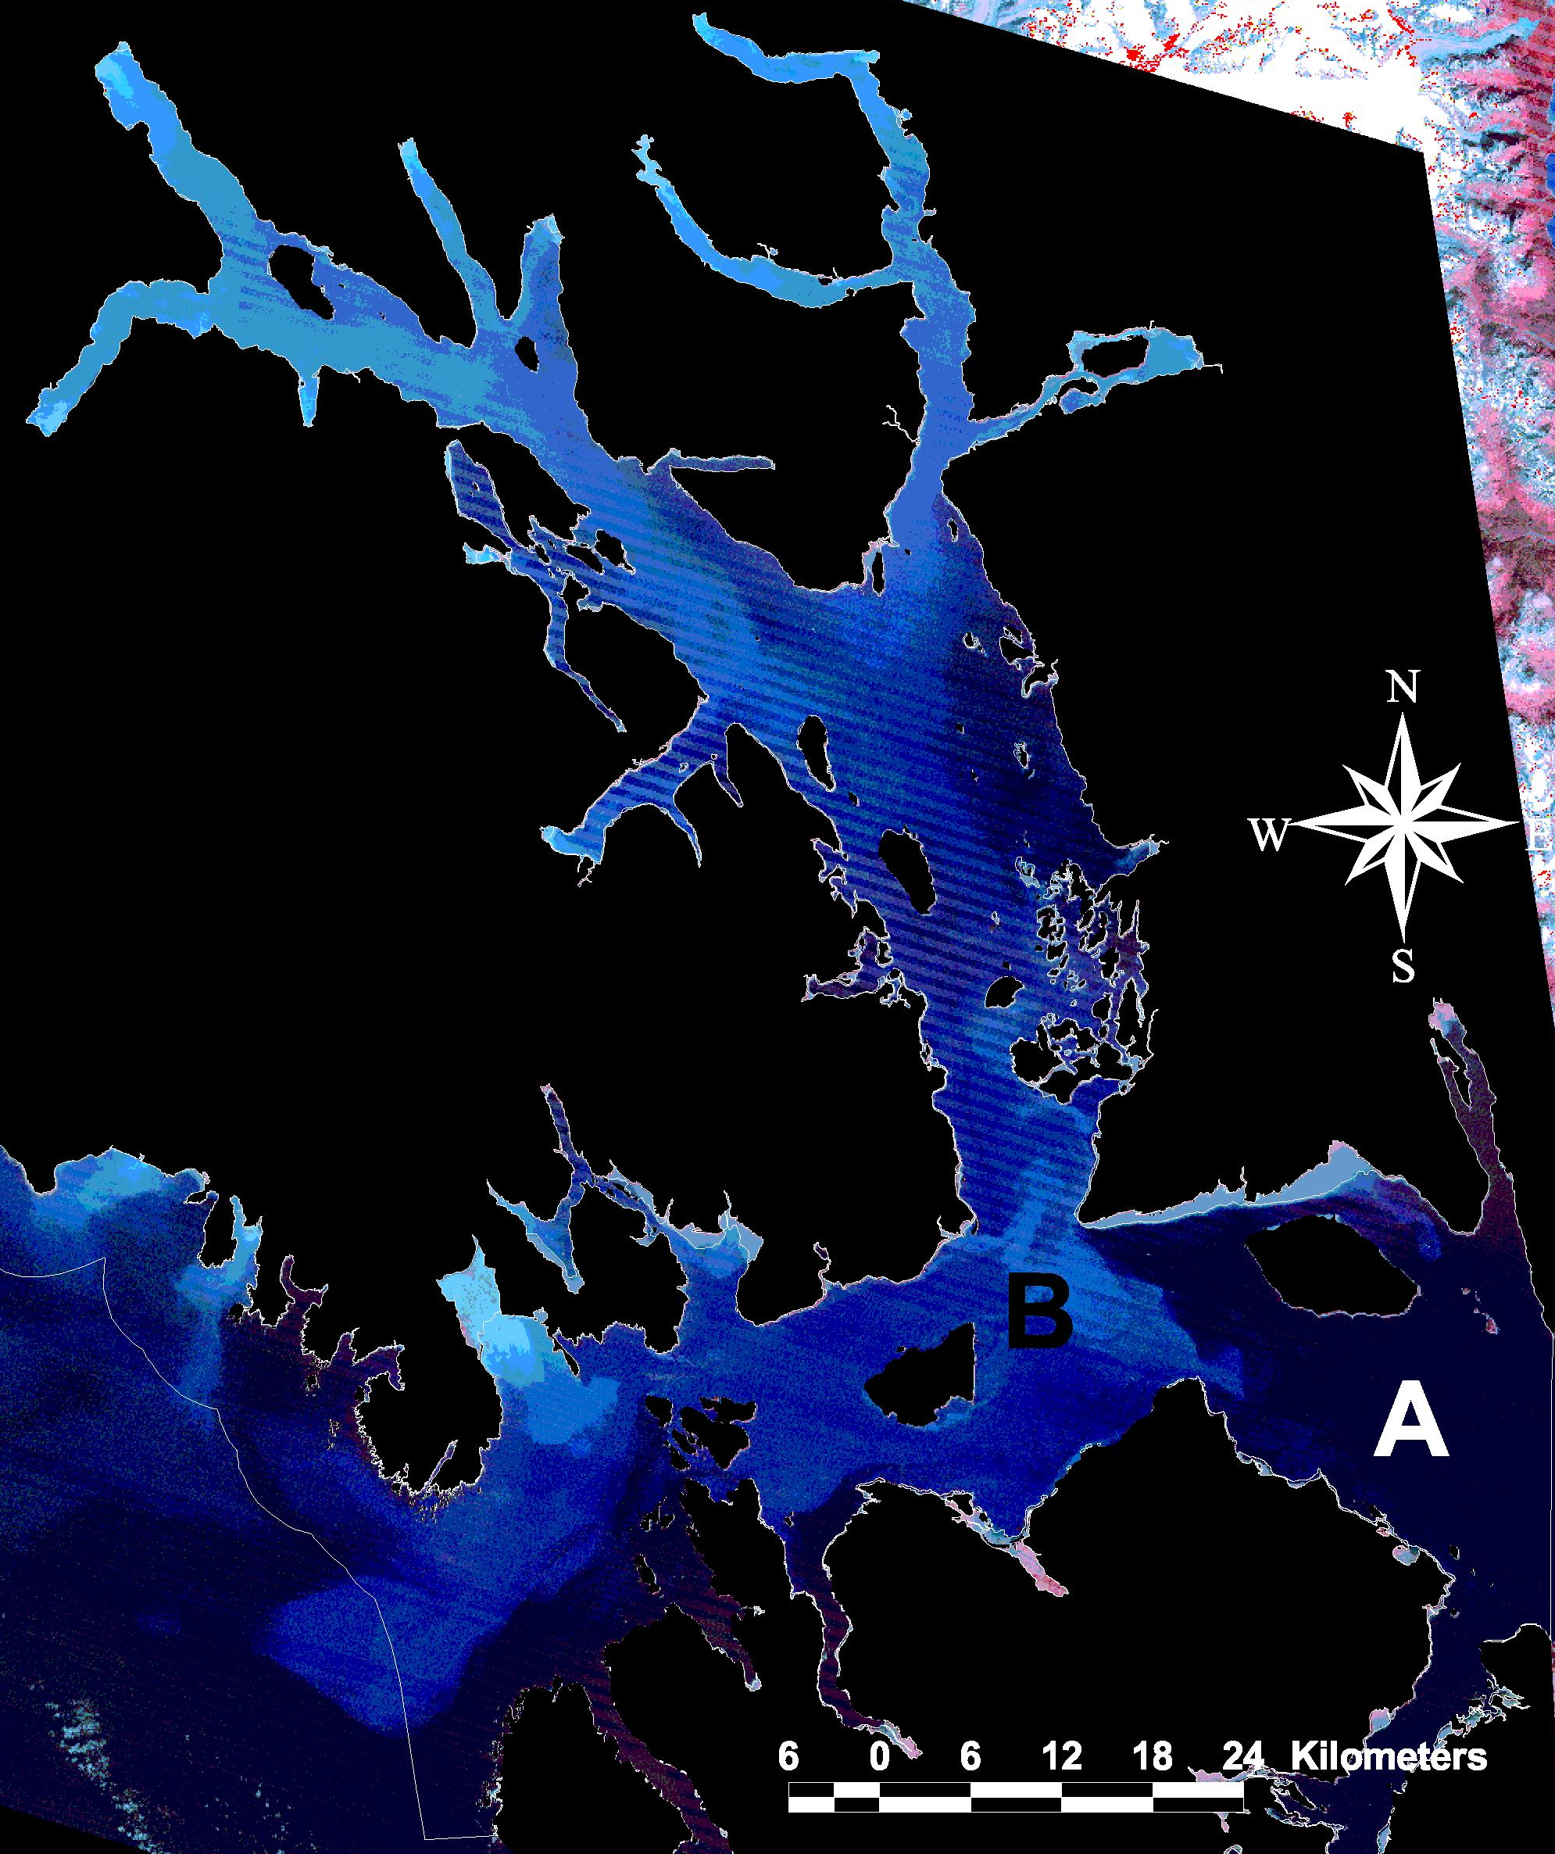
Figure 28. Landsat composite image (Bands 1, 2, and 3), 21 August, 1986. Turbidity patterns are shown in blue, with paler shades indicating greater amounts of sediment in the surface waters. The upper Bay’s high turbidity is due to glacial discharge remaining within the surface waters. An eddy of higher turbidity due to tidally induced upwelling is visible at the mouth of the Bay (B). Glacier Bay’s surface sediment plume does not travel east (A), but principally west into Cross Sound and thence into the Gulf of Alaska.

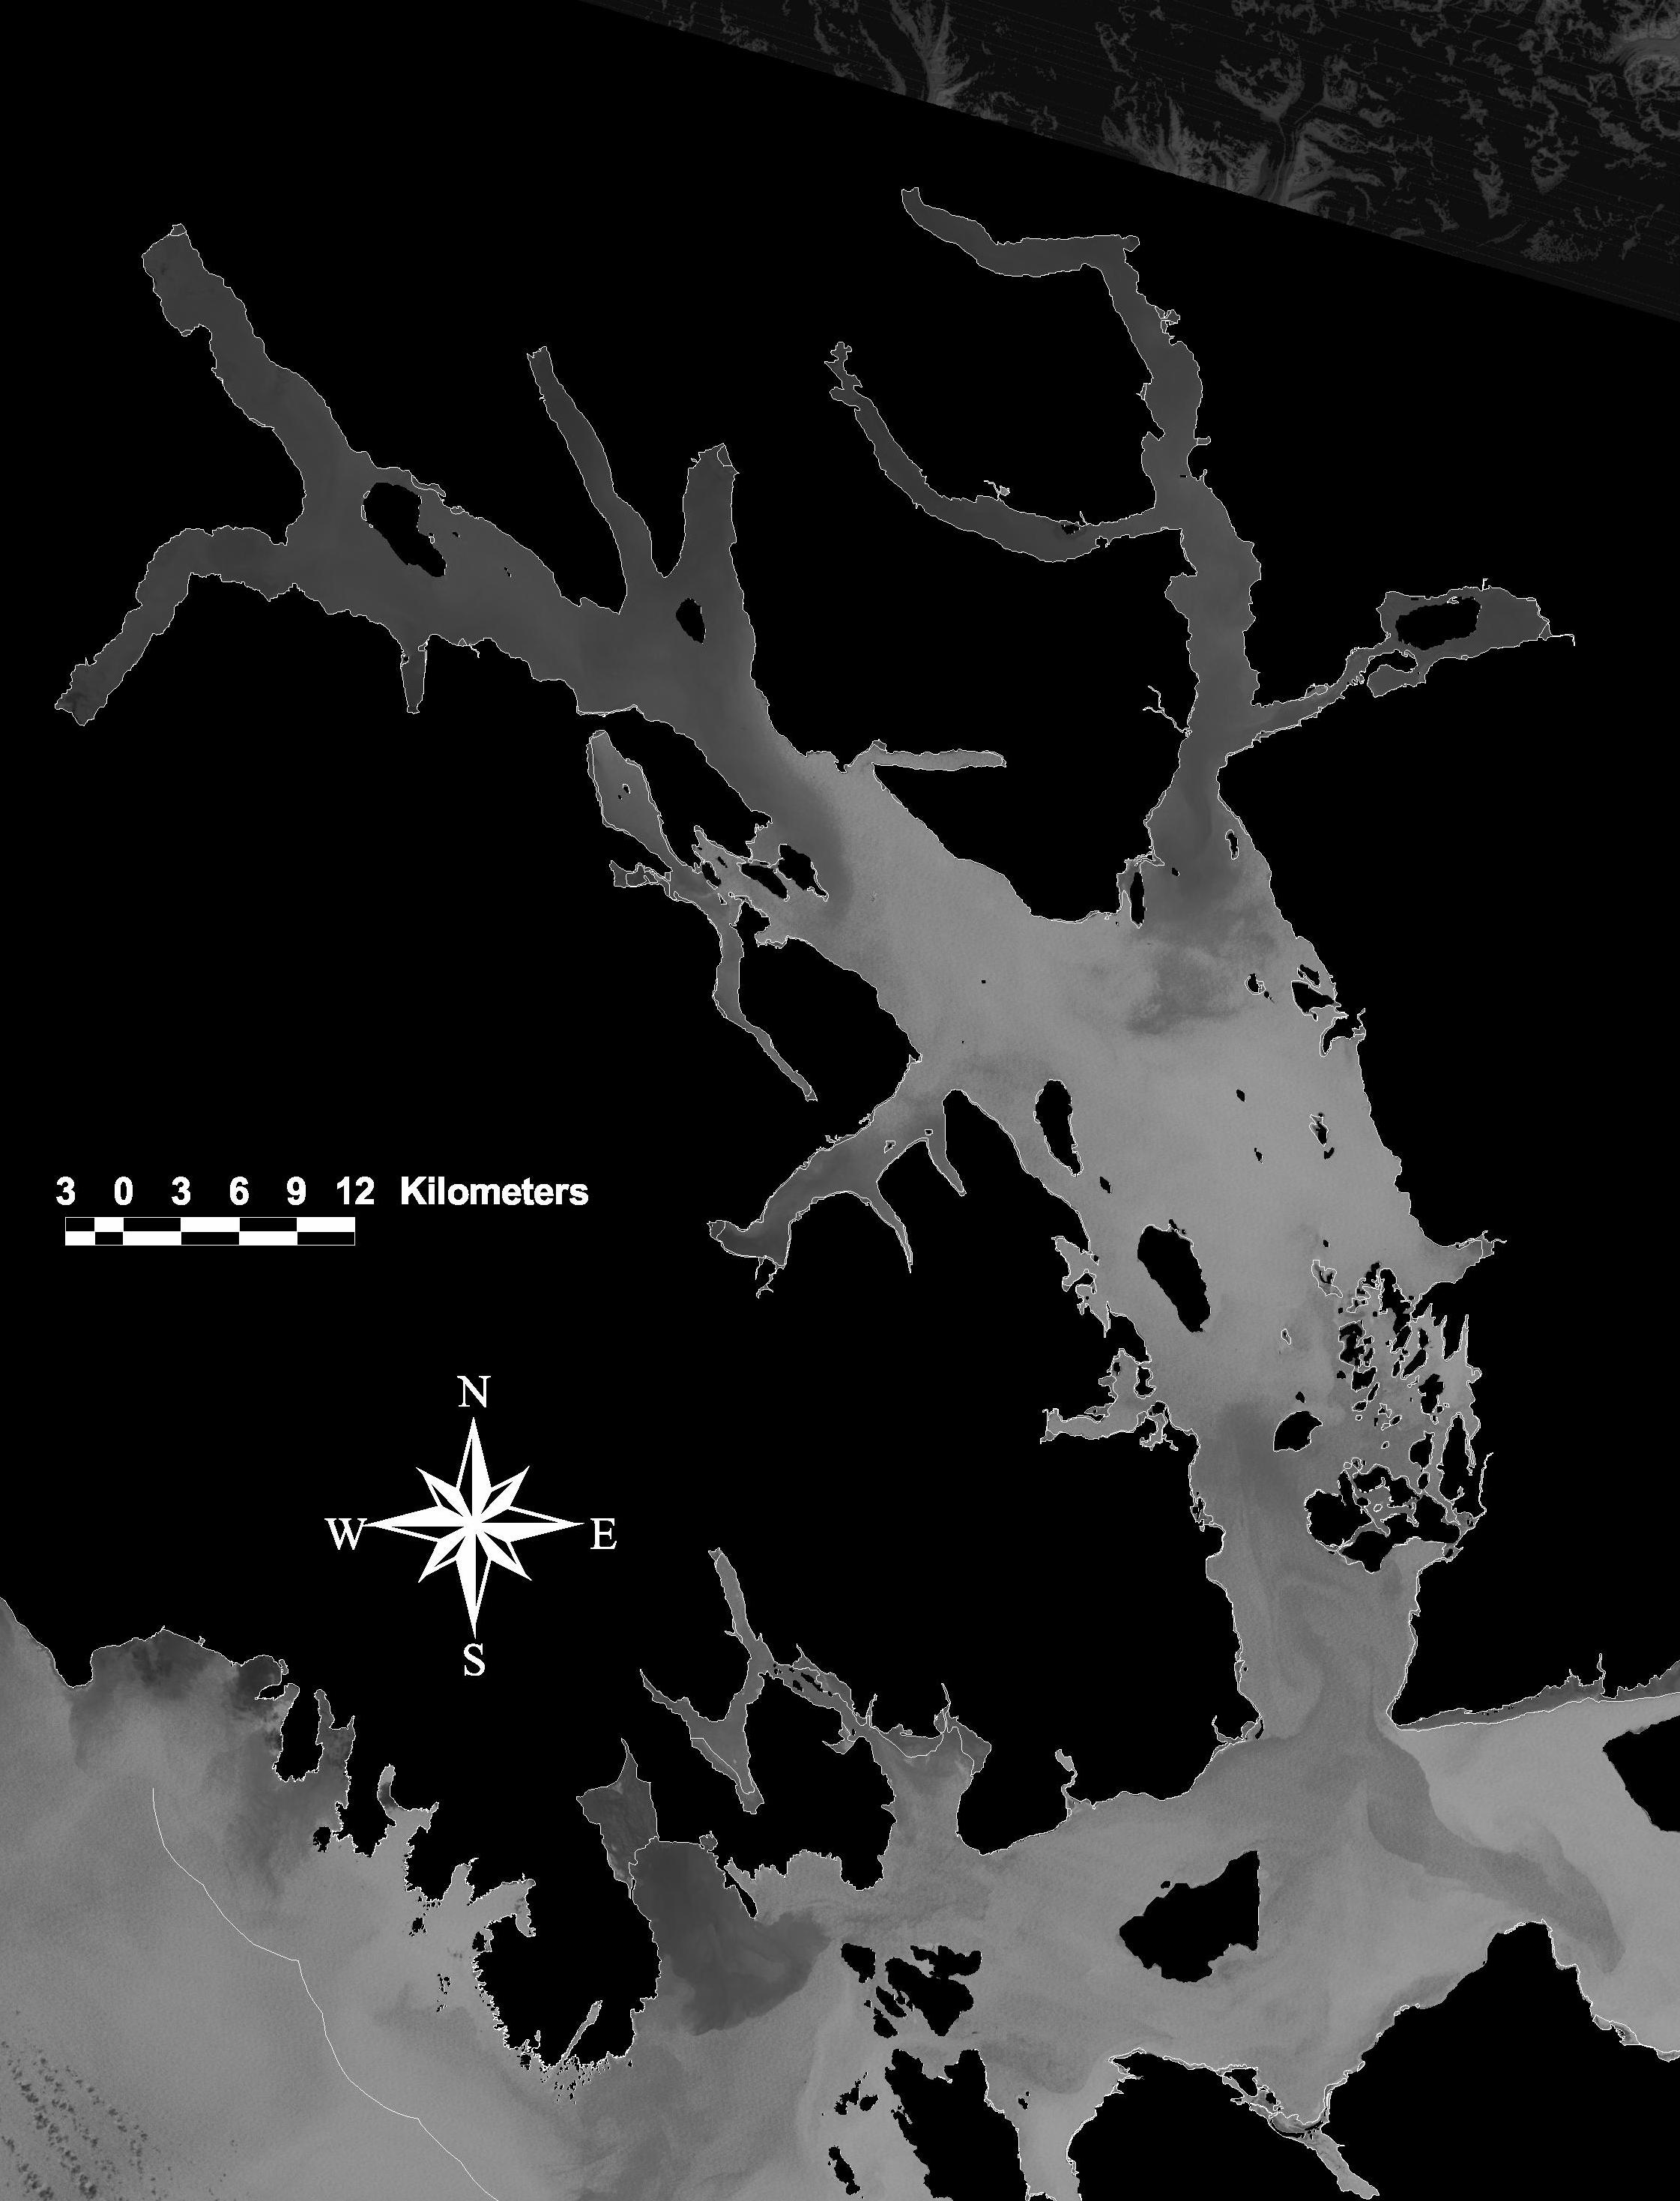

Figure 29. Landsat image (Band 1) 07 June, 1995. Turbidity patterns are shown in shades of gray, with darker shades indicating greater amounts of sediment in the surface waters. The upper Bay’s glacial discharge is again apparent, as is the westward export of surface-carried sediment into Cross Sound and the Gulf. In this image the stirring of sediment to the surface waters in the lower Bay is more extensive.

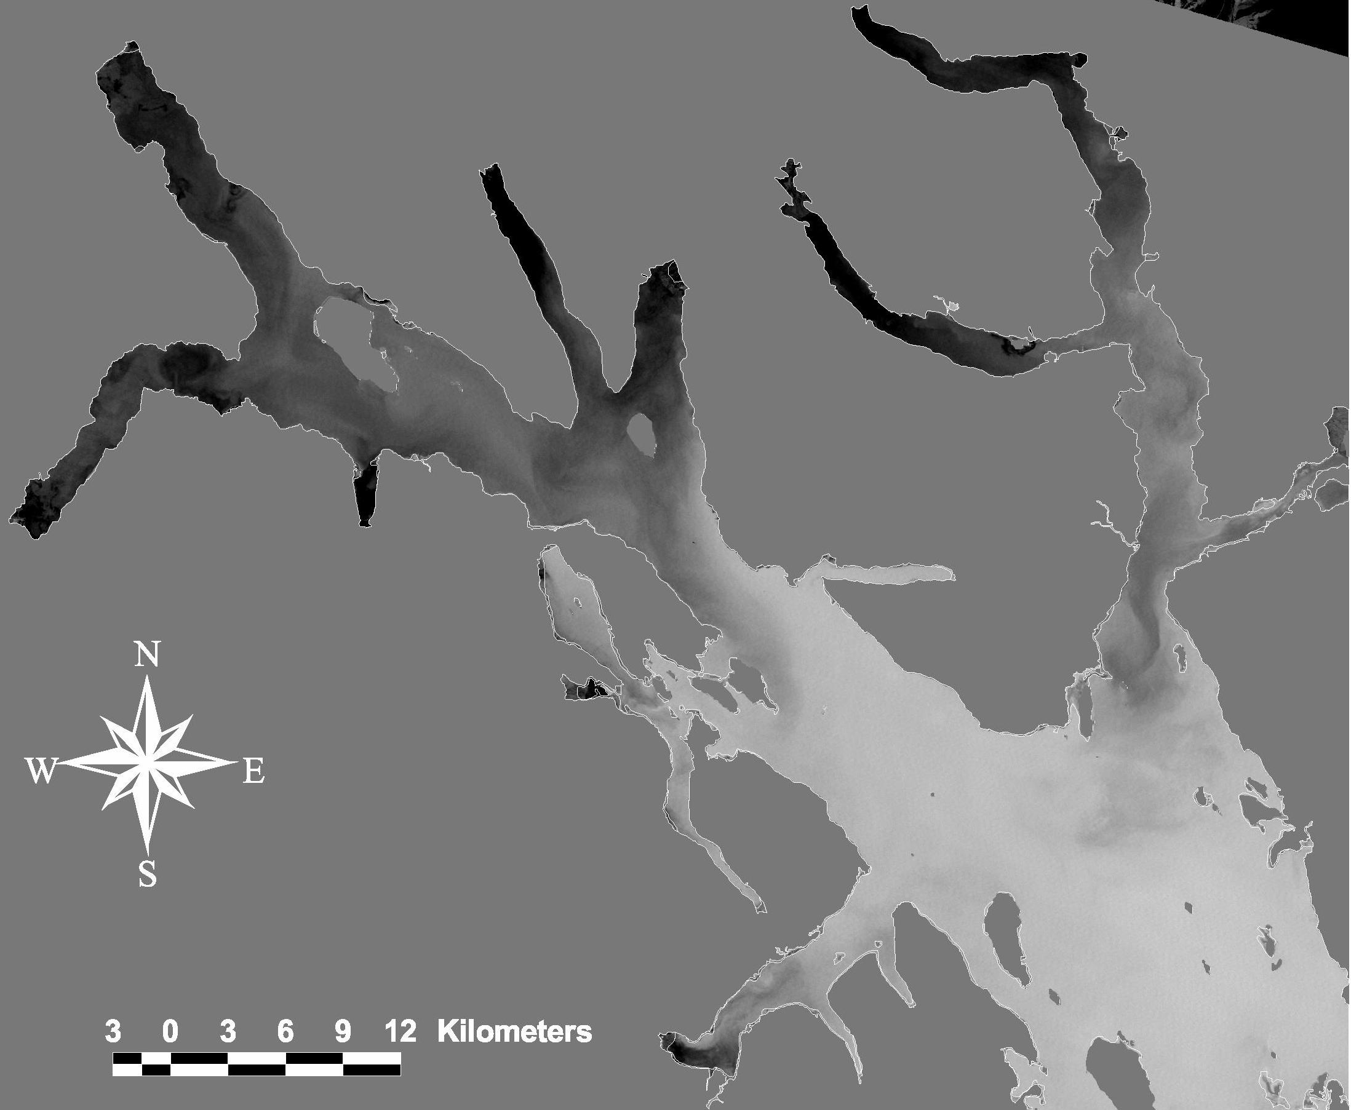

Figure 30. Close-up of Landsat TM composite sediment image (Band 1) in Figure 29, 07 June, 1995, showing fine-scale details of the sediment eddies and plumes in the upper Bay. Turbidity patterns are shown in shades of gray, with darker shades indicating greater amounts of sediment in the surface waters.

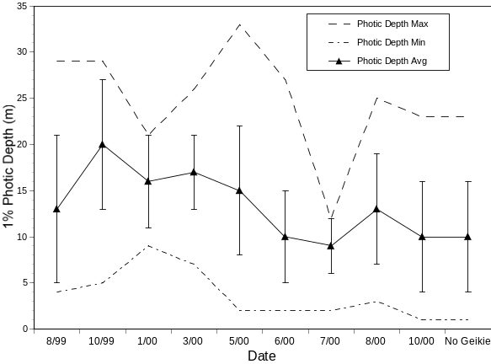
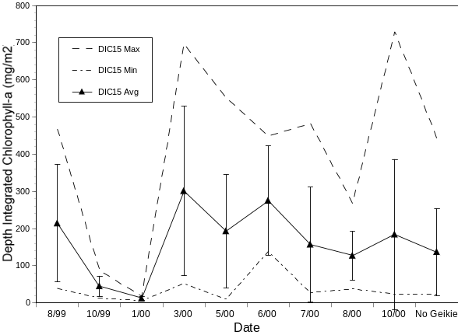
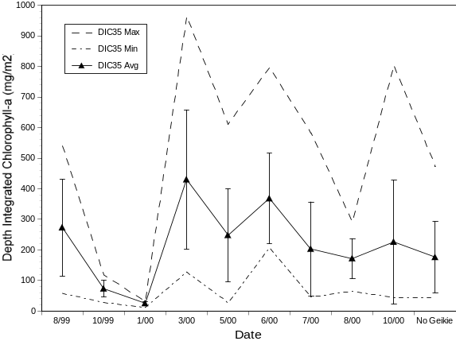
A
B
C

Figure 31. Seasonal patterns of phytoplankton standing crop and light penetration in Glacier Bay. The solid lines depict the mean (averaged over all stations for each survey) depth-integrated chlorophyll-a levels for 15m (A) and 35m (B), and the mean 1% photic depth (C), with error bars representing one standard deviation. The minimum and maximum values from each survey are shown by dotted lines. The 1% photic depth (C) is the depth to which 1% of the maximum surface PAR value penetrated.

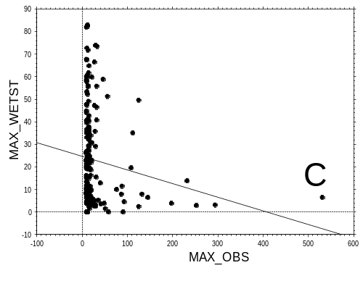
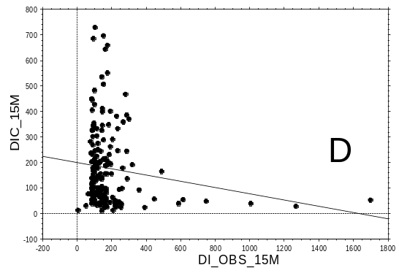
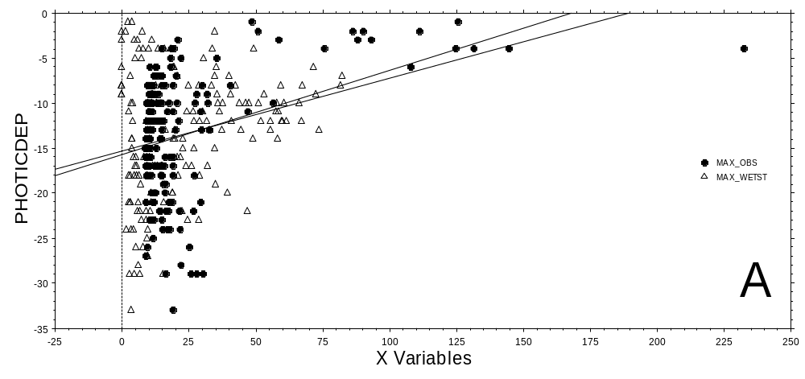
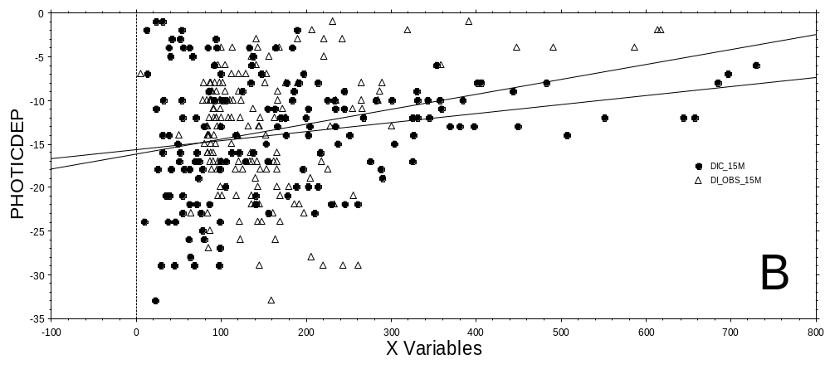

Figure 32. The relationships between sediment concentration, chlorophyll-a concentration, and photic depth from August, 1999, through October, 2000. In A, the 1% photic depth (PHOTICDEP, m) is plotted against both the maximum turbidity value (MAX_OBS, mV) and maximum fluorescence value (MAX_WETST, mg/m³) for each cast. In B, 1% photic depth is plotted against both the 15m depth-integrated chlorophyll-a value (DIC_15M, mg/m2) and the 15m depth-integrated turbidity value (DI_OBS_15M, mV) for each cast. The correlations between maximum turbidity and fluorescence values (C) and between depth-integrated turbidity and fluorescence values (D) are also shown. Regression lines are shown to indicate general trends, not statistical significance. December-February casts have been omitted.

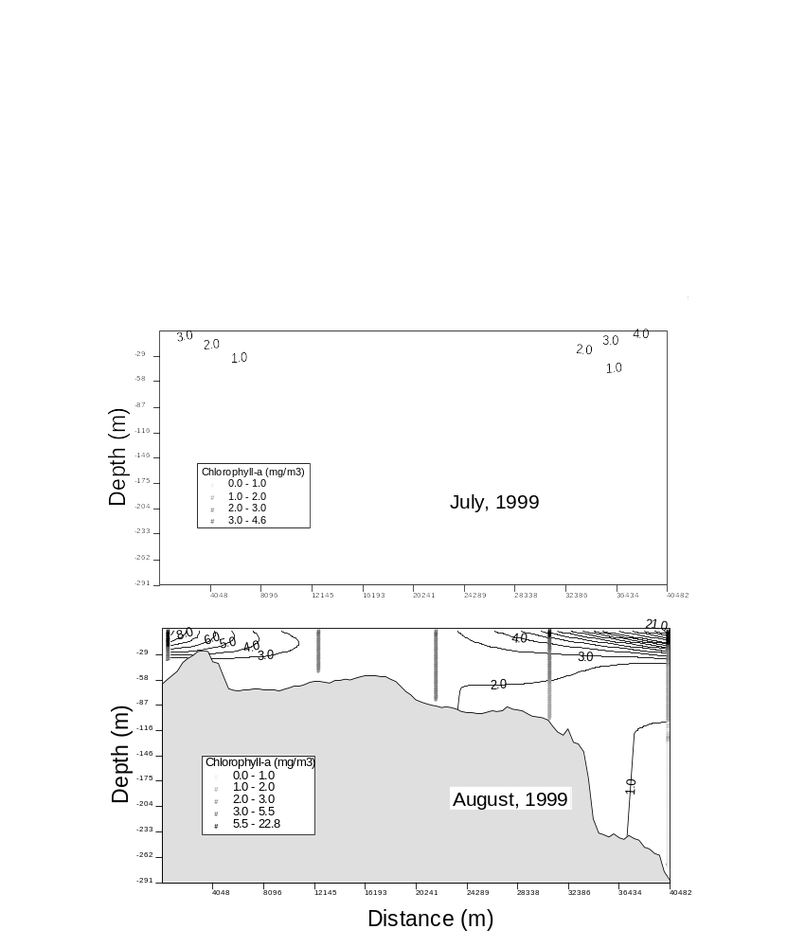
A
B
C
00 01 02 03 04

Figure 33. Fluorescence profiles and contours along the lower Bay survey line (stations 00 – 04) during three summer months of 1999: 09 & 15 June (A), 07 & 09 July (B), and 22-23 August (C). The non-stratified stations (see Figure 8), and often other lower Bay stations as well, exhibited chlorophyll-a throughout the water column. The cast profiles are numbered by oceanographic station, and fluorescence is contoured every 1.0mg/m³.

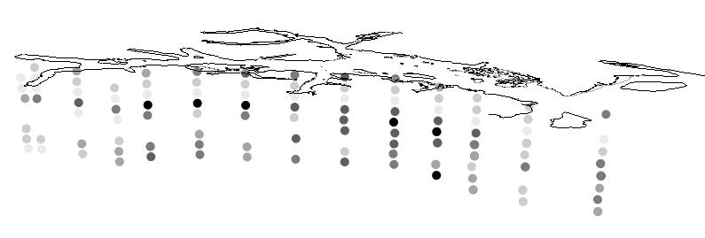
00
01
05
06
07
08
09
10
11
12
02
03
04
21
04
13
14
15
16
17
18
20
19
B
A
Survey
(Date)
Survey
(Date)

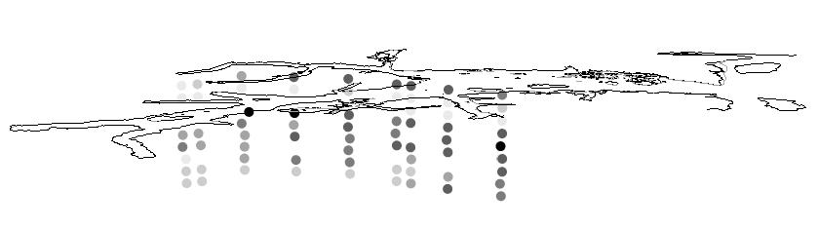

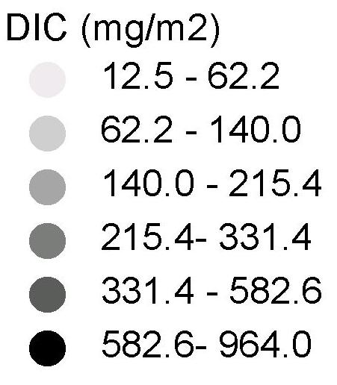

Figure 34. The spatial and temporal variability of phytoplankton (DIC, 35m depth-integrated chlorophyll-a) along the main Glacier Bay – West Arm (A) and East Arm (B) survey lines between August, 1999 and September, 2000. The images are rotated three dimensionally to optimize the viewing of the survey lines, with North to the left. The vertical dimension represents different surveys in chronological order from top to bottom. The surveys represented are, in order, August and October, 1999, and January, March, May, June, July, August, and October, 2000. The DIC values are numbered by oceanographic station; station 04 is included in both the West Arm and the East Arm survey lines. Some stations do not have values from all surveys (missing dots).

00 01 02 03 04 05 06 07 08 09 10 11 12

Figure 35. Fluorescence profiles and contours along the main Glacier Bay - West Arm survey line during the warm-water intrusion event of 26-28 June, 1998. Chlorophyll-a levels were elevated at the base of the water column at stations 04 - 07. Another (presumably unrelated) fluorescence anomaly was also detected at station 12 at the head of Tarr Inlet, and chlorophyll-a was vertically well mixed throughout the lower Bay. The cast profiles are numbered by oceanographic station, and fluorescence is contoured every 1.0mg/m³ except for values below 1.0mg/m³.

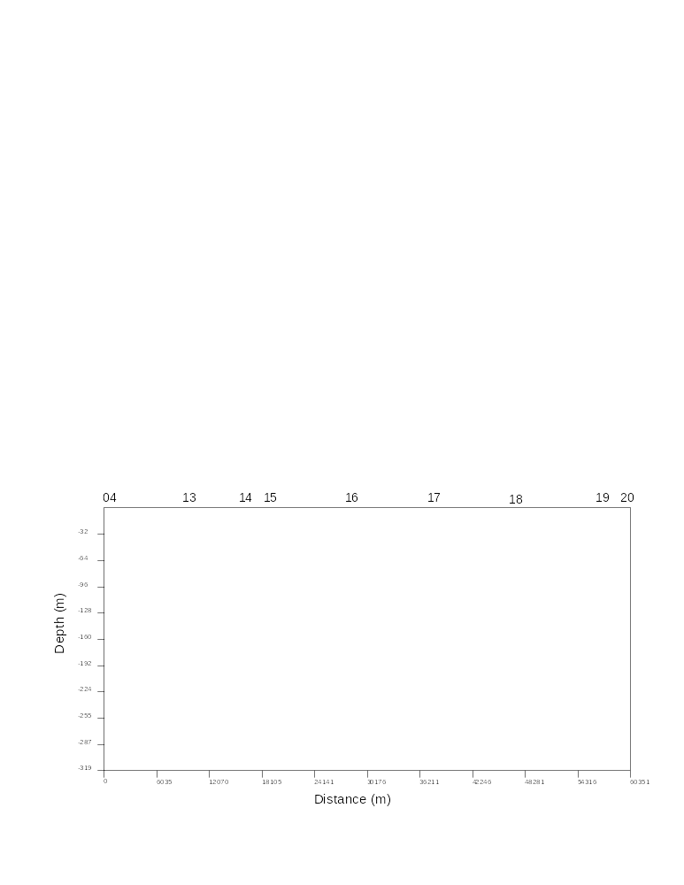

Figure 36. Fluorescence profiles along both the main Glacier Bay - West Arm and East Arm oceanographic survey lines during 07-09 July, 1999. Elevated densities of chlorophyll-a were detected deep in the water column at stations 12, 21, and 20. Phytoplankton was also fully mixed at station 02 in Sitakaday Narrows. The cast profiles are numbered by oceanographic station; the arrow indicates station 04 in both survey lines.

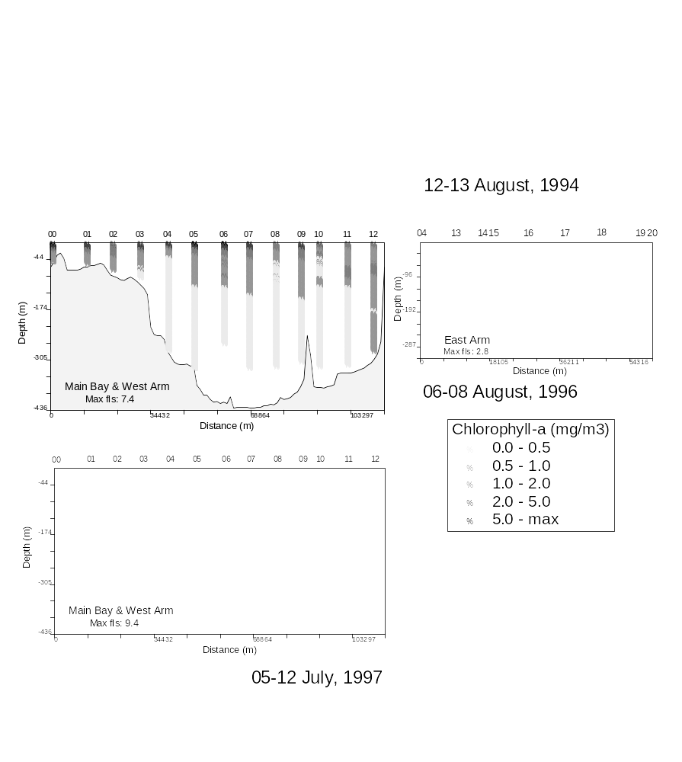
A

B

C

06-08 September, 1996

Figure 37. Fluorescence profiles along both the main Glacier Bay - West Arm and East Arm oceanographic survey lines during three head-of-fjord chlorophyll-a anomaly events (A: 12-13 August, 1994; B: 06-08 September, 1996; and C: 05-12 July, 1997). Elevated densities of chlorophyll-a were detected deep in the water column at stations 12, 19, and 20. In each case, phytoplankton was also mixed throughout the water column at the lower Bay stations. Chlorophyll-a also extends to anomalous depths in the lower West Arm during September, 1996. The cast profiles are numbered by oceanographic station; station 04 is included in both the West Arm and the East Arm survey lines.

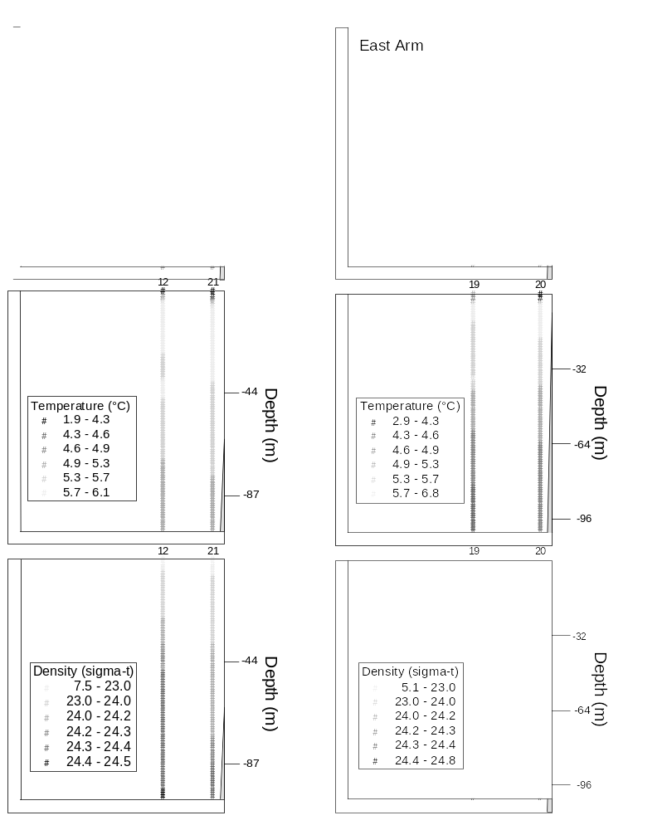
A
B

Figure 38. Salinity, temperature, and density profiles for the surface 100m at stations 12 and 21 (A; head of Tarr Inlet) and 19 and 20 (B; head of Muir Inlet) during the fluorescence anomaly of 07-08 July, 1999, shown in Figure 36. The water column was stratified. The cast profiles are numbered by oceanographic station.

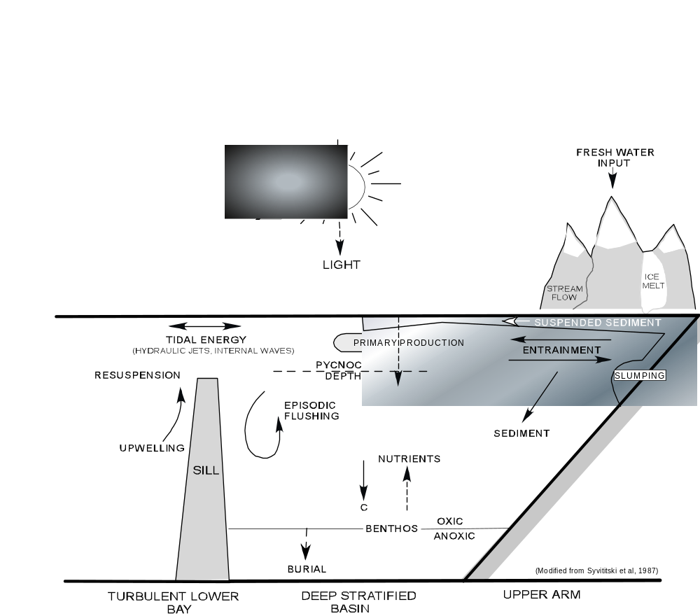

RAIN

Modified from Syvitski et al., 1987

Figure 39. Conceptual model for the major processes influencing the oceanography of Glacier Bay. The model depicts the three different oceanographic regimes hypothesized by this paper. This figure is based on one in Syvitski et al. (1987).

III. Oceanographic Data Resources At
Glacier Bay
The overall root directory for these data resources is /eco_data/data/glba/ocean/. This can either be found on the Glacier Bay computer network server “Barco” on the k:/ drive or from the two-CD-ROM set of oceanographic data. The difference between the two CD’s is the years of processed oceanographic cast data included; all other files are identical. CD #1 has years 1992-1997 and CD #2 has years 1998-2000. From this point onward, all references are to files within the /eco_data/data/glba/ocean/ directory. The FGDC metadata for all data types are in /GIS/FGDC_METADATA, and all metadata text files have a “.met” extension. Metadata also exists as html files, which can be displayed with an internet browser.

OVERALL FILE CONSTRUCTION (Found on both BARCO and the CD-ROM set):
…/OCEAN
ANALYSIS
PUBLICATIONS Publications on oceanography
REPORTS This report
DATA
PROCESSED All the processed CTD files by year and survey, within GIS projects
TEMP_LOGGERS Temperature logger files
WEATHER Weather data from stations around Glacier Bay
RAW_CTD The raw instrument data files from the CTD, by instrument, year, and upload session
GIS
ArcExplorer_Install A simple utility to view the data if the user does not have ESRI’s ArcView GIS
AVHRR AVHRR satellite data in georeferenced GIS projects
FGDC_Metadata The metadata for all data files
Oceanographic_Analyst_Extension The 3&4-D processing, analysis, and visualization tool to use within ArcView
…MULTIPLE GIS COVERAGE DIRECTORIES
PROTOCOL The oceanographic monitoring protocol

A. OCEANOGRAPHIC DATA:
- CTD Cast Data: The principle data are contained in CTDMaster files and ProfileMaster files. Metadata for each of these files is in the metadata directory. The CTDMaster files are 2-D spatial data (X = longitude, Y = latitude) consisting of one record per cast; the attributes are various summary values for the entire profile of that cast. These files are named CTDMasterYYYYMMDD with YYYY standing for the year, MM for the month, and DD for the day. MM and DD include a leading zero if necessary. The CTDMaster files are in the form of .dbf files with the X and Y values as attributes that are projected “on the fly” in each ArcView Project.

The ProfileMaster files consist of the combined profiles throughout the water column for all of the casts in a survey. The ProfileMasters are 3-D spatial datasets (X = longitude, Y = latitude, Z = Depth) consisting of one record for each one meter of depth that was profiled. Each record has all of the different sensor data; multiple readings for each sensor are averaged together over that 1-meter “depth bin”. These ProfileMaster files have been turned into “Point-Z files” or georeferenced 3-D ArcView shape files, with the attributes contained in .dbf files. The Point-Z files are named as YYYYMMDD plus the type of trip (e.g., “200001ocean”). In addition to the ProfileMaster and PointZ files, each cast is also saved and named by its Instrument+Dump#+Cast# as .dbf files (e.g. “C2006800.dbf”). The data that constituted each of these .dbf files are labeled with the “.cnv” extension and were themselves created from raw data .hex files utilizing Sea-bird software (from the manufacturer of the CTD instrument). These .cnv files are text files and can be viewed with a text editor. For more details about these data, consult the Fjord Oceanography Monitoring Handbook.

- ArcView Projects: The data from each survey are processed and displayed within an ArcView GIS project. The template for this project is located at …/GIS/ocean_template.apr. These ArcView projects require Spatial Analyst, 3D Analyst, and the Oceanographic Analyst to be viewed. Each project is identically constructed with three 2-D overhead Views in different projection systems (unprojected UTM NAD27, UTM-projected decimal-degrees NAD27, and UTM-projected decimal-degrees NAD83). Each of these Views contains multiple base coverages useful to the display or analysis of oceanographic patterns (e.g., bathymetry). These base coverages exist in the …/GIS directory.

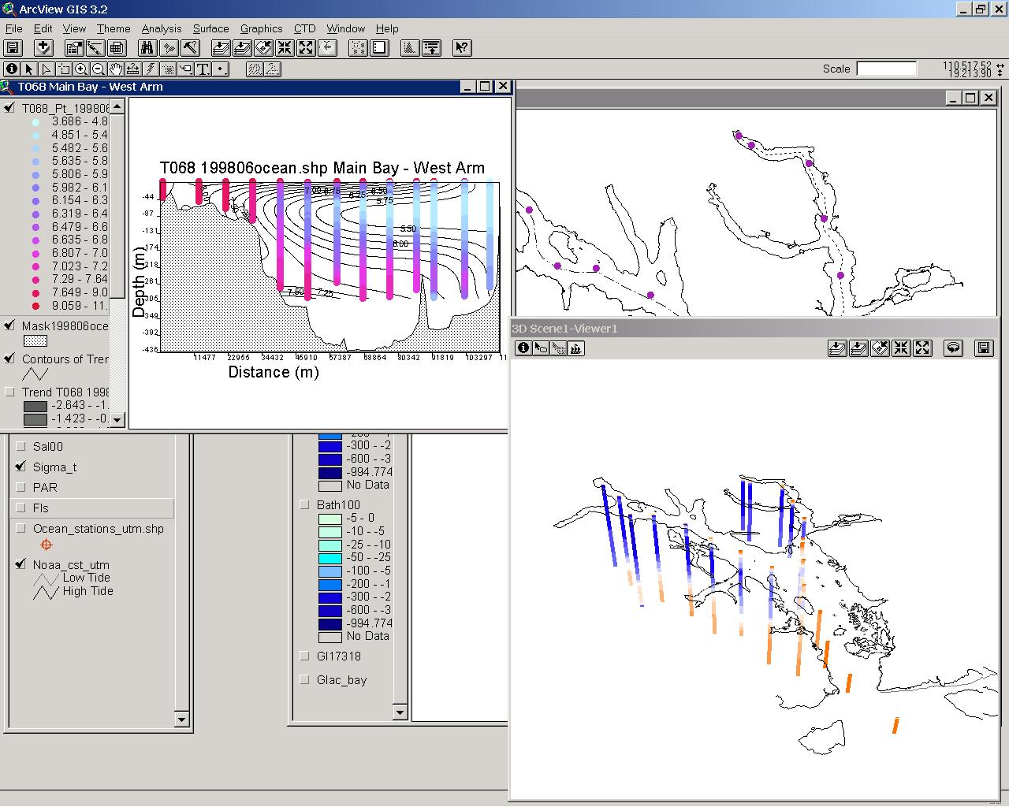

The screen-shot above shows, in the upper left corner, a 2D “slice” of temperature along the Main Bay-West Arm transect. A 3-D rotating view of all the temperature cast data is displayed in the lower right corner. The main 2-D View with the CTDMaster data is visible behind the other two windows.

The principle oceanographic file displayed in these Views is the 2-D CTDMaster file. There are also multiple Views that represent 2-D “slices” of the water column taken along various long-Bay transects, with one View for each type of instrument data. These 2-D “slices” are created from the ProfileMaster PointZ (3D) shape file. Finally, there are also 3-D rotating coverages of the ProfileMaster data projected into 3D Scenes, in which the cast data are displayed down through the water column. For more details about the ArcView Projects, consult the Fjord Oceanography Monitoring Handbook.

- AVHRR data: Multiple AVHRR satellite images are displayed in an ArcView project (…/GIS/avhrr2.apr). The satellite data are located in the …/GIS/AVHRR/ directory by date, and are saved as ArcInfo GRIDS and Stacks. Metadata for these files are found in each directory and are labeled “*.met”.

B. WEATHER DATA:
Twenty years (1980-2000) of NOAA National Climatic Data Center (NCDC) weather data from 26 weather stations surrounding Glacier Bay have been processed as part of this project. A tool to convert NCDC files into a usable format is part of the Oceanographic Analyst Extension (see below). Over 36 different weather variables may exist for each station. All of the files have been converted and saved as one .dbf file, named “GLBAWeather.dbf”. This file is found in the …/Data/Weather/ folder. Metadata for this file are found within this folder and in the …/GIS/FGDC_Metadata/ folder. The weather data file is constructed so that each record represents a single day at a single station, with the different weather variables as columns of data (fields). The list of station names and locations is found in the .dbf file :Stations.dbf”. This file can be joined to GLBAWeather.dbf in ArcView to create a spatial point dataset.

C: ANALYSIS TOOLS
The Oceanographic Analyst Extension and ArcView project with all scripts are found in the …/GIS/Oceanographic_Analyst_Extension/ folder. The Ocean.avx file should be copied to the user’s ArcView ext32 folder. This extension, which is described in detail in the Fjord Oceanography Monitoring Handbook, was specially created for the Glacier Bay oceanography project, but is designed to be used with any oceanographic data set. The program allows 3- and 4-D analysis and display of volumetric and time series oceanographic data. It is the only tool available at the current time that allows integration of full-cast oceanographic data into a GIS system. It has a special module for processing Sea-bird CTD data from the raw text form into a 3-D hierarchical spatial data set. In addition, there are multiple tools for functions such as calculating photic depth, integrating chlorophyll-a, processing weather data, exporting and importing, aggregation, summarizing, etc.

IV. Resource Needs For An Oceanographic Monitoring Program At Glacier Bay

EQUIPMENT AND RESOURCES AVAILABLE:
-Two identical fully-instrumented CTD’s, capable of recording depth, temperature, salinity, sediment (turbidity, via an OBS sensor), light penetration (photosynthetically active radiation, PAR), and phytoplankton (chlorophyll-a, via a fluorometer) throughout the water column to a depth of 300 meters.
-One Acoustic Doppler Current Profiler, capable of measuring current at one-meter intervals throughout the water column to a depth of 300 meters.
-A set of geographic information system integrated tools for the processing, analysis and display of data.

EQUIPMENT AND RESOURCES NEEDED:
Vessel Needs:
-270 hours of vessel/field time for five surveys. This represents working and travel time and does not include sleep time. The winter survey must be conducted on a larger vessel (e.g., R/V Alaskan Gyre, M/V Nunatak) due to the inclement weather conditions at this time of year. The spring, summer, and fall samples may be taken from a mid-sized boat (e.g. Eider, Capelin) that has a davit and motorized powerblock. To allow for comparison between years (a primary objective of all monitoring programs), these surveys should be conducted on the same calendar dates each year.

Personnel Needs:
-270 hours of boat operator time: Captain the boat during surveys.
-350 hours of skilled technician time*: Prepare and maintain equipment, take measurements, process data, error-check data.
-60 hours of oceanographer time, or a marine biologist with strong oceanographic background: Analyze output for oceanographic phenomena, compare to past data and weather, and prepare a basic report.

*The technician position requires a precise, highly trained individual, dedicated to the task. Numerous CTD casts taken since 1992 had to be discarded due to attempts to utilize “available personnel”. The work performed by this individual can be directly compared to a skilled lab technician preparing DNA samples for analysis. While the methods are prescribed in detail (see the Fjord Oceanography Monitoring Handbook), the execution requires skill, precision, and dedication.

Additional Re-occurring Needs:
-$2,000 in calibration tests each year
-$3,500 food and CTD supplies
-$2,500 for satellite imagery (maximum, based on every survey occurring during clear weather)

Additional One-time Needs:
-$2,000 OBS calibration for sediment samples taken from five oceanographic stations in Glacier Bay, to allow conversion of OBS millivoltages to density of sediment in the water.

Recommended Dates for Surveys (and primary objectives for each month):
-January: Determine whether winter unstratification occurred, as well as conditions for continual deep-water renewal from outside Glacier Bay and water column mixing within the Bay.
-March: Determine whether early stratification occurred and whether the Bay has moved out of the winter pattern. Determine the intensity of the phytoplankton bloom.
-May: Determine degree of phytoplankton decrease post-bloom, or the presence of a late bloom.
-July: Determine the summer water column conditions and whether summer deep-water renewal has occurred. This is the best month to obtain stable summer temperatures to correspond with winter (January) temperatures to determine long-term warming or cooling.
-September: Determine the intensity of fall freshwater and sediment discharge into the Bay and whether the bloom continues into fall or is suppressed due to sediment discharge. Determine whether freshwater discharge is “capping off” deep-water renewal at the sill.

The exact date each month should coincide with the Landsat satellite overpass to maximize the information that can be extrapolated cross-Bay from the CTD sampling. There are four basic patterns of oceanography at Glacier Bay: winter, spring, summer, and fall. The importance of the timing, intensity, and length of the phytoplankton bloom in the spring and summer warrants an additional sample in May.

V. Proposed Future Oceanographic Research

The work that has been conducted to date has suggested several research topics that would add significant missing information to our understanding of oceanographic processes in Glacier Bay and of how these processes might affect biotic processes. We have limited this list of research to short-duration projects that we believe would result in the highest ratio of information produced to effort expended. These projects are listed in their suggested sequence of execution, in order to build on previous knowledge and to provide essential information for later projects. However, several of the projects can and would stand on their own, providing valuable information even without completion of the other suggested research.

1. Determine Hydraulic Flow Patterns at the
Sitakaday Narrows Sill and Contraction

PURPOSE
Previous oceanographic data from CTD casts taken in the Sitakaday Narrows area (see Section II) indicate strong tidal mixing and suggest that very fast currents are producing hydraulic instabilities. Our data and the literature suggest that these hydraulic instabilities in turn produce hydraulic jets and internal waves that result in mixing phenomena at great depths and distances from the Sitakaday area. If this is true, then the frequency, intensity, and extent of this phenomenon could have profound effects on nutrient regeneration and mixing, as well as many biotic processes such as system productivity and larval dispersal and transport.
The purpose of this study would be to quantify the relationships between the intensity and pattern of current flow, water source, and mixing, and to determine the nature of any hydraulic instabilities. To do this, continuous current measurements from all depths at multiple stations in Sitakaday Narrows, taken simultaneously with CTD samples of the water column, would be necessary. This procedure would be performed during both a spring and a neap tide series, representing periods of maximal and minimal flow, respectively. The resulting data should be fitted into a mathematical model of hydraulic properties in a spatial environment representing the real-world variability of the area. This would allow extrapolation of the results to other current speeds, and to baseline oceanographic conditions.

POSSIBLE METHODS
This study could be performed with two vessels, each equipped with an Acoustic Doppler Current Profiler (ADCP) and a CTD. The ADCP would be configured to take continuous samples in a downward direction utilizing a Y-encrypted P-code Global Positioning System (GPS) receiver to obtain positional data in order to correct for boat movement. One vessel would take continuous current measurements while traveling between oceanographic stations 01 and 02, while the second vessel would take continuous current measurements between stations 02 and 03 (see Section II). At each oceanographic station, a CTD profile would be taken to allow comparison with previous years’ data at these stations. Both vessels would sample throughout two tidal cycles on each of two dates that would be selected to represent the peak tidal flow (spring tide series) and lowest tidal flow (neap tide). Sampling two tidal cycles per tide series would allow for one replicate and some understanding of variability. The resulting dataset would require integration into a 3- and 4-D capable GIS, which could accomplished by modifying the Oceanographic Analyst GIS Extension to handle vector data (current speed and direction at each depth). This would allow the creation within a GIS environment of a hydraulic model that takes into account the physical structure of the area.

SUGGESTED PRODUCTS
The primary digital product of this study should be a 4-dimensional GIS dataset of current patterns and oceanographic structure during peak and lowest tidal flow throughout a complete tidal cycle. The primary analytical product should be a spatially specific mathematical model elucidating the pattern of any hydraulic processes in the Sitakaday Narrows area. This model could then be used by future research on primary productivity, nutrient flow, zooplankton distribution, larval dispersal, and by many other studies. Because of the possibly profound effects of these hydraulic processes as well as the complexity of the phenomenon, it is strongly suggested that the products from this study be incorporated into a peer-reviewed publication submitted to an oceanographic journal.

2. Determine the Presence and Pattern of
Internal Waves in Glacier Bay

PURPOSE
Previous oceanographic data from CTD casts taken in the Sitakaday Narrows area (see Section II) indicate strong tidal mixing and suggest that very fast currents are producing hydraulic instabilities. Our data and the literature suggest that these hydraulic instabilities in turn produce hydraulic jets and internal waves that result in mixing phenomena at great depths and distances from the Sitakaday area. Internal waves were previously reported from one station (in central Glacier Bay) during one 13-hour sampling period in 1965. The frequency, intensity, and extent of internal waves could have profound effects on nutrient regeneration and mixing, as well as many biotic processes such as system productivity and larval dispersal and transport.
The purpose of this study would be to determine the vertical and horizontal extent of internal waves produced by hydraulic and tidal action in Sitakaday Narrows. If the previously proposed study (proposed project #1) confirms the presence of hydraulic jets, this study would expand on that theme. The vertical and horizontal extent of the resultant internal waves would then be analyzed to determine their impact on mixing phenomena at various distances from Sitakaday Narrows.

POSSIBLE METHODS
This study should be hierarchical in its approach; the presence of internal waves would first be confirmed at each oceanographic station before sampling occurs at the next, starting at oceanographic station 03 and traveling up-Bay (see Section II). Twenty-four hours of sampling would be conducted at each station during a spring and a neap tide series. This sampling would consist of obtaining a CTD profile each hour from the surface to the bottom, or to a depth of 300m, for a total of 48 casts at each station. The time series of oceanographic parameters at each depth would then be examined to determine whether cyclical vertical movement in parameters such as salinity was observed. If it were, then sampling would be repeated at the next sequential station (station 04), and so on. This would be conducted up both arms of the Bay if the phenomenon were observed at the mouth of each arm. The data from this project would be integrated into the Oceanographic GIS utilizing the Oceanographic Analyst software.

SUGGESTED PRODUCTS
The primary digital product of this study should be a 4-dimensional GIS dataset of internal wave patterns as represented by the vertical motion of oceanographic parameters during peak and lowest tidal flow through a complete tidal cycle. The primary analytical product should be a conceptual model quantifying the pattern and extent (both vertically and horizontally) of internal waves in the mid- to upper Bay. This model could then be used by future research on primary productivity, nutrient flow, zooplankton distribution, larval dispersal, and by many other studies. If the presence of substantial internal waves is demonstrated, these data should be integrated into a large peer-reviewed work on fjord oceanographic processes at Glacier Bay, or should be published as a separate short note adding to previously published work.

3. Determine Nutrient Availability
In Glacier Bay

PURPOSE
Oceanographic observations have indicated that mixing and deep-water renewal occur frequently and throughout the year in Glacier Bay. In addition, internal waves have once been documented in the mid-Bay, and multiple sources for such internal waves have been hypothesized. These phenomena combined with the high and sustained levels of phytoplankton observed from spring through fall in Glacier Bay imply that nutrient availability is not limiting in either the deep or surface waters of the Bay, even in summer. This pattern is unlike that observed in other Alaskan fjords and coastal waters, where both low nutrient availability and low levels of phytoplankton characterize summertime surface waters once the initial spring bloom has occurred. However, this assumption that nutrients are not limiting in Glacier Bay needs to be tested in order fully to understand circulation and mixing patterns, as well as the patterns of primary productivity.

POSSIBLE METHODS
Because this study requires substantial laboratory resources and skills that are currently unavailable in Glacier Bay, we believe this study would best be conducted in collaboration with a professor or graduate student at a university with lab facilities. During regular oceanographic monitoring surveys in Glacier Bay, water bottle sampling equipment would be deployed at each survey station. Water samples would be collected at multiple depths from the surface to the bottom, with more samples taken from surface waters and larger sampling intervals at greater depths. Ideally, sampling would occur for at least one full year to capture seasonal variation, although samples from spring through early fall are most crucial. Concentrations of nitrogen, phosphorus, and silica in the water samples would then be measured and correlated with station location, sampling depth, and phytoplankton abundance. Simple testing kits are available for monitoring water quality in the field, and this method of measuring nutrients could easily be implemented at Glacier Bay with our existing facilities. However, true laboratory facilities such as those found in an oceanographic or water sampling lab would produce much more accurate and detailed results. Other nutrients might also be measurable if better laboratory facilites were used.

SUGGESTED PRODUCTS
The principal digital product of this study would be a GIS database of absolute nutrient availability at multiple depths of each oceanographic survey station throughout Glacier Bay. The primary analytical product would be a correlation of these nutrient levels with phytoplankton levels at each location, and of the nutrient levels with geographic location in the Bay. Spatial and temporal patterns of nutrient enrichment and/or of nutrient depletion will assist in confirming or modifying our model of mixing and circulation patterns in Glacier Bay. They will also be incorporated into current hypotheses about the underlying causes for large standing crops of phytoplankton observed throughout the summer.

4. Determine Timing and Intensity of the Bloom
In Glacier Bay

PURPOSE
An understanding of the timing and intensity of the phytoplankton bloom is necessary to understand the fundamental pattern of primary productivity in Glacier Bay and to calibrate and/or place bounds around the oceanographic monitoring sampling. Work from the APPRISE Project at Auke Bay, Alaska, demonstrated a short intense peak of phytoplankton productivity in late April, with very low productivity levels before and after. Sampling conducted in Glacier Bay indicates chlorophyll-a levels as high as those observed at Auke Bay, with continued large standing crops of phytoplankton sustained throughout the summer and fall (see Section II). However, with the relatively infrequent sampling in Glacier Bay, it is impossible to determine whether there may be a short-term peak of even higher levels. In addition, the precise timing of the onset of the bloom has not been determined. Not knowing how high primary productivity levels can reach in Glacier Bay makes a full understanding of the processes controlling primary productivity and a comparison of productivity between different years difficult.

POSSIBLE METHODS
There are two possible ways to obtain these data. One requires substantial labor and boat time, while the other requires substantial equipment investment. The first option is quite simple in its field implementation, requiring only that CTD samples (with a fluorometer and OBS and PAR sensors) be taken on a daily basis throughout the water column. However, the most convenient place to take these samples is probably not deep enough (the outer dock of Bartlett Cove), and the waters of Bartlett Cove are probably too mixed (as indicated by nearby oceanographic station sampling and by satellite imagery) to accurately indicate phytoplankton levels Bay-wide. Thus, to accurately obtain data would require daily or every-other-day sampling in the mid-Bay area of Glacier Bay, between the dates of March and October. The labor and boat costs, as well as the difficulty of traveling in a boat in late winter/early spring, make this simple method, which uses existing equipment, prohibitively expensive.
The alternative method is to utilize a specially-purchased fixed oceanographic instrument (with wiping shutters to clean off marine growth) set at a depth of 10 meters in the central portion of Glacier Bay. This unit would only require maintenance and downloading twice a year. The additional advantages are two-fold. First, the measurements would be continuous. Also, at little additional expense, it would be possible to obtain multiple years of data at the one site or samples from different sites in subsequent years. The primary disadvantage of this method is that measurements could be taken at only one depth, while most oceanographic parameters require evaluation throughout the water column in order to accurately discern patterns. However, measurements of chlorophyll-a at one carefully chosen depth would reveal the timing and intensity of the bloom at one site, as has previously been demonstrated in Auke Bay by the APPRISE Project. Additional samples of the entire water column could occasionally be taken in order to calibrate the data from the moored instrument with depth-integrated chlorophyll-a levels.
The data from this study would be integrated with the standard oceanographic monitoring data into the Oceanographic GIS utilizing the Oceanographic Analyst software. Integration into the GIS system would allow time series analysis and extrapolations to broader areas. In addition, weather data should be integrated in order to understand the role of air temperature and cloud cover on primary productivity.

SUGGESTED PRODUCTS
The principal digital product of this study would be chlorophyll-a levels at a particular location and depth throughout the phytoplankton growing season, integrated into the oceanographic GIS system. The primary analytical product would be a curve showing the height and timing of the bloom during several years and its relationship with whole-Bay oceanographic patterns and weather. These results could be used to calibrate samples taken from the oceanographic monitoring program.

5. Determine Relationships of Weather Patterns and Broad-scale Oceanographic Patterns with
Oceanographic Patterns at Glacier Bay

PURPOSE
In Glacier Bay there are large interannual variations in the values and patterns of oceanographic parameters (see Section II). In addition, there are multiple examples of large between-year population and fecundity changes in species that are dependent on the marine ecosystem of Glacier Bay (e.g., humpback whales, harbor seals, Black-legged Kittiwakes). Many critical resource issues at Glacier Bay require determining whether these rapid biotic changes have local anthropogenic causes or are “natural” or part of broader regional or global changes. Now that we have a multi-year dataset of oceanographic values, we can begin to examine how broader-scale processes affect Glacier Bay and its marine ecosystem.
The purpose of this study would be to elucidate the relationships, if any, between Glacier Bay’s oceanographic patterns and both weather and external oceanographic patterns, on a local, regional, and global scale.

POSSIBLE METHODS
This study is principally an analytical project, but it requires the continual input of data from Glacier Bay’s oceanographic monitoring program. Data from the oceanographic monitoring program for the last nine years, as well as local weather data for the last twenty years, are currently integrated into an oceanographic GIS. These data would be combined with broad-scale oceanographic data from NOAA and with regional and global weather data from the NCDC. Trend analysis and spatial and temporal autocorrelation analysis would be conducted on the resulting datasets to determine associations. Relationships between local and global phenomena would also be compared to long-term datasets of species abundance and/or fecundity for Glacier Bay.

SUGGESTED PRODUCTS
If analysis results in significant correlations, then the primary analytical product from this analysis would be a predictive model for local relationships of oceanographic patterns with global and regional oceanographic and weather patterns. In addition, a predictive model for population and fecundity relationships with local oceanographic conditions should be developed. Both of these models should be tested in subsequent years of sampling for validity. The complexity of these possible analyses and any proposed relationships, as well as the controversy about using them in management predictions/actions, would necessitate a rigorous peer-reviewed publication process to obtain acceptance from the scientific community.

6. Determine the Validity of Extrapolating Cross-Bay Patterns from Center-channel Sampling

PURPOSE
The oceanographic monitoring program has been built on the premise that the lengthwise axis of Glacier Bay and its two principle arms represent the primary axis of oceanographic variability. An understanding of oceanographic processes along this principle axis is therefore assumed to explain the major oceanographic processes throughout the Bay. While there are no contradictory data to this premise (but see satellite imagery, Section II), and this sampling scheme has been widely used in other fjord estuarine systems, it is still an untested concept. It should be an early priority in the oceanographic monitoring program to test this premise and to determine whether significant sources of variability or significant oceanographic processes are being missed.
The primary purpose of this study would be to simultaneously examine and compare the cross-Bay patterns of oceanographic variables with the standard central-channel sampling. These data would then be used to validate, modify, or place bounds around interpretations of the current monitoring program.

POSSIBLE METHODS
This study would be performed most efficiently by utilizing both CTD casts and satellite data. Using two boats and two CTD instruments simultaneously, multiple full-water-column profiles would be taken along a survey line perpendicular to the Bay’s primary axis at each oceanographic station, with one kilometer spacing at most between casts. These cross-Bay samples should extend towards the shore until the bottom depth reaches 20 meters, in order to ensure that shallow-water coastline effects are evaluated. Simultaneous timing of the samples in the lower to mid-Bay would be critical to avoid interpreting tidal patterns as cross-Bay patterns. These samples would be integrated into the Oceanographic GIS utilizing the Oceanographic Analyst, which would be ideal for comparing cross-Bay with central-channel patterns.
Satellite data could also be used to compare surface values of temperature on an even finer scale, and to examine the effects of a wide range of topographical variability. This examination would require Landsat Thematic Mapper (TM) imagery (30m pixels) due to the coarseness of Advanced Very High Resolution Radiometry (AVHRR) imagery (1.113km pixels) and the resulting tendency in the Bay for many AVHRR values to be significantly affected by terrestrial temperatures. The timing of multiple oceanographic sampling trips would be planned so that they coincide with passes of the Landsat TM over the Glacier Bay area. This coordination of oceanographic monitoring program sampling with TM imagery acquisition would need to be repeated multiple times due both to the need for multiple samples and to the high probability that cloud cover would interfere with acquiring the TM imagery. The integration and analysis of these data once the TM images were obtained would be relatively straightforward utilizing the Oceanographic Analyst Extension in ArcView GIS.

SUGGESTED PRODUCTS
The primary digital products of this study would be broad coverage of CTD cast data during one oceanographic survey. These samples would be projected into volumetric space utilizing the Oceanographic Analyst Extension. An additional digital product would be multiple georeferenced Landsat TM images and synoptic oceanographic datasets. Such a series of satellite imagery spaced throughout a year would also be very valuable for conducting vegetation classification and for understanding terrestrial plant phenology in Glacier Bay.
The primary analytical product would be a test of the cross-Bay validity of the oceanographic sampling protocol. If this test showed significant discrepancies, then the sampling should be used to suggest remedial sampling locations or to place interpretive bounds around the results of the oceanographic monitoring program.

7. Determine the Patterns of and Processes Underlying the Head-of-Fjord Chlorophyll Anomaly

PURPOSE
The oceanographic monitoring has revealed distinctive anomalies in phytoplankton standing crop (chlorophyll-a) at the heads of both the West and East Arms (see Section II). This anomaly is characterized by large amounts of phytoplankton found throughout the water column. This pattern is usually observed during one summer survey, but the date can vary from May through September; most frequently it has been seen in July or August. These large amounts of phytoplankton throughout the water column exist in addition to the standard peak abundance of phytoplankton in the photic zone (the area where plankton have enough light to grow and reproduce, which is usually much shallower than 20m at the heads of the fjords). There is no evidence at these locations for significant mixing phenomena, which account for phytoplankton distributed below the photic zone in highly mixed areas such as Sitakaday Narrows. It is hypothesized in this report (Section II) that this anomaly is caused by interactions between organic (diatoms) and inorganic (glacial silt) constituents that form flocculants (larger particles that settle out) during times of high sediment discharge. One alternative hypothesis, that the anomaly merely represents the normal settling rates of phytoplankton, would require tremendously high primary productivity in this area. Another possibility is that there is a localized mixing phenomenon that we have not yet documented at the heads of the fjords, and that is camouflaged by overall water column stability in this area.
The purpose of this study is to determine whether the phytoplankton anomalies found at the heads of Glacier Bay’s fjords at certain times of the year are caused by the interaction between biological organisms and silt with a resultant rapid settling rate. Alternatively, this study would discover whether productivity (as measured by chlorophyll-a density) in this area is phenomenally higher than expected, or whether previously undetected mixing is occurring. The discovery of extremely high productivity in this area would have significant implications for understanding the attraction of some species to the heads of the fjords (e.g., euphausiids and Black-legged Kittiwakes), as would the discovery of a previously unknown mixing phenomenon. Alternatively, the confirmation of flocculant formation and resultant rapid sinking would increase our understanding of ice-margin anoxic organic build-up within deposited sediments and of the interactions between the biotic and physical environments.

POSSIBLE METHODS
During each oceanographic monitoring trip, the fluorometer readings of chlorophyll-a density would be examined for the presence of the anomaly immediately after taking casts at the head of each arm. Alternatively, data could be downloaded and displayed in real time during CTD casts at the tops of the fjords if the proper cables (instrument to computer) and slip-ring hydraulics were purchased and deployed. If the anomaly were observed, then multiple CTD samples would be taken in a pre-determined grid-spaced pattern throughout the head of the fjord. This sampling would be designed to determine both the extent of the anomaly and the presence of localized but very intense phytoplankton blooms. The CTD casts would also reveal localized mixing zones through density measurements and the resulting presence or absence of water column stratification. These data would be integrated into the Oceanographic GIS utilizing the Oceanographic Analyst Extension, which would allow visualization of both the extent and intensity of blooms and/or mixing patterns.
In addition, water bottle samples would be taken to obtain phytoplankton samples from below the photic zone. Additional samples to compare with these head-of-fjord samples would be taken at the same depths in the mid-Bay area. The phytoplankton and particulates in the samples would first be examined with a standard light microscope to determine visible differences in structure, and then sent to an electron microscopy lab for further comparisons.

SUGGESTED PRODUCTS
The primary digital product of this study would be a fine-scale volumetric interpretation of water column characteristics (primarily chlorophyll-a and stratification) at the heads of both arms during a phytoplankton anomaly. The primary analytical product would be a determination of whether there is a structural difference between the diatoms found in the anomaly and those from a non-anomalous area, and/or whether a particularly large sediment influx is a contributing factor. In addition, we would identify whether extremely localized but highly productive patches of phytoplankton or previously undocumented mixing events might be contributing to or causing this phenomenon.

8. Determine the Temporal and Spatial Patterns of Phyto- and Zooplankton Species Assemblages

PURPOSE
The oceanographic monitoring program provides an ideal opportunity to understand how species’ presence, abundance, and replacement may occur for both phytoplankton and zooplankton in Glacier Bay. It is known from the APPRISE study at Auke Bay, Alaska, that species assemblages for both plankton and zooplankton can vary greatly throughout the year in Southeast Alaska. Glacier Bay, with its large oceanographic variability within a small area, may exhibit even higher species diversity and changeover than other areas in Southeast Alaska. On the other hand, extreme conditions often diminish species diversity. The species assemblages found in an area can have large effects on patterns of primary productivity as well as of primary and higher-trophic-level consumption. Glacier Bay, with its lengthwise variability in oceanographic parameters as well as the differences between the East and West Arms, provides an excellent opportunity to examine phytoplankton and zooplankton associations under various oceanographic conditions.
The purpose of this study would be to determine the correlates, if any, between oceanographic parameters and phytoplankton and zooplankton species’ presence, abundance, and/or turnover.

POSSIBLE METHODS
This study would require substantial laboratory resources and personnel skilled in phyto- and zooplankton identification. In addition, it would require sampling over two or more years in order to elucidate the variability in species composition. However, the field methodology would only require small mesh net collecting, which could easily be done simultaneously with oceanographic monitoring sampling. For these reasons we believe this would best be done as a cooperative M.S. or Ph.D. project between a student committed to long-term data collection and analysis and the Glacier Bay oceanographic monitoring program. One year of these data for zooplankton has been collected; this effort should be expanded to phytoplankton and repeated for a least two years.

SUGGESTED PRODUCTS
The primary digital product of this study should be a GIS map of the probability of species occurrence each year. The primary analytical product should be an elucidation of the role of oceanographic conditions in species’ occurrence, abundance, and turnover. The complexity of the probable species/habitat relationships and analysis as well as the controversy about using the results in management predictions/actions would necessitate a rigorous peer-reviewed publication process to obtain acceptance from the scientific community.

9. Determine the Source Waters for Intermediate and Deep Water Renewal in Glacier Bay

PURPOSE
Oceanographic data from CTD casts taken in the Sitakaday Narrows and mid-Bay areas (see Section II) indicate that, contrary to previously published reports, deep-water renewal does occur during summer months in Glacier Bay. Deep-water renewal that occurs during the summer months results in nutrient enhancement during the time of maximum potential primary productivity. Previous accounts (e.g., Martin 1967, Matthews 1981) also hypothesized that the source water for winter deep-water renewal was from the Gulf of Alaska through Chatham and Icy Straits. However, none of the drift card experiments placed cards in or immediately outside of Cross Sound. Recent work (see Section II) suggests that the source waters for Glacier Bay’s intermediate and deep-water renewal come from the Gulf of Alaska via Cross Sound, a much shorter distance to travel. This deep-water renewal may be limited to spring tide series, or it may occur regardless of the tidal series. Determining the source waters would provide significant insight into the processes of intermediate and deep-water renewal in Glacier Bay and into the ability of waters that enter Glacier Bay to enhance productivity here.
The purpose of this study would be to determine whether the source water for Glacier Bay is Chatham Strait or Cross Sound. This question would be resolved for both summer and winter deep-water renewal events, which may differ.

POSSIBLE METHODS
This study could take advantage of new advances in inexpensive GPS drifters in combination with current and water column characteristic data in order to obtain a detailed understanding on the movements of water masses in the Cross Sound and Icy Strait area. The general methodology would include four GPS drifters, each with a VHF radio homing beacon, being released and then recovered during several separate 24hr periods. During these intervals, water column characteristics (salinity and temperature) and acoustic Doppler current profiles would be measured at intervals along the drift paths. Two drifters for each test would provide replication for each sample. A 24hr time period would allow for two complete tidal cycles to occur. Placement of drifters would occur at the Cross Sound/Icy Strait border and at the Chatham Strait/Icy Strait border at the start of flood tide currents on both spring and neap tide series. Drogues for the drifters would be set at both five meters and at a depth below the thermocline (if present) to determine the potential differences between the movements of different water masses in stratified waters. Current profiles and water column characteristics would then be entered into a flow model to determine the expected water mass movements and the resulting expected paths of the drifters. The actual drifter paths would then be compared with the model’s predictions to test its validity. The release of drifters would need to be done at least once during the summer and once during the winter.

SUGGESTED PRODUCTS
The primary digital product of this study would be a three-dimensional map of the currents and water column characteristics in Icy Strait. The primary analytical product would be a model determining the source water for Glacier Bay and the characteristics of that source water. In addition to its primary purpose, this project would produce information useful for several additional resource issues, including predicting oil spill movement and dispersion, identifying possible sources of phytoplankton, zooplankton, and larval immigration, and determining the potential for marine reserves within Glacier Bay to export larvae into other areas.

10. Determine the Relationship Between Chlorophyll-a Levels and True Primary Productivity at Glacier Bay

PURPOSE
The sampling of phytoplankton levels at Glacier Bay has been conducted using chlorophyll-a fluorescence as a proxy for phytoplankton productivity. This was done primarily because alternative sampling would not have been sustainable for a long-term monitoring program with limited funds in a remote location without laboratory facilities. Measuring chlorophyll-a as a proxy for primary production is widely practiced and is often presented in the literature, particularly for making relative comparisons. However, there are several assumptions that are potentially violated when making comparisons between areas or times of the year and when describing actual primary production vs. the standing crop of phytoplankton. These problems include the fact that the standing crop of phytoplankton does not directly represent primary production but is instead an integration of productivity, predation, and settling rates. In addition, different species of phytoplankton contain different amounts of chlorophyll-a; moreover, species composition can vary significantly over the course of a year and between locations, especially between locations with different oceanographic conditions. The extremely high levels of chlorophyll-a observed in Glacier Bay, as well as the high spatial and temporal variability in oceanographic conditions, make it more critical that a detailed understanding of the relationship between chlorophyll-a levels and productivity be determined. This relationship, in particular, needs to be determined before we can confidently extrapolate Glacier Bay’s high chlorophyll-a levels into causation for higher trophic relationships (such as predator abundances).
The purpose of this study would be to elucidate the relationships between chlorophyll-a levels and primary production in Glacier Bay. It will determine the validity of seasonal, annual, and spatial comparisons of phytoplankton production as indicated by fluorometry alone as part of a long-term monitoring program. This study will also place the high levels of chlorophyll-a observed in Glacier Bay into a larger regional perspective, and will establish the validity of using the hypothesized high productivity levels to explain higher trophic-level community structure and abundance.

POSSIBLE METHODS
This study would involve considerable field, laboratory, and analysis efforts. The field portion would consist primarily of obtaining water bottle samples of phytoplankton at the same time oceanographic sampling is occurring. Samples would need to be taken throughout the Bay and at multiple depths. It is suggested that at least every other oceanographic station be sampled and that samples would be taken during each oceanographic survey for at least one year. These samples would be field processed and fixed in such a manner that both phytoplankton species composition and abundance could be determined, as well as the level of chlorophyll-a fluorescence in the samples. Additional samples would be taken to conduct laboratory-based productivity experiments. The laboratory portion of this project would consist of species counts, chlorophyll-a fluorescence determination, and the conduct of light and dark bottle incubation experiments. While in situ experiments are generally assumed to provide more accurate data, the field conditions and lack of large ship-based laboratory facilities would make such analysis difficult and potentially less accurate than shore-based laboratory efforts. Data analysis would consist of determining the statistical relationships between the observed CTD fluorescence measurements, the actual species composition and abundance, the chlorophyll-a fluorescence of the samples in the laboratory, and the observed levels of actual primary production from the light and dark bottle experiments.

SUGGESTED PRODUCTS
The primary analytical product of this analysis would be a calibration of the chlorophyll-a data recorded as part of the oceanographic monitoring. As a result, it would be a valuable part of future publications on productivity in Glacier Bay. These data should also reveal patterns of phytoplankton species distribution and abundance in Glacier Bay. These results could comprise a separate publication placing the Glacier Bay patterns into a local and regional context.

VI. A Selected Oceanographic Bibliography Relevant to Glacier Bay

VII. Acknowledgments

We would like to thank the many people who collected, provided, and/or helped to analyze oceanographic data, and those who played a role in developing protocols and oceanographic insights, including Gretchen Bishop, Jim de La Bruere, Susan Bigl, Caroline Dezan, Chohla Dick, David Douglas, Gary Drew, Fritz Koschmann, Dan Lawson, John Piatt, Martin Robards, Lewis Sharman, Elizabeth Solomon, and Jim Taggart. Thanks to Gary Drew, Eric Knudsen, Jennifer Mondragon, and Chad Soiseth for editing, and to Bill Eichenlaub for ArcView Avenue programming inspiration. This project was a cooperative effort between the USGS-Alaska Science Center, the National Park Service-Glacier Bay National Park, and the U.S. Army Corps of Engineers-Cold Regions Research and Environmental Laboratory.

VIII. Index

A
AVHRR, 9, 13, 21, 25, 67, 83, 86, 103
B
basins, 3, 7, 8, 9, 15, 17, 19, 25, 37, 52
bathymetric, 10, 15
bloom, 23, 33, 89, 90, 98, 99
C
chlorophyll-a, 9, 11, 14, 22, 23, 24, 32, 35, 36, 75, 76, 77, 78, 79, 80, 87, 88, 98, 99, 104, 105, 106, 111, 112
chlorophyll-a anomaly, 36
circulation, 8, 9, 10, 18, 23, 27, 28, 29, 31
contraction, 15, 26
contractions, 3
CTD, 3, 10, 11, 12, 21, 25, 32, 83, 84, 87, 88, 89, 90, 91, 92, 94, 98, 102, 103, 105, 109, 112
current, 3, 4, 5, 7, 9, 13, 16, 17, 20, 22, 28, 35, 67, 87, 88, 92, 102, 109, 110
currents, 3, 91, 94
D
decadal climate shifts, 31
DIC, 23, 24
E
estuarine circulation, 3, 4, 8, 27
estuarine flow, 27, 28
estuary, 4
F
fjord, 3, 4, 95, 102, 105
flocculants, 36
fluorescence, 11, 22, 23, 24, 33, 78, 81
fluorometer, 11, 88, 98, 105, 111
fresh-water runoff, 8, 29
G
glacier, 8, 19, 21, 32
global warming, 5, 31
H
hydraulic, 26, 30, 35, 91, 92, 94
hydraulic jump, 26
I
isohalines, 19, 27, 48
Isopleths, 19
isopycnals, 19, 26, 50, 51
K
Kriging, 13
L
Landsat, 9, 14, 21, 25, 32, 68, 69, 71, 72, 73, 90, 103
light penetration, 3, 4, 88
M
macrophytic algae, 34
mixing, 3, 4, 7, 10, 18, 20, 21, 23, 25, 26, 27, 28, 31, 32, 37, 89, 91, 92, 94, 104
moraine, 8
N
nutrient, 4, 30, 33, 34, 35, 36, 37, 91, 92, 94, 95, 109
O
OAE, 12
OBS, 11, 21, 22, 36, 70, 88, 89, 98
Oceanographic Analyst Extension, 5, 12, 86, 87, 103, 105
oceanographic stations, 12, 44, 89, 92
Oceanography, 3, 5, 7
P
PAR, 11, 12, 22, 74, 88, 98
photic, 22, 23, 35, 36, 75, 87, 104, 105
Photosynthetically active radiation, 22
phytoplankton, 4, 9, 10, 11, 23, 25, 32, 33, 34, 35, 36, 37, 74, 77, 80, 88, 89, 90, 98, 99, 104, 105, 106, 107, 108, 110, 111, 112
productivity, 3, 4, 7, 31, 33, 35, 37, 91, 92, 94, 95, 98, 99, 104, 107, 109, 111, 112
pycnocline, 9
R
renewal, 4, 8, 25, 28, 31, 34, 37, 89, 90, 109
runoff, 3
S
salinity, 3, 7, 9, 11, 17, 18, 19, 20, 27, 46, 47, 48, 53, 60, 61, 62, 88, 94, 110
satellite, 9, 12, 20, 25, 32, 83, 86, 89, 90, 102, 103
Sea-Bird Electronics, 10, 11
sediment, 3, 4, 7, 9, 21, 22, 32, 33, 35, 36, 37, 70, 72, 73, 75, 88, 89, 90, 104, 106
sedimentation, 3, 4, 7
sediments, 12, 32, 36, 105
sigma-t, 11, 17, 46, 47, 60
sill, 8, 9, 15, 19, 20, 26, 27, 28, 29, 30, 35, 37, 48, 65, 66, 90
silled fjord’s, 8
sills, 3
Sitakaday Narrows, 4, 10, 13, 15, 16, 20, 22, 26, 28, 30, 32, 48, 79, 91, 92, 94, 104, 109
StatView, 14
stratification, 18, 19, 20, 23, 24, 26, 29, 33, 35, 59, 89
stratified, 4, 110
T
temperature, 3, 7, 9, 10, 11, 13, 18, 19, 20, 29, 46, 47, 53, 55, 60, 63, 68, 81, 82, 85, 88, 99, 103, 110
Tidal, 4, 13, 16, 30
tidewater, 3, 7, 8, 17, 19, 21, 22, 27, 30, 32, 60
tidewater glaciers, 3
transport, 22, 28
turbidity, 9, 11, 14, 71, 88
turbulent, 4
U
upwelling, 3
V
variation, 3, 4
W
WETStar, 11
Z
zooplankton, 4, 34, 92, 95, 107, 110



