NOVA Extrusion Pressure Tester

And First Results

Hans Jostlein November 2, 2007

Introduction:
We have completed a new testing device for NOVA extrusions.
It uses water to pressurize 6 inch long samples of the 16-cell NOVA PVC extrusion to failure.
The tester uses 4 hydraulic cylinders to seal the extrusion against rubber mats, and an electric water pump. It can measure an extrusion in about 8 minutes time.

History
We have recently measured 11 extrusion samples with a primitive manual setup.
Here is a picture of the setup:

PVC Sample
Pressure Gauge
Water Fill Line

Fig. 1: Test Device

Aluminum Bars
Gaskets

Test Setup

We used pressurized water to keep the stored energy extremely low.
As result there is not only just a minimal safety risk, but also the extrusions survive the failure event nearly intact, allowing meaningful failure analysis by inspection.

Figure 1 is a drawing of the test device. A NOνA extrusion RPVC sample, approximately six (6) inches long, was placed between two large aluminum bars, measuring 2 7/8” H × 3 ¾” W × 32” L . The bottom face of the top aluminum bar was machined creating a channel to allow pressurized water to fill each of the sixteen cells of the sample. At one end of the channel, a threaded fill hole was drilled through the bar. At the other end of the channel, a second threaded hole was drilled to accommodate a 0–200 psi pressure gauge and a bleed-off value.
To ensure the ability to maintain internal pressure, two large rectangular gaskets were manufactured. The gaskets were drilled with sixteen (16) 3/4” holes with positions corresponding to the center of the individual cells (See Figure 2.). The gaskets were placed between the sample’s top and bottom and the corresponding aluminum bar. To enable the test device to maintain pressure, bolts, washer, and 1/2” all-thread rods were used to clamp the top and bottom sections securely together. A picture of the test device is included (See Figure 3.)
Water was placed in the sample cells through a hose connected to a nearby sink. Air trapped in the cells was bled off. The test device was then pressurized by a hand pump until failure. Each test average forty-five (45) minutes in length. Figure 4 illustrates test results.

The Gasket:
Holes for 1/2”
All-thread Rod

Fill Holes for Cells
Test Sample

Example of a failed extrusion:

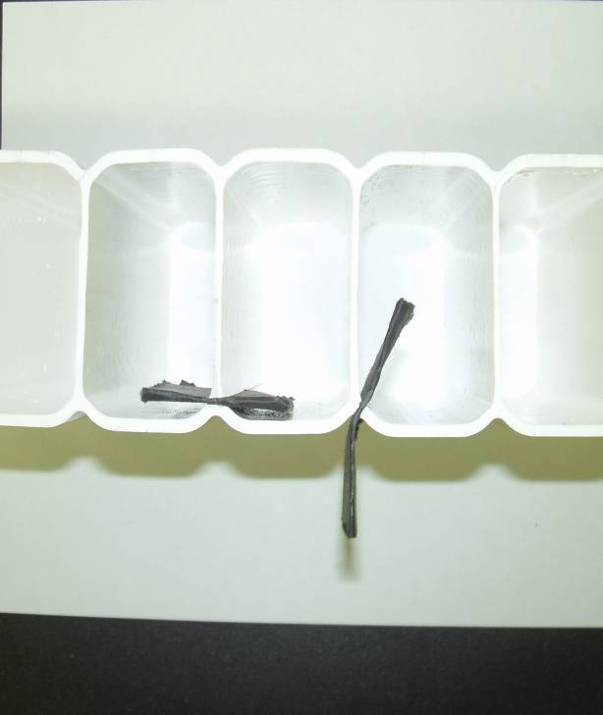

Drawbacks and Limitations of the Manual Test

The manual test proved the concept, but was cumbersome and time consuming.
Several tons of force are required to seal the ends of the extrusion against a rubber mat.
Using threaded rod to provide the clamping force worked, but was quite slow.
The hand pump used for pressurizing the water was supplying only a small rate of flow, preventing it from pressurizing if there were even small leaks.
Lastly, at each sample failure all the water ended up on the floor and had to be mopped up.
It took about an hour for each test, and a large amount of frustration.

The New Tester

We have completed construction of a more efficient, pressure test device.

The device is equipped with
--hydraulic cylinders to compress and seal the rubber gaskets
--springs to release the sample after the test
--a closed circuit water system, using an electric pump and a water tank
--valving to allow quick water filling,
followed by slow and controlled pressurizing through a separate needle valve

Here is an Assembly Drawing:

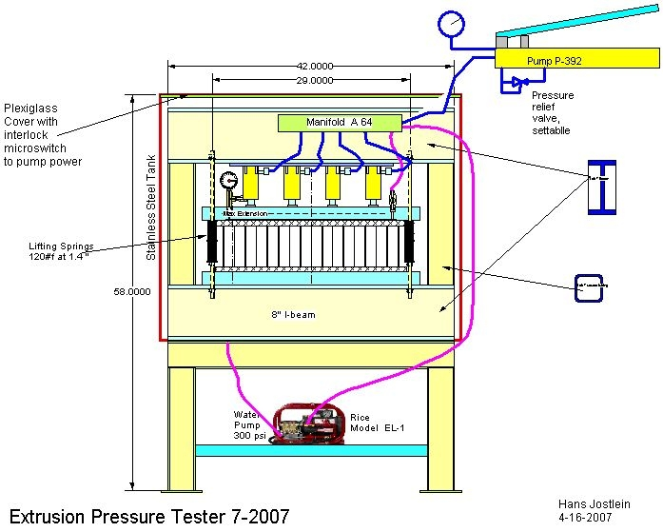

Description of the New Tester:

The extrusion is clamped between a top aluminum bars against the bottom I-beam, using rubber 1/2” thick gaskets , reinforced with fiberglass mats.
For gasket compression, we use four hydraulic cylinders, all pressurized from the same hand pump.
This assures sufficient force and uniform force distribution over the length of the bar.
The hydraulic pressure is limited to 5000 psi, and the force on the frame to 40,000#f.
The current pressure gauge has a range to 4000 psi, which provides a maximum force of 32,000 # f, which appears adequate to achieve a good seal.

The cylinder forces are resisted by a steel frame made from steel I-beam of 5 1/2 flange width, 8 3/8 height, with a moment of inertia of 58.7 in^4.
The maximum stress in the I-beam at 40,000 #f is 11,600 psi.
The steel frame has been proof loaded to 4000 psi (32,000 #f) by operating the hydraulic cylinders against cribbing material.
The steel frame sits in an open tank made form 1/16” stainless sheet.
The tank is 36” long by 18” wide by 36” high, and has a hinged half-inch thick plastic cover.
The tank has a bottom drain which connects to a small circulation pump, which is located below the tank. The circulation pumps provides the positive pressure required by the high pressure test pump.
The high pressure pump is a Rice EL-1A pump rated at 3 gpm at 500 psi.
The pump outlet (the high pressure hose) connects to the top aluminum bar.
The second hose connection at the top aluminum bar is used for air bleeding and pressurization control, as follows:

A 10 f t high pressure water hose goes to the operator valve box, mounted on the operator’s control panel. (this is not shown on the above diagram)
The operator valve box has a bleed valve which sends the air (and water, as the case may be) back to the tank sump.
A pressure gauge is included to read the maximum pressure before extrusion failure.
The pump is powered from a GFI outlet in an outdoor type outlet box.
To pressurize, the operator turns on the water pump while the outlet valve from the extrusion is open. This flushes the air out of the test extrusion and fills it with water.
When no air exits the extrusion (as seen through the transparent drain hose), the operator closes the main input valve, and then the output drain valve to the extrusion. Pressurized water enters the test extrusion at low flow volume through the needle valve, causing the test pressure to rise in the extrusion. The rate of rise is controlled by this valve.
After the extrusion has failed, the operator turns the water pump off,opens the bleed valve, and releases the hydraulic seal pressure in preparation for the next sample.
The springs push the top bar up to free the failed extrusion and to allow insertion of the next sample.

The operator uses the hydraulic hand pump to seal the new sample, closes the tank lid, and proceeds to the operator control box for the next cycle.

Here are a few pictures of the Pressure tester:
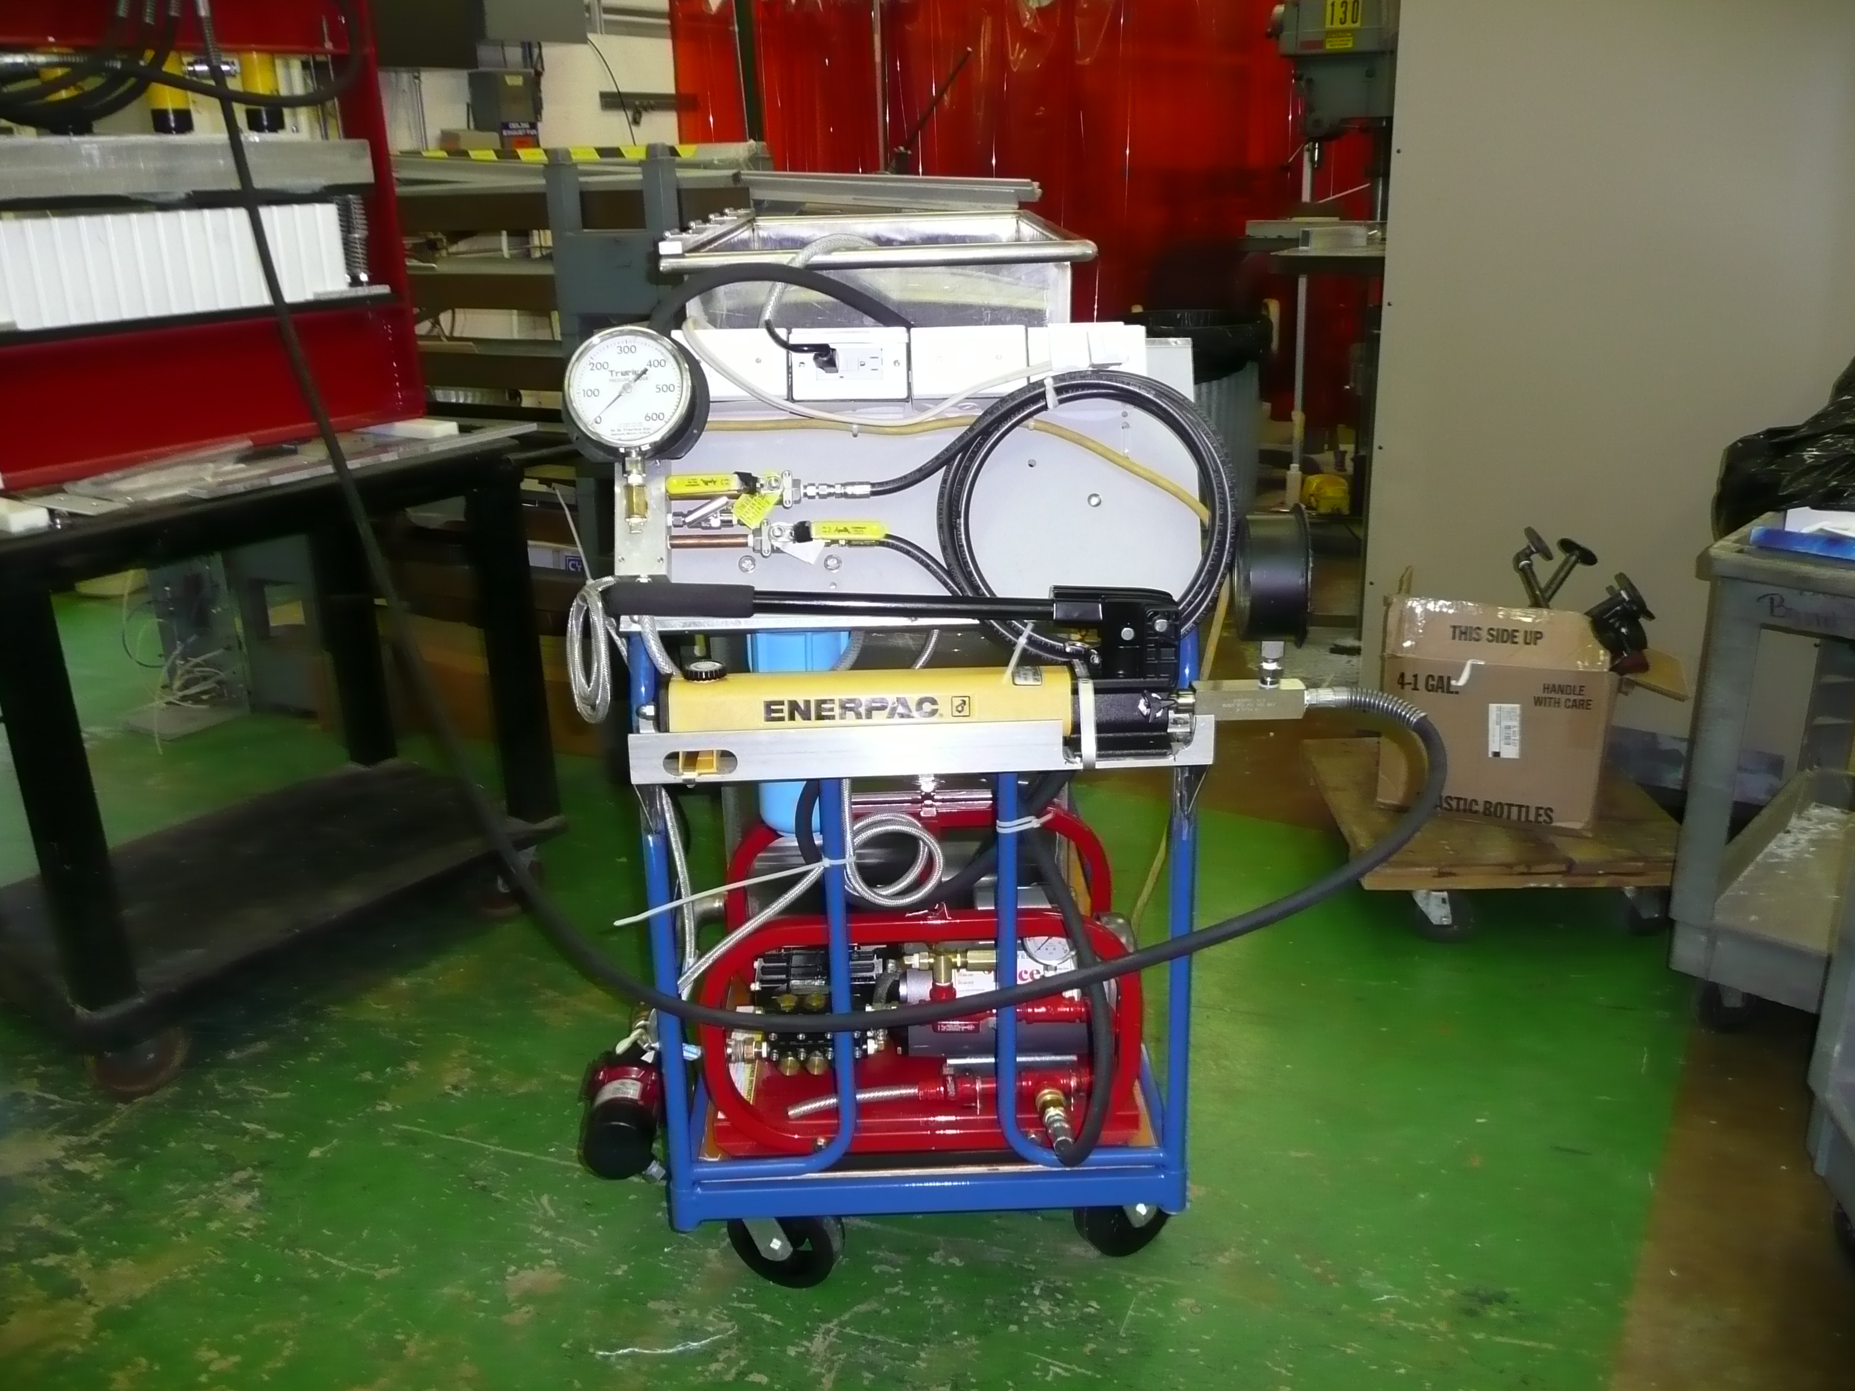

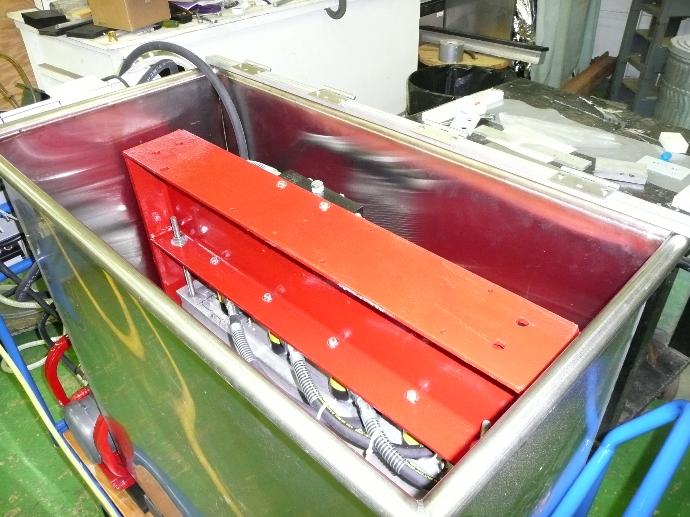

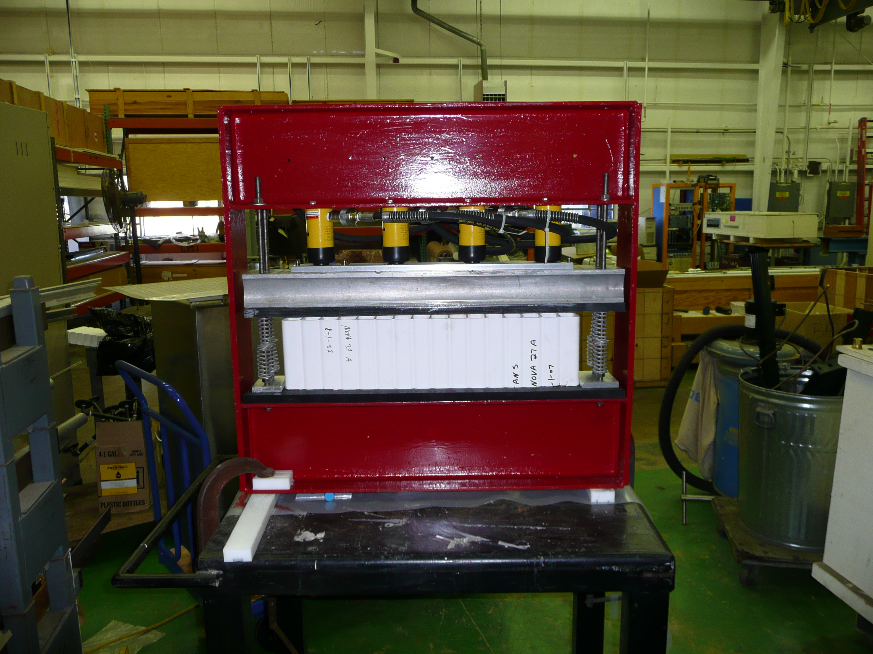
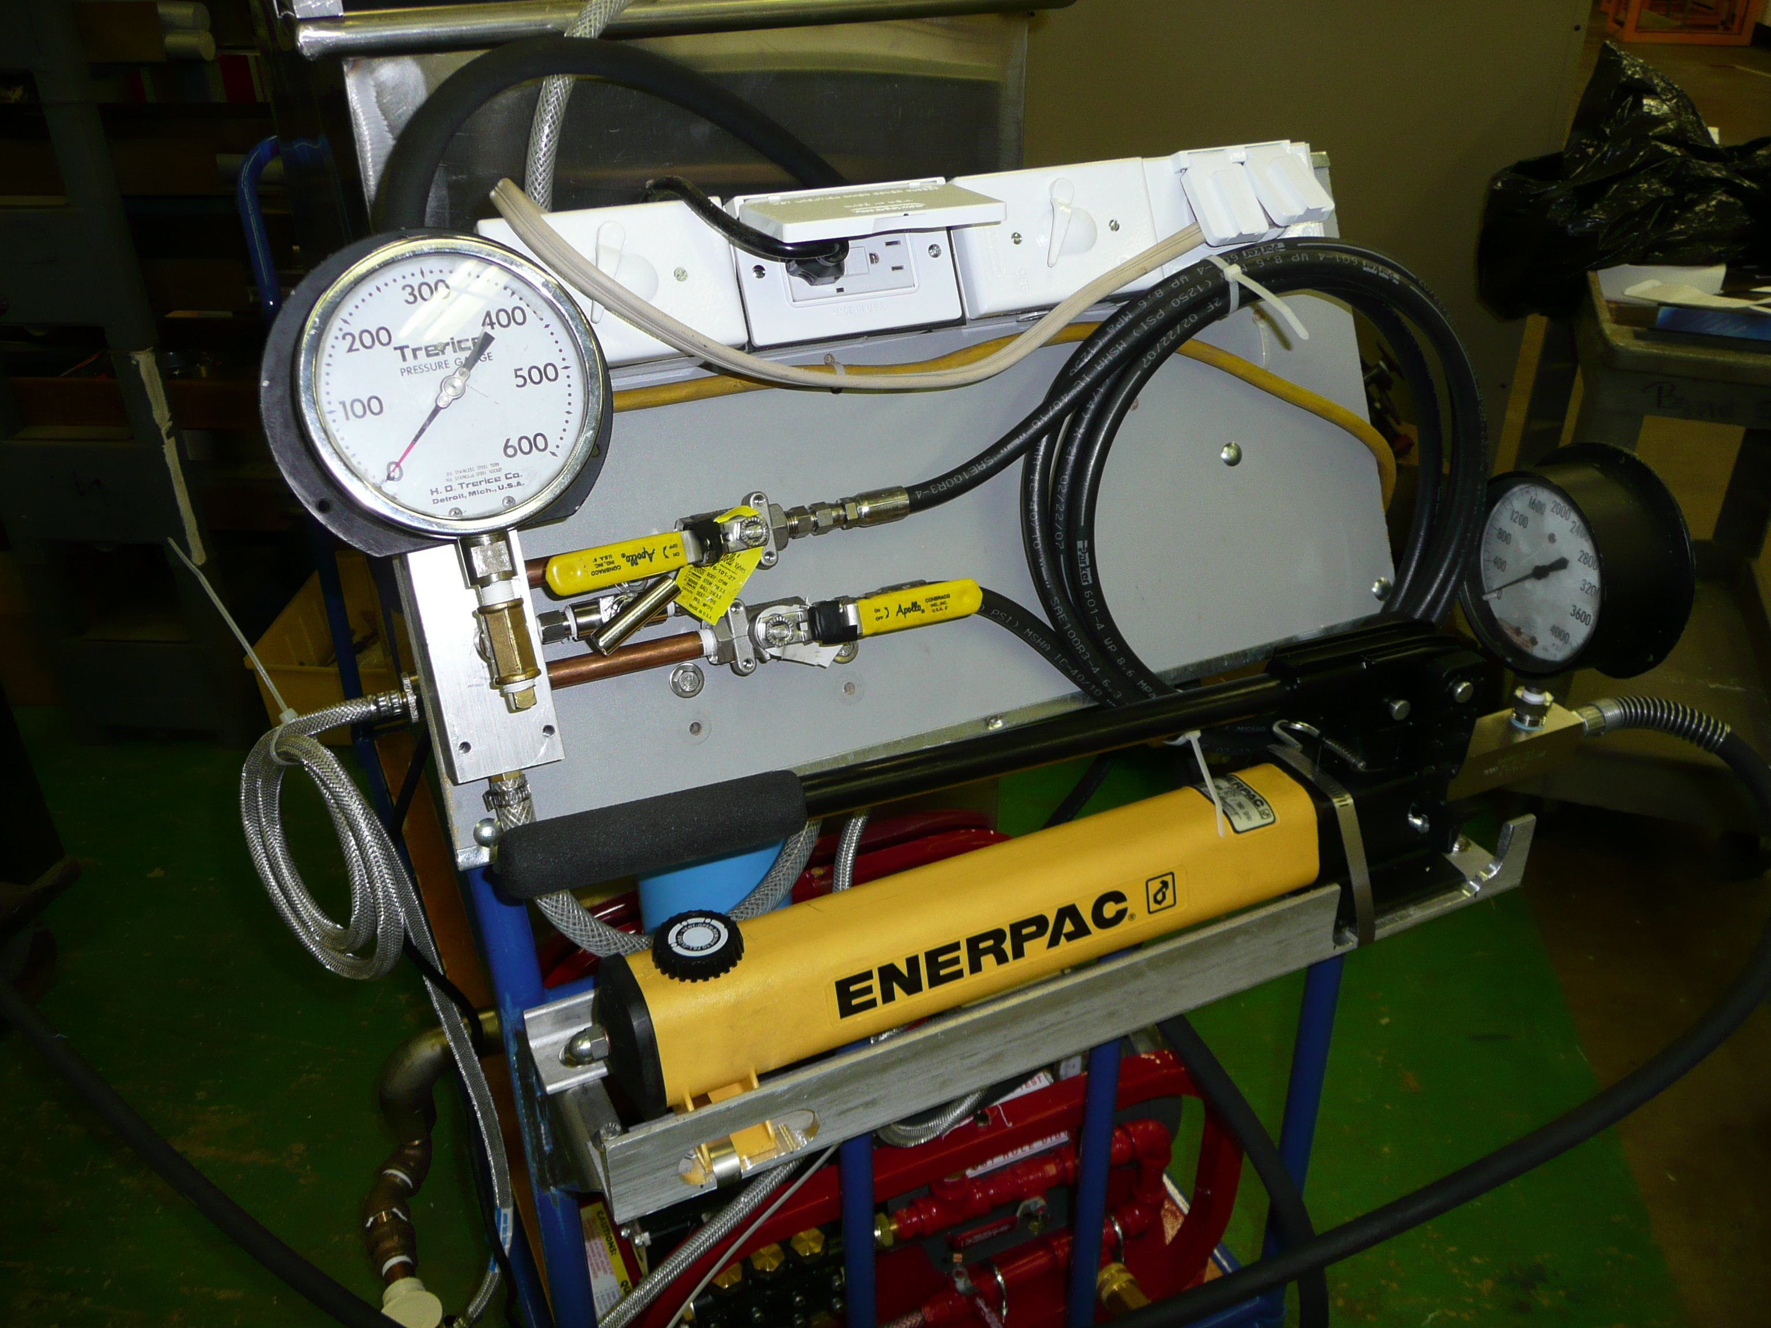

Initial Results

We have tested seven “vertical” extrusion that were made from NOVA 27-material in August 2007. All failed by having the end cell split at mid-level. This is the highest stress point as per Ang Lee’s FEA calculations, thus indicating no flaws in material, knitting, or shapes.

The pressure at failure was

Sample #4 330 psi

Sample #5 340 psi,

Sample #6 320 psi, time to test 4 minutes

Sample #7 350 psi, time to test 7 minutes

Sample #8 380 psi, time to test 6 minutes

Sample #9 320 psi, time to test 6 minutes

Sample #10 320 psi, time to test 5 minutes

The pressures at failure were quite similar between samples.
We will next test other samples , including horizontal samples and samples made from problematic PVC runs, to verify that this device can tell the difference between sound and flawed extrusions.

Appendix: Details

The Pump

Rice Hydro EL-1A Electric Hydrostatic Test Pump 3 GPM, 500 PSI
SKU

EL-1A

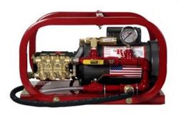  View larger photo | Usually ships within 1 - 2 weeks  Check stock  Purchasing options & Accessories below
  Sale Price: | $1,102.00
  Original Price: | $1,160.00
Picture Gallery: Click on a thumbnail below to view
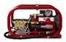 | 

View super-sized pic 1 | View super-sized pic 2

Features:
• | Hydrostatic Test Pump, designed for testing sprinkler systems, irrigation lines, pressure vessels, plant process piping, and small diameter water lines
• | 1 HP Electric Motor, TEFC, 110/220 Volt, 50/60 HZ
• | Automatic Pressure regulator with inlet bypass
• | Stainless Steel liquid-filled gauge ensures accurate readings
• | Rugged roll cage construction, protects pump from damage
• | Dimensions: 22x14x14, 1 Year Warranty from Manufacture Defect

Item | Price | Qty.
Rice Hydro EL-1A Electric Hydrostatic Test Pump 3 GPM, 500 PSI SKU EL-1A | $1,102.00  $1,160.00 | 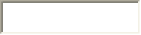

Hydraulic system

Hand pump: Choose P-392 with pressure gauge

P series  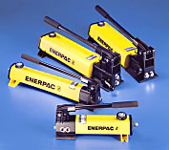 | Lightweight Hand Pumps  - Lightweight and compact design  - Durable glass-filled nylon reservoir and nylon encapsulated aluminium pump base  - Two-speed operation to reduce handle strokes  - Integral 4-way valve on P-842 for operation of double-acting cylinders  - Large oil capacities to power a wide variety of cylinders and tools  - Internal pressure relief valve for overload protection  Download Catalog page pdf

Pump  Typex | Usable  Oil  Capacity | Model  Number | Pressure  Rating** |  | Oil Displacement/Stroke |  | Max.  Handle  Effort | Piston  Stroke | Weight
Pump  Typex | Usable  Oil  Capacity | Model  Number | bar |  | cm³ |  | Max.  Handle  Effort | Piston  Stroke | Weight
Pump  Typex | cm³ | Model  Number | 1st stage | 2nd stage | 1st stage | 2nd stage | kg | mm | kg
Single-  Speed | 327 | P-141 | - | 700 | - | 0,90 | 32,7 | 12,7 | 2,0
Single-  Speed | 901 | P-391 | - | 700 | - | 2,47 | 38,6 | 25,4 | 4,1
Two-  Speed | 327 | P-142* | 13 | 700 | 3,62 | 0,90 | 35,4 | 12,7 | 2,0
Two-  Speed | 901 | P-202 | 13 | 700 | 3,62 | 0,90 | 28,6 | 12,7 | 3,4
Two-  Speed | 901 | P-392* | 13 | 700 | 11,26 | 2,47 | 42,2 | 25,4 | 4,1
Two-  Speed | 2540 | P-802 | 27 | 700 | 39,33 | 2,47 | 43,1 | 25,4 | 8,2
Two-  Speed | 2540 | P-842 | 27 | 700 | 39,33 | 2,47 | 43,1 | 25,4 | 10,0
* Available as sets (Cylinder, gauge, couplers, hose and pump)
Choose Cylinders: RC-102

Cylinder  Capacity | Stroke | Model Number | Cylinder  Effective Area | Oil Capacity | Coll. Height | Weight
ton (kN) | mm | Model Number | cm² | cm³ | mm | kg
5  (45) | 16 | RC-50 | 6,5 | 10 | 41 | 1
5  (45) | 25 | RC-51 | 6,5 | 16 | 110 | 1
5  (45) | 76 | RC-53 | 6,5 | 50 | 165 | 1,5
5  (45) | 127 | RC-55* | 6,5 | 83 | 215 | 1,9
5  (45) | 177 | RC-57 | 6,5 | 115 | 273 | 2,4
5  (45) | 232 | RC-59 | 6,5 | 151 | 323 | 2,8
10(101) | 26 | RC-101 | 14,5 | 38 | 89 | 1,8
10(101) | 54 | RC-102* | 14,5 | 78 | 121

