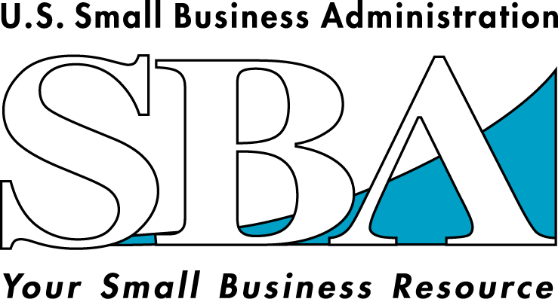
Frequently Asked Questions
SBA and the President’s Faith-Based
and Community Initiative
www.sba.gov U.S. Small Business Administration 

SBA and the President’s Faith-Based and Community Initiative: Frequently Asked Questions and Answers

Why did President Bush launch the Faith-Based and Community Initiative?

President Bush knows that faith-based and other community organizations have long been performing a critical service by helping people in need. Unfortunately, though the Federal government spends billions of dollars yearly for social service programs, faith-based and community groups have found it difficult to provide Federally-funded services. President Bush believes that faith-based and other community organizations should be able to compete on an equal footing to provide these services. To facilitate the involvement of such organizations in Federal programs within constitutional parameters, the President launched the Faith-Based and Community Initiative. In 2001, he issued Executive Orders creating the White House Office of Faith-Based and Community Initiatives and five Centers for Faith-Based and Community Initiatives in the Departments of Justice, Education, Labor, Health and Human Services and Housing and Urban Development. Two more Centers were created in 2002 at Agriculture and the Agency for International Development and three more were created in 2004 at the Small Business Administration and the Departments of Commerce and Veterans Affairs. Each of the ten Centers is administered by a Center Director who works closely with the White House Office of Faith-Based and Community Initiatives.

What are the ten Centers for the Faith-Based and Community Initiative trying to accomplish?

The Centers have three main goals:

- Coordinate agency efforts to eliminate regulatory, contracting and other programmatic obstacles to the participation of faith-based and other community organizations in the provision of social and community services.

- Reach out to faith-based and community organizations to assist them in identifying Federal resources and educate them on partnering with government; and

- Provide agency sources for technical assistance to faith-based and community organizations designed to expand their capacity to help the needy.

How does SBA fit into the overall Faith-Based and Community Initiative?

The SBA is the leading government agency established to help small business. It does this through loan guarantees, technical assistance and counseling. It also provides disaster loans and federal contracting assistance.

In recent years, faith-based and community organizations have increasingly emphasized economic and community development. SBA and its resource partners offer a wide range of financial and technical assistance programs that may help faith-based and community organizations better serve their communities.

These programs can help accomplish two goals:

- Give faith-based and community organizations the knowledge base they need to help people in their communities start or expand their own small businesses—businesses that will open new opportunities for them and for everyone in their communities; and

- Help these organizations instruct people in their communities on how to obtain credit with which to launch or expand their own enterprises.

Does SBA guarantee loans and award grants to faith-based and community organizations?

In general, the SBA does not guarantee loans made to non-profit organizations. A business must operate for profit to be eligible for an SBA guarantee loan. (SBA Physical Disaster Loans are the only exception, where loans may be made to non-profits.) Thus, charitable, faith-based, and other non-profit organizations are generally not eligible. However, SBA may, and does, provide loan guarantees to intermediary loan institutions that are themselves non-profit organizations, including faith-based and community organizations (e.g., credit unions, certified development companies and micro-lenders). These intermediary loan institutions, in turn, make loans to for-profit small businesses.

SBA—the smallest Federal agency involved in the President’s Initiative—has only a few grant programs compared to other Federal agencies participating in the Initiative. SBA grant programs are generally designed to help organizations that provide small businesses with management, technical and financial assistance. Faith-based and community organizations have successfully competed for funding under these programs. Some of SBA’s competitive grant programs have resulted in awards to Small Business Development Centers (SBDC) at non-profit educational institutions to develop programs for small businesses and new entrepreneurs; participating non-profit micro-lenders to assist micro-borrowers develop business skills; and non-profit community-based Women’s Business Centers (WBC) to provide training to women business owners and entrepreneurs.

How can SBA’s efforts to partner with faith-based and community organizations help state and local governments promote economic development?

In recent years, governors and mayors have placed considerable emphasis on attracting large corporations to cities, especially inner-cities, as a means of promoting economic development. This approach, while important and necessary, is often insufficient—especially when many large corporations are down-sizing or out-sourcing. That is why economic development and job creation must also take place at the grassroots level in city neighborhoods and must be spearheaded by both established and start-up small businesses. Unfortunately, many of these small businesses lack sufficient capital and the knowledge to put together a good business plan. Working together with faith-based and other community organizations, SBA can help provide the necessary technical and financial assistance to the entrepreneurs and small businesses that bring jobs and hope to economically distressed communities all across our Nation.

How do faith-based and community organizations partner with the SBA to promote community economic development?

SBA has sixty-eight District Offices located across the United States. All of these District Offices are committed to advancing the President’s Faith-Based and Community Initiative by working with local faith-based and community organizations and will know how best to address your organization’s needs. To find the SBA District Office nearest you, visit our website at www.sba.gov, or call the SBA Center for the Faith-Based and Community Initiative at (202) 205-7316.

All SBA’s programs and services are provided on a nondiscriminatory basis.

U.S. Small Business Administration 1-800-U ASK SBA

