October 2005 NC Weather Review

Overview

Significant rain fell across North Carolina during the first week of October, which brought relief to some areas that had experienced drought conditions. Unfortunately, the heaviest rain fell along the coast and in the foothills of the Blue Ridge Mountains, in areas that were not classified in a drought. This resulted in localized flooding problems in those areas, but provided no relief for the severe drought conditions over the Piedmont.

The early month’s rain was a fleeting memory by month’s end. The dry pattern that had plagued much of the region since mid summer reared its ugly head again by the second week of October, and lasted the rest of the month. Raleigh-Durham, which recorded nearly 2 inches of rainfall between October 5 and October 8, recorded only 0.14 of an inch between October 9 and October 31. The lack of rain during the last three weeks of the month sent local municipalities scurrying to re-implement mandatory water restrictions (ones that had been relaxed just after the brief rainy period) due to dropping reservoir levels from Raleigh-Durham to Greensboro. Figure 1 is the North Carolina drought monitor as seen on November 1, 2005. Of note are the severe drought conditions over portions of the northern and central Piedmont of North Carolina, and the contrasting wet conditions near the coast. For the latest information concerning the drought visit http://www.ncwater.org/drought/

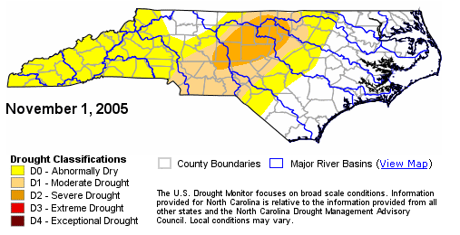
Figure 1. North Carolina Drought Monitor as of November 1, 2005. Note that first level to severe drought conditions are shown over central North Carolina.

Along with the dry weather, the trend of above average monthly temperatures continued in October 2005. The monthly temperatures generally averaged 2 to 4 degrees above normal across the state. This was the sixth straight month of above normal monthly temperatures at Greensboro and Raleigh-Durham.

Details

Precipitation

The rainfall totals during the first week of October 2005 were quite impressive. The heaviest rain, ranging from 5 to locally 13 inches, fell along the Blue Ridge Mountains, and throughout the coastal area. The heavy rain produced localized flooding problems. Much lighter rainfall totals of 1 to 3 inches were common throughout the drought stricken Piedmont. The rainfall rates and amounts did not create enough runoff over this region to begin to replenish reservoir levels depleted by the drought. The rainfall was beneficial; however, as it brought the regions first general soaking rain since July. Top soil moisture improved greatly, which led to less water usage for irrigation purposes. Figure 2 depicts the rainfall totals during the first week of the month. Note the large gradient in rainfall from the coast into the Piedmont, and from the eastern slopes of the Blue Ridge to the southwestern Smoky Mountains.

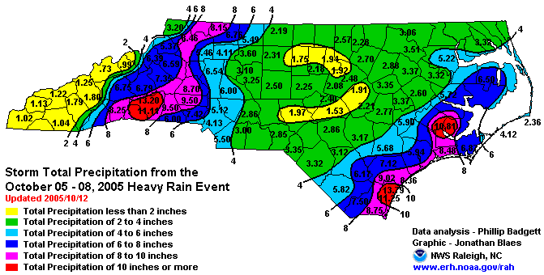
Figure 2. Storm Total Rainfall Amounts from the October 5-8, 2005 Heavy Rain Event.

The rain was produced by the development of a mid and upper level trough that extended from the Ohio Valley to the East Coast during the first week of October. Unfortunately, this pattern that brought the widespread rain lasted only a few days, and this ended up being the only significant widespread rain event across North Carolina for the balance of the month. Hurricane Wilma, after hitting south Florida, was pulled up the eastern United States seaboard by the large trough. Luckily, the hurricane remained far enough offshore in the western Atlantic, and spared the North Carolina coast from another landfall from a hurricane.

The pattern turned dry again across North Carolina after the passage of the troughs in early October. Very little rainfall was recorded during the last 3 weeks of October, as most locations had around 0.25 of an inch of rain or less during the last half of the month. High pressure ridging along the Gulf Coast States was responsible for the extended dry weather pattern.

With the return of the dry ridge of high pressure, it was not surprising that monthly rainfall tallies ended up very close to the tallies that were recorded just after the first week of the month. Figures 3 and 4 are final October 2005 rainfall totals as observed by the official National Weather Service observation sites and NWS cooperative observers. Note that 80 to 95 percent of the rainfall fell during the October 5-8 rain event.

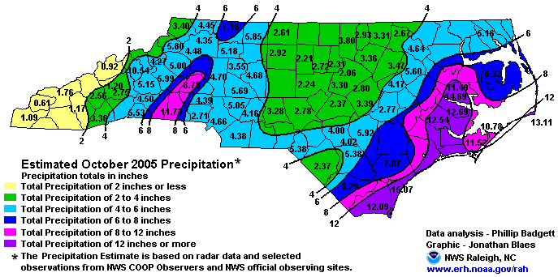
Figure 3. October 2005 Estimated monthly precipitation totals.

Figure 4. Comparison of observed precipitation and normal precipitation for October 2005 at selected locations across North Carolina.

Temperatures

The month began very warm with average daily temperatures generally 5 to 15 degrees above normal between October 1 and 15. High temperatures reached the 80s over many inland locations outside of the Mountains and the immediate Atlantic Coast during the first week. After a brief two day cool down on October 16 and 17, temperatures returned to the 80s between October 18 and 20. Finally, a long awaited pattern change allowed a shift from warm toward much cooler conditions began October 23. This cool pattern lasted through the end of the month, waxing between October 27 and 30, when the first freeze of the fall season was recorded at many Piedmont locations. Due to the warmth during the first half of the month, the first freeze came 1 to 2 weeks later than average for much of North Carolina. Figure 5 depicts the 30 year average first 32 degree occurrences, or “first freeze” in fall for North Carolina.

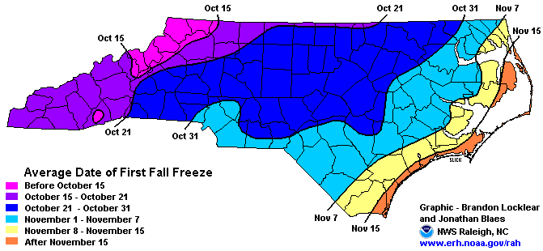
Figure 5. The 30 year average occurrence of the first 32 degrees “first freeze” in fall.

October 2005 continued the recent trend of above normal monthly temperatures across North Carolina. Average monthly temperatures generally ranged between 60 and 66 degrees, except across the Mountains where temperatures averaged about 5 to 10 degrees cooler. The average monthly temperatures across North Carolina are shown below in Figure 6. These temperatures were generally 2 to 4 degrees above the 30 year normal.

The warmest readings were reported along the Coastal Area and on the Outer Banks, including: Ocracoke (66.9 degrees), Wilmington (66.5), Cape Hatteras (66.2), Jacksonville (65.3), Gum Neck (66.1), and Longwood (64.9). The coolest readings were found over the higher elevations of the Mountains, where Mount Mitchell, Mount Pisgah, and Grandfather Mountain (all at elevations above 5000 feet) averaged 50 degrees or lower. The coolest average temperature was found atop Mount Mitchell (a refreshing 47.4 degrees). Populated locations in the Mountains had temperatures that averaged in the 50’s, including Boone (53.8 degrees), Jefferson (54.7), Asheville (58.5), and Bryson City (59.3). These temperatures were still generally 1 to 3 degrees above the 30 year normal.

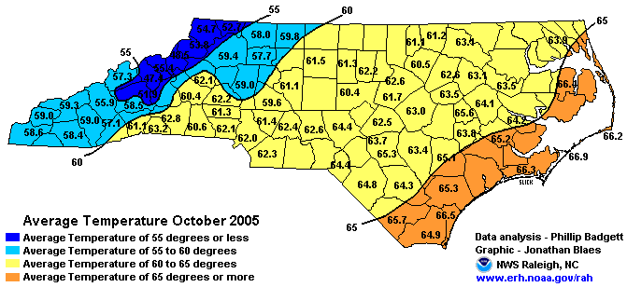
Figure 6. October 2005 Average monthly temperatures across North Carolina.

Figures 7 and 8 depict the daily maximum and minimum temperatures observed at both Raleigh-Durham (RDU) and Greensboro (GSO) during October 2005. The dashed lines represent the normal maximum temperature (red) and the normal minimum temperature (blue). The very warm temperatures during the first and third week of the month are noteworthy at both RDU and GSO.

Figure 7. Daily maximum and minimum temperatures observed during October 2005 at
Raleigh-Durham (RDU).

Figure 8. Daily maximum and minimum temperatures observed during October 2005 at Greensboro (GSO).

Current, Semi-Annual and Annual Temperature Trends

October marked the 6th straight month of above normal average monthly temperatures at both Greensboro and Raleigh-Durham. Temperatures have averaged above normal in 8 of the 10 months at both sites during 2005. Only March and May averaged slightly cooler than the 30 year normal. Dating back to 2004, both Greensboro and Raleigh-Durham have recorded warmer than normal monthly temperatures in 12 of the past 14 months. Figure 9 illustrates the annual monthly temperature departures from normal as observed at Greensboro and Raleigh-Durham.

Figure 9. Annual monthly temperature departures from normal at Raleigh-Durham and Greensboro.

Current, Semi-Annual, and Annual Precipitation Trends

The months of August, September, and October brought very little rainfall to central North Carolina. Had it not been for the widespread soaking of 1 to 3 inches that fell during the October 5-8 period, rainfall during this three month period would have been nearly non-existent over the interior of North Carolina.

August was characterized by isolated thunderstorms with wide gaps between rainfalls. Hurricane Ophelia brought heavy rain to the coast in the middle of September, but little else fell during the month over the rest of the state. October turned decidedly dry again after the brief rainy spell, as Hurricane Wilma brought a scare to the North Carolina coast.

During the quarterly period that included the months of August, September, and October, Raleigh-Durham (RDU) only recorded 6.78 inches of rain. The normal during this period is 11.22 inches, which is only 60 percent of normal. The nearby cooperative observer at Raleigh (NC State campus) received only 5.14 inches during this three month period (only 40 percent of normal). Quarterly rainfall deficits elsewhere in central North Carolina generally ranged between 5 and 8 inches.

The total precipitation for the calendar year 2005 at RDU (January 1 through October 31) was 29.59 inches. This total was 7.54 inches below normal. Drier than normal conditions have been the rule at RDU in 9 of the past 12 months.

Figure 10. Semi-annual and annual precipitation trends at Raleigh-Durham (RDU).

Even more parched during this past 3 month period were areas just to the west and north of Raleigh, including Greensboro (GSO). This area was at the center of the ongoing severe drought that had taken stranglehold over central North Carolina. The August-October rainfall at GSO totaled a mere 4.99 inches, which was 6.29 inches below normal, or 44 percent of normal.

The yearly total for 2005 at GSO indicated a net precipitation deficit of 11.24 inches. Ten of the past twelve months have been drier than normal. Figure 11 depicts the monthly precipitation totals and the departure from normal during this period at Greensboro.

Figure 11. Semi-annual and annual precipitation trends at Greensboro (GSO).

North Carolina Water Resources Information

Severe drought conditions continued to grip the central and northern Piedmont of North Carolina at the end of October. The rainfall during the first week of the month only provided very short term relief which mainly helped in dampening the top soils and with greening up the backyard grasses. The lack of rain over interior sections during the last three weeks in October greatly offset the benefits of the widespread rain early in the month.

Stream flow conditions and local water reservoirs actually became more depleted as October progressed. The rainfall 2005 rainfall deficits over the interior of North Carolina reached between 7 and 14 inches by October 31. The driest conditions and severe drought classification was centered on the Greensboro to Roxboro to Raleigh-Durham regions of the Piedmont.

The agricultural concerns from mid summer quickly became hydrological concerns as summer became fall. The streams, lakes, and reservoirs saw significant falls. Many locations, including the Raleigh-Durham and Greensboro regions, implemented water usage restrictions to protect the diminishing reservoir supplies in mid September. Those restrictions were loosened after the rain in early October but tightened again as the conditions turned dry.

2005 rainfall surpluses were confined to areas of the Mountains and along the Coast of North Carolina. The rainfall surpluses kept the southeast Coastal Plain, Coastal Area, and Outer Banks out of any water resource concerns.
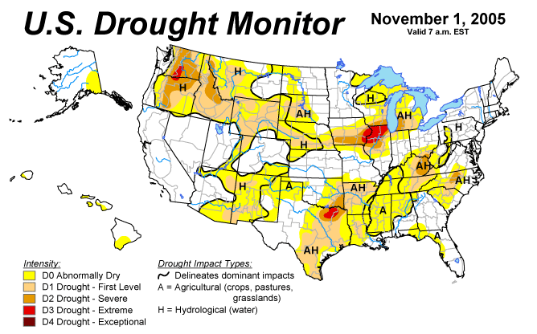
Figure 12. The U.S. Drought Monitor as of November 1, 2005.

Climate Outlook for November, December, and January 2005

The Climate Prediction Center released its latest 3 month outlook recently. Details concerning this forecast can be found at:

http://www.cpc.ncep.noaa.gov/products/predictions/multi_season/13_seasonal_outlooks/color/page2.gif.

Significant relief from the severe drought conditions should be slow to come as fall becomes winter. Current indications are that there is an equal chance of above normal, normal, or below normal temperatures and precipitation during this three month period across North Carolina. This means that there are no signals that clearly support a forecast of above normal or below normal precipitation over central North Carolina as we move into the winter season.

NC Weather Review Team

Phillip Badgett
Michael Strickler

