HEADQUARTERS
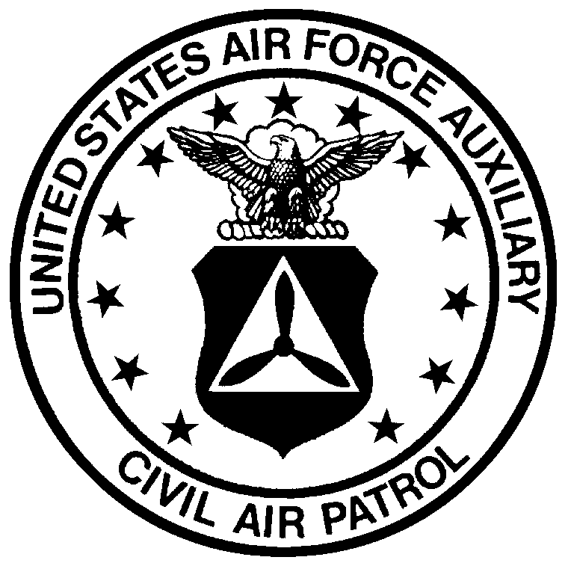

Nevada Wing - Civil Air Patrol

United States Air Force Auxiliary

6400 Kleppe Lane
P.O. Box 339
Sparks, NV 89432

01 March 2005

MEMORANDUM FOR: All Units

FROM: DCP

SUBJECT: Integrated Leadership Program (ILP) Update

- I am pleased to announce that 2Lt Brandy Kown has been selected as the Project Officer / Commander of Nevada Wing’s first ILP event. Our combined Airman Training School (ATS) & Non-Commissioned Officer (NCO) School will be held at Nellis Air Force Base during Memorial Day weekend. Lt. Kown will be requesting cadets and senior members interested in working on staff to apply soon. This is your ‘heads-up’ that additional help will be needed.

- For those unfamiliar with the concept of the ILP, let me explain just a little. The ILP is a continuous training program for cadets of all levels. There are six different courses ranging from Basic Cadet School to Advanced Cadet Staff Seminar (Earhart cadets and up). The Airman Leadership School, the second course, is an excellent ‘prep’ for cadets going to encampment for the first time. As California has been using an ILP structure for over 20 years, you can be assured that the summer encampment will be following this model. Any cadet that wants a ‘leg up’ on others basic encampment participants is encouraged to attend our ALS.

- More information will be sent to all units soon. Lt. Kown will need the support from all units to make this endeavor successful. Please assist her in promoting and supporting this event. I look forward to seeing our first class of graduates from Nevada’s own ILP!

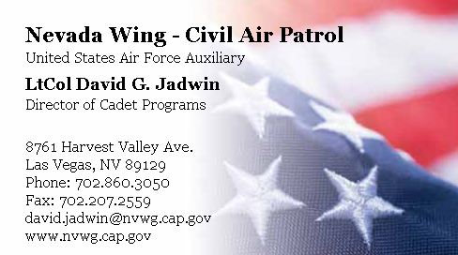

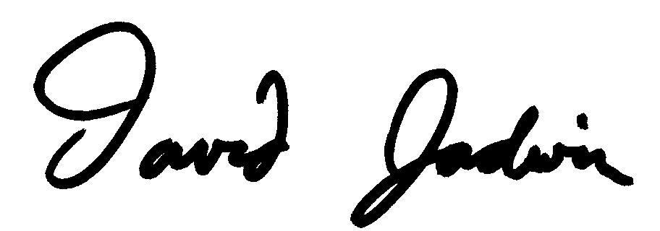
DAVID G. JADWIN, LTCOL, CAP
Director of Cadet Programs

