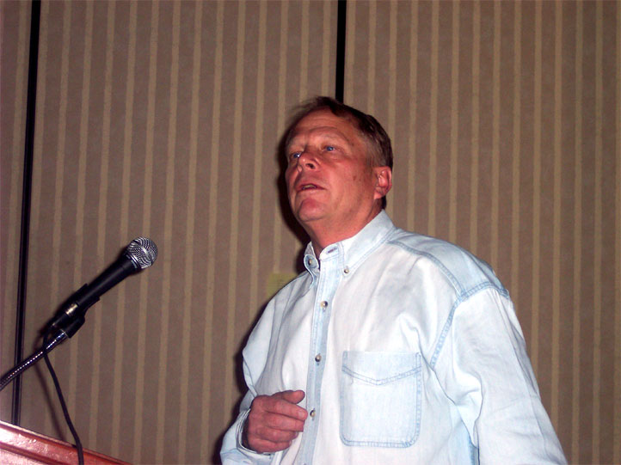
Simulating the Value of El Niño Forecasts
for the Panama Canal
Nicholas Graham and Konstantine Georgakakos
Hydrologic Research Center, San Diego, CA
Carlos Vargas and Modesto Echevers
Meteorology and Hydrology Section
Panama Canal Authority, Panama Canal Zone, Panama

FACTS
- The Panama Canal requires a supply of fresh water for operations.
- Canal fresh water storage has an operational time constant of months.
- El Niño variability strongly modulates rainfall and water supply for the Canal.
- El Niño variability is somewhat predictable at lead times of 9-12 months.
- Canal inflow is modestly predictable at lead times of months.

QUESTION
- Can routine El Niño predictions be used assist in Canal operational planning?
DATA

1) CLIMATE
- NATURAL INFLOW INTO GATUN LAKE (1906-2000)
- NIÑO3 SST (1906-2000; Smith and Reynolds, 2004)
- PREDICTED NIÑO3 (NCEP; 1981-97; MONTHLY)
2) CANAL CHARACTERISTICS (PCA)
PROJECT DESIGN AND GOALS
- Build a basic, monthly time step, model of the Canal system, embodying:
  - Management objectives –
    - Reliable lockage
    - Additional income through hydro-power generation
    - Low risk
b) Physical constraints
i) Gatun Lake capacity, vol. / stage, level requirements
ii) Lockage, hydropower, spillage discharge capacities
iii) Lockage and hydropower income
c) Inflow predictability (3 models, each with variable uncertainty )
i) CLIMATE - Assume every year inflow follows climatology
ii) PERFECT - Assume future inflows are perfectly known
iii) FORECAST - Inflow outlooks derived from El Nino forecasts
- Operate the model using probabilistic inflow outlooks (i, ii, iii) using an optimizer to simulate management with objective forecast information.
- Evaluate performance of simulated system in terms of added value and operational reliability afforded by El Nino forecast information and formal inclusion of uncertainty.
CLIMATOLOGY AND PREDICTABILITY
- CANAL INFLOWS HAVE A STRONG ANNUAL CYCLE
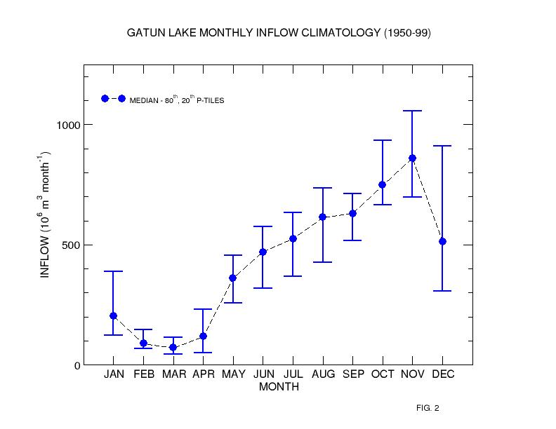

- EL NIÑO VARIABILITY MODULATES CANAL REGION RAINFALL AND INFLOWS.
CORRELATIONS: WATER YEAR GATUN INFLOW vs NINO3 SST 1915-1999
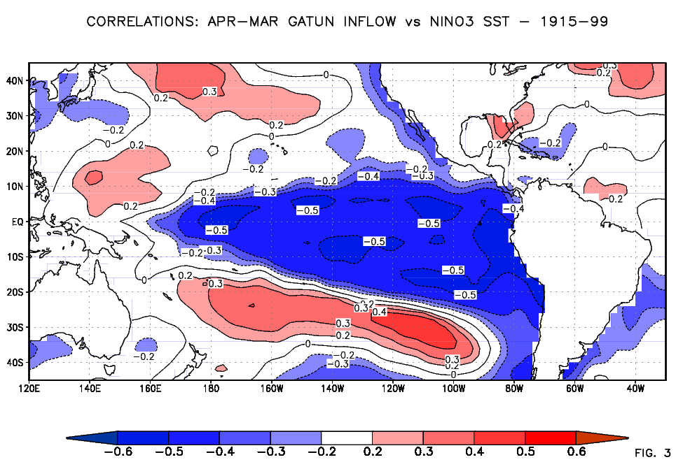
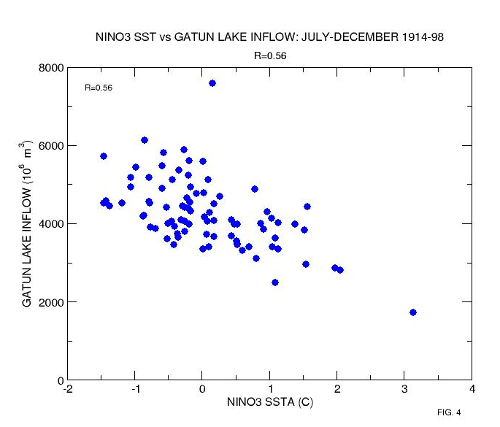
- THE STRENGTH OF THE RELATIONSHIP BETWEEN EL NIÑO AND FLOW VARIES FROM STRONG TO VERY WEAK DURING THE YEAR.
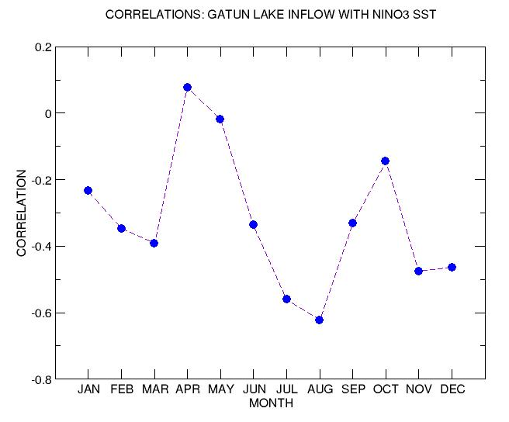
EL NIÑO VARIABILITY IS PREDICTABLE
OPERATIONAL NINO3 SST PREDICTION CORRELATIONS
1981-1998
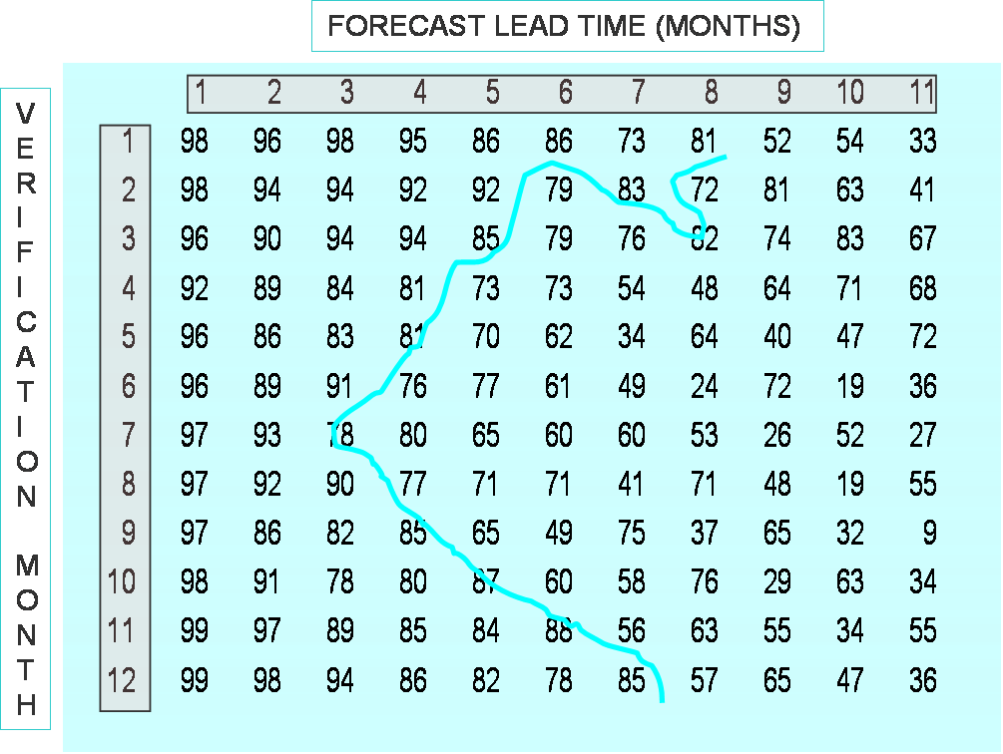
EL NINO PREDICTIONS REDUCE UNCERTIAINTY IN INFLOW OUTLOOKS
FRACTIONAL REDUCTIONS IN INFLOW UNCERTAINTY (RMS)
COMPARED WITH CLIMATOLOGY
USING OPERATIONAL NINO3 SST PREDICTIONS
1981-1998
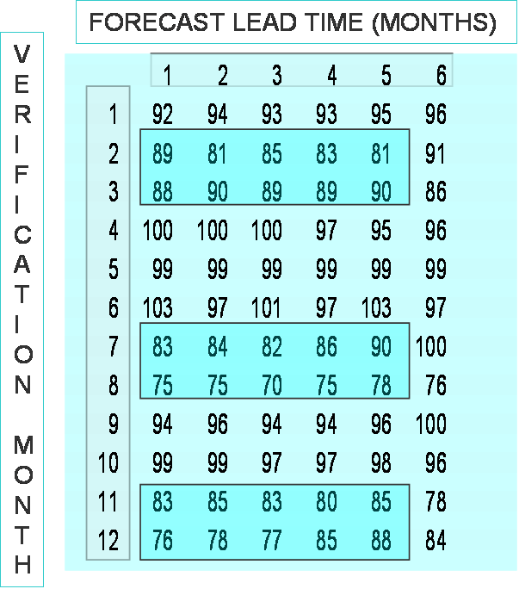
CANAL SIMULATION SYSTEM

- INITIAL STATE (GATUN LAKE VOLUME)
- GATUN LAKE CAPACITY – LEVEL / VOLUME RELATIONSHIP
- LOCKAGE REQUIREMENTS, WATER USE
- HYDROPOWER REQUREMENTS, WATER USE
- SPILL LEVEL, POSSIBLE RANGES
- EVAPORATION, MUNICIPAL WATER REQUIREMENTS
- EXISTING RULE CURVE
- LOCKAGE INCOME
- HYDROPOWER INCOME
- PROBABILISTIC INFLOW PROJECTIONS (6 MONTH HORIZON)
- OPTIMIZER and VIRTUAL MANAGER
PANAMA CANAL SIMULATION SYSTEM
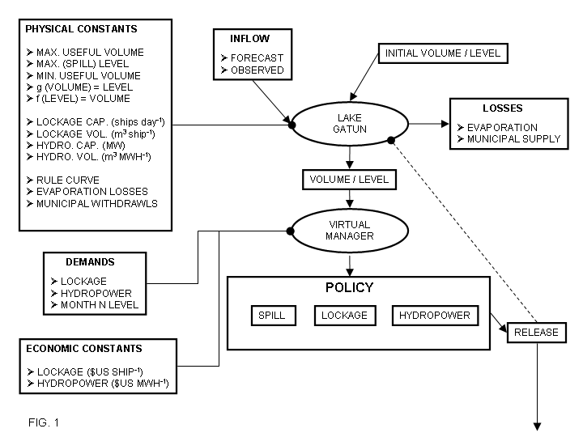
PARAMETERS FOR SIMULATED PANAMA CANAL SYSTEM

GATUN LAKE PARAMETERS

Useful volume (VU) – 766 Mm3
Lowest useful level (HL) – 24.84 m
Maximum (spill) level (HU) – 26.67 m
Evaporation and Municipal withdrawal (E) 6.16 Mm3 month-1
Maximum spill rate (RUS) – 13358.30 Mm3 month-1
Actual spill rate per month (RS) Mm3
Rule curve level for a particular month (H*m) m
Actual level for a particular month (H*m) m

CANAL PARAMETERS

Volume required per unit ship passage (VL) – 196,820 m3 ship-1
Maximum number of ships per month (SU) – 1200 ships month-1
Maximum lockage volume per month (RUL) – 236.18 Mm3 month-1
Actual lockage volume per month (RL)
Volume required per unit MWH hydropower production (VH) – 19,114 m3 MWH-1
Maximum hydropower production per month – 17,280 MWH month-1
Maximum hydropower volume per month (RUH)– 330.29 Mm3 month-1
Actual hydropower volume per month (RH)

INCOME PARAMETERS

Income per ship passage (iL) – $US 50,000
Maximum lockage income per month (IUL) - $US 60M
Actual lockage income per month (IL)
Income per MWH (iH) - $US 50
Maximum hydropower income per month (IUH)- $US 864,000
Actual hydropower production per month (IH)
Maximum possible total income per month (IMAX) - $US 60.864M
ASSESSING PERFORMANCE OF CANAL SIMULATIONS
- Start with initial state at time t (Gatun Lake volume)
- Use inflow outlook (probabilistic) for next 6 months
- Derive optimal feasible policy (lockage, hydropower, spill) for next 6 months.
- Execute optimal feasible policy for ONE month (to t+1)
- Tabulate results with respect to objectives
- Update state (Gatun Lake volume) with OBSERVED inflow
- Repeat
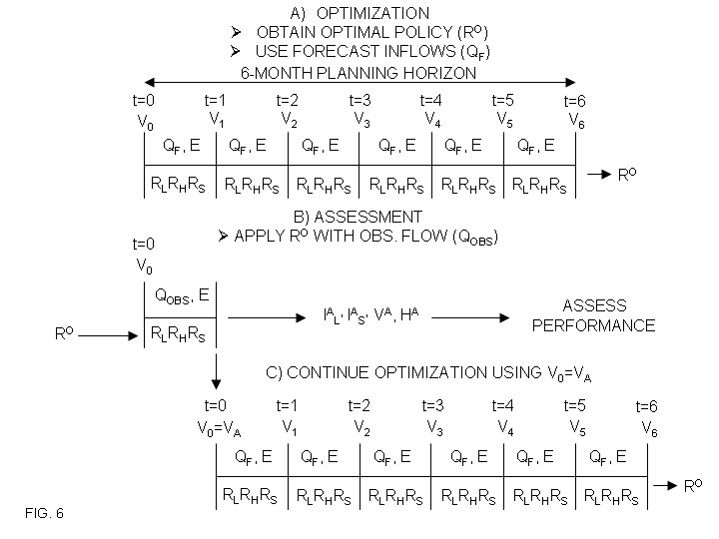

DOES EL NIÑO FORECAST INFORMATION HELP?
NOTICE THE EFFECT ON INCORRECTLY SPECIFIED UNCERTAINTY

UNCERTAINTY vs TOTAL CANAL INCOME (1981-1997)

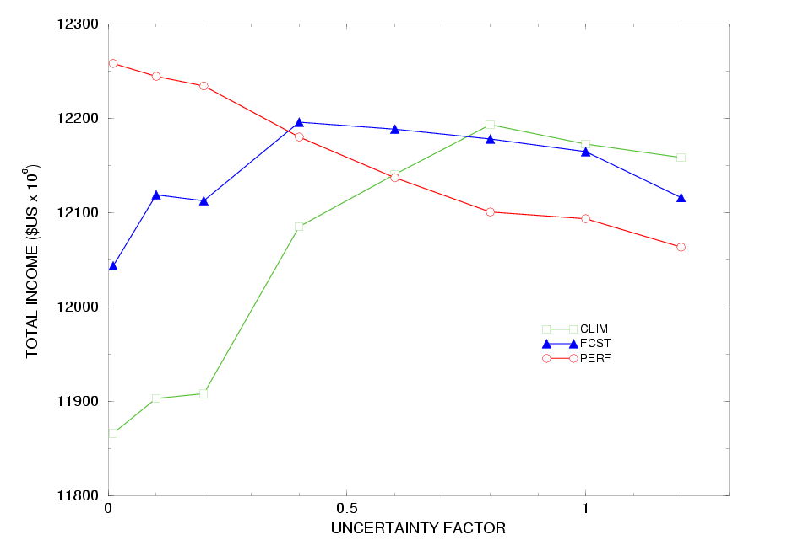
RESULTS

3 SETS OF SIMULATIONS
- PERFECT – PERFECT FORESIGHT.
NOMINAL UNCERTAINTY: ~ZERO
- FORECAST – USE INFLOWS DERIVED FROM EL NIÑO FORECASTS.
NOMINAL UNCERTAINTY: MEAN-SQUARE FORECAST ERROR.
- CLIMATE – INFLOWS ARE FROM LONG-TERM CLIMATOLOGY.
NOMINAL UNCERTAINTY: MEAN-SQUARE CLIMATOLOGY ERROR
EACH SET OF SIMULATIONS IS ASSIGNED THE NOMINAL UNCERTAINTY, AND ALSO VALUES RANGING FROM SMALL TO LARGE.
THIS ALLOW US TO SEE THE SENSIVITY TO CHANGES IN:
A) THE SKILL OF THE MEAN PREDICTION
B) THE ASSOCIATED UNCERTAINTY
COMPARISON OF TOTAL INCOME (1981-1997)
CLIMATOLOGY - DETERMINISTIC
FORECAST – UNCERTAINTY 0.4
PERFECT - DETERMINISTIC
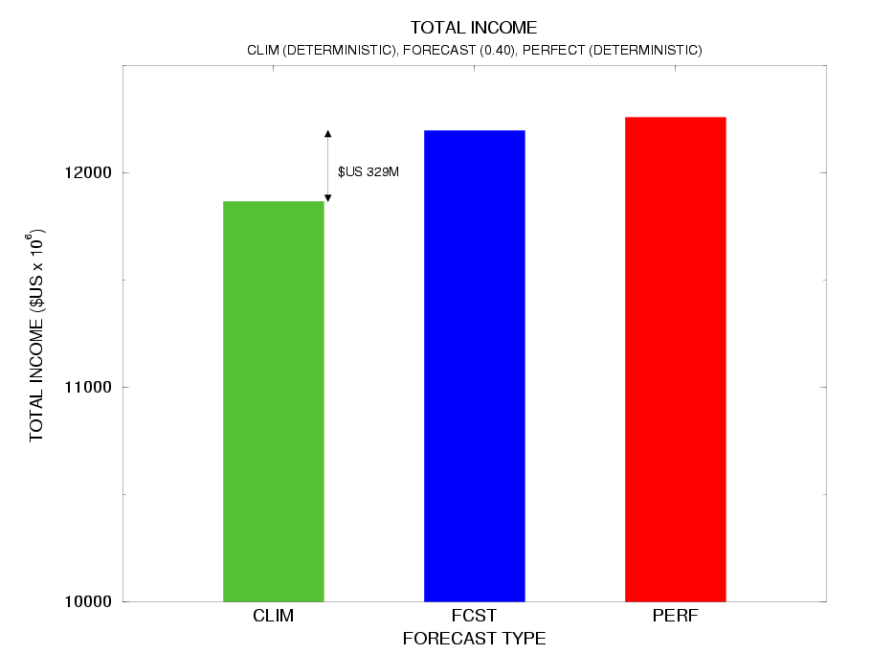
EXAMPLE OF MONTHLY INCOMES:
PERFECT AND FORECAST MODELS
IN GENERAL, THE CANAL PERFORMS ROBUSTLY

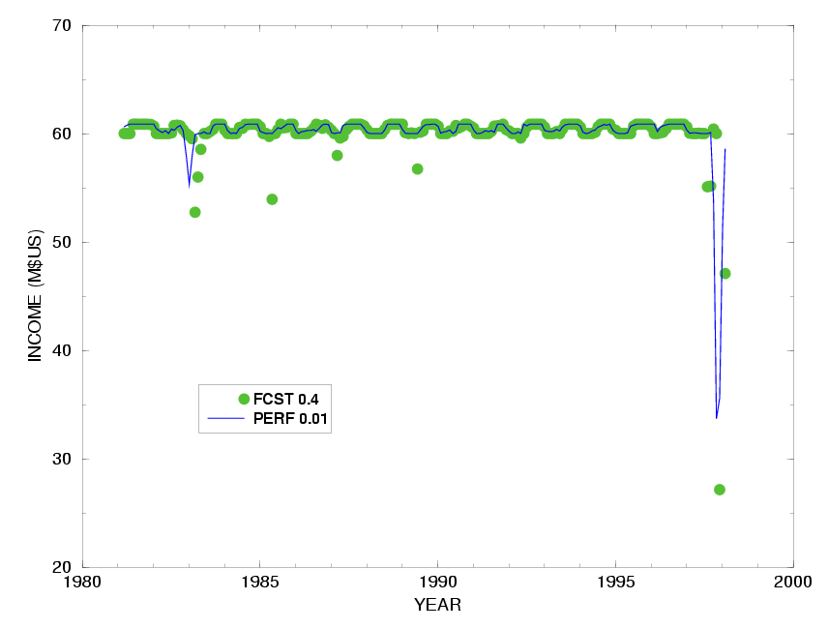
NORMALIZED HYDRO-POWER INCOME
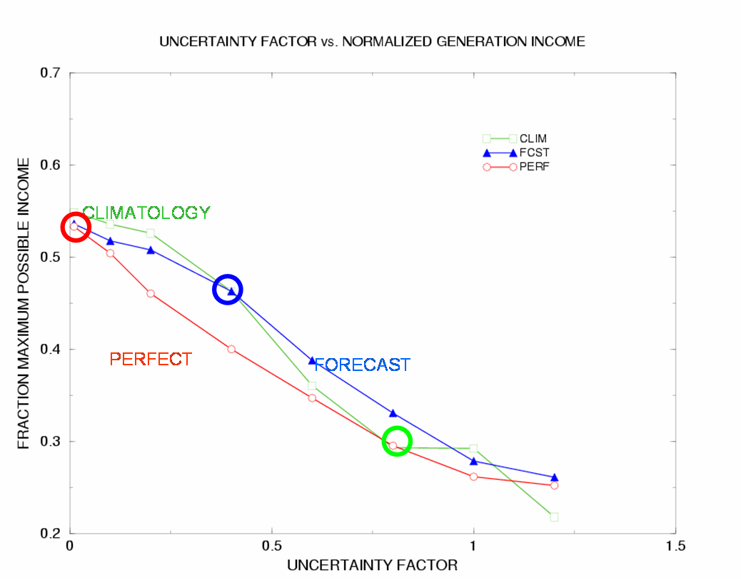
AVERAGE SPILL
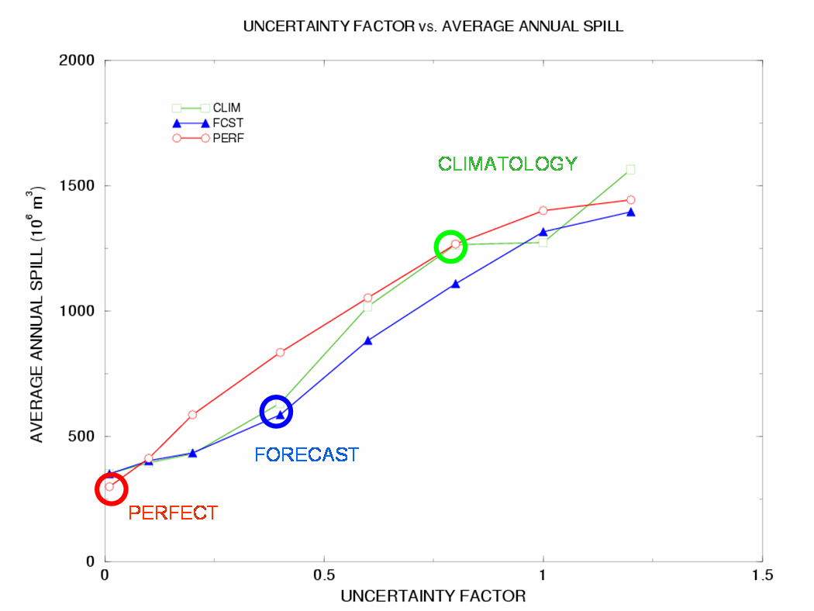

COMPARISON OF BEHAVIOR: EXISTING RULE CURVE vs FORECAST SIMULATION,
EFFECT IS TO TAKE BETTER ADVANTAGE OF EXISTING SUPPLY
CIRCLES INDICATE MONTH 1 (VERIFICATION) LEVELS
FOR EACH CALENDER MONTH
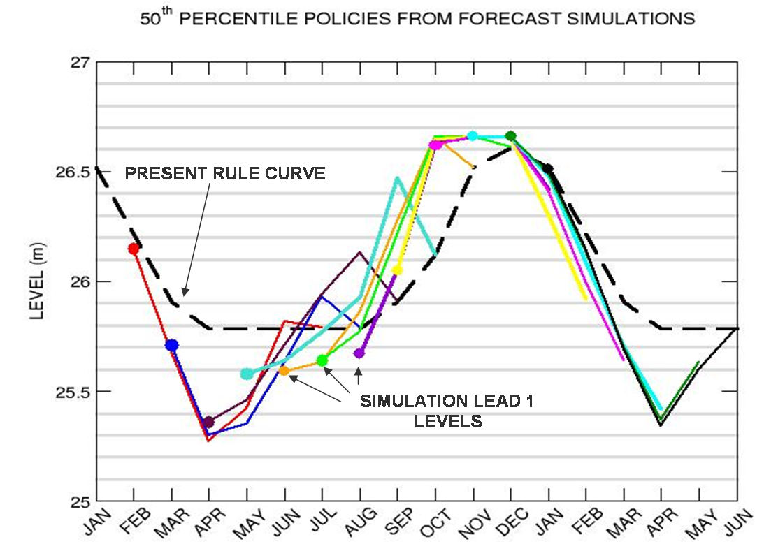
TEST BEHAVIOR OF CANAL TO INCREASED LOCKAGE DEMAND
(EFFECT IS TO INCREASE THE SENSITIVITY TO UNCERTAINTY SPECIFICATION)
N = 40, 48, 56 SHIPS PER DAY
AS FRACTION OF MAXIMUM POSSIBLE INCOME FOR N SHIPS DAY-1
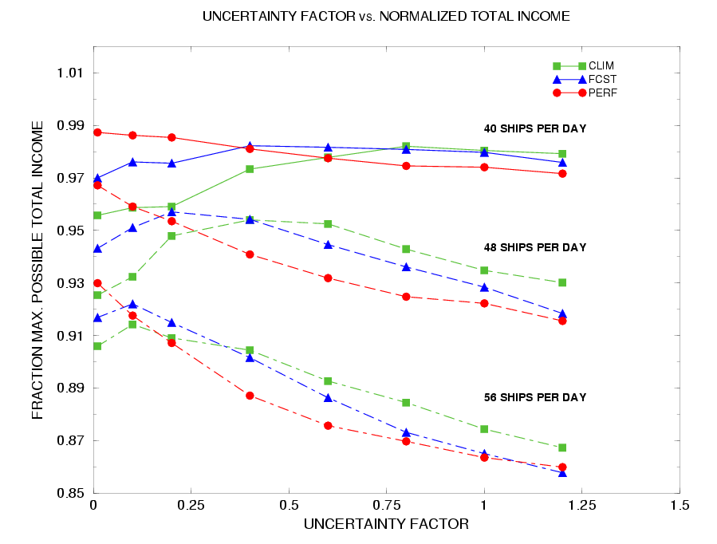
AS FRACTION OF MAXIMUM POSSIBLE INCOME FOR 40 SHIPS DAY-1
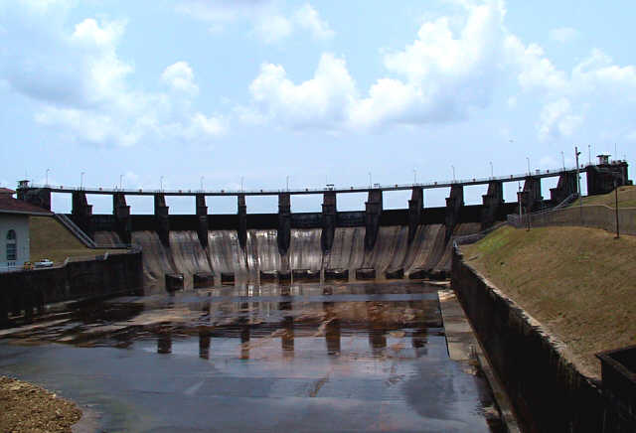
NOTE STEEPER DEPENDENCE ON UNCERTAINTY
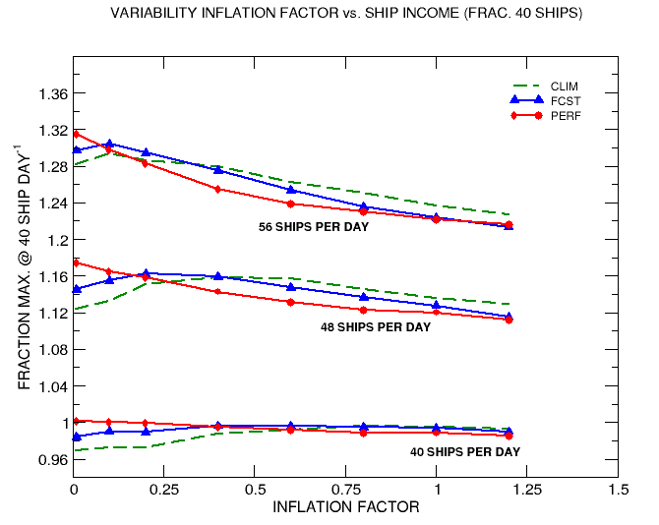
SUMMARY

- ROUTINE EL NIÑO FORECASTS CAN BE USED TO REDUCE THE UNCERTAINTY IN GATUN INFLOW PROJECTIONS AT LEAD TIMES OF MONTH.
- THE USE OF THIS INFORMATION INCREASES SIMULATED CANAL INCOME IN COMPARISON TO CLIMATOLOGICAL EXPECTATIONS. VALUE = $322M.
- THE VALUE OF FORECAST INFORMATION INCREASES AS THE DEMANDS ON CANAL RESOURCES ARE INCREASED.
- OPTIMAL CANAL OPERATION IS VERY SENSITIVE TO CORRECT SPECIFICATION OF UNCERTAINTY.

INACCURATE FORECASTS WITH CORRECT UNCERTAINTY BETTER THAN ACCURATE FORECASTS WITH INCORRECT UNCERTAINTY



