
February 17, 2004

Electronic submission to ghgregistry.comments @hq.doe.gov

Re: Comments to Department of Energy, Federal Register Notice (68203), 10 CFR Part 300, General Guidelines for Voluntary Greenhouse Gas Reporting; Proposed Rule.

The U.S. Climate Partnership Association (USCPA) is pleased to offer the following comments regarding the proposed revisions to the General Guidelines for governing voluntary reporting of greenhouse gases (GHG) under the Energy Policy Act of 1992 ("1605(b)").

USCPA is a cross-industry trade association of companies dedicated to helping companies manage their greenhouse gas (GHG) emissions and advocating and communicating that voluntary actions are effective in addressing the challenges concerning GHG emissions reduction strategies and reporting activities.

USCPA places high importance on establishing a credible voluntary GHG reporting system for the United States that not only is flexible but will encourage robust and diverse participation from all sectors of the economy.

USCPA believes that the Department of Energy's 1605(b) GHG Guidelines are an important strategic tool to accomplish a number of key public policy objectives, and it is critical that changes to the Guidelines enhance our ability to achieve these objectives. From USCPA’s perspective, these objectives are:

- Demonstrate that voluntary measures should be viewed as a preferable alternative to GHG reduction mandates in achieving GHG reductions; due to their cost effectiveness and flexibility in providing government and industry a means of achieving real reductions;

- Encourage the broadest range of participation from the manufacturing, power generation, government, commercial and transportation sectors of the economy;

- Provide a clear roadmap for companies on how to measure and report GHG emissions and emission reductions within each company;

- Encourage competitiveness of American business and stimulate innovation;

One Thomas Circle, NW
Tenth Floor
Washington, DC 20005
Phone: 202-296-0539 Fax: 202-530-0659

- Encourage companies to inventory their global GHG emissions and mitigation efforts and encourage proper recognition for these past and future reductions;

- Provide the flexibility to allow companies to report actions that enable them to share best practices or other examples of voluntary initiatives.

We thank you again for the opportunity to participate in the process and look forward to reviewing revisions to the General Guidelines along with the initial draft of the Technical Guidelines, and continuing the dialogue with DOE on these important issues.

Sincerely,
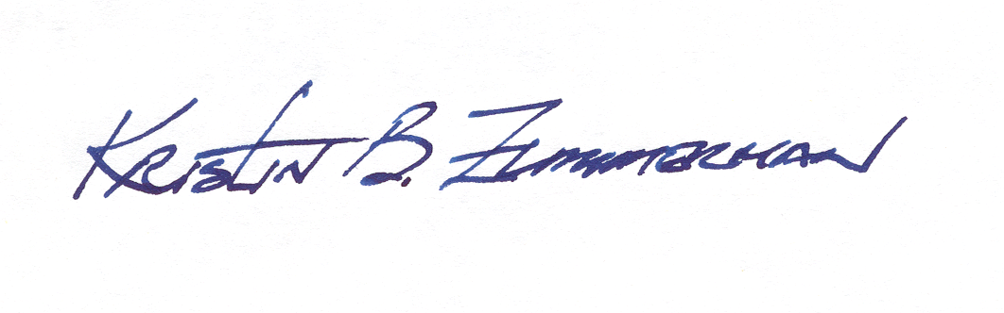
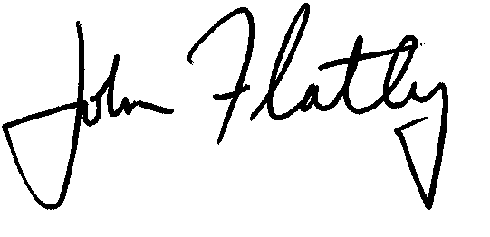

Kristin B. Zimmerman, Ph.D. John Flatley
USCPA Chair USCPA Executive Director

cc margot.anderson@hq.doe.gov larisa.dobriansky@hq.doe.gov
al.cobb@hq.doe.gov
mark.friedrichs@hq.doe.gov

