

November 30, 2007

Dear Partners in Preparedness:

Every year nearly half of all Americans will make at least one New Year’s resolution. The Department of Homeland Security’s Ready Campaign is partnering with FEMA’s Citizen Corps Program to encourage businesses and voluntary organizations to Resolve to be Ready in 2008.

Enclosed you will find a toolkit to help your organization develop internal and external messages to encourage your members, employees, constituents, customers and community to make a New Year’s resolution to prepare for emergencies. You will also find Web banners for your organization’s Web site, a sample E-mail you can send to your key constituents, as well as background information on Ready. You can also visit ready.gov or call 1-800-BE-READY to learn more about how to prepare for emergencies and receive free materials, including family emergency plan templates and sample business continuity plans. Additionally, you can help spread the message throughout your community by partnering with state and local Offices of Emergency Management, Citizen Corps Councils (www.citizencorps.gov), and other organizations to host and arrange activities and events on and around New Year’s Eve.

In a recent national survey conducted by the Ad Council, 91 percent of Americans agreed that taking some simple steps to prepare for emergencies could help protect themselves and their families in the event of an emergency. However, only 54 percent had taken any of the three steps recommended by the U.S. Department of Homeland Security’s Ready Campaign, including getting an emergency supply kit, making a family emergency plan and being informed about the different types of emergencies that could occur and their appropriate responses.

We wish you a very happy and safe New Year! And remember: Don’t wait. Set a date. Resolve to be Ready in 2008. If you have questions or would like to showcase your organization’s involvement in Resolve to be Ready 2008, please E-mail ready@dhs.gov.

Sincerely,


Erin Streeter
Director, Ready Campaign
U.S. Department of Homeland Security
RESOLVE TO BE READY

Tool Kit contents

Materials and Documents | Page Number
Sample E-mail Announcement to Encourage Emergency Preparedness | 3
Resolve to be Ready Web Banners | 4
Resolve to be Ready PDFs for Newsletters, Handouts or Other Display | 5
Preparedness Tips to Include in Newsletters | 6
Ready Campaign/Resolve to be Ready/Citizen Corps Background Information | 7–9
Sample Events Organizations Can Host to Encourage Preparedness | 10
Media Advisory for Events | 11
Rex Costume Order Form | 12
Ordering Ready Materials | 13
Ready Materials Order Form | 14

RESOLVE TO BE READY

SAMPLE E-MAIL ANNOUNCeMENT TO ENCOURAGE EMERGENCY PREPAREDNESS AMONG MEMBERS/EMPLOYEES/CUSTOMERS/CONSTITUENTS/Communities

Dear MEMBERS:

This New Year’s Eve, nearly 50 percent of Americans will make at least one resolution as they look toward the New Year. Today, ORGANIZATION is encouraging all of our MEMBERS to make a resolution that is both important and easy to keep: preparing for emergencies.

In a recent national survey conducted by the Ad Council, 91 percent of Americans agreed that taking some simple steps to prepare could help protect themselves and their families in the event of an emergency. However, only 54 percent had taken at least one of the three steps recommended by the U.S. Department of Homeland Security’s Ready Campaign, including getting an emergency supply kit, making a family emergency plan, and being informed about the different types of emergencies that could occur and their appropriate responses.

<To help everyone take these simple steps to get prepared, ORGANIZATION is proud to be hosting/sponsoring/organizing EVENTS with our local CITY Office of Emergency Management. EVENT DESCRIPTION.>

ORGANIZATION is encouraging you to visit ready.gov or call 1-800-BE-READY to learn how to prepare your families, homes and businesses for all types of emergencies including natural and human-caused disasters. Free materials, including family emergency plan templates and sample business continuity plans, are available through these resources. These materials will provide you with tools to make a New Year’s resolution that will bring you and your loved ones peace of mind. If you wish to take a more active role in your community’s preparedness, get involved by joining or starting a Citizen Corps Council near you. Citizen Corps brings community and government leaders together to coordinate the involvement of community members and non-governmental resources in emergency preparedness, planning, mitigation, response, and recovery. Visit citizencorps.gov for more information.

Wishing you a happy and safe New Year – and remember – Don’t wait. Set a date. Resolve to be Ready in 2008.

Sincerely,

NAME
TITLE, ORGANIZATION
RESOLVE TO BE READY

Resolve to be ready web banners
*Post on your Web site*
Electronic versions available for download by visiting
ready.gov/america/resolve08/banners.html.









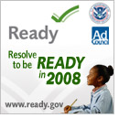
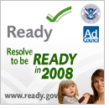
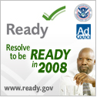
RESOLVE TO BE READY

Resolve to be ready pdfs FOR YOUR NEWSLETTERS,
HANDOUTS OR OTHER DISPLAYS
Electronic versions available for download by visiting
ready.gov/america/resolve08/sidebars.html.

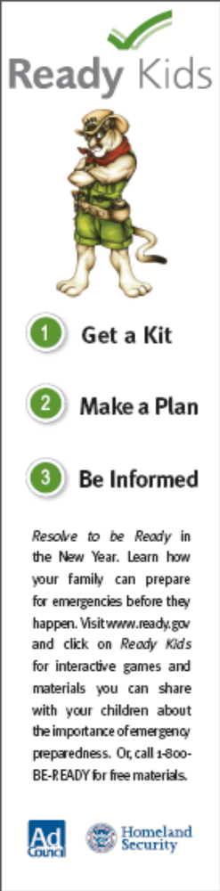
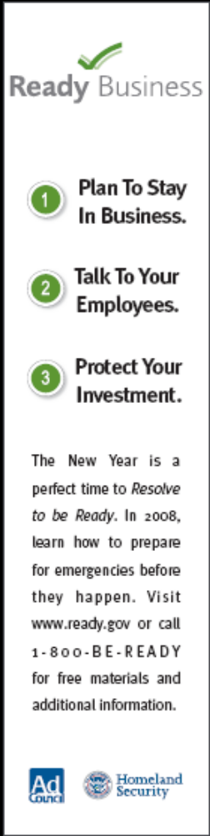
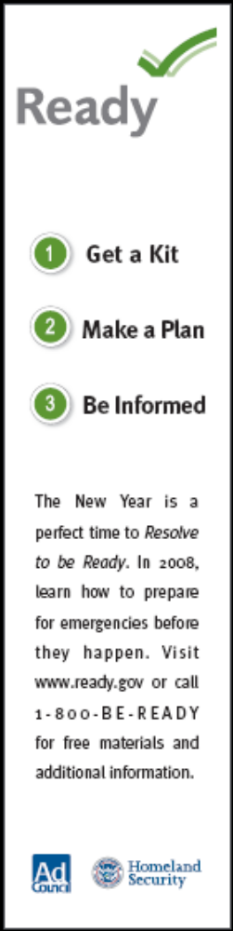

RESOLVE TO BE READY

PREPAREDNESS TIPS to INCLUDE IN YOUR NEWSLETTER

For Families:
- Get an emergency supply kit. Be sure to consider additional items to accommodate family members’ special needs:
  - Prescription medications and glasses
  - Infant formula and diapers
  - Pet food, extra water for your pet, leash and collar
  - Important family documents such as copies of insurance policies, identification and bank account records in a waterproof, portable container
  - Books, games, puzzles or other activities for children
- Make sure your family has a plan in case of an emergency. Before an emergency happens, sit down together and decide how you will get in contact with each other, where you will go and what you will do in an emergency.
  - Determine a neighborhood meeting place, a regional meeting place and an evacuation location.
  - Identify an out-of-town emergency contact. It may be easier to make a long-distance phone call than to call across town, so an out-of-town contact is important to help communicate among separated family members. Be sure every member of your family knows the out-of-town phone number and has coins or a prepaid phone card to call the emergency contact. You may have trouble getting through, or the telephone system may be down altogether, but be patient.
  - You may also want to inquire about emergency plans at places where your family spends time, such as their place of employment. If no plans exist, consider volunteering to help create one.
- Talk to your neighbors about how you can work together in the event of an emergency. You will be better prepared to safely reunite your family and loved ones during an emergency if you think ahead and communicate with others in advance.

For Parents:
If you are a parent, or guardian of an elderly or disabled individual, make sure schools and daycare providers have emergency response plans:
- Ask how they will communicate with families during a crisis.
- Ask if they store adequate food, water and other basic supplies.
- Find out if they are prepared to "shelter-in-place" if need be, and where they plan to go if they must get away.

For Workplaces:
- Take a critical look at your heating, ventilation and air conditioning system to determine if it is secure or if it could feasibly be upgraded to better filter potential contaminants, and be sure you know how to turn it off if you need to.
- Think about what to do if your employees can't go home.
- Make sure you have appropriate supplies on hand.

For Communities:
- Find out what kinds of disasters, both natural and man-made, are most likely to occur in your area and how you will be notified. Methods of getting your attention vary from community to community. One common method is to broadcast via emergency radio and TV broadcasts. You might hear a special siren, or get a telephone call, or emergency workers may go door-to-door. Contact a nearby Citizen Corps Council for help with emergency planning, or work with your local government and emergency management office to help start a Council in your area. Visit citizencorps.gov to find local Councils or learn how to start one in your community.

For additional tips and information, visit ready.gov
RESOLVE TO BE READY

READY CAMPAIGN / RESOLVE TO BE READY/ CITIZEN CORPS
BACKGROUND INFORMATION

Ready Campaign

Question: What is the Ready Campaign?

Answer: Ready is a national public service advertising campaign designed to educate and empower Americans to prepare for and respond to emergencies including natural disasters and potential terrorist attacks. The goal of the campaign is to get the public involved and ultimately to increase the level of basic preparedness across the nation. Ready asks individuals to do three key things: get an emergency supply kit, make a family emergency plan, and be informed about the different types of emergencies that could occur and their appropriate responses. Individuals can visit www.ready.gov or call 1-800-BE-READY for information about emergency preparedness.

February 2008 will mark the fifth anniversary of the Ready Campaign – The campaign was launched in 2003 by the Department of Homeland Security and The Advertising Council. It has proven to be one of the most successful campaigns in Ad Council’s more than 60-year history.

Question: What does the Ready Campaign include?

Answer: The Ready Campaign includes a general consumer campaign called Ready America. In addition, the campaign has extensions for pet owners, older Americans, and people with disabilities and special needs. In 2004, Homeland Security and the Ad Council launched Ready Business, an extension of the Ready Campaign that focuses on business preparedness. Ready Business helps owners and managers of small to medium-sized businesses prepare their employees, operations and assets in the event of an emergency. In 2006, Homeland Security launched Ready Kids, a tool to help parents and teachers educate children, ages 8 - 12, about emergencies and how they can help get their family prepared. There are also Spanish language campaigns, Listo America, Listo Negocios and Listo Niños.

Question: What is Resolve to be Ready?

Answer: As people think about their New Year’s resolutions this year, we hope they will make a resolution that is both important and easy to keep: preparing themselves, their families and their workplaces for emergencies. Resolve to Be Ready is an effort by the Ready Campaign and its partners to encourage Americans to follow three simple steps: get an emergency supply kit, make a family emergency plan and be informed about the types of emergencies that can occur in their area and the appropriate responses.

Question: What resources are available for emergency preparedness?

Answer: By visiting ready.gov or calling 1-800-BE-READY, individuals and businesses can learn how to prepare their families and workplaces for emergencies including natural disasters and potential terrorist attacks. Free materials, including family emergency plan templates and sample business continuity plans, are available on the Web site providing Americans with the resources needed to make New Year’s resolutions that will bring piece of mind.
Question: What should be included in an emergency supply kit?
Answer: In a basic emergency supply kit, the Ready Campaign recommends including the following:
- One gallon of water per person per day, for three days – remember to include enough for your pets, too
- At least a three-day supply of non-perishable food. Select foods that require no refrigeration, preparation or cooking and little or no water and choose foods your family will eat: ready-to-eat canned meats, peanut butter, protein or fruit bars, dry cereal or granola. Also pack a manual can opener and eating utensils
- Battery-powered or hand crank radio and a NOAA Weather Radio with tone alert and extra batteries for both
- Flashlight and extra batteries
- First aid kit
- Whistle to signal for help
- Dust mask, to help filter contaminated air and plastic sheeting and duct tape to shelter-in-place
- Moist towelettes, garbage bags and plastic ties for personal sanitation
- Wrench or pliers to turn off utilities
- Local maps
Ready also encourages an individual to think about the special needs of family members:
- Prescription medications and glasses
- Infant formula and diapers
- Pet food, extra water for your pet, leash and collar
- Important family documents such as copies of insurance policies, identification and bank account records in a waterproof, portable container
- Books, games, puzzles or other activities for children
For a complete list of items, we encourage people to visit ready.gov to download a free emergency supply checklist or call 1-800-BE-READY.
Question: How can I develop a family emergency plan?

Answer: Preparing a family emergency plan is free and simple. You can get started by using a free family emergency plan template available at ready.gov. A family emergency plan can help a family to stay in contact if they are separated during an emergency. Make it part of your New Year’s resolution to take a few minutes to sit down with your family and fill out the information. It will give you a peace of mind as you celebrate and embark into the New Year!

Question: How can I stay informed about emergencies?

Answer: It’s important that you know the potential emergencies that can happen in your state, region, and community. Go to ready.gov and click on Ready America, then Community and States Information to find out more information about your local area. Ready recommends including a battery operated radio, such as a NOAA radio with tone alert, to stay apprised of developments during emergencies. It is always important to listen to and follow the advice of local officials in the event of an emergency.
Citizen Corps

Question: What is Citizen Corps?

Answer: Citizen Corps is a grassroots initiative to strengthen America’s communities and increase their resiliency to the wide array of natural and man-made hazards that threaten our safety and security. The program was created by the President in 2002 and is headquartered in the Federal Emergency Management Agency’s (FEMA) Community Preparedness Division. Inspired by the vast outpouring of spontaneous volunteer support after the September 11, 2001, terrorist attacks, Citizen Corps strives to answer the essential questions “What can I do?” and “How can I help?” in a meaningful way. Citizen Corps does this by providing local opportunities for Americans of all abilities to prepare, train and volunteer to help address all types of natural and man-made hazards. Please visit citizencorps.gov for more information.

Question: What is the Citizen Corps mission?

Answer: Citizen Corps’ mission is to bring community and government leaders together to coordinate the involvement of community members and non-governmental resources in emergency preparedness, planning, mitigation, response, and recovery.

Question: How does Citizen Corps work?

Answer: With so many different roles and functions to play in an emergency, successful response and recovery must be supported by well-coordinated planning, training, and preparation. Citizen Corps Councils are designed to bring together government, community leaders, first responders, emergency managers, businesses, non-profit and volunteer organizations, and other groups with a direct interest in strengthening their communities. When disaster strikes, everyone knows what their role is, who they need to coordinate with, and how to get support where and when it is needed most.

Question: Where are Citizen Corps Councils located?

Answer: Over 2,200 State, local, tribal and territorial governments all 56 states and U.S. territories have formed Citizen Corps Councils, and every day new Councils are formed in communities around the country. These Councils help drive local citizen preparedness and participation by assessing possible threats, identifying local resources, developing community action plans, and coordinating Citizen Corps programs to train and exercise volunteers. To find a Council near you, visit citizencorps.gov/cc/CouncilMapIndex.do.

Question: What are Citizen Corps Partner Programs and Affiliates?

Answer: Citizen Corps works with five national Partner Programs through partnerships with other federal agencies and national organizations. The five programs—Community Emergency Response Teams (CERT), Medical Reserve Corps (MRC), Fire Corps, USA On Watch/ Neighborhood Watch (NWP), and Volunteers in Police Service (VIPS)—provide national resources for training and exercising citizens at the state and local levels. In addition, 25 Citizen Corps Affiliate Programs and Organizations offer community resources for public education, outreach, and training; represent volunteers interested in helping to make their community safer; or offer volunteer service opportunities to support first responders, disaster relief activities, and community safety efforts. Visit citizencorps.gov/programs/ for more information.

RESOLVE TO BE READY

SAMPLE EVENTS ORGANIZATIONS CAN HOST TO ENCOURAGE
EMERGENCY PREPAREDNESS AMONG MEMBERS/EMPLOYEES/CUSTOMERS/CONSTITUENTS/COMMUNITies

- Reach out to your local Citizen Corps Council to find out if they are organizing any New Year’s events that your organization can sponsor. You can find local emergency contacts on the “Be Informed” section of ready.gov.

- Reach out to your local American Red Cross Chapter to schedule a Be Red Cross Ready workplace or community presentation, or to find out if your organization can help sponsor or facilitate any preparedness events they may be holding in affiliation with their Be Red Cross Ready campaign which educates and engages people in first aid and CPR training or preparedness actions throughout the year. To locate the Red Cross Chapter in your area, visit: http://www.redcross.org/where/chapts.asp.

- The National Weather Service—part of the National Oceanic and Atmospheric Administration—provides life-saving weather and water services, around-the-clock, every day. Each of its 122 forecast offices, which cover the United States and its territories, has a Warning Coordination Meteorologist (WCM) on staff who is the conduit between the local office and the community—from emergency officials to the public. To contact the WCM for your area, please visit: http://www.stormready.noaa.gov/contact.htm.

- As you prepare your organization’s holiday events, consider weaving in a preparedness theme. If you’re hosting a dinner, consider giving each employee a flashlight or NOAA Weather Radio to include in their emergency supply kit at home.

- Organize an emergency preparedness event for your employees and customers. Rent Rex, the Ready Kids mascot, and have activities for children to learn about the importance of having a family emergency plan.

MEDIA ADVISORY TEMPLATE FOR COMMUNITY EVENTS

MEDIA ADVISORY
Attention News Directors and Assignment Editors

Write a HEADING - (Example: <cOMPANY> HOLDS NEW YEAR’S BASH WITH PREPAREDNESS THEME AND FAMILY ACTIVITIES) - IncLuding Catchy title and some details

GIVE a brief description here – 3 or 4 sentences maximum. include and explain as briefly as possible the 5 w’s of what’s happening: who, what, when, where and why. Please be sure to bold the important/factual elements – so they catch a reader’s eye.

****PHOtos or interview opportunities-If Available****

Who: Includes the organization name, executive directors, management, quoted sources, sponsors, speakers, etc.

What: The name of the event, what the event is about

Where: place
address

When: FuLL DATE AND TIME

WHY: This information may not always be relevant, but it will be important if you are putting together a fundraising event or an awareness campaign

URL: url If available

Contact: Your name, organizer
Phone Number
Email Address




“Rex” the New Ready Kids
Mascot Now Available For Use

Brought to you by the U.S. Department of
Homeland Security and The Advertising Council

Important:

All reservations must be made two weeks in advance. NO EXCEPTIONS!

Requests will be taken on a first come first serve basis.

(Approximately six uses per month available.) A confirmation E-mail will be

sent upon receipt of the request to inform you of the availability.

This contract must be filled out with all the correct information.

Rental fee is $150.00 plus shipping costs.

Date Needed: _____________________ Date Returning: _________________________
Organization Name: _______________________________________________________
Organization Contact: ______________________________________________________
Contact Phone: _____________________ Contact Email: _______________________
Address: _________________________________________________________________
City: _____________________ State: __________ Zip: __________
Credit Card Information - Name: _____________________________________________
Expiration Date: _____________________ CVS: ______________________________

IMPORTANT INFORMATION:
I have read and fully understand the following financial and maintenance responsibilities invoiced in the use of this costume:
- I agree to pay for any damage that occurs to the costume while it is in my possession.
- I acknowledge the rental agreement stating that I may only keep the costume for three days upon receipt. (i.e. Friday – Monday) or I will be charged for $50 per day.
- I will arrange and pay for the costume to be returned by the date indicated.
- I agree to pay $150 + shipping for its three-day use and comply with all instructions including maintenance, repacking and return of the costume.
- If the costume can’t be returned by set date, I will contact M&C to reschedule.

2841 Oakland Avenue, Minneapolis, MN 55407-1301 (612) 874-8176 • Fax (612) 874-6003
www.mascotsandcostumes.com E-mail Address: contract.service@mascotsandcostumes.com

Ordering Ready Materials

Homeland Security’s Ready PSAs, produced and distributed by the Ad Council, are available to be shared with your members, employees, stakeholders, etc. Include new Ready print ads in your organization or community newsletters and publications, or post or play them in your break room or at local community centers and libraries. You can also provide copies to your local newspapers, television and radio stations and encourage them to run the PSAs. Note that there are also localizable versions available to state and local governments. You may view all of the Ready PSAs at ready.gov.

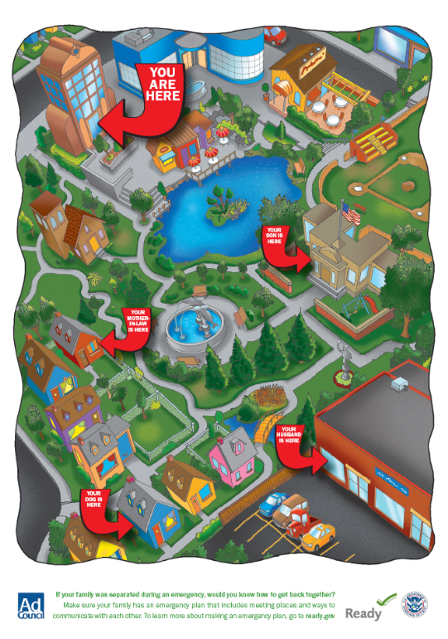
To download or order copies of the TV, radio, print, Internet or outdoor PSAs, visit the Ad Council’s PSA Central Web site at http://psacentral.adcouncil.org/psacentral. All available materials are provided free of charge. Please check the PSA Central Web site for the various lengths and sizes available for the public service announcements (PSAs).

Ready brochures and pamphlets are also available free of charge. There are materials for Ready America, Ready Business, Ready Kids, and also brochures for pet owners, older Americans, and Americans with disabilities and special needs.

Ready materials are available free in limited supply. To order Ready materials, please call the FEMA warehouse at 1-800-480-2520 or fax the attached request form to 301-362-5335.

In the event that you need a quantity of materials that exceeds what can be ordered for free, Ready provides a couple of options. All the brochures can be downloaded off Ready.gov, at http://www.Ready.gov/america/publications/allpubs.html. Additionally, if you would like to have the brochures professionally printed at your own expense, Ready will send you the source files.

Having brochures professionally printed at your own expense will allow you the option to localize the brochures by placing your local emergency contact information on the back cover.

*** Important Note: Please allow 4 to 6 weeks for the shipping of these materials. To receive materials more quickly, you can select express mail at your own expense, and will need to provide your DHL or FedEx number on the order form. ***
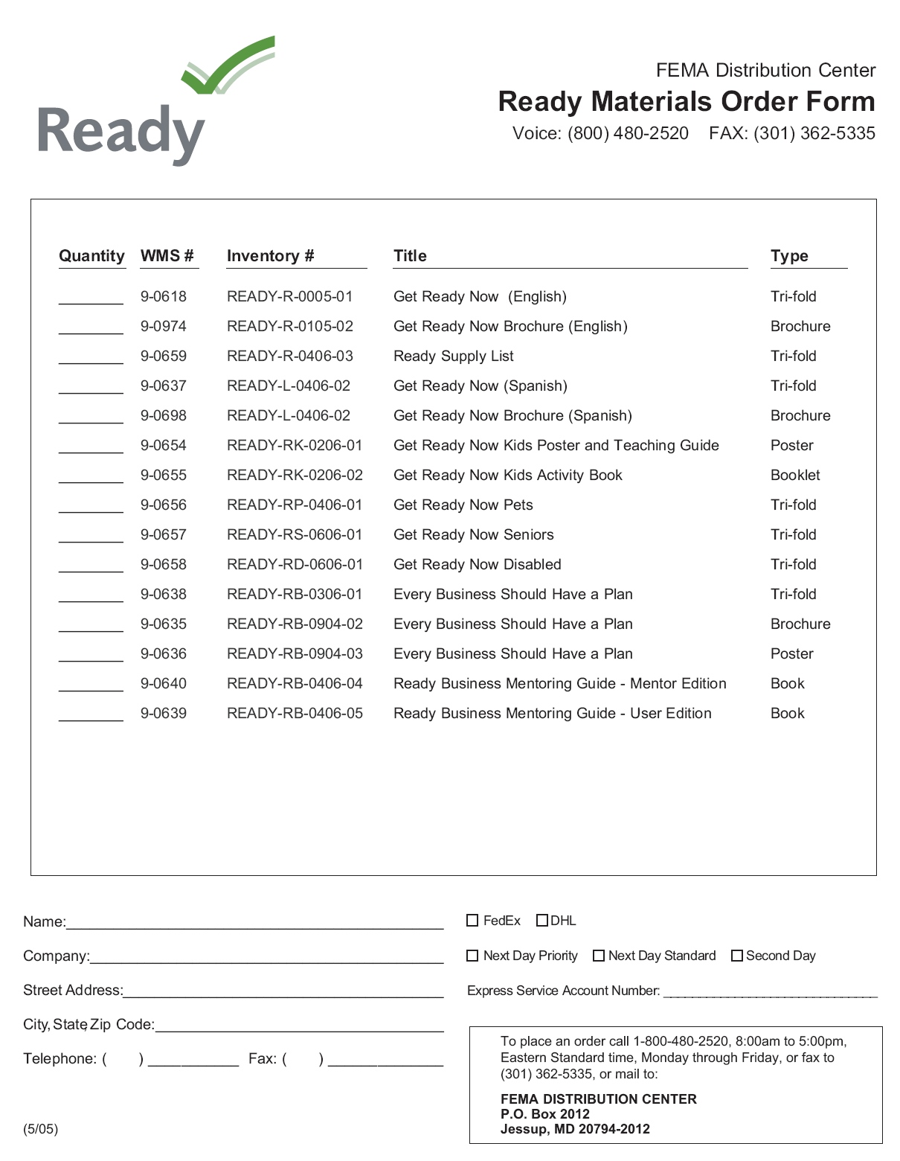

*** Important Note: Please allow 4 to 6 weeks for the shipping of materials. To receive materials more quickly, you can select express mail at your own expense, and will need to provide your DHL or FedEx number on the order form. ***

