FRESHWATER MOLLUSK CONTROLLED PROPAGATION PLAN FOR

KENTUCKY DEPARTMENT OF FISH AND WILDLIFE RESOURCES

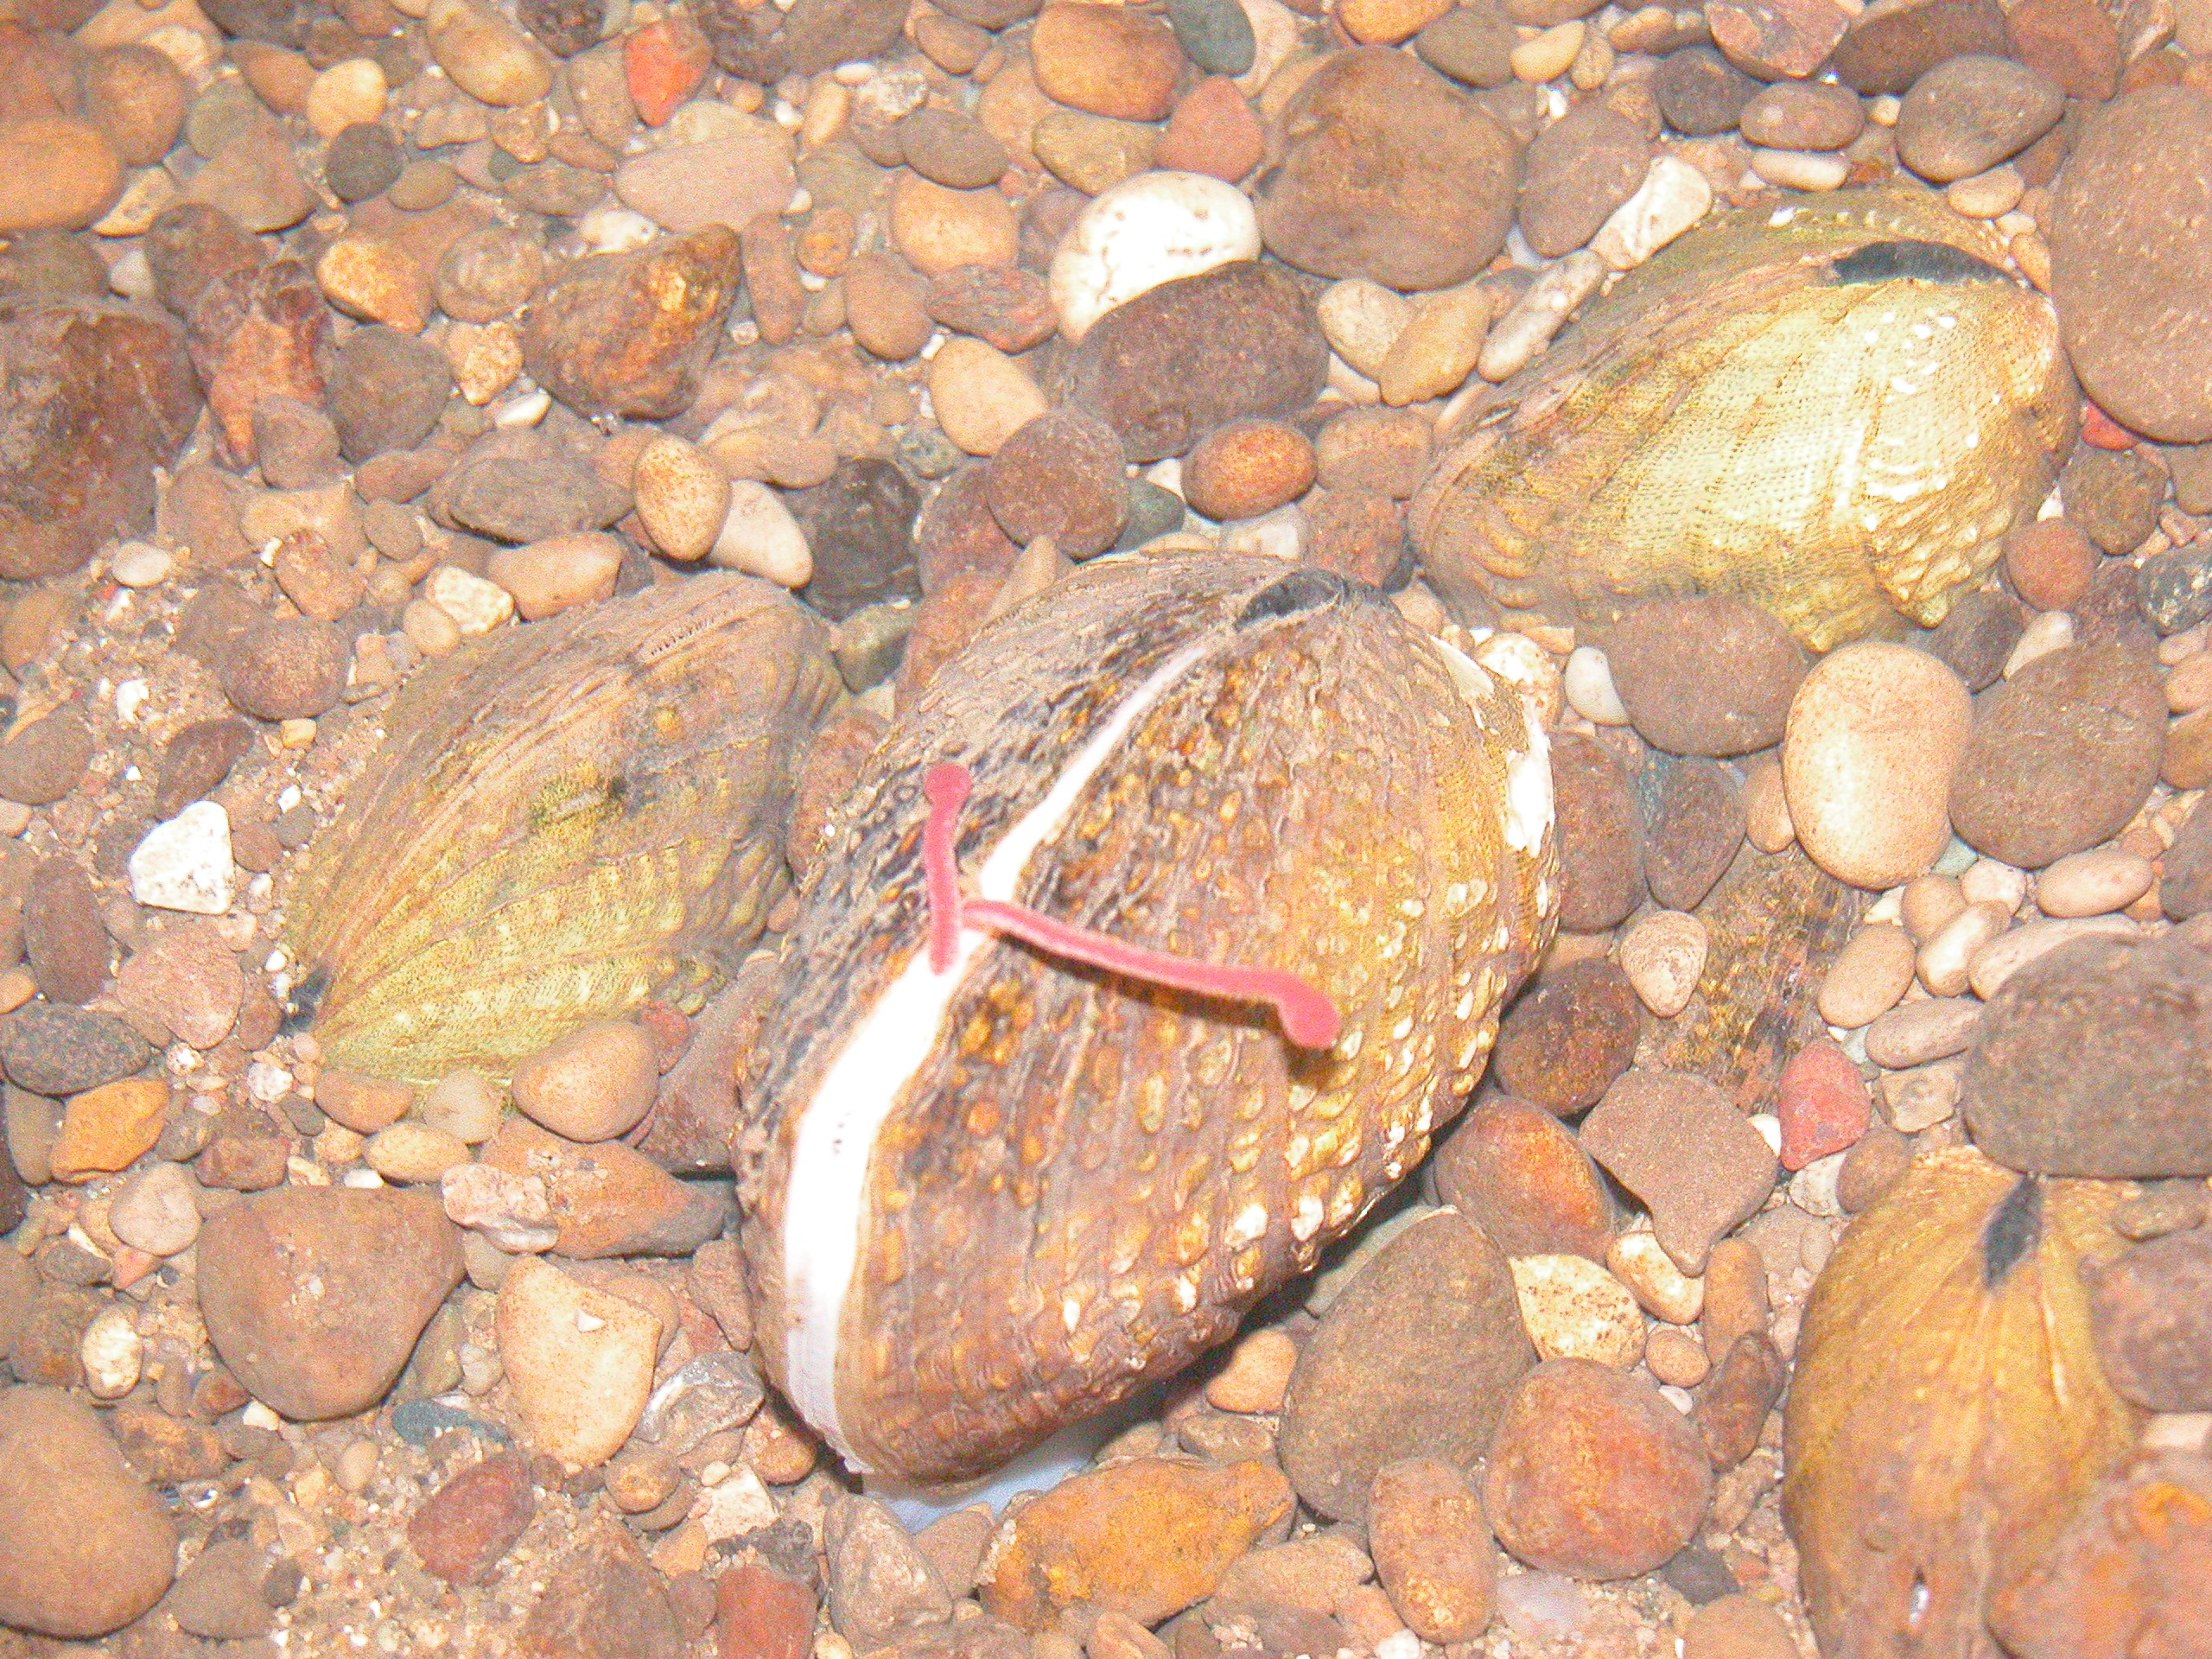

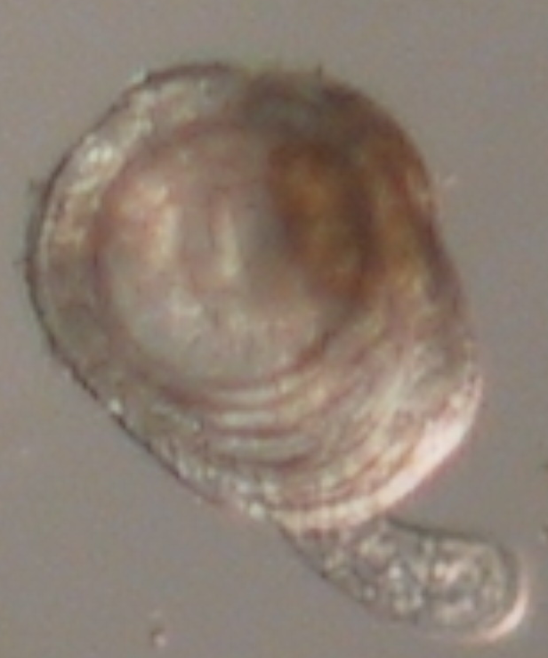
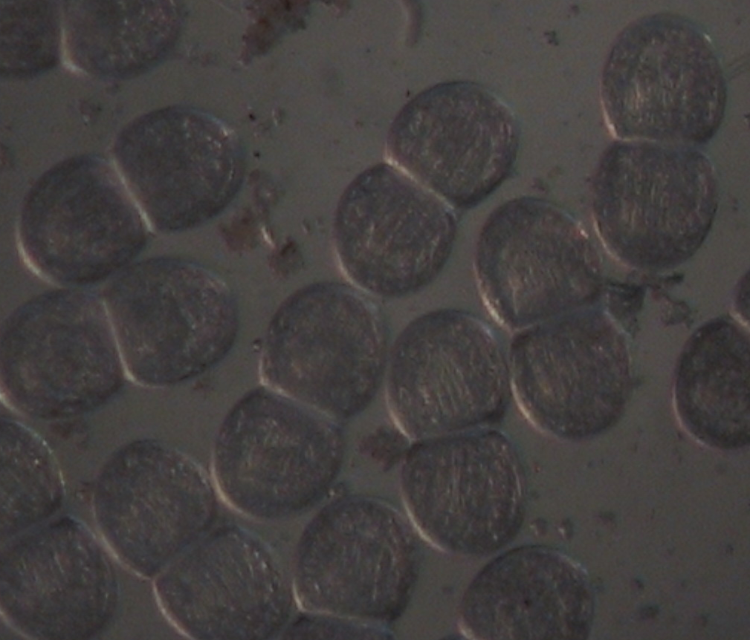

Prepared by:

Monte A. McGregor, Ph.D.

Kentucky Department of Fish and Wildlife Resources
# 1 Sportsman’s Lane
Frankfort, KY 40601

May 2005

TABLE OF CONTENTS

Introduction ...........................................................................................................1

Goals and Objectives..............................................................................................3

Justification for Controlled Propagation.................................................................5

Partners...................................................................................................................6

Definitions..............................................................................................................6

Controlled Propagation...........................................................................................9

Population Augmentation, Expansion, Reintroduction..........................................10

Site Selection..............................................................................................11

Monitoring..................................................................................................11

Stock...........................................................................................................11

Reporting....................................................................................................12

Genetic Considerations...........................................................................................12

Disposition of Excess Progeny from Research Activities.......................................13

Potential Sites Selected for Augmentation/Expansion/Reintroduction...................13

Facitlities for Propagation.......................................................................................27

Literature Cited........................................…………………………………………28

TABLES

Table 1: List of the Federal Endangered freshwater mussels in Kentucky
identified for propagation and recovery efforts. ……............................…..........…4

Table 2. Mussel Augmentation, Expansion, and Reintroduction opportunities
in Kentucky......................................................……………………………………16

Table 3. List of freshwater mussels in Kentucky and presence in Priority Management

Units for imperiled species……................………………………..........….....…...18

Table 4. List of additional freshwater mussels found in Kentucky but absent from Priority
Management Units...........................................……………………………………21

Table 5. Example of a site evaluation for augmentation, expansion, and reintroduction...22

Table 6. Rank of Kentucky mussels for propagation purposes. A high rank implies that a
species can be cultured with a higher probability of success...............…..........…23

FIGURES

Figure 1. Unionid provinces in North America (Parmalee and Bogan 1998)…………….1

Figure 2. Status of the mussels found in Kentucky……………………………………….2

Figure 3. Generalized geological map of Kentucky with major streams and rivers………2

Figure 4. Map of Priority Management Units for mussel conservation…………………..14

Figure 5. Map of Priority Management Units & Subunits for mussel conservation….…..15

APPENNDIX

Center for Mollusk Conservation Photo Gallery………………………………………….30

Partners/Contacts, , List of Kentucky’s Mussels............................................................…………………………………………....31

List of the 103 Freshwater Mussels Kentucky with author, sufamily, U.S., KSNPC, and AFS listing (Cicerello et al. 1991)……………………………………………………………...33

INTRODUCTION

Freshwater mussels are the most at-risk group of animals in North America. Of the 297 native mussel species in the United States, 71.7% are considered endangered, threatened, or of special concern, including 21 mussels that are endangered and presumed extinct (Williams et al. 1993). Seventy species (23.6%) are considered to have stable populations, although information is lacking for many of these species. Mussel and host fish populations are projected to decline if habitats are not restored and individual species numbers increased.

Modern day threats to mussels include habitat destruction from a variety of factors, including: sedimentation from agricultural land, logging and mining operations, construction projects, stream channelization and dredging, toxic spills (oil, gas, industrial acids, pesticides, fertilizers) and resulting fish kills, and invasion from exotic species (Parmalee and Bogan 1998). With the low numbers of mussels and continuing population declines, protecting each stage in the life cycle of the mussel is critical. Vital life stages include the availability of fish hosts, production of juveniles (currently inhibited by low density levels), and juvenile survival. Sufficient habitat is necessary for grow-out of juveniles to the adult stage. Good water quality and habitat are important to all stages of development, especially so for the larval and juvenile stages.
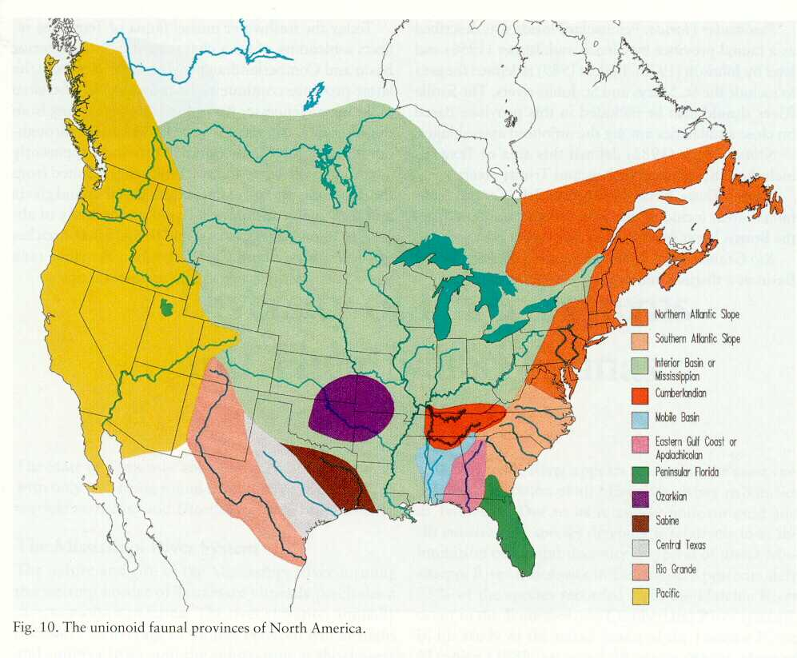
Figure 1. Unionid provinces in North America (Parmalee and Bogan 1998).
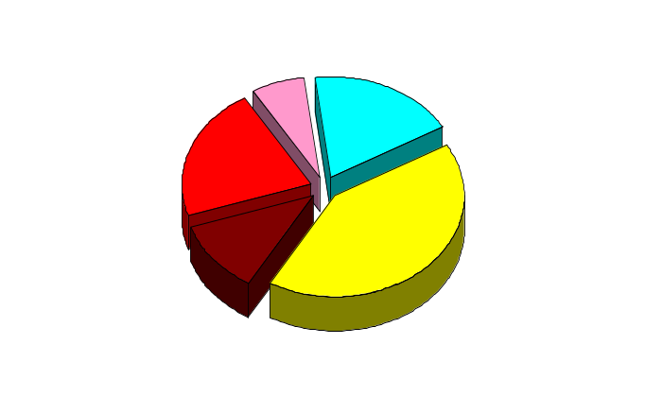
The mussel fauna in Kentucky is represented by the Mississippian or Interior Basin, the Cumberlandian, and Atlantic Slope Faunal groups (Figure 1). The Interior Basin faunal area includes the whole Mississippi River Basin minus the Ozarkian and Cumberlandian faunal areas (Bogan and Parmalee 1998). In Kentucky, the Mississippian fauna can be divided into the Mississippi River mainstem (and its minor tributaries) and the tributaries (including the Ohio River & tributaries minus the Cumberland and Tennessee Rivers). The Cumberlandian fauna encompasses the Tennessee and Cumberland River systems. Each faunal area contains specific species assemblages: the Mississippian fauna consists of ~80 species (5 extinct and 14 FE) (Mississippi mainstem fauna has ~22 species (none listed); the Cumberlandian fauna has ~22 species (7 extinct and 8 FE); the Atlantic Slope has one species (none listed). Overall, Kentucky has one of the most diverse mussel populations in North America with 41 genera and 103 recognized species (see Appendix Table 1) (Cicerello et al. 1991; Gordan and Layzer 1989). Twelve mussels are presumed extinct (Figure 2), and another 22 (Table 1) are listed by the U.S. Fish and Wildlife Service as endangered (at least 8 of the 22 are considered extirpated from the state) (Williams et al. 1993, Cicerello et al. 1991).
19
7
12
43
Federal Endangered
Extinct
Currently Stable
Special Concern
Threatened
22
Figure 2. Status of the mussels found in Kentucky.

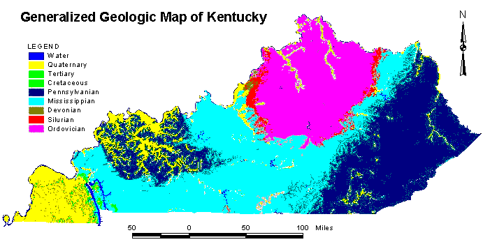
Due to recent advances in technology and interests in proactive recovery of freshwater mussels, the Kentucky Department of Fish and Wildlife’s Wildlife Diversity Program has started an Aquatic Restoration Initiative to restore and recover the highly imperiled freshwater habitats and its native fauna. Kentucky has over 89,000 miles of rivers and streams located in multiple geological provinces (Figure 3). Approximately 55 percent of Kentucky’s land is underlain by karst topography and therefore supports the necessary hard water for mussel shell construction. With significant mussel and fish populations in many of the state’s river systems (e.g., Mississippi, Ohio, Tennessee, Cumberland, Green, and Licking Rivers), the potential to augment existing areas with low population numbers is high.
Figure 3. Generalized geological map of Kentucky with major streams and rivers.

GOAL AND OBJECTIVES
The goal of this program is to recover imperiled mussels and to restore freshwater mollusk biodiversity and associated ecological functions to appropriate reaches of the rivers and streams in the Ohio and Mississippi River drainages. The objectives of this plan are to:
1) establish protocols for holding and propagating mollusks,
2) ensure communication and coordination among partners prior to relocation of wild stock, or the release of hatchery stock to the wild, and,
3) facilitate mollusk augmentation, expansion, and reintroduction activities in the Ohio and Mississippi River drainages, primarily through captive propagation.
Success of captive mollusk propagation efforts will
1.) reduce or alleviate risk of extinction,
2.) restore extirpated populations, and
3.) rebuild low population numbers via augmentation

Table 1. Federal listed endangered and candidate freshwater mussels in Kentucky identified for propagation and recovery efforts. Common name and subfamily from Turgeon et. al (1998) .
SPECIES in Kentucky | Common Name | Subfamily | status
Alasmidonta atropurpurea | Cumberland elktoe | Anodontinae | FE
Cumberlandia monodonta | spectaclecase | Margartiferidae | FC
Cyprogenia stegaria | Fanshell | Lampsilinae | FE
Dromus dromas | Dromedary pearlymussel | Lampsilinae | FE
Epioblasma brevidens | Cumberlandian combshell | Lampsilinae | FE
Epioblasma capsaeformis | oyster mussel | Lampsilinae | FE
Epioblasma florentina walkeri | tan riffleshell | Lampsilinae | FE
Epioblasma obliquata obliquata | Catspaw | Lampsilinae | FE
Epioblasma torulosa gubernaculum | Greenblossom, (pearlymussel) | Lampsilinae | FE
Epioblasma torulosa rangiana | Northern riffleshell | Lampsilinae | FE
Hemistena lata | Cracking pearlymussel | Pleurobeminae | FE
Lampsilis abrupta | pink mucket | Lampsilinae | FE
Leptodea leptodon | Scaleshell | Lampsilinae | FE
Obovaria retusa | ring pink | Lampsilinae | FE
Pegias fabula | Littlewing pearlymussel | Anodontinae | FE
Plethobasus cicatricosus | white wartyback | Pleurobeminae | FE
Plethobasus cooperianus | orange-foot pimpleback | Pleurobeminae | FE
Pleurobema clava | clubshell | Pleurobeminae | FE
Plethobasus cyphyus | sheepnose | Pleurobeminae | FC
Pleurobema plenum | rough pigtoe | Pleurobeminae | FE
Potamilus capax | fat pocketbook | Lampsilinae | FE
Ptychobranchus subtentum | fluted kidneyshell | Lampsilinae | C
Quadrula fragosa | winged mapleleaf | Ambleminae | FE
Villosa fabilis | rayed bean | Lampsilinae
Villosa trabilis | Cumberland bean | Lampsilinae | FE

ROLE OF CONTROLLED PROPAGATION: coordinate with habitat management and restoration programs and use when other methods to recovery species have failed.

JUSTIFICATION FOR CONTROLLED PROPAGATION
The Mississippi and Ohio River Basins in and near the geographic boundaries of Kentucky contain some of the highest diversity of freshwater mussels in the world. Major obstacles to recovery of mollusks in Kentucky are the fragmentation and isolation of river habitats by dams and impounded waters and/or pollution. Most imperiled mollusks now occur in only a few localized reaches, or in some cases at a single site (e.g., Pegias fabula, Epioblasma walkeri, Obovaria retusa, Plethobasus cicatricosus). Some isolated stream reaches where mollusks were extirpated due to historical pollution events or other temporally isolated causes, have now improved to a degree that mussels may now survive (e.g., Big South Fork Cumberland River, Upper Green, Lower Licking River) and reproduce. However, dams and/or extensive areas of impounded waters prevent re-colonization and natural gene flow through the processes of immigration and emigration. Some species have become exceedingly rare, with apparently low reproductive and recruitment success (e.g., Pegias fabula, Obovaria retusa). Such species often require extensive sampling efforts to locate in the wild for use in recovery. Isolated mollusk populations are subject to inbreeding depression and stochastic events. Limited information is available on mussel & host fishes (e.g., Obovaria retusa Pleurobema plenum) and the life history requirements of both mussels and host fishes, especially from a propagation perspective. Because of these conditions, human intervention is required to understand, manage, and restore populations of endemic aquatic species, including:

- developing technology and facilities for holding endangered and threatened mollusks,
- producing captive reared individuals for research and technology development,
- in some cases, establishing and maintaining captive populations of endangered mollusks,
- producing individuals for supplementing (augmenting) existing populations, and
- producing individuals for reintroduction of species into restored or recovered habitats.

The U.S. Fish and Wildlife Service (FWS) has been working with State and private partners to locate populations of rare mussels and snails in Kentucky, and more recently, to develop appropriate protocols and facilities for holding and propagating mussels. As a result, Kentucky Department of Fish and Wildlife Resources is at a point where progeny of federally protected and rare mussels can be produced in hatchery facilities in excess of the numbers required to maintain the captive population. This plan serves as the necessary documentation of USFWS policy requirements in the development of a reintroduction plan prior to the release of propagated endangered and threatened species into the wild (Fed. Register 2000).

PARTNERS

The State of Kentucky has identified multiple partners, including (but not limited to) U.S. Fish and Wildlife Service, Universities (Eastern Kentucky University, Murray State University, University of Kentucky, Kentucky State University, Tennessee Technological University), Daniel Boone National Forest, Mammoth Cave National Park, The Nature Conservancy, Tennessee Wildlife Resources Agency Kentucky State Nature Preserves Commission, U.S. Forest Service (FS), U.S. Geological Survey (USGS), U.S. Army Corps of Engineers, and others have been cooperating in studies of the Basin’s endemic mussel life histories, and in developing holding and propagation technology for several species. Live mussels are currently held and used for life history research at the Center for Mollusk Conservation (Frankfort, KY). See appendix more a detailed list of partners.

DEFINITIONS
The purpose of these guidelines is to provide a structure to the process of increasing populations of endangered mussels in the wild. All endangered species recovery plans recommend the introduction of the each species as a task towards delisting. In this document there are three levels of introduction; augmentation, expansion, and reintroduction. Each level establishes varying degrees of effort and contacts.

Level 1: Augmentation - release of species at a reach where the species currently exists in low

numbers.

- Augmentation reach must be thoroughly surveyed to determine presence of target species. Species must already be present within the augmentation reach.
- Augmentation can occur by 1) the translocation of adult mussels from a source population, 2) release of newly metamorphosed juveniles, or 3) release of infected host fishes collected from the augmentation reach. Source population must contain sufficient numbers so that it would be unaffected by the removal of a few specimens.
- When stocking adults or when the recipient population is too small to adequately supply adults for artificial propagation, the specimens will come from another population using the following criteria:
- Stock from another metapopulation in the same stream/tributary system in the same physiographic province.
- Stock from another population in an adjacent stream/tributary system in the same physiographic province.
- Stock from another population in an adjacent stream/tributary system in an adjacent physiographic province.
- Stock from the only population known.

Authority - Augmentation will be based on the decision of Department biologists. Because species are extant in the reach, no additional regulations or special designations would be needed.

Level 2: Expansion - release of species into suitable historical habitat in a reach where the species is currently extirpated but exists upstream or downstream and can migrate to naturally.

- Recipient reach must be thoroughly surveyed to determine absence of target species. If target species are found, use Level 1 justification.
- Expansion can occur by 1) translocation of adults from a source population, 2) release of newly metamorphosed juveniles or 3) release of infected host fishes collected from recipient reach. Source populations must contain sufficient numbers so that it would be unaffected by the removal of a few specimens.
- When stocking adults or producing juveniles, the source should be from a population using the following criteria:
1) Stock from another metapopulation in the same stream/tributary system in the same physiographic province.
2) Stock from another population in an adjacent stream/tributary system in the same physiographic province.
- Stock from another population in an adjacent stream/tributary system in an adjacent physiographic province.
- Stock from the only population known.

Authority: Stocking of mussels will be based on the decision of Department biologists and the recommendations of the Controlled Population Guidelines. Because species could potentially migrate to target reach naturally, no additional regulations or special designations would be needed.

Level 3. Reintroduction - release of species into suitable historical habitat in a reach where they are currently extirpated and cannot migrate to naturally.
- Recipient reach must be thoroughly surveyed to determine absence of target species. Species must have been historically documented in the recipient reach.
- Reintroduction of species can occur by 1) translocation of adults from source population, 2) release of newly metamorphosed juveniles or 3) release of infected host fishes collected from recipient reach/drainage. Source populations must contain sufficient numbers so that it would be unaffected by the removal of a few specimens. Stocking of species should use the following criteria:
- Stock from another population in the same stream/tributary system in the same physiographic province.
- Stock from another population in an adjacent stream/tributary system in the same physiographic province.
- Stock from another population in an adjacent stream/tributary system in an adjacent physiographic province.
- Stock from the only population known.

Authority: Because species has not occurred in the recipient reach for an extended period of time, the decision to reintroduce must be coordinated by Department biologists and affected groups, such as regulatory authorities and/or landowners. Reintroduced population may need special designations such as “experimental” or “nonessential.”

CONTROLLED PROPAGATION

The biology, life history and genetics of many of Kentucky’s mollusk species are poorly known. Only a few attempts have been successfully made to propagate any of these species in captivity. Therefore, controlled propagation will be treated as experimental in nature, and will require detailed proposals prior to issuance of appropriate permits. In general, any parties wishing to conduct controlled propagation of mollusks must abide by the following guidelines:

- present a detailed plan to the KDFWR and the USFWS (listed species) outlining their expertise, facilities and methodology, species to be propagated, source of stock, disposition of progeny, etc.; an Environmental Assessment may also be necessary;
- provide justification for the work, including benefits;
- obtain all necessary State and Federal permits;
- take all necessary precautions to prohibit the potential introduction or spread of diseases, parasites, and exotic species (e.g., zebra mussels) into controlled environments or suitable habitat;
- conduct all activities in a manner that will prevent the escape or accidental introduction of individuals outside of their historical range; and,
- keep detailed notes and records of life history observations, fecundity, survival and mortality, water chemistry, seasonality, and any other conditions/observations important to successful propagation of these species.

POPULATION AUGMENTATION, EXPANSION, OR REINTRODUCTION

Although many streams in Kentucky have been highly modified, a number of opportunities exist to improve mussel populations through controlled augmentation, expansion, or reintroduction. Propagation activities have not been attempted for many of the species in Kentucky beyond the research phase, and should be considered as individual experiments. In order to protect genetic integrity, biological diversity, and to avoid conflicts, all activities will be coordinated with all appropriate Recovery Partners (i.e., USFWS, State agency, riparian landowner, affected Federal agency).

SITE PLANS
Partners wishing to plan, sponsor, or conduct specific actions will produce a Site Augmentation/Expansion/Reintroduction Plan (Site Plan) prior to conducting any activities. Site Plans for potential activities will be developed and distributed to the appropriate FWS Field Office(s) and Regional Office prior to propagation. It is understood that collection of gravid females, successful production of progeny, number of progeny produced, etc. is difficult to predict. However, Site Plans should include as much information as possible, including:
- the exact location where animals are to be introduced,
- status of the target species at the site, and why propagation is necessary,
- an Alternatives Plan (e.g., no action),
- relationship of the site to other populations of the target species,
- current habitat conditions at the site,
- possible limiting factors at the site (e.g., recruitment, fish hosts presence and abundance)
- source of the animals for activity (adults, juveniles, hatchery-produced, or wild),
- source of the stock (location and drainage),
- monitoring plan and responsibilities,
- cooperating and responsible partners,
- a copy of all appropriate permits, and,
- any other pertinent information.

All Recovery Partners, and any other affected private or public entity identified by the Partners, will be notified of planned activities, and will be provided upon request with the Site Plan prior to relocating or releasing animals in the wild.

Site Selection

Sites for augmentation/expansion/reintroduction activities should be selected based on criteria identified above, including historical and current distribution of the species, habitat conditions (e.g., water quality, recruitment, fish hosts), and past, present or future threats. Since methods are experimental in nature, activities for a species or suite of species should be restricted to discrete sites within a drainage. The site should be used and monitored for a period of years, or until there is evidence of success or failure. Concentrating efforts at a site will reduce monitoring costs and facilitate genetic modeling.

Monitoring

Since methods are experimental in nature, monitoring is critical to determine effectiveness and/or success of such programs. The facility and/or Partner conducting the release is responsible for developing and conducting a monitoring plan, unless otherwise specified in the Site Plan.

Stock

Transplantations of subadult or adult mollusks should come from locally robust populations.
Removal of mollusks for transplantations should affect less than 5% of the donor population if possible. Adults taken for propagation should represent various age and size classes to ensure genetic diversity. Based on recent work, KDFWR recommends a minimum of 10-12 males and 10-12 females (total of 20-24 individuals) of each species to initiate spawning in captivity. However, biologists have observed glochidia production with as few as one female and three males with multiple species. Some species may require more or less individuals based on population genetics. Hatchery progeny used for augmentation should come from parental stock in the drainage nearest to the augmentation site, whenever possible. It is recommended that donor populations come from the specific site or as close as possible to the site. If females can not be obtained from the site, upon recommendations by partners, adults may be collected from an adjacent site in the same minor drainage, a secondary site in the same drainage, or from the only source available if necessary (see definitions section for more details).

Reporting

Recovery Partners conducting hatchery propagation studies, augmentation or reintroduction releases, or release monitoring studies will provide an annual report of activities to the KDFWR and other involved partners, including:
- a brief description of their propagation program, including objectives and status,
- list of cooperators, if any,
- activities conducted, prospects for, or obstacles to achieving their research, propagation, or reintroduction efforts, and,
- a brief description of the status of targeted populations, if any.

GENETIC CONSIDERATIONS

Very little is known of genetic differences between drainage populations of the mollusk species, as they relate to expressions in morphology, behavior, and other forms of habitat adaptation. As such, it is preferred that stock for propagation should come from the same drainage as the proposed release site. Geneticists recommend that up to 50 females may be necessary to provide the necessary offspring for maintaining genetic diversity. However, most rare mussel populations do not support sufficient numbers to accomplish this task. Therefore, KDFWR recommends the use of at least three females for propagation purposes if possible. In cases where only a single known population of a once wide ranging species is known to survive, or where a drainage population has been severely reduced or extirpated, genetic issues are not of immediate concern.
Juveniles produced in a hatchery by a single female mussel may number in the hundreds to thousands. Juvenile mussel mortality after release is believed to be extremely high, with only a small fraction of released juveniles surviving to maturity. Natural mortality and survival in the wild is difficult to establish.
In order to minimize any potential of inbreeding affects, it is preferred that hatchery produced juveniles from a specific female mussel will only be used once per site. Gravid mussels used to produce juveniles for stocking will be uniquely marked and returned to the point of capture. Subsequent releases should come from other appropriate wild mussel stock whenever possible.

DISPOSITION OF EXCESS PROGENY FROM RESEARCH ACTIVITIES
Various partners periodically conduct laboratory host-fish trials with endangered and threatened mussels. Propagation efforts or host fish trials may result in excess juvenile mussels. Larger numbers of research or hatchery-produced offspring should be considered for:

- augmentation or reintroduction releases,
- toxicity testing, or
- other existing experimental needs.

Small numbers of juvenile mollusks, excess individuals, or specimens rendered unfit for population augmentation or reintroduction to historical habitats that result from research activities can be properly preserved for genetic testing (e.g., ethanol or frozen), appropriately labeled, and deposited in appropriate facilities.

Priority Areas Selected for Augmentation/Expansion/Reintroduction

Select areas (priority management units with boundaries defined by HUC 14) in Kentucky have been identified based on presence of imperiled mussels as the most appropriate areas for augmentation, expansion, and reintroduction (Figure 4, Tables 2, 3, & 4). Additional priority management units may be identified as more information becomes available through the review process. Each priority management unit will be reviewed and ranked based on the level of conservation priority for each species and the cumulative diversity of rare species within the unit (see Table 5). Once specific sites within the priority management unit have been selected, those sites with multiple rare species are ranked higher than sites with low diversity. All management units in Kentucky were divided into hydrologic units based on 8 digit and 14 digit HUC. Species richness was identified within each of the HUC units and prioritized based on the level of richness. We identified ten HUC 8 (larger watersheds) priority management units and several HUC 14 (smaller units) within the larger HUC 8. The highest HUC 8 was labeled Priority Management Unit 1 and had four smaller units (either HUC 14 or a combination of adjacent HUC 14s) labeled 1a, 1b, 1c, and 1d. These ten Priority Management Units support most of the freshwater mussel richness in Kentucky. However, species may also be ranked based on status, culture capability (e.g., host known, handling sensitivity, fecundity, number of donor females, fish host sensitivity), costs, and other (see Table 6). In the case of extremely rare animals (i.e., present at only one site), it may be necessary to hold brood stock in captivity for expansion purposes.
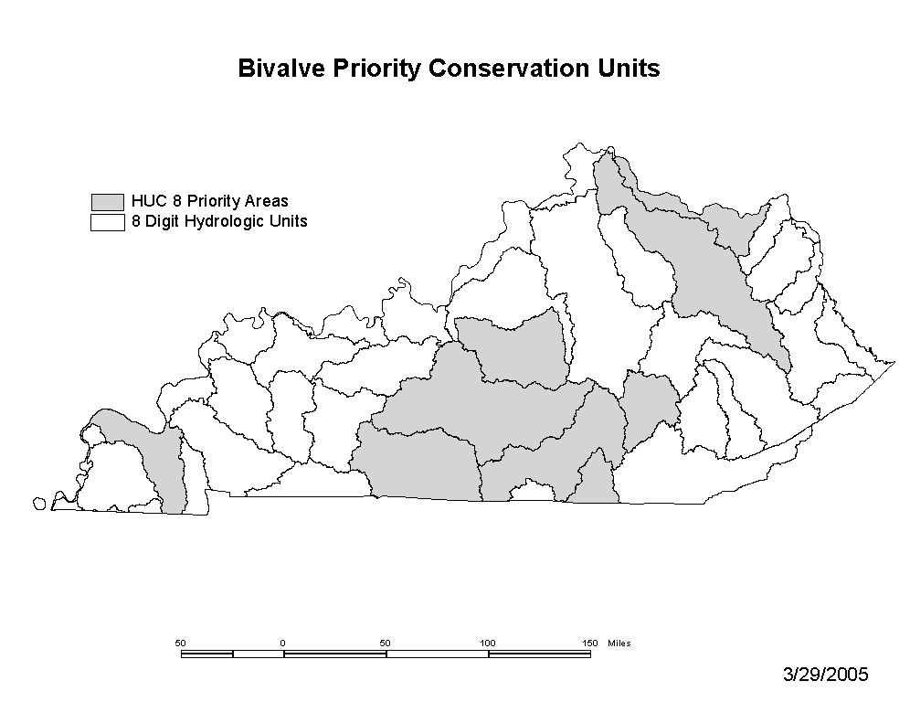
1
2
5
3
10
4
9
7
6
8
Figure 4. Map of Priority Management Units for mussel conservation (see Table 3 for detailed species lists by unit). Areas in gray with no rank number are additional units that harbor several species, but did not rank in the top ten. These areas do not have any additional species that are not included in at least one other priority management unit.
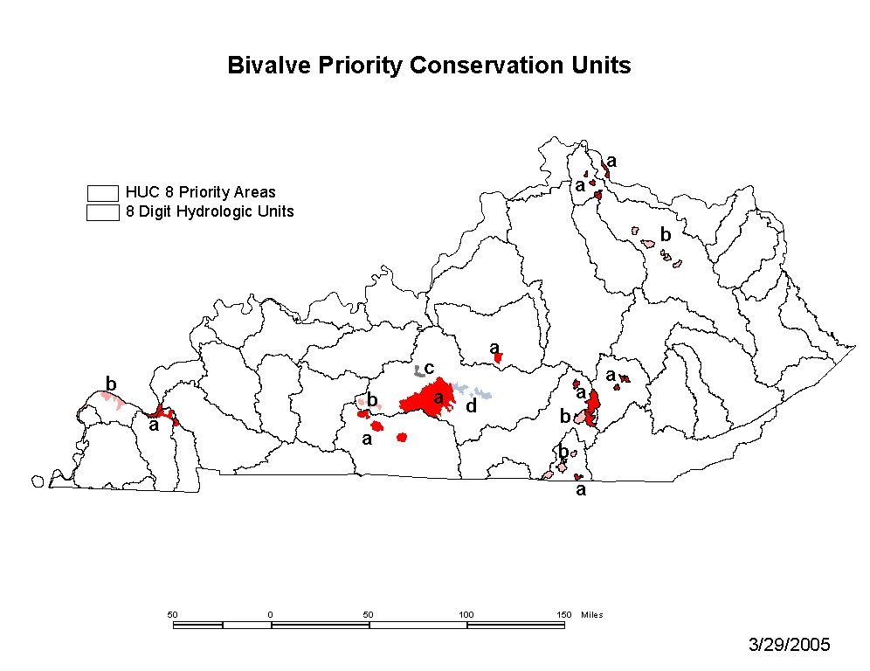
Figure 5. Map of Priority Management Subunits (HUC 14) ranked (a,b,c,d) within each larger hydrologic unit (HUC 8) for mussel conservation (see Table 3 for a list of species by each larger unit).
1
2
5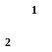
3
10
4
9
7
6
8
Bivalve Priority Conservation Subunits within Priority Management Units

Table 2. Examples of mussel augmentation, expansion, and reintroduction opportunities in Kentucky (see Table 3 for more species and areas.
Site | Reference | # Species Present | # FE Species | Rare species
Cumberland River (Upper)
Big South Fork | Biggins and Bakaletz (2002) | 25 | 5 | A. atropurpurea, P. fabula, E. walkeri, E. brevidens, E. capsaeformis, V. trabilis, P.subtentum
Buck Creek | Hagman and Schuster (1999) | 29 | 4 | P. fabula, E. capsaeformis E. brevidens, V. trabilis, P.subtentum
Horse Lick Creek | Layzer et al. (1996) | 18 | 2 | P. fabula, V. trabilis, E. capsaeformis, E. brevidens, P.subtentum
Marsh Creek | Cicerello (1995) | 7 | 1 | A. atropurpurea
Rock Creek | Cicerello (1996) | 5 | 1 | A. atropurpurea
Rockcastle River | Cicerello (1994), Thompson (1978) | 26 | 3 | E. capsaeformis E. brevidens, V. trabilis, P. fabula, P.subtentum
Sinking Creek | Personal collections | 8 | 2 | A. atropurpurea, V. trabalis, P. fabula
Cumberland River (Lower) | Cicerello et al. 1991 | 70 | 7 | L. abrupta, P. capax, O. retusa, P. fabula, P. cooperianus, P. clava, C. stegaria
Red River | Starnes and Bogan 1988 | 22 | 2 | E. florentina, E. walkeri, P. fabula
Licking River (Lower and Middle Sections) | Cicerello et al. 1991 | 53 | 5 | C. stegaria, E. torulosa rangiana, P. clava, P. plenum, V. fabilis, L. abrupta
Site | Reference | # Species Present | # FE Species | Rare species
Ohio River (mainstem) |  | ? | 14 | L. abrupta, P. capax, O. retusa, P. cooperianus, P. clava, P. plenum, V. fabilis C. stegaria, P. cicatricosus, D. dromus, P.capax, C. monodonta, P. cyphyus, V. fabilis
Mississippi River |  | ? | 4 | P.capax, C. monodonta, P. cyphyus, L. abrupta
Green River  Upper Green & Barren | Cicerello et al. 1991 | 66 | 12 | C. stegaria, E. obliquata, E. torulosa rangiana, H. lata, L. abrupta, L. leptodon, O. retusa, P. cooperianus, P. clava, P. plenum, P. capax, V. fabilis
Lower Green | Cicerello et al. 1991 | 60 | 7 | C. stegaria, E. obliquata, E. torulosa rangiana, O. retusa, P. cooperianus, P. plenum, P. capax, L. abrupta
Salt River
Rolling Fork | Akers and Schuster 2000 | 33 | 1 | C. stegaria, E. triquetra
Tennessee River
Lower TN below KY Dam | Cicerello et al. 1991 | 55 | 5 | C. stegaria, L. abrupta, O. retusa, P. cooperianus, P. clava, P. plenum, D. dromus, P. cicatricosus, C. monodonta
Kentucky River
Red River | Cicerello (1997) | 23 | 0 | E. triquetra
Red Bird River | Cicerello (1996) | 20 | 0 | E. triquetra

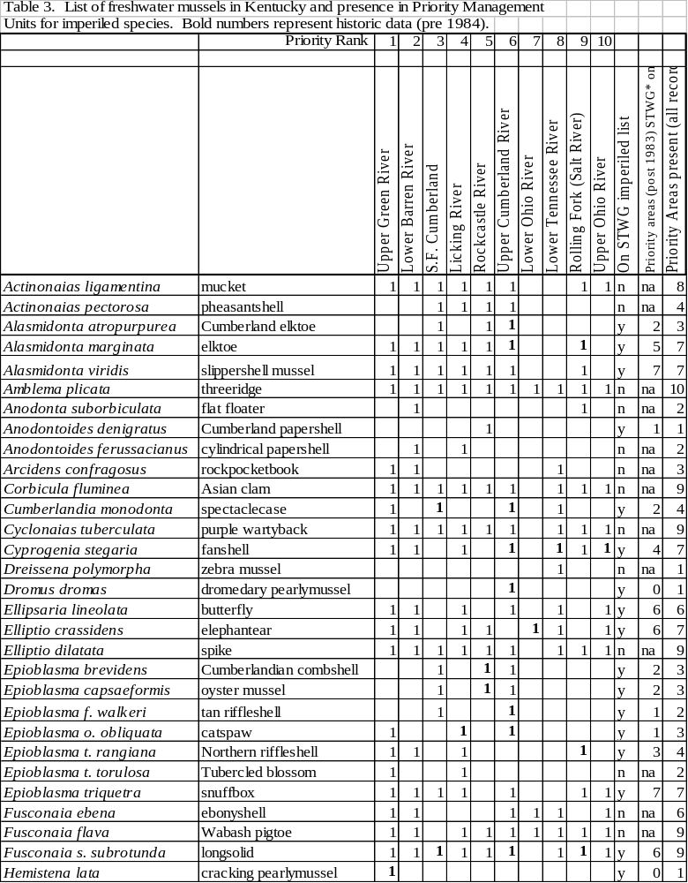

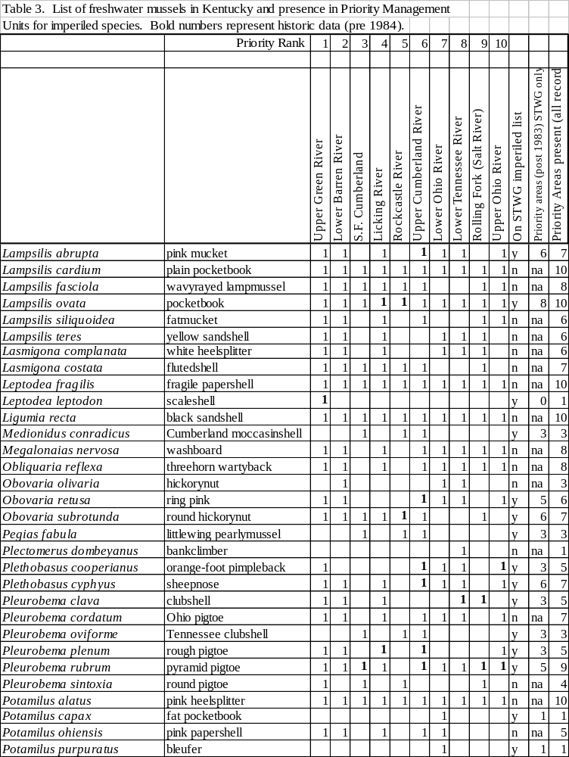

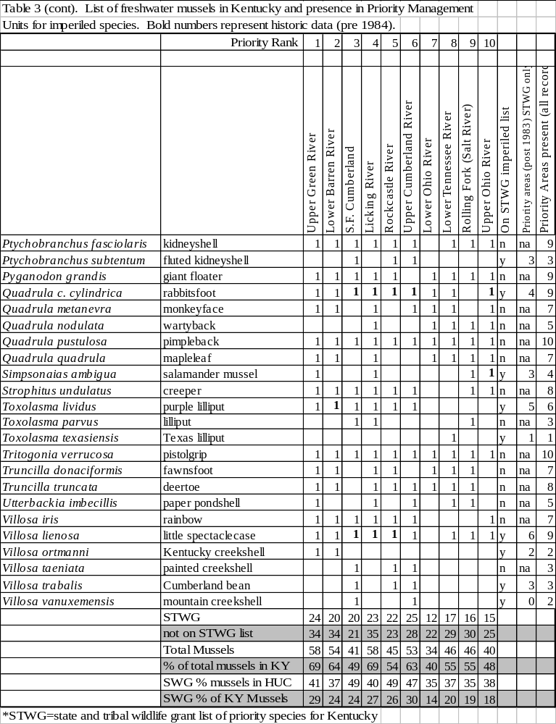

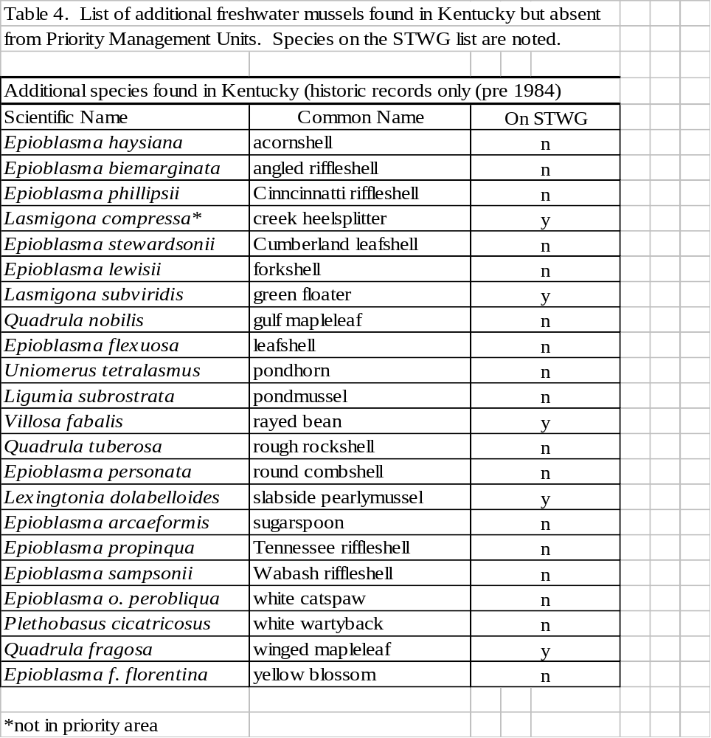

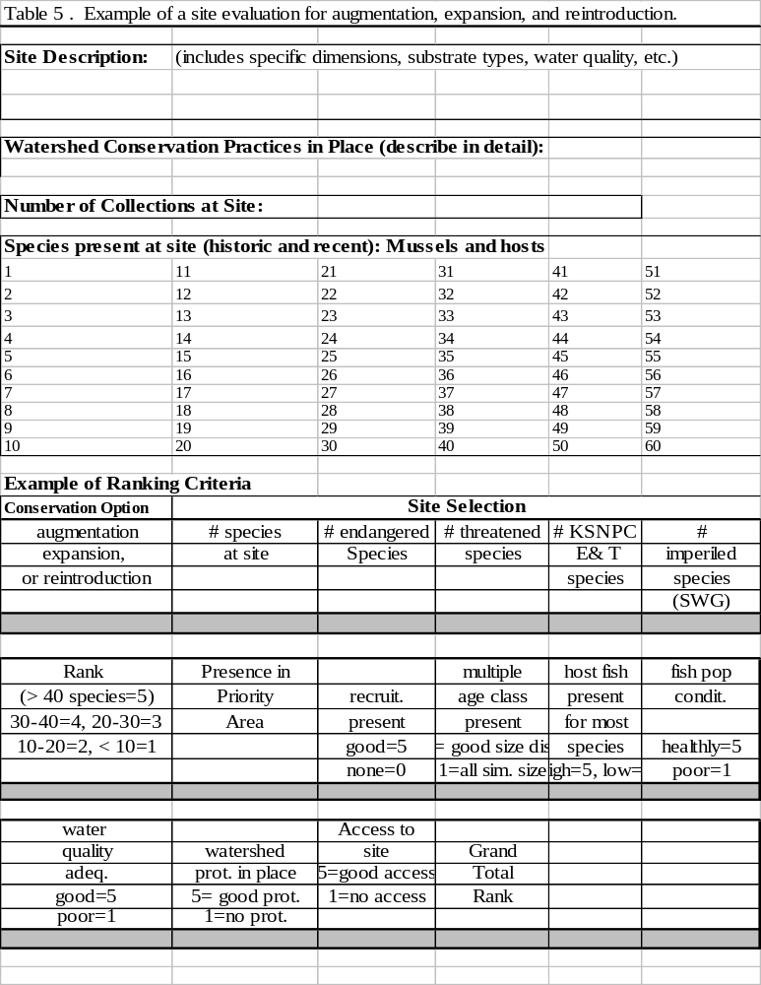

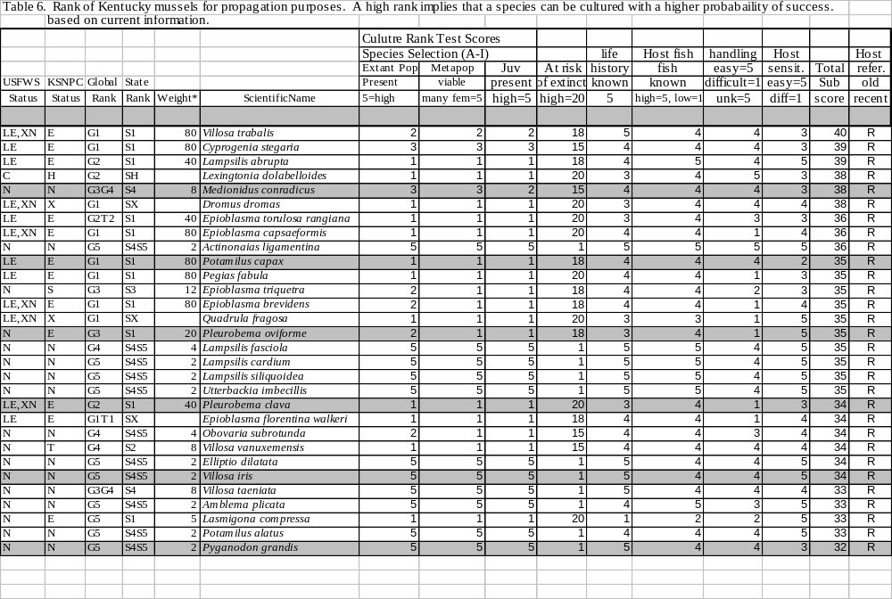

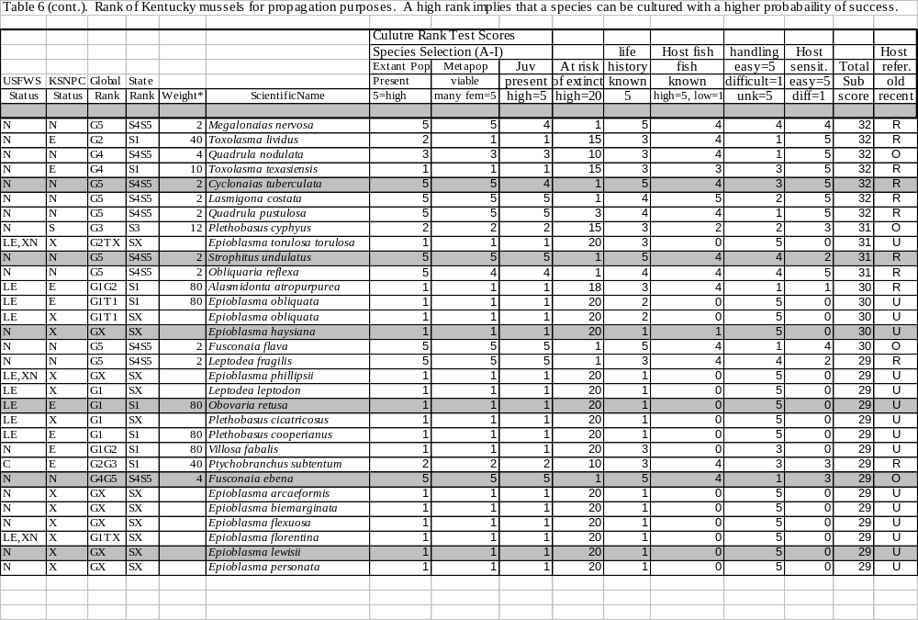

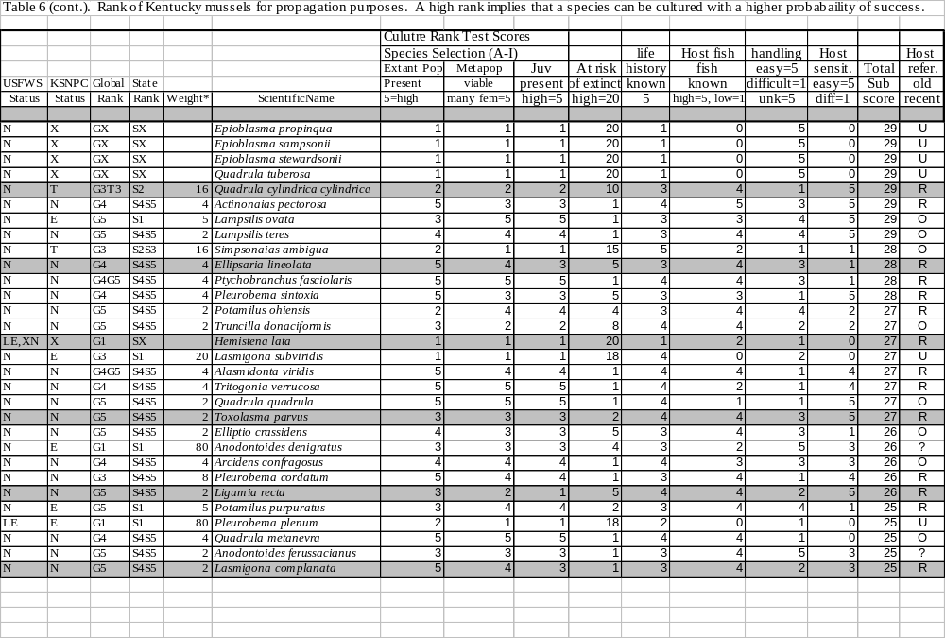

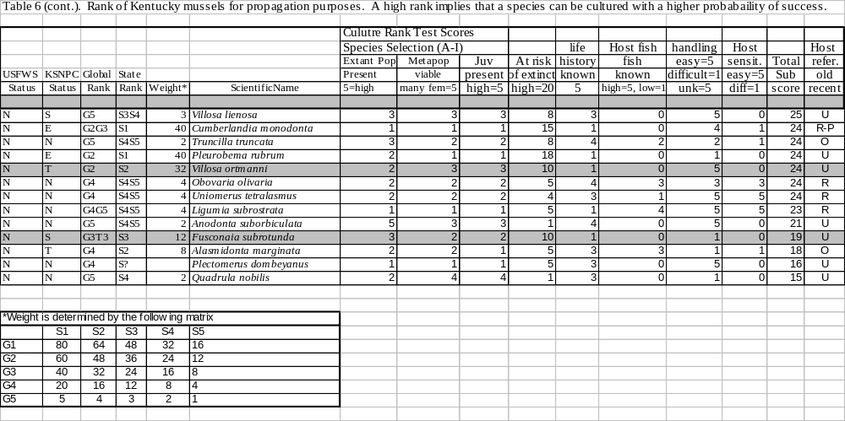

Facilities for Propagation

KDFWR has developed facilities for mussel propagation at the Forks of Elkhorn Transportation Section (an old fish hatchery) and at Minor Clark National Fish Hatchery (in coordination with Tennessee Technological University). KDFWR is also working cooperatively with Kentucky State University, Eastern Kentucky University, and the Wolf Creek National Fish Hatchery. The primary facility is the Center for Mollusk Conservation (see Appendix), established in 2002 as a multiphase facility capable of holding adults in semi-natural conditions, culture of juvenile mussels, and growout of juveniles to a larger, stockable size. In 2002-2003, biologists have successfully reared several species and have shown significant growth of many of these species. Survival has been good at the facility for the last year and many mussels have displayed normal brooding cycles (compared to natural periods). KDFWR has the ability to expand its capability to work with additional species and is seeking funds to work with endangered species found in KY’s waters. It may be necessary to work with a surrogate species to develop techniques if that genus/species has not been cultured previously.
Benefits of a mussel propagation facility include enhanced ability to augment, restore, and recover endangered mussel populations. Information on mussel resources, including distribution, population status, recruitment, life history, culture and growout methods, holding facilities for critically rare animals will be evaluated and examined for improving awareness of the resource needs and recovery potential. Increasing public awareness (education and outreach) about endangered and imperiled aquatic fauna and threats and mitigation practices will make citizens aware of conservation issues and needs. The project will promote a cooperative effort among intra and inter state organizations and state and federal wildlife agencies.

This Plan is a working document that is subject to modification based on results of current and future research and recovery activities involving mollusk propagation, augmentation, or reintroduction. Recovery Partners are encouraged to provide comments and suggestions to Monte McGregor, Kentucky Department of Fish and Wildlife Resources.

Literature Cited

Akers, E.P. and G.A. Schuster. 2000. The freshwater mussels (Bivalvia: Unionidae) of the Rolling Fork River drainage of Kentucky. KY Division of Water Report. 35 pages.

Biggins, R. and S. Bakaletz. 2002. (Draft) Recovery of the Freshwater Mussel Fauna in the Free-Flowing Reach of the Big South Fork of the Cumberland River within Big South Fork National River and Recreation Area Kentucky and Tennessee. Draft Environmental Assessment. 27 pages

Cicerello, R.R. 1993. A survey of the unionids (Bivalvia: Unionidae) of Rockcastle River, Middle Fork to Billows, Kentucky. Report to Daniel Boone National Forest. 26 pages

Cicerello, R.R. 1994. A survey of the unionids (Bivalvia: Unionidae) of Rockcastle River, Billows, Kentucky, to the Cumberland River. Report to Daniel Boone National Forest.

Cicerello, R.R. 1995. A survey of the unionids (Bivalvia: Unionidae) of Marsh Creek, McCreary County, Kentucky. Report to Daniel Boone National Forest. 21 pages.

Cicerello, R.R. 1996. A survey of the unionids (Bivalvia: Unionidae) of Red Bird River, Clay and Leslie Counties, Kentucky. Report to Daniel Boone National Forest. 15 pages.

Cicerello, R.R. 1996. A survey of the unionids (Bivalvia: Unionidae) of Rock Creek, McCreary County, Kentucky. Report to Daniel Boone National Forest. 11 pages.

Cicerello, R.R. 1997. A survey of the unionids (Bivalvia: Unionidae) of Red River in Daniel Boone National Forest. Report to Daniel Boone National Forest. 18 pages plus notes.

Federal Register. 2000. Volume 65 (183). Wed., September 20, 2000.

Gordan, M.E. and J.B. Layzer. 1989. Mussels (Bivalvia:Unionidea) of the Cumberland River: Review of life histories and ecological relationships. U.S. Fish and Wildlife Service Biological Report 89(15). 99 pages.

Hagman, T.E. and G.A. Schuster. 1999. Stress analysis and mussel (Bivalvia:Unionidae) bed mapping of Buck Creek in Pulaski County, Kentucky, utilizing geographic information systems with special emphasis on the four endangered mussel species living in the stream. Report to KDFWR. 89 pages.

Layzer, J.B., B.S. Houslet, and L.M. Madison. 1996. Monitoring mussel populations, and age and growth of Villosa taeniata in Horse Lick Creek. Report to Daniel Boone National Forest. 43 pages.

Parmalee, P.W. and A.E. Bogan. 1998. The freshwater mussels of Tennessee. University of Tennessee Press, Knoxville, TN.

Starnes, L.B. and A.E. Bogan. 1988. The mussels (Mollusca:Bivalvia:Unionidae) of Tennessee. American Malacological Bulletin, Vol. 6(1):19-37.

Thompson, Y.L. 1985. The mussel fauna of the Rockcastle River system, Kentucky (Bivalvia: Unionidae). M.S. Thesis. 51 pages.

Williams, J. D., M. L. Warren, Jr., K. S. Cummings, J. L. Harris, and R. J. Neves. 1993. Conservation status of freshwater mussels of the United States and Canada. Fisheries 18(9):6-22.

APPENDIX:
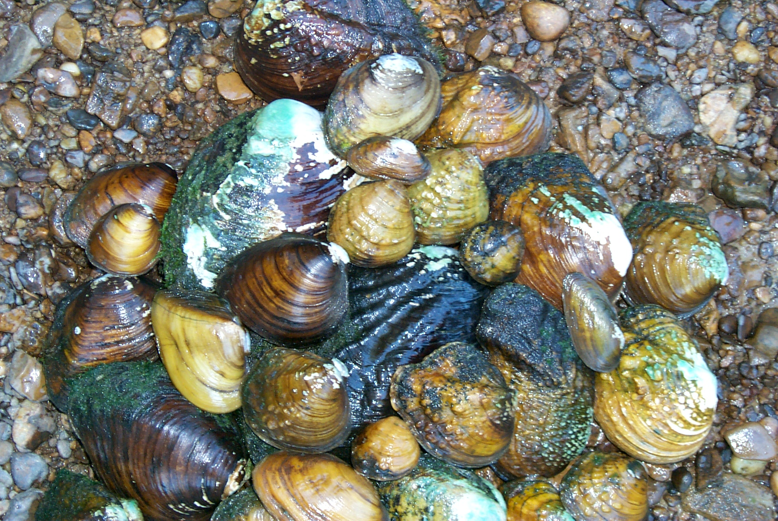
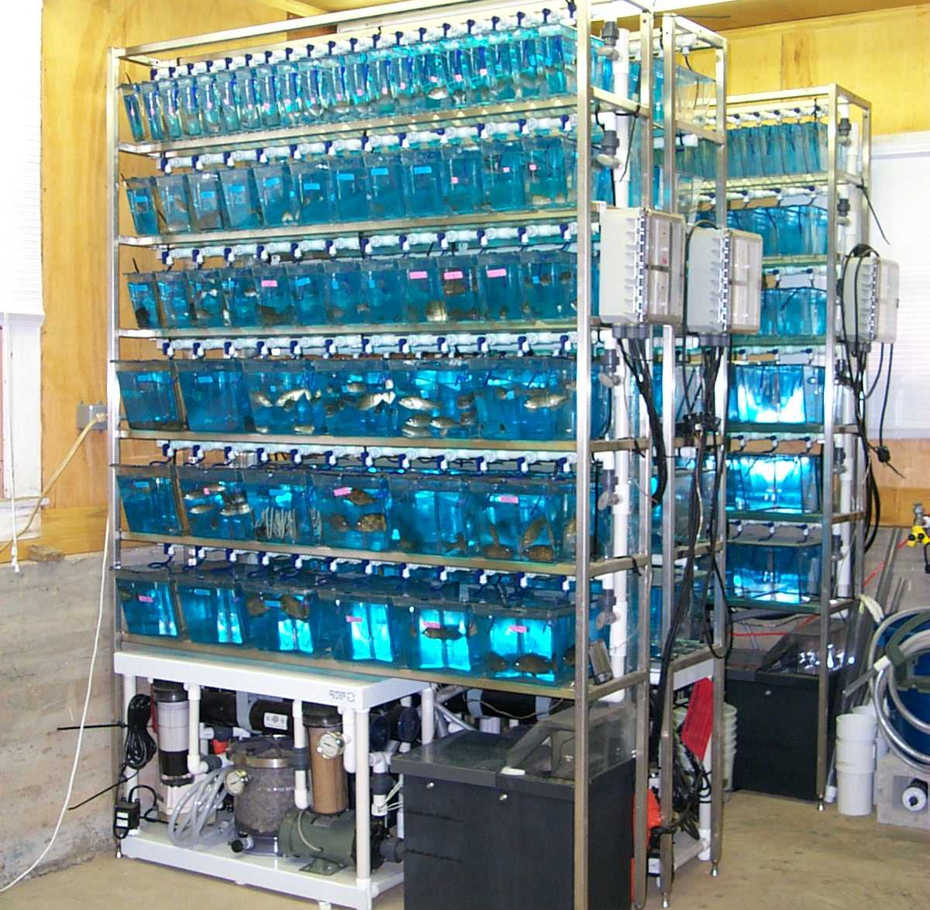
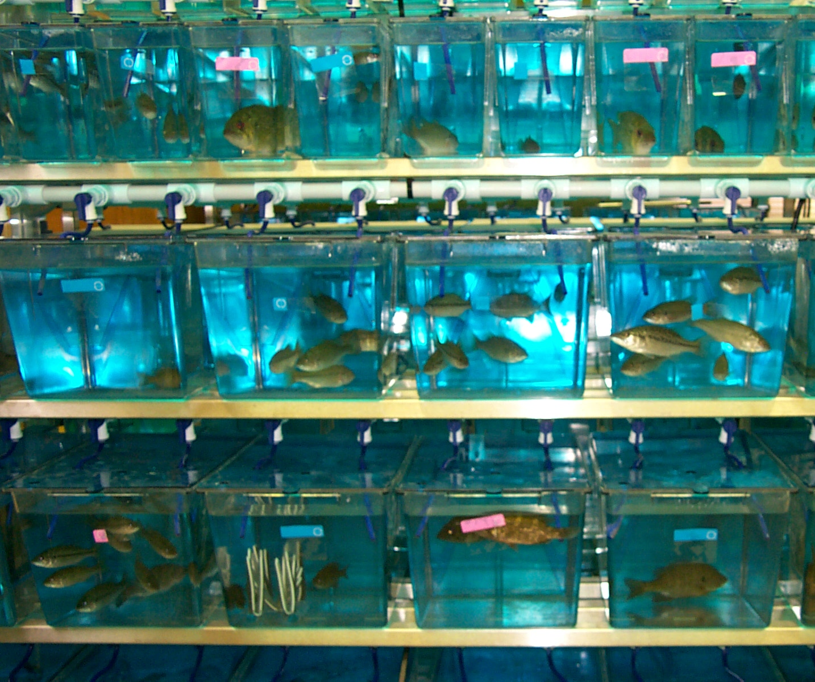
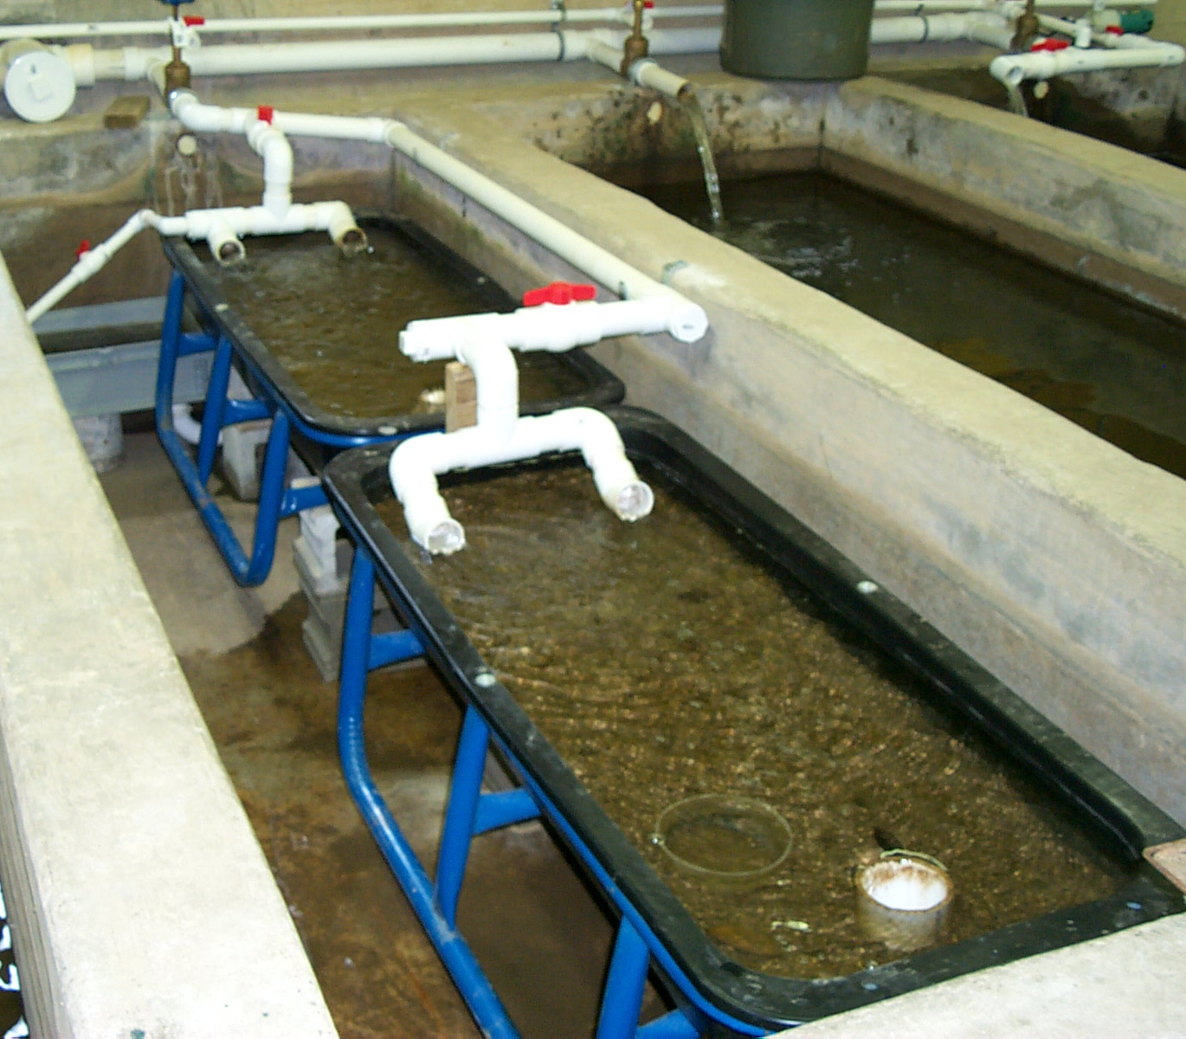

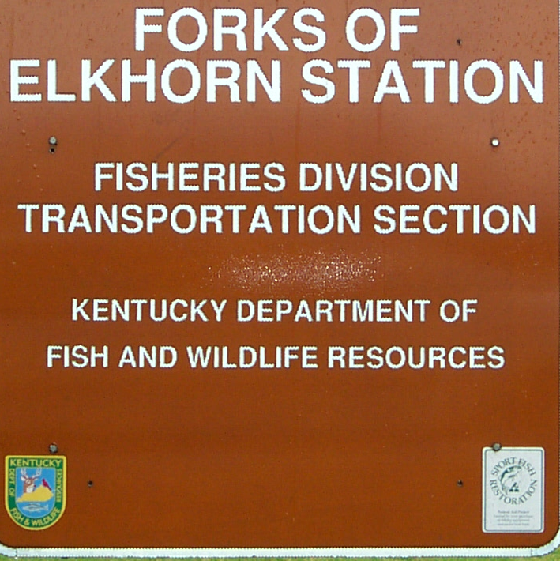
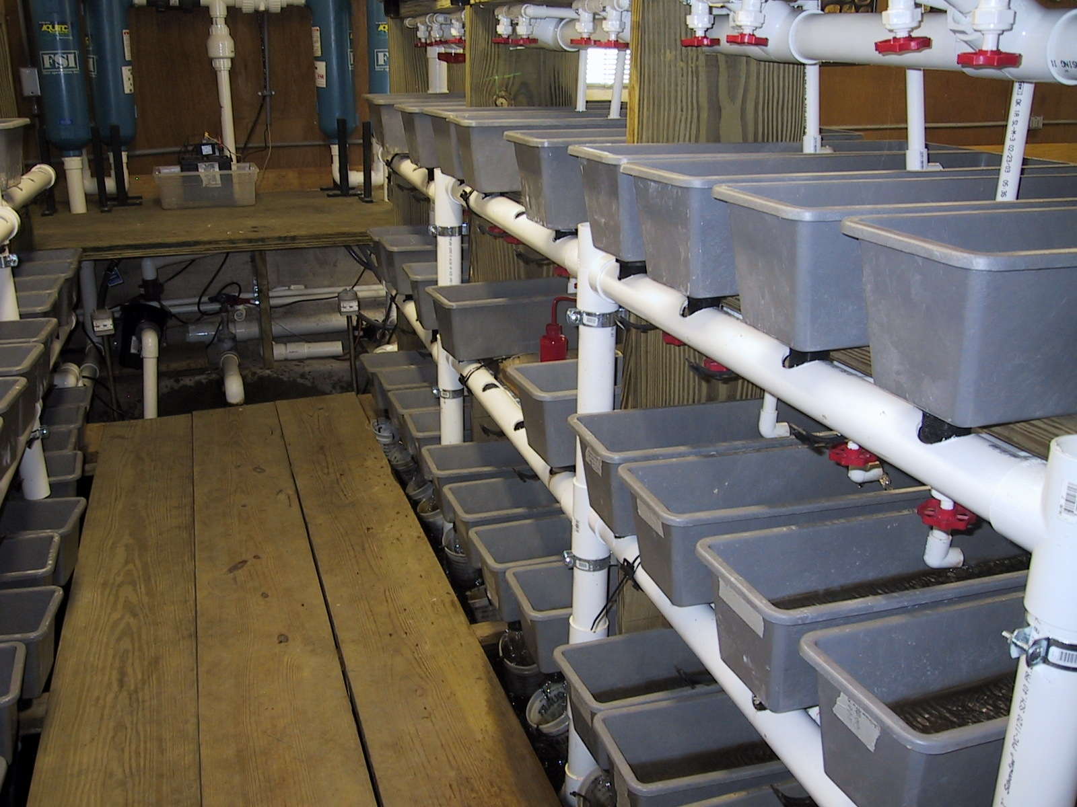
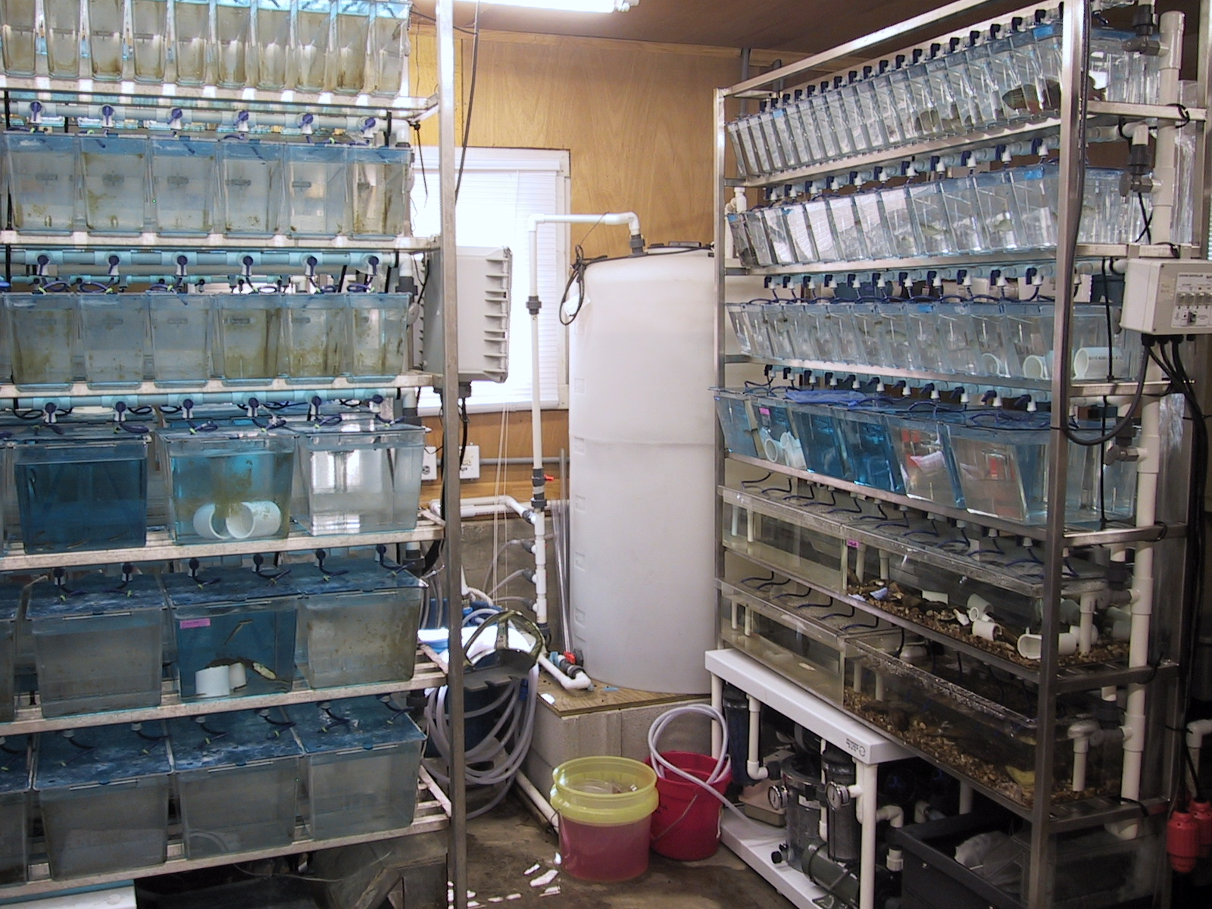
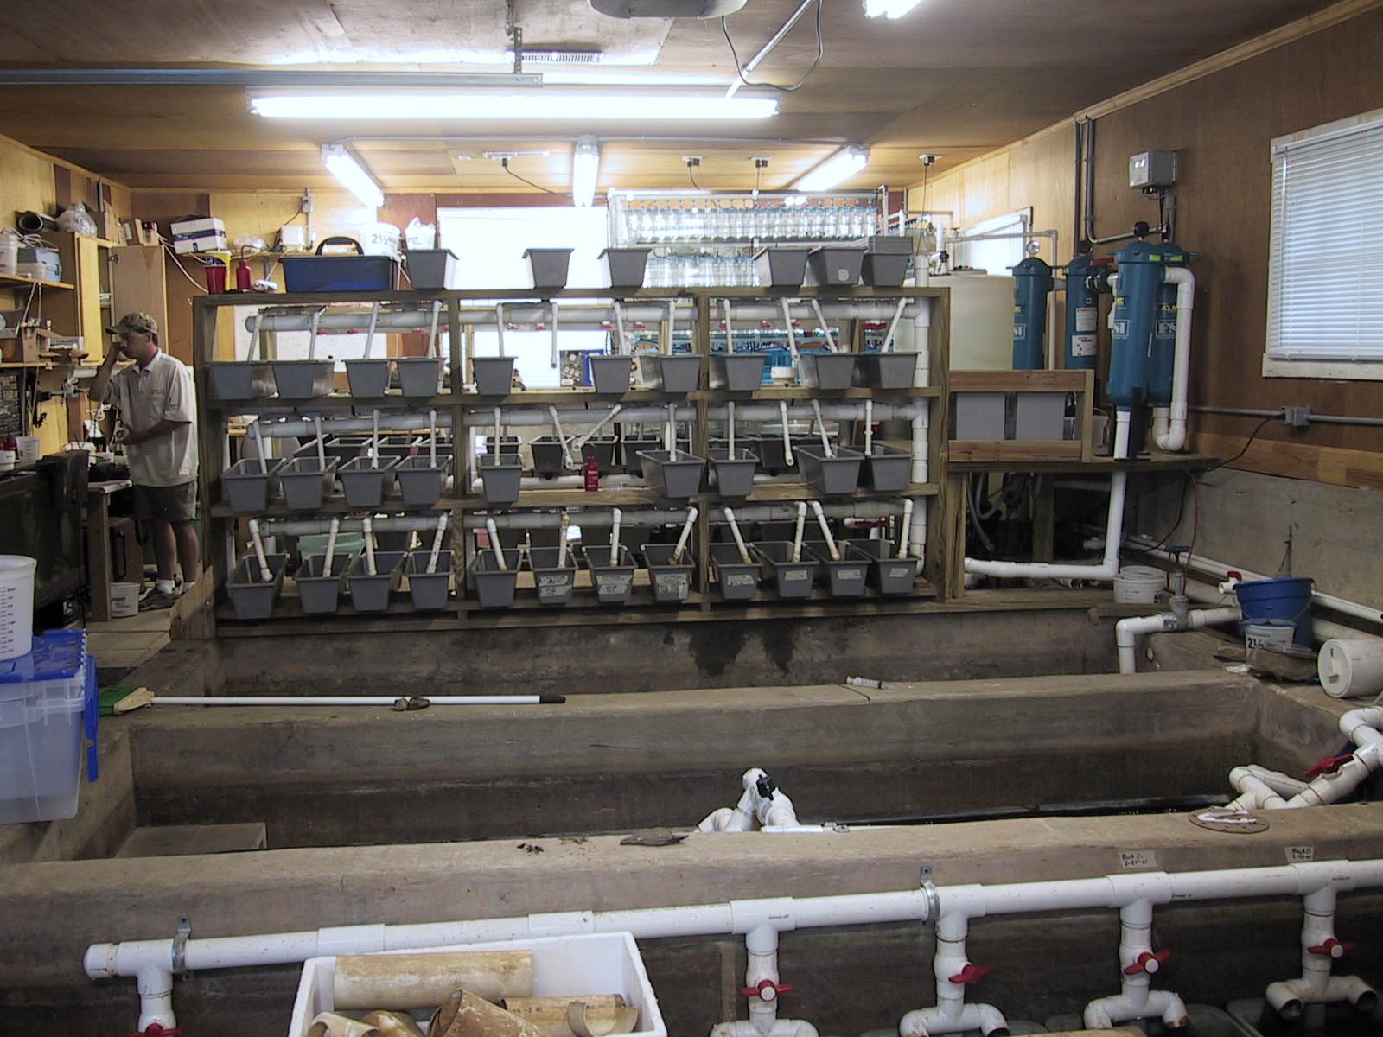
Kentucky Department of Fish and Wildlife Resources
Center for Mollusk Conservation
Seminatural raceways with river bottom substrata
Culture tanks for infesting hosts

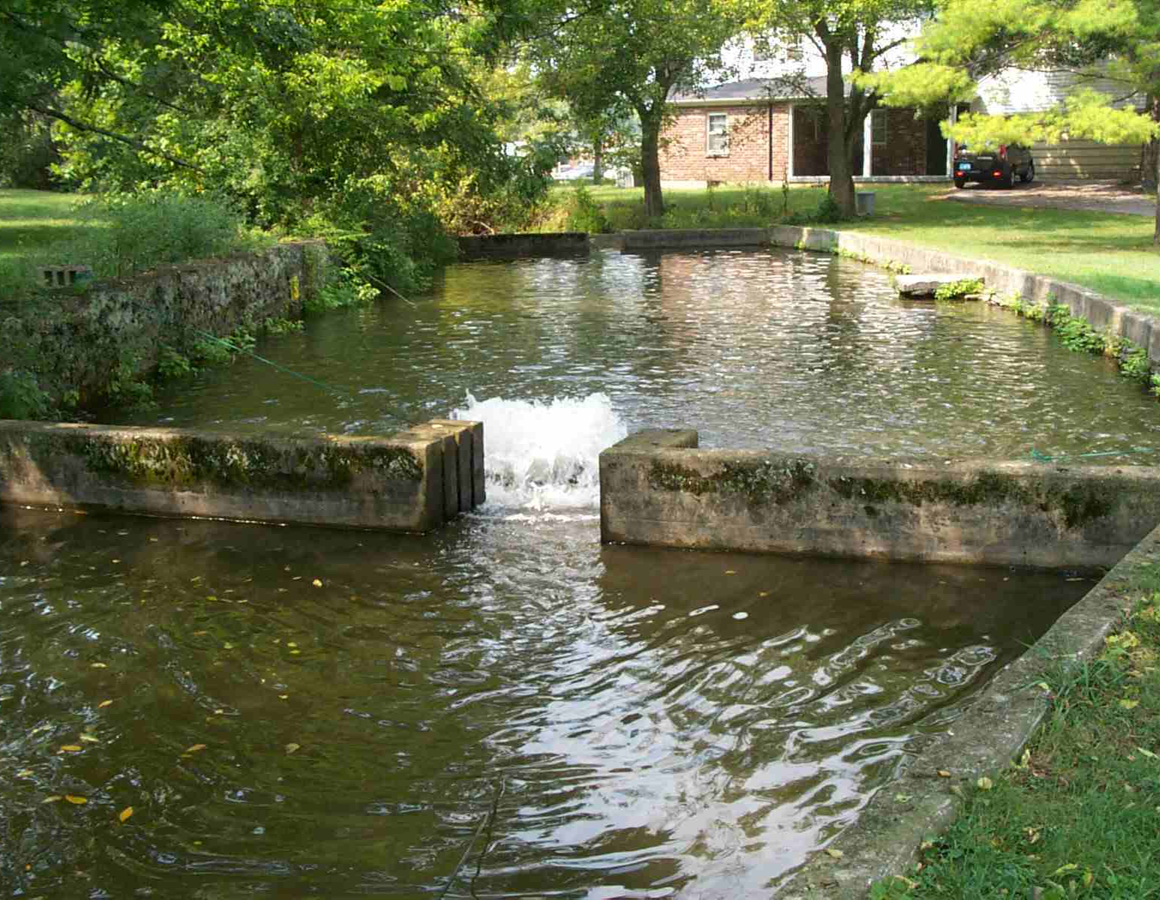
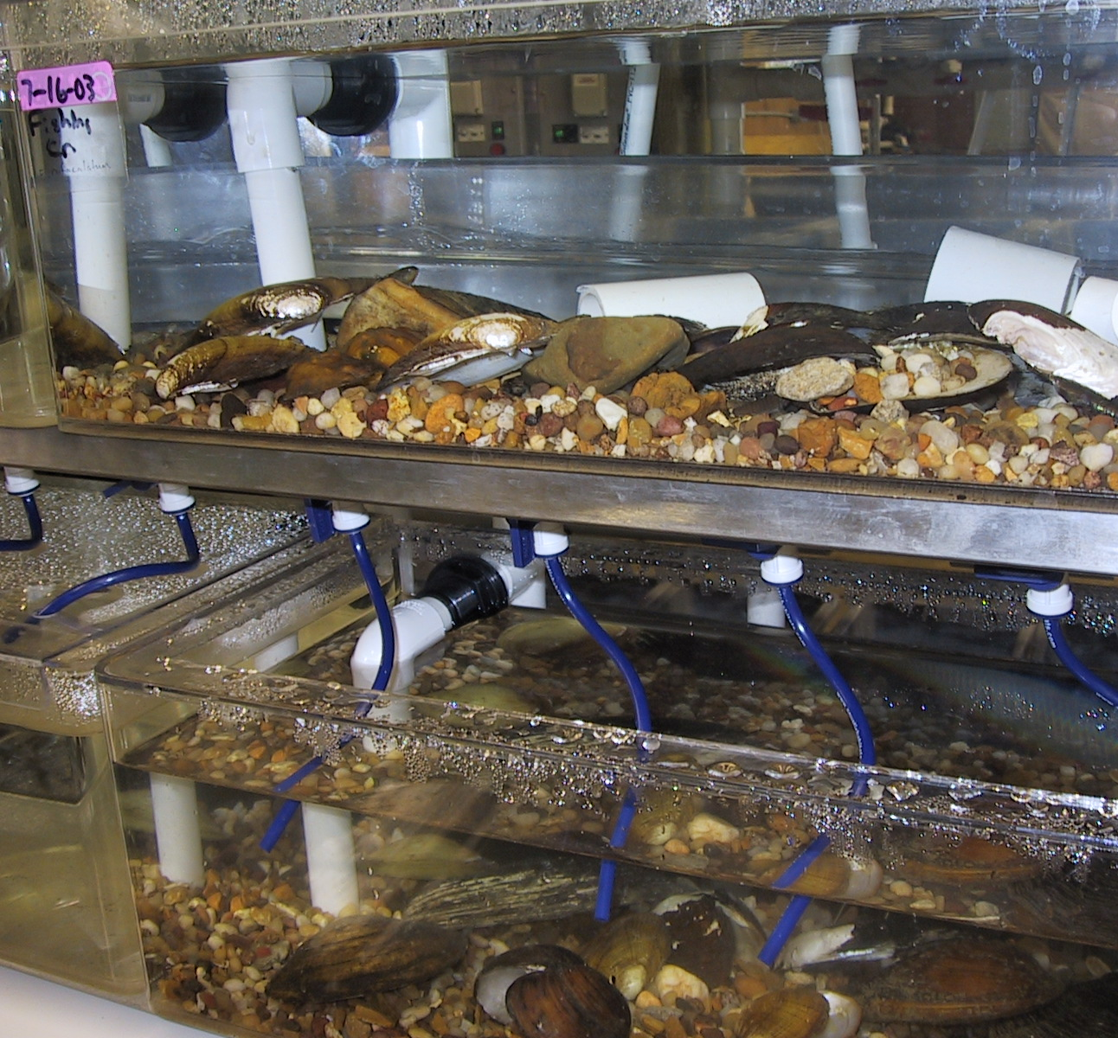
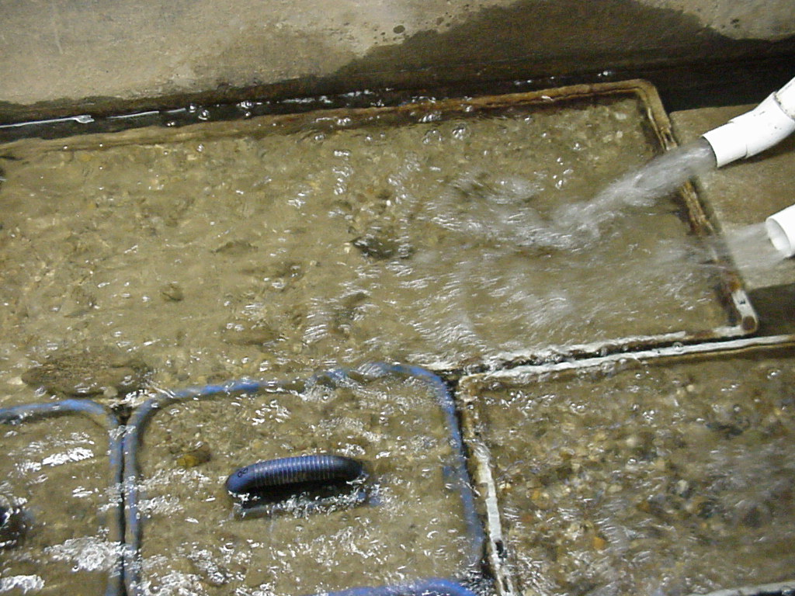

Juvenile nursery
Center for Mollusk Conservation
Fish holding tanks

Mussel tanks
Outside raceways for fish and mussels

RECOVERY PARTNER CONTACTS

Mike Turner Kathryn Huie Tim Slone
Army Corps of Engineers US Forest Service KDFWR
ATTN: PMP-E Daniel Boone National Forest #1 Game Farm Road
PO Box 59 705 W College Avenue Frankfort, KY 40601
Louisville, KY 40201 Stanton, KY 40380 (502) 564-5448
(502) 315-6878 (606) 663-2852 tim.slone@ky.gov
Michael.Turner@lrl02.usace.army.mil khuie@fs.fed.us

Ronald R. Cicerello Mitch Gandy Jim Widlak
KY Nature Preserves Forest Service USFWS
801 Schenkel Lane 91 Peabody Road 446 Neal Street
Frankfort, KY 40601 Big Creek, KY 40914 Cookeville, TN 38501
(502) 573-2886 (606) 598-2192 (931) 528-6481 ext. 202
ronald.cicerello@ky.gov mgandy@fs.fed.us james_widlak@fws.gov

Bob Butler Kim Tarter Robert Tawes
USFWS USDA Forest Service USFWS – Cookeville
160 Zillicoa Street Redbird Ranger District 446 Neal Street
Asheville, NC 23801 91 Peabody Road Cookeville, TN 38501
(828) 258-3939 ext. 235 Big Creek, KY 40914 (931) 528-6481 ext. 213
bob_butler@fws.gov (606) 598-2192 robert_tawes@fws.gov
ktarter@fs.fed.us

Guenter Schuster John R. Omer James Gray
Eastern Kentucky University USDA FS DBNF USFWS Wolf Creek FH
Dept. Biological Sciences South Laurel Road 50 Kendall Road
Richmond, KY 40475 London, KY 40741 Jamestown, KY 42629
(859) 622-1016 (606) 864-4163 (270) 343-3797
guenter.schuster@eku.edu jomer@fs.fed.us jeff_conway@fws.gov

Jim Sickel Stephen McMurray Jim Hays
Murray State University KDOW Nature Conservancy
Biology Dept. Watershed Mgmt Branch 620 Dormitory Street
Blackburn 334 14 Reilly Road London, KY 40741
Murray, KY 42071 Frankfort, KY 40601 (606) 878-7664
(270) 762-6326 (502) 564-3410 jhays54@yahoo.com
jim.sickel@murraystate.edu steve.mcmurray@ky.gov

Brent Harrel Stacy Surgenor Bonny Laflin
USFWS Mammoth Cave National Park SW Fishery District
3761 Georgetown Road P.O. Box 7 970 Bennett Lane
Frankfort, KY 40601 Mammoth Cave, KY 42259 Bowling Green, KY 42104 (502) 695-0468 (270) 758-2162 (270) 746-7127
brent_harrel@fws.gov Stacy_Surgenor@nps.gov swfd@kih.net

Leroy Koch Mark Depoy Brian Smith
USFWS Mammoth Cave National Park KDFWR
3761 Georgetown Road PO Box 7 #1 Game Farm Road
Frankfort, KY 40601 Mammoth Cave, KY 42259 Frankfort, KY 40601
(502) 695-0468 (270) 758-2162 (502) 564-7109 ext. 494
leroy_koch@fws.gov Mark_DePoy@nps.gov brianw.smith@ky.gov

Richard Tippit Ed Hartowicz Steve Ahlstedt
Nashville District, COE Third Rock Consultants USGS
PO Box 1070 2514 Regency Road, Suite 104 1820 Midpark Drive
Nashville, TN 37202 Lexington, KY 40503 Suite A
(615) 736-7958 (859) 977-2000 Knoxville, TN 37921
richard.n.tippit@usace.army.mil ehartowicz@thirdrockconsultants.com (865) 545-4140
ahlstedt@usgs.gov

Victoria R. Bishop Lee Andrews Jim Layzer
USDA FS DBNF USFWS TN Co. Fish. Res. Unit
1700 Bypass Road 3761 Georgetown Road Box 5114
Winchester, KY 40391 Frankfort, KY 40601 Tennessee Tech Univ.
(859) 745-3184 (502) 695-0468 Cookeville, TN 38505
vbishop01@fs.fed.us lee_andrews@fws.gov (931) 372-3094
jim_layzer@tntech.edu

Joy Malone Jim Bennett Michael Floyd
US Forest Service Daniel Boone National Forest USFWS
705 W College Avenue 1700 Bypass Road 3761 Georgetown Road
Stanton, KY 40380 Winchester, KY40391 Frankfort, KY 40601
(606) 663-2852 (859) 745-3148 (502) 695-0468
jmalone@fs.fed.us jimbennett@fs.fed.us michael_floyd@fws.gov

List of the 103 Freshwater Mussels Kentucky with author, sufamily, U.S., KSNPC, and AFS listing (Cicerello et al. 1991). ▼ found in mainstem Mississippi River
SPECIES in Kentucky | AUTHOR | Common Name | Subfamily | Fanual group | KSNPS | AFS* | FWS
 |  |  |  |  |  | status | status
Actinonaias ligamentina | Lamarck, 1819 | mucket | Lampsilinae | Mississippian | NL | CS
Actinonaias pectorosa | Conrad, 1834 | pheasantshell | Lampsilinae | Cumberlandian | NL | SC
Alasmidonta atropurpurea | Raf., 1831 | Cumberland elktoe | Anodontinae | Cumberlandian | E | E | FE
Alasmidonta marginata | Say, 1818 | elktoe | Anodontinae | Mississippian | T | SC
Alasmidonta viridis | Raf., 1820 | slippershell mussel | Anodontinae | Mississippian | NL | SC
Amblema plicata plicata | Say, 1817 | threeridge | Ambleminae | Mississippian▼ | NL | CS
Pyganodon grandis | Say, 1829 | giant floater | Anodontinae | Mississippian▼ | NL | CS
Utterbackia imbecillis | Say, 1829 | paper pondshell | Anodontinae | Mississippian▼ | NL | CS
Anodonta suborbiculata | Say, 1831 | flat floater | Anodontinae | Mississippian | NL | CS
Anodontoides ferrussacianus=denigratus | I. Lea, 1834 | cylindrical papershell=Cumberland papershell | Anodontinae | Mississippian | E | CS
Arcidens confragosus | Say, 1829 | rockpocketbook | Anodontinae | Mississippian▼ | NL | CS
Cumberlandia monodonta | Say, 1829 | spectaclecase | Cumberlandinae | Mississippian | E | T
Cyclonaias tuberculata | Raf., 1820 | purple wartyback | Pleurobeminae | Mississippian | NL | SC
Cyprogenia stegaria | Raf., 1820 | fanshell | Lampsilinae | Mississippian | E | E | FE
Dromus dromas | I. Lea, 1834 | dromedary pearlymussel | Lampsilinae | Cumberlandian | E | E | FE
Ellipsaria lineolata | Raf., 1820 | butterfly | Lampsilinae | Mississippian | NL | SC
Elliptio crassidens | Lamarck, 1819 | elephantear | Pleurobeminae | Mississippian▼ | NL | CS
Elliptio dilatata | Raf., 1820 | spike | Pleurobeminae | Mississippian | NL | CS
Epioblasma arcaeformis | I. Lea, 1831 | sugarspoon | Lampsilinae | Cumberlandian | NL* | E* | FE*
Epioblasma biemarginata | I. Lea, 1857 | angled riffleshell | Lampsilinae | Cumberlandian | NL* | E* | FE*
Epioblasma brevidens | Lea, 1831 | Cumberlandian combshell | Lampsilinae | Cumberlandian | E | E | FE
Epioblasma capsaeformis | Lea, 1834 | oyster mussel | Lampsilinae | Cumberlandian | E | E | FE
Epioblasma flexuosa | Raf., 1820 | leafshell | Lampsilinae | Mississippian | NL* | E* | FE*
Epioblasma f. florentina | I. Lea, 1857 | yellow blossom | Lampsilinae | Cumberlandian | NL* | E* | FE*
Epioblasma f. walkeri | Wilson & Clark, 1914 | tan riffleshell | Lampsilinae | Cumberlandian | NL | E | FE
Epioblasma haysiana | I. Lea, 1833 | acornshell | Lampsilinae | Cumberlandian | NL* | E* | FE*
Epioblasma lewisii | Walker, 1910 | forkshell | Lampsilinae | Cumberlandian | NL* | E* | FE*
Epioblasma obliquata obliquata | Raf., 1820 | catspaw | Lampsilinae | Mississippian | E | E | FE
Epioblasma obliquata perobliqua | Conrad, 1836 | white catspaw | Lampsilinae | Mississippian | NL | E | FE
Epioblasma personata | Say, 1829 | round combshell | Lampsilinae | Mississippian | NL* | E* | FE*
Epioblasma propinqua | I. Lea, 1857 | Tennessee riffleshell | Lampsilinae | Mississippian | NL* | E* | FE*
Epioblasma sampsonii | I. Lea, 1861 | Wabash riffleshell | Lampsilinae | Mississippian | NL* | E* | FE*
Epioblasma stewardsonii | I. Lea, 1852 | Cumberland leafshell | Lampsilinae | Cumberlandian | NL* | E* | FE*
Epioblasma t. rangiana | I. Lea, 1839 | Northern riffleshell | Lampsilinae | Mississippian | E | E | FE
Epioblasma t. torulosa | Raf., 1820 | Tubercled blossom | Lampsilinae | Mississippian | NL* | E* | FE*
Epioblasma triquetra | Raf., 1820 | snuffbox | Lampsilinae | Mississippian | S | T
Fusconaia ebena | I. Lea, 1831 | ebonyshell | Ambleminae | Mississippian▼ | NL | CS
Fusconaia flava | Raf., 1820 | Wabash pigtoe | Ambleminae | Mississippian | NL | CS
Fusconaia subrotunda | I. Lea, 1831 | longsolid | Ambleminae | Mississippian | S | SC
Glebula rotundata | Lamarck, 1819 | round pearlshell | Lampsilinae | Mississippian | NL | CS
Hemistena lata | Raf., 1820 | cracking pearlymussel | Pleurobeminae | Mississippian | NL | E | FE
Lampsilis abrupta | Say, 1831 | pink mucket | Lampsilinae | Mississippian | E | E | FE
Lampsilis cardium | Raf., 1820 | plain pocketbook | Lampsilinae | Mississippian | NL | SC
Lampsilis fasciola | Raf., 1820 | wavyrayed lampmussel | Lampsilinae | Mississippian | NL | CS
Lampsilis ovata | Say, 1817 | pocketbook | Lampsilinae | Mississippian | E | SC
Lampsilis siliquoidea | Barnes, 1823 | fatmucket | Lampsilinae | Mississippian | NL | CS
Lampsilis teres | Raf., 1820 | yellow sandshell | Lampsilinae | Mississippian▼ | NL | CS
Lasmigona complanata | Barnes, 1823 | white heelsplitter | Anodontinae | Mississippian▼ | NL | CS
Lasmigona compressa | I. Lea, 1829 | creek heelsplitter | Anodontinae | Mississippian | E | CS
Lasmigona costata | Raf., 1820 | flutedshell | Anodontinae | Mississippian | NL | CS
Lasmigona subviridis | Conrad, 1835 | green floater | Anodontinae | Mississippian | E | T
Leptodea fragilis | Raf., 1820 | fragile papershell | Lampsilinae | Mississippian▼ | NL | CS
Leptodea leptodon | Raf., 1820 | scaleshell | Lampsilinae | Mississippian | NL | E | FE
Lexingtonia dolabelloides | I. Lea, 1840 | slabside pearlymussel | Ambleminae | Cumberlandian | H | T
Ligumia recta | Lamarck, 1819 | black sandshell | Lampsilinae | Mississippian▼ | NL | SC
Ligumia subrostrata | Say, 1831 | pondmussel | Lampsilinae | Mississippian | NL | CS
Medionidus conradicus | I. Lea, 1834 | Cumberland moccasinshell | Lampsilinae | Cumberlandian | NL | SC
Megalonaias nervosa | Raf., 1820 | washboard | Megalonaidinae | Mississippian▼ | NL | CS
Obliquaria reflexa | Raf., 1820 | threehorn wartyback | Lampsilinae | Mississippian▼ | NL | CS
Obovaria olivaria | Raf., 1820 | hickorynut | Lampsilinae | Mississippian▼ | NL | CS
Obovaria retusa | Lamarck, 1819 | ring pink | Lampsilinae | Mississippian | E | E | FE
Obovaria subrotunda | Raf., 1820 | round hickorynut | Lampsilinae | Mississippian | NL | SC
Pegias fabula | I. Lea, 1838 | littlewing pearlymussel | Anodontinae | Cumberlandian | E | E | FE
Plectomerus dombeyanus | Valenciennes, 1827 | bankclimber | Ambleminae | Mississippian | NL | CS
Plethobasus cicatricosus | Say, 1829 | white wartyback | Pleurobeminae | Mississippian | NL | E | FE
Plethobasus cooperianus | I. Lea, 1834 | orange-foot pimpleback | Pleurobeminae | Mississippian | E | E | FE
Plethobasus cyphyus | Raf., 1820 | sheepnose | Pleurobeminae | Mississippian | S | T
Pleurobema clava | Lamarck, 1819 | clubshell | Pleurobeminae | Mississippian | E | E | FE
Pleurobema coccineum | Conrad, 1834 | round pigtoe | Pleurobeminae | Mississippian | NL | CS
Pleurobema cordatum | Raf., 1820 | Ohio pigtoe | Pleurobeminae | Mississippian | NL | SC
Pleurobema oviforme | Conrad, 1834 | Tennessee clubshell | Pleurobeminae | Cumberlandian | E | SC
Pleurobema plenum | I. Lea, 1840 | rough pigtoe | Pleurobeminae | Mississippian | E | E | FE
Pleurobema rubrum | I. Lea, 1840 | pyramid pigtoe | Pleurobeminae | Mississippian | E | T
Potamilus alatus | Say, 1817 | pink heelsplitter | Lampsilinae | Mississippian▼ | NL | CS
Potamilus capax | Green, 1832 | fat pocketbook | Lampsilinae | Mississippian | E | E | FE
Potamilus ohiensis | Raf., 1820 | pink papershell | Lampsilinae | Mississippian▼ | NL | CS
Potamilus purpuratus | Lamarck, 1819 | bleufer | Lampsilinae | Mississippian▼ | E | CS
Ptychobranchus fasciolaris | Raf., 1820 | kidneyshell | Lampsilinae | Mississippian | NL | CS
Ptychobranchus subtentum | Say, 1825 | fluted kidneyshell | Lampsilinae | Cumberlandian | E | SC | C
Quadrula apiculata | Say, 1829 | southern mapleleaf | Ambleminae | Mississippian▼ | NL | CS*
Quadrula c.cylindrica | Say, 1817 | rabbitsfoot | Ambleminae | Mississippian | T | T
Quadrula fragosa | Conrad, 1835 | winged mapleleaf | Ambleminae | Mississippian | NL | E | FE
Quadrula metanevra | Raf., 1820 | monkeyface | Ambleminae | Mississippian | NL | CS
Quadrula nodulata | Raf., 1820 | wartyback | Ambleminae | Mississippian▼ | NL | CS
Quadrula p.pustulosa | Lea, 1831 | pimpleback | Ambleminae | Mississippian▼ | NL | CS
Quadrula quadrula | Raf., 1820 | mapleleaf | Ambleminae | Mississippian▼ | NL | CS
Quadrula sparsa | I. Lea, 1841 | Appalachian monkeyface | Ambleminae | Cumberlandian | NL | E | FE
Quadrula tuberosa | I. Lea, 1840 | rough rockshell | Ambleminae | Cumberlandian | NL* | E* | FE*
Simpsonaias ambigua | Say, 1825 | salamander mussel | Anodontinae | Mississippian | T | SC
Strophitus undulatus | Say, 1817 | creeper | Anodontinae | Mississippian | NL | CS
Toxolasma lividus | Raf., 1831 | purple lilliput | Lampsilinae | Mississippian | E | SC
Toxolasma parvus | Barnes, 1823 | lilliput | Lampsilinae | Mississippian | NL | CS
Toxolasma texasensis | I. Lea, 1857 | Texas lilliput | Lampsilinae | Mississippian | E | CS
Tritogonia verrucosa | Raf., 1820 | pistolgrip | Ambleminae | Mississippian▼ | NL | CS
Truncilla donaciformis | I. Lea, 1827 | fawnsfoot | Lampsilinae | Mississippian | NL | CS
Truncilla truncata | Raf., 1820 | deertoe | Lampsilinae | Mississippian▼ | NL | CS
Uniomerus tetralasmus | Say, 1831 | pondhorn | Pleurobeminae | Mississippian | NL | CS
Villosa fabilis | I. Lea, 1831 | rayed bean | Lampsilinae | Mississippian | E | SC
Villosa iris | I. Lea, 1829 | rainbow | Lampsilinae | Mississippian | NL | CS
Villosa lienosa | Conrad, 1834 | little spectaclecase | Lampsilinae | Mississippian | S | CS
Villosa ortmanni | Walker, 1925 | Kentucky creekshell | Lampsilinae | Mississippian | T | SC
Villosa taeniata | Conrad, 1834 | painted creekshell | Lampsilinae | Cumberlandian | NL | CS
Villosa trabilis | Conrad, 1834 | Cumberland bean | Lampsilinae | Cumberlandian | E | E | FE
Villosa v. vanuxemensis | I. Lea, 1838 | mountain creekshell | Lampsilinae | Cumberlandian | T | SC
AFS listing: E*=presumed extinct (12); E=Endangered (22); T=Threatened (7); U=Undetermined (19); CS=Currently stable (44); SC=special concern
KSNPC listing: E=endangered (27); T=threatened (5); S=special concern (4); H=historic resource (1); NL=no listing (56)=total 93 species
USFWS listing: FE*=presumed extinct (12); FE=Endangered (22); FT=Threatened (0); C=candidate (proposed for listing) (1)
▼ also found in mainstem Mississippi River in Kentucky

