Considerations for Ring and RTBT BPM Electronics
Prepared by: Martin Kesselman
07-09-02

Abstract:
The Spallation Neutron Source (SNS) Ring accumulates about 1060 pulses of 38mA peak current 1GeV H-minus particles from the Linac thru the HEBT line, then delivers this accumulated beam in a single pulse to a mercury target via the RTBT line. Bunching frequency of beam in the HEBT line is 402.5MHz, and about 1MHz in the Ring and RTBT. Position monitor electrodes in HEBT are of the shorted stripline type, with apertures of 12cm except in the dispersive bend, where the aperture is 21cm. Ring and RTBT electrodes are open striplines, with apertures of 21, 26, 30, and 36cm. All pickups are dual plane. The electronics will be PC-based with the Analog/Digital Front End passing data and receiving control and timing thru a custom PCI interface developed by LANL. LabVIEW will be used to direct the acquisition, process the data, and transfer results via ethernet to the EPICS control system. To handle the dynamic range required with well over 60dB variation in signal size, the Ring and RTBT electronics will employ a fast gain switching technique that will take advantage of the 300ns head-tail gap to provide position measurement during the entire accumulation cycle. Beam-based alignment will be utilized as part of the system calibration. This document will discuss present plans, and initial design considerations leading to a preliminary design configuration. We will also show that we can not meet the requirement for turn-by-turn resolution of 0.15mm for a 105mm half aperture BPM at study beam currents of 15ma.

Basic Requirements – Specifications:
Ring-RTBT BPM
Quantity 44+17=61
Intensity 5E10 – 2E14 ppp
Half Aperture +/- 105mm typical for Ring, +/- 130mm, +/- 150mm
Accuracy +/- 1% half aperture
Resolution +/- 1% of radius turn by turn, +/- 0.5% of radius averaged for intensity < 15E10ppp

Quantity:

Ring: (floated stripline)
21 cm bpm: 28
26 cm bpm: 8
30 cm bpm: 8
RTBT: (shorted stripline)
21 cm bpm: 15
36 cm bpm: 2

Some associated Information:
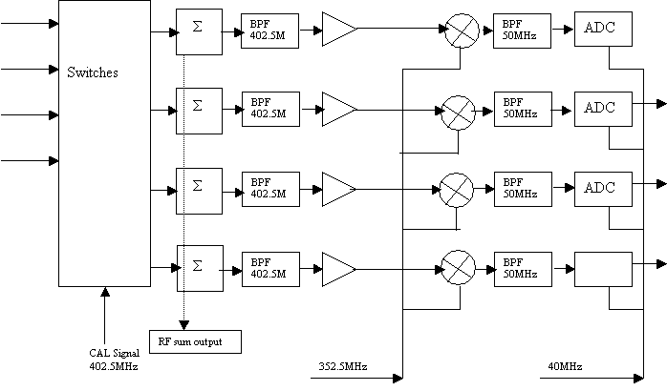
A paper that was generated a number of years ago, investigating the output of the BPM system in the Ring is available as Technote 038, Under SNS Reports, Technical Notes; “Simulations of SNS Accumulator Ring Beam Position Monitor Signals”, J. Beebe-Wang, A.U. Luccio, R. Witkover, at the following website.

http://server.ags.bnl.gov/bnlags/bnlsns/sns.html

Minor changes to the system have been made since this investigation, however, it is believed that the basic results will be representative of expected signals. It should be noted that the RF structure of the injected bunches is not simulated. The largest output signals are of the order of +/- 20 Volts. Early turns are expected to have rise times near the chopper edge of 10ns, while after many turns the edge is expected to deteriorate to near 50ns.

The RF structure during the first turn dominates, and produces pulses of high frequency information (402.5MHz plus harmonics). If these pulses are filtered to base band with something near a 10MHz band pass, there will be very little energy available at the output of this filter (fundamental of 402.5MHz). Virtually nothing will be available for processing (figure 1). After this single bunch has been allowed to diffuse, by rotating around the Ring a number of times, the output depicted by the above paper can be expected, and a crude PSpice simulation showed that one might be able to obtain about 2.0mV peak from a 5MHz low pass filter (figure 2). After the edge has deteriorated to about 50ns (7.5MHz) the peak has been found to be about 1.5mV for a 15ma signal (figure 3). However, this will take numerous times around the Ring to slow the edge. The simulation circuit is shown below (figure 4).

Figure 1 – Results of a simulation of 150ps RF bunched beam pulses chopped to 645ns with a 300ns gap. Shows the low-pass filter response is poor due to the near zero low frequency energy.

Figure 2 – BPM Simulation showing the response of five pole, 5MHz, Low Pass Bessel and Gaussian Filters to a fast edge 0.015 Amp beam signal. Note; the filtered response is shown ten times normal output to permit it being viewed on the same scale as the input signal. Both filters provide similar output signals. A slight undershoot for the Bessel filter is observable.

Figure 3 - BPM Simulation showing the response of 5MHz Low Pass Bessel and Gaussian Filters to a slow edge 0.015 Amp beam signal. Both filters provide similar output signals.

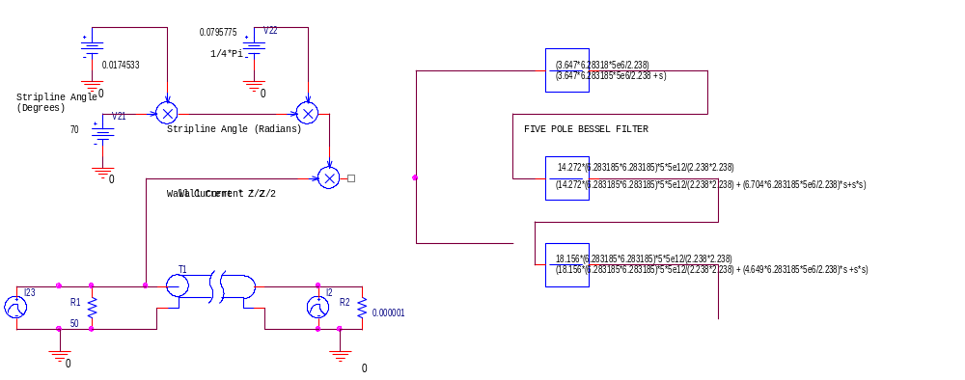

Figure 4 – Simulation Circuit

Challenges:
- Dynamic Range
- Resolution (noise) and system band-width selection
- Single turn (commissioning) vs. multi-turn operation (RF processing/base-band)
- Cable reflections due to out-of-band mismatch
- BPM linearity over a large range of aperture (+/- 100mm out of =/- 105mm, ie: 95%)
- Method of position calculation

General Discussion:
The beam in the HEBT is primarily composed of short bunches. These give rise to a large RF component at the bunching frequency and it’s harmonics. The character of the pick-up signals in this region of the SNS is the same as that of the Linac section, and it is intended to use identical electronics to that of the Linac in this region.

The Ring accumulates the injected bunches from the HEBT, and after a number of turns the charge diffuses and the RF character is quickly lost. With a millisecond of injection and about a 1 MHz revolution frequency, the charge will grow by a factor of about 1000. Early injected turns will have RF character, while turns that have been accumulated for many turns will have the character of a 645ns pulse with a repetition rate of 945ns. The pulses with little RF character will provide a base-band signal, while those that have recently been injected will provide an RF character. Therefore, to obtain position information two types of electronics are required. For early turns something similar to the Linac electronics is necessary, while for the later turns a base-band approach is required.

The RTBT has a beam that displays primarily the character of a single bunch of particles for 645ns. Therefore, this is similar to that of the Ring base-band signal, and electronics based upon this design would be most appropriate. During commissioning and studies, however, one could expect to see a single mini-pulse transported through the entire system. To observe this, electronics similar to that used in the Linac are required.

A beam based alignment technique will be employed in the Ring to locate the BPM/Quad center. A processing scheme employing normalization will eliminate gain from the results, and the calculated position will become dependent upon the basic sensitivity of the BPM.

History:
The original thought was to utilize a number of Linac BPM electronic systems to get a general handle on beam position for early turns. In addition, the base-band concept was pursued and a basic design scheme was developed. This included a switched gain concept that follows the beam current monitor system,,,,. The basic concept provides different paths for the signal to follow, each with different gain. The paths are summed in a sum stage. Each path is capable of being switched, in or out, by a logic signal to a switched amplifier (OPA3680). In so doing, the gain can be switched within 100ns, sufficient for switching during the beam “gap” time in the Ring. A detailed discussion of this approach is presented in the section discussing amplifiers.

To permit a simpler more general solution to commissioning the Ring, an approach that utilizes the electronics of the Linac has been considered, with some modifications, to permit it’s use with base-band signals. This basic concept uses the RF sensitive electronics for early turns and also during the commissioning process. Provision for switching the mixer off, providing base-band filtering only, will permit the base-band signal to propagate through the system to the ADC. Processing will continue in the normal manner, and data analyzed for position. The Ring and RTBT do not require the phase information, and I/Q demodulation need not be used. In addition, some calibration-switching circuitry is suggested to be replaced by local oscillator switches and front end filters to conserve circuit board real estate.

Details:
The basic design is based upon the Bergoz® BPM analog Front End (AFE ), designed for the Linac. A simplified block diagram is shown in Figure 5a. This diagram shows an example of a 402.5MHz AFE. The pickup signals are passed through a switching matrix that permits calibration information to be placed on the inputs to the electronics or the BPM pickup elements. Alternatively, the signals alone can be sent to the electronics. These signals are band pass filtered to allow only the 402.5 MHz information to pass. They are amplified as necessary, and mixed with a local oscillator of 352.5 MHz. This yields a difference frequency of 50 MHz, which is selected by another band pass filter. The result is digitized by about a 40MHz digitizer. This digitizer brings the resulting signal to base-band, and the information of interest is a 5 MHz band after I/Q demodulation of the 10MHz-demodulated signal.

Switches
CAL Signal
402.5MHz
Σ
Σ
Σ
Σ
BPF
402.5MHz
BPF
402.5MHz
BPF
402.5MHz
BPF
402.5MHz
BPF
50MHz
BPF
50MHz
BPF
50MHz
BPF
50MHz
ADC
ADC
ADC
ADC
40MHz

RF sum output

352.5MHz

Figure 5a – Block diagram of basic Linac BPM Electronics
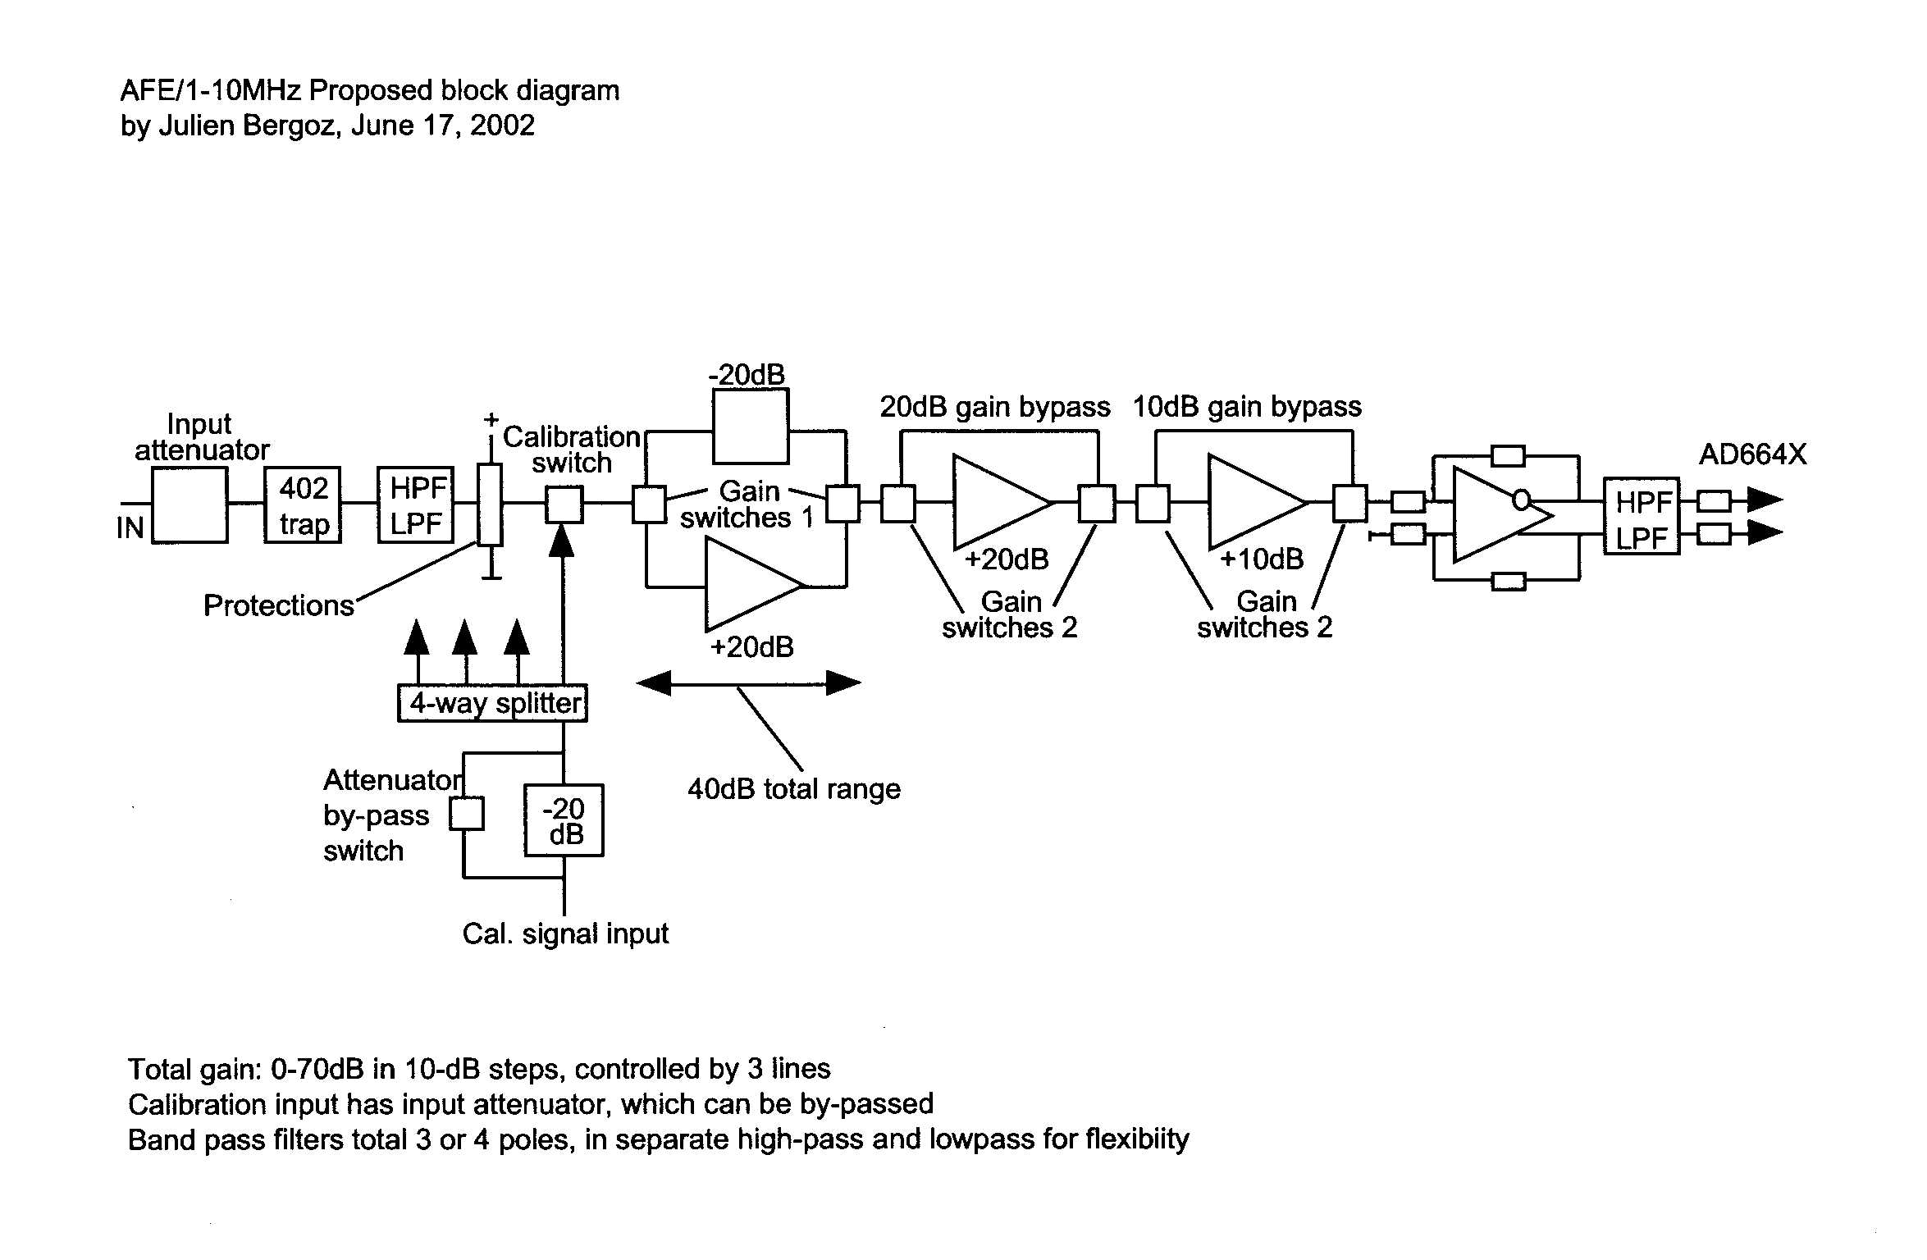
20dB Gain
Figure 5b- Proposed Block Diagram showing the base-band Bergoz AFE

Bergoz® has indicated that they can provide an AFE (figure 5b) designed with the same format as that designed for the SNS Linac. It uses the same I/Os (appendix D) and should plug into the present Digital Front End (DFE) without a problem after the switch control pins are designated. The product is BPM-AFE/1-10MHz.

It features:
0-70dB gain per channel, in steps of 10dB controlled by three (3) lines.
Gain precision better than 0.2dB (can be further calibrated by software)
Strict filtering of signal, with objective of fast settling time
50 Ohm signal path
Stable gains by current feedback op-amps.
Fast settling of filters after gain switching
Differential outputs matched to AD664x ADC inputs
Calibration by signals balanced to <0.1dB into each channel
Calibration mode controlled by a single line
Calibration input with switchable attenuator controlled by one line

Implementing circuitry:
Four processing channels, each with:
Input attenuator 50 ohms
High-pass two pole filter
Low-pass two pole filter
402.5 MHz trap
Protective diodes
Input switch (high voltage) under common control line
Switchable gain stage 10dB under common control line
Switchable gain stage 20dB under common control line
Switchable gain stage 40dB under common control line
High-pass one pole filter
Low-pass one pole filter
Buffer and differential driver, in line with ADC recommendations

Calibration circuitry:
Switchable input attenuator
High precision four-way splitter
Calibration switches (4) (high voltage) under same control as inputs
Precision 50-ohm input/calibration summing circuit

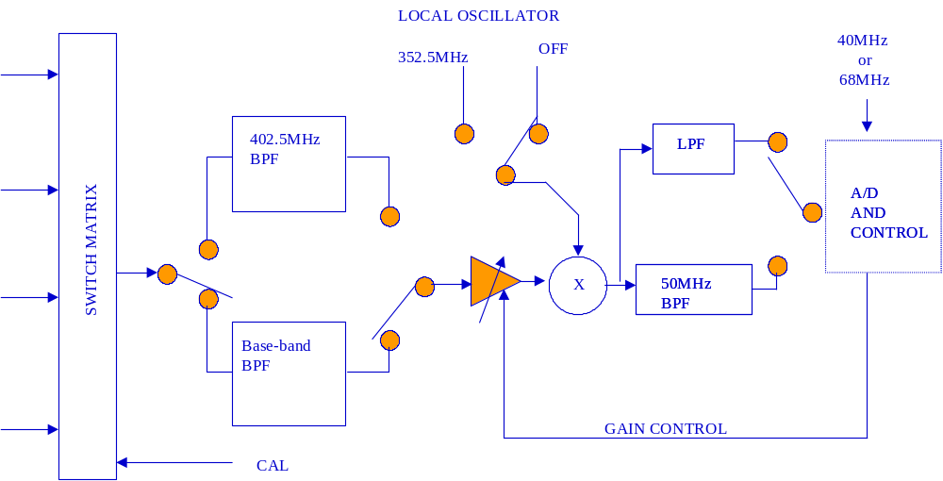
Figure 5c – Modified block diagram of AFE electronics

A modified design (Figure 5c) would eliminate or reduce the switching, since the Ring will be calibrated by beam-based alignment. Some switching will be required to establish filtering and channel gain. The initial band-pass filtering will be switch selected to be either at RF or a 5MHz low-pass. The local oscillator will be a 352.5 MHz oscillator that will move the signal to 50MHz (for the 402.5MHz case), and the mixer will be biased to avoid mixing for the base-band case. The 50 MHz low-pass filter will be changed to a 5MHz filter for this application.

The available ADC bandwidth is 20MHz when clocked at 40MHz. Since I/Q demodulation is not required (not interested in phase in the Ring and RTBT) one could try to use the full ADC bandwidth, however, the full ADC bandwidth is not easily utilized since the band-pass characteristics required to restrict settling time to the 300ns “gap” time could result in broad cut-off characteristics (see bandwidth section). As a result, it is suggested that the digitizer be clocked at 64 times the revolution frequency (about 68MHz). This will provide the separation between signal and clock needed for anti-aliasing filter characteristics, and a clock based upon the revolution frequency to provide better time stamping and synchronization to the Ring signal.

In addition to the dual operating mode mentioned above, it would also be desirable to examine the spectral lines of the tune system. This could be accommodated with another modification, now under investigation, that allowed a spectrum of 40MHz to 60MHz to be processed. If this was delivered to the ADC, and sampled at 40MHz, the spectrum would be brought back to base-band and occupy a 20MHz bandwidth. This could be analyzed by an FFT algorithm to obtain the spectrum.

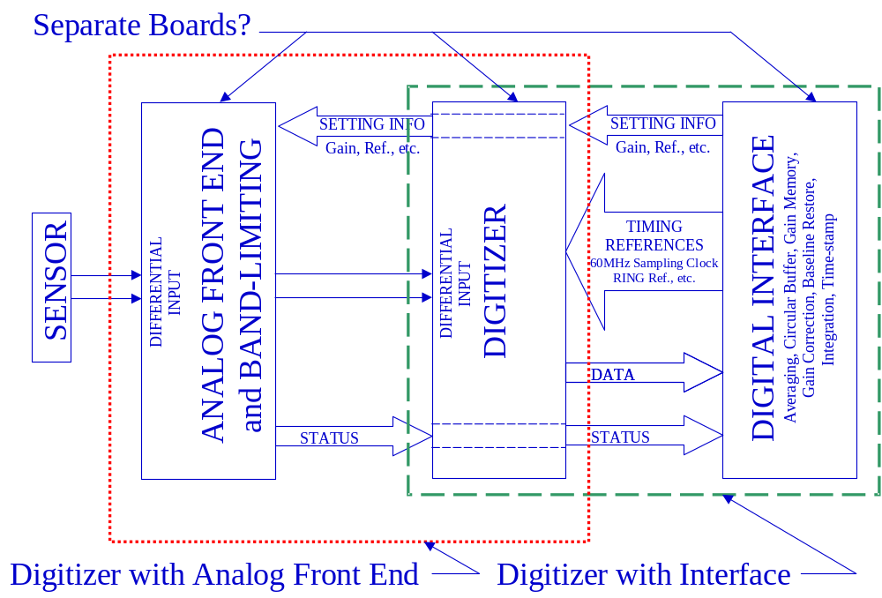
Figure 6 – General system block diagram

The general system configuration follows that of figure 6. Signal is processed by an analog front end (AFE) electronics block, fed to a digitizer, and then interfaced to a personal computer. In this case, Bergoz® will provide the AFE, LANL/BNL will provide the digitizer, and LANL/BNL will provide the digital PCI interface.

Some base-band considerations:
The details to follow reflect the thinking done prior to a decision to use Bergoz® to modify their present AFE for the Linac for use in the Ring. Of particular interest is the processing, which will apply to any hardware configuration. A summary is presented here, and more detailed analysis is found in appendix C. Also of some interest is the bandwidth chosen for processing, along with some of the additional work done selecting switches, amplifiers, gains, and attenuators. Therefore, this is presented in Appendix A of this report. Some of the details of the BPM resolution, sensitivity and noise analysis, work are included as appendicies B and C.

Bandwidth:
The bandwidth was determined by evaluating the transient response and noise requirements. The system must settle, after a mini-pulse, within the 300ns gap time to allow it to process the next turn. A 5 pole Bessel or Gaussian filter exhibits minimal overshoot, and settles in about 6 time constants. This requires a filter of minimum bandwidth about 3.5MHz (6/(6.28*fc)=270ns). Higher order filters or filters with sharper roll-off will ring much longer. A bandwidth of 5MHz will settle in about 190ns, and will pass a few more harmonics of the revolution frequency.

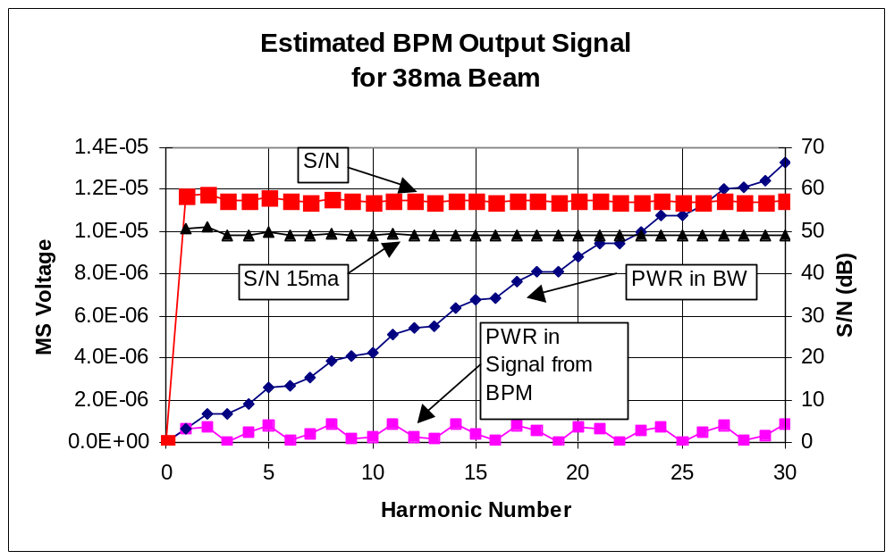

Figure 7 – Estimated signal power in harmonics of the revolution frequency at the output of a BPM element with a 38ma beam pulse of 645ns duration with period 945ns. The power included in a “brick-wall” filter BW is also shown, along with the resulting S/N ratio.

The chart above (figure 7) shows the expected frequency component power in the signal from the BPM. One can observe the S/N ratio is fairly constant. The added difficulties associated with anti-aliasing filtering at wider bandwidths, and the lack of improvements in S/N indicate a reasonable choice of bandwidth of about 1 MHz. It should be pointed out that due to the pulse shape of the current, the third harmonic is near zero and contributes little, as does the 6th , 9th & 13th . A 1MHz bandwidth is less than that required by transient response considerations. Therefore, a compromise bandwidth near 5MHz is selected.

To achieve about 14 bits of anti-aliasing requires about 84dB rejection at the Nyquist frequency (fs/2). Placing a sharp roll-off filter after a Bessel or Gaussian filter will provide the good transient response of the Bessel, with some overshoot introduced, with the good rejection of the Chebyshev. Therefore a dual filter is suggested. A 5 pole 5MHz Bessel or Gaussian filter provides about 40dB attenuation at 20MHz. A 5 Pole 10MHz, 0.01dB Chebyshev filter provides about another 34dB at 20MHz for a total of 74dB at 20 MHz (Nyquist BW for a 40MHz clock). The design can be improved with two Bessel filters, each with 7.07MHz BW (over-all bandwidth of 5MHz, providing about 27dB attenuation each at 20MHz), for a total of 88dB attenuation at 20MHz. The 7MHz filters have already been design for the BCM system. A simulation is shown in Figure 8 & 9.

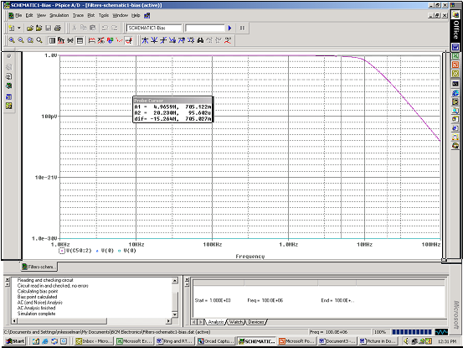

Figure 8 – Simulated dual filter response 2 each 5-pole 7MHz Gaussian followed by 5-pole 10MHz 0.01dB Chebyshev
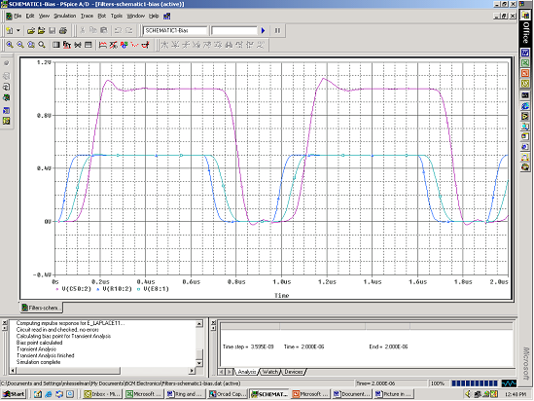
Figure 9 – Pulse response, showing the two Gaussian filters with good transient response, and the over-all response corrupted by the Chebyshev filter (amplitudes are arbitrary).

The transient response to a pulse shown in figure 9 has significant ringing, barely recovering by the end of the “gap”time. This can be reduced significantly by increasing the cut-off frequency of the Chebyshev filter and requiring an increased sampling frequency. It was considered to run the digitizer in the Ring electronics synchronously with the Ring revolution frequency. A frequency of 64 times Frev was selected (about 68MHz). For this case, an AD6645-80 (80MHz – 14 bit digitizer) would be used, and the Chebyshev filter, increased to a bandwidth of 34/2=17MHz, would be selected. A comparison of using a single 5-pole, 5MHz Gaussian filter and a 5-pole 0.01dB, 17MHz Chebyshev filter vs. using two 5-pole 7MHz Gaussian filters and a 5-pole 0.01db, 10MHz Chebyshev filter is shown in figures 10 and 11. As pointed out in the caption, the second 7MHz Gaussian filter provides a much needed 9dB of attenuation at 20MHz. Clearly the transient response is greatly improved by increasing the clock rate and it is suggested that the digitizer be clocked at 64 times the revolution frequency.

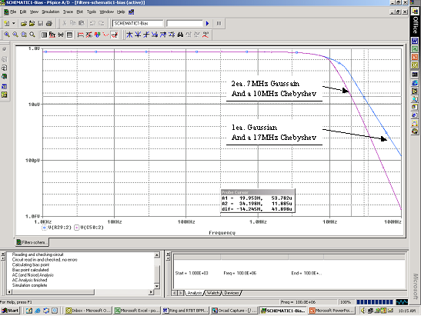
Figure 10 – Comparison of anti-aliasing capabilities of increasing Sampling Frequency. The signal is down by about 92dB at 34MHz, while the other provides about 79dB at 20MHz. If a single Gaussian filter was used the signal would be down about 70dB at 20 MHz.

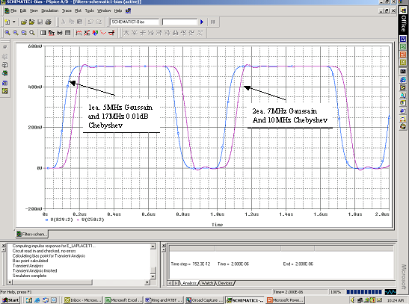
Figure 11 – Comparison of pulse response for the two choices of filtering and sampling frequency. The transient response is drastically improved by using a 17MHz Chebyshev vs. using a 10MHz chebyshev.

Processing:
It is proposed to process the data using a mean square analysis coupled with a log ratio calculation. This will provide position information weighted more over the entire beam current pulse. Peak detection, on the other hand, will favor the beam edges.

First, the log ratio technique offers a position output that is linear over a larger range. Secondly, the squaring of the signals to compute power will double the sensitivity ie:

Log(x²) = 2 * log(x)

One would expect an output, then, similar to the standard log ratio technique. The taking of the mean square for each PUE provides the difference, and yields power in the signal, power in the noise, and a cross-correlation term between noise and signal.

The mean square calculation basically generates a mean square power of the signal plus the noise. This adds noise squared plus a cross-correlation term that correlates the signal and the noise, evaluated at zero. An excerpt from some MathCAD calculations is presented below.

The general concept is to take the mean of the square signal of the right PUE and divide by the mean of the square of the left PUE, and then take a logorithm.

If we call the right pickup signal fr(t), and the left pickup signal fl(t):
Then for small displacements of beam along the axis by a distance r:

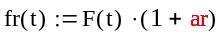
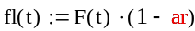

F(t) is the signal on the PUE for zero displacement.

Let the noise on the right PUE be enr(t) and on the left PUE enl(t).

Then the signal out will be :

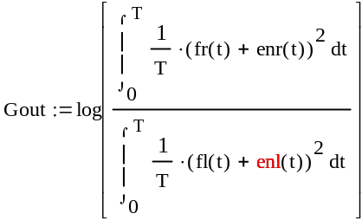

The output is approximately given by;

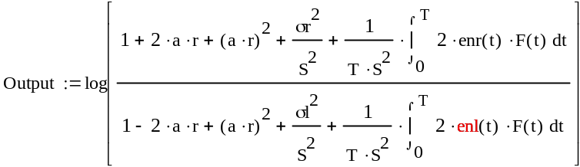

S is rms signal voltage (V), and σr² and σl² is the mean squared noise voltages on right and left PUEs.

Assuming the terms in both the numerator and denominator are small compared to 1 we get:

This is approximately:

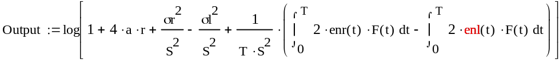

The output is approximately (eliminating higher order terms):

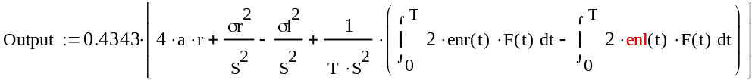

We observe that this requires 4*a*r to be equal to the other terms to establish resolution requirements. The mean square noise terms for the right and left PUE channels subtract from each other, and so do the cross-correlation terms between the noise and the signal. There are higher order terms that will add to noise but they can be neglected for a*r<<1.

Thus, mean square noise tends to cancel, as do cross-correlation terms. However, the cross-correlation terms can be either positive or negative, and will vary with a random character. Therefore, these terms could, in fact, add. The result, then, assuming a good estimate of σr and σl are achieved, and that these noise terms are near equal (both due to 50 Ohm resistor noise), yields:

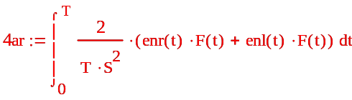

remember that a is:

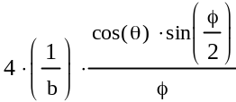

and an approximation for the minimum resolvable displacement is:

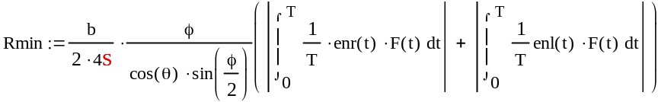

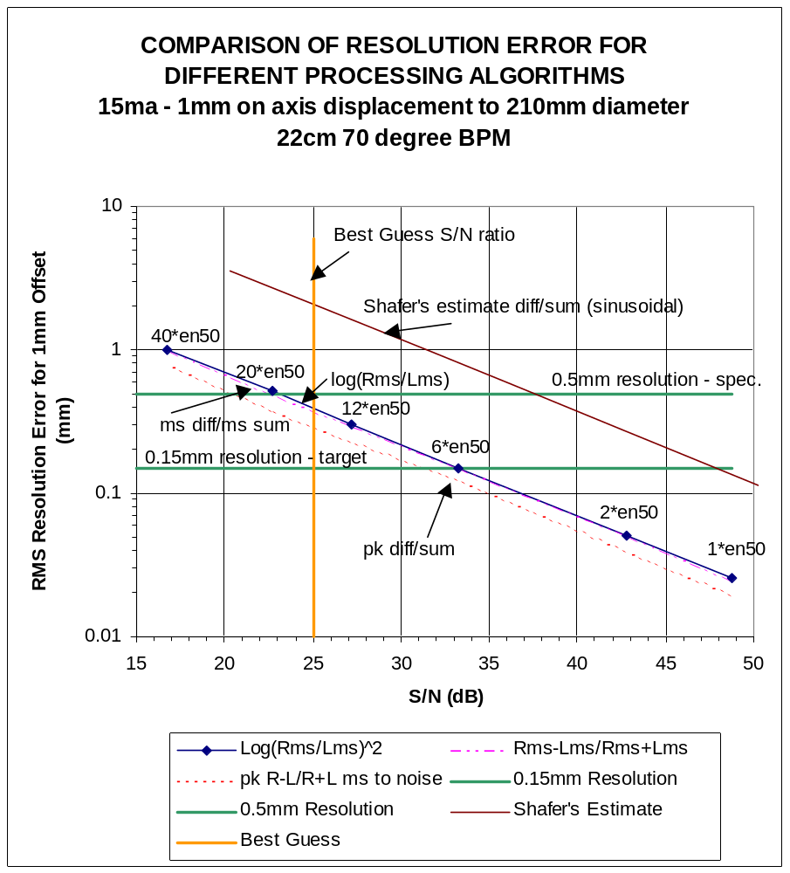
Figure 12 – The comparison of different processing algorithms shown above indicates that peak difference-over-sum is best, with mean-squared difference-over-sum basically identical to log mean-squared ratio. The indicated points reflect noise levels of 1,2,6,12,20 & 40 times the noise of a 50 ohm resistor for reference. A S/N > 33dB is necessary for a 0.15mm resolution.

Processing methods were compared (see figure 12). Calculations were made that approximated the BPM output signal, with noise added. Output calculations were made for the case of difference over sum, using a near peak signal, difference of mean squares over sum of mean squares (with and without subtraction of mean square noise, although not plotted), and log-ratio of mean squares. The results show that the standard difference-over-the sum provides the best results when based upon signal detection at time of peak. The log ratio of mean squares approach will provide improved signal linearity with displacement, and is equivalent to the difference over the sum of mean squares.

The plot of figure 12 shows the standard deviation (using 1000 values) of the error in output signal vs. signal power to noise power ratio. In each case the output signal was estimated with and without noise. The difference between the output with noise and that without noise was divided by the output without noise, and multiplied by 100 to obtain a percent error. In this way, the standard difference-over-sum method, using signals sampled near the expected peak time, was compared to a difference of mean squares-over-sum of mean squares, and a log-ratio of mean squares approach. The actual output errors could be as much as 3 sigma or more. Therefore, to estimate a single reading resolution one should multiply the error on the plot by about 3 to 4. Shafer’s estimate of (1/(2*sqrt2))*sqrt(N/S) is also included for comparison to a sinusoidal signal.

It is interesting to note that if the noise for the left and right PUE are near equal, they tend to subtract as noise variance (power) squared. However, the cross-correlation terms are functions of time and do not subtract as nicely. It is these terms that dominate and limit the resolution. Also interesting, is the attempt to subtract noise variance values that are independent of time. The thought was to measure noise power in each channel and then subtract it from the mean-squared values of signal and noise measured (the output equation indicates that these values subtract from each other). This was done and found to provide virtually no difference to that of mean-squared difference over mean-squared sum, and was not included in the plot. The fact that adding and subtracting measured noise (basically of equal power) causes minor differences in calculated resolution for the difference over sum of mean-squares case, supports the conclusion that the noise variances tend to cancel, and are not dominent. Furthermore, the added measurements afford us no extra benefit, and this calculation need not be performed.

An estimate of the signal to noise ratio of 25dB was developed assuming about a 3nV/rtHz amplifier and cable loss of 2dB, additional loss of 6dB for switches and filters, and an intentional additional 6dB attenuator loss for matching purposes. This yields an estimated best resolution near 0.4mm for a 105mm half aperture. To achieve a better resolution (near 0.15mm) one must average. One method of performing this averaging would be to pass the digitized data through a narrow band digital filter (about 22KHz at 2MHz). Selecting the second harmonic would provide a near peak signal component, and would require averaging about 46 turns to achieve this resolution.
APPENDIX A

The following information is included as documentation of work that was performed before deciding to utilize Bergoz® to design the AFE as a modification of the LANL design. This effort includes investigations of handling the large input signals, switch requirements, impedance concerns, amplifiers and noise considerations, and calibration injection methods.

The protected amplifier:
The system needs a method to deal with the large dynamic range and large input signals that will become available during the later accumulated turns in the Ring. The higher gain paths will require protected amplifiers to assure that the input levels are not exceeded.

There are a number of considerations associated with the choice for protection and components utilized. It is desired to maintain a linear system. This requires an analysis of the distortion that will be contributed to the system during circuit protection/non-linearities. It is desired to keep the distortion to 0.1% if possible. One wants to maintain a good input match to minimize reflections. If input diode protection is employed, the current flowing in the protection diodes must be low enough to protect the diodes and prevent sufficient differential voltage build-up to cause amplifier failures. Some wide-band amplifiers can only tolerate a differential input of +/-1.1 Volts. A method of injecting a calibration signal should be considered as part of this effort, and noise considerations become a major concern.

A simulation assuming a 50ns bunch rise-time indicated about a 10 to 15 Volt peak signal for 100 Amps and a 10MHz bandwidth limited input signal. The need for signal pre-filtering becomes evident when the input signal peak voltage is estimated at high beam currents. The 100Amps is a safety margin design point since the signal is expected to be 50Amps with some cresting due to RF reshaping of the beam bunch. Therefore, it may be possible to use a 15Volt op-amp at the input that exhibits large differential and common mode input signal capability, and provide limiting for the output of this stage to 4 to 5 volts for the remainder of the system electronics. Using a 15 volt input stage will require an additional power supply. A potential amplifier for this is a Texas Instruments THS4021. This amplifier boasts a 1.5nV/rtHz noise voltage, BW=350MHz at a gain of 10, a common mode voltage over the entire supply range (+/- 15 Volts) and can tolerate as much as +/- 4 V differential input voltage. It has a minimum stable gain of 10.

As pointed out earlier, the input noise must be kept low to achieve the required resolution at low current study levels, near 10mA. Therefore it is desirable to use low input resistor values. Using low values of resistance will accentuate the distortion introduced by protection components. A 15 Volt input stage will not require input protection since the peak input will not exceed 15 volts for a pre-filtered input scheme.

For an input scheme utilizing 5 volt amplifiers input protection is required. The associated noise and distortion considerations for this configuration must be dealt with. The distortion will require a large input resistor to both minimize mismatch and limit diode currents due to large input voltages. Diode protection requires about a 1K series resistor to assure that the diode voltage and currents are kept low (for a BAS70 it is 1V at 17 ma; for an HSMS2812 it is 1V at 35ma, a 1N4148 or 1N914/4448 can deal with larger currents but has more capacitance). This assures the diodes would properly limit, and can support the signal levels. In addition, to minimize the input loading/distortion, values near 1K to 2K are also required.

Ie: I= (V_{pk} – V_{diode})/R and R_{in} = V_{pk} /[(V_{pk} – V_{diode})/R]. The input resistance change when clamping signals to 0.5V will change by 1+0.5/V_{pk} , yielding about a 3.33% change for a 15 volt peak. To minimize this change, the resistor should be shunted by a low value at the input. This will yield a parallel resistance change of Δ(1-R₂/(R₁+R₂)); where Δ is the fractional change in R₂. From this we see that for small changes in the parallel combination we require a large value for R₂ (R₂ = 32.2* R₁ or 1.6K for R₁=50 Ohms).

Resistors of this value will generate significant noise and will degrade performance considerably at low levels. It should be noted that if attenuators are used before the amplifier the affect of the resistance change is reduced on the input by about the power ratio ie: ½ for 3dB, 1/3 for 10dB.

Noise:
The equivalent rms input noise for the THS4021 is given by:

E_{ni}=sqrt[ (e_{n})^2 + (I_{n+}*R_{i+})^2 + (I_{n-}*R_{i-}||R_{f})^2 + 4*K*T* R_{i+} + 4*K*T* (R_{i-}||R_{f}) ] V/rtHz

Given: e_{n}=1.5nV/rtHz
I_{n}=2pA/rtHz
R_{i+}=50
R_{i-}=50
K=1.38E-23
T=300
R_{f}=1000
Gain=20

E_{ni}=sqrt[ (1.5E-9)^2 + (100E-12)^2 + (95.2E-12)^2 + 0.83E-18+ 0.79E-18 ] V/rtHz

E_{ni}=1.97nV/rtHz

A PSpice simulation using the manufacturer’s model for this part yielded 2.1nV/rtHz at 10KHz.

Noise is amplified by the stages that follow, and there is ADC noise and noise from the wide bandwidth ADC drive amplifier that is not filtered that must be considered. The ADC noise is estimated from the data sheet as 0.246mV. This adds in quadrature with noise from the 300MHz AD8138, (5nV/rtHz, 2pA/rtHz, 500 Ohm unity gain) approximately 6.45nV/rtHz (0.11mV over 300MHz). If we assume all of this folds into the pass band when the ADC converts we have a digitizer with about 0.27mVrms noise. A maximum gain of about 0.5/1.5E-3 = 333 is required yielding noise of 333*2.1E-9*sqrt(5E6)=1.56mVrms which dominates, providing about a 50dB s/n ratio.

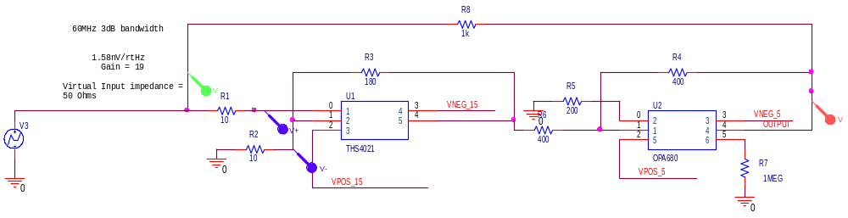
Figure A-1 – Schematic of a low noise amplifier providing 1.58nV/rtHz employing a virtual input impedance of 50 Ohms, and providing a Gain of 19 and Bandwidth of 60MHz.

The schematic shown in Figure A-1 is a simulation of a low noise amplifier employing a THS4012, 15 volt amplifier operating at a gain of 19, and followed by a unity gain inverting OPA680 amplifier. The result is a low noise amplifier with a controlled gain allowing the feedback resistor to be divided by 20 to yield a virtual input impedance of 50 Ohms. This provides a match to a 50 Ohm transmission line, at no additional noise penalty. Resistor values are selected that are low, minimizing noise. The published noise voltage for the THS4012 is 1.5nV/rtHz, and a PSpice simulation yielded 1.58nV/rtHz at 10KHz.

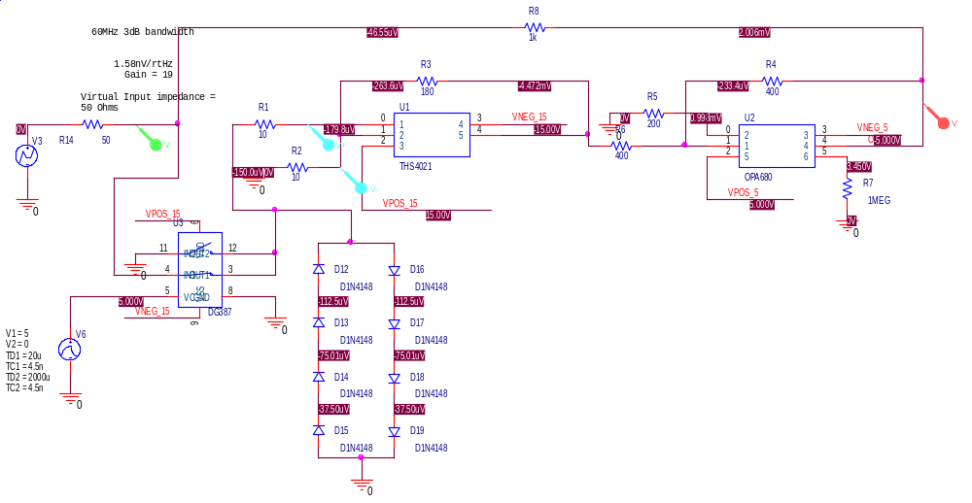
Figure A-2 – A simulation of the Low Noise Amplifier of Figure 13 showing a solid state switch capable of dealing with +/- 15 Volt signals.

The circuit of Figure A-2 can handle 15-volt signals, and protects the amplifier by switching the signal to ground after a number of turns. The problem with this is reliability of receiving the shutdown signal. Should this signal fail to activate the switch the circuit can see the high over-voltage at the input. Additional protection in the form of a diode string can be used for safety. During normal operation the signal is switched to ground long before the diodes clamp. During the switch failure mode the diodes protect and cause distortion (however, the circuit has already failed and needs repair).

The switch resistance may not be well matched from unit to unit, and the amplifier noise is dependent upon the resistance at the input. An estimate of equivalent input noise has been done to examine this affect. The results are shown in figure A-3. Total input noise varies from 2nV to 3.7nV per root Hz.

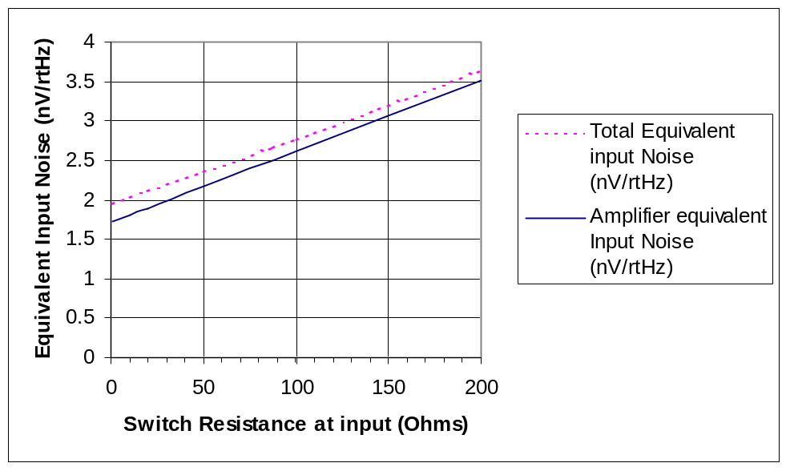

Figure A-3 – Noise estimates for the circuit of Figure 14

Calibration:
The system must allow for in-place calibration. Standard techniques include a calibration source that is switched to each electrode, and measurements made at all electrodes. These measurements are compared with measurements made during bench calibration, and appropriate gain adjustments are provided to each electrode channel. These gain changes can be included in the digital processing part of the system if the system is linear, requiring minimum impact on the analog front-end electronics.

A “beam-based alignment” approach is intended to align the quad-center and BPM. This is accomplished by applying a slowly varying current to the “trim” winding in a Quad and observing the BPM signals. When the beam is at the magnetic center of the quad under adjustment, there is no force applied to the beam, and the BPM signal that is correlated to the “trim” current frequency is zero. Reading position voltages on each PUE channel should yield a zero position. Therefore, all voltages computed by the electronics need to be stored for later subtraction.

The channel gains must be balanced to assure the proper sensitivity is established for position. Thus, if the same signal was injected into all channels, the resulting output signals should be the same for the same gain through each channel. This must be done for different signal levels to assure a gain calibration exists for each gain setting.

The implementation of the switching system and the required levels for adequate coupling to the other electrodes could introduce problems with component selection and availability. Therefore, it is desired to avoid sending a signal to the PUE. Instead a signal will be placed on all channels of the electronics. It is desired that calibration be accomplished between macro-pulses. A fast switching scheme is preferred. There is about 15ms between pulses for calibration purposes. In general, relays do not respond quickly enough to permit calibration without losing a mini-pulse/macro-pulse. Therefore, it is highly desired to find a solid state switching solution. Wide band solid state switches have limited voltage-handling capability, as do low noise variable gain amplifiers. RF switches require AC coupling, and have typical 1dB compression levels near 21 - 24dBm (2.5 - 3.5Vrms, 3.5 - 5Vpk). The amplifiers under consideration (AD60x series) can handle a maximum input of only +/- 2V continuously (+/- Vs for 10ms).

Approach 1 (not in priority order):
To accommodate switches and filtering with good cable matching, a scheme of matching networks, attenuators, and switches has been devised.

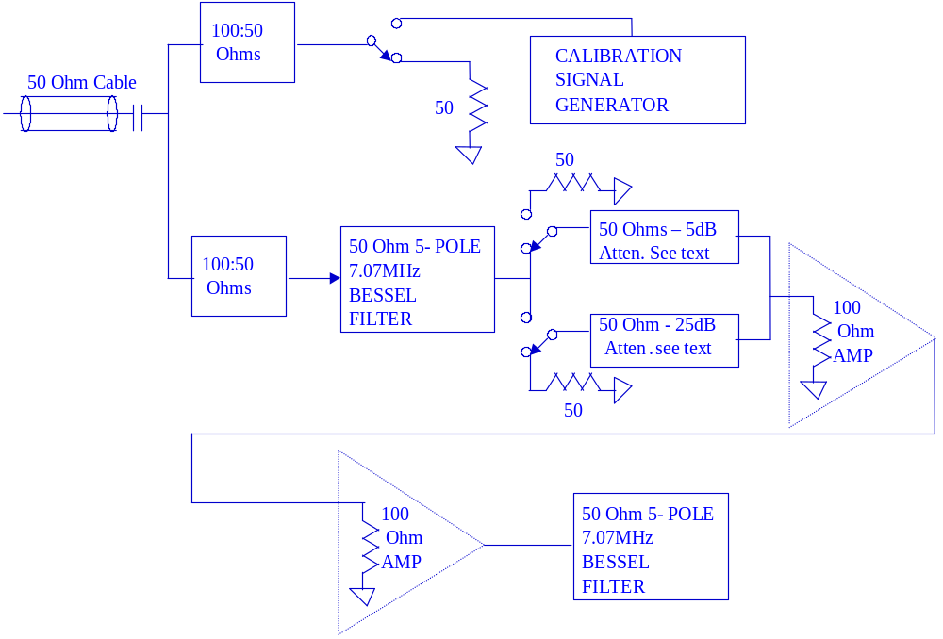

Figure A-4 – A scheme to maintain impedance match and switch signals during calibration and gain changes.

Switches:
The switches will have to handle voltages that could be as high as 15 volts. The BPM signals could be higher but will be attenuated before they reach the switches. Fast acting solid state switches characterized in the RF frequency range of interest require AC coupling, and have typical 1dB compression levels near 21 - 24dBm (2.5 - 3.5Vrms, 3.5 - 5Vpk). Therefore, a MAXIM switch (MAX4666) capable of handling +/- 15 volts is being considered for testing in this application. This switch exhibits a large capacitance to ground, and the affect on frequency response must be evaluated. In addition, this switch could see large input signals with system power off. This could cause excessive currents at the input protection diode and alternative switches like the MAX 4510/4520 and IH5341/5352 with fault protection are also being considered. It is thought that the switch capacitance, if consistent one switch to another, could be utilized as part of the output capacitance required for a Diplexer or Bessel filter. A switch configuration is under consideration to provide no reflections when switched “off”. This places an appropriate 50 Ohm termination on the line being switched.

Matching and attenuators:
To properly match the signal cable, two 100:50 Ohm minimum loss pads are used to split the signal. These provide about a 7.7dB loss. To match a switched attenuator, a technique has been chosen that will maintain constant loading on the filter and attenuators when the switch is positioned for attenuation or without attenuation. To accomplish this, the switches place 50 Ohms across the attenuator when switched in the “off” condition. Use is made of an attenuator made up of a series 22.36 Ohm resistor and a shunt 161.8 Ohm resistor. This combination provides a 50 Ohm impedance looking into the series end with the other end terminated in 33.33 Ohms, and 50 Ohm looking into the shunt end with the series end terminated in 50 Ohms. When loaded with 33.33 Ohms it provides 5dB attenuation and a 50 Ohm input impedance (see figure A-4). A similar attenuator placed at the output of a conventional 20dB - 50 Ohm pad will provide 20 dB additional attenuation with a match to 33.33 Ohms. The 33.33 Ohm termination is achieved by a parallel combination of the100 Ohm load from the amplifier and the 50 Ohm impedance looking back into the matching pad described above. Since this pad appears as a load for both paths the system is matched with the switch in either position.

Approach 2 (not in priority order):
Using a splitter for the signal path, we lose 3dB in the signal path, but decouple the calibrator from the signal path (Macom DS113/DSS113, 0.4-400MHz). Hybrid couplers capable of passing frequencies as low as 200KHz and with bandwidths of 35MHz (Macom HH-108) can be purchased for this application as well. This could be used in coordination with a protected amplifier gain selection approach, similar to that of the BCM electronics. The system would use separate channels that are switched in or out as gain is required. Signal processing must not rely upon DC, and some other averaging calculation could be used on the full cycle signal. An RMS approach will work after appropriate DC removal.

Amplifiers:
The AD602 variable gain amplifier is being considered for its low noise (1.4nV/sqrt Hz) and controlled bandwidth with gain (35MHz) which matches the ADC sampling frequency (68MHz) well. This low noise is only attainable at full gain. This particular unit (AD602) can provide attenuation as well as gain (-10dB to +30dB). The AD600 provides 0 to 40 dB gain with 35MHz bandwidth, and the AD603 provides –11 to +31 with a 90MHz bandwidth. The AD600/602 provides two amplifier sections. The match between sections on a single chip is good, and this could be used to help balance the characteristics between the two channels. Therefore, it is recommended to use a single chip as the amplifier for both channels, followed by a different dual amplifier chip that would provide the second amplifier in both channels. The gain biasing will be selected to provide the first stage with 3dB more gain than the second stage. This will reduce the ripple in the gain as a function of control voltage, and provide more gain in the earlier stage to reduce noise contribution from the second stage.

Dealing with dynamic range:
One of the design challenges is to deal with a very large dynamic range in the Ring and RTBT. The signal is expected to change by a factor of about 1000 due to the storage of 1060 turns. In addition the target of 0.15mm resolution will necessitate an additional 1000 for a total of 6 orders of magnitude. It would be nice to adjust gain in such a way that we lose no turn information. Input signal voltages could be quite large directly out of the BPM (very wide-band, 20mV to 20V peak). When filtered to 5MHz, signals will range from 1.8mV peak to 10 Volts peak, for 15ma and 100 amp beams with no allowances for terminations and matching circuits.

Of the various methods to deal with the required sensitivity during studies with low currents, and large signals during normal operation, a diplexer approach will yield the best signal with minimal reflections and losses.

An alternate approach, a 6dB termination network placed at the BPM output terminal to match the >100 meter long transmission line for reflections, will reduce signal. The result is a maximum signal near 0.9mV peak for a 15mA beam and a 6 Volt peak signal for 100 Amps. The estimate is based upon a 10ns rise time at low currents and a 50ns rise time at high currents. Therefore, it is desirable to filter the signal as soon as practical. Placing a filter at the end of a long cable will create a mismatch for out of band signal components. These components will be reflected back to the source where they will encounter an open circuited 50 Ohm stripline. They will again be reflected, and this will create signal interference with “real” signals. To minimize this, a specially designed 6dB pad is being considered to act as a moderate matching element. This pad will look like 50 Ohms into each end, yet will match an open circuit to terminate the long line at lower frequencies (3400-25.5-51.1 see figure A-5).

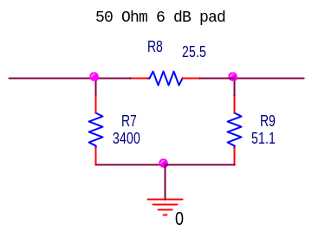
Fig. A-5 - Special matching network will match the open stripline to a 50 Ohm cable, while terminating the cable in 50 Ohms (for lower frequencies) for reflected signals.
Open stipline
100m 50 Ohm Cable

Diplexer:

As an alternative to the resistive termination and matching scheme mentioned above, a Diplexer circuit that will provide a broadband 50 Ohm matching impedance for the 50 Ohm stripline, and band-limit the signal for transmission on the long cable is presented below. The requirement for a constant input impedance, independent of frequency is that L/C = 2*R^2 (for 50 Ohms L=5000*C, cross-over frequency = 1/(2*π*sqrt(L*C))).

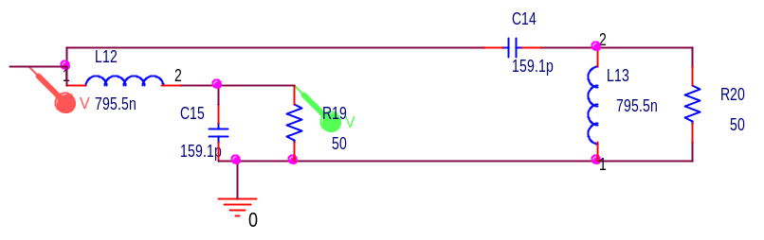
Figure A-6 - Circuit of a 14.4MHz Diplexer

The circuit shown in Figure A-6 will separate the signal into a 14.1 MHz low-pass band and a high–pass band above 14.1 MHz. This will provide a good broadband match to the transmission line, and provide initial filtering for the BPM system electronics to follow.
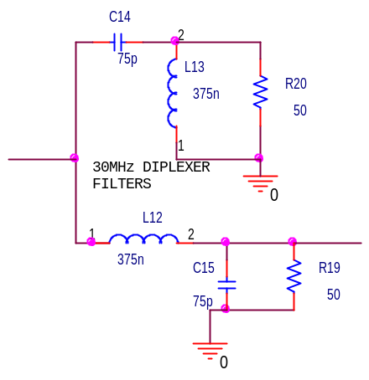

Figure A-7 – Circuit of a 30MHz Diplexer

The circuit shown in Figure A-7 will separate the signal into a 30 MHz low-pass band and a high–pass band above 30 MHz. This will provide a good broadband match to the transmission line, and provide initial filtering for the BPM system electronics to follow.

The circuits of figure A-6 and A-7 can be placed at the end or beginning of the long transmission line connecting the BPM to the Ring BPM electronics. If the circuit is placed at the beginning, near the BPM, the stripline is terminated, the signal bandwidth is limited on the transmission line and the peak signal at the electronics is smoothed and reduced. This will limit signal bandwidth, and not permit RF processing. Alternatively, placing this circuit at the receiving end, will split the signal into a base-band signal and an RF signal.

Using a Diplexer will increase the available signal from that mentioned earlier. It is estimated that the signal at the input to the electronics will be about 8mV peak with the 30MHz filter. The 30 MHz Diplexer filter will yield near unity gain at the 5MHz signal bandwidth expected for this system, and add minimally to distortion. The electronics must terminate the cable in 50 Ohms to minimize the reflections. After bandwidth reduction to 5MHz the signal is expected to be about 1.76mV peak.

Linearity:
In addition to the resolution, operation over a range of +/- 100mm for narrow beam studies will be required. For a 210mm aperture, this represents linear operation over 95% of the beam pipe aperture. Using the linear approach (R-L)/(R+L) yields a linear range of about +/- 20mm. An analysis of a 70 degree, stripline designed, indicates the BPM will require non-linearity correction. An example of non-linear response for the difference over the sum mode of operation is shown below derived from equations developed by Shafer, AIP212, Accelerator Instrumentation 1989, “Beam Position Monitoring”.

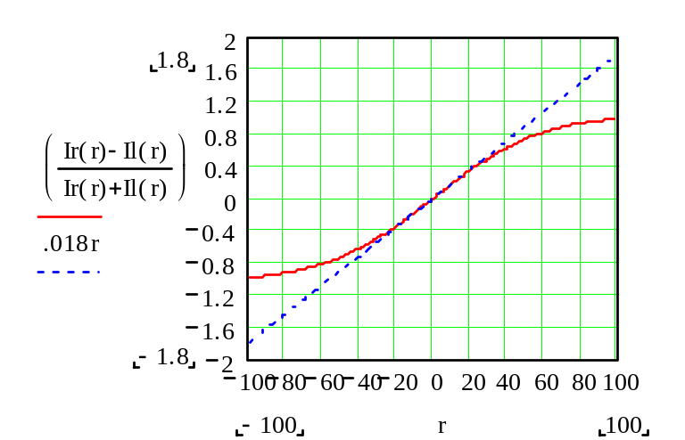
Figure A-8- A plot of sensitivity along the axis of a pair of pick-up elements for a 70 degree stripline designed BPM with a half aperture of 105mm. The sensitivity is shown to be 0.018V/V per mm. Linearity is shown to be “reasonable” over a range of +/- 20mm.

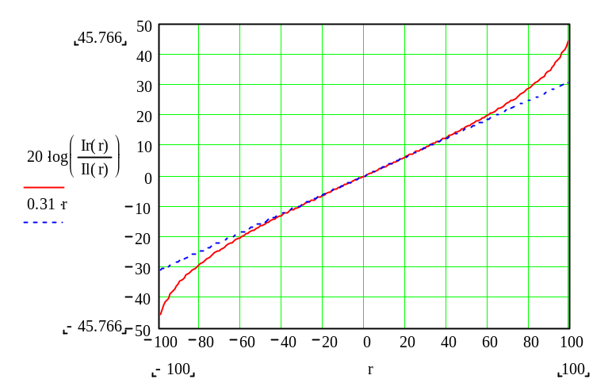

Figure A-9 - A plot of sensitivity along the axis of a pair of pick-up elements for a 70 degree stripline designed BPM with a half aperture of 105mm. The sensitivity is shown to be 0.31dB per mm. Linearity is shown to be “reasonable” over a range of +/- 65mm.

From the above plots (figures A-8 & A-9) it is clear that the log-ratio approach provides a more linear range of measurement, along the axis of the element pair, without corrections. For this reason the log-ratio is a more advantageous processing approach. Problems associated with balanced logarithmic amplifiers have made this approach challenging. We propose doing the log-ratio digitally.

A hardware approach is included here for completeness. Recently (Feb. 2001, http://content.analog.com/pressrelease/prdisplay/0,1622,301,00.html), Analog Devices has developed an IC with two logarithmic amplifiers, laser trimmed and matched for temperature, process, frequency and supply voltage that will operate over a 60dB dynamic range (see AD8302 data sheet, http://products.analog.com/products/info.asp?product=ad8302). This device, although designed for RF applications with a demodulating logarithmic amplifier system can be used at lower frequencies. Alternate devices that provide a large dynamic range are the AD640 (350MHz operation, provides two 50dB amplifiers in a single IC), and the AD8307 (500MHz operation, contains a single amplifier). The AD8302 (2.7GHz operation, provides two 60 dB amplifiers and additional circuitry to provide phase analysis) device can handle signals from 223uV to 223mV. The maximum allowable input signal is 0.707V. Therefore, a method to insure that this voltage is not exceeded must be employed for the Ring, and RTBT. The automatic DC offset compensation control loop must be adjusted to operate at frequencies below 1MHz to permit use in the Ring. This can be achieved by using coupling and bypass capacitors that will pass this frequency (using 0.02uF capacitors will extend the low frequency response to near 100KHz. This approach has merit and should be considered.

From manufacturer provided curves of magnitude ratio conformance, an error of less than 0.25dB can be obtained over a +/- 25dB range. From the above estimates of sensitivity, 1mm for a 105mm half aperture is about 0.3dB. Therefore an accuracy of less than +/- 1mm can be expected from this unit. Referencing the AD640 data sheet, a discussion of “Effect of Waveform on Intercept” is presented. Since it would be expected that both channels would see the same waveform, the intercept would affect both channels equally, and the resulting output would not exhibit any effect. This is also alluded to in the data sheet for the AD8302 on page 15.

The full wave detector provided with each stage of the logarithmic amplifier effectively provides an absolute magnitude function, and doubles the frequency. This is a good feature for our purposes and we can do an average of the absolute magnitude to develop a number representing the signal over the entire mini-pulse. This number can be used for the position information. Thus, the output from the log ratio amplifier averaged over an entire mini-pulse can be used.

APPENDIX B
Taken from a MathCAD file.

SENSITIVITY OF BPM
This section will apply signals and develop plots and data of a simulated beam. Noise is added at the end.
Shafer AIP Conference 212 -1989 "Beam Position Monitoring"
wall current density for a pencil beam Ib(t) at position r,θ inside a grounded circular conducting beam pipe of radius b. The wall current density iw at b,φw is then

iw(b,φw,t)=-(Ib(t)/2πb)[1+2Σ(r/b)^n (cos(n(φw-θ))]

iw(b,φw,t)=(-Ib(t)/2πb)[(b^2-r^2)/9b^2+r^2-2br cos(φw-θ)]
Two forms are provided by Shafer. A sum and a closed form solution
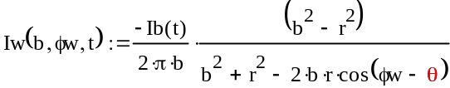
Eq 2-1
Eq 2-2
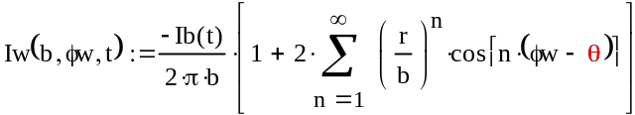
Two electrodes with angular width φ placed at zero and 180 degrees the resultant currents flowing parallel to the beam inside surface of these electrodes are (assuming they are grounded and also at radius b):
Right pickup
let the electrode have an angle of 70 degrees:
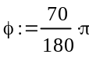
The beam is at point (r,θ):
Let θ=0 to examine along the axis of the pickup
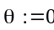
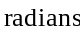
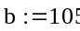
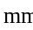
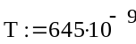
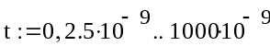
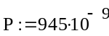
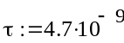
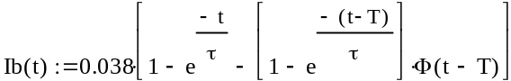
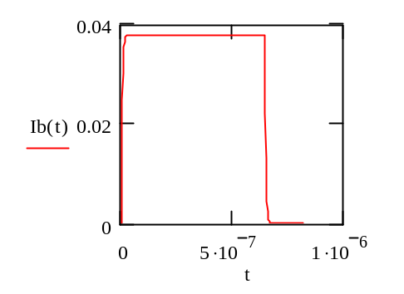
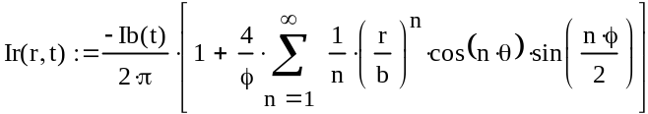
Left Pickup
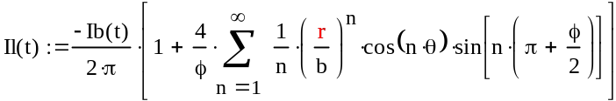
Consider n= only 1, for small displacements from center.
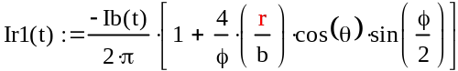
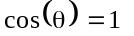
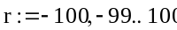
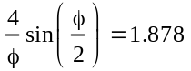
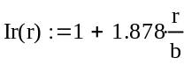
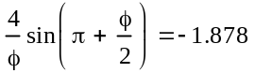
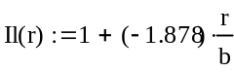
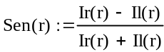
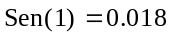
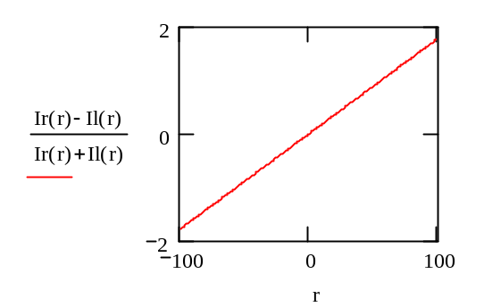
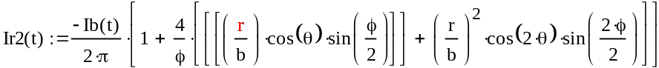
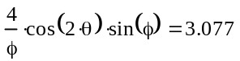
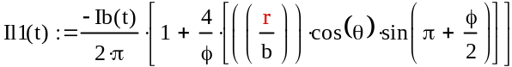
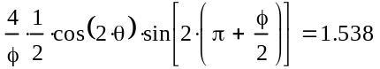
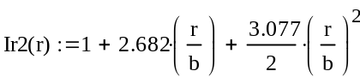
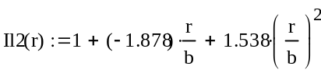
Consider the closed form solution
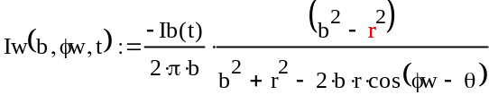
Eq 2-3
Integrating from φw=-φ/2 to +φ/2
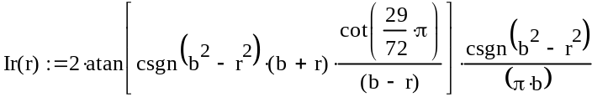
Eq 2-4
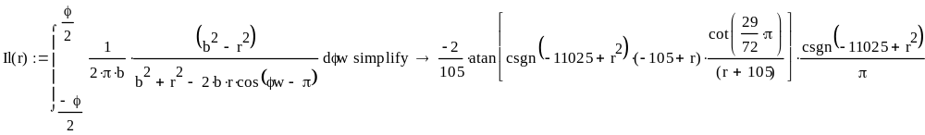
Eq 2-5
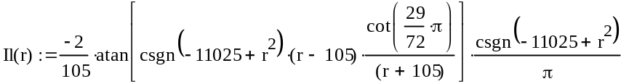
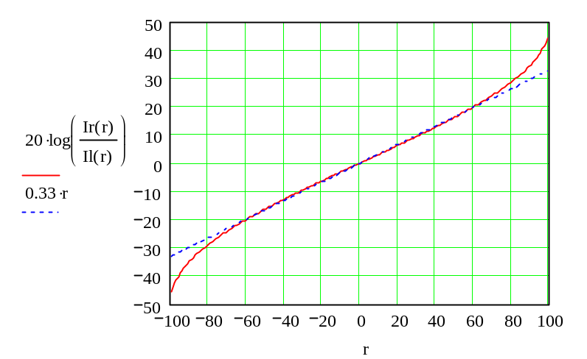
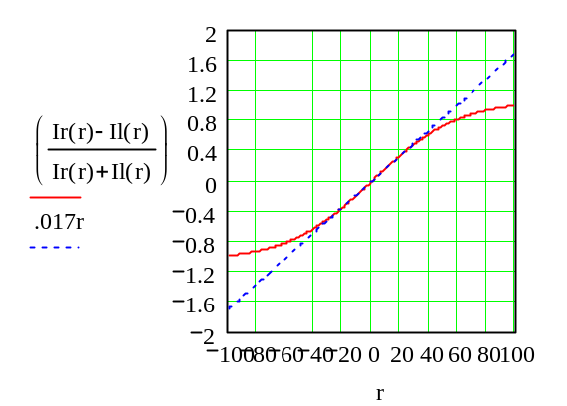
Clearly , the log ratio technique is more linear over a larger range of the beam pipe radius, and has about twice the sensitivity of the diff/sum method.
Let the signals developed by an electrostatic pickup with 70 degree angular width and 22cm length be the pickup element signals. Each signal from the right and left is passed through a system filter with gain and noise. We are interested in estimating the resolution.
From Shafer's sum equations, using only the linear term since we are interested in displacements that are a small fraction of the radius, we get the output of each element for an on axis beam at location (r,0).
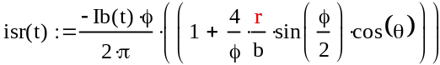
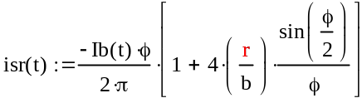
assuming the pickup length is L, the charge deposited on the inside surface of the electrode is:
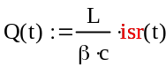
The signal current flowing into the capacitance is the derivative of the charge.
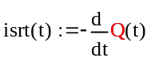
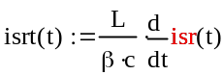
If this current is delivered to the characteristic resistance of a matched transmission line the voltage developed is:
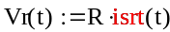
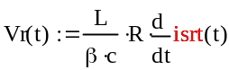
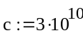
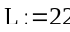
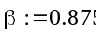
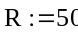
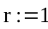
Eq 2-6
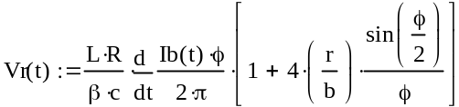
Eq 2-7
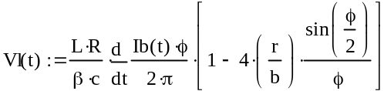
For :
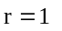
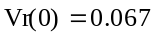

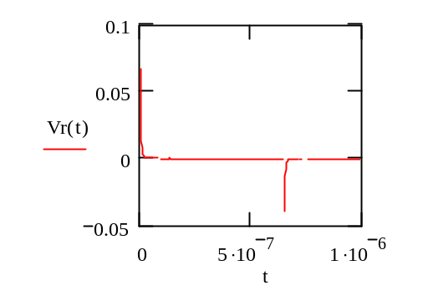
Eq 2-8
Filter response to an exponential is:
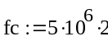
use 2 times the fc for 1db point of a single order filter
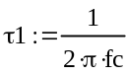
Eq 2-9
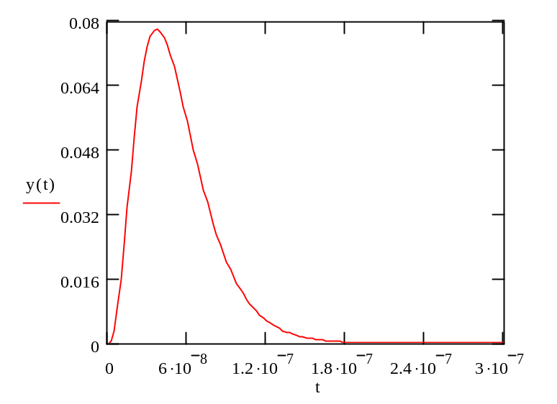
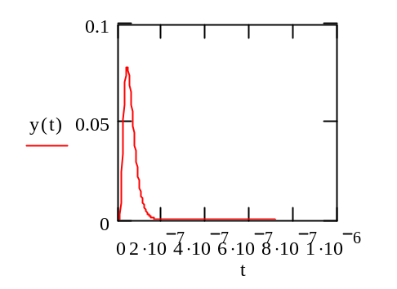
Define the bipolar response:
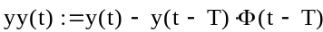
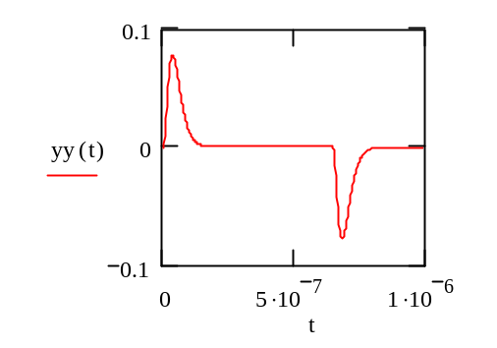
and when multiplied by the scaling:
define beam average current:
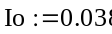
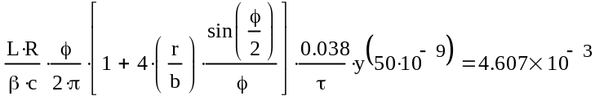
The output of the filter to the signal is:
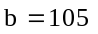
For the right electrode;
Eq 2-10
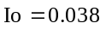
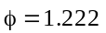
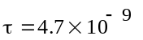
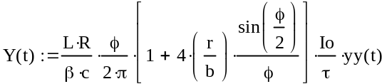
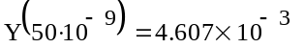
For the left electrode;
Eq 2-11
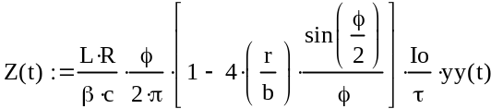
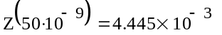
The difference is:
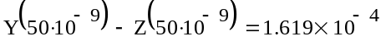
For 15ma beam the difference is;
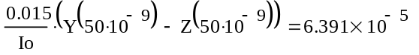
This confirms a "ball park" number for the output of a 5MHz filter for a 38mA input beam. If this is changed to a 15 mA beam the signal will drop as shown: Earlier estimates showed an output peak at about 1.9mV and this analysis shows about 2.1mV.
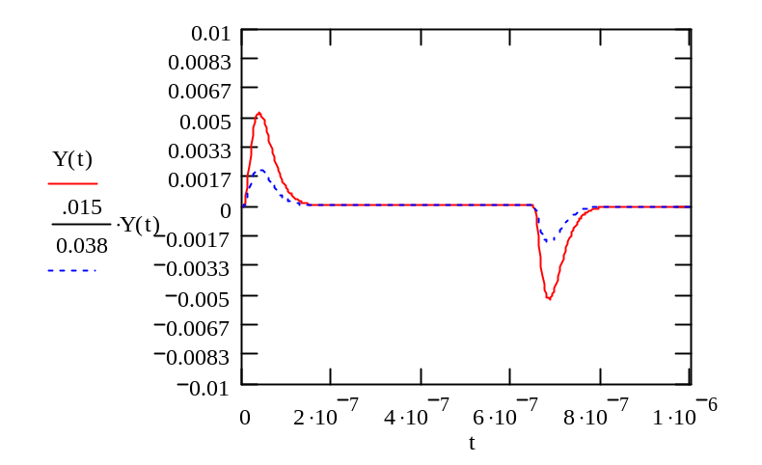
Consider now the processing:
Consider taking the signal and squaring it and then taking the average of the square over the time interval of an entire mini-pulse. We therefore, obtain the power in the signal averaged over about 945ns. This will automatically include power from the negative parts of the signal, and will add the noise power to the signal power.
With the standard difference processing; we will have a signal at the input of about 63uV per mm displacement (161*15/38uV). The bandwidth for this is 5MHz. For noise to equal signal, this reflects to a noise voltage density of 63/2236 uV/rtHz.
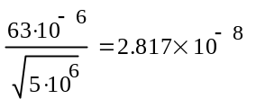
this is 28nV/rtHz and is about 31 times the noise of a 50 Ohm resistor.
Using RMS analysis we get ;
Eq 2-12
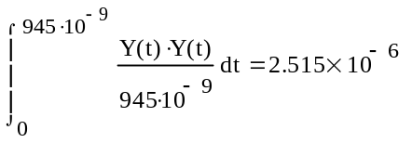
Eq 2-13
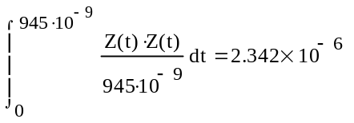
The mean squared difference signal is:
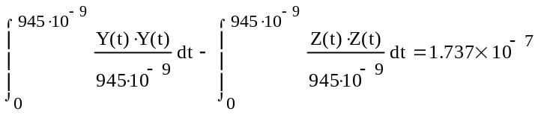
Eq 2-14
The rms difference signal is:
For :
Eq 2-15
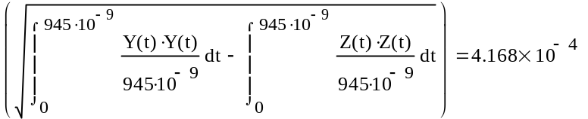
This difference mean square signal is the numerator with no noise, and will be about 63uV as before, for a 15ma Beam current (15/38)^2*417=65. This indicates little difference using mean-squared analysis over peak signal analysis.

EXAMINE THE SENSITIVITY
To examine the sensitivity of the mean square approach consider the BPM response of equation 2-4 and 2-5 again.
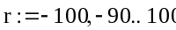
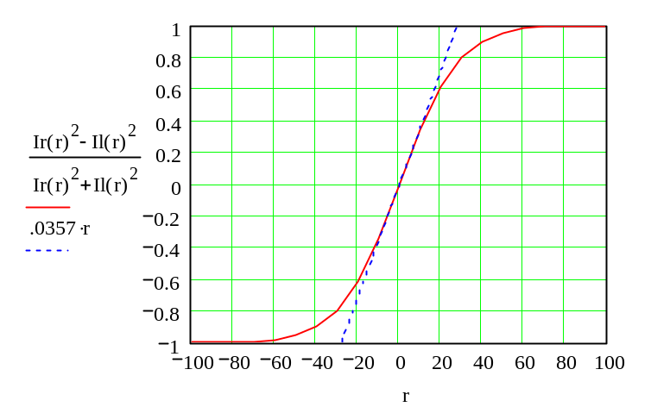
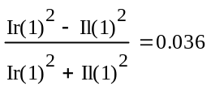
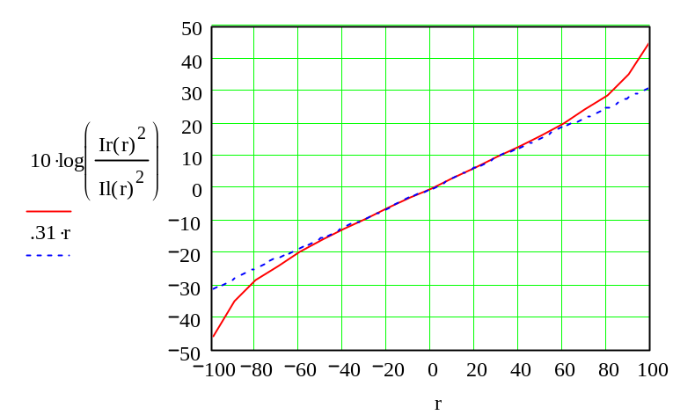
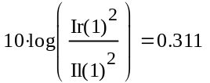
ADD NOISE TO ANALYZE THE RESULTS
Add noise:
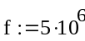
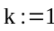
k is the number of times the noise is a factor of a 50 Ohm resistor
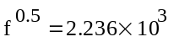
Generate 4 independent noise sources (divide by Pi/2 to normalize to an arbitrary bandwidth):
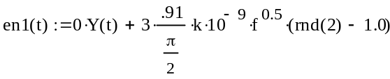
Noise of right pickup
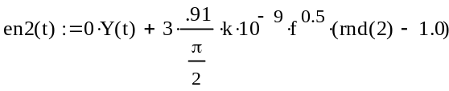
Noise of left pickup
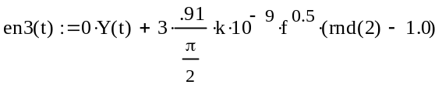
Measured noise of right pickup
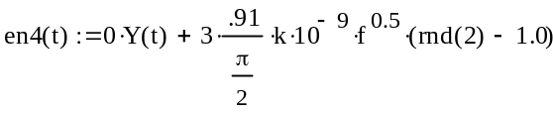
Measured noise of left pickup
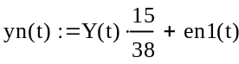
15 ma beam with noise, Right pickup
15 ma beam with noise, Left pickup
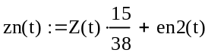
Mean Squared Noise:
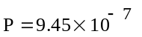
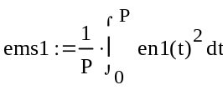
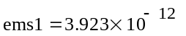
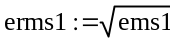
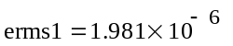
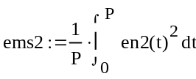
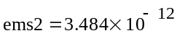
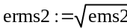
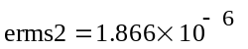
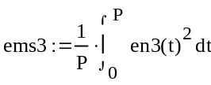
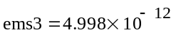
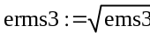
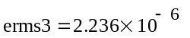
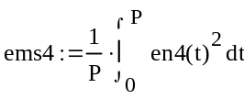
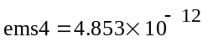
For no noise:
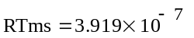
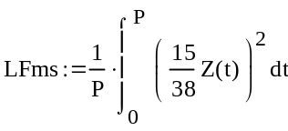
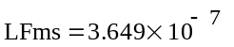
Mean squared signal is:
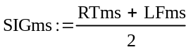
For no noise
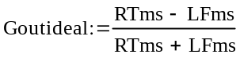
Including Noise:
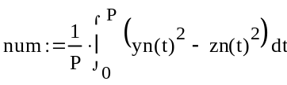
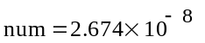
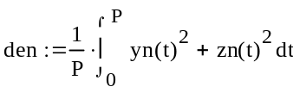
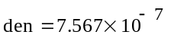
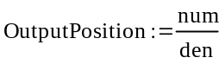

Using the noise subtraction we get:
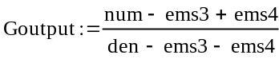
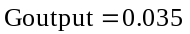
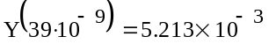
second sample point:
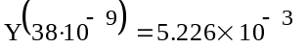
pk point
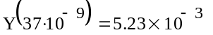
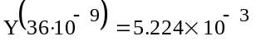
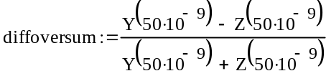
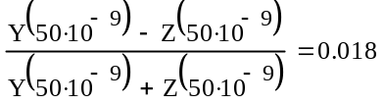
Output std Diff
notice exact timing not required, but same timing is:
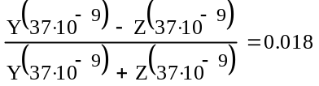
With noise:
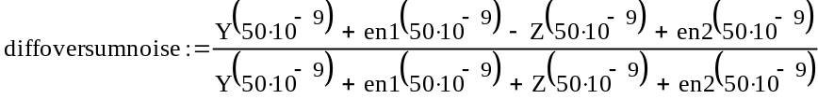
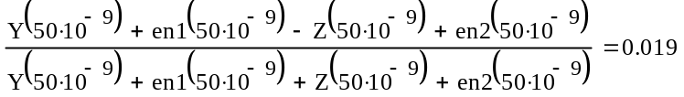
Apply log ratio approach:
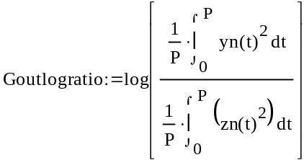
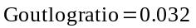
Ratio of S/N is:
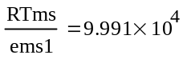
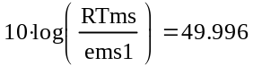
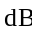
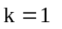
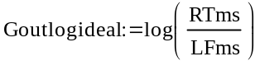
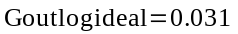
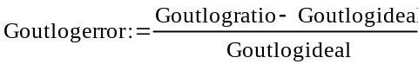
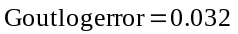
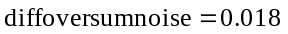
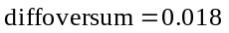

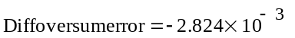
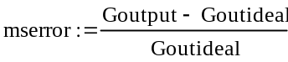
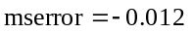
with extra noise compensation
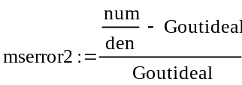
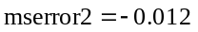
no noise compensation
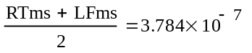
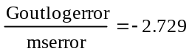
Conclusion : The sensitivity seems to be improved by a factor of two over the difference over sum calculation.
This calculation does not show a definitive advantage to subtract the mean squared noise from earlier measurements. However, the mean squared noise represents a smaller percentage of the signal power than the root mean squared noise does from the peak signal.
Ratio of S/N is:
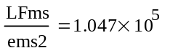
Calculate cross-correlation:
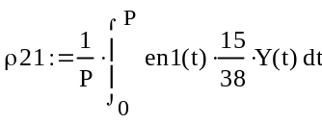
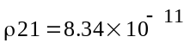
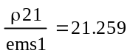
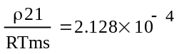
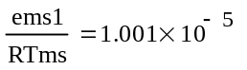
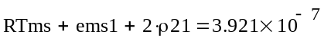
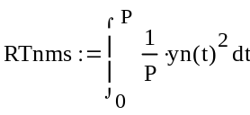
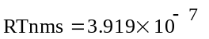
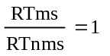
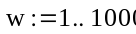
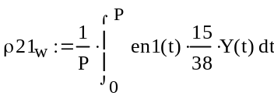
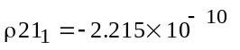
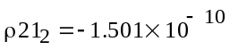
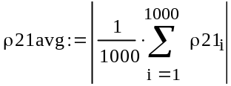
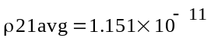
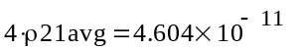
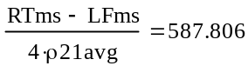
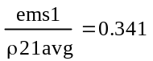
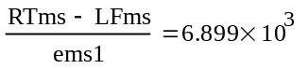
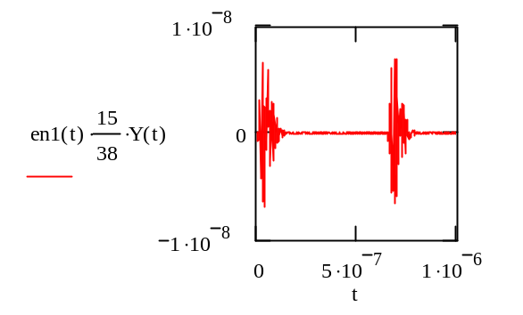
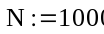
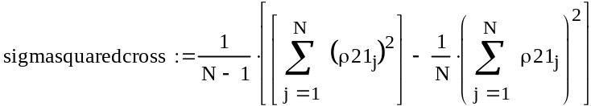
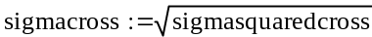
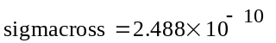
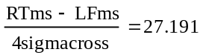
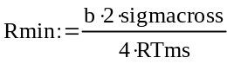
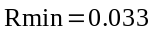
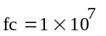

SET UP A LOOP TO CALCULATE SOLUTIONS
Add noise:
k is the number of times the noise is a factor of a 50 Ohm resistor
Generate independent noise sources:
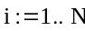
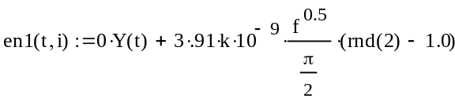
Noise of right pickup
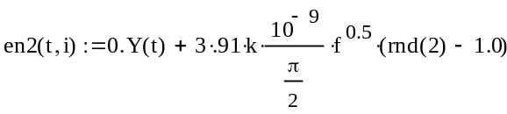
Noise on left pickup
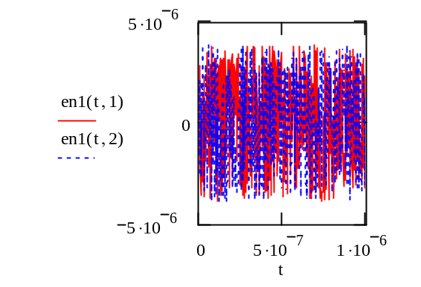
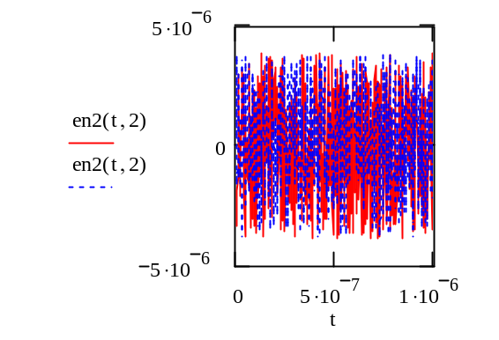
Observe the function en2(t,2) seems to be recomputed each time the function is called
Define signal period "P":
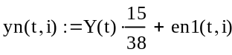
15 ma beam with noise, Right pickup
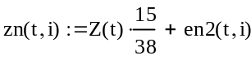
15 ma beam with noise, Left pickup
Plot of the signals
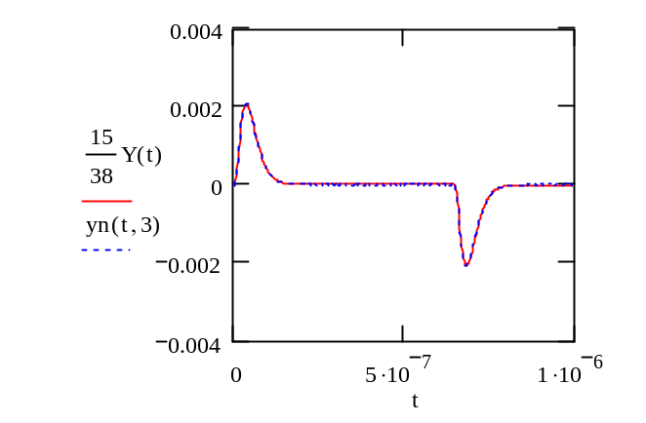
Output for log ratio calculation is:
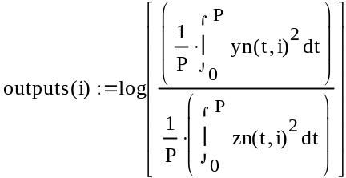
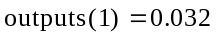
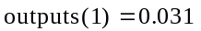
note outputs changes with each call....
change this to an array to solidify the calculation:
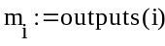
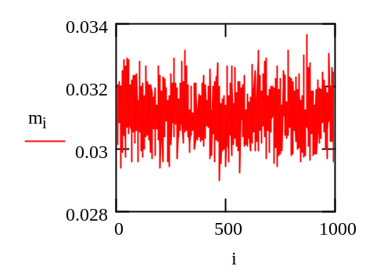
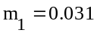
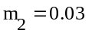
now results do not change
display iterations N:
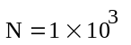
calculate mean of the squares:
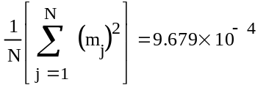
calculate square of the mean:
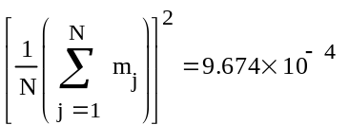
use following formula to compute the variance:
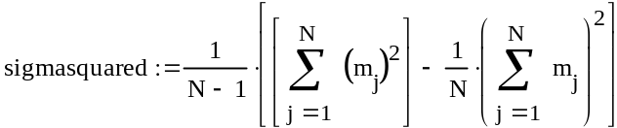
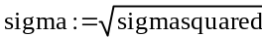
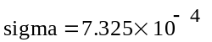
remember the ideal log ratio output is:
compute the percent error of the log ratio output:
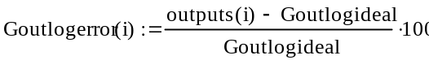
check some values:
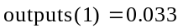
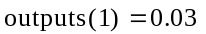
note outputs seem to be recomputed each time....



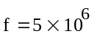
compute an array of output percent error values:
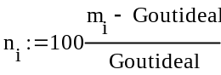
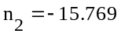
values not changing now
as before find the variance of this error (which should have a mean of zero:
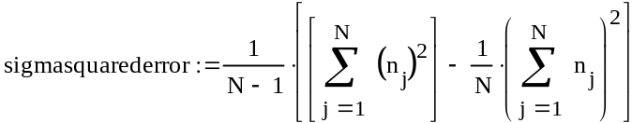
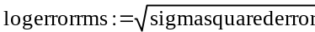
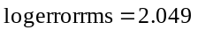
find the signal to noise ratio: (remember, RTms is the right signal mean squared value)
notice it does not change when recomputed.
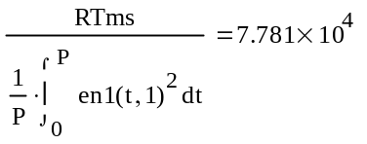
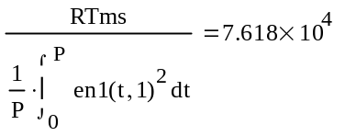
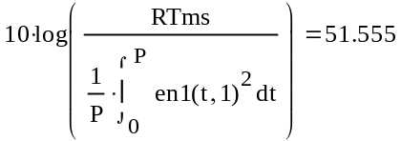
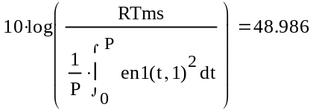
However , the noise calculation causes the ratio to change when recomputed.

This should not be a problem since we are trying to allow this ratio to be influenced by noise anyway.

We do want to use an average S/N ratio for an eventual plot.
compute a mean squared power for the signals from each PUE. Form them into an array.
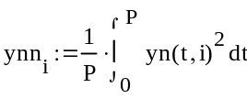
right PUE
left PUE
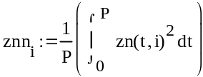
some evaluations:
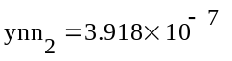
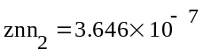
notice these values do not get recalculated and are defined by the subscript.
compute a mean-squared difference over mean squared sum and form an array with the answers:
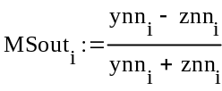
sample calculated answers:
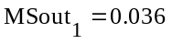
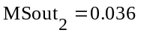
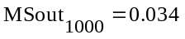
This is the equivalent calculation:
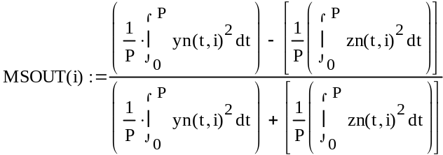
Define an ideal output ratio with no noise corruption:
note the ideal mean squared output answer is, and is not influenced by noise:
Define an array of percent error of the answers:
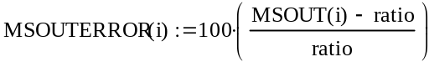
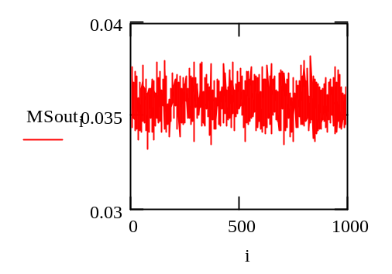
or :
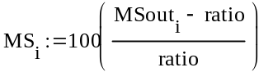
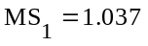
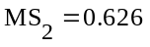
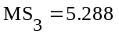
Compute the variance of the percent error:
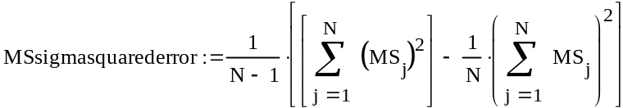
work on the difference over the sum using the peak signals:
First find the ratio of the peak signal to the rms signal to compare signal power calculations:
Find the ideal difference over the sum, with no noise included:
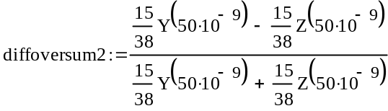
some sample results:
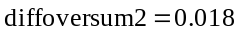
Output std Diff
With noise:
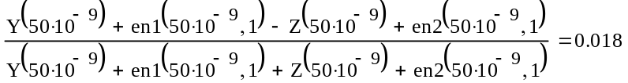
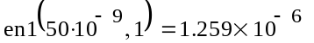
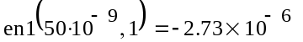
This is no good because it uses different numbers in the numerator and the denominator
define a noise array:
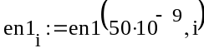
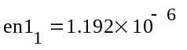
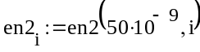
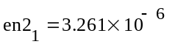
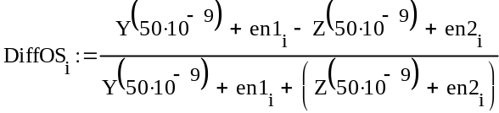
create an array of percent errors for this difference over sum (DOS) calculation:
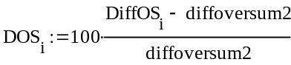
array of differences over sums percent error
find the variance:
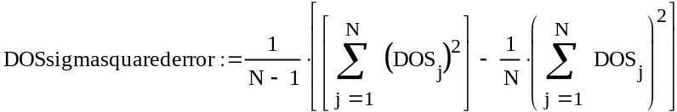

compute the signal to noise ratio two ways. First as mean squared signal to mean squared noise, then as peak squared signal to mean squared noise.
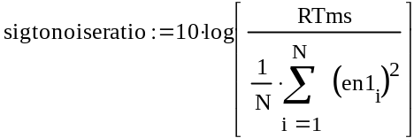
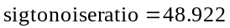
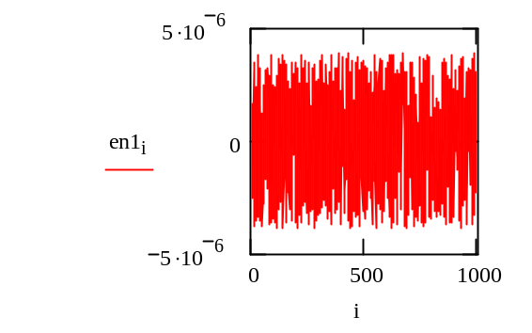
number of iterations
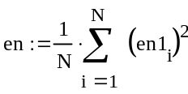
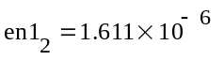
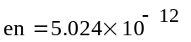
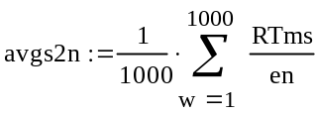
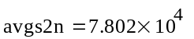
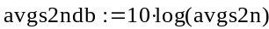
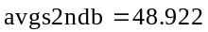
Now using Peaks:
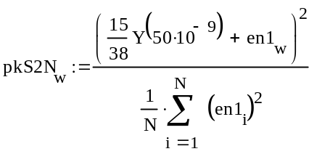
compare answers in dB
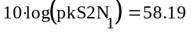
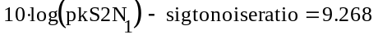
compute variance of the signal to noise ratio calculation:
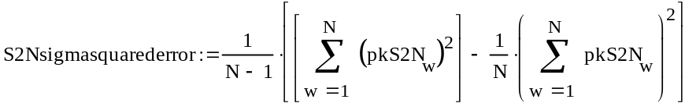
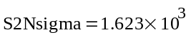

Plotted data:

APPENDIX C

APPROXIMATE ESTIMATION OF SENSITIVITY TO NOISE
The general concept is to take the mean of the square signal of the right PUE and divide by the mean of the square of the left PUE, and then take a logarithm.
If we call the right pickup signal fr(t), and the left pickup signal fl(t):
Then for small displacements of beam along the axis by a distance r:
F(t) is the signal on the PUE for zero displacement.
let the noise on the right PUE be enr(t)
and on the left PUE enl(t)
Then the signal out will be :
The numerator of the logarithm argument is:
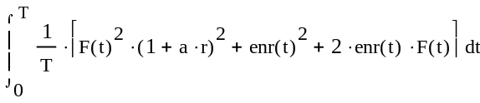
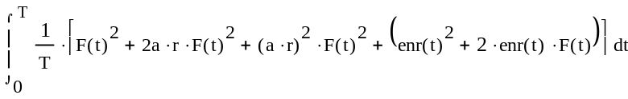
The denominator is:
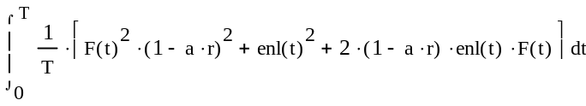
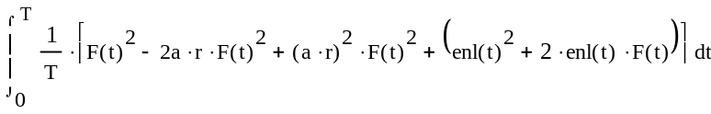
With signal power squared =:
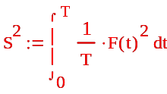
Dividing numerator and denominator by S squared, and σr² and σl² the mean squared noise voltages of the right and left PUEs:
assuming the terms in both the numerator and denominator are small compared to 1 we get:
This is approximately:
taking a natural log to provide an expansion
The log(w)=log(e)*ln(w)

and ln(1+x)=x-(1/2)x^2+(1/3)x^3-.....
The output is approximately (eliminating higher order terms):
We observe that this requires 4*a*r to be equal to the other terms to establish resolution requirements. The mean square noise terms for the right and left PUE channels subtract from each other, and so do the cross-correlation terms between the noise and the signal. There are higher order terms that will add to noise but they can be neglected for a*r<<1.

Thus, mean square noise tends to cancel, as does cross-correlation terms. However, the cross-correlation terms can be either positive or negative, and will vary with a random character. Therefore, these terms could, in fact add. The result, then, assuming a good estimate of σr and σl are achieved, and that these noise terms are near equal (both due to 50 Ohm resistor noise), yields

remember that a is:
and :
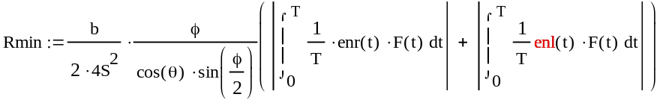

APPENDIX D
AFE card pins allocation – Linac version – provided by Bergoz®
January 22, 2001
Revision 2, March 21, 2001

Signal names structure:
Signals that belong to a particular processing channel start with a letter (A,B,C or D) referring to the channel.

Example: A.CAL-SW means Channel A, Calibration Switch control signal.
Each channel has 3 switches, every switch is individually controlled by its own control line.

PICKUP-SW is the switch on the pickup side
RCVR-SW is the switch at the input of the analog processing chain
CAL-SW is the switch which sends the calibration signal to the common point between the pickup and the processing chain.

The output signal gain for all 4 processing chains is controlled by a single control line IF.HIGAIN
N.OUT+ and N.OUT- are the differential outputs of channel N (N=A,B,C,D)

Control signals logic:
TTL levels, active when low.

Power supplies:
The AFE requires 1 supply rail: +12 V for a nominal current of 500mA

Connecting to AFE recommendations:
ADCs implementation on DFE board should respect the provisions of AD6644 data sheet. Pls. note 25-ohm series resistors in each input line, close to the input pins: AIN = pin 11 and AIN (inv.) = pin 12. AFE provides a differential output signal for each
of the channels. The AFE driver output has impedance < 200 ohms. It is dc-isolated from
ground by a transformer. The output transformer center tap is connected to AFE ground plane via a 100-nF capacitor. Signal connections to each ADC should be routed as parallel lines of minimum line width (≤ 0.010” ) to minimize capacitive loading. They should be as short as possible and be of same electrical length (signal delay) to ensure a common phase reference. These analog signal lines are very sensitive to
noise pick up and should stay well away from all digital lines. Considering this differential analog interface, we believe that a common ground plane for AFE and DFE board is preferable and provide therefore many ground pins over the whole width of the
interface connector. We recommend that all AFE ground pins be connected to DFE ground plane. The PCI components side area under AFE should preferably be a solid ground plane.

Pin numbers, per AFE pin numbering (Document: Connector location, type, style and pins numbering dated Jan. 24, 2001 and John Power’s email dated 3/21/2001)
1 GND 2 +12V 1A
3 +5V analog <0.1A 4 -12V 1A
5 -5V analog <0.1A 6 A.PICKUP-SW
7 +5V digital 1A 8 A.RCVR-SW
9 +3,3V digital 1A 10 A.CAL-SW
11 GND 12 B.PICKUP-SW
13 GND 14 B.RCVR-SW
15 GND 16 B.CAL-SW
17 GND 18 C.PICKUP-SW
19 GND 20 C.RCVR-SW
21 GND 22 C.CAL-SW
23 GND 24 D.PICKUP-SW
25 GND 26 D.RCVR-SW
27 GND 28 D.CAL-SW
29 GND 30 IF.HIGAIN
31 GND 32 GND
33 GND 34 A.OUT-
35 GND 36 A.OUT+
37 GND 38 GND
39 GND 40 B.OUT-
41 GND 42 B.OUT+
43 GND 44 GND
45 GND 46 C.OUT-
47 GND 48 C.OUT+
49 GND 50 GND
51 GND 52 D.OUT-
53 GND 54 D.OUT+
55 GND 56 GND
57 GND 58 SPARE
59 GND 60 SPARE
Note: Even-numbered pins 6 to 30 may still be swapped around.

J. Power et al, “Beam Position Monitors for the SNS Linac”, PAC2001, NY.
M. Kesselman, et-al, “SNS Project Wide Beam Current Monitors”, BIW 2000, Cambridge MA May 8-11, 2000
M. Kesselman et-al, “SNS Project Wide Beam current Monitors”, EPAC 2000, Vienna Austria, June 26-30, 2000
M. Kesselman, “Spallation Neutron Source Beam Current Monitor Electronics”, PAC 2001, Chicago IL, June 18-22, 2001
M. Kesselman, “Technote 104- Considerations for the Design of the Beam Current Monitor System for the Spallation Neutron Source (SNS)”, SNS-BNL Technote, March 5, 2001, http://server.ags.bnl.gov/bnlags/bnlsns/sns.html
M. Kesselman, et-al, Spallation Neutron Source Beam Current Monitor Electronics, to be published BIW 2002, New York NY, May 6-9, 2002

